DDOS DETECTION AND MITIGATION IN IOT CLOUD GATEWAY

BY
ALIYU LATEEFAT
HND/23/COM/FT/0561

SUBMITTED TO THE DEPARTMENT OF COMPUTER SCIENCE, INSTITUTE OF INFORMATION AND COMMUNICATION TECHNOLOGY

KWARA STATE POLYTECHNIC, ILORIN.
IN PARTIAL FULFILLMENT OF THE REQUIREMENTS FOR THE AWARD OF HIGHER NATIONAL DIPLOMA (HND) IN
COMPUTER SCIENCE

JUNE, 2025.

CERTIFICATION
This is to certify that this project was carried out by ALIYU LATEEFAT of Matriculation Number: HND/23/COM/FT/0561 in the Department of Computer Science, Institute of Information Communication Technology, Kwara State Polytechnic, Ilorin, Kwara State.

…………………………………. ….………………………
MR. BOLAJI-ADETORO, D. F. Date
Project Supervisor

…………………………………. ….………………………
MR. OYEDEPO, F. S. Date
Head of Department

…………………………………. ….………………………
External Examiner Date

DEDICATION
I dedicate this project work to Almighty God who inspired me and directed my ways during my academic stay in the polytechnic.

ACKNOWLEDGEMENT
All praise is due to Almighty God the Lord of the universe. I praise him and thank him for giving me the strength and knowledge to complete my HND program and also for our continued existence on Earth.
I appreciate the utmost effort of my supervisor, Mr. Bolaji-adetoro, D. F. whose patience, support, and encouragement have been the driving force behind the success of this research work. He gave useful corrections, constructive criticisms, comments, recommendations, and advice and always ensures that excellent research is done. My sincere gratitude goes to the Head of the Department Mr. Oyedepo F. S., and other members of staff of the Department of Computer Science, Kwara State Polytechnic, Ilorin, for their constant cooperation, constructive criticisms, and encouragement throughout the program.
Special gratitude to my parents, who exhibited immeasurable financial, patience, support, prayers, and understanding during the period in which I was busy tirelessly with my studies, special thanks go to my lovely siblings
My sincere appreciation goes to my friends and classmates.

TABLE OF CONTENTS
Title page i
Certification ii
Dedication iii
Acknowledgments iv
Table of Contents v
Abstract vi
CHAPTER ONE: GENERAL INTRODUCTION
1.1 Background to the Study 1
1.2 Statement of the Problem 2
1.3 Aim and Objectives 2
1.4 Significance of Study 3
1.5 Scope of Study 3
1.6 Organization of the Report 3
CHAPTER TWO: LITERATURE REVIEW
2.1 Review of Related Works 5
2.2 Review of General Text 10
2.3 Review of Related Concepts 10
CHAPTER THREE: RESEARCH METHODOLOGY AND
ANALYSIS OF THE SYSTEM
  - Research Methodology 15
  - Analysis of the Existing System 17
  - Problem of the Existing System 18
  - Analysis of the Proposed System 19
  - Advantages of the Propose System 20
CHAPTER FOUR: DESIGN, IMPLEMENTATION AND
DOCUMENTATION OF THE SYSTEM
  - Design of the System 22
    - Output Design 22
    - Input Design 23
    - Database Design 25
    - Procedure Design 27
  - Implementation of the System 27
    - Choice of programming language 27
    - Hardware support 28
    - Software Support 28
    - Implementation Techniques used in Details 28
  - System Documentation 28
    - Operating the System 28
    - Maintaining of the System 29
CHAPTER FIVE: SUMMARY CONCLUSION AND
RECOMMENDATION
5.1 Summary 30
5.2 Conclusion 30
5.4 Recommendations 31
References 32

ABSTRACT
Distributed Denial of Service (DDoS) attacks pose a significant threat to IoT cloud gateways, disrupting services and compromising the security of connected devices. Traditional DDoS detection and mitigation methods, which rely on static rules and predefined signatures, are inadequate in the face of evolving attack patterns and the scalability demands of IoT environments. This study proposes a comprehensive solution that integrates advanced machine learning algorithms for adaptive anomaly detection, a scalable cloud-based architecture, and lightweight security agents deployed on IoT devices. The system also incorporates real-time mitigation strategies to minimize latency and maintain service performance during attacks. Through detailed analysis and experimental evaluation, the proposed system demonstrates superior accuracy, scalability, and efficiency compared to traditional approaches. This research underscores the necessity of adopting innovative, adaptive, and resource-efficient security solutions to effectively protect IoT cloud gateways against the growing threat of DDoS attacks.

CHAPTER ONE
GENERAL INTRODUCTION
  - Background to the Study
Cloud computing, as defined by the National Institute of Standards and Technology (NIST), is a paradigm that provides ubiquitous and on-demand access to a shared pool of configurable computing resources over the internet. This transformative model is characterized by key features such as on-demand self-service, broad network access, resource pooling, rapid elasticity, and measured service (Armbrust et al., 2020).
In essence, cloud computing offers three primary service models: Infrastructure as a Service (IaaS), Platform as a Service (PaaS), and Software as a Service (SaaS). IaaS provides virtualized computing resources, PaaS offers a platform for application development, and SaaS delivers software applications over the internet (Grance, 2019. Additionally, cloud computing deployment models include public, private, and hybrid clouds, each catering to specific organizational needs (Francisco, et al., 2019).
The advent of Internet of Things (IoT) technology has ushered in a new era of interconnected devices, facilitating seamless communication and data exchange. Within the IoT ecosystem, cloud gateways serve as vital components that bridge the gap between IoT devices and the cloud infrastructure, enabling efficient data transfer, storage, and management. However, the growing interconnectedness also exposes IoT cloud gateways to security threats, particularly Distributed Denial of Service (DDoS) attacks (Khalid, et al., 2022).
The purpose of this study is to address the challenges posed by DDoS attacks on IoT cloud gateways. DDoS attacks, characterized by a flood of malicious traffic overwhelming a system, can severely impact the functionality and availability of IoT services. Thus, developing effective detection and mitigation strategies tailored to the unique characteristics of IoT cloud gateways becomes paramount for ensuring the integrity and reliability of IoT ecosystems. In this way, it is possible to have the interruption of services or the use of devices as a launching point of attacks for diverse domains, as is the case of the DDoS attack, which has been consolidated for several reasons, such as (i) simplicity and facility of execution, not requiring vast technological knowledge on the attacker side, and (ii) variety of platforms and applications for facilitated attack orchestration. Many of these attacks succeeded in disrupting essential Internet services such as DNS, affecting millions of users around the world, and commercial platforms such as GitHub, prompting severe financial losses to the organizations that depend on those services (Ammarah, et al., 2022).
  - Statement of the Problem
The proliferation of IoT devices and the increasing reliance on cloud-based services have rendered IoT cloud gateways susceptible to DDoS attacks. These attacks, if successful, can disrupt normal operations, leading to service degradation or complete unavailability. The problem lies in the need for specialized security measures that can discern legitimate IoT traffic from malicious attempts, ensuring the continuous and secure functioning of IoT cloud gateways.
Moreover, the dynamic nature of IoT environments, characterized by a diverse array of devices and communication patterns, poses additional challenges for traditional DDoS detection and mitigation methods. Therefore, there is a critical need to investigate and develop tailored solutions to safeguard IoT cloud gateways from the evolving landscape of DDoS threats.
  - Aim and Objectives of the Study
This research project aims to enhance the security of IoT cloud gateways by developing effective DDoS detection and mitigation mechanisms.
The objectives are:
- investigate the characteristics and patterns of DDoS attacks specifically targeting IoT cloud gateways.
- develop a robust DDoS detection system tailored to the unique characteristics of IoT traffic.
- design and implement mitigation strategies to effectively counter DDoS attacks on IoT cloud gateways.
- evaluate the performance and efficacy of the proposed detection and mitigation mechanisms through simulations and real-world scenarios.
  - Significance of the Study
The study on DDoS detection and mitigation in IoT cloud gateways is highly significant due to its potential impact on enhancing the security and reliability of IoT ecosystems. By developing tailored strategies to combat DDoS attacks targeting cloud gateways, this research aims to mitigate disruptions and ensure uninterrupted access to IoT services. Protecting critical infrastructure, reducing costs associated with downtime, and optimizing resource utilization are key benefits of implementing effective DDoS mitigation measures. Furthermore, this study contributes to industry growth by fostering confidence in IoT technologies and promoting the adoption of secure IoT deployments. Insights gained from this research can also inform industry best practices and standards, supporting risk management and compliance efforts. Overall, the significance of this study extends beyond technical aspects to encompass broader implications for IoT security, service continuity, and the maturity of the IoT industry.
  - Scope of the Study
The study will involve the development and implementation of specialized detection mechanisms, including anomaly detection and machine learning-based approaches, tailored to differentiate between normal IoT traffic and malicious DDoS activity. Mitigation strategies will also be designed to effectively respond to detected DDoS incidents, ensuring minimal disruption to IoT services. Simulation-based evaluations will be conducted to validate the performance and efficacy of these strategies, considering diverse scenarios and traffic patterns.
  - Organisation of the Report
For easy study and proper understanding of this project write-up, It is planned and organized into five chapters. The description of what each chapter contains is explained below:
Chapter One: This contains an Introduction to the whole write-up, the problem of the study, aims and objectives of the study, the significant of the study, the scope and limitation of the study, and organization of the report. Chapter Two: It focuses on the literature review of the study, organization of the board of director, computerization of the current state of the art. Chapter Three: It presents data collection method employed, analysis of data and existing system, advantages of the proposed system, design and implementation, programming language used with reasons, hardware and software support. Chapter Four: It deals with the system design implementation and documentation, design of the system, output design, input design, file system, procedural design, and documentation of the new system. Chapter Five: This centres the summary, experienced gained, recommendation and conclusion.

CHAPTER TWO
LITERATURE REVIEW
2.1 Review of Related Work
Francisco, et al., (2019) Smart Detection: An Online Approach for DoS/DDoS Attack Detection Using Machine Learning. Users and Internet service providers (ISPs) are constantly affected by denial-of-service (DoS) attacks. is cyber threat continues to grow even with the development of new protection technologies. Developing mechanisms to detect this threat is a current challenge in network security. is article presents a machine learning- (ML-) based DoS detection system. The proposed approach makes inferences based on signatures previously extracted from samples of network traffic. The experiments were performed using four modern benchmark datasets. The results show an online detection rate (DR) of attacks above 96%, with high precision (PREC) and low false alarm rate (FAR) using a sampling rate (SR) of 20% of network traffic.
Ammarah, et al., (2022) Prevention Techniques against Distributed Denial of Service Attacks in Heterogeneous Networks: A Systematic Review. The Distributed Denial of Service (DDoS) attack is one of the most critical issues in network security. These sorts of attacks pose a noteworthy danger to the accessibility of network services for their legitimate users by flooding the bandwidth or network service using various infected computer systems. 'e targeted servers are overwhelmed with malicious packets or connection requests, causing them to slow down or even crash the server operations which results in preventing genuine users from accessing the service. In this paper, we discussed the detailed classification of DDoS attacks and identified attackers’ motivations behind them and their consequences. Further, the DDoS attacks on IoT devices are elaborated based on applications and network layers. A comprehensive literature review has been conducted on cutting-edge defense techniques to defend against such attacks. An in-depth analysis of each mechanism has been carried out to find the optimal solutions. We fairly evaluated the existing defense techniques for DDoS attacks and presented key findings in comparison tables. Furthermore, this paper provides recommendations for future work for new researchers.
Khalid, et al., (2022) A DDoS Detection and Prevention System for IoT Devices and Its Application to Smart Home Environment. The Internet of Things (IoT) has become an integral part of our daily life as it is growing in many fields, such as engineering, e-health, smart homes, smart buildings, agriculture, weather forecasting, etc. However, the growing number of IoT devices and their weak configuration raise many security challenges such as designing protocols to protect these devices from various types of attacks such as using them as bots for DDoS attacks on target servers. In order to protect IoT devices from enslavement as bots in a home environment, we develop a lightweight security model consisting of various security countermeasures. The working mechanism of the proposed security model is presented in a two-part experimental scenario. Firstly, ‘;we describe the working mechanism of how an attacker infects an IoT device and then spreads the infection to the entire network. Secondly, we propose a set of mechanisms consisting of filtration, detection of abnormal traffic generated from IoT devices, screening, and publishing the abnormal traffic patterns to the rest of the home routers on the network. We tested the proposed scheme by infecting an IoT device with malicious code. The infected device then infects the rest of the IoT devices in its network and launches a DDoS attack by receiving attack-triggering commands from the botmaster. Finally, the proposed detection mechanism is used to detect abnormal traffic and block the connection of infected devices in the network. The results reveal that the proposed system blocks abnormal traffic if the packets from an IoT device exceed a threshold of 50 packets. Similarly, the network packet statistics show that, in the event of an unwanted situation, the detection mechanism runs smoothly and avoids any possible delays in the network.
Shu-Hung, et al., (2022) Detection and Prevention of DDoS Attacks on the IoT. The Internet of Things (IoT) system has been a hot topic in recent years. Its operation is a system that stores data in data storage and is completed by the exchange of network information about things. Therefore, the security of information between network transmissions is very important. In recent years, the most likely cause of information security problems has been a distributed denial of service (DDoS) attack. In this paper, we proposed an autonomous defense system that combines edge computing with a two-dimensional convolutional neural network (CNN) to recognize whether the data server in IoT suffers from DDoS attacks and identify the attack mode. The accuracy of trained two-dimensional CNN is up to 99.5% and 99.8% for packet traffic and packet features training, respectively. A field experiment’s results show that the data server in the proposed system can effectively distinguish the difference between the DDoS attacks and the normal transmission to reduce the impact of DDoS attacks on the IoT data storage while it is under attack.
Sapna, (2023) A Lightweight Model for DDoS Attack Detection Using Machine Learning Techniques. The study in this paper characterizes lightweight IoT networks as being established by devices with few computer resources, such as reduced battery life, processing power, memory, and, more critically, minimal security and protection, which are easily vulnerable to DDoS attacks and propagating malware. A DDoS attack detection model is crucial for attacks in various industries, ensuring the availability and reliability of their networks and systems. The model distinguishes between legitimate and malicious traffic by analyzing network traffic patterns and identifying anomalies. This safeguards critical infrastructure, preserves business continuity, and protects the user experience, minimizing the impact of DDoS attacks. Numerous scholars have studied the notion that protecting lightweight IoT networks essentially requires improving intrusion detection systems. This research is valuable, as it follows a tailored pre-processing methodology specific to IoT network challenges, addressing a pressing need in cybersecurity by focusing on a growing concern related to IoT devices and DDoS attacks, enhancing the security of essential network systems in various industries by effectively detecting DDoS attacks, and developing a lightweight intrusion detection system that aligns with the limited resources of IoT devices. This manuscript proposes a compact and lightweight intrusion detection system that blends machine learning classifiers with a fresh approach to data pre-processing. The handling of missing values, data standardization using Standard Scalar, feature selection using ExtraTreeClassifier wherein only the 15 best features are extracted, and anomaly detection using a classifier are performed. The network dataset of TON-IOT and BOT-IOT datasets is used for experiments, specifically binary classifications and multiple-class classification for the experiment with DDoS and all attacks, respectively. There is an imbalance between the TON-IOT and BOT-IOT attack classes. In trials using the TON-IOT and BOT-IOT datasets, the classes were balanced using several iterations of the SMOTE approach. This research provides several classifier types, namely logistic regression, random forest, naïve bayes, artificial neural network, and k nearest neighbor algorithms, which are used to build a lightweight intrusion detection system that is ideally suited for protecting against DDoS attacks in IoT networks. The time taken to train and predict the DDoS attacks is also implemented. Random forest performed well under TON-IOT and naïve bayes performed well under BOT-IOT under binary and multiple-class classification, achieving an accuracy of 100% with less training and prediction time.
Vikash (2019) review statistical and distributed packet ﬁlter against DDoS attacks in Cloud environment, Distributed Denial of Service (DDoS) attacks are a serious threat to Cloud. These attacks consume large amount of resources and increase the service usage cost by a signiﬁcant factor. Due to multi-tenancy and self-provisioning properties of Cloud, traditional DDoS detection techniques cannot be directly applied. Hence, there is a need for Cloud-speciﬁc DDoS detection framework. In this paper, a statistical and distributed network packet ﬁltering model is proposed against DDoS attacks in Cloud. The key idea of this scheme is to distribute multiple packet ﬁlters among individual virtual machines, which generate and share collective proﬁle of normal behaviour with a coordinator node at constant intervals. Statistics of selected network attributes construct the normal behaviour proﬁle. Based on the deviation from normal behaviour a decision is made whether to accept or reject the incoming packet. The coordinator node monitors ﬁlter and distribute the averaged proﬁle to newly provisioned nodes. Individual proﬁles have low memory and storage requirements and are updated dynamically. Simulation study indicates the effectiveness of this scheme in detecting DDoS attacks in Cloud.
Adrien & Martin (2020) A survey of denial-of-service and distributed denial of service attacks and defenses in cloud computing, Cloud Computing is a computing model that allow subiquitous, convenient and on-demand access to a shared pool of highly configurable resources (e.g., networks, servers, storage, applications and services). Denial-of-Service (DoS) and Distributed Denial-of-Service (DDoS) attacks are serious threats to the Cloud services’ availability due to numerous new vulnerabilities introduced by the nature of the Cloud, such as multi-tenancy and resource sharing. In this paper, new types of DoS and DDoS attacks in Cloud Computing are explored, especially the XML-DoS and HTTP-DoS attacks, and some possible detection and mitigation techniques are examined. This survey also provides an overview of the existing defense solutions and investigates the experiments and metrics that are usually designed and used to evaluate their performance, which is helpful for the future research in the domain.
Zalak & Hardik (2019) Analysis of Detection and Prevention of DDoS Attack in Cloud, Cloud computing is the most dynamic field used by the IT industry. Most Probably every industry of the public sectors are taking on the cloud computing today, there are many cloud platforms are in demand like, openstack, AWS etc. The cloud has become the most important part of the global infrastructure but there are no borders to safeguard from the critical attacks. In cloud computing, providing the secure and reliable services is the big challenge. DoS and DDoS attacks are the top attacks in the cloud network as it prevents the legitimate users to use the cloud services and sometimes it also can crash the cloud server after having too much requests from unauthorized domains. It causes unavailability of the services to the authorized users. DoS attack is the security breach to make the network resources unavailable to the users by spoofing the IP. This Paper contains the survey about some detection and prevention techniques of DDoS attack in cloud.
Priyanka et al (2019) review enhanced cbf packet filtering method to detect ddos attack in cloud computing environment, Tremendous and extraordinary growths in the field of internet, intranet, extranet and its users have developed an innovative era of great global competition and contention. Denial of service attack by multiple nodes is accomplished of disturbing the services of rival servers. The attack can be for multiple reasons. So it is a major threat for cloud environment. Due to low effectiveness and large storage conventional defending approaches cannot be easily applied in cloud security. The effects of various attacks can decrease the influence of a cloud. So, in view of this challenge task, this paper aims at enhancing a proposed method for cloud security. We propose a modification to the confidence Based Filtering method (CBF) which is investigated for cloud computing environment based on correlation pattern to mitigate DDoS attacks on Cloud. The modification introduces nominal additional bandwidth and tries to increase the processing speed of the victim initiated server.
Kiruthika & Subbulakshmi (2020) Review a comparative analysis of security methods for ddos attacks in the cloud computing environment, Cloud security is of the major concern in the deployment and protection of cloud deployment models. In this paper, detailed investigations on the recent DDoS attacks and comparative analysis of the various DDoS security solutions in the cloud computing environment are carried out. The comprehensive study of the cloud DDoS solutions clearly exemplifies the techniques, deployment layer, benchmark datasets, tools and performance metrics. The Cloud DDoS Detection and defense model using learning algorithms is designed to protect the cloud infrastructure considering the pitfalls in the existing procedures for real world problems. The model is based on anomaly detection and thus it is capable of protecting the public/private cloud from zero-day attacks. The availability of the cloud applications.
2.2 Review of General Study
In the realm of cloud computing and cybersecurity, several studies have contributed valuable insights into the challenges and solutions related to DDoS detection and mitigation. This section reviews key studies that have addressed DDoS attacks in various contexts, providing a foundation for understanding the broader landscape of DDoS defense strategies. a comprehensive study on DDoS attacks and mitigation techniques, emphasizing the importance of early detection and rapid response. Their research highlighted the role of flow-based analysis and anomaly detection in effectively identifying and mitigating DDoS attacks before they impact critical services.
Khan et al. (2018) explored the application of machine learning algorithms for DDoS attack detection, demonstrating the effectiveness of supervised learning techniques in distinguishing between normal and malicious traffic patterns. Their study highlighted the potential of artificial intelligence in enhancing DDoS defense mechanisms.
2.3 Review of Related Concepts
The literature on DDoS detection and mitigation in the context of IoT cloud gateways is enriched by related concepts that contribute to understanding the underlying principles and technologies involved. This section reviews key concepts relevant to the study, providing insights into foundational aspects of cybersecurity and IoT.
2.3.1 Cybersecurity Fundamentals
Cybersecurity fundamentals encompass essential principles and practices vital for safeguarding digital assets, systems, and networks against malicious threats and unauthorized access. These foundational concepts form the backbone of effective cybersecurity strategies, including defenses against Distributed Denial of Service (DDoS) attacks. Key fundamentals include threat modeling, which involves identifying potential vulnerabilities and attack vectors to prioritize security measures effectively. Risk assessment is another critical aspect where organizations evaluate potential risks, their likelihood, and impact to identify areas requiring mitigation strategies.
The defense-in-depth approach is fundamental, employing multiple layers of defense mechanisms to protect systems and data. This strategy ensures that even if one layer is breached, additional layers provide supplementary protection. Security controls encompass a range of technical, administrative, and physical safeguards like access controls, encryption, intrusion detection systems (IDS), firewalls, and antivirus software. Incident response procedures are vital for detecting, analyzing, containing, and recovering from cybersecurity incidents promptly. Additionally, security awareness and training programs educate users about cybersecurity best practices to recognize and report suspicious activities, reducing the risk of successful attacks.
Compliance with cybersecurity regulations and standards is also crucial, ensuring adherence to frameworks like GDPR (General Data Protection Regulation), HIPAA (Health Insurance Portability and Accountability Act), and PCI DSS (Payment Card Industry Data Security Standard). These standards help organizations maintain security and privacy standards and uphold legal and regulatory requirements. By leveraging cybersecurity fundamentals, organizations establish robust security postures, implement proactive measures, and maintain operational resilience against DDoS attacks and other cybersecurity threats. These principles emphasize risk awareness, continuous monitoring, and rapid incident response to safeguard digital assets effectively.
2.3.2 Machine Learning for Anomaly Detection:
Machine learning (ML) plays a pivotal role in cybersecurity, particularly in anomaly detection for identifying abnormal patterns indicative of potential threats, including Distributed Denial of Service (DDoS) attacks. Anomaly detection leverages ML algorithms to differentiate between normal and suspicious behaviors within network traffic or system activity. Supervised learning techniques involve training ML models on labeled datasets to classify network traffic as normal or malicious based on predefined patterns. Unsupervised learning, on the other hand, does not require labeled data and can identify anomalies by learning the inherent structure of the data. Ensemble methods combine multiple ML algorithms to improve detection accuracy and robustness.
ML models for anomaly detection in cybersecurity often use features such as traffic volume, packet attributes, and behavioral patterns to identify deviations from expected norms. These models adapt and learn over time, enhancing their ability to detect emerging threats and evolving attack techniques. In the context of DDoS attacks targeting IoT cloud gateways, ML-based anomaly detection can provide proactive defense by identifying abnormal traffic patterns or resource consumption indicative of DDoS activity. By integrating ML into DDoS detection systems, organizations can enhance their ability to respond swiftly and effectively to emerging threats, ensuring the security and resilience of IoT environments.
2.3.3 Cloud Computing Security Principles
Cloud computing security principles encompass foundational guidelines and practices designed to protect data, applications, and infrastructure within cloud environments from cyber threats, including Distributed Denial of Service (DDoS) attacks. These principles are essential for ensuring the confidentiality, integrity, and availability of cloud services and data.
Data encryption is a core security principle in cloud computing, involving the encoding of data to prevent unauthorized access during storage, transmission, and processing within cloud environments. Strong encryption protocols are crucial for maintaining data confidentiality and privacy. Access control mechanisms are employed to enforce policies that limit and manage user access to cloud resources based on roles, permissions, and authentication factors. Robust access controls mitigate the risk of unauthorized access and data breaches by ensuring that only authorized users can interact with cloud services.
Virtualization security focuses on securing virtual machines (VMs) and hypervisors to prevent attacks that exploit vulnerabilities in virtualized environments. Techniques such as hypervisor hardening, VM isolation, and secure VM migration are employed to protect cloud infrastructure from malicious activities. Network security principles involve implementing firewalls, intrusion detection/prevention systems (IDS/IPS), and secure networking protocols to protect cloud networks from unauthorized access, data interception, and malicious activities. These measures ensure the integrity and confidentiality of data transmitted across cloud networks.
Data integrity is maintained through techniques such as checksums, cryptographic hashes, and integrity verification mechanisms to ensure that data remains accurate, consistent, and unaltered throughout its lifecycle in cloud environments. Identity and authentication principles verify the identities of users and devices accessing cloud services, enhancing security by implementing multi-factor authentication (MFA), single sign-on (SSO), and identity federation. Compliance with regulatory requirements and industry standards (e.g., GDPR, HIPAA, PCI DSS) is essential for maintaining cloud security. Regular auditing and compliance assessments ensure adherence to security policies and practices, fostering trust and transparency in cloud-based services.
By applying cloud computing security principles, organizations can establish a secure and resilient cloud infrastructure capable of mitigating DDoS attacks and other cybersecurity threats. These principles guide the implementation of effective security controls, risk management practices, and compliance measures to protect cloud environments and ensure the integrity and availability of cloud-based services.

2.3.4 Network Traffic Analysis Techniques
Network traffic analysis techniques are critical for identifying and mitigating cybersecurity threats, including Distributed Denial of Service (DDoS) attacks, within cloud computing environments. These techniques leverage advanced monitoring and analysis methods to detect anomalies, malicious activities, and unauthorized access attempts within network traffic. One essential technique is flow-based analysis, which involves examining network traffic patterns based on flow records generated by routers and switches. Packet inspection techniques involve deep packet inspection (DPI) to analyze packet headers and payloads for suspicious patterns or signatures associated with DDoS attacks. DPI enables the identification of specific attack vectors, such as SYN floods or UDP amplification attacks, within network traffic. Behavioral analysis techniques monitor and analyze network traffic behaviors over time to establish baseline patterns and identify deviations indicative of DDoS attacks. Machine learning algorithms are often applied to detect abnormal behaviors and trigger alerts for potential threats.
Statistical analysis techniques involve statistical methods to detect anomalies in network traffic metrics, such as traffic volume, packet rates, or protocol distributions. Deviations from normal statistical distributions can signal potential DDoS attacks or abnormal network activities. Flow correlation techniques correlate flow records from multiple network devices to reconstruct end-to-end communication paths and identify distributed DDoS attack sources. This approach enables the detection and mitigation of coordinated attacks targeting cloud-based services.
By leveraging network traffic analysis techniques, organizations can enhance their ability to detect and mitigate DDoS attacks targeting cloud environments. These techniques provide real-time visibility into network activities, enabling proactive threat detection and response to ensure the availability and reliability of cloud-based services. Integration of machine learning and AI-driven analytics further enhances the effectiveness of network traffic analysis for combating evolving cybersecurity threats in cloud computing.
CHAPTER THREE
RESEARCH METHODOLOGY AND ANALYSIS
3.1 Research Methodology
The architecture of the detection system was designed to work with samples of network traffic provided by industrial standard traffic sampling protocols, collected from network devices. The unlabeled samples are received and grouped in flow tables in the receiver buffer. Thus, when the table length is greater than or equal to the reference value, they are presented to the classifier responsible for labeling them, as shown in Figure 3. If the flow table expires, it may be processed one more time. The occurrence of small flow tables is higher at lower sampling rates or under some types of DoS attacks, e.g., SYN flood attacks.
The complete algorithm of the detection system is summarized in Figure 4. During each cycle of the detection process, traffic samples are received and stored in a flow table. For each new flow, a unique identifier (FlowID) is calculated based on the 5-tuple (src_IP, dst_IP, src_port, dst_port, and transport_protocol) in steps 1 and 2. If this is a new flow, i.e., there is not any other flow table stored with the same FlowID, the flow table is registered in a shared memory buffer. Otherwise, if there is a flow table registered with the same FlowID such as the previously calculated one, the data of the new flow will be merged with the data in the existing flow table in steps 3 and 4. After the merging operation, if the table length is greater than or equal to the reference value (Tl ≥ Tmax), the flow table is classified, and if it is found to be an attack, a notification is emitted.
Otherwise, it is inserted back into the shared memory buffer. Meanwhile, in step 7, the cleanup task looks for expired flow tables in the shared buffer, i.e., flow tables that exceed the expiration time of the system (E > ET). For each expired flow table, the system
checks the table length. If the flow table length is less than or equal to the minimum reference value (Tl ≤ Tmin), this flow table will be processed by step 8. A new FlowID is calculated using the 3-tuple (src_IP, dst_IP, and transport_protocol), as the flow table is routed back to steps 3 and 4.

3.1.1 Traffic Sampling.
Smart Detection uses a network traffic sampling technique because processing all the packets in the network can be a computationally expensive task, even if only the packet headers are parsed. In many cases, performing a deep inspection and analyzing the data area of the application layer is unfeasible for detection systems. Among the protocols adopted by the industry for sampling network traffic, the sFlow protocol is widely used in current devices. The technique used by sFlow is called n-out-of-N sampling. In this technique, n samples are selected out of N packets. One way to achieve a simple random sample is to randomly generate n different numbers in the range of 1 to N and then choose all packets with a packet position equal to one of the n values. This procedure is repeated for every N packets.
Besides, the sample size is fixed in this approach.
The sFlow monitoring system consists of an agent. The embedded in a switch, a router, or an independent probe and a collector. The architecture used in the monitoring system is designed to provide continuous network monitoring of high-speed switched and routed devices. The agent
uses the sampling technology to capture traffic statistics from the monitored device and forward them to a collector system.
3.1.2 Feature Extraction.
In supervised classification strategies, a set of examples is required for training the classifier model. This set is commonly defined as the signature database. Each instance of the database has a set of characteristics or variables associated with a label or a class. In this work, the goal is to identify characteristics in network traffic that are able to distinguish the normal network behavior from DoS attacks. The study is focused on the analysis of the header variables of the network and transport layer packets of the TCP/IP architecture because it allows saving computational resources and simplifies the deployment in the ISP networks.

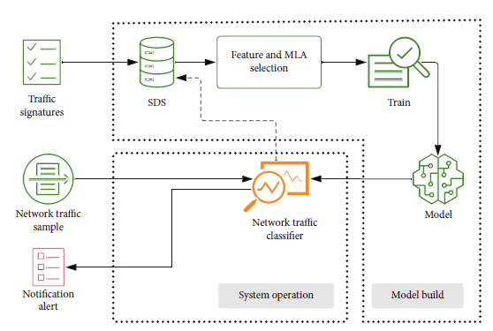
Figure 3.1: Detection system overview.
3.2 Analysis of the Existing System
The existing system for DDoS detection and mitigation in IoT cloud gateways primarily relies on traditional security measures, such as firewalls, intrusion detection systems (IDS), and rate limiting. Firewalls and IDS form the backbone of these defenses, utilizing predefined rules and signatures to identify and block malicious traffic. However, these systems are often limited by their static nature, which can fail to adapt to the dynamic and sophisticated attack patterns characteristic of modern DDoS attacks. As IoT environments continue to evolve, the static rules that traditional systems depend on can become outdated, leading to an increased likelihood of false positives (benign traffic misidentified as malicious) and false negatives (malicious traffic not detected).
Moreover, the scalability of traditional DDoS mitigation techniques is a significant concern. IoT cloud gateways need to manage an ever-growing number of connected devices and the substantial volume of data they generate. Many existing solutions are not designed to handle such scale, resulting in potential bottlenecks and inefficiencies. Rate limiting, for instance, is a commonly used technique to mitigate DDoS attacks by restricting the amount of traffic allowed through a network interface. While effective to some extent, it can also inadvertently limit legitimate traffic, causing service degradation and adversely affecting user experience. The inability to scale effectively with the increasing demands of IoT ecosystems poses a major limitation for these traditional security measures.
Additionally, the resource constraints of IoT devices present another challenge for existing systems. IoT devices often have limited computational and storage capabilities, making it difficult to implement resource-intensive security measures. Traditional DDoS mitigation techniques can impose significant overhead on these devices, further straining their limited resources and potentially impacting their primary functions. Furthermore, certain mitigation strategies, such as deep packet inspection, require substantial processing power and can introduce latency, which is particularly detrimental in real-time IoT applications. The cumulative effect of these limitations underscores the need for more adaptive, scalable, and resource-efficient solutions to effectively safeguard IoT cloud gateways against DDoS attacks.
3.3 Problems of Existing Procedures
- Static Rule-Based Detection: Traditional DDoS detection systems rely heavily on static rules and predefined signatures to identify malicious traffic. This approach is limited in its ability to adapt to the evolving nature of DDoS attacks. Attackers continuously develop new techniques to bypass these static defenses, leading to higher rates of false positives (benign traffic flagged as malicious) and false negatives (malicious traffic undetected). The rigidity of static rule-based detection makes it insufficient for addressing the dynamic threats in IoT environments.
- Limited Scalability: Many existing DDoS mitigation solutions struggle with scalability issues. IoT cloud gateways must manage an increasing number of connected devices and the massive volume of data they generate. Traditional systems are often not designed to handle such scale, resulting in performance bottlenecks and inefficiencies. This lack of scalability hampers the ability to effectively monitor and protect large, distributed IoT networks, leaving them vulnerable to extensive DDoS attacks.
- Resource Constraints: IoT devices typically have limited computational power, memory, and storage capabilities, which poses a significant challenge for implementing robust security measures. Traditional DDoS mitigation techniques, such as deep packet inspection and real-time traffic analysis, can be resource-intensive, leading to high overhead on these constrained devices. This can degrade the performance of the IoT devices and limit their primary functionalities, making traditional approaches less viable in resource-constrained IoT environments.
- Latency and Performance Impact: Some existing DDoS mitigation strategies, particularly rate limiting and deep packet inspection, can introduce significant latency and negatively impact the performance of legitimate network traffic. Rate limiting, while useful in controlling traffic volumes, can also restrict legitimate traffic, leading to service degradation and poor user experience. Deep packet inspection, which requires substantial processing power, can slow down network traffic, affecting the real-time operations crucial for many IoT applications.
- Inadequate Real-Time Response: The ability to respond to DDoS attacks in real-time is crucial for minimizing damage and maintaining service availability. Many traditional DDoS mitigation systems lack the capability to detect and respond to threats in real-time effectively. This delayed response can result in prolonged downtime, significant data loss, and disruption of services. The absence of efficient real-time detection and mitigation mechanisms leaves IoT cloud gateways vulnerable to prolonged and damaging DDoS attacks.
3.4 Description of the Proposed System
The proposed system for DDoS detection and mitigation in IoT cloud gateways is designed to address the limitations of traditional security measures by incorporating advanced machine learning techniques and a scalable cloud-based architecture. The core of this system is an anomaly detection framework that leverages machine learning algorithms to identify and respond to suspicious network traffic patterns indicative of DDoS attacks. Unlike static rule-based systems, this adaptive approach enables the detection system to learn from network behavior over time, thereby improving its ability to identify novel and evolving attack vectors with greater accuracy.
A significant feature of the proposed system is its scalable cloud-based architecture, which ensures the efficient handling of the large volumes of data generated by IoT devices. This architecture leverages cloud computing resources to perform extensive data analysis and processing without overburdening the individual IoT devices. The centralization of processing power in the cloud allows for the implementation of complex machine learning models that would be impractical to run on resource-constrained IoT devices. Additionally, this scalability ensures that the system can grow alongside the increasing number of connected IoT devices and the expanding data traffic they produce, maintaining robust security measures without degradation in performance.
The system also includes real-time mitigation strategies tailored to the specific characteristics of detected DDoS attacks. Upon identifying an anomaly, the system can dynamically adjust traffic filtering rules, apply rate limiting selectively, or reroute traffic to mitigate the impact of the attack while maintaining the performance of legitimate services. These real-time responses are optimized to minimize latency and ensure the continuity of service, crucial for the functionality of IoT applications. By integrating these advanced detection and mitigation techniques, the proposed system aims to provide a comprehensive, scalable, and efficient solution for enhancing the security of IoT cloud gateways against DDoS attacks.
3.5 Advantages of the Proposed System
The proposed system for DDoS detection and mitigation in IoT cloud gateways offers several distinct advantages over traditional security measures, making it a robust and effective solution for safeguarding IoT environments.
- Adaptive Detection: The proposed system employs machine learning algorithms for anomaly detection, which can adapt to evolving attack patterns.
- Enhanced Scalability: Leveraging a cloud-based architecture, the proposed system can efficiently handle the large volumes of data generated by an increasing number of IoT devices. The cloud infrastructure provides the necessary computational resources to perform extensive data analysis and processing without overburdening individual IoT devices.
- Resource Efficiency: To address the resource constraints of IoT devices, the system deploys lightweight security agents on the devices themselves. These agents perform initial traffic monitoring and anomaly detection with minimal computational and storage overhead.
- Reduced Latency: The proposed system includes real-time mitigation strategies that are optimized to minimize latency and maintain the performance of legitimate services. Upon detecting an anomaly, the system can dynamically adjust traffic filtering rules, apply selective rate limiting, or reroute traffic to mitigate the impact of the attack.
- Comprehensive Protection: By combining anomaly detection, scalable architecture, and real-time mitigation, the proposed system offers comprehensive protection against DDoS attacks in IoT cloud gateways.

CHAPTER FOUR
DESIGN, IMPLEMENTATION AND DOCUMENTATION OF THE SYSTEM
  - Design of the System
The proposed system is designed in modules with each modules working together to perform the electronic voting system in order to enhance the performance of the existing system as earlier discussed in chapter three. The ability to analyze and give focus to the system is explained in the following formats which are output design, input design, database design and procedure design.
    - Output Design
The output and output to be extracted from the proposed system are as shown below

Fig 4.1: Index Page
This Page is the welcome page that display the welcome content
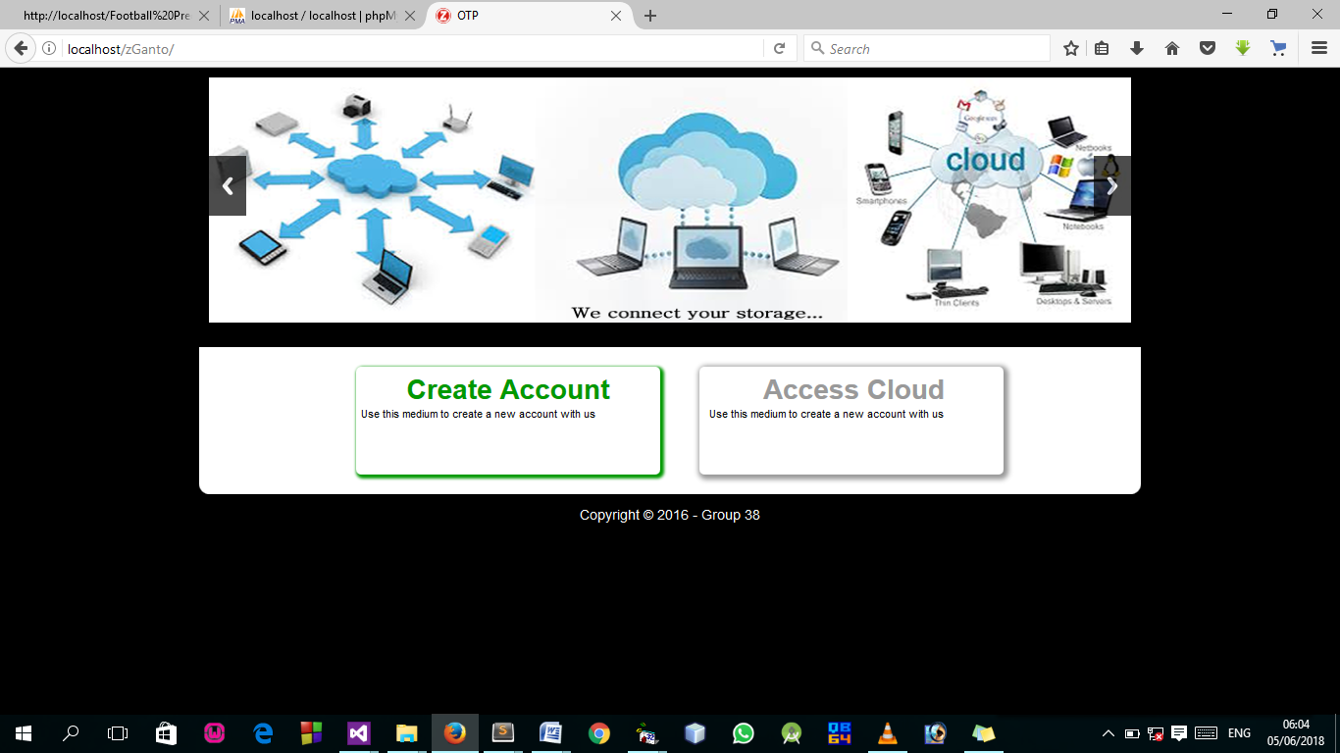Fig 4.2: Index page output design: This is the page for creating account to access local cloud computing.

Fig 4.3 User Welcome Page output design: This is the welcome page where icons are selected, a click on any of this icon channel the user to another page.

4.1.2 Input Design

It is also necessary to denote that data inputted in the computer for processing determines what the output will be. The inputs are use in collecting information the student through the keyboard. Inputs are necessary information needed for processing so as to produce the expected outputs; which are supplied through the keyboard.
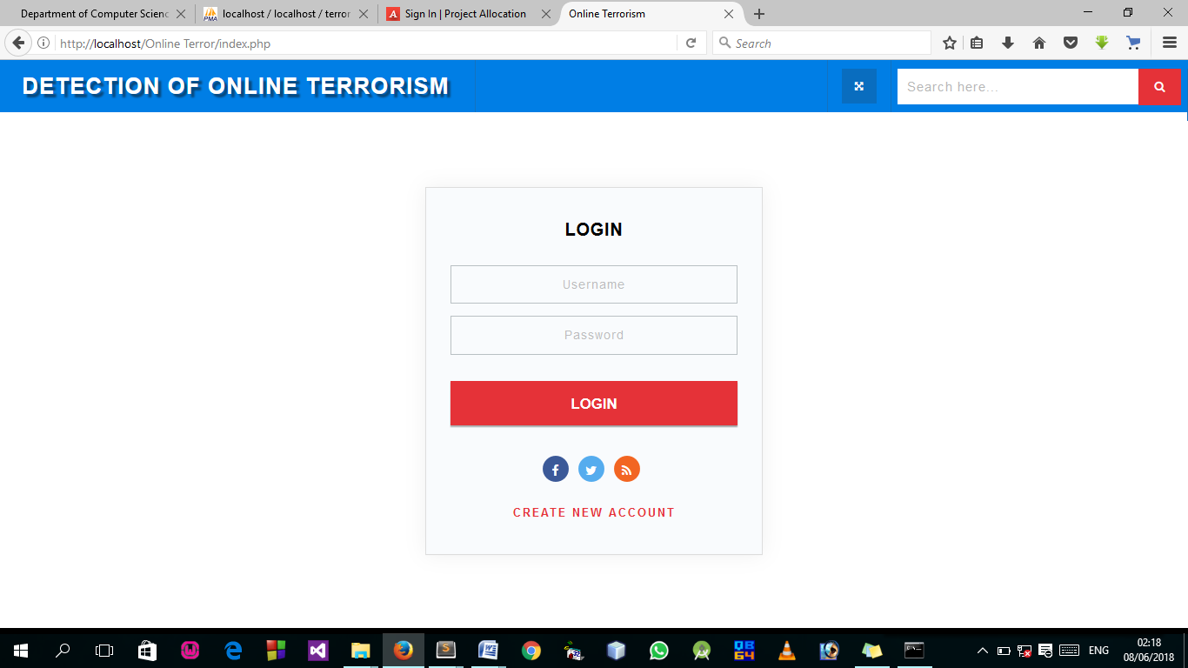
Fig 4.4: Login Page
This Page allow authorized user to log into the system.

Fig 4.5: Sign Up Page
This Page allow user to their details and gain access to the system.
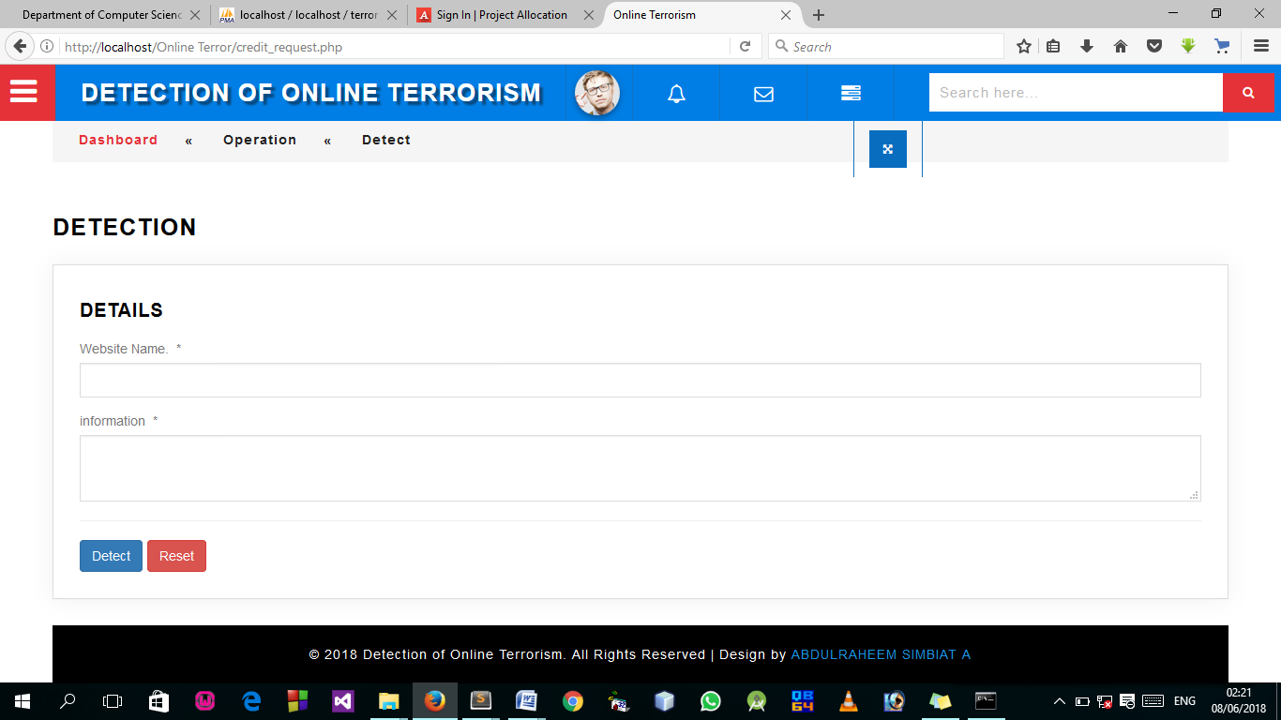
Fig 4.6: Detection Page
This is where the terrorism detection takes place.
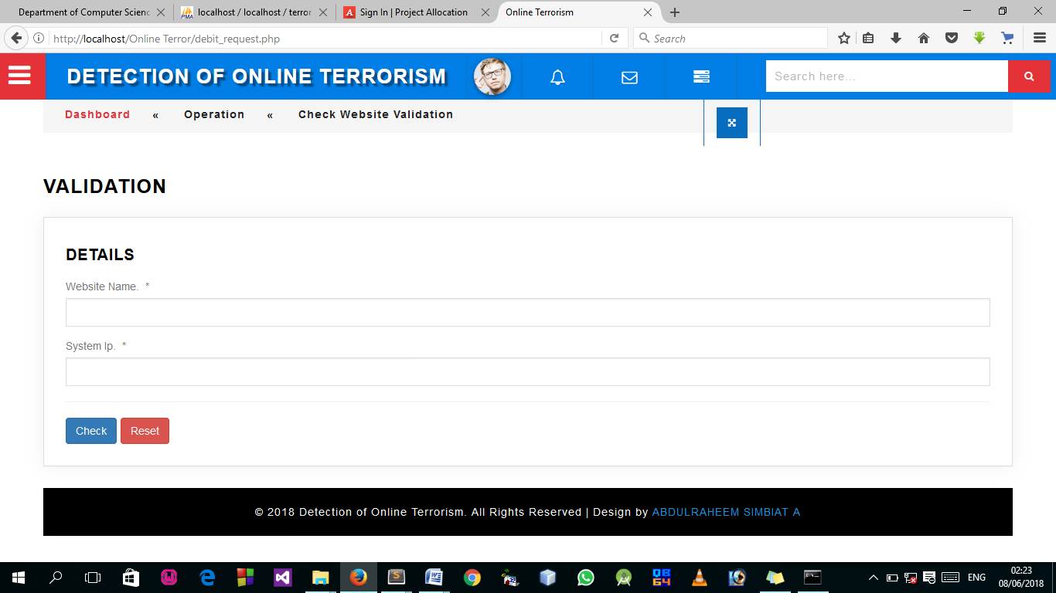
Fig 4.7: Detection Page
This page allow user to check if website is still valid or not.

4.1.3 Database Design
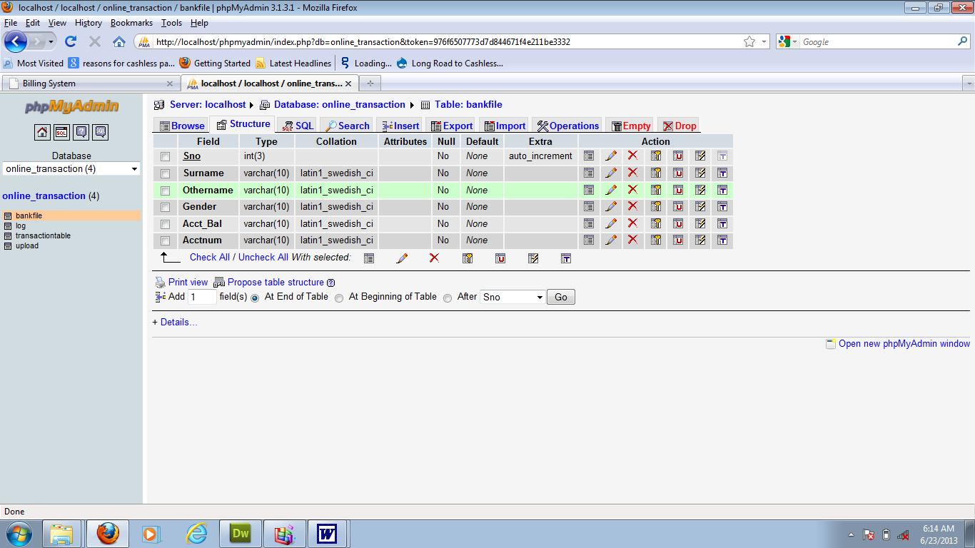
A database table is used for storing information about the files. The database use for this application is mysql database. The files and their respective modes of access as well as information they hold are given below;

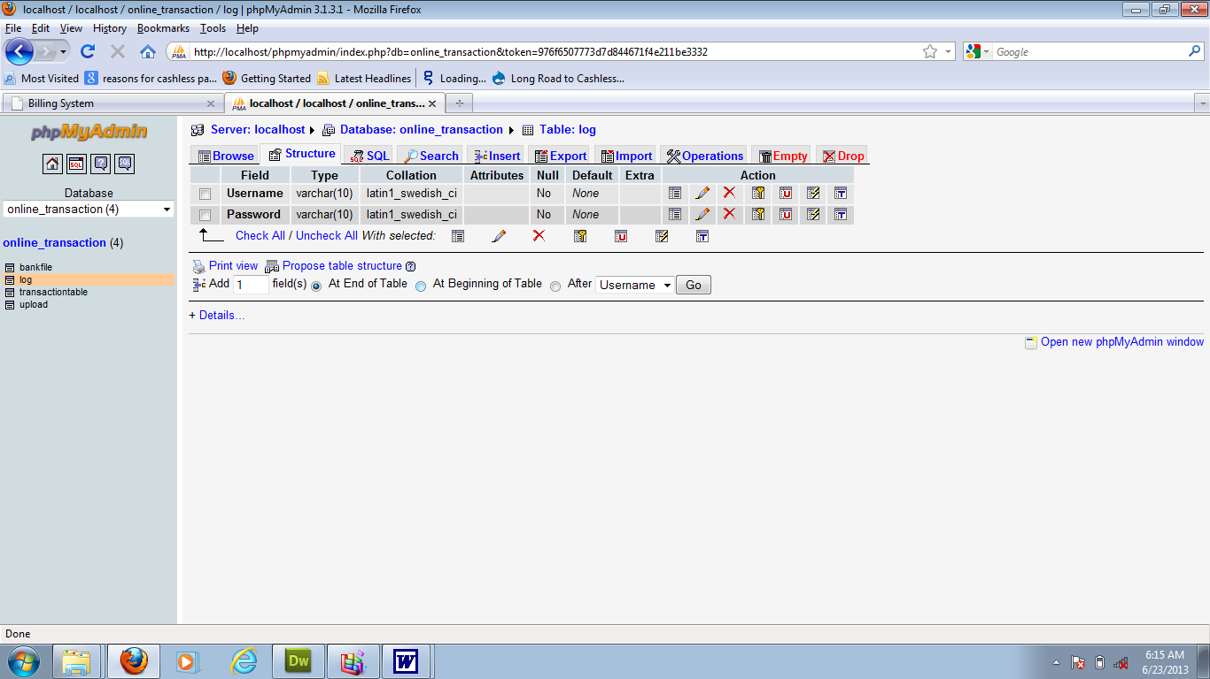
Table 4.1: Registration structure
Table 4.2: Admin Login Table structure
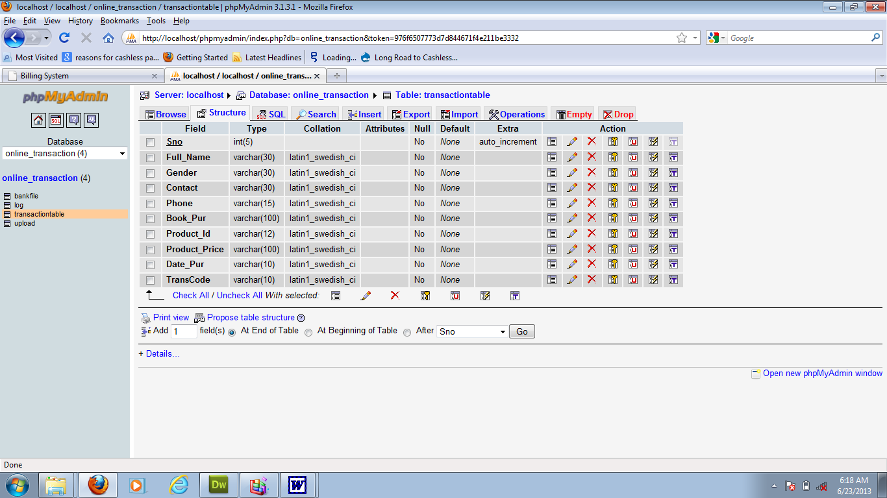
Table 4.3: user Personal Data table
4.1.3 Procedure Design
Procedures are steps which verify the whole process. That is everything put together to produce the desired output. This involves the organization of the source document and end with the output result.
Documents are sent to various departments to be filled by the employees and later returned to the personnel department which are analysed to determine which record goes into the computer.
After selecting the necessary data, this serves as input to the computer system.

4.2 Implementation of the System
It is always good to develop new ideas, to implement them on a computer and eventually to relish the satisfaction of achieving a successful result. The implementation process involves converting the system design into a complete and tested EDP that is fully operational and that can be used by the system users to meet their business needs. During implementation phase, the hardware and the software must be implemented.
Implementation of a system can be explained in six steps:-
1 Review design specification
2 Code, test and document programs
3 Train users
4 Perform system test
5 Convert to new system
6 Evaluate and maintain the new system
4.2.1 Choice of Programming Language
The application is designed in Sublime web development package which involves the use of PHP server-side scripting language, MYSQL for database management and HTML (with other embedded functionalities) for the page design and layout settings. Hence, the program testing simply involves running it directly from a Mozilla Firefox web browser on local host server provided by Apache 2.0 inWampServer 2.0 application.
In preparation for the installation of the new system, the method of changeover is given serious consideration to determine the success of the new system. Suitable changeover technique for this system is pilot changeover. The pilot changeover is operated by applying the new system bit-by-bit until it covers the whole of the operations. The result obtained from using the pilot method on a small portion of the operations would be used in determining the suitability of the need system for the rest of the operations. This method is similar to testing small sample of a distribution, if the test yields a good result then the whole system becomes fully operational and the manual/existing system is eliminated.
4.2.2 Hardware Support
- Minimum of Microcomputer Pentium II- Intel 533 MHZ processor, 128 MB RAM, 3.5GB HDD, 3.5”FDD, 14” VGA Monitor Windows 2000 Enhanced keyboard, mouse and pad.
- Scanner
- Printer
- HP DeskJet 3820c series

4.2.3 Software Support
  - Interface Design Language, windows Notepad for help interface design Hypertext Mark-up Language (HTML)
- ii MY SQL Database Management Software
- iii Programming PHP (Hypertext Pre-processor)
- Operating system window 07 professional
- Graphic software paint shop and choosing these two formats GIF (Graphic Image Format)
- Scanner software, Mira scan
- Web browser software MOZILLA
4.3 Program Documentation
4.3.1 Operating the System
Step 1: Boot your computer and click on start button on task bar
Step 2: Launch wamp server
Step 3: Login to your Application
Step 4: Click on Options
4.1 Click on Dashboard(to view operations)
4.2 Click on Detect(to Detect online Terrorism)
4.3 Click on Check (to check for website validation)
Step 5: Logout
4.3.3 Maintaining the System
The use of the term maintenance for software is different from other references to maintenance. Unlike the tires on your car, software does not “wear out”. If this is the case, then why does software maintenance account for such a high percentage of the Total Cost of Ownership for software?
The software maintenance definition refers to changes for defect correction, performance improvements, or adaptations to a changed environment (enhancements). According to this definition, if we build software that is defect-free, performs well, and contains user-controlled parameters to adjust processing rules in response to changing requirements, then most maintenance would not be necessary.
Why does this happen? There are many reasons but the most common reasons are time constraints and lack of experience. Adding validation logic takes time. So, people make assumptions about the quality of in-bound data. Assumptions are also made about the volume of transactions and the impact on performance and the stability of the automated business processes. Finally, it is common for new software to be developed by younger developers who don’t understand the maintenance impacts of their designs.
The reality is that business requirements change and most of these assumptions are flawed. Transaction volumes increase, changing business processes require new transactions or new validation criteria, and software users will use the software incorrectly. The cost of software maintenance and the total cost of ownership can dramatically be reduced, if developers build software that adjusted to changes in transaction volumes; validated all inbound data and provide user-configurable options for logic decision and data validation.

CHAPTER FIVE
SUMMARY, CONCLUSION, AND RECOMMENDATIONS
5.1 Summary
This study explored the detection and mitigation of Distributed Denial of Service (DDoS) attacks in IoT cloud gateways. Traditional security measures, such as firewalls and intrusion detection systems, were found to be inadequate due to their reliance on static rules and limited scalability. The proposed system addresses these limitations by incorporating machine learning algorithms for adaptive anomaly detection, a scalable cloud-based architecture, and lightweight security agents deployed on IoT devices. The system’s real-time mitigation strategies ensure minimal latency and optimal performance for legitimate services. The study highlights the necessity of advanced, scalable, and resource-efficient security solutions to protect IoT cloud gateways against evolving DDoS threats.
5.2 Conclusion
The research concluded that traditional DDoS detection and mitigation methods are insufficient for the dynamic and expansive nature of IoT environments. The proposed system, with its adaptive machine learning-based detection, scalable architecture, and real-time mitigation, offers a robust solution for safeguarding IoT cloud gateways. By addressing the shortcomings of existing procedures, the proposed system enhances the security, reliability, and performance of IoT infrastructures. This innovative approach not only mitigates current DDoS threats effectively but also adapts to emerging attack patterns, ensuring long-term resilience of IoT ecosystems.
5.3 Recommendations
Based on the findings of this study, several recommendations are proposed:
- Adopt Advanced Detection Techniques: Organizations should implement machine learning-based anomaly detection systems to enhance the accuracy and adaptability of DDoS detection in IoT environments. These systems can learn and evolve with emerging threats, providing a dynamic defense mechanism.
- Leverage Cloud Scalability: Utilizing cloud-based architectures can significantly improve the scalability of DDoS mitigation systems. This approach allows for the efficient handling of large data volumes and the growing number of connected IoT devices, ensuring robust and seamless protection.
- Deploy Lightweight Security Agents: To address the resource constraints of IoT devices, lightweight security agents should be deployed for initial traffic monitoring and anomaly detection. These agents can operate with minimal computational and storage overhead, preserving device performance.
- Implement Real-Time Mitigation Strategies: Organizations must incorporate real-time mitigation techniques, such as dynamic traffic filtering and selective rate limiting, to ensure the continuity and performance of legitimate services during DDoS attacks. These strategies should be optimized to minimize latency and service disruption.
- Continuous Evaluation and Adaptation: Regular evaluation and updating of security systems are essential to keep pace with evolving cyber threats. Organizations should continuously monitor their DDoS detection and mitigation systems, incorporating new threat intelligence and adjusting defenses accordingly.

References
Al-Duwairi, B. et al., (2020). SIEM-based detection and mitigation of IoT-botnet DDoS attacks. International Journal of Electrical and Computer Engineering, 10(2), 2182–2191. https://doi.org/10.11591/ijece.v10i2.pp2182-2191
Bhardwaj, K., et al., (n.d.). Towards IoT-DDoS Prevention Using Edge Computing.
Galeano-Brajones, J., et al (2020a). Detection and mitigation of DoS and DDoS attacks in iot-based stateful SDN: An experimental approach. Sensors (Switzerland), 20(3). https://doi.org/10.3390/s20030816
Galeano-Brajones, J., et al (2020b). Detection and mitigation of DoS and DDoS attacks in iot-based stateful SDN: An experimental approach. Sensors (Switzerland), 20(3). https://doi.org/10.3390/s20030816
Lee, S. H., et al., (2022). Detection and Prevention of DDoS Attacks on the IoT. Applied Sciences (Switzerland), 12(23). https://doi.org/10.3390/app122312407
Lima Filho, F. S. et al., (2019). Smart Detection: An Online Approach for DoS/DDoS Attack Detection Using Machine Learning. Security and Communication Networks, 2019. https://doi.org/10.1155/2019/1574749
Abdelwahab, O. F., et al., (2021). Efficient Combination of RSA Cryptography, Lossy, and Lossless Compression Steganography Techniques to Hide Data. Procedia Computer Science, 182, 5–12. https://doi.org/10.1016/j.procs.2021.02.002
Adam, K. et al., (2021). The impact of the soft errors in convolutional neural network on GPUS: Alexnet as case study. Procedia Computer Science, 182, 89 94. https://doi.org/10.1016/j.procs.2021.02.012
Alotaibi, D. (2021). Survey on Network Slice Isolation in 5G Networks: Fundamental Challenges. Procedia Computer Science, 182, 38–45. https://doi.org/10.1016/j.procs.2021.02.006
Basori, A. H., et al., (2021). Intelligent socio-emotional control of pedestrian crowd behavior inside smart city. Procedia Computer Science, 182, 80–88. https://doi.org/10.1016/j.procs.2021.02.011
Boughaci, D. (2021). Solving optimization problems in the fifth generation of cellular networks by using meta-heuristics approaches. Procedia Computer Science, 182, 56–62. https://doi.org/10.1016/j.procs.2021.02.008
El-Ganiny, M. Y. et al., (2021). A preamble based channel estimation methods for FBMC waveform: A comparative study. Procedia Computer Science, 182, 63–70. https://doi.org/10.1016/j.procs.2021.02.009
Faisal, A. et al., (2021). Diversity Schemes in Multi-hop Visible Light Communications for 6G Networks. Procedia Computer Science, 182, 140–149. https://doi.org/10.1016/j.procs.2021.02.019
Gaber, L., et al., (2021). Fast auto-correction algorithm for digital VLSI Circuits. Procedia Computer Science, 182, 95–102. https://doi.org/10.1016/j.procs.2021.02.013

PROGRAM SOURCE CODE

<!DOCTYPE html>
<html lang="en">
<head>
<title>CEE LOGIN</title>
<meta charset="UTF-8">
<meta name="viewport" content="width=device-width, initial-scale=1">
<link rel="icon" type="login-ui/image/png" href="images/icons/favicon.ico"/>
<link rel="stylesheet" type="text/css" href="login-ui/vendor/bootstrap/css/bootstrap.min.css">
<link rel="stylesheet" type="text/css" href="login-ui/fonts/font-awesome-4.7.0/css/font-awesome.min.css">
<link rel="stylesheet" type="text/css" href="login-ui/fonts/Linearicons-Free-v1.0.0/icon-font.min.css">
<link rel="stylesheet" type="text/css" href="login-ui/vendor/animate/animate.css">
<link rel="stylesheet" type="text/css" href="login-ui/vendor/css-hamburgers/hamburgers.min.css">
<link rel="stylesheet" type="text/css" href="login-ui/vendor/select2/select2.min.css">
<link rel="stylesheet" type="text/css" href="login-ui/vendor/daterangepicker/daterangepicker.css">
<link rel="stylesheet" type="text/css" href="login-ui/css/util.css">
<link rel="stylesheet" type="text/css" href="login-ui/css/main.css">
</head>
<body>
<div class="limiter">
<div class="container-login100" style="background-image: url(login-ui/images/bg-01.jpg);">
<div class="wrap-login100">
<div class="login100-form-title" style="background-image: url(login-ui/images/bg-01.jpg);">
<span class="login100-form-title-1"> COMPUTER BASED TEST (CBT) EXERCISE </span>
</div>
<form method="post" id="examineeLoginFrm" class="login100-form validate-form">
<div class="wrap-input100 validate-input m-b-26" data-validate="Username is required"> <span class="label-input100">Matric No.</span>
<input class="input100" type="text" name="username" placeholder="Enter your Matric Number">
<span class="focus-input100"></span>
</div>
<div class="wrap-input100 validate-input m-b-18" data-validate = "Password is required">
<span class="label-input100">Password (Surname)</span>
<input class="input100" type="password" name="pass" placeholder="Enter password">
<span class="focus-input100"></span>
</div>
<div class="container-login100-form-btn" align="right">
<button type="submit" class="login100-form-btn"> Login </button>
</div>
</form>
marquee behavior='scroll' bgcolor="#008000"><h3> <font color='#FFFFFF'> Designed by HND 2 (2020/2021 Academic Session) Computer Science Department CBT Group Member</font></h3></marquee>
</div>
</div>
</div>
<script src="login-ui/vendor/jquery/jquery-3.2.1.min.js"></script>
<script src="login-ui/vendor/animsition/js/animsition.min.js"></script>
<script src="login-ui/vendor/bootstrap/js/popper.js"></script>
<script src="login-ui/vendor/bootstrap/js/bootstrap.min.js"></script>
<script src="login-ui/js/main.js"></script>

</body>
</html>

<script type="text/javascript" >
function preventBack(){window.history.forward();}
setTimeout("preventBack()", 0);
window.onunload=function(){null};
</script>
<?php
$examId = $_GET['id'];
$selExam = $conn->query("SELECT * FROM exam_tbl WHERE ex_id='$examId' ")->fetch(PDO::FETCH_ASSOC);
$selExamTimeLimit = $selExam['ex_time_limit'];
$exDisplayLimit = $selExam['ex_questlimit_display'];
?>
<div class="app-main__outer">
<div class="app-main__inner">
<div class="col-md-12">
<div class="app-page-title">
<div class="page-title-wrapper">
<div class="page-title-heading">
<div>
<?php echo $selExam['ex_title']; ?>
<div class="page-title-subheading">
<?php echo $selExam['ex_description']; ?>
</div>
</div>
</div>
<div class="page-title-actions mr-5" style="font-size: 20px;">
<form name="cd">
<input type="hidden" name="" id="timeExamLimit" value="<?php echo $selExamTimeLimit; ?>">
<label>Remaining Time : </label>
<input style="border:none;background-color: transparent;color:blue;font-size: 25px;" name="disp" type="text" class="clock" id="txt" value="00:00" size="5" readonly="true" />
</form>
</div>
</div>
</div>
</div>
<div class="col-md-12 p-0 mb-4">
<form method="post" id="submitAnswerFrm">
<input type="hidden" name="exam_id" id="exam_id" value="<?php echo $examId; ?>">
<input type="hidden" name="examAction" id="examAction" >
<table class="align-middle mb-0 table table-borderless table-striped table-hover" id="tableList">
<?php
$selQuest = $conn->query("SELECT * FROM exam_question_tbl WHERE exam_id='$examId' ORDER BY rand() LIMIT $exDisplayLimit ");
if($selQuest->rowCount() > 0)
{
$i = 1;
while ($selQuestRow = $selQuest->fetch(PDO::FETCH_ASSOC)) { ?>
<?php $questId = $selQuestRow['eqt_id']; ?>
<tr>
<td>
<p><b><?php echo $i++ ; ?> .) <?php echo $selQuestRow['exam_question']; ?></b></p>
<div class="col-md-4 float-left">
<div class="form-group pl-4 ">
<input name="answer[<?php echo $questId; ?>][correct]" value="<?php echo $selQuestRow['exam_ch1']; ?>" class="form-check-input" type="radio" value="" id="invalidCheck" >

<label class="form-check-label" for="invalidCheck">
<?php echo $selQuestRow['exam_ch1']; ?>
</label>
</div>
<div class="form-group pl-4">
<input name="answer[<?php echo $questId; ?>][correct]" value="<?php echo $selQuestRow['exam_ch2']; ?>" class="form-check-input" type="radio" value="" id="invalidCheck" >
<label class="form-check-label" for="invalidCheck">
<?php echo $selQuestRow['exam_ch2']; ?>
</label>
</div>
</div>
<div class="col-md-8 float-left">
<div class="form-group pl-4">
<input name="answer[<?php echo $questId; ?>][correct]" value="<?php echo $selQuestRow['exam_ch3']; ?>" class="form-check-input" type="radio" value="" id="invalidCheck" >
<label class="form-check-label" for="invalidCheck">
<?php echo $selQuestRow['exam_ch3']; ?>
</label>
</div>
<div class="form-group pl-4">
<input name="answer[<?php echo $questId; ?>][correct]" value="<?php echo $selQuestRow['exam_ch4']; ?>" class="form-check-input" type="radio" value="" id="invalidCheck" >
<label class="form-check-label" for="invalidCheck">
<?php echo $selQuestRow['exam_ch4']; ?>
</label>
</div>
</div>
</div>
</td>
</tr>
<?php }
?>
<tr>
<td style="padding: 20px;">
<input name="submit" type="submit" value="Submit" class="btn btn-xlg btn-primary p-3 pl-4 pr-4 float-right" >
</td>
</tr>
<?php
}
else
{ ?>
<b>No question at this moment</b>
<?php }
?>
</table>
</form>
</div>
</div>

<div class="app-main__outer">
<div class="app-main__inner">

<?php
@$exam_id = $_GET['exam_id'];

if($exam_id != "")
{
$selEx = $conn->query("SELECT * FROM exam_tbl WHERE ex_id='$exam_id' ")->fetch(PDO::FETCH_ASSOC);
$exam_course = $selEx['dept_id'];
$exmneLevel = $selEx['exmne_year_level'];

$selExmne = $conn->query("SELECT * FROM examinee_tbl et WHERE department='$exam_course'AND exmne_year_level='$exmneLevel' ORDER BY matric_no ASC");
?>
<div class="app-page-title">
<div class="page-title-wrapper">
<div class="page-title-heading">
<div><b class="text-primary">STUDENT'S RESULT</b><br>
<!-- <span class="border" style="padding:10px;color:black;background-color: yellow;">Excellence</span>
<span class="border" style="padding:10px;color:white;background-color: green;">Very Good</span>
<span class="border" style="padding:10px;color:white;background-color: blue;">Good</span>
<span class="border" style="padding:10px;color:white;background-color: red;">Failed</span>
<span class="border" style="padding:10px;color:black;background-color: #E9ECEE;">Not Answering</span> -->
</div>
</div>
</div>
</div>

<div class="col-md-12">
<div class="main-card mb-3 card">

<div class="content-header">

<div class="card-header">
<?php echo $selEx['ex_title']; ?> : <?php echo $selEx['ex_description']; ?>

</div>

<div class="right-title">

<a href="export.php?exam_id=<?=$exam_id;?>" class="btn btn-rounde btn-sm btn-info" style="float:right;"> Write to CSV</a>

</div>

</div>

<div class="table-responsive">
<table class="align-middle mb-0 table table-borderless table-striped table-hover" id="tableList">
<thead>
<tr>
<th width="50%">Matric Number</th>
<th>Score</th>
<th>Grade</th>
</tr>
</thead>
<tbody>
<?php
while ($selExmneRow = $selExmne->fetch(PDO::FETCH_ASSOC)) { ?>
<?php
$exmneId = $selExmneRow['exmne_id'];
$selScore = $conn->query("SELECT * FROM exam_question_tbl eqt INNER JOIN exam_answers ea ON eqt.eqt_id = ea.quest_id AND eqt.exam_answer = ea.exans_answer WHERE ea.axmne_id='$exmneId' AND ea.exam_id='$exam_id' AND ea.exans_status='new' ORDER BY ea.exans_id DESC");
$selAttempt = $conn->query("SELECT * FROM exam_attempt WHERE exmne_id='$exmneId' AND exam_id='$exam_id' ");
$over = $selEx['ex_questlimit_display'] ;
@$score = $selScore->rowCount();

