SMART LECTURE ATTENDANCE REGISTER
Presented By:

ADEBAYO RAHEEMAT OMOTOLANI HND/23/COM/FT/0504
Submitted to the

DEPARTMENT OF COMPUTER SCIENCE,
INSTITUTE OF INFORMATION AND COMMUNICATION TECHNOLOGY (IICT), KWARA STATE POLYTECHNIC, ILORIN

IN PARTIAL FULFILMENT OF THE REQUIREMENTS FOR THE AWARD OF HIGHER NATIONAL DIPLOMA (HND) IN COMPUTER SCIENCE

JULY, 2025

CERTIFICATION

This is to certify that this project was carried out by ADEBAYO RAHEEMAT OMOTOLANI with matriculation number HND/23/COM/FT/0504 has been read and approve as meeting part of the requirements for the award of Higher National Diploma (HND) in Computer Science.

Mr. Oyedepo, F.S.
Project Supervisor Date

Mr. Oyedepo, F.S.
Head of Department Date

External Examiner Date
DEDICATION

I dedicate this work to Almighty God, whose unfailing love and mercy have been my source of strength and inspiration throughout this journey.
To my beloved parents, for their unconditional love, sacrifices, and unwavering support that have shaped who I am today.
To my family and friends, whose encouragement, prayers, and belief in me provided the motivation to persevere through every challenge.
This achievement is a testament to all of you who have stood by me, encouraged me, and believed in my potential. Thank you for being my pillars of strength.

ACKNOWLEDGEMENTS

All glory and praise be to Almighty God, the Lord of the universe. I am profoundly grateful for the strength, wisdom, and perseverance He bestowed upon me to complete my Higher National Diploma (HND) program and for His unwavering guidance throughout my life's journey.
I wish to express my deepest gratitude to my supervisor and Head of Department, Mr. Oyedepo,
F.S. His insightful guidance, constant encouragement, and unwavering patience were pivotal to the successful completion of this research. I am particularly thankful for his valuable corrections and constructive criticisms, which ensured this work met the highest standards of academic excellence.
My sincere appreciation also extends to the entire academic staff of the Department of Computer Science at Kwara State Polytechnic, Ilorin. Their collective support, motivation, and constructive feedback throughout my studies were invaluable.
Finally, I owe a special debt of gratitude to my beloved parents. Their immeasurable financial support, prayers, patience, and understanding formed the foundation of my academic pursuit. Thank you all for being an integral part of this journey and for helping me achieve this significant milestone.
TABLE OF CONTENTS Title Page i
Dedication iii
Acknowledgements iv
Table of Contents v–vii
Abstract ix
CHAPTER ONE: INTRODUCTION 1
  - Background to the Study 1–2
  - Statement of the Problem 2
  - Aim and Objectives of the Study 3
  - Significance of the Study 4
  - Scope of the Study 4
  - Organization of the study 4
  - Definition of Terms 5
CHAPTER TWO: LITERATURE REVIEW 6
  - Review of Related Works 6–9
  - Review of General Studies 9-11
    - Automated Attendance Systems 11
    - Fingerprint Features 12
  - Minutiae Extraction 13
CHAPTER THREE: RESEARCH METHODOLOGY 14
  - Research Methodology 14-16
  - Analysis of the Existing Systems 16-18
  - Problem of the Existing System 19
  - Description of the Proposed System 19
  - Advantages of the Proposed Systems 21–23

CHAPTER FOUR: SYSTEM DESIGN AND IMPLEMENTATION 24

  - Design of the System 24
    - Output Design 24
    - Input Design 25
    - Database Design 28
    - Procedure Design 29
  - System Implementation 30
    - Choice of Programming Language 30
    - Hardware Support 31
    - Software 32
  - Program Documentation 33
    - Operating System 33
    - Maintaining the System 34

CHAPTER FIVE: SUMMARY, CONCLUSION AND RECOMMENDATIONS 35

  - Summary 35
  - Conclusion 35
  - Recommendations 36

References Flowcharts

ABSTRACT

The manual process of recording student attendance is inefficient and susceptible to fraud, such as proxy signing. This research focuses on the development of a Smart Lecture Attendance Register using biometric fingerprint technology to ensure accuracy and authenticity. The system requires students to register their fingerprints once, creating a unique digital identity within a secure database. For each lecture, students simply place their finger on a biometric scanner to be marked present. The system instantly captures and records the attendance, time-stamps the entry, and stores it securely. This method provides a robust and irrefutable proof of presence, completely eliminating buddy punching and manual errors. The backend interface allows for easy management of student records and the generation of detailed attendance reports, significantly improving the administrative efficiency and integrity of the attendance process.

CHAPTER ONE INTRODUCTION

BACKGROUND TO THE STUDY

In today’s educational landscape, institutions are increasingly adopting innovative technologies to improve administrative efficiency, ensure data accuracy, and enhance security. One crucial area requiring modernization is students attendance monitoring. Traditionally, attendance has been recorded manually—through roll calls or paper-based registers—or semi-digitally using barcodes or ID cards. While these methods are still in use, they often suffer from limitations such as human error, easy manipulation (e.g., proxy attendance), inefficiency, and lack of real-time data processing.

To overcome these limitations, biometric technologies have gained prominence as reliable tools for automating attendance management. Among various biometric methods, fingerprint recognition has emerged as one of the most practical and secure options due to its uniqueness, ease of use, and cost-effectiveness. Fingerprint-based systems identify individuals by analyzing unique fingerprint patterns, such as ridges and minutiae points, which remain consistent throughout a person’s lifetime. This characteristic makes fingerprint recognition particularly suitable for authentication in organization generally and in specifically academic environments.

According to Olasupo et al. (2022), biometric attendance systems significantly reduce time wastage, eliminate proxy attendance, and improve data accuracy. These systems use sensors to capture a student’s fingerprint, which is then processed and compared with stored data in a database. If a match is found, the system confirms the student’s presence. Otherwise, access is denied, and the student is marked absent. This automated process simplifies data management for lecturers and administrators, reduces workload, and enables real-time tracking and analysis of student attendance.

Basila and Danladi (2020) explain that biometric validation involves capturing unique physical features such as fingerprints, iris patterns, or facial features, which are processed into digital templates and stored securely. When verification is required, the system compares a new scan with
stored data to authenticate the individual. This method ensures high accuracy and security in attendance tracking.

Garg et al. (2018) affirm that manual attendance systems are often tedious, time-consuming, and susceptible to errors and fraudulent entries. In contrast, biometric systems streamline the process by providing automated, tamper-proof records. Moreover, they enable institutions to quickly identify students with poor attendance records and generate accurate reports for academic evaluation or disciplinary actions.

Oloruntoba and Akinode (2020) emphasize that the integration of a fingerprint-based attendance system not only promotes punctuality and accountability among students but also assists in performance evaluation and resource planning. Although the system requires initial investment in fingerprint scanners and software infrastructure, the long-term benefits—such as reduced administrative burden, enhanced data reliability, and prevention of impersonation—make it a viable solution for modern educational institutions.

In summary, the adoption of a Smart Lecture Attendance Register using biometric fingerprint technology addresses several challenges associated with traditional attendance systems. It provides a secure, efficient, and accurate mechanism for recording student presence, fostering integrity and accountability in the academic environment.

STATEMENT OF THE PROBLEM

Despite advancements in technology, most universities and polytechnics in Nigeria continue to rely on manual methods for recording student attendance. This traditional system typically involves students signing on paper-based registers each time they attend a lecture. However, this method poses several significant challenges. Firstly, it is prone to loss or damage, especially when handled by lecturers or student representatives such as the Class Representative, leading to irretrievable data loss. Secondly, it allows for manipulation and impersonation, as students often sign in on behalf of their absent colleagues, thereby undermining the integrity of attendance records.
Additionally, manual attendance tracking is time-consuming and inefficient, making it difficult for lecturers and administrators to monitor students participation accurately over time. It also lacks the capability for real-time analysis, making it challenging to identify students with poor attendance or to correlate attendance with academic performance. Furthermore, irregular class attendance negatively impacts students’ academic engagement, knowledge acquisition, and overall performance.

Given these persistent issues, there is a critical need to adopt a more secure, efficient, and reliable approach. A biometric-based automatic attendance system, particularly one that leverages fingerprint recognition technology, offers a promising solution by ensuring authenticity, accuracy, and ease of data management, thereby addressing the shortcomings of the manual attendance system.

AIM AND OBJECTIVES

The aim of this study is to design and implement a Smart Lecture Attendance Register using fingerprint biometric technology to automate, secure, and enhance the accuracy of attendance monitoring in educational institutions.

To achieve this aim, the specific objectives of the study are to:

- develop an authentication-based attendance system that utilizes fingerprint biometrics to verify and record students attendance accurately;

- design a user-friendly interface that enables seamless interaction for both students (for check- in/check-out) and institute members; and

- implement the front-end of the system using PHP programming language, while deploying Microsoft SQL Server for back-end database development to ensure reliable data storage and retrieval.

SIGNIFICANCE OF THE STUDY

The implementation of a Smart Lecture Attendance Register using fingerprint biometric technology holds substantial significance for educational institutions. Firstly, it enhances the security and integrity of attendance records by preventing unauthorized access and eliminating fraudulent entries such as proxy sign-ins. Secondly, it offers a high level of accuracy and reliability in tracking students attendance, reducing human error commonly associated with manual record- keeping. Furthermore, the system streamlines the attendance process, saving valuable instructional time for both lecturers and students. With a simple fingerprint scan, students can quickly check in and out of classes, eliminating the need for time-consuming manual sign-ins. This not only improves administrative efficiency but also supports better monitoring of students participation, which is critical for academic performance evaluation and decision-making.

SCOPE OF THE STUDY

This study is specifically focused on the design and implementation of a fingerprint-based attendance monitoring system for the Department of Computer Science, Kwara State Polytechnic Ilorin. It covers the development of both the software and hardware components necessary for capturing, processing, and storing fingerprint data. The scope includes designing the user interface, integrating the fingerprint scanner, and developing the backend database system using PHP and Microsoft SQL Server. The system will be tested within a controlled academic environment to evaluate its effectiveness, user-friendliness, and reliability in recording lecture attendance.

ORGANIZATION OF THE STUDY

This research is organized into five comprehensive chapters to ensure clarity and coherence in presenting the study. Contents of each chapter are briefly explained here

    - Chapter One: introduces the study, stating the background, problem statement, aim and objectives, significance, scope, and organization of the report.
    - Chapter Two: reviews the existing literature relevant to attendance systems, biometric technology, and the current state of related innovations, providing a theoretical framework for the study.
    - Chapter Three: describes the methodology adopted, including data collection techniques, analysis of the existing system, and justification for the proposed system. It also details the design approach, programming tools used, and required hardware and software resources.
    - Chapter Four: focuses on the implementation and documentation of the developed system, including system design, input/output specifications, file structure, and user guide documentation.
    - Chapter Five: presents the summary of findings, conclusion drawn from the research, and recommendations for future enhancements or wider deployment of the system.

DEFINITION OF TERMS

    - Smart Lecture Attendance Register: An automated system used to electronically record, store, and manage student attendance using modern technologies such as biometrics, RFID, or facial recognition.
    - Biometrics: A technology that identifies individuals based on their unique physical or behavioral characteristics, such as fingerprints, iris patterns, facial features, or voice.
    - Fingerprint Recognition: A type of biometric authentication that uses the unique patterns
and ridges of an individual’s finger to verify identity.
    - Authentication: The process of verifying the identity of a user or system, ensuring that the individual is who they claim to be.
    - Database: A structured collection of data that can be accessed, managed, and updated electronically, often used to store user records in an attendance system.
    - Microsoft SQL Server: A relational database management system (RDBMS) developed by Microsoft used to store, retrieve, and manage data.
    - Proxy Attendance: A form of academic malpractice where one student marks or signs the attendance for another absent student.
    - Verification: The act of confirming that a biometric sample (e.g., fingerprint) matches the stored template associated with a specific individual.

CHAPTER TWO

LITERATURE REVIEW

REVIEW OF RELATED WORKS

Fingerprint-based biometric attendance systems have garnered significant attention in academic and industrial settings due to their potential to streamline students monitoring, eliminate impersonation, and improve the reliability of attendance records. Numerous studies and projects have approached this subject from different technical angles. The following related works are reviewed:

Olasupo et al. (2022) developed a comprehensive fingerprint-based attendance system aimed at addressing inefficiencies in traditional methods, including impersonation and data loss. Their system was structured using the Software Development Life Cycle (SDLC) and implemented using Visual Studio with a C# backend, supported by a SQL Server database. The deployment of a digital persona fingerprint scanner and an intuitive GUI ensured that student data could be captured, verified, and stored securely and efficiently. The system significantly improved attendance accuracy and administrative convenience.

Garg et al. (2018) introduced a mobile-based fingerprint attendance system that leveraged an Android application. This project focused on improving portability and real-time processing by using smartphone integration. The solution aimed to eliminate proxy attendance and manual entry errors, with data directly stored and retrieved through the application interface. This approach showcased the growing trend of mobile-centric biometric solutions in academia.

Oloruntoba and Akinode (2020) emphasized the burden of manual attendance tracking and proposed a fingerprint-based solution for students at the Federal Polytechnic, Ilaro. The developed system, which used a feature extraction algorithm for fingerprint template matching, resulted in a marked improvement in student class participation and academic performance. The research was backed by quantitative surveys, which validated the superiority of the biometric system over traditional attendance methods.
Basila and Danladi (2021) constructed a hardware-based fingerprint attendance system, focusing on electronic circuitry and real-time data logging. Their use of a 9V battery with a voltage regulation circuit allowed for portable operation, and their solution was implemented to resolve attendance inefficiencies at Adamawa State University. Their approach demonstrated how embedded systems and biometric technology could work together to create a scalable and power- efficient attendance system.

Akanbi et al. (2020) adopted a Minutia-based fingerprint recognition algorithm, which identifies and compares key fingerprint features to ensure highly accurate authentication. Their hybrid system, developed with C++, PHP, and MySQL, was aimed at minimizing false acceptance rates and processing delays. The authors noted that although the system performed well, integrating additional algorithms such as ridge flow or pattern matching could further improve recognition accuracy.

Alhothaily et al. (2015) presented a flexible and low-cost fingerprint attendance system suitable for educational institutions in developing regions. The innovation of this project lay in its simplicity and integration capabilities. The system was designed to be internet-enabled, allowing parents and guardians to access student attendance data remotely. This added dimension of parental involvement contributed to enhanced student discipline.

Lebi (2021) explored the broader application of fingerprint-based systems across various sectors and focused on solving recurrent lecture attendance issues in developing countries. Using a handheld fingerprint sensor, the system reduced attendance fraud, provided real-time updates, and enabled administrators to make data-driven decisions based on accurate attendance statistics.

Ezema et al. (2015) developed a fingerprint-based attendance system capable of functioning without a connected computer, making it suitable for remote and under-resourced environments. Unlike other systems, their model featured a standalone design with onboard storage and fingerprint processing capabilities, offering versatility and ease of use.

Rahman (2018) proposed an automated fingerprint attendance system using a minutiae-based algorithm to enhance fingerprint matching speed and accuracy. The system was designed for a
large-scale academic setting and implemented using C#. The research emphasized scalability and addressed the computational challenges posed by large fingerprint databases.

Harshadbhai et al. (2016) focused on wireless communication, particularly the integration of Bluetooth modules to facilitate seamless data transfer between fingerprint devices and host computers. Their system highlighted the potential of wireless biometric systems in environments where traditional network infrastructure is limited.

Ahmed et al. (2019) designed a multi-authentication biometric system incorporating both fingerprint and RFID technologies to improve attendance monitoring and security. This dual-factor approach reduced the possibility of unauthorized access and improved data integrity. Although the system was more complex, it demonstrated the potential of hybrid biometric models for future developments.

Fatoki and Adeniyi (2021) examined the application of biometric systems in Nigerian universities and emphasized the socio-cultural factors affecting adoption. Their study revealed that while students and staff appreciated the effectiveness of fingerprint systems, issues such as power supply, maintenance cost, and technical expertise remained barriers to full implementation. Their recommendations called for more investment in infrastructure and training.

Rahman, (2018) worked on Automated Student Attendance System using Fingerprint Recognition. The project work aims to design a student attendance system that could effectively manage the attendance of students of the Department of Computer Science and Engineering at Jatiya Kabi Kazi Nazrul Islam University. In this project work, attendance is marked after the student’s biometric identification. For students identification, a fingerprint recognition-based identification system is used. Fingerprint features are considered to be the best and fastest method for biometric identification. These features are more secure to use and unique for every person that doesn’t change in one's lifetime. Fingerprint recognition is a mature field today, but still identifying an individual from a set of enrolled fingerprints is a time-consuming process. It was very necessary to improve the fingerprint identification system for implementation on large databases, e.g. of an institute or a country. In this project, the minutiae algorithm is used to develop the identification system which is faster in implementation than any other available today in the market. The
proposed automated attendance system based on fingerprint recognition was tested on a class of student fingerprint databases and achieved significant results for taking attendance of the students of the Department of Computer Science and Engineering. The proposed system has been implemented using the C# programming paradigm platform.
Harshadbhai, et al. (2016) conducted a study on Fingerprint Based Attendance System. Fingerprint identification is one of the most well-known and common biometric identification systems. Because of their uniqueness & consistency over time, fingerprints have been used for identification over many years, more recently becoming automated due to their high computing capabilities. So, here the fingerprint identification technique was used for maintaining the attendance record. The database of the fingerprints of various students is maintained. The PC and Module wireless communication is done using Bluetooth.

Okafor et al. (2020) focused on the integration of cloud computing into fingerprint attendance systems to enable remote access, secure data backup, and synchronization across multiple campuses. Their approach illustrated how modern technologies such as cloud infrastructure could extend the capabilities of biometric systems and enhance administrative reach.

REVIEW OF GENERAL STUDIES

Historically, the use of fingerprints for identification can be traced back to ancient times. During the Tang Dynasty in 8th-century China, fingerprints were impressed in clay as a form of signature in legal and commercial agreements. These early applications highlight the enduring value of fingerprint patterns in personal identification. Over the centuries, this practice evolved and was later adopted more formally in law enforcement and forensic science.

In the earlier phases of fingerprint capture for forensic purposes, the ink-based method, often referred to as offline sensing, was predominantly used. This process required smearing a subject's fingertip with ink and pressing it onto a fingerprint card. The card would then be scanned to digitize the fingerprint for storage or matching. Although effective, this method was messy, time- consuming, and impractical for civil and commercial applications.
With advancements in technology, the modern approach has shifted toward automated fingerprint identification systems (AFIS). These systems allow users to simply place a finger on an electronic fingerprint scanner, which captures the ridge and valley pattern of the fingerprint in real-time. No ink is involved, and the image is immediately transmitted to a computer system where pre- processing, feature extraction, and matching algorithms are applied to authenticate or identify an individual (Ain et al., 2018).

Fingerprint recognition has now become one of the most widely accepted and implemented biometric technologies due to its accuracy, uniqueness, and stability over time. According to Letian and Yazhou (2016), fingerprint recognition has been utilized in forensic applications for over a century and was further advanced in the 1970s when the FBI and other U.S. government departments established large-scale biometric databases. These systems were critical in criminal investigations, border security, and identity management.

In today's digital age, fingerprint recognition is not limited to law enforcement. It has found widespread use in civilian applications such as mobile phone unlocking, banking authentication, school attendance systems, and access control. The shift from knowledge-based (PINs and passwords) to biometric-based authentication ensures greater security and user convenience. Unlike passwords, which can be forgotten, stolen, or shared, biometric traits such as fingerprints are unique to each individual and difficult to forge.

Biometric authentication, particularly fingerprint recognition, operates on the principle of identifying “who you are” rather than “what you know” or “what you have.” This intrinsic link between the user and the credential eliminates many of the vulnerabilities associated with traditional methods of authentication.

Overall, the evolution of fingerprint technology from clay impressions to high-speed digital systems underscores its reliability, universality, and robustness as a biometric modality. The continued integration of fingerprint recognition in modern systems, especially in educational and enterprise environments, reflects its effectiveness in personal identification and attendance management.

Automated Attendance Systems

Automated attendance systems are technological solutions designed to eliminate the need for manual paper-based tracking of attendance records. These systems leverage devices such as barcode badges, magnetic stripe cards, RFID tags, smart cards, touch screens, or biometric modalities like fingerprint, retina, and facial recognition. Such systems provide numerous benefits to organizations, including improved accuracy, efficiency, and security in attendance management.

In a typical deployment, the system automatically logs when a student or employee enters and exits the designated premises, thereby reducing errors associated with manual entry, buddy punching, or timesheet manipulation. These systems also reduce administrative workload and streamline the payroll process, thanks to integrated data collection and reporting features.

There are several types of automated attendance systems in use today, including:

      - Radio Frequency Identification (RFID) Card-Based Attendance Systems
      - Barcode-Based Attendance Tracking Systems
      - Smart Card Access Control Systems
      - Punch Card Systems
      - Magnetic Stripe Card Attendance Systems
      - Biometric Attendance Systems

Among these, biometric-based systems are considered the most secure and accurate due to their reliance on unique physiological characteristics of individuals. Specifically, fingerprint-based attendance systems have gained popularity in educational institutions for monitoring and calculating student attendance in real time. These systems minimize impersonation, increase accountability, and support data-driven decision-making for instructors and administrators.

For this project, a fingerprint-based smart lecture attendance register has been implemented to address challenges such as inaccurate attendance reporting, manual data entry errors, and student impersonation. The system ensures that each student’s presence is verified biometrically, making the attendance process both efficient and tamper-proof.

Fingerprint Features

A fingerprint is composed of a pattern of ridges (raised lines) and valleys (recessed spaces) that flow across the surface of the fingertip. In digital fingerprint images, ridges typically appear darker while valleys appear lighter (Akanbi, Abdulrahman, Saka & Olojeola, 2019). The structure of these patterns is unique to every individual, making them highly suitable for biometric recognition.

Key features in fingerprint identification are known as minutiae, which include:

      - Ridge endings: Points where a ridge terminates.
      - Bifurcations: Points where a single ridge splits into two branches.

These minutiae form the local features of a fingerprint, while the overall ridge flow pattern forms its global features. Together, they enable precise matching in biometric systems.

Common fingerprint patterns include:

      - Arch: Ridges enter from one side, rise in the center, and exit on the other side.
      - Loop: Ridges enter from one side, loop around, and exit from the same side.
      - Whorl: Circular or spiral ridge patterns.

Fingerprint recognition systems analyze these features for identity verification. In particular, minutiae-based matching is a widely used approach due to its high reliability and efficiency in distinguishing fingerprints from different individuals (Yusuf, Akanbi, Bolaji-Adetoro & Jimoh, 2018).

MINUTIAE EXTRACTION

Minutiae extraction is a critical process in automated fingerprint recognition systems. The accuracy and efficiency of fingerprint matching largely depend on the successful detection and representation of minutiae points. Modern systems use feature-based matching rather than full- image correlation, as minutiae offer a compact and discriminative representation of the fingerprint.

The process of minutiae extraction involves three main stages:
- Image Segmentation: Separates the foreground (actual fingerprint ridges and valleys) from the background noise. Accurate segmentation ensures that irrelevant data is excluded from the analysis.
- Image Enhancement: Improves the quality of the fingerprint image by:
- Strengthening ridge flow without distorting singular points.
- Bridging broken ridges.
- Removing artifacts between pseudo-parallel ridges.
- Preserving true ridge structures while minimizing false information.
- Minutiae Detection: Identifies minutiae points (ridge endings and bifurcations) and computes their location and orientation. The success of the recognition system heavily depends on this step’s accuracy.

A robust minutiae extraction algorithm ensures that the smart fingerprint-based attendance system can handle variations in fingerprint image quality due to factors like dry skin, smudges, or sensor noise. By focusing on unique minutiae and maintaining data integrity during extraction, the system guarantees high identification accuracy, essential for consistent and reliable attendance tracking in smart lecture environments.

CHAPTER THREE
METHODOLOGY AND ANALYSIS OF THE SYSTEM

RESEARCH METHODOLOGY

The research methodology for developing a Smart Lecture Attendance Register using fingerprint recognition technology involves a detailed, systematic approach to ensure accurate and efficient attendance tracking in educational institutions. This methodology encompasses understanding the problem, setting clear research objectives, conducting a literature review, gathering data through interviews and surveys, designing the system architecture, developing a prototype, evaluating its performance, and analyzing the results. The outcome will provide a more secure, efficient, and automated solution to traditional attendance tracking methods.

The process is outlined as follows:

Understanding Requirements:
The first step is to understand the specific requirements of the smart attendance system. This includes defining the key features such as fingerprint authentication for students identification, automated attendance recording, integration with existing school management systems, reporting, and real-time monitoring. The system aims to ensure accuracy, reduce fraud, and automate the attendance process.

Hardware Setup:
The necessary hardware components must be set up, including fingerprint scanners for capturing students' fingerprints, a central server or database for storing attendance records, and computing devices for system management (e.g., desktops, tablets). The fingerprint scanner will be used to verify students' identities at the point of entry to the classroom.

Fingerprint Registration:
Students will register their fingerprints into the system, which will store the biometric data securely in the database. This data will be used to identify the students each time they mark their attendance. Fingerprint data will be encrypted for privacy and security.

System Design and Software Development:
The system will be designed to interact with the fingerprint scanner, process attendance data, and store it in a central database. The software will include modules for managing user profiles (students and staff), processing attendance data, generating reports, and ensuring data security.
The software will be developed using a suitable programming language (e.g., Python, C#) and a database management system (e.g., MySQL, PostgreSQL).

Database Setup and Data Management:
A centralized database will be set up to store student information, attendance records, and other related data. The database will be optimized for efficient retrieval and reporting of attendance data. It will also allow administrators to view attendance trends, reports, and exceptions (e.g., absenteeism).

Integration with School Management Systems:
If required, the attendance system can be integrated with existing school management systems (e.g., student management, grading systems). This will ensure seamless data exchange between the systems and provide a comprehensive solution for managing student data.

User Interface Design:
A user-friendly interface will be developed for administrators and institute members to manage student profiles, view attendance records, and generate reports. The interface will also allow for system settings management (e.g., class schedules, faculty assignments) and real-time monitoring of attendance.

Testing and Evaluation:
The system will undergo rigorous testing to ensure its accuracy, reliability, and security. This includes testing the fingerprint recognition algorithm for false acceptance/rejection rates and evaluating the system's performance under various conditions (e.g., network connectivity, scanner quality). User feedback will also be collected to identify areas for improvement.

Deployment:
Once the system has been tested and optimized, it will be deployed in lecture rooms for actual
use. The system will be installed, configured, and tested in a live environment to ensure that it meets the institution's needs.

Training and Maintenance:
Training will be provided for administrators and students to ensure proper use of the system. Ongoing maintenance will be performed to update the system, address any technical issues, and ensure that the system remains secure and efficient.
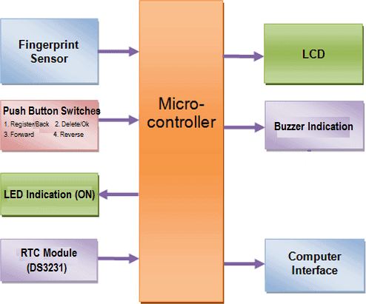

3.1 Block Diagram of Smart Attendance Register

ANALYSIS OF THE EXISTING SYSTEM

The current attendance system in many Nigerian institutions, particularly in the Computer Science Departments, still relies on a traditional manual approach that is highly dependent on paper-based records. This method, although widely used, suffers from various limitations that reduce its efficiency and accuracy in tracking attendance.

Manual Attendance System

In the manual system, lecturers either call out students' names and mark their attendance or pass around an attendance sheet for students to sign next to their names. Both methods are fraught with several drawbacks that affect the integrity and timeliness of attendance tracking.

Drawbacks of the Manual Attendance System:

    - Time Consumption:
      - The process of calling names or passing the attendance sheet takes valuable time during lectures, especially in large classes where there are many students. This time could otherwise be spent on teaching, which reduces the overall effectiveness of the lesson.

Prone to Errors:
      - Manual methods are susceptible to human error. Lecturers might accidentally skip names or misinterpret handwriting, leading to incomplete or inaccurate attendance records. These errors compromise the reliability of the attendance data.

Susceptibility to Manipulation:
      - The paper-based system is highly prone to manipulation. Students may sign in for their absent friends, creating fraudulent attendance records. This introduces the potential for dishonesty and compromises the accuracy of attendance tracking.

Inconvenience for Large Classes:
      - In larger classes, where students' names can be difficult to manage, the manual attendance process becomes even more cumbersome. Checking the attendance of numerous students individually increases the time spent on this task, delaying the start of lectures and reducing teaching time.

No Real-time Tracking:
      - The manual system does not allow for real-time tracking of attendance. Lecturers or administrators cannot immediately view or generate attendance reports, which makes it difficult to monitor student attendance patterns or identify students with poor attendance early on.

Data Storage and Retrieval Challenges:
      - Storing and retrieving attendance records from paper sheets can be cumbersome and inefficient. Attendance sheets may get misplaced, damaged, or lost, making it difficult to access past attendance records when needed. In addition, retrieving specific records or generating reports requires manual effort, which is time- consuming.

Environmental Concerns:
      - The constant use of paper in recording attendance contributes to environmental degradation. The manual system requires significant paper usage, leading to unnecessary waste and an increased carbon footprint, which contradicts modern sustainability practices.

Lack of Security and Privacy:
      - The manual attendance sheets are not secure and may be accessed by unauthorized individuals, risking student data privacy. Since no authentication measures are in place, it is easy for someone to tamper with attendance records, leading to potential breaches of confidentiality.

Impact of the Existing System

The inefficiencies and limitations of the manual system make it a poor fit for modern educational environments. With large class sizes, increasing pressure to improve academic performance, and a growing emphasis on digital transformation, the manual attendance method is no longer adequate. The potential for errors, manipulation, and time wastage places lecturers and institutions at a significant disadvantage, particularly in the competitive landscape of higher education.

Moreover, the lack of an automated system makes it challenging for lecturers and administrators to manage and analyze student attendance efficiently. Consequently, many institutions are starting to explore automated alternatives, such as biometric-based attendance systems, to address these challenges and improve the overall experience for both lecturers and students.

In conclusion, the manual attendance system, with its inherent flaws, is not suitable for the demands of modern educational institutions. There is a need for more efficient, accurate, and secure solutions to address the challenges of attendance tracking. The next section will explore how the proposed Smart Lecture Attendance Register using fingerprint recognition technology can offer a more efficient solution to these problems.

PROBLEMS OF THE EXISTING SYSTEM

The manual paper-based attendance system currently in use in Nigerian institutions has several problems that hinder its effectiveness. These problems have been growing over time as institutions expand, and they include:

- Time-Consuming: The process of taking attendance manually is extremely time-consuming. Lecturers are required to call out each student's name and mark their attendance. This not only wastes valuable teaching time but can also be chaotic in large classes where numerous students are present. In some cases, students even have to queue to sign an attendance sheet, further increasing the time spent on this task.

- Difficult to Process: The manual method requires lecturers to manually collate and keep track of attendance records, which can be cumbersome and prone to errors. At the end of each semester, lecturers need to cross-check all attendance records to determine which students are eligible for exams or other activities. This process can lead to discrepancies and errors, and it consumes significant administrative time and resources.

- Proxy Attendance: One of the most significant issues with the paper-based system is the prevalence of proxy attendance. In this scenario, students who are absent may ask their friends to sign their names on the attendance sheet. This leads to inaccurate records and makes it difficult for lecturers to track actual attendance. Proxy attendance undermines the integrity of the system and can be used to manipulate attendance records.

These problems make the manual system inefficient and unreliable, highlighting the need for an automated solution like the Smart Lecture Attendance Register using fingerprint recognition technology.

DESCRIPTION OF THE PROPOSED SYSTEM

The proposed system aims to automate the process of tracking student attendance using fingerprint recognition technology. Unlike traditional methods, this system will address the common problems associated with manual attendance, such as time consumption, errors, and proxy
attendance. The system will utilize biometric technology to authenticate and record student attendance efficiently.

In the Smart Lecture Attendance Register system, the fingerprint of each student will serve as their unique identifier. The process will involve capturing the fingerprint data, matching it with the stored data, and recording the student's attendance without any manual intervention. Below is a detailed description of the proposed system:

- Fingerprint Authentication: Each student will be assigned a unique fingerprint that will be stored in the system's database. Upon arrival at the lecture, students will place their fingers on a fingerprint scanner. The scanner captures the fingerprint data, which is then compared with the stored data in the system's database.

- Data Matching and Attendance Recording: Once the fingerprint data is matched, the system will automatically record the attendance of the student. If the fingerprint matches, the student’s attendance is successfully registered. This eliminates the need for manual data entry and ensures accuracy and authenticity in the attendance records.

- Microcontroller and Database Integration: The system will have a microcontroller that connects the fingerprint scanner with the central database. The microcontroller will process the fingerprint data, compare it with the stored data, and update the attendance records accordingly. The database will store all relevant data, such as student information and attendance records, and will be easily accessible for future reference and reporting.

- User Interface: A user-friendly interface will be provided for both students and lecturers. The interface will display the status of attendance and allow lecturers to monitor attendance records in real time. The system will also be able to generate reports on attendance patterns, helping the institution identify trends and address attendance-related issues.

- Security Features: The fingerprint data will be encrypted to ensure privacy and security. Only authorized personnel will have access to the database, ensuring that attendance records remain confidential and protected from unauthorized access or tampering.
- Automated Attendance Updates: Once the attendance is recorded, the system will automatically update the attendance list in the database. This removes the need for manual entry and reduces the likelihood of errors. Additionally, lecturers will be able to view attendance reports at any time, helping them track student participation and improve overall classroom management.

- Integration with Other Systems: The Smart Lecture Attendance Register can be integrated with other institutional systems, such as academic performance tracking and student management systems. This integration will help create a seamless workflow, ensuring that attendance data is automatically reflected in other aspects of the student's academic record.

By automating the attendance process and incorporating fingerprint recognition technology, the proposed system will significantly improve the accuracy, efficiency, and security of attendance tracking in educational institutions.

ADVANTAGES OF THE PROPOSED SYSTEM

The proposed Smart Lecture Attendance Register using fingerprint recognition technology offers several significant advantages over the traditional paper-based systems and even other automated systems such as RFID. Below are the key benefits of the proposed system:

Automation:
The system automates the entire attendance process, from student identification to attendance recording. This automation saves valuable class time by eliminating the need for manual roll calls and manual data entry, thereby allowing lecturers to focus more on teaching rather than administrative tasks.

Accuracy and Reliability:
By using fingerprint recognition, the system eliminates human errors that often occur in manual attendance systems, such as spelling mistakes, missed names, or incorrect sign-ins. Fingerprints are unique to each individual, ensuring that the attendance record is always accurate and reliable.

Convenience:
Traditional attendance systems, such as paper-based or sign-in sheets, can be cumbersome, requiring significant time and effort to record, verify, and process attendance. The proposed
system simplifies this process by automatically recording attendance as soon as the student is identified by their fingerprint. This significantly reduces the effort required by both students and lecturers and improves the overall convenience of the attendance process.

Eradicates Proxy Attendance:
One of the major problems in manual attendance systems is proxy attendance, where students ask others to sign in on their behalf. The fingerprint recognition system completely eliminates this issue, as only the student whose fingerprint matches the registered record can mark their attendance. This ensures that only those who are physically present in the lecture room are marked as present.

Time Efficiency:
The system streamlines the attendance process, making it much quicker than traditional methods. Students simply need to scan their fingerprint upon entering the lecture room, and their attendance is automatically recorded. This is much faster than waiting for students to sign in manually, thereby reducing the time spent on attendance, which can be particularly valuable in large lecture rooms.

Seamless Data Processing:
The system simplifies the process of calculating and maintaining attendance records. Once the fingerprint is matched, the data is automatically sent to a centralized database where attendance is recorded and stored securely. At the end of the semester, the system can easily generate attendance reports, which can be used to assess student participation, monitor trends, and determine eligibility for exams or other academic activities.

Improved Security and Privacy:
Since fingerprints are unique to each individual, they offer a high level of security. The use of encrypted fingerprint data ensures that the attendance information is securely stored and protected from unauthorized access. Only authorized personnel can access and manage the attendance data, reducing the risk of data breaches or tampering.

Reduced Administrative Burden:
With the automation of attendance tracking, there is no need for manual record-keeping or time-consuming calculations. This reduces the administrative burden on both lecturers and school administration staff, allowing them to focus on more critical tasks related to student performance and academic management.

Integration with Other Systems:
The proposed system can be easily integrated with other student management systems, such as performance tracking and student portals. This allows for a holistic approach to student management, where attendance data is synchronized with other academic records, improving the overall workflow of the institution.
CHAPTER FOUR
DESIGN AND IMPLEMENTATION OF THE SYSTEM

DESIGN OF THE SYSTEM

System design and specification is very important in every software development. At this stage, the developer puts every factor into consideration while making this design. In the course of the design, the system has to be designed in a way that there will be a close relationship between the inputs and outputs. Also, the design format must be made in a way that it will be acceptable to the end users.

OUTPUT DESIGN
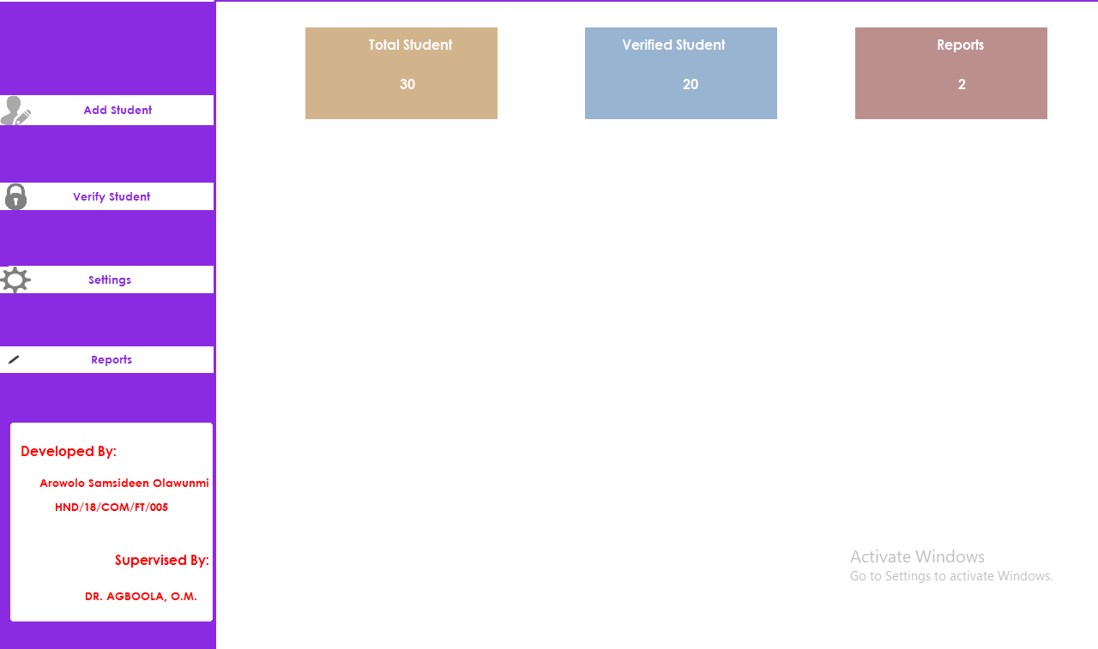

Figure 4.1: Dashboard Interface
Show information about the functionality of the system.
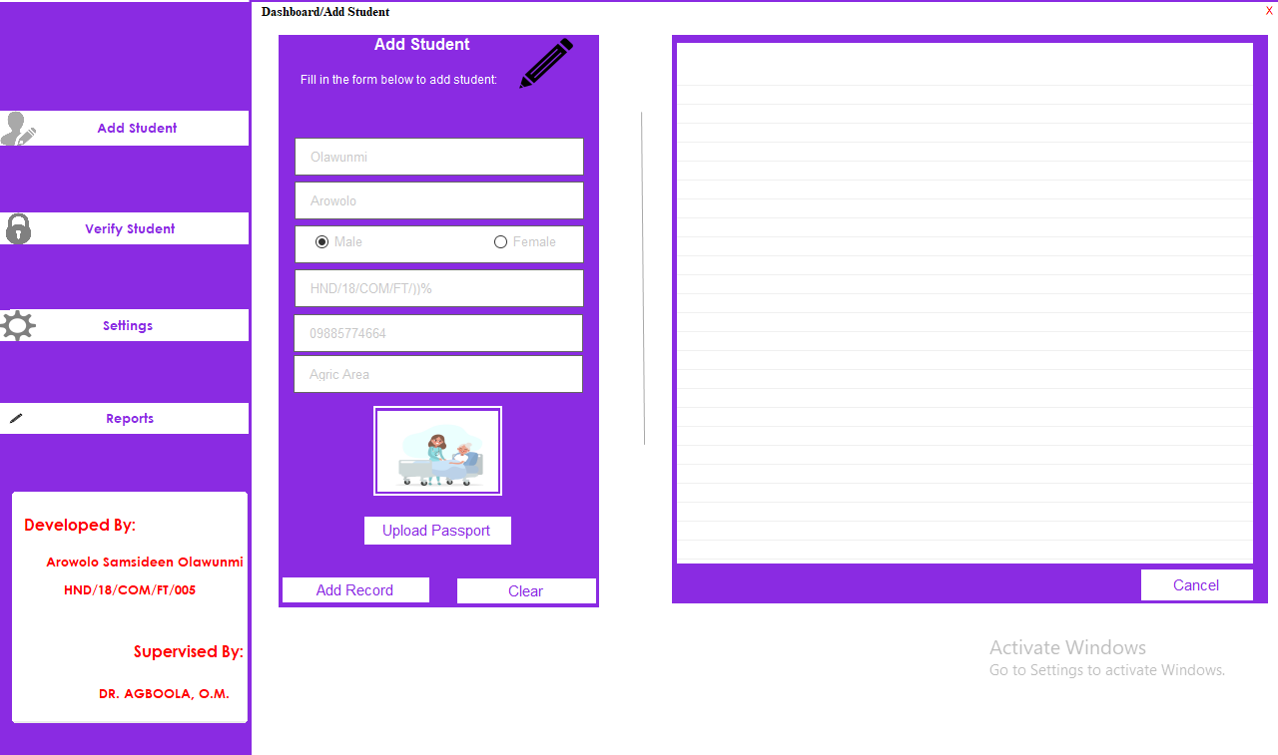

Figure 4.2: Add Module
Student Personal details are input for processing and verification

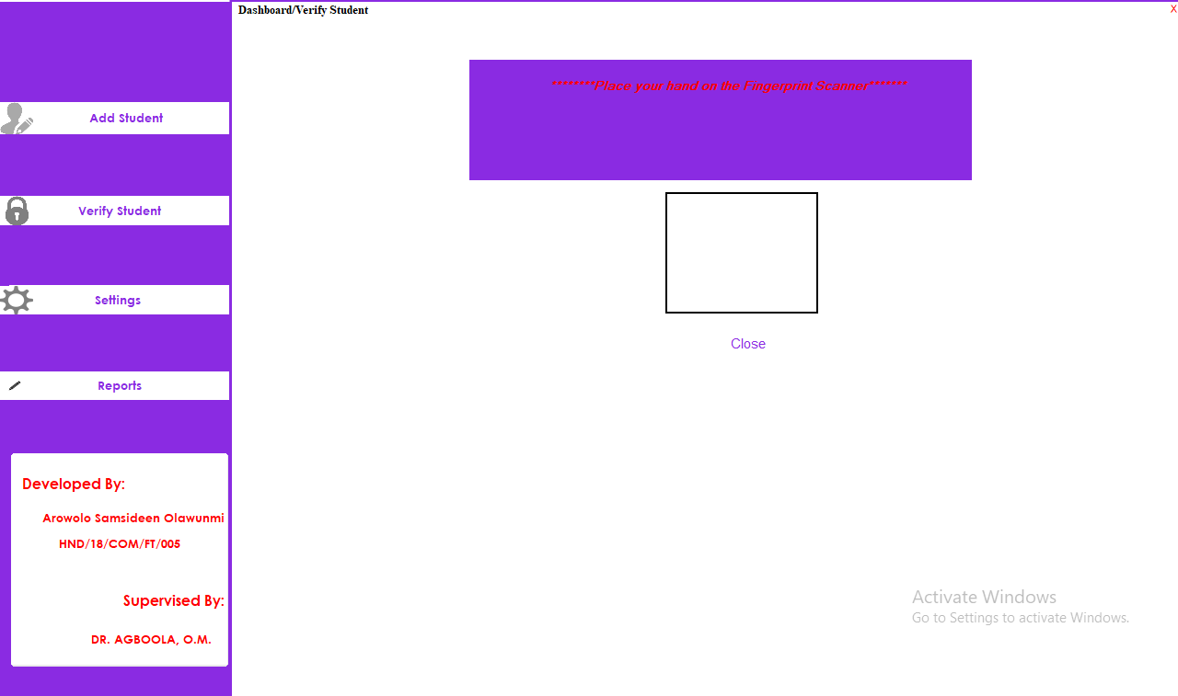

Figure 4.3: Verification Module
This is where student record are check for verification

INPUT DESIGN

It is also necessary to denote that data inputted in the computer for processing determines what the output will be. The inputs are use in collecting information the student through the keyboard. Inputs are necessary information needed for processing so as to produce the expected outputs; which are supplied through the keyboard.

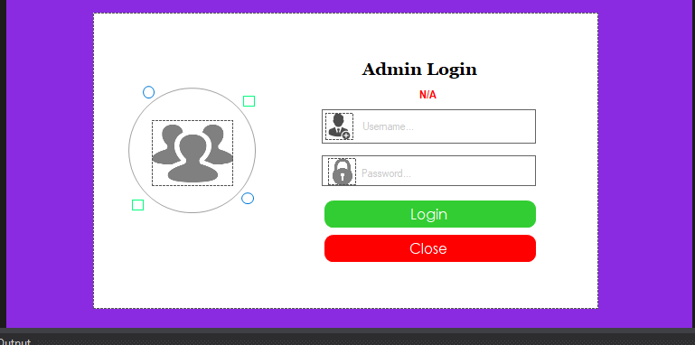

Figure 4.4: Input Interface for Admin login.

The login environment for users
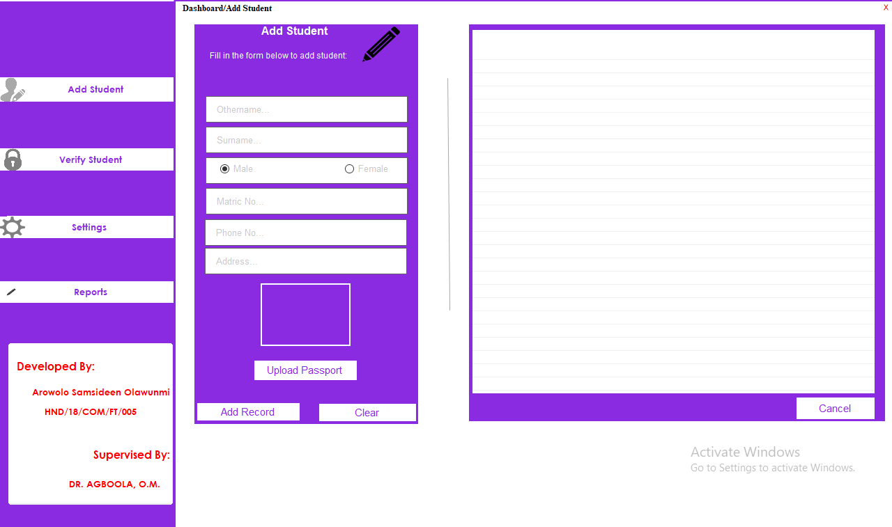

Figure 4.5: Student Add Details Page

This is where student personal details are entered.

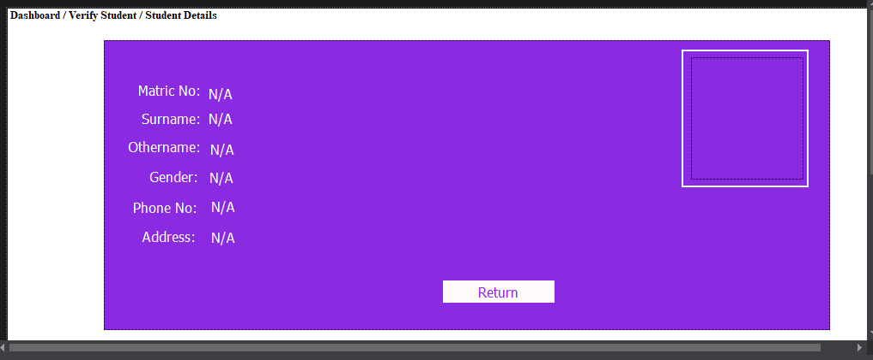

Figure 4.6: Student Details Page

This display verified student details.
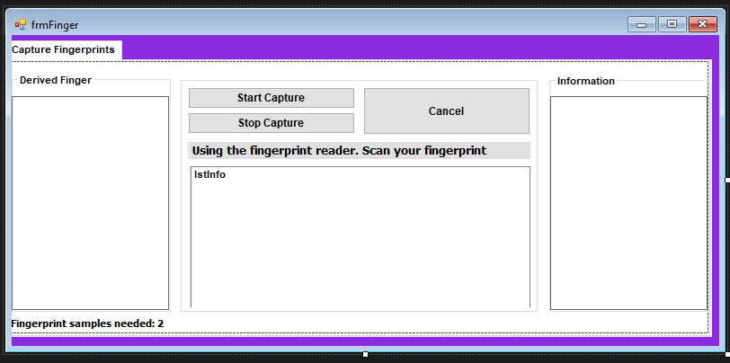

Figure 4.7: Finger Capturing Page

This is where the student finger are captured.

Table 4.1: Table showing various student and their capturing process time RESULT
Numbers of Student | Right Finger | Capturing Process Time | Left Finger | Capturing Process Time
Student 1 | First finger | 0.9654455444 | Second finger | 0.5768645
Student 2 | First finger | 0.865898899 | Second finger | 0.4998458
Student 3 | First finger | 1.9867376635 | Second finger | 0.9876988
Student 4 | First finger | 0.7654321879 | Second finger | 0.9674523
Student 5 | First finger | 1.9987654923 | Second finger | 0.9765987

DISCUSSION

A fingerprint looks at the patterns found on a fingertip. There are a variety of approaches to fingerprint verification. Some emulate the traditional police method of matching pattern; others use straight minutiae matching devices; and still others are a bit more unique, including things like moiré fringe patterns and ultrasonic characteristics. A greater variety of fingerprint devices is available than for any other biometric technology.
Fingerprint systems translate illuminated images of fingerprints into digital code for further software such as enrolment (fingerprint registration) and verification (authentication or verification of registered users).
ONE- O-ONE (1:1) matching process in which the biometric system compares an individual’s biometric sample to previously enrolled data for that user. The process of verification narrows the biometric database search by including other identifiers such as names or IDs. The terms “verification” and “authentication” are sometimes used interchangeably because both terms are used primarily to establish a specific user’s validity rather than to identify users by querying an entire database of biometric samples. Hence this system will be develop using Microsoft Visual Studio as the compiler, C# as the Programming Language while MYSQL as the database Back end.

DATABASE DESIGN

A database table is used for storing information about the files. The database use for this application is mysql database. The files and their respective modes of access as well as information they hold are given below;

Table 4.1: Admin Data table

This is admins table where data are stored and retrieved
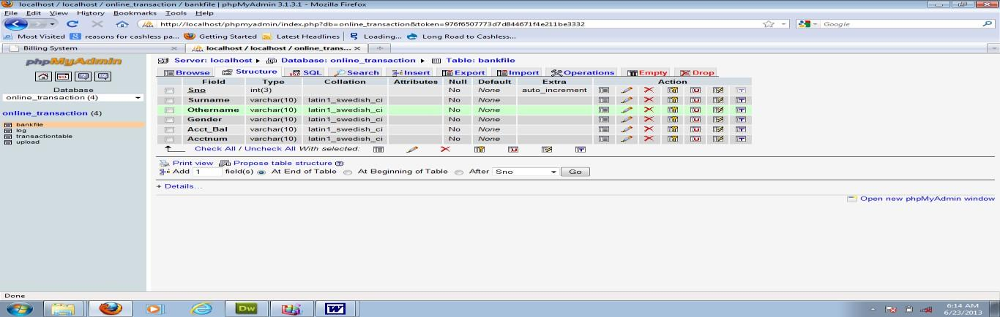

Table 4.2: Student Details Data Table

This is where student data are stored and retrieved
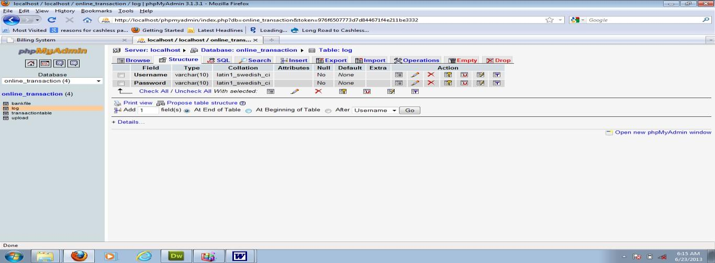

PROCEDURE DESIGN
Procedures are steps which verify the whole process i.e which are everything put together to produce the desired output. This involves the organization of the source document and end with the output result.
Documents are sent to various departments to be filled by the employees and later returned to the personnel department which are analyzed to determine which record goes into the computer.
After selecting the necessary data, this serves as input to the computer system.

IMPLEMENTATION OF THE SYSTEM
It is always good to develop new ideas, to implement them on a computer and eventually to relish the satisfaction of achieving a successful result. The implementation process involves converting the system design into a complete and tested EDP that is fully operational and that can be used by the system users to meet their business needs. During implementation phase, the hardware and the software must be implemented.

Implementation of a system can be explained in six steps:-
- Review design specification
- Code, test and document programs
- Train users
- Perform system test
- Convert to new system
- Evaluate and maintain the new system

CHOICE OF PROGRAMMING LANGUAGE
The application is designed using C# as the programming language and MYSQL for database management. Hence, the database testing simply involves running it directly from a Mozilla Firefox web browser on local host server provided by Apache 2.0 in WampServer 2.0 application.
In preparation for the installation of the new system, the method of changeover is given serious consideration to determine the success of the new system. Suitable changeover technique for this system is pilot changeover. The pilot changeover operates by applying the new system bit-by-bit until it covers the whole of the operations. The result obtained from using the pilot method on a small portion of the operations would be used in determining the suitability of the need system for the rest of the operations. This method is similar to testing small sample of a distribution if the test yields a good result then the whole system because fully operational and the manual/existing system is eliminated.

HARDWARE SUPPORT
The computer configuration required to run the software is;
Computer/memory processor PC with a 48dx, MHZ or Pentium, Intel or higher processor required.

Memory: | 2GB of RAM
Cache memory: | 512KB
Hard disk Minimum size | 500GB
Recommended | 200GB
Virtual Memory | 32Bits
Cache memory | 512KB
Fingerprint Scanner

SOFTWARE
I. Microsoft Visual Studio
- MY SQL Database Management Software
- Operating system window 07 professional
- Graphic software paint shop and choosing these two formats GIF (Graphic Image Format)
- Scanner software, Mira scans
- Web browser software MOZILLA

PROGRAM DOCUMENTATION
    - OPERATING THE SYSTEM
Step 1: Boot your computer and click on start button on task bar Step 2: Click on document
Step 3: Locate Visual Studio and click it Step 4: Locate your application and click it Step 5: Choose user and enter the password Step 6: Click on Options
  - Click on Dashboard (to manage student)
  - Click on Verify (to verify a student)
  - Click on Report (to view student report)
  - Click on About (to view the about page) Step 5: Logout

MAINTAINING THE SYSTEM
The use of the term maintenance for software is different from other references to maintenance. Unlike the tires on your car, software does not “wear out”. If this is the case, then
why does software maintenance account for such a high percentage of the Total Cost of Ownership for software?
The software maintenance definition refers to changes for defect correction, performance improvements, or adaptations to a changed environment (enhancements). According to this definition, if we build software that is defect-free, performs well, and contains user-controlled parameters to adjust processing rules in response to changing requirements then most maintenance would not be necessary.
Why does this happen? There are many reasons but the most common reasons are time constraints and lack of experience. Adding validation logic takes time. So, people make assumptions about the quality of in-bound data. Assumptions are also made about the volume of transactions and the impact on performance and the stability of the automated business processes. Finally, it is common for new software to be developed by younger developers who don’t understand the maintenance impacts of their designs.
The reality is that business requirements change and most of these assumptions are flawed. Transaction volumes increase, changing business processes require new transactions or new validation criteria, and software users will use the software incorrectly. The cost of software maintenance and the total cost of ownership can dramatically be reduced if developers build software that adjusted to changes in transaction volumes; validated all inbound data and provide user-configurable options for decision logic and data validation.

CHAPTER FIVE
SUMMARY, CONCLUSION AND RECOMMENDATION

SUMMARY
Image quality is related directly to the ultimate performance of automatic fingerprint authentication systems. Good quality fingerprint images need only minor preprocessing and enhancement for accurate feature detection algorithm. This project reviewed a large number of techniques described in the literature to extract minutiae from fingerprint images. The approaches are distinguished on the basis of several factors like: the kind of input images they handle i.e. whether binary or gray scale, techniques of binarization and segmentation involved, whether thinning is required or not and the amount of effort required in the post processing stage, if exists. But low quality fingerprint images need preprocessing to increase contrast, and reduce different types of noises as noisy pixels also generate a lot of spurious minutiae as they also get enhanced during the preprocessing steps. Further, more emphasis is to be laid on defining the local criteria, in order to establish the validity of a minutia point, which is particularly useful during fingerprint matching and adopting more sophisticated identification models, for instance extending minutiae definition by including trifurcations, islands, bridges, spurs etc.

CONCLUSION

The project work is an attempt to enhance the pre-processing and post-processing algorithm of the fingerprint recognition and gradually improve overall performance. In the preprocessing phase gradient based orientation estimation method was enhanced to remove inconsistency, also enhanced O’Gorman filter to improve the ridge and valley contrast and connect broken ridges. The main benefit of this algorithm is its fast running speed. It improves the verification performance too. The algorithm identifies the unrecoverable corrupted areas in the fingerprint and removes them from further processing. This is an important aspect of the algorithm as the presence of these areas would prove to be extremely harmful for the extraction of minutiae points. It helps in removing the spurious minutiae too which may also prove to be harmful in matching fingerprints correctly.

RECOMMENDATION

This research work discussed automatic fingerprint recognition techniques, although many academic and commercial systems for fingerprint recognition exist, there is a necessity for further research in this topic in order to improve the reliability and performances of the current systems. Many unresolved problems still need to be explored and investigated. For example, for a large automated fingerprint identification system, the recognition accuracy, matching speed and its robustness to poor image quality are normally regarded as the most critical elements of system performance. Also, fast comparison algorithm is necessary since most minutiae based matching algorithms will fail to meet the high speed requirement. Further, matching partial fingerprints still needs lots of improvement. The major challenges faced in partial fingerprint matching are the absence of sufficient level 2 features (minutiae) and other structures such as core and delta. Finally, there is still a lot of research to be done when dealing with latent fingermarks. Low quality, incompletion and distortion are typical problems that forensic fingerprint recognition systems have to face when extracting features from latent fingermarks.

REFERENCES
Abderraouf, T., Wassim, A. A., & Larabi, S. (2024). An Embedded Intelligent System for Attendance Monitoring. arXiv. https://arxiv.org/abs/2406.13694arXiv
Abderraouf, T., Wassim, A. A., & Larabi, S. (2024). An Embedded Intelligent System for Attendance Monitoring. arXiv. https://arxiv.org/abs/2406.13694arXiv
Alshehri, A., & Drews, P. (2020). Biometric-Based Smart Attendance System in Educational Institutions. AIP Conference Proceedings. https://pubs.aip.org/aip/acp/article/2979/1/020004/2917937GitHub
Barnouti, N.H. (2016) Fingerprint Recognition Improvement Using Histogram Equalization and Compression Methods. International Journal of Engineering Research and General Science, 4, 685-692.
Farag, W. A. (2023). An RFID-Based Smart School Attendance and Monitoring System. British Journal of Computing and Information Communication. https://www.researchgate.net/publication/374245505_An_RFID
based_smart_school_attendance_and_monitoring_system
Han, J., Kim, H., & Lee, S. (2020). Smart Attendance System Using Face Recognition and Deep Learning. EAI Endorsed Transactions on Industrial Networks and Intelligent Systems. https://eudl.eu/pdf/10.4108/eai.7-12-2021.2314721
Khabarlak, K., & Koriashkina, L. (2021). Mobile Access Control System Based on RFID Tags and Facial Information. arXiv. https://arxiv.org/abs/2103.06767arXiv
Khabarlak, K., & Koriashkina, L. (2021). Mobile Access Control System Based on RFID Tags and Facial Information. arXiv. https://arxiv.org/abs/2103.06767arXiv
Khan, M., & Ahmed, S. (2019). Biometric-Based Attendance Tracking System for Education Sectors. International Journal of Computer Applications. https://onlinelibrary.wiley.com/doi/10.1155/2019/7410478
Krishnam, K. V., et al. (2019) Implementation of Fingerprint Recognition System using Minutiae Score Matching. International Journal of Recent Technology and Engineering (IJRTE) ISSN: 2277-3878, Volume-8 Issue-1S3.
Kumar, A., & Verma, S. (2022). Smart Attendance System Using Face Recognition and RFID. International Journal of Research Publication and Reviews. https://ijrpr.com/uploads/V5ISSUE11/IJRPR35104.pdf
Kumar, R., & Sharma, A. (2022). Smart Attendance System Using QR Code, Fingerprint, and Face Recognition. New Journal of Computer and Communication Systems. https://njccs.journals.ekb.eg/article_244463_f575fc0fe6aca9e99ccc2d9e4dc3234a.pdf
L. Hong, Y. Wan, and A. K. Jain, (2020) “Fingerprint image enhancement: Algorithms and performance evaluation”, IEEE Transactions on Pattern Analysis and Machine Intelligence, vol. 20(8), 1988, pp. 777–789.
M. K. Khan, (2022) “Fingerprint Biometric-based Self Authentication and Deniable AuthenticationSchemes for the Electronic World”, IETE Technical Review, Volume 26, Issue 3, 2009.
Meghna B. P., et al. (2019) An Improved Approach in Fingerprint Recognition Algorithm. DOI: 10.1007/978-981-13-6295-8_12
Mina, M. (2023). Attendo: Attendance Management System Based on Face Recognition.
GitHub. https://github.com/Mina329/attendoGitHub
Minaee, S., Abdolrashidi, A., Su, H., Bennamoun, M., & Zhang, D. (2019). Biometrics Recognition Using Deep Learning: A Survey. arXiv. https://arxiv.org/abs/1912.00271arXiv
Omran, A. et al (2015) Comparative Study of Fingerprint Image Enhancement Methods,
Journal of Babylon University/Engineering Sciences, vol. 22, no. 4, pp.708-723.
Patel, A., Joseph, A., Survase, S., & Nair, R. (2019). Smart Student Attendance System Using QR Code. SSRN. https://papers.ssrn.com/sol3/papers.cfm?abstract_id=3370769
Perichappan, K.A.P. and Sasubilli, S. (2017) Accurate Fingerprint Enhancement and Identification Using Minutiae Extraction. Journal of Computer and Communic ations 5, 28-38. https://doi.org/10.4236/jcc.2017.514003
Rao, A. (2022). AttenFace: A Real-Time Attendance System Using Face Recognition. arXiv. https://arxiv.org/abs/2211.07582arXiv
Rao, A. (2022). AttenFace: A Real-Time Attendance System Using Face Recognition. arXiv. https://arxiv.org/abs/2211.07582arXiv
Rao, P., & Singh, K. (2021). Smart Attendance System Using Face Recognition and RFID. Academia.edu. https://www.academia.edu/44230133/Smart_Attendance_System_using_Face_Recognit
on_and_RFIDAcademia
Sahu, R., & Bhatt, R. (2021). Smart Attendance System Using QR Code. International Journal of Research Publication and Reviews. https://ijrpr.com/uploads/V5ISSUE11/IJRPR35104.pdf
Sharma, R., & Gupta, S. (2022). Smart Attendance System Applying QR Code. Academia.edu. https://www.academia.edu/67579520/Smart_Attendance_System_Applying_QR_Code
Singh, R., & Kaur, P. (2024). Smart Attendance System Using QR Code. International Journal of Engineering and Advanced Technology, 13(6). https://www.researchgate.net/publication/383561536_Contactless_Smart_Attendance_S
stem_Using_Facial_Recognition_and_QR_CodeResearchGate
Socheat, S. and Wang, T.J. (2020) Fingerprint Enhancement, Minutiae Extraction and Matching Techniques. Journal of Computer and Comm unications , 8, 55-74. https://doi.org/10.4236/jcc.2020.85003
Tsoi, K., & Chan, M. (2019). Enhancing Attendance Accuracy and Efficiency in Primary Schools. International Journal of Computer Applications. https://www.academia.edu/44230133/Smart_Attendance_System_using_Face_Recognit
on_and_RFIDAcademia+1GitHub+1
Wolf, P., Alim, A., Kasaro, B., Saneem, M., Namugera, P. and Zorigt, T. (2017) Introducing Biometric Technology in Elections. International IDEA, Stockholm.
SIGN IN FLOWCHART

NO
MORE OPERATION?
PERFORM OPERATION
CLOSE DATABASE
46
EXIT TO MAIN MENU
PRESS ANY KEY TO CONTINUE
OPEN DATABASE
YES
DISPLAY INFORMATION
YES
NO
DOES FINGERPRINT EXIST?
SUPPLY FINGERPRINT
START
REPORT

START

NO

NO
IS IT END OF FILE?
YES
DISPLAY REPORT
MORE?
YES
OPEN DATABASE

ACCEPT FIELDS
CLOSE DATATBASE

EXIT TO MAIN MENU
STUDENTS REGISTRATION FLOWCHART

IS IT CORRECT ?
NO
YES

START
ENTER STUDENT DETAILS
SAVE RECORD
YES
MORE RECORDS ?
NO
RETURN

CLOSE DATABASE
OPEN DATABASE
SIGN OUT

EXIT TO MAIN MENU
CLOSE DATABASE
MORE OPERATION?
NO
49
PRESS ANY KEY TO CONTINUE
PERFORM OPERATION
OPEN DATABASE
YES
DISPLAY INFORMATION
YES
NO
DOES FINGERPRINT EXIST?
SUPPLY FINGERPRINT
START
MAIN MENU

START

SPLASH SCREEN

STUDENT REGISTER

SIGN IN

SIGN OUT

BIOMETRIC AUTHENTICAT ION

50

DISPLAY OPTION
ACCEPT OPTION
IS OPTION
= REG
YES
IS OPTION
= SIGN IN
YES
IS OPTION
= SIGN OUT
YES
IS OPTION
= BIO AUT
YES
END

