DESIGN AND IMPLEMENTATION OF MULTIMEDIA BASED APPROACHED FOR TRAINING DEAF COMMUNITY
(A CASE STUDY OF SCHOOL OF SPECIAL NEED)

BY`

FATAI BOLAJI QUAM
HND/23/COM/FT/0267

SUBMITTED TO THE DEPARTMENT OF COMPUTER SCIENCE,
INSTITUTE OF INFORMATION AND COMMUNICATION TECHNOLOGY
KWARA STATE POLYTECHNIC, ILORIN.

IN PARTIAL FULFILLMENT OF THE REQUIREMENTS FOR THE AWARD OF HIGHER NATIONAL DIPLOMA (HND) IN
COMPUTER SCIENCE

JULY, 2025.

CERTIFICATION
This is to certify that this project work was carried out by FATAI BOLAJI QUWAM with Matriculation Number: HND/23/COM/FT/0267 and it has been read and approved as meeting the requirements for the award of Higher National Diploma in the Department of Computer Science, Institute of Information and Communication Technology (IICT), Kwara State Polytechnic Ilorin, Kwara State.

…………………………………. ….………………………
MR. ABIODUN, E.T Date
Project Supervisor

…………………………………. ….………………………
MR. OYEDEPO, F.S Date
Head of Department

…………………………………. ….………………………
External Examiner Date

DEDICATION
I dedicate this project work to Almighty God who inspired me and directed my ways during my academic stay in the polytechnic.

ACKNOWLEDGEMENT
All praise is due to Almighty God the Lord of universe. I praise him and thank him for giving me the strength and knowledge to complete my HND program and also for our continued existence on the earth.
I appreciate the utmost effort of our supervisor, Mr. Abiodun, E.T whose patience, support and encouragement have been the driving force behind the success of this research work. She gave useful corrections, constructive criticisms, comments, recommendations, advice and always ensures that an excellent research is done. My sincere gratitude goes to Head of Department and other members of staff of the Department of Computer Science, Kwara State Polytechnic, Ilorin, for their constant cooperation, constructive criticisms and encouragements throughout the programme.
Special gratitude to my parents, who exhibited immeasurable financial, patience, support, prayers and understanding during the period in which I was busy tirelessly on mystudies, special thanks go to my lovely siblings
My sincere appreciation goes to my friends and classmates.

LIST FIGURES
Figure 4.1: Prediction result page 14
Figure 4.2: Diagnosis Administration page 15

LIST OF TABLES
Table 4.1: prediction data table: this where all prediction are analyze 15
Table 4.2: Deafness data table: this is where all user data are stored 16

TABLE OF CONTENT
TITLE PAGE i
CERTIFICATION ii
DEDICATION iii
ACKNOWLEDGEMENT iv
LIST OF FIGURES v
LIST OF TABLES vi
TABLE OF CONTENT vii – viii
ABSTRACT ix
CHAPTER ONE: GENERAL INTRODUCTION
  - BACKGROUND OF THE STUDY 1
  - STATEMENT OF THE PROBLEM 3
  - AIMS AND OBJECTIVES 3
  - SIGNIFICANCE OF THE STUDY 3
  - DEFINITION OF TECHNICAL TERM 4
  - ORGANIZATION OF THE REPORT 4
CHAPTER TWO: BACKGROUND CONCEPTS AND LITERATURE REVIEW
2.1 REVIEW OF THE PAST WORK 5
2.2 REVIEW OF ALL RELATED WORK 7
2.3 LEARNING STYLE OF DEAFNESS STUDENT 8
2.4 DEVELOPMENT OF MULTIMEDIA BASED LEARNING MATERIAL 8
2.4.1 MULTIMEDIA LEARNING VIDEO 10
CHAPTER THREE: ANALYSIS OF THE EXISTING SYSTEM
3.1 RESEARCH METHODOLOGY 12
3.2 ANALYSIS OF THE EXISTING SYSTEM 12
3.3 PROBLEMS OF THE EXISTING SYSTEM 12
3.4 DESCRIPTION OF THE PROPOSED SYSTEM 13
3.5 ADVANTAGES OF THE PROPOSED SYSTEM 13
CHAPTER FOUR: DESIGN, IMPLEMENTATION AND DOCUMENTATION OF THE PROPOSED SYSTEM
4.1 DESIGN OF THE SYSTEM
4.1.1 OUTPUT DESIGN 14
4.1.2 INPUT DESIGN 14
4.1.4 PROCEDURE THE DESIGN 16
4.2 IMPLEMENTATION OF THE SYSTEM
4.2.1 CHOICE OF PROGRAMMING LANGUAGE 17
4.2.2 HARDWARE SUPPORT 17
4.2.3 IMPLEMENTATION TECHNIQUES 17
4.3 SYSTEM DOCUMENTATION
4.3.1 PROGRAM DOCUMENTATION 18
4.3.2 OPERATING THE SYSTEM 18
4.3.3 MAINTAINING THE SYSTEM 18
CHAPTER FIVE: SUMMARY, RECOMMENDATION AND CONCLUSION
5.1 SUMMARY 19
5.2 CONCLUSION 19
5.3 RECOMMENDATION 20
REFERENCES 21
APPENDICES
Appendix 1: login flowchart 30
Appendix 2: parameter flowchart 31
Appendix 3: parameter access intruder flowchart 32
Appendix 4: test for intrusion flowchart 33
Appendix 5: program source code 34

CHAPTER ONE
GENERAL INTRODUCTION
  - BACKGROUND TO THE STUDY
According to Masran et al.(2019), the use of technology can facilitate teaching and learning to become more simple, effective, productive, and engaging. Educational technology refers to the application of technology-related processes and materials to solve teaching and learning problems(2020). On a similar note, all materials in teaching and learning that involve technology are known as instructional technology. Instructional technology is a guide in the production of effective teaching aids. Teaching aids are objects or devices used by a teacher to enhance or enliven classroom instructions. It can be in the form of audiovisual such as videos, objects such as a book, picture, or map, and devices such as a DVD or computer (2023), To incorporate ICT in education, it is necessary to provide the necessary educational materials and tools to enable all students, including those who are underprivileged, to access education(2024). Education is the foundation of life. Therefore, the opportunity to receive education should be provided equally to all, including disabled people, regardless of their background. A better understanding of the need for new educational technology teaching aid among deaf students is vital. The findings can guide the interactive multimedia design in the teaching aid for deaf students to enhance the teaching and learning sessions. This study showed an overview of interactive multimedia teaching aids for deaf students and the determinant factors in developing an effective interactive multimedia design teaching aid specifically for deaf students.
Education is very critical for human beings to develop their potentials. Therefore, education should be made available to all including children with special needs, ones of which are deaf children. The hearing impairment they suffer affects their cognitive, the linguistic, learning, and reading development. Basically, linguistic ability is fundamental and influential in the personal development because it is a means of everyday communication. Moreover, one of the linguistic abilities is reading. As things stand, an instructional media is needed to facilitate the learning of deaf children and to help them reduce their difficulties in everyday life. There have been many studies on media development. Ahmadi et al.(2021) developed a multimedia software to identify deaf children’s health priority needs in elementary schools. The developed software contained educational videos, sign language, picture guide, translation texts, and animation specifically designed to teach children with hearing impairment. Moreover, an analysis on the use of multimedia storybooks discussing the vocabulary acquisition has been done by Donne and Briley(2024).
According to the World Health Organization (WHO), more than 466 million people worldwide suffer from hearing problems, with 34 millions of them being children. The Malaysian Social Statistics Bulletin in 2018 reported a total of 453,258 people with disabilities registered with the Department of Social Welfare (JKM). Of those, 7.6 percent or 34,448 individuals were deaf (2021). The development of special education in Malaysia began in the 1920s and it remains an important agenda for the Malaysian government(2022). The government continues to be highly committed to addressing any issues in the development of special education for the deaf community. Furthermore, voluntary bodies and non-governmental organizations are also encouraged to assist and support the deaf in safeguarding their rights in various sectors in Malaysia(2021). Under the Education Act 1996, various improvements were proposed to fulfill special education needs. For example, special education classes would be provided if the needs arise among the community. In addition, the government would also equip the students with the skills and knowledge for them to learn effectively and live productively in an increasingly global and digital world. To achieve that, all teachers would be provided with the necessary Information and Communication Technology (ICT) training so that they can incorporate ICT in teaching. With the support of the teachers, the students can apply ICT innovations to practice distance learning and self-learning in an effective manner [2]. In the current learning environment, teaching and learning for the deaf incorporate the total communication method. It is an educational philosophy first introduced in the 1960s incorporating all modalities of communication (spoken, signed, and written), lip reading, and gestures in the education of deaf children(2022). However, the total communication method is not easy to learn and the teaching and learning of deaf students involve a variety of mechanisms and strategies. Hence, proper teaching aid and technological support to strengthen the deaf learners' learning environment can be the key to fostering better communication and interaction skills in their learning process to enhance their academic performance.

  - STATEMENT OF THE PROBLEM
The main factors contributing to this problem include insufficient and inappropriate teaching aids developed based on the latest information and communication technology (ICT), as well as challenges in integrating interactive multimedia teaching aid into the teaching and learning process of deaf students. Therefore, this study aimed to identify the current use of interactive multimedia teaching aid among deaf students and the factors influencing the development of an effective interactive multimedia design teaching aid specifically for deaf students.

  - AIM AND OBJECTIVES OF THE STUDY
The project is aimed to develop a concept of instructional media for deaf children that considers characteristics of multimedia for deaf students, and then it was implemented in inquiry-based learning interactive multimedia. Having been implemented, the deaf children’s opinions were analyzed to figure out if the developed media is relevant to their needs. Generally, the developed media could be used by children with hearing impairment at all stages.
  - SIGNIFICANCE OF THE STUDY
According to many studies, deaf children have much trouble to read. Many of them still to have comprehension difficulties on reading into adulthood. Moreover, reading levels of hearing impaired is lower than the reading level of hearing student. In 1996, [9] have confirmed that their learning progress is extremely slow. In fact, the reading capability of the high-school graduate deaf is similar to the reading potential of 8 to 9 year old hearing child. Consequently, the gain of experience collected by deaf children in four years is equivalent to the gain of one year for hearing children [9]. Using ICT we can improve the classic pedagogical methods by new e-learning methods based on multi-media contents.
  - SCOPE OF THE STUDY
Multimedia-based learning material is packaged in a more vibrant form and can simulate the learning material to be more attractive so as to make the deaf students grasp and understand the material that is being taught to them. Therefore, multimedia-based learning materials for students with hearing impairment are very effective to be applied in education.
  - ORGANIZATION OF THE STUDY
For easy study and proper understanding of this project write-up, It is planned and organized into five chapters. The description of what each chapter contains is explained below:
Chapter One: This contains an Introduction to the whole write-up, the problem of the study, aims and objectives of the study, the significant of the study, the scope and limitation of the study, and organization of the report.
Chapter Two: It focuses on the literature review of the study, organization of the board of director, computerization of the current state of the art.
Chapter Three: It presents data collection method employed, analysis of data and existing system, advantages of the proposed system, design and implementation, programming language used with reasons, hardware and software support.
Chapter Four: It deals with the system design implementation and documentation, design of the system, output design, input design, file system, procedural design, and documentation of the new system.
Chapter Five: This centres the summary, experienced gained, recommendation and conclusion.

CHAPTER TWO
LITERATURE REVIEW

2.1 REVIEW OF RELATED PAST WORK
Enjun & topik, et al (2018) developed A concept and implementation of instructional interactive multimedia for deaf students based on inquiry-based learning model: Education is very critical for human beings to develop their potentials. Therefore, education should be made available to all including children with special needs, ones of which are deaf children. The hearing impairment they suffer affects their cognitive, the linguistic, learning, and reading development (2019). Basically, linguistic ability is fundamental and influential in the personal development because it is a means of everyday communication. Moreover, one of the linguistic abilities is reading. As things stand, an instructional media is needed to facilitate the learning of deaf children and to help them reduce their difficulties in everyday life. There have been many studies on media development. Ahmadi et al. (2020) developed a multimedia software to identify deaf children’s health priority needs in elementary schools. The developed software contained educational videos, sign language, picture guide, translation texts, and animation specifically designed to teach children with hearing impairment. Moreover, an analysis on the use of multimedia storybooks discussing the vocabulary acquisition has been done by Donne and Briley (2023).
This research was aimed to develop a concept of instructional media for deaf children that considers characteristics of multimedia for deaf students, and then it was implemented in inquiry-based learning interactive multimedia. Having been implemented, the deaf children’s opinions were analyzed to figure out if the developed media is relevant to their needs. Generally, the developed media could be used by children with hearing impairment at all stages. This study used following three methodologies. First, this study used the waterfall method to develop multimedia (2024). This method consists of: analysis, design, development/ implementation, and software testing. Second, the data were analyzed using a qualitative analysis technique (2022). This technique had three steps: data reduction, data representation, and conclusion. Third, the inquirybased learning model was used to develop the instructional media for children with hearing impairment.
Lane (2005) mentioned that Deaf-world and hearing-world are different world which needs a bridge to ease the overlap between those two (Lane, 2005). In fact, Deaf education and interpreter services are two of many things which can decrease the overlapping condition. Therefore, this article will be developed model to ease the practice of education which is relevant for not only hearing-world but also Deafworld. Deaf students are those who have the deafness and hearing loss on the ears which impact their hearing ability (Hidayat et al., 2017). People are categorised as Deaf if they are unable or less able to hear sounds. Deaf students, mainly students with total hearing impairment, are unable to achieve linguistic mastery through hearing, and they thus rely on their vision for language learning. Some have argued that hearing impairment is a general term, one that may indicate anything from mild to severe trouble hearing loss. It may include those who are Deaf and less Deaf (Winarsih, 2007), i.e., those whose residual hearing abilities can be improved using hearing aids.
To communicate with Deaf students, various communication media can be used. First, for Deaf students who can speak, people can continue to talk with them while they are reading the meaning (lip-reading). Second, people can use written media (paper, email, chat, etc.). Last, people can use gestures (sign language) to explain their messages. Even though Deaf students have the same potential intelligence as other students, the effects of Deafness can hinder their ability to develop themselves (Hidayat et al., 2017).
Other perspective argues that to see Deaf student as people who has deafness and hearing loss is not ideal because this is a superiority and hegemony towards those who has different ability. As part of culture which see Deaf student as disable, many organizations do not feel any urgency to provide facilities to support the Deaf (Drion & Buhler, 2016). Instead, linguistic discrimination still happens in many places, especially in education institution which implements type of education which is far from Deaf students needs (Haenudin, 2013). Some people asked Deaf students to learn lip movement, so they can understand other people who are able to speak. Thus, sign language is important tools in education system to fulfil Deaf students’ rights at classes as citizen (Emmorey et al., 2009). Culture approach also argue that culture is not only about geographical location or traditional foods and clothes, but physical abilities could lead to group of different culture (Padden & Humphries, 2006). In the Deaf world, Deaf people could be seen as minority group who also have different ethnicity which leads to difficulties to gain access to understand language. Sign language could be a start to understand multi-cultural and multi-lingual society (McIlroy & Storbeck, 2011), however, learning sign language needs commitment, motivation, and time which is not ideal at a short period preparation of study model (Gilmore et al., 2019). On the other hand, sign language should be trained to educator and other students to reduce the gap of Deaf-world and hearing-world.

2.2 REVIEW OF ALL RELATED WORK
Learning media for the hearing impaired is actually different from the media for normal children. This is because they use more visual sense. Proven by some related research. The following are studies related to learning media for the hearing impaired. There are several researchers who develop applications for helping communications of deaf students, such as Darmayanti, et al (2019) designing mobile-based learning applications with the name "on chat" which can be accessed for free and only need to connect to the internet to be used. The purpose of this application to add vocabulary, can communicate with classmates or friends cyberspace, the results achieved from this application is a child with special needs deaf can retell the learning process experienced during "on chat" in the class orally. So, with mobile-based learning for children with special needs deaf using the application "on chat" to be effective, efficient and has appeal. Ohene-Djan et al.(2022) developed two new communication-based learning systems namely Mak-Messenger and Finger-Chat. The application is similar to Microsoft Messenger and Yahoo Messenger specifically designed to help teach languages and the means of exchanging ideas, messages or information.
There are some researchers who develop e-learning such as Masitry et al. (2018) developed multimedia for pre-school students with hearing problems, the developed multimedia is called e-MSL. e-MSL can be run on a computer or notebook and can not only be used in class, but also used anywhere. There are four modules developed by e-MSL that consist of alphabet, number, words and quiz 2018 L. S. Riza et al, 2018. with colored text, animation, sound, video and picture using Malaysian Sign Language (MSL).
The survey results show that 100% of respondents have agreed that using e-MSL successfully reduces student's learning time by more than 80%. Thus, the learning performance using e-MSL is better than traditional learning. AlOsaimi et al.(2019) built an e-learning interface designed specifically for hearingimpaired children to enhance the learning experience. The prototype of the elearning program is used to get children's feedback on interface design. Furthermore, the guidelines proposed here are built on deaf children and their teacher input. This guide is suitable for designing e-learning programs for deaf children between the ages of seven and thirteen.
Ahmadi et al. (2020) helped identify priority health needs of deaf students in elementary school and make it into the form of health education software. Multimedia software programs created including educational videos are enriched with sign language, guided images, and subtitles with simple phrases and special animations specially designed to suit the education of the Deaf. The software also helps teachers and student families to promote deaf students' health so they learn effectively. Kourbetis et al.(2019) has presented an innovative interactive app for deaf and hard-hearing student education (D/HH). The contents of educational documents are given in Greek Sign Language (GSL). The multimedia electronic form of Hybrid books combines presentations from the original GSL textbooks, subtitled texts under GSL video, video with text navigation, as well as audiorecorded texts by native speakers. This app is free and accessible to everyone via the web. Shin et al. (2022) developed a conceptual understanding of mathematical topics with virtual manipulation that is an interactive visual model that can be used as a tool for students while actively engaging in mathematics learning.

2.3 LEARNING STYLE OF DEAF STUDENTS
Basically the deaf students' learning styles emphasize on other senses that are functioning or that can still be maximized. The ability of the deaf students in language will determine the learning outcomes and processes of social interaction. Deaf students have multiple learning styles based on the capabilities and characteristics such as learning styles of visual, auditory, sign language, and total communication.
Visual Learning Style
Visual learning style emphasizes the use of the senses of sight for deaf students, seeing is the most dominant aspect in obtaining information. Deaf students are very difficult to define abstract learning materials. If this situation is allowed, it will lead to misconceptions. Making learning materials that have many portions of visual aspects can strengthen the concept and meaning.
Auditorial Learning Style
The residual hearing, of deaf students who still have residual hearing, should be maximized. They should be trained continually as much as possible to have a more sensitive hearing. If a hearing aid is often used, the deaf students will become more sensitive in responding information. Deaf students who still have residual hearing can use hearing aid in order to maximize the potential of their hearing.
Learning Style
using Sign Language Deaf students without residual hearing can use sign language to communicate with other students and teachers. The essence of sign language is the same with other languages, namely communication with the speaker, to exchange information.

2.3 THE DEVELOPMENT OF MULTIMEDIA BASED LEARNING MATERIALS
The presence of technology in education is basically intended to facilitate students in learning. Principles of technology when integrated with the principles of education will result in something that can help the efficiency in terms of learning. Morrison and Lowther (2010) revealed that "education technology is not a homogeneous intervention but a wide range of modalities, tools, and strategies for learning effectiveness, therefore, depends on how well it helps teachers and students to achieve instructional goals desired. The presence of multimedia technology should be utilized as much as possible for education, in particular those that can be applied in special schools, because the learning in special schools requires a lot of engineering and the use of technology in order to help the learning process for students. This is because students have different learning styles from regular students in public schools. The current educational paradigm has shifted from teacher-centered learning to the opposite now. Currently, there is a tendency for student-centered learning (Jonassen, 2000). Students need learning materials in accordance with their needs, abilities and characteristics, therefore the technology and learning materials are engineered in such a way so that it is accessible with the students’ characteristics and assist students in independent learning. Good learning materials are learning materials that can be used based on the demands of time. Learning materials are always evolving and adapting to the demands of the curriculum, students’ needs and students’ characteristics.
Good learning materials are learning materials that can be used based on the demands of time. Learning materials are always evolving and adapting to the demands of the curriculum, students’ needs and students’ characteristics. Multimedia learning materials need to pay attention to avoid sentences or anything abstract. The immensity of the materials on each learning videos must be observed so that the scope of the materials presented are not too much, too little or too complicated so as to achieve the desired competencies. In studying the learning material to achieve a competency, teachers need to see the readiness of deaf students in terms of the modalities of learning materials. Identifying early ability of deaf students related to difficulties experienced previously, deaf students who do not have sufficient knowledge or deaf students who have the ability to quickly understand the learning materials. It is important to be done by the teacher so that the sufficient knowledge can be used or support to learn new teaching materials. For example, to learn how the breeding of living things, then the student should learn the names and characteristics of living things. To determine whether students have sufficient modalities of learning materials, then the teacher must give the prerequisite test. If known student does not have enough knowledge to learn new learning materials, the teachers will give the debriefing (matriculation), using the previous learning materials.

2.3.1 MULTIMEDIA LEARNING VIDEO
Video learning is a merger between the video and learning materials. Video is created using video editing software. Content in learning videos can also be made as attractive as possible, and most importantly be able to bring a new experience that is relevant to learning materials in accordance with the basic competencies. Learning video can also enrich the exposure as a material integrated with other media such as text, pictures or animations. One of the most cherished material applied to language learning and teaching is, of course, video. Canning-Wilson (2000) revealed that students like to learn the language through the use of video, which is often used for something very significant and different in language teaching. The existence of a video in the learning enables communication in learning. Video is a form of communication and can be accessed without the help of language, because we often interact with gestures, eye contact and facial expressions to convey meaning. The learning process for deaf students as much as possible takes advantage of software and multimedia tools that can help students' understanding. Learning materials that include animation and video clips into learning requires more effort to locate and include the type of material (not to mention the effort involved in creating animation and video), studies show that these materials have a strong impact on student learning (Mayer & Moreno, 2002). In lessons, some materials require information that is more than just oral or written, so with multimedia, especially video learning, material can be presented more complexly by the use of images, animation or video illustrations, sign language video as interpreters of the learning materials into the sign language conversation, writing / text describing the material and the sound output is intended for deaf students who still have residual hearing.

CHAPTER THREE
RESEARCH METHODOLOGY AND ANALYSIS OF THE EXISTING SYSTEM
3.1 RESEARCH METHODOLOGY
Two decision level fusion models were constructed by applying an artificial neural network, logistic regression, and decision tree. Three algorithms were applied individually on the same dataset, and then the decision scores of the DNN and DT algorithm were combined as well asthe scores of DNN and LR.
The fusion models Deep Neural Network- Decision Tree and Deep Neural Network-Logistic Regression(DNN+DT) and (DNN+LR) gave a better result than individual achievement.
The two Artificial Intelligence Based Techniques
- Deep Neural Network- Decision Tree(DNN+DT)
- Deep Neural Network-Logistic Regression(DNN+LR)

3.2 ANALYSIS OF THE EXISTING SYSTEM
Sign Writing [12] is a system of transcription of the manual gestures and face expressions of sign languages as shown in Figure 1. It was developed in 1974 in order to allow deaf person (or who using sign language) to take notes in paper or notepad. The Sign Writing system is a combination of symbols for hand configuration (hand shapes) body locations, motions in sign language as shown in Figure 2. It is used to write books, web sites and also to teach sign language. It uses the International Movement Writing Alphabet (IMWA) which describes the all hand, body and face movement.
3.3 PROBLEM OF THE EXISTING SYSTEM
contrary to popular belief, sign language is not universal. Wherever communities of deaf people exist, sign languages develop, but as with spoken languages, these vary from region to region. Hundreds of sign languages are in use around the world and are at the core of local Deaf cultures [10]. Some sign languages have obtained some form of legal recognition, while others have no status at all. For this reason, we introduced the concept of community.

3.4 DESCRIPTION OF THE PROPOSED SYSTEM
To resolve the problem of the locality of sign language, we implemented the notion of community. A community is a group of users that can build and share a common dictionary of sign language. A dictionary can be created totally by a specific community or can be just an instance of an existent dictionary where some specific words are interpreted differently to respect the intrinsic specification of the concerned community. Each community has an administrator, who has the responsibility of the management of his community’s dictionary.

3.5 ADVANTAGES OF THE PROPOSED SYSTEM
This research work contains a sets of activities designed to teach math concepts, signs, and corresponding English terminology to deaf pupil, parents, and teachers. this project is developed using virtual reality technology. This technology offers many advantages over others technologies:
- The control of the appearance and the orientation of the avatar.
- Real time translation with no limits of combination of sign.
- Sentences can be linked together smoothly.
- No need to a large bandwidth like the video.
- The controls of sign can be easily applied to other characters.

CHAPTER FOUR
DESIGN, IMPLEMENTATION AND DOCUMENTATION OF THE SYSTEM
  - DESIGN OF THE SYSTEM
The proposed system is designed in modules with each modules working together to perform the electronic allocation system in order to enhance the performance of the existing system as earlier discussed in chapter three.
The ability to analyze and give focus to the system is explained in the following formats which are output design, input design, database design and procedure design.
    - OUTPUT DESIGN
Output design for the computerized system to go to the screen and the outputs are designed to present report in a meaningful way. The outputs of the system include import report and lying report.

Figure 4.1: Prediction Result

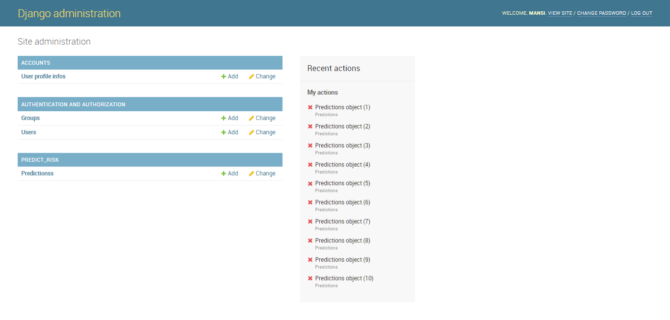
Figure 4.2: Diagnosis Administration
This page display the list of all the registered business operator

4.1.2 INPUT DESIGN
This aspect entails the description of the expected data input that will provide our output as described above. This section list out all the input required for the implementation of Career Guidance System. Data entry is done through the keyboard and mouse selection where required. The sample input interfaces are as shown below:

    - DATABASE DESIGN
Table 4.2: Prediction Dataset
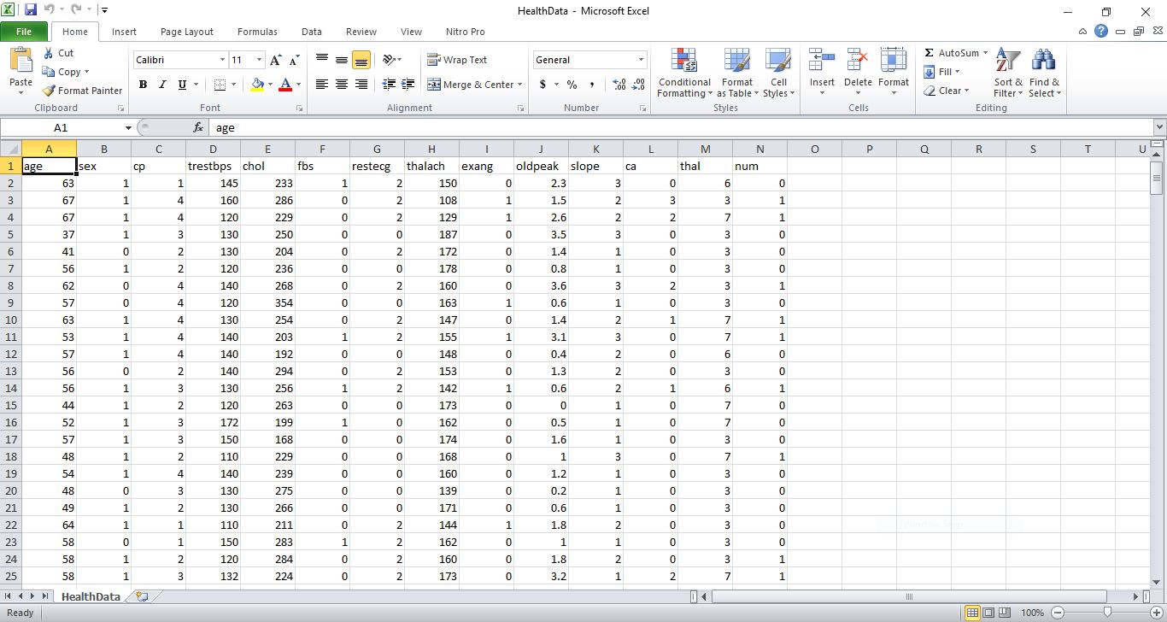
Table 4.2: Deafness Database
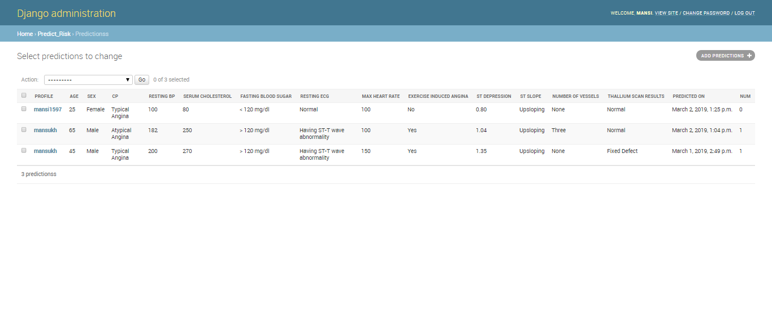
4.1.4 PROCEDURE DESIGN
The administrator can perform the following
- Add new business operator
- Generate shop for the market
- Allocate shop for each operator

4.2 IMPLEMENTATION OF THE SYSTEM
4.2.1 CHOICE OF PROGRAMMING LANGUAGE
In determining a suitable programming language for the design of the online patient management system, the factors to be considered are:-
- The difficulty of the problem
- The technical skills required of the computer program
- The type of processing required
- The availability of sub-programming facilities
- The efficiency of the language translator
- Ease of maintaining and updating the program
- Hardware and software requirement
For the project work, the programming language to be used for the design of the system is PHP and MYSQL for database management system with embedded Structured Query Language (SQL) for database manipulation

4.2.2 HARDWARE SUPPORT
The hardware requirements for this program are:
- PC: The computer should be minimum of Pentium IV with 1000GHs processor speed but preferably Dua Core Processor for greater efficiency
- Memory: This system requires a Higher RAM not less than 512MG, 1GB RAM is recommended.
- Storage: the storage capacity must be 80GB and above.
- VDU: Visual Display Unit required should be a very high resolution not less than 1024 x 768 with 256 colour capability.
- Printer: This system also requires a printer
- Input: The input device required is a mouse, Optical Mouse should be provides for easy use.
4.2.3 SOFTWARE REQUIREMENTS
The software requirements for the operation of this program are as follows:
- Window Operating System
- XAMPP or WampServer (for Apache server on localhost)
- Web Browser e.gMozila Firefox
- Macromedia dreamweaver
4.2.4 CHANGE OVER TECHNIQUE
The method used in the implementation of the proposed system is parallel, simply because parallel system supports the use of the existing system together with the proposed system and when there system failure information will not be totally lost and will not be back to square one for the users.
4.3 DOCUMENTATION OF THE SYSTEM
4.3.1 PROGRAM DOCUMENTATION
In order for the proposed system to be used on any computer system it takes the following ways
- Boot the system
- Copy the folder to www inside wamp folder of the drive C: after WAMP server is installed onto the system.
- Open any browser on the system (Microsoft internet Explorer, Mozilla Firefox, Netscape Navigator, Opera, Flock, Safari e.t.c)
- Type http://localhost/Shop Allocation System/index.php on the address bar and press the return key or enter key.
4.3.2 OPERATING THE SYSTEM
This refers to the step by step method of using the proposed system. The proposed system comprises of. The steps to use the proposed system are as follows
- On the address bar of any browser type http://localhost/www.kpshopallocation/index.php
- You are prompted to supply the username and password this verifies that you are a registered voter and has the privileged to vote.

4.3.3 MAINTAINING THE SYSTEM
- Data cable should be plugged properly
- Repair or replacement of all damaged accessories, system cards, peripheral e.t.c.
- prevention from dust
- Prevention of system from heat and moisture
- Prevention from static charges
- Examination of the new system from time to time to ensure it is performing as specified.
- Operators and users to the system must constantly check the output of the system to make sure that it is working accordingly.

CHAPTER FIVE
SUMMARY, CONCLUSION AND RECOMMENDATION
5.1 SUMMARY
Having communication with Deaf students is a challenge for some lecturers. Multimedia provides a potential solution for this situation; however, few people know how to develop it ideally. This study uses primary and secondary data to create a strategic model for multimediabased learning for Deaf students through focus group discussion with the expert, lecturers, parents, and practitioners. At the same time, however, this model recognises that multimedia communication is not sufficient in and of itself for full engagement with them. This article, thus, proposes implementing several activities within universities based on four stages: identify the level of hard hearing, choose the learning style, design multimedia learning, and create engagement. By developing these strategies, Deaf students in higher education can have a comfortable and effective place to learn to minimize the communication barriers between Deaf student and others.
5.2 CONCLUSION
Learning using multimedia helps teachers to make the atmosphere becomes interesting and fun, because the learning material, which is packaged in the form of animation, is more lively, easy to understand and clear so that the deaf students can easily understand the learning material. Multimedia-based learning material is packaged in a more vibrant form and can simulate the learning material to be more attractive so as to make the deaf students grasp and understand the material that is being taught to them. Therefore, multimedia-based learning materials for students with hearing impairment are very effective to be applied in education. Support from the government and the parties concerned is needed to support and disseminate this program to schools that support the education of deaf students to use multimedia teaching materials to improve the quality of learning for deaf students to be better, to reach a brilliant future.

5.3 RECOMMENDATION
Multimedia-based learning with a total communication learning style offers an ideal approach for Deaf students. In addition, lecturer’s teaching style should be able to accommodate students’ need by creating personalised material and interactive activities throughout the session. They require extra support from many people, i.e., students, lecturers, employees, university directors, parents, etc. This is not easy, as other students and lecturers must change our everyday behaviour and respect others with disabilities. However, this is important if the university want to provide full accommodation for students with special needs. By adding new style of learning, including lecturer awareness of Deaf people’s condition, that means the higher education institution tries to move closer to understand the culture of Deaf world, as they may not seen only has different physical abilities (Lane, 2005). Deaf people have their own world with their own culture, thus, study model and habitual should be developed within the education institution. When an institution realize that they need to learn sign language to improve their ability to communicate with Deaf student, that means a sustainable education has built at least at the earliest stage to understand multi-cultural and multi-lingual society (McIlroy & Storbeck, 2011; Padden & Humphries, 2006).

REFERENCES
Arsyad, Azhar. (2010). Media Pembelajaran. Jakarta: PT Raja Grafindo Persada 3. Canning-Wilson, C. (2000). Practical aspects of using video in the foreign language classroom. The Internet TESL Journal, 4(11). Retrieved June 25, 2012, from http://iteslj.org/Articles/Canning-Video.
California Department of Education, “Programs for Deaf and Hard of Hearing Student Guidelines for Quality Standards,” 2000.
Dowaliby J. and Lang G., “Adjunct Aids in Instructional Prose: A Multimedia Study with Deaf College Students,” Computer Journal of Deaf Studies and Deaf Education, vol. 4, no. 4, pp. 270-282, 1999.
Jonassen, D., & Kim, B. (2010). Arguing to learn and learning to argue: design justifications and guidelines. Educational Technology: Research and Development. 58(4), 439-457.Mayer, R.E. & Moreno, R. (2002). Educational Psychology Review 14: 87. doi:10.1023/A:1013184611077
N. Kholis, P. Purwowibowo, and M. A. Ibra, “The Total Communication Learning Model to Support the Effectiveness of Social Interaction for Deaf Children,” vol. 409, no. SoRes 2019, pp. 482–484, 2020, doi: 10.2991/assehr.k.200225.104.
P. Boudreault, A. Wolfson, B. Berman, V. L. Venne, J. S. Sinsheimer, and C. Palmer, “Bilingual Cancer Genetic Education Modules for the Deaf Community: Development and Evaluation of the Online Video Material,” Journal of Genetic Counseling, vol. 27, no. 2, pp. 457–469, 2018, doi: 10.1007/s10897-017-0188-2.
V. Anindhita and D. P. Lestari, “Designing interaction for deaf youths by using user-centered design approach,” 4th IGNITE Conference and 2016 International Conference on Advanced Informatics: Concepts, Theory and Application, ICAICTA 2016, 2016, doi: 10.1109/ICAICTA.2016.7803135.
Z. Cheng and K. Sabran, “User Interface Design for The Asia Elderly: A Systematic Literature Review,” in e-Proceedings of International Conference on Language, Education, Humanities &Social Sciences (i-LEdHS2021), 2021, pp. 589–599.
M. H. Mohd Hashim and Z. Tasir, “An e-learning environment embedded with sign language videos: research into its usability and the academic performance and learning patterns of deaf students,” Educational Technology Research and Development, vol. 68, no. 6, pp. 2873–2911, 2020, doi: 10.1007/s11423-020-09802-4.
Ohene-Djan, J.; Zimmer, R.; Bassett-Cross, J.; Mould, A.; and Cosh, B. (2004). Mak-messenger and finger-chat, communications technologies to assist in teaching of signed languages to the deaf and hearing. Proceedings of the Advanced Learning Technologies. Proceedings IEEE. Joensuu, Finland, 744-746.
Masitry, A.K.; Majid, M.A.; Toh, M.Z.; and Herawan, T. (2013). An investigation on learning performance among disabled people using educational multimedia software: A case study for deaf people. International Journal of Bio-Science and Bio-Technology, 5(6), 9-20.
Al-Osaimi, A.; AlFedaghi, H.; and Alsumait, A. (2009). User interface requirements for e-learning program designed for deaf children. In Proceedings of the first Kuwait Conference on e-Services and e-Systems . Safat, Kuwait, 7-11.
Kourbetis, V.; Boukouras, K.; and Gelastopoulou, M. (2016). Multimodal accessibility for deaf students using interactive video, digital repository and hybrid books. Proceedings of the International Conference on Universal Access in Human-Computer Interaction. Toronto, Canada, 93-102.
Shin, M.; Bryant, D.P.; Bryant, B.R.; McKenna, J.W.; Hou, F.; and Ok, M.W. (2017). Virtual manipulatives: Tools for teaching mathematics to students with learning disabilities. Intervention in School and Clinic, 52(3), 148-153.
Mahapatro, M. (2017). Qualitative research in public health. Asian Journal of Social Science,
45(1-2), 73-92.

APPENDIX 1:

