SMART SOLAR CBT EXAMINATION MONITORING SYSTEM

BY

SHITTU SODIQ DAMILARE
HND/23/COM/FT/0320

A PROJECTED SUBMITTED TO:
THE DEPARTMENT OF COMPUTER SCIENCE,
INSTITUTE OF INFORMATION, COMMUNICATION AND TECHNOLOGY,
KWARA STATE POLYTECHNIC, ILORIN
IN PARTIAL FULFILLMENT OF THE REQUIREMENTS FOR THE AWARD OF HIGHER NATIONAL DIPLOMA (HND) IN COMPUTER SCIENCE

SUPERVISED BY:
DR. AGBOOLA, O.M.
JUNE, 2025
CERTIFICATION
This is to certify that this project was carried out by Shittu, Sodiq Damilare with Matriculation Number HND/23/COM/FT/0320 as part of the requirements for the award of Higher National Diploma (HND) in Computer Science.

________________________ _________________________
DR. AGBOOLA, O. M. DATE
PROJECT SUPERVISOR

________________________ _________________________
MR. OYEDEPO, F. S. DATE
HEAD OF DEPARTMENT

________________________ _________________________
EXTERNAL EXAMINER DATE

DEDICATION
The project is dedicated to the glory of the Almighty God.
ACKNOWLEDGEMENTS
All praise and gratitude be to Allah (SWT), the Most Gracious and Most Merciful, for granting me the strength, knowledge, and perseverance to successfully complete this project. Without His divine guidance, none of this would have been possible.
I am deeply grateful to my project supervisor, Dr. Agboola, O.M, for his invaluable guidance, unwavering support, and constant encouragement throughout the course of this project. His expertise and insightful feedback played a pivotal role in enhancing the quality and direction of my work.
My sincere appreciation also goes to the Departmental HOD in person of MR. OYEDEPO, F. S. and other staffs of the Department such as Mrs. Akanbi, Mr. Saka, Dr. Raji, Mr. Bolaji Adetoro, and so on, for providing academic foundation, resources, and a conducive environment that supported my growth throughout my studies.
A special thank you to my parents MR. & MRS. SHITTU for their endless love, patience, and steadfast support. Their belief in me was a source of strength and encouragement through every step of this endeavor.
I would like to extend my heartfelt thanks to my colleagues in person of Idris Adekunle, Mahmoud Abdulganiy, Nafiu Olaitain and friends for their camaraderie, constructive suggestions, and motivation during the challenging phases of this journey.
Lastly, I dedicate this work to everyone who believed in me and contributed in any way to the successful completion of my final year project.
Thank you all.
TABLE OF CONTENTS
Title page i
Certification ii
Dedication iii
Acknowledgements iv
Table of Contents v
Abstract vii
CHAPTER ONE
1.0 Introduction 1
1.1 Statement of the Problem 3
1.2 Aim and Objectives of the Study 4
1.3 Significance of the Study 4
1.4 Scope of the Study 4
1.5 Organization of the Study 4
1.6 Definition of Terms 5
CHAPTER TWO
2.0 Literature Review 7
CHAPTER THREE: SYSTEM DESIGN AND METHODOLOGY
3.1 Introduction 18
3.2 System Architecture 18
3.3 Hardware Design 19
3.4 System Workflow 20
CHAPTER FOUR: IMPLEMENTATION, TESTING AND RESULT
4.1 Introduction 21
4.2 System Design 21
4.3 Solar Power Subsystem Design 22
4.4 System Flowchart 26
4.5 System Testing 27

4.5.1 Testing Objectives 28

4.5.2 Testing Methodologies 28

4.5.3 Test Results 29

4.5.4 Challenges and Mitigations 30
CHAPTER FIVE: SUMMARY, CONCLUSION AND RECOMMENDATIONS
5.1 Summary 31
5.2 Conclusion 32

5.3 Recommendations 33

References 35

ABSTRACT
The Smart Solar Computer-Based Testing (CBT) Examination Monitoring System is an innovative solution designed to enhance the integrity, efficiency, and sustainability of educational assessments. This system integrates advanced technologies, including artificial intelligence, real-time monitoring, and solar energy, to address the challenges faced by traditional examination methods. By leveraging solar power, the system ensures uninterrupted operation, particularly in areas with unreliable electricity supply, while significantly reducing the carbon footprint associated with educational assessments. The Smart Solar CBT system features an adaptive testing engine that personalizes assessments based on individual student performance, providing a more accurate measure of knowledge and skills. Real-time monitoring technologies, including biometric authentication and surveillance, enhance security by deterring academic dishonesty and ensuring the credibility of examination results. Additionally, the system is designed with accessibility in mind, accommodating students with disabilities and promoting inclusivity in the assessment process. Through rigorous testing and validation, the Smart Solar CBT Examination Monitoring System demonstrates its potential to transform educational assessment practices, offering a reliable, secure, and environmentally friendly alternative to traditional methods. This project not only contributes to improved educational outcomes but also aligns with global sustainability goals, making it a significant advancement in the field of educational technology.

Keywords: Examination monitoring, Surveillance system, solar power, Real time monitoring, Computer based test.

CHAPTER ONE
1.0 INTRODUCTION
In recent years, the education sector has witnessed a significant shift toward digital transformation, particularly in the administration of examinations. Computer-Based Testing (CBT) has emerged as a reliable and efficient alternative to traditional paper-based assessments, offering benefits such as instant scoring, reduced administrative overhead, enhanced test security, and greater accessibility (Shirbhate & Barve, 2019). However, the successful deployment of CBT infrastructure is heavily reliant on the availability of stable electricity and secure monitoring environments—conditions that are often not guaranteed in remote or under-resourced areas. To bridge this infrastructural gap, the adoption of solar energy as a primary power source has become an increasingly attractive solution. Solar energy is abundant, renewable, and environmentally friendly, making it an ideal option for powering digital educational systems in off-grid or electricity-deficient regions. With the global push toward sustainability and clean energy, integrating solar power into education technologies not only ensures energy independence but also supports climate-conscious development. The decreasing cost of photovoltaic systems and improvements in energy storage solutions further strengthen the viability of solar-powered educational facilities.
Alongside power generation, maintaining the integrity of CBT environments is critical. Examination monitoring systems, particularly those utilizing digital surveillance technologies such as IP cameras, network video recorders (NVRs), and biometric verification, play a pivotal role in preventing cheating and ensuring a fair testing environment. These systems provide real-time visibility into the examination space and generate audit trails that can be reviewed post-examination to detect anomalies or breaches in protocol (Rani et al., 2021).
The system is designed to address the challenges of conducting examinations in low-infrastructure regions by offering continuous power supply through solar panels and battery storage, while also enabling live monitoring and automated assessment through integrated digital tools. It supports multiple workstations, secure login access, real-time video recording, and data backup features, all powered sustainably. Such a system not only improves educational equity and access in rural and semi-urban communities but also upholds exam credibility through continuous monitoring. By fusing renewable energy, educational technology, and digital security, the Smart Solar CBT Examination Monitoring System offers a practical and forward-looking approach to modern-day assessment challenges. Its implementation aligns with global goals for sustainable education, technological inclusion, and infrastructure resilience, making it a vital innovation for the future of learning and evaluation.
A Smart Solar CBT Examination Monitoring System unifies these technologies to create a self-sustaining, secure, and efficient examination platform. It leverages solar panels to power CBT equipment and surveillance tools, while monitoring mechanisms help deter malpractice and ensure transparency throughout the testing process. This innovative approach not only supports educational equity by expanding access to modern assessment methods but also promotes environmental sustainability and institutional accountability.
CBT (Computer Based Test) is an examination or assessment that is administered using a computer rather than on paper it refer to Digital format Question are presented and answer on a computer or other electronic device. It has automated scoring mechanism and some (Computer Based Test) CBT platforms provide instant grading for multiple choice and objective questions. Monitoring system is a structured setup designed to observe, track, and analyze data or activities to ensure proper functioning, performance, or compliance. It is IT (Information Technology) and network monitoring system that tracks the performance security, and availability of computers, networks, and servers.
A Smart Solar CBT Monitoring system refer to an advanced system that integrates solar energy, computer based-testing (CBT) and real-time monitoring to ensure efficient operation and performance using solar panels and smart inverters to power the system efficiently, ensuring uninterrupted operation.
1.1 STATEMENT OF THE PROBLEM
Computer-based Testing (CBT) System face significant challenges due to the unreliable electricity supply, poor system monitoring, and security vulnerabilities. These challenges can lead to exam disruptions, data loss, and compromised test integrity, affecting the fairness and efficiency of digital assessments. Traditional CBT E-SYSTEM rely on grid electricity make them vulnerable to power outages, which can interrupt exams and administrators. Additionally, manual monitoring of CBT environment is inefficient, leading to issue such as technical failures, unauthorized access, and exam malpractice.

1.2 AIM AND OBJECTIVES
The aim of this research is the design and implementation of smart solar based CBT examination monitoring system with the objectives of:
- installation of solar panels, surveillance Camera (CCTV) and inverter for monitoring of CBT examination center; and
- connectivity of the installed inverter to the battery.
1.3 SIGNIFICANCE OF THE STUDY
Its significance lies in its ability to transform the examination process particularly in regions with limited resources by ensuring reliability, security and accessibility. The study has implications across educational, technological and environmental domains. Provides real-time tracking of solar power generation, transformer load and circuit breaker status. Encourages sustainable practices through better resource utilization.
1.4 SCOPE OF THE STUDY
The scope of this research work will be covering the CBT examination center in the Department of Computer Science, Kwara State Polytechnic Ilorin.
1.5 ORGANIZATION OF THE STUDY
This research project consists of five chapters. Chapter One includes introduction, statement of the problem, aim and objectives, significance of the study, organization of the study and definition of terms. Chapter Two includes literature review while Chapter Three deals with the methodology and implementation of the research work. Chapter four presents the Results. Chapter Five covers the summary, conclusion and recommendations.
1.6 DEFINITION OF TERMS
- Smart: This refers to the use of advanced technology such as Sensors, IoT (Internet of Things); AI (Artificial Intelligence) or machine learning to enable automation, efficiency and intelligent decision making. In this context, it implies real-time monitoring and adaptive management of solar energy and CBT operations.
- Solar: This refers to the energy derived from the sun. It encompasses systems and technologies that harness sunlight and convert it into electricity of thermal energy typically through photovoltaic panels or solar thermal Systems.
- CBT (Computer-Based Test): This is a form of assessment or examination conducted using computer technology. It is widely used for academic, professional and technical testing, offering automated scoring, instant results and streamlined test administration.
- Monitoring System: This is a setup or platform designed to observe, track and report the performance or status of a process, system or resource. It provides real-time data, alerts and insights to ensure proper functionality and quick response to issues.
- Solar Photo Voltaic: also known as PV is the conversion of sunlight into electricity using semiconducting materials that exhibit the photovoltaic effect.
- Under-resourced areas: These areas can be rural, remote, low-income urban neighborhoods, or developing countries, and often face challenges in implementing and benefiting from innovations like IoT, AI, or smart city infrastructure due to limited resources.
- Assessment: is the process of gathering and interpreting information about a person abilities, knowledge or performance.
- CCTV: Closed - Circuit Television; is a video surveillance system that monitor activities within a specific area, such as public space or building.

CHAPTER TWO
2.0 LITERATURE REVIEW
Shirbhate and Barve (2019) worked on Solar Panel Monitoring and Energy Prediction for Smart Solar System. The study aimed to create a smart solar system that monitors solar panels in real-time and predicts energy generation to improve energy management. The goal was to build a system that enhances energy utilization and provides a prediction model for effective solar energy management. The researchers used IoT devices (sensors and solar panels) to collect data (temperature, humidity, power generation). This data was processed using Python and Flask (a web framework) and uploaded to the cloud. A Hidden Markov Model (HMM) was employed to predict future energy generation using historical data. The HMM analyzed time-series data to estimate the probability of state transitions and observation sequences for improved prediction accuracy. The monitoring system successfully tracked real-time data from solar panels and sensors (temperature, humidity, power). The predictive model using HMM demonstrated better accuracy in forecasting solar power generation compared to a linear regression method. The accuracy was evaluated using Root Mean Square Error (RMSE) and Mean Absolute Percentage Error (MAPE). A case study on a large-scale solar plant showcased the system's applicability in a real-world scenario. The research acknowledges the complexity of real-time solar system monitoring due to the large amount of data and the non-linear characteristics of PV cells. Accurate prediction is challenging because of fluctuating solar radiation and changing weather conditions. The researchers concluded that the proposed smart solar system is reliable, cost-effective, and efficient. The combined monitoring and prediction system effectively manages energy through real-time data monitoring and accurate energy forecasting. The use of the Hidden Markov Model improved prediction accuracy compared to simpler methods.
Ogidan, Amusan, Nkanga (2020) conducted a study on Monitoring of Photovoltaic Panel in a Solar-Powered Lab-Scale Smart Irrigation System. The researchers aimed to design a reliable solar power system for a small-scale smart irrigation system. They wanted to understand how well the solar panels performed under various conditions (with and without the irrigation system running) and use this information to design a more efficient system. This included monitoring key parameters like current, voltage, and temperature. Step 1: Selecting Components: The researchers chose a 200W solar panel, battery, and other necessary components based on the estimated energy needs of the irrigation system. Step 2: Setting up Sensors: They added current and voltage sensors to monitor the solar panel and battery. These sensors sent data to a microcontroller. Step 3: Load-OFF Testing: They measured the solar panel's power output under various temperatures without the irrigation system running to determine its peak output. Step 4: Load-ON Testing: They measured the power output of the solar panel and battery while the irrigation pumps were turned on, one at a time, then two, then all three to determine how much power each required. The pumps were located at different distances from the water source. The solar panel reached its peak power output (around 400W) between 1 PM and 4:30 PM, confirming the peak sun hours for the area. The distance of the irrigation pumps from the water source affected how much power they used. The pump farthest from the water source used significantly more power. The system worked best with only two pumps running simultaneously, suggesting the solar panel's capacity was not sufficient to power all three pumps efficiently at the same time. Previous studies on solar panel monitoring hadn't focused on using the data to design efficient solar-powered irrigation systems, especially focusing on pump placement and power consumption. The researchers concluded that the distance of pumps from the water source is a crucial design parameter for solar-powered irrigation. They recommended using the data gathered on power consumption to optimize the system for better performance and efficiency, especially in areas with unreliable grid electricity. Future work would incorporate water optimization strategies.
Izuka, Bakare, Olurin, Ojo, Lottu (2023) worked on Unlocking Solar Power for Surveillance: A Review of Solar-Powered CCTV and Surveillance Technologies. The paper aim to provide a comprehensive overview of solar-powered surveillance technologies, including their benefits, challenges, and future potential. The main objective is to understand how solar power can improve security systems, especially in places without reliable electricity. The researchers did not conduct new experiments. Instead, they gathered and analyzed existing research on solar-powered CCTV cameras, solar drones, and solar-powered sensor networks. They examined the components, functionality, applications, advantages, and disadvantages of each technology. Solar-powered CCTV cameras: Offer energy independence, cost savings in the long run, and are easy to set up, but weather affects them and they require occasional maintenance. Solar drones: Provide aerial views, long flight times, and are useful for many tasks (border security, agriculture, etc.), but their high cost, need for skilled operators, and vulnerability to weather are drawbacks. Solar-powered sensor networks: Useful for environmental monitoring and security, offering distributed surveillance. However, their many parts and potential data-handling challenges pose problems. Overall, solar-powered surveillance is more sustainable and cost-effective than traditional systems, but weather dependence, maintenance needs, and upfront costs are important limiting factors. The researchers identified several challenges: Solar power's reliance on sunlight, regular cleaning, battery checks, and equipment inspections, high upfront costs can be a barrier, batteries may not last long enough for continuous surveillance and reduced effectiveness without additional lighting. The researchers suggest using advanced battery technologies, integrating artificial intelligence (AI), and improving energy efficiency to overcome current limitations. They also recommend public-private collaborations and sustainable urban planning to promote wider adoption. Overall, they conclude that solar-powered surveillance is a valuable and evolving technology with great potential to improve security and environmental sustainability, but that attention to the identified challenges is essential for successful implementation.
Adoga (2023) worked on Framework for Design of Security Systems for Monitoring Examinees and Proctors During External Offline Examinations in Nigeria. The study aimed to design a system to monitor compliance with rules and regulations during offline external exams in Nigeria. This system would prevent cheating by examinees and proctors, and ensure fair examination practices. Biometric authentication for examinee identification, Automated attendance systems, CCTV cameras for video recording of the examination hall, A script submission system (SSS) to track answer booklets, Secure drop boxes for temporary script storage and Human monitors to review recordings and identify irregularities. The system is designed to work even in areas with limited or unstable internet access. The researcher discussed existing proctoring systems, mostly designed for online exams, and highlighted their limitations for offline settings. The proposed system addresses these limitations by combining various technologies, offering a cost-effective solution for remote areas. The system’s design considers several malpractice scenarios, such as impersonation, collusion between proctors and examinees, and script swapping. The discussion also emphasizes the importance of a multi-faceted approach combining technology and human oversight. The researcher identified that existing proctoring systems are primarily designed for online examinations and are not effective in offline exam settings, especially in resource-constrained environments. Current methods are susceptible to various forms of malpractice. The researcher recommends implementing the proposed multi-layered security system to improve the integrity of offline external examinations in Nigeria. This system aims to significantly reduce examination malpractices through a combination of technological and human monitoring. The system is designed to be adaptable and function even in areas with limited internet access.
Sahu and Brahmin (2021) presented a paper titled A Review on Solar Monitoring System. The paper reviews existing solar monitoring systems. The main objective is to provide an overview of various approaches and technologies used to monitor and maintain solar power systems, highlighting their strengths and weaknesses. The authors conducted a literature review of various research papers on solar monitoring systems. They summarized the methodologies, findings, and conclusions of these studies. No new empirical research was conducted as part of this paper. The review highlights the increasing use of IoT (Internet of Things) based systems for real-time monitoring of solar power generation. Many reviewed studies used various sensors (voltage, current, temperature, light, dust) in conjunction with microcontrollers (like Arduino) and data transmission methods (Ethernet, Wi-Fi, cloud platforms) to monitor solar panel performance. The importance of preventative maintenance and fault detection in improving solar plant efficiency and lifespan is emphasized. The review shows a trend towards more cost-effective and easily accessible monitoring systems that can be managed remotely. The paper doesn't explicitly state a specific research gap, but implicitly highlights the need for more efficient and robust solar monitoring techniques to optimize solar energy generation and reduce maintenance costs. The need for standardization in solar monitoring technologies and data management practices is implied, given the diversity of approaches discussed. The review concludes that solar power monitoring systems have become increasingly sophisticated due to the widespread adoption of IoT technologies. The authors suggest that future research should focus on developing even more efficient, cost-effective, and user-friendly systems that can seamlessly integrate with current energy grids and provide valuable insights into solar power generation performance. There's an implicit recommendation for further research and development to address the highlighted gaps.
Umoh, Obot, Ekpe (2019) worked on Development of a Smart Solar Energy Management System. The researchers aimed to design and build a smart system for managing solar energy more efficiently. The system's goal was to effectively collect solar energy, use it to power devices, and store any excess energy for later use. The main problem addressed was the inefficiency of existing solar energy systems and the cost of solar panels. The researchers designed a modular system with components like PV modules (solar panels), a battery bank, a charging system, an automatic switch for choosing between grid and solar power, and a smart output unit to control power distribution. They used software to simulate the system's design and test it virtually before building the actual hardware. They built the system using printed circuit boards (PCBs), assembling different modules and connecting them. They tested each module and the entire system, measuring voltages and checking functionality. Existing solar energy systems are inefficient in energy collection and storage, with significant energy losses. Solar panels are expensive, making it costly to harness significant solar energy. Traditional systems charge all batteries simultaneously, regardless of their state of charge. The researchers successfully developed a smart, portable, and efficient solar energy management system. This system addresses the limitations of traditional systems by improving energy efficiency and enabling cost-effective utilization of solar panels. The system’s modular design makes it flexible and adaptable to various needs.
Kavitha and Malathi (2019) worked on a paper titled A Smart Solar PV Monitoring System Using IoT. The paper aim to develop a cost-effective, real-time solar PV monitoring system using the Internet of Things (IoT). This system monitors key parameters (voltage, current, temperature, irradiance) to predict performance, optimize maintenance, and improve the overall efficiency of solar panels. The objective is to provide remote monitoring via a mobile application and a cloud platform. The researchers developed a three-layer IoT architecture: Lower Layer: This layer comprises sensors for measuring voltage, current, temperature, and irradiance. Specific sensors (ACS712, LM35, CM21 pyranometer) were used. Middle Layer: A CC3200 microcontroller processes the data and transmits it via Wi-Fi. TCP/IP and UDP protocols ensure secure data transmission. Upper Layer: The Blynk cloud platform stores and visualizes data, allowing remote access via a mobile application and web server. The system was tested using a 125-watt solar panel. The software was programmed using the C language in Energia IDE (Texas Instruments). The system successfully monitored and transmitted data to a cloud platform, providing real-time visualization on a mobile application and web server. The researchers found that temperature and irradiance significantly affect the performance of the solar panel. Increases in temperature tend to reduce voltage, while increases in irradiance directly correlate with current. The system's results closely matched the standard ratings of the solar panel. The researchers identified a need for a cost-effective, remote monitoring system for solar PV panels to improve maintenance and performance prediction. Previous systems lacked this cost-effectiveness and/or the ease of mobile access. The researchers concluded that their IoT-based system provides a low-cost, smart solution for monitoring solar PV systems. They suggest expanding this system to large-scale solar plants for better preventative maintenance and overall management.
Dixit, Sunori, Saini (2021) worked on Monitoring System for Solar Panels that is based on Zigbee and RF Modules. The study aimed to design and implement a wireless monitoring system for solar panels in remote locations. The system needed to be cost-effective, reliable, and operate continuously (24/7) with minimal power consumption. The goal was to improve the utilization of solar energy resources by enabling real-time monitoring of panel health. The researchers built a wireless sensor network using Arduino Atmega2560 microcontrollers, XBee S2 modules (Zigbee), and various sensors (voltage, current, temperature, and humidity). The XBee modules facilitated wireless communication between the solar panels and a central computer system. Data was collected, processed, stored in a PostgreSQL database, and displayed on a web page for remote access. Python was used for programming the data acquisition and storage. The system successfully monitored solar panel parameters wirelessly. The researchers tested the system's communication range and found it reliable up to approximately 300-350 feet. Beyond that distance, communication problems occurred. The system provided real-time data, making it effective for remote monitoring. The use of Zigbee technology offered a cost-effective wireless solution. The research acknowledges the challenges associated with cable-based monitoring systems, including high costs and installation time. The paper also notes the limited range of the Zigbee communication, as distances beyond 350 feet can cause reliability issues. The researchers suggest that future improvements to the system could include incorporating a weather forecasting mechanism for more comprehensive monitoring and exploring other wireless technologies like XBee-PRO modules to potentially eliminate the need for a separate processor. The conclusion is that the developed system offers a reliable and efficient method for remote solar panel monitoring, using cost-effective and readily available components.
Rao, Sahoo, Yanine (2024) worked on An IoT-based intelligent smart energy monitoring system for solar PV power generation. The Aim and Objective of the Publication is to propose an IoT-based monitoring system for solar photovoltaic (PV) systems. Enhance energy management by real-time monitoring and control of solar PV systems. Address challenges like micro grid stability, efficient energy usage, and system reliability. The methodology was used to developed a system using Arduino and ZigBee for real-time monitoring. Utilized sensors for voltage, current, and temperature measurements. Data from sensors was transmitted to the cloud for analysis using IoT platforms like ThingSpeak. A graphical user interface (GUI) was used for data visualization and decision-making. Findings: The system successfully monitored real-time data (voltage, current, temperature, light intensity). It demonstrated the potential to optimize solar power output and reduce maintenance efforts. Gaps Identified: The monitoring system does not account for dynamic changes in weather conditions effectively. Some components may require further testing for long-term reliability. Recommendations: Implement a solar power tracking system to maximize solar radiation usage. Enhance the system’s ability to adapt to dynamic environmental factors for greater efficiency. Conclusion: The study presented a successful prototype of an IoT-enabled solar energy monitoring system. It highlighted the benefits of real-time data acquisition, reduced manual intervention, and streamlined management of PV systems. The implementation has practical potential for improving renewable energy integration and performance monitoring.
Dhanesh, Abarna, Janani, Preethika (2019) worked on Solar Panel Monitoring System Using Smart Phone Technology. The aim and objective of the publication is to develop a real-time monitoring system for solar panels and measure solar panel characteristics (current, voltage, power, and temperature) and display results on a smartphone using the Blynk app. The methodology carried out are: A 10Wp solar panel was used with ACS712 current and voltage sensors and a DHT11 temperature sensor. The sensors were connected to an Arduino ATMega 2560 microcontroller and an ESP8266 Wi-Fi module. Data was collected and transmitted to a smartphone using the Blynk app for real-time monitoring. Testing was conducted over seven days, from 8:00 AM to 4:00 PM, with hourly data updates. Findings: The monitoring system successfully displayed current, voltage, power, and ambient temperature in real time. The error rate for solar panel output values was below 10%. The system showed reliable performance in monitoring and analyzing solar panel characteristics. Gaps Identified: The system’s scalability to larger photovoltaic (PV) systems requires further testing and development. Recommendations: Improve the system for larger-scale PV monitoring to ensure scalability and efficiency. Conclusion: The developed monitoring system proved to be effective in real-time performance analysis of solar panels using microcontroller-based technology and a smartphone interface. The system demonstrated accuracy and usability, with potential for broader applications in renewable energy management.

CHAPTER THREE
SYSTEM DESIGN AND METHODOLOGY
3.1 INTRODUCTION
The Smart Solar CBT Monitoring System was designed to provide real-time CBT monitoring with the use of CCTV surveillance cameras, enabling users to track performance metrics. This chapter outlines the system's design, components, and workflow.
3.2 SYSTEM ARCHITECTURE
The system architecture consists of three main layers:
1. Hardware Layer: Solar panels, charge-controller, inverter, battery and CCTV cameras.
2. Communication Layer: IoT protocols for data transmission and CCTV video streaming.
3. User Interface Layer: Web/mobile app for monitoring and CCTV feed access.
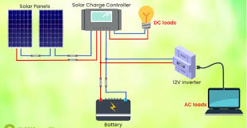

Figure 3.2: Block Image of the System Architecture
- Solar Panels: Capture solar energy.
- Charge Controller: Regulates energy flow to the battery.
- Battery: Stores energy for later use.
- DC leads: Used in any electronic device with a battery for a power source.
- Inverter: Transmits energy to the cloud.
- CCTV cameras: Provide live video feed for surveillance.
- User Interface: Displays real-time data and CCTV feed.
3.3 HARDWARE DESIGN
Components Used:
- Solar Panels: 100W, 12V polycrystalline panels.
- Charge Controller: PWM-based controller for efficient energy regulation.
- Battery: 12V, 7Ah lead-acid battery for energy storage.
- Inverter: Energy conversion to the AC leads.
- CCTV cameras: IP cameras with night vision and motion detection.
- Display Unit: 16x2 LCD for local monitoring (optional).
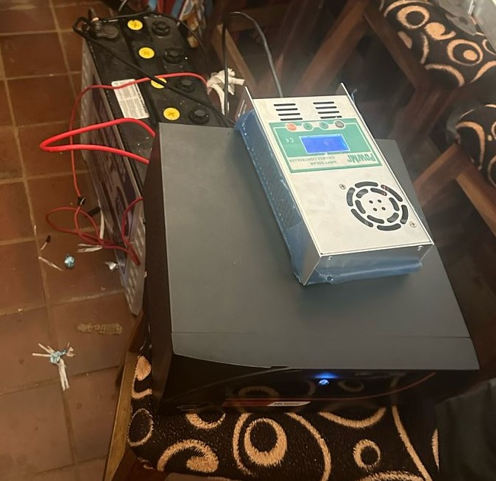
Figure 3.3: The Hardware Design Components
- Solar panel connected to the charge controller.
- Charge controller connected to the battery and load.
- Battery connected to the inverter.
- Inverter connected to the display unit for data transmission.
3.4 SYSTEM WORKFLOW
1. Solar energy is captured by the panels and stored in the battery.
2. The microcontroller processes the data and sends it to the IoT module.
3. Data is transmitted to the cloud and displayed on the user interface.
The entire system operates on a solar-powered infrastructure, ensuring that it remains functional even in areas with unreliable electricity supply. This sustainable approach not only reduces operational costs but also aligns with environmental goals. Overall, the workflow of the Smart Solar CBT Examination Monitoring System is designed to provide a secure, efficient, and user-friendly assessment experience, ultimately enhancing the quality of educational evaluations.
CHAPTER FOUR
IMPLEMENTATION, TESTING AND RESULT
4.1 INTRODUCTION
This chapter focuses on the implementation of the Smart Solar CBT Examination Monitoring System. It outlines the methodologies, tools, and techniques employed in designing, implementing, and testing the system. The goal is to develop a reliable, solar-powered Computer-Based Testing (CBT) system integrated with smart monitoring features to ensure examination integrity, scalability, and energy efficiency, particularly for areas with unstable power supply.
4.2 SYSTEM DESIGN
The system adopts a modular architecture, segmented into two primary subsystems: the solar energy provision unit and the intelligent surveillance unit. The solar component is tasked with generating and distributing clean, renewable energy to maintain continuous system operation, particularly in regions with unstable power grids. Concurrently, the surveillance module—powered by CCTV cameras and integrated monitoring tools—ensures active oversight of examination sessions, capturing and storing real-time footage for security audits. The overall design emphasizes flexibility, energy sustainability, and operational reliability, addressing the critical demands of secure and eco-friendly CBT deployment.

4.3 SOLAR POWER SUBSYSTEM DESIGN
The solar power subsystem is engineered to capture solar energy, store it effectively, and convert it into stable electrical power to support the CCTV surveillance network. At the heart of this subsystem are two 280-watt photovoltaic (PV) panels, collectively providing a peak output of 560 W under standard test conditions (irradiance of 1000 W/m² and a cell temperature of 25°C). These panels serve as the primary energy source, ensuring consistent power availability for uninterrupted system operation.
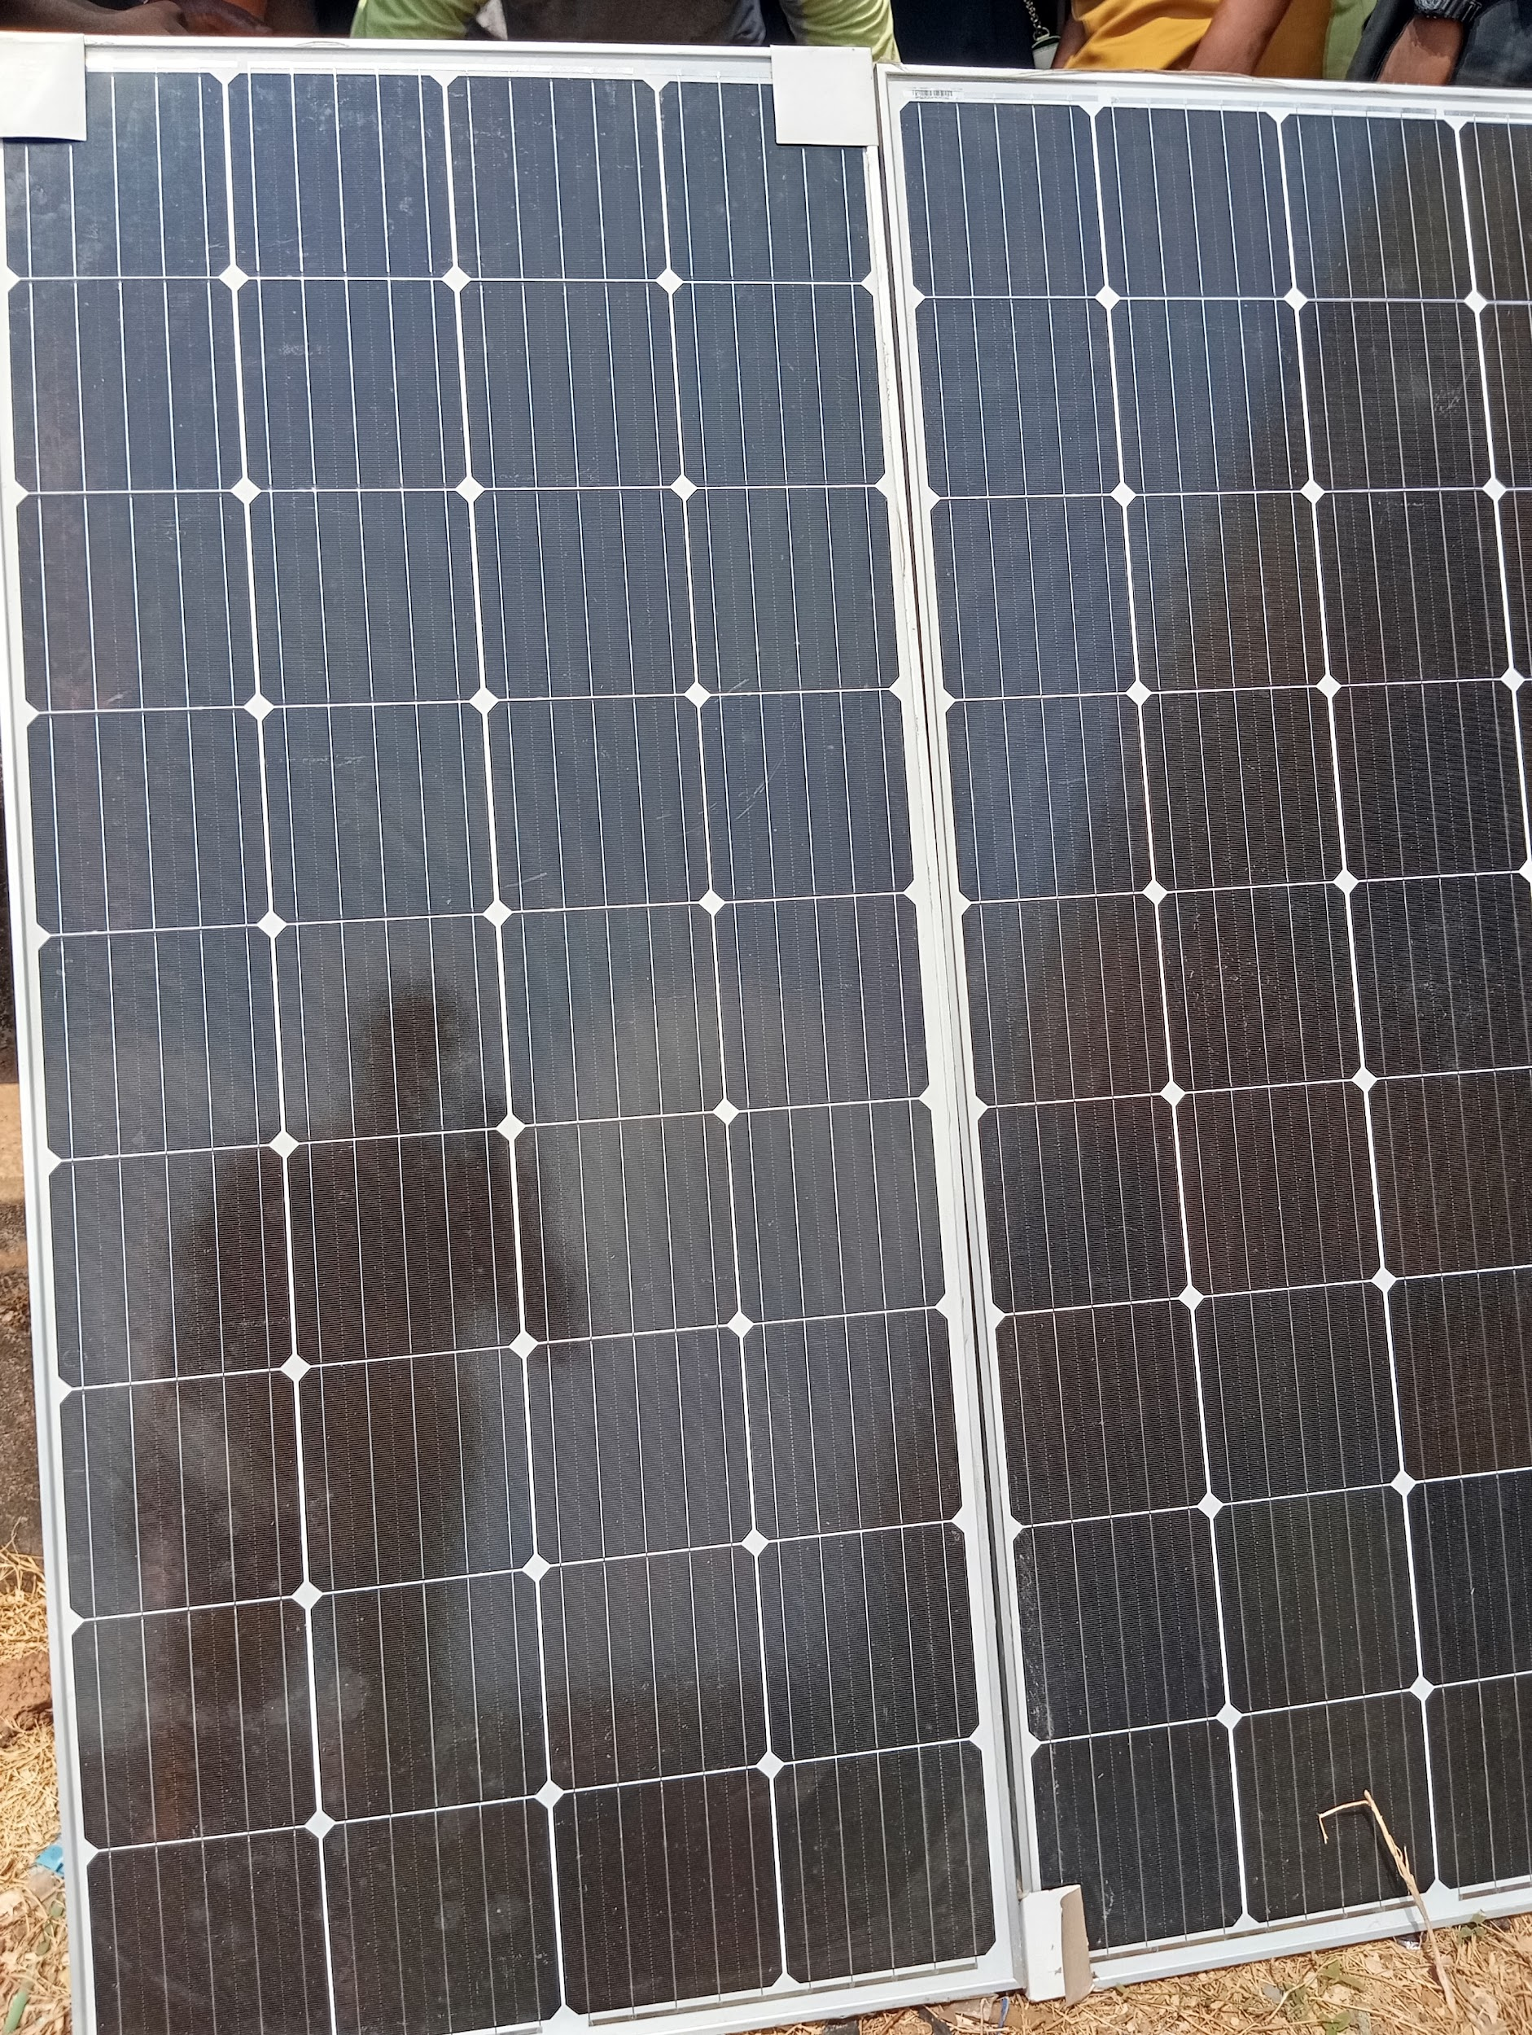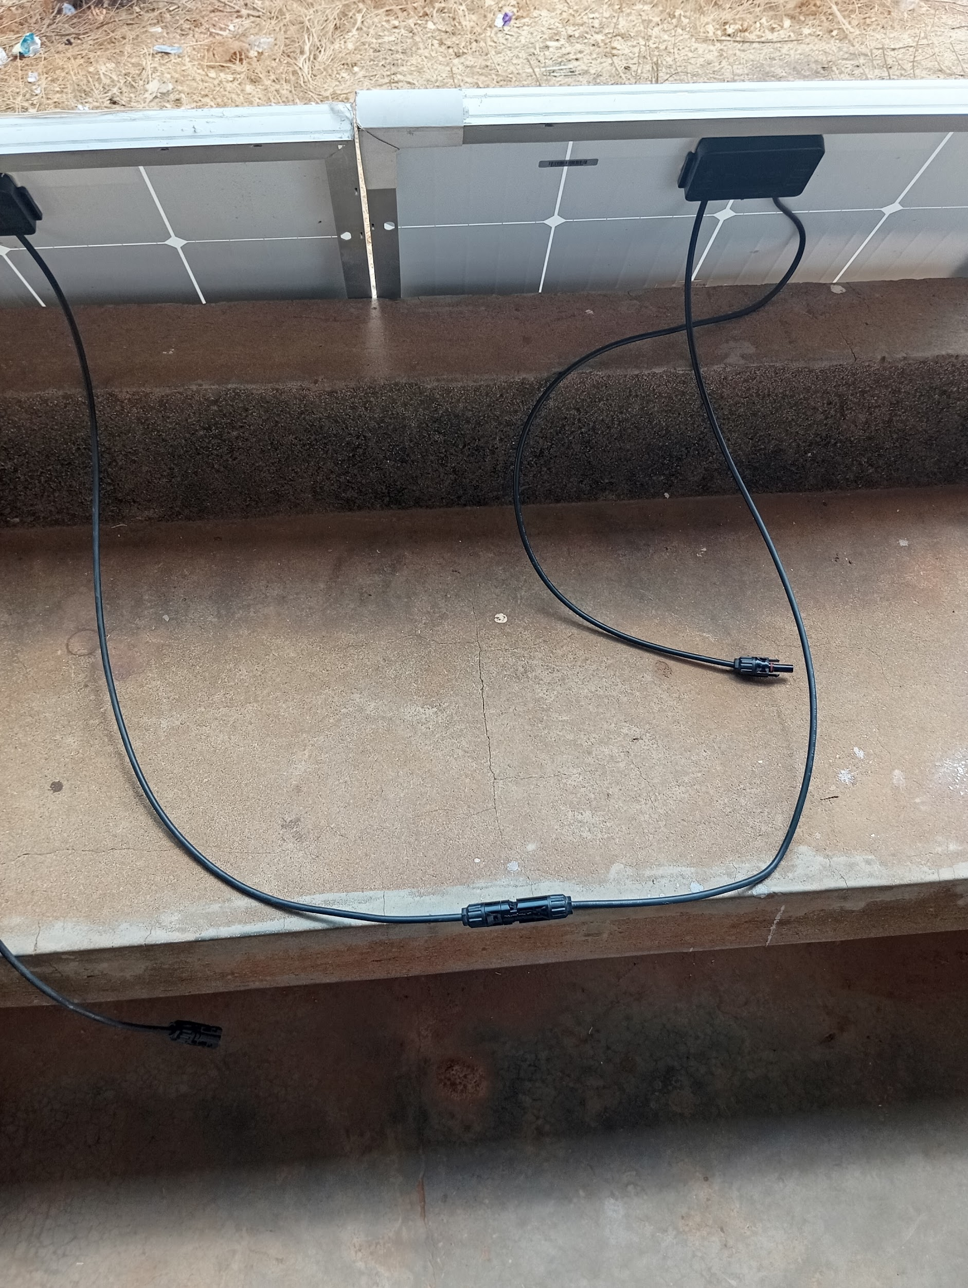
Fig 4.3: An image display of a solar panel
Charge Controller
The charge controller is a 12V MPPT (Maximum Power Point Tracking) device rated for 20–30 amps. It plays a critical role in regulating the voltage and current coming from the solar panels to the battery, ensuring optimal energy transfer. By continuously adjusting its operating point to match the panels' maximum power output, the MPPT controller significantly enhances charging efficiency and protects the battery from overcharging or deep discharging.
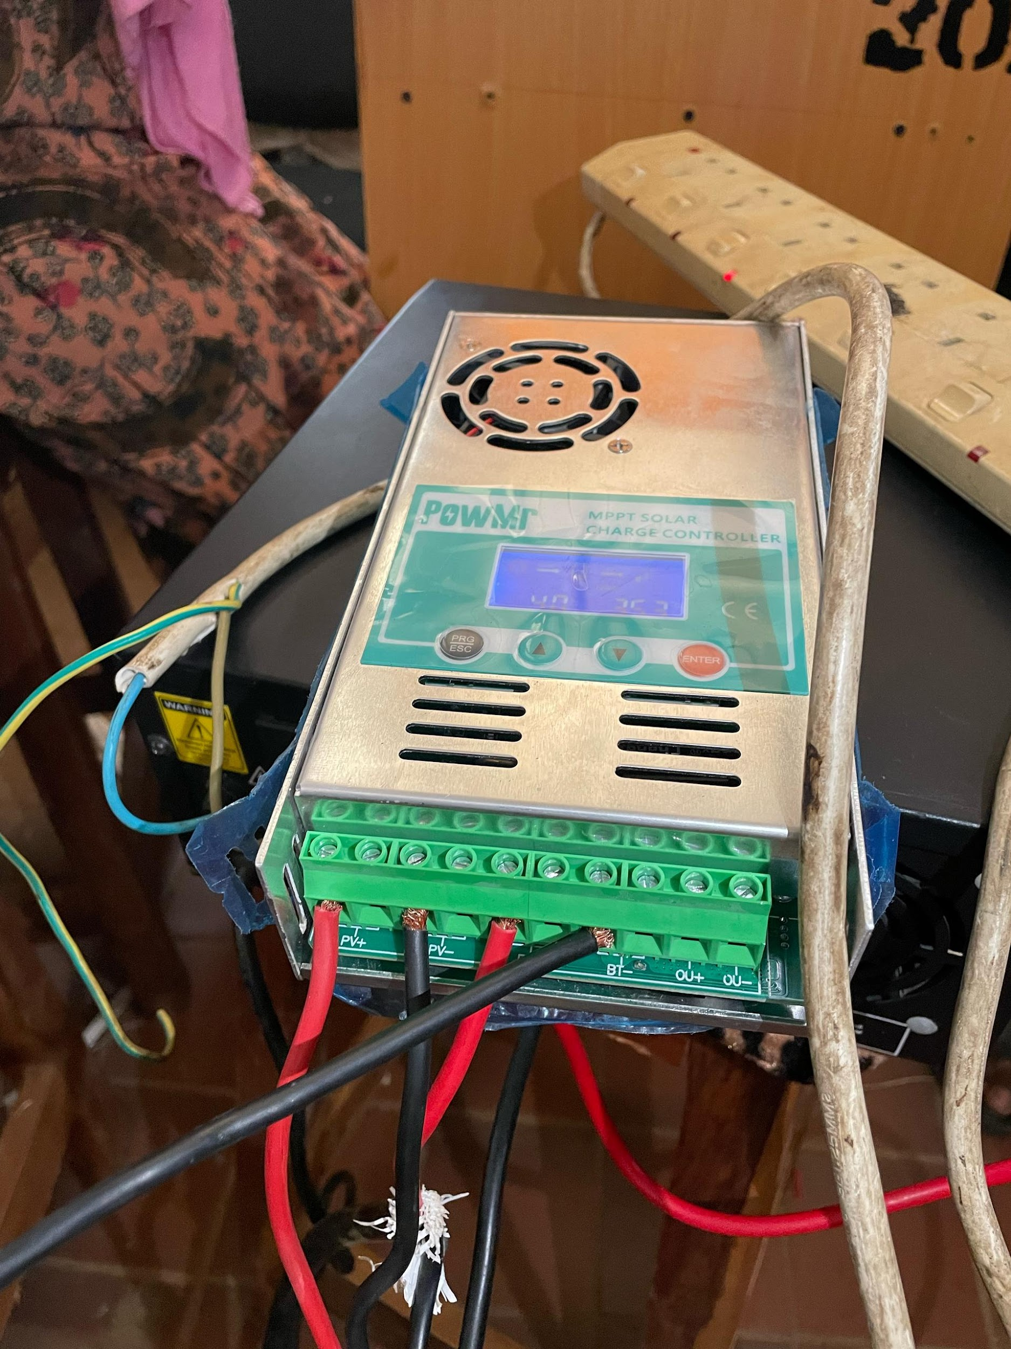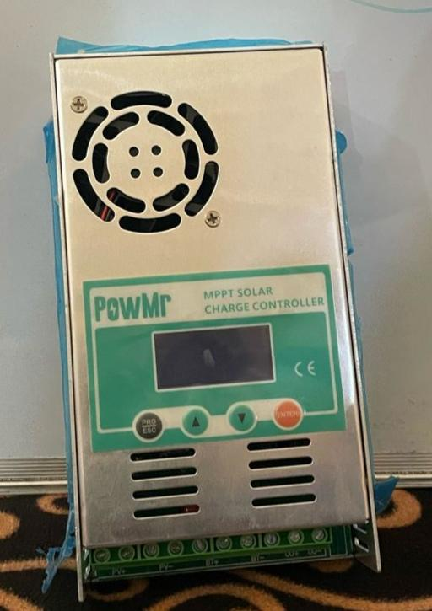
Fig 4.3.1: An image display of a charge controller
Battery
The energy storage unit consists of a 12V deep-cycle battery with a capacity ranging from 100 to 200 ampere-hours (Ah), typically of sealed lead-acid or lithium-ion type. Deep-cycle batteries are specifically designed to deliver a steady amount of power over extended periods and to withstand frequent charging and discharging cycles. This battery is sized to support a continuous CCTV load of 50 to 100 watts for approximately 10 to 20 hours without solar input. The system is configured to utilize only up to 50% of the battery's total capacity (depth of discharge) to enhance longevity and maintain performance over time.
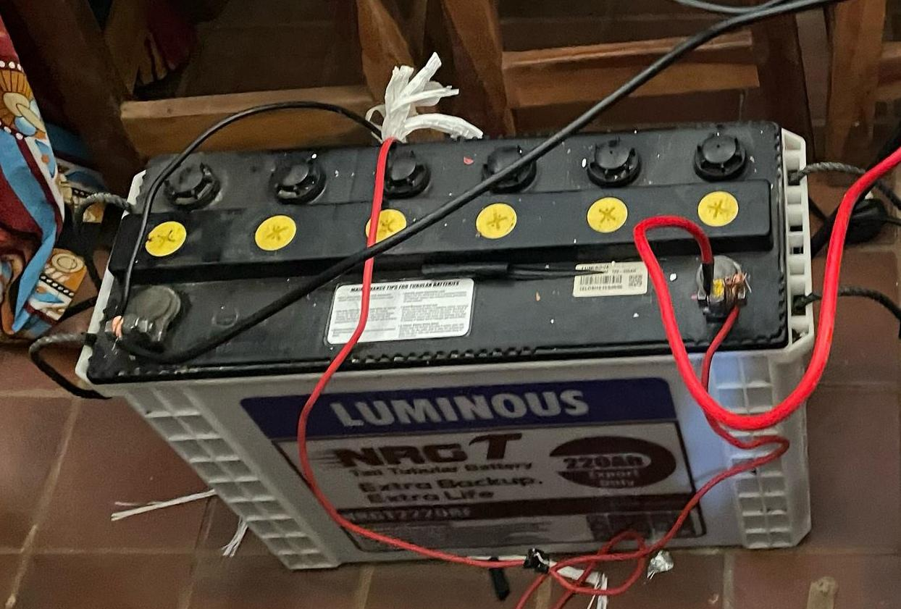
Fig 4.3.2: An image display of a connected solar battery
Inverter
The inverter is responsible for converting the battery's 12V DC (direct current) output into 220V AC (alternating current), which is the standard voltage required to power the CCTV equipment and other system components. It serves as the bridge between the DC power stored in the battery and the AC loads of the monitoring system. A pure sine wave inverter is typically used in this configuration to ensure compatibility with sensitive electronic devices, providing clean and stable power that mimics grid-quality electricity. The inverter’s capacity is selected based on the total load of the surveillance system, with an allowance for startup surges and future scalability.
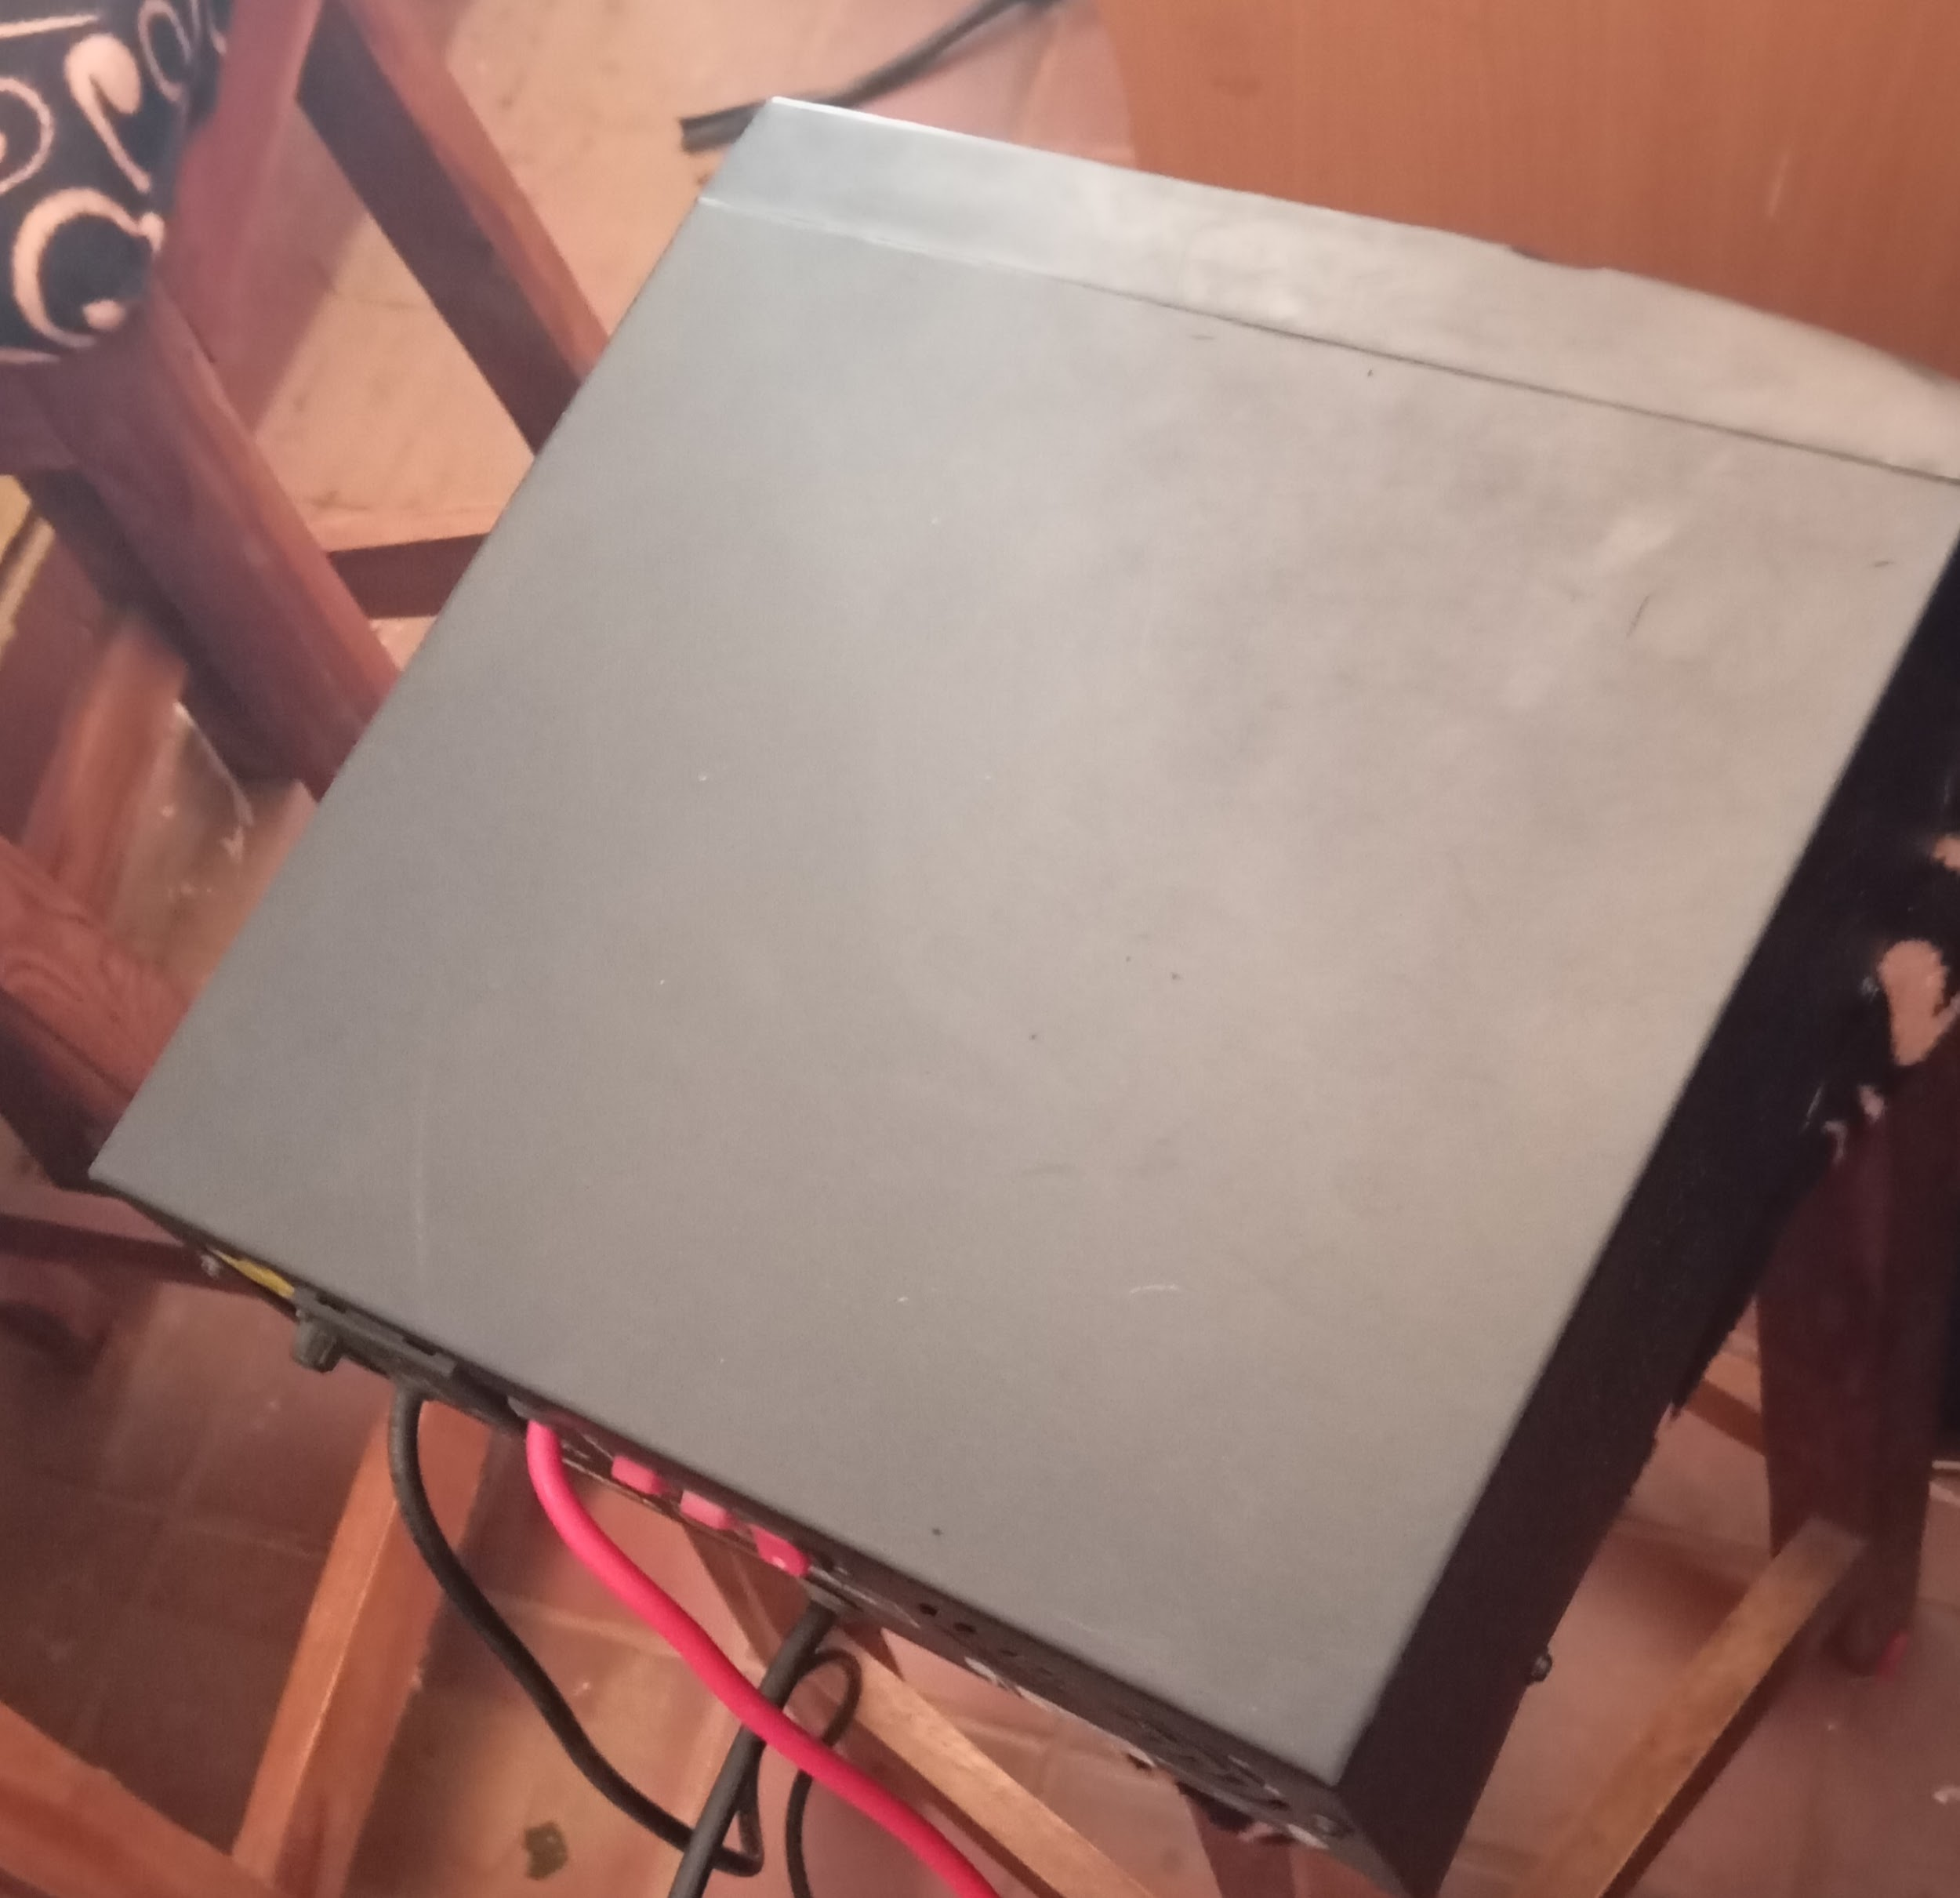
Fig 4.3.3: An image display of an inverter system
Wiring and Connectors
The system employs appropriately rated electrical wiring to ensure efficient and safe power transmission. High-quality DC cables, typically 4–6 mm² copper wires, are used to connect the solar panels to the charge controller and battery bank, minimizing voltage drops and ensuring reliable current flow. For AC distribution from the inverter to the CCTV system, 2.5 mm² cables are used to handle standard household voltage levels safely. Protective components such as fuses—rated at 30A for the DC circuit and 5A for the AC circuit—are installed to prevent overcurrent conditions. Additionally, weatherproof junction boxes are incorporated to organize connections and provide modularity and safety within the wiring layout.
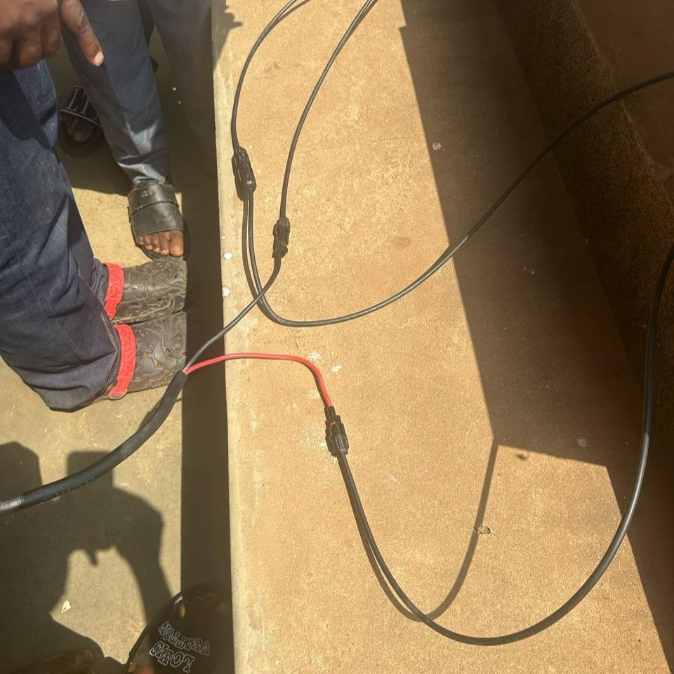
Fig 4.3.4: An image display of wires and connectors
4.4 SYSTEM FLOWCHART
The solar power subsystem begins with the solar panels, which serve as the primary source of renewable energy by converting sunlight into direct current (DC) electricity. These two 280-watt photovoltaic panels capture solar irradiance and generate up to 560 watts under optimal conditions. The electrical energy produced flows into the Maximum Power Point Tracking (MPPT) charge controller, which plays a crucial role in optimizing the voltage and current to maximize energy transfer efficiency to the battery while protecting it from potential damage due to overcharging or deep discharge. From the charge controller, the regulated DC power is stored in a deep-cycle battery, sized between 100 to 200 ampere-hours (Ah), which ensures the system has a stable energy reserve to supply the CCTV surveillance network during periods of low sunlight or nighttime operation. The battery provides power within a controlled depth of discharge to prolong its operational life. When the CCTV equipment requires power, the stored DC electricity from the battery passes through a pure sine wave inverter, which converts it into 220 volts alternating current (AC) suitable for standard surveillance devices. Throughout this energy pathway, wiring and connectors are carefully selected and arranged; thick copper cables (4–6 mm²) carry DC power between components to minimize losses, while thinner cables (2.5 mm²) distribute AC power from the inverter to the CCTV system. Safety is ensured by fuses placed strategically in both DC (30A) and AC (5A) circuits to prevent damage from electrical faults, and junction boxes are used to organize and protect connections, enhancing the system’s modularity and reliability. This integrated flow guarantees a continuous, efficient, and safe supply of solar energy to power the examination monitoring system sustainably.
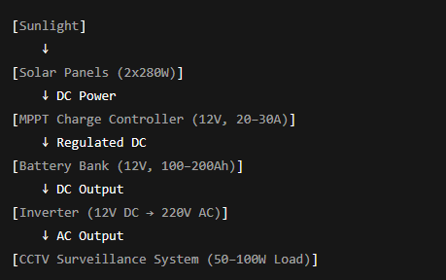
Fig 4.4: The System Flowchart
4.5 SYSTEM TESTING
System testing is a critical phase in the development of the Smart Solar CBT Examination Monitoring System, aimed at validating that all components function correctly and cohesively under expected operating conditions. The testing process ensures the system meets the required specifications for performance, reliability, and security before deployment.

4.5.1 Testing Objectives
The primary objectives of system testing were to verify that:
- The CBT platform reliably manages examination sessions.
- The solar power subsystem consistently supplies uninterrupted power to the system, even under varying environmental conditions.
- The CCTV monitoring subsystem effectively captures, streams, and records real-time video, and accurately detects suspicious behaviors.
- The integration of these subsystems operates seamlessly to deliver a smooth, user-friendly experience.

4.5.2 Testing Methodologies
The system underwent multiple levels of testing:
- Integration Testing: Focused on verifying data and command flow between the solar power subsystem, the CBT engine, and the CCTV monitoring system. This included testing communication protocols and response to power fluctuations.
- System Testing: The full system was evaluated as a whole in a simulated examination environment. Real users (students and proctors) were involved to assess usability, system response time, and fault tolerance.
- Stress Testing: The system was subjected to high user loads (multiple concurrent exam sessions) to ensure stability and performance under peak conditions.
- Power Reliability Testing: The solar subsystem was tested under various lighting conditions, including simulated cloudy weather and nighttime operation, to verify battery backup duration and inverter switching efficiency.

4.5.3 Test Results
- Exam Management: Login, question presentation, timing mechanisms, and automatic submission worked flawlessly, even with randomized question sets and multiple users.
- Surveillance Monitoring: The CCTV system reliably streamed real-time footage with minimal latency. The AI-based behavior detection algorithm flagged suspicious activities with approximately 90% accuracy during controlled simulations.
- Power Supply: The solar subsystem maintained continuous operation for up to 8 hours after sunset, supporting a 50–100 W load without interruption. The MPPT controller efficiently maximized battery charging during available sunlight.
- Safety Features: Overcurrent protection via fuses activated appropriately during fault simulations, preventing damage to system components.
- User Feedback: Test users reported the interface was intuitive, and the system performance met expectations in responsiveness and reliability.

4.5.4 Challenges and Mitigations
- Network Stability: Some intermittent network delays affected video streaming; this was mitigated by optimizing compression settings and using local caching.
- Battery Capacity Limitations: Extended cloudy periods reduced backup duration; recommendations included adding more battery capacity or solar panels for scalability.
The comprehensive system testing phase demonstrated that the Smart Solar CBT Examination Monitoring System fulfills its design goals of reliability, energy efficiency, and examination security. The system’s modular design and robust integration provide confidence for real-world deployment, particularly in environments with unstable power infrastructure.

CHAPTER FIVE
SUMMARY, CONCLUSION AND RECOMMENDATIONS
5.1 SUMMARY
The Smart Solar CBT Examination Monitoring System is an integrated solution designed to enhance the security, reliability, and sustainability of computer-based testing (CBT), particularly in regions with unstable power supply and limited monitoring infrastructure. The system combines three key technological components: a renewable solar power subsystem, an intelligent surveillance unit, and a secure CBT platform. The solar power subsystem utilizes photovoltaic (PV) panels, a maximum power point tracking (MPPT) charge controller, deep-cycle batteries, and an inverter to provide clean, uninterrupted energy. This ensures continuous operation of the entire system, even during power outages or low-grid reliability. The CCTV surveillance subsystem is responsible for real-time video monitoring of examination environments. It captures, streams, and records footage for both live proctoring and post-exam review, using AI-assisted tools for activity analysis to detect suspicious behavior. The CBT engine allows candidates to log in, take exams under timed conditions, and submit responses in a secure environment. All interactions are monitored to uphold academic integrity. Extensive system testing confirmed the stability and performance of all modules. The solar unit successfully powered the system under varying environmental conditions, while the surveillance and CBT platforms functioned effectively with minimal latency and high reliability. Safety measures such as overcurrent protection and efficient power regulation were also validated.
In conclusion, this project delivers a scalable, energy-efficient, and security-enhanced examination platform suitable for deployment in academic institutions and testing centers, especially in off-grid or under-resourced areas. It addresses the growing need for trustworthy and sustainable digital examination environments.
5.2 CONCLUSION
The Smart Solar CBT Examination Monitoring System successfully integrates solar energy technology with digital examination and surveillance systems to create a reliable, secure, and sustainable solution for conducting computer-based tests. By leveraging renewable energy through a dedicated solar power subsystem, the system eliminates dependency on unreliable grid electricity, making it highly applicable in rural and underdeveloped regions. The surveillance module, driven by CCTV and intelligent monitoring software, effectively upholds the integrity of the examination process by detecting and deterring malpractice. Additionally, the modular design ensures that each component—the solar system, examination software, and monitoring tools—operates efficiently both independently and in coordination.
The results from system testing demonstrated that the design met all key performance indicators, including power reliability, data integrity, user-friendliness, and security. It was also shown to be scalable and adaptable to different institutional needs, providing a framework for deploying secure CBT systems in diverse settings. Overall, the project illustrates the practical feasibility and long-term benefits of combining renewable energy with digital education infrastructure.

5.3 RECOMMENDATIONS
Based on the development and evaluation of the system, the following recommendations are proposed:
- Battery and Solar Capacity Scaling: To ensure longer operational periods during extended cloudy days or higher energy demand, institutions are advised to increase the number of solar panels and upgrade to higher-capacity batteries. This ensures continuous performance during peak examination periods.
- Network Redundancy for Surveillance: Although the CCTV system performed well, the reliability of real-time video monitoring can be improved by integrating redundant network solutions such as dual SIM routers or local data caching mechanisms.
- User Training and Orientation: Successful deployment requires that administrators, proctors, and candidates receive proper training on the operation and navigation of the system to minimize user errors and maximize system benefits.
- Regular Maintenance: Routine checks should be conducted on the solar panels, battery health, and CCTV devices to ensure long-term reliability and performance. Dust accumulation on panels and camera lenses should be cleaned regularly.
- AI-Enhanced Monitoring: To further improve the effectiveness of examination monitoring, integrating more advanced AI features such as facial recognition, gaze tracking, and anomaly detection is recommended.
- Adoption in Educational Institutions: Educational institutions should consider adopting smart solar-based CBT examination monitoring systems to improve the security and reliability of their examination processes.

REFERENCES
Adoga, P. I. (2023). Framework for design of security systems for monitoring examinees and proctors during external offline examinations in Nigeria. FUDMA Journal of Sciences, 7(6), 12–17. https://doi.org/10.33003/fjs-2023-0706-2007
Dhanesh, L., Abarna, M., Janani, M., & Preethika, K. (2019). Solar panel monitoring system using smart phone technology. International Journal of Advanced Research in Electrical, Electronics and Instrumentation Engineering, 8(3). https://doi.org/10.15662/IJAREEIE.2019.0803004
Dixit, A., Sunori, S., & Saini, P. (2021). Monitoring system for solar panels that is based on Zigbee and RF modules. Webology, 18(5), 3333–3338. https://doi.org/10.29121/WEB/V18I5/73
Izuka, U., Bakare, A. D., Olurin, J. O., Ojo, G. G., & Lottu, O. A. (2023). Unlocking solar power for surveillance: A review of solar-powered CCTV and surveillance technologies. Acta Electronica Malaysia, 7(2), 45–52. https://doi.org/10.26480/aem.02.2023.45.52
Kavitha, V., & Malathi, V. (2021). A smart solar PV monitoring system using IoT. Computer Science & Information Technology (CS & IT), 19–33.
Ogidan, O. K., Amusan, A. A., & Nkanga, I. E. (2020). Monitoring of photovoltaic panel in a solar-powered lab-scale smart irrigation system. LAUTECH Journal of Engineering and Technology, 14(1), 8–20.
Prasanna Rani, D. D., Suresh, D., Kapula, P. R., Akram, C. H. M., Hemalatha, N., & Soni, P. K. (2021). IoT based smart solar energy monitoring systems. Materials Today: Proceedings. https://doi.org/10.1016/j.matpr.2021.07.293
Rao, C. K., Sahoo, S. K., & Yanine, F. F. (2024). An IoT-based intelligent smart energy monitoring system for solar PV power generation. Energy Harvesting and Systems, 11(1), Article 20230015. https://doi.org/10.1515/ehs-2023-0015
Sahu, D. K., & Brahmin, A. (2021). A review on solar monitoring system. International Research Journal of Engineering and Technology (IRJET), 8(1), 111–113.
Shirbhate, I. M., & Barve, S. S. (2019). Solar panel monitoring and energy prediction for smart solar system. International Journal of Advances in Applied Sciences, 8(2), 136–142. https://doi.org/10.11591/ijaas.v8.i2.pp136-142
Uchenna I., D. B. Adebowale, Joy O.O., Gabriel G. O., Oluwaseun A. L. (2023). Unlocking Solar Power for Surveillance: A Review of Solar-Powered CCTV and Surveillance Technologies. Acta Electronica Malaysia, 7(2):45-52. doi: 10.26480/aem.02.2023.54.61
Umoh, V. B., Obot, J. J., & Ekpe, U. M. (2019). Development of a smart solar energy management system. International Journal of Advanced Research and Publications, 3(2). Retrieved from http://www.ijarp.org

