COMPARATIVE EVALUATION OF ANT COLONY OPTIMIZATION AND ARTIFICIAL BEE COLONY OPTIMIZATION TO SOLVE TRAVELING SALESMAN PROBLEM
(ILORIN-ABEOKUTA-LAGOS-IBADAN-OSOGBO)

BY
OKUNLADE, IDRIS ADEKUNLE
HND/23/COM/FT/0318

BEING A PROJECTED SUBMITTED TO:
THE DEPARTMENT OF COMPUTER SCIENCE,
INSTITUTE OF INFORMATION, COMMUNICATION AND TECHNOLOGY,
KWARA STATE POLYTECHNIC, ILORIN
IN PARTIAL FULFILLMENT OF THE REQUIREMENTS FOR THE AWARD OF HIGHER NATIONAL DIPLOMA (HND) IN COMPUTER SCIENCE

SUPERVISED BY:
DR. AGBOOLA, O.M.

JUNE, 2025
CERTIFICATION
This is to certify that this project was carried out by Okunlade, Idris Adekunle with Matriculation Number HND/23/COM/FT/0318 as part of the requirements for the award of Higher National Diploma (HND) in Computer Science.

________________________ _________________________
DR. AGBOOLA, O. M. DATE
PROJECT SUPERVISOR

________________________ _________________________
MR. OYEDEPO, F. S. DATE
HEAD OF DEPARTMENT

________________________ _________________________
EXTERNAL EXAMINER DATE

DEDICATION
The project is dedicated to the glory of the Almighty God.

ACKNOWLEDGEMENTS
My gratitude goes to Almighty God for sparing my life and making it possible for me to complete my Higher National Diploma programme, I say Glory be to the Almighty God.
My special and sincere appreciation goes to my amiable supervisor in person of DR. AGBOOLA, O.M. for his efforts and assistance towards the accomplishment of the project work.
He is hereby acknowledged for his understanding, guidance and support towards the completion of this project, I pray to the Almighty God to lift him up to next level in every area of his career.
My sincere appreciation also goes to the Departmental HOD in person of MR. OYEDEPO, F. S. and other staffs of the Department such as Mrs. Akanbi, Mr. Saka, Mr. Bolaji Adetoro, and so on, for providing academic foundation, resources, and a conducive environment that supported my growth throughout my studies.
My special appreciation goes to my parents, MR. & MRS. OKUNLADE and my great siblings for their indelible support, love and encouragement throughout the entire journey. Thank you for believing in me.
More so, my special thanks goes to project partner in person of, HUSSEIN, YUSUF OLAMILEKAN for his advice and support throughout this entire project work. I would like to extend my heartfelt thanks to my friends in person of Sodiq, Mahmoud, Olaitan, Kenny, Ayomide, Rahmon, Peter, AbdulNafiu, Hauwa, TechEngineGuy, to mention few and my colleagues for their camaraderie, constructive suggestions, and motivation during the challenging phases of this journey. I say thank you all.
TABLE OF CONTENTS
Title page i
Certification ii
Dedication iii
Acknowledgements iv
Table of Contents v
Abstract viii
CHAPTER ONE
1.0 Introduction 1
1.1 Statement of the Problem 2
1.2 Aim and Objectives of the Study 3
1.3 Significance of the Study 3
1.4 Scope of the Study 3
1.5 Organization of the Study 4
1.6 Definition of Terms 4
CHAPTER TWO
2.0 Literature Review 6
CHAPTER THREE: RESEARCH METHODOLOGY
3.1 The Methodology 15
3.1.1 Ant Colony Optimization Algorithm 15
3.1.2 Artificial Bee Colony Optimization Algorithm 16
3.2 Analyzing the Problem of the Existing System 17
3.3 Step-By-Step Approach to the ACO Algorithm 19
3.3.1 Adaptation of Ant Colony Optimization Algorithm to TSP 21
3.4 Step-By-Step Approach to ABCO Algorithm 26
3.4.1 Adaptation of Artificial Bee Colony Optimization Algorithm to TSP 27
3.5 Analysis of the Proposed System 31
3.6 Advantages of the Proposed System 31
CHAPTER FOUR: IMPLEMENTATION, RESULT AND DISCUSSION
4.1 Introduction 33
4.2 System Implementation 33
4.3 System Requirement 35
4.3.1 Hardware requirement 36
4.3.2 Software requirement 36
4.3.3 Choice of Programming Language 36
4.4 Program Documentation 37
4.5 Interface Design 43
4.6 Results and Discussion 46

CHAPTER FIVE: SUMMARY, CONCLUSION AND RECOMMENDATIONS
5.1 Summary 53
5.2 Conclusion 54
5.3 Recommendations 54
REFERENCES 56

ABSTRACT
The Traveling Salesman Problem (TSP) is a classical combinatorial optimization challenge that aims to determine the shortest possible route that visits a set of cities exactly once and returns to the origin. This project presents a comparative evaluation of two nature-inspired metaheuristic algorithms, Ant Colony Optimization (ACO) and Artificial Bee Colony Optimization (ABCO) for solving TSP effectively. ACO simulates the foraging behavior of ants, while ABCO is inspired by the food foraging strategies of honeybee colonies. The research involved adapting both algorithms to TSP, implementing them using Python and Django, and applying them to a dataset of five Nigerian cities (Ilorin, Abeokuta, Lagos, Ibadan, and Osogbo). The performance of each algorithm was assessed based on solution quality, convergence speed, and computational efficiency. Experimental results show that while ABCO achieved a slightly better route with a minimum distance of 590 km, ACO demonstrated faster execution time at 0.18 seconds. Both algorithms successfully satisfied hard constraints like tour completeness and the absence of sub tours, and soft constraints such as minimizing travel distance. This study highlights the practical benefits of swarm intelligence algorithms in route optimization and recommends further exploration of hybrid models for large-scale real-world applications in logistics and transportation.
Keywords: Traveling Salesman Problem, Ant Colony Optimization, Artificial Bee Colony Optimization, Metaheuristic Algorithms, Route Optimization.

CHAPTER ONE
- INTRODUCTION
The Traveling Salesman Problem is a classic NP-hard problem that involves finding the shortest possible tour that visits a set of cities and returns to the starting city. In one tour, the traveling salesman visits each city just once, and finishes up where he started. TSP became a benchmark for many new approaches in combinatorial optimization. The TSP has numerous applications in logistics, transportation, and telecommunications, making it a significant problem in operations research and computer science. In recent years, nature-inspired optimization algorithms, such as Ant Colony Optimization (ACO) and Artificial Bee Colony (ABC) Optimization, have been successfully applied to solve Traveling Salesman Problem (TSP). As the name suggests, ant algorithms have been inspired by the behavior of real ant colonies, in particular, by their foraging behavior. The real ants have the capability to find the shortest path from the food source to the nest (destination) without any visual cues (Holldobler and Wilson, 1990). Ants can communicate with each other through chemical substance called pheromones in their immediate environment. Also, they are capable of adapting to change in the environment, for example finding a new shortest path once the old one is no longer feasible due to a new obstacle (Beckers, Deneubourg and Goss, 1992).
The ants deposit some amount of pheromones on the ground while walking from nest to the food source or food source to the nest, this pheromone is the trivial factor for finding the best solution. An ant senses the pheromone deposited by the other (earlier) ants and tend to imitate the trail with stronger pheromone. So, a shorter path having a higher amount of pheromone is probability that ants will tend to choose the shorter path. M. Dorigo applied this method to solve the classical TSP in (1992) and found that the algorithm has some advantages than others such as robustness and distributive nature,
Artificial Bee Colony (ABC) optimization is a swarm intelligence algorithm inspired by the foraging behavior of honey bees. It was first proposed by Karaboga in (2005). In ABC optimization, a population of artificial bees is simulated to search for the optimal solution. The bees are mainly categorized into three groups; employed bees, onlooker bees and scout bees. The employed bee is assigned to a specific food source (solution) and perform a local search in the neighborhood of that food source, onlooker bees observe the employed bees and select a food source to visit based on its quality fitness Value), while the scout bees perform a random search for new food sources (solutions).
ABC optimization has been applied to various optimization problems, including: numerical optimization, combinatorial optimization and engineering Optimization.
1.1 STATEMENT OF THE PROBLEM
As the number of cities in a TSP increases, the complexity becomes computationally intractable using conventional algorithms. There’s a need for efficient, scalable solutions, which enable to determine whether ACO or ABCO provides better results in terms of route quality, convergence speed, and resource efficiency.

1.2 AIM AND OBJECTIVES
The aim of this project is to solve the TSP using Ant Colony Optimization and Artificial Bee Colony Optimization and also to compare the solution of the implemented algorithms based on distance, time and memory usage.
The objectives are as follows:
- adaptation of the Traveling Salesman Problem to the algorithms (ACO & ABCO);
- implementation of the Adapted Algorithms; and
- evaluation of ACO and ABCO for solving TSP in term of time and memory usage.
1.3 SIGNIFICANCE OF THE STUDY
This study contributes to optimization research by demonstrating the strengths and weaknesses of ACO and ABCO. It informs practical applications in logistics, delivery routing, and supply chain systems by recommending the most efficient algorithm for small to medium-scale TSP instances.
1.4 SCOPE OF THE STUDY
This study focuses of the comparison evaluation of Ant Colony Optimization (ACO) and Artificial Bee Colony Optimization (ABCO) as approaches to solving the Travelling Salesman Problem (TSP) using the dataset of five cities which are (Ilorin-Abeokuta-Lagos-Ibadan-Osogbo).

1.5 ORGANIZATION OF THE STUDY
This study is organized into five chapters. Chapter one provides an introduction to the study, statement of the problem, aim and objectives, significance of the study, scope of the study, organization of the study, and definition of terms. Chapter Two reviews the literature on ACO and ABC optimization, including their principles, applications, and performance evaluation. Chapter Three presents the methodology used in the study, including the experimental design, parameter settings and performance metrics. Chapter Four includes implementation, results of the study, including the performance comparison of ACO and ABCO optimization. Chapter Five concludes the study, summarizes the findings and provides recommendations for future research.
1.6 DEFINITION OF TERMS
The following terms which have been technically used, are defined for the purpose of this study:
- Ant Colony Optimization (ACO): A nature-inspired optimization algorithm that simulates the foraging behavior of ants.
- Artificial Bee Colony (ABC) Optimization: A nature-inspired optimization algorithm that simulates the foraging behavior of honey bees.
- Traveling Salesman Problem (TSP): A Classic NP-hard problem that involves finding the shortest possible tour that visits a set of cities and returns to the starting city.
- Benchmark instances: A set of standardized TSP instances algorithm used to evaluate the performance of optimization algorithm.
- Performance metrics: Measures used to evaluate the performance of optimization algorithms, including convergence speed, solution quality, and computation efficiency.
- Nature-inspired: refer to the use of principles, mechanisms and processes found in nature to develop innovative solutions, algorithms and technologies.
- Foraging: is the process of searching for and gathering food, resources, or other essential materials.
- Pheromones: Chemical signals or substances that are released by living organisms such as animals, plants and insects, to communicate with each other.

CHAPTER TWO
2.0 LITERATURE REVIEW
Bajpai and Yadav (2015) worked on Ant Colony Optimization (ACO) for the Traveling Salesman Problem (TSP) using Partitioning. The aim of the research was to use ant colony optimization for the traveling salesman problem using partitioning. The objective of the research was to find shortest closed tour in a set of cities such that each city is visited once and only once. In this study a new strategy was developed in which the large problem of the TSP was partitioned into the number of sub problems by creating the small number of cities in each group and then apply the ACS algorithm for the sub problems. The researcher discussed on the Ant Colony System (ACS) that builds on the Ant system which is inspired from the foraging behavior of the real ant. This study presents an efficient approach for solving traveling salesman problem based on the divide and conquers strategy (in which cities are divided into the number of sub city) in which the ant colony algorithm using the candidate list is applied. From our experimental result the proposed algorithm is more effective than the conventional ant colony algorithm to find the better solution. Future work is to apply the proposed algorithm to other combinational problems and check the efficiency by comparing this method with other proposed method.
Yao, Ou and Zhou (2021) worked on Traveling Salesman Problem Utilizing Improved Ant Colony Algorithm. This research aims at TSP solving utilizing Improved Ant colony Algorithm. The objective of the research was inspired by the above literature, this research will use the improved ACO (IACO) which combines the ACO and PSO algorithms to solve the TSP issue. The method used to solve the TSP are; first, the PSO was used to solve the TSP problem for obtaining initial solution. Then the gained initial solution was converted into the increment of pheromone in the ACO to implement further iterative optimization for obtaining the final optimal solution. According to these improvement strategies, it can effectively solve the shortcomings of the ACO's slow convergence speed in the early stage and the local extreme value of the PSO in the later stage. The finding and discussion presented IACO in this paper combines the advantages of the PSO with strong global search ability and good feedback ability of the ACO to speed up the convergence speed and to avoid falling into local extremum in the later stage. In solving the TSP, the obtained initial solution of TSP by using PSO is transformed into the enhancement of the pheromone in the ACO at first, and then the ACO is executed to further solve the optimal solution of the TSP problem. Additionally, the pheromone concentration is appointed. Finally, select the optimal solution from the optimal path under each pheromone concentration. In conclusion, the research helps to solve the shortcomings of ACO in the early stage of convergence and the drawback of PSO, which is easy to fall into local extremes in the later stage, this paper presents an improved ant colony algorithm (IACO) by combining the highlights of ACO and PSO to address TSP. The experimental results show that the optimized solution obtained by the discussed IACO is better than a single ant colony algorithm or a single particle swarm algorithm.
Yang, Shi, Marchese and Liang (2008) worked on An Ant Colony Optimization Method for Generalized TSP Problem. The aim and Objective of the study was to extend the Ant Colony Optimization (ACO) method, originally designed for the TSP, to solve the Generalized Traveling Salesman Problem (GTSP). It seeks to improve the ACO method by introducing a mutation process and a local search technique to enhance performance and avoid local minima. The methodology of the study modifies ACO for GTSP by incorporating group influence, mutation processes, and local search techniques like 2-OPT. Benchmarks from TSPLIB were used to test the proposed methods. Results of five variations of the ACO method were compared. The findings and gaps of the research shows an improved ACO method performs better than the basic version, especially when combining group influence, mutation and local search techniques. The results show effectiveness for problems with less than 200 cities, but the performance for larger problems or other GTSP variations was not thoroughly addressed. The findings, recommendations, and conclusion of the study finds that introducing group influence and techniques like mutation and 2-OPT significantly enhances the solution quality. It recommends applying these improvements for similar optimization problems and highlights the need for further exploration in larger-scale problems. The conclusion confirms the proposed methods as effective for handling small to medium- sized GTSP problems, emphasizing their potential for real-world applications.
Sagayam and Akilandeswari [2012] conducted a research tilted Comparison of Ant Colony and Bee Colony Optimization for Spam Host Detection. The aim of the research was to detect spam hosts by comparing two optimization algorithms: Ant Colony Optimization (ACO) and Bee Colony Optimization (BCO). The study trains a learning model using features extracted from hosts and determines which algorithm provides better spam detection. The authors used the WEBSPAM - 4K 2007 data set, processed it in a java environment and trained classification models using ACO and BCO algorithms. They extracted content and link-based features from hosts, applied classification rules and compared the performance of algorithms. During the findings, the study showed that ACO performed better than BCO in detecting spam hosts, as it provided a more Optimal Solution due to higher pheromone trails. The study focused only on the WEBSPAM-4K2007 dataset. ACO showed higher performance and efficiency in spam host detection compared to BCO, future studies could explore additional datasets and heuristic techniques for improved spam detection. The researcher concluded that ACO is better than BCO for spam host detection based on the comparison of optimal solutions. Future work may involve using additional heuristic information or datasets to enhance classification rules.
Stutzle and Dorigo (1999) worked on Ant Colony Algorithms for the Traveling Salesman Problem. The aim and objective of the research was to provide an overview of Ant Colony Optimization (ACO) algorithms for solving the Traveling Salesman Problem (TSP), presenting improvements to these algorithms and evaluating their performance compared to other approaches. The methodology of the research include; application of ACO algorithms, to symmetric and asymmetric TSP instances, use of pheromone-based decision-making by artificial ants for constructing tours, implementation of local search algorithm (e.g 2-opt, 3-opt) to improve the solutions generated by ACO and evaluation of performance through experiments using benchmark TSP instances from TSPLIB. One of the problems of the research was that, despite improvements, the algorithms require high Computational time for large instances. The researcher discover that ACO algorithms effectively solve NP-hard combinatorial problems, particularly the TSP, by balancing exploration and exploitation in search spaces. In conclusion, ACO algorithms, especially improved versions like MMAS, provide a robust framework for solving the TSP and other combinatorial optimization problems, offering a significant contribution to the field of metaheuristics. Future work should focus on improving computational efficiency, incorporating more advanced local search engine techniques and exploring other applications of ACO algorithms beyond TSP.
Bell and McMullen (2004) worked on Ant Colony Optimization Techniques for the Vehicle Routing Problem. The aim and objective of the researcher was to apply the ACO method to solve VRP efficiently, focusing on minimizing route costs and distances while improving solution quality for large-scale logistical challenges. The researcher used the ACO algorithm to simulate ant behaviors for decision-making, modified the Traveling Salesman Problem approach to handle multiple routes in VRP, and experimented with single and multiple ant colonies and different candidate list sizes to evaluate their effectiveness on VRP instances. This paper work found ACO solutions within 1% of known optimal results for small problems and competitive with other methods for larger VRPs. The gaps of the research work is; ACO method struggled with very large VRPs compared to other advanced algorithms. In conclusion, the study provides a competitive and adaptable ACO approach for VRPs, with potential for further refinement to handle larger and more complex problems. Further research on integrating ranking techniques and optimizing candidate list sizes were recommended.
Jamaluddin, Hayati, Mahmud, and Muhammat Pazil (2022) worked on Solving the Travelling Salesman Problem by using Artificial Bee Colony Algorithm. The aim and objective of the publication was to find the minimum cost of time or distance for the traveling salesman problem using the Artificial Bee Colony (ABC) algorithm. The methodology of the researchers involves the use of secondary data of 29 cities in Bavaria, sourced from the Library of Traveling Salesman Problem and MATLAB Software was used for computations. Then discussed about the shortest route obtained for visiting all 29 Cities and returning to the start was 3974km. The study highlights the efficient of the ABC algorithm but does not address potential improvements for real time dynamic environments or scalability to larger datasets. Future work could explore dynamic adaptations of the algorithm for real-world applications and test on larger datasets. In conclusion, the ABC algorithm is a reliable optimization tool for TSP, demonstrating its capability in finding the shortest route efficiently.
Akay, Aydogan and Karacan (2012) worked on 2-opt based Artificial Bee COLONY Algorithm for Solving Traveling Salesman Problem. The study aimed to improve the solution of the Traveling Salesman Problem (TSP), a complex optimization problem where the goal is to find the shortest route that visits all cities exactly once and returns to the starting city. They wanted to create a more efficient algorithm that overcomes the limitations of existing methods. The researcher combined two algorithms: Artificial Bee Colony (ABC) algorithm and 2-opt algorithm in which the ABC acts as a global search, exploring many possible solutions broadly and 2-opt is a local search method that improves a given solution by swapping pair of edges. They integrated these, using ABC to find good starting points and 2-opt to refine those solutions locally. They tested their combined approach (2-opt-ABC) against 2-opt algorithm alone on various TSP datasets. In the researcher findings and discussion, the 2-opt-ABC algorithm significantly outperformed the 2-opt algorithm in most cases. The 2-opt-ABC algorithm often found optimal or near-optimal solutions, demonstrating the effectiveness of combining a global search (ABC) with local improvement (2-opt). The improved algorithm showed better mean results and lower standard deviations (less variability), suggesting that it is more robust than 2-opt alone. The research paper shows that the standard 2-opt algorithm has limitations. Its performance heavily depends on the initial solutions and it can get stuck in local optima (sub optimal solutions) without finding the truly best one. The study successfully demonstrated that integrating 2-opt local search within the ABC algorithm framework created a hybrid algorithm that solves the TSP more efficiently and robustly than the 2-opt algorithm alone. Further research could explore using different local search methods or other global optimization algorithms to further improve the TSP solution.
Dervis Karaboga and Beyza Gorkemli (2019) worked on Solving Traveling Salesman Problem by using Combinatorial Artificial Bee Colony Algorithms. The aim and objective of the study was to address the TSP, a well-known NP-hard combinatorial optimization problem. It introduces two algorithmic variations: Combinatorial ABC (CABC): A version adapted from the Artificial Bee Colony (ABC) algorithm for discrete optimization. Quick CABC (qCABC): An improved version of CABC with enhanced convergence speed. The primary goal is to assess these algorithms' efficiency in solving TSP, comparing their performance against existing optimization methods on 15 different TSP benchmark problems. The methodology of the research paper are, Algorithm Design, Experimental Setup, Parameter Tuning During findings, the research talks about performance, in which both CABC and qCABC outperformed many GA variants and metaheuristic algorithms across benchmarks. The qCABC showed improved convergence, attributed to its advanced neighborhood exploration. Then in efficiency, statistical tests confirmed that qCABC consistently achieved lower tour lengths (closer to optimal solutions) in shorter computational times. Results highlighted the algorithms robustness and scalability for different problem sizes. Prior research focused on Small TSP Problems, limiting the generalizability of the findings. The new algorithms were primarily benchmarked against GA Variants, leaving room for broader comparisons with other modern meta heuristic techniques. Real-world applications of TSP-like scenerios were not explored, restricting the study to academic datasets. In conclusion, the qCABC algorithm offers significant advantages in solving TSP, with faster convergence and better solution quality. Both algorithms are suited for combinatorial optimization problems beyond TSP. This research paper recommends the extension of the algorithms’ application to other combinatorial challenges, such as vehicle routing and scheduling problems.
Wong, Hean Low and Chong (2009) worked on An Efficient Bee Colony Optimization Algorithm for Traveling Salesman Problem Using Frequency-based Pruning. The aim and objective of the study aims to improve the Bee Colony Optimization (BCO) algorithm's efficiency when solving the TSP. It introduces two new mechanisms: Frequency-Based Pruning Strategy (FBPS) is used to reduce computational overhead and Fixed-Radius Near Neighbor (FRNN) 2-Opt, is used to make the 2 opt local search faster and more efficient. The objective is to optimize TSP solutions by enhancing computational speed while maintaining solution quality. In this research the methodology uses to solve the problem are; algorithm design and experimental setup. The findings discuss on and the performance improvements, solution quality and efficiency of the computational resources. The study primarily focused on small to medium-scale TSP benchmarks, with city sizes up to 318. No real-world applications were tested to validate practical effectiveness. The algorithm's performance on asymmetric TSP or non-Euclidean spaces was not explored. In conclusion, the study demonstrated the feasibility of using these mechanisms to tackle TSP effectively. The research work recommends a parallelized version of the algorithm should be developed to handle more extensive datasets and reduce computational times further. Future work should apply to the enhanced ABCO algorithm to larger-scale problems, potentially involving thousands or millions of cities. Expanding the methodology to include asymmetric and real-world TSP scenarios would provide broader insights into its applicability.

CHAPTER THREE
RESEARCH METHODOLOGY
  - THE METHODOLOGY
- Ant Colony Optimization Algorithm
- Artificial Bee Colony Optimization Algorithm
3.1.1 Ant Colony Optimization Algorithm
Ant Colony Optimization (ACO) Algorithm is a metaheuristic algorithm inspired by the foraging behavior of real ants. It is used to solve combinatorial optimization problems by simulating how ants find the shortest path between their colony and a food source using pheromones. In ACO, a set of artificial ants explores potential solutions, deposits pheromones, and gradually converge towards an optimal or near-optimal solution. It was first introduced by Marco Dorigo in 1992.
ACO & Adapted ACO Algorithm for TSP
- Define the fitness function: Establish a fitness function to assess the quality of each solution. This function should aim to minimize the number of penalties violated which ensures the smoothness of the tour.
- The parameter setting: Determine the parameters of the ACO based on the characteristics of the problem. Key parameters include: Number of ants, number of iterations, evaporation rate, pheromone influence, and the stopping criterion.
- Generate solutions: Create initial tours from a city through the rest of cities through randomization. These solutions should adhere to the specified constraints to avoid penalty.
- Evaluate the solutions: Calculate the fitness of each solution using the defined fitness function.
- Update pheromones: Update the pheromones by selecting the best tour from the solutions through the use of the parameters that has been set.
- Repeat the iterations: Continue this process until a stopping criterion is met, such as the maximum number of iterations is met or convergence is achieved.
- Select the best tour: Choose the best and shortest tour to represent the solution.
3.1.2 Artificial Bee Colony Optimization Algorithm
Artificial Bee Colony Optimization (ABCO) Algorithm is a swarm intelligence-based optimization algorithm inspired by the foraging behavior of honeybee colonies. It is used to solve complex optimization problems by mimicking how bees search for food sources, share information, and optimize their choices. It was first proposed by Karaboga in 2005.
ABCO and Adapted ABCO Algorithm for TSP
- Define the fitness function: Establish a fitness function to assess the quality of each solution. This function should aim to minimize the number of penalties violated which ensures the smoothness of the tour.
- The parameter setting: Determine the parameters of the ABCO based on the characteristics of the problem. Key parameters include: Colony size, maximum of iterations, lower bound, upper bound, and the stopping criterion.
- Generate each phase solutions: Create solutions from all the phases i.e. Employed bee phase, onlooker bee phase and scout bee phase by each checking the solution and fitness before moving to the next phase. These solutions should adhere to the constraints.
- Evaluate the solutions: Calculate the fitness of each solution using the defined fitness function.
- Update the solutions: Update the solution by selecting the best fitness value.
- Repeat the iterations: Continue this process until a stopping criterion is met, such as the maximum number of iterations is met or convergence is achieved.
- Select the best tour: Choose the best and shortest tour to represent the solution.
3.2 ANALYZING THE PROBLEMS OF EXISTING SYSTEM
The main problem with the Traveling Salesman Problem (TSP) is its NP-hard complexity, meaning that finding the optimal solution becomes computationally intractable as the number of cities (or nodes) increases, requiring exponential time and resources. This problem of traveling salesman problem is improved by introducing the existence of a set of constraints, which is typically divided into two types: Hard and Soft constraints.
Hard constraints are requirements that must be satisfied for a solution to be considered valid. Violating these constraints typically results in the solution being discarded or heavily penalized, while Soft constraints are desirable but not strictly required. Violating these constraints results in a penalty that affects the quality (fitness) of the solution but does not render it invalid. The following outlines the hard and soft constraints formulated through our research and understanding of the traveling salesman problem in a visited city.
Hard Constraints
1. Completeness of the Tour:
- The solution must visit every city exactly once and return to the starting city.
2. Feasibility of the Path:
- The path must be a valid cycle (Hamiltonian cycle) without any disconnections.
3. No Sub tours:
- The solution must not contain any sub tours (smaller cycles that do not include all cities).
Soft Constraints
1. Minimization of Tour Length:
- The primary objective of TSP is to minimize the total distance of the tour.
2. Balanced Exploration and Exploitation:
- The algorithm should balance exploration (searching new areas of the solution space) and exploitation (refining known good solutions).

3. Computational Efficiency:
- The algorithm should converge to a good solution within a reasonable time frame.
4. Robustness:
- The algorithm should perform consistently across different instances of TSP (e.g., different numbers of cities or city distributions).
Penalty for Soft Constraints
Soft constraints should have a smaller penalty to encourage optimal solutions without completely discarding less ideal ones.
- The fitness function directly incorporates the total tour length. Longer tours receive higher penalties.
- Poor balance may lead to suboptimal solutions or slow convergence, which can be measured by the algorithm's performance over iterations.
- Slower convergence or higher computational cost can be penalized by comparing the runtime or number of iterations required to reach a solution.
- Inconsistent performance can be penalized by evaluating the variance in solution quality across multiple runs or problem instances.
3.3 STEP-BY-STEP APPROACH TO THE ACO ALGORITHM
1. Initialize Parameters
- Set parameters such as:
- Number of ants (m)
- Number of iterations (T)
- Evaporation rate (p)
- Pheromone influence (α)
- Heuristic information influence (β)
- Initialize pheromone levels (T) on all paths with a small positive value.
2. Construct Solutions
- Each ant starts at a randomly chosen node (or city in TSP.
- Ants construct solutions iteratively by choosing the next node probabilistically based on:
P_{ij} = $\frac{(Tij)α(ηij)β}{\sum_{k∈Ni}{(Tik)α(ηik)β}}$
where:
P_{ij} = Probability of selecting node j from node i
T_{ij} = Pheromone level on edge (i,j)
η_{ij} = Heuristic value (e.g., 1/d_{ij} for TSP, where d_{ij} is the distance)
α, β = Control the influence of pheromone vs. heuristic information
N_{i} = Set of feasible next nodes
3. Evaluate Solutions
- Compute the quality of each ant's solution (e.g., total path length for TSP).
- Identify the best solution in the current iteration.
4. Update Pheromone Trails
- Evaporate pheromone on all paths to prevent stagnation:
T_{ij} = (1- p)T_{ij}
- Deposit pheromone based on solution quality:
Τ_{ij} = T_{ij} + $\sum_{k=1}^{m}{∆}T_{ij}^{k}$
where:
p = Evaporation rate (0 < p < 1)
$∆T_{ij}^{k}$= $\frac{Q}{L^{k}}$ if ant k used edge (i,j), otherwise 0
Q = Constant pheromone amount
L^{k} = Total cost (or path length) of ant k's solution
5. Check Termination Criteria
- If the maximum number of iterations or a convergence criterion is met (e.g., no improvement over a certain number of iterations), stop the algorithm.
- Otherwise, go back to Step 2 for the next iteration.
3.3.1 Adaptation of Ant Colony Optimization Algorithm to Traveling Salesman Problem
We have modified both ACO and ABCO to effectively solve TSP by representing certain cities (i.e. our dataset), distances and paths in a way that aligns with their optimization processes to obtain the best output.
The Steps is as Follows:
Step 1: Initialize the data and parameters
- State the input data used for the optimization problems including the locations that the salesman must visit which are llorin, Lagos, Abeokuta, Ibadan, Osogbo) and must return to the starting point which is Ilorin.
- Set the parameters such as (Number of ants, Number of iterations, Evaporation rate, Pheromone influence, Heuristic information influence (Alpha, Beta and Q).
Population size = 05
Max iterations=10
Pheromone Evaporation Rate = 0.5
Pheromone influence = 1.35135
Alpha = 1
Beta = 1
Q=1000
- Define the problem as a graph which represents solution components i.e (the distance of the cities which ACO want to work on).

Fig 3.3.1: Block diagram of the tour distance covered

Step 2: Construct Solution:
- Select Random City
- Build Tour from Current City to Unvisited Cities
- Return Tour to the City in which the Salesman Started
Step 3: Evaluate Solution:
- Calculate Distance between each city which is already indicated in Step 1
- Any City is randomly Selected by Ant
- Build Tour from Current City to Unvisited Cities using Stochastic mechanism i.e.

P_{ij} = $\frac{(Tij)α(ηij)β}{\sum_{k∈Ni}{(Tik)α(ηik)β}}$
where
T_{ij} = Pheromone level on edge
n_{ij} = $\frac{1}{dij}$
α = Constant 1
β = Constant 1
ij = Set of unvisited cities
- Compare the random value condition to the solution set i.e (Random value <= solution set) with the cities and choose the next selected cities.
- More Ant from the randomly selected city to the next selected city
- Repeat process to select the next 3 cities starting from the selected cities.
- When there is no unvisited city left, Move Ant from current city to initial city.

Hard Constraints
- The solution must visit every city exactly once and return to the starting city.
- The path must be a valid cycle (Hamiltonian cycle) without any disconnections.
- The solution must not contain any sub tours (smaller cycles that do not include all cities).
Soft Constraints
- The primary objective of TSP is to minimize the total distance of the tour.
- The algorithm should balance exploration (searching new areas of the solution space) and exploitation (refining known good solutions).
- The algorithm should converge to a good solution within a reasonable time frame.
- The algorithm should perform consistently across different instances of TSP (e.g., different numbers of cities or city distributions).
- To satisfy the soft constraints, repeat the process for multiple iterations by selecting a random visit to other cities and after returning to the initial city, determine the best tour that has the less time to complete the tour.
Step 4: Update Pheromones
- Check for the best and shortest tour to receive more pheromones to make it more attractive for the next iterations over the other tours.
Step 5: Check Termination Criterion
- Repeat Step 3 and 4 until the termination criterion is met.
- If the maximum number of iterations is met, stop the algorithm. Otherwise, go back to step 3 for the next iteration.
Load dataset
Initialize parameter
Start
Construct solutions and Evaluate
Did the ant visits every cities and complete the tour?
YES
Update pheromone
YES
Is the termination criteria met?
NO
YES
Output best tour
End

Fig 3.3.2: Ant Colony Optimization Flowchart
By applying the Ant Colony Optimization Algorithm to this Traveling Salesman Problem, we can systematically construct solutions that visits all cities once and return to the starting city, and satisfy both hard and soft constraints.
3.4 Step-By-Step Approach of ABCO Algorithm
1. Initialize the Population
- Define the number of food sources N (equal to the number of employed bees).
- Define control parameters:
- Colony size (number of bees),
- Maximum number of iterations,
- Limit parameter (used to abandon poor solutions).
- Randomly initialize the food source positions X_{i} within the search space:
X_{i,j} = X_{min,j} + rand(0,1).(X_{max,j} - X_{min}, where X_{min,j} and X_{max,j} are the lower and upper bounds of the j-th dimension.
2. Evaluate the Fitness of Each Food Source
- Compute the fitness f(X_{i}) of each food source using the objective function.
3. Employed Bee Phase (Exploration & Exploitation)
- Each employed bee selects a neighboring food source and generates a new solution:
V_{i,j} = Х_{і,ј} + ϕ_{і,ј} .(Х_{і,j} – Х_{k,j}) where:
- V_{i,j} is the new candidate solution.
- k is a randomly chosen food source index (k≠i)
- ϕ_{i,j} is a random number in [-1, 1] to control perturbation.
- Apply a greedy selection: If V_{i} is better than X_{i}, replace X_{i} with V_{i}.
4. Onlooker Bee Phase (Exploitation - Selecting Good Food Sources)
- Compute the probability P_{i} of each food source being selected:
P_{i} = $\frac{f(Xi) }{\sum_{j=1}^{N}{f(Xj)}}$
- Each onlooker bee selects a food source based on P_{i} and applies the same neighborhood search as employed bees.
5. Scout Bee Phase (Abandonment & Exploration of New Areas)
- If a food source is not improved for a certain number of iterations (defined by limit), it is abandoned.
- The scout bee replaces it with a new randomly generated solution.
6. Repeat until Stopping Criterion is met
- Steps 2-5 are repeated until a termination condition is met (e.g., max iterations or convergence).
3.4.1 Adaptation of Artificial Bee Colony Optimization Algorithm to Traveling Salesman Problem
Step 1: Initialize the initial population of routes randomly
- Set the parameters such as of colony size, maximum number of iterations, lower bound, and upper bound.
Colony Size = 05,
Maximum numbs of iteration = 100
Lower Bound = -10
Upper Bound = 10
- Compute the fitness value of each of each food source using the objective function i.e
D^{i} = ∑ α(C_{i}, C_{i}+1) + α(C_{N},C1)
F^{i} = $\frac{1}{1+Di}$
Step 2: Employed Bee phase:
- Each employed bee modifies its current route to find a better one.
- To modifier, employed bees needs to swap two cities in the route to create a new candidate solution.
- Calculate the New Route's Fitness using the objective function as stated in StepI
- Apply Greedy Solution i.e if the new route has a better (shorter) distance, replace the old route. Otherwise, the bee keeps the original route.
Hard Constraints
- The solution must visit every city exactly once and return to the starting city.
- The path must be a valid cycle (Hamiltonian cycle) without any disconnections.
- The solution must not contain any sub tours (smaller cycles that do not include all cities).

Soft Constraints
- The primary objective of TSP is to minimize the total distance of the tour.
- The algorithm should balance exploration (searching new areas of the solution space) and exploitation (refining known good solutions).
- The algorithm should converge to a good solution within a reasonable time frame.
- The algorithm should perform consistently across different instances of TSP (e.g., different numbers of cities or city distributions).
Step 3: Onlooker Bee phase:
- Each onlooker bee selects a TSP route based on fitness i.e the higher the fitness value, the higher the probability to be selected.
- Onlookers modify selected routes by either swap, inverse or shift modifications.
- Evaluate new route and update if new fitness is better.
Step 4: Scout Bee Phase:
- If a route does not improve after a certain number of iterations, it is abandoned.
A scout bee replaces it with a new random generated route.
Step 5: Check Termination Criteria
- Repeat step 2-5 are repeated until the termination condition are met (maximum number of iterations is reached and convergence).

Initialize parameter
Start
Generate random routes and compute fitness for each route
YES
YES
NO
Update solution
Onlooker Bee Phase
Scout Bee Phase
End
Employed Bee Phase
Do the solution have the best fitness?

Output best tour
Is termination criteria met?

Fig 3.4.1: Artificial Bee Colony Optimization Flowchart
3.5 ANALYSIS OF THE PROPOSED SYSTEM
This section entails step by step solutions of the existing problem of traveling salesman problem by using the proposed algorithms; the experiment will be carried out by using dataset of a traveling salesman obtain from five different cities e.g., Ilorin-Lagos-Abeokuta-Ibadan-Osogbo.
3.6 THE ADVANTAGES OF THE PROPOSED SYSTEM
The proposed system offers several key advantages:
- Enhanced Optimization Accuracy: By utilizing nature-inspired algorithms like Ant Colony Optimization (ACO) and Artificial Bee Colony Optimization (ABCO), the system effectively searches for near-optimal solutions to the Traveling Salesman Problem (TSP), which is NP-hard and difficult to solve with traditional methods.
- Constraint Handling: The system incorporates hard constraints (such as visiting each city exactly once, valid Hamiltonian cycles, and avoiding sub tours) and soft constraints (like minimizing total tour length and balancing exploration and exploitation), ensuring feasible and efficient solutions.
- Adaptability and Flexibility: Both algorithms are adapted specifically for TSP, allowing them to handle dataset variations (such as different city configurations) robustly, ensuring consistent performance across different problem instances.
- Balance of Exploration and Exploitation: The algorithms are designed to explore new solutions while refining promising ones, reducing chances of getting trapped in local optima.
- Potential for Improved Cost and Time Savings: By finding shorter and more optimal routes, the system can significantly reduce travel costs and time, providing practical benefits in logistics and route planning.

CHAPTER FOUR
IMPLEMENTATION, RESULT AND DISCUSSION
4.1 INTRODUCTION
This chapter provides an overview of the implementation details, presents the results obtained, and discusses the findings of the traveling salesman problem by comparative evaluation of Ant Colony Optimization (ACO) algorithm and Artificial Bee Colony Optimization (ABCO) algorithm in python. The system aims at evaluating and implementing ant colony optimization algorithm and artificial bee colony optimization algorithm to solve traveling salesman problem. These algorithms are used to solve the traveling salesman problem effectively.
4.2 SYSTEM IMPLEMENTATION
The Implementation of the Traveling Salesman problem was carried out using Ant Colony Optimization, Artificial Bee Colony Optimization algorithm and Python within the Django framework, where data is managed through the route animation. The performance of the two algorithm is evaluated and compared based on their ability to generate the best tour with the shortest time. It involves the steps below:
- Data Preparation
- The system retrieve route data from the cities stored in the database (Ilorin - Ibadan - Lagos – Abeokuta - Osogbo - Ilorin).
- The routes are then processed to produce the best possible tours with the shortest time.
- The distance and time of each iteration is then generated.
- Parameters are defined for both ACO & ABCO algorithms:
ACO:
- Number of cities = 5
- Pheromone evaporation rate = 0.5
- Number of iterations = 50
ABCO:
- Colony Size: 5
- Number of iterations = 50
- Hard Constraints
- The hard constraint function is defined to check if a solution is truly the best tour that satisfies the traveling salesman problem.
- Hard constraint includes the completeness of the tour, the subtours, and the feasibility of the path.
- Soft Constraints
- The soft constraint function is defined to check the soft constraint of the traveling salesman problem.
- Soft constraint includes minimization of tour length, balanced exploration and exploitation, computational efficiency.
- Ant Colony Optimization and Artificial Bee Colony Optimization Algorithm
- The main loops runs for the specified number of iterations.
- The algorithm is evaluated for its fitness value, which include both hard and soft constraints.
- The best fitness value is updated if the new solution has a better fitness value
- The best tour is printed.
- The loop stops when the iterations reach its maximum indicating a feasible solution satisfying all constraints.
- After the algorithm finishes the final best iterations are printed, showing the best tour.
- Performance Comparison
After running both algorithms, the performance of Ant Colony Optimization and Artificial Colony Optimization is compared based on their respective tours. The system takes into consideration each the constraints and outputs a detailed analysis of each algorithms results. This comparison serves as the basis of evaluating the effectiveness of each method.
- Final Outputs
The best tour found by each algorithm is saved to the database. The system outputs both the final possible tours and summary of how well each algorithm performed the in terms of minimization of tour length.
4.3 SYSTEM REQUIREMENT
We look at the system requirements from the hardware and software application used for effective implementation of the new design.

4.3.1 Hardware requirement
For effective use of the new system, the minimum requirements for the hardware components are:
Table 1: Component Specification
COMPONENT | SPECIFICATION
Processor speeds | Intel(R) Pentium(R) CPU 4417U @  2.30GHz
Ram Size | 4.0 GB
Hard Disk | 118 GB
4.3.2 Software requirement
For effective use of the new system, the minimum requirements for the software components are:
Table 2: Software requirements
SOFTWARE | SPECIFICATION
Operating System | Windows 10 Pro, 22H2
Code Editor IDE | Visual Studio Code
Programming Language | Python
Database | MySQL
4.3.3 Choice of Programming Language
This system is developed in Visual Studio Code using Python programming language, a high-level language. With Visual Studio Code, you can install some plugins, analyze data and develop algorithms. Python is a high-level programming language that offers several advantages, including:
- Easy to Learn: Python has a simple syntax and is relatively easy to learn, making it a great language for beginners.
- High-Level Language: Python abstracts away many low-level details, allowing developers to focus on the logic of their program without worrying about memory management, etc.
- Versatile: Python can be used for a wide range of applications, including web development, data analysis, machine learning, automation, and more.
- Large Standard Library: Python has a vast collection of libraries and modules that make it easy to perform various tasks, such as file I/O, networking, and data analysis.
- Dynamic Typing: Python is dynamically typed, which means that you don't need to declare the type of a variable before using it.
- Cross-Platform: Python can run on multiple operating systems, including Windows, macOS, and Linux.
4.4 PROGRAM DOCUMENTATION
The python program for the traveling salesman problem to generate near optimal solution. The algorithm takes into consideration both hard constraints, such as the completeness of tour and soft constraints such as minimization of tour length. Here is the python Code for the algorithm below.

Fig 4.4 (1): ACO Code; where initialization takes place.
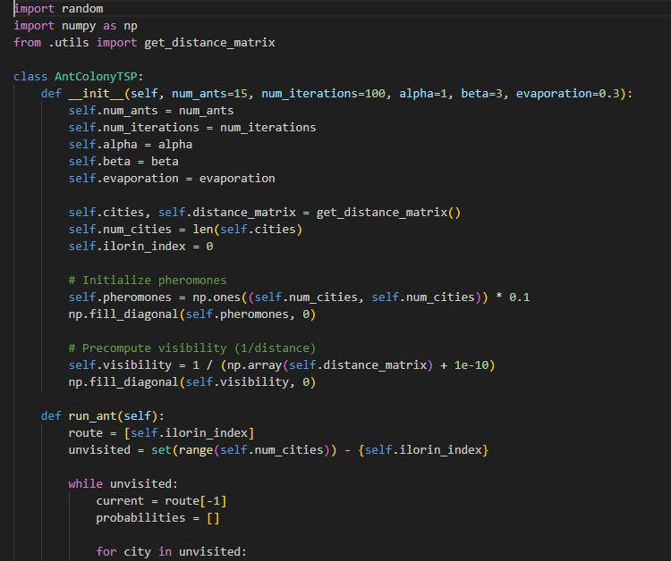

Fig 4.4 (2): ACO Code; where initialization pheromones update takes place.
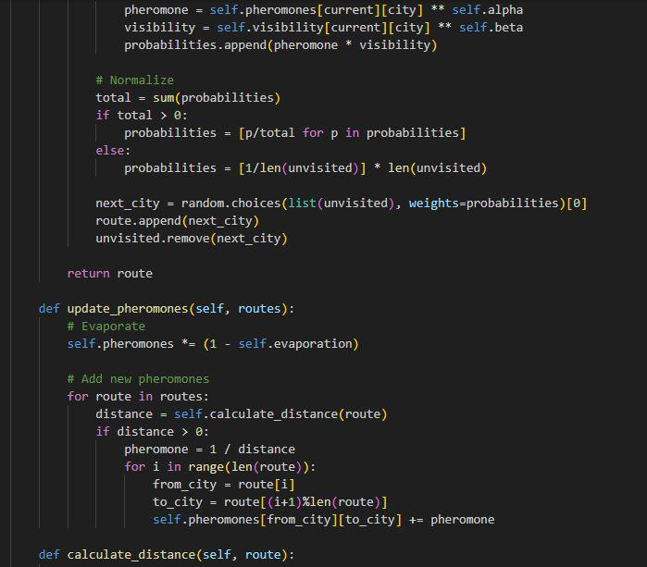
Fig 4.4 (3): ACO Code; where the final optimization takes place to update the best optimum solution.
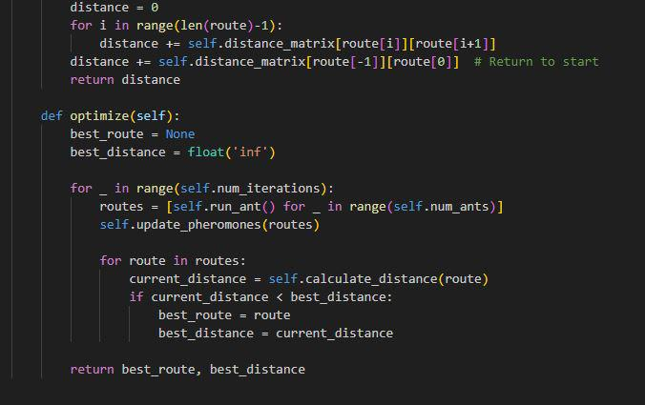
Fig 4.4 (4): ABCO Code; where initialization takes place.
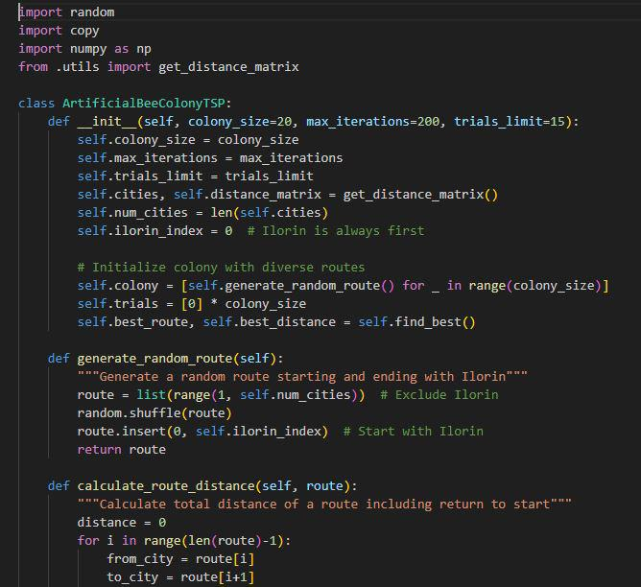

Fig 4.4 (5): ABCO Code; where optimization takes place.
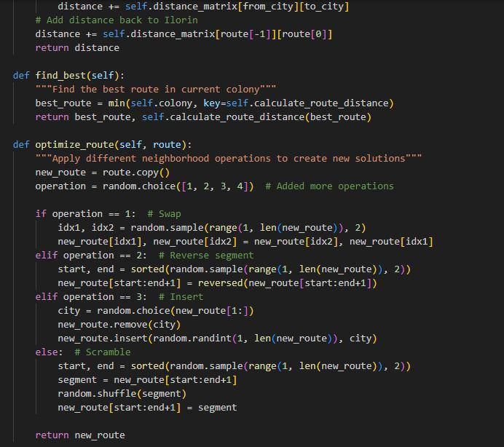

Fig 4.4 (6): ABCO Code; where the bee phase begin.
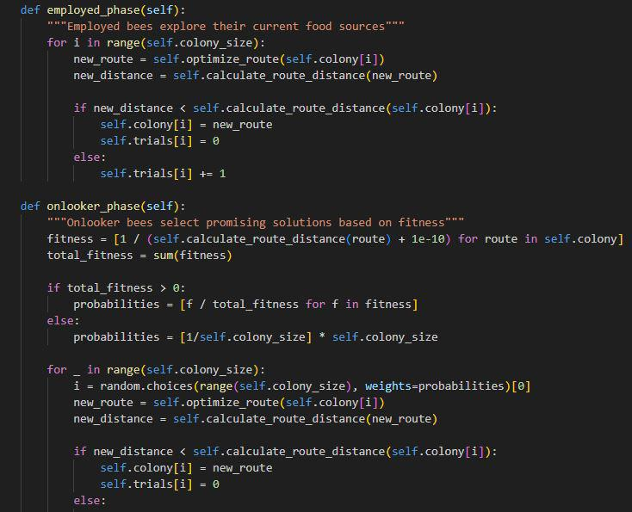

Fig 4.4 (7): ABCO Code; where the bee phases ends and final optimization takes place to update the best optimum solution.
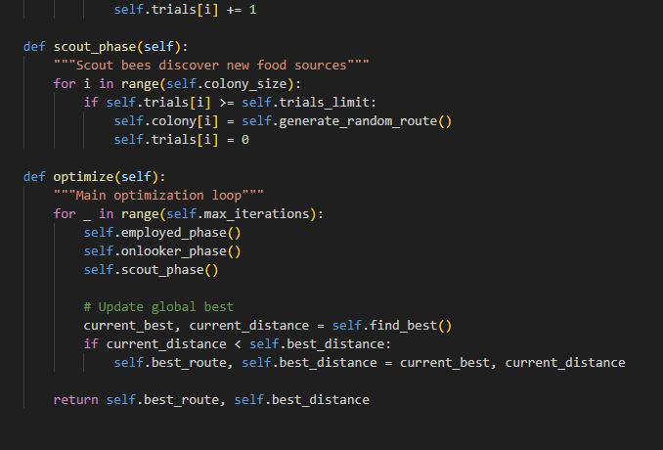
4.5 INTERFACE DESIGN
This section presents the user interface design developed for the system. Each interface is designed with user friendliness and usability ensuring a smooth user experience. The images below shows the key screen of the system, including navigation elements, display outputs and highlighting how users interact with the application.
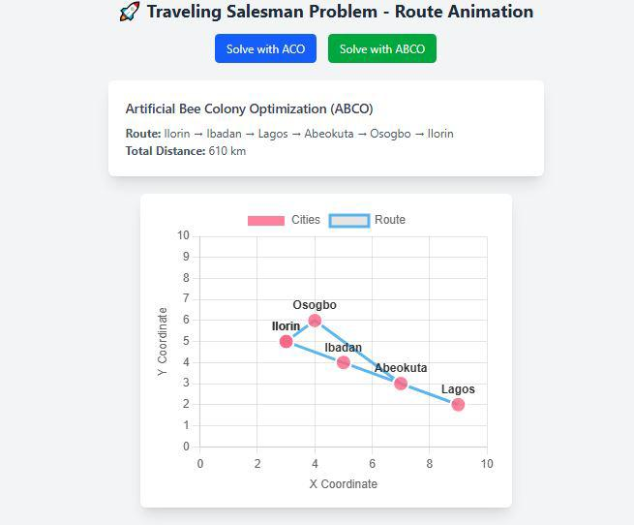
Fig 4.5.1: Route Animation
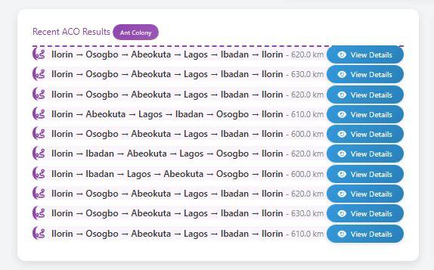
1
2
3
4
5
6
7
8
10
9
Fig 4.5.2: ACO Route iterations
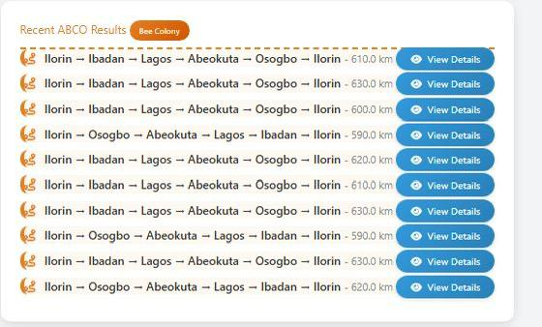
1
2
3
4
5
6
7
8
10
9
Fig 4.5.3: ABCO Route iterations

Fig 4.5.4: Result of a TSP Route Analysis based on distance, time and memory usage.
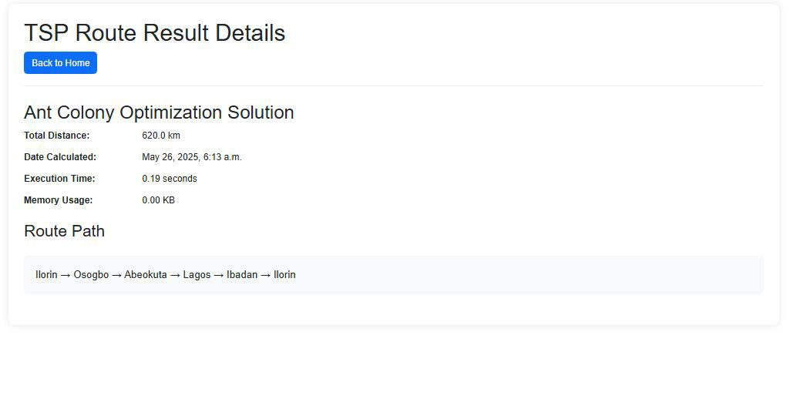
4.6 RESULTS AND DISCUSSION
It's experimented with the traveling salesmen problem data to determine how well the Ant Colony Optimization and Artificial Bee Colony Optimization solved the traveling salesmen problem. It is solved by utilizing the ACO & ABCO by taking into account both hard and Soft constraints, generate new solution, evaluate their fitness value and update the best solution. The result makes it easier to keep track of the algorithm’s progress which is as follows:

TABLE 3: RESULT SUMMARY FOR ANT COLONY OPTIMIZATION ALGORITHM
Iteration | Route path | Distance Taken (Tour length) | Time Taken  (Sec) | Memory Usage
1. | Ilorin(115km)_Osogbo(211km)_Abeokuta(19km)_Lagos(131km)_Ibadan(173km)_Ilorin | 620.0km | 0.19 | 0.00kb
2. | Ilorin(115km)_Osogbo(211km)_Abeokuta(19km)_Lagos(131km)_Ibadan(173km)_Ilorin | 630.0km | 0.19 | 0.00kb
3. | Ilorin(115km)_Osogbo(211km)_Abeokuta(19km)_Lagos(131km)_Ibadan(173km)_Ilorin | 620.0km | 0.20 | 0.00kb
4. | Ilorin(115km)_Osogbo(211km)_Abeokuta(19km)_Lagos(131km)_Ibadan(173km)_Ilorin | 620.0km | 0.21 | 0.00kb
5. | Ilorin(115km)_Osogbo(211km)_Abeokuta(19km)_Lagos(131km)_Ibadan(173km)_Ilorin | 600.0km | 0.19 | 0.00kb
6. | Ilorin(173km)_Ibadan(123km)_Abeokuta(19km)_Lagos(224km)_Osogbo(115km)_Ilorin | 620.0km | 0.22 | 12.00kb
7. | Ilorin(173km)_Ibadan(123km)_Abeokuta(19km)_Lagos(224km)_Osogbo(115km)_Ilorin | 600.0km | 0.18 | 0.00kb
8. | Ilorin(115km)_Osogbo(211km)_Abeokuta(19km)_Lagos(131km)_Ibadan(173km)_Ilorin | 610.0km | 0.16 | 4.00kb
9. | Ilorin(115km)_Osogbo(211km)_Abeokuta(19km)_Lagos(131km)_Ibadan(173km)_Ilorin | 630.0km | 0.17 | 16.00kb
10. | Ilorin(115km)_Osogbo(211km)_Abeokuta(19km)_Lagos(131km)_Ibadan(173km)_Ilorin | 610.0km | 0.17 | 152.00kb
Ant Colony Optimization results discussion: The first ACO output starts with iteration 1 and continues to iteration 50, each iteration were run and the best 10 iteration was recorded which includes the route path distance, distance, time taken and memory usage. The best output tour as indicated in the table above is iteration 7 with the distance of 600.0 km, the execution time of 0.18 secs and memory usage of 0.00kb.

TABLE 4: RESULT SUMMARY FOR ARTIFICIAL BEE COLONY OPTIMIZATION ALGORITHM
Iteration | Route path | Distance Taken(tour length) | Time Taken(Sec) | Memory Usage
1. | Ilorin(173km)_Ibadan(131km)_Lagos(19km)_Abeokuta(211km)_Osogbo(115km)_Ilorin | 610.0km | 0.25 | 0.00kb
2. | Ilorin(173km)_Ibadan(131km)_Lagos(19km)_Abeokuta(211km)_Osogbo(115km)_Ilorin | 630.0km | 0.28 | 4.00kb
3. | Ilorin(173km)_Ibadan(131km)_Lagos(19km)_Abeokuta(211km)_Osogbo(115km)_Ilorin | 600.0km | 0.27 | 0.00kb
4. | Ilorin(115km)_Osogbo(211km)_Abeokuta(19km)_Lagos(131km)_Ibadan(173km)_Ilorin | 590.0km | 0.27 | 0.00kb
5. | Ilorin(173km)_Ibadan(131km)_Lagos(19km)_Abeokuta(211km)_Osogbo(115km)_Ilorin | 620.0km | 0.26 | 0.00kb
6. | Ilorin(173km)_Ibadan(131km)_Lagos(19km)_Abeokuta(211km)_Osogbo(115km)_Ilorin | 610.0km | 0.35 | 0.00km
7. | Ilorin(173km)_Ibadan(131km)_Lagos(19km)_Abeokuta(211km)_Osogbo(115km)_Ilorin | 630.0km | 0.25 | 0.00kb
8. | Ilorin(115km)_Osogbo(211km)_Abeokuta(19km)_Lagos(131km)_Ibadan(173km)_Ilorin | 590.0km | 0.25 | 0.00kb
9. | Ilorin(173km)_Ibadan(131km)_Lagos(19km)_Abeokuta(211km)_Osogbo(115km)_Ilorin | 630.0km | 0.21 | 12.00kb
10. | Ilorin(115km)_Osogbo(211km)_Abeokuta(19km)_Lagos(131km)_Ibadan(173km)_Ilorin | 620.0km | 0.22 | 28.00kb
Artificial Bee Colony Optimization results discussion: The first ABCO output starts with iteration 1 and continues to iteration 50, each iteration was run and the best 10 iteration was recorded which includes the route path, distance, time taken and memory usage. The best output tour as indicated in the table above is iteration 8 with the distance of 590.0 km, the execution time of 0.25 secs and memory usage of 0.00kb.
Analysis of Ant Colony Optimization result for 10 iteration of the best tours of the TSP, in the first iteration, the algorithm returns a result with a distance of 620.0km, total execution time of 0.19 secs and 0.00kb memory usage. The algorithm proceeds through the iterations to search for near optimal solution, aim to satisfy the soft constraint (minimization of tour length). The second iteration returns a result with a distance of 630.0km, total execution time of 0.19 secs and 0.00kb memory usage. The third iteration returns a result with a distance of 620.0km, total execution time of 0.20 secs and 0.00kb memory usage. The fourth iteration returns with a result with a distance of 620.0km, total execution time of 0.21 secs and 0.00kb memory usage. The fifth iteration returns with a result with a distance of 600.0km, total execution time of 0.19 secs and 0.00kb memory usage. The sixth iteration returns with a result with a distance of 620.0km, total execution time of 0.22 secs and 12.00kb memory usage. The seventh iteration returns with a result with a distance of 600.0km, total execution time of 0.18 secs and 0.00kb memory usage. The eighth iteration returns with a result with a distance of 620.0km, total execution time of 0.16 secs and 4.00kb memory usage. The ninth iteration returns with a result with a distance of 630.0km, total execution time of 0.17 secs and 16.00kb memory usage while the tenth iteration returns with a distance of 610.0km, total execution time of 0.17 secs and 152.00kb memory usage. In these 10 iterations, it shows that the 7th iteration is the best four with a distance of 600.0km, total execution time of 0.18 secs and 0.00kb memory usage.
Analysis of Artificial Bee Colony Optimization result for 10 iteration of the best tours of the TSP, in the first iteration, the algorithm returns a result with a distance of 610.0km, total execution time of 0.25 secs and 0.00kb memory usage. The algorithm proceeds through the iterations to search for near optimal solution, aim to satisfy the soft constraint (minimization of tour length). The second iteration returns a result with a distance of 630.0km, total execution time of 0.28 secs and 4.00kb memory usage. The third iteration returns a result with a distance of 600.0km, total execution time of 0.27 secs and 0.00kb memory usage. The fourth iteration returns with a result with a distance of 590.0km, total execution time of 0.27 secs and 0.00kb memory usage. The fifth iteration returns with a result with a distance of 620.0km, total execution time of 0.26 secs and 0.00kb memory usage. The sixth iteration returns with a result with a distance of 610.0km, total execution time of 0.35 secs and 0.00kb memory usage. The seventh iteration returns with a result with a distance of 630.0km, total execution time of 0.25 secs and 0.00kb memory usage. The eighth iteration returns with a result with a distance of 590.0km, total execution time of 0.25 secs and 0.00kb memory usage. The ninth iteration returns with a result with a distance of 630.0km, total execution time of 0.21 secs and 12.00kb memory usage while the tenth iteration returns with a distance of 620.0km, total execution time of 0.22 secs and 28.00kb memory usage. In these 10 iterations, it shows that the 8th iteration is the best four with a distance of 590.0km, total execution time of 0.25 secs and 0.00kb memory usage.

TABLE 5: BEST ITERATION SUMMARY
Algorithm | Best iteration | Distance (Tour length) | Time Taken (Sec) | Memory Usage(Kb)
Ant Colony Optimization | 7th | 600.0km | 0.18 | 0.00
Artificial Bee Colony Optimization | 8th | 590.0km | 0.25 | 0.00

PERFORMANCE COMPARISON
Soft Constraint Satisfaction (minimization of tour length): Artificial Bee Colony Optimization wins because it achieves a shorter distance of (590.0km) compared to Ant Colony optimization of (600.0km) which means it satisfies the soft constraints better.
Execution Time: ACO is slightly faster in its best iteration (0.18 secs) than ABCO (0.25 secs) although the difference is minimal (0.07 secs).
Memory Usage: There is no difference between the two algorithms as they both produced the same output of memory usage (0.00kb).

CHAPTER FIVE
SUMMARY, CONCLUSION AND RECOMMENDATIONS
5.1 SUMMARY
This project focused on solving the Traveling Salesman Problem (TSP) using two bio-inspired metaheuristic algorithms, Ant Colony Optimization (ACO) and Artificial Bee Colony Optimization (ABCO). TSP, a classical NP-hard problem, requires determining the shortest route that visits a set of cities exactly once and returns to the starting point. Due to its computational complexity, exact methods are often impractical for large instances, hence the need for heuristic-based approaches.
The project involved the adaptation and implementation of both ACO and ABCO algorithms to solve a TSP instance involving five major Nigerian cities (Ilorin, Abeokuta, Lagos, Ibadan, and Osogbo). The algorithms were developed using Python and integrated into a Django framework, with MySQL used for data storage. Both algorithms were evaluated based on their ability to satisfy hard constraints (e.g., visiting all cities, no sub tours) and soft constraints (e.g., minimizing distance, execution time, and computational efficiency).
Performance comparison showed that ABCO achieved a shorter tour length of 590 km, demonstrating superior solution quality, while ACO outperformed in convergence speed with a faster execution time of 0.18 seconds. Memory usage was minimal for both algorithms.
In conclusion, the study demonstrated the practicality of swarm intelligence algorithms in solving complex optimization problems like TSP. It provided insights into their comparative strengths, establishing a foundation for further research and application in logistics, route planning, and other domains requiring efficient pathfinding solutions.
5.2 CONCLUSION
The comparative evaluation of the Ant Colony Optimization and Artificial Bee Colony Optimization algorithm provides valuable insight into solving the Traveling Salesman problem. By considering the solution quality, convergence speed e.t.c. Users can identify the most suitable algorithm to solve the TSP with the appropriate data and objective.
The overall better algorithm is the Ant Colony optimization algorithm, its convergence speed (0.18 secs) means it satisfies the soft constraints better than the Artificial Bee Colony Optimization algorithm (0.25 secs) even though its solution quality is slightly higher than that of the ABCO. The algorithm's performance was evaluated based on the result obtained from the 10 iterations of each algorithm and the resources utilized.
5.3 RECOMMENDATIONS
Based on the findings from this research, the following recommendations are made:
- Adopt ABCO for real-world TSP applications such as route planning in logistics, especially in small to medium-scale transportation networks like the case study of Nigerian cities.
- Further research should explore hybrid models, combining the strengths of ACO and ABCO to address the weaknesses of each and potentially improve performance for more complex or large-scale TSP instances.
- Optimization models should be tailored to specific problem sizes. While ABCO works well for small datasets, ACO may still be suitable for very large datasets with proper parameter tuning.
- Further research should explore hybrid models, combining the strengths of ACO and ABCO to address the weaknesses of each and potentially improve performance for more complex or large-scale TSP instances.
- Practical applications in logistics, delivery services, and supply chain management should consider ABCO-based routing models to improve operational efficiency and cost-effectiveness.

REFERENCES

Akay, B., Aydogan, E., & Karacan, L. (2012). 2-opt based artificial bee colony algorithm for solving traveling salesman problem. AWER Procedia — Information Technology & Computer Science, 1, 666-672. https://doi.org/10.1016/j.procs.2012.05.104
Dahan, F., El Hindi, K., Mathkour, H., & AlSalman, H. (2019). Dynamic flying ant colony optimization (DFACO) for solving the traveling salesman problem. Sensors, 19(8), 1837. https://doi.org/10.3390/s19081837
Dhanasekar, S., Dash, S. K., & Uthaman, N. (2022). A branch and bound algorithm to solve travelling salesman problem (TSP) with uncertain parameters. Mathematics and Statistics, 10(2), 358–365. https://doi.org/10.13189/ms.2022.100210
Ella, J., & McMullen, P. R. (2004). Ant colony optimization techniques for the vehicle routing problem. Advanced Engineering Informatics, 18(1), 41–48. https://doi.org/10.1016/j.aei.2004.07.001
Jamaluddin, S. H., Mohd Naziri, N. A. H., Mahmud, N., & Muhammat Pazil, N. S. (2022). Solving the Traveling Salesman Problem by Using Artificial Bee Colony Algorithm. Journal of Computing Research and Innovation, 7(2), 121-131. https://doi.org/10.24191/jcrinn.v7i2.295

Karaboga, D., & Gorkemli, B. (2019). Solving Traveling Salesman Problem by Using Combinatorial Artificial Bee Colony Algorithms. International Journal on Artificial Intelligence Tools, 28(1), 1950004. https://doi.org/10.1142/S0218213019500040
Kiran, M. S., & Beskirli, M. (2024). A New Approach Based on Collective Intelligence to Solve Traveling Salesman Problems. Biomimetics, 9(2), 118.
Liu, H., Lee, A., Lee, W., & Guo, P. (2023). DAACO: Adaptive dynamic quantity of ant ACO algorithm to solve the traveling salesman problem. Complex & Intelligent Systems. https://doi.org/10.1007/s40747-022-00949-6
Rufai, K. I., Usman, O. L., Olusanya, O. O., & Adedeji, O. B. (2021). Solving travelling salesman problem using an improved ant colony optimization algorithm. University of Ibadan Journal of Science and Logics in ICT Research, 6(2), 158–170.
Skinderowicz, R. (2022). Improving ant colony optimization efficiency for solving large TSP instances. Applied Soft Computing, 114, 108653. https://doi.org/10.1016/j.asoc.2022.108653
Xing, Z., & Tu, S. (2020). A Graph Neural Network Assisted Monte Carlo Tree Search Approach to Traveling Salesman Problem. IEEE Access, 8, 108418–108428.
Yang, J., Shi, X., Liang, Y., & (2008). An ant colony optimization method for the generalized traveling salesman problem. Progress in Natural Science, 18(7), 1417–1422. https://doi.org/10.1016/j.pnsc.2008.03.028

