DESIGN AND IMPLEMENTATION OF DRUG VERIFICATION AND MANAGEMENT SYSTEM USING DEEP LEARNING ALGORITHM.
(A CASE STUDY HEALTH-WAY PHARMARCEUTICAL, ILORIN)

BY

ADEBISI FATHIA OLAYEMI
HND/23/COM/FT/0198

A PROJECT SUBMITTED TO:
DEPARTMENT OF COMPUTER SCIENCE, INSTITUTE OF INFORMATION AND COMMUNICATION TECHNOLOGY (IICT), KWARA STATE POLYTECHNIC, ILORIN.

IN PARTIAL FULFILLMENT OF THE REQUIREMENTS FOR THE AWARD OF NATIONAL DIPLOMA (HND) IN COMPUTER SCIENCE.

JUNE, 2025

CERTIFICATION
This is to certify that this project was carried out by HND23/COM/FT/0198 with Matriculation Number: HND23/COM/FT/0198 and it has been read and approved as meeting the requirements for the award of Higher National Diploma in Department of Computer Science, Institute of Information and Communication Technology (IICT), Kwara State Polytechnic.

__________________________ __________________
MR. ABIODUN, E.T. Date
Project Supervisor

__________________________ ___________________
MR. OYEDEPO F.S Date
Head of Department

__________________________ ___________________
External Examiner Date

DEDICATION
This project work is sincerely dedicated to Almighty God for his mercy upon my live, divine protection, for his wisdom, knowledge and understanding given to me to put this project work together and throughout the course our study in this great polytechnics. May his name be praise forever and ever (amen).Also to my lovely, caring and darling parents for their moral and financial support. God bless you.

ACKNOWLEDGEMENT
All praise and thanks to my inestimable Almighty God the most beneficial, merciful, nourished and the sustainer for his guidance over my lives throughout this research work and my programme in this great institution.
I also appreciate the effort of my amiable supervisor Mr Abiodun E.T for his supervision and corrections made during the project work. May almighty God bless you and your home (amen).
Special thanks to HOD of the department Mr Oyedepo F.S, MR. ISIAKA O.S, Mrs Olusi R.T, Dr Agboola O.M,Mrs Dada M.O, (Dr.Raji A.K) and other members of the staff of the Department of Computer science for their support always.
Finally, I express my profound gratitude to all lecturers in computer science department in Kwara State Polytechnics, Ilorin. God bless you all (amen). More grease to your elbow.

TABLE OF CONTENTS
TITLE PAGE i
CERTIFICATION PAGE ii
DEDICATION iii
ACKNOWLEDGMENT iv
TABLE OF CONTENTS v
LIST OF TABLES vii
LIST OF FIGURE viii
ABSTRACT xi
CHAPTER ONE: GENERAL INTRODUCTION
  - INTRODUCTION 1
  - STATEMENT OF THE PROBLEM 2
  - AIM AND OBJECTIVES 2
  - SIGNIFICANCE OF THE STUDY 3
  - SCOPE OF THE STUDY 3
  - ORGANIZATION OF THE REPORT 3
  - DEFINATION OF TERMS 4
CHAPTER TWO: LITERATURE REVIEW
2.1 REVIEW OF RELATED PAST WORK 6
2.2 REVIEW OF GENERAL TEXT 8
2.3 HISTORICAL BACKGROUND OF NAFDAC 15

CHAPTER THREE: METHODOLOGY AND ANALYSIS OF THE SYSTEM
3.1 RESEARCH METHODOLOGY 17
3.2 ANALYSIS OF THE EXISTING SYSTEM 17
3.3 PROBLEM OF THE EXISTING SYSTEM 18
3.4 DESCRIPITON OF THE PROPOSED SYSTEM 18
3.5 ADVANTAGE OF THE PROPOSED SYSTEM 19
CHAPTER FOUR: DESIGN, IMPLEMENTATION AND DOCUMENTATION TO THE SYSTEM
4.1 DESIGN OF THE SYSTEM 21
4.2 IMPLEMENTATION OF THE SYSTEM 25
4.3 DOCUMENTATION OF THE SYSTEM 27
CHAPTER FIVE: CONCLUSIONS AND RECOMMENDATIONS
5.1 SUMMARY 29
5.2 CONCLUSION 29
5.3 RECOMMENDATION 29
REFERENCES 31
APPENDIX 1: PROGRAM FLOW CHART 32
APPENDIX 2: ADMIN 33
APPENDIX 3: LOGIN 34
APPENDIX 4: TRACK 35
APPENDIX 5: REGISTER 36
APPENDIX 6: PROGRAM SOURCE CODE 37
LIST OF TABLES
Table 4.1: Database 24
Table 4.2: Add drug 24

LIST OF FIGURES
Figure 4.1 Search box 21
Figure 4.2: Admin page 22
Figure 4.3: Add drug 22
Figure 4.4: admin login 23
Figure 4.5: Drug manufacturer 23

ABSTRACT
The agencies responsible for regulating and approving these pharmaceutical drugs are doing their best to provide the general population with at least a yearly update of all registered drugs approved for various distributions at local drug stores, hospital pharmacies, private pharmacies and licensed chemical sellers. However, due to challenging factors such as cost of production, middlemen distribution, research and legal issues, accessibility and reliable source of sale, there have been more issues arising from the illegal and unregistered pharmaceutical drugs. There is also no guarantee of an individual seeking medical help through the use of prescription drugs. Records gained after each annual registration will be made available and it will provide the various stakeholders with information regarding pharmaceutical drugs allowed for regulation on the local drug markets and the also the manufacturers responsible for each drug distribution.
Statement of the problem. The major and core issue that gave rise to this project work, is on the fact that most of the pharmaceutical drug users seek to use original product but because fake of counterfeit drugs now, do not let one differentiate from the original anymore, and the process of verifying a product currently is not encouraging because it will take much time and before then, the ill person is supposed to take his medication, which is to say that the verification process is slow and not reliable as sometimes you don’t get thee feedback at all. This issue is what the research work seek to resolve by developing a secure and reliable system that can function better than the previous one. The objective are Structure Mapping Technique (SME) technique will be used in the software development, an Application enabling the citizens to check the authenticity of the drugs online, tracking and tracing of the drug where manufactured to ensure the reliable supply of drugs to consumers for patient safety and brand protection of manufacturer as well as nation and the information like Name of Drug, Name of Manufacturer, Batch number, Date of manufacturing, Date of expiry, Usage of drug (optional) and Composition of drug (optional), to be provided on the web platform to the consumer. This is develop using web developing tools like html, php, css and mysql

CHAPTER ONE

GENERAL INTRODUCTION
1.1 Introduction to the Study
In Nigeria today, there is an influx into the market of fake machine parts, fake motor spare part, take chemicals, fake adulterated food items, amongst others. It may appear that almost every existing product has a fake counterpart. The era 1985-2000 in Nigeria has heralded the regime of faking and quackery, counterfeit drugs, quack doctors, illegal chemist shops and hospitals. Drugs are no exception (Ohuabunwa, 2010). The menace of fake drug became prevalent in the last decade and the present situation is alarming in the West African Sub-region, including Nigeria. Empirical observations have shown that there may be more fake than genuine drug in circulation (Osibo, 2014).
A disturbing aspect of the counterfeit drug menace is that the effects of consuming such drugs go unnoticed most of the times except in such cases where it results in mass deaths. There are generally no reliable data on the mortality or morbidity arming from the consumption of counterfeit drugs in Nigeria. In 1947, 14 children were reported dead after being administered Chloroquine phosphate injections and in 1990, 1909 children died after being administered fake Paracetamol (Aluko, 2012). Usually such incidence stimulates governments into taking positive steps, principally arising from public outcry.
A disturbing aspect of the counterfeit drug menace is that the effects of consuming such drugs go unnoticed most of the times except in such cases where it results in mass deaths. There are generally no reliable data on the mortality or morbidity arming from the consumption of counterfeit drugs in Nigeria. In 1947, 14 children were reported dead after being administered Chloroquine phosphate injections and in 1990, 1909 children died after being administered fake Paracetamol (Aluko, 1994). Usually such incidence stimulates governments into taking positive steps, principally arising from public outcry.
The trend in the last decade prompted the public and particularly the professional body’s notably pharmaceutical society of Nigeria, to pressure the government to take definite steps towards controlling the preponderance of fake drugs in Nigeria, the government responded by promulgating the counterfeit and fake drugs (miscellaneous provisions) decree No.21 of 1988. This decree prohibited the sale and distribution of counterfeit, adulterated, banned and fake drugs or poisons in open markets and without License of registration. It also created penalties for the breach of the responsibility of seizing any drug or poison illegally displayed unlicensed or unregistered premises. Shortcomings in the degree led to its being repealed by decree No.21 in 1989 and subsequent amendments.
1.2 Statement of the Problem
Presently, Companies product registration is done manually, which leads to the delay of getting a genuine registration number for a product. Another problem, is that, National Agency for Food and Drug administration and control (NAFDAC) does not have an online directory where individuals can view and cognize the different registered products and enable companies of this products edit relevant data like, for instance, in case of a new change in company's information such as location, product information, product images and company contacts. Similarly, the two problems summarily are individual unawareness of this genuine products and a slow process of registration which may lead to the increase of counterfeit products and activities when people try to fake NAFDAC regulated products.
1.3 Aim and Objectives
The aim of this project is to develop an application for National Agency for Food and Drug administration and control (NAFDAC) that as online drug registration and verification. Objectives include:
i. To develop a dynamic web application to the registration admin, integrating an online portal, using php programming language. Php is chosen as the programming language because it user friendliness and easy to use in implementing the technical aspect and to enable individual view the genuine registered products.
ii. Provide a resolution to the obsolete client registration initiation process by developing a part in the system that automates the process using a secure means through face recognition.
iii. To create a record that can handle all food production company
1.4 Significance of the Study
This project work is useful to national agency for food and drug administration and control, this system can be used by cooperate organization which needs their product to be registered.This project will cover the regulatory and control of drug, importation, exportation, manufacture, distribution and use of drugs
1.5 Scope of the Study
This project work is designed to take care of drug registration and distribution system for pharmaceutical products. It keeps adequate records of appraised drugs or products and their registration numbers respectively. The design accepts information about such product stores them and generates adequate result when needed.
1.6 Organization of the Report
This report is organized as stated below. Chapter one discusses the general introduction and overview of the whole project. It also discusses the statement of the problem, aim and objectives of the proposed system, significance of the study, scope and limitations of the project, organization of the report and the definition of technical terms used.
Chapter two deals with the literature review, it reviews related topic to the project, discussion of related aspect of the project topic relative to computer technology.
Chapter three deals with analysis of the system which include the data collection method employed, the description of the existing system and its problems and the description of the proposed system and possible advantages it will provide the will solve problems encountered in the existing manual system.
Chapter four deals with the design, implementation and the description of the proposed system. It covers description of the output design, input design, database design and procedure design. The implementation techniques used, the programming language used in developing the new system and system requirements for running the system. And also talks about the program documentation as well user documentation.
Lastly chapter five presents a brief summary of the work done, experience gained and problems encountered in the course of the project, conclusion and recommendation. Other appendices included after the references used are; algorithm, system flowchart, program flowchart, program source listing and generated computer output.
1.7 Definition of Terms
- Drug: A drug is any substance other than food, that when inhaled, injected, smoked, consumed, absorbed via a patch on the skin or dissolved under the tongue causes a physiological change in the body.
- Pharmacy Drug: a pharmaceutical drug or medicine is a chemical substance used to treat, cure, prevent, diagnose a disease or promote well-being. Traditionally drugs were obtained through extraction from medicinal plants, but more recently also by organic synthesis.Pharmaceutical drugs may be used for a limited duration, or on a regular basis for chronic disorders.
- Product: Products are the species formed from chemical reactions. During a chemical reaction reagents are transformed into products after passing through a high energy transition state. This process results in the consumption of the reagents. It can be a spontaneous reaction or mediated by catalysts which lower the energy of the transition state, and by solvents which provide the chemical environment necessary for the reaction to take place
- Fingerprint: fingerprint in its narrow sense is an impression left by the friction ridges of a human finger. The recovery of fingerprints from a crime scene is an important method of forensic science. Fingerprints are easily deposited on suitable surfaces (such as glass or metal or polished stone) by the natural secretions of sweat from the accrue that are present in epidermal ridges
- Directory: directory is a file system cataloging structure which contains references to other computer files, and possibly other directories
- Regulatory Agency: is a public authority or government agency responsible for exercising autonomous authority over some area of human activity in a regulatory or supervisory capacity
- Medical Device: is any instrument, apparatus, appliance, software, material or other article, whether used alone or in combination, including the software intended by its manufacturer to be used specifically for diagnostic and/or therapeutic purposes and necessary for its proper application, intended by the manufacturer to be used for human beings for the purpose of Diagnosis, prevention, monitoring, treatment or alleviation of disease.
- Diethylene Glycol (DEG): is an organic compound with the formula (HOCH₂CH₂)₂O. It is a colorless, practically odorless, poisonous, and hygroscopic liquid with a sweetish taste.

CHAPTER TWO

LITERATURE REVIEW
2.1 Review of Related Past Works
2.1.1 Richard, A. (2012), Description for drug identification
Introduction: He says Information Technology (IT) has set a new world order turning the world into a global village, where information plays an indispensable role. National Agency for Food and Drug administration and control (NAFDAC) is an agency whose responsibility is to detect and arrest drug addicts and traffickers for necessary prosecution according to the law. If we should go by this maxim, it buttresses the need at which classified information is to this outfit.
Methods: This is developed using Triple DES.Is a symmetric-key block cipher, which applies the Data Encryption Standard (DES) cipher algorithm three times to each data block.
Result & findings: He has developed this software to make the registration of NAFDAC easy enough. he Provisions are formulated for the purposes of ensuring the safety, efficacy and quality of drugs and regulating drug registration in accordance with the Drug Administration Law of the People's Republic of Nigeria.
He said products are created by brand owners and handed to third parties (contract manufacturer, shipping company, distribution) for delivery to merchants for later sale to consumers. These products can range from commodity items (e.g., flour) to limited quantity “luxury” items (e.g., designer handbags) to one-of-a-kind items (e.g., original artwork). Counterfeit products are often created and sold as the “real thing.” Counterfeits leverage the original brand but generally have less overhead due to some combination of lower quality, reduced marketing expenses, reduced support costs and/or reduced corporate expenses (ranging from lower labor costs to failure to pay tariffs).
Discussion: Over the years, this outfit had made tremendous impact in combating drug related crimes, but in recent times, there has been an avalanche of drug trafficking and usage in the country leading to insecurity of life and properties close investigation concerning crime activities reveals that most offenders were under the influence of drugs hence the importance of this Agency and the upgrading of their obsolete equipment to meet with the international standard.
2.1.2 Lovett, Y. (2014):
Introduction: Also contribute to the research. Despite the glint strides taken by this outfit over the years changing their investigation and recording equipment to tape storage using cassette as recorder, there are still a lot of surmountable problems which has hitherto, reduced the efficiency of the outfit throughout Nigeria.
Methods: This is developed using RSA algorithm. RSA is a public-key encryption algorithm and the standard for encrypting data sent over the internet.
Result & findings: This implementation is done to help them register for each rug production and verification.
With the majority of the world‟s population seeking required medications for various illnesses and medical conditions day-in-day-out, there is a need for appropriate pharmaceutical drugs. The agencies responsible for regulating and approving these pharmaceutical drugs are doing their best to provide the general population with at least a yearly update of all registered drugs approved for various distributions at local drug stores, hospital pharmacies, private pharmacies and licensed chemical sellers. However, due to challenging factors such as cost of production, middlemen distribution, research and legal issues, accessibility and reliable source of sale, there have been more issues arising from the illegal and unregistered pharmaceutical drugs. There is also no guarantee of an individual seeking medical help through the use of prescription drugs. Records gained after each annual registration will be made available and it will provide the various stakeholders with information regarding pharmaceutical drugs allowed for regulation on the local drug markets and the also the manufacturers responsible for each drug distribution.
Discussion: The panacea to this may no doubt; lie in the introduction of a properly designed case filling system which will bring the much-desired automation hence, a prerequisite for being a member of the new world order vis-à-vis information technology.
2.2 Review of General Text
2.2.1 Pre-Processing
Pre-processing helped enhancing the quality of an image by filtering and removing unnecessary noises. As a result, the ridges were highlighted with black color while the furrows were highlighted with white color. This process partly removed some noises in an image and helped enhance the edge detection. Furthermore, there are two more steps to improve the best quality for the input image: minutiae extraction and false minutiae removal. The minutiae extraction was carried out by applying ridge thinning algorithm which was to remove redundant pixels of ridges. As a result, the thinned ridges of the fingerprint image are marked with a unique ID so that further operation can be conducted. After the minutiae extraction step, the false minutiae removal was also necessary. The lack of the amount of ink and the cross link among the ridges could cause false minutiae that led to inaccuracy in fingerprint recognition process.
2.2.2 Pattern-Based (or Image-Based) Algorithms
Pattern based algorithms compare the basic fingerprint patterns (arch, whorl, and loop) between a previously stored template and a candidate fingerprint. This requires that the images can be aligned in the same orientation. To do this, the algorithm finds a central point in the fingerprint image and centers on that. In a pattern-based algorithm, the template contains the type, size, and orientation of patterns within the aligned fingerprint image. The candidate fingerprint image is graphically compared with the template to determine the degree to which they match.
2.2.3 Concept of Drug
Is any substance other than food, that when inhaled, injected, smoked, consumed, absorbed via a patch on the skin or dissolved under the tongue causes a physiological change in the body.
In pharmacology, a pharmaceutical drug, also called a medication or medicine, is a chemical substance used to treat, cure, prevent, ordiagnose a disease or to promote well-being. Traditionally drugs were obtained through extraction from medicinal plants, but more recently also by organic synthesis. Pharmaceutical drugs may be used for a limited duration, or on a regular basis for chronic disorders.
Pharmaceutical drugs are often classified into drug classes groups of related drugs that have similar chemical structures, the same mechanism of action (binding to the same biological target), a related mode of action, and that are used to treat the same disease. The Anatomical Therapeutic Chemical Classification System (ATC), the most widely used drug classification system, assigns drugs a unique ATC code, which is an alphanumeric code that assigns it to specific drug classes within the ATC system. Another major classification system is the Biopharmaceutics Classification System. This classifies drugs according to their solubility and permeability or absorption properties.
Psychoactive drugs are chemical substances that affect the function of the central nervous system, altering perception, mood or consciousness. They include alcohol, a depressant, and the stimulants nicotine and caffeine. These three are the most widely consumed psychoactive drugs worldwide and are also considered as recreational drugs since they are used for pleasure rather than medicinal purposes.
Other recreational drugs include hallucinogens, opiates and amphetamines and some of these are also used in spiritual or religious settings. Some drugs can cause addiction and all drugs can have side effects. Excessive use of stimulants can promote stimulant psychosis. Many recreational drugs are illicit and international treaties such as the Single Convention on Narcotic Drugsexist for the purpose of their prohibition.
2.2.4 Effect of Fake Drugs
Legitimate pharmaceutical drugs may have side effects but if your doctor is fully aware of your medical history and current health status, the chances of experiencing side effects are reduced. With counterfeit medicines, these side effects are more likely to occur since the exact composition of these drugs are unknown. Allergic reactions and gastrointestinal disturbances like nausea, vomiting and diarrhea, are among the common side effects. Heavy metals and toxic compounds may cause symptoms of poisoning including changes in heart function, blood glucose levels, gas perfusion (transport of oxygen and carbon dioxide in the blood), dyspnea and even organ failure.
The regular use of substandard or counterfeit medicines can lead to therapeutic failure or drug resistance. In some cases, it can lead to death. Some of these characteristics and untoward effects are described briefly below:
- Toxic Effects: Some fake drugs contain ingredients that, if ingested or injected, can cause health problems. For example, the recently counterfeited Procrit, an important drug for cancer and AIDS patients, contained nonsterile tap water, which can cause an infection in the bloodstream.
- Unintended Effects: Some counterfeits substitute one drug for another. For example, insulin has been substituted for a more expensive injectable drug. And there was a report that counterfeiters emptied bottles of Zyprexa, a drug used for schizophrenia and acute bipolar mania, and replaced them with white tablets imprinted with the word “aspirin.”
- Ineffective Treatments: Some fake drugs contain some active ingredient, but are sub potent. Others attempt to accurately copy the real drug, but still pose safety risks because they are not formulated in a way that achieves the right therapeutic levels in the patient’s blood.
- No active ingredients: some counterfeit drugs have any active ingredients. For example, a counterfeit version of Serostim, a growth hormone used in AIDS patients, was found to have no active ingredients hence leads to therapeutic failure and further deterioration of health.
- Labels that look real: Over the past several years, counterfeiters have gained access to sophisticated technologies that enable them to very closely duplicate the packaging and labeling of legitimate prescription drugs. In fact, labeling for a product can be so exactly duplicated that it may require extremely close inspection by experts in order to identify subtle differences from the legitimate product.
2.2.5 Face Detection System
Face detection can be regarded as a specific case of object-class detection. In object-class detection, the task is to find the locations and sizes of all objects in an image that belong to a given class. Examples include upper torsos, pedestrians, and cars. Face-detection algorithms focus on the detection of frontal human faces. It is analogous to image detection in which the image of a person is matched bit by bit. Image matches with the image stores in database. Any facial feature changes in the database will invalidate the matching process. A reliable face-detection approach based on the genetic algorithm and the eigen-face technique. Firstly, the possible human eye regions are detected by testing all the valley regions in the gray-level image. Then the genetic algorithm is used to generate all the possible face regions which include the eyebrows, the iris, the nostril and the mouth corners. Each possible face candidates is normalized to reduce lightning effect caused due to uneven illumination and the shirring effect due to head movement. The fitness value of each candidate is measured based on its projection on the eigen-faces. After a number of iterations, all the face candidates with a high fitness value are selected for further verification. At this stage, the face symmetry is measured and the existence of the different facial features is verified for each face candidate.
2.2.6 Face Detection Technique

i. Traditional
Some face recognition algorithms identify facial features by extracting landmarks, or features, from an image of the subject's face. For example, an algorithm may analyze the relative position, size, and/or shape of the eyes, nose, cheekbones, and jaw. These features are then used to search for other images with matching features. Other algorithms normalize a gallery of face images and then compress the face data, only saving the data in the image that is useful for face recognition. A probe image is then compared with the face data. One of the earliest successful systems is based on template matching techniques applied to a set of salient facial features, providing a sort of compressed face representation.
Recognition algorithms can be divided into two main approaches, geometric, which looks at distinguishing features, or photometric, which is a statistical approach that distills an image into values and compares the values with templates to eliminate variances. Popular recognition algorithms include principal component analysis using eigenfaces, linear discriminant analysis, elastic bunch graph matching using the Fisherface algorithm, the hidden Markov model, the multilinear subspace learning using tensor representation, and the neuronal motivated dynamic link matching.

ii. 3-dimensional recognition
A newly emerging trend, claimed to achieve improved accuracy, is three-dimensional face recognition. This technique uses 3D sensors to capture information about the shape of a face. This information is then used to identify distinctive features on the surface of a face, such as the contour of the eye sockets, nose, and chin. One advantage of 3D face recognition is that it is not affected by changes in lighting like other techniques. It can also identify a face from a range of viewing angles, including a profile view. Three-dimensional data points from a face vastly improve the precision of face recognition. 3D research is enhanced by the development of sophisticated sensors that do a better job of capturing 3D face imagery. The sensors work by projecting structured light onto the face. Up to a dozen or more of these image sensors can be placed on the same CMOS chip each sensor captures a different part of the spectrum. Even a perfect 3D matching technique could be sensitive to expressions. For that goal a group at the Technion applied tools from metric geometry to treat expressions as isometries A company called Vision Access created a firm solution for 3D face recognition. The company was later acquired by the biometric access company Bioscrypt Inc. which developed a version known as
iii. 3D FastPass.
A new method is to introduce a way to capture a 3D picture by using three tracking cameras that point at different angles; one camera will be pointing at the front of the subject, second one to the side, and third one at an angle. All these cameras will work together so it can track a subject’s face in real time and be able to face detect and recognize.

iv. Skin texture analysis
Another emerging trend uses the visual details of the skin, as captured in standard digital or scanned images. This technique, called skin texture analysis, turns the unique lines, patterns, and spots apparent in a person’s skin into a mathematical space. Tests have shown that with the addition of skin texture analysis, performance in recognizing faces can increase 20 to 25 percent.

2.2.7 3D Dimension Face Recognition
Three-dimensional face recognition (3D face recognition) is a modality of facial recognition methods in which the three-dimensional geometry of the human face is used. It has been shown that 3D face recognition methods can achieve significantly higher accuracy than their 2D counterparts, rivaling fingerprint recognition. 3D face recognition has the potential to achieve better accuracy than its 2D counterpart by measuring geometry of rigid features on the face. This avoids such pitfalls of 2D face recognition algorithms as change in lighting, different facial expressions, make-up and head orientation. Another approach is to use the 3D model to improve accuracy of traditional image based recognition by transforming the head into a known view. Additionally, most 3D scanners acquire both a 3D mesh and the corresponding texture. This allows combining the output of pure 3D matchers with the more traditional 2D face recognition algorithms, thus yielding better performance (as shown in FRVT 2006).
The main technological limitation of 3D face recognition methods is the acquisition of 3D image, which usually requires a range camera. Alternatively, multiple images from different angles from a common camera (e.g. webcam^{[1]}) may be used to create the 3D model with significant post-processing. (See 3D data acquisition and object reconstruction.)^{[2]} This is also a reason why 3D face recognition methods have emerged significantly later (in the late 1980s) than 2D methods. Recently commercial solutions have implemented depth perception by projecting a grid onto the face and integrating video capture of it into a high resolution 3D model. This allows for good recognition accuracy with low cost off-the-shelf components. 3D face recognition is still an active research field, though several vendors offer commercial solutions.
2.2.8 Functions of National Agency for Food and Drug Administration and Control (NAFDAC)
National Agency for Food and Drug administration and control (NAFDAC) has various basic functions. According to the requirements of its enabling decree, the Agency was authorized to:
- Regulate and control the importation, exportation, manufacture, advertisement, distribution, sale and use of drugs, cosmetics, medical devices, bottled water and chemicals
- Conduct appropriate tests and ensure compliance with standard specifications designated and approved by the council for the effective control of quality of food, drugs, cosmetics, medical devices, bottled water, and chemicals.
- Undertake appropriate investigation into the production premises and raw materials for food, drugs, cosmetics, medical devices, bottled water and chemicals and establish a relevant quality assurance system, including certification of the production sites and of the regulated products
- Undertake inspection of imported foods, drugs, cosmetics, medical devices, bottled water, and chemicals and establish a relevant quality assurance system, including certification of the production sites and of the regulated products.
- Compile standard specifications, regulations, and guidelines for the production, importation, exportation, sale and distribution of food, drugs, cosmetics, medical devices, bottled water, and chemicals
- Undertake the registration of food, drugs, medical devices, bottled water and chemicals
- Control the exportation and issue quality certification of food, drugs, medical devices, bottled water and chemicals intended for export
- Establish and maintain relevant laboratories or other institutions in strategic areas of Nigeria as may be necessary for the performance of its functions.
NAFDAC envisions that by making these functions known, that its actions will be apparent “in all sectors that deal with food, cosmetics, medical devices, bottled water, and chemicals to the extent of instilling extra need for caution and compulsion to respect and obey existing regulations both for healthy, living and knowledge of certain sanctions or default. Despite the establishment of NAFDAC, the sale and use of fake drugs did not end.
2.3 Historical Background of NAFDAC
The organization was formed in 1993to checkmate illicit and counterfeit products in Nigeria in 1993 under the country's health and safety law. Adulterated and counterfeit drugs are a problem in Nigeria. In 1989, over 150 children died as a result of paracetamol syrup containing diethylene glycol. The problem of fake drugs was so severe that neighbouring countries such as Ghana and Sierra Leone officially banned the sale of drugs, foods and beverages products made in Nigeria. Such problems led to the establishment of NAFDAC, with the goal of eliminating counterfeit pharmaceuticals, foods and beverages products and ensuring that available medications are safe and effective. The formation of NAFDAC was inspired by a 1988 World Health Assembly resolution requesting countries' help in combating the global health threat posed by counterfeit pharmaceuticals.
In December 1992, NAFDAC's first governing council was formed. The council was chaired by Dr. TanimuSaulawa. In January 1993, supporting legislation was approved as legislative Decree No. 15 of 1993. On January 1, 1994 NAFDAC was officially established as a “parastatal of the Federal Ministry of Health”. NAFDAC replaced an earlier Federal Ministry of Health body, the Directorate of Food and Drug Administration and Control, which had been deemed ineffective, partially because of lack of laws concerning fake drugs.

CHAPTER THREE

METHODOLOGY AND ANALYSIS OF THE SYSTEM

3.1 Research Methodology
Research methodology has been described as all specific technique used to secure and analyze the raw or original observations.
Research methodology typically involves a full breakdown of all the options that have been chosen by a company in order to investigate something. This would include the procedures and techniques used to perform the research as well as any of the terminology and explanations of how these methods will be applied effectively. The research methodology used is the observation method. The hospital staffs were observed to collect the information or procedures involved in the inventory system of the organization.
3.2 Analysis of the Existing System
The current means of operation of National Agency for Food and Drug administration and control (NAFDAC) are;
First get the requisition form: Is the first thing to be done, these represent the register form for all organization that needs to get their product registered. This process monitors the units of Quality of product, units of Quantities with their descriptions. Payment issuing voucher: The payment section Issuing Voucher is the kind of receipt of issuance to the product owner but used to reference to the list of product requesting for verification. Application for marketing authorization: An application generally consists of a number of documents regarding quality, efficacy, and safety of the product gathered in a file, often called an application dossier. Dossiers have different contents depending on national requirements, the nature of the drug for which a marketing authorization is sought, and the capability of the applicant to assemble a complete set of information. Each application for marketing authorization is given a number, by the regulatory authority, called the application number.

  - Problem of the Existing System
- Time Consuming: The current procedure makes the registration process to be every slow due to stages involves in processing quality to be issued from the department handling verification of product.
- Inefficiency: Many error being make reduce efficiency of the material methods.
- Difficulty in enquiry: Making enquiry in the department is always based on the manual processing by consulting the department involver in each enquiry to be made.
- High Labour Requirement: Enough labours are requested due to stages involved in getting product to be registered, Organizing information for data entry, Decide on product classification, e.t.c
- Security Lapses: The record of companies and drug are not safe as the manual method is still in use

3.4 Description of the Proposed System
This entails undertaking preparatory work to meet prerequisites, organizing working procedures, establishing information formats, securing resources. To create a standard National Agency for Food and Drug administration and control (NAFDAC) online drug registration and verification solution. In a computerized system it is very easy to retrieve and review decisions previously made on a similar drug item. This ensures that technical decisions are made with a proper degree of consistency and transparency. The ease of retrieval and access to a great variety of up to date reports reduces the likelihood of inappropriate duplications, and permits a global view of the drugs already authorized. A computerized system can also track any application process, allowing the regulatory authority to determine the status of an application at any given time, and raise alarms when the process is delayed beyond user-defined limits.

3.5 Advantages of The Proposed System
A lot of advantage was enhanced with the computerized system as opposed to manual approach and some of the advantages are:
i. More time for professional work: Initially, the introduction of computer-assisted drug registration will put an additional burden on staff, especially when existing information needs to be examined and organized. However, once the system is operational, staff will face less routine and clerical work, and will have more time available for technical and professional work because many frequent tasks, such as searching for information on similar items and producing certificates, will be simplified or automated.
ii. Fewer imprecisions, oversights, and mistakes: In a manual system it is very common that substance names or quantities are stated incorrectly, or in a different way in different documents related to the same drug item. This causes confusion and gives the impression that regulatory work is done unprofessionally. A computerized system will greatly reduce these types of errors, because it is designed to help ensure consistency in data entry.
iii. Improved communication within the regulatory authority: Operational links between drug registration, quality control (QC) laboratory, and drug inspectorate officials need to be effective and timely. In a manual system, when information needs to be exchanged, officials may contact each other on the phone or by visiting the appropriate office. This may require several days when officials are out on field visits or work on different shifts. A computerized system permits recording information on inspection results and ensures its linkage to drug registration data, and the computer data is easily accessible at any time to users with the appropriate level of access.
iv. Increased efficiency: Most correspondence and certificates issued by regulatory authorities can easily be standardized. The adoption of a computerized system allows the authority to issue such documentation almost automatically in a predefined format. In addition, computerization greatly facilitates preparation of reports.
v. Improved quality of work: In a manual system, data recorded to identify a drug product and its status are generally stored in the application file itself and only selected data are transferred to a manual card system to permit retrieval. This, in the best situation, may include: marketing authorization number, company name, drug item name, and name of “main” active ingredient. Usually, no other criteria can be used to retrieve information. In this situation, the preparation of reports is a time consuming exercise that requires intensive editing to overcome inevitable copying and typing mistakes.

CHAPTER FOUR
Design, Implementation and Documentation to the System
4.1 Design of the System
System designs calls for the creativity of the analyst. Therefore, creating an acceptable design, the system analyst must exclude all prejudice.
The design of the system is the approach of work out how best computers together with other resources may be applied to perform data storage, management and retrieval for decision making.
4.1.1 Output Design

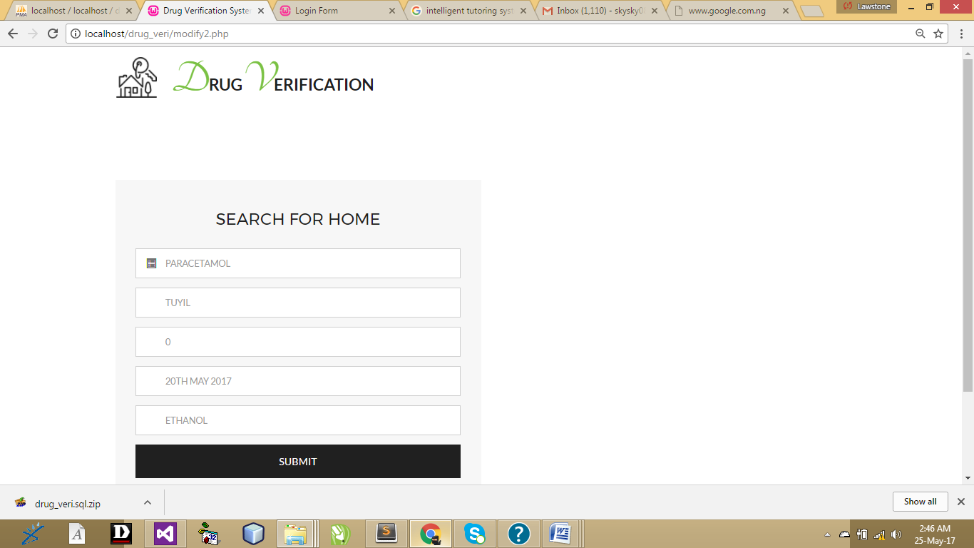
Figure 4.1 Search box: This page to update information about drugs

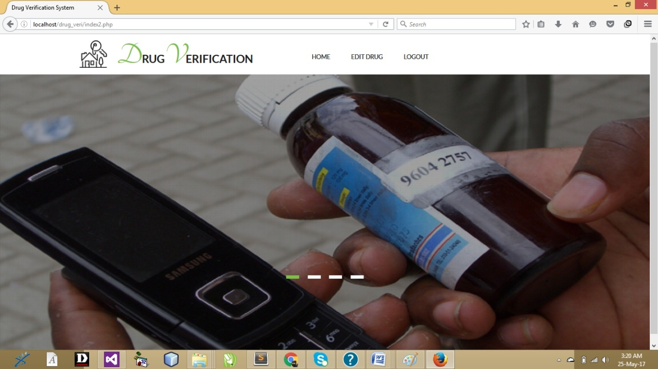
Figure 4.2: Admin page: This is the admin page

4.1.2 INPUT DESIGN
Input design are interface which requires user intervention like supply of information
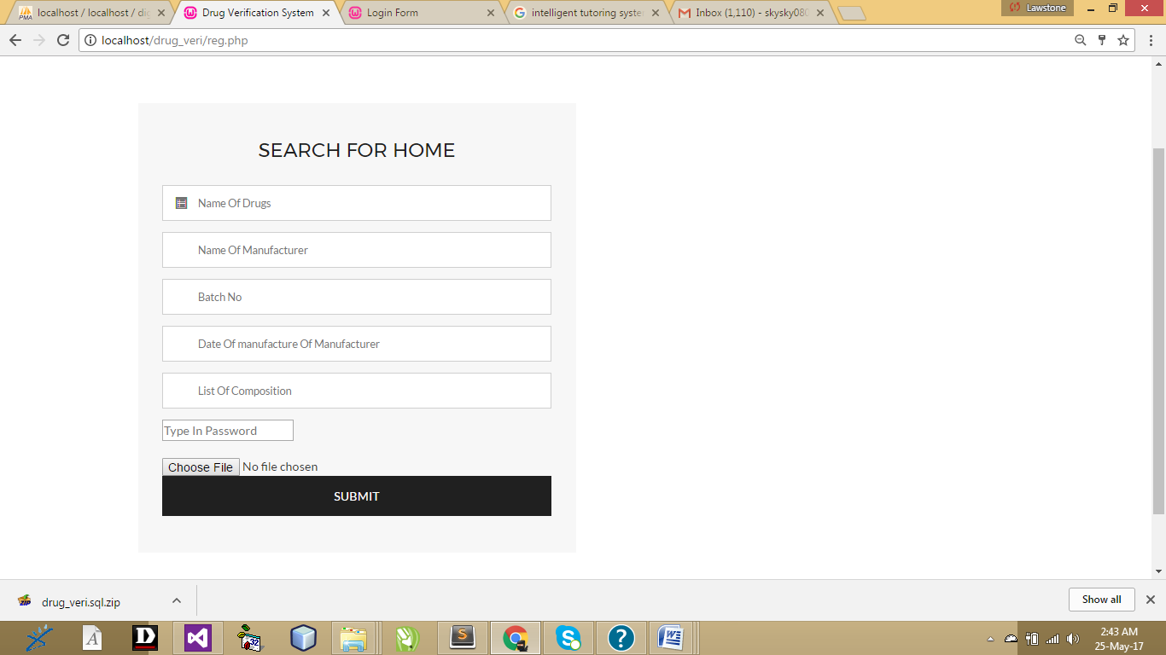
Figure 4.3: Add drug: This is the page where the user can dd drugs
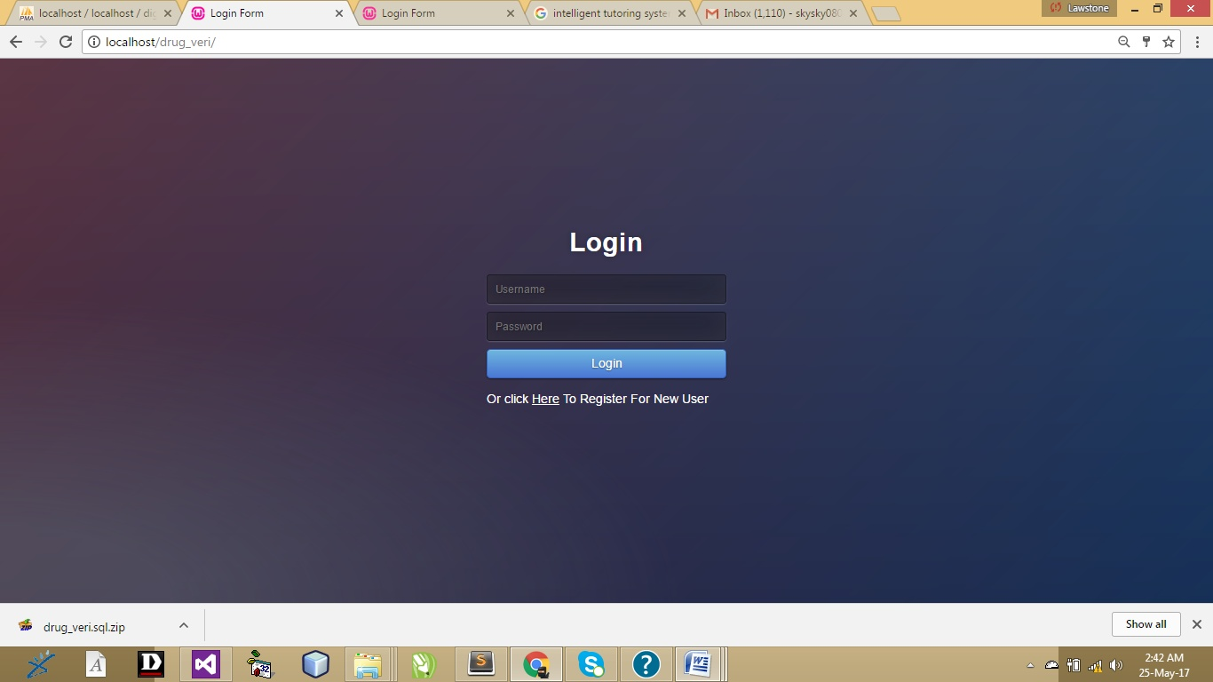
Figure 4.4: admin login:
This is the login page for this application

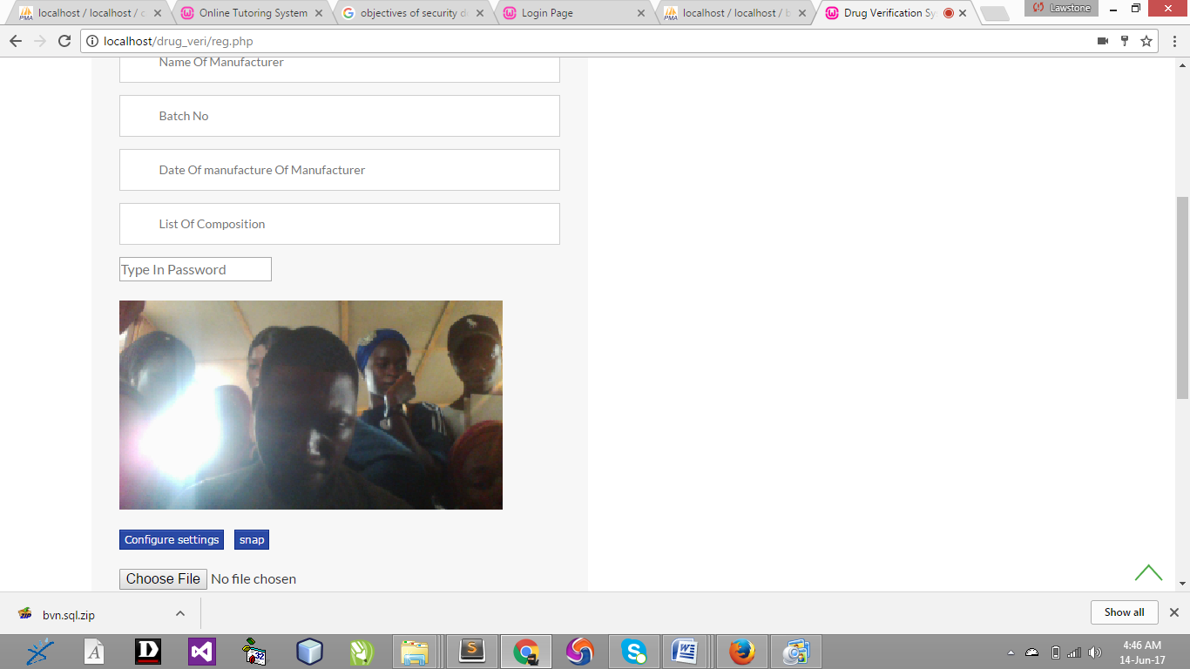
Figure 4.5: Drug manufacturer: This take the face scan of the drug manufacturer
4.1.3 FILE DESIGN

Table 4.1: Database
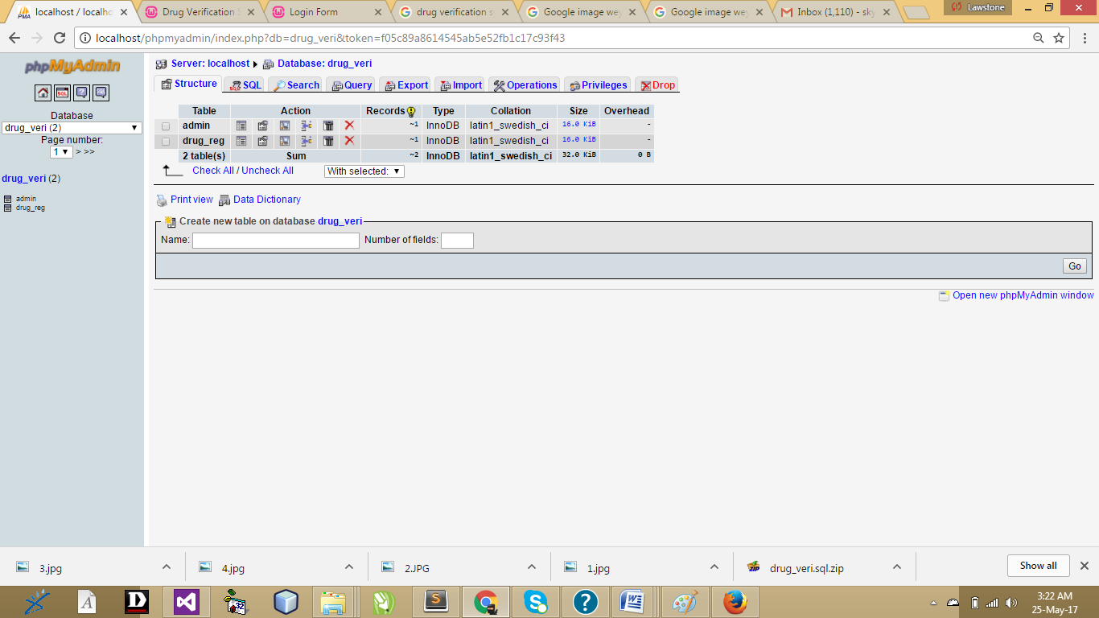

Table 4.2: Add drug
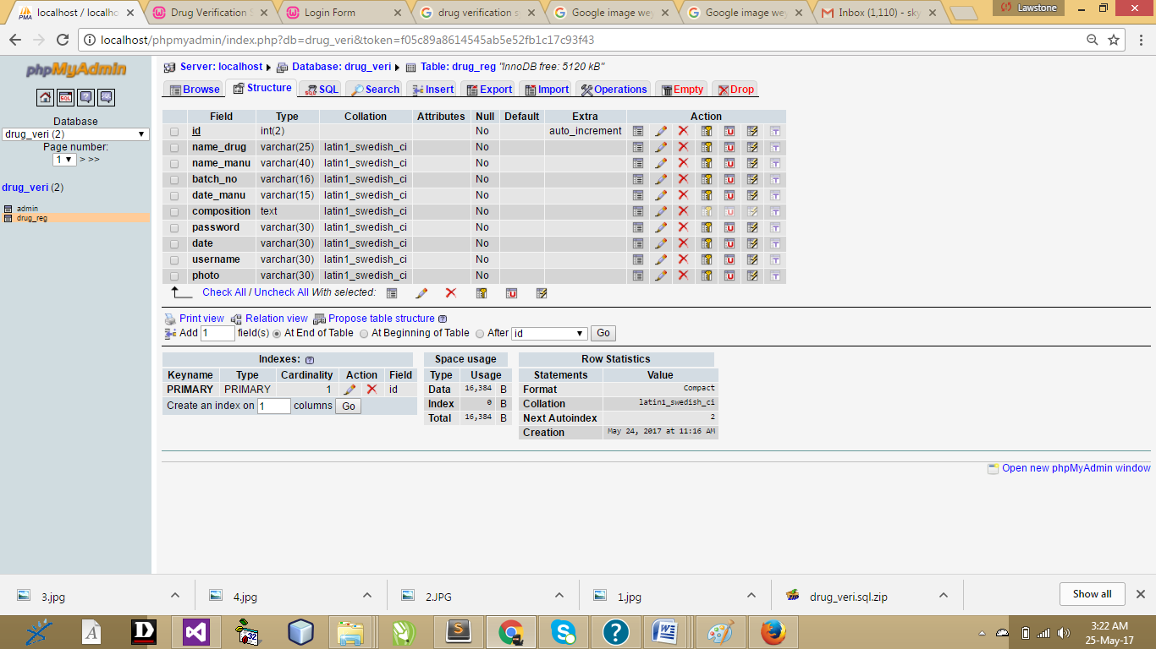
4.1.4 Procedure Design
This refers to the ways in which the proposed system will be used and the steps are as follows:
- Click start on the computer desktop
- Select all programs
- Select any browser e.gMorzillaFirefox , internet Explorer , Google Chrome e.t.c
- Type the URL (Uniform Resource Locator) of the system into the address bar (localhost/sch_payment /index.php)

4.2 Implementation of the System
The design system depends on the capabilities and power of the computer on which the application system is installed. However, selecting a choice of application support (Hardware and Software) depends much on:
- How readily the user is to interfere with the computer
- Cost and benefits
- Managements support for changes
Hence, choosing the appropriate hardware and software will enhance the performance of the system. A most important requirement on which the running of the program basically depends on is the provision of internet facility. So any system that must run this program must be internet ready.

4.2.1 Choice of Programming Language
The programming language used in the proposed system is php. PHP meaning (PHP Hypertext Preprocessor) is a server-side programming language. It is an open source server-side scripting language that has taken web-based development to a new level of sophistication. The PHP scripting engine is well optimized for the response times needed on web applications, it can even be part of the web server itself improving the throughput even more. If it were only a matter of improving the speed of the scripts, then PHP will be one of many solutions. But there is more to the PHP equation than that. There is the simplicity and robustness of the language and the scripting engine. There is the connectivity to an ever increasing number of database servers, the shorter development cycles and the ease (encouraged by the syntaxes and constructs) of creating modular and reusable components.

4.2.2 Hardware Support
The hardware requirements for the support of the online inventory application are as follows:
- An enhanced keyboard and mouse
- Minimum of PIII computer and internet enabled
- A processor speed of 500MHz
- RAM size is 18mb
- hard disk size is 100mb
- UPS
- VGA or SVGA colored monitor to be able to achieve the effective user friendliness of the program
- A printer for hard copy record production

4.2.3 Change over Techniques
The new system is run alongside the old system, but only processes some of the data. For example a supermarket might try out a new stock control system on one till in a store, with all sales at this till being recorded by both the old and new systems. Sales at this till may take longer, but the amount of effort required is less than that for a parallel changeover. The results produced by the two systems can be compared to see if the new system appears to work. As the new system is only being used with a small amount of data, problems that might result from processing a realistically large volume of data might not be noticed.

4.2.4 Student Documentation
The software required are basically any web browser (internet explorer, Firefox and the likes), Wamp Server and a network service, be it wired or wireless.
- A network operating system windows NT from Microsoft, Novell Netware.
- A DBM either Php My Admin
- MySQL as the query language to query the database.
- Wambserver

4.3.1 Documentation of the Program
It has to do with the installation and usage of the new system.
After the program has been well tested with input that the output has already been known, the next is to install the software in to the computer system for use.
The process of installing are been stated below
- Insert the CD into the system through the CD-ROM after the computer is switch on
- Locate the CD drive directory in my computer and click it to open
- After open, locate setup.exe, and then click to install the program by following the necessary step in installing the program.
- Ensure full installing of the software for effective operation of the system.
After the program has been fully install. The next thing is to locate the package install to put it into operation, to locate the package for expiration purpose the following step are to be taking
v. Click on start menu from task bar. Then select all program
From the display sub option, select by locating the software installed named temperament/ personality check to load the software.

4.3.2 Operating System
- REGISTER STUDENT
- LOGIN STUDEN
- ADMIN LOGIN
- CREATE PAYMENT ID
- MAKE PAYMENT
4.3.3 Maintaining The System
This refers to the changes that have to be, made to complete systems after having been delivered. This project takes care of two types of maintenance these are:
- Adaptive maintenance and
- Perfective maintenance
- Adaptive Maintenance: This refers to the type of maintenance which will be done to the system to make it adjust to any changes occurring to it. An example of adaptive maintenance is the yearly updating of the customers database to change account code in database.
- Corrective Maintenance: This is a type of maintenance which takes care of some parts of the system which have been omitted in the initial design. The need for this arises as the system is being put into use over a period of time.

CHAPTER FIVE
SUMMARY, RECOMMENDATION AND CONCLUSION
5.1 Summary
With the majority of the world‟s population seeking required medications for various illnesses and medical conditions day-in-day-out, there is a need for appropriate pharmaceutical drugs. The agencies responsible for regulating and approving these pharmaceutical drugs are doing their best to provide the general population with at least a yearly update of all registered drugs approved for various distributions at local drug stores, hospital pharmacies, private pharmacies and licensed chemical sellers. However, due to challenging factors such as cost of production, middlemen distribution, research and legal issues, accessibility and reliable source of sale, there have been more issues arising from the illegal and unregistered pharmaceutical drugs. There is also no guarantee of an individual seeking medical help through the use of prescription drugs. Records gained after each annual registration will be made available and it will provide the various stakeholders with information regarding pharmaceutical drugs allowed for regulation on the local drug markets and the also the manufacturers responsible for each drug distribution
5.2 Conclusion
In conclusion, the problem of drug verification control are not peculiar to Hospital alone; other smaller and bigger companies experience the same thing.. It may then be stated, the necessities and sufficiency conditions for effective and efficient management of verification depend on the development of efficient computerization of drug verification control and store keeping with proper implementation and administration of such technique. It should be noted at this junction that inventories are not a major problem in an enterprise but lack of efficient verification and store keeping management system.
5.3 Recommendation
During the real life operation of the new system, the following change over procedures are recommended during implementation. The training must be supervised by the system designer and presentation of the new system must be carried out. The old and the new system should be run completely and concurrently using of some input from the old system until the new system proves to be satisfactory by the coordinating committee.

REFERENCE
Adam M (2012). "Guide to Inspection of Computerised Systems (The Blue Book)". US Food and Drug Administration, Maryland, USA.
Agalloco, J. (2013). "Validation: an unconventional review and reinvention". Validation: an unconventional review and reinvention. 49 (4): 175–179.
(Aluko, 2012) “Chloroquine phosphate injections and in 1990, 1909 children died after being administered fake Paracetamol”
Balogh, M. (2015). "Taming the Regulatory Beast: Regulation vs Functionalism". Pharmaceutical Technology Europe. 17 (3): 55–58.
Hoffmann, A., (2015), 'Computer system validation: An overview of official requirements and standards', PharmaceuticaActaHelvetiae, vol. 72, no. 6, pp. 317–325.
Leveson, N (2009), 'An investigation of the Therac-25 accidents', Computer, vol. 26, no. 7, pp. 18–41.
Lucas, I. (2013). "Testing Times in Computer Validation". Journal of Validation Technology. 9 (2): 153–161.
Lovett, Y. (2014). “ reveals that most offenders were under the influence of drugs hence the importance of this Agency and the upgrading of their obsolete equipment to meet with the international standard”
Richard, A. (2012), Description for drug identification
(Ohuabunwa, 2010). “Drugs are no exception”
(Osibo, 2014). :Empirical observations have shown that there may be more fake than genuine drug in circulation”
Smith H (2012). "Guidelines on General Principles of Process Validation".
Smith, H. (2015). "Considerations for Improving Software Validation, Securing better assurance for less cost". Journal of Validation Technology. 7 (2): 150–157.
Weichel, P. (2010). "Survey of Published FDA Warning Letters with Comment on Part 11 (21 CFR Part 11)". Journal of Validation Technology. 11 (1): 62–66.
APPENDIX 1
PROGRAM FLOWCHART

MAIN MENU

Start
Open database
Select option
Is option home
Is option register
Is option track
Is option admin
Close database
Return
Home
Register
Track
Admin
Yes
No
Yes
No
Yes
No
Yes
No

APPENDIX 2: ADMIN
Start
Open database
Select option
Is option admin
No
Yes
Input username & password
Is username & password Correct?
No
Yes
More ?
Yes
No
Close database
Return

APPENDIX 3: LOGIN
Start
Open database
Input username & password
Is username & password correct?
No
Yes
More ?
No
Close database
Return

APPENDIX 4: TRACK
Start
Open database
Input record details
Is username & password
No
Yes
Close database
Return
Search record

APPENDIX 5: REGISTER
Start
Open database
Input reg details
Is reg ok ?
More ?
No
Yes
Yes
No
Save to database
Close database
Exit to main menu

APPENDIX 6
PROGRAM SOURCE CODE
EDIT
<?php session_start(); ?>
<!DOCTYPE html>
<html>
<head>
<title>Drug Verification System</title>
<!-- for-mobile-apps -->
<meta name="viewport" content="width=device-width, initial-scale=1">
<meta http-equiv="Content-Type" content="text/html; charset=utf-8" />
<meta name="keywords" content="Fetch Villa Responsive web template, Bootstrap Web Templates, Flat Web Templates, Android Compatible web template,
Smartphone Compatible web template, free webdesigns for Nokia, Samsung, LG, SonyEricsson, Motorola web design" />
<script type="application/x-javascript"> addEventListener("load", function() { setTimeout(hideURLbar, 0); }, false);
function hideURLbar(){ window.scrollTo(0,1); } </script>
<!-- //for-mobile-apps -->
<link href="css/bootstrap.css" rel="stylesheet" type="text/css" media="all" />
<link rel="stylesheet" type="text/css" href="css/zoomslider.css" />
<link rel="stylesheet" type="text/css" href="css/style.css" />
<link href="css/font-awesome.min.css" rel="stylesheet" type="text/css" media="all" />
<script type="text/javascript" src="js/modernizr-2.6.2.min.js"></script>
<!--/web-fonts-->
<link href='//fonts.googleapis.com/css?family=Tangerine:400,700' rel='stylesheet' type='text/css'>
<link href='//fonts.googleapis.com/css?family=Lato:400,300,300italic,700' rel='stylesheet' type='text/css'>
<link href='//fonts.googleapis.com/css?family=Montserrat:400,700' rel='stylesheet' type='text/css'>
<!--//web-fonts-->
<script>
function validate()
{
name_drug = document.frmedit.name_drug.value;
batch_no = document.frmedit.batch_no.value;
if(name_drug == "")
{
document.getElementById('msg').innerHTML = "Invalid Drug Name Used!";
document.frmedit.name_drug.focus();
return false;
}
if(batch_no == "")
{
document.getElementById('msg').innerHTML = "Invalid Batch No Used!";
document.frmedit.batch_no.focus();
}
}
</script>
</head>
<body>
<!--/main-header-->
<div class="top-main" id="home">

<div class="header-bottom">
<div class="container">
<nav class="navbar navbar-default">
<!-- Brand and toggle get grouped for better mobile display -->
<div class="navbar-header">
<button type="button" class="navbar-toggle collapsed" data-toggle="collapse" data-target="#bs-example-navbar-collapse-1">
<span class="sr-only">Toggle navigation</span>
<span class="icon-bar"></span>
<span class="icon-bar"></span>
<span class="icon-bar"></span>
</button>
<div class="logo">
<h1><a class="navbar-brand" href="index.html"><span class="one">D</span>rug<span class="one">V</span>erification</a></h1>
</div>
</div>

<!-- Collect the nav links, forms, and other content for toggling -->

<!-- /.navbar-collapse -->
</nav>

</div>
</div>
<!--/banner-section-->

<!--/banner-section-->
</div>
<!--/main-header-->
<!-- /pop-->

<!-- //pop-->
<!--/price-section-->
<div class="price-section">
<div class="container">
<div class="col-md-6 price">
<h3><span>Search For Drug</span></h3>
<div class="reservation">
<div class="keywords">
<span id="msg" style="color:#FFFFFF"><?php echo @$_SESSION['msg'] ?></span>

<form class="form-horizontal" name="frmedit" action="edit_action2.php" method="post" enctype="multipart/form-data">
<span class="glyphicon glyphicon-list-alt" aria-hidden="true"></span>
<input type="text" name="name_drug" id="name_drug" placeholder="Name Of Drugs" required=" ">
<div class="clearfix"></div>

<span class="glyphicon glyphicon-list-alt" aria-hidden="true"></span>
<input type="text" name="batch_no" id="batch_no" placeholder="Batch No" required=" ">
<div class="clearfix"></div>
<input type="submit" name="submit" value="Search">
</form>
</div>

</div>
</div>

<div class="clearfix"></div>
</div>
</div>

<script src="js/jquery-1.11.1.min.js"></script>
<script type="text/javascript" src="js/jquery.zoomslider.min.js"></script>
<!-- search-jQuery -->
<script src="js/main.js"></script>
<!-- //search-jQuery -->
<script type="text/javascript">
$(window).load(function() {
$("#flexiselDemo1").flexisel({
visibleItems:3,
animationSpeed: 1000,
autoPlay: true,
autoPlaySpeed: 3000,
pauseOnHover: true,
enableResponsiveBreakpoints: true,
responsiveBreakpoints: {
portrait: {
changePoint:480,
visibleItems: 1
},
landscape: {
changePoint:640,
visibleItems: 2
},
tablet: {
changePoint:768,
visibleItems: 2
}
}
});

});
</script>
<script type="text/javascript" src="js/jquery.flexisel.js"></script>

<!-- Horizontal-Tabs-JavaScript -->
<script src="js/easyResponsiveTabs.js" type="text/javascript"></script>
<script type="text/javascript">
$(document).ready(function () {
$('#horizontalTab').easyResponsiveTabs({
type: 'default',
width: 'auto',
fit: true,
});
});
</script>
<!-- Horizontal-Tabs-JavaScript -->
<script src="js/jquery.picEyes.js"></script>
<script>
$(function(){
//picturesEyes($('.demo li'));
$('.demo li').picEyes();
});
</script>
<!--start-smooth-scrolling-->
<!--/script-->
<script type="text/javascript" src="js/move-top.js"></script>
<script type="text/javascript" src="js/easing.js"></script>

<script type="text/javascript">
jQuery(document).ready(function($) {
$(".scroll").click(function(event){
event.preventDefault();
$('html,body').animate({scrollTop:$(this.hash).offset().top},900);
});
});
</script>
<script type="text/javascript">
$(document).ready(function() {
/*
var defaults = {
containerID: 'toTop', // fading element id
containerHoverID: 'toTopHover', // fading element hover id
scrollSpeed: 1200,
easingType: 'linear'
};
*/

$().UItoTop({ easingType: 'easeOutQuart' });

});
</script>
<!--end-smooth-scrolling-->
<script src="js/bootstrap.min.js"></script>

</body>
</html>
<?php
$_SESSION['msg']="";
$_SESSION['keep']="";
unset($_SESSION['rs']);
?>
FORMPROCESS
<?php
session_start();
if ($_FILES['image']['size'] <= 0)
{
die ('Please you must upload a picture. Click <a href="reg.php">here</a> to return to registration page') ;
}
else{
//require ("connectme.php");
define("SQL_HOST","localhost");
define("SQL_USER","root");
define("SQL_PASS","");
define("SQL_DB","drug_veri");
require ("postings.php");
require ("image_process.php");

$conn = mysql_connect(SQL_HOST, SQL_USER, SQL_PASS) or die("Could not connect to MySQL database. ". mysql_error());
mysql_select_db(SQL_DB,$conn) or die(mysql_error());
$_SESSION['name_drug']=$_POST['name_drug'];
$_SESSION['name_manu']=$_POST['name_manu'];
$_SESSION['batch_no']=$_POST['batch_no'];

$_SESSION['date_manu']=$_POST['date_manu'];
$_SESSION['composition']=$_POST['composition'];
$password=$_POST['password'];

$date=date('Y-m-d');
$_SESSION['date'] = $date;
$_SESSION['num'] = $numb;
$_SESSION['image']= $mypix;

$sqlb="insert into drug_reg (`name_drug`,`name_manu`,`batch_no`,`date_manu`,`composition`,`password`,`date`,`username`,`photo`) values('$_POST[name_drug]','$_POST[name_manu]','$_POST[batch_no]','$_POST[date_manu]','$_POST[composition]','$_POST[password]','$date','$numb','$mypix')" or die(mysql_error());
mysql_query($sqlb) or die(mysql_error());
header("location:print.php");
}

?>
IMAGE_PROCESS

<?php
session_start();
// define a constant for the maximum upload size
define ('MAX_FILE_SIZE', 1000000000);
//gets extension
$ext=end(explode(".", $_FILES["image"]["name"]));
$user=$numb;
// define constant for upload folder
define('UPLOAD_DIR', 'upload/');
$file = str_replace(' ', '_', $_FILES['image']['name']);
// convert the maximum size to KB
$max = number_format(MAX_FILE_SIZE/1024, 1).'KB';
// create an array of permitted MIME types
$permitted = array('image/gif','image/jpeg','image/pjpeg','image/png');
// begin by assuming the file size and type is unacceptable
$sizeOK = false;
$typeOK = false;
// check that file is within the permitted size
if ($_FILES['image']['size'] > 0 && $_FILES['image']['size'] <= MAX_FILE_SIZE) {
$sizeOK = true;
}
// check that file is of a permitted MIME type
foreach ($permitted as $type) {
if ($type == $_FILES['image']['type']) {
$typeOK = true;
break;
}
}
if ($sizeOK && $typeOK) {
switch($_FILES['image']['error']) {
case 0:
// move the file to the upload folder and rename it
$success = move_uploaded_file($_FILES['image']['tmp_name'],UPLOAD_DIR.$user.".".$ext);

if ($success) {
$result = "$file uploaded successfully";
}
else {
$result = "Error uploading $file. Please try again.";
}
break;
case 3:
$result = "Error uploading $file. Please try again.";
default:
$result = "System error uploading $file. Contact webmaster.";
}
}
elseif ($_FILES['image']['error'] == 4) {
$result = 'No file selected';
}
else {
$result = "$file cannot be uploaded. Maximum size: $max.";
}

//elseif {
//$result = "$file cannot be uploaded. Maximum size: $max.Acceptable file types: gif, jpg, png.";
//}
echo "<p><strong>$result</strong></p>";
$mypix= "$user.$ext";
$_SESSION['image']= $mypix;
//echo'<img src="upload/'.$_SESSION['image'].'" width="150" height="150" align="right">';
?>
<?php
//session_start();
//if (array_key_exists('upload', $_POST)) {
// define constant for upload folder
//define('UPLOAD_DIR', 'upload/');
// replace any spaces in original filename with underscores
// at the same time, assign to a simpler variable
//$file = str_replace(' ', '_', $_FILES['image']['name']);
// move the file to the upload folder and rename it
//move_uploaded_file($_FILES['image']['tmp_name'],
//UPLOAD_DIR.$_FILES['image']['name']);
// displaying the image uploaded
//echo '<img src="upload/'.$_FILES['image']['name'].'" width="150" height="150" align="right">';
//$_SESSION['image'] = $_FILES['image']['name'];
//}?>
INDEX
<!DOCTYPE html>
<html >
<head>
<meta charset="UTF-8">
<title>Login Form</title>

<link rel="stylesheet" href="css/a.css">

<style>
/* NOTE: The styles were added inline because Prefixfree needs access to your styles and they must be inlined if they are on local disk! */
@import url(http://fonts.googleapis.com/css?family=Open+Sans);
.btn { display: inline-block; *display: inline; *zoom: 1; padding: 4px 10px 4px; margin-bottom: 0; font-size: 13px; line-height: 18px; color: #333333; text-align: center;text-shadow: 0 1px 1px rgba(255, 255, 255, 0.75); vertical-align: middle; background-color: #f5f5f5; background-image: -moz-linear-gradient(top, #ffffff, #e6e6e6); background-image: -ms-linear-gradient(top, #ffffff, #e6e6e6); background-image: -webkit-gradient(linear, 0 0, 0 100%, from(#ffffff), to(#e6e6e6)); background-image: -webkit-linear-gradient(top, #ffffff, #e6e6e6); background-image: -o-linear-gradient(top, #ffffff, #e6e6e6); background-image: linear-gradient(top, #ffffff, #e6e6e6); background-repeat: repeat-x; filter: progid:dximagetransform.microsoft.gradient(startColorstr=#ffffff, endColorstr=#e6e6e6, GradientType=0); border-color: #e6e6e6 #e6e6e6 #e6e6e6; border-color: rgba(0, 0, 0, 0.1) rgba(0, 0, 0, 0.1) rgba(0, 0, 0, 0.25); border: 1px solid #e6e6e6; -webkit-border-radius: 4px; -moz-border-radius: 4px; border-radius: 4px; -webkit-box-shadow: inset 0 1px 0 rgba(255, 255, 255, 0.2), 0 1px 2px rgba(0, 0, 0, 0.05); -moz-box-shadow: inset 0 1px 0 rgba(255, 255, 255, 0.2), 0 1px 2px rgba(0, 0, 0, 0.05); box-shadow: inset 0 1px 0 rgba(255, 255, 255, 0.2), 0 1px 2px rgba(0, 0, 0, 0.05); cursor: pointer; *margin-left: .3em; }
.btn:hover, .btn:active, .btn.active, .btn.disabled, .btn[disabled] { background-color: #e6e6e6; }
.btn-large { padding: 9px 14px; font-size: 15px; line-height: normal; -webkit-border-radius: 5px; -moz-border-radius: 5px; border-radius: 5px; }
.btn:hover { color: #333333; text-decoration: none; background-color: #e6e6e6; background-position: 0 -15px; -webkit-transition: background-position 0.1s linear; -moz-transition: background-position 0.1s linear; -ms-transition: background-position 0.1s linear; -o-transition: background-position 0.1s linear; transition: background-position 0.1s linear; }
.btn-primary, .btn-primary:hover { text-shadow: 0 -1px 0 rgba(0, 0, 0, 0.25); color: #ffffff; }
.btn-primary.active { color: rgba(255, 255, 255, 0.75); }
.btn-primary { background-color: #4a77d4; background-image: -moz-linear-gradient(top, #6eb6de, #4a77d4); background-image: -ms-linear-gradient(top, #6eb6de, #4a77d4); background-image: -webkit-gradient(linear, 0 0, 0 100%, from(#6eb6de), to(#4a77d4)); background-image: -webkit-linear-gradient(top, #6eb6de, #4a77d4); background-image: -o-linear-gradient(top, #6eb6de, #4a77d4); background-image: linear-gradient(top, #6eb6de, #4a77d4); background-repeat: repeat-x; filter: progid:dximagetransform.microsoft.gradient(startColorstr=#6eb6de, endColorstr=#4a77d4, GradientType=0); border: 1px solid #3762bc; text-shadow: 1px 1px 1px rgba(0,0,0,0.4); box-shadow: inset 0 1px 0 rgba(255, 255, 255, 0.2), 0 1px 2px rgba(0, 0, 0, 0.5); }
.btn-primary:hover, .btn-primary:active, .btn-primary.active, .btn-primary.disabled, .btn-primary[disabled] { filter: none; background-color: #4a77d4; }
.btn-block { width: 100%; display:block; }

* { -webkit-box-sizing:border-box; -moz-box-sizing:border-box; -ms-box-sizing:border-box; -o-box-sizing:border-box; box-sizing:border-box; }

html { width: 100%; height:100%; overflow:hidden; }

body {
width: 100%;
height:100%;
font-family: 'Open Sans', sans-serif;
background: #092756;
background: -moz-radial-gradient(0% 100%, ellipse cover, rgba(104,128,138,.4) 10%,rgba(138,114,76,0) 40%),-moz-linear-gradient(top, rgba(57,173,219,.25) 0%, rgba(42,60,87,.4) 100%), -moz-linear-gradient(-45deg, #670d10 0%, #092756 100%);
background: -webkit-radial-gradient(0% 100%, ellipse cover, rgba(104,128,138,.4) 10%,rgba(138,114,76,0) 40%), -webkit-linear-gradient(top, rgba(57,173,219,.25) 0%,rgba(42,60,87,.4) 100%), -webkit-linear-gradient(-45deg, #670d10 0%,#092756 100%);
background: -o-radial-gradient(0% 100%, ellipse cover, rgba(104,128,138,.4) 10%,rgba(138,114,76,0) 40%), -o-linear-gradient(top, rgba(57,173,219,.25) 0%,rgba(42,60,87,.4) 100%), -o-linear-gradient(-45deg, #670d10 0%,#092756 100%);
background: -ms-radial-gradient(0% 100%, ellipse cover, rgba(104,128,138,.4) 10%,rgba(138,114,76,0) 40%), -ms-linear-gradient(top, rgba(57,173,219,.25) 0%,rgba(42,60,87,.4) 100%), -ms-linear-gradient(-45deg, #670d10 0%,#092756 100%);
background: -webkit-radial-gradient(0% 100%, ellipse cover, rgba(104,128,138,.4) 10%,rgba(138,114,76,0) 40%), linear-gradient(to bottom, rgba(57,173,219,.25) 0%,rgba(42,60,87,.4) 100%), linear-gradient(135deg, #670d10 0%,#092756 100%);
filter: progid:DXImageTransform.Microsoft.gradient( startColorstr='#3E1D6D', endColorstr='#092756',GradientType=1 );
}
.login {
position: absolute;
top: 50%;
left: 50%;
margin: -150px 0 0 -150px;
width:300px;
height:300px;
}
.login h1 { color: #fff; text-shadow: 0 0 10px rgba(0,0,0,0.3); letter-spacing:1px; text-align:center; }

input {
width: 100%;
margin-bottom: 10px;
background: rgba(0,0,0,0.3);
border: none;
outline: none;
padding: 10px;
font-size: 13px;
color: #fff;
text-shadow: 1px 1px 1px rgba(0,0,0,0.3);
border: 1px solid rgba(0,0,0,0.3);
border-radius: 4px;
box-shadow: inset 0 -5px 45px rgba(100,100,100,0.2), 0 1px 1px rgba(255,255,255,0.2);
-webkit-transition: box-shadow .5s ease;
-moz-transition: box-shadow .5s ease;
-o-transition: box-shadow .5s ease;
-ms-transition: box-shadow .5s ease;
transition: box-shadow .5s ease;
}
input:focus { box-shadow: inset 0 -5px 45px rgba(100,100,100,0.4), 0 1px 1px rgba(255,255,255,0.2); }

</style>

<script src="js/a.js"></script>

</head>

<body>
<div class="login">
<h1>Login</h1>
<form action="login_process.php" method="post" name="login" id="form1">
<input type="text" name="username" placeholder="Username" required="required" />
<input type="password" name="password" placeholder="Password" required="required" />
<button type="submit" class="btn btn-primary btn-block btn-large">Login</button>
<p style="color:white">Or click <a href="reg.php" style="color:white">Here</a> To Register For New User</p>
</form>
</div>

<script src="js/index.js"></script>

</body>
</html>

