ANALYSIS ON AWARENESS AND USAGE OF CONTRACEPTIVES AMONG FEMALE STUDENTS IN POLYTECHNIC
(A CASE STUDY OF INSTITUTE OF APPLIED SCIENCE, KWARA STATE POLYTECHNIC.)

BY

SALAUDEEN YUSUF OPEYEMI
ND/23/STA/FT/0004

BEING A RESEARCH WORK SUBMITTED TO THE
DEPARTMENT OF STATISTICS, INSTITUTE OF APPLIED SCIENCES, KWARA STATE POLYTECHNIC, ILORIN.

IN PARTIAL FULFILMENT OF THE REQUIREMENT FOR THE AWARD OF NATIONAL DIPLOMA (ND) IN STATISTICS
JULY, 2025

CERTIFICATION
This is to certify that this research project work was carried out by SALAUDEEN YISUF OPEYEMI matric number- ND/23/STA/FT/0004 has been read and approved by the undersigned as meeting part of the requirement for the award of National Diploma (ND) in statistics, Kwara state Polytechnic, Ilorin, kwara State.

____________________ __________________
Dr. (Mrs.) Aiyelabegan A.B Date
Project Supervisor

____________________ __________________
ELEPO T.A Date
Head of Department

____________________ ____________________
External Examiner Date

Dedication
This research work is dedicated to Almighty Allah and Mr and Mrs Salaudeen

Acknowledgment
I would like to express my deepest gratitude to all those who have contributed to the successful completion of this project.
Special thanks go to my supervisor, Dr. Aiyelabegan A.B and Mrs Ajiboye R.A., for their invaluable guidance, patience, and support, may Allah continue to bless you.
I am grateful to the head of department (HOD) Mrs. Elepo. I am also grateful to my lecturers for their insightful advice and encouragement.
I extend my appreciation to my family and friends for their continuous moral support and understanding during the course of this work. Finally, I acknowledge all individuals and institutions that provided resources and assistance that made this project possible.

ABSTRACT

This project introduced the awareness and usage of contraceptives among female students in polytechnic, the problem statement, research questions, objectives, hypotheses, and significance of the study are talked about in chapter one. Chapter Two reviewed relevant literature and theoretical frameworks concerning substance use among youths and students. Chapter Three detailed the research methodology, including the population, sampling techniques, instruments, data collection, and analysis methods.
In Chapter Four, data were presented and analyzed using descriptive statistics (frequencies and percentages) and inferential statistics (Chi-square tests).
Keywords: chi square, descriptive, gender, age.

TABLE OF CONTENTS
TITLE PAGE
CERTIFICATION
DEDICATION
ACKNOWLEDGEMENT
ABSTRACT
TABLE OF CONTENTS
CHAPTER ONE 1

CHAPTER TWO 14

CHAPTER THREE 22

CHAPTER FOUR 24

CHAPTER FIVE 34

REFERENCES 37

CHAPTER ONE

INTRODUCTION

1.1 Background to the Study
Several studies show that the rate of contraceptive use among Nigerian youths has remained low over time, in spite of reported high rates of sexual activity and increased awareness of contraceptive technologies (Nwokocha, 2007; Akani, Enyindah and Babatunde, 2008; World Health Organisation (WHO), 2011; Lamina, 2013). Students in Nigerian tertiary institutions are considered a particularly high risk group in terms of reproductive health (Abiodun and Balogun, 2009). With these considerations in mind, I have used a mixed-methods research design to explore students’ contraceptive knowledge and practices in a tertiary institution in Northern Nigeria (Federal Polytechnic Kaduna) and to see whether certain social characteristics, which emerged from my review of the literature, are significant in informing their understanding and use of contraceptives in heterosexual relationships1 . These characteristics are gender, religious and traditional beliefs, and sexual behaviour. The increase in the incidence and prevalence rate of sexually transmitted infections (STIs)2 and unwanted pregnancies3 around the world, as well as the adverse consequences these developments have on the world’s population, have put the issue of contraception on the global agenda. According to the World Health Organisation (WHO), an estimated 24.4 million women globally resort to abortions annually, with youths accounting for about 50% of abortion related mortality in the African region (WHO, 2004). Unwanted pregnancies have been related to unprotected sexual intercourse as well as to contraceptive failure, also referred to as ‘contraceptive accident’ (Bankole, Oye-Adeniran, Singh, Adewole, Wulf, Sedgh and Hussain, 2006; Tayo, Akinola, Adewunmi, Osinusi, and Shittu, 2011; Osakinle, Babatunde and Alade, 2013). Unprotected sex and contraceptive accidents have been found to be responsible for an estimated 498 million cases of STIs each year among young couples (WHO, 2011).4 Over the years Nigeria has, compared to developed nations, recorded high rates of both sexually transmitted infections (STIs) and maternal deaths resulting from unsafe abortions in response to unwanted pregnancies. Unsafe abortions and the spread of STIs are still considered among the greatest challenges associated with youths’ reproductive health in Nigeria (Sedgh, Bankole, OyeAdeniran, Adewole, Singh, and Hussain, 2006). Nigerian youths (young adults in the age bracket of 18-25 years) also form the majority of people exposed to the risk of unwanted pregnancies and contraction of STIs (Orji, Adegbenro, and Olalekan, 2005; Fatusi and Blum, 2008: Osakinle et al, 2013). Also, due to the restrictive law against abortion in Nigeria (as discussed in the next chapter), abortions are usually done in clandestine conditions, often resulting in complications that may cause either health hazards to the individual or even death (Abiodun and Balogun, 2009). These health challenges could be significantly reduced, if not entirely avoided, by effective contraception (OmoAghoja, Omo-Aghoja, Aghoja, Okonofua, Aghedo, Umueri, Otayohwo, Feyi-Waboso, Onowhakpor and Inikori, 2009). I conducted my study among students of Federal Polytechnic Kaduna (Kad Poly) in Kaduna, northern Nigeria. The polytechnic is located within Kaduna metropolis, the headquarters of Kaduna State. This location has a history of rapid urbanisation and is inhabited by people from diverse religious and cultural backgrounds from across the country, hence is often referred to by many Nigerians as a “Mini-Nigeria”. It serves as a melting pot of all ethnic nationalities in Nigeria. In this introductory chapter, I first discuss my research problem and rationale as well as present my research questions. Following a brief statement about my research design I outline my conceptual framework, looking in particular at issues related to health-seeking behaviour, gender and sexuality (here drawing on Connell) as well as the significance of culture.
Tertiary institutions represent a critical phase in the lives of young adults. It is during this period that most students begin to explore various aspects of independence, including sexual relationships. Despite increasing access to information in today’s digital age, misconceptions and inadequate knowledge about sexual health, particularly contraceptive use, remain prevalent among students in higher education.
Contraceptive methods, ranging from pills to intrauterine devices and condoms, are essential for preventing unplanned pregnancies, sexually transmitted infections (STIs), and for giving individuals control over their reproductive choices. However, cultural taboos, religious sentiments, peer pressure, and misinformation often hinder open discussions around contraceptive use. This creates a gap in awareness that can lead to serious social, academic, and health consequences.
Government awareness and usage, non-governmental interventions, and health education programs in Nigeria have attempted to promote contraceptive awareness. However, the extent to which these efforts have penetrated tertiary institutions remains unclear. The lack of a structured contraceptive awareness within many Nigerian tertiary institutions is a pressing concern. This study seeks to investigate the awareness level, challenges, and awareness and usage frameworks regarding contraceptive use among students in tertiary institutions, with the goal of advocating for a more effective and inclusive policy. Family planning FP has been defined by the World Health Organization (WHO) as a voluntary and informed decision by an individual or couple on the number of children to have and when to have them (1). Among the targets (3.7) in goal 3 of the United Nations sustainable development goals (SDGs) is to assure universal access to sexual and reproductive health (RH) services, including contraception, information and education, and the integration of RH into national strategies and programs (2). Modern contraceptives have been recognized as an effective tool for fertility reduction and are being widely promoted to slow rapid population growth, particularly in developing countries (3). Despite these established benefits of family planning, the use of modern contraceptives is low especially in sub-Saharan Africa countries, worldwide, among the 1.9 billion women of reproductive age group (15–49 years) in 2019, 1.1 billion have a need for family planning; of these, 842 million are using contraceptive methods, and 270 million have an unmet need for contraception (4). In eastern Africa, the abortion rate increased by 20% while the share of unintended pregnancies ending in abortion rose from 24% to 35%. In 2015–2019, there were a total of 20,900,000 pregnancies annually. Of these, 9,890,000 pregnancies were unintended and 3,500,000 ended in abortion (5). Past research studies on young women, although primarily small-scale surveys, have shown that just over two in three young women are aware of modern contraceptives. More than half of them have the good knowledge (6) and while knowledge of contraception, awareness and benefits however may not necessarily translate into commensurate utilization among young women since other factors like availability, accessibility and preference also influence usage (7). This paper examines contraceptive awareness by female students in ENP since knowledge plays vital role in choosing which method of contraceptive to use.
Avoiding unwanted pregnancies through the promotion of family planning methods has become important in achieving the health-related Sustainable Development Goals (target 3.2) on reducing child mortality and improving maternal health [1]. Proper family planning through contraceptive use also has other health benefits such as preventing unplanned pregnancies, ensuring optimum spacing between births, and improving the upon lives of women and children in general [2]. The use of modern contraceptives in persons of reproductive age is a vital tool that helps in controlling births through child spacing. Modern contraceptives like condoms also serve as protection against sexually transmitted infection. Even so, the use of contraceptives is generally much lower in underdeveloped countries than it is in developed countries [3]. A current study showed that the proportion of modern contraceptive use among adolescents was highest in Northern America and Europe at 94.6% and it was lowest in Western Asia and Northern Africa at 71.0% [4]. It is said that approximately, 37% of single sexually active females aged 15–24 in Sub-Saharan Africa use contraceptives with 8% using a non-barrier method [1]. In Ghana, the issue of low contraceptive use is also a public health challenge. The use of modern contraceptives is found to increase from 22% in 2014 to 25% in 2017 among women in their reproductive age [5]. The perception of contraceptive use according to a study conducted in the Kintampo district in Ghana revealed that the majority of males compared with the females thought that contraception leads to female promiscuity [6]. It was also perceived that the use of contraceptives was the responsibility of women and so men should not be bothered about it. These perceptions of people do not enhance the use of contraceptives [6]. These indicators so far highlight the need for continuous research to examine the factors influencing the use of modern contraceptives among females in the Sub-Saharan Africa region. Previous studies have also emphasized contraceptive use among females in the general population but have failed to look at the phenomenon within special populations like female university students who are expected to become agents of change in the foreseeable future [7,8].

1.2 Statement of the Problem
Although contraceptives are accessible in many urban areas, the knowledge and usage among tertiary institution students are alarmingly low. Unintended pregnancies and rising STI rates among undergraduates point to a lack of comprehensive awareness. Current health education systems often fail to address the specific needs of this age group in a relatable and stigma-free way.
There is also the problem of inconsistent awareness and usage implementation. While some institutions have health centers and counseling services, few actively promote contraceptive education. Moreover, there is resistance from stakeholders due to perceived moral and cultural conflicts. This research therefore seeks to identify these gaps and offer practical recommendations for developing or strengthening contraceptive awareness policies in tertiary institutions.

1.3 Objectives of the Study
The main objective of this study is to examine the level of contraceptive awareness and the presence or absence of related policies in tertiary institutions. The specific objectives are:
- To assess the level of contraceptive awareness among students.
- To identify factors that influence students’ knowledge and use of contraceptives.

1.4 Research Questions
- What is the level of awareness about contraceptives among tertiary institution students?
- What are the major sources of information on contraceptives for students?
- Are there any institutional policies or programs promoting contraceptive awareness?
- What challenges hinder the implementation of effective contraceptive education in tertiary institutions?

1.5 Significance of the Study
This study is significant in multiple ways. For policymakers, it provides evidence to support the formulation or revision of contraceptive awareness policies. For school authorities, it highlights the need for student-centered health education. For health professionals, it identifies opportunities to engage with young adults more effectively. Most importantly, it empowers students by promoting informed decision-making about their reproductive health.

1.6 Scope of the Study
The study is limited to selected tertiary institutions in Nigeria and focuses on undergraduate students. It examines awareness levels, attitudes, usage patterns, and the presence of institutional policies related to contraceptive education.

1.7 Definition of Terms
- Contraceptives: Devices or methods used to prevent pregnancy.
- Awareness: Knowledge or perception of a situation or fact.
- Policy: A deliberate system of principles to guide decisions and achieve rational outcomes.
- Tertiary Institution: Universities, polytechnics, and colleges of education that offer post-secondary education.

CHAPTER TWO

LITERATURE REVIEW

2.1 Introduction
This chapter reviews existing literature on contraceptive awareness among students, institutional awareness and usage frameworks, and cultural factors affecting sexual health education in tertiary institutions. Unexpected or unplanned pregnancy poses a major public health challenge in women of reproductive age, especially in developing countries. It has been estimated that of the 210 million pregnancies that occur annually worldwide, about 80 million (38%) are unplanned, and 46 million (22%) end in abortion.1 More than 200 million women in developing countries would like to delay their next pregnancy or even stop bearing children altogether,2 but many of them still rely on traditional and less effective methods of contraception or use no method at all. Those who do not use any contraceptive method may lack access or face barriers to using contraception.2 These barriers include lack of awareness, lack of access, cultural factors, religion, opposition to use by partners or family members, and fear of health risks and side effects of contraceptives.3In Nigeria, unintended intercourse is the primary cause of unwanted pregnancies, and many women with unwanted pregnancies decide to end them by abortion.4 Since abortion is illegal in Nigeria (unless medically recommended to save a mother’s life) many abortions are carried out in an unsafe environment.5 The consequences of these clandestine abortions are grave and can be life-threatening, often leading to maternal death.5–7 Abortions account for 20%–40% of maternal deaths in Nigeria. Many factors contribute to unwanted pregnancy in Nigeria, and a very important factor is the low level of contraceptive use.8–10 In addition, a desire to limit family size to enable the family to provide a better education for the children, the increased participation of women in the labor force, and urbanization are other factors leading to the desire of Nigerian women to have a predetermined number of children.11Contraceptive prevalence rates have correlated with maternal mortality and it has been shown that countries with low contraceptive prevalence rates are also countries with very high maternal mortality ratios.12 Nigeria has one of the highest maternal mortality ratios in sub-Saharan Africa, and ranks as the country with the second highest number of maternal deaths in the world,13 with illegal and unsafe abor-tions contributing 20%–40% of about 60,000 maternal deaths that occur yearly in Nigeria.14 Similarly, the rate of induced abortions is a good indicator of the current state of medical care and family planning in any country.15 Among Nigerian women of reproductive age, one in seven (14%) have tried to have an abortion, and one in 10 (10%) have actually ended an unwanted pregnancy,16 suggesting up to 760,000 induced abortions annually.16The use of modern contraceptive methods translates into the prevention of unwanted pregnancy and subsequent abortions. If contraceptive use in the population increases among Nigerian men and women who are sexually active, there will be a signiﬁcant reduction in unwanted pregnancies and abortions leading to reduced maternal mortality. Research in Nigeria indicates that more than 60% of women with an unplanned pregnancy are not using any form of contraception.17This literature review of contraception use in Nigeria identiﬁes reasons for low levels of contraceptive use, the factors responsible for this low utilization, and recommends interventions, programs, and policies to increase contraceptive utilization. In addition, the review provides recommendations and direction for future political policy changes and is intended to serve ultimately as a guide for population and demographic planning. Chapter 2: Literature review The aim of this chapter is to contribute to a better understanding of the research problem, by reviewing the available literature on youth and contraception internationally and within the Nigerian context. 2.1 An overview of contraception Arguably, the practice of contraception is as old as human existence. Contraception refers to the deliberate prevention of pregnancy using any of several methods; contraceptives such as condoms also function to protect its users from contracting sexually transmitted infections (STIs) (OlugbengaBello, Abodunrin, and Adeomi, 2011; Obinna, 2011). Contraceptives that are reliable and safe (irrespective of whether they are reversible or not or designed for males or females) thus offer sexually active people the chance to lead a healthy sex life (Ogunbanjo and Bogaert 2004). The ideal contraceptive according to Guillebaud (2004) should be 100% effective, safe, convenient; it should be reversible, cheap, easily accessible, and acceptable to all religions and cultures. However, no form of contraceptive method, other than abstinence, has been proven to provide 100% protection in terms of pregnancy prevention or protection from STIs. Extensive research and clinical trials have led to improvement in existing methods of contraception and the development of new, more effective and acceptable methods with fewer side effects (Monjok et al, 2010). However, the level of effectiveness offered by contraceptives varies (Trussell and Raymond, 2012). According to Family Health International (FHI), cited in Steiner, Trussell, Mehta, Condon, Subramaniam and Bourne (2006), the failure rate of contraceptive methods can vary from as high as 30 pregnancies per 100 women in a year to as low as one or even fewer. Studies have shown that human factors also influence the efficacy of contraception ranging from the knowledge of the individual about the proper use of contraceptive methods to the capacity of the individual to adhere to instructions of use (Benagiano, Bastianelli and Farris, 2006; Trussell and Raymond, 2012). As such, people using contraceptive methods need to understand the risks and benefits of available contraceptive methods to be able to make an informed choice (Steiner et al, 2006) Contraception methods can be broadly divided into the traditional and the modern methods (Abiodun and Balogun, 2009). According to Nigeria’s National Demographic Health Survey (NDHS) 2008, modern contraceptive methods include female sterilisation, male sterilisation, the pill, intra-uterine device (IUD), injectables, implants, male condom, female condom, diaphragm, foam/jelly, lactation amenorrhoea method (LAM), and emergency contraceptives. Methods such as rhythm (periodic abstinence) and withdrawal are grouped as traditional methods, along with herbal and other interventions described further below.

2.2 Contraception in Nigeria In pre-colonial Nigerian communities, procreation was generally regarded as the primary function of marriage. Children were seen as assets, as the number of children born in a family would determine the work force of the family as well as its status within the community. Families with higher numbers of children were given greater respect as they were believed to be contributing more to the workforce and wellbeing of the community (Obinna, 2011). Despite this desire for more children in families, there was a general knowledge about reproductive health issues concerning the health of the woman and the baby, hence the need to control pregnancy for adequate child spacing (Bablola, 2009). Traditional methods of birth control used local resources to ensure the reduction of reproductive health problems among its people. A major form of contraception in pre-colonial Nigerian societies was abstinence from sex during breastfeeding. Traditional beads were also worn by women as waist bands or as armlets. These items were usually soaked in recipes available as concoctions or decoctions, and thereafter, believed to possess certain spiritual powers to protect women from getting pregnant during sex. Rings and padlocks were also used as clamps on the woman’s vagina to ensure that she abstained from sex within a given period. These were being provided and administered by Traditional Medicine Practitioners (TMPs), who were mostly women (Nwachukwu and Obasi, 2008; Bablola, 2009; Obinna, 2011; Olugbenga-Bello et al, 2011; Adesina, 2013). Herbal contraceptives also form an important aspect of traditional contraceptives in Nigeria. Bablola defines herbal contraceptives as “those plants used for birth control or in the prevention of pregnancy and for premature expulsion of the foetus from the womb” (2009:142). These plants possess sterilizing properties which act to inhibit implantation by causing disturbance in the oestrogenprogesterone balance in females. They also function by affecting the viability and count of sperm cells in males (Ciganda and Laborde cited in Bablola 2009). Herbs used may include the leaf, stem, bark, root, seed or fruits of specific plants which are collected and prepared by knowledgeable TMPs (Sofowora, 2006). Although, the efficacy of these methods is often only explicated by the TMPs and their clients, it is however important to emphasize the relevance of traditional contraceptive methods to these clients. Admittedly, most users of traditional contraceptives in Nigeria may lack access to modern contraceptives; they however, believe that traditional contraceptive methods are products of their forefather’s wisdom, which recognises their socio-cultural and religious values and has little or no side effects when compared to modern contraceptives (Adesina, 2013). These traditional methods are still being used in contemporary Nigerian societies as reported by Bablola (2009) and Olugbenga-Bello et al (2011). Prior to 1988, most attempts to address family planning issues in Nigeria were carried out or led by international organisations (Smith, 2003). It was in 1988 that the Nigerian government showed its firstsignificant concern with problems associated with reproductive health, which saw to the establishment of the National Policy on Population (NPP) in the Nigerian Ministry of Health (NMH). This policy discussed the need to improve the quality of reproductive health among its citizens to boost economic growth. An evaluation of this policy’s objectives after 22 years of implementation, by Adekunle and Otolorin, reveals a rather insignificant improvement in the quality of reproductive health. Poor quality and limited availability of health services, as well as low rates of contraceptive use (estimated at about 11%), still lingers on in Nigeria (Adekunle and Otolorin, 2000). The Nigerian government in 2001 adopted a replica of the 1988 policy, this time called the National Population Policy (NPP) and National Reproductive Health Policy (NRHP). Designed to ensure quality reproductive and sexual health for all Nigerians, the policy aimed at addressing issues of low level of awareness and use of contraceptive services so that all Nigerians (male and female, young and old) would have the opportunity to obtain and use contraceptives of their choice, at the right place, at all times and at the cheapest possible cost (Ogundipe, 2011). In the same year (2001), The Bill and Melinda Gates foundation provided funds for the ‘Get it together’ project initiated by the Nigerian Urban Reproductive Health Initiative (NURHI). ‘Get it together’ was a media campaign that used both electronic and print media to increase awareness and utilization of contraceptive methods (NUHRI, 2012). Although it is difficult to access recent evidence-based appraisals of contraceptive mass media initiatives in Nigeria online, assessments of media campaigns on reproductive health in Nigeria have proven such initiatives to be effective in increasing awareness on STIs as well as encouraging the practice of safe sex (Keating, Meekers and Adewuyi, 2006). In 2003, the Nigeria government, in collaboration with the United States Agency for International Development (USAID), initiated the Contraceptive Logistics Management System (CLMS) with the primary objective of forecasting and procuring contraceptives; clearing, storing and managing inventories; transportation and distribution of contraceptives; monitoring and supervision; improving logistics management; and cost recovery (Kolapo, Bunde, Ronnow and Igharo, 2007). A 2011 evaluation by USAID indicated that despite the acceptance of these initiatives by Nigerians, and the high levels of training conducted for personnel responsible for contraceptives at medical facilities across the country, the initiative recorded little success. This they attributed to poor supervision and the reluctance of trained personnel to adhere strictly to the CLMS guidelines, also, lack of support from policy makers in Nigeria in terms of funding which led to an uneven distribution of ordered contraceptives across states in Nigeria. Subsequently, the National Population Policy (NPP) of 2004 presented a multi-sectional strategy for problems affecting the Nigerian population, including issues of reproductive health. This policy has specific objectives, among which is to improve the reproductive health of all Nigerians at every stage of the life cycle as well as to accelerate the response to HIV/AIDS epidemics and other related issues, by increasing the prevalence rate of modern contraceptives by at least two percentage points per year, and the reduction of HIV/AIDS prevalence (3.6%)7 in adults by 25% every five years (NPC, 2004). In 2012, as reported by Oshodi (2012), the Nigerian Government stated its commitment to tripling the current funding for contraceptives in the country. This led to the approval of a ‘task sharing’ policy that will now allow community health workers to provide injectable contraceptives, which previously was only administered by doctors, nurses and midwives, to women in their neighbourhood. This practice had prevented some women in rural areas from having access to injectable contraceptives (Oshodi, 2012). Despite efforts made by government and NGOs to improve contraceptive use among Nigerians, numerous studies have consistently revealed low contraceptive usage among Nigerians, especially among the youth (Duze and Mohammed, 2006; Ebuehi et al, 2006; Wusu, 2010; Cadmus and Owoaje, 2010; Ijadunola, Abiona, Ijadunola, Afolabi, Esimai, and OlaOlorun, 2010; Tayo et al, 2011; Adebayo, 2013). It is therefore pertinent to explore the levels of sexual activity among students so as to have a better understanding of the nature of contraceptive use.

2.3 Theoretical Framework

2.3.1 Health Belief Model (HBM)
This theory posits that individuals are more likely to engage in health-promoting behaviors—like using contraceptives—if they believe they are susceptible to a health problem (e.g., STIs) and that taking a specific action would reduce their susceptibility. This model helps explain why awareness campaigns must be tailored to address perceived barriers and benefits.

2.3.2 Theory of Planned Behavior
This theory explains how attitudes, subjective norms, and perceived control over behavior influence the decision to engage in practices such as contraceptive use. Peer influence, societal judgment, and access all affect students’ decisions.

2.4 Empirical Review
Several studies have shown low levels of contraceptive use among Nigerian undergraduates. A study by Asekun-Olarinmoye et al. (2013) revealed that despite high awareness of condoms among students in Osun State, actual usage was low. Another study by Adebayo and Omisore (2017) noted that while students acknowledged the benefits of contraceptives, cultural and religious factors discouraged open discussions.
Institutions with student health programs reported higher awareness levels, proving that awareness and usage and institutional engagement can make a difference.

2.5 Summary of Literature
The literature reveals a consistent gap between awareness and usage of contraceptives among students. It also underscores the absence of structured awareness and usage to promote contraceptive education. This study aims to bridge this gap by exploring policy-level solutions within Nigerian tertiary institutions.

CHAPTER THREE

METHODOLOGY

3.1 Method of Data Collection
Data was collected only by physical administration of the questionnaire. Instructions were provided, and consent was obtained from all participants. Anonymity was preserved.

3.2 Instrument for Data Collection
Primary data were collected using a structured self-administered questionnaire. The questionnaire was designed to capture information on:
- Demographic information (age, gender, level, faculty, marital status etc.)
- Types of substance used
- Factors affecting substance use and drug abuse
- Effects of substance abuse among students
The instrument was administered physically to maximize response rates. The questions were designed using dichotomous (Yes/No) responses, and multiple-choice formats.

3.3 Method of Data Analysis
The collected data was entered into SPSS for statistical analysis. Both descriptive (frequency, percentage, and charts) and inferential (Chi-square) analyses were used were used to test significance relationship between variables. Results were presented using tables and charts.
Chi square test: this is a statistical test used to compare observed results with expected results, particularly when dealing with categorical data.

3.4 Population of the Study
The population comprises of hundred (100) full-time undergraduate students of Institute of Applied Science, Kwara State Polytechnic. These students are from various academic levels and age to ensure fair representation.

CHAPTER FOUR
DATA PRESENTATION AND ANALYSIS
4.0 Introduction
This chapter presents the analysis and interpretation of the data collected from undergraduate students regarding their substance use behavior. The data is analyzed in relation to the research objectives and hypotheses. Both descriptive and inferential statistical tools were employed for the analysis. Descriptive statistics (such as frequencies and percentages) summarize the demographic profile of respondents, while inferential statistics (notably Chi-square tests) examine the relationships between
4.1 DATA PRESENTATION
This section presents the demographic data analysis of respondents based on selected variables: age group, gender, marital status, academic level and religion.

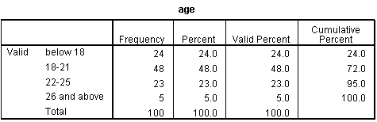

Table 1

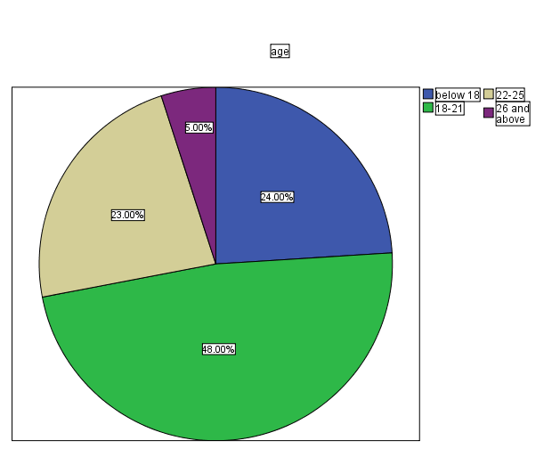

Fig 1

Interpretation: From table 1 and fig 1 above, it shows that 18-21 years of age has the highest population in this study.

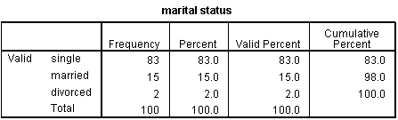

Table 2

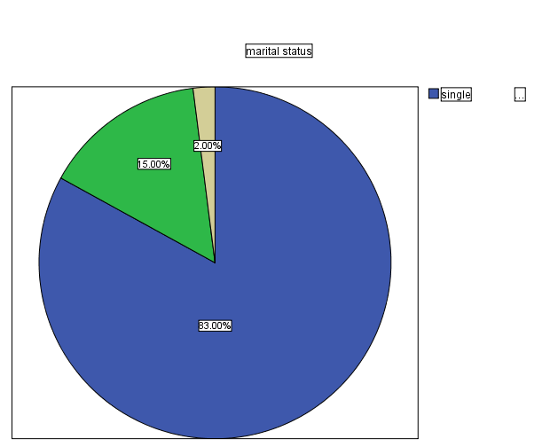

Fig 2

Interpretation: From table 2 and fig 2 above, it shows that most respondents are single.

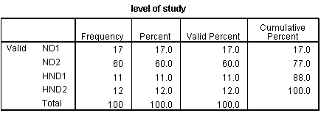

Table 3
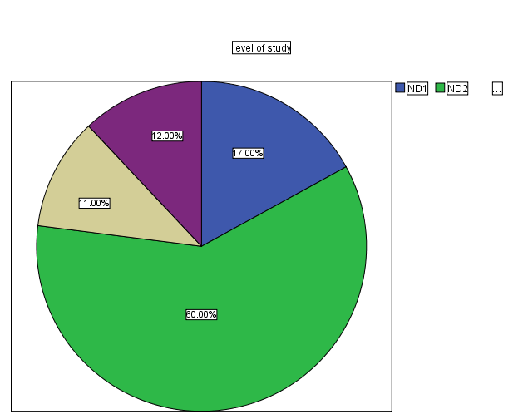

Fig 3

Interpretation: From table 3 and fig 3 above, it shows most respondents are I ND 2

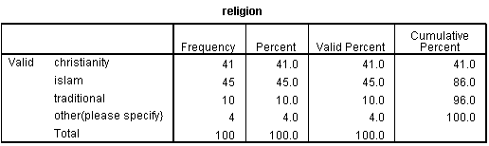

Table 4

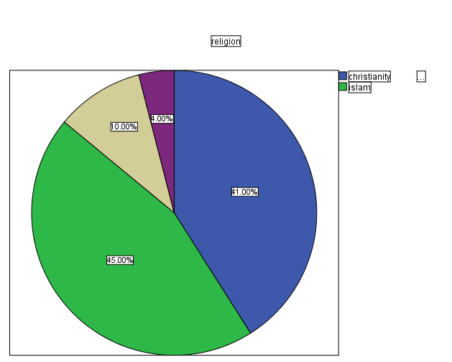

Fig 4

Interpretation: From table 1 and fig 1 above, it shows that most respondents are muslims.

4.2 DATA ANALYSIS AND RESULTS

This section presents the chi-square analysis of respondents examining selected variables: marital status and type of contraceptive used.

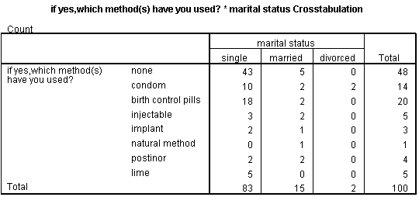

Table 1

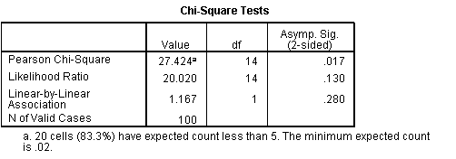

Table 2

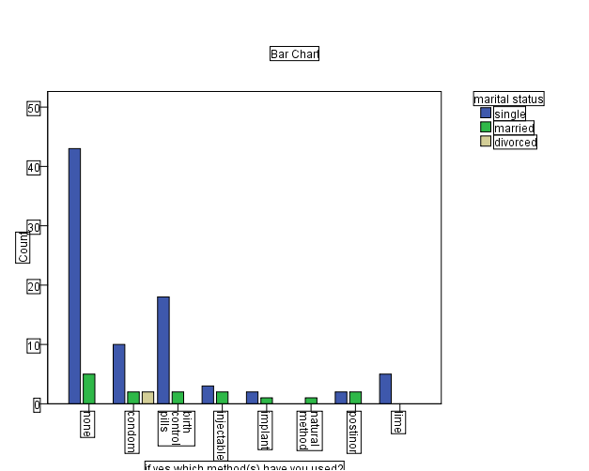

Fig 1.

HYPOTHESIS

H0: method of contraceptives use is independent on marital status.

H1: method of contraceptives use is dependent on marital status.

Decision rule: Reject H0 if p < 0.05 otherwise accept

Decision: Since p=0.017 < 0.05, we reject H0, and conclude that Marital status have a significant effect on method of contraceptives

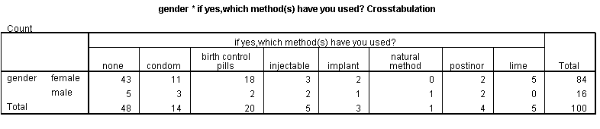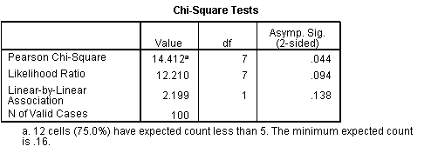
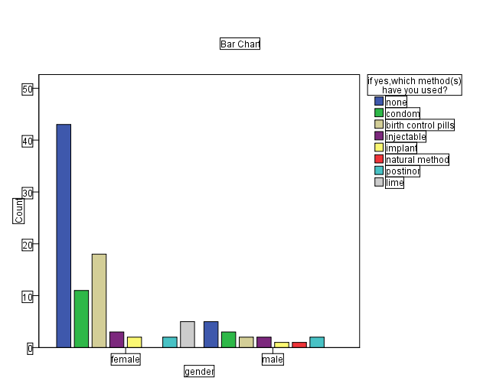

HYPOTHESIS

H0: method of contraceptives use is independent on Gender.

H1: method of contraceptives use is dependent on Gender.

Decision rule: Reject H0 if p < 0.05 otherwise accept

Decision: Since p=0.044 < 0.05, we reject H0, and conclude that gender have a significant effect on method of contraceptives

CHAPTER FIVE

SUMMARY, CONCLUSION AND RECOMMENDATIONS

5.1 Summary of Findings

This study investigated the substance use behavior among undergraduate students, focusing on demographic variables such as age, gender, marital status, academic level, and religion. The study adopted a quantitative survey approach, using a structured questionnaire to collect data from a representative sample of students.

Chapter One introduced the background of the study, the problem statement, research questions, objectives, hypotheses, and significance of the study. Chapter Two reviewed relevant literature and theoretical frameworks concerning substance use among youths and students. Chapter Three detailed the research methodology, including the population, sampling techniques, instruments, data collection, and analysis methods.

In Chapter Four, data were presented and analyzed using descriptive statistics (frequencies and percentages) and inferential statistics (Chi-square tests). Findings indicated that:
- Most respondents were aged 18–21 years.
- A significant portion of the respondents were single and in their second year (ND II).
- A majority identified with a major religious group.

5.2 Conclusion
- The first test assessed the relationship between gender and method of contraceptive used. The result revealed a p-value of 0.044, which is less than the significance level of 0.05. This led to the rejection of the null hypothesis, indicating that gender significantly influences the choice of contraceptive method.
- The second test evaluated the association between marital status and method of contraceptive used. With a p-value of 0.017, also below the 0.05 threshold, the null hypothesis was rejected again. This implies that marital status plays a significant role in determining contraceptive preferences among respondents.
5.3 Recommendation
Based on the findings of this study, the following recommendations are proposed:
- Health Education Campaigns:
Institutions should organize regular seminars and workshops on the dangers of substance use and its consequences on academic performance and health.
- Counseling and Support Services:
Schools should strengthen guidance and counseling units to provide support for students facing behavioral and emotional challenges related to substance use.
- Curriculum Integration:
Topics on substance abuse prevention and reproductive health should be integrated into General Studies (GNS) courses to reach a wider student population.
- Peer Education Programs:
Engage students in peer-to-peer education programs to enhance relatability and encourage openness in discussing substance-related issues.
- Policy Implementation:
School administrations should enforce strict policies against drug and alcohol abuse within campuses, while also promoting rehabilitation programs for affected students.
- Parental and Religious Involvement:
Parents and religious leaders should be involved in sensitization efforts, as moral and cultural upbringing has a major influence on students' choices.

5.4 Suggestions
To expand upon this research, future studies may consider:
- Exploring the psychological and emotional factors influencing substance use.
- Conducting qualitative interviews to gather in-depth personal experiences.
- Comparing substance use behavior across different institutions (e.g., universities, polytechnics, colleges of education).
- Examining the longitudinal impact of substance use on students’ academic and health outcomes.

REFERENCES
- Abah, A.L. 2009. Popular Culture and Social Change in Africa: the Case of the Nigerian Video Industry. Media, Culture and Society. 31(5): 731-748. Abdulraheem, I.S. and Fawole, O.I. 2009.
- Young People’s Sexual Risk Behaviour in Nigeria. Journal of Adolescent Research, 24(4): 505-527.
- Abiodun, O. and Balogun, R. 2009. Sexual Activity and Contraceptive use Among Young Female Students of Tertiary Educational Institutions in Ilorin, Nigeria. Contraception, 79: 146-149.
- Abu, P.b. and Akerele, E.O. 2006. Parental Influences on Adolescents Sexual Behaviour in Ibadan North Local Government Area of Oyo State, Nigeria. International Journal of Africa and African American Studies, 1: 41-56.
- Duze, M. and Mohammed, I. 2006. Male Knowledge, Attitudes, and Family Planning Practices in Northern Nigeria. African Journal of Reproductive Health, 10(3): 53-65.
- Ebuehi, O.M., Ekanem, E.E. and Ebuehi, O.A. 2006. Knowledge and Practice of Emergency Contraception among Female Undergraduates in the University of Lagos,Nigeria. East African Medical Journal, 83(3): 90-95.
- Egbochukwu, E.O. and Akinrele, J.O. 2007. Stimulant Use as Correlate of Abusive Behaviour among Nigerian Undergraduates.
- Ajuwon, A. J., Olley, B. O., Akin-Jimoh, I., & Akintola, O. (2001). Experience of sexual coercion among adolescents in Ibadan, Nigeria. African Journal of Reproductive Health, 5(3), 120–131.
- Adewuya, A. O., Ola, B. A., Aloba, O. O., Dada, A. O., & Fasoto, O. O. (2006). Prevalence and correlates of alcohol use among Nigerian university students. Drug and Alcohol Dependence, 87(1), 1–5.
- World Health Organization. (2018). Global status report on alcohol and health 2018. World Health Organization.
- Olley, B. O. (2008). Child sexual abuse, harmful alcohol use and age as determinants of sexual risk behaviours among freshmen in a Nigerian university. African Journal of Reproductive Health, 12(2), 75–88.
- Duru, C. B., Okafor, C. N., Uwakwe, K. A., Diwe, K. C., Iwu, A. C., & Ahaneku, G. I. (2015). Health risk behaviors and their determinants among university students in Nigeria. International Journal of Preventive Medicine, 6(1), 40.
- National Institute on Drug Abuse. (2020). Monitoring the Future Survey: High School and Youth Trends. National Institute on Drug Abuse.
- Ajayi, A. I., & Somefun, O. D. (2020). Substance use and sexual risk behavior among young people in Nigeria: Evidence from a nationwide survey. BMC Public Health, 20(1), 1241.
- Peltzer, K., & Pengpid, S. (2016). Correlates of illicit drug use among university students in Africa: A systematic review and meta-analysis. Substance Use & Misuse, 51(14), 1994–2000.
- Odejide, A. O. (2006). Status of drug use/abuse in Africa: A review. International Journal of Mental Health and Addiction, 4(2), 87–102.
- Akinade, E. A., & Alao, A. A. (2010). Substance abuse and family background: A study of some secondary school students in Nigeria. The African Symposium, 10(2), 41–48.

