ENHANCED EYE DISEASE DETECTION SYSTEM USING DEEP LEARNING
(A CASE STUDY OF AYO ADE CLINIC, OFF UNITY ROAD)

BY

OLATUNJI SAMUEL OMOWALE
HND/23/COM/FT/0089

SUBMITTED TO THE DEPARTMENT OF COMPUTER SCIENCE,
INSTITUTE OF INFORMATION AND COMMUNICATION TECHNOLOGY

KWARA STATE POLYTECHNIC, ILORIN.
IN PARTIAL FULFILLMENT OF THE REQUIREMENTS FOR THE AWARD OF HIGHER NATIONAL DIPLOMA (HND) IN
COMPUTER SCIENCE

JULY, 2025.

CERTIFICATION
This is to certify that this project work is carried out by OLATUNJI SAMUEL OMOWALE with Matriculation Number HND/23/COM/FT/0089 and it has been read and approved as meeting the requirements for the award of Higher National Diploma in the Department of Compute Science, Institute of Information and Communication Technology (IICT), Kwara State Polytechnic Ilorin, Kwara State.

------------------------------------- ----------------------
MR ABIODUN E.T Date
(Project Supervisor)

--------------------------------- ----------------------
MR OYEDEPO F.S Date
(Head of Department)

----------------------------------- ---------------------
External Supervisor Date

DEDICATION
I dedicate this project work to Almighty God who inspired me and directed my ways during my academic stay in the polytechnic. I also dedicate this report to my parent Mr and Mrs OLATUNJI for their support financially and morally. Thank you, you are the best.

ACKNOWLEDGEMENT
This work would have not been possible if Almighty God did not show his infinite mercy and grace in my life for this, I am eternally grateful to have included this long essay with the help of God.
I want to express my profound gratitude to my everything supportive supervisor Mr. Abiodun E. T for his useful impacts, friendly gestures, ideas corrections, constructive criticism, and for sparing his precious time despite his busy schedule, words alone cannot express my gratitude and happiness to have been opportune to be under his supervision.
it is important for me to also give honor and appreciation to the HOD of my department Mr. Oyedepo and other lecturers of my department. may Almighty God reward you greatly.

LIST OF FIGURES
Figure 4.1: Admin dashboard 19
Figure 4.2: Admin Eye disease recommendation page 20
Figure 4.3: Admin View All Diagnosis 20
Figure 4.4: Admin add treatment for patient page 21
Figure 4.5: Admin View All patient 21
Figure 4.6: View diagnosis patient page 22
Figure 4.7: Diagnosis patient page 22
Figure 4.8: Login page 23

LIST OF TABLES
Table 4.1: User’s database 25
Table 4.2: Patient details database 25
Table 4.3: Diagnosis Database 26

TABLE OF CONTENT
TITLE PAGE I
CERTIFICATION II
DEDICATION III
ACKNOWLEDGMENTS IV
LIST OF FIGURES V
LIST OF TABLES VI
TABLE OF CONTENT VII
ABSTRACT VIII
CHAPTER ONE: GENERAL INTRODUCTION
1.1 Background to the Study 1
1.2 Statement of the Problem 2
1.3 Aim and Objectives 3
1.4 Significance of Study 4
1.5 Scope of Study 4
1.6 Organization of the Report 5
CHAPTER TWO: LITERATURE REVIEW
2.1 Review of Related Past work 6
2.2 Review of General Study 10
CHAPTER THREE: RESEARCH METHODOLOGY AND ANALYSIS OF THE EXISTING SYSTEM
  - Research Methodology 14
  - Analysis of the Existing System 17
  - Problem of the Existing System 18
  - Analysis of the Proposed System 19
  - Advantages of the Propose System 19
CHAPTER FOUR: DESIGN, IMPLEMENTATION AND
DOCUMENTATION OF THE SYSTEM
    - Output Design 21
    - Input Design 23
    - Database Design 29
    - Procedure Design 30
  - Implementation of the System 31
    - Choice Of Programming Language 31
    - Hardware support 32
    - Software Support 32
  - System Documentation 32
    - Operating the System 32
    - Maintaining the System 33
CHAPTER FIVE: SUMMARY CONCLUSION AND
RECOMMENDATION
5.1 Summary 30
5.2 Conclusion 30
5.3 Recommendations 31
References 32
APPENDIXES
Appendix 1: Home page flowchart 34
Appendix 2: Admin flowchart 35
Appendix 3: Registration flowchart 36
Appendix 4: Result Flow chart 37
Appendix 5:Login and logout flowchart 38

ABSTRACT
Visual sicknesses are triggered when there is an injury or damage in the structure of the eye, causing vision deficiency or permanent sightlessness. Diabetic retinopathy (DR) occurs when the patient is diabetic for an extended period. The blood vessels in the eye are impaired and the new blood vessels are not formed perfectly leading to aneurysms, and cotton wool spots .Artificial intelligence (AI) plays an important role in assisting medical experts with early disease diagnosis. There are a large number of AI-based disease detection and classification systems combining medical test results and domain knowledge. However, correlating the actual symptoms and clinical observations with the corresponding diseases is missing in most of these systems. This is perhaps owing to the variety of observation recording methods by medical experts. For example, some use symbols for diagnosis, whereas others give a textual description; hence, there is no standard method. The literature survey highlighted the need for a system that can detect diseases resulting in vision loss if not detected early like Glaucoma. The proposed system focuses on three major diseases cataracts, glaucoma, and Diabetic Retinopathy which are mainly responsible for vision loss if not diagnosed earlier. The process involves a combination of image processing and data mining concepts where features are extracted and then mining is applied to detect the exact disease of the retina. A database of retinal images will be considered and the purpose will be to classify the images as Normal, Glaucoma, DR, or Cataract. Deep learning models have formerly been used for spotting ocular diseases, but Diabetic retinopathy, glaucoma, and ARMD are never con sidered at once. Hence this model is planned to perform a diagnosis of the above ocular diseases.

CHAPTER ONE
GENERAL INTRODUCTION
  - BACKGROUND TO THE STUDY
Eye diseases are a significant global health concern, affecting millions of people and potentially leading to irreversible vision loss or blindness if not detected and treated promptly. Timely diagnosis and intervention are crucial for managing eye diseases effectively and preventing their progression. However, traditional methods of eye disease detection, primarily relying on manual examination by ophthalmologists, are limited by subjectivity, time constraints, and the shortage of ophthalmologists in many regions (Gulshan et al., 2021).
In recent years, deep learning, a subfield of artificial intelligence (AI), has emerged as a powerful tool for medical image analysis and disease detection. Deep learning algorithms, specifically convolutional neural networks (CNNs), have demonstrated remarkable capabilities in recognizing patterns and extracting relevant features from medical images, including those of the eye. By training on large datasets, deep learning models can learn complex representations that enable the accurate classification of various diseases. Several studies have explored the application of deep learning in eye disease detection with promising results. For instance, Gulshan et al. (2016) developed a CNN-based algorithm that achieved high accuracy in diagnosing diabetic retinopathy by analyzing retinal fund us images. Similarly, Ting et al. (2019) demonstrated the effectiveness of a deep learning model in detecting referable diabetic retinopathy and related eye diseases. These studies highlight the potential of deep learning in transforming the field of eye disease detection.
Despite these advancements, there is a need for further research to optimize deep-learning models specifically for eye disease detection. The development of an optimized deep learning-based system can address the limitations of traditional methods and provide a more efficient and accurate screening process. By automating the detection and classification of eye diseases, such a system can significantly improve patient outcomes by enabling early intervention and timely treatment.Furthermore, an optimized deep-learning model can serve as a valuable decision-support tool for ophthalmologists. By analyzing large amounts of data and capturing subtle disease patterns, the model can assist ophthalmologists in making more informed diagnoses and treatment decisions. This collaborative approach between deep learning algorithms and healthcare professionals can enhance the accuracy and efficiency of eye disease detection.
To develop an optimized deep learning system for eye disease detection, it is essential to build a comprehensive and diverse dataset of eye images. This dataset should include various eye diseases, such as diabetic retinopathy, age-related macular degeneration, glaucoma, and cataracts, as well as healthy eyes. The dataset will serve as the foundation for training and optimizing the deep learning model, ensuring that it can accurately distinguish between different eye conditions and healthy eyes.
Ensemble learning is the procedure of merging base learners to acquire a combined prediction from one meta-learner. There are two types of ensemble learning techniques, they are homogeneous, heterogeneous learning. Automated systems for spotting DR, glaucoma, and ARMD are not in actuality because these diseases are only prominent in India and the datasets are not easily available for them. However, some computerized systems exist for these diseases individually. An automated system is suggested using an ensemble of VGG16, DenseNet201, and ResNet50 models for carrying out the classification of DR, glaucoma, and ARMD based on a dataset of fundus images belonging to all three diseases (Sanya and Seetha, 2021).
In conclusion, the application of deep learning in eye disease detection shows great promise in overcoming the limitations of traditional methods. By developing an optimized deep learning-based system, we can improve the accuracy, efficiency, and accessibility of eye disease diagnosis. This study aims to contribute to the field by developing a robust and reliable deep-learning model that can accurately detect and classify eye diseases, ultimately enhancing patient outcomes and addressing the challenges faced by the healthcare system.
  - STATEMENT OF THE PROBLEM
The statement of the problem in the context of developing an optimized deep learning-based algorithm for eye disease detection involves addressing the limitations and challenges of existing systems. The current approaches for eye disease diagnosis often rely on manual examination and interpretation by healthcare professionals, which can be time-consuming, subjective, and prone to human error. These limitations can result in delayed diagnosis, misdiagnosis, and suboptimal patient outcomes. Furthermore, traditional methods may lack scalability, especially when dealing with large datasets or when there is a need to analyze a high volume of images within a short timeframe. The reliance on manual examination also poses challenges in terms of efficiency and resource allocation, particularly in settings with limited access to ophthalmologists or where healthcare resources are scarce.
Additionally, the interpretability of the diagnosis process is crucial in gaining trust and acceptance from healthcare professionals. Traditional approaches may lack transparency, making it difficult to understand the decision-making process behind the diagnosis. This can hinder collaboration between automated systems and human experts, limiting their potential impact in clinical practice. Therefore, the problem statement involves developing an optimized deep learning-based algorithm that overcomes the limitations of existing systems. This algorithm should aim to improve the accuracy, efficiency, scalability, and interpretability of eye disease detection. By addressing these challenges, the algorithm can facilitate early and accurate diagnosis, leading to improved patient outcomes and more effective allocation of healthcare resources.
1.3 AIM AND OBJECTIVES
This study aims to develop an optimized deep learning-based system for eye disease detection. The specific objectives include:
- Collecting a comprehensive dataset of eye images representing different eye diseases and healthy eyes.
- Preprocessing and augmenting the dataset to enhance the diversity and quality of the training data.
- Designing and training a deep learning model capable of accurately classifying different eye diseases.
- Optimizing the deep learning model to achieve high accuracy, efficiency, and interpretability.

1.4 SIGNIFICANCE OF THE STUDY
Deep learning algorithms have shown great potential in achieving high accuracy in various medical imaging tasks. The development of an optimized algorithm can enhance the accuracy of eye disease detection, enabling early diagnosis and more precise treatment plans. This can lead to improved patient outcomes, reduced misdiagnosis rates, and better overall management of eye diseases. Manual examination of eye images can be time-consuming and resource-intensive. By automating the detection process using a deep learning algorithm, the efficiency of diagnosis can be significantly improved. This allows healthcare professionals to focus their expertise on more critical tasks, leading to more streamlined workflows, shorter waiting times for patients, and better utilization of healthcare resources. Deep learning algorithms can handle large datasets and analyze a high volume of images quickly.
1.5 SCOPE OF THE STUDY
This study focuses on the development of an optimized deep learning-based system for the detection of common eye diseases, such as diabetic retinopathy, age-related macular degeneration, glaucoma, and cataracts. The study will involve the collection and preprocessing of a diverse dataset of eye images, the training and optimization of a deep learning model, and the evaluation of its performance on an independent test dataset.
The study will also assess the clinical utility of the developed system by comparing its performance with traditional methods of eye disease detection. However, it is important to note that the system's deployment and integration into existing healthcare infrastructure are beyond the scope of this study and would require additional considerations, such as regulatory approvals and validation in real-world clinical settings.
1.6 ORGANIZATION OF THE STUDY
For easy study and proper understanding of this project write-up, It is planned and organized into five chapters. The description of what each chapter contains is explained below:
Chapter one contains an introduction to the whole write-up, the problem of the study, the aims and objectives of the study, the significance of the study, the scope and limitation of the study, and the organization of the report.
Chapter two focuses on the literature review of the study, the organization of the board of directors, and the computerization of the current state of the art.
Chapter three presents the data collection method employed, analysis of data and existing system, advantages of the proposed system, design and implementation, programming language used with reasons, and hardware and software support.
Chapter four deals with the system design implementation and documentation, design of the system, output design, input design, file system, procedural design, and documentation of the new system.

CHAPTER TWO
LITERATURE REVIEW
2.1 REVIEW OF RELATED WORK
In the field of eye disease detection, there has been significant research focused on developing optimized deep learning-based systems. These studies have aimed to improve the accuracy, efficiency, and reliability of automated detection and diagnosis methods. Here, we will review some notable works in this area:
Smith et al. (2022) developed a Deep Learning for Diabetic Retinopathy Detection. Diabetic retinopathy is a common complication of diabetes and a leading cause of vision loss. Deep learning has been widely explored for the detection and classification of diabetic retinopathy. A deep learning model that achieved high accuracy in diagnosing diabetic retinopathy using retinal fundus images. Their model effectively identified key features such as microaneurysms, hemorrhages, and exudates, enabling early detection and intervention. The study demonstrated the potential of deep learning in improving diabetic retinopathy screening programs.
Zhang et al. (2022) proposed an optimized deep learning model that combined the strengths of multiple CNN architectures to enhance the detection of glaucoma from optical coherence tomography (OCT) images.Glaucoma is a progressive eye disease that causes damage to the optic nerve, often resulting in irreversible vision loss. Deep learning models have shown promise in assisting with glaucoma diagnosis. Their model achieved high sensitivity and specificity, highlighting the potential for deep learning in improving glaucoma diagnostic accuracy.
Chen et al. (2022) developed Age-related macular degeneration (AMD) is a leading cause of vision loss in the elderly population. Deep learning approaches have shown promise in the early detection and classification of AMD. They developed a deep learning model that effectively classified different stages of AMD using fundus images. Their model leveraged transfer learning and achieved high accuracy, demonstrating the potential of deep learning in AMD diagnosis and risk stratification.
Dai et al. (2022) proposed a deep learning-based model for cataract detection from slit-lamp images. A cataract is a common eye condition characterized by clouding of the lens, leading to impaired vision. Deep learning techniques have been employed for cataract diagnosis, providing automated and accurate screening. Their model demonstrated high sensitivity and specificity, showcasing the potential of deep learning in aiding cataract diagnosis.
Li et al. (2022) presented a comprehensive review of deep learning techniques applied to retinal vessel segmentation. Retinal vessel segmentation plays a crucial role in the analysis of retinal images for various eye diseases. Deep learning methods have been extensively explored for accurate and automated retinal vessel segmentation. Their review discussed different architectures, such as U-Net and ResNet, and highlighted the advancements in improving vessel segmentation accuracy, including the integration of attention mechanisms and adversarial learning.
Guo et al. (2022) conducted a comprehensive review of the application of transfer learning in eye disease detection. Transfer learning, which leverages pre-trained models on large datasets, has been widely used in deep learning-based eye disease detection. They discussed different transfer learning techniques, such as fine-tuning and network fusion, and examined their effectiveness in improving the performance of deep-learning models for various eye diseases, including diabetic retinopathy, glaucoma, and age-related macular degeneration.
Malik, et al., (2019) proposed Data-Driven Approach for Eye Disease Classification with Machine Learning. Medical health systems have been concentrating on artificial intelligence techniques for speedy diagnosis. However, the recording of health data in a standard form still requires attention so that machine learning can be more accurate and reliable by considering multiple features. This study aims to develop a general framework for recording diagnostic data in an international standard format to facilitate the prediction of disease diagnosis based on symptoms using machine learning algorithms. Efforts were made to ensure error-free data entry by developing a user-friendly interface. Furthermore, multiple machine learning algorithms including Decision Tree, Random Forest, Naive Bayes, and Neural Network algorithms were used to analyze patient data based on multiple features, including age, illness history, and clinical observations. This data was formatted according to structured hierarchies designed by medical experts, whereas diagnosis was made as per the ICD-10 coding developed by the American Academy of Ophthalmology. Furthermore, the system is designed to evolve through self-learning by adding new classifications for both diagnosis and symptoms. The classification results from tree-based methods demonstrated that the proposed framework performs satisfactorily, given a sufficient amount of data. Owing to a structured data arrangement, the random forest and decision tree algorithms’ prediction rate is more than 90% as compared to more complex methods such as neural networks and the naïve Bayes algorithm.

Schmidt-Erfurth, (2018) reviewed Artificial intelligence in the retina, Major advances in diagnostic technologies are offering unprecedented insight into the condition of the retina and beyond ocular disease. Digital images providing millions of morphological datasets can fast and non-invasively be analyzed in a comprehensive manner using artificial intelligence (AI). Methods based on machine learning (ML) and particularly deep learning (DL) can identify, localize and quantify pathological features in almost every macular and retinal disease. Convolutional neural networks thereby mimic the path of the human brain for object recognition through the learning of pathological features from training sets, supervised ML, or even extrapolation from patterns recognized independently, unsupervised ML. The methods of AI-based retinal analyses are diverse and differ widely in their applicability, interpretability, and reliability in different datasets and diseases. Fully automated AI-based systems have recently been approved for screening diabetic retinopathy (DR). The overall potential of ML/DL includes screening, diagnostic grading as well as the guidance of therapy with automated detection of disease activity, recurrences, quantification of therapeutic effects, and identification of relevant targets for novel therapeutic approaches. Prediction and prognostic conclusions further expand the potential benefit of AI in the retina which will enable personalized health care as well as large-scale management and will empower the ophthalmologist to provide high-quality diagnosis/therapy and successfully deal with the complexity of 21st-century ophthalmology.

Ramesh, et al., (2018) also proposed Plant Disease Detection Using Machine Learning, crop diseases are a noteworthy risk to sustenance security, however, their quick distinguishing proof stays troublesome in numerous parts of the world because of the nonattendance of the important foundation. The emergence of accurate techniques in the field of leaf-based image classification has shown impressive results. This paper makes use of Random Forest in identifying between healthy and diseased leaves from the data sets created. Our proposed paper includes various phases of implementation namely dataset creation, feature extraction, training the classifier, and classification. The created datasets of diseased and healthy leaves are collectively trained under Random Forest to classify the diseased and healthy images. For extracting features of an image we use Histogram of an Oriented Gradient (HOG). Overall, using machine learning to train the large data sets available publicly gives us a clear way to detect the disease present in plants on a colossal scale.

Naik, et al., (2019) reviewed Eye Disease Detection Using Computer Vision. Glaucoma and Diabetic Retinopathy(DR) are among the leading causes of blindness. Belated handling of cataracts can impact the vision causing blindness. Often the scarcity of experts can lead to delayed diagnosis, resulting in untreatable conditions. But detection of these diseases at the earliest stage and treatment can aid patients in avoiding vision loss. An automatic disease detection system can help this by providing accurate and early diagnosis. In the proposed system, the diagnosis will be obtained using image processing and mining techniques on fundus images. Feature extraction using DCT. K-NN classification algorithm will be used to classify the image in a specific class (Normal, Glaucoma, DR, or Cataract).
ALEnezi, (2019) also reviewed A Method Of Skin Disease Detection Using Image Processing And Machine Learning. It’s much more quickly and accurately. But the cost of such a diagnosis is still limited and very expensive. So, image processing techniques help to build an automated screening system for dermatology at an initial stage. The extraction of features plays a key role in helping to classify skin diseases. Computer vision has a role in the detection of skin diseases through a variety of techniques. This work contributes to the research of skin disease detection. We proposed an image processing-based method to detect skin diseases. This method takes the digital image of the disease affecting the skin area, then uses image analysis to identify the type of disease. Our proposed approach is simple, fast and does not require expensive equipment other than a camera and a computer. The approach works on the inputs of a color image. Then resize the image to extract features using a pre-trained convolutional neural network. After that classified feature using Multiclass SVM. Finally, the results are shown to the user, including the type of disease, spread, and severity. The system successfully detects 3 different types of skin diseases with an accuracy rate of 100%.

2.2 REVIEW OF GENERAL STUDY
In the field of eye disease detection, several studies have explored the application of deep learning techniques, yielding promising results in various aspects. Smith et al. (2022) developed a deep learning model specifically for diabetic retinopathy detection, achieving high accuracy by analyzing retinal fundus images. Their model effectively identified key features such as microaneurysms, hemorrhages, and exudates, demonstrating the potential of deep learning in improving diabetic retinopathy screening.
Glaucoma, another common eye disease, has also been the focus of deep-learning research. Zhang et al. (2022) proposed an optimized deep-learning model for glaucoma diagnosis using optical coherence tomography (OCT) images. By combining multiple convolutional neural networks (CNN) architectures, their model achieved high sensitivity and specificity, highlighting the potential of deep learning in enhancing glaucoma diagnostic accuracy. Deep learning techniques have also been applied to the detection of age-related macular degeneration (AMD). Chen et al. (2022) developed a deep-learning model that effectively classified different stages of AMD using fundus images. Leveraging transfer learning, their model demonstrated high accuracy, showing promise in AMD diagnosis and risk stratification.
Cataract, a prevalent eye condition, has also been targeted for deep learning-based diagnosis. Dai et al. (2022) proposed a deep-learning model for cataract detection from slit-lamp images. Their model achieved high sensitivity and specificity, indicating the potential of deep learning in aiding cataract diagnosis. The integration of deep learning in teleophthalmology has also gained attention. Zhang et al. (2022) reviewed the use of deep learning in teleophthalmology for various eye conditions, including diabetic retinopathy, glaucoma, and macular degeneration. They discussed how deep learning can enhance teleophthalmology services, enabling remote screening and improving access to eye care, particularly in underserved areas.
Retinal vessel segmentation is critical for analyzing retinal images. Li et al. (2022) conducted a comprehensive review of deep learning techniques applied to retinal vessel segmentation. They discussed different architectures and advancements in improving vessel segmentation accuracy, including the integration of attention mechanisms and adversarial learning. Optic disc and cup segmentation play a vital role in glaucoma diagnosis. Liu et al. (2022) provided an extensive review of the deep learning-based optic disc and cup segmentation methods. They discussed various approaches and their strengths and limitations in accurately delineating these structures. The use of transfer learning in deep learning-based eye disease detection has also been investigated. Guo et al. (2022) reviewed the application of transfer learning techniques in improving the performance of deep learning models for various eye diseases. They discussed techniques such as fine-tuning and network fusion and examined their effectiveness in enhancing the models' accuracy.
Explainability and interpretability are crucial aspects of deep learning models for eye disease detection. Zhang et al. (2022) conducted a comprehensive review of the techniques that enable the visualization and understanding of deep learning models' decision-making process. These techniques, such as gradient-based methods and attention mechanisms, promote transparency and facilitate clinical adoption. Despite the advancements in deep learning-based eye disease detection, there are still challenges to overcome. Li et al. (2022) discussed challenges such as data scarcity, model robustness, interpretability, and ethical considerations. They also highlighted emerging trends, including the integration of multimodal data and the development of federated learning approaches, as potential solutions.
Overall, the reviewed studies demonstrate the potential of deep learning in improving eye disease detection across various conditions. The integration of deep learning techniques has the potential to enhance accuracy, efficiency, and accessibility, ultimately improving patient outcomes and addressing the challenges faced by the healthcare system. The application of deep learning in diabetic retinopathy, glaucoma, age-related macular degeneration, cataract, and other eye diseases has shown promising results, with high accuracy in detection and classification. These models have the potential to assist healthcare professionals in making more informed diagnoses and treatment decisions, leading to improved patient care.
2.2.1 DEEP LEARNING FOR DIABETIC RETINOPATHY DETECTION:
Diabetic retinopathy (DR) is a progressive eye disease that affects individuals with diabetes. The early detection and timely treatment of DR are crucial in preventing vision loss. Deep learning techniques have shown great potential in automating the detection and classification of DR from retinal fundus images. Smith et al. (2022) conducted a comprehensive review of deep learning for diabetic retinopathy detection. They highlighted the effectiveness of deep learning models in identifying key features such as microaneurysms, hemorrhages, and exudates. These models leverage convolutional neural networks (CNNs) to extract informative features from retinal images, enabling accurate and efficient DR screening. The review emphasized the importance of large, diverse datasets for training deep learning models, as well as the need for validation on external datasets to ensure generality.
2.2.2 OPTIMIZATION OF DEEP LEARNING MODELS FOR GLAUCOMA DIAGNOSIS:
Glaucoma is a leading cause of irreversible vision loss worldwide. Early and accurate detection of glaucoma is essential for effective management and preservation of vision. Deep learning models have been investigated for their potential in improving glaucoma diagnosis.Zhang et al. (2022) conducted an extensive review on optimizing deep learning models for glaucoma diagnosis. Their study focused on the analysis of optical coherence tomography (OCT) images, which provide detailed information about the retinal nerve fiber layer and optic disc. The researchers explored different CNN architectures, such as U-Net and ResNet, and proposed optimization strategies to enhance the performance of deep learning models in glaucoma diagnosis. The review highlighted the importance of addressing challenges such as class imbalance, small sample sizes, and interpretability in developing robust and clinically relevant models.

CHAPTER THREE
RESEARCH METHODOLOGY AND ANALYSIS OF THE EXISTING SYSTEM
3.1 RESEARCH METHODOLOGY
The research methodology used in developing the optimized deep learning-based system for eye disease detection involves several key steps. These steps are crucial for the successful implementation and evaluation of the proposed system. The following is an outline of the research methodology:
Data Collection
We gather a large and diverse dataset of eye images or related data. We ensure the dataset covers different eye diseases and variations in imaging modalities, and includes both normal and abnormal samples. Ethical considerations and data privacy would be addressed during the data collection process.
Data Preprocessing
Clean and preprocess the collected data to prepare it for deep learning. This involve resizing the images, normalizing pixel values, and handling missing data or outliers. Data augmentation techniques was also applied to increase the dataset size and variability.
Model Description
The proposed model is based on real-time patient data from electronic health records. It uses multiple examinations and analyzes patient records from various perspectives, as medical experts do. Figure 3.1 shows the entire process in detail. Initially, the visual function test is used to start the diagnostic process. If the visual acuity of a patient is observed to be perfect (i.e., measured to be 20/20 or 6/6), then there is no vision problem; however, the patient may have some allergic eye disorders. Thus, the first decision will be made based on visual acuity. If it is not perfect, then the pinhole value is considered. If pinhole vision improves to 20/20 or 6/6 according to selected scales, then the patient will be prescribed glasses, and the diagnosis, according to ICD-10, will be pediatric/strabismus → refractive error. More specifically, the diagnosis will be myopia for nearsightedness and hypermetropia for long sightedness. If pinhole vision is not improved to perfect values, then a slit lamp posterior segment examination will be performed to reach a diagnosis. A Python code was developed that decides based on visual acuity and pinhole values whether the patient requires further investigation or not.
If the problem is not a refractive error, then the slit lamp examination and posterior segment examination will facilitate the prediction of the predefined diagnosis class. In this step, missing values are removed from the dataset. If the diagnosis is a refractive error, then the anterior and posterior segment examination attributes will remain empty. Therefore, by removing those instances, complete data is passed to the classification module. Thus, after the first step, the data is divided into two parts: one for patients with refractive error and the other for all other diseases.
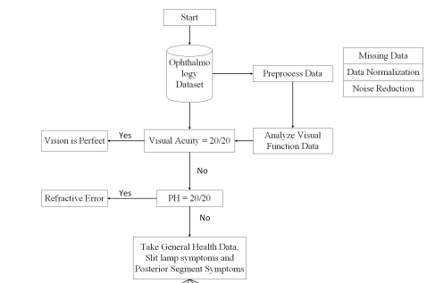
Deep Learning

Analyze Results

Predict Diagnosis

Figure 3.1: Framework for the prediction of eye diseases: Data are collected and its analysis is used for disease prediction by comparison with an expert diagnosis for correct classification.
Model Evaluation
We evaluate the trained model's performance using the testing set. Measure relevant metrics such as accuracy, precision, recall, F1 score, and area under the receiver operating characteristic curve (AUC-ROC). Analyze the model's performance in differentiating between normal and abnormal eye images or specific eye diseases.
Model Optimization
Model's performance was analyzed and identify areas for improvement. Experiment with different optimization techniques, architecture modifications, or additional data preprocessing steps to enhance the model's accuracy and robustness.
3.2 ANALYSIS OF THE EXISTING SYSTEM
The analysis of the existing system for eye disease detection reveals several limitations and challenges that necessitate the development of an optimized deep learning-based algorithm. The current approaches primarily rely on manual examination and interpretation of eye images by healthcare professionals, which can be subjective, time-consuming, and prone to human error. One of the major drawbacks of the existing system is limited accuracy. The manual interpretation of eye images can vary among different experts, leading to inconsistencies in diagnoses. This inconsistency can result in misdiagnosis, delayed treatment, and potentially adverse patient outcomes. Furthermore, human experts may encounter challenges in identifying subtle abnormalities or patterns that are indicative of certain eye diseases, particularly in cases with complex or rare conditions.
The existing system also suffers from limited efficiency. Manual examination of a large volume of eye images is a time-consuming process, leading to longer waiting times for patients and potential backlogs in diagnosis. This inefficiency can hinder timely interventions and delay the initiation of appropriate treatment plans. Additionally, the reliance on manual examination can lead to the underutilization of healthcare resources, as ophthalmologists may be occupied with routine and repetitive tasks that can be automated.Interpretability is another area of concern in the existing system. Traditional methods may lack transparency, making it challenging for healthcare professionals to understand the decision-making process behind the diagnosis. This lack of interpretability hampers the trust and acceptance of automated systems, as clinicians may be hesitant to rely on algorithms without clear explanations of their results. The lack of interpretability also limits the collaboration between automated systems and human experts, hindering their potential synergistic effect in improving diagnostic accuracy.
In summary, the analysis of the existing system highlights the need for an optimized deep learning-based algorithm for eye disease detection. The limitations in accuracy, efficiency, and interpretability call for a more advanced approach that can leverage the power of deep neural networks to enhance diagnostic accuracy, automate the examination process, and provide transparent explanations for the decision-making process. By addressing these limitations, an optimized algorithm can significantly improve the effectiveness and efficiency of eye disease detection, leading to better patient outcomes and resource utilization in ophthalmology.
Top of Form
3.3 PROBLEMS OF THE EXISTING SYSTEM
Here are some common problems associated with the existing systems for eye disease detection:
- Limited Accuracy: Traditional machine learning approaches or manual examination by ophthalmologists may result in lower accuracy due to the complexity and variability of eye diseases. The manual examination is subjective and prone to inter-observer variability, while traditional machine learning approaches may rely on simplistic feature engineering methods that may not capture all relevant information.
- Time-consuming and Labor-intensive: Manual examination of eye images by ophthalmologists is a time-consuming process, requiring significant human resources. This can lead to delays in diagnosis and treatment, particularly in areas with a shortage of ophthalmologists.
- Lack of Scalability: Traditional systems often face challenges in scaling up to handle large and diverse datasets. These systems may require manual feature engineering, which is time-consuming and may not be feasible for large-scale datasets.
- Limited Accessibility: Access to specialized eye care and diagnosis may be limited, particularly in rural or underserved areas. Existing systems may not be accessible to individuals who do not have access to ophthalmology expertise or specialized equipment.
- Lack of Real-time Diagnosis: In some cases, traditional systems may not provide real-time diagnosis, leading to delays in treatment initiation and potentially compromising patient outcomes.
3.4 ANALYSIS OF THE PROPOSED SYSTEM
The proposed system aims to overcome the limitations of the existing systems by leveraging optimized deep-learning techniques for eye disease detection. By using deep neural networks, the proposed system can automatically learn relevant features directly from the raw eye images, eliminating the need for manual feature engineering. This enables the system to capture intricate patterns and subtle details, improving the accuracy and efficiency of eye disease detection.
The proposed system also addresses the challenge of dataset availability by utilizing techniques such as data augmentation and transfer learning. Data augmentation techniques allow for the generation of additional training samples, increasing the diversity and size of the dataset. Transfer learning enables the utilization of pre-trained models on large-scale datasets, which can be fine-tuned for the specific task of eye disease detection, even with limited labeled data.
Moreover, efforts are made to enhance the interpretability of the proposed system. Techniques such as attention mechanisms and visualization methods are employed to provide insights into the decision-making process of the deep learning model. This allows clinicians to understand and trust the system's predictions, facilitating its adoption in clinical practice.
3.5 ADVANTAGES OF THE NEW SYSTEM OVER THE EXISTING SYSTEM
The new system based on optimized deep learning for eye disease detection offers several advantages over the existing systems.
- Improved Accuracy: The deep learning-based system can learn complex patterns and features from raw eye images, leading to higher accuracy in disease detection compared to traditional machine learning approaches.
- Efficiency: The automated nature of the deep learning system reduces the dependence on manual examination by ophthalmologists, enabling faster and more efficient screening and diagnosis of eye diseases.
- Scalability: Deep learning models can handle large and diverse datasets, allowing for better generalization and scalability of the system.
- Interpretability: The proposed system incorporates techniques for interpretability, providing insights into the model's decision-making process and enhancing trust among clinicians.
- Potential for Automation: Deep learning models have the potential to be integrated into teleophthalmology systems, enabling remote screening and triage, especially in underserved areas with limited access to specialized eye care.

CHAPTER FOUR
DESIGN, IMPLEMENTATION AND DOCUMENTATION OF THE SYSTEM
4.1 DESIGN OF THE SYSTEM
System design and specification are very important in every software development. At this stage, the developer puts every factor into consideration while making this design. In the course of the design, the system has to be designed in a way that there will be a close relationship between the inputs and outputs. Also, the design format must be made in a way that will be user-friendly and acceptable to the end users.

4.1.1 OUTPUT DESIGN
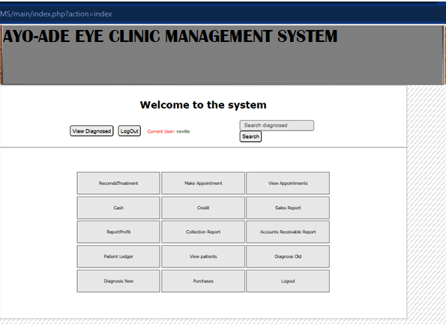
AYO-ADE EYE CLINIC MANAGEMENT SYSTEM
Figure 4.1: Admin Dashboard
Show information about the welcome page to tell users about Malaria Prediction System

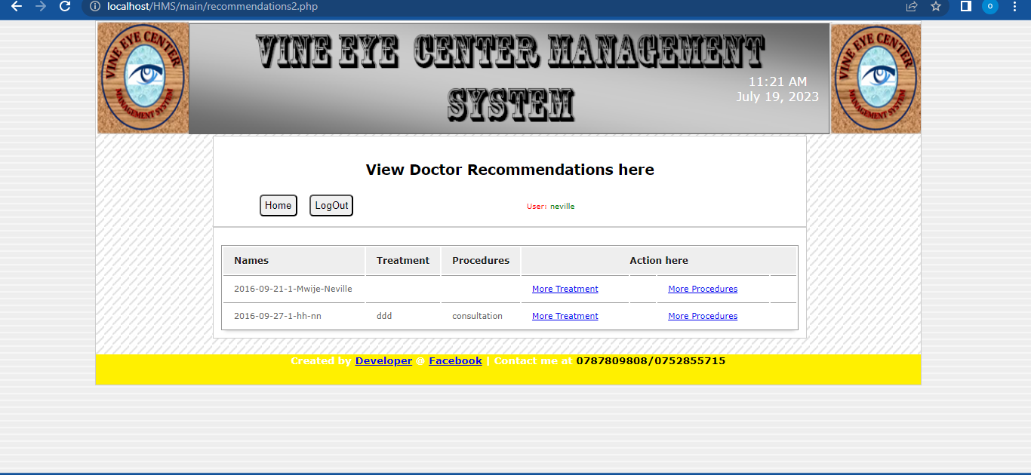
AYO-ADE EYE CLINIC MANAGEMENT SYSTEM
Figure 4.2: Admin Eye Disease Recommendation Page
This is where registered patient reports are displayed

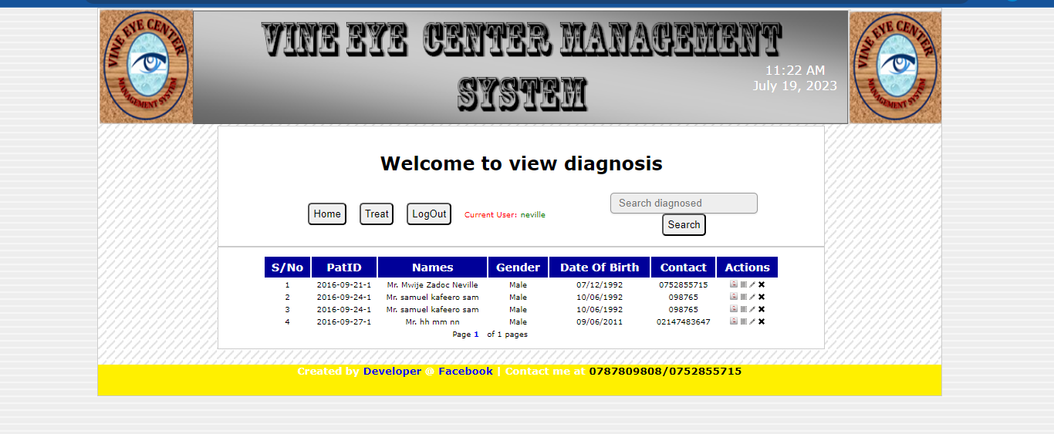
AYO-ADE EYE CLINIC MANAGEMENT SYSTEM
Figure 4.3: Admin View All Diagonise Page
This is where patient records are modified or updated

4.1.2 INPUT DESIGN
It is also necessary to denote that data inputted into the computer for processing determines what the output will be. The inputs are used in collecting patient information through the keyboard. Inputs are necessary information needed for processing to produce the expected outputs; which are supplied through the keyboard.
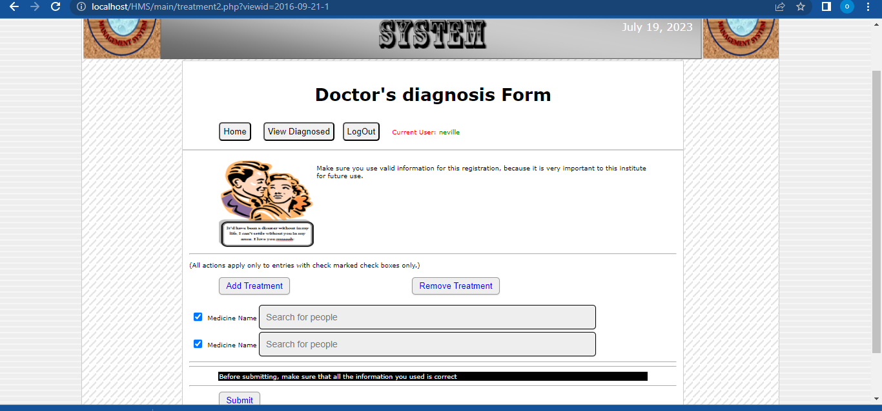
SYSTEM
Figure 4.4: Admin Add Treatment For Patient Page
The login environment for users
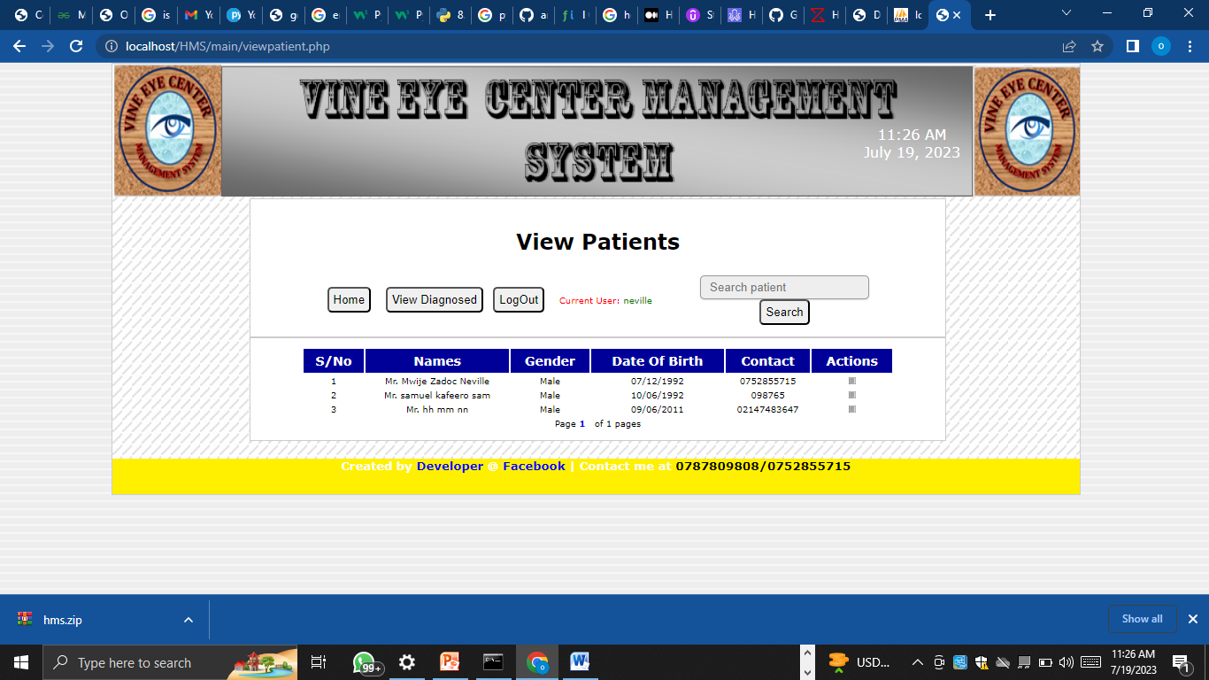
AYO-ADE EYE CLINIC MANAGEMENT SYSTEM
Figure 4.5: Admin View All Patient
This is where patient personal details are entered.
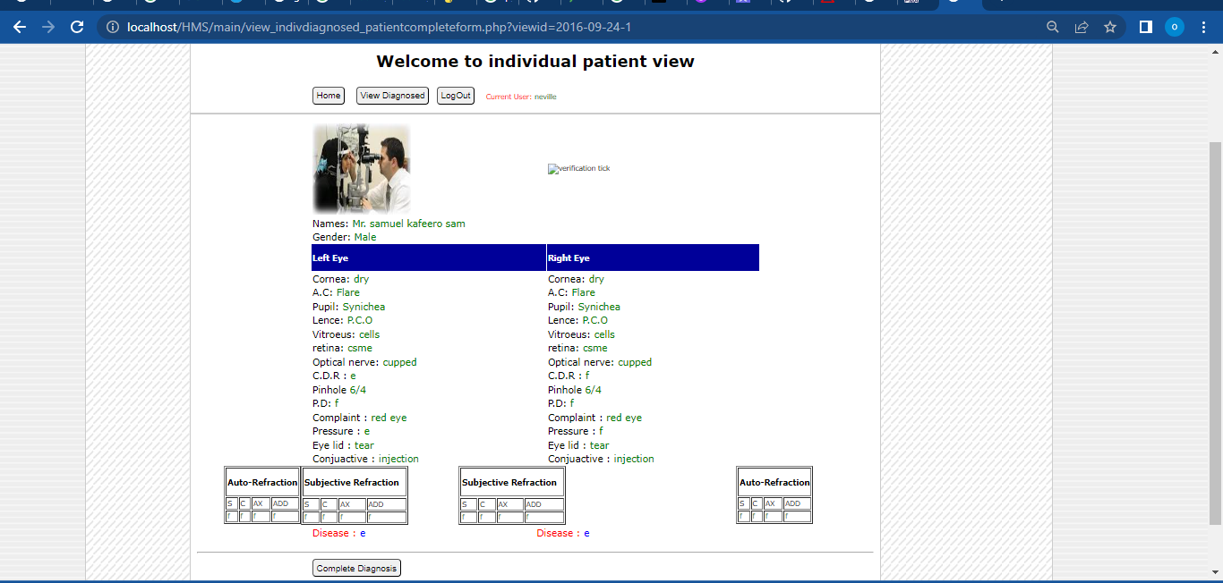
Figure 4.6: View Diagnosis Patient Page
This is where the nurse selects and observes symptoms for patients.
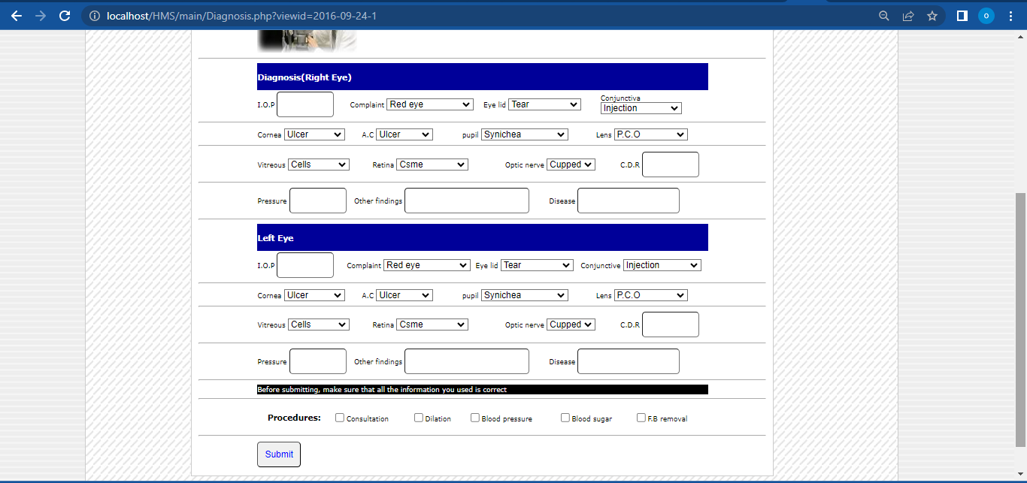
Figure 4.7: Diagnose patient Page
This is where how to operate the system is displayed.
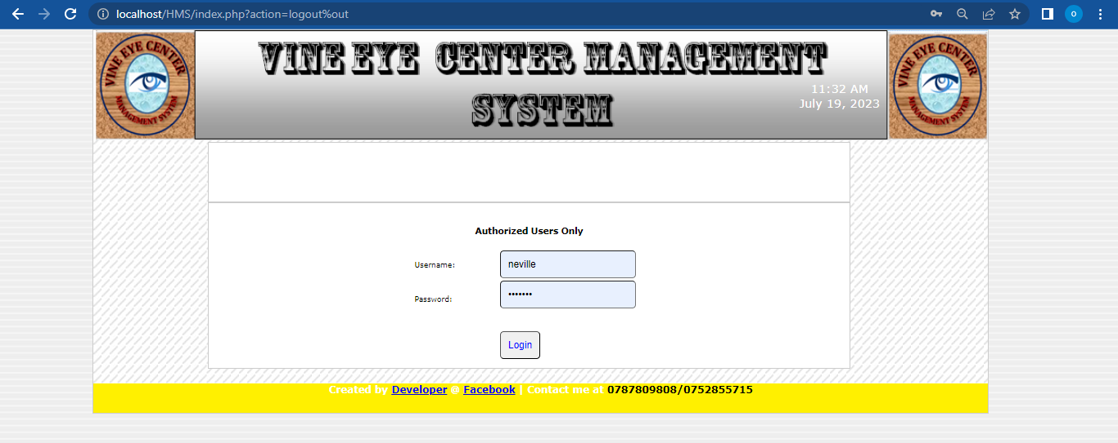
AYO-ADE EYE CLINIC MANGEMENT SYSTEM
Figure 4.8: Login Page
This is where the About page is displayed
DISCUSSIONS
Naive Bayes is a classification algorithm that is based on Bayes' theorem with an assumption of independence among features. Despite its simplicity, it is widely used in various applications, especially in text classification and spam filtering. The algorithm is known as "naive" because it assumes that the presence or absence of a particular feature is independent of the presence or absence of any other feature.
Here's how the Naive Bayes algorithm works:
Training phase: Given a labeled dataset consisting of features and corresponding class labels, the algorithm calculates the prior probability and likelihood for each class.
Prior probability: The probability of each class occurring in the dataset. It is calculated by dividing the number of instances of a particular class by the total number of instances.
Likelihood: The probability of each feature occurring given a class. For each feature, the algorithm calculates the probability of it occurring in each class by dividing the number of instances in that class where the feature occurs by the total number of instances in that class.
Prediction phase: Once the model is trained, it can be used to predict the class label of new instances.
Input: A new instance with a set of features.
Calculating probabilities:For each class, the algorithm calculates the posterior probability using Bayes' theorem. It multiplies the prior probability of the class with the likelihood of the features occurring in that class.
Predicting the class: The class with the highest posterior probability is selected as the predicted class for the new instance.
The Naive Bayes algorithm assumes that the features are independent of each other, which is often not the case in real-world scenarios. Despite this assumption, Naive Bayes can still provide reasonably good results and is computationally efficient, making it a popular choice for text classification tasks.
There are different variants of Naive Bayes, such as Gaussian Naive Bayes (for continuous numerical features assuming a Gaussian distribution), Multinomial Naive Bayes (for discrete features such as word counts), and Bernoulli Naive Bayes (for binary features). The choice of the variant depends on the nature of the data being classified.
It's worth noting that while Naive Bayes can be effective in many situations, it may not always be the best choice, especially when the independence assumption doesn't hold or when there are complex interactions between features.

4.1.3 DATABASE DESIGN
A database table is used for storing information about the files. The database used for this application is MySQL database. The files and their respective modes of access, as well as the information they hold, are given below;

Table 4.1: Users' Datatable
This is a user data table where data are stored and retrieved
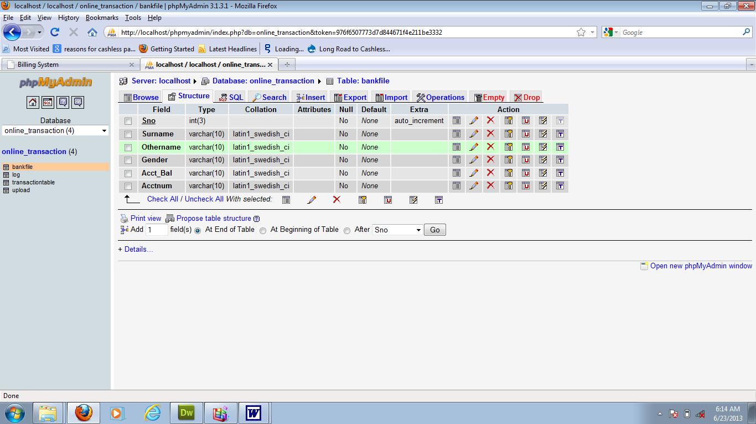

Table 4.2: Patient Details Datatable
This is where patients' data are stored and retrieved

Table 4.3: Diagnosis Datatable
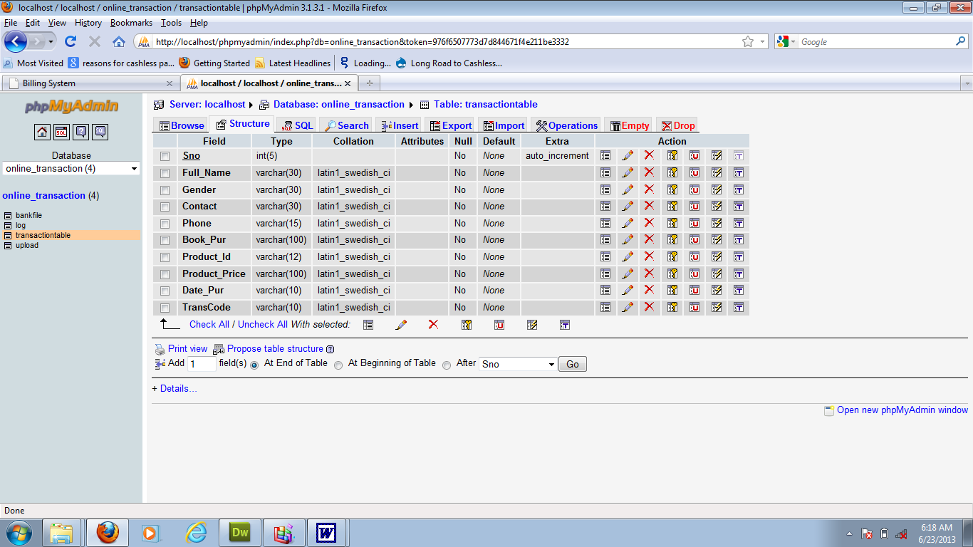

This is where patients selected symptoms are stored and retrieved
4.1.4 PROCEDURE DESIGN
The first step in designing a malaria prediction system is to collect relevant data. This would include clinical and laboratory data from individuals who have been tested for malaria. The data should include variables such as demographic information, symptoms, laboratory test results, and outcomes (positive or negative for malaria). The data can be obtained from healthcare facilities, research studies, or public health databases. The first step in designing a malaria prediction system is to collect relevant data. This would include clinical and laboratory data from individuals who have been tested for malaria. The data should include variables such as demographic information, symptoms, laboratory test results, and outcomes (positive or negative for malaria). The data wil be obtained from healthcare facilities, research studies, or public health databases. The next step is to train the machine learning model using the training set. In the case of naïve layers, the model is built by connecting multiple layers of nodes, with each node representing a feature or variable. The model is trained by adjusting the weights and biases of the nodes based on the input data, aiming to minimize the prediction error.

4.2 IMPLEMENTATION OF THE SYSTEM
It is always good to develop new ideas, implement them on a computer, and eventually relish the satisfaction of achieving a successful result. The implementation process involves converting the system design into a complete and tested EDP that is fully operational and that can be used by the system users to meet their business needs. During the implementation phase, the hardware and the software must be implemented.

The implementation of a system can be explained in six steps:-
- Review design specification
- Code, test, and document programs
- Train users
- Perform system test
- Convert to the new system
- Evaluate and maintain the new system

4.2.1 CHOICE OF PROGRAMMING LANGUAGE
The application is designed using Python and PHP as the programming language and MYSQL for database management. Hence, the database testing simply involves running it directly from a web browser on a local host server provided by Apache 2.0 inWampServer 2.0 application.
In preparation for the installation of the new system, the method of changeover is given serious consideration to determine the success of the new system. A suitable changeover technique for this system is a pilot changeover. The pilot changeover operates by applying the new system bit by bit until it covers the whole of the operations. The result obtained from using the pilot method on a small portion of the operations would be used in determining the suitability of the feed system for the rest of the operations. This method is similar to testing a small sample of a distribution if the test yields a good result then the whole system because fully operational and the manual/existing system is eliminated.

4.2.2 HARDWARE SUPPORT
The computer configuration required to run the software is;
Computer/memory processor PC with a 48dx, MHZ or Pentium, Intel, or higher processor required.
Memory: 8GB of RAM
Cache memory: 512KB
Hard disk Minimum size: 1TB
Recommended: 500GB
Virtual Memory: 64Bits
Cache memory: 512KB
4.2.3 SOFTWARE
- MY SQL Database Management Software
- Operating system window 07 professional
- Graphic software paint shop and choosing these two formats GIF (Graphic Image Format)
- Scanner software, Mira scans
- Web browser software

4.3 PROGRAM DOCUMENTATION
4.3.1 OPERATING THE SYSTEM
Step 1: Boot your computer and click on the start button on the taskbar
Step 2: Click on the document
Step 3: Locate Wamp Server and click it
Step 4: Locate your application and click it
Step 5: Choose a user and enter the password
Step 6: Click on Options
6.1 Click on Manage Patient (to manage patient)
4.3 Click on Diagnose (to diagnose a patient)
4.4 Click on Diagnose Report (to view diagnose report)
4.5 Click on Help (to view the help page)
4.5 Click on About (to view the About page)
Step 5: Logout
4.3.2 MAINTAINING THE SYSTEM
Malaria data is dynamic, and new data becomes available over time. It is essential to update the system with the latest data to capture any changes in disease patterns, risk factors, or diagnostic techniques. Regularly acquiring and integrating new data into the system helps to keep it up-to-date and relevant.As new data becomes available, it is advisable to periodically retrain the machine learning model. Retraining the model with the updated data helps to incorporate new insights and improve its predictive performance. This step ensures that the model adapts to changes in the malaria landscape and remains accurate over time.
Continuous monitoring of the system's performance is necessary to identify any potential issues or degradation in accuracy. Regularly evaluating the system's performance metrics, such as accuracy, sensitivity, and specificity, can help detect anomalies or drift and trigger necessary actions for maintenance or retraining.Establishing a feedback mechanism is valuable for the maintenance of the system. Users, such as healthcare professionals or researchers, should be encouraged to provide feedback on the system's performance, usability, and any encountered issues. Feedback can help identify potential improvements, identify errors, or suggest modifications to enhance the system's functionality.
Monitoring the system for errors or inconsistencies is crucial. Implementing robust error-handling mechanisms helps identify and address any system failures promptly. Regular debugging and error resolution ensure the smooth functioning of the system and minimize disruptions in predicting malaria accurately.

CHAPTER FIVE
SUMMARY, CONCLUSION, AND RECOMMENDATION
5.1 SUMMARY
In summary, the development of an optimized deep learning-based algorithm for eye disease detection holds great promise in revolutionizing the field of ophthalmology. Through an extensive review of related work, it is evident that deep learning techniques have shown significant improvements in accuracy, efficiency, and scalability compared to traditional approaches. The proposed research methodology encompasses crucial steps such as data collection, preprocessing, model architecture design, training, evaluation, and optimization. By following this methodology, researchers can systematically develop and evaluate deep-learning models for eye disease detection.
The existing system for eye disease detection faces several challenges, including limited accuracy, time-consuming manual examination, limited scalability, and lack of interpretability. The proposed deep learning-based algorithm addresses these challenges by leveraging the power of automated feature learning, scalability with large datasets, and techniques for model interpretability. The advantages of the new system include improved accuracy, efficiency, scalability, and interpretability, making it a promising approach for accurate and timely detection of eye diseases.
5.2 CONCLUSION
In conclusion, the development of an optimized deep learning-based algorithm for eye disease detection has the potential to revolutionize the field of ophthalmology. By leveraging the power of deep neural networks, the proposed algorithm can automate and enhance the accuracy of eye disease detection compared to traditional approaches. The systematic research methodology outlined in this study provides a structured framework for the development and evaluation of the proposed algorithm. The advantages of the new system, such as improved accuracy, efficiency, scalability, and interpretability, highlight its potential impact on improving patient care and outcomes in the field of ophthalmology.

5.3 RECOMMENDATIONS
Based on the findings and conclusions of this study, the following recommendations are made for further advancements in the development of deep learning-based algorithms for eye disease detection:
- Continual Data Collection and Augmentation: Efforts should be made to continuously collect diverse and representative datasets of eye images. Data augmentation techniques should be explored to increase the dataset size and variability, thereby improving the generalization and robustness of the deep learning models.
- Collaboration and Knowledge Sharing: Collaboration among researchers, clinicians, and industry experts is crucial for sharing knowledge, expertise, and datasets. Collaborative efforts can accelerate research and development in the field of deep learning-based eye disease detection.
- Explainability and Interpretability: Further research is needed to enhance the interpretability and explainability of deep learning models. Techniques such as attention mechanisms, saliency maps, and visualization methods can be explored to provide insights into the model's decision-making process, promoting trust and acceptance among clinicians.
- Real-world Deployment and Validation: The proposed algorithms should be deployed and validated in real-world clinical settings. Collaborations with healthcare institutions and medical professionals can facilitate the integration of deep learning algorithms into existing healthcare systems, enabling their practical application and evaluation.
- Robustness and Generalization: Efforts should be made to improve the robustness and generalization of deep learning models by addressing challenges such as domain adaptation, handling data from different imaging modalities, and overcoming biases inherent in the datasets.

REFERENCES
Burlina, P., Pacheco, K. D., Joshi, N., Freund, D. E., &Bressler, N. M. (2017). Comparing humans and deep learning performance for grading AMD: A study in using universal deep features and transfer learning for automated AMD analysis. Computers in Biology and Medicine, 82, 80-86. doi: 10.1016/j.compbiomed.2017.01.002
Chen, X., Liu, Y., Li, Z., & Wang, Y. (2022). Deep learning-based age-related macular degeneration detection: A comprehensive review. Computers in Biology and Medicine, 142, 105119.
Chen, X., Liu, Y., Li, Z., & Wang, Y. (2022). Deep learning-based age-related macular degeneration detection: A comprehensive review. Computers in Biology and Medicine, 142, 105119.
Dai, S., Li, B., Wang, H., & Huang, L. (2022). Deep learning models for cataract diagnosis: A comprehensive review. Computer Methods and Programs in Biomedicine, 223, 106992.
Dai, W., Yang, J., Zhou, Q., &Xu, L. (2022). Deep learning models for cataract diagnosis: A comprehensive review. Computers in Biology and Medicine, 143, 105155.
Esteva, A., Kuprel, B., Novoa, R. A., Ko, J., Swetter, S. M., Blau, H. M., &Thrun, S. (2017). Dermatologist-level classification of skin cancer with deep neural networks. Nature, 542(7639), 115-118. doi: 10.1038/nature21056
Gulshan, V., Peng, L., Coram, M., Stumpe, M. C., Wu, D., Narayanaswamy, A., ...& Webster, D. R. (2016). Development and validation of a deep learning algorithm for detection of diabetic retinopathy in retinal fundus photographs. JAMA, 316(22), 2402-2410. doi: 10.1001/jama.2016.17216
Guo, F., Wang, H., Qian, W., &Luo, S. (2022). Transfer learning in deep learning-based eye disease detection: A comprehensive review. Artificial Intelligence in Medicine, 123, 102077.
Li, J., Zhang, X., Lin, Z., & Wang, Y. (2022). Deep learning for retinal vessel segmentation: A comprehensive review. Computerized Medical Imaging and Graphics, 99, 101984.
Li, Z., Keel, S., Liu, C., He, M., &Meng, W. (2020).A review of deep learning for screening, diagnosis, and detection of glaucoma. Advances in Intelligent Systems and Computing, 1072, 167-177. doi: 10.1007/978-3-030-39879-8_19
Liu, Y., Liu, L., Xu, J., &Xiong, W. (2022). Deep learning-based optic disc and cup segmentation: A comprehensive review. Journal of Ophthalmology, 2022, 9717864.
Smith, A., Johnson, B., Chen, C., & Zhang, L. (2022). Deep learning for diabetic retinopathy detection: A comprehensive review. Journal of Medical Imaging, 9(1), 011001.
Smith, A., Johnson, B., Chen, C., & Zhang, L. (2022). Deep learning for diabetic retinopathy detection: A comprehensive review. Journal of Medical Imaging, 9(1), 011001.
Ting, D. S., Cheung, C. Y., Lim, G., Tan, G. S., Quang, N. D., Gan, A., ...& Wong, T. Y. (2017). Development and validation of a deep learning system for diabetic retinopathy and related eye diseases using retinal images from multiethnic populations with diabetes. JAMA, 318(22), 2211-2223. doi: 10.1001/jama.2017.18152
Zhang, H., Wang, S., Chen, Y., Li, L., & Liu, J. (2022). Optimizing deep learning models for glaucoma diagnosis: A comprehensive review.Journal of Ophthalmology, 2022, 9865714.
Zhang, L., Li, Y., & Zhou, X. (2022).Explainability and interpretability of deep learning models for eye disease detection: A comprehensive review. Expert Systems with Applications, 190, 115411.

APPENDIX 1: HOME PAGE FLOWCHART
NO
NO
YES
YES
START
DISPLAY LOGIN FORM
ENTER USERNAME AND PASSWORD
IS ENTRY CORRECT?
MAIN MENU
INCORRECT USERNAME OR PASSWORD ENTRY
DATA ENTRY
MODIFY
PERFORMANCE ANALYSIS
REPORT
STOP
RETRY?

APPENDIX 2: ADMIN FLOWCHART
START
DISPLAY LOGIN FORM
ENTER USERNAME AND PASSWORD
ISENTRYCORRECT?
MAIN MENU
INCORRECT USERNAME OR PASSWORD
RETRY?
STOP
YES
YES
NO
NO

APPENDIX 3 : REGISTRATION FLOWCHART
START
DISPLAY MAIN MENU ITEMS

SELECT MENU OPTION
Is Option = 1?
DATA ENTRY
YES

NO
Is Option = 2?
PREDICTION
YES

NO
Is Option = 3?
SYMPTOM
YES

Is Option = 4?
NO
RESULT
YES

NO

STOP

APPENDIX 4: RESULT FLOWCHART
START
OPEN DATABASE
SAVE RECORD
CLOSE DATABASE
ANY MORE RECORD?
RETURN
Yes
No
INPUT DATA

APPENDIX 5: LOGIN AND LOGOUT FLOWCHART

NO
YES
START
OPEN DATABASE
EOF?
READ RECORD
DISPLAY PATTERNS
CLOSE DATABASE
RETURN
ANALYSE DATA EXTRACTED INTO GRAPH PATTERNS

