DESIGN AND IMPLEMENTATION OF AN EXPENDITURE AND BUDGETING SYSTEM USING GENETICS ALGORITHM
(A CASE STUDY OF ILORIN EAST LOCAL GOVT)

HAMMED ABUBAKAR AYODEJI
HND/23/COM/FT/0088

A PROJECT SUBMITTED TO:
DEPARTMENT OF COMPUTER SCIENCE,
INSTITUTE OF INFORMATION AND COMMUNICATION TECHNOLOGY (IICT),
KWARA STATE POLYTECHNIC, ILORIN.

IN PARTIAL FULFILLMENT OF THE REQUIREMENTS FOR THE AWARD OF HIGHER NATIONAL DIPLOMA (HND) IN COMPUTER SCIENCE.

JULY, 2025
CERTIFICATION
This is to certify that this project work is carried out by HAMMED ABUBAKAR AYODE with Matriculation Number HND/23/COM/FT/0088 and it has been read and approved as meeting the requirements for the award of Higher National Diploma in the Department of Compute Science, Institute of Information and Communication Technology (IICT), Kwara State Polytechnic Ilorin, Kwara State.

------------------------------------- ----------------------
MR ABIODUN E.T Date
(Project Supervisor)

--------------------------------- ----------------------
MR OYEDEPO F.S Date
(Head of Department)

----------------------------------- ---------------------
External Supervisor Date

DEDICATION
This project is dedicated to the Almighty Allah for his mercies of counting me among living being and makes me witness the end of this program. I also dedicate this report to my parent MR. AND MRS. HAMMED, MR. OKANLAWON SAHEED AND DR. ISSA ATOLAGBE For their support financially, morally, you are the best.

ACKNOWLEDGEMENT
All Glory, Honor and Adoration belong to God who is the source of Grace, Mercy, Protection, Wisdom, Knowledge Foresight and Guidance for the opportunity giving unto me throughout my years in Kwara State Polytechnic. Indeed GOD has been my backbone.
I am indebted to my able Supervisor MR ABIODUN E.T for all the implacable analysis, corrections and modification towards the attainment of the success of my project, my profound gratitude goes to the head of department Mr Oyedepo F.S, the institute director Dr Raji.A.K, project coordinator Dr Mrs Dada .O.M and all the lecturer at the department of computer science.

LIST OF FIGURES
Figure 4.1: Splash Screen Page 14
Figure 4.2: Main Menu Page 14
Figure 4.3: Appropiation Page 15
Figure 4.4: Obligation Page 15
Figure 4.5: Budget 16
Figure 4.4: Budget Obligation 16

TABLE OF CONTENTS
TITLE PAGE I
CERTIFICATION PAGE II
DEDICATION III
ACKNOWLEDGEMENT IV
LIST OF FIGURES V
TABLE OF CONTENT VI
ABSTRACT VIII

CHAPTER ONE: GENERAL INTRODUCTION

1.1 BACKGROUND OF STUDY 1
1.2 STATEMENT OF PROBLEM 2
1.3 AIM AND OBJECTIVES OF THE STUDY 2
1.4 SIGNIFICANCE OF THE PROJECT 2
1.5 SCOPE OF THE STUDY 3
1.6 ORGANIZATION OF THE REPORT 4

CHAPTER TWO: LITERATURE REVIEW
2.1 REVIEW OF RELATED PAST WORK 5
2.2 REVIEW OF GENERAL TEXT . 5 – 6
2.2.1 GENETIC ALGORITHM 6
2.2.2 GENETIC ALGORITHM BUILDING 7
2.2.3 OVERVIEW OF GENETIC ALGORITHM 8
2.3 COMPARISON OF SYSTEM DEVELOPMENT PROCESS MODEL 9

CHAPTER THREE: METHODOLOGY AND ANALYSIS OF THE EXISTING SYSTEM
3.1 RESEARCH METHODOLOGY 12
3.2 ANALYSIS OF DATA AND THE EXISTING SYSTEM 13
3.3 PROBLEMS IN THE EXISTING SYSTEM 14
3.4 DESCRIPTION OF THE PROPOSED SYSTEM 14
3.5 ADVANTAGES OF THE PROPOSED SYSTEM 14

CHAPTER FOUR: DESIGN AND IMPLEMENTATION OF THE SYSTEM

4.1 DESIGN OF THE SYSTEM 16
4.1.1 OUTPUT SYSTEM 16
4.1.2 INPUT SYSTEM 16
4.1.3 DATABASE DESIGN 17
4.1.4 PROCEDURE DESIGN 17
4.2 IMPLEMENTATION OF THE SYSTEM 17
4.2.1 CHOICE OF PROGRAMMING LANGUAGE 18
4.2.2 HARDWARE SUPPORT 18
4.2.3 SOFTWARE SUPPORT 18
4.2.4 CHANGE OVER TECHNIQUES 19
4.3 SYSTEM DOCUMENTATION 19
4.3.1 DOCUMENTATION OF THE PROGRAM 19
4.3.2 MAINTAINING THE SYSTEM 20

CHAPTER FIVE: CONCLUSION AND RECOMMENDATION
5.1 SUMMARY OF FIGURES 21
5.2 CONCLUSION 21
5.2 RECOMMENDATION 22
REFERENCE SECTION
APPENDIXES
Appendix 1: Home page flowchart 22
Appendix 2: Admin flowchart 23
Appendix 3: Registration flowchart 24
Appendix 4: Login and logout flowchart 25

ABSTARCT
Planning and monitoring one’s budget will help one’s identify wasteful expenditures, adapt quickly as your financial situation changes, and achieve one’s financial goals. When you actually see the breakdown of your expenses, you may be surprised by what you find; this process is essential to fully grasping how things can add up. Creating a budget will decrease your stress levels because, with a budget, there are no surprises. Unexpected car problems or medical bills? That dream vacation your best friends are planning? With a budget, you don’t have to panic or wonder if you have the money you already know. This sense of financial clarity is important not only in college, but throughout life.
The effectiveness of a budgeting system is judged by its success in moving the organization towards its vision; a vision that usually requires financial stability and strategic change. A ministry is not a business. More precisely, a not-for-profit ministry is significantly different from a for-profit business. A ministry has no owners but it is a public trust. Without owners, it has no one to pay dividends to, and no one for whom it must maximize its profits. A business has a single overriding goal: the maximization of return for the owners. A ministry has a multiplicity of goals which include serving its community.

CHAPTER ONE
GENERAL INTRODUCTION
  - BACKGROUND OF STUDY
Technically, a budgeting system is not a decision system; it is a system for implementing decisions. Nevertheless, each budgeting system shapes and informs decisions on. The allocation of resources to tasks and functions on the investment of resources in new ventures, and on the easing of existing activities. Once the decisions are made, much of the implementation is done through the allocation of resources that control or give incentives to various actions of participants in the organization. Simply put, a budget is an itemized summary of likely income and expenses for a given period. It helps you determine whether you can grab that bite to eat or should head home for a bowl of soup. It is typically created using a spreadsheet, and it provides a concrete, organized, and easily understood breakdown of how much money you have coming in and how much you are letting go. It’s an invaluable tool to help one prioritize one’s spending and manage one’s money no matter how much or how little you have.
Planning and monitoring one’s budget will help one’s identify wasteful expenditures, adapt quickly as your financial situation changes, and achieve one’s financial goals. When you actually see the breakdown of your expenses, you may be surprised by what you find; this process is essential to fully grasping how things can add up. Creating a budget will decrease your stress levels because, with a budget, there are no surprises. Unexpected car problems or medical bills? That dream vacation your best friends are planning? With a budget, you don’t have to panic or wonder if you have the money you already know. This sense of financial clarity is important not only in college, but throughout life.
The effectiveness of a budgeting system is judged by its success in moving the organization towards its vision; a vision that usually requires financial stability and strategic change. A ministry is not a business. More precisely, a not-for-profit ministry is significantly different from a for-profit business. A ministry has no owners but it is a public trust. Without owners, it has no one to pay dividends to, and no one for whom it must maximize its profits. A business has a single overriding goal: the maximization of return for the owners. A ministry has a multiplicity of goals which include serving its community. Nevertheless, both a ministry and a business are economic entities, and as economic entities, they must maintain financial viability to survive. This similarity is why they both generally have budgeting systems. While the necessity of financial viability is well aligned with the single goal of a business, it is not well aligned with the multiple goals of a ministry. Thus, government budgeting systems must ensure financial viability while improving a ministry’s ability to reach its central goals. This is the task at hand.

  - STATEMENT OF THE PROBLEM
One major problem facing the economic development of the state is poor budgeting system employed so far. This problem is associated with inability of the ministry to track incoming revenue from other sectors. In a case where a particular sector raised 10 million naira in a month and recorded 5 million naira in the files, at the end of the year, excuses of missing files can make cover-up for the theft. The problem is as a result of unavailability of digital or electronic means of documenting revenue generation of the state. This in turn affects the expenditure because there will always be shortage of funds. Physical destruction of manual files, record alteration and lots of problems like these are only associated with manual record keeping system. This is will be eliminated in the computer-based application as only authorised administrator have the permission to access most vital parts of the system and even if any alteration happens, it is very easy to trace since only one man (The Administrator) has the authentic power to do so.
  - AIM AND OBJECTIVES
The aim of this project is to develop an automated revenue/expenditure budgeting system using genetic algorithm. The objectives are:
- The system will provide sufficient information to the board of control to allow it to exercise its constitutionally mandated management and control responsibilities.
- To develop a system that will advance the Ministry’s financial strategy. By computerizing it.
- To invent a computer-based application that will foster decisions at the organizational level where the greatest understanding exists.
- To develop a system that will force simultaneous resource-allocation decisions, not sequential decisions.
- It is also aimed at developing a simple and easy to operate application that will ease the budgeting and expenditure analysis of the ministry.

  - SIGNIFICANCE OF THE STUDY
The project will bring more benefits to the Ministry with its ease of implementation and low political costs, as an ideal system. The proposed budgeting and revenue allocation system is a low overhead system. Its information requirements are moderate and its methodology is easy to learn. The need to effect this change requires a financial strategy and a budgeting system that is at least partially expenditure driven, but that also improves the ministry’s instruction and service. These goals are less opposed than it may seem. Strength in instruction and service, if aligned with the requirements of the people of the state, will enhance the state’s success in catering for the welfare of the citizens. The project work will be very important to the ministry in maintaining budgets and reporting results by fund category and make it appear well understood by the board and community and help maintain cash control.
Other roles of budget and expenditure system are:
- Providing Capacity in Budget analysis, advocacy and monitoring.
- Developing models and tools for analysis, monitoring and advocacy.
- Opening participation spaces for civil society in the budget process.
- Creating linkages with government agencies and institutions.
- Coordinating networking amongst partners and with a broader civil society audience.
- Creating linkages at State, national and international levels for effective implementation of the project.

1.5 SCOPE OF THE STUDY
The target of the project is to develop a computer based application for automated revenue expenditure budgeting system. The project presents the monthly expenditure of the ministry in graphical method (histogram). A limitation of the project is on the project implementation, the project is not implemented online. No facility was provided to access or execute the project on a local area network.

  - ORGANIZATION OF THE REPORT
This project work is divided into five chapters and below are the description of what each chapter contains.
Chapter One describes the background of the project, statement of the problem, project aim and objective, significance of the project, report outlines, definition of term.
Chapter Two talks about the review of the past work related to work, review of general test, comparison of system development process models, comparison of application manage used, comparison of relationship database management system, summary
Chapter Three deals with the research methodology, analyzing of the existing system, flowchart of the existing system, problem of the existing system, description of the proposed system, flowchart of the proposed system, advantages of proposed system, summary.
Chapter Four includes design of the system, output system, input system, database design, procedure design, implementation of the system, choice of programming language, hardware support, change over techniques, student documentation, documentation of the program, operating system, maintaining the system and summary.
Chapter Five deals with the conclusion, recommendation and reference

CHAPTER TWO
LITERATURE REVIEW
2.1 REVIEW OF THE PAST WORK RELATED TO WORK
Birkett, P. (2021) Prior to the discovery of oil in Nigeria, other sectors of the economy thrived. Agriculture, for instance, was a major source of revenue for the Western Region. The Eastern Region that was less endowed devised other sources of revenue. All this has however changed since the discovery of oil in the country. This has led to the demise of the other productive sectors of the economy. In fact, Nigerians are poorer today than they were in the pre-oil boom days. This is mainly because of the methodology of sharing the oil revenue. The struggle for the control of the oil wealth has led to an unfortunate shift from a revenue-oriented principle to an expenditure-oriented principle of revenue allocation. It is an act of self-deception for anyone to argue that there is nothing wrong with the revenue formula. We have had basically two systems of revenue allocation in Nigeria.
Emst, Y. (2022) The first system which we practiced during the First Republic allowed the North to keep the proceeds from its groundnut and cotton, the West to keep the proceeds from its cocoa, and the East to keep the proceeds from coal and oil produce. Then we changed the system so that the Federal Government got its hands on the proceeds from on-shore and off-shore crude petroleum proceeds, and yet we don't expect the minorities in the oil-producing areas to perceive that is an injustice done to them. The oil-producing minorities have a point that the rule of the revenue allocation game was changed to disfavor them." It is against the backdrop of the preceding assertion, delivered by a Nigeria academic and a delegate to the National Political Reform Conference, that the complicated discussion regarding the revenue allocation formula at the National Political Reform Conference might be visualized. In review of a project work undertaken by Nurudeen Abdullateef in 2019 titled “Line-item Budget System”, the major advantage of line-item budgeting is its simplicity.

2.2 REVIEW OF GENERAL TEXT
The application allows the authorized staff member to pick up the line-item budget of a human service agency and see
(a) The source and amount of the agency’s revenues
(b) How the funds will be used in terms of staff, equipment, facilities, travel, and so on, a
(c) If the budget is balanced.
The major disadvantages of line-item budgeting systems as stated in his work are twofold. First, line-item budgets say nothing about how much service a human service agency provides, the cost of that service, the number of outcomes the agency accomplished, or their attendant costs. The first major disadvantage of line-item budgeting leads directly to the second. Resource allocation discussions and decisions tend to be framed by the line-items themselves because no other information is available.
Another author lays emphasis on the advantages and disadvantages of Performance Budgeting System. The major advantages of performance budgeting systems are that
(a) they provide information on the amount of service provided by a human service program and the attendant costs including determination of the cost per output or per unit of service and
(b) they raise the level of debate from line-items to programs, program services, program costs, and program efficiency. The major disadvantage of performance budgeting systems and program budgeting systems as well is that human service agencies must employ sophisticated cost analysis techniques in order to determine the full cost of a program and to derive accurate unit costs. While describing this aspect of performance budgeting as a major disadvantage, the point should also be made that being able to fully cost one’s programs and derive accurate unit costs is nevertheless an essential component of the financial management of human service agencies today.

2.2.1 GENETIC ALGORITHM
In computer science and operations research, a genetic algorithm (GA) is a metaheuristic inspired by the process of natural selection that belongs to the larger class of evolutionary algorithms (EA). Genetic algorithms are commonly used to generate high-quality solutions to optimization and search problems by relying on bio-inspired operators such as mutation, crossover and selection.

2.2.2 GENETIC ALGORITHM BUILDING BLOCKHYPOTHESIS
Genetic algorithms are simple to implement, but their behavior is difficult to understand. In particular it is difficult to understand why these algorithms frequently succeed at generating solutions of high fitness when applied to practical problems. The building block hypothesis (BBH) consists of:
- A description of a heuristic that performs adaptation by identifying and recombining "building blocks", i.e. low order, low defining-length schemata with above average fitness.
- A hypothesis that a genetic algorithm performs adaptation by implicitly and efficiently implementing this heuristic.
Goldberg Describes The Heuristic As Follows:
Short, low order, and highly fit schemata are sampled, recombined, and resampled to form strings of potentially higher fitness. In a way, by working with these particular schemata [the building blocks], we have reduced the complexity of our problem; instead of building high-performance strings by trying every conceivable combination, we construct better and better strings from the best partial solutions of past samplings.
Because highly fit schemata of low defining length and low order play such an important role in the action of genetic algorithms, we have already given them a special name: building blocks. Just as a child creates magnificent fortresses through the arrangement of simple blocks of wood, so does a genetic algorithm seek near optimal performance through the juxtaposition of short, low-order, high-performance schemata, or building blocks.Despite of the lack of consensus regarding the validity of the building-block hypothesis, it has been consistently evaluated and used as reference throughout the years. Many estimation of distribution algorithms, for example, have been proposed in an attempt to provide an environment in which the hypothesis would hold. Although good results have been reported for some classes of problems, skepticism concerning the generality and/or practicality of the building-block hypothesis as an explanation for GAs efficiency still remains. Indeed, there is a reasonable amount of work that attempts to understand its limitations from the perspective of estimation of distribution algorithms.

2.2.3 OVERVIEW OF GENETIC ALGORITHM
GAs simulate the survival of the fittest among individuals over consecutive generation for solving a problem. Each generation consists of a population of character strings that are analogous to the chromosome that we see in our DNA. Each individual represents a point in a search space and a possible solution. The individuals in the population are then made to go through a process of evolution.
GAs are based on an analogy with the genetic structure and behaviour of chromosomes within a population of individuals using the following foundations:
- Individuals in a population compete for resources and mates.
- Those individuals most successful in each 'competition' will produce more offspring than those individuals that perform poorly.
- Genes from `good' individuals propagate throughout the population so that two good parents will sometimes produce offspring that are better than either parent.
- Thus each successive generation will become more suited to their environment.
A population of individuals are is maintained within search space for a GA, each representing a possible solution to a given problem. Each individual is coded as a finite length vector of components, or variables, in terms of some alphabet, usually the binary alphabet {0,1}. To continue the genetic analogy these individuals are likened to chromosomes and the variables are analogous to genes. Thus a chromosome (solution) is composed of several genes (variables). A fitness score is assigned to each solution representing the abilities of an individual to `compete'. The individual with the optimal (or generally near optimal) fitness score is sought. The GA aims to use selective `breeding' of the solutions to produce `offspring' better than the parents by combining information from the chromosomes.
The GA maintains a population of n chromosomes (solutions) with associated fitness values. Parents are selected to mate, on the basis of their fitness, producing offspring via a reproductive plan. Consequently highly fit solutions are given more opportunities to reproduce, so that offspring inherit characteristics from each parent. As parents mate and produce offspring, room must be made for the new arrivals since the population is kept at a static size. Individuals in the population die and are replaced by the new solutions, eventually creating a new generation once all mating opportunities in the old population have been exhausted. In this way it is hoped that over successive generations better solutions will thrive while the least fit solutions die out.
New generations of solutions are produced containing, on average, more good genes than a typical solution in a previous generation. Each successive generation will contain more good `partial solutions' than previous generations. Eventually, once the population has converged and is not producing offspring noticeably different from those in previous generations, the algorithm itself is said to have converged to a set of solutions to the problem at hand.

2.3 COMPARISON OF SYSTEM DEVELOPMENT PROCESS MODELS
Software development is the process of computer programming, documenting, testing, and bug fixing involved in creating and maintaining applications and frameworks resulting in a software product. Software development is a process of writing and maintaining the source code, but in a broader sense, it includes all that is involved between the conception of the desired software through to the final manifestation of the software, sometimes in a planned and structured process. Therefore, software development may include research, new development, prototyping, modification, reuse, re-engineering, maintenance, or any other activities that result in software products. Software can be developed for a variety of purposes, the three most common being to meet specific needs of a specific client/business (the case with custom software), to meet a perceived need of some set of potential users (the case with commercial and open source software), or for personal use (e.g. a scientist may write software to automate a mundane task). Embedded software development, that is, the development of embedded software such as used for controlling consumer products, requires the development process to be integrated with the development of the controlled physical product. System software underlies applications and the programming process itself, and is often developed separately. The need for better quality control of the software development process has given rise to the discipline of software engineering, which aims to apply the systematic approach exemplified in the engineering paradigm to the process of software development. There are many approaches to software project management, known as software development life cycle models, methodologies, processes, or models. The waterfall model is a traditional version, contrasted with the more recent innovation of agile software development.
1. Preliminary analysis: The objective of phase 1 is to conduct a preliminary analysis, propose alternative solutions, describe costs and benefits and submit a preliminary plan with recommendations.
- Conduct the preliminary analysis: in this step, you need to find out the organization's objectives and the nature and scope of the problem under study. Even if a problem refers only to a small segment of the organization itself, you need to find out what the objectives of the organization itself are. Then you need to see how the problem being studied fits in with them.
- Propose alternative solutions: In digging into the organization's objectives and specific problems, you may have already covered some solutions. Alternate proposals may come from interviewing employees, clients, suppliers, and/or consultants. You can also study what competitors are doing. With this data, you will have three choices: leave the system as is, improve it, or develop a new system.
- Describe the costs and benefits.
2. Systems analysis, requirements definition: Defines project goals into defined functions and operation of the intended application. It is the process of gathering and interpreting facts, diagnosing problems and recommending improvements to the system. Analyzes end-user information needs and also removes any inconsistencies and incompleteness in these requirements.
A series of steps followed by the developer are:
- Collection of Facts: End user requirements are obtained through documentation, client interviews, observation and questionnaires,
- Scrutiny of the existing system: Identify pros and cons of the current system in-place, so as to carry forward the pros and avoid the cons in the new system.
- Analyzing the proposed system: Solutions to the shortcomings in step two are found and any specific user proposals are used to prepare the specifications.
3. Systems design: Describes desired features and operations in detail, including screen layouts, business rules, process diagrams, pseudocode and other documentation.
4. Development: The real code is written here.
5. Integration and testing: Brings all the pieces together into a special testing environment, then checks for errors, bugs and interoperability.
6. Acceptance, installation, deployment: The final stage of initial development, where the software is put into production and runs actual business.
7. Maintenance: During the maintenance stage of the SDLC, the system is assessed to ensure it does not become obsolete. This is also where changes are made to initial software. It involves continuous evaluation of the system in terms of its performance.
8. Evaluation: Some companies do not view this as an official stage of the SDLC, while others consider it to be an extension of the maintenance stage, and may be referred to in some circles as post-implementation review. This is where the system that was developed, as well as the entire process, is evaluated. Some of the questions that need to be answered include: does the newly implemented system meet the initial business requirements and objectives? Is the system reliable and fault-tolerant? Does the system function according to the approved functional requirements? In addition to evaluating the software that was released, it is important to assess the effectiveness of the development process. If there are any aspects of the entire process, or certain stages, that management is not satisfied with, this is the time to improve. Evaluation and assessment is a difficult issue. However, the company must reflect on the process and address weaknesses.
9. Disposal: In this phase, plans are developed for discarding system information, hardware and software in making the transition to a new system. The purpose here is to properly move, archive, discard or destroy information, hardware and software that is being replaced, in a manner that prevents any possibility of unauthorized disclosure of sensitive data. The disposal activities ensure proper migration to a new system. Particular emphasis is given to proper preservation and archival of data processed by the previous system. All of this should be done in accordance with the organization's security requirements.

CHAPTER THREE

METHODOLOGY AND ANALYSIS OF THE EXSITING SYSTEM
3.1 RESEARCH METHODOLOGY
Data collection methodology refers to the means of gathering relevant information that facilitate the research project. Discussing the methods used in collecting information relevant in every research work to ease further review of the work by subsequent researchers. Methods of data collection used in this work are interview and literature review.
Javascript is one of the programming languages used or this website application. A Javascript library is a library of pre-written Javascript which allows easier access throughout the development of the web application.
PHP: Popular general-purpose scripting language that is especially suited to web development. It is a server side scripting language.
CSS3: it is called cascading style sheets used in front-end development of sites and applications.
Mysql: is a collection of information that is stored so that it can be retrieved, managed and updated.

3.2 ANALYZING OF THE EXISTING SYSTEM
The existing budgeting system in Ilorin east local government is inefficient, poor data collection and poorly monitored. These weaknesses hinder effective planning, implementation, and accountability, ultimately affecting the quality of services delivered to the public. This is will be eliminated in the computer-based application as only authorized administrator have the permission to access Objective and clear categorization of these costs can be tricky and thus can jeopardize the entire budgeting process.

3.3 PROBLEM OF THE EXISTING SYSTEM
INADEQUATE BUDGET PLANNING : occurs when financial plans are unrealistic, poorly structured, and not aligned with actual needs. This leads to funding shortfalls, project delays, and inefficient service delivery.
POOR TRACKING AND MONITORING OF BUDGET: means there is no effective system to regularly check how funds are spent compared to the approved budget. This often leads to overspending, mismanagement of resources, and difficulty in identifying financial irregularities.
WEAK FINANCIAL MONITORING: means there is little oversight of spending, leading to misuse of funds and unnoticed budget deviations.
Poor collection of data for the budgeting system: means that budgets are prepared without accurate or up-to-date information on revenues, expenditures, and community needs. This leads to unrealistic budgets and ineffective resource allocation.
LACK OF PERFORMANCE-BASED BUDGETING: means budgets are prepared without linking spending to specific results or outcomes. This makes it hard to measure the effectiveness of public spending and ensure value for money.

3.4 DESCRIPTION OF THE PROPOSED SYSTEM
A budget is a fundamental tool for an event director to predict with a reasonable accuracy whether the event will result in a profit, a loss or will break-even. A budget can also be used as a pricing tool. There are two basic approaches or philosophies, when it comes to budgeting. One approach is telling you on mathematical models, and the other on people. The first school of thought believes that financial models, if properly constructed, can be used to predict the future. The focus is on variables, inputs and outputs, drivers and the like. Investments of time and money are devoted to perfecting these models, which are typically held in some type of financial spreadsheet application. The other school of thought holds that it’s not about models, it’s about people. No matter how sophisticated models can get, the best information comes from the people in the business. The focus is therefore in engaging the managers in the business more fully in the budget process, and building accountability for the results. The companies that adhere to this approach have their managers develop their own budgets. While many companies would say that they do both, in reality the investment of time and money falls squarely in one approach or the other.
3.6 ADVANTAGES OF PROPOSED SYSTEM
- To control resources
- To communicate plans to various responsibility center in budgeting department.
- To motivate managers to strive to achieve budget goals.
- To evaluate the performance of managers
- To provide visibility into the budget performance
- For accountability of the budget
- Tools provide a forecast of budgeting and expenditures, that is, construct a model of how a budget might perform by carrying out certain strategies, events and plans.
- Tools enable the actual financial operation of the budget to be measured against the forecast.
- Lastly, tools establish the cost constraint for a project, program, or operation.

CHAPTER FOUR
DESIGN, IMPLEMENTATION AND DOCUMENTATION OF THE SYSTEM
4.1 DESIGN OF THE SYSTEM
4.1.1 OUTPUT SYSTEM

Figure 4.1: Splash screen: This is the first page that will load
Figure 4.2: Main menu: This is where to choose if is to pay for the budget or save the budget information

4.1.2 INPUT SYSTEM
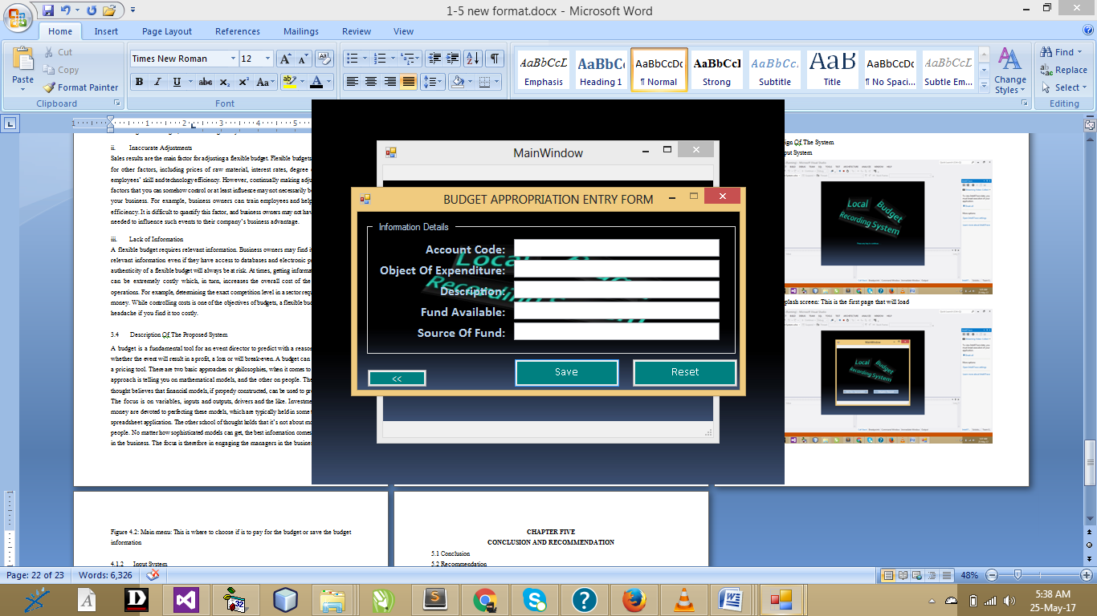
Figure 4.3: Budget appropriation: This is the page to book for appropriation.
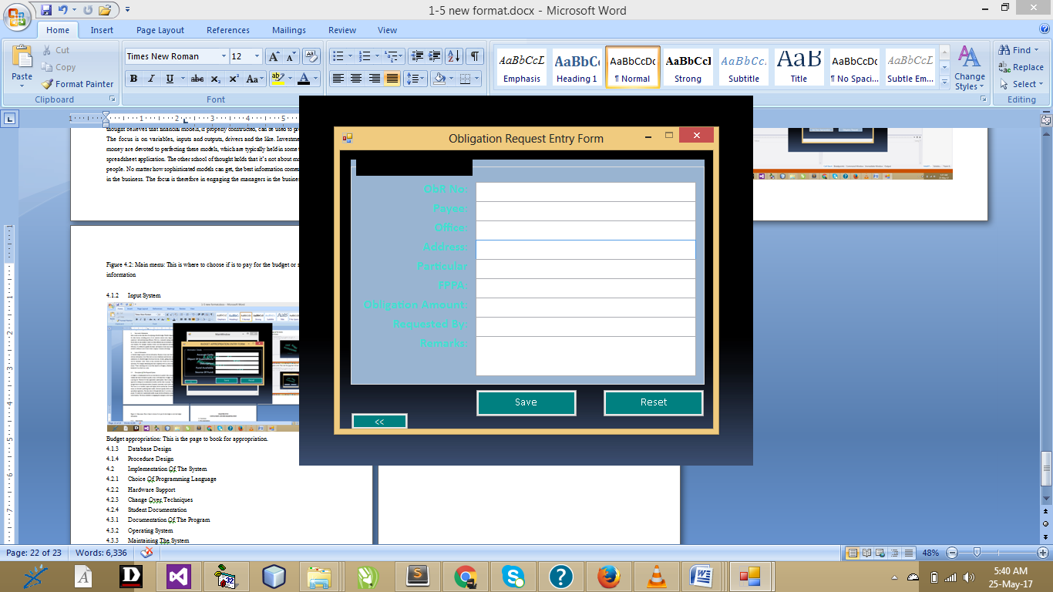
Figure 4.4: Obligation: This is the page to make amount request

4.1.3 DATABASE DESIGN
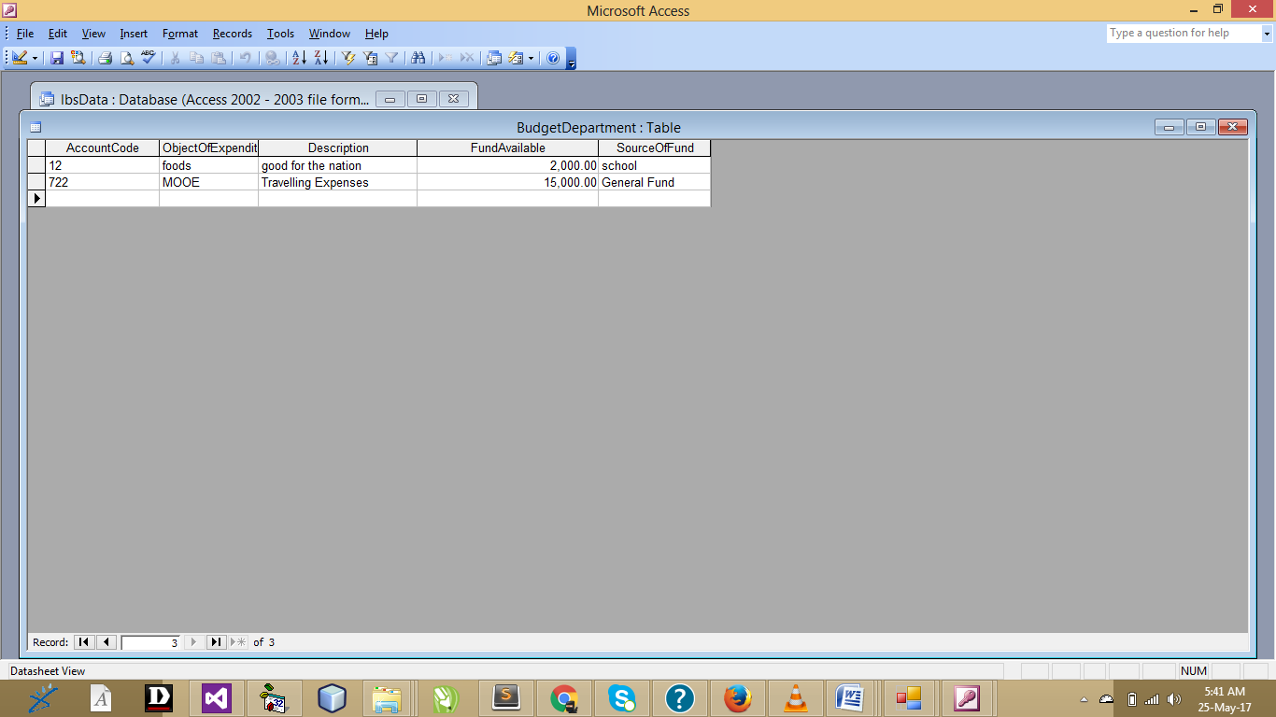
Figure 4.5: Budget
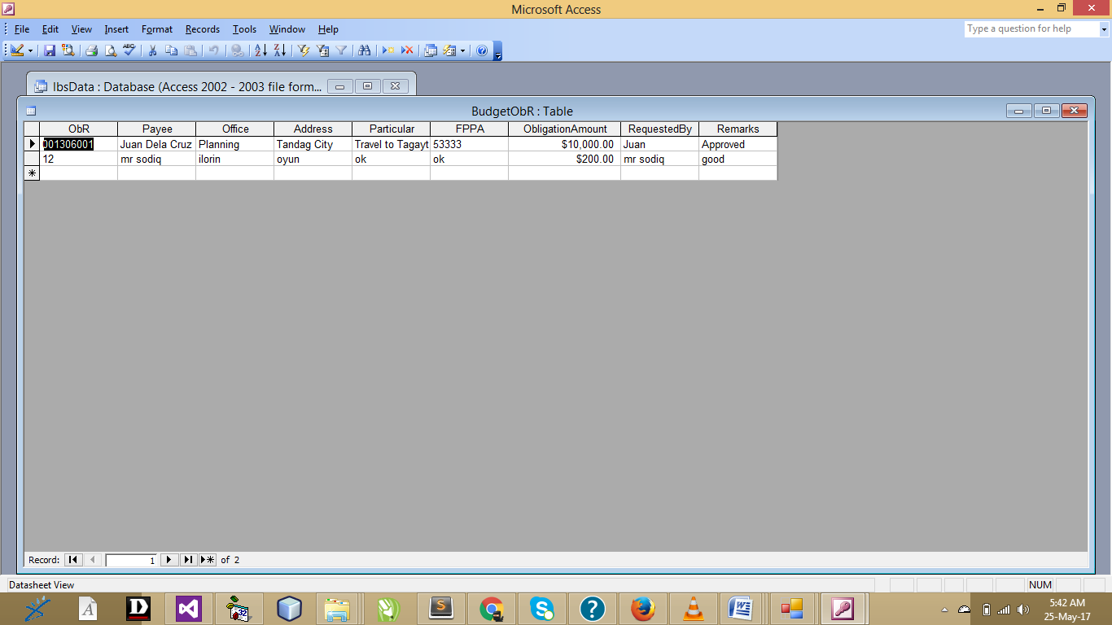
Figure 4.6: budget obligation

4.1.4 PROCEDURE DESIGN
The system consists of the splash screen, registration. System analysis is the process examining an existing system to the designing and the implementation of the new system entirely. Hence, the act of developing any computer application involved carrying out system study and converting them into a form that can be easily programmed into the computer by providing the input design, the files within the output design and the linkage between them. This refers to the ways in which the proposed system will be used and the steps are as follows:
- insert the disc into the system cd-rom
- Open the content from “my computer” icon on the desktop or clicking the start button.
- Double click the set up icon from the content of the package folder in the device (flash, CD).
- Follow the instruction and click on the appropriate button and the installation will be completed in a few moments.
Using the software after installation
- Click start on the computer desktop
- Select all programs
- Select budget
- Wait for the splash screen to finish loading
Enter username and password to begin using the software
4.2 IMPLEMENTATION OF THE SYSTEM
4.2.1 CHOICE OF PROGRAMMING LANGUAGE
The programming language used is VB.Net 2010. Visual Basic is a tool that allows you to develop Windows (Graphic User Interface - GUI) applications. The applications have a familiar appearance to the user.
Visual Basic is event-driven, meaning code remains idle until called upon to respond to some event (button pressing, menu selection). Visual Basic is governed by an event processor. Nothing happens until an event is detected. Once an event is detected, the code corresponding to that event (event procedure) is executed. Program control is then returned to the event processor.
Some Features of Visual Basic
- Full set of objects - you 'draw' the application
- Lots of icons and pictures for your use
- Response to mouse and keyboard actions
- Clipboard and printer access
- Full array of mathematical, string handling, and graphics functions
- Can handle fixed and dynamic variable and control arrays
- Sequential and random access file support
- Useful debugger and error-handling facilities
- Powerful database access tools
- ActiveX support
- Package & Deployment Wizard makes distributing your applications simple
4.2.2 HARDWARE SUPPORT
The requirement for the implementation of this proposed system are the following:
- Computer system must have at least 2.0GHZ speed for the processor
- 2.0GHZ RAM or higher
- At least 20GB and above hard disc or hard drive
- At least Pentium III and above board configuration

4.2.3 CHANGE OVER TECHNIQUES
Pilot technique:
The new system is run alongside the old system, but only processes some of the data. For example a supermarket might try out a new stock control system on one till in a store, with all sales at this till being recorded by both the old and new systems. Sales at this till may take longer, but the amount of effort required is less than that for a parallel changeover. The results produced by the two systems can be compared to see if the new system appears to work. As the new system is only being used with a small amount of data, problems that might result from processing a realistically large volume of data might not be noticed.
4.2.4 STUDENT DOCUMENTATION
i. splash screen
ii. add obligation
add budget
iii. Logout

4.3.1 DOCUMENTATION OF THE PROGRAM
It has to do with the installation and usage of the new system.
After the program has been well tested with input that the output has already been known, the next is to install the software in to the computer system for use.
The process of installing are been stated below
- Insert the CD into the system through the CD-ROM after the computer is switch on
- Locate the CD drive directory in my computer and click it to open
- After open, locate setup.exe, and then click to install the program by following the necessary step in installing the program.
- Ensure full installing of the software for effective operation of the system.
After the program has been fully install. The next thing is to locate the package install to put it into operation, to locate the package for expiration purpose the following step are to be taking
v. Click on start menu from task bar. Then select all program
From the display sub option, select by locating the software installed named temperament/ personality check to load the software.

4.3.2 MAINTAINING THE SYSTEM
- Keeping the system free from virus so as not to corrupt the program installed on the system.
- Having an updated anti-virus.

CHAPTER FIVE
SUMMARY, CONCLUSION AND RECOMMENDATION
5.1 SUMMAY
This approach improves accuracy, reduces bias, supports data-driven decisions, and enhances overall budget performance and service delivery. A genetic algorithm improves expenditure budgeting by optimizing resource allocation, enhancing accuracy, and supporting data-driven, efficient decision-making. This system will transfer the work in this department from the local to the web-based system and is able to store huge data of the staff, also enables the user to get access to data through a user-friendly interface. In addition, this system can promote the management of Ilorin East local govt to carry out its tasks high efficiently.

5.2 CONCLUSION
Expenditure budgeting System can reduce time and effort required in the process of managing users' information, also the need for a large number of staff to carry out the functions of the system, where the management of this system need only one employee, furthermore it will help the administration of the local government to speed decision-making, where this system has made it possible for the administration of the company to use real-time data when making decisions, which flows into the benefit of the company. The characteristics of this system are the answer for all the questions raised from the purpose of this study.

5.3 RECOMMENDATION
Users can be involved in operations of updating and modifying his information, which leads to faster order fulfillment in budgeting system.
The work presented in this Project has the following limitations:
- The system has not been tested.
- The budget is not discussed.
- Organizational transition and staff education is excluded.
- While the current system is getting replaced by the proposed system both systems need to be in service for the transition phase. This requires planning on both executive staff and management.

REFERENCES
Birkett, P. (2011). Competency Framework for Internal budgeting (CFIA). Alamonte Springs: The Institute of Internal Auditors Research Foundation.
Emst Y. (2012) Committee of Sponsoring Organizations of the Treadway Commission (COSO). Internal Control Integrated Framework: An Executive Summary.
Fargason, S. (2013). Law and the Internal budgeting auditing profession. Alamonte Springs, FL: The Institute of Internal Auditors, 2013.
Frigo, M., (2013). The Impact of Business Process Reengineering on Internal Auditing. The Institute of Internal Auditors Research Foundation.
Frederick G. (2012) Information Technology Control and Audit; 2nd Edition.
Reider, R. (2014) The Complete Guide to Operational Auditing. New York: John Wiley & Sons, Inc., 2014.
Rittenburg,,K. (2015) "The Outsourcing Phenomena." Internal Auditor. April 2015, 42.
Sawyer, B. (2014) Sawyer's Internal Auditing. Alamonte Springs, FL: Institute of Internal Auditors, Inc.
Selim, M. (2013) Risk Management: Changing the Paradigm. Alamonte Springs, FL: The Institute of Internal Auditors Research Foundation.
Tony A. (2014) The Information Systems Audit and Control Association & Foundation. COBIT: Control Objectives for Information and Related Technology, 2014. Available from www.isaca.org .

APPENDIX 1: HOME PAGE FLOWCHART
Start
Is Database Empty ?
Select Serial No
Open Database
Display Serial No, UserId and Name
Return
Display Track Reports Details
More Operation ?
Close Database
Display Empty Database
N
N
Y
Y
APPENDIX 2: ADMIN FLOWCHART
Start
Input Details
Return
Open Database
Is option save?
Save to database
More appropriate
Close Database
No
Yes
Yes
No

APPENDIX 3 : REGISTRATION FLOWCHART
Start
Open Database
Select AOD
Does not exist
Load obligation no
Input amount of bridget
Is option requested?
Close database
Return
No
Yes
Yes
No
Amount approval

APPENDIX 4: LOGIN AND LOGOUT FLOWCHART
Start
Load content
Display splash screen
Press any key to continue
Login page
Return

