AUTOMATED AMBULANCE DISPATCH MONITORING SYSTEM USING GOOGLE MAP
(A CASE STUDY OF KWARA STATE POLYTECHNIC MEDICAL CENTRE, ILORIN)

BY`

ADEKOYA OLORUNJUEDA ABDULSALAM
HND/23/COM/FT/0002

SUBMITTED TO THE DEPARTMENT OF COMPUTER SCIENCE,
INSTITUTE OF INFORMATION AND COMMUNICATION TECHNOLOGY
KWARA STATE POLYTECHNIC, ILORIN.

IN PARTIAL FULFILLMENT OF THE REQUIREMENTS FOR THE AWARD OF HIGHER NATIONAL DIPLOMA (HND) IN
COMPUTER SCIENCE

JULY, 2025.

CERTIFICATION
This is to certify that this project work is carried out and it has been read and approved as meeting the requirements for the award of Higher National Diploma in the Department of Compute Science, Institute of Information and Communication Technology (IICT), Kwara State Polytechnic Ilorin, Kwara State.

…………………………………. ….………………………
MR. ABIODUN, E.T Date
Project Supervisor

…………………………………. ….………………………
MR. OYEDEPO, F.S Date
Head of Department

…………………………………. ….………………………
External Examiner Date

DEDICATION
I dedicate this project work to Almighty God who inspired me and directed my ways during my academic stay in the polytechnic.

ACKNOWLEDGEMENT
All praise is due to Almighty God the Lord of universe. I praise him and thank him for giving me the strength and knowledge to complete my HND program and also for our continued existence on the earth.
I appreciate the utmost effort of our supervisor, Mr. Abiodun, E.T whose patience, support and encouragement have been the driving force behind the success of this research work. She gave useful corrections, constructive criticisms, comments, recommendations, advice and always ensures that an excellent research is done. My sincere gratitude goes to Head of Department and other members of staff of the Department of Computer Science, Kwara State Polytechnic, Ilorin, for their constant cooperation, constructive criticisms and encouragements throughout the programme.
Special gratitude to my parents, who exhibited immeasurable financial, patience, support, prayers and understanding during the period in which I was busy tirelessly on mystudies, special thanks go to my lovely siblings
My sincere appreciation goes to my friends and classmates.

LIST OF FIGURES
Figure 4.1: Dashboard Page Screenshot 18
Figure 4.2: View Program Page 19
Figure 4.3: View Request Page 19
Figure 4.4: Add Blood Page 19
Figure 4.5: Emergency Patient Report Page 20
Figure 4.6: Emergency Patient Transportation Report Page 20
Figure 4.7: Emergency Blood Bank Report Page 21
Figure 4.8: Login Page 21
Figure 4.9: Add Patient Page 22
Figure 4.10: Make Request Page 22

LIST OF TABLES
Table 4.1: Admin Data Table 23
Table 4.2: All Details Data Table 23

TABLE OF CONTENTS
TITLE PAGE I
CERTIFICATION II
DEDICATION III
ACKNOWLEDGEMENTS IV
LIST OF FIGURES V
LIST OF TABLES VI
TABLE OF CONTENTS VII
ABSTRACT VIII
CHAPTER ONE: GENERAL INTRODUCTION
1.1 Background to the Study 1
1.2 Statement of the Problem 2
1.3 Aim and Objectives 3
1.4 Significance of the Study 3
1.5 Scope of the Study 3
1.6 Organization of the Report 4
CHAPTER TWO: LITERATURE REVIEW
2.1 Review of Related Past Works 5
2.2 Review of Related Concept 7
2.3 Access to the Emergency Medical System 9
2.4 Emergency Rescue Systems 11
2.5 Pre-Hospital Medical Care 12
CHAPTER THREE: RESEARCH METHODOLOGY AND ANALYSIS OF THE SYSTEM
  - Research Methodology 15
  - Analysis of the Existing System 16
  - Problem of the Existing System 17
  - Analysis of the Proposed System 17
  - Advantage of the Propose System 17

CHAPTER FOUR: DESIGN, IMPLEMENTATION AND DOCUMENTATION OF THE SYSTEM
  - Design of the System 18
    - Output Design 18
    - Input Design 20
    - Database Design 23
    - Procedure Design 24
  - Implementation of the System 24
    - Choice of programming language 24
    - Hardware support 24
    - Software Support 24
    - Implementation Techniques used in Details 25
  - System Documentation 25
    - Operating the System 25
    - Maintaining of the System 25
CHAPTER FIVE: SUMMARY CONCLUSION AND RECOMMENDATION
5.1 Summary 26
5.2 Conclusion 26
5.4 Recommendations 26
References 28
APPENDIXES
APPENDIX1: SYSTEM FLOWCHART 29
APPENDIX 2:SPLASH FLOWCHART 30
APPENDIX 3:LOGIN 31
APPENDIX 4:MAIN MENU 32
APPENDIX 5: REGISTER 33
APPENDIX 6: AMBULANCE REQUEST 34
ABSTRACT
Monitoring system during the golden hour of patient transportation helps in improved Medicare. Presently there are different physiological data acquisitions and transmission systems using cellular network and radio communication links. Location monitoring systems and video transmission systems are also commercially available. The emergency patient transportation systems uniquely require transmission of data pertaining to the patient, vehicle, time of the call, physiological signals like ECG, blood pressure body temperature, blood oxygen saturation, and location information. These requirements are presently met by using separate communication systems for physiological data and location that result in lot of inconvenience to the technicians, maintenance related issues, in addition to being expensive. This project presents design, development and implementation of such a monitoring system for emergency patient transportation using visual basic and Microsoft SQL was used in the design of thedatabase for the patients. This system is found to be very useful foremergency patient transportation being undertaken by organizations.Top down design methodology was employed where all thesubsystems are accessible through the main menu. The sub systems are designed to perform a specific task in the program. Hence this project will be develop using Microsoft Visual Studio C# as the programming language while MYSQL will be use as the back end.

CHAPTER ONE
GENERAL INTRODUCTION
1.1 BACKGROUND TO THE STUDY
In this urban life transportation is very common. A lot of miss-happenings occur on the road every day. Therefore the need of security and monitoring is developed. To resolve such problems, a system is developed using GPS and GSM technologies and an application is introduced in this research work.
All these problems are overcome by this system immediate medical attention to critically ill patients and accident victims requires a system to transmit vehicle location information. A centralize monitoring system required in hospital which have information of accident victim vehicle and ambulance location. The doctor needs to understand the physical and physiological condition of the patient so that the right decision regarding administration of drugs and transport destination can be appropriately taken. Hence there is a need for communication between the staff of the ambulance and the monitoring station. The requirement can be achieved by using system in ambulance which uniquely transmits location information and status of patient through parameters i.e. heart beat rate and temperature etc. The system needs to include biomedical sensors to transmit status of patient. All systems are connected to each other through wireless communication which transmits information and data. Use of GPS and GSM for higher communication links will make system more effective and fast response even with this. Proposed project achieves all requirements by including four units called as Ambulance unit, Monitoring Unit, Vehicle Unit, and signal unitA Tele monitoring system incorporates innovation technology with in-home, self-monitoring assistances to collect real time updates regarding your loved ones vital signs. The self-monitoring test result are captured and transmitted to a central database that stores the information that can be accessed remotely by the patient, family and their healthcare team. Actions and modifications can be made with the results and can be utilized for on-going care recommendations(Alesancoand Garcia, 2019).
Tele monitoring is a medical practice that involves remotely monitoring patients who are not at the same location as the health care provider (Segen's Medical Dictionary). In general, a patient will have a number of monitoring devices at home and the result of these devices will be transmitted via a telephone to the health care provider.
General Packet Radio Service (GPRS) is a data transfer specification used by the Time Division Multiple Access (TDMA) and Global System for Mobile communications (GSM) networks. The GPRS system makes use of the entire coverage area and frequency of its host networks to transmit data packets. Data packets are segments of data sent between computers or network devices. The GPRS system provide subscribers uninterrupted data connection instead of a dial-up connection(Khan &Mistra, 2021).
Global Positioning System (GPS) is a navigation system for portable devices. It uses a network of satellites surrounding the planet. A compatible device such bas a smartphone or a dedicated navigation device has a built-in receiver chip that picks up regular signals from the satellites. Each signal is time-coded so the device can calculate how far away it is from the satellite based on the time the signal takes to arrive. By combining the distances from at least four satellites, the device can calculate its position to within a few feet. It can also cross-reference this with map data to provide navigation such as driving directions.
Emergency patient Transportation is handled with an ambulance which is a vehicle for transportation of sick or injured people to, from or between places of treatment for an illness or injury especially in emergency and I some instance will provide out-of-hospital medical care to the patient.
1.2 STATEMENT OF THE PROBLEM
The number of road accidents victims in every busy city in Nigeria can be unimaginable. Immediate medical attention to critically ill patients and accident victims followed by transportation to a well-equipped local facility within the golden hour can save many lives.
Ambulances are specifically designed to carry emergency drugs and instruments. The inner area of an ambulance is fabricated in such a way that it houses emergency medicine, sterilizer, stretcher and so forth. The personnel inside the ambulances are specially trained to be emergency technicians. There exists a need to augment the skill of such paramedics with the Central Monitoring Station (CNS). The CNS helps in identifying the nearest and appropriate hospital and coordinating with the medical personnel of the hospital.

1.3 AIM AND OBJECTIVES OF THE STUDY
The major aim of this work is to design a data transfer and navigation system into a Tele monitoring system for the purpose of facilitating information passage between the operators of the Tele-monitoring system and ambulance drivers in an Hospital for the emergency transportation of patients.
The objectives of this project work are to:
- design and implement a system that cater the specific requirement of acquiring physiological data, keyed-in data, patient snapshot, and voice signals and transmitting them using a cellular network to a Central Monitoring Station that helps in identifying the nearest and appropriate hospital and coordinating with the medical personnel of that hospital.
- To allow for the objective evaluation of patient’s symptoms received for optimal dose finding.
- Track the motion of patients in their surroundings.
1.4 SIGNIFICANCE OF THE STUDY
Implementation of a GPS and GPRS based telemonitoring system for emergence patient transportation will be of immense benefit to the hospital. The system will assist the hospital achieve the following:
- easily be retrieved Improve the communication between the staff of the ambulance and the central monitoring station records
- The doctor will understand the physical and physiological condition of the patient better so that right decision regarding administration of drugs and transport destination can be appropriately taken
- Administrative requirements including the location of the vehicle, patient’s attendance details can.

1.5 SCOPE OF THE STUDY
The extent to be covered in this project work is limited to the confines of an emergency unit of hospital, which is well equipped with modern day ambulances and equipment, but with more researches in this project topic, it can be used in all hospitals with emergency unit and ambulances to reduce the rate of deaths in emergency situations.
1.6 ORGANISATION OF THE REPORT
This project is segmented into five distinct chapters. Chapter one describes the introduction, statement of the problem, aims and objectives, significance of the study, scope and limitation as well as the organization of the report.
The second chapter talks about the review of relevant literature, pre-requisites of the IP spool system, overview of the considered IP system.
The third chapter deals with the analysis of the existing system description and the advantages of the proposed system and methodologies.
The second to the last chapter deals with the design of the system which entails the output, database and procedure design of the system, the implementation comprises of the hardware and support while the documentation comprise of how to use the system and the system maintenance.
The last chapter deals with the summery experienced gained, conclusion and recommendation.

CHAPTER TWO
LITERATURE REVIEW
2.1 REVIEW OF RELATED WORK
David (2021), present a journal title “Ambulance Service Operational Improvement”, since the start of industrialisation in the beginning of the previous century, processes, and technology have evolved drastically. Technology that had been developed for a specific application was found to open new horizons in other domains. A good example is the use of sonar technology on military submarines which eventually found medical applications in medical imaging (Oakley, 2019). The paramedic profession is still considered to be a relatively young profession, and although the clinical scope of practice of ambulance staff has widened there have been few noticeable and significant changes in the way Ambulance Services operate as public service providers. There is, however, great variation in the way pre-hospital emergency care provision is delivered and organised from country to country due for example to historical, cultural, financial, and geographical factors.
Ashwini (2024), also present a paper titled“Design and Implementation of GPS and GSM Based Intelligent Ambulance Monitoring with Patient Health Care”, Monitoring during the golden hour of patient transportation helps to improve medical care. Presently there is different physiological data acquisition and transmission systems’ using cellular network and radio communication links. Proposed project presents design and implementation Ambulance system for emergency patient transportation employing ARM 7. The monitoring (server) system at hospital monitors ambulance location as well as Accident victim vehicle using Google maxp. It also include biomedical sensors to monitor heart bit rate and temperature of patient through SMS. The front end application at the monitoring system is developed using visual basic software in Personal Computers. It can display location of ambulance and status of heart bit rate and temperature of patient. After receiving SMS hospital can prepare their staff for proper treatment of coming patient.
Shubhangi& Maruti (2020) write and present a journal titled “Real Time Health Monitoring Using GPRS Technology”, advances in sensor technology, personal mobile devices, and wireless broadband communications are enabling the development of an integrated personal mobile health monitoring system that can provide patients with a useful tool to assess their own health and manage their personal health information anytime and anywhere. Personal mobile devices, such as PDAs and mobile phones, are becoming more powerful integrated information management tools and play a major role in many people's lives. Here I focus on designing a Mobile health-monitoring system for people who stay alone at home or suffering from Heart Disease. This system presents a complete unified and mobile platform based connectivity solution for unobtrusive health monitoring. Developing a hardware which will sense heart rate and temperature of a patient, using Bluetooth modem all information lively transmitted to smart phone, from smart phone all information transmitted to server using GPRS. At server the received data compared with the standard threshold minimum and maximum value. The normal range of heart rate is 60 to 135 and the temperature of the patient is said to be normal above 95^F and below 104^F. If at all the rate increases above 145 or decreases below 55,it may be fatal and if it crossed this threshold limit then SMS will be sent to the relative of patient and Doctors along with measured values.
Iñaki, et al.,(2022) write on “Assessment of a primary care-based telemonitoring intervention for home care patients with heart failure and chronic lung disease”, Telemonitoring technology offers one of the most promising alternatives for the provision of healthcare services at the patient’s home. The primary aim of this study is to evaluate the impact of a primary care-based telemonitoring intervention on the frequency of hospital admissions. A primary care-based randomised controlled trial will be carried out to assess the impact of a telemonitoring intervention aimed at home care patients with heart failure (HF) and/or chronic lung disease (CLD).The results will be compared with those obtained with standard health care practice. The duration of the study will be of one year. Sixty patients will be recruited for the study. In-home patients, diagnosed with HF and/or CLD, aged 14 or above and with two or more hospital admissions in the previous year will be eligible. For the intervention group, telemonitoring will consist of daily patient self-measurements of respiratory-rate, heart-rate, blood pressure, oxygen saturation, weight and body temperature. Additionally, the patients will complete a qualitative symptom questionnaire daily using the telemonitoring system. Routine telephone contacts will be conducted every fortnight and additional telephone contacts will be carried out if the data received at the primary care centre are out of the established limits. The control group will receive usual care. The primary outcome measure is the number of hospital admissions due to any cause that occurred in a period of 12 months post-randomisation. The secondary outcome measures are: duration of hospital stay, hospital admissions due to HF or CLD, mortality rate, use of health care resources, quality of life, cost-effectiveness, compliance and patient and health care professional satisfaction with the new technology.
2.2 REVIEW OF RELATED CONCEPTS
Immediate medical attention to critically ill patients and accident victims followed by transportation to a well equipped medical facility within the golden hour saves many lives. Numbers of road accidents in India are the highest across the world. According to National Transportation Planning and Research Centre (NTPRC) the number of road accidents for 1000 vehicles in India is about 35 while the figure is between 4 to 10 in developed countries. About 1,05,000 accidents take place every year (WHO report, 2023). There are several governmental and non governmental agencies like Emergency Management Research Institute (EMRI), located across the country, which have been dedicated to the cause of transporting critically ill patients and accident victims. About 2,87,000 lives have been saved by EMRI in past six years. The ambulances are specially designed to carry emergency drugs and instruments. Inner area of ambulance is fabricated in such a way that it houses emergency medicines, sterilizer, stretcher etc. A typical inside layout of an ambulance employed for emergency patient transportation is shown in Fig.1. The paramedics that accompany the ambulances are specially trained to be emergency technicians. There exists a need to augment the skill set of such paramedics with the expert doctor’s advice from the central monitoring station (CMS). CMS helps in identifying nearest and appropriate hospital and coordinating with the medical personnel of that hospital.
Hence there is a need for communication between the staff of the ambulance and the central monitoring station. The doctor needs to understand the physical and physiological condition of the patient so that right decision regarding administration of drugs and transport destination can be appropriately taken. Administrative requirements include the location of the vehicle, personnel attendance details etc. Deploying these instruments would mean that separate communication mechanism namely usage of separate SIM cards and separate GSM / GPRS modems would be required resulting in increased recurring expenditure. Hence a comprehensive, cost effective system that can acquire physiological data from the patient, keyed in data from a keyboard, location data from a GPS receiver as well as voice signals and send them using cellular network is needed.
Several systems related to telemonitoring are reported in literature (Yen et al, 2021). Plesniket al., (2020) have developed a real-time remote monitoring system for combining ECG data and GPS data before transmitting to a Central Monitoring Station (CMS). Similar systems are independently developed by researchers at the Glenn Research Center (NASA), University of Akron and CaseWesternUniversity. Abid Khan and Ravi Misra, (2022) reported that position and velocity of vehicle can be estimated using GPS receiver fitted in the vehicle and sent to the central monitoring station using GSM. Zhang and Lu (2019) developed an ECG telemonitoring system with GPS and GPRS to continuously monitor ECG of the cardiac patient along with the position and posture. Fang Zu-xiang and Lai Da-kun (2020) have developed a system to monitor the ECG of cardiac patient who is away from the hospital. A mobile ECG telemonitoring system along with an accelerometer, to sense sudden postural changes that reflect sudden cardiac failure, has been developed (Alesanco, 2020). Philips Company has developed systems for remote monitoring of cardiac patients from their research centers worldwide in 2009. Exact and continuous blood pressure monitoring system along with location information and time synchronization facility to work with other measurement modules has also been proposed (Krejcar, 2019). Recent advances in telemonitoring systems resulted in early diagnosis and management of chronic and degenerative conditions, significantly prevalent in elderly people. The number of recurring visits to the hospital can be reduced. Physicians are provided with better insight into the patient’s health. Telemonitoring can also be applied on a long-term basis to elderly persons to detect gradual deterioration in their health status resulting in inability to live independently. Monitoring the activity of upper limbs can help in assessing the health status. (Kiss et al, 2011). Several digital signal processing techniques have also been employed to denoise and study GPS and ionospheric studies (Yedukondalu et al,2021; Ratnam et al, 2021). Companies including QRS diagnostic, VivoMetrics, Human Network Technology, AMD Telemedicine, Health Frontier and Cardionet have been engaged in development of telemonitoring systems. Though all these systems are intended towards remote monitoring of cardiac patients, the concept of a unified system is not satisfied by any of the existing systems. They do not cater to the specific requirement of acquiring the physiological data, keyed-in data, patient snapshot and voice signals and transmitting them using cellular network. Hence, it is proposed to develop an indigenous system to meet these requirements (Fig. 2). The system developed by us is a comprehensive, cost-effective system (approximately USD 4500), which can acquire the physiological data, GPS data, vehicle parameters, patient information, patient snap shot and SOS messages and transmit them as a single data packet using a cellular network. This system has been built around ARM 9 / 11 micro controller based module exclusively designed for this purpose and integrated with commercially available GPS, GSM modules, physiological signal acquisition systems like Medicaid and GSM phone with Blue Tooth (BT) facility. The necessary software for the embedded system has been developed using KEIL compiler for ARM family of micro controllers. The front end application at the central monitoring system is developed using .net technologies. The system has been deployed in an ambulance for initial evaluation. This system is found to be very useful for emergency patient transportation being undertaken by organizations like EMRI.
Fig 2.1: Architecture of the proposed system.

2.3 ACCESS TO THE EMERGENCY MEDICAL SYSTEM
A national emergency number speeds up the process and guarantees that all relevant agencies are warned and involved. In high-income countries, access to the emergency medical system is almost always made by telephone, but the coverage and reliability of the telephone link varies between countries. The growth in the use of mobile telephones is having a helpful effect on crash notification (Peden, 2018). For the European Union, 112 is the emergency telephone number which allows European citizens in distress to contact the emergency services in all Member States. It was established by Council Decision of 29 July 1991and reinforced through the Directive 98/10/ECand now to be found in the Universal Service Directive. According to the European Commission it has now been implemented in all EU countries, although the number is little known by EU citizens according to European Commission monitoring. No information is available about the time taken to answer this emergency call number and no EU standard exists for call receipt.
In vehicle emergency notification systems, ‘Mayday’ systems aim to reduce the time between when the crash occurs and when medical services are provided. By improving information transfer between the trauma care physician and emergency medical service personnel, they aim for faster and more appropriate treatment. In 2000, Autolive and Volvointroduced one of the world's first post-crash safety systems.
Automatic Crash Notification (eCall) which is currently under development takes the safety benefits of Mayday systems further by providing emergency responders with data that indicates the severity of the crash and the nature of injuries sustained. A Finnish study has estimated that such a system might reduce between 4-8% of road deaths and 5-10% of motor vehicle occupant deaths in Finland (Virtanen, 2017).
An efficient call receiving system is essential to avoid wasted time. A variety of models exists but has not been studied. In some Member States, calls are answered by the ambulance services or the emergency medical services, in others by other emergency services – police and fire service – and then appropriate calls are transferred to the emergency medical system. A priori direct over indirect contact is to be preferred (Buylaert, 2016). It is not known whether all countries have standards for call receipt, although several countries have developed call receipt performance indicators.
2.3.1 EMERGENCY MEDICAL DISPATCH
In Europe, calls received by the Emergency Medical System either results in:
- Automatic dispatch of an emergency ambulance requiring the call taker to give accurate identification of the location of the incident and to mobilize the emergency crew;
- Selective dispatch depending on the perceived nature and urgency of the incident and the process of doing this is known as Emergency Medical Dispatch.
The functions of the Emergency Dispatch System are:
- Prioritization by level of urgency (triage) to determine the speed of response
- Prioritization by level of need to determine type of response
- Provision of pre-ambulance arrival instructions in first aid and scene management
- Communication with those on the scene and in the receiving hospital.
Clinical experts across Europe believe that all calls to the Emergency Medical System in Europe should be transferred as soon as possible to a trained dispatcher able to make a layered response using an appropriate Emergency Dispatch System (Buylaert, 2010).
A computerized system which promotes the call taker, records responses, supports decision making and provides information for audit and quality assurance is considered essential (Nicholl, 1997). There are various ways of operating emergency medical dispatch systems: the essential elements which have been identified are the use of a standard protocol, the need for medical supervision, audit of operations and the training of dispatchers (Buylaert, 2015).
2.4 EMERGENCY RESCUE SYSTEMS
Emergency rescue requires effective coordination between all the emergency services. The objective is to ensure speedy first aid and transport to an appropriate treatment centre. There needs to be close professional cooperation at the scene between fire-fighters, coastguards and police (who may arrive first at the scene) and the emergency medical service personnel.
Emergency medical technicians who staff an ambulance who carry out basic pre-hospital care techniques to save lives and limit disability. However, research shows that the level of training and the degree of professionalism involved varies (Huemer, 2011). The important status of the emergency medical technician is often not well recognized, is seen as an accessory for the fire department, or is even left to volunteers. The establishment of minimum standards at European Union level has been recommended by clinical experts in Europe (Buylaert, 2010).Non-medical emergency services need to be trained in basic life support in order to provide immediate first aid. There also needs to be cooperation between the fire-fighting services and medical personnel when victims are not readily accessible and special training is organized in many Member States to this effect. One issue, in particular, is the need for safe extrication of victims and awareness of the rescue services of special hazards such as un-deployed airbags.
Land ambulances are used in the majority of road collisions in Europe. The standardization of equipment in ambulances in Europe has been recommended, together with the development of appropriate vehicle and driver safety standards, given the considerable number of crashes involving ambulances (Buylaert, 2010).
A research overview by Elvik and Vaa (Elvik, 2004)indicates that the faster a road casualty can gain access to expert first aid, the greater the chance of survival and full recovery. Research shows that:
- In general, road traffic deaths increase with increasing ambulance response time which is strongly related to population density
- The proportion of fatal crashes is lowest where ambulance availability is best and highest where ambulance availability is poor.

2.5 PRE-HOSPITAL MEDICAL CARE
While the old method of ‘scoop and run’ without any treatment is no longer practiced in high income countries in Europe, to ‘stay and play’ at the scene may also be detrimental for the prognosis of the patient (Buylaert, 2016). A recent survey of pre-hospital literature found only 24 randomized controlled trials and concluded there was insufficient data to provide a strong evidence base for the effectiveness of many common pre-hospital interventions (Bunn, 2001). The World Health Organization (Sasser, 2005)distinguishes between basic and advanced systems of pre-hospital care.
Basic Life Support (BLS): Consists of emergency medical care to restore or sustain vital functions (airway, respiration, circulation) without specialized medical equipment and to limit further damage in the period preceding the arrival of specialized, advanced emergency medical care.
Advanced Life Support (ALS): Medical care given by medical doctors and nurses trained in critical care medicine with the use of specialized technical equipment, infusion of fluids and drugs aimed to stabilize or restore vital functions. Advanced life support is an integral part of a system of emergency medical services that needs adequate medical supervision.
While advanced systems are impressive and undoubtedly benefit some patients, WHO states that there is little evidence that they are inherently superior to systems that offer basic pre-hospital care. They may also hinder the overall provision of pre-hospital care if they lead system planners to divert scarce resources from basic interventions that benefit large numbers of patients to interventions that benefit fewer patients. With few exceptions (such as early defibrillation for victims of cardiac arrest), most advanced interventions have not been scientifically proven to be effective because the necessary randomized trials have not been conducted. In contrast, improved outcomes have been documented after bystanders and health-care providers have been educated to provide the fundamental elements of trauma care (Sasser, 2005).
Scientific knowledge about the efficacy of pre-hospital medical care techniques is, thus, still evolving. The optimal approach needs to be determined for different types of trauma patients and well-controlled studies need to be carried out to address this question further. It is clear, however, that only essential treatment should be given so there is no unnecessary waste of time. Measures to protect the victim from further injury, basic life support measures such as providing a free airway and techniques used to aid breathing are considered essential.
Mouth to mouth resuscitation and mask bag valve ventilation and decompression are also essential techniques. Measure to reduce circulatory failure and maneuvers started for immobilizing possible fractures to prevent further damage are also considered to be essential treatments (Buylaert, 2019).
Those who provide basic pre-hospital trauma care have had formal training in pre-hospital care, scene management, rescue, stabilization and transport (World Health Organization, 2005). Essential basic pre-hospital care techniques can be delivered by emergency medical technicians staffing ambulances. Advanced techniques can only be provided by:
• Paramedics (emergency medical technicians who have received further training) e.g. in the UK
• Nurses specialized in critical care e.g. in the Netherlands
• Physicians in mobile intensive care units which is a system widely used in Europe e.g. in Belgium, Germany, France, Italy.
In order to make the best use of resources, a two-tier system has been set up in some European countries comprising emergency medical technicians as the first tier and mobile intensive care units as a second tier.
Different factor needs to be taken into account in the decision about the appropriate hospital for the road traffic victim such as type of injuries, services available at the hospital, comparative distances and times to reach hospitals, and regulations concerning the transport of injured people.
Triage is the term applied to the process of classifying patients at the scene according to the severity of their injuries to determine how quickly they need care. Careful triage is needed to ensure that resources available in a community are properly matched to each victim’s needs. Formal algorithms or protocols need to be developed to ensure that community resources are used properly to care for trauma patients; these algorithms must exist for both the pre-hospital and hospital setting. Failure to develop protocols may lead to over-triage or under-triage.
Over-triage occurs when non-critical patients are sent to facilities offering the highest level of care. Under-triage occurs when critically injured patients are treated at the local level or sent to facilities that are not properly equipped to meet their needs. This may result in increased morbidity and mortality among patients with otherwise treatable injuries care (Sasser, 2005).
Physician input is needed throughout the planning, implementation, evaluation and audit of the Emergency Medical System. Medical control and direction of pre-hospital care is essential and at the local level, a knowledgeable and committed health-care professional should be identified to serve as the medical director. In urban areas, an experienced hospital-based physician trained in accident and emergency medicine, anesthesiology or critical care, or trauma surgery, and ideally trained or experienced in pre-hospital care, may be best suited to this role. In rural communities where a physician may not be available, the most experienced nurse or paramedical professional should fill this role. It is important that qualified individuals be assigned responsibility for assuring the availability and quality of pre-hospital care in their community, whether it is delivered through paid health-care providers or local volunteers care (Sasser, 2015).
Major road crashes which involve multiple casualties; Contributory factors include fog and excess speed (Buylaert, 2020). Large numbers of injured persons may also result from collisions involving buses or Lorries carrying explosive, toxic or inflammable chemical products. A disaster planning document is needed to strengthen the capacity of local and regional governments, health-care providers and public health organizations to react to such events (Sasser, 2005). Best practice indicates that a region-wide trauma team is the optimal means of dealing with such events utilizing such a disaster plan. Post impact care is coordinated by hospital-based medical teams who are trained in disaster management and in collaboration with the ambulance, police and the fire service. Efficient rescue involves on-site triage and immediate care, evacuation and hospital admission speed (Buylaert, 2010).

CHAPTER THREE
RESEARCH METHODOLOGY AND ANALYSIS OF THE EXISTING SYSTEM
3.1 RESEARCHMETHODOLOGY
The proposed system is developed with Microsoft Visual studio as the compiler C# as the Programming language while MYSQL is used as the back end with PHP as the server-side scripting language. During the analysis of the programming language to be use, various language where examines but C# were chosen because of the ability to import design, code is easy to tress and debugin this programming language, C#were decided to be use due to the following reason.
- It is easy to understand during designing
- It can be easily manipulate in other to design a user friendly environment
- It can be easily manipulate with MySQL in access for database reference.
The Google Geolocation API provides the geographic information of the particular location like latitude and longitude associated with the hosting device. Information about the location can be tracked using the GPS and the other sources which provide the location information such as IP address, Wi-Fi,Bluetooth Mac address, GSM,CDMA etc.
We use Google Geolocation API for identifying the current address of the user.
- Geolocation API provides the geographical location of hosting device.
- This API is used in this project for obtaining the latitude and longitude.
A system for obtain the current location of the user was designed. The block diagram of the proposed system is shown in figure 3.1. The location of the user will be identified with the help of Google Geolocation API. This system provides the current location of the user or the hosting device. We firstly calculate the geographical coordinates i.e., latitude and longitude of the current location of the hosting device.Then based on the values of latitude and longitude, the address will be calculated. Reverse Geocoding will be performed on the set of geographical coordinates to convert the latitude and longitude into the formatted address. This system will use the geolocation API for providing the address of the user.

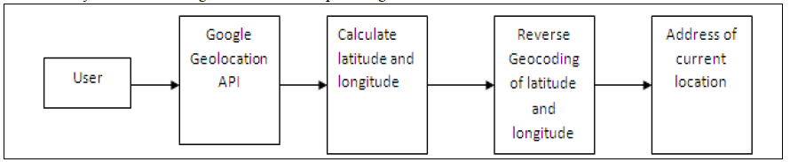

Figure 3.1: Block diagram of the proposed system
3.2 ANALYSIS OF THE EXISTING SYSTEM
The monitoring consists of several networked computers with voice facility. An accident victim, or patient in emergency or an attendant dials a toll free, pre designated number belonging to the central monitoring station being managed by an NGO. The call is answered by the call centre executive, who obtains details like nature of emergency, assesses the help needed and then transfers the call to a medical expert, Emergency Response Care Physician (ERCP) in the call centre. Initial advice is given to the patient’s attendant. Based on the information related to the location, an ambulance in the vicinity of the site is dispatched. Once the ambulance reaches the site, The Emergency Medical Technician (EMT) provides pre hospital care to the victim at the scene. He then connects the physiological data acquisition to the patient, which acquires required data from the victim and transfers the data (including patient’s image, previous history etc.) to the call centre ERCP,’s computer system, where the doctor is available. The data received through internet is extracted to obtain the individual parameters. These extracted parameters include ambulance position, patient’s physiological parameters and patient’s image. These are displayed on graphical user interface of the system. The precise position of the ambulance and its movement is also displayed on the monitor with the help mapping software on PC at the monitoring. Because of this mapping interface the Dispatch Officer (DO) at the monitoring has a chance to know the position of ambulance exactly and guide that ambulance to the accident location on receiving the accident call. Later this software helps the staff at the central monitoring station to guide the ambulance to the appropriate, nearest hospital. EMT is advised by the ERCP, who assesses the patient with the available clinical information made available to him, regarding the care and drugs to be administered to the patient. This is followed by shifting of the emergency victim to nearest and appropriate hospital. GPS information is useful in identifying the appropriate hospital with requisite medicare facilities. The ambulance is equipped with a variety of medical equipment, medical consumables and disposables to ensure the victim is stabilized (pre hospital care) by the time the ambulance reaches the hospital for further treatment. Once the patient is handed over to the hospital, the ambulance returns to its pre designated base location and is ready for attending next emergency.
3.3 PROBLEMS OF THE EXISTING SYSTEM
The current system is opposed by a lot of problems which includes:
- Inaccurate Record: The hospital cannot give accurate record of the number of emergency in there care without going through the file register to count the numbers.
- Identification Problem: The manual system poses the problem of identifying the patient as there is no pictures to identify them.

3.4 ANALYSIS OF THE PROPOSED SYSTEM
The new system will make provision for the collection of the patient’s bio data with the picture and also the collection of the contact information. This will be store in the database for retrieval when needed. The new system with the facilities built in it will among other things:
- Store the patient’s information on the database
- Enable easy identification of the patients during accident
- Have accurate statistics of the number of patients in the hospital.
- Have the database secured through the use of password

3.5 ADVANTAGES OF THE NEW SYSTEM OVER THE EXISTING SYSTEM
The new system have the following advantages over the existing system
- It is easy to use.
- It is accurate.
- It quickly identifies people.

CHAPTER FOUR
DESIGN, IMPLEMENTATION AND DOCUMENTATION OF THE SYSTEM
4.1 DESIGN OF THE SYSTEM
System designs calls for the creativity of the analyst. Therefore, creating an acceptable design, the system analyst must exclude all prejudice.
The design of the system is the approach of work out how best computers together with other resources may be applied to perform data storage, management and retrieval for decision making.
4.1.1 OUTPUT DESIGN
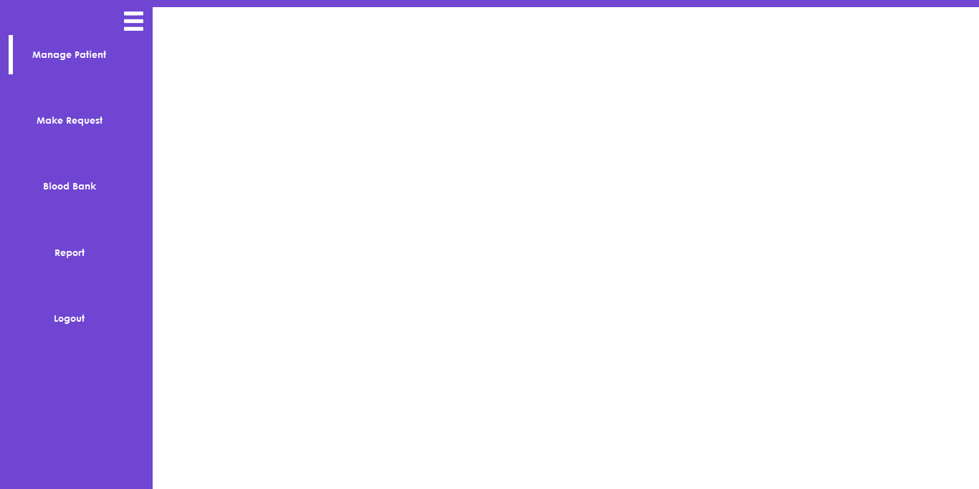

Figure 4.1: Dashboard Page: This is where all the icon is shown, a click on one of this icon will channel you to another page
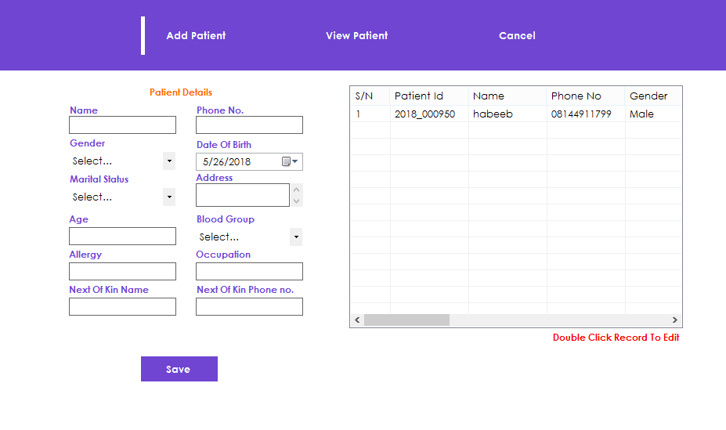

Figure 4.2: View Patient Page: This is where you view the patient details
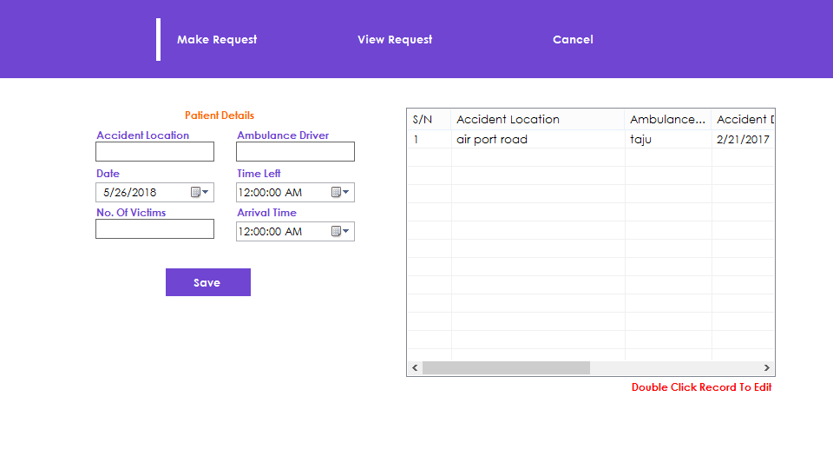

Figure 4.3: View Request Page: This is the page where you view the ambulance requested for.
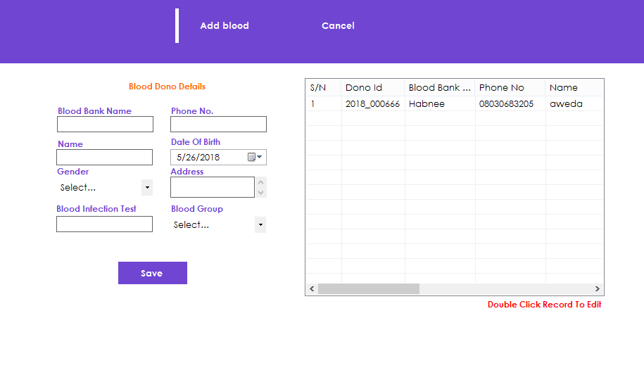

Figure 4.4: Add Blood Page: This is the page where blood donor details are displayed

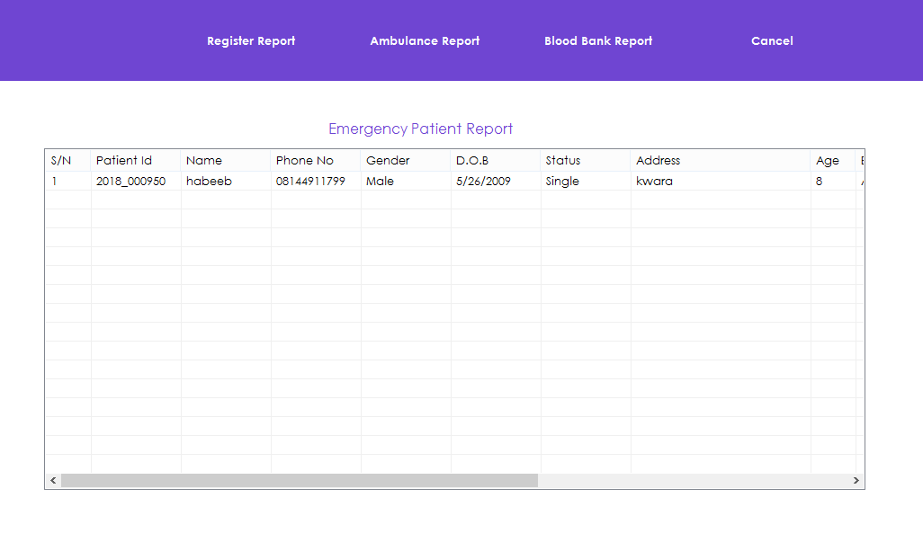

Figure 4.5: Emergency Patient Report Page: This is where the emergency patient report is displayed

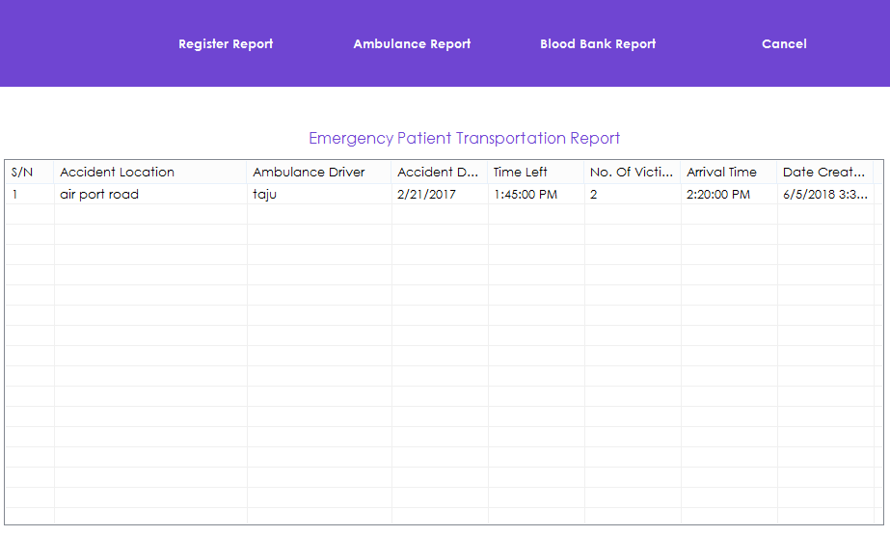

Figure 4.6: Emergency Patient Transportation Report Page: This is the page where an emergency patient Transportation report is viewed

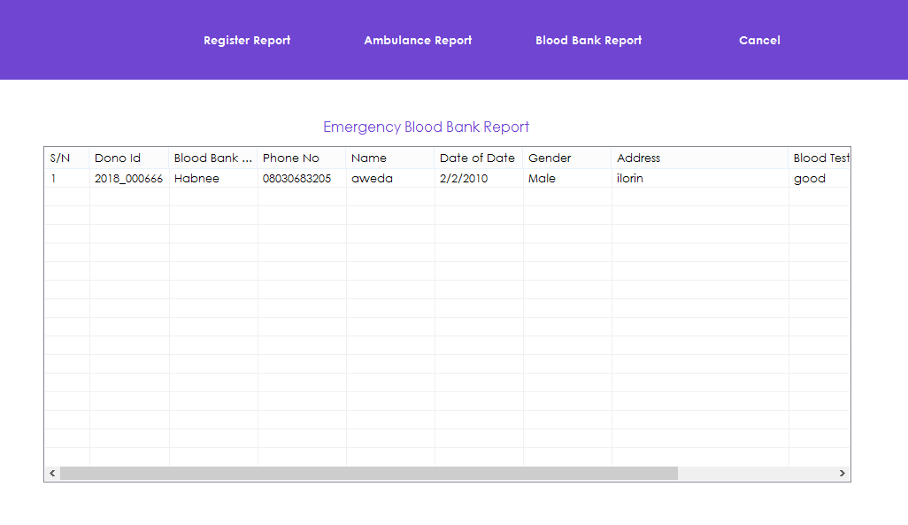

Figure 4.7: Emergency Blood Bank Report Page: This is the page where blood bank report is displayed

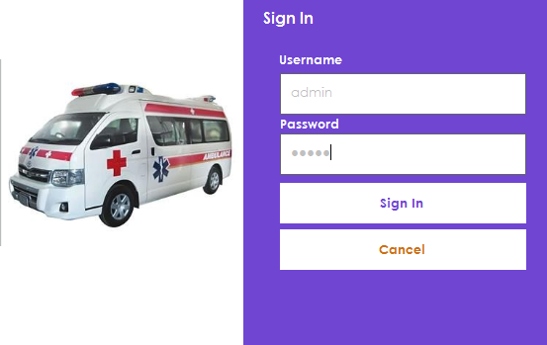
4.1.2 INPUT DESIGN

Figure 4.8: Sign in Page: This is the page username and password is entered to sign into the application

Figure 4.9: Add Patient Page: This is the page where patient records are entered

Figure 4.10: Make Request Page: This is the page where you make request for a patient

4.1.3 DATABASE DESIGN
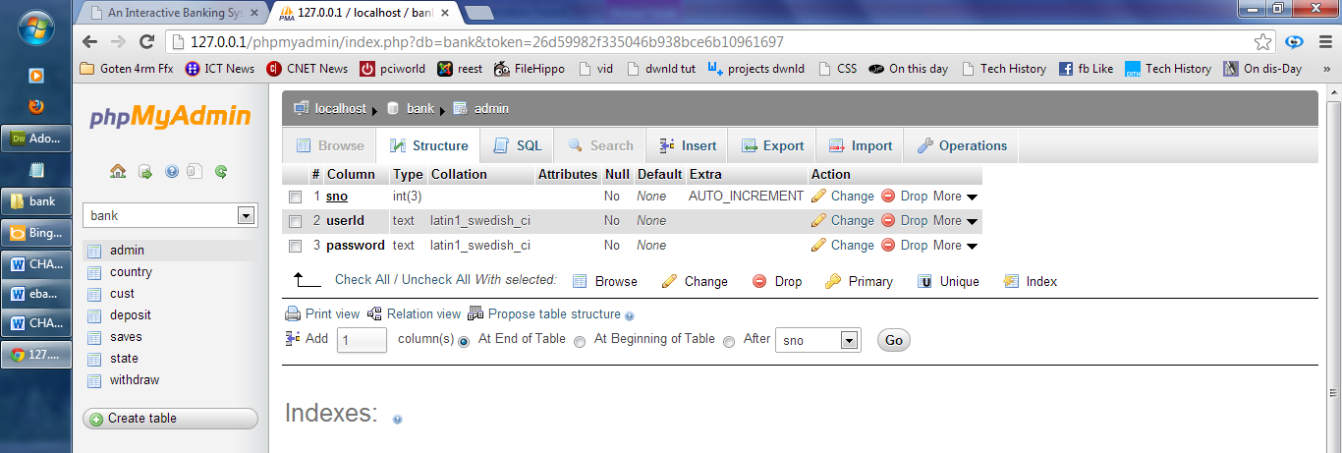
Table 4.1: Admin Data Structure: This is the admin database where username and password entered by users are displayed
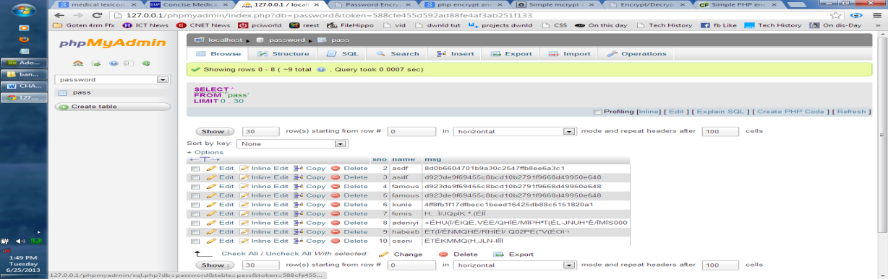
Table 4.2: All Details Data table: This is the page where all patient, ambulance requested details, blood bank are displayed

4.1.4 PROCEDURE DESIGN
The procedural design describes the system generally. It describes the various main programs in the system as well as the relationship that exist between all subprograms included. The procedural designs in this new system are of 5 menus of which each menu has it sub menu.
The application also contains several modules of which each module has its own specific function. The purpose of dividing the program into modules is because it enhances maintainability, readability and easy debugging.
4.2 SYSTEM IMPLEMENTATION
4.2.1 CHOICE OF PROGRAMMING LANGUAGE
Visual basic 6.0 is the chosen programming language for the implementation of the proposed system because of its pedagogy and open source help when needed. As well it has a support for variety of database application like sql server, sqllite, mysql, and Microsoft access but Microsoft Access is selected.
4.2.2 HARDWARE SUPPORT
The computer configuration required to run the software is;
Computer/memory processor PC with a 48dx, MHZ or Pentium, Intel or higher processor required.
Memory: 2GB of RAM
Cache memory:512KB
Hard disk Minimum size : 500GB
Recommended : 200GB
Virtual Memory :32Bits
Cache memory :512KB
4.2.3 SOFTWARE SUPPORT
The software support for the design of the proposed system involves operating system, Microsoft visual basic 6.0, Microsoft Access as well as an anti-virus software which prevents the system from being infected by virus.

4.2.4 IMPLEMENTATION TECHNIQUES USED IN DETAILS
The system will be implemented using the parallel approach. This approach is considered because it ensure that the new system is tested along side with the old system to ensure the effectiveness and efficiency of the system.
4.3 SYSTEM DOCUMENTATION
4.3.1 PROGRAM DOCUMENTATION
Program documentation includes:
- Installing application software to allow easy communication of the proposed system.
- Open Application software to implement the program
- Locate the project by Browsing through the system by going to the window menu key,
- Then prompt All Program then click on Spatial Matrix Game Software.
- Follow all the instruction to play the game and played with intelligence
- Best of Luck
4.3.2 OPERATING THE SYSTEM
- Click start on the computer desktop
- Select all programs
- Select any browser e.g internet Explorer, Mozilla Firefox, Google Chrome e.t.c
- Type the url (Uniform Resource Locator) of the system into the address bar (localhost/password/)
4.3.3 MAINTAINING THE SYSTEM
The following instructions must be strictly adhere to in other to make efficient use of the system. Install an anti-virus and always make sure it is usually updated to.

CHAPTER FIVE
SUMMARY, CONCLUSION AND RECOMMENDATION
5.1 SUMMARY
Monitoring during the golden hour of patient transportation helps to improve medical care. Presently there is different physiological data acquisition and transmission systems’ using cellular network and radio communication links. The monitoring (server) system at hospital monitors ambulance location as well as Accident victim vehicle using Google map. It also include biomedical sensors to monitor heart bit rate and temperature of patient through SMS. The front end application at the monitoring system is developed using visual basic software in Personal Computers. It can display location of ambulance and status of heart bit rate and temperature of patient. After receiving SMS hospital can prepare their staff for proper treatment of coming patient.

5.2 CONCLUSION
The project saves a few critical minutes of response times by monitoring location of ambulance from Hospital. Status of patient transmitted through Parameters Heart beat Rate and Temperature with Ambulance Location. Project found very useful for emergency treatment of patient during transportation as expert doctors connected to the system. It transmits information of vehicle location which provides medical facility within short period of time to accident victim. Signal provided to signal unit using RFID reader’s controls traffic and valuable time can be saved. Monitoring unit using 89C51 receives information from ambulance unit. It displays status of patient with location of Ambulance and vehicle. The hospital can prepare its staff for proper treatment of coming patient.

5.3 RECOMMENDATIONS
Students can be involved in operations of updating andmodifying his/her information, which leads to faster order fulfillment.
The work presented in this Project has limitations; moreover, the statisticians in charge of the data analysis will be blinded to group assignment. The number of patients included in the present study is limited by the available monitoring devices. Despite recruitment of a higher number of patients

REFERENCES
David, G. (2017) “Ambulance Service Operational Improvement” IEEE transactions on information technology in Biomedicine, Vol. 14, No. 5, pp. 1144-1152.
Ashwini, F., et al.,(2018) “Design and Implementation of GPS and GSM Based Intelligent Ambulance Monitoring with Patient Health Care” International Journal Of Engineering Trends and technology, Vol. 3, No. 2.
Shubhangi, N.& Maruti, C., (2021) Real Time Health Monitoring Using GPRS Technology. 61: 147-161.
Iñaki, B.et al., (2019) “Assessment of a primary care-based telemonitoring intervention for home care patients with heart failure and chronic lung disease”. 30: 191-199.
Association of Telehealth Service Providers (2019). “Report on U.S Telemedicine activity 2019”.
Barbaro V, Bartolini P, and Bernaducci R (2021). A portable for remote monitoring of pace maker patients”. 3: 96-102.
Barro, S., Presedo, J. and Castro D., et al., (2017). Intelligent telemonitoring of critical-care patient”. 18: 80-88.
Belmont J.M., Matholi, L.F. and Goertz K.K et al., (2019). Education of remote stethoscopy for pediatric telecardiology. 1: 133-149.
Calagan J., Mamo S. and Bigott T.R., et al., (2021) “Remote interactive monitoring of patients on anticoagulation therapy to improve outcome and avoid complications”. 7:174.
Cordisco M.E., Benjaminovitz A., Hammond K., et al., (2018). Use of telemonitoring to` decrease the rate of hospitalization in patients with sever congestive heart failure. Am J. CARDIOL. 84: 860-862.
VenkataRatnam,D,Sarma,A, D.,SatyaSrinivas, V., and Sreelatha.P. (2021). Performance of selected ionospheric delay models during geomagnetic storm conditions in low latitude region. Vol. 46, No. 3, Article ID RSODOS.
De Lusignan S, Althans A, Wells et al., (2017). “A pilot study of radiotelemetry for continuous cardiopulmonary monitoring of patients at home”. 6 (suppl 1): 5119-5121.
E.Plesnik, O. Maigina, J.F Tasic and M. Zajc(2017), “ECG Signal Acquisition and Analysis for Telemonitoring”. 15th IEEE Mediterranean Electro-technical Conference (MELECON) pp. 1350-1355
Finkelstein J. Cabrera M.R, Hripcsak G. (2016). “Internet-based home asthma telemonitoring: can patients handle the technology?”. Pp. 117: 148-155.
Firm D.M, Goumnerora L.C. (2016). “In vivo intracranial pressure dynamics in patients with hydrocephalus treated by-shunt placement”. 92: 927-932.
Gomez E.J., Hernando M.E., Garcia A., et al., (2017). “Telemedicine as a tool for intensive management of diabetes.theDIABTel experience”. 69: 163-177.
Gray J.E, Safran C., Davis R.b., et al., (2015). “Baby carelink: using the internet and Telemedicine to improve care for the high-risk infants”. 106: 1318-1324.
J. Zhang and Z. Lu (2016). The mobile ECG Telemonitoring system based on GPRS and GPS” in proceeding of the international conference on networks.

APPENDIX 1: SYSTEM FLOWCHART
Start
Splash Screen
Stop
Login
Main Menu
Register
Ambulance Request
Blood Bank
Members
View all Members
Report
Register Report
Ambulance Report

APPENDIX 2: SPLASH SCREEN
Start
Stop
Display Splash Screen Details

Open Database

Close Database

APPENDIX 3 : LOGIN
Yes
Start

Open Database

Invalid Username and Password
Main Menu
Is Username and Password Correct
Close Database
Is any field empty
Enter Username and Password

All field are required to proceed

Return

APPENDIX 4: MAIN MENU

Start
Select option
Open Database

View All Member
Register
Ambulance Request
Blood Bank
Member
Report

Stop

APPENDIX 5: REGISTER
Start

Open Database

All field are required to proceed
Return
Is any field empty
Enter Details

Save to Database

Close Database

APPENDIX 6: AMBULANCE REQUEST
Start

Open Database

Return
Close Database
Request for Ambulance

