ENHANCED DRYING OF TOMATOES AND CAYENNE PEPPERUSING APARABOLICSOLARREFLECTOR

BY
ADEBISI TIMILEYIN JANET
ND/23/SLT/PT/0420

ARESEARCHPROJECT SUBMMITEDTO DEPARTMENTOFSCIENCES LABORATRYTECHNOLOGY,INSTITUTEOFAPPLIEDSCIENCES(IAS) KWARASTATE POLYTECHNIC,ILORIN,NIGERIA

INPARTIALFULFILMENTOFTHEREQUIREMENTFORTHEAWARDOF NATIONAL DIPLOMA (ND) SCIENCE LABORATRY TECHNOLOGY
(PHYSICS/ELECTRONICUNIT)
Supervised By:DR.OLAOREK.O

JULY,2025

CERTIFICATION
This to certify the project work was successful carried carry out by group 1 of the department of sciences laboratory technologyand has beenprepared inaccordance withthe regulation governing the preparationand presentationof kwara polytechnic,Ilorin.

DATE
DR.OLAOREK.O
(Projectsupervisor)

Headofunit(physical/eletronic) DATE

DR.USMANA. DATE
(Headofdepartment)

______________ _____________
(EXTERNAL EXAMINER ) DATE

DEDICATION

This project work is dedicated to Almighty God, the most beneficent, the merciful, who is worthy of praise, that gave us strength, power, wisdom to understand the course and showered us His mercy on us throughoutthis project.
We alsodedicate this projecttoour belovedparents for their tireless effortinsupportingand encouragingus throughoutthe program.
Also this project is dedicated to all the lectures and staffs of the department of science laboratorytechnology,KwaraState Polytechnic,Ilorin.

ACKNOWLEDGEMENT

We givethankstoAlmightyGod forHeisgoodandHis merciesendureforever.Ourspecial appreciation goes to our parents, siblings, guardians and friends. Our special appreciation also goes to our projectsupervisor inpersonofDR. K.O. OLAOREwho have been there for us before and during our project work, thanks for being our father during this journey. We sincerely appreciate you sir, Our prayer for you is that God should grant you more understanding and success in all your endeavor, and for your children, May God’s favor locatethemwherevertheygoinlife. Weaswell celebrateand givekudos toall ouramazing and brilliant lecturers as well as the technologist of the department of science laboratory technology(Physics/Electronics Unit). God blessyou all(AMEN).

ABSTRACT

Sun drying is the most common practice in drying agricultural products in Nigeria. The aim of this project is to carry out the performance evaluation of a stand-lone parabolic solar reflector for dryingtomatoes and cayenne pepper which was carried out on the 15th and 17th of April,2023for bothtomatoes andcayenne pepper respectively inPhysics andElectronics unit (Science Laboratory Technology), Kwara state polytechnic , Ilorin. The globalradiation obtainedfor drying of tomatoes was 958.8W/m², the fluid temperature was 96.7˚C, the ambient temperature was 55.7˚C, absorber temperature was 98.4˚C and the global radiation obtained for dryingcayenne pepper was 822.3W/m², the ambient temperature was 90.3˚C, the absorber temperature was 93.4˚C. Therefore, fromthe experiment, conclusively, the parabolic solar reflectorperformed better than the open sun drying.

TABLEOFCONTENTS

Tile page i
Certification ii
Dedication iii
Acknowledgements iv
TableofContents v
CHAPTERONE
  - Introduction 1
  - BackgroundOfTheStudy 1
  - StatementOfTheProblem 4
  - Justification 4
  - Aim 5
  - Objectives 5
CHAPTERTWO
  - LiteratureReview 6
  - ClassificationOfSolarDryers 15
    - PassiveOrDirectSolarDryers 16
    - ActiveSolarDryers 17
    - HybridSolarDryers 18
  - AdvantagesOfSolarDryers 19
  - FoodDryingTechnology 21
  - SolarEnergyAndDrying 22
  - OpenSunDrying 22
CHAPTERTHREE
  - MaterialsAndMethod 24
  - Samples 24
  - Study Area 24
  - SolarDrying 24

3.4 | MaterialSelection | 24
3.4.1 | MaterialForBodyOfTheDish | 24
3.4.2 | MaterialForTheReflecting Surface | 25
3.4.3 | MaterialForTheDrying Pan | 25
3.5 | ChemicalCompositionOfSpecimens | 25
3.6 | ExperimentalEquipments | 26
3.6.1 | ExperimentalSetUp | 29
3.7 | Method | 30
3.8 | Nomenclature | 33
3:9 | MathematicalExpression | 34
3.9.1 | DeterminationOfApertureArea | 34
3.9.2 | DeterminationOfReceiverArea | 34
3.9.3 | DeterminationOfFocalLength | 34
3.9.4 | DeterminationOfRimAngle | 35
3.9.5 | DeterminationOf TheSurfaceAreaOfTheParaboloid | 35
3.9.6 | DeterminationOfLengthOfCircumference | 36
CHAPTERFOUR
  - ResultAndDiscussion 38
  - GeneralObservation 38
CHAPTERFIVE
  - Conclusion 41
  - Recommendations 41
References 42
Appendix I 45
AppendixIi 47

CHAPTERONE

  - INTRODUCTION

  - BACKGROUNDOFTHESTUDY

Drying is a simple process of moisture removed from a product in order to reach a desired moisture content and is an energy intensive operation. The prime objective of drying apart from extended storage life can also be quality enhancement,ease of handling,further processingand is probablythe oldest method of food preservationpracticed by humankind. Solar drying is the most common method of preservation, especially in many African countries. It is an alternative which offers several advantages over the traditional direct sun drying. The traditional method of dryingrequires a lotof handling and leads to considerable loss due to contamination by insects, sand and gravel. It is an ancient practice, whichexhibits slow drying rate, dirt or fungal contamination in product, birds and rodents attack and deterioration of quality, especially colour or flavour degradation ( Hassan,2003). The quantity of energy received by the earth from the sun is extraordinarily large but it is also quite diffused. The use of solar cookers are oftenlimited due to the fact that the sunis not available 24 hours a day. As a result, solar cookers are often either not functional or fully effective oncloudydays or when there is no sunshine. Infact, solar energy is clean, safe and italsoguarantees use without negative impactonthe environmentandsociety.However,the era ofcheap fuel (coal, wood, petroleumand so on) is becomingsmaller, invariablypointing to the need of exploiting and harnessing renewable resources as paramount. Due to high demand for energy, people are beginningto see the energycrises ina very different light. In the presentera,the parabolic dishreflector is used to focus sunlightfor makingfire and also

to dryagricultural products faster (Ashokraj & Sekar, 2016). Usingparabolic solar reflector to dry limit losses due to contamination, save time and achieve better quality results. Historically, solar energy has always beenpresentindaily activities such as cooking, drying food and clothes and heating water.
There is a high demand for inexpensive dried products with quality in food processing industries in order to produce better and cheaper dried products, energy must be used in a most productive (Jangeer, 2006). The renewable energyresources has a vital role inthe life of farmers in improvising the technology in farming which will increase their productivity. Lackofadequate infrastructure for food processing and it's storage leads to average wastage of food of adequate infrastructure for food processing and it's storage leads to average wastage of food of 10% to 40% (Adhikari, 2006). Drying process dehydrates the food products which enhances the shelf life by resisting the growth of bacteria. Parabolic solar reflector utilizes solar energy to heat up the air and to dryanyfood substances loaded on it whichis beneficial inreducingwastage ofagricultural products and helps inthe preservation ofagricultural products (Abdullahi etal,2013).Inthepresentdays,thedemand for tomatoes and cayenne pepper are increasing steadily with the increase in population and likeness towards them. At current time, spoilage of fresh tomatoes and cayenne pepper is significantly massive in rural areas where they are grown. Post harvest loses should be minimized to improve the distribution of food to needy people.Widespread use of solar energy for domestic, agricultural and agro-industries activities has been practiced almost since the development of civilization, the increasing threat of shortage of the commercial sources ofenergycoupled withserious environmental pollutionproblems has brought about

interest in the scientific exploration of renewable sources of energy. It is estimated that the small fractionofsolar radiation falling onearthis equal to the world energydemand for one year.
Some of the conventional method of food preservation methods include bottling, canning, freezing, sugaring, salting (curing), drying, smoking, refrigerating and pickling.Among these methods, dryingis most commonpractical method to preserve food at a verylow cost and means of renewable energy( Prakash& Gary,2001). Most of the natural food drying methods can hardly provide products with desired specifications because of inadequate hygienic conditions. Although drying of food under direct sunlight is economical, dried products lack quality due to contamination caused by dust, insects, birds and rain (Rajeshwari &Ramalingam,2010), therefore,dryingusingrenewable energyresources have become widespread. Moreover, direct sunlight drying is not only time consuming but also leads to loss ofvitamins, nutrients and unpleasant color change due to its exposure to direct ultraviolet rays. In these conditions some problems such as crack of structure, bleaching, hard texture, loss of flavor and nutritional properties,low rehydrationcapacitywhich makes tomatoes and cayenne pepper to worsen in its quality could occur, thereby damaging the qualityof the produce (Cernisev, 2010). These problems pertainingto direct sunlight drying is eliminated throughdehydrating usingparabolic solar reflector. Inaddition, parabolic solar reflector generate a higher temperature, minimumrelative humidity, lesser moisture content of the product and lower damage of drying. Solar dryingremoves 20% more moisture than directsun drying to produce better quality of driedproducts (Madhlopa, etal, 2002).

STATEMENTOFTHEPROBLEM

Drying is a vital method used by human beings to preserve food for survival, and it is responsible for a large amount of energy consumption in many countries. Nigeria being Africa'ssecondlargesttomatoproducer,approximately,200,000farmers,growsmorethan
2.3millionmetric tons ofbothtomatoesandcayenne peppereveryyear(Oberoietal,2005).

This is not enough tomeet annually in the country's demand and the supply is further affected by 40-50% of the harvest that never reaches the market. Those that make it are subject to market vitality prices often plummet during harvest glut. Using parabolic solar reflector to drytomatoes and cayenne pepper is a method ofpreserving excess productionof agricultural products after harvest. However, this method has proved it's limits, because the operationis done withdrying time, it takes approximately 3 hours to decrease the moisture content (8-10%) depending on the weather conditions which can damage the quality of tomato and cayenne pepper product especially since the quality is closely linked to the climate conditions. On the other hand, using temperature to dry produce lead to loss of volatilecompounds,nutrientsand color( Adeoduet al, 2018).

JUSTIFICATION

Parabolic solar reflector is used to dry because of its very high temperature. It performs better thanthe direct sundryingas it control the dryingoperationproperly, the lengthof the drying time, whether uncertainties, high labor costs, large area requirement and insect infestation, mixingwith dust and other foreign materials.

AIM

Theaimofthisprojectistodesign, construct,evaluateperformance and analyzethe thermal efficiency of astand-alone parabolicdishcollectorto drytomatoesand cayennepepper.

OBJECTIVES

Thespecificobjectivesofthisprojectare:

- To design and construct a parabolic solar reflector using locallyavailable materials which isused to generate heat for drying.
- Todeterminethethermalefficiencyoftheparabolicsolarreflector'sperformance measuring the following parameters:
  - Ambienttemperature(Tam)

  - Temperaturefluid(Tf)

  - Absorbertemperature(Ta)

  - Solarradiation(SR)

  - Weightofthetomatoatevery10minuteinterval

  - Dryage(massofwaterlossateachminuteinterval)

CHAPTERTWO

  - LITERATUREREVIEW

Varghese et al, 2021, They designed and constructed a parabolic solar cooker having a diameter of 1.8m, height of 0.28m, radius of 0.9m, area of 0.26m, an aperture area of 0.167m, rim angle of 63.76•, concentrator ratio of 0.081, a focal length of 0.047m and receiver area of 2.061m to dry peanuts. They stated that peanut is a widely available edible seed inIndia, obtained froma legume crop (Arachis hypogaea) whichis used either directly infood or for extractingcooking oil. Fromtheir analysis itwas found that the parabolic dish collectorgenerates a maximum temperature of79°C at 12.30 PMand dries 1.5 kilograms of peanut in5 hours of a day. Theyconcluded that hot air fromthe parabolic dishconcentrator reduces moisture contentof peanut by21%more than obtained from opensolar drying.
AbdEl RamanetAl,2019, theyconstructeda simple parabolic solar reflector toserve as an alternative renewable source of energy to dry tomatoes. In their work they use both the constructed parabolic solar reflector and direct sunlight to dry tomatoes. They analyzed the study of time influence on moisture content losses ,weight of tomatoes, various parameters such as temperature and solar radiation on tomato and compared direct sun drying with the solar drying. Their tomatoes sample were sliced into two and arranged ona flat pan placed onthe rimand left to drynaturally. Their result shows that : the weight of the tomatoes was decreased by increasing drying time. The weight of tomatoes was lower compared to the direct sun drying method.In their result, they observed that the losses of dried tomatoes were higher with the parabolic solar reflector than the direct sun drying method. They concludedintheir workthatthe parabolic solar reflector appears tobe aneffective and faster

methodofdryingtomatoes becausethe dryingtimeis less compared tothe directsundrying, They observed that this is due to the solar drying effect focused under the drying material. Theyalso concluded that this is due to the solar dryingeffect of the parabolicsolar reflector where the temperaturekeeps on increasing with decreaseinrelativehumidity.
Aidan, 2014 designed and constructed a suitable solar parabolic dishcollector cooker under Yola climatic conditions using the international standard procedures for the evaluation of solar parabolic cookers. In the experiment he conducted, his result showed that the optical efficiency of the collector has been found to be about 17.86%, the overall heat loss coefficient of 8.896 WK-1m-2 and the adjusted cooking power that measures its performance has been found to be 96.53 W. His work showed that the parabolic solar dish collector cooker can be used by families for cooking in Yola to minimize the purchase of other cooking fuels for atleastcooking the afternoon meals.
Arunetet al 2014, reported in their workthat the solar drying system utilizes solar energy to heat up air and to dryanyfood substance loaded,whichis beneficial inreducingwastage of agricultural products and helps inpreservationof agricultural products. Theydefined a solar cooker as a device which uses the energyof sunlight to heat food or drinkor to sterilize it. Theyexplained further that the vast variety of the solar cookers presently in use are cheap, low tech devices, because they use no fuel and cost nothing to operate, they reduce air pollution and slow deforestation and desertification. Furthermore, they observed that solar cooking is a form of outdoor cooking and is often used in situations where minimal fuel consumptionis important or the danger ofaccidental fires is high. Theyexplained that Solar energyrepresentsnonpolluting,inexhaustiblerenewablesourceofenergythatcanbe

utilized economically to supply man's needs for all the time. They carried out their performanceevaluationof thesystemand their equipmentwas testedfor cookingand drying of food materials
Abdelhamid et al, 2013. In their workattempted to assess the efficiencyand profitabilityof the greenhouse (used inagriculture) to dryagricultural products. They aimed atstudyingand analyzing the drying of red pepper known as “Baklouti” by three different solar processes. They analyzed three drying processes which enables human to profit from a free energy coming from the sun. They reported that two experimental devices were used. They stated that drying kinetics wereset up ina natural convectionsolar drier, under greenhouse and in opensun, respectively. Their resultshowed that dryingtimes (includingnights) are about 73 hours in the dryer, 79 hours in the greenhouse and 118 hours in open sun. Six thin-layer drying models (Newton, Henderson and Pabis, Modified Henderson and Pabis, Wang and Singh, Logarithmic and Twoterm) were fitted to their experimental data to select a suitable drying equation. In their result they observed that the Logarithmic was found to bestdescribe the drying behavior of pepper for open sun,greenhouse and solar drier drying. Their experimental results also showed that the solar tunnel greenhouse dryer must be improved to become competitiveto thesolarairdryer.
Kamaldeenand Okedokun,2021 reported that a parabolic solar dryer was developed by the Nigerian Stored Products Research Institute andit was used to dry bell pepper. They stated in their work that the drying rate, color changes and drying kinetics using some empirical modeling equations were determined. They also used the Open sun drying method as a control.Intheirwork,theyobservedthatthedryingrate(2.11kg/day)oftheparabolicsolar

dryer was significantly higher than that of the direct sun drying (1.92 kg/day). Theyobserved that bell peppers dried under parabolic dryer retained their color better than those peppers under sun drying. They observed that Page model is the most suitable model to describethedryingkinetics of thebell pepper under solar drying. Their resultshows that the drying constant k (0.607) of the parabolic dryer is significantly higher than that of the sun drying (0.321)indicating highermass transferintheparabolicsolardryer.
Barret, 2008, They carried out a comprehensive study to appraise tomato valuechain in order to promote the development of tomato production and processing industry in Nigeria. They stated in their work that currently in Nigeria, about 1.8 million tons of tomatos were produced per year, but over 50% of these were lost due to poor storage system, poor transportationand lackof processingenterprises.Theystated that this makes it important to developstrategiesfor thedevelopment of tomato value chain.The method theyemployedin their work include semi-structured informal interviews with key value chain actors such as producers, intermediate traders and input suppliers. They revealed in their study that there are good varieties oftomatoes inNigeria, butonly feware sustainingprocessingwith regard to quantityand quality.Their researchalso revealed thatNigeria is still nota major exporter of eitherfood orprocessed tomato product despite the high production of tomatoes. This was due to inadequate supply of good quality seeds, inadequate storage facilities, poor disease, pest management andpoor processing facilities. In their work, they observed that the developmentof tomatoes for industrial use is currently gaining momentumin the area of production of tomato juice, paste, ketchup, puree and powder. They analyzed strategies to overcomethechallengeswhichinclude:PolicyshifttoencourageSmallandMedium

Enterprises (SMEs) as well as industries along the value chain; improve input supplies; organizationof farmers into corporative so as to initiate innovative funding mechanisms for them; establishment of clusters for processor improvement in marketingstrategies including guaranteed price for fresh tomato products, adjustments in tariff regime to favor local manufacturers including outright ban on transportation of processed tomato products; increased investments in research and development (R & D) to produce improved seed varieties and develop technologies for storage and processingadoptionof Good Agricultural Practice(GAP) by farmers and astrong National CommodityAssociationor Network.
Gwaniaetal, Confirmed intheir workthat the sustainabilityofour ecosystemis under threat due to the frequent use of fossil fuel for cooking purpose in the rural communities. They further explained that efforts are being made to replace our existing cooking fuel with renewable energysource. The aimof their researchwas to design, fabricate and test a solar parabolic dish concentrator for application in remote areas. The solar concentrator was designed and fabricated with low cost available material and skills that can be operate and easily repaired by the users and can be track manually to follow the movement of the sun. The performance test they carried out reveals that the concentrator can attain a very high temperature of 180oc for frying oil on a clear sunny day and boiling water of 100oc. Their study also revealsthat the concentrator can be used for cooking and drying purpose.
Aliyu et al, 2021, in their work reported that despite being able to supply beyond energy required for global use, the sun is still being greatly under-utilized possibly due to the availability of alternative sources of energies which are finite, costly, and far more hazardous.Theaim oftheirresearch work istoseek betterwaysofutilizingtheluminous

flux (luminous energy emitted per second) or power from solar radiation, which is renewable,pollutionfreeand whichisfreelyavailableto mankind to generate heat or power required for cooking and for related needs of a cooker. They reported in their work that a solar cooker, which is a family size type was designed (with the design specification temperatureof180°C)whichwasconstructedandtestedbetween theperiodsof9.00amand
4.00 pmduringsunshine days. Their result showed that the maximum temperature attained was140°C.Theyrevealedthattheparabolicsolarcooker constructed has four panel booster reflectors (with rectangular plane mirrors on each booster reflector) each of which is detachable and a mechanical device is provided to constantly tilt the reflectors in the azimuthallydirectionso as to trackthe sun. These reflectors reflect the sunrays which falls incident on it to a focal point which give solar energy of high intensity. A known size pot was positionedwithaidofapotholder onthe focal point.Theyfurther explained that the use of the parabolic cooker will help tremendously in the conservation of fossil fuel energy. However, they observed that on the sunny and cloudless days, the cooker can work effectively for various cookingpurposes at almost the same rate as the conventional stoves. They stated that the efficiency of the cooker was determined and recorded. They further statesthat thecookercould be moreefficientiftheentirereflectorsurfacesofthecookercan beable toradiate heatenergyfromall its surfaces tothe focal point.Their reviewshows that the cooker could be used for cooking on sunny days and in areas where electricity availabilityis questionable in terms of supply.
Craig, 2015 stated in his work that the reduction in the availability and the ever-increasing prices offossil fuels, as well as the expensive and insufficientelectricitysupply, are some of

the reasons explaining why the public awareness of the use of alternative cooking methods has increased inrecent years. He further explained that In mostrural areas ofAfrica, the use ofwood isevenmore preferred for cookingthaneither fossil fuel or electricity, and thishas led to deforestation in many areas. However, he observed that the time spent on wood collectionby women, who oftenwalk kilometers under scorching hot, sunnyconditions, can be utilized better in more productive activities. Most of those lacking access to convenient cooking methods live in places with good solar resources and where solar cookers would thrive if developed. This studypresented in this report considered aprototype solar cooking system that is relatively cheap and that can be modified to meet these challenges faced in African communities. He designed a parabolic solar cooker, which uses a parabolic dish as concentrator. The concentrator he used was a televisionsatellite dishof 2 m indiameter, in which the reflectingarea was covered withreflective aluminumstrips. The dishconcentrates radiation from the sun onto aconical cavity receiver placed at its focal point.Hemadeuse of specially modified automotive pump that was used to circulate the heat transfer fluid throughout the system, while a cooking head in the formofa flatspiral copper tube putonto the storage tank was used as the cooking section. His experiment was carried out under winter conditions inSouth Africa and eachcookingtest was done accordingto international standard procedure for testing solar cooker performance. His result shows that a utilization efficiency of 47 % was obtained,the energy efficiency was 0.05 %, while the average characteristic boiling time was around 13.32 min/kg. He concluded that solar cooker canbe used indoors, thus eliminating the need for its user to stay in the sun and that the cooking sectionofthesystemcanbemodifiedtobeusedforotherhightemperature-based

development activities in African communities, such as, among other things, industrial baking.
Tiris et al. (1994) revealed that there were two methods to avoid spoilage and wastage of food stuffs especiallytomatoes. Theystated the firsthas beenthe cold storage method where the food stuffs will be stored ina highlyrefrigerated roomtherebyenhancing the small-scale farmers to meet the suddenand highdemands inthe market without anysignificant wastage whereas,this method is anexpensive one and small-scale farmers cannot afford itwhile the second method is the product drying which is the most appropriate solution for reducing spoilage, gaining prolonged shelf-life and enhancing the market value of the products, therebyallowingpoor small-scale farmers to achieve profit. In their work, theyconstructed a parabolic solar reflector which showed a good performance in drying cayenne pepper for a shorter period oftime compared to the directsundrying. Theyobserved thatone of the main reasons for the slow drying time might be due to the cracking of the reflective material (aluminum foil) which sample are placed on before placing on the drying equipment. They concluded that further investigation should be conducted to replace aluminum foil with a reflective material that is strong and durable to improve the efficiency ofthe reflector.Vishal et Al, 2017, They investigated theuse of solar energy in both direct sun drying and parabolic solar drying for drying crops, fruits, vegetables etc. They affirmed that solarenergy drying is one of the techniques which overcome the traditional method of drying. They carried out an experimental investigation using tomato flake to compare the drying rates of both traditional sun drying and parabolic solar drying, their result shows that better conditions at high temperature and low relative humiditywere found to be good inparabolic

solar drying as the hot air from the parabolic dishconcentrator reduces moisture content of tomatoby 21%more than the directsun drying.
AzeezetAl, 2010, theyconducted anexperimentona parabolic solar cooker and discovered that this cooker can achieve an average power scale of175W and efficiencyof 26.6%. They stated that drying under direct sun using solar radiation for food preservation has been practiced since ancient times. Their research further explained that drying involve heat and mass transfer phenomenoninwhichheatenergysupplied to the productsurface is utilized in two ways (1) to increase the product surface temperature in the formof sensible heat (2) to vaporize the moisture content present in product through the provision of latent heat of vaporization. They stated that direct sun drying is the most common and oldest traditional method to preserve agricultural products, grains, fruits, vegetables etc. Their result shows that with the increasing population, economic growth and environmental concerns, theuseof solar energyindryingis becominga good alternative for sustainable development which willgreatly decreasemortality,deforestation and soil erosion.
Olajideet al. (2003) theyestimated food loses due to spoilage and mishandlingin the lesser and underdeveloped countries to fall between25% and 40%. Theyobserved that increasing the temperature or velocity of the drying air, the drying time decreased, while the relative humidity decreased. On the other hand, increasing the drying air temperature decreased the equilibrium moisture content and the total dryingtime. Theyreported that it was difficult to control the quality specifications of final products. Drying processes carried out in a closed system,where dryingparameters were better controlledthan natural drying;enable to obtain more hygienicand acceptable products.

CLASSIFICATIONOFSOLARDRYERS

During the last decades, various types of solar dryers have been developed to reduce post- harvest losses and to improve product quality. However, only few types are used on scales beyond demonstration projects or have been commercialized (Müller et al., 2012). Solar dryers are devices that use solar energyto drysubstances, especiallyfood. Solar dryers use the heat fromsuntoremove the moisture contentof food substances. There are two general types of solar dryers: Direct and Indirect solar dryer. Solar dryers for agricultural products can be classified based on their size, design of the system, and mode of solar energy utilization. Herein,thepassive,active,and hybridsolar dryers focusingonthe methodofair movement (natural or forcedconvection) and mode ofheat transfer (direct orin- direct)are presented.

PassiveorDirectSolarDryers

The direct passive solar dryers (natural convection) such as cabinet and greenhouse dryers have a simple and cheap construction. A drying chamberusually consists of an insulated box with inlet and outlet holes and a transparent glass/polyethylene/polycarbonate sheet (Kumar et al.,2016). The solar-heated air is circulated through the agricultural materials either bybuoyancyforces or as aresultofair pressure,or acombinationofboth. The humid air escapes through an outlet on top or is ventilated through the chimney of the dryer. During drying, the solar radiation is partially reflected to the atmosphere while the rest is transmitted into the cabinet and absorbed by the materials. Tomar et al. (2017) suggested thatanadequatemoistureremovalisrequiredtopreventdegradationofthematerialsby

condensation in the dryingchamber. The cabinet dryer is suitable for small-scale dryingof fruits and vegetables, while the greenhouse dryer is used for large-scale dryingof multiple agricultural products. The average dryingefficiencyof the passive dryer ranges from20 to 40%, depending on the type of materials, airflow rate, and location. Although a passive dryer can protect agricultural products from rain and foreign materials, it has some drawbacks. For example, Hii et al. (2006) reports that passive drying causes overheatingand low product quality.

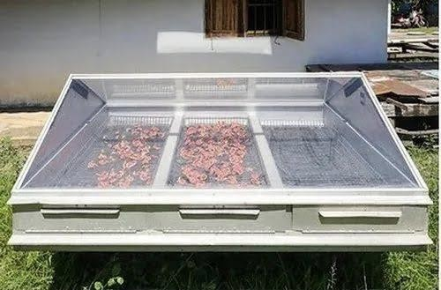
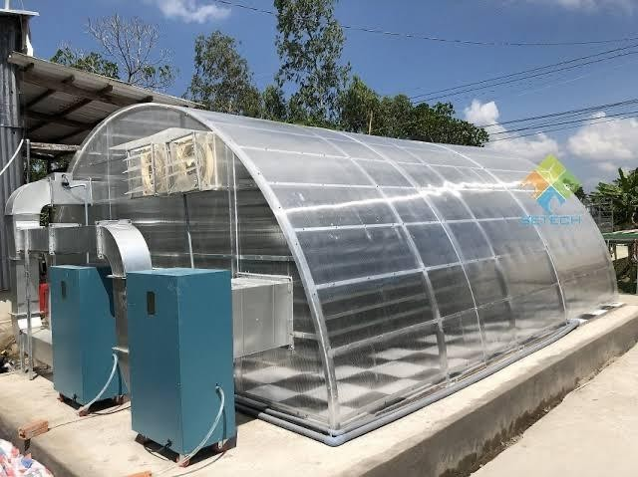

ActiveSolarDryers

Active dryers have a ventilationsystem to circulate heated air inside the dryingchamber or fromthesolarcollectorto thedrying chamber. Fansorblowersarerun byelectricity, which

can be harnessed from a photovoltaic (PV)module orgrid. In particular, in the passive mode of the greenhouse dryer, a ventilator or chimneyis built for the natural circulationof heated air, and in the active dryer, an exhaust fan is provided for air movement. An active dryer has beenre- ported to be more suitable for crops witha highermoisture content such as papaya, kiwi, cabbage, and cauliflower than the passive dryer (Chua and Chou, 2003). The active dryer requires more investment than a passive dryer and is more difficult to operate and maintain. To achieve high drying efficiency and product quality, the optimal temperature and air mass flow rate must be controlled. The indirect passive dryer (forced convection) contains a drying unit with a separate solar collector and three main components: solar collector,dryingunit, andair duct for circulation. Theair is heatedwhile flowing through a low-pressure drop solar collector and then passes through air ducts into the dryingchamber and over the dryingtrays. The moist air isdischarged throughair vents or a chimneyat the top of the chamber. The average dryingefficiencyis 13–25%, whichis lower than the direct solar dryer (Kumar et al., 2016). However, Tomar et al. (2017) reportedthatunlikethedirectpassivedryer,thismethodovercomestheproblemof

cracking and helps to preserve vitamins and color as agricultural products are not directly exposed to solar radiation.

HybridSolarDryers

Ina hybriddryer,agricultural materials are driedunder directsolar radiationand/or back-up energyor stored heat inthe absence ofsun- light. The airis pre-heated byanother auxiliary sourceof energy such as asolarPV module, electricity,and liquefiedpetroleum gas (LPG),
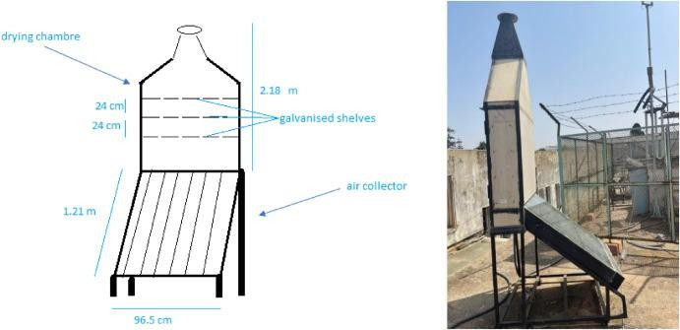
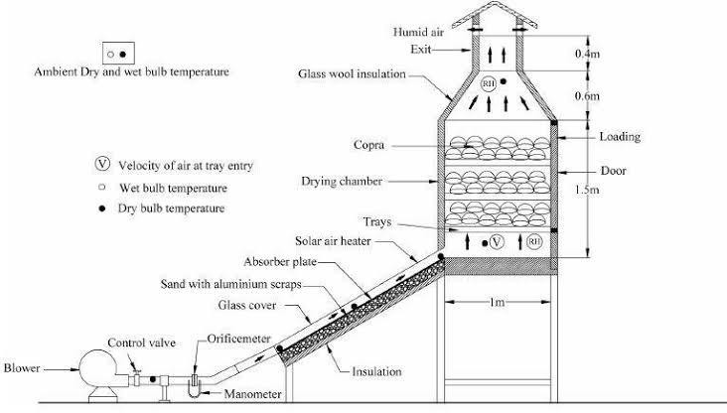

diesel, or biomass. This dryer can be used in both single and mixed modes (direct and indirect types of drying). Bala and Woods (1994) report that hybrid drying could reduce microbialinfestation in products. Queiroz et al. (2004) showthat the heat pump dryer can be 40% more energy efficient relative to the electric resistant dryer. Ferreira et al. (2007) present a study for banana and determine that the drying time obtained in hybrid drying is lowercompared to open-air or artificial drying. Inaddition, better color, aroma, and texture wereobserved inhybrid driedbananacomparedto open-airsundrying.Eltawiletal.(2018)

developed a hybrid, portable tunnel dryer to dry peppermint by enhancing its performance using a solar PV system and flat plate solar collector. They determinedthat the quality of the hybrid-dried peppermint was higher than that of open sun-dried peppermint. The dryer efficiencywas31%withanetcarbondioxide(CO2)mitigationof32tons over its life span.

ADVANTAGESOFSOLARDRYERS

This technology has several socio-economic advantages. One of the main problems facing developing countries today is food security. The solar dryer, using this renewable energy, canimprovefoodsecurity,allowingforbetterpreservationoffoodafterdryingcomparedto

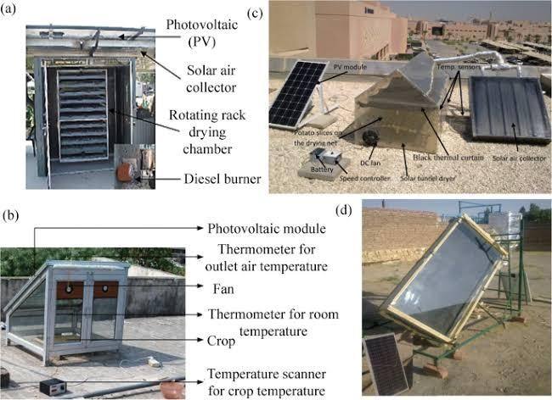
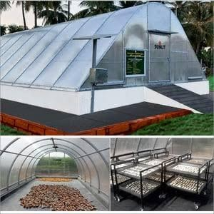

food that has not been dried. The solar dryer reduces the drying time and facilitates the drying of food compared to the sun drying method.

The solar dryer saves fuel and electricity when replacing dryer variants that require an external energy source in the form of electricity or fossil fuel. In addition, solar dryers reduce drying times compared to solar drying. While dryers powered by fossil fuels or electricity may have some advantages (smoother airflow and higher temperatures), the financial barriers associated with these technologies maybe too high for marginal farmers. For example, electricity may not be available or may be too expensive, and drying with fossil fuelsmayinvolvehighinitial and operatingcosts.Fruit, vegetables andmeat dried in a solar dryer are of better quality and more hygienic than sun-dried fruit, vegetables and meat. As mentioned, due to the closed system design, contamination of food is avoided or minimized. In addition, the food is not vulnerable to rain and dust, unlike the open sun- drying system.
In rural areas where farmers grow fruit and vegetables without adequate drying facilities, they have to sell the food on the market soonafter harvest. Whenfood production is high, farmers need to sell the food at a low price to prevent it from losing value through decomposition.Therefore,thesolar fooddryer maybeabletoavoidthefinancial lossesthat farmers face inthese situations. Driedfoodcanbe storedfor longer andretainits qualityfor longer. Inaddition, dried fruits and vegetables canbe soldasdifferentiated products, which canincrease their market value. For example, dried meat canbe processed into a varietyof different products. The food will be drier and less bulky. Therefore, in addition to a longer storage time, the food is also easier to transport after dryingwiththe help of the integrated racks in the solar dryer.

FOODDRYINGTECHNOLOGY

Food spoilage refers to irreversible changes where food becomes inedible, or its quality is dangerous. Food harm can be prevented or reduced by implementing food preservation techniques, one of which is drying. Drying is a process of removing water to prevent the growth of microorganism, which can cause the decay process. The principle of drying is to remove water fromfood bydehydration. Food dryingtechniques have longbeenapplied in conventional ways, such as dryingin the sunor throughblowingwind. Thesemethods are still use today because they are considered more economical and efficient by utilizing natural energywith unlimited energy. However, this method’s drawbackis the instabilityof power from nature, which affect drying rate. The development of drying technology in the last few decades has been very rapid, including the pretreatment process, techniques, equipment andthe qualityofthe final principlesproduced.All these methods havedifferent principlesand mechanismhave their respectiveadvantagesand disadvantages.

SOLARENERGYANDDRYING

Solar energyis quite simply the energyproduced througha thermonuclear process directly bythe sun. The process creates heat and electromagnetic radiation. The heat remains in the sun and the electromagnetic radiation in the form of visible light, infra-red light and ultra- violet radiation stream out into space in all directions. Small fraction of the total radiation producedreachthe earth.The radiationthatreaches the earthis the indirectsourceof nearly everytype ofenergy usedtoday (Geothermalenergy, Nuclear energy and Exceptions).

Two essential components are required to store and convert to usable formof solar energy. One is “collector” and other is “storage unit”. The function of the collector is simplycollects the radiation that falls on it and covert a fraction of it to required forms of energy. The function of the storageunit is required to store the excess solar produced during striking high intensity of solar radiation.
Drying principle: When hot air is circulated over the moist product moisture will remove from the product till the hot air is fully saturated i.e. means absolute humidity has been reached. But moisture will removal is depending on the temperature. The higher the temperature the larger is the removal of moisture. If the air is warmed and the moisture contains remains the same, butthe relative humidity falls so the airremoves more moisture from the product. For gettingbetter result drying rate mustbehigh.

OPENSUNDRYING

Drying under open sun using the solar radiations for food preservation is practiced since ancient times. Drying involves a heat and mass transfer phenomenon in which heat energy supplied to the product surface is utilized in two ways (i) to increase the product surface temperature inthe formof sensible heat and (ii) to vaporize the moisture present inproduct through the provision of the latent heat of vaporization. It is the oldest and most common traditional method to preserve agricultural products, grain, fruits, vegetable, fish etc. In which products are spread on ground directly exposed to solar radiations. The solar radiationsfallingonthesurfaceispartlyreflectedandpartlyabsorbed.Theabsorbed

radiationssurroundingair heat up the surface.A partof thisheatis utilized toevaporate the moisture fromthe surface atmosphere and throughthe conduction to the ground.

CHAPTERTHREE

  - MATERIALSANDMETHOD

  - SAMPLES

Tomatoandcayennepeppersampleswereobtainedfrom IpataMarket,locatedin Ilorin, Kwara State in therepublic of Nigeria.

STUDYAREA

This study was carried out in Physic and Electronics unit laboratory(Science and Technology Department) Kwara State Polytechnic Ilorin. The thermal efficiency and processing of drying was also experimented there. It was carried out on the 15th and 17th of April 2023, for both cayennepepperand tomato respectively.

SOLAR DRYING

Solardrying is a more advanced version of conventional sun drying; the product is kept in a transparent container exposed to the sun. The critical difference betweensolar dryingand sun dryingis that solar dryingrequires a solar collector, and thehydratingproduct isnot exposed to the directsunlight(Fargali et al, 2008).

MATERIALSELECTION

    - MATERIALFORBODYOFTHEDISH

Steel was selected over aluminium because of its strength, cost, durability, and energy effectiveness in use of material. It is easy to clean. Its smooth contour shapeminimizes the slopingerror ofthe reflective mirror material.Energyconsumed to produce steel isestimated to be16500kJ/kg compared to that of aluminiumwhich is 141,000kJ/kg

MATERIALFORTHEREFLECTINGSURFACE

A light glass mirror of high surface quality and good spectacular reflectance was selected. Glass mirror was selectedover polishedaluminiumsurface because its reflectivityof95% is better than that of aluminium (85%). A glass mirror of 3 mm thickness was selected to reduce theoverallweight of theparabolicsolar cooker.

MATERIALFORTHEDRYINGPAN

Fromour findings, we discoveredthat aluminiumis not onlycheap and easilyavailable,but also has a very good specific heat per cubic centimetre. Material of aluminium was chosen for the drying pan. Aluminium is cheap and easily available, because this reflector istargeted for use in the rural community.

CHEMICALCOMPOSITIONOF SPECIMENS TOMATO
Tomato (Solanumlycopersium) is one of the most widely consumed fresh vegetables in both the industrialized and non-industrialized world. Tomatoes are considered as part of healthydiet regime as they are low in fats and are without any harmful cholesterol. Nutrient like vitamin A, ascorbic acid and potassium are present in significant concentrations in tomatoes. Non nutrient phytochemicals like carotenoids (lycopene, phytoene, and B-carlene) and polyphenols (flavonoids, flavanones, and flavones) are also present in significant amount in tomato (solanum lycopersium). Phytochemicals are fortified with ripening and cooking of tomatoes. Carotene is present in high concentration in opened tomatoes and cooking fortifies thelycopenecontent intomatoes. Lutein isalsopresentinhigh concentration inripetomatoes.

CAYENNEPEPPER

Cayenne pepper is widely grown in central and South American and in Nigeria. It was cultivated7,000 yearsagoandinPeru4,000 yearsago. NativeAmericanshave use thecropas a food and medicine for stomach ache, cramping pains, gas and disorder of the circulatory system for 9,000 years. It contains up to 1.5% capsaicinoids (pungent principles) including 0.11% capsaicin, 6,7 dihydrocapsaicin, nordihydrocapsaicin, homodydrocapsaicin and homocapsaicin; fixed oils; carotenoid pigment including capsanthin, capsorubin, alpha -and beta - carotene, steroids glycosides.

EXPERIMENTALEQUIPMENTS
- DigitalThermocouple: Alsoknownasthermoelectricalthermometerorthermistor sensorcoupledwithdataloggersarenowusedtosenseandrecordtemperaturesandrecord
them inadigitalformat.Itisatemperature-measuringdeviceconsistingoftwowiresof different materials joined at each end.

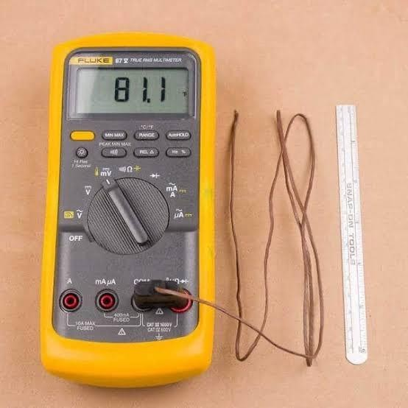

  - Pyranometer: is a type if actinometer used for measuring solar irradiance on a planar surface and it is designed to measure the solar radiation flux density ( W/m2) from the hemisphere above within a wavelength range of 0.3m to 3m.It is an instrument used to convert the global solarradiationitreceivesinto an electricalsignal that can bemeasured.
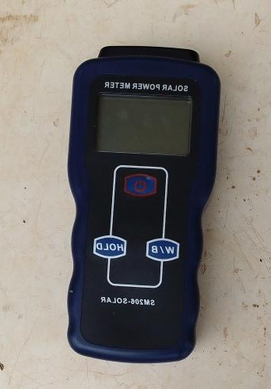

- Digital Weighing Balance: It is a device used to measure weight or mass. Theyare also known asmass scales, mass balances and weight balances. It is the most accurate and precise analog front-end (AFE) instrument that uses force sensor tomeasure the weight ofan objectwiththe value not more than 5kg or 500g.
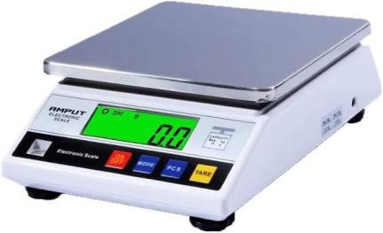

- ParabolicDish:Isareflectivesurfaceusedtoprojectenergy such aslight,soundor radiowaves.It is used to generate heat for cooking or drying.
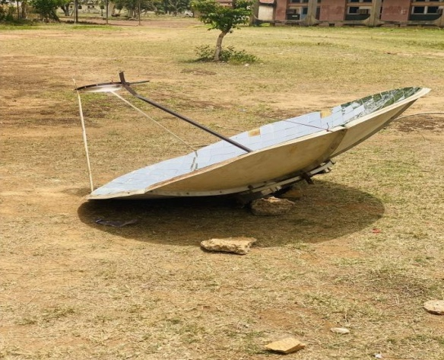

- Knife: Itis atool or weaponwithacuttingedgeor blade,usuallyattachedto a handleor hilt. It isordinarilymade of wood,bone and stone. It isused for cutting.
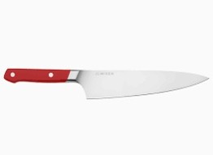
- Dryingpan:Itisaflatbottompanusedforfrying,grillingaswellasdrying.

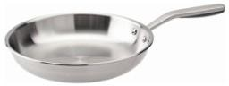

- Tray: It isaplastic materialwhich theproduct isbeenkept in ordertogiveit accurate arranging and easilyweighing of the product.

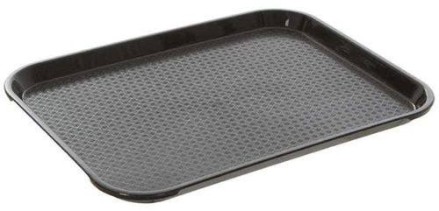

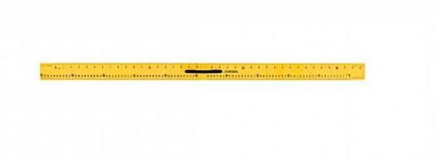
- Meter rule: It isa wooden nature (type)rule used in measuring the length, breadth and other measurementduring an experiment.

EXPERIMENTALSETUP

A satellite dish of diameter 1.8m and height of 0.27m, radius of 0.9m, area of 0.26m, aperturearea of0.016m, concentrator ratio of0.081and focal lengthof 0.047mwas used for the construction of the parabolic solar reflector. A reflective mirror was cut using a glass cutter into small square pieces sizes 4cm x 4cm, these reflective mirrors was used to cover the surface of the satellite dishby usinga glue to stick the small square size mirrors to the interiorsurfaceofthesatellitedishwhichformtheparabolicconcentrator.Theparabolic

dish concentrator was set to move freely in any direction for tracking purpose by rotating dish manually. As the rays of the sun falls on the surface of the dish, the focus of the reflected rays was calculated and the point of reflection was located using a plane white sheetofpaper. Duringthe construction process the dryingpanis placed on a handle directed to the east.
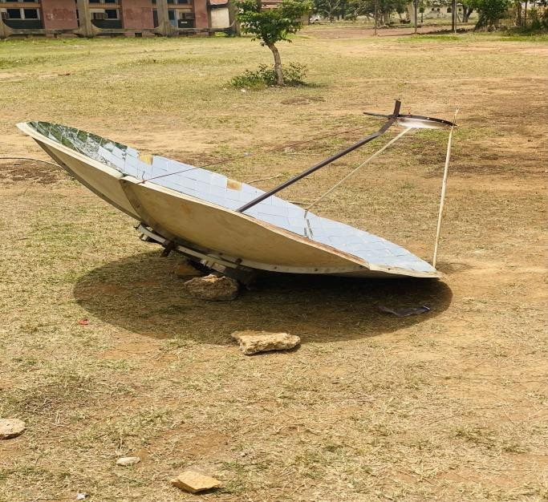

METHOD

The experiment was conducted on the 15th and 17thApril 2023 in Kwara State Polytechnic, Ilorin. The experimental set up was placed at a free space at the backof the laboratory; the parabolic dishwas setina waythatitcanbe moved freelyinanydirectiondependingon the focal point of the solar radiation. A retort stand was placed in a particular direction wherethefocal pointwasfoundduringthetimeof theday.Thedistancefromthe focal point to the retortstandisrecordedandalsotheheightoftheretortstandfromthegroundisalso

measuredusingameterrule.Thedryingspecimensweretomatoandcayennepepper purchased from the market and brought to the laboratory.
The specimens were washed withcleantap water toremove dirt and decaying tomatoes and cayenne pepper , each samples ware sliced vertically using theknife into pieces and placed onthetrayswiththefleshofthetomatoesandcayennepepperlayingonthetray.The specimenswereweighedandthevaluesobtainedare249gand107gfortomatoesand cayenne pepper respectively. The experiment for the dryingof tomatoes started at 11:40 am and ends at02:00pmon the 15thof April and that of the cayenne pepper started at11:45 am anddriedconsiderablyat1:25pmduringtheoverheadsunonthe17thofApril.The thermocouplewas usedfor the temperature measurementwhicharethe ambienttemperature, absorber temperature, and fluid temperature while the pyranometer was used to measure the solar radiation and weighing balance was used to measure the moisture content loss of both the tomatoesand cayennepepperat everyten minutesinterval.
Tomatoesof 249g werereducedto140g andcayennepepperof 107g wasreducedto34g at 3 hours and 20 minutes and 1 hour, 40 minutes respectively. Inthe course ofdata collection, conditions ofcloudcoverduringdryingmayhavecontributedtovariationsin solarradiation.

SAMPLE
WASHINGOF
SAMPLES
SLICINGOFTHE
SAMPLE
SPREADINGOF THE
SAMPLEONTHE DRYING PAN
TAKINGREADINGS
PARKINGAND
STORAGEOFTHE SAMPLE

Table1.1MEASUREMENTSANDPARAMETERS

MEASUREMENT | PARAMETERS
Diameter | 1.8m
Height | 0.27m
Radius | 0.9m
Area | 0.26m
Aperture | 0.016m
Concentrator | 0.081m
Focallength | 0.047m
Glass | 0.4m
Length | 1.45m

NOMENCLATURE

Ssurface areaofparabolic Ffocal length
Ddiameter

Rradius of parabolic Hheight ofparabolic Llength of parabolic Aarea of parabolic
Qheatoffoodrequire

3:9 MATHEMATICALEXPRESSION

    - DETERMINATIONOFAPERTUREAREA

ApertureArea()

=π(ra)²

=3.142(0.9×0.256)²

=3.142×0.053

=0.167m²

DETERMINATIONOFRECEIVERAREA

ReceiverArea()

π(rr²)=3.142(0.9×0.9)²

=3.142(0.81)

=3.142×0.6561

=2.061m

DETERMINATIONOFFOCALLENGTH

FocalLength(F)

F=(𝑟𝑎)²=(0.9×0.256)²
4ℎ 4×0.28

=(0.2304)²
4×0.28

=0.0531
1.12

=0.047m

DETERMINATIONOFRIMANGLE

RimAngle(Q)

𝑡𝑎𝑛

(𝑄)
= 1
d/8h
_2h
d

= 1
1.8/8×0.28
_2×0.28
1.8

1
=
1.8

2.24

= 1
_0.56
1.8

– 0.311

0.804

= 1
0.493
=2.029
Q=tanˉˡ2.029
Q=63.76°

DETERMINATIONOFTHESURFACEAREAOFTHE PARABOLOID

The surfaceareaoftheparaboloid(As)

8𝜋(𝑓)^{⅔}×[(d/4f)+³⁄²1]−1

=8×3.142× (0.047)⅔×[(1.8/4×0.047)+1]³⁄²-1

=8×3.142×(0.047)²³̸×[(1.8/4×0.047)+1]-1

=8×3.142×2.209×10ˉ³×[(1.8/0.188)+1]³⁄²-1

=0.0555/3×[9.57+1]³⁄²-1]

=0.0185×[10.57]³⁄²-1]

=0.0185×[10.57]^1.5–1]

=0.0185×[34.36– 1]

=0.0185×33.36

=0.62m².

Byusingindices

=0.0555÷3×(9.57+1)³⁄²-1

=0.0185×[10.57]³⁄²-1

x^1/a= a√x [10.57]³⁄²=2√10.57³
=2√1180.9
=68.73
=0.0185×[68.73-1]
=5.60-1
s=5.5m²

DETERMINATIONOFLENGTHOFCIRCUMFERENCE

Lengthofcircumference

π×D×a
=3.142×1.8×0.265

=1.499m²

DETERMINATIONOFCONCENTRATIONRATIO

𝑨𝒂
𝑨𝒓
=0.167
2.061

=0.081

CHAPTERFOUR

RESULTANDDISCUSSION

GENERALOBSERVATION

The drying of the tomatoes and cayenne pepper using the parabolic solar reflector had an initial highdryingrate,as thedryingprocess continued. Thedryingrate declinedin adrastic manner.

CHAPTERFIVE

CONCLUSION

A parabolic solar cooker was designed and constructed using locally available materials. The designparameters were aperture area, receiver area, focal length, rimangle, the surface area of the parabola and concentrator ratio. The constructed parabolic solar cooker showed a good performance indryingtomato and cayenne pepper for a shortperiod of time compared to the open sun drying.

RECOMMENDATIONS

Basedonthefindingofthiswork,the followingrecommendationsweremade;

    - The parabolic solar reflector should be adopted as a method of drying agricultural product in most part of therural area inNigeria.
    - Base on the poor and erratic electricity supply in the nation. The parabolic solar reflector should be deployed for the purpose of drying agricultural products to prevent spoilages andmassive waste of agricultural product after harvesting which isthe commonphenomenoninthe nation agricultural sector

REFERENCES

A. A. Abd El-Rahmam, Abdel Mohsen, H.,and H. E. Hassan. 2019. Drying of tomato fruits using solar energy. Agricultural Engineering International: CIGR Journal, 21(2): 204–215

Abdullahi,Y., Momoh, M., Garba, M. M., and M. Musa, M., “Design and Construction of an Adjustable and Collapsible Natural Convection Solar Food Dryer,” International Journal of ComputationalEngineeringResearch, vol. 3, no. 6, pp. 1–8, 2013.

Abdelhamid Fadhel , Sami Kooli , Abdelhamid Farhat and Ali Belghith, The Thermal Process Laboratory, The Research and Technology Center of Energy, Hammam-lif BP, Tunisia 2 Department of Physics, Facultyof Sciences Mathematics, Physics and Natural of Tunis, Belvèdère, Tunisia.

Adeodu O. Adefemi, Daniyan A. Ilesanmi: Development and optimization of Drying parameters for Low-cost Hybrid solar dryer. ISSN: 8, 23-35 (2018).
Aidan,J. DepartmentofPhysics,ModibboAdama Universityof Technology, Yola,Nigeria. AliyuSamuelJacob,*,NnodimChiebukaTimothy,KazeemRazakAdebayo,Adedayo
Aaron Banji: 2021: Department of Mechanical Engineering, Landmark University, Omu-Aran, Nigeria 2Department of Electrical and Information Engineering, LandmarkUniversity,Omu-Aran,Nigeria.

Arunet, S., Ayyappan, S. and Sreenarayanan, V.V 2014. Experimental Studies on Drying CharacteristicsofTomatoina SolarTunnel Greenhouse Dryer. International Journal of Recent Technologyand Engineering (IJRTE). ISSN: 2277-3878,3(4):32–37.

Ashokraj, S. & Sekar, M. (2016). Designand analysis of receiver for aparabolicsolar dish collector, Department of Mechanical Engineering. Government College of Technology,Coimbatore, Tamil Nadu, India.

Azeez, L., Adebisi, S. A., Oyedeji, A. O., Adetoro, R. O. & Tijani, K. O. Bioactive compounds’ contents, drying kinetics and mathematical modelling of tomato slices influenced by drying temperatures and time. J. Saudi Soc. 10, 120–126 (2019).

Bala, B.K., Woods, J.L., 1994. Simulationofthe indirectnatural convectionsolar dryingof roughrice. Sol. Energy53, 259–266.

Barrett DM, Anthon GE. Color quality of tomato products. Color quality of fresh and processed foods; 2008131–9.

Cernisev, S. 2010. Effects of conventional and multistage drying processing on non- enzymaticbrowning intomato.Journal ofFood Engineering,96(1):114–18.

Chua, K.J., Chou, S.K., 2003. Low-cost drying methods for developing countries. Trends Food Sci. Technol. 14, 519–528.

Eltawil, M.A., Azam, M.M., Alghannam, A.O., 2018. Energy analysis of hybrid solartunnel dryer withPVsystem and solar collector for drying mint (Mentha Viridis). J. Clean. Prod.181, 352364.

Ferreira,A.G.,Charbel,A.,Silva,J.G.,2007.Experimentalstudyofhybriddryer.Therm.
Eng.6(2),3–7.

Gwania*, M., Abubakarb, G.A., Abbasc, M., Na Allahd, M., Danyaroe J., a,b,c,e DepartmentofPhysics,KebbiStateUniversityofscienceandTechnologyAliero,
P.M.B1144,KebbiStateNigeria:NationalMathematicalCenter,Abuja.Nigeria, Email: gwanimohammed@gmail.com.

HassanH. E.,HebaAbdel Mohsen, AbdEl-Rahmam,A.A.(1.Researcher,Agric.Eng.Res. Institute,Agric.Res.Center,Egypt;2.Prof.ofAgric.Eng. Res.Institute, Agric.Res. Center, Egypt; 3. Prof. of National Institute of Laser Enhanced Sciences (NILES), Cairo University,Egypt)

Hii,C.L.,Rahman,R.A.,Jinap,S.,Che, ManYB., 2006.Qualityofcocoabeansdriedusing a directsolar dryer at different loadings. J. Sci. Food Agric. 86 (8), 1237–1243.

Jahangeer,K.A.2006andHawlader,M.N.A. Solar heatpumpdryingandwater heatingin the tropics. Solar Energy, 80(5): 492–499. S. Adhikari, Postharvest Management of Fruit and Vegetablesinthe Asia-PacificRegion. 2006.

Jobin Varghese1, Rupesh S2, Jithu Augustine1, Adithya Nair1, Prajith1 - Adishankara Institute of Engineeirng and Technology, Kalady. 2PES College of Engineering, Mandy :jobinvargheset@gmail.com.

Kamaldeen O. S 1, *and Okedokun O. W 21 NigerianStored Products Research Institute (NSPRI), Kano Station, Nigeria. 2 Federal College of Agricultural Produce Technology, Kano, Nigeria. GSC Advanced Engineering and Technology, 2022, 04(02),025–031.

Kumar, M., Sansaniwal, S., Khatak, P., 2016. Progress in solar dryers for drying various commodities. Renew. Sustain. Energy Rev. 55, 346–360.

Madhlopa, A., Jones, S.A and Kalenga Saka, J.D “A solar air heater with composite absorbersystems forfooddehydration,”RenewableEnergy,vol.27, no.1,pp.27–37, 2002.

Müller, J., Mühlbauer, W., 2012. Solar drying. In: Tsotsas, E., Mujumdar, A.S. (Eds.), Modern Drying Technology, Energy Savings. Wiley-VCH Verlag & Co. KGaA, Weinheim,pp. 199–243.

Olajide, J. O., O. J. Oyelade and A. T. Y. Tundeand, 2003. Design of a cabinet tray dryerforsmall and mediumscale food processors. InNigeriandryingsymposiumseries 1., University of Port – Harcourt, Nigeria.

Omotoyosi Onalapo Craig - Thesis presented in fulfilment of the requirements for the degree of Master of Engineering (Mechanical) in the Faculty of Engineering at Stellenbosch University.December 2015 .

Prakash, G. and Garg, H.P., Solar Energy: Fundamentals and Applications. Tata McGraw- Hill Publishing Company,2000.

Queiroz, R., Gabas, A.L., Telis1, V.R.N., 2004. Drying kinetics oftomato by usingelectric resistance and heat pumpdryers.Dry. Technol. 22 (7),1603–1620.

Rajeshwary, N. and Ramalingam, A. 2012, “low cost material used to construct effective box type solar dryer’’, archive of applied science reaches ,2012,4(3);1476-1482.

Tiris C., Özbalta, N., Tiris M. and Dinçer, I.,1994. Experimental testing of a new solar dryer. InternationalJournal of EnergyResearch, 18(4): 483–490.

Tomar, V., Tiwari, G.N., Norton, B., 2017. Solar dryers for tropical food preservation: thermophysicsofcrops, systems and components.Sol. Energy 154, 2–13.

APPENDIXII

 