
A PROJECT
ON
COMPARATIVE EVALUATION OF ACCURACY AND RELIABILITYOF DIGITAL LEVELLING AND TOTAL
STATION EQUIPMENT TO DETERMINE THE HEIGHT MEASUREMENT
(A CASE STUDY OF PART OF KWARA STATE POLYTECHNIC)
BY
ABDUL-QUDUS SHUKURAH TEMITOPE
HND/23/SGI/FT/0083

SUBMITTED TO

DEPARTMENT OF SURVEYING AND GEO-INFORMATIC, INSTITUTE OF ENVIRONMENTAL STUDIES (I.E.S), KWARA STATE POLYTECHNIC, ILORIN.

IN PARTIAL FULFILLMENT OF THE REQUIREMENTS FOR THE AWARD OF THE HIGHER NATIONAL DIPLOMA (HND) IN SURVEYING AND GEO-INFORMATIC.

JULY, 2025.
DECLARATION
I hereby certified that all the information given in this project were obtained as a result of observations and measurements made by me and that the survey was carried out in accordance with Survey Rules, Regulations and Departmental instructions.

NAME:ABDUL ABDUL QUDUS SHUKURAH TEMITOPE
MATRICNO.:HND/23/SGI/FT/0083

SIGNATURE: ………………………………….

DATE OF COMPLETION: ……………………………………………….

CERTIFICATION
This is to certify that ABDUL QUDUS SHUKURAH TEMITOPE with matriculation number HND/23/SGI/FT/0083 has satisfactorily carried out this project under our instructions and direct supervision.

SURV. A. G. AREMU _______________________
(PROJECT SUPERVISOR) SIGNATURE AND DATE

SURV. AWOLEYE R. S ________________________
(PROJECT COODINATOR) SIGNATURE AND DATE

MR. ABIMBOLA I. ISAU ________________________
(HEAD OF DEPARTMENT) SIGNATURE AND DATE

___________________________ ________________________
EXTERNAL MODERATOR SIGNATURE AND DATE
DEDICATION
I dedicate this project to Almighty God, whose guidance, strength, and blessings have been my constant source of inspiration and perseverance. Through every challenge and triumph, your presence has been my guiding light and steadfast support. Thank You for granting me the wisdom, knowledge, and patience to complete this goal.
ACKNOWLEDGEMENTS
As I stand at the threshold of this significant milestone, I am overwhelmed with gratitude and love for the people who have made this journey possible.
I earnestly express my deepest gratitude to my project supervisor Surv. A.G. AREMU for the guidance and patience throughout my research work indeed he is an epitome of a great Lecturer.
My sincere gratitude also goes to My (H.O.D) MR. ABIMBOLA ISAU and other lecturers at the Department of Surveying Geo-informatics (SUR. A.G AREMU, SUR. R.S ASONIBARE, SUR. R.O AWOLEYE, SUR. BANJI, SUR. AYUBA, SUR. DIRAN, SUR. KAZEEM, SUR. KABIRU ), for nurturing me in my academic activities. May Almighty Allah continue to bless you all abundantly.
My unreserved appreciation goes to my beloved parent, Mr. and Mrs. ABDUL-QUDUS for their un-measured words of encouragement, financial, moral and spiritual support given to me all through this program.
My profound gratitude goes to my wonderful friends and my group Member thanks for the good experience we have together.

.

ABSTRACT
This project undertakes a thorough comparison and analysis of the performance of Total Station and digital level instruments in determining terrain heights, with a focus on accuracy and reliability. Height observations are a critical component of surveying and geodetic science-related areas, and this project aimed to evaluate the effectiveness of these two instruments in obtaining accurate height measurements. A fieldwork was conducted within the Kwara State Polytechnic campus, Total station was used to measured the perimeter points and 20 stations were established randomly within the site perimeter, Total station and Digital level instrument were used to determine the height of those station (as spot height). The data obtained from digital leveling and Total Station measurements were carefully processed and analyzed, revealing that both instruments produced comparable results. The maximum and minimum heights obtained using the digital level instrument were 356.680m and 354.208m, respectively, while the Total Station instrument yielded maximum and minimum heights of 356.736m and 354.268m, respectively. The project found that the differences between the heights obtained using both instruments were relatively small, ranging from 28mm to 62mm. Importantly, the project concluded that both instruments can be used interchangeably for terrain height determination, given the absence of significant differences in their performance. The findings of this project contribute to the understanding of the capabilities and limitations of Total Station and digital level instruments in surveying and mapping applications, and have implications for the selection of instruments for specific projects.

TABLE OF CONTENTS
Cover page…………………………………………………………………………………….i
Declaration………..………………………………………………………………….………..ii
Certification…………………………………………………………………………….……..iii
Dedication……………………………………………………………………………….…….iv
Acknowledgement……………………………………………………………………….….....v
Abstract…………………………………………………………………………………….….vi
Table of contents ….……………………………………………………………………….vii-ix
CHAPTER ONE
- Introduction…………………………………………………………..…….………. ….1
1..1 Background to the study………………………………………….……...……….……1
1.2 Statement of the problem……………………………...…...................................……..3
1.3 Aim…………………………………………………………………..……….......…….4
1.4 Objectives …………………………………………………………….………………..4
1.5 Justification …….………………………………………………………...………….4
1.6 Significance of the Project……………………………………………………………..5
1.7 Pesonnel……………………………………….…………………………….……..…...6
1.8 Study Area………………………………………………………….…………………..7
CHAPTER TWO
- Literature Review………………………………………………….……………….…..8
2.1 Digital Leveling Instruments……..…………..…………………….……..……….….11
2.2 Total Station Instrument………..….……………………………………….…………11
2.3 Comparison of Height Measurement Capabilities…………………,..………….……12
2.4 Literature Review on Comparison of Total Station and Levelling Instrument in Height Measurement ……………………………………………………………………….13
2.5 Project Review……………………………………………………………………....15

CHAPTER THREE

Methodology……………………………………….……..………………………….16

3.1 Reconnaissance………………………………………..……………………………...16
3.2 Beaconing……………………………………………………..…………….………..18

3.3 Instrumentation………………………………………………….………………...…19

3.4 Test of Instrument ……………………………………………..……………………...21
3.5 Control Check………………..…………………………………...…………………...25
3.6 Data Acquisition …………………………………,……………….………..………...25
3.7 Perimeter, Detailing and Spot Heighting………………………………..…………….27

CHAPTER FOUR
- Data Downloading, Processing, Analysis and Discussion……………………………30
4.1 Data Download………………………………………….........................……………30
4.2 Data Editing……………………………………………………………….………..…30
4.3 Data Processing using Autocad 2007……………………………………...………….31
4.4 Results and Discussion……………………………………………………..…………31
4.5 Statistical Analysis……………………………………………………………………36
CHAPTER FIVE
5.0 Costing, Summary, , Recommendation and Conclusion…………………………...…39
5.1 Costing..........................................................................................................................39
5.2 Summary……………………………………………..………………………….……46
5.3 Recommendation …………………………………………………………………….46
5.4 Conclusion……………………………………………………………………............47
References…….……………………………………….………………………….….…....…48
Appendix data…………………………….……..……….…………………..……………….50

CHAPTER ONE
- INTRODUCTION
Height determination is an essential aspect of surveying that involves determining the vertical location of a point relative to a reference datum. Surveyors typically use different techniques to determine the elevation of a point, including trigonometric levelling, barometric levelling, and digital levelling (Simbolon et al., 2017). Levelling is a widely used method for determining the elevations of ground points relative to a reference datum. It involves measuring the vertical distance between the ground point and the reference datum to obtain what is known as the reduced level. This is an important procedure that is used in various fields such as mapping, engineering design, construction, and setting out. The reference datum used in levelling is usually the mean sea level, which is assumed to be an equipotential surface. This means that points on this surface have the same gravitational potential energy. As such, the mean sea level is adopted as the reference surface for vertical control surveys (Schofield & Breach, 2007; Uren & Price, 2010).
Leveling Schofield and Breach (2007) opined that levelling is a technique used to determine the vertical location of a point on or beneath the surface of the earth relative to a reference datum, while planimetry refers to the horizontal position of a point relative to a coordinate system. The authors also noted that these two procedures are separate and distinct, as each involves different equipment, procedures, and techniques. This idea is further supported by Ghilani and Wolf (2014), who stated that levelling is primarily concerned with determining the elevations of ground points, whereas planimetry is focused on determining the position of those points in a horizontal plane. The choice of height system is critical in many applications, especially those that require accurate determination of elevation. For instance, in civil engineering projects such as road construction, it is important to know the elevation of the terrain to design the road profile, drainage, and culverts. The orthometric height system is widely used in such projects as it provides a meaningful height reference that is directly linked to the earth's gravity field. However, other height systems, such as the ellipsoidal height system, are used in different applications. The ellipsoidal height system is based on the normal to the reference ellipsoid and is commonly used in satellite positioning systems such as GPS. The choice of height system depends on the application, and it is important to understand the differences between them to avoid errors in height determination (Torge, 2001). Orthometric heights are determined by measuring the vertical distance between the point of interest and the geoid. This can be achieved through traditional techniques such as spirit levelling, trigonometric levelling, and GPS measurements (Odumosu et al., 2018). In spirit levelling, a series of measurements are taken with a level instrument, and the heights are computed based on the height of the instrument and the readings taken at the different locations. Trigonometric levelling involves measuring the angles and distances between two points and computing the height difference between them using trigonometric functions. GPS measurements use satellite signals to determine the height of a point above the ellipsoid and geoid is computed with high accuracy (Ghilani & Wolf, 2014). The process of levelling involves using a levelling instrument to measure the vertical distance between the ground point and the reference datum. The levelling instrument consists of a spirit level and a graduated staff. The spirit level is used to ensure that the staff is held World Scientific News 189 (2024) 87-101 -89- vertically, while the graduated staff is marked with a series of divisions that enable the observer to measure the vertical distance between the ground point and the reference datum. There are several methods for leveling observations in modern days, they include geometric leveling and trigonometric leveling methods (Lee & Rho, 2021). The choice of method to use largely depends on the accuracy desired, nature of the work to do and the availability of instrument to use.
Total Station The total station is a surveying instrument that combines the angle measuring capabilities of theodolite with an electronic distance measurement (EDM) and processing capabilities to calculate and determine horizontal angle, vertical angle and slope distance to the particular point (Lin, 2014). The determination of the coordinates for an unknown point in relation to a known coordinate is achievable through the utilization of a total station, provided that a direct line of sight can be established between the two points (Putra et al., 2023). The process involves measuring angles and distances from the total station to the points under survey. Subsequently, trigonometry and triangulation are employed to calculate the coordinates (X, Y, and Z or northing, easting, and elevation) of surveyed points concerning the position of the total station (Reyes, 2021). To get data on the distance of a point, the Total Station emits a wave, then the object will reflect the wave and be received back by the tool. Then the software inside the tool will automatically calculate the distance from where the tool stands to the measured point. To determine an absolute location, a total station requires line of sight observations and must be set up over a known point or with line of sight to two or more points with known location (Solomon, 2014).

1.2 STATEMENT OF THE PROBLEM
In height determination we have a number of instruments of different precisions and relatively different field procedures which ends with different precisions. The highest precision in levelling is obtained by the use of digital levelling. Total station is less precise but how much is it imprecise compared to conventional digital levelling? The use of digital levels saves 3 computational and observation time. It is therefore expected to be less tedious than the conventional digital levelling. The question is how much tedious is it? Does it give the same precision compared to conventional analogue digital levelling? These are some of the problems which are going to be discussed in this project.
1.3 AIM AND OBJECTIVES OF THE PROJECT
1.3.1 AIM OF THE PROJECT
The primary aim of this project is to compare the accuracy and reliability of digital leveling and total station equipment in determining height measurements.
1.3.2 OBJECTIVES OF THE PROJECT
The objective of this study is to assess the performance of total station instrumentation and digital levels to determine the height measurement in executing levelling for vertical control in topographic surveys for route engineering projects.

1.4 SCOPE OF THE PROJECT
This study is limited to the comparison between total station levelling and digital levelling on the four segments that are 7km in lengths. The comparison will be judged by statistical quantities such as maximum, minimum, mean and root mean square differences.
1.5 PERSONNEL INVOLVED
The project was assigned to and was successfully carried by the personnel listed below;
NAME | MATRIC. NO.
Jimoh Halimah Titilayo | HND/22/SGI/FT/082 | Writer
Ganiyu Akeem Abiodun | HND/23/SGI/FT/0076 | Member
Abdul Kareem Ramota Olawumi | HND/23/SGI/FT/0078 | Member
Kazeem Kabirat Damilola | HND/23/SGI/FT/0079 | Member
Adeoti Qudus Adebayo | HND/23/SGI/FT/0080 | Member
Adeleye Sheriffdeen Olawale | HND/23/SGI/FT/0081 | Member
Abdul Qudus Shukurah Temitope | HND/23/SGI/FT/0083 | Member
Ogunsuyi Babatunde Sunday | HND/23/SGI/FT/0118 | Member

1.6 PROJECT LOCATION
The project site is located inside Kwara state polytechnic Ilorin, Kwara state.
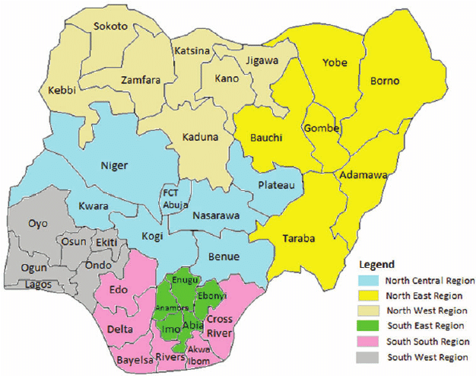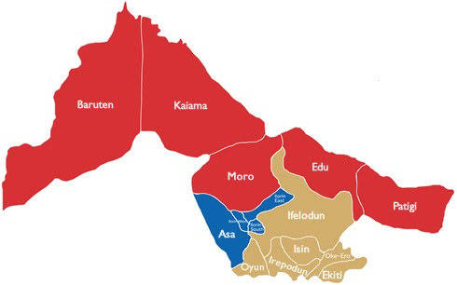
Map of Kwara State
Map of Nigeria
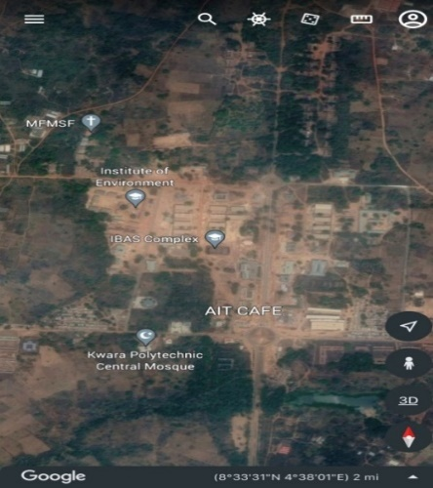
` 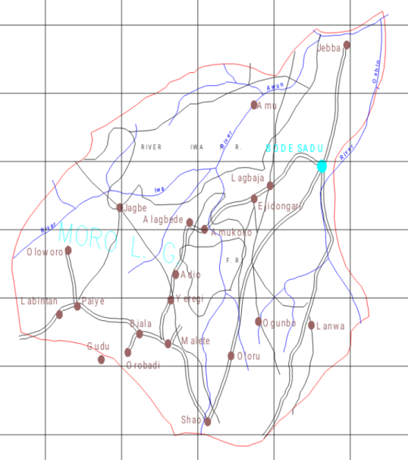
Map of Moro L.G.A
Google Imagery of the Study Area

Google Earth Imagery of the Study Area,

CHAPTER TWO
2.0 LITERATURE REVIEW
Height measurement is a crucial aspect of geospatial and civil engineering projects, whether for land surveys, construction, or topographic mapping. Traditionally, height measurements were obtained using optical and mechanical instruments such as spirit levels and total stations. However, advancements in technology have introduced digital levelling systems and modern total stations as alternative methods for determining height with high precision. This literature review explores the comparative evaluation of the accuracy and reliability of these two technologies in height measurement, providing insights into their respective strengths and weaknesses.
The process of levelling involves using a levelling instrument to measure the vertical distance between the ground point and the reference datum. The levelling instrument consists of a spirit level and a graduated staff. The spirit level is used to ensure that the staff is held World Scientific News 189 (2024) 87-101 -89- vertically, while the graduated staff is marked with a series of divisions that enable the observer to measure the vertical distance between the ground point and the reference datum. There are several methods for leveling observations in modern days, they include geometric leveling and trigonometric leveling methods (Lee & Rho, 2021). The choice of method to use largely depends on the accuracy desired, nature of the work to do and the availability of instrument to use.
The determination of the coordinates for an unknown point in relation to a known coordinate is achievable through the utilization of a total station, provided that a direct line of sight can be established between the two points (Putra et al., 2023). The process involves measuring angles and distances from the total station to the points under survey. Subsequently, trigonometry and triangulation are employed to calculate the coordinates (X, Y, and Z or northing, easting, and elevation) of surveyed points concerning the position of the total station (Reyes, 2021). To get data on the distance of a point, the Total Station emits a wave, then the object will reflect the wave and be received back by the tool. Then the software inside the tool will automatically calculate the distance from where the tool stands to the measured point. To determine an absolute location, a total station requires line of sight observations and must be set up over a known point or with line of sight to two or more points with known location (Solomon, 2014).
- Digital Levelling Technology
Digital levelling technology involves the use of digital levels (also known as electronic levels) which combine a digital sensor with an electronic display to automate the process of measuring height differences. The device measures the difference in elevation between two points by automatically capturing data through a digital readout. Some models also incorporate automatic compensators to maintain precise horizontal alignment, increasing measurement stability.
Accuracy
Digital levelling is known for its high accuracy in measuring vertical distances. According to studies, digital levels can achieve accuracy levels up to 0.2 mm/km (2 mm over a 10 km distance). The primary advantage of digital levelling over traditional optical levels is its automated data capture, which reduces human error, particularly with reading the staff measurements.
Reliability
The reliability of digital levelling is influenced by factors such as atmospheric conditions, the quality of the instrument, and the terrain over which measurements are taken. Digital levelling instruments have proven to be reliable under standard survey conditions and have low susceptibility to errors in measuring elevation, as they are less sensitive to environmental disturbances (e.g., wind, temperature) compared to optical systems.
Limitations
Despite the advantages, digital levelling has certain limitations:
- Limited Range: Digital levelling equipment is usually confined to short-range measurements compared to total stations, typically within a few kilometers.
- Cost: Digital levelling systems can be more expensive than traditional optical systems, which may limit their use in some survey projects.
- Sensitivity to Setup: The instrument setup and calibration require careful handling to ensure maximum accuracy.
2. Total Station Technology
A total station is an electronic/optical instrument that combines the functions of an electronic theodolite and an electronic distance measuring device (EDM). It is used to measure both horizontal and vertical angles, as well as distances. When measuring height, a total station calculates the elevation difference between two points by capturing both the horizontal distance and angle of inclination between the instrument and the target.
Accuracy
Total stations offer high accuracy for both horizontal and vertical measurements, with typical vertical accuracy within 1-3 mm depending on the model and measurement range. The vertical accuracy is achieved by measuring angles and distances, and then applying trigonometric calculations to determine the height difference.
Reliability
Total stations are versatile and can be used for long-range measurements, making them suitable for large survey projects. Their reliability is also high, especially when combined with modern technology like GPS or robotic total stations that can automate the targeting and tracking of survey points. However, total stations are more sensitive to weather conditions, particularly for longer-range measurements, where visibility and atmospheric refraction can affect results.
Limitations
- Environmental Sensitivity: Total stations can be affected by weather conditions such as rain, fog, and extreme temperatures, which can introduce measurement errors.
- Line of Sight: The performance of a total station depends on clear line-of-sight, which can be obstructed by buildings, trees, or other obstacles.
- Setup Time: Setting up and aligning a total station is time-consuming and requires skilled operators, especially for complex surveys.
3. Comparative Evaluation: Digital Levelling vs. Total Station
Accuracy and Precision
Several studies have shown that digital levelling provides superior vertical accuracy compared to total stations. For example, Kula et al. (2015) found that digital levelling systems could achieve vertical accuracy of 0.2 mm/km, while total stations typically achieve 1-3 mm accuracy for vertical measurements over similar distances. This makes digital levelling a preferred choice for high-precision projects where vertical accuracy is critical.
However, for long-distance or large-scale surveys, total stations are more versatile because they can measure horizontal and vertical distances with a single instrument. Total stations are also able to measure in more complex environments, such as urban areas, where measurements are taken over larger distances.
Reliability
In terms of reliability, digital levelling is generally less prone to environmental factors than total stations. According to studies by Elashmawi et al. (2017), digital levelling instruments were found to be less affected by weather conditions such as fog or rain, whereas total stations may experience errors due to these factors. Moreover, digital levelling instruments provide more consistent results as they minimize operator influence and the need for line-of-sight, a limitation for total stations.
However, total stations offer more flexibility in data collection, as they can measure multiple points without needing to be recalibrated, and they can measure both horizontal and vertical distances simultaneously.
Cost and Practical Application
While digital levelling offers superior accuracy, total stations are more widely used in surveying due to their multifunctionality. The ability to perform both angle and distance measurements makes them ideal for more comprehensive survey projects. However, digital levelling tends to be more cost-effective for projects that primarily require high-accuracy height measurements.

CHAPTER THREE
3.0 METHODOLOGY
Methodology is the systematic theoretical analysis of the methods applied to a field of study, it comprises the theoretical analysis of the body of methods and principles associated with a branch of knowledge. Typically, it encompasses concepts such as paradigm, theoretical model, phases and quantitative or qualitative techniques.
3.1 Reconnaissance
This has to do with framework of survey operation whereby all survey operations are going to base on.
Reconnaissance is also known as (Recce). Reconnaissance is examination of all part of an area accomplished insufficient detail to make generalization about the type and distribution of historical properties that may be present with a given project area. Also, is the process of having the general overview of the area to be surveyed with the view of determining the arrangement of the work such as method to employed, personnel to be involved, instrument to be used, scale at which plan/map is to be drawn. There are two stages of reconnaissance namely: Office and Field reconnaissance.
    - Field Reconnaissance
The first stage in this project was search for existing information in connection with the area in which the project was undertaken. Rough sketch diagram(recce) of the project area was drawn selecting and marking the approximate position of each point. To sum up, the reconnaissance facilitated the planning and execution of the actual survey as its takes into consideration, the possible problems that are likely to be encountered, and how such problems can be overcome or reduced to minimum.
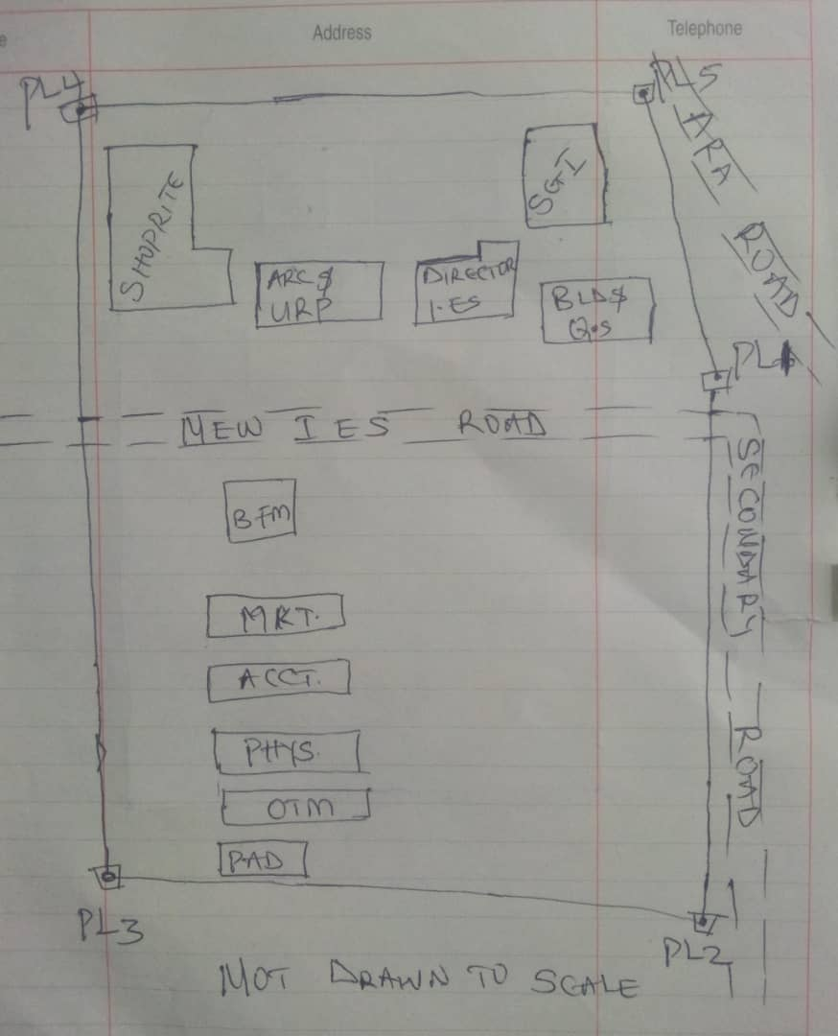

Recce diagram

3.1.2 Office Reconnaissance
Office reconnaissance/data gathering as the name implies is the exploratory survey, scouting or examination, to collect information necessary for the successful execution of the project. It can be simply define as making a preliminary survey before the actual mobilization for the project site. For the purpose of this project, the data search involved retrieving of the coordinate of three (3) existing control.
Pillar No. | Easting(m) | Northing(m) | Height | Location
KWPT 49 | 674341.289 | 937679.115 | 353.682 | Kwara Polytechnic
KWPT 50 | 674555.841 | 937618.402 | 354.903 | Kwara Polytechnic
Table 1: Show coordinates of existing and used control point.
3.1.3 Selection of Station
The boundaries as shown in the recce diagram were laid down by marking points on the ground (station).
The factors considered in selecting these stations include:
- Inter visibility between two points.
- Firmness of the ground at the selected point.
- Working convenience over the station.
- Points located where not disturbed.
3.2 Survey Rod
A survey rod is a physical marker, typically made of metal, used to mark the boundaries of a parcel of land. These markers are used to define the limits of a property and can be used as reference points for future surveys. Rods are durable and can be used in a variety of environments.
3.2.1 Survey rules guiding rod uses:
1. Placement: Rods should be placed at boundary corners or points of change in the boundary.
2. Visibility: Rods should be visible and easily identifiable
3. Durability: Rods should be durable and resistant to weathering.
4. Accuracy: Rods should be placed accurately, following the surveyed boundary.
5. Documentation: the location and description of rods or pegs should be documented in the survey records.

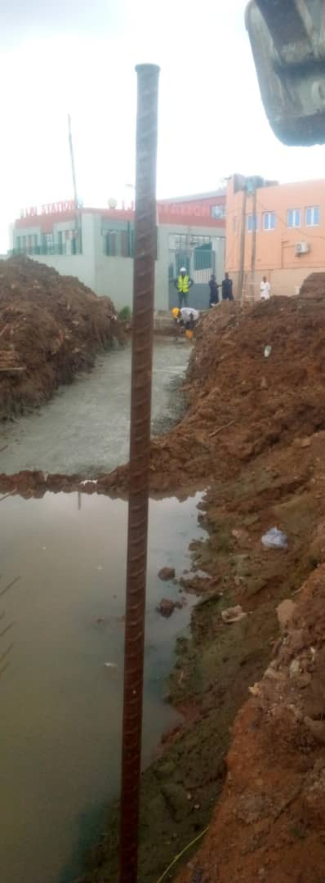

Figure 3.1: Graphical View of Cadastral Survey Rod
3.3 Instrumentation
It refers to the equipment and accessories employed for the successful execution of this project and they are as follows:
Hardware Used
- Stonex R2 Plus Total Station and its accessories
- Leica Digital Level instrument and its accessories
- Handheld GPS
- Hp Core i5 vPro 8th Gen Laptop
- Cutlasses
- Head-pan
- Nail and bottle cover
- 1 Hammer
- 1 Spade
- 1 Hand-trowel
Software Used
- AutoCAD 2007
- Golden Software Surfer 20.0
- Microsoft Office Excel 2013
- Microsoft Office Word 2013
Material Used
- Water
- Cement
Total Station:- It is an electronic or optical instrument used in modern surveying and building construction that used Electronic Distance Measurement (EDM). It is also known as electronic data collection and storage system of which all the data acquired on site is been stored and secured for office reconnaissance.
Digital Leveling:- It is considered one of the most precise methods for height determination. It employs an electronic level instrument and a bar-coded staff to measure vertical distances, reducing human errors common in conventional leveling.
Table 3.2: Equipment Description
S/N | Equipment | Uses
1 | Stonex R2 Plus Total Station | X, Y and Z coordinates of boundaries
2 | Leica Automatic Level | Determination of the reduced level
3 | Handheld GPS | X & Y coordinates of details
4 | Autodesk AutoCAD 2007 | Presentation of the boundaries
5 | Golden Software Surfer 20.0 | Contour and Generation of 3D model
6 | Microsoft Office Excel 2013 | X, Y and Y coordinates editing&program
7 | Microsoft Office Word 2013 | Report writing
3.4 Test of Instrument
For any survey job, testing of the instrument must be done before execution of the job, the instruments used for data acquisition were tested to ascertain whether they are in good working condition.
The following test were carried out,

3.4.1 Total Station
The total station instrument used (Stonex R2 Plus Total Station) underwent a two-phase check. Firstly, the vertical and horizontal angles were verified using pre-established control points within the school campus. Secondly, the electronic distance measurement (EDM) capability was tested for horizontal distances. The instrument passed all tests and was deemed suitable for use.
Below is the procedure for carryout the tests
3.4.1 Total Station
Instrument used in data acquisition was checked for integrity before moving them to site. Apart from check carried-out on Total Station, the following instruments were also checked: Tripod stand legs and their screw were confirmed okay, foot screws, focusing knob, vertical and horizontal knob for slow motion and clamp were all confirmed okay.
3.4.1.1 Horizontal Collimation Test
This error exists when the optical axis of the total station is not exactly perpendicular to the telescope axis. To test for horizontal collimation error, station A was selected and the instrument was set on it and leveled using three foot screws. Then, the telescope was rotated through 360°, but the bubble did not run out of the level tube centre which shows that the line of sight is parallel to the axis of the level tube.
Furthermore, the telescope was pointed to a target on station B in face left, then, pointed back to same target in face right; the difference in horizontal circle readings after averaging the result from both faces of the instrument was 180° except small variation is seconds which is permissible based on the allowable accuracy limit (least Count). The following results were displayed below.
Fairly Level Ground
STATION A
100m
REFLECTOR
(TARGET)
STATION B
Total Station

Fig 3.4.1.1: Horizontal Collimation and Vertical Index error test.
Table 3.4.1.1: Horizontal Collimation Data
Station | Target | Face | Hz Reading | Difference | Error
A | B | L | 38˚42’32”
 |  | R | 218˚42’35” | 180˚00’03” | 03”

3.4.1.2 Vertical Index Error Test
This test was performed to ensure that the vertical reading is exactly ninety degrees (90˚) when the line of sight is horizontal. Any deviation from this figure is known as vertical index error.
The Total Station was set over a point and necessary temporary adjustments were performed. A target set about 100m away from the Total station was sighted and bisected with the instrument on the face left and the reading was recorded. The target was also sighted and bisected on face right and the reading was also recorded. These readings are shown below
Table 3.4.1.2: Vertical Index Data
Instrument Station | Target Station | Face | Vertical | Sum | Error
A | B | L | 90˚00’00”
 |  | R | 270˚00’02” | 360˚00’02” | 02”

3.4.1.3 Analysis of Collimation and Vertical Index Data
The reading obtain during calibration were reduced to obtain new collimation and vertical errors.
Horizontal collimation = {(FR – FL) – 180}/2 = {(00˚00’03”}/2 = 1.5”
Vertical collimation = {(FL + FR) – 360} = (90˚00’00” + 270˚00’02”) - 360} = 02”
The result shows that the instrument is still in good working condition.
3.4.2 Digital Level Instrument
The level instrument employed for the research was Leica Digital level. Two pegs test was carried out on the digital level to check the collimation error of the instrument. The level instrument was set on a specific point A, with initial adjustments made for proper alignment, levelling, and focusing to eliminate parallax, it was now backsight on peg 1 and foresight on peg 2, the instrument was then now moved to another point B, and all the necessary adjustments were made, the peg 2 was bisected as backsight, and the peg 1 as foresight.

Level instrument STAFF (TARGET)

Fairly Level Ground
STATION A PEG 1
Fig3.4.1.1.: Horizontal Collimation error test
Table3.4.2.Horizontal Collimation Data
STATION | Remarks | BS | IS | FS | Diff.
A | Peg 1 | 1.734
A | Peg 2 |  |  | 2.042
 |  |  |  |  | 0.308
B | Peg 2 | 1.578
B | Peg 1 |  |  | 1.262
 |  |  |  |  | 0.316
 | Collimation Error |  |  |  | 0.008
The difference of the two-pegs test from 2 stations (0.008), shows the instrument is in good condition and can be used for the project.

3.5 Control Check
The control points were found along the road in Kwara State Polytechnic. In order to determine their correctness and their true position, one was used as station point KWPT 49 while the point KWPT 50 was used as the back sight. The coordinates obtained were compared with the received data from Department Field Data Records, the difference falls within the allowable accuracy of 3rd order survey job as can be seen in Table 3.3 below:
Table 3.3: Analysis of control check
PILLAR | COORDINATE | EASTING(m) | NORTHING(m) | HEIGHT(m)
KWPT 49 | RECEIVED | 674341.289 | 937679.115 | 353.682
KWPT 49 | OBSERVED | 674341.289 | 937679.115 | 353.682
KWPT 49 | DIFFERENCE | 0.000 | 0.000 | 0.000
PILLAR | COORDINATE | EASTING(m) | NORTHING(m) | HEIGHT(m)
KWPT 50 | RECEIVED | 674555.841 | 937679.115 | 353.682
KWPT 50 | OBSERVED | 674555.853 | 937679.097 | 353.691
KWPT 50 | DIFFERENCE | 0.012 | 0.018 | 0.009
Allowable accuracy |  | 0.600 | 0.600 | 0.600

3.6 Data Acquisition
Data acquisition in land surveying refers to the process of collecting and recording data about the land, its features, and boundaries. This can include:
- Geometric data acquisition
- Attribute data acquisition
3.6.1 Geometric Data Acquisition
Geometric data acquisition involves collecting data that defines the spatial relationships and positions of features on the land. This can include:
- Coordinates: Collecting X, Y, and Z coordinates of points on the land using instruments like total stations, GPS, and levels.
- Distances and angles: Measuring distances and angles between points on the land using instruments like total stations and tape measures.
- Elevations: Determining the height of points on the land above a reference datum using instruments like levels and GPS.
The geometric data of this project was obtained using the total station i.e. combination of electronic theodolite and the Electronic Distance Measurement (for X, Y, Z determination), and Level instrument (for height measurement) Geometric data are positional data, (i.e. they have the X, Y, Z) coordinates which make it easy to locate their actual position of features on the earth surface.
Here is a step-by-step procedure used for Total Station for geometric data acquisition:
Preparation
1. Setup: The Total Station was set over a known control point (KWPT 49).
2. Leveling: Level the instrument to ensure accurate measurements.
3. Orientation: It was done using two know control points KWPT 49(as occupy station) and KWPT 50(as backsight)
Data Collection
1. Target sighting: Sight the target (reflector) at the point to be measured.
2. Measurement: Determination of X, Y, Z of the target.
3. Recording: Record the measured data (coordinates).
4. Repeat: Repeat the process for each point to be measured.
Here's a step-by-step procedure used for Level instrument for data acquisition:
Preparation
1. Setup: The Level instrument was set on a stable surface, ensuring it's level and secure.
2. Leveling: Level the instrument using the built-in leveling mechanism.
3. Focus: The telescope was focused on the target (staff or rod).

Data Collection
1. Backsight: Took a backsight reading on a benchmark (KWPT 49).
2. Foresight: Take foresight readings on points to be measured, ensuring the staff is held plumb.
3. Reading: Record the readings, including the staff readings and points description.
4. Repeat: Repeat the process for each point to be measured.
3.6.2 Attributes Data Acquisition
Attribute data refers to information that describes the characteristics and properties of spatial features. It provides details such as names, classifications, and functions of geographic objects. In this study, the attribute data collected Include the names of buildings (e.g., lecture room of office), as well as information on roads. Handheld GPS was used to acquire attribute data for this project.
Handheld GPS units we used to gather attribute data by:
Collecting positional data: the GPS determines the location (LATITUTDE, Longtitude, and sometimes elevation) of the point where we standing.
Attaching attribute: you can then link attribute information to that location. This could be done by entering the information manually, (e.g. using the keypad on the GPS unit) or by uploading the data to a computer.
Saving the data: the GPS saves the location data along with the attributes, creating a dataset of points with associated information.
3.7 Perimeter, Detailing and Spot Heighting
Perimeter is the total distance covered along the boundary line and an area of land, the total distance covered is 1.214km. It is very important in order to get the exact location of a property. Traversing is a subordinate to perimeter and it may be defined as the process of connecting the series of lines with known bearing and distances (or XYZ).
The Total Station was carefully set up over control point KWPT49, with a back sight taken to point KWPT 50 after performing the necessary station adjustments, including cantering, levelling, and focusing, the KWPT50 (backsight) was measured and the observed coordinates was compared with given one, the difference is not significant and allowable. Then peg1 was established and measured in other to transfer the control to the site. The same procedure was repeated to determine the coordinates of the next point (peg2), and continued progressively until the site was reached. The radiation method was used for data acquisition, where two or more points were coordinated from a single instrument station.
The following steps outline the procedure:
- After completing temporary adjustments, the instrument was powered on, and a new job titled PRJT1 was created in the internal memory under the job menu.
- In the coordinate menu, orientation was established by inputting the coordinates of the instrument station and back sight.
- The height of the instrument and the reflector height were measured and entered into the instrument.
- The reflector at the back sight was accurately bisected before confirming the orientation.
- Once oriented, the reflector was aimed at the next target (nail), and the "OBS" (observe) function was selected. The three-dimensional coordinates (Easting, Northing, and Height) were displayed and saved by pressing "REC" (record). For subsequent observations, the "ALL" option was used to streamline the process.
- It was ensured that the centre of the prism on the reflector was properly aligned and securely mounted on the tripod to minimize height determination errors.
- Once all visible details, including boundary points, spot heights and building, had been observed from the current station, the instrument was relocated to the next control nail, and the temporary adjustments were repeated.
This process was systematically carried out until all boundary points and elevation data were captured. In this project, spot heights were not recorded at regular grid intervals but were instead collected randomly after it has been pegged. For each building, three corner points were surveyed. Upon completing the data acquisition phase, all relevant features were accurately recorded and positioned accordingly on the final site plan.
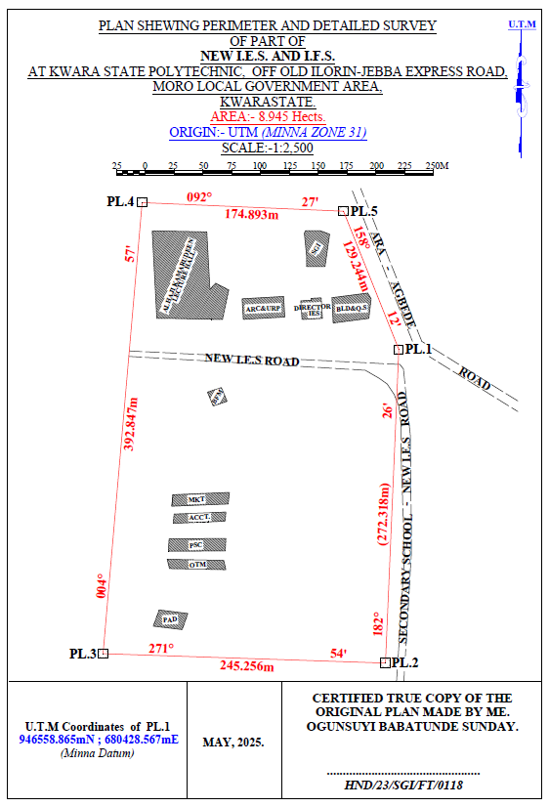
HND/23/SGI/FT/0076
GANIYU AKEEM ABIODUN
GANIYU AKEEM ABIODUN
Figure 3.7: Plan showing Perimeter and Detailed Survey.

Area Computation using Cross Multiply Coordinates
E1 N1
E2 N2
E3 N3
E4 N4
E5 N5
E1 N6
680428.567 946558.865
680417.004 946286.792
680171.885 946294.956
680205.833 946686.334
680380.567 946678.865
680428.567 946558.865
∑ - ∑
2
460,787,138,011.03 – 460,786,959,116.36
2

178,894.67
2
Area = 89,447.335 sqft
Area = 8.945 hect.

CHAPTER FOUR
4.0 DATA DOWNLOADING, PROCESSING, ANALYSIS AND DISCUSSION
This chapter provides a detailed overview of the procedures involved in data download, data processing, correction, and data analysis conducted on the acquired data from the site and data presentation.
4.1 Data Download
All the recorded data was stored in the memory of the total station. To download the data, the total station was connected to a computer using a wired cable and downloading software. The software parameters were configured to match those of the instrument. The instrument's menu was accessed, and the memory manager was selected. From there, the "send data" option was chosen, and the file named "PRJT1" was located and downloaded to the computer through the software. The data was saved with a ".txt" file extension on the desktop of the laptop for further processing.
4.2 Data Editing
The downloaded geometric data were further processed to convert them into usable formats and improve their accuracy. The resulting coordinate data were edited using Notepad and Excel software. This file was then imported into AutoCAD2007 for additional processing.

4.3 Data Processing using Autocad 2007
Before using AutoCAD, we processed the coordinate data observed in the field by first transferring it into Notepad, then copying it into AutoCAD. The following steps outline the process for handling the data in AutoCAD:
- Launch AutoCAD on the computer.
- Click "New" from the application menu to start a new drawing.
- Type UNITS in the command line and press Enter.
- Select the desired unit type (e.g., decimal, architectural, engineering).
- In the menu bar, select the "Polyline" tool.
- Copy the data from Notepad and paste it into AutoCAD.
- Type Z (for zoom) and press Enter, then type E (for extents) and press Enter to adjust the view.
4.4 Results and Discussion
Table 4.4: Total station and Digital level Spot height Readings and their differences
REMARKS | EASTING | NORTHING | HEIGHT |  | DIFF.
REMARKS | EASTING | NORTHING | T.S | LEVEL | DIFF.
SH1 | 680272.275 | 946497.781 | 355.749 | 355.715 | 0.034
SH2 | 680267.717 | 946479.907 | 356.403 | 356.362 | 0.041
SH3 | 680273.327 | 946450.469 | 354.811 | 354.772 | 0.039
SH4 | 680287.358 | 946434.349 | 354.268 | 354.208 | 0.060
HSH5 | 680317.873 | 946433.648 | 355.036 | 354.984 | 0.052
SH6 | 680304.544 | 946455.727 | 355.710 | 355.668 | 0.042
SH7 | 680337.867 | 946463.436 | 355.448 | 355.386 | 0.062
SH8 | 680342.774 | 946441.708 | 356.295 | 356.240 | 0.055
SH9 | 680342.774 | 946441.708 | 356.736 | 356.680 | 0.056
SH10 | 680348.740 | 946443.460 | 355.971 | 355.931 | 0.040
SH11 | 680377.262 | 946451.836 | 355.725 | 355.673 | 0.052
SH12 | 680382.060 | 946482.711 | 355.318 | 355.277 | 0.041
SH13 | 680381.009 | 946518.108 | 354.819 | 354.766 | 0.053
SH14 | 680350.494 | 946509.345 | 355.174 | 355.128 | 0.046
SH15 | 680356.104 | 946484.813 | 355.033 | 355.005 | 0.028
SH16 | 680332.603 | 946480.960 | 355.228 | 355.188 | 0.040
SH17 | 680308.051 | 946470.796 | 355.517 | 355.464 | 0.053
SH18 | 680298.581 | 946490.422 | 355.834 | 355.802 | 0.032
SH19 | 680318.222 | 946506.191 | 355.726 | 355.678 | 0.048
SH20 | 680308.753 | 946526.168 | 356.148 | 356.096 | 0.052
Mean |  |  | 355.8163 | 355.7726 | 0.0437
Variance |  |  | 2.5758 | 2.5881 | 0.0123
Standard Deviation |  |  | 1.6049 | 1.6088 | 0.0039

Working Formulas for Mean, Variance and Standard Deviation Calculation
The mean is calculated as:
µ = ∑xi
n
µ= mean
xi = each point height
n = number of points
The variance is calculated as:
ꭤ²=∑(xi - µ)²
n
ꭤ²= variance
xi = each point height
µ= mean
n = number of points
The Standard Deviation is calculated as:
ꭤ = √ꭤ²
ꭤ= standard deviation
ꭤ²= variance
Mean calculation for Total Station Height readings
µ = ∑xi
n
µ=355.749+356.403+354.811+354.268+355.036+355.710+355.448+356.295+356.736+355.971+355.725+355.318+354.819+355.174+355.033+355.228+355.517+355.834+355.726+356.148
20
µ= 7116.326
20
µ=355.8163
Mean calculation for Reduced Level Height readings
µ=355.715+356.362+354.772+354.208+354.984+355.668+355.386+356.240+356.680+355.931+355.673+355.277+354.766+355.128+355.005+355.188+355.464+355.802+355.678+356.096
20
µ= 7115.452
20
µ = 355.7726
Mean calculation for Total Station Height readings - Mean calculation for level height readings 355.8163 – 355.7726 = 0.0437
ꭤ²=∑(xi - µ)²
n
ꭤ²=∑(xi - µ)²
n
0.0673²+0.5867²+1.0053²+1.5483²+0.5327²+0.2521²+0.1582²+0.4126²+0.9284²+0.0992²+0.1104²+0.1327²+1.0217²+0.6184²+0.7834²+0.4926²+0.2581²+0.0164²+0.0428²+0.3317
20
ꭤ²=51.516
20
ꭤ² =2.5758
Variance calculation for Reduced Level Height readings
0.576²+0.5894²+1.006²+1.5686²+0.5285²+0.2375²+0.1382²+0.4103²+0.9126²+0.0821²+0.1013+0.1104²+1.0102²+0.6014²+0.7695²+0.4818²+0.2443²+0.0071²+0.0289²+0.32047
20
ꭤ²=51.762
20
ꭤ² =2.5881
Variance calculation for total station – variance calculation for level height readings 2.5758 – 2.5881 = 0.0123
The Standard Deviation for Total Station Height readings:
ꭤ = √ꭤ²
ꭤ = √2.5758
ꭤ = 1.6049

The Standard Deviation for Reduced Level Height readings:
ꭤ = √2.5881
ꭤ = 1.6088
The standard deviation for total station – standard deviation for level height reading 1.6049 – 1.6088 = 0.0039

The table above shows the station Id, eastings, northings, total station height, digital level reduced level and the difference between the total station height and the digital level reduced level.
The comparison of the two pieces of equipment revealed variations within a specific range. The differences observed between the two pieces of equipment were found to be in the range of 0.028 to 0.062 meters. These differences indicate slight disparities in the measurements obtained from each instrument. Statistical analysis was performed to evaluate the mean, variance, and standard deviations of the observed differences. The mean difference was calculated to be 0.0437, indicating an average deviation between the measurements obtained by the two equipment. The variance, which quantifies the spread of the differences, was found to be 0.0123.
This value suggests that the variations in the measurements obtained by the two pieces of equipment were relatively consistent. The standard deviation, which provides a measure of the dispersion of the data, was determined to be 0.0039. This indicates that the differences between the measurements obtained from the two pieces of equipment had a moderate level of variability.
Overall, the results of the analysis demonstrate that there were slight variations between the measurements obtained from the two pieces of equipment. The mean, variance, and standard deviations provide insights into the magnitude and consistency of these differences, offering valuable information for assessing the accuracy and reliability of the equipment in question.

Figure 1:Bar chart showing heights obtained from the total station and level instrument

Figure 2:Histogram showing the difference in the two instrument’s result
The histogram presented above illustrates the distribution of deviations between the two methods being compared. The deviations are depicted in centimeter, showcasing the level of accuracy achieved by both methods. The histogram highlights that the deviations are tightly clustered and exhibit a consistent pattern.
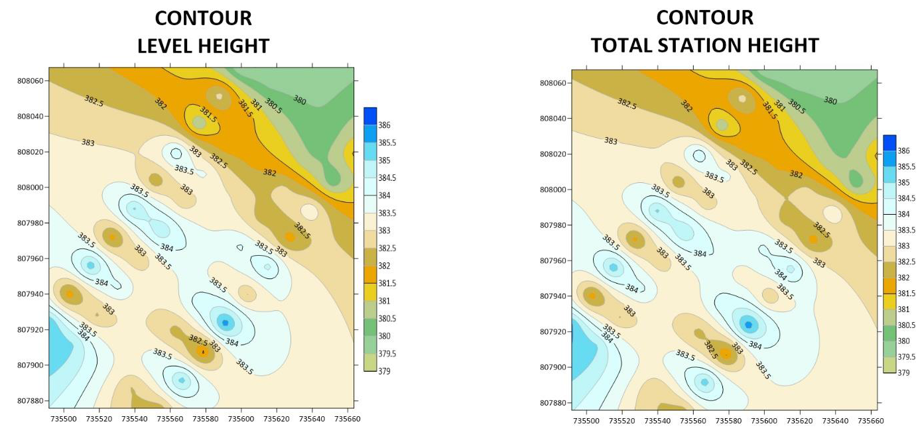Figure 3. Showing the contour map obtained from the two instruments.
3-D SURFACE MODEL USING TOTAL STATION
3-D SURFACE MODEL USING AUTO LEVEL
CONTOUR MAP USING TOTAL STATION
CONTOUR MAP USING AUTO LEVEL
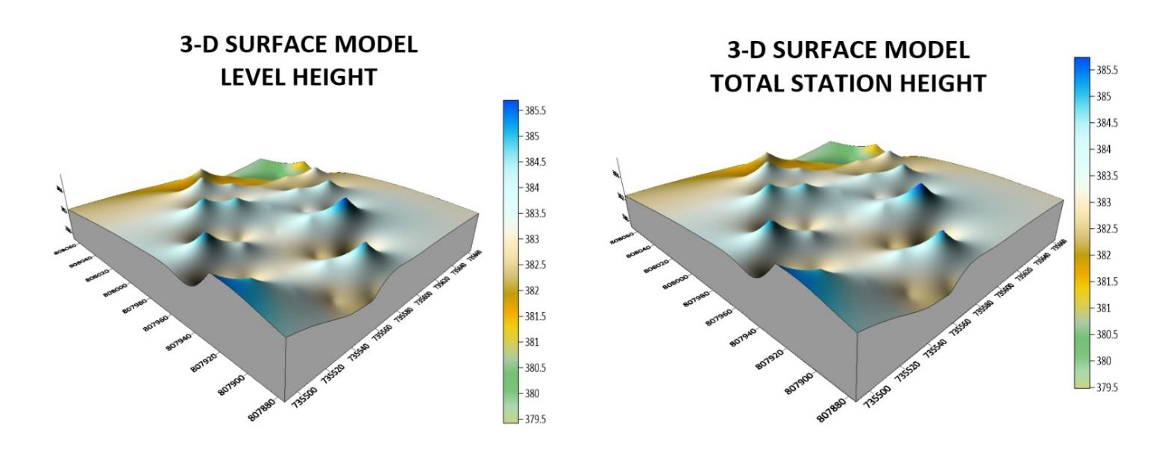Figure 4:Showing the 3D surface map obtained from the two instruments
The mean of the deviations, calculated to be 0.0437m, provides an indication of the average difference between the measurements obtained from the two methods. This value signifies a small average deviation, suggesting that the two methods generally yield similar results with minimal variation.
The histogram provides a visual representation of the data, allowing for a comprehensive understanding of the distribution of deviations. By examining the histogram, one can observe the concentration of deviations around the mean value, indicating a central tendency in the measurements obtained by the two methods.
The centimeter-level accuracy exhibited by the deviations underscores the precision of the measurement techniques employed. This level of accuracy is crucial, particularly in applications that require high precision, such as engineering, construction, or geospatial analysis. The contour maps presented above exhibit strikingly similar patterns, which serve as a testament to the high degree of precision achieved by the instruments used. The consistent and replicated patterns observed on the maps reinforce the reliability and accuracy of the measurements obtained.
The similarity in the contour patterns indicates that the instruments employed in the surveying process were able to capture the subtle variations in elevation with great precision.
This level of accuracy is crucial in applications such as topographic mapping, land surveying, and engineering, where even minor deviations can have significant implications. By displaying the contours of the surveyed area, the maps provide a visual representation of the landscape's topography and elevation changes.
The congruity in the contour lines across the maps signifies that the instruments effectively captured and recorded the elevation data, resulting in a reliable representation of the terrain
4.5 Statistical Analysis
A statistical investigation was carried out using Paired Two Samples as Means to test whether there is any significant difference in the performance of the two instruments for terrain height determination. The independent sample t-test is a member of the t-test family, which consists of tests that compare mean value(s) of continuous-level (interval or ratio data), normally distributed data (Hinton, 2004). The independent-sample t-test evaluates the difference between the means of two independent or unrelated groups. That is, we evaluate whether the means for the two independent groups are significantly different from each other.
Hypothesis
A hypothesis was set up and tested using an Independent – sample T-Test:
- Null Hypothesis: H0: There is no difference between the terrain height obtained from the total station and digital level instrument.
- Alternative Hypothesis: H1: There is a difference between terrain height obtained from total station and digital levelling instrument.
The null hypothesis is rejected if the calculated t value has a probability sig. (p) greater than the chosen significance level. An Independent sample T-Test was used in testing the hypothesis at a significance level of 0.05. Data analysis Package extension in Excel was activated and used in running the T-Test.
Table 4.5: T-Test: Two-Sample Assuming Unequal Variances
 | Digital Level | Total Station
Mean | 355.77262 | 355.81628
Variance | 2.588092118 | 2.575687471
Observations | 20 | 20
Pearson Correlation | 0.032104369 | 0.031950494
Hypothesized Mean Difference | 0.001605218 | 0.001597525
t Stat | 0.056215684 | 0.056208782
P(T<=t) one-tail | 0.145413689 | 0.144776257
P(T<=t) two-tail | 0.290982737 | 0.289552551
Sum | 7096.631 | 7095.814
Kurtosis | 2.049052417 | 2.0403051292
Skewness | 0.612867732 | 0.5907755549
Median | 354.772 | 354.811
Maximum | 356.680 | 356.736
Minimum | 354.208 | 354.268
Range | 2. 472 | 2.468
The statistical data provided supports our discussion by indicating a high degree of agreement and consistency between the digital level and total station measurements. The mean values are very close, the variances are similar, and the Pearson correlation coefficient indicates a strong linear relationship. The t-test results suggest that any observed difference between the two instruments' means is likely due to random variation rather than a significant discrepancy. After carrying out the project, we observe that digital level is more accurate than total station, although the different can be quite small.

CHAPTER FIVE
5.0 COSTING, SUMMARY, RECOMMENDATION AND CONCLUSION.
5.1 Cost Estimation of the Project
The project costing was based on number of variables which includes area to be covered, instruments, personnel, transportation and so on. However, another critical factor to be considered is the time duration in which the project was executed. The table below shows the duration the project was accomplished.
Table 5.1: Scheduled and Duration of the Project Execution
Description | Duration (Days)
Reconnaissance | 1
Beaconing / Monumentation | 1
Spot height points establishment | 1
XYZ acquisition of the spot height points (using TS) | 1
Height observation of the spot height points (using level instrument) | 1
Detailing (using handheld GPS) | 1
Data Downloading / Processing | 3
Plotting and Report Writing | 7
Submission of Report and Plan | 5
Total No. of Days Spent for the Project | 21

5.1.1 Project Costing Breakdown

Costing of this project was based on Professional Scale of Fees as approved by Nigerian Institution of Surveyor (NIS) in 2017 using 1996 Federal Government Approved Scale of Fees for Consultants in the Construction Industry. The prevailing inflation rate as at February 2023 was 21.91 % and this was applied to the cost estimate.
Table 5.2: Worked out Calculation for the grand Total Cost
S/N | OPERATION | RATE/DAY | NO OF DAYS | UNIT  COST (#) | AMOUNT (#)
1 | RECONNISSANCE(1 DAY)
 | 4 Technician | 15,189.11 | 1 | 15,189.11 x 4 | 60,756.40
 | 1 Skilled Labour | 9,468.61 | 1 | 9,468.61x 1 | 9,468.61
 | Transportation (Field vehicle + Driver / Mechanic + fuel | 46,027.61 | 1 | 46,027.61 x 1 | 46,027.61
 | Basic equipment (Hand held GPS etc.) | 46,027.61 | 1 | 46,027.61 x 1 | 46,027.61
 | SUB TOTAL |  |  |  | 157,546.00
2 | - BEACONS (5)  (standard Cadastral Beacon) | 5,000 per Beacon |  | 5,000 x 5 | 25,000.00
2 | - BEACONING/  MONUMENTATION (1 day)
2 | 6 Surveyors | 15,189.11 | 1 | 6x 15,189.11x 1 | 91,134.11
2 | 3 Skilled Labour | 9,468.61 | 1 | 3x 9,468.61x 1 | 28,405.83
2 | Transportation (Field vehicle + Driver / Mechanic + fuel) | 46,027.61 | 1 | 46,027.61 x 1 | 46,027.61
2 | Basic tools (Crow bar, Trowel, Shovel etc) | 13,929.00 | 1 | 13,929.00x 1 | 13,929.00
2 | SUBTOTAL |  |  |  | 179,496.55
3 | Spot Height Establishment  ( 1 DAY)
 | 2 surveyors | 15,189.11 | 1 | 2x15,189.11 x 1 | 30,378.22
 | 3 Unskilled Labour | 9,468.61 | 1 | 3 x9,468.61x 1 | 56,811.66
 | Basic Equipment | 46,027.61 | 1 | 46,027.61x1 | 92,055.22
 | Transportation (Field vehicle + Driver / Maintenance + Fuel) | 46,027.61 | 1 | 46,027.61 x 1 | 92,055.22
 | SUBTOTAL |  |  |  | 271,300.32
4 | XYZ ACQUISITION USING (TS)  (1 DAY)
 | 1 Senior Surveyor | 22,783.67 | 1 | 1x 22,783.67 x 2 | 45,567.34
 | 2 Surveyors | 15,189.11 | 1 | 2 x15,189.11 x 2 | 60,756.44
 | 2skilled Labour | 9,468.61 | 1 | 2 x9,468.61x 2 | 37,874.44
 | Basic Equipment | 46,027.61 | 1 | 46,027.61x 2 | 92,055.22
 | Transportation (Field vehicle + Driver / Maintenance + Fuel) | 46,027.61 |  | 46,027.61 x 2 | 92,055.22
 | SUBTOTAL |  |  |  | 328,308.66
5 | HEIGHT OBSERVATIION (LEVEL INSTRUMENT)  (1DAY)
 | 1 Senior Surveyor | 22,783.67 | 1 | 1x 22,783.67 x 2 | 45,567.34
 | 2 surveyors | 15,189.11 | 1 | 2 x15,189.11 x 2 | 60,756.44
 | 2skilled Labour | 9,468.61 | 1 | 2 x9,468.61x 2 | 37,874.44
 | Basic Equipment | 46,027.61 | 1 | 46,027.61x 2 | 92,055.22
 | Transportation (Field vehicle + Driver / Maintenance + Fuel) | 46,027.61 | 1 | 46,027.61 x 2 | 92,055.22
 | SUBTOTAL |  |  |  | 328,308.32
6 | DETAILING  (1 DAY)
 | 2 Surveyors | 15,189.11 | 1 | 2x 15,189.11x 1 | 30,378.22
 | 3 Skilled Labour | 9,468.61 | 1 | 3x 9,468.61x 1 | 28,405.83
 | Transportation (Field vehicle + Driver / Mechanic + fuel) | 46,027.61 | 1 | 46,027.61 x 1 | 46,027.61
 | Basic Equipment | 46,027.61 | 1 | 46,027.61x 1 | 46,027.61
 | SUBTOTAL |  |  |  | 150,839.27
7 | DATA DOWNLOADING  / PROCESSING  (3 DAYS)
 | 1 Senior Surveyor | 22,783.67 | 3 | 22,783.67 x 3 | 68,351.01
 | 2 surveyors | 15,189.11 | 3 | 2x15,189.11 x 3 | 91,134.66
 | Computer Accessories | 49,315.28 | 3 | 49,315.28 x 3 | 147,945.84
 | SUBTOTAL |  |  |  | 307,431.51
8 | PLOTTING AND REPORT WRITTING  (7 DAYS)
 | 1 Senior Surveyor | 22,783.67 | 7 | 1x22783.67 x 7 | 159,485.69
 | 2 surveyors | 15,189.11 | 7 | 2x15,189.11 x 7 | 212,647.54
 | Standard set (computer, plotter etc) | 65,753.70 | 7 | 1x65,753.70 x 7 | 460,275.90
 | SUBTOTAL |  |  |  | 832,409.13
9 | SUBMISSION OF REPORT AND PLAN  (1 DAY)
 | 1 Chief Surveyor | 30,800.00 | 1 | 30,800.00x 1 | 30,800.00
 | 2 surveyors | 15,189.11 | 1 | 2x 15,189.11x 1 | 30,378.22
 | 1 Computer | 46,027.61 | 1 | 46,027.61 x 1 | 46,027.61
 | Consumables | 13,929.00 | 1 | 13,929.00 x 1 | 13,929.00
 | SUBTOTAL |  |  |  | 121,135.41
COST OF TH]E PROJECT = |  |  |  |  | 2,676,775.17 |  |  | 1,379,346.77
ACCOMODATION(15% of the cost of the project) |  |  |  |  | 595,177.22
MOBILIZATION/DEMOBILIZATION (10% of cost of the project) = |  |  |  |  | 396,784.81
CONTINGENCIES (5% of cost of the project) = |  |  |  |  | 198,392.41
VAT (7.5% of the Total cost of the project)= |  |  |  |  | 297,588.61
ACTUAL BILL/ GRAND TOTAL = |  |  |  |  | 4,164,718.22
Hence, the total cost of expenditure used for comparative evaluation of digital levelling and total station equipment for height measurement project was estimated to be Four Million, One Hundred and Sixty Four Thousand, Seven Hundred Eighteen Naira, Twenty Two Kobo only.
5.2 Summary
The comparative evaluation of digital levelling and total station equipment for height measurement reveals that both tools have their advantages and disadvantages. Digital levelling offers high precision and accuracy, particularly in precise levelling tasks, whereas total station equipment provides flexibility and versatility in various surveying applications. The project demonstrates that the choice between these two instruments depends on the specific requirements of the project, including the range, precision, and type of measurement. The results of this research contribute to a deeper understanding of the capabilities and limitations of digital levelling and total station equipment, ultimately enhancing the accuracy and reliability of height measurements in various fields.
5.3 Recommendation
Develop long-term strategies for sustainable surveying practices by adopting eco-friendly technologies, such as solar-powered equipment or reducing the use of single-use materials. This will contribute to environmental conservation and improve the reputation of the surveying industry as it aligns with global sustainability goals. Allocate resources for continuous investment in emerging technologies like artificial intelligence (AI), machine learning (ML), and blockchain for data verification and storage. These innovations will improve data processing, enhance survey accuracy, reduce human error, and streamline project workflows in the long term.
5.4 Conclusion
Surveying is rapidly evolving with technological advancements, and staying ahead of the curve will be essential for the long-term success of the industry. Continuous adaptation to new technologies will improve precision, reduce operational costs, and expand the scope of surveying services, enabling the profession to meet future challenges.

REFERENCES
Audu, H.A.P., Tijjani, M.Y. (2017). Comparative Assessment of the Accuracy of the Elevation differences obtained from different Geomatics Techniques and Instruments. Nigerian Journal of Environmental Sciences and Technology Vol 1, No. 1 pp 136 - 145
Beshr, A.A.A.; Abo Elnaga, I.M. ( 2011). Investigating the Accuracy of Digital Levels and Total Stations for Purposes of Geodetic Engineering. Alex. Eng. J. 50, 399–405
Journal of Spatial Science: Accuracy Assessment of Digital Levelling and Total Station in Surveying.
M. A (2018).Comparative Study of Conventional Surveying Techniques with Total Station and Digital Levelling International Journal of Civil Engineering Technology, 9, 440–446
Simbolon, A. B. S., Yuwono, B. D., &Amarrohman, F. J. (2017). Comparatory analysis of the accuracy between Total Station and Digital Levelling. UndipJournal of Geodesy, 6(4), 285-294. https://doi.org/10.14710/jgundip.2017.18153
W. Maembe, “Potential Application of Total Station Levelling as a Precise Geodetic Levelling” BSc. Thesis, Department of Geomantic Ardhi University Dare Salam Tanzania,2012.

APPENDIX

ID EASTING NORTHING TS HEIGHT LEVEL HEIGHT
PL.1 680428.567 946558.865 356.128
PL.2 680417.004 946286.792 354.746
PL.3 680171.885 946294.956 353.013
PL.4 680205.833 946686.334 357.652
PL.5 680380.567 946678.865 356.849
SH1 680272.275 946497.781 355.749 355.715
SH2 680267.717 946479.907 356.403 356.362
SH3 680273.327 946450.469 354.811 354.772
SH4 680287.358 946434.349 354.268 354.208
SH5 680317.873 946433.648 355.036 354.984
SH6 680304.544 946455.727 355.710 355.668
SH7 680337.867 946463.436 355.448 355.386
SH8 680342.774 946441.708 356.295 356.240
SH9 680342.774 946441.708 356.736 356.680
SH10 680348.740 946443.460 355.971 355.931
SH11 680377.262 946451.836 355.725 355.673
SH12 680382.060 946482.711 355.318 355.277
SH13 680381.009 946518.108 354.819 354.766
SH14 680350.494 946509.345 355.174 355.128
SH15 680356.104 946484.813 355.033 355.005
SH16 680332.603 946480.960 355.228 355.188
SH17 680298.581 946490.422 355.834 355.802
SH18 680318.222 946506.191 355.726 355.678
SH19 680308.753 946526.168 356.148 356.096
SH20 680342.774 946441.708 356.736 356.680

SHOPRITE 680275.567 946584.865 , S.G.I 680364.567 946630.865
SHOPRITE 680229.567 946585.865 , S.G.I 680368.567 946658.865
SHOPRITE 680218.567 946585.865 , S.G.I 680360.567 946661.865
SHOPRITE 680214.567 946661.865 , S.G.I 680347.567 946661.865
SHOPRITE 680262.006 946660.833 , S.G.I 680346.567 946659.865
SHOPRITE 680264.633 946610.907 , S.G.I 680348.567 946639.865
SHOPRITE 680269.493 946616.306 , S.G.I 680348.567 946630.865
SHOPRITE 680281.021 946610.551 , S.G.I 680364.567 946630.865
SHOPRITE 680281.021 946610.551
DRCT. IES 680344.567 946584.865 , BLD&QS 680371.567 946581.865
DRCT. IES 680343.551 946601.098 , BLD&QS 680370.514 946603.802
DRCT. IES 680352.430 946601.591 , BLD&QS 680401.497 946607.815
DRCT. IES 680352.329 946603.210 , BLD&QS 680404.537 946602.905
DRCT. IES 680361.208 946603.703 , BLD&QS 680402.499 946585.830
ARC&URP 680328.567 946604.865 , BFM 680262.567 946521.871
ARC&URP 680292.567 946602.865 , BFM 680267.567 946509.867
ARC&URP 680293.684 946585.013 , BFM 680279.567 946513.862
ARC&URP 680329.684 946587.013 , BFM 680274.567 946525.865
MKT. 680215.442 946426.097 , ACCT.680262.660 946428.209
MKT. 680214.930 946436.134 , ACCT.680218.483 946419.645
MKT. 680263.075 946445.466 , ACCT.680218.891 946411.655
MKT. 680263.587 946435.430 , ACCT.680263.068 946420.219
PHYS. 680266.105 946405.563 , OTM. 680266.988 946386.384
PHYS. 680267.046 946394.755 , OTM. 680218.393 946380.018
PHYS. 680218.331 946387.08 , OTM. 680221.571 946372.409
PHYS. 680217.389 946397.897 , OTM. 680270.166 946378.775
PAD. 680240.402 946321.660
PAD. 680215.235 946320.874
PAD. 680218.077 946335.465
PAD. 680243.244 946336.252

