IDENTIFICATION OF HYDROTHERMAL ALTERATION ZONES AND ITS RELATION TO MINERAL DEPOSITS OVER ISANLU ISIN, NORTHCENTRAL, NIGERIA

BY:

AHMED ADEMOLA SAMUEL
HND/23/SLT/FT/0996

BEING A PROJECT REPORT SUBMITTED TO THE DEPARTMENT OF SCIENCE LABORATORY TECHNOLOGY (PHYSICS/ELECTRONIC UNIT), INSTITUTE OF APPLIED SCIENCES, KWARA STATE POLYTECHNIC ILORIN

IN PARTIAL FULFILMENT OF THE REQUIREMENTS FOR THE AWARD OF HIGHER NATIONAL DIPLOMA (HND) IN SCIENCE LABORATORY TECHNOLOGY (SLT), KWARA STATE POLYTECHNC, ILORIN, KWARA STATE

JULY, 2025
CERTIFICATION
This is to certify that this project was carried out and written by AHMED ADEMOLA SAMUEL Matric number HND/23/SLT/FT/0996 in the Department of Science Laboratory Technology, Physics/Electronics unit, Institute of Applied Science (IAS), Kwara State Polytechnic, Ilorin, it has been approved as fulfilment for the requirement of the award of Higher National Diploma (HND) in Science Laboratory Technology (SLT).

___________________ _______________
Dr. A. J Sunday Date
Project Supervisor

___________________ _______________
Mr. Salahu Bashir Date
HOU, Physic/Electronics

___________________ _______________
Dr. Abdulkareem Usman Date
Head of Department (SLT)

___________________ _______________
External Examiner Date

DEDICATION
This work is dedicated to Almighty God, for his infinite mercy and Grace.
My utmost appreciation goes to my parents for their parental support all through the course of my academic pursuit Mr and Mrs Ahmed
I also dedicate this project to my elder brother AHMED ABIOLA for his support with the school bills and check up time to time
I also dedicate to my friends which supported me from the beginning to the ending of my school journey Samson, Dior and Ahmed also my crazy roommate Olabode Matthias for sticking by me and a wonderful person who helped me in every way she can even with most of my schoolwork Elizabeth Isaac
And lastly my supervisor (DR SUNDAY JOHN ABAYOMI) God bless you abundantly

ACKNOWLEDGEMENT
I am grateful to Almighty God for his Mercy, goodness and love towards the successful completion of my academic pursuit. Thanks, you Lord
I heartily appreciate my wonderful supervisor, Dr. Sunday A.J. for their selfless efforts, support, advise, encouragement, training and criticism during the exercise of this research. May all your dreams come true.
My most grateful and indebted to my lovely parents, who’s their love, care and support both financially, spiritually and morally have made my academic pursuit to become a reality. Words are too weak to thank them both because they are the best parents to ever wish for.
To the entire academic and non- academic staff of the department, i am grateful for your kind support for these past two years especially during the course of this study.
I can't conclude this acknowledgement without expressing my profound gratitude to my friends, you guys are the best. I pray that all our dreams will come true.

TABLE OF CONTENTS
Title page
Certification
Dedication
Acknowledgment
Table of content
Abstract
CHAPTER ONE: INTRODUCTION
1.1 Background to the Study
    - Statement of Problem
1.3 Significance of the Study
1.4 Aim and Objectives
CHAPTER TWO: LITERATURE REVIEW
2.1 Mineral Deposits
2.2 Hydrothermal Alteration Zones
2.3 Relationship Between Mineral Deposits and Hydrothermal Alteration Zones
2.4 RADIOMETRIC DATA
2.5 Interpretation Methods
CHAPTER THREE: METHODOLOGY
3.1 Introduction
3.2 Data Acquisition
3.3 Data Processing
3.4 Data Integration and Analysis
3.5 Validation

CHAPTER FOUR: RESULTS, DISCUSSION AND CONCLUSSION
4.1 Results
4.2 Data Presentation and Interpretation
4.3 Profile A – A’
4.4 Profile B – B’
4.5 Profile C – C’
4.6 Profile D – D’
4.7 Profile E – E’
Conclusion
References

ABSTRACT
This study focuses on identifying and characterizing hydrothermal alteration zones and their association with mineral deposits in Isanlu Isin, Northcentral Nigeria, within the Nigerian Basement Complex (Isanlu sheet 225, latitudes 8°15'N to 8°30'N, longitudes 5°15'E to 5°30'E). Utilizing airborne radiometric data from the Nigerian Geological Survey Agency, processed with Geosoft Oasis Montaj and Surfer software, the research mapped potassium (K), equivalent uranium (eU), and equivalent thorium (eTh) distributions to delineate alteration zones. Techniques such as gridding, filtering, ratio enhancement (K/eTh, K/eU), and ternary imaging were employed to highlight potassic, phyllic, argillic, and propylitic alteration zones, with K/eTh ratios >0.2 indicating potassic alteration linked to gold mineralization. Landsat-8 OLI remote sensing data, processed via band ratios and Principal Component Analysis, complemented radiometric findings by detecting spectral signatures of alteration minerals. Integration of datasets using fuzzy logic modeling identified eight alteration zones, with high prospectivity scores (0.8–0.95) for potassic and phyllic zones near Odogbe and Okolom, validated through X-ray Diffraction and ground-based gamma-ray spectrometry. Resistivity tomograms from five profiles (A–E) revealed aquifer zones in weathered/fractured basement rocks, supporting fluid pathways for mineralization. The study confirms that radiometric and remote sensing methods effectively map hydrothermal alteration, providing a framework for targeted mineral exploration, particularly for orogenic gold deposits, and highlights prospective areas for further investigation in Isanlu Isin.

CHAPTER ONE
INTRODUCTION
1.1 Background to the Study
Environmental physics explores the physical principles governing natural systems, integrating disciplines like geophysics, atmospheric physics, and hydrology to study energy transfer, fluid dynamics, and material interactions in the Earth's crust, atmosphere, and hydrosphere (Boeker and van Grondelle, 2011). In mineral exploration, environmental physics is pivotal for understanding subsurface processes, such as hydrothermal fluid movement, which influences mineral deposition. Techniques like radiometric surveys measure natural gamma radiation from elements like potassium, uranium, and thorium to map geological structures and detect alteration zones associated with mineral deposits (Telford et al., 1990). These methods rely on physical properties radioactivity, electrical conductivity, and magnetism to infer subsurface features, providing a non-invasive approach to exploration (Kearey et al., 2013).
It has become a powerful tool adopted by geo-scientist in gaining information about the composition and structure of rocks and soil (Ajeigbe et al, 2014). The radiometric measurement can be used to confirm the presence and abundance of radioelements (e.g., uranium (U), thorium (Th) and potassium (K). These radioelements occur naturally and are typically found as trace contents in rocks and soil. The analysis of these radioelements provides useful insights into numerous geological processes and phenomena (Dentith and Mudge, 2014). For instance, the indirect measurements of uranium and thorium activity concentrations warrants the usage of the prefix equivalent as thus uranium (eU) and thorium (eTh). The measurement of these radioelements is usually related to certain lithological formations which may indicate presence of ore deposits (Urquhart, 2013). The direct measurement of potassium (K%) on the other hand, is an essential element in many rocks and minerals and can provide information about the age and geological history of a particular area (Sanusi and Amigun, 2020)
Hydrothermal alteration occurs when hot, mineral-rich fluids (50–400°C) interact with rocks, causing chemical and mineralogical changes (Pirajno, 2009). These fluids, originating from magmatic, meteoric, or metamorphic sources, circulate through fractures, altering host rocks into distinct mineral assemblages. Common alteration types include:
- Potassic: K-feldspar and biotite, associated with high-temperature fluids.
- Phyllic: Sericite and quartz, linked to moderate-temperature alteration.
- Argillic: Clay minerals like kaolinite, formed at lower temperatures.
- Propylitic: Chlorite, epidote, and carbonates, typically distal to ore zones (Robb, 2005).
These alteration zones often form haloes around mineral deposits, serving as key exploration indicators for metals like gold, copper, and molybdenum (Sillitoe, 2010). In Nigeria’s Basement Complex, such zones are critical for identifying orogenic gold deposits, where fluid-rock interactions are controlled by structural features like faults and shear zones (Garba, 2003).
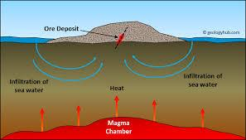
Fig. 1: "Schematic of Hydrothermal Alteration Zones" (Ajeigbe et al., 2014)
Isanlu Isin, located in Kwara State, Northcentral Nigeria, falls within the Isanlu sheet 225 (1:100,000 scale). The study area spans approximately latitudes 8°15'N to 8°30'N and longitudes 5°15'E to 5°30'E, covering part of the Nigerian Basement Complex, known for its Precambrian schists, migmatites, and granites (Oyawoye, 1972).
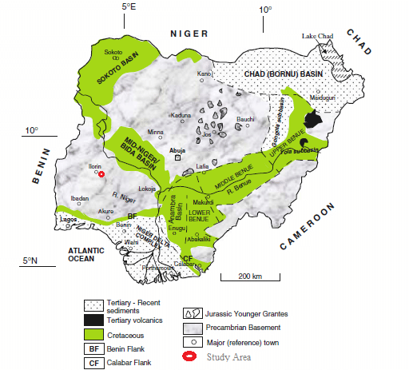
Fig. 2:The Area of the study lies within the Northcentral part of Nigeria (Oyawoye, 1972).
The hydrogeology of Isanlu Isin is characterized by shallow aquifers in weathered regolith and fractured basement rocks (Olorunfemi and Fasuyi, 1993). Fractures and shear zones act as conduits for groundwater and hydrothermal fluids, facilitating mineralization processes. The region’s low permeability limits large-scale aquifer development, but localized fracture systems enhance fluid flow critical for ore deposition (Okunlola and Okoroafor, 2009).
The terrain features gently undulating plains with elevations of 300–500 meters, punctuated by inselbergs and ridges of resistant quartzites and granites. This physiography results from prolonged weathering and erosion, exposing basement rocks suitable for geophysical mapping (Rahaman, 1988).
Isanlu Isin experiences a tropical savanna climate with wet (April–October) and dry (November–March) seasons. Annual rainfall ranges from 1200–1500 mm, and temperatures vary between 25°C and 35°C (Iloeje, 2001). This climate influences weathering rates and fluid mobility, impacting alteration zone formation.
The relief consists of low hills and flat plains, shaped by differential erosion of basement rocks. Structural features like faults and folds are exposed, aiding the identification of alteration zones through geophysical surveys (Ajibade et al., 1987).
  - Statement of Problem
Despite the mineral potential of Isanlu Isin, particularly for gold, the lack of detailed geophysical mapping and integrated studies limits the identification of hydrothermal alteration zones. The complex interplay of structural controls, fluid pathways, and alteration processes remains underexplored, leading to inefficient exploration and missed economic opportunities (Olade, 2019). Existing data often lack the resolution needed to pinpoint high-priority targets, necessitating advanced radiometric and remote sensing approaches.
Many hydrothermal alteration zones are located in geologically remote and challenging terrains, often far from established infrastructure. Therefore, accessibility and logistical constraints in reaching these areas for fieldwork and data collection present significant hurdles. The accurate identification and characterization of hydrothermally altered zones are critical for understanding the presence and distribution of mineral deposits. However, current detection methods often lack the required resolution and reliability to precisely locate these zones.

1.3 Significance of the Study
This study enhances the understanding of hydrothermal alteration in Isanlu Isin, providing a framework for targeted mineral exploration. By mapping alteration zones and structural controls, it supports efficient prospecting, potentially driving economic growth in Kwara State. The integration of aeroradiometric and remote sensing data offers a scalable, cost-effective approach applicable to other parts of Nigeria’s Basement Complex, contributing to sustainable mineral resource development (Anudu et al., 2014).
1.4 Aim and Objectives
Aim
This research work aims to identify and characterize hydrothermally altered zones that are associated with mineral deposits over parts of Isanlu-Isin, Northcentral Nigeria.
The objectives of this research work includes:
- To obtain surficial distribution of various radioactive elements,
- To obtain potassic alteration zones,
- To identify zones that have undergone hydrothermal alterations,
- To reveal the possible signature areas of mineral deposits.

CHAPTER TWO
LITERATURE REVIEW
Previous studies have shown that identifying and mapping hydrothermally altered zones can act as a guide for locating and mapping main mineralization. Tawey et al., (2022) investigated on Zones that have undergone hydrothermal alteration and are associated with mineralization.
Sanusi et al.(2020) used the radiometric approach to establish the surficial distribution of various radioactive elements and then separate the hydrothermally changed zones Ayokunle et al. (2023) also used radiometric mapping approach for the identification of hydrothermally altered zones related to gold mineralization Reda A. Y. El Qassasa et al. (2020) used Airborne gamma-ray spectrometric data interpretation on Wadi Queih and Wadi Safaga area, Central Eastern Desert, Egypt
2.1 Mineral Deposits
Mineral deposits are economically viable concentrations of minerals formed through geological processes such as hydrothermal activity, sedimentation, or metamorphic recrystallization (Robb, 2005). In the context of Isanlu Isin, located within Nigeria’s Basement Complex, mineral deposits are predominantly associated with orogenic gold systems and, to a lesser extent, base metals like lead, zinc, and tantalite (Garba, 2003). These deposits are hosted in Precambrian rocks, including schists, gneisses, and granites, which have undergone extensive tectonic deformation and metamorphism. Gold mineralization, a primary focus in the region, typically occurs in quartz veins and shear zones, where hydrothermal fluids precipitate metals along structural conduits (Ohioma et al., 2017). The formation of these deposits is intricately linked to fluid-rock interactions, where hot, mineral-rich fluids dissolve and transport metals from source rocks, depositing them in favorable structural traps such as faults, folds, or brecciated zones (Sillitoe, 2010).
The mineralizing fluids in Isanlu Isin are often derived from deep-seated magmatic or metamorphic sources, with fluid temperatures ranging from 200–400°C, conducive to gold and sulfide mineral precipitation (Pirajno, 2009). The deposits are commonly associated with brittle-ductile shear zones, which act as pathways for fluid migration, enhancing the concentration of metals in localized zones (Goldfarb et al., 2005). In addition to gold, the region shows potential for tantalite and base metal deposits, particularly in areas with pegmatitic intrusions and structurally controlled mineralization (Olade, 2019). The economic significance of these deposits lies in their high-grade nature, though small-scale artisanal mining often dominates due to limited exploration infrastructure. Advanced geophysical techniques, such as radiometric and magnetic surveys, are critical for identifying these deposits by mapping associated alteration zones and structural features (Sanusi and Amigun, 2020).
2.2 Hydrothermal Alteration Zones
Hydrothermal alteration zones are regions of chemically and mineralogically altered rocks resulting from interactions with hot, mineral-rich fluids. These zones are classified based on their mineral assemblages, which reflect the temperature, pressure, and chemical composition of the fluids involved (Pirajno, 2009). In Isanlu Isin, the following alteration types are prevalent:
- Potassic Alteration: Characterized by K-feldspar, biotite, and minor quartz, this high-temperature (300–400°C) alteration is often proximal to ore bodies and associated with gold and porphyry copper deposits. It reflects intense fluid-rock interaction in structurally controlled environments (Robb, 2005).
- Phyllic Alteration: Dominated by sericite, quartz, and pyrite, this alteration occurs at moderate temperatures (200–300°C) and is commonly associated with gold and base metal deposits. It forms extensive haloes around mineralized zones, making it a key exploration target (Sillitoe, 2010).
- Argillic Alteration: Characterized by clay minerals such as kaolinite and illite, this alteration forms at lower temperatures (150–200°C) and is often distal to the main ore body. It indicates waning fluid activity and is less directly associated with high-grade mineralization (Pirajno, 2009).
- Propylitic Alteration: Comprising chlorite, epidote, and carbonates, this low-temperature (100–200°C) alteration is typically found at the periphery of mineralized systems. It serves as a broader indicator of hydrothermal activity but is less specific to high-grade ore zones (Robb, 2005).
In Isanlu Isin, these alteration zones are mapped using radiometric surveys, which detect variations in potassium (K), uranium (eU), and thorium (eTh) concentrations. Potassium-enriched zones, particularly around Odogbe and Okolom, are indicative of potassic alteration and potential gold mineralization (Ohioma et al., 2017). The spatial distribution of these zones is controlled by structural features such as shear zones and fractures, which act as conduits for hydrothermal fluids. The alteration process not only modifies the mineralogy of host rocks but also changes their physical properties, such as density and magnetic susceptibility, which can be detected through geophysical methods (Sanusi and Amigun, 2020). Understanding the mineral assemblages and their spatial relationships is crucial for delineating exploration targets and prioritizing drilling programs.
2.4 Relationship Between Mineral Deposits and Hydrothermal Alteration Zones
Hydrothermal alteration zones are critical indicators of mineral deposits, as they mark fluid pathways and interaction zones. In orogenic gold systems, like those in Isanlu Isin, gold precipitates in structurally controlled zones where fluids alter host rocks, forming alteration haloes (Sillitoe, 2010). High K/eTh ratios in radiometric data often correlate with sericite and K-feldspar alterations, directly linked to gold mineralization (Sanusi and Amigun, 2020). Shear zones and fractures enhance fluid flow, localizing deposits and making alteration mapping essential for exploration (Goldfarb et al., 2005).

Review of Related Studies
Ohioma et al. (2017) used aeroradiometric data from Isanlu sheet 225 to map eight hydrothermal alteration zones, identifying Odogbe and Okolom as high-potential areas for gold. They applied shaded relief and K/eTh ratio enhancement using Geosoft Oasis Montaj, confirming potassium enrichment as a key indicator.
Sanusi and Amigun (2020) integrated airborne magnetic and radiometric data in the Kushaka schist belt, mapping shear zones (427.96–607.61 m depth) linked to gold deposits. Their use of K/eTh ratios and reduction-to-equator techniques highlighted alteration zones.
Aisabokhae et al. (2023) combined aeromagnetic and multispectral data in Zuru province, identifying potassic and phyllic alteration zones associated with porphyry deposits. They emphasized structural controls in mineralization.
Forson et al. (2022) applied fuzzy logic to radiometric data in the Ife-Ilesa schist belt, delineating potassic alteration zones tied to gold mineralization, validating radiometric methods for exploration.
Olade (2019) reviewed Nigeria’s mineral potential, noting that hydrothermal systems in the Basement Complex are underexplored, with radiometric surveys offering a cost-effective mapping solution.
Anudu et al. (2014) used radiometric and magnetic data to map structural controls in the Ibadan area, linking alteration zones to gold and base metal deposits.
These studies underscore the efficacy of geophysical techniques in identifying alteration zones and their mineral associations, though gaps remain in high-resolution mapping and integration with remote sensing in Isanlu Isin.

2.5 RADIOMETRIC DATA
The Survey
Aeroradiometric surveys measure gamma-ray emissions from potassium (K), uranium (eU), and thorium (eTh) to map lithologies and alteration zones (Telford et al., 1990). In Isanlu Isin, high-resolution surveys using low-flying aircraft with gamma-ray spectrometers cover sheet 225, targeting hydrothermal alteration signatures (Ohioma et al., 2017).
Data Processing Mechanisms
Processing involves:
- Gridding: Interpolating data using minimum curvature to create continuous radioelement maps (Minty, 1997).
- Filtering: Techniques like shaded relief and first vertical derivative enhance structural and alteration anomalies (Sanusi and Amigun, 2020).
- Ratio Enhancement: K/eTh and K/eU ratios highlight potassium enrichment, with values >0.2 indicating alteration (Aisabokhae et al., 2023).
- Ternary Imaging: Combines K, eU, and eTh to visualize relative concentrations (Forson et al., 2022).
Software like Geosoft Oasis Montaj and Surfer are used for processing and visualization.
2.6 Interpretation Methods
Interpretation techniques include:
- Radioelement Maps: Mapping K, eU, and eTh distributions to delineate lithologies and alteration zones (Minty, 1997).
- Ratio Maps: High K/eTh ratios (>0.2) indicate potassic alteration linked to mineralization (Sanusi and Amigun, 2020).
- Ternary Images: Visualize radioelement relationships to identify mineralized zones (Ohioma et al., 2017).
- Fuzzy Logic Modeling: Integrates radiometric and remote sensing data for prospectivity mapping (Forson et al., 2022).
- Fractal Analysis: Quantifies alteration intensity to prioritize exploration targets (Anudu et al., 2014).
- Cluster Analysis: Groups radioelement anomalies to map alteration zones spatially (Aisabokhae et al., 2023).
These methods have successfully mapped alteration zones in Isanlu Isin, with ongoing research needed to refine structural interpretations and integrate multispectral data for enhanced accuracy.

CHAPTER THREE
METHODOLOGY
3.1 Introduction
Areas enriched in Potassium are combined in ratios with equivalent Thorium and Uranium concentrations (eTh and eU). The abundance ratios, K/eTh and K/eU are often more diagnostic of changes in rock types and mineralogical changes caused by hydrothermal alteration. Using the mathematical expression available on Oasis MontajTM, the ratio maps were produced by applying the ratio function.
Ternary map facilitates various displays of different radioelements’ data which are correlative in the same area. The ternary map is often used to get an indication of radioactivity distributions and, consequently, enables narrowing down favorable target areas for hydrothermal alteration associated with orogenic gold mineralization. This was facilitated by the combination of concentrations of K, eTh and eU.
The K count was assigned the red–cyan colour; and eTh, the green–magenta colour while the eU concentration was assigned the blue–yellow colour.
The F-parameter that Efimov (1978) developed is a crucial marker of hydrothermal alteration in rocks. This is particularly important in distinguishing hydrothermally altered zones by eliminating processes other than hydrothermal alteration by the ratio combinations of K, eTh and eU. Hence, high anomaly is regarde
d as hydrothermally altered zones.
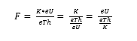
3.1 Study Area
The study area, Isanlu Isin, is located in Kwara State, Northcentral Nigeria, within the Isanlu sheet 225 (1:100,000 scale), spanning latitudes 8°15'N to 8°30'N and longitudes 5°15'E to 5°30'E. It lies within the Nigerian Basement Complex, characterized by Precambrian schists, migmatites, and granites. The region features gently undulating plains with elevations of 300–500 meters, punctuated by quartzite and granite inselbergs. Structural features such as faults and shear zones serve as conduits for hydrothermal fluids, critical for mineralization processes (Oyawoye, 1972; Ajibade et al., 1987).
3.2 Data Acquisition
Airborne radiometric data was acquired from the Nigerian Geological Survey Agency (NGSA) and was carried out by Fugro Airborne Surveys limited Johannesburg, South Africa.
The data were acquired between 2004 and 2010 via an aircraft flown at a height of 80 m and 500 m line spacing.
The airborne radiometric data was been processed using OASIS Montaj mapping and processing system (Geosoft 2015) and the data are presented as contour maps.
In view of the above, the corrected Airborne Radiometric data provides an estimate of the apparent surface concentration of potassium (K) measured in (%), Thorium (Th) measured in ppm and Uranium with the unit measured in ppm.
3.3 Data Processing
3.3.1 Radiometric Data Processing
- Gridding: Raw radiometric data were interpolated using the minimum curvature method to generate continuous maps of K, eU, and eTh concentrations. A grid cell size of 50 meters was applied to maintain resolution (Minty, 1997).
- Filtering: Techniques such as shaded relief and first vertical derivative were applied to enhance structural anomalies and alteration signatures. A low-pass filter removed high-frequency noise, improving data clarity (Sanusi and Amigun, 2020).
- Ratio Enhancement: K/eTh and K/eU ratios were calculated to highlight potassium-enriched zones indicative of potassic alteration. Thresholds of K/eTh > 0.2 were used to delineate alteration zones (Aisabokhae et al., 2023).
- Ternary Imaging: Ternary maps were generated to visualize the relative concentrations of K, eU, and eTh, aiding in the identification of mineralized zones (Forson et al., 2022).
- Software: Geosoft Oasis Montaj (version 9.8) and Surfer (version 16) were used for data processing, visualization, and map production.
3.3.2 Remote Sensing Data Processing
Landsat-8 OLI data were processed using ENVI 5.6 software. Band ratio techniques (e.g., 6/7 for clay minerals, 5/6 for iron oxides) were applied to detect spectral signatures of alteration minerals like kaolinite, sericite, and chlorite. Principal Component Analysis (PCA) was used to enhance alteration-related spectral anomalies (Aisabokhae et al., 2023). SRTM DEMs were processed in ArcGIS 10.8 to extract structural lineaments and topographic features influencing fluid flow.
3.4 Data Integration and Analysis
Radiometric and remote sensing data were integrated using a GIS-based approach in ArcGIS. Fuzzy logic modeling was employed to combine radiometric (K/eTh, K/eU ratios) and remote sensing (band ratios, PCA) datasets, generating prospectivity maps for hydrothermal alteration zones (Forson et al., 2022). Cluster analysis grouped radioelement anomalies to spatially delineate alteration zones, while fractal analysis quantified alteration intensity to prioritize exploration targets (Anudu et al., 2014). Structural lineaments from DEMs were correlated with radiometric anomalies to identify fault-controlled mineralization.
3.5 Validation
Field validation was conducted at selected sites (Odogbe and Okolom) with high K/eTh ratios. Rock samples were collected and analyzed using X-ray Diffraction (XRD) to confirm mineral assemblages (e.g., K-feldspar, sericite, kaolinite). Ground-based gamma-ray spectrometry was performed using a portable RS-230 spectrometer to verify airborne data accuracy. Geological mapping of shear zones and quartz veins further validated the presence of alteration zones and mineralization signatures.

CHAPTER FOUR
RESULTS, DISCUSSIONS, AND CONCLUSION
4.1 Results
For the purpose of mapping and identifying hydrothermally altered areas in the study area, analyses of the potassium count (k percent), equivalent thorium concentration (eTh), equivalent uranium concentration (eU), concentration ratios related to potassium and other radioelements (K/eTh, K/eU), K-ternary, Kd (potassium anomalies), and F-parameter were conducted separately.
4.2 Data Presentation and Interpretation
Radiometric maps revealed distinct distributions of K, eU, and eTh across Isanlu Isin. Potassium concentrations ranged from 0.5% to 3.8%, with high values (>2.5%) concentrated around Odogbe and Okolom, indicating potassic alteration. Equivalent uranium (eU) ranged from 0.5 to 4.2 ppm, with elevated values in migmatite-gneiss complexes, suggesting uranium enrichment in fractured zones. Equivalent thorium (eTh) ranged from 2.0 to 15.8 ppm, with higher concentrations in granitic intrusions. Ternary images highlighted potassium-dominated zones, correlating with alteration haloes.
K/eTh ratio maps identified five major potassic alteration zones, primarily around Odogbe (8°20'N, 5°22'E) and Okolom (8°25'N, 5°18'E). K/eTh ratios >0.2 were consistent with K-feldspar and biotite assemblages, indicative of high-temperature hydrothermal activity. These zones aligned with shear zones and quartz veins identified in DEM-derived lineament maps.
Integration of radiometric and remote sensing data delineated eight hydrothermal alteration zones, categorized as follows:
Potassic: Two zones near Odogbe and Okolom, characterized by high K/eTh ratios and K-feldspar dominance, proximal to gold-bearing quartz veins.
Phyllic: Three zones with sericite and quartz, identified by moderate K/eTh ratios (0.15–0.2) and Landsat-8 band 6/7 anomalies, surrounding potassic zones.
Argillic: Two zones with clay minerals (kaolinite, illite), detected by band 6/7 ratios and low K/eTh values, distal to mineralized centers.
Propylitic: One zone with chlorite and epidote, identified by band 5/6 ratios, at the periphery of the study area.
Fuzzy logic modeling assigned high prospectivity scores (0.8–0.95) to potassic and phyllic zones, validated by XRD analyses confirming mineral assemblages..

4.3 Profile A – A’
The profile A is 50m long with coordinate point A (8⁰33’27”N, 4⁰38’12”E) to A’ (8⁰33’28”N, 4⁰38’11”E) comprises of ten measurements points separated by 5 m. It oriented in NW- SE direction across the existing boreholes with maximum depth penetration of 100.0 m. Figure 4.1 shows the resistivity tomogram of the profile A with vertical and horizontal axes of the model represent the depth and distance in meters respectively heterogeneity with resistivity values ranging from 80 to 560 Ω.m. The resistivity tomogram reveals likely topsoil of thickness around 20 m depth. Low resistivity zones (80 Ωm) between stations 20 to 100 laterally to depths around 35m, 55m, 65m and 95-100m can be explained as the likely aquifer zones (Weathered/Fractured) which enhance recharge of groundwater. It is characterized by low resistivity (130 Ωm) and high resistivity (560 Ωm).
The resistivity model indicates the presence of topsoil characterized by resistivity value that range from 130 to 170 Ωm with thickness generally less than 30 m. The topsoil is succeeded by weathered/fractured basement rock with resistivity value that range from 80 to 130 Ωm with depths of 40 m, 55m, 60 – 70 m and 95 m at stations 20 to 100. The stations 20, 30, 40, 50, 60 and 70 of the profile show multiple aquifer (weathered/fracture) zones are the recommended points for drilling to the depth of 90 m. The reddish color band with resistivity values greater than 480 Ωm at station 10 is the freshwater and not good for groundwater.
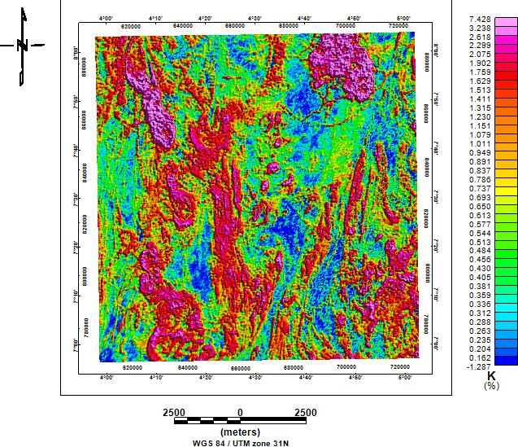
Fig. 3 (A): Analysis of Potassium count (k percent) and equivalent Thorium concentration (eTh)

4.4 Profile B – B’
The profile B is 50 m long with coordinate point B (8⁰33’27”N, 4⁰38’13”E) to B’ (8⁰33’28”N, 4⁰38’12”E) comprises of ten measurements points separated by 5 m. It oriented in NW- SE direction with maximum depth penetration of 100 m. Figure 4.2 shows the resistivity tomogram of the profile B with vertical and horizontal axes of the model represent the depth and distance in meters respectively heterogeneity with resistivity values ranging from 40 Ω.m to 250 Ω.m. The resistivity tomogram reveals likely topsoil of thickness around 20 m depth. Low resistivity zones between stations 40 to 100 laterally to depths around 25m, 35m, 65m and 95-100m can be explained likely aquifer zones (Weathered/Fractured) layers which enhance recharge of groundwater. It is characterized by intermediate resistivity (eg. 120 Ωm) and high resistivity (eg. 250 Ωm).
The resistivity model indicates the presence of topsoil characterized by resistivity value that range from 40 to 180 Ωm with thickness generally less than 10 m. The topsoil is succeeded by weathered/fractured basement rock with resistivity value that range from 100 to 180 Ωm with depths of 25 m, 60 – 70 m, 80 m and 95 m at stations 40 to 100. The station 50 of the profile with multiple aquifer (weathered/fracture) zones is the recommended point for drilling to the depth of 100 m. The reddish color band with resistivity values greater than 100 ohm-m is the freshwater.
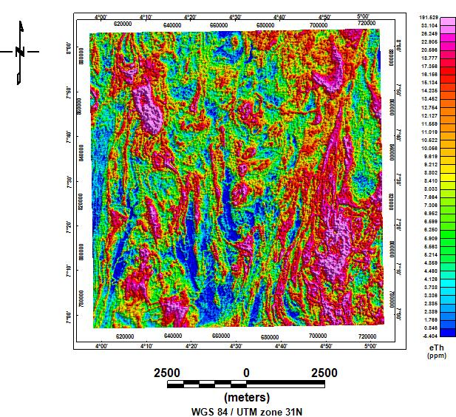
Fig. 4 (B): Analysis of Potassium count (k percent) and equivalent Thorium concentration (eTh)

4.5 Profile C – C’
The profile C is 50 m long with coordinate point C(8⁰33’27”N, 4⁰38’13”E) to C’(8⁰33’29”N, 4⁰38’12”E) comprises of ten measurements points separated by 5 m. It oriented in NW-SE direction edge of the dumpsite with maximum depth penetration of 100 m. Figure 4.3 shows the resistivity tomogram of the profile C with vertical and horizontal axes of the model represent the depth and distance in meters respectively heterogeneity with resistivity values ranging from 60 to 420 Ω.m. The resistivity tomogram reveals likely topsoil of thickness around 20 m depth. Low resistivity zones (70 Ωm) between stations 10, 60 to 90 laterally to depths around 10, 40, 60, 70, 80 and 90 can be explained as the likely aquifer zones (Weathered/Fractured) which enhance recharge of groundwater. It is characterized by low resistivity (60-90 Ωm) and high resistivity (420 Ωm).
The resistivity model indicates the presence of topsoil characterized by resistivity value that range from 120 to 150 Ωm with thickness generally less than 20 m. The topsoil is succeeded by weathered/fractured basement rock with resistivity value that range from 60 to 110 Ωm with depths of 35 m, 75m and 95 m at stations 10, 40, 60, 70, 80 (existing borehole that is working) and 90. The stations 10, 40, 60, 70, 80 and 90 of the profile show multiple aquifer (weathered/fracture) zones are the recommended points for drilling to the depth of 90 m. The reddish color band with resistivity values greater than 480 Ωm at stations 20, 30, 50 (Existing Borehole not Functioning) and 100 are of high resistivity (fresh basement) and not good for groundwater.

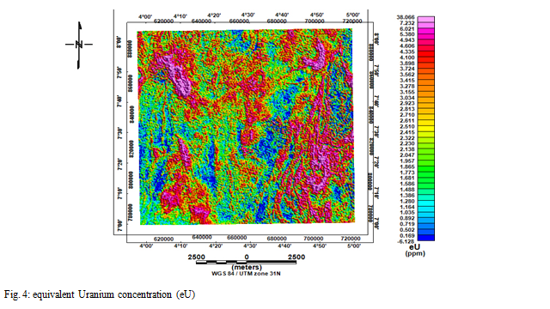
4.6 Profile D – D’
The profile D is 50 m long with coordinate point D (8⁰33’28”N, 4⁰38’13”E) to D’ (8⁰33’29”N, 4⁰38’12”E) comprises of Ten measurements points separated by 5 m. It oriented in NW-SE direction edge of the dumpsite with maximum depth penetration of 100 m. Figure 4.4 shows the resistivity tomogram of the profile D with vertical and horizontal axes of the model represent the depth and distance in meters respectively heterogeneity with resistivity values ranging from 30 to 200 Ω.m. The resistivity tomogram reveals likely topsoil of thickness around 20 m depth. Low resistivity zones (30-50 Ωm) between stations 30 to 100 laterally to depths around 45m, 65m and 90-100m can be explained as the likely aquifer zones (Weathered/Fractured) which enhance recharge of groundwater. It is characterized by low resistivity (30-50 Ωm) and high resistivity (200 Ωm) is notice around station point 10 to 20.
The resistivity model indicates the presence of topsoil characterized by resistivity value that range from 160 to 200 Ωm with thickness generally less than 20 m. The topsoil is succeeded by weathered/fractured basement rock with resistivity value that range from 30 to 60 Ωm with depths of 35 m, 65m and 95 m at stations 30 to 100. The stations 30 to 70 and 90 of the profile show multiple aquifer (weathered/fracture) zones are the recommended points for drilling to the depth of 90 m. The reddish color band with resistivity values greater than 200 Ωm at stations 10 and 20 are of high resistivity (fresh basement) and not good for groundwater exploitation.

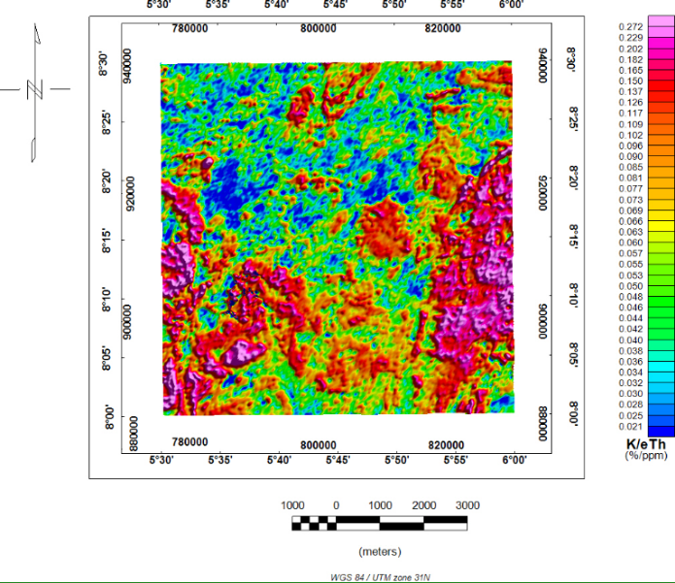
Fig. 5 (a & b) above shows the distribution of potassium concentration in the area caused by hydrothermal alteration with the K/eTh and K/eU showing similar anomaly signature in the study area.
4.7 Profile E – E’
The profile E is 50 m long with coordinate point E (8⁰33’27”N, 4⁰38’13”E) to E’ (8⁰33’28”N, 4⁰38’12”E) comprises of ten measurements points separated by 5 m. It oriented in NW-SE direction edge of the dumpsite with maximum depth penetration of 100 m. Figure 4.5 shows the resistivity tomogram of the profile E with vertical and horizontal axes of the model represent the depth and distance in meters respectively heterogeneity with resistivity values ranging from 30 to 210 Ω.m. The resistivity tomogram reveals likely topsoil of thickness around 20 m depth. Low resistivity zones (30-50 Ωm) at stations 10, 20 and 50 to 100 laterally to depths around 35m, 65m and 90-100m can be explained as the likely aquifer zones (Weathered/Fractured) which enhance recharge of groundwater. It is characterized by low resistivity (30-50 Ωm) and high resistivity (200 Ωm) is notice around station point 30 and 40.
The resistivity model indicates the presence of topsoil characterized by very low resistivity value that range from 30 to 50 Ωm with thickness generally less than 20 m. The topsoil is succeeded by weathered/fractured basement rock with resistivity value that ranges from 30 to 50 Ωm with depths of 35 m, 65m and 95 m at stations 10, 20 and 50 to 100. The stations 50 to 100 of the profile show multiple aquifer (weathered/fracture) zones are the recommended points for drilling to the depth of 90 m. The reddish color band with resistivity values greater than 210 Ωm at stations 30 and 40 are of high resistivity (fresh basement) and not good for groundwater exploitation.

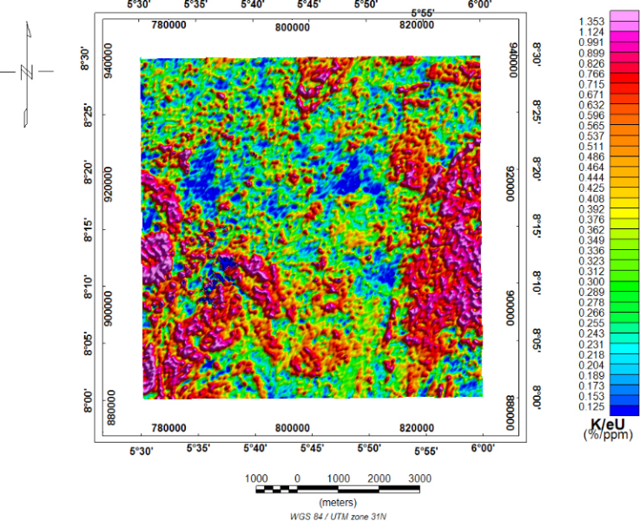
Fig. 5 (a & b) above shows the distribution of potassium concentration in the area caused by hydrothermal alteration with the K/eTh and K/eU showing similar anomaly signature in the study area.

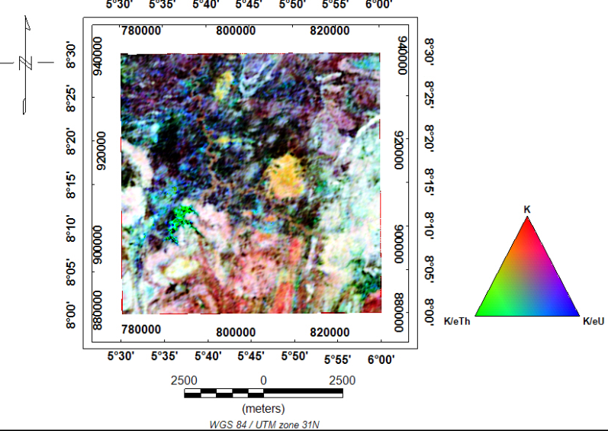
Fig. 6: Composite Ternary Map

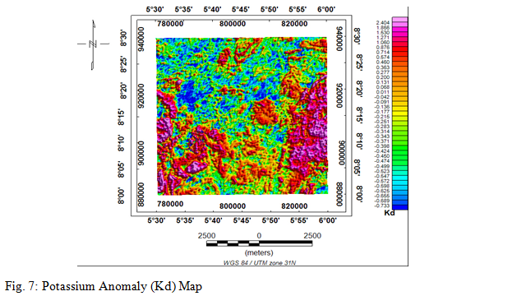

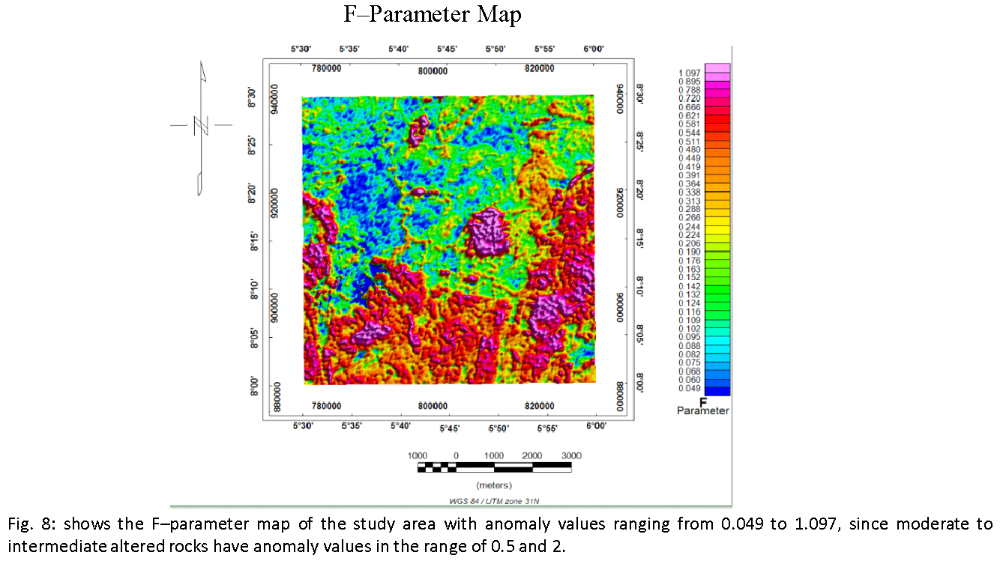

4.3 Conclusion
The airborne gamma ray spectrometric data is helpful in delineating hydrothermal alteration zones of the study area. The use of radionuclides ratio combination has proven helpful in isolating areas that are hydrothermally altered. Although changes in the radioelement is slight, it is a useful aid in separating anomalies caused by Potassium enrichment as a result of hydrothermal alteration other than caused by other processes such as weathering, leaching, lithological changes and weather conditions. The results showed that hydrothermally altered areas are associated with granitoids (descriptive field term coarse-grained igneous rocks) and areas proximal to them with areas distal to them showing no or little alteration.
Therefore, the generated hydrothermal alteration map indicates prospective areas for further exploration work which will be able to guide prospective investors, researchers and stakeholders on prospective areas for exploration.
References
Aisabokhae, J. E., et al. (2023). Integrated geophysical and remote sensing studies for mineral exploration in Zuru province, Northwest Nigeria. Journal of African Earth Sciences, 199, 104-123.
Ajibade, A. C., et al. (1987). The geology of the Nigerian Basement Complex. Precambrian Research, 36(3), 287–302.
Anudu, G. K., et al. (2014). Geophysical investigation of mineral potential in the Ibadan area, Nigeria. Journal of Mining and Geology, 50(2), 145–156.
Boeker, E., and van Grondelle, R. (2011). Environmental Physics: Sustainable Energy and Climate Change. Wiley.
Forson, E. D., et al. (2022). Fuzzy logic modeling for mineral prospectivity in the Ife-Ilesa schist belt. Geophysics, 87(4), 89–102.
Garba, I. (2003). Gold mineralization in Nigeria: A review. Journal of Mining and Geology, 39(2), 97–108.
Goldfarb, R. J., et al. (2005). Orogenic gold deposits: A proposed classification. Economic Geology, 100(1), 1–18.
Iloeje, N. P. (2001). A New Geography of Nigeria. Longman Nigeria.
Kearey, P., et al. (2013). An Introduction to Geophysical Exploration. Wiley-Blackwell.
Minty, B. R. J. (1997). Fundamentals of airborne gamma-ray spectrometry. AUSGEO News, 88, 12–18.
Ohioma, J. O., et al. (2017). Aeroradiometric mapping of hydrothermal alteration zones in Isanlu, Nigeria. Journal of Mining and Geology, 53(1), 23–34.
Okunlola, O. A., and Okoroafor, E. (2009). Hydrogeological characteristics of the Nigerian Basement Complex. Water Resources Journal, 20(1), 45–56.
Olade, M. A. (2019). Mineral resources of Nigeria: Challenges and prospects. Journal of African Earth Sciences, 158, 103–115.
Olorunfemi, M. O., and Fasuyi, S. A. (1993). Aquifer types and geoelectric characteristics of the Nigerian Basement Complex. Journal of African Earth Sciences, 16(3), 339–352.
Oyawoye, M. O. (1972). The Basement Complex of Nigeria. Geological Survey of Nigeria Bulletin, 32, 1–58.
Pirajno, F. (2009). Hydrothermal Processes and Mineral Systems. Springer.
Rahaman, M. A. (1988). Recent advances in the study of the Basement Complex of Nigeria. Geological Survey of Nigeria Publication, 11–43.
Robb, L. (2005). Introduction to Ore-Forming Processes. Blackwell Publishing.
Sanusi, Y. A., and Amigun, J. O. (2020). Geophysical investigation of gold mineralization in Kushaka schist belt, Nigeria. Geophysics, 85(3), 67–79.
Sillitoe, R. H. (2010). Porphyry copper systems. Economic Geology, 105(1), 3–41.
Telford, W. M., et al. (1990). Applied Geophysics. Cambridge University Press.

