CHAPTER ONE
1.1 Introduction
Route surveying plays a vital role in the initial stages of infrastructure development, particularly in the construction of roads, railways, pipelines, and transmission lines. It provides essential data that helps engineers and planners determine the most efficient and cost-effective path for a proposed route. The purpose is not just to find a straight line from point A to point B, but to consider the natural terrain, existing developments, and environmental factors that could influence the design and implementation of a route. Without an accurate route survey, the risk of construction issues and budget overruns significantly increases.
In the broader context of civil and geospatial engineering, route surveying bridges the gap between design theory and practical implementation. It is the foundation upon which successful projects are built, and it requires careful planning, technical expertise, and an understanding of both natural landscapes and human settlements. A well-executed route survey allows stakeholders to visualize the terrain, identify potential obstacles, and make informed decisions regarding construction methods and materials.
The process of route surveying typically begins with reconnaissance, where a general inspection of the area is carried out to determine feasible corridors. This is followed by a preliminary survey, which collects more detailed data to evaluate and compare possible alignments. Finally, a location or final survey is conducted to gather precise information required for design, including elevations, distances, and cross-sections. Each of these stages plays a crucial role in ensuring that the proposed route is practical, sustainable, and economically viable.
Modern surveying equipment and techniques have significantly enhanced the efficiency and accuracy of route surveys. Total Stations, GPS, GIS software, and even drone photogrammetry have become essential tools in the surveyor’s toolkit. These technologies enable faster data collection, better terrain modeling, and improved visualization of potential alignments. As a result, surveyors can now provide more detailed and reliable information to engineers and planners in a shorter time.
Route surveying is not purely technical—it also involves socio-economic and environmental considerations. When selecting a route, surveyors must take into account land ownership, existing communities, protected natural areas, and future development plans. In many cases, the most technically feasible route may not be socially or environmentally acceptable. As such, route surveying is often a multidisciplinary activity that requires input from urban planners, environmental scientists, and local stakeholders.
In educational and training contexts, undertaking a route survey project offers students and young professionals an opportunity to gain hands-on experience with real-world challenges. It teaches them how to operate surveying instruments, work as part of a team, and apply classroom knowledge in the field. Through exposure to actual terrain and data, students learn to appreciate the complexity of route planning and develop the critical thinking needed to solve practical problems.
In this project, we focused on conducting a route survey for a proposed road within a specific area. The process included reconnaissance, data collection with modern instruments, data processing using CAD software, and the creation of profiles and maps for design use. The project not only demonstrates the technical aspects of route surveying but also emphasizes the importance of planning, coordination, and accuracy in delivering useful outputs for engineering purposes.

1.2 Aim
The aim of this project is to carry out a comprehensive route survey for a proposed road network, identifying the best alignment and collecting the necessary data for engineering design.

1.3 Objectives
- To identify and evaluate possible alignments for the proposed route.
- To gather detailed topographic and geometric data along the selected path.
- To prepare maps, profiles, and cross-sections necessary for design and construction.
- To ensure that the selected route minimizes environmental impact and maximizes economic viability.
- To apply modern surveying tools and techniques in real-world route survey applications.

1.4 Scope
This project covers:
- Preliminary reconnaissance survey
- Field data acquisition using GPS and Total Station
- Processing and plotting of data using AutoCAD and Civil 3D
- Creation of longitudinal and cross-sectional profiles
- Basic design considerations and documentation
It focuses on a specific corridor within the study area and does not cover detailed engineering design, cost estimation, or construction supervision.
Additionally, this project serves as a learning opportunity to practice professional surveying skills, bridging the gap between classroom knowledge and real-world application.

1.6 Personnel
The route survey project was carried out by a field team composed of the following personnel:
Name Matric number Role played
Hassan Halimah Ashabi ND/23/SGI/PT/0017 AUTHOR
Popoola Emmanuel Oluwafemi ND/23/SGI/PT/0024 Member
Iyanda Timininu Racheal ND/23/SGI/PT/0019 Member
Rabiu Toheeb Morenikeji ND/23/SGI/PT/0025 Member
Omotosho Kabir Hassan ND/23/SGI/PT/0022 Member
Sanyaolu Olamilekan Emmanuel ND/23/SGI/PT/0023 Member

1.7 Study Area
The study area for this route survey project is situated within Kwara State Polytechnic, located in Ilorin, the capital of Kwara State, Nigeria. The specific route surveyed runs from the Clinic Roundabout—a central and busy junction within the campus—towards Akuo Village, a nearby settlement that houses both staff and student residents. This corridor was selected due to its current lack of well-developed road infrastructure and its high potential for improvement. It serves as a vital connection between the academic core of the polytechnic and one of its expanding residential zones.
Clinic Roundabout is an important point in the campus. It connects various roads leading to major facilities such as the school clinic, administrative buildings, hostels, and departmental blocks. Because of this, the roundabout experiences significant foot and vehicle traffic daily. However, the road that extends toward Akuo Village is largely unpaved, narrow, and often affected by seasonal weather conditions, particularly during the rainy season when erosion and waterlogging reduce accessibility.
Akuo Village, which forms the endpoint of the surveyed route, is an informal but rapidly growing area that has become home to many students and staff due to its affordability and proximity to the school environment. Despite its strategic location, the road connecting it to the main campus has not received proper engineering attention, making mobility difficult. Residents rely on footpaths and occasionally on motorbikes to navigate the route, especially when the terrain becomes muddy or uneven.
The terrain along the surveyed path is generally gently sloped with pockets of undulating surfaces and sparse vegetation. There are no major obstacles like rivers or large rock formations, but minor drainage paths and loose soil areas were observed. These features were noted during the reconnaissance survey, and they influenced decisions about the route alignment and the positioning of survey stations. The presence of trees, electric poles, and other minor obstructions also required attention during fieldwork. In terms of geographic location, the route lies between the following approximate coordinates:
Clinic Roundabout:
Latitude 8.4819° N, Longitude 4.5257° E
Akuo Village:
Latitude 8.4842° N, Longitude 4.5275° E
These coordinates were obtained using a handheld GPS device and cross-verified using Google Earth. Satellite imagery of the area was also reviewed during planning to observe elevation changes, visible structures, and natural features. This imagery supported better decision-making in terms of station placement and expected visibility during the actual survey.
Overall, the route from Clinic Roundabout to Akuo Village provides a meaningful context for practical surveying. It combines the technical challenges of a real-world route survey with the social relevance of improving campus connectivity. The data collected along this path can support future road construction or rehabilitation, benefiting both the polytechnic and the surrounding community. This area serves as a perfect case study for applying route surveying techniques in a setting that is both accessible and impactful.

To give a broader understanding of the study area, three key map references were used:
Map of Nigeria
This map shows the entire country of Nigeria, divided into 36 states and the Federal Capital Territory (FCT). Kwara State is located in the North Central region of Nigeria. Including this map helps the reader understand the national context and where Kwara is positioned relative to the rest of the country.
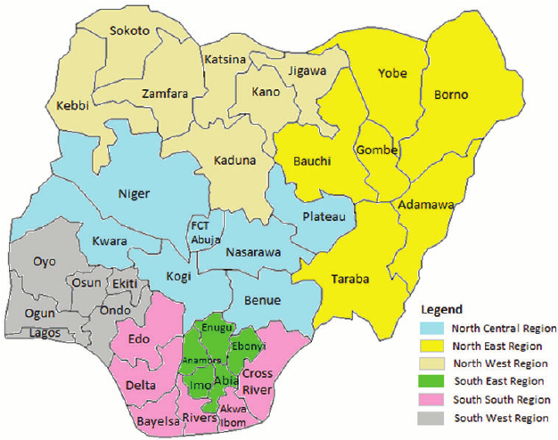

MAP OF MORO LOCAL GOVERNMENT AREA:
Within Kwara State, Moro Local Government Area (LGA) is one of the sixteen LGAs and lies to the north of Ilorin. Although the Polytechnic itself is located in Ilorin West LGA, its proximity to Moro LGA helps define the terrain, climate, and local features of the broader area where development like road networks may be extended. Showing Moro LGA on the Kwara map gives a closer view of the regional layout relevant to the project.
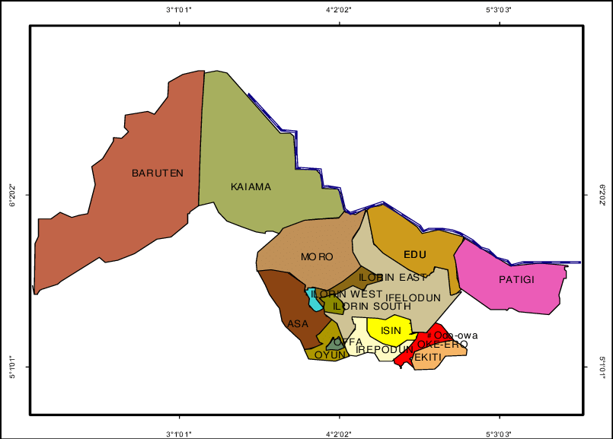

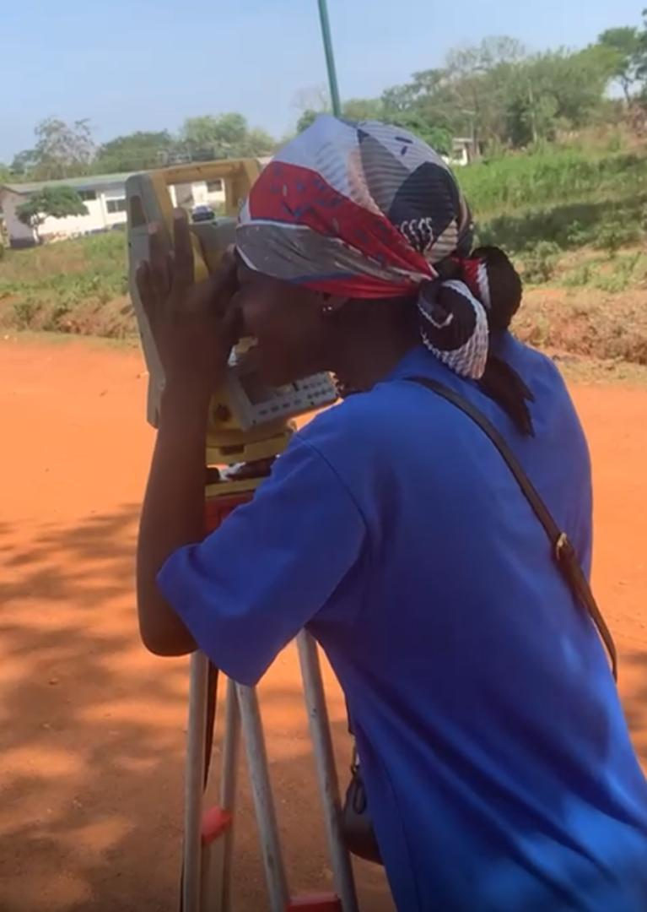
Imagery of the Project Site:
A satellite image of the Kwara State Polytechnic campus was used to visualize the exact location where the route survey was conducted. This image provides real-time information about the physical environment—like buildings, roads, vegetation, and elevation changes. It was particularly useful during the planning and reconnaissance stages of the project.

CHAPTER TWO

2.1 Literature Review
Route surveying is a specialized branch of land surveying that focuses on the planning and alignment of linear infrastructure such as roads, railways, pipelines, and power lines. According to Schofield and Breach (2007), the primary purpose of a route survey is to determine the most suitable path for a proposed route by collecting and analyzing spatial data along a corridor. This involves both horizontal and vertical alignment design, which are critical in ensuring functionality, safety, and economic efficiency.
The process of route surveying is generally divided into three main stages: reconnaissance, preliminary survey, and final location survey. During reconnaissance, surveyors explore possible alignments based on topographic maps, satellite imagery, or site visits to identify the most feasible route corridors. Uren and Price (2010) emphasized that this early stage helps avoid physical and environmental obstacles and forms the foundation for more detailed fieldwork. The preliminary survey then involves taking actual measurements along selected routes to evaluate their practicality. Finally, the location survey provides precise data required for construction, including centerline positions, profiles, and cross-sections.
Advancements in surveying technology have significantly improved the speed and accuracy of route surveys. Traditional instruments like theodolites and chains have been largely replaced by Total Stations, GPS receivers, and drone-based photogrammetry. These tools allow surveyors to collect high-resolution spatial data with greater efficiency. As noted by Bannister and Raymond (2007), the integration of Geographic Information Systems (GIS) further enhances route analysis by enabling users to overlay multiple data sources—such as land use, elevation, and environmental impact zones—onto a digital map for informed decision-making.
The application of route surveying is not limited to new infrastructure development. It is also critical in the rehabilitation of existing roads and facilities. For instance, accurate route surveys can help identify areas of slope failure, erosion, or poor drainage in existing roadways. This allows engineers to design effective interventions and upgrades. Furthermore, with the increasing emphasis on sustainable development, route surveys are now expected to consider not just technical and economic factors, but also environmental and social impacts. Choosing an alignment that minimizes tree cutting, displacement of residents, or disturbance to natural habitats is becoming a standard practice.
Route surveying also plays an important role in educational and professional development. In academic institutions, it serves as a core practical component of programs in Surveying, Civil Engineering, and Geo-Informatics. Field exercises allow students to apply theoretical concepts such as bearing, leveling, and triangulation in a real-world context. Beyond technical skills, route surveying teaches teamwork, critical thinking, and problem-solving—qualities that are essential in professional practice.
Despite its many benefits, route surveying comes with challenges. Factors such as rough terrain, weather conditions, instrument errors, and accessibility issues can affect the quality of data collected. As pointed out by Olayemi (2016), proper planning, use of modern tools, and regular calibration of equipment are necessary to ensure accuracy. Additionally, collaboration with local authorities and communities is important to avoid disputes and ensure smooth project execution.
Another important consideration in route surveying is the analysis of topography and terrain characteristics. These features directly affect alignment decisions, construction costs, and the long-term maintenance of the proposed infrastructure. For example, routes that pass through steep slopes or valleys may require additional engineering interventions such as retaining walls, cut-and-fill operations, or drainage systems. As emphasized by Ezeigbo (2004), understanding the elevation profile of the terrain helps in selecting the most economical and technically sound alignment, minimizing the need for excessive earthworks.
Moreover, horizontal and vertical alignments must be carefully designed to provide safety and comfort, particularly in road and railway construction. Horizontal alignment determines the curvature of the route in plan view, while vertical alignment refers to the changes in elevation or grade. An ideal route balances these alignments to reduce sharp turns and steep slopes that could endanger users or complicate construction. According to Ogunmola and Ibitoye (2015), the route survey must provide precise data for designers to create alignments that comply with engineering standards and traffic regulations.
The integration of environmental and social impact assessments into route surveying has become more prominent in recent years. In the past, alignment decisions were mostly made based on technical and cost considerations alone. Today, however, surveyors and planners are expected to evaluate how a proposed route will affect local communities, natural ecosystems, cultural heritage sites, and public safety. This has led to more collaborative and multidisciplinary approaches where environmental scientists, community leaders, and policy makers contribute to alignment planning. Route surveys now serve as a foundation for sustainable and socially responsible infrastructure development.
Additionally, legal and cadastral data are often required in the route survey process, especially when land acquisition is involved. Surveyors must identify land ownership boundaries, right-of-way (ROW) limits, and any existing encumbrances. Failing to consider cadastral information can lead to legal conflicts, delays in project implementation, and even financial losses. Incorporating this information into route surveys ensures compliance with land use laws and promotes transparency during negotiations with landowners or affected communities.
In academic research and education, route surveying has also been used as a case study for modern surveying techniques. Many institutions now combine traditional methods such as chaining and compass traverses with digital technologies like RTK GPS and LiDAR scanning. Students and researchers use these techniques to generate accurate terrain models, evaluate multiple alignment scenarios, and simulate construction processes. These experiences help prepare future surveyors to operate in a technology-driven professional environment where data precision and decision support systems are crucial.
Lastly, the increasing use of remote sensing and satellite imagery in route surveys has transformed how surveyors gather preliminary information. High-resolution images and terrain models from sources such as Google Earth, Landsat, or UAVs allow for early analysis of terrain types, vegetation cover, water bodies, and human activities. These tools are especially useful in remote or inaccessible areas where physical reconnaissance may be challenging. When combined with field measurements, remote sensing data enhances the quality and completeness of the survey results.
Another emerging development in the field of route surveying is the use of Building Information Modeling (BIM) for infrastructure design and management. Traditionally associated with architectural design, BIM is now being adopted in road and highway projects to model the entire life cycle of a route—from planning and survey through to design, construction, and maintenance. When combined with accurate route survey data, BIM provides a 3D, data-rich model that allows engineers to visualize and simulate different scenarios. According to Adewumi et al. (2020), this integration not only enhances collaboration between stakeholders but also reduces costly design errors and construction delays.
Additionally, drone technology has become increasingly popular in modern route surveying. Drones equipped with cameras or LiDAR sensors can quickly cover large areas and collect highly detailed spatial data, even in difficult terrain. This method is especially beneficial in areas that are hard to access due to vegetation, slope, or safety concerns. Compared to traditional surveying methods, drones reduce the need for manual labor on-site and produce digital elevation models and orthophotos that are ready for analysis. As noted by Adebayo (2018), drone-based surveys are now being used in many African countries to support large-scale infrastructure development.
Data processing and visualization tools have also evolved significantly. Software applications such as AutoCAD Civil 3D, ArcGIS, and Surfer allow for efficient handling of survey data, creation of profiles, and generation of cross-sections. These tools help surveyors analyze terrain behavior, calculate cut-and-fill volumes, and produce digital terrain models (DTMs). They also support the integration of spatial, statistical, and visual data, giving decision-makers a comprehensive understanding of the proposed route. The accuracy and presentation of data are essential for convincing stakeholders and getting approvals from regulatory bodies.
Furthermore, interdisciplinary collaboration is becoming a key component in successful route survey projects. Surveyors now work closely with civil engineers, hydrologists, urban planners, environmental scientists, and even economists. Each professional contributes insights that enrich the survey process. For instance, a hydrologist may identify areas prone to flooding, while an environmental scientist may point out regions with protected species or sensitive habitats. This collaboration ensures that route alignment is not only technically sound but also socially and environmentally acceptable.
The use of mobile data collection apps and cloud-based systems has also improved how survey data is gathered and shared. With handheld devices and field-ready apps like Collector for ArcGIS or Trimble Mobile Mapper, surveyors can record coordinates, capture images, take notes, and synchronize data to a central database in real time. This enhances project coordination and allows team members in different locations to access the latest data instantly. It also supports transparency and traceability in decision-making, which is increasingly important in public infrastructure projects.
In conclusion, the practice of route surveying has evolved far beyond its traditional roots. It now encompasses a broad range of tools, technologies, and collaborative practices that make it a critical step in the development of modern infrastructure. From topographic analysis and GPS mapping to drone imaging and environmental impact assessment, route surveys play a central role in shaping how communities grow and how transportation systems are developed. As the demand for smart, sustainable infrastructure increases, the importance of accurate and forward-thinking route surveying will only continue to grow.

CHAPTER THREE
3.0 METHODOLOGY
This involve the method and techniques used to perform particular task. The major method involved in the execution of this project are:- Reconnaissance survey which involved office and field reconnaissance survey, location of the control pillars and check selection or marking of station, test of instrument data acquisition which included: Horizontal and vertical analysis detailing by total station method, data processing and information presentation.
3.1 RECONNAISSANCE
This is the general overview of the practical site. So as to have the overall picture of the nature of the terrain and feature on the site and to make decision on proper planning and execution of the project. It is on essential aspect of planning in surveying which involve preliminary examination of the site by physical inspection. It is an operation done to the actual survey exercise.
The reconnaissance survey involve two accept namely
- Office planning
- Field reconnaissance
3.1.1 OFFICE PLANNING
Office planning which could be termed as office reconaissance involved knowing the types of instrument, purpose, specification and accuracy required of the survey to be carried out these lead to the chosen of appropriate equipment and method to be employed also costing of the survey operation was done in the office.
Information related to the given project area was collected from various sources, such as project supervisors, department Ilorin. The coordinate (x,y,z) of the initial and that of the three control point used for orientation where all obtained.
TABLE 1.0: Shows the Coordinates of control point used.
STATION | NORTHING (m) | EASTING (m) | HEIGHT
PT01 | 946624.430 | 679060.142 | 357.133
PT02 | 946620.733 | 679038.328 | 357.131
PT03 | 946612.715 | 679960.109 | 357.135
Source: Project supervisor

3.1.2 FIELD RECCONIASSANCE
The project sit was visited by all the group member to have the true picture of the site for the better planning and excursion and to locate the control pillar for the necessary orientation of the study area, why the boundaries where marked with nails and bottle cover driving into the ground for the proper identification of this intersection points.
The three control pillars where founded within the study area the end product of this field reconnaissance is the sketch or recci diagram which are show below.
3.2 EQUIPMENTS USED/SYSTEM SELECTION/SOFTWARES
The instrument used for execution of the project are listed below
- EQUIPMENTS USED
- Total station
- Reflector
- Ranging pole
- Steel tape
- Wooden pegs
- Nails
- Field book
- SYSTEM SELECTION
- Laptop Hp
- Printer
- SOFTWARE
- Civil cad 2014
- Micro soft Excel 2015
- Micro soft word 2015
- Note pad 2015
- Mts downloading software
3.3 INSTRUMENT TEST
Having collected the instrument to be used, the following test were carried out on total station instrument to ascertain the proper working of condition of the instrument test.

- TEST OF TOTAL STATION AND CONFIGURATION
The total station (South 1205R) used was tested to ensure that is line of sent was perpendicular to trunion axis, this test is called collimation test. The test was set on a point and the temporary adjustment i.e centering leveling, focusing after this target was equally set on another point and leveled the target was bisected on above face left and face right on the instrument why both the horizontal and vertical reading on each faces where read and booked respectively.
TABLE 1.1 Shows The Result of Instrument Test.
STN | SIGHT | FACE | HORIZONTAL | VERTICAL | DIFFERENCE | DIST(m)
A | B | L | 116⁰17”40” | 49⁰ 00’ 20”
 | B | R | 296⁰18”00” | 268⁰52’ 20” | 180⁰00”20” | 50
Horizontal collimation error = 180⁰00’ 20” - 180⁰00’ 20”
Difference = 00⁰00”20” -2
= 00⁰00”20”
Vertical collimation error = 360⁰00”00” - 359⁰59”40”
= 00⁰00”20” ÷ 2
Difference = 00⁰00”10”
i.e misclosure = 30⁰
Where N = 1
Hence the allowable misclosure = 00⁰00’ 30”
3.4 CONTROL CHECK
The excess of carry out this operation was to ascertain the reliability of all the control to be used for the project because these will go along the toward determining the accurate of the project, the checked involved base Northing, Easting and height the instrument was set up on control 1
i. (KWPT02) and all the necessary temporary adjustment performed on it. The target at back station (KWPT01) was bisected and reading was obtained.
The telescope was pointed to face station (KWPT03) and bisected the reading also recorded.

Kwpt01 kwpt02 kwpt03

TABLE 1.2: Control check (control 1)
STATION | NORTHING | EASTING | HEIGHT | REMARK
KWPT01 | 946624.430 | 679060.142 | 357.133 | OBSERVED
KWPT01 | 946624.400 | 679060.138 | 357.131 | ORIGINAL
DISCREPANCY | ∆N=0.030m | ∆E=0.004m | ∆H=0.002m

TABLE 1.3: Control check (control 2)
STATION | NORTHING | EASTING | HEIGHT | REMARK
KWPT02 | 946620.733 | 679038.328 | 357.140 | OBSERVED
KWPT02 | 946620.723 | 679038.320 | 357.135 | ORIGINAL
DISCREPANCY | DN=0.010m | DE=0.008m | ∆H =0.005

TABLE 1.4: Control check (control 3)
STATION | NORTHING | EASTING | HEIGHT | REMARK
KWPT03 | 946612.715 | 679960.109 | 357.135 | OBSERVED
KWPT03 | 946612.707 | 679960.102 | 357.133 | ORIGINAL
DISCREPANCY | DN=0.008m | DE=0.007m | ∆H =0.002
3.5 DATA ACQUISITION
Data acquisition begins with the physical phenomenon or physical property to be measured. Example of this include temperature light intensity, distance from one point to another etc. regardless of the type of physical to be measured must first be transformed into a unified form that can be sampled by a data acquisition system.
A data acquisition system is a collection of software and hardware that let y measure or control physical characteristics of something in the real world.

3.5.1 GEOMETRIC DATA
These started at chainage 0+000. Three existing control point where used KWPT01, KWPT02, KWPT03 and there where establish side the road.
The job commercial by setting up the instrument (South 205R) on KWPT 01 and all temporary adjustment where performed and instrument was oriented by the following procedures:-
- Setting up (centering, levelling, elimination of parallax).
- The instrument was powered on.
- “MENU” was pressed (The following was set on the instrument).
- “JOB” was click
- File folder was click
- Automatic data was set by the instrument
- Data capture was click (the first coordinate was input then the height instrument was measured with a steel tape and was also input on the instrument)
- Save
- Esc was pressed in order to go back to the back sight to check the control point.
On the back sight input was clicked and the reflector was mounted on the back sight KWPT02 and observation is taken.
Having perfectly done the telescope was turn bisect the reflector on the center line of the road which 25meter to the occupied station (KWPT01) measured was clicked the reflector was moved to the left edge of the road and observation was taken and also to the right edge of road and measured was taken.
3.5.2 TRAVERSING
Traversing may be defined sequence of connected straight lines whose direction and distance was been measured that is, it involved the determination of the bearing and distance of series of connected straight line from know coordinated point so as to obtain the coordinate of the newly established station. This includes the following.
3.5.3 SPOT HIGHTING
The total station was used in conjunction with reflector stand to execute this task. The procedure is as follows
The total station was set up on a point (point A) with a known coordinate (Northing, Easting and Height).
All the necessary temporary adjustment were out on the instrument the height of instrument was measured using steel tape and recorded. The telescope was directed to the target and bisect on point B for orientation. The telescope was turned clockwise to the target which has been placed at every 5meter to the edge or the road both left and right of edge road.
3.5.4 DETAILING
These is refer to as the man-made (artificial and natural feature on the ground) within the project site which are determine and obtain by using a total station and finally represented with a suitable scale on plan. The position of details with the project area was fixed using total station. The reflector man move the reflector to the edge of interest details. Such as (building, electrical pole, trees) and the telescope was directed to the reflector were the three edges of the building were picked and recorded and the position of details like electric pole were field.
3.5.5 ATTRIBUTE DATA
These are the name given to a particular building block, street or road of a the study area i.e
Below shows the lost of the attribute collect from the site.
BID - Building
EP - Electric pole
DR - Drainage
LF - Left side of the road
RT - Right side of the road
ACC.RD - Access Road Name.
3.6 DATA DOWNLOADING AND EDITING
After the completion of all earth works. Data were downloading with aid of total station SD card, the data were downloaded into the computer via SD card using the South-TS software inserted into computer and go to CD card and downloading, copy and data from CD card down to system (computer) and was later saved in excel for further editing.

3.6.1 EDITING
Excel is used in data editing, NOTEPAD is also part of software used in editing data.
The following procedure were followed
- Highlight the column A
- Go data and select the data
- Click on comer and click on select
- The data was now selected.
- Copy and paste and editing NOTEPAD
- Go to format and click on replace
- And save on NOTEPAD
- Then go to CIVILCAD
- Go to format and set the unit. Then the data was put in to load from text file: EXP and click on paste.
- Select on open
- Click on refresh
- Click on Z enter
- Click on E enter
- And data was displayed
3.7 DATA PROCESSING AND REPORT ANALYSIS
After the downloading of the acquired data from the field through cable then software civil 2012 and AUTOCAD 2007 was used to plot the horizontal alignment and longitudinal profile and where prepared in a proper and acceptable way here, the project area was visualized using sketched obtained after plotting to guide against omission of feature representing by data.
3.8 PROCESSING OF DATA BASE MANAGEMENT
The input data are proceed via data base management system (DBMS) which comprise of a set of program which manipulation and maintenance data in the data base.
3.8.1 DATA SECURITY
For a data to be move and easily secured if the user supposed to have and knows his/her password.
The computer room must be out of bound to authority’s user by copying the data base file and program file and program files into compact disk.
3.8.2 DATA INTEGRITY
Integrity of the data base most be ensured at all times and care must be taken while inserting data and updating the data base.
3.8.3 DATA MAINTANCE
The quality of data base depend, on its currency and fitness for us as a decision support system and most therefore be kept to data the integrity must be maintained.

CHAPTER FOUR
4.0 ANALYSIS AND INFORMATION PRESENTATION
From the results of observation and computation the information was presented in digital form, the digital plan produced using the coordinate computed. The plotting was done by using coordinate.
After plotting the control coordinate the coordinate of details and spot high were also plotted in rectangular system and all feature were seen to appear in their appropriate relationship.
The digital plan showing all details and that showing the spot height and contour were produced by AUTOCAD and SURFER.
Preparing script file with note pad (Bold)
i. Launch notepad
ii. Tape P line and press enter
iii. Enter co-ordinate of all point on different line
iv. Repeat the first coordinate of lose boundary.
v. Click file menu
vi. Click on save as.
Running the script in AUTOCAD
i. Launch AUTOCAD
ii. Click format, click unit in the unite dialogue box, select desired option such as precision, direction, unit etc and then click Ok.
iii. Add layer by selecting the layer, repeat for all other and click Ok.
iv. Select tools menu
v. Select run scripts
vi. In the run scripts dialog box, search for your script file and click Ok.
vii. Press escape, type 2 and press enter (200m)
viii. Type E and press enter key (extend) the polygon is displayed.

Fixing details
i. Select spot height layer or details layer on the object properties bar.
ii. Select format unit
iii. Select direction other-pick angle
iv. Select P line tools
4.1 LONGITUDINAL SECTION
These are section which follow some particular line of defining a part of a new construction and are usually run along the centre lines of a proposed work such as new roads, pipelines railways etc. the particular line may consist of a straight line connected by curves this longitudinal section was done for this project so as produce on paper the existing was done for this project so as produce on paper the existing ground profile along a particular line.
4.2 VERTICAL SECTION
Vertical sections are straight up and down or 90⁰ from horizontal. There are two shot taken at the same distance or station when a vertical section is taken.
4.3 APPLICATION OF PRODUCT
Horizontal Alignment of the road
Used to determine and calculating horizontal curve that is the corner of road/
Vertical section
- Elevation along the centerline of the road that is profiling
- It is used determine the volume of cut and field
- It is used to determine the introduction of grade (slope).
1. The product generated can be use to cost the construction fee for the job by the users.
2. The horizontal and vertical curves can be determine through the product.
3. The volume of earth-work can be easily determine through the product, which enable the engineers to determine the type and source of material such as borrow-pit.

CHAPTER FIVE

5.1 Summary
This project involved carrying out a route survey within Kwara State Polytechnic with the aim of identifying a suitable alignment for a proposed road. The process began with a reconnaissance survey to observe the general layout of the area, identify possible challenges, and select the most practical path. This was followed by detailed fieldwork using modern surveying instruments to collect accurate data on distances, angles, and elevations along the proposed route.
The survey team made use of equipment such as the Total Station and GPS devices, which helped ensure precision during data collection. The fieldwork was carried out in sections, with each station clearly marked for proper referencing. Special attention was given to factors like terrain slope, visibility between stations, and ease of access, which are all important in route planning.
After data collection, the information was processed and analyzed using software tools like AutoCAD and Civil 3D. These tools allowed for the generation of route profiles, cross-sections, and maps that can be used for design and planning. The results provided a clear picture of the terrain and helped visualize how the road could be constructed to fit the area’s topography.
Overall, the project served both practical and educational purposes. It offered hands-on experience in surveying techniques, teamwork, and data analysis, while also contributing useful information for potential infrastructure development within the polytechnic. The experience highlighted the real-world importance of accuracy and planning in route surveying.

5.2 Conclusion
In conclusion, the route survey project carried out at Kwara State Polytechnic successfully demonstrated the fundamental processes involved in planning and mapping a proposed road alignment. From reconnaissance to data collection and processing, each stage of the work was carefully executed to ensure accuracy and relevance to real-world applications. The experience offered a complete view of how route surveys are essential in the early stages of infrastructure development.
The use of modern surveying instruments such as the Total Station and GPS made the fieldwork more efficient and precise. These tools helped in capturing important data like elevations, distances, and angles, which are necessary for creating detailed route profiles and cross-sections. The combination of technology and teamwork played a key role in the success of the project.
This project also served as an important learning experience, especially for students involved in surveying and geo-informatics. It provided hands-on exposure to real challenges faced in the field, such as dealing with uneven terrain, ensuring station visibility, and working under time constraints. These practical lessons complement classroom knowledge and build the confidence needed for future professional work.
Overall, the project emphasized the importance of route surveying in planning safe, cost-effective, and well-designed roads. It showed that with proper planning, teamwork, and the right tools, a route survey can provide valuable data that supports both academic learning and practical development goals.

5.3 Recommendations
Based on the outcome of this project, it is recommended that similar route surveys should be conducted regularly within institutions like Kwara State Polytechnic, especially in areas where road conditions are poor or development is ongoing. This will help in planning better internal road networks and guiding future construction projects.
It is also advisable to provide students with access to modern surveying equipment and updated software tools. Practical experience with these tools not only improves the quality of the survey work but also prepares students for real-world jobs in the field of surveying, civil engineering, and geo-informatics.
Proper training on teamwork, field safety, and data handling should be integrated into every practical survey exercise. Surveying is not only about collecting data but also about organizing the work effectively and making sure that everyone understands their role in achieving the project’s goal.
Lastly, data collected from such projects should be properly documented and stored for future use. This information can serve as a reference for future improvements, academic research, or proposals for campus infrastructure development. When practical projects are taken seriously, they can benefit both students and the larger community.

References
Adebayo, S. M. (2018). Application of UAV in engineering surveying: A case study in Nigeria. Nigerian Journal of Surveying and Geoinformatics, 6(2), 34–41.
Adewumi, T. O., Ayodele, A., & Ibrahim, M. A. (2020). Integration of building information modelling (BIM) in road infrastructure design. Journal of Civil and Environmental Engineering, 11(1), 55–62.
Akanbi, O. M., & Ibrahim, A. Y. (2019). Geospatial techniques in route planning and alignment selection for road infrastructure. Nigerian Journal of Geoinformatics, 8(2), 47–59.
Autodesk Inc. (2007). AutoCAD 2007 [Computer software].
Autodesk Inc. (2012). Civil 3D 2012 [Computer software].
Ayoade, J. O. (2013). Introduction to surveying and leveling. Ibadan University Press.
Bannister, A., & Raymond, S. (2007). Surveying (7th ed.). Pearson Education Limited.
Bolstad, P. (2016). GIS fundamentals: A first text on geographic information systems (5th ed.). XanEdu Publishing.
Chandra, A. M. (2015). Higher surveying (3rd ed.). New Age International Publishers.
Ezeigbo, H. I. (2004). Principles and practice of engineering surveying. Amazing Grace Publishers.
Faiz, A., & Kuon, H. (2018). Highway and road survey techniques for sustainable rural infrastructure. Transportation Research Journal, 4(1), 55–64.
Ghilani, C. D., & Wolf, P. R. (2017). Elementary surveying: An introduction to geomatics (14th ed.). Pearson.
Kavanagh, B. F., & Slattery, D. J. (2014). Surveying with construction applications (8th ed.). Pearson.
Microsoft Corporation. (2015). Microsoft Excel, Word, and Notepad [Computer software].
Miller, C. P., & Laflamme, R. A. (2009). Developing a GIS: A practical guide for implementing geographic information systems. ESRI Press.
Olaleye, J. B. (2011). Principles and practice of engineering surveying. Elevation Press.
Ogunmola, A. B., & Ibitoye, S. O. (2015). Design considerations in highway alignment: A practical guide. Nigerian Journal of Transportation and Civil Engineering, 4(1), 23–29.
Olayemi, O. A. (2016). Challenges in route surveying and data accuracy. Conference Paper Presented at the Nigerian Institution of Surveyors, Ilorin.
Popoola, A. A., & Alabi, S. A. (2020). Assessing the accuracy of total station and GPS integration in engineering survey projects. Nigerian Journal of Geomatics, 9(1), 60–75.
Project Supervisor, Department of Surveying and Geoinformatics, Kwara State Polytechnic, Ilorin. (2025). Control coordinates and field supervision data [Unpublished departmental data].
South Survey. (n.d.). Total Station South 1205R Series User Manual.
Schofield, W., & Breach, M. (2007). Engineering surveying (6th ed.). Butterworth-Heinemann.
Uren, J., & Price, W. F. (2010). Surveying for engineers (5th ed.). Palgrave Macmillan.

