DEVELOPMENT OF ONLINE PATIENT APPOINTMENT SCHEDULING SYSTEM USING DECISION TREE ALGORITHM

BY
SHITTU HASSAN TAIWO
HND/23/COM/FT/0588

A Project Submitted to the Department of Computer Science, Institute of Information and Communication Technology, Kwara State Polytechnic, Ilorin

In Partial Fulfillment of the Requirements for the Award of Higher National Diploma (HND) in Computer Science

June, 2025
CERTIFICATION
This is to certify that this project research was carried out by SHITTU, Hassan T, with Matric Number HND/23/COM/FT/0588, has been read and approved as meeting part of the requirements for the award of Higher National Diploma (HND) in Computer Science.

_______________________ __________________
MR. OLAJIDE A.T DATE
Project Supervisor

_______________________ __________________
MR. OYEDEPO, F. S. DATE
Head of Department

_________________________ __________________ EXTERNAL EXAMINER DATE
DEDICATION
This project is dedicated to the creator of the earth and the universe, the Almighty God. It is also dedicated to my parents for their moral and financial supports.

ACKNOWLEDGEMENT
All praise is due to the Almighty God the Lord of the universe. I praise Him and thank Him for giving me the strength and knowledge to complete my HND programme and also for my continue existence on the earth.
I appreciate the utmost effort of my supervisor, Mr. Olajide A.T., whose patience, support and encouragement have been the driving force behind the success of this research work. He gave useful corrections, constructive criticisms, comments, recommendations, advice and always ensures that an excellent research is done. My sincere gratitude goes to the Head of the Department and other members of staff of the Department of Computer Science, Kwara State Polytechnic, Ilorin, for their constant cooperation, constructive criticisms and encouragements throughout the programme.

TABLE OF CONTENTS
Title Page i
Certification ii
Dedication iii
Acknowledgements iv
Abstract v
Table of Contents vi
CHAPTER ONE: GENERAL INTRODUCTION
  - Background to the Study 1
  - Statement of the Problem 3
  - Aim and Objectives of the Study 4
  - Significance of the Study 4
  - Scope of the Study 5
  - Organization of the Report 5
CHAPTER TWO: LITERATURE REVIEW
2.1 Review of Related Works 6
2.2 Description of Scheduling System 10
2.2.1 Overview of Hospital Patient 10
2.2.2 Computerized Booking System 11
2.2.3 Patients’ Appointment Scheduling System 12
2.2.4 Overview of Decision Algorithm 13
2.2.5 Patients’ Appointment Scheduling using Decision Algorithm14
CHAPTER THREE: RESEARCH METHODOLOGY AND ANALYSIS OF THE EXISTING SYSTEM
  - Research Methodology 15
3.1.1 The Decision Tree Algorithm 16
  - Analysis of the Existing System 17
  - Problems of the Existing System 17
  - Description of the Proposed System 18
  - Advantages of the proposed system 19
CHAPTER FOUR: DESIGN, IMPLEMENTATION AND DOCUMENTATION OF THE SYSTEM
  - Design of the System 21
    - Output Design 21
    - Input Design 25
    - Database Design 26
    - Procedure Design 27
  - Implementation of the System 28
    - Choice of Programming Language 28
    - Hardware Support 28
    - Software Support 28
  - Documentation of the System 29
    - Program Documentation 29
    - Maintaining the System 30
CHAPTER FIVE: SUMMARY, CONCLUSION AND RECOMMENDATION
  - Summary 31
  - Conclusion 31
  - Recommendations 31
References 32

ABSTRACT
The number of missed appointments in healthcare institutions in Nigeria caused problems, hence the need for integrated healthcare system to intervene and provide seamless care for patients. Appointment scheduling system lies at the intersection of providing efficiency and timely access to health services. This project presents a computerized medical appointment booking system for hospitals using genetic algorithm where patients can access and view any available personnel or doctor schedule in order to book an appointment with the corresponding time as specified by the available doctor. The system was developed using C#.Net, Microsoft visual studio and MYSQL. This is to ensure that the application is robust, cheap and is able to run on different platforms. The system provides the platform to facilitate the booking and management of patients’ appointment bookings. Patients can also view their appointment reports. It also provides the healthcare workers an easy access to manage patients’ appointments and to generate relevant reports.
CHAPTER ONE
GENERAL INTRODUCTION
1.1 BACKGROUND TO THE STUDY
The advent of computer-based systems has revolutionized various sectors, and the healthcare industry is no exception. This introduction explores the significance of leveraging decision tree algorithms in developing a patient appointment scheduling system for efficient healthcare service delivery (Anjola, 2022). Appointment scheduling is one of the most important processes for health care services, and it is the first step for any health organization/system to monitor and measure patient access and patient workflow. A good appointment scheduling system should be efficient and accessible. It should also be able to smooth workflow, deal with unscheduled emergencies and satisfy patient and provider preferences while matching supply and demand (Gupta & Kumar, 2019).
With the improvements in living standards and the development of technologies, people ask for better health care services and start to lose patience, many people have busy lives and do not want to waste their time waiting in a medical office. Under such circumstances, many appointment scheduling methods and techniques have been developed to shorten the treatment process and reduce patient waiting time. At present, there are generally two ways for scheduling an appointment. One is to schedule manually using an appointment book, the other is to schedule electronically using a computer (Smith & Johnson, 2018).
Jones and Brown (2020) asserted that the demand for medical care is growing due to many reasons, e.g., the aging society. Timely service is critical for the patients and challenging for the hospital managers. Appointment scheduling is one of the most effective ways to match the demand with supply, and thus to reduce outpatients’ waiting times. Harnessing the capabilities of decision tree algorithms, this research aims to redefine patient appointment scheduling, introducing a sophisticated, data-driven approach for enhanced decision-making in healthcare settings. By fusing decision tree algorithms with appointment scheduling, this study seeks to augment operational efficiency in healthcare institutions, optimizing resource allocation and minimizing delays.
Hospitals are a service industry; therefore, enhancing quality and efficiency is a key factor in enhancing competitiveness. Most customers value efficiency and judge hospitals on the quality of their services and the fluency of service flow the occurrence of waiting is a leading target for complaints. Efficiency can be enhanced if patients feel they have saved a notable amount of time, this study delves into the groundbreaking realm of healthcare innovation, exploring the integration of decision tree algorithms in a computer-based system to revolutionize patient appointment scheduling. (Chen & Wang, 2018).
1.2 STATEMENT OF THE PROBLEM
The healthcare sector is confronted with challenges in the efficient management of patient appointments, often leading to suboptimal resource utilization and decreased patient satisfaction. Manual scheduling systems are prone to errors and inefficiencies, causing delays and hindering the overall healthcare service delivery. This study addresses the pressing need for an advanced computer-based patient appointment scheduling system, employing decision tree algorithms, to overcome these challenges and enhance the effectiveness of healthcare scheduling processes.

1.3 AIM AND OBJECTIVES OF THE STUDY
The primary aim of this project is to develop a computer-based patient appointment scheduling system utilizing decision tree algorithms to optimize scheduling processes within healthcare institutions. The objectives are to:
- Design a computer-based patient appointment scheduling system;
- Integrate the decision tree algorithm in the system developed; and
- Implement the above in C Sharp (C#) programming language.
1.4 SIGNIFICANCE OF THE STUDY
This project holds significant importance as it aims to revolutionize healthcare scheduling, introducing a computer-based system with decision tree algorithms to enhance operational efficiency, improve patient experiences, strategically allocate resources, promote data-driven decision-making, and contribute to proactive healthcare management, thereby advancing the field and setting the stage for further research and development.
1.5 SCOPE OF THE STUDY
This project focuses on the development of a computer-based patient appointment scheduling system utilizing decision tree algorithms within a specified healthcare setting. The scope encompasses the analysis of existing scheduling challenges, the design and implementation of the system, and the assessment of its impact on efficiency and patient satisfaction. The study does not extend to broader healthcare management aspects beyond the specified scheduling domain. Additionally, it considers a hypothetical scenario and may need further adaptation for diverse healthcare settings.

1.6 ORGANIZATION OF THE REPORT
The project write-up is organized into five distinct chapters. Chapter one covers general introduction, which contains introduction to the research topic, statement of the problem, aim and objectives, significance of the study, scope of the study and organization of the report. Chapter two covers literature review, which contains review of related past work, review of general text which include overview of hospital patient, overview of scheduling system, computer based patient appointment, overview of patient, benefit of appointment scheduling computer based appointment scheduling, importance of patient appointment scheduling and overview of decision tree algorithm. Chapter three explains the project methodology which includes the implementation algorithm, analysis of existing system, problems of the existing system, and the description of the proposed system and advantages of proposed system. Chapter four explains the design, implementation and documentation of the system which contain system design output design, input design, database design and procedure design, implementation of the system hardware and software support and documentation of the new system installation procedure, operating the system and system maintenance. Lastly, chapter five explains the summary of the research, recommendations and conclusion.

CHAPTER TWO
REVIEW OF RELATED WORKS
2.1 LITERATURE REVIEW
The literature on appointment scheduling can be separated into two categories: static and dynamic. Static scheduling is where all decisions are made before the clinical session begins. This is the most common scheduling system in health care. In this section some journal related to this topic of study will be reviewed.
Smith (2021) developed a genetic algorithm approach to appointment scheduling in healthcare. This study introduced a novel approach to patient appointment scheduling in healthcare facilities using Genetic Algorithms (GA). The authors addressed the challenge of optimizing scheduling criteria such as minimizing patient waiting times and maximizing resource utilization by employing Genetic Algorithms to generate optimal appointment schedules. The research demonstrated the adaptability of Genetic Algorithms in dynamically adjusting schedules based on varying patient demands and resource constraints, leading to more efficient use of healthcare resources and improved patient satisfaction. Through simulations and case studies, the authors illustrate the effectiveness of the proposed approach in enhancing appointment scheduling processes within healthcare settings. The study explored the implementation challenges and practical considerations associated with integrating Genetic Algorithms into existing appointment scheduling systems. The authors discussed the system architecture, data requirements, and computational complexities involved in deploying Genetic Algorithms -based scheduling solutions in real-world healthcare environments.
Johnson (2022) proposed an optimization of patient scheduling in outpatient departments using genetic algorithm. The research focused on optimizing patient scheduling specifically within out-patient departments through the application of Genetic Algorithms (GA). By utilizing Genetic Algorithms, the study aims to minimize patient waiting times, enhance resource allocation, and improve overall operational efficiency in outpatient settings. Through a series of experiments and simulations, the authors demonstrate the capability of Genetic Algorithms to generate optimal appointment schedules that adapt to dynamic scheduling conditions and patient preferences, thereby optimizing outpatient department workflows and service delivery. The study investigated the practical implementation aspects of Genetic Algorithms based patient scheduling systems within outpatient departments. Emily Johnson and her team discuss the integration of Genetic Algorithm into existing scheduling software, data management considerations, and the user interface design to ensure usability and acceptance by healthcare staff. The research provided insights into the potential challenges and opportunities of deploying Genetic Algorithm based scheduling solutions in outpatient settings, offering recommendations for successful implementation and adoption by healthcare organizations.
Klassen (2019) implemented a method for managing patients’ appointment using multiple schedule appointment in multiple period environments. Patients can call for any appointment time but if the period time is full, they should replace the appointment to another time. Moreover, various combinations for multi appointment and double booking are measured and recommended for different operational use depending on the health care environment because the varying appointment request has little effect on appointment system performance, especially maintaining acceptable performance, except when the system has the overloaded option.
Malik, etal (2016) carried out a mobile application that accepts appointments by saving the records of the appointments which is linked with calendar. The user gets notifications based on the preset specified time before the appointment .This application is easy and friendly with user purpose. Here the admin will manage the doctor and patient details. .The patient can book their appointment according to their convenient time. The patient can choose their favorable doctor and book appointment. The mobile appointment reservation and scheduling system can help the patients, the doctors, and the office staffs by reducing their time. It can be easily performed by using computers and making an appointment, rather than going to the hospital.
Another method developed by Mustafa, (2018) allowed a registered patient, having user name and password, to access and explore the list of physicians alphabetically and select a physician whose email contact and profile are also provided. A patient can also view the physician working calendar to find out his/her working and non-working day to make an appointment. When the patient selects, view calendar the patient can then choose any valid day in any month to make an appointment. After that, the patient will receive an e-mail from the system to confirm the appointment time or to inform the patient that the selected time is already taken by another patient or blocked by the physician. In general, the patient appointment system provides all the choices and the capabilities to the patients, such as selecting a physician, selecting the time of appointment, and allows them to access the health care system day or night and schedule their own appointments using the Internet without spending time holding for a nurse or having lengthy phone calls.
Porta (2020) worked on patient appointment scheduling system. The main concept of the system is contacting, screening and scheduling appointment with the health care center initially by an expert nurse and the patient initiating contacting with the health care center using the telephone. Moreover, the health care center can be accessible from different places. So there should be PC resources and PC consultations to be accessed from different sources, from other hospitals, from general practitioners, or even from the patients themselves. Porta studied 534 patients for a period exceeding one year. After the first visit, 195 patients did not return for the second scheduled appointment and 203 patients had progressed on to the third scheduled visit. The main reason given for the scheduled visits was admission into the health care; the median time-lapse between the first and second visit was 21 days, between the second and third was 27.5 days and between the first and third was 48 days. Comparing patients, who did not attend the three consecutive visits with those who did, indicated that the former had (at the first visit) a lower performance status.
Yidong et al (2019) proposed an enhanced patient appointment scheduling system using genetic algorithms. The study evaluated different optimization techniques, including Genetic Algorithms, for patient appointment scheduling in healthcare. The study compared their effectiveness in achieving scheduling objectives and identifies the strengths and weaknesses of each approach. It discussed the features, functionality, and performance evaluation of the system in optimizing appointment schedules and improving healthcare service delivery.

2.2 REVIEW OF RELATED CONCEPTS
In this section, some concepts relating to this topic of study will be reviewed.

2.2.1 Overview of Hospital Patient
Hospital patient overview involves several key aspects that contribute to the effective management of patient care within healthcare facilities. Firstly, upon arrival, patients typically undergo a registration process where their demographic information, medical history, and insurance details are recorded. This initial step ensures that the hospital has accurate and up-to-date information about the patient, facilitating efficient communication and co-ordination throughout their stay. Moreover, registration allows hospital staff to verify insurance coverage, which is crucial for determining eligibility for certain services and treatments (Chua, 2020).
Once registered, patients are triaged based on the severity of their condition or chief complaint. Triage helps prioritize patient care, ensuring that those with more urgent medical needs receive timely attention. This process involves assessing vital signs, symptoms, and medical history to determine the appropriate level of care and allocation of resources. Patients requiring immediate medical attention are directed to the emergency department, while others may be directed to specialty clinics or admitted to specific hospital wards based on their medical needs. Throughout their hospital stay, patients are continuously monitored and treated by healthcare professionals, including physicians, nurses, and support staff. Medical interventions may include diagnostic tests, medication administration, surgical procedures, and therapeutic interventions aimed at managing the patient's condition and promoting recovery. Interdisciplinary teams collaborate to develop and implement personalized care plans tailored to each patient's unique needs, ensuring comprehensive and coordinated care delivery (Klassen, 2019).
Upon discharge, patients receive instructions and follow-up care plans to facilitate their transition from the hospital to home or another care setting. This may include medication prescriptions, dietary recommendations, rehabilitation exercises, and appointments for out-patient follow-up. Discharge planning aims to optimize patient outcomes and prevent complications by ensuring continuity of care and support beyond the hospital setting. Additionally, hospital staff may coordinate with community resources and healthcare providers to arrange necessary services and support for patients upon their return home. Overall, the hospital patient overview encompasses the entire continuum of care, from admission to discharge, with a focus on providing high-quality, patient-centered care to promote health and well-being (Anjola, 2022).
2.2.2 Overview of Scheduling System
A computer-based scheduling system refers to a software application or platform that utilizes computational capabilities to automate and manage the scheduling of various activities, events, or resources within an organization. These systems are designed to streamline and optimize scheduling processes, replacing or enhancing manual and paper-based methods. Computerized scheduling systems are a method of using scheduling algorithms and rules to help multiple people manage appointments and meetings. Computerized scheduling allows users to publicly share free time on their calendars while keeping specific appointments private. They tend to be more efficient than manual scheduling, but a good appointment secretary can more effectively handle some situations. Hospitals are continuously fighting a scheduling problem that causes either a waste in medical experts’ time or a decrease in patient satisfaction and staff morale (Miller, 2022).
Health organizations need a comprehensive scheduling system that patients can easily interact and make an appointment. Scheduling systems provide a doctor-patient interaction system based on Android where Doctors can manage appointments from anywhere they are and patients don’t have to stand in a long queuing to fix their appointment. The systems help to save the precious time, money of Doctors and patients. It is also helpful to decrease paperwork. Although a well-developed system gives priority to Doctors than patients. Even if the Health Care industry is rapidly growing in most countries in needs several improvements in the quality of service and patient waiting times. Accordingly making an appointment with the hospital staff is becoming tedious. Different systems such as m-commerce, e-commerce, and telemedicine have been developed to improve those problems (Adams & Turner, 2020).
2.2.3 Computer Based Patient Appointment
A computer-based patient appointment scheduling system is a software application designed to automate and optimize the process of scheduling medical appointments for patients within a healthcare facility. This system replaces manual or paper-based methods, offering features such as a user-friendly interface, calendar integration, automated scheduling based on predefined rules, secure user authentication, real-time updates, reporting and analytics, communication tools, customization options, and mobile accessibility. By leveraging computational capabilities, these systems aim to enhance efficiency, reduce errors, and improve collaboration among healthcare staff, ultimately contributing to a more streamlined and patient-centric approach in healthcare scheduling processes (Mustafa, 2018).
2.2.4 Overview of Patient
An illness, injury, or health-related condition. In the context of healthcare, a patient typically seeks assistance, diagnosis, or treatment from healthcare professionals such as doctors, nurses, or other medical practitioners. An appointment is a scheduled meeting or arrangement, typically between two or more individuals, for a specific purpose or activity. In a healthcare context, an appointment usually refers to a prearranged time for a patient to meet with a healthcare provider, such as a doctor, nurse, or specialist, to receive medical care, consultation, diagnosis, treatment, or other healthcare services (Miller, 2022).
Key aspects of appointments in a healthcare setting include:
- Scheduling: The process of setting a specific date and time for a patient to meet with a healthcare provider. This can be done through various methods, including phone calls, online booking systems, or in-person scheduling at the healthcare facility.
- Confirmation: Patients often receive confirmation of their appointments through reminders, either via phone calls, text messages, or emails. This helps reduce the likelihood of missed appointments.
- Purpose: Appointments serve various purposes, ranging from routine check-ups and preventive care to addressing specific health concerns, receiving test results, or discussing treatment plans.
- Duration: The length of an appointment can vary based on the nature of the visit. Some appointments may be brief, while others, such as consultations or certain medical procedures, may require more extended time.
- Follow-up: After the appointment, there may be a need for follow-up appointments to monitor progress, adjust treatment plans, or address any new developments in the patient's health.
- No-shows and Cancellations: Instances where patients do not attend their scheduled appointments (no-shows) or need to cancel or reschedule are common challenges in appointment management. Healthcare facilities often have policies to address these situations (Jones & Brown, 2020).
2.2.5 Benefit of Appointment Schedule
Implementing an appointment schedule in various settings, particularly in healthcare and business, offers numerous benefits and advantages. Here are some key advantages:
- Time Efficiency:
Appointment schedules help streamline daily operations by allocating specific time slots for each appointment.
- Optimal Resource Utilization:
Appointment schedules allow businesses and healthcare facilities to allocate resources, including staff and equipment, more effectively.
- Enhanced Customer/Patient Satisfaction:
Scheduled appointments reduce wait times and provide customers or patients with a sense of predictability and control over their time.

- Improved Service Quality:
Appointment schedules enable service providers to allocate sufficient time for each client or patient, ensuring a more focused and personalized service.
- Reduced No-Shows and Cancellations:
Appointment schedules often include confirmation and reminder systems, reducing instances of no-shows and cancellations.
- Effective Communication:
Appointment scheduling facilitates clear communication between service providers and clients or patients regarding the timing and purpose of the appointment.
- Data Collection and Analysis:
Appointment schedules generate data on the frequency and nature of appointments.
2.2.6 Importance of Computer Based Patient Appointment Scheduling System
The importance of a computer-based patient appointment scheduling system lies in its ability to revolutionize and optimize healthcare operations, contributing to enhanced efficiency, improved patient experiences, and strategic resource management (Guptar & Kumar, 2019). Here are key aspects highlighting the significance of such a system:
- Efficiency and Time Savings: A computer-based system automates the appointment scheduling process, reducing manual work and streamlining operations. This efficiency leads to time savings for both healthcare staff and patients.
- Minimized Wait Times: By optimizing the scheduling of patient appointments, the system helps minimize wait times, contributing to a more patient-friendly experience and improving overall satisfaction.
- Enhanced Patient Satisfaction: Patients appreciate the convenience of online scheduling, timely reminders, and reduced waiting periods. This, in turn, enhances their overall satisfaction with the healthcare services.
- Personalized Scheduling: The system can be designed to accommodate patient preferences, allowing for personalized scheduling based on individual needs, availability, and specific healthcare requirements.
- Resource Optimization: Strategic allocation of resources, including healthcare providers, equipment, and facilities, is facilitated by the system. This ensures that resources are used efficiently, reducing idle periods and enhancing productivity.
- Improved Communication: The system enables effective communication between healthcare providers and patients by sending automated reminders, notifications, and updates about appointments. This helps reduce no-shows and cancellations.
- Data-Driven Decision Making: The system generates valuable data on appointment trends, patient preferences, and resource utilization. This data can be analyzed to make informed decisions, optimize scheduling processes, and improve overall healthcare service delivery.
- Accessibility and Convenience: Patients can access the scheduling system from the convenience of their homes through online portals or mobile applications, promoting accessibility and ease of use.
- Reduced Administrative Burden: Automation of appointment scheduling reduces the administrative burden on healthcare staff, allowing them to focus on more critical tasks related to patient care.
- Proactive Healthcare Management: The system allows for proactive healthcare management by analyzing historical data and adapting to changing patient needs. This contributes to more efficient and responsive healthcare delivery.
- Integration with Electronic Health Records (EHR): Integration with EHR systems ensures seamless coordination between appointment schedules and patient medical records, leading to more comprehensive and coordinated care.
- Compliance with Regulations: A computer-based scheduling system can assist healthcare facilities in complying with industry regulations and standards related to appointment scheduling and patient care.
- Cost-Effective Solution: While there may be initial implementation costs, a well-designed system can lead to long-term cost savings through improved efficiency and resource utilization (Ajibola, 2021).
2.2.7 Decision Tree Algorithm
Decision Tree algorithm belongs to the family of supervised learning algorithms. Unlike other supervised learning algorithms, the decision tree algorithm can be used for solving regression and classification problems too.
The goal of using a Decision Tree is to create a training model that can use to predict the class or value of the target variable by learning simple decision rules inferred from prior data (training data). In Decision Trees, for predicting a class label for a record we start from the root of the tree. We compare the values of the root attribute with the record’s attribute. On the basis of comparison, we follow the branch corresponding to that value and jump to the next node (Walia, 2021).

CHAPTER THREE
RESEARCH METHODOLOGY AND ANALYSIS OF THE EXISTING SYSTEM
3.1 RESEARCH METHODOLOGY
Research methodology combines aspects of software development, decision tree modeling, and healthcare system integration to create an intelligent patient appointment scheduling system. The iterative nature of the development process allows for continuous improvement and adaptation to the specific needs of the healthcare environment.
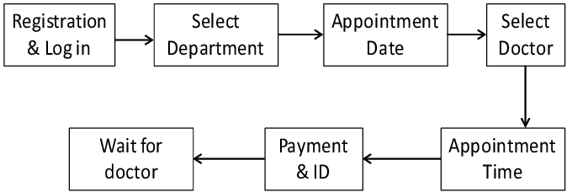
Figure 3.1: Appointment framework
Several techniques have been implemented and tested in existing system for the computerized appointment scheduling and a new approach is being proposed. When attempting to optimize an appointment scheduling system, the decision tree algorithm is the one that produces the best results.
3.1.1 Algorithm 3.1: Implementation Algorithm
1. Function ScheduleAppointment(patient):
2. if patient.hasPreferredTime():
3. // Patient has a preferred time
4. if isTimeSlotAvailable(patient.getPreferredTime()):
5. // Preferred time slot is available
6. scheduleAppointment(patient, patient.getPreferredTime())
7. return "Appointment scheduled successfully."
8. else:
9. // Preferred time slot is not available, try the next available slot
10. return tryNextAvailableSlot(patient)
11. else:
12. // Patient does not have a preferred time
13. return tryNextAvailableSlot(patient)

14. Function tryNextAvailableSlot(patient):
15. for each time slot in availableTimeSlots:
16. if isTimeSlotAvailable(timeSlot) and patient.isAvailableAt(timeSlot):
17. scheduleAppointment(patient, timeSlot)
18. return "Appointment scheduled successfully."

19. // No suitable time slot found
20. return "No available time slots. Please try again later."

21. Function isTimeSlotAvailable(timeSlot):
22. // Check if the specified time slot is available in the schedule
23. // Implement logic to verify against existing appointments, resource availability, etc.
24. return true or false
25. Function scheduleAppointment(patient, timeSlot):
26. // Logic to schedule the appointment in the system
27. // This may involve updating schedules, databases, or relevant data structures
28. updateSchedule(patient, timeSlot)
29. Function updateSchedule(patient, timeSlot):
30. patient = getPatientInfo() // Function to get patient information
31. result = ScheduleAppointment(patient)
32. print(result)
Decision Tree Algorithm Source (Miller, 2017)
3.1.2 Appointment Flow
- Start:
  - The process begins.
- Get Patient Information:
  - Retrieve information about the patient, such as preferences and availability.
- Does Patient Have Preferred Time?
  - Check if the patient has specified a preferred appointment time.
- Yes:
  - If the patient has a preferred time,
    - Check if the preferred time slot is available.
    - If available, schedule the appointment and end.
    - If not available, proceed to the next step.
- No or Preferred Time Not Available:
  - If the patient does not have a preferred time or the preferred time is not available,
    - Try to find the next available time slot based on the decision tree logic.
- Is Suitable Time Found?
  - Check if a suitable time slot is found based on the decision tree logic.
- Yes:
  - If a suitable time is found,
    - Schedule the appointment and end.
    - Display a success message.
- No:
  - If no suitable time is found,
    - Display a message indicating no available time slots.
    - End the process.
- End:
  - The process concludes.
3.2 ANALYSIS OF THE EXISTING SYSTEM
The existing patient appointment scheduling system relies on manual processes, lacks consideration for patient preferences, exhibits inefficiencies in resource allocation, and suffers from a high incidence of no-shows. The system's adaptability is limited, and it lacks the utilization of data-driven insights, leading to a suboptimal patient experience and overall inefficiency. The integration of decision tree algorithms is imperative to address these challenges and enhance the system's efficiency, responsiveness, and patient-centricity.

3.3 PROBLEMS OF THE EXISTING SYSTEM
The existing patient appointment scheduling system faces challenges stemming from manual processes, they are:
  - Human Errors in Manual Scheduling: Manually scheduling appointments increases the risk of booking multiple patients for the same time slot. Staff might also enter wrong details, leading to scheduling conflicts or patient dissatisfaction.
  - Lack of Real-Time Updates: Without real-time updates, appointment changes are not immediately communicated to all relevant parties.
  - Inadequate Handling of High Volume of Appointments: Many scheduling systems struggle with efficiently managing a high volume of appointments, especially during peak times. These systems often cannot handle last-minute changes, cancellations, or rescheduling efficiently, causing inconvenience for patients and staff.
  - Poor Integration with Electronic Health Records (EHRs): When scheduling systems are not integrated with EHRs, patient information is not seamlessly updated, leading to potential errors in patient care.
  - Restricted Access to Information: Patients may find it difficult to view available time slots or manage their appointments without adequate self-service features.
These issues collectively contribute to a suboptimal scheduling experience, underscoring the imperative need for system improvements to enhance efficiency and patient satisfaction.
3.4 DESCRIPTION OF THE PROPOSED SYSTEM
The proposed computer-based patient appointment scheduling system represents a paradigm shift from the limitations of the existing manual processes. By integrating advanced decision tree algorithms, the system introduces intelligent and data-driven scheduling, ensuring optimal resource allocation based on patient preferences and historical data. Patients benefit from a personalized scheduling experience, including features for expressing preferences and receiving automated reminders. The system's adaptability, driven by real-time data, addresses the inefficiencies of the existing system, while streamlined communication channels and enhanced operational efficiency further contribute to an improved overall experience. This holistic approach aims to revolutionize patient appointment scheduling, offering a solution that is both efficient and patient-centric.
3.5 ADVANTAGES OF THE PROPOSED SYSTEM
The proposed computer-based patient appointment scheduling system offers several advantages over the existing system:
- Enhanced Patient Satisfaction: Patient-centric features and personalized scheduling contribute to increased satisfaction, providing a more tailored and positive experience for patients.
- Optimized Resource Allocation: Decision tree algorithms lead to more efficient resource allocation, minimizing wait times for patients and maximizing the productivity of healthcare providers and facilities.
- Reduced No-Show Rates: Automated reminders and personalized scheduling contribute to a significant reduction in patient no-shows and appointment cancellations, improving overall appointment efficiency.
- Operational Efficiency: Streamlined administrative processes and improved resource utilization enhance the overall operational efficiency of healthcare facilities, reducing the burden on staff.
- Data-Driven Decision-Making: Leveraging data-driven insights allows for continuous optimization of scheduling processes, leading to informed decision-making, trend analysis, and strategic improvements.
- Adaptability to Changing Needs: The decision tree-driven adaptability ensures the system can promptly respond to changing patient needs, providing flexibility and responsiveness in scheduling.
- Improved Communication Channels: Enhanced communication channels between healthcare providers and patients contribute to more transparent and efficient interactions regarding appointment scheduling, reducing misunderstandings.
- Personalized Scheduling Experience: Patients benefit from a personalized scheduling experience, allowing them to express preferences and choose suitable appointment times, contributing to a more patient-centric approach.
CHAPTER FOUR
DESIGN, IMPLEMENTATION AND DOCUMENTATION OF THE SYSTEM
4.1 DESIGN OF THE SYSTEM
This is the computation of the particulars of a new system and the determination of what the new system would be and the function it is to perform. This may involve changing from one system to another or modifying the existing system operation.
The most challenging phase of the system life cycle is the change from manual operation to a faster and more accurate one; system design stage covers the technical specifications that will be employed in the implementation of the new system in order to modify the previous system. Some factors are put in consideration. These factors include input design, output design, the database and procedure designs and other documentation.
4.1.1 OUTPUT DESIGN
This incorporates the objectives of solving the existing system problems and challenges. The outputs extracted from the system are displayed in the screenshot images below:


Figure 4.1: Main menu
The main menu interface contains some menus where the user can navigate to other pages on the system.
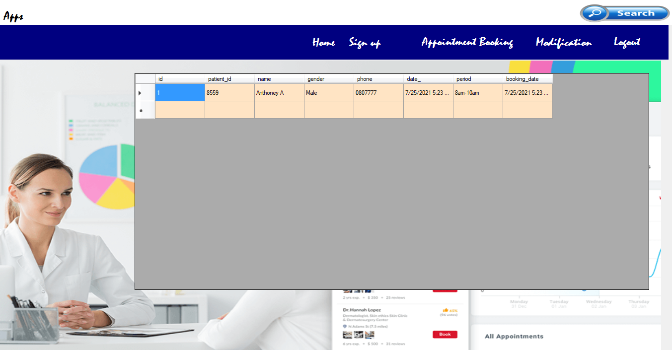
Figure 4.2: Appointment Booked Records
This is the page where all the appointment booked by the patient can be displayed and approve by the doctor.
4.1.2 INPUT DESIGN
The following input was obtained from the online appointment software. They are:

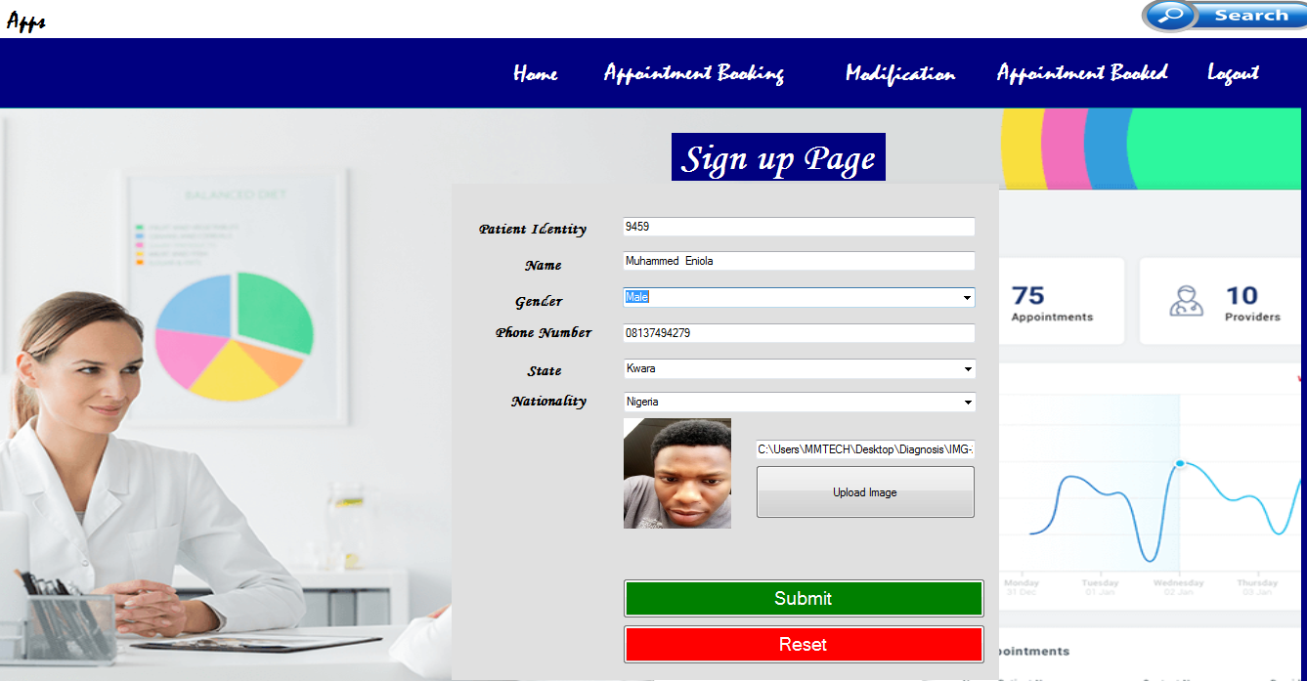
Figure 4.3: Patient Registration Page
This interface is the page where a patient can register on the system; he/she needs to enter some details which includes name, gender, and state and so on.

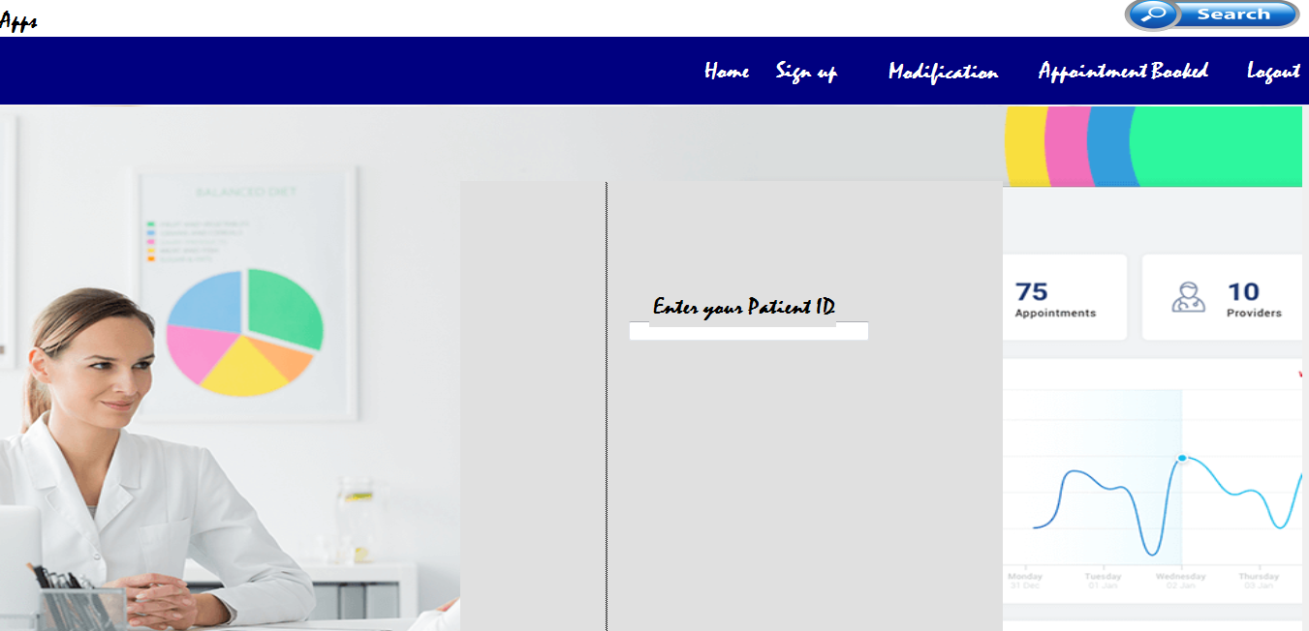
Figure 4.4: Modification Page
This interface shows a page where the admin can modify the records of a patient anytime the need arises.

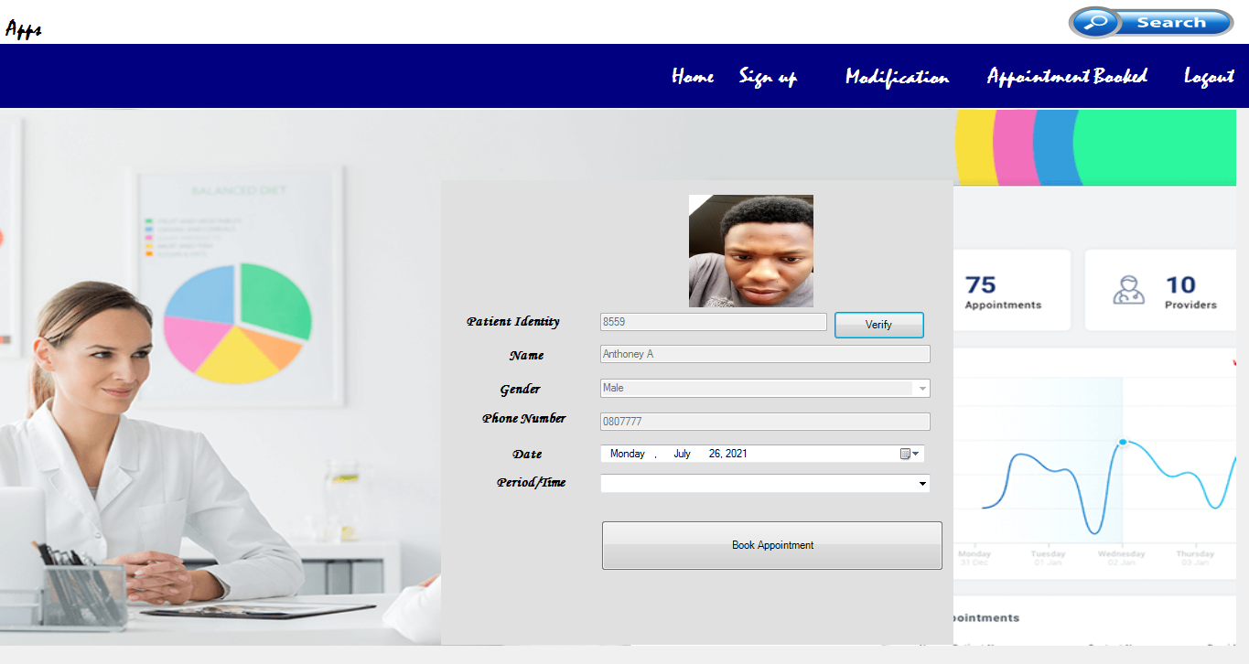
Figure 4.5: appointment Booking Interface
As displayed above, here the patient can book for appointment by clicking on the “book appointment” button.
4.1.3 DATABASE DESIGN
Table 4.1 Appointment booked record

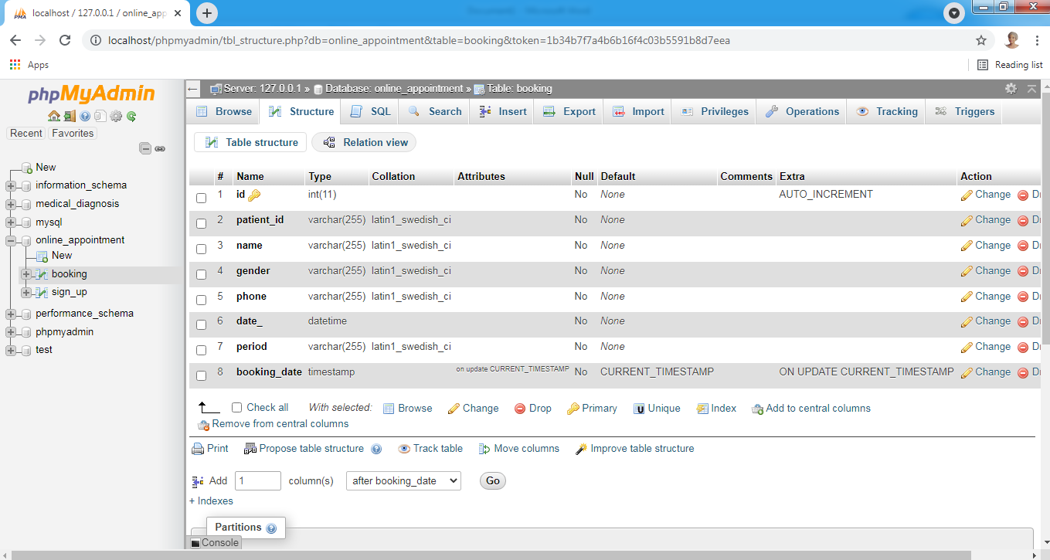
This table displays all the records of the booked appointments.

Table 4.2: Patient Registration table
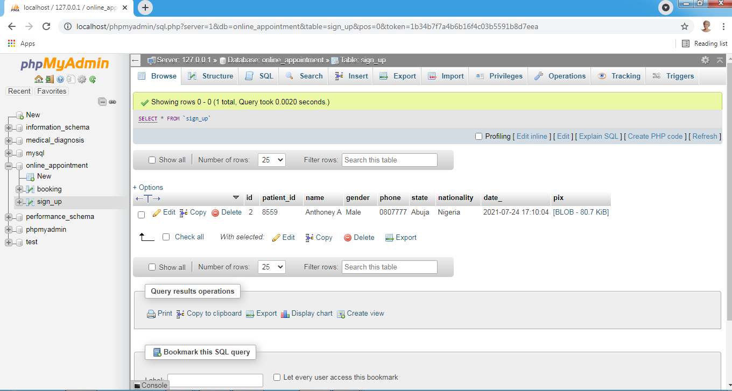
This table houses the entire patient that had registered on the system
4.1.4 PROCEDURE DESIGN
These are the steps involved in unifying the whole process to produce the desired output. It involves computer procedures which start from the original input lessons to the output result file. This allows the processing of user information and result to be possible. Menu is provided to aid user in the processing of the output file.
4.2 IMPLEMENTATION OF THE SYSTEM
This entails the choice of the programming language employed to implement the system which should-be suitable for online patient appointment for hospitals. The system is designed for the use of hospitals which should serve as an assistant. It is also expected to be used in conjunction with the user.
4.2.1 CHOICE OF PROGRAMMING LANGUAGE
The Application was developed in Microsoft Visual Studio (.Net), an integrated development environment (IDE). The Application IDE is chosen following the fact that extracted information needs to be presented in an enhanced pictorial/graphical format and easy communication with the database for program flexibility in windows platform.
4.2.2 HARDWARE REQUIREMENTS
i. 250 Hz minimum with CD ROM drive etc.
ii. Hard disk of capacity 10GB Minimum
iii. 126-512 megabyte of RAM
iv. An Uninterrupted power supply (UPS)
v. A voltage stabilizer
vi. A power generating set and so on.

4.2.3 SOFTWARE REQUIREMENTS
I. Window Operated system such Windows7
ii. Microsoft Visual C#.Net
iii. Structure Query Language (SQL).
4.3. PROGRAM DOCUMENTATION
The program is packaged for use in any system. After developing the system, there is a facility provided in Visual Studio suite called “Package and Deployment Wizard” that is used in Microsoft Visual C# .Net app packaging and deployment.
This software is packaged into an installable setup that can be run from any system.
4.3.1 MAINTAINING THE SYSTEM
The system maintenance refers to making modification to an already existing application/program without necessarily re-writing everything from start. Program maintenance of a program includes modification of the program to meet-up with certain requirements of the users. In this course, additional features can be added, errors corrected, ambiguous interfaces redesigned to eliminate confusions and unnecessary features removed.
Maintaining this program can be done in Microsoft Visual C# environment. Any future modification can be by re-running the program source code in a Visual studio making necessary changes and updates and recompile the application into an upgrade version of the existing version of the mini word processing application. Further versions of this program can be named following their year of release or it can be given a different version number.

CHAPTER FIVE
SUMMARY, CONCLUSION AND RECOMMENDATIONS
5.1 SUMMARY
The implementation of a computer-based patient appointment scheduling system using decision tree represents a significant advancement in healthcare service delivery. By integrating computational optimization techniques into the scheduling process, this system offers a dynamic and efficient approach to managing patient appointments. Through the use of decision tree, the system can adaptively generate appointment schedules that minimize patient waiting times, maximize resource utilization, and improve overall operational efficiency within healthcare facilities. Moreover, features such as online appointment booking, automated reminders, and real-time schedule adjustments enhance patient convenience and accessibility, leading to improved patient satisfaction and engagement. The adoption of such a system holds great promise for enhancing the quality of care delivery, streamlining administrative workflows, and optimizing resource allocation in healthcare settings.

The project appointment system for patients has been implemented in Microsoft visual studio for application development and the system is developed using C Sharp.Net and MySQL for the database. The proposed system is efficient and has friendly user interface. It has the admin and doctor modules in the in the system. This would help the doctor to register on the application and perform all the tasks on the system. The admin would be able to use the online system for managing the details of the patients and the doctors instead of using the manual way (pen and paper).

5.2 CONCLUSION
In the project a new method for patient scheduling has been described. With the use of genetic algorithm an effective method that finds qualitative solutions has been provided. The introduction of actors, sources and activities allows all kinds of scheduling problems to be described and solved. With the modification of genetic algorithm the premature convergence to a suboptimal solution is avoided and successful rearrangement of existing schedules is achieved. An adequate internal representation of individuals together with chosen genetic operators guarantees all solutions to be feasible, and in this manner the possibility of very important user interaction with the system. The ease of controlling the direction of evolution by adjusting importance of the parameters that affect the quality of final solution makes the method even more appropriate to be incorporated into an interactive scheduling tool. Because of its effectiveness and low computing resources consumption it could be used also for very complex problems.
5.3 RECOMMENDATIONS
Based on the findings of the study, the researcher recommends the following;
- Hospital in Nigeria should adopt the new system this will enhance the effectiveness of the hospital.
- Computerized appointment scheduling is effective particularly in areas where contacting doctors is not easily attainable.
- The integration of decision offers a data-driven and adaptive approach to appointment scheduling, allowing facilities to optimize scheduling criteria while accommodating dynamic scheduling conditions and patient preferences.
- The automation and optimization capabilities of the proposed system can significantly reduce administrative burdens, minimize wait times, and enhance the overall patient experience.

REFERENCES
Adebayo, P., I., Olajide, O., A. & Kehinde, O., W. (2019). Dependable Online Appointment Booking System for NHIS Outpatient in Nigerian Teaching Hospitals, International Journal of Environmental Research and Public Health. Vol. 3, 2. Pp. 35-36. DOI: 10.5121/ijcsit.2014.6405
Ajibola, A. (2021). Design and Implementation of Patient Appointment Scheduling, International Journal of Research and Scientific Innovation (IJRSI). 1, Pp. 5-6.
Anjola, M. (2022). Challenges in Manual Appointment Scheduling: A Case Study in Healthcare, Journal of Health Operations Management. 14(1). Pp. 56-72.
Chua, N. (2020). A Study of Queues and Appointment Systems in Hospital Outpatient Departments, With Special Reference to Waiting Times, Journal of the Royal Statistical Society. Vol.1. Pp. 185-199.
Eniola, S. M. (2021). Optimizing Resource Allocation in Healthcare: A Decision Support Approach. Health Management Review, 28(3). Pp. 201-218.
Gupta, N., & Kumar, A. (2019). Decision Trees in Healthcare Operations: Applications and Challenges, International Journal of Health Information Systems. 22(4). Pp. 321-340.
Hema, S., K., Uday, J., K., Ambeth, V., D., Saranya, G. & Ramalakshmi, V. (2019). Effective Online Medical Appointment System, International Journal of Scientific & Technology Research. 8:9. Pp. 115-116. ISSN 2277-8616 803 IJSTR©2019 www.ijstr.org.
Johnson, S. (2022). Optimization of Patient Scheduling In Outpatient Departments Using Genetic Algorithm, International Journal of Research and Scientific Innovation (IJRSI). Vol. 3, Issue: 1. Pp. 15-16.
Jones, M. L., & Brown, S. E. (2020). Patient-Centric Care: A Paradigm Shift in Modern Healthcare, Health Systems Journal. 35(2). Pp. 78-95.
Klassen, K., J. & Rohleder, T. R. (2020). Outpatient Appointment Scheduling with urgent Clients in a Dynamic, Multi-Period Environment, International Journal of Service Industrial Management. Vol. 15, Issue: 2. Pp. 167–168.
Koole, G. & Kaandorp, G. (2016). Optimal Outpatient Appointment Scheduling, Working Paper, Department of Mathematics. Pp. 4-5. http://www.math.vu.nl/˜koole/articles/hcms07b/.
Koole, G. (2017). Designing Appointment Scheduling Systems for Ambulatory Care Services, Journal of Health Care Management Science. Vol. 3. Pp. 47–50.
Po-Chin, Y., Feng-Yuan, C., Hao-Yen, L., Mei-Ju, S., Tzeng-Ji, C., Li-Fang, C. & Shinn-Jang, H. (2019). Features of Online Hospital Appointment Systems in Taiwan: A Nationwide Survey, International Journal of Environmental Research and Public Health. Vol. 6. Pp. 67-68.
Shafaq, M., Nargis, B., Sehrish, K., Razia, S. & Sadaf, A. (2016). Mr.Doc: A Doctor Appointment Application System, International Journal of Computer Science and Information Security. Vol. 14, Issue: 3. Pp. 152-154.
Smith, D. (2021). Genetic Algorithm Approach to Appointment Scheduling in Healthcare, International Journal of Research and Scientific Innovation (IJRSI). Vol. 3, Issue: 1. Pp. 15-16.
Smith, A. M. & Johnson, P. Q. (2018). Artificial Intelligence in Healthcare: A Comprehensive Review, Journal of Medical Informatics. 25(3). Pp. 123-145.
Wang, H., & Lee, K. (2019). Towards Personalized Healthcare Scheduling: Decision Tree Applications in Patient-Centric Approaches. Journal of Personalized Medicine. 26(6). Pp. 127-143.
World Health Organization (2019). The World Health Report 2000: Health Systems: Improving Performance. Retrieved on February 23, 2042, from www.who.int/whr/2000/index.htm.
Yidong, P. (2019). Applying Simulation and Genetic Algorithm for Patient Appointment Scheduling Optimization, International Journal of Environmental Research and Public Health. Vol. 2, Issue: 3. Pp. 8-9.

Appendices: System Flowchart
Appendix 1: Main Menu Flowchart
Start
Display Option

Schedule Patient Appointment
Patient Registration
Patient Record Modification
Report

Stop

Appendix 2: Patient Registration Flowchart
Start
CLOSE Database
MORE RECORD?
RETURN
Yes
OPEN DATABASE

ENTER PATIENT DETAILS

No
YES
DISPLAY PATIENT FORM
INCREMENT ID BY 1
SAVE TO DATABASE

Appendix 3: Patient Record Modification Flowchart
START
RETURN
OPEN DATABASE
IS RECORD FOUND?
MODIFY ANOTHER ORDER?
CLOSE DATABASE
No
Yes
Yes
SEARCH FOR RECORD
No
ENTER PATIENT ID

MODIFY RECORD

SAVE

Appendix 4: Patient Appointment Scheduling Flowchart
Start
Open Database

Enter Patient ID

Display Details

Is Record Found?
No

Apply Decision Tree Algorithm

Yes
Assign Day and Time

No
EOF?
Close Database
Stop
Yes

Appendix 5: View Patient Report Flowchart

RETURN
CLOSE DATABASE
OPEN DATABASE
START
VIEW PATIENT RECORD

VIEW MORE?
Yes
No
ENTER PATIENT ID

