CHAPTER ONE
INTRODUCTION
1.1 Background of the study
The complex mixture of gases that make up the earth atmosphere has been altered much more significantly in the recent time. Human activities that range from domestic energy utilization to large scale industrial operations are largely responsible for this undesirable status of atmospheric constituents due to addition of pollutants. Air pollution is a major environmental problem affecting both the developing and the developed countries of the world. The effects of air pollution on human health are very complex as there are different sources; thereby producing varying effects (www.edugreen.teri.res.in). Although industries such as power plants, cement, refineries, petrol-chemicals and mines have been identified as major sources of air pollutants, the emission of particulates is quite outstanding from quarries. Generally, the effects of dust emission from quarries have both micro and regional dimension. Air pollution and ground vibration arising from blasting, crushing and emission of noxious gases have negative impacts on human health and well-being. Quarrying products are increasingly demanded for industrial, domestic, agricultural and other purposes so as to satisfy the needs of the rapidly growing population. Quarrying operations generally involve removal of over burden, drilling, blasting and crushing of rock materials.
The various impacts produced by these operations are both size and locations dependent. Manifestations of specific impacts are on the air, water, soil, earth surface, floral and fauna, and human beings (Areola, 1991; Enger and Smith, 2002). Apart from land degradation, other negative impacts of quarrying includes swamp creation, deterioration of ground water, erosion of soil, noise and percussions from rock blasting, generation of dust, smoke and fumes; production of noxious gases and ground vibration. Suspended particulate matter is quite outstanding among all pollutants emanating from quarrying operations (USEPA, 2008). Solid materials in the form of smoke, dust and also vapour generated during quarrying operations are usually suspended over a long period in the air. Moreover, particulate matter in the air are capable of being transported from the point of generation to areas far removed (UNEP, 1991b). Once particles of varying chemical compositions are inhaled, they lodge in human lungs; thereby causing lung damages and respiratory problems (Last, 1998).
1.2 Aim of the Study
The aim of this project is focus on chemical and trace elemental composition of quarry dust and its health implication.
1.3 Objective of the Study
The objective of this study includes:
i. to determine the chemical composition of quarry dust.
ii. to determine the trace elemental constituents of quarry dust and its health implications
iii. to compare with standard parameters.
1.4 Problem statement
Particulate concentration constitute hazards to humans, animals and plants. Either the human are at work at quarry sites or live in proximity to quarry sites. These humans are exposed to respiratory and other deadly disease caused by exposure to particulate matter.
1.5 Justification of the Study
This project work is aimed at determining the chemical and elemental composition of the dust particulates from Kam quarry with tendency of potentially harmful elements in the dust and their possible health implications.
1.6 Scope of the Study
The scope of this project will be restricted to collection of quarry dust from Kam quarry, Kwara State. The project is limited to field work and laboratory analysis.

CHAPTER TWO
LITERATURE REVIEW
2.1 Review of previous studies
Several researchers has reported the effect of quarry dust in Nigeria. Among these authors,
Richard et al. (2002) reiterate that suspended particulate matter may be affecting more people globally than any other pollutant on a continuous basis. According to UNEP (1991b) Solid materials in the form of smoke, dust and also vapour generated during quarrying operations are usually suspended over a long period in the air. Moreover, particulate matter in the air are capable of being transported from the point of generation to areas far removed. Raspan et al. (2018) reported that the complex mixture of gases that makes up the earth atmosphere has been altered much more significantly in the recent time by human activities that range from domestic energy utilization to large scale industrial operations which are largely responsible for atmospheric pollution. Infantes et al. (2020) who opined that when dust from quarrying operations is uncontrolled and allowed to enter the atmosphere, it can cause a variety of unpleasant environmental problems which may include wear and tear on machines, decreased visibility, an increase in the risk of accidents, and pulmonary damage from breathing in minerals like silica, asbestos, and coal dust. WHO (2024) estimates, ischemic heart disease and stroke accounted for about 37% of premature deaths linked to outdoor air pollution. From the statistical report of WHO in 2019, 18% of chronic obstructive pulmonary disease 23% of acute lower respiratory infections linked to deaths of human beings respectively, and respiratory tract cancer accounted for 11% of deaths. Oguntoke et al. (2009) reported that there are various air pollutants, the emission of particulates is quite outstanding from quarries which have both micro and regional effect. Air pollution and ground vibration arising from blasting, crushing and emission of noxious gasses have negative impacts on human health and well-being.
2.2 Geology of Nigeria
Nigeria lies approximately between 4⁰N and 15⁰N and longitude 3⁰E and 14⁰E within the Pan African Mobile belt between the West African and Congo Cratons. The geology of Nigeria is dominated by crystalline and sedimentary rocks which occurring approximately in equal proportion (Woakes et al., 1987).
The Basement complex is one of the three major litho-petrological components that make up the geology of Nigeria (Figure 2.1). The Nigeria Basement complex form a part of the Pan African mobile belt and lie between the West African and Congo Cratons and South of the Tuareg shield (Black, 1980). It is intruded by the Mesozoic Cal alkaline ring complexes (young granites) of the Jos Plateau and is unconformably overlie by Cretaceous and Younger sediment. The Basement complex of Nigeria, four major Petr- lithological units are distinguishable which are the pegmatite, the schist belt (metal sedimentary and meta volcanic rocks), the Older granite (Pan African Granitites) and under formed Acid and Basic Dykes.
Nigeria is underlain by seven major sedimentary Basin (from the oldest), the Calabar Flank, the Benue trough, the Chad basin, SE, Iullumenden (Sokoto) Basin.

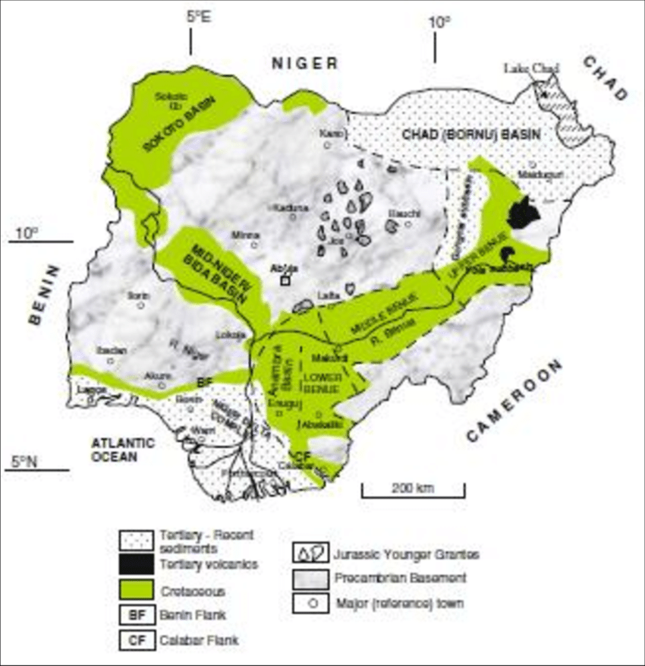

FIG 2.1: Geological Map of Nigeria (after, Obaje, 2004).

2.3 GEOLOGY OF THE STUDY AREA.
The study area is located in Yikpata and Lema in Edu Local Government Area of Kwara State. The coordinates of Yikpata is latitude N08⁰49¹69¹¹, Longitude E005⁰05¹ 82¹¹and elevation of 117m. The Lema pegmatite has a coordinate of latitude N08⁰ 40¹ 79¹¹ and longitude E008⁰ 14¹ 47¹¹ with an elevation of 239m.The study area (Fig. 2.2) falls in the basement complex of North – central part of Nigeria, which is of Precambrian to Lower Paleozoic in age (Rahaman, 1976).

Figure 2.1: Geological Map of Nigeria (Obaje, 2004)

2.3 Geology of the Study Area
The study area is located within latitude of N08°27’04.0” and E004°21’25.5” at elevation of 304m for Kam quarry. (Figure 2.2). This Precambrian crystalline basement complex consists of gneisses, migmatites, and metasediments (that is, schists quartzite and meta volcanics: and Pan-African (Older) granite and minor pegmatitic and aplitic intrusive rocks (Oluyide et al., 1998). The rock units’ form part of the regional south - western highlands of Nigeria running NW-SE parallel to the River Niger. The subsurface comprises the weathered, slightly weathered and fresh (fracture or unfractured) crystalline basement rocks. The oldest rocks in the area comprise gneiss complex whose principal member is biotite-hornblende gneiss with intercalated amphibolite. This underlies over half of the city. Other rock types are older granite mainly porphyritic granite, gneiss and granite-gneiss and quartz schist. The mineralogical composition in the area consists of feldspar, quartz, muscovite and biotite.

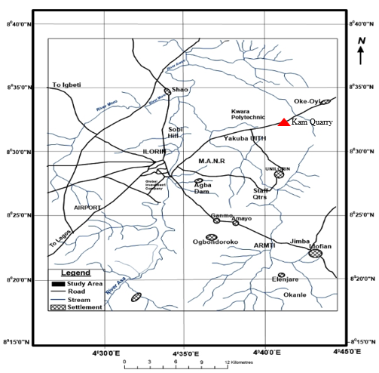
Figure 2.2: Location Map of the Study Area (modified after Olasehinde et al., 1998)

2.4 Composition of Quarry Dust
Quarry dust can be described as the residue or tailing material after the extraction and processing of rocks and that forms fine particles less than 4.75mm. As oppose to smooth granular nature of sand, quarry dust has rough surface textures and angular shape due to crush nature of the aggregate. Rough surface texture provide better interlocking and good bond between the cement paste and the aggregate. It constitutes 20% - 25 % of the output of rubble crushing (Information gathered from the quarry owners). Smooth round shape of river sand makes bond between the cement paste and the aggregate relatively weak. However, due to spherical shape of the river sand (surface area to volume of sand is small) and relatively low percentage of voids.
2.5 Chemical Composition of Quarry Dust
The chemical composition of quarry dust is typically 70 - 77% silica, 11 - 13% alumina, 3 - 5% potassium oxide, 3 - 5% soda, 1% lime, 2 - 3% total iron and less than 1% magnesia and titanium. While the main element of sand is silicon dioxide (SiO₂), followed by smaller amount of aluminum, iron oxide, and calcium oxide. (Nanda et al., 2010). Silica, SiO₂, is a colourless crystalline compound found mainly as sand, quartz, flint, and many other minerals. Silica is an important element to manufacture to enhance the strength property in a wide variety of materials. It is understood that the SiO₂ is the main chemical component which possess the strength parameters in cement and sand. Hence, in this regards it is recommended to crusher owners to check chemical property of SiO₂ of their quarries shows higher than 80%.

CHAPTER THREE
MATERIALS AND METHOD
3.1 Sample Collection
Representative samples of quarry dust tagged Sample A, Sample B and Sample C were collected on the field using equipment such as hammer, chisel, sample bags and global positioning system among others. The three (3) samples was separated in different sample bags and transported to Nigerian geological Survey agency (NGSA), Kaduna for detailed analysis.
3.2 Atomic Absorption Spectrometry
Atomic Absorption Spectrophotometer (N1100A model) was used to analyze the rock samples. Graphite cuvette was used for electro thermal atomizer; ultra-high purity acetylene was used as the carrier gas. Volumetric measurements were carried out with the analyzer TA-4 with polyethylene impregnated graphite electrode. As a reference electrode, silver/silver chloride electrode was used. Calibration solutions of lead, nickel, and cobalt were obtained by diluting the standard samples obtained from Sigma. Nitric, hydrofluoric and hydrochloric acids were purchased ultrapure quality.
Rocks samples are dried, ground, and homogenized. An aliquot is digested with a combination of nitric, hydrofluoric, and perchloric acids, in Teflon '^' beakers, heated on a hot plate at 200°C. The resulting salts are dissolved in hydrochloric acid and deionized water. The solutions are analyzed by atomic absorption spectroscopy after the addition, in certain cases, of appropriate matrix modifiers. Additional interferences are removed or compensated for through the use of mixed-salt standards and background correction.

3.3 Procedure for Atomic Absorption Spectrometry
All glassware should be cleaned immediately before use by rinsing, first with dilute HCl (1+1) and then with demineralized water. Dry the sample by an appropriate procedure such as freeze-drying, or in an oven at 105°C. If the sample is greater than 100g, split it down to less than 100g by use of a nonmetallic sample splitter (riffle sampler) or by coning and quartering. Grind the sample with a mixer mill or an agate mortar and pestle until all material is finer than 100 mesh. Weigh and transfer 0.5000 g of finely ground sample to a 100 mL Teflon beaker; weigh out appropriate standard materials as well, and use several empty beakers for blanks. Place the hot plate in a perchloric acid hood, turn on the hood and hotplate, and adjust the hot plate to produce a surface temperature of 200°C. To each beaker, add 6 mL HNO₃ (SP Sr. 1-41), and place it on the hot plate for approximately 30 minutes.
Remove the beakers from the hot plate and wait 5 minutes. Add 6 mL HF (specific gravity of 1.17) and 2 mL HCl specific gravity of 1.67), and return the beakers to the hot plate. Continue heating until the evolution of white per chloric fumes and the solutions have reached incipient dryness; however, do not bake the residues. Remove the beakers from the hot plate, wait 5 minutes, and repeat the process again. Remove the beakers from the hot plate, wait 5 minutes, and add 2 mL HCl (sp gr 1.67) and return the beakers to the hot plate. Continue heating until the evolution of white per chloric fumes and the solution reaches incipient dryness; however, do not bake the residues. Remove the beakers from the hot plate, lower the hot plate temperature to 100°C, and add 2 mL dilute HCl (1+1) and swirl the beaker; add 10 mL demineralized water and return to the hotplate until the residues dissolve. Cool the beakers, and pour each solution into a 50 mL volumetric flask. Rinse the beaker several times with demineralized water and bring to the mark with demineralized water. Pour the solution into an acid-rinsed plastic bottle for storage. This solution represents a dilution factor of 100X. Remove a 5 mL aliquot from the 100X solution, add 1 mL HCl (Specific gravity 1.19), place in a 50 mL volumetric flask, and bring to the mark with demineralized water. Pour the solution into an acid rinsed plastic bottle for storage. This solution represents a dilution factor of 1000X. Finally, remove a 5 mL aliquot from the 1000X solution, add 1 mL HCl (Specific gravity 1.19) and place in a 50 mL volumetric flask, and bring to the mark with demineralized water. Pour the solution into an acid rinsed plastic bottle for storage. This solution represents a dilution factor of 10000X. Set up the atomic absorption spectrophotometer according to the specifications and analyze the 100X solutions for Cr, Co, Cu, Pb and Ni.
Determine the concentration of each constituent in the 100X solutions (Cr, Co, Cu, Pb and Ni) from the digital display while aspirating each sample and record the results (average of 3 readings once the system has stabilized). The actual concentration of each constituent in the sample, can be obtained by multiplying the concentration in each sample solution by 100, if no further dilutions are made.
Each quarry dust samples were further pulverized and digested in aqua-regia (HNO₃/HCl) in the ratio 1:3. The digested samples were analyzed for Zn, Fe, Pb, Cd, Cu, Co, Ni, As, Mn, and Cr. The analysis was done using an Atomic Absorption spectrophotometer (AAS) at the Nigerian Geological Survey Agency (NGSA) Laboratory, Kaduna. Standard stock solutions for all the elements were procured from Merck as well as prepared in the laboratory following the procedures as described in APHA (2012). The glassware used was Pyrex, which was washed several times with soap, distilled water, and diluted nitric acid to remove any impurities. Similarly, water samples were directly aspirated into the Atomic Absorption Spectrometry (A.A.S) and the concentration of each metal (Pb, Zn, Cu, Fe, Co, Ni, As, Mn, Cd and Cr) was determined when extracts were sprayed into the flame, light rays from a hollow cathode lamp is shone through the flame, thereby triggering atoms of the elements to be determined, leading to radiation absorption. The rate of absorption is directly proportional to the concentration of the element. Each element is detected with its cathode lamp, and the concentrations are recorded in mg/L units.

CHAPTER FOUR
RESULTS AND DISCUSSION
4.1 Results of Major oxides
The results of major oxides of quarry dusts for the three samples is shown in table 4.1.
S/n | Sample Name  Chemical Compositions (%) | Sample A (%) | Sample B (%) | Sample C (%) | Range | Mean (%)
1. | SiO₂ | 65.25 | 64.33 | 61.24 | 61.24 – 65.25 | 63.51
2. | Al₂O₃ | 14.25 | 14.83 | 13.88 | 13.88 – 14.83 | 14.32
3. | Fe₂O₃ | 8.05 | 8.02 | 7.25 | 7.25 – 8.05 | 7.77
4. | CaO | 5.25 | 5.23 | 4.32 | 4.32 – 5.25 | 4.93
5. | MgO | 2.08 | 2.06 | 2.01 | 2.01 – 2.08 | 2.05
6. | TiO₂ | 0.88 | 0.99 | 0.79 | 0.79 – 0.99 | 0.84
7. | Na₂O | 3.82 | 2.88 | 3.11 | 2.88 – 3.82 | 3.27
8. | K₂O | 0.35 | 0.43 | 0.42 | 0.35 – 0.43 | 0.40
Table 4.1. Concentration of major oxides analyzed in the Quarry dusts

4.2 Discussion of X – Ray Fluorescence
The major oxides for Sample A, Sample B and Sample C was evaluated for their chemical composition. The major oxide in Table 4.1 indicates that the percentage Silicon oxides for the three samples ranges from 61.24% to 65.25% with an average of 63.51%, Aluminum oxide (Al₂O₃) ranges from 13.88% to 14.83% with an average of 14.32%, Iron oxide (Fe₂O₃) ranges from 7.25% to 8.05% with an average of 7.77%. Calcium oxide (CaO) also falls within 4.32% and 5.25% with an average of 4.93%, Magnesium oxide (MgO) ranges from 2.01% to 2.08% with an average of 2.05%, Titanium oxide (TiO₂) ranges from 0.79% to 0.99% with an average of 0.84%, Sodium oxide (Na₂O) ranges from 2.88% to 3.82% with an average 3.27% while Potassium oxide (K₂O) ranges from 0.35% to 0.43% with an average of 0.40%.
Geochemical distribution values generally suggest that the study area possess high silica concentrations and these support the granitic origin of the analyzed rock samples. The high silica content clearly indicate felsic origin and this is supported by the low Fe₂O₃ content while the mean of Na₂O and K₂O reflects the abundance of potassium rich rock forming silicate like biotite. Low concentration of MgO and TiO₂ values are indicative of plutonic origin. This trend is characteristic of Archean granitic rocks. The relatively low alumina suggest the abundance of biotite and feldspar in the rock. Major minerals that are found includes quartz, orthoclase and plagioclase feldspar, albite, hematite, anorthite, hyperstene and corundum while the minor minerals includes rutile, ilmenite and zircon. The presence of K₂O are indicative of calc- alkaline affinity.

4.3 Results of Trace Elemental Constituents
The result for the trace elements (in ppm) for the quarry dust from Kam quarry is given in table 4.2 below.
S/n | Sample Name  Trace Compositions | Sample A (ppm) | Sample B (ppm) | Sample C (ppm) | Range (ppm) | Mean (ppm)
1. | Arsenic (As) | 0.4 | 1.0 | 1.3 | 0.4 - 1.3 | 0.9
2. | Cadmium (Cd) | 0.29 | 0.26 | 0.25 | 0.25 - 0.29 | 0.27
3. | Chromium (Cr) | 4 | 3 | 8 | 3 – 8 | 5.0
4. | Cobalt (Co) | 0.9 | 0.8 | 1.1 | 0.8 - 1.1 | 0.93
5. | Nickel (Ni) | <0.001 | <0.001 | <0.001 | <0.001 | <.0.001
6. | Lead (Pb) | 45.64 | 42.55 | 37.23 | 37.23 - 45.64 | 41.31
7. | Copper (Cu) | 3.18 | 2.23 | 2.21 | 2.23 - 3.18 | 2.54
8. | Zinc (Zn) | 129.1 | 128.6 | 133.56 | 129.1 – 133.56 | 130.42
9. | Molybdenum (Mo) | 500.4 | 540.5 | 570.0 | 500.4 – 570.0 | 536.97
Table 4.2. Results of Trace Element of Quarry Dust

4.4 Discussion of Trace Elemental Composition
Trace elements in the quarry dust from Kam quarry includes Arsenic (As) concentration which ranges from 0.4 - 1.3ppm with average concentration of 0.88 ppm. Cadmium (Cd) concentration ranges from 0.25ppm - 0.29ppm with average concentration of 0.27ppm. Chromium (Cr) concentration fall within 3 - 8ppm with average concentration of 5ppm. Cobalt (Co) concentration ranges from 0.8ppm - 1.1ppm with average concentration of 0.95. Nickel (Ni) concentration ranges from 0.6ppm - 0.9ppm and has average concentration 0.7ppm. Lead (Pb) concentration is very high; it ranges from 37.23ppm - 45.64ppm with average concentration of 41.31ppm. The highest concentrations are recorded in dust samples from Kam quarry.
Copper (Cu) concentration in Kam quarry ranges from 2.23ppm - 3.18ppm with average concentration of 2.54ppm. It can be seen that the concentration of Cu in samples from Kam quarry is relatively high and it also showed slight distinct concentration. Zinc (Zn) concentration is very high and maintained almost the same concentration in all the dust samples from Kam quarry. The concentration ranges from 129.1ppm - 133.56ppm and has average concentration of 130.42ppm. Molybdenum concentration in dust samples from Kam quarry ranges from 500.4ppm – 570.0ppm and has average concentration of 536.97ppm (Table 4.2).
4.5 Discussion on Health Implications
Generally, Quarry workers and those close to Kam quarry are at high health risk due to long exposure to these high trace elemental concentration may be through direct ingestion, percutaneous absorption, inhalation or bioaccumulation in the human system through the food chain. Trace elements and their possible health implications are however associated with deficiency that are dangerous to both human and animal environments. The Arsenic concentration in the dust ranges 0.4ppm - 1.3ppm with average concentration of 0.88 ppm exceeds the WHO permissible limit of 0.01ppm (Table 4.3). Generally, Arsenic is regarded as human carcinogen from extremely low levels of exposure, having no possible beneficial metabolic function for human (Daspan et al., 2008). Its low level exposure causes Nausea and vomiting, based on low level of exposures essentially causes abdominal pains while its long term exposure results to darkening of the skin along with appearance of small corns in palm soles. Minor effects that may occur include anorexia, fever, fluid loss, goiter, hair loss, headache, sore throat, weakness and interferes with the uptake of folic acid. The highly toxic non – essential heavy metal, Cadmium does not have a role in biological processes. It ranges from 0.25ppm - 0.29ppm with average concentration of 0.27ppm and it can be lethal even in low concentrations. It is found to exceed the WHO permissible limit of 0.01ppm (Table 4.3). Long term exposure to cadmium can lead to possible lung damage and kidney disease including fragile bones. Cadmium is very toxic, its long- term exposure to lower level leads to build up in the kidney and possible kidney disease, lung damage, and fragile bones. Arthritis, diabetes, Hypertension, anaemia, cancer, cardiovascular disease, cirrhosis, headache and strokes are some it long term effect or diseases associated with Cadmium. Lead is also a toxic metal even at low or minimal concentration levels. The relatively low concentration of lead in the dust ranges from 37.23ppm - 45.64ppm with average concentration of 41.31ppm which essentially exceeds the WHO permissible limit of 0.05ppm (Table 4.3). Diseases associated with deficiency of lead is not recognized but those associated with excess exposure either through ingestion or inhalation can leads to varieties of disorder such as destruction of red blood cells; liver necrosis, system hypertension; gastro intestinal pains and bleeding, pulmonary edema; anemia, kidney failure and other central and peripheral nervous system disorder including lingering toxicity which could lead to skin disorder such as eczema, hyperkeratosis, melanosis, ulceration and skin cancers Chromium concentration in the dust ranges from Chromium (Cr) concentration in the dust fall within 3ppm - 8ppm with average concentration of 5ppm. (Table 4.3). Chromium is vital to the maintenance of metabolism in the human body. It is apply in effective in management of diabetic patients and it serves as a cofactor with insulin. Its absence result in defective glucose metabolism, hyperlipidemia, corneal opacity. On health grounds, excess exposures of Chromite dust causes irritation and generation of lesions in skin, respiratory tract, and, pulmonary edema, acute kidney failure, Long-term risk for lung cancer, pneumoconiosis from exposure. Cobalt is vital component of vitamin B12 molecules. It is an essential element needed in human body for normal physiological function. Its concentration in the dust however ranges from 0.8ppm - 1.1ppm with average concentration of 0.95ppm which are above the WHO permissible limit of 0.1ppm (Table 4.3). Health implications of cobalt includes anemia and anorexia. Excess ingestion results to Cardiomyopathy, including cancer. Excess inhalation causes respiratory irritation “Hard metal” pneumoconiosis. Percutaneous exposure also causes allergic dermatitis.
Copper is an essential element for plant and animal health. Its concentration in the dust ranges from 2.23ppm - 3.18ppm with average concentration of 2.54ppm. It all exceeds WHO permissible limit. Copper concentration which falls below the permissible limit (Table 4.3). Its deficiencies is lead to Anemia. Its health effects is associated with excess inhalation and ingestion. Intestinal and liver inflammation, hemolysis (destruction of red blood cells, with diffusion of hemoglobin into surrounding fluids), and hyperglycemia are the deadly illness associated with copper dusts. Zinc is an element that is also crucial for human and animal health. It has an important role in metabolism, growth and general wellbeing. Zinc concentration in the dust ranges from 154.1ppm - 157.6ppm and has average concentration of 156.6ppm exceeding the WHO permissible limit of 5.0ppm (Table 4.3). Diseases associated with Zn deficiency are anorexia, dwarfism, anemia, hypogonadism, hyperkeratosis, acrodermatitis, enteropathica, depressed immune response and teratogenic effects. Health effects associated with excess ingestion is hyperchronic anemia and inhalation is metal fume fever at high doses.
Molybdenum is an important element necessary for human and animal body to perform it normal physiological function. Molybednum concentration in the dust varies from 500.4ppm and 570.0ppm and has average concentration of 536.97ppm. This is exceedingly high in the concentration. Molybdenum dust is commonly associated with Mo deficiencies are growth depression, keratinization effects and hyperurinemia. Exposure to excess of Mo causes high uric acid in serum and urine, loss of appetite, diarrhea, slow growth, anemia, “gout-like lesions and molebdenosis. Nickel plays some roles in body functions including enzyme function. In trace or minute amount, it may be beneficial to activate some systems. It has a concentration of <0.001ppm in the dust. This concentration is found to be much lower and inconsequential than the permissible limit of 0.02ppm by WHO/EPA (Table 4.3). However, the health effect associated deficiency is not recognized but exposure to Nickel inhalation results to chronic bronchitis, emphysema, reduced lung capacity, cancers of the lung and nasal sinus. Ingestion of Ni can also lead to cardiac arrest, which is essentially death. Gastrointestinal effects such as nausea, cramps, diarrhea, including vomiting, along with effect on blood, liver, kidney is also as a result of Nickel ingestion. Also, neurological effects such as giddiness weariness can also be attributed to Nickel inhalation or ingestion.

Table 4.3. Measured Concentration of some selected Heavy Metals in Dust from Kam Quarry and WHO (2000) maximum permissible limit
Heavy Metals (ppm) | Measured Concentration range in Quarry dust (ppm) | Average Concentration (ppm) | WHO/EPA permissible limit (ppm)
As | 0.4 - 1.3 | 0.88 | 0.01
Cd | 0.25 - 0.29 | 0.27 | 0.01
Cr | 3.0 - 8.0 | 5.0 | 0.1
Cu | 2.23 - 3.18 | 2.54 | 2.00
Ni | <0.001 | <0.001 | 0.02
Mo | 500.4 – 570.0 | 536.97 | 0.15
Pb | 37.23 - 45.64 | 41.31 | 0.05
Co | 0.8 - 1.1 | 0.95 | 0.10
Zn | 129.1 – 133.56 | 130.42 | 5.00

CHAPTER FIVE
Conclusion and Recommendations
5.1 Conclusion
Quarrying of rocks have shown to have contributed to the development of many developed and developing nations. However, it generates and releases particulate pollution in the environment. The high level of particulates generated at the drilling and crushing areas depicts them as hazard zones. Geochemical analysis of quarry dust from Kam quarry suggest that the concentration of trace elements in the dust exceeds the permissible limit set by WHO. Some of which are very harmful to human health even at very low concentration. It is certain that long exposure of quarry worker and those living in close proximity through inhalation, ingestion and percutaneous absorption can result to various health challenges. Trace elemental concentrations are much higher and extensively contaminated. The release of these trace elements in high concentration by this quarry can enrich their concentration in the environment thereby polluting the air, soil and both surface and ground water which variably affects human, animal and plant lives through food chain which may cause diseases and eventual death of man.
5.2 Recommendations
The following recommendation should be carried out:
- Air pollution from quarry dust at quarrying site can be tackled through dust suppression techniques and treating quarry pit with water before discharging
- Air pollution need proper attention at the quarrying site in order to prevent severe environmental hazards because nobody decides the type of air to breath.

References
Areola, O. (1991). Ecology of Natural Resources in Nigeria. Avebury Academic Publishing Group, Aldershot, England, 178 - 196.
Enger, E. D and Smith, B. F (2002). Environmental Science: A study of Interrelationship (8th edition) McGraw-Hill Higher Education, New York, 372 -377
Last, J.M. (1998). Public Health and Human Ecology (2nd Edition) McGraw-Hill Medical Publishing Prentic.
UNEP (1991b). Urban air Pollution. In: Environment Library, No. 4, Nairobi: UNEP. USEPA (1996). Review of National Ambient Air Quality standards for Particulate Matter: Policy Assessment of scientific and Technician information, Report No. EPA- 452/R-96-013 (USEPA, Washington D.C) V-20 -V-24, 27, V-28 & V-71.
USEPA (2008). Region 4: Laboratory and Field operations – PM 2.5: Objectives and History. As available at en.wikipedia.org/wiki/particulate.
www.edugreen.teri.res.in/explore/air/air.htm

