A PROJECT REPORT
ON
TOPOGRAPHIC INFORMATION SYSTEM OF ODO-OKUN,
SECONDARY SCHOOL, ILORIN WEST LOCAL GOVERNMENT AREA KWARA STATE.

PRESENT BY:
OKEDELE SAMSON OPEYEMI
HND/23/SGI/FT/0054

SUBMITTED TO:
THE DEPARTMENT OF SURVEYING AND GEOINFORMATICS

INSTITUTE OF ENVIRONMENTAL STUDIES
KWARA STATE POLYTECHNIC P.M.B 1340
ILORIN, KWARA STATE.

IN PARTIAL FULFILLMENT OF THE REQUIREMENT FOR
THE AWARD OF HIGHER NATIONAL DIPLOMA IN SURVEYING
AND GEO-INFORMATICS

JULY, 2025

DECLARATION
I hereby certify that all the information given in this project was obtain as result of field observation and measurement made by me and that the survey was carried out in accordance with survey rules and regulation and department instructions.

NAME: OKEDELE SAMSON OPEYEMI
MATRIC NO: HND/23/SGI/FT/0054

DATE:

SIGNATURE:

CERTIFICATION
This is to certify that this project report was prepared and submitted by OKEDELE SAMSON OPEYEMI of Matric No: HND/23/SGI/FT/0054 to the Department of Surveying and Geo-Informatics, Institute of Environmental Studies Kwara State Polytechnic Ilorin, as a result of field observation and measurement using appropriate instrument and equipment to carry out the task.

---------------------------------------- --------------------------
SURV. R. O. ASONIBARE DATE
Project Supervisor

---------------------------------------- --------------------------
SURV. R.S AWOLEYE DATE
Project Coordinator

---------------------------------------- --------------------------
SURV. ABIMBOLA IBRAHIM ISAU DATE
Head of Department

---------------------------------------- --------------------------
EXTERNAL SUPERVISOR DATE

DEDICATION
This project is dedicated to Almighty God, for his immeasurable blessing and graces shown on me before, during and after the completion of my project.

ACKNOWLEDGEMENT
I am grateful to almighty God for the successful completion of this program and for making this course a success in my life. To everyone around me come rain, come sunshine, I say thank you a million times. Also I appreciate my Parents Mr. and Mrs. Simeon Okedele for their support in the course to pursue surveying and Geo- Informatics to this level, word can’t be enough to appreciate you.
My gratitude goes to my project supervisor Surv. R. O. Asonibare for the knowledge been impact to me during the program may almighty God be with you and your family. I will not relent to appreciate the effort of all the staffs in the department in person of Surv. Abimbola Ibrahim Isau (HOD), Surv. Babatunde Kabir, Surv. R.S. Awoleye, Surv. Ayuba Abdulsalam, Surv. Bello Felix and humble Surv. A.G. Aremu may almighty God enrich you all (Amen).
To my beloved sisters Miss Atanda Margret, I say thank you.
And also to mention is the care, love and support received from colleagues in the class especially my project group members, and the rest. I pray that God will bless you all and all others who have contributed immensely to the successful completion of this course.

ABSTRACT
This project is development of topographic information system of part of Odo-Okun Secondary School, Ilorin West Local Government, Ilorin. It was observed that the study area, ,has an updated topographic plans and maps showing the relief of the school premises. Therefore, this project would provide a relevant data of the topography of the school. This project was therefore carried out with the aim of producing a tools for effective planning and proper environmental management of Odo-Okun Secondary School. Field and office reconnaissance survey were carried out in order to be familiar with the nature of the terrain and plan the methodology and equipment to be used for the acquisition and assembling of spatial and attribute data. Total station and its accessories was used in the acquisition of Geometric and Attribute data. The data processing were adequately and effectively done with the use of AUTOCAD2007, SURFER9, ARCGIS, Microsoft excel, note pad, and Microsoft Word software. using the data processing as the management phase, a spatial database was modeled and structured using the relational table format. The usefulness of the topographic information generated was highlighted and map revealed the true configuration of study site and vacant areas for future development. A digital terrain model was created to enhance further analysis on slope, aspect, contour, flow direction and flow accumulation analysis of the study site. The information is also available for query that will assist in the physical planning of the area under investigation. The study concluded that topographic information system is essential for physical and accurate decision making. The system allows easy updating of information and quick retrieval of information for better planning and environmental management.

TABLE OF CONTENTS
TITLE PAGE i
DECLARATION ii
CERTIFICATION iii
DEDICATION iv
ACKNOWLEDGEMENTS v
ABSTRACT vi
TABLE OF CONTENTS vii
LIST OF TABLES x
LIST OF FIGURES xi
CHAPTER ONE
- INTRODUCTION 1
1.1 BACKGROUND OF STUDY 1
1.2 STATEMENT OF PROBLEM 3
1.3 AIM OF THE PROJECT 3
1.3.1 OBJECTIVE OF THE PROJECT 4
1.4 SCOPE OF THE STUDY 5
1.5 STUDY AREA 6
1.6 PERSONNEL INVOLVED 6
CHAPTER TWO
2.0 LITERATURE REVIEW 7
CHAPTER THREE
3.0 METHODOLOGY 14
3.1 DATABASE DESIGN 14
3.1.1 VIEW VALIDITY 14
3.1.2 CONCEPTUAL DESIGN 16
3.1.3 LOGICAL DESIGN 17
3.1.4 PHYSICAL DESIGN 17
3.2 RECONNAISSANCE 18
3.2.1 OFFICE PLANNING 18
3.2.2 FIELD RECONNAISSANCE 19
3.3 EQUIPMENT USED/ SYSTEM SELECTION AND SOFTWARE 21
3.3.1 HARDWARE USED . 21
3.3.2 SOFTWARE COMPONENT 21
3.4 INSTRUMENT TEST 22
3.4.1 HORIZONTAL COLLIMATION TEST 22
3.4.2 VERTICAL INDEX ERROR TEST 23
3.4.3 ANALYSIS OF COLLIMATION AND VERTICAL INDEX DATA 24
3.5 CONTROL CHECK 24
3.6 MONUMENTATION 26
3.7 DATA ACQUISITION 26
3.7.1 GEOMETRIC DATA ACQUISITION 27
3.7.2 ATTRIBUTES DATA ACQUISITION 28
3.8 DATA DOWNLOADING AND PROCESSING 28
3.8.1 DATA DOWNLOADING AND EDITING 28
3.8.2 DATA PROCESSING AND DATA EDITING 29
3.8.3 DATA PROCESSING USING ARCGIS 10.3 29
3.9 DATABASE IMPLEMENTATION 40
3.9.1 DATABASE MANAGEMENT SYSTEMS 41
3.9.2 DATABASE MAINTENANCE 41
3.9.3 BACK COMPUTATION 42
3.9.4 AREA COMPUTATION 43
CHAPTER FOUR
4.0 SPATIAL ANALYSIS AND RESULT PRESENTATION 44
4.1 TESTING OF DATABASE 44
CHAPTER FIVE
5.0 COST ESTIMATION, SUMMARY, CONCLUSION AND RECOMMENDATION 48
5.1 COST ESTIMATION 48
5.2 SUMMARY 50
5.2.1 PROBLEM ENCOUNTERED 51
5.3 RECOMMENDATION 51
5.4 CONCLUSION 51
REFERENCE 52
APPENDIX 53

LIST OF TABLES
Table 3.1..4.1: Building and its attributes 17
Table 3.1.4.2: Road and its attributes 18
Table 3.1.4.3 : Trees and its attributes 18
Table 3.4.1.1: Horizontal Collimation Data 23
Table 3.4.2.1: Vertical Index Data 23
Table 3.5.1: Table showing the back computation of the control coordinates 25
Table 3.5.2: Table showing the distance observation result of the control check 25
Table 3.5.3: Table showing the observation result of the control check 25
Table 3.8.3.1: Building 36
Table 3.8.3.2: Road 37
Table 3.8.3.3: Trees 37
Table 3.8.3.4: Electric Poles 37
Table 3.9.3.1: Back Computation 42
Table 3.9.4.1: Area Computation 43
Table 5.1.1: Direct cost parameters 48

LIST OF FIGURES
Fig 1.1 Diagram of the study area 5
Fig. 3.1 Design and Construction Phases in Spatial Database 15
Fig. 3.1.2.1: E-R Diagram (Entity relationship diagram) 16
Fig. 3.2.2.1: Recce diagram of the study area (not drawn to scale) 20
Fig 3.4.1.1; Horizontal Collimation and Vertical Index error test 22
Fig. 3.6.1: Pillar Description 26
Fig 4.1.1: Retrieving Area whose height is greater than 320 meters 45
Fig 4.1.2: Result of area whose height is greater than 320 meters 45
Fig 4.1.3: Result of area whose height is greater than 320 meters 46
Fig 4.1.4 Query Result Of Buildings Used For Class Rooms 47
Fig 4.1.5 Query Result Of Buildings Used For Offices 47

CHAPTER ONE
1.1 INTRODUCTION
Surveying has been described as an essential element in every human development activity since the beginning of recorded history. It has been discovered to be an imperative requirement in the planning and execution of every forms of meaning development (Bannister et al., 1986). Provision of infrastructure; planning of towns and cities; management of hazardous natural events and human actions such as erosion, flooding, earthquakes and subsidence; coastal management; exploration and exploitation of minerals; sitting of industries; resources exploitation on the land and on the sea are dependent on land surveying products (E. O. Oriola, and Asonibare S. O, 2011).
The demand for topographic information for various needs and applications by numerous users is on the increase. From a global point of view, there is no meaningful development embarked upon by an individual, government and agencies without information about the topography of the area to be developed. In recent past, classical and conventional techniques were used to produce topographical maps, whereas the configuration of the terrain can be shown inform of contour lines (Jimoh, 2014).
Topography is generally known as the study of earth surface, and its features and shape. It also gives the description of the features (such as surface, shapes, vegetation cover & elevations), depicted in maps. In essence, topography mainly concerned with local details such as vegetative and man-made features including local history and culture. More specifically, topographic surveying involves the gathering information on terrain, three dimensional details of the surface including recognizing the specific landforms. In modern terms, it is the generation of data digitally or electronically. The outcome of topographic survey is the graphic representation of a given land parcel on a map using several techniques such as contour lines, Hypsometric tints and relief shading (i.e. topographic maps). There are varieties of methods used in topographic surveying. For example, direct surveying, remote sensing, aerial and satellite imagery, photogrammetry, radar and sonar. The most appropriate method to be used depends on the scale, size (extent of the area of interest), purpose and complexity of the subject to be study. Also, it depends on the accessibility and the quality of existing survey information (Olaniyi, 2013).
Understanding the topography of the land around and beneath any type of structure is essential when it comes to changing an existing property or even building an entirely new one. Agric Estate, Ilorin has undergone rapid development and the existing topographical map covers part the built-up area. So, there is need to produce a complete topographic information system based on the existing topographical data in order to determine the topographic variation of the land surface, to ensure effective socio-economic development and to produce an updated map in digital format thereby displaying the shortcomings of the analogue map. It is also imperative that a comprehensive database be created, which will serve as a source of information for future development, hence the necessity of this research.
The implications of the above is that no meaningful development can be embarked upon by an individual, government and any other agencies without information about the topography of the area where such development is to take place. Topographic information system can be derived from the topographic data with the employment of the analytical capabilities of geographic information system [GIS].
Geographic Information System (GIS) evolved as a new technology in surveying. It combines geographic data (location) and attribute data about object feature on the earth‘s surface with cartographic representation in order to perform spatial decision making using spatial analysis. According to Burrough [1986], GIS is a tool for collecting, storing, retrieving at will, transforming and displaying spatial data from the real world for a particular set of purposes. In short, GIS can be used to add value to spatial data [Sharma et al, 2006]. This is by allowing data to be organized and viewed effectively, by integrating them with other data, by analysis and by the creation of new data that can be operated on in turn to create useful information that can help decision making. GIS is unique in its ability to integrate data from variety of sources. A GIS can thus be described as a form of spatial decision support system.
1.2 STATEMENT OF THE PROBLEM
The demand for topographical information for various needs and applications by the town planning is on the increase due to the rapid physical changes such as construction of buildings that are taking place in the project location. Therefore, in order to meet the present need without jeopardizing the future in term of physical development, topographic information system is required for proper planning and development purposes. Also, Analogue method adopted for record keeping of the estate was not effective and sufficient; this does not provide the basis for rapid and economic updating purposes. Therefore, in order to facilitate easy retrieval of information with other relevant spatial data information there is need to carry out Topographical information system of the project area.
1.3 AIM OF THE PROJECT
The aim of the project is to create Topographical Information System of part of Odo-Okun Secondary School, Ilorin West Local Government, Kwara State, Kwara State.
1.3.1 OBJECTIVES OF THE PROJECT
In order to adhere the above aim, the following objectives were employed
- Acquisition of spatial and attribute data
- Data downloading and processing
- Data base design
- Creation of spatial database
- Generation of spatial queries and analysis
- Information, presentation and in digital and hard copy format
- Comprehensive report writing
1.4 SCOPE OF THE PROJECT
The scope of the project includes:
- Office planning and field reconnaissance.
- Data acquisition.
- Data processing.
- Query and spatial analysis.
- Database creation.
- Information presentation

1.5 STUDY AREA
The study area falls within Odo-Okun Secondary School, in Ilorin West Local Government Kwara State. The study area falls on latitude 08° 28’ 25.56” N and longitude 04° 30’ 52.15”E, latitude 08° 28’ 26.53”N, longitude 04° 31’ 45.56”E. The area of the project site was found to be 86.688acres. The project area is a developed area with features like buildings, roads, trees, electricity lines, street lights, and masts e.t.c.
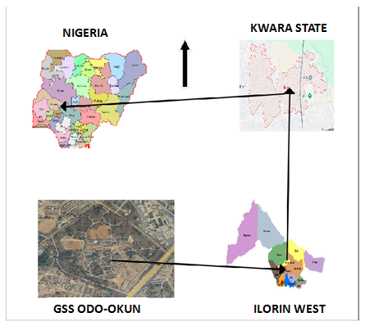

Figure 1: Map of the Study Area
Source: Google Earth

1.6 PERSONNEL
The project was carried out by the underlisted names of Group (5) members of High National Diploma (HND II) 2022/2023 set.
NAMES MATRIC NUMBERS
- OKEDELE SAMSON OPEYEMI HND/23/SGI/FT/054 (Author)
- ABDULGANIYU MUSTAPHA HND/23/SGI/FT/057
- HUSSEIN TAWAKALITU OLAMIDE HND/23/SGI/FT/046
- IBITOYE MARYAM OMOLADE HND/23/SGI/FT/044
- FOLORUNSHO DAMILOLA HND/23/SGI/FT/048
- ALFA AHMMED ALHAJI HND/23/SGI/FT/052
- ABDULSALAM GANIYAT YETUNDE HND/22/SGI/FT/003

CHAPTER TWO
2.0 LITERATURE REVIEW
Surveying Profession dates back to the beginning of the world which has its origin in Almighty God: The dictionary defines Surveying as taking a general view of; by Observation and measurement determining the boundaries, size, position, quantity, Condition, value etc of land, estates, buildings, farms, mines etc. This definition covers the work of the valuation Surveyor, Quantity Surveyor Mining Surveyor as well as Land Surveyor. However, in every case there is a common basic approach to the work, which ends with presentation of Survey data in Suitable form. Adesina (2009) stresses that land is the solid position of the earth’s surface. It is the basis of all forms of life; without it all human activities as known today would not have existed. Thus land is the principal source of wealth in agriculture, and non - industrial societies like ours. Unfortunately, land cannot be increased in any appreciable manner to match the rising population, and that which cannot be increased must be properly planned, developed and managed for sustainability. Land in the law of real property is defined as a term including the surface of the earth the land beneath the surface to the center of the earth, and the air above. The term also includes property permanently affixed to the Soil, such as water collected in wells, houses and fences.
Surveying, which is also interchangeably called “Geomatics” has traditionally been defined as the science, art and technology of determining the relative positions of point above, on or beneath the earth’s surface or of establishing such points. In a broad Senses Surveying (Geomatics) can be regarded as that discipline which encompasses all methods for measuring and collecting information about the physical earth and our environment processing that information and disseminating a variety of resulting products to a wide range of clients.
Topography is generally Known as the study of earth surface, and its features and shape. lt also gives the description of the features such as (surfaces, shapes, vegetation Cover and elevation), depicted in maps (Ojiako & Jimoh, 2017). These characteristics are natural and artificial (or man-made). Man- made features are highways, bridges, dams, wharfs, buildings and so forth. Topographic surveying as the process of determining the location of selected ground natural and man-made features of a given area, and of determining the configuration of the terrain as defined by (Chandra 2008). The location of the features is referred to as planimetry and the configuration of the ground is referred to as topography or hyposography.
The graphical portrayal of the features by conventional symbols is a topographic map: Such a map shows both the horizontal distances between the features and their elevations above a given datum. The representation of the difference in elevation is called relief. This implies that, the purpose of topographic survey is to gather data necessary for the construction of topographic maps which are very essential for the planning and designing of the most engineering projects, drainage Systems, the development of hydro-electric power, layout of city planning and industrial plants and land use architecture.
Information is in element which may be described as knowledge contained in a message, it is a data which has been processed or defined form that is meaningful to the recipient and perceived value in the current or perspective decision making as described by (Amough 2007) and (Oyinloye 2002), saw information as Simply data that have been processed, interpreted and understand by the recipient and described information as a large volume of data which are usually handled with GIS/LIS.
An information System as combination of human and technical resources with a set of organized procedure that result in the collection, storage and retrieval and dissemination and use of data in systematic version which is stated by (Harden 2003). Chakraborty and Sahoo (2009) explained that we can define geographic Information System in our own language, as an informative System used to store, organize, retrieve, analyze, output and update Geo-referenced (or Spatially referenced) data, in order to support decision making for planning and management of activities like natural resources and environmental management, transportation and telecommunication, utilities, commerce and business affairs, defense services and various administrative management. Topographic information System is a special type of GIS which is designed to handle detailed land information.
Every property is identified by fixing its location and by showing its boundaries on the topographical map. Information can be best handled by a well-structured information system
as to maintain topographical relationship with neighboring properties. Topographical formation System is a computerized tool where topographic data are collected, stored,
checked, analyzed, modeled, referenced, retrieved and displayed. “Topographic information System is also a subset of GlS that enables the maintenance of data retrieval, easy manipulation of data, manipulation of graphic and non- graphic data in’ a related manner (Opaleye 2005). Topographic maps includes base maps and other maps showing the horizontal and vertical coordinates of features which are useful in planning and monitoring development on land. He said further that where topographic maps are not available there will be poor planning and monitoring of development on land this will result to natural waste (Ejriobih, 2008). Topographic maps with larger scales as well as digital map products are necessary for better planning (Charles and Paul, 2012).
A topographic information System (TIS) is described as Computer based system for collecting and maintaining, storing and recognizing, modeling and analyzing topographic data as well as for the multimedia representation and visualization of these data, ( Kraus 2000), A TIS would best be described as an incorporation of human efforts, information and communication technology ICT using computerized tools and relevant software for the collection, storages analysis, manipulation and retrieval of various kinds of earth related data (natural and artificial). A TIS consists of a topographical database and application programs. The topography itself consists of the data in the form of topographical models and of the database management System (DBMS) which provide the means of communication between data and application programs. The topography itself consists of the data in the form of topographical models communication between data and the application programs.
Topographic database as an organized integrated collection of topographical data (about natural and artificial features in a particular locality and their relationship with each other) stored so as to be used by relevant application with the data being accessed by different logical paths as defined by (Dania, 2002). The advantage of database as real world models is that they are potentially three dimensional dynamic. It is easy to query a database and combine data from the different layers. (Bill and Fitsch, l990) illustrated that with respect to the architecture of a database system, three layers can be distinguished
• The external Scheme
• The Conceptual scheme or logical database model
• The internal Scheme Physical database model
The external Scheme is the one directly visible for the user. It provides the data in the one of the modeling techniques because, these data structures best shifted for graphic representation. In order to make the implementation of new object types in the application programs easier, object-oriented program design should be used. Note that the aspect of the external Scheme cannot be obtained directly from the data base, but the data can only be retrieved from the database via the conceptual scheme. Thus, the data have to be prepared in a special way. This is done by the database management system (DBMS).
The conceptual Scheme or logical data model is important because it has to provide the tools for data manipulations and transactions in a way to ensure integrity of the data. It is also responsible for providing interfaces to the application programs.
The internal scheme or physical database model defines the actual way the data are reorganized, for instance in the form of files, lights or tables: According to (Bill and Fritsch 1999), database system should fulfill certain requirements which are: -
- There should be no redundancy in the data.
- Access to the data should be fast
- The integrity and security of date has to be guaranteed
- The structure of the data models should be flexible
- Both interactive and batch model should be possible
- Several users should be able to use database simultaneously
The acronym GIS sometimes wed for Geographic information Science is used to refer to the academic discipline that studies geographic information systems and is a large domain within the broader academic discipline of Geoinformatics. Geographic Information System (GIS) evolved as a new technology: in surveying it combines geographic data (Location) and attribute data about object feature on the earth surface with cartographic representation in order to perform spatial decision making using spatial analysis (ado, Idhoko, Oha, Okoro, Okafor, 2015). A GIS is a Computer-based system that provides the following four sets of Capabilities to handle geo-referenced data (Otto and RoIf, 2009).
- Data Capture and Preparation
- Data Management including storage and Maintenance
- Data manipulation and analysis
- Data Presentation
Geographic information System (GIS) lets us visualize, question, analyze and interpret data to understand relationships, patterns and trends. GIS is an integrated system of computer hardware, software and trained personnel linking topographic, demographic, utility, facility, image and other resource data that is geographically referenced: Configuration of hardware, software, communication networks and analytical procedures for the extraction of information from data to support decision making so as to achieve planning and managerial objectives (Anthony Adeoye 2001).
Oyinloye (2002) defined DTM as a computer assisted techniques representing the nature of the terrain of an area. It can be described as the numerical description of the terrain based on the measured or derived coordinates of numerous points distributed all over the area using both plain metric (X,Y) and Z quantities while (Kufoniyi 1994) viewed DTM as a model representing terrain relief i.e slope of the topographic surface in 3D space, they opined that, with the increasing awareness and the use of GIS attention is being focused on the integration of DTM and related packages into GIS such that DTM specific information can be3 derived from the same database just like any spatial information under a single database management system (DBMS).
Data modeling is the process of designing such a database. The information generated in this project will serve as knowledge of the mature of the terrain which will facilitate the proper utilization of the under developed part of the project area. As a result of changing in technology, it is clear that the need for digital topographic database cannot be over emphasized. The following are some of the advantages of digital database over the conventional map.
- Possibility of last amendment and dynamic updating of data
- Facilitates the analysis of many important spatial problems
- Provides basis to additional information with relatives cases for production of maps.
- Flexibility output possibilities
- Versatility in integrating data collected from various sources.
Kraus (2000) emphasized that DTM area valuable data source for generation and visualization of DTM were developed early. Most system for DTM generation model i.e the terrain surface in 2.5D which means that only surface can be represented on 2 + (X.Y) Can be modeled by this system, as the earth cannot be described by their closed analytic function in a scale appropriate for topographic mapping. Topographic map indicates relief of the ground in such a way that elevations may be determined by inspection.
From the fore going, it is clear that the need for digital topographic database cannot be questioned over emphasized. In this project which focuses on the production of topographic information system of Ilorin South Secondary school okeandi, Sango, Ilorin South, Kwara State, Nigeria being a school area, data collected defines the location of features with their attributes giving information on the developmental need underdeveloped or developed area.

CHAPTER THREE

3.0 METHODOLOGY

This stage involves the methods and procedure used in planning, data acquisition, data processing, creation of database, creation of database management system and information presentation. These operations were logically structured and carried out in stages involving database design. It is normally considered to involve a spatially referenced and structured digital database and appropriate application software for geospatial analysis. This basically describes the techniques and principles adopted in carrying out the project.
Geographic information system methods were adopted in accomplishing the desired results.

3.1 DATABASE DESIGN

The design of any database involves three stages namely;
i. Conceptual design
ii Logical design
iii Physical design

3.1.1 VIEW OF REALITY
In database design, there is need for reality which is referred to as the phenomenon that actually exists, including all aspects which may or may not be perceived by individuals. The view of reality however, is the mental abstraction of the reality for a particular application or group of applications.
For this application, the view of reality is made of the topography of the project. Since it is not possible to represent the real world, the only option is to conceptualize and model it in a specified manner to represent the real world. The area of interest to us in this project

includes; Green Reserve, Roads, Electric poles, Trees, Water Facilities, Buildings, Football pitch, Streams.
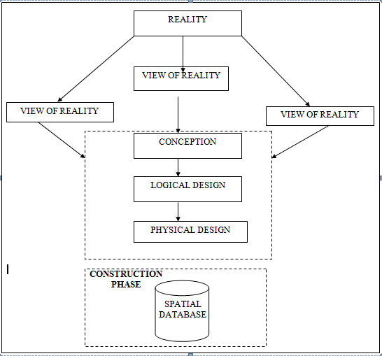
DESIGN

Fig. 3.1 Design and Construction Phases in Spatial Database (R Sobh, C Perry)

3.1.2 CONCEPTUAL DESIGN

Vector data model is the data type adopted for this project, which is represented, by points, lines and polygon. The identified entities are: -
      - Green Reserve (polygon)

      - Roads (line)

      - Electric poles (point)

      - Trees (point)

      - Buildings(polygon)

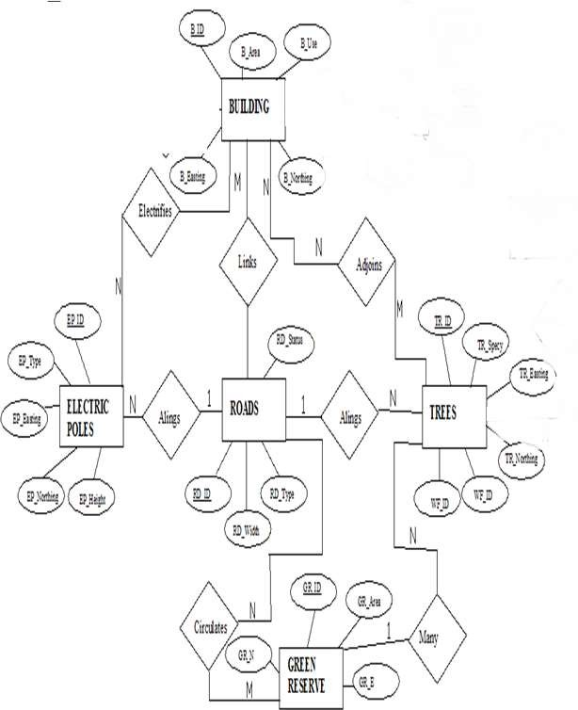
Google source

Fig. 3.1.2.1: E-R Diagram (Entity relationship diagram)

3.1.3 LOGICAL DESIGN
This is the design aspect of the database refers to the process of creating a conceptual framework or model that represents the structure and organization of spatial data within the system. It involves defining the data element, their relationship, and the rules for data manipulation and analysis. In this phase, the entities, their attributes and their relationships are represented in a single uniform manner in form of relation in such a way that would be no information loss and at the same time no unnecessary duplication of data. In this study, the logical database design is employed to generate a geo-relation database structure. Each entity has unique identifier in bold type. An attribute type or combination of attribute types that serves to identify an entity type is termed an identifier.
- Building (B_ID, B_Area, B_Name, B_Easting, B_Northing)
- Roads (R_ID, R_Width, R_Type, R-Condition, R_Easting, R_Northing )
- Vegetation (V_ID,GR_Area,)
- Tree (TR_ID, TR_spp, TR_Importance, TR_Easting, TR_Northing )
- Electric Pole (EP_No, EP_Type, EP_Height,EP_Easting, EP_Northing)
- Football Pitch (FP_ID, FP_Area, FP_Status)
3.1.4 PHYSICAL DESIGN
Table 3.1.4.1.: Building and its attribute

ENTITY | DESCRIPTION
B_ID | Building Identification
B_name | Building Name
B_Area | Building Area
B_Easting | Building Easting
B_Northing | Building Northings

Table 3.1.4.2: Road and its attributes

ENTITY | DESCRIPTION
R_ID | Road Identifier
R_Length | Road Length
R_Width | Road Width
R_Type | Road Type
R_Condition | Road Condition

Table 3.1.4.3: Trees and its attributes

ENTITY | DESCRIPTION
TR_ID | Tree Identifier
TR_Spp | Tree specy
TR_E | Tree_Easting
TR_N | Tree Northing

3.2 RECONNAISSANCE
This is the preparatory stage before the execution of this project; it involves collection of available information about the project area.
The necessary step taken for the successful execution of the project involves two stages, which are: -
- Office Planning
- Field reconnaissance

3.2.1 OFFICE PLANNING
This involves the collection of information about the study area, testing the instrument to be used in execution of the project and itemizing the numbers of equipment needed, number of days to be use, how each activity is to be carried out, delegation of works to each team members based on supervisor’s guide/instructions.
3.2.2 FIELD RECONNAISSANCE
The field reconnaissance stage involves conducting a physical survey of the project area. This typically includes visiting the site to gather firsthand information, assess the current conditions, and verify the accuracy of the existing data.
During field reconnaissance, the project team uses various tools and techniques to collect data, such as Hand held (GPS). We may also take photographs, make observations, and gather other relevant data about the project area.
- Boundary points was selected
- The distribution of features was studied
- Controls to be used were located
- The selection of the method and instrument type has been finalized
- Subsidiary point for Ground control Points were picked and define using nail and bottle cock
- A diagram of the study area was drawn.

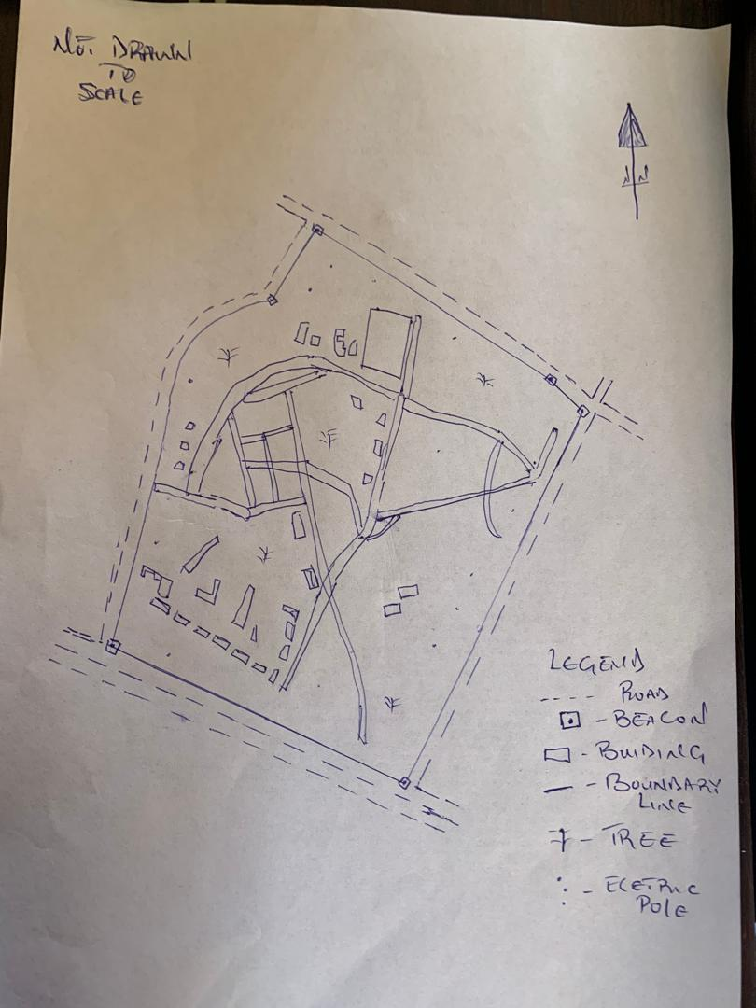

Fig. 3.2.2.1: shows Recce diagram of the study area (not drawn to scale)

3.3 EQUIPMENT USED/ SYSTEM SELECTION AND SOFTWARE
3.3.1 HARDWARE USED

- Total station

- 1 reflector with a tracking rod.

- 1 Tripod

- One (1) 50m tape

- One (1) umbrella

- 1 cutlass

- Hand held GPS

- Hammer

- Nails and bottle cover

- Field book and writing materials

- 1-No of Personal Computer HP655 and its accessories

- 1-No of HP DeskJet K7100 A3 printer

- 1-No of HP DeskJet 1110 A4 printer

3.3.2 SOFTWARE COMPONENT
- Notepad.

- Microsoft Excel.

- AutoCAD 2007

- ArcMAP10.2

- Surfer 25

- Microsoft Word.

3.4 INSTRUMENT TEST
To ensure data quality, the Total Station used for this project was tested for both vertical index and horizontal collimation errors. It was also to ascertain the efficiency and reliability of the instrument. The procedure used is described below.
3.4.1 HORIZONTAL COLLIMATION TEST
This test was conducted to ensure that the line of sight was perpendicular to the trunnion axis. The Total Station was positioned over a specific point, and initial adjustments were made to ensure proper alignment, leveling, and focus (to eliminate parallax in the telescope). A vertical target was placed at a distance of 100 meters from the Total Station. To access the configuration menu of the Total Station, the menu key was pressed and held for approximately 2 seconds. From the main menu, the calibration sub-menu was selected, and within that, the horizontal collimation test option was chosen. The target was then observed and divided into two halves, with horizontal readings recorded for Face left and Face right. The readings are shown in Table 3.4.1 below.

Total Station

REFLECTO R (TARGET)
100m

STATION A
Fairly Level Ground
STATION B

Fig 3.4.1.1; Horizontal Collimation and Vertical Index error test.

Table 3.4.1.1: Horizontal Collimation Data

Station | Target | Face | Hz Reading | Difference | Error
A | B | L | 25˚32‟32”
 |  | R | 205˚32‟35” | 180˚00‟03” | 0˚0’03”

3.4.2 VERTICAL INDEX ERROR TEST

This test was conducted to verify the accuracy of the vertical reading when the line of sight is horizontal. The desired measurement for this test is exactly ninety degrees (90˚), any deviation from this value is referred to as the vertical index error.

The Total Station was positioned over a specific point, and necessary temporary adjustments were made to ensure proper alignment and functionality. A target was placed approximately 100 meters away from the Total Station, and the instrument was aimed at the target. The target was bisected by aligning the instrument on the face left, and the corresponding reading was recorded. Similarly, the target was then bisected on the face right, and the respective reading was also recorded. The recorded readings are provided below:

Table 3.4.2.1: Vertical Index Data

Instrument Station | Target Station | Face | Vertical | Sum | Error
A | B | L | 95˚00‟00”
 |  | R | 275˚00‟02” | 360˚00‟02” | 0˚0’02”

3.4.3 ANALYSIS OF COLLIMATION AND VERTICAL INDEX DATA
The reading obtain during calibration were reduced to obtain new collimation and vertical errors.
Horizontal collimation = {(FR – FL) – 180}/2 = {(00˚00‟03”}/2 = 1.5”

Vertical collimation = {(FL + FR) – 360} = (95˚00‟00” + 275˚00‟02”) – 360} = 02” The result shows that the instrument is still in good working condition.

3.5 CONTROL CHECK
Three control beacons (SC/KW GI544AD, SC/KW GI545AD and SC/KW GI547AD) were used. In order to ascertain the in-situ of the control beacons, a check was carried out on them by observing the angle between them and comparing the result obtained with the computed angles from the giving coordinates.
The total station instrument was set on the control beacon PBIL3306. After performing all the necessary temporary adjustment, the reflector was placed on the control beacon PBIL3306 which served as the back station. The horizontal angular reading was taken and recorded while the instrument was on face left. The reflector was then taken to the NILL which serves as the forward station, the horizontal angle reading was then taken and recorded on both face left and face right. The reflector was taken back to the back station, the horizontal angle was then recorded on face right.

Table 3.5.1: Table showing the back computation of the control coordinates

From STN | Bearing | Dist (m) | ∆N | ∆E | Northing (m) | Easting (m) | To STN
 |  |  |  |  | 936467.388 | 668133.317 | SC/KW GI544AD
SC/KW GI544AD | 118°6'  1'' | 41.031 | 19.326 | -36.194 | 936486.714 | 668097.123 | SC/KW GI545AD
SC/KW GI544AD | 97°16'  21'' | 43.730 | -5.536 | 43.379 | 936481.178 | 668140.502 | SC/KW GI547AD

Table 3.5.2: Table showing the distance observation result of the control check

FROM | OBSERVED DISTANCE  (m) | COMPUTED DISTANCE  (m) | TO
SC/KW GI544AD | 41.041 | 41.031 | SC/KW GI545AD
SC/KW GI545AD | 43.741 | 11.562 | SC/KW GI547AD

Table 3.5.3: Table showing the observation result of the control check

STN | SIGHT | FACE | OBSERVED HZ ANGLE | REDUCED HZ ANGLE | MEAN
 | KWPT3009PT | L1 | 10° 42' 35''
ND20 | KWPT3009APT | L2 | 128° 48' 49'' | 118° 6' 14''
 | KWPT3009APT | R2 | 308° 48' 52'' | 118° 6' 11''
 | KWPT3009APT | R1 | 190° 42' 41'' |  | 118° 6' 13''

Difference in angle (observed - computed) =118° 6' 13''-188° 6' 9'' = 00° 00' 04''

Since the allowable accuracy (angular) of third order traverse of one station is 00° 00' 30'' and the result obtained from the control check (00° 00' 04'') is less than allowable error. Therefore, the controls were angularly intact.

3.6 MONUMENTATION
The boundary of the area carved out was demarcated with the precast concrete beacons, after clearing the required line of sights. The identified points of changes in directions were dug and beacons were buried on it, leaving about 15cm part of the beacon above the ground level. The beacons were buried at convenient distances as dictated by the nature of the boundary.
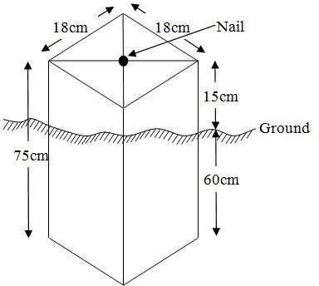

Fig. 3.6.1: Pillar Description

3.7 DATA ACQUISITION
PRIMARY DATA SOURCE
Field observation was the primary source of data for this project. Ground based method was used in acquiring data with the use of Total Station Instrument, which involved the collection of X, Y, Z data through coordinated Ground control Points (GCP) established at conspicuous points within the study area.

SECONDARY DATA SOURCE

An imagery of the area was acquired through Updated Google earth; this was used to ascertain the extent of coverage of the project area.

3.7.1 GEOMETRIC DATA ACQUISITION
The total station instrument was set carefully on control point SC/KW GI545AD, back sight taken to SC/KW GI544AD after necessary station adjustments has been carried out on it. The adjustments include; centering, leveling and focusing. The following procedures were then followed to determine the position of the next point (PL1) and the same procedure were repeated until all we come close to the site. The method used in acquiring data on site was radiation method where two or more points are coordinated from one point.

- Having set up the instrument and temporary adjustment carried out, the instrument was powered „on‟ and a job was created under job menu in the internal memory of the instrument. The job created was named GRP2B
- On the job, the coordinates of the three (2) control points were keyed in to the memory of the instrument and some codes were also saved. The codes include „RD‟ for road, „SP‟ for spot height, „BD for buildings, etc.
- The height of the instrument was measured and saved on the memory of the instrument as well as the reflector height.
- On coordinate menu, orientation was set by inputting the coordinates of the instrument station and back sight. The reflector at the back station was perfectly bisected before the orientation was confirmed by clicking “yes‟.
- Having done the orientation, the reflector at the next nail; was bisected and “obs‟ (observe) option was clicked. The three-dimensional coordinate of the point (E, N, H) were displayed on the display unit of the instrument and „rec‟ (record) was clicked to save the data into the memory of the instrument. For subsequent observation after this, „all‟ option was used instead of pressing “obs‟ and pressing „record‟ later.

- It was ensured that the center of the prism of the reflector was bisected and that it was set perfectly on the tripod in order to minimize the error on height determination.
- The instrument is been shifted to another nail after all details, spot height and boundary point visible from the instrument station have been picked, set over it and temporary adjustments carried out.

Nonetheless, the above operations were repeated until all the boundary points with heights were coordinated.

In this project all spot height is not in grid intervals but randomly acquired. Three edges (3) of building were picked. At the end of data acquisition process all details were acquired and properly recorded to be shown in their respective positions on the plan.

3.7.2 ATTRIBUTES DATA ACQUISITION
Attribute data is information about spatial features. They provide the characteristics, description and nomenclature about spatial objects. Thus, the attributes data acquired includes names of buildings and their uses such as classrooms, roads, water facilities and prominent natural features likes river and trees found and vegetation were properly identified within and around the study area.
3.8 DATA DOWNLOADING AND PROCESSING
3.8.1 DATA DOWNLOADING AND EDITING
This is stage whereby all data acquired which were automatically stored in the Total Station were downloaded into personal computer. This was done with the aid of downloading cable connected to the computer and some associated complementing software installed on the System.

3.8.2 DATA PROCESSING AND DATA EDITING
The geometric data downloaded were further processed in order to convert it to a useful format and to enhance its accuracy. The output coordinates, were edited and exported in *.txt, *.xls and *.pdf format. Thereafter, they were imported into Arc GIS 10.3 for further operations and to carry out spatial analysis.

3.8.3 DATA PROCESSING USING AUTOCAD 2007

Before lunched AutoCAD, we used Notepad to processed the coordinate data we observed in field after it copy it to AutoCAD and this following bellow is step by step were used for process in Autocad
- Launch AutoCAD on computer.
- Click on New from the application menu o
- Type UNITS in the command line and press Enter.
- Select the desired unit type (eg, decimal, architectural, engineering).
- Select poly line in menu bar
- Copy from notepad to Autocad and press Z enter E enter
3.8.4 DATA PROCESSING USING ARCGIS 10.3
Before launching of ArcGIS AutoCAD was used in plotting of feature data saving them separately in different file named road, boundary line, buildings, tree.
- Launch the ArcMap in ArcGIS 10.3
- Click on A NEW EMPTY MAP on the dialog box displayed after loading
- Click on Tools on the menu bar, then select extensions, mark all and close.
- At the LHS, right click on layers, and then select properties.
- Click on coordinate system to set the projection system to MINNA DATUM ZONE 31N and general to set the unit, then apply and okay.
- Add data was selected at the tool bar all saved AutoCAD fie was selected and load onto the table of content layer section
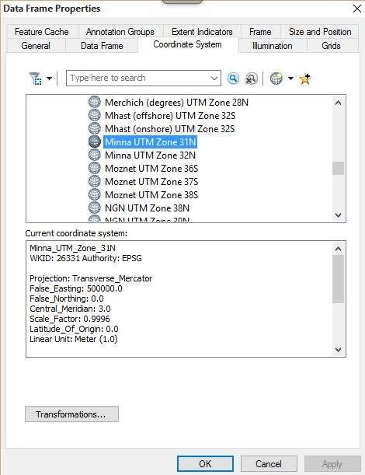
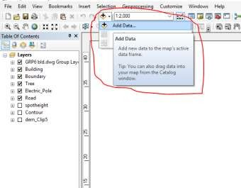
All drawing was exported to shape file. After the feature class has been creates, click on Editor to start Editing, and then click on the load object.

CRATING CONTOUR: Firstly, DEM was created by searching in the search icon INTERPOLATION> NATURAL NIGHBOR and selecting THE XYZ data for creation of DEM in respect to the boundary line as extent. In order to create contours, you will need to enable the Spatial Analyst toolbar, which can be found by going to Customize > Toolbars > Spatial Analyst or open the search bar. You can do this by clicking Windows >Search, or by clicking on the search icon.
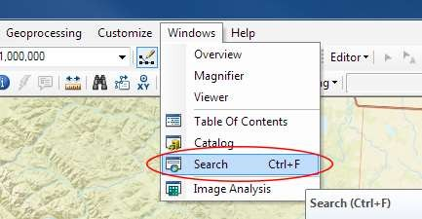

In the search bar type Contour, and select Contour (Spatial Analyst) from the search results list.
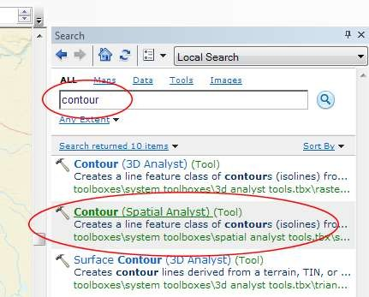

After choosing Contour, a dialogue window will appear, prompting you for five settings: Input raster: select the DEM file from which you want to generate contours by locating it on your hard drive or in the dropdown menu, showing layers present in the Table of Contents Output polyline features: indicate where you want to save your output contours Contour interval: set the distance between contour lines in meters – the smaller the number, the greater the number of lines Base contour (optional): the starting point from which the lines are generated – for example, the default is 0 so with an interval of 25 meters, the contours are generated at 25, 50, 75, 100…, but if the base contour is set at 40, then the contours are generated at 65, 90, 115, 140 and so on Z factor (optional): can be used to adjust the units of data; for example, if you have data in meters and you want to produce your contours in feet, use a z-factor of 3.28 because 3.28 feet equals one meter.

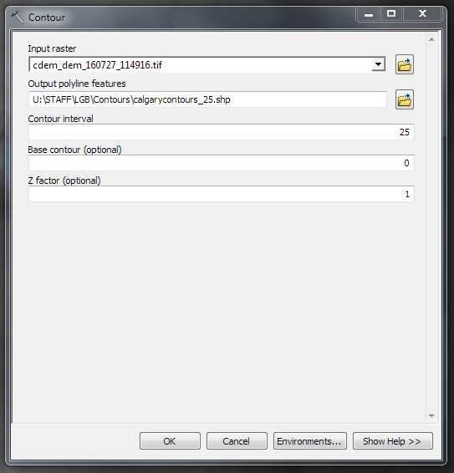

The generated contours will automatically be added to the map.
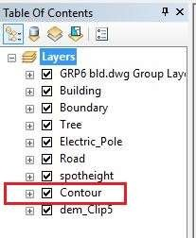

Input the data which is the AutoCAD drawing and select the feature type you want to load,

- Click Add and Next, then select the Target layer you want it to be

- Load it into from the feature class created on the ARCGIS.

- Click on Next, then select “only the features that satisfy the

- Query” and click on Query Builder to query for the feature to be loud e.g. “layer” = Boundary”.
- Click on Next. Then finish
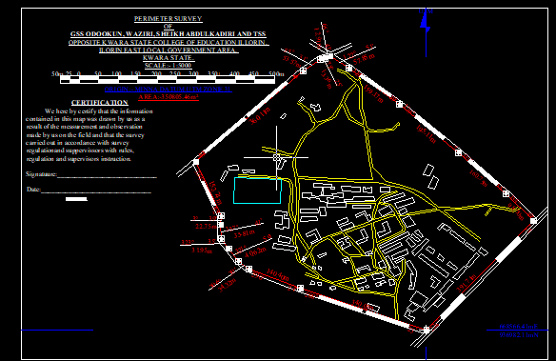
Right click on the Boundary In the table of content and click on zoom to layer to display the feature.

EDITING, CONVERTING AND MERGING GEODATABASE

- Remove all necessary features by right clicking on it and press "REMOVE"

- Convert some features that are not in their correct „features -type‟ like point, line, and polygon features etc.
To convert a GOEDATABASE FEATURE CLASS to another the following steps were taken:
- FOR LINE FEATURE CLASS TO POLYGON FEATURE CLASS

- Go to WINDOW on the menu bar and select ARC Toolbox.

- Select DATA MANAGEMENT TOOLS, click on FEATURES, and then Select FEATURE TO POLYGON.
- ON INPUT FEATURES, select feature to be converted, on OUTPUT FEATURE CLASS, then save on the GRP6C FOLDER, press OK and CLOSE.
- Then remove the converted feature class in the LAYER Menu and ARC CATALOG files.
- On INPUT DATASETS, select features to be merged, on OUTPUT DATASETS, then save on the GRP6C folder, press OK and CLOSE.
- Then remove the converted feature class in the LAYER Menu and ARC CATALOG files.

TABLE CREATION

There is need to create attribute tables for the features so as to be used for queries. NOTE: The editor on the menu bar must be stopped before adding field to its table. THE FOLLOWING PROCEDURES WERE FOLLOWED:
- Right click on the feature class, then select OPEN ATTRIBUTES TABLE click on OPTIONS and select ADD FIELD.
- Give it FIELD NAME, click on TYPE and select [SHORT INTEGER or LONG INTEGER for SHORT or LONG WHOLE VARIABLES or DOUBLE FOR
- DECIMAL VARIABLES OR TEXT variable or DATE for DATE], then enter precision or LENGTH for text width and scale for DECIMAL PLACES, and then click OK
- To input variables on the ATTRIBUTE TABLE, go to the EDITOR on Menu bar, select START EDITING,
- Click on ATTRIBUTE on menu bar [behind the TARGET], click on the features on the DATA VIEW display, and then input the variables of data acquired through SOCIAL SURVEY or DATA ACQUIRED ON THE FIELD.
- Save it after the input by selecting SAVE EDITS on the editor menu. To switch to other layers, select STOP EDITING on the EDITOR menu. Then repeat the above step to create other fields. Populate the table and save.

Table 3.8.3.1: Building

ENTITY | FIELD ALIAS | DATA TYPE | FIELD SIZE
B_ID | Building Identification | Numeric | -
B_name | Building Name | Text | 14
B_Area | Building Area | Numeric | -
B_E | Building Easting | Numeric | -
B_Northing | Building Northings | Numeric | -

Table 3.8.3.2: Road

ENTITY | FIELD ALIAS | DATA TYPE | FIELD SIZE
R_ID | Road Identifier | Numeric | -
R_Length | Road Length | Numeric | -
R_Width | Road Width | Numeric | -
R_Type | Road Type | Text | 14
R_Condition | Road Condition | Text | 14

Table 3.8.3.3: Trees

ENTITY | FIELD ALIAS | DATA TYPE | FIELD SIZE
TR_ID | Tree Identifier | Numeric | -
TR_Spp | Tree specy | Text | 14
TR_E | Tree_Easting | Numeric | -
TR_N | Tree Northing | Numeric | -

Table 3.8.3.4: Electric Poles

ENTITY | FIELD ALIAS | DATA TYPE | FIELD SIZE
EP_ID | Electric pole Identifier | Numeric | -
EP_Type | Electric pole Type | Text | 14
EP_Height | Electric pole Height | Numeric | -
EP_E | Electric pole Easting | Numeric | -
EP_N | Electric pole Northing | Numeric | -

ADDING SPOT HEIGHTS DATA

- NOTE: STOP EDITING on the EDITOR MENU before adding data field,

- Go to FIELD ON THE MENU BAR, scroll to add Data and then ADD XYZ DATA

- Browse the EXCEL FILE for SPOT HEIGHTS, select EASTING VALUE on X - FIELD and NORTHING VALUE on Y - IELD and ELEVATION
- « Select DATA the EXPORT DATA, locate the folder created and give it name then YES AND OK, remove the previous layer by right clicking on it and select REMOVE.

TIN, ASPECT AND SLOPE CREATION USING ARCMAP

Uses of tin in map
- High Accuracy: Represents terrain more precisely in areas with complex elevation changes.
- Efficient Modelling: Requires fewer data points in flat areas and more in rugged areas — making it efficient and detailed.
- 3D Modelling: Helps generate realistic 3D models of the earth's surface.
- Engineering Design: Used in road and site grading design, mining, and flood simulation.
- Volume Calculations: Useful in cut-and-fill analysis for construction or excavation
NOTE: Making sure the 3D Analyst Extension is active, select VIEW on MENU bar, then click TOOLBARS and MARK the 3D Analyst EXTENTION Then X, Y Data

TO CREATE TIN

- Click on 3D Analyst arrow, select create TIN and then create TIN from FEATURE.
- On layers mark the SPOTHEIGHT LAYER, select height data on HEIGHT, then ok.
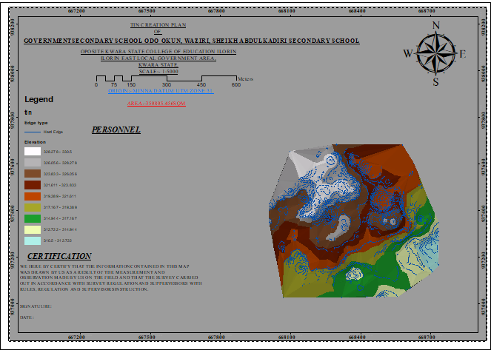

TO CHANGE THE FACE OF THE TIN ACCORDING TO ITS ELEVATION

- RIGHT CLICK on the TIN, select PROPERTIES, and click on SYMBOLOGY.

- Then ADD, select FACE ELEVATION WITH COLOR RAMP, click ADD, and then select APPLY and OK.

TO CREATE ASPECT

- Click on 3D analyst arrow, select SPATIAL ANALYST TOOLS, SURFACE and THEN DOUBLE CLICK on ASPECT.
- Browse to where the raster format of all the acquired data created from the surfer was saved to.
- Browse to where you want the OUTPUT RASTER to be saved

- You can change the OUTPUT MEASUREMENT to Degree OR percent

- Click OK [then it displays on the data view screen], then Close.

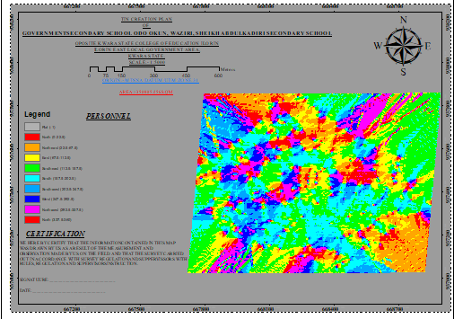

3.9 DATABASE IMPLEMENTATION

This is the database creation phase. Having completed the three stages of design phase (i.e. Reality, Conceptual and Logical design), the database was created using ArcGIS 10.3 software. It involves the combination and storage of acquired graphic data and attributes data in creating the database for the purpose of spatial analysis and query.
Database is an organized integrated collection of data stored so as to be capable of use by revenant application with data being accessed by different logical part. After the Attribute table was populated via the keyboard, some attributes such as areas of settlements were automatically displayed by special command in the ArcGIS 10.3 version. The ArcGIS software was used to link the graphic data and table for query generation.

3.9.1 DATABASE MANAGEMENT SYSTEMS
Database management is a collection of software for creating, storing, manipulating, updating, organizing and querying of information in a database (Kufoniyi, 1998). It is a software package whose function is to manipulate a database on behalf of the user.
A good DBMS must provide the following functions:

      - Storage and retrieval of data.

      - Access to by several users at a time.

      - A standardized interface between database and application programmed.

      - Standardized access to data and separation of data storage and retrieval functions from the program using the data.
      - Maintenance of data security and integrity.

3.9.2 DATABASE MAINTENANCE
Having created the database, proper maintenance practice was made to meet its stated objectives. The ability to include more data and remove irrelevant data was possible by way of maintenance. There is every need for the data to be updated regularly because of the physical changes that may occur on the landscape with time. Both security and integrity were also exercised to ensure maintenance and to meet its stated objectives.
Proper observance, updating and management of database ensure its currency and quality to stand a profound chance in Spatial Decision Support System (SDSS). The quality of any database depends on the currency and fitness for use as a decision support system (SDSS). The quality of database depends on its ability to generally fit and use as a decision system (DSS). The storage media should be from time to time justified if otherwise could necessitate data inaccessibility or physical deterioration of the storage media. Also, care must be taken during populating any database system, as a database is only good as the data supplied. In archiving stable media should be used. Examples of these are
- Computer compatible tape reader

- Magnetic tape

- Optical disc and compact disc

3.9.3 BACK COMPUTATION
Table 3.9.3.1: Back Computation
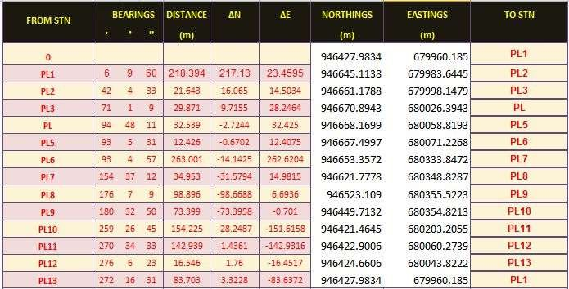

3.9.4 AREA COMPUTATION
Table 3.9.4.1: Area Computation
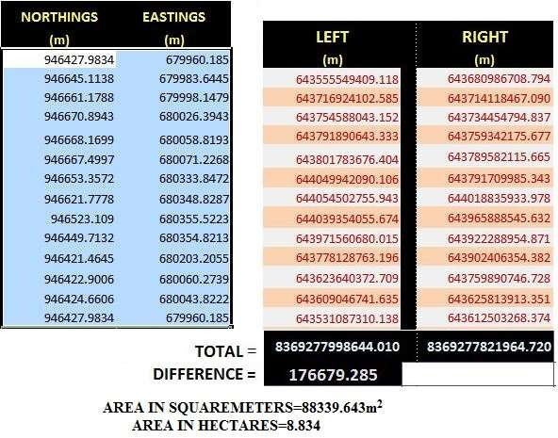

CHAPTER FOUR

4.0 SPATIAL ANALYSES AND PRESENTATION
GIS is distinct among other information system because of its spatial analytical capability; especially overlay operation, buffering, spatial search, topographic operation, and neighborhood and connectivity operations. GIS uses this spatial analytical capability to answer fundamental generic question of location, condition, trend, routing, pattern and modeling by the manipulation and analysis of input data. The major analyses performed in this project were overlay operations, topographic operations and spatial search.
4.1 TESTING OF DATABASE
This is the test carried out to determine whether there exists a relationship between data modeled about entities in a spatial database as well as putting into test its retrieval capabilities. This was done by designing a sample query with certain conditions attached and the query will be ran to see if desired result is achieved.

Analysis of Result

The contour whose value is greater or equal to 350 meters depicts the likelihood that such area may not be prone to flood in the project area as shown in Fig. 4.5(Query 1). This represents the elevation of points that are greater than to 350m. The displayed attribute table confirmed that North-East part of the institute had the highest elevation. Height is an important factor when considering the surface or slope of the terrain. The South-west part of the school had the lowest elevation which is very prone to erosion. Buildings that will be sited in that region must have a very high foundation above the ground level. The result of the query will afford the school management to decide concisely the terrain characteristics and the kind of building that should build in every region of the project area looking critically at the terrain of the area.

SINGLE SELECTION CRITERION

Query 1: Shows the retrieving Area whose height is Greater than 320 meters

SELECT* FROM Contour WHERE "CONTOUR">320

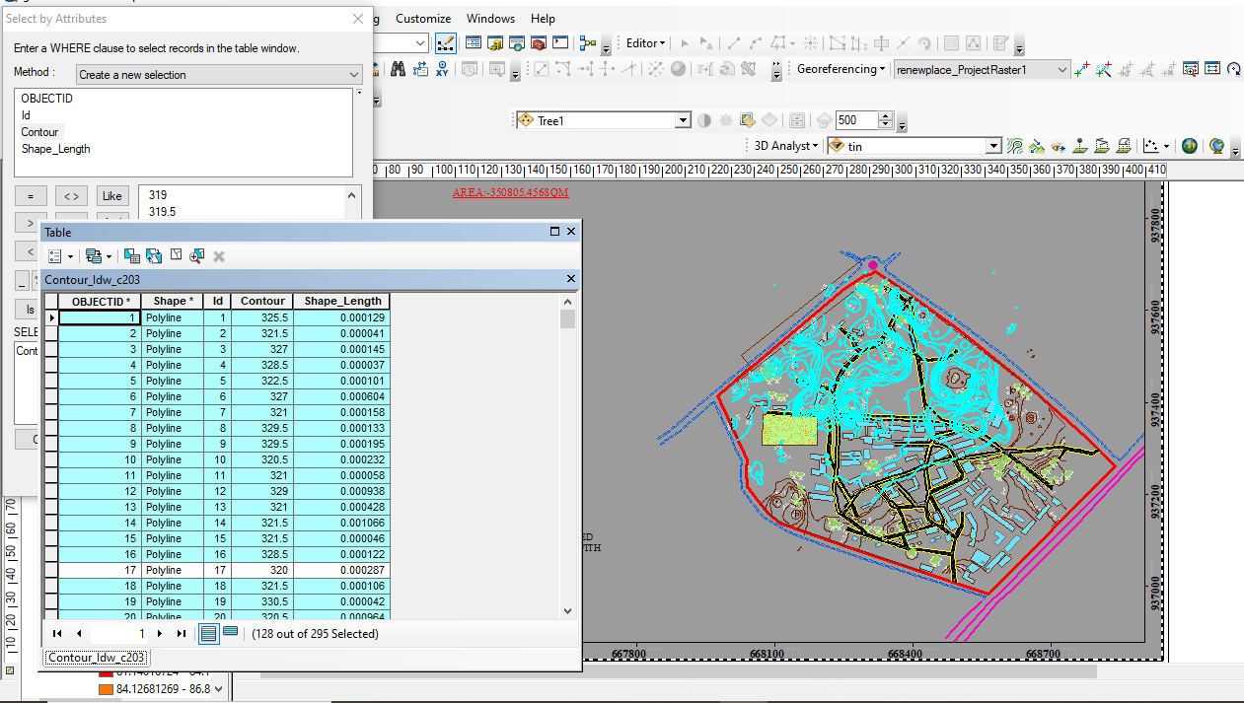

Fig 4.1.1: Shows the retrieving Area whose height is greater than 320 meters

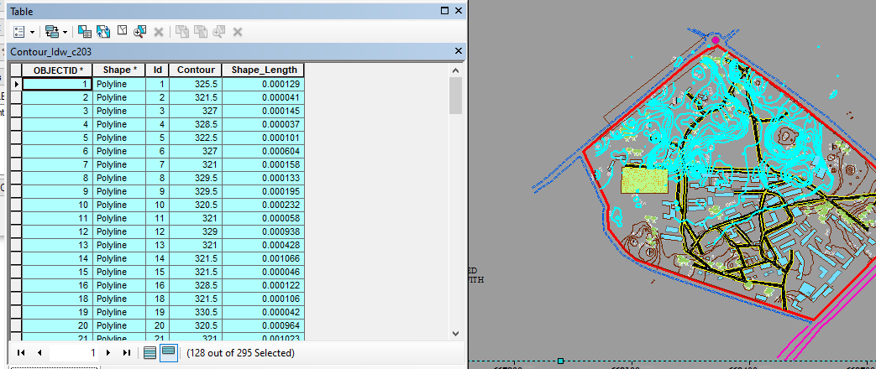

Fig 4.1.2: Shows the result of area whose height is greater than 320 meters

Fig 4.1.3: Show the result of area whose height is greater than 320 meters

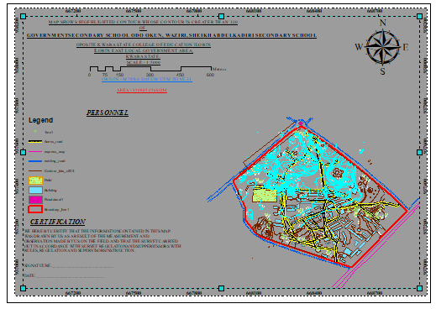
Fig 4.1.4 Query Shows the result of Buildings Used for Class Rooms (B_NAME = 'CLASS_ROOM')

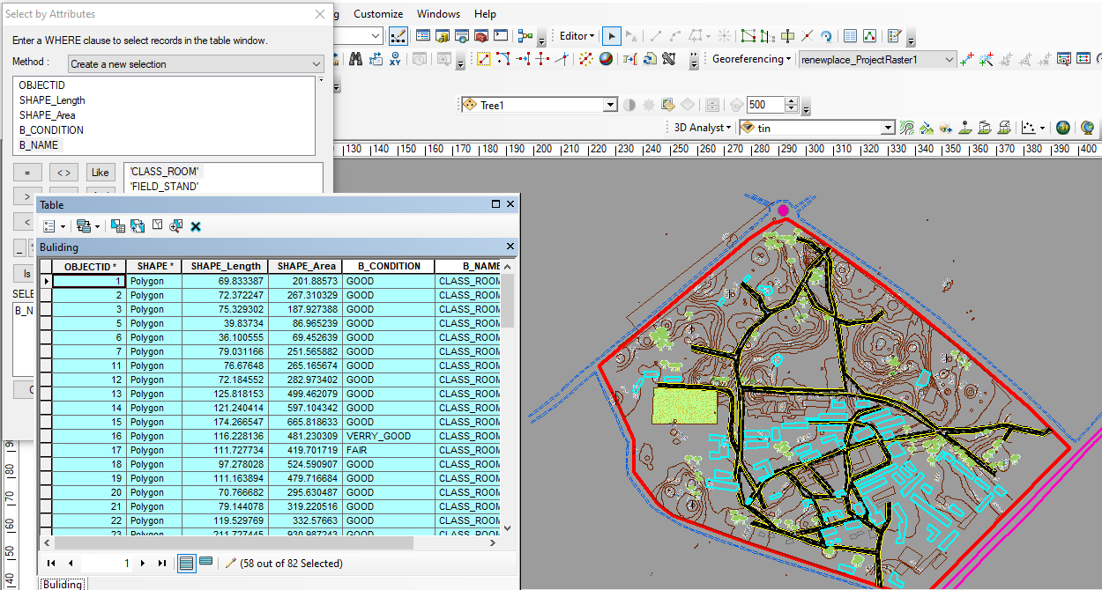

Fig 4.1.5 Query Shows the result of Buildings Used for Offices (B_NAME = 'OFFICE')

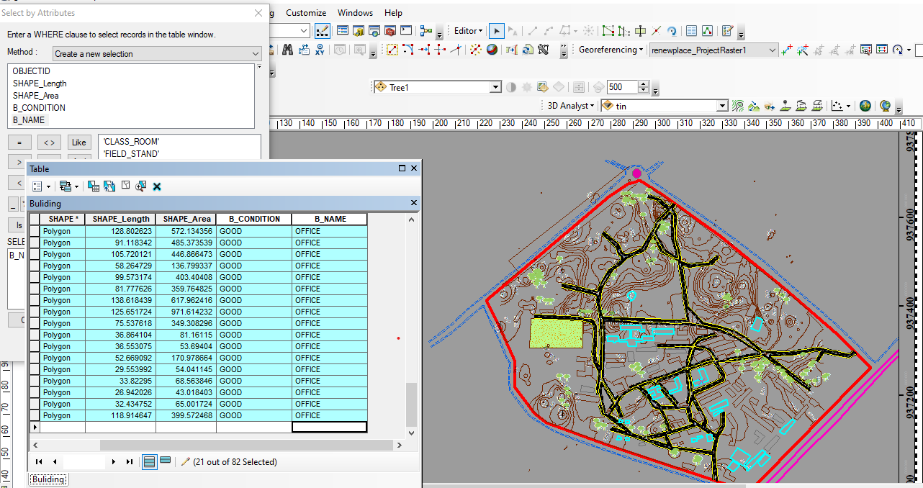

CHAPTER FIVE
5.0 COST ESTIMATION, SUMMARY, RECOMMENDATION AND CONCLUSION
5.1 COST ESTIMATION

This stage the total cost spent on the project from day one to the final stage.

Table 5.1.1: Direct cost parameters

S/N | DIRECT COST
1 | Reconnaissance (1 day)
 | PERSONNEL | Daily rate | Amount (N:K)
 | 1 x surveyor | 9814.20 | 9814:20
 | 1 x assistant surveyor | 7944.83 | 7944:83
 | 1 x technical officer | 6542.8 | 6542:80
 | 3 x skilled labour | 4078.66 | 12235:98
 | basic equipment | 5000 | 5000:00
 | transportation (vehicle, Driver and fuel) | 10000 | 10000:00
 |  | sub-total | 51537:81
2 | Monumentation (1 day)
 | PERSONNEL
 | 1 x assistant surveyor | 7944.83 | 7944:83
 | 1 skilled labour | 6542.8 | 6542:80
 | transportation (vehicle, Driver and fuel) | 10000 | 10000:00
 | basic equipment | 5000 | 5000:00

 | Beacon (6) | 1000 | 6000
 |  | sub-total | 43,644:95
3 | Data acquicision (2 days)
 | PERSONNEL
 | 1 x assistant surveyor | 7944.83 | 15889:66
 | 1 x technical officer | 6542.8 | 13085:60
 | 3 x skilled labour | 4078.66 | 24471:96
 | Total Station and accessories | 15000 | 30000:00
 | transportation (vehicle, Driver and fuel) | 10000 | 20000:00
 |  | sub-total | 103447:22
5 | Data Processing (2 days)
 | PERSONNEL
 | 1 x surveyor | 9814.2 | 19628:40
 | 1 x assistant surveyor | 7944.83 | 15889:66
 | 1 x technical officer | 6542.8 | 13085:60
 | computer / accessories | 15000 | 30000:00
 |  | sub-total | 78603:66
7 | Technical Report (1 day)
 | PERSONNEL
 | 1 x surveyor | 9814.2 | 9814:20
 | 1 x assistant surveyor | 7944.83 | 7944:83

 | 1 x secretary | 5000 | 5000:00
 | computer / accessories | 15000 | 15000:00
 |  | sub-total | 37759.03
TOTAL (DIRECT COST) 1,170,205:09 MOBILIZATION/DEMOBILIZATION = 5% of Direct Cost
= 0.05 × 1,170,205:09

= N58,510:25

CONTINGENCY ALLOWANCE = 5% of Direct Cost

= 0.05 × 1,170,205:09

= N58,510:25

GRAND TOTAL = N1,170,205:09 + N58,510:25 + N58,510:25

= N1,287,225:59

VAT (@5% GRAND TOTAL) = 0.05 × 1,170,205:09

= N64,361:28

TOTAL COST PAYABLE = GRAND TOTAL + VAT

= N1,287,225:59 + N64,361:28

= N1,351,586:87.
5.2 SUMMARY
The primary objective of this project is to accurately determine the elevation differences in the terrain and identify the various features within the designated site area. This was achieved through the implementation of a ground survey method using specialized equipment like the Total Station instrument and its associated accessories. By utilizing the radiation method, the instrument efficiently collected precise data on coordinates and elevation.

5.2.1 PROBLEMS ENCOUNTERED
The problem encountered is was delay in getting approval to access the project premises due to administrative bureaucracy and there was weather challenges due rain season in which the project was executed

5.3 RECOMMENDATION
I strongly recommend that topographic and detail survey should be carried on both existing and new government infrastructures so has to aid in proper development and planning.
And also the government should invest more in Topographical Information System of the state so to aid future decision on government policy on infrastructure distribution.

5.4 CONCLUSION
The topographical and detail survey was successfully completed with accuracy within the Third- order survey jobs specification. The execution of the project was also in accordance with the survey laws and regulations.

REFERENCES
Alabi A. O et.al. (2011). Topographic Survey of University of Lagos Using Differential Global Position System (DGPS).
Alamu, A.S. et al (2010). Topographic Survey of University of Lagos Akoka, Lagos Using Total Station.
Brinker, R.O. and Wolf P. R. (1977). Elementary Surveying sixth edition, New-York, Dun- Donnelley
Charles D. Ghilani and Paul R. Wolf (2012). Elementary Surveying - An Introduction to Geomatics.
Clark D. and Jackson J. E. (1972). Plan and Geodetics surveying, sixth edition, London, constable, volume 1, page 1.
Dashe, J. D. J, (1981). Cadastral Surveying Practice (in Nigeria), Kaduna Polytechnic. Morag Chivers. Differential GPS Explained, Esri Press.
Oseni G. K. (1996). Source of Errors in Traversing and Levelling in The Project On Topographical Surveying, FSS Oyo
Oxford Advanced Learner’s Dictionary, The sixth edition
Racelogic. How does DGPS (Differential GPS) work? Racelogic Support Centre https://racelogic.support/01vbox_automotive/01general_information/knowledge_base/ Accessed On 03-March-2018
SURCON, Specification for Large Scale Cadastral and Engineering Survey.
SURCON (2015): Examination Guidelines for Pupil Surveyors, SURCON Publication, Lagos. Uren, J., and Price, W. F., (1996). Surveying for Engineers. The McMillan press limited, London. Webster dictionary
Wikipedia.org, Encyclopedia Online.

APPENDIX

Name | Code | E | N | H
PT1 | PL1 | 668540.954 | 937014.622 | 288.648
PT2 | RD1 | 668538.472 | 937010.066 | 288.089
PT3 | RD2 | 668535.291 | 936996.628 | 288.064
PT4 | BLD1 | 668530.936 | 937021.166 | 288.522
PT5 | BLD2 | 668530.424 | 937018.73 | 288.799
PT6 | BLD3 | 668526.305 | 937022.924 | 288.681
PT7 | MAX1 | 668528.989 | 937031.797 | 288.687
PT8 | MAX2 | 668519.696 | 937034.502 | 288.786
PT9 | MAX3 | 668516.548 | 937024.499 | 288.921
PT10 | MAX4 | 668525.491 | 937021.724 | 288.846
PT11 | BLD4 | 668525.127 | 937020.356 | 288.89
PT12 | EP1 | 668516.201 | 937028.539 | 288.838
PT13 | TR1 | 668511.175 | 937028.198 | 289.111
PT14 | TR2 | 668508.701 | 937029.359 | 289.223
PT15 | MAX5 | 668504.398 | 937028.846 | 289.663
PT16 | MAX6 | 668494.844 | 937032.102 | 290.379
PT17 | MAX7 | 668497.671 | 937041.726 | 290.543
PT18 | MAX8 | 668507.136 | 937038.522 | 289.659
PT19 | EP2 | 668508.304 | 937040.906 | 289.707
PT20 | BLD5 | 668488.047 | 937044.391 | 290.681
PT21 | BLD6 | 668487.674 | 937042.768 | 290.832
PT22 | BLD7 | 668489.155 | 937039.181 | 290.717
PT23 | BLD8 | 668487.49 | 937037.554 | 290.673
PT24 | BLD9 | 668486.032 | 937037.509 | 290.949
PT25 | BLD10 | 668484.72 | 937035.138 | 290.526
PT26 | BLD11 | 668465.742 | 937052.469 | 290.962
PT27 | Sp1 | 668474.457 | 937056.722 | 290.995
PT28 | Sp2 | 668476.194 | 937061.27 | 290.814
PT29 | Sp3 | 668478.807 | 937066.151 | 290.835
PT30 | Sp4 | 668480.71 | 937071.685 | 290.708
PT31 | Sp5 | 668482.052 | 937077.34 | 290.632
PT32 | Sp6 | 668483.217 | 937083.17 | 290.764
PT33 | TR3 | 668482.03 | 937087.267 | 290.868
PT34 | TR4 | 668483.413 | 937091.976 | 291.047
PT35 | TR5 | 668489.448 | 937098.137 | 291.064
PT36 | TR6 | 668494.391 | 937094.031 | 290.989
PT37 | BLD12 | 668481.09 | 937097.558 | 290.953
PT38 | BLD13 | 668479.081 | 937103.4 | 291.285
PT39 | BLD14 | 668489.156 | 937107.193 | 291.299
PT40 | BLD15 | 668491.262 | 937107.809 | 291.384
PT41 | BLD16 | 668491.252 | 937101.511 | 290.749
PT42 | BLD17 | 668493.415 | 937101.845 | 291.186
PT43 | BLD18 | 668503.236 | 937105.433 | 291.106
PT44 | BLD19 | 668501.33 | 937111.25 | 291.359
PT45 | TR7 | 668503.064 | 937114.081 | 291.467
PT46 | SP7 | 668499.121 | 937116.19 | 291.457
PT47 | BLD20 | 668498.294 | 937120.018 | 291.399
PT48 | FLW1 | 668498.793 | 937121.49 | 291.53
PT49 | BLD21 | 668494.709 | 937130.531 | 291.857
PT50 | BLD22 | 668472.488 | 937123.071 | 292.028
PT51 | SP8 | 668467.403 | 937121.116 | 292.072
PT52 | SP9 | 668469.177 | 937113.963 | 291.881
PT53 | BLD23 | 668476.044 | 937112.607 | 291.388
PT54 | BLD24 | 668461.906 | 937107.815 | 291.866
PT55 | BLD25 | 668458.321 | 937118.176 | 292.121
PT56 | TR8 | 668456.411 | 937122.731 | 292.263
PT57 | SP10 | 668450.575 | 937120.664 | 292.389
PT58 | SP11 | 668442.821 | 937118.195 | 292.472
PT59 | BLD26 | 668436.187 | 937110.772 | 292.468
PT60 | BLD27 | 668439.609 | 937100.252 | 291.971
PT61 | SP12 | 668435.156 | 937099.227 | 292.358
PT62 | SP13 | 668428.755 | 937109.078 | 292.831
PT63 | SP14 | 668423.197 | 937110.282 | 292.67
PT64 | SP15 | 668417.247 | 937106.307 | 293.08
PT65 | SP16 | 668412.691 | 937108.198 | 292.866
PT66 | SP17 | 668405.689 | 937103.277 | 293.229
PT67 | BLD28 | 668391.377 | 937095.579 | 293.272
PT68 | BLD29 | 668381.707 | 937092.808 | 293.718
PT69 | BLD30 | 668383.409 | 937086.571 | 293.459
PT70 | BLD31 | 668393.308 | 937089.501 | 293.292
PT71 | TR9 | 668390.312 | 937083.233 | 293.226
PT72 | TR10 | 668379.483 | 937081.218 | 293.606
PT73 | SP18 | 668385.053 | 937104.675 | 293.661
PT74 | SP19 | 668394.917 | 937109.303 | 293.663
PT75 | SP20 | 668404.951 | 937112.491 | 293.543
PT76 | SP21 | 668414.971 | 937116.801 | 293.187
PT77 | SP22 | 668424.141 | 937121.172 | 293.215
PT78 | SP23 | 668428.654 | 937125.644 | 293.255
PT79 | BLD32 | 668507.657 | 937113.419 | 291.735
PT80 | BLD33 | 668518.336 | 937116.034 | 291.014
PT81 | BLD34 | 668521.35 | 937102.222 | 290.614
PT82 | BLD35 | 668510.883 | 937099.78 | 290.864
PT83 | SP24 | 668511.652 | 937093.646 | 290.606
PT84 | SP25 | 668516.368 | 937091.74 | 290.537
PT85 | SP26 | 668523.064 | 937090.334 | 290.504
PT86 | SP27 | 668522.677 | 937082.703 | 290.153
PT87 | SP28 | 668515.842 | 937079.412 | 289.894
PT88 | SP29 | 668526.929 | 937078.716 | 289.922
PT89 | SP30 | 668534.519 | 937085.291 | 289.954
PT90 | SP31 | 668538.863 | 937086.458 | 290.075
PT91 | SP32 | 668537.145 | 937089.403 | 290.192
PT92 | SP33 | 668535.185 | 937089.548 | 289.878
PT93 | SP34 | 668532.423 | 937090.4 | 290.259
PT94 | SP35 | 668532.879 | 937092.702 | 289.948
PT95 | SP36 | 668534.025 | 937094.811 | 290.331
PT96 | SP36 | 668537.483 | 937098.264 | 290.129
PT97 | SP38 | 668538.953 | 937100.725 | 290.594
PT98 | SP39 | 668542.34 | 937105.924 | 290.819
PT99 | SP340 | 668539.956 | 937110.18 | 290.891
PT100 | TR11 | 668545.259 | 937107.538 | 290.908
PT101 | TR112 | 668547.853 | 937120.737 | 291.223
PT102 | TR13 | 668540.759 | 937121.905 | 291.12
PT103 | BLD36 | 668538.163 | 937129.486 | 291.175
PT104 | BLD36 | 668520.77 | 937120.57 | 291.223
PT1041 | BLD37 | 668520.774 | 937120.572 | 291.215
PT1042 | BLD38 | 668509.837 | 937141.006 | 292.157
PT106 | BLD38 | 668512.876 | 937143.303 | 292.512
PT1061 | BLD39 | 668512.84 | 937143.334 | 292.497
PT107 | BLD40 | 668499.049 | 937168.665 | 292.979
PT108 | BLD41 | 668501.938 | 937170.92 | 293.564
PT109 | BLD42 | 668486.893 | 937198.386 | 294.556
PT110 | BLD43 | 668500.308 | 937206.024 | 295.287
PT111 | SP41 | 668500.13 | 937213.619 | 295.083
PT112 | SP42 | 668495.548 | 937218.931 | 295.229
PT113 | BLD44 | 668489.376 | 937222.058 | 295.332
PT114 | BLD45 | 668478.878 | 937244.627 | 296.274
PT115 | SP43 | 668482.866 | 937252.766 | 296.449
PT116 | SP44 | 668492.199 | 937257.898 | 296.301
PT117 | SP45 | 668497.183 | 937260.435 | 296.208
PT118 | BLD46 | 668500.79 | 937255.208 | 296.017
PT119 | BLD47 | 668511.544 | 937232.246 | 295.283
PT120 | SP46 | 668512.593 | 937227.896 | 295.154
PT121 | BLD48 | 668510.685 | 937211.788 | 294.555
PT122 | SP47 | 668519.127 | 937221.115 | 294.695
PT123 | SP48 | 668528.837 | 937226.682 | 294.799
PT124 | SP49 | 668538.298 | 937232.554 | 294.955
PT125 | SP450 | 668543.718 | 937236.608 | 295.074
PT126 | BLD49 | 668547.262 | 937232.004 | 295.055
PT127 | BLD50 | 668552.499 | 937223.701 | 294.547
PT128 | BLD51 | 668553.269 | 937218.555 | 294.486
PT129 | BLD52 | 668545.504 | 937212.532 | 294.018
PT130 | BLD53 | 668560.822 | 937192.652 | 293.436
PT131 | BLD54 | 668568.972 | 937199.002 | 293.465
PT132 | BLD55 | 668569.478 | 937208.292 | 293.734
PT133 | BLD56 | 668576.515 | 937214.846 | 293.911
PT134 | BLD57 | 668561.192 | 937230.837 | 294.338
PT135 | BLD58 | 668554.172 | 937224.363 | 294.641
PT136 | BLD59 | 668563.029 | 937232.503 | 294.458
PT137 | BLD60 | 668569.769 | 937239.022 | 295.216
PT138 | BLD61 | 668583.901 | 937224.639 | 294.735
PT139 | BLD62 | 668577.259 | 937218.218 | 294.261
PT140 | BLD63 | 668587.512 | 937218.07 | 294.048
PT141 | BLD64 | 668558.593 | 937182.995 | 293.328
PT142 | BLD65 | 668560.053 | 937181.477 | 293.498
PT143 | BLD66 | 668556.348 | 937177.198 | 293.455
PT144 | BLD67 | 668555.426 | 937177.79 | 293.357
PT145 | BLD68 | 668561.599 | 937169.71 | 293.421
PT146 | BLD69 | 668550.015 | 937182.933 | 292.943
PT147 | BLD70 | 668518.382 | 937165.529 | 292.326
PT148 | BLD71 | 668512.917 | 937173.982 | 292.681
PT149 | BLD72 | 668544.696 | 937191.402 | 293.572
PT150 | BLD73 | 668539.576 | 937200.766 | 293.701
PT151 | BLD74 | 668534.777 | 937209.59 | 293.934
PT152 | BLD75 | 668505.073 | 937197.224 | 294.334
PT153 | BLD76 | 668515.646 | 937202.931 | 294.262
jPT154 | BLD77 | 668539.671 | 937170.43 | 292.942
jPT155 | BLD78 | 668543.927 | 937163.628 | 292.295
jPT156 | BLD79 | 668525.172 | 937152.927 | 291.899
jPT157 | BLD80 | 668520.953 | 937160.227 | 292.08
jPT158 | BLD81 | 668507.431 | 937173.233 | 292.79
jPT159 | BLD82 | 668521.568 | 937147.186 | 292.13
jPT160 | BLD83 | 668528.37 | 937147.873 | 291.637
jPT161 | BLD84 | 668545.644 | 937157.663 | 292.183
jPT162 | BLD85 | 668553.251 | 937161.908 | 292.846
jPT163 | BLD86 | 668555.972 | 937139.765 | 291.819
jPT164 | BLD87 | 668560.078 | 937131.432 | 291.662
jPT165 | BLD88 | 668560.328 | 937128.112 | 291.959
jPT166 | BLD89 | 668557.159 | 937128.339 | 291.401
jPT167 | BLD90 | 668554.861 | 937108.417 | 291.101
jPT168 | BLD91 | 668557.16 | 937107.383 | 291.289
jPT169 | BLD92 | 668556.39 | 937102.428 | 291.716
jPT170 | BLD93 | 668552.962 | 937102.463 | 290.729
jPT171 | BLD94 | 668550.331 | 937092.849 | 290.301
jPT172 | BLD95 | 668561.228 | 937090.921 | 290.064
jPT173 | PL2 | 668564.226 | 937089.215 | 290.661
jPT174 | EP3 | 668564.73 | 937096.588 | 290.776
jPT175 | BLD96 | 668568.874 | 937135.759 | 291.775
jPT176 | BLD97 | 668563.631 | 937144.344 | 292.202
jPT177 | BLD98 | 668553.745 | 937161.521 | 292.771
jPT178 | BLD99 | 668562.222 | 937169.402 | 293.391
jPT179 | BLD100 | 668573.347 | 937172.429 | 292.923
jPT180 | BLD101 | 668634.097 | 937121.876 | 290.468
jPT181 | BLD102 | 668639.594 | 937128.928 | 290.424
jPT182 | BLD103 | 668579.316 | 937179.785 | 292.893
jPT183 | BLD104 | 668573.293 | 937173.126 | 292.801
jPT184 | BLD105 | 668564.515 | 937176.407 | 293.097
jPT185 | BLD106 | 668594.505 | 937212.679 | 293.827
jPT186 | BLD107 | 668587.724 | 937191.198 | 292.956
jPT187 | SP51 | 668585.469 | 937193.791 | 293.055
jPT188 | SP52 | 668588.927 | 937199.804 | 293.298
jPT189 | SP53 | 668592.251 | 937203.695 | 293.336
jPT190 | BLD108 | 668594.981 | 937200.218 | 293.223
jPT191 | BLD109 | 668608.635 | 937189.137 | 292.716
jPT192 | STR1 | 668605.618 | 937183.674 | 292.76
jPT193 | BLD110 | 668601.466 | 937179.925 | 292.675
jPT194 | FLW2 | 668593.981 | 937177.141 | 292.745
jPT195 | SP54 | 668587.878 | 937180.74 | 292.847
jPT196 | SP55 | 668601.192 | 937172.108 | 292.482
jPT197 | SP56 | 668605.863 | 937167.23 | 292.218
jPT198 | BLD111 | 668611.032 | 937172.219 | 292.283
jPT199 | BLD112 | 668618.215 | 937181.328 | 292.423
jPT200 | SP57 | 668614.808 | 937183.565 | 292.544
jPT201 | BLD113 | 668630.21 | 937171.788 | 292.002
jPT202 | BLD114 | 668623.003 | 937162.643 | 291.983
jPT203 | SP58 | 668619.245 | 937157.871 | 291.813
jPT204 | SP59 | 668626.325 | 937150.844 | 291.635
jPT205 | BLD115 | 668632.504 | 937154.826 | 291.428
jPT206 | BLD116 | 668638.098 | 937162.243 | 291.684
jPT207 | SP60 | 668642.323 | 937165.613 | 291.652
jPT208 | SP61 | 668648.347 | 937162.431 | 291.553
jPT209 | SP62 | 668659.324 | 937155.7 | 291.378
jPT210 | BLD117 | 668656.608 | 937147.881 | 290.71
jPT211 | SP63 | 668659.599 | 937144.307 | 290.828
jPT212 | SP64 | 668658.016 | 937144.553 | 290.532
jPT213 | SP65 | 668657.276 | 937143.764 | 290.705
jPT214 | BLD118 | 668650.22 | 937140.411 | 290.788
jPT215 | SP66 | 668645.937 | 937136.201 | 290.644
jPT216 | SP67 | 668641.641 | 937138.908 | 290.773
jPT217 | FLW3 | 668636.537 | 937141.998 | 291.097
jPT218 | SP68 | 668646.029 | 937126.456 | 290.274
jPT219 | SP69 | 668650.174 | 937131.308 | 290.436
jPT220 | SP70 | 668653.995 | 937135.865 | 290.704
jPT221 | EP4 | 668655.473 | 937137.358 | 290.837
jPT222 | SP71 | 668671.123 | 937157.142 | 291.081
jPT223 | SP72 | 668676.731 | 937162.909 | 291.255
jPT224 | EP5 | 668684.42 | 937172.114 | 291.483
jPT225 | BLD119 | 668674.958 | 937171.645 | 291.316
jPT226 | BLD120 | 668669.309 | 937164.558 | 291.288
jPT227 | BLD121 | 668657.961 | 937172.969 | 291.602
jPT228 | BLD122 | 668663.575 | 937180.263 | 291.696
jPT229 | SP73 | 668665.658 | 937183.272 | 291.702
jPT230 | SP74 | 668671.535 | 937190.568 | 291.75
jPT231 | SP75 | 668665.339 | 937196.719 | 292.084
jPT232 | SP76 | 668656.759 | 937191.753 | 291.999
jPT233 | SP77 | 668649.84 | 937196.201 | 292.2
jPT234 | SP78 | 668653.84 | 937205.39 | 292.485
jPT235 | SP79 | 668646.897 | 937211.036 | 292.761
jPT236 | SP80 | 668639.674 | 937203.659 | 292.529
jPT237 | SP81 | 668633.659 | 937208.673 | 292.791
jPT238 | SP82 | 668638.852 | 937217.908 | 293.115
jPT239 | SP83 | 668632.439 | 937226.345 | 293.532
jPT240 | SP84 | 668623.627 | 937225.053 | 293.501
jPT241 | SP85 | 668627.202 | 937231.598 | 293.889
jPT242 | BLD123 | 668616.1 | 937239.411 | 294.678
jPT243 | BLD124 | 668627.906 | 937254.235 | 294.276
jPT244 | BLD125 | 668629.542 | 937253.822 | 294.037
jPT245 | BLD126 | 668623.041 | 937245.953 | 294.347
jPT246 | BLD127 | 668636.732 | 937234.087 | 293.799
jPT247 | BLD128 | 668638.658 | 937233.497 | 293.654
jPT248 | BLD129 | 668643.553 | 937242.084 | 293.547
jPT249 | BLD130 | 668644.118 | 937239.998 | 293.534
jPT250 | BLD131 | 668673.022 | 937215.441 | 291.979
jPT251 | BLD132 | 668676.177 | 937212.689 | 291.731
jPT252 | BLD133 | 668667.171 | 937208.47 | 292.272
jPT253 | BLD134 | 668670.821 | 937206.061 | 292.203
jPT254 | BLD135 | 668690.082 | 937189.852 | 291.527
jPT255 | BLD136 | 668695.658 | 937196.269 | 291.572
jPT256 | BLD137 | 668707.624 | 937196.962 | 291.337
jPT257 | BLD138 | 668701.399 | 937189.165 | 291.245
jPT258 | BLD139 | 668697.193 | 937184.061 | 291.294
jPT259 | BLD140 | 668673.238 | 937154.972 | 290.954
jPT260 | BLD141 | 668670.291 | 937151.629 | 290.902
jPT261 | BLD142 | 668646.178 | 937122.853 | 290.198
jPT262 | BLD143 | 668640.64 | 937115.894 | 290.233
jPT263 | BLD144 | 668620.051 | 937111.319 | 290.246
jPT264 | BLD145 | 668612.664 | 937117.626 | 290.699
jPT265 | BLD146 | 668611.676 | 937118.573 | 290.77
jPT266 | BLD147 | 668601.744 | 937126.627 | 291.102
jPT267 | BLD148 | 668595.548 | 937119.675 | 291.12
jPT268 | BLD149 | 668605.421 | 937111.148 | 290.668
jPT269 | BLD15 | 668599.115 | 937101.605 | 290.295
jPT2691 | BLD150 | 668599.14 | 937101.592 | 290.287
jPT270 | BLD151 | 668606.581 | 937095.156 | 289.995
jPT271 | BLD152 | 668616.581 | 937086.958 | 289.686
jPT272 | BLD153 | 668612.962 | 937082.735 | 289.755
jPT273 | EP6 | 668598.901 | 937070.242 | 289.901
jPT274 | TR14 | 668587.999 | 937093.522 | 290.407
jPT275 | PL3 | 668597.866 | 937066.012 | 289.807
jPT276 | BLD154 | 668595.701 | 937060.745 | 289.669
jPT277 | BLD155 | 668593.72 | 937058.298 | 289.876
jPT278 | BLD156 | 668582.391 | 937038.058 | 289.524
jPT279 | PL4 | 668575.203 | 937027.491 | 289.103
jPT280 | PL5 | 668597.269 | 937013.108 | 288.835
jPT281 | EP7 | 668600.502 | 937021.698 | 288.892
jPT282 | EP8 | 668605.731 | 937024.948 | 288.834
jPT283 | EP9 | 668602.495 | 937028.842 | 288.919
jPT284 | BLD157 | 668586.39 | 937035.759 | 289.293
jPT285 | BLD158 | 668599.911 | 937053.07 | 289.351
jPT286 | BLD159 | 668602.2 | 937055.896 | 289.376
jPT287 | BLD160 | 668603.919 | 937054.073 | 289.398
jPT288 | BLD161 | 668611.839 | 937046.757 | 288.927
jPT289 | EP10 | 668630.287 | 937060.348 | 289.711
jPT290 | BLD162 | 668631.164 | 937069.34 | 289.769
jPT291 | BLD163 | 668622.868 | 937076.272 | 289.6
jPT292 | BLD164 | 668619.851 | 937077.269 | 289.589
jPT293 | BLD165 | 668623.197 | 937081.426 | 289.726
jPT294 | EP10 | 668649.352 | 937088.056 | 289.912
jPT295 | EP11 | 668662.762 | 937100.644 | 290.215
jPT296 | BLD166 | 668647.383 | 937110.291 | 290.15
jPT297 | BLD167 | 668652.996 | 937117.037 | 290.057
jPT298 | BLD168 | 668677.386 | 937145.724 | 290.868
jPT299 | BLD169 | 668680.017 | 937149.247 | 290.882
jPT300 | BLD170 | 668704.128 | 937177.992 | 291.048
jPT301 | BLD171 | 668714.621 | 937178.08 | 291.138
jPT302 | BLD172 | 668721.03 | 937185.798 | 290.992
jPT303 | PL6 | 668735.139 | 937182.367 | 291.563
jPT304 | PL7 | 668630.891 | 937272.088 | 294.766
fkd jPT305 | BLD173 | 668565.059 | 937252.979 | 295.304
fkd jPT306 | BLD174 | 668550.09 | 937243.871 | 295.195
fkd jPT307 | BLD175 | 668537.717 | 937263.578 | 295.451
fkd jPT308 | BLD176 | 668552.844 | 937272.808 | 295.808
fkd jPT309 | BLD177 | 668548.22 | 937281.046 | 296.096
fkd jPT310 | BLD178 | 668544.588 | 937289.569 | 296.428
fkd jPT311 | BLD179 | 668530.143 | 937284.114 | 296.49
fkd jPT312 | BLD180 | 668532.931 | 937275.294 | 296.131
jPT313 | EP12 | 668530.353 | 937286.459 | 296.522
jPT314 | BLD181 | 668526.89 | 937292.39 | 296.706
jPT315 | BLD181 | 668522.963 | 937302.377 | 296.82
jPT3151 | BLD182 | 668522.846 | 937302.364 | 296.795
jPT316 | BLD183 | 668561.918 | 937317.698 | 296.365
jPT317 | FLW4 | 668559.511 | 937323.783 | 296.766
jPT318 | TR15 | 668548.523 | 937332.653 | 297.11
jPT319 | BLD184 | 668543.789 | 937331.559 | 296.931
jPT320 | BLD185 | 668547.201 | 937323.12 | 296.845
jPT321 | BLD186 | 668500.027 | 937305.224 | 297.301
jPT322 | BLD186 | 668496.766 | 937313.873 | 297.365
jPT3221 | BLD187 | 668496.763 | 937313.881 | 297.375
jPT323 | BLD188 | 668487.484 | 937313.658 | 297.508
jPT324 | BLD189 | 668478.588 | 937313.539 | 297.666
jPT325 | BLD190 | 668478.081 | 937319.852 | 297.682
jPT326 | BLD191 | 668434.816 | 937318.577 | 298.521
jPT327 | BLD192 | 668434.372 | 937311.311 | 298.731
jPT328 | BLD193 | 668422.39 | 937316.072 | 298.827
jPT329 | BLD194 | 668422.048 | 937319.597 | 298.965
jPT330 | BLD195 | 668413.092 | 937309.546 | 298.365
jPT331 | BLD196 | 668413.352 | 937306.548 | 298.205
jPT332 | BLD197 | 668391.364 | 937314.694 | 299.053
jPT333 | BLD198 | 668390.941 | 937324.964 | 299.972
jPT334 | BLD199 | 668510.556 | 937298.231 | 297.031
jPT335 | BLD200 | 668514.293 | 937293.104 | 297.287
jPT336 | BLD201 | 668516.71 | 937292.461 | 296.836
jPT337 | BLD202 | 668517.334 | 937290.622 | 296.746
jPT338 | BLD203 | 668516.683 | 937289.571 | 297.136
jPT339 | BLD204 | 668518.546 | 937285.907 | 296.648
jPT340 | BLD205 | 668494.318 | 937270.752 | 296.709
jPT341 | BLD206 | 668486.35 | 937282.955 | 297.124
jPT342 | FD1 | 668296.012 | 937288.209 | 299.166
jPT343 | FD2 | 668179.735 | 937286.666 | 299.549
jPT344 | FD3 | 668150.671 | 937352.83 | 300.078
jPT345 | FD4 | 668162.808 | 937374.462 | 300.578
jPT346 | FD5 | 668165.231 | 937387.254 | 300.723
jPT347 | FD6 | 668189.125 | 937399.003 | 300.682
jPT348 | FD7 | 668306.417 | 937366.679 | 300.039
jPT349 | PL8 | 668463.384 | 937595.206 | 296.919
jPT350 | RD3 | 668466.281 | 937599.804 | 296.942
jPT3501 | RD3 | 668108.538 | 937390.557 | 300.872
jPT3491 | PL8 | 668112.081 | 937392.746 | 300.964
jPT351 | RD4 | 668097.294 | 937379.289 | 300.735

