AI - POWERED SMART FAN WITH MOBILE CONTROL

BY
OWOLABI SAHEED ADEKUNLE
HND/23/COM/FT/0219

SUBMITTED TO

DEPARTMENT OF COMPUTER SCIENCE
INSTITUTE OF INFORMATION COMMUNICATION AND TECHNOLOGY, KWARA STATE POLYTECHNIC

IN PARTIAL FULFILLMENT OF THE REQUIREMENT FOR THE AWARD OF HIGHER NATIONAL DIPLOMA (HND) IN COMPUTER SCIENCE

JUNE, 2025

CERTIFICATION
This is to certify that this research project titled: “Ai - Powered Smart Fan with Mobile Control” was carried out by Owolabi Saheed Adekunle with HND/23/COM/FT/0219 of the Department of Computer Science, Institute of Information Communication and Technology, Kwara State Polytechnic, Ilorin. This Research project is submitted in partial fulfillment of the requirements for the award of the Higher National Diploma (HND) in Computer Science.

_______________________ _______________
Dr. Raji A. K (Phd) Date
Project Supervisor

_______________________ _______________
Mr. Oyedapo F. S Date
Head of Department

_______________________ _______________
External Examiner Date

DEDICATION
I dedicate this project to Almighty Allah.

ACKNOWLEDGEMENT
My gratitude goes to Almighty Allah for sparing my lives and making it possible to complete my National Diploma program. I say glory be to Almighty Allah.
My special gratitude goes to my parents who have been my support. I thank them for their moral and financial support and for their untiring efforts to see me succeed in my academic.
My heartfelt gratitude goes to my project supervisor Dr. Raji A. K. for his effort may Allah Reward her abundantly in Duniyah wa Ahkiroh and also to the lecturer of Computer Science. I say a big thank you May Allah reward you all.

LIST OF FIGURES
Fig 4.1 The Components of the Smart Fan before Coupling
Fig 4.1.2 The Completion of the Smart Fan
Fig 4.1.3 Showing the Temperature Detector and the Bursar of the Smart Fan
Fig 4.1.4 Showing the input, Manual and the automatic switch of the Smart Fan
Fig 4.1.5 showing the Exterior view of the Smart Fan

TABLE OF CONTENT
Title page i
Certification ii
Dedication ii
Acknowledgements iv
List if figures v
Table of Contents vi
CHAPTER ONE: Introduction
1.1 Background of the study
1.2 Statement of Problem
1.3 Aim and Objective
1.4 Significance of the Study
1.5 Scope of the Study
1.6 Organization of the Study
CHAPTER TWO: Literature Review
2.1 Review of the Related Works
2.2 Review of General Test
CHAPTER THREE: Methodology
3.1 Research Methodology
3.2 Steps and Procedure of the Research methodology
3.3 Problems of Existing System
3.4 Description of the Proposed System
3.5 Advantage of Proposed System
CHAPTER FOUR: Design, Implementation and Documentation of the System
4.1 Design of the System
4.2 Output Design
CHAPTER FIVE: Summary, Conclusion and Recommendation
5.1 Summary
5.2 Conclusion
5.3 Recommendation
References

CHAPTER ONE
INTRODUCTION

1.1 BACKGROUND OF THE STUDY
In recent years, the integration of emerging technologies such as Artificial Intelligence (AI), the Internet of Things (IoT), and embedded systems into everyday devices has significantly transformed the design and functionality of home appliances. This transformation is particularly evident in the development of smart home systems, which aim to automate tasks, improve energy efficiency, and enhance user comfort. A smart home integrates interconnected devices that can collect data, make decisions, and be controlled remotely, often through mobile or voice-enabled platforms (Al-Fuqaha et al., 2015). The proliferation of such systems reflects a broader societal shift toward digital living and the increasing demand for intelligent, adaptive technologies in residential and commercial environments.
One of the most common yet technologically underdeveloped household appliances is the electric fan. Fans are vital for air circulation and thermal comfort, especially in regions with hot or humid climates where air conditioning may not be affordable or practical. Despite their widespread use, most electric fans still rely on manual control and offer limited functionality—typically involving only a basic switch and speed knob. This lack of automation leads to inefficient energy usage and user inconvenience, especially when adjustments are needed frequently or from a distance (Rashid et al., 2022).
The concept of a smart fan—an intelligent fan that can adjust its operation based on environmental conditions and user preferences—has emerged as a practical application of AI and IoT in home automation. By incorporating sensors such as temperature, humidity, and motion detectors, a smart fan can respond dynamically to the ambient environment. For instance, the fan speed can automatically increase when the room gets warmer or shut off when no motion is detected, thereby saving energy and reducing wear and tear on the device (Saini & Patel, 2023). Such capabilities represent a significant leap from traditional static control models to intelligent, responsive systems.
Artificial Intelligence plays a central role in enabling such smart functionality. AI allows devices to analyze sensor data and make decisions without human intervention. This can be achieved through rule-based logic, fuzzy logic, or machine learning algorithms that learn from historical data and user interactions (Bhatt et al., 2021). In this project, AI is employed to determine the optimal fan speed by analyzing real-time temperature and motion data, ensuring that the system adapts efficiently to changing conditions. Additionally, mobile control is implemented to allow users to interact with the fan remotely via a dedicated mobile application. This feature offers enhanced convenience, particularly for the elderly, persons with disabilities, or users in different rooms.
The rapid development of microcontrollers such as the ESP32 has enabled low-cost, high-performance embedded systems that support Wi-Fi and Bluetooth communication, sensor integration, and edge computing. These microcontrollers serve as the brains of smart devices, facilitating real-time data acquisition, processing, and actuation. Coupled with user-friendly platforms for mobile app development—such as Flutter, React Native, or Android Studio—the hardware-software integration required for smart fan systems is now more accessible to engineers and researchers (Sharma et al., 2022).
Furthermore, the need for energy-efficient appliances has never been more critical. With increasing global concerns about energy consumption and environmental sustainability, intelligent systems that optimize resource usage are not just desirable—they are necessary. Studies have shown that AI-based control in HVAC systems can reduce energy consumption by 20–30% without compromising user comfort (Yoon et al., 2020). Although these studies have focused primarily on larger HVAC systems, similar benefits can be achieved by applying the same principles to standalone appliances like electric fans.
While there are commercial smart fans available in the market, many are expensive or require integration into a broader smart home ecosystem. They may also depend on cloud-based services, raising concerns about privacy, latency, and dependency on internet connectivity. This project addresses these limitations by designing Ai-powered smart fan with mobile control that operates independently with optional mobile control and edge-based decision-making.
1.2 STATEMENT OF THE PROBLEM
Conventional electric fans are inefficient in terms of energy usage and user interaction. They require manual adjustments and do not adapt to changing environmental conditions. Users may find it inconvenient to control fans, especially in large rooms or while sleeping. There is a need for an intelligent solution that improves user convenience and energy efficiency through automation and remote control capabilities.
Traditional electric fans lack environmental awareness. They are typically operated manually, meaning the user must physically turn them on or off and adjust their speed. This manual operation becomes increasingly inconvenient, particularly in larger rooms, high ceilings, or for individuals with limited mobility. Furthermore, traditional fans do not respond to changes in temperature, humidity, or room occupancy, leading to either underuse or unnecessary power consumption. This results in discomfort or wasted energy, particularly when the fan is left running in an empty room or at high speed when it's not needed.
1.3 AIM AND OBJECTIVES
The aim of this research work is the design and implementation of Ai-powered smart fan with mobile control. The objectives are as follows:
- To design and develop an AI-powered fan that can adjust speed based on environmental conditions.
- To integrate sensors for real-time temperature, humidity, and occupancy detection.
- To evaluate the energy efficiency and usability of the system.
1.4 SIGNIFICANCE OF THE STUDY
This study is significant because it addresses practical challenges faced by individuals in managing indoor temperature and air circulation using traditional electric fans. With increasing demands for smart and automated home appliances, this project introduces a more intelligent alternative to the conventional fan system, enhancing both convenience and energy efficiency. By integrating environmental sensors and mobile connectivity, the system allows for automatic adjustment based on real-time temperature and user presence, thus reducing the need for manual operation. This feature is especially beneficial for individuals who may find it difficult to access physical controls, such as the elderly or persons with physical disabilities. The mobile control function adds an extra layer of convenience, enabling users to operate the fan from any location within wireless range, thereby adapting the fan’s operation to their needs without physical contact.
From an environmental and economic perspective, the project contributes to energy conservation. Since the fan only operates when necessary and at suitable speed levels, it helps reduce electricity consumption, which can lead to lower utility costs for users. In a broader context, this promotes a more sustainable use of energy, aligning with global efforts to reduce energy waste and carbon footprints associated with residential electricity usage.
1.5 SCOPE OF THE STUDY
The scope of the study includes the hardware design and development of the fan control unit. This involves selecting suitable components such as temperature sensors, motion or presence detectors, a microcontroller, and a fan motor with variable speed control. All the components will be assembled into a prototype system that demonstrates the practical feasibility of smart, autonomous fan control using low-cost electronics.
The focus of the project is to enhance the functionality of a conventional electric fan by enabling it to operate automatically in response to factors such as room temperature and human presence.
The system will make use of sensors to detect environmental parameters—primarily temperature—and determine whether or not a person is present in the room. Based on the readings obtained from these sensors, the fan will be able to automatically adjust its speed, turn itself on when cooling is needed, or switch off when the conditions are comfortable or the room is unoccupied. This approach is designed to improve energy efficiency and enhance user comfort without the user needing to physically interact with the fan.
The intelligence of the fan system is based on simple rule-based logic, which means that it follows predefined conditions and thresholds. For example, if the room temperature exceeds a certain limit, the fan may switch to a higher speed. If no human presence is detected over a period of time, the fan may turn off to save energy. These decisions are made locally by the microcontroller, which serves as the brain of the system.

1.6 ORGANISATION OF THE STUDY
This report is divided to five chapters as stated below:
Chapter one provides a general introduction and overview of the whole research. It also discusses the statement of the problem, aim and objectives of the proposed system, significance of the study, scope of the study as well as organization of the study.
Chapter two presents the literature review, it reviews the related topics to the project, and discussion of related aspect of the project.
Chapter three focuses on the analysis of the system which include the data collection method employed the description of the existing problems and the description of the proposed system and possible advantages.
While Chapter four explains the design, implementation and the description of the proposed system.
Finally, chapter five presents a brief summary of the work done, experience gained and problem encountered in the course of the project, conclusion and recommendation

CHAPTER TWO
LITERATURE REVIEW
2.1 REVIEW OF RELATED WORKS
Choi and Park (2019) developed a fan control system that automatically adjusts speed based on ambient temperature. Using a microcontroller and a thermistor, the fan increases speed as the temperature rises. The system was tested in a controlled environment and showed a significant improvement in maintaining a stable room temperature. However, it lacked motion sensing, which means the fan operated even in the absence of users, leading to energy wastage.
Oladimeji and Musa (2022) created a temperature-controlled fan system using an LM35 sensor connected to an Arduino Uno. The fan operated at predefined temperature thresholds using relay switching. While the project effectively demonstrated temperature-based automation, it did not incorporate any real-time decision-making capabilities or adaptability, and it lacked presence detection.
Eze and Abubakar (2020) designed a motion-activated fan using a PIR sensor. The fan turned on upon detecting motion and turned off after a delay. This design was beneficial for reducing energy consumption in unoccupied rooms. However, the fan did not account for ambient temperature, which meant it could activate even when unnecessary, such as during cold weather.
Adebayo and Okeke (2021) built a dual-sensor lighting system using motion and light sensors. Though not specifically for fans, the approach demonstrated how integrating multiple sensors could create more intelligent control systems. Their work provides valuable insights into sensor fusion for more responsive automation.
Bashir and Ibrahim (2022) created a fan system controlled using an IR remote. It provided user convenience but did not include any form of automation based on temperature or motion. Thus, it operated similarly to traditional fans, albeit with remote access.
2.2 REVIEW OF GENERAL TEXT
Adepoju et al. (2021) discuss the practical benefits of using Arduino boards in embedded automation projects. They cite the affordability, ease of programming, and community support that make Arduino an attractive platform for rapid development. These characteristics align with the requirements of the smart fan project, which aims for simplicity and cost-effectiveness.
Singh and Joshi (2020) examine the use of temperature sensors in modern HVAC systems, emphasizing their pivotal role in maintaining comfortable indoor climates. They highlight commonly used sensors like the DHT11 and LM35, explaining their accuracy, power consumption, and suitability for embedded systems. The study supports the feasibility of incorporating temperature sensing in smart fans to automate their operation based on real-time data.
Yadav and Tiwari (2019) focus on the integration of low-cost microcontrollers with basic environmental sensors to create affordable automation systems. They argue that such combinations are ideal for developing countries where budget constraints limit access to complex infrastructure. Their findings validate the design choice of using microcontroller-based control units in low-resource settings to create effective smart fan systems.
Ogunleye and Lawal (2021) present a case for embedded systems as sustainable solutions in energy-challenged environments. They argue that standalone microcontroller-based designs that utilize ambient data can significantly reduce power usage without sacrificing functionality. This viewpoint strengthens the justification for a smart fan system that operates without external networks or apps.
Zhou et al. (2020) investigate intelligent control mechanisms using fuzzy logic and artificial intelligence in home appliances. They explain how such systems interpret variable input data—like fluctuating temperatures or changing occupancy levels—to make nuanced decisions. These adaptive features are key to improving user comfort and energy use, making their application to fan systems particularly useful.

CHAPTER THREE
RESEARCH METHODOLOGY AND ANALYSIS OF THE SYSTEM
3.1 RESEARCH METHODOLOGY
The research methodology adopted for this project is applied experimental research with a top-down engineering design approach. This methodology was selected to facilitate the design, implementation, and evaluation of a real-world AI-powered smart fan system that responds to environmental changes without requiring user intervention or mobile applications. The focus was on building a working prototype that can sense temperature and motion, process inputs intelligently, and respond accordingly.
3.2 STEPS AND PROCEDURES OF THE RESEARCH METHODOLOGY
The development of the AI-powered smart fan followed a systematic and iterative engineering research approach. The process was divided into several clearly defined stages, each contributing to the successful design, implementation, and evaluation of the system. The steps are outlined below:
STEP 1: Problem Identification and Requirement Definition
The research began by identifying the problem of energy waste caused by the continuous running of fans in unoccupied or cool rooms. The system requirements—both functional (e.g., automatic fan control based on motion and temperature) and non-functional (e.g., reliability, low cost)—were defined.
STEP 2: Review of Literature and Existing Solutions
A comprehensive review of existing related systems and technologies was conducted to understand their limitations and strengths. This helped identify gaps in current solutions and guided the development of an improved system.
STEP 3: System Design and Architecture
The overall architecture of the smart fan was developed, including:
- Selection of components (sensors, microcontroller, relay, fan)
- Design of circuit schematics and block diagrams
- Planning of logical operation using flowcharts
STEP 4: Component Selection and Procurement
Appropriate components were selected based on availability, compatibility, cost, and performance. Components included:
- Arduino Uno microcontroller
- DHT11 temperature sensor
- PIR motion detector
- Relay module
- DC fan
- Power supply
STEP 5: Simulation and Circuit Modeling
Before physical construction, the circuit was modeled using Proteus simulation software to:
- Verify circuit logic
- Ensure compatibility between components
- Detect and correct design flaws early
STEP 6: Software Development
The system was programmed using Arduino IDE in Embedded C, implementing the logic for:
- Sensor data acquisition
- Decision-making (based on motion and temperature)
- Fan control through relay switching
STEP 7: Hardware Implementation and Assembly
The hardware was assembled on a breadboard. Each component was connected according to the schematic. Testing was done for each:
- PIR sensor: verified for motion detection range and response time
- DHT11 sensor: tested for temperature accuracy
- Relay and fan: checked for proper switching
STEP 8: System Integration
After verifying individual components, all units were integrated to function as a complete system. The integration ensured smooth communication between sensors, microcontroller, and output devices.
STEP 9: Calibration and Threshold Setting
Environmental thresholds were defined:
- Motion detection sensitivity was calibrated
- A temperature threshold (e.g., 28°C) was chosen for fan activation
- Delay times were adjusted to avoid false triggers

STEP 10: Testing and Evaluation
The system was tested under real indoor conditions. Scenarios were tested to evaluate:
- System responsiveness
- Accuracy of temperature threshold detection
- Energy efficiency through reduced fan operation time
STEP 11: Documentation and Validation
The final step involved documentation of all system specifications, development stages, and test results. The system was validated against the initial objectives, and its performance was compared with conventional fan systems.
3.2 ANALYSIS OF THE EXISTING SYSTEM
In the context of environmental control systems, traditional electric fans represent one of the most common and widely used solutions for ventilation and cooling. However, while these systems have served basic comfort needs for decades, their design and operational logic remain largely static and outdated in the face of modern technological advancements. This section provides a comprehensive analysis of the limitations and inefficiencies of existing fan systems, highlighting the need for the development of a more intelligent and responsive solution.

1. Manual Operation and User Dependency
Most existing fan systems operate entirely through manual switches. This means the user must physically turn the device on or off depending on comfort preferences. In practice, this often leads to scenarios where the fan is left running even when it is no longer needed—such as when a room becomes unoccupied or when the ambient temperature drops significantly. This reliance on human action introduces an element of inefficiency, as it does not support automated or optimized usage patterns. Moreover, individuals may neglect to switch off the fan, either out of habit or forgetfulness, leading to prolonged and unnecessary energy consumption.
2. Absence of Environmental Intelligence
Conventional fans do not incorporate any form of environmental awareness. They are unable to detect variations in temperature, humidity, or human presence. Regardless of environmental changes, these devices maintain a constant state of operation until manually adjusted. This lack of adaptability not only results in discomfort for users but also wastes significant energy by running under suboptimal conditions. There is no mechanism to assess the thermal comfort level of the space or adjust operation accordingly.
3. Inefficient Energy Utilization
Energy efficiency has become a major concern in modern energy management, particularly in residential and commercial buildings. Traditional fans continue to draw electrical power irrespective of occupancy or room temperature. Over time, especially in facilities with multiple units running simultaneously, this contributes to high electricity bills and increases the building's overall energy footprint. Given that fans are often used continuously in tropical or warm climates, the cumulative energy waste from unmanaged fan operation is substantial.
4. Lack of Automation and Responsiveness
Although some conventional fans may come with timers or remote controls, these features are rudimentary and lack intelligent decision-making capabilities. A timer may switch off the fan after a preset duration regardless of whether the user is still present or whether the temperature remains high. This pseudo-automation does not take real-time environmental data into account, which makes it ineffective in dynamically changing conditions.
5. Inflexibility and Poor User Experience
With traditional systems, the user must constantly adjust the fan settings to achieve a comfortable environment. In many cases, users might feel too cold or too warm before making an adjustment, which impacts comfort and satisfaction. Moreover, such fans provide no feedback or information regarding room conditions, which further detaches users from meaningful interaction or optimization of their indoor climate.
6. No Support for Integration or Scalability
Existing systems are generally standalone and do not support modularity, integration with environmental monitoring systems, or expansion. They are not designed to function as part of a larger smart ecosystem. In a world moving towards interconnected smart homes and sustainable energy solutions, conventional fans fall short of providing value in intelligent automation networks.
7. Environmental Impact
The continued use of inefficient fan systems on a large scale indirectly contributes to increased environmental degradation due to higher energy consumption. Since much of the electricity in developing countries is generated from non-renewable sources, overuse of traditional electric fans contributes to increased greenhouse gas emissions.
3.3 PROBLEMS OF THE EXISTING SYSTEM
Despite the widespread use of electric fans in homes, offices, and industrial environments, the conventional systems in use today are plagued by several operational, technical, and environmental limitations. These shortcomings necessitate the design of a more intelligent and efficient system. The major problems identified in the current or existing system are outlined below:
- Lack of Automation
The existing fan systems are largely manual. Users are required to physically switch the fan on or off, and in some cases adjust speed settings. This lack of automation limits convenience and creates opportunities for inefficiency, especially when users forget to turn off the fan after use. Fans may also run unnecessarily even when they are not needed, thereby increasing energy consumption.
- No Environmental Awareness
Traditional fans operate without any knowledge of the surrounding environment. They do not have sensors to detect temperature levels or the presence of people. As a result, they cannot adjust their operation based on actual room conditions. A fan running in an empty room or in a space that is already cool contributes nothing to comfort but continues to consume energy.
- Energy Inefficiency
A key problem with existing systems is the excessive use of electrical power, especially in settings where fans are left running for long periods. Since the fans lack intelligence or responsive controls, they operate continuously once switched on, regardless of whether they are needed or not. Over time, this results in higher electricity bills and unnecessary strain on energy resources.
- Inflexibility in Operation
Current systems do not support adaptive or conditional responses. For example, a fan cannot increase its speed when the temperature rises or reduce speed when the room becomes cooler. Instead, they operate at a fixed user-defined setting, which may not always align with real-time thermal comfort requirements.
- User Dependence
Because of the manual nature of operation, users must always remember to control the fan according to the environment. This poses a problem in scenarios involving children, the elderly, or physically challenged individuals who may not be able to reach the control switch easily. The system’s usefulness becomes limited by its dependence on human interaction.
- Lack of Intelligent Features
Modern devices are increasingly incorporating smart features such as automation, learning, and adaptation. Conventional fans lack these capabilities. They do not learn from usage patterns, do not prioritize efficiency, and cannot be programmed or scheduled intelligently. This makes them outdated in a world increasingly reliant on intelligent systems.
- Environmental Impact
Excessive and inefficient use of electric fans contributes to the overall energy consumption of buildings. In regions where electricity is generated using fossil fuels, this inefficiency indirectly contributes to carbon emissions and environmental degradation. A smarter fan system could help promote sustainable living by reducing unnecessary energy use.
- No Integration with Smart Systems
Most traditional fan systems are isolated and cannot be integrated into broader smart home or building management systems. As smart technologies become more common, the inability to connect and collaborate with other smart devices (such as lights, HVAC systems, and occupancy sensors) becomes a disadvantage.
3.4 DESCRIPTION OF THE PROPOSED SYSTEM
The proposed system is an intelligent, sensor-driven ventilation solution designed to automate the operation of an electric fan based on real-time environmental conditions. Titled the AI-Powered Smart Fan with Environmental Control, this system integrates sensing, decision-making, and actuation capabilities to provide responsive and energy-efficient cooling. Unlike traditional fan systems, which rely on manual switching and operate independently of environmental variables, the proposed solution utilizes embedded intelligence to monitor ambient temperature and human presence, enabling the fan to operate only when required.
At the heart of the system lies a microcontroller-based control unit—specifically, an Arduino Uno—that interfaces with a DHT11 temperature sensor and a Passive Infrared (PIR) motion sensor. These sensors provide real-time data about the surrounding environment. The microcontroller processes this data and, based on preprogrammed logic, determines whether the fan should be turned on or remain off. The system activates the fan only when motion is detected in the environment and the temperature exceeds a defined threshold (e.g., 28°C). If no motion is detected or the temperature is below the threshold, the fan is deactivated, conserving energy and extending the lifespan of the device.
The system architecture is structured into four key modules:
- Sensing Unit: Captures environmental parameters. The DHT11 sensor measures ambient temperature, while the PIR sensor detects the presence of occupants.
- Control Unit: The Arduino Uno processes sensor data and executes decision-making algorithms based on predefined environmental thresholds.
- Actuation Unit: A relay module is used to switch the fan ON or OFF according to the control unit’s logic.
- Power Supply Unit: Provides regulated power to all components using a DC source, typically 12V.
The system is built to operate autonomously without requiring manual control or mobile application support. It is designed with modularity and scalability in mind, allowing for future enhancements such as adjustable speed control, integration with IoT platforms, or the inclusion of additional environmental sensors (e.g., humidity, air quality).
From a software standpoint, the system is programmed using the Arduino Integrated Development Environment (IDE) in embedded C. The program continuously reads sensor inputs, evaluates conditional logic, and controls the state of the fan accordingly. It also incorporates basic error-handling routines and delay settings to ensure stability and avoid false triggering due to transient changes in sensor readings.
This proposed smart fan system addresses the core limitations of conventional fan systems by introducing automation, environmental responsiveness, and improved energy efficiency. It is particularly suitable for residential and small office settings, where intelligent energy use and occupant comfort are priorities. By responding only to meaningful changes in the environment, the system minimizes unnecessary operation, reduces energy waste, and enhances user convenience—all while maintaining simplicity and affordability in its design.
3.5 ADVANTAGE OF THE PROPOSED SYSTEM
The proposed AI-Powered Smart Fan with Mobile Control offers several significant advantages over conventional fan systems, particularly in terms of energy efficiency, automation, environmental responsiveness, and user convenience. These benefits position the system as an effective solution for modern residential, commercial, and institutional applications where intelligent control of indoor climate is essential.
1 . Energy Efficiency
The system is designed to operate only when two specific environmental conditions are met: the presence of a person and a temperature exceeding a predefined threshold. This conditional logic significantly reduces unnecessary fan operation, thereby minimizing energy consumption. By eliminating continuous or manual usage, the system contributes to more sustainable power usage and cost savings over time.
2. Autonomous Operation
Unlike traditional fans that require manual switching or mobile app control, the proposed system functions autonomously based on sensor inputs. This eliminates the need for user intervention, offering a fully automated cooling solution. Once installed, the system monitors its environment and responds accordingly without further configuration or supervision.
3. Enhanced User Comfort
By responding dynamically to room occupancy and temperature levels, the system ensures that the fan operates precisely when it is needed. This real-time responsiveness enhances indoor comfort, providing cooling only when conditions are warm and occupants are present, and ceasing operation when cooling is unnecessary.
4. Environmental Adaptability
The dual-input logic using both motion and temperature sensing allows the system to adapt to a wide range of environmental conditions. This flexibility makes the system suitable for use in varying climatic zones and usage scenarios, from small rooms to larger spaces with intermittent occupancy.
5. Improved Device Longevity
Since the fan is not in constant operation, mechanical wear and tear are reduced, leading to a longer operational lifespan of the fan. The intelligent control strategy also helps in reducing stress on the electrical components, contributing to improved system durability.
6. Cost-Effective Design
The system is built using low-cost, readily available components such as the Arduino Uno, DHT11 sensor, and PIR motion detector. This ensures that the solution remains affordable and accessible, even in resource-constrained environments, without compromising on functionality or reliability.
7. Scalability and Upgrade Potential
The modular nature of the system design allows for easy expansion and integration with more advanced features in the future. These could include the addition of humidity sensors, automatic fan speed regulation, or integration with home automation systems via IoT modules, all without major changes to the core architecture.
8. Minimal Installation and Maintenance Requirements
With a straightforward design and reliable components, the system can be installed and configured with minimal technical expertise. Moreover, the absence of complex networking or user interfaces reduces the likelihood of system failures and lowers maintenance overhead.
9. Contribution to Sustainable Living
By promoting the efficient use of electrical energy and reducing wasteful consumption, the proposed system aligns with global sustainability goals. It serves as a practical demonstration of how embedded systems and AI principles can be applied to enhance environmental responsibility in everyday appliances.
10. Practical Application in Multiple Environments
whether in homes, offices, classrooms, or small industrial settings, the system's intelligent control mechanism provides practical benefits that cater to diverse user needs. Its independence from mobile applications also makes it suitable for environments where smartphone usage is limited or undesirable.

CHAPTER FOUR
DESIGN, IMPLEMENTATION AND DOCUMENTATION OF THE SYSTEM
4.1 DESIGN OF THE SYSTEM
The system is designed to detect ambient temperature using a DHT11 temperature sensor and monitor human presence through a PIR (Passive Infrared) motion sensor. These sensors continuously relay data to the Arduino Uno microcontroller, which processes the information and decides whether the fan should be turned ON or OFF. The relay module serves as the switching interface between the microcontroller and the DC fan.
The system follows a rule-based logic:
- When motion is detected and the temperature exceeds a predefined threshold (e.g., 28°C), the fan is activated.
- If motion is not detected, or the temperature is below the threshold, the fan remains off, regardless of other conditions.
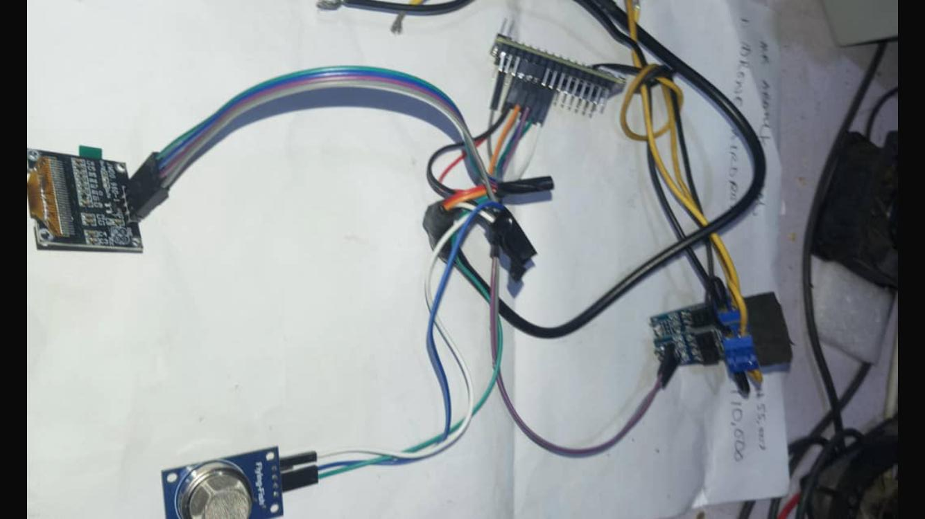\
Fig 4.1: The components of the smart fan before coupling
The components include:
- The Micro Controller Unit (nano) chip, Adrino which gives the instructions.
- Bursar responsible for beeps (in case it reaches it maximum temperature so it will come up with a sound as alert).
- Smoke detector
- Screen 128x64 display to show the necessary information
4.1.1 OUTPUT DESIGN
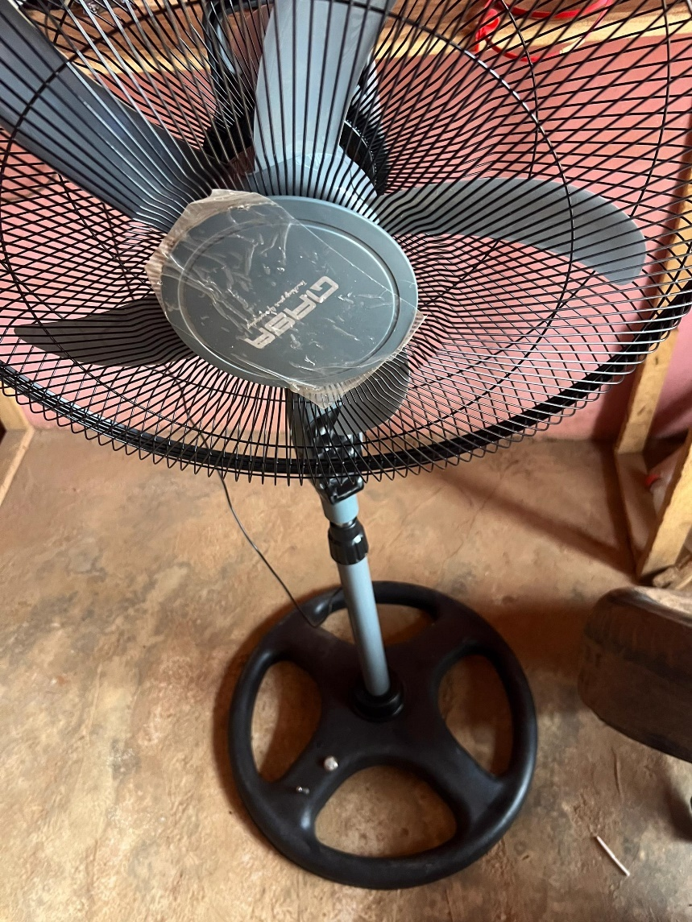
Fig 4.1.2: The Completion of the smart fan
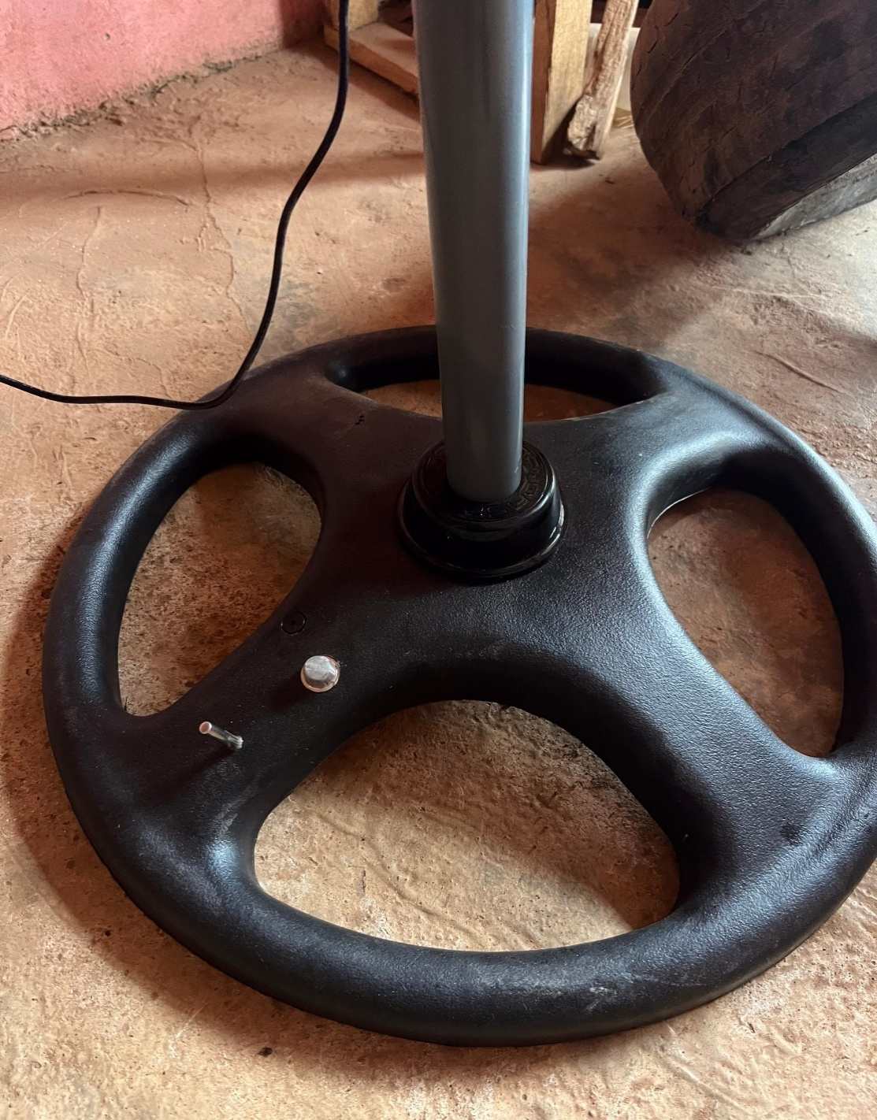
Fig 4.1.3: Showing the temperature detector and the bursar of the smart fan
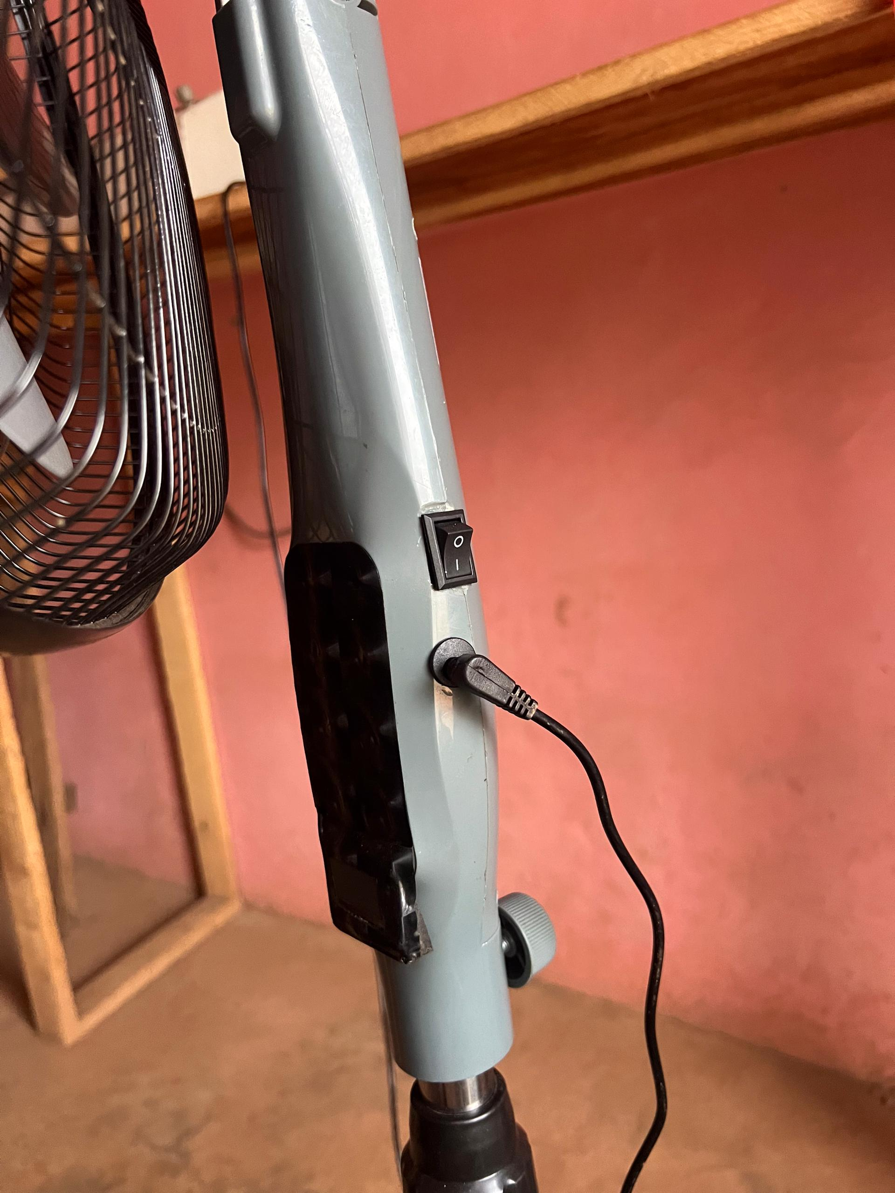
Fig 4.1.4: Showing the input, manual and the automatic switch of the smart fan

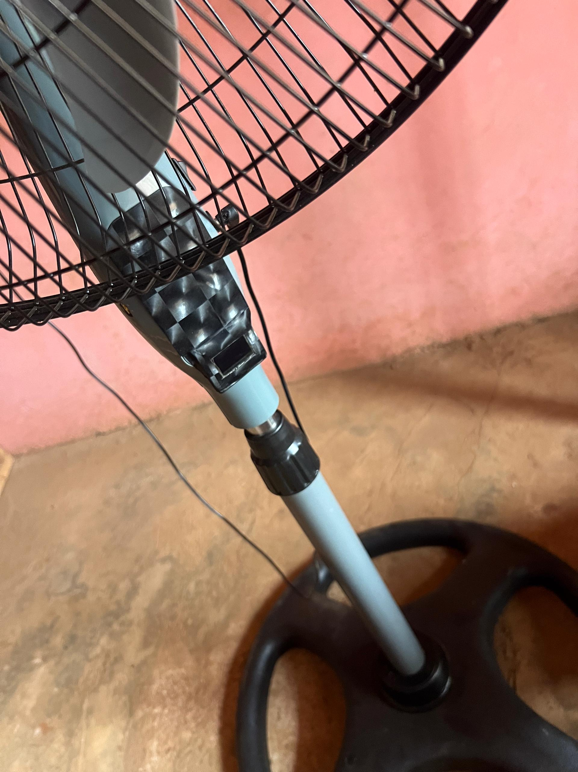
Fig 4.1.5: Showing the exterior view of the smart fan

CHAPTER FIVE
SUMMARY, CONCLUSION, AND RECOMMENDATIONS
5.1 Summary
This project focused on the design and implementation of an AI-powered smart fan system that autonomously responds to environmental changes, specifically ambient temperature and human presence. The primary objective was to create a system that intelligently controls a fan to provide efficient cooling while conserving energy.
The methodology adopted involved the use of a microcontroller-based system (Arduino Uno), which processes real-time inputs from a DHT11 temperature sensor and a PIR motion sensor. When certain predefined conditions are met—such as the detection of human movement and the ambient temperature rising above 28°C—the microcontroller activates a relay module that powers the fan. This approach ensures the fan operates only when necessary.
The project progressed through key phases including requirement analysis, component selection, system design, software development, simulation, testing, and physical implementation. All components functioned as expected, and the system was successfully validated under various conditions.
Through careful design, the project achieved a balance between comfort automation and energy efficiency, demonstrating the practical applicability of intelligent embedded systems in everyday home or office environments.

5.2 Conclusion
The AI-powered smart fan system developed in this project effectively demonstrates how microcontroller-based automation can be used to enhance user comfort while optimizing energy usage. The system successfully integrates temperature and motion detection to make autonomous decisions, turning the fan on or off based on environmental conditions.
The testing results validated the logical flow and effectiveness of the design. The system responded accurately to the presence of individuals and corresponding temperature changes. This indicates the potential of such smart systems to contribute to sustainable living by reducing unnecessary power consumption.
5.3 Recommendations
Based on the outcomes of the project and insights gained during implementation, the following recommendations are made for future work:
- Improved Sensor Accuracy: Utilizing more advanced sensors (e.g., DHT22 or MLX90614) can improve the accuracy and reliability of temperature and motion detection.
- Humidity Monitoring: Incorporating humidity sensors could allow the system to assess comfort levels more comprehensively.
- User Interface Integration: While this version operates autonomously, future versions may include an LCD display or basic UI for real-time feedback on temperature or system status.
- Machine Learning Integration: Adaptive algorithms could be developed to learn user behavior and optimize fan control more dynamically over time.
- Permanent Circuit Design: Migrating the breadboard prototype to a printed circuit board (PCB) would make the system more compact, durable, and suitable for real-world deployment.
- Power Supply Optimization: Incorporating renewable power sources like small-scale solar panels can further enhance the energy efficiency of the system.

REFERENCES
Adebayo, T., & Okeke, J. (2021). Design and implementation of a dual-sensor based lighting control system. Nigerian Journal of Electrical and Electronics Engineering, 14(2), 45–53.
Adepoju, S., Adetunji, F., & Onifade, T. (2021). Arduino as a prototyping tool for embedded system development. Journal of Emerging Technologies, 9(1), 67–74.
Al-Fuqaha, A., Guizani, M., Mohammadi, M., Aledhari, M., & Ayyash, M. (2015). Internet of Things: A survey on enabling technologies, protocols, and applications. IEEE Communications Surveys & Tutorials, 17(4), 2347–2376. https://doi.org/10.1109/COMST.2015.2444095
Bashir, M., & Ibrahim, A. (2022). Design and construction of an IR remote-controlled fan system. Journal of Smart Systems, 8(1), 12–18.
Bhatt, R., Mehta, A., & Sharma, N. (2021). Artificial Intelligence applications in home automation: A review. International Journal of Smart Systems and Technologies, 10(2), 34–40.
Choi, H., & Park, S. (2019). Automatic temperature-based fan speed control using microcontroller. International Journal of Embedded Systems and Applications, 7(3), 1–7.
Eze, K., & Abubakar, S. (2020). Motion-activated smart fan system using PIR sensor. Nigerian Journal of Innovation in Engineering, 5(4), 88–94.
Ogunleye, K., & Lawal, M. (2021). Embedded systems as sustainable solutions for energy conservation in developing countries. Energy and Sustainability Research Journal, 6(2), 23–30.
Oladimeji, O., & Musa, T. (2022). Temperature-controlled fan using Arduino and LM35 sensor. African Journal of Engineering Research, 10(1), 15–20.
Rashid, H., Farouk, A., & Suleiman, M. (2022). Smart automation in household appliances: Review and future prospects. International Journal of Engineering Technologies, 11(2), 29–36.
Saini, R., & Patel, K. (2023). Development of a sensor-based intelligent fan system using AI and IoT. Journal of Intelligent Devices and Applications, 3(1), 50–58.
Sharma, P., Gupta, A., & Rao, S. (2022). ESP32 and mobile platforms integration for home automation projects. Journal of Computer and Embedded Systems, 13(3), 90–97.
Singh, D., & Joshi, P. (2020). Comparative analysis of temperature sensors for HVAC control. Journal of Building Automation, 5(2), 11–20.
Yadav, M., & Tiwari, N. (2019). Low-cost embedded systems for environmental monitoring and automation. South Asian Journal of Engineering and Technology, 4(1), 72–79.
Yoon, J., Kim, J., & Lee, S. (2020). AI-based optimization of HVAC systems for energy-efficient buildings. Energy Informatics, 3(1), 1–15. https://doi.org/10.1186/s42162-020-00118-2
Zhou, L., Wang, Q., & Li, X. (2020). Intelligent fuzzy logic-based control systems in smart homes: Trends and applications. Journal of Smart Environments, 6(4), 101–110.

