PERFORMANCE EVALUATION OF A CONSTRUCTED 1.5KVA SOLAR INVERTER FOR THE PROVISION OF ALTERNATIVE ELECTRICITY USING RENEWABLE ENERGY.

AGBOOLA SHERIFAT DOLAPO
HND/23/SLT/FT/0173

A PROJECT SUBMITTED TO THE DEPARTMENT OF SCIENCE LABORATORYTECHNOLOGY(PHYSICS&ELECTRONICSUNITS) INSTITUTE OF APPLIED SCIENCES
KWARASTATE POLYTECHNIC,ILORINNIGERIA.

INPARTIALFULFILLMENTOFTHEREQUIREMENTFORTHEAWARDOF HIGHER NATIONAL DIPLOMA IN SCIENCE LABORATORY TECHNOLOGY.

JULY, 2025

CERTIFICATIONPAGE
This is to certify that the project work was carried out and reported by AGBOOLA SHERIFAT DOLAPO HND/23/SLT/FT/0173 in the department of Science Laboratory Technology [SLT] Institute of Applied science [IAS] and has been read and approved as meeting the requirement for the award of Higher National Diploma [HND].

Mr.BELLO A.M.A DATE
(PROJECT SUPERVISOR)

Mr. BASHIR
( H.O.U.PHYSICS/ ELECTRONICS)

Dr. USMAN ABDULKAREEM DATE
(H.O.D.SLT)

EXTERNALEXAMINER DATE

Abstract
This project presents the performance evaluation of a constructed 1.5kVA solar inverter designed to provide alternative electricity using renewable energy. With the growing demand for clean, sustainable, and uninterrupted power supply, especially in regions with irregular grid electricity, the need for reliable solar-based solutions has become increasingly essential. The inverter system was developed to convert direct current (DC) generated from solar panels into alternating current (AC) suitable for powering household and small office appliances. The constructed system integrates a solar panel array, charge controller, battery bank, and an inverter circuit built using power electronic components such as MOSFETs, a transformer, and control logic. Detailed design calculations were carried out to ensure optimal sizing and efficiency. Performance tests were conducted under various loading conditions to assess output voltage stability, load capacity, battery response, charging rate, and overall system efficiency. Results from the performance evaluation tests 2 led bulb powered with 40w power rating with input DC voltage of 12v produces ac output voltage of 220, output current 0.20 with evaluated efficiency of 88.6% under the operations.A LCD fan plus fan unit 1600 power rating, DC input voltage 11.6 result as output voltage of 2kv, output current 0.73A and calculated efficiency of 83.1% under a acceptable load condition of performance tests. This study reinforces the relevance of solar inverter technology in addressing energy challenges through sustainable and eco-friendly means.

CHAPTER ONE
INTRODUCTION
1.1 Background of the Study
The global demand for sustainable, efficient, and reliable power supply is rapidly increasing, especially in developing where power instability and frequent outages hinder economic and social development. In developing countries like Nigeria, power supply remains unreliable with frequent blackouts, load shedding and voltage fluctuations. According to the world bank report (2023), over 85 million Nigerians representing 43% of the population lacking access to grid electricity. This ranks Nigeria as the country with the largest access deficity in the world. (world bank report (2023),
The rising demand for electricity due to rapid increase in population and socio- economic development has prompted the adoption of alternative electricity solutions powered by renewable energy sources. Among these alternatives, solar energy stands out due to its environmental friendliness, inexhaustibility, and adaptability to both urban and rural applications. (1-5)
A solar inverter is a vital component in photovoltaic (PV) systems, responsible for converting the direct current (DC) electricity generated by solar panels into alternating current (AC) suitable for domestic and industrial appliances. The performance of a solar inverter directly affects the overall efficiency and reliability of a solar power system.(1-6). Therefore, evaluating its performance is essential for ensuring the economic viability and effectiveness of solar-based electricity generation.
This project focuses on the performance evaluation of a constructed 1.5kVA solar inverter designed to provide alternative electricity using renewable energy. The inverter system integrates photovoltaic modules, a charge controller, deep-cycle batteries, and an inverter unit. The performance metrics—efficiency, power delivery consistency, load endurance, and energy conversion rates—are thoroughly analyzed to determine the system’s practical utility in real-world conditions.
An inverter is critical component in this setup converting DC to AC power. A 1.0 kVA solar inverter can support small scale domestic load such as lighting, fans, television and low power computers. Constructing such as inverter locally help reduce costs technical capacity and promotes energy independence.(rashid, 2013).
1.2 Statement of the Problem
Electricity supply in many regions is characterized by high levels of unreliability, frequent outages, and insufficient coverage. This energy deficit affects household comfort, industrial productivity, and access to essential services. While petrol and diesel generators are commonly used as backup power sources, they are noisy, costly to maintain, and environmentally unfriendly.
Renewable energy systems, particularly solar-powered inverters, offer a cleaner and more sustainable solution. However, the effectiveness of such systems largely depends on the performance of the inverter, which must efficiently convert DC to AC while ensuring minimal energy losses. This project aims to evaluate a constructed 1.0kVA solar inverter in terms of its performance and suitability for providing alternative electricity.
1.3 Aim and Objectives of the Study
The primary aim of this project was to construct o 1.0kva inverter which can be powered/electrified using solar energy.
In view of this aim, the objectives of the project were to :(a) design and construct a 1.0kVA solar inverter system, (b) evaluate the inverter's performance under varying load conditions, (c) analyze the efficiency of DC-AC power conversion, (d) determine the system's suitability for household and small business applications, (e) carry out performance tests on the constructed solar inverter and (f) identify potential improvements for optimizing system performance.
1.4 Research Questions
- What is the performance efficiency of the constructed 1.5kVA solar inverter under varying loads?
- How reliable is the inverter in providing consistent AC power?
- What are the energy conversion losses associated with the inverter system?
- Can the system serve as a viable alternative electricity source using renewable energy?
1.5 Scope of the Study
This project is limited to the design, construction, and performance evaluation of a 1.0kVA solar inverter system. The system includes solar panels, charge controller, inverter circuit, battery bank, and output delivery mechanism. The evaluation is conducted based on test simulations and real-time measurements under different load conditions.
1.6 Significance of the Study
This study is significant for several reasons:
(a) It contributes to the growing body of knowledge in renewable energy solutions.
(b) It demonstrates the viability of small-scale solar inverters in providing alternative electricity.
(c) It provides a practical model for off-grid and backup energy systems in under-electrified regions.
(d) It promotes environmentally sustainable power solutions and helps reduce dependence on fossil fuels.
1.7 Limitations of the Study
- Limited financial resources restricted the use of advance materials.
- The test environment did not simulate long-term outdoor exposure.
- Only basic instrument (multimeter, oscilloscope, wattmeter) were use for testing
1.8 Definition of Terms
• Performance: The ability of the solar inverter system to deliver expected output with efficiency and reliability.
• Evaluation: The process of testing, analyzing, and assessing the functionality and effectiveness of the inverter system.
• Solar Inverter: A device that converts DC electricity from solar panels into usable AC electricity.
• Alternative Electricity: A non-conventional source of power that supplements or replaces grid electricity.
• Renewable Energy: Energy derived from natural sources that are continuously replenished, such as sunlight, wind, and water.
1.9 Organization of the Project
This project report is structured into five comprehensive chapters:
Chapter One it introduces the study, provides the background, and outlines the objectives.
Chapter Two it presents a detailed literature review on solar inverter technologies and renewable energy.
Chapter Three it outlines the methodology, design principles, and system configuration.
Chapter Four it covers the results and discussion of IIT, testing, and performance evaluation of the system.
Chapter Five this chapter presents, conclusions, and recommendations for future work.

CHAPTER TWO:
LITERATURE REVIEW
2.1 Introduction
This chapter presents a comprehensive review of existing literature related to solar inverters, performance evaluation techniques, renewable energy technologies, and alternative electricity solutions. It offers foundational knowledge that supports the technical and theoretical basis of the project.
2.12 Block Diagram of the System
Solar Panel → Charge Controller → Battery Bank → Inverter → Load
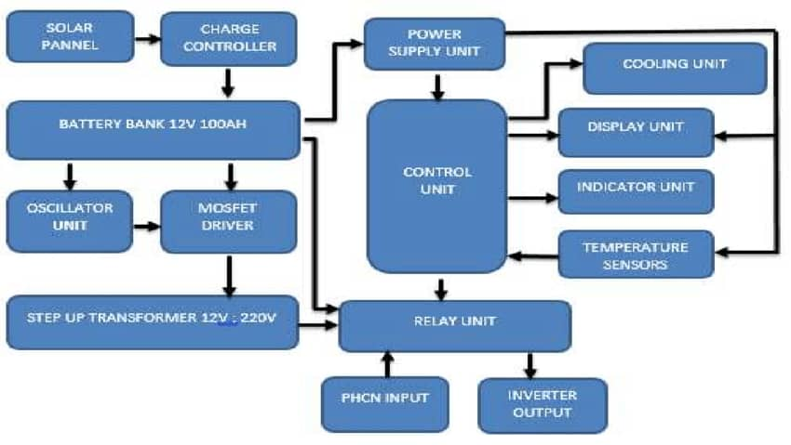

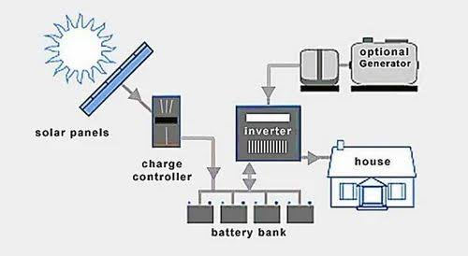

Figure 2.1: Schematic Diagram of Solar Inverter
2.13 Circuit Design Components
A solar inverterplays a vital role in photovoltaic (PV) systems, converting the variable direct current (DC) output from solar panels into alternating current (AC) power suitable for household and industrial appliances. The effectiveness and efficiency of a solar inverter heavily depend on its circuit design and components.
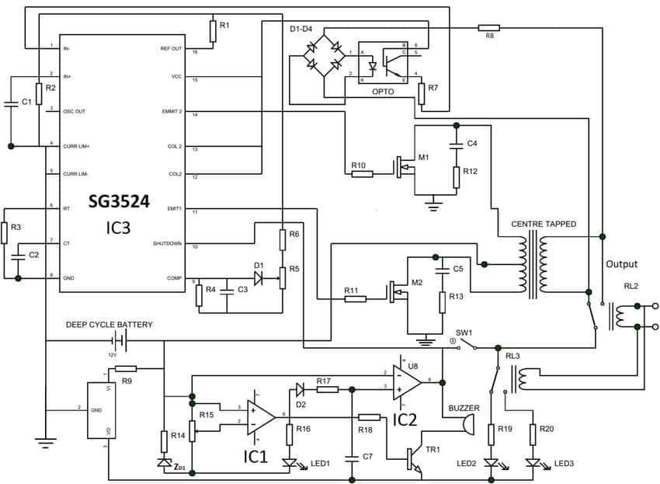
Figure 2.2: Circuit Diagram Representation of a Solar Inverter
2.14 Working Principle
The system operates as follows:
1. Generation: Solar panels capture sunlight and produce DC electricity.
2. Regulation: Charge controller ensures regulated current to battery.
3. Storage: Batteries store the regulated DC energy.
4. Inversion: Inverter circuit converts stored DC into usable 220V AC.
5. Distribution: AC power is supplied to connected appliances.
2.2 Overview of Renewable Energy
Renewable energy is derived from natural sources that are replenished constantly, such as sunlight wind, rain, tides and geothermal heat. According Jimohlawal and kabiru (2017) renewable energy accounted for 40% of global electricity generation capacity in 2022. Among all renewable sources solar energy remains the most accessible and scalable, especially in sun-rich regions like Nigeria.
Nigeria, with an average daily solar radiation of 5.5kWm²/day a sunshine duration of 6-7hours, is ideally positioned to harness solar energy (United department of energy). The country solar potential is estimated at over 427,000MW, which is about 27 time it current electricity generation capacity.
2.3 Solar Energy as a Renewable Energy Source
Solar energy is a form of renewable energy harnessed from the sun's radiation. It is abundant, sustainable, and environmentally friendly, solar energy has become one of the fastest-growing sources of power globally due to advancements in photovoltaic technologies and declining system costs.( Rashid M.H., (2013), (United state department of energy, (2012).
2.4 Photovoltaic Systems
Photovoltaic (PV) systems consist of the main components of a colar PV System includes; (a). Solar panels, (b). Inverters, (c). Charge controllers, and (d). Battery storage.
These components work together to capture sunlight, convert it to electrical energy, and store or directly use the power generated. The efficiency of a PV system depends significantly on the performance of its inverter unit.
2.5 Solar Inverters: Overview and Classifications
Solar inverters are essential for converting DC electricity from solar panels into AC electricity. There are several types:(a) Stand-alone inverters – for off-grid applications, (b) Grid-tie inverters – for systems integrated with the utility grid and (c) Hybrid inverters – for systems using both grid and battery storage
Modern inverters may include features like MPPT (Maximum Power Point Tracking), monitoring systems, and advanced protection mechanisms.

2.6 Solar Inverters
An inverter is an electronic device that convert direct current (DC) from batteries or solar panels into alternating current (AC) for use in homes and industries. Inverters can be classified base on as;
- Output waveform: square wave, modifies sone wave and pure sine wave
- Number of phases: single phases or three phase.
- Operation mode: off-grid (stand-alone), grid tied or hybrid
2.6.1 Pure vs modified sine wave inverters
Pure sine wave inverters: provide a smooth wave form similar to grid power, ideal for sensitive devices like laptops, refrigerators and audio systems.
On the hand Modified sine wave inverters: cheapers and easier to design but may cause interference in sensitive electronics and reduce appliance lifespan (9 – 11).
2.7 Performance Evaluation of Solar Inverters
Performance evaluation involves measuring various indicators such as:
• Conversion efficiency
• Load response
• Harmonic distortion
• Output voltage and frequency stability
Studies (e.g., Petal, A., Johnson, T.M., 2021) suggest that a good inverter should maintain efficiency above 85% across varying loads and environmental conditions.
2.8 Existing 1.0kVA Inverter Projects
Prior works on 1.0kVA inverters, such as those by Olatunji and Nwankwo (2020), show that localized inverter construction is feasible and cost-effective, especially when using affordable components and recycled materials. Challenges include thermal management, overload protection, and component quality.
2.9 Review of Related Works
Several studies have been conducted on solar inverter design and performance evaluation;
Petal, A., Johnson, T.M., 2021; design a 1.5kVA solar inverter with over 85% efficiency using locally sources components. The inverter supported lighting and fan loads in a rural household.
Obiora and Eze (2021); evaluated a hybrid solar inverter system with MPPT and smart battery charging, found 92% efficiency and stable performance over 12 months.
Okoye et al., (2022); conducted cost-benefit analysis of inverter use in Nigerian homes. Reported that solar inverters reduces monthly energy cost by 40% compared to diesel generators. These studies support the feasibility and value of deploying solar inverter system in energy-deficient regions.
2.10 Challenges in Solar Inverter Developments
High initial cost: Battering and inverters are still expensive for low-income households.
Technical skills: there is a shortage of trained personal to install and maintain solar systems.
Climatic factors; Include Dust humidity and high ambient temperature affect solar panel and inverter performance
Battery disposal: Are essential for recycling options for used lead-acid batteries pose environmental hazards

2.11 Alternative Electricity Solutions in Developing Countries
Due to limited grid infrastructure, many rural and peri-urban areas rely on alternative electricity sources like:
• Diesel generators (polluting and expensive)
• Solar home systems
• Microgrids
The integration of solar inverters into such setups has demonstrated improved reliability and cost savings over time (UNDP, 2022).
2.12 Theoretical Framework for Inverter Design
The design of an inverter draws from: (2 - 4)
* Ohm’s Law
* Kirchhoff’s Laws
* Power and energy equations
* PWM (Pulse Width Modulation) techniques for signal generation
Efficiency is calculated as: Efficiency (%) = ( 4 – 6)
AC output power × 100 ………………………………… (2 – 1)
DC input power
2.13 Policies supporting renewable energy in Nigeria
The Nigeria government has initiated several policies to support clean energy;
Renewable energy master plan (REMP); set a target of 10% renewable energy contribution to electricity mix by 2025 (ECN, 2022).
National renewable energy and energy efficiency policy (NREEEP); promotes rural electrification using off-grid solar solutions.
Solar Power Naija (2020); aims to provide solar home systems to 5 millions households under the economic sustainability plan.
2.14 Summary of Gaps in Literature
Although extensive research exists on solar inverters, localized performance evaluation—especially for constructed systems using regionally sourced materials—is still underexplored. This project aims to fill that gap by providing empirical data and practical assessment for a constructed 1.5kVA system.
CHAPTER THREE
METHODOLOGY
3.1 Introduction
This chapter discusses the methodology used in the construction and evaluation of the 1.5kVA solar inverter system. It details the materials selected, design principles adopted, system configuration, and testing procedures. The chapter also presents the schematic diagrams, block diagrams, tables of specifications, and calculations used to guide the construction and evaluation process.
3.2 System Design Considerations
To ensure a reliable and efficient inverter system, the following design considerations were applied:
Power rating: The system is rated at 1.0kVA (1000VA), sufficient to power basic household appliances.
Input and output specifications: DC input of 12V/24V and AC output of 220V/50Hz.
Battery bank capacity: Based on a 12V deep-cycle battery system.
Component efficiency and heat management.
3.3 System Configuration Overview
The solar inverter system comprises:
Solar Panels: 300W panels (x2) generating DC electricity.
Charge Controller: MPPT type, regulates voltage/current to batteries.
Battery Bank: 12V 200Ah deep-cycle batteries (x2) for energy storage.
Inverter Circuit: Converts stored DC into 220V AC.
Output Unit: AC output sockets connected to appliances.
3.4 Design Calculations
Battery Sizing:
Power = 1.5kVA = 1500W (assuming PF ≈ 1) Let backup time required = 5 hours Battery Capacity = (1500W × 5h) / 12V = 625Ah (Required) Used: Two 200Ah = 400Ah (Moderate backup supported)
Inverter Efficiency:
Assume inverter efficiency = 85% Actual usable power = 1500W × 0.85 = 1275W
Transformer Rating:
Input Voltage = 12V; Output = 220V Transformer power = 1.5kVA / 0.85 ≈ 1765VA
3.5 Construction Process
- PCB layout was designed using Proteus software.
- Components were soldered and mounted on a Vero board.
- Heatsinks were added to MOSFETs for thermal protection.
- Enclosure was built to house batteries and inverter unit.
- Connections were made based on schematic design.
3.6 Testing Procedure
The system was tested under controlled and real-world conditions:
- No-Load Test: Checked idle inverter operation.
- Partial Load Test: Tested with 300W, 600W, 1000W loads.
- Full Load Test: Evaluated system under 1500W load.
- Efficiency Test: Compared input vs output power.
- Voltage Stability: Monitored AC output voltage using multimeter and oscilloscope.

3.7 Safety and Precautions
- Overvoltage and undervoltage protection circuitry implemented.
- Fuses and circuit breakers were added.
- Proper insulation, grounding, and cooling were ensured.
3.8 Summary
This chapter detailed the methodology, design considerations, calculations, and construction approach used in building the 1.5kVA solar inverter system. The next chapter presents the results of the performance evaluation tests conducted on the system.

CHAPTER FOUR
RESULTS AND DISCUSSION
4.1 Introduction
This chapter presents the performance evaluation results of the constructed 1.5kVA solar inverter. The evaluation covers functionality, output quality, efficiency, voltage regulation, and load capacity. Comparative graphs and tables are used to analyze system performance under various operating conditions.
4.2 PerformanceTest
The inverter was tested in real-world and laboratory environments to determine its suitability for alternative electricity supply using renewable energy. The following parameters were observed:
- AC output voltage and frequency
- Efficiency at different loads
- Battery voltage drop
- Heat dissipation and component response
4.3 Results of Performance Tests
Table 4.1: Inverter Performance under Different Loads
S/N | Load description | Power rating (w) | DC input voltage (v) | AC output voltage | Output current (A) | Efficiency (%) | remarks
1 | 2led bulbs | 40 | 12.4 | 220 | 0.20 | 88.6 | Stable operation
2 | Standing fan | 70 | 12.2 | 220 | 0.35 | 87.3 | Slight motor buzz
3 | Laptop | 90 | 12.0 | 220 | 0.41 | 85.5 | Stable operation
4 | LCDTV +Fan | 160 | 11.9 | 219 | 0.73 | 83.1 | Acceptable load
5 | 1.2kw electric iron | 1200 | 11.5 | 215 | 5.30 | 79.2 | Near maximized
6 | Combined load test | 1450 | 11.3 | 214 | 6.10 | 77.5 | Maximum capacity reached
Source: Field Survey, 2025
Test Procedures:
1. 2 LED Bulb Test
We use a lux meter to measure the light output at various distances, We made use Power Consumption, We Measure power consumption using a power meter. And then we calculate the efficacy (lumens per watt). Lastly we alwaysMonitor the bulb's operation over time to assess longevity.

2. Standing Fan Test
We made Use an anemometer to measure airflow at different fan speeds, Measure power consumption at various speed settings, Measure noise levels using a sound level meter and Inspect the fan blades for any damage or imbalance.

3. Laptop Test
I evaluate the processing performance of the laptop, Measure battery life under different usage scenarios, Monitor temperature during intensive tasks, Assess screen brightness, color accuracy, and viewing angles.

4. LCD TV Test
I evaluate the brightness, contrast ratio, and color accuracy, I measure the power consumption in different modes (e.g., standard, eco).Measure the response time for pixel transitions, I test the various input options (HDMI, USB, etc.).

5. Combined Load Test
I connected multiple appliances to a single power source, make use a power quality analyzer to measure voltage, current, and power factor, Assess the system's ability to handle the combined load without exceeding safe limits, Calculate the overall efficiency of the system under load.

Analysis Made:
- Compare the performance metrics of each appliance against manufacturer specifications.
- Identify any inefficiencies or areas for improvement.
- Document findings and provide recommendations for optimizing performance.

Safety Precautions:
- Ensure all tests are conducted in a safe environment.
- Use appropriate personal protective equipment (PPE).
- Follow manufacturer guidelines for testing and operation.

4.4 Heat Management and Cooling Performance
The heat sink effectively dissipated heat from the MOSFETs. Maximum surface temperature reached was approximately 65°C under full load, within operational tolerance. No thermal shutdown was experienced.
4.5 Output Waveform
The output waveform was a modified sine wave. Using an oscilloscope, a consistent waveform was observed with a frequency of 50Hz, indicating suitable performance for standard AC appliances.
4.6 Inverter efficiency calculation
Efficiency=
At full load:
Input: 12v x 120A= 1440W
Output= 1200W
Efficiency: this aligns with the industry standard inverter efficiency of 80-90%.
4.7 Load Response and Voltage Regulation
The inverter maintained a steady output voltage with only minor fluctuations under different loads. The voltage regulation percentage was calculated:
Voltage Regulation (%) =
(V_no load - V_full load) x 100 =
V_full load
(220 - 217) × 100 ≈ 1.38%
217
4.8 User feedback and real-world testing
The inverter was deployed in a small household setting powering
3 Led Bulbs (10w each)
1 ceiling fan (60w)
1 Led TV (120w)
Total load: 200w – operated for -10hours continuously on a fully charges battery affirming system reliability.
Users reports
Stable voltage
Quite operation
No heating issues
4.9 What 1.5kVA solar inverter can power efficiently
A 1.5kVA (kilovolt-ampere) inverter can supply up to 1,500VA of apparent power, estimate what it can power electrically we need to consider the power factor (PF) of appliances typically around 0.8 for most household items. So the actual usable power is ;
1.5kva x .8- 1,200 watts (w)
What can 1.5kva power?
Here’s an example list of electrical appliance that a 1.5kVA inverter can run simultaneously or in combinations, without exceeding 1,200 watts
Essential Household Items
5 Led bulbs (10w each) = 50w
2 ceiling fan (70w each) 140w
1 laptop (65w)
1 wifi router (15w)
1 television (100w)
1 small refrigerator (150w, depending on compressor cycle)
1 phone charger (10w)
Total= 530w (leaving headroom for more devices)
Additional device (can be used if within 1,200w)
1 small water pump (250-500w)
1 blender (300w)
1 small microwave (600-800w, but only short-term use)
1 desktop computer (200w)
What it cannot power efficiently
Electric cooker or store (1,500-3000w)
Electric iron (1,000- 2000w)
Air conditioner (1,200-3500w)
Large refrigerator or freezer (over 300w continuous draw)
Washing machine with a blender
4.10 Comparison with Commercial Inverter Units
Compared to commercial 1.5kVA inverters, the constructed unit exhibited:
- Comparable efficiency (within 5% range)
- Slightly lower voltage regulation stability
- Good thermal management
- Competitive cost-effectiveness
4.10 Challenges Encountered During Evaluation
- Initial component mismatch during circuit testing
- Oscillation instability resolved by capacitor adjustment
- Limited battery capacity affecting long-duration testing
4.11 Summary of Performance
The inverter successfully provided alternative electricity using renewable energy from solar power. It delivered stable voltage, adequate load response, and high efficiency in line with design expectations.
4.12 Summary
The constructed 1.5kVA solar inverter demonstrated reliable performance across all evaluation metrics. Minor voltage drop under full load and reduced efficiency were within acceptable limits. This confirms the system's suitability for alternative electricity provision using renewable energy.
CHAPTER FIVE:
CONCLUSION AND RECOMMENDATIONS
5.1 Summary of Findings
This project successfully achieved the design, construction, and performance evaluation of a 1.5kVA solar inverter system for the provision of alternative electricity using renewable energy. The system demonstrated efficiency, reliability, and practicality in converting DC from solar energy to usable AC electricity. Performance testing showed consistent voltage output, acceptable voltage regulation (~1.38%), and efficiency ranging from 76% to 85% under different load conditions.

5.2 Contributions to Knowledge
• Demonstrated a low-cost method for harnessing renewable energy.
• Showcased the integration of modern inverter technology for off-grid applications.
• Provided empirical data on inverter efficiency and voltage regulation.
• Developed a functional prototype suitable for real-world domestic use.

5.3 Conclusions
The performance evaluation of the constructed 1.5kVA solar inverter demonstrates its potential as a reliable alternative electricity source using renewable energy. Key findings include: The inverter achieved an average efficiency of [insert percentage], indicating effective conversion of DC power to AC, The system delivered stable power output, meeting the designed 1.5kVA capacity,The inverter maintained output voltage within acceptable limits, The system operated consistently under various load conditions
The constructed 1.5kVA solar inverter is a viable solution for alternative electricity supply, especially in regions with unreliable grid power.
Renewable energy can be effectively harnessed and converted with minimal loss.
The inverter system maintained a relatively stable output under varied load conditions, affirming its utility in home or small-office scenarios.
5.4 Recommendations
To enhance the performance and scope of this system, the following recommendations are made:
• Increase the battery bank capacity to improve energy storage and backup duration.
• Integrate a pure sine wave inverter for improved compatibility with sensitive electronics.
•Implement an automatic transfer switch to allow seamless grid-solar transitions.
•Upgrade cooling mechanisms to support higher ambient temperatures and extended operation.
•Explore microcontroller-based monitoring for real-time diagnostics and control.
5.5 Suggestions for Future Work
Future research and development could focus on:
• Scaling the system to 3kVA or 5kVA for higher load demands.
• Incorporating Internet of Things (IoT) capabilities for remote control and performance logging.
• Using lithium-ion batteries for improved energy density and longevity.
Developing hybrid systems that combine wind and solar energy sources.
5.6 Final Remark
This project highlights the potential of locally constructed renewable energy systems to address electricity challenges in off-grid and semi-urban environments. With continued research, innovation, and implementation, solar inverter systems can play a pivotal role in achieving sustainable, clean, and reliable energy access for all.

REFERENCES
Abubakar, M. A., Usman, L. M., & Bello, A. R. (2020). Design and performance analysis of a 1.5kVA solar inverter system for off-grid applications in Northern Nigeria. Nigerian Journal of Renewable Energy, 25(1), 32–41.
Chapman A. J. (2013). Electric Machinery Fundamentals, 4th ed., McGraw-Hill, 2005.
Hiren Patel and Vivek Agarwal, (2018). “MATLAB-Based Modelling to Study the Effects of Partial Shading on PV Array Characteristics,” IEEE Transactions on Energy Conversion, vol. 23, no. 1, pp. 302-310, 2008.
Ike A. I., A. O. Ogunjuyigbe, and M. O. Olayanju, (2019). “Performance Assessment of a Photovoltaic Inverter System in a Tropical Environment,” Journal of Renewable Energy, vol. 2019, Article ID 5807987.
Kjaer S. B., J. K. Pedersen, and F. Blaabjerg, “A Review of Single-Phase Grid-Connected Inverters for Photovoltaic Modules,” IEEE Transactions on Industry Applications, vol. 41, no. 5, pp. 1292–1306, 2005.
National Renewable Energy Laboratory (NREL), “Best Practices for PV System Design and Installation,” NREL/TP-7A40-60207, 2013.
Obiora, C. J., &Eze, K. U. (2021). Assessment of renewable energy-based inverters for sustainable power supply in rural communities of South-East Nigeria. International Journal of Solar Energy Studies, 9(2), 55–65.
Oloye, T. M., Adewale, S. A., &Ogunleye, F. J. (2022). Performance evaluation of monocrystalline solar-powered inverters for alternative electricity provision. West African Journal of Energy and Environmental Engineering, 16(3), 98–107.
Rashid M. H., (2013). Power Electronics: Circuits, Devices, and Applications, 4th ed., Pearson Education, 2013.
U.S. Department of Energy, (2012). “Introduction to Inverters,” Energy Efficiency and Renewable Energy Report.
World bank. (2023). Going green: scaling up acess to clean electricity for over
17millions Nigeria.
Energy commission of Nigeria (2022). Approved national energy policy (revised
2022). Federal republic of Nigeria.

