DESIGN AND IMPLEMENTATION OF A CONGESTION CONTROL SYSTEM FOR MULTI-USER TELECOMUNICATION NWTWORK

BY
GBADAMOSI JAMIU OLAMILEKAN
ND/23/COM/PT/0367
SUBMITTED TO THE DEPARTMENT OF COMPUTER SCIENCE,
INSTITUTE OF INFORMATION AND COMMUNICATION TECHNOLOGY
KWARA STATE POLYTECHNIC, ILORIN.

IN PARTIAL FULFILLMENT OF THE REQUIREMENTS FOR THE AWARD OF NATIONAL DIPLOMA (ND) IN
COMPUTER SCIENCE

JULY, 2025.
CERTIFICATION
This is to certify that this project carried out by GBADAMOSI JAMIU OLAMILEKAN of Matriculation Number: ND/23/COM/PT/0367 in the Department of Computer Science, Institute of Information Communication Technology, Kwara State Polytechnic, Ilorin, Kwara State.

…………………………………. ….………………………
MR. BOLAJI-ADETORO D.F. Date
Project Supervisor

…………………………………. ….………………………
MR. OYEDEPO F.S. Date
Head of Department

…………………………………. ….………………………
External Examiner Date

DEDICATION
I dedicate this project work to Almighty God and my parents who inspired me and directed my ways during my academic stay in the polytechnic.

.

ACKNOWLEDGEMENT
I give thanks to Almighty God for granting me success for the completion of my programme.
My utmost appreciation goes to our able supervisor Mr Bolaji-Adetoro D.F. for his fatherly support and his moral advice throughout this project. My profound appreciation goes to the Head of Department (H.O.D) Mr. Bolaji-Adetoeo D.F. for his fatherly support and also my gratitude goes to my lecturers and all the staff of the Computer Science department both teaching and non-teaching staff.
My sincere gratitude also goes to my beloved parents for their care and support towards my academic program. I say a big thank you and may Almighty God bless you abundantly (Amen).

Abstract
The study of congestion control on GSM network in Nigeria is necessary as congestion remains a major challenge to telecommunication service provision both to service providers and the subscribers as well. The subscribers are threatened to quite service providers who fail to meet up with the services required of them. Invariably, quitting the service providers will not solve the problems; instead it will create more problems. In science, problem paves way for research and development and that is the brain child of this project work. Analytical method used in this project is recommended as the best control measure for GSM congestion. This research work has made it possible for some of the key performance indicators to reach a bench mark as recommended by the International Telecommunication Union. Hence the proposed system will be develop in Software Application which makes use of the following C# (CSHARP) as the programming language due to its user friendliness while MYSQL is used as the back end (Database).

TABLE OF CONTENTS
Title page i
Certification ii
Dedication iii
Acknowledgement iv
Abstract vii
Table of contents viii
CHAPTER ONE: GENERAL INTRODUCTION
1.1 Introduction 1
1.2 Statement of the Problem 3
1.3 Aim and Objectives of the Study 4
1.4 Significance of the Study 4
1.5 Scope of the Study 4
1.6 Organization of the Study 5
CHAPTER TWO: LITERATURE REVIEW
2.3 Review of Related Work 6
2.2 Review of General Text 12
CHAPTER THREE: METHODOLOGY AND ANALYSIS OF THE SYSTEM
  - Research Methodology 17
  - Analysis of the Existing System 18
  - Problem of the Existing System 18
  - Description of the Proposed System 19
  - Advantage of the New System Over the Existing System 19
CHAPTER FOUR: DESIGN, IMPLEMENTATION AND DOCUMENTATION OF THE SYSTEM
  - Design of the System 20
4.1.1 Output Design 20
4.1.2 Input Design 22
4.1.3 Database Design 24
4.1.4 Procedure Design 25
  - System Implementation 25
4.2.1 Choice of Programming Language 26
4.2.2 Hardware Support 27
4.2.3 Software 27
    - Implementation Techniques used in Details 27
  - Program Documentation 27
4.3.1 Operating the System 27
4.3.2 Maintaining the System 28
CHAPTER FIVE: SUMMARY, CONCLUSION AND RECOMMENDATION
5.1 Summary of findings 30
5.2 Conclusion 30
5.3 Recommendations for future work 30
References 32
APPENDICES
Appendix 1: System flowchart 33
Appendix 2: Splash Screen 34
Appendix 3: View Queue 35
Appendix 4: Main Menu 36
Appendix 5: Control Congestion 37
Appendix 6: Source code 38

CHAPTER ONE
GENERAL INTRODUCTION
  - INTRODUCTION
The current trend on the telephone technology is the cellular telephone usually referred to as the cell phone. A cellular telephone is designed to afford user a maximum degree of freedom of movement. Consequently, there is a rapid increase in the cellular telephone density. Other factors are as well responsible for this growth and include reduction in service cost as well as the ever increasing range of services available through the cell phone. The cellular system began in the United States of America with the release of the Advanced Mobile Phone Service (AMPS) system. (Lee, 2023). Asia, Latin America and Oceanic countries adopted the AMPs standard creating the largest potential market in the world for cellular (Mehrotra,2019). GSM communication revolution in Nigeria started in August 2001 and this brought a great change in the face of Information and Communication Technology (ICT) (Adegoke et al., 2018). In the early 1980s, most mobile telephone system was based on electronics technology. Some of the challenges facing analog systems are their inability to accommodate the growing bandwidth needs in a cost efficient manner because analog transceiver cannot handle more than one call at a point in time. Also several facilities as well as services are not possible in the analog system. On the contrary, digital technology was welcomed. The advantages of digital system over analog system include ease of signaling lower level of interference, integration of transmission and switching as well as increased ability to meet capacity demands. Therefore the limitation of analog system becomes clearer as the number of subscribers increased. This gave way to the digital system. The GSM is more advanced than the analog system and uses digital data which accommodates more subscribers. This technology increased the number of subscriber beyond expectations (Okwor & Godwin, 2018).
Congestion is the unavailability of network to the subscriber at the time of making a call. Congestion occurs when there are limited resources at the service point, this leads to queues, called traffic or congestion. It is the situation when the blocking occurs and no free path can be provided for an offered call (Syski, 2018). That is, when a subscriber cannot obtain a connection to the wanted subscriber immediately. The ideal telephone system is a situation where it is possible for all subscribers to talk in pairs simultaneously. According to the International Telecommunication Union, by 1996 Nigeria's teledensity ratio was a mere 0.3. It rose slightly to 0.4 by 1999. Nigeria's teledensity is a far cry from the African average of 1.67. As at 1999, Nigeria had limited telephone network with a long waiting list of subscribers. Even the NCC admits that Nigeria had a very limited telephone network for many years, and the waiting list is estimated at over 10 million people, who have applied to the Nigeria Telecommunications Limited, NITEL, for services. However, with the liberalization of the telecommunication industry in 2001, the story changed dramatically (Kuboye, 2020).
The teledensity ratio had tripled within just five years of GSM operations. By May 2005, Nigeria with an estimated population of 128,771,988 had more than 9 million GSM subscribers, making the country one of the fastest growing GSM markets in the world (Ajala, 2005). Nigerian telecommunication market looks forward to achieve a tele-density of 100% by 2020 driven by massive telephone and mobile communication improvements, calling for a huge growth in the ICT sector. Nigeria, with a population of nearly 140 million people being serviced by 60 phone lines, a 45% success rate in a development where in it will boost the Nigerian economy and infrastructure. No modern economy can thrive without an integral information technology and telecommunications infrastructure. This is because ICTs provide the veritable platform for development across the economic and other sectors if well harnessed, (Ndukwe, 2018).
Congestion is a problem all GSM service providers are facing and trying to solve; the first issue that needs to be tackled by a G.S.M operator is the provision of network coverage to the target population. Calls cannot be made or received in areas where there is no network. Again, where a network exists but has poor connectivity; calls may be difficult to make or receive. However, poor connectivity of call may occur as a result of a number of factors chief among, which is congestion. Congestion is a situation that arises when the number of calls emanating or terminating from a particular network is more than the capacity that the network is able to cater for at a particular time.
1.2 STATEMENT OF THE PROBLEM
Congestion simply means ‘full of traffic’. It occurs when too many things or people are seeking for use of a resource that is limited. The Oxford- Advanced Learner’s Dictionary (year) defines congestion as the state of being crowded, blocked or too full of traffic. Congestion is the unavailability of network to the subscriber at the time of making a call. It is the situation when the blocking occurs and no free path can be provided for an offered call. It manifests in various ways, hence it is usually an everyday experience. It therefore, makes an economic sense for congestion to occur because naturally, in every real world situation resources most time are limited and it is necessitated by an unequal relationship between services required and the facilities used for rendering the service. Congestion often results in queues. Queuing is seen as a line of things or people waiting to use a particular resource. For instance, a traffic jam usually occurs when there are many vehicles prying a road at the same time.

1.3 AIM AND OBJECTIVES
The aim of this research is to design and implement a congestion control system with mtn as the case study, the objectives are:
- Create application that increase reliability and error free data transfer in mobile communication.
- Provides status of GSM network resources allocations between users and networks.
- Develop a user friendly application for easy access.
1.4 SIGNIFICANCE OF THE STUDY
This study will help us to know the status of GSM network resource allocation in Nigeria with a view to knowing areas to be addressed for better performance. This research work will aid telecommunication companies in Nigeria to keep record of calls across the GSM networks, use Interswitch to put calls through to the right designation without delay, distortions or diversion, determine the calling network and receiving network and use this information for the purpose of interconnectivity tariffs and maintain a database of all registered GSM lines for all GSM communication companies. This research work is also significant in other ways like:
1.5 SCOPE OF THE STUDY
This research covers network connectivity and traffic control of network in Nigeria. The system covers all forms of congestion within the network in forms of voice calls, data connection, SMS, Push SMS and Video calls across the network. Both call identification, recording and network interconnectivity.
1.6 ORGANIZATION OF THE STUDY
This is the overall organizational structure of the work as presented in this project write-up.
Chapter one of this project deals with the general introduction to the work in the project. It also entails the statement of the problem, aim and objectives of the project, the significance of the study, the scope and limitation of the study and organization of the report.
Chapter two deals with the review related journals and books, historical background of the study, as well as computerization current state of the art.
Chapter three covers the methods used for data collection, description of the current procedure, problems of existing system, description of the proposed system and the basic advantages of the proposed web based application.
Chapter four entails design, implementation and documentation of the system. The design involves the system design, output design form, input design form, database structure and the procedure of the system. The implementation involves the implementation techniques used in details, choice of programming language used and the hardware and software support. The documentation of the system involves the operation of the system and the maintenance of the system.
Chapter five deals with the summary, conclusion, recommendations and references.

CHAPTER TWO
LITERATURE REVIEW
2.1 REVIEW OF RELATED WORK
Sophia, Olatokun & Adegbola (2020) presented a journal titled Congestion Control Mechanisms and Patterns of Call Distribution in GSM Telecommunication Networks: The Case of MTN Nigeria Congestion remains a major challenge to telecommunications service provision both to the service providers as well as the subscribers. We attempted to determine the causes of congestion and evaluated congestion control mechanisms adopted by service providers in Nigeria using MTN Nigeria as a case study. A survey research design methodology using stratified random sampling technique was employed for selecting six states out of 36 states in Nigeria that formed the target population. Automated data from MTN’s data logging machine was the main data collected and supplemented by unstructured interview. Six research questions were stated and tested in line with the set objectives. Data analysis was done using MS Excel and results presented using descriptive statistics. Findings from the study showed that apart from the carrying capacity of the MTN network other factors such as the use of phones for data transfer and multimedia activities contributes to traffic congestion on the network. Other external factors such as vandalization of network equipments, weather and high rise buildings also contributes negatively in varying degrees to service sustainability. Recommendations were made based on these findings.
Oda, Hisamatsu & Noborio (2019) also presented a journal article titled Design, Implementation and Evaluation of Congestion Control Mechanism for Video Streaming. In recent years, video streaming services over TCP, such as YouTube, have become more and more popular. TCP NewReno, the current TCP standard, performs greedy congestion control, which increase the congestion window size until packet loss occurs. Therefore, because TCP transmits data at a much higher rate than the video playback rate, the probability of packet loss in the network increases, which in turn takes bandwidth from other network traffic. In this paper, we propose a new transport-layer protocol, called TCP Stream, that solves the problem of TCP in video streaming. TCP Stream performs a hybrid congestion control that combines the loss-based congestion control, which uses packet loss as an index of congestion, and the delay-based congestion control, which uses delay as an index of congestion. Simulation and experimental results show that TCP Stream transmits data at the adjusted rate, unlike TCP NewReno, and does not steal bandwidth from of other network traffic.
Peng, Walid, Hwang, Steven (2020) also presented a journal titled Multipath TCP: Analysis, Design and Implementation Multi-path TCP (MP-TCP) has the potential to greatly improve application performance by using multiple paths transparently. We propose a fluid model for a large class of MP-TCP algorithms and identify design criteria that guarantee the existence, uniqueness, and stability of system equilibrium. We clarify how algorithm parameters impact TCP-friendliness, responsiveness, and window oscillation and demonstrate an inevitable tradeoff among these properties. We discuss the implications of these properties on the behavior of existing algorithms and motivate our algorithm Balia (balanced linked adaptation) which generalizes existing algorithms and strikes a good balance among TCP-friendliness, responsiveness, and window oscillation. We have implemented Balia in the Linux kernel. We use our prototype to compare the new algorithm with existing MP-TCP algorithms.
Wang & Shujing (2020) also published a journal titled Design of the Congestion Control for TCP/AQM Network with Time-Delay The purpose of this paper is to design congestion controller for TCP/AQM (transmission control protocol/active queue management) networks using model following control; the equilibrium of a class of TCP/AQM networks with time-delay is investigated, and the effect of communication time-delay on the stability is addressed. The features of this design method are bounded property of the internal states of the control system being given and the utility of this control. Such design exhibits important attributes including fast convergence with high accuracy to a desired queue length. Simulation results show that the time-delay nonlinear behavior of the system can be controlled by this method.
Narayan et al., (2021) Restructuring Endpoint Congestion Control This paper describes the implementation and evaluation of a system to implement complex congestion control functions by placing them in a separate agent outside the datapath. Each datapath—such as the Linux kernel TCP, UDP-basedQUIC, or kernel-bypass transports like mTCP-on-DPDK—summarizes information about packet round-trip times, receptions, losses, and ECN via a well-defined interface to algorithms running in the off-datapath Congestion Control Plane (CCP). The algorithms use this information to control the datapath’s congestion window or pacing rate. Algorithms written in CCP can run on multiple datapaths. CCP improves both the pace of development and ease of maintenance of congestion control algorithms by providing better, modular abstractions, and supports aggregation capabilities of the Congestion Manager, all with one-time changes to datapaths. CCP also enables new capabilities, such as Copa in Linux TCP, several algorithms running on QUIC and mTCP/DPDK, and the use of signal processing algorithms to detect whether cross-traffic is ACK-clocked. Experiments with our user-level Linux CCP implementation show that CCP algorithms behave similarly to kernel algorithms, and incur modest CPU overhead of a few percent.
Emuoyibofarhe & et al., (2020) also presented a journal titled Performance Analysis of Traffic Control Congestion Management in Mobile Wireless Communication in South West of Nigeria Traffic Congestion of GSM has always been a major problem and challenge in Nigeria to the service provider and the subscribers. This work deals greatly with the traffic control congestion and management in mobile wireless communications with the aim of guaranteeing customer’s satisfaction so as to provide very accurate and reliable throughput whenever wireless network is utilized. Also increase reliability and error free data transfer in mobile communication, so as to ensure concurrent access to users without any interference or congestion. The research was developed by exploring the use Erlang-B and critically analyzed the call data for a period of busy hour for a week that was collected, and these data are used to describe a model to estimate the maximum number of calls a channel can handle concurrently based on the number of Er1ang’s channel. The data are used to determine the total load per call setup attempts, the effective load or successful call setup (times), the available channels or successful TCH assignments and also the blocking rate or TCH congestion ratio (%).
Okwor, et al., (2020) also presented a journal titled Congestion control of the GSM network in Nigeria The study of congestion control on GSM network in Nigeria is necessary as congestion remains a major challenge to telecommunication service provision both to service providers and the subscribers as well. The subscribers are threatened to quite service providers who fail to meet up with the services required of them. Invariably, quitting the service providers will not solve the problems; instead it will create more problems. In science, problem paves way for research and development and that is the brain child of this project work. Analytical method used in this project is recommended as the best control measure for GSM congestion. This research work has made it possible for some of the key performance indicators to reach a bench mark as recommended by the International Telecommunication Union. Chapter five gives a summary of the recommendation made for the service providers to create a mutual benefit between the service providers and subscribers.
Abdel-Rahim & Dixon (2019) also presented a journal titled Guidelines for Designing and Implementing Traffic Control Systems for Small- and Medium-Sized Cities in Idaho. In order to achieve the strategic goals of reducing congestion, improving safety on the state highway system and maintaining both operational and capital costs at minimum levels, Idaho Transportation Department (ITD) is investing in the deployment of Intelligent Transportation System (ITS) signal integration projects in a number of cities throughout the state. Because the traffic signal technology and associated capabilities are so dynamic, there are few, if any, design or process criteria and standards to guide implementation of such projects. It is difficult for traffic engineers to determine what type of traffic signal control system, supporting software, communication and detection systems they need. In addition, the implementations of such systems are often faced with many technical difficulties, especially with the limited technical resources available for the staff designing, implementing and operating the signal control systems.
Usikalu et al., (2020) also presented a journal titled Design and Construction of Density Based Traffic Control System Congestion is a serious issue due to vehicular traffic. One of the known causes of traffic congestion is the amount of time spend waiting for the red light to change to green. The changing of traffic light is hard-coded and it is not reliant on traffic volume. There is therefore need to simulate and optimize traffic control to better accommodate density based traffic rather than time based. This system attempts to lessen possibilities of traffic jams brought about by traffic lights to a reasonable degree. This project, a density based traffic control system is been implemented to solve this problem. The system entails programming an Arduino using Arduino integrated development environment (IDE) to enable traffic lights give the right of access to the road by selecting the lane with the high number of cars. The traffic lights are modified to chip away at an auspicious premise until there is a signal identified by the infrared sensors. The sensor identifies an object (i.e. a vehicle, a motorcycle etc) and signals the Arduino to control the traffic lights for its individual path. Once there is no sign identified by any of the four sensors the traffic lights keep on dealing with an auspicious premise. The mean response time of the sensor was found to be 0.39 seconds. Further research is recommended to produce the device on a large scale to be deployed to all roads in the country.
Wischik, et al., (2019) also presented a journal titled Design, implementation and evaluation of congestion control for multipath TCP Multipath TCP, as proposed by the IETF working group mptcp, allows a single data stream to be split across multiple paths. This has obvious benefits for reliability, and it can also lead to more efficient use of networked resources. We describe the design of a multipath congestion control algorithm, we implement it in Linux, and we evaluate it for multihomed servers, data centers and mobile clients. We show that some ‘obvious’ solutions for multipath congestion control can be harmful, but that our algorithm improves throughput and fairness compared to single-path TCP. Our algorithm is a drop-in replacement for TCP, and we believe it is safe to deploy.

Oden (2020) also presented a journal titled Congestion Control in GSM Network a Case Study of 9mobile Nigeria Traffic Congestion of GSM has always been a major problem and challenge in Nigeria to the service provider and the subscribers. This work deals greatly with the traffic control congestion and management in mobile wireless communications with the aim of guaranteeing customers satisfaction so as to provide very accurate and reliable throughput whenever wireless network is utilized. Also increase reliability and error free data transfer in mobile communication, so as to ensure concurrent access to users without any interference or congestion. The research was developed by exploring the use 9mobile and critically analyzed the call data for a period of busy hour for a week that was collected, and these data are used to describe a model to estimate the maximum number of calls a channel can handle concurrently based on the number of 9mobile’s channel. The data are used to determine the total load per call setup attempts, the effective load or successful call setup (times), the available channels or successful TCH assignments and also the blocking rate or TCH congestion ratio (%). This was done using correlated analysis hypothesis. In this work, from the result analysis obtained graphically, it was discovered that a lot of available channels are being underutilized especially in areas with low blocking ratio where the available channels exceeded the required channels for transmitting the effective load. Therefore, in reducing impulsive congestion in most of these cells, excess channels that are been underutilized should be converted to other cells that may be experiencing congestion. Thereby will help to reduce traffic congestion and save a lot of cost from been wasted on acquiring more cells or more channels for effective transmission on congested cells should be setting up. Microsoft Visual BASIC programming language was used because of its powerful features with the visual studio 2012 development environment.
2.2 REVIEW OF GENERAL TEXT
Network Capacity
Various attempts have been made to define the capacity of the network; the Erlang capacity, which has been used in telephony networks, is a probabilistic definition. It specifies the arrival rate of calls that the system can allow so that the probability of blocking of calls on arrival is lower than some threshold (Erlang, 2000 in Altman, 2004). Altman (2004) in giving another definition to capacity, which is more appropriate for wireless phone, declares that capacity is taken to be the rate of calls that the system can allow so that the probability that the quality of service not attained is sufficiently minimal. Here calls are not blocked when exceeding the limit of the system to provide the required quality of service. From the above definitions, the transmission rate used by a cell is a fixed constant, which may be class dependent. Most packet losses observed over a unicast audio connection are caused by congestion in the network.
The TCP/AQM Networks in Congestion
Control Model
In this paper, the network in Figure 1 is considered. The network consists of 𝑛 nodes (sender), 1 node (receiver), and 1 bottleneck router. The bottleneck router sends packets from these senders to the receiver. This network topology denotes 1 server machine to multiple client machines in a computer network. TCP is only the communication protocol. Large-scale networks can be simplified as in Figure 1 in case of designing congestion controllers if only one router is bottleneck in the large-scale computer network. In this approach, we overview the dynamical fluid-flow model developed by [24–29] to describe the behavior of TCP/AQM networks. A simplified version of that system model is considered, which ignores the timeout and slow start mechanism of TCP. The model involves the average value of key network variables and is described by the following coupled nonlinear differential equations with time-delay
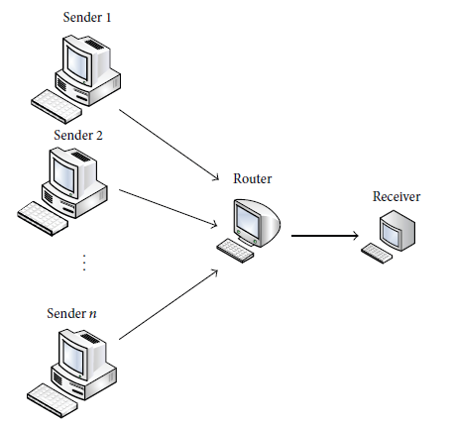
Figure 2.1: The network of the congestion control.
CCP Design Principles to enable rich new congestion control algorithms on data paths, CCP must provide a low-barrier programming environment and access to libraries (e.g., for optimization, machine learning, etc.). Further, new algorithms should also achieve high performance running at tens of Gbit/s per connection with small packet delays in the data path. Should congestion control algorithms run in the same address space as the data path? There are conflicting factors to consider: Safety. Supporting experimentation with algorithms and the possibility of including user-space code means that programs implementing congestion control algorithms should be considered untrusted. If algorithms and the data path are in the same address space, bugs in algorithm or library code could cause data path crashes or create vulnerabilities leading to privilege escalations in the kernel data path. Flexibility. Placing congestion control functionality outside the data path provides more flexibility. For example, we anticipate future use cases of the CCP architecture where a congestion control algorithm may run on a machine different from the sender, enabling control policies across groups of hosts. Performance. On the other hand, congestion control algorithms can access the data path’s congestion measurements with low delays and high throughput if the two reside in the same address space.
Table 2.1: Results as the number of flows increases
Implementation | Reporting Interval | Mean Throughput
Kernel | - | 43 Gbit/s
CCP | Per ACK | 29 Gbit/s
CCP | Per 10 ms | 41 Gbit/s

Single-flow throughput for different reporting intervals between the Linux kernel and CCP user-space, compared to kernel TCP throughput. Per-ACK feedback (0 μs interval) reduces throughput by32%while using a 10 ms reporting interval achieves almost identical throughput to the kernel.
Also, Cell 22 is another region that has high traffic intensity; exhibiting the highest Erlang on Wednesday to be 1502erlang, 1501 on Monday and Thursday while 1500erlang was for Tuesday and Friday. Then Cell 12 was the third highest traffic intensity recording the highest Erlang as 960 on Thursday, 957erlang on Friday, 956erlang on Monday and Tuesday while 950erlang was for Wednesday. All these occurred due to unavailable channels in the cell which is not sufficient enough to accommodate the heavy traffic in the area which can be mostly a commercial center.
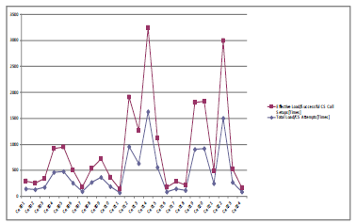
Figure 2.2: Comparism of total load and effective load.

CHAPTER THREE
RESEARCH METHODOLOGY AND ANALYSIS OF THE EXISTING SYSTEM
3.1 RESEARCH METHODOLOGY
Method of data collection refers to the techniques in research used to gather, process, and manipulate information that can then be used to test ideas and theories about social life. Types of methodologies include interview, textbooks and internet research. The main type of method employed in this system is observation on the ways in which message is been sent and not known may be it delivered or not. The propose system will be develop in Window Application which makes use of C# (CSHARP) as the programming language while MYSQL is used as the back end (Database).
METHOD OF SIMULATION
- For each ACK on path r, increase window Wr by 1/Wtotal.
- For each loss on path r, decrease window Wr by Wtotal/2.
- Here Wtotal is the total window size across all subflows. We bound Wr to keep it non-negative, in our experiments we bound it to be ≥ 1pkt, but for the purpose of analysis it is easier to think of it as ≥ 0.
- To get a feeling for the behavior of this algorithm, we now derive an approximate throughput formula. Consider first the case that all paths have the same loss rate p. Each window wr is made to increase on ACKs, and made to decrease on drops, and in equilibrium the increases and decreases must balance out, i.e. rate of ACKs × average increase per ACK must equal rate of drops × average decrease per drop, i.e.
Wt(1-p)
RTT
- Solving for wtotal gives wtotal = p 2(1 − p)/p ≈ p 2/p (where the approximation is good if p is small).
3.2 ANALYSIS OF THE EXISTING SYSTEM
Congestion remains a major challenge to telecommunications service provision both to the service providers as well as the subscribers. The attempted to determine the causes of congestion and evaluated congestion control mechanisms adopted by service providers in Nigeria using MTN Nigeria as a case study. A survey research design methodology using stratified random sampling technique was employed for selecting six states out of 36 states in Nigeria that formed the target population. Automated data from MTN’s data logging machine was the main data collected and supplemented by unstructured interview. Six research questions were stated and tested in line with the set objectives. Data analysis was done using C# Programing language and results presented using View Report.

3.3 PROBLEMS OF THE EXISTING SYSTEM
Lack of Adequate Base Stations: Since there are inadequate base stations, it therefore implies that there will be a lack of adequate channels to support the subscribers and the service rolled out by these operators.
Lack of Good Quality Phones: In any radio link communication, it is the radio link between the handset and the base station that remains the weakest part of the communication system.
Competition for Subscribers among the Operators
Congestion control in the GSM network: Congestion occurs when there are limited resources at the service point. This type of congestion is known as traffic congestion.
3.4 DESCRIPTION OF THE PROPOSED SYSTEM
The purpose of this research work is to establish a transparent set of Interconnection Rules, which shall encompass at least the following requirements. Every operator must allow all other operators full interconnection to its network at technically feasible and convenient points of interconnection, such that traffic may originate on one network and terminate on another, or otherwise pass across networks, without interference, signal deterioration, delay, congestion, or restriction. To design software that will serve as a congestion control system for multi-user telecommunication networks.

3.5 ADVANTAGE OF THE PROPOSED SYSTEM OVER THE EXISTING SYSTEM
It help us to know the status of GSM network resource allocation in Nigeria with a view to knowing areas to be addressed for better performance as follows.
- Keep record of calls across the GSM networks.
- Use Interswitch to put calls through to the right designation without delay, distortions or diversion.
- Determine the calling network and receiving network and use this information for the purpose of interconnectivity tariffs.
- Maintain a database of all registered GSM lines for all GSM communication companies.

CHAPTER FOUR
DESIGN, IMPLEMENTATION AND DOCUMENTATION OF THE SYSTEM
4.1 DESIGN OF THE SYSTEM
System design and specification is very important in every software development. At this stage, the developer puts every factor into consideration while making this design. In the course of the design, the system has to be designed in a way that there will be a close relationship between the inputs and outputs. Also, the design format must be made in a way that it will be acceptable to the end users.
4.1.1 OUTPUT DESIGN
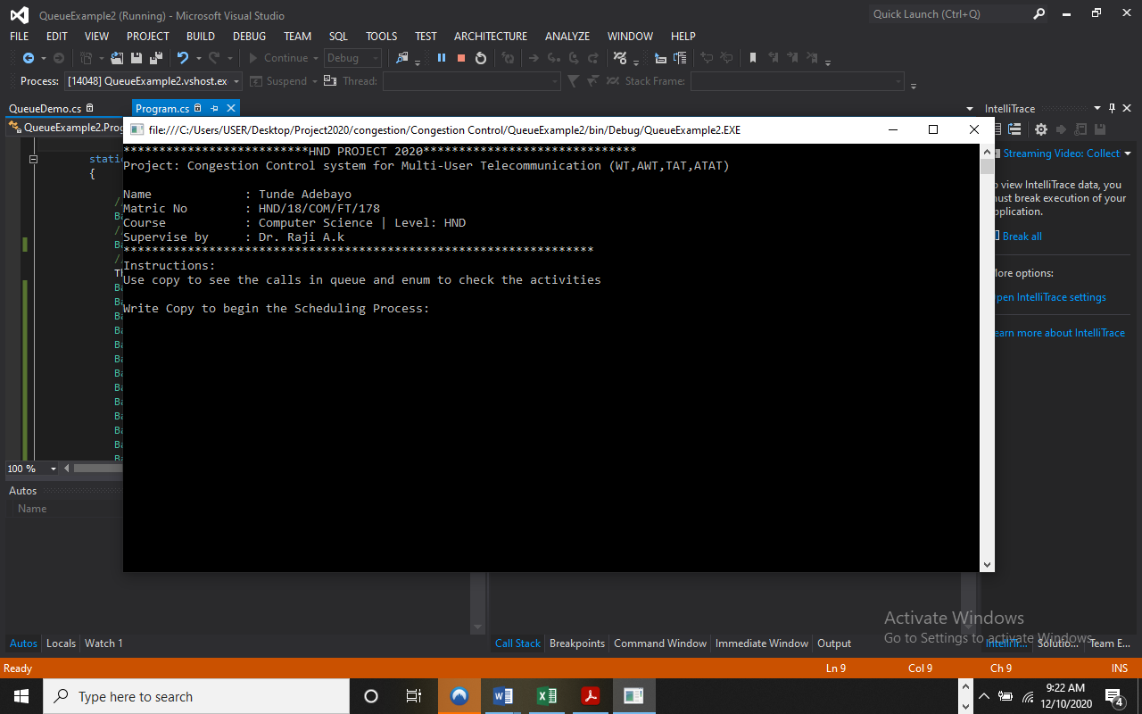
Figure 4.1: Runtime First Page Interface
Show information about the developer and display process to follow.

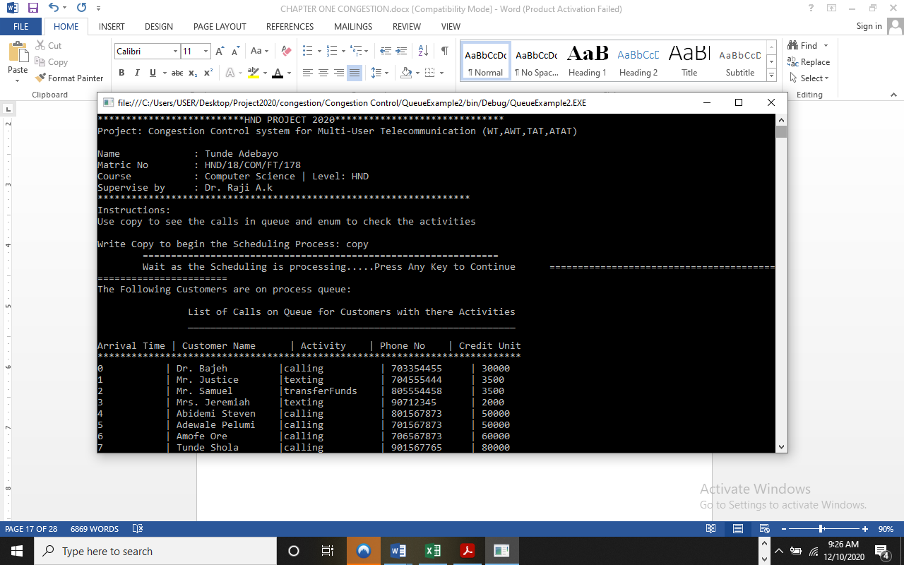
Figure 4.2:
This shows the list of ongoing call with available credit unit.

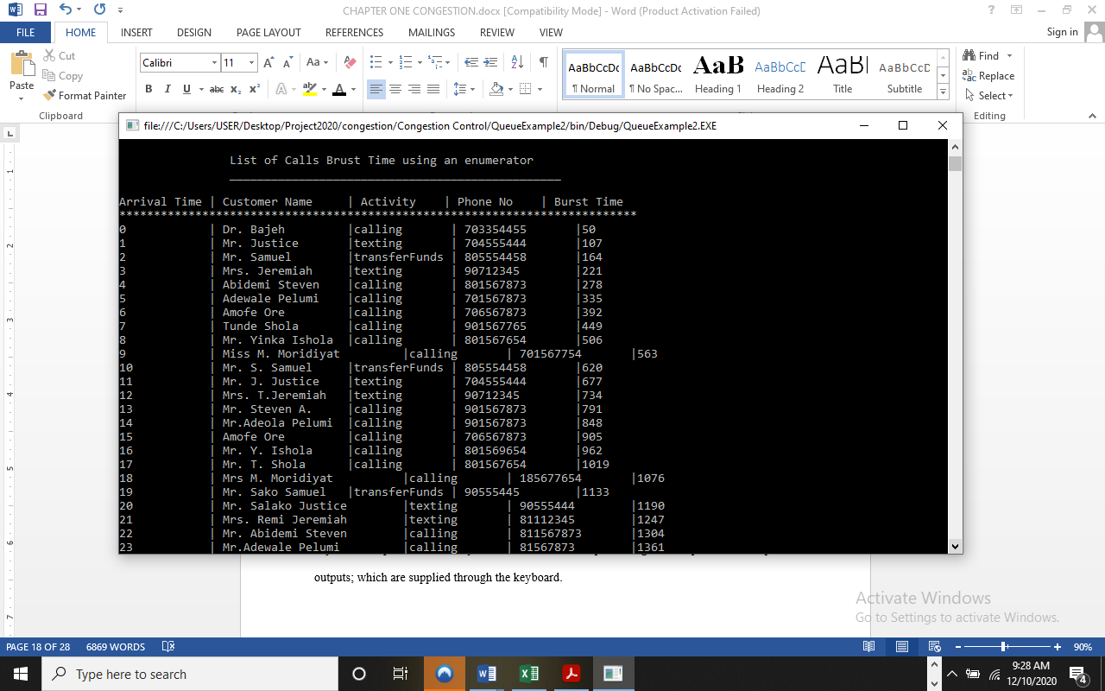
Figure 4.3: List of Calls Burst Time Module
This display list of all burst time users and their details.
4.1.2 INPUT DESIGN
It is also necessary to denote that data inputted in the computer for processing determines what the output will be. The inputs are use in collecting information the student through the keyboard. Inputs are necessary information needed for processing so as to produce the expected outputs; which are supplied through the keyboard.

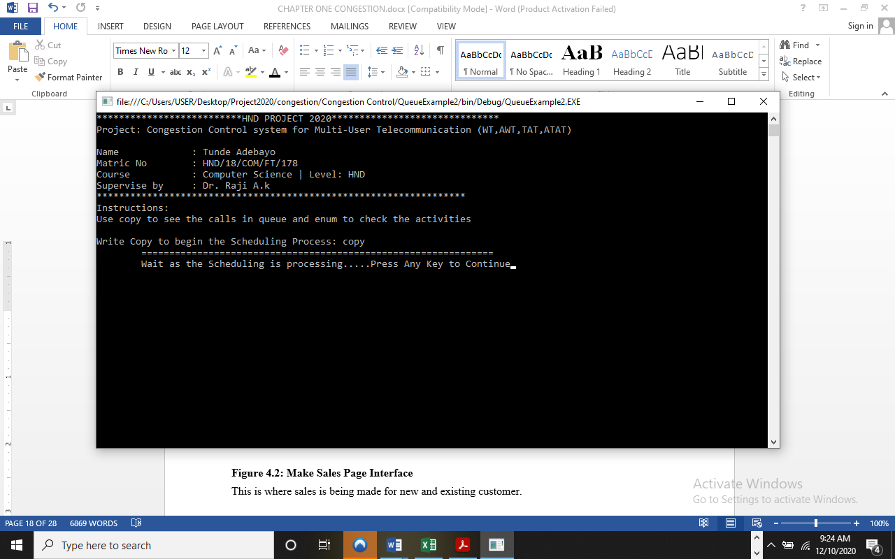
Figure 4.4: Input Interface for operation.
The input environment to begin a schedule
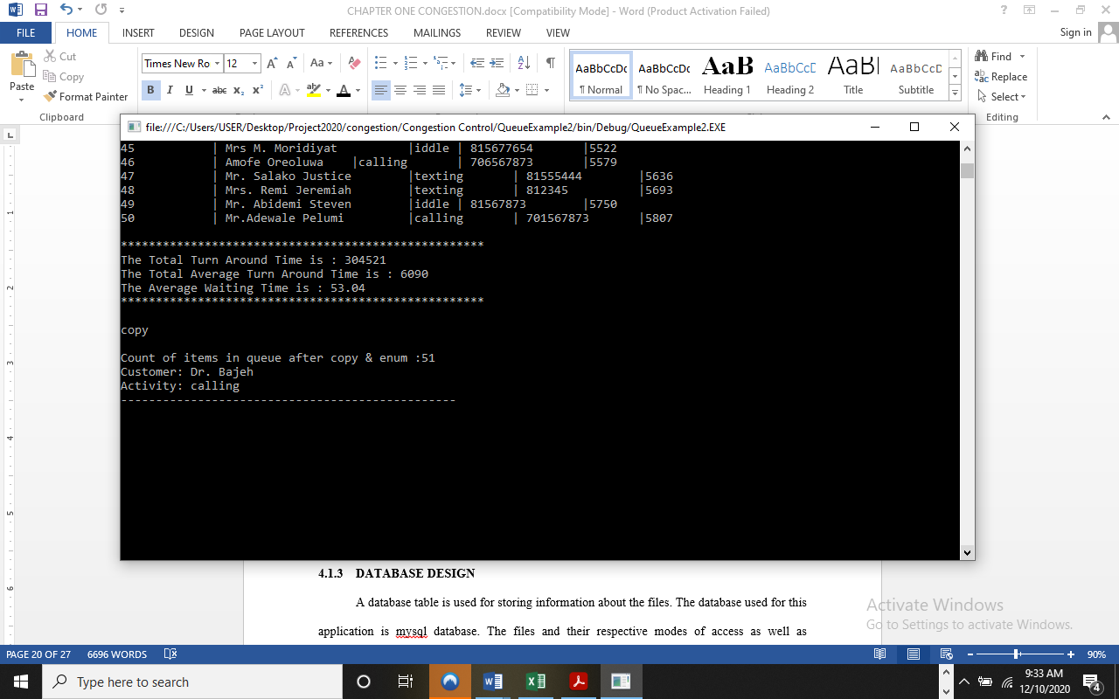
Figure 4.5: input Copy Page
This allow to write and display the calling schedule.
RESULT
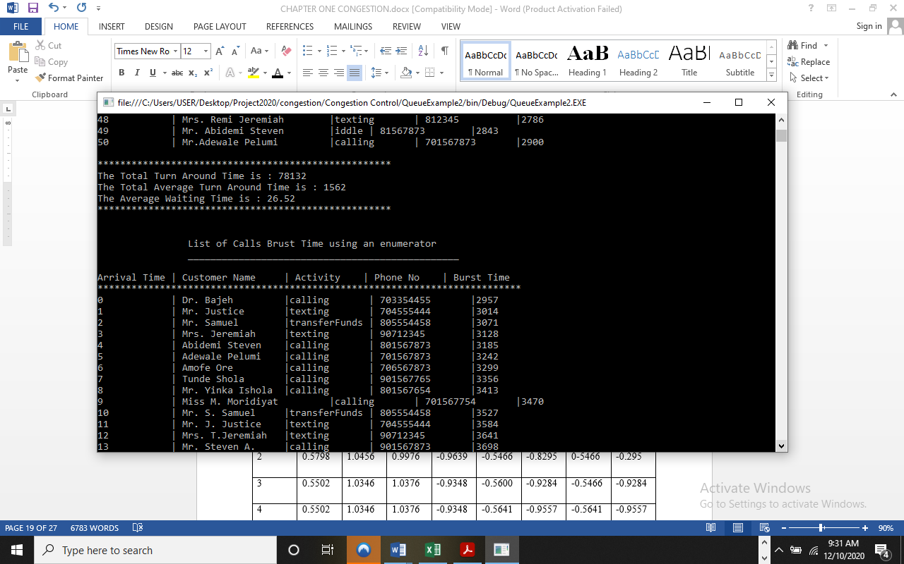
Figure 4.6: call and waiting time result.
This display the waiting time of the process
4.1.3 DATABASE DESIGN
A database table is used for storing information about the files. The database used for this application is mysql database. The files and their respective modes of access as well as information they hold are given below;
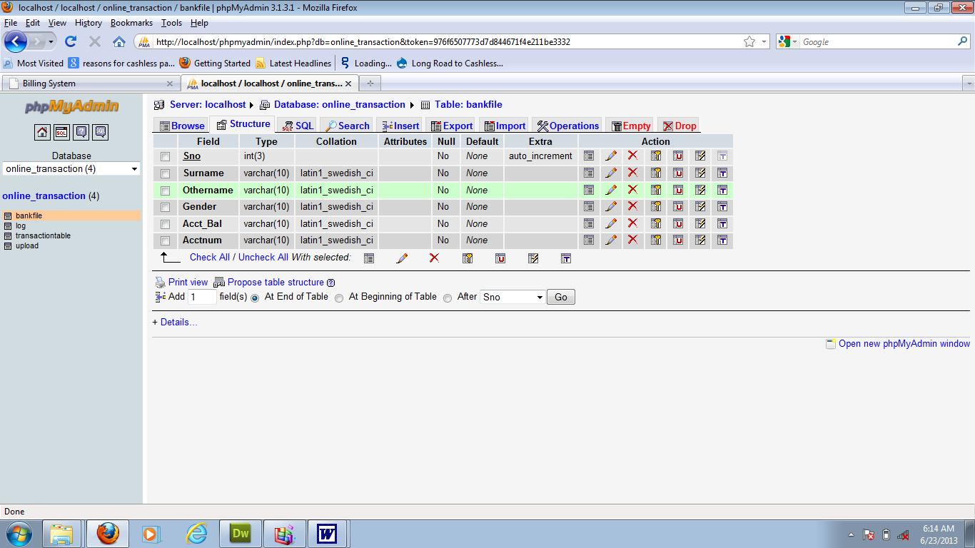
Table 4.1: Users Data base

This are user’s data table where data are stored and retrieved.

Table 4.2: Process Details Data table
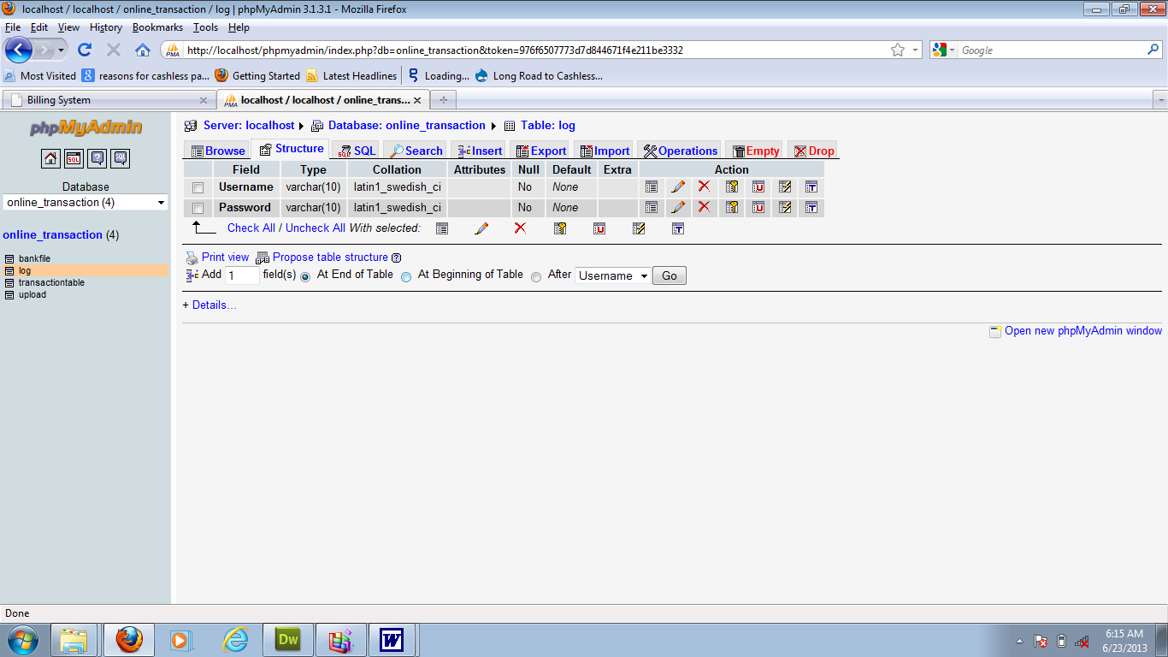
This is where Products data are stored and retrieved
4.1.4 PROCEDURE DESIGN
Procedures are steps which verify the whole process i.e which are everything put together to produce the desired output. This involves the organization of the source document and end with the output result. Documents are sent to various departments to be filled by the employees and later returned to the personnel department which are analyzed to determine which record goes into the computer. After selecting the necessary data, this serves as input to the computer system.

4.2 IMPLEMENTATION OF THE SYSTEM
It is always good to develop new ideas, to implement them on a computer and eventually to relish the satisfaction of achieving a successful result. The implementation process involves converting the system design into a complete and tested EDP that is fully operational and that can be used by the system users to meet their business needs. During implementation phase, the hardware and the software must be implemented.
Implementation of a system can be explained in six steps:-
1. Review design specification
2. Code, test and document programs
3. Train users
4. Perform system test
5. Convert to new system
6. Evaluate and maintain the new system

4.2.1 CHOICE OF PROGRAMMING LANGUAGE
The application is designed using C# as the programming language and MYSQL for database management. Hence, the database testing simply involves running it directly from a Mozilla Firefox web browser on local host server provided by Apache 2.0 in WampServer 2.0 application.
In preparation for the installation of the new system, the method of changeover is given serious consideration to determine the success of the new system. Suitable changeover technique for this system is pilot changeover. The pilot changeover operates by applying the new system bit-by-bit until it covers the whole of the operations. The result obtained from using the pilot method on a small portion of the operations would be used in determining the suitability of the need system for the rest of the operations. This method is similar to testing small sample of a distribution if the test yields a good result then the whole system because fully operational and the manual/existing system is eliminated.

4.2.2 HARDWARE SUPPORT
The computer configuration required to run the software is;
Computer/memory processor PC with a 48dx, MHZ or Pentium, Intel or higher processor required.
Memory: 2GB of RAM
Cache memory: 512KB
Hard disk Minimum size 500GB
Recommended 200GB
Virtual Memory 32Bits
Cache memory 512KB
4.2.3 SOFTWARE
I. Microsoft Visual Studio
ii. MY SQL Database Management Software
iii. Operating system window 07 professional
v. Graphic software paint shop and choosing these two formats GIF (Graphic Image Format)
vi. Scanner software, Mira scans
vii. Web browser software MOZILLA

4.3 PROGRAM DOCUMENTATION
4.3.1 OPERATING THE SYSTEM
Step 1: Boot your computer and click on start button on task bar
Step 2: Click on document
Step 3: Locate Visual Studio and click it
Step 4: Locate your application and click it
Step 5: Choose user and enter the password
Step 6: Click on Options
6.1 Click on Main (toSelect Function)
4.3 Click on Sales (to Make Sales)
4.4 Click on Report (to view Sales Report)
4.5 Click on Help (to view the help page)
4.5 Click on About (to view the about page)
Step 5: Logout
4.3.2 MAINTAINING THE SYSTEM
The use of the term maintenance for software is different from other references to maintenance. Unlike the tires on your car, software does not “wear out”. If this is the case, then why does software maintenance account for such a high percentage of the Total Cost of Ownership for software?
The software maintenance definition refers to changes for defect correction, performance improvements, or adaptations to a changed environment (enhancements). According to this definition, if we build software that is defect-free, performs well, and contains user-controlled parameters to adjust processing rules in response to changing requirements then most maintenance would not be necessary.
Why does this happen? There are many reasons but the most common reasons are time constraints and lack of experience. Adding validation logic takes time. So, people make assumptions about the quality of in-bound data. Assumptions are also made about the volume of transactions and the impact on performance and the stability of the automated business processes. Finally, it is common for new software to be developed by younger developers who don’t understand the maintenance impacts of their designs.
The reality is that business requirements change and most of these assumptions are flawed. Transaction volumes increase, changing business processes require new transactions or new validation criteria, and software users will use the software incorrectly. The cost of software maintenance and the total cost of ownership can dramatically be reduced if developers build software that adjusted to changes in transaction volumes; validated all inbound data and provide user-configurable options for decision logic and data validation.

CHAPTER FIVE
5.0 SUMMARY, RECOMMENDATIONS AND CONCLUSION
  - SUMMARY
This research have demonstrated a working multipath congestion control system. It brings immediate practical benefits in result a seamlessly balance traffic over 3G and WiFi radio links, as signal strength faded in and out enables the same simulation code to run on a variety of data paths. Increases the “velocity” of development and improves maintainability, and Facilitates new capabilities such as the congestion manager-style aggregation and sophisticated signal processing. The implementation achieves high fidelity compared to native data path implementations at low CPU overhead. The use of fold functions and summarization reduces overhead, but not at the expense of correctness or accuracy.
5.2 CONCLUSION
In this research work, a new design method for the congestion controller of the simulation networks is introduced. The developed approach can theoretically guarantee the system performances, including the disturbance rejection and the implied stability of the closed-loop system. This property is useful for congestion controller design. This system studies a control system with time-delay using a model following method which is one of the effective means of solving time-delay problems in a control system. The method can efficaciously control time-delay under disturbances and has excellent practicability.
5.3 RECOMMENDATION
The density based traffic control system has been designed, constructed and tested to ensure validation of its function and operations. In this research, we have succeeded in minimizing the traffic congestions created by the fixed time based traffic light system. The system is effective and the cost of production is very low. Future work is recommended in order to produce the device on a large scale and deploy to all roads in order to reduce traffic congestion in places like Lagos where traffic congestion has become a big issue. Congestion is a canker worm that has devastated GSM network starting from the year 1986 to date. Researchers have been trying their best to ensure that it is brought under control.
The bench mark created by the international telecommunication union has not been achieved even in the developed nations, a reason being that service providers are bent on making fabulous gains instead of satisfying their customers.

REFERENCES
Damon et al (2020) Design, implementation and evaluation of congestion control for multipath TCP. International Journal of Engineering Research & Technology (IJERT) ISSN: 2278-0181
Gaoxiong et al (2021) Congestion Control for Cross-Datacenter Networks. See discussions, stats, and author profiles for this publication at: https://www.researchgate.net/publication/305110968
Hannan (2019) Socially-Aware Congestion Control in Ad-Hoc Networks: Current Status and The Way Forward.
Keith & Hari (2021) Computer-Generated Congestion Control. Vol. 3(8), pp. 155- 162, August 2021 Available online at http://www.academicjournals.org/AJMCSR
Mughele & Tunde (2022) Congestion Control Mechanisms and Patterns of Call Distribution in GSM Telecommunication Networks: The Case of MTN Nigeria.
Okwor & Godwin (2020) Congestion control of the GSM network in Nigeria.
Shin-ichi (2020) Proposed congestion control method for cloud computing environments.
Sara (2021) Congestion Control in Wireless Cellular Networks. International Journal of Computer and Electrical Engineering, Vol. 2,
Wei et al (2022) Adaptive Congestion Control with Reinforcement Learning. International Journal of Computer Networks & Communications (IJCNC) Vol.3, No.3
Yuxin et al (2020) Delay-based virtual congestion control in multi-tenant datacenters. International Journal of Computer Applications (0975 – 8887) Volume 180 – No.26, March 2020

Appendix 1: System Flowchart
Main Menu

Welcome Page

Start

Logout
Result
News Trends
Data Consumption

Stop

Appendix 2: Splash Screen

Start
Display Splash Screen Details
Stop
Open Database

Close Database

Appendix 3: View Queue
Start
Display Activities on Queue
Stop
Open Database

Close Database

Appendix 5: Control Congestion
Start
Open Database

Enter Control code

Output connection activities

Control

Save Data base

Close data

Return

Appendix 6: Source Code
# import scraping modules
from selenium import webdriver
import pandas as pd
# open browser
driver = webdriver.Chrome()
# scrape vital signs
driver.get("https://medicalprogress.dev/patient_file2/vit_signs.html")
html = driver.page_source
driver.close()
data = pd.read_html(html)
data = data[0]
data = pd.DataFrame(data)
# replace empty bloodpressure values (- / -) with nothing
data = data.replace(to_replace='- / -', value='')
# replace all comments behind numbers with nothing
data[data.columns[1]] = data[data.columns[1]].str.replace(r'[a-zA-Z].*', '', regex=True)
print(data)
# make two new columns for sys and dias BP
data['Systolic BP'] = ''
data['Diastolic BP'] = ''
# mask all temp > 43 and < 35
data["Temperature"] = data["Temperature"].mask(data["Temperature"] > float(40))
#transport BP into two new columns separated on systolic and diastolic
#data["Temperature"] = data["Temperature"].mask(data["Temperature"] < float(35))
data['Systolic BP'] = data[data.columns[1]].str.replace(r'[/].*', '', regex=True)
data['Diastolic BP'] = data[data.columns[1]].str.replace(r'.*[/]', '', regex=True)
#mask breathing frequency > 50 and < 3
data["Breathing frequency"] = data["Breathing frequency"].mask(data["Breathing frequency"] > float(50))
# drop the blood pressure column
# data["Breathing frequency"] = data["Breathing frequency"].mask(data["Breathing frequency"] < float(5))
data.drop(data.columns[1], axis=1, inplace=True)
# mask saturation > 100 and <60
data["Saturation"] = data["Saturation"].mask(data["Saturation"] > float(100))
data["Saturation"] = data["Saturation"].mask(data["Saturation"] < float(60))
import plotly.graph_objs as go
fig_graph_vit_par = go.Figure()
import dash
import dash_core_components as dcc
import dash_html_components as html
external_stylesheets = ['https://codepen.io/chriddyp/pen/bWLwgP.css']
app = dash.Dash(__name__, external_stylesheets=external_stylesheets)
server = app.server
app.layout = html.Div([
html.Center(
html.H1('VITAL SIGNS'),
),
html.Div([
dcc.Graph(
id="vit signs",
figure=fig_graph_vit_par)
]),
])
if __name__ == '__main__':
app.run_server(debug=True)

