AN ENHANCED ONLINE LEARNING MANAGEMENT SYSTEM WITH INTEGRATED VIDEO LECTURES
BY

FASHINA ELIZABETH OLAYIDE
ND/23/COM/PT/0122
SUBMITTED TO THE DEPARTMENT OF COMPUTER SCIENCE, INSTITUTE OF INFORMATION AND COMMUNICATION TECHNOLOGY KWARA STATE POLYTECHNIC, ILORIN.
IN PARTIAL FULFILLMENT OF THE REQUIREMENTS FOR THE AWARD OF NATIONAL DIPLOMA (ND) IN COMPUTER SCIENCE

JULY, 2025.

CERTIFICATION
This is to certify that this project work was carried out by FASHINA ELIZABETH OLAYIDE with Matriculation Number ND/23/COM/PT/0122, has been read and approved as meeting part of the award of National Diploma (ND) in computer Science.

…………………………………. ….………………………
MR. BOLAJI-ADETORO D.F Date
(Project Supervisor)

…………………………………. ….………………………
MR. OYEDEPO F.S. Date
(Head of Department)

…………………………………. ….………………………
External Examiner Date

DEDICATION
This project is dedicated to God, the most beneficent, the most merciful and to my Parent

ACKNOWLEDGEMENT
My sincere appreciation and profound gratitude goes to God Almighty for sparing my life during the course of this project work.
I appreciate my project supervisor, the person of Mr.Bolaji-Adetoro D.F. for the love and support that he showered on me like his child throughout the project exercise. God bless you sir.
Lastly, great thanks to my lovely parent and my family at large for supporting me endlessly and keeping me up in prayers.

TABLE OF CONTENTS
Title page i
Certification ii
Dedication iii
Acknowledgements iv
Table of contents v
Abstract vi
CHAPTER ONE: GENERAL INTRODUCTION
1.1 Background of the Study 1
1.2 Statement of the Problem 3
1.3 Aim and Objectives of the Study 4
1.4 Significance of the Study 4
1.5 Scope of the Study 5
1.6 Definition of Term 5
1.7 Organization of the Report 5
CHAPTER TWO: LITERATURE REVIEW
2.1 Review of Related Works 7
2.2 Approaches to e- learning 13
2.3. Computer-based training 15
2.4 Overview of E-learning Models 16
CHAPTER THREE:
RESEARCH METHODOLOGY AND ANALYSIS OF THE SYSTEM
  - Research Methodology 20
  - Analysis of the Existing System 23
  - Problem of the Existing System 23
  - Advantage of the Propose System 24
CHAPTER FOUR:
DESIGN, IMPLEMENTATION AND DOCUMENTATION OF THE SYSTEM
  - Design of the System 22
    - Output Design 22
    - Input Design 24
    - Database Design 24
    - Procedure Design 25
  - Implementation of the System 26
    - Choice of programming language 26
    - Hardware support 27
    - Software Support 27
  - System Documentation 28
    - Operating the System 28
    - Maintaining of the System 28
CHAPTER FIVE: SUMMARY CONCLUSION AND RECOMMENDATION
5.1 Summary 30
5.2 Conclusion 30
5.4 Recommendations 30
References 32
APPENDICES
Algorithm (if any)
Flowcharts
Source Code

Abstract
Learning Management Systems (LMS) reinforce the learning process through online classroom environments. A standard LMS supports an inclusive learning environment for academic progress with interceding structures that promote online collaborative-groupings, professional training, discussions, and communication among other LMS users. Instructors should balance active learning with the use of LMS technological resources and the use of guidelines from the qualified curriculum. An LMS allows instructors to facilitate and model discussions, plan online activities, set learning expectations, provide learners with options, and assist in problem-solving with processes for decision making. An Instructor’s presence within an LMS creates an engaging learning environment. Students can retain their autonomy, enthusiasm, and motivation with LMS use. Stakeholders of the educational community must find scientific studies to support their contributions in LMS platforms to assist scholars in learning mathematics and other academic subjects.

CHAPTER ONE
INTRODUCTION
  - Background to the Study
Learning Management Systems (LMSs) are web-based platforms designed for the management, documentation, monitoring, reporting, and delivery of courses in both higher education and other educational systems. They can assist in traditional classrooms, distance learning, or any combination of the two. LMSs deliver and manage instructional content and typically handle student registration, online course administration, and tracking and assessment of student work. LMSs are known by various names: course management system (CMS), learning content management system (LCMS), virtual learning environment (VLE), and virtual learning system (VLS). (Ghilay, 2020).
Online learning has become an integral part of modern education, revolutionizing the traditional classroom model. With advancements in technology, particularly the widespread availability of high-speed internet, the delivery of educational content has evolved significantly. One crucial component of this evolution is the integration of video lectures into Learning Management Systems (LMS). Video lectures offer a dynamic and engaging way for students to access course material, enhancing the overall online learning experience. Bradley (2021).
Software (web) application used to plan, implement, and assess learning processes. An LMS provides instructors with a way to create and deliver content, monitor learner participation, and assess performance. An LMS provides interactive features such as threaded discussions, video conferencing, discussion forums, etc. Examples include Moodle, WebCT (Blackboard), and Sakai. (About eLearning, 2020).
Today, higher education institutions face many challenges, including the increasing number of students in their education. Learning management systems can be useful for adjusting increased enrollment, varying lessons, and supporting student learning (Dobre, 2021).
Learning Management Systems (LMS) provide teachers and students with an online classroom that reinforces learning processes. In online classroom environments, Learning Management Systems (LMS) reinforce teachers and students in the learning process. A standard LMS supports an inclusive learning environment for academic progress with interceding structures that promote online collaborative groupings, professional training, discussions, and communication among other LMS users,. state that LMS usage provides online learners with consistent information regarding their performance. LMS usage allows online learners to become independent. Learner engagement is sustainable as online users use an LMS to monitor their progress, Al-Fraihat, et al., (2020).
There are several problems with the current way of training and learning in tertiary institutions and other cooperative training. These include: lack of adequate training and required commitment by the lecturers, unreliable technology that hinders lecturers’ ability to monitor students’ activities, students technical limitations were not put into consideration, students finding that lecturers are not sufficiently responsive because the lecturers’ workload or unfamiliarity with new technology and the requirements of reading, following instructions, reducing distractions, and exercising self-discipline have been found difficult to communicate to the students that need to understand the perils of enrolling in online courses if they are not equipped to handle the different learning environments. As a result of these problems, this research is undertaken to deliver an e-learning system for universities and other learning institutions and organizations. It allows upload of learning materials online and gives room for one-on-one interaction with the lecturer by creating an avenue for the students to ask questions and get their answers online. The system is aimed at being user-friendly, reliable and improved with better specifications. The e-learning system is designed such using HTML, CSS, PHP, Ajax, and MySQL, (Wood et al., 2020).
Learning Management Systems (LMS) provide teachers and students with an online classroom that reinforces learning processes. In online classroom environments, Learning Management Systems (LMS) reinforce teachers and students in the learning process. A standard LMS supports an inclusive learning environment for academic progress with interceding structures that promote online collaborative-groupings, professional training, discussions, and communication among other LMS users state that LMS usage provides online learners with consistent information regarding their performance. LMS usage allows online learners to become independent. Learner engagement is sustainable as online users use an LMS to monitor their progress (Hadjithoma & Clark, 2019).

  - Statement of the problem
Despite the growing recognition of the benefits associated with integrating video lectures into Learning Management Systems (LMS), numerous challenges persist, hindering the realization of an optimized online learning experience. These challenges encompass technical, pedagogical, and accessibility aspects, necessitating a closer examination to address the current limitations and propel the evolution of online education to new heights. One of the primary challenges lies in the technological disparities among students. While some learners may have access to high-speed internet and advanced devices, others may face limitations due to geographical location or socioeconomic factors. This digital divide hampers the equitable distribution of educational resources and can impede the effectiveness of video-based learning. An improved LMS must account for these disparities, ensuring that all students, regardless of their technological environment, can access and benefit from video lectures.
  - Aim and objectives
This study aims to develop an improved online LMS that revolutionizes video lectures by incorporating interactive features, personalized learning pathways, and accessibility options. The objectives are:
- To design and implement interactive video lectures with quizzes, polls, and real-time Q&A sessions to promote active learning and engagement.
- To curate personalized learning paths based on individual student performance, learning styles, and preferences, adapting to their pace and needs.
- To integrate AI-powered adaptive learning algorithms that personalize video content and recommend relevant supplementary materials for deeper understanding.
1.4 Significance of the Study
This study holds significant potential for transforming online learning, by promoting active learning, personalization, and accessibility, the improved LMS can lead to deeper understanding, enhanced knowledge retention, and better skill development. Interactive features and personalized learning paths can keep students motivated, reduce drop-out rates, and foster a more enjoyable learning experience. By providing accessible and adaptable learning opportunities, the LMS can cater to diverse learners and bridge educational gaps, promoting inclusivity and equity. This study can contribute to the evolution of online learning platforms, setting new standards for engaging, effective, and personalized video-based education.
1.5 Scope of the Study
This study will focus on the development and evaluation of the core functionalities of the improved LMS, including interactive video lectures, personalized learning paths, and adaptive learning algorithms. It will consider accessibility features like transcripts and captions but may not delve into broader LMS functionalities like course management or administrative tools. Additionally, the study will focus on a specific subject area or course to allow for more in-depth research and evaluation.
1.6 Definition of Terms
Online Learning Management System (LMS): A software application used to deliver educational content, track student progress, and facilitate communication between students and instructors over the internet.
Interactivity: The degree to which students can actively engage with video content through features such as quizzes, annotations, and discussions.
Video Lectures: Pre-recorded video presentations delivered by instructors to convey course content and concepts.
1.7 Organisation of the Report
This is the overall organizational structure of the work as presented in this project write-up. Chapter one of this project deals with the introduction to the general work in the project. It also entails the statement of the problem, aims and objectives of this project, the significance of the study, the scope and limitation of the study and organization of the report.
Chapter two focuses on the review related journals and books, historical background of the study, as well as computerization current state of the art.
Chapter three covers the methods used for data collection, description of the current procedure, problems of existing system, description of the proposed system and the basic advantages of the proposed web-based application.
Chapter four entails design, implementation and documentation of the system. The design involves the system design, output design form, input design form, database structure and the procedure of the system. The implementation involves the implementation techniques used in details, choice of programming language used and the hardware and software support. The documentation of the system involves the operation of the system and the maintenance of the system.
Chapter five contains with the summary, experience gained, conclusion and recommendation.

CHAPTER TWO
LITERATURE REVIEW
2.1 Review of Related Works
Yaron, (2019) reviews a journal on the Effectiveness of Learning Management Systems in Higher Education: Views of Lecturers with Different Levels of Activity in LMSs. The study aimed to examine the effectiveness of the Learning Management System (LMS) according to the views of lecturers with different levels of activity in LMS. The research was based on a sample of lecturers (n = 45) who teach academic courses using Moodle. They were asked to answer an online questionnaire to assess their attitudes about the characteristics of Moodle LMS they use for their courses as well as their level of activity in Moodle. The findings indicate that there was a significant difference between the two groups of lecturers. Concerning faculty members whose level of activity in LMS is medium or higher, all of the LMS characteristics examined were very highly rated. On the other hand, for lecturers whose level of activity in LMS is low, most of the factors examined were rated with lower than intermediate scores. Possible explanations for this considerable gap in activity may be a lack of knowledge or motivation. Therefore, it is recommended to identify the reasons for lecturers’ low activity and train, encourage, or motivate them so that they become more active in LMS.
Vaughn, (2020) Learning Management System (LMS) Use with Online Instruction. Learning Management Systems (LMS) reinforce the learning process through online classroom environments. A standard LMS supports an inclusive learning environment for academic progress with interceding structures that promote online collaborativegroupings, professional training, discussions, and communication among other LMS users. Instructors should balance active learning with the use of LMS technological resources and the use of guidelines from the qualified curriculum. An LMS allows instructors to facilitate and model discussions, plan online activities, set learning expectations, provide learners with options, and assist in problem-solving processes for decision-making. An Instructor’s presence within an LMS creates an engaging learning environment. Students can retain their autonomy, enthusiasm, and motivation with LMS use. Stakeholders of the educational community must find scientific studies to support their contributions to LMS platforms to assist scholars in learning mathematics and other academic subjects.
David, et al (2020). This study empirically examines the instructional value of online video lecture videos that a course instructor prepares to supplement classroom or onlinebroadcast lectures. The study examines data from a classroom course, where the videos have a slower, more step-by-step lecture style than the classroom lectures; student use of videos is voluntary, can be tailored by students to meet their learning and topic-review needs, and can occur when and where students learn most effectively. The study's specific objectives are to identify and measure the types of learning benefits that video lectures provide, gauge students' acceptance and use of this form of computer-based instruction, and compare results from alternative video designs to determine if learning is differently affected. The course is highly technical (financial accounting) and is required of all business school students as they enter the school. The university is middle-tier and located in a medium-sized metropolitan area. Students are highly varied in their academic abilities and motivation, and they often have substantial off-campus job responsibilities. Findings are based on analysis of survey data and grade distributions. They include comparisons of with-videos and no-videos sample data. The most significant findings are that video lectures are used by students for tutorial help, they improve initial learning, they reduce dropout rates, and they improve course grades.
Vinay and Hosam, (2019) OLMS: Online learning management system for e-learning.In this paper, we introduce a learning management system that provides a management system for centralized control of course content. A secure system to record lectures is implemented as a key feature of this application. This feature would be accessed through a web camera and mobile recording. These features are mainly designed for e-learning environments. In addition, we integrate a learning management system with a platform for social activities, and student assessment analysis is developed. Users Including students, professors, and administrators can manage schedules, lectures, assignments, jobs, events, discussions, and research.
Bello, &Abubakar, (2021) An Improved E-Learning System. This research deals with the design and implementation of an improved e-learning system taking Computer Science Unit, Mathematics Department of Usmanu Danfodiyo University, Sokoto as the case study. It allows the upload of learning materials online and gives room for one-on-one interaction with the lecturer by creating an avenue for the students to ask questions and get their answers online. The system is aimed at being user-friendly, reliable, and improved with better specifications. The e-learning system is designed using HTML, CSS, PHP, Ajax, and MySQL. To ensure proper interaction between students and lecturers, this proposed system incorporates audio calls to lecturers through Skype and also video conferencing through webinar (Web Based Seminar); a software that enables lecturers to deliver lectures live. It gives the system the ability to give, receive, and discuss information in real-time.

Jamal and Ameera, (2019) Using Learning Management Systems (LMSs) in educational environments has facilitated the communication between students and teachers, and raised new challenges as well. The aim of this research is to investigate the role of LMS in the learning and teaching processes from students and teachers perspectives. We adopted a social constructivist worldview. We used an inductive qualitative approach, a single case study design and hermeneutical approach for analyzing the interviews and observations. We used Garrison et al. (2000) community of inquiry framework as a theoretical guide for the study. The research took place at the School of Computer Science, Physics and mathematics department at Linnaeus University, Växjö campus. The participants of this research were students and teachers from two master levels within the program of Information Systems. The study results indicated that students and teachers were content with the usage of Blackboard in organizing courses materials. Although, most teachers didn’t encourage interactive and discussion activities on Blackboard, students expressed the need for such activities to help them in constructing and building new meanings.
Khaleel and Pilar, (2020) A breakthrough in the development of online learning occurred with the utilization of Learning Management Systems (LMS) as a tool for creating, distributing, tracking, and managing various types of educational and training material. Since the appearance of the first LMS, major technological enhancements transformed this tool into a powerful application for managing curriculum, providing rich-content courseware, assessment and evaluation, and dynamic collaboration. With several current research fields targeting various technologies related to the LMS, the future promises many changes in its structure, operations, and implementation. The most important technology that is expected to transform many future aspects is the Internet of Things (IoT). In this paper, we provide a framework for a future LMS enhanced by IoT capabilities. We outline several elements of the LMS that will be affected by IoT, and the expected enhancements and changes that IoT will bring to the LMS functionalities. The framework presented for the IoT-enhanced LMS constitutes the main component of a three year research project that is being conducted at the Arts, Sciences, and Technology University (AUL). In this paper, we illustrate the main parts of this project and the implementation plan of each part, including the prospected outcomes and benefits.
Khawlah and Mesonovich, (2019) In today’s technology driven societies, academic institutions, especially at the tertiary level, are incorporating Information and Communication Technologies (ICTs), utilizing learning management systems (LMS) and adopting blended learning approaches to improve student performance and enhance student learning. Currently a good deal of research is conducted to assess the effectiveness of such techniques and technologies on student learning and performance. A great deal of this research deals with LMS’s, e-learning platforms, such as Blackboard, but not much is being conducted on LMS’s provided by publishing companies, like McGraw Hill Education, whose course management systems are available for a range of courses and being used throughout the world. This paper examines the effectiveness of McGraw Hill Education’s Connect on improving student grades in a pre-calculus course at a university in a Gulf Cooperation Council (GCC) country. Using simple and multiple linear regression analysis to investigate whether there was a relationship between the Connect online assignments’ grades and the total course grade of students in the course, and two independent sample t-tests to compare the grades between two pre-calculus courses (one taught using the Connect component, and the other taught in the traditional format) results show that using Connect has positive impact on student grades.
Goyal et al (2022) Web-based learning is becoming a newly accepted standard in education, more so with COVID-19 pandemic. To use technology to redesign learning experiences, a blend of synchronous and asynchronous approaches was used wherein the routine lectures through MS Teams (synchronous) were integrated with an online learning management system (LMS), ‘Moodle’ (modular object-oriented dynamic learning environment) based, four-quadrant approach (asynchronous). We aimed to determine the student’s engagement, performance and perception of the new online LMS. All 170 students of the 1st year MBBS of batch 2020 were enrolled in the course. A module was developed for teaching ‘Physiology of Vision’ with this blended approach. Along with routine online lectures through Microsoft Teams, supplementary materials in the form of multimedia presentations and additional links to useful websites were provided through online LMS. The online activity of students was recorded and assessments were done. A feedback form was filled out by students at the end of the course. A significant positive correlation of examination scores with individual student’s activity logs and significantly better scores in top Moodle users along with significantly higher marks in Moodle-based modules than in other modules confirmed the value of Moodle in improving student performance. Overall feedback from students was clearly in favour of implementing Moodle as a complementary tool to traditional teaching.
Khaleel and Wakim,(2019) A breakthrough in the development of online learning occurred with the utilization of Learning Management Systems (LMS) as a tool for creating, distributing, tracking, and managing various types of educational and training material. Since the appearance of the first LMS, major technological enhancements transformed this tool into a powerful application for managing curriculum, providing rich-content courseware, assessment and evaluation, and dynamic collaboration. With several current research fields targeting various technologies related to the LMS, the future promises many changes in its structure, operations, and implementation. The most important technology that is expected to transform many future aspects is the Internet of Things (IoT). In this paper, we provide a framework for a future LMS enhanced by IoT capabilities. We outline several elements of the LMS that will be affected by IoT, and the expected enhancements and changes that IoT will bring to the LMS functionalities. The framework presented for the IoT-enhanced LMS constitutes the main component of a three year research project that is being conducted at the Arts, Sciences, and Technology University (AUL). In this paper, we illustrate the main parts of this project and the implementation plan of each part, including the prospected outcomes and benefits.
2.2 Approaches to e- learning
Since technology was first applied in education, e-learning has changed. A shift is being observed towards blended learning services, which combine computer-based exercises with in-person, interactive, or classroom settings.
Bates and Poole suggest that different types or forms of e-learning can be considered as a continuum, from no e-learning, i.e. no use of computers and/or the Internet for teaching and learning, through classroom aids, such as making classroom lecture PowerPoint slides available to students through a course web site or learning management system, to laptop programs, where students are required to bring laptops to class and use them as part of a face-to-face class, to hybrid learning, where classroom time is reduced but not eliminated, with more time devoted to online learning, through to fully online learning, which is a form of distance education. This classification is somewhat similar to that of the Sloan Commission reports on the status of elearning, which refer to web enhanced, web supplemented and web dependent to reflect increasing intensity of technology use. In the Bates and Poole continuum, 'blended learning' can cover classroom aids, laptops and hybrid learning, while 'distributed learning' can incorporate either hybrid or fully online learning. It can be seen then that e-learning includes a wide range of applications and it is often by no means clear, even in peer reviewed research publications, which form of e-learning is being discussed. However, Bates and Poole argue that when instructors say they are using e-learning, this most often refers to the 9 use of technology as classroom aids, although over time, there has been a gradual increase in fully online learning.
2.2.1 Impact on learning outcomes
The pervasive use of digital technologies and online courses has led researchers to question the impact of on-line learning technology on student’s educational engagement and learning outcomes. Research conducted has presented somewhat mixed findings. However, while some research conducted showed no significant difference between online and traditional learning, a great deal of studies support the effectiveness of using online learning, presenting empirical evidence that shows that there is significant positive impact of online, blended and hybrid courses on learning outcomes. Such positive impact has been attributed to the fact that they not only accommodate pedagogical requirements, disciplines, and course levels, but also student needs. They have been described as being fair in their assessment practices and reported as aiding in helping students become responsible learners who can utilize the knowledge they gained in a variety of contexts. Positive effects on students’ academic outcomes and increased student engagement and ownership of learning have been reported, and teachers have also reported that it enables them to be more effective in being able to meet student needs and make fundamental shifts toward higher-value responsibilities. In sum the studies report that such blended learning contexts increase student motivation, ownership of learning, and improve academic outcomes.
2.2.2 Two popular tools for E-learning are Blackboard Inc. and Module
Blackboard Inc. has over 20 million users daily. Offering six different platforms: Blackboard Learn, Blackboard Collaborate, Blackboard Mobile, Blackboard Connect, Blackboard Transact, and Blackboard Analytics; Blackboard's tools allow educators to decide whether their program will be blended or fully online, asynchronous or synchronous. Blackboard can be used for K-12 education, Higher Education, Business, and Government collaboration. decide whether their program will be blended or fully online, asynchronous or synchronous. Blackboard can be used for K-12 education, Higher Education, Business, and Government collaboration. Module is an Open Source Course Management System. It is free to download and provides blended learning opportunities as well as platforms for distance learning courses. The Module website has many tutorials for creating a program or becoming a Module student. ICT expenditures in education have differed within and between countries. Finland, Norway, Belgium and Korea appear to make best use of educational ICT.

2.3 Computer-based training
Computer-based learning or training (CBT) refers to self-paced learning activities delivered on a computer or handheld device. CBT often delivers content via CD-ROM, and typically presents content in a linear fashion, much like reading an online book or manual. For this reason, CBT is often used to teach static processes, such as using software or completing mathematical equations. Computer-based training is conceptually similar to web-based training (WBT), the primary difference being that WBTs are delivered via Internet using a web browser. Assessing learning in a CBT is often by assessments that can be easily scored by a computer such as multiple choice questions, drag-and-drop, radio button, simulation or other interactive means. Assessments are easily scored and recorded via online software, providing immediate end-user feedback and completion status. Users are often able to print completion records in the form of certificates. CBTs provide learning stimulus beyond traditional learning methodology from textbook, manual, or classroom-based instruction. For example, CBTs offer user-friendly solutions for satisfying continuing education requirements. Instead of limiting students to attending courses or reading printed manuals, students are able to acquire knowledge and skills through methods that are much more conducive to individual learning preferences. For example, CBTs offer visual learning benefits through animation or video, not typically offered by any other means.
2.4 Overview of E-learning Models
There are really no models of elearning per se only e-enhancements of models of learning. That is to say: using technology to achieve better learning outcomes, or a more effective assessment of these outcomes, or a more cost-efficient way of bringing the learning environment to the learners. Models of e-learning describe where technology plays a specific role in supporting learning. These can be described both at the level of pedagogical principles and at the level of detailed practice in implementing those principles. Cunningham pointed out the importance of linking theory to practice in the design and development of any instructional system and emphasized, “…effective design is possible only if the developer has a reflexive awareness of the theoretical basis underlying the design” (p.90). Appropriate instructional design that includes learning theories and principles are critical to the success of e-leaning. Instructional design has always relied on instructional models, namely behaviorism, cognitivism, humanism, and constructivism. Much of the attention in the last two decades has been shifted to constructivism because it promotes active learning through knowledge construction. It is a good fit for e-learning because it ensures learning among learners. The social aspect of learning is also important in building e-learning model. In educational settings, these distributed forms of interaction are manifested in learner-instructor, learner-content, and learner-learner interactions. These types of interactions are perceived as necessary in enhancing social learning skills such as communication or group-process skills. In E-Learning contexts, distributed forms of interaction can take place in knowledge networks, virtual classrooms, and asynchronous learning networks where groups of learners or professionals with a common goal congregate to share information and resources, ask questions, solve problems, and achieve goals, and in doing so, collectively build new knowledge and evolve the practices of their community. Since the aim of this research is to describe and assess teaching and learning experience through the usage Blackboard from the users perceptions, we need to base our work on a model that focus on the users, the social collaborative aspect of learning and how it helps in constructing new knowledge. The Community of Inquiry (COI) model is suitable for this research since it is based on the constructivism and social collaborative aspects of learning. The underlying construct of the community of inquiry is that the optimal educational experience lies in the vortex of three educational elements. It is this defining characteristic of the community of inquiry that allows it to be used as an evaluation tool.
2.4.1 Collaborative learning
Computer supported collaborative learning (CSCL) uses instructional methods designed to encourage or require students to work together on learning tasks. CSCL is similar in concept to the terminology, "e-learning 2.0". Collaborative learning is distinguished from the traditional approach in which the instructor is the principal source of knowledge and skills For example; the neologism "e-learning 1.0" refers to the direct transfer method in computer-based learning and training systems (CBL). In contrast to the linear delivery of Content, often directly from the instructor's material, CSCL uses blogs, wikis, and cloudbased document portals (such as Google Docs and Drop box). With technological Web 2. 0 distances, sharing information between multiple people in a network has become much easier and use has increased. 1 One of the main reasons for its usage states that it is "a breeding ground for creative and engaging educational endeavors.
Using Web2.0 social tools in the classroom allows for students and teachers to work collaboratively, discuss ideas, and promote information. According to Sandal (2008), blogs, wikis, and social networking skills are found to be significantly useful in the classroom. After initial instruction on using the tools, students also reported an increase in knowledge and comfort level for using Web 2.0 tools. The collaborative tools additionally prepare students with technology skills necessary in today's workforce.
2.4.2 Technology
There are many types of technologies used in the education system. Most e-Learning situations now use combinations of these techniques, including blogs, collaborative software, portfolios, and virtual classrooms.
2.4.3 Audio
The radio has been around for a long time and has been used in educational classrooms. Recent technologies have allowed classroom teachers to stream audio over the internet. There are also webcasts and podcasts available over the internet for students and teachers to download. For example, iTunes has various podcasts available on a variety of subjects that can be downloaded for free.
2.4.4 Videos
Videos may allow teachers to reach students who are visual learners and tend to learn best by seeing the material rather than hearing or reading about it. Teachers can access video clips through the internet instead of relying on DVDs or VHS tapes. Websites like YouTube are used by many teachers. Teachers can use messaging programs such as Skype, or webcams, to interact with guest speakers and other experts. Interactive video games are being integrated in the curriculum at both K-12 and higher education institutions.

2.4.5 Learning managements
Learning management systems, for example, Blackboard or Module, are internet based applications that institutions used to reach their students. It allows educators to create and deliver course material using the internet. Educators can post announcements, grade assignments, check on course activity, and participate in class discussions. Students can submit their work, read and respond to discussion questions, and take quizzes.

CHAPTER THREE
RESEARCH METHODOLOGY AND ANALYSIS OF THE EXISTING SYSTEM
3.1 Research Methodology
The proposed e-learning system requirements statements define the capabilities and performances that the system will provide. The requirements are used to guide the design of specific system deliverables and to assess whether those deliverables are satisfactory for the intended purpose. The system requirements describe what is needed; the deliverables are how that is accomplished; and the outcomes describe why the system is worthwhile. These requirements are:
- The admin will be able to manage courses, levels, users, departments or units, students, lecturers, and contents.
- The lecturer will be able to manage classes for his/her classes, send and receives messages to and from his/her students and other lecturers, set conference using webinar send the link to the intended class via notification, and manage downloads, announcements, assignments, and quiz.
- The student will be able to view his/her class, view notifications, send and receive messages to and from his/her lecturers and other students, view and download lecture materials including audio and videos, and call and chat will the lecturers via Skype.
- Students can take quiz questions anytime they are ready.
- Notification can be put up by the lecturer at any time and students can read them once they log on.
- Students can attend classes live through software incorporated into the system called WEBINAR.
- Students can also contact the lecturer through Skype.

Use Case Diagram of the Proposed System
A use case diagram is a UML model that represents the dynamic behavior of a system. It is
considered for high-level requirement analysis of a system. So when the requirements of a system are analyzed the functionalities are captured in use cases. So, they are system functionalities written in an organized manner. Taking Computer Science Unit, Department of
Mathematics, Usmanu Danfodiyo University Sokoto as the case study there are three actors including: admin, lecturer and student.
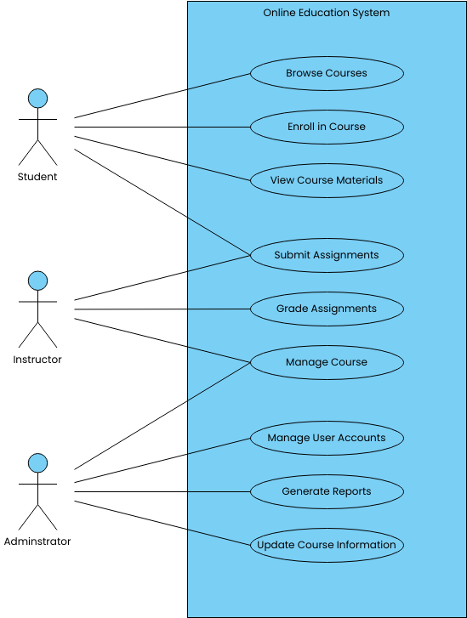

The existing learning management system (LMS) serves as the backbone of online education delivery within our institution. It provides a centralized platform for course materials, assignments, assessments, and communication between instructors and students. The system primarily relies on text-based resources, discussion boards, and occasional multimedia elements for content delivery.
Features and Functionality:
The current LMS offers a range of features, including:
Course organization: Materials are organized by course, with modules or units for easy navigation.
Content delivery: Text-based lectures, documents, and occasionally embedded multimedia elements like images or audio files.
Assignments and assessments: Submission of assignments, quizzes, and tests, with grading and feedback functionalities.
Communication: Discussion boards, messaging systems, and announcements for interaction between instructors and students.
Gradebook: A centralized area for tracking student progress and grades.
Strengths:
Familiarity: The existing system is well-established and familiar to both instructors and students.
Reliability: It has a proven track record of uptime and stability, ensuring consistent access to course materials.
Basic Functionality: Provides essential features for content delivery and assessment management.
Scalability: It can accommodate a large number of users and courses.
3.3 PROBLEMS OF THE EXISTING SYSTEM
The existing learning management system (LMS) serves as the cornerstone of online education delivery within our institution. However, despite its functionality, reliability, and familiarity, several critical problems hinder its effectiveness and limit its potential to facilitate optimal learning experiences. This section delves into the key challenges and shortcomings of the current system.
Limited Interactivity: One of the primary issues with the existing LMS is its limited interactivity. The system predominantly relies on text-based resources and lacks robust support for interactive learning experiences. Without features such as interactive quizzes, simulations, or collaborative activities, students' engagement and active participation may suffer. Passive consumption of content can lead to decreased motivation, comprehension, and retention, ultimately undermining the effectiveness of online education.
Accessibility Challenges: Accessibility is a critical aspect of online education, ensuring that all students, regardless of disabilities or impairments, can access and engage with course materials effectively. However, the existing system may fall short in addressing accessibility standards and accommodating diverse needs. Lack of support for screen readers, alternative text for images, keyboard navigation, or other accessibility features can exclude differently-abled students from fully participating in online courses, violating principles of inclusivity and equity.
3.4 ANALYSIS OF THE PROPOSED SYSTEM
The proposed online learning management system offers a comprehensive solution enriched with innovative features, notably the integration of video lectures, aiming to enhance interactivity, engagement, and accessibility for both instructors and students while addressing the shortcomings of the existing system through a modernized user interface, robust multimedia support, enhanced mobile optimization, and adherence to accessibility standards, thereby fostering an enriched online learning experience conducive to improved learning outcomes.
The proposed system also emphasizes an intuitive user interface designed to streamline navigation and enhance usability, ensuring an effortless user experience for instructors and students alike. The integration of video lectures represents a significant advancement, providing instructors with a powerful tool for delivering dynamic, multimedia-rich content that caters to diverse learning preferences and enhances comprehension. The system's enhanced mobile optimization ensures seamless access to course materials on a variety of devices, empowering learners to engage with content anytime, anywhere. By prioritizing accessibility standards, the proposed system aims to create an inclusive learning environment, accommodating the needs of all users, including those with disabilities or impairments.
3.5 ADVANTAGES OF THE NEW SYSTEM OVER THE EXISTING SYSTEM
- Clear enumeration of the benefits that the new system brings.
- Enhanced user experience through improved interface design and navigation.
- Faster performance and better responsiveness.
- Increased accessibility features for all users.
- Comprehensive support for various learning methods, including video lectures.
- Enhanced engagement tools for students, such as interactive quizzes or discussion forums.
CHAPTER FOUR
IMPLEMENTATION AND DOCUMENTATION OF THE SYSTEM
4.1 Design of the System
Generally, all efforts are geared toward designing a system program that eliminates all the setbacks of the existing manual method. This new approach is simple, efficient, and guaranteed. The proposed method is designed to meet the goal and objective of the organization. The design of the system is intended to solve the various problems of online goods ordering
4.1.1 Output Design
It refers to the report expected to be generated from files in the database. The generated reports are lists of views, index pages, etc. Below is the snapshot of the output designs
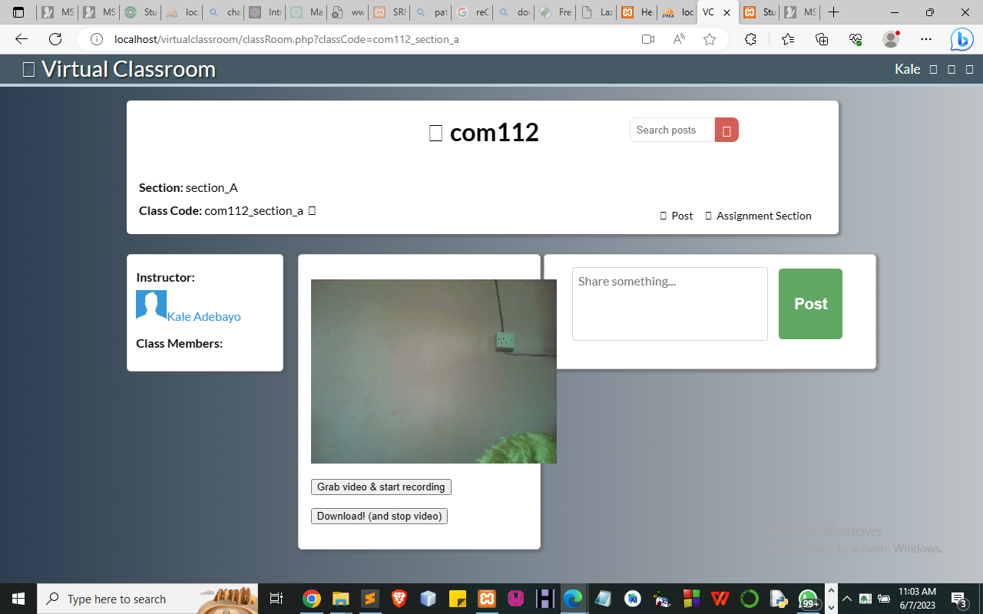
Figure 4.1: Classroom Live Page

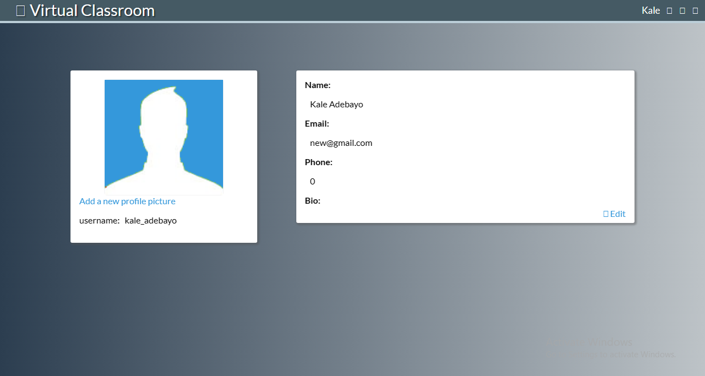
Figure 4.2: Profile Page
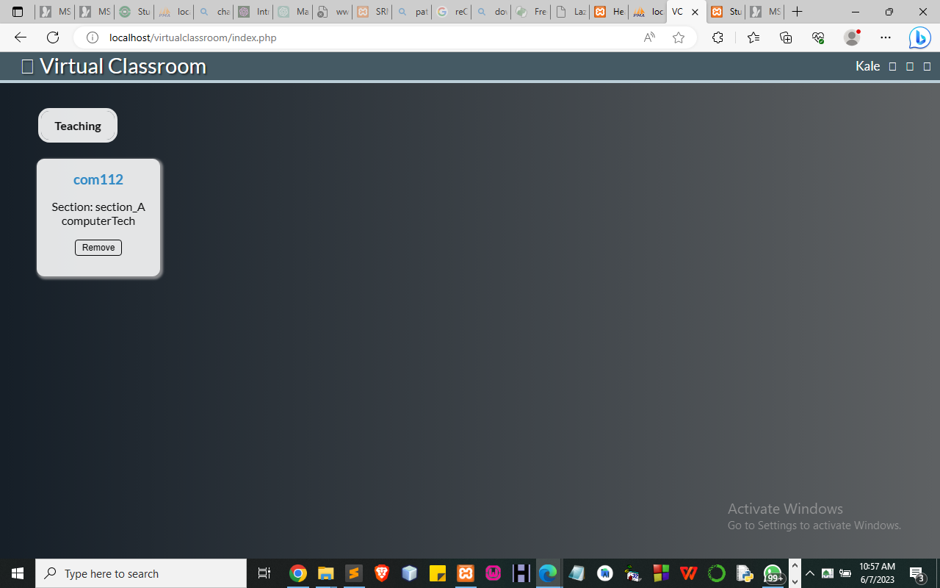
Figure 4.3: Available Created Class Page/ E-Classroom Page
4.1.2 Input Design
Design is a way of mapping and arranging parts into a whole, which satisfies the objective involved. The input design refers to the type of all data used to feed information into the database via the program and the format and the input used for the system. Below are the snapshots of the input designs
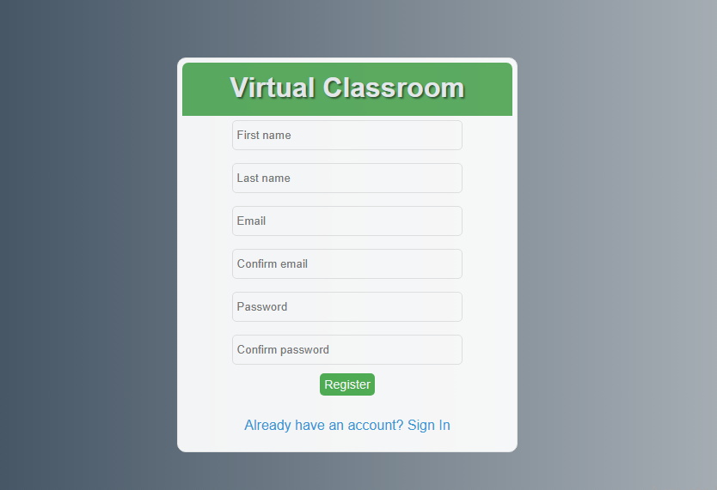
Figure 4.4: This page display where student Join or Create Class Page
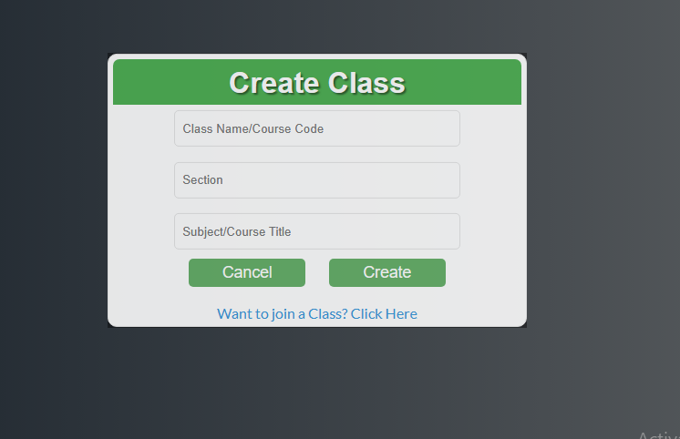
Figure 4.5: Create Class Page allows the user to create a class
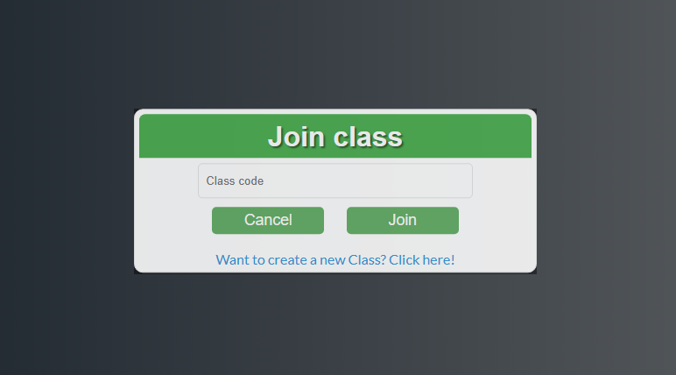
Figure 4.6 Join Class Page. This page allows the student to join the class
4.1.3 Procedure Design
Procedures are steps that verify the whole process i.e. which are everything put together to produce the desired output. This involves the organization of the source document and ends with the output result. Documents are sent to various departments to be filled by the employees and later returned to the personnel department which is analyzed to determine which record goes into the computer.
After selecting the necessary data, this serves as input to the computer system.
4.2 Implementation of the System
It is always good to develop new ideas, implement them on a computer, and eventually relish the satisfaction of achieving a successful result. The implementation process involves converting the system design into a complete and tested EDP that is fully operational and that can be used by the system users to meet their business needs. During the implementation phase, the hardware and the software must be implemented.
The implementation of a system can be explained in six steps:-
1. Review design specification
2. Code, test, and document programs
3. Train users
4. Perform system test
5. Convert to the new system
6. Evaluate and maintain the new system
4.2.1 Choice of Programming Language
The application is designed in Adobe CS4 Dreamweaver web development package which involves the use of PHP server-side scripting language, MYSQL for database management, and HTML (with other embedded functionalities) for the page design and layout settings. Hence, the program testing simply involves running it directly from a Mozilla Firefox web browser on a local host server provided by Apache 2.0 inWampServer 2.0 application.
In preparation for the installation of the new system, the method of changeover is given serious consideration to determine the success of the new system. A suitable changeover technique for this system is a pilot changeover. The pilot changeover operates by applying the new system bit by bit until it covers the whole of the operations. The result obtained from using the pilot method on a small portion of the operations would be used in determining the suitability of the feed system for the rest of the operations. This method is similar to testing a small sample of a distribution if the test yields a good result then the whole system because fully operational and the manual/existing system is eliminated.
4.2.2 Hardware Support
The computer configuration required to run the software is;
Computer/memory processor PC with a 48dx, MHZ or Pentium VI, Intel, or higher processor required.
Memory: 8GB of RAM
Cache memory: 512KB
Hard disk Minimum size 500GB
Recommended 200GB
Virtual Memory 62Bits
Cache memory 512KB
4.2.3 Software
I. Interface Design Language, windows Notepad for help interface design Hypertext Mark-up Language (HTML)
ii. MY SQL Database Management Software
iii. Programming PHP (Hypertext Pre-processor)
iv. Operating system window 07 professional
v. Graphic software paint shop and choosing these two formats GIF (Graphic Image Format)
vi. Scanner software, Mira scans
vii Web browser software MOZILLA
4.3 Program Documentation
4.3.1 Operating the System
Step 1: Boot your computer and click on the start button on the taskbar
Step 2: Launch WampServer
Step 3: Locate Online_goods
Step 4: Click on Options
4.1 Click on Virtual Class (to able to input password and username)
4.2 Click on Join class (to select class)
4.3 Click on create class (to join the class)
4.4 Click on continue (to continue the class)
Step 5: Logout.
4.3.2 Maintaining the System
The use of the term maintenance for software is different from other references to maintenance. Unlike the tires on your car, the software does not “wear out”. If this is the case, then why does software maintenance account for such a high percentage of the Total Cost of Ownership for software?
The software maintenance definition refers to changes for defect correction, performance improvements, or adaptations to a changed environment (enhancements). According to this definition, if we build defect-free software, that performs well, and contains user-controlled parameters to adjust processing rules in response to changing requirements then most maintenance would not be necessary.
Why does this happen? There are many reasons but the most common reasons are time constraints and lack of experience. Adding validation logic takes time. So, people make assumptions about the quality of inbound data. Assumptions are also made about the volume of transactions and the impact on performance and the stability of the automated business processes. Finally, it is common for new software to be developed by younger developers who don’t understand the maintenance impacts of their designs.
The reality is that business requirements change and most of these assumptions are flawed. Transaction volumes increase, changing business processes require new transactions or new validation criteria, and software users will use the software incorrectly. The cost of software maintenance and the total cost of ownership can dramatically be reduced if developers build software that adjusted to changes in transaction volumes; validated all inbound data and provide user-configurable options for decision logic and data validation.

CHAPTER FIVE
SUMMARY, CONCLUSION, AND RECOMMENDATIONS
5.1 Summary
This proposed system will developed to meet and satisfy end-user needs according to their specification. The system will be developed to eradicate the problems in the traditional learning system by improving student and lecturer interaction without having to be physically present in class during study. The e-learning system developed is not free of flaws as the video upload aspect of the system is one of the limitations of this research. But the system after thorough testing and evaluation was found to be efficient and effective enough within the scope of the research.
5.2 Conclusion
In conclusion, the exploration of an improved online learning management system (LMS) with video lectures unveils a landscape rich with possibilities and challenges. The comprehensive research methodology, incorporating a mixed-methods approach, allowed for a nuanced understanding of the current state of online education and provided valuable insights into the key components required for an enhanced learning experience. This concluding section synthesizes the major findings, discusses their implications, and outlines potential directions for future research and implementation.
5.3 Recommendation
The usage of LMSs has become a main part of many courses. In fact, it has been noticed that although these courses were held in a blended learning context most teachers were relying on Blackboard to the extent that they reduced face-to-face lectures. However, Blackboard was not used in an effective way to achieve higher educational outcomes. At this respect, several questions arise of whether LMSs are used in educational contexts in order to foster a higher level of education? Or whether it has been used just as a tool or storage place? Whether teachers need to modify the teaching plan to fit the blended learning context? And whether students and teachers should be more aware of the importance of LMSs in their learning and teaching processes and if they need guidance or proper training in using such tools? Eventually, we believe that to have a better and more successful educational experience using LMSs, learning and teaching activities should be managed and aligned with blended learning contexts. In a sense, that the benefits of online and face-to-face interactions can be better utilized

