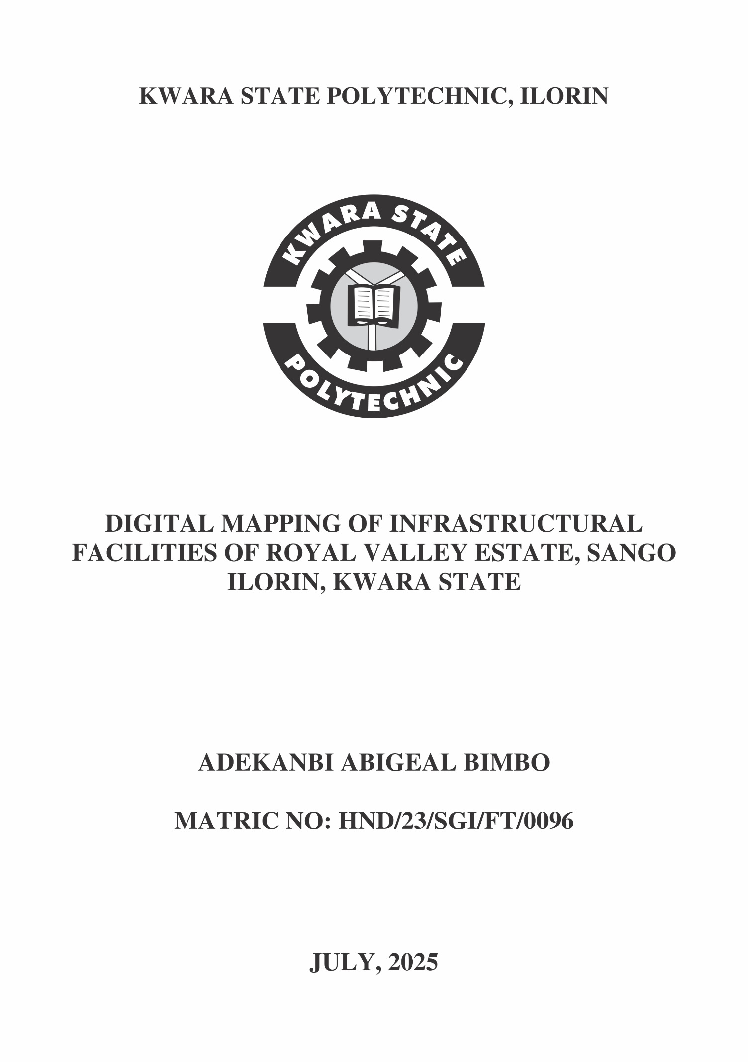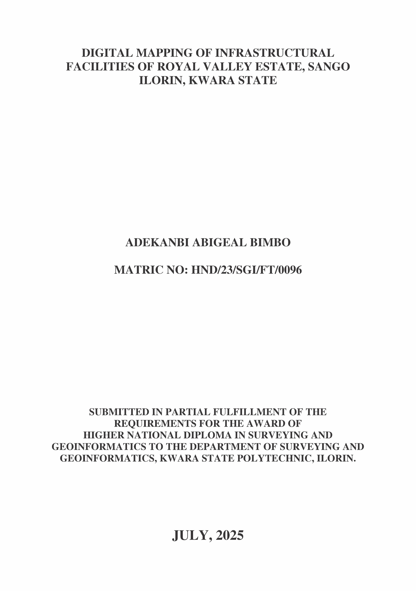 CERTIFICATE
I hereby certify that all the information given in this project work was carried out in accordance with the survey Laws, Regulations and departmental instructions. To be submit to the Department of Surveying and Geoinformatics, Institute of Environmental Studies, Kwara State Polytechnic, Ilorin. In partial fulfilment of the requirements for award of Higher National Diploma in Surveying and Geoinformatics.

Candidate’s Name: ADEKANBI ABIGEAL BIMBO
Matric No: HND/23/SGI/FT/0096
Signature ...............................................
Date:…………………………………...

CERTIFICATION
This is to certify that this project was carried out by ADEKANBI ABIGEAL BIMBO with matric number HND/23/SGI/FT/0096 in accordance with survey laws and departmental instructions.

Surv. R. S. Awoleye ……………………………
Supervisor Signature & Date

Surv. R. S. Awoleye …………………………..
Project Coordinator Signature & Date

Surv. I. I. Abimbola ……………………………
Head of Surveying & Geoinformatics Department Signature & Date

DEDICATION
This project work is dedicated to Almighty ALLAH, the author and the finisher of everything who gave me the grace and privileged to attain this stage in my education pursuit.

ACKWOLEDGEMENTS

I give thanks and glory to my Creator for the privilege bestowed on me that resulted in the accomplishment of this project work and also a big thanks to the management of Kwara State Polytechnic for the privilege and opportunity given to me to study in their great institution.

A project of such scope as this could not have been done without the assistance of proven professionals, consultancies, advisors, well-wishers, family and friends.

My sincere gratitude goes to my supervisor; SURV. R.S. AWOLEYE for being my backbone right from the beginning of this project and all his support academically, morally, I really appreciate you sir. I also acknowledge my amiable lecturers in the department (Surv. A.G Aremu, Surv. R.O. Asonibare, Surv A.I Isau, Surv. A.O. Akinyede, Surv Ayuba Abdulsalam, Surv. Felix Diran, Surv. Kabir Babatunde, Surv. William Kazeem) for being the true leader of this great department.

I'm deeply grateful to my parents; MR & LATE (MRS) ADEKANBI for their unconditional love, support, and wisdom. Their encouragement and sacrifices have been the driving force behind my endeavors. Thank you, Mom and Dad, for being my pillars of strength and inspiration. I dedicate this project to you, with love and appreciation.

Special thanks to my father, MR. ADEKANBI, for his unwavering love, care, and dedication that has shaped me into the person I am today. His selfless love and His influence and values have guided me throughout this project, and I'm forever grateful for his presence
in my life.

I would like to extend my heartfelt thanks to my beloved family members and friends who have supported me throughout this project. Special appreciation to my selfless family;
Mrs. Wojuola Toyosi and Olushote Adeyemi Simon for their guidance, encouragement, and unwavering support.

I'm also grateful to my friends, Uthman Badira, Ajibola Toheeb, Adeyemo Mariam, Ibrahim Faridah and Raji Ishola for their camaraderie, motivation, and help whenever I needed it. Their collective support has made this journey more enjoyable and fulfilling.
May Almighty GOD bless you all (Amin).

ABSTRACT:
This project focuses on the digital facility mapping of Royal Valley Estate in Sango, Ilorin, utilizing Total Station surveying techniques for precise spatial data acquisition by systematically capturing the coordinates of critical infrastructures—such as roads, buildings, drainage systems, utility poles, and water lines—the study aims to generate an accurate, georeferenced digital map that supports efficient infrastructure planning, management, and maintenance through the integration of Total Station data with CAD and GIS software, the project delivers a high-resolution digital representation of the estate’s physical layout, offering a valuable tool for estate administrators, facility managers, and urban planners to facilitate informed decision-making and future developmental strategies.

TABLE OF CONTENT
CHAPTER ONE 5
1.0 INTRODUCTION 5
1.2 STATEMENT OF THE PROBLEM 6
1.3 AIM AND OBJECTIVES OF THE STUDY 6
1.31 AIM 6
1.32 OBJECTIVES OF THE STUDY 6
1.40 SCOPE AND LIMITATIONS 7
1.41 SCOPE: 7
1.42 LIMITATIONS: 7
1.5 PROJECT QUESTIONS 8
1.6 SIGNIFICANCE OF THE PROJECT 9
1.7 PERSONNEL 9
1.8 STUDY AREA 10
CHAPTER TWO 11
2.0 LITERATURE REVIEW 11
2.1 TECHNOLOGICAL EVOLUTION 12
2.2 APPLICATIONS OF GIS IN FACILITY MANAGEMENT 21
2.3 THEORETICAL FOUNDATIONS AND CONCEPTUAL FRAMEWORKS 23
2.4 LIMITATIONS AND CHALLENGES 24
2.5 CASE STUDIES & INDUSTRY ADOPTION 24
2.6 FUTURE PROSPECTS 25
CHAPTER THREE 26
3.0 METHODOLOGY 26
3.1 OFFICE PLANNING 26
3.2 FIELD RECONNAISSANCE 26
3.3 INSTRUMENT USED 27
3.4 CHECKING OF INSTRUMENT OF ERROR FREE TABLE (COMPUTE FROM PRESENCE PROJECT) 28
3.5 MONUMENTATION 29
3.6 DATA ACQUISITION 30
3.6.1 GEOMETRIC DATA ACQUISITION 30
3.6.2 PERIMETER TRAVERSE AND GEOMETRY POINTS GENERATION 30
3.7 DATA PROCESSING 30
CHAPTER FOUR 32
4.0 ANALYSIS OF RESULT AND DISCUSSION 32
4.1 RESULT OF THE ANALYSIS 32
4.2 BACK COMPUTATION 32
4.3 PERIMETER PLAN 33
4.4 DETAIL MAP 34
4.5 SPOT HEIGTING 34
4.6 PRODUCT APPLICATION 35
4.6.1 Uses of Digital Map 35
CHAPTER FIVE 36
5.0 Costing Estimation, Summary, Conclusion, Recommendation and Problem Encountered 36
5.1 Costing Estimation 36
5.2 SUMMARY 39
5.3 CONCLUSION 39
5.4 PROBLEM ENCOUNTER 39
5.5 RECOMMENDATION 39
APPENDICES 41

LIST OF FIGURES

Figure 1.0: Map showing the Study Area……………………………………………………………10
Figure 3.2: shows the Recce diagram of the study area.............................................................26
Figure 3.4: show the instrument test.........................................................................................27
Figure 3.5 Typical Third Order Survey Beacon..........................................................................28
Figure 4.3: Shows the Perimeter Survey of the study Area.........................................................32
Figure 4.4: Detail plan of the project area.................................................................................33
Figure 4.5: Spot height plan of the Project Area........................................................................34

LIST OF TABLE
Table1.7: Personnel.............................................................................................................8
Table 2.5: Case Studies and industry Adoption....................................................................23
Tab. 3.1: shows the value of Controls..................................................................................25
Tab. 3.4: Show the result of instrument test........................................................................28
Table 3.6.2: Station coordinate...........................................................................................29
Table 4.0: Analysis and respective formulae........................................................................31
Table 4.2: Back computation..............................................................................................31
CHAPTER ONE

1.0 INTRODUCTION
Digital Facility Mapping (DFM) is the process of digitally identifying and mapping facilities infrastructure with the explicit goal to improve operational management and planning tasks such as dispatching, inventorying, and maintenance (EWG, 2010). Some examples of facilities include utilities (i.e. gas, water, telephone, and electricity), airport siting, and transportation planning. Facilities as used in this paper, however, refer to all man-made structures or other improvements whose function, size, service area, or uniqueness give them the potential to improve the well-being of the people without disruption of vital socioeconomic activities. Decision makers require timely, reliable information regarding the availability and state of facilities in their domain. Not only will they require quality baseline information on the way the facility are functioning, there is also need to get regular updates from time to time so as to be able to monitor funds expended on the facilities. The ability to generate futuristic models of these facilities in order to have a clear vision of what expenditures are expected to achieve, and also to analyze the effect of various environmental factors on these facilities, in order to anticipate impending problems; are some of the desires of decision makers that were formerly viewed as being in the realm of science fiction.
The GIS has now become known for being an efficient and powerful decision making tool capable of handling the different scenarios stated in the preceding paragraph (Kaundinya & Bagati, 1998; Rita Davies, 2010). The spatial resolution of satellite data used with the GIS had continued to improve significantly over the years. In the early nineties SPOT‘s panchromatic band (10m) used to be the ultimate. Since then, Space Imaging in 1999 launched IKONOS with a panchromatic band of 1m. By 2003 ORBIMAGE launch Orb-View, which also had a panchromatic band of 1m. Two years after IKONOS, Digital Globe launched Quick Bird with a panchromatic band of 0.6m. With Geoeye’s plans to launch yet another satellite with a resolution of 0.4m (Jensen, 2007), the sky is the limit for satellite technology. It is this kind of significant improvements in the spatial resolutions of satellite images that have made it possible for the GIS to provide needed information with a remarkable degree of details. Unfortunately, in Nigeria, lip service is still being paid to GIS based facility mapping. Majority of government agencies still rely on ground surveys and analogue maps. In the few cases where facility maps were created using the GIS e.g. in the case of Musa & Tukur, 2006, once the maps were printed, the function of computers reverted back to word processing. The only evidence that such a project had ever been carried out, are the map albums decorating some of the offices. It therefore didn’t come as a surprise when it was discovered that many of the government agencies in the study area were in possession of analogue maps that were in deplorable state. Some of them were so bad that they could not be traced. The Plateau State Ministry of Survey and Planning, was expected to be at the forefront of other government agencies in the use of digital mapping techniques. However, they were found instead to be using ground surveys techniques and analogue maps, Different kind of facilities have been successfully mapped digitally in a time effective and cost efficient manner. Analyses made from such maps have helped in proper planning and management of the facility.
Abbas et al (2012) investigated the spatial distribution of healthcare centres in Chikum local government area of Kaduna State Nigeria using the GIS and GPS. The study then used the WHO criteria for the location of health care centres in developing countries to propose nine new sites for the location of new health care centres to adequately cover the health needs of the people of the study area. Similar health facility mapping has been carried out also in India (Gambhir & Rodnuguez, 2013) and Nepal (DHS, 2010). Other facilities that have been successfully mapped include cultural facilities (Rita Davies, 2010); Oil and Gas Pipeline (PRLog, 2009); refuse disposal facilities (Musa, 2012) and telecommunications (Edan et al, 2013).

1.2 STATEMENT OF THE PROBLEM
The electricity company of Nigeria (Power Holdings Cooperation of Nigeria - PHCN) claims to have a plan showing the electricity distribution network of the study area. Unfortunately, this map cannot be located. The loss cannot be unconnected with the way the maps were stored. Maps on other facilities like education and health can at best be described as glorified sketches with no meaningful information decipherable in them. It is the desire of this project to address such problems and also to demonstrate the effectiveness of facilities mapping that this project intends to:
- Show the locations of these facilities/ utility services on a digital map.
- Identify facilities that may require upgrading and expansion.
- Carry out an assessment of facilities/ utility services in the metropolis.
Therefore, this research aims to address the problem by utilizing GIS mapping and analysis techniques to gather comprehensive and up-to-date data on infrastructural facilities within the project location. By developing a geospatial database, this study seeks to provide accurate information on the spatial distribution, accessibility, and efficiency of infrastructural facilities.

1.3 AIM AND OBJECTIVES OF THE STUDY

1.31 AIM
The aim of the project is to carry out digital mapping of infrastructural facilities of Royal valley Estate at Sango Ilorin, Kwara State to develop a comprehensive, geospatial accurate digital representation of existing infrastructure towards enhancing spatial planning, facilitating informed decision making, optimize infrastructural facilities allocation and improve long-term sustainability.

1.32 OBJECTIVES OF THE STUDY
- To conduct a detailed field survey of existing infrastructural facilities (e.g., roads, electricity, water supply, drainage, buildings, etc.) within Royal Valley Estate using appropriate geospatial data collection tools and techniques.
- To acquire and integrate high-resolution satellite imagery and/or drone imagery for accurate base mapping and verification of infrastructural elements.
- To create a geospatial database that captures the spatial location, attributes, and conditions of infrastructural facilities within the estate.
- To produce a comprehensive digital map of Royal Valley Estate’s infrastructure using Geographic Information Systems (GIS) for visualization and spatial analysis.
- To perform spatial analysis on the mapped infrastructure to identify spatial gaps, accessibility, and service coverage across the estate.
- To support decision-making by providing stakeholders with accurate geospatial information for planning, development, and future expansion of infrastructure.
- To assess the current distribution and adequacy of infrastructural facilities in relation to population density and land use within the estate.
- To propose recommendations for optimizing infrastructure allocation and improving service delivery based on the digital mapping outputs.
- To enhance sustainable urban development practices by promoting data-driven planning and efficient resource management through digital geospatial technologies.

1.40 SCOPE AND LIMITATIONS

1.41 SCOPE:
The scope of the project "GIS mapping and analysis of waste management facilities in Lagos State" encompasses the following:
- Geographic Area: The study focuses specifically on Royal valley Estate, at Sango, Ilorin Kwara state, Nigeria
- Digital Infrastructural Facilities Mapping: The project aims to carry out digital mapping of infrastructural facilities of Royal valley Estate at Sango Ilorin, Kwara State to develop a comprehensive, geospatial accurate digital representation of existing infrastructure towards enhancing spatial planning, facilitating informed decision making, optimize infrastructural facilities allocation and improve long-term sustainability.
- Spatial Analysis: The project utilizes GIS technology to conduct spatial analysis and mapping of infrastructural facilities. It involves data collection, processing, data integration, and visualization of spatial patterns and analysis.
- Environmental Impacts: The project evaluates the environmental impacts on the facilities allocation and sustenance.
- Efficient Asset Management: To digitally record and manage the locations and conditions of facilities like water pipes, electrical lines, buildings, etc., for easy access and maintenance.
- Improved Planning and Development: To support urban planning, infrastructure expansion, and land-use management with accurate spatial data.
- Enhanced Decision-Making: To provide reliable geospatial data that helps stakeholders make informed decisions regarding resource allocation and infrastructure upgrades.
- Risk Assessment and Emergency Response: To identify critical facilities and assess vulnerabilities, aiding in disaster preparedness and quick emergency response.
- Cost Reduction: To reduce operational and maintenance costs by having up-to-date digital records instead of relying on outdated paper maps or manual inspections.
- Regulatory Compliance: To ensure that facility layouts and installations comply with relevant legal, environmental, and safety standards.
- Public Service Improvement: To enhance service delivery (like electricity, water, or waste management) by knowing the exact layout and status of facility networks.

1.42 LIMITATIONS:
There are certain limitations that need to be considered for the project:
- Data Availability: The availability of accurate and up-to-date data on infrastructural facilities may pose a challenge. Obtaining comprehensive data from various source and difference in the instrumentation might be time-consuming and resource-intensive.
- Data Quality: The quality and consistency of data can vary, which may impact the accuracy and reliability of the analysis. Incomplete or inconsistent data could limit the precision of the findings and affect the overall conclusions of the study.
- Infrastructure Assessment: Methodology and choice of instrument for data acquisition may hinder delve into detailed assessments of specific infrastructure deficiencies or constraints. Detailed engineering assessments and feasibility studies for infrastructure improvements may require additional resources and expertise.
- Time and Resource Constraints: The project's scope and objectives need to be tailored considering the available time, resources, and constraints. The depth and extent of analysis may be influenced by the project timeline and available resources.
It is important to acknowledge these limitations while interpreting the results and drawing conclusions from the project. Despite these limitations, the project aimed at carry out digital mapping of infrastructural facilities of Royal valley Estate at Sango Ilorin, Kwara State to develop a comprehensive, geospatial accurate digital representation of existing infrastructure towards enhancing spatial planning, facilitating informed decision making, optimize infrastructural facilities allocation and improve long-term sustainability.

1.5 PROJECT QUESTIONS
The research questions aim to guide this study by addressing key aspects related to the spatial distribution, accessibility, efficiency, environmental impacts, and challenges of waste management facilities in Lagos State. By answering these questions, the research will contribute to a better understanding of the existing waste management infrastructure, identify areas for improvement, and provide insights for developing effective policies and interventions for sustainable waste management practices. While these questions are not exhaustive, they will however create a framework around which the research will revolve;
- What is the spatial distribution of infrastructural facilities in Royal Valley Estate?
- How accessible are the facilities to different population centers the Estate?
- What are the types and patterns of distribution of the facilities?
- What are the key performance indicators of facilities in terms of allocation, availability, and efficiency?
- What are the environmental impacts associated with existing waste management practices in Lagos State?
- Which areas of the Estate lack adequate infrastructural facilities?
- How does the spatial distribution of infrastructural facilities correlate with population density?
- What are the current policies and regulations their usage?
- What are the challenges and barriers faced in implementing efficient management practices for infrastructural facilities within the Estate?

1.6 SIGNIFICANCE OF THE PROJECT
The digital mapping of infrastructural facilities plays a critical role in modern urban and regional developments. This project is significant for several key reasons:
ENHANCED INFRASTRUCTURE MANAGEMENT: By providing an accurate spatial inventory of infrastructure such as roads, drainage systems, power lines, and water networks, the study supports efficient maintenance, monitoring, and upgrading of public utilities.
SUPPORT FOR SUSTAINABLE DEVELOPMENT: Digital mapping facilitates integrated planning and development that aligns with sustainable land use practices, environmental conservation, and resource optimization.
INFORMED DECISION-MAKING: Access to detailed geospatial data enables planners, engineers, and policymakers to make data-driven decisions, reducing the likelihood of infrastructure failure or misallocation of resources.
DISASTER PREPAREDNESS AND RISK MANAGEMENT: A well-mapped infrastructure system aids in vulnerability assessment and enhances emergency response strategies during natural disasters or infrastructure breakdowns.
TRANSPARENCY AND ACCOUNTABILITY: Digital records create a transparent and traceable system for infrastructure development and public service delivery, minimizing inefficiencies and misuse of public funds.
INTEGRATION WITH SMART TECHNOLOGIES: The study lays the groundwork for integrating smart technologies and Geographic Information Systems (GIS) into infrastructure planning, supporting future innovations in smart city development.
ACADEMIC CONTRIBUTION: This research contributes to the growing body of knowledge in geospatial studies, urban planning, and civil infrastructure, offering a valuable reference for further academic inquiry and practical applications.

1.7 PERSONNEL
The listed names below all participated to the success and effective execution of this project.

Table 1: Personnel
NAMES | MATRIC NUMBERS | REMARK
ADEKANBI ABIGEAL .B | HND/23/SGI/FT/0096 | AUTHOR
POPOOLA BLESSING | HND/23/SGI/FT/094 | MEMBER
ADEYEMO MARAIM. O | HND/23/SGI/FT/095 | MEMBER
OGUNDEPO QUADRIL. O | HND/23/SGI/FT/102 | MEMBER
ALAI ABDULLAH AKANNI | HND/23/SGI/FT/105 | MEMBER
OKE TEMITOPE JOHN | HND/23/SGI/FT/103 | MEMBER
ALADA TOLUWANI. O | HND/23/SGI/FT/126 | MEMBER
OLAREWAJU DAVID.O | HND/23/SGI/FT/131 | MEMBER

1.8 STUDY AREA
The project location is situated at ROYAL VALLEY ESTATE at Sango, Ilorin South local government area, Kwara State. Nigeria. It lies approximately within latitude 8°31'39.76"N to 8°31'39.76"N and longitude 4°34'29.72"E to 4°34'33.72"E with an approximate area of 14.00 hectares.

Figure 1.0: Map showing the Study Area

CHAPTER TWO

2.0 LITERATURE REVIEW
We are blindly passing to the future generations, urban environments which are rapidly deteriorating and cities so populated that the option for future generation will be limited,” said Professor J.E. Hardoy. Humanity which began as hunter gatherers 212 million years ago started living in small settlements nearly a million years ago, while the first cities and towns are thought to have been built only around 3000 to 5000 years ago. After the industrial revolution of the 18th century, industrial units started up in and around human settlements which later on attracted people from other parts, including rural areas and turned into towns and mega cities. The exponential growth of population, along with the disintegration or stagnant growth of the rural agricultural ecosystems and the hope that the urban centres would provide better opportunities, have accelerated the influence of people to urban centres. It is expected that the 300 million population of the first century might have increased by more than 21 times by the beginning of the 21st century. By 1970, the number of people living in urban settlements had reached 1350 million and UN estimates and projections set the figure at 3200 million in 2000 AD which means that half of humanity will live in cities by the end of the century. In other words, sustainable management of urban environments has become one of the most important agenda of mankind. Thanks to the advances in space technology development and utilisation, the remote sensing satellites have enabled the observation of planet Earth over a wide range of the electromagnetic spectrum. Over the years considerable progress has been made in effectively utilising the space derived inputs for sustainable urban management. These apart, the advent of computers has changed the scope of information processing, either as an end-user application or for technology export. Computers have enabled the processing of maps, both individually and along with tabular data, leading to the integration of them to provide a new perception the spatial visualisation of information. This has provided yet another dimension to the processing of information on Earth and its resources. Besides, new technologies such as the geographic information system (GIS) allow synergism of map and tabular data in the most efficient manner. The advances in Earth observation systems along with developments in information technology thus enable arriving at management plans for urban environments.
In industry and big organisations facility management has become a managing tool of more and more importance. In times of decreasing profit rates and harder competition every company is forced to develop better strategies for resource and facility management. In this context the questions arise: What is facility management, what offers GIS and how can Geographic Information Systems improve facility management?
In GIS we are focusing on how to import, manage, analyse and present spatial data. In facility management, however, the focus lies on the management of facilities, buildings and the rooms inside. Buildings have a 3D geometry and many attributes. Graphic Information Systems handle such data. We are trying to develop a concept that takes advantage of GIS functionality to implement a so called Building Information System. Spatial data of a building are stored and managed by a GIS DBMS. The Institute for Photogrammetry at the University of Stuttgart is responsible for the implementation of a facility management system for all rooms and buildings of the University. In order to establish such an environment several steps have to be done.
The evaluation process of existing systems is still in progress and CAFM (computer aided facility management) systems are still being developed. All these systems have to handle the problem of geometrical dimensions. Most of the systems represent databases only without any spatial link. For the management of a building, however, graphical data is required that is not thumb CAD data. It must be „intelligent “graphic data. If e.g. you want to get an overview of all rooms in a building that are accessible for handicapped people you would prefer a map to a list. If you want to know to whom this particular room belongs, a mouse click should deliver the results instead of offering endless lists.
Another crucial point in these systems is that you also need 3D data or even 4D capabilities. The time factor is very important in FM. The University of Stuttgart is located in more than 100 buildings, several of them are rented. In order to plan renovation, controlling the functions of the building, analyse which parts are often damaged and re-renting of buildings, an instrument for analysing is an absolute necessity. At the moment those analyses take too much time and are for that not very suited. The first step in order to get an operational Building Information System is to examine the requirements of the potential users. We created a questionnaire that helps us to examine the taskstock/requirements of the users. It was sent to a group of employees who were selected as a key group. In addition interviews were taken to maximize the feedback rate and quality of answers.
Secondly a market study is undertaken to get an overview of possible system candidates. In the meantime we sort all questionnaires by different criteria such as workflow, main topics, and analysis with time, 2D, 3D and simple database queries. After the sorting we get an overview about the relevant criteria that help us selecting the appropriate system.
Digital infrastructural mapping Digital infrastructure mapping is used to denote the application of digital technologies to capture, store, visualize, and analyze data on physical infrastructures (e.g., roads, bridges, utilities, pipelines). It enables more effective design, build, operations, and infrastructure maintenance, for both the public and private sectors.
Infrastructure is basic physical and organizational structures needed for the operation of a society or enterprise, or the services and facilities necessary for an economy to function. It can be generally defined as the set of interconnected structural elements that provide framework supporting an entire structure of development. It is an important term for judging a country or region’s development. The term typically refers to the technical structures that support a society, such as roads, schools, water supply, electrical grids, telecommunications, public transportation, fire station, airports, hospitals and public space.

2.1 TECHNOLOGICAL EVOLUTION
In the past, the management of infrastructural related data was operated by means of manual survey and paper-based solutions, time sensitive and often inaccurate. The use of digital technology has greatly enhanced the precision, effectiveness, and availability of infrastructural information (Rahman et al., 2013). Until recently, infrastructural mapping had been primarily done through manual surveying and paper maps, the latter of which were usually inaccurate and became outdated rapidly. The increased use of digital technology has generated dynamic and real-time infrastructure databases, which are accurate to a very high level (Goodchild, 2007)
The physical components of interrelated systems providing commodities and services essential to enable, sustain, or enhance societal living conditions. Infrastructure contribute to economic growth (acting through both demand and supply).in an aggressive sense, the character and the availability of infrastructure and utilities influence the marginal productivity of private capita; public investment complement private investment. At the microeconomic level, this effect of infrastructure is seen specifically through. Reduced cost production-infrastructure hence affects, profitability levels of output, income and employment, particularly for small medium scale enterprises. It also has impact on the cost and service quality in international trade (trade logistics), which determines competitiveness in export/import markets (kessids 1993).this is a major reason why goods produced in Nigeria are very expensive which water down the ability of the country to compete in the international market.
Technology in facility management Information Technology (IT) and software are leading a revolution in FM targeting methods for data gathering and streamlining FM processes (Hinks, 1998). According to Lunn and Stephenson (2000), in the past 25 years, the power of IT systems and user availability has soared, although the cost has plummeted. Due to this, a synergistic interaction is now possible between the processes of FM and the specialist technology, wherein the networking and data handling capabilities of IT will directly affect FM processes. But there is a need to define how information systems contribute to the organization and how they are to be managed (Remenyi et al., 1997). The type of Information Technology and software procured for a facility also varies depending on the type and function of the facility (Mathiassen and Sorenson, 1996; Paulk et al., 1993). According to Hinks (1998), the emergence of a variety of specialist IT support tools for various FM activities appears to offer the scope for integration of FM function in those FM organizations which are ready and prepared to progress using it. Changes due to technology in facility management are inevitable, and organizations need to anticipate these changes and modify their strategies accordingly (Price and Shaw, 1998).
In the area of maintenance management, the literature identifies a need to fundamentally re-design the business processes in order to accommodate the computer rather than “the computer simply used to automate the traditional process” (Jones and Collis, 1996). Owen and Aitchinson (1988), stated that: “What organizations really want from IT is the information, not the technology.” According to Remenyi et al. (1997), though information system outputs have automated FM processes like data entry of work orders in software systems and electronic logs, it has not succeeded in delivering significant savings in time and money to handle FM processes, such as work order management. This reflects the fact that information systems are not delivering adequate business benefits (Remenyi et al., 1997). The growth in FM appears to replicate that which has occurred in construction; changes led by IT applications at an operational level rather than changes led by the evolution of the management process (Whitman, 1996). Tools such as computer-aided drafting technologies, 3D modeling technologies, and a host of internet and standards-based design and project collaboration technologies can streamline historically fragmented operations of FM in the capital facilities industry (Galleher et al., 2004). The latest in the advancement of the use of technology in FM is the use of web-based type software to access information in real-time through network communication. This started out by the use of simple network based activities like locating a person or an asset, submit a work order request, investigate health and safety data and display floor plans but now can support activities such as real-time design, workflow, collaborative single models, project management environments and facilities data repositories, which are of increasing tactical and strategic importance (Teicholz, 1997; Cairncross, 1998). It is still difficult due to numerous reasons to find out which FM technology is beneficial for which FM activities. Even if technology is used on a large scale in FM, the right types of technology should be used at the right places to increase its effectiveness (Lai and Yik, 2012). As FM technology and automation becomes cheaper, the minimum size of the facility where it can be applied will also reduce. Advice on the considerations that should be taken in using a Computerized Maintenance Management Systems (CMMS) are available, but how such systems are being used to also evaluate facility performance and maintenance management performance is largely unknown (Levitt, 2007). Interoperability problems in FM Interoperability is defined as the ability to manageand communicate electronic product and project data between collaborating firms’ and within individual companies’ design, construction, maintenance, and business process systems (Galleher et al., 2004). According to the U.S. Census Bureau Report (2004), over $370 billion was invested in new facilities, facility renovations and additions in the United States in 2004. This figure excludes residential facilities, transportation infrastructure, such as bridges and roads, and facility operation and maintenance costs (Fallon and Palmer, 2006). The highest costs were incurred by owners and operators, and 85% of those costs were incurred during operations and maintenance. Annual interoperability costs of $15.8 billion were quantified for the capital facilities industry in 2002 (Galleher et al., 2004). The major cost was time spent finding and verifying facility and project information, which shows that extensive research is still needed to find out ways that can reduce the cost of operations and maintenance in building projects. As identified in Wong et al. (2005), there exist nowadays two main challenges in intelligent building integration research. The first refers to overcoming the hindering factors imposed by the lack of interoperability amongst the building automation systems products from the multitude of available vendors. The second challenge is on integrating building automation systems with the overall enterprise applications and moreover doing so over the internet (Pfeifer et al., 2001). Most of the problems in interoperability arise due to a lack of impetus to invest in interoperability solutions (Augenbroe, 2004)
A large number of documents and drawings are generated within the design stage of a construction project. The rapid growth in the volume of project information as the project progresses makes it increasingly difficult to find, organize, access and maintain the information required by project users (Ruikar et al., 2007). The need for integration of this information is evident due to the numerous benefits it can bring to both the occupants of the building as well as the facilities operators/managers (Wang and Xie, 2002). Hence strategic planning can be a way to avoid interoperability problems which helps in defining open and universal standards for not only current facilities, but for any planned facilities in the foreseeable future. Cotts (1999) distinguishes between long-term (more than 3 years) and short-term (0-3 years) planning in relation to FM, and it is primarily the long-term planning, which is strategic in nature, but it is important to take a coherent view on the different planning perspectives. Therefore, short-term planning has its main focus on existing facilities and the long-term planning is concerned with possible changes in the property portfolio. It is in this long term planning where BIM comes into the picture as a tool to be used for data handover (HNTB Federal, 2010). Efforts to provide more effective and efficient solutions to the interoperability issues led to the adoption of open and standard communication protocols to uniform the communication process in all layers of interaction (Kastner et al., 2005). Since 1995 initiatives such as the Industry Foundation Classes (IFC) developed by the International Alliance for Interoperability (IAI) have driven interoperability between software vendors who support the sharing and reuse of design, as-built and maintenance data on building projects. According to Jordani (2010), well-run BIM projects result in coordinated and consistent information about a facility as it evolves through design and construction. This information in the form of a BIM model can by itself be used for operations and maintenance, without the need of the added step of data extraction. Communication, co-ordination and partnering for FM According to Oberlender (1993), once a project is completed and in use by the owner, a formal meeting should be held with owner’s representatives to obtain feedback regarding the performance of the finished facility. Such kind of communication is also important to gather the different parties to work together for the data formulation process during and after construction. Collaboration between all parties involved is now being seen as an important aspect to enable efficient FM even by the largest building owners in the US, like the General Services Administration (GSA 2011).
According to Kubal (1994) partnering results in more successful business relationships and less dependence on legal assistance. Some of the most effective information management tools in the building sector are project extranets, workflow management tools, and groupware applications for collaborative working (Christiansson et al., 2002). It is important to understand that accurate equipment inventories affect many different aspects of building management, including management of energy, projects, operations, maintenance, and customer service, and, therefore, they affect the overall finances of an organization (Sullivan et al., 2010). According to Kymell (2008) the use of BIM in construction and facility management is a great change and will result in a “cultural change” in every company that commits itself to its adoption. Kymell (2008) goes on to explain that this can have both a positive and a negative impact. Negative because any mistakes can be clearly seen, which can cause discomfort to project participants. According to Cholakis (2011), using project delivery systems which promote collaboration during construction will also help the facility throughout its lifecycle. By nature, when Integrated Project Delivery (IPD) and Job Order Contracting (JOC) work in done parallel with BIM, they enable the effective and transparent transfer of information among all construction project participants; this creates and builds trust and collaboration. For example, contractors provide input about the potential cost, constructability, and value engineering that aids the owners and design team to make more efficient and cost-effective decisions. In addition, the many challenges endemic to traditional construction delivery methods, such as miscommunications, change orders, adversarial relationships, and legal battles are virtually eliminated. FM databases and Construction Operations Building Information Exchange (COBie) Today’s buildings are increasingly sophisticated and the need for information to operate and maintain them is vital (Jordani, 2010). This information may also help track facility components accurately, identify inefficiencies in building operations, and respond quickly to client requests (Forns-Samso, 2010). Each facility component or asset has a cost associated with its installation, replacement, and scheduled maintenance. An accurate equipment inventory is essential for budgeting repair/replacement and maintenance costs (GSA, 2011). Typically, a facility manager obtains the majority of initial facility information from the general contractor constructing the facility. This process takes place at the stage just before the building is occupied, which is believed to be the best period to collect and streamline facility information (Edgar, 2000).
Facility management activities depend on the accuracy and accessibility of facility data created in the facilities’ design and construction phases and maintained throughout the operations and maintenance phase. Lack of this information can result in cost overruns, inefficient building operations, and untimely resolution of client requests (GSA, 2011). Operations and maintenance incurs additional time, manpower, and costs with inaccurate or lack of equipment inventories. The failure to properly track equipment inventories reduces the reliability of project scopes and cost estimates, impairs emergency response, and degrades the ability to make executive decisions (Keady, 2009). Since the majority of the building data is generated during the construction phase, it is important to have an extensive database collection process throughout the life cycle of the project, starting from the design phase. Thus, if BIM has to be used as a “Portal to life cycle FM”, the timing of data gathering process early in the life cycle of the project is also important (Jordani, 2010). According to East (2011), most contracts require the handover of this data in the form of paper documents containing equipment lists, product data sheets, warranties, spare part lists, preventive maintenance schedules, and other information. Clayton et al. (1998) coin a new term called “operational documents” for this type of information, which are intended to reuse design and construction information to support operations and maintenance. Gathering this information at the end of the job, which is today’s standard practice, is expensive, since most of the information has to be recreated from information created earlier on. Construction Operations Building Information Exchange (COBie) simplifies the work required to capture and record project handover data (East, 2011). The GSA BIM Guide for Facility Management (2011) defines COBie as a vendor neutral, IFC-based data exchange specification that describes the information exchange between the construction and operations phases of a project. Many organizations have yet realized the importance of having a complete and formidable inventory of its facility to aid facility management (Sullivan et al., 2010). While it would seem obvious that a complete inventory would be the most beneficial to an organization, the reality is that most organizations do not understand the impact equipment inventories have on their business.
Facility management is divided into two essential areas: hard facility management (hard FM) and soft facility management (soft FM). Hard FM deals with physical assets such as plumbing, heating, cooling, and elevators. Soft FM focuses on tasks performed by people such as custodial services, lease accounting, catering, security, and groundskeeping. The first area of FM refers to the physical built environment and infrastructure, e.g., planning, design, workplace, construction, lease, occupancy, maintenance, and furniture. The second area refers to people and organizations, and is related to work psychology and occupational physiology, e.g., catering, cleaning, ICT (Information and Communications Technology), HR (human resources), marketing, and hospitality. IFMA launched an updated global job task analysis (GJTA) initiative in order to determine the most critical roles and responsibilities for modern-day facility management based on 62 countries’ responses to facility managers. IFMA established 11 core modern facility management competencies.
Gupta, Y.K., Gupta, R.D, Kumar. K (2009): The infrastructure available in rural areas is rather inadequate that creates a regional imbalance in development causing migration of population from rural to urban areas. A structured planning procedure is needed so that developmental activities together with infrastructural facilities are made available in rural areas. GIS is a useful tool for integration and analysis of multi-thematic information for a particular application and can be used for solving complex geographical and planning problems to assist decision makers to get the updated planning scenario for a region.
Motuka, Mishael A (2008) GIS-based Facility Management Systems (FMS) offer several advantages over the traditional analogue mode and/or Computer-Aided Design (CAD)-based systems. For instance, they can integrate a campus location and facility management (building, floor and room location) into one package. The integration simplifies the querying of such data. The Kenya Polytechnic University College’s mode of manual space inventory does not provide for querying the available data for the purpose of quick decision making; neither does it provide for a structured storage system. The objective of this study is therefore to develop, using an existing GIS tool kit, a method of setting up a typical geo-database for organising digital data so as to facilitate information management, its visualization and illustration. In this project, a GIS database for the U-Block of the Kenya Polytechnic University College has been created. As a result of time constraint, it was not possible to have a GIS database for every building of the College. From the U-Block database, one is able to extract information on space, such as the amount space available, the department to which some space is assigned, or even the maximum number of students a room can accommodate (stations) By integrating the different U-Block floor plans, the attribute tables and the room pictures, it is possible to easily manipulate the data and display different views of the rooms, based on usage and assignment to departments. On the basis of this success of the U-Block database, it is recommended that a geodatabase for the entire College be established. Such an intranet-based system should permit the linking of the various building floor plans, facilities data and the general base map layers, which should then be accessed through some standard browser for visualization and reporting of space utilization across the entire College.
GIS technology enables the collecting, storage, analysis, and visualization of spatial data, making it a valuable tool in Facility Management. Wang et al. (2021) define GIS as computerized systems that manage spatial information, facilitating tasks such as disaster planning, space management, and infrastructure maintenance.
Recent literature highlights the shift toward human-centered FM, where user experience, well-being, and productivity are emphasized. Concepts like activity-based working, wellness design, and neurodiversity inclusion influence facility design and service delivery.
FM plays a role in shaping the psychological and social dimensions of workspaces, going beyond physical comfort to support mental health, collaboration, and flexibility (Haynes, 2008; Vischer, 2007).
The development of standards such as the ISO 41000 series, EN 15221, and various national-level codes (e.g., BSI, ANSI) has formalized FM as a profession. ISO 41001:2018, the international management system standard for FM, emphasizes consistency, risk reduction, and integration with corporate strategies. Moreover, sustainability frameworks like LEED, BREEAM, and WELL Building Standards have reshaped how FM is practiced in terms of environmental and social responsibility (Elmualim et al., 2010).
Abdulahmeen Babajide. E and others (2017) several organizations have been managing a number of assets in their facility portfolio using GIS for several years. In recent years, GIS has been applied in electricity distribution in an equitable and efficient manner, pavement management at airports and in utility management. GIS applications adopted by US Air force provide decision support system for the handlers of the Air Force bases management affairs.
In the 1980s and 1990s, GIS technology started to find applications in healthcare facility planning (Drummond & French, 2008; Khashoggi & Murad, 2020). Its early use was characterized by basic mapping and analysis functionalities, providing healthcare professionals with tools to visualize the geographical distribution of healthcare facilities and patient populations. This laid the foundation for more advanced applications in subsequent decades (M. K. Boulos, Roudsari, & Carson, 2001; Davenhall & Kinabrew, 2012). The 2000s witnessed a notable shift toward the integration of GIS into broader healthcare information systems. The emphasis moved beyond mere spatial representation to incorporating data analytics, allowing for more robust decisionmaking in healthcare facility planning and management. GIS became an essential component in assessing the geographical accessibility of healthcare services and optimizing resource allocation. In recent years, the evolution of GIS in healthcare has been propelled by advancements in data collection technologies, such as remote sensing and the integration of real-time data streams. This has enabled healthcare planners to make more informed decisions based on dynamic and up-to-date spatial information (Blaschke, Hay, Weng, & Resch, 2011; Safari Bazargani, Sadeghi-Niaraki, & Choi, 2021; Weng, 2010).
Aerial Imagery or Global Positioning Systems (GPS) are the most commonly used primary sources of spatial data to be used for a facility geo-database. While the aerial imagery give a bird eye view of the nature of the facilities and through which the physical attributes of the facility can be derived from, the GPS fixed the relative position of the facility to the centre of the earth surface. The limitations of these two data sources are often the fact that they could not penetrate the roof to see through what is inside a covered facility. This limitation led to increasing demand for more improved technologies to reduce the significant holes that this has left in the creation of facility geodatabases.
New technologies such as Computer Aided Design (CAD) floor plains or Building Information Model (BIM) are bridging the gap from the aerial imagery and GPS. The new technology provides inside information about the facilities to give a more complete description of the facilities. The integration of the new technology and geo-technology is making it gradually possible to unmask the business activities taking place inside the building.
Today, GIS provides a good alternative to analyze the spatial aspects of components of facility management workflows in a cost effective manner. It provides support system that will optimize the use of financial and human resources leading to optimal productivity.
Facilities are designed and created to serve a particular purpose in a convenient way. Catering facilities are created for catering services in a more hygienic and speedy way, toilet facilities are created to provide toilet services, educational facilities provide a good learning services, etc. Facility mapping is however the process of identifying the spatial locations of these facilities in relation to one another and to see at a glance their interactions. The process would help in improvement of space planning and general operational management. The major importance of FM application development is to provide a decision support system for the decision makers that will make utilities more efficient and effective. The components of the application vary with respect to the demand of the users. The components have become dynamic with the adoption of GIS in the mapping. FM application may be grouped into the following general categories: query and display; design/work order processing; equipment maintenance; network analysis and customer service/service call analysis. Two examples, query and display, and design/work order processing, should serve to illustrate the range of FM system. Using GIS to integrate geographic with other corporate data has become absolute to this task, (ESRI).
As a practice, digital infrastructural mapping is one in which geospatial technologies are applied to the creation, management, and analysis of maps of physical infrastructural systems ranging from roads and utilities to buildings and communication networks. The advent of Geographic Information Systems (GIS), Remote Sensing (RS) and Global Navigation Satellite Systems (GNSS) has largely transformed the traditional approach of planning, monitoring and maintaining the infrastructure during last few decades.
Several organizations have been managing a number of assets in their facility portfolio using GIS for several years. In recent years, GIS has been applied in electricity distribution in an equitable and efficient manner, pavement management at airports and in utility management. GIS applications adoption by US Air force provides decision support system for the handlers of the Air Force bases management affairs. Aerial Imagery or Global Positioning Systems (GPS) are the most commonly used primary sources of spatial data to be used for a facility geo database. While the aerial imagery give a bird eye view of the nature of the facilities and through which the physical attributes of the facility can be derived from, the GPS fixed the relative position of the facility to the centre of the earth surface. The limitations of these two data sources are often the fact that they could not penetrate the roof to see through what is inside a covered facility. This limitation led to increasing demand for more improved technologies to reduce the significant holes that this has left in the creation of facility geo-databases. New technologies such as Computer Aided Design (CAD) floor plains or Building Information Model (BIM) are bridging the gap from the aerial imagery and GPS. The new technology provides inside information about the facilities to give a more complete description of the facilities. The integration of the new technology and geo-technology is making it gradually possible to unmask the business activities taking place inside the building.
Today, GIS provides a good alternative to analyze the spatial aspects of components of facility management workflows in a cost effective manner. It provides support system that will optimize the use of financial and human resources leading to optimal productivity such system will incorporate element of space, time and money in business decision making processes support systems. This system if developed will provide an advanced spatial analytic support system to support businesses that are situated in multiple geographical areas. GIS provides platform that support the integration of information from spatial, temporal and informational dimensions. Such integrations provide solutions such as:
1) Optimal use of resources by integrating cost data with the visualization of space and occupancy.
2) Routing path for immediate evacuation during emergency.
3) Determining the total value of the land and property assets which the city has sold within a particular period of time.
4) Shortest route to deliver sold to the homes of new customers.
5) Model to determine and predict the spread and direction, effect of fire at any particular weather condition.
6) Visualization of energy consumption data at the room level while simultaneously managing maintenance workflows for mechanical, electrical and plumbing systems for a nationwide facility infrastructure.
GIS tool provide efficient and effective management of surface and subsurface facilities. Subsurface facilities however create a daunting challenge to the managers, information such as exact location, network distribution and analysis, and management of sub surface facilities, are extremely tasking to the managers. Adoption of GIS has simplified the problems associated with the management of these subsurface facilities. This can be identified by integration of aerial photo or any other ground feature with underground facilities, and then perform measurements; such as geographical location and the area extent. Also, GIS can provide network-based spatial analysis for utilities including flow direction and topology creation. Moreover, GIS can be used to track work orders such as landscape and utilities maintenance. For example, a list of maintenance tasks showing the description and location in the work order.
In landscape management, GIS mapping and display capabilities can be used to map out the landscape features such as flowers, trees and other plants and them displayed using the symbols embedded in ArcMap. The locations of these features will be collected using GPS and plotted for display in ArcMap. These features have symbols in ArcMap that depict them. These features can further be draped on the digital elevation model to give a more accurate surface model of the landscape. ArcMap has graphical representation for different kind of trees and the ability to include schedule for regular requirements of watering, pruning, weeding, and fertilizing. Thus, GIS can help in maintenance of landscape appearance and increases productivity of the facilities department staff. GIS can be used in facility space planning such as emergency planning and response.
In space planning, map can contain the parking spaces allocated for visitors and students, accessible buildings, routes, etc. These can further being reclassified into handicap parking space, buildings that are handicap accessible. Ferries State University (FSU) in its adoption of GIS to provision of services for physical challenged students, it integrates aerial photographs with other mapping techniques to map out handicap accessibility facilities. The space planning was possible by delineating the suitable areas in ArcMap using the aerial photograph as the data source. Pedestrian and Transportation planning can also be carried out showing paths such as different paths for bicycles, cars, motorcycles while also displaying visitors and students parking spaces. This can be colour coded to differentiate one path from the other or one parking space.
In emergency planning and response management, GIS can be used to show fire hydrants and display their locations. In the event of a fire or earthquake, a campus planner will be able to determine the area that are prone to fire risk and the area that are risk free. During the fire outbreak, GIS would be able to provide risk free path through which people can be evacuated from. In addition, it helps a campus planner under any emergency to quickly locate water and gas shut-off valves.
Generation of 3D maps and events requires careful planning and design processes. The first process will be to examine the design process which will influence the look of the final outcome. The examination of the process is to have a better understanding of the application of the cues and resources to give a required output. The first step of the design process is data modelling. This involved data analysis, format conversion, etc. At this stage, geometric and semantic aspects are reshaped and aggregated and classified in the format required with the specific software used for designing and producing 3D maps. Symbolization is the next step. This step involves defining the legend for both the Digital terrain model section and the thematic objects. The last step is visualization. Parameters are chosen for creating the image and completing the scenery that will become the final 3D map.
Becerik-Gerber et al. (2012) discussed the growing synergy between BIM and GIS in Facility Management, noting how BIM provides detailed building information, while GIS offers spatial context.
Motawa and Almarshad (2013) supported this by advocating for integrated platforms to improve data consistency and reduce operational costs.
Shojaei et al. (2016), GIS enhances the management of urban facilities by integrating spatial data with real-time asset tracking, thus improving planning and operations.
Zhao et al. (2014) highlighted the role of GIS in managing campus environments, where spatial data on utilities, buildings, and roads support effective resource planning.
Facilities Management (FM) as the total management of all services supports the core businesses of an organisation in a building. However, today’s buildings are increasingly sophisticated and the need for information to operate and maintain them is vital. Facility Managers have to acquire, integrate, edit, and update diverse facility information ranging from building elements, fabric data, operational costs, contract types, room allocation, logistics, maintenance, etc. However, FM professionals face challenges resulting in cost and time related productivity, efficiency and effectiveness losses. Building Information Modelling (BIM), that seeks to integrate the building lifecycle, can provide improvements and help to overcome those challenges. Thus, the paper explores how BIM can contribute to and improve the FM profession. It uses the MediaCityUK project as a case study, which is a regeneration project aiming to attract media institutions locally and worldwide and establish itself as an international centre for excellence. For this purpose, the key FM tasks are identified and a BIM model for the new university building in MediaCityUK is developed and experimented with the FM tasks by a group of FM experts. As a result, the paper explains how BIM can support FM tasks in an itemized manner.
Building Information Modelling (BIM) as a lifecycle evaluation concept seeks to integrate processes throughout the entire lifecycle of a building. It aims to provide a more streamlined business process, associated project and site management methodologies including complete facilitation of construction knowledge during the full lifecycle of a building (Kymell, 2008). The focus is to create and reuse consistent digital information by the stakeholders throughout the lifecycle. BIM in most simple terms is the utilization of a database infrastructure to encap-sulate built facilities with specific viewpoints of stakeholders (Arayici et al., 2009). It is a methodology to integrate digital descriptions of all the building objects and their relationships to others in a precise manner, so that stakeholders can query, simulate and estimate activities and their effects of the building process as a lifecycle entity (Gillard et al., 2008). BIM incorporates a methodology based around the notion of collaboration between stakeholders using ICT to exchange valuable information throughout the lifecycle. Such collaboration is seen as the answer to the fragmentation that exists within the building industry and has caused various inefficiencies (Jordani, 2008) and it has come to a point where change is now eminent (NBIMS, 2007) because BIM can provide the required valued judgments that create more sustainable infrastructures to satisfy owners and occupants. However, it is necessary to realize that while the users and owners can change over the lifecycle of a building within different intervals, the most important aspect is to minimize the impact to the natural environment. While this can be achieved in a variety of ways using maturated BIM integrated construction methodologies, they are not discussed here due to our specific focus on facilities management.
Facilities Management is a multi-disciplinary field encompassing multi-disciplines to ensure the functionality of built environment by integrating people, place, process and technology (Cotts et al., 2009). In scenarios such as major relocation of organization into new buildings, FM for the building lifecycle is the key aspects that should be conducted effectively and efficiently (Nazali et al., 2009). However, there are key challenges in the current practice such as building operational life cycle management, some of which revolves around information collection retrieval and sharing (Cardellino & Finch, 2006). The challenges in FM are revealed more when the information exchange challenges are experienced during design/construction are multiplied across the lifecycle of a facility (Jordani, 2010). There is a need for optimizing the building use from an FM point of view for effective and efficient building lifecycle management. 85% of the lifecycle cost of a facility occurs after construction is completed and the NIST (National Institute of Standards and Technology) Interoperability Study indicated that two-thirds of the estimated cost is lost in the US due to inefficiencies during operations and maintenance phases (Jordani, 2010; Rundell, 2006). The maintenance requirements of a building (hard issues) (Olomolaiye et al., 2004) such as maintenance of window and doors require a managed approach due to the size of the facility. It is also important to identify designed and actual occupant functions (soft issues) (Olomolaiye et al., 2004) and allocate spaces during the building life cycle for operational efficiency. Space reallocation is a consideration that should not be overlooked as the functional requirement of the owner/user may change in time that also underscores building life cycle management.

2.2 APPLICATIONS OF GIS IN FACILITY MANAGEMENT
- Asset and Space Management: Elmualim et al. (2010) found that GIS facilitates effective tracking of building components, room allocation, and space utilization. This enables institutions to optimize the use of physical assets and adapt to organizational changes.
It also enables precise mapping of facility assets, including buildings, utilities, and equipment. For instance, a study conducted at Ahmadu Bello University, Zaria, developed a GIS-based facility management system for staff housing units. The research highlighted that approximately one-third of the infrastructure was in poor condition, emphasizing the need for effective management strategies.

- MAINTENANCE PLANNING: GIS can automate maintenance schedules, spatially reference equipment, and track maintenance histories. Sarpong and Ndekugri (2015) reported reduced downtime in facility operations through GIS-based maintenance scheduling. GIS facilitates maintenance scheduling by integrating spatial data with maintenance records. This integration allows for proactive maintenance strategies, reducing downtime and extending the lifespan of assets.

- UTILITY AND INFRASTRUCTURE MAPPING: Kincaid (2003) discussed how GIS enables visualization of underground utilities, supporting safe excavation and efficient repairs. Accurate utility mapping also minimizes service disruption.

- EMERGENCY AND SAFETY PLANNING: GIS plays a crucial role in emergency preparedness by mapping exits, hazardous zones, and evacuation routes, thus enhancing facility safety protocols. Tang and Austin (2009) emphasized GIS's role in emergency preparedness.

- GIS integration with Computer-Aided Facility Management (CAFM) and Building Information Modeling (BIM) enhances its effectiveness.

- INTEGRATION OF GIS WITH OTHER SYSTEMS
- GIS and Building Information Modeling (BIM): The integration of GIS with Building Information Modeling (BIM) enhances FM by combining spatial analysis with detailed building information. A study by Mangia et al. (2023) presents an integrated GIS-BIM-FM system for managing public real estate, highlighting improvements in data consistency and operational efficiency.
- 3D Modeling and Visualization: Advancements in 3D GIS and BIM integration allow for more accurate representations of facilities. A case study demonstrates that integrating GIS and BIM provides a more accurate representation of real-world structures, facilitating better facility management.
(Neutens, 2015; Verma & Dash, 2020; Yerramilli & Fonseca, 2014): GIS has revolutionized healthcare facility location analysis and selection by offering a spatially informed approach. By integrating demographic data, disease prevalence, and accessibility factors, GIS aids in identifying optimal locations for new healthcare facilities. For example, GIS can help determine areas with underserved populations, high disease burdens, or inadequate healthcare infrastructure. GIS optimizes resource allocation by providing a comprehensive understanding of the geographical distribution of healthcare resources. Through spatial analysis, healthcare planners can identify areas with resource deficiencies and allocate resources more equitably. Furthermore, GIS enhances accessibility by analyzing travel times, transportation networks, and geographic barriers, ensuring that healthcare services are geographically accessible to diverse populations. GIS plays a vital role in healthcare facility management by enhancing operational efficiency. For maintenance, GIS helps track the spatial distribution of assets, schedule maintenance tasks, and monitor equipment conditions. In terms of security, GIS enables the mapping of security incidents, surveillance camera locations, and emergency response plans, contributing to a safer healthcare environment. Workflow optimization is facilitated through spatial analysis of patient flows, enabling better organization of spaces and resources for efficient healthcare delivery (Lee et al., 2015; Vissers, 2005). The synergy between GIS and other cutting-edge technologies is reshaping healthcare facility planning and management. The integration of the Internet of Things (IoT) with GIS allows real-time monitoring of medical equipment, patient vital signs, and environmental conditions. Big Data analytics, when combined with GIS, provides a deeper understanding of healthcare trends and supports evidence-based decision-making. Artificial Intelligence (AI) enhances GIS capabilities by automating spatial analyses, predicting healthcare resource needs, and optimizing facility workflows (Babitsch et al., 2012; Rane, 2023a, 2023b).
Most of the government or organization realize that providing good quality environment lead to good performance and help in sustaining operation for longer period. In order to provide good environment to the people especially students, the quality of education facilities and assets need to be monitored and kept in top condition; especially within university campus. This required a good and well practice facilities management. According to FMA (2012), facilities management (FM) can be define as process of guiding and managing the operations and maintenance of buildings, precincts and community infrastructure on behalf of property owner. FM has been practicing for decades since it was formally acknowledged in the United State and Canada in 1975 (Che Mohd Nasir, Siti Nuratirah, 2018). In Malaysia, definition of asset and facilities management can be befined from Manual on Asset and Facilities Management, CIDB 2010: “A Strategic Management towards preservation of asset and facilities value throughout its life cycle.”. From the manual, the term of asset and facilities means built environment asset and facilities that are man-made asset and facilities that are physical in nature – not financial asset and Facilities such as unit trusts introduced by the government several years back. The definition that has gained the most preference by the industry players to define facilities management in Malaysia is the management of multidisciplinary activities to ensure continuous functionality of the built environment by linking and integrating people, place, processes and technology. Abdul Hakim bin Mohammed (2006) the scope of FM discipline covers all aspects of property, space environment control, health and safety and support services.
Mohd Nazali Mohd and Micheal Pitt (2008) In Malaysia, property assets in the form of building and infrastructure always been manage by an in-house, outsources service team or combination of both of it. Stakeholders of the properties commonly take the cost of maintenance as the main factor into consideration in order to choose which option is better. The most efficient option must be chosen without compromise the quality of the maintenance service so that the quality of the asset can be keep at its highest. FM in this paper/section only covers on the assets and space management at UKM Bangi. As for the project development progress, we intended to manage UKM space and assets (buildings, man-made structure and others) for a better management with the long term goal as to minimize the cost for maintenance and better management in the future.
A geographic information system (GIS) is a set of technology procedure designed to capture, store, manipulate, analyse, manage, present (Cantwell and Milem, 2010) and disseminate spatial or geographic data for public or decision makers.(Manson et al., 2015). GIS system utilizes spatial data and attributes (related tabular information/characteristic of its spatial data) for decision making process of a particular area (e.g. UKM for spatial inventory).

2.3 THEORETICAL FOUNDATIONS AND CONCEPTUAL FRAMEWORKS
Various theoretical lenses have been applied to understand FM practices:

(Then, 1999): Systems Theory views the facility as a complex, interdependent system comprising physical assets, human capital, processes, and external factors. This model emphasizes integration and alignment.

(Lavy & Shohet, 2007): Contingency Theory suggests that FM practices must adapt to the specific context of the organization—its size, sector, environment, and culture.

(Barrett & Baldry, 2003): Resource-Based View (RBV) positions FM capabilities as strategic resources that can provide competitive advantage, particularly when tied to workplace productivity and employee experience.

(Pathirage et al., 2008): Knowledge Management Theory has been applied to FM in the context of capturing institutional memory, best practices, and operational knowledge.

2.4 LIMITATIONS AND CHALLENGES
Despite the benefits, several challenges persist in GIS-FM integration:
- Data quality and standardization: Inconsistent data formats and lack of spatial accuracy can compromise analysis (Wong et al., 2011).
- Cost and expertise: Implementation can be expensive, requiring trained personnel and continuous system updates (Krygiel & Nies, 2008).
- System interoperability: Integration with legacy systems and ensuring real-time data flow remain technical challenges (Zlatanova & Fabbri, 2009).
- Data Acquisition and Accuracy: Collecting accurate spatial data can be resource-intensive, and inconsistencies can compromise analysis.
- Technical Expertise: Implementing and maintaining GIS systems require skilled personnel, which may be a barrier for some organizations.
- Integration Issues: Combining GIS with existing FM systems can be complex, and data interoperability remains a challenge.
- Cost and Infrastructure: The initial investment in GIS technology and infrastructure can be significant, particularly for small-scale organizations.

2.5 CASE STUDIES & INDUSTRY ADOPTION
Table 2.5: Case Studies and industry Adoption
INDUSTRY | GIS-FM APPLICATION | REFERENCE
Healthcare | Patient flow optimization, asset tracking | Yang et al. (2021)
Universities | Campus space management | Al-Hader et al. (2009)
Smart Cities | Utility network monitoring | Resch et al. (2016)
Retail | Store layout optimization | Wong & Zhou (2015)

2.6 FUTURE PROSPECTS
- Smart Facility Management: Integration of GIS with IoT and AI for real-time monitoring and predictive maintenance.
- Indoor GIS and 3D Visualization: Advancements in indoor mapping and 3D modeling will enhance facility management capabilities.
- Cloud-Based GIS: Enabling remote access, collaboration, and data sharing through cloud platforms.
- Sustainable Facilities: GIS aids in energy monitoring, green space planning, and reducing environmental impact. AI-driven GIS-FM for automated anomaly detection (Zhang et al., 2023).
- Blockchain for secure FM data management (Li et al., 2022).
- IoT and Real-Time Monitoring: Linking sensors to GIS for predictive maintenance and environmental monitoring.
- 3D and Indoor GIS: Supporting indoor navigation and vertical facility management.
- Web-Based GIS and Mobile Access: Enabling remote facility tracking and mobile updates by field staff.

From the above reviewed research from different researchers, it was known that different approaches ranging from conventional method of mapping had been previously adopted for infrastructural facilities mapping. This project aimed at achieving similitude fits using GIS approach through the uses of Total station for data acquisition and Arcmap for data processing, integration, visualization, query and spatial analysis.

CHAPTER THREE

3.0 METHODOLOGY
This stage involves the methods and procedure used in planning, data acquisition, data processing, and creation of database, creation of database management system and information presentation. These operations were logically structured and carried out in stages involving database design. It is normally considered to involve a spatially referenced and structured digital database and appropriate application software for geospatial analysis. This basically describes the techniques and principles adopted in carrying out the project.
Geographic information system methods were adopted in accomplishing the desired results.
3.1 DATABASE DESIGN
The design of any database involves three stages namely;
i Conceptual design
ii Logical design iii Physical design
3.1.1 VIEW OF REALITY
In database design, there is need for reality which is referred to as the phenomenon that actually exists, including all aspects which may or may not be perceived by individuals. The view of reality however, is the mental abstraction of the reality for a particular application or group of applications.
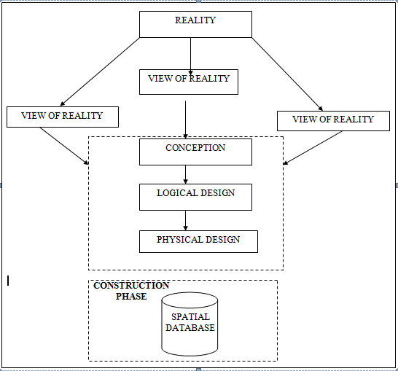
For this application, the view of reality is made of the topography of the project. Since it is not possible to represent the real world, the only option is to conceptualize and model it in a specified manner to represent the real world. The area of interest to us in this project Includes; Green Reserve, Roads, Electric poles, Trees, Water Facilities, Buildings, Football pitch, Streams.
Fig. 3.1 Design and Construction Phases in Spatial Database

3.1.3 LOGICAL DESIGN
This is the design aspect of the database refers to the process of creating a conceptual framework or model that represents the structure and organization of spatial data within the system. It involves defining the data element, their relationship, and the rules for data manipulation and analysis. In this phase, the entities, their attributes and their relationships are represented in a single uniform manner in form of relation in such a way that would be no information loss and at the same time no unnecessary duplication of data. In this study, the logical database design is employed to generate a geo-relation database structure. Each entity has unique identifier in bold type. An attribute type or combination of attribute types that serves to identify an entity type is termed an identifier.
- Building( B_ID, B_Area, B_Name, B_Easting, B_Northing)

- Roads (R_ID, R_Width, R_Type, R-Condition, R_Easting, R_Northing )

- Vegetation (V_ID,GR_Area,)

- Tree (TR_ID, TR_spp, TR_Importance, TR_Easting, TR_Northing )

- Electric Pole (EP_No, EP_Type, EP_Height,EP_Easting, EP_Northing)

- Water Facility (WF_ID, WF_Depth,WF_Type, WF_Easting, WF_Northing)

- Football Pitch (FP_ID , FP_Area, FP_Status)

- Stream(S_ID, Length, Width)

3.1.4 PHYSICAL DESIGN
Table 3.1: Building and its attribute
ENTITY | DESCRIPTION
B_ID | Building Identification
B_name | Building Name
B_Area | Building Area
B_Easting | Building Easting
B_Northing | Building Northings

Table 3.2: Road and its attributes
ENTITY | DESCRIPTION
R_ID | Road Identifier
R_Length | Road Length
R_Width | Road Width
R_Type | Road Type
R_Condition | Road Condition

Table 3.3: Trees and its attributes
ENTITY | DESCRIPTION
TR_ID | Tree Identifier
TR_Spp | Tree specy
TR_E | Tree_Easting
TR_N | Tree Northing

3.1.2 CONCEPTUAL DESIGN
Vector data model is the data type adopted for this project, which is represented, by points, lines and polygon. The identified entities are:-
      - Vegetation area (polygon)

      - Roads (line)

      - Trees (point)

      - Boundary line (polygon)

      - Buildings(polygon)

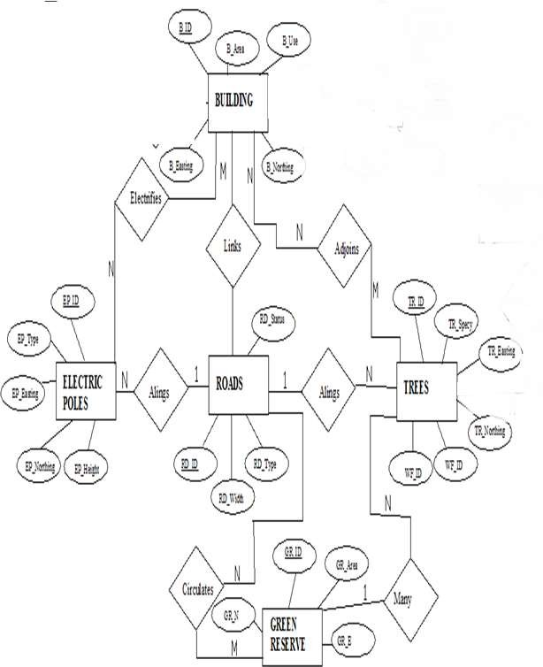
Fig. 3.2.: E-R Diagram (Entity relationship diagram)
This explain the method and techniques used to achieve the aims and objectives this project of this project work, the execution of this project was based on the following basic principle of surveying
- Working from whole to the part.
- The principle of choosing the method of survey most appropriate to meet the desired result.
- The principle of provision for adequate checks to meet the required accuracy

3.1 OFFICE PLANNING
Office planning which could be termed as office reconnaissance involved knowing the type of instruments, purpose, specification and accuracy require of the survey to be carried out. These led to the choosing of appropriate equipment and method to be employed, also costing of the survey operation was done in the office. Information related to the give project was collected from various sources the coordinate (x, y, and z) of the initial and that of the three choosing controls used for orientation were all obtained from department office.
Tab. 3.1 shows the value of Controls
KWCS 625T | 941451.040 | 674200.278 | 255.212
KWCS 623T | 941753.095 | 673845.702 | 250.532
KWCP 690 | 94I802.041 | 673810.314 | 249.087

3.2 FIELD RECONNAISSANCE
The project site was visited by all the group members to have the true picture of the site for the better planning. The recce diagram was drawn alongside the carrying out and the reasonable artificial features were fixed along and within the traverse lines, the traverse was fixed to maintain perfect indivisibility.
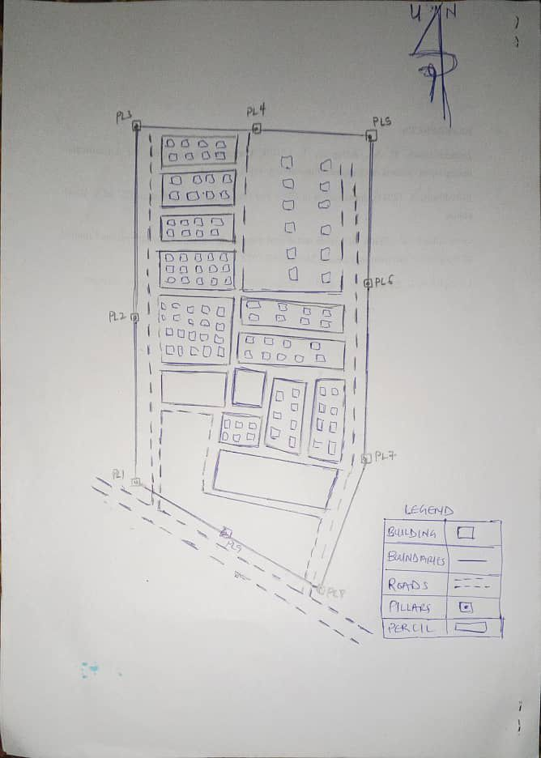
Figure 3.2: shows the Recce diagram of the study area

3.3 INSTRUMENT USED
Selection of instrument to be used is:
- Total station
- Tripod
- Linear tape
- Steal tape
- Field book
- Pencil
- Targets and their tripod
- Reflectors stand and target
- Nails
- Pegs

3.4 INSTRUMENT CHECKI

3.4.1 HORIZONTAL COLLIMATION TEST
Checking of instrument is very important in surveying operation, the accuracy of any work done at times depends on the quality of the instrument used, and using faulty instrument may result to wrong observation and bad work.
This test was conducted to ensure that the line of sight was perpendicular to the trunnion axis. The Total Station was positioned over a specific point, and initial adjustments were made to ensure proper alignment, leveling, and focus (to eliminate parallax in the telescope). A vertical target was placed at a distance of 100 meters from the Total Station. To access the configuration menu of the Total Station, the menu key was pressed and held for approximately 2 seconds. From the main menu, the calibration sub-menu was selected, and within that, the horizontal collimation test option was chosen. The target was then observed and divided into two halves, with horizontal readings recorded for Face left and Face right.
This is a perquisite exercise for any controls to be used for orientation; the control has to be checked through series of observation on the control through series of observation on the control pillars as to be ascertaining their stability and reliability both linear and angular.
The check was carried out as follows: -
The total station was set on a pillar, temporary adjustment was centering, leveling, and focusing.
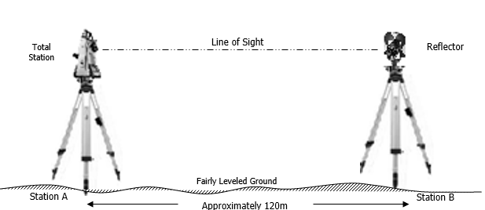
Figure 3.4: show the instrument test
Tab. 3.4: Show the result of instrument test
Instrument Station. | Sight (Reflector) | Face | Horizontal Circle Reading | Vertical. Circle Reading
 | B | L | 87º 35’ 10’’ | 88º 26’ 15’’
A | B | R | 267º 35’ 12’’ | 271º 33’ 46’’
 |  |  | Diff= 180º 00’ 02’’ | Sum= 360º 00’ 01’
Horizontal Collimation = [(FR – FL) - 180º]/2
= [(180º 00’ 02’ - 180º 00’ 00’’) /2] = 00º 00’ 02’’/2
= 00° 00’ 01’’
3.4.2 VERTICAL INDEX ERROR TEST
This test was conducted to verify the accuracy of the vertical reading when the line of sight is horizontal. The desired measurement for this test is exactly ninety degrees (90˚), any deviation from this value is referred to as the vertical index error.
The Total Station was positioned over a specific point, and necessary temporary adjustments were made to ensure proper alignment and functionality. A target was placed approximately 100 meters away from the Total Station, and the instrument was aimed at the target. The target was bisected by aligning the instrument on the face left, and the corresponding reading was recorded. Similarly, the target was then bisected on the face right, and the respective reading was also recorded. The recorded readings are provided below:
Table 3.6: Vertical Index Data
Instrument Station | Target Station | Face | Vertical | Sum | Error
A | B | L | 90˚00‟00”
 |  | R | 270˚00‟02” | 360˚00‟02” | 02”

Vertical Collimation = [(FR – FL) - 360º]/2
= [(360º 00’ 01’’ - 360º 00’ 00’’)/2] = 00º 00’ 01’’/2
= 00° 00’ 01’’

3.5 CONTROL CHECK

Three control beacons (KWCS 625T, KWCS 623T and KWCP 690) were used. In order to ascertain the in-situ of the control beacons, a check was carried out on them by observing the angle between them and comparing the result obtained with the computed angles from the giving coordinates.

The total station instrument was set on the control beacon KWCS 623T. After performing all the necessary temporary adjustment, the reflector was placed on the control beacon KWCS 625T which served as the back station. The horizontal angular reading was taken and recorded while the instrument was on face left. The reflector was then taken to the control beacon KWCP 690 which serves as the forward station, the horizontal angle reading was then taken and recorded on both face left and face right. The reflector was taken back to the back station, the horizontal angle was then recorded on face right.

Table 3.7: showing the back computation of the control coordinates

From STN | Bearing | Dist (m) | ∆N | ∆E | Northing (m) | Easting  (m) | To STN
 |  |  |  |  | 941451.040 | 674200.278 | KWCS 625T
KWCS 625T | 130°25'37'' | 465.791 | 302.055 | -354.576 | 941753.095 | 673845.702 | KWCS 623T
KWCS 623T | 149°38'02'' | 60.399 | 48.946 | -35.388 | 941802.041 | 673810.314 | KWCP 690

Table 3.8: showing the distance observation result of the control check

FROM | OBSERVED DISTANCE  (m) | COMPUTED DISTANCE  (m) | TO
KWCS 625T | 465.902 | 465.791 | KWCS 623T
KWCS 623T | 60.521 | 60.399 | KWCP 690

Table 3.9 showing the observation result of the control check

STN | SIGHT | FACE | OBSERVED HZ ANGLE | REDUCED  HZ ANGLE | MEAN
 | KWCS 625T | L1 | 195° 14' 07''
KWCS 623T | KWCP 690 | L2 | 64° 47' 29'' | 130°26'38''
 | KWCP 690 | R2 | 15° 14' 13'' | 130°26'22''
 | KWCS 625T | R1 | 145° 40' 35'' |  | 130°26'30''

Difference in angle (observed - computed) =188° 31' 40''-188° 31' 36'' = 00° 00' 04''

Since the allowable accuracy (angular) of third order traverse of one station is 00° 00' 30'' and the result obtained from the control check (00° 00' 04'') is less than allowable error. Therefore, the controls were angularly intact.

3.5 MONUMENTATION
In selecting station to represent the perimeter of the while carved, establishment of the station were done so as to define the boundaries of the project study area using a temporary Pegs since the place is Government property, station was established and they were marked with pegs. the peg was firmly even into the ground hence, ensuring that stability of the station pegs in such w away that they cannot be temper with.
Ground level
18cm
18cm
Beneath Ground level
75cm long
60cm
80cm Iron rod
Above Ground level
15cm

Figure 3.5 Typical Third Order Survey Beacon

3.6 DATA ACQUISITION
Data acquisition is the next stage after reconnaissance, this was done on the field and it includes the determination of point’s geometry and attribute value i.e. linear measurement and the coordinating of each station using total station.

3.6.1 GEOMETRIC DATA ACQUISITION
The total station instrument was set carefully on control point KWCS 623T back sight taken to KWCS 625T after necessary station adjustments has been carried out on it. The adjustments includes; centering, leveling and focusing. The following procedures were then followed to determine the position of the next point KWCS 623T and the same procedure were repeated until all we come close to the site. The method used in acquiring data on site was radiation method where two or more points are coordinated from one point.
- Having set up the instrument and temporary adjustment carried out, the instrument was powered „on‟ and a job was created under job menu in the internal memory of the instrument. The job created was named GRP6B
- On the job, the coordinates of the three (3) control points were keyed in to the memory of the instrument and some codes were also saved. The codes include
- „RD‟ for road, „SP‟ for spot height, „BD for buildings, etc.
- The height of the instrument was measured and saved on the memory of the instrument as well as the reflector height.
- On coordinate menu, orientation was set by inputting the coordinates of the instrument station and back sight. The reflector at the back station was perfectly bisected before the orientation was confirmed by clicking „yes‟.
- Having done the orientation, the reflector at the next nail; was bisected and „obs‟ (observe) option was clicked. The three dimensional coordinate of the point (E,N, H) were displayed on the display unit of the instrument and „rec‟ (record) was clicked to save the data into the memory of the instrument. For subsequent observation after this, „all‟ option was used instead of pressing „obs‟ and pressing
- „Record‟ later.
- It was ensured that the center of the prism of the reflector was bisected and that it was set perfectly on the tripod in order to minimize the error on height determination.
- The instrument is been shifted to another nail after all details, spot height and boundary point visible from the instrument station have been picked, set over it and temporary adjustments carried out.
- Nonetheless, the above operations were repeated until all the boundary points with heights were coordinated.
- In this project all spot height are not in grid intervals but randomly acquired. Three edges (3) of building were picked. At the end of data acquisition process all details were acquired and properly recorded to be shown in their respective positions on the plan.
3.6.2 ATTRIBUTES DATA ACQUISITION
Attribute data is information about spatial features. They provide the characteristics, description and nomenclature about spatial objects. Thus the attributes data acquired includes names of buildings and their uses such as classrooms, roads, water facilities and prominent natural features likes river and trees found and vegetation were properly identified within and around the study area.
3.7 DATA DOWNLOADING AND PROCESSING
3.7.1 DATA DOWNLOADING AND EDITING
This is stage whereby all data acquired which were automatically stored in the Total Station were downloaded into personal computer. This was done with the aid of downloading cable connected to the computer and some associated complementing software installed on the System.

3.7.2 DATA PROCESSING AND DATA EDITING
The geometric data downloaded were further processed in order to convert it to a useful format and to enhance its accuracy. The output coordinates, were edited and exported in *.txt, *.xls and *.pdf format. Thereafter, they were imported into Arc GIS 10.3 for further operations and to carry out spatial analysis.
3.7.3 DATA PROCESSING USING ARCGIS 10.3
- Launch the Arc Map in ArcGIS 10.3
- Click on A NEW EMPTY MAP on the dialog box displayed after loading
- Click on Tools on the menu bar, then select extensions, mark all and close.
- At the LHS, right click on layers, and then select properties.
- Click on coordinate system to set the projection system to MINNA DATUM ZONE 31N and general to set the unit, then apply and okay.
- Add data was selected at the tool bar all saved AutoCAD fie was selected and load onto the table of content layer section

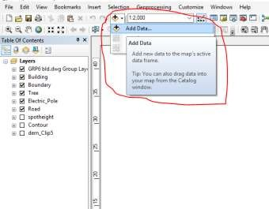
All drawing was exported to shape file. After the feature class has been creates, click on Editor to start Editing, and then click on the load object.
3.7.4 Topographical Map (DEM)
CRATING CONTOUR: Firstly DEM was created by searching in the search icon INTERPOLATION> NATURAL NIGHBOR and selecting THE XYZ data for creation of DEM in respect to the boundary line as extent. In order to create contours, you will need to enable the Spatial Analyst toolbar, which can be found by going to Customize > Toolbars > Spatial Analyst or open the search bar. You can do this by clicking Windows > Search, or by clicking on the search icon.
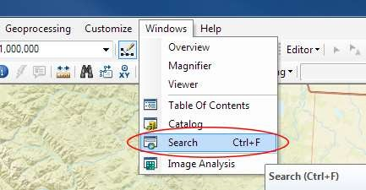

In the search bar type Contour, and select Contour (Spatial Analyst) from the search results list
After choosing Contour, a dialogue window will appear, prompting you for five settings: Input raster: select the DEM file from which you want to generate contours by locating it on your hard drive or in the dropdown menu, showing layers present in the Table of Contents Output polyline features: indicate where you want to save your output contours Contour interval: set the distance between contour lines in meters – the smaller the number, the greater the number of lines Base contour (optional): the starting point from which the lines are generated – for example, the default is 0 so with an interval of 25 meters, the contours are generated at 25, 50, 75, 100…, but if the base contour is set at 40, then the contours are generated at 65, 90, 115, 140 and so on Z factor (optional): can be used to adjust the units of data; for example, if you have data in meters and you want to produce your contours in feet, use a z-factor of 3.28 because 3.28 feet equals one meter.

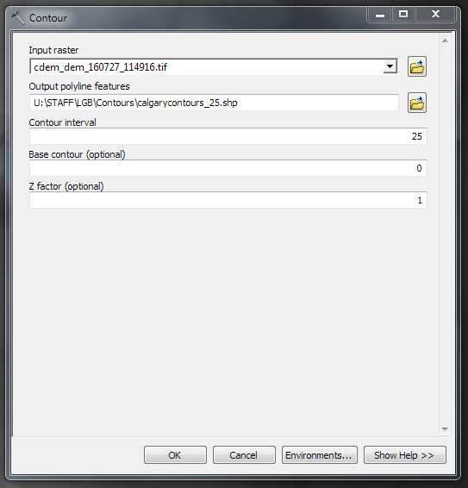

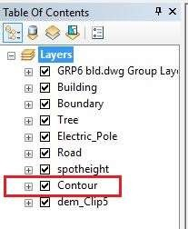
The generated contours will automatically be added to the map.

Input the data which is the AutoCAD drawing and select the feature type you want to load,
- Click Add and Next, then select the Target layer you want it to be
- Load it into from the feature class created on the ARCGLS.
- Click on Next, then select “only the features that satisfy the

- Query” and click on Query Builder to query for the feature to be loud e.g. “layer” = Boundary”.
- Click on Next. Then finish.
Right click on the Boundary In the table of content and click on zoom to layer to display the feature.
EDITING, CONVERTING AND MERGING GEODATABASE
- Remove all necessary features by right clicking on it and press "REMOVE"
- Convert some features that are not in their correct „features -type‟ like point, line, and polygon features etc.
- To convert a GOEDATABASE FEATURE CLASS to another the following steps were taken:
- FOR LINE FEATURE CLASS TO POLYGON FEATURE CLASS
- Go to WINDOW on the menu bar and select ARC Toolbox.
- Select DATA MANAGEMENT TOOLS, click on FEATURES, and then Select FEATURE TO POLYGON.
- ON INPUT FEATURES, select feature to be converted, on OUTPUT FEATURE CLASS, then save on the GRP6C FOLDER, press OK and CLOSE.
- Then remove the converted feature class in the LAYER Menu and ARC CATALOG files.
- On INPUT DATASETS, select features to be merged, on OUTPUT DATASETS, then save on the GRP6C folder, press OK and CLOSE.
- Then remove the converted feature class in the LAYER Menu and ARC CATALOG files.
ADDING SPOT HEIGHTS DATA
- NOTE: STOP EDITING on the EDITOR MENU before adding data field,
- Go to FIELD ON THE MENU BAR, scroll to add Data and then ADD XYZ DATA
- Browse the EXCEL FILE for SPOT HEIGHTS, select EASTING VALUE on X - FIELD and NORTHING VALUE on Y - IELD and ELEVATION
- « Select DATA the EXPORT DATA, locate the folder created and give it name then YES AND OK, remove the previous layer by right clicking on it and select REMOVE.
TIN, ASPECT AND SLOPE CREATION USING ARCMAP
NOTE: Making sure the 3D Analyst Extension is active, select VIEW on MENU bar, then click TOOLBARS and MARK the 3D Analyst EXTENTION Then X, Y Data
TO CREATE TIN
- Click on 3D Analyst arrow, select create TIN and then create TIN from FEATURE.
- On layers mark the SPOTHEIGHT LAYER, select height data on HEIGHT, then ok.
TO CHANGE THE FACE OF THE TIN ACCODING TO ITS ELEVATION
- RIGHT CLICK on the TIN, select PROPERTIES, and click on SYMBOLOGY.
- Then ADD, select FACE ELEVATION WITH COLOR RAMP, click ADD, and then select APPLY and OK.
TO CREATE ASPECT
- Click on 3D analyst arrow, select SPATIAL ANALYST TOOLS, SURFACE and THEN DOUBLE CLICK on ASPECT.
- Browse to where the raster format of all the acquired data created from the surfer was saved to.
- Browse to where you want the OUTPUT RASTER to be saved
- You can change the OUTPUT MEASUREMENT to Degree OR percent
- Click OK [then it displays on the data view screen], then Close.

3.8.5 Facility Map Production
The buildings were digitized from the downloaded Google earth image using ArcGIS 10.2.1. Shape files for the facilities were created in Arc Catalogue. The created shape files were added to Arc Map and editor was started to digitize out to facilities. The road network, buildings are extracted using polyline and polygon respectively while street lights and trees are represented by point data for 3D map production the generated 2D map is shown in Figure 3.6, Figure 3.7 shows the old 2D CAD map of the campus
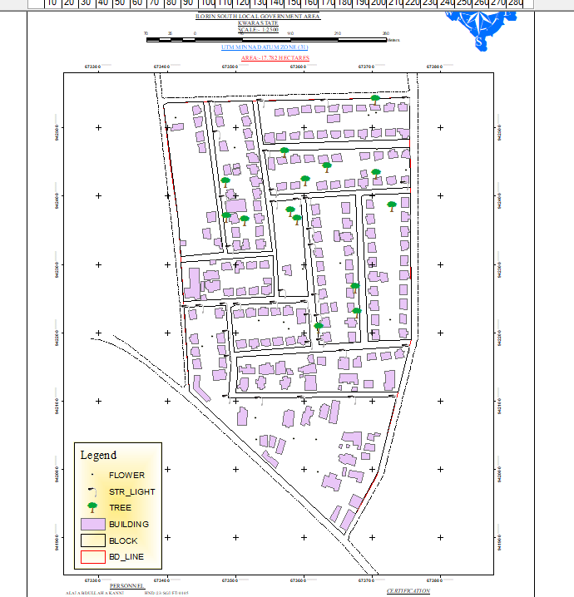

Figure 3.6 showing the 2D facility map of the study area.
3.8.6 3D Map Production
The 3D image was done Arc Scene using the created DEM; the created DEM was added to Arc Scene and extruded with the heights gotten on the field. Extrusion incorporates the height of these features in their representation to give them 3D look and was made to float on DEM to have a true land representation.
The created DEM was also added to Arc Scene, The height of the buildings gotten from the field was added to the already created height field in the attribute table of each of the facility shape file in Arc Map. Arc Scene was launched and all the shape files were added, from the table of content each shape file was right clicked on to access the property dialog box, from the property dialog box the shape files were extruded to give them 3D look and were made to float on the DEM to have a full 3D visualization.
3.8.7 Findings
This study has demonstrated a capability of GIS in facility mapping with different visualizations techniques i.e. 2D and 3D visualization, Figure 3.6 shows the generated 2D map while Figure 4(a) and Figure 4(b) show cross-sections of the generated 3D map of the campus. All the facilities were geo-located with the aid of total station and imported into ArcGIS 10.2, the facilities were also digitized from the Google earth image downloaded for the study area. 3D topographic maps of the study areas were created from the point data gotten from field-work and also from the downloaded SRTM DEM image downloaded from USGS, Figure 5 shows the 2D Topographic map generated from the point data gotten from the field using Total station while Figure 6 shows the 3D topographic map generated using the same data source. Figure 7 shows the 2D topographic map generated from SRTM 30 m while Figure 8 shows the 3D topographic map generated using the same data source. The 2D facility map was produced by digitizing all the facilities out as features from the Google earth image downloaded using Google downloader. The 3D model of the campus was produced by exporting all the features created in Arc Map to Arc Scene for extrusion; the extruded features were made to float on the 3D topography map created through interpolation using Kriging method. The 3D visualization gives the study area a near real life view.
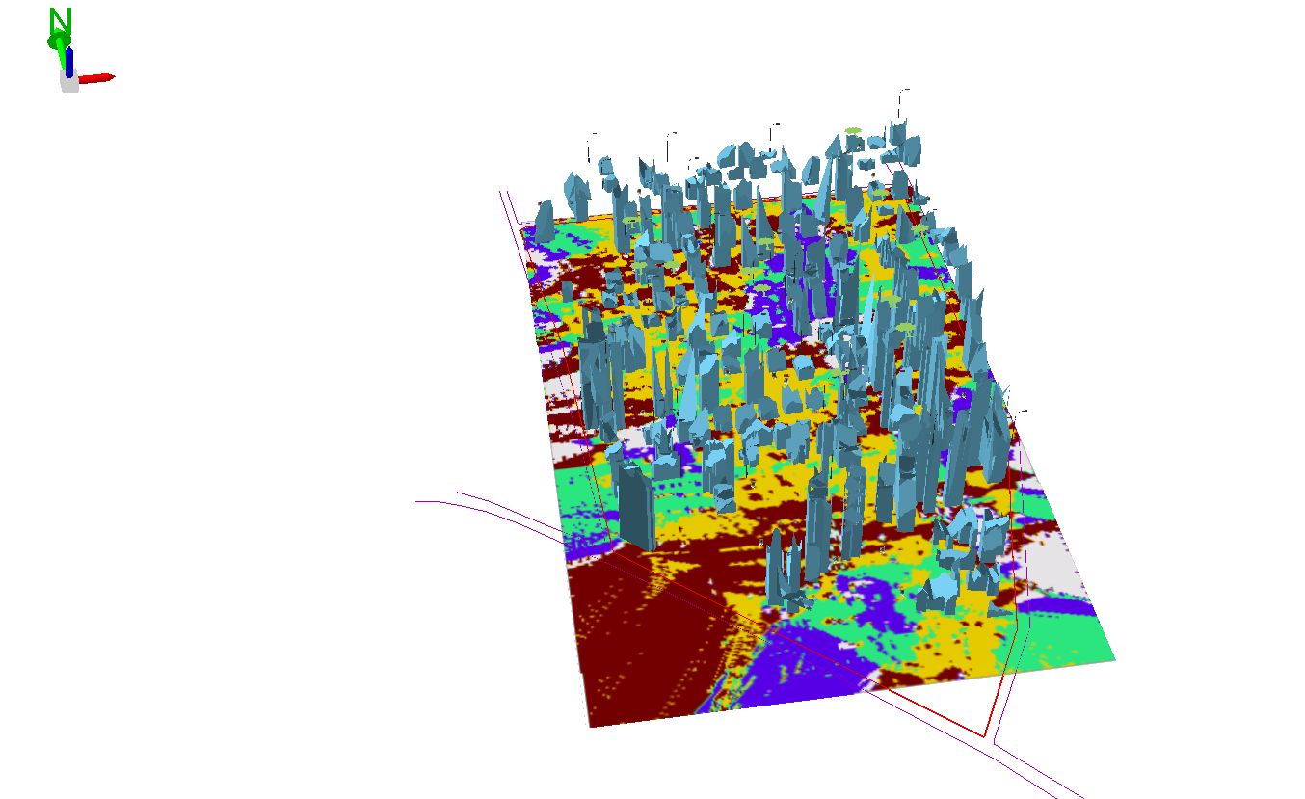

Figure 3.7 (a) Showing 3D model of the study area

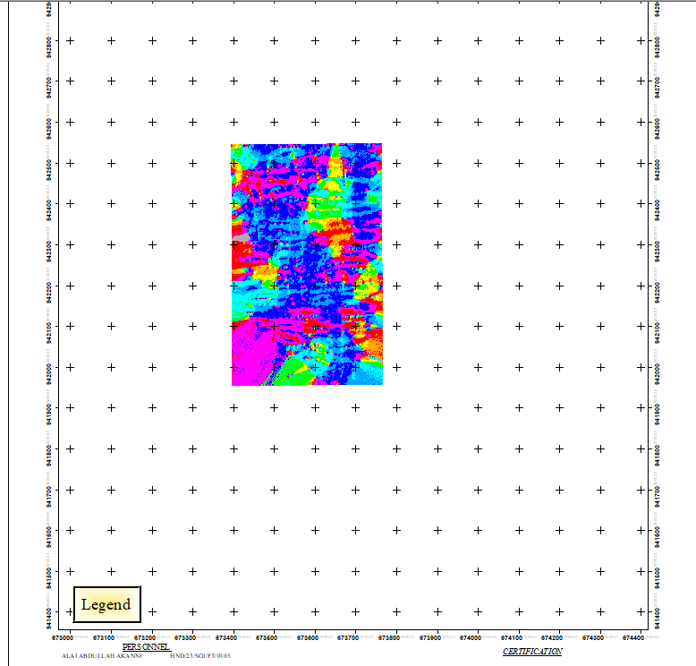

Figure 3.8 showing the 2D DEM (Digital elevation model) of the study area (derived from the field data)
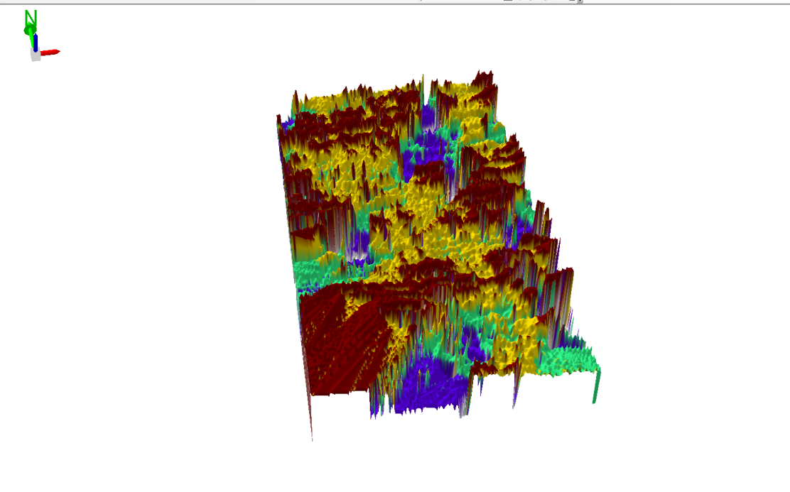

Figure 3.9 Showing 3D DEM (Digital Elevation Model) of the study area (derived from the field data).

3.8.8 Attribute data creation
There is need to create attribute tables for the features so as to be used for queries. NOTE: The editor on the menu bar must be stopped before adding field to its table. THE FOLLOWING PROCEDURES WERE FOLLOWED:
- Right click on the feature class, then select OPEN ATTRIBUTES TABLE click on OPTIONS and select ADD FIELD.

- Give it FIELD NAME, click on TYPE and select [SHORT INTEGER or LONG INTEGER for SHORT or LONG WHOLE VARIABLES or DOUBLE FOR DECIMAL VARIABLES OR TEXT variable or DATE for DATE], then enter precision or LENGTH for text width and scale for DECIMAL PLACES, and then click OK
- To input variables on the ATTRIBUTE TABLE, go to the EDITOR on Menu bar, select START EDITING,
- Click on ATTRIBUTE on menu bar [behind the TARGET], click on the features on the DATA VIEW display, and then input the variables of data acquired through SOCIAL SURVEY or DATA ACQUIRED ON THE FIELD.
- Save it after the input by selecting SAVE EDITS on the editor menu. To switch to other layers, select STOP EDITING on the EDITOR menu. Then repeat the above step to create other fields. Populate the table and save.
Table 3.10: Building
ENTITY | FIELD ALIAS | DATA TYPE | FIELD SIZE
B_ID | Building Identification | Numeric | -
B_name | Building Name | Text | 10
B_Area | Building Area | Numeric | -
B_E | Building Easting | Numeric | -
B_Northing | Building Northings | Numeric | -

Table 3.11: Road
ENTITY | FIELD ALIAS | DATA TYPE | FIELD SIZE
R_ID | Road Identifier | Numeric | -
R_Length | Road Length | Numeric | -
R_Width | Road Width | Numeric | -
R_Type | Road Type | Text | 10
R_Condition | Road Condition | Text | 10

Table 3.12: Trees
ENTITY | FIELD ALIAS | DATA TYPE | FIELD SIZE
TR_ID | Tree Identifier | Numeric | -
TR_Spp | Tree specy | Text | 10
TR_E | Tree_Easting | Numeric | -
TR_N | Tree Northing | Numeric | -

Table 3.13: Electric Poles
ENTITY | FIELD ALIAS | DATA TYPE | FIELD SIZE
EP_ID | Electric pole Identifier | Numeric | -
EP_Type | Electric pole Type | Text | 10
EP_Height | Electric pole Height | Numeric | -
EP_E | Electric pole Easting | Numeric | -
EP_N | Electric pole Northing | Numeric | -
3.8.9 DATABASE IMPLEMENTATION
This is the database creation phase. Having completed the three stages of design phase (i.e. Reality, Conceptual and Logical design), the database was created using ArcGIS 10.3 software. It involves the combination and storage of acquired graphic data and attributes data in creating the database for the purpose of spatial analysis and query.
Database is an organized integrated collection of data stored so as to be capable of use by revenant application with data being accessed by different logical part. After the Attribute table was populated via the keyboard, some attributes such as areas of settlements were automatically displayed by special command in the ArcGIS 10.3 version. The ArcGIS software was used to link the graphic data and table for query generation.

3.8.10 DATABASE MANAGEMENT SYSTEMS
Database management is a collection of software for creating, storing, manipulating, updating, organizing and querying of information in a database (Kufoniyi, 1998). It is a software package whose function is to manipulate a database on behalf of the user.
A good DBMS must provide the following functions:
      - Storage and retrieval of data.
      - Access to by several users at a time.
      - A standardized interface between database and application programmed.
      - Standardized access to data and separation of data storage and retrieval functions from the program using the data.
      - Maintenance of data security and integrity.
3.8.11 DATABASE MAINTENANCE
Having created the database, proper maintenance practice was made to meet its stated objectives. The ability to include more data and remove irrelevant data was possible by way of maintenance. There is every need for the data to be updated regularly because of the physical changes that may occur on the landscape with time. Both security and integrity were also exercised to ensure maintenance and to meet its stated objectives.
Proper observance, updating and management of database ensure its currency and quality to stand a profound chance in Spatial Decision Support System (SDSS). The quality of any database depends on the currency and fitness for use as a decision support system (SDSS). The quality of database depends on its ability to generally fit and use as a decision system (DSS). The storage media should be from time to time justified if otherwise could necessitate data inaccessibility or physical deterioration of the storage media. Also care must be taken during populating any database system, as a database is only good as the data supplied. In archiving stable media should be used. Examples of these are:-
- Computer compatible tape reader
- Magnetic tape
- Optical disc and compact disc
3.8.12 AREA COMPUTATION Table
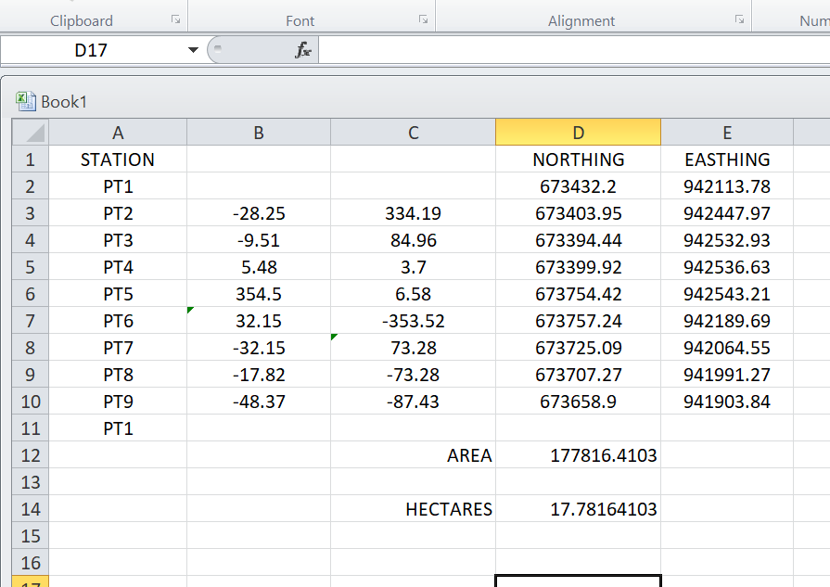
Table 3.14: shows area computation

CHAPTER FOUR

4.0 SPATIAL ANALYSES AND PRESENTATION
GIS is distinct among other information system because of its spatial analytical capability; especially overlay operation, buffering, spatial search, topographic operation, and neighborhood and connectivity operations. GIS uses this spatial analytical capability to answer fundamental generic question of location, condition, trend, routing, pattern and modeling by the manipulation and analysis of input data. The major analyses performed in this project were overlay operations, topographic operations and spatial search.
4.1 TESTING OF DATABASE
This is the test carried out to determine whether there exists a relationship between data modeled about entities in a spatial database as well as putting into test its retrieval capabilities. This was done by designing a sample query with certain conditions attached and the query will be ran to see if desired result is achieved.
4.11 ANALYSIS OF RESULT
The contour whose value is greater or equal to 350 meters depicts the likelihood that such area may not be prone to flood in the project area as shown in Fig. 4.5(Query 1). This represents the elevation of points that are greater than to 350m. The displayed attribute table confirmed that North-East part of the institute had the highest elevation. Height is an important factor when considering the surface or slope of the terrain. The South-west part of the school had the lowest elevation which is very prone to erosion. Buildings that will be sited in that region must have a very high foundation above the ground level. The result of the query will afford the school management to decide concisely the terrain characteristics and the kind of building that should build in every region of the project area looking out critically for the terrain of the area.
SINGLE SELECTION CRITERION
Query 1: shows the completed building
SELECT* FROM Building WHERE "BLD_STATUS" LIKE COMPLETED
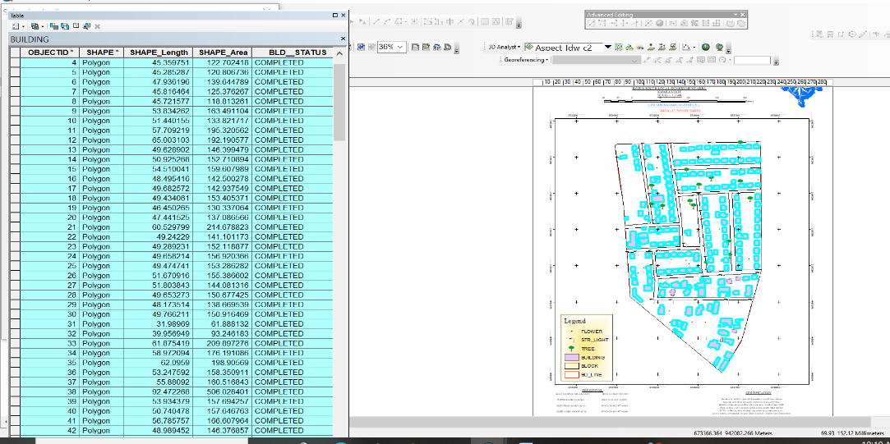

Fig 4.1: shows the completed building

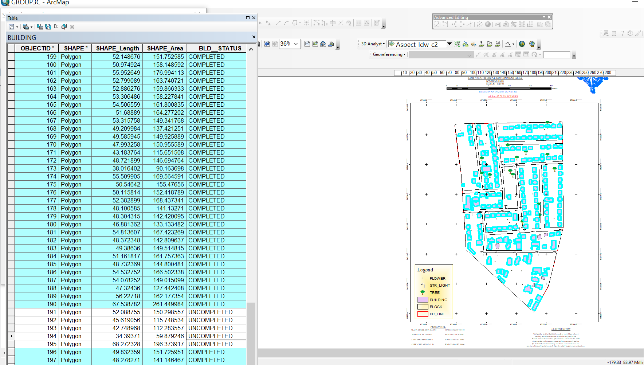

Fig 4.2: shows the 2D completed building
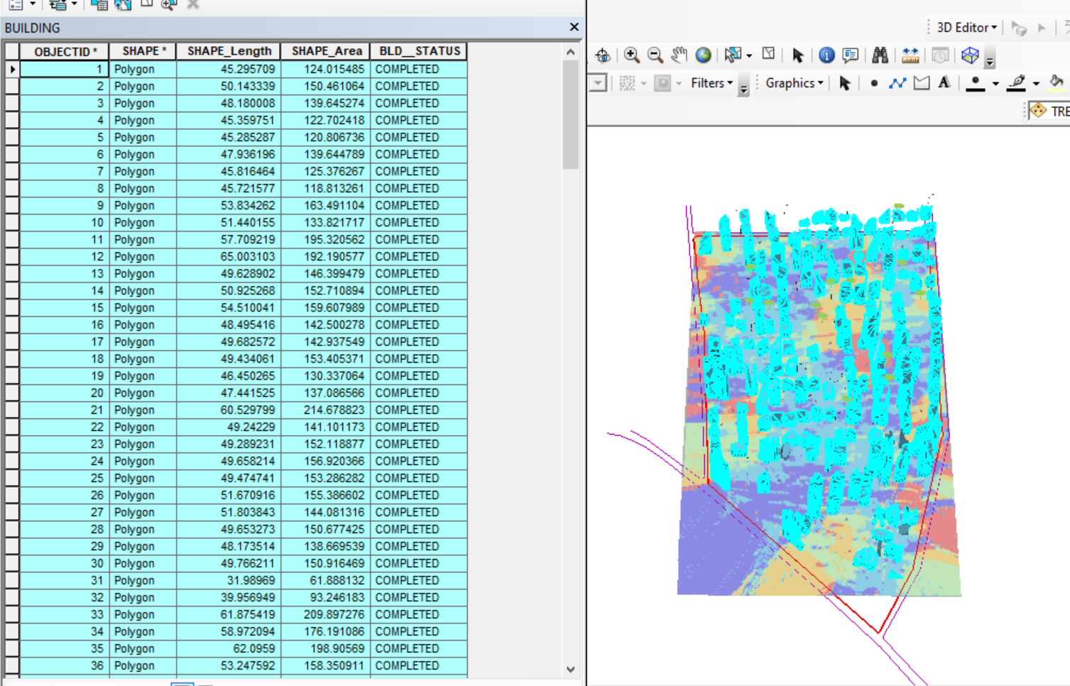

Figure 4.3 shows the 3D of completed building

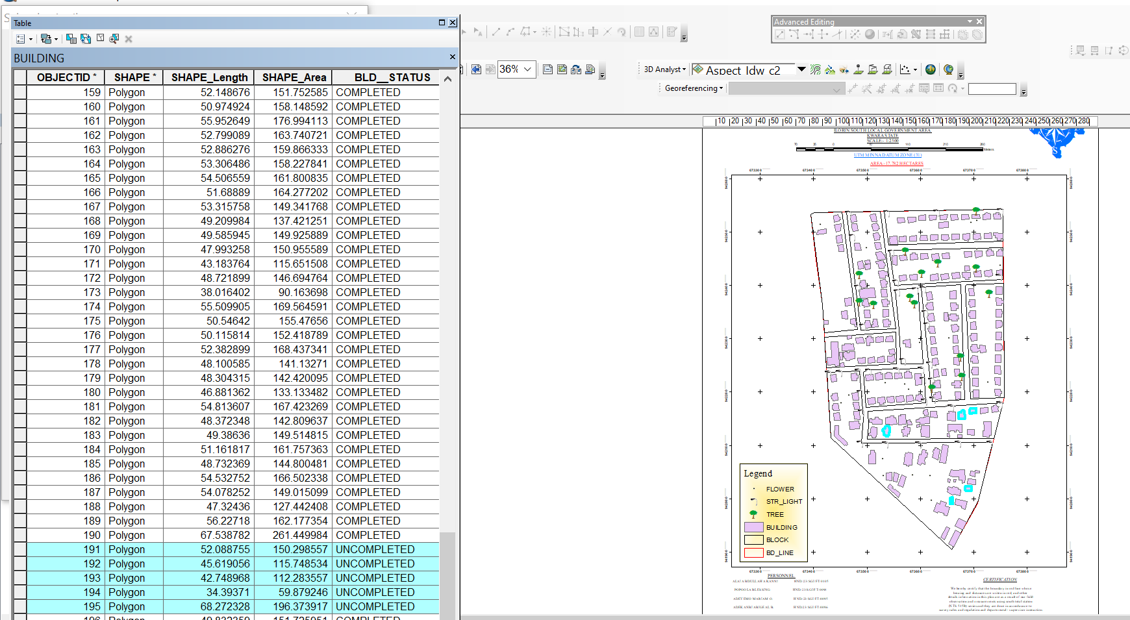

Fig 4.4 Query shows the 2D of uncompleted building
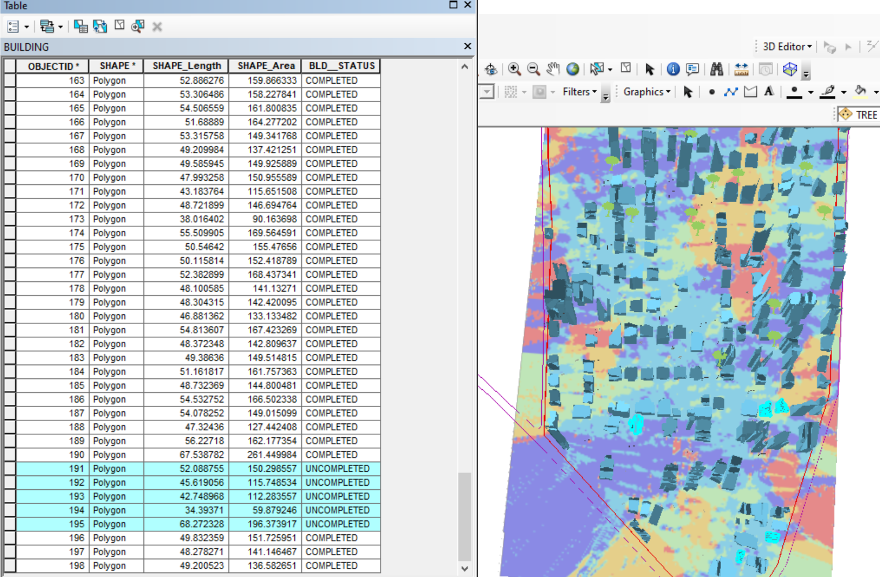

Figure 4.5 shows the 3D of uncompleted building

CHAPTER FIVE

5.0 Costing Estimation, Summary, Conclusion, Recommendation and Problem Encountered

5.1 Costing Estimation
RECCONNAISSANCE
S/N | PERSONNEL | QTY | DAILY RATE | NO OF DAYS | REMARK
1 | Group leader | 1 | 5000 | 1 | 5000
2 | Ass group leader | 1 | 2500 | 1 | 2500
3 | Basic equipment | 1 | 25000 | 1 | 25000
4 | Transportation | 1 | 3000 | 1 | 3000
Subtotal = #35,500
Monumentation
S/N | PERSONNEL | QTY | DAILY RATE | NO OF DAYS | REMARK
1 | Group leader | 1 | 5000 | 1 | 5000
2 | Ass group leader | 1 | 2500 | 1 | 2500
3 | Skilled labor | 3 | 1500 | 1 | 4500
4 | Basic equipment | 1 | 25000 | 1 | 25000
5 | Transportation | 1 | 7500 | 1 | 3000
Subtotal = #40,000
Beaconing
S/N | PERSONNEL | QTY | DAILY RATE | NO OF DAYS | REMARK
1 | Group leader | 1 | 5000 | 1 | 5000
2 | Ass group leader | 1 | 2500 | 1 | 2500
3 | Basic equipment | 1 | 5000 | 1 | 5000
4 | Transportation | 1 | 3000 | 1 | 3000
Subtotal = #5,500
Beacon
S/N | PERSONNEL | QTY | DAILY RATE | NO OF DAYS | REMARK
1 | Group leader | 1 | 5000 | 1 | 5000
2 | Ass group leader | 1 | 2500 | 1 | 2500
3 | Beacon | 10 | 1000 | 1 | 10,000
4 | Transportation | 1 | 3000 | 1 | 3000
Subtotal = #19,500
Traversing
S/N | PERSONNEL | QTY | DAILY RATE | NO OF DAYS | REMARK
1 | supervisor | 1 | 6000 | 1 | 6000
2 | Group leader | 1 | 5000 | 1 | 5000
3 | Ass group leader | 1 | 2500 | 1 | 2500
4 | Skilled labour | 6 | 1500 | 1 | 10,000
5 | Basic equipment | 1 | 25000 | 1 | 5000
6 | Transportation | 1 | 10,500 | 1 | 10,500
Subtotal = #43,500
Spot Height
S/N | PERSONNEL | QTY | DAILY RATE | NO OF DAYS | REMARK
1 | Supervisor | 1 | 6000 | 2 | 12,000
2 | Group leader | 1 | 5000 | 2 | 10,000
3 | Ass group leader | 1 | 2500 | 2 | 5000
4 | Skilled labor | 6 | 1500 | 2 | 20,000
5 | Basic equipment | 1 | 25000 | 1 | 5000
6 | Transportation | 1 | 10,500 | 2 | 21,000
Subtotal = #73,000
Data processing
S/N | PERSONNEL | QTY | DAILY RATE | NO OF DAYS | REMARK
1 | Group leader | 1 | 5000 | 1 | 5000
2 | Ass group leader | 1 | 2500 | 1 | 2500
3 | Basic equipment | 1 | 10,000 | 1 | 10,000
4 | Generator and fuel | 1 | 10,000 | 1 | 10,000
Subtotal = #27,500
Technical report
S/N | PERSONNEL | QTY | DAILY RATE | NO OF DAYS | REMARK
1 | Group leader | 1 | 5000 | 1 | 5000
2 | Ass group leader | 1 | 2500 | 1 | 2500
3 | Basic equipment | 1 | 10,000 | 1 | 10,000
4 | Generator and fuel | 1 | 10,000 | 1 | 10,000
Subtotal = #27,500
Sum total = 271,500.00

Contingency allowance = 271,500.00 X 5/100= 13,575

VAT = 271,500.00 X 7.5/100=20,362.5

ACCOMODATION = 271,500.00 X 1.5/100 = 4,072.5

MOB/DEMB = 271,500.00 X 10/100 = 27,150

CLEARANCE TAX = 65, 159.5

5.2 SUMMARY
The digital facility mapping of Royal Valley Estate in Sango, Ilorin involves the systematic collection, analysis, and presentation of spatial data concerning physical infrastructures within the estate. The primary aim is to produce a detailed digital map that accurately represents the layout and location of facilities such as roads, buildings, drainage systems, electrical poles, water lines, and other utilities for effective planning, maintenance, and management.
The project employs Total Station surveying technology, which combines electronic distance measurement (EDM) and angle measurement to precisely capture the coordinates of various physical features. The process begins with reconnaissance and control point establishment, followed by field data collection using the Total Station to record horizontal and vertical positions of facilities. The gathered data is then processed using CAD and GIS software to generate a digital map that is both accurate and georeferenced.
This method ensures high precision, improves data reliability, and supports future facility upgrades or expansions. The final output serves as a vital tool for facility managers, urban planners, and estate administrators in making informed decisions regarding infrastructure maintenance and development.

5.3 CONCLUSION
The digital facility mapping of Royal Valley Estate at Sango, Ilorin, using Total Station technology has proven to be an efficient and precise approach to capturing and documenting existing infrastructure within the estate. By integrating modern surveying tools with geospatial processing software, the project delivers a comprehensive digital representation of the estate's facilities. This not only enhances the accuracy of facility records but also provides a reliable foundation for future planning, development, and maintenance activities. Ultimately, the mapping exercise contributes significantly to improved estate management, supports informed decision-making, and aligns with modern standards of urban infrastructure documentation.

5.4 PROBLEM ENCOUNTER
- Unfavorable weather, particularly intense sunlight and intermittent rainfall, disrupted field operations and affected the visibility and accuracy of measurements.
- Post-field processing took longer than anticipated due to the need to clean and verify raw data before importing into CAD.
- Indifferent of group members during data acquisition.
- Newbies with the instrument used.
- Financial Incapability.

5.5 RECOMMENDATION
- Students should familiarize themselves with the Total Station and associated software before going to the field. Practical training sessions help reduce mistakes and build confidence.
- Students are encouraged to explore GIS, AutoCAD, and other mapping software beyond classroom lectures. This will improve their technical skills and prepare them for real-world professional practice.
- A project of this nature benefits from teamwork. Students should collaborate and assign roles such as instrument operation, data recording, and observation targeting to enhance efficiency and reduce stress.
- Where possible, using Total Stations with advanced features such as built-in GNSS or reflectorless capabilities can improve data collection, especially in areas with line-of-sight problems.
REFERENCES
Bingaith, A. A. (2010). Implementing GIS for Facilities Management at the California Institute of Technology (Master's thesis, University of Redlands). Retrieved from https://inspire.redlands.edu/ gis_gradproj/12
Axel rapp. (2023): DIGITAL MAPPING OF CRITICAL INFRASTRUCTURE
Augustine C. Emeribeole , Chima J. Iheaturu (2015). Digital Mapping Techniques: A Vital Tool for Updating Topographic Maps in Nigeria (A Case Study of Okigwe Local Government Area in Imo State) International Journal of Science and Research (IJSR) ISSN (Online): 2319-7064 Index Copernicus Value (2013): 6.14 | Impact Factor (2014): 5.611
Biljecki, F., Stoter, J., Ledoux, H., Zlatanova, S., & Coltekin, A. (2015): Applications of 3D City Models: State of the Art Review. ISPRS International Journal of GeoInformation, 4, 2842–2889. https://doi.org/10.3390/ijgi4042842.
Mohd Aizat Saiful Bahri1 , Khairul Nizam Abdul Maulud2 , Muhammad Amartur Rahman1 , Aslinda Oon Binti Ridzuan Oon5 , Adi Irfan Che Ani3 Che Hafify Che Hashim1 , Hairi Karim6 Muhammad Syahidi Hasbullah1 Mohd Za’Im Aziz4. (2019): DEVELOPMENT OF GIS DATABASE AND FACILITY MANAGEMENT SYSTEM: ASSET AND SPACE IN UKM. The International Archives of the Photogrammetry, Remote Sensing and Spatial Information Sciences, Volume XLII-4/W16, 2019 6th International Conference on Geomatics and Geospatial Technology (GGT 2019), 1–3 October 2019, Kuala Lumpur, Malaysia. https://doi.org/10.5194/isprs-archives-XLII-4-W16-563-2019 | © Authors 2019. CC BY 4.0 License.

APPENDICES
COORDINATE LIST

ID | EASTINGS | NORTHINGS
B1 | 666472 | 937402.5
B2 | 666484.9 | 937400.9
B3 | 666483.2 | 937390.2
B4 | 666470 | 937391.8
B5 | 666488.5 | 937412
B6 | 666516 | 937406.7
B7 | 666514.7 | 937395
B8 | 666486.5 | 937399.9
B9 | 666493.4 | 937431.3
B10 | 666505.4 | 937428.8
B11 | 666501.4 | 937411.7
B12 | 666489 | 937414.4
B13 | 666502.4 | 937464.7
B14 | 666512.1 | 937462.9
B15 | 666505.4 | 937428.8
B16 | 666495.4 | 937431.5
B17 | 666496.1 | 937473.4
B18 | 666501.2 | 937472.2
B19 | 666499.9 | 937465.1
B20 | 666494.2 | 937467
B21 | 666502.1 | 937480.3
B22 | 666555 | 937468.8
B23 | 666553.3 | 937459.1
B24 | 666501 | 937470.5
B25 | 666556 | 937468.2
B26 | 666563.7 | 937466.8
B27 | 666560.9 | 937455.8
B28 | 666553.1 | 937457.4
B29 | 666536.1 | 937394
B30 | 666550.7 | 937457.5
B31 | 666563.2 | 937454.9
B32 | 666548.6 | 937390.6
B33 | 666520.1 | 937405.8
B34 | 666536.3 | 937403.6
B35 | 666534.7 | 937393.3
B36 | 666516.3 | 937395.6
B37 | 666516.6 | 937401.6
B38 | 666519.4 | 937401.4
B39 | 666512.5 | 937495.1
B40 | 666559 | 937484.2
B41 | 666556.4 | 937472
B42 | 666509.4 | 937484.4
B43 | 666508.3 | 937512.3
B44 | 666546 | 937503.8
B45 | 666541.7 | 937489.7
B46 | 666505.1 | 937499.1
B47 | 666512.5 | 937530.7
B48 | 666550.1 | 937522.3
B49 | 666546 | 937506.4
B50 | 666508.8 | 937514.8
B51 | 666552.2 | 937521.6
B52 | 666564 | 937518.3
B53 | 666556.3 | 937489.5
B54 | 666545.2 | 937493.2
B55 | 666566.8 | 937517.6
B56 | 666577.2 | 937515
B57 | 666569.7 | 937485.5
B58 | 666559.1 | 937489.6
B59 | 666574.3 | 937526
B60 | 666604 | 937520
B61 | 666601.9 | 937508.7
B62 | 666572.4 | 937516.2
B63 | 666612.9 | 937520.2
B64 | 666617.9 | 937519.7
B65 | 666617.2 | 937510.3
B66 | 666611.8 | 937511.1
B67 | 666612.3 | 937503
B68 | 666617 | 937502.6
B69 | 666615.9 | 937491.5
B70 | 666611.5 | 937492
B71 | 666470.8 | 937486.2
B72 | 666474.4 | 937486.1
B73 | 666474.1 | 937481.5
B74 | 666470.7 | 937481.7
B75 | 666473.3 | 937500.4
B76 | 666476.9 | 937500.3
B77 | 666476.9 | 937497.6
B78 | 666473 | 937497.8
B79 | 666472.1 | 937517.6
B80 | 666476.4 | 937517.2
B81 | 666475.8 | 937510.8
B82 | 666471.9 | 937511.4
B83 | 666472.7 | 937535
B84 | 666478.9 | 937534.7
B85 | 666478.1 | 937526.2
B86 | 666472.2 | 937526.3
B87 | 666479.4 | 937539.6
B88 | 666485.9 | 937539.1
B89 | 666485.9 | 937535.6
B90 | 666479.2 | 937536.3
B91 | 666495 | 937536.2
B92 | 666508 | 937534
B93 | 666505.6 | 937519.6
B94 | 666492.6 | 937522.1
PL1 | 666472.2 | 937540.7
PL2 | 666618.3 | 937521.3
PL3 | 666607.4 | 937371.4
PL4 | 666468.4 | 937392
RD 1 | 666651 | 937536.1
RD2 | 666470.5 | 937557.3
RD3 | 666469.8 | 937584.6
RD 4 | 666651.8 | 937521.6
RD 5 | 666469.2 | 937545.7
RD 6 | 666463.1 | 937332.5
RD 7 | 666445.1 | 937341.2
RD 8 | 666452.1 | 937584.6
RD 9 | 666464.5 | 937381.6
RD 10 | 666609.9 | 937359.6
RD 11 | 666464.5 | 937381.6
RD 12 | 666609.9 | 937359.6
RD 13 | 666624.2 | 937525.6
RD 14 | 666608.8 | 937346.4
RD 15 | 666637.5 | 937523.5
RD 16 | 666619.4 | 937345.5

