FACTORS ASSOCIATED WITH SUBSTANCE USE AMONG UNDERGRADUATE STUDENTS IN TERTIARY INSTITUTIONS IN ILORIN METROPOLIS
(A CASE STUDY OF INSTITUTE OF INFORMATION AND COMMUNICATION TECHNOLOGY)

BY
ABDULWAKEEL AISHAT ABIODUN

ND/23/STA/FT/0123

BEING A RESEARCH WORK SUBMITTED TO THE
DEPARTMENT OF STATISTICS, INSTITUTE OF APPLIED SCIENCES, KWARA STATE POLYTECHNIC, ILORIN.

IN PARTIAL FULFILMENT OF THE REQUIREMENT FOR THE
AWARD OF NATIONAL DIPLOMA (ND) IN STATISTICS
JULY, 2025

CERTIFICATION
This project work has been read, supervised and approved as meeting the requirement for the award of the national diploma (ND) in statistics department, institute of applied science (IAS), Kwara state polytechnic, Ilorin, Kwara state.

---------------------------- -----------------------------
PASTOR KURANGA L.J. DATE
Project supervisor

---------------------------- ------------------------------
MRS. ELEPO T.A DATE
Head of department

---------------------------- ------------------------------
EXTERNAL EXAMINER DATE

DEDICATION
This research work is dedicated to Almighty Allah, and Mr and Mrs Abduwakeel.

ACKNOWLEDGMENT
I would like to express my deepest gratitude to all those who have contributed to the successful completion of this project.
Special thanks go to my supervisor, Mr. Kuranga L.J., for his invaluable guidance, patience, and support, may Allah continue to bless you.
I am grateful to the head of department (HOD) Mrs. Elepo. I am also grateful to my lecturers for their insightful advice and encouragement.
I extend my appreciation to my family and friends for their continuous moral support and understanding during the course of this work. Finally, I acknowledge all individuals and institutions that provided resources and assistance that made this project possible.

ABSTRACT
This study investigates the prevalence, patterns, and socio demographic factors associated with substance use among undergraduate students in a Nigerian tertiary institution. Substance use, particularly involving psychoactive drugs such as alcohol, tobacco, cannabis, and unauthorized prescription medications, has emerged as a serious health and social challenge within the Nigerian university system. Tertiary institutions are characterized by freedom, experimentation, and peer interaction, all of which can create a fertile ground for risky behaviors.

Keywords: substance use, students, questionnaire, polytechnic.
TABLE OF CONTENTS
- TITLE PAGE i
- DEDICATION ii
- ACKNOWLEDGEMENT iii
- ABSTRACT iv
- TABLE OF CONTENTS v

- CHAPTER ONE: INTRODUCTION 1-3
1.1 Background to the Study 1
1.2 Statement of the Problem 2
1.3 Aim and Objectives of the Study 2
1.4 Significance of the Study 3
1.5 Scope of the Study 3
1.6 Operational Definition of Terms 3

- CHAPTER TWO: LITERATURE REVIEW 4-12
2.1 Introduction 4
2.2Empirical Review 11
2.3Gaps in Literature 12

- CHAPTER THREE: RESEARCH METHODOLOGY 13-14
3.1 Introduction 13
3.2 Method of Data Collection and Analysis 13
3.3 Population of the Study 13
3.4 Instrument for Data Collection 14

- CHAPTER FOUR: DATA PRESENTATION AND ANALYSIS15 26
4.0Introduction 15
4.2 Data Analysis and Interpretation 16

- CHAPTER FIVE: SUMMARY, CONCLUSION AND RECOMMENDATIONS 27-29
5.1 Summary 27
5.2 Conclusion 27
5.3 Recommendations 28
5.4 Suggestions for Further Research 28

- REFERENCES

CHAPTER ONE
INTRODUCTION
1.1 Background of the study
The current trend of substance abuse among youth is a major national concern, it is troubling, it has derogatory effects on youth such as health and behavioral problems, or even death. Falco (1988); as cited by Sambo (2008) viewed that “chronic use of substance can cause serious, sometimes irreversible damage to adolescents’ physical and psychological development. Therefore, the issue of substance abuse has become a worrisome phenomenon, because youth are dying morally, socially, psychologically and physically. Currently, drugs ranging from alcohol, cigarettes, marijuana, cocaine, heroin to hashish and many others are readily available to youth in Nigeria and this has made many youths to be perpetrators of social vices in the society. Mersy (2003) described substance abuse as problematic use of alcohol, tobacco, or illicit and /or prescription drugs and it has been referred to as nation’s number one health problem. While, David, Derald & Stanley (1990) refers to substance abuse as a pathological pattern or excessive use, intake of a substance even though it may be causing physical damage, jeopardizing safety (such as driving a car while intoxicated) or impairing social relationships and occupational functioning. Need for substance may lead to a pre-occupation with its acquisition and use. Substance abuse may reduce undergraduate chances of graduating from school or of landing and holding a steady job, it may also be causing student unrest in the campus which will disturb academic calendar and this may also lead to poor academic performance. According to Hawkins, Cataland and Miller (1992) a low level of commitment to education and higher truancy rates appears to be related to substance use among adolescent. Bureau of Justice Statistics (1992) posited that cognitive and behavioral problems experienced by alcohol and drug-using youth may interfere with their academic performance and also present obstacles to learning for their classmates. Substance abuse is common among undergraduate students; many of them abuse substance such as drug alcohol and tobacco. Alcohol is the most widely used and abused drug among youth, and it causes serious and potentially life-threatening problems for this population. Eke Jumba (1991) notes that alcohol is the most abused substance in Nigerian campuses. Denga in Piwana and Haggai (2007) points out that alcohol has become a recreational past time with students, to the extent that students have found a new religion in which drinking alcohol is the major sacrament. This refers to the “Kegites” Fraternity. The findings of Piwana and Haggai (2007) also revealed that the drugs commonly used at cult meetings include first and foremost alcohol and tobacco; all cult groups abuse these two drugs regularly. In the same vein Ayatse (2005) reported that the materials needed for initiation of cult members include intoxicating wine prepared with 331 Factors Influencing Substance Abuse among Undergraduate Students in Osun State hallucinating drugs such as Indian hemp and cocaine. These drugs will intoxicate the cult members and it will make them to be bold, and under the influence of drug they can kill or destroy their mates or lecturers. Tobacco is another substance that it is easily been abused by many undergraduates and it has negative effect on mental health of the people. It could be taking in different forms; it can be smokeable, chewable and snuffable. Osu in Piwana and Haggai (2007) points out that tobacco is a narcotic which affects the nervous system by stimulating it. The effects produced by smoking tobacco depend not on the nicotine that is absorbed from the smoke. Many of the students graduate from tobacco smoking to Marijuana smoking which they believe it will be more powerful on them and make them hyperactive. It is cheap and can easily be purchased from drug peddlers that are increasingly targeting the youth, as a symbol of revolution. They seek to sacrifice at the altar of money and mental derangement self-seeking clamoring for the minds and souls of the young people the action which has negative consequences on the society. This is evident in Nigeria as revealed by the findings of Okonafua in Amala (1992) and Okatahi (2003) in their studies of some University Undergraduates in Nigeria. Okanafua in Amali (1992) discovered a drug abuse rate of 26% marijuana. Marijuana was discovered to be one of the commonest drugs abused by students. The study he conducted examined the factors like: the population of youths with the aim of identifying the most commonly used drug; the pattern of abuse; the source of drug supply and reasons why the drugs were abused and how they were used. At the end of their study, the researchers discovered that 40% of the 500 students responded and of this 26% used two main drugs. These were stimulant and Marijuana. Two thirds of the Marijuana smoking population had secondary education and the rest one third had Grade II Teacher Education: 70% were from Southern Nigeria, 20% from neighboring African Countries and the rest from other parts of Nigeria. According to the study, the mood and personality of the users were affected by the drugs they used. Various reasons were given by students on why they took drugs to feel happy, excited and friendly especially to members of opposite sex. Some said they used drugs for sexual excitements. Twelve of the students said they took drugs for mental alertness and the rest said drugs give them better visual and auditory experienceIn the same vein, Okatachi (2003) carried out a study on predisposing factors associated with drug abuse in Kano and Lagos cities in Nigeria, using a sample of 144 subjects. The study conducted examined the effects of gender family background, and knowledge of drugs and drug abuse. At the end of the study, the researcher discovered that: male tend to abuse drugs more than females; children from unstable homes are more prone to drug abuse than children from stable homes; children from low socio-economic status families are more likely to engage in drug abuse than those from high; children from polygamous families are more likely to engage in drug abuse than those from monogamous families; children having single parents are more likely to engage in drug. A greater number of respondents (66.67%) were not aware of the dangers of drug abuse before they got into it. While, the study carried out by National Parents’ Resource Institute for Drug Education (1997) found a significant association between crimes committed by adolescents and their use of alcohol and other drugs. This shows that many youths can commit crime under the influence of drugs. Therefore, in order to reduce and prevent social vices, moral decadences and crime rate in Nigerian, there is need for more preventive measure to be put in place to reduce the rate or eliminate the acts of substance abuse among the undergraduates in Nigeria. Herein lays the rationale for this study.
1.2 Statement of the Problem
Despite awareness campaigns, law enforcement interventions, and school-based prevention programs, substance use among students remains prevalent. Most studies focus on the prevalence and types of drugs used without a comprehensive look at psychosocial and attitudinal factors.
What motivates a student to indulge in substance use? Is it peer pressure, curiosity, emotional distress, or a combination of factors? Understanding the specific attitudes and beliefs associated with substance use is essential to develop effective interventions.

CHAPTER TWO

LITERATURE REVIEW

2.1 Introduction
This chapter reviews the existing body of literature surrounding substance use among undergraduates in higher education. It explores key definitions, theoretical frameworks, factors influencing substance use, its impact on students, and previous empirical studies. By doing so, it provides a foundational context for the current research.

Substance Use
Substance use is defined as the intentional consumption of chemical substances for non-medical purposes. These substances include legal agents such as alcohol and tobacco, as well as illicit drugs like marijuana, codeine, tramadol, and other narcotics. Among undergraduates, substance use may begin as experimentation and escalate into habitual or dependent behavior. Substance use is associated with a number of adverse consequences in young adulthood, including academic problems, unwanted sexual encounters, legal consequences, injury, suicide, and death (6–8). Accordingly, it is important to understand the changes in substance use that occur across the critical first year when students go to institutions, and associated risk and protective factors. Using data from an incoming cohort of freshmen at a large diverse urban university we aimed to characterize patterns of substance use across the first year of entry to university. One limitation of the existing literature on institutions student substance use is that it is focused largely on alcohol use. However, it is common for individuals to use more than one substance at the same time, particularly during drug experimentation phases in late adolescence and young adulthood. Importantly, patterns of comorbidity across substances show that different patterns of multiple substance use may have distinctive aetiologists and consequences. Thus, it is important to consider multiple substances simultaneously to better understand the aetiology and consequences of substance use among institutions students. Further, the majority of comorbidity studies across adolescence and young adulthood have focused on alcohol, tobacco, and/or cannabis. Few studies have considered other forms of illicit drugs, despite evidence that the mean ages of initiating high-risk illicit drug use are clustered in early adulthood. In a cohort study of Swiss young men, there was evidence for distinctive subgroups of individuals characterized by the use of those high-risk illicit drugs in addition to other substances. Thus, incorporating measures of illicit drug use beyond marijuana use is important in understanding patterns of institutions student substance use. To address these gaps in the literature, we studied patterns of substance use that incorporated alcohol, nicotine, marijuana, and other drug use. Identifying factors that influence substance use and abuse are important to prevent substance use-related negative consequences. Factors that influence substance use/abuse have been identified across a number of domains such as personality, cognitive, familial, and situational. In addition, these factors may be differentially associated with substance use in males and females. For example, girls with low parental monitoring were more vulnerable to early onset drinking, and aggression has been shown to influence substance use more strongly in males. Most studies on risk factors of substance use have been designed to examine relationships between the factors and a single type of substance. However, given the co-occurrence of different types of substance use during early adulthood and the possibility of different etiological factors associated with different patterns of substance use, considering the effect of risk factors to overall patterns of multi substance use, rather than considering each substance separately, may be more informative to understanding the development of substance use among institutions students. In the present study, we applied the latent transition analysis (LTA) to repeatedly measured substance uses from a cohort of first year institutions students, assessed upon entry into institutions and again midway through their spring semester, to identify patterns of substance use and associated factors. LTA is a longitudinal extension of latent categorical variable approaches which allows for identification of subgroups of individuals, called latent classes, based on multivariate patterns of responses. LTA is particularly suited to examine multiple substance use and change in patterns of use among institutions students, as it identifies subgroups of individuals based on the combined patterns of responses across different occasions. Specifically, LTA identifies groups of individuals at different time points based on their patterns of multiple responses (i.e., different substances), and estimates individuals’ changes in substance use patterns as transitions between the groups identified at each occasion. Covariates can be included in LTA as predictors of class memberships and transitions between classes. Specifically, in this study, we used LTA to: (1) identify groups of individuals who share homogeneous patterns of alcohol, tobacco, cannabis, and other illicit drug use; (2) identify transitions between the groups across the first year of institutions; and (3) identify predictors of the group memberships and the transitions. To predict group memberships and transition patterns, variables from multiple domains, including personality traits, cognitive, situational, and familial factors, traumatic/stressful experiences, and internalizing symptoms (anxiety and depression), were included as covariates. A subset of the situational factors, traumatic/stressful experiences and internalizing symptoms, were measured during both fall and spring semesters. The variables measured at the spring semester indexed participants’ experiences during institutions. By incorporating multiple types of substance use, including both licit and illicit substances, by studying experiences across the first year of institutions in addition to pre-existing risk and protective factors, and by fitting models separately to data from males and females, this study represents, to our knowledge, the largest study of patterns of substance use across the transition to institutions.The current trend of substance abuse among youth is a major nationalconcern, it is troubling, it has derogatory effects on youth such as health and behavioral problems, or even death. Falco (1988); as cited by Sambo (2008) viewed that “chronic use of substance can cause serious, sometimes irreversible damage to adolescents’ physical and psychological development. Therefore, the issue of substance abuse has become a worrisome phenomenon, because youth are dying morally, socially, psychologically and physically. Currently, drugs ranging from alcohol, cigarettes, marijuana, cocaine, heroin to hashish and many others are readily available to youth in Nigeria and this has made many youths to be perpetrators of social vices in the society. Mersy (2003) described substance abuse as problematic use of alcohol, tobacco, or illicit and /or prescription drugs and it has been referred to as nation’s number one health problem. While, David, Derald & Stanley (1990) refers to substance abuse as a pathological pattern or excessive use, intake of a substance even though it may be causing physical damage, jeopardizing safety (such as driving a car while intoxicated) or impairing social relationships and occupational functioning. Need for substance may lead to a pre-occupation with its acquisition and use. Substance abuse may reduce undergraduate chances of graduating from school or of landing and holding a steady job, it may also be causing student unrest in the campus which will disturb academic calendar and this may also lead to poor academic performance. According to Hawkins, Cataland and Miller (1992) a low level of commitment to education and higher truancy rates appears to be related to substance use among adolescent. Bureau of Justice Statistics (1992) posited that cognitive and behavioral problems experienced by alcohol and drug-using youth may interfere with their academic performance and also present obstacles to learning for their classmates. Substance abuse is common among undergraduate students; many of them abuse substance such as drug alcohol and tobacco. Alcohol is the most widely used and abused drug among youth, and it causes serious and potentially life-threatening problems for this population. Eke Jumba (1991) notes that alcohol is the most abused substance in Nigerian campuses. Denga in Piwana and Haggai (2007) points out that alcohol has become a recreational past time with students, to the extent that students have found a new religion in which drinking alcohol is the major sacrament. This refers to the “Kegites” Fraternity. The findings of Piwana and Haggai (2007) also revealed that the drugs commonly used at cult meetings include first and foremost alcohol and tobacco; all cult groups abuse these two drugs regularly. In the same vein Ayatse (2005) reported that the materials needed for initiation of cult members include intoxicating wine prepared hallucinating drugs such as Indian hemp and cocaine. These drugs will intoxicate the cult members and it will make them to be bold, and under the influence of drug they can kill or destroy their mates or lecturers. Tobacco is another substance that it is easily been abused by many undergraduates and it has negative effect on mental health of the people. It could be taking in different forms; it can be smokeable, chewable and snuffable. Osu in Piwana and Haggai (2007) points out that tobacco is a narcotic which affects the nervous system by stimulating it. The effects produced by smoking tobacco depend not on the nicotine that is absorbed from the smoke.. Talaei et al. (2008) corroborated this, identifying peer pressure as the most commonly cited reason for substance use among university students. Other reasons included emotional distress, unemployment, and family issues. The study also revealed that students with a family history of substance use—especially fathers and brothers—had a higher likelihood of engaging in substance use themselves. Age and gender disparities are also significant in substance use. Wills (2013) found that younger students (18–22 years) were more likely to experiment with drugs, whereas older students used substances as coping mechanisms. Similarly, Talaei et al. (2008) found that most substance users (78.8%) were between the ages of 18 and 24. The study also confirmed that male students were significantly more involved in substance use than female students. Socioeconomic factors further shape substance uses behaviors. Anetor (2019) and Morgan (2019) found that students from higher-income backgrounds had greater access to expensive drugs, whereas those from lower-income backgrounds relied on cheaper substances like alcohol and tobacco. Talaei et al. (2008) found that students from agricultural and psychology disciplines reported the highest rates of substance use. Additionally, unemployed students hada significantly lower rate of substance use compared to those who were employed. Substance use has also been linked to mental health conditions such as depression. Okoro and Chikezie (2024) found that medical students who used alcohol were three times more likely to experience depression, while those using psychoactive substances had a fourfold increase in depression risk. Students with a history of substance use scored significantly higher on the Beck Depression Inventory, according to Talaei et al. (2008), who also found a strong correlation between substance use and depression. The high prevalence of substance use among university students underscores the urgent need for intervention. Empirical research highlights peer influence, gender, age, socioeconomic status, and mental health as critical determinants. These findings provide a foundation for understanding substance use trends at Niger Delta University and developing targeted prevention strategies, including awareness campaigns, campus-based support systems, and stricter substance control policies.adolescents Many of the students graduate from tobacco smoking to Marijuana smoking which they believe it will be more powerful on them and make them hyperactive. It is cheap and can easily be purchased from drug peddlers that are increasingly targeting the youth, as a symbol of revolution. They seek to sacrifice at the altar of money and mental derangement self-seeking clamouring for the minds and souls of the young people the action which has negative consequences on the society. This is evident in Nigeria as revealed by the findings of Okonafua in Amala (1992) and Okatahi (2003) in their studies of some University Undergraduates in Nigeria. Okanafua in Amali (1992) discovered a drug abuse rate of 26% marijuana. Marijuana was discovered to be one of the commonest drugs abused by students. The study he conducted examined the factors like: the population of youths with the aim of identifying the most commonly used drug; the pattern of abuse; the source of drug supply and reasons why the drugs were abused and how they were used. At the end of their study, the researchers discovered that 40% of the 500 students responded and of this 26% used two main drugs. These were stimulant and Marijuana. Two thirds of the Marijuana smoking population had secondary education and the rest one third had Grade II Teacher Education: 70% were from Southern Nigeria, 20% from neighboring African Countries and the rest from other parts of Nigeria. According to the study, the mood and personality of the users were affected by the drugs they used. Various reasons were given by students on why they took drugs to feel happy, excited and friendly especially to members of opposite sex. Some said they used drugs for sexual excitements. Twelve of the students said they took drugs for mental alertness and the rest said drugs give them better visual and auditory experience. In the same vein, Okatachi (2003) carried out a study on predisposing factors associated with drug abuse in Kano and Lagos cities in Nigeria, using a sample of 144 subjects. The study conducted examined the effects of gender family background, and knowledge of drugs and drug abuse. At the end of the study, the researcher discovered that: male tend to abuse drugs more than females; children from unstable homes are more prone to drug abuse than children from stable homes; children from low socio-economic status families are more likely to engage in drug abuse than those from high; children from polygamous families are more likely to engage in drug abuse than those from monogamous families; children having single parents are more likely to engage in drug. A greater number of respondents (66.67%) were not aware of the dangers of drug abuse before they got into it. While, the study carried out by National Parents’ Resource Institute for Drug Education (1997) found a significant association between crimes committed by adolescents and their use of alcohol and other drugs. This shows that many youths can commit crime under the influence of drugs. Therefore, in order to reduce and prevent social vices, moral decadences and crime rate in Nigerian, there is need for more preventive measure to be put in place to reduce the rate or eliminate the acts of substance abuse among the undergraduates in Nigeria.
Commonly Abused Substances Among Students: Studies have shown that the most commonly used substances among undergraduates include:
- Alcohol – Frequently used in social gatherings; often considered socially acceptable.
- Tobacco/Nicotine – Used in the form of cigarettes or vaping products.
- Cannabis (Marijuana) – Increasingly popular due to peer influence and false perceptions of safety.
- Prescription drugs – Including tramadol, codeine, and benzodiazepines, often abused for their calming or euphoric effects.
- Stimulants – Such as caffeine pills or methamphetamines used during exams to stay awake and alert.

Consequences of Substance Use
- Academic Consequences: Substance use negatively impacts academic performance by impairing concentration, reducing attendance, and increasing the likelihood of dropouts or suspensions.
- Health Implications: Substance use can lead to serious health problems, including liver damage (alcohol), respiratory issues (smoking), addiction, and mental health disorders such as anxiety, paranoia, and psychosis.
- Social and Legal Consequences: Students caught using or in possession of illegal substances face disciplinary actions from school authorities and may also be prosecuted under national drug laws. It may also lead to strained family relationships and social isolation.

2. 2Empirical Review
- Adekeye et al. (2019) found that over 35% of undergraduates in South-West Nigeria had used psychoactive substances at least once.
- Eneh & Stanley (2004) reported high tobacco and alcohol use among university students in Port Harcourt.
- Duru et al. (2017) showed that gender and peer pressure were strong predictors of drug use.
- Aguocha et al. (2009) linked socioeconomic status to the choice and frequency of substance use.
- A recent local study (Fatima et al., 2016, adapted) emphasized that physical inactivity and poor lifestyle habits significantly affect students’ well-being, with over 60% needing improvement in physical fitness and nutrition.

2.3 Gaps in Literature
Few studies provide integrated data on both substance use and wellness factors in Nigerian tertiary institutions. This study aims to bridge that gap using a composite wellness model adapted from international studies.

CHAPTER THREE

RESEARCH METHODOLOGY

3.1 Introduction
This chapter describes the research design, population, sampling method, instrument development, data collection procedure, and analysis techniques used in the study. Ethical considerations are also addressed.The study adopts a descriptive analysis. This design enables the researcher to capture a snapshot of substance use behavior and related factors among a defined population at a specific point in time.

3.3 Method of Data Collection and Analysis
Data was collected only by physical administration of the questionnaire. Instructions were provided, and consent was obtained from all participants, Anonymity was preserved.The collected data was entered into SPSS for statistical analysis. Descriptive statistics is used and Results were presented using charts.

3.2 Population of the Study
The population comprises of hundred (100) full-time undergraduate students of Institute of information and communication technology, Kwara State Polytechnic.
3.4 Instrument for Data Collection
Primary data were collected using a structured self-administered questionnaire. The questionnaire was designed to capture information on:
- Demographic information (age, gender, level, faculty, marital status etc.)
- Types of substance used
- Factors affecting substance use and drug abuse
- Effects of substance abuse among students
The instrument was administered physically to maximize response rates. The questions were designed using dichotomous (Yes/No) responses, and multiple-choice formats.

CHAPTER FOUR
DATA PRESENTATION, ANALYSIS AND RESULT
4.0 INTRODUCTION
This chapter presents the analysis of the data collected on the factors associated with substance use among undergraduate students in tertiary institutions in Ilorin Metropolis. The responses were analyzed using descriptive statistics).
4.1 DATA ANALYSIS
This chapter presents the analysis of the data collected on the factors associated with substance use among undergraduate students in tertiary institutions in Ilorin Metropolis. The data consist of responses from students on their engagement with substance use and their perceptions or beliefs measured through variables c1 to c11. Each of these variables shows the effect of drug and substance abuse among students.
SUBSTANCE USE AFFECTS PERSON THINKING
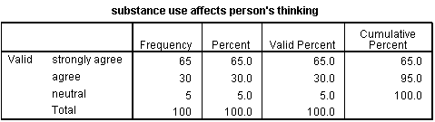
Table 1
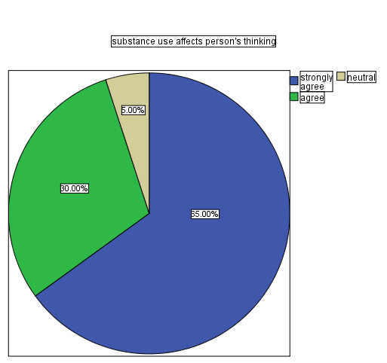
Fig 1
Interpretation: most respondents agreed that substance use affects person’s thinking.
SUBSTANCE ABUSE INCREASE RISK OF SEXUALLY TRANSMITTED DISEASE
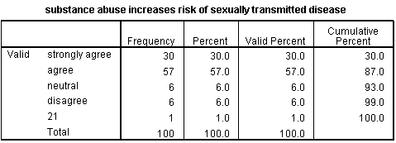
Table 2
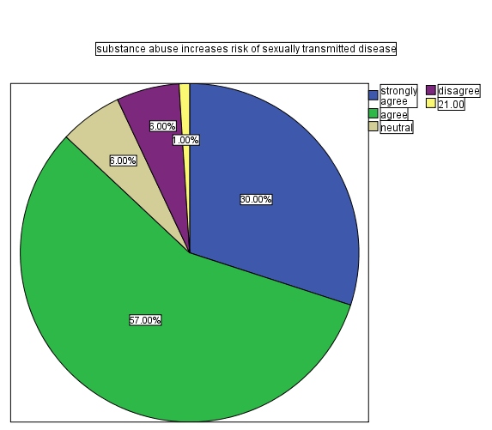
Fig 2
Interpretation;most respondent agreed that substance abuse increase risk of sexually transmitted disease
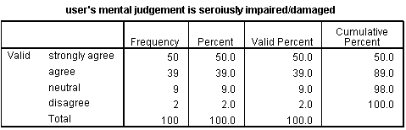
Table 3
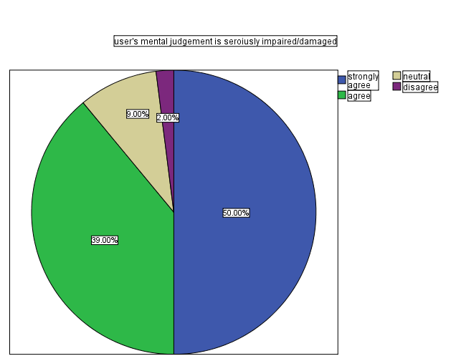
Fig 3
Interpretation;most respondent agreed that substance use affect user’s mental judgement is seriously impaired/damaged
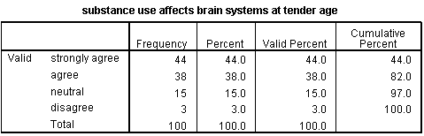
Table 4
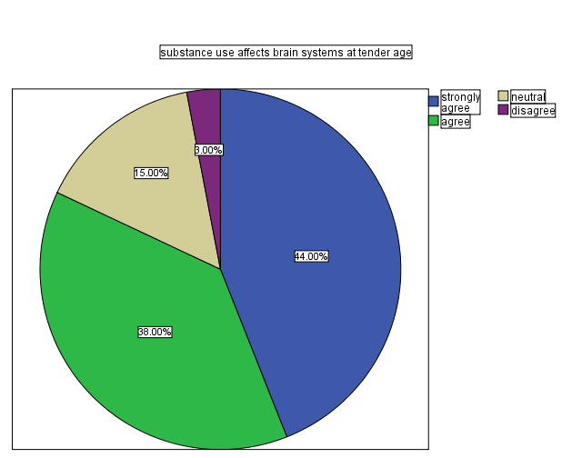
Fig 4
Interpretation; most respondent agreed that substance use affect brain systems at tender age
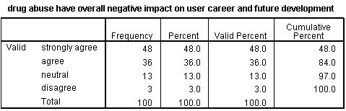
Table 5
z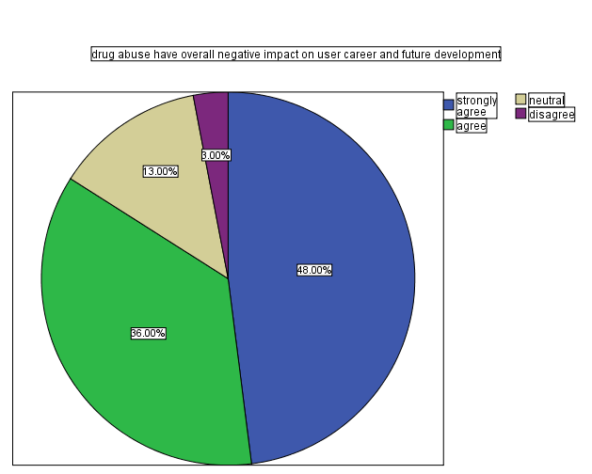
Fig 5
Interpretation; most respondent agreed that drug abuse have overall negative impact on user career and future development
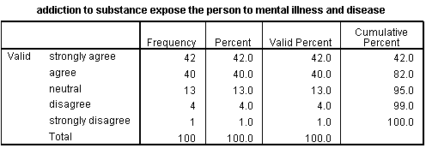
Table 6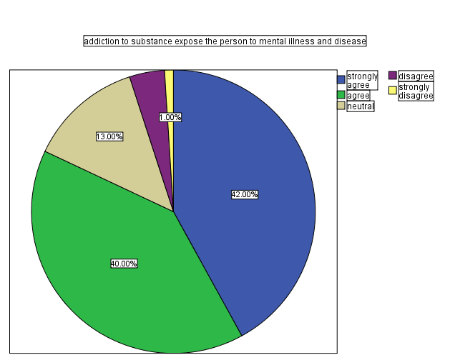
Fig 6
Interpretation; most respondent agreed that addiction to substance expose the person to mental illness and disease
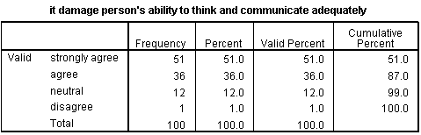
Table 7
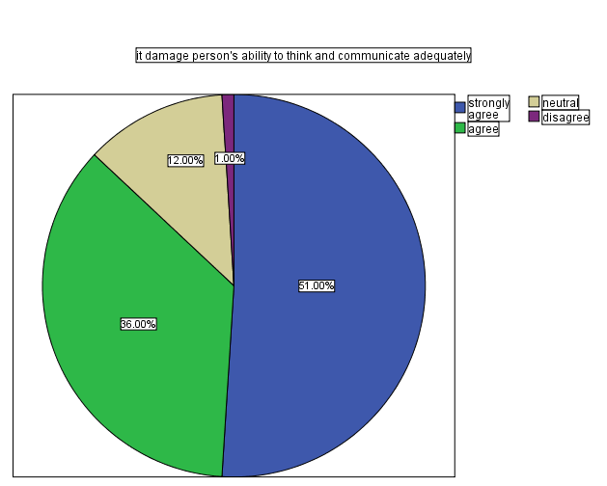
Fig 7
Interpretation; most respondent agreed that substance use damage person’s ability to think and communicate adequately
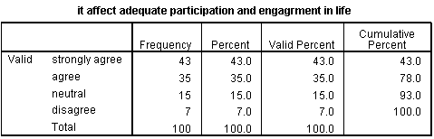
Table 8
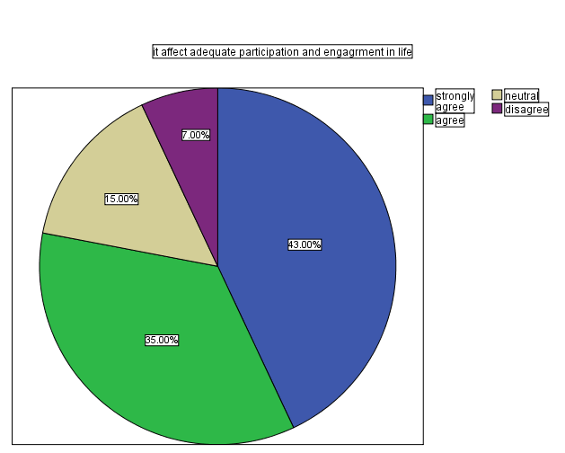
Fig 8
Interpretation; most respondent agreed that use of substance affect adequate participation engagement in life
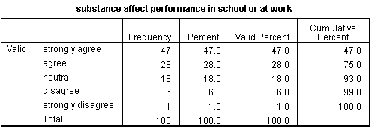
Table 9
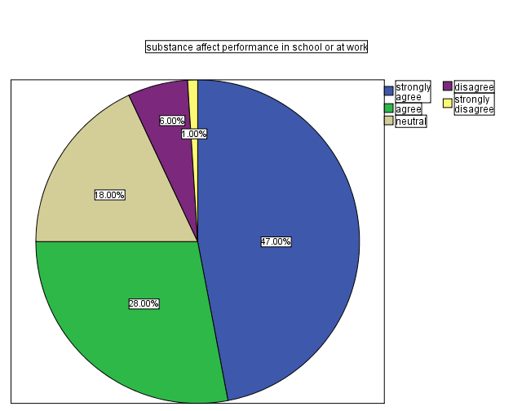
Fig 9
Interpretation;most respondent agreed that substance use affect performance in school or at work
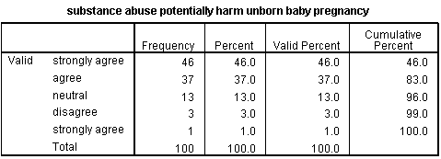
Table 10
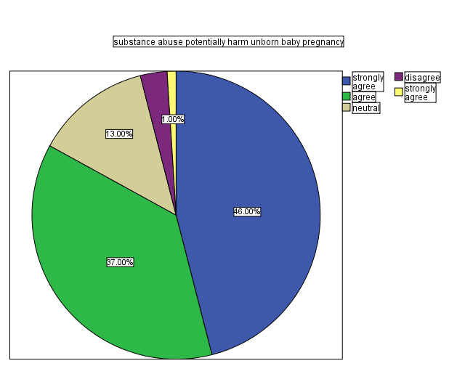
Fig 10
Interpretation;most respondent agrred that substance abuse potentially harm unborn pregnancy
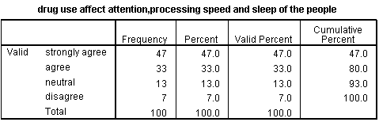
Table 11
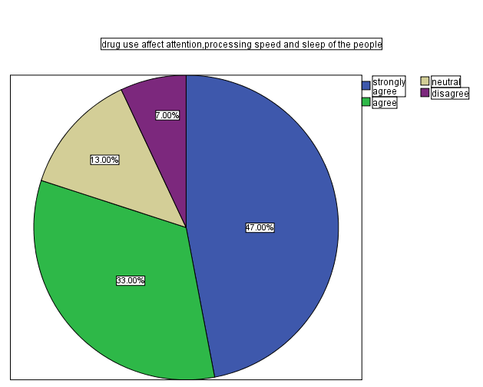
Fig 1
Interpretation; mostrespondent agreed that drug use affect attention, processing speed and sleep of the people

CHAPTER FIVE

SUMMARY, CONCLUSION AND RECOMMENDATIONS

5.1 Summary of Findings
This study investigated the factors associated with substance use among undergraduate students in selected tertiary institutions within the Ilorin metropolis. The research employed descriptive statistics and frequency analysis based on structured questionnaires administered to 135 respondents. The major findings are summarized as follows:
- Onset of Substance Use:
A significant number of respondents (48%) started using substances during secondary education, 35% in higher institutions, and 17% during primary education. This highlights secondary school as a critical entry point for substance use.
- Parental/Guardian Education Level:
The highest proportion of respondents (40%) had parents or guardians with secondary education, 38% with tertiary (graduate) education, and 22% with only primary education. This indicates that substance use cuts across various parental educational backgrounds.
- Types of Substances Abused:
The most commonly abused substance was prescription or non-prescription medication (33%), followed by tramadol (14%), alcohol (13%), and cocaine (10%). Other substances included tobacco, cannabis, methamphetamine, and others, each representing 5.9–8% of the valid responses.
- Missing Data:
Across all variables, 25.9% of the total responses were missing. This may indicate sensitivity or reluctance in addressing substance use topics.

5.2 Conclusion
The findings of this study suggest that substance use is prevalent among undergraduates in Ilorin metropolis, with a majority reporting initiation during secondary school. The use of easily accessible substances like prescription drugs and tramadol is particularly alarming. Moreover, parental education does not appear to significantly shield students from substance abuse, suggesting that other factors like peer pressure, academic stress, curiosity, and social mediainfluence might be more critical.
These trends imply a growing need for preventive measures and early intervention strategies, especially targeted at the secondary school level where most students begin substance use. Without proper education and support structures, these habits are carried into tertiary institutions, leading to long-term consequences.

5.3 Recommendations
Based on the findings and conclusions, the following recommendations are proposed:
- Early Intervention Programs:
Government and school authorities should initiate drug education and prevention programs in junior and senior secondary schools, emphasizing the dangers of substance abuse.
- Strengthen Guidance and Counseling Units:
Every tertiary institution should be equipped with a functional guidance andcounseling unit trained to handle issues related to substance abuse, peer influence, and mental health.
- Parental Involvement:
Parents and guardians should be more actively involved in their children's academic and social life, regardless of their level of education. Regular conversations about drug use should be encouraged at home.
- Strict Regulation of Prescription Drugs:
Authorities should enforce stricter regulations on the sale of over-the-counter medications, especially painkillers like tramadol and codeine, which are frequently abused
- Public Awareness Campaigns:
non-governmental organizations, student bodies, and religious institutions should collaborate on awareness campaigns to sensitize students and communities on the implications of substance abuse.

REFERENCES
Abiona, T. C., Fatoye, F. O., &Akinhanmi, A. O. (2006). Pattern of alcohol consumption among
secondary school students in Nigeria.
African Journal of Drug and Alcohol Studies, 5(2), 71–80.
Adelekan, M. L., Ndom, R. J. E., & Ekundayo, O. (2019). Substance use and associated factors
among undergraduate students in a Nigerian university. West African Journal of Medicine, 31(1), 15–21.
Aguocha, C. M., &Okwaraji, F. E. (2015). Substance use among undergraduate students in a
Nigerian university: A cross-sectional study. Nigerian Journal of Clinical Practice, 18(5), 646–650.
Ajayi, A. I., &Somefun, O. D. (2020). Substance use among African adolescents: A review of
trends and emerging issues. African Health Sciences, 20(1), 393–405.
Eneh, A. U., & Stanley, P. C. (2004). Pattern of substance use among secondary school students
in Rivers State, Nigeria. Nigerian Journal of Medicine, 13(4), 408–414.
Gureje, O., &Lasebikan, V. O. (2006). Drug abuse in Nigeria: Epidemiological and policy
perspectives. World Psychiatry, 5(3), 156–157.
Ibrahim, A., & Akinyemi, J. O. (2021). Socio-demographic factors influencing substance abuse
among Nigerian youths. Journal of Substance Use, 26(2), 212–220.
Mohammed, Z., & Bello, S. (2017). Assessment of factors influencing drug abuse among
students in tertiary institutions in Kano, Nigeria. International Journal of Scientific Research and Management, 5(6), 5120–5129.
Ndom, R. J. E., & Adelekan, M. L. (1996). Psychosocial correlates of substance use among
undergraduates in Ilorin, Nigeria. West African Journal of Medicine, 15(3), 146–151.
National Institute on Drug Abuse. (2020). Monitoring the Future Survey: High School and Youth
Trends. Retrieved from https://www.drugabuse.gov
Oshodi, O. Y., Aina, O. F., &Onajole, A. T. (2010). Substance use among secondary school
students in an urban setting in Nigeria: Prevalence and associated factors. African Journal of Psychiatry, 13(1), 52–57.
Okpataku, C. I., &Okoza, J. (2017). The prevalence and consequences of drug abuse among
undergraduates in Nigeria. Journal of Education and Practice, 8(22), 104–110.
UNODC (United Nations Office on Drugs and Crime). (2018). Drug Use in Nigeria: 2018
National Survey on Drug Use and Health. Vienna: UNODC Publishing.
World Health Organization. (2016). Preventing youth violence and substance abuse. Geneva:
WHO Press.
Yusuf, A. S., & Adedokun, M. O. (2022). Factors influencing drug abuse among students in
tertiary institutions: A case study of Kwara State Polytechnic. Ilorin Journal of Social Sciences, 10(2), 87–94.

