HUMAN ACTIVITIES RECOGNITION SYSTEM USING CNN ALGORITHM

BY
MAHMUD MARYAM NIKE
HND/23/COM/FT/0239

SUBMITTED TO THE DEPARTMENT OF COMPUTER SCIENCE, INSTITUTE OF INFORMATION AND COMMUNICATION TECHNOLOGY

KWARA STATE POLYTECHNIC, ILORIN.
IN PARTIAL FULFILLMENT OF THE REQUIREMENTS FOR THE AWARD OF HIGHER NATIONAL DIPLOMA (HND) IN
COMPUTER SCIENCE

JULY, 2025.

CERTIFICATION
This is to certify that this project was carried out by MAHMUD MARYAM NIKE of Matriculation Number: HND/23/COM/FT/0239 in the Department of Computer Science, Institute of Information Communication Technology, Kwara State Polytechnic, Ilorin, Kwara State.

…………………………………. ….………………………
MR. SADIQ, K. A. Date
Project Supervisor

…………………………………. ….………………………
MR. OYEDEPO, F. S. Date
Head of Department

…………………………………. ….………………………
External Examiner Date

DEDICATION
I dedicate this project work to Almighty God who inspired me and directed my ways during my academic stay in the polytechnic.

ACKNOWLEDGEMENT
All praise is due to Almighty God the Lord of the universe. I praise him and thank him for giving me the strength and knowledge to complete my HND program and also for our continued existence on Earth.
I appreciate the utmost effort of my supervisor, Mr. Sadiq, K. A. whose patience, support, and encouragement have been the driving force behind the success of this research work. He gave useful corrections, constructive criticisms, comments, recommendations, and advice and always ensures that excellent research is done. My sincere gratitude goes to the Head of the Department Mr. Oyedepo F. S., and other members of staff of the Department of Computer Science, Kwara State Polytechnic, Ilorin, for their constant cooperation, constructive criticisms, and encouragement throughout the program.
Special gratitude to my parents, who exhibited immeasurable financial, patience, support, prayers, and understanding during the period in which I was busy tirelessly with my studies, special thanks go to my lovely siblings
My sincere appreciation goes to my friends and classmates.

TABLE OF CONTENTS
Title page i
Certification ii
Dedication iii
Acknowledgments iv
Table of Contents v
Abstract vi
CHAPTER ONE: GENERAL INTRODUCTION
1.1 Background to the Study 1
1.2 Statement of the Problem 3
1.3 Aim and Objectives 3
1.4 Significance of Study 4
1.5 Scope of Study 4
1.6 Organization of the Report 4
CHAPTER TWO: LITERATURE REVIEW
2.1 Review of Related Works 5
2.2 Review of General Text 9
2.3 Concept of Human Activity Recognition 9
CHAPTER THREE: RESEARCH METHODOLOGY AND
ANALYSIS OF THE SYSTEM
  - Research Methodology 16
  - Analysis of the Existing System 18
  - Problem of the Existing System 19
  - Analysis of the Proposed System 20
  - Advantages of the Propose System 22

CHAPTER FOUR: DESIGN, IMPLEMENTATION AND
DOCUMENTATION OF THE SYSTEM
  - Design of the System 24
    - Output Design 24
    - Input Design 27
    - Database Design 28
    - Procedure Design 30
  - Implementation of the System 30
    - Choice of programming language 30
    - Hardware support 30
    - Software Support 31
    - Implementation Techniques used in Details 31
  - System Documentation 31
    - Operating the System 31
    - Maintaining of the System 31
CHAPTER FIVE: SUMMARY CONCLUSION AND
RECOMMENDATION
5.1 Summary 33
5.2 Conclusion 33
5.4 Recommendations 34
References 35

ABSTRACT
Human Activity Recognition (HAR) is a significant application of deep learning, particularly Convolutional Neural Networks (CNNs), which have shown great promise in extracting relevant features from time-series data such as sensor readings or video frames. HAR involves classifying and identifying different activities performed by individuals, such as walking, running, sitting, or standing, based on sensor data or visual input. Human activity recognition (HAR) systems have been developed to protect human safety. As an example, a system can monitor the movements of patients in a hospital. In industries or factories, it is often used to monitor the health of workers in hazardous areas. For healthcare, the system is designed to remember and record movement or behavior, as can be seen from exercise products. The increase in the elderly and those who live alone leads to the need to develop a monitoring system and the need for new ways to solve problems. Most elderly people have various health problems, such as memory problems, decreased ability to help themselves, fainting, or falling easily. These problems cause the elderly to need care or monitoring by a caregiver. In current social conditions, most caregivers leave the house for a career or to study. They are unable to constantly care for the elderly, and the elderly without care remains a problem. The first step is to collect a dataset of images containing people with and without smiles. The dataset should be diverse enough to capture different races, genders, ages, lighting conditions, and facial expressions.

CHAPTER ONE
INTRODUCTION
  - Background to the Study
The implementation of a real-time Human Activity Recognition (HAR) system using a Convolutional Neural Network (CNN) follows a structured approach, starting from data preprocessing to real-time activity classification using a webcam. This system aims to recognize human actions such as walking, running, sitting, and jumping by processing video frames and applying deep learning techniques (Harjot, 2022).
The first step is to gather a dataset containing video samples of various human activities. Publicly available datasets such as UCF101, HMDB51, KTH, or custom-recorded videos can be used. These videos are organized into labeled folders corresponding to different activities. Since CNNs work with images, video frames must be extracted and converted into images. This is done using OpenCV, where frames are captured at regular intervals (e.g., every 5th frame) to reduce redundancy. After extraction, images are resized to a fixed dimension, typically 64×64 pixels, to ensure uniformity. Each image is then normalized by scaling pixel values between 0 and 1, improving the CNN’s performance. Finally, the dataset is split into training and testing sets, ensuring the model can generalize well. (Zameer, Anny, and Malaserene, 2019).
A CNN model is designed to classify extracted frames into different activity categories. The architecture includes convolutional layers for feature extraction, pooling layers to reduce dimensionality, and fully connected layers to make final predictions. A softmax activation function is used in the output layer to classify activities. The model is compiled using the Adam optimizer and categorical cross-entropy loss function. The training process involves feeding the preprocessed dataset into the model, adjusting hyperparameters such as the learning rate, batch size, and number of epochs to optimize accuracy. Additionally, data augmentation techniques like rotation and flipping are applied to improve model robustness. Once trained, the model is saved for real-time inference. (Charmi, Jatna, and Nishant, 2019).
For real-time activity recognition, the trained CNN model is integrated with OpenCV to process live video input from a webcam. Each video frame is captured, resized, and normalized before being fed into the CNN for prediction. The model classifies the frame into one of the predefined activity categories, and the predicted activity label is overlaid on the video feed. The system continuously processes new frames in a loop, ensuring real-time classification. If the user presses a designated key (e.g., 'q'), the system stops the webcam feed and exits.
1.2 Statement of the Problem
Elderly population growth is bringing significant challenges requiring more healthcare services and facilities. Most elderly people have various health problems, such as memory problems, decreased ability to help themselves, fainting, or falling easily. These problems cause the elderly to need care or monitoring by a caregiver. In current social conditions, most caregivers leave the house for a career or to study. They are unable to constantly care for the elderly, and the elderly without care remains a problem.
1.3 Aim and Objectives
The research aim to develop an accurate and robust human activity recognition (HAR) system and the objectives are to:
- Implement a deep learning-based model that can accurately recognize and classify different human activities in real time.
- Extract frames from video sequences and convert them into a suitable format for CNN processing.
- Develop a CNN model optimized for classifying human activities from video frames.
- Integrate the trained CNN model with OpenCV for real-time activity classification from live video streams.
- Explore the use of 3D CNNs or CNN-LSTMs to capture both spatial and temporal features for improved recognition.

1.4 Scope of the Study
The system will classify activities such as walking, running, sitting, jumping, standing, and falling based on video frames.
1.5 Significance of the Study
HAR systems can significantly impact healthcare by providing continuous monitoring of patients, especially the elderly and those with chronic conditions. This can facilitate early detection of health issues, assist in rehabilitation by tracking patient activities, and improve overall patient care. This can lead to more reliable and real-time monitoring of human activities, essential in numerous applications.
1.6 Organization of the Study
For easy study and proper understanding of this project write-up, It is planned and organized into five chapters. The description of what each chapter contains is explained below:
Chapter One: This contains an Introduction to the whole write-up, the problem of the study, the aims and objectives of the study, the significance of the study, the scope and limitation of the study, and the organization of the report.
Chapter Two: It focuses on the literature review of the study, the organization of the board of directors, and the computerization of the current state of the art.
Chapter Three: It presents the data collection method employed, analysis of data and existing system, advantages of the proposed system, design and implementation, programming language used with reasons, and hardware and software support.
Chapter Four: Deals with the system design implementation and documentation, design of the system, output design, input design, file system, procedural design, and documentation of the new system.
Chapter Five: This centers on the summary, conclusion, and recommendations

CHAPTER TWO
LITERATURE REVIEW
2.1 Review of Related Works
Zameer, et al. (2019) make research on Human Activity Analysis using Machine Learning Classification Techniques. Artificial Intelligence (AI) models are developed to recognize the activity of the human from the provided UCI online storehouse. The data chosen is multivariate and we have applied various machine classification techniques Random Forest, KNN, Neural Network, Logistic Regression, Stochastic Gradient Descent and Naïve Bayes to analyse the human activity In them, Logistic Regression and neural network gave good results whereas Naive Bayes result was not good. Experiment results proved that the Neural Network and logistic regression provides better accuracy for human activity recognition compared to other classifiers such as k-nearest neighbor (KNN), SGD , Random Forest and Naïve Bayes though they take higher computational time and memory resources.
Leandro, et al. (2017) make a new approach to Human Activity Recognition using Machine Learning techniques. The aim of this paper is to evaluate a new approach of feature selection along with the PCA technique and compare the performance of several machine learning techniques for activity monitoring. In this work, they assess a new approach of feature selection for human activity recognition. For the task, we also compare state-of-the-art classifiers, e.g., Bayes classifier, kNN, MLP, SVM, MLM and MLM-NN. As suggestions for a future study there are others classifiers such as the Optimum-Path Forest (OPF). Another suggestion is the use other distance metrics in MLM and MLM-NN. Results show that the proposed feature selection approach is a promising alternative to activity recognition on smartphones.
Kaixuan, et al. (2018) makes a review Deep Learning for Sensor-based Human Activity Recognition: Overview, Challenges and Opportunities. This work aims at suggesting a rough guideline for novices and experienced researchers who have interest in deep learning methods for sensor-based human activity recognition. In this study, we present a survey of the state-of-the-art deep learning methods for sensor-based human activity recognition. We first introduce the multi-modality of the sensory data and provide information for public datasets that can be used for evaluation in different challenge tasks. We then propose a new taxonomy to structure the deep methods by challenges. Many machine learning methods have been employed in human activity recognition. However, this field still faces many technical challenges. Some of the challenges are shared with other pattern recognition fields such as computer vision and natural language processing, while some are unique to sensor-based activity recognition and require dedicated methods for real-life applications Recently, as deep learning has demonstrated its effectiveness in many areas, plenty of deep methods have been investigated to address the challenges in activity recognition.
Antonio, et al. (2018) make a research on Human Activity Recognition with Convolutional Neural Networks. The purpose of this paper is to assess the classification performance of different groups of IMU sensors for different activities. In this paper, we propose to use Convolutional Neural Networks (CNNs) to classify human activities. Our models use raw data obtained from a set of inertial sensors. More activities could be included in the workflow, and different aggregations on the activities can be tested. The experimental results obtained on a dataset of 16 lowerlimb activities, collected from a group of participants with the use of five different sensors, are very promising.
Daniele, et al. (2016) also make a review on Deep Learning for Human Activity Recognition: A Resource Efficient Implementation on Low-Power Devices. To identify activities from inertial sensor data for specific applications. The proposed method uses sums of temporal convolutions of the transformed input. Accuracy of the proposed approach is evaluated against the current state-of-the-art methods using both laboratory and real world activity datasets. To handle different sensor configurations and different types of activities, the raw inertial data is projected to the spectral domain. A systematic analysis of the feature generation parameters and a comparison of activity recognition computation times on mobile devices and sensor nodes are also presented.
Jiang et al. (2019) considered learning an ideal Bayesian system classifier is a NP- difficult issue, learning-improved innocent Bayes has pulled in much consideration from scientists. In this paper, improved calculations and proposed a covered up innocent Bayes (HNB). In HNB, a shrouded parent is made for each characteristic which joins the impacts from every other property. HNB is tested as far as characterization exactness, utilizing the 36 UCI informational collections chosen by Weka, and contrast it with gullible Bayes (NB), specific Bayesian classifiers (SBC), innocent Bayes tree, tree-expanded guileless Bayes, and found the middle value of one-reliance estimators (AODE). The exploratory outcomes demonstrate that HNB essentially beats NB, SBC, NBTree, TAN, and AODE. In numerous information mining applications, a precise class likelihood estimation and positioning are likewise attractive.
Jie Hu et al. (2019) proposed the method to recognize the human facial expressions from the recorded videos. The input is bounding boxes detected from sequence of images represented in three layers and the chosen Weizmann dataset contains nine human actions of ten different peoples. The models built contain the spatial and temporal part to capture the typical characteristics. Random forest method is applied on the Weizmann, UCF and facial expression datasets to recognize the human behavior and obtained the improved performance on the Weizmann dataset.
Shahroudy et al. (2019) examined late methodologies top to bottom based human movement examination accomplished exceptional execution and demonstrated the viability of 3D portrayal for arrangement of activity classes. As of now accessible profundity based and RGB+D-based activity acknowledgment benchmarks have various restrictions, including the absence of preparing tests, unmistakable class names, camera perspectives and assortment of subjects. In this paper presented a vast scale dataset for human activity acknowledgment of 56,000 video tests and 4 million edges, gathered from 40 particular subjects. It contains sixty diverse activity classes including day by day, shared, and wellbeing related activities. Moreover, another repetitive neural system structure is proposed to demonstrate the long haul transient connection of the highlights for all the body parts, and use them for proper activity characterization. Finally demonstrated the benefits of applying profound learning strategies over cutting edge hand that includes cross-subject and cross assessment criteria for the chosen dataset.
Charmi and Jatna (2019) opined that human activity recognition has been a challenging problem yet it needs to be solved. It will mainly be used for eldercare and healthcare as an assistive technology when ensemble with other technologies like Internet of Things (IoT). HAR can be done with the help of sensors, smartphones or images. In this paper, we present various state-of-the-art methods and describe each of them by literature survey. Different datasets are used for each of the methods wherein the data are collected by different means such as sensors, images, accelerometer, gyroscopes, etc. and the placement of these devices at various locations. The results obtained by each technique and the type of dataset are then compared. Machine learning techniques like decision trees, K-nearest neighbours, support vector machines, hidden markov models are reviewed for HAR and later the survey for deep neural network techniques like artificial neural networks, convolutional neural networks and recurrent neural networks is also presented.
David (2019) discussed human activity recognition is an area of interest in various domains such as elderly and health care, smart-buildings and surveillance, with multiple approaches to solving the problem accurately and efficiently. For many years hand-crafted features were manually extracted from raw data signals, and activities were classified using support vector machines and hidden Markov models. To further improve on this method and to extract relevant features in an automated fashion, deep learning methods have been used. The most common of these methods are Long Short-Term Memory models (LSTM), which can take the sequential nature of the data into consideration and outperform existing techniques, but which have two main pitfalls; longer training times and loss of distant pass memory. A relevantly new type of network, the Temporal Convolutional Network (TCN), overcomes these pitfalls, as it takes significantly less time to train than LSTMs and also has a greater ability to capture more of the long term dependencies than LSTMs. When paired with a Convolutional Auto-Encoder (CAE) to remove noise and reduce the complexity of the problem, our results show that both models perform equally well, achieving state-of-the-art results, but when tested for robustness on temporal data the TCN outperforms the LSTM. The results also show, for industry applications, the TCN can accurately be used for fall detection or similar events within a smart building environment.

2.2 Review of General Text
Human Activity Recognition using CNN has become an important area of research due to its potential applications in fields such as psychology, human-computer interaction, and entertainment. CNNs have been shown to be effective in learning discriminative features from images and achieving high accuracy in smile detection tasks.
One of the main challenges in Human Activity Recognition is the variability of facial expressions, lighting conditions, and pose. This can affect the performance of the CNN model and make it difficult to generalize to new images. Researchers have proposed various techniques to address these challenges, such as data augmentation, transfer learning, and multi-task learning.
2.3 Concept of Human Activity Recognition
The topic which has increased its importance in last few decades in the domain of Computer Vision and A.I. is “Human Activity Recognition”. As the concepts of the human activity recognition helps in understanding the concepts and issues of the human action understanding which majorly helps in medication, management, learning patterns and many situations of video retrievals. The Human Activity Recognition Systems (HAR) is capable of recognizing physical activities like running, playing, sleeping, eating and many such activities. The detection of the physical activities by different such sensors and recognition process is a key topic of research in wireless, smartphones and mobile computing. Human Activity recognition Systems is able to perform different tasks and recognize the multi day to day actions performed by humans which can be either simple activities like sleeping or the complex activities like running and eating. For the purpose of activity recognition of human’s different actions, multiple types of sensors and devices are required like video sensors, environmental activities sensors, body inertia sensors and many other sensors like these which record or sense the human actions (Ann and Theng, 2018).
There are many other sensors used by the HAR systems but with the limited availability of use due to the effect of outdoor environments and activities on them like GPS receiver which is limited to outdoor environments. Thus in this research paper we are trying to implement Human Activity Recognition through resnet-34 algo which is an artificial neural network (ANN) type algo which is based on the constructs of the basic things known from the pyramidal cells of the cerebral cortex. The ResNet algos specifically ResNet-34 do the process of this by the usage of skip connections and the process of jumping over some layers in the different neural networks. The general ResNet Algo and specifically the ResNet 34 algo are basically implemented with two and it’s three layer skip which generally contains the nonlinearities (ReLU) and the batch normalization for the usage in the residue neural network techniques. The skip weights can be recalled by the usage of an additional weight matrix which are known as the HighWayNets term. In ResNet the procedure followed by the models with multiple levels of parallel levels skips are referred as DenseNets (Sadiq, 2021).
2.3.1 Neural Network Layers
- Applications
Human activity recognition systems have widespread applications in various fields. The main aim of human activity recognitions systems is to understand and analyze classified human actions and to interpret their semantic meaning in different domains. Human activities consist of simple atomic actions such as walking, breathing; complex actions such as dancing, exercising; interpersonal interactions like handshaking, waving; or human-object interaction such as preparing meals, and working in production lines. As human activity recognition has very close ties with human behavior understanding and modeling, human activity recognition systems have application in diverse application domains. In this section, we briefly discuss some of the prevalent application domains of human activity recognition.
- Healthcare Systems
Human activity recognition systems are widely used in healthcare systems to analyze and interpret patient activities for facilitating healthcare and essential workers to monitor, diagnose, and care for patients. This result in improved accuracy of diagnosis and case, the decreased workload for healthcare staff, increased quality of service received by patients, decreased hospital stays, decreased medical cost, and decreased chances of serious injury. Human activity recognition systems are used in various medical use cases such as automatic fall detection and response systems for detecting accidental falls and providing immediate response services respiratory behavior modeling systems to recognize and diagnose sleep disorder, cardiovascular diseases, and stroke, medication intake monitoring systems to ensure proper usage of medicine hand movement monitoring system to recognize and diagnose eating disorders exercise-aid systems to guide in proper postures during regular exercises hand gesture recognition system for sign language-based interaction and automatic wheelchair movement.
- Surveillance Systems
Surveillance systems are another application domain that extensively utilizes human activity recognition systems. Activity recognition systems are used in surveillance scenarios to track and monitor individuals and crowds, thus supporting security personnel to observe and detect suspicious activities and threats. Human activity recognition systems have different use cases in surveillance systems such as gait based long range person recognition and authentication to detect and recognize specific individuals from a long distance based on gait-patterns driver drowsiness detection systems to ensure proper driver behavior and to reduce road accidents due to driver inattention automatic drowning detection systems in swimming pools to save lives of swimmers and to reduce chances of long-term damage loitering detection systems to detect suspicious loitering behavior or erratic movements of individuals around important public spaces suspicious activity detection systems to detect violent interpersonal behaviors.
- Entertainment Systems
Human activity recognition systems are widely used in entertainment systems to both monitor and aid referees and players in sports and to interact with computer games in fun ways. Some of the use cases of activity recognition systems in entertainment systems are as follows: accurate automatic timer systems that detect the start and end time of an activity such as swimming, diving pose-estimation systems for detecting and scoring real-life dance moves, navigating in 3-D spaces, interacting in virtual environments; movement recognition system for detecting various types of strokes and events during tennis games.

2.3.2 Temporal Convolution Network
The default choice when dealing with sequence problems were LSTMs because of their powerful ability to find patterns in temporal dependencies in sequential data. A recent advancement from the CNN, known for image recognition achievements, is the TCN which uses a 1D fully-connected structure, in which each hidden layer is the same length as the input layer. To ensure that layers have the same size, zero-padding of length filter size minus one is added. Next, causal convolutions (defined above) are used to ensure no information leakage from future to past. Dilated convolutions are used to reduce the model’s look back history complexity which is size linear in network depth and filter size. Also, due to the TCN’s growth in depth, convolutional layers are swapped for residual modules, which help to stabilize the network.
The TCN takes the sequential 12-vector embedding space as its input. The kernel size of the TCN is determined by the embedding size, which in this case is 12, and after experiments 100 nodes was found to be an optimal number. The number of layers in the TCN is directly related to the filter size and number of inputs, as each input is linearly connected to the output. The output of the model is the prediction of what activity was performed. The loss function used was softmax cross-entropy, which is a distance calculation between the probabilities from the softmax function and the one-hot-encodings of the activities. The same optimizer, reducing learning rate and early stopping criterion were used to train the TCN as above.
To compare with a LSTM, the TCN has lower memory requirements during training as the filters are shared across a layer, and back-propagation paths only depend on the depth of the network. LSTM captures only the temporal information of the data, whereas TCN captures both temporal and local information due to its convolutional operations. A big advantage TCN has over LSTMs is that when dealing with big data, TCNs can be parallelized because the convolutions can be run in parallel since the same filter is used in each layer, whereas in an LSTM the model has a looping process and runs sequentially, with time-step t waiting until time-step t-1 has completed.

2.3.3 Neural Network Techniques
The neural network is information processing units which to mimic the neurons of human brain (Haykin, 2018). Multilayer perceptron (MLP) is the widely used neural network architecture in many pattern recognition problems. A MLP network consists of an input layer including a set of sensory nodes as input nodes, one or more hidden layers of computation nodes, and an output layer of computation nodes. Each interconnection has associated with it a scalar weight which is adjusted during the training phase. In addition, the back propagation learning algorithm is usually used to train a MLP, which are also called as back propagation neural networks. First of all, random weights are given at the beginning of training. Then, the algorithm performs weights tuning to define whatever hidden unit representation is most effective at minimizing the error of misclassification.
- Artificial Neural Network
A data acquisition module prototype developed which gathers the data of the patient and recognizes abnormal status of the patient’s health so that early treatment would be available for arm posture recognition,
i. Input device: Accelerometer embedded in a smart watch.
ii. Preprocessing: Filtering, normalization, feature extraction for body posture recognition.
iii. Input device: On chest. A new dataset with different sets of accelerometer data and data from heart rate sensor was used to identify various activities.
- Convolutional Neural Network
Human activity recognitions through a very robust deep neural network technique that is convolutional neural network which can model the features effectively.
i. Input device: Inertial Measurement Unit sensors and triaxial sensors.
ii. Placement of sensors: Two sensors each on the left and right shank, two sensors centered on feet, and one on the lumbar region were placed.
iii. Sensor configuration: Single device, double device and triple device setups which used individual sensor data, in combination of two sensor data and adding third sensor data in combination of two respectively.
- Shape of window: (6(no. of sensors) ╳ 204). When observed, the combination of two or three sensors gave better results.
- Recurrent Neural Network
Recurrent neural network (RNN) recognizes the patterns which are separated by some intervals. Long Short Term Memory (LSTM) is a RNN architecture which models temporal sequences and has the capacity of memorizing the things the author describes HAR using LSTM.
i. Input device: Sensors embedded in houses at various locations.
ii. Data representation: 1) Raw sensor data where the data from the sensor is directly used
2) Last-fired sensor data which are the data received from the sensor that was fired last.

CHAPTER THREE
RESEARCH METHODOLOGY AND ANALYSIS OF THE NEW SYSTEM
  - Research Methodology
Data Collection
The first step is to collect a dataset of images containing people with and without smiles. The dataset should be diverse enough to capture different races, genders, ages, lighting conditions, and facial expressions.
Data Acquisition
The proposed system uses UCI-2020 dataset. That consists of 33478 data which include classification of 6 activities such as walking, laying, sitting, walking, finger raising and sleeping with the models using python program, then this system collected data from the wrist and right hip position to find a suitable position for use.
Data Preprocessing
- Extract Frames from Video
  - Convert each video into individual image frames.
- Resize Frames
  - Resize each frame to a fixed size (e.g., 224 × 224 pixels).
- Convert to Color Format
  - Convert frames to either RGB (for full color) or Grayscale (for simplicity).
- Normalize Pixel Values
  - Scale pixel values to the range [0, 1] by dividing by 255.
- Label the Data
  - Assign a label to each video/frame sequence based on the activity it represents.
Model Training
The next step is to train a convolutional neural network (CNN) using the preprocessed dataset. The CNN should consist of multiple convolutional layers, pooling layers, and fully connected layers. The number of layers and their hyperparameters can be adjusted to achieve the best performance.
Model Evaluation
After the CNN has been trained, it needs to be evaluated on a separate test set. This will give an estimate of the model's accuracy and generalization ability.
Deployment Once the model has been trained and evaluated, it can be deployed in a real-world application. This may involve integrating the model into an existing software system or developing a new application from scratch.
Algorithm
- Collect the dataset, N
- IF (A belong to class B) {Classify attack = B; Mark N as class C; Give decision; Return N; } 3. For I =1 to n
- Split dataset
- Yb= training attributes
- ya = testing attribute
- N.ya = attributes having highest features
- If (N.ya == continuous) {Find threshold}
- For (Each A in splitting of A)
- If (T is empty) {Attack feature is void ;} Else {child of N = is an attack category}}
- Build Decision tree classifier
- Evaluate the classification error rate of Node N
- Return N;
- End

Process Flow
Figure 3.1: Architecture of the Proposed System Design.
3.2 Analysis of the Existing System
As per the existing system either vision or sensor is sufficient to identify the activity. But this prototype works on videos, which are big challenge how the videos are identified. During current situation the complete and detailed examination has been carried out regarding the growth it has taken place in this area. However, complex or unfamiliar activities are often difficult to understand and model. For example, a researcher studying activities of daily living for a person with dementia will have a difficult time fitting a model unless she is an expert in dementia and understands its related behavioral science.
Dataset

Modeling
Features Extraction

Activity Recognition

Existing system flow
3.3 Problems of the Existing System
The manual method of smile detection has several problems, including:
- Subjectivity: The human expert may have their own biases and preferences, leading to inconsistent and unreliable classification.
- Time-consuming: The manual method is time-consuming, especially when dealing with large datasets, which can limit the scalability and efficiency of the system.
- Costly: The manual method requires the involvement of a human expert, which can be costly, especially in the long run.
- Sensitive to variations in lighting, pose, and expression
- Inaccurate detection: Manual methods rely on human judgment, which can be subjective and prone to error. This can result in inaccurate smile detection, leading to false positives or false negatives.
- High human bias: Manual methods are influenced by human bias, such as race, gender, or age. This can lead to inaccurate results and limit the applicability of the system in diverse settings.
3.4 Analysis of the Proposed System
The proposed system consists of two components: data management and machine learning. The first component involves data of tracked the elderly person details both indoors and outdoors. The classification settings of the system are designed to be flexible for increasing activity types, changing the training information updates. The flexibility of this classification makes it always possible to improve classification efficiency and to apply the system to a wide variety of activities. The system deployed will predict the new activities of elderly from the models learned using the provided dataset. This obtained dataset is split into two groups: training and test sets of 80% and 20%, respectively. Both groups will continue to be used in machine learning part.
- Importing Data
The data was read into notebook as csv file. The data was shuffled so that there is random distribution of the observation. Now K-fold cross validation is performed using different models.
- K-fold cross validation technique
K-fold cross validation technique is used to test the predictive accuracy of the models. The technique involves dividing the data set in K-partitions of equal number of observations. Then the K-1 number of partition are used as training set and the other complementary partition is used as validation set or the test set. The technique is usually used to prevent over fitting of data which may produce errors when prediction are made using the model developed. This study uses 10 fold cross validation. The data has been divided into 10 different partition then one partition is assigned as the test set. The system then develop model on the remaining 9 sets which are used as training set. The new model is then test on the test partition and its accuracy is noted. This process is repeated 10 times by taking a different partition as the test set and complementary as training set. Accuracy of prediction is calculated noted using Confusion matrix.
- Feature Selection
In order to reduce the dimensionality of the database, this system uses the Principal Components Analysis (PCA) to select the features that amounted 98% the information of the eigenvalues. The approaches consist of selecting the features with variance greater than a threshold and after that apply PCA technique, this procedure will be referred to as Var-PCA. The threshold Var-PCA can be chosen by the machine learning. The threshold values and accuracy of ML classifier with Euclidean distance, using all training set as K points of references. As can be observed, the accuracy decreases with increasing threshold and, consecutively, with reduced dimensionality. However, there is a range that accuracy is maintained almost constant as the threshold decreases. Low variance might indicate that the feature is not having an active role in identifying the samples, the higher the threshold, the more aggressive the reduction. Therefore, the decay in the accuracy of the classifiers can be avoid through a suitable choice of threshold value. The optimal threshold can be defined through an optimization step using a classification algorithm.

Dataset

Modeling
Features Extraction

Activity Recognition

Dataset Updating
Alerting system

Figure 3.2: Flow of the New System
This new approach is simple, efficient and guaranteed. It is always good to develop new ideas, to implement them on a computer and eventually to relish the satisfaction of achieving a successful result. The implementation process involves converting the system design into a complete and tested that is fully operational and that can be used by the system users to meet their needs. During implementation phase, the hardware and the software must be implemented.
Implementation of a system can be explained in six steps:-
1 Review design specification
2 Code, test and document programs
3 Train users
4 Perform system test
5 Convert to new system
6 Evaluate and maintain the new system

3.5 ADVANTAGES OF THE NEW SYSTEM OVER THE EXISTING SYSTEM
The new method for smile detection using CNN has several advantages, including:
- Objectivity: The CNN model is objective and consistent in its classification, leading to higher accuracy and reliability of the system.
- Scalability: The CNN model can be trained on large datasets and can handle a large volume of data, making it more scalable and efficient than the manual method.
- Cost-effective: The CNN model requires less human involvement and can be trained once and used repeatedly, making it more cost-effective in the long run.
- Robustness: The CNN model can handle variations in facial expressions, lighting, pose, and occlusion, making it more robust and applicable in real-world scenarios.
  - Speed: CNNs can process large amounts of data quickly, making them well-suited for real-time applications. Smile detection using CNN can be performed in real-time, allowing for faster and more efficient processing of large volumes of data.
- Adaptability: The system is adaptable to different types of input data, which means it can be used for other types of facial recognition tasks, such as emotion detection or age estimation. This makes it a versatile tool that can be used in a variety of applications.
- Low error rate: CNNs have been shown to have low error rates in image classification tasks, which translates to high accuracy in smile detection. This is important for applications where accuracy is crucial, such as security systems or medical applications.
- Reduced human bias: Traditional methods of smile detection can be influenced by human bias, such as race, gender, or age. The proposed system using CNN eliminates this bias, as the model is trained on a diverse dataset and can learn to identify smiles regardless of the person's race, gender, or age.

CHAPTER FOUR
DESIGN, IMPLEMENTATION, AND DOCUMENTATION OF THE SYSTEM
4.1 Design of the System
System designs call for the creativity of the analyst. Therefore, to create an acceptable design, the system analyst must exclude all prejudice. The design of the system is the approach of working out how best computers together with other resources may be applied to perform data storage, management, and retrieval for decision-making.
4.1.1 Output Design
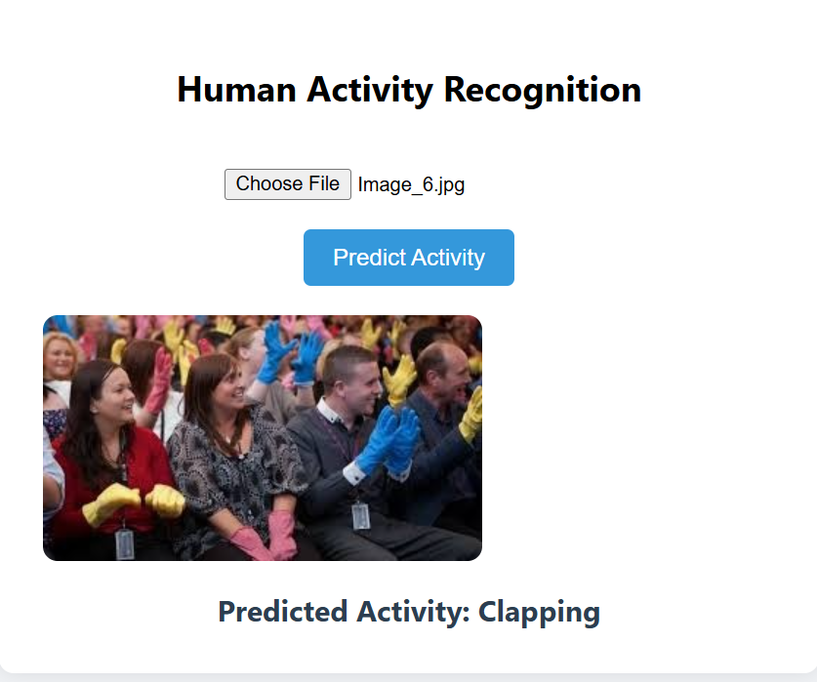
Figure 4.1 Predicted Activity Recognition: Clapping
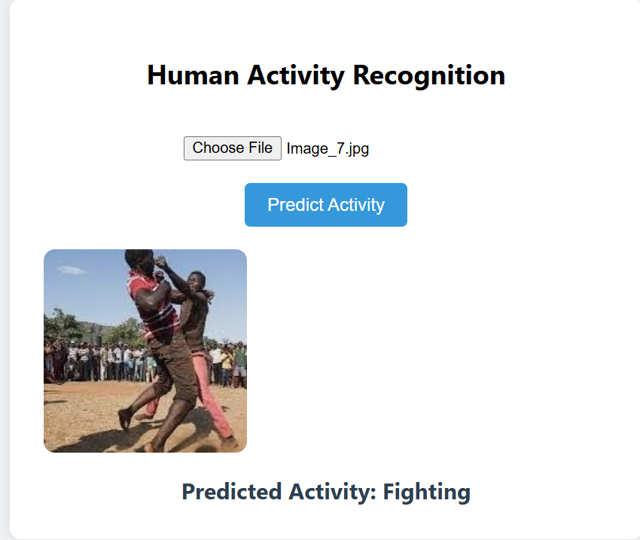
Figure 4.2: Fighting Activity
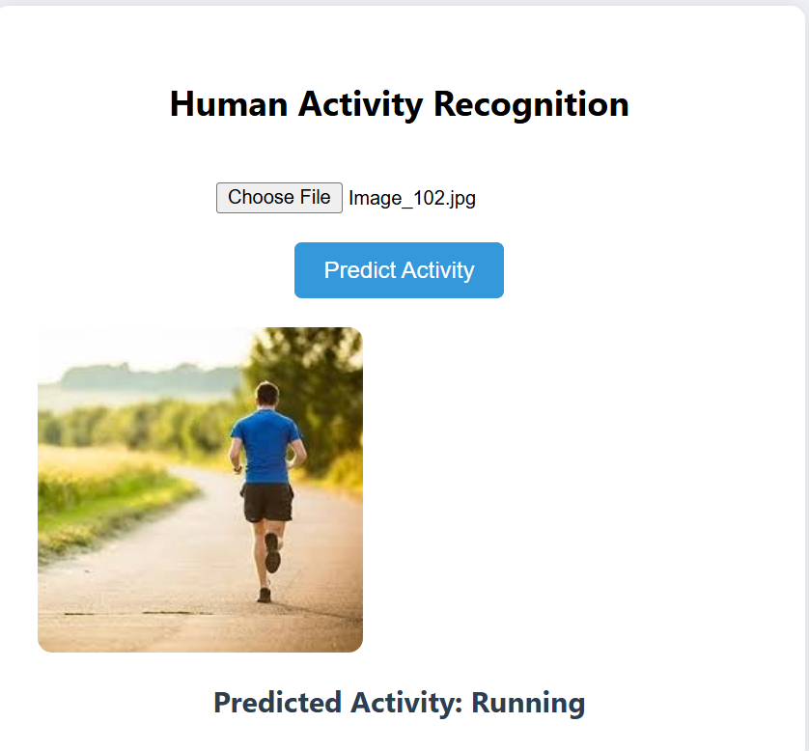
Figure 4.3: Running Activity
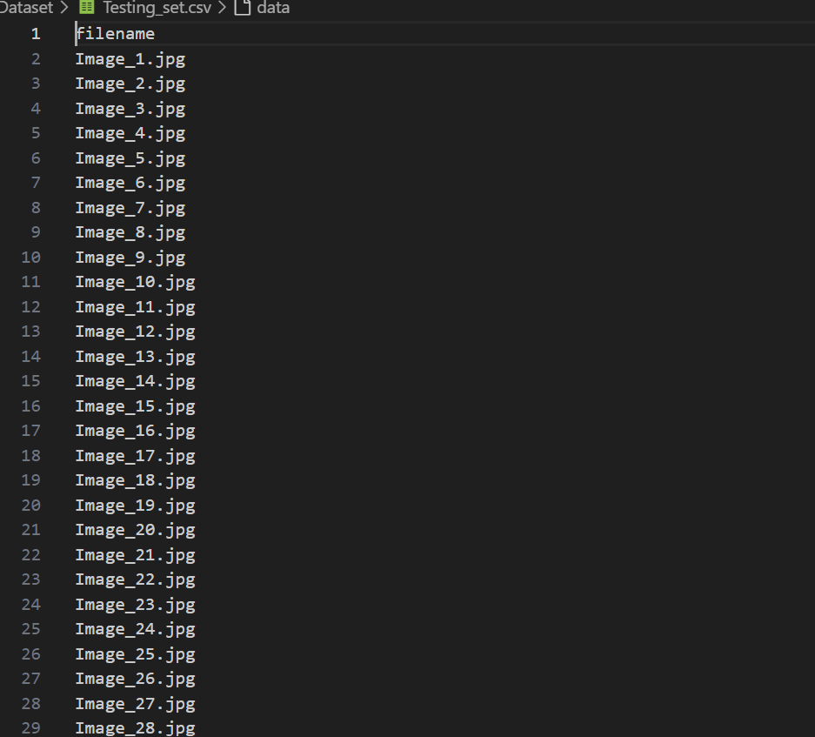
Figure 4.4 Training accuracy of dataset
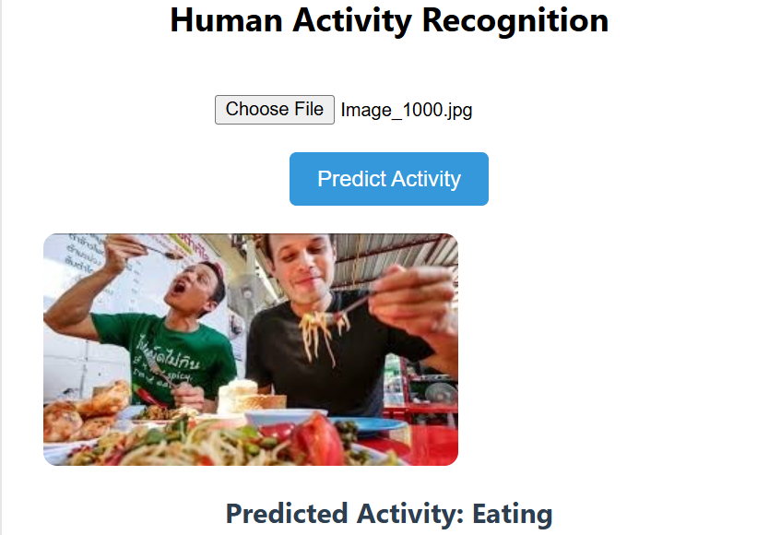
Figure 4.5: Recognition of Human Eating

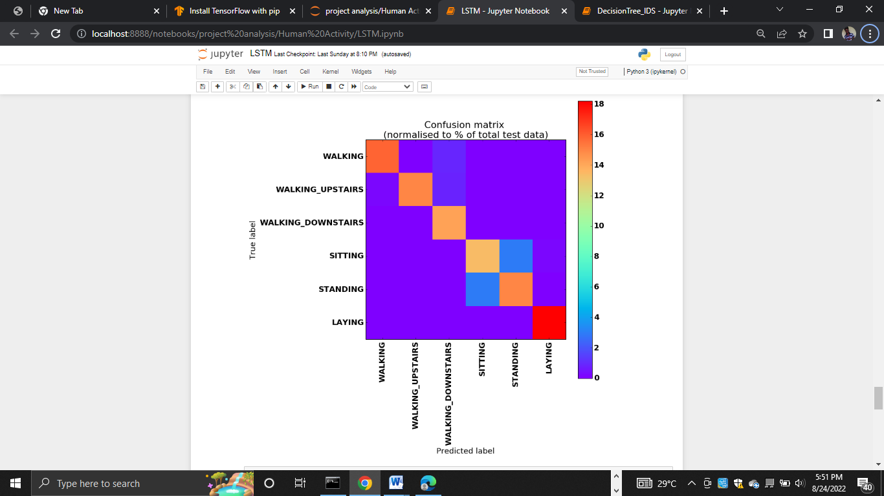
Figure 4.5: Predicted Label
Summary of general information on the population sample.
4.1.2 INPUT DESIGN
The input to be extracted from the proposed system are
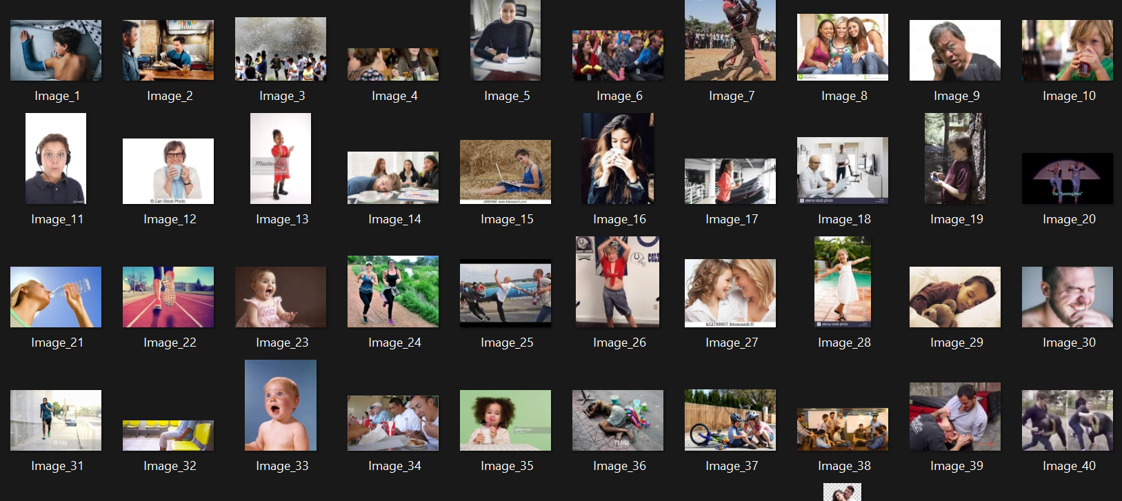
Figure 4.6: Test dataset
Visual Result of the training set of the 80% of the data set showing the accuracy of the model.

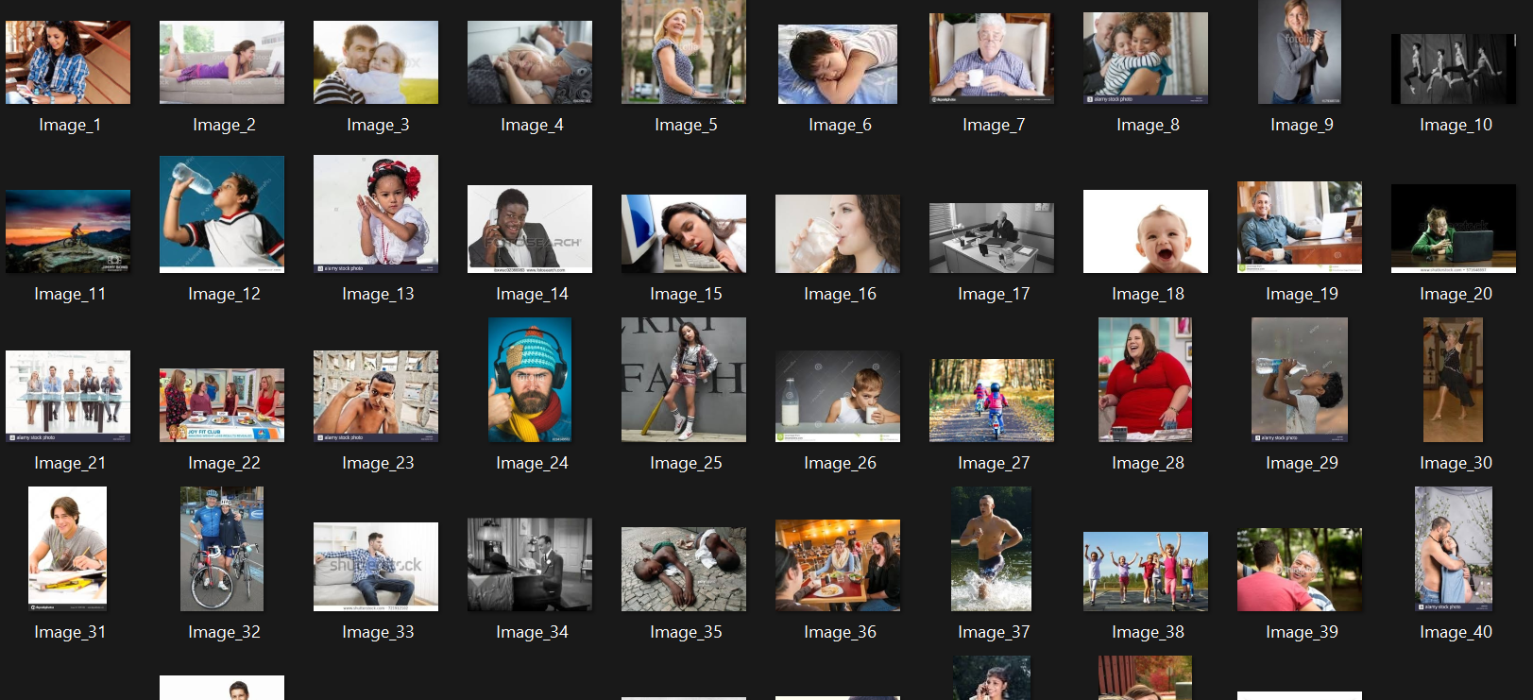
Figure: Train Dataset

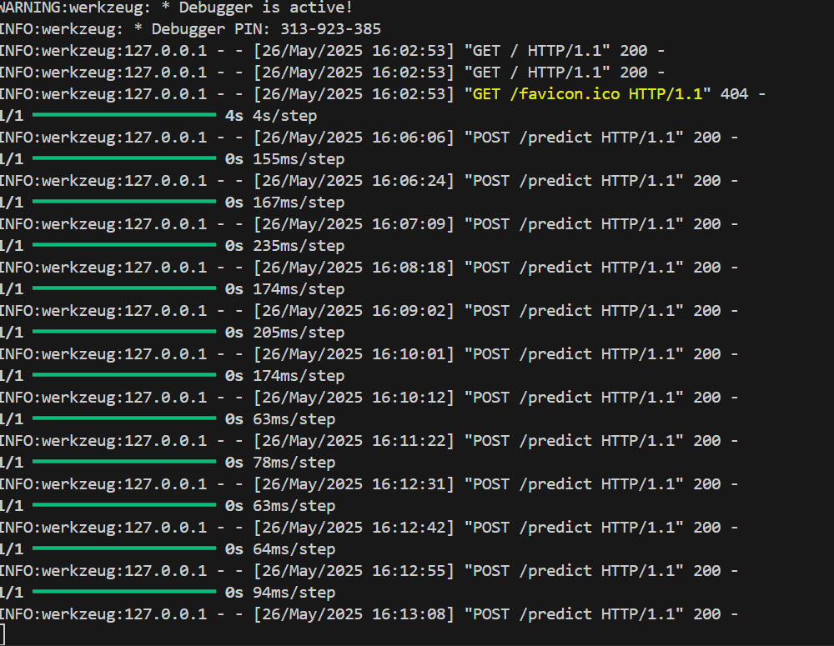
Figure: Train CSV db

4.1.3 Database Design
Database Design is the collection of related data in an organized mechanism that has the capability of storing information. End-user can retrieve stored information effectively and efficiently which has the means of protecting them.
In an Automated Security Lock System, data are handled using a WAMP server as the server-side for the design. The database design is structured using Mysql and PHP linking codes.
Below is the database design of the system:

Table 4.1 Administrator table in PHPMyAdmin


Table 4.2 view for all encrypted message
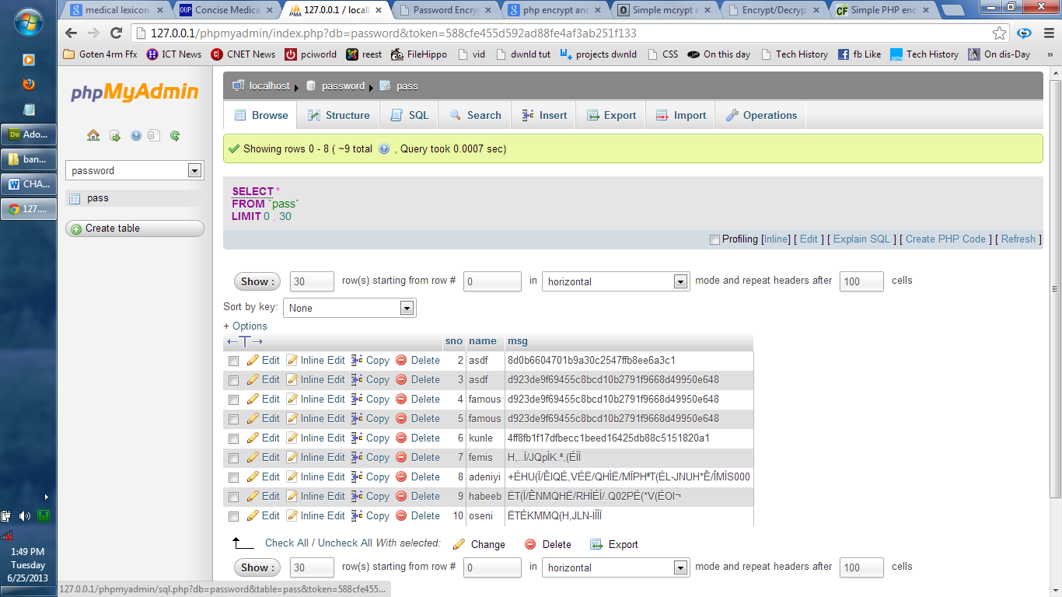

Result Discussion
Since the data is a multivariate classification problem the proposed system uses supervised and unsupervised learning algorithms. Orange Tool has been used for implementation and Neural Network is implemented in Python with drop outs which in turn gave better results. The dataset was fed into the modules for Neural Network. The Precision and Recall Values are calculated and a Confusion Matrix for the model was made. The architecture diagram of the proposed system is shown. Parameters and result is obtained depends upon the learning rate. The initial learning rate is 0.0100 with constant and number of iterations is fixed as 1000, number of passes through the training data, outstandingly, the final accuracy is of 93%. This means that the neural networks are almost always able to correctly identify the movement type so predictions are extremely accurate given this small window of context and raw data. Confusion Matrix are used to measure the performance of an algorithm in Machine learning process , it is mostly used in supervised learning .Each row of the matrix represents the actual value of class to be predicted and column represents the value of the predicted class.
After training/building our models, the performance metrics results achieved shows that the system performance in terms of accuracy, recall, f- score and precision is higher than those reviewed in previous researches. Classifier had the highest accuracy result which is about 93.76%, recall with 0.91%, f- score with 0.96% and precision with 0.92% The below table shows the results of the existing research compared to this research.
4.1.4 Procedure Design
The procedural design describes the system generally. It describes the various main programs in the system as well as the relationship that exists between all subprograms included. The procedural designs in this new system are of 5 menus of which each menu has its sub menu.
The application also contains several modules of which each module has its specific function. The purpose of dividing the program into modules is because it enhances maintainability, readability, and easy debugging.

4.2 System Implementation
4.2.1 Choice of Programming Language
Python is the chosen programming language for the implementation of the proposed system because of its pedagogy and open-source help when needed. As well it has support for a variety of database applications like SQL servers, SQLite, MySQL, and Microsoft Access but Mysql is selected.
4.2.2 Hardware Support
The computer configuration required to run the software is; Computer/Memory processor PC with a 48dx, MHZ or Pentium, Intel, or higher processor required.
Memory :512MB of RAM
Cache memory :512KB
Hard disk Minimum size : 10.2GB
Recommended : 40GB
Virtual Memory :32Bits
Cache memory :512KB
Floppy disk drive :1.44MB

4.2.3 Software Support
The software support for the design of the proposed system involves an operating system, Microsoft visual studio 12, MYSQL as well as an anti-virus software that prevents the system from being infected by viruses.

4.2.4 Implementation Techniques used in Details
The system will be implemented using the parallel approach. This approach is considered because it ensures that the new system is tested alongside the old system to ensure the effectiveness and efficiency of the system.

4.3 System Documentation
4.3.1 Program Documentation
The system must be used as instructed according to the hardware and software supports to make optimal use of it.
4.3.2 Operating the System
- Click start on the computer desktop
- Select all programs
- Select any browser e.g Internet Explorer, Mozilla Firefox, Google Chrome e.t.c
- Type the URL (Uniform Resource Locator) of the system into the address bar (localhost/password/)
4.3.3 Maintaining the System
Maintenance is any activities carried out after the implementation of the new system to make sure that the system is correctly and constantly running. This can be any of the following types of maintenance.
- Corrective maintenance: This is done to correct any defect that discovers in the course of using the new system to keep the system in tune with day-to-day functions.
- Adaptive maintenance: This is done to make sure that the system is not obsolete and adapts to any new systems of technology.
- Preventive Maintenance: This is a kind of maintenance adopted for continuous improvement in a new system without waiting for failure to occur or for the user to change. This is adopted to prevent the occurrence of failure.

CHAPTER FIVE
SUMMARY, CONCLUSION ANND RECOMMENDATIONS
5.0 Summary
In this research carried out the comprehensive study of various tools and techniques which can be used in human activity recognition which included different machine learning algorithms and neural network techniques. The techniques were implemented on the datasets and they had varying observations depending upon the environmental conditions, type of data used such as accelerometer data, other sensor data, placement of sensors, methods of implementation. These techniques are compared on the basis of those contexts and also on the basis of computational complexities. Finally, challenges to human activity recognition are also presented. The proposed system consists of two components: data management and machine learning. The first component involves data of tracked the elderly person details both indoors and outdoors. The classification settings of the system are designed to be flexible for increasing activity types, changing the training information updates. The flexibility of this classification makes it always possible to improve classification efficiency and to apply the system to a wide variety of activities. The system deployed will predict the new activities of elderly from the models learned using the provided dataset. This obtained dataset is split into two groups: training and test sets of 80% and 20%, respectively. Both groups will continue to be used in machine learning part.
5.1 Conclusion
Human activity analysis is a popular activity in the growing industry and this research work applied different machine learning algorithm, neural network gave good results whereas Naive Bayes result was not good. The implementation of Neural Network on Python gave better results than the one provided in the Orange tool. The limitations of this work is though the efficiency of neural network is good, the model is dynamic. The inability of getting trained with real time data will force us to train the model every time new data comes. This research worked on the application system for tracking elderly information in many areas because caring for the elderly who are healthy or strong is still necessary to track personal information or welfare that should be received. The elderly who have an underlying disease or are at risk of daily life accidents should have a system that supports requesting emergency help. Furthermore, falling or fainting may cause the elderly to lose consciousness or even to die, which our system will automatically detect and alert the caregivers for immediate help. Besides, each elderly may have different movement characteristics with each activity.
5.2 Recommendation
In future, these results can be used for making smart watches and similar devices which can track a user’s activity and notify him/her of the daily activity log. They can also be used for monitoring elderly people, prison inmates, or anyone who needs constant supervision.

References

Aggarwal, J. et al. (2017). The First International Conference on Intelligent Computing in Data Sciences International Journal of Innovative Technology and Exploring Engineering (IJITEE) ISSN: 2278-3075, Volume-9 Issue-2

Charmi, H., Jatna, R. & Nishant (2019) Human Activity Recognition: A Survey International Workshop on Recent advances on Internet of Things: Technology and Application Approaches (IoT-T&A 2019) August 19-21, 2019, Halifax, Canada Procedia Computer Science 155 (2019) 698–703

ChinAnn, V. & LauBee, T. (2019) Human Activity Recognition: A Review IEEE International Conference on Control System, Computing and Engineering, 28 - 30 November 2019, Penang, Malaysia, : https://www.researchgate.net/publication/282298953

Harjot, T., (2019) Human Activity Recognition using Machine Learning Techniques, Manipal institute of Technology,manipal harjot.s.parmar@gmail.com Dataset. UCI Machine Learning Repository. http://archive.ics.uci.edu/ml/datasets/Human+Activity+Recog nition+Using+Smartphones

Jiang, R. et al. (2019) A Review of Human Activity Recognition Methods Department of Computer Science and Engineering, University of Ioannina, Ioannina, Greece, 2 Computational Biomedicine Laboratory, Department of Computer Science, University of Houston, Houston, TX, USA

Jie Hu, Y. et al. (2019) Human Activity Recognition and Pattern Discovery International Journal of Computer Science and Mobile Computing A Monthly Journal of Computer Science and Information Technology ISSN 2320–088X IMPACT FACTOR: 6.017

Leandro, R., Souza, K. & Reboucas, B. (2018) An Analysis of Human Activities Recognition using Smartwatches Dataset International Journal of Advanced Computer Science and Applications, Vol. 11, No.

Ping-Shun, D. et al., (2018) An Analysis of Human Activities Recognition using Smartwatches Dataset International Journal of Advanced Computer Science and Applications Vol 11(12):334-339 DOI:10.14569/IJACSA.2020.0111241

Qingzhong, U. et al (2018) Human Activity Recognition International Journal of Creative Research Thoughts (IJCRT) www.ijcrt.org Volume 9, Issue 6 June 2018 | ISSN: 2320-288

Shahroudy, M. et al. (2019) HUMAN ACTIVITY RECOGNITION AND ANALYSIS USING ACCELEROMETER DATA based physical-activity recognition via augmented-signal features and a hierarchical recognizer, Information Technology in Biomedicine, IEEE Transactions on,2010;14:5–1166

Viola, E. et al. (2018) Activity Discovery and Activity Recognition: A New Partnership Diane Cook, Fellow, IEEE, Narayanan Krishnan, Member, IEEE, and Parisa Rashidi, Member, IEEE

Zameer, V. & Leema, F. (2019) Activity recognition using cell phone accelerometers, ACM SigKDD Explorations Newsletter, 12:2–74
Zameer, V. Anny, T. & Malaserene, R., (2019) Human Activity Recognition using Machine Learning Classification Techniques International Journal of Innovative Technology and Exploring Engineering (IJITEE) ISSN: 2278-3075, Volume-9 Issue-2, December 2019

