IMPLEMENTING IOT SECURITY USING DATA ENCRYPTION AND DECRYPTION TECHNIQUES
BY

AKEEM KULUYAT OVAYOZA
HND/23/COM/FT/0155

SUBMITTED TO THE DEPARTMENT OF COMPUTER SCIENCE, INSTITUTE OF INFORMATION AND COMMUNICATION TECHNOLOGY
KWARA STATE POLYTECHNIC, ILORIN

KWARA STATE POLYTECHNIC, ILORIN.
IN PARTIAL FULFILLMENT OF THE REQUIREMENTS FOR THE AWARD OF HIGHER NATIONAL DIPLOMA (HND) IN
COMPUTER SCIENCE

JULY, 2025.

CERTIFICATION
This is to certify that this project was carried out by AKEEM KULUYAT OVAYOZA with matriculation number HND/23/COM/FT/0155 in the Department of Computer Science, Institute of Information Communication Technology, Kwara State Polytechnic, Ilorin, Kwara State.

…………………………………. ….………………………
MR. SADIQ, K. A. Date
Project Supervisor

…………………………………. ….………………………
MR. OYEDEPO, F. S. Date
Head of Department

…………………………………. ….………………………
External Examiner Date

DEDICATION
I dedicate this project work to Almighty God who inspired me and directed my ways during my academic stay in the polytechnic.

ACKNOWLEDGEMENT
All praise is due to Almighty God the Lord of the universe. I praise him and thank him for giving me the strength and knowledge to complete my ND program and also for our continued existence on Earth.
I appreciate the utmost effort of my supervisor, Mr. Sadiq, K. A. whose patience, support, and encouragement have been the driving force behind the success of this research work. He gave useful corrections, constructive criticisms, comments, recommendations, and advice and always ensures that excellent research is done. My sincere gratitude goes to the Head of the Department Mr. Oyedepo F. S., and other members of staff of the Department of Computer Science, Kwara State Polytechnic, Ilorin, for their constant cooperation, constructive criticisms, and encouragement throughout the program.
Special gratitude to my parents, who exhibited immeasurable financial, patience, support, prayers, and understanding during the period in which I was busy tirelessly with my studies, special thanks go to my lovely siblings
My sincere appreciation goes to my friends and classmates.

TABLE OF CONTENTS
Title page i
Certification ii
Dedication iii
Acknowledgments iv
Table of Contents v
Abstract vi
CHAPTER ONE: GENERAL INTRODUCTION
1.1 Background to the Study 1
1.2 Statement of the Problem 2
1.3 Aim and Objectives 2
1.4 Significance of Study 3
1.5 Scope of Study 3
1.6 Organization of the Report 4
1.7 Definition of Terms 5
CHAPTER TWO: LITERATURE REVIEW
2.1 Review of Related Pastworks 5
2.2 Overview of IoT Architecture 8
2.3 IoT Security Challenges 11
2.4 Role of Cryptography in IoT Security 14
CHAPTER THREE: RESEARCH METHODOLOGY AND
ANALYSIS OF THE SYSTEM
  - Research Methodology 18
  - Analysis of the Existing System 20
  - Problem of the Existing System 21
  - Analysis of the Proposed System 21
  - Advantages of the Propose System 22

CHAPTER FOUR: DESIGN, IMPLEMENTATION AND
DOCUMENTATION OF THE SYSTEM
  - Design of the System 24
    - Output Design 24
    - Input Design 27
    - Database Design 29
    - Procedure Design 29
  - Implementation of the System 30
    - Choice of programming language 30
    - Hardware support 30
    - Software Support 30
    - Changeover Techniques 30
  - System Documentation 31
    - Operating the System 31
    - Maintaining of the System 31
CHAPTER FIVE: SUMMARY CONCLUSION AND
RECOMMENDATIONS
5.1 Summary 32
5.2 Conclusion 32
5.4 Recommendations 33
References 34

ABSTRACT
The Internet of Things (IoT) is rapidly transforming various sectors by enabling seamless interconnectivity among smart devices. However, the increased integration of IoT devices into critical systems has amplified the risk of data breaches, unauthorized access, and cyber-attacks. Securing the data transmitted between IoT devices is paramount to ensuring privacy, confidentiality, and system integrity. This research explores the implementation of data encryption and decryption techniques as effective methods to secure IoT networks. It emphasizes the importance of lightweight cryptographic algorithms suitable for resource-constrained IoT devices and compares symmetric and asymmetric encryption approaches. The study also discusses hybrid encryption models, blockchain integration, and emerging solutions such as homomorphic and post-quantum encryption. By leveraging robust data encryption and decryption methods, this research aims to enhance the security architecture of IoT ecosystems, addressing key challenges such as key management, scalability, and computational efficiency. The findings contribute to the development of secure, scalable, and efficient IoT frameworks that can support a wide range of applications in smart homes, healthcare, industry, and smart cities.

CHAPTER ONE
INTRODUCTION
  - Background to the Study
The Internet of Things (IoT) is a rapidly evolving technology that connects billions of devices worldwide, enabling seamless communication and data exchange across various domains such as healthcare, smart cities, industrial automation, and agriculture (Ullah, et al., 2024). These devices, embedded with sensors and communication modules, collect and transmit data over the internet, enhancing automation and improving decision-making processes. However, the widespread adoption of IoT brings significant security challenges, primarily due to its architectural designs and deployment nature, which expose it to poor data privacy and protection. As IoT ecosystems continue to grow, ensuring the security of data transmission and storage has become a critical concern for industrial and academia (Nawaz, et al., 2023).
An effective ways to address IoT poor data privacy is through encryption and decryption techniques. Encryption ensures that sensitive data is transformed into an unreadable format, accessible only to authorized users with the correct decryption key (Ogundare, 2024). Decryption, in turn, restores encrypted data to its original form, allowing legitimate users to access meaningful information. These techniques are crucial for maintaining the confidentiality, integrity, and authenticity of data in IoT systems (Blessing & Olusegun, 2024). Without proper encryption measures, IoT networks are vulnerable to various threats, including unauthorized access, data breaches, and cyberattacks such as man-in-the-middle (MITM) attacks, denial-of-service (DoS) attacks, and device hijacking (Ali, et al., 2024).
The deployment of IoT security solutions necessitates the use of appropriate tools and programming languages that enable cryptographic operations and efficient IoT device integration. In this study, programming languages such as Python, C/C++, and JavaScript (Node.js) will be employed to develop encryption and decryption modules. Python provides robust cryptographic libraries like pycryptodome and cryptography that simplify encryption operations, while C/C++ ensures efficient execution on resource-limited IoT devices such as Arduino and ESP8266/ESP32 microcontrollers. Cloud platforms, including AWS IoT Core, Google Cloud IoT, and Microsoft Azure IoT Hub, will be utilized to facilitate secure cloud-based data processing and storage. Additionally, IoT communication protocols such as MQTT (Message Queuing Telemetry Transport), CoAP (Constrained Application Protocol), and HTTPS will be implemented to ensure secure data transmission.
This research aim to contribute to the development of practical and efficient security solutions that enable secure IoT deployments across various industries. By leveraging suitable encryption methods and modern cryptographic tools, organizations can safeguard their IoT infrastructure and ensure the confidentiality and integrity of transmitted data.
  - Problem Statement
IoT devices often operate with limited computational resources, making it challenging to implement robust security measures. Additionally, the heterogeneity of IoT devices and their distributed nature make them susceptible to cyber threats such as data interception, unauthorized access, and denial of service attacks. Consequently, security measure ineffective in addressing these challenges, necessitating the convention of efficient encryption and decryption techniques tailored for IoT environments.
1.3 Aim and Objectives
The aim of the research is to develop a data encryption and decryption system for IoT Security.
Objectives:
- Implement End-to-End Encryption using Python Programming Language
- Authenticate device with Public Key Infrasture (PKI)
- Automate firmware updates and Patch Management
- Develop an IoT security framework that integrates encryption techniques.

  - Significance of the Study
The research provides insights into the critical security challenges faced by IoT systems and highlights the importance of data encryption and decryption in mitigating these risks.
1.5 Scope of the Study
The research focuses on the implementation of data encryption and decryption techniques in IoT environments. It covers various encryption algorithms, including symmetric and asymmetric encryption, and evaluates their applicability to IoT devices with limited resources. The study will also consider challenges related to key management, data integrity, and computational efficiency. However, the study does not cover physical security measures of IoT devices or network-level security beyond encryption.
1.6 Organization of the Study. This study is organized into five chapters:
Chapter 1: Introduction, which provides the background, problem statement, objectives, significance, scope, and key definitions.
Chapter 2: Literature Review, which discusses existing research on IoT security and encryption techniques.
Chapter 3: Research Methodology, detailing the approach, data collection methods, and system design.
Chapter 4: System Implementation and Analysis, presenting the development and evaluation of the security framework.
Chapter 5: Conclusion and Recommendations, summarizing findings and providing suggestions for future work.

1.7 Definition of Technical Terms
- IoT (Internet of Things): A network of interconnected devices that communicate and exchange data over the internet.
- Encryption: The process of converting plain text data into an unreadable format to prevent unauthorized access.
- Decryption: The process of converting encrypted data back into its original readable form.
- Symmetric Encryption: An encryption technique where the same key is used for both encryption and decryption.
- Asymmetric Encryption: An encryption technique that uses a pair of public and private keys for encryption and decryption.
- Cybersecurity: The practice of protecting systems, networks, and data from digital attacks.
- Data Integrity: The assurance that data has not been altered or tampered with during transmission or storage.

CHAPTER TWO
LITERATURE REVIEW
2.1 Review of Related Work
(Nawaz, et al., 2023) concluded that the Internet of Things (IoT) contains intelligent objects which are comprised with various types of sensors, networks, electronics devices and process technologies that are integrated and work altogether, where the effective and intelligent services are provided to the users. Smart Cities have been proposed as a solution to urban problems, where the people of that city can live with more comfortable by using the innovative technology. The purpose of this paper is to provide thorough analysis of IoT technology, with major focus on privacy and security risks, attacks surfaces, vulnerabilities. Although the researchers are conducting studies on the services offered and challenges of IoT to make the Smart Cities effective. There is still some space between theory and practical of using Information and Communication Technology, (ICT). In order to highlight the basic requirements and concerns of users in the area of security and privacy, the requirements and problems of IoT users have been defined. In order to conduct this IoT privacy and security study, a systematic literature review is conducted using electronic databases and other sources to search for all articles that met specific criteria, enter information about each research into a personal database, and then create summary tables. Body of research. Consequently, the paper summarizes recent advances in IoT privacy and security, highlights outstanding issues, and suggests topics for further research.
(Ullah, et al., 2024) Internet of Things Security, Device Authentication and Access Control: A Review. The Internet of Things (IoT) is an emerging technology that has garnered significant attention from both academia and industry. IoT involves the interconnection of internet-enabled devices, allowing them to communicate with each other and with humans to achieve common objectives. In the near future, IoT is expected to be seamlessly integrated into our daily lives, making humans increasingly reliant on this technology for convenience and an improved lifestyle. Any security breach within IoT systems could directly impact human well-being, making security and privacy critical concerns that must be addressed. In this paper, we present a comprehensive study of security challenges in IoT and classify potential cyberattacks across different layers of the IoT architecture. We also explore the limitations of traditional security solutions, such as cryptography, authentication mechanisms, and key management, within the context of IoT. One crucial yet under-explored aspect of IoT security is device authentication and access control. In this work, we consolidate the latest advancements in device authentication and access control techniques, providing a thorough overview in a single document.
Mustafa, et al., (2018) A Review of Data Security and Cryptographic Techniques in IoT based devices. The idea of the Internet of Things (IoT) is to connect or give access to everything to the Internet. IoT environment not only provides the facility of Human to Machine connectivity, however, it also creates Machine to Machine connectivity. As everything is going to connect to the Internet and also generating the data. So, the data generating by these devices is growing up rapidly, that huge amount of data is called Big Data. This data has huge Volume, High Velocity, and different Variety. The security of this data is a risk. As we know that, the IoT devices have constraints like low power and less computational speed and the traditional encryption algorithms like DES, 3DES, and AES are more complex.
Traditional encryption algorithm seems not feasible for IoT devices. So, we need to develop Lightweight encryption algorithm for IoT devices for secure communication and secure data transmission in IoT environment. Cryptography and Steganography techniques are used for securing the data over the Internet. Cryptography encrypts the data by using a key and make a ciphertext that cannot be readable by the normal user. Steganography hides the data by concealing it into another medium like data, image, audio, video, or mixed. This paper provides a review of important lightweight cryptographic techniques used for IoT devices.
Qureshi, et al., (2023) Examining Techniques to Enhance the Security and Privacy of IoT Devices and Networks against Cyber Threats. Improvements in technology have led to further enhancements in cyber security threats. Additionally, the mass application of IoT technology and networks has made the ecosystem vulnerable to cyber-attacks. Thus, this study focuses on analysing methods to enhance the security and privacy of IoT devices and networks against cyber threats/AI through a primary quantitative method. The methodology section looks into different factors associated with the development of the study. In order to analyse cyber security, a primary quantitative method is employed. It is found that factors such as data security protocol, type of IoT device, users’ precautions, and regulatory policy are related to the security measures of the study. The discussion section briefly considers the findings of the study. Moreover, detailed observation can be found in the discussion section of the study.
Blessing and Olusegun (2024) Implementing Robust Data Encryption Techniques: Best Practices and Challenges in Developing Effective Security Policies. In the ever-evolving landscape of cybersecurity, robust data encryption remains a cornerstone for safeguarding sensitive information against unauthorized access and breaches. This paper explores best practices and challenges associated with implementing effective data encryption techniques and developing comprehensive security policies. It begins by delineating fundamental encryption concepts and current standards, followed by an examination of advanced cryptographic methods that enhance data protection. Key practices such as selecting appropriate encryption algorithms, managing cryptographic keys, and ensuring secure data transmission are discussed. The paper also highlights common challenges, including balancing encryption strength with system performance, addressing regulatory compliance, and adapting to emerging threats. By providing a critical analysis of these practices and obstacles, the study aims to offer actionable insights for organizations striving to fortify their data security infrastructure while navigating the complexities of modern cybersecurity threats.
Goyal and Zafar (2020) A Cryptographic Approach for Securing IoT Devices. Cryptography is a way of communication that is secure. The prefix "crypt" means "hidden" and the suffix "graphy" means "writing". In cryptography, plain text is converted to encrypted text before it is sent, and it is converted to plain text after communication on the other side. The algorithms are utilized to create cryptographic keys, for digital signatures, for verification to secure the confidentiality of information, to browse the Internet and to ensure confidential transactions such as credit and debit card transactions. The Internet of Things (IoT) is a vastly growing area in computer science as it helps exchange data by interconnecting devices over the internet, therefore, it should be secured. IoT’s are making smart devices smarter and of higher quality to enhance the user experience. IoT’s security challenges are more vulnerable because the devices are openly accessible to all in the network. In this paper, cryptographic methods are proposed to secure the IoT devices i.e. four of the most used encryption algorithms namely: AES (Rijndael), DES, Triple DES and Blowfish.

Ogundare, (2024) Security of Internet of Things (IoT) Devices and Systems. The rapid increase in devices that are connected in recent decades has led to the emergence of the technology known as the Internet of Things (IoT). IoT gadgets include a number of objects which are submerged together with sensors and software that allows for the collection and the exchange of data via the internet (Kumar et al., 2019). These gadgets include game devices, home appliances and smart phones down to industrial machines. Thus, IoT systems is a representation of a large network of devices which are connected together, transmit and work together so as to perform an array of activities and services on their own without any form of supervision by human.

2.2 Overview of IoT Architecture
The Internet of Things (IoT) architecture serves as the foundational structure that defines how IoT devices, networks, and systems interact to deliver connected and automated functionalities. IoT architecture is generally composed of multiple layers, each responsible for specific operations that contribute to the overall efficiency and functionality of IoT ecosystems. These layers include the Perception Layer, Network Layer, and Application Layer, each of which plays a crucial role in facilitating seamless data flow, communication, and service delivery in IoT environments.

2.2.1 The Perception Layer
The Perception Layer is often referred to as the sensing layer, as it forms the physical foundation of the IoT system. This layer comprises IoT devices such as sensors, actuators, and embedded systems that collect data from the physical environment. For instance, temperature sensors, humidity detectors, GPS modules, and motion detectors fall under this category. The primary function of this layer is to gather real-time data and convert it into a digital format that can be processed by the system.
However, the Perception Layer is highly resource-constrained in most IoT systems. Devices in this layer often have limited computational power, memory, and energy supply, making them particularly vulnerable to physical attacks, tampering, and environmental damage. As such, security in this layer must ensure data integrity and prevent unauthorized access to sensitive information. Lightweight cryptographic techniques and secure device authentication mechanisms are commonly used to protect this layer.

2.2.2 The Network Layer
The Network Layer is responsible for transmitting the data collected at the Perception Layer to other devices, gateways, or cloud platforms. This layer leverages various communication protocols and technologies, including Wi-Fi, Zigbee, Bluetooth, LoRaWAN, cellular networks, and MQTT (Message Queuing Telemetry Transport).
In addition to managing data transmission, the Network Layer plays a critical role in ensuring the security of data in transit. Without proper security measures, the transmitted data is susceptible to interception, eavesdropping, or man-in-the-middle (MITM) attacks. Protocols like TLS (Transport Layer Security) and secure versions of IoT communication protocols such as MQTTS (MQTT Secure) are commonly used to ensure encrypted and secure data transmission. Moreover, this layer also handles data routing, addressing, and error detection, ensuring that data reaches its intended destination accurately.

2.2.3 The Application Layer
The Application Layer represents the interface between the IoT system and its users. It is responsible for processing the data transmitted through the Network Layer and presenting it in a meaningful and actionable format. This layer often includes cloud platforms, databases, and user applications where data is stored, analyzed, and visualized. For example, a smart home system’s mobile app, which allows users to monitor and control devices remotely, operates at this layer.
Security in the Application Layer is critical, as it involves the storage and processing of sensitive data. Weaknesses in this layer can result in data breaches, unauthorized access, and exploitation of user data. Implementing encryption mechanisms for data storage, access control measures, and user authentication techniques ensures the confidentiality and integrity of the data handled in this layer.

2.2.4 Cross-Layer Integration and Security
IoT systems are highly interdependent, with the three layers working together to achieve the system’s overall functionality. However, this interdependence also increases the attack surface for potential threats. For instance, a vulnerability in the Perception Layer can compromise data transmitted through the Network Layer and processed in the Application Layer. Therefore, end-to-end security measures are essential to protect data as it moves across layers.
Cross-layer integration is facilitated through IoT middleware platforms that manage device connectivity, data processing, and communication protocols. These platforms often include security features such as identity management, encryption, and anomaly detection to enhance the system’s resilience against cyber threats.

2.2.5 Challenges in IoT Architecture
While IoT architecture enables powerful applications, it also faces several challenges. One major issue is the heterogeneity of devices, communication protocols, and platforms, which makes it difficult to establish universal security standards. Additionally, the scalability of IoT systems introduces complexities in managing large-scale deployments, particularly in ensuring secure key management and authentication.
Another challenge is maintaining the energy efficiency of resource-constrained devices in the Perception Layer while implementing robust security measures. Furthermore, ensuring real-time data processing and transmission in the Network and Application Layers without compromising security remains a significant hurdle.

2.3 IoT Security Challenges
As the Internet of Things (IoT) continues to expand across various industries, its security challenges have become a significant concern. The interconnected nature of IoT devices, networks, and applications makes them particularly vulnerable to numerous threats. These challenges arise from the unique characteristics of IoT systems, such as their heterogeneity, resource constraints, and large-scale deployments. This section discusses the primary security challenges faced in IoT environments.

2.3.1 Resource Constraints
Most IoT devices are designed to be small, low-cost, and energy-efficient. As a result, they often have limited computational power, memory, and battery life. These resource constraints make it difficult to implement robust security mechanisms, such as strong encryption algorithms, firewalls, or intrusion detection systems, which require significant processing power and energy. The challenge lies in finding lightweight security solutions that can provide adequate protection without overwhelming the device's resources.

2.3.2 Scalability and Key Management
IoT ecosystems are inherently scalable, with networks often consisting of thousands or even millions of devices. Managing security in such large-scale deployments is a complex task. One significant challenge is key management for encryption and decryption. In a large network, distributing, updating, and revoking cryptographic keys securely can be daunting. A single compromised key can lead to a cascade of security breaches, jeopardizing the entire system.

2.3.3 Heterogeneity of Devices and Protocols
IoT devices come in a wide variety of types, designs, and functions, manufactured by different vendors and operating on diverse platforms. This heterogeneity extends to the communication protocols used, such as MQTT, CoAP, Zigbee, and Bluetooth. The lack of standardization makes it challenging to implement universal security measures that work seamlessly across all devices and protocols. This variability also introduces interoperability issues, which attackers can exploit to target vulnerable devices or communication channels.

2.3.4 Physical Security Risks
Unlike traditional computing systems, IoT devices are often deployed in remote or unsecured environments, such as outdoor locations, industrial sites, or homes. This increases the risk of physical attacks, including tampering, theft, and hardware manipulation. Once attackers gain physical access to a device, they can extract sensitive data, clone the device, or compromise its functionality to serve malicious purposes.

2.3.5 Data Privacy Concerns
IoT devices collect massive amounts of data, including sensitive personal information, such as health records, location data, and behavioral patterns. Unauthorized access to this data can lead to significant privacy breaches, identity theft, or misuse of sensitive information. Ensuring data confidentiality and integrity during collection, transmission, and storage is a critical challenge in IoT systems.

2.3.6 Insecure Communication
Data transmitted between IoT devices and networks is often susceptible to interception, eavesdropping, and modification. Attackers can exploit vulnerabilities in communication protocols or encryption mechanisms to conduct man-in-the-middle (MITM) attacks, inject malicious data, or disrupt system operations. Secure communication protocols, such as TLS, are not always feasible for resource-constrained devices, leaving many IoT systems exposed to these threats.

2.3.7 Vulnerable Software and Firmware
Many IoT devices run on outdated or poorly designed software and firmware, which may contain unpatched vulnerabilities. Attackers can exploit these vulnerabilities to gain unauthorized access to the device, inject malware, or use the device as a part of a botnet for larger-scale attacks, such as distributed denial-of-service (DDoS) attacks. Ensuring timely updates and patch management is a significant challenge, especially in devices with limited remote update capabilities.

2.3.8 Lack of Standardization
The rapid growth of IoT has outpaced the development of security standards. There is no universal framework or guideline for securing IoT devices and systems, leading to inconsistent implementation of security measures. This lack of standardization creates gaps that attackers can exploit and complicates efforts to develop interoperable security solutions for diverse IoT environments.

2.3.9 Insider Threats
In addition to external threats, IoT systems are also vulnerable to insider threats. Malicious actors within an organization, such as employees or contractors, may exploit their access to IoT devices or data for personal gain or sabotage. Managing access control and monitoring user activity are critical to mitigating insider threats.

2.3.10 Attack Surface Expansion
The interconnected nature of IoT systems means that a vulnerability in one device can have far-reaching consequences. Attackers can exploit a single weak point to compromise an entire network, gaining access to sensitive data or disrupting operations. This interconnectedness significantly expands the attack surface, making it more difficult to secure IoT systems comprehensively.

2.3.11 Regulatory and Legal Challenges
As IoT systems become more prevalent, they face increasing scrutiny from regulators and lawmakers. Compliance with data protection laws, such as the General Data Protection Regulation (GDPR) or California Consumer Privacy Act (CCPA), adds complexity to IoT security. Organizations must ensure that their IoT systems adhere to legal requirements while maintaining functionality and performance.

2.4 Role of Cryptography in IoT Security
Cryptography plays a pivotal role in securing Internet of Things (IoT) systems by providing the tools and techniques necessary to protect data, devices, and communication channels from unauthorized access and malicious attacks. As IoT systems involve large-scale data collection, transmission, and processing, cryptography ensures confidentiality, integrity, and authentication, addressing the key security challenges posed by the IoT ecosystem.

2.4.1 Data Confidentiality
Data confidentiality is a fundamental requirement in IoT security to ensure that sensitive information is accessible only to authorized entities. Cryptography achieves this through encryption, which transforms plaintext data into an unreadable format called ciphertext. Only entities with the appropriate decryption keys can revert the data to its original form.
- Symmetric Encryption: In IoT systems, symmetric encryption techniques such as AES (Advanced Encryption Standard) are commonly used to secure real-time data transmission between devices. These algorithms are computationally efficient, making them suitable for resource-constrained IoT devices.
- Asymmetric Encryption: Asymmetric cryptography, such as RSA and Elliptic Curve Cryptography (ECC), is often employed for secure key exchange and data sharing in IoT. ECC, in particular, is preferred for IoT systems due to its smaller key size and lower computational requirements.

2.4.2 Data Integrity
Data integrity ensures that the data transmitted or stored in an IoT system has not been tampered with or altered. Cryptographic techniques such as hash functions and digital signatures are employed to verify data integrity.
- Hash Functions: Algorithms like SHA-256 (Secure Hash Algorithm) generate a fixed-size hash value from input data. Any modification to the original data will produce a different hash, allowing devices to detect tampering.
- Digital Signatures: By combining hashing and asymmetric encryption, digital signatures provide a mechanism to verify the authenticity and integrity of data. In IoT systems, digital signatures can be used to validate firmware updates and secure communications.

2.4.3 Authentication
Authentication is essential in IoT to verify the identity of devices, users, and services within the network. Cryptographic techniques ensure that only authorized entities can access or interact with the system.
- Public Key Infrastructure (PKI): PKI is widely used in IoT to issue, manage, and validate digital certificates, ensuring that devices and users are authenticated before exchanging information.
- Challenge-Response Protocols: These protocols use cryptographic algorithms to generate unique challenges that must be correctly responded to by an entity attempting to authenticate. For instance, devices can use symmetric or asymmetric keys to respond to challenges securely.

2.4.4 Secure Communication
Cryptography enables secure communication between IoT devices by protecting data in transit from eavesdropping, interception, and modification. Protocols like TLS (Transport Layer Security) and DTLS (Datagram TLS) leverage encryption to provide end-to-end security for IoT communication.
- End-to-End Encryption: By encrypting data from the source device to the destination device or application, end-to-end encryption ensures that no intermediary can access the data, even if the communication channel is compromised.
- Message Authentication Codes (MACs): MACs are used alongside encryption to verify the authenticity and integrity of messages during communication.

2.4.5 Secure Key Management
Effective key management is critical for ensuring the security of cryptographic systems in IoT. Cryptographic techniques enable secure key generation, distribution, storage, and revocation.
- Key Exchange Protocols: Protocols like Diffie-Hellman and Elliptic Curve Diffie-Hellman (ECDH) allow devices to establish shared keys securely, even over insecure channels.
- Key Storage: Hardware security modules (HSMs) and secure elements are often used to store cryptographic keys securely, protecting them from unauthorized access.

2.4.6 Protection Against Advanced Threats
IoT systems are susceptible to advanced threats, such as replay attacks, man-in-the-middle (MITM) attacks, and side-channel attacks. Cryptography provides mechanisms to defend against these threats.
- Replay Attack Prevention: Cryptographic techniques like timestamps, nonces, and session keys prevent attackers from reusing intercepted data to impersonate legitimate devices.
- MITM Attack Mitigation: Secure communication protocols leveraging encryption and digital certificates help prevent MITM attacks by verifying the identity of communication parties.
- Side-Channel Attack Resistance: Cryptographic algorithms are being optimized to resist side-channel attacks that exploit device emissions, such as power consumption or electromagnetic signals.

2.4.7 Lightweight Cryptography for IoT
The resource-constrained nature of IoT devices necessitates the development of lightweight cryptographic algorithms. These algorithms are designed to deliver robust security while consuming minimal computational resources.
- Examples of Lightweight Cryptographic Algorithms: Algorithms like SPECK, SIMON, PRESENT, and Tiny Encryption Algorithm (TEA) are specifically designed for IoT devices. They offer a balance between security and performance, making them suitable for constrained environments.
- Standardization Efforts: Organizations such as NIST (National Institute of Standards and Technology) are actively working on standardizing lightweight cryptographic techniques to ensure widespread adoption and interoperability.

2.4.8 Challenges in Implementing Cryptography in IoT
While cryptography is crucial for IoT security, its implementation faces several challenges:
- Resource Limitations: Many cryptographic algorithms require significant computational power and memory, which are limited in IoT devices.
- Scalability Issues: Managing cryptographic keys and certificates in large-scale IoT deployments is complex.
- Latency Concerns: Real-time IoT applications, such as industrial automation, require low-latency solutions that do not compromise performance.
- Interoperability Problems: The diversity of IoT devices and protocols complicates the adoption of uniform cryptographic solutions.

CHAPTER THREE
RESEARCH METHODOLOGY AND ANALYSIS

3.1 Research Methodology
The research methodology employed in this study combines both exploratory and experimental approaches to investigate and develop a robust IoT security solution based on encryption and decryption techniques. The methodology ensures a comprehensive exploration of IoT security vulnerabilities, followed by the implementation of a proposed solution in a real-world IoT environment. Below is a breakdown of the two main components of the research methodology:

3.1.1 Exploratory Research
The exploratory phase of this research focuses on gaining a deep understanding of existing IoT systems and the security challenges they face. This includes reviewing literature on IoT architecture, existing security protocols, and cryptographic methods employed in IoT environments. The goal of this phase is to analyze common vulnerabilities within current IoT systems, such as data breaches, unauthorized device access, and insecure communication protocols.
- Literature Review: An in-depth review of academic papers, industry reports, and case studies will be conducted to identify common security threats and the effectiveness of existing cryptographic solutions, such as AES (Advanced Encryption Standard) and RSA (Rivest-Shamir-Adleman).
- Analysis of Existing Systems: The security measures in current IoT frameworks will be analyzed to identify shortcomings in device authentication, data encryption, and key management practices.
- Review of Cryptographic Techniques: The study will assess various cryptographic methods, including symmetric and asymmetric encryption, digital signatures, and hashing algorithms, to determine the most suitable techniques for enhancing IoT security.

3.1.2 Experimental Approach
The experimental phase of this research involves the actual design, development, and testing of a proposed IoT security solution using encryption and decryption techniques. The approach includes both software and hardware implementation, ensuring that the solution is scalable, practical, and effective in real-world IoT environments.
- Design and Implementation: The system will be developed by first integrating IoT hardware, such as sensors (temperature, motion, etc.), microcontrollers (e.g., Raspberry Pi, Arduino), and communication modules (e.g., Wi-Fi, Zigbee). The IoT system will be designed to simulate real-world scenarios where data encryption and decryption techniques are crucial to maintaining security.
- Programming Languages: To implement the encryption algorithms and system functionalities, Python and C++ will be used. Python will be utilized for developing backend encryption and data processing, while C++ will be employed for more performance-oriented tasks, particularly in handling device communication and microcontroller interfacing.
- Security Algorithms: The focus will be on implementing secure encryption techniques like AES (Advanced Encryption Standard) for symmetric encryption and RSA (Rivest-Shamir-Adleman) for asymmetric encryption, ensuring that sensitive data is encrypted during transmission.
- Testing and Evaluation: The IoT security system will undergo extensive testing in a controlled environment. Various attacks, such as man-in-the-middle (MITM) and replay attacks, will be simulated to evaluate the effectiveness of the encryption techniques in preventing unauthorized data access and manipulation. Performance metrics like encryption/decryption time and network latency will also be measured to ensure the system is efficient and scalable.

Tools and Equipment
- Hardware: The study will utilize IoT hardware components such as Arduino or Raspberry Pi for device control, sensors for data collection, and communication modules like Wi-Fi or Zigbee for data transmission.
- Software Tools: Tools such as PyCharm (for Python programming) and Visual Studio (for C++ development) will be used. Additionally, simulation tools like Proteus or Fritzing may be employed to visualize the IoT setup and connections.

3.2 Analysis of the Existing System
Existing IoT systems face significant security vulnerabilities due to several factors. One of the key issues is the lack of end-to-end encryption, which leaves data vulnerable to interception during transmission. Additionally, many systems use weak authentication methods, such as default credentials or single-factor authentication, making devices easy targets for unauthorized access. Another major concern is poor key management. Many IoT devices use static or insecure keys for encryption, and there is often a lack of automated key rotation or secure key storage. This undermines the effectiveness of encryption and increases the risk of data breaches.
Many IoT devices also suffer from insufficient firmware updates and patching, leaving them exposed to known vulnerabilities. Users often neglect to apply updates, or updates are not provided for older devices, further compromising system security. Moreover, IoT systems are vulnerable to various cyber threats, such as man-in-the-middle attacks, replay attacks, and DDoS attacks. These threats exploit weaknesses in device communication, lack of intrusion detection, and insufficient monitoring systems. The absence of standardization in IoT security protocols creates interoperability issues between devices from different manufacturers, resulting in security gaps. Additionally, IoT devices often have limited computational resources, making it difficult to implement complex security measures like advanced encryption or real-time intrusion detection.
Finally, the lack of adequate monitoring and logging makes it difficult to detect and respond to security incidents, and as IoT systems scale, managing security becomes more complex. Addressing these issues requires a more robust and standardized security framework that can address encryption, key management, authentication, and overall system integrity

3.3 Problems of Existing Procedures
Existing procedures for securing IoT systems have several key issues that compromise their effectiveness. One major problem is the use of weak or outdated security protocols, which leaves devices and data vulnerable to modern cyberattacks. Additionally, many IoT devices come with default usernames and passwords that users often fail to change, making them easy targets for attackers. Another issue is poor key management. Cryptographic keys, essential for encryption and authentication, are often stored insecurely or hardcoded into devices, making them susceptible to exploitation. Many IoT systems also lack regular firmware updates or timely patches, leaving devices vulnerable to known security flaws.
Furthermore, the absence of comprehensive monitoring and logging systems means that security breaches often go undetected until significant damage is done. Finally, as IoT networks grow larger and more complex, managing security across a diverse range of devices becomes increasingly difficult, especially when there is a lack of standardization across manufacturers. These issues highlight the need for more robust and standardized security measures in IoT systems.

3.4 Description of the Proposed System
The newly proposed system aims to address the security vulnerabilities in existing IoT systems by implementing a more robust and comprehensive security framework. The system will focus on enhancing data protection, ensuring device authentication, and providing secure communication between IoT devices and networks. At the core of the proposed system is end-to-end encryption. By utilizing modern cryptographic techniques such as Advanced Encryption Standard (AES) for data encryption, the system will ensure that sensitive data transmitted between devices and servers is securely encrypted and protected from unauthorized interception. In addition, public key infrastructure (PKI) will be implemented to facilitate secure device authentication and secure communication across devices, ensuring only authorized devices can connect to the network.
The proposed system will also improve key management by incorporating dynamic key rotation mechanisms. This will ensure that cryptographic keys are regularly updated, reducing the risk of compromise. Key storage will be enhanced by utilizing secure storage methods, such as hardware security modules (HSM) or trusted execution environments (TEEs), to protect keys from being exposed or stolen. To further strengthen security, the system will adopt multi-factor authentication (MFA) for device access. This will require users or administrators to provide two or more forms of authentication before gaining access to the system, thus preventing unauthorized access even if a password is compromised. The MFA system will combine passwords with biometric data or device-based tokens to ensure higher levels of security.
The proposed system will include a firmware update mechanism to automatically push security patches and updates to IoT devices. This will help mitigate vulnerabilities from outdated firmware and ensure that devices remain protected against emerging threats. In addition, the system will feature a real-time monitoring and alerting system. This will continuously monitor IoT devices for unusual activity, unauthorized access attempts, or potential security breaches. Alerts will be sent to administrators in real-time, enabling quick response to incidents.
Finally, to improve the scalability and manageability of security across large IoT networks, the system will implement a centralized security management platform. This platform will allow administrators to configure, monitor, and update security policies for all connected devices from a single location, making it easier to manage security as the network grows. In summary, the proposed system aims to provide a holistic approach to IoT security by combining strong encryption, secure authentication, efficient key management, automatic updates, real-time monitoring, and centralized management to protect devices and data in a scalable and sustainable manner.

3.5 Advantages of the Proposed System
The proposed system offers several advantages over existing solutions:
- Enhanced Security: The use of robust cryptographic techniques, such as AES and ECC, ensures the confidentiality, integrity, and authenticity of data.
- Scalability: The system is designed to handle large-scale IoT networks, with efficient key management and lightweight cryptographic algorithms.
- Resource Efficiency: Lightweight encryption techniques ensure that the system is compatible with resource-constrained IoT devices.
- Interoperability: The system adheres to industry-standard security protocols, enabling seamless integration with various IoT devices and platforms.
- Real-Time Protection: The proposed system provides real-time encryption and decryption, ensuring secure communication even in dynamic IoT environments.
- Ease of Implementation: The use of widely available programming tools and hardware makes the system cost-effective and easy to deploy.

CHAPTER FOUR

IMPLEMENTATION AND DOCUMENTATION OF THE SYSTEM

4.1 DESIGN OF THE SYSTEM
This section outlines the structure and operation of the IoT security system, focusing on how data is captured, encrypted, transmitted, decrypted, and displayed.

4.1.1 OUTPUT DESIGN
The output design focuses on the decrypted data received from IoT devices. After decryption, the data is displayed on a user-friendly dashboard or terminal interface, showing the original sensor values along with timestamps. The output also includes status indicators such as "Data Secure" or "Integrity Compromised" based on validation checks.
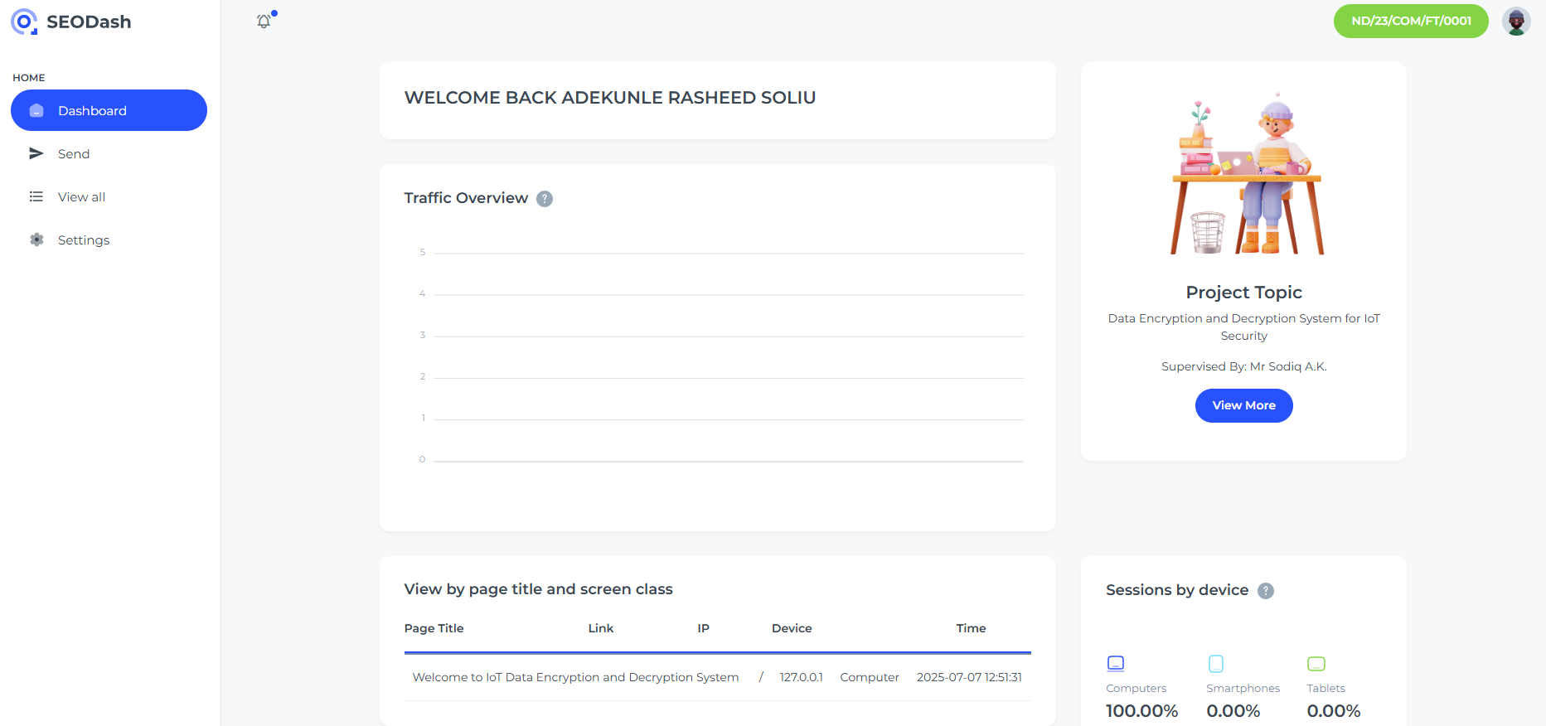Figure 4.1: Dashboard Page
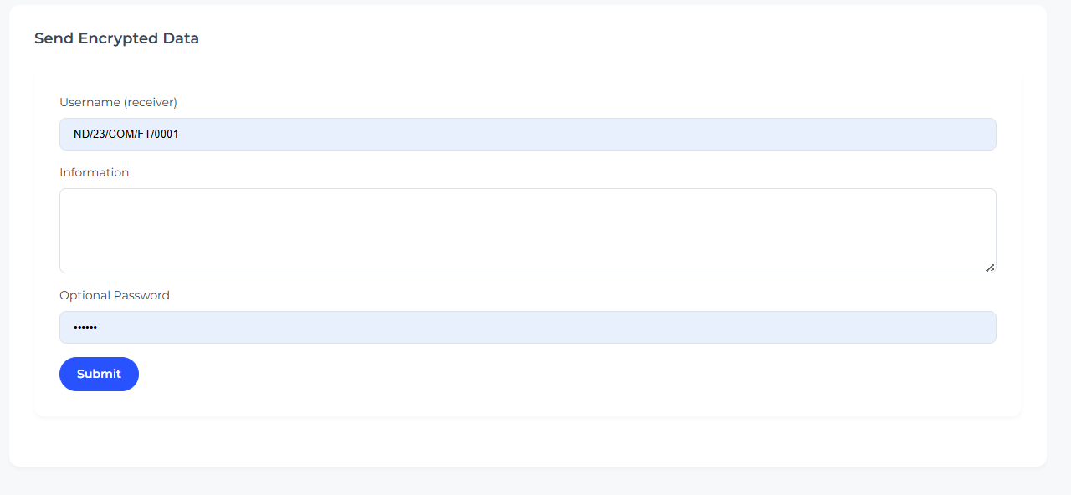
Figure 4.2: Send Encrypted Data

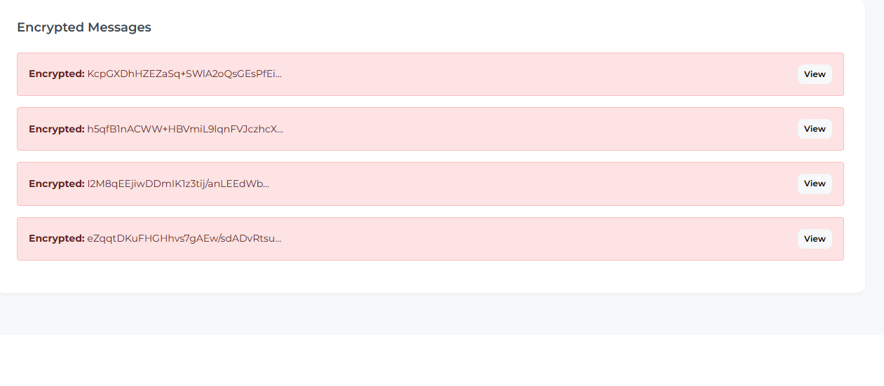Figure 4.3: All Sent Encrypted Data
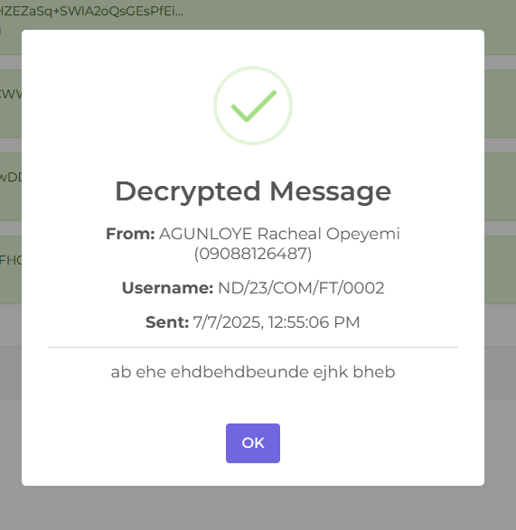
Figure 4.4: Data Decrypted MDAL


Figure 4.5: Access Denial for Unauthorized Access of Message

4.1.2 INPUT DESIGN
Inputs are collected from various IoT sensors (e.g., temperature, humidity). These readings serve as the raw data for the system. Once captured, the data is immediately passed through the encryption algorithm before being transmitted to the server. Proper validation checks are applied to ensure only legitimate sensor values are accepted.
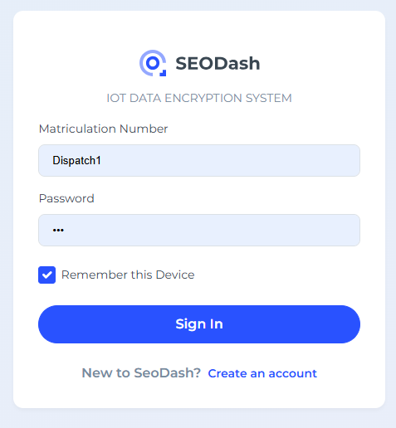
Figure 4.6: Sign In Page
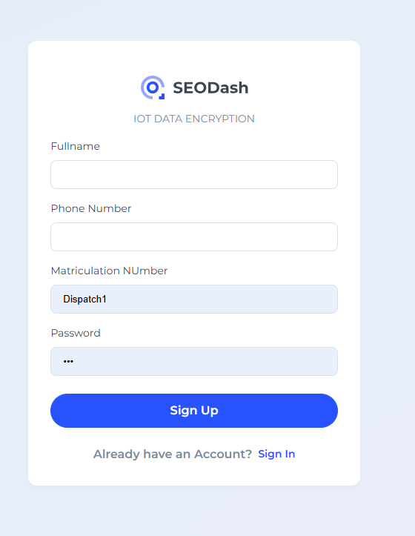
Figure 4.6: Sign Up Page

4.1.3 DATABASE DESIGN
A lightweight database (such as Firebase or SQLite) is used to store encrypted and decrypted data records. Each entry includes:
- Device ID
- Timestamp
- Encrypted Data
- Decrypted Data
- Integrity Status
The database enables traceability, data verification, and audit logging for monitoring system behavior.

4.1.4 PROCEDURE DESIGN
The system follows a sequential procedure:
- Sensor captures environmental data.
- Data is encrypted using AES.
- Encrypted data is transmitted via secure communication protocols.
- The server receives and decrypts the data.
- Data is verified and displayed/stored.
This procedure ensures end-to-end data protection throughout the lifecycle of each data packet.

4.2 IMPLEMENTATION OF THE SYSTEM

4.2.1 CHOICE OF PROGRAMMING LANGUAGE
The system is implemented using:
- Python: Used for encryption/decryption algorithms, data processing, and backend services.
- C++: Used for embedded code running on microcontrollers (e.g., Arduino).
These languages offer efficiency, hardware compatibility, and support for cryptographic libraries.
4.2.2 HARDWARE SUPPORT
The hardware components used include:
- Raspberry Pi or Arduino Uno for processing sensor data.
- Sensors like DHT11 (temperature and humidity).
- Wi-Fi Module (ESP8266/NodeMCU) for network communication.
These devices form the core of the IoT infrastructure, collecting and transmitting data.

4.2.3 SOFTWARE USED
- PyCharm / Thonny IDE: For Python development.
- Arduino IDE: For writing and uploading code to microcontrollers.
- Firebase: Cloud-based database to store and sync data.
- Wireshark: For monitoring data traffic and testing encryption security.

4.2.4 IMPLEMENTATION TECHNIQUE USED
The modular programming technique was adopted. Each functional component—encryption, transmission, decryption, and display was developed as a separate module and integrated after successful individual testing. This approach improves scalability and makes debugging easier.

4.3 SYSTEM DOCUMENTATION

4.3.1 PROGRAM DOCUMENTATION
The system is structured with clear comments and documentation throughout the source code. Each function is well-labeled, describing its purpose, parameters, and return values. Security modules (AES, RSA) include notes on key size and encryption flow.
4.3.2 OPERATING THE SYSTEM
To operate the system:
- Power on the IoT device and connect to Wi-Fi.
- The sensor collects data and sends it through the encryption module.
- The encrypted data is transmitted to the server.
- On the server, the data is decrypted and stored/displayed.
- Administrators can monitor and manage system activities through the dashboard.

4.3.3 SYSTEM MAINTENANCE
System maintenance includes:
- Periodic updates to encryption libraries and microcontroller firmware.
- Key rotation and certificate renewal for secure authentication.
- Regular backups of data and configurations.
- Monitoring logs for any irregularities or unauthorized access attempts.

CHAPTER FIVE

SUMMARY, CONCLUSION, AND RECOMMENDATIONS

5.1 SUMMARY
This project focused on the design and implementation of a secure IoT system using encryption and decryption techniques to protect data during transmission. The study began by identifying the vulnerabilities inherent in traditional IoT systems, particularly the lack of proper security protocols that expose sensitive data to threats such as unauthorized access, data tampering, and interception. The research adopted a hybrid methodology, combining both exploratory and experimental approaches. Cryptographic methods such as AES (Advanced Encryption Standard) and RSA were explored and implemented to ensure confidentiality, integrity, and authenticity of data. The system architecture included IoT sensors, encryption modules, secure communication protocols, and a centralized server for decryption and data management. The implementation was carried out using Python and C++, with supporting tools like PyCryptodome, OpenSSL, Arduino IDE, and Firebase for data storage. The system was tested in a simulated environment using microcontrollers and sensors, and the results showed that the encryption techniques successfully protected data without significantly affecting performance.

5.2 CONCLUSION
The successful implementation of encryption and decryption techniques in this project demonstrates that it is possible to significantly improve the security of IoT systems. By applying modern cryptographic standards and secure communication protocols, the system ensures that data transmitted between devices remains private and unaltered. The project also proves the feasibility of integrating lightweight encryption algorithms into resource-constrained IoT devices, allowing for secure data handling without overwhelming the device's processing power. The modular design of the system ensures flexibility, scalability, and ease of maintenance, making it suitable for various IoT applications in smart homes, healthcare, agriculture, and industry. In conclusion, this research has shown that strong cryptographic solutions are not only necessary but practical for real-world IoT deployments, especially as the number of connected devices continues to grow rapidly.

5.3 RECOMMENDATIONS
Based on the findings and implementation experience, the following recommendations are made:
- Adopt Standardized Encryption Across All IoT Devices
Manufacturers and developers should implement standardized encryption protocols like AES and RSA to ensure uniform security levels across devices.
- Regularly Update Firmware and Keys
IoT systems should support over-the-air (OTA) updates for firmware and cryptographic key rotation to guard against emerging threats.
- Implement Real-Time Monitoring and Logging
Integrating intrusion detection systems and real-time logging mechanisms can help in early detection of threats and quick incident response.
- Educate Users and Developers on IoT Security Best Practices
Awareness and training should be provided to users and developers to discourage the use of default credentials and promote secure system configuration.
- Future Enhancements with AI for Threat Detection
Incorporating artificial intelligence or machine learning can further improve the system by predicting and identifying unusual patterns in network behavior, enhancing proactive security.

References
Alaba, F. A., Othman, M., Hashem, I. A. T., & Alotaibi, F. (2017). Internet of Things Security:A Survey. Journal of Network and Computer Applications, 88, 10–28. https://doi.org/10.1016/j.jnca.2017.04.002
Ali, I., Sabir, S., & Ullah, Z. (2024). Internet of Things Security, Device Authentication and Access Control: A Review. http://arxiv.org/abs/1901.07309
Arduino. (2023). Arduino Documentation and Examples. Retrieved from https://www.arduino.cc/
Blessing, M., & Olusegun, J. (2024). Implementing Robust Data Encryption Techniques: Best Practices and Challenges in Developing Effective Security Policies. https://www.researchgate.net/publication/383457714
Brasoveanu, A., Moodie, M., & Agrawal, R. (2020). Textual evidence for the perfunctoriness of independent medical reviews. CEUR Workshop Proceedings, 2657, 1–9. https://doi.org/10.1145/
Goyal, V., & Zafar, A. (2020). A Cryptographic Approach for Securing IoT Devices. International Research Journal of Engineering and Technology. www.irjet.net
Gupta, M. (2024). Examining Techniques to Enhance the Security and Privacy of IoT Devices and Networks against Cyber Threats †. Engineering Proceedings, 62(1). https://doi.org/10.3390/engproc2024062023
National Institute of Standards and Technology (NIST). (2001). FIPS 197: Advanced Encryption Standard (AES). U.S. Department of Commerce.
Ogundare, E. (n.d.). Security of Internet of Things (IoT) Devices and Systems. https://www.researchgate.net/publication/379430395
RSA Laboratories. (2020). PKCS #1: RSA Cryptography Standard. Retrieved from https://www.rsa.com/
Sharma, V., & You, I. (2018). Security in IoT Using Lightweight Cryptography. IEEE Access, 6, 48999–49007. https://doi.org/10.1109/ACCESS.2018.2869350
Stallings, W. (2017). Cryptography and Network Security: Principles and Practice (7th ed.). Pearson Education.
Zhang, Y., Deng, R. H., & Liu, K. (2021). Towards Secure and Efficient Data Transmission in IoT Using Encryption Techniques. IEEE Internet of Things Journal, 8(2), 1234–1245.

