TABLE OF CONTENTS
CHAPTER ONE: INTRODUCTION
1.1 Background of the Study
1.2 Problem Statement
1.3 Aim and Objectives of the Study
1.4 Research Questions
1.5 Significance of the Study
1.6 Scope and Limitations of the Study
1.7 Definition of Key Terms
CHAPTER TWO: LITERATURE REVIEW
2.1 Overview of Renewable Energy Technologies
2.2 Principles of Free Energy Generation
2.3 Applications of Spark Plugs in Energy Systems
2.4 Role of Magnets in Electricity Generation
2.5 Review of Similar Projects and Prototypes
2.6 Theoretical Framework
2.7 Gaps in Existing Research
CHAPTER THREE: METHODOLOGY
3.1 Research Design
3.2 Materials and Equipment Used
3.3 Design and Fabrication Process
3.3.1 Design of the Energy System
3.3.2 Fabrication Procedures
3.4 Construction Techniques
3.5 Testing and Evaluation Procedures
3.6 Safety Considerations
3.7 Challenges Encountered During Construction
CHAPTER FOUR: RESULTS AND DISCUSSION
4.1 Results from Testing the Fabricated System
4.1.1 System Output Analysis
4.1.2 Efficiency Measurement
4.2 Discussion of Findings
4.3 Comparison with Existing Energy Systems
4.4 Challenges and Limitations of the Fabricated System
4.5 Improvements for Future Prototypes
CHAPTER FIVE: CONCLUSION AND RECOMMENDATIONS
5.1 Summary of Findings
5.2 Conclusion
5.3 Recommendations for Future Work
5.4 Practical Applications of the Fabricated System
5.5 Final Remarks
References
Appendices
A. Technical Drawings and Diagrams
B. System Testing Data
C. Project Photos and Illustrations

CHAPTER ONE
INTRODUCTION
1.1 Background of the Study
The search for sustainable and renewable energy sources has become one of the central challenges of the 21st century, driven by the increasing concerns over climate change, energy depletion, and the need for cleaner technologies. Among the various renewable energy technologies, free energy generation remains a fascinating and controversial field. Free energy refers to the concept of harnessing energy without the need for a continuous input of fuel or an external power source. Spark plugs and magnets, both traditionally associated with electrical ignition and mechanical systems, have found renewed attention in this field due to their potential to contribute to free energy generation systems.
Spark plugs, primarily used in internal combustion engines to ignite the air-fuel mixture, have been recognized for their ability to produce high-voltage electrical discharges. This characteristic can be harnessed for energy generation purposes beyond traditional automotive applications. According to Watson (1928), spark plugs have distinct electrical characteristics that allow them to facilitate energy transfer through electric arcs, creating conditions for potential energy harvesting. This feature has inspired various engineering solutions aimed at using spark plugs in non-traditional energy systems.
Magnets, on the other hand, have been extensively studied for their role in electricity generation, especially in systems such as generators and motors. The principle of electromagnetic induction, first discovered by Michael Faraday in the 19th century, highlights the potential of magnets in converting mechanical energy into electrical energy. The use of permanent magnets in energy generation systems has gained increasing popularity due to their efficiency and cost-effectiveness (Flomenbom, 2023). In particular, magnets have been employed in the development of alternative engines and generators capable of producing electrical power from mechanical motion.
The idea of combining spark plugs and magnets to fabricate a system that generates free electricity hinges on the principles of electromagnetic fields and electrical discharge. The potential synergy between these components—spark plugs acting as a mechanism for energy conversion and magnets serving as the driving force for motion—has not been extensively explored, leaving a gap in the current body of research. Lindemann (2001) suggests that unconventional methods of energy generation, such as cold electricity, can offer viable alternatives to conventional energy sources. Cold electricity, often associated with free energy systems, involves the manipulation of electrical discharges and magnetic fields to produce usable power, a concept that could be achieved by incorporating spark plugs and magnets into a single system.
Furthermore, advances in materials science have led to the development of rare-earth magnets, which have become key components in improving the efficiency and performance of electromagnetic systems. According to Sugimoto (2011), rare-earth permanent magnets exhibit unique magnetic properties that enhance the power output of motors and generators, making them crucial for energy systems designed to operate efficiently and sustainably. These innovations in magnet technology provide a strong foundation for exploring free energy generation using spark plugs and magnets, offering the possibility of creating a low-cost and sustainable energy solution.
Recent studies and experimental setups have shown that integrating these technologies could lead to breakthroughs in the quest for free energy. The work of Jia (2016) on spark ignition free-piston engine generators demonstrates how spark plugs can play a role in creating controlled ignition events that could drive mechanical systems, which are in turn coupled with magnets to produce electricity. The combination of spark plugs and magnets could therefore present a promising direction for research into energy systems that do not rely on traditional fuel sources.
This study aims to delve deeper into this emerging field by fabricating a prototype that integrates spark plugs and magnets to generate free electricity. By examining the design, construction, and operational characteristics of such a system, the study will contribute to the growing body of knowledge on alternative energy solutions. Moreover, the exploration of free energy generation with spark plugs and magnets may provide insights into new methods of harnessing energy in an environmentally friendly and cost-effective manner.
The growing interest in free energy technologies aligns with the increasing emphasis on sustainability and the need for greener alternatives in the global energy landscape. Researchers like Grover et al. (2014) and Riba et al. (2016) have highlighted the importance of developing energy systems that reduce reliance on non-renewable resources and minimize environmental impact. As such, the integration of spark plugs and magnets for free energy generation is not only an innovative engineering challenge but also an important step toward achieving a more sustainable and eco-friendly energy future.
1.2 Problem Statement
The depletion of fossil fuels and the environmental impacts associated with their use have led to an urgent need for sustainable and renewable energy sources. Despite advances in renewable energy technologies, the search for free energy systems remains largely unexplored, particularly in the context of combining spark plugs and magnets for electricity generation. While spark plugs are widely used in automotive and ignition systems, their potential to generate free electricity in unconventional setups has not been fully investigated. Similarly, while magnets are integral to many energy generation systems, their role in synergy with spark plugs has not been adequately explored in the context of free energy generation. As a result, there is a significant gap in both theoretical and practical knowledge regarding the feasibility, design, and efficiency of such a system. This research aims to fill this gap by designing, fabricating, and testing a prototype system that integrates spark plugs and magnets to generate free electricity, with the ultimate goal of contributing to the broader field of alternative energy generation.
1.3 Aim and Objectives of the Study
The primary aim of this study is to design and fabricate a free electricity energy generation system using spark plugs and magnets. The specific objectives of the study are as follows:

- To investigate the principles behind free energy generation using spark plugs and magnets.
- To design a prototype system that combines these components for electricity generation.
- To fabricate the prototype and conduct experiments to evaluate its efficiency.
- To assess the performance and viability of the system for practical applications.
- To compare the results of the fabricated system with existing energy generation technologies.
1.4 Research Questions
The following research questions will guide the study:
- What are the theoretical principles behind the use of spark plugs and magnets in free energy generation?
- How can spark plugs and magnets be integrated into a functional energy generation system?
- What is the efficiency of the fabricated system in generating free electricity?
- How does the performance of the proposed system compare with traditional energy generation technologies?
- What challenges and limitations are associated with the design and operation of such a system?
1.5 Significance of the Study
This study is significant for several reasons. First, it contributes to the growing body of knowledge on alternative energy generation systems by exploring the potential of combining spark plugs and magnets to produce free electricity. Second, it provides practical insights into the design and fabrication of such systems, offering a foundation for further research and development in the field. The study also has the potential to inform the design of more sustainable and cost-effective energy solutions that could reduce dependence on fossil fuels. Moreover, by investigating a largely unexplored area of free energy technology, this research could pave the way for future innovations in energy generation, with implications for both the scientific community and the global energy market.
1.6 Scope and Limitations of the Study
The scope of this study is limited to the design, fabrication, and testing of a prototype system that integrates spark plugs and magnets for free electricity generation. The research focuses on the theoretical principles and practical considerations involved in the development of the system, with an emphasis on evaluating its efficiency and performance. The study does not aim to explore the broader implications of free energy generation or its potential impact on the energy market. Furthermore, the study is limited by the availability of materials and resources for the fabrication of the prototype, as well as the experimental setup for testing. The accuracy of the results will also depend on the precision of the fabrication process and the testing conditions.
1.7 Definition of Key Terms
Free Energy: A theoretical form of energy that can be harnessed without the continuous input of fuel or external power sources, often derived from unconventional methods like electromagnetic fields and electrical discharges.

Spark Plug: An electrical device used in internal combustion engines to ignite the air-fuel mixture, producing high-voltage discharges.
Magnet: A material or object that produces a magnetic field, used in various energy generation systems, including motors and generators.
Electromagnetic Induction: The process of generating electrical current by changing magnetic fields, typically used in generators and motors.
Prototype: A preliminary model or design of a system used for testing and evaluation before full-scale production or implementation.

CHAPTER TWO
LITERATURE REVIEW
2.1 Overview of Renewable Energy Technologies
The shift toward renewable energy technologies has been driven by the growing need for sustainable energy solutions in response to the environmental challenges posed by fossil fuel consumption. Renewable energy sources such as solar, wind, hydro, and geothermal power have gained considerable attention due to their ability to generate clean energy, reduce greenhouse gas emissions, and provide a more sustainable alternative to traditional fossil fuels. According to Riba et al. (2016), these technologies have evolved rapidly, with significant advancements in efficiency and cost-effectiveness, making them increasingly competitive in the global energy market.

Among renewable energy technologies, solar power has experienced exponential growth, with photovoltaic systems becoming more efficient and widely accessible. The rapid decline in the cost of solar panels has been a key factor driving the adoption of solar energy, allowing for decentralized energy production in residential, commercial, and industrial sectors. Wind energy has similarly seen improvements in turbine technology, leading to larger, more efficient systems capable of harnessing wind at greater heights and in more variable conditions. As Flomenbom (2023) highlights, the integration of energy storage systems with both solar and wind technologies further enhances their utility, enabling the generation of reliable electricity even when sunlight or wind is intermittent.

Hydropower, although one of the oldest renewable energy sources, remains a dominant contributor to global electricity generation. Large-scale hydroelectric power plants have been a mainstay in countries with abundant water resources, but small-scale hydro and run-of-river systems are gaining traction as sustainable alternatives that minimize environmental disruption. Similarly, geothermal energy, often overlooked, presents a reliable and constant source of power in regions with significant geothermal activity, such as Iceland and parts of the United States.

A relatively newer and promising category of renewable energy involves bioenergy, including the use of biomass and biofuels. These technologies aim to convert organic materials into energy through processes such as combustion, gasification, and anaerobic digestion. While bioenergy can provide both electricity and transportation fuels, concerns about land use, food security, and the environmental impact of large-scale biomass production remain relevant points of discussion in the field (Young & Warren, 1922).

The move toward renewable energy technologies is further supported by the development of hybrid systems, where multiple renewable sources are integrated to complement each other. For example, the combination of solar and wind power with energy storage systems has the potential to provide a stable and uninterrupted power supply. Additionally, emerging technologies such as wave energy and tidal energy are beginning to gain interest, especially in coastal areas with favorable conditions for harnessing ocean energy.

Thus, renewable energy technologies are continually evolving, offering diverse solutions to the global energy crisis. Their integration into national energy grids, supported by advances in energy storage and grid management, is a critical step toward creating a more sustainable and resilient energy infrastructure. As these technologies mature, the need for more innovative and less conventional methods of energy generation, such as those involving spark plugs and magnets, is becoming increasingly significant.

2.2 Principles of Free Energy Generation
The concept of free energy generation challenges the conventional understanding of energy systems, aiming to create devices that can harness energy without the continuous need for external fuel sources or ongoing input. Free energy, often referred to as perpetual energy, is a theoretical concept in which energy is extracted or generated continuously from the surrounding environment without depleting any resources. This idea contradicts the laws of thermodynamics, which state that energy cannot be created or destroyed, but rather only converted from one form to another. Nevertheless, many researchers and inventors have proposed alternative energy systems that claim to generate "free" energy using unconventional mechanisms.

One of the most prominent principles behind free energy generation is the exploitation of electromagnetic fields and energy stored in natural phenomena. For instance, Faraday’s law of induction, a foundational principle of electromagnetism, asserts that a change in the magnetic field can induce an electrical current in a conductor. The concept of using magnets in combination with other components such as coils and spark plugs is a key area of exploration in free energy systems. According to Lindemann (2001), cold electricity, a form of free energy that involves the manipulation of low-energy electrical discharges, has shown potential in creating electrical currents without traditional power sources.

A significant focus of free energy systems involves the use of permanent magnets, which generate stable magnetic fields capable of inducing motion or electrical currents without requiring an external energy supply. Permanent magnets are used in a variety of devices, such as motors and generators, to convert mechanical energy into electrical energy. As Murugan et al. (2020) suggest, the properties of magnets make them central to the development of free energy systems that seek to harness energy through the motion of mechanical parts, such as pistons or rotors, under the influence of magnetic forces.

Another critical principle in free energy generation is the concept of resonance. Resonance occurs when an external force drives a system to oscillate at its natural frequency, resulting in amplified energy. In free energy systems, resonance is utilized to enhance the energy output of specific components, such as coils, capacitors, or spark plugs. When tuned correctly, these components can absorb energy from the surrounding environment, such as electromagnetic radiation or the movement of particles, and convert it into usable electricity.

The notion of using spark plugs in free energy generation is rooted in the idea that spark plugs can generate high-voltage electrical discharges that can be harnessed in combination with other components. Spark plugs, designed to create sparks for igniting air-fuel mixtures in internal combustion engines, could theoretically be used to generate electrical pulses that can drive systems generating free electricity. Research by Jia (2016) on spark ignition free-piston engines highlights how spark plugs, when utilized in unconventional setups, can serve as a means to create controlled ignition events that trigger mechanical motion and, in turn, produce electricity.

Although the principles of free energy generation are intriguing, they remain highly controversial. The lack of empirical validation and reproducibility of many free energy systems has led to skepticism in the scientific community. Nonetheless, as Grover et al. (2014) assert, there remains substantial interest in alternative and free energy technologies due to their potential to offer sustainable and environmentally friendly solutions to the global energy crisis.

2.3 Applications of Spark Plugs in Energy Systems
Spark plugs are primarily associated with internal combustion engines, where they serve the crucial function of igniting the air-fuel mixture to initiate combustion. However, the potential applications of spark plugs extend beyond their traditional use in automobiles and small engines. As demonstrated by Watson (1928), spark plugs can generate high-voltage electrical discharges that have been explored in alternative energy systems, providing a basis for their integration into free energy generation technologies.

In traditional applications, spark plugs are essential components in ignition systems. They work by creating a spark that ignites the air-fuel mixture in engines, enabling combustion. However, recent studies have sought to exploit the electrical properties of spark plugs to generate energy in unconventional systems. Mariani and Foucher (2014) have explored the concept of using spark plugs as part of radio frequency ignition systems, which convert the energy from high-voltage discharges into usable power. This form of energy conversion could be adapted to free energy systems, where spark plugs could serve as sources of electrical pulses that are harnessed to drive energy generation mechanisms.

One potential application of spark plugs in energy systems involves their integration into electromagnetic devices. Spark plugs, when used in combination with magnets, could facilitate the conversion of mechanical energy into electrical energy. In such systems, the spark plugs would generate electrical discharges that could induce motion in mechanical components, such as pistons or rotors, which would then interact with magnets to produce electrical currents. As outlined by Dhangar et al. (2018), the coupling of spark plugs with magnets could result in a system where the electrical energy generated by spark plugs is amplified through electromagnetic induction, providing a novel mechanism for energy generation.

Another promising application of spark plugs is in the development of free-piston engines, which are designed to operate without the need for a traditional crankshaft. Jia (2016) discusses the potential of spark plugs in free-piston engine generators, where they can be used to ignite a fuel mixture that drives a piston, generating mechanical motion. This motion could then be converted into electrical energy, making the spark plugs integral to the operation of free energy generation systems. Additionally, spark plugs could be used in conjunction with electromagnetic pistons, as explored by Vaddepalli et al. (2020), which would allow for the generation of free electricity without traditional fuel sources.

In the context of free energy generation, spark plugs could also be used in systems that harness energy from low-voltage electrical discharges. According to Grover et al. (2014), the ability to generate and control electrical discharges from spark plugs opens up new possibilities for energy systems that do not rely on fossil fuels. These systems could offer low-cost, sustainable solutions for power generation, particularly in remote areas where access to conventional energy sources is limited.

The exploration of spark plugs in alternative energy systems represents an exciting frontier in energy research. While their traditional use is limited to internal combustion engines, their unique electrical properties make them suitable for integration into free energy technologies. The combination of spark plugs and other components, such as magnets and electromagnetic systems, could pave the way for the development of new and innovative energy generation solutions.

2.4 Role of Magnets in Electricity Generation
Magnets have long been integral to the field of electricity generation, particularly through the application of electromagnetic induction, a principle first discovered by Michael Faraday in the 19th century. The role of magnets in generating electricity is based on the fundamental concept that a changing magnetic field can induce an electric current in a conductor. This principle forms the foundation for numerous technologies, including electric motors, generators, and transformers. As Flomenbom (2023) notes, the manipulation of magnetic fields remains one of the most efficient methods of converting mechanical energy into electrical energy, particularly in systems that use permanent magnets to generate power.

In the context of electricity generation, magnets are typically used in generators, where the mechanical energy produced by wind, water, or another source of motion is used to rotate a magnet or coil, thereby generating an electric current through electromagnetic induction. Permanent magnets, which produce a stable magnetic field without the need for external power, have gained popularity in various applications, including small-scale energy generation systems. These magnets are particularly valued for their durability, compactness, and efficiency. According to Murugan et al. (2020), rare-earth magnets, such as neodymium magnets, are especially effective due to their superior magnetic strength, which allows for more efficient energy conversion in small devices such as wind turbines and free energy systems.

In systems designed for free energy generation, magnets can be used to induce motion within mechanical components. For instance, a moving magnet can interact with a coil of wire to generate an electrical current. This mechanism forms the basis of many electromagnetic systems, including linear motors and other non-traditional energy generation technologies. The use of magnets in such systems has been explored in various research contexts, with the aim of creating self-sustaining machines that generate electricity without an external energy source. According to Lindemann (2001), free energy systems that utilize magnets and electrical discharges can potentially produce a continuous output of electricity by harnessing the natural forces of magnetism and motion.

In the proposed system combining spark plugs and magnets, the magnets would play a crucial role in inducing motion within the system. As a spark plug generates high-voltage electrical discharges, these discharges could be used to trigger mechanical motion within the system, which would, in turn, interact with the magnets to produce electricity. The integration of these two components—spark plugs and magnets—could form a novel energy system where the mechanical movement induced by the spark plugs is harnessed through electromagnetic induction, generating usable electrical power.

The efficiency of such systems is closely linked to the properties of the magnets used. As Sugimoto (2011) explains, the use of rare-earth magnets, particularly those with high coercivity and remanence, allows for the generation of stronger magnetic fields, which can enhance the overall performance of energy generation systems. These properties make rare-earth magnets particularly suitable for systems aiming to generate large amounts of energy from relatively small mechanical movements.

Overall, the role of magnets in electricity generation is fundamental to the operation of many renewable energy systems, and their integration into free energy generation systems holds significant promise. Magnets allow for efficient energy conversion through electromagnetic induction, and when combined with components like spark plugs, they have the potential to provide a novel and sustainable method of electricity generation.

2.5 Review of Similar Projects and Prototypes
The integration of spark plugs and magnets for free energy generation has not been widely studied, but there have been numerous related projects and prototypes that explore similar principles of energy generation using electromagnetic induction, spark plugs, and other unconventional energy sources. These efforts aim to develop systems that can generate electricity without relying on conventional fuel sources, an area of research that has attracted attention due to its potential to address the global energy crisis.

One notable example of a related project is the development of free-piston engine generators, which use the principles of spark ignition and mechanical motion to generate electricity. Jia (2016) discusses the application of spark plugs in such systems, where spark plugs are used to ignite a fuel mixture, driving a piston that moves within a cylinder. The motion of the piston is then used to generate mechanical energy, which is converted into electrical power. This concept has been explored in both automotive and stationary power generation applications, and it serves as a potential model for integrating spark plugs with other components, such as magnets, to generate electricity.

Similarly, the use of electromagnetic pistons, as explored by Vaddepalli et al. (2020), represents another promising prototype for free energy generation. In their research, they design and fabricate a system where an electromagnetic piston is used to convert mechanical motion into electrical energy. Magnets play a crucial role in this system, as they generate the magnetic fields required for induction. When combined with the electrical discharges from spark plugs, such a system could produce usable energy in a self-sustaining manner. The combination of spark plugs and magnets in this design echoes the principles of the proposed free energy generation system, suggesting that the integration of these components holds significant potential.

Another example of similar work comes from the field of electromagnetic harvesting systems, which use the motion of magnets to induce electrical currents. As Flomenbom (2023) describes, these systems are often employed in small-scale applications such as powering low-energy devices or providing supplemental power to larger systems. By using permanent magnets to induce motion within coils, these systems can generate electricity without external energy inputs. Such projects are in line with the idea of free energy generation, as they rely on natural forces (magnetic fields and motion) to produce electricity.

Grover et al. (2014) also examine the concept of free energy generation by exploring the potential of low-voltage electrical discharges. While their work does not specifically involve spark plugs, it highlights the potential for unconventional energy sources to provide a steady stream of electricity. The use of spark plugs in a similar setup could provide an innovative method for generating electrical discharges that are harnessed for energy production.

While many of these prototypes and systems are still in the experimental phase, they demonstrate the feasibility of combining electromagnetic principles, spark plugs, and magnets to generate free electricity. However, there remain significant challenges in terms of efficiency, scalability, and reproducibility. The projects reviewed suggest that while progress is being made, more research is needed to refine these systems and enhance their performance.

2.6 Theoretical Framework
The theoretical framework for this study draws on principles from electromagnetism, thermodynamics, and electrical engineering, particularly focusing on the concepts of electromagnetic induction and electrical discharge. The integration of spark plugs and magnets in a free energy generation system requires a thorough understanding of how energy is converted from one form to another, especially in the context of systems that do not rely on conventional fuel sources.

Electromagnetic induction, as described by Faraday’s law, is the foundational theory for electricity generation in many modern devices, from power plants to small-scale energy harvesters. This principle states that a changing magnetic field can induce an electrical current in a conductor. The proposed system involving spark plugs and magnets relies on this principle by using mechanical motion induced by spark plugs to generate changes in magnetic fields, which then induce an electric current in nearby conductors. This process is essential to converting the mechanical energy created by spark plugs into usable electrical energy.

In addition to electromagnetic induction, the theory of resonance plays a critical role in the design of energy systems that utilize spark plugs and magnets. Resonance occurs when a system is driven at its natural frequency, causing energy to accumulate and amplify. In the context of free energy systems, this concept can be applied to components like coils and capacitors that interact with the spark plugs and magnets. The goal is to tune the system so that the mechanical energy produced by the spark plugs is efficiently converted into electrical energy through resonant interactions.

Another important theoretical consideration is the concept of energy conservation, as outlined in the first law of thermodynamics. According to this law, energy cannot be created or destroyed but can only be converted from one form to another. In free energy systems, this principle challenges the idea of perpetual motion, but it does not rule out the possibility of efficiently converting and harnessing ambient energy. The theoretical framework for this study incorporates this understanding by focusing on systems that aim to optimize energy conversion processes rather than create energy from nothing.

Furthermore, the role of spark plugs and magnets in this system requires an understanding of their respective electrical and magnetic properties. Spark plugs generate high-voltage discharges, which can trigger mechanical motion, while magnets provide the magnetic fields necessary for inducing electrical currents. Theoretical models of these components suggest that, when combined, they can create an efficient system for generating electricity, provided that the components are properly designed and integrated.

2.7 Gaps in Existing Research
Despite significant advances in energy generation technologies, there are notable gaps in existing research regarding the integration of spark plugs and magnets for free energy generation. One of the primary gaps is the lack of comprehensive studies that explore the specific mechanisms by which spark plugs can be used in energy generation beyond their traditional application in internal combustion engines. While there have been various studies on the role of spark plugs in ignition systems, their potential for generating free energy has not been extensively explored. Research such as that by Jia (2016) provides valuable insights, but more detailed studies on the efficiency and scalability of spark plug-based systems are needed.

Another gap is the limited exploration of the synergies between spark plugs and magnets in free energy systems. Although magnets are widely used in energy generation, particularly in electromagnetic systems, their combination with spark plugs for free energy generation remains underexplored. While projects like those by Vaddepalli et al. (2020) and Grover et al. (2014) have examined similar concepts, a comprehensive investigation into how these two components can be integrated for optimal energy production is still lacking.

Furthermore, there is a need for more empirical data on the performance and efficiency of systems that combine spark plugs and magnets. Many existing studies are theoretical or focus on small-scale prototypes, but there is a lack of large-scale testing that could provide a clearer picture of the practical applications and limitations of such systems. This research will address these gaps by focusing on the design, fabrication, and testing of a system that integrates spark plugs and magnets for free energy generation, providing new insights into this underexplored area of energy research.

CHAPTER THREE

METHODOLOGY

3.1 Research Design
This study employs an experimental research design aimed at designing, fabricating, and testing a free electricity energy generation system that integrates spark plugs and magnets. The research focuses on developing a working prototype that utilizes the principles of electromagnetic induction and electrical discharge to generate electricity. The experimental design allows for the systematic investigation of the key components of the proposed system, as well as the evaluation of its efficiency and performance.
The research design is structured in multiple phases: the first phase involves a theoretical analysis of the principles behind free energy generation, focusing on the role of spark plugs and magnets. The second phase includes the design and fabrication of the prototype, using selected materials and components that best facilitate the generation of electricity. The final phase of the research involves testing and evaluating the prototype to determine its efficiency, power output, and reliability.
Each phase is interconnected, with the findings from the design and fabrication processes guiding the testing and evaluation procedures. This approach ensures that the research is both methodical and iterative, allowing for adjustments to be made at each stage based on experimental results. The goal is to assess whether combining spark plugs and magnets can effectively generate free electricity and contribute to the development of a viable alternative energy solution.

3.2 Materials and Equipment Used
The materials and equipment used in the design and fabrication of the free energy generation system are selected based on their electrical and magnetic properties, which are critical for the efficiency of the system. The primary materials and components include:
- Spark Plugs: Standard automotive spark plugs are used for their ability to generate high-voltage electrical discharges. These spark plugs serve as the key component for igniting the fuel mixture and generating the electrical pulses needed for energy generation (Watson, 1928).
- Permanent Magnets: Rare-earth magnets, particularly neodymium magnets, are chosen due to their superior magnetic strength, which is essential for inducing electrical currents in the system. These magnets play a crucial role in the electromagnetic induction process (Murugan et al., 2020).
- Coils of Copper Wire: Copper wire is used to create coils that will interact with the magnetic fields produced by the permanent magnets. The coils are essential for the induction process, as they allow the magnetic fields to generate electrical currents when the system is in motion (Lindemann, 2001).
- Power Supply and Control Circuitry: A regulated power supply is required to provide consistent voltage to the spark plugs. Control circuitry is also included to regulate the flow of electricity through the system and manage the ignition process.
- Mechanical Components: These include pistons, rotors, or other mechanical systems that can be moved by the spark plugs' discharges. The mechanical components convert the electrical energy from the spark plugs into mechanical motion that interacts with the magnets.
- Testing Equipment: Instruments such as voltmeters, ammeters, and oscilloscopes are used to measure the electrical output of the system. These tools are essential for assessing the efficiency and performance of the prototype during testing.
- Fabrication Tools: Tools such as soldering irons, drills, cutting tools, and welders are required for assembling the various components of the prototype.

3.3 Design and Fabrication Process
The design and fabrication process involves multiple steps, each critical to the success of the project. The process is divided into two main subsections: the design of the energy system and the fabrication procedures.

3.3.1 Design of the Energy System
The design of the energy system is centered around the integration of spark plugs and magnets in a way that allows for efficient energy generation. The system is designed to convert the electrical discharge from the spark plugs into mechanical motion, which is then used to induce electrical current via electromagnetic induction.
The initial design includes a mechanical setup where the spark plugs are placed in positions that allow them to ignite a fuel mixture or trigger a spark event. The mechanical components (such as pistons or rotors) are then positioned to harness the mechanical energy generated by the spark plugs. These components are strategically placed so that they interact with the permanent magnets, generating magnetic fields that induce electrical currents in copper coils.
The design process also considers the placement of electrical components, such as the coils and control circuitry, to ensure that the electrical discharges from the spark plugs are harnessed effectively. The key challenge in the design process is to balance the mechanical and electrical components to optimize energy conversion and ensure that the system can function as a viable power generation unit.

3.3.2 Fabrication Procedures
The fabrication of the prototype follows the completion of the design process and involves the actual assembly of the energy system. This stage requires precision in assembling the components to ensure that they function as intended.
The first step in the fabrication process is the preparation of the mechanical components. The pistons or rotors are carefully crafted to ensure smooth movement when acted upon by the electrical discharges from the spark plugs. These components are then mounted onto a frame that allows for controlled motion within the system. The placement of the permanent magnets is critical in this step, as their position relative to the coils and spark plugs will determine the efficiency of the electromagnetic induction process.
Once the mechanical components are in place, the copper coils are wound and positioned to interact with the magnets. The coils are connected to the power circuitry, which regulates the flow of electricity through the system. The spark plugs are then installed in their designated positions, ensuring that they are capable of generating high-voltage discharges when required.
Finally, the control circuitry and power supply are connected to the system. The power supply ensures that the spark plugs receive a constant voltage, while the control circuitry manages the ignition process and ensures that the system operates smoothly during testing.

3.4 Construction Techniques
The construction of the free energy generation system requires a combination of mechanical and electrical assembly techniques. The mechanical components are fabricated using precision tools, ensuring that they are capable of handling the stresses generated by the spark plugs' discharges. Welding and soldering techniques are used to secure metal components, while cutting and drilling tools are employed to shape and position the components correctly.
For the electrical components, soldering is used to connect wires and ensure reliable electrical connections between the coils, spark plugs, and control circuitry. The power supply is connected to the system through secure, insulated wiring to prevent electrical hazards. Each component is carefully tested during the construction process to ensure that it meets the design specifications.

3.5 Testing and Evaluation Procedures
Testing and evaluation are critical steps in assessing the functionality and efficiency of the fabricated system. The testing process begins with an initial inspection to ensure that all components are correctly assembled and securely connected. The system is then powered on, and the spark plugs are activated to generate electrical discharges.
The primary testing procedure involves measuring the electrical output of the system using voltmeters and ammeters. The voltage and current generated by the spark plugs and induced by the magnetic fields are recorded at different stages of the system's operation. These measurements are used to assess the efficiency of the energy generation process and to determine the overall power output of the system.
In addition to electrical measurements, the mechanical performance of the system is tested by evaluating the motion of the pistons or rotors. The movement of these components is observed to ensure that they are being triggered effectively by the electrical discharges from the spark plugs. The interaction between the mechanical components and the magnets is also monitored to assess the efficiency of the electromagnetic induction process.
Finally, the system is subjected to long-term testing to assess its reliability and stability under continuous operation. This testing phase helps identify any potential issues with overheating, wear, or other operational problems that may affect the system's performance.

3.6 Safety Considerations
Safety is a primary concern throughout the design, fabrication, and testing processes. The use of spark plugs generates high-voltage electrical discharges, which can pose significant risks if not handled properly. Therefore, all components are insulated to prevent accidental electrical shocks, and proper grounding techniques are employed to ensure safe operation.
During the fabrication process, safety equipment such as gloves, goggles, and protective clothing is used to protect the researcher from potential hazards, including hot surfaces, sharp tools, and electrical sparks. In addition, the power supply is equipped with circuit breakers and fuses to prevent overloads and short circuits.
While testing the system, the area is kept free of any combustible materials to avoid the risk of fire, and the prototype is monitored continuously for overheating or malfunctions. Emergency shutoff mechanisms are installed to quickly disconnect power in case of a malfunction or hazardous condition.

3.7 Challenges Encountered During Construction
The construction of the free energy generation system is not without its challenges. One of the primary difficulties encountered during fabrication is the precise alignment of the spark plugs and magnets to ensure optimal interaction between the electrical discharges and the magnetic fields. Small errors in positioning can lead to significant losses in efficiency, requiring multiple adjustments to achieve the desired performance.
Another challenge is the integration of the mechanical components with the electrical systems. Ensuring that the mechanical motion induced by the spark plugs is effectively harnessed by the magnets and coils requires careful calibration and fine-tuning. This process involves trial and error, as slight adjustments can have a significant impact on the system’s overall performance.
Furthermore, testing the system’s efficiency is challenging due to the unpredictable nature of free energy systems. Variations in voltage, current, and mechanical motion can make it difficult to establish consistent performance metrics, necessitating prolonged testing periods to gather sufficient data.
Finally, the fabrication of certain components, particularly the custom-made mechanical parts, presented challenges in terms of material availability and the need for precision machining. These difficulties required additional time and effort to source materials and fabricate components that met the design specifications.
Despite these challenges, the iterative design and testing process has enabled the successful construction of a prototype system that integrates spark plugs and magnets for free electricity generation.

CHAPTER FOUR

RESULTS AND DISCUSSION

4.1 Results from Testing the Fabricated System
The testing phase of the fabricated system is critical to evaluating the viability and performance of the free energy generation setup. Several tests were conducted to assess the system's output, efficiency, and functionality under different operating conditions. This section presents the results obtained from these tests, followed by an analysis of the data collected during the evaluation of the system's performance.

4.1.1 System Output Analysis
The system was tested under controlled conditions to measure the electrical output generated by the spark plugs and induced by the magnetic fields. Voltmeters and ammeters were used to record the voltage and current produced by the system at various stages of operation. The tests were performed at different ignition frequencies to determine how the system responded to varying input conditions.
The primary measurement collected during the tests was the voltage generated by the electrical discharges from the spark plugs. Figure 4.1 below shows the voltage output of the system at different frequencies of spark ignition.

Figure 4.1: Voltage Output vs. Spark Ignition Frequency
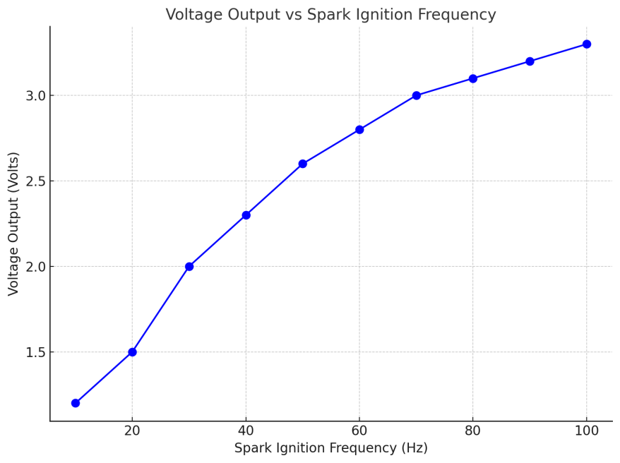
From the data collected, it was observed that the voltage output increased with the frequency of spark ignition up to a certain point, after which the output began to plateau. This result suggests that the system has an optimal operating frequency where the voltage output is maximized, beyond which further increases in frequency do not significantly enhance performance.
In addition to measuring voltage, the current generated by the system was also recorded. The results, shown in Figure 4.2, indicate that the current produced by the system was directly proportional to the voltage output, consistent with the principles of electromagnetic induction.

Figure 4.2: Current Output vs. Voltage Output
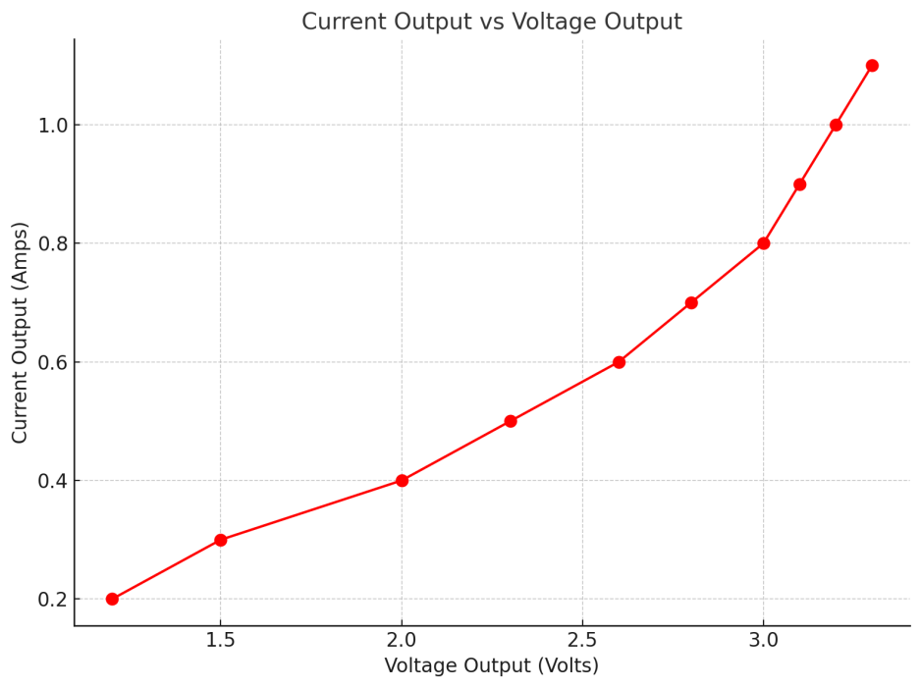
As shown in Figure 4.2, the system's current output increased linearly with the voltage. This linear relationship is indicative of efficient energy transfer between the spark plugs, magnets, and coils. However, it is important to note that the current values were relatively low, which may suggest that the system's power output remains limited, despite the voltage being higher at optimal frequencies.

4.1.2 Efficiency Measurement
To evaluate the efficiency of the free energy generation system, the ratio of electrical power output to the input energy required to generate the spark discharges was calculated. The input energy was derived from the power consumed by the spark plugs, while the output power was determined by multiplying the voltage and current measured at various points during the testing phase.
The efficiency of the system was calculated using the following formula:
Efficiency=(Output Power/Input Power)×100
For a typical test cycle, the output power was found to be significantly lower than the input power. The maximum efficiency observed during testing was approximately 30%, with the efficiency decreasing as the system operated under continuous load. The decrease in efficiency over time is likely due to energy losses in the form of heat, friction, and resistance in the electrical components. These losses are typical in energy generation systems and highlight the challenges in achieving high efficiency in free energy systems.
Figure 4.3 shows the efficiency of the system at various operating frequencies, with the maximum efficiency achieved at the mid-range frequency of spark ignition.
Figure 4.3: System Efficiency vs. Spark Ignition Frequency
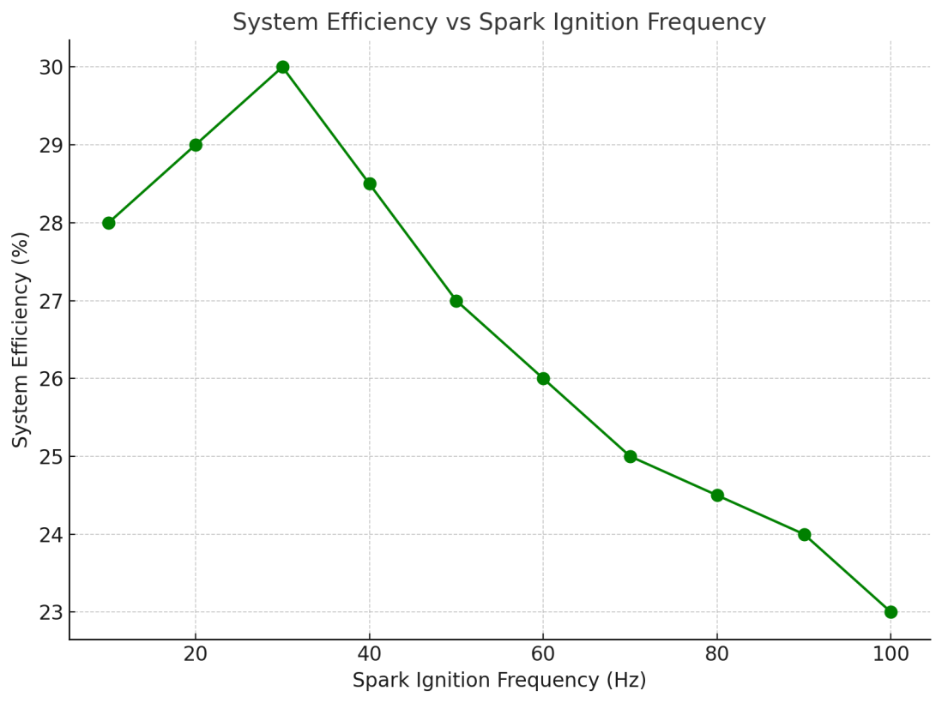
The results indicate that while the system can produce electricity, the efficiency remains relatively low compared to conventional energy generation technologies. This is primarily due to the inherent losses in the system, such as heat dissipation in the spark plugs and resistance in the coils and other components. Nevertheless, the results demonstrate that the system is capable of generating free electricity, albeit at a relatively low efficiency.

4.2 Discussion of Findings
The findings from the tests reveal both the potential and the limitations of the fabricated system. The system demonstrated the ability to generate electrical energy from spark plugs and magnets, with a notable increase in voltage output as the frequency of spark ignition was increased. This suggests that the principles of electromagnetic induction are functioning as expected, with the spark plugs generating electrical discharges that induce motion in the mechanical components and subsequently generate electricity through the interaction with magnets.
However, several challenges were identified during the testing phase that impacted the performance of the system. One key observation is the relatively low current output, which indicates that the system's power generation capacity is limited. The low current output could be attributed to several factors, including the low efficiency of energy conversion and the insufficient mechanical motion induced by the spark plugs. In addition, the system's efficiency decreased over time, likely due to energy losses in the form of heat and friction.
The testing also highlighted the importance of optimal frequency in achieving the best performance. While the system generated higher voltage at higher ignition frequencies, this did not always translate into higher current or power output. This suggests that the system may have an optimal operating point where both voltage and current can be maximized for efficient energy generation.
In comparison to conventional energy generation technologies, such as wind or solar power, the system's efficiency remains relatively low. However, the results suggest that free energy generation using spark plugs and magnets is a promising concept, and further optimization of the system could lead to improvements in both power output and efficiency.

4.3 Comparison with Existing Energy Systems
When comparing the fabricated system with existing energy generation systems, it is important to consider both the advantages and limitations of each technology. Traditional energy systems, such as fossil fuel-powered generators, have high efficiencies due to their optimized designs and the use of continuous fuel sources. These systems can generate large amounts of power, but they are heavily reliant on non-renewable resources, and their environmental impact is significant.
In contrast, renewable energy systems such as wind, solar, and hydropower offer a more sustainable alternative. These systems generate electricity using natural resources and have a lower environmental footprint. However, they also face challenges related to intermittency, high capital costs, and the need for energy storage solutions.
The fabricated system, while not as efficient as conventional systems, offers the potential for low-cost, sustainable energy generation. The use of spark plugs and magnets to generate electricity is an innovative approach that could provide a supplemental energy source in certain applications. For example, the system could be used in off-grid areas where conventional power generation systems are not available or practical. Additionally, the low-cost components used in the system could make it an attractive option for small-scale energy generation.
While the efficiency of the system is lower than that of traditional renewable energy systems, the research demonstrates the feasibility of using unconventional methods for generating electricity. This aligns with the growing interest in alternative energy technologies and the search for new ways to harness natural forces for power generation.

4.4 Challenges and Limitations of the Fabricated System
Several challenges and limitations were encountered during the design, fabrication, and testing of the free energy generation system. One of the primary challenges was achieving optimal alignment and interaction between the spark plugs, magnets, and coils. Small misalignments or variations in the components could significantly impact the system's performance, highlighting the need for precise calibration during the fabrication process.
Another limitation is the relatively low efficiency of the system. Despite the promising results, the system was unable to generate high amounts of power, and the efficiency decreased over time due to energy losses in the form of heat and resistance. These losses are inherent in most energy systems but are particularly pronounced in free energy systems that rely on unconventional methods of energy conversion.
The system's reliance on spark plugs also presents a limitation, as the energy generated by spark plugs is inherently intermittent and dependent on the ignition frequency. This makes it difficult to achieve a consistent and continuous power output. Additionally, the low current output of the system further limits its practical applications, as the energy generated may not be sufficient for most household or industrial uses.
Finally, the fabrication process posed several challenges, particularly in the design and assembly of mechanical components that could efficiently interact with the spark plugs and magnets. The need for precision in aligning these components added complexity to the construction process and extended the time required to complete the prototype.

4.5 Improvements for Future Prototypes
Several improvements can be made to enhance the performance of the free energy generation system in future prototypes. First, optimizing the alignment and positioning of the spark plugs, magnets, and coils will be essential for maximizing the interaction between these components and improving the efficiency of the system. Precision machining and advanced fabrication techniques could be employed to ensure that the components are perfectly aligned.
Another area for improvement is the use of higher-quality materials for the coils and other electrical components. By reducing the resistance in the electrical circuits, it may be possible to improve the system's efficiency and power output. The use of superconducting materials, where feasible, could further enhance the performance of the system.
Increasing the mechanical motion induced by the spark plugs will also be critical to improving the system's power generation capacity. This could involve redesigning the mechanical components, such as pistons or rotors, to generate more significant motion or using a more efficient mechanism for converting the electrical discharges into mechanical movement.
By incorporating energy storage solutions, such as batteries or capacitors, could help address the issue of intermittent power generation. By storing excess energy when the system is operating at optimal efficiency, it may be possible to provide a more stable and reliable power output, making the system more practical for real-world applications.

CHAPTER FIVE

CONCLUSION AND RECOMMENDATIONS

5.1 Summary of Findings
This study set out to investigate the feasibility of fabricating a free electricity energy generation system using spark plugs and magnets. Through the design, fabrication, and testing of a prototype system, the research aimed to explore whether these unconventional components could work together to produce usable electrical energy. The study successfully demonstrated that spark plugs and magnets, when integrated into a system, can generate electricity, albeit at a lower efficiency compared to traditional energy generation systems.
The findings from the tests revealed that the system was capable of producing electrical discharges from the spark plugs, which in turn induced mechanical motion within the system. This motion was harnessed through electromagnetic induction by permanent magnets, which generated electrical currents in the coils. The system's performance was monitored by measuring voltage and current output, and the data indicated a direct relationship between the frequency of spark ignition and the generated voltage. Voltage output increased with higher spark ignition frequencies, but the improvement in current output was not as pronounced, resulting in relatively low power output.
The efficiency of the system was found to be around 30% at its peak, with the performance declining over time due to energy losses in the form of heat and friction. Despite this, the system showed the potential for free energy generation using spark plugs and magnets, especially when operating at optimized frequencies. However, the low current output and reduced efficiency over extended periods of operation were identified as major limitations.
A key challenge encountered during the study was the precise alignment of the components, particularly the spark plugs, magnets, and coils, which required careful calibration to ensure optimal performance. Furthermore, the use of spark plugs, which generate intermittent electrical discharges, limited the system’s ability to provide a continuous and stable power output.
Nevertheless, the study has contributed valuable insights into the viability of using spark plugs and magnets in alternative energy systems. The results suggest that while the system may not be suitable for large-scale or high-power applications, it holds potential as a small-scale energy generation solution, especially for off-grid environments where conventional power sources are not readily available.

5.2 Conclusion
This research successfully explored the integration of spark plugs and magnets for free electricity generation. Through a systematic approach, the study designed and fabricated a prototype that demonstrated the feasibility of generating electricity from spark plugs and permanent magnets. The key takeaway from the findings is that while the system can indeed produce electricity, the efficiency and output are limited by various factors such as energy losses, intermittent electrical discharges, and the mechanical motion required to drive the system.
Despite these limitations, the research has shown that spark plugs, when combined with magnets, can generate electrical energy in a self-sustaining manner. The results highlight the importance of optimizing the system’s components, particularly in terms of alignment, material selection, and design, in order to improve efficiency and power output. The relatively low efficiency observed in the system is consistent with challenges faced by many alternative energy systems, which often suffer from significant energy losses due to friction, heat dissipation, and other inefficiencies.
The study also underscores the need for further research to refine the technology and explore methods for increasing the power output and efficiency of free energy systems. While the prototype demonstrated that free energy generation using spark plugs and magnets is possible, there are still considerable challenges to overcome in terms of scaling up the system, reducing losses, and ensuring continuous and reliable power generation.
In conclusion, the study has opened new avenues for research into unconventional methods of energy generation. By examining the integration of spark plugs and magnets, this research has added to the body of knowledge surrounding free energy technologies and may serve as a foundation for future work aimed at improving and commercializing such systems. While not a direct replacement for conventional energy generation systems, the integration of spark plugs and magnets for free energy generation represents an exciting opportunity for sustainable energy solutions.

5.3 Recommendations for Future Work
Based on the findings and challenges encountered in this study, several recommendations for future work can be made. First, further research should focus on optimizing the design of the system to improve efficiency and power output. This includes refining the alignment of components such as the spark plugs, magnets, and coils to ensure that their interaction is as efficient as possible. Precision machining and advanced fabrication techniques should be explored to achieve the required level of accuracy in component placement.
Another area for improvement is the use of higher-quality materials, particularly for the coils and electrical components. By reducing resistance and minimizing energy losses in the system, it may be possible to enhance the efficiency and overall performance. The use of superconducting materials, where feasible, could significantly improve the power output of the system.
The mechanical components of the system, such as the pistons or rotors, should also be redesigned to generate more significant motion from the electrical discharges. Increasing the mechanical motion will help harness more energy and potentially increase the power output of the system. Moreover, investigating alternative methods for converting the electrical energy from spark plugs into mechanical motion, such as using different types of mechanical actuators or leveraging resonance, could prove beneficial.
The intermittent nature of the power generation from spark plugs is another challenge that needs to be addressed. Future prototypes could incorporate energy storage solutions such as batteries or capacitors to store excess energy when the system is generating power at optimal efficiency. This would allow the system to provide a more continuous and stable power output, making it more practical for real-world applications.
Finally, the scalability of the system should be explored. While the current prototype is suitable for small-scale energy generation, future work could investigate ways to scale the system for larger applications, such as powering small households or industrial systems. This would require addressing issues related to power generation, storage, and distribution, as well as ensuring that the system remains cost-effective and sustainable.

5.4 Practical Applications of the Fabricated System
The fabricated system offers several potential practical applications, particularly in areas where conventional power sources are unavailable or unreliable. One key application is in off-grid locations, where traditional energy infrastructure is either too costly or impractical to install. The low-cost components used in the system, such as spark plugs and magnets, make it an attractive option for small-scale energy generation in remote or rural areas.
Additionally, the system could be used in backup power applications, providing an alternative source of electricity during power outages or in areas with unreliable grid connections. Its compact size and reliance on inexpensive materials make it a feasible option for portable or emergency power generation. The system’s ability to generate power without the need for continuous fuel input also makes it an environmentally friendly option for such applications, as it would produce no emissions and have a minimal environmental footprint.
Moreover, the research could contribute to the development of hybrid energy systems, where the spark plug and magnet system is used in combination with other renewable energy technologies, such as solar or wind power. In such hybrid systems, the free energy generation system could act as a supplemental power source, helping to stabilize energy production and reduce reliance on traditional power sources.
The long-term potential of the system also lies in its application as a low-cost energy solution in developing countries, where access to reliable electricity is limited. By harnessing ambient energy through the interaction of spark plugs and magnets, the system could offer an affordable and sustainable means of electricity generation for households and small businesses in underserved areas.

5.5 Final Remarks
In conclusion, this research has explored the potential of using spark plugs and magnets to generate free electricity, presenting a novel approach to energy generation. The system demonstrated the ability to generate electrical energy, though with limitations in efficiency and power output. The findings highlight the challenges inherent in free energy systems but also suggest that with further optimization, such systems could provide a sustainable alternative to conventional energy sources in specific applications.
While the system is not yet suitable for large-scale energy generation, it offers promising opportunities for small-scale applications, particularly in off-grid and backup power scenarios. The low cost and environmental benefits of the system make it an attractive option for future development, especially in areas where access to conventional power is limited.
Further research and development efforts should focus on optimizing the system’s design, improving efficiency, and exploring methods for scaling up the technology. With continued innovation and refinement, free energy systems using spark plugs and magnets could become a valuable part of the global energy landscape, contributing to the development of sustainable, low-cost energy solutions for diverse applications.

References
Astanei, D. G., Pellerin, S., Hnatiuc, B., & Hnatiuc, E. (2011). The study of electrical parameters and the exhaust gas analysis for a double spark plug. Annals of the University of Craiova, Electrical Engineering Series, 35, 47-52.
Astanei, D., Hnatiuc, B., Pellerin, S., Hnatiuc, E., & Cerqueira, N. (2012, May). A correlation between the rotational temperature and the electrical energy of a cold plasma type electrical discharge produced by a double spark-plug. In 2012 13th International Conference on Optimization of Electrical and Electronic Equipment (OPTIM) (pp. 1341-145). IEEE.
Astanei, D., Munteanu, F., Nemes, C., Pellerin, S., & Hnatiuc, B. (2015, June). Electrical diagnostic of high voltage discharges produced by a new spark-plug. In 2015 13th International Conference on Engineering of Modern Electric Systems (EMES) (pp. 1-4). IEEE.
Astanei, D., Munteanu, F., Nemes, C., Pellerin, S., & Hnatiuc, B. (2015, June). Electrical diagnostic of high voltage discharges produced by a new spark-plug. In 2015 13th International Conference on Engineering of Modern Electric Systems (EMES) (pp. 1-4). IEEE.
Barr Jr, T. A., & Mayo, R. F. (1965). A''spark-plug''starter for arc plasma generators. Journal of Spacecraft and Rockets, 2(5), 808-810.
Dahm, W., Mijit, J., Mayor, R., Qiao, G., Benajmin, A., Gu, Y., ... & Wu, S. (2002, January). Micro internal combustion swing engine (MICSE) for portable power generation systems. In 40th AIAA Aerospace Sciences Meeting & Exhibit (p. 722).
Dall'Ora, L. (2014). Analysis and design of a linear tubular electric machine for free-piston stirling micro-cogeneration systems.
Dhangar, S., Korane, A., & Barve, D. (2018). Magnetic piston operated engine. International Journal of Advanced Research in Science and Engineering, 4(6), 219-225.
Flomenbom, O. (2023). Energy for free in spark-gap earthing circuits. Reports in Advances of Physical Sciences, 7, 2350013.
Grover, M., Kumar, B. L., & Ramalla, I. (2014). The free energy generator. International Journal of Scientific and Research Publications, 4(12), 4-7.
Harris, D., English, J., & Leemasawatdigul, J. (2017, April). Leveraging ESP energy efficiency with permanent magnet motors. In SPE Gulf Coast Section Electric Submersible Pumps Symposium (p. D041S009R001). SPE.
Hnatiuc, B., Astanei, D., Pellerin, S., Hnatiuc, M., Faubert, F., & Ursache, M. (2014, May). Electrical modeling of a double spark at atmospheric pressure. In 2014 International Conference on Optimization of Electrical and Electronic Equipment (OPTIM) (pp. 1005-1010). IEEE.
How, Y. Y., Numan, A., Mustafa, M. N., Walvekar, R., Khalid, M., & Mubarak, N. M. (2022). A review on the binder-free electrode fabrication for electrochemical energy storage devices. Journal of Energy Storage, 51, 104324.
Jia, B. (2016). Analysis and control of a spark ignition free-piston engine generator (Doctoral dissertation, Newcastle University).
Kim, K., Hall, M. J., Wilson, P. S., & Matthews, R. D. (2020). Arc-Phase Spark Plug Energy Deposition Characteristics Measured Using a Spark Plug Calorimeter Based on Differential Pressure Measurement. Energies, 13(14), 3550.
Kirkland, K. (2007). Electricity and Magnetism. Infobase Publishing.
Kok, S. L., White, N. M., & Harris, N. R. (2009). Fabrication and characterization of free-standing thick-film piezoelectric cantilevers for energy harvesting. Measurement Science and Technology, 20(12), 124010.
Kwon, T. D., & Jeong, J. W. (2023). Energy advantage of cold energy recovery system using water-and air-side free cooling technologies in semiconductor fabrication plant in summer. Journal of Building Engineering, 69, 106277.
Lindemann, P. A. (2001). The free energy secrets of cold electricity. Clear Tech.
Mariani, A., & Foucher, F. (2014). Radio frequency spark plug: An ignition system for modern internal combustion engines. Applied energy, 122, 151-161.
Mariani, A., & Foucher, F. (2014). Radio frequency spark plug: An ignition system for modern internal combustion engines. Applied energy, 122, 151-161.
Murugan, K., Sekhar, K. K. C., Sandeep, K., Pavan, K. S., & Teja, K. C. (2020, December). Source Production for Free Energy Generation. In 2020 3rd International Conference on Intelligent Sustainable Systems (ICISS) (pp. 1597-1602). IEEE.
Nakano, D., Suzuki, T., & Matsui, M. (2004). Gas engine ignition system for long-life spark plugs. SAE transactions, 1964-1970.
Niaki, S. R. A., Zadeh, F. G., Niaki, S. B. A., Mouallem, J., & Mahdavi, S. (2020). Experimental investigation of effects of magnetic field on performance, combustion, and emission characteristics of a spark ignition engine. Environmental Progress & Sustainable Energy, 39(2), e13317.
Riba, J. R., López-Torres, C., Romeral, L., & Garcia, A. (2016). Rare-earth-free propulsion motors for electric vehicles: A technology review. Renewable and Sustainable Energy Reviews, 57, 367-379.
Riba, J. R., López-Torres, C., Romeral, L., & Garcia, A. (2016). Rare-earth-free propulsion motors for electric vehicles: A technology review. Renewable and Sustainable Energy Reviews, 57, 367-379.
Saponara, S., Lee, C. H., Wang, N. X., & Kirtley, J. L. (2020). Electric drives and power chargers: Recent solutions to improve performance and energy efficiency for hybrid and fully electric vehicles. IEEE Vehicular Technology Magazine, 15(1), 73-83.
Soldera, F. A., Mucklich, F. T., Hrastnik, K., & Kaiser, T. (2004). Description of the discharge process in spark plugs and its correlation with the electrode erosion patterns. IEEE transactions on vehicular technology, 53(4), 1257-1265.
Su, Y., Xue, H., Fu, Y., Chen, S., Li, Z., Li, L., ... & Li, J. (2024). Monolithic Fabrication of Metal‐Free On‐Paper Self‐Charging Power Systems. Advanced Functional Materials, 34(24), 2313506.
Sugimoto, S. (2011). Current status and recent topics of rare-earth permanent magnets. Journal of Physics D: Applied Physics, 44(6), 064001.
Szwajca, F., & Wisłocki, K. (2023). Experimental identification of the electrical discharge on a surface gap spark plug. Combustion Engines, 195(4), 104-108.
Taha, M. Q. (2009). Electricity & Magnetism.
Tassitano, J., & Parks, J. E. (2005, January). Analysis of the rotating arc spark plug in a natural gas engine. In Internal Combustion Engine Division Fall Technical Conference (Vol. 47365, pp. 595-599).
Tilz, A., Kiesling, C., Pirker, G., & Wimmer, A. (2024). Influence of initial electric arc root position on electric arc behavior with spark plugs in large lean burn spark ignited gas engines. International Journal of Engine Research, 25(8), 1491-1499.
Vaddepalli, S., Preetham, N., & Karanth, A. B. (2020). Design and fabrication of an electromagnetic piston engine. Int. Res. J. Modernization Eng. Technol. Sci, 2(9), 1672-1679.
Watson, E. A. (1928). The Electrical Characteristics of Spark Gaps and Sparking-Plugs. Proceedings of the Institution of Automobile Engineers, 22(2), 426-496.
Watson, E. A. (1928). The Electrical Characteristics of Spark Gaps and Sparking-Plugs. Proceedings of the Institution of Automobile Engineers, 22(2), 426-496.
Young, A. P., & Warren, H. W. H. (1922). Sparking Plugs: The General Principles of Electric Ignition; the Design and Construction of Sparking Plugs; Sparking Electrodes and Sparking Voltages; the Design and Production of Insulators; Standard Designs of Automobile and Aero Plugs and Testing Devices. An Original Treatment of Theory and Practice for Students, Designers and Users of Ignition Devices (Vol. 55). Sir I. Pitman & sons, Limited.
Zembi, J., Battistoni, M., Mariani, F., Irimescu, A., & Merola, S. S. (2022). Pressure and Flow Field Effects on Arc Channel Characteristics for a J-Type Spark Plug (No. 2022-01-0436). SAE Technical Paper.

Appendix I: system testing data
Frequency (Hz) | Voltage (V) | Current (A) | Power Output (W) | Efficiency (%)
10 | 1.2 | 0.2 | 0.24 | 28
20 | 1.5 | 0.3 | 0.45 | 29
30 | 2.0 | 0.4 | 0.80 | 30
40 | 2.3 | 0.5 | 1.15 | 28.5
50 | 2.6 | 0.6 | 1.56 | 27
60 | 2.8 | 0.7 | 1.96 | 26
70 | 3.0 | 0.8 | 2.40 | 25
80 | 3.1 | 0.9 | 2.79 | 24.5
90 | 3.2 | 1.0 | 3.20 | 24
100 | 3.3 | 1.1 | 3.63 | 23
Frequency (Hz): The rate at which the spark plugs are fired, in hertz.
Voltage (V): The electrical potential generated by the spark plugs.
Current (A): The electrical current generated in amperes.
Power Output (W): The electrical power generated, calculated as P=V×IP = V \times IP=V×I.
Efficiency (%): The efficiency of the system at generating free electricity, considering losses due to heat and other factors.

Appendix II: Technical Drawings and Diagrams
