

PRJECT REPORT
ON
AS-BUILT SURVEY OF PART OF HONEYWELL ESTATE OFF OKE-OSE/OKE OYI ROAD ILORIN,
ILORIN EAST LOCAL GOVERNMENT AREA
KWARA STATE

BY
IDOWU ABEEB LOLADE
HND/23/SGI/FT/0106

SUBMITTED IN PARTIAL FULFILMENT OF THE REQUIREMENTS FOR THE AWARD OF HIGHER NATIONAL DIPLOMA IN SURVEYING AND GEO-INFORMATICS TO THE DEPARTMENT OF SURVEYING AND GEO-INFORMATICS, KWARA STATE POLYTECHNIC ILORIN, KWARA STATE

JUNE, 2025

CERTIFICATE
I hereby certify that the information contained in this project report was obtained as a result of the observations and measurements made by me on the field and that the survey was done in accordance with survey rules, regulations, and departmental instructions.

IDOWU ABEEB LOLADE HND/23/SGI/FT/0106 NAME OF STUDENT MATRIC NUMBER

CERTIFICATION
This is to certify that IDOWU ABEEB LOLADE with matriculation Number HND/23/SGI/FT/0106 has satisfactory carried out the survey duties contained in this project report under our direct supervision.
I hereby declare that He had conducted himself with due diligence, and honest on the project.

SURV ABDULSALAM AYUBA DATE
Project Supervisor

MR. A I ISSAU DATE
Head of Department

SURV R.S AWOLEYE DATE
Project coordinator

External supervisor DATE

DEDICATION
This project is dedicated to Almighty God who has been there right from the beginning to this very point. Special dedication also to my ever supportive parents MR / MRS IDOWU for their relentless support and compassion towards me and during the course of my study

AKNOWLEDGEMENTS
The dream of becoming an achiever in life comes true, not only by one’s fortitude and hard work based on his knowledge, but it is also involving the positive influence of various factors and ideas of some people in the community.
First and foremost, all glory, honor and adoration is to Almighty God. I appreciate God for his grace upon my life, for keeping me safe since my advent in this school and most especially, during the execution of this project.
I sincerely wish to express my affectionate gratitude to my lovely and caring parent MR&MRS. IDOWU whose toils and struggles have helped a lot in transforming my life for better may Almighty God grant them long life to enable her reap the fruits of their labor.
My heartfelt gratitude goes to my supervisor, SURV. AKINYEDE ADEBANJI for his time, guidance, corrections, and direction throughout this project. May Almighty God reward you abundantly? (Amen) More so, my appreciation goes to my able HOD MR. A. I ISSAU and SURV. ASONIBARE R. O, SURV AYUBA ABDULSALAM, SURV A.G AREMU, SURV R.S AWLEYE, SURV. KAZEEM SURV. BABATUNDE KABBIR AND SURV BELLO DIRAN FELIX God bless you all.
More so, I seize this opportunity in acknowledging the efforts and contribution of my sister and my brother MISS KAFAYAT and MR SODIQ for their support morally, financially and for the impartation of knowledge in me that pertains to surveying and farming profession.
Finally, I thanks my family and friends like ABDULMUHEEZ OLADITI (ABYEM), AHMED TOYYIB(ZUGLOOL), ABDULAKEEM HAMID(ASWADU), GANIYU AKEEM, GANIYU AYUBA, ALAI ABUDULLAHI, AINA JOSEPH and all my classmates for their support, advice and encouragement and understanding throughout this journey, love I really appreciate you all.
My heartfelt thanks also go to all my group members for their cooperation and understanding during the project, I pray that we will never fail in our life (AMEN).

ABSTRACT
The continuous rise in infrastructural growth within all sectors in developing countries, due to expansion, improvement, and inventory of new things, is not unexpected as the quest to come to a standard where such country came to be called developed is the driving force. This affects all sectors of the country. Education is one of which without infrastructural growth, its purpose will be hardly achieved. In the study area the HONNEY WELL ESTATE, buildings are raised from time to time as its one of her aims to operate as a citadel of excellence. Therefore, a proper plan must be in place and be followed as to where buildings should be located, not only so but also after construction confirms its compliance to the design, as well as update, and this process is called an As-built survey. This will make all buildings within the study area have a touch of expertise in it and reduce assumptions as to the conformity of buildings to their design plan. The data acquisition was done using the ground survey method and acquisition of the building plan from the physical planning unit. The data acquired were processed using AutoCAD 2007, Microsoft Excel, and Arc GIS 10.2software. The output implied very little change from the design plan after overlay, however, other few details like the walkway, soak away, water tank, etc. have not existed in the plan, this can affect future designs which may be placed beside such buildings as they do not exist in the database of the plan.

TABLE OF CONTENTS
CERTIFICATE ii
CERTIFICATION iii
DEDICATION iv
AKNOWLEDGEMENTS v
ABSTRACT vi
CHAPTER ONE 1
1.0 INTRODUCTION 1
1.1 BACKGROUND TO THE STUDY 1
1.3 AIM AND OBJECTIVE 9
1.3.1 AIM 9
1.4 SCOPE OF THE PROJECT 10
1.5 PERSONNEL 11
CHAPTER TWO 13
2.0 LITERATURE REVIEW 13
2.1 Concept of As-Built Surveys 13
2.2 Technological Evolution in As-Built Surveying 13
2.3 Integration with BIM, GIS, and LIS 14
2.4 Standards and Institutional Frameworks 14
2.5 Challenges in Current Practice 15
2.6 Emerging Trends and Future Directions 15
2.7 Legal and Regulatory Frameworks for As-Built Surveys 16
2.8 Applications of As-Built Surveys in Key Sectors 17
2.9 Gaps in the Literature and Practice 18
2.10 Data Management and Interoperability 18
2.11 Capacity Building and Human Resource Constraints 19
2.18 Sustainability and Environmental Compliance 21
2.19 Post-Disaster Reconstruction and Humanitarian Response 22
2.21 Quality Assurance and Accuracy Standards in As-Built Surveys 23
2.22 Role in Lifecycle Asset Management 24
2.24 Case Studies and Best Practices 25
CHAPTERTHREE 27
3.0 METHODOLOGY 27
3.1 PLANNING 27
3.1.1 OFFICE PLANNING (RECONNAISSANCE) 27
3.1.2 FIELD PLANNING (RECONNAISSANCE) 28
3.2 DATABASEDESIGN 30
3.2.1 VIEW OF REALITY 30
3.2.2 CONCEPTUALDESIGN 32
3.2.3 LOGICALDESIGN 33
3.2.4 PHYSICALDESIGN 33
3.3 EQUIPMENTUSED/SYSTEMSELECTIONANDSOFTWARE 34
3.3.1 HARDWAREUSED 34
3.3.2 SOFTWARECOMPONENT 35
3.4 INSTRUMENTTEST 35
3.4.1 HORIZONTALCOLLIMATIONTEST 35
3.4.2 VERTICAL IX ERNDEROR TEST 36
3.5 CONTROL CHECK 37
3.6 MONUMENTATION 39
3.7 DATA ACQUISITION 40
3.7.1 GEOMETRIC DATA ACQUISITION 40
3.7.2 TRAVERSING 41
3.7.3 DETAILING 41
3.7.4 ATRIBUTES DATA ACQUISITION 42
3.8 DATA DOWNLOADING AND PROCESSING 42
3.8.1 DATADOWNLOADINGANDEDITING 42
3.8.2 DATA PROCESSING AND DATA EDITING 42
3.5.1 Spatial Relationships 43
3.5.2 Overlay of plan 43
3.9 DATABASE IMPLEMENTATION 43
3.9.1 DATABASE MANAGEMENT SYSTEMS 44
3.9.2 DATABASE MAINTENANCE 44
3.9.3 BACK COMPUTATION Table 45
3.9.4 AREA COMPUTATION 46
3.9.5 LINEAR ACCURACY COMPUTATION 47
CHAPTER FOUR 49
4.0 RESULTS, ANALYSIS, AND DISCUSSION 49
4.1 TESTING OF DATABASE 49
CHAPTE FIVE 53
5.0 COST ESTIMATION, SUMMARY, RECOMMENDATION, AND CONCLUSION 53
5.1 COSTING ANALYSIS 53
5.2 SUMMARY 56
5.3 PROBLEM ENCOUNTER 57
5.4 RECOMMENDATION 57
5.5 CONCLUSION 58
REFERENCE 59
APPENDIX I 61

LIST OF TABLES
Table.3.1 Coordinates of Controls 28
Table3.2: Building and its attribute 33
Table3.3: Road and its attributes 34
Table3.4: Trees and its attributes 34
Table3.5: Horizontal Collimation Data 36
Table3.6: Vertical Index Data 37
Table3.7: Table showing the back computation of the control coordinates 38
Table3.8: Table showing the distance observation result of the control check 38
Table3.9: TABLE showing the observation result of the control check 38
TABLE 3.11 SHOWS Area Computation 46

LIST OF FIGURS
Figure 1.1 shows the study area of the project 12
Fig.3.1: Reece diagram of the study area (not drawn to scale) 29
Fig.3.2 Design and Construction Phases in Spatial Database 31
Fig.3.3. E-R Diagram (Entity relationship diagram) 32
Fig3.4; Horizontal Collimation and Vertical Index error test. 36
Fig.3.4: Pillar Description 39
FIGURE 3.5 SHOW THE DETAILING OBSEVATION 42
Fig4.1. showing the 2d plan architecture structure of the building 50
Fig4.2: showing overlaid of all building in block A 50
Fig 4.3: showing overlaid of all building of all block 51
Figure 4.4 Shows the Height of Drainages 52

CHAPTER ONE

1.0 INTRODUCTION

1.1 BACKGROUND TO THE STUDY
In the construction and civil engineering industries, the accuracy of documentation throughout the lifecycle of a project is critical. One key aspect of ensuring that constructed elements match design specifications is the as-built survey. An as-built survey is a comprehensive, post-construction documentation process that records the exact dimensions, locations, and specifications of a completed structure or project site. These surveys play an essential role in confirming compliance with design plans and providing a reliable reference for future maintenance, renovations, or legal verification.
Historically, discrepancies between design plans and final construction outcomes have led to costly delays, legal disputes, and safety concerns. To mitigate such issues, the implementation of as-built surveys has become a standard practice in modern construction projects. By capturing detailed spatial and dimensional data, as-built surveys provide a factual basis for certifying that work has been completed according to approved designs and within regulatory tolerances.
Technological advancements in surveying methods—such as total stations, GPS, laser scanning (LiDAR), and unmanned aerial vehicles (UAVs)—have significantly improved the accuracy, speed, and efficiency of as-b
uilt data collection. Moreover, the integration of Geographic Information Systems (GIS), Building Information Modeling (BIM), and Land Information Systems (LIS) has enhanced the utility of as-built data by enabling better visualization, analysis, and long-term data management.
Despite these advancements, many projects still face challenges in implementing effective as-built documentation due to poor data management, lack of trained personnel, or inadequate integration of modern technologies. In regions with limited access to advanced surveying tools or standardized practices, the quality and consistency of as-built data can vary widely.
This study seeks to explore the methodologies, challenges, and significance of as-built surveys within the context of contemporary construction and land information systems. By analyzing case studies and current practices, the research aims to highlight the critical role as-built surveys play in ensuring project accuracy, legal compliance, and lifecycle management of built environments.
Let me know if you'd like to adjust the scope (e.g., focus on road construction, housing projects, or integration with LIS) or if you have specific regional or technical details to include.
The built environment is a product of meticulous planning, design, and construction processes, all of which depend on accurate and up-to-date spatial data. Among the critical components of this process is the as-built survey, a vital phase in project delivery that ensures that the physical construction aligns with the design specifications and regulatory requirements.
An as-built survey involves the measurement and documentation of all physical features of a construction project after completion or during different phases of construction. This includes structural components, utility lines, boundaries, elevations, and any deviations from the original design. These surveys serve multiple functions: they provide validation of construction accuracy, form the basis for final approvals, support facility management, and offer essential data for future modifications or developments.
As-built documentation is essential for quality control, risk management, and regulatory compliance. It is used by architects, engineers, surveyors, and government agencies to verify that structures have been built according to approved plans. Where discrepancies exist, as-built records provide a factual basis for conflict resolution, contract enforcement, and project close-out certification.
In recent years, the role of as-built surveys has expanded significantly due to technological innovations. Tools such as terrestrial laser scanning, photogrammetry, drone-based surveys, and mobile mapping systems have enabled rapid and highly accurate data collection. These technologies minimize human error and drastically reduce the time and labor costs associated with traditional surveying techniques.
Moreover, the integration of as-built data with digital platforms such as Building Information Modeling (BIM), Geographic Information Systems (GIS), and Land Information Systems (LIS) has transformed how built assets are visualized, analyzed, and managed. In the context of smart cities and digital twins, as-built surveys are not just static records but dynamic datasets that feed into ongoing urban and infrastructure development strategies.
Despite these advancements, challenges persist, particularly in developing regions or smaller-scale projects. These include limited access to advanced technology, lack of standardized procedures, insufficiently trained personnel, and weak coordination among stakeholders. Inaccurate or incomplete as-built records can lead to operational inefficiencies, safety risks, and increased costs in the long term.
Given the growing complexity of construction projects and the rising demand for sustainable, data-driven infrastructure management, the importance of reliable as-built surveys cannot be overstated. This study aims to investigate the role, methods, and impact of as-built surveying within the broader framework of construction management and land information systems. The research will also examine how emerging technologies and practices are shaping the future of as-built documentation, particularly in contexts where infrastructure development is accelerating.
In the evolving landscape of infrastructure development, accurate and timely documentation of the built environment is crucial for ensuring long-term functionality, safety, and regulatory compliance. One of the most critical phases of any construction or engineering project is the as-built survey — a process of verifying and recording the actual locations, dimensions, and features of structures after or during construction. As-built surveys not only validate that construction aligns with approved designs but also serve as a vital resource for operations, maintenance, legal records, and future project planning.
Historically, the concept of as-built documentation was limited to manual drawings and annotations of on-site changes made during construction. These rudimentary methods were prone to inaccuracies and inconsistencies, often resulting in costly rework or disputes during the handover phase. However, with the increasing complexity of construction projects and growing urban populations, there emerged a critical need for more precise, real-time, and data-driven methods of verifying constructed works. This demand gave rise to modern as-built surveying practices that integrate advanced geospatial technologies with digital modeling systems.
The importance of as-built surveys has grown beyond the immediate needs of construction verification. Today, they play a foundational role in land administration, urban planning, disaster management, environmental monitoring, and public utility management. For instance, accurate as-built records of underground utilities such as water, sewage, or electrical lines can prevent accidents during future excavation and are vital for emergency response planning. In urban planning, they provide a reliable basis for zoning compliance and infrastructure upgrades.
With the advent of Geographic Information Systems (GIS), Land Information Systems (LIS), and Building Information Modeling (BIM), as-built surveys now contribute to the creation of dynamic digital environments that reflect real-world conditions with high fidelity. These systems allow stakeholders — from engineers and planners to policymakers and developers — to interact with a digital twin of the physical environment, enabling better-informed decisions and predictive analysis.
However, despite the technological progress, several challenges still hinder the effective implementation of as-built surveys. These include high initial costs of equipment, lack of skilled professionals, absence of standardized protocols, and insufficient legal or institutional frameworks, particularly in developing nations. In many cases, the value of accurate as-built data is only recognized after problems occur, such as construction failures, boundary disputes, or difficulties in facility management.
Given the critical importance of spatial accuracy in contemporary development and governance, the need for high-quality, standardized, and accessible as-built surveys has never been greater. As nations and cities strive toward sustainable development, smart infrastructure, and improved land governance, the role of accurate post-construction data becomes increasingly central.
This study explores the historical evolution, current practices, technological advancements, and institutional frameworks surrounding as-built surveys. It investigates how these surveys contribute to project lifecycle management, land administration, and urban resilience. Through a detailed analysis of existing practices, this research aims to propose strategies for enhancing the accuracy, accessibility, and utility of as-built data, particularly in contexts where infrastructure development is rapidly expanding or where traditional surveying practices dominate.
In today’s rapidly urbanizing world, the demand for resilient infrastructure, effective land governance, and sustainable development has placed unprecedented importance on the accurate documentation of the built environment. As-built surveys — which capture the actual state of a completed project — play a crucial role in ensuring that infrastructure development is not only technically sound but also legally compliant and economically viable. These surveys mark the transition from the design and construction phases to the operational and maintenance phases, forming a bridge between planning intent and physical reality.
The importance of as-built surveys extends far beyond construction verification. In legal contexts, they are essential in confirming that a structure lies within defined property boundaries, helping to prevent disputes over land encroachment or unauthorized modifications. In public infrastructure, they serve as permanent records that facilitate asset management, service delivery, and disaster preparedness. For governments and regulatory agencies, reliable as-built records support taxation, permitting, compliance auditing, and updating cadastral records functions that are integral to national land administration systems.
Moreover, in economies where infrastructure development is a key driver of growth, as-built surveys contribute to project transparency and accountability, especially when public funds or international financing are involved. Accurate as-built data allows for proper auditing, progress tracking, and final project valuation, which are essential for attracting investment and maintaining stakeholder trust.
With the increasing use of Land Information Systems (LIS) — computerized systems that store, analyze, and display land-related information — the integration of as-built data has become a foundational component of digital land governance. LIS platforms depend on precise spatial data to support land registration, tenure security, planning, and environmental monitoring. In this context, as-built surveys enrich these systems with high-resolution, verified data that reflect actual conditions on the ground.
Internationally, development organizations and standardization bodies have begun to emphasize the importance of harmonizing geospatial data collection practices, including as-built surveys. The United Nations Committee of Experts on Global Geospatial Information Management (UN-GGIM) and the International Federation of Surveyors (FIG) have called for stronger institutional frameworks, professional capacity building, and data-sharing protocols to improve the quality and accessibility of spatial data. In many countries, however, there remains a significant gap between policy aspirations and field-level implementation due to weak institutional coordination, outdated laws, or lack of investment in survey infrastructure.
In addition to institutional challenges, digital transformation is reshaping expectations around data collection and usability. The move toward digital twins, smart infrastructure, and real-time monitoring systems requires as-built surveys to evolve from static, paper-based documents into dynamic digital assets. These assets must be continuously updated, interoperable with other platforms, and compliant with data standards. Thus, the role of the as-built surveyor is also transforming — from a technician to a critical data custodian in the lifecycle of built assets.
Despite these developments, many regions especially in developing countries still struggle with low adoption of modern as-built survey practices. Manual data collection, inconsistent measurements, poor data storage, and limited access to geospatial tools hinder the potential of these surveys to support sustainable development goals. There is a pressing need to bridge the gap between advanced surveying technologies and local realities, through policy reforms, capacity development, and the promotion of affordable, scalable solutions.
In light of these dynamics, this study seeks to investigate the multifaceted role of as-built surveys in modern infrastructure development and land information management. It aims to assess current practices, identify gaps in institutional and technical frameworks, and explore innovative solutions for improving accuracy, usability, and integration of as-built data. Ultimately, the research will contribute to the growing discourse on how geospatial data — and as-built surveys in particular — can be leveraged for inclusive, efficient, and sustainable development.
1.2 STATEMENT OF PROBLEM
Due to the implications of poor or missing as-built documentation are far-reaching. From a construction perspective, errors in as-built data can lead to structural or safety risks, especially when future modifications or retrofits are undertaken. From a governance perspective, unreliable spatial data undermines effective land administration, taxation, public utility management, and emergency response planning.
Therefore, this study is driven by the need to investigate the root causes of deficiencies in current as-built survey practices and to explore ways to enhance their accuracy, standardization, and integration into broader geospatial and construction information systems. Addressing this problem is essential for improving infrastructure delivery, ensuring compliance with regulatory frameworks, and enabling effective land and asset management.

1.3 AIM AND OBJECTIVE

1.3.1 AIM
The aim of this study is to examine the practices, challenges, and significance of as-built surveys in construction and land information management, with a view to improving the accuracy, standardization, and integration of as-built data into modern geospatial and infrastructure management systems.
1.3.2 OBJECTIVE
The following objectives were considered in order to accomplish the above aim
- Project planning
- Monumentation
- Data downloading and data processing
- Data analysis and information presentation
- Query
- Report writing

1.4 SCOPE OF THE PROJECT
The scope of the work involves detailed procedures for the development of Land Information System of Urban Estate Layout. It however entails the creation of functional Database of the present situation of the research Area and to display digital Information and to display Information such as Ownership details, Parcel information, Plot type, Land use, Status was developed and other attribute information. All these entities and attributes will form the base for database creation.
Base and significance of this project, the scope includes;
1. Project planning: which include office planning and field reconnaissance
2. Monumentation: (At least 5 hectares of land according to Higher National Diploma)
3. Data acquisition (geometric data with total station, social survey through oral interview for the purpose of query and building name and colors
4. Data processing: This includes downloading and processing of data using appropriate software (GIS software)
5. Information presentation: It involved plotting of survey data on both soft copy and hard copy showing correct location of a points.

1.5 PERSONNEL
Table 1.1 shows the group personnel involved in project
S/N | NAME | MATRIC NO | REMARKS
1 | IDOWU ABEEB LOLADE | HND/23/SGI/FT/0106 | AUTHOR
2 | OLONA IDRIS A. | HND/23/SGI/FT/0108 | MEMBER
3 | OYEWUMI TOHEEB O. | HND/23/SGI/FT/0107 | MEMBER
4 | TOMOYE PELUMI F. | HND/23/SGI/FT/0119 | MEMBER
5 | TIJANI DAMILOLA F. | HND/23/SGI/FT/0119 | MEMBER
6 | OBAMILA ODUNAYO F. | HND/23/SGI/FT/0101 | MEMBER
7 | ADEYINKA GRACE T. | HND/23/SGI/FT/0098 | MEMBER
8 | DADA OLUWAFERANMI N. | HND/23/SGI/FT/0122 | MEMBER

1.6 STUDY AREA
Urban estate opposite Government cemetery area along OKE-OYI ROAD OKE-OSE ILORIN, KWARA STATE, ILORIN East local government area. (683903E, 946221N). The project site is geographically defined by these parameters; Latitude 8° 33' 23.443"N and Longitude 4° 40' 15.384"E
NIGERIA

KWARA STATE

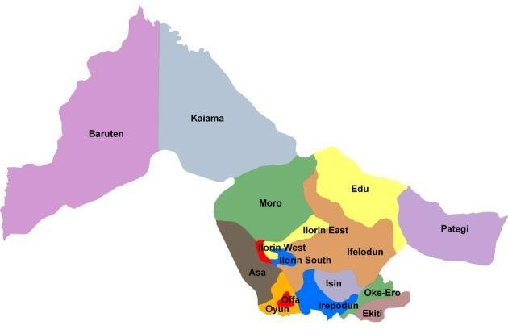
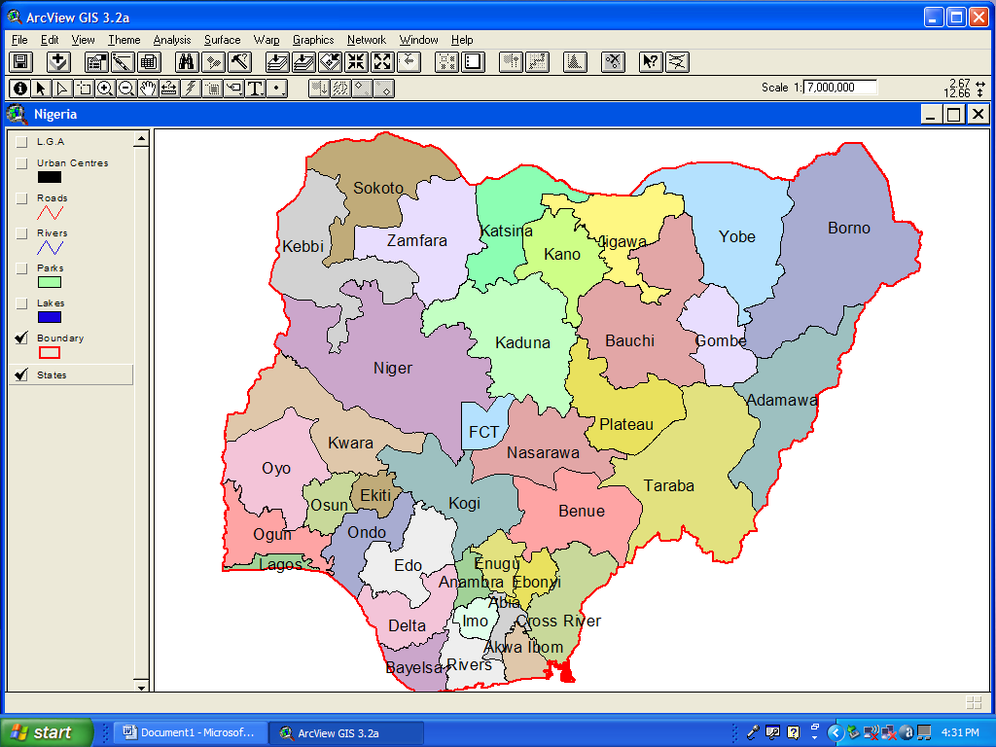
N

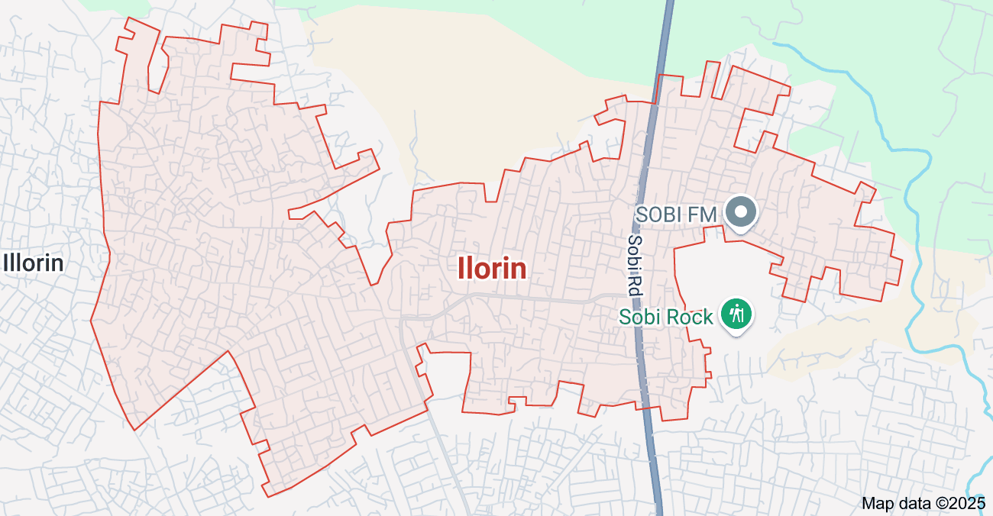
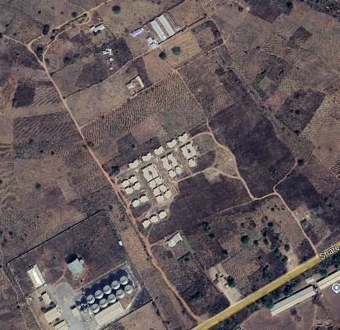

`
ILORIN

HONEYWELL

Figure 1.1 shows the study area of the project

CHAPTER TWO

2.0 LITERATURE REVIEW

2.1 Concept of As-Built Surveys
As-built surveys are detailed records of the actual physical and spatial characteristics of a constructed project, captured after or during completion. According to Kavanagh and Slattery (2009), an as-built survey provides a geometric verification of completed works, recording deviations from design drawings due to field conditions or construction changes. Traditionally, these surveys were conducted using manual measurement tools, but the advancement of modern geospatial technologies has transformed them into high-precision data capture operations.
As-built data is essential for construction close-out, future maintenance, and for feeding into digital records such as Building Information Modeling (BIM) or Land Information Systems (LIS) (Eastman et al., 2011). The accuracy and comprehensiveness of these surveys directly affect the usability of such systems for asset management, renovation, or public infrastructure planning.

2.2 Technological Evolution in As-Built Surveying
Recent decades have seen significant innovation in surveying technology. Total stations, GPS/GNSS, terrestrial laser scanners, unmanned aerial vehicles (UAVs), and mobile LiDAR systems have increased the speed, efficiency, and accuracy of as-built data collection (Lemmens, 2017). These tools enable detailed 3D capture of site conditions and are increasingly integrated into digital workflows.
Studies by Tang et al. (2010) and Volk et al. (2014) emphasize how laser scanning and photogrammetry have allowed for rapid generation of point clouds and 3D models of as-built conditions. Such data can then be integrated with BIM or GIS platforms for analysis and long-term asset tracking. However, these technologies require significant investment, skilled personnel, and standardized workflows — challenges that remain in many parts of the world.

2.3 Integration with BIM, GIS, and LIS
The integration of as-built survey data with BIM has become a growing trend in infrastructure and facility management. BIM allows for a digital representation of both the physical and functional characteristics of a structure, which can be updated with as-built data to create accurate "digital twins" (Succar, 2009).
Similarly, when integrated into GIS or LIS platforms, as-built data enhances spatial decision-making, especially for utility mapping, cadastral updates, and urban planning. In many developed countries, this integration supports smart city development, tax assessments, infrastructure monitoring, and emergency services (Williamson, Enemark, Wallace &Rajabifard, 2010). However, in many developing nations, poor as-built documentation hinders the full potential of LIS implementation.

2.4 Standards and Institutional Frameworks
A significant challenge in as-built surveying is the lack of standardized procedures. Different countries and even different agencies within the same country adopt varied formats, precision standards, and documentation practices. The International Organization for Standardization (ISO), particularly through ISO 19650 (related to BIM data), and organizations like the International Federation of Surveyors (FIG) advocate for harmonized practices to ensure data interoperability.
In many regions, the institutional mandates for as-built surveys are weak, and data are often archived in siloed formats, limiting accessibility and reuse (Enemark et al., 2014). The literature highlights the need for legal and policy frameworks to mandate, regulate, and standardize the preparation and submission of as-built surveys.

2.5 Challenges in Current Practice
Despite technological progress, studies continue to identify critical barriers to the effective implementation of as-built surveys. These include:
- Inadequate technical capacity (lack of trained surveyors or equipment)
- Limited awareness among stakeholders of the long-term value of as-built data
- Poor integration between contractors, surveyors, and government agencies
- Data loss due to poor archiving and non-digitized records
For example, a study by Love et al. (2013) found that incomplete or inaccurate as-built records were a major contributor to cost overruns and operational inefficiencies in public infrastructure projects.

2.6 Emerging Trends and Future Directions
The future of as-built surveying lies in automation, real-time data capture, and integration with cloud platforms. Concepts such as digital twins, IoT-based infrastructure monitoring, and AI-driven construction analytics rely heavily on accurate and continuously updated as-built data. There is also growing interest in low-cost, scalable solutions for as-built documentation in low-resource settings, such as mobile data collection apps and open-source GIS platforms.
The literature points to a need for interdisciplinary collaboration between surveyors, engineers, IT professionals, and policymakers to unlock the full potential of as-built data in modern construction and land governance.

2.7 Legal and Regulatory Frameworks for As-Built Surveys
The preparation and submission of as-built surveys are increasingly being recognized as legal requirements in many jurisdictions. Regulatory bodies mandate these surveys for issuance of completion certificates, occupancy permits, and inclusion in public land records. For instance, in the UK, as-built documentation must comply with PAS 1192 or ISO 19650 standards, particularly when linked with BIM requirements for public projects.
In contrast, in many developing countries, the absence of robust legal mandates leads to poor enforcement of as-built survey requirements. According to Enemark (2005), weak cadastral systems, overlapping land claims, and informal settlements often result in inconsistencies between official land records and on-ground realities. The lack of updated as-built data exacerbates this issue, resulting in disputes and undermining property rights and planning decisions.
There is a growing call for governments to legislate and standardize the format, timing, and content of as-built surveys. Standardization would ensure uniformity, reliability, and interoperability of spatial data across institutions and sectors.

2.8 Applications of As-Built Surveys in Key Sectors
- Construction and Civil Engineering:
As-built surveys are crucial for verifying construction tolerances, managing change orders, and ensuring compliance with structural and zoning regulations. They are especially vital for large-scale infrastructure like bridges, tunnels, dams, and highways, where even small discrepancies can have significant safety and cost implications (Ashcraft, 2008).
- Utilities and Facility Management:
In water, energy, and telecommunications sectors, as-built surveys provide accurate locations of underground and above-ground installations. These records are critical for repairs, upgrades, and avoiding service disruptions. Utility mapping using high-precision GNSS and LiDAR has become common practice in developed countries but is underutilized in many parts of Africa, Asia, and Latin America.
- Urban Planning and Land Administration:
For city planners, access to accurate as-built data supports informed decision-making on land use, zoning, and public service provision. In land administration, as-built surveys are essential for updating parcel boundaries, resolving encroachments, and managing tenure rights. A study by Williamson et al. (2010) shows how as-built surveys complement cadastral systems and contribute to the development of fit-for-purpose land administration frameworks.
- Disaster Risk Management and Environmental Monitoring:
Post-disaster assessments and hazard mapping rely heavily on pre-existing as-built data to assess damages, plan reconstructions, and enforce resilience standards. Accurate records of terrain modifications, building footprints, and critical infrastructure can be decisive during emergency responses.

2.9 Gaps in the Literature and Practice
While the body of literature on as-built surveys is growing, several gaps remain: Limited research on integration strategies for low-resource settings, particularly how to scale down modern technologies (like UAVs or 3D laser scanning) for local government or community-level use. Few empirical case studies examining the long-term benefits of high-quality as-built records on lifecycle infrastructure costs, land tenure security, or urban sustainability.
Insufficient exploration of data interoperability issues, especially between different formats (e.g., CAD, GIS, BIM) and among different stakeholders (engineers, land administrators, utility managers). Neglect of policy and governance aspects, such as institutional capacity building, legal frameworks, and stakeholder coordination required to implement national or regional as-built data strategies.

2.10 Data Management and Interoperability
One of the key issues emerging from the literature is the fragmentation of as-built data across platforms, formats, and institutional boundaries. As-built surveys are often produced using CAD-based tools, while land management and infrastructure systems increasingly rely on GIS or BIM environments. The lack of seamless interoperability between these platforms results in data loss, duplication, and inefficiencies in data sharing (Eastman et al., 2011).
For example, Borrmann et al. (2018) discuss the challenges of integrating 3D BIM models with GIS data, citing differences in coordinate systems, data schemas, and intended use. Similarly, Zevenbergen et al. (2013) emphasize that data integration failures between surveying departments and land registries can delay property titling, infrastructure maintenance, and disaster response.
International efforts such as the Open Geospatial Consortium (OGC) and building SMART are developing open standards to improve interoperability, such as City GML for urban models and IFC for BIM. However, adoption remains limited in many countries due to institutional resistance, technical barriers, and limited awareness among professionals.

2.11 Capacity Building and Human Resource Constraints
A recurring theme in the literature is the shortage of trained personnel to conduct modern as-built surveys, particularly in developing regions. While advanced tools such as terrestrial laser scanners, UAVs, and GNSS receivers offer high accuracy and speed, their effectiveness is heavily dependent on proper training and expertise (Lemmens, 2017).
Many studies report that even when equipment is available, lack of technical knowledge, insufficient field experience, and weak academic-industry collaboration hinder the quality of outputs. Enemark (2014) argues that land and spatial data infrastructure reform efforts must go hand-in-hand with investments in professional education, certification, and institutional capacity building.
Capacity gaps are also evident in data management for example, the lack of trained GIS or BIM technicians in government offices often leads to underutilization or mismanagement of valuable as-built data. Therefore, strengthening curricula in surveying, geomatics, and geoinformat0-ics is an essential part of improving the quality and use of as-built surveys.
2.12 Emerging Innovations and Future Research Directions
Recent developments in technology and data science are reshaping the landscape of as-built surveying:
- Artificial Intelligence (AI) and machine learning are being explored for automating feature extraction from point clouds and drone imagery.
- Mobile mapping systems using smartphones or tablets are making it possible to perform basic as-built surveys in remote or low-resource areas.
- Blockchain is being proposed for tamper-proof as-built data storage and certification, particularly in land administration and construction auditing.
- Cloud-based platforms are enabling real-time collaboration and centralized storage of as-built data across dispersed teams and stakeholders (Delgado et al., 2020).
Moreover, the global trend toward "smart cities" and digital twins is placing greater demand on as-built data that is not only accurate but also continuously updated and machine-readable. These innovations promise to reduce cost, increase accessibility, and enable real-time decision-making but only if appropriate governance and technical standards are in place.
2.17 Digital Transformation and Smart Infrastructure
With the rise of digital transformation in infrastructure, as-built surveys are increasingly becoming central to smart infrastructure systems. Cities that embrace digital urban management are integrating as-built data into real-time monitoring platforms — enabling remote diagnostics, traffic optimization, predictive maintenance, and energy efficiency improvements (Batty et al., 2012).
Smart infrastructure frameworks such as Digital Twins — virtual replicas of physical infrastructure — require accurate, continuously updated as-built data to reflect real-world conditions (Glaessgen & Stargel, 2012). In accurate or outdated as-built can lead to major system inefficiencies, especially in automated systems relying on sensor data, spatial analytics, or AI-driven decisions.
Governments and engineering firms are now investing in as-built data standardization as a prerequisite for scaling digital infrastructure projects. Yet the literature warns that while the technological tools exist, the institutional readiness to adopt and manage such tools varies widely by region and sector.

2.18 Sustainability and Environmental Compliance
As-built surveys are also critical for environmental monitoring, compliance, and impact mitigation. In sectors such as mining, oil and gas, or large-scale housing developments, the post-construction footprint must be compared with environmental impact assessments (EIAs). Accurate as-built maps allow regulators and planners to assess whether the built environment aligns with approved plans, buffer zones, and ecological safeguards (Glasson et al., 2013).
Moreover, for infrastructure designed to support climate adaptation (e.g., flood-control structures, green corridors, resilient housing), as-built surveys provide baseline data to track future performance and modifications. This use of geospatial feedback loops is central to adaptive planning, a growing theme in sustainable development literature.

2.19 Post-Disaster Reconstruction and Humanitarian Response
Another area where as-built surveys are critical yet under-researched — is post-disaster and emergency response. In the aftermath of natural disasters (e.g., earthquakes, floods, or hurricanes), existing as-built data helps emergency responders understand building layouts, utility networks, and access routes. It also supports damage assessments, reconstruction planning, and infrastructure recovery (Yuan & Wang, 2009).
In many developing regions, however, the absence of reliable as-built records hampers emergency response. Humanitarian mapping initiatives like Open Street Map (OSM) and HOT (Humanitarian Open Street Map Team) often step in to create rapid surveys but these are limited in scope and often lack formal validation or integration with official systems.
There is increasing advocacy in the literature for pre-disaster planning that includes systematic as-built documentation, particularly for critical infrastructure like hospitals, bridges, and schools.
2.20 Ethical Considerations and Data Governance
As-built surveys raise important ethical questions related to data privacy, surveillance, and ownership — especially as they increasingly rely on drones, mobile sensors, and cloud storage. Who owns as-built data: the client, the contractor, the government, or the public?
Scholars like Sui et al. (2013) argue that as-built data should be treated as a public good where safety, transparency, and infrastructure planning are concerned — especially for utilities, public housing, and roads. Yet in many cases, the data is locked behind private contracts, non-disclosure agreements, or proprietary software.
The literature calls for data governance frameworks that ensure responsible data collection, transparent storage policies, equitable access, and the protection of sensitive information (e.g., in military bases, prisons, or diplomatic facilities). Clear regulations are needed to govern the collection, sharing, and long-term stewardship of as-built records, especially as countries move toward open-data infrastructures.

2.21 Quality Assurance and Accuracy Standards in As-Built Surveys
The precision of as-built surveys plays a pivotal role in determining their usefulness. Several studies have emphasized the importance of establishing quality assurance (QA) and quality control (QC) frameworks to ensure the accuracy and reliability of collected data (Frolov, 2015). For example, survey-grade GNSS instruments provide centimeter-level accuracy, but this depends on correct calibration, environmental conditions, and operator expertise.
Internationally, accuracy classifications such as those from the American Society for Photogrammetry and Remote Sensing (ASPRS) or the Federal Geographic Data Committee (FGDC) provide benchmarks for positional accuracy in spatial data. However, in many developing contexts, the absence of national standards or enforcement mechanisms results in inconsistent as-built deliverables.
Moreover, the lack of post-survey validation protocols means that errors in as-built drawings often go unnoticed until future construction or legal disputes arise. Literature highlights the need for certified QA/QC checklists, independent reviews, and stakeholder validation before as-built documents are finalized and archived.

2.22 Role in Lifecycle Asset Management
As-built surveys are no longer seen merely as documentation tools, but as integral components of infrastructure lifecycle management. According to Teizer and Kibert (2011), accurate as-built data improves the long-term efficiency of operations, maintenance, and retrofitting activities. When integrated into digital platforms like BIM or Computerized Maintenance Management Systems (CMMS), as-built data can inform decisions about repair schedules, utility outages, and safety upgrades.
The Facility Management Association (IFMA) recognizes that post-construction documentation often dictates how effectively a facility can be maintained and repurposed. Without reliable as-builts, facility managers face greater risks of service disruption, increased downtime, and higher operational costs.
Studies in the energy, water, and transport sectors show that lifecycle costs can be significantly reduced through accurate as-built integration — but achieving this requires proactive collaboration between design, construction, and operations teams, starting from project inception.
2.23 Socioeconomic Implications of As-Built Survey Practices
The broader socioeconomic implications of poor or absent as-built survey practices are becoming more apparent. Inaccurate spatial records can lead to:
Infrastructure conflicts (e.g., new roads or pipelines interfering with existing but undocumented services)
Increased costs due to rework or litigation
Safety risks, particularly in post-disaster settings where accurate maps are essential
Property disputes in informal or unregulated developments
In the context of land administration, particularly in regions with informal settlements or communal landholding, the absence of up-to-date as-built records can delay regularization processes and deny residents access to legal tenure and public services (UN-Habitat, 2016).
Moreover, studies (e.g., by the World Bank and FAO) highlight that reliable as-built and cadastral data support gender equity, taxation fairness, and inclusive urban development. Thus, investment in as-built survey systems is not only a technical requirement but a developmental necessity.

2.24 Case Studies and Best Practices
The literature provides several case studies that illustrate effective as-built survey systems:
Singapore uses mandatory digital submission of as-built data for all infrastructure projects, integrated into its national GIS and Smart Nation initiative.
The Netherlands operates Kadaster with highly accurate, publicly accessible spatial records tied to real-time infrastructure updates.
Rwanda has piloted mobile-based as-built and land survey tools to support rapid urban planning and land titling under budget-constrained conditions.
These examples reinforce the value of integrated, standardized, and technologically enabled as-built systems in improving both infrastructure quality and governance outcomes.

CHAPTERTHREE

3.0 METHODOLOGY
The process followed to achieve the expected result is grouped into the following three stages;
- Planning
- Data acquisition
- Data processing

3.1 PLANNING
The following are the methods adopted in carrying out as-built survey of Honeywell estate off oke ose/oke oyi road Ilorin, olrin south local government area

3.1.1 OFFICE PLANNING (RECONNAISSANCE)
This includes the purpose, precision, and accuracy of the survey, the type of equipment used, and the best method engage for the survey carried out. It also involves the decision and collection of instruments needed for the work, acquisition of existing building plans for buildings studied, instrument test, work plan, and acquiring and evaluating of all relevant data used for the project. Other secondary data needed for the study, such as the available coordinates of the control network used, was gotten from the department of surveying and geo-informatics.

Table.3.1 Coordinates of Controls
Station | Northing(m) | Easting(m) | Height(m)
KPT 120X | 945235.040 | 682280.278 | 211.976
KWCS102 | 945738.095 | 683583.702 | 201.532
SC/KWEAS5072 | 945974.041 | 684070.314 | 200.087
Source: office of surveyor general kwara state

3.1.2 FIELD PLANNING (RECONNAISSANCE)
This starts by visiting the study area to be pre-informed about the state of the site, and to determine the work path, then to ground truth the information obtained during the office recce.

Fig.3.1: Reece diagram of the study area (not drawn to scale)

3.2 DATABASEDESIGN
The design of any database involves three stages namely;
i Conceptual design
ii Logical design
iii Physical design

3.2.1 VIEW OF REALITY
In database design, there is need for reality which is referred to as the phenomenon that actually exists, including all aspects which may or may not be perceived by individuals. The view of reality however, is the mental abstraction of the reality for a particular application or group of applications.
For this application, the view of reality is made of the as-built of the project. Since it is not possible to represent the real world, the only option is to conceptualize and model it in a specified manner to represent the real world. The area of interest to using this project Includes; Green serve, Roads, Electric poles, Trees, Water Facilities, Buildings, Football pitch, Streams.

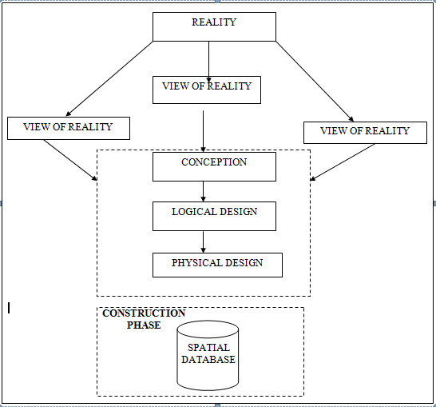
Fig.3.2 Design and Construction Phases in Spatial Database

3.2.2 CONCEPTUALDESIGN
Vector data model is the data type adopted for this project, which is represented, by points, lines and polygon. The identified entities are:-
      - Vegetation area (polygon)
      - Roads(line)
      - Trees(point)
      - Boundary line (polygon)
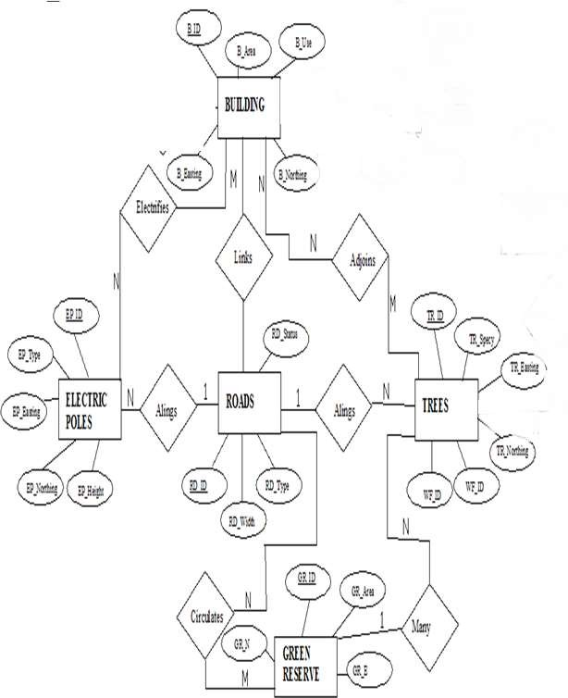
      - Buildings(polygon)

Fig.3.3. E-R Diagram (Entity relationship diagram)

3.2.3 LOGICALDESIGN
This is the design aspect of the database refers to the process of creating a conceptual framework or model that represents the structure and organization of spatial data within the system. It involves defining the data element, their relationship, and the rules for data manipulation and analysis. In this phase, the entities, their attributes and their relationships are represented in a single uniform manner in form of relation in such a way that would be no information loss and at the same time no unnecessary duplication of data. In this study, the logical database design is employed to generate a geo-relation database structure. Each entity has unique identifier in bold type. An attribute type or combination of attribute types that serves to identify an entity type is termed an identifier.
- Building(B_ ID, B_ Area, B_ Name, B_ Easting, B_ Northing)
- Roads(R _ ID, R _ Width , R _ Type, R- Condition, R_ Easting, R_ Northing)
- Tree(TR _ ID, TR_ spp, TR_ Importance, TR_ Easting, TR_ Northing)

3.2.4 PHYSICALDESIGN

Table3.2: Building and its attribute
ENTITY | DESCRIPTION
B_ID | Building Identification
B_name | Building Name
B_Area | Building Area
B_Easting | Building Easting
B_Northing | Building Northings

Table3.3: Road and its attributes
ENTITY | DESCRIPTION
R_ID | Road Identifier
R_ Length | Road Length
R_ Width | Road Width
R_ Type | Road Type
R_ Condition | Road Condition

Table3.4: Trees and its attributes
ENTITY | DESCRIPTION
TR_ID | Tree Identifier
TR_ Spp | Tree specy
TR_E | Tree_ Easting
TR_N | Tree Northing

3.3 EQUIPMENTUSED/SYSTEMSELECTIONANDSOFTWARE

3.3.1 HARDWAREUSED
- Total station
- 1reflector with a tracking rod.
- 1Tripod
- One(1)50m tape
- One(1)umbrella
- 1cutlass
- Hand held GPS
- Hammer
- Nails and bottle cover
- Field book and writing materials
- 1-NoofPersonalComputerHP655 and its accessories
- 1-NoofHP DeskJetK7100 A3 printer
- 1-NoofHPDeskJet 1110 A4printer

3.3.2 SOFTWARECOMPONENT
- Notepad.
- Microsoft Excel.
- AutoCAD2007
- Arc GIS10.2
- Microsoft Word.

3.4 INSTRUMENTTEST
To ensure the quality of the data, the Total Station employed for this project was tested for vertical index and horizontal collimation errors. These tests also aimed to verify the instrument’s efficiency and reliability. The procedure followed is outlined below.

3.4.1 HORIZONTALCOLLIMATIONTEST
This test was conducted to ensure that the line of sight was perpendicular to the trunnion axis. The Total Station was positioned over a specific point, and initial adjustments were made to ensure proper alignment, leveling, and focus (to eliminate parallax in the telescope). A vertical target was placed at a distance of 100 meters from the Total Station. To access the configuration menu of the Total Station, the menu key was pressed and held for approximately 2 seconds. From the main menu, the calibration sub-menu was selected, and within that, the horizontal collimation test option was chosen. The target was then observed and divided into two halves, with horizontal readings recorded for Face left and Face right. The readings are shown in Table 3.4.1 below.
Total Station
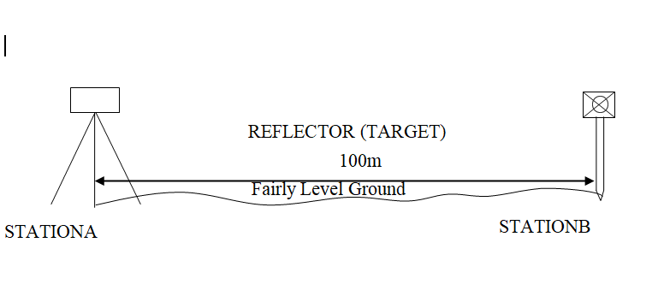

Fig3.4; Horizontal Collimation and Vertical Index error test.

Table3.5: Horizontal Collimation Data
Station | Target | Face | Hz Reading | Difference | Error
A | B | L | 38˚42‟32”
 |  | R | 218˚42‟35” | 180˚00‟03” | 03”
Source field work

3.4.2 VERTICAL IX ERNDEROR TEST
To perform the test, the Total Station was set up over a known point, and all necessary temporary adjustments were made to ensure proper alignment and functionality. A target was placed approximately 100 meters away, and the instrument was aimed at it. The target was first bisected using the face left position, and the corresponding vertical angle was recorded. The same process was then repeated using the face right position, and the resulting reading was also documented. The recorded values are presented below:

Table3.6: Vertical Index Data
Instrument Station | Target Station | Face | Vertical | Sum | Error
A | B | L | 90˚00‟00”
 |  | R | 270˚00‟02” | 360˚00‟02” | 02”
Source field work

3.4.3 ANALYSISOFCOLLIMATIONANDVERTICALINDEXDATA
The reading obtain during calibration were reduced to obtain new collimation and vertical errors.
Horizontal collimation={(FR–FL)–180}/2={(00˚00‟03”}/2=1.5”
Verticalcollimation={(FL+FR)–360}=(90˚00‟00”+270˚00‟02”)-360}=02”Theresult shows that the instrument is still in good working condition.

3.5 CONTROL CHECK
Three control beacons (KPT 120X, KWCS102 and SC/KWEAS5072) were used. In order to ascertain the in-situ of the control beacons, a check was carried out on them by observing the angle between them and comparing the result obtained with the computed angles from the giving coordinates.
The total station instrument was set on the control beacon KWCS102. After performing all the necessary temporary adjustment, the reflector was placed on the control beacon KPT 120X which served as the back station. The horizontal angular reading was taken and recorded while the instrument was on face left. The reflector was then taken to the control beacon SC/KWEAS5072 which serves as the forward station, the horizontal angle reading was then taken and recorded on both face left and face right. The reflector was taken back to the back station, the horizontal angle was then recorded on face right.

Table3.7: Table showing the back computation of the control coordinates
From STN | Bearing | Dist(m) | ∆N | ∆E | Northing(m) | Easting(m) | ToSTN
 |  |  |  |  | 945235.040 | 682280.278 | KPT 120X
KPT 120X | 68°53'46'' | 1397.130 | 503.050 | 1303.424 | 945738.095 | 683583.702 | KWCS102
KWCS102 | 64°07'57'' | 540.797 | 235.946 | 486.612 | 945974.041 | 684070.314 | SC/KWEAS5072
Source: office of surveyor general kwara state

Table3.8: Table showing the distance observation result of the control check
FROM | OBSERVED  DISTANCE  (m) | COMPUTED  DISTANCE  (m) | TO
KPT 120X | 1397.029 | 1397.130 | KWCS102
KWCS102 | 540.694 | 540.797 | SC/KWEAS5072

Table3.9: TABLE showing the observation result of the control check
STN | SIGHT | FACE | OBSERVEDHZANGLE | REDUCED HZANGLE | MEAN
 | KPT 120X | L1 | 357° 08'47''
KWCS102 | KPT 120X | L2 | 288° 14'07'' | 68° 54'40''
 | SC/KWEAS5072 | R2 | 108° 52'13'' | 68° 54'46''
 | SC/KWEAS5072 | R1 | 177° 46'59'' |  | 68° 54' 43''

Difference in angle (observed -computed)=68°54'43''-68°54'40''
=00° 00'03''
Since the allowable accuracy (angular) of third order traverse of one station is 00° 00' 30'' and the result obtained from the control check (00°00'03'') is less than allow able error. Therefore, the controls were angularly intact.

3.6 MONUMENTATION
The boundary of the area carved out was demarcated with the precast concrete beacons, after clearing the required line of sights. The identified points of changes in directions were dug and beacons were buried on it, leaving about 15cm part of the beacon above the ground Level. The beacons were buried at convenient distances as dictated by the nature of the boundary.
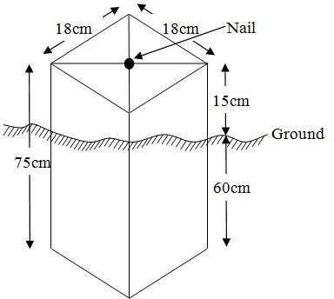

Fig.3.4: Pillar Description

3.7 DATA ACQUISITION

Data acquisition is a fundamental aspect of digital mapping. It involves collecting coordinate data of map features in a format compatible with computers. Various techniques exist for gathering topographical data, and the choice of method depends on several factors, including the data source, available hardware and software, desired level of accuracy, and the manpower involved. In addition to field and laboratory methods, data can also be obtained through social surveys.

In the context of this project, data acquisition refers to the methods and processes used to obtain the necessary data. The acquired data is categorized into two main types: geometric data and attribute data.

PRIMARYDATASOURCE
Field observation was the primary source of data for this project. Ground based method was used in acquiring data with the use of Total Station Instrument, which involved the collection of X, Y, Z data through coordinated Ground control Points (GCP) established at conspicuous points within the study area

SECONDARYDATASOURCE
An imagery of the area was acquired through Updated Google earth; this was used to ascertain the extent of coverage of the project area.

3.7.1 GEOMETRIC DATA ACQUISITION
This involves the acquisition of Northings, Easting and Height value of features that are present on the project site. In the aspect of this project digital land survey method was adopted.

3.7.2 TRAVERSING
This is a series of connected straight lines, the length and direction of which are determined from measurements. This includes the distance measurement and angular measurements which include horizontal angle and vertical angle between points, whose direction between selected points is determined after some calculations. The total station computed directly the angle and distance measured on the site to determine the coordinates of the point with the aid of the processor. The total station was used to determine the coordinates of the boundary of the project site. The instrument was set on control ‘Y’ and adjustment (temporary) was done, the instrument was focused at the reflector on point ‘X’ to set orientation and point ‘Z’ was observed as the forward station. All other boundary point was observed as the reflector was placed on them.

3.7.3 DETAILING
Detailing entails fixing both natural and artificial feature that exists in the boundary. These include buildings, electric poles, footpaths, culverts, etc. In this project, details were fixed using the total station and its accessories using the ray shooting method.
Here, the ray shooting method was employed to effectively fix the details along the project area. Features such as roads, buildings, storex, etc. were fixed. To achieve this, the total station is set on the transferred point in the project boundary to bisect many edges of details and the reflector was placed at a known station for orientation before positioning it at each corner of the details. The coordinate of each corner is observed and recorded. The details taken include Road, Building, Storex, and Electric poles.

Orientation station
Building

Instrumentation

FIGURE 3.5 SHOW THE DETAILING OBSEVATION

3.7.4 ATRIBUTES DATA ACQUISITION
Attribute data is information about spatial features. They provide the characteristics, description and nomenclature about spatial objects. Thus the attributes data acquired includes names of buildings and their uses such as classrooms, roads, water facilities and prominent natural features likes river and trees found and vegetation were properly identified within and around the study area.

3.8 DATA DOWNLOADING AND PROCESSING

3.8.1 DATADOWNLOADINGANDEDITING
This is stage whereby all data acquired which were automatically stored in the Total Station were downloaded into personal computer. This was done with the aid of downloading cable connected to the computer and some associated complementing software installed on the System.

3.8.2 DATA PROCESSING AND DATA EDITING
These data were processed using AutoCAD 2007 where the acquired coordinate was plotted, and details fixed to depict the study area, after which were exported to Arc GIS 10.2 where digitizing was done, and the attribute data was used to create a database table in relationship to the details. This data table was queried to provide useful cadastral information.

3.5.1 Spatial Relationships
Spatial relationships are the relationship determined by the location, size, shape, and other features of spatial objects. The most common spatial relationships are distance relationships, direction relationship, and topological relationships.

3.5.2 Overlay of plan
The 2D plan of the building in the study was gotten from the ministry and was captured with a digital camera. After which, the captured image was added into the Arc GIS 10.2 environment as a geo-referenced raster image and the conversion to digital form was done by digitizing, then the overlay was done by putting on the two layers containing both files.

3.9 DATABASE IMPLEMENTATION
This phase involves the creation of the spatial database. Following the completion of the three design stages Reality, Conceptual, and Logical design the database was developed using ArcGIS10.2 software. This process entails integrating and storing both the acquired geometric (graphic) data and attribute data to enable spatial analysis and queries.
A database is an organized and integrated collection of data that is structured for efficient access and use by relevant applications, with data retrievable through various logical operations. Once the attribute table was populated manually via the keyboard, certain attributes such as the areas of settlements were automatically calculated and displayed using specific commands available in ArcGIS10.2.
Arc GIS was also used to link the graphic data with the attribute table, allowing for the execution of spatial queries and further analysis.

3.9.1 DATABASE MANAGEMENT SYSTEMS
Database management is a collection of software for creating, storing, manipulating, updating, organizing and querying of information in a database (Kufoniyi, 1998). It is a software package whose function is to manipulate a database on behalf of the user.
A good DBMS must provide the following functions:
- Storage and retrieval of data.
- Access to by several users at a time.
- A standardized interface between database and application programmed.
- Standardized access to data and separation of data storage and retrieval functions from the program using the data.
- Maintenance of data security and integrity.

3.9.2 DATABASE MAINTENANCE
Having created the database, proper maintenance practice was made to meet its stated objectives. The ability to include more data and remove irrelevant data was possible by way of maintenance. There is every need for the data to be updated regularly because of the physical changes that may occur on the landscape with time. Both security and integrity were also exercised to ensure maintenance and to meet its stated objectives.
Proper observance, updating and management of database ensure its currency and quality to stand a profound chance in Spatial Decision Support System (SDSS). The quality of any database depends on the currency and fitness for use as a decision support system (SDSS).The quality of database depends on its ability to generally fit and use as a decision system (DSS). The storage media should be from time to time justified if otherwise could necessitate data inaccessibility or physical deterioration of the storage media. Also care must be taken during populating any database system, as a database is only good as the data supplied. In archiving stable media should be used. Examples of these are
- Computer compatible tape reader
- Magnetic tape
- Optical disc and compact disc

3.9.3 BACK COMPUTATION Table
STN FROM | BEARING  ‘ ” | DIST  (m) | N | E | X | Y | STN  TO
 |  |  |  |  | 683827.457 | 946283.854 | PL1
PL1 | 66 1 55 | 303.145 | 123.146 | 277.005 | 684104.462 | 946407.843 | PL2
PL2 | 149 46 46 | 192.751 | -166.555 | 97.017 | 684201.479 | 946241.288 | PL3
PL3 | 155 17 55 | 50.039 | -45.426 | 20.985 | 684222.464 | 946195.862 | PL4
PL4 | 249 25 28 | 312.969 | -109.990 | -293.005 | 683929.459 | 946085.872 | PL5
PL5 | 332 44 31 | 222.713 | 197.982 | -102.002 | 683827.457 | 946283.854 | PL1

3.9.4 AREA COMPUTATION

TABLE 3.11 SHOWS Area Computation
Double Latitude | Departure | Multiplier
123.99 | -277.00 | -34,345.23
123.99
247.98
-166.55
81.43 | 97.02 | 7900.34
-166.55
-85.12
-45.43
-130.55 | 20.98 | -2738.94
-45.43
-175.98
-109.99
-285.97 | -293.00 | 83,789.21
-109.99
-395.96
+197.98
-197.98 | -102.00 | 20,193.96
+197.98
0.00

Total Area = {(-34,345.23--2738.94) + (7,900.34+83,789.21+20,193.96)}/2
Total Area = {(-37,084.174) + (111,883.51)}
Total Area = 74,799.336/2
Total Area = 37,399.668 SQ MTS

3.9.5 LINEAR ACCURACY COMPUTATION
Linear Accuracy = 1
{[SQRT (change in Northing) ² _{+ (change in Easting)} ²
_{Total Distance}
Linear Accuracy = 1
{SQRT [(0) ² ₊ ₍₋₅₅₄₎ ²]
_{1081.954}
Linear Accuracy = 1
{SQRT [306916]}
_{1081.954}
Linear Accuracy = 1
554
_{1081.954}
Linear Accuracy = 1
0.512036
Linear Accuracy = 1: 0.5

CHAPTER FOUR

4.0 RESULTS, ANALYSIS, AND DISCUSSION
GIS stands out from other information systems due to its powerful spatial analytical capabilities particularly overlay operations, buffering, spatial search, topographic analysis, and neighborhood and connectivity functions. These capabilities enable GIS to answer fundamental questions related to location, conditions, trends, routing, patterns, and modeling by manipulating and analyzing spatial data. In this project, the primary analyses conducted included overlay operations, topographic analysis, and spatial searches.

4.1 TESTING OF DATABASE
This is the test carried out to determine whether there exists a relationship between data modeled about entities in a spatial database as well as putting in to test its retrieval capabilities. This was done by designing a sample query with certain conditions attached and the query will began to see if desired result is achieved.
Analysis of Result
Data captured were full to ensure standardization of task. Coordinated point was used in order to produce information required and lastly to decision making and produce the output in digital form, while the attribute presented in tabular form. In most GIS operation package including arc view these include measurement techniques, query analysis and geometric operation in this project include questions such as:-
- Architectural planning
- Building overlay
The above listed queries are shown

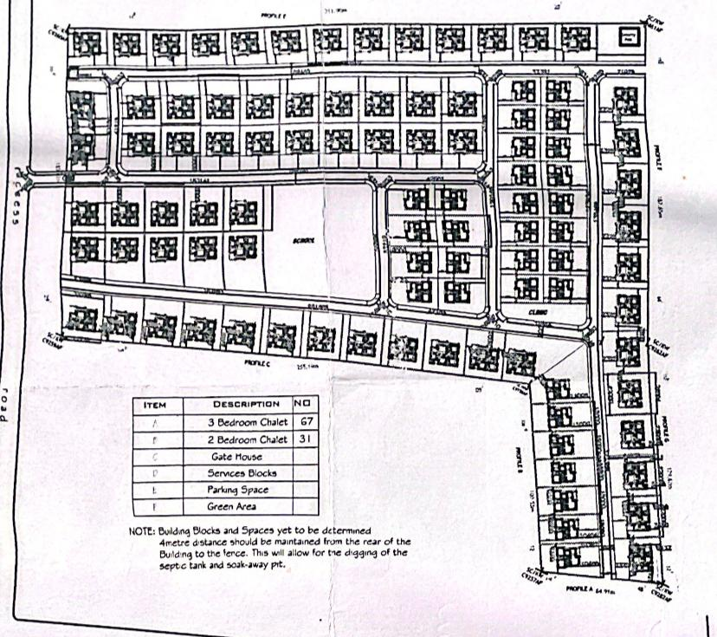

Fig4.1. showing the 2d plan architecture structure of the building
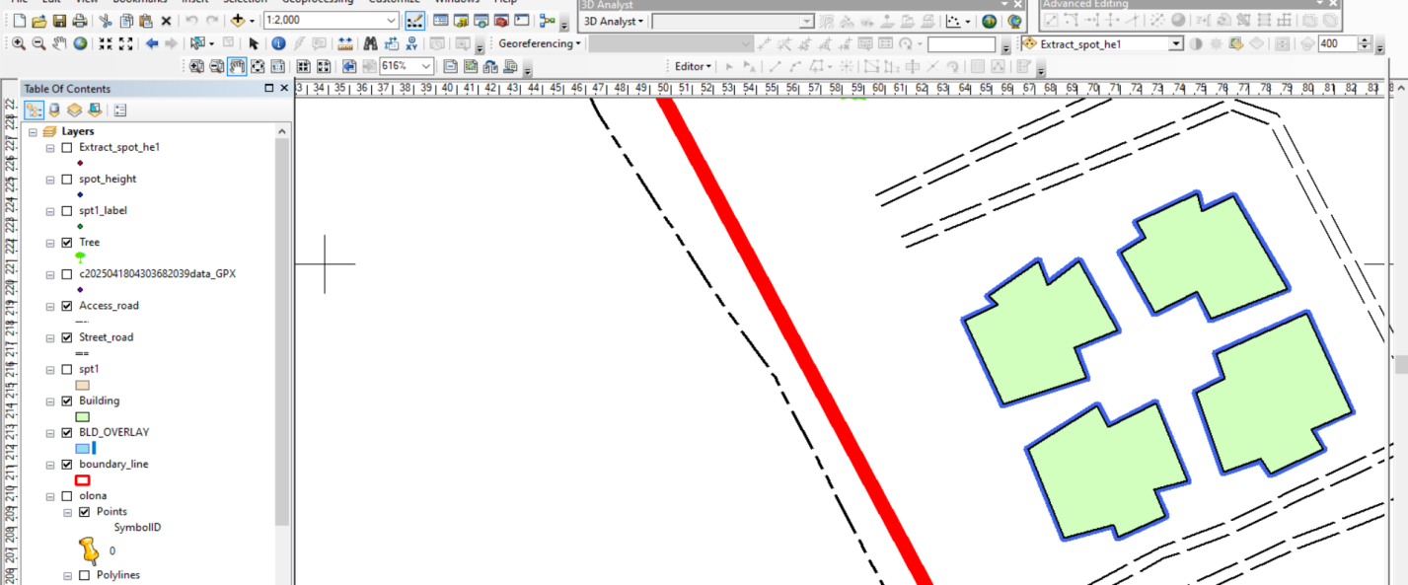
Note: - the 2d plan of the building in the study was gotten from the owner of the Honeywell estate and was captured with a digital camera. after which, the captured image was added into the ArcGis 10.2 environmental as a geo-referenced raster image and the conversion to digital form was done by digitizing then the overlay was done by putting on the two layers containing both files

Fig4.2: showing overlaid of all building in block A
Discussion of result (building overlay block A)
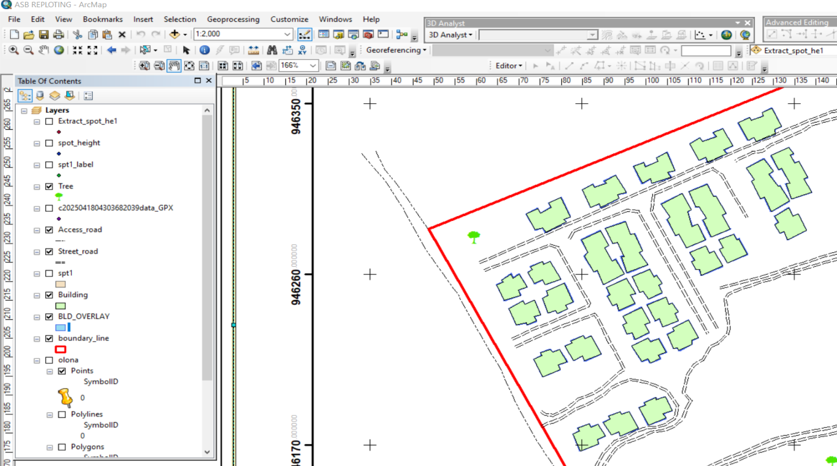
The blue line represents observed edges of the building while the black line represents the digitized edges of the building. It was noticed that the existing building archive design is the same with what we observed in field.

Fig 4.3: showing overlaid of all building of all block
Discussion of result (building overlay of building in all block)
The blue line represents observed edges of the building while the black line represents the digitized edges of the building. It was noticed that the existing building archive design is the same with what we observed in field. But some road paramount with existing architecture lay out while some not paramount, and all of the building shows in architecture plan are not built in land.

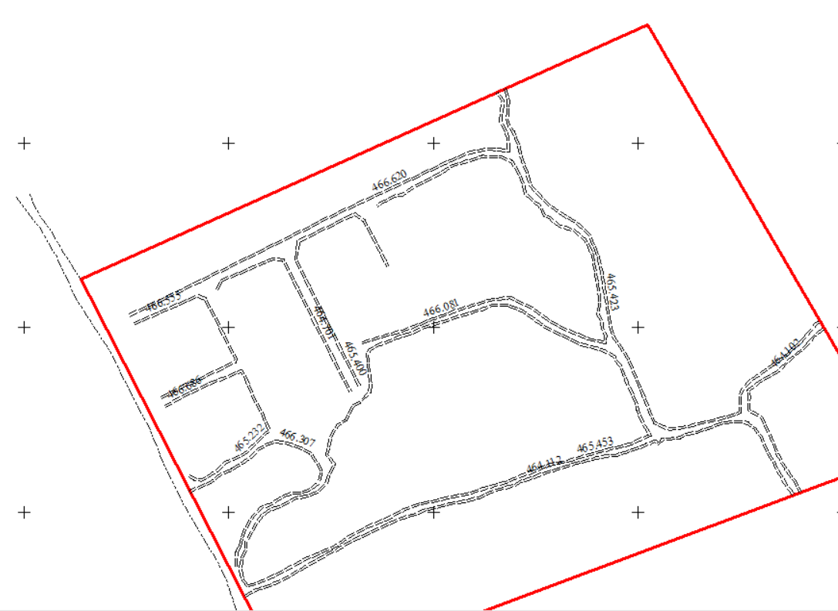

Figure 4.4 Shows the Height of Drainages
This is the height shows in the figure 4.4 above is the height of drainage were measured in sight with total stations

CHAPTE FIVE

5.0 COST ESTIMATION, SUMMARY, RECOMMENDATION, AND CONCLUSION

5.1 COSTING ANALYSIS
Costing Analysis for As-Built Survey of Honeywell Estate
S/No | Item | Cost (₦)
1 | Instrumentation and Rent | 15,000.00
2 | Supervisor | 30,800.00
3 | Technologist | 22,783.67
4 | Technician (7 persons) | 106,323.77
5 | Basic Equipment | 46,027.61
6 | Transportation | 46,027.61
 | Subtotal | 266,962.66
Beaconing Materials
Item | Cost (₦)
5 Beacons @ ₦5,000 | 25,000.00

Beaconing/Emplacement Phase
S/No | Item | Cost (₦)
1 | Technician (7 persons) | 106,323.77
2 | Transportation | 46,027.61
3 | Basic Equipment | 46,027.61
 | Subtotal | 193,378.99

Data Acquisition Phase
S/No | Item | Cost (₦)
1 | Technologist | 22,783.67
2 | Technician (7 persons) | 106,323.77
3 | Basic Equipment | 46,027.61
4 | Transportation | 46,027.61
 | Subtotal | 221,162.66

Data Processing & Manipulation
S/No | Item | Cost (₦)
1 | Technologist | 113,918.35
2 | Technician (7 persons) | 531,618.85
3 | Personal Computer | 230,138.05
4 | Consumables | 69,645.00
 | Subtotal | 945,320.25

Information Presentation & Analysis
S/No | Item | Cost (₦)
1 | Supervisor | 92,400.00
2 | Technologist | 68,351.01
3 | Technician (7 persons) | 318,971.31
4 | Personal Computer | 138,082.83
5 | Consumables | 41,787.00
 | Subtotal | 659,592.15

Comprehensive Report Writing
S/No | Item | Cost (₦)
1 | Principal Surveyor | 154,000.00
2 | Technologist | 113,918.35
3 | Technician (7 persons) | 531,618.85
4 | Personal Computer | 230,138.05
 | Subtotal | 1,099,320.25

Total Cost = ₦3,410,737.00

5.2 SUMMARY
This project focused on the development of a Land Information System (LIS) for an urban estate located opposite the Government Cemetery along Oke-Ose/Oke-Oyi Road, Ilorin, in Ilorin East Local Government Area of Kwara State, Nigeria. The primary objective was to collect, process, and present spatial data that accurately represents the land terrain and features within and around the project site.
To achieve this, modern surveying technology was employed. Specifically, a CST/Berger (205) Total Station and its accessories were used for field data acquisition. The survey involved key techniques such as spot heighting and the fixing of topographic and built environment features across the project area.
The collected data were downloaded, systematically organized, and processed using standard surveying software. Tolerance tests were conducted to ensure accuracy and reliability of the data, and the results were found to be within acceptable limits.
The processed spatial data were then used to produce detailed LIS maps, which graphically illustrate the relative positions, elevations, and distribution of features within the estate. Finally, a comprehensive report was compiled and printed to document the methodologies, results, and applications of the project.

5.3 PROBLEM ENCOUNTER
The problem encountered on the site were unavoidable especially the movement of vehicles and the students of our site project were disturbing when working. Also, the total station battery was also getting weak time to time, so it consumes us more battery and stress before getting another battery.

5.4 RECOMMENDATION
It is recommended that Land Information Systems (LIS) be incorporated into the practical and project-based curriculum for students in educational institutions. This integration will equip students with the technical skills and spatial understanding necessary for effective land terrain analysis and future project planning. Additionally, schools should invest in modern digital tools and geospatial technologies to support hands-on learning and enhance students’ capacity to apply LIS in real-world scenarios.

5.5 CONCLUSION
The study of Land Information Systems is increasingly relevant in today's world, where land-related issues intersect with economic development, urbanization, climate change, and social equity. A well-designed LIS supports transparent, efficient, and equitable land administration, which is essential for achieving sustainable development and good governance. As such, LIS is a multidisciplinary field involving geography, information technology, law, economics, and public administration.

REFERENCE
- Ali, D. A., Deininger, K., & Goldstein, M. (2015). Environmental and gender impacts of land tenure regularization in Africa: Pilot evidence from Rwanda. Journal of Development Economics.
- Dale, P., & McLaughlin, J. (1999). Land administration. Oxford University Press.
- Enemark, S., Williamson, I., & Wallace, J. (2005). Building modern land administration systems in developed economies. Journal of Spatial Science.
- Lemmen, C., Van Oosterom, P., & Bennett, R. (2015). The Land Administration Domain Model. Land Use Policy.
- Williamson, I., Enemark, S., Wallace, J., & Rajabifard, A. (2010). Land administration for sustainable development. ESRI Press.
- Zevenbergen, J., Augustinus, C., Antonio, D., & Bennett, R. (2013). Pro-poor land administration: Principles for recording the land rights of the underrepresented. Land Use Policy.
- Augustinus, C. (2010). Social tenure domain model: What it can mean for the land industry and for the poor. FIG Congress.
- Barry, M., & Meinzen-Dick, R. (2010). The spatial and institutional linkages of land tenure. Land Use Policy.
- Bandyopadhyay, D. (2013). Reforming land administration in India: Issues and perspectives. Economic and Political Weekly.
- Deininger, K., & Feder, G. (2009). Land registration, governance, and development: Evidence and implications. The World Bank Research Observer.
- Giovarelli, R., et al. (2013). Gender and land governance: Evidence from Ethiopia, Ghana, and India. World Bank.
- Lemmen, C., & Bennett, R. (2019). Blockchain for land administration: Hype or relevant? Land Use Policy.
- Larson, A. M., et al. (2013). Land tenure and REDD+: The good, the bad and the ugly. Global Environmental Change.

APPENDIX I
A | E | Z | REMARK
917077.357 | 726052.265 | 466.361 | A1
917056.108 | 726040.409 | 465.352 | A2
917072.805 | 726060.179 | 466.071 | A3
917051.593 | 726048.197 | 465.159 | A4
915053.0600 | 726038.880 | 465.080 | B1
917042.186 | 726032.737 | 464.667 | B2
917048.469 | 726046.528 | 465.308 | B3
917037.732 | 726040.501 | 464.865 | B4
917038.766 | 726031.025 | 464.532 | C1
917028.020 | 726024.815 | 463.986 | C2
917034.505 | 726038.812 | 464.651 | C3
917023.621 | 726032.673 | 464.293 | C4
917025.865 | 726020.798 | 463.798 | D1
917017.815 | 726016.481 | 463.581 | D2
917018.546 | 726030.204 | 464.084 | D3
917012.381 | 726026.919 | 463.880 | D4
917018.197 | 726010.815 | 463.403 | DRAINAGE
917041.543 | 726024.149 | 464.746 | DRAINAGE
917074.177 | 726042.012 | 466.174 | DRAINAGE
917080.541 | 726052.044 | 466.457 | DRAINAGE
917069.807 | 726070.461 | 466.161 | DRAINAGE
917095.850 | 726017.412 | 466.896 | A1
917095.810 | 726010.527 | 466.609 | A2
917082.355 | 726034.474 | 466.728 | A3
917074.478 | 726029.992 | 466.393 | A4
917095.812 | 726001.694 | 466.308 | B1
917095.812 | 725994.695 | 466.004 | B2
917070.365 | 726027.738 | 466.253 | B3
917062.474 | 726023.368 | 466.830 | B4
917095.928 | 725974.880 | 465.193 | C1
917096.021 | 725967.849 | 464.904 | C2
917045.048 | 726013.696 | 465.070 | C3
917037.177 | 726009.264 | 464.603 | C4
917096.929 | 725931.892 | 463.179 | D1
917097.235 | 725924.856 | 462.858 | D2
917007.799 | 725991.856 | 463.093 | D3
917000.000 | 725987.045 | 462.697 | D4
917103.817 | 726008.505 | 467.031 | Drainage
917092.494 | 726030.854 | 466.935 | Drainage
917076.298 | 726036.311 | 466.424 | Drainage
917055.363 | 706024.862 | 465.404 | Drainage
917021.068 | 726005.573 | 463.499 | Drainage
 | Building CD
917004.843 | 725996.779 | 462.820 | A
916997.068 | 725992.188 | 462.340 | B
916998.502 | 726007.570 | 462.805 | C
916991.889 | 726004.993 | 463.021 | D
917077.357 | 726052.265 | 466.361 | A1
917056.108 | 726040.409 | 465.352 | A2
917072.805 | 726060.179 | 466.071 | A3
917051.593 | 726048.197 | 465.159 | A4
915053.0600 | 726038.880 | 465.080 | B1
917042.186 | 726032.737 | 464.667 | B2
917048.469 | 726046.528 | 465.308 | B3
917037.732 | 726040.501 | 464.865 | B4
917038.766 | 726031.025 | 464.532 | C1
917028.020 | 726024.815 | 463.986 | C2
917034.505 | 726038.812 | 464.651 | C3
917023.621 | 726032.673 | 464.293 | C4
917025.865 | 726020.798 | 463.798 | D1
917017.815 | 726016.481 | 463.581 | D2
917018.546 | 726030.204 | 464.084 | D3
917012.381 | 726026.919 | 463.880 | D4
917018.197 | 726010.815 | 463.403 | DRAINAGE
917041.543 | 726024.149 | 464.746 | DRAINAGE
917074.177 | 726042.012 | 466.174 | DRAINAGE
917080.541 | 726052.044 | 466.457 | DRAINAGE
917069.807 | 726070.461 | 466.161 | DRAINAGE
917057.181 | 726089.631 | 466.699 | A1
917035.756 | 726078.137 | 465.664 | A2
917053.016 | 726097.826 | 466.539 | A3
917031.261 | 726086.501 | 465.391 | A4
917032.494 | 726076.368 | 465.536 | B1
917022.047 | 726069.781 | 464.957 | B2
917028.248 | 726084.646 | 465.277 | B3
917017.119 | 726078.969 | 464.914 | B4
917048.331 | 726110.610 | 466.458 | Drainage
917051.116 | 726101.126 | 466.440 | A1
917029.677 | 726089.536 | 465.571 | A2
917046.948 | 726109.387 | 460.530 | A3
917025.277 | 7260097.689 | 460.610 | A4
917026.233 | 726087.772 | 465.397 | B1
917015.438 | 726081.930 | 464.904 | B2
917021.812 | 726095.734 | 465.371 | B3
917010.693 | 726091.024 | 464.922 | B4
917002.471 | 726092.888 | 464.701 | Drainage
917021.141 | 726103.313 | 465.400 | Drainage
917038.138 | 726111.877 | 466.081 | Drainage
917013.401 | 726106.348 | 465.232 | Drainage
917024.013 | 726112.045 | 465.604 | Drainage
917039.909 | 726127.173 | 465.516 | Drainage
917071.486 | 726062.584 | 466.377 | A1
917050.126 | 726050.925 | 465.566 | A2
917067.128 | 726071.063 | 466.994 | A3
917045.752 | 726059.413 | 466.017 | A4
917046.918 | 726049.362 | 465.353 | B1
917036.305 | 726043.590 | 464.843 | B2
917042.606 | 726057.660 | 465.853 | B3
917031.798 | 726051.854 | 465.559 | B4
917032.858 | 726041.654 | 464.688 | C1
917022.034 | 726035.727 | 464.373 | C2
917028.253 | 726050.015 | 464.347 | C3
917017.221 | 726044.702 | 464.812 | C4
917017.246 | 726033.107 | 464.040 | 1
917010.602 | 726030.314 | 463.746 | 2
917012.387 | 726046.502 | 464.562 | 3
917004.360 | 726042.253 | 464.266 | 4
917060.568 | 726074.673 | 466.620 | Drainage
917030.236 | 726059.223 | 465.423 | Drainage
917001.534 | 726043.767 | 464.102 | Drainage
916998.512 | 726049.158 | 464.112 | Drainage
916034.047 | 726068.345 | 465.453 | Drainage
917053.140 | 726078.458 | 466.307 | Drainage
917059.031 | 726091.415 | 466.686 | Drainage
917054.211 | 726099.820 | 466.555 | Drainage

