

CERTIFICATE
I hereby certify that the information in this project was obtained as a result of the field
observations, measurements and processing made by me in accordance with survey rules,
regulations and departmental instructions.

Signature of Student: …………………………...
Name of Student: SHUAIB OLOHUNTOYIN SHUAIB
Matric No: HND/23/SGI/FT/0064
Date of Completion: ……………………

CERTIFICATION
This is to certify that MR. SHUAIB OLOHUNTOYIN SHUAIB with Matriculation No: HND/23/SGI/FT/0064 had satisfactorily carried out his project under our instructions and direct supervision.

I hereby declare that he has conducted himself with due diligence, honesty and sobriety on this
project.

SUPERVISOR’S SIGNATURE: ……………….…………..

NAME: MR. ABIMBOLA I. ISAU

DATE OF APPROVAL: ………………..…………..……..

COORDINATOR’S SIGNATURE: ……………….…………..

NAME: SURV. R. S. AWOLEYE

DATE OF APPROVAL: ………………..…………..……..

H.O.D’S SIGNATURE: ……………….…………..

NAME: MR. ABIMBOLA I. ISAU

DATE OF APPROVAL: ………………..…………..……..

OFFICIAL STAMP
DEDICATION
This project is dedicated to ALMIGHTY ALLAH, The Creator of the universe, the great teacher who gave me His divine knowledge, grace and opportunity throughout the execution of this project task.

ACKNOWLEDGEMENTS
My sincere appreciation goes to Almighty Allah, for giving me the grace, knowledge and opportunity to compile this project report. I give glory, honor, and adoration to Almighty Allah, the creator, author and the finisher of my fate; who had made me endure the rigours of my project. So, I return all glory to Him and say Alhamdulillah Robil-Alamin.
I passionately express my profound gratitude to my supervisors Mr. Abimbola I. Isau for his effort in correcting my project, the time he sets aside to painstakingly go through my work. Also, I acknowledge my amiable lecturers from the department (Surv. A.G Aremu, Surv. R.O. Asonibare, Surv R.S Awoleye, Surv. A.O. Akinyede, Surv. Ayuba Abdulsalam, Surv. Felix Diran, Surv. Kabir Babatunde & Surv. William Kazeem) for their unwavering support in the course of this academic pursue I pray God will bless you all.
I sincerely acknowledge the love of my parents Mr. and Mrs. Yusuf Abdulfatai for their financial spiritual and moral support day and night towards the success of my academics. I also want to use this medium to appreciate my siblings for their concern shown towards my success. May the almighty God bless you all?
My special thanks go to my bloods brother’s and sister like of Shuaib Yusuf, Shuaib Soliu, Shuaib Habeebat Olaitan, Shuaib Abdulbasit, Shuaib Abubakar who has contributed spiritually and financially to backed me up during the school days. May Almighty Allah increase you in wealth, knowledge and understanding (Amen)?
I will not fail to acknowledge the effort of my project group members for their impact and unity of purpose which brought this project to a successful completion. I says thank you all.

SHUAIB OLOHUNTOYIN SHUAIB.
JULY 2025.

ABSTRACT
This project presents the development of a high-resolution Digital Surface Model (DSM) for a designated area within Kwara State Polytechnic, Ilorin, integrating modern geospatial techniques to enhance topographic data acquisition and analysis. Handed (GPS) was employed for establishing precise horizontal and vertical control points, ensuring positional accuracy across the survey area. Total Station surveying was then utilized for detailed data acquisition, capturing Easting, Northing, Elevation, and Remote Elevation readings at numerous spatially distributed transverse points; the collected dataset was processed using AutoCAD for initial drafting, while ArcGIS facilitated 2D spatial visualization, map generation, and data management while ArcScene was employed for 3D visualization of the terrain, providing an enhanced perspective of both natural and artificial surface features which enabled advanced spatial analyses including slope determination, elevation profiling, and hydrological assessments and at the back ends demonstrates the synergy of traditional surveying equipment and modern GIS tools in producing accurate and visually interpretable terrain models, supporting effective decision-making in engineering design, infrastructure planning, and academic research within the polytechnic environment.

TABLE OF CONTENTS

LIST OF FIGURE xi
CHAPTER ONE 1
1.0 INTRODUCTION 1
1.1 BACKGROUND TO THE PROJECT 1
1.2 STATEMENT OF PROBLEM 2
1.3 AIM AND OBJECTIVE OF THE PROJECT 3
1.3.1 AIM OF THE PROJECT 3
1.3.2 OBJECTIVES OF THE PROJECT 3
1.4 SIGNIFICANCE OF THE PROJECT 3
1.5 SCOPE OF THE PROJECT 4
1.6 PERSONNEL 4
1.7 PROJECT AREA 4
CHAPTER TWO 5
2.0 LITERATURE REVIEW 5
CHAPTER THREE 11
3.0 METHODOLOGY 11
3.1 PROJECT PLANNING 11
3.1.1 FIELD RECONNAISSANCE 11
_Toc199580926
12
3.1.2 OFFICE PLANNING 12
3.2 EQUIPMENT USED/ SYSTEM SELECTION SOFTWARE 13
3.2.1 HARDWARE USED 13
3.2.2 SOFTWARE USED 14
3.3 DATA ACQUISITION 14
_Toc199580934
3.3.1 PRIMARY DATA SOURCE. 14
3.3.2 SECONDARY DATA SOURCE. 14
3.4 TEST OF INSTRUMENT 14
3.4.1 TEST FOR TOTAL STATION 14
3.4.2 REFERENCING AND ORIENTATION OF TOTAL STATION 16
3.3.7 PERIMETER TRAVERSING 17
3.3.8 DETAILING 18
3.3.9 REMOTE ELEVATION MEASUREMENT 18
3.3.9A SPOT HEIGHTINGS 19
3.4 PHYSICAL DESIGN 19
3.5 DATABASE CREATION 22
3.5.1 ATTRIBUTE DATA ACQUISITION 22
3.6 DATA PROCESSING 23
3.6.1 TOTAL STATION DATA DOWNLOADING PROCEDURE 23
3.6.2 DRAFTING AND PLOTTING 23
3.7 DATABASE MANAGEMENT 24
3.7.1 DATA SECURITY 24
3.7.2 DATA INTEGRITY 24
3.8.3 DATABASE MAINTANANCE 25
CHAPTER FOUR 26
4.0 SPATIAL ANALYSIS AND INFORMATION PRESENTATION 26
4.1 TESTING OF DATABASE 26
4.2 SPATIAL QUERY 27
4.2.1 SINGLE CRITERIA QUERY 27
4.2.2 MULTIPLE CRITERIA 31
4.2 SPATIAL ANALIYSIS 33
4.2.1 OVERLAY OPERATION 33
4.2.2 TOPOGRAPHICAL OPERATIONS 35
4.3 RESULT ANALYSIS 42
4.4 APPLICATION OF PROJECT 42
CHAPTER FIVE 45
5.0 SUMMARY, CONCLUSION, RECOMMENDATION AND COSTING ANALYSIS. 45
5.1 SUMMARY 45
5.2 PROBLEMS ENCOUNTERED 45
5.3 CONCLUSION 46
5.4 RECOMMENDATIONS 47
5.4 COSTING ANALYSIS 49
. 49
APPENDICES 53
COORDINATE LIST 54

LIST OF FIGURE

Figure 1.7: DIAGRAM OF THE PROJECT AREA 9
Figure 2.1: DSM VS DTM 11
Figure 3.4: RECCI DIAGRAM 17
Figure 3.5: INSTRUMENT TEST...................................................................................................................20
Figure 3.3.9: REM OBSERVATION STRATEGY……………………………………………………………………………..23
Figure 3.5: ABSTRACTED OF TABLE CREATED…………………………………………………………………………. 26
Figure 3.6.2: AUTOCAD PLOTTING……………………………………………………………………………………………..28
Figure 4.1: SAMPLE OF ATTRIBUTE TABLE…………………………………………………………………………………30
Figure 4.2.1.1 RESULT OF QUERY: (BLD_FUNCTION = “ADMINISTRATIVE”)………………………….. 31
Figure 4.2.1.2: RESULT OF QUERY: (BLD_FUNCTION = “AGRICULTURAL”)...................................32
Figure 4.2.1.3: QUERY BLD_FUNCTION"ACADEMIC"............................................................................33
Figure 4.2.1.4: RESULT OF QUERY: (TREE_FUNCTION “ORNAMENT”).............................................34
Figure 4.2.2.1 RESULT OF QUERY: TREE_FUNCTION “ORNAMENT” AND TREE_TYPE “HARD………………………………………………………………………………………………………………………………………….35
Figure 4.2.2.2 RESULT OF QUERY: BLD_FUNCTION =“RELIGIOUS” AND BLD_STATUS= “AVERAGE”………………………………………………………………………………………………………………………………….36
Figure 4.2.1: COMPOSITE MAP OF THE PROJECT AREA……………………………………………………………..37
Figure 4.2.2.1: TIN AND DETAILS OVERLAY MAP OF THE PROJECT AREA.....................................39
Figure 4.2.2.2: SLOPE MAP OF THE PROJECT AREA...............................................................................40
Figure 4.2.2.3: ASPECT MAP OF THE PROJECT AREA............................................................................41
Figure 4.2.2.4: CONTOUR MAP OF THE PROJECT AREA......................................................................42
Figure 4.2.2.5 FLOW_DIRECTION MAP OF THE PROJECT AREA........................................................43
Figure 4.2.2.6: DIGITAL SURFACE MAP OF THE PROJECT AREA........................................................44
Figure 4.2.2.7: LAND USE PIE CHART........................................................................................................45

LIST OF TABLES
Table 3.1: Point Entity and its Attributes 17
Table 3.2: Line Entity and its Attributes 17
Table 3.3: Polygon Entity and its Attributes 17
Table 3.4: Collimation test table 24
Table 3.5: Tree table 27
Table 3.6: Road table 28
Table 3.7: Electric Pole Table 32
Table 3.8: Building table 35
Table 3.9: Street light 37

CHAPTER ONE

1.0 INTRODUCTION

1.1 BACKGROUND TO THE PROJECT
The surface of the land is an important resource which human activities are continually modifying. Land is the earth's surface. Land, water, and natural resources in their original state, such as: mineral deposit, wildlife, fish, timber, etc. Particular areas of land can be utilized by humans in diverse ways. These can include residential, institutional, business, industrial, agricultural, forestry, park, and other relatively natural land uses. In order to create a sustainable and favourable living, it is essential to protect our property or investment, in which land surveying helps in the positioning of objects in space and time as well as the positioning and monitoring of physical features, structures and engineering works on, above or below the surface of the earth and the analysis, interpretation and integration of spatial objects and phenomena in GIS, including the visualization and communication of such data in maps, models and mobile digital devices. (http://en.wikipedia.org/)
A Digital Elevation Model (DEM) is a digital representation of ground surface, topography or terrain. A DEM can be represented as a raster (a grid of squares) or as a triangular irregular network. DEMs are commonly built using remote sensing techniques; however, they may also be built from land surveying. DEMs are used often in geographic information systems, and are the most common basis for digitally-produced relief maps.
A Digital Surface Model (DSM) is a representation of any surface by using three dimensional (3D) coordinates, normally X, Y, Z Cartesian coordinates. The surface might be part of a small object, for example a vase, or it may be a very large object such as the surface of the Earth. When related to the Earth’s surface, these coordinates are often converted into Easting, Northing and Height (E, N and H). A Digital Elevation Model (DEM) specifically relates to elevation and therefore height, and so will be defined as a DSM of the Earth’s surface. It is used generically to define the ground surface, also called a Digital Terrain Model (DTM), and the ground surface plus the tops of features above the ground surface such as artificial structures and vegetation. The DSM is therefore the first surface that many airborne
and space borne sensors will interact with. A DTM is normally created by stripping off all above ground surface features from the DSM to reveal a bald-earth Model.
Digital Elevation Model (DEM) represents a very important geospatial data type in the analysis and modeling of different hydrological and ecological phenomenon which are required in preserving our immediate environment. DEMs are typically used to represent terrain relief. DEMs are particularly relevant for many applications such as lake and water volumes estimation, soil erosion volumes calculations, flood estimate, quantification of earth materials to be moved for channels, roads, dams, embankment etc.
There are known methods by which DSMs can be constructed. Such methods include but not limited to digitizing existing topographic maps or by using stereoscopic aerial photographs, with the advance of digital photogrammetry.
Maune (2001) stated that Surface modeling is essential for various applications; orthophoto productions, engineering design, floodplain mapping, telecommunication, etc. all require surface data with different level of detail and accuracy.

1.2 STATEMENT OF PROBLEM
kwara state polytechnic, lacks an up-to-date topographical information system (TIS). Without accurate data about the topography of the project area, and height of features above mean sea level, planning and design processes for this project may be based on incomplete or outdated information. Without Digital Surface Modeling, decision-making related to land development or resource exploration may be less informed and could result in negative consequences for the environment or existing structures. The production of Digital Surface Model will solve the following problems.
- Lack of current maps for the school’s management use.
- Lack of information about the height of details within the School.

1.3 AIM AND OBJECTIVE OF THE PROJECT

1.3.1 AIM OF THE PROJECT
The aim of the project is to produce Digital surface model of part of kwara state polytechnic, Ilorin

1.3.2 OBJECTIVES OF THE PROJECT
In pursuit of the overarching aim mentioned earlier, the project involved a series of specific operations designed to achieve comprehensive insights into the project area. The specific objectives were as follows:
- Reconnaissance
- Data Acquisition.
- Geometric (Locational) Data Acquisition (X, Y, and Z).
- Attribute Data Acquisition (Features & description).
- Creation of Database for Spatial entities within the project area.
- Information Representation and visualization.
- Spatial query and Analysis.

1.4 SIGNIFICANCE OF THE PROJECT
The significance of this project is as stated below;
- Easy planning of any meaningful development.
- Provide up-to-date Digital Elevation Model for the School.
- Provision of useful spatial analysis of information about any object for viable decision making.
- For map revision purposes i.e. easy retrieval and updating of the database.
- To get student acquainted with the knowledge needed for future environmental occurrences.

1.5 SCOPE OF THE PROJECT
The scope of the project covers the following:
- Project Planning.
- Data Acquisition with automated Survey equipment for perimeter traversing, detailing and spot heightens.
- Database Design and model.
- Data processing
- Visualization, information presentation, and spatial analyses.

1.6 PERSONNEL
The following are the personnel involved in executing the project:
NAMES MATRIC NUMBER
SHUAIB OLOHUNTOYIN SHUAIB HND/23/SGI/FT/0064 (WRITER)
ILESANMI ESTHER OLUWASEUN HND/23/SGI/FT/0055
TIAMIYU ZAINAB OLAITAN HND/23/SGI/FT/0056
BABALOLA OLUWATOSIN .O HND/23/SGI/FT/0059
MALIK ADEOYE AYOBAMI LAWRENCE HND/23/SGI/FT/0063
OGUNLADE MATHEW KAYODE HND/23/SGI/FT/0065
AGANIYU MISTURA DAMILOLA HND/22/SGI/FT/0111
AYINLA ABDULWAHAB BOLAKALE HND/22/SGI/FT/0094

1.7 PROJECT AREA
The project location is situated at Kwara State Polytechnic, Along Old Jebba Road, Mooro Local Government Area, Kwara State. Nigeria. It lies approximately within latitude 8°29'27.87"N and longitude 4°30'53.02"E with an approximate area of 5 hectares. The project site has some embedded facilities such as road, parking space, class room, telecommunication mast, administration block, electric pole, street light, etc.

Figure 1.7: DIAGRAM OF THE PROJECT AREA

CHAPTER TWO

2.0 LITERATURE REVIEW
A digital elevation model (DEM) is one of the most important spatial datasets in many geographical information systems (GIS). It is defined as an ordered or unordered digital set of ground elevation (spot height) for terrain representation. In literature, there are three commonly used terms related to this, namely, digital elevation model (DEM), digital terrain model (DTM), and digital surface model (DSM). The distinction among the three terms is not clear and universally agreed, but some common tenets may apply, as follows.
• A DEM is a “bare” land surface model, which is supposedly free of trees, buildings or other “no ground” objects.
• A DSM is an elevation model that includes the tops of everything, including buildings, treetops, and ground where there is nothing else on top of it.
• A DTM is a more generic term referring to a DEM with one or more types of terrain information, such as terrain morphological features, drainage patterns, and soil properties. When dealing with only one terrain information type (i.e., height), this is a DEM. Obviously, DEMs is a subset of DTMs
A digital surface model represents the elevation associated with the surface of the earth including topography and all natural or human-made features located on the surface of the earth. There is a variety of DSM source data available for developed areas and the suitability of this available data is depending on the project specifications. In remote regions around the World, were little or no source data is available, the DSM can be produced automatically from stereo satellite scenes, from satellite sensors such as IKONOS, SPOT-5 and Terra-ASTER l topography at various resolutions, depending on the quality and scale of the aerial photography.
A digital terrain model is a topographic model of the bare earth –terrain relief - that can be manipulated by computer programs. The data files contain the spatial elevation data of the terrain in a digital format which usually presented as a rectangular grid. Vegetation, buildings and other man-made (artificial) features are removed digitally - leaving just the underlying terrain ( on the other hand, Digital Surface Model (DSM) is usually the main product produced from photogrammetry, which contain all the features mentioned above, while a filtered DSM results in a DTM).
Digital Surface Model stands for the Earth’s surface including all the objects on it, for instance, trees, plants, buildings, and other features elevated above the "Bare Earth" On the other hand, the Digital Terrain Model represents the bare ground surface without any object. An important fact that has to be taken into account in the DTM generation is the resolution attribute, the higher the resolution capture, more feasible the DTMs generation which depends on the application of complex algorithms. LIDAR is a good example of high resolution capture, the advantages of using the LIDAR include the high density of sampling, high vertical accuracy, and the opportunity to derive these set of surface models given that some laser scanning systems can already provide at least two versions of the surface: the vegetation canopy (first returns) and ground surface (last returns).

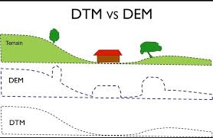
Figure 2.1: DSM VS DTM
Three-dimensional models consisting of the geometry and texture of urban surfaces could aid applications such as urban planning and heritage conservation. A standard technique used to create large-scale city models automatically or semi-automatically is to apply stereo vision on aerial or satellite imagery. 3D city models are digital representations of the Earth's surface and related objects belonging to urban areas (like cities, factories, buildings, etc.). Several disciplines like urban planning, architecture, telecommunication, tourism, environmental protection, and many others have an increasing demand for digital 3D building, to use such complex data for planning, analyses, visualization, and simulation in different applications (Biljecki et al., 2015).
Additionally, the open geospatial viewers (e.g. Google Earth, Virtual Earth, etc.) increase the demand for 3D city models. 3D building and its update require the development of automatic methods for the acquisition of Digital Surface Models (DSM). Digital photogrammetry, both airborne and spatial, is an efficient modern technique for DSM acquisition as a base for 3D building (El Garouani et al., 2014).
Surface modeling is already an established tool in the fields of land use planning, engineering, hydrology, and meteorology. When used in the GIS environment it becomes more than a planning tool because the real strength of a GIS is not simply its ability to work with spatially referenced data, but also how it permits different data sets to be integrated. Technological advances in personal computing have made surface modeling far more accessible to the average user, and it is no longer found only in the enclaves of large research organizations. For this reason, it is bound to become more commonly used both in structural planning and by many disciplines in data analysis exercises (Öztürk et al., 2013).

A digital terrain model is a topographic model of the bare earth –terrain relief - that can be manipulated by computer programs. The data files contain the spatial elevation data of the terrain in a digital format which is usually presented as a rectangular grid. Vegetation, buildings, and other man-made (artificial) features are removed digitally - leaving just the underlying terrain (on the other hand, Digital Surface Model (DSM) is usually the main product produced from photogrammetry, which contains all the features mentioned above, while a filtered DSM result in a DTM). Digital terrain models (DTMs) are of significant interest for applications such as environment planning, flood risk assessment, or building detection. DTM is considered as a continuous usually smooth surface which, in addition to height values (as DEMs) also contains other element that describes a topographic surface; slope, aspect, curvature, gradient, and others. A DTM can be derived from a DSM if the distinction between ground and non-ground pixels can be automated (Ouédraogo et al., 2014).
A digital terrain model (DTM) is a representation of surface relief encoded in a format that can be analyzed by computer. DTMs can be created using any data set which consists of several geographical coordinates with an elevation or quantity attached to each position. Data that have been represented in this way are topography, meteorological statistics (e.g. rainfall, evaporation, and temperature), and soil analysis. Other areas where the use of DTMs in data analysis could be useful are suggested. The process involved in creating the DTM is discussed. The DTM can then be analyzed by interpolation of contours at the desired scale, by interrogation at a specific point using the computer's cursor, or by producing a perspective view three-dimensional (3-D) drawing. Digital Terrain Model may be used with appropriate software to perform terrain analysis and to generate a variety of products (Forkuo, 2008).
Digital Surface Models (DSMs) play a crucial role in providing topographic models of the Earth's surface, representing terrain elevations, surface elevations of tree canopies, and the tops of buildings. It is important for many applications (scientific, commercial, industrial, operational, and military) such as extraction of terrain parameters, Global Navigation Satellite Systems applications, combining into a geographic information system (GIS), creation of relief maps and correction of satellite images, etc. Examples of applications of the Digital Surface Model include the following: flood risk analysis, risk assessments, feasibility studies, line of sight analysis, noise and wind modeling, climate impact studies, mapping purposes, and educational programs, geomorphology and landscape analysis, geological and hydrological modeling, telecommunication (i.e positioning or antennas), planning and construction, geological exploration, generating and updating geo-information for governmental issues, administering assistance in areas inflicted by disasters, airline operation safety and security relevant activities (risk and hazard), etc. 3D land use zoning allowed building volumes, usage, and density. They are the main tools for defining the image of a city and specifying, visualizing, analyzing, and storing the zoning in 3D (Hirt, 2016).
DSMs measure the height values of the first surface on the ground. This includes terrain features, buildings, vegetation power lines, etc. DSM's therefore provide a topographic model of the earth's surface (Envirocheck.htm). This digital surface model represents the terrain elevations and surface elevation of the tree canopy and the top of the buildings. Over time, the methodologies used for DSM generation have experienced a dramatic improvement: from coarse to high-resolution elevation model generation with detailed building shapes if high resolution data is used. Like Digital Terrain Models, Digital Surface Models contain the spatial elevation data of the terrain in digital format which is usually presented as a grid with natural and artificial features such as vegetation, buildings, etc. (Zhou, 2017).
These elevation models are essential for creating accurate maps, topographic surveys, and aiding in infrastructure planning and design for projects like roads, bridges, and buildings). Elevation data is critical for a wide range of applications, and it’s collected through techniques like aerial data capture and LiDAR sensors, providing valuable information for urban planning, forestry, and natural resource management. Elevation data is critical for a wide range of applications in various fields. It also plays a key role in helping us better understand and manage the Earth’s resources and environment. The data is collected through various techniques, typically aerial data capture and LiDAR sensors (Lakshmi & Yarrakula, 2019).
Elevation data plays a crucial role across various domains, starting with mapping and surveying, where it enables the creation of precise maps and topographic surveys essential for urban planning, forestry, and natural resource management. In infrastructure planning and design, elevation data informs projects such as roads, bridges, and buildings by determining optimal routes, slopes, and elevations, ensuring their safety and structural integrity. Hydrology benefits from elevation data for modeling water flow and drainage, aiding in flood risk prediction, water resource management, and habitat protection. Additionally, elevation data supports environmental monitoring efforts by tracking changes in the Earth's surface over time, including erosion, land use alterations, and deforestation, thereby informing strategies to mitigate human-induced environmental impacts. Furthermore, in disaster response, elevation data assists in assessing damage caused by natural disasters, enabling emergency responders to plan relief efforts and allocate resources efficiently (Lakshmi & Yarrakula, 2019).
Digital surface models, or DSMs, are used for many different reasons in many different industries. One area in which they are especially useful is urban planning, where they provide a detailed depiction of the Earth's surface and its above-ground buildings, which helps with decision-making as cities develop. These models which were frequently produced utilizing stereo photogrammetry or LiDAR (Light Detection and Ranging) technology, offer important insights into intricate urban environments, particularly as built-up areas change over time due to urban expansion. DSMs are essential for evaluating the encroachment of the runway approach zone in aviation as well as for examining the possible effects of proposed constructions on views in urban planning. DSMs are also used in decision-making processes, navigation, vegetation monitoring, disaster management, and visualization. Using LiDAR 11 technology, for example, light pulses are emitted from a LiDAR unit, bounce off nearby objects, and then return to the sensor allowing distance measurements as well as surface geometry and material composition estimations. The generated DSMs provide detailed elevation data that can be used for a variety of applications. They capture changes in manmade buildings as well as natural features like tree canopies. Digital Surface Model (DSM) data can be sourced from various methods, including topographic maps storing coordinate and elevation information of terrain features, remote sensing materials captured in stereo mode for generating DSMs and orthophotos, as well as laser scanning data producing point clouds. Additionally, ground-based photographs from multiple perspectives are necessary to construct photorealistic 3D models of buildings, complementing information derived from orthophotos and topographic maps, particularly for delineating building contours. DSMs find diverse applications, including urban and architectural planning, tourism, navigation systems, intelligent transport systems, urban risk forecasting, positioning of mobile phone transmitters for telecommunications, and flood risk mapping. A DSM comprehensively captures both natural and human-made environmental features, whereas a Digital Terrain Model (DTM) solely retains characteristics of bare-earth terrain, such as rivers and ridges. Importantly, a DTM can be derived from a DSM, but not vice.
In previous reviewed projects, a variety of methods including conventional surveying methods were being utilized for topographic information system as evidenced by our review. This project seeks to attain similar outcomes through Total station traversing referencing to know control frame within the project location, embraces the utilization of uses of GIS approach for data visualization, presentation, and spatial analysis. At its core, the project aimed at producing topographic information, generate and analyze a high-resolution digital surface model of part of kwara state polytechnic along old jebba road, mooro local government area, Kwara state.

CHAPTER THREE

3.0 METHODOLOGY

3.1 PROJECT PLANNING

Before beginning any survey assignment, project planning is a crucial requirement. It entails a careful investigation of the topic matter about a certain land region that is being evaluated. This

crucial step in the surveying process allows the surveyor to become acquainted with the chosen location before starting work. During the reconnaissance phase, the survey's goals, requirements, and required precision levels are examined because these elements have a big impact on the choice of survey tools and techniques. In the end, this project resulted in the development of a first working diagram. Reconnaissance is divided into two phases: (i) Office Planning and (ii) Field reconnaissance.

3.1.1 FIELD RECONNAISSANCE

As part of this process, a surveyor or student must physically visit the site to gain a thorough understanding of its topography, including any vegetation, accessibility, existing frame work, as well as the social and economic 19 activities that take place there. The optimal approach and tools for improved decision-making must also be chosen. This on-site visit gives the surveyor or student a comprehensive grasp of the entire region and allows them to look at the entire area of the land. To guarantee correct orientation, the locations of all accessible horizontal and vertical controls in the region of the research area will be visited, and their outlooks will be viewed. This exercise makes it easier to create a Recce diagram, which is shown below but is not drawn to scale:

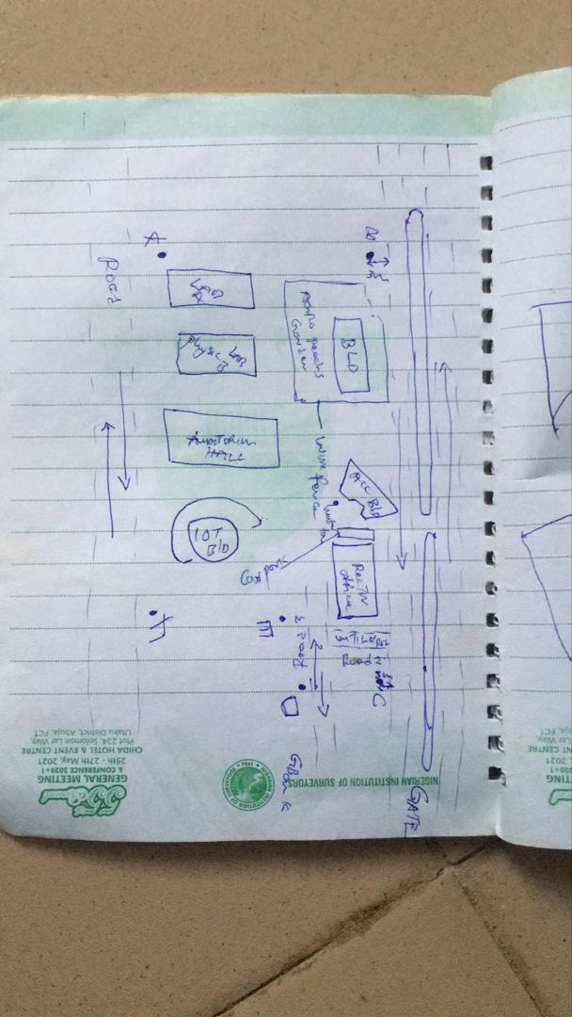

Figure 3.4: RECCI DIAGRAM

3.1.2 OFFICE PLANNING

Gathering crucial project information is the focus of this phase, which is usually done in an office setting. It is the initial phase of planning that comes before the fieldwork itself and entails gathering and analyzing a variety of project-related data. This covers a range of requirements for the project, scheduling, budgeting, and generating the coordinates for the control points under the project control prefix. It includes figuring out the best process, picking the right tools, as well as subscription for the CORS station.

3.2 EQUIPMENT USED/ SYSTEM SELECTION SOFTWARE
The following equipment was used:
- Total station and accessories
- One Tripod
- Two Prism
- One 7.5 meters short tape
- One Plumb bob
- One Cutlass
- Bottle corks and nails
- Writing materials.

3.2.1 HARDWARE USED
Model: HP 15 Note book PC
System Manufacturer: Hewlett-Packard
Rating: 1.0 Windows Experience Index.
Processor: Intel(R) Core(TM) i5-3230M CPU @ 2.60GHz, 2601 Mhz, 2 Core(s), 4 Logical Processor(s)
Installed Memory RAM: 8.00 GB
System Type: x64-based PC.
Product ID: F9F84EA#ABV

3.2.2 SOFTWARE USED
Some of the software used includes:
- AutoCAD 2007
- Notepad
- Microsoft Word 2007
- Microsoft Excel 2007
- Arc GIS 10.5

3.3 DATA ACQUISITION

This involves using different surveying methods and tools to gather data and make observations in the field. To acquire data for this project, GPS and Total station were both used.

3.3.1 PRIMARY DATA SOURCE: This is a type of data source in which data is direct acquired from the field such as data acquired from field survey operations.

3.3.2 SECONDARY DATA SOURCE: This data source are already made data or gotten from research work, which has been acquired for future use. This involves downloading satellite imagery used for the project area and Google map as guide.

3.4 TEST OF INSTRUMENT
Testing of instruments is very crucial when carrying out any survey operation. Having collected the required instruments from the department, the check was carried out on the accuracy and precision of both the Differential GPS and TOTAL STATION to ensure they were in proper working condition before the actual field observation of the project.

3.4.1 TEST FOR TOTAL STATION
The horizontal collimation and vertical index inaccuracies of the instrument were confirmed. Once the device was positioned on a rather flat surface, the required temporary modifications, including focusing, centering, and setting, were made. Configuration information, such as extra parameters and fast settings, was examined and adjusted as necessary. The configuration parameters selected collimation, namely horizontal collimation. Next, to focus on a distant object, the means' option located on the left side of the device was chosen. The instrument was transited, and the right side went through the same procedure. Then, when the 'accept' button was pushed, the table that was displayed showed the old and new values for the vertical index errors and horizontal collimation. Re-press "ok" signified acceptance of the updated values, which were minimal.

The diagrammatic representation of the procedure and the readings obtained are shown below

Figure 3.5: INSTRUMENT TEST

Table 3.4.1 COLLIMATION TEST OF TOTAL STATION
STN | SIGHT | FACE | HCR | REDUCTION | VCR | REDUCTION
A | B | L | 126º 07’ 11.33” |  | 67º 22’40”
 | B | R | 306º 07’ 31.3” | 180º 00’ 20” | 292º 37’ 1” | 359 º 59’ 41”

HORIZONTAL COLLIMATION ERROR = 180°00’20’’ - 180°
=00°00’20’’
=00°00’20’’/2 =00°00’10’’
VERTICAL INDEX ERROR=360° - 359°59’41.6’’
=00°00’18.4’’
=00°00’18’’/2 =00°00’9.2’’
The instrument's satisfactory operation was validated by the acceptance of the updated readings. It appears from this result that any possible issues can be resolved or at least greatly reduced.

3.4.2 REFERENCING AND ORIENTATION OF TOTAL STATION
Tripod Setup:
- Place the tripod over the station point (known or assumed).
- Level the tripod head as much as possible by adjusting the legs.
Mount the Total Station:
- Fix the total station onto the tripod head.
- Ensure it is securely locked in place.
Centering and Leveling:
- Use the optical plummet or laser plummet to center the instrument exactly over the survey station mark (station point).
- Level the instrument using the foot screws and circular bubble.
- Fine-tune leveling using the electronic level display.

Power On and Instrument Configuration
- Switch on the Total Station.
- Set the correct project, coordinate system, and units.
- Select the appropriate survey mode (e.g., topographic survey or station setup).
Orientation (Station Setup)
Orientation means establishing the direction of the horizontal angle reference (back sight direction).
Orientation by Known Coordinates (Resection or Free Station)
Used when both the instrument station and a back sight point have known coordinates.
- Input the coordinates of the instrument station (or let the instrument compute it later).
- Sight and measure to one or more known reference points (minimum of 2 for better accuracy).
- The Total Station calculates the instrument position and orientation using these known points.

Table 3.4.2: List of Control Stations and Coordinates
STN | NORTHING(m) | EASTING(m) | HEIGHT(m)
KP 704 CP | 946339 | 679950 | 450.561
KP 705 CP | 9466686 | 679959 | 453.520

3.3.7 PERIMETER TRAVERSING
The perimeter of the project area was traversed for the purpose of the coordinating the boundary points. GPS (GALAXY G1) was connected to kwara state CORS station for referencing and orientation after which all the boundary points were traversed using GPS from the initial until each successive boundary is occupied.

3.3.8 DETAILING
All features such as roads, buildings, electric poles, street light, trees, etc. were captured by coordinating their edges simultaneously as the perimeter is being measured within the project area. Buildings were measured and identifiers (BD) were used to differentiate them from other features. Roads were also measured and labelled (RD) accordingly. Data captured here were basically in 3Dimension i.e. Easting, Nothings and Elevations (X, Y, and Z) coordinates.

3.3.9 REMOTE ELEVATION MEASUREMENT
All the features such as buildings, electric poles, street light, etc. captured by coordinating their edges from a subsidiary traverse stations created within the project area. Buildings heights were measured and recorded. Electric poles height were also measured and recorded accordingly. So also the same was repeated for the trees. Data captured here were basically in 3Dimension i.e. Easting, Nothings and Elevations + Heights (X, Y and Z + H) coordinates. The following procedures were followed:
- Escape key was pressed then F1 for MENU
- The REM programme was selected.
- Observation was made again and the height of reflector was displayed.
- The telescope was tilted to the top of the object and the height keeps changing until F4 is been pressed to stop.
- The value was recorded.
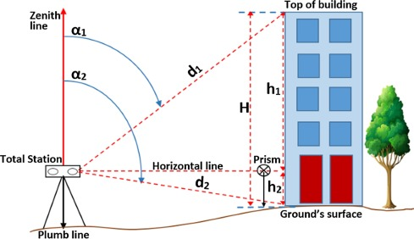
Figure 3.3.9: REM OBSERVATION STRATEGY

3.3.9A SPOT HEIGHTINGS
This was carried out by occupying randomly the subsidiary points within the project area and taking measurements (Easting, Nothings and Heights) along the terrain at approximate intervals to determine the difference in height between points and some areas within the project location. Spot heighten is very important in producing topographical information of the area with the aid of ArcGIS 10.5.

3.4 PHYSICAL DESIGN
At this stage, all geospatial (attribute) data were structured and organized to form a database in a format acceptable by the implementing software and hardware. This was done in a way that, stored information can be accessed and retrieved at any time. Also, for regular updates when the need arise and to allow for analytical functions to be carried out answering generic questions. Also, it provided integrity and security that must be obeyed before such data could be accepted into the records. These virtues are as show in the tables below. ArcGIS 10.5 was used for database creation of the project area.

Table 3.4A TREE TABLE
ATTRIBUTE | DATA TYPE | WIDTH | DECIMAL
T_ ID | String | 5 | -
T_NAME | Float | 20 | -
EASTING | Number | 10 | 3
NORTHING | Number | 10 | 3
T_USE | Float | 10 | -
T_HEGHT | Number | 7 | 3

Table 3.4B ROAD TABLE
ATTRIBUTE | DATA TYPE | WIDTH | DECIMAL
POINT_ID | String | 10 | -
NORTHING | Number | 10 | 3
EASTING | Number | 10 | 3
RD_HEIGHT | Number | 7 | 3

Table 3.4C ELECTRIC POLE TABLE
ATTRIBUTE NAME | DESCRIPTION OF ATTRIBUTE | DATA TYPE | WIDTH | DECIMAL
POINT_ID | Electric pole identifier | Number | 6 | -
NORTHING | Coordinate | Number | 15 | 3
EASTING | Coordinate | Number | 15 | 3
EP_TYPE | Type of Electric pole | Text | 15 | -
EP_HEIGHT | Height of the Electric pole | Number | 5 | 2

Table 3.4D BUILDING TABLE
ATTRIBUTE | DATA TYPE | WIDTH | DECIMAL
P_ID | String | 15 | -
NAME | Text | 15 | -
CONDITION | Text | 15 | -
USE | Text | 15 | -
HEIGHT | Number | 15 | 2
AREA_METERS | Number | 15 | 2

Table 3.4E STREETLIGHT TABLE
ATTRIBUTE NAME | DESCRIPTION OF ATTRIBUTE | DATA TYPE | WIDTH | DECIMAL
POINT_ID | Street light identifier | Number | 6 | -
NORTHING | Coordinate | Number | 15 | 3
EASTING | Coordinate | Number | 15 | 3
SL_HEIGHT | Height of the street light | Number | 5 | 2

3.5 DATABASE CREATION
Database is an organized integrated collection of data stored so as to be capable of use by relevant application with data being accessed by different logical part. This was the construction phase where database was created. After the table has being populated via the keyboard, some attributes such as area, perimeters of parcel were automatically displayed by special command in the ArcGIS 10.5 version.
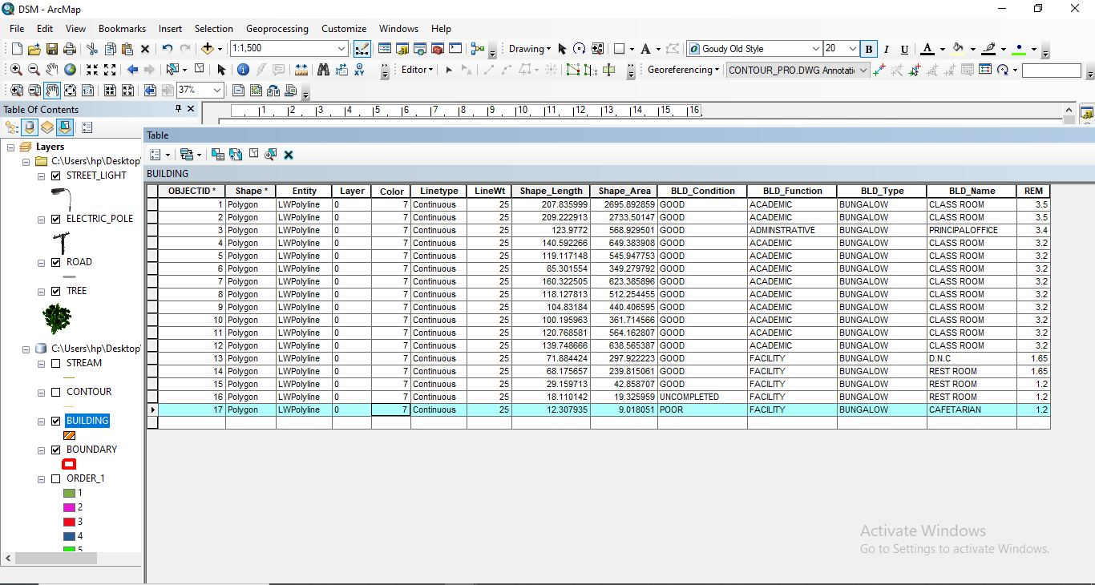
Figure 3.5: ABSTRACTED OF TABLE CREATED

3.5.1 ATTRIBUTE DATA ACQUISITION
The data about the characteristics of features especially man-made features were acquired through oral interview method and online source (Google Earth). Social survey was carried out during which information such as; building name, building use and related data about features were obtained from the students and staffs within the school. All these data formed the attribute aspect of the feature necessary for the database creation.

3.6 DATA PROCESSING

3.6.1 TOTAL STATION DATA DOWNLOADING PROCEDURE
Data downloading is the process of transferring data from the instrument into the computer system connected through the connection cable or wireless such as Bluetooth with the help of software in the computer, the process is as follows as performed on Total station.
- Connection of the two devices (computer and the instrument).
- Go to project working folder created on the instrument.
- Click on export.
- Input the name of file
- Indicate the file extension for the output
- Permit the other device to receive the file.

3.6.2 DRAFTING AND PLOTTING
The script file created containing the refined coordinates was then opened in the AutoCAD environment and the boundary of the project area was plotted using AutoCAD 2007. This was followed by the details, which included buildings, roads, trees, sport facilities and electric poles.
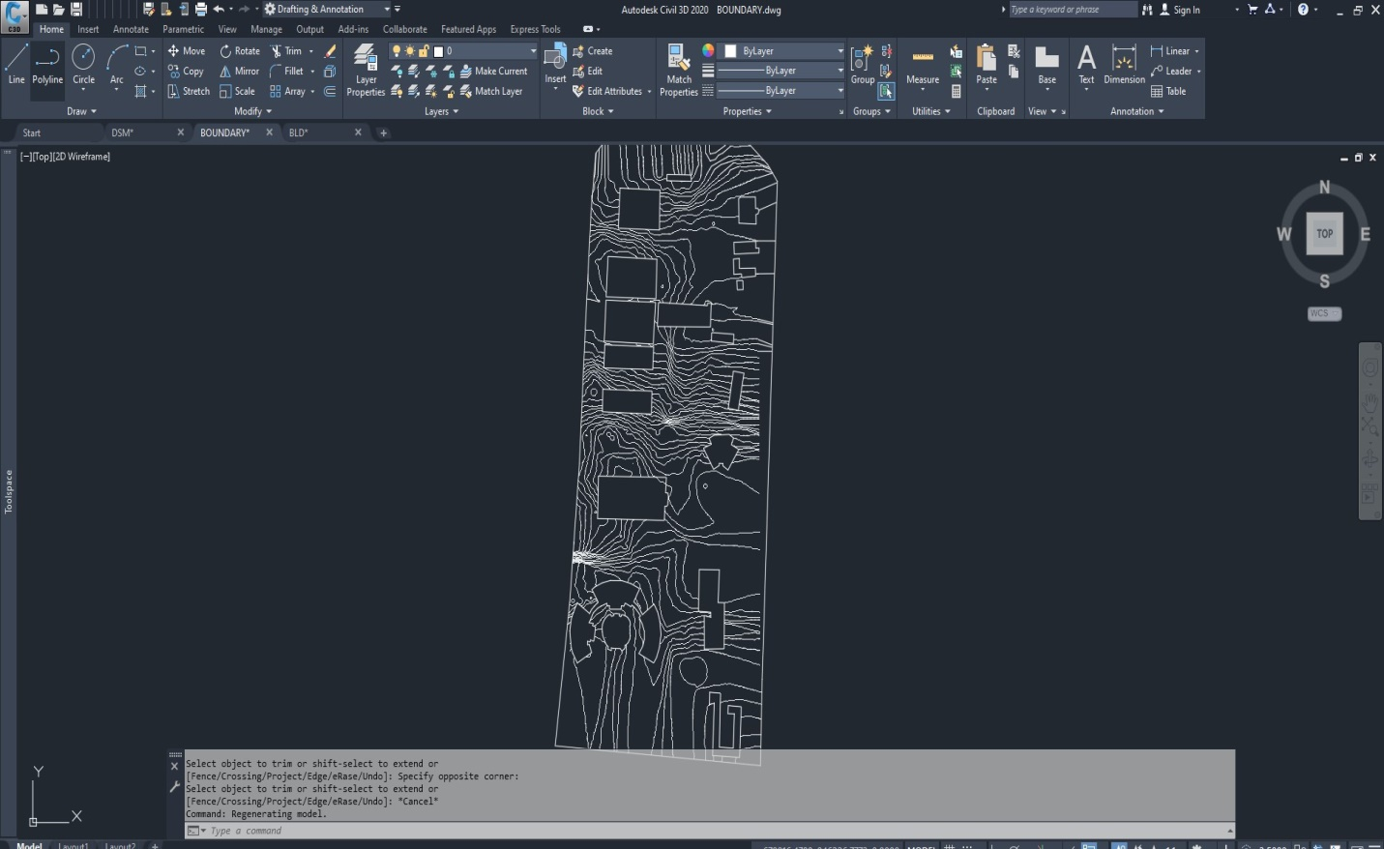
Figure 3.6.2: AUTOCAD PLOTTING.

3.7 DATABASE MANAGEMENT

3.7.1 DATA SECURITY
This is the security measure used the protection of the database security is very important since it is vital for data integrity. The strategic measure used included controlling access to database by use of password.

3.7.2 DATA INTEGRITY
This ensures that data in the database is accurate and that cases of violation of integrity can be detected automatically by the system. Here, care was taken while entering data into the system, such that, accurate data were entered and updating could be done accurately without tampering with existing data. Backups are provided to cater for any loss of data through system failure. Also a member of the project group was appointed for quality assurance and checks therefor do checks the consistency, accuracy and integrity of the input data.

3.8.3 DATABASE MAINTANANCE
Having created the database, proper maintenance practice was made to meet its stated objectives. The ability to include more data and remove irrelevant data can be possible. There is every need for the data to be updated regularly because of the physical changes that tends to occur on the landscape with time, even as a result of development.
Both security and integrity were also exercised to ensure maintenance and to meet its stated objectives.

CHAPTER FOUR

4.0 SPATIAL ANALYSIS AND INFORMATION PRESENTATION

4.1 TESTING OF DATABASE
This is the test carried out to determine whether the relationship between the spatial data of a feature and their attributes is capable of being retrieved. This is necessary to ascertain the quality of data in the database, its reliability to satisfy the demand of the user. The spatial data were arranged logically in an organized manner with respect to their attributes. This was carried out by designing a sample query and running the query to see if the desired result would be achieved. In this project, the database was queried to show different categories of information levels in the project area. Hence the database was confirmed fit for analysis. A sample of the attribute table in the database design can be found on the next page.
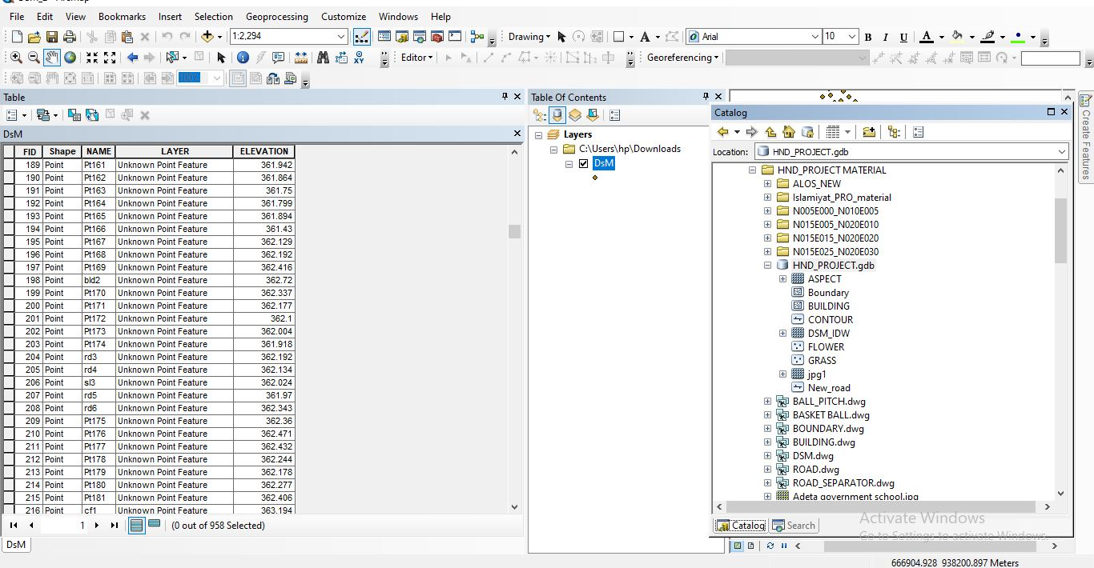
Figure 4.1: SAMPLE OF ATTRIBUTE TABLE

4.2 SPATIAL QUERY
Queries were designed for the purpose of retrieving information from the database. The queries performed in this project gave answers to certain generic questions asked from the database. This was made possible as a result of the implicit link of both the spatial and attributes data. The queries were based on the products from the analysis carried out on the database.

4.2.1 SINGLE CRITERIA QUERY
A single criterion is carried out where one condition is used to design query. This condition is used to retrieve the information from the database.

QUERY ANALYSIS 1 (selection by attribute)
ANALYSIS ONE
Analysis Name: Database extraction
Analysis Type: Single criteria analysis
Syntax: Query analyses showing buildings that are used for Administrative.

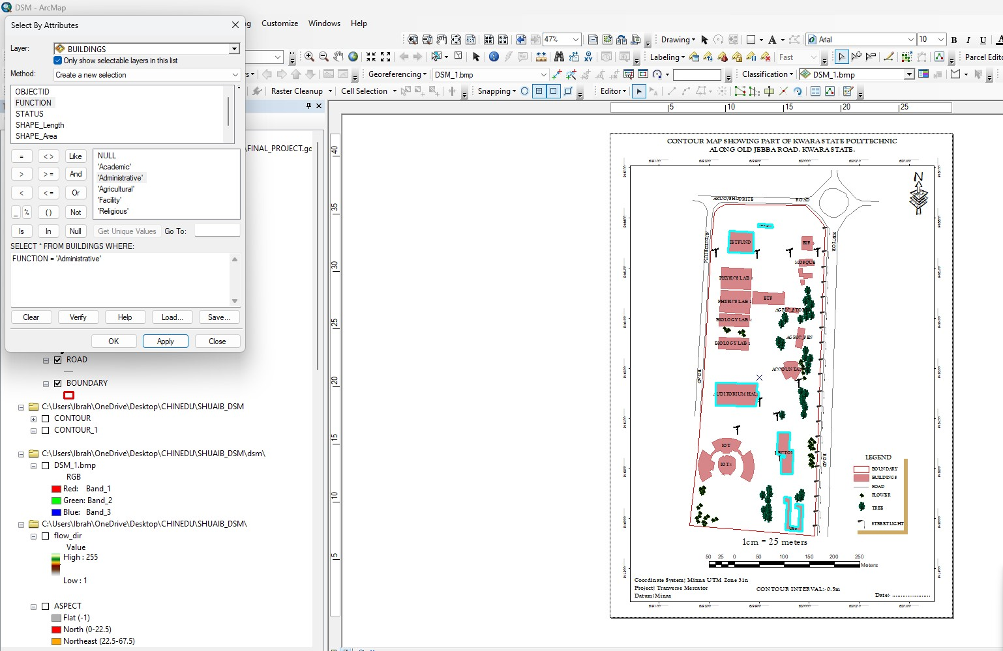
Figure 4.2.1.1 RESULT OF QUERY: (BLD_FUNCTION = “ADMINISTRATIVE”).

Analysis Name: Database extraction
Analysis Type: Single criteria analysis
Syntax: “BLD_ Function” =”Agricultural”
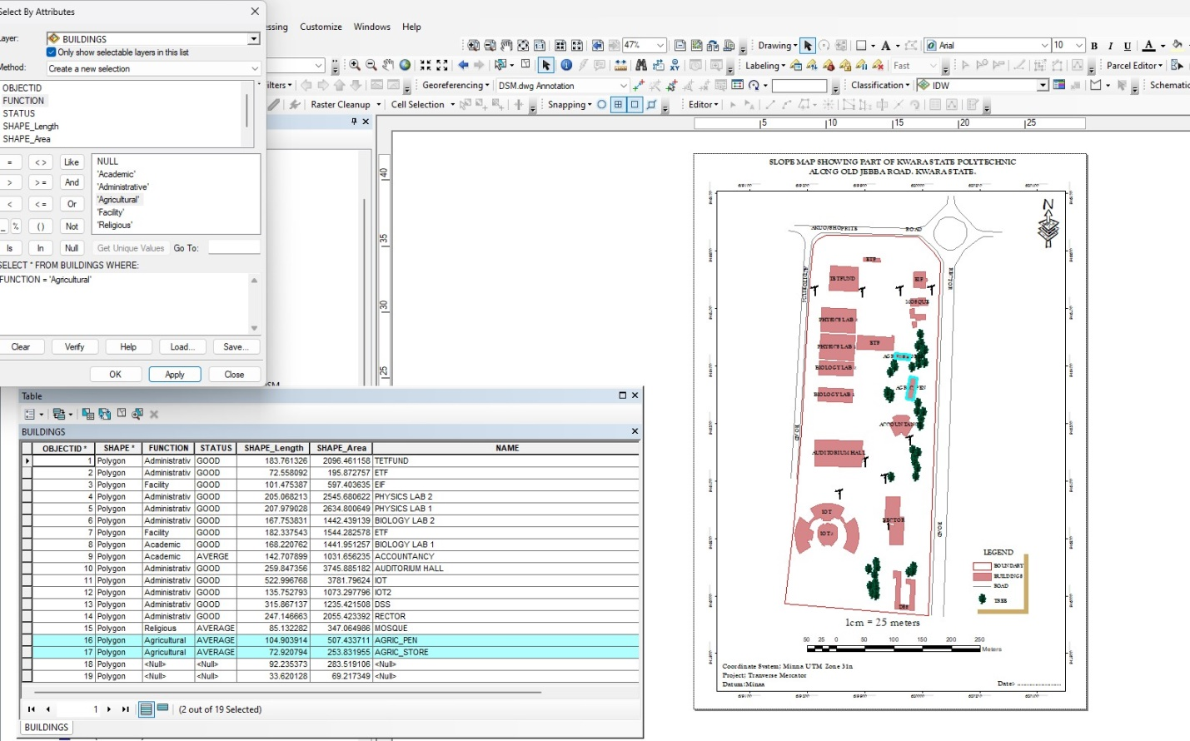
Figure 4.2.1.2: RESULT OF QUERY: (BLD_FUNCTION = “AGRICULTURAL”).
ANALYSIS THREE
Analysis Name: Database extraction
Analysis Type: Single criteria analysis
Syntax: “BLD_ CODITION” =”ACADEMIC”
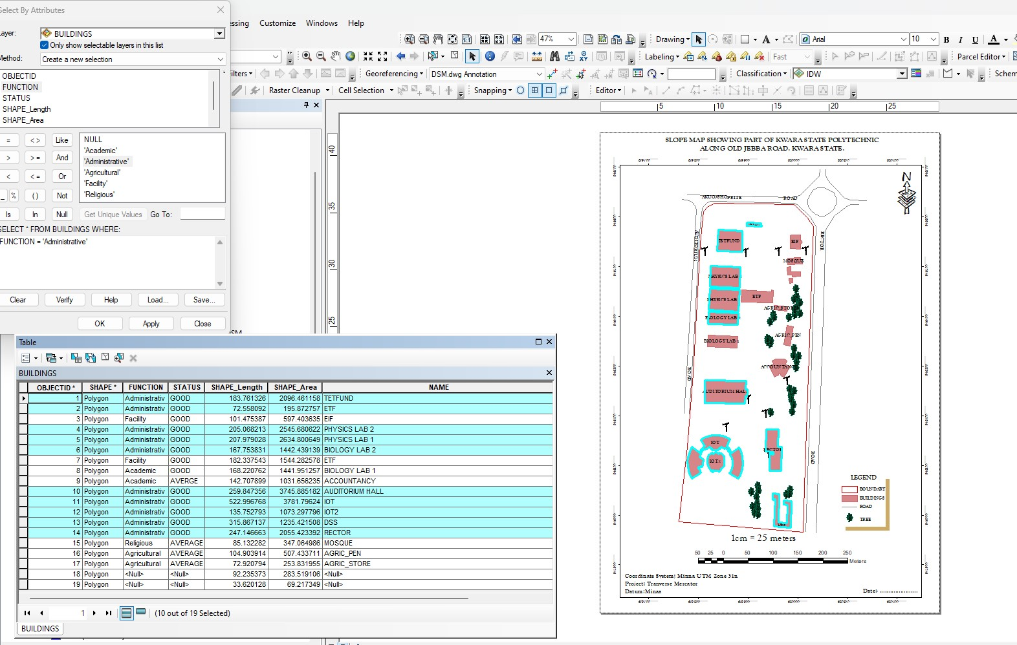
Figure 4.2.1.3: QUERY BLD_FUNCTION"ACADEMIC"

ANALYSIS FOUR
Analysis Name: Database extraction
Analysis Type: Single criteria analysis
Syntax: “TREE_FUNCTION= ORNAMENT”

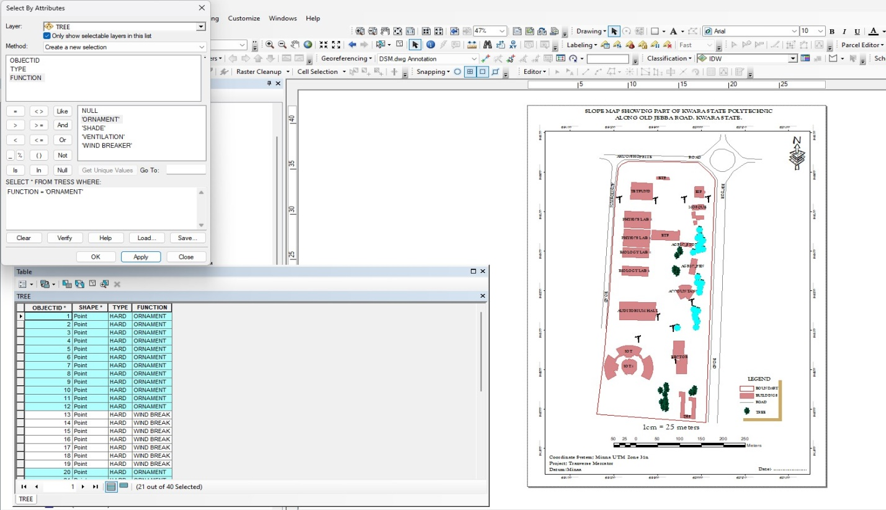
Figure 4.2.1.4: RESULT OF QUERY: (TREE_FUNCTION “ORNAMENT”).

4.2.2 MULTIPLE CRITERIA
This is a situation where two or more conditions are used to design a query. The conditions determine the information that may be requested by the user from the database.
Query for QUERY: TREE_FUNCTION “ORNAMENT” AND TREE_TYPE “HARD”
ANALYSIS FOUR
Analysis Name: Database extraction
Analysis Type: Multiple criteria analysis
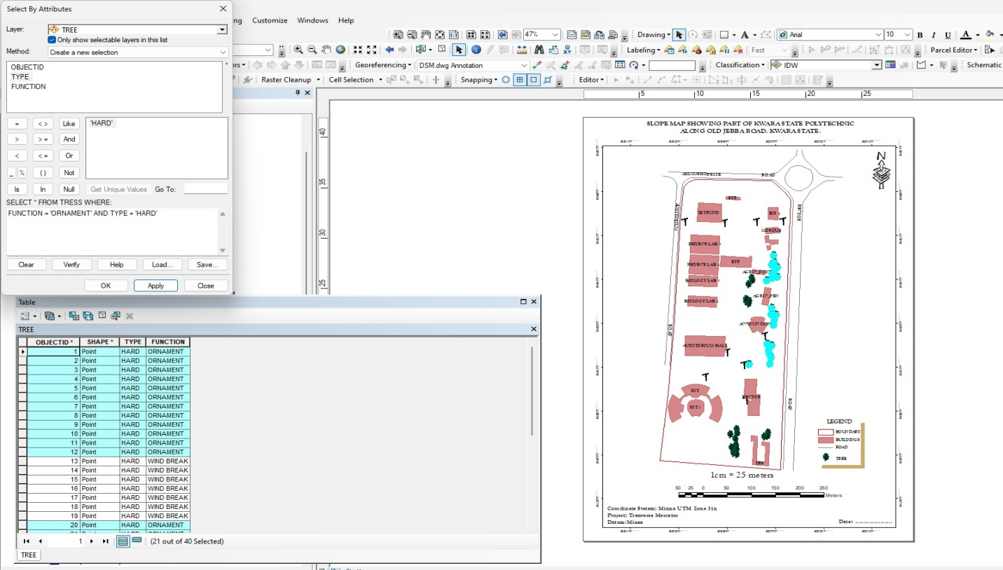
Figure 4.2.2.1 RESULT OF QUERY: TREE_FUNCTION “ORNAMENT” AND TREE_TYPE “HARD”
Query for BLD_FUNCTION =“RELIGIOUS” AND BLD_STATUS= “AVERAGE”
ANALYSIS FOUR
Analysis Name: Database extraction
Analysis Type: Multiple criteria analysis

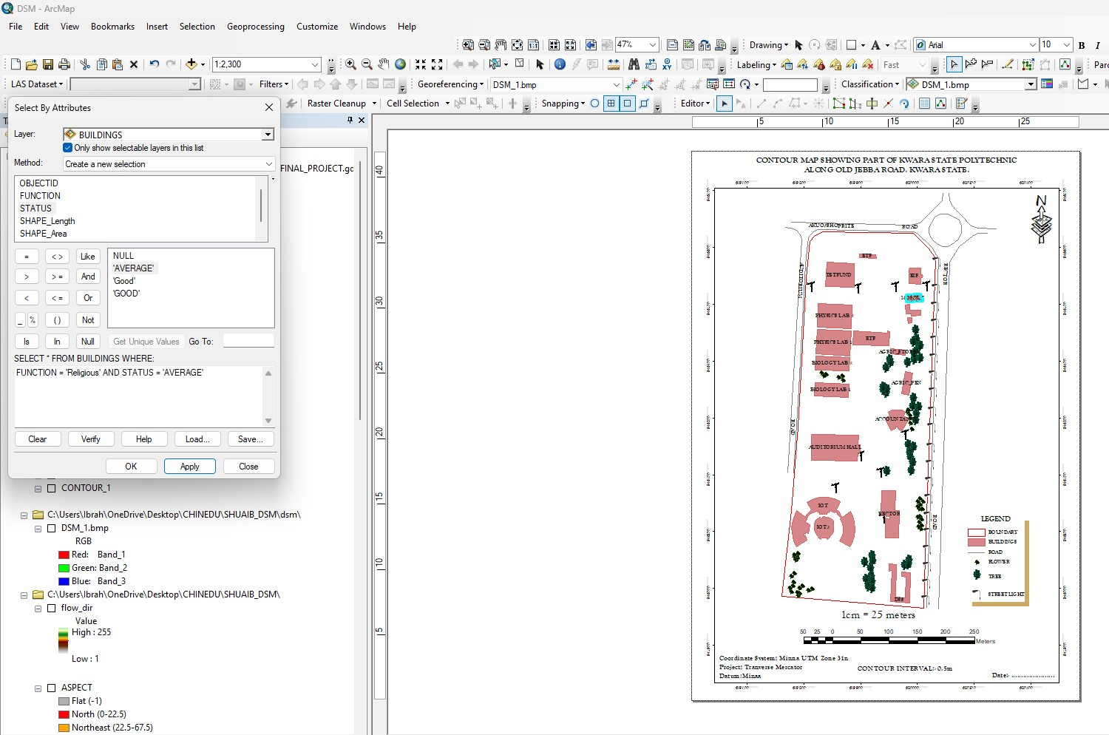
Figure 4.2.2.2 RESULT OF QUERY: BLD_FUNCTION =“RELIGIOUS” AND BLD_STATUS= “AVERAGE”

4.2 SPATIAL ANALIYSIS
This makes Geographic Information System (GIS) a unique analytical tool or technique because of its ability to combine spatial attribute data to produce information relevant for decision making. The basic GIS analysis performed in this project includes overlay and topographic operations. Maps on various themes were overlaid since they were from the same geometric origin.

4.2.1 OVERLAY OPERATION
This overlay operation is the presentation that shows different features within the project area. The outcome of overlay operation could be composite plan if it shows all the existing features, and boundary.

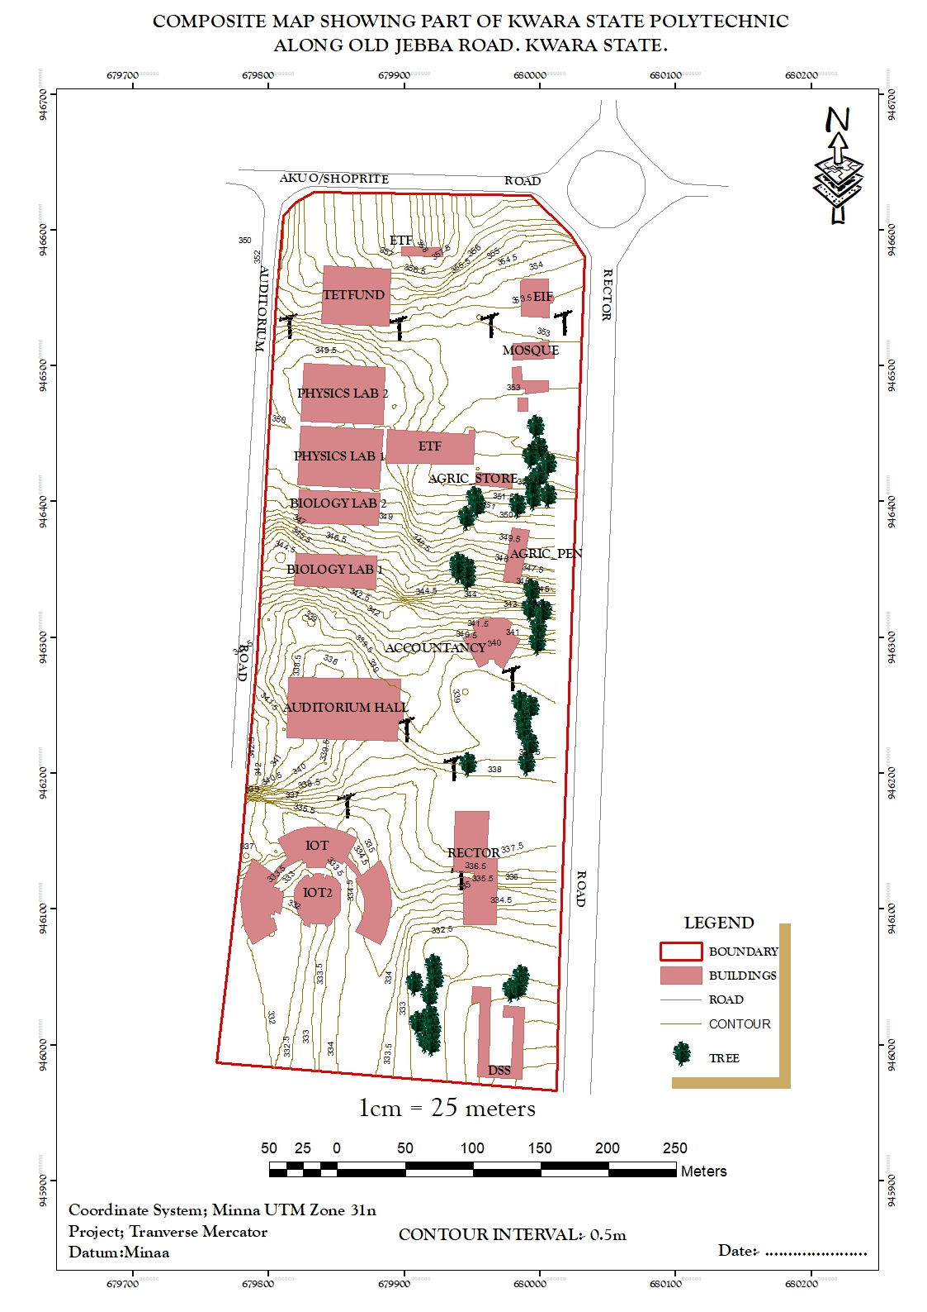
Figure 4.2.1: COMPOSITE MAP OF THE PROJECT AREA.

4.2.2 TOPOGRAPHICAL OPERATIONS
Topographic operations were carried out to determine the surface characteristic of the area which showed the relief of the project. These operations were performed on the Digital Elevation Model (DEM) generated from the use of relevant software, in this case, ArcGIS 10.5 and ArcScene 10.5 was used. The following maps were produced from the topographic operations and analysis:

- TRIANGULATION IRREGULAR NETWORK (TIN): this shows series of triangulated surface automatically generated from ArcGIS 10.5 using 3D analysis tools. This is applicable in finding suitable place for building or any engineering construction
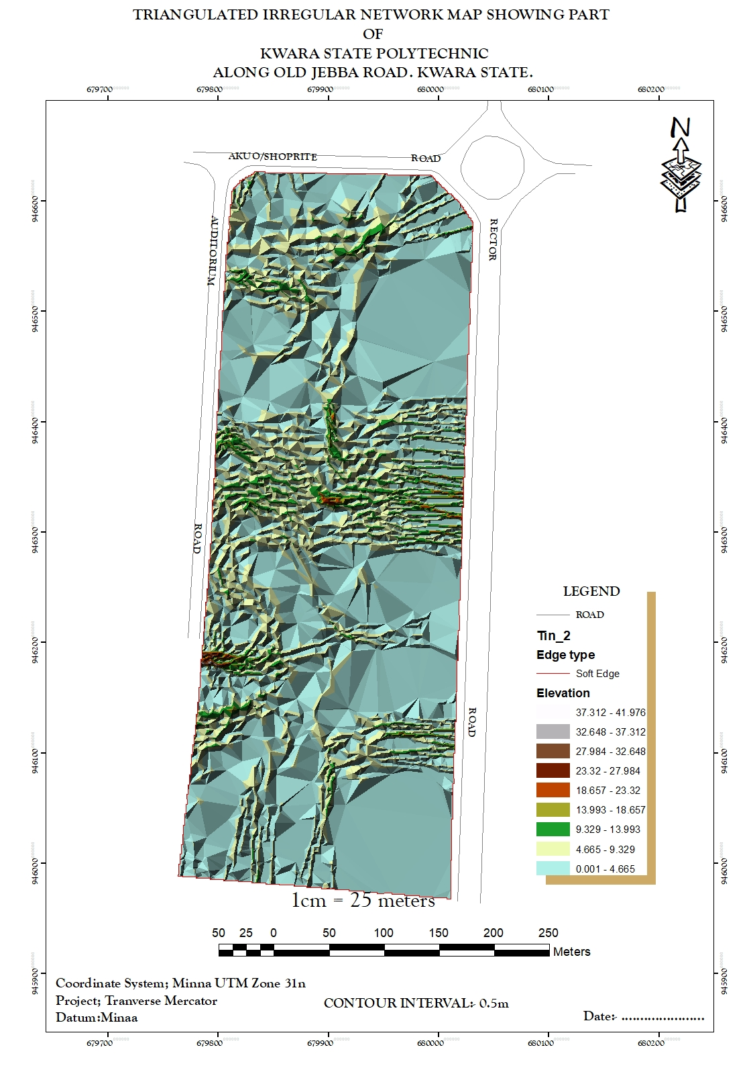
Figure 4.2.2.1: TIN AND DETAILS OVERLAY MAP OF THE PROJECT AREA
- SLOPE MAP: A slope map represents the gradient or steepness of the terrain's surface. It calculates the rate of change in elevation between neighboring pixels or points on a digital elevation model (DEM). Typically, slope is measured in degrees or percentage. Steeper slopes are represented by higher values, while flatter areas have lower values.
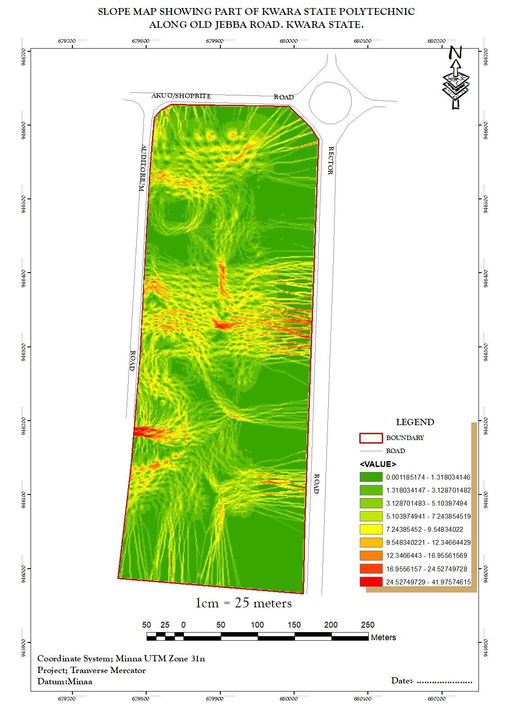
Figure 4.2.2.2: SLOPE MAP OF THE PROJECT AREA

- THE ASPECT MAP:
This shows the direction of the surface faces. It is used to determine how much sun a hill received and the information can be used to put building where they will get enough sun. Also the aspect map shows the suitable place for plane landing i.e. the flat terrain area and also solar illumination which can affect the diversity of life i.e. Vegetation and soil studies; glaciology.

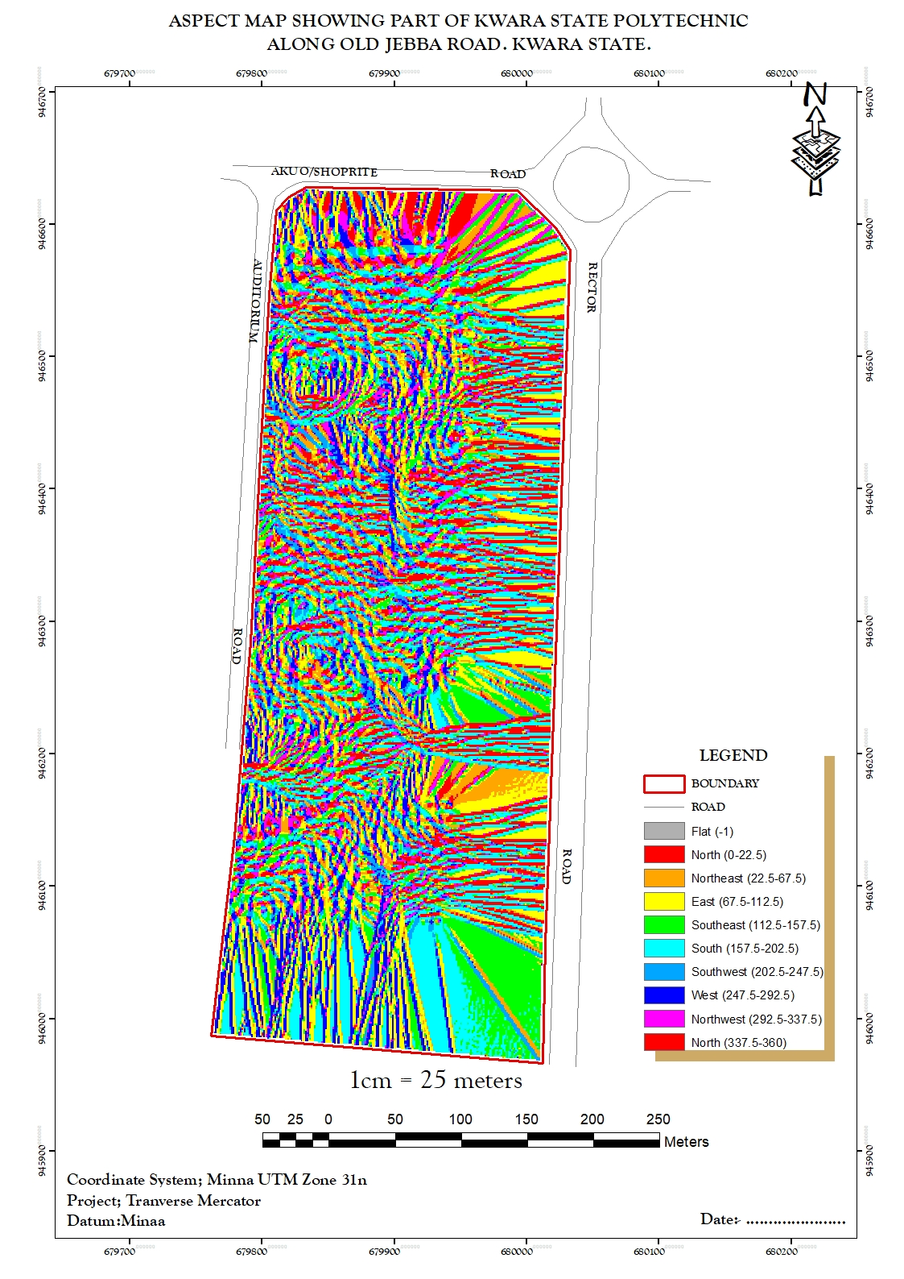
Figure 4.2.2.3: ASPECT MAP OF THE PROJECT AREA.
- THE CONTOUR MAP:
Contour maps display lines connecting points of equal elevation on the terrain surface. These lines, called contour lines, depict the shape and elevation of the land. Contour maps are widely used in topographic mapping and land surveying for visualizing elevation changes and terrain features. This provides a very intuitive view of the landscape. Contour map of the project area can aid in giving information on the highest and the lowest point on the terrain. This is important in road construction and location of other facilities like storage tanks for water distribution.
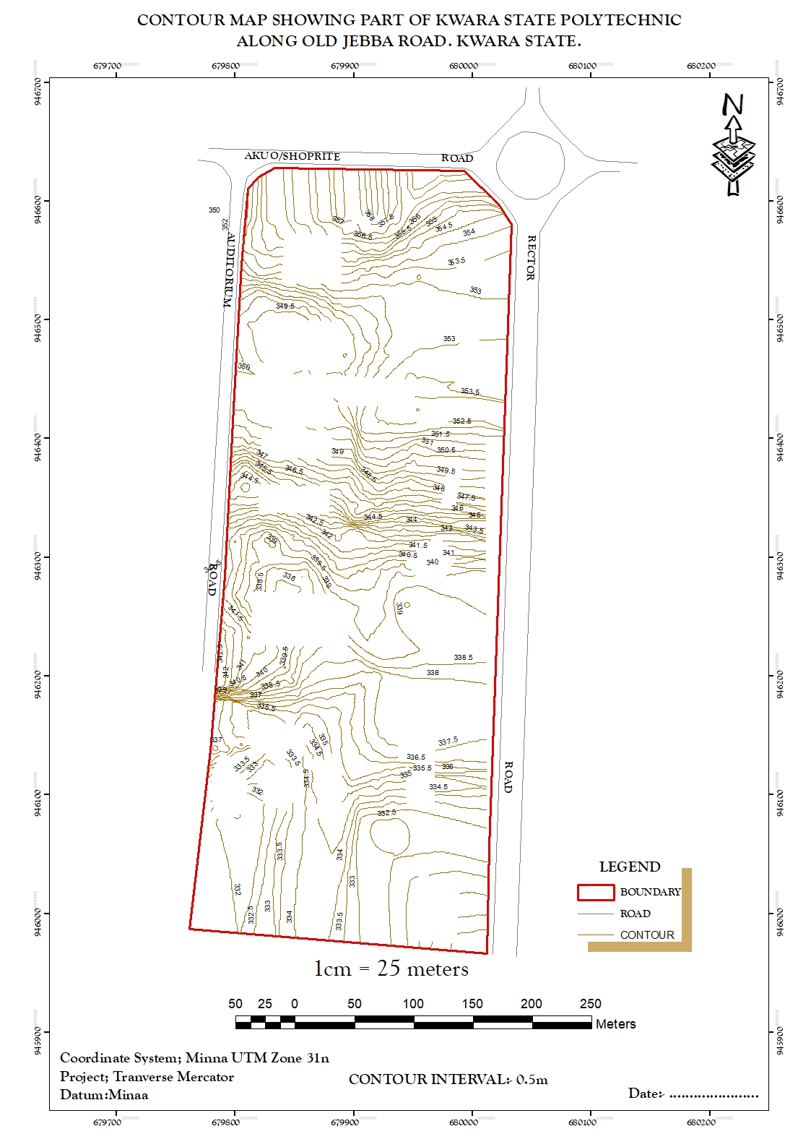
Figure 4.2.2.4: CONTOUR MAP OF THE PROJECT AREA.

- FLOW DIRECTION MAP:
This is used to determine the direction of flow of water within the project area. It also indicates the magnitude and erosive force water passing through an area.
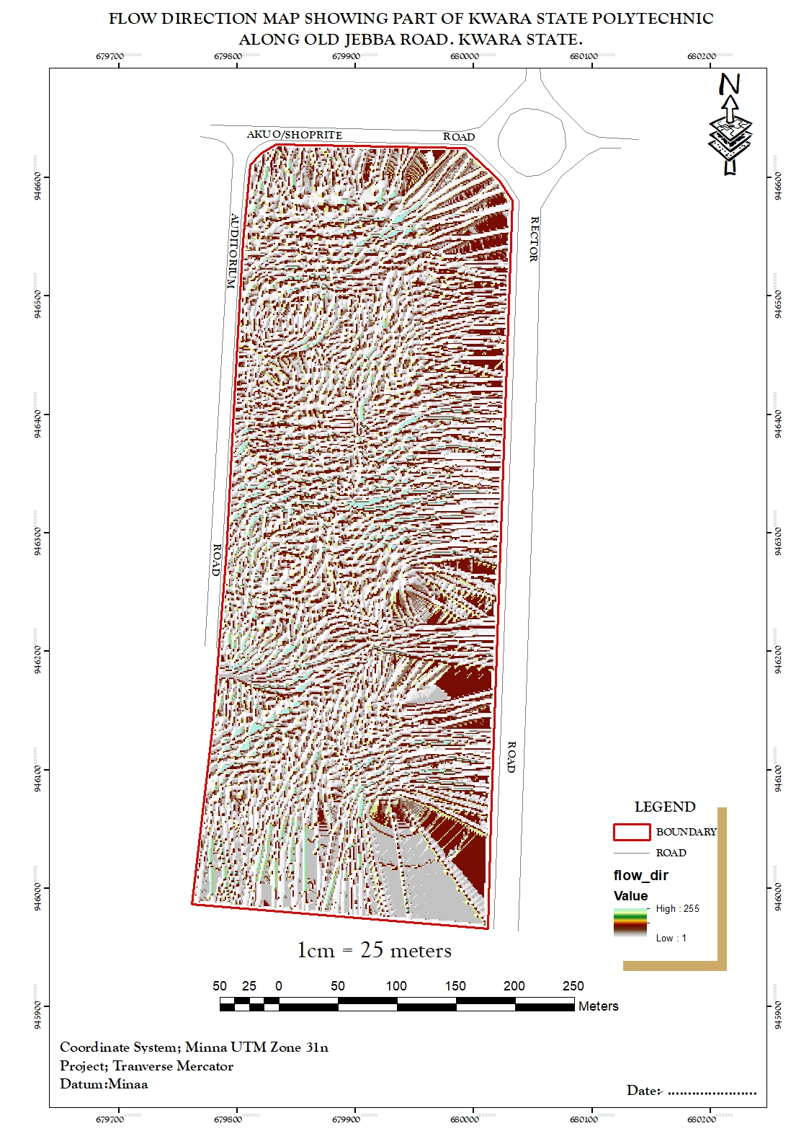
Figure 4.2.2.5 FLOW_DIRECTION MAP OF THE PROJECT AREA
- DIGITAL SURFACE MODEL MAP:
A DSM (Digital Surface Model) map, or Digital Surface Model, represents the elevation of the Earth's surface including all objects on it, such as buildings, vegetation, and other structures. Unlike a DTM (Digital Terrain Model), which only includes the bare-earth surface, a DSM incorporates both natural and man-made features. DSMs are useful for various applications, including urban planning, infrastructure design, and 3D visualization. They are often derived from aerial or satellite imagery, LiDAR data, or photogrammetry techniques. This shows the reality of the terrain of the project area.
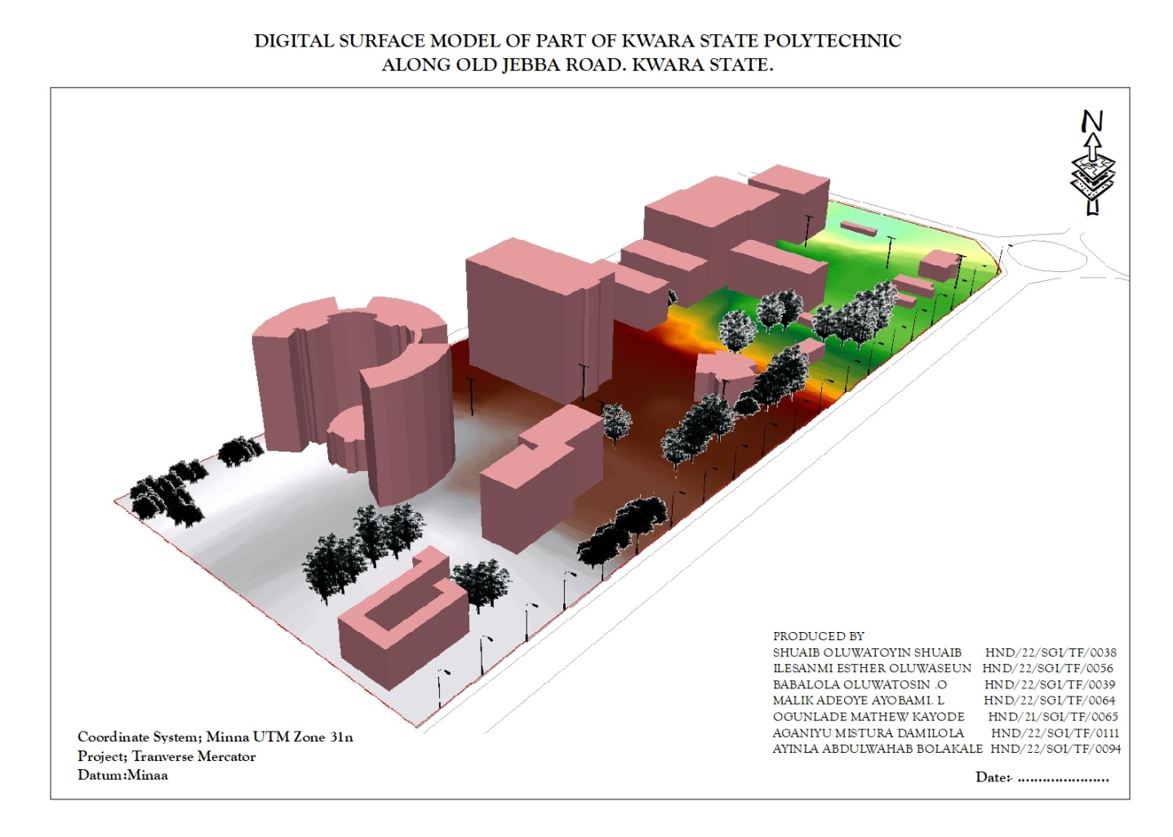
Figure 4.2.2.6: DIGITAL SURFACE MAP OF THE PROJECT AREA

4.3 RESULT ANALYSIS
From the below pie chart, it is inferred that large percentage is serving academic function. The DSM project commenced with the utilization of a Total station referenced to control station within kwara state polytechnic to capture 3D data of the project area. The captured data were then processed using software, employing photogrammetry techniques to generate a high-precision DSM and create a detailed 3D model. Subsequently, ArcGIS and ArcScene software was employed to visualize and analyze the DSM data, facilitating spatial analysis and information presentation both in 2D and 3D respectively.
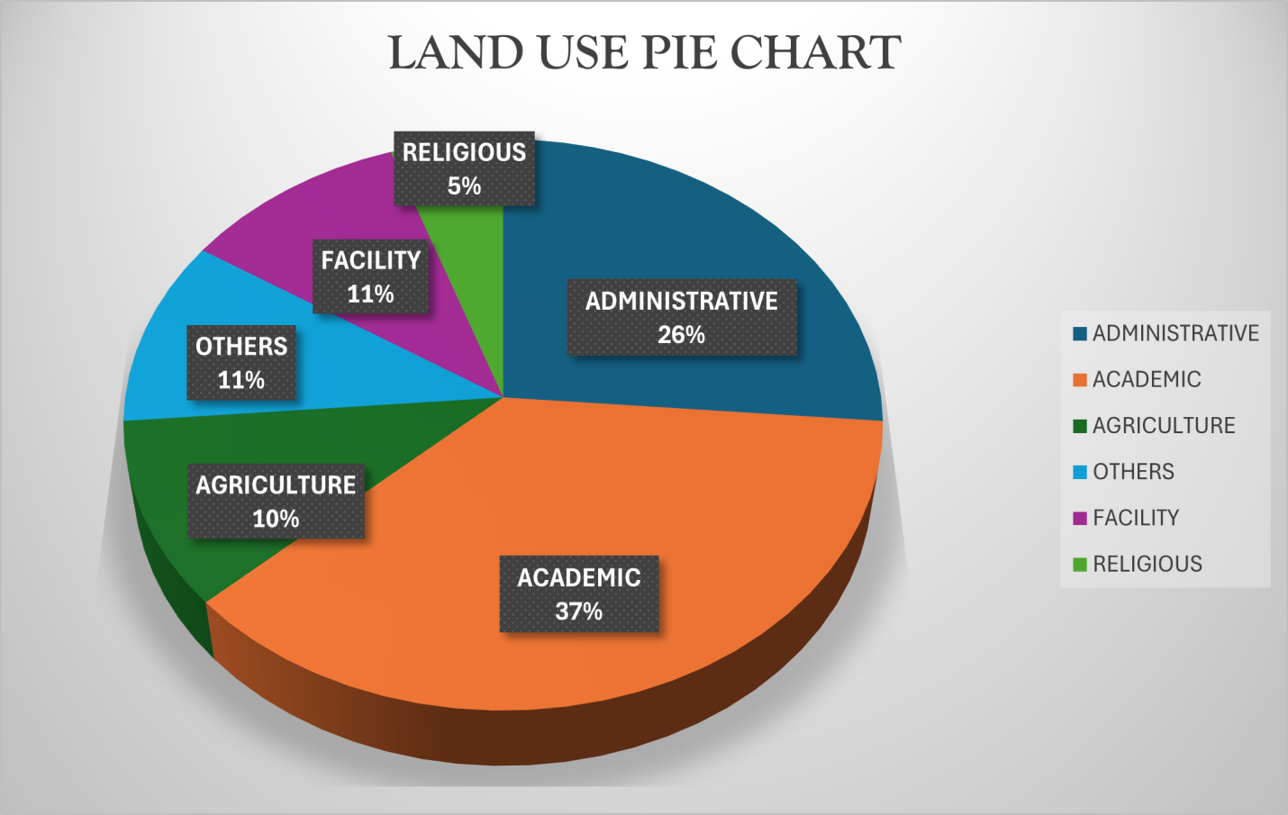
Figure 4.2.2.7: LAND USE PIE CHART

4.4 APPLICATION OF PROJECT
- Generally DSM is applicable in urban development modeling.
- It enhanced visualization and communication of such data not only in maps modeling but also in mobile digital devices for quick navigation and assessment.
- To create a sustainable and favourable living environment.
- Positioning and monitoring of physical features, structures and engineering works on, above or below the surface of the earth to protect properties or investment.
- The feasibility studies through the use of line of sight analysis provide visibility between two points. This is good for network distribution in telecommunication.
- The profile graph is good road construction which will provide the cross section of the topography from which rivers, streams and depression can be shown. Points require bridges, culverts and filling can be known from the profile graph.
- The vector map shows the direction of rivers, streams and depression which helps in road construction.
- The aspect map shows the direction of the surface faces. It is used to determine how much sun a hill received and the information can be used to put building where they will get enough sun also used to find where different crop will do best and also the Converging/diverging flow; soil water properties.
- The aspect map shows the suitable place for plane landing i.e. the flat terrain area and also solar illumination which can affect the diversity of life i.e. Vegetation and soil studies; glaciology.
- The result from the analysis can be help in managing the land resources of the project area. With the DSM, adequate information has been provided for proper decision making on the school land. Proper allocation various land use can now be done without difficulty in the decision making process.
- The slope map which is used to find low- slope for potential construction site and high slope that may be vulnerable to erosion or landslide.
- Also, the slope map shows slope length which is important topographical parameters for soil erosion analysis and traditional soil erosion studied
- Contour map of the project area can aid in giving information on the highest point on the terrain as well as the lowest. This is important in Road construction and location of other facilities like storage tank for water distribution.

CHAPTER FIVE

5.0 SUMMARY, CONCLUSION, RECOMMENDATION AND COSTING ANALYSIS.

5.1 SUMMARY
In summary, this project is centered on the development of a high-resolution Digital Surface Model (DSM) for a selected area within Kwara State Polytechnic, Ilorin, using total station surveying techniques. The main objective is to produce accurate topographic information and generate a detailed DSM for spatial analysis, infrastructure planning, and environmental assessment.
The project involves the systematic collection of elevation and positional data across the study area using a total station, which provides precise horizontal and vertical measurements. Fieldwork will include establishing control points, conducting traverses where necessary, and capturing spot heights and structural features. The collected data will be processed using appropriate surveying and mapping software (e.g., AutoCAD Civil 3D, ArcGIS, or Surfer) to interpolate surface elevations and create the DSM.
The resulting DSM will reflect both natural terrain and man-made features, enabling analysis such as slope determination, elevation profiling, and drainage mapping. The accuracy and resolution of the model will be evaluated based on the density and distribution of observed points.
Ultimately, this project demonstrates the effective use of traditional surveying equipment for digital terrain modeling and supports enhanced decision-making in land development, engineering design, and academic research within Kwara State Polytechnic.

5.2 PROBLEMS ENCOUNTERED
The problem encountered in the course of carrying out this project was:
- Refusal of the management of the Institution to approve the letter of permission given to us initially, which delays the execution of the project in time.
- Harsh weather condition as there is burning sun on the day of data acquisition
- Financial challenges
- Inconsistent weather conditions such as rain and harsh sunlight affected fieldwork and equipment performance.
- Physical obstructions like buildings, trees, and moving vehicles caused difficulty in capturing continuous surface data.
- Fatigue from long hours in the field affected concentration and increased the risk of human error.
- Inadequate internet access slowed down research, cloud sync, and software updates

5.3 CONCLUSION
The successful execution of the Digital Surface Model (DSM) project for a portion of Kwara State Polytechnic marks a significant step toward improved spatial understanding and digital terrain analysis within the institution. Through the integration of modern geospatial techniques—such as ground-based data acquisition and digital processing—a detailed representation of the surface features, including buildings, vegetation, and other topographical elements, was achieved.
This DSM serves as a valuable resource for various applications, including planning, infrastructure development, environmental assessment, and flood modeling. The project not only enhanced the accuracy of surface representation but also demonstrated the practical value of remote sensing and surveying technologies in academic and institutional environments.
Despite minor challenges such as data noise and occlusions, the final model met acceptable accuracy standards and provided a reliable spatial reference for future planning and research purposes within the Polytechnic. The experience gained further reinforces the importance of spatial data infrastructure in supporting informed decision-making and sustainable development.
Aim of generating high resolution DSM for the part of Kwara stat polytechnic. Ilorin, Kwara state was achieved through the application of GIS to generate the topographical information of the project area adopting the use of ArcGIS 10.5 and ArcScene 10.5 software for the product generation and Topographic analysis

5.4 RECOMMENDATIONS
Based on the experience gained during the execution of this project, the following recommendations are proposed to improve the quality, efficiency, and impact of similar surveying and geospatial modeling tasks in the future:
- Adoption of Advanced Survey Technologies
- The institution should invest in modern equipment such as drones (UAVs), 3D laser scanners, and high-precision GNSS receivers to enhance data accuracy and coverage, especially for large or inaccessible areas.
- Regular Spatial Data Updates
- To ensure effective campus planning and infrastructure management, periodic updates to spatial datasets and DSMs should be encouraged, particularly in rapidly changing or developing areas of the polytechnic.
- Capacity Building and Training
- More training sessions and workshops should be organized for students and staff on the use of GIS, remote sensing software, and digital modelling tools. This will bridge the gap between theory and field application.
- Improved Access to Software and Computers
- There should be more accessible, licensed versions of processing software (e.g., ArcGIS, AutoCAD Civil 3D, Global Mapper) and high-performance computers in the surveying lab to support effective data processing and analysis.
- Collaboration with Industry Professionals
- Future projects can benefit from partnerships with government agencies, surveying firms, or GIS companies to gain real-world insights, mentorship, and access to additional data or tools.
- Backup and Data Management
- Proper data storage, naming conventions, and backup practices should be emphasized to prevent data loss and confusion during processing.
- More Student-Led Projects
- Projects like this should be encouraged as part of practical coursework. They foster hands-on learning, innovation, and contribute to the Polytechnic’s development through student efforts.
- As GIS becomes the new phase of surveying, more GIS related practical to the students so as to harness what improved technology is introducing.

5.4 COSTING ANALYSIS

Costing of the project relied on the prevailing Scale of Fees approved by the Nigerian Institution of Surveyors and the Federal Government of Nigeria. It was calculated primarily on direct field costs, considering personnel, equipment, beaconing, transportation, and other contingencies. Personnel costs were determined by the man’s daily rate, equipment costs by hiring rates, and consumable materials by their respective charges. The utilization of modern equipment notably reduced the overall duration of the project. The actual costing was based on the parameters outlined in the project scheduling, which included the following job contents.

1. Project Planning and Reconnaissance
Item | Quantity | Rate (₦) | Days | Total (₦)
Supervisor | 1 | 30,000 | 1 | 30,000
Technologist | 1 | 22,000 | 1 | 22,000
Technicians (x3) | 3 | 15,000 | 1 | 45,000
Transportation | 1 | 25,000 | 1 | 25,000
Equipment rental (GPS/TS) | 1 | 35,000 | 1 | 35,000
Subtotal |  |  |  | ₦157,000

2. Data Acquisition
Item | Quantity | Rate (₦) | Days | Total (₦)
Technologist | 1 | 22,000 | 2 | 44,000
Technicians (x3) | 3 | 15,000 | 2 | 90,000
Equipment rental | 1 | 35,000 | 2 | 70,000
Transportation | 1 | 25,000 | 2 | 50,000
Field consumables | 1 | 10,000 | 1 | 10,000
Subtotal |  |  |  | ₦264,000

3. Data Processing and DSM Generation
Item | Quantity | Rate (₦) | Days | Total (₦)
Technologist | 1 | 22,000 | 3 | 66,000
Personal computer usage | 1 | 10,000 | 3 | 30,000
Software licensing/support | 1 | 25,000 | 1 | 25,000
Internet/Data for cloud sync | 1 | 5,000 | 1 | 5,000
Subtotal |  |  |  | ₦126,000

4. Map Production & Presentation
Item | Quantity | Rate (₦) | Days | Total (₦)
Technician (map layout) | 1 | 15,000 | 2 | 30,000
Plotting/Printing | 1 | 10,000 | 1 | 10,000
Consumables (ink, paper) | 1 | 8,000 | 1 | 8,000
Subtotal |  |  |  | ₦48,000

5. Report Compilation and Final Submission
Item | Quantity | Rate (₦) | Days | Total (₦)
Student report writing | 1 | 0 (self) | — | 0
Printing & binding (5 copies) | 1 | 5,000 | 1 | 5,000
Flash drive/digital storage | 1 | 3,000 | 1 | 3,000
Subtotal |  |  |  | ₦8,000

Phase | Cost (₦)
Planning & Reconnaissance | 157,000
Data Acquisition | 264,000
Data Processing & DSM Generation | 126,000
Map Production & Presentation | 48,000
Report Writing & Submission | 8,000
Total Project Cost | ₦603,000

REFERENCES
Al-Soghir, M., Mohamed, A., El-Desoky, M., & Awad, A. (2022): Comprehensive Assessment of Soil Chemical Properties for Land Reclamation Purposes in the Toshka Area, EGYPT. Sustainability, 14, 15611.https://doi.org/10.3390/su142315611
Balasubramanian, A. (2017): DIGITAL ELEVATION MODEL (DEM) IN GIS. https://doi.org/10.13140/RG.2.2.23976.47369
Benedek, C., Majdik, A., Nagy, B., Rozsa, Z., & Sziranyi, T. (2021): Positioning and perception in LIDAR point clouds Digital Signal Processing, 119, 103193. https://doi.org/10.1016/j.dsp.2021.103193.
Biljecki, F., Stoter, J., Ledoux, H., Zlatanova, S., & Coltekin, A. (2015): Applications of 3D City Models: State of the Art Review. ISPRS International Journal of GeoInformation, 4, 2842–2889. https://doi.org/10.3390/ijgi4042842.
Boyle, S., Kennedy, C., Torres, J., Colman, K., Pérez-Estigarribia, P. E., & De La Sancha, N. (2014): High-Resolution Satellite Imagery Is an Important yet Underutilized Resource in Conservation Biology. PloS One, 9, e86908. https://doi.org/10.1371/journal.pone.0086908.
El Garouani, A., Alobeid, A., & Garouani, S. (2014): Digital Surface Model based on aerial image stereo pairs for 3D Building. International Journal of Sustainable Built Environment, 3. https://doi.org/10.1016/j.ijsbe.2014.06.004.
Ezeomedo, I. (2019): ROLE OF LAND SURVEYORS AND GEOSPATIAL ENGINEERS IN THE BUILT ENVIRONMENT. Vol 2, pp 102-117.
Florinsky, I. (2016): Digital Terrain Analysis in Soil Science and Geology (p. 486).
Forkuo, E. K. (2008): DIGITAL TERRAIN MODELING IN A GIS ENVIRONMENT.
Haleem, A., Javaid, M., Qadri, M. A., & Suman, R. (2022): Understanding the role of digital technologies in education: A review. Sustainable Operations and Computers, 3, 275–285. https://doi.org/10.1016/j.susoc.2022.05.004.

APPENDICES

COORDINATE LIST

Detail E N ELEVATION
679549.147 940622.115 349.661
679571.054 940634.161 349.647
679592.961 940646.207 349.647
679614.867 940658.253 357.133
679636.911 940670.039 4330
679659.764 940680.158 349.661
679683.38 940688.339 349.661
679707.585 940674.572 349.647
679731.947 940700.18 349.661
679,756 940705.789 349.661
679780.673 940711.397 349.647
679805.036 947717.006 349.647
679829.399 940722.614 357.133
679853.761 940728.223 349.635
679878.124 940733.831 350.567
679902.468 940739.52 349.731
679926.406 940746.703 350.484
679949.664 940755.852 350.233
679972.079 940766.906 350.012
679993.497 940779.788 349.347
680013.768 940794.407 349.402
680032.752 940810.663 349.661
680050.318 940808.441 349.661
680067.208 940846.873 349.647
680084.097 940865.305 349.647
680100.986 940883.738 357.133
680177.876 940902.17 349.635
680134.765 940920.602 350.567
680151.654 940939.034 349.731
680168.544 940957.467 350.484
680185.433 940975.899 350.233
680202.323 940994.331 350.012
680219.212 941012.764 349.347
680236.101 941031.196 349.402
680252.991 941049.628 349.661
680269.88 941068.06 349.661
680286.77 941086.493 349.647
680303.996 941104.607 349.647
680322.097 941121.847 357.133
680341.038 941138.161 349.635
680360.77 941153.507 350.567
680381.244 941167.848 349.731
680402.41 941181.148 350.484
680424.213 941193.373 350.233
680446.601 941204.494 350.012
680469.485 941214.558 349.347
680492.472 941224.39 349.402
680595.455 941234.233 349.661
680538.44 941244.055 349.661
680561.426 941253.888 349.647
680584.411 941263.72 349.647
680677.396 941273.552 357.133
680630.382 941283.385 349.635
680653.367 941293.271 350.567
680676.352 941303.05 349.731
680699.337 941312.882 350.484
680722.323 941322.547 350.233
680745.308 941342.379 350.012
680768.296 941352.212 349.347
680791.279 941362.044 349.402
680814.264 941371.877 349.661
680837.249 941381.779 349.661
680869.234 941391.542 349.647
680883.22 941401.374 349.647
680906.205 941411.206 357.133
680929.19 941421.039 349.635
680952.175 941430.871 350.567
680975.161 941440.774 349.731
680998.146 941450.334 350.484
681021.216 941459.483 350.233
681044.482 941468.576 350.012
681067.77 941477.669 349.347
681091.057 941486.761 349.402
681114.345 941495.854 356.33
681160.921 941504.947 333.336
681184.209 941514.039 350.561
681207.496 941523.132 350.528
681230.784 941532.225 349.57
681254.072 941541.318 349.314
681277.36 941550.411 336.852
681300.248 941559.503 336.426
681323.935 941568.596 336.839
681347.223 941577.689 336.841
681370.511 941586.782 346.601
681393.799 941595.874 335.186
681417.087 941604.967 346.322
681440.374 941614.06 346.327
681463.662 941623.153 346.33
681486.95 961632.245 335.276
681510.238 941641.338 335.358
681533.526 941650.431 335.304
676356.26 938198.37 335.258
676368.289 938195.409 356.33
636364.319 938192.449 333.336
676368.348 938189.448 350.561
676372.377 938186.528 350.528
676376.407 938183.568 349.57
676380.436 938180.607 349.314
676384.465 938177.647 336.852
676388.495 938174.686 336.426
676392.524 938171.726 336.839
676396.553 938168.765 336.841
676400.583 938165.805 346.601
676404.612 938160.847 335.186
676408.648 938159.892 346.322
676412.698 938156.961 346.327
676416.763 938154.049 346.33
676420.842 938151.158 335.276
676424.936 938148.287 335.358
676429.044 938145.437 335.304
676433.158 938142.596 335.258
676437.272 938139.754 356.33
676441.386 938136.913 333.336
676445.5 938134.071 350.561
676449.615 938131.229 350.528
676453.729 938128.388 349.57
676457.843 938125.546 349.314
676461.957 938122.705 336.852
676466.071 938119.863 336.426
676470.185 938117.022 336.839
676474.299 938114.18 336.841
676478.415 938111.341 346.601
676482.538 938108.541 335.186
676486.49 938105.7 346.322
676490.808 938102.89 346.327
679494.943 938100.08 346.33
676499.079 938097.271 335.276
676503.215 938094.461 335.358
676507.351 938091.651 335.304
676511.487 938088.841 335.258
675515.622 938086.031 356.33
676519.758 938083.222 333.336
676523.894 938080.412 350.561
676528.03 938077.602 350.528
676532.166 938074.792 349.57
676536.302 938071.982 349.314
676540.437 938069.173 336.852
676544.573 938066.363 336.426
676548.709 938063.553 336.839
676552.845 938060.743 336.841
676556.981 938057.934 346.601
676561.117 938055.124 335.186
676565.252 938052.314 346.322
676569.388 938049.504 346.327
676573.524 938046.694 346.33
676577.66 938042.885 335.276
676581.796 938041.075 335.358
676585.932 938038.265 335.304
676590.067 938035.455 335.258
676594.205 938032.647 335.354
676598.354 938029.857 335.526
676602.517 938027.088 346.038
676606.694 938024.34 346.075
676610.884 938021.612 346.127
676615.086 938019.902 335.887
676619.289 938016.194 335.276
676623.492 938013.486 335.358
676627.695 938010.778 335.304
676631.898 938008.069 335.258
676636.101 938005.361 335.354
676640.302 938002.649 335.526
676644.48 937999.903 346.038
676648.63 937997.114 346.075
676652.759 937994.294 346.127
676656.887 937991.472 335.887
676661.014 937988.65 348.773
676665.142 937985.829 349.333
676669.269 937983.006 349.333
676673.397 937980.185 348.33
676677.525 937977.363 335.354
676681.652 937974.541 335.354
676685.78 937971.719 335.526
676689.907 937968.897 346.038
676694.035 937966.075 346.075
676698.162 937963.253 346.127
676702.29 937960.431 335.887
676706.417 937957.609 335.276
676710.545 937951.965 335.358
676714.672 937949.143 335.304
676718.8 937946.321 335.258
676722.927 937943.521 335.354
676727.069 937940.818 335.526
676731.276 937938.221 346.038
676735.548 937935.732 346.075
676739.885 937933.345 346.127
676744.278 937930.981 335.887
676748.684 937928.616 348.773
676753.089 937926.252 349.333
676757.495 937923.888 349.333
676761.901 937921.524 348.33
676766.307 937919.16 335.354
676770.713 937919.16 349.661
676775.118 937916.196 349.661
676779.524 937914.432 349.647
676783.93 937912.068 349.647
676788.336 937909.103 357.133
679950.479 946498.189 349.661
679950.491 946498.191 349.661
679950.504 946498.018 349.647
679950.518 946498.081 349.647
679934.511 946685.294 357.133
679950.555 946498.085 349.635
679767.154 946487.096 350.567
679889.863 946495.087 349.731
679908.552 946495.934 350.484
679922.324 946485.237 350.233
679938.369 946482.334 350.012
YB 679942.726 946447.667 349.347
YB 679951.616 946494.93 349.402
muu 679954.166 946493.685 356.33
zsu 680052.252 946663.441 333.336
Pl 679877.555 946362.24 350.561
kp704cp 679790.101 946612.117 350.528
Rd1 679797.106 946608.52 349.57
Rd1 679798.963 946607.102 349.314
PL1 679951.493 946504.835 336.852
PL2 679778.794 946218.243 336.426
PL3 679773.011 946212.525 336.839
Rd2 679776.97 946218.623 336.841
Rd2 679776.992 946218.657 346.601
Rd2 679874.136 946428.193 335.186
679884.297 946419.018 346.322
679874.159 946428.114 346.327
679935.313 946390.241 346.33
679761.812 946401.236 335.276
IOT 679767.23 946400.507 335.358
IOT 679766.877 946397.766 335.304
IOT 679767.39 946393.899 335.258
IOT 679768.185 946392.132 335.354
IOT 679780.852 946390.63 335.526
Ep 679787.141 946389.368 346.038
Ep 679796.626 946383.742 346.075
IOT 679795.987 946382.484 346.127
IOT 679802.37 946376.284 335.887
IOT 679797.038 946362.095 335.276
IOT 679798.791 946356.995 335.358
IOT 679799.368 946350.984 335.304
IOT 679811.452 946351.109 335.258
IOT 679809.795 946338.021 335.354
IOT 679808.56 946332.144 335.526
IOT 679856.7 946402.607 346.038
IOT 679865.099 946413.267 346.075
AUD 679868.065 946417.833 346.127
AUD 679874.472 946430.042 335.887
AUD 679821.234 946466.003 348.773
AUD 679796.705 946483.775 349.333
RD1 679802.487 946480.038 349.333
RD1 679824.499 946474.962 348.33
STL 679992.15 946412.203 335.354
ACC 679928.325 946404.352 335.526
ACC 679947.108 946413.144 346.038
ACC 679966.022 946430.1 346.075
TREE 679954.869 946416.095 346.127
TREE 679951.942 946418.633 335.887
TREE 679946.089 946403.635 348.773
679955.07 946420.288 349.333
679970.027 946416.214 349.333
679949.719 946391.003 348.33
EP 679953.97 946390.006 335.354
679940.811 946369.187 335.526
679926.79 946376.368 346.038
679917.705 946382.196 346.075
679921.791 946399.618 346.127
679902.133 946412.212 335.887
679886.129 946422.819 348.773
679880.055 946408.541 349.333
679894.626 946399.673 349.333
679908.308 946390.299 348.33
67896.923 946375.722 335.887
679981.384 946376.767 348.773
STL 679878.204 946367.443 349.333
WT 679875.94 946369.131 349.333
WT 679876.93 946371.023 348.33
WT 679879.252 946369.096 335.276
WT 679881.127 946385.816 335.358
679869.276 946393.585 335.304
679903.999 946366.986 335.258
MSQ 679916.947 946363.527 335.354
MSQ 679910.932 946354.601 335.526
MSQ 679900.085 946357.584 346.038
MSQ 679912.022 943330.948 346.075
CARP 679908.229 946326.306 346.127
CARP 679872.245 946368.601 335.887
CARP 679868.541 946364.229 335.276
CARP 679863.66 946350.6 335.358
RECTOR 679879.993 946341.304 335.304
RECTOR 679868.976 946925.282 335.258
RECTOR 679873.052 946312.293 335.354
RECTOR 679866.974 946302.191 335.526
RECTOR 679842.011 946372.685 346.038
RECTOR 679842.007 946372.683 346.075
679844.923 946386.445 346.127
679830.916 946371.166 335.887
679818.994 946358.6 348.773
679805.906 946377.496 349.333
679809.597 946383.496 349.333
679816.535 946393.23 348.33
EP 6798626.452 946405.202 347.586
679808.254 946421.525 335.276
679799.138 946408.163 335.358
679791.397 946395.303 335.304
679773.316 946398.098 335.258
679767.303 946409.27 335.354
679770.338 946414.894 335.526
TREE 679782.687 946419.253 346.038
679795.94 946435.294 346.075
679802.913 946438.451 346.127
679790.889 946448.778 350.752
STL 679790.165 946418.168 349.338
EP 679809.615 946383.514 348.733
EP 679822.886 946353.509 349.029
679828.814 946348.826 349.377
679840.564 946345.286 349.179
EP 679850.537 946338.807 348.3302
679916.014 946412.481 353.37
676917.035 946433.207 353.3308
ACC 679936.018 946460.231 355.228
ACC 679969.032 946503.296 356.711
WIREFENCE 679959.048 946497.993 356.208
679944.204 946506.013 355.33
679930.437 946512.695 350.752
679919.293 946494.447 349.338
679928.906 946485.964 348.733
679939.243 946476.365 349.029
679929.081 946460.821 349.377
679914.112 946468.615 349.179
679904.141 946472.315 348.3302
679887.739 946444.47 353.37
679899.748 946438.196 353.3308
679913.373 946434.103 355.228
679844.744 946322.441 356.711
679835.358 946308.958 356.208
679820.262 946317.617 355.33
679811.268 946322.831 350.752
679792.405 946308.835 349.338
679810.85 946298.029 348.733
679823.981 946295.136 349.029
679808.038 946293.822 349.377
EP 679804.218 943278.115 349.179
679800.779 946273.668 348.3302
TREE 679791.67 946264.05 344.233
TREE 679803.187 946266.737 335.15
RD3 679812.433 946259.653 335.231
RD3 679813.059 946259.106 335.011
AUD 679822.607 946253.774 335.272
AUD 679791.984 946234.386 333.705
RD3 679786.581 946232.487 333.033
RD3 689758.276 946229.73 342.651
EP 679757.229 946231.852 342.609
679776.672 946852.809 344.233
679776.674 946282.812 335.15
PL5 679776.684 946282.8 335.231
PL5 679729.76 946217.895 335.011
IOT 679724.982 946202.784 335.272
IOT 679720.122 946191.069 333.705
IOT 679727.667 946189.137 333.033
IOT 679731.729 946185.142 342.651
IOT 679732.753 946173.222 342.609
IOT 679731.566 946156.504 344.233
IOT 679736.458 946160.546 335.15
IOT 679748.502 946150.008 335.231
IOT 679763.547 946135.015 335.011
IOT 679765.932 946123.941 335.272
IOT 679755.728 946154.631 333.705
IOTCAR 679761.208 946165.795 333.033
IOTCAR 673761.328 946181.224 342.651
IOTCAR 679759.198 946190.102 342.609
IOTCAR 679756.778 946198.261 344.233
IOTCAR 679748.325 946209.728 335.15
IOTCAR 679738.387 946216.575 335.231
IOTCAR 679729.133 946193.58 335.011
IOTCAR 679791.431 946273.704 335.272
PL5 679780.157 946220.381 333.705
PL4 679842.028 946222.811 333.033
AUD 6798280275 946219.97 347.857
RD 6798270872 946217.076 347.829
RD 679701.552 946284.126 350.326
PL6 679711.47 946286.216 350.3303
679726.233 946282.318 350.207
679749.786 946279.757 350.309
679766.964 946277.688 350.763
679778.44 946275.937 350.732
679916.412 946440.847 353.3304
679967.317 946502.488 351.3305
LAB 679953.447 946495.441 352.013
LAB 679932.711 946484.612 347.857
LAB 679918.429 946477.254 347.829
LAB 679896.597 946519.121 350.326
LAB 679894.309 946524.58 350.3303
679887.459 946513.309 350.207
679877.034 946506.23 350.309
679866.745 946499.249 350.763
679877.531 946479.312 350.732
679890.763 946484.201 353.3304
679903.82 946489.798 351.3305
679914.965 946471.205 352.013
679899.523 946464.72 347.857
STREETLIGHT 679888.742 946459.561 347.829
679893.393 946446.288 350.326
679893.348 946446.299 350.3303
679905.506 9464510413 350.207
679920.122 946454.749 350.309
679889.219 946537.761 350.763
679878.716 946559.804 350.732
LAB 697842.259 946566.147 353.3304
LAB 679841.218 946557.973 351.3305
LAB 679841.226 956557.965 352.013
679841.179 946547.3 351.641
679859.662 946543.615 350.33
679863.356 946555.265 350.265
679880.926 946552.61 349.3308
679881.131 946539.771 350.088
679894.893 946550.513 349.313
679929.131 946546.304 348.562
679910.9 946533.748 348.833
679922.266 946531.412 348.533
679923.969 946538.261 347.3301
679925.312 946544.538 348.529
679920.956 946549.028 347.3301
679937.632 946530.579 347.28
679942.359 946540.665 350.33
679961.886 946536.949 350.265
679954.955 946533.448 349.3308
676899.008 946540.596 350.088
679595.563 926077.774 349.313
679584.498 926096.94 348.562
679610.828 926041.662 348.833
679530.083 926071.317 348.533
680136.869 946468.048 347.3301
PL1 680118.501 946563.078 348.529
PL2 680162.982 946533.033 347.3301
680143.539 946535.543 347.28
680135.188 946537.814 350.33
680129.161 946540.4 350.265
680122.031 946540.418 349.3308
680124128 946534.5 350.088
680135.503 946524.907 349.313
680126.966 946526.341 348.562
BLD 680117.808 946509.489 348.833
BLD 680099.807 946519.512 348.533
BLD 680087221 946500.313 347.3301
BLD 680112.801 946482.968 348.529
BLD 680108.689 946476.814 330.611
BLD 680121.514 946477.457 330.533
6801127.184 946485.028 330.153
680130.068 946491.122 330.333
680139.799 946482.89 330.115
680138.212 946490.96 330.633
680144.614 946499.432 331.325
680137.673 946509.715 331.3308
680148.336 946516.23 332.375
680119.823 946500.707 330.782
680107.316 946507.273 330.3308
680090.498 946515.917 330.611
680087.674 946510.725 330.533
680102.204 946503.742 330.153
680118.045 946493.463 330.333
680117.252 946475.535 330.115
680111.624 946463.279 330.633
680103.628 946455.397 331.325
680090.966 946444.463 331.3308
680083.202 946449.399 332.375
680073.893 946456.352 330.782
680079.016 946462.359 330.3308
680083.982 946469.515 330.611
680090.234 946464.677 330.533
680072.27 946470.994 330.153
680065.653 946471.062 330.333
680089.305 946429.839 330.115
680080.898 946436.514 330.633
680074.493 946442.448 331.325
680067.942 946444.048 331.3308
680060.661 946444.139 332.375
680057.18 946437.511 330.782
680053.972 946430.704 330.3308
680060.373 946426.062 330.783
680066.994 946421.446 330.88
680074.955 946416.657 330.03
680080.257 946413.373 330.26
680075.453 946407.571 330.3308
680067.385 496404.576 330.575
680060.997 946409.008 330.313
980055.631 946412.843 330.276
680049.554 946408.475 330.3308
680043.739 956401.831 330.577
680051.182 946398.539 330.72
680057.742 946394.685 330.855
680052.102 946389.309 330.57
680034.027 946378.19 330.378
BLD 680039.434 946385.919 330.379
BLD 680029.451 946392.61 330.33
BLD 680064.95 946449.304 330.116
BLD 680072.991 946462.481 330.178
BLD 680060.274 946470.863 330.3306
BLD 680026.388 946279.188 330.553
CP1 680026388 946279.188 330.553
CP1 687969.31 946303.241 330.035
CP1 679967.787 946291.188 330.722
CP2 679915.507 945264.285 330.035
PT4 679938.317 946279.995 330.722
BLD 679960.805 946294.594 330.429
BLD 679944.446 946328.264 330.3306
BLD 679957.896 946322.486 330.859
679965.619 946311.485 330.622
679970.16 946304.965 330.05
679940.921 946298.082 330.256
679970.341 946298.082 330.731

