THE INSTALLATION OF 4.2KVA HYBRID
INVERTER

BY

BADMUS AHMED ABIODUN
ND/23/EEE/FT/0024

SUBMITTED TO

THE DEPARTMENT OF ELECTRICAL/ELECTRONICS ENGINEERING,
INSTITUTE OF TECHNOLOGY,
KWARA STATE POLYTECHNIC, ILORIN.

IN PARTIAL FULFILMENT OF THE REQUIREMENTS FOR THE AWARD OF NATIONAL DIPLOMA (ND) CERTIFICATION IN ELECTRICAL/ELECTRONICS ENGINEERING.

JULY, 2025

CERTIFICATION
This is to certify that this project work was carried out by Badmus Ahmed Abiodun of matriculation number ND/23/EEE/FT/0024 in the department of Electrical/Electronic Engineering, Kwara State Polytechnic in partial fulfilment of the requirements for the award of National Diploma (ND) certificate in Electrical/Electronic Engineering.

_________________________ ________________
ENGR. SANNI MUMINI DATE
(Project Supervisor)

____________________________ ___________________
ENGR. ABDULKADIR Z. A DATE
(Project Coordinator)

________________________ ___________________
ENGR. O. A. LAWAL DATE
(Head of Department)

__________________________ _______________________
EXTERNAL EXAMINER DATE

DEDICATION
This project is dedicated to Almighty Allah, the One who grants purpose to every journey and strength for every step. I also dedicate it to Mr and Mrs Badmus, and all my humble family a figure of quiet wisdom and unwavering support. Your words often came at the right moments not to impress, but to strengthen. You reminded me that calmness and clarity are equally powerful in moments of pressure. May your life continue to reflect growth, grace, and greatness.
.

ACKNOWLEDGEMENT
All gratitude belongs to Almighty Allah, who in His infinite mercy and kindness granted me the knowledge, patience, and resilience needed to complete this academic work. Without His divine favour, none of this would have been possible.
I extend my deepest appreciation to my project supervisor, Engr. Sanni Mumini, for his excellent guidance, open-minded approach, and firm academic discipline. His ability to identify both the strengths and weaknesses of my work helped me make necessary improvements and gain a deeper understanding of my project.
My sincere thanks also go to our dedicated project coordinator, Engr. Abdulkadir Z.A, whose commitment to ensuring smooth progress and timely feedback kept me on track. I equally appreciate Engr. O.A. Lawal, the Head of Department, for creating an enabling academic environment through his strong and principled leadership.
I am also grateful to everyone who played a role in supporting me whether through words, actions, or silent prayers. Every contribution, no matter how small, added value to this journey. May Almighty Allah reward you all abundantly.

ABSTRACT
This project presents the installation and integration of a 4.2 kVA hybrid inverter system aimed at providing a stable and sustainable power solution. The setup includes 4.2KW-24VSMS hybrid inverters, supported by an array of eight monocrystalline solar panels four rated at 200 W and four at 250 which are connected in series to deliver a total of 1800 W. A battery bank, consisting of two 12 V 220 Ah lithium batteries connected in series to form a 24 V system, was implemented for energy storage. The installation process involved component selection, system sizing, wiring configuration, and compliance with safety standards. The hybrid system operates by combining solar energy and grid power to optimize energy availability while minimizing reliance on non-renewable energy sources. The successful implementation demonstrated the viability of small-scale hybrid energy systems, particularly in regions with inconsistent grid supply. The results emphasize the efficiency, reliability, and cost-effectiveness of hybrid inverter technology as a sustainable energy solution for residential and commercial applications.

TABLE OF CONTENTS

Title Page
Certification
Dedication
Acknowledgements
Abstracts
Table of Contents
CHAPTER ONE
INTRODUCTION
1.1 Background of the Study
1.2 Problem Statement
1.3 Aim & Objectives
1.4 Scope of the Study
1.5 Justification
CHAPTER TWO
LITERATURE REVIEW
2.1 Overview of hybrid inverter
2.1.2 types of hybrid inverter
2.1.3 Important feature of hybrid inverter
2.2 Technology related to hybrid inverter
2.2.1 Solar router
2.2.1.2 Red back technology
2.3 project related to hybrid inverter
2.3.1 Solar hybrid inverter
2.4 Usage of hybrid inverter during different modes.
2.4.1 Off grid mode
2.4.2 On grid mode
2.4.3 Hybrid mode
2.4.4 Backup mode
2.5 Solar panels
2.5.1 Types of solar panel
2.6 Battery bank
2.6.1 Types of Battery

CHAPTER THREE
DESIGN METHODOLOGY
3.1.1 Solar panels
3.1.2 Battery Bank
3.1.3 Hybrid Solar Inverter
3.1.4 DC Cables
3.1.5 AC Cables
3.1.6 Circuit Breaker
3.1.6.1 DC Circuit Breaker
3.1.6.2 AC Circuit Breaker
3.1.7 Mounting Hardware
3.2 Connection

CHAPTER FOUR
RESULTS TEST AND DISCUSSION
4.1 The Specifications of Solar power and Efficiency
4.2 The Generation of Solar power through the day
4.3 The Performance of the Battery
4.4 Hybrid Inverter Performance
4.5 Voltage Balance under Different load Condition
CHAPTER FIVE
CONCLUSION AND RECOMMENDATIONS
5.1 Conclusion
5.2 Recommendations
REFERENCES

LIST OF TABLES AND LIST OF FIGURES
TABLES
Table 2.1 Various solar cell panel…….
Table 3.1 Various size of components use in the installation……..
Table 4.1 The specification of solar panels and efficiency……….

FIGURES
Figure 1 Solar Router…………………..
Figure 2. Off Grid mode ………………
Figure 3.On Grid mode ………………
Figure 4.Hybrid mode……………
Figure 5.Backup mode…………..
Figure 6.A monocrystalline solar panel…….
Figure 7.A 12v 220Ah Tubular battery……
Figure 8.Hybrid Inverter…………………….
Figure 9. DC Cables………………………..
Figure 10. AC Cables…………
Figure 11.DC Circuit Breaker………..
Figure 12. AC Circuit Breaker………..
Figure13. Metal rack…………………
Figure 14. Illustrations of diagrammatic connection of Inverter……………
Figure 15. The Generation of Solar power through the day ………………………
Figure 16. Voltage Balance under Different load Condition…………

CHAPTER ONE
1. INTRODUCTION
In developing countries like Nigeria, interrupted power supply has posed a serious threat to economic development. That is to say, where there is an irregular power supply, there is no development. This is because uninterrupted or regular power supply is essential to promote and boost the economy of a country (Singh and Manga 2012).
Nevertheless, most companies, industrial, commercial, and even domestic, are dependent on public power supply, which has erratic supply such as phase failure, phase imbalances, or total power failure due to one or more technical problems or imbalances in power generation, transmission, or distribution (Adedokun and Osupidan, 2010).
In addition, electricity plays a major role in the economic development of any nation, but the supply keeps dwindling and is sometimes not enough in Nigeria. The increase in urbanization, development and offshoots of industries and companies keeps adding to the power instability and collapse Majority of industries. Nigeria suffers a lot of economic loss and revenue due to power instability and failure. Most of the time, the voltage supplied by the power companies is very low to power the load. The power plants are subjected to the usage of diesel engines to power them. This requires a lot of money to keep the engine running. Also, power instability and failure result in voltage surges, and they result in equipment/load failure or damage. Sometimes the impact of power disturbances and interruptions on a plant’s equipment and processes caused by voltage sag may require a complete restart of the load with hours of interrupted production. This causes substantial economic loss and load that are automated and have suffered a lot of setbacks due to power instability and failure.
The world's increasing demand for electricity has traditionally been met by grid-connected power plants. However, this reliance has led to numerous environmental, economic, and social challenges, including the depletion of fossil fuels, high energy costs, and the emission of greenhouse gases contributing to climate change. Additionally, the lack of skilled personnel to maintain and operate these conventional power systems further reduces the reliability and availability of electricity, with the growing dependency on electrical power for various aspects of human endeavors, such as sophisticated medical life-saving equipment, accurate data and processing machines, and the need for a more reliable and efficient power source, becoming crucial. In response, renewable energy sources, particularly hybrid inverter systems, have emerged as viable alternatives to address these challenges.
A hybrid solar inverter system integrates solar panels with battery storage, allowing electricity generation during the day and energy storage for later use, especially during power outages. This technology is particularly beneficial in developing countries like Nigeria, where unreliable grid power remains a persistent issue. By reducing dependence on the national grid.hybrid inverter system provide a stable and sustainable power solution, ensuring energy availability for households, businesses, and essential services.
This project focuses on the installation and comprehensive performance analysis of a 4.2 kVA hybrid solar inverter system designed to provide reliable power to the Institute of Technology, Kwara State Polytechnic, Ilorin. The system will consist of 12 solar panels with a combined peak power output of 6 kW, a battery bank with a capacity of 5.28 kWh, and a 4.2 kVA hybrid inverter. This installation aims to demonstrate the feasibility and effectiveness of hybrid inverter technology in mitigating the impact of frequent power outages, thereby reducing operational costs associated with diesel generators and minimizing revenue loss. The performance analysis will include data logging of power generation, consumption, and battery state of charge, as well as a cost-benefit analysis to evaluate the system's economic viability. This project will contribute to the understanding of the long-term potential of hybrid inverter systems as a sustainable and economically viable solution to Nigeria's persistent power challenges and also serve as a practical teaching aid for the students of the institute.

1.1 Aim of the project
This project aims to improve the Institute of Technology, Kwara State Polytechnic, Ilorin's energy sustainability and resilience through the integration of a reliable 4.2 kV hybrid solar inverter system and provide a practical educational platform for students, promoting the development of skills in renewable energy technologies.

1.2 OBJECTIVES OF THE PROJECT
⦁ Install a 4.2 kVA hybrid solar inverter system, including [Number] solar panels, a [Capacity] kWh battery bank, and a 4.2 kVA inverter, tailored to the Institute of Technology's energy consumption profile.
Analyze the impact of the hybrid solar inverter system on the availability and reliability of power for specific critical loads within the Institute of Technology, such as computer labs, workshops, and research equipment.
Evaluate the system's performance under varying weather conditions (e.g., during the rainy season, dry season, and periods of high solar irradiance) to determine its robustness and adaptability.
Develop a safety protocol for the system, and teach the maintenance officer how to safely operate and maintain the system.
To provide a source of electrical power with no running cost and low maintenance.

⦁ 1.3 PROBLEM STATEMENT
The current state of electricity in Nigeria is a major hindrance to economic development and quality of life. Power outages are a daily occurrence, leading to disruptions in businesses. loss of productivity and inconvenience. Reliance on diesel generators as a backup power source is not only costly but also harmful to the environment. Installation of this 4.2 kVA hybrid inverter will help to address these challenges by providing a more reliable and sustainable source of electricity.

1.4 SCOPE OF THE PROJECT
This project covers the installation of 4.2 kVA hybrid inverters to provide a reliable and efficient power backup solution. The work includes site assessment, procurement of the inverters and battery bank, electrical wiring and connection, system configuration, and testing. The hybrid inverter will be set up to automatically switch between grid, battery, and solar power, ensuring seamless operation and documentation of the installation for future reference.

1.5 JUSTIFICATION
⦁ This system provides a stable and uninterrupted power supply, reducing reliance on the national grid.
⦁ This integration ensures better energy management, leading to improved efficiency and sustainability.
⦁ By reducing dependence on the grid electricity and fuel-powered generators, long-term savings on energy costs can be achieved.
⦁ This project will provide valuable insights into the feasibility of hybrid inverters, contributing to research on renewable energy adoption and energy management.
CHAPTER TWO
2. LITERATURE REVIEW
2.1 Overview of hybrid inverter
The population of the world and its energy demands are increasing day by day. Today most of our energy demands are dependent on nonrenewable energy sources [1]. Due to the limited amount of nonrenewable energy resources, we can't depend on them forever; therefore, it is necessary to have some other sources of energy. According to a survey in 2015, 93 percent of electricity was being produced from a combination of coal, natural gas, hydropower plants, nuclear power plants, and oil, where only 7 percent was being produced from renewable energy sources. [2]. We must find a method to get more energy from renewable energy resources, as it is eco-friendly and economical. [3] Discuss the hybrid inverter system. When an AC power outage occurs, the battery storage should be preserved. The battery will be accurately charged by a solar AC grid source during the day or in muddy conditions when source light is available. In any case, the battery will be charged. [4] Introduce a hybrid energy system that uses solar power in addition to main power as its primary source. Depending on energy availability, the system design enables the battery to receive energy from the two sources and use it to power the load separately or simultaneously. That will be useful in rural and hilly regions. The paper focuses on a hybrid battery design and its application. In the design they were able to overcome the battery of solar energy limitations. An inverter powered by a 12-volt battery powers the solar battery charging system, and the inverter creates up to 230 V AC. Thus, batteries are charged from two sources: main power and solar energy. If the main power is available, then the relay switches to the main power supply for applying the load.
The hybrid inverter operates primarily on wind turbine, main power, and solar energy, providing a reliable power supply to loads under all conditions. This is because it functions as an uninterruptible power source, offering various operating modes such as solar and wind modes. If they are unavailable, the hybrid mode can be enabled as a backup [5]. A system that draws power from two or more sources is called a hybrid power system. Solar PV systems cannot generate electricity at night or in overcast conditions. In the winter, however, sunlight intensity is low, allowing for maximum electricity production. [6]. In the event that all energy sources are unavailable, a battery that is also connected to the system will serve as a backup power source. The electric utility will retain the power utilization from renewable energy sources and use it as a power source. As the electric power system becomes more dependable, a hybrid inverter has an advantage over a single power source.
2.1.2 types of hybrid inverter
[6] discusses in his paper that there are four hybrid inverters, which are the basic hybrid solar inverter, multimode hybrid solar inverter, all-in-one battery energy storage system (BESS), and advanced AC-coupled system.
Basic Hybrid Solar Inverter: This is a common type that allows solar energy storage in a battery but may not reliably supply power during outages as it isn't connected to the grid.
Multimode Hybrid Solar Inverter: An advanced inverter with a built-in backup or a separate unit, enabling battery charging and usage during power cuts.
All-in-one Battery Energy Storage System (BESS): This new hybrid solar inverter includes both batteries and an inverter, easily adaptable to existing solar systems.
Advanced AC-Coupled System: These systems employ a DEYE hybrid inverter for battery charging and are simple to use for powering AC loads, though slightly less efficient than DC-coupled systems. Efficiency can be improved by using multiple hybrid solar inverters.
2.1.3 Important feature of hybrid inverter
Hybrid inverters can operate during off-grid and on-grid conditions. During on-grid conditions, both energy sources, i.e., solar and grid, are used, whereas during off-grid conditions, stored energy in the battery is used to power household items, as mentioned by T. Mallickj et al. [7]. When the power generation is greater than the power demanded by loads, the controller decides how much power to deliver to the load and how much for the battery charging.
[8] mention that hybrid inverters play a crucial role in modern energy systems by:
Maximizing solar energy utilization: They efficiently convert DC power from solar panels to AC power for immediate use and simultaneously charge batteries for later consumption, reducing reliance on the grid.
Providing reliable backup power: During power outages, hybrid inverters seamlessly switch to battery power, ensuring critical appliances and systems remain operational.
Enabling energy independence: By storing excess solar energy, they allow homeowners and businesses to consume self-generated power, reducing electricity bills and dependence on traditional energy sources.
Facilitating smart energy management: Advanced hybrid inverters often integrate with smart home systems and energy management platforms, allowing users to monitor and control their energy consumption, optimize energy usage, and participate in demand response programs.
Integrating battery storage: The integration of battery storage into one device simplifies installation and reduces cost compared to separate solar and battery inverter systems.
Supporting off-grid applications: Hybrid inverters can be used in off-grid or microgrid applications, providing a reliable power source in remote areas or locations without grid access to national energy sources.
Advantages of hybrid inverter: higher power output, Reliable backup power, optimized solar energy cost savings, smart monitoring, and longer battery life.
2.2 Technology related to inverter
2.2.1 Solar router
Through an intuitive interface, the solar router also lets the user know how much electricity is generated, and control, optimization, and management of the generated energy are made possible by solar routers. [12]. Energy generated by a solar system that is not being used can be transferred to the national grid, and the amount of electrical energy being sent to it can be displayed. This solar router helps in selecting the energy source. For example, a consumer can choose the energy source manually, which may be solar or power from an electric utility company. [13]. Moreover, this system also allows you to control or monitor the hybrid system remotely through an application on a smartphone or on computers and laptops. [14]. show in the fiqure below
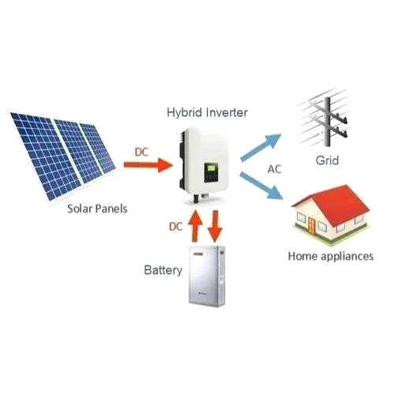
Fiqure.1 Solar router.
2.2.1.1 Features
⦁ compact in size
⦁ fully integrated with the national grid
⦁ reliable and strong construction
⦁ A built-in solar charger (MPPT)
⦁ 220v _ 240v (sine wave )
⦁ control microprocessor
⦁ A stable charge system
2.2.1.2 Red back technology
Redback Technology is a company that aims to change the way of electrical household usage. The hybrid system of this company stores solar energy during the daytime up to the maximum level by using batteries so that when there is unavailability of solar energy, power can be provided to the household items that operate on electricity. This initiative can help power authorities in many ways; for example, an owner can sell electricity produced by solar panels to the national grid.
Although there are many companies that are manufacturing hybrid inverters, Redback Technology is the only company that is popular for manufacturing a hybrid system that is economical to use. [15]. The Redback hybrid inverter was 30 percent less costly than that of other products. New safety measures are taken by Redback Technologies, as all switchgear is prewired and tested in the industry before releasing the product in the market. The Redback system is more adaptable and dynamic from the software perspective, and its architecture monitoring is being improved continuously.
2.3 Project related to hybrid inverter
2.3.1 solar hybrid inverter
A hybrid inverter is a new type of uninterruptible power supply (UPS) that supplies electrical energy for household items. Maximum production from solar panels is produced around midday. Electricity produced from solar is not enough, whereby the MPPT charge is used to yield the output at a desired voltage level, as illustrated. [16]. Hybrid inverters store maximum energy during the daytime, and then later on, this stored energy can be utilized during the night.
The output of a solar panel changes with the movement of the sun. If the sun is directly above the solar panel, we will get the maximum possible voltage, but if the sun is away from the panel, then the voltage will not be sufficient by Abdur Rafay and three others. [17]. So far, for making the output voltage constant, we use MPPT (maximum power point tracking ) charge control. Maximum power point tracking, or MPPT, charge control is what we employ. In essence, MPPT is a buck-boost converter that keeps the solar panel output voltage constant. The buck-boost converter will function as a buck-boost converter and scale down the voltage to a desired level if the sun is directly overhead, and the output voltage is high. In a similar manner, the converter raises the output voltage to the required amount if the sun is not penetrating the panel.
2.4 Usage of hybrid inverter during different modes.
There are 4 modes in which a hybrid inverter can be used. The modes are off-grid mode, on-grid mode, hybrid mode, and backup mode. The block diagram below will describe each of them.
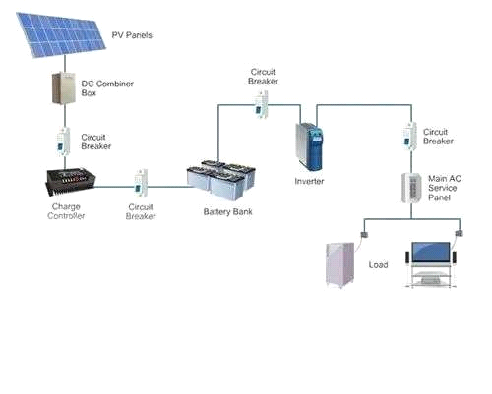
Fiqure.2 Off Grid mode.
2.4.1 Off Grid mode
Off-grid inverters are standalone systems, relying solely on solar and battery power. They convert DC power from solar panels and batteries into AC power for use in homes or businesses. They do not connect to the utility grid and operate independently. ALSO Rely on batteries for backup power during outages. And energy storage requires batteries for energy storage.[18].
A solar panel is linked to it during off-grid, and the battery bank should be connected to the inverter to provide power supply to the load.
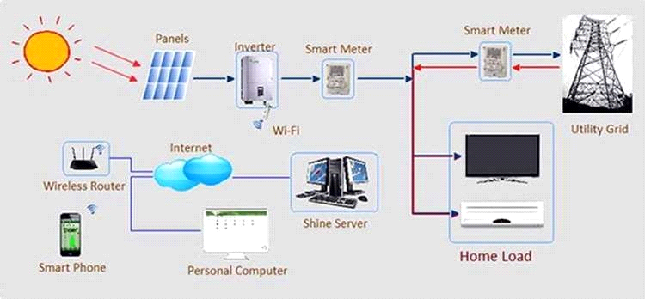
Fiqure. 3 On Grid mode
2.4.2. On Grid mode
On-grid modes are designed to work directly with the utility grid, feeding excess solar energy back into it and synchronizing its output with the grid's frequency and voltage.
On grid mode is used for selling extra energy to the national grid

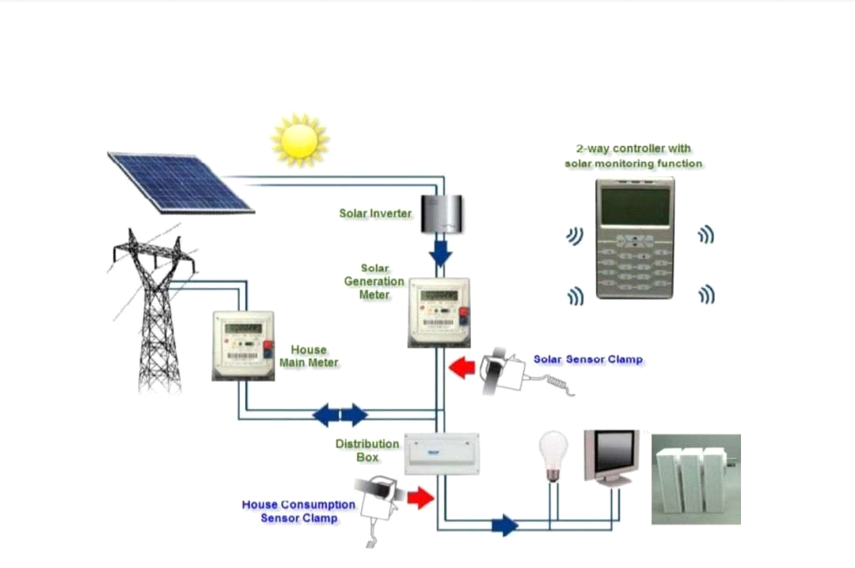
fiqure. 4 Hybrid mode.

2.4.3 Hybrid mode
Hybrid mode is the combination of off-grid and on-grid modes. A hybrid mode is created by combining a solar inverter and the main power source into a single unit. This allows the hybrid solar inverter to intelligently handle power coming from your solar panels, solar batteries, and the utility grid all at the same time.[19].
For smart energy management, we use hybrid mode in which battery bank operates the inverter.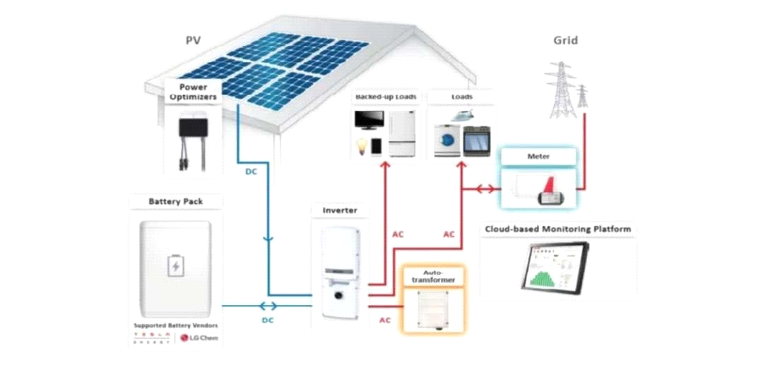
Fiqure. 5 Backup mode.
2.4.4 Backup mode
Backup mode is used when there is blackout and it switches itself to off grid system.[18].

2.5 SOLAR PANEL
A PV module, sometimes referred to as a solar panel or photovoltaic module, is a device that uses the photovoltaic effect to directly convert sunlight into electrical energy. It is an essential part of solar power systems, which use the sun to generate renewable energy. When exposed to sunlight, a PV module's numerous linked solar cells—which are usually composed of silicon-based materials—produce energy. To guarantee longevity and resilience to environmental influences, these solar cells are encased in a protective substance, like tempered glass. A flow of electricity is produced when photons in the sunlight activate the electrons in the solar cells on the PV module's surface. Direct current
DC is the form of electricity that is produced. An inverter is frequently used to transform DC power into alternating current (AC) electricity so that it is compatible with conventional electrical systems. PV modules differ in terms of efficiency, power output, and size. They can range from tiny panels for battery charging or powering little gadgets to huge installations for utility-scale solar power systems in residential or commercial settings. PV's output power, which is expressed in watts (W), depends on a number of variables, including the module's surface area, the solar cells' efficiency, and the amount of sunshine.
Over time, PV modules have grown more affordable and effective, which has helped solar energy become a more popular clean and sustainable electricity source. They play a
crucial role in utilizing solar energy for a variety of purposes, such as off-grid installations, remote power systems, and the production of electricity for homes and businesses. [20].
2.5.1 TYPES OF SOLAR PANEL
Monocrystalline solar panels are made from a single piece of silicon, therefore making it easier for electricity to flow through. They have a pyramid cell pattern, which offers a larger surface area, enabling monocrystalline PV panels to collect a greater amount of energy from the sun's rays.
Polycrystalline PV panels are created from several parts of silicon being melted together, which makes it more difficult for electricity to flow.
Thin-film PV panels are made from one or more layers and are the least efficient photovoltaic panels available. [21].
Concentrated photovoltaic power generation uses the same photovoltaic material as PV panels, and the solar radiation is concentrated through lenses on the material.
various solar cell panels available along with their efficiency, advantages, and disadvantages. [22].
types of solar panel | Efficiency  % | Advantages | Disadvantages
Monocrystalline panel | -20 | High lifetime and Efficiency, Used for commercial application | High Cost
polycrystalline panel | -15 | Cost Effective | Low life and Efficiency,sensitive to variation in temperature,short Life span
Thin flim: amorphus silicon solar panel | -17-20 | Cost,Effective,Flexible | Short lifespan
Concentrated PV Cell | -42 | High efficiency and performance | cooling system required
Table. 2.1 Various solar cell panel
2.6 BATTERY BANK
A battery bank is a collection of one or more batteries connected together to store electrical energy, often used to power systems or devices when grid power is unavailable or unreliable. Battery banks serve as a storage system for electrical energy, allowing it to be used later when needed. They are used in various applications, including Renewable energy systems: storing energy from solar panels or wind turbines. Uninterruptible power supplies (UPS): Providing backup power during power outages. Electric vehicles: Storing energy for propulsion. Telecommunications: Providing backup power for critical infrastructure.[23].
2.6.1 Types of Batteries
Batteries can be categorized in terms of the materials used to build them. They define it in terms of capacity, cost, and area of usage. In this categorization there are four major types.
⦁ Nickel-cadmium (Ni-Cd) battery
⦁ Nickel-metal hydride (NiMH) battery
⦁ lead-acid battery
⦁ lithium-ion battery
⦁ lithium polymer.
A key factor in prolonging battery life and obtaining optimum performance from it is a proper charging environment. This is only possible if the charging and voltage are properly controlled and matched to the battery temperature. The circuitry to recharge the batteries in a portable product is an important part of any power supply design. The complexity and cost of the charging system are primarily dependent on the types of battery and the recharge time [23].
Chapter three

3.1 METHODOLOGY
3.1.1 Solar panel
A photovoltaic (PV) is an important component of a solar energy system, which comprises cells. It is a device that absorbs sun energy that penetrates through it, which is in the form of heat, and converts the energy into DC electrical energy. Then a monocrystalline panel was used for this installation, which is one of the types of solar panels. The monocrystalline solar panel is made from a single piece of silicon, which makes it easier for electricity to flow through it. The monocrystalline panel has a pyramid cell pattern, which offers a larger surface area, enabling the monocrystalline panel to collect a greater amount of energy from the sun. The monocrystalline use was comprised of 72 cells, which are made from silicon, and each cell produces 0.5 V.

Fig. 6: A monocrystalline solar panel.

Reason for using a monocrystalline solar panel
⦁ Monocrystalline panels typically have the highest efficiency rates among common panel types, which makes them generate more power.
⦁ It performs better in low-light conditions, e.g., early morning or cloudy days.
⦁ Monocrystalline panels often have longer lifespans and better build quality with high resistance to heat and weathering.
⦁ Monocrystalline panels typically have higher power capacity, meaning they can produce more electricity.
⦁ Monocrystalline panels are less affected by temperature than other types of panels, meaning they maintain their efficiency better in hot weather.

3.1.2 Battery Bank
A battery bank was used to store excess energy to provide backup power or off-grid electricity. On this installation, a 12V, 220AH tubular battery was used, which is one of the most popular and efficient inverter batteries. They have a complex design, great efficiency, a longer operational life, and low maintenance. Because of so many advantages, they are costly.
Fig 7:A 12v 220AH tubular battery

Advantages of Battery Bank
⦁ A tubular battery has a longer lifespan because it can be refilled with distilled water when the water level is low.
⦁ Deep Discharge Capacity.
⦁ High efficiency.
⦁ Low maintenance.
⦁ High load support
⦁ Better performance at high temperatures.
Disadvantages of Tubular Battery
Due to many advantages, the tubular battery is a
⦁ Highly costly in price
⦁ Heavier
⦁ Longer charging time
⦁ Initial maintenance.
Comparing both advantages and disadvantages together, a tubular battery is still recommended and preferable.

3.1.3 Hybrid Solar Inverter
A hybrid solar inverter, as its name implies, is a combination of two or more different things. 4.2 kVA. A hybrid solar inverter was used for this project and is a piece of equipment that is created by combining a solar inverter, battery bank, and the utility grid all at the same time. This helps to convert the direct current (DC) direct current electricity generated by the photovoltaic to (AC) alternating current used to power the appliances that use (AC) as input. This 4.2 kVA hybrid inverter also helps or makes it possible to send excess electricity for consumption. The hybrid inverter stores charges on the battery for use in the night and gives a power output on the day without absorbing from the battery except when the PV system is not generating enough power due to weather conditions or the load (output consumption ) is higher than the available PV power. This 4.2 kVA hybrid inverter has an internal charge controller (MPPT), maximum power point tracking, to ensure that the solar panel array operates at its maximum available power from the sun.
Fig.8: Hybrid inverter

The general specification of 4.2 kVA hybrid
PV INPUT (solar input )
⦁ Nominal operating voltage: 240Vdc
⦁ Vmax PV (maximum photovoltaic voltage): 500 Vdc
⦁ PV input voltage range 60–450 Vdc
⦁ Imax PV (maximum photovoltaic current): 18A
⦁ Full load MPPT range: 240–450 Vdc
⦁ Maximum PV Input power: 6200W
⦁ Maximum Solar Charging Current: 120A
GRID/AC OUTPUT
Nominal Output Voltage: 220/230/240 Vac Feed-in Grid Voltage Range: 195–253 Vac Feed-in Grid Frequency Range: 50 ± 1 Hz
Nominal output current 18.2A
Power Factor Range: >0.99
Maximum Conversion Efficiency (DC/AC): 97%
Nominal Operating Frequency: 50/60 Hz
TWO LOAD OUTPUT POWER
Full Load: 4200 W
Maximum Main Load: 4200 Load
Maximum Second Load: 1400 1400W
Main Load Cutoff Voltage: 26Vdc
Main Load Return Voltage: 27Vdc
AC INPUT
Nominal operating voltage: 230 Vac
Maximum input current: 30A
Nominal operating frequency : 50/60 Hz
Surge Power: 8400 VA
Maximum AC charging current: 100 A
BATTERY
Battery Voltage: 24Vdc
Maximum battery current.
3.1.4 DC CABLE
The DC cable was used in this installation for connecting the DC devices together, such as connecting the panels together, batteries, and inverter. The DC cable helps to handle direct current (DC) to ensure safe and efficient current flow without overheating or damage; it also helps to minimize power loss.
Figure.9: DC Cable.
3.1.5 AC CABLE
AC cables were used to connect the load to the hybrid inverter and can also be used to connect the hybrid inverter to the grid, which are essential to safety and effectively transferring AC power. Using DC cables for this could cause overheating, voltage drop, power loss, or safety risks due to incorrect insulation and ratings.
Fig.10:AC Cable.

3.1.6 CIRCUIT BREAKER n
A circuit breaker is a safety device used to protect an electrical circuit from damage caused by overcurrent, overload, or short circuit. The reason for using the circuit breaker in this installation is to automatically interrupt the flow of electricity when a fault is detected. There are two different types of circuit breaker used in this installation, which are AC and DC circuit breakers, which serve similar protective functions but are designed differently due to the nature of AC and DC current.
Fig.11:DC Circuit Breaker

Fig.12: AC Circuit Breaker
3.1.7 MOUNTING HARDWARE
Mounting hardware is the various components and accessories used to attach, secure, and stabilize devices, equipment, or objects to a surface or structure. Mounting hardware was used in this installation to secure the battery on the ground and the solar panel on the roof using a metal rack and to mount the hybrid inverter on a plane surface by using a rubber peg and bolt.
Fig.13:Metal rack.

COMPONENTS QUANTITY NOTES
__________________________________________________________
Solar panels 8(4x200W,4x 250W ) Inseries string
__________________________________________________________
Batteries 2x 12V, 220Ah Connected in series for 24v
__________________________________________________________

Inverter 4.2KVA (in built MPPT) Pure sine wave
__________________________________________________________
DC CABLES 1 COIL As recommended
__________________________________________________________
AC CABLES 1 COIL As recommended
__________________________________________________________
Table 3. 1: Various size of component use in the installation.
3.2 CONNECTION
This explains how the components were connected together.
Four 200W solar panels and four 250W solar panels were connected in series , connecting the positive (+) of the first panel to the negative (–) of the next, continuing until all 8 panels were in one series string. Connecting the final positive (+) and negative (–) ends of the series string to the solar input terminals of the inverter (with built-in MPPT). Connecting two 12V 220Ah batteries in series (positive of first to negative of second) to form a 24V battery bank. Connecting the battery terminals to the battery input of the inverter. Connecting the AC output of the inverter to the institute distribution board (load) with proper circuit breakers. installing surge protection and grounding at key points.

Figure.14:Illustration of diagrammatical connection of inverter.
CHAPTER FOUR

4.Result,Test and Discussion
This chapter present the result gather from the text of the installation of 4.2kva hybrid different condition,the main objective analyzed include solar power generation, the efficiency of the inverter system and stability of the voltage.

4.1 The specification of the Solar power and efficiency.
This system consist of eight monocrystalline panel which contain of four 200W and four 250W of 36.50V with different current which are 5.48A and 6.85A.
mathematically
P=IV
When
p= power measure in watt
I= current meaasure in ampere
V= voltage measure in volt.
P=IV
P= 5.48A * 36.50= 200W.

P= 6.85A * 36.50V = 250W.
The solar panel was connect in series to increase the voltage and the theoretical photovoltaic input power is 1800W or 1.8kva and the real performance varies slightly because of some environmental factor such as the temperature and sunlight intensity.

panel type |  | power (W) |  |  |  | Voltage ( V) | current (A) |  |  | Quantity | total power
monocrystalline | 200W |  |  | 36.50V |  |  |  | 5.48A |  | 4 |  | 800W
monocrystalline |  | 250W |  |  | 36.50V |  |  | 6.85A | 4 |  |  | 1000W
Total |  |  | - |  | - |  |  | - |  | 8 panel |  |  | 1800W
table 4.1 the specification of solar panel and efficiency

4.2 The Generation of solar power through the day
The photovoltaic output charges through out the day was determine by the position of the sun and weather condition.

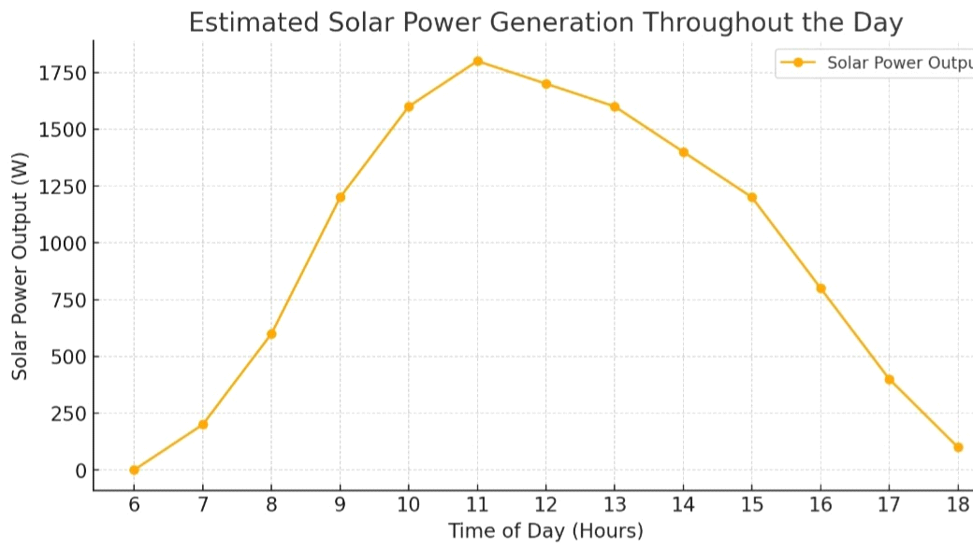
Figure 15:The Generation of solar power through the day

4.3 THE PERFORMANCE OF THE BATTERY
On this installation two 12v tubular battery was use which are connected in series to increase the voltage of the battery and the energy storage of the battery can be calculated.
mathematically:
Energy(WH)=Voltage * Capacity
the energy store in the battery (Wh) = (AH) * V
220Ah * 24= 5,280Wh or 5.28kwh

4.4 HYBRID INVERTER PERFORMANCE
The 4.2kva hybrid inverter install was use which can withstand the maximum load capacity of 4200W or 4.2kva with a maximum efficiency of 97% and the operating frequency of 50\60 Hz and then the nominal output voltage of 220\230\240v and handle the expected load with stable voltage output.

4.5 VOLTAGE BALANCE UNDER DIFFERENT LOAD CONDITION
The hybrid inverter output voltage remain stable under the various load conditrion
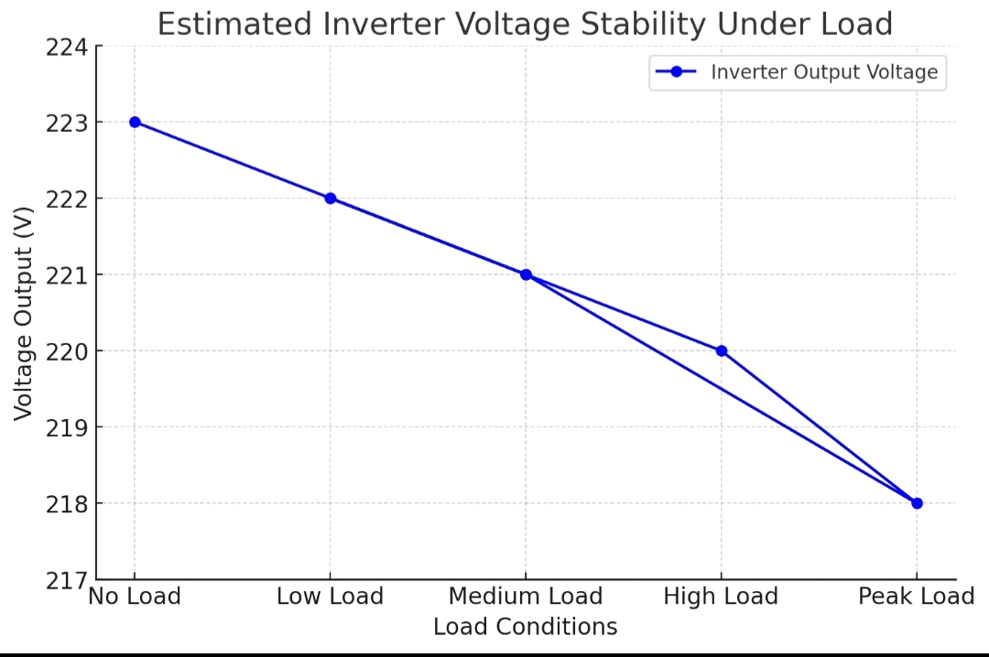
figure.16:voltage balance under different load condition

The hybrid system mantained an efficiency of 93% which was close to the expected 97% under norminal condition with a minor voltage fluctuation were observed and also remain within safe operating limit under peak loads.

CHAPTER FIVE

5.1 CONCLUSION
The successful installation of the hybrid solar power system demonstrates the effective integration of key components including monocrystalline solar panels, a tubular battery bank, a 4.2 kVA hybrid inverter with MPPT, as well as proper DC and AC cabling, circuit protection, and secure mounting. Each component was selected based on performance, efficiency, and suitability for the operational environment, ensuring a reliable and sustainable energy solution.
The monocrystalline panels provide high energy efficiency and superior performance in varied lighting conditions. The use of high-capacity tubular batteries offers extended backup with low maintenance. The hybrid inverter plays a central role in converting and managing energy between the solar array, battery, and grid, ensuring uninterrupted power supply. Proper wiring and protective components enhance system safety and longevity.
Overall, this installation not only supports the goal of reducing dependency on the national grid but also promotes the use of renewable energy technology for consistent and clean electricity supply. The system serves as a model for similar future deployments aimed at sustainable energy generation.
5.2 RECOMMENDATION
Based on the successful implementation and performance of this hybrid solar power system, it is recommended that similar systems be adopted in other institutions, homes, and commercial facilities to reduce reliance on the national grid and promote energy sustainability. For future installations, the following considerations are advised:
- System Scaling: For higher energy demands, consider scaling up the system by increasing the number of solar panels and battery capacity to ensure consistent power supply during extended periods of low sunlight.
- Routine Maintenance: Although the system components are low-maintenance, periodic inspections and preventive maintenance should be conducted to ensure optimal performance and longevity.
- Surge Protection and Grounding: Proper grounding and surge protection must always be implemented to prevent damage from lightning strikes or power surges.
- Monitoring System: Incorporate a real-time monitoring system to track energy production, storage, and consumption, which aids in performance analysis and troubleshooting.
- User Training: Basic training should be provided to users or maintenance personnel to enable them to handle simple system diagnostics and respond effectively to alerts or faults.
The hybrid solar power setup proves to be a cost-effective and eco-friendly solution, and its wider adoption can significantly contribute to cleaner energy use and improved energy security.

REFERENCE LIST
(1) Z. Sen "Sole Energy Fundamental and Modeling Techniques" listed.Vol.2.Springer,pp,58.125,2008.
(2) U Fseli,R,Bayir and M.Ozer," Design and implementation of a domestic Solar and wind hybrid energy system. International Conference on Electrical and Electronics Engineering Vol.1.no.2,pp.29-33,2009.
(3) Imitiaz,Masudul Haider,MST RUMANA AKTAR SUNMI,KAZI RIZWANA Mehzabeen, MD ISTIAQMAH BUB and Nafisa Shahera Nur." Design & Implementation of an intelligent Solar Hybrid inverter in grid oriented system for utilizing PV Energy. International journal of engineering science and technollogy.2,no.12 ( 2010): 7524 -7530.
(4) Layyar,Srashi,Tushar Saini, Abhishek Verna, and Ashwani Kumar. Hybrid Inverter with wind and solar Battery charging "International journal for Engineering and technical Research 8,no.7.2018.
(5) B.Ravitreja,2 Dr.G.jayakrishna,3 Akhib khan bahamani " hybrid inverter with solar battery charging " journal of engineering and technology and innovative Research.2018.JETIR July 2018.volme 5, issue 7.
(6) Ashiq PA Annad PH,AKhil Suvarnan,Lithul Krishna, rejoice Thomas Paul,:" Hybrid inverter with solar battery charging, “Global Research and Development journal for Engineering, National conference on emerging Research trend in electrical and electronics Engineering may 2019.
(7) Kagil S.Sanore,Palash N. Meshram,Mayur R. Chaudhary " literature survey for sun tracking Hybrid Solar Inverter " international journal research.
(8) Subramaniam,Umashankar,Sridhar Vavilapalli,Sanjeevikumar Padmanaban,Frede Blabjerg,Jens Bo Holm Nielsen, and Dhafer Almakhles " A hybrid PV Battery system for ON and OFF Grid Application.controller_in_loop.simulation validation " Energies 13,no.3 (2020):755.
(9) Jagadesh,Y," A new concept of intelligent Hybrid inverter for battery charging " 2020.
(10) Vijay Sarade,prof B.G Hogade" Hybrid inverter incorporating solar, Wind Battery, ON Grid and OFF Grid journal of engineering Research and Application Vol.9,issue 5 ( series II ) may 2019,PP 29_ 32.
(11) M.Muralikrishna and V.Lakshaminaraynar. " Hybrid Solar and wind energy system for rural Electrification " ARPN journal for engineering and applied science,Vol.3,no.5,PP.50-58,2008.
(12) P.H. Patil.P.Undre,S.Wavhal and P,Patil "Solar based inverter and charger " International journal of scientific of Engineering Research,Vol,4,no.79-82,2013.
(13) Y.Kang and j lavers "Power electronics simulation, Current progress and future development" in proceeding of 1994 IEEE workshop on computer in power Electronics,1994.
(14) R.Bandwawi,M Abusara and t.mallick "A review of hybrid Solar PV and Wind energy syste,.Smart science Vol.3,no.3,pp.127-138,2015.
(15) Y.zhang,j.Wu and Z.li,"Design of compact high voltage capacitor charging power supply for pulsed power application." IEEE pulsed power Conference ( PPC).vol.2,no.3,pp.78-87,2015.
(16) V.Babrekar,S.Bandawar and A.Behader,"Review Paper on Hybrid Solar and wind Power generator "International journal for computer Application Vol.165,no,5,pp.36 _ 40,2017.
(17) Abdur rafay,Ahsan Iqbal, Ahsan Shahzad,Fahad Ahmad" Smart hybrid inverter "Hitech University of Engineering and technology taxilla.Vol,1,july.2018.
(18) A.Ingole and B.Rakhonde " hybrid power generation system using wind energy and Solar energy "International journal of scientific and Research (19) R.Badwawi,M.Abusara and T.Mallick " A review of Hybrid Solar PV and Wind Energy system " smart science Vol.3,no.3.PP.127_ 138,2015.
(19) A.Ingole and B.Rakhonde " hybrid power generation system using wind energy and Solar energy "International journal of scientific and Research publication.Vol,5.no.3,PP,1_4,2015.
(20-21) Bright Osaige EZE "Performance Evaluation of Solar powered Battery Charge"IRE Journals.Vol.8.no.1, 2024.
(22) Sandeep Arya & Prerna Mahajan " Solar cell Types and Application,https://books.google.com.ng/books?id=M6LJE AAA QBAJ & pg = PA17 & dq = Advantages + and + disadvantages + of + solar + panel &hl + = en & newbks= 1 & newbks_red ir = 0 & source =gb _ Mobile _ Search & Ovdme = 1 & sa = x&ved=2ah Ukewj _ 1pm6 _ 4UMA * WORUEAHRMDKKKQ6AF6BAGKEAMHV = one page & q = Advantages % 20 and % 20 disadvantages’ % 20 of % 20 Solar % 20 Panel & F = False.
( 23 ) Bright Osagie Eze " Performance Evaluation of Solar powered Battery Charge" IRE Journalsd.VOL.8,NO.1.2024.

