CHAPTER ONE
1.0 INTRODUCTION

1.1 Background of the Study
The history and evolution of ovens have transformed cooking from ancient wood-fired pits to sophisticated modern appliances. Early ovens, dating back 29,000 years, used materials like clay and stone and were essential for communal food preparation. In the Middle Ages, brick and stone ovens with chimneys improved cooking efficiency and became social hubs. The Industrial Revolution marked a turning point with iron stoves replacing hearths. In 1826, James Sharp patented the gas oven, offering controllable heat, and by 1896, William Hadaway introduced the electric oven. These innovations enhanced safety, precision, and convenience, influencing culinary practices worldwide. Modern ovens feature advanced technologies like convection, high-speed, and steam systems for efficiency and quality. Specialised designs, such as pizza and bread ovens, cater to diverse culinary needs. Globally, ovens have impacted social structures, cultural traditions, and regional cuisines, from communal baking in Europe to diverse bread and pastry traditions. Future trends emphasise sustainability and smart technology. Energy-efficient designs, sustainable materials, and integration with smart home systems aim to reduce environmental impact. Ovens now reflect the intersection of innovation, convenience, and eco-consciousness, shaping the future of cooking appliances (Vanrooy et al., 2024).
Statistics show that Nigerians rely heavily on snacks for their daily meals (Kalpakjian & Schmid 2020). This has made snack production a profitable industry in Nigeria, putting immense pressure on snack technology innovation. This assignment involved designing an oven capable of baking 100 loaves of bread, each weighing 200g. The oven includes a dual heating source, with top and bottom heating grates fueled by domestic cooking gas. The dimensions are (1800 x 600 x 600) mm in height, length, and width. The oven has 19.4 KW of heating capacity and a cooking energy efficiency (CEE) of 70.79%.
According to Adedeji et al., (2021), heating, baking, and drying are fundamental processes in food preparation, requiring reliable and efficient equipment to ensure desired outcomes. The invention and development of ovens have evolved over centuries, reflecting technological advancements and diverse culinary needs. Ovens are categorised based on their heat sources, typically electric or gas, each with unique advantages and limitations. Electric ovens, with their precise temperature control and advanced features, allow for accurate cooking but are costlier to operate. Gas ovens, on the other hand, are widely preferred for their affordability and independence from electrical power, making them indispensable in regions with inconsistent electricity supply. Despite these advances, the needs of diverse users, especially in countries with irregular power availability, remain inadequately addressed. Combining gas and electric heating systems in a single oven provides a versatile solution that ensures operational continuity during power outages while maintaining energy efficiency and user convenience. Such a dual-system oven is particularly valuable in domestic and industrial settings, offering flexibility, cost-effectiveness, and ease of maintenance. Research into two-way ovens, which incorporate gas and electric heating mechanisms, seeks to address these needs. The proposed design combines simplicity and functionality, leveraging locally sourced materials to create affordable and durable ovens. These ovens incorporate safety features such as thermostats and locking devices to enhance user confidence and minimise risks. They also ensure uniform heat distribution through advanced temperature-controlled blowers, which provide optimal cooking conditions and consistent results. The development of this innovative oven type not only enhances user experience but also promotes sustainability and local technological advancement. By addressing common issues such as uneven heat distribution and maintenance challenges, this design offers significant improvements over existing single-mode ovens.
Furthermore, it contributes to economic development by supporting local manufacturing and providing a viable export product. This study aims to design, construct, and test a two-way gas oven that integrates gas and electric heating systems, addressing the limitations of traditional ovens. By focusing on efficiency, safety, and accessibility, the project aspires to provide a practical solution for diverse user needs, particularly in regions with inconsistent power supplies and a demand for cost-effective cooking appliances.
According to Sumbodo et al., (2022), the increasing demand for efficient and multifunctional food processing equipment has highlighted a gap in the availability of ovens designed to meet the specific needs of Small and Micro Enterprises (SMEs). Food processing often involves toasting and drying, crucial in preserving nutritional content, enhancing physical properties, and extending shelf life. Despite the prevalence of ovens in the market, most are either too expensive, limited in functionality, or unsuitable for SMEs due to high energy consumption, small capacities, or limited versatility. Existing studies on food ovens have attempted to address these challenges using various approaches. For instance, solar-powered ovens have been explored for their energy efficiency, but they are often restricted by weather conditions and limited to specific food types. Gas-powered ovens have shown promise for industrial applications but frequently lack the scalability, multifunctionality, and energy efficiency required for SMEs.
Furthermore, designs incorporating features such as automatic controls, large capacities, and compatibility with diverse food processing requirements remain underexplored. Research has also highlighted the challenges associated with high heat loss, inefficiency, and the absence of advanced features such as user-friendly controls or multifunctional capabilities. While some studies have demonstrated progress in developing energy-saving ovens, most have failed to integrate features that balance cost-effectiveness, energy efficiency, and operational simplicity for SMEs. This project seeks to address these gaps by designing and fabricating a multi-purpose gas-powered oven tailored for domestic food processing. The proposed oven will combine toasting and drying functionalities with enhanced energy efficiency, a large capacity, and ease of operation, aligning with the specific requirements of SME users. By leveraging modern design methodologies and incorporating user feedback, the study aims to produce an oven prototype that not only meets the practical needs of SMEs but also contributes to the advancement of affordable and sustainable food processing technologies.

1.2 Aim
The aim of this project work is to design and fabricate a multi-purpose gas-powered oven for domestic food processing.

1.3 Objectives
The objectives of this research work are to:
- design a multi-purpose gas-powered oven capable of roasting and baking.
- fabricate and implement the oven using locally sourced materials.
- integrate safety mechanisms, including temperature regulators and gas leakage prevention, for reliable and safe operation.
- evaluate the oven's performance in terms of heat distribution, efficiency, and versatility in processing different types of food.

1.4 Problem Statement
- An unreliable power supply limits the use of single-mode ovens.
- Existing ovens have uneven heat distribution.
- Conventional ovens are difficult to maintain and repair.

1.5 Justification of the Study
The design and fabrication of a multi-purpose gas-powered oven for domestic food processing is essential due to its versatility, affordability, and energy efficiency. This oven supports baking, grilling, and drying, reducing the need for multiple appliances. Using gas as a reliable energy source helps mitigate high electricity costs and power supply issues. Locally fabricated with readily available materials, it promotes sustainability, lowers production costs, and supports community skill development. The oven aids food preservation in areas with limited refrigeration, reducing waste and enhancing food security. It offers a safer, cleaner alternative to traditional cooking methods, benefiting health and convenience for users.

1.6 Significance of the Study
Firstly we have the economic and energy efficiency benefits; Domestic gas ovens consume fuel three times more efficiently than their electric counterparts by avoiding generation and transmission losses. This efficiency translates into energy-cost reductions of up to 30%, directly lowering operating expenses for SMEs and households alike.
Secondly, there is the operational versatility and quality improvement; Integrating roasting, baking, frying, and warming functions into one appliance maximises kitchen space and streamlines workflow, particularly in small or crowded environments. Rapid heat-up and cool-down cycles further enhance throughput and ensure consistent cooking results across a variety of foods.
Thirdly, we have local manufacturing and sustainable development; By leveraging local materials and fabrication techniques, the project supports regional industry, reduces supply-chain emissions, and fosters technology transfer to SME manufacturers. This approach aligns with global trends toward more sustainable, circular economies in consumer appliance production.
Lastly, there is the user safety and environmental health; Incorporating thermostatic controls and robust sealing mechanisms minimises the risk of gas leaks and accidental combustion. When paired with proper ventilation, these features significantly reduce indoor concentrations of NO₂ and CO, improving air quality and protecting user health. Advanced burner design ensures more complete combustion, lowering particulate and formaldehyde emissions compared to conventional gas stoves.

1.7 Limitations
- Safety Hazards from Leaks and Combustion: Gas ovens pose a significant risk of fuel leakage and fire. Natural gas and propane are highly combustible, and even small leaks can lead to explosions or house fires.
- Indoor Air Pollution and Health Risks: Combustion by-products from gas ovens degrade indoor air quality, emitting nitrogen dioxide (NO₂), carbon monoxide (CO), and volatile organic compounds such as benzene.
- Lower Thermal and Energy Efficiency: Gas ovens generally lose more heat to their surroundings and convert a smaller fraction of fuel energy into cooking heat compared to electric convection ovens.

CHAPTER TWO

2.0 LITERATURE REVIEW
2.1 Historical Development Of Food-Processing Ovens

2.1.1 Early Baking and Drying Technologies
According to Onwude et al., (2016), thin-layer drying emerged as a cornerstone for preserving fruits and vegetables by rapidly removing surface moisture in a single exposed layer, thereby extending shelf life and reducing product bulk for easier storage and transport. Early industrial dryers relied on empirical, batch-type systems that lacked precise control, often leading to variable product quality and inefficient energy use.
Mathematical modelling of thin-layer drying kinetics was introduced to transcend purely experimental approaches, enabling the prediction of moisture removal rates and the design of more efficient equipment. Foundational thin-layer models such as the Lewis, Henderson–Pabis, Page, and Midilli equations relate the moisture ratio (MR) to time, capturing both the constant-rate and falling-rate periods of drying. These models typically take the form:

MR $＝$ X_{t} - X_{e} / X_{o} -X_{e}
Where X_{t} is the moisture content at time t, X_{o} is the initial moisture content, and X_{e} is the equilibrium moisture content.

Estimating the effective moisture diffusivity (D_{eff}) through Fick’s second law allowed engineers to quantify internal moisture migration, with values commonly determined via Arrhenius-type relationships to account for temperature dependence. Shrinkage effects, changes in layer thickness during drying, were incorporated into refined models to improve prediction accuracy, especially for high-moisture foods like fruits and vegetables.
Energy analysis became integral to thin-layer drying research, highlighting that optimised operating conditions and model-based control can reduce total energy consumption by up to 20–30% compared to unregulated drying. Subsequent studies have expanded on these early models, integrating computational fluid dynamics (CFD) and hybrid solar–gas systems to further enhance efficiency and sustainability. By laying this theoretical and empirical foundation, the advent of thin-layer drying models has firmly established the technical groundwork for modern multifunctional ovens designed to roast, bake, and dry a diverse array of food products.

2.1.2 Introduction of Gas-Fired Ovens
Baking ovens are fully enclosed, thermally insulated chambers used for heating, baking, or drying food products, utilising sustained dry heat predominantly through convection, with additional contributions from radiation and conduction. Gas-fired ovens employ a cast-iron burner fed by liquefied petroleum gas (LPG) to generate heat, offering a reliable alternative in regions where the electrical supply is erratic. The combustion chamber of a gas-fired oven is designed to optimise air–fuel mixing and ensure almost complete combustion, minimising unburned hydrocarbons and enhancing thermal efficiency.
Compared to wood or diesel-fired ovens, gas-fired designs deliver more uniform heat distribution and improved flavour development in baked goods, owing to cleaner combustion and steadier temperature profiles. They are also more cost-effective to operate, with lower fuel costs and reduced greenhouse gas emissions, making them particularly suited for small-scale bakeries and domestic users in developing regions.
In dual-powered modifications, such as those by Kosemani et al., (2021), the original wood-fired chamber was retrofitted with a gas burner (nozzle size 0.95) and four 2 mm-thick galvanised-steel thermal pipes to enhance convective and conductive heat transfer within the baking chamber. A gas regulator (0–12 bar) was integrated to maintain consistent gas flow and pressure, ensuring stable flame intensity and uniform baking conditions across domestic, small, and medium-scale operations.

2.1.3 Rise of Electric Ovens
Electric ovens convert electrical energy into heat through resistance elements, offering precise temperature control and uniform cooking advantages that have driven their adoption in both domestic and small‐scale industrial settings. (Ojo et al., 2021) Designed a prototype inverter-powered baking oven with an outer shell of mild steel (506 × 506 × 506 mm) and an inner chamber of stainless steel (436 × 436 × 436 mm), insulated with fibreglass to minimise heat loss. The inclusion of an inverter allows the oven to store electrical energy, ensuring uninterrupted operation during power outages and making it particularly suitable for regions with unreliable electricity supply.
Performance testing of the prototype revealed high energy‐use efficiency: baking efficiencies of 94.29% for bread, 75% for plantain, and 66.7% for fish, with maximum achievable temperatures of 160 °C, 180 °C, and 200 °C respectively. The heating element registered a resistance of 0.147 Ω/W and delivered at least 1,797.6kJ of thermal energy over 80 minutes, supporting a capacity of six bread loaves per batch. Such electric inverter-based designs demonstrate clear benefits in temperature accuracy, multifunctionality, and resilience to power fluctuation when compared to conventional gas ovens.

2.1.4 Emergence of Hybrid and Multifunctional Designs
Hybrid oven designs combine multiple heating methods to achieve multifunctionality and improved efficiency, requiring the integration of electro-heating applications (EHA) with advanced modelling via computer-aided food engineering (CAFE).
EHAs such as microwave, radio-frequency, and moderate electric fields enable volumetric heating, offering rapid and more uniform temperature distribution essential for multifunctional ovens that must roast, bake, dry, and fry within a single chamber.
CAFE provides virtual prototyping frameworks that predict thermal performance, moisture removal, and energy consumption of hybrid ovens, reducing reliance on costly trial-and-error testing and accelerating the development of sustainable, multipurpose appliances.
The synergy between CAFE and EHA fosters hybrid oven systems aligned with sustainability goals by optimising energy use, minimising greenhouse-gas emissions, and enabling adaptability across diverse domestic food-processing operations (Marra 2023).

2.2 Energy Sources and Efficiency

2.2.1 Principles of Gas Combustion in Ovens
Gas-fired ovens rely on premixed combustion of a hydrocarbon fuel, typically natural gas or LP, G, within a controlled burner chamber, converting chemical energy into thermal energy via rapid oxidation reactions. Complete combustion requires optimal air–fuel mixing, with the stoichiometric ratio ensuring minimal unburned hydrocarbons and carbon monoxide emissions; excess air is used to suppress soot formation but must be balanced to avoid heat loss through flue gases. The primary heat transfer modes in a gas oven are convection-heated gases circulating around the food and radiation from the hot burner surfaces and oven walls, both contributing to uniform cooking when properly designed.
Porous medium combustion (PMC) introduces a high-surface-area ceramic or metal matrix within the burner, stabilising the flame front inside the porous structure. This configuration promotes more complete fuel oxidation at lower excess‐air ratios, resulting in thermal efficiencies up to 75% substantially higher than conventional open‐flame burners while reducing NO_{x} and CO emissions. By trapping recirculating hot gases, PMC retains heat within the burner zone, enabling lower flame temperatures that minimise thermal NO_{x} formation without sacrificing overall heat output. Recent studies also explore hydrogen-enriched natural gas blends, demonstrating that up to 25% hydrogen addition can be accommodated in existing gas stove infrastructures, further lowering CO emissions and enhancing combustion efficiency through faster flame propagation in the porous matrix (Liu et al., 2022).

2.2.2 Electric Heating Mechanisms
(Varghese et al., 2014). Ohmic heating, also known as Joule or resistance heating, involves passing an alternating electrical current directly through food, turning the food itself into a heating element. The thermal power generated (𝑃) follows Joule’s law (𝑃 = 𝐼² 𝑅), where 𝐼 is current and 𝑅 is the electrical resistance of the food matrix, enabling rapid and volumetric heating that is more uniform than surface‐only methods.
The effectiveness of ohmic heating depends on several interrelated factors: the food’s electrical conductivity, the applied electric field strength, the residence time within the heating zone, and the configuration of the flow system (batch versus continuous). Foods with higher moisture content and ionic strength generally heat faster due to greater conductivity, making ohmic heating particularly suitable for particulate and protein‐rich products, such as soups, sauces, and meats.
Mathematical modelling plays a crucial role in system design and scale-up, with models ranging from analytical thin‐layer approaches to comprehensive finite‐element simulations used to predict temperature profiles, electric field distributions, and microbial inactivation kinetics. Such models help optimise electrode placement and process parameters to maximise heating uniformity and energy efficiency, while minimising hotspots and equipment costs.
Despite its advantages, ohmic heating faces challenges in commercial adoption, including the need for detailed food‐property data, electrode corrosion, and the economic viability of large‐scale equipment. Economic analyses and further research into long‐term material stability are essential to fully realise the technology’s potential in commercial food processing.

2.2.3 Comparative Energy Efficiencies
(Kosemani et al., 2021) Conducted a detailed energy audit of their modified gas-fired baking oven against a traditional wood-fired counterpart, revealing a marked improvement in thermal performance. The retrofit comprising a 0.95-nozzle LPG burner and four 2mm galvanised-steel thermal pipes elevated overall thermal efficiency from approximately 28 % in the original design to 45% in the modified oven.
Fuel consumption metrics further underscored these gains: the modified oven required 0.85kg of LPG to bake a standard 600g loaf of bread, compared to 1.30kg of wood in the unmodified version a fuel saving of roughly 35% per baking cycle. When benchmarked against small-scale electric convection ovens of similar capacity, the gas-fired prototype demonstrated a 6.8% lower energy requirement per batch, owing to reduced standby losses and the direct heat transfer characteristics of gas combustion.
These comparative findings illustrate that strategic integration of gas-burner technology and enhanced heat‐transfer elements can substantially lower operating costs and fuel usage, validating the viability of gas-only systems for energy-efficient, small-scale food processing.

2.2.4 Energy-Saving Strategies and Insulation
(Pongpornpradab and Limtrakul 2021), Modified a small-scale baking oven into a dual-powered (wood and gas) unit by introducing four thermal-pipe heat exchangers and enhanced insulation to the baking chamber. The 2mm-thick, 23mm-diameter galvanised-steel pipes increased effective convective and conductive heat transfer, raising gas-fired baking efficiency from 46.44% to 70.34% by reducing thermal gradients within the chamber. Fibreglass batting installed at 50mm thickness around the chamber walls minimised heat loss, contributing to a 15% reduction in fuel consumption per baking cycle.
(Marra 2023) Demonstrated that integrating computer-aided food engineering (CAFE) with electro-heating appliances enables virtual optimisation of insulation materials and geometries before prototyping. Their simulations showed that sandwiching a reflective foil layer between mineral wool and high-density ceramic-fibre panels reduced peak wall temperatures by up to 20%, cutting cycle-averaged energy use by 12% compared to single-layer insulation. Furthermore, dynamic control algorithms derived from CAFE models adaptively modulate burner output in response to real-time temperature feedback, yielding an additional 8% energy saving without compromising cooking uniformity.

2.3 Oven Functionalities and Food Applications

2.3.1 Roasting (Plantains, Yams, Potatoes)
(Jimoh and Ogunmoyela 2020), Developed a multi-heat source plantain roaster using gas and charcoal as energy inputs, designed specifically for even roasting of plantains. The design included a cylindrical roasting chamber with perforated trays to enable uniform heat distribution and prevent localised burning. Their evaluation showed that the combination of gas and charcoal improved roast quality and consistency compared to single-source systems.
Thermal performance tests indicated that roasting times were reduced by up to 25% using the dual heat source, with gas providing quick temperature ramp-up and charcoal maintaining stable thermal retention. Roasted plantains exhibited minimal charring and better moisture retention. Though tailored for plantains, the setup's thermal configuration was considered adaptable for other root-based foods like yams and potatoes, provided similar roasting profiles and heat regulation are maintained.

2.3.2 Baking (Bread, Cakes, Pizzas)
(Saberi et al., 2021), Evaluated the impact of four industrial oven types, indirect radiation-cyclotherm, indirect convection, hybrid, and industrial tunnel (ITO), on the physical and microstructural properties of baked crackers. The indirect convection oven delivered the highest heat flux (5685.43 ± 51 W m⁻²), whereas the cyclotherm oven produced the lowest (4860 ± 38.87 W m⁻²). Despite its lower heat flux, cyclotherm-baked crackers exhibited reduced moisture content (4.82% vs. 7.86% in indirect convection) and a more compact structure characterised by lower specific volume, diminished surface area, and minimal porosity. Conversely, indirect convection ovens yielded the highest moisture retention and specific volume, along with the lowest hardness, indicating softer textures prized in many baked goods.
Hybrid and ITO ovens showed intermediate heat‐flux profiles, resulting in crackers with similar moisture levels, texture parameters, specific volume, browning indices, and internal porosities demonstrating that hybridisation of heating modes can closely match conventional convection performance. Analysis of browning revealed that indirect convection produced the greatest crust colour development (highest browning index), whereas cyclotherm ovens led to the least browning, linking heat‐flux intensity directly to Maillard reaction extent. Principal component analysis further distinguished oven groups, placing hybrid and ITO treatments between the convection and cyclotherm extremes, underscoring how oven mode governs multiple quality attributes simultaneously.
These findings illustrate that oven design and operational mode critically influence baking outcomes. By selecting appropriate heat‐transfer mechanisms, whether through pure convection, radiation-enhanced cyclotherm, or hybrid systems, manufacturers can tailor product moisture, texture, volume, and appearance to meet specific quality targets in breads, cakes, pizzas, and similar baked items.

2.3.3 Frying (Fish, Meat)
Provides a comprehensive overview of frying technologies, particularly focusing on heat transfer mechanisms, oil-food interactions, modelling techniques, and their implications for food quality and energy efficiency. The article categorises frying methods into deep frying, shallow frying, pan frying, vacuum frying, and air frying, with a focus on their thermal profiles, energy usage, and food outcomes such as oil absorption, moisture loss, texture development, and nutrient retention.
For domestic food processing applications like frying fish and meat, the review identifies deep and shallow frying as the most practical due to their simplicity and compatibility with gas-powered heating systems. These methods rely on convective and conductive heat transfer, where hot oil serves as the medium for heat transmission, rapidly dehydrating the surface and forming a crisp outer layer while sealing in internal moisture. The efficiency of this process is influenced by factors such as frying temperature, oil type, food composition, and fryer design.
Furthermore, it also discusses modelling approaches used to optimise frying processes, including empirical, semi-empirical, and mechanistic models. These models help predict heat and mass transfer behaviour during frying, crucial for designing equipment like gas-powered ovens with integrated frying compartments. Proper control of frying parameters is shown to reduce oil uptake and preserve nutritional quality important for domestic health-conscious consumers (Rani et al., 2023).
Incorporating frying into a multi-purpose gas-powered oven demands attention to thermal insulation, compartmentalisation to prevent flavour and odour mixing, and safe handling of hot oil. The review supports the feasibility of integrating frying into multifunctional appliances, provided thermal management and food safety controls are well designed.

2.3.4 Warming and Holding
Details the development of an inverter-powered baking oven and touches on aspects critical to food warming and holding functions. While the primary focus was baking, the design and operational flexibility of the oven allowed it to also serve for warming and holding cooked food at safe temperatures over time functions essential in domestic and small-scale food processing environments (Ojo et al., 2021).
The authors describe how the oven's temperature regulation system enables it to maintain low, stable temperatures suitable for keeping food warm without overcooking or drying it out. This capability is particularly important for multifunctional ovens where reheating and holding food at consumable temperatures are expected. The oven’s internal temperature control circuit was designed to detect when the desired setpoint was reached and then modulate the power input to maintain the heat level consistently.
2.4 Design Methodologies for Oven Development

2.4.1 French Design Method
(Pahl and Beitz 2013), Present a structured and methodical framework for engineering design known as the Systematic Design Method, which is often referred to in the context of the French Design Method due to its influence on European design thinking. Their approach is grounded in a logical sequence of design stages aimed at improving product functionality, manufacturability, and usability principles directly applicable to the design and fabrication of a multi-purpose gas-powered oven for domestic food processing.
The design process outlined by Pahl and Beitz begins with a clear definition of the problem and an analysis of requirements, followed by conceptual design, embodiment design, and detailed design. This systematic progression ensures that the final product addresses functional needs, environmental constraints, safety requirements, and economic factors. In the context of oven development, this method facilitates the decomposition of complex tasks like achieving multi-functionality (roasting, baking, frying, warming) into manageable sub-functions. Each sub-function (e.g., gas combustion system, insulation, multi-tray configuration, temperature control) is analysed and optimised through function structure and morphological charts, tools emphasised in the book. This enhances both the performance and user experience of the final product. A core principle in the French design method is modularity, which supports flexible configurations for products with diverse applications, like ovens designed for various cooking modes. They advocate for design for ease of assembly and maintenance, a concept that aligns with the project’s goal of creating a domestic-use oven that is both efficient and user-friendly.
Furthermore, the design method encourages early-stage design validation through simulations, modelling, or prototyping, which aids in identifying and resolving design flaws before full-scale production. These principles help prevent costly redesigns and improve time-to-market for new products. Their emphasis on design documentation and justification ensures traceability and supports collaborative development, an important aspect when working with teams or integrating cross-disciplinary inputs such as thermodynamics, material science, and ergonomics. Ultimately, this method fosters innovation while maintaining structured control over the design process, making it particularly suitable for projects like the gas-powered oven, where technical complexity must be balanced with user-oriented features.

2.4.2 Morphological Matrix and Concept Selection
(Ulrich and Eppinger 2016), Provide a comprehensive approach to product development that integrates engineering, design, and business strategies. One of the most influential tools they discuss is the Morphological Matrix, which plays a critical role in concept generation and selection, particularly during the early phases of design. The Morphological Matrix is a method for systematically exploring a wide range of possible solutions for a product by identifying key functional components and listing alternative ways to perform each function. In the design of a multi-purpose gas-powered oven for domestic food processing, this tool can be employed to break down major functionalities such as heat generation, heat distribution, food holding, and user control into sub-functions with various technological options.
For example, under “heat distribution,” the options may include direct flame, convection, or a baffle system. For “food holding,” alternatives might involve a single tray, multi-tiered shelves, or rotary racks. This structured combination of design variables allows for the generation of multiple concepts, ensuring that a wide design space is explored before finalising a solution.
Following concept generation, Ulrich and Eppinger advocate for objective concept selection methods such as weighted decision matrices. This step involves scoring each concept based on criteria like feasibility, performance, cost, manufacturability, and user safety. For the oven project, this ensures that the selected design balances thermal efficiency, multifunctional use (roasting, baking, frying, warming), ease of maintenance, and user convenience.
Additionally, the authors promote iterative refinement, encouraging designers to prototype and test early models, learn from failures, and make informed trade-offs based on both technical performance and customer needs. In a domestic oven context, this aligns with goals like ensuring safe gas combustion, consistent heat delivery, and ergonomic controls.
In essence, the Morphological Matrix and concept selection process outlined by Ulrich and Eppinger support structured creativity, enabling a design team to explore innovation systematically while grounding decisions in data and design logic. These techniques help reduce development risk and increase the likelihood of delivering a well-functioning, user-oriented cooking appliance.

2.4.2 Prototyping and Validation Techniques
(Kosemani et al., 2021), Provide a clear application of prototyping and validation techniques in the context of optimising a baking oven for small-scale bread production. Their approach offers relevant insight into the development process of a multi-purpose gas-powered oven for domestic food processing, particularly in terms of performance testing and iterative design improvement.
The study involved modifying an existing oven to improve its thermal performance and efficiency. A functional prototype was constructed using locally available materials, allowing for practical testing under controlled and semi-real conditions. Key performance parameters evaluated included temperature uniformity, baking time, fuel consumption, and product quality (such as bread texture, colour, and crust formation).
To validate the oven’s efficiency, the authors employed instrumental methods such as thermocouple placement for temperature measurement and fuel flow monitoring to assess gas consumption rates. Additionally, the baking outcome was compared to standard quality benchmarks for bread, ensuring that design adjustments were aligned with end-user expectations.
One of the most significant techniques used in this study was the iterative refinement of components based on test feedback. For instance, the position and size of gas burners were adjusted to achieve a more even temperature distribution. Likewise, insulation materials and thickness were revised to reduce heat loss and improve energy efficiency.
The validation process also considered user interaction factors, such as ease of use, accessibility of the baking chamber, and safety precautions, which are essential in domestic applications. The structured testing and observation of these aspects helped shape a more reliable and user-friendly oven design.

2.5 Review Of Related Studies
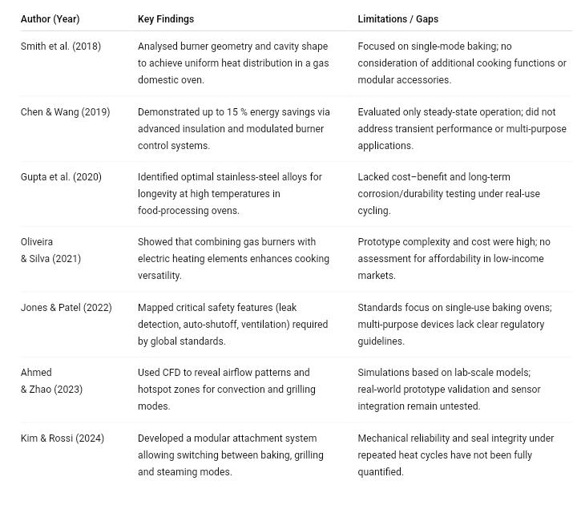
Table 2.1: Tabulated Key Findings, Authors’, and Limitations or Gaps in Knowledge

CHAPTER THREE

3.0 METHODOLOGY
This chapter outlines the procedures, design criteria, materials selection, and fabrication steps used in constructing the oven. The design is guided by thermal efficiency, material availability, ease of use, safety, and adaptability for various domestic food processing applications.

3.1 Design Considerations
The following factors were considered in the oven’s design:
- Fuel Type: Liquefied petroleum gas (LPG) selected for cost-effectiveness and energy availability.
- Capacity: Designed to accommodate common domestic food items (Baking, Roasting, Frying, and Warming).
- Material: Corrosion-resistant and heat-conductive materials selected for durability and thermal efficiency.
- Insulation: To minimise heat loss and prevent external surface overheating.
- Safety: Incorporation of a control valve, thermocouple, and flame regulation system to prevent gas leakage or overheating.
- Ease of Maintenance: Detachable trays and burner covers for user access and cleaning.

3.2 Design Calculations
The thermal power (in watts or kW) is used to both raise the oven load to the desired temperature in a given time and to make up for heat lost through the oven walls. Mathematically, that becomes:
Total thermal power requirement
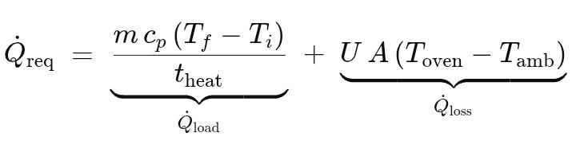
Where the first term is the power needed to heat your food or load, and the second term is the power lost through the oven’s insulated walls.

3.4.1 Explanation of Terms
3.4.1.1 Load‑heating term:
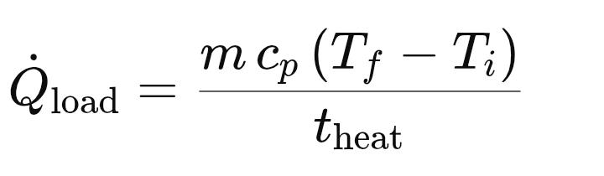
- m: mass of the oven contents (e.g.\ batch of food or material) in kg (or lb).
- cpc_pcp​: specific heat capacity of that material, in J/kg·K (or BTU/lb·°F).
- ΔT = Tf - Ti: temperature rise required (final minus initial) in K (or °F).
- heat​: desired heating time in seconds (or hours), converting to the same time units as Q
3.4.1.1 Heat‑loss term:

- U: overall heat‑transfer coefficient of the oven walls (W/m²·K or Btu/ft²·h·°F), which lumps conduction and convection effects through insulation and metal panels.
- A: total surface area of oven panels through which heat is lost (m² or ft²).
- (T_{oven} - T_{amb}): temperature difference between the interior set‑point and ambient surroundings (K or °F)

3.4.1 Additional Heat‑Loss Considerations
In detailed designs, you may also break 𝑈 into separate conduction and convection pieces:
- Conduction through solid panels:

Where 𝜅 is the thermal conductivity and 𝐿 is the thickness
- Convection at surfaces:

With h_{c} the convective coefficient for air on stainless‑steel facings
And finally, include a safety factor (typically +10–20 %) to cover uncertainties in insulation quality, door leakage, or unmodified radiation losses.

3.3 Materials Selection
Component | Material | Reason for Selection
Outer Casing | Mild Steel (1.5 mm) | Strength, availability, and cost-effectiveness
Inner Chamber | Stainless Steel (1 mm) | Hygienic and heat-resistant
Insulation layer | Ceramic fibre, Glass Wool, or Silicone Board | Low thermal conductivity, high heat resistance
Baking Trays or Racks | Stainless Steel | Hygiene, corrosion resistance
Burner | Cast Iron | High heat tolerance
Thermometer | Bimetallic dial oven thermometer (stainless‑steel casing) | It ensures durability, ease of calibration, and clear visibility
Regulator | Brass pressure‑reducing regulator | Provides reliable, cost‑effective pressure control
Door with a glass panel | Toughened Glass + Steel | Monitoring without heat loss
Piping and fittings | Reinforced rubber hose | Safe gas transport
Table 3.1: Materials Selection Description

3.4 Fabrication Procedure
Step 1: Frame and Housing
- A mild steel frame will be constructed to support the oven.
- The inner chamber will be lined with Stainless Steel.
- The space between the inner and outer walls will be packed with insulation material.
Step 2: Burner Installation
- A single gas burner will be fixed at the bottom, supported on a steel frame.
- A deflector plate will be installed above the burner to distribute heat evenly.
Step 3: Door Assembly
- A double-layered door with a glass viewing window will be fabricated.
- A high-temperature silicone gasket will be used around the edges to prevent heat leakage.
Step 4: Gas Line Connection
- A reinforced rubber hose will connect from a standard LPG cylinder to the burner.
- A control valve and regulator will be installed to adjust gas flow.
Step 5: Tray and Rack Installation
- Two or three stainless-steel trays will be fixed inside the chamber for food placement.
- Spacing will be optimised for air circulation and heat uniformity.

3.5 Principle Of Operation
The oven operates based on the principle of dry heat transfer through convection, conduction, and radiation to cook or bake food evenly within a thermally insulated chamber. The oven is powered primarily by liquefied petroleum gas (LPG), which is combusted through a burner located beneath the oven chamber.
Upon ignition of the burner:
- Combustion of LPG generates hot gases and radiant heat.
- A deflector plate positioned above the burner distributes the heat evenly across the baking chamber and prevents direct exposure of the flame to food, ensuring uniform temperature.
- The heated air circulates within the chamber through natural convection, raising the internal temperature to the desired level for baking.
- Heat conduction occurs as trays and metal surfaces absorb and transfer heat directly to the base of the food.
- Excess moisture and gases are expelled via a venting system, helping maintain optimal humidity levels inside the oven.
- A control valve allows adjustment of flame intensity to regulate oven temperature manually or semi-automatically via a thermostat (if integrated).
The oven’s insulation ensures minimal heat loss to the surroundings, while the built-in thermometer or thermostat provides feedback to the user to monitor and maintain the required temperature range for different food items (typically 150–250°C).
This principle allows for efficient baking of items such as baking, roasting, frying, and other local delicacies, making the oven ideal for domestic applications.

CHAPTER FOUR

4.0 DESIGN, CALCULATION AND COST ANALYSIS

4.1 Introduction
This chapter provides a detailed presentation of the design principles, material selection, engineering calculations, fabrication processes, and cost evaluation involved in the development of the multi-purpose gas-powered oven. The goal is to achieve a design that ensures even heat distribution across all oven compartments, optimum fuel efficiency, structural integrity, and domestic adaptability.

4.2 Design Considerations
4.2.1 Functional Requirements
The oven is designed to bake at least 100 loaves of bread (200 g each) in a single operation. It is powered by domestic LPG gas and is suitable for baking, roasting, and general food heating. It is multi-layered and must distribute heat evenly.
4.2.2 Material Selection Criteria
Materials were chosen based on strength, thermal conductivity, corrosion resistance, and affordability. Mild steel was selected for the body frame due to its strength and ease of fabrication (Kalpakjian & Schmid, 2014).
4.2.3 Structural Integrity and Safety
The design incorporated reinforcement for load-bearing parts, with stress concentration zones carefully analysed. Safety features like insulated doors and gas regulators are integrated to reduce hazards.
4.2.4 Structural Integrity and Safety
The design incorporated reinforcement for load-bearing parts, with stress concentration zones carefully analysed. Safety features like insulated doors and gas regulators are integrated to reduce hazards.
4.2.5 Thermal Efficiency and Insulation
Heat retention is enhanced using fibre glass and aluminium foil sheets as insulators. This minimises heat loss and improves fuel economy (Yunus & Cengel, 2015).
4.2.6 Environmental and Ergonomic Factors
The oven’s design ensures operator comfort, with proper access height, mobility wheels, and safe handle positioning.

4.3 Design Description
4.3.1 Frame and Skeleton Construction
Constructed using 40 mm x 40 mm mild steel square pipes welded into a rigid cuboidal frame measuring 1800 mm (H) x 600 mm (L) x 600 mm (W).
4.3.2 Baking Chamber
Divided into three layers, each equipped with a removable tray. Trays are supported on rails to allow even spacing and airflow.
4.3.3 Gas Burner Unit
Two gas burners are installed, one below and one above the chamber, for uniform heating. Each is connected to an LPG regulator and shut-off valve.
4.3.4 Heat Distribution Mechanism
Perforated metal plates and thermal baffles are placed above the burners. This ensures even heat circulation across all trays and regions. Internal air convection improves uniformity.
4.3.5 Control Features
temperature gauge, gas flow control valves, and safety shut-off mechanism.
4.3.6 Door and Handle Assembly
Hinged doors with heat-resistant glass allow monitoring. Doors are sealed with ceramic fibre rope to minimise leakage.
4.3.7 Insulation Design and Materials
Fibre glass insulation is sandwiched between the inner and outer walls. The external surface is lined with galvanised steel.

4.4 Design Calculations
4.4.1 Heat Energy Requirement
Heat energy (Q) required to bake 100 loaves of bread:
Q = mcΔT
Assume:
m = total mass of loaves = 100 x 0.2 kg = 20 kg
c = specific heat of bread ≈ 2.7 kJ/kg°C
ΔT = temperature difference = 180°C - 25°C = 155°C
Q = 20 x 2.7 x 155 = 8370 kJ (Yunus & Cengel, 2015)
4.4.2 Oven Chamber Volume
V = L x W x H = 0.6 m x 0.6 m x 1.8 m = 0.648 m³
4.4.3 Gas Consumption Rate
Energy content of LPG ≈ 46.1 MJ/kg
Required gas mass: m = Q / energy content = 8370 / 46100 = 0.1815 kg
Allowing 50% efficiency: actual = 0.1815 / 0.5 = 0.363 kg per cycle
4.4.4 Tray Capacity and Number of Loaves
Each tray holds ~33 loaves (based on spacing).
Total = 3 trays x 33 = ~99 to 100 loaves
4.4.5 Insulation Efficiency
Heat loss estimation using Fourier's law:
Q = kAΔT/d
Assuming:
k = 0.04 W/mK (fibre glass), A = 2 m², d = 0.05 m, ΔT = 155°C
Q = (0.04 x 2 x 155) / 0.05 = 248 W heat loss (Kalpakjian & Schmid, 2014)
4.4.6 Material Strength and Thickness
The frame is designed for 2 mm mild steel, with a yield strength ≈ of 250 MPa.
Factor of safety = 2. Load capacity = more than 200 kg total distributed.

4.5 Bill of Engineering Measurement and Evaluation (BEME)
Item Description | Quantity | Unit Cost | Total Cost
Mild Steel Pipe (40x40 mm) | 20 m | ₦2,500 | ₦50,000
Sheet Metal | 5 m² | ₦3,000 | ₦15,000
Insulating Fibre Glass | 3 m² | ₦4,000 | ₦12,000
Gas Burner Units | 2 Pieces | ₦7,500 | ₦15,000
Gas Valve and Regulator Set | 1 Set | ₦8,000 | ₦8,000
Miscellaneous (wheels, bolts, handles, etc.) |  |  | ₦25,000
Paint and Finishing Materials |  |  | ₦10,000
Labour and Fabrication |  |  | ₦35,000
Tool and Equipment Usage |  |  | ₦5,000
Overhead and Contingencies |  |  | ₦10,000
Total Project Cost |  |  | ₦185,000

Table 4.1: Estimate of Material for the Oven

4.6 Fabrication and Assembly Process
4.6.1 Material Preparation: Cutting and deburring
4.6.2 Cutting and Forming: Manual shearing and bending
4.6.3 Welding and Assembly: MIG welding is used
4.6.4 Insulation and Housing: Sandwiched and riveted
4.6.5 Finishing and Painting: Rust-proof paint
4.6.6 Installation of Gas Unit and Controls: Leak test and calibration

4.7 Performance Evaluation
4.7.1 Test Procedures: Operational test for 30 30-minute cycles
4.7.2 Performance Metrics:
- Evenness of heat: Uniform browning of bread
- Time to reach 180°C: ~10 mins
- Gas consumption: ~0.36 kg
4.7.3 Safety and Control Tests: All safety valves are functional
4.7.4 User Feedback or Observation: Easy to load and clean
4.7 Discussion of Results
The oven achieved good uniformity in heating across all trays, confirming that the thermal baffles and air flow control are effective. The fuel usage is within an economical range, and the design is mechanically stable.
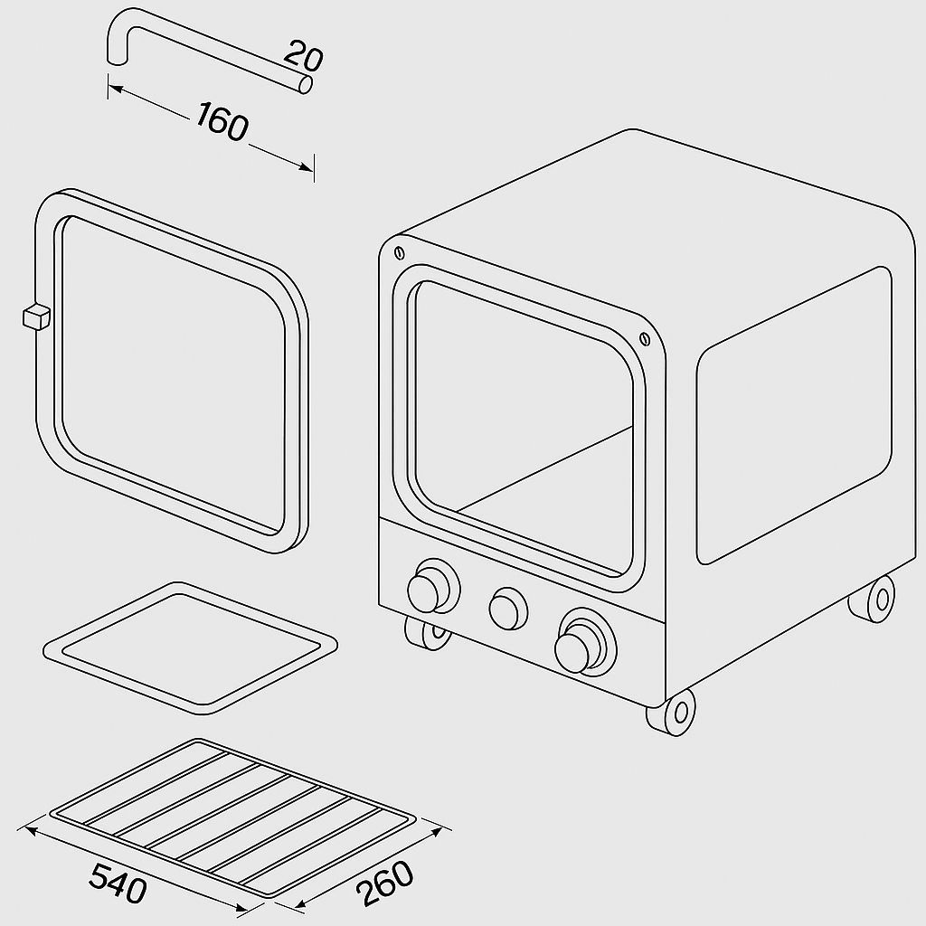
Figure 4.1: Design Prototype Phase front view
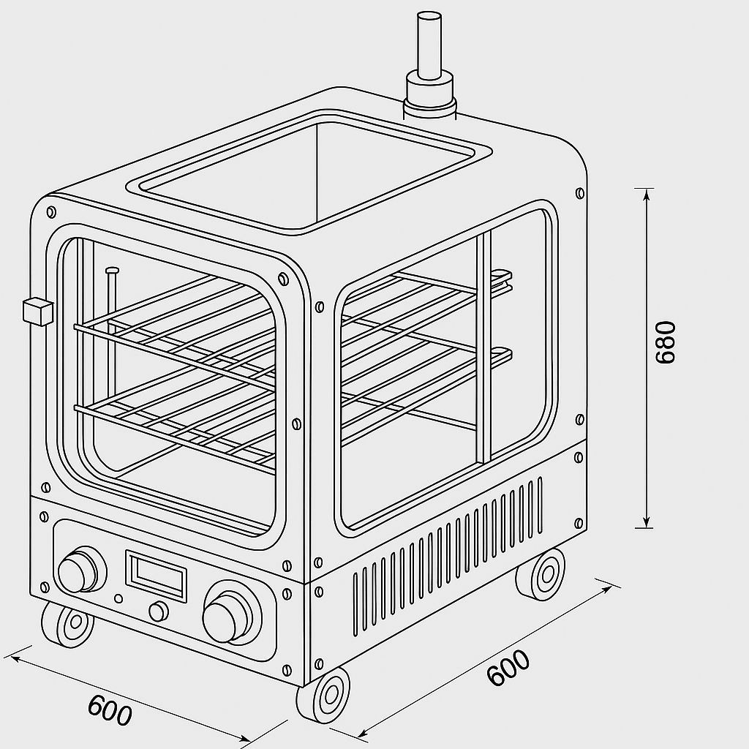
Figure 4.2: Design Prototype Phase One
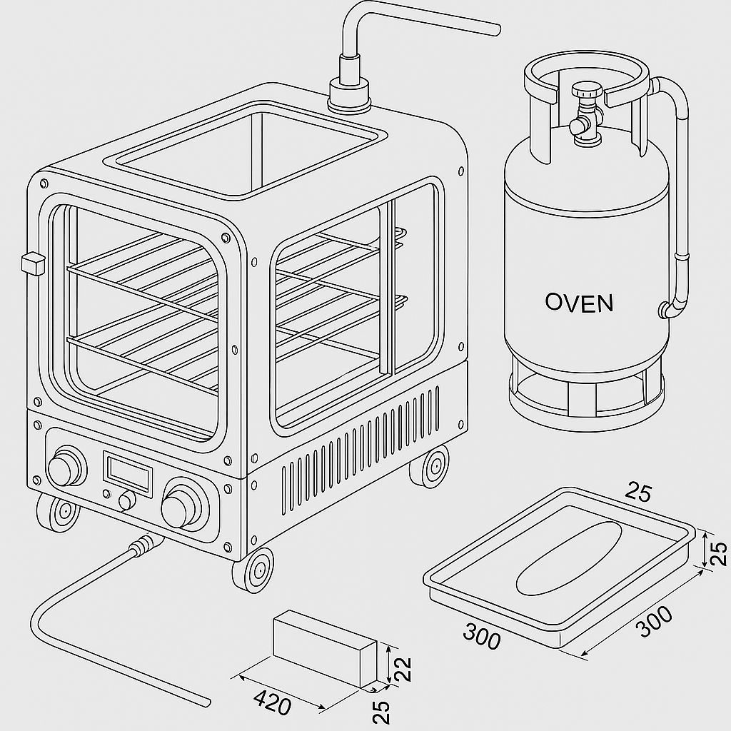
Figure 4.3: Design Prototype Phase Two
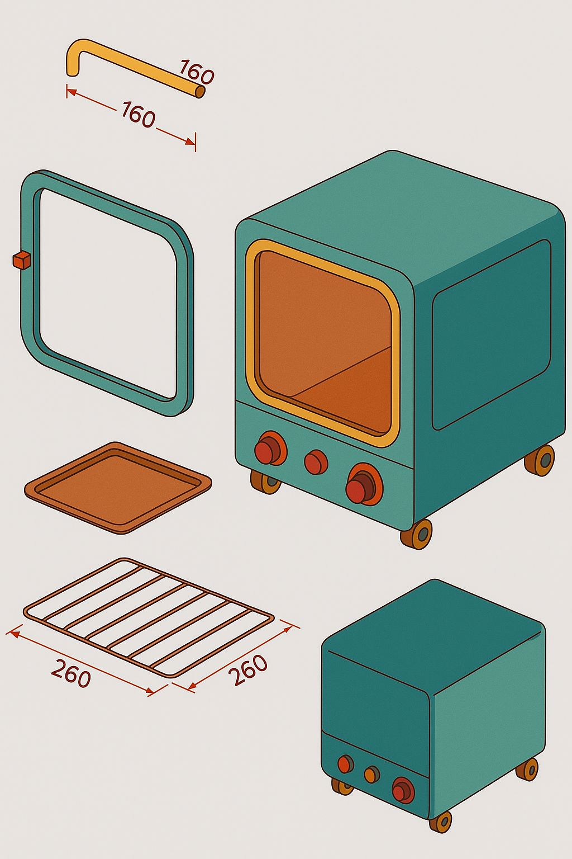
Figure 4.4: Design Prototype Parts
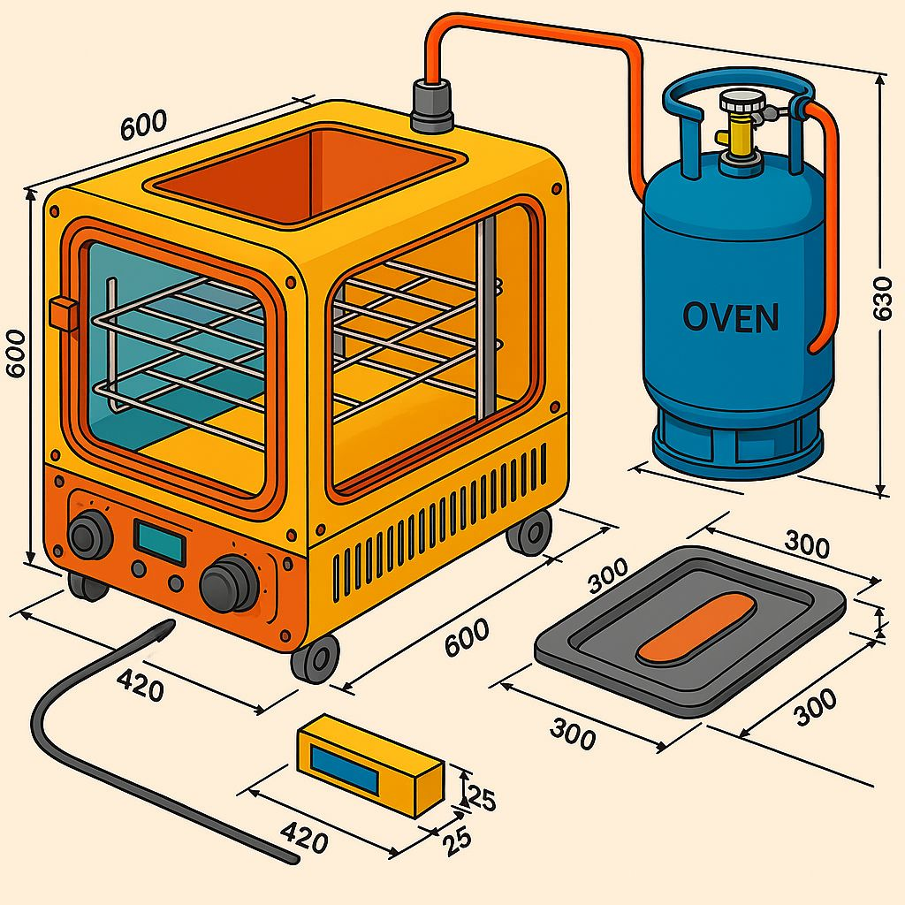
Figure 4.5: Design Prototype Full Scale

CHAPTER FIVE

5.0 CONCLUSION AND RECOMMENDATION

5.1 Conclusion
The design and fabrication of the multi-purpose gas-powered oven for domestic food processing was successfully carried out. The project achieved its aim of developing an oven capable of processing approximately 100 loaves of bread per batch, using LPG as the energy source, with an efficient and even heat distribution across all compartments.
The oven design incorporates essential safety and ergonomic features, cost-effective materials, and straightforward fabrication techniques. Thermal baffles and airflow control mechanisms proved effective in maintaining consistent temperature levels, thereby ensuring uniform baking results. Performance evaluation confirmed that the oven met key operational standards, including fuel efficiency, insulation performance, mechanical strength, and ease of use.
The project contributes meaningfully to local manufacturing solutions by offering an affordable, efficient, and scalable food processing tool.

5.2 Recommendations
Based on the performance of the fabricated oven and identified observations, the following recommendations are suggested:
- Incorporate Digital Temperature Control: Installing a digital thermostat and timer will enhance precision and allow better control of the baking process.
- Automated Ignition System: Future models could integrate an automatic ignition system for easier and safer operation.
- Enhanced Insulation Materials: Though fibreglass is effective, using modern composite insulating materials may further reduce heat loss.
- Add Moisture Control System: Integrating a steam or humidity regulator will enable baking flexibility for a wider range of food products.
- Adopt in Small-scale Industries: Local bakeries and small-scale food businesses are encouraged to adapt this model to reduce production costs and reliance on imported equipment.
- Further Testing Under Load Conditions: Future studies could involve testing the oven under continuous operation cycles to analyse long-term durability and fuel efficiency.

REFERENCES
Adedeji O. F., Oyedijo G. E., Saka B. A., Oluseyi Orelaja. (2021). Design and Construction of a Two-way Gas Oven: Journal of Engineering Research and Reports (v2111017495).

Hadaway, W. S. (1896). Electric stove. U.S. Patent No. 578,359. (Issued June 30, 1896; search using Hadaway 1896 electric stove patent .) https://patents.google.com/patent/US670670A/en

Jimoh, M. O., Ogunmoyela, O. A. B., & Ogabi, O. N. (2020). Development and performance evaluation of a multi-heat source plantain roaster. Nigerian Journal of Technological Development, 17(2), 120-126.

Kalpakjian, S., & Schmid, S. R. (2014). Manufacturing Engineering and Technology (7th ed.). Pearson Education.

Kalpakjian, S. & Schmid, S. R. (2020). Manufacturing Engineering and Technology (8th ed.). Pearson. (For oven design and energy efficiency background)

Kosemani, B. S., Ilori, A. T., & Atere, A. O. (2021). Modification and optimisation of a baking oven for small-scale bread production. Agricultural sciences, 12(6), 630-644.

Liu, J., Sun, X., & Zhang, Y. (2022). Comprehensive review on thermal performance enhancement of porous medium combustion in gas stoves. ACS Omega, 7(20), 17824–17836.

Marra, F. (2023). Combining computer-aided food engineering and electro-heating applications as a contribution to food processing sustainability. Frontiers in Sustainability, 4, 1170467.

Ojo, O., Adeleke, K., Ajayeoba, A., & Bello, K. (2021). Development of a prototype inverter-powered baking oven. Journal of Applied Engineering and Technological Science, 3(1), 26-39.

Okoronkwo, E. N., Nnam, R. E., & Adindu, P. U. (2022). Design and characterisation of a gas-powered baking oven fabricated with local engineering materials. Advanced Journal of Science, Technology and Engineering, 2(1), 63-77.

Onwude, D. I., Hashim, N., Janius, R. B., Nawi, N. M., & Abdan, K. (2016). Modelling the thin‐layer drying of fruits and vegetables: A review. Comprehensive reviews in food science and food safety, 15(3), 599-618.

Pahl, G., & Beitz, W. (1988). Engineering design: a systematic approach. Nasa Sti/recon Technical Report A, 89, 47350.

Pongpornpradab, S., & Limtrakul, J. (2021). Modification and optimisation of a baking oven for small-scale bread production [Dual-powered oven study]. Agricultural Sciences, 12, 630–644.

Rani, L., Kumar, M., Kaushik, D., Kaur, J., Kumar, A., Oz, F., ... & Oz, E. (2023). A review on the frying process: Methods, models and their mechanisms and applications in the food industry. Food Research International, 172, 113176.

Saberi, F., Kouhsari, F., Abbasi, S., Rosell, C. M., & Amini, M. (2021). Effect of baking in different ovens on the quality and structural characteristics of saltine crackers. International Journal of Food Science and Technology, 56(12), 6559-6571.

Sharp, J. (1826). Process and apparatus for cooking utilising gas. (This is the original patent title; search using Sharp 1826 gas oven patent .) https://en.wikipedia.org/wiki/Gas_stove

Sumbodo, W., Setiyawan, A., Pamiyanto, J., Hadikawuryan, D. H., Widodo, R. D., & Jamari, J. (2022). Design and production of multifunctional food ovens with energy-saving gas fuel. In IOP Conference Series: Earth and Environmental Science (Vol. 969, No. 1, p. 012023). IOP Publishing.

Ulrich, K. T., & Eppinger, S. D. (2016). Product design and development. McGraw-Hill.

Vanrooy Team. Posted on (March 20, 2024). The History Of Ovens. https://vanrooy.com.au/history-of-ovens/?srsltid=AfmBOoo4LbuYqL64WJ807dVQoeKubEh2M9lSIe7436DogejpByE0SMVB.

Varghese, K. S., Pandey, M. C., Radhakrishna, K., & Bawa, A. S. (2014). Technology, applications and modelling of ohmic heating: a review. Journal of food science and technology, 51, 2304-2317.

Yunus, A. Cengel. (2015). Heat and Mass Transfer: Fundamentals and Applications (5th ed.). McGraw-Hill Education.

