

A PROJECT REPORT
ON
TOPOGRAPHIC INFORMATION SYSTEM OF GOVERNMENT GIRLS DAY SECONDARY SCHOOL, PAKATA, ILORIN WEST LGA, KWARA STATE.

BY
SMART OPEYEMI EWAOLA
HND/23/SGI/FT/0037

SUBMMITED TO:
THE DEPARTMENT OF SURVEYING AND GEO-INFORMATICS, INSTITUTE OF ENVIRONMENTAL STUDIES, KWARA STATE POLYTECHNIC ILORIN.

IN PARTIAL FULFILLMENT OF THE REQUIREMENT FOR THE AWARD OF HIGHER NATIONAL DIPLOMA IN SURVEYING AND GEO-INFORMATICS.

JUNE, 2025

CERTIFICATE
I hereby certified that the information given in this project was obtained as a result of the observation and measurement made by me and that the survey was carried out in accordance with survey laws, regulations and departmental instructions
_________________________________
SMART OPEYEMI EWAOLA
Matric. No: HND/23/SGI/FT/0037

CERTIFICATION
This is to certify that this project was carried out by SMART OPEYEMI EWAOLA with Matric No.: HND/23/SGI/FT/0037 under my instruction and supervision for the award of Higher National Diploma in Surveying and Geo-informatics, Kwara State Polytechnic, Ilorin, Kwara State Nigeria. I hereby declared that she has conducted herself with due diligence and honesty on the said duties.

………………………………… ………………………………
SURV.A. AYUBA DATE
(Project Supervisor)

………………………………. …………………………
SURV. R.S. AWOLEYE DATE
(Project Coordinator)

……………………………… ………………………………
A.I ISAU DATE
Head of Department (H.O.D)
Surveying & Geo-informatics

……………………………….. ……………………………..
EXTERNAL EXAMINER DATE

DEDICATION
This project is dedicated to Almighty GOD, the author and the finisher of everything who gave me the grace and privilege to attain this stage in my education pursuit.

ACKWOLEDGEMENT
I give thanks and glory to my Creator for the privilege bestowed on me that resulted in the accomplishment of this project work and also a big thanks to the management of Kwara State Polytechnic for the privilege and opportunity given to me to study in their great institution.
My sincere gratitude goes to my Head of Department (HOD); A.I ISAU and my Supervisor; SURV.A. AYUBA for their support towards the success of this project, I really appreciate you sir.
To all the lecturers in the department of Surveying and Geo-informatics; Abimbola I. Isau, Surv. A. Ayuba, Surv. R.S. Awoleye, Surv. A.G. Aremu, Surv. B.F Diran, Surv. Wlliams Kazeem, Surv. Kabir Babatunde, Surv. R.O. Asonibare who has imparted their knowledge in me in one area or the other during my year of study, I am grateful for the effort and support. May Almighty GOD bless you all (Amen).
I'm deeply grateful to my parents; MR & MRS SMART for their unconditional love, support, and wisdom. Their encouragement and sacrifices have been the driving force behind my endeavors. Thank you, Mom and Dad, for being my pillars of strength and inspiration. I dedicate this project to you, with love and appreciation.
Special thanks to my brother and sister for your unwavering love, care, and dedication that has shaped me into the person I am today. Your selfless love and your influence and values have guided me throughout this project, and I'm forever grateful for your presence in my life.
I would like to extend my heartfelt thanks to my beloved family members and friends who have supported me throughout this project.
May Almighty GOD bless you all (Amen).

TABLE OF CONTENTS
Pages
Title Page i
Certification ii
Dedication iii
Acknowledgment iv
Table of contents v
List of Figures ix
Abstract x
CHAPTER ONE
General Introduction
1.1 Background to the Study 1
1.2 Statement of the Problem 3
1.3 Aim and Objectives of the Project 4
1.3.1 Aim of the Project 4
1.3.2 Objectives of the Project 4
1.4 Scope of the Project 5
1.5 Personnel 5
1.6 Significance of the Study 5
1.7 Study Area 7
CHAPTER TWO
Literature review
2.1 Foundational Concepts of Topographic Information System (TIS) 8
2.2 Conceptual Framework 9
2.2.1 Evolution and Technological Advancements 12
2.2.2 Data Acquisition and Processing in Topographic Information System 14
2.2.3 Data Storage and Management in Topographic Information System 16
2.3 Applications of Topographic Information Systems 18
2.4 Integration of Topographic Information Systems 20
2.5 Challenges and Limitations 21
2.6 Emerging Trends and Future Directions 23
CHAPTER THREE
Research Methodology
3.1 Methodology 23
3.2 Equipment and Materials 23
3.3 Survey Procedure 24
3.3.1 Reconnaissance Survey 24
3.3.2 Establishment of Control Points 26
3.3.3 Perimeter Surveying (Boundary Measurement) 30
3.3.4 Fixing of Details 31
3.3.5 Spot Height Measurement 33
3.4 Deliverables and Output 34
CHAPTER FOUR
Result and Analysis
4.1 Perimeter Survey Result 35
4.2 Detailed (Planimetric) Survey Result 36
4.3 Spot Height Measurement and Elevation Analysis 37
4.4 Topographic Map Result 39
4.5 Digital Terrain Model (DTM) Output 40
4.6 Integrated Spatial Interpretation and Site Assessment 41
CHAPTER FIVE
Costing, Summary, Problem Encountered, Conclusion and Recommendations
5.1 Cost Estimation 43
5.2 Summary 45
5.3 Problem Encountered 47
5.4 Conclusion 47
5.5 Recommendations 48
References
Appendix

LIST OF TABLES
Pages
Table 1.1: Table showing the personnel 5
Table 3.1: Table showing the new established control points 27
Table 3.2: Table showing the coordinate of the control point after the orientation 29
Table 5.1: Table showing the cost estimation 43

LIST OF FIGURES
Pages
Fig. 1.1: Maps Showing the Study Area 6
Fig. 3.1: Diagram showing the control station connection 28
Fig. 4.1: Detailed plan of the study area 37
Fig. 4.2: Spot Height Plan of the study area 38
Fig. 4.3: Contour Map of the study area 40
Fig. 4.4: Digital Terrain Model Map of the study area 41

ABSTRACT
This project developed a detailed Topographic Information System (TIS) for a section of Government Girls’ Day Secondary School, Pakata, Ilorin West Local Government Area, Kwara State, Nigeria. Recognizing the critical need for accurate spatial data to support effective land use planning, infrastructure development, and environmental management in this rapidly urbanizing area, the study employed field surveys using GPS technology and Total Station (TS). Key topographic features, including elevation points, contours, slopes, drainage patterns, and significant man-made structures, were meticulously captured and integrated. The processed data was used to generate essential digital products, including a high-resolution Digital Elevation Model (DEM), detailed contour maps, slope classification maps, and a comprehensive topographic map of the study area. These outputs were systematically organized and managed within a Geographic Information System (GIS) environment, creating a robust spatial database. The resulting Topographic Information System provides a vital geospatial framework. It offers planners, engineers, environmental scientists, and local government authorities precise and readily accessible information on the terrain characteristics of Government Girl’s Day Secondary School. This system is fundamental for informed decision-making in site suitability analysis, flood risk assessment, road network planning, construction projects, and sustainable land management within the studied locality.
CHAPTER ONE
INTRODUCTION
1.1 BACKGROUND OF THE STUDY
A Topographic Information System (TIS) is a specialized form of Geographic Information System (GIS) that focuses on the detailed representation of the Earth's surface, including its natural and artificial features. The study of TIS is rooted in the need to accurately capture, store, analyze, and visualize spatial data related to the terrain, which is essential for a wide range of applications in fields such as urban planning, environmental management, disaster response, military operations, and infrastructure development.
The concept of topographic mapping dates back to ancient civilizations, where rudimentary maps were created to represent land features for navigation, agriculture, and territorial expansion. However, the systematic study and development of topographic information systems began in the 19th and 20th centuries with the advent of advanced surveying techniques, aerial photography, and cartography. The introduction of computers in the mid-20th century revolutionized the field, enabling the digitization of maps and the development of GIS, which laid the foundation for modern TIS.
The evolution of TIS has been closely tied to advancements in technology. The integration of remote sensing, Global Positioning Systems (GPS), and Light Detection and Ranging (LiDAR) has significantly enhanced the accuracy and resolution of topographic data. These technologies allow for the collection of high-resolution elevation data, which is crucial for creating detailed topographic maps. Additionally, the development of sophisticated software tools has enabled the efficient processing, analysis, and visualization of large datasets, making TIS an indispensable tool in various sectors.
Despite its numerous applications, the implementation of TIS faces several challenges. These include the high cost of data acquisition, the complexity of data processing, and the need for specialized skills to interpret and analyze topographic data. Additionally, the rapid pace of technological change requires continuous updates and upgrades to TIS infrastructure and software.
Looking ahead, the future of TIS is likely to be shaped by advancements in artificial intelligence (AI), machine learning, and big data analytics. These technologies have the potential to automate data processing, enhance predictive modeling, and improve the accuracy of topographic maps. Furthermore, the integration of TIS with other emerging technologies such as the Internet of Things (IoT) and augmented reality (AR) could open up new possibilities for real-time terrain analysis and immersive visualization.
Topographic information plays a crucial role in urban planning, land management, and infrastructure development. A Topographic Information System (TIS) integrates geospatial data to provide detailed insights into the physical features of a given area, including elevation, drainage patterns, land use, and built structures. The development of a TIS for a section of Government Girls Day Secondary School, Pakata, Ilorin, is essential for effective planning and sustainable development.
Government Girls Day Secondary School, Pakata, Ilorin, is experiencing rapid urbanization, necessitating accurate topographic data for informed decision-making. Traditional land survey methods, combined with modern geospatial technologies such as Geographic Information Systems (GIS) and Global Positioning Systems (GPS), enable efficient mapping and analysis of the estate’s terrain. This study aims to generate a topographic information system that provides a comprehensive understanding of the area's landform, aiding in flood control, infrastructure planning, and environmental management.
The research involves data collection through field surveys, GPS mapping, and GIS applications to produce a digital topographic map of the selected area. The findings will serve as a valuable resource for urban planners, engineers, and policymakers in making strategic land-use decisions. By implementing a TIS, stakeholders can ensure sustainable development while mitigating environmental risks such as erosion and poor drainage.
This study highlights the significance of topographic information systems in modern urban development, demonstrating their role in optimizing land use and enhancing infrastructural planning.
In conclusion, the study of Topographic Information Systems is a multidisciplinary field that combines elements of geography, computer science, engineering, and environmental science. It plays a crucial role in understanding and managing the Earth's surface, and its importance is expected to grow as we face increasingly complex challenges related to urbanization, climate change, and resource management.
1.2 STATEMENT OF THE PROBLEM
The rapid urbanization of Government Girls Day Secondary School, Pakata, Ilorin, has led to increasing challenges in land use planning, infrastructure development, and environmental management. However, the absence of an accurate and comprehensive Topographic Information System (TIS) for the area has made it difficult for urban planners, engineers, and policymakers to make informed decisions.
One of the major issues in the estate is the lack of precise elevation and drainage data, which contributes to poor water management, frequent flooding, and soil erosion. Additionally, inadequate mapping of land features and infrastructure has resulted in inefficient land allocation, haphazard construction, and improper road network planning. These challenges hinder sustainable urban development and may lead to long-term environmental and infrastructural problems.
Moreover, the reliance on outdated or non-digital topographic data limits the effectiveness of planning efforts. Without a well-structured TIS, authorities and developers struggle to assess land suitability, optimize resource utilization, and mitigate environmental risks.
This study seeks to address these issues by developing a reliable Topographic Information System for a section of Government Girls Day Secondary School, Pakata, Ilorin. By integrating field survey data, GPS mapping, and GIS applications, the research aims to provide accurate and up-to-date topographic information to support better decision-making in urban planning and land management.
1.3 AIM AND OBJECTIVES OF THE PROJECT
1.3.1 AIM OF THE PROJECT
The aim of the project is to carry out the Topographic Information System of GOVERNMENT GIRLS DAY SECONDARY SCHOOL PAKATA, ILORIN and presenting the information in a digital cartographic format.
1.3.2 OBJECTIVES OF THE PROJECT
The objectives of this study is to:
- conduct a detailed topographic survey of the study area using geospatial techniques such as GPS mapping and GIS applications.
- generate an accurate topographic map that represents the terrain characteristics, elevation levels, drainage patterns, and land use distribution within the estate.
- analyze the impact of topography on land development, infrastructure planning, and environmental risks such as flooding and erosion.
- create a digital database for storing and managing topographic information, which can be accessed for future planning and decision-making.
- provide recommendations on the application of topographic data in sustainable urban development, land administration, and disaster mitigation strategies.

1.4 SCOPES OF THE PROJECT
The project scopes are the stages that will be involve to achieve our aims.
- Project planning
- Recce
- Data acquisition
- Data processing
- Data analysis
- Data presentation
- Technical report writing

1.5 PERSONNEL
The students listed below were the members of this group who participated in the execution of the project.
Table 1.1: Table showing the personnel
NAME | MATRIC NO. | ROLE
AJIBADE TIMILEHIN PRAISE | HND/23/SGI/FT/0036 | AUTHOR
AGBENI OLUWATOYIN AMEENAT | HND/23/SGI/FT/0008 | MEMBER
HAMMED QUDUS OPEYEMI | HND/23/SGI/FT/0040 | MEMBER
ABDULWAHEED LAWAL OLAREWAJU | HND/23/SGI/FT/0039 | MEMBER
FANIWA ELIZABETH BRIGHT | HND/23/SGI/FT/0035 | MEMBER
SMART OPEYEMI EWAOLA | HND/23/SGI/FT/0037 | MEMBER

1.6 SIGNIFICANCE OF THE STUDY
The significance of studying a Topographic Information System (TIS) lies in its critical role in enhancing spatial decision-making and resource management across diverse sectors. By integrating detailed elevation data, landform features, and human-made structures, a TIS provides a comprehensive framework for analyzing terrain characteristics, which is vital for sustainable urban planning, environmental conservation, and disaster risk mitigation. In urban development, it aids in optimizing infrastructure design, zoning, and floodplain management, while in environmental sectors, it supports watershed analysis, habitat preservation, and climate resilience strategies. Additionally, the system’s ability to synthesize real-time geospatial data with advanced technologies like GIS and remote sensing enables governments, planners, and researchers to address challenges such as land degradation, deforestation, and emergency response with greater precision. By democratizing access to accurate topographic insights, a TIS fosters interdisciplinary collaboration, empowers evidence-based policymaking, and contributes to long-term ecological and socio-economic sustainability, ultimately bridging the gap between geospatial innovation and practical applications for community and environmental well-being.

  - STUDY AREA
Government Girls Day Secondary School Pataka, Ilorin is along Oloje in Ilorin West Local Government Area of Kwara State, the premises is on Latitude 008⁰ 30’ 05"N and Longitude 004⁰ 30' 58” E on the geographical location of the State.
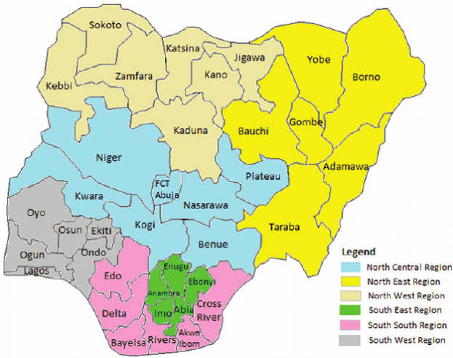
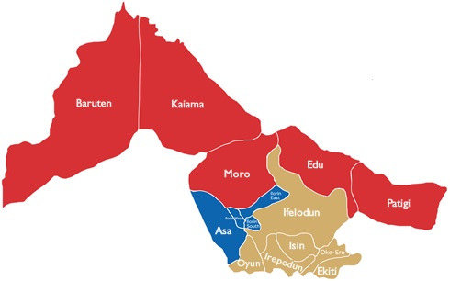
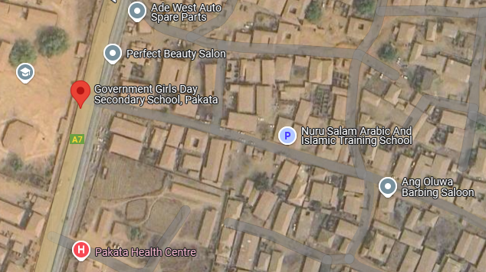
Fig. 1.1: Maps showing the study area

CHAPTER TWO
LITERATURE REVIEW
2.1 FOUNDATIONAL CONCEPTS OF TOPOGRAPHIC INFORMATION SYSTEM (TIS)
Topographic Information Systems (TIS) are a specialized subset of Geographic Information Systems (GIS) that concentrate on the representation, analysis, and interpretation of the Earth's surface features, particularly elevation and terrain morphology. While GIS encompasses a broad range of spatial data applications—such as land use planning, environmental monitoring, and infrastructure development—TIS are uniquely focused on capturing, managing, and analyzing topographic information with high precision (Burrough & McDonnell, 1998). This distinction defines the narrower yet deeper scope of TIS, which is oriented towards applications requiring detailed surface modeling, such as hydrological modeling, slope analysis, and terrain-based navigation (Longley et al., 2015).
A core aspect of TIS is terrain representation, which involves translating the continuous surface of the Earth into digital form. This is achieved using specialized data models, most notably Digital Elevation Models (DEMs) and Triangulated Irregular Networks (TINs). DEMs represent elevation data in a raster format where each cell contains a single elevation value, making them suitable for grid-based analyses such as flow direction or hillshade generation (Li et al., 2005). On the other hand, TINs use irregularly spaced elevation points connected by triangles, allowing for more accurate representation of varied terrain features, especially in areas with abrupt elevation changes (Zhou & Chen, 2011).
Coordinate systems form another foundational element of TIS, enabling the precise georeferencing of topographic data. Both geographic coordinate systems (e.g., latitude and longitude) and projected coordinate systems (e.g., Universal Transverse Mercator) are employed to ensure spatial accuracy and consistency when integrating terrain data with other thematic layers. These systems are essential for tasks such as calculating slope gradients, determining visibility, and conducting terrain-based simulations (Snyder, 1987).
In sum, TIS extend the capabilities of general GIS by incorporating terrain-specific data structures and analytical functions tailored to elevation-based phenomena. The use of high-resolution terrain models, accurate coordinate frameworks, and dedicated analysis tools enables TIS to support complex geospatial tasks in engineering, environmental science, and defense sectors. By focusing on topography as the primary analytical dimension, TIS provide deeper insights into spatial problems where surface form and elevation play a critical role (de Smith, Goodchild, & Longley, 2020).
2.2 CONCEPTUAL FRAMEWORK
The concept of a Topographic Information System (TIS) has evolved significantly over time as scholars and practitioners have increasingly recognized the value of topographic data in geographic information science. According to Longley et al. (2015), TIS represents a specialized application of Geographic Information Systems (GIS) that is particularly focused on the representation and analysis of surface features, such as elevation, slopes, and natural terrain forms. These authors emphasize that topographic information is foundational to spatial thinking because it underpins nearly all geospatial analysis, from hydrological modeling to infrastructure design. They argue that TIS should not be viewed merely as a repository of map data, but as an analytical platform that facilitates understanding of how terrain influences human and environmental systems.
Burrough and McDonnell (1998) contribute a foundational perspective by highlighting the role of spatial data structures in TIS. They stress the importance of accurate data modeling techniques such as Triangulated Irregular Networks (TINs) and Digital Elevation Models (DEMs) in representing surface variability. Their work underscores the complexity involved in managing topographic data, especially when dealing with large-scale or high-resolution datasets. Furthermore, they assert that the utility of TIS is dependent not only on data quality but also on the algorithms used for interpolation, contour generation, and surface analysis. These technical insights help lay the groundwork for understanding the computational challenges that accompany topographic mapping.
Goodchild (2007) expands the discussion by addressing the social and technological transformations that have impacted TIS. He introduces the concept of "citizens as sensors," acknowledging that the rise of volunteered geographic information (VGI) and participatory mapping has brought new forms of topographic data into TIS environments. This shift, he argues, enhances the dynamism and accessibility of TIS, allowing non-experts to contribute observations and updates that may improve the accuracy of terrain-related information. However, Goodchild also warns of the potential for data inconsistency and stresses the need for robust validation mechanisms to maintain scientific integrity in TIS applications.
In the context of land use and environmental planning, Maguire, Goodchild, and Rhind (2005) discuss the integration of TIS with other spatial decision support systems. They argue that TIS is particularly powerful when combined with land cover data, demographic information, and temporal datasets, enabling multidimensional analyses that inform policy and development. For instance, they describe how terrain data can be overlaid with hydrological layers to model flood risks, a process that is essential for sustainable urban planning. Their work emphasizes the value of interoperability and data fusion in extending the functionality of TIS beyond topography alone.
More recently, Zhang and Li (2020) have explored the integration of artificial intelligence into TIS, focusing on the automation of topographic feature extraction from satellite imagery and LiDAR data. They argue that machine learning techniques, such as convolutional neural networks (CNNs), have dramatically improved the speed and accuracy of terrain classification. This advancement, they suggest, positions TIS as a key component of smart geospatial technologies, with applications in autonomous navigation, precision agriculture, and real-time environmental monitoring. Their work highlights the future-oriented trajectory of TIS and the growing role of automation in topographic analysis.
The system architecture of a TIS typically comprises several core components: data input, storage, processing, analysis, and visualization. Data acquisition may involve satellite imagery, aerial photography, GPS surveys, and ground-based measurements. These inputs are transformed into structured topographic data through processes such as digitization, georeferencing, and interpolation. The database management system (DBMS) forms the backbone of the TIS by ensuring that spatial and attribute data are efficiently stored and retrieved (Burrough & McDonnell, 1998). Analytical tools within a TIS enable users to perform terrain analysis, slope and aspect mapping, watershed delineation, and landform classification, which are essential for informed decision-making in various sectors.
A key aspect of the conceptual framework is interoperability, which allows TIS to integrate with other geospatial systems and datasets through standardized protocols and formats such as XML, GML, and GeoJSON. This interoperability enhances data sharing and collaboration among government agencies, research institutions, and private organizations. Moreover, the advancement of web-based TIS and cloud computing has significantly improved the accessibility and scalability of topographic data, allowing real-time updates and remote access to spatial information (Goodchild, 2007).
The effectiveness of a TIS also relies heavily on the accuracy and resolution of the data it manages. High-resolution topographic data, such as those derived from LiDAR (Light Detection and Ranging) and UAV (Unmanned Aerial Vehicle) surveys, contribute to precise modeling of surface characteristics. However, the development and maintenance of a TIS require substantial technical expertise, financial investment, and institutional coordination. Challenges such as data redundancy, lack of standardization, and limited technical capacity in developing regions often hinder the implementation of robust TIS frameworks (Maguire, Goodchild, & Rhind, 2005).
In summary, the scholarly discourse around Topographic Information Systems reflects a convergence of foundational theory, technological advancement, and applied research. From the early emphasis on data structures and cartographic modeling (Burrough & McDonnell, 1998) to the incorporation of public data sources (Goodchild, 2007) and AI-driven automation (Zhang & Li, 2020), TIS continues to evolve in scope and complexity. These diverse perspectives illustrate that TIS is not merely a mapping tool but a dynamic, interdisciplinary system that plays a critical role in spatial science, policy-making, and environmental stewardship.
2.2.1 EVOLUTION AND TECHNOLOGICAL ADVANCEMENTS
The evolution of the Topographic Information System (TIS) reflects a broader transformation in geospatial sciences, marked by a steady shift from traditional analog cartography to highly advanced digital systems. Initially, topographic mapping was a manual process, relying on field surveys, triangulation, and hand-drawn contour lines on paper maps. These analog methods, though foundational, were labor-intensive, time-consuming, and limited in spatial accuracy and temporal flexibility. With the advent of computer technology and Geographic Information Systems (GIS) in the late 20th century, TIS underwent a major transformation. Cartographic data were digitized, stored in spatial databases, and manipulated using software tools that allowed for efficient editing, analysis, and visualization (Burrough & McDonnell, 1998). This digital shift enabled the integration of topographic data with other thematic layers such as land use, hydrology, and infrastructure, greatly enhancing the analytical power and applicability of TIS across various sectors.
The incorporation of advanced data acquisition technologies has further revolutionized modern TIS. One of the most significant advancements is the use of Light Detection and Ranging (LiDAR), a remote sensing technique that uses laser pulses to generate high-resolution, three-dimensional representations of the Earth's surface. LiDAR provides unprecedented accuracy in capturing elevation data, making it especially valuable for terrain modeling, forest canopy analysis, flood risk assessment, and infrastructure planning (Zhang & Li, 2020). Alongside LiDAR, satellite-based remote sensing has played a pivotal role in the development of TIS by enabling consistent, large-scale data collection across time and space. Multispectral and hyperspectral imagery from platforms such as Landsat, Sentinel, and MODIS offer essential information on surface reflectance and terrain patterns, which can be analyzed to monitor environmental changes, assess landforms, and support digital elevation modeling (Campbell & Wynne, 2011).
Moreover, the rise of Unmanned Aerial Vehicles (UAVs), commonly known as drones, has brought a new dimension to TIS by allowing for flexible, cost-effective, and high-resolution topographic data collection in real time. UAVs are particularly useful in areas that are difficult to access or require frequent monitoring, such as construction sites, coastal zones, and disaster-affected regions. Equipped with high-definition cameras and photogrammetry software, UAVs can produce accurate orthophotos and digital surface models (DSMs), which can then be seamlessly integrated into TIS platforms for detailed analysis. The real-time capabilities and spatial precision offered by UAVs make them indispensable tools in modern topographic workflows, bridging the gap between ground truthing and remote sensing (Colomina & Molina, 2014).
Collectively, these technological advancements have transformed TIS from a static mapping tool into a dynamic and intelligent system capable of continuous data acquisition, real-time analysis, and decision support. The integration of LiDAR, remote sensing, and UAVs not only enhances the spatial and temporal resolution of topographic data but also enables more nuanced, multi-dimensional understanding of terrain and landscape processes. As these technologies continue to evolve, supported by machine learning and cloud computing, the future of TIS promises even greater automation, scalability, and interoperability—cementing its role as a critical component of geospatial science and sustainable development.
2.2.2 DATA ACQUISITION AND PROCESSING IN TOPOGRAPHIC INFORMATION SYSTEM
Data acquisition and processing form the core foundation of any Topographic Information System (TIS), as the accuracy, reliability, and resolution of topographic analyses depend largely on the quality of input data and the rigor of subsequent processing techniques. The primary methods for acquiring topographic data include satellite imagery, GPS-based surveys, and aerial photogrammetry, each offering unique advantages in terms of spatial coverage, resolution, and cost. Satellite imagery, particularly from high-resolution earth observation platforms such as Landsat, Sentinel-2, and SPOT, provides broad-scale, multispectral data suitable for terrain analysis, landform classification, and base mapping. These data are frequently used in combination with elevation products like the Shuttle Radar Topography Mission (SRTM) and the Advanced Spaceborne Thermal Emission and Reflection Radiometer (ASTER) for generating large-scale Digital Elevation Models (DEMs) (Campbell & Wynne, 2011).
Global Positioning System (GPS) surveys, especially those using Differential GPS (DGPS) or Real-Time Kinematic (RTK) methods, offer high-precision point elevation data. This method is particularly effective for ground truthing and supplementing remote sensing data in areas where satellite visibility is limited or where ultra-high accuracy is required. Meanwhile, photogrammetry, the science of extracting 3D information from overlapping 2D images, remains a critical tool in TIS. When applied through manned aircraft or drones, photogrammetric techniques generate detailed surface models and orthophotos, especially when integrated with ground control points (GCPs) to enhance georeferencing accuracy (Colomina & Molina, 2014).
Once acquired, the raw spatial data must undergo several processing steps to become usable within a TIS framework. One of the most important processing outputs is the Digital Elevation Model (DEM), which digitally represents the Earth’s surface elevation in a grid or raster format. DEM generation may involve stereo image matching from satellite or aerial imagery, laser scanning data from LiDAR, or ground survey points. Following generation, DEMs require rigorous error correction procedures to eliminate data inconsistencies such as voids, spikes, or artificial depressions that may arise from sensor errors or occlusions. These errors are often addressed through filtering techniques, terrain conditioning, or reference to auxiliary datasets.
Interpolation algorithms play a vital role in estimating elevation values in areas where data is sparse or missing. Techniques such as Inverse Distance Weighting (IDW), Kriging, and Spline interpolation are commonly applied, each with strengths depending on the spatial structure of the data and the terrain complexity. For example, Kriging not only interpolates but also provides estimates of uncertainty, making it suitable for applications requiring both precision and statistical reliability (Burrough & McDonnell, 1998). Additionally, hillshading, slope, and aspect derivations are performed on DEMs to support advanced topographic analyses within TIS environments.
In summary, the process of data acquisition and processing within Topographic Information Systems is both multifaceted and highly technical. By integrating satellite imagery, GPS data, and photogrammetric inputs with sophisticated processing techniques such as DEM generation, error correction, and interpolation, TIS enables the construction of accurate and analytically rich representations of the Earth's surface. This capability underpins a wide range of applications from infrastructure planning to environmental monitoring, reinforcing the role of TIS as a crucial tool in spatial data science and geoinformatics.
2.2.3 DATA STORAGE AND MANAGEMENT IN TOPOGRAPHIC INFORMATION SYSTEM
Effective data storage and management are critical to the functionality and scalability of a Topographic Information System (TIS), especially given the immense volume, diversity, and complexity of spatial data it handles. Topographic datasets—ranging from raw elevation points to processed Digital Elevation Models (DEMs), orthophotos, and vector layers—require robust and specialized storage architectures capable of supporting both high performance and long-term accessibility. Traditional file-based storage systems have increasingly given way to more sophisticated spatial databases such as PostgreSQL with PostGIS extensions, Oracle Spatial, and Microsoft SQL Server with spatial capabilities. These databases are designed to efficiently store, query, and manipulate geospatial objects such as points, lines, polygons, and raster layers, all while preserving spatial relationships and supporting complex topological operations (Shekhar & Xiong, 2008). Moreover, the emergence of cloud-based storage and computing solutions, such as Amazon Web Services (AWS), Google Earth Engine, and Microsoft Azure, has transformed how topographic data is managed and accessed. Cloud platforms offer virtually unlimited storage capacity, high-speed processing, and the flexibility to share data and computation across users and institutions in real time, which is especially valuable for collaborative projects and large-scale topographic modeling.
The challenge of managing large-scale datasets in TIS is compounded by the need for seamless data retrieval, real-time updates, and integrity across different formats and sources. High-resolution DEMs, LiDAR point clouds, satellite imagery, and UAV-derived models can quickly scale into terabytes, necessitating not only high-capacity storage but also efficient indexing and compression strategies. Tiling, pyramiding, and spatial indexing methods—such as quadtrees and R-trees—are commonly employed to improve data retrieval speed and enable interactive visualization of massive datasets. Furthermore, the integration of real-time streaming data, such as GPS updates or UAV feeds, introduces additional complexities in temporal data management, requiring dynamic databases and versioning systems to track changes over time.
Equally important to storage is the implementation of rigorous metadata standards, which ensure that topographic data can be accurately described, discovered, and shared. Metadata documents essential information about the dataset’s source, scale, resolution, coordinate system, projection, and data lineage. Standards such as the Federal Geographic Data Committee (FGDC) in the United States, the ISO 19115 international standard, and the INSPIRE directive in the European Union provide frameworks for documenting spatial metadata consistently across institutions and platforms (Nebert, 2004). Adhering to these standards not only facilitates interoperability among different TIS platforms but also enhances data transparency and usability, especially in multi-user or cross-border applications.
In summary, the architecture of data storage and management in Topographic Information Systems has evolved to accommodate the increasing demands of spatial data science. Through the use of advanced spatial databases, cloud computing, and international metadata standards, TIS platforms are now capable of handling vast, heterogeneous datasets with efficiency and precision. These advancements ensure that topographic information remains accessible, reliable, and scalable—cornerstones for its continued use in planning, analysis, and decision-making across disciplines.

2.3 APPLICATIONS OF TOPOGRAPHIC INFORMATION SYSTEMS
Topographic Information Systems (TIS) serve as essential tools across a wide range of practical and analytical domains, providing detailed terrain and elevation data that inform decision-making, risk assessment, and resource management. In urban planning, TIS supports the strategic development of infrastructure by helping planners assess terrain suitability for construction, identify flood-prone zones, and optimize transportation routes. By integrating topographic layers with demographic and land-use data, urban planners can model growth patterns, guide zoning decisions, and ensure the resilience of urban environments (Longley et al., 2015). In the field of disaster management, TIS plays a critical role in hazard assessment and emergency response. For instance, in flood modeling, Digital Elevation Models (DEMs) derived from TIS enable precise simulations of water flow and accumulation, allowing authorities to predict inundation zones, plan evacuation routes, and implement early warning systems (Chen et al., 2009). Similarly, in the context of landslides and earthquakes, topographic data can be used to identify vulnerable slopes and assess post-disaster terrain changes.
Environmental monitoring is another major application area where TIS proves invaluable. By combining topographic data with satellite imagery and time-series data, environmental scientists can monitor changes in vegetation cover, soil erosion, and watershed dynamics. For example, topographic gradients can influence microclimates and biodiversity distribution, making elevation data crucial for conservation planning and habitat modeling (Turner et al., 2001). In defense and military operations, TIS is used for terrain analysis, route optimization, surveillance planning, and line-of-sight calculations. Accurate elevation and surface models enhance situational awareness and strategic planning, particularly in rugged or unfamiliar terrain. The integration of TIS into geospatial intelligence systems further supports battlefield simulations and logistical coordination.
Beyond these general applications, TIS also supports specialized scientific analyses. In hydrological modeling, topographic data form the basis for delineating catchment areas, identifying stream networks, and modeling surface runoff. Elevation gradients directly influence hydrological processes such as water flow direction and speed, making DEMs essential for accurate water resource management and flood prediction (Wilson & Gallant, 2000). In slope stability analysis, topographic attributes such as slope angle, curvature, and aspect are used to assess the likelihood of landslides or soil movement, particularly in areas with significant elevation variation. These analyses are critical in infrastructure design, mining operations, and natural hazard mitigation. Tools such as GIS-integrated slope stability models (e.g., SINMAP or SHALSTAB) depend heavily on accurate terrain inputs from TIS.
In sum, the versatility of Topographic Information Systems across disciplines—from city planning and disaster preparedness to environmental science and military operations—demonstrates their foundational role in spatial analysis and decision-making. As data quality and processing capabilities continue to improve, the scope and precision of TIS applications will expand even further, reinforcing their importance in addressing complex geographic and environmental challenges.
2.4 INTEGRATION OF TOPOGRAPHIC INFORMATION SYSTEMS
The integration of Topographic Information Systems (TIS) with other digital frameworks represents a significant advancement in spatial data infrastructure, fostering more dynamic, precise, and context-rich geospatial applications. One of the most notable areas of synergy is with Building Information Modeling (BIM), where the combination of detailed terrain models from TIS and structural data from BIM enables seamless planning and simulation of infrastructure projects within their real-world topographic context. This integration supports more accurate site selection, earthwork calculations, and environmental impact assessments, allowing architects, engineers, and urban planners to visualize how buildings will interact with the surrounding landscape in three dimensions (Amirebrahimi et al., 2016). Furthermore, the incorporation of Internet of Things (IoT) technology enhances TIS by enabling real-time monitoring of environmental and infrastructure conditions. IoT sensors deployed across terrain—such as in smart cities or agricultural fields—can feed continuous data streams into TIS platforms, allowing for dynamic analysis of topographic changes, weather impacts, or land deformation, and facilitating responsive decision-making in fields like disaster risk reduction and precision farming (Li et al., 2020).
Additionally, TIS functions as a foundational layer in multi-layered Geographic Information Systems (GIS), where it integrates with thematic datasets such as land use, transportation, hydrology, and demographics. In such environments, TIS enhances spatial analytics by providing the elevation and surface structure upon which other geospatial data can be layered, modeled, and visualized. This multidimensional integration enables complex spatial queries, such as viewshed analyses, watershed delineation, or slope-based land suitability assessments, making TIS indispensable in sectors ranging from public health to environmental planning. However, successful interoperability between TIS and other systems hinges on adherence to standardized data protocols. Here, organizations such as the Open Geospatial Consortium (OGC) play a critical role by establishing interoperability standards like the Web Map Service (WMS), Web Feature Service (WFS), and the Geography Markup Language (GML). These standards ensure that spatial data can be shared, visualized, and manipulated across different platforms and software environments without loss of fidelity or function (Percivall, 2010). Compliance with OGC specifications also promotes open data ecosystems and cross-organizational collaboration, particularly important in large-scale governmental or international geospatial initiatives.
In conclusion, the integration of Topographic Information Systems with BIM, IoT, and GIS platforms, along with the enforcement of interoperability standards, significantly enhances the analytical power, accuracy, and real-world applicability of spatial data. These synergies not only expand the functional scope of TIS but also position it as a critical component in the future of smart infrastructure, environmental intelligence, and global spatial data infrastructures.
2.5 CHALLENGES AND LIMITATIONS
Despite their transformative role in geospatial analysis and decision-making, Topographic Information Systems (TIS) face several persistent challenges and limitations that impact their effectiveness and adoption. One of the foremost technical issues is data accuracy and resolution trade-offs. High-resolution topographic data, such as that derived from LiDAR or UAV photogrammetry, offers precise elevation models and surface details, but comes with substantial storage and processing demands. Conversely, lower-resolution datasets, such as SRTM-derived DEMs, are easier to handle and more widely available but may lack the granularity needed for detailed terrain analysis or local-scale modeling. This trade-off becomes particularly problematic in regions where fine-scale terrain variation is critical for applications such as flood modeling or infrastructure planning (Wilson & Gallant, 2000). Additionally, computational demands remain a limiting factor, as processing high-resolution datasets—especially over large geographic extents—requires advanced hardware, optimized software, and often, parallel computing environments. The rendering, analysis, and real-time updating of topographic data in interactive platforms can strain system resources and reduce performance, particularly in resource-limited settings.
Beyond technical constraints, ethical and governance-related issues pose significant barriers to the equitable use of TIS. One growing concern is data privacy, especially in urban environments where detailed elevation models and geospatial overlays can unintentionally reveal private property features or individual movements. As the resolution and integration of spatial datasets increase, so too does the risk of infringing on personal privacy or exposing sensitive infrastructure layouts (Crampton, 2010). In tandem with privacy issues, data sovereignty has emerged as a critical topic, particularly for Indigenous communities and nations with strict controls over territorial data. The collection, storage, and use of topographic data by foreign entities or third-party cloud platforms may conflict with national policies or cultural norms, raising questions about consent, control, and the long-term use of geospatial information (Kukutai & Taylor, 2016).
Another pressing challenge is accessibility. Advanced TIS platforms often require specialized technical skills, proprietary software, and high-bandwidth internet connections, creating barriers for users in developing regions or marginalized communities. The digital divide can prevent stakeholders from accessing, understanding, or contributing to topographic datasets, thereby limiting the inclusivity and effectiveness of TIS in participatory planning or disaster preparedness efforts. Even where open-source tools exist, the lack of training or localized data can hinder meaningful application. Finally, inconsistencies in metadata documentation and interoperability between different systems and data formats can result in fragmented datasets, duplicative efforts, or inaccurate analyses if users are unaware of underlying data assumptions and limitations.
In summary, while Topographic Information Systems have revolutionized terrain analysis and spatial decision-making, they are not without significant limitations. From the technical burdens of high-resolution data processing to ethical concerns over privacy and sovereignty, and socio-economic barriers to access, these challenges necessitate continuous innovation, policy development, and capacity building to ensure TIS can be both powerful and responsibly used tools in the geospatial landscape.
2.6 EMERGING TRENDS AND FUTURE DIRECTIONS
As technological innovation accelerates, Topographic Information Systems (TIS) are undergoing a transformative evolution marked by the integration of cutting-edge tools and paradigms that promise to redefine how terrain data is acquired, analyzed, and applied. One of the most impactful developments is the incorporation of Artificial Intelligence (AI) and Machine Learning (ML) algorithms into topographic workflows. These technologies facilitate automated terrain analysis, enabling faster and more accurate classification of landforms, detection of geomorphic features, and extraction of drainage networks from large-scale Digital Elevation Models (DEMs). For instance, convolutional neural networks (CNNs) and other deep learning models are increasingly used to interpret complex surface patterns, identify anomalies, and predict terrain-related hazards such as landslides or erosion zones with minimal human intervention (Zhu et al., 2017). The result is a significant reduction in manual processing time and an improvement in analytical precision, particularly over vast or remote areas.
In parallel, real-time data integration is revolutionizing the responsiveness and utility of TIS platforms. Advances in remote sensing technologies, sensor networks, and Internet of Things (IoT) devices now enable topographic systems to ingest and process continuously updated datasets from UAVs, satellite constellations, and ground-based sensors. This shift from static to dynamic TIS infrastructure supports applications such as real-time flood modeling, infrastructure monitoring, and adaptive urban planning, where terrain conditions must be monitored and analyzed as they change (Li et al., 2020). Alongside these analytical improvements, advanced visualization technologies such as Virtual Reality (VR) and Augmented Reality (AR) are enhancing how topographic data is experienced and communicated. Through immersive 3D environments, users—ranging from engineers to policymakers—can explore terrain features at true scale, simulate environmental scenarios, and interactively plan spatial interventions. These tools are especially beneficial in stakeholder engagement, education, and collaborative planning processes, where intuitive understanding of spatial relationships is essential (Billinghurst et al., 2015).
Furthermore, the future of TIS is increasingly being shaped by a growing emphasis on sustainability and ethical geospatial practices. Sustainable TIS development entails minimizing the environmental impact of data acquisition (e.g., reducing the carbon footprint of UAV and satellite missions), promoting the use of open-source platforms to reduce dependency on proprietary systems, and ensuring long-term data stewardship. In addition, initiatives such as the FAIR data principles (Findable, Accessible, Interoperable, Reusable) and support for community-led mapping are gaining traction as means to democratize access and promote equitable use of terrain data. There is also rising interest in energy-efficient computation, data storage strategies, and the application of green IT standards in geospatial processing infrastructure (Goodchild, 2018).
In conclusion, the future of Topographic Information Systems lies in their intelligent automation, real-time adaptability, immersive visualization, and sustainability. As these systems continue to integrate with AI, cloud computing, and interactive platforms, they will not only become more powerful in technical terms but also more inclusive, responsive, and aligned with the broader goals of environmental stewardship and equitable development.

CHAPTER THREE
3.1 METHODOLOGY
The methodology adopted for this topographic survey involved the use of a Total Station to establish the perimeter, fix details, and capture spot heights for terrain representation. The science behind the process relies on geodetic principles, trigonometry, and electronic distance measurement (EDM) to determine precise locations, elevations, and feature positions. The Total Station, an advanced surveying instrument, integrates an electronic theodolite, EDM, and a data processor to measure angles and distances with high accuracy. The data collected was later processed using specialized software to produce topographic maps and elevation models.
3.2 EQUIPMENT AND MATERIALS
The equipment used to carried out the Topographic Information System of Government Day Secondary School, Pakata are;
- Differential Global Positioning System (DGPS)
- Total Station (South Total Station)
- Prism
- Cutlass
- Survey Beacon
- Field Book
- Computer System
The primary instrument used was a Total Station, which operates on the principle of trigonometric distance measurement. It emits an infrared or laser beam that reflects off a prism placed at the target point. By analyzing the time taken for the signal to return, the Total Station calculates distances and, together with angular measurements, determines the precise position of each point. A tripod provided stability for the Total Station, ensuring measurement accuracy. A prism and prism pole were used as target reflectors, allowing the Total Station to lock onto and measure the position of survey points.
Benchmarks and control points provided a reference framework, ensuring all measurements were relative to a fixed coordinate system. A field book was used to manually record observations, sketches, and any necessary adjustments during the survey. Finally, data processing software such as AutoCAD Civil 3D and ArcGIS was employed to analyze and visualize the collected data, transforming it into usable topographic outputs.
3.3 SURVEY PROCEDURE
The survey was conducted in a systematic manner to ensure precision. It involved pre-survey planning, control point establishment, perimeter measurement, detail fixing, spot height recording, and data processing.
3.3.1 RECONNAISSANCE SURVEY
A reconnaissance survey is the preliminary stage of a topographic survey that involves gathering essential information about the site both in the office and in the field. The goal is to assess the terrain, identify potential challenges, plan the survey workflow, and ensure all necessary resources are available before the detailed survey begins.
Office Planning
The office reconnaissance involves researching existing data, reviewing maps, and planning the fieldwork to improve efficiency and accuracy. This step ensures that surveyors are well-prepared before stepping into the field.
1. Gathering Existing Data
- Available maps, and previous survey records of the area are collected and reviewed.
2. Identifying Control Points
- Existing geodetic control points are identified from national or local survey databases.
- Since control points are unavailable, plans are made to establish new ones within the survey area.
3. Planning Survey Workflow
- The survey approach, including the use of Total Stations, GPS, and leveling instruments, is determined.
- Team roles and responsibilities are assigned, and required equipment is listed.
- Potential challenges such as dense vegetation, water bodies, or built-up areas are noted for field adaptation.
4. Preparation of Field Materials
- Field sketches, coordinate lists, and necessary software for data collection are prepared.
- Batteries, tripods, and measuring tools are checked and calibrated.
Field Reconnaissance
The field reconnaissance involves physically visiting the site to verify office findings and assess real-time conditions that may impact the survey.

1. Site Visit and Visual Assessment
- The team walks through the survey area, confirming boundaries, terrain conditions, and accessibility.
- The presence of obstacles like water bodies, dense forests, or buildings is noted.
2. Verification of Control Points
- New control point locations are selected for proper coverage of the survey area.
3. Identifying Suitable Instrument Stations
- Locations for Total Station setups are chosen based on line-of-sight and coverage.
- Safe and stable positions for survey equipment are determined to minimize measurement errors.
3.3.2 ESTABLISHMENT OF CONTROL POINTS
Control points are the foundation of any survey, providing fixed reference positions that all subsequent measurements rely upon. These points ensure that the survey maintains consistency and accuracy across the entire area. The process of establishing control points involves setting up known reference stations from which measurements of boundaries, details, and elevations can be made.
Scientific and Technological Basis
Control points are based on geodetic and trigonometric principles. The positions of these points are determined using total stations, ensuring their precise locations in relation to a coordinate system. The Total Station works by measuring the horizontal and vertical angles, along with the slope distances to reference targets, and calculating the X, Y, and Z coordinates using trigonometry and EDM (Electronic Distance Measurement).
Step-by-Step Procedure
1. Selection of Control Point Locations
- The first step is to identify existing geodetic control points near the site.
- Since, no existing control points are available, new ones are established in stable, accessible locations.
- The locations are selected based on visibility, accessibility, and security, ensuring that the points can be used throughout the survey.
- The equipment used for the establishment of the control point is Differential Global Positioning System (DGPS)
Table 3.1: Table showing the new established control points
Control Station | Northing | Easting
KP 001 | 938 774.336 | 666 705.731
KP 002 | 938 668.328 | 666 518.319
KP 003 | 938 665.326 | 666 559.394

2. Setting up the Total Station
- A tripod is placed over the control point and carefully leveled to ensure stability.
- The Total Station is mounted on the tripod and centered over the control point using the built-in optical plummet or laser plummet.
- Fine adjustments are made using the leveling screws and circular bubble to ensure accuracy.
3. Backsighting to a Known Point
- The instrument is aligned to a known reference point (geodetic benchmark or previously established control point).
- A prism is placed at the reference point, and a backsight measurement is taken to establish orientation.
- This ensures that all subsequent measurements are tied to the correct coordinate system.
Fig. 3.1: Diagram showing the control station connection

KP
001

KP
002

KP
003
Backsight
Total Station

4. Measurement of New Control Points
- The Total Station emits a laser or infrared beam toward the prism held at the target control point location.
- The instrument measures the angle and distance and automatically calculates the X, Y, and Z coordinates of the new control point.
- Multiple readings are taken for accuracy.
5. Checking and Adjustment of Control Points
- A closed traverse is conducted, ensuring that the last control point connects back to the first one, forming a loop.
- Any misclosure errors are adjusted using the Bowditch method or Least Squares Adjustment, ensuring consistency and reliability of control points.
These control points now serve as the reference framework for all subsequent survey operations.
Table 3.2: Table showing the coordinate of the control point after the orientation
Control Station | Northing | Easting
KP 001 | 938 774.214 | 666 705.643
KP 002 | 938 668.328 | 666 518.319
KP 003 | 938 665.200 | 666 559.254

3.3.3 PERIMETER SURVEYING (BOUNDARY MEASUREMENT)
Once control points have been established, the next step is to determine the exact perimeter of the survey area. This involves measuring all boundary points to create an accurate map of the land extent.
Scientific and Technological Basis
Perimeter surveying relies on traverse computations and geospatial mapping. Using the Total Station, precise angular and distance measurements are taken from control points to define the boundary. The EDM system in the Total Station measures distances by calculating the travel time of an emitted laser beam, while the internal processor applies trigonometric calculations to determine the boundary points’ exact coordinates.
Step-by-Step Procedure
1. Setting Up the Total Station
- The Total Station is positioned at a control point and carefully leveled.
- A backsight measurement is taken to orient the instrument correctly to the established control network.
2. Marking Boundary Points
- The boundary points are identified in the field using physical markers (wooden pegs, iron rods, or concrete beacons).
- Each boundary corner is assigned a unique point number.
3. Measuring Boundary Points
- The prism reflector is placed at each boundary corner.
- The Total Station records horizontal angles, vertical angles, and slope distances to compute the exact location of each boundary point.
- If the distance is too far, the instrument is repositioned at a new control point to continue measurements.
4. Closing the Perimeter Traverse
- To ensure accuracy, the last boundary point is connected back to the first boundary point, creating a closed traverse.
- If errors exist in the traverse, adjustments are made using a traverse adjustment technique.
The perimeter survey ensures that the land boundaries are accurately mapped and legally verifiable.
3.3.4 FIXING OF DETAILS
After defining the perimeter, the next step is to fix natural and man-made details within the site, such as buildings, roads, trees, drainage channels, power poles, fences, and water bodies.
Scientific and Technological Basis
Fixing details involves topographic feature mapping, using the Total Station to determine the precise locations of objects within the survey area. The coordinate geometry (COGO) principles and EDM technology allow for highly accurate spatial positioning of objects.

Step-by-Step Procedure
1. Total Station Setup at a Control Point
- The Total Station is placed at a known control point, and backsighting is performed for orientation.
2. Detail Point Identification
- A prism pole is placed at specific feature locations, such as corners of buildings, road edges, electric poles, and trees.
- For linear features such as roads and drainage channels, multiple points are measured along their alignment.
3. Measurement of Features
- The Total Station records angles, distances, and elevations, calculating the precise X, Y, and Z coordinates of each detail point.
- Each recorded feature is assigned a category, ensuring organized mapping.
4. Verification and Cross-Checking
- The recorded points are plotted on a real-time sketch or digital map to verify their correctness.
Fixing details ensures that all site features are mapped accurately for design, analysis, or documentation.

3.3.5 SPOT HEIGHT MEASUREMENT
Spot height measurement is essential for understanding the elevation variations across the survey area. It involves recording the altitude (Z-coordinates) of multiple locations, which is crucial for terrain modelling, contour mapping, and engineering design.
Scientific and Technological Basis
Spot height measurement uses trigonometric leveling and terrain modeling principles. The Total Station calculates elevations by measuring vertical angles and slope distances to the prism, computing the precise height difference between the instrument and each point.
Step-by-Step Procedure
1. Setting Up the Total Station and Backsighting
- The instrument is placed on a control point with a known elevation (benchmark).
- A backsight is taken on another reference point to ensure correct height reference.
2. Grid-Based Spot Height Measurement
- A grid system is established, where spot heights are measured at uniform intervals across the site.
- The prism pole is placed at each grid point, and the Total Station records the elevation.
3. Recording Breakline Heights
- Additional spot heights are taken at breaklines (significant slope changes) such as road edges, embankments, and depressions.
4. Processing and Contour Mapping
- The collected elevations are used to generate contour lines and Digital Elevation Models (DEM), which visually represent the terrain.
Spot height measurements are essential for engineering design, flood analysis, and landscape assessment.
3.4 DELIVERABLES AND OUTPUT
The final deliverables of the topographic survey included:
1. Topographic Map – A detailed representation of the survey area, including contour lines, elevation points, and fixed features.
2. Digital Elevation Model (DEM) – A 3D visualization of the terrain, useful for hydrological and engineering analysis.
3. GIS and CAD Files – Digital data compatible with GIS and CAD software for further analysis and integration into project designs.

CHAPTER FOUR
RESULTS AND ANALYSIS
This chapter presents the results derived from the topographic survey carried out using Total Station equipment. The survey generated key outputs that include the defined perimeter of the site, fixed planimetric features, measured spot heights, a topographic map, and a digital terrain model (DTM). These outcomes were analyzed to evaluate the spatial characteristics, elevation dynamics, and surface morphology of the project site. The interpretations presented in this chapter are intended to aid physical planning, civil engineering design, land assessment, and environmental appraisal.
4.1 PERIMETER SURVEY RESULT
The first deliverable from the survey was the precise demarcation of the boundary enclosing the project area. Using Total Station equipment, angular and linear measurements were recorded along traverse lines connecting perimeter points. A closed traverse was executed, and adjustments were applied to eliminate angular and linear misclosures using Bowditch’s method. After corrections, coordinate computation yielded a total enclosed area of 5.746 hectares.
Each traverse station was referenced to a consistent datum, and coordinates were computed in a Universal Traverse Mercator (UTM) coordinate system. Bearings between stations and line distances were recorded with high accuracy, and redundant checks (backsight and foresight readings) confirmed data integrity.
Interpretation
The perimeter defines the legal footprint of the land parcel and forms the spatial foundation for all subsequent surveying and design activities. Its accuracy is critical for preventing encroachment and for ensuring compliance with planning laws. The 5.746-hectare area size is moderately expansive and suitable for mixed land uses, such as institutional development, housing schemes, or infrastructural expansion. The successful closure of the traverse with minimal misclosure values indicates a high level of precision in the control framework.
4.2 DETAILED (PLANIMETRIC) SURVEY RESULT
Following perimeter control, planimetric detail features were fixed within the site. This involved the identification and coordinate measurement of all physical features, both natural and man-made. The detail survey recorded 21 existing buildings, all of which were measured using reflector-based Total Station shots to capture at least three to four defining corners per building. This allowed for accurate plotting of their geometries.
Additionally, two mature trees were observed within the site. These were recorded with their coordinates and plotted for spatial awareness and environmental relevance. The survey also documented the adjoining road infrastructure along the stretch between PL11 and PL1, providing vital context for access and transport planning.
Interpretation:
The detailed feature inventory is essential for base mapping, land-use classification, and infrastructure alignment. The presence of 21 structures indicates active or past land usage, which must be considered in any redevelopment or land allocation strategy. Their layout can also inform site zoning, access corridors, and utility planning. The inclusion of tree positions aids in environmental impact assessments and landscaping design. Moreover, the bordering road increases the site's connectivity and suitability for development by ensuring access and linking the site to external infrastructure networks.
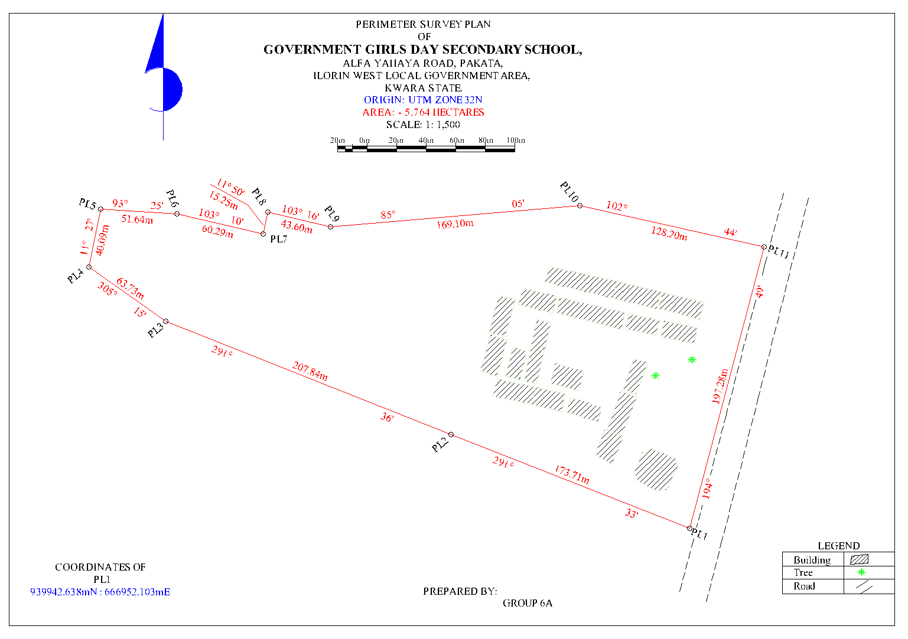 Fig 4.1: Detailed Plan of the Study area
4.3 SPOT HEIGHT MEASUREMENT AND ELEVATION ANALYSIS
Spot height measurements were obtained at regularly spaced intervals across the terrain to capture the vertical variation of the site. The spot heights ranged from 302.00 meters to 321.00 meters above mean sea level, indicating an elevation variation of 19 meters. Readings were taken at terrain breaks, slope transitions, and grid intersections to provide a full surface elevation dataset.
From the spot heights, contour lines were interpolated at 1.00-meter intervals, generating a continuous representation of elevation change across the site. The contours illustrate gradual and moderate slope patterns, with the steepest gradients located toward the northeastern section and relatively flatter terrain to the southwest.
Interpretation:
The elevation range reflects a moderate topographic undulation, which is advantageous for natural surface drainage, minimizing the risk of waterlogging. Slopes are not extreme, suggesting that grading requirements for construction will be minimal and cost-effective. The elevation profile also guides where best to site sensitive infrastructure such as roads, buildings, and stormwater channels. High points (up to 321m) are ideal for positioning critical structures, while lower points (around 302m) should be evaluated for potential runoff collection or water retention.
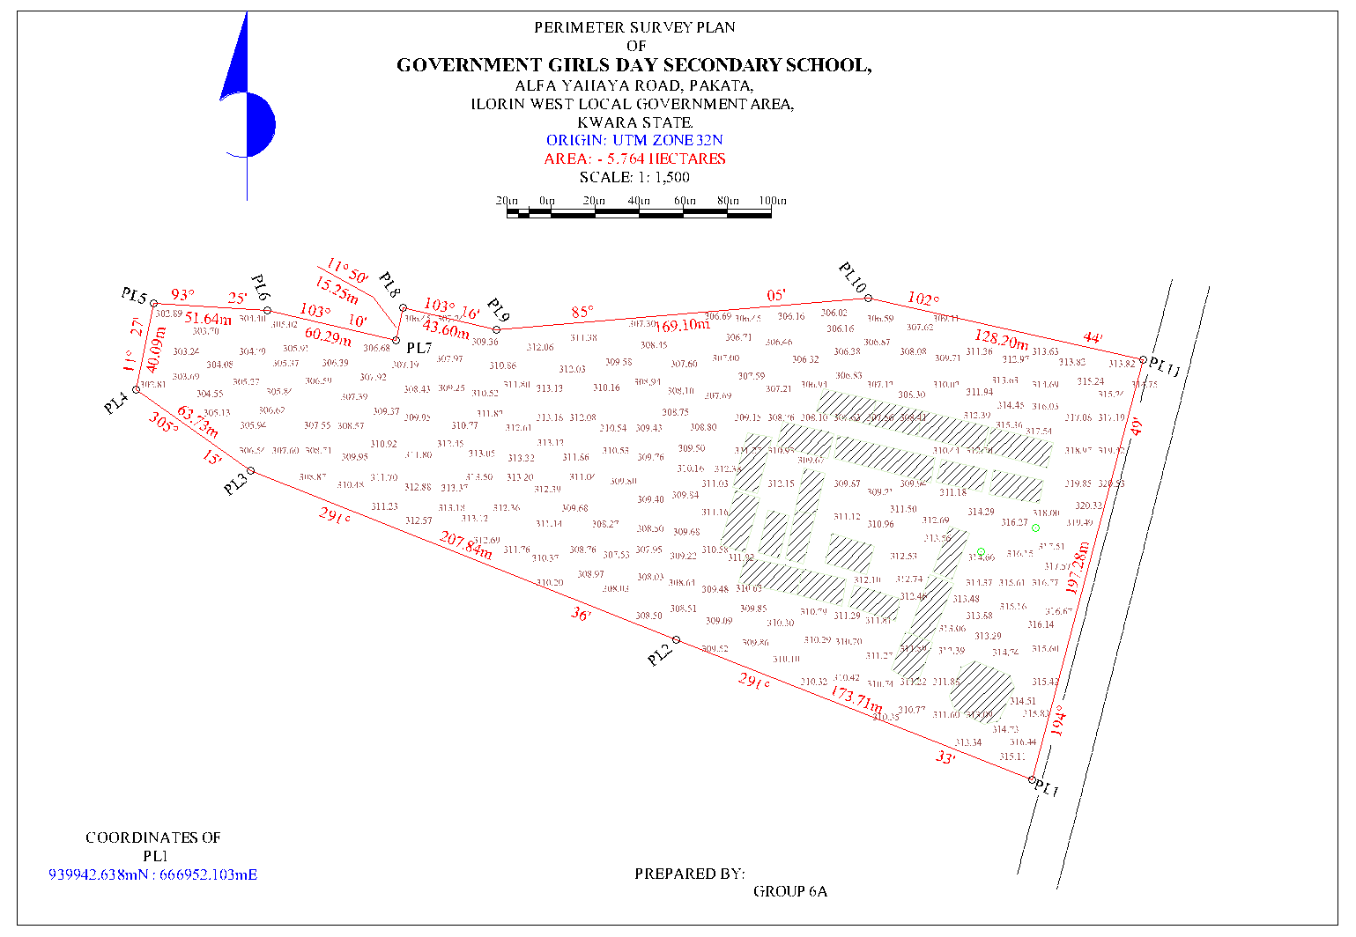 Fig 4.2: Spot Height Plan of the Study area
PLAN SHEWING THE SPOT HEIGHTS
OF
GOVERNMENT GIRLS DAY SECONDARY SCHOOL,
ALFA YAHAYA ROAD, PAKATA,
ILORIN WEST LOCAL GOVERNMENT AREA,
KWARA STATE.
ORIGIN: UTM ZONE 32N
AREA: - 5.764 HECTARES
SCALE: 1: 1,500

4.4 TOPOGRAPHIC MAP RESULT
The topographic map produced combines all collected spatial data — perimeter, details, and elevation — into a georeferenced and scaled map. The map visually represents both the horizontal arrangement of features and the vertical variations in elevation. Buildings are symbolized with clearly marked outlines, trees are shown with natural feature symbols, and roads are represented with line features matching their real-world orientation.
Contour lines dominate the elevation representation, showing continuous terrain levels at 1.00-meter intervals. The map layout includes northing, easting, scale bar, legend, and title block to comply with cartographic standards.
Interpretation:
The topographic map provides a single-source spatial document that aids decision-making across various disciplines. For architects, it allows the preparation of conceptual site layouts; for engineers, it supports terrain grading and slope analysis; and for urban planners, it informs land zoning and development control. Its clarity and completeness make it useful as both a presentation and analytical tool. It also enables integration into GIS environments for further spatial modeling or overlay with satellite imagery and planning datasets.
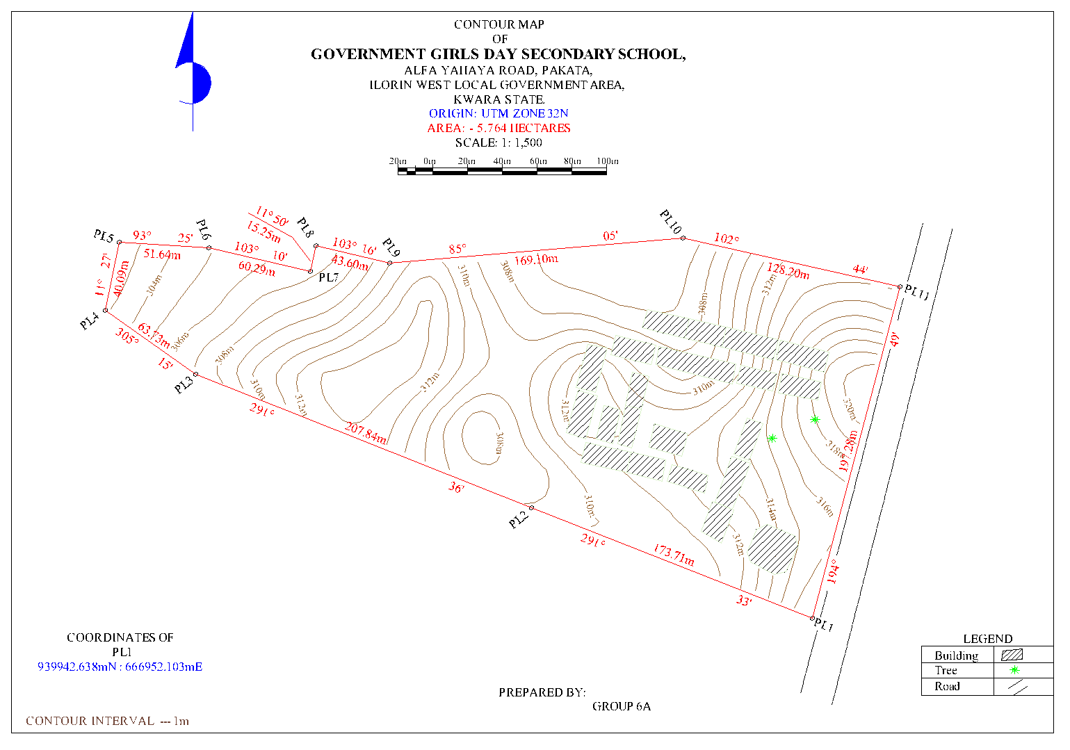 Fig 4.3: Contour Map of the Study area
CONTOUR PLAN
OF
GOVERNMENT GIRLS DAY SECONDARY SCHOOL,
ALFA YAHAYA ROAD, PAKATA,
ILORIN WEST LOCAL GOVERNMENT AREA,
KWARA STATE.
ORIGIN: UTM ZONE 32N
AREA: - 5.764 HECTARES
SCALE: 1: 1,500
4.5 DIGITAL TERRAIN MODEL (DTM) OUTPUT
Using the spot height dataset, a Digital Terrain Model (DTM) was generated to present the terrain as a continuous, 3D surface. The DTM was developed using interpolation techniques (e.g., Triangulated Irregular Network or Inverse Distance Weighting), and surface rendering was applied to visualize elevation differences, slope directions, and terrain curvature.
The DTM reveals subtle terrain changes not always visible on contour maps, such as micro-depressions or ridgelines. It is capable of supporting 3D visualization, fly-throughs, and terrain profiling, thereby enabling more advanced engineering applications.

Interpretation:
The DTM is a powerful tool for simulating hydrological flow, estimating earthwork quantities, and visualizing site development impact. It is especially useful for road design, cut-and-fill balancing, and modeling surface runoff. The 19-meter elevation range, when analyzed in the DTM, supports the identification of natural drainage paths and areas of potential erosion. The use of the DTM improves efficiency and reduces risks during planning and construction.
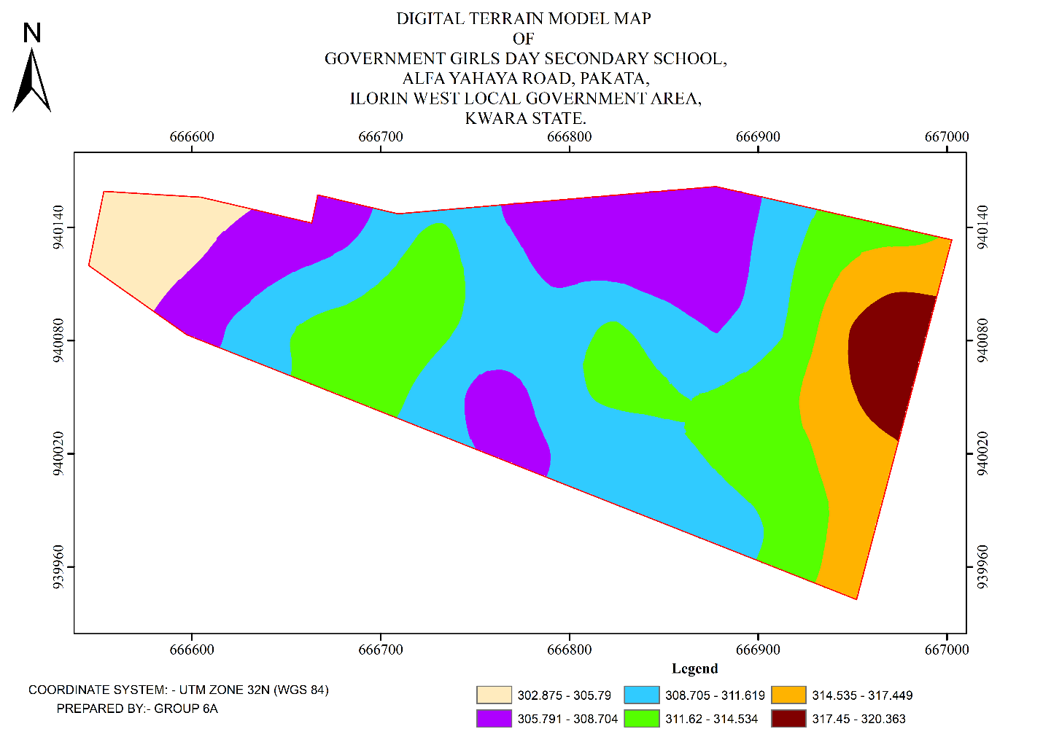 Fig 4.4: Digital Terrain Model Map of the Study area

4.6 INTEGRATED SPATIAL INTERPRETATION AND SITE ASSESSMENT
From the compiled results, it is evident that the site exhibits a balanced terrain with mild slopes, active land use, and strong access potential due to the bordering road. The presence of several buildings suggests partial occupation or previous use, while the terrain characteristics support new development with minimal site modification.
The combination of perimeter survey, detailed feature fixing, spot height data, contour mapping, and digital modeling ensures a comprehensive understanding of the site. The overall dataset can be used for:
- Land-use planning and zoning (based on building distribution and access routes)
- Engineering design (based on elevation and slope analysis)
- Drainage and stormwater design (from DTM slope flow directions)
- Construction layout and supervision
Integration into a GIS-based land information system

CHAPTER FIVE

COSTING, SUMMARY, PROBLEM ENCOUNTERED CONCLUSION AND RECOMMENDATIONS.
5.1 COST ESTIMATION
This stage the total cost spent on the project from day one to the final stage.
Table 5.1.1: Direct cost parameters
S/N | DIRECT COST
1 | Reconnaissance (1 day)
 | PERSONNEL | Rate | Total Amount (N:K)
 | 1 x surveyor | 10500 | 10500
 | 1 x assistant surveyor | 7500 | 7500
 | 1 x technical officer | 6500 | 6500
 | 3 x skilled labour | 4000 | 12000
 | basic equipment | 5000 | 5000:00
 | transportation (vehicle, Driver and fuel) | 10000 | 10000:00
 |  | sub-total | 51,500
2 | Monumentation (1 day)
 | PERSONNEL
 | 1 x assistant surveyor | 7500 | 7500
 | 1 skilled labour | 4000 | 4000
 | transportation (vehicle, Driver and fuel) | 10000 | 10000
 | basic equipment | 5000 | 5000:00

 | Beacon (6) | 1000 | 6000
 |  | sub-total | 32,500
3 | Data acquisition (2 days)
 | PERSONNEL
 | 1 x assistant surveyor | 7500 | 7500
 | 1 x technical officer | 6500 | 6500
 | 3 x skilled labour | 4000 | 12000
 | Total Station and accessories | 15000 | 15000
 | transportation (vehicle, Driver and fuel) | 10000 | 10000
 |  | sub-total | 51,000
5 | Data Processing (2 days)
 | PERSONNEL
 | 1 x surveyor | 10500 | 10500
 | 1 x assistant surveyor | 7500 | 7500
 | 1 x technical officer | 6500 | 6500
 | computer / accessories | 15000 | 15000
 |  | sub-total | 39,500
7 | Technical Report (1 day)
 | PERSONNEL
 | 1 x surveyor | 10500 | 10500
 | 1 x assistant surveyor | 7500 | 7500

 | 1 x secretary | 5000 | 5000:00
 | computer / accessories | 15000 | 15000:00
 |  | sub-total | 38,000
TOTAL (DIRECT COST) 212,500 MOBILIZATION/DEMOBILIZATION = 5% of Direct Cost
= 0.05 × 212,500

= N10,625

CONTINGENCY ALLOWANCE
= 5% of Direct Cost
= 0.05 × 212,500

= N10,225

GRAND TOTAL = N212,500 + N10,625 + N10,625

= N233,750

VAT (@5% GRAND TOTAL) = 0.05 × 233750

= N11,687.5
TOTAL COST PAYABLE = GRAND TOTAL + VAT

= N233,750+ N11,687.5 = N245,437.5

5.2 SUMMARY
The application of Topographic Information Systems (TIS) to the study of part of the Government Girls Day Secondary School, Pakata, Ilorin West (LGA), Kwara State, represents an important step towards modernizing urban planning, infrastructure development, and environmental management in the region. TIS, through the integration of advanced tools such as Digital Elevation Models (DEMs), satellite imagery, and geospatial data analysis, provides a comprehensive understanding of the terrain characteristics of the area, including elevation, slope, and landforms. This information is critical for planning and development in urban zones like the Government Girls Day Secondary School, where the population density is increasing, and there is a need for sustainable infrastructure development.
The topographic data derived from TIS can assist in a variety of applications, including flood modeling, land use planning, drainage system design, and risk assessment for potential natural hazards, particularly flooding due to the region’s topographic features and seasonal rainfall patterns. The detailed mapping and analysis of the area’s topography also provide insights into potential sites for future urban expansion and infrastructure projects while ensuring that the built environment is adapted to the natural terrain. Moreover, TIS can aid local authorities and stakeholders in creating policies that prioritize environmental sustainability, resilient urban infrastructure, and public safety, particularly in the face of climate change and population growth.
As the use of TIS in Government Girls Day Secondary School continues to grow, it will contribute to the integration of smart city technologies, including real-time data integration and IoT-driven solutions for more effective urban management. This could include the continuous monitoring of infrastructure health, soil conditions, and environmental changes. Additionally, the accurate terrain data generated by TIS will be instrumental in addressing challenges related to land tenure, property disputes, and infrastructure maintenance.

5.3 PROBLEM ENCOUNTERED
The following were the problems encountered during the execution of this project.
- The project was financially expensive, energetic and time consuming.
- On the day of carrying out the practical, there was a delay in getting the instrument that resulted in getting to the site lately.
- Throughout the practical, we worked under the sun reason that we got to the site lately.

5.4 CONCLUSION
In conclusion, the integration of Topographic Information Systems (TIS) into the planning and development of Government Girls Day Secondary School, Pakata, Ilorin West (LGA), Kwara State, offers a transformative approach to understanding and managing the region’s complex topographic and environmental characteristics. By leveraging advanced geospatial tools such as Digital Elevation Models (DEMs), satellite imagery, and real-time data collection technologies, TIS provides crucial insights into the terrain, which are invaluable for urban planning, disaster management, and infrastructure development. The use of TIS in this area enables stakeholders to make informed decisions about land use, flood risk assessment, and the design of resilient infrastructure that is aligned with the natural landscape, helping to mitigate the risks associated with topographic challenges.
Furthermore, the potential of TIS to integrate with emerging technologies like AI, IoT, and virtual/augmented reality promises to enhance the system's capability for real-time monitoring and dynamic decision-making. This integration will be pivotal in addressing future challenges as the region continues to urbanize, ensuring that growth is sustainable and that urban systems can effectively adapt to environmental changes.
However, for TIS to reach its full potential in Government Girls Day Secondary School, it is essential that data accuracy, accessibility, and local expertise are prioritized. Moreover, addressing the ethical concerns related to data privacy and ensuring equitable access to TIS benefits are key considerations for the long-term success of this technology in the region. With proper implementation and continuous improvements in data integration, TIS will play a critical role in shaping a more sustainable, resilient, and efficient urban future for Ilorin West LGA, enhancing the quality of life for its residents and fostering more effective governance.

5.5 RECOMMENDATION
Here is the recommendation section for the topic "Topographic Information Systems (TIS) of Government Girls Day Secondary School, Pakata, Ilorin West (LGA), Kwara State, in a listed format:
  - Enhance Data Accuracy and Resolution: It is recommended to improve the resolution and accuracy of topographic data by using advanced technologies such as LiDAR and UAV-based photogrammetry for more detailed mapping of terrain features in Government Girls Day Secondary School. This will provide more precise information for urban planning and flood risk assessments.
  - Integrate Real-Time Monitoring Systems: The integration of Internet of Things (IoT) sensors and other real-time monitoring systems within the TIS framework will enable continuous updates on environmental changes, infrastructure health, and disaster management. This will facilitate quicker decision-making and responses to dynamic urban challenges.
  - Adopt Advanced Visualization Technologies: Utilize Virtual Reality (VR) and Augmented Reality (AR) technologies to create immersive 3D models of the topography for urban planners, engineers, and the local community. This will improve stakeholder engagement, enhance understanding of the terrain, and aid in effective spatial decision-making.
  - Strengthen Capacity Building and Training: Provide training programs for local government officials, urban planners, and other stakeholders to build capacity in using TIS tools and interpreting topographic data. This will ensure better utilization of the system and foster local expertise in managing urban development challenges.
  - Promote Public-Private Partnerships: Foster collaborations between government agencies, private sector firms, and academic institutions to improve data collection, system development, and the long-term sustainability of TIS in the region. These partnerships can support funding, research, and the sharing of best practices.

REFERENCES
Amirebrahimi, S., Rajabifard, A., Mendis, P., & Ngo, T. (2016). A data model for integrating GIS and BIM for assessment and 3D visualization of flood damage to building infrastructure. International Journal of Digital Earth, 9(4), 363–386.
Billinghurst, M., Clark, A., & Lee, G. (2015). A Survey of Augmented Reality. Foundations and Trends in Human–Computer Interaction, 8(2-3), 73–272.
Burrough, P. A., & McDonnell, R. A. (1998). Principles of Geographical Information Systems. Oxford University Press.
Campbell, J. B., & Wynne, R. H. (2011). Introduction to Remote Sensing (5th ed.). Guilford Press.
Chen, Y., Yu, J., & Khan, S. (2009). Spatial sensitivity analysis of multi-criteria weights in GIS-based land suitability evaluation. Environmental Modelling & Software, 24(12), 1508–1515.
Colomina, I., & Molina, P. (2014). Unmanned aerial systems for photogrammetry and remote sensing: A review. ISPRS Journal of Photogrammetry and Remote Sensing, 92, 79–97.
Crampton, J. W. (2010). Mapping: A Critical Introduction to Cartography and GIS. Wiley-Blackwell.
Goodchild, M. F. (2018). Reimagining the History of GIS. Annals of GIS, 24(1), 1–8.
ISO (2003). ISO 19115: Geographic Information—Metadata. International Organization for Standardization
Kukutai, T., & Taylor, J. (Eds.). (2016). Indigenous Data Sovereignty: Toward an Agenda. ANU Press.
Li, S., Da Xu, L., & Zhao, S. (2020). 5G Internet of Things: A survey. Journal of Industrial Information Integration, 10, 1–9.
Longley, P. A., Goodchild, M. F., Maguire, D. J., & Rhind, D. W. (2015). Geographic Information Science and Systems. Wiley.
Nebert, D. D. (2004). Developing Spatial Data Infrastructures: The SDI Cookbook. GSDI Association.
Percivall, G. (2010). The role of open standards in geospatial interoperability. In Handbook of Research on Geoinformatics, IGI Global, 92–103.
Shekhar, S., & Xiong, H. (2008). Encyclopedia of GIS. Springer.
Turner, M. G., Gardner, R. H., & O'Neill, R. V. (2001). Landscape Ecology in Theory and Practice. Springer.
Wilson, J. P., & Gallant, J. C. (2000). Terrain Analysis: Principles and Applications. Wiley.
Zhu, X. X., Tuia, D., Mou, L., Xia, G. S., Zhang, L., Xu, F., & Fraundorfer, F. (2017). Deep Learning in Remote Sensing: A Comprehensive Review and List of Resources. IEEE Geoscience and Remote Sensing Magazine, 5(4), 8–36.

APPENDIX
GROUP 6A TOPO RAW DATA
P.I.D EASTING NORTHING ELEVATION | P.I.D EASTING NORTHING ELEVATION
1,PT,666559.393,938655.226,324.403  2,BLD,666564.888,938655.589,324.609  3,BLD,666572.856,938656.418,324.845  4,BLD,666579.384,938656.990,325.081  5,BLD,666587.417,938657.779,325.249  6,FF,666584.030,938674.217,324.847  7,FF,666578.461,938674.102,324.602  8,SH,666562.850,938672.506,324.086  9,SH,666548.780,938675.012,323.749  10,SH,666529.505,938681.031,323.445  11,WF,666509.740,938692.262,322.828  12,GT,666501.195,938679.925,323.593  13,GT,666500.602,938679.080,323.629  14,WF,666494.023,938669.408,323.585  15,PIL,666489.939,938663.250,323.784  16,SH,666504.839,938663.969,323.640  17,SH,666518.319,938668.328,323.512  18,SH,666534.636,938665.045,323.618  19,SH,666537.246,938651.342,324.351  20,SH,666537.116,938640.217,324.791  21,PIL,666549.802,938626.341,325.710  22,BLD,666566.949,938635.507,325.534  23,SH,666560.052,938640.072,325.173  24,SH,666551.407,938652.598,324.272  25,SH,666550.568,938689.169,323.494  26,SH,666538.375,938698.658,323.125  27,SH,666518.282,938705.519,322.835  28,TR,666530.522,938714.804,323.065  29,BLD,666532.985,938723.275,322.886  30,BLD,666535.020,938722.153,323.014  31,BLD,666536.550,938724.511,323.043  32,BLD,666537.444,938726.038,323.111  33,BLD,666538.628,938728.344,323.073  34,TR,666547.428,938716.448,323.439  35,SH,666561.960,938714.995,323.735  36,SH,666577.398,938714.165,323.962  37,SH,666588.013,938713.553,324.333  38,SH,666594.902,938733.181,324.533  39,FF,666585.859,938745.789,324.080  40,FF,666580.138,938746.859,324.004  41,SH,666567.418,938742.689,323.674  42,BLD,666562.092,938744.078,323.581  43,BLD,666553.297,938748.849,323.116  44,WF,666548.166,938751.757,323.022  45,BLD,666573.843,938764.473,323.318  46,SH,666582.419,938761.025,323.802  47,SH,666592.201,938757.277,323.907  48,SH,666599.902,938752.070,324.093  49,SH,666602.626,938762.939,324.184  50,SH,666596.583,938765.303,324.118  51,SH,666588.891,938769.861,323.589  52,SH,666576.869,938779.026,323.581  53,SH,666579.252,938790.592,323.338  54,PIL,666578.121,938796.557,323.355  55,WF,666591.126,938795.641,323.822  56,SH,666599.788,938791.439,324.047  57,SH,666596.692,938780.969,323.967  58,SH,666606.748,938775.310,324.247  59,BLD,666616.773,938784.907,324.987  60,BLD,666617.378,938787.730,325.240  61,WF,666617.119,938792.478,324.683  62,BLD,666619.559,938784.367,325.202  63,BLD,666622.361,938785.821,325.247  64,BLD,666621.226,938776.323,324.742  65,SH,666620.229,938765.813,325.022  66,SH,666612.733,938767.946,324.700  67,SH,666611.600,938753.333,324.728  68,SH,666612.441,938739.964,324.961  69,SH,666615.825,938724.599,325.333  70,TR,666621.296,938715.292,325.998  71,SH,666610.096,938713.356,325.410  72,SH,666609.137,938700.165,325.546  73,SH,666611.831,938687.882,325.848  74,SH,666615.842,938679.399,326.144  75,SH,666616.033,938674.189,326.252  76,BLD,666615.837,938662.628,326.442  77,SH,666605.260,938663.643,326.041  78,BLD,666593.748,938659.167,325.634  79,SH,666592.892,938667.768,325.400  80,BLD,666619.597,938663.260,326.505  81,BLD,666639.099,938665.984,327.375  82,BLD,666643.840,938666.654,327.485  83,BLD,666665.520,938669.765,328.330  84,BLD,666668.596,938670.268,328.448  85,BLD,666690.662,938673.491,329.178  86,BLD,666693.533,938675.060,329.155  87,BLD,666691.985,938685.179,328.896  88,SH,666692.573,938693.992,328.445  89,SH,666695.917,938702.946,328.240  90,BLD,666700.844,938707.759,328.343  91,BLD,666709.733,938708.123,328.623  92,SH,666710.532,938699.058,328.854  93,SH,666712.030,938688.499,329.226  94,SH,666693.790,938710.254,327.952  95,SH,666686.278,938708.401,327.550  96,SH,666671.562,938706.433,327.388  97,SH,666672.225,938694.999,327.675  98,SH,666676.052,938681.708,328.054  99,SH,666662.792,938677.496,327.654  100,SH,666652.241,938687.813,327.079  101,SH,666644.262,938681.957,327.057  102,SH,666638.083,938670.981,327.071  103,SH,666628.032,938668.980,326.716  104,SH,666630.313,938687.812,326.474  105,SH,666631.197,938704.013,326.052  106,SH,666642.761,938708.216,326.404  107,EP,666656.192,938706.350,326.926  108,SH,666661.644,938716.765,326.692  109,FF,666667.418,938725.667,326.569  110,FF,666667.138,938728.920,326.538  111,SH,666685.351,938726.847,327.195  112,BLD,666699.212,938737.115,327.714  113,BLD,666698.524,938740.612,327.598  114,SH,666693.983,938749.480,327.262  115,BLD,666697.372,938760.585,327.093  116,BLD,666700.240,938766.370,327.154  117,SH,666688.669,938758.316,326.945  118,SH,666677.388,938760.922,326.541  119,BLD,666679.895,938768.787,326.580  120,SH,666667.611,938770.000,326.252  121,BLD,666655.808,938771.721,325.814  122,BLD,666648.235,938772.767,325.569  123,BLD,666643.650,938773.528,325.455  124,WT,666640.280,938769.175,325.522 | 125,WT,666639.790,938767.687,325.569  126,WT,666641.358,938766.991,325.575  127,SH,666634.854,938764.789,325.446  128,SH,666637.255,938755.218,325.526  129,SH,666648.479,938750.478,326.051  130,SH,666651.677,938748.545,326.060  131,SH,666651.176,938743.616,325.941  132,SH,666653.487,938743.635,326.074  133,EP,666664.619,938749.247,326.356  134,SH,666661.779,938738.151,326.352  135,SH,666650.737,938734.922,326.119  136,SH,666638.825,938734.261,325.675  137,FF,666627.213,938729.227,325.561  138,FF,666627.154,938726.027,325.519  139,FF,666652.971,938722.396,326.084  140,FF,668126.774,939305.647,371.880  141,CP,666731.883,938714.114,329.118  142,CP,666722.880,938709.571,329.095  143,CP,666731.861,938714.103,329.090  144,BLD,666719.330,938776.283,328.847  145,BLD,666724.640,938775.642,329.538  146,BLD,666724.811,938777.345,329.013  147,WF,666727.860,938779.930,328.852  148,SH,666729.117,938765.766,328.551  149,SH,666713.970,938764.828,328.315  150,SH,666705.731,938774.336,328.143  151,WF,666703.715,938782.214,328.655  152,BLD,666707.042,938760.928,328.164  153,SH,666714.641,938751.563,328.524  154,SH,666711.044,938743.638,328.569  155,BLD,666708.008,938741.096,329.147  156,BLD,666708.301,938737.492,329.393  157,SH,666719.039,938737.120,328.664  158,SH,666728.749,938734.462,328.506  159,SH,666741.792,938741.734,328.911  160,SH,666747.719,938751.513,328.909  161,BLD,666740.177,938763.414,328.789  162,SH,666749.275,938757.111,328.961  163,BLD,666759.775,938762.004,329.385  164,SH,666759.454,938748.967,329.185  165,SH,666751.653,938739.045,329.162  166,SH,666753.335,938727.717,329.548  167,SH,666755.412,938716.761,329.795  168,SH,666756.582,938710.874,329.914  169,BLD,666769.016,938706.899,330.306  170,BLD,666749.991,938703.089,329.885  171,BLD,666746.416,938702.440,329.791  172,BLD,666727.171,938698.381,329.546  173,BLD,666729.017,938689.493,329.729  174,PIL,666727.095,938688.956,330.002  175,PIL,666728.798,938676.309,330.773  176,PIL,666714.192,938674.035,330.810  177,BLD,666713.774,938676.953,330.512  178,BLD,666713.612,938677.901,330.458  179,BLD,666712.298,938688.217,329.882  180,SH,666721.299,938676.028,330.531  181,SH,666721.212,938690.196,329.749  182,SH,666717.543,938705.002,329.084  183,SH,666719.324,938719.819,328.830  184,BLD,666772.395,938707.875,330.401  185,BLD,666791.143,938711.646,330.850  186,BLD,666796.208,938712.817,331.437  187,BLD,666815.736,938717.126,331.687  188,SH,666813.009,938726.677,331.091  189,SH,666800.600,938724.265,330.640  190,SH,666785.915,938721.751,330.486  191,SH,666772.111,938719.587,330.221  192,SH,666757.289,938716.674,329.897  193,SH,666753.103,938726.211,329.572  194,SH,666764.504,938730.925,329.584  195,SH,666776.799,938733.664,329.930  196,SH,666787.651,938734.839,330.088  197,SH,666800.791,938739.366,330.340  198,SH,666809.360,938743.631,330.602  199,SH,666824.472,938747.742,330.967  200,SH,666814.001,938751.846,330.764  201,SH,666797.995,938745.083,330.206  202,SH,666785.156,938745.079,329.911  203,SH,666777.323,938745.625,329.701  204,SH,666762.019,938747.240,329.348  205,SH,666753.730,938750.513,329.096  206,BLD,666764.031,938761.616,329.347  207,BLD,666796.632,938759.832,330.269  208,BLD,666806.074,938758.626,330.484  209,BLD,666810.530,938757.750,330.603  210,CP,666837.386,938731.730,332.055  211,CP,666829.131,938729.840,331.835  212,CP,666837.322,938731.715,332.032  213,GT,666843.144,938741.280,331.875  214,GT,666842.294,938746.971,331.905  215,GH,666839.370,938746.798,331.704  216,GH,666838.857,938750.142,331.727  217,PIL,666839.251,938771.826,331.955  218,BLD,666831.234,938766.354,331.569  219,BLD,666830.371,938756.749,331.569  220,TR,666832.903,938751.431,331.596  221,TR,666805.617,938750.605,331.361  222,TR,666790.209,938742.444,331.555  223,BLD,666786.825,938760.003,331.241  224,BLD,666783.240,938760.270,331.293  225,EP,666810.029,938738.888,331.489  226,BLD,666817.703,938707.898,332.618  227,BLD,666818.554,938700.375,332.887  228,BLD,666839.493,938700.429,333.542  229,WF,666813.858,938682.646,333.753  230,SH,666812.465,938693.685,333.032  231,SH,666817.384,938702.759,332.763  232,SH,666823.585,938706.568,332.769  233,SH,666827.141,938719.144,332.147  234,SH,666837.287,938714.607,332.603  235,SH,666847.470,938710.193,332.886  236,SH,666849.643,938698.050,333.158  237,SH,666851.768,938687.648,333.427  238,SH,666845.065,938725.354,332.337  239,SH,666843.736,938733.935,332.005  240,SH,666834.883,938741.786,331.707  241,SH,666825.509,938741.317,331.440  242,SH,666816.523,938749.139,331.327  243,SH,666815.465,938738.232,331.351  244,SH,666808.713,938719.009,331.950  245,SH,666797.606,938718.224,331.998  246,SH,666803.858,938715.008,332.217  247,SH,666790.493,938713.012,332.421  248,SH,666775.471,938711.294,332.557

