LAND INFORMATION SYSTEM
(A CASE STUDY OF PART OF ASA-DAM COMMUNITY AREA, ILORIN WEST LOCAL GOVERNMENT, KWARA STATE.) (LAND USEAGE)

PRESENTED BY

ODENIYI IDAYAT BOLUWATIFE
MATRIC NUMBER: HND/23/SGI/FT/0012

TO

THE DEPARTMENT OF SURVEY AND GEOINFORMATICS,
INSTITUTE OF ENVIROMENTAL STUDIES,
KWARA STATE POLYTECHNIC, ILORIN

IN PARTIAL FULFILMENT OF THE REQUIREMENTS FOR AWARD OF HIGHE NATIONA DIPLOMA IN SURVEYING AND GEOINFORMATICS.

JULY, 2025.

CERTIFICATE
I Odeniyi Idayat Boluwatife, with the Matriculation number HND/23/SGI/FT/0012 hereby certify that all the information given in this project work was carried out in accordance with the survey Laws, Regulations and departmental instructions. To be submit to the Department of Surveying and Geoinformatics, Institute of Environmental Studies, Kwara State Polytechnic, Ilorin. In partial fulfilment of the requirements for award of Higher National Diploma in Surveying and Geoinformatics.

Candidate’s Name: Odeniyi Idayat Boluwatife
Matric No: HND/23/SGI/FT/0012
Signature ............................................... and Date:…………………………...

CERTIFICATION
This is to certify that this project was carried out by Odeniyi Idayat Boluwatife with matric number HND/23/SGI/FT/0012 in accordance with survey laws and departmental instructions.

___________________________ ____________________________
Surv. R. O. Asonibare Signature & Date
Supervisor

Surv. R. S. Awoleye …………………………..
Project Coordinator Signature & Date

Surv. I. I. Abimbola ……………………………
Head of Surveying & Geoinformatics Department Signature & Date

DEDICATION
This project work is dedicated to Almighty God for His infinite mercy and protections over my life and my families.

ACKNOWLEDGEMENT
Glory be to Almighty God who gave me the opportunity to complete my ND and HND.
My profound gratitude goes to my late Mother and Father, Mrs. Odeniyi and Mr. Odeniyi, who supported me through my academic both financially, spiritually, morally and for their advice towards my academics. I’m also grateful to project supervisor in person of Surv. R.O Asonibare, for his gracious technical advice and encouragement and his unreserved teaching guidance and supervision. I also acknowledge my amiable lecturers in the department who encouraged me toward my academics.
I also appreciate my siblings especially Dammy and Titilayo for their support and encouragement both financially and morally.
My sincere appreciation goes to my friends and coursemate, Margaret, Fatimah, who always put me through what I didn’t understand through my academic. I am so happy to have you guys.
Finally, my sincere thanks goes to my fellow students for the love we showed each other.

TABLE OF CONTENTS
Tittle page i
Certificate ii
Certification iii
Dedication iv
Acknowledgement v-vi
Abstracts vii
Table of contents viii
List of Figures
List of Tables
CHAPTER ONE
1.0. INTRODUCTION 1
1.1. BACKGROUND OF STUDY 1
1.2. STATEMENT OF THE PROBLEM
1.3. AIM AND OBJECTIVES
1.3.1. AIM OF THE PROJECT
1.3.2. OBJECTIVES
1.4. SCOPES OF THE PROJECT
1.5. SPECIFICATIONS OF THE PROJECT
1.6. LIMITATION OF PROJECT
1.7. STUDY AREA
1.8. PERSONNEL
CHAPTER TWO
2.0. LITERATURE REVIEW
CHAPTER THREE
3.0 METHODOLOGY
3.1 RECONNAISSANCE
3.2.1 OFFICE RECONNAISSANCE
3.2.2 FEILD RECONNAISSANCE
3.3.1 EQUIPMENT USED
3.3.2. HARDWARE
3.3.3. CONTROL CHECK
3.5.1. DATA SOURCE
3.5.2. PRIMARY SOURCE
3.5.3. SECONDARY SOURCE
3.6.1. GEOMETRIC DARA ACQUISITION
3.6.2. PERIMETER
3.6.3. DETAILING
3.6.4. ATTRIBUTE / SOCIAL SURVEY
3.7.1. DATABASE CREATION/ IMPLEMENTATION
3.7.2. DATABASE MANAGEMENT SYSTEM (DBMS)
3.7.3. DATA QUALITY
3.7.4. DATA INTEGRITY
3.7.5. DATA SECURITY
3.8.1. DATA PROCESSING
3.8.2. DRAFTING AND PLOTTING
3.8.3. DATABASE CREATION AND PROCEDURE
CHAPTER FOUR
4.0. SPATIAL ANALYSIS, DATA DOWNLOADING, PROCESSING AND PRESENTATION
4.1. SPATIAL ANALYSIS
4.3.1. QUERIES
4.3.2. SPATIAL QUERY
4.4. SINGLE CRITERION QUERY
4.5. MULTIPLE CRITERIA QUERY
4.6. RESULT ANALYSIS
4.7. APPLICATION OF PRODUCT
4.8. SPATIAL SEARCH
4.9. SPATIAL DEPENDANCE
CHAPTER FIVE
5.0. COSTING, SUMMARY, PROBLEMS ENCOUNTERED, CONCLUSION AND RECOMMENDATIONS
5.1. PROJECT COSTING
5.1.1. RECCI
5.1.2. BEACON 61
5.1.3 BEACONING 62
5.1.4. TRAVERSING 62
5.1.5. DATA DOWNLOADING AND PLOTTING 63
5.1.6. INFORMATION PRESENTATION
5.1.7. CONTINGENCIES
5.1.8. VALUE ADDED TAX(VAT)
5.1.9. MOBILIZATION AND DEMOBILIZATION
5.1.10. ACCOMODATION
5.2. SUMMARY
5.3. PROBLEM ENCOUNTERED
5.4. RECOMMENDATIONS
5.5 CONCLUSION

LIST OF FIGURES
Fig. 1.1: Diagram of study area…………………………………………………………….
Fig. 4.4.1: Shows a single query made on the database of the project ……………………….
Fig. 4.4.2: Showing the question made on the database for a built up area<196.12m² ......
Fig. 4.4.3: Showing the result of query made on the database for a built up area<196.12m²..........
Fig. 4.4.4: Showing the result of query made on the database for a built up area<196.12m² …………
Fig. 4.5.1: Showing the question made on the database for built up area >403.99m² and their purpose are for commercial use
Fig. 4.5.2: Showing the result of query made on the database for built up area >403.99m² and their purpose are for commercial use……………………………………………………………..
Fig. 4.5.3: Showing the result of query made on the database for built up area >403.99m² and their purpose are for commercial use …………………………………………………………………
Fig. 4.5.4: Showing the question made on the database for vacant area less than or equal to 901.93m2 and are not fenced........
Fig. 4.5.5: Figure: Showing the result of query made on the database for vacant area less than or equal to 901.93m² and are not fenced …………….
Fig. 4.5.6: Showing the result of query made on the database for vacant area less than or equal to 901.93m² and are not fenced...........
Fig. 4.9.1: Screen-shot showing the database created for the study area ...............

LIST OF TABLES
Table 1.1: Personnel………………………………………………………………………
Table 3.4.1: Coordinate of the observed and the original values of (KW/1206/AW)
Table 3.7: Coordinate of the observed and the original values of (KW/37RB) …..
Table 3.8: Coordinate of the observed and the original values of (KW/12210/RS) …..
Table 5.1: Costing for Recci …………………………………………………………
Table 5.2: Costing for Beaconing …………………………………………………..
Table 5.3: Costing for Traversing …………………………………………………..
Table 5.4: Downloading Data and Plotting …………………………..
Table 5.5: Costing for Information presentation ……………………………………………………..
ABSTRACT
Determining the true size and shape of the earth has intrigued humans for centuries. Today, the importance of measuring and monitoring our environment is becoming increasingly critical as the population expands, value of land appreciate, natural resources dwindle and human continues to stress the quality of land, water and air. This project report focuses on land information system and how it's essential in our today world due to its sophisticated importance. The need to improve on a system must begin with glare lapse(s) in the existing system yearning for redress.Land as a resource is fixed in supply but its demand for various uses is variable and on the innnufcrease as human population keeps on increasing. This explains why efficient land administration is central to socioeconomic development and sustainable land information systems of any nation. This paper presents an overview of GIS application in the development of Land Information System for managing and monitoring the study area.A Land Information System is a tool for legal, administrative and economic decision-making and an aid for planning and development which consists on the one hand of a data base containing spatially referenced landrelated data for a defined area, and on the other hand, of procedures and techniques for the Systematic collection, updating, processing and distribution of the data.. The base of a land information system is a uniform spatial referencing system usually includes a geometric description of land parcels linked to other records describing the nature of interests, the ownership or control of other interests and often the value of the parcel and its improvements. Therefore, a comprehensive discussion of the concept of land administration systems was attempted, in view of this; a prototype land information system of Ownership details, Parcel information, Plot type, Land use, Status was developed and other attribute information were obtained by physical inspection. The development of Land Information System however brought about the need for accurate information in planning and decision making well as effective land-use administration and thereby, more generally, promote economic development, social cohesion and sustainable development.
CHAPTER ONE
- INTRODUCTION
1.1 Background Of The Study
The management of land information has been in existence since people first took to sedentary agriculture (Dale et al, 1988). When the Babylonians occupied the lands between the Tigris and the Euphrates and the Egyptians cultivated the fertile regions of the Nile, the need for orderly land management was recognized. This in turn led to the development of rudimentary land information systems. More recent examples include topographical and geological mapping programs, valuation and forest inventory surveys and land title survey and registration systems. These systems provide both the information infrastructure necessary for land allocation and settlement and the additional techniques and resource information needed for resource development.
Land is the most great value property of mankind. It is also an essential intelligence asset of any state or country. The welfare of the nation and its economic development are reliable on the state of the land and its practice. It is therefore, obvious that any information on land is crucial and serves as a foundation to financial investments, commerce, industry and agriculture.
Information management is critical for sound decision making in every facet of life. Harrison, as cited by Obongo (2003), opined that information is the lifeblood which flows into and out of an organization. The success of any enterprise or organization to a large extent depends on the accuracy and timing of the information supplied and its effective use. The Ministry of Lands, Survey and Town Planning especially in Nigeria, should effectively tap the potentials of communication and information technology to improve on its service delivery, revenue collection and physical land use planning.
Land information is a prime requisite for making decisions related to land investment, development and management. Information therefore reduces uncertainty by helping to identify and analyze problems and the strategies to overcoming them may be prepared and implemented. The value of the information and the effectiveness of the decision making process are directly related to the quality of the information and the manner in which it is made available and capable of supporting land administration, surveying, planning and taxation, as well as automated mapping systems capable of communicating with infrastructure and utilities planning, design and management systems. The records are very important because they form the basis for assignment and settlement of land titles, which should be flawless and pass all legal scrutiny.
Land Information System (LIS) is a "tool for legal, administrative and economic decision making and an aid for planning and development which consists of a database containing spatially referenced land related data for a defined area and of procedures and techniques for the systematic collection, updating, processing and distribution of that data". (Dale, 2000), (Chandrasekhar, 2000)
A Land Information System (LIS) is essentially a computerized tool for legal, administrative and economic decision making for land use planning and development. It consists of a structured database with spatial referenced land related attributes and spatial data for a defined area as well as procedures and techniques for systematic collection, processing, updating and distribution of the data to aid in solving land management problems (Pindiga, 2012).
Land use or physical planning can be described as a process aimed at achieving orderly physical development with the overall aim of evolving a functional and liveable environment where individual and common goals can be achieved. In urban centres, the essence of land use planning is to ensure that urban activities are organized and developed in physical space with due consideration for the protection of the public interest which include health, safety, convenience, efficiency, energy conservation, environmental quality, social equity, social choice and amenity (Adeagbo, 1998; Nnah et al., 2007).
Benefits Of Land Information System
Land information system offers several benefits including;
- Reduced corruptions: Transparency in land transactions through a centralized system can minimize opportunities for fraud and bribery
- Efficient property taxation:Preciseland data allows for fair and accurate property taxation assessments,generating reliable revenue for government
- Improved Urban Planning: Access to detailed and use information enables better planning for infrastructure development, zoning and urban growth
- Enhanced Credit Security: Reliable land ownership information provides greater confidence for lenders, facilitating access to loans secured by property
- Land Market Monitoring: Tracking land transaction and market trends helps in informed decision-making for investors and policymakers
- Environmental Management: Integration of environmental data with land information can support sustainable land use planning and resource management
- Disaster Response: Detailed land information aids in disaster preparedness and post disaster recovery efforts
- Conflict Resolution: A well-functioning land information system can settle land disputes through clear and documented evidence
1.2 Statement of the Problem
Effective land information system not only provides the necessary information on the land title, land use and records for the use of the stakeholders but also does that with dispatch. The need to leverage and improve on the land information management system cannot be overemphasized especially in the contemporary age of information and communication technology (ICT) driven global economy. Computerizing land administration can ensure speedy processing of first registration of title, prevention of unnecessary duplications, and facilitation of access to land-related data as well as in-built quality control measures, among others.
The Ministry of Lands and Urban Development in most states comprises different departments which complement each other in the discharge of their core functions to the public. Improvement in their working relationships is imperative for better service delivery. But before such improvement is considered, review of present processes is very necessary. Such a review will identify the existing gaps and likely areas that require improvement.

1.3 The Aim And Objectives
The aim of this research is to develop a Land Information system of part of Asa-Dam community area, Ilorin, Kwara State. Nigeria. The objectives of this research are:
- To develop a LIS database for monitoring plots allocation (Land Usage).
- Identify key elements of a Land information system
- Updating the manual records of land
- Digitizing all relevant Plans to create a spatial database.
- Creating a non spatial (attribute) database
- Link the spatial data with its attribute information.
- Subject the system to make queries and analysis Make appropriate recommendations.
- Acquisition of Spatial Data through Field Survey, office & Interviews
- Linking Graphic with Attribute Database
- Demonstrating the Database Functionality
- Presentation of information (Graphic & Reports)
- Testing the efficiency of the cadastral database

1.4 Scope Of The Project
- Field recce and office recce
- Data collection and digitization
- Database development
- Geographic Information System (GIS) Integration
- User interface and access control
- Analysis of the report
- Plan production
- Comprehensive report writing

1.5 Specification Of The Project
In other to obtain the land information system of (Land Use), special key factors must be considered. These specifications include;
- Data Types:

- Spatial data: Parcel boundaries ,property lines, topographic features and infrastructural networks
- Attribute Data: Ownership details(owners names, addresses), land use classification(residential, commercial, agricultural), zoning regulations, property values and legal descriptions

- Data Collection Methods:

- Cadastral surveys(field measurements, aerial photographs)
- Existing land records digitization
- Remote sensing data integration

- Data Quality standards:

- Accuracy level for spatial data
- Data validation procedures

- Database Design:

- Entity relationship diagrams defining data relationships
- Spatial data storage and indexing mechanisms
- Data integrity constraints to maintain data consistency

- System Functionalities:

- Data capture and update capabilities
- Spatial analysis tools(buffering, overlay analysis)
- Query and reporting functions for data retrieval
- Maps visualization and display options
- Reporting and visualization tools(maps, graphs, tables.)
- Integration with other systems (e.g tax assessment, property registration

- Access Controls And Security:

- User authentication and authorization levels
- Data encryption for sensitive information
When these specifications are adhered to properly it brings about Improved land title security and clarity, streamlined land registration process, Efficient land managements and planning, Reduced land disputes and fraud, and Facilitate informed decision-making for land development and land use projects.
1.6 Limitation Of Project
The project shall be limited to the boundary demarcated; land information system for part of Asa-Dam community area, Ilorin and all analysis of information shall be with part of Asa-Dam community area, Ilorin.
1.7 Location Of Project Area
The study area is located at part of Asa-Dam community area, Ilorin, Asa local government area. It is located in zone 31 of the Universal Transverse Mercator (UTM) system between longitude 4º 55’ E and latitude of 8º 48’ N in the north central geopolitical zone of Nigeria. The figure 1.1 below shows the imagery of the study area.

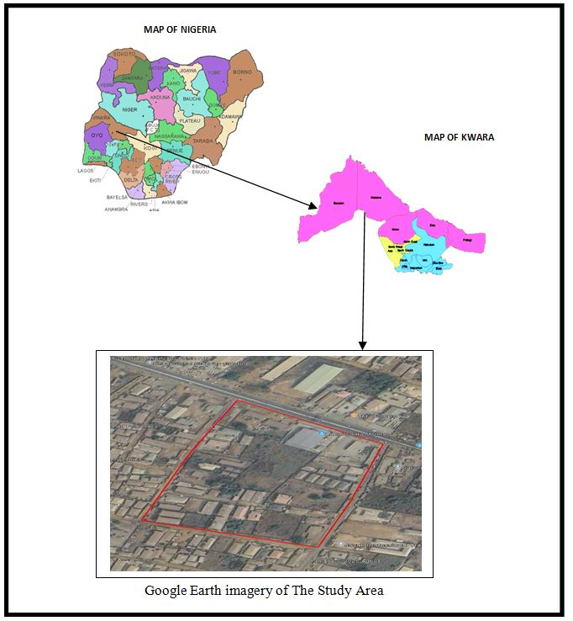
Fig. 1.1 Imagery Of The Study Area

Table 1.1: Personnel
NAMES | MATRIC NO | ROLE
- ODENIYI IDAYAT BOLUWATIFE | HND/23/SGI/FT/0012 | AUTHOR
- ADULAZEEZ QUDUS | HND/23/SGI/FT/0006 | MEMBER
- OCHOCHE EMMANUEL | HND/23/SGI/FT/0007 | MEMBER
- GANIYU AYUBA ALANI | HND/23/SGI/FT/0009 | MEMBER
- ADEBOWALE MARY PROMISE | HND/23/SGI/FT/0011 | MEMBER
- ADAMS FATIMAH OLAMIDE | HND/23/SGI/FT/0013 | MEMBER
- ODEYEMI IKEOLUWA | HND/23/SGI/FT/0014 | MEMBER

CHAPTER TWO
2.0 LITERATURE REVIEW
Land parcel is basic unit for access and control of land, land use and decisions. Current reliable and information necessary for many public programs, for example: Land planning, Infrastructural development and maintenance, Environmental protection and resource management, Emergency services, Basis for land market, development, and other economic activities and Social services programs.
However, all organizations need information in order to survive. Most organizations have a large number of data sources but are hampered by their inability to combine them in a meaningful way. Developing a good land information system in Nigeria has been hindered by so many obstacles as stated by Asoegwu, R.N. (unpublished 2000):
- Most parcels of land have not been located by proper surveys that are tied to the national framework of controls;
- The records of land already surveyed are either not available or faulty;
- The records that are pertinent to the parcels of land properly surveyed are not located in a central place;
- Inadequate laws that could enforce the compulsory collection of appropriate land data;
- Ignorance on the part of experts to appreciate the need for land records;
- Reluctance of some governments to fund adequately long-term projects that do not yield immediate profits;
- Initial high cost/financial barrier.
The need for LIS implementation includes; transfer of legal rights on land, which could be attributed to three methods for processing such relevant records as follows:
- First method is by private Conveyance; a situation whereby the records and transfer of land are handled by private arrangement.
- Registration of Deed is another method that has copies of such records being maintained by the state Government.
- Registration of Title of Land is the third method; this is a situation where a state organization maintains the records of land ownership. Many of the defects in deeds based systems, currently in operations, can be curve by changing to Registration of Title under which the unit for registration is the land parcel, not the deeds. The register must be kept up to date at all time, so as to be a reflection of the legal position on ground (Dale and McLaughlin, 2008).
An ideal land administration must be able to include the provision of information on land in an effective and efficient way to correctly identify those people who have interest in real estate and providing information about these interests (such as duration of leases). It must also allow easy access to land for development where it is needed, increase efficiency in land use management through good planning, and promote greater social equity. It should also allow for revenue generation to the government (taxation), maintenance of environmental quality, and provide security of tenure.
Conventional paper-based map information, any information associated with a map feature has to be recorded separately. A simple example is topographical map showing the parcels of land, and properties in a particular location where the details relating to these land and properties would need to be referred to other files and records. There is a need for a tool to manage the huge volume of map data. There is a need also for a system that will remain flexible enough to handle the sophisticated modern needs of mapping information. The solution is Land Information System.
A. Land Information System
The International Federation of Surveyors defines Land Information System (LIS) “as a tool for legal, administrative and economic decision making and an aid for planning and development which consist of procedure and techniques for the systematic collection, updating, processing and distribution of spatial data” .Shard and More (1989).
A land information system (LIS) gives support to land management by providing information about the land, the resources upon it and the improvements made to it.
According to Dale et al (1988), an Information system may be formally defined as a combination of human and technical resources, together with a set of organizing procedures that produces information in support of some managerial requirement. Data relating to land may be acquired and held in alphanumeric form, graphically or digitally. To become information, the raw data must be processed so that they can be understood by a decision maker. A land information system gives support to land management by providing information about the land, the resources upon it and the improvement made on it.
The efficient and effective use of land and its associated resources depends on the availability of sound land information. Many nations are computerizing their cadastral records and creating large, national databases. Land-related data are now being integrated, analysed, and distributed in ways that until recently were not possible (Zegeye, 2019).
Kurwakumire (2007) submitted that without functional and up-to-date land information, it is difficult to implement planning, development and exploitation of land resources sustainably for the betterment of the communities. Land is unarguably one of the most valuable resources of any nation and land information management forms a major part of urban development. Likewise, the increasing growth in rural population and the massive migration of people to the cities (especially in the developing countries) have put increasing pressure on rural and urban lands and facilities (Dale & McLaughlin 1988). Therefore, a systematic record and rational use of the land should be of prime importance to planners and policy makers.
An ideal land administration must be able to include the provision of information on land in an effective and efficient way to correctly identify those people who have interest in real estate and providing information about these interests (such as duration of leases). It must also allow easy access to land for development where it is needed, increase efficiency in land use management through good planning, and promote greater social equity. It should also allow for revenue generation to the government (taxation), maintenance of environmental quality, and provide security of tenure.
The lack of adequate functional and coordinated land information system and networks underpins this weak system, requiring that land related agencies maintain up-to-date scientific data, maps, and plans. In a broad sense, land administration is defined as an operational system designed to implement land policies. Many definitions are found in the literature endorsing this meaning. For example, the United Nations (1996) defines land administration as “the process of determining, recording, and disseminating information about ownership, value and use of land when implementing land policies.” Similarly, land administration comprises the sub-systems that actualize strategies to implement land policy, and other related policies, within land management systems." Land administration is sometimes viewed as the management of land. From this perspective, the term ‘land administration’ is used to refer to “the processes of regulating land and property development and the use and conservation of the land, the gathering of revenues from the land through sales, leasing, and taxation, and the resolving of conflicts concerning the ownership and use of land” (Dale and McLaughlin, 2009). For this study, the author adopts Barry’s definition (1999) of land administration as a set of operational sub-systems that puts policies concerning land into action. This definition implies that the administration of land is not in itself a strategic process. In particular, land administration does not involve strategic planning or policy development; rather, it is merely an implementation system that follows regulations and rules stated in the policies.
A computer-based land administration system will force standardization in the collation and processing of land data; decrease the cost and space required for storing records; prevent unnecessary duplication; facilitate access to land related data; improve information distribution, reduce the time and cost involved in transferring property rights, processing mortgages, facilitates the monitoring and analysis of market and rental value of land and property; and provide built in mechanism for quality control. The system will permit the integration of records of land ownership, land values, and land use with sociological, economic, and environmental data in support of physical planning. This will allow spatial analysis of any kind - this is the power of the system as a generic tool. The use of a database system will allow managers to re-examine their current procedures and thereby improve delivery. It will also permit better monitoring of organizational performance, providing information on what is happening on the land in a better way so that problem areas are identified and appropriate remedial measures applied.
Database Management System (DBMS): A database management system is a computerized record-keeping system. It is a repository or a container for collection of computerized data files. The overall purpose of DBMS is to allow the users to define, store, retrieve and update the information contained in the database on demand Database Management System was used to accomplish this study. Specifically, a Structured Query Language (SQL) database containing information that describes or defines a plot of land among several others within a layout was designed.

CHAPTER THREE
3.0 METHODOLOGY
​The following are the methods adopted in carrying out land information system analysis of part of Asa-Dam area, Ilorin, Asa local government area, Nigeria.
3.1 RECONNAISSANCE
​This is the preliminary field inspection of the project site to be surveyed. It involves the overall view of the entire land in question or the project site in order to plan on how to go about the surveying operation to achieve the aim of the work in accordance with the survey rules and regulation pertaining to the order of job required (i.e. first. Second or third order), the reconnaissance was done by considering the purpose of the survey operation and method of observation. There are the two types of reconnaissance that are carried out are:-
- Field Reconnaissance
- Office Reconnaissance
3.2.1OFFICE RECONNAISSANCE
​Information about the study area like existing map/plan of the project site and preferably historical data of the site in question, letter of notification, necessary information equipment needed to carry out the survey and coordinates of control point was carried out under this section.
3.2.2FIELD RECONNAISSANCE
At this stage, we visited the project area and take note of the crucial points, locating of existing control points, drawing of the reconnaissance diagram and also the determination of the best method for the Survey.
3.3.1EQUIPMENT USED
Total Station and its accessories.

3.3.2 HARDWARE
1. Laptop Computer
2. Mouse
3, Printer etc.
3.3.3SOFTWARE
The following Software was used:
1. Microsoft word
2. Microsoft Excel
3. Note Pad
4. Google Earth
5. ArcGis 10.0
3.4 CONTROL CHECK (CONTROL COMPARISON METHOD)
In other to ensure the reliability and accuracy of the existing control network, a control control comparison was conducted as part of the pre-observation checks. This procedure involved reoccupying selected known control points within the project area and measuring their spatial relationships (coordinates, bearings and distances) to other established points. The results was then compared to the original coordinate records to determine any positional shift or inconsistencies.
PROCEDURE:
- The total station as set up over a known control point, leveled and oriented.
- Observations (angles and distances) were taken to adjacent known control points.
- Coordinates of the observed point were computed based on the measurements.
- The computed coordinates were compared against the recorded coordinates.
- Differences (Easting, Northing, And Elevation) were calculated for each control point
It is not enough to work from whole to part but it is equally expected that the set of controls to be used are properly checked to ascertain their suitability for the job. The insitu check for both linear and angular measurements as well as the coordinates.
Table 3.4.1: Coordinate of the observed and the original values of PT 31
PILLAR | NORTHING | EASTING | STATUS | REMARKS
PT 31 (KW/AW/ 1206) | 934630.687 | 668601.336 |  | ORIGINAL
PT 31 ( KW/AW/1206) | 934630.677 | 668601.356 | FIXED | OBSERVED
DISCREPANCY | 0.010 | 0.020

Table 3.4.2: Coordinate of the observed and the original values of PT 32
PILLAR | NORTHING(m) | EASTING(m) | STATUS | REMARKS
PT32 ( KW/RB/37) | 934634.584 | 668590.327 |  | ORIGINAL
PT32 ( KW/RB/37) | 934634.563 | 668590.349 | FIXED | OBSERVED
DISCREPANCY | 0.021 | 0.022
Table 3.4.3: Coordinate of the observed and the original values of PT 33
PILLAR | NORTHING(m) | EASTING(m) | STATUS | REMARKS
PT33 KW/RS/12210) | 934663.590 | 668506.841 |  | ORIGINAL
PT33 KW/RS/12210) | 934663.579 | 668506.861, | FIXED | OBSERVED
DISCREPANCY | 0.011 | 0.020

3.5.1 DATA SOURCE
Control coordinate were given from existing map, which is considered as secondary data. This was plotted using AutoCAD. There are two main source of data used primary and secondary source.
3.5.2 PRIMARY SOURCE
This involve the collection of the X,Y and Z coordinate (Spatial data) using land surveying Technique with Total Station and its accessories.

3.5.3 SECONDARY SOURCE
This type of source that was gotten from the google earth application for land information system of part of Asa Dam Agaka area. Ilorin, Kwara State.
3.6.1 GEOMETRIC DATA ACQUISITION
This involve the acquisition of both Northing, Easting And Height value of features that are present on the project site. The instrument was set on one of the control pointed, backsight and the foresight was carried out to the other controls respectively. After which the traversing was carried out and data were recorded such as (angles and distance). In the aspect of this project digital land survey method was adopted.
3.6.2​ PERIMETER
This coordinate of the boundary pillar of the project site were obtained through perimeter traversing of the area
3.6.3 DETAILING
​Detailing refer to fixing of features that are found in an area where survey operation had been carried out. Building, Roads, Electricity pole and other facilities located within the project area were detailed using land survey method.
3.6.4​ ATTRIBUTE/ SOCIAL SURVEY
​This aspect of data acquisition entails the collection of other data which Such data were directly related to the features to which geometric data was acquired. They included building names, the purpose of which the building is used for etc.
​To collect attribute data, questionnaire Survey was employed. This involve oral interviews, reading information from sign posts, wall signs, virtual observation, etc.
3.7.1 DATABASE CREATION/IMPLEMENT
For efficient and effective management of data in the computer environment, data item are usually arranged and stored in a database or databank. The content of this database could be in form of a text, number, polygon or graphics. The creation of this database involved the combination and storage of the acquired graphical and attributes data obtained in former designed GIS database of a generic structure for the purpose in spatial analysis and queries on project site
In the creation of a land information system data mode, a widely used technique called layering was employed. The features that are present within the project site have been classified into different layers in the AutoCAD software independently. The polyline entities were joined using the polyline tool while appropriate symbols were used for the point entities. These layers were then exported to ArcGIS environment where shape files was created using attributes fields as conceptualized in the schema. These attribute table were then populated accordingly with attributes values for each particular entity as observed in the field and from the social survey template (attached as appendix)
The personal Geo database was then created finally in Arc Catalog environment. Where other tables that are non-geometric where created while the already created shape files where imported. Relationship between these tables were also established and the tables were later populated in the Arc Map environment. The following are some of the table created
3.7.2 DATABASE MANAGEMENT SYSTEM (DBMS)
​According to Dale and McLaughlin (1998), database management system was defined as a computer program to control the storage, retrieval and modification of data in the database. DBMS comprises of set of programmers which are used to maintain and manipulate the data orderly and acts as the central control over all the interactions. It is manages that data using alphanumeric data with limited capabilities of performing spatial queries
​A DBMS must allow the definition of data and their attributes and relationships as well as providing security and on interface between the end users and their application and the data themselves it reduces redundancy. Therefore, Arc GIS 10.0version was used to create, manipulate, maintain and access the database easily.
3.7.3​ DATA QUALITY
Some forms of quality control and quality assurance were incorporated in the project at every phase. These include conformity with data templates, data competences and data accuracy. Conformity with data templates in this premises refers to the degree to which the captured data conformed with the designed templates, while data competence was understood as the degree to which the available data in the report and for which there are specific templates have been extracted.
3.7.4 DATA INTEGRITY
​The data captured as exactly downloaded into the system then exported to AutoCAD via notepad and eventually into Arc GIS. The process involves ensuring that the data in the database were accurate and setting of certain constraint to prevent inconsistency in the database.
3.7.5​ DATA SECURITY
​Security is of great concern to land administration because of the legal implication of cadastral records. Security of the records is of almost importance to all concerned. This includes:
- Physical and system security
- Physical security: The use of burgling proof, firefighting equipment controlled access, proper records of the moment of personal and our of the office circuit break
- System Security: Uninterrupted power supply (UPS) will be used to control voltage, use of passwords and backups
In view of the foregoing, locking mechanism was adopted to protect the data in the database from unconscious deletion. Password was used to prevent unauthorized user from breaking into the database and a back up was created for the whole project on the rentable DVD.
Having succeeded in analysis the methodology employed in the execution of this project to arrive at the successful completion. It is equally necessary to examine the processes undertaken to ascertain the reliability and effectiveness of the created land information system

3.8.1​ DATA PROCESSING
AutoCAD and ArcGIS were used for plotting and database creation.
3.8.2. DRAFTING AND PLOTTING
​During plotting of the data, was firstly used to plot out all the points that are picked on the field. The downloaded data of those points were well arranged in the Microsoft excel. The following steps were carried out:
- The data was save on the desktop for easy location
- AutoCAD 2007 was launched
- All the necessary parameters were set ranging from the drawing units, text, point style and others
- The data was then located on the desktop through the Civil CAD and opened,
- The refresh button was clicked and the data was refresh with a successful message displayed
- Then the zoom extend was used to bring all the plotted point into view.
The Civil CAD plotted the coordinate along with their point ID and this make the detailing of the features (such as Roads, electric poles and other) quite easier when transfer into AutoCAD environment.
3.8.3​ DATABASE CREATION PROCEDURES
​The plan in the AutoCAD format was added as data on ArchMap10.0. on Arc Catalog, a file Geo-database was created and subsequently a feature classes such as the line feature for the roads and others and polygon feature for the buildings.
Below are the procedures:
1. A folder was created for the project on the desktop and the plan with Dwgextension was saved in it,
2. ArcMap in ArcGIS10.0 software was launched
3. Then an empty new map which was displayed after loading was clicked on the minimize catalog on the right side was then maximize to view the ready created folder which contain the drawing in the AutoCAD format. The drawing was dragged from the folder and placed on the empty map and then the coordinate system was set.

CHAPTER FOUR
4.0 SPATIAL ANAYSIS, DATA PROCESSING AND PRESENTATION
4.1 SPATIAL ANALYSIS
Spatial analysis is a specialized function that distinguishes GIS from other information systems. It entails the examination of spatial and attributes characteristics of geographic features that are within the database to establish relationships from which spatial problems can be tackled. In this project work, spatial analyses were performed to select, combine and intersect existing geospatial data-sets in order to generate new information suitable for answering specific spatially-related questions.
The results from these analyses can be shown in a number of ways depending on the required output format. Where attribute information about map features are required, they can be presented as tables containing such valves as are needed from the query analysis. They can also be presented as maps with legend information showing the queried features and their topological relationships with other features shown on the map.
4.2. TESTING OF DATABASE
This is carried out to ascertain the quality of the database created, it was necessary to tryout the database so as to determine if information could be readily retrieved from it as required. Testing the database was important to determine whether the established relationships between features and their characteristics attributes are so represented on the database.
4.3.1 QUERIES
Queries are specific questions in the form of "what is where", "where is what", "when" or how long has it been there. This provides answer to the needed information through processing or manipulating spatial data.
4.3.2SPATIAL QUERY
Queries were designed for the purpose of retrieving information from the database. The queries performed in this project gave answers to certain generic questions asked from the database. This was made possible as a result of the implicit link of both the spatial and attributes data. The queries were based on the products from the analysis carried out on the database.
4.4 SINGLE CRITERION QUERY
A single criterion is carried out where one condition is used to design query. This condition is used to retrieve the information from the database. An example of a single criteria query is shown below
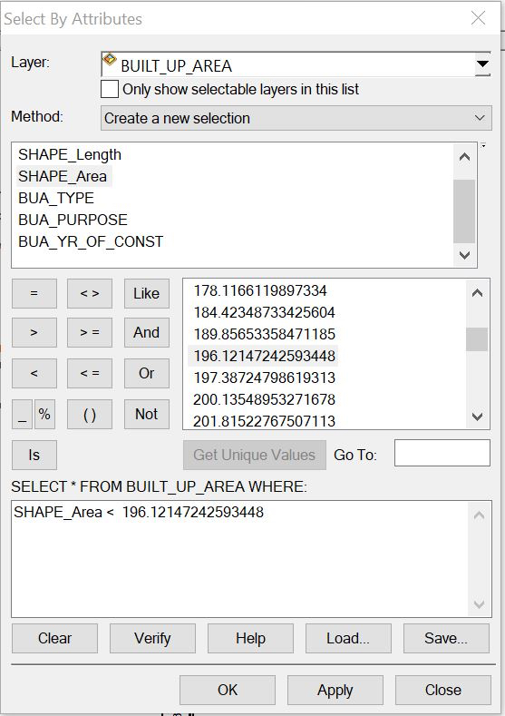
Figure: 4.4.1 Shows a single query made on the database of the project
Query 1: The query one is in interested in selecting or showing the built up area that have an area less than 196.12msq/m²
Syntax:built _up _area <196.12msq/m²
Figure: 4.4.2 showing the question made on the database for built _up _area <196.12msq/m²

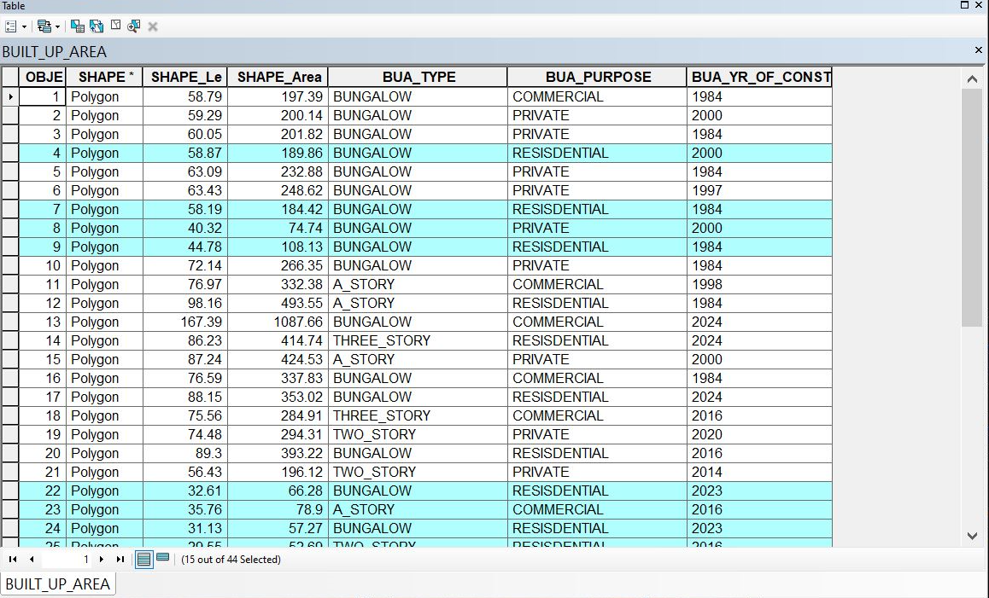

Figure: 4.4.3 showing the result of the query made on the database for built _up _area <196.12msq/m² in form of a table

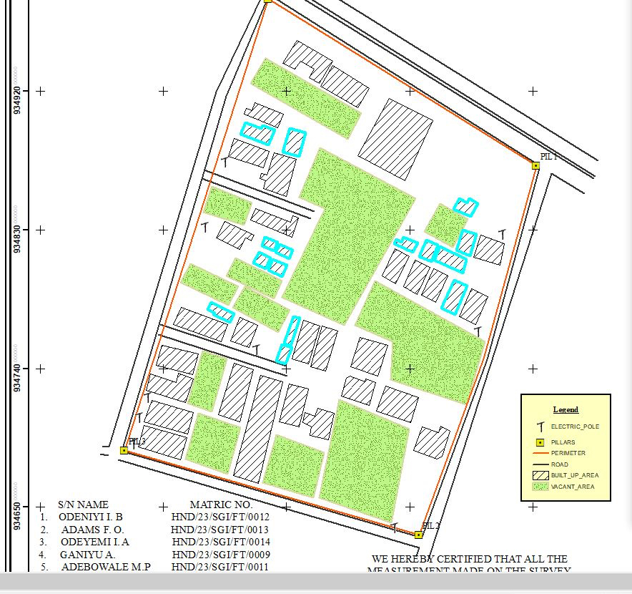

Figure: 4.4.4showing the result of the query made on the database for built _up _area <196.12msq/m²on the plan
Discussion of Result
Figure 4.4.3 and 4.4.4 Shows the built up area that have an area less than 196.12msq/m It consists of the syntax model or the query builder box, attribute table as well as the map of the selected plot in mint blue color. The result shows that 15 built_up_areaout of the 44built _up _area have an area less than 196.12msq/m²

4.5 MULTIPLE CRITERIA QUERY
The database created is then used for implementing several selection queries in determination of user-defined requirements such as built up area whose purpose are for commercial or private use, year of construction, type of building (bungalow,2 story, duplex etc.) and other security which will be effective in planning in such environment.
Query2: The query 2 is interested in showing the building area that are greater than 403.99m²and their purpose that are used for commercial
Syntax:built_up_ area > 403.99 m²ANDtheir purpose are for commercial use.

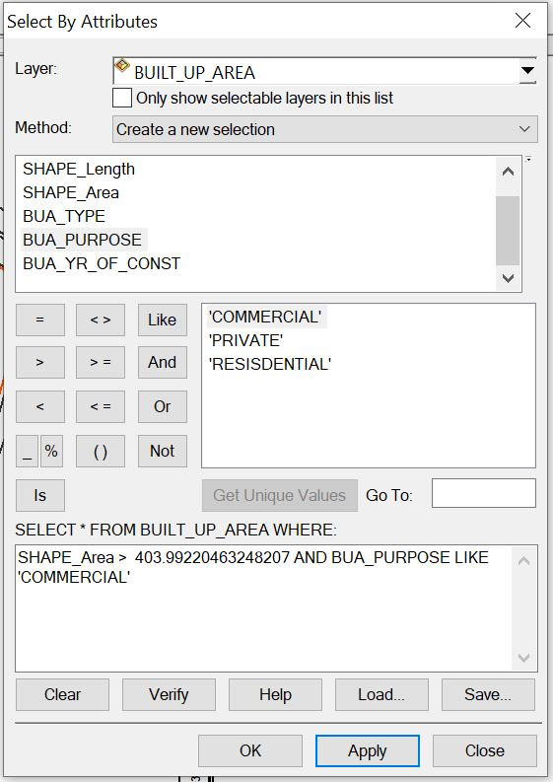
Figure:4.5.1 showing the question made on the databasefor built _up_ area > 403.99m² and their purpose are for commercial use.

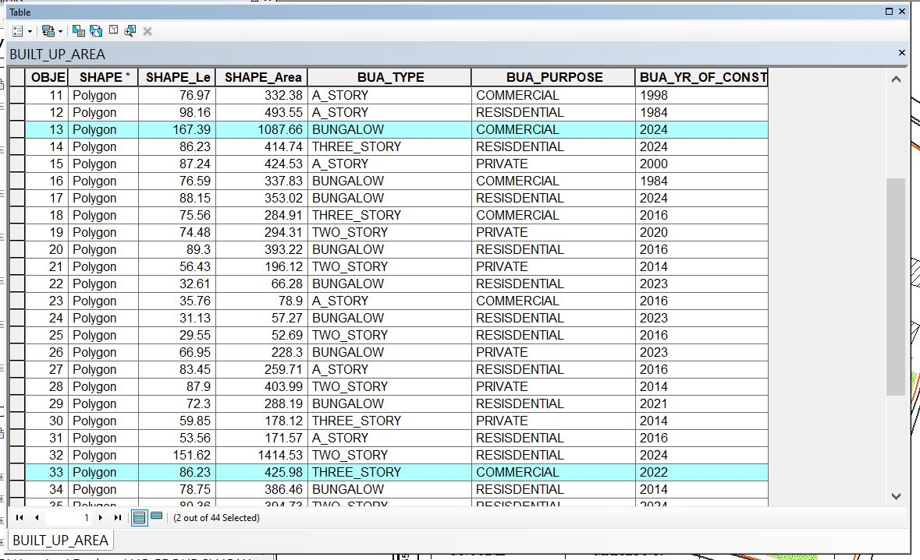

Figure: 4.5.2 showing the result of the query made on the databasefor built _up_ area > 403.99 m² and their purpose are for commercial usein form of a table
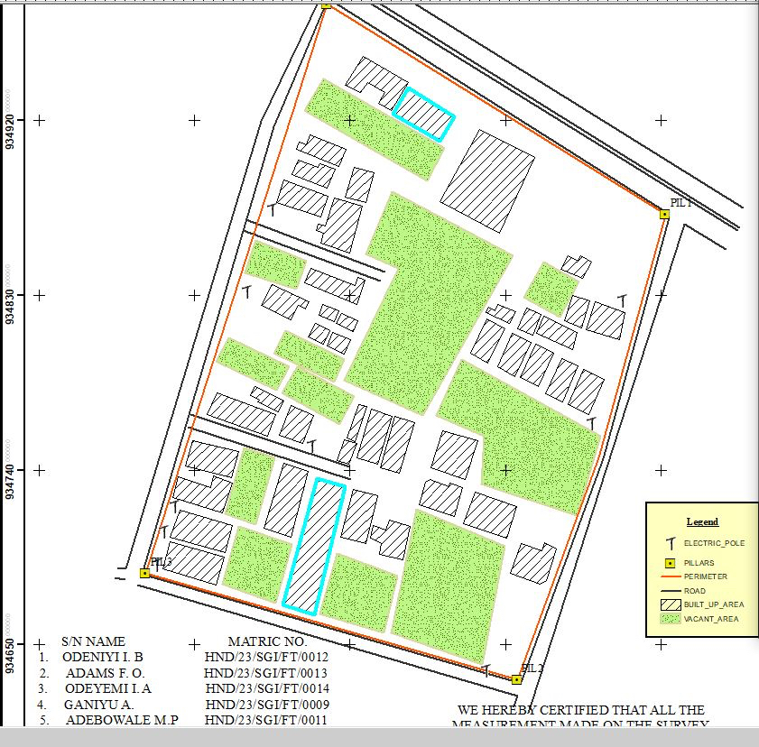
Fig: 4.5.3 showing the result of the query made on the database for built _up_ area > 403.99 m² and their purpose are for commercial use on the plan
Discussion of Result
Figure 4.5.2 and 4.5.3 Shows the built _ up _ area > 403.99㎡and purpose are commercial on the plan It consists of the syntax model or the query builder box, attribute table as well as the map of the selected plot in mint blue color. The result shows that 2 built _up _area out of the 44 built _up _area have an area greater than 403.99 m² and their purpose are for commercial use.
Query3: The query 3 is interested in showing the vacant area less than or equal to 901.99m and are not fenced to query about the vacant area of land less than or equal to 901.13m²and are not fenced
Syntax:vacant_ area <= to 901.13m²AND are not fenced

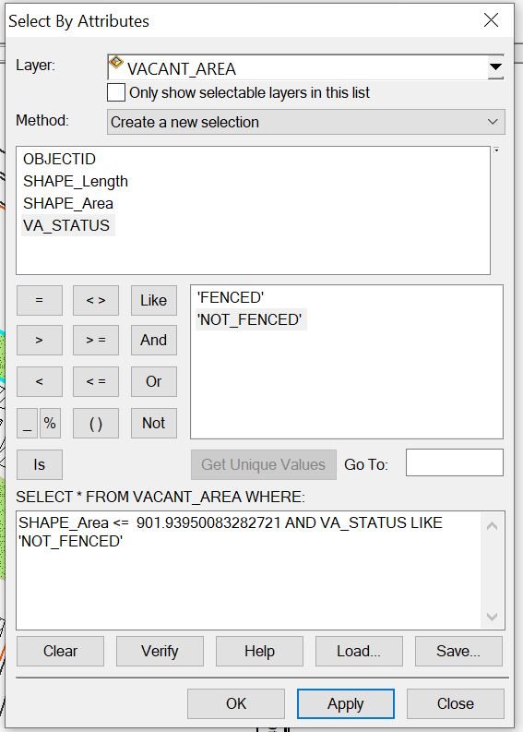
Figure: 4.5.4 showing the question made on the database for vacant_ area less than or equal to 901.93m²and are not fenced

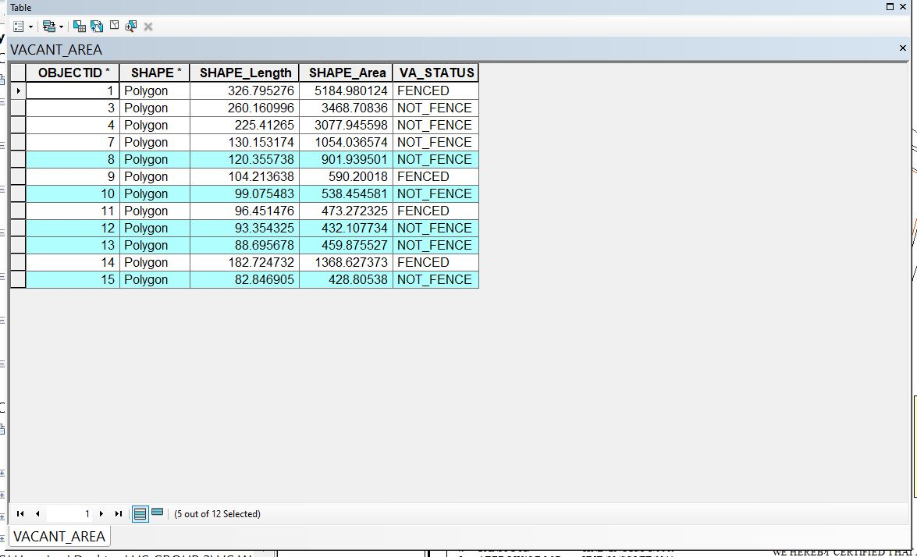
Figure: 4.5.6 showing the result of the query made on the database for vacant_ area <= 901.13m²and are not fenced in form of a table
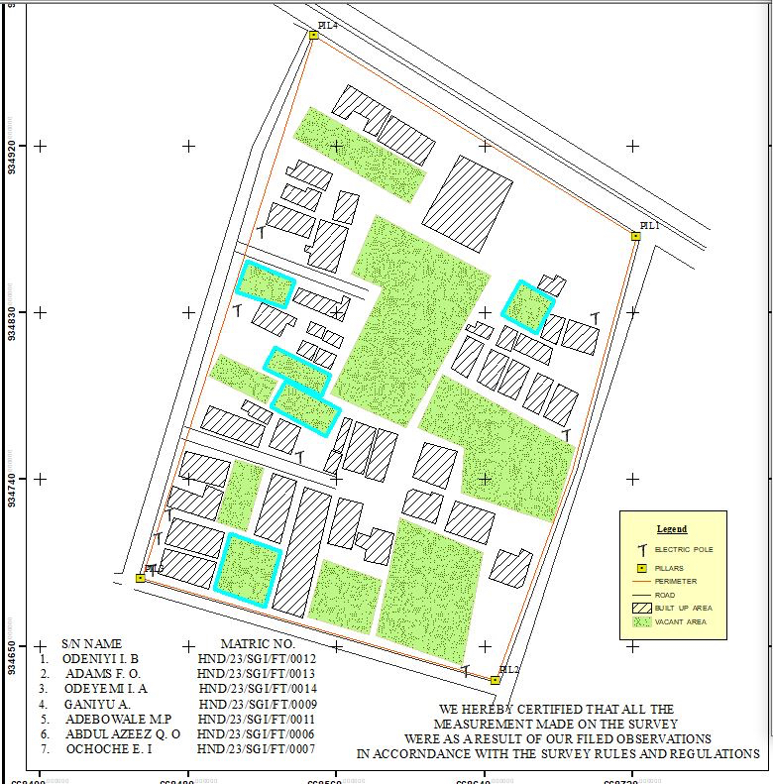
Figure: 4.5.7 showing the result of the query made on the database for vacant_ area <= 901.93m²and are not fenced on the plan.
Discussion of Result
Figure 4.5.7 and 4.5.8 Shows the vacant area less than or equal to 901.93m²and are not fenced on the plan It consists of the syntax model or the query builder box, attribute table as well as the map of the selected plot in mint blue color. The result shows that 5 vacant_area out of the 12vacant _area have an area less than 901.93m² and are not fenced.

4.6 RESULTS ANALYSIS
The results analysis gotten from this project can be used by authority in charge to facilitate planning on the land available to also know certain features about the area in question such as the type of building, the purpose of the building etc. The pie chart shows the representation of the features that existing the project site, it also shows the percentage of the each features.
Table 4.1: RESULTS ANALYSIS​
LOCATION | SIZE | PERCETAGE
Total built Up Area | 1285.2724 | 42.3%
Vacant area | 48165.342 | 52.2%
Total Road Distance (meters) | 1685.195 | 5.5%
TOTAL ROAD DISTANCE
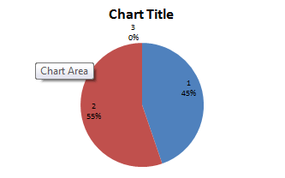
TOTAL BUILT-UP AREA
VACANT AREA

4.7 APPLICATION OF PRODUCT
- It facilitates the use of GIS for effective land management and physical planning.
- It can be used for distribution of infrastructural facility in the study area.
- It can be used for utility distribution, planning and operation.
- The product will provide an integrated approach to analysis of land information.
- It can be used for sustainable land development project in the study area
4.8 SPATIAL SEARCH
The database developed/created was queried in order to reduce the spatial variation in the various information categories ranging from built up area, vacant area, electric poles, and roads (as revealed by the database created) were used for the information system.
4.9 SPATIAL DEPENDENCE
Information system is not the same in every place, even within the project area, to talk of the whole institution neither the whole state, therefore, to detect the information increment/decrement within Part of Asa Dam area,Agaka ( which is the study area) the strength of spatial relationships between the attributes must be established, the strength is known as "Spatial Dependence" and is based on Waldo Tabler's "First Law of Geography" whereby everything is related to everything else, but closer things are more related. Spatial dependence must be measured to establish a relationship limit between the environment and how the facilities is used by the people. This dependence will likely changes over the study area as the environmental factors change (Haining, 2003). This is known as a spatial process, and when it changes across space it will non-stationery. This cannot be measured just by visually determining what is on ground because it is subjective and this must be done with a scientific approach to achieve a more concrete and precise information.

Screen-shot showing the database created for the study area
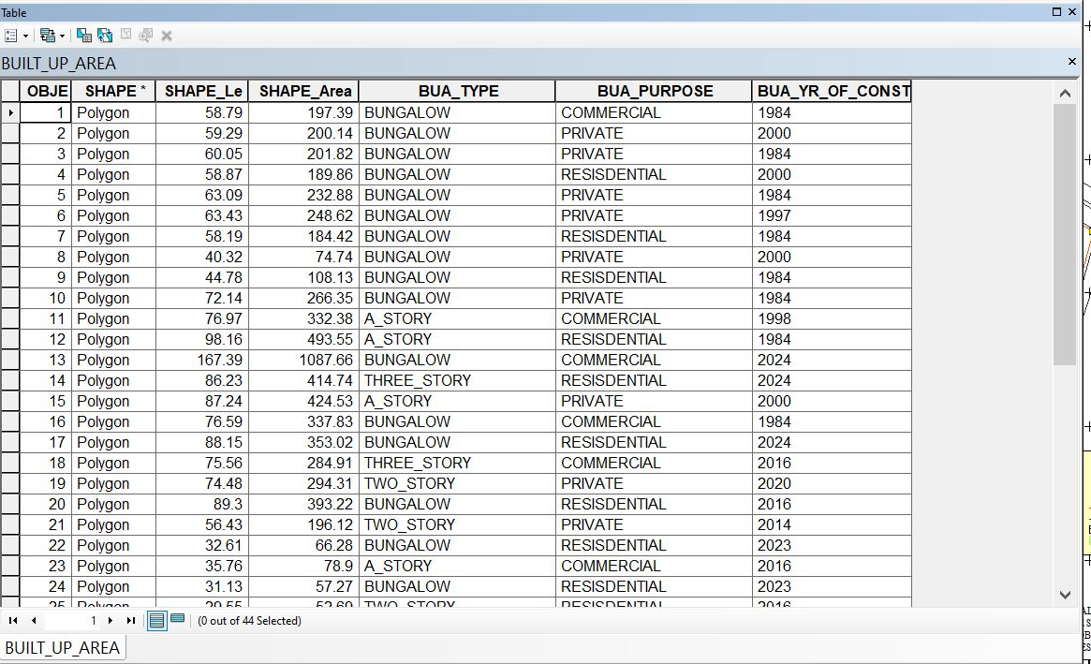

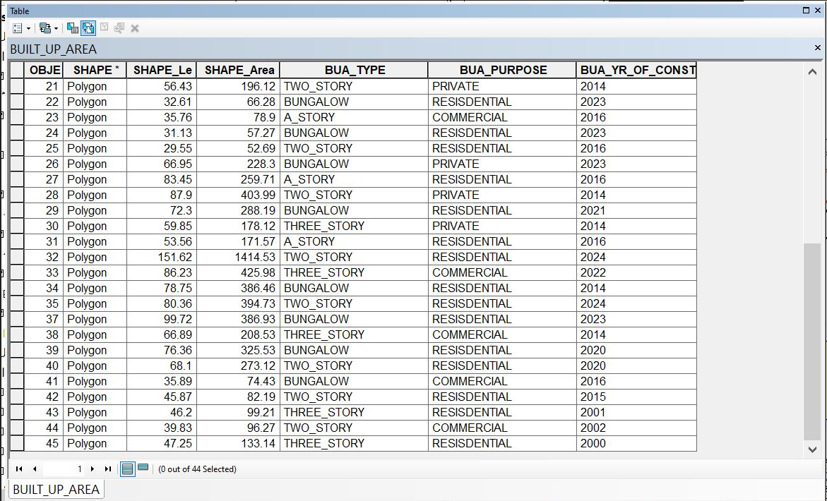

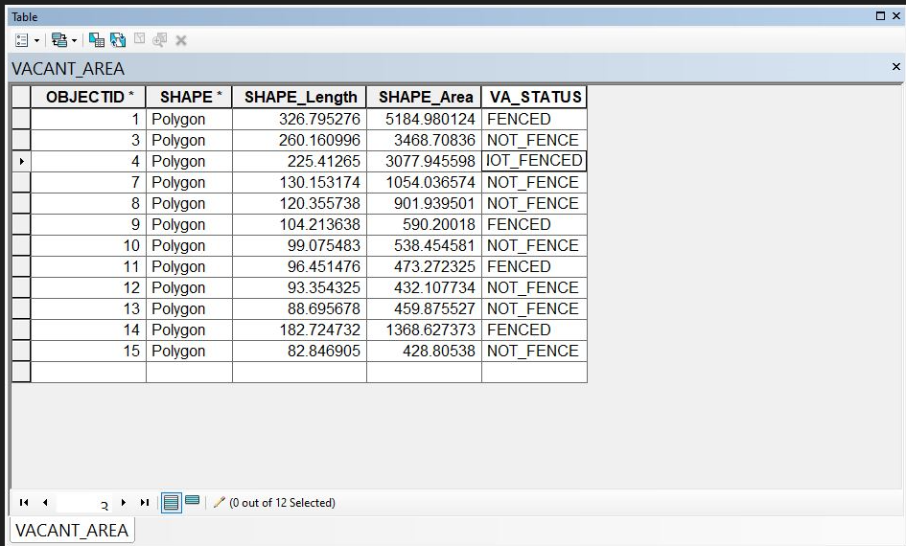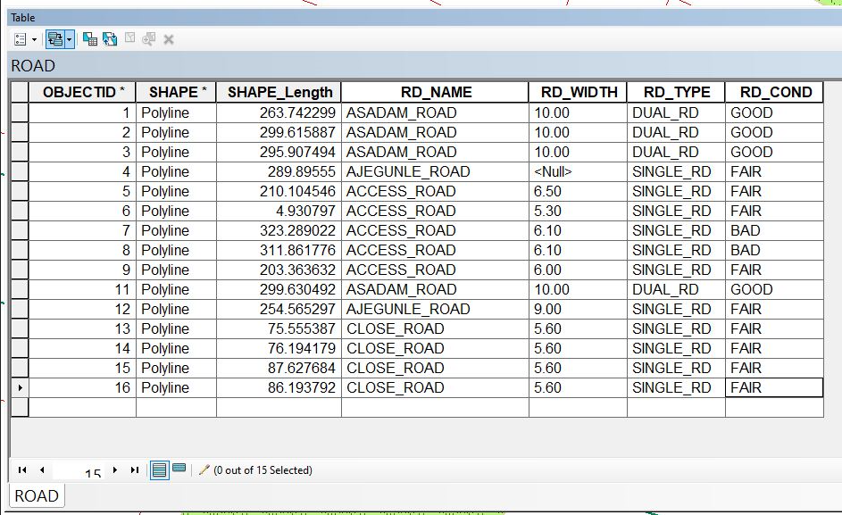
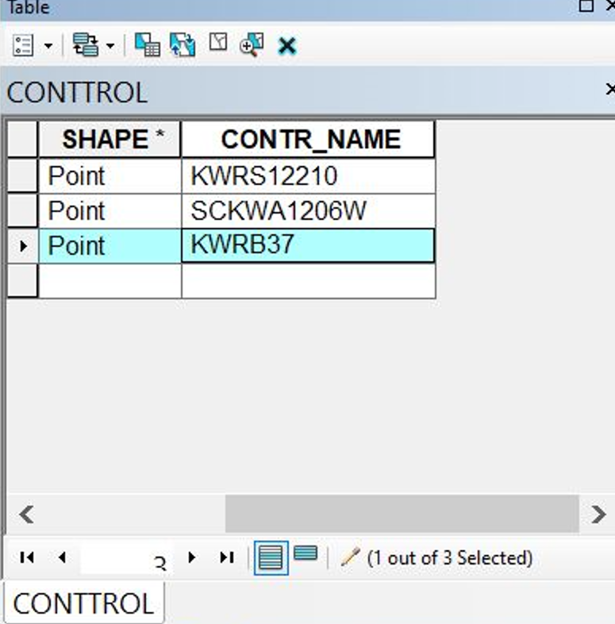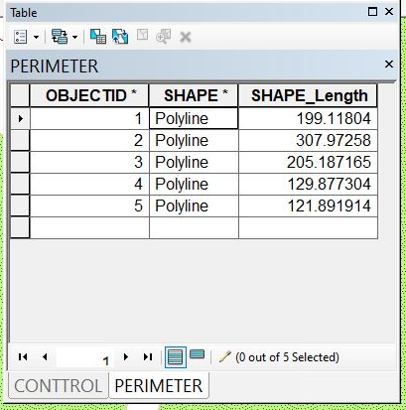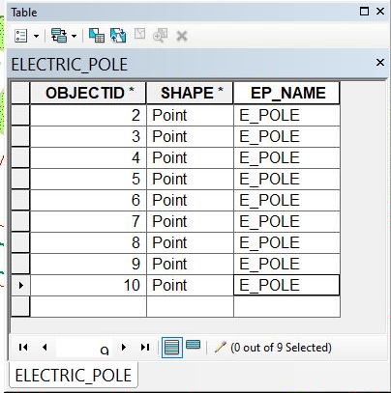

CHAPTER FIVE
5.0 COSTING, PROBLEMS ENCOUNTERED, RECOMMENDATION AND CONCLUSION
5.1 COSTING
The costing of this project was done using the Nigeria Institution of Surveyor's (NIS) professional scale of fees for consultant in the construction industry. This stage shows the total cost that was spent on the project from day one to the final stage.
5.1.1 RECCI
PERSONAL/QUALITY | DAY(S) | UNITRATE(N) | TOTAL AMOUNT(N)
1 Senior Surveyor | 1 | 15,000.00 | 15,000.00
Assistant Surveyor | 1 | 8,000.00 | 8,000.00
Transportation | 1 | 7,000.00 | 7,000.00
Basic Equipment | 1 | 8,000.00 | 7,000.00
TOTAL |  |  | #38,000.00

5.1.2 BEACON= 2,100 × 5
= #10,500

5.1.3 BEACONING
PERSONAL/QUALITY | DAY(S) | UNITRATE(N) | TOTALAMOUNT(N)
1Assistant Surveyor | 1 | 8,000.00 | 8,000.00
Basic Equipment(6) | 1 | 8,000.00 | 8,000.00
Transportation | 1 | 7,000.00 | 7,000.00
TOTAL |  |  | #23,000.00

5.1.4 TRAVERSING
PERSONAL/QUALITY | DAY(S) | UNITRATE(N) | TOTALAMOUNT(N)
1 Assistant Surveyor | 2 | 8,000.00 | 16,000.00
Basic Equipment | 2 | 8,000.00 | 16,000.00
Transportation | 2 | 7,000.00 | 14,000.00
TOTAL |  |  | #46,000.00

5.1.5 DOWNLOADING DATA AND PLOTTING
PERSONAL/QUALITY | DAY(S) | UNITRATE(N) | TOTALAMOUNT(N)
1Senior Surveyor | 2 | 15,000.00 | 30,000.00
1AssistantSurveyor | 2 | 8,000.00 | 16,000.00
Transportation | 2 | 7,000.00 | 14,000.00
Consumables | 2 | 7,000.00 | 14,000.00
TOTAL |  |  | #74,000.00
5.1.6 INFORMATION PRESENTATION
PERSONAL/QUALITY | DAY(S) | UNITRATE(N) | TOTALAMOUNT(N)
1Assistant Surveyor | 1 | 8,000.00 | 8,000.00
Transportation | 1 | 7,000.00 | 7,000.00
TOTAL |  |  | #15,000.00

(1) # 38,000.00
(2) # 10,500.00
(3) # 23,000.00
(4) # 46,000.00
(5)#74,000.00
(6) # 15,000.00
TOTAL # 206,500.00
5.1.7 CONSTIGENCIES=5%
206,500.00×5%÷ 100
= #10,325.00
5.1.8 V. A. T = 7.5%
206,500.00×7.5%÷100
= #15,487.50
5.1.9 MOBILIZATION AND DEMOBILIZATION =10%
206,500.00 × 10%. ÷ 100
= #20,650.00
5.1.10 ACCOMODATION = 1.5%
206,500.00 ×1.5%÷100
= 3,097.50
TOTAL = 206,500.00
10,325.00
15.487.50
20,650.00
3,097.50
GRAND TOTAL = 256,060.00
5.2 SUMMARY
The purpose of the project was to create a database for Land Information System (LIS) using (GIS) Geographic Information System the work covered data capturing, data processing and information presentation.
The reconnaissance surveying was properly carried out, both the ground field reconnaissance and the office reconnaissance and this allowed for proper planning of the operation. Also control check was carried out to ensure that the controls used are insitu. The work covered data capturing, data processing and information presentation.
Finally, the plans of the project area were produced format and a comprehensive report was written.
5.3 PROBLEMS ENCOUNTERED
The following were the problems encountered during the execution of the project;
Due to the fact that we were using total station, our measurement and observation took a longer period which cause a delay in the execution of our project.
Due to the fact that we were taking the coordinates of each building some people were harassing us, and asking a lot of questions which also delayed our work
Due to the change in our location, the money we spent on transportation was beyond our budget

5.4 CONCLUSION
It was a remarkable experience, because the aim of the project was accomplish which is and Information system of part of Asa-Dam community area, Ilorin, Kwara State in order to have a database for the information that existed in Part Of Ada Dam Area, Ilorin, to allow easy access to information regarding land, buildings such as commercial buildings, industrial buildings and private houses etc. road, electric poles and any other structures. The challenges faced and the simple and complex approach apply will ever remain fresh in our memories.
Finally, these project government authorities to plan and implement future developments. It could also be used by the students of the department of surveying and geo-informatics for practical.
5.5 RECOMMENDATION
Based on the analysis and findings, it is recommended land information of environment shout be carried out more frequently which will help in Efficient property taxation, Enhanced Credit Security.
I will hereby recommend that much surveying instrument should be provided for the department and also laboratory should be provided in order to hasten any project being given and to make data processing and presentation easier, faster and more accurate.

REFERENCES
- Abdul, Majid Bin Mohamed (1984). Proposed Land Information System in the Malaysian Context. National Seminar on LIS. Kualalumpur, Malaysia. P. 2-9
- Adams, k, Broad, D&Davis A.R 2020, Haarbrink and koers,2016,Redmond,J&Farhadi,2017, Classification of drone, Przybilla et al,1979,Geomatics application.
- Angus-Leppan, P.V. (1988). A Cadastral Land Information System for Thailand. International. GIS Development Publishers. P.10-14
- Dale P.F and McLaughlin J.D. (1976): Land Information Management, Oxford University Press, New York. P21
- Demers, M.N. (2000): Fundamentals of Geographic Information System, 2nd edition, John wiley & Sons, New York, PP 7-9.
- International Journal Of Science And Technology Management
Vol. No. 6 Issue No. 6, June 2017
www.ijstm.com
- Land Vic 2020 definition of Cadastral survey,Niranyan et al, 2007 ,Uavs civilian application,Everaerts,2008 regulation, classification in the mapping.

APPENDIX

668548.191 934980.009
APPENDIX
668547.444 934980.307
668544.293 934982.894
668544.636 934985.710
668548.811 934982.607
668552.283 934991.899
668553.984 934993.093
668558.627 935001.645
668612.439 934967.966
668607.837 934959.071
668606.116 934957.957
668601.641 934949.128
668722.519 934871.483
668723.124 934872.773
668724.097 934869.820
668731.395 934865.208
668732.254 934866.800
668741.023 934874.594
668742.620 934875.863
668745.124 934885.688
668698.610 934743.591
668689.780 934745.713
668648.259 934630.293
668646.292 934623.439

668644.216 934617.787
668651.595 934614.517
668653.983 934620.525
668656.616 934627.794
668646.138 934631.747
668615.759 934624.995
668601.356 934630.677
668590.349 934634.563
668506.861 934663.579
668508.229 934669.629
668454.711 934686.553
668452.802 934686.335
668450.440 934680.815
668443.943 934683.679
668444.292 934689.110
668440.342 934689.467
668439.062 934684.378
668477.787 934768.863
668472.675 934772.053
668501.603 934853.331
668495.835 934856.335
668503.845 934857.130
668503.181 934853.400
668520.586 934917.005

668330.073 | 934975.882
668328.992 | 934964.073
668319.569 | 934966.250
668318.736 | 934954.992
668305.881 | 934943.799
668300.220 | 934950.705
668301.033 | 934950.755
668298.428 | 934952.025
668321.104 | 934924.364
668332.039 | 934911.762
668340.412 | 934902.341
668339.462 | 934903.387
668342.002 | 934902.159
668345.628 | 934894.337
668356.216 | 934903.513
668356.235 | 934913.457
668367.037 | 934912.573
668367.051 | 934922.633
668375.290 | 934927.740
668379.518 | 934921.695
668382.943 | 934930.495
668383.519 | 934930.846
668384.672 | 934931.755
668388.637 | 934925.416
668400.405 | 934935.273
668410.694 | 934944.050
668419.914 | 934951.844
668430.100 | 934960.652
668439.336 | 934968.353
668442.424 | 934968.837
668445.738 | 934967.573
668433.111 | 934973.249
668434.863 | 934976.583
668434.489 | 934979.525
668421.764 | 934992.501
668412.992 | 934002.332
668413.674 | 934001.431
668413.978 | 934999.115
668400.765 | 934983.361
668387.643 | 934970.816
668372.546 | 934956.453
668364.659 | 934941.208
668361.683 | 934948.254
668359.006 | 934947.770
668355.937 | 934947.982
668352.330 | 934948.924
668349.740 | 934942.036
668345.407 | 934956.388
668232.803 | 934006.370
668236.243 | 934001.262
668243.668 | 934997.611
668246.723 | 934995.725
668258.677 | 934985.928
668267.990 | 934974.700
668277.762 | 934962.964
668287.608 | 934951.569
668296.917 | 934939.935
668305.526 | 934929.423
668313.738 | 934919.229
668314.056 | 934917.640
668312.926 | 934920.662
668294.021 | 934898.148
668292.028 | 934898.084
668282.578 | 934905.380
668284.330 | 934892.422
668284.450 | 934891.265
668274.794 | 934902.138
668263.628 | 934913.475
668271.875 | 934917.725
668260.952 | 934929.200
668919.463 | 934354.974
668747.065 | 934930.769
668249.484 | 934941.101
668236.143 | 934942.333
668230.950 | 934960.340
668230.233 | 934948.397
668220.299 | 934958.778
668205.690 | 934983.850
668205.762 | 934972.832
668204.564 | 934973.115
668194.701 | 934963.732
668183.777 | 934953.210
668173.975 | 934943.265
668185.313 | 934931.280
668196.735 | 934919.087
668202.541 | 934913.271
668213.234 | 934922.664
668207.074 | 934927.995
668215.849 | 934935.512
668213.337 | 934901.798
668223.888 | 934890.587
668233.518 | 934898.610
668245.472 | 934908.718
668250.384 | 934902.109
668241.487 | 934894.703
668229.640 | 934884.388
668240.262 | 934873.056
668247.325 | 934865.816
668251.618 | 934864.934
668260.617 | 934871.607
668271.918 | 934880.313
668353.041 | 934881.175
668361.489 | 934866.745
668368.638 | 934854.674
668373.526 | 934846.366
668392.444 | 934862.869
668386.136 | 934868.355
668398.086 | 934878.892
668403.983 | 934873.186
668413.133 | 934882.227
668416.867 | 934883.038
668418.066 | 934881.953
668390.206 | 934911.981
668401.420 | 934911.340
668399.567 | 934900.992
668411.959 | 934899.981
668407.767 | 934893.019
668408.536 | 934891.575
668408.506 | 934889.819
668422.483 | 934888.530
668432.318 | 934878.086
668438.260 | 934859.979
668388.677 | 934819.770
668392.797 | 934818.164
668396.893 | 934810.435
668407.718 | 934819.929
668403.455 | 934827.977
668417.997 | 934829.394
668414.386 | 934838.161
668429.317 | 934839.706
668424.666 | 934847.624
668440.401 | 934849.583
668444.149 | 934865.114
668450.932 | 934859.108
668462.498 | 934868.505
668455.517 | 934875.155
668465.022 | 934883.863
668465.786 | 934886.040
668465.263 | 934888.202
668471.026 | 934893.907
668472.749 | 934892.991
668476.534 | 934894.045
668485.052 | 934901.651
668495.414 | 934911.778
668496.054 | 934914.071
668494.952 | 934915.928
668511.623 | 934909.718
668507.142 | 934908.510
668503.908 | 934906.499
668495.940 | 934899.490
668484.813 | 934889.469
668461.051 | 934904.686
668454.370 | 934900.152
668451.357 | 934915.371
668444.144 | 934911.083
668440.556 | 934927.162
668433.581 | 934922.671
668430.988 | 934937.049
668424.496 | 934932.520
668454.970 | 934958.396
668464.931 | 934947.753
668475.340 | 934936.764
668484.834 | 934926.772
668535.706 | 934948.642
668533.816 | 934947.782
668531.735 | 934947.993
668529.396 | 934949.483
668520.761 | 934958.700
668510.934 | 934968.974
668500.061 | 934980.496
668490.422 | 934991.175
668479.937 | 934002.172
668469.618 | 934013.182
668457.819 | 934025.340
668452.040 | 934031.749
668441.855 | 934042.616
668431.218 | 934053.846
668425.505 | 934059.376
668415.832 | 934070.030
668406.527 | 934080.474

