

A PROJECT REPORT
ON
TOPOGRAPHIC INFORMATION SYSTEM OF GOVERNMENT GIRLS DAY SECONDARY SCHOOL, PAKATA, ILORIN WEST LGA, KWARA STATE.

BY
HAMMED QUDUS OPEYEMI
HND/23/SGI/FT/0040

SUBMMITED TO:
THE DEPARTMENT OF SURVEYING AND GEO-INFORMATICS, INSTITUTE OF ENVIRONMENTAL STUDIES, KWARA STATE POLYTECHNIC ILORIN.

IN PARTIAL FULFILLMENT OF THE REQUIREMENT FOR THE AWARD OF HIGHER NATIONAL DIPLOMA IN SURVEYING AND GEO-INFORMATICS.

JUNE, 2025

CERTIFICATE
I hereby certified that the information given in this project was obtained as a result of the observation and measurement made by me and that the survey was carried out in accordance with survey laws, regulations and departmental instructions

_________________________________
HAMMED QUDUS OPEYEMI
Matric. No: HND/23/SGI/FT/0040

CERTIFICATION
This is to certify that this project was carried out by HAMMED QUDUS OPEYEMI with Matric No.: HND/23/SGI/FT/0040 under my instruction and supervision for the award of Higher National Diploma in Surveying and Geo-informatics, Kwara State Polytechnic, Ilorin, Kwara State Nigeria. I hereby declared that he has conducted himself with due diligence and honesty on the said duties.

………………………………… ………………………………
SURV.A. AYUBA DATE
(Project Supervisor)

………………………………. …………………………
SURV. R.S. AWOLEYE DATE
(Project Coordinator)

……………………………… ………………………………
A.I ISAU DATE
Head of Department (H.O.D)
Surveying & Geo-informatics

……………………………….. ……………………………..
EXTERNAL EXAMINER DATE

DEDICATION
This project is dedicated to Almighty ALLAH, the author and the finisher of everything who gave me the grace and privilege to attain this stage in my education pursuit.

ACKWOLEDGEMENT
I give thanks and glory to my Creator for the privilege bestowed on me that resulted in the accomplishment of this project work and also a big thanks to the management of Kwara State Polytechnic for the privilege and opportunity given to me to study in their great institution.
My sincere gratitude goes to my Head of Department (HOD); A.I ISAU and my Supervisor; SURV.A. AYUBA for their support towards the success of this project, I really appreciate you sir.
To all the lecturers in the department of Surveying and Geo-informatics; Abimbola I. Isau, Surv. A. Ayuba, Surv. R.S. Awoleye, Surv. A.G. Aremu, Surv. B.F Diran, Surv. Wlliams Kazeem, Surv. Kabir Babatunde, Surv. R.O. Asonibare who has imparted their knowledge in me in one area or the other during my year of study, I am grateful for the effort and support. May Almighty ALLAH bless you all (Amiin).
I'm deeply grateful to my parents; MR & MRS HAMMED for their unconditional love, support, and wisdom. Their encouragement and sacrifices have been the driving force behind my endeavors. Thank you, Mom and Dad, for being my pillars of strength and inspiration. I dedicate this project to you, with love and appreciation.
Special thanks to my brother and sister for your unwavering love, care, and dedication that has shaped me into the person I am today. Your selfless love and your influence and values have guided me throughout this project, and I'm forever grateful for your presence in my life.
I would like to extend my heartfelt thanks to my beloved family members and friends who have supported me throughout this project.
May Almighty ALLAH bless you all (Amiin).

TABLE OF CONTENTS
Pages
Title Page i
Certification ii
Dedication iii
Acknowledgment iv
Table of contents v
List of Figures ix
Abstract x
CHAPTER ONE
General Introduction
1.1 Background to the Study 1
1.2 Statement of the Problem 3
1.3 Aim and Objectives of the Project 3
1.3.1 Aim 3
1.3.2 Objectives 4
1.4 Scope of the Project 4
1.5 Personnel 5
1.6 Significance of the Study 5
1.7 Study Area 6
CHAPTER TWO
Literature review
2.1 Historical Development of Topographic Mapping 7
2.2 Conceptual Framework 9
2.2.1 Role of GIS in Topographic Data Management 11
2.2.2 Remote Sensing Technologies in Topography 12
2.2.3 Digital Elevation Models (DEMs) and Terrain Analysis 14
2.3 Applications of Topographic Information Systems 16
2.4 Accuracy and Data Quality Issues 19
2.5 Advancements in 3D Topographic Visualization 20
CHAPTER THREE
Research Methodology
3.1 Methodology 23
3.2 Equipment and Materials 23
3.3 Survey Procedure 24
3.3.1 Reconnaissance Survey 24
3.3.2 Establishment of Control Points 26
3.3.3 Perimeter Surveying (Boundary Measurement) 30
3.3.4 Fixing of Details 31
3.3.5 Spot Height Measurement 33
3.4 Deliverables and Output 34
CHAPTER FOUR
Result and Analysis
4.1 Perimeter Survey Result 35
4.2 Detailed (Planimetric) Survey Result 36
4.3 Spot Height Measurement and Elevation Analysis 37
4.4 Topographic Map Result 39
4.5 Digital Terrain Model (DTM) Output 40
4.6 Integrated Spatial Interpretation and Site Assessment 41
CHAPTER FIVE
Costing, Summary, Problem Encountered, Conclusion and Recommendations
5.1 Cost Estimation 43
5.2 Summary 45
5.3 Problem Encountered 47
5.4 Conclusion 47
5.5 Recommendations 48
References
Appendix

LIST OF TABLES
Pages
Table 1.1: Table showing the personnel 5
Table 3.1: Table showing the new established control points 27
Table 3.2: Table showing the coordinate of the control point after the orientation 29
Table 5.1: Table showing the cost estimation 43

LIST OF FIGURES
Pages
Fig. 1.1: Maps Showing the Study Area 6
Fig. 3.1: Diagram showing the control station connection 28
Fig. 4.1: Detailed plan of the study area 37
Fig. 4.2: Spot Height Plan of the study area 38
Fig. 4.3: Contour Map of the study area 40
Fig. 4.4: Digital Terrain Model Map of the study area 41

ABSTRACT
This project developed a detailed Topographic Information System (TIS) for a section of Government Girls’ Day Secondary School, Pakata, Ilorin West Local Government Area, Kwara State, Nigeria. Recognizing the critical need for accurate spatial data to support effective land use planning, infrastructure development, and environmental management in this rapidly urbanizing area, the study employed field surveys using GPS technology and Total Station (TS). Key topographic features, including elevation points, contours, slopes, drainage patterns, and significant man-made structures, were meticulously captured and integrated. The processed data was used to generate essential digital products, including a high-resolution Digital Elevation Model (DEM), detailed contour maps, slope classification maps, and a comprehensive topographic map of the study area. These outputs were systematically organized and managed within a Geographic Information System (GIS) environment, creating a robust spatial database. The resulting Topographic Information System provides a vital geospatial framework. It offers planners, engineers, environmental scientists, and local government authorities precise and readily accessible information on the terrain characteristics of Government Girl’s Day Secondary School. This system is fundamental for informed decision-making in site suitability analysis, flood risk assessment, road network planning, construction projects, and sustainable land management within the studied locality.
CHAPTER ONE
INTRODUCTION
1.1 BACKGROUND OF THE STUDY
Topographic survey is about mapping and determining the geometry of a property. It’s a direct and reliable way or source of determining if there’s an encroachment. Aside from determining the geometry, perimeter surveying is also valuable in documenting boundary locations with respect to existing features near the property lines. This is useful in working with the deed restrictions when it comes to new construction projects.
For the property owner or developer, this is valuable information for construction planning. Property developers could accurately assess the potential of a land. In addition, they can also build fences or walls that are positioned more accurately to better protect their property. The survey is also valuable for future references. After the survey, the team of surveyors will install monuments to serve as markings of boundary corners. These will serve as visual reminders for the owners, developers and neighbors around the landed property.
The concept of topographic mapping dates back to ancient civilizations, where rudimentary maps were created to represent land features for navigation, agriculture, and territorial expansion. However, the systematic study and development of topographic information systems began in the 19th and 20th centuries with the advent of advanced surveying techniques, aerial photography, and cartography. The introduction of computers in the mid-20th century revolutionized the field, enabling the digitization of maps and the development of GIS, which laid the foundation for modern TIS.
The evolution of TIS has been closely tied to advancements in technology. The integration of remote sensing, Global Positioning Systems (GPS), and Light Detection and Ranging (LiDAR) has significantly enhanced the accuracy and resolution of topographic data. These technologies allow for the collection of high-resolution elevation data, which is crucial for creating detailed topographic maps. Additionally, the development of sophisticated software tools has enabled the efficient processing, analysis, and visualization of large datasets, making TIS an indispensable tool in various sectors.
Despite its numerous applications, the implementation of TIS faces several challenges. These include the high cost of data acquisition, the complexity of data processing, and the need for specialized skills to interpret and analyze topographic data. Additionally, the rapid pace of technological change requires continuous updates and upgrades to TIS infrastructure and software.
Looking ahead, the future of TIS is likely to be shaped by advancements in artificial intelligence (AI), machine learning, and big data analytics. These technologies have the potential to automate data processing, enhance predictive modeling, and improve the accuracy of topographic maps. Furthermore, the integration of TIS with other emerging technologies such as the Internet of Things (IoT) and augmented reality (AR) could open up new possibilities for real-time terrain analysis and immersive visualization.
Topographic information plays a crucial role in urban planning, land management, and infrastructure development. A Topographic Information System (TIS) integrates geospatial data to provide detailed insights into the physical features of a given area, including elevation, drainage patterns, land use, and built structures. The development of a TIS for a section of Government Girls Day Secondary School, Pataka Ilorin West LGA, Kwara State, Ilorin, is essential for effective planning and sustainable development.
The research involves data collection through field surveys, GPS mapping, and GIS applications to produce a digital topographic map of the selected area. The findings will serve as a valuable resource for urban planners, engineers, and policymakers in making strategic land-use decisions. By implementing a TIS, stakeholders can ensure sustainable development while mitigating environmental risks such as erosion and poor drainage.
This study highlights the significance of topographic information systems in modern urban development, demonstrating their role in optimizing land use and enhancing infrastructural planning.
In conclusion, the study of Topographic Information Systems is a multidisciplinary field that combines elements of geography, computer science, engineering, and environmental science. It plays a crucial role in understanding and managing the Earth's surface, and its importance is expected to grow as we face increasingly complex challenges related to urbanization, climate change, and resource management.
1.2 STATEMENT OF THE PROBLEM
Recently there are developments in our various schools in terms of construction and infrastructural facilities to enhance the conducive of both the staff and students, though most schools have been surveyed but there’s need to update the map by carrying out the perimeter, detailing survey and as more importantly the Topographic Information System (T.I.S) to delineate the boundary, the details there –in as well as topography for better and further configuration of the area and decision making for planning, and updating of old maps for the school.
1.3 AIM AND OBJECTIVES OF THE PROJECT
1.3.1 AIM OF THE PROJECT
The aim of the project is to carry out the Topographic Information System of GOVERNMENT GIRLS DAY SECONDARY SCHOOL PAKATA, ILORIN and presenting the information in a digital cartographic format.

1.3.2 OBJECTIVES OF THE PROJECT
The objectives of this study is to:
- conduct a detailed topographic survey of the study area using geospatial techniques such as GPS mapping and GIS applications.
- generate an accurate topographic map that represents the terrain characteristics, elevation levels, drainage patterns, and land use distribution within the estate.
- analyze the impact of topography on land development, infrastructure planning, and environmental risks such as flooding and erosion.
- create a digital database for storing and managing topographic information, which can be accessed for future planning and decision-making.
- provide recommendations on the application of topographic data in sustainable urban development, land administration, and disaster mitigation strategies.
1.4 SCOPES OF THE PROJECT
The project scopes are the stages that will be involve to achieve our aims.
- Project planning
- Recce
- Data acquisition
- Data processing
- Data analysis
- Data presentation
- Technical report writing

1.5 PERSONNEL
The students listed below were the members of this group who participated in the execution of the project.
Table 1.1: Table showing the personnel
NAME | MATRIC NO. | ROLE
AJIBADE TIMILEHIN PRAISE | HND/23/SGI/FT/0036 | AUTHOR
AGBENI OLUWATOYIN AMEENAT | HND/23/SGI/FT/0008 | MEMBER
HAMMED QUDUS OPEYEMI | HND/23/SGI/FT/0040 | MEMBER
ABDULWAHEED LAWAL OLAREWAJU | HND/23/SGI/FT/0039 | MEMBER
FANIWA ELIZABETH BRIGHT | HND/23/SGI/FT/0035 | MEMBER
SMART OPEYEMI EWAOLA | HND/23/SGI/FT/0037 | MEMBER

1.6 SIGNIFICANCE OF THE STUDY
The significance of studying a Topographic Information System (TIS) lies in its critical role in enhancing spatial decision-making and resource management across diverse sectors. By integrating detailed elevation data, landform features, and human-made structures, a TIS provides a comprehensive framework for analyzing terrain characteristics, which is vital for sustainable urban planning, environmental conservation, and disaster risk mitigation. In urban development, it aids in optimizing infrastructure design, zoning, and floodplain management, while in environmental sectors, it supports watershed analysis, habitat preservation, and climate resilience strategies. Additionally, the system’s ability to synthesize real-time geospatial data with advanced technologies like GIS and remote sensing enables governments, planners, and researchers to address challenges such as land degradation, deforestation, and emergency response with greater precision. By democratizing access to accurate topographic insights, a TIS fosters interdisciplinary collaboration, empowers evidence-based policymaking, and contributes to long-term ecological and socio-economic sustainability, ultimately bridging the gap between geospatial innovation and practical applications for community and environmental well-being.
  - STUDY AREA
Government Girls Day Secondary School Pataka, Ilorin is along Oloje in Ilorin West Local Government Area of Kwara State, the premises is on Latitude 008⁰ 30’ 05"N and Longitude 004⁰ 30' 58” E on the geographical location of the State.
Fig. 1.1: Maps showing the study area
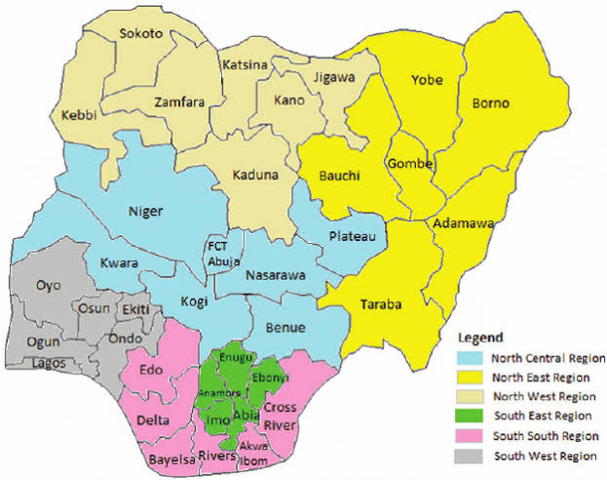
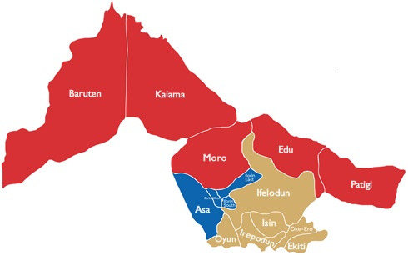
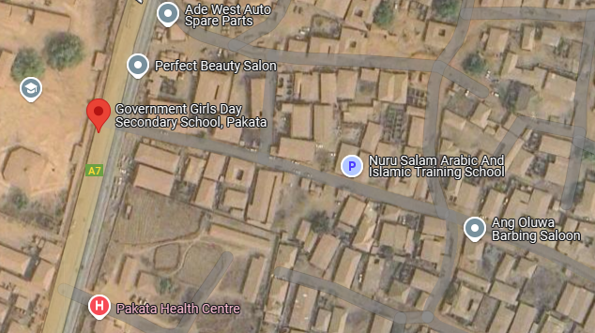

CHAPTER TWO
LITERATURE REVIEW
2.1 HISTORICAL DEVELOPMENT OF TOPOGRAPHIC MAPPING
The historical development of topographic mapping is a testament to humanity’s enduring quest to represent the Earth’s surface with precision and utility. Its origins trace back to ancient civilizations, where rudimentary tools like the groma and chorobates were used by Egyptians, Greeks, and Romans for land division, irrigation, and infrastructure projects such as road construction. These early efforts laid the groundwork for systematic cartography, which saw significant strides during the Renaissance. Innovations like Gerardus Mercator’s 1569 cylindrical projection revolutionized navigation by preserving directional accuracy, while Willebrord Snell’s formalization of triangulation in 1615 enabled large-scale terrestrial surveys through geometric principles. By the 18th and 19th centuries, topographic mapping became institutionalized with national initiatives such as France’s Cassini surveys—Europe’s first comprehensive topographic series—and Britain’s Ordnance Survey, established in 1791 to support military and administrative needs. In the United States, the founding of the U.S. Geological Survey (USGS) in 1879 marked a pivotal shift toward standardized mapping, driven by post-Civil War expansion and resource management demands.
Traditional methods of ground surveying dominated this era, relying on tools like theodolites, chains, and levels to measure angles, distances, and elevations manually. Techniques such as triangulation and traversing established control points across landscapes, though these approaches were labor-intensive and limited to accessible terrain. Concurrently, plane table surveying emerged as a hybrid method, combining field observations with real-time map drafting on portable tables, which remained popular for local-scale mapping into the early 20th century. The late 19th century introduced photogrammetry, pioneered by figures like Nadar, who captured aerial photographs from balloons in 1858. This method evolved dramatically during the World Wars, as aerial reconnaissance photos and stereoscopic analysis allowed cartographers to reconstruct 3D terrain models from ovszerlapping images. Analog tools like stereoplotters, such as the Wild A7, mechanized the extraction of contour lines and features, enabling rapid mapping of vast, remote regions post-1945.
The 20th century ushered in transformative technological shifts. Electronic Distance Measurement (EDM) devices replaced manual chains with laser and radio wave technology, accelerating data collection. Satellite remote sensing, exemplified by NASA’s Landsat program (1972) and France’s SPOT satellites (1986), provided global, multispectral imagery that enriched topographic datasets. The integration of GPS in the 1980s–90s further revolutionized surveying by offering real-time georeferencing, reducing dependence on ground control points. By the late 20th century, digital photogrammetry replaced analog systems, allowing for computerized image processing and GIS (Geographic Information Systems) platforms that layered topographic data into dynamic digital maps. Airborne Lidar (Light Detection and Ranging), emerging in the 1990s–2000s, achieved centimeter-level elevation accuracy, while open-source tools like Google Earth democratized access to topographic information.
These historical advancements underscore a transition from labor-intensive, localized practices to automated, global-scale systems. Traditional methods like ground surveying and analog photogrammetry remain foundational, often integrated with modern technologies such as drone-based mapping and AI-driven analysis. Today, topographic mapping underpins critical applications like climate modeling, urban planning, and autonomous navigation, reflecting centuries of innovation shaped by exploration, conflict, and the relentless pursuit of spatial precision.
2.2 CONCEPTUAL FRAMEWORK
The concept of a Topographic Information System (TIS) is rooted in the integration of geospatial data, cartographic principles, and computational tools to model, analyze, and visualize terrain features. Early foundational work by Tomlinson (1967) in "An Introduction to the Geographic Information System of the Canada Land Inventory" highlighted the importance of systematic data layers (e.g., elevation, hydrology) for land management, laying the groundwork for modern TIS. Burrough and McDonnell (1998) expanded this in "Principles of Geographical Information Systems," emphasizing that topographic systems rely on Digital Elevation Models (DEMs) and vector datasets to represent terrain morphology, slope, and aspect, which are critical for applications like flood modeling and infrastructure planning.
The evolution of TIS has been shaped by advancements in data acquisition technologies. Li et al. (2005), in "Digital Terrain Modeling: Principles and Methodology," underscored the role of photogrammetry and LiDAR (Light Detection and Ranging) in generating high-resolution topographic data, replacing labor-intensive field surveys. Similarly, Petrie and Kennie (1990) in "Terrain Modelling in Surveying and Civil Engineering" argued that TIS transformed engineering practices by enabling 3D visualization of terrain, facilitating slope stability analysis and route optimization. The integration of TIS with Geographic Information Systems (GIS), as discussed by Longley et al. (2015) in "Geographic Information Science & Systems," has further enhanced its utility, allowing dynamic overlays of socio-economic and environmental data onto topographic basemaps.
Scholars like Clarke (2003) in "Getting Started with Geographic Information Systems" noted that TIS democratized access to topographic data through platforms like USGS’s National Map and OpenTopography, fostering interdisciplinary research in climatology, ecology, and urban planning. Meanwhile, Hengl and Reuter (2009) in "Geomorphometry: Concepts, Software, Applications" highlighted the rise of machine learning algorithms in TIS, enabling predictive modeling of erosion patterns and landslide risks by analyzing topographic parameters. Critically, Goodchild (2007) in "Citizens as Sensors: The World of Volunteered Geography" emphasized the role of crowdsourced data (e.g., OpenStreetMap) in enriching TIS, though he cautioned about variable data quality and standardization challenges.
Recent innovations, such as cloud-based TIS (e.g., Google Earth Engine) and real-time topographic monitoring using IoT sensors, reflect the field’s ongoing transformation. Gesch et al. (2014) in "The National Elevation Dataset" demonstrated how TIS supports global initiatives like climate adaptation planning, while Tateosian (2019) in "Python For ArcGIS" illustrated the growing reliance on programming tools to automate topographic analysis. Despite these advances, authors like Fisher and Tate (2006) in "Causes and Consequences of Error in Digital Elevation Models" warned that inaccuracies in source data or resolution limitations can propagate errors in TIS outputs, necessitating rigorous validation protocols.
In summary, Topographic Information Systems represent a confluence of cartographic tradition and digital innovation, driven by contributions from geographers, engineers, and computer scientists. Their evolution—from manual contour mapping to AI-driven terrain analysis—reflects broader trends in geospatial technology, as noted by Rhind (1999) in "Framework for the World," who described TIS as a cornerstone of the "digital earth" paradigm, essential for addressing 21st-century environmental and infrastructural challenges.
2.2.1 ROLE OF GIS IN TOPOGRAPHIC DATA MANAGEMENT
The role of Geographic Information Systems (GIS) in topographic data management is transformative, revolutionizing how spatial information is stored, analyzed, and visualized. GIS serves as a centralized platform for integrating diverse topographic datasets—such as elevation models (e.g., DEMs, LiDAR), contour lines, hydrologic networks, and land cover—into a unified georeferenced framework. This integration enables efficient storage through structured spatial databases (e.g., geodatabases) that support large-scale data organization, versioning, and metadata management. For instance, Burrough and McDonnell (1998) emphasize that GIS’s relational database architecture allows seamless layering of raster (elevation grids) and vector (streams, roads) data, ensuring interoperability and reducing redundancy.
In terms of analysis, GIS provides advanced tools to derive actionable insights from topographic data. Slope, aspect, and curvature calculations enable terrain characterization, while hydrological modeling tools simulate water flow and watershed delineation (Li et al., 2005). Spatial overlays of topography with socio-economic or environmental datasets (e.g., flood risk zones, infrastructure layouts) support decision-making in urban planning and disaster management. Longley et al. (2015) highlight how GIS facilitates 3D terrain analysis, such as line-of-sight visibility for telecommunications or military applications, and cut-and-fill calculations for engineering projects. Machine learning integration, as noted by Hengl and Reuter (2009), further enhances predictive modeling of erosion or landslide susceptibility by correlating topographic indices with historical data.
For visualization, GIS transforms raw topographic data into intuitive maps and models. Tools like hillshading, 3D rendering, and contour interpolation create dynamic visual representations of terrain, aiding in education, public engagement, and policy formulation. Platforms such as ArcGIS Pro or QGIS enable interactive web maps, allowing stakeholders to explore elevation profiles or simulate landscape changes (e.g., sea-level rise). Clarke (2003) underscores how GIS democratizes access to topographic information through user-friendly interfaces and open-source platforms like Google Earth, which combine satellite imagery with elevation data for global-scale visualization.
Moreover, GIS enhances collaboration by enabling real-time data sharing across disciplines. Cloud-based systems (e.g., ArcGIS Online) allow multiple users to update and analyze topographic datasets simultaneously, fostering transparency in projects like transportation planning or environmental conservation. However, challenges such as data resolution limitations and computational demands persist, as Fisher and Tate (2006) caution, necessitating rigorous error-checking and scalable infrastructure.
In summary, GIS bridges the gap between raw topographic data and actionable knowledge, empowering industries—from agriculture to defense—to leverage terrain intelligence with unprecedented precision. By harmonizing storage, analysis, and visualization, GIS has become indispensable in managing the Earth’s dynamic surface, as Rhind (1999) aptly describes in the context of the "digital earth" paradigm.
2.2.2 REMOTE SENSING TECHNOLOGIES IN TOPOGRAPHY
Remote sensing technologies have revolutionized topographic mapping by enabling the acquisition of high-resolution, large-scale geospatial data through satellite imagery, aerial photography, and advanced sensors. These tools overcome the limitations of traditional ground surveys, offering unparalleled efficiency, coverage, and precision in capturing terrain features. Satellite-based systems, such as NASA’s Landsat and the European Space Agency’s Sentinel missions, provide multispectral and radar data that underpin global elevation models like the Shuttle Radar Topography Mission (SRTM) and TanDEM-X. These datasets, as noted by Farr et al. (2007) in "The Shuttle Radar Topography Mission," achieve near-global coverage with resolutions as fine as 12 meters, enabling detailed slope and relief analysis even in remote or inaccessible regions.
Aerial remote sensing, including LiDAR (Light Detection and Ranging) and photogrammetry, complements satellites by delivering ultra-high-resolution topographic data. Airborne LiDAR systems, as highlighted by Axelsson (2000) in "DEM Generation from Laser Scanner Data," emit laser pulses to measure ground elevation with centimeter-level accuracy, penetrating vegetation to map bare-earth terrain—critical for floodplain mapping and forestry. Similarly, unmanned aerial vehicles (UAVs/drones) equipped with photogrammetric cameras generate 3D point clouds and orthomosaics through Structure-from-Motion (SfM) algorithms, democratizing access to cost-effective, localized mapping (Westoby et al., 2012).
The integration of synthetic aperture radar (SAR) and interferometric SAR (InSAR) further enhances topographic accuracy. SAR satellites, such as ALOS-PALSAR, detect subtle elevation changes over time, useful for monitoring subsidence or volcanic activity (Rosen et al., 2000). InSAR’s phase difference measurements between radar images, as discussed by Massonnet and Feigl (1998), create deformation maps with millimeter precision, bridging gaps in dynamic terrain analysis.
Remote sensing also streamlines data processing and integration. Platforms like Google Earth Engine and ESA’s Copernicus leverage cloud computing to process petabytes of satellite data, automating the extraction of contour lines, drainage networks, and landforms. Machine learning algorithms, as explored by Zhu et al. (2017) in "Deep Learning in Remote Sensing," classify topographic features (e.g., cliffs, valleys) from imagery, reducing manual interpretation errors.
However, challenges persist, including cloud cover obscuring optical satellite data, the high cost of LiDAR surveys, and the need for ground control points (GCPs) to calibrate aerial photogrammetry. Despite these limitations, remote sensing remains indispensable for applications like disaster response, urban planning, and climate modeling. As Petrie and Kennie (1990) assert in "Terrain Modelling in Surveying and Civil Engineering," the synergy of satellite and aerial technologies has transformed topography from a static discipline into a dynamic, real-time science, underpinning sustainable development and environmental stewardship in the 21st century.
2.2.3 DIGITAL ELEVATION MODELS (DEMS) AND TERRAIN ANALYSIS
Digital Elevation Models (DEMs) are foundational tools in modern terrain analysis, providing a gridded or vector-based representation of the Earth’s surface elevation. Derived from remote sensing technologies such as LiDAR, photogrammetry, and radar (e.g., SRTM, ASTER), DEMs serve as the backbone for quantifying and visualizing topographic attributes, enabling precise analysis of slope, aspect, and watershed dynamics.
Slope Analysis:
DEMs calculate slope gradients by determining the rate of elevation change between adjacent pixels. This is critical for assessing terrain steepness, which informs landslide risk mapping, agricultural suitability, and infrastructure planning. For example, in urban development, slope maps derived from high-resolution LiDAR DEMs identify buildable land while avoiding unstable slopes. Algorithms like the Horn method or D8 flow direction compute slope values in degrees or percentages, enabling engineers to design road alignments or drainage systems that adapt to natural topography.
Aspect Analysis:
Aspect, defined as the compass direction a slope faces, is calculated by analyzing the orientation of the steepest descent from each DEM pixel. This parameter influences microclimates, vegetation patterns, and solar exposure. In renewable energy planning, aspect maps identify optimal locations for solar panels by highlighting south-facing slopes (in the Northern Hemisphere) that receive maximum sunlight. Similarly, ecologists use aspect data to study species distribution, as north-facing slopes in temperate regions tend to be cooler and more humid, supporting distinct ecosystems.
Watershed Delineation and Hydrological Modeling:
DEMs are indispensable for watershed analysis, which involves defining drainage basins, stream networks, and flow accumulation. Using hydrological correction techniques (e.g., filling sinks), DEMs simulate water movement across landscapes. Tools like the D8 algorithm or TauDEM derive flow direction and accumulation grids, enabling the delineation of watershed boundaries. This is vital for flood prediction, reservoir management, and soil conservation. For instance, the USDA employs DEM-based watershed models to design contour farming systems that reduce erosion in agricultural regions.
Integration with Advanced Technologies:
Modern DEMs, particularly those from airborne LiDAR (1–2 m resolution) or drone photogrammetry, enhance the accuracy of terrain analysis. Machine learning algorithms now automate feature extraction, such as identifying gully erosion or landslide scars from DEM derivatives. Open-source platforms like QGIS and GRASS GIS democratize access to these tools, allowing researchers to compute slope, aspect, and curvature indices at scale.
Challenges and Considerations:
Despite their utility, DEMs have limitations. Low-resolution datasets (e.g., 30 m SRTM) may overlook fine-scale terrain features, while errors in elevation data can propagate into flawed slope or flow models. Additionally, vegetated or urban areas require ground-filtered LiDAR DEMs to represent bare-earth topography accurately.
In summary, DEMs have transformed terrain analysis into a dynamic, data-driven discipline. By enabling precise slope, aspect, and watershed studies, they underpin sustainable land management, disaster resilience, and environmental science, illustrating the synergy between geospatial technology and Earth’s physical processes.
2.3 APPLICATIONS OF TOPOGRAPHIC INFORMATION SYSTEMS
Topographic Information Systems (TIS) are indispensable tools across diverse sectors, leveraging geospatial data to address complex challenges in urban planning, agriculture, infrastructure development, and disaster management. By integrating elevation models, terrain attributes, and spatial analytics, TIS enables data-driven decision-making, optimizing efficiency and sustainability.

1. Urban Planning
TIS supports smart city development by analyzing terrain for optimal land use, zoning, and infrastructure placement. Slope and aspect maps identify flood-prone areas or unstable slopes, guiding safe residential and commercial development (Burrough & McDonnell, 1998). For instance, 3D terrain models derived from LiDAR data help planners visualize urban sprawl, design drainage systems to mitigate flooding, and preserve green spaces. In cities like Singapore, TIS integrates with GIS to simulate shadow effects of skyscrapers or solar potential on rooftops, enhancing energy efficiency. Additionally, TIS aids in heritage conservation by modeling historic landscapes and assessing erosion risks to cultural sites.

2. Agriculture
In agriculture, TIS enhances precision farming and soil conservation. Slope analysis determines erosion-prone areas, enabling farmers to implement contour plowing or terracing, as practiced in the vineyards of Tuscany or rice paddies in Southeast Asia. DEMs combined with soil moisture data optimize irrigation systems, ensuring water reaches crops efficiently in regions like California’s Central Valley. Aspect maps identify microclimates for crop rotation, while elevation data assists in frost risk assessment for orchards. The USDA’s National Resources Inventory uses TIS to monitor land degradation and promote sustainable practices (Hengl & Reuter, 2009).

3. Infrastructure Development
Engineers rely on TIS for route optimization and slope stability analysis in road, rail, and pipeline projects. DEMs calculate cut-and-fill volumes to minimize earthmoving costs during highway construction, such as in the mountainous terrain of the Swiss Alps. Hydrological models predict water flow to design resilient bridges and culverts, while LiDAR-derived elevation data ensures precise alignment of tunnels and dams. For example, China’s Three Gorges Dam project utilized TIS to assess reservoir capacity and landslide risks. TIS also aids in renewable energy projects, such as identifying optimal slopes for wind farms or solar arrays.

4. Disaster Management
TIS is critical for risk assessment and emergency response. Flood models using DEMs and watershed delineation predict inundation zones, as seen in the Netherlands’ flood defense systems. Landslide susceptibility maps, generated from slope, curvature, and soil data, guide evacuations in regions like Nepal’s Himalayas. Post-disaster, aerial LiDAR and satellite imagery rapidly assess damage, as demonstrated after Hurricane Katrina or the 2011 Tōhoku tsunami. Real-time TIS platforms, such as FEMA’s Flood Map Service Center, provide dynamic updates during crises, while InSAR monitors ground subsidence in earthquake-prone areas like Mexico City.

Cross-Sector Impact and Challenges
TIS fosters interdisciplinary collaboration—e.g., combining agricultural soil data with urban expansion models to address food security. However, challenges include data resolution gaps (e.g., coarse DEMs in remote regions), computational costs for large datasets, and the need for localized calibration. Advances in AI-driven terrain analysis and crowdsourced geospatial data (e.g., OpenStreetMap) are addressing these barriers, democratizing access to TIS tools.
In conclusion, Topographic Information Systems are transformative across sectors, bridging the gap between terrain data and actionable insights. From designing climate-resilient cities to safeguarding food production and mitigating disasters, TIS exemplifies the convergence of geospatial innovation and real-world problem-solving, as emphasized by Longley et al. (2015): “Terrain intelligence is no longer a luxury—it is a necessity for sustainable development.”

2.4 ACCURACY AND DATA QUALITY ISSUES
The reliability of Topographic Information Systems (TIS) hinges on the accuracy and quality of underlying geospatial data, yet challenges related to resolution, consistency, and validation persistently complicate their application. Data resolution—the granularity at which terrain features are captured—directly impacts the precision of outputs. For instance, low-resolution DEMs (e.g., 30–90 m SRTM data) may fail to detect microtopographic features like gullies or small ridges, leading to flawed flood models or infrastructure designs in complex landscapes. Conversely, high-resolution LiDAR (1–2 m) or drone-derived DEMs improve detail but demand significant storage and computational resources, creating trade-offs between accuracy and practicality (Fisher & Tate, 2006). In urban planning, coarse resolution datasets can misrepresent building footprints or drainage networks, risking flawed zoning decisions.
Consistency issues arise when integrating multi-source or multi-temporal datasets. Disparities in coordinate systems, elevation benchmarks, or data collection methods (e.g., combining legacy contour maps with modern LiDAR) introduce errors during fusion. For example, satellite-derived DEMs may misalign with ground-surveyed control points due to georeferencing inaccuracies, skewing watershed delineation (Li et al., 2005). Temporal inconsistencies also pose challenges: vegetation growth or urban expansion can render older DEMs obsolete, as seen in rapidly developing regions like Mumbai or Lagos, where outdated topographic maps fail to account for new infrastructure.
Validation remains a critical yet underappreciated hurdle. Elevation data errors—stemming from sensor noise, interpolation artifacts, or incomplete ground truthing—propagate into slope, aspect, and hydrological models. Fisher and Tate (2006) emphasize that even minor DEM errors (e.g., 1–2 m vertical inaccuracies) can distort floodplain mapping, with cascading impacts on disaster preparedness. Validation often relies on ground control points (GCPs) or independent surveys, but these are resource-intensive and impractical in remote or hazardous areas like the Amazon rainforest or Himalayan glaciers. Automated validation tools, such as cross-comparison with ICESat satellite altimetry, offer partial solutions but struggle with scale-dependent biases.
Emerging technologies like AI-based error correction and crowdsourced validation (e.g., OpenStreetMap edits) are mitigating these challenges. However, issues like subjective data interpretation and algorithmic biases in machine learning models introduce new uncertainties. For instance, automated feature extraction from DEMs may misclassify natural vs. artificial slopes without human oversight, risking engineering failures.
Ultimately, addressing accuracy and data quality issues demands a holistic approach: adopting standardized metadata protocols, prioritizing high-resolution datasets for critical applications, and investing in hybrid validation frameworks. As Burrough and McDonnell (1998) assert, “The value of a topographic system lies not in its data, but in the trustworthiness of its outputs.” Without resolving these foundational challenges, even the most advanced TIS risks generating misleading insights, undermining their role in sustainable development and resilience planning.
2.5 ADVANCEMENTS IN 3D TOPOGRAPHIC VISUALIZATION
The advent of 3D topographic visualization has redefined spatial interpretation, merging cutting-edge technologies like LiDAR (Light Detection and Ranging) and advanced 3D modeling to create immersive, high-fidelity representations of terrain. These innovations address the limitations of traditional 2D maps by providing dynamic, interactive views of landscapes, enhancing decision-making in fields ranging from urban planning to environmental conservation.
LiDAR technology lies at the core of this revolution, capturing sub-centimeter accuracy elevation data through pulsed laser measurements. Unlike traditional photogrammetry, LiDAR penetrates dense vegetation to map bare-earth topography, as demonstrated in Axelsson’s (2000) seminal work on DEM generation from laser scanner data. Airborne and terrestrial LiDAR systems generate dense point clouds, which are processed into Digital Surface Models (DSMs) and Digital Terrain Models (DTMs). These datasets form the foundation for 3D modeling, enabling the reconstruction of complex features like cliffs, river networks, and urban infrastructure with unprecedented precision. For example, the U.S. Geological Survey’s 3D Elevation Program (3DEP) leverages LiDAR to map floodplains and assess landslide risks, providing actionable insights for disaster management.
3D modeling software, such as Esri’s ArcGIS Pro, Blender, and CloudCompare, transforms raw LiDAR data into interactive visualizations. Techniques like texture mapping overlay satellite imagery onto 3D meshes, while voxel-based modeling adds volumetric depth to subsurface features like caves or aquifers. Structure-from-Motion (SfM) photogrammetry, as explored by Westoby et al. (2012), further democratizes 3D visualization by using drone-captured images to build cost-effective, high-resolution terrain models. These tools empower planners to simulate urban growth in 3D, as seen in Singapore’s Virtual Singapore project, which integrates building models with terrain data to optimize energy use and emergency response.
The integration of Virtual Reality (VR) and Augmented Reality (AR) has elevated 3D visualization from static models to immersive experiences. Platforms like Unreal Engine and Unity enable users to “walk through” virtual landscapes, assessing slope stability or sightlines for infrastructure projects. Archaeologists, for instance, use AR to overlay historical terrain changes onto modern landscapes, revealing ancient settlement patterns obscured by urbanization. Similarly, Google Earth Engine combines global DEMs with real-time data streams, allowing scientists to visualize glacier retreat or coastal erosion in 3D, fostering public engagement with climate science.
Despite these advancements, challenges persist. The sheer volume of LiDAR data strains storage and processing systems, necessitating cloud-based solutions like AWS LiDAR Serverless. Additionally, disparities in data resolution—such as mixing low-resolution satellite DEMs with high-resolution LiDAR—can create visual inconsistencies. Hugenholtz et al. (2013) caution that UAV-based SfM models may suffer from “doming” distortions without proper calibration, underscoring the need for rigorous validation.
Looking ahead, machine learning algorithms are automating feature extraction from 3D models, identifying landslide scars or archaeological sites with minimal human intervention (Zhu et al., 2017). Meanwhile, 4D visualization (3D + time) is emerging, enabling dynamic tracking of terrain changes, such as post-volcanic deformation or urban subsidence. As Longley et al. (2015) note, these tools are transforming topography from a static discipline into a living, interactive science.
In essence, 3D topographic visualization bridges the gap between raw geospatial data and human intuition, offering a lens to explore Earth’s complexity with unmatched clarity. By merging LiDAR’s precision with the creative potential of 3D modeling, it empowers industries to navigate the planet’s challenges—one pixel, and one polygon, at a time.

CHAPTER THREE
3.1 METHODOLOGY
The methodology adopted for this topographic survey involved the use of a Total Station to establish the perimeter, fix details, and capture spot heights for terrain representation. The science behind the process relies on geodetic principles, trigonometry, and electronic distance measurement (EDM) to determine precise locations, elevations, and feature positions. The Total Station, an advanced surveying instrument, integrates an electronic theodolite, EDM, and a data processor to measure angles and distances with high accuracy. The data collected was later processed using specialized software to produce topographic maps and elevation models.
3.2 EQUIPMENT AND MATERIALS
The equipment used to carried out the Topographic Information System of Government Day Secondary School, Pakata are;
- Differential Global Positioning System (DGPS)
- Total Station (South Total Station)
- Prism
- Cutlass
- Survey Beacon
- Field Book
- Computer System
The primary instrument used was a Total Station, which operates on the principle of trigonometric distance measurement. It emits an infrared or laser beam that reflects off a prism placed at the target point. By analyzing the time taken for the signal to return, the Total Station calculates distances and, together with angular measurements, determines the precise position of each point. A tripod provided stability for the Total Station, ensuring measurement accuracy. A prism and prism pole were used as target reflectors, allowing the Total Station to lock onto and measure the position of survey points.
Benchmarks and control points provided a reference framework, ensuring all measurements were relative to a fixed coordinate system. A field book was used to manually record observations, sketches, and any necessary adjustments during the survey. Finally, data processing software such as AutoCAD Civil 3D and ArcGIS was employed to analyze and visualize the collected data, transforming it into usable topographic outputs.
3.3 SURVEY PROCEDURE
The survey was conducted in a systematic manner to ensure precision. It involved pre-survey planning, control point establishment, perimeter measurement, detail fixing, spot height recording, and data processing.
3.3.1 RECONNAISSANCE SURVEY
A reconnaissance survey is the preliminary stage of a topographic survey that involves gathering essential information about the site both in the office and in the field. The goal is to assess the terrain, identify potential challenges, plan the survey workflow, and ensure all necessary resources are available before the detailed survey begins.
Office Planning
The office reconnaissance involves researching existing data, reviewing maps, and planning the fieldwork to improve efficiency and accuracy. This step ensures that surveyors are well-prepared before stepping into the field.
1. Gathering Existing Data
- Available maps, and previous survey records of the area are collected and reviewed.
2. Identifying Control Points
- Existing geodetic control points are identified from national or local survey databases.
- Since control points are unavailable, plans are made to establish new ones within the survey area.
3. Planning Survey Workflow
- The survey approach, including the use of Total Stations, GPS, and leveling instruments, is determined.
- Team roles and responsibilities are assigned, and required equipment is listed.
- Potential challenges such as dense vegetation, water bodies, or built-up areas are noted for field adaptation.
4. Preparation of Field Materials
- Field sketches, coordinate lists, and necessary software for data collection are prepared.
- Batteries, tripods, and measuring tools are checked and calibrated.
Field Reconnaissance
The field reconnaissance involves physically visiting the site to verify office findings and assess real-time conditions that may impact the survey.

1. Site Visit and Visual Assessment
- The team walks through the survey area, confirming boundaries, terrain conditions, and accessibility.
- The presence of obstacles like water bodies, dense forests, or buildings is noted.
2. Verification of Control Points
- New control point locations are selected for proper coverage of the survey area.
3. Identifying Suitable Instrument Stations
- Locations for Total Station setups are chosen based on line-of-sight and coverage.
- Safe and stable positions for survey equipment are determined to minimize measurement errors.
3.3.2 ESTABLISHMENT OF CONTROL POINTS
Control points are the foundation of any survey, providing fixed reference positions that all subsequent measurements rely upon. These points ensure that the survey maintains consistency and accuracy across the entire area. The process of establishing control points involves setting up known reference stations from which measurements of boundaries, details, and elevations can be made.
Scientific and Technological Basis
Control points are based on geodetic and trigonometric principles. The positions of these points are determined using total stations, ensuring their precise locations in relation to a coordinate system. The Total Station works by measuring the horizontal and vertical angles, along with the slope distances to reference targets, and calculating the X, Y, and Z coordinates using trigonometry and EDM (Electronic Distance Measurement).
Step-by-Step Procedure
1. Selection of Control Point Locations
- The first step is to identify existing geodetic control points near the site.
- Since, no existing control points are available, new ones are established in stable, accessible locations.
- The locations are selected based on visibility, accessibility, and security, ensuring that the points can be used throughout the survey.
- The equipment used for the establishment of the control point is Differential Global Positioning System (DGPS)
Table 3.1: Table showing the new established control points
Control Station | Northing | Easting
KP 001 | 938 774.336 | 666 705.731
KP 002 | 938 668.328 | 666 518.319
KP 003 | 938 665.326 | 666 559.394

2. Setting up the Total Station
- A tripod is placed over the control point and carefully leveled to ensure stability.
- The Total Station is mounted on the tripod and centered over the control point using the built-in optical plummet or laser plummet.
- Fine adjustments are made using the leveling screws and circular bubble to ensure accuracy.
3. Backsighting to a Known Point
- The instrument is aligned to a known reference point (geodetic benchmark or previously established control point).
- A prism is placed at the reference point, and a backsight measurement is taken to establish orientation.
- This ensures that all subsequent measurements are tied to the correct coordinate system.
Fig. 3.1: Diagram showing the control station connection

KP
001

KP
002

KP
003
Backsight
Total Station

4. Measurement of New Control Points
- The Total Station emits a laser or infrared beam toward the prism held at the target control point location.
- The instrument measures the angle and distance and automatically calculates the X, Y, and Z coordinates of the new control point.
- Multiple readings are taken for accuracy.
5. Checking and Adjustment of Control Points
- A closed traverse is conducted, ensuring that the last control point connects back to the first one, forming a loop.
- Any misclosure errors are adjusted using the Bowditch method or Least Squares Adjustment, ensuring consistency and reliability of control points.
These control points now serve as the reference framework for all subsequent survey operations.
Table 3.2: Table showing the coordinate of the control point after the orientation
Control Station | Northing | Easting
KP 001 | 938 774.214 | 666 705.643
KP 002 | 938 668.328 | 666 518.319
KP 003 | 938 665.200 | 666 559.254

3.3.3 PERIMETER SURVEYING (BOUNDARY MEASUREMENT)
Once control points have been established, the next step is to determine the exact perimeter of the survey area. This involves measuring all boundary points to create an accurate map of the land extent.
Scientific and Technological Basis
Perimeter surveying relies on traverse computations and geospatial mapping. Using the Total Station, precise angular and distance measurements are taken from control points to define the boundary. The EDM system in the Total Station measures distances by calculating the travel time of an emitted laser beam, while the internal processor applies trigonometric calculations to determine the boundary points’ exact coordinates.
Step-by-Step Procedure
1. Setting Up the Total Station
- The Total Station is positioned at a control point and carefully leveled.
- A backsight measurement is taken to orient the instrument correctly to the established control network.
2. Marking Boundary Points
- The boundary points are identified in the field using physical markers (wooden pegs, iron rods, or concrete beacons).
- Each boundary corner is assigned a unique point number.
3. Measuring Boundary Points
- The prism reflector is placed at each boundary corner.
- The Total Station records horizontal angles, vertical angles, and slope distances to compute the exact location of each boundary point.
- If the distance is too far, the instrument is repositioned at a new control point to continue measurements.
4. Closing the Perimeter Traverse
- To ensure accuracy, the last boundary point is connected back to the first boundary point, creating a closed traverse.
- If errors exist in the traverse, adjustments are made using a traverse adjustment technique.
The perimeter survey ensures that the land boundaries are accurately mapped and legally verifiable.
3.3.4 FIXING OF DETAILS
After defining the perimeter, the next step is to fix natural and man-made details within the site, such as buildings, roads, trees, drainage channels, power poles, fences, and water bodies.
Scientific and Technological Basis
Fixing details involves topographic feature mapping, using the Total Station to determine the precise locations of objects within the survey area. The coordinate geometry (COGO) principles and EDM technology allow for highly accurate spatial positioning of objects.

Step-by-Step Procedure
1. Total Station Setup at a Control Point
- The Total Station is placed at a known control point, and backsighting is performed for orientation.
2. Detail Point Identification
- A prism pole is placed at specific feature locations, such as corners of buildings, road edges, electric poles, and trees.
- For linear features such as roads and drainage channels, multiple points are measured along their alignment.
3. Measurement of Features
- The Total Station records angles, distances, and elevations, calculating the precise X, Y, and Z coordinates of each detail point.
- Each recorded feature is assigned a category, ensuring organized mapping.
4. Verification and Cross-Checking
- The recorded points are plotted on a real-time sketch or digital map to verify their correctness.
Fixing details ensures that all site features are mapped accurately for design, analysis, or documentation.

3.3.5 SPOT HEIGHT MEASUREMENT
Spot height measurement is essential for understanding the elevation variations across the survey area. It involves recording the altitude (Z-coordinates) of multiple locations, which is crucial for terrain modelling, contour mapping, and engineering design.
Scientific and Technological Basis
Spot height measurement uses trigonometric leveling and terrain modeling principles. The Total Station calculates elevations by measuring vertical angles and slope distances to the prism, computing the precise height difference between the instrument and each point.
Step-by-Step Procedure
1. Setting Up the Total Station and Backsighting
- The instrument is placed on a control point with a known elevation (benchmark).
- A backsight is taken on another reference point to ensure correct height reference.
2. Grid-Based Spot Height Measurement
- A grid system is established, where spot heights are measured at uniform intervals across the site.
- The prism pole is placed at each grid point, and the Total Station records the elevation.
3. Recording Breakline Heights
- Additional spot heights are taken at breaklines (significant slope changes) such as road edges, embankments, and depressions.
4. Processing and Contour Mapping
- The collected elevations are used to generate contour lines and Digital Elevation Models (DEM), which visually represent the terrain.
Spot height measurements are essential for engineering design, flood analysis, and landscape assessment.
3.4 DELIVERABLES AND OUTPUT
The final deliverables of the topographic survey included:
1. Topographic Map – A detailed representation of the survey area, including contour lines, elevation points, and fixed features.
2. Digital Elevation Model (DEM) – A 3D visualization of the terrain, useful for hydrological and engineering analysis.
3. GIS and CAD Files – Digital data compatible with GIS and CAD software for further analysis and integration into project designs.

CHAPTER FOUR
RESULTS AND ANALYSIS
This chapter presents the results derived from the topographic survey carried out using Total Station equipment. The survey generated key outputs that include the defined perimeter of the site, fixed planimetric features, measured spot heights, a topographic map, and a digital terrain model (DTM). These outcomes were analyzed to evaluate the spatial characteristics, elevation dynamics, and surface morphology of the project site. The interpretations presented in this chapter are intended to aid physical planning, civil engineering design, land assessment, and environmental appraisal.
4.1 PERIMETER SURVEY RESULT
The first deliverable from the survey was the precise demarcation of the boundary enclosing the project area. Using Total Station equipment, angular and linear measurements were recorded along traverse lines connecting perimeter points. A closed traverse was executed, and adjustments were applied to eliminate angular and linear misclosures using Bowditch’s method. After corrections, coordinate computation yielded a total enclosed area of 5.746 hectares.
Each traverse station was referenced to a consistent datum, and coordinates were computed in a Universal Traverse Mercator (UTM) coordinate system. Bearings between stations and line distances were recorded with high accuracy, and redundant checks (backsight and foresight readings) confirmed data integrity.
Interpretation
The perimeter defines the legal footprint of the land parcel and forms the spatial foundation for all subsequent surveying and design activities. Its accuracy is critical for preventing encroachment and for ensuring compliance with planning laws. The 5.746-hectare area size is moderately expansive and suitable for mixed land uses, such as institutional development, housing schemes, or infrastructural expansion. The successful closure of the traverse with minimal misclosure values indicates a high level of precision in the control framework.
4.2 DETAILED (PLANIMETRIC) SURVEY RESULT
Following perimeter control, planimetric detail features were fixed within the site. This involved the identification and coordinate measurement of all physical features, both natural and man-made. The detail survey recorded 21 existing buildings, all of which were measured using reflector-based Total Station shots to capture at least three to four defining corners per building. This allowed for accurate plotting of their geometries.
Additionally, two mature trees were observed within the site. These were recorded with their coordinates and plotted for spatial awareness and environmental relevance. The survey also documented the adjoining road infrastructure along the stretch between PL11 and PL1, providing vital context for access and transport planning.
Interpretation:
The detailed feature inventory is essential for base mapping, land-use classification, and infrastructure alignment. The presence of 21 structures indicates active or past land usage, which must be considered in any redevelopment or land allocation strategy. Their layout can also inform site zoning, access corridors, and utility planning. The inclusion of tree positions aids in environmental impact assessments and landscaping design. Moreover, the bordering road increases the site's connectivity and suitability for development by ensuring access and linking the site to external infrastructure networks.
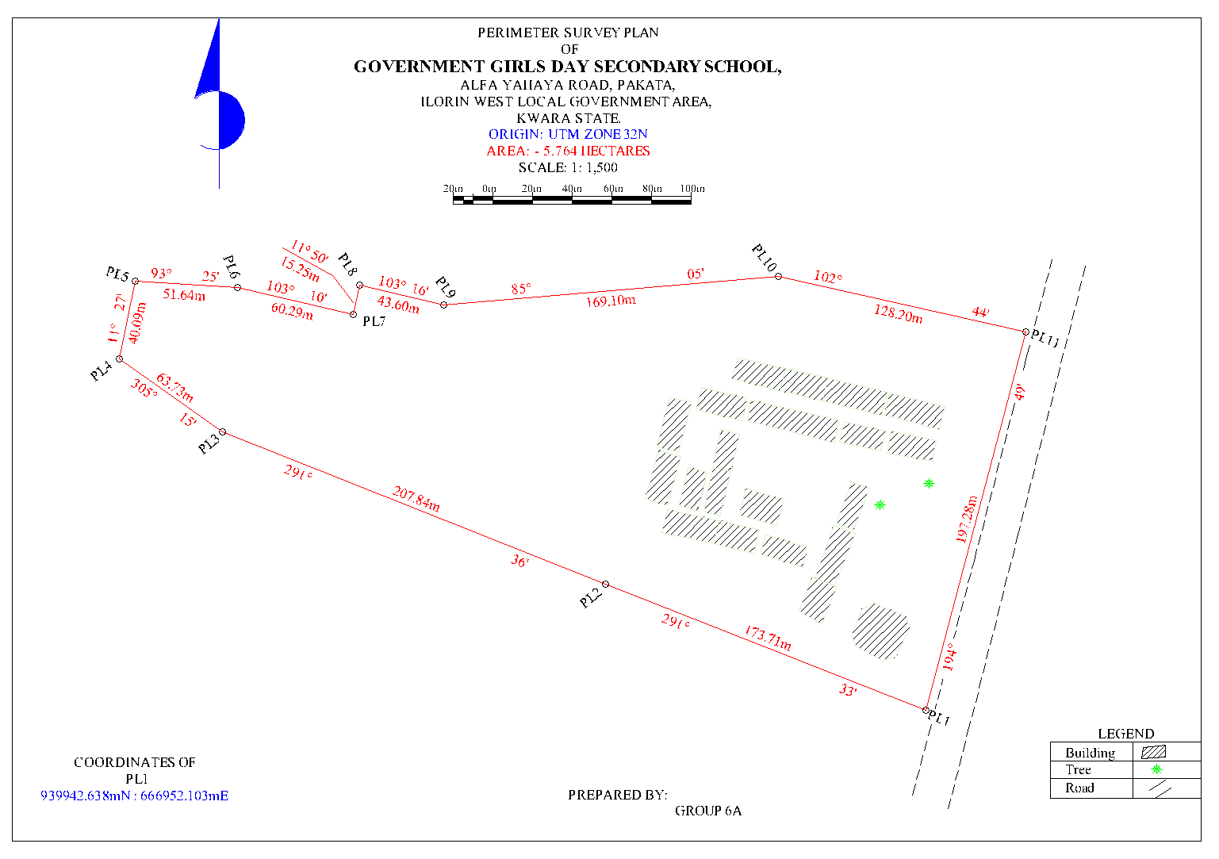 Fig 4.1: Detailed Plan of the Study area
4.3 SPOT HEIGHT MEASUREMENT AND ELEVATION ANALYSIS
Spot height measurements were obtained at regularly spaced intervals across the terrain to capture the vertical variation of the site. The spot heights ranged from 302.00 meters to 321.00 meters above mean sea level, indicating an elevation variation of 19 meters. Readings were taken at terrain breaks, slope transitions, and grid intersections to provide a full surface elevation dataset.
From the spot heights, contour lines were interpolated at 1.00-meter intervals, generating a continuous representation of elevation change across the site. The contours illustrate gradual and moderate slope patterns, with the steepest gradients located toward the northeastern section and relatively flatter terrain to the southwest.
Interpretation:
The elevation range reflects a moderate topographic undulation, which is advantageous for natural surface drainage, minimizing the risk of waterlogging. Slopes are not extreme, suggesting that grading requirements for construction will be minimal and cost-effective. The elevation profile also guides where best to site sensitive infrastructure such as roads, buildings, and stormwater channels. High points (up to 321m) are ideal for positioning critical structures, while lower points (around 302m) should be evaluated for potential runoff collection or water retention.
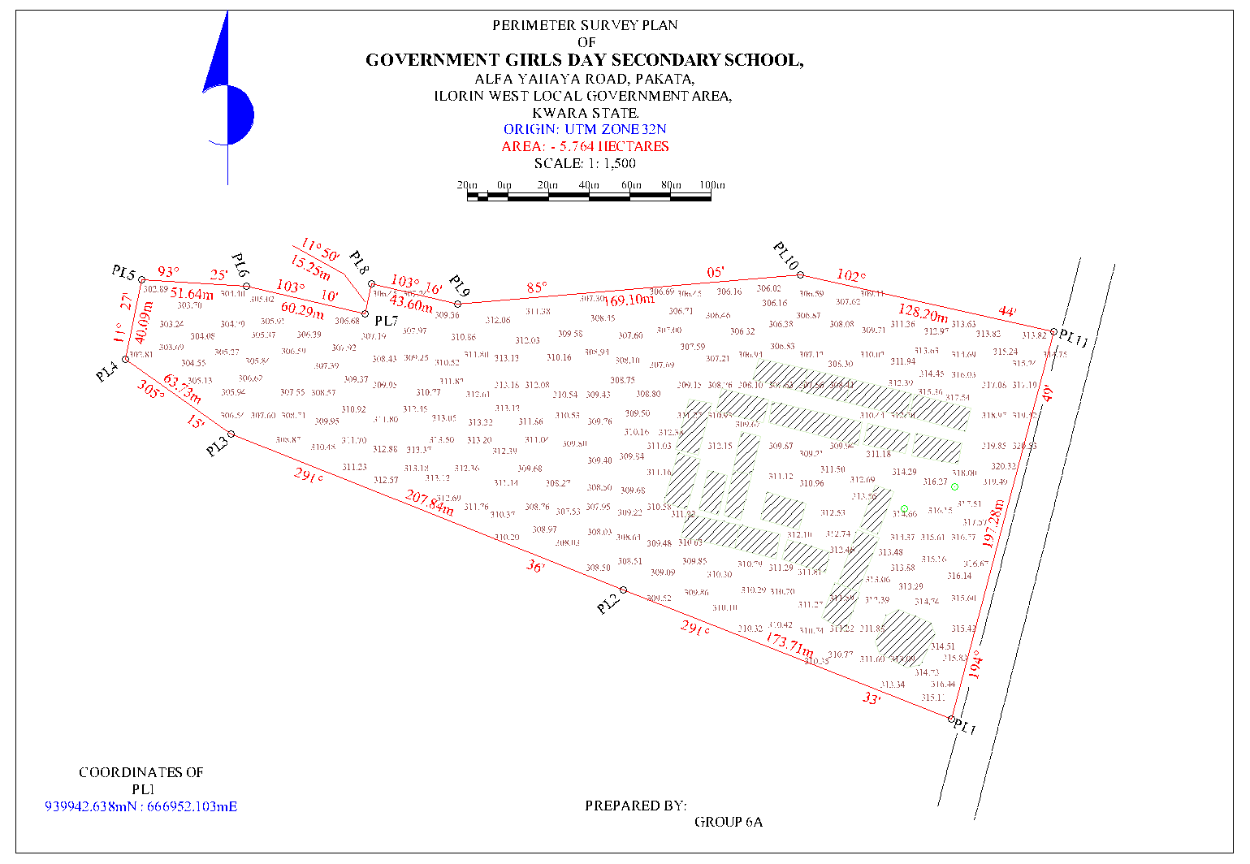 Fig 4.2: Spot Height Plan of the Study area
PLAN SHEWING THE SPOT HEIGHTS
OF
GOVERNMENT GIRLS DAY SECONDARY SCHOOL,
ALFA YAHAYA ROAD, PAKATA,
ILORIN WEST LOCAL GOVERNMENT AREA,
KWARA STATE.
ORIGIN: UTM ZONE 32N
AREA: - 5.764 HECTARES
SCALE: 1: 1,500

4.4 TOPOGRAPHIC MAP RESULT
The topographic map produced combines all collected spatial data — perimeter, details, and elevation — into a georeferenced and scaled map. The map visually represents both the horizontal arrangement of features and the vertical variations in elevation. Buildings are symbolized with clearly marked outlines, trees are shown with natural feature symbols, and roads are represented with line features matching their real-world orientation.
Contour lines dominate the elevation representation, showing continuous terrain levels at 1.00-meter intervals. The map layout includes northing, easting, scale bar, legend, and title block to comply with cartographic standards.
Interpretation:
The topographic map provides a single-source spatial document that aids decision-making across various disciplines. For architects, it allows the preparation of conceptual site layouts; for engineers, it supports terrain grading and slope analysis; and for urban planners, it informs land zoning and development control. Its clarity and completeness make it useful as both a presentation and analytical tool. It also enables integration into GIS environments for further spatial modeling or overlay with satellite imagery and planning datasets.
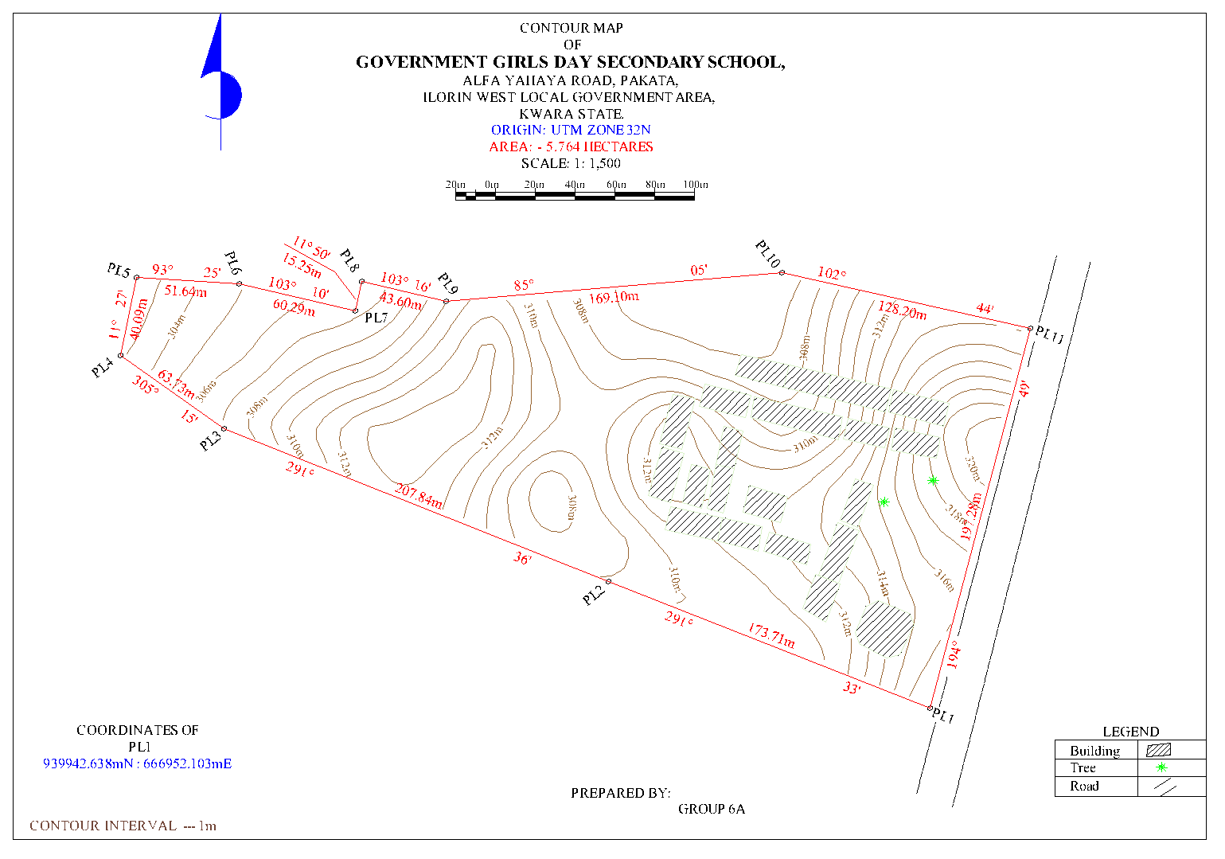 Fig 4.3: Contour Map of the Study area
CONTOUR PLAN
OF
GOVERNMENT GIRLS DAY SECONDARY SCHOOL,
ALFA YAHAYA ROAD, PAKATA,
ILORIN WEST LOCAL GOVERNMENT AREA,
KWARA STATE.
ORIGIN: UTM ZONE 32N
AREA: - 5.764 HECTARES
SCALE: 1: 1,500
4.5 DIGITAL TERRAIN MODEL (DTM) OUTPUT
Using the spot height dataset, a Digital Terrain Model (DTM) was generated to present the terrain as a continuous, 3D surface. The DTM was developed using interpolation techniques (e.g., Triangulated Irregular Network or Inverse Distance Weighting), and surface rendering was applied to visualize elevation differences, slope directions, and terrain curvature.
The DTM reveals subtle terrain changes not always visible on contour maps, such as micro-depressions or ridgelines. It is capable of supporting 3D visualization, fly-throughs, and terrain profiling, thereby enabling more advanced engineering applications.

Interpretation:
The DTM is a powerful tool for simulating hydrological flow, estimating earthwork quantities, and visualizing site development impact. It is especially useful for road design, cut-and-fill balancing, and modeling surface runoff. The 19-meter elevation range, when analyzed in the DTM, supports the identification of natural drainage paths and areas of potential erosion. The use of the DTM improves efficiency and reduces risks during planning and construction.
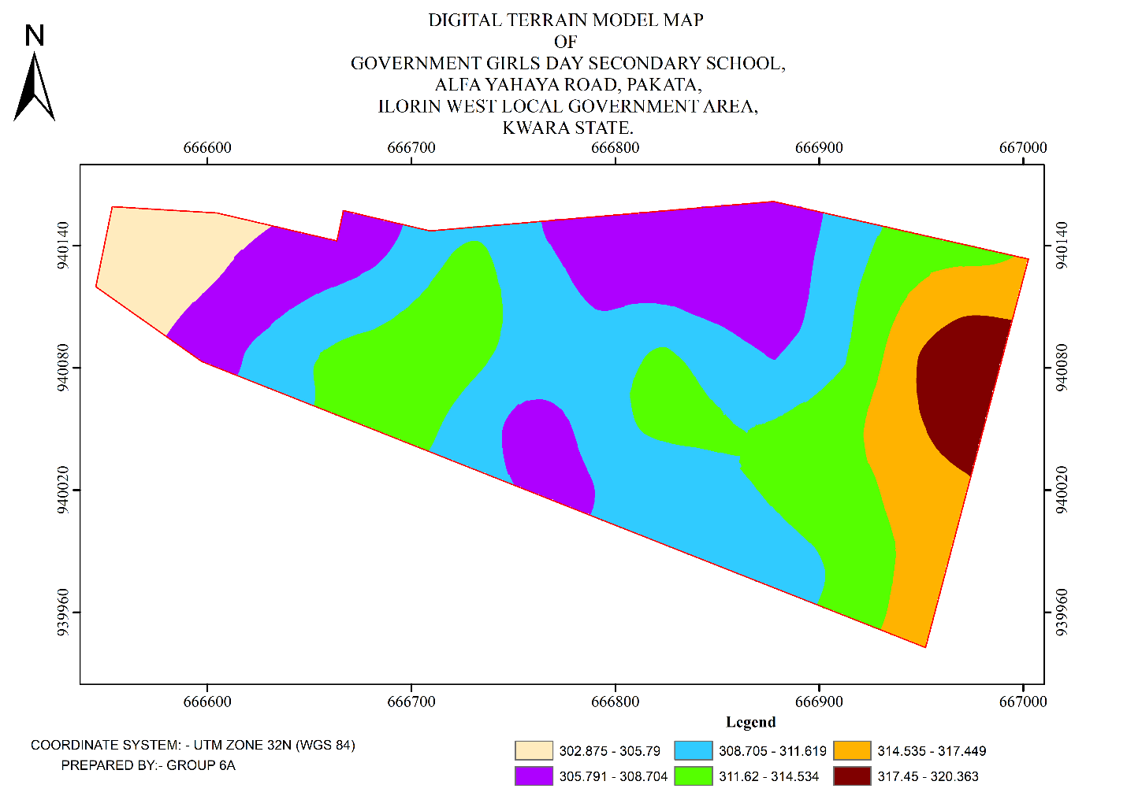 Fig 4.4: Digital Terrain Model Map of the Study area

4.6 INTEGRATED SPATIAL INTERPRETATION AND SITE ASSESSMENT
From the compiled results, it is evident that the site exhibits a balanced terrain with mild slopes, active land use, and strong access potential due to the bordering road. The presence of several buildings suggests partial occupation or previous use, while the terrain characteristics support new development with minimal site modification.
The combination of perimeter survey, detailed feature fixing, spot height data, contour mapping, and digital modeling ensures a comprehensive understanding of the site. The overall dataset can be used for:
- Land-use planning and zoning (based on building distribution and access routes)
- Engineering design (based on elevation and slope analysis)
- Drainage and stormwater design (from DTM slope flow directions)
- Construction layout and supervision
Integration into a GIS-based land information system

CHAPTER FIVE

COSTING, SUMMARY, PROBLEM ENCOUNTERED CONCLUSION AND RECOMMENDATIONS.
5.1 COST ESTIMATION
This stage the total cost spent on the project from day one to the final stage.
Table 5.1.1: Direct cost parameters
S/N | DIRECT COST
1 | Reconnaissance (1 day)
 | PERSONNEL | Rate | Total Amount (N:K)
 | 1 x surveyor | 10500 | 10500
 | 1 x assistant surveyor | 7500 | 7500
 | 1 x technical officer | 6500 | 6500
 | 3 x skilled labour | 4000 | 12000
 | basic equipment | 5000 | 5000:00
 | transportation (vehicle, Driver and fuel) | 10000 | 10000:00
 |  | sub-total | 51,500
2 | Monumentation (1 day)
 | PERSONNEL
 | 1 x assistant surveyor | 7500 | 7500
 | 1 skilled labour | 4000 | 4000
 | transportation (vehicle, Driver and fuel) | 10000 | 10000
 | basic equipment | 5000 | 5000:00

 | Beacon (6) | 1000 | 6000
 |  | sub-total | 32,500
3 | Data acquisition (2 days)
 | PERSONNEL
 | 1 x assistant surveyor | 7500 | 7500
 | 1 x technical officer | 6500 | 6500
 | 3 x skilled labour | 4000 | 12000
 | Total Station and accessories | 15000 | 15000
 | transportation (vehicle, Driver and fuel) | 10000 | 10000
 |  | sub-total | 51,000
5 | Data Processing (2 days)
 | PERSONNEL
 | 1 x surveyor | 10500 | 10500
 | 1 x assistant surveyor | 7500 | 7500
 | 1 x technical officer | 6500 | 6500
 | computer / accessories | 15000 | 15000
 |  | sub-total | 39,500
7 | Technical Report (1 day)
 | PERSONNEL
 | 1 x surveyor | 10500 | 10500
 | 1 x assistant surveyor | 7500 | 7500

 | 1 x secretary | 5000 | 5000:00
 | computer / accessories | 15000 | 15000:00
 |  | sub-total | 38,000
TOTAL (DIRECT COST) 212,500 MOBILIZATION/DEMOBILIZATION = 5% of Direct Cost
= 0.05 × 212,500

= N10,625

CONTINGENCY ALLOWANCE
= 5% of Direct Cost
= 0.05 × 212,500

= N10,225

GRAND TOTAL = N212,500 + N10,625 + N10,625

= N233,750

VAT (@5% GRAND TOTAL) = 0.05 × 233750

= N11,687.5
TOTAL COST PAYABLE = GRAND TOTAL + VAT

= N233,750+ N11,687.5 = N245,437.5

5.2 SUMMARY
The application of Topographic Information Systems (TIS) to the study of part of the Government Girls Day Secondary School, Pakata, Ilorin West (LGA), Kwara State, represents an important step towards modernizing urban planning, infrastructure development, and environmental management in the region. TIS, through the integration of advanced tools such as Digital Elevation Models (DEMs), satellite imagery, and geospatial data analysis, provides a comprehensive understanding of the terrain characteristics of the area, including elevation, slope, and landforms. This information is critical for planning and development in urban zones like the Government Girls Day Secondary School, where the population density is increasing, and there is a need for sustainable infrastructure development.
The topographic data derived from TIS can assist in a variety of applications, including flood modeling, land use planning, drainage system design, and risk assessment for potential natural hazards, particularly flooding due to the region’s topographic features and seasonal rainfall patterns. The detailed mapping and analysis of the area’s topography also provide insights into potential sites for future urban expansion and infrastructure projects while ensuring that the built environment is adapted to the natural terrain. Moreover, TIS can aid local authorities and stakeholders in creating policies that prioritize environmental sustainability, resilient urban infrastructure, and public safety, particularly in the face of climate change and population growth.
As the use of TIS in Government Girls Day Secondary School continues to grow, it will contribute to the integration of smart city technologies, including real-time data integration and IoT-driven solutions for more effective urban management. This could include the continuous monitoring of infrastructure health, soil conditions, and environmental changes. Additionally, the accurate terrain data generated by TIS will be instrumental in addressing challenges related to land tenure, property disputes, and infrastructure maintenance.

5.3 PROBLEM ENCOUNTERED
The following were the problems encountered during the execution of this project.
- The project was financially expensive, energetic and time consuming.
- On the day of carrying out the practical, there was a delay in getting the instrument that resulted in getting to the site lately.
- Throughout the practical, we worked under the sun reason that we got to the site lately.

5.4 CONCLUSION
In conclusion, the integration of Topographic Information Systems (TIS) into the planning and development of Government Girls Day Secondary School, Pakata, Ilorin West (LGA), Kwara State, offers a transformative approach to understanding and managing the region’s complex topographic and environmental characteristics. By leveraging advanced geospatial tools such as Digital Elevation Models (DEMs), satellite imagery, and real-time data collection technologies, TIS provides crucial insights into the terrain, which are invaluable for urban planning, disaster management, and infrastructure development. The use of TIS in this area enables stakeholders to make informed decisions about land use, flood risk assessment, and the design of resilient infrastructure that is aligned with the natural landscape, helping to mitigate the risks associated with topographic challenges.
Furthermore, the potential of TIS to integrate with emerging technologies like AI, IoT, and virtual/augmented reality promises to enhance the system's capability for real-time monitoring and dynamic decision-making. This integration will be pivotal in addressing future challenges as the region continues to urbanize, ensuring that growth is sustainable and that urban systems can effectively adapt to environmental changes.
However, for TIS to reach its full potential in Government Girls Day Secondary School, it is essential that data accuracy, accessibility, and local expertise are prioritized. Moreover, addressing the ethical concerns related to data privacy and ensuring equitable access to TIS benefits are key considerations for the long-term success of this technology in the region. With proper implementation and continuous improvements in data integration, TIS will play a critical role in shaping a more sustainable, resilient, and efficient urban future for Ilorin West LGA, enhancing the quality of life for its residents and fostering more effective governance.

5.5 RECOMMENDATION
Here is the recommendation section for the topic "Topographic Information Systems (TIS) of Government Girls Day Secondary School, Pakata, Ilorin West (LGA), Kwara State, in a listed format:
  - Enhance Data Accuracy and Resolution: It is recommended to improve the resolution and accuracy of topographic data by using advanced technologies such as LiDAR and UAV-based photogrammetry for more detailed mapping of terrain features in Government Girls Day Secondary School. This will provide more precise information for urban planning and flood risk assessments.
  - Integrate Real-Time Monitoring Systems: The integration of Internet of Things (IoT) sensors and other real-time monitoring systems within the TIS framework will enable continuous updates on environmental changes, infrastructure health, and disaster management. This will facilitate quicker decision-making and responses to dynamic urban challenges.
  - Adopt Advanced Visualization Technologies: Utilize Virtual Reality (VR) and Augmented Reality (AR) technologies to create immersive 3D models of the topography for urban planners, engineers, and the local community. This will improve stakeholder engagement, enhance understanding of the terrain, and aid in effective spatial decision-making.
  - Strengthen Capacity Building and Training: Provide training programs for local government officials, urban planners, and other stakeholders to build capacity in using TIS tools and interpreting topographic data. This will ensure better utilization of the system and foster local expertise in managing urban development challenges.
  - Promote Public-Private Partnerships: Foster collaborations between government agencies, private sector firms, and academic institutions to improve data collection, system development, and the long-term sustainability of TIS in the region. These partnerships can support funding, research, and the sharing of best practices.

REFERENCES
Amirebrahimi, S., Rajabifard, A., Mendis, P., & Ngo, T. (2016). A data model for integrating GIS and BIM for assessment and 3D visualization of flood damage to building infrastructure. International Journal of Digital Earth, 9(4), 363–386.
Billinghurst, M., Clark, A., & Lee, G. (2015). A Survey of Augmented Reality. Foundations and Trends in Human–Computer Interaction, 8(2-3), 73–272.
Burrough, P. A., & McDonnell, R. A. (1998). Principles of Geographical Information Systems. Oxford University Press.
Campbell, J. B., & Wynne, R. H. (2011). Introduction to Remote Sensing (5th ed.). Guilford Press.
Chen, Y., Yu, J., & Khan, S. (2009). Spatial sensitivity analysis of multi-criteria weights in GIS-based land suitability evaluation. Environmental Modelling & Software, 24(12), 1508–1515.
Colomina, I., & Molina, P. (2014). Unmanned aerial systems for photogrammetry and remote sensing: A review. ISPRS Journal of Photogrammetry and Remote Sensing, 92, 79–97.
Crampton, J. W. (2010). Mapping: A Critical Introduction to Cartography and GIS. Wiley-Blackwell.
Goodchild, M. F. (2018). Reimagining the History of GIS. Annals of GIS, 24(1), 1–8.
ISO (2003). ISO 19115: Geographic Information—Metadata. International Organization for Standardization
Kukutai, T., & Taylor, J. (Eds.). (2016). Indigenous Data Sovereignty: Toward an Agenda. ANU Press.
Li, S., Da Xu, L., & Zhao, S. (2020). 5G Internet of Things: A survey. Journal of Industrial Information Integration, 10, 1–9.
Longley, P. A., Goodchild, M. F., Maguire, D. J., & Rhind, D. W. (2015). Geographic Information Science and Systems. Wiley.
Nebert, D. D. (2004). Developing Spatial Data Infrastructures: The SDI Cookbook. GSDI Association.
Percivall, G. (2010). The role of open standards in geospatial interoperability. In Handbook of Research on Geoinformatics, IGI Global, 92–103.
Shekhar, S., & Xiong, H. (2008). Encyclopedia of GIS. Springer.
Turner, M. G., Gardner, R. H., & O'Neill, R. V. (2001). Landscape Ecology in Theory and Practice. Springer.
Wilson, J. P., & Gallant, J. C. (2000). Terrain Analysis: Principles and Applications. Wiley.
Zhu, X. X., Tuia, D., Mou, L., Xia, G. S., Zhang, L., Xu, F., & Fraundorfer, F. (2017). Deep Learning in Remote Sensing: A Comprehensive Review and List of Resources. IEEE Geoscience and Remote Sensing Magazine, 5(4), 8–36.

APPENDIX
GROUP 6A TOPO RAW DATA
P.I.D EASTING NORTHING ELEVATION | P.I.D EASTING NORTHING ELEVATION
1,PT,666559.393,938655.226,324.403  2,BLD,666564.888,938655.589,324.609  3,BLD,666572.856,938656.418,324.845  4,BLD,666579.384,938656.990,325.081  5,BLD,666587.417,938657.779,325.249  6,FF,666584.030,938674.217,324.847  7,FF,666578.461,938674.102,324.602  8,SH,666562.850,938672.506,324.086  9,SH,666548.780,938675.012,323.749  10,SH,666529.505,938681.031,323.445  11,WF,666509.740,938692.262,322.828  12,GT,666501.195,938679.925,323.593  13,GT,666500.602,938679.080,323.629  14,WF,666494.023,938669.408,323.585  15,PIL,666489.939,938663.250,323.784  16,SH,666504.839,938663.969,323.640  17,SH,666518.319,938668.328,323.512  18,SH,666534.636,938665.045,323.618  19,SH,666537.246,938651.342,324.351  20,SH,666537.116,938640.217,324.791  21,PIL,666549.802,938626.341,325.710  22,BLD,666566.949,938635.507,325.534  23,SH,666560.052,938640.072,325.173  24,SH,666551.407,938652.598,324.272  25,SH,666550.568,938689.169,323.494  26,SH,666538.375,938698.658,323.125  27,SH,666518.282,938705.519,322.835  28,TR,666530.522,938714.804,323.065  29,BLD,666532.985,938723.275,322.886  30,BLD,666535.020,938722.153,323.014  31,BLD,666536.550,938724.511,323.043  32,BLD,666537.444,938726.038,323.111  33,BLD,666538.628,938728.344,323.073  34,TR,666547.428,938716.448,323.439  35,SH,666561.960,938714.995,323.735  36,SH,666577.398,938714.165,323.962  37,SH,666588.013,938713.553,324.333  38,SH,666594.902,938733.181,324.533  39,FF,666585.859,938745.789,324.080  40,FF,666580.138,938746.859,324.004  41,SH,666567.418,938742.689,323.674  42,BLD,666562.092,938744.078,323.581  43,BLD,666553.297,938748.849,323.116  44,WF,666548.166,938751.757,323.022  45,BLD,666573.843,938764.473,323.318  46,SH,666582.419,938761.025,323.802  47,SH,666592.201,938757.277,323.907  48,SH,666599.902,938752.070,324.093  49,SH,666602.626,938762.939,324.184  50,SH,666596.583,938765.303,324.118  51,SH,666588.891,938769.861,323.589  52,SH,666576.869,938779.026,323.581  53,SH,666579.252,938790.592,323.338  54,PIL,666578.121,938796.557,323.355  55,WF,666591.126,938795.641,323.822  56,SH,666599.788,938791.439,324.047  57,SH,666596.692,938780.969,323.967  58,SH,666606.748,938775.310,324.247  59,BLD,666616.773,938784.907,324.987  60,BLD,666617.378,938787.730,325.240  61,WF,666617.119,938792.478,324.683  62,BLD,666619.559,938784.367,325.202  63,BLD,666622.361,938785.821,325.247  64,BLD,666621.226,938776.323,324.742  65,SH,666620.229,938765.813,325.022  66,SH,666612.733,938767.946,324.700  67,SH,666611.600,938753.333,324.728  68,SH,666612.441,938739.964,324.961  69,SH,666615.825,938724.599,325.333  70,TR,666621.296,938715.292,325.998  71,SH,666610.096,938713.356,325.410  72,SH,666609.137,938700.165,325.546  73,SH,666611.831,938687.882,325.848  74,SH,666615.842,938679.399,326.144  75,SH,666616.033,938674.189,326.252  76,BLD,666615.837,938662.628,326.442  77,SH,666605.260,938663.643,326.041  78,BLD,666593.748,938659.167,325.634  79,SH,666592.892,938667.768,325.400  80,BLD,666619.597,938663.260,326.505  81,BLD,666639.099,938665.984,327.375  82,BLD,666643.840,938666.654,327.485  83,BLD,666665.520,938669.765,328.330  84,BLD,666668.596,938670.268,328.448  85,BLD,666690.662,938673.491,329.178  86,BLD,666693.533,938675.060,329.155  87,BLD,666691.985,938685.179,328.896  88,SH,666692.573,938693.992,328.445  89,SH,666695.917,938702.946,328.240  90,BLD,666700.844,938707.759,328.343  91,BLD,666709.733,938708.123,328.623  92,SH,666710.532,938699.058,328.854  93,SH,666712.030,938688.499,329.226  94,SH,666693.790,938710.254,327.952  95,SH,666686.278,938708.401,327.550  96,SH,666671.562,938706.433,327.388  97,SH,666672.225,938694.999,327.675  98,SH,666676.052,938681.708,328.054  99,SH,666662.792,938677.496,327.654  100,SH,666652.241,938687.813,327.079  101,SH,666644.262,938681.957,327.057  102,SH,666638.083,938670.981,327.071  103,SH,666628.032,938668.980,326.716  104,SH,666630.313,938687.812,326.474  105,SH,666631.197,938704.013,326.052  106,SH,666642.761,938708.216,326.404  107,EP,666656.192,938706.350,326.926  108,SH,666661.644,938716.765,326.692  109,FF,666667.418,938725.667,326.569  110,FF,666667.138,938728.920,326.538  111,SH,666685.351,938726.847,327.195  112,BLD,666699.212,938737.115,327.714  113,BLD,666698.524,938740.612,327.598  114,SH,666693.983,938749.480,327.262  115,BLD,666697.372,938760.585,327.093  116,BLD,666700.240,938766.370,327.154  117,SH,666688.669,938758.316,326.945  118,SH,666677.388,938760.922,326.541  119,BLD,666679.895,938768.787,326.580  120,SH,666667.611,938770.000,326.252  121,BLD,666655.808,938771.721,325.814  122,BLD,666648.235,938772.767,325.569  123,BLD,666643.650,938773.528,325.455  124,WT,666640.280,938769.175,325.522 | 125,WT,666639.790,938767.687,325.569  126,WT,666641.358,938766.991,325.575  127,SH,666634.854,938764.789,325.446  128,SH,666637.255,938755.218,325.526  129,SH,666648.479,938750.478,326.051  130,SH,666651.677,938748.545,326.060  131,SH,666651.176,938743.616,325.941  132,SH,666653.487,938743.635,326.074  133,EP,666664.619,938749.247,326.356  134,SH,666661.779,938738.151,326.352  135,SH,666650.737,938734.922,326.119  136,SH,666638.825,938734.261,325.675  137,FF,666627.213,938729.227,325.561  138,FF,666627.154,938726.027,325.519  139,FF,666652.971,938722.396,326.084  140,FF,668126.774,939305.647,371.880  141,CP,666731.883,938714.114,329.118  142,CP,666722.880,938709.571,329.095  143,CP,666731.861,938714.103,329.090  144,BLD,666719.330,938776.283,328.847  145,BLD,666724.640,938775.642,329.538  146,BLD,666724.811,938777.345,329.013  147,WF,666727.860,938779.930,328.852  148,SH,666729.117,938765.766,328.551  149,SH,666713.970,938764.828,328.315  150,SH,666705.731,938774.336,328.143  151,WF,666703.715,938782.214,328.655  152,BLD,666707.042,938760.928,328.164  153,SH,666714.641,938751.563,328.524  154,SH,666711.044,938743.638,328.569  155,BLD,666708.008,938741.096,329.147  156,BLD,666708.301,938737.492,329.393  157,SH,666719.039,938737.120,328.664  158,SH,666728.749,938734.462,328.506  159,SH,666741.792,938741.734,328.911  160,SH,666747.719,938751.513,328.909  161,BLD,666740.177,938763.414,328.789  162,SH,666749.275,938757.111,328.961  163,BLD,666759.775,938762.004,329.385  164,SH,666759.454,938748.967,329.185  165,SH,666751.653,938739.045,329.162  166,SH,666753.335,938727.717,329.548  167,SH,666755.412,938716.761,329.795  168,SH,666756.582,938710.874,329.914  169,BLD,666769.016,938706.899,330.306  170,BLD,666749.991,938703.089,329.885  171,BLD,666746.416,938702.440,329.791  172,BLD,666727.171,938698.381,329.546  173,BLD,666729.017,938689.493,329.729  174,PIL,666727.095,938688.956,330.002  175,PIL,666728.798,938676.309,330.773  176,PIL,666714.192,938674.035,330.810  177,BLD,666713.774,938676.953,330.512  178,BLD,666713.612,938677.901,330.458  179,BLD,666712.298,938688.217,329.882  180,SH,666721.299,938676.028,330.531  181,SH,666721.212,938690.196,329.749  182,SH,666717.543,938705.002,329.084  183,SH,666719.324,938719.819,328.830  184,BLD,666772.395,938707.875,330.401  185,BLD,666791.143,938711.646,330.850  186,BLD,666796.208,938712.817,331.437  187,BLD,666815.736,938717.126,331.687  188,SH,666813.009,938726.677,331.091  189,SH,666800.600,938724.265,330.640  190,SH,666785.915,938721.751,330.486  191,SH,666772.111,938719.587,330.221  192,SH,666757.289,938716.674,329.897  193,SH,666753.103,938726.211,329.572  194,SH,666764.504,938730.925,329.584  195,SH,666776.799,938733.664,329.930  196,SH,666787.651,938734.839,330.088  197,SH,666800.791,938739.366,330.340  198,SH,666809.360,938743.631,330.602  199,SH,666824.472,938747.742,330.967  200,SH,666814.001,938751.846,330.764  201,SH,666797.995,938745.083,330.206  202,SH,666785.156,938745.079,329.911  203,SH,666777.323,938745.625,329.701  204,SH,666762.019,938747.240,329.348  205,SH,666753.730,938750.513,329.096  206,BLD,666764.031,938761.616,329.347  207,BLD,666796.632,938759.832,330.269  208,BLD,666806.074,938758.626,330.484  209,BLD,666810.530,938757.750,330.603  210,CP,666837.386,938731.730,332.055  211,CP,666829.131,938729.840,331.835  212,CP,666837.322,938731.715,332.032  213,GT,666843.144,938741.280,331.875  214,GT,666842.294,938746.971,331.905  215,GH,666839.370,938746.798,331.704  216,GH,666838.857,938750.142,331.727  217,PIL,666839.251,938771.826,331.955  218,BLD,666831.234,938766.354,331.569  219,BLD,666830.371,938756.749,331.569  220,TR,666832.903,938751.431,331.596  221,TR,666805.617,938750.605,331.361  222,TR,666790.209,938742.444,331.555  223,BLD,666786.825,938760.003,331.241  224,BLD,666783.240,938760.270,331.293  225,EP,666810.029,938738.888,331.489  226,BLD,666817.703,938707.898,332.618  227,BLD,666818.554,938700.375,332.887  228,BLD,666839.493,938700.429,333.542  229,WF,666813.858,938682.646,333.753  230,SH,666812.465,938693.685,333.032  231,SH,666817.384,938702.759,332.763  232,SH,666823.585,938706.568,332.769  233,SH,666827.141,938719.144,332.147  234,SH,666837.287,938714.607,332.603  235,SH,666847.470,938710.193,332.886  236,SH,666849.643,938698.050,333.158  237,SH,666851.768,938687.648,333.427  238,SH,666845.065,938725.354,332.337  239,SH,666843.736,938733.935,332.005  240,SH,666834.883,938741.786,331.707  241,SH,666825.509,938741.317,331.440  242,SH,666816.523,938749.139,331.327  243,SH,666815.465,938738.232,331.351  244,SH,666808.713,938719.009,331.950  245,SH,666797.606,938718.224,331.998  246,SH,666803.858,938715.008,332.217  247,SH,666790.493,938713.012,332.421  248,SH,666775.471,938711.294,332.557

