DESIGN AND IMPLEMENTATION OF SOLAR POWER SYSTEM FOR RESIDENTIAL LODGING

BY

AMINU MOSHOOD OLAWALE
HND/23/EEE/FT/0241

BEING A RESEARCH PROJECT REPORT SUBMITTED TO THE, DEPARTMENT OF ELECTRICAL/ELECTRONIC ENGINEERING TECHNOLOGY, INSTITUTE TECHNOLOGY (IOT), KWARA STATE POLYTECHNIC, ILORIN,

IN PARTIAL FULFILLMENT OF THE REQUIREMENT FOR THE AWARD OF HIGHER NATIONAL DIPLOMA (HND) IN ELECTRICAL/ELECTRONIC ENGINEERING TECHNOLOGY

JULY, 2025
CERTIFICATION
This is to certify that this project titled “Design And Implementation Of Solar Power System For Residential Lodging" was carried out by AMINU MOSHOOD OLAWALE with matric number HND/23/EEE/FT/0241, has been approved as meeting part of the requirement of the Department of Electrical/Electronic Engineering in the institute of Technology, Kwara State Polytechnic, Ilorin for the award of Higher National Diploma (HND) In Electrical/Electronic Engineering, Kwara State Polytechnic Ilorin.

_______________________________ __________________
ENGR. JIMOH ADEYEMI DATE
Project Supervisor

____________________ ________________
ENGR. (DR.) O.A LAWAL DATE
Head of Department

____________________ ________________
ENGR. ABDULKADIR Z.A DATE
Project Coordinator

_____________________ ________________
EXTERNAL EXAMINER DATE

DEDICATION
This project is dedicated to the creator of Heaven and the Earth the Almighty GOD that guide us through the course of this project. If not for him this project would not have been a fulfilled one.
I also give regards to my parent MR. and MRS. AMINU for their support in all aspect to make the fulfillment of the Higher National Diploma (HND) a successful one.

ACKNOWLEDGEMENT
I return all glory to the one whom is worthy of our praise, the Almighty and all sufficient God, who made the success of this project a reality.
I also give regards to my parent MR. and MRS. AMINU for their support in all aspect to make the fulfillment of the Higher National Diploma (HND) a successful one.
I cannot underestimate the effort and support of my late supervisor Engr. A.A. Alawode, who state this project with us and later pass on along the way, are will always give thanks to my success supervisor Engr. Jimoh Adeyemi and Engr. Abdulkadir Z.A who helped me to attain these much and have inspire me more to reach this junction of success. May God help you through in all ramification of your life (Amin).
My profound gratitude goes to my trusted and able Head of Department, Engr. (Dr.) O.A Lawal and other reliable lecturer in the department for their support.
My gratitude also goes to all Family and Friends for their support I really appreciate all.

ABSTRACT
Residential comfort is a fundamental requirement for human habitation, and access to stable and reliable electricity plays a vital role in achieving this. However, the persistent collapse of the national power grid in recent years has raised serious concerns about the reliability of the electrical power supply to residential areas. The increasing frequency of blackouts and power interruptions has negatively impacted the quality of life and the functionality of many household appliances and systems. In response to this growing challenge, this project focuses on the design and construction of a 2 kVA inverter system tailored specifically for residential buildings. The inverter system is developed to serve as an alternative source of power, ensuring a continuous electricity supply during periods of grid failure. The system comprises essential components such as a power inverter module, battery bank, charge controller, and changeover switch, all configured to deliver efficient and uninterrupted power. The design prioritizes affordability, portability, and ease of maintenance, making it a suitable option for residential use. The project also addresses safety considerations and energy efficiency, with provisions for future integration with renewable energy sources such as solar panels. Through practical implementation and testing, the constructed inverter system demonstrates the potential to significantly improve power reliability in homes, thereby enhancing comfort and productivity. This initiative contributes to bridging the energy gap in residential areas and supports sustainable living in the face of Nigeria’s ongoing power supply challenges.

TABLE OF CONTENT
Title Page i
Certification ii
Dedication iii
Acknowledgment iv
Abstract v
Table of content vi
CHAPTER ONE: INTRODUCTION
1.1 Background of the Study 1
1.2 Electrical Signal Waves 2
1.3 Problem Statement 3

1.4 Aim and Objective of the Project 3

1.5 Scope of the Project 4

1.6 Significance of the Project 4
CHAPTER TWO
2.1 Literature Review 5
2.2 The Inverter 6
2.3 Common Component of Inverter 9
2.4 Classification of Inverter 10
2.5 Advantages and Disadvantages of Inverter 11
2.6 Things to Consider Before Buying an Inverter 12

2.6.1 Other Names of Square Wave Inverter 13

2.7 Batteries 15

2.8 Types of Batteries 16

2.8.1 Inverter Battery Connection 17

2.9 State of the Art 18
CHAPTER THREE
3.1 Project Methodology 21
3.2 Design and Construction of 2kva Inverter 21
3.3 Online Uninterruptible Power Supply System 22
3.4 Offline Uninterruptible Power Supply System 22
3.5 Electronic of the Circuit Diagram 23
3.5.1 The Transformer 23
3.6 The Electronics of an Inverter System 23
3.7 Performance Analysis 27
CHAPTER FOUR
4.1 Principle of Operation of an Inverter System 30
4.2 Discussions and Equation Modelling 35
CHAPTER FIVE
5.1 Conclusion 38

CHAPTER ONE
INTRODUCTION
1.1 Background of the Study
The National grid relied fully on the hydro and gas generation power plant for mains input on the grid but series of factors as led to supply shortage ranging from natural and artificial disasters, poor maintenance culture, lack of skilled personnel, etc. all these factors sum up to reduce the mains supply reliability and availability. In recent times, virtually all aspect of human endeavors such as sophisticated medical life savings equipment, accurate data and processing machines among other electronic machines are all electrical power dependency and are capable of malfunctioning on a slight input voltage fluctuation talk less of total mains outage or unavailability.
A worthy alternative power supply system commonly found in homes, offices, hospitals etc are the power inverter system. An inverter or a power inverter system is an electronic device or circuitry that changes direct current (DC) to alternating current (AC). Comprehensively, inverter is that device which is being employed by the electrical engineers to tackle and support the power supplies. This support comes to play when there is power outage, this makes the inverter indispensable especially in developing countries like Nigeria where there is an epileptic power supply. However, an alternative power supply to the mains need be efficient, stable and deliver optimum power to the end loads, hence the need for the design and construction of a pure sine wave power inverter. In this regards, this project work presents design and construction of a pure sine wave power inverter system for optimum electrical power delivery and improvement of performance of a locally designed and constructed power inverter system.
1.2 Electrical Signal Waves
Electrical sine waves are depiction of electrical signal represented by a sinusoidal graph, the wave shows all the properties of a wave like: the amplitude, frequency, wavelength and the can exhibit the wave-like properties of reflection, refraction, diffraction and polarization. Moreover, when an electrical signal wave is said to be pure, its means the wave depiction is devour of harmonics as shown in Figure 1.0. More so, when the wave output of the oscillation unit of an inverter is free of harmonics, then the power inverter is term ‘pure sine wave power inverter’.
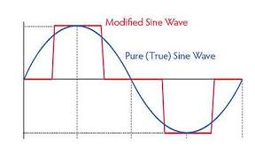
Figure 1.0: Electrical Signal Wave.

Advantages of pure sine wave inverters over modified sine wave inverters:
- Output voltage wave form is pure sine wave with very low harmonic distortion and clean power like utility-supplied electricity.
- Inductive loads like microwave ovens and motors run faster, quieter and cooler.
1.3 Problem Statement
The project work will solve the problems of poor power supply delivery to electrical load, by the design and construction of pure sine wave power inverter.

1.4 Aim and Objective of the Project
The aim of the study is to locally design and construct a 2kVA/12Volts power inverters for domestic electric power supply.

Objectives of the Project
The objectives of the study are stated as follow.
- To study the effect of pure sine wave on electrical loads
- To determine the battery discharging current/voltage on load and the effect of load on the inverter
- To design and construct a reliable pure sine wave power inverter

1.5 Scope of the Project
The scope to be employed in this project work will require the critical study of how to design and construct a locally made uninterruptible power supply inverter system. Thereafter, series of load test will be performed for loads study evaluation.

1.6 Significance of the Project
The study can enable:
- To help student(s) have basic knowledge about uninterruptible power inverter system.
- It help student(s) to get acquainted with power electronics

CHAPTER TWO
2.1 LITERATURE REVIEW
Electricity generation is the process of generating electric power from other source of primary energy. Energy conversion process is divided into different type such as, thermo electric (heat- electric energy), steam engine (heat – mechanical energy), etc. Circumstances around the development of new technology in the engineering field have become very attractive for power industries in power electronics application during the last years the main purpose that lead to the development of the studies of inverter is the generation of output signals with low harmonies distortion, reduction of switching frequency. This development has made it possible to change from D.C power to the conventional A.C power that you can use for all kinds of device or appliances, such as electric light, kitchen appliances, power tools, television sets and so on.
Early inverters from the late nineteenth century through the middle of the twentieth century, DC-to-AC power conversion were accomplished using rotary converter or motor generator (MG) sets. In the early twentieth century, vacuum tube and gas filled tubes began to be used as switches in inverter circuits.
The origins of electromechanical inverters explain the source of the term inverter. Early AC- to- DC converter used an induction or synchronous ac motor direct - connected to a generator (dynamo) so that the generators commentator reversed its connections at exactly the right moments to produce D.C. A later development is the synchronous converter in which the motor and generators winding are combined into one armature, with slip rings at one end and a commutator at the other and only one field frame. The result with either is AC-in, DC-out. With an MG set, the D.C can be considered to be separately generated from the AC; with a synchronous converter, in a certain sense it can be considered to be “mechanically rectified AC “. Given the right auxiliary and control equipment, MG set or rotary converter can be “run backwards”, converting DC to AC. Hence an inverter is an inverted converter.
Over the years, electricity has been generated using the following methods: Solar, Thermal, Wind, Electric generators. These methods have proved to be quit reliable and sufficient. However, due to inadequate source of energy, the need for standby supply is essential which brought into existence an alternative means called inverter.

2.2 The Inverter
An Inverter is a device that converts DC power from sources such as batteries to AC power. Figure 2.1 shows the inner circuitry of an inverter power system
Fig. 2.1: Inverter inner circuitry.
An uninterruptible power supply (ups) uses batteries and an inverter to supply AC electrical power when main power is not available. When main power is restored, a rectifier supplies DC power will be fed to recharge the batteries.
An Inverter can also be said to be an electronic device or circuitry that changes direct current (DC) to alternating current (AC). The input voltage, output voltage, frequency and overall power handling depend on the design of the specific device or circuitry. The Inverter does not produce any power; the power is provided by the D.C source. The basic circuit of the inverter comprises the following parts:
- Charger Section
- Rectifier Section
- DC-AC Converter
- Drivers Section/FET Gang
- Inverter Module
- Transformation Section
- CHARGER SECTION: The charger card basically senses the AC input and then generates the silicon control rectifier triggering pulse. The feature for the soft start is incorporated in this card using the concept of saw tooth generation and then its conversion into the triggering pulses, which eventually gets transported through the pulse transformer to the output connector of the charger card with its other end connected to the SCR module.
- RECTIFIER SECTION: The rectifier module used is a full wave semi controlled rectifier with two SCR and two diodes in single phase. In the case of three phase system the rectification is full controlled and six SCR are used for solving this purpose.
- DC-AC CONVERTER: This card is responsible for generation of the DC voltages (+15V and +5V) to supply it to the other cards. It accepts its input from the taping over the DC capacitors. The Input DC through fuse is converted into AC and is amplified using a TOP switch. This is then Fed to a transformer with multiple taping at its secondary. The AC from the taping is then rectified through diodes and given 37 to voltage regulator eventually producing the voltage sources of +15V and +5V. These voltages are then used as a P/S for all other cards.
- DRIVER SECTION: The driver card primarily has two features
1) To provide isolation of control circuit with the power circuit.
2) To block the PWM pulses forcing the UPS to go into the protection in case of short circuit at the output end.
INVERTER SECTION: In this section conversion of DC to AC is done. The technology of PWM triggering is implicated over the IGBT based inverters. PWM generated by DSP card through the driver card, providing electrical isolation, reaches the IGBTs gate and emitter terminal. Using this high frequency triggering the IGBTs which producing the AC output from the DC link.
- TRANSFORMATION SECTION: The card is basically used to sense the input and output voltages and their conversion into a low voltage AC for further processing.

2.3 Common Component of Inverter

MOSFET:

It is a switching device used to convert ac into dc. It is of different rating for different capacities of inverters. e.g. Z44, IRF 3205, IRF2807, P55.
TRANSISTOR:
It is also of same appearance as of mosfets used for signal (voltage and current) amplification in the circuit. It was also working as switching device earlier. Now we are using mosfets & IGBTs in place of it. e.g BC 547, BC557 ,BD 139 etc.

REGULATOR:
It is a device used to regulate the voltage coming at its input and supply that voltage to the device. e.g a device operates on 12V supply and supply is coming more than this so we use 12V regulator to give 12V supply to it. e.g. 7812, 7805 etc.
ZENER DIODE:
A Zener diode is a type of diode that permits current to flow in the forward direction like a normal diode, but also in the reverse direction if the voltage is larger than the breakdown voltage known as zener knee voltage or zener voltage. Zener diodes are widely used to regulate the voltage across a circuit.

RELAY:

A relay is an electrical switch that opens and closes under the control of another electrical circuit in the original form, the switch is operated by an electromagnet to open or close one or many sets of contacts. It is used as a changeover device in inverters to do change over from mains to inverter and inverter to mains e.g. 40A/12V, 63A/12V.

2.4 Classification of Inverter
Inverters can be classified into three broad types. They are:
- Stand-Alone Inverters:
This type of inverter is used in isolated systems where the inverter draws its DC energy from batteries charged by photovoltaic arrays. Many stand-alone inverters also incorporate integral battery chargers to replenish the battery from an AC source, when available. Normally these do not interfere in any way with the utility grid and as such are not required to have anti-islanding protection.
- Grid-Tie Inverters: These inverter matches phase with a utility supplied sine wave. Grid tie inventers are designed to shut down automatically upon loss of utility supply, for safety reasons. They do not provide back-up power during utility outages.
- Battery Backup Inventers: These are special inverters which are designed to draw energy from a battery, manage the battery charge via an onboard charger and export excess energy to the utility grid. These inverters are capable of supplying AC energy to selected loads during a utility outage, and are required to have anti islanding protection.

2.5 Advantages and Disadvantages of Inverter
A Number of Advantages which Include:
- It is virtually always on
- It has no running cost
- It brings about protection of appliances
- It changes automatically when the mains goes off
- It is easy to maintain
One of the disadvantages of inverter is the high initial cost, i.e., initial cost of purchase

2.6 Things to Consider Before Buying an Inverter
Since it would cost quite some money for the procurement, it’s important to ensure that you get good quality that matches your expenditure i.e plan value for money principle. So, be sure of your source and that the quality you get is what you paid for. These things include:
- OUTPUT WAVE FORM
There are two major types of inverters output waves form available in the market. These are square wave form inverter and pure sine wave form inverter.
- Square Wave Inverters: As mentioned in the name itself, the wave form of the output current from this type of inverter is like square. The current we get from grid is neither square wave nor pure sine wave, it’s nearly sine wave. So, our electronic device like fan and tube light will emit some buzz noise while operating in square wave current. Of course, square wave current won’t spoil your fan or tube light. In some rare cases, these square wave inverter have spoiled the speed control dimmers of ceiling fans. The main reason for this fault is high voltage output.
Normally, voltage output from square wave inverters is between 230 volt to 290 volt, hence it’s not recommended to sensitive electronic device like computers. I am just saying “it’s not recommended”, this is based on some experiment carried out and proper observation. But desktop computers and laptops will operate flawlessly in square wave inverter. As desktop pc’s are equipped with SMPS the current from the square wave inverter won’t make any big disturbances in the computer.

2.6.1 Other Names of Square Wave Inverter
Some Inverter UPS manufacturer name their product as digital inverters, modified-sine wave, trapezoidal wave form, stepped time wave, quasi time wave e.t.c, all these are nothing but square wave inverter. So, it’s pertinent and advisable that one reads carefully the specification of the inverter before he/she purchases.
- Pure Sine Wave Inverter: Pure sine wave inverter gives the purest form of current to your sensitive devices. Most probably the current from this type of inverter are very safe to desktop computers, laptops, camera batteries, cell phone chargers, mixer, small house hold water pumping motors as show in fig 2.1 e.t.c
This type of Inverter will save your current bill compared to square wave inverters.

Fig .2.3pure sine wave

No Fan Speed Difference and Noise
In square wave inverter, where power goes off, the speed of the ceiling fan will increase slightly and make some buzz sound whereas in pure sine wave inverter, the speed of the fan remains same and makes no noise. You cannot feel the difference when power goes out.

OUTPUT FREQUENCY
The AC output frequency of a power inverter device is usually as standard power line frequency 50 or 60 hertz. If the output of the device or circuit is to be further conditioned (for example stepped up) that the frequency maybe much higher for good transformer efficiency.
- OUTPUT VOLTAGE
The AC output voltage of a power inverter device is often the same as the standard power line voltage such as household 120V or 240V. This allows the inverter to power numerous types of equipment designed to operate off the standard line power.
The designed-for output voltage is often provided as a regulated output. That is, changes in the load the inverter is driving will not result in an output voltage change from the inverter. In a sophisticated inverter, the output voltage may be selectable or even continuously variable.
- OUTPUT POWER
A power inverter will often have an overall power rating expressed in watts (W) or kilowatts (KW). This describes the power that will be available to the device, the power that will be needed from the DC source. Smaller popular consumer and commercial devices designed to mimic line power typically range from 150 to 3000 watts.
Not all inverter applications are primarily concerned with brute power delivery; in some cases the frequency and or waveform properties are used by the follow-on circuit or device.
Other things to consider when buying an inverter may include (inverter size, warrantee, durability and portability.) etc.

2.7 Batteries
Battery is the combination of one or more electrochemical galvanic cells which stores chemical energy that can be converted into electric potential energy, creating electricity. Since the invention of the first voltaic pile in 1800 by Alessandro volt, the battery has become a common power source for many household and industrial applications. The name ‘battery’ was coined by Benjamin Franklin for an arrangement of multiple “Leyden jars” by analogy to a battery of cannon.
If on the other hand, energy is induced in the chemical substance by applying an external source, which is called a secondary battery or rechargeable battery. Examples of secondary cells are the lead-acid cell, nickel-cadmium cell, nickel-iron cell, nickel-zinc cell etc.
When the energy is stored inherently present in the chemical substance, it is called a primary cell e.g. zinc chlorine cell, alkaline manganese cells. Batteries convert chemical energy directly to electrical energy. A battery consists of some number of voltaic cells. Each cell consists of two-half cells connected in series by a conductive electrolyte containing anions.
A battery is a vital part of an inverter. The performance and life of an inverter largely depends on its battery. There are several classifications of inverter batteries. Here are a few of them:

2.8 Types of Batteries
- LEAD ACID BATTERIES
Lead acid batteries are the most common inverter batteries. These are rechargeable in nature and produce large amount of current. They are light in weight and most economical. They usually last for a period of 3-4 years. But they require regular maintenance. The electrolyte level check and topping up has to be done regularly. They also release harmful gases during charging and discharging. So they must be installed at a well-ventilated place in homes or offices. When one cannot afford the deep cycle sealed maintenance free battery, ideally recommended for your inverter, you can still consider the option of wet cell batteries. They cost far less, can serve you reasonably though you must realize that they are more challenging to manage. Besides, if they are not deep cycle, they are not designed for deep discharge, which may affect their durability. Good quality wet cell batteries have, however, given satisfactory performance in use.
- TUBULAR BATTERIES
Tubular batteries are the most popular and efficient inverter batteries. They have a complex design, great efficiency, longer operational life (8+ years) and low maintenance. Because of so many advantages they are costly.
NOTE: The lead-acid batteries otherwise known as wet cells, they use liquid electrolytes, which were prone to leakage and spillage if not handled correctly. Many use glass jars to hold their components, which makes them fragile. These characteristics make the lead acid unsuitable for portable appliances. Near the end of the Nineteenth century, the invention of dry cell batteries, which replaced the liquid electrolyte with a paste, made portable electrical devices practical. These flaws encountered with the lead acid batteries gives the sealed maintenance free batteries (SMF) an edge over others.

2.8.1 Inverter Battery Connection
The runtime of an inverter is dependent on the battery power and the amount of power being drawn from the inverter at a given time. As the amount of equipment using the inverter increases, the runtime will decrease. In order to prolong the runtime of an inverter, additional batteries can be added to the inverter. When attempting to add more batteries to an inverter, there are two basic options for installation. These are (series configuration and parallel configuration).
- Series Configuration: If the goal is to increase the overall voltage of the inverter, one can connect chain batteries in a series configuration as shown in fig 2.4. In this type of connection, if a single battery dies, the other batteries would not be able to power the load.
12V
12V

Fig 2.6 Diagram of Batteries Connection
- Parallel Configuration; If the goal of the connection is to increase capacity and prolong the runtime of the inverter, batteries can be connected in parallel as shown in fig 2.5. This increases the overall Ampere-hour (Ah) rating of the battery set.
12V
12V

Fig 2.7 Diagram of Batteries Connections

2.9 State of the Art
Your inverter quality may substantially determine the fate of your batteries. The battery plates may be affected by the quality of voltage the battery receives. Damage that could shorten the life of your batteries could result from unregulated charging voltage coming from the inverter’s charging system. Good inverter brands may protect against such damage. SU-KAM, for instance, boasts of its battery protection mechanism, based on its CCCV, (constant current constant voltage) charging system. That ensures regulated voltage to protect the battery plates, extend battery life and gives optimal delivery. It uses silicon controller rectifier technology, believed to be the best for battery chargers, to achieve constant charging and minimum power consumption. Fuzzy logic control (FLC) technology protects the batteries by controlling the charging current of the battery to an optimum level which extends battery life and achievers reduced power consumption.
A good quality inverter should also have a low battery/deep discharge protection to prevent low discharge that can damage the battery bank. Having your battery discharge to very low level is virtually completely could easily ruin them. You could manually monitor the battery level, but that could become an engaging chore. A good inverter product will provide in built protection. Let’s use the SU-KAM example again. SU-KAM, first, has L (1) display of inverter performance status, Part of the alternating displays is battery charge level information. So, you can see your battery level at a glance, anytime. That way, you know when it is getting low without guess work. That’s not all; the SU-KAM inverter will give an alarm if the battery gets to its low charge indication point. So, it warns you to reduce your load (and extend use time or remaining battery charge) or better still, power down the system.
That message is clearly displayed on its LCD message panel. SU-KAM inverter has the additional protection of being able to shut itself off, if you fail to heed its low battery alert. The moment the battery is down to a potentially harmful level, the inverter shuts itself off. That shut-off does not just happen, it is preceded by an extended alarm that alerts you that the system is about to go off, so you get a brief moment to save a PC job for instance etc.
It is pertinent to note that battery overcharge is also as damaging, meaning that the inverter you buy should have an inbuilt protection.

CHAPTER THREE
3.1 Project Methodology
The methodology employed in the research project consist two main stages. First the design and construction of the 2 kVA locally made inverter and secondly, the performance analysis.
3.2 Design and Construction of 2kva Inverter
Most of us take the mains Ac supply for granted and use it almost casually without giving the slightest thought of Its inherent shortcomings and the danger posed to sophisticated and sensitive electronic instruments and equipment. For ordinary household appliances such as incandescent lamps, tubes, fan, TV and fridge, the mains ac supply does not make such difference, but when used for computers, medical equipment and telecommunication systems, a clean, stable interruption free power supply is of the outmost importance of the myriad of devices, processes and system which rely on ac power, computer are probably the most sensitive to power disturbances and failure. Interruptions in power supply may cause contents of memory to be lost or corrupt. The central processing unit of the system may malfunction or fail. In order to protect a sensitive system from power losses and blackouts, an alternative power source is required that can switch into operation immediately when disruption of the mains occurs. An uninterruptible power supply (UPS) is just such an alternative source. A UPS generally consists of a rectifier, battery charger, a battery bank an inverter .the rectifier should have its input protected and should be capable of supplying power to the inverter when the commercial supply is either slightly below the normal voltage or slightly above. There are three distinct types of uninterruptible power supply system, namely, online UPS, offline UPS and electronic generators.
3.3 Online Uninterruptible Power Supply System
In the online UPS whether the mains power is on or off, the battery operating or connected to the inverter is on all the time and supplies the AC output voltage. When the mains power supply goes off, The UPS will be on only until the battery gets discharged, when the main power resumes, the battery will get discharged again.
3.4 Offline Uninterruptible Power Supply System
In the offline UPS and electronic generators UPS, their inverter is off when the power is present and the output voltage derived directly from the mains is the same as the mains supply voltage. The inverter turns on only when the main supply goes off. Recent demand survey shows that demand rate is in the order of electronic generators UPS, offline UPS and then online UPS. Although the offline and online UPS system are somewhat prefer in places where PC or computes are used, the demand for online ups systems is less than for offline UPS systems because of the online UPS system is higher. The circuit diagram of Figure 3.1 shows the circuit components and stages that are required in the designing of the 4 KVA uninterruptible power supply system. Some of the stages involve include, the rectification stage, batteries charging stage, oscillator stage, switching stage amplification and transformation stages.
3.5 Electronic of the Circuit Diagram
This section explicitly dealt with some of the electrical technicalities that were considered in the making of the project. Some explanation takes authority or support from manufacturer guide or handbook and datasheet of some the components used.
3.5.1 The Transformer
The input to the primary winding of the transformer (T1) is 240V. The secondary winding can be raised up to 15 volts if the value is at least 12 volts running 2 amps, the fuse (FS1) acts as a mini circuit breaker for protection against short circuits or a detective battery cell in fact. The presence of electricity will cause the LED1 to light. The light of LED will set off upon power outage and UPS battery will take over. The circuit was designed to offer more flexible pattern where in it can be customized by using different regulators and batteries to produce regulated and unregulated voltage. Utilizing two 12volts batteries in series and positive input 7815 regulator can control a 15v supply.
3.6 The Electronics of an Inverter System
The basic principle in terms of operation of a UPS is a device that can convert the chemical energy stored in a battery to electrical energy. Although the process of conversion (inverting) require some stages to be fulfilled, some of the stages are discuss next.
- THE RECTIFICATION STAGE: It is a rectifier stage which simply means the conversion of alternating signal (AC) into direct signal (DC). It has two main functions. Firstly the alternating current (AC) into direct current (DC), through the supply of filtered load, or the supply inverter. Secondly, to provide battery charging voltage, therefore it also plays a role in the charging section.
- BATTERIES BANK: The batteries are used as a storage energy device, which consist of several cells in series, with a capacity to maintain its size which determine the discharge (supply) time. Its main function is that when electricity is normal, the energy converted into chemical energy stored in the battery interval; when the electricity tails, the chemical energy provided to the inverter or the load.
- INVERTING STAGE- Generally, inverting is a direct current (DC) to alternating current (AC) process. It mainly consists of the oscillation stage.
- STATIC SWITCH- It is a contact typed switch, in this project design, FET and electromechanical rely are employ for the switch stages.
- OSCILLATOR STAGE:- this is a stage that receivers voltage from the battery, this is a stage where the circuit generate frequency from D.C to A.C .This is a device (stage) that increase the power of a signal. It does this by taking energy from a power supply and control the output this to match the impute signal shape but with lager amplitude.in this case (sense) from amplifier modulates the output of the power supply. This stage is couple with some electronic services like transistor, resistor, capacitor, variable resistor; integrate circuit (IC) etc. And we make use of IC with Chirp. All the output it will generate it will not more than 5volts (7805).
- INTEGRATED CIRCUIT: - it can also called I.C in clip they are very complex in construction. An IC has a pin which in numbered anticlockwise round the chip starting at notch in dot. In this circuit we make use of CD4047 with 14 legs.
- BIPOLAR JUNCTION TRANSISTOR (BJT): this has base, collector and emitter as a terminal. The base a very than layer, has server doping atom them emitter and connector, this very small current emitter collector flow.
- DRIVER STAGE: - This is where lower voltage is converted to high current through use of Mosfet. This Mosfet is the main component in this stage, and it has three terminal, the source, drain and gate, (S.D.G). When the drives stage received the signal it will free or force the gate in order to generate high current .This mosfet it couple with 1000ohms resistor connected to the mosphet. In the circuit we have six (6) mosfet connected together and 6 resistor as well.
- TRANSFORMER TAGE: - We make use of transformer in this stage, this is a stage Where we generate and final (AC) alternative current i.e. 220V 50Hz. This stage is mainly made if transformer, but to know the transformer is been constructed it couple with some component and follows some laws that give it.
V is the mains power supply, 45.05 is Constant, Vs is the secondary side voltage, E is the lamination breath and is the cross sectional area. Before the design the transformers lamination parameters will be measured, (i.e E and S) then they are multiply by the area and breath.
Therefore , then substitute into the formula
For primary side because we want to generate 12V then our
= 22.309; 22 turns for the primary side
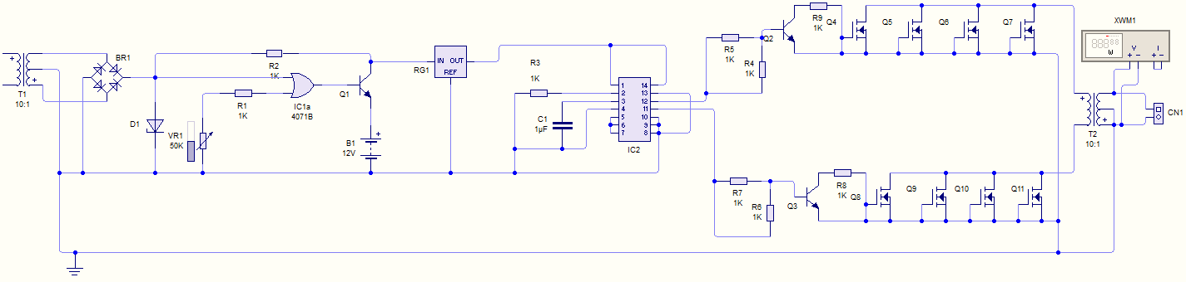
Figure 3.1 Circuit Diagram for 4KVA Uninterruptible Power Supply System.
3.7 Performance Analysis
Metric campaigns were conducted on the 2kVA inverter as presented in Table 1.0 at a predetermined load in kVA. The data set were keyed into the (SPSS – 23) for performance analysis. The assessment employed for gauging the performance of the inverter at any given time (t), was bedrock on the ability of the inverter to maintain a near constant output voltage at full load. Since in the case of a small machine; the output voltage regulation may be found by direct loading. This assertion was taken from the fact that if the output voltage of an inverter drops considerably on full load as compared to the no load output voltage; the performance of the inverter will be poor due to high voltage regulation ratio. In this regards, technical assessment was employed to put the metric of performance of the inverter on the following independent parameters of: the duration of time spent on full load support (t), the load output voltage (V_{OL}) and load output current (I_{OL}). With this assertion, the instant where the inverter voltage regulations ratio was less than zero (0) was rated very okay performance, 1 – 20 was rated fairly okay and above 20 was rated not okay.
TABLE 1.0: METRIC CAMPAIGN FOR THE 2 kVA LOCALLY DESIGNED INVERTER
S/N | TIME (mins) | BATTERY VOLTAGE (Volts) | OUTPUT VOLTAGE (Volts) | BATTERY CURRENT (Amps) | LOAD CURRENT (Amps)
1 | 20 | 14 | 260 | 12.60 | 3.15
2 | 40 | 13.97 | 257 | 12.63 | 3.15
3 | 60 | 13.95 | 253 | 12.65 | 3.16
4 | 80 | 13.94 | 250 | 12.66 | 3.16
5 | 100 | 13.40 | 243 | 13.16 | 3.29
6 | 120 | 13.00 | 245 | 13.57 | 3.39
7 | 140 | 12.95 | 242 | 13.62 | 3.40
8 | 160 | 12.40 | 240 | 14.23 | 3.55
9 | 180 | 11.54 | 220 | 15.29 | 3.82
10 | 200 | 11.35 |  | 15.54 | 3.88
11 | 220 | 11.00 | 190 | 16.04 | 4.01
12 | 240 | 10.56 | 185 | 16.71 | 4.17
The over drain level of the battery was set at 10.50 Volts and measurements were recorded for every 20 minutes interval with a 1.9KVA load.

CHAPTER FOUR
4.1 Principle of Operation of an Inverter System
An inverter power system is an electronics device which invert and charge the chemical energy stored in a battery bank. It is an electrical apparatus that provides emergency power to load when the input power source or main power fails.
An inverter differs from an emergency Power System or Standby generator in that it will provide near instantaneous protection from input power interruptions, by supplying energy stored in batteries the on – battery runtime of some uninterruptible power supply/sources is relatively short but sufficient to start a standby power source or properly shut down the protected equipment. The batteries are rated in certain period of time.
An inverter is typically used to protect hardware such as computers, data centers, telecommunication equipment or other electrical equipment where an unexpected power disruption could cause injuries, facilities, serious business disruption or data loss.
The most basic features of a ups is providing surge protection and battery backup. The protected equipment is normally connected directly to incoming utility power. When the incoming voltage falls below or rises above a predetermined level the ups turns on its internal DC – AC inverter circuitry, which is powered from an internal storage battery. The inverter then mechanically switches the connected equipment on to its DC- AC inverter output. The switch over time can be as long as 25 milli seconds depending on the amount of time it takes the standby inverter to detect the lost utility voltage.
5 RESULTS
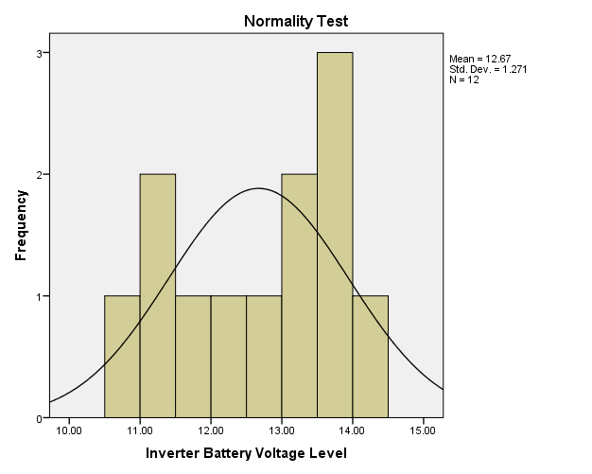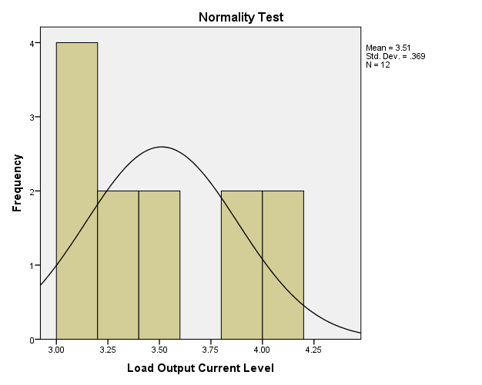
(b)
(a)
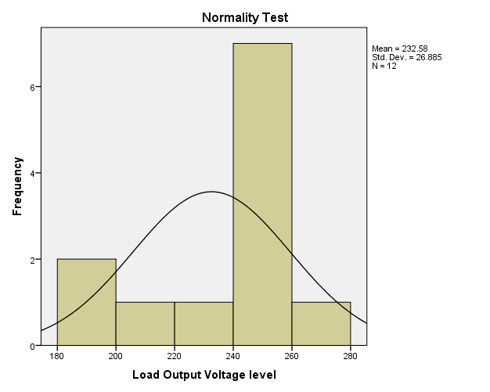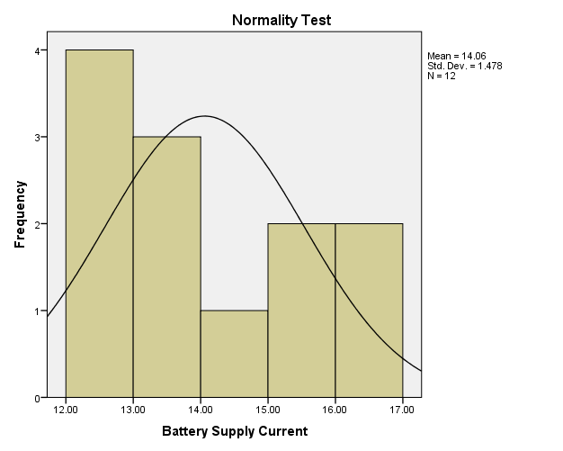
(d)
(c)

Figure 1.0: Normality Test for the Measured Values of 2 kVA Locally Designed and Constructed Inverter (a) Inverter Battery Voltage Level (b) Load Output Current Level (c) Load Output Voltage Level and (d) Battery Supply Current.
(a)
(b)

(c)

(d)
Figure 2.0: Metric Parameters Observation over Time (a) Load Voltage Variation (b) Battery Voltage Variation (c) Battery Current Variation and (d) Load Current Variation.
Table 2.0: Model Summary
Model | R | R Square | Adjusted R Square | Std. Error of the Estimate
1 | .965ª | .930 | .904 | .22852
- Predictors (Constant), Load Output Current Level, Measurement Time, Load Output Voltage Level

Model Variables |  | Unstandardized Coefficients |  | Standardized Coefficients | t | Sig.
 |  | B | Std. Error | Beta | t | Sig.
1 | (Constant) | 18.472 | 5.851 |  | 3.157 | .013
1 | Measurement Time | .012 | .003 | 1.184 | 3.582 | .007
1 | Load Output Voltage level | -.034 | .011 | -1.216 | -2.974 | .018
1 | Load Output Current Level | -2.906 | 1.062 | -1.453 | -2.737 | .026
- Dependent Variable: Perfomance Level
Table 3.0: Modeling Coefficients
4.2 DISCUSSIONS AND EQUATION MODELLING
Generally, measurements are known to be liable to outliers, sometimes called error. Errors arise due to imperfection on the part of human and machines that are used to obtain the numeric data. In this research work, a normality test was run on SPSS-23 software simulator to check for the normality test of the measured data in Table 1.0 as presented in Figure 1.0. The Figures show that the metric data are normal and they are completely devoid of outliers, hence they possess some level of credence when used in the investigation of the 2 kVA performance and equation modeling analysis. Figure 2.0 shows the depiction of the metric parameters variation with time. In Figure 2.0 (a), the graph depiction shows that the inverter provides support when maximally loaded for about four (4) hours, however, the inverter output voltage only drops by 20 volts in nearly two (2) hours. This indicates a very good performance by the inverter, although, afterward the output drops drastically with a compensation for the load sustainability through the corresponding increase in the battery current level as shown in Figure 2.0(c). Table 2.0 on the other hand comprises the model summary and it shows the Adjusted R square value, which indicate that the metric parameters that were keyed in to the SPSS-23 software were 90.4% capable of determining the success of the inverter performance and it was therefore adjudged okay. Table 3.0 shows the modeling coefficients for the metric parameter that was keyed in to SPSS software. At this stage, it is worth mentioning that, all the components used as well as the metric parameters obtained are all ohmic in nature (i.e they obey ohm’s law, having a voltage – current linear relationship), with this credence, a linear regression equation was adopted for the equation modeling formulation. Fundamentally, the equation modeling therefore takes a form of general regression equation of the form: 1
where P(invt) is the inverter performance, K is the constant value in the modeling coefficient table, K₁ is the constant of measurement time at time t, K₂ is the constant of the load output voltage and K₃ is the constant of load output current. In this regard, the performance equation for the 2KVA inverter is equal to
2
With the equation modeling derived, the performance of a 2 kVA locally designed and constructed inverter can be determined at any time t of operation of the inverter with the load output voltage measured (V_{OL}) at time t and the load output current (I_{OL}) at time t

CHAPTER FIVE
5.1 CONCLUSION
The performance and equation modeling for assessing and gauging of the performance index of the 2 kVA locally designed and constructed inverter has been investigated and formulated. Although, the simulation results of Table 2.0 shows that the modeled performance equation is 90.4% capable of determining the performance of the locally made 2kVA inverter. This shows the independent performance analysis that forbear the usual known comparison method of foreign and locally made inverter is a welcoming idea. The recent unreliability of most foreign gadgets called for concern when they are used to bedrock the performance evaluation of a locally made inverter.
REFRENCES
Andrew, A. L., “Applied physics for Electronic Technology”, Arnold Holder Headline publishers, London. pp 45. 1998.
Bogart, ft., Jr., “Electronics devices and circuit Merrill publishing” Co. First Edition, pp.237 – 307, 1990.
Bogart, Jr., “Electronics devices and circuit Merrill publishing” Co. First Edition, pp 237 – 307, 1990.
Gupta J. B., “Electrical Machines”, 14TH edition, Tata McGraw- Hill Publishing company Ltd, New Delhi, India. pp. 7. 2012.
http//www.son.gov.ng/google. (Accessed on 27th July, 2017) by 10:23Am
https://en.wikipedia.org/wiki/inverter_datasheet_catalog.com (electrical), Accessed on 23/03/2019, By 09:00hrs.
HUGES, E., “Electrical Technology”, Planet publishers, Moscow Russia. pp. 56,1993.
Jimoh A. A., Lawal A. O., Kabiru, L., “Performance Equation Modeling for A 2 kVA Locally Designed and Constructed Inverter Systems”, International Conference of Science, Engineering & Environmental Technology (ICONSEET), ISSN 0794-9650 2(4): pp. 23-28, 2017.
Larry P. W., Lewis F., “Solar Cells and their Applications Second Edition”, ISBN 978-0-470-44633-1, Section10.2. 2010.
Owen, E. L., “Origin of the Inverter” IEEE Industry Applications Magazine, History Department, pp. 16. February, 1996
Syed, N., (2016), “Electrical Power System’’, Schw Outline Series, Fifth EEdition pp 166 – 168, 2016.
Syed, N., “Electrical Power System’’, Schw Outline Series, Fifth Edition pp 166 – 168. 2016.
Theraja A. K., Theraja B. L., “A Textbook of Electrical Technology”, First Multicolour Edition. S Chand and Company Limited, Ram Nagar, New Delhi. 2005.
Theraja, A. K., (2010), “Development of Electrical Power System”, Twenty Two Edition, S Chand and Company Limited, Ram Nagar New delhi-110053, pp. 212 – 214. 2010.

