DESIGN AND CONSTRUCTION OF 360° ROTATION SOLAR TRACKER WITH WEATHER MONITORING SYSTEM

BY

SEGILOGBON OLADELE
HND/23/EEE/FT/0054

A PROJECT SUBMITTED TO THE DEPARTMENT OF ELECTRICAL ELECTRONICS ENGINEERING, INSTITUTE OF TECHNOLOGY (IOT), KWARA STATE POLYTECHNIC, ILORIN.

IN PARTIAL FULFILMENT OF THE REQUIREMENT FOR THE AWARD OF HIGHER NATIONAL DIPLOMA (HND) IN ELECTRICAL ELECTRONICS ENGINEERING.

JULY, 2025.
CERTIFICATION
This is to certify that this project was carried out by SEGILOGBON OLADELE of matriculation number HND/23/EEE/FT/0054 in the Department of Electrical/Electronic Engineering, Kwara State Polytechnic in partial fulfillment of the requirements for the award of Higher National Diploma (HND) Certificate in Electrical/Electronic Engineering.

________________________ ________________
ENGR. DR. OBA M.Z DATE
Project Supervisor

________________________ ________________
ENGR. LAWAL O.A DATE
Head of Department

________________________ ________________
ENGR. Z.A ABDUKADIR DATE
Project Coordinator

________________________ ________________
EXTERNAL EXAMINER DATE

DEDICATION
I dedicate this project to the loving memory of my late parents, whose sacrifices, prayers, and values continue to inspire me every day. I also dedicate it to God Almighty for His grace, strength, and guidance throughout this journey.

ACKNOWLEDGEMENT
I give all thanks to Almighty God for His grace, strength, and guidance throughout the course of this project. My sincere appreciation goes to my supervisor, Engr. Dr. M.Z. Oba, for his consistent support, valuable guidance, and constructive feedback, which played a major role in the success of this work. I am deeply grateful to Segilogbon Abayomi for his continuous support and encouragement from my OND days up to the completion of my HND program. My heartfelt appreciation also goes to my elder siblings Segilogbon Afolashade, Segilogbon Oluwagbemiga, Segilogbon Gbemisola, Segilogbon Abimbola, Bakare Shakirat, and Micheal Bukola for their moral support and care throughout this academic journey.
I also wish to acknowledge the contributions of those who supported me in various ways during this project: Rev. Dr. Olabode Paul Durojaye, Mrs. Osileye Temitope, Mrs. Segilogbon Shakirat Omolara, Caulcrick Akintunde, Mrs. Ogbodo, Brother Sodiq, Mrs. Owoiya Omolara and John Olatide Michael. Your encouragement and assistance are sincerely appreciated.

TABLE OF CONTENTS
Title Page i
Certification ii
Dedication iii

Acknowledgement iv
Table of Contents v
List of Tables vii
List of Figure viii
Abstract xi
CHAPTER ONE
1.0. Introduction 1
1.1 Problem Statement 1
1.2. Aim 2
1.3 Objectives 2
1.4. Significance 3
1.5. Scope and Limitation 3
CHAPTER TWO
2.0 Literature Review 4
2.1 Introduction 5
2.2 Classification of Solar Tracker Based on Axis Rotation 5
2.3. 360º Solar Tracking system 16
CHAPTER THREE
3.0 Methodology 18
3.1 Introduction 18
3.2 List of Electronic Components 19
3.3 Resistor 19
3.4 Light Dependent Resistors (LDRs) 20
3.4 Capacitor 21
3.5 Inductor 22
3.6 Diode 23

3.7 Voltage Regulator Circuit 24
3.8 Crystal Oscillator 25

3.9 Servo Motor 26
3.10 Temperature Sensor 28
3.11 IC Socket 29

3.12 LCD Display 29
3.13 Printed Circuit Board (PCB) 30

3.14 Solar Panel 30

3.15 Battery 31
3.16 Background of Solar Tracking Systems 32
CHAPTER FOUR
4.0 Construction and Performance Test 37
4.1 Introduction 37
4.2 Construction Procedure 37
4.3 Performance Test 40
CHAPTER FIVE
5.0 Conclusion and Recommendation 48
5.1 Conclusion 48
5.2 Recommendations 48

References
Appendix

LIST OF TABLES
Table 2.1. Comparison between the Solar Tracking System based on Axis rotation. 16
Table 3.1: Servomotor Wire Configuration 27
Table 3.2: DHT11 Pin Configurations 28
Table 4.1: The Solar Panel Specifications 41
Table 4.2 The estimated hourly Readings of Panel Voltage, Power, and Angle of Rotation for Day 1 41
Table 4.3: The Estimated Hourly Readings of Panel Voltage, Power, and Angle of Rotation for Day 2 43
Table 4.4: The Estimated Hourly Readings of panel Voltage, Power, and Angle of Rotation for Day 3 45

LIST OF FIGURES
Figure 2.1 Various Single-axis Solar Tracking Systems. (a) HSAT; (b) VSAT; (c) PASAT; (d) TSAT.
Figure 2.2 Various Dual-axis Solar Tracking Systems. (a) TTDAT; (b) AADAT.
Figure 2.3 Hybrid Solar Tracking System.
Figure 2.4 360º Solar Tracking System
Figure 3.1 Resistor
Figure 3.2 Light Dependent Resistors (LDRs)
Figure 3.3 Capacitor
Figure 3.4 Inductor
Figure 3.5 Diode
Figure 3.6 Voltage Regulator Circuit
Figure 3.7 Crystal Oscillator
Figure: 3.8 Servo Motor
Figure 3.9 Servo Motor Interface to Microcontroller
Figure 3.10 IC Socket
Figure 3.11 LCD Display
Figure 3.12 Printed Circuit Board (PCB)
Figure 3.13 Solar Pannel

Figure 3.14 Battery
Figure 3.15 Comparison between Fixed and Simple Solar Tracking Systems.
Figure 3.16 Solar Angles.
Figure 3.17 Circuit diagram of 360º rotation solar tracker with weather monitoring system.
Figure 4.1 System Booting.
Figure 4.2 Constructed Solar Tracking System
Figure 4.3 Complete 360⁰ solar tracker system.
Figure 4.4 Angle of Rotation against Time.
Figure 4.5 Panel Voltage against Time.
Figure 4.6 Angle of Rotation against Time
Figure 4.7 Panel Voltage against Time
Figure 4.8 Angle of Rotation against Time.
Figure 4.9 Panel Voltage against Time

ABSTRACT
This project presents the development of a 360° solar tracking system combined with a weather monitoring unit. The main objective is to improve the efficiency of solar energy generation by allowing the panel to rotate fully and follow the sun’s movement from sunrise to sunset. Unlike fixed panels, this system ensures that the solar panel stays at the best angle to receive maximum sunlight throughout the day. In addition, the system includes sensors to measure environmental conditions such as temperature, humidity, and solar intensity in real time.

CHAPTER ONE
1. INTRODUCTION
The growing demand for a consistent and plentiful energy supply has led governments to enhance the utilization of renewable energy, reducing dependence on conventional sources. Solar energy, particularly harnessed through photovoltaic cells, stands out as a valued renewable source.[1] These cells utilize the photovoltaic effect to convert solar energy into electricity, applicable in various fields such as solar thermal energy, solar heating, photovoltaic applications, and solar architecture. The efficiency of photovoltaic cells is directly linked to light intensity, and Solar power is the fastest growing means of renewable energy. The project is to designed and construction 360º solar tracker system.[2] In order to maximize energy generation from sun, it is necessary to introduce solar tracking systems into solar power systems. A 360º tracker can increase energy by tracking sun rays from switching solar panel in various directions. This solar panel can rotate in all directions.[3] This 360º solar tracker project can also be used to sense weather, and it will be displayed on LCD. As sun is a major source of this renewable energy. A 360º solar tracker which can track the radiations from the sun in all the directions with maximum intensity is found.[4]
In order to maximize energy absorption, the solar panel is kept perpendicular to the sun, achieved through the use of a solar tracker. This integration improves efficiency by 40% compared to fixed panels. Traditional 360º rotational trackers move horizontal during the day. Light Detecting Resistors (LDRs) sense the maximum light intensity, and an Arduino system guides the rotation of servomotors to optimize the solar panel's alignment with the highest light intensity.[5] Servomotors are responsible for rotating the solar panel based on this information. By incorporating weather sensors, the system adapts to varying weather conditions. Over the past million years, human energy needs have increased steadily. Solar energy emerges as a promising and reliable source, free from polluting effects. Maximizing energy efficiency through this method becomes. [6]
1.1 Problem Statement
Due to the dynamic nature of the earth caused by rotation and revolution of the earth around its axis, the solar energy at a particular point varies as the earth rotates and revolves. For an efficient harnessing of the solar energy, the solar panel must be perpendicular to the rays of the sun which yields more power. Most of the solar panels lacks the capability to focus on the sun at all times making it inefficient. The changes in atmospheric conditions such as solar radiation level and temperature throughout the day have a great impact on the panel efficiency. Therefore, it has a great importance to know the solar radiation level and temperature effect on PV panel. This project design and construction of 360⁰ solar tracking system with temperature, and sun radiation intensity measurement capability tracks the direction of the sun and turns the solar panel to the direction of the sun for efficient utilization of the solar energy. In addition to this, it provides the temperature and sun radiation status to help in making certain decisions and planning purposes.
1.2. Aim
The aim of this project is to design and construct 360º rotation solar tracker with weather monitoring system.

1.3 Objectives
The following are the objectives of the project:
- To design a mechanism that enables the solar panel to rotate 360º horizontally to follow the sun’s movement across the sky and maximizing sunlight exposure.
- To construct a physical frame and rotational base capable of supporting the solar panel
- To construct and install a monitoring system with sensor for sunlight, temperature, humidity, and potentially wind speed.
- To provide stable electric power supply using solar energy
1.4. Significance
The main significance of this project is that it implements a solar tracking system that ensures the sun rays fall perpendicularly on the solar panel and thus harness the maximum amount of solar energy possible in that location. In doing so, increases the efficiency of solar cells. The system also provides the environmental temperature conditions and the locations solar radiation which will assist in making power management decisions. In addition to this, the system provides a reference materials for future research purposes.
1.5. Scope and Limitation
The project design is limited to the design of the 360⁰ rotation solar tracker system that will track the location of the sun and turns the panel to face the location and at the same time displays the weather condition of the given location. The system will not be able to control the load connected the panel or to charge the battery.
CHAPTER TWO
LITERATURE REVIEW
2.1 Introduction
Renewable energy sources are energies that come from the Sun directly, such as thermal, photochemical, and photoelectric energy, or indirectly, such as wind, hydropower, and photosynthetic energy stored in biomass, as well as other climate regulation and natural motions, such as geothermal and tidal energy; these are then converted into usable forms of energy, such as electricity, heat, and fuels [7]. The most abundant renewable energy that is directly obtained from the Sun is solar energy, which also serves as a regulator of the hydrological cycle and a source of wind energy because the Sun’s heating effect on the atmosphere causes air to move [8,9].
Solar power, also known as solar energy, can be generated by a solar panel, which largely depends on the amount of sunlight it is exposed to. Solar photovoltaic energy has a much higher installed capacity than other renewable energy concepts and technologies due to its abundance, versatility, and ease of implementation with minimal negative environmental impact in terms of land use [10,11]. Maximum solar power can be obtained only when the Sun is directly on the panel. Due to the variation of the position of the Sun throughout the day, there is a need to adjust the solar panel so that it is always aimed precisely at the Sun. A solar tracker is a device employed to operate a solar photovoltaic panel, particularly in solar cell applications, and requires a high level of precision to ensure that sunlight is directed accurately onto the power device [12]. Solar tracking systems also play an important role in the advancement of solar concentration applications such as solar-pumped lasers and parabolic concentrators [13,14]. These trackers can improve the efficiency of the overall solar photovoltaic system, reducing the size and the cost per kilowatt hour (kWh). To increase the efficiency of photovoltaic (PV) systems, several solar tracking systems have been developed over the years, and a few have been reviewed, for instance, [15,16]. However, these reviews did not consider hybrid solar trackers or learning-based solar tracking systems as most of these reviews are limited to classification based on two-axis, single-, and dual-axis solar tracking systems and classification based on the nature of motion, that is, active and passive solar tracking systems. This paper thus aims to provide a holistic review of the different existing developed time-based solar tracking systems based on various classifications to show the trend and proffer further research directions.
2.2 Classification of Solar Tracker Based on Axis Rotation
According to the movement of the axis of rotation, two types of solar trackers have been designed and implemented in the literature. These include single-axis trackers and dual-axis trackers. In addition, some authors have designed and developed tracking systems with three or more axes categorized under hybrid-axis solar trackers. This section presents and reviews these time-based solar tracking systems based on the axis rotation.
2.2.1. Single-Axis Solar Tracking System
This solar tracking system comprises only one axis, either vertically or horizontally, and cannot rotate for both. Examples of this type of solar tracking system in the literature include Horizontal Single-Axis Trackers (HSAT), Vertical Single-Axis Trackers (VSAT), Tilted Single-Axis Trackers (TSAT), and Polar-Aligned Single-Axis Trackers (PASAT) [15]. Figure 3 depicts the various existing single-axis solar trackers.
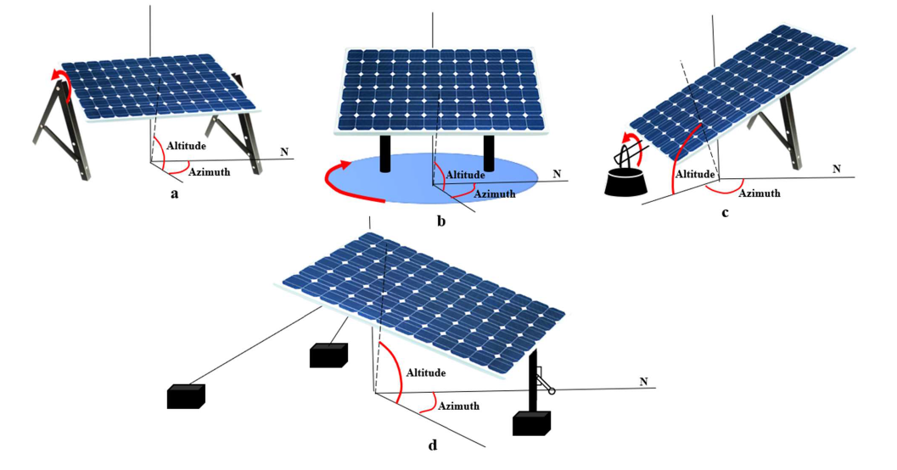

Figure 2.1. Various Single-axis Solar Tracking Systems. (a) HSAT; (b) VSAT; (c) PASAT; (d) TSAT.
HSAT rotates from north to south on a fixed axis parallel to the ground, as shown in Figure 3a, throughout the day and is considered the most economical tracker setup in many PV applications [17,18]. VSAT, on the other hand, rotates vertically with respect to the ground, as shown in Figure 3b, and can be mounted in either a north/south or east/west orientation to track the Sun’s movement up-and-down in the sky; such systems are more common in high-altitude/mountainous areas or more severe latitudes [19,20]. PASAT, as shown in Figure 3c, was derived by aligning the tilted single-axis solar tracker to the polar star [17]. Finally, the TSAT, shown in Figure 3d, has axes of rotation that alternate between horizontal and vertical, where the module sweeps a cylinder that is rotationally symmetrical around the rotation axis to track the Sun [12,17]. The solar azimuth angles of a single-axis solar tracking system range from −100° to 99.87° [19]. The following is a review of several developed single-axis time-based solar tracking systems.
A low-power single-axis solar tracking system was designed and developed to track the Sun’s position regardless of the motor speed and generate maximized solar power. The system implementation was divided into hardware and software parts, and the tracking system comprised two LDR sensors, a PIC16F877A microcontroller, a bi-directional DC-geared motor, a voltage regulator, a driver circuit, and a solar panel. To evaluate the performance of the developed system, a comparison with a fixed solar panel system was conducted in which the voltage and current for each system were measured between 8 a.m. to 6 p.m. The results showed that the developed system performed better than the fixed system by generating higher power. However, the system was not tested for different weather conditions[20]. A single-axis solar tracking system was developed based on LDR as a sensor. The methodology adopted for this research was divided into two parts, hardware development and programming development. The hardware development part was concerned with the components used to develop the solar tracker, which includes a solar panel, bidirectional DC geared motor, drive circuit, PIC16F667A microcontroller, two LDR sensors, and voltage regulator, while the programming development part was concerned with the development of the program that would be fed into the PIC16F667A microcontroller. To evaluate the performance of the developed solar tracker, a comparison with a fixed solar panel was conducted, and the results showed that the developed system received more sunlight and generated higher solar power than the fixed system. However, the research only considered sunny weather conditions and did not consider other weather conditions[21]. A high-efficiency single-axis solar tracking system was designed and developed in where the system was based on a microcontroller focused primarily on small applications in remote areas. The tracking system consists of a power supply circuit, servo motor, light-dependent resistor (LDR), solar panel, liquid crystal display (LCD), real-time clock, and two different types of voltage regulators. The system was demonstrated to be a cost-effective solution and increased the solar output from the panel by 30–40% compared to the fixed solar panels [22].
A single-axis solar tracker to track the Sun on the azimuth axis by using an AVR microcontroller was designed and implemented. The implemented system consisted mainly of the ATmega328 controller, DC motor, light sensors, relay, and solar panel. The results showed that the designed low-cost solar tracker increased the output power gain by 18–25% compared to the fixed panel located at Kirkuk city, Iraq. The output power was increased and improved by adding an ear side panel and reflector by about 65% and 70–80%, respectively. However, the overall system is limited to just one axis, reducing reliability [23]. A solar tracking system was utilized which operates based on light-dependent resistor (LDR) sensors, a microcontroller for controlling the system, and DC motors. The study aims to establish a cost-effective solar tracker system by identifying and removing the parts that consume unnecessary energy, reducing energy loss. To achieve this, a timer circuit was used to shut down the system for 29 min after one minute of work during which the amount of solar panel power gain and loss was measured due to the timer[24]. A single-axis time-based solar tracking mechanism was proposed by [25] that can automatically track the movement of the Sun and then display the tilt angle values and the corresponding solar irradiance values in real time. The tracking unit comprises a solar panel, a real-time clock, a stepper motor, and a stepper motor driver. The study utilized the zenithal angle as a reference angle, which the microcontroller follows and then moves the stepper motor to track the position of the Sun. The system is a cost-effective, accurate, and efficient method to track the position of the Sun compared to a stationary solar panel.
2.2.2. Dual-Axis Solar Tracking System
This solar system has two degrees of flexibility that act as the axis of rotation; that is, it allows for maximized solar power output levels due to its ability to track the Sun both vertically and horizontally. Two common implementations are Tip-Tilt Dual-Axis Trackers (TTDAT) and Azimuth-Altitude Dual-Axis Trackers (AADAT). Figure 4 depicts the operation of a dual-axis solar tracking system.
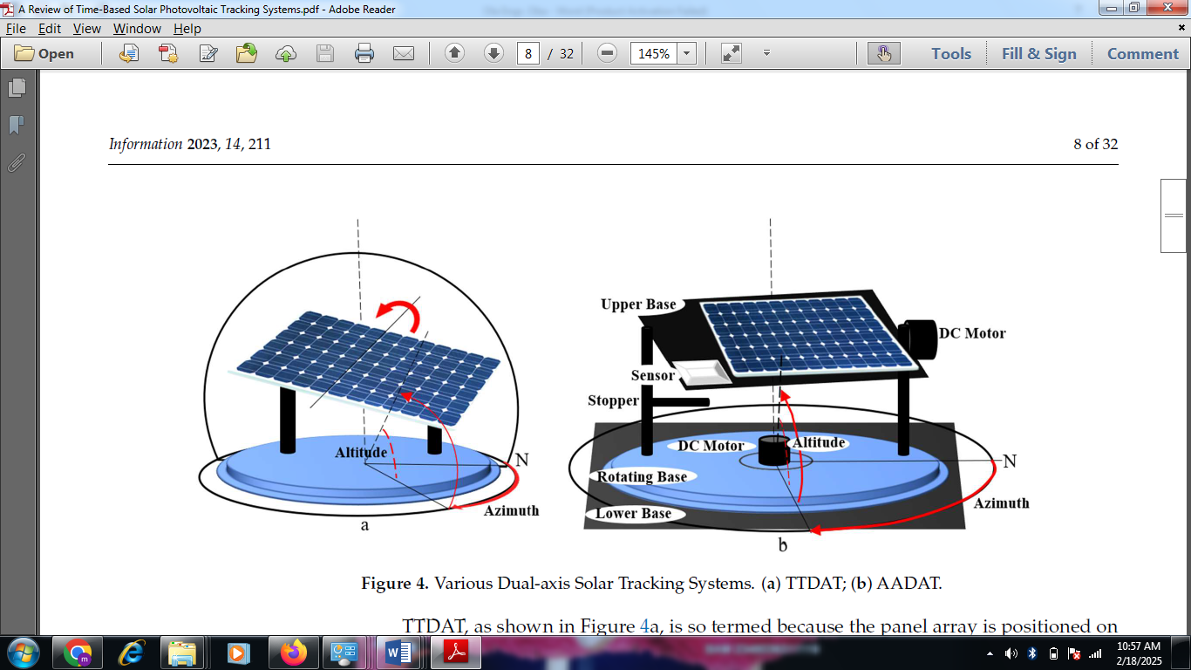

Figure 2.2. Various Dual-axis Solar Tracking Systems. (a) TTDAT; (b) AADAT.
TTDAT, as shown in Figure 4a, is so termed because the panel array is positioned on the top of vertical poles. Typically, the east–west movement is caused by rotating the array around the top of the pole. The posts at each end of the primary axis of rotation of a tip-tilt dual-axis tracker can be reused between trackers to reduce installation expenses [26]. The primary axis of AADAT, also known as the azimuth axis, is parallel to the ground while the secondary axis, also known as the elevation axis, is normal to the primary axis [26]. A servo motor for the azimuth axis (horizontal) and a linear actuator for the elevation axis (vertical) are used in an AADAT to track the Sun [27]. AADAT systems can use a huge ring mounted on the ground with the array positioned on a series of rollers rather than rotating the array around the top of the pole as shown in Figure 4b. This enables AADAT to support much larger arrays; however, the system cannot be positioned closer together than the diameter of the ring, which may diminish system density, especially when inter-tracker shadowing is included [26]. The solar azimuth and altitude angles of a dual-axis solar tracking system can range from 61.1° to 299.1° and −10.1° to 10.7°, respectively [28]. To ensure robust system performance, in [29] proposed a novel dual-axis solar tracking PV system design that leverages feedback control theory, a four-quadrant light-dependent resistor (LDR) sensor, and simple electronic circuits. The proposed system utilized a distinctive dual-axis AC motor and a stand-alone PV inverter to achieve solar tracking. The execution of the control was a technical innovation with a simple and effective design that did not require programming or a computer interface. In addition, a scaled-down laboratory prototype was built to test the scheme’s effectiveness, and experiment results indicated that the developed system increased the energy gain up to 28.31% for a partly cloudy day. The developed system achieved attractive features, but it is limited to a laboratory prototype with no real-life implementation.
A smart dual-axis solar system was proposed, where an embedded controller was utilized as the major system controller that detects the voltage difference and estimates the solar azimuth angle with four groups of cadmium-sulfide (CDS) as sensor elements. The control system comprises solar panels, motors, sensors, an A/D controller, an embedded controller, a drive circuit, and GSM modules. The system utilized two motors as an actuator to regulate the elevation and azimuth while the CDS tracked the position of the Sun through the movement of the embedded controller motor. The GSM module was used to notify the maintenance personnel in the event of a failure. A comparison between the proposed system and a fixed solar panel system was carried out under different weather conditions, and the results showed that the generated power increased by 30% when the proposed system was utilized [30]. The design and implementation of a dual-axis solar tracking system were presented by [31] based on a closed-loop technique. The system was divided into two parts, mechanical and electrical. The mechanical part, which was said to be the most challenging part of the development, dealt primarily with the azimuthal and vertical movements of the solar tracker and consisted of servo motors and panel carriers. The electrical part, which is concerned with sensing the sunlight and the movement of the panel in that direction, consists of four light sensors and an ATmega328P microcontroller. To evaluate the performance of the developed system, a comparison with other systems, which included the fixed solar panel system and the single-axis solar tracking system, was conducted, and the results showed that the developed dual-axis solar tracking system always outperformed the other systems. One major limitation of this research is that the developed system is limited to small-scale use.
A double-axis solar tracking system was designed and implemented by [32], where the overall system design is divided into two parts, electrical and mechanical. The electrical part is further subdivided into control system design and programming. In contrast, the mechanical part comprises two DC motors that provide horizontal-to-vertical and left-to-right motions, as well as gears that transfer their movements to the solar panel. Other components include a light-dependent resistor (LDR), microcontroller, battery, mount limit switches, profile iron stand, and roller. To evaluate the performance of the system, a comparison was made between the proposed system and a stationary solar panel system; the results showed that the generated energy increased by 25% when the proposed system was utilized and based on the cost analysis carried out in the study, the proposed system is very cost-effective. An automatic dual-axis solar tracking system was designed and developed using a light-dependent resistor (LDR) to determine the intensity of falling sunlight and DC motors on a mechanical structure with gear arrangement to track the Sun accurately. The results showed that the energy gained from the solar panel with the dual tracker exceeds 35% of the energy gained from the fixed solar panel. In analyzing the data, the energy gained from the solar tracker is mostly in the morning and the evening because there is little difference at noon, proving that the fixed solar panel is efficient at noon. One major limitation of the system is the cost, as the system utilizes four LDR sensors [9].
A dual-axis solar tracking system was designed and developed in [33] for a standalone PV system using worm gear. The system comprised solar cell plates, a PIC microcontroller, an LCD, a real-time clock, LDR sensors, DC motors, and servo motors. The performance of the system was evaluated against a fixed-axis solar panel, and the input and output power were measured and utilized to calculate the efficiency for different days. The results obtained showed that the proposed system performed better, with a power gain of 84% in the morning, and in the evening, the power gain was 100%. However, the developed system was limited to small-scale use.
2.2.3. Hybrid Solar Tracking System
The hybrid solar tracker, also known as the three-axis or triple-axis solar tracker, moves along three axes, allowing it to capture solar energy for the longest time of the day and with the most accurate alignment with the position of the Sun in different seasons and weather conditions [34]. Figure 5 depicts a hybrid solar tracker system developed in [35], which comprised a solar panel mounted between two vertical poles and a rotating horizontal surface adapted to mount the two vertical poles. A scissor lift approach was employed to smoothly move the axis up and down to obtain the third axis and minimize shading. The location of the Sun was tracked using four LDRs placed on top of the solar panel, and signals from these sensors are sent to the servo motor through the microcontroller, which thus moves the solar panel toward the direction of the Sun. Another LDR is connected at the bottom of the solar module and was used to automatically control the functioning of the third axis, sending signals to a relay and activating the DC motor to move the scissor lift upward when shading is detected. The system was compared with both fixed and dual-axis solar tracking systems in terms of power output and energy efficiency, and it was shown the hybrid system produced the highest power output, particularly in shading areas; however, it consumed more energy than the dual-axis solar tracking system. The relative error of the solar azimuth and altitude angles ranges from 0.844° to 0.251° and −0.498° to 0.576°.
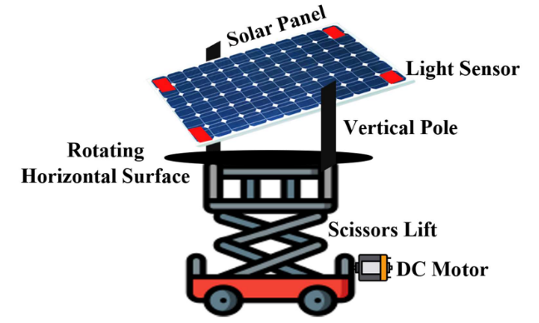

Figure 2.3. Hybrid Solar Tracking System.
A hybrid solar tracking system was proposed by [36]. combining a mechanical and an electrical tracking system. The mechanical tracking system was based on a photodiode array (PDA) that was implemented using a sphere whose inner surface was optimized, allowing the PDA to function as a high-precision sensor. On the other hand, the electrical tracking system consisted of a maximum power point tracking (MPPT) feedback control system. The system was simulated, and it concluded that although the single solar tracking system is more efficient than the fixed solar panel, it cannot track the variation of the azimuth angle, which was hard-coded into the microcontroller of the proposed system. Additionally, the proposed system can track the Sun at any time, thus increasing the output power. The research did not implement the proposed system, hence the limitation.
A multidimensional automatic solar tracking system was developed based on a hybrid hardware and software prototype that automatically provides the best alignment of a solar panel with the Sun to obtain the maximum power output. The tracking system comprised a sensor, a light-dependent resistor, a relay, a light-emitting diode, a stepper motor, a capacitor, gears, and a microcontroller. To evaluate the performance of the proposed system, measurements of the PV system were taken with and without a tracking system in the local climates of Bangladesh, and the results obtained showed that the overall efficiency of the solar power system increased by 31% with the tracker system [37]. An electromechanical system programmed using C++ was developed by [38] that controls the solar panel movement based on a hybrid-axis tracking system (one-axis and two-axis) so that it is always positioned towards the direction of the Sun. The major component of the tracking system includes solar panels, a deep cycle rechargeable battery, a microcontroller, signal conditioning circuits, and a motor drive, which are then connected to four-quadrant light-dependent resistor (LDR) sensors and a solar rotation mechanism. The system provides a reliable and cost-effective means of aligning a solar panel with the Sun to optimize energy output and efficiency by 31% when compared to a stationary solar panel. The tracking system suitable for a smart photovoltaic blind (SPB) and indirect tracking method was adopted as a preliminary study of a two-axis hybrid (direct and indirect) solar tracking method. According to the research, an SPB is a device that can be utilized for both electricity generation and Sun-shading functions and can be installed in the windows of buildings. The indirect tracking method was conducted via two steps: calculating the hourly altitude and azimuth of the Sun and calculating the hourly slope of the panel (SoP) and the azimuth of the panel (AoP) that are perpendicular to the altitude and azimuth of the Sun. The results obtained showed the SoP tracked the Sun from 0° to 90°, while the AoP tracked the Sun from −9° to 9°. The limitation of this research is that no solar tracking system was developed.

Table 2.1. Comparison between the Solar Tracking System based on Axis rotation.
Properties | Single-Axis | Dual-Axis | Hybrid-Axis
Cost | Cheap to implement | More expensive to implement than a single but less expensive than a hybrid | Most expensive to implement
Complexity | Less complex | High complexity | Very complex to implement
Tracking accuracy | It offers the least accuracy compared to the other types of trackers | It offers high accuracy compared to the single-axis | It offers the best accuracy as the Sun will be tracked at any  angle and position
Number of Axis | It is limited to only one axis | It is limited to having only two axes | It can have three or more axes
Efficiency | Very reduced since it only tracks the Sun’s movement in the East–West direction, and during cloudy days, its efficiency is almost close to the fixed-angle solar tracking system | Has high efficiency as in addition to tracking the Sun’s movement from East–West, it also follows the angular height position of the Sun | Has the highest efficiency, especially during the cloudy days

2.3. 360º Solar Tracking system
This is a system that adjusts the orientation of a solar panel to follow sun’s movement throughout the day, ensuring movement exposure to sun light unlike traditional solar tracker that track the sun only on one axis (horizontal or vertical) or two axis (azimuth and elevation), a 360º solar tracker is capable of rotating completely around to capture sunlight from any direction, it is essential in regions were the sun’s path varies significantly. The key components of the 360º solar tracker system are: solar panels, rotational mechanism (Dual axis or 360º tracking) sensors, control system, motor and Actuators and power source.
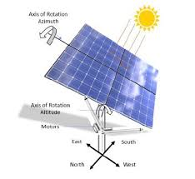

Figure 2.4: 360º Solar Tracking System
Challenges of 360º Solar Tracking system
The following are challenges of 360º solar tracking system:
- 360º solar tracking system involve two separate axes of movement (typically north-south and east-west), requiring more complex control systems and more mechanical components.
- Active tracking systems, including 360º trackers, consume power to operate the motors and control mechanisms.
- Cloud cover and other weather conditions can affect the performance of any tracking system, including 360º trackers.
- Implementing 360º tracking systems can be challenging, particularly in areas with limited resources or where specialized technical expertise is not readily available.
- 360º trackers require ongoing maintenance, including regular inspections, repairs, and potential component replacements.

CHAPTER THREE
3.0 METHODOLOGY
3.1 Introduction
This chapter deals with the design of a 360º solar tracking system with temperature and solar radiation measurement capability. A solar tracking system is a device that tracks the position of the sun during the day and throughout the year for a maximum and efficient absorption of the solar energy. A solar panel is a device that converts solar energy to electrical energy. The solar tracker rotates the solar panel so that is will be facing the sun at right angle at all time of the day and the year. The system also determines the solar intensity or radiation of the given area and also the weather monitoring system is designed to measure and monitor key environmental conditions in the surrounding area. Parameters such as temperature and solar radiation are captured and displayed on a Liquid Crystal Display (LCD), which serves as the user interface. It deals with the design of the hardware and the software of the system and as well the actual construction of the various parts of the system.

The following are the list of the electronics components for their specification used in the project.
3.2 List of Electronic Components
S/No. | Components of Solar Tracker | Specification
1. | Resistors | 10k
2. | Capacitors | 1000uf, 25v
3. | Diodes | C1815
4. | Crystal oscillator | 16,000
5. | Voltage regulator | LM7805
6. | IC socket | ATmega 328P
7. | Inductor
8. | LCD | 1602A
9. | LDR
10. | servo motor | Tower pro SG-90
11. | PCB
12. | Battery | 12v, 18AH
13. | Pannel | 30w, 17.5v
14. | Temperature sensor | DHT11

3.3 Resistor
Resistor is a passive two-terminal electrical component that implements electrical resistance as a circuit element. In electronic circuits, resistors are used to reduce current flow, adjust signal levels, to divide voltages, bias active elements, and terminate transmission lines, among other uses was shown in the figure below:
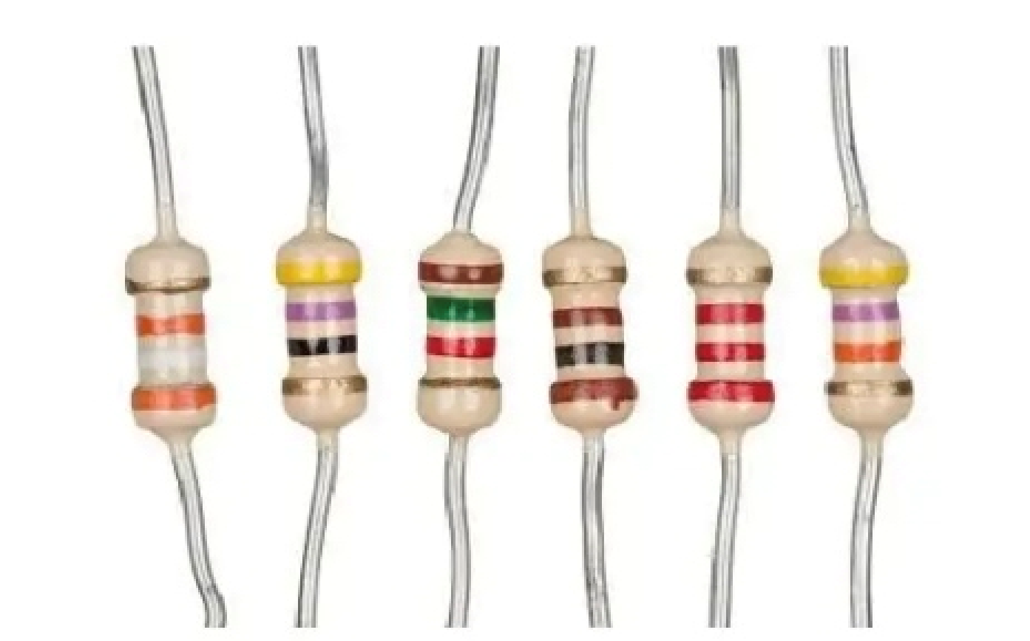
Figure 3.1: Resistor
V= IR (1)
Where:
R = Resistance (Ohms)
V = Voltage (Volts, V)
I = Current (Amperes, A)
R = $\frac{V}{I}$
I = $\frac{V}{R}$

3.4 Light Dependent Resistors (LDRs)
A photoresistor (acronymic LDR for Light Decreasing Resistance, or light-dependent resistor, or photo-conductive cell) is a passive component that decreases resistance with respect to receiving luminosity (light) on the component's sensitive surface. The resistance of a photo resistor decreases with increase in incident light intensity; in other words, it exhibits photoconductivity.
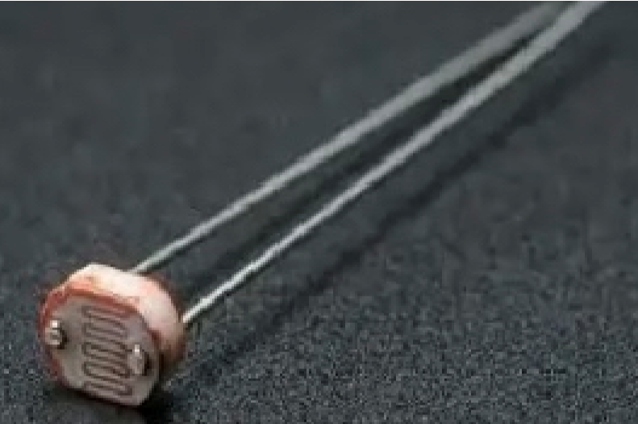
Figure 3.2: Light Dependent Resistors (LDRs

(2)
Where:
R = Resistance of the LDR (Ohm’s)
L= Light intensity (Lux)
A and K = constant that depend on the specific LDR (from its datasheet)
K is typically between 0.7 and 1.1

3.4 Capacitor:
Capacitor can store electric energy when it is connected to its charging circuit. And when it is disconnected from its charging circuit, it can dissipate that stored energy, so it can be used like a temporary battery. Capacitors are commonly used in electronic devices to maintain power supply while batteries are being changed.
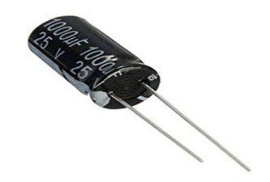
Figure 3.3: Capacitor
Capacitance
C = Q x V (3)
Where:
C = Capacitance (Farads, F)
Q = Charge (Coulombs)
V = Voltage (Volts)
Other uses capacitor equations
- Energy stored in capacitor
E =
- Capacitors in series
- Capacitors in parallel
C_{total} = C₁ + C₂ + C₃ + ….

3.5 Inductor:
An inductor is a passive electrical component that stores energy in a magnetic field when electric current flows through it. It typically consists of a coil of wire wound around a core (which can be air, iron, or another magnetic material)
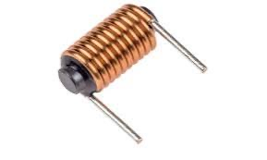
Figure 3.4: Inductor
V = L (4)
Where:
V = Voltage across the inductor (Volts)
L = Inductance (Henrys, H)
= Rate of change of current (Amps per second)
3.6 Diode
Diode is a two-terminal electronic component that conducts current primarily in one direction (asymmetric conductance); it has low (ideally zero) resistance in one direction, and high (ideally infinite ) resistance in the other.
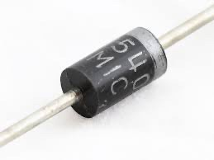
Figure 3.5: Diode
(5)
Where:
I = Current through the diode (A)
I_{s} = Reverse saturation current (A)
V = Voltage across the diode (V)
n = Ideality factor (usually between 1 and 2)
V_{T} = Thermal voltage (≈25.85 mV at room temperature)

3.7 Voltage Regulator Circuit
Voltage regulators are designed to automatically maintain voltages at a constant level. The LM7805 voltage regulator is used. It is a member of the 78xx series of fixed linear voltage regulator ICs. Voltage sources in circuits could be having fluctuations and thus not be able to give fixed voltage output. The voltage regulator IC maintains the output voltage at a value that is constant. The LM7805 provides +5V regulated power supply. Capacitors are connected at the input and output depending on respective levels of voltage.
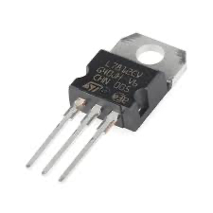
Figure 3.6: Voltage Regulator Circuit
V_{out} = V_{ref} (6)

Where:
(Usually V_{ref}≈ 1.25V)
R₁ and R₂ set the output voltage
I_{adj} is usually small and often neglected
3.8 Crystal Oscillator
Crystal oscillator is an electronic oscillator circuit that uses the mechanical resonance of a vibrating crystal of piezoelectric material to create an electrical signal with a precise frequency. The crystal oscillators have very high frequency stability. The crystal oscillator is possible to obtain very high precise and stable frequency of oscillators.
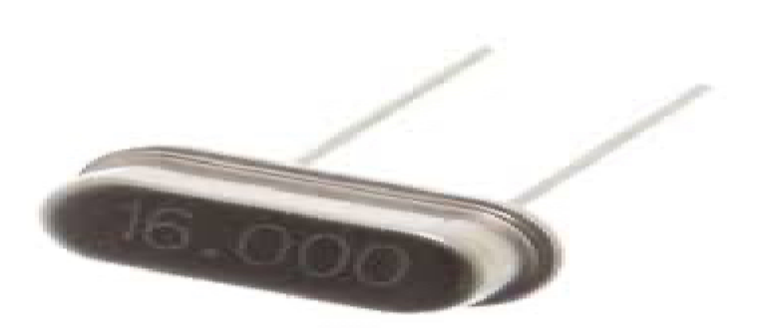
Figure 3.7: Crystal Oscillator

Series Resonant Frequency:
f_{s} = (7)
Where:
f_{s} = Series resonant frequency
L = Inductance of the crystal
C_{s} = Series capacitance

3.9 Servo Motor

In this project, the servomotors were interfaced to the microcontroller’s digital pin and for the vertical and the horizontal movements respectively. The VCC pins were connected to a +5V power supply, the GND pins were connected to the common circuit GND while the PWM pins wire connected to the digital pins and for the vertical and horizontal servos respectively.

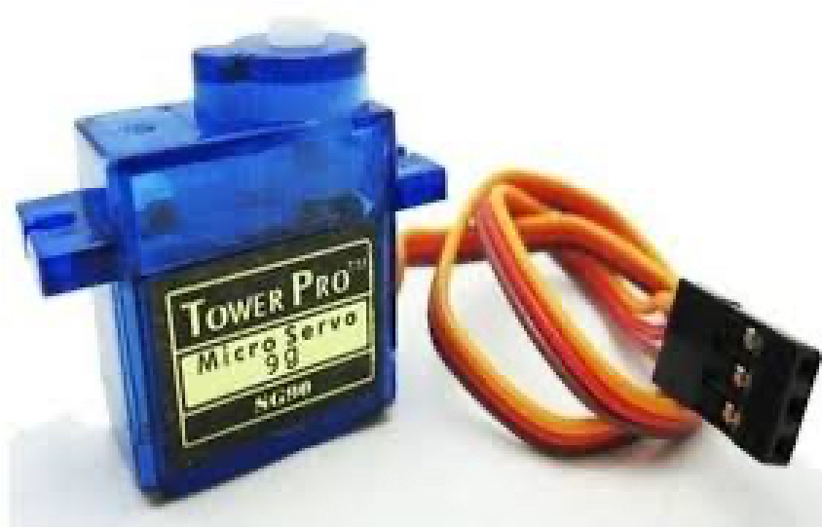
Figure: 3.8: Servo Motor
3.9.1 Servo Motor Interface to the Microcontroller
In this project, the servomotors were interfaced to the microcontroller’s digital pin – and – for the vertical and the horizontal movements respectively. The VCC pins were connected to a +5V power supply, the GND pins were connected to the common circuit GND while the PWM pins wire connected to the digital pins – and – for the vertical and horizontal servos respectively. The connections of the servomotor to the microcontroller were as shown in the figure below.
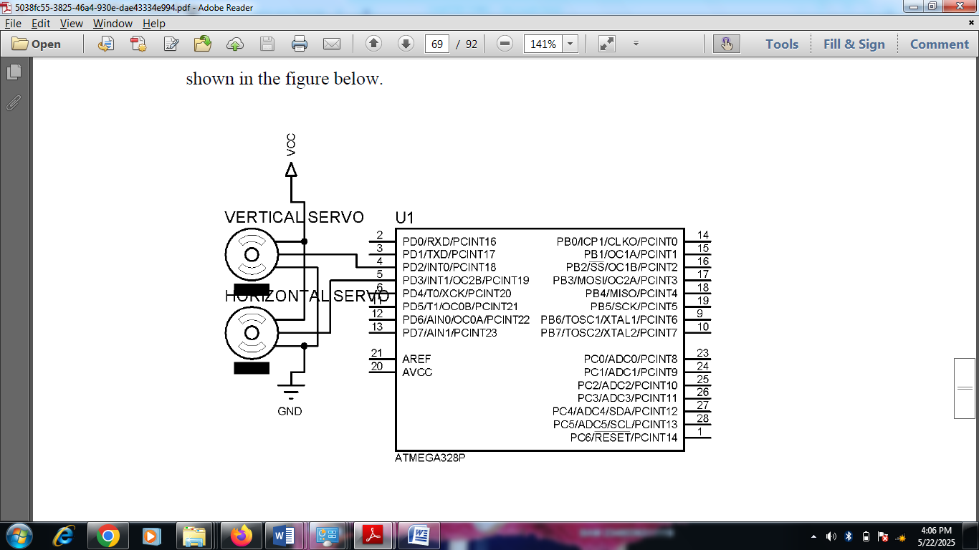
Figure 3.9: Servo Motor Interface to Microcontroller
Table 3.1: Servomotor Wire Configuration
Wire Number | Wire Colour | Description
1 | Brown | Ground wire connected to the ground of system
2 | Red | Powers the motor typically +5V is used
3 | Orange | PWM signal is given in through this wire to drive the motor
TowerPro SG-90 Features
- Operating Voltage is +5V typically
- Torque: 2.5kg/cm
- Operating speed is 0.1s/60°
- Gear Type: metal
- Rotation : 0°-180°
- Weight of motor : 9gm
3.10 Temperature Sensor
The DHTIl is a commonly used Temperature and humidity sensor that comes with a dedicated NTC to measure temperature and an 8-bit microcontroller to output the values of temperature and humidity as serial data.
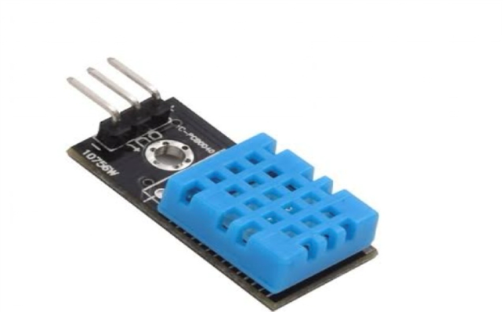
Figure 3.9: Temperature Sensor
Table 3.2: DHT11 Pin Configurations
DHT11 pin configurations
1 | VCC | Power supply 3.5V to 5.5V
2 | Data | Outputs both Temperature and Humidity through serial Data
3 | Ground | Connected to the ground of the circuit

Interfacing DHT11 to the Microcontroller
The temperature gives out a digital output at a specific intervals. The sensor is connected to the analogue ports of the microcontroller. The power pins which includes the VCC and GND were connected to the systems +5V and ground terminal of the power supply respectively. The signal pin of the sensor was connected to the pin 27 of the microcontroller which is analogue pin A4. The sensors senses the environmental temperatures and constantly sends it to the microcontroller through the data pin. The interface of the sensor to the microcontroller is as shown in the diagram below.
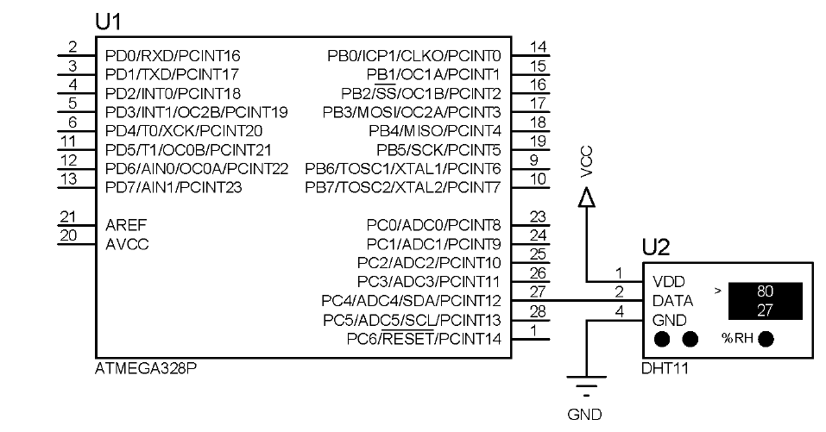
Figure 3.9.1: DHT11 Interface to the Microcontroller
3.11 IC Socket
An IC socket, or integrated circuit socket, is a tool that connects an integrated circuit (IC, also commonly referred to as a chip,) to a printed circuit board (PCB).
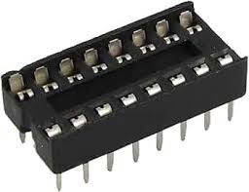
Figure 3.10: IC Socket

3.12 LCD Display
LCD (Liquid Crystal Display) screen is an electronic display module which is a very basic and commonly used module in various devices and circuits. These modules are preferred over seven segments and other multi segment LEDs. The reasons being popularity of LCDs because it is economical, easily programmable, has no limitation of displaying special & ever custom characters (unlike in seven segments), animations and so on. A 16x2 LCD means it can display 16 characters per line and there are 2 such lines. In this LCD each character is displayed in a 5x7 pixel matrix. This LCD has two registers, namely, Command and Data.

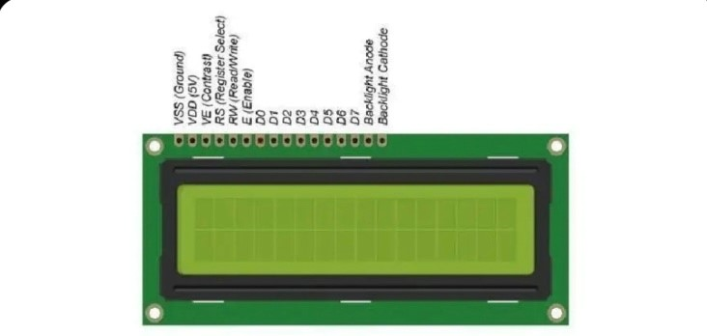
Figure 3.11: LCD Display
3.13 Printed Circuit Board (PCB)
Printed Circuit Board (PCB) provides the framework for connecting electronic components and facilitating the flow of electrical signals
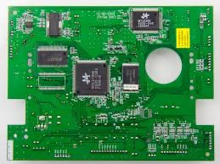
Figure 3.12: Printed Circuit Board (PCB)
This is a solar tracker circuit, its goal is to maximize the efficiency of solar panels by adjusting their position to follow the sun throughout the day. Here's a detailed explanation of the components and their functions in the schematic you provided:

3.14 Solar Panel
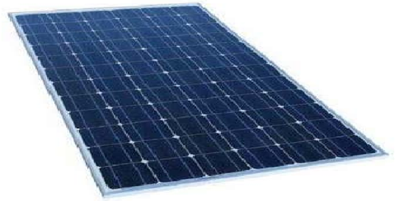
Figure 3.13: Solar Pannel
Solar panels are devices that convert light into electricity. They are called "solar" panels because most of the time, the most powerful source of light available is the Sun, called Sol by astronomers. Some scientists call them photovoltaic which means, basically, "light-electricity."
A solar panel is a collection of solar cells spread over a large area and can work together to provide enough power to be useful. The more light that hits a cell, the more electricity it produces.

3.15 Battery
An electric battery is a device consisting of one or more electrochemical cells with external connections provided to power electrical devices such as flashlights, and electric cars. When a battery is supplying electric power, its positive terminal is the cathode and its negative terminal is the anode. The terminal marked negative is the source of electrons that will flow through an external electric circuit to the positive terminal. When a battery is connected to an external electrical load.
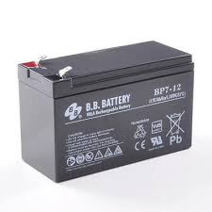

Figure 3.14: Battery
3.16 Background of Solar Tracking Systems
The amount of sunlight received varies throughout the year as a result of the motions of the Earth; however, the amount of solar energy received over a certain period on a surface that is perpendicular to the radiation’s path of propagation outside of the atmosphere at the mean earth–sun distance is known as the solar constant [40] and can be expressed mathematically as given in Equation (8):
GS_{C} = σ.T^{4.2} = 1367W/m² (8)
Where σ denotes the Stefan–Boltzmann constant (5.67×10⁻⁸ Wm⁻²K⁻⁴), R is the radius of the Earth (6371 km), and D denotes the average distance between the Sun and Earth (148.72×10⁹ km).
According to [41], the substantial amount of daily solar irradiation has led to the use of solar energy for power generation in a variety of applications, such as water pumping, telecommunication, and lighting. This has resulted in the design and implementation of solar photovoltaic panels, which can collect solar energy and convert it to other forms of energy, such as electrical energy. However, the amount of energy that may be produced is directly proportional to the intensity of the sunlight that falls on the panel. As a result, the necessity to build a system that can follow the position of the Sun over time has emerged, hence the solar tracking system. A solar tracking system can track the Sun’s movement and location over time to increase solar energy output, which in turn boosts electrical energy. Figure 3.15 shows the difference and limitations of the fixed solar tracking system compared to a simple solar tracking system.
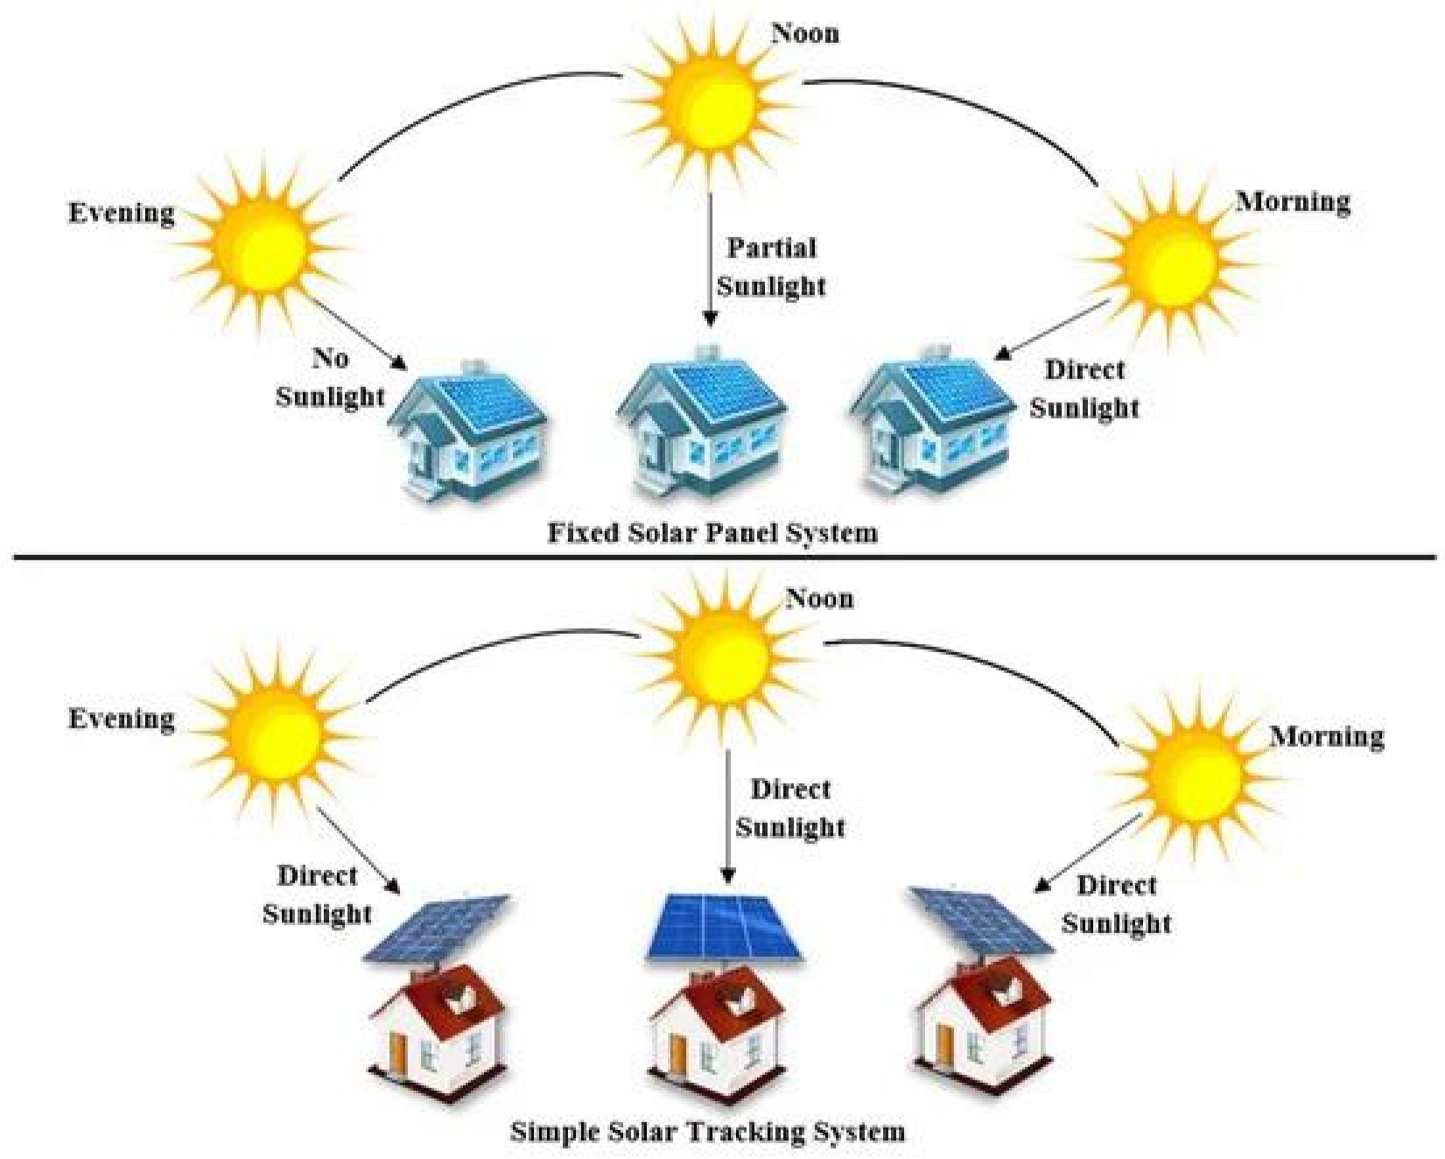
Figure 3.15: Comparison between Fixed and Simple Solar Tracking Systems.
For the accurate design, implementation, and installation of a solar tracking system, several parameters must be considered, such as the latitude, angle of incidence, solar irradiance, tilt angle, declination angle, elevation angle, zenith angle, orientation angle, solar azimuth angle, and inclination angle.
Latitude is a measure used to calculate the angular distance (south or north) of the equator in any location on Earth. The latitude angle can be measured in degrees. The angle of incidence is the most critical factor to consider when installing solar tracking systems. It is the angle formed by the Sun’s rays falling on the surface and the rays perpendicular to that surface.
Solar irradiance is another important parameter to consider, and it can be calculated by measuring the power of the light source or the luminous flux. The angle formed by the solar tracking system and the horizontal axis is known as the tilt angle. The angle of incidence is a variety of tilt angles. The declination angle is the angle formed between the equator and a line drawn from the center of the Sun to the center of the Earth. It can be expressed mathematically as given in Equation (9):
δ = −23.45×cos (9)
The elevation and zenith angles are similar to the declination angle: the elevation angle is the angle between the Sun’s center and the horizon, while the zenith angle is the angle formed by the center of the Sun and the vertical. They are both measured in degrees and expressed mathematically as shown in
Equations (10) and (11), respectively:
α = 90° - θz (10)
qz = cos−1 sin Ls_{t}sind + cosLs_{t}cosdcos ST (11)
where αis the elevation angle, θzis the zenith angle, L_{st}is the standard longitude that is positive for the east region and negative for the west, δ is the declination angle, and ST is the standard time. The orientation angle can be used to adjust a solar tracking system to keep the solar photovoltaic module perpendicular to the Sun and generate the maximum power. The solar azimuth angle is defined as the angle formed by projecting the Sun’s center onto the horizontal plane and pointing due south. It is represented with a positive sign for the position east of south, and the position west of south is represented with a negative sign. It can be represented mathematically as given in Equation (12): (12)
Where is the solar azimuth angle, 𝛿is the declination angle, δ is the zenith angle, and ℎis the hour angle expressed as given in Equation (13):
ℎ=15° (solartime−12) (13)
The inclination angle is the angle between a photovoltaic module and the positive x-axis, measured in degrees. As shown in Figure 3.16, these variables can be used to determine the optimal location for installing a solar tracking system or to establish the best orientation for such systems to obtain the maximum solar power.

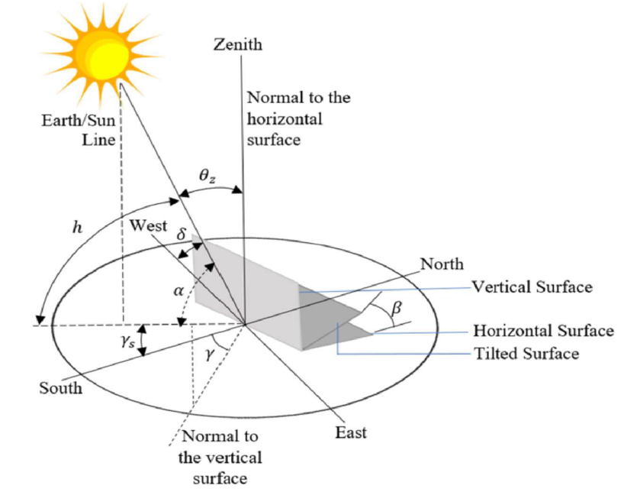
Figure 3.16: Solar Angles.

Although a solar tracking system can be used to maximize solar power, designing and implementing one is complex for a variety of reasons, including the need for intensive mathematical computations and detailed measurement of numerous solar parameters. It is also more expensive and sophisticated than a fixed-angle solar tracking system. The complexity, however, is determined by the number of axes utilized to move the solar panels horizontally or vertically.

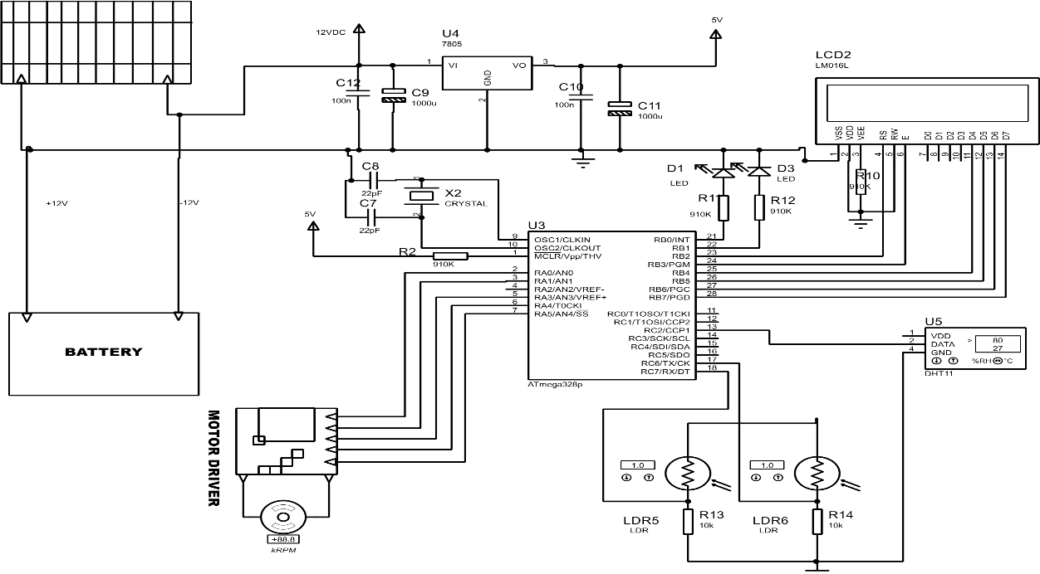

Figure 3.17: Circuit diagram of 360º rotation solar tracker with weather monitoring system.

CHAPTER FOUR
Construction and Performance Test
4.1 Introduction
This chapter presents the experimental testing and performance analysis of the designed 360° rotation solar tracker with an integrated weather monitoring system. The system was tested to observe how it responds to solar intensity changes by adjusting its orientation throughout the day. The key parameters measured and recorded include the Time (T), Panel angle (°), Voltage (V), Current (A), and Power (W) generated by the solar panel. Under real weather conditions using 30-minute intervals at the beginning. During the morning period, the surrounding temperature was relatively low at about 27°C and gradually increased as the day progressed, with slight variations. The temperature reached its peak when the sun was directly overhead, and began to decrease gradually towards the evening. Humidity, measured in percentage, was high in the early hours of the day but steadily declined as the temperature rose. Solar radiation increased proportionally with the intensity of sunlight throughout the day. Correspondingly, the solar tracking system continuously adjusted its position by rotating and revolving in response to the sun’s movement across the sky.
4.2 Construction Procedure
The construction procedure refers to the actual arranging of the various parts of the system to form a single system. This involves designing and printing of the printed circuit board, testing and soldering of the components, construction of the mechanical parts and the casing of the project.
4.2.1 Soldering and Testing of Components.
Component testing involves determining whether the components possess the actual electrical properties expected of it. Components testing was done prior to soldering of the components into the circuit board. The testing of the components was done with the help of the multimiter and the modules and sensors were tested with an arduino-uno board. The actual values of the components were tested and their stated functional characteristics. After testing for the workability of each individual component, the circuit was wired on a vero-board. Both short circuit and open circuit tests were carried out using a digital Multimeters. Also the system was tested to ensure its capability of performing the stated function. Components soldering involves placing the components in their actual position on the circuit board and securing it with a soldering lead. The components were arranged on the board according to the PCB design. The soldering iron was heated to the required temperature and the soldering lead was applied to the tip of the iron placed on the base of the component at the copper plaited side of the board. This was done to all the remaining components of the circuit. Delicate component and sensors were attached to the board through connectors to avoid destruction by heat. The mechanical parts of the system provides support to the solar panel and also ensures the rotation and movement of the panel. Mechanical arm were provided which corresponds for the horizontal movement.
4.2.2 Casing and Packaging.
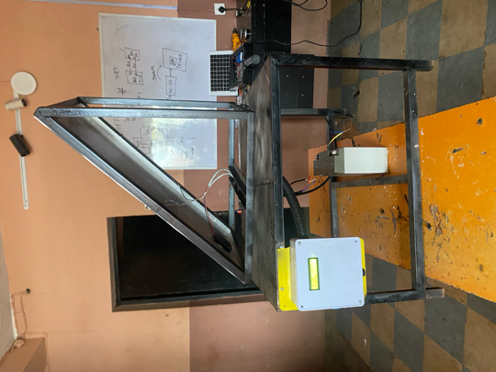
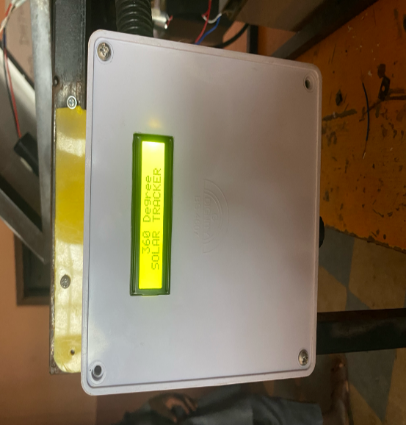
A prototype of a 360°solar tracking system with weather monitoring, temperature and solar intensity measurement capability. The main circuit was mounted on a rectangular plastic box which houses the major electrical part of the circuit. The solar panel was supported with a metal arm which allows for its free rotation in both axis. At the top of the box, a space was carved out to accommodate the LCD module.

Figure 4.1: System Booting. Figure 4.2: Constructed Solar Tracking System

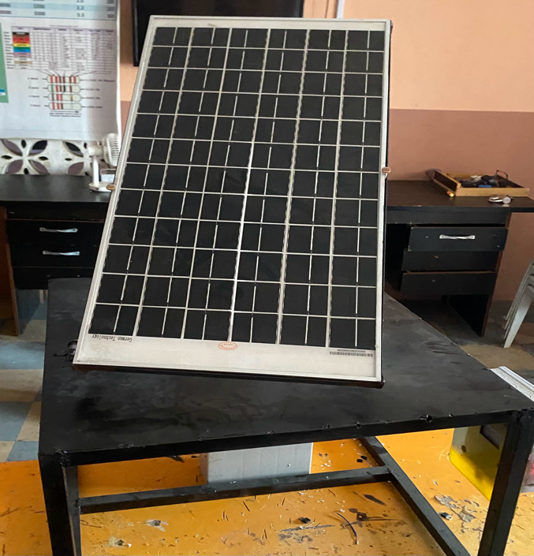
Figure 4.3: Complete 360⁰ solar tracker system.
The tracking accuracy of the 360° rotation solar tracker with weather monitoring system over the three days period was consistently effective, with the system closely following the sun’s path from morning to evening. The angle of rotation increased progressively as expected, and the corresponding voltage and current readings showed a clear peak around midday, indicating that the panel was accurately aligned with the sun during periods of highest solar intensity. Throughout the observations, the system maintained smooth transitions in angle adjustments with minimal fluctuations, suggesting a responsive and well calibrated tracking mechanism. Overall, the tracker demonstrated the reliable performance in maximizing solar exposure optimizing energy output over the testing period as shown in fig. 4.3.
4.3 Performance Test
The system 360° solar tracking system with weather monitoring, temperature, humidity is a microcontroller based solar tracking system. The system enhances solar energy harnessing hereby making it more efficient to harness solar energy during the day. The system makes use light sensors to determine the position of the sun at any point in time. The system compares the values of the solar intensity received from the east, west, north and south. The system uses servo motor to rotate the solar panel to face the direction with the highest solar intensity. When the sun moves from east towards the west and the other directions of the globe the system senses the changes in the solar intensity and turns the panel accordingly. Similarly, the system makes use of a temperature and humidity sensors to measure the value of the surrounding temperature and humidity. The measured value are displayed on the LCD screen. The performance of the system was tested during the day. The system was placed at an open place and the reactions of the system to the direction of the sun were noted. Similarly, the changes in the temperature, humidity and solar intensity were noted.
Table 4.1: The Solar Panel Specifications
Description | Value
Open circuit voltage (Voc) | 20V
Short circuit current (Isc) | 9A
Battery capacity (Ah) | 18Ah
Estimated angles are derived based on the sun’s apparent movement and the rotation behavior of the tracker throughout the day.
Table 4.2 The estimated hourly Readings of Panel Voltage, Power, and Angle of Rotation for Day 1:
Time (t) | Panel Voltage (v) | Power (P) | Angle of Rotation (º)
9:19am | 10.5 | 12.60 | 68
9:49am | 11.2 | 12.88 | 75
10:19am | 12.0 | 13.20 | 83
11:19am | 14.4 | 14.40 | 100
11:49am | 15.6 | 14.82 | 108
12:19pm | 16.8 | 15.12 | 115
12:49pm | 17.3 | 14.71 | 122
1:19pm | 17.8 | 14.24 | 130
1:49pm | 18.2 | 13.65 | 137
2:19pm | 18.6 | 13.02 | 143
2:49pm | 19.0 | 12.35 | 150
3:19pm | 19.3 | 11.58 | 158
3:49pm | 19.6 | 10.78 | 165
4:19pm | 19.8 | 9.90 | 172
4:49pm | 19.9 | 8.96 | 178
5:19pm | 20.0 | 8.00 | 183

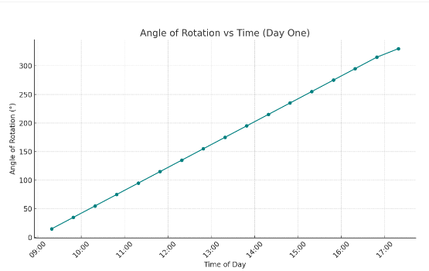

Figure 4.4: Angle of Rotation against Time.

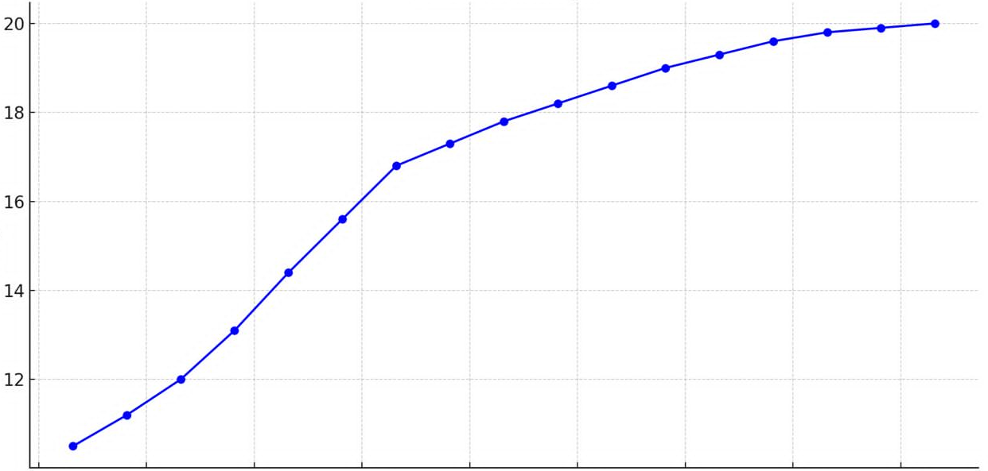
Panel Voltage vs Time (Day One)

Panel Voltage

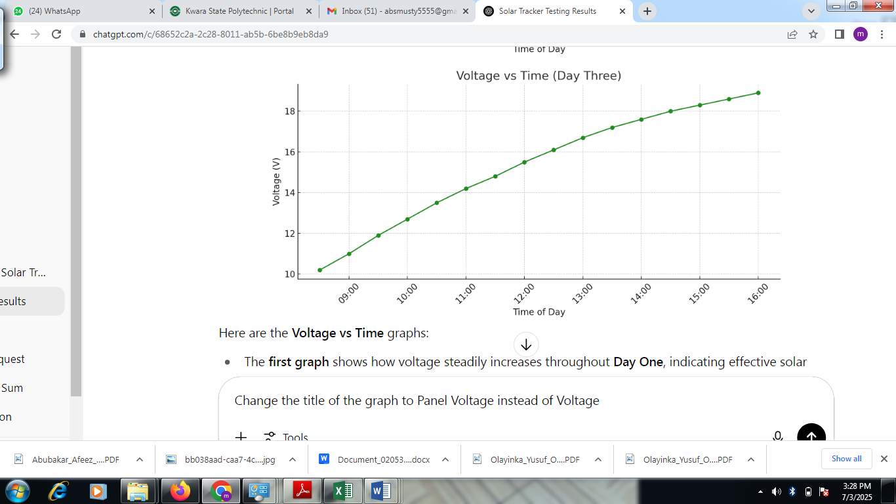
`

Figure 4.5: Panel Voltage against Time.
The two table graphs presented in figure 4.4 and figure 4.5 demonstrate the operational Efficiency of the solar tracking system in one day. Fig. 4.4, which shows a linear relationship between time of day and angle of rotation, indicating that the angle increases steadily throughout the day, suggesting constant rotational motion and tracking. The second graph displays a nonlinear increase, where the values rise quickly at first and then gradually level off, indicating a decelerating trend possibly representing a process like temperature rise, saturation, or energy storage over time.
Table 4.3: The Estimated Hourly Readings of Panel Voltage, Power, and Angle of Rotation for Day 2:
Time | Panel Voltage (V) | Power (W) | Angle of Rotation (°)
10:09 | 11.7 | 13.81 | 45
10:39 | 12.5 | 14.00 | 47
11:09 | 13.2 | 13.86 | 49
11:39 | 14.0 | 13.86 | 55
12:09 | 14.6 | 13.58 | 65
12:39 | 15.3 | 13.46 | 80
1:09 | 15.9 | 13.04 | 95
1:39 | 16.5 | 12.71 | 110
2:09 | 17.0 | 12.07 | 125
2:39 | 17.5 | 11.55 | 140
3:09 | 18.0 | 10.98 | 155
3:39 | 18.4 | 10.12 | 165
4:09 | 18.8 | 9.21 | 175
4:39 | 19.1 | 8.40 | 179
Figure 4.6: Angle of Rotation against Time

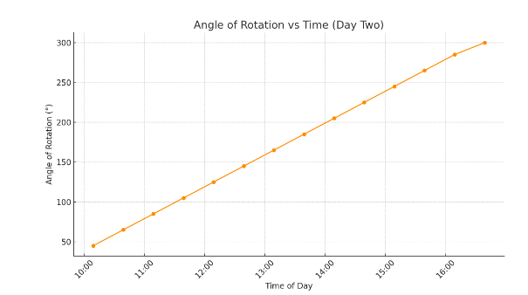

Panel Voltage vs Time (Day Two)
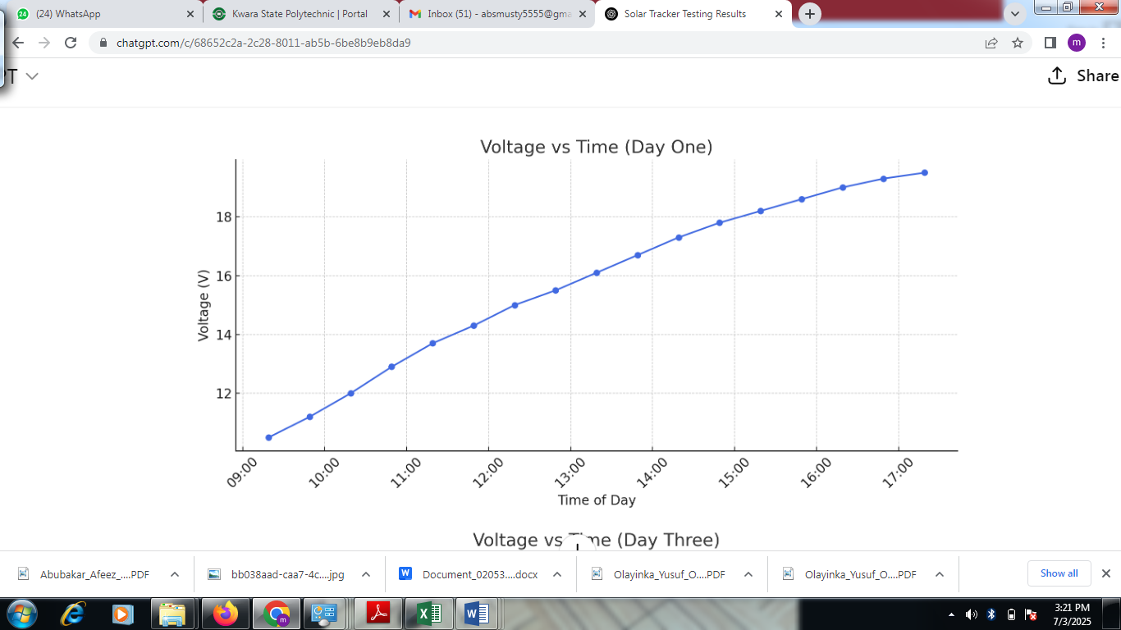
Panel Voltage
Figure 4.7: Panel Voltage against Time

Fig. 4.6 illustrate how the solar panel’s angle of rotation and voltage output vary with time throughout the day. The second graph, titled Angle of Rotation vs Time Day Three, demonstrates the rotation of the solar panel throughout the day. The angle of rotation increases linearly from about 50° at 8:30 AM to nearly 185° by 4:00 PM. This consistent increase reflects the functioning of the solar tracker system, which gradually rotates to follow the sun position across the sky to maximize energy absorption. Together, these graphs validate the efficiency of the 360° solar tracker system. The consistent voltage rise corresponds with the smooth angular rotation, proving that the tracking mechanism successfully maintains optimal alignment with the sun throughout the day, as shown in Figure 4.6 and Figure 4.7.
Table 4.4: The Estimated Hourly Readings of panel Voltage, Power, and Angle of Rotation for Day 03:
Time | Panel Voltage (V) | Power (W) | Angle (°)
8:30 | 10.2 | 12.75 | 50
9:00 | 11.0 | 13.20 | 54
9:30 | 11.9 | 13.57 | 60
10:00 | 12.7 | 13.84 | 65
10:30 | 13.5 | 13.91 | 78
11:00 | 14.2 | 13.92 | 86
11:30 | 14.8 | 13.76 | 95
12:00 | 15.5 | 13.49 | 110
12:30 | 16.1 | 13.04 | 125
1:00 | 16.7 | 12.53 | 140
1:30 | 17.2 | 12.04 | 155
2:00 | 17.6 | 11.44 | 165
2:30 | 18.0 | 10.80 | 175
3:00 | 18.3 | 9.88 | 179
3:30 | 18.6 | 9.11 | 183
4:00 | 18.9 | 8.32 | 185

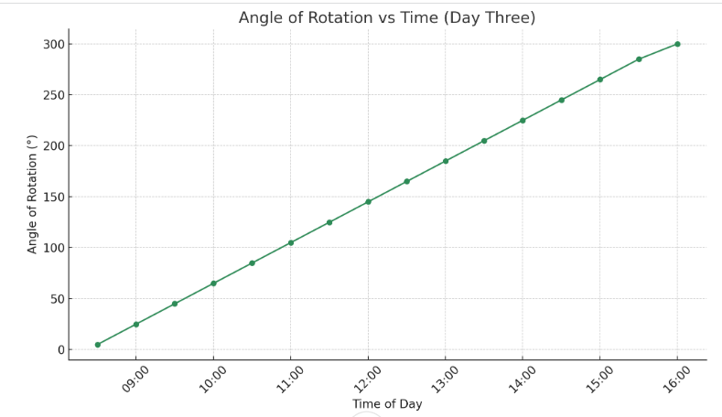
Figure 4.8: Angle of Rotation against Time.

Panel Voltage vs Time (Day Three)
Panel Voltage

Figure 4.9: Panel Voltage against Time

The graphs show that the solar tracker effectively followed the sun from morning to evening across all three days, with the panel angle increasing smoothly throughout the day. Voltage rose steadily from about 10.5V to 20.0V, while current decreased from 1.20A to around 0.40A. This inverse relationship is due to changing sunlight intensity. Despite the drop in current, the system maintained stable power output around 13–14W at peak times, confirming the tracker's efficiency in maximizing solar energy.

CHAPTER FIVE
CONCLUSION AND RECOMMENDATION
5.1 Conclusion
The aim of this project was to design and construct a 360° rotation solar tracking system integrated with a weather monitoring unit, and this was successfully achieved. The system rotates to follow the position of the sun from sunrise to sunset, ensuring maximum solar energy absorption through full horizontal movement. Unlike limited-range or fixed trackers, the 360° design allows the panel to continuously face the direction of highest sunlight intensity. In addition to tracking, the system is equipped with sensors that measure and display temperature, humidity, and solar intensity, making it not only efficient for solar energy collection but also functional as a basic weather monitoring tool. Overall, the project has met its objectives by delivering a cost-effective, automated, and efficient solar tracking solution that can support future improvements in renewable energy systems and smart solar technologies.

5.2 Recommendations
To enhance the functionality and efficiency of the solar tracking system, several improvements are recommended. Integrating IoT capabilities using GSM or Wi-Fi modules would allow for remote monitoring and data logging of key parameters like voltage, current, and panel angle via a cloud-based dashboard or mobile app. An automatic cleaning mechanism, such as a motorized wiper or brush, would maintain panel efficiency by preventing dust and debris buildup. Real-time current measurement can be achieved by incorporating a current sensor module like the ACS712, enabling accurate monitoring of power output and battery performance. The system can also be scaled to support multiple solar panels and higher-capacity batteries for residential, agricultural, or commercial use. Lastly, adding a digital display (LCD or OLED) to show the current tracking angle would improve user interaction, assist in troubleshooting, and confirm the proper functioning of the tracker.

REFERENCES
[1]. U. Goverment, "Solar Radiation Basics," 21 August 2013. [Online]. Available:https://www.energy.gov/eere/ solar/articles. [Accessed 28 June 2019].
[2]. Y. Jake, "Solar tracker technology," 2019. [Online]. Available: www.britanica.com/solartracker-technology. [Accessed 29 June 2019].
[3]. R. O. Oloka, "Solar Tracker for Solar Panel," University Of Nairobi, Kenya, 2015.
[4]. M. Hossein, K. Alireza, J. Arzhang, M. Hossein and A. a. A. S. Karen, "A review of principle and sun-tracking methods for maximizing solar systems output," Renewable and Sustainable Energy Reviews, pp. 1800-1818, 2009.
[5]. N. Dangi, "Monitoring environmental parameters: humidity and temperature using Arduino based microcontroller and sensors," Helsinki Metropolia University of Applied Sciençec Halcinli Metronolio 2017
[6]. P. a. A. A. Bhavesh, "Automatic Sun Tracking System Using PSoC," International Journal of Innovative Research in Science, Engineering and Technology, vol. 1, no. 1, pp. 66-70, 2012.
[7]. Ellabban, O.; Abu-Rub, H.; Blaabjerg, F. Renewable Energy Resources: Current Status, Future Prospects and Their Enabling Technology. Renew. Sustain. Energy Rev. 2014, 39, 748–764. [CrossRef]
[8]. Oghogho, I.; Sulaimon, O.; Egbune, D.; Abanihi, K. V Solar Energy Potential and Its Development for Sustainable Energy Generation in Nigeria: A Road Map to Achieving This Feat. Int. J. Eng. Manag. Sci. 2014, 5, 61–67.
[9]. Mustafa, F.I.; Shakir, S.; Mustafa, F.F.; Naiyf, A.T. Simple Design and Implementation of Solar Tracking System Two Axis with Four Sensors for Baghdad City. In Proceedings of the 2018 9th International Renewable Energy Congress (IREC), Hammamet, Tunisia, 20–22 March 2018.
[10]. Choudhary, P.; Srivastava, R.K. Sustainability Perspectives—A Review for Solar Photovoltaic Trends and Growth
Opportunities. J. Clean. Prod. 2019, 227, 589–612. [CrossRef]
[11]. El Hammoumi, A.; Chtita, S.; Motahhir, S.; El Ghzizal, A. Solar PV Energy: From Material to Use, and the Most Commonly Used Techniques to Maximize the Power Output of PV Systems: A Focus on Solar Trackers and Floating Solar Panels. Energy Rep. 2022, 8, 11992–12010. [CrossRef]
[12]. Ray, S.; Tripathi, A.K. Design and Development of Tilted Single Axis and Azimuth-Altitude Dual Axis Solar Tracking Systems. In Proceedings of the 2016 IEEE 1st International Conference on Power Electronics, Intelligent Control and Energy Systems (ICPEICES), Delhi, India, 4–6 July 2016; ISBN 9781467385879.
[13]. Costa, H.; Liang, D.; Almeida, J.; Catela, M.; Garcia, D.; Tibúrcio, B.D.; Vistas, C.R. Seven-Rod Pumping Concept for Highly Stable Solar Laser Emission. Energies 2022, 15, 9140. [CrossRef]
[14]. Tibúrcio, B.D.; Liang, D.; Almeida, J.; Garcia, D.; Catela, M.; Costa, H.; Vistas, C.R. Tracking Error Compensation Capacity Measurement of a Dual-Rod Side-Pumping Solar Laser. Renew. Energy 2022, 195, 1253–1261. [CrossRef]
[15]. Muhammad, J.Y.; Tajudeen Jimoh, M.; Baba Kyari, I.; Abdullahi Gele, M.; Musa, I. A Review on Solar Tracking System: A Technique of Solar Power Output Enhancement. Eng. Sci. 2019, 4, 1–11. [CrossRef]
[16]. Hafez, A.Z.; Yousef, A.M.; Harag, N.M. Solar Tracking Systems: Technologies and Trackers Drive Types—A Review. Renew. Sustain. Energy Rev. 2018, 91, 754–782. [CrossRef]
[17]. Racharla, S.; Rajan, K. Solar Tracking System—A Review. Int. J. Sustain. Eng. 2017, 10, 72–81.
[18]. De Rooij, D. Single Axis Trackers. Available online: https://sinovoltaics.com/learning-center/csp/single-axis-trackers/ (accessed on 4 March 2023).
[19] Das, A.; Durgaprasad, S. Simulation and Implementation of Single Axis Solar Tracker. Int. Res. J. Eng. Technol. 2020, 7, 756.
[20] Ponniran, A.; Hashim, A.; Joret, A. A Design of Low Power Single Axis Solar Tracking System Regardless of Motor Speed. Int. J. Integr. Eng. 2011, 3, 5 – 9.
[21] Ponniran, A.; Hashim, A.; Ali Munir, H. A Design of Single Axis Sun Tracking System. In Proceedings of the 2011 5th International Power Engineering and Optimization Conference, Shah Alam, Malaysia, 6–7 June 2011; ISBN 9781457703546.
[22] Karthik, K.; Kumar, D. Design and Implementation of High Efficiency Solar Tracking System. Int. J. Eng. 2013, 2, 2886– 2892.
[23] Akbar, H.S.; Fathallah, M.N.; Raoof, O.O. Efficient Single Axis Sun Tracker Design for Photovoltaic System Applications. IOSR J. Appl. Phys. 2017, 9, 53–60. [CrossRef]
[24] Nori, A.F.; Moh mmed, F.G. Design and Implementation of an Efficient Solar Tracker Syste . J. Phys. Conf. Ser. 2020, 1530, 12150. [CrossRef]
[25]. Musa, A.; Suleiman, S.A.; Fijabi, M.M.; Hussain, A.O.; Ganiyu, I.A. Design and Implementation of a Real Time Clock Based Solar Tracking System. Zaria J. Electr. Eng. Technol. 2021, 10, 39–46.
[26]. Balaji, B.; Arulvizhi, J.A. Maximum Solar Power Tracker Mechanically by Using Dual Axis Tracker. J. Int. J. Adv. Res. 2017, 3, 1157–1162.
[27]. Driggs, D.; Mensah, P.; Stephen, A.; Fareed, D.; Jana, A. Dual Axis Solar Panel Optimized Using Programming Languages. In Proceedings of the 2006 GSW; ASEE Conferences, Tuscaloosa, AL, USA, 6–10 March 2006. Available online: https://sites.asee. org/se/publications/proceedings/2006-asee-se/ (accessed on 6 March 2023).
[28]. Shufat, S.A.A.; Kurt, E.; Hancerliog˘ulları, A. Modeling and Design of Azimuth-Altitude Dual Axis Solar Tracker for Maximum Solar Energy Generation. Int. J. Renew. Energy Dev. 2019, 8, 7. [CrossRef]
[29]. Wang, J.M.; Lu, C.L. Design and Implementation of a Sun Tracker with a Dual-Axis Single Motor for an Optical Sensor Based Photovoltaic System. Sensors 2013, 13, 3157–3168. [CrossRef]
[30]. Wu, Y.E.; Huang, K.C. Design and Implementation of Dual-Axis Solar Tracking System with GSM Fault Reporting Capability. In Applied Energy Technology; Trans Tech Publications Ltd.: Bäch, Switzerland, 2013; Volume 724, pp. 43–51.
[31]. Munna, M.S.; Bhuyan, M.A.I.; Rahman, K.M.; Hoque, M.A. Design, Implementation and Performance Analysis of a DualAxis Autonomous Solar Tracker. In Proceedings of the 2015 International Conference on Green Energy and Technology, ICGET 2015 , Dhaka, Bangladesh, 11 September 2015; pp. 1 – 5.
[32]. Özer, T.; Mustafa Kelek, M.; Og˘uz, Y.; Kivrak, S.; Kıvrak, S.; S¸ahin, M. Double Axis Solar Tracking System Design and Implementation. Int. J. Sci. Eng. Res. 2018, 9, 66–71.
[33]. Prakash, M.B.; Govindarajulu, K. Analysis and Testing of Dual Axis Solar Tracker for Standalone PV Systems Using Worm Gear. Int. J. Mod. Trends Sci. Technol. 2022, 8, 1 – 8.
[34]. Tamang, D.; Roy, O.P. Hybrid Solar Tracking System: A Brief Overview. In Proceedings of the 2019 3rd IEEE International Conference on Electrical, Computer and Communication Technologies, ICECCT 2019, Coimbatore, India, 20–22 February 2019 ; pp. 1 – 5.
[35]. Gupta, P.; Gupt , V.; Sharma, M.; Pachauri, R.K.; Akhtar, J. Design and Performance A alysis of Three Axis Solar Tracking System. In Proceedings of the 2022 7th Asia Conference on Power and Electrical Engineering (ACPEE), Hangzhou, China, 15–17 April 2022; pp. 1876–1880.
[36]. Siddharth, P.S.; Ganesh, S.; Sreenath, S. A Hybrid Solar Tracking System. Int. J. Electr. Electron. Eng. Res. 2013, 3, 77–80.
[37]. Mumtahina, U.; Bhuiya, M.; Sayem, A.; N, A.; Mohammad, N. Design and Implementation of a Multi-Dimensional Automatic Solar Tracking System. Energy Technol. 2014, 6, 1–11.
[38]. Abdulrahman, A.; Hamoud, A.; Al-Nehari, A.; Almakhlafy, M. Design and Implementation of Solar Tracking System. In Proceedings of the 2015 International Conference on Applied Science and Engineering Innovation (ASEI 2015), Jinan, China, 30–31 August 2015; Volume 12, pp. 785–788. [CrossRef].

APPENDIX
BILL OF ENGINEERING MEASUREMENT AND EVALUATION
S/No | Material Specification | Quality | Rate | Amount (N)
1. | Resistor | 14 Pieces | 1,000 | 14,000
2. | Capacitor | 12 Pieces | 1,000 | 12,000
3. | Diode | 7 Pieces | 1,000 | 7,000
4. | Crystal oscillator | 2 Pieces | 2,000 | 4,000
5. | Voltage regulator | 1 Piece | 5,000 | 5,000
6. | IC socket | 1 Piece | 5,000 | 5,000
7. | Connecting wires |  | 5,700 | 5,700
8. | LCD | 1 Piece | 10,000 | 10,000
9. | LDR | 2 Pieces | 1,500 | 3,000
10. | Servo motor | 1 Piece | 15,000 | 15,000
11. | PCB |  | 20,000 | 20,000
12. | Mechanism |  | 57,000 | 57,000
13. | Solar Panel | 1 Piece | 10,000 | 10,000
14. | Adaptable Box | 1 Piece | 5,000 | 5,000
 | TOTAL |  |  | 172,700

