

A PROJECT REPORT
ON
LAND INFOFMATION SYSTEM OF URBAN ESTATE OPPOSITE OF GOVERNMENT CEMETERY AREA OKE OYI ILORIN KWARA STATE

PRESENT BY:
ABDULQUADRI ABUBAKR SIDDIQ
HND/23/SGI/FT/0075

SUBMITTED TO:
THE DEPARTMENT OF SURVEYING AND GEOINFORMATICS
INSTITUTE OF ENVIRONME NTAL STUDIES
KWARA STATE POLYTECHNIC P.M.B 1340
ILORIN,KWARA STATE.
IN PARTIAL FULFILLMENT OF THE REQUIREMENT FOR
THE AWARD OF HIGHER NATIONAL DIPLOMA IN SURVEYING
AND GEO-INFORMATICS

SUPERVISOR:
SURV. ADEBANJI AKINYEDE

JULY,2025
TABLE OF CONTENTS
INTRODUCTION
  - Background to the study…………………….,……,………………………………….2
  - Statement of the problem……………………………………………………………..2
  - Aim of the project……………………………………………………………………..3
1.4 Objectives of the project………………………………………………………………3
  - Scope of the project…………………………………………………………………3
1.6 Personnel…………………………..…………………………..……………………4
  - Study Area………………………………………..………………………………..4
1.8 Specifications……………………………………………………………………..5

CHAPTER TWO
2.1 Literature review………………………..,…….………………………………………7
2.2 Concept of land information system (LIS)……………………..………………………7
2.3 Historical developments of Land information system…………..………………..7
2.4 components of a land information system……………………………………………8
2.5 Applications of land information system…………………..………………………….8
2.6 Benefits of land information system……………………………………………………9
2.7 Challenges in implementing land information system………..………………….9
2.8 Emerging Trends and future Directions……………………………..………………..9
2.9 The Nigerian Context of land information system……………….………………..10

CHAPTER THREE
3.0 Methodology………………………………………..…………………………………..11
3.1 Database Design…………………………………………….……………………………11
3.1.1 View of Reality……………………………………………..…………………………11
3.2 Conceptual Design…………………………………..………………………………….12
3.2.1 Logical Design……………………………………………………………………….12
3.3 Data Processing……………………………………………..…………………………13
3.3.1 Data downloading…………………………………………….………………………13
3.3.2 Downloading procedure of total station………………….………………………13
3.3.3 Back computation of the project Area……………….…………………………..13
3.4. Perimeter Survey………………………………………………….…………………..13
3.4.1 Area computation…………………………………………..……………………….14
3.4.2 Linear Accuracy………………………………………….……………………………14
3.5. Physical Design…………………………………………..……………………………15
3.6. Database Creation………………………………………………………………………17
3.7. Database Management system………………..……………………………….18
3.8. Data Security………………………….………………………………………………19
3.8.1 Data Integrity…………………………………………………………………………19
3.8.2 Database Maintenance……………………..……………………………………19.

CHAPTER FOUR
4.0 Analysis and information presentation………………………………………..20
4.1 Testing of Database………………………….………………………………………20
4.1.1 Spatial Analysis…………………………………….……………………………..20
4.1.2 Database Implementation……..……………………………………………..21
4.1.3 Query and Presentation of Analysis……………………………………….22
4.2 Analysis Preformed……………………………………………………………..23.
4.3.1 Single Criteria Query…………………………..………………………………24
4.3.2 Multiple Criteria Query………………..………………………………………25
4.4 Application of product…………………………………………………………..26

CHAPTER FIVE
5.1 Costing ……………………………………………………………………………..30
5.2 Summarily……………………………………….…………,……………………..31
5.3 Problems encountered………………..……………………………………….32
5.4 Recommendations……………………….……………………………………..33
5.5 Conclusion…………………………………….…………………………………..33
Reference
DEDICATION
I also dedicate this work to my beloved parents, whose endless support, prayers, and encouragement have been my driving force. To all my lecturers, mentors, and colleagues in the Department of Surveying and Geoinformatics, Kwara State Polytechnic—this is for you.

ACKNOWLEDGEMENT
I give all glory to the Almighty God for granting me the life, strength, and wisdom to successfully complete this project.
My sincere appreciation goes to my project supervisor, SURV ADEBANJI AKINYEDE, for his guidance, constructive criticism, and encouragement throughout the duration of this project.
I would also like to express my gratitude to the entire staff of the Department of Surveying and Geoinformatics, Kwara State Polytechnic, for the knowledge and support received during my course of study.
Special thanks go to my parents and family members for their moral and financial support, and to my friends and coursemates for their help, advice, and shared experiences.
May God bless you all abundantly.

CERTIFICATION
This is to certify that the project titled:
“Land Information System of Urban Estate Opposite Government Cemetery Area Along Oke Oyi Road, Ilorin, Kwara State (Ilorin East Local Government Area)”
Was carried out by [ABDULQUADRI ABUBAKR SIDDIQ] with Matric Number [HND/23/SGI/FT/075] in partial fulfillment of the requirements for the award of Higher National Diploma (HND) in Surveying and Geoinformatics, School of Environmental Studies, Kwara State Polytechnic, Ilorin.
This work has been read and approved as meeting the requirements and standards of the department.

____________________________. __________________
Project Supervisor. Date
SURV. ADEBANJI AKINYEDE

___________________________. __________________
Head of Department. Date
SURV. ABIMBOLA. A.O

_________________________. _________________
External Supervisor. Date

ABSTRACT
Land is one of the most valuable natural resources, and its effective management is essential for sustainable development. This project focuses on the design and implementation of a Land Information System (LIS) for the Urban Estate opposite Government Cemetery Area along OkeOyi Road, located in Ilorin East Local Government Area of Kwara State.
The system was developed to provide an organized and digital means of storing, analyzing, and managing both spatial and attribute data related to land parcels, roads, buildings, and ownership information within the estate. Data were collected through field surveys using GNSS equipment and total station, alongside desk research involving existing cadastral records.
The spatial and attribute data were integrated into a geodatabase using Geographic Information System (GIS) tools. The database design followed a structured methodology, including the view of reality, conceptual design, and logical design phases. The resulting LIS offers functionalities such as land parcel visualization, ownership query, and spatial analysis.
This project demonstrates the relevance of modern geoinformatics tools in land administration, decision-making, and urban planning. It is recommended that the system be adopted and expanded by local authorities for wider land management applications.

CHAPTER ONE

1.0 INTRODUCTION

Background to the Study
Land is one of the most critical resources in human existence. Its effective administration and management are fundamental to sustainable development, especially in urban areas where population growth and economic activities exert increasing pressure on land resources. The development of cadastral information systems (CIS) is essential to manage urban land effectively, providing accurate and up-to-date information about land ownership, boundaries, and usage.
Cadastral information systems integrate spatial and non-spatial data to address challenges in land management. They facilitate effective land registration, reduce disputes, support urban planning, and provide a foundation for property taxation and valuation. As urbanization accelerates in many parts of Nigeria, including Kwara State, the need for accurate and reliable cadastral systems has become more apparent.

1.2 STATEMENT OF PROBLEM
Due to the challenges faced in land management and administration, particularly in Nigeria, land administration faces significant challenges such as inefficiency, lack of accurate data, inadequate accessibility to land records, and poor management of land resources. The absence of an integrated and automated system to store, update, and retrieve land data often leads to confusion, land disputes, and ineffective policy implementation. The complexity of managing land ownership, boundaries, transactions, and land use further exacerbates issues like corruption, encroachment, and the illegal allocation of land.
This situation results in substantial economic losses, delays in infrastructure development, and an overall lack of transparency and accountability in land management processes. Traditional land management systems are outdated, paper-based, and prone to human error, making it difficult for land stakeholders, including government agencies, developers, and the general public, to efficiently access and manage land-related information. The absence of a comprehensive and digitized Land Information System (LIS) impedes sustainable development and poses a significant barrier to effective urban planning, investment, and governance in land-related matters.
This problem statement addresses key issues like inefficiency, poor data management, disputes, and outdated systems that can be alleviated with the implementation of a comprehensive Land Information System.

1.3 AIM AND OBJECTIVES OF THE PRACTICAL

1.3.1 AIM OF THE PROJECT
The aim of this project is to provide an integrated platform for managing, storing, and analyzing land-related data to support efficient land administration, planning, and decision-making.

1.3.2OBJECTIVES OF THE PROJECT
The following objectives were considered in order to accomplish the above aim
- Planning
- Monumentation
- Data downloading and data processing
- Data analysis and information presentation
- Query
- Report writing

1.4SCOPE OF THE PROJECT
The scope of the work involves detailed procedures for the development of Land Information System of Urban Estate Layout. It however entails the creation of functional Database of the present situation of the research Area and to display digital Information and to display Information such as Ownership details, Parcel information, Plot type, Land use, Status was developed and other attribute information. All these entities and attributes will form the base for database creation.
Base and significance of this project, the scope includes;
1. Project planning: which include office planning and field reconnaissance
2. Monumentation: (At least 5 hectares of land according to Higher National Diploma)
3. Data acquisition (geometric data with total station, social survey through oral interview for the purpose of query and building name and colors
4. Data processing: This includes downloading and processing of data using appropriate software (GIS software)
5. Information presentation: It involved plotting of survey data on both soft copy and hard copy showing correct location of a points.

1.5 PERSONNEL
The following are the personnel who participated in the execution of the project.
NAME
1.ABDULQUADRI ABUBAKR S.
2. AKEEM HAMID AJAGBE
3. AYODELE TAIYE OPEYEMI
4. ABOLADE BISOLA OPEYEMI
5. AFOLAYAN IFEOLUWA MARY
6. ABDULFATAI ABDULAFEEZ O.
7.AYEGBOYIN QUDUS A.
8. ADEKUNLE FLORENCE A.

1.6 STUDY AREA
The study area, an urban estate located opposite the Government Cemetery along Oke-Oyi Road, Oke-Ose in Ilorin East Local Government Area, Kwara State, is geographically defined by Latitude 8° 33’ 23.443”N and Longitude 4° 40’ 15.384”E (UTM coordinates: 683903E, 946221N). This area is experiencing rapid urbanization, leading to increasing demand for structured land administration. However, the absence of a proper cadastral information system has resulted in challenges such as land disputes, illegal developments, and inefficient land use
This study seeks to address these issues by developing a comprehensive cadastral information system for the project site. The proposed system will ensure the availability of reliable geospatial data to aid in urban planning, property management, and sustainable development.
KWARA STATE

N
NIGERIA

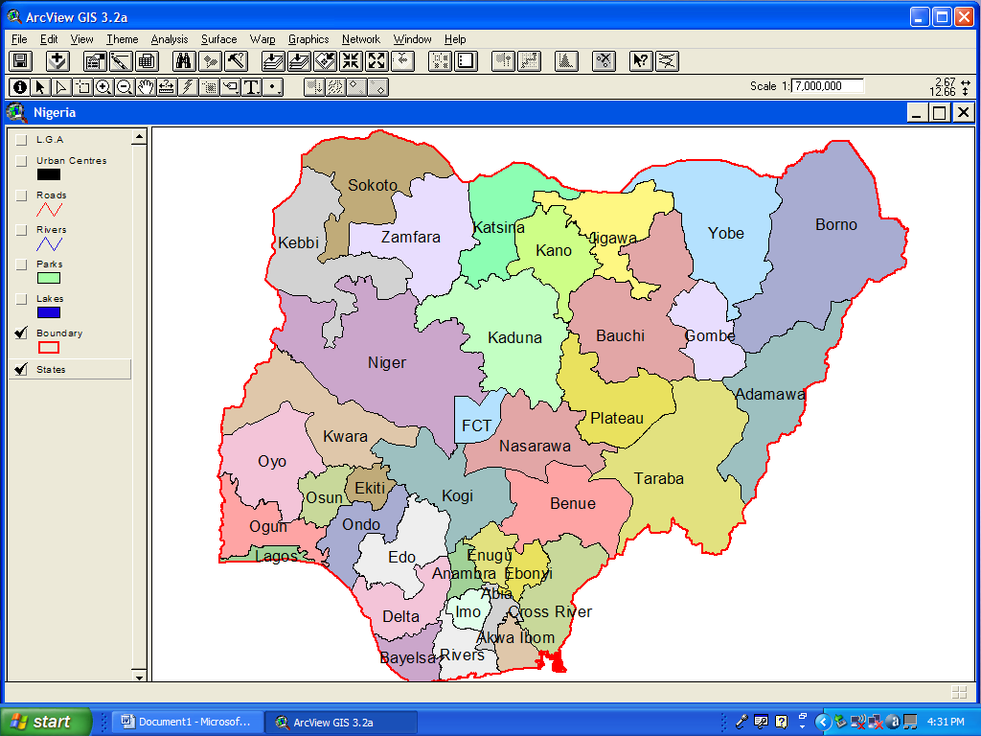
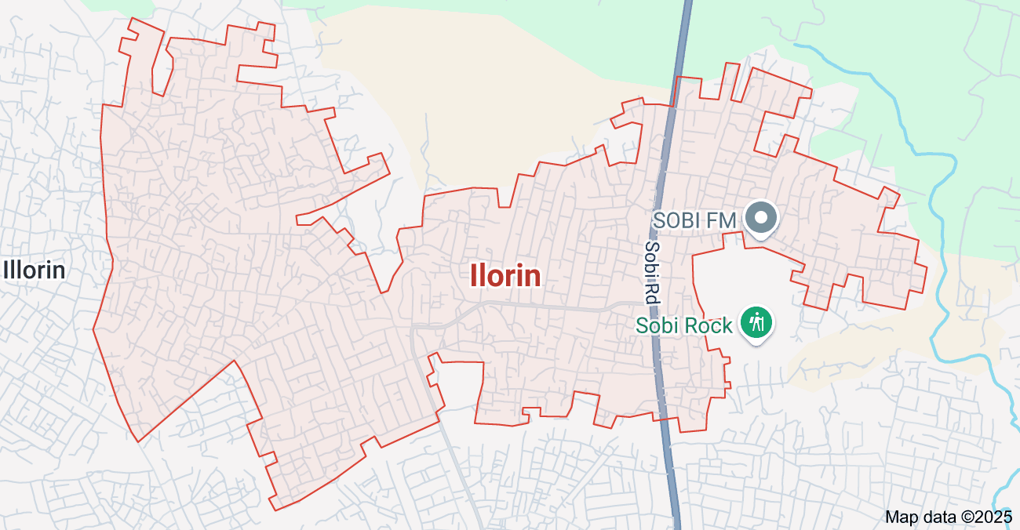

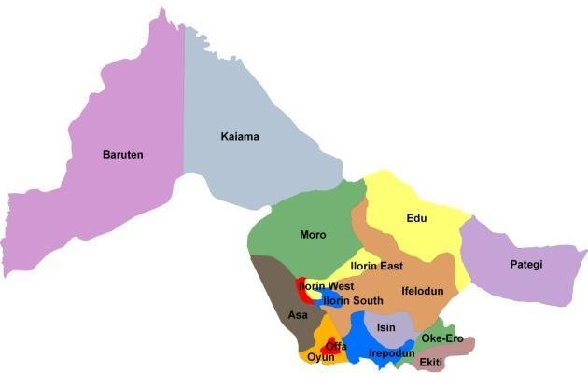
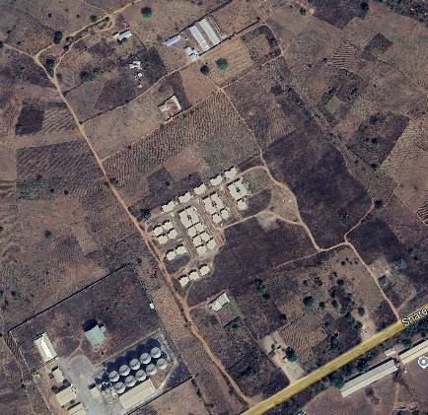

ILORIN

URBAN ESTATE

1.7 SPECIFICATIONS
The project speciation’s were referenced to the speciation for land information system using total station which was sources from the Higher National Diploma. The specification includes the following:
- Total station
- Minimum number of datum control required- three (3)
- Traverse should run between secondary or higher order control point.

CHAPTER TWO

2.0 LITERATURE REVIEW

2.1 Introduction
A Land Information System (LIS) is a tool for legal, administrative, and economic decision-making and an aid for planning and development. It consists of spatially referenced land-related data for a defined area and procedures and techniques for the systematic collection, updating, processing, and distribution of the data. This chapter presents a review of literature on LIS, exploring its conceptual framework, components, development, applications, benefits, challenges, and recent advancements. Various scholarly contributions have been examined to provide a comprehensive understanding of the subject.

2.2 Concept of Land Information System (LIS)
The concept of LIS has evolved over the years from basic land record-keeping to a sophisticated digital and geospatial system. According to Dale and McLaughlin (1988), a Land Information System is defined as “a system for acquiring, processing, storing and distributing information about land.” LIS integrates data on land ownership, land use, land value, and land development to support land administration and management.
Williamson et al. (2010) emphasized that LIS is a subset of a broader Geographic Information System (GIS), specifically focused on land-related data. It provides tools and functionalities for spatial analysis, cadastral mapping, and land registry.
Recent definitions by Enemark (2018) highlight LIS as a foundational element in land administration systems that support sustainable development, good governance, and poverty alleviation.

2.3 Historical Development of Land Information Systems
The development of LIS can be traced to the early 1960s and 70s when governments began to recognize the limitations of paper-based land records. In Canada and Australia, pioneering efforts in automating land records laid the groundwork for modern LIS (Dale & McLaughlin, 1988).
In the 1980s and 1990s, technological advancements in GIS, remote sensing, and database management systems contributed significantly to the evolution of LIS (Maguire et al., 1991). The shift from analogue to digital systems led to increased efficiency, accuracy, and accessibility of land information.
By the 2000s, international organizations such as the World Bank and UN-Habitat began promoting LIS as part of land reform and sustainable development programs in developing countries (Deininger et al., 2008).

2.4 Components of a Land Information System
According to Onsrud (1991), the main components of LIS include:
- Spatial Data Infrastructure (SDI): Base maps, cadastral maps, and land parcels.
- Attribute Data: Ownership details, land use, land value, zoning, etc.
- Database Management System (DBMS): Manages the storage, retrieval, and manipulation of spatial and attribute data.
- User Interface and Tools: Applications for query, analysis, editing, and reporting.
- Hardware and Software: Computers, GPS, servers, GIS software like ArcGIS, QGIS.
Rajabifard et al. (2002) further added institutional and legal frameworks as critical components to ensure effective LIS implementation, particularly in developing countries.

2.5 Applications of Land Information Systems
Land Information Systems are used in various domains. Some of the key applications include:
- Cadastral Mapping and Land Registration: LIS aids in maintaining accurate and up-to-date cadastral data (Williamson et al., 2010).
- Urban Planning and Development Control: LIS supports land use planning, zoning enforcement, and urban infrastructure management (Zevenbergen et al., 2013).
- Taxation and Valuation: Accurate land value data improves property taxation and revenue generation (Deininger et al., 2008).
- Environmental Management: LIS helps in monitoring land degradation, deforestation, and land cover changes (Longley et al., 2005).
- Disaster Management: Used for risk assessment, hazard mapping, and post-disaster recovery (van Westen et al., 2002).

2.6 Benefits of Land Information Systems
Several scholars have documented the benefits of LIS, including:
- Improved Land Governance: LIS fosters transparency, reduces land disputes, and enhances tenure security (Enemark et al., 2005).
- Efficient Public Administration: Automation of land records reduces processing time and improves service delivery (Dale & McLaughlin, 1999).
- Economic Development: Facilitates investment by providing reliable land data to stakeholders (Zevenbergen et al., 2013).
- Data Integration and Sharing: Enhances collaboration between government agencies through a unified land database (Williamson et al., 2010).

2.7 Challenges in Implementing Land Information Systems
Despite its advantages, LIS implementation faces several challenges:
- High Initial Cost: Development of LIS requires significant financial investment in infrastructure and capacity building (Onsrud, 1991).
- Technical Expertise: Lack of skilled personnel to manage and maintain the system is common in developing countries (Rajabifard et al., 2002)
- Data Inaccuracy and Incompleteness: Poor data quality undermines system reliability and trust (Maguire et al., 1991).
- Institutional Barriers: Resistance to change, poor inter-agency collaboration, and weak legal frameworks hinder LIS success (Enemark, 2018).

2.8 Emerging Trends and Future Directions
Recent developments in digital technology have introduced new dimensions to LIS:
- Cloud-Based LIS: Offers scalability, real-time data access, and cost-effectiveness (Saitta et al., 2020).
- Integration with Internet of Things (IoT): Enhances real-time data collection on land use and environmental factors (Zhou et al., 2021).
- Mobile GIS: Field data collection and citizen participation through mobile apps are improving data accuracy (Konecny, 2020).
- Blockchain for Land Registration: Provides secure, immutable records and reduces fraud (Lemmen et al., 2019).
- AI and Machine Learning: For automated land use classification, predictive modeling, and decision support (Li et al., 2022).

2.9 The Nigerian Context of Land Information System
In Nigeria, efforts to digitize land information began in the late 2000s. States like Lagos, Kaduna, and Kwara have initiated various forms of LIS projects (Akingbade et al., 2012). The Kwara State Geographic Information System (KWAGIS) is an example aimed at modernizing land records and improving revenue.
However, LIS adoption in Nigeria still faces challenges such as poor funding, inadequate policy support, limited public awareness, and technical skill gaps (Ajayi&Olayanju, 2019

CHAPTER THREE

3.0 METHODOLOGY
This stage involves the methods and procedure used in planning, data acquisition, data processing, and creation of database, creation of database management system and information presentation. These operations were logically structured and carried out in stages involving database design. It is normally considered to involve a spatially referenced and structured digital database and appropriate application software for geospatial analysis. This basically describes the techniques and principles adopted in carrying out the project.
Geographic information system methods were adopted in accomplishing the desired results.

3.1 DATABASEDESIGN
The design of any database involves three stages namely;
i Conceptual design
ii Logical design
iii Physical design

3.1.1 VIEW OF REALITY

In database design, there is need for reality which is referred to as the phenomenon that actually exists, including all aspects which may or may not be perceived by individuals. The view of reality however, is the mental abstraction of the reality for a particular application or group of applications.
For this application, the view of reality is made of the topography of the project. Since it is not possible to represent the real world, the only option is to conceptualize and model it in a specified manner to represent the real world. The area of interest to using this project

Includes;GreenReserve,Roads,Electricpoles,Trees,WaterFacilities,Buildings,Footballpitch,Streams.

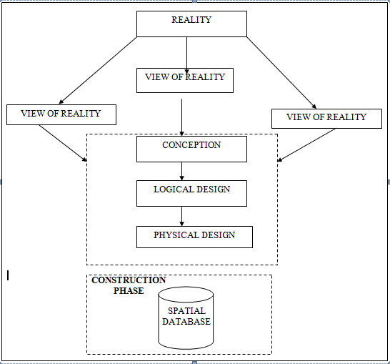
Fig.3.1Design and Construction Phases in Spatial Database

3.1.2 CONCEPTUALDESIGN
Vector data mode list the data type adopted for this project, which is represented, by points, lines and polygon. The identified entities are:-
      - Vegetation area (polygon)

      - Roads(line)

      - Trees(point)

      - Boundary line (polygon)

      - Buildings(polygon)
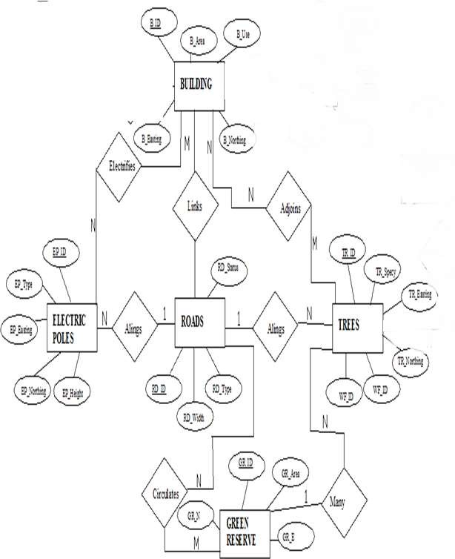

Fig.3.2.:E-RDiagram(Entityrelationship diagram)

3.1.3 LOGICALDESIGN

This is the design aspect of the database refers to the process of creating a conceptual framework or model that represents the structure and organization of spatial data within the system. It involves defining the data element, their relationship, and therules for data manipulation and analysis. In this phase, the entities, their attributes and their relationships are represented in a single uniform manner in form of relation in such a way that would be no information loss and at the same time no unnecessary duplication of data. In this study, the logical database design is employed to generate a geo-relation database structure. Each entity has unique identifier in bold type. An attribute type or combination of attribute types that serves to identify an entity typeis termed an identifier.
- Building (B_ID,B_Area, B_Name,B_Easting,B_Northing)

- Roads (R_ID,R_Width,R_Type,R-Condition,R_Easting,R_Northing)

- Vegetation (V_ID,GR_Area,)

- Tree (TR_ID,TR_spp,TR_Importance,TR_Easting,TR_Northing)

- Electric Pole (EP_No,EP_Type,EP_Height,EP_Easting,EP_Northing)

- Water Facility (WF_ID,WF_Depth,WF_Type,WF_Easting,WF_Northing)

- Football Pitch(FP_ID,FP_Area,FP_Status)

- Stream (S_ID,Length,Width)

3.1.4 PHYSICALDESIGN

Table3.1: Building and its attribute
ENTITY | DESCRIPTION
B_ID | Building Identification
B_name | Building Name
B_Area | Building Area
B_Easting | Building Easting
B_Northing | Building Nothings

Table3.2:Road an ditsattributes
ENTITY | DESCRIPTION
R_ID | RoadIdentifier
R_Length | RoadLength
R_Width | Road Width
R_Type | RoadType
R_Condition | RoadCondition

Table3.3: Trees and its attributes
ENTITY | DESCRIPTION
TR_ID | Tree Identifier
TR_Spp | Tree specy
TR_E | Tree_ Easting
TR_N | Tree Northing

Table3.4. Vegetation and its Attributes
ENTITY | DESCRIPTION
V_ID | Vegetation Identifier
V_Area | Vegetation Area
V_E | Vegetation Easting
V_N | Vegetation Northing

3.2 RECONNAISSANCE
This is the preparatory stage before the execution of this project; it involves collection of available information about the project area.
The necessary step taken for the successful execution of the project involves two stages, which are:-
- Office Planning
- Field reconnaissance

3.2.1 OFFICEPLANNING
This involves the collection of information about the study area, testing the instrument to be used in execution of the project and itemizing the numbers of equipment needed, number of days to be use, how each activity is to be carried out, delegation of works to each team members based on supervisor’s guide/instructions.

Table.3.5CoordinatesofControls
Station | Northing(m) | Easting(m) | Height(m)
KPT 120X | 945235.040 | 682280.278 | 211.976
KWCS102 | 945738.095 | 683583.702 | 201.532
SC/KWEAS5072 | 945974.041 | 684070.314 | 200.087

Source: office of surveyor general kwara state

3.2.2 FIELDRECONNAISSANCE
The field reconnaissance is the first visitation to the project site to get intimated with the environment.
- Boundary points was selected

- The distribution of features was studied

- Controls to be used were located

- Method and type of instrument to be uses was determined

- Subsidiary point for Ground control Points were picked and define using nail and bottle cock
- A diagram of the study area was drawn.

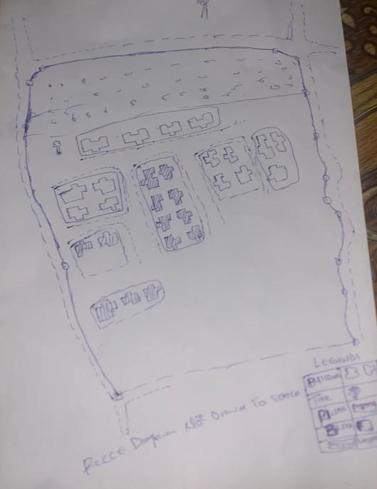

Fig.3.3: Recce diagram of the study area (not drawn to scale)

3.3 EQUIPMENTUSED/SYSTEMSELECTIONANDSOFTWARE

3.3.1 HARDWAREUSED

- Total station

- 1reflectorwith a tracking rod.

- 1Tripod

- One(1)50m tape

- One(1)umbrella

- 1cutlass

- Handheld GPS

- Hammer

- Nails and bottle cover

- Field book and writing materials

- 1-NoofPersonalComputerHP655 and its accessories

- 1-NoofHP DeskJetK7100 A3 printer

- 1-NoofHPDeskJet 1110 A4printer

3.3.2 SOFTWARECOMPONENT

- Notepad.

- Microsoft Excel.

- AutoCAD2007

- ArcGIS10.2

- Microsoft Word.

3.4 INSTRUMENTTEST
To ensure data quality, the Total Station used for this project was tested for both vertical index and horizontal collimation errors .It was also to ascertain the efficiency and reliability of the instrument. The procedure used is described below.

3.4.1 HORIZONTALCOLLIMATIONTEST

This test was conducted to ensure that the line of sight was perpendicular to the trunnion axis. The Total Station was positioned over a specific point, and initial adjustments were made to ensure proper alignment, leveling, and focus (to eliminate parallax in the telescope). A vertical target was placed at a distance of 100 meters from the Total Station. To access the configuration menu of the Total Station, the menu key was pressed and held for approximately 2 seconds. From the main menu, the calibration sub-menu was selected, and within that, the horizontal collimation test option was chosen. The target was then observed and divided into two halves, with horizontal readings recorded for Face left and Face right. The readings are shown in Table 3.4.1 below.
Total Station
100m
REFLECTOR(TARGET)

STATIONA
Fairly Level Ground

STATIONB

Fig3.4; Horizontal Collimation and Vertical Index error test.

Table3.6: Horizontal Collimation Data
Station | Target | Face | Hz Reading | Difference | Error
A | B | L | 38˚42‟32”
 |  | R | 218˚42‟35” | 180˚00‟03” | 03”
Source field work

3.4.2 VERTICALINDEXERRORTEST
This test was conducted to verify the accuracy of the vertical reading when the line of sight is horizontal. The desired measurement for this test is exactly ninety degrees (90˚), any deviation from this value is referred to as the vertical index error.

The Total Station was positioned over a specific point, and necessary temporary adjustments were made to ensure proper alignment and functionality. A target was placed approximately100 meters away from the Total Station, and the instrument was aimed at the target .The target was bisected by aligning the instrument on the face left, and the corresponding reading was recorded. Similarly, the target was then bisected on the face right, and the respective reading was also recorded. The recorded readings are provided below:

Table3.7: Vertical Index Data
Instrument Station | Target Station | Face | Vertical | Sum | Error
A | B | L | 90˚00‟00”
 |  | R | 270˚00‟02” | 360˚00‟02” | 02”
Source field work

3.4.3 ANALYSISOFCOLLIMATIONANDVERTICALINDEXDATA
The reading obtain during calibration were reduced to obtain new collimation and vertical errors.
Horizontal collimation={(FR–FL)–180}/2={(00˚00‟03”}/2=1.5”

Verticalcollimation={(FL+FR)–360}=(90˚00‟00”+270˚00‟02”)-360}=02”Theresult shows that the instrument is still in good working condition.

3.5 CONTROLCHECK
Three control beacons (KPT 120X, KWCS102 and SC/KWEAS5072) were used.In order to ascertain the in-situ of the control beacons, a check was carried out on them by observing the angle between them and comparing the result obtained with the computed angles from the giving coordinates.
The total station instrument was set on the control beacon KWCS102. After performing all the necessary temporary adjustment, the reflector was placed on the control beacon KPT 120X which served as the back station. The horizontal angular reading was taken and recorded while the instrument was on face left. The reflector was then taken to the control beacon SC/KWEAS5072 which serves as the forward station, the horizontal angle reading was then taken and recorded on both face left and face right. The reflector was taken back to the back station, the horizontal angle was then recorded on face right.

Table3.8: Table showing the back computation of the control coordinates
From STN | Bearing | Dist(m) | ∆N | ∆E | Northing(m) | Easting(m) | ToSTN
 |  |  |  |  | 945235.040 | 682280.278 | KPT 120X
KPT 120X | 68°53'46'' | 1397.130 | 503.050 | 1303.424 | 945738.095 | 683583.702 | KWCS102
KWCS102 | 64°07'57'' | 540.797 | 235.946 | 486.612 | 945974.041 | 684070.314 | SC/KWEAS5072
Source: office of surveyor general kwara state

Table3.9: Table showing the distance observation result of the control check
FROM | OBSERVED  DISTANCE  (m) | COMPUTED  DISTANCE  (m) | TO
KPT 120X | 1397.029 | 1397.130 | KWCS102
KWCS102 | 540.694 | 540.797 | SC/KWEAS5072

Table3.10: Table showing the observation result of the control check
STN | SIGHT | FACE | OBSERVEDHZANGLE | REDUCED HZANGLE | MEAN
 | KPT 120X | L1 | 357° 08'47''
KWCS102 | KPT 120X | L2 | 288° 14'07'' | 68° 54'40''
 | SC/KWEAS5072 | R2 | 108° 52'13'' | 68° 54'46''
 | SC/KWEAS5072 | R1 | 177° 46'59'' |  | 68° 54' 43''

Difference in angle (observed -computed)=68°54'43''-68°54'40''

=00° 00'03''

Since the allowable accuracy (angular) of third order traverse of one station is 00° 00' 30'' and the result obtained from the control check (00°00'03'') is less than allow able error. Therefore, the controls were angularly intact.

3.6 MONUMENTATION

The boundary of the area carved out was demarcated with the precast concrete beacons, after clearing the required line of sights. The identified points of changes in directions were dug and beacons were buried on it, leaving about 15cm part of the beacon above the ground level. The beacons were buried at convenient distances as dictated by the nature of the boundary.
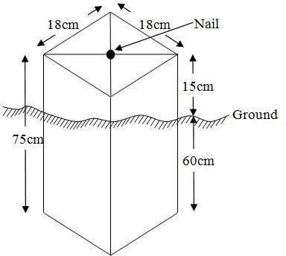

Fig.3.5: Pillar Description

DATAACQUISITION
It’s fundamental to digital mapping. Data acquisition here implies security coordinate data of map features in a computer compatible from there exist several topographical data collection techniques the choice of a particular technique depends on the source of data available hardware / software, envisage revel of accuracy, man power etc. apart from field and laboratory data acquisition data may be obtained from social survey, in this project, data acquisition it refers the ways and method through which the data used were obtained. There was divided in to two viz; geometric data and attribute data

PRIMARYDATASOURCE

Field observation was the primary source of data for this project. Ground based method was used in acquiring data with the use of Total Station Instrument, which involved the collection of X, Y, Z data through coordinated Ground control Points (GCP) established at conspicuous points within the study area

SECONDARYDATASOURCE

An imagery of the area was acquired through UpdatedGoogleearth; this was used to ascertain the extent of coverage of the project area.

3.7.1 GEOMETRICDATAACQUISITION

The total station instrument was set carefully on control point; KWCS102 back sight taken to KPT 120X after necessary station adjustments has been carried out on it. The adjustments include; centering, leveling and focusing. The following procedures were then followed to determine the position of the next point SC/KWEAS5072 and the same procedure were repeated until all we come close to the site. The method used in acquiring data on site was radiation method where two or more points are coordinated from one point.

- Having setup the instrument and temporary adjustment carried out,the instrument was powered „on‟ and a job was created under job menu in the internal memory of the instrument. The job created was named GRP5B
- On the job, the coordinates of the three (3) control points were keyed in to the memory of the instrument and some codes were also saved. The codes include
„RD‟forroad,„SP‟forspotheight,„BD for buildings ,etc.

- The height of the instrument was measured and saved on the memory of the instrument as well as the reflector height.
- On coordinate menu, orientation was set by inputting the coordinates of the instrument station and back sight. The reflector at the back station was perfectlybisectedbeforetheorientationwasconfirmedbyclicking„yes‟.
Having done the orientation, the reflector at the next nail; was bisected and „obs‟(observe)optionwasclicked.ThethreedimensionalcoordinateofthepointN, H) were displayed on the display unit of the instrument and „rec‟ (record) was clicked to save the detain to the memory of the instrument. For subsequent to observation after this, “all‟ option was used instead of pressing „obs‟ and pressing
„ Record‟ later.

- It was ensured that the center of the prism of the reflector was bisected and that itwassetperfectlyonthetripodinordertominimizetheerroronheightdetermination.
- The instrument is been shifted to another nail after all details, spot height and boundary point visible from the instrument station have been picked, set over it and temporary adjustments carried out.
Nonetheless, the above operations were repeated until all the boundary points with heights were coordinated.
In this project all spot height are not in grid intervals but randomly acquired. Three edges (3) of building were picked. At the end of data acquisition process all details were acquired and properly recorded to be shown in their respective positions on the plan.

3.7.2 TTRIBUTESDATAACQUISITION

Attributedataisinformationaboutspatialfeatures.Theyprovidethecharacteristics,description and nomenclature about spatial objects. Thus the attributes data acquired includes names of buildings and their uses such as classrooms, roads, water facilities and prominent natural features likes river and trees found and vegetation were properly identified within and around the study area.

3.8 DATADOWNLOADINGANDPROCESSING

3.8.1 DATADOWNLOADINGANDEDITING
This is stage whereby all data acquired which were automatically stored in the Total Station were downloaded into personal computer. This was done with the aid of downloading cable connected to the computer and some associated complementing software installed on the System.

3.8.2 DATAPROCESSINGANDDATAEDITING
The geometric data downloaded were further processed in order to convert it to auseful format and to enhance its accuracy. The output coordinates, were edited and exportedin *.txt, *.xls and *.pdf format. Thereafter, they were imported into Arc GIS 10.3 for further operations and to carryout spatial analysis.

3.8.3 DATA PROCESSING IN AUTOCAD
The AutoCAD is tool that can be used for design and drawings, the software was built to general drawing standard hence the difficulty that comes with localizing this standard to various discipline.
Plotting in AutoCAD can be achieved using coordinate geometry (COGO)by either running script file (.scr) or using the command line (i.e. inputting the values using keyboard). In this project plotting was achieved by using command line in AutoCAD environment. The layout plan was produced as shown in figure below.
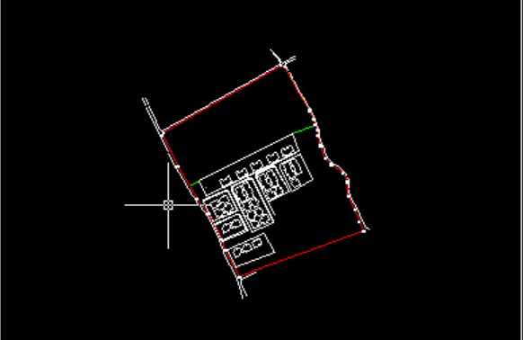

Figure 3.6 shows the layout plan in AutoCAD
Exporting to Arc View, cad file can be exported to GIs software environmental for final cartographic production. This requires that the graphic data can be in a standard exchange format. A standard graphic data exchange format AutoCAD dxf (data exchange format).

3.8.4 DATAPROCESSINGUSINGARCGIS10.3 SOFTWARE
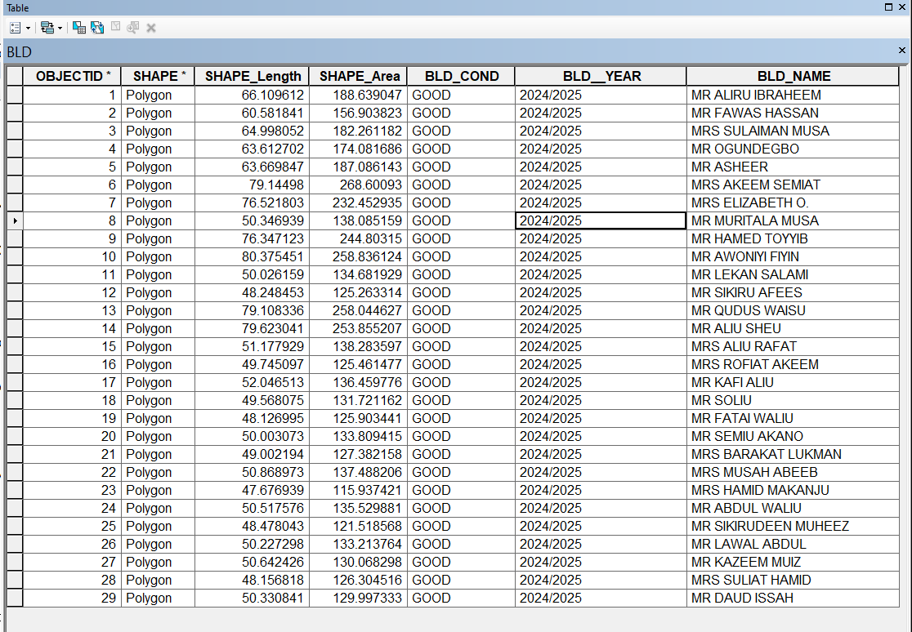
Is one of the contemporary software that is easy and facilitate geographic system operation design, map production, analysis and result computation possibility in any spatial project. Arc View was launched by double clicking on the desktop shortcut icon. See the attribute table in table 3.1

Figure 3.7 shows the attribute table

It demonstrates capability of carrying out a wide range of spatial analysis that may required in land administration. The land information system (LIS) was robust enoughto produce (spatial and non spatial). It was subjected to as show in figure 2 below;

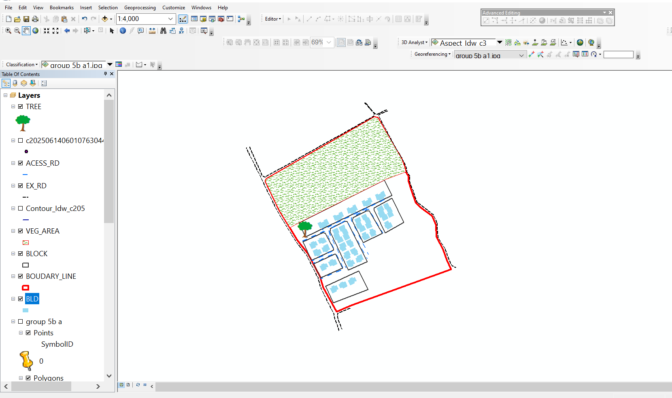

Figure 3.8 shows lay out view in Arc View windows

3.9 DATABASEIMPLEMENTATION

This is the database creation phase. Having completed the three stages of design phase (i.e .Reality, Conceptual and Logical design), the database was created using ArcGIS10.2 software. It involves the combination and storage of acquired graphic data and attributes detain creating the database for the purpose of spatial analysis and query.
Database is an organized integrated collection of data stored so as to be capable of use by revenant application with data being accessed by different logical part. After the Attribute table was populated via the keyboard, some attributes such as areas of settlements wereautomaticallydisplayedbyspecialcommandintheArcGIS10.3version.TheArcGISsoftwarewas used to link the graphic data and table for query generation.

3.9.1 DATABASEMANAGEMENTSYSTEMS

Database management is a collection of software for creating, storing, manipulating, updating, organizing and querying of information in a database (Kufoniyi, 1998). It is a soft ware package whose function is to manipulate a database on behalf of the user.
A good DBMS must provide the following functions:

- Storage and retrieval of data.
- Access to by several users at a time.
- A standardized interface between database and application programmed.
- Standardized access to data and separation of data storage and retrieval functions from the program using the data.
- Maintenance of data security and integrity.

3.9.2 DATABASEMAINTENANCE
Having created the database, proper maintenance practice was made to meet its stated objectives. The ability to include more data and remove irrelevant data was possible by way of maintenance. There is every need for the data to be updated regularly because of the physical changes that may occur on the landscape with time. Both security and integrity were also exercised to ensure maintenance and to meet its stated objectives.
Proper observance, updating and management of database ensure its currency and quality to stand a profound chance in Spatial Decision Support System (SDSS). The quality of any database depends on the currency and fitness for use as a decision support system (SDSS).The quality of database depends on its ability to generally fit and use as a decision system(DSS). The storage media should be from time to time justified if otherwise could necessitate data inaccessibility or physical deterioration of the storage media. Also care must be taken during populating any database system, as a database is only good as the data supplied. In archiving stable media should be used. Examples of these are
- Computer compatible tape reader

- Magnetic tape

- Optical disc and compact disc

3.9.3 BACK COMPUTATION Table 3.11: Back Computation

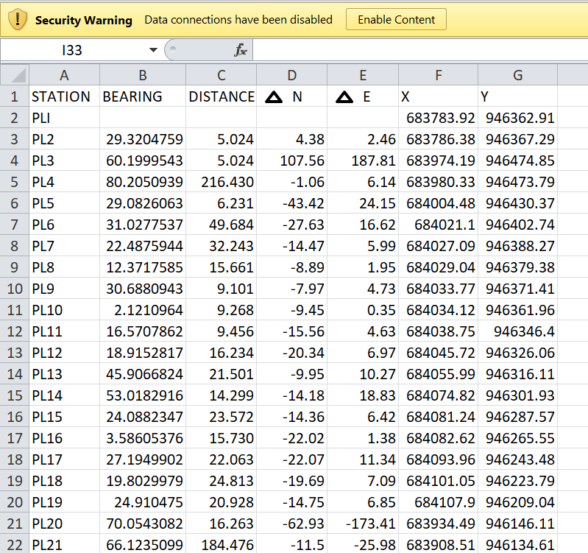

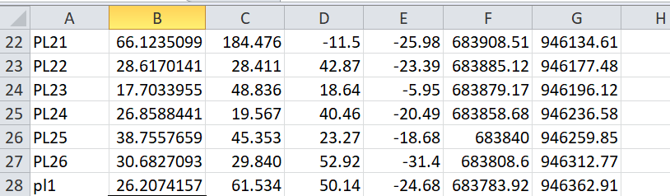

3.9.4 AREA COMPUTATION

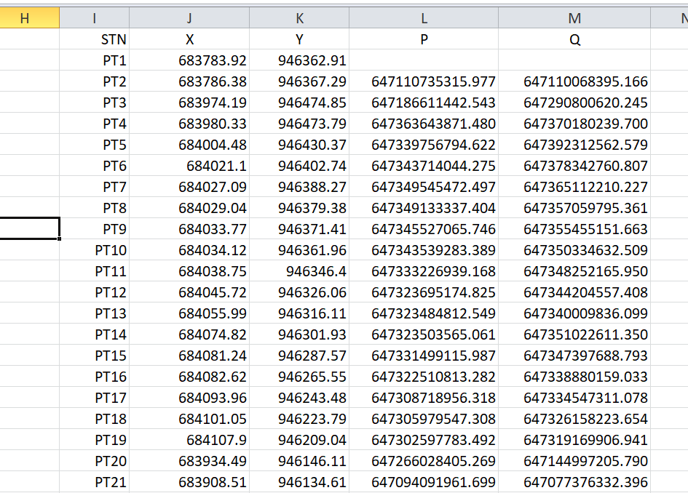
Table3.12:Area Computation

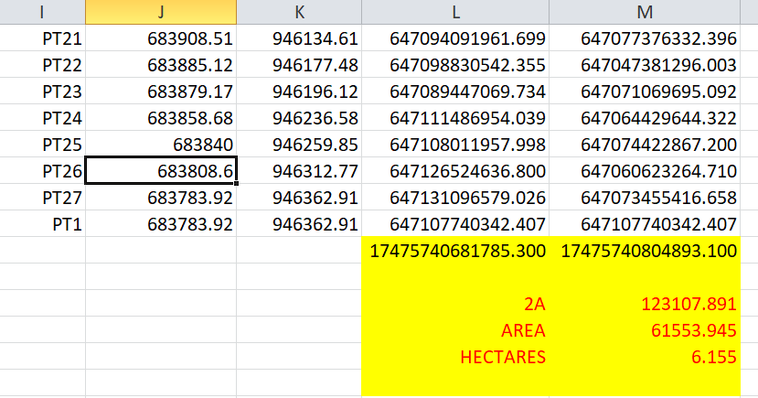

CHAPTER FOUR

4.0 SPATIALANALYSESANDPRESENTATION

GIS is distinct among other information system because of its spatial analytical capability;especiallyoverlayoperation,buffering,spatialsearch,topographicoperation,andneighborhoodandconnectivityoperations.GISusesthisspatialanalyticalcapabilitytoanswerfundamentalgenericquestionoflocation,condition,trend,routing,patternandmodeling by the manipulation and analysis of input data. The major analyses performed in this project were overlay operations, topographic operations and spatial search.

4.1 TESTINGOF DATABASE

This is the test carried out to determine whether there exists a relationship between datamodeledaboutentitiesinaspatialdatabaseaswellasputtingintotestitsretrievalcapabilities. This was done by designing a sample query with certain conditions attached and the query will began to see if desired result is achieved.
Analysis of Result
Data captured were full to ensure standardization of task. Coordinated point were used in order to produce information required (LIS) and lastly to decision making and produce the output in digital form, while the attribute presented in tabular form. In most GIS operation package including arc view these include measurement techniques, query analysis and geometric operation in this project include questions such as:-
- Residential land use
- Vegetation area
- Developed area
- Slope aspect
- Building that does not have C of O
- Building that have C of O
- Building that have R of O
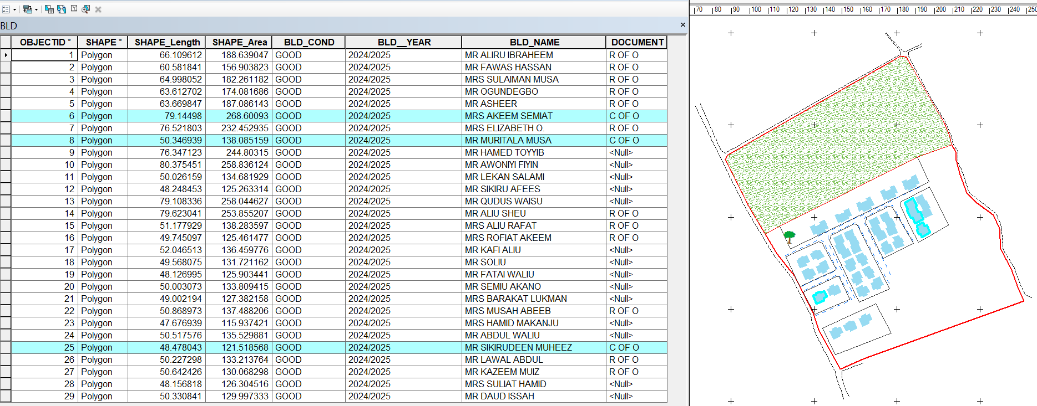
The above listed queries are shown in blue

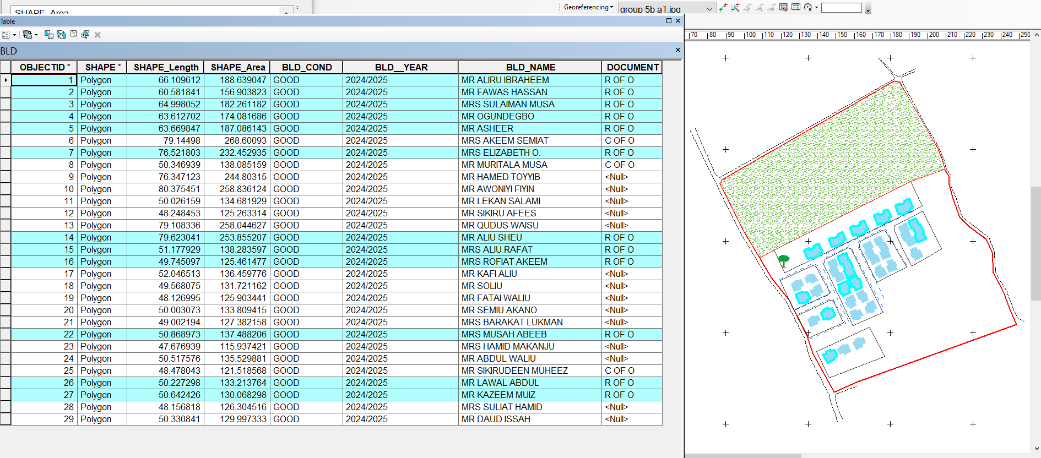
Fig4.1.:shows the building that have C of O

Fig4.2:shows the building that have R of O
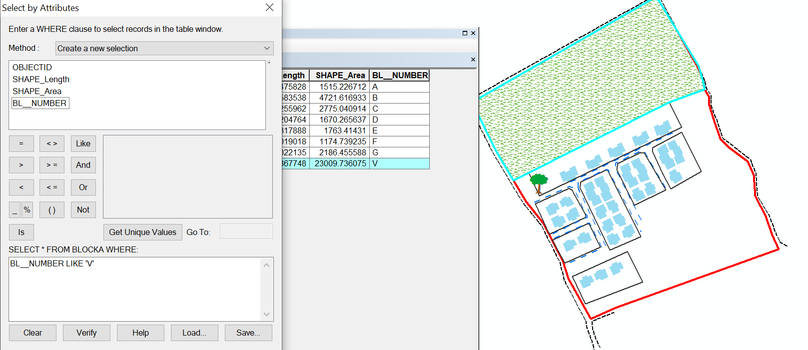

Fig 4.3: show the area use for vegetation

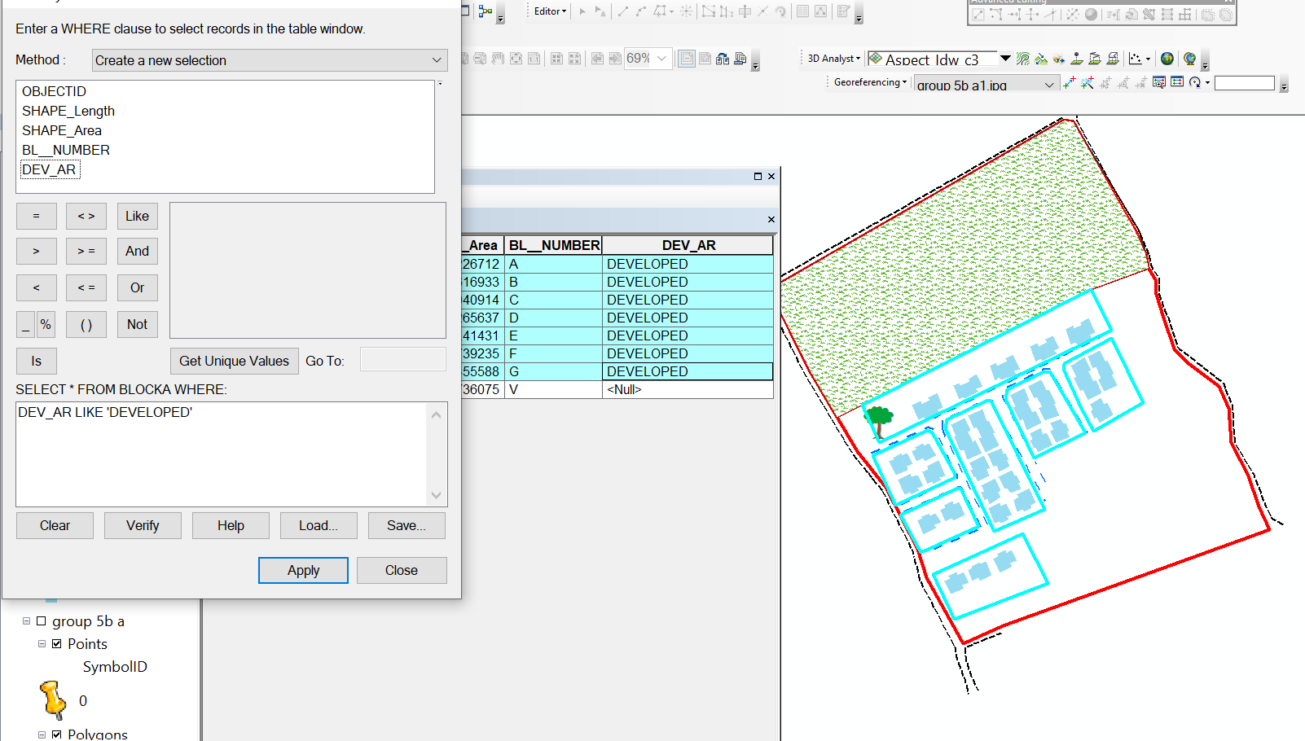

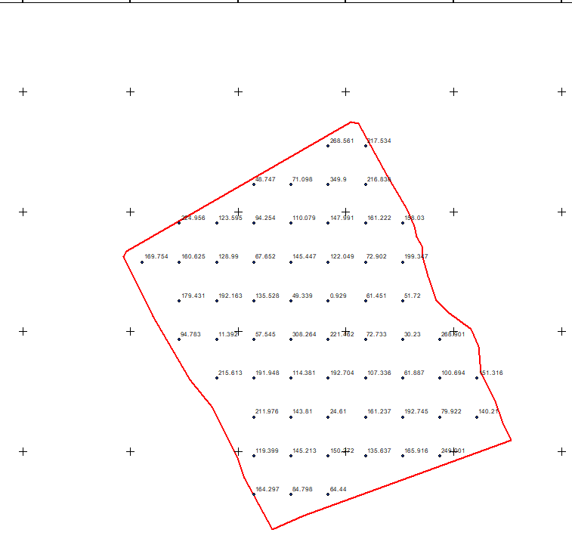
Fig 4.4: show the developed area

Figure 4.5 shows the spot height
This is the compass direction of that a slope faces and it plays a significant role in environmental and land management decision

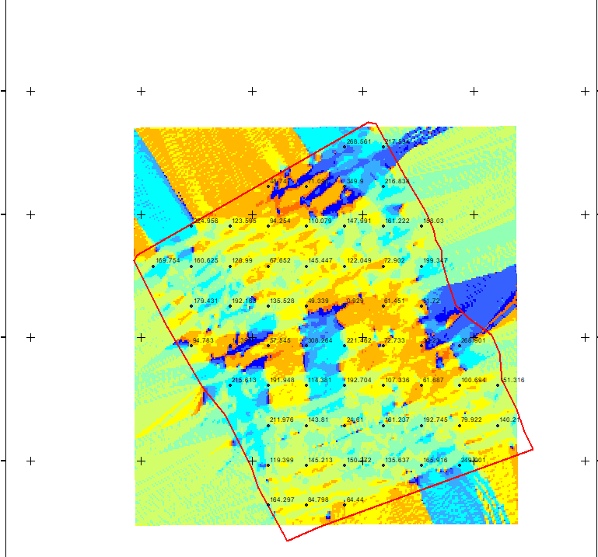

Figure 4.6 shows the slope aspect

The total number of building in the lay out are29 all of them are residential and vegetation area is 1, the table 4.1 below shows the land use percentage

Table 4.1 shows the land use percentage
Residential | 0.475266 percent
Vegetationarea | 2.292255 percent

Figure 4.7 shows the pie chart of land use

CHAPTER FIVE

SUMMARY, CONCLUSION AND RECOMMENDATIONS

5.1 Summary
This research focused on the development and implementation of a Land Information System (LIS) for the Urban Estate located opposite the Government Cemetery Area along OkeOyi Road, Ilorin East Local Government Area, Kwara State. The study aimed to capture, analyze, store, and present spatial and attribute data relating to land parcels within the estate to aid effective land administration, planning, and decision-making.
Chapter One introduced the background of the study, problem statement, objectives, significance, and scope. It highlighted the challenges associated with traditional land management systems such as data redundancy, slow retrieval of land records, and lack of transparency in land ownership and usage.
Chapter Two reviewed existing literature on LIS, its components, development history, applications, benefits, and challenges globally and within the Nigerian context. Several authors and studies were consulted to establish a theoretical foundation for the research.
In Chapter Three, the methodology used for the project was explained. This included field data collection using GNSS receivers for spatial data acquisition and administrative records for attribute data. The acquired data were processed using GIS software (e.g., ArcGIS) to generate parcel maps, ownership databases, and land use patterns.
Chapter Four presented and analyzed the results. A digital cadastral map of the study area was produced, and relevant information such as parcel ID, land use type, and ownership details were integrated into a spatial database. This resulted in a functional LIS capable of supporting land inventory, querying, and spatial analysis.
The developed system provides a comprehensive digital representation of the land parcels within the estate, showing their geometry and related attribute information. It is suitable for applications in land tenure administration, infrastructure planning, and monitoring of land development activities.

5.2 Conclusion
The research has successfully demonstrated the significance and applicability of a Land Information System in improving land management practices in urban areas. The LIS developed for the Urban Estate opposite the Government Cemetery area in Ilorin provides a digital platform that ensures accurate, reliable, and up-to-date information about land parcels.
Through this project, it has become clear that LIS:
- Enhances transparency and accountability in land dealings.
- Reduces duplication and inconsistencies in land records.
- Improves planning and decision-making by providing spatially enabled data.
- Supports quick retrieval and analysis of land information.
In the context of Ilorin and similar urbanizing areas, implementing such systems is vital for achieving sustainable land use, effective urban development, and improved revenue generation through land taxation.

5.3 Recommendations
Based on the findings and experiences from this study, the following recommendations are made
- Adoption of LIS by Local and State Governments:
The Kwara State Government should invest in the development and integration of LIS across all its urban and peri-urban estates. This will enhance the state’s land administration capacity and facilitate e-governance.
- Capacity Building and Training:
Training programs should be organized for land officers, surveyors, town planners, and GIS analysts to equip them with the technical skills required to manage and maintain LIS platforms.
- Digitization of Land Records:
Existing analogue land records in Kwara State should be systematically digitized and integrated into centralized LIS databases to improve data accessibility and reduce manipultaxation

- Legislative and Policy Support:
Policies and laws guiding land administration should be updated to include the use of LIS and ensure legal backing for digital land records and transactions.
- Public Awareness and Stakeholder Engagement:
Public enlightenment campaigns should be conducted to inform landowners and stakeholders about the benefits of LIS and how to engage with the system.
- Regular Updating and Maintenance:
The LIS should be regularly updated to reflect changes in land ownership, land use, and property development. This ensures the data remains current and useful for long-term planning.
- Integration with Other Urban Systems:
The LIS should be integrated with other systems such as building permit systems, environmental monitoring, and taxation platforms to form a comprehensive Urban Information System (UIS).

5.4 Limitations of the Study
While the project achieved its objectives, certain limitations were encountered:
- Limited access to historical land records and documentation slowed the data compilation process
- Financial and logistical constraints limited the scope of field data acquisition.
- Lack of high-resolution satellite imagery restricted certain spatial analyses.
These limitations should be addressed in future research and system upgrades to enhance the system’s efficiency and coverage.
5.5 Suggestions for Further Research
To build upon this study, the following areas are suggested for future research:
- Integration of Remote Sensing Techniques: Use of satellite imagery to monitor land cover change and detect encroachments.
- Blockchain Application in Land Registry: Ensuring secure and tamper-proof digital land titles.
- Mobile-based LIS Applications: Development of mobile platforms to improve data collection and public access to land information.
- Multi-temporal Analysis: Assessing land use changes over time to guide sustainable development.

REFERENCE
Akingbade, A. (2005): Improvement of availability of land registration and cadastral information Ondo State, Nigeria: In department of urban and regional planning and geo-information management, international institute for geo-science and earth observation (ITC.),137.Enschede:ITC.
Dale, P.,& McLaughlin, J. (1999). Land administration. Oxford, Oxford University Press: U
ObayomiAbiola Benjamin: The Need for Computerization of Land Information Systems in ……..Nigeria
Pindiga&Orisakwe, 2013. (2013). Development of a Land Information System of Tumpure Residential and Commercial Layout in Akko Local Government Area of Gombe State.
Musa, B., Umaru, W., Polytechnic, F., & State, K. (2016). Developing a Cadastral Information System for Proper Land Administration in TudunSalmanu Area of Bauchi Metropolis , Bauchi State , Nigeria. 10(1), 76–86.
Usman, B., &Sc, M. (2013). Cadastral Information System for Title Management in Nigeria . Cadastral Information System for Title Management in Nigeria .December.
Williamson, I. P. (n.d.). The Role of Land and Geographic Information Systems In Economic and Environmental Management. [7] Yusuf Y. D (2009). Property Law Practice in Nigeria. Nigeria: Jos University Press Limited.
Siriba, D. N., &Dalyot, S. (2017). Adoption of Volunteered Geographic Information into the Formal Land Administration System in Kenya. Land Use Policy, 63, 279–287.
Zeng, Z., & Cleon, C. B. (2018). Factors Affecting the Adoption of a Land Information System: An Empirical Analysis in Liberia. Land Use Policy, 73, 353–362.

