

A PROJECT REPORT
ON
TOPOGRAPHIC INFORMATION SYSTEM OF ODO-OKUN,
SECONDARY SCHOOL, ILORIN WEST LOCAL GOVERNMENT AREA KWARA STATE.

PRESENT BY:
ABDULSALAM GANIYAT YETUNDE
HND/22/SGI/FT/003

SUBMITTED TO:
THE DEPARTMENT OF SURVEYING AND GEOINFORMATICS

INSTITUTE OF ENVIRONMENTAL STUDIES
KWARA STATE POLYTECHNIC P.M.B 1340
ILORIN, KWARA STATE.

IN PARTIAL FULFILLMENT OF THE REQUIREMENT FOR
THE AWARD OF HIGHER NATIONAL DIPLOMA IN SURVEYING
AND GEO-INFORMATICS

JUNE, 2025
I hereby certify that all the information given in this project was obtain as result of field observation and measurement made by me and that the survey was carried out in accordance with survey rules and regulation and department instructions.

NAME: ABDULSALAM GANIYAT YETUNDE
MATRIC NO: HND/22/SGI/FT/003

DATE:

SIGNATURE:

CERTIFICATION
This is to certify that this project report was prepared and submitted by ABDULSALAM GANIYAT YETUNDE of Matric No: HND/22/SGI/FT/003 to the Department of Surveying and Geo-Informatics, Institute of Environmental Studies, Kwara State Polytechnic Ilorin, as a result of field observation and measurement using appropriate instrument and equipment to carry out the task.

---------------------------------------- --------------------------
SURV. A. O. ASONIBARE DATE
Project Supervisor

---------------------------------------- --------------------------
SURV. A.OAKINYEDE DATE
Project Coordinator

---------------------------------------- --------------------------
SURV. ABIMBOLA IBRAHIM ISAU DATE
Head of Department

---------------------------------------- --------------------------
EXTERNAL SUPERVISOR DATE

DEDICATION

This project is dedicated to Almighty Allah, the author and finisher of our faith.

ACKNOWLEDGEMENT
I am grateful to almighty Allah for the successful completion of this program and for making this course a success in my life. To everyone around me come rain, come sunshine, I say thank you a million times. Also I appreciate my Parents Mr. and Mrs. Abdulsalam for their support in the course to pursue surveying and Geo- Informatics to this level, word can’t be enough to appreciate you.
To my beloved brothers and sisters Mr. Saheed, Miss Shukurat, and my husband, Mr Babatunde Balogun , I say thank you.
My gratitude goes to my project supervisor Surv. R.O Asonibare for the knowledge been impact to me during the program may almighty Allah be with you and your family allahumo Aameen. I will not relent to appreciate the effort of all the staffs in the department in person of Surv. Abimbola Ibrahim Isau (HOD), Surv. Babatunde Kabir, Surv. R.S. Awoleye, Surv. Ayuba Abdulsalam, Surv. Bello Felix and humble Surv. A.G. Aremu may almighty Allah enrich you all(Amin).
So also want to mention the care, love and support received from colleagues in the class especially my project group members, and the rest. I pray that God will bless you all and all others who have contributed immensely to the successful completion of this course.
Finally,my profound gratitude goes to my amazing and supporting friends. I say a big thank you and God bless you all.

ABSTRACT
This project is development of topographic information system of part of Odo-Okun Secondary School, Ilorin West Local Government, Ilorin. It was observed that the study area,
has an updated topographic plans and mapsshowing the relief of the school premises. Therefore, this project would provide a relevantdata of the topography of the school. This project was therefore carried out with the aim ofproducing a tools for effective planning and proper environmental management of Odo-Okun Secondary School. Field and office reconnaissancesurvey were carried outin order to be familiar with the nature of the terrain and plan the methodology and equipmentto be used for the acquisition and assembling of spatial and attribute data. Total station andits accessories was used in the acquisition of Geometric and Attribute data. The dataprocessing were adequately and effectively done with the use of AUTOCAD2007,SURFER9,ARCGIS, Microsoft excel, note pad, and Microsoft Word software. using the data processingas the management phase, a spatial database was modeled and structured using therelational table format. The usefulness of the topographic information generated washighlighted and map revealed the true configuration of study site and vacantareas for futuredevelopment. A digital terrain model was created to enhance further analysison slope,aspect, contour, flow direction and flow accumulation analysis of the study site. Theinformation is also available for query that will assist in the physical planning of the areaunder investigation. The study concluded that topographic information system is essential forphysical and accurate decision making. The system allows easyupdating of information andquick retrieval of information for better planning and environmental management.

TABLE OF CONTENTS
TITLE PAGE i
DECLARATION ii
CERTIFICATION iii
DEDICATION iv
ACKNOWLEDGEMENTS v
ABSTRACT vi
TABLE OF CONTENTS vii
LIST OF TABLES x
LIST OF FIGURES xi
CHAPTER ONE
- INTRODUCTION 1
1.1 BACKGROUND OF STUDY 1
1.2 STATEMENT OF PROBLEM 2
1.3 AIM OF THE PROJECT 3
1.4 OBJECTIVE OF THE PROJECT 3
1.5 SCOPE OF THE STUDY 4
1.6 STUDY AREA 5
1.6 PERSONNEL INVOLVED 6
CHAPTER TWO
2.0 LITERATURE REVIEW 7
CHAPTER THREE
3.0 METHODOLOGY 16
3.1 DATABASE DESIGN 16
3.1.1 VIEW VALIDITY 16
3.1.2 CONCEPTUAL DESIGN 17
3.1.3 LOGICAL DESIGN 19
3.1.4 PHYSICAL DESIGN 20
3.2 RECONNAISSANCE 21
3.2.1 OFFICE PLANNING 21
3.2.2 FIELD RECONNAISSANCE 21
3.3 EQUIPMENT USED/ SYSTEM SELECTIONAND SOFTWARE 23
3.3.1 HARDWARE USED . 23
3.3.2 SOFTWARE COMPONENT 23
3.4 INSTRUMENT TEST 24
3.4.1 HORIZONTAL COLLIMATION TEST 24
3.4.2 VERTICAL INDEX ERROR TEST 25
3.4.3 ANALYSIS OF COLLIMATION AND VERTICALINDEX DATA 26
3.5 CONTROL CHECK 26
3.6 MONUMENTATION 28
3.7 DATA ACQUISITION 28
3.7.1 GEOMETRIC DATA ACQUISITION 29
3.7.2 ATTRIBUTES DATA ACQUISITION 30
3.8 DATA DOWNLOADING AND PROCESSING 30
3.8.1 DATA DOWNLOADING AND EDITING 30
3.8.2 DATA PROCESSING AND DATA EDITING 31
3.8.3 DATA PROCESSING USING ARCGIS 10.3 31
3.9 DATABASE IMPLEMENTATION 42
3.9.1 DATABASE MANAGEMENT SYSTEMS 43
3.9.2 DATABASE MAINTENANCE 43
3.9.3 BACK COMPUTATION 44
3.9.4 AREA COMPUTATION 45
CHAPTER FOUR
4.0 SPATIAL ANALYSIS AND RESULT PRESENTATION 46
4.1 TESTING OF DATABASE 46
CHAPTER FIVE
5.0 COST ESTIMATION, SUMMARY, CONCLUSION AND RECOMMENDATION 50
5.1 COST ESTIMATION 50
5.2 SUMMARY 53
5.3 RECOMMENDATION 53
5.4 CONCLUSION 54
REFERENCE 55
APPENDIX 56

LIST OF TABLES
Table 3.1..4.1: Building and its attributes 20
Table 3.1.4.2: Road and its attributes 20
Table 3.1.4.3 : Trees and its attributes 20
Table 3.4.1.1: Horizontal Collimation Data 25
Table 3.4.2.1: Vertical Index Data 26
Table 3.5.1: Table showing the back computation of thecontrolcoordinates 27
Table 3.5.2: Table showing the distance observation resultof the control check 27
Table 3.5.3: Table showing the observation resultof the control check 27
Table 3.8.3.1: Building 38
Table 3.8.3.2: Road 39
Table 3.8.3.3: Trees 39
Table 3.8.3.4: Electric Poles 39
Table 3.9.3.1: Back Computation 44
Table 3.9.4.1: Area Computation 45
Table 5.1.1: Direct cost parameters 50

LIST OF FIGURES
Fig 1.1 Diagram of the study area 5
Fig. 3.1 Design and Construction Phases in Spatial Database 17
Fig. 3.1.2.1: E-R Diagram (Entity relationship diagram) 18
Fig. 3.2.2.1: Recce diagram of the study area (not drawn to scale) 22
Fig 3.4.1.1; Horizontal Collimation and Vertical Index error test 24
Fig. 3.6.1: Pillar Description 28
Fig 4.1.1: Retrieving Area whose height is greater than 320 meters 47
Fig 4.1.2: Result of area whose height is greater than 320 meters 47
Fig 4.1.3: Result of area whose height is greater than 320 meters 48
Fig 4.1.4 Query Result Of Buildings Used ForClass Rooms 49
Fig 4.1.5 Query Result Of Buildings Used For Offices 49

CHAPTER ONE
1.0 INTRODUCTION
Surveying is a multidisciplinary field that encompasses the science, art, and technology of measuring distances and angles to determine the relative positions of both natural and artificial features on the Earth's surface. These measurements are utilized to create graphical or numerical representations, including plans and maps, which serve critical functions in land development, urban planning, engineering, and environmental management.
1.1 BACKGROUND TO THE STUDY
Land surveying plays a foundational role in all meaningful land development projects. From infrastructure provision and town planning to disaster management and resource exploitation, surveying supplies essential geospatial data necessary for informed decision-making.
Topography—the study of surface characteristics such as hills, valleys, and plains—provides key insights into the relief features of a given area. Beyond elevation, topographic surveys capture the physical attributes of both natural and man-made features in three dimensions (X, Y, Z). These surveys are crucial for planning and zoning, site layout, engineering, and construction projects.
A topographical survey seeks to generate a map or plan that accurately illustrates the three-dimensional relationships of a given area. Without precise topographical information, development projects—whether initiated by individuals, government agencies, or private organizations—lack the necessary groundwork for effective implementation.
Advancements in Geographic Information System (GIS) technology have further enhanced the analysis and utilization of topographical data. GIS enables the organization, visualization, and integration of spatial data, facilitating better decision-making. As noted by Burrough (1986), GIS functions as a tool for collecting, storing, retrieving, transforming, and displaying spatial data from the real world. The ability to integrate diverse datasets makes GIS a powerful asset in geospatial analysis.
The evolution of digital technology has transformed the field of mapping. By the late 1960s, automated techniques were introduced to accelerate map production (Perera & Shanta, 2002). As technology has progressed, the concept of topographic databases has gained prominence within surveying and mapping organizations worldwide, enabling the delivery of comprehensive geospatial information to users.
1.2 STATEMENT OF THE PROBLEM
The absence of an updated topographical information system for Odo-Okun Secondary School in Ilorin West Local Government Area, Kwara State, poses challenges for effective planning and accessibility. This study aims to provide a comprehensive topographical information system that can be accessed globally, ensuring informed decision-making and facilitating geospatial problem-solving.
1.3 AIM AND OBJECTIVES
1.3.1 Aim
The primary aim of this research is to develop a Topographical Information System for Odo-Okun Secondary School, Ilorin West Local Government Area, Kwara State. This system will address geo-spatial challenges and contribute to enhanced physical planning and decision-making.
1.3.2 Objectives
To achieve this aim, the following objectives will be pursued:
- Designing an efficient topographic database for the study area.
- Acquiring accurate data using ground survey methods with the aid of a total station.
- Creating a database containing both attribute and geometric data.
- Conducting spatial queries, including overlay analysis, buffering, classification, and data retrieval.
1.3.3 Significance of the Study
This research is significant for several reasons:
- It enables quick and efficient access to large volumes of spatial data.
- It facilitates the search for specific feature characteristics and ensures information is available for future applications.
- It supports data integration by merging geometric and attribute datasets.
- It enhances information retrieval, improving planning efficiency.
- It contributes to environmental impact assessments and sustainable development planning.
1.4 SCOPE OF THE PROJECT
The scope of this project includes:
- The design and development of a spatial database.
- The utilization of automated surveying equipment for precise data collection.
- The processing of field data using computer hardware and software to generate topographic queries.
- The representation of information in both digital and printed formats.
- The compilation of a comprehensive report detailing findings and analyses.
1.5 STUDY AREA
The study focuses on Odo-Okun Secondary School, located in Ilorin West Local Government Area, Kwara State. Geographically, the site is positioned between the coordinates Latitude 08° 28’ 25.56” N, Longitude 04° 30’ 52.15”E and Latitude 08° 28’ 26.53” N, Longitude 04° 31’ 45.56”E, covering an area of approximately 8.83 hectares.
The project site is a developed area featuring infrastructure such as buildings, roads, trees, electricity lines, streetlights, and communication masts. The study will provide an updated spatial database to support efficient planning, accessibility, and data management within the school environment.

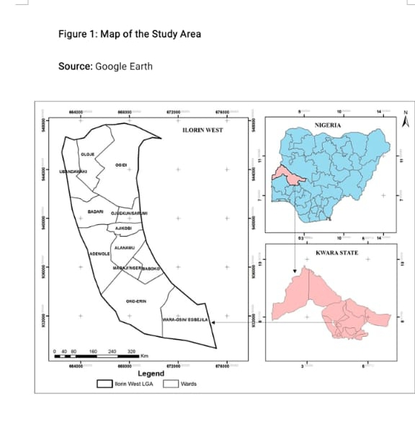

Figure 1; Map of the study area
Source; Google Earth

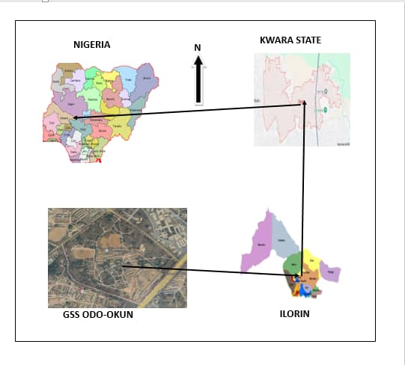

1.6. PERSONNEL
The under listed names were the personnel involved in the execution of the project with their names and matriculation numbers.
NAMES MATRIC NUMBERS
1. ABDULSALAM GANIYAT YETUNDE HND/22/SGI/FT/003 (Author)
2. ABDULGANIYU MUSTAPHA HND/23/SGI/FT/057
3. HUSSEIN TAWAKALITU OLAMIDE HND/23/SGI/FT/046
4. IBITOYE MARYAM OMOLADE HND/23/SGI/FT/044
5. FOLORUNSHO DAMILOLA HND/23/SGI/FT/048
6. ALFA AHMMED ALHAJI HND/23/SGI/FT/052
7. OKEDELE SAMSON OPEYEMI HND/23/SGI/FT/054

\

CHAPTER TWO
2.0 LITERATURE REVIEW
Surveying, which has recently also been interchangeably called geomatics has traditionally been defined as the science, art and technology of determining the relative positions of points above, on, or beneath the Earth’s surface, or of establishing such points. In a more general sense, however, surveying can be regarded as that discipline which encompasses all methods for measuring and collecting information about the physical earth and our environment, processing that information, and disseminating a variety of resulting products to a wide range of clients. Surveying has been important since the beginning of civilization. Its earliest applications were in measuring and marking boundaries of property ownership. Throughout the years, its importance has steadily increased with the growing demand for a variety of maps and other spatially related types of information and the expanding need for establishing accurate line and grade to guide construction operations. (Charles D. Ghilani, and Paul R. Wolf (2012).Geomatics is a relatively new term that is now commonly being applied to encompass the areas of practice formerly identified as surveying.
The name has gained widespread acceptance in the United States, as well as in other English-speaking countries of the world, especially in Canada, the United Kingdom, and Australia. In the United States, the Surveying Engineering Division of The American Society of Civil Engineers changed its name to the Geomatics Division. Many college and university programs in the United States that were formerly identified as “Surveying” or “Surveying Engineering” are now called “Geomatics” or “Geomatics Engineering.” (Charles D. Ghilani, and Paul R. Wolf (2012).
The principal reason cited for making the name change is that the manner and scope of practice in surveying have changed dramatically in recent years. This has occurred in part because of recent technological developments that have provided surveyors with new tools for measuring and/or collecting information, for computing, and for displaying and disseminating information. It has also been driven by increasing concerns about the environment locally, regionally, and globally, which have greatly exacerbated efforts in monitoring, managing, and regulating the use of our land, water, air, and other natural resources. These circumstances, and others, have brought about a vast increase in demands for new spatially related information. (Charles and Paul, 2012). (Charles D. Ghilani, and Paul R. Wolf (2012).
Surveying has been described as an beginning of recorded history. It has been discovered to be an imperative requirement in the planning and execution of every forms of meaning development (Bannister, A. & Raymond, S. 1986): Provision of infrastructure; planning of towns and cities; management of hazardous natural events and human actions such as erosion, flooding, earthquakes and subsidence; coastal management; exploration and exploitation of minerals; sitting of industries; resources exploitation on the land and on the sea are dependent on land surveying products(E.O.Oriola, and Asonibare S.O,2011).
Topography of an area describes the surface characteristics of relief features of such area as depicted by hills, valleys and plains. It can be used to study and represent as a surface, any characteristic that has a continuously changing value other than elevation, for geo-chemical data. Topographical surveying involves the acquisition of topographic data of the features on the earth‘s surface, both man-made and natural in three-dimension (x, y, z). This employs the techniques of plane surveying and other special techniques to establish horizontal and vertical controls. The implications of the above is that no meaningful development can be embarked upon by an individual, government and any other agencies without information about the topography of the area where such development is to take place. Topographic information system can be derived from the topographic data with the employment of the analytical capabilities of geographic information system [GIS]. Geographic Information System (GIS ) evolved as a new technology in surveying. It combines geographic data (location) and attribute data about object feature on the earth‘s surface with cartographic representation in order to perform spatial decision making using spatial analysis.
According to Burrough, P,A (1986). GIS is a tool for collecting, storing, retrieving at will, transforming and displaying spatial data from the real Topographic Information System as a Tool.
In short, GIS can be used to add value to spatial data (Sharma et al 2006), Modelling through Geographical Information System and global system . This is by allowing data to be organized and viewed effectively, by integrating them with other data, by analysis and by the creation of new data that can be operated on in turn to create useful information that can help decision making. GIS is unique in its ability to integrate data from variety of sources. A GIS can thus be described as a form of spatial decision support system.
A digital terrain model (DTM) is a topographic model of the terrain relief that can be manipulated by computer programs Ndukwe, K. N. (2001)The data files contain the spatial elevation of the terrain in digital format which are usually represented as a rectangular grid. Vegetation, buildings and other man made (artificial) features are removed leaving only the underlying terrain. Modeling terrain relief using DTM is a powerful tool in GIS analysis and visualization. DTM can be stored in GIS database in several ways: -As a set of contour vectors, a rectangular grid of equal spaced corner/point height or an irregularly spaced set of point connected in triangles (TINTriangular Irregular Network).
2.1 TOPOGRAPHIC SURVEY
Topography is generally known as the study of earth surface, and its features and shape. It also gives the description of the features (such as surface, shapes, vegetation cover & elevations), depicted in maps (Ojiako, J.C, and Jimoh, S.O. 2017). These characteristics are natural and artificial (or man-made).Man-made features are highways, bridges, dams, wharfs, buildings, and so forth.
A topographic survey is a survey conducted to obtain the data needed for the preparation of a topographic map. This data consists of the horizontal and vertical locations of the features to be shown on the map. Topographic Surveys are surveys made to determine the configuration of the earth’s surface and to locate natural and cultural features on it. Topographic surveys establish the different man-made and the natural features of land. This type of survey can be very beneficial to home owners, industrial owners, or even for properties under construction. Land may include hills, trees, fences, buildings, ravines. A topographical survey will provide exact figures of the size, height and position of different changes that have occurred over the course of time with regard to their presence or that of any man-made structures. A graphic representation of the topography of this area is called a topographic map. A topographic map is simply a drawing that shows the natural and artificial features of an area. Topographic maps with larger scales as well as digital map products are necessary for better planning (Charles D. Ghilani, and Paul R. Wolf (2012).
This report comprises the few of the activities involved in topographic map compilation such as field data acquisition, processing of field data, analyses of data and presentation of results and elevation models of acquired topographic field data using AutoCAD Civil 3D, Surfer 10 and ArcGIS 10.3.
Topographic Information System
Digital technology was successfully introduced in the field of mapping in the late 1960‟s as means of speeding up map production. (Perera, S. and Shanta, K. O). (2002). With the change in technology in the last two decades and the growth in the number of spatial information systems, the concept of topographic database has been introduced in several mapping-surveying organizations in the world, in order to deliver more Geo-information to the user community.
Topographic Information System is very crucial in this present age in other to be able to update maps and retrieve necessary data at any given time with minimal efforts. Topographic Information System can be explained as the combination of human effort and computer-based tools for the collection, storage, analysis, manipulation and retrieval of various kinds of data relating to geographic features (man-made and natural coming essential to understanding what is happening and what will happen in geographic space. Once we understand, we can prescribe action. This new approach to management-managing geographically-is transforming the way organizations operate.
A GIS is a computer-based system that provides the following four sets of capabilities to handle georeferenced data (Otto , H., & Rolf , A. d. 2009). Principles of Geographic Information Systems. Enscheda, The Netherlands: International Institute for Geo-Information Science and Earth Observation.
i. Data capture and preparation.
ii. Data management, including storage and maintenance. Data manipulation and analysis.
iii. Data presentation.
A geographic information system (GIS) lets us visualize, question, analyze, and interpret data to understand relationships, patterns, and trends. “GIS is an integrated system of computer hardware, software, and trained personnel linking topographic, demographic, utility, facility, image and other resource data that is geographically referenced. “National Aeronautics and Space Administration (NASA)”.
Salimon O., (2015); approached Topographical Information System of Durbar Grammar School, Oyo East Local Government Area, Oyo State. The processes involved in the execution of the project include: spatial data acquisition, designing and creation of the database, data downloading, data processing, etc. spatial data were acquired using SOUTH (S/No:S16126) Total Station, while attribute data were acquired through social surveys. All the techniques involved were explicitly itemized and discussed. Spatial analysis and product generation were carried out. Plotting was done using AutoCAD 2007 Land Development, Surfer 10 was used in generating the contour. Database design and creation were carried out using ArcGIS 10.1 software. The topographic database was tested by running queries and subsequently the required information necessary for decision making were generated.
Also, Bayewumi S., (2009); approached his Topographical Surveying for Awe High School, Awe, Oyo State. Using an analogue approach of spatial data acquisition using analogue Theodolite ,automatic leveling instrument, processing of data acquired manually using programmable calculator and presentation of the product in analogue map. The final product of his plan shows the perimeter boundary, features and contour plan of the area. Limitation using this approach is that the form of data acquisition is time consuming and the product is rigid and all information are kept in analogue form and could not be easily updated and converted to digital spatial database.
Furthermore, Odo, K. O., Idhoko, K. E., Oha, C. P., Okoro, E. G., &Okafor, C. E. (2015), using digital methods of data acquisition and data processing. Total Station (KOLIDA K46346) was used to acquire spatial data (X, Y, Z Coordinates) within the study area through the process of traversing, leveling and detailing, which were simultaneously carried out. The data processing was adequately and effectively done with the use of AutoCAD 2013, ArcGIS 10.1 and Surfer 9.0 software using the data processing as the management phase, a spatial database was modeled and structured using the relational table format. A digital terrain model (DTM) was created to enhance further analysis on slope, aspect, hill shade and view shed analysis of the study site. Limitation to his product is that only part of the study area was sampled and information about the neighboring environment was not included in his approach.
Another study by (Ojiako, J. C., &Jimoh, S. O. (2017). on Topographic Information System (TIS) of Federal School of Surveying, Oyo East Local Government Oyo State Nigeria carried out TIS with the aim of producing a tool for effective planning and land management of the school. Field and Office reconnaissance were carried out in order to be familiar with the terrain and do proper planning on the methodology and equipment to be used for the acquisition and assembling of spatial and attribute data. The geometric (spatial) data were acquired by ground survey method using Total station (South S74301) through the process of traversing, detailing and obtaining spot heights which were carried out simultaneously. The data processing was adequately and effectively done using Leica Geo Office Tools and South NTS Software for Data downloading, Notepad and Microsoft Excel for editing and preprocessing, AutoCAD 2016 for draughting, Surfer 11 for generating the Digital Terrain Model (DTM) and 3D Wireframe Map while ArcGIS 10.0 version was used for spatial analysis, query generation and information presentation. A model database was created and structured using the relational table format.
Finally, a study by Adewara M. B. and Kolawole O.A. on Topographic Information System (TIS): A Tool for Effective Planning and Proper Environmental Management (A part of The Federal Polytechnic, Ilaro, Nigeria). In their study, Landsat 8 (2010) image of the project site was used during the planning stage to have a general overview of the project site. Field data were collected using Total station instrument and processed using the Microsoft excel spreadsheet then saved into notepad to be called up in AutoCAD Civil 3D 2013 for scripting and generation a surface contour. Topographic information (TI) was created in the computer based on the collected datasets. Digital Terrain Model was created for further enhancement of the slope map, aspect map, hill shade and view shed analysis of the area using ArcGIS 10.2 and Surfer 10 software. The TI is available for manipulations and querying. The study concludes that TIS is essential for physical planning and accurate decision making as it is a system that allows easy updating of information and quick retrieval of information for better planning and environmental management.
In conclusion, from the reviews carried out, most of the authors incorporated the use of Ground based Total Station of various make in the execution of their study. This method is usually very tedious and cost implicative.

CHAPTER THREE

3.0 METHODOLOGY

This stage involves the methods and procedure used in planning, data acquisition, data processing, creation of database, creation of database management system and information presentation. These operations were logically structured and carried out in stages involving database design. It is normally considered to involve a spatially referenced and structured digital database and appropriate application software for geospatial analysis. This basically describes the techniques and principles adopted in carrying out the project.
Geographic information system methods were adopted in accomplishing the desired results.

3.1 DATABASE DESIGN
The design of any data base involves three stages namely;
i. Conceptual design
ii Logical design
iii Physical design

3.1.1 VIEW OF REALITY
In database design, there is need for reality which is referred to as the phenomenon that actually exists, including all aspects which may or may not be perceived by individuals. The view of reality however, is the mental abstraction of the reality for a particular application or group of applications.
For this application, the view of reality is made of the topography of the project. Since it is not possible to represent the real world, the only option is to conceptualize and model it in a specified manner to represent the real world. The area of interest to us in this project includes; Green Reserve, Roads, Electric poles, Trees, Water Facilities, Buildings, Football pitch, Streams.
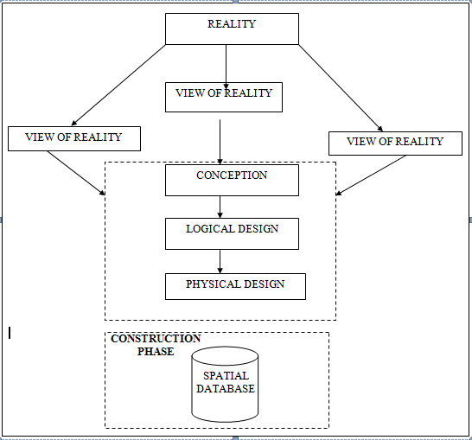

Fig.3.1Design and Construction Phasesin Spatial Database (R Sobh, C Perry)

3.1.2 CONCEPTUAL DESIGN

Vector data mode list the data type adopted for this project, which is represented, by points, lines and polygon. The identified entities are: -
      - Green Reserve(polygon)

      - Roads(line)

      - Electric poles(point)

      - Trees(point)

      - Buildings(polygon)

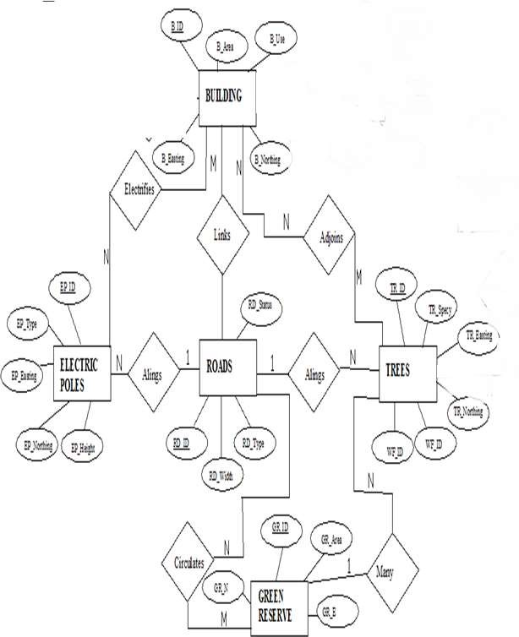
Google source

Fig.3.1.2.1:E-RDiagram(Entityrelationship diagram)

3.1.3 LOGICALDESIGN
This is the design aspect of the database refers to the process of creating a conceptual frame work or model that represents the structure and organization of spatial data within the system. It involves defining the data element, their relationship, and the rules for data manipulation and analysis. In this phase, the entities, their attributes and their relationships are represented in a single uniform manner in form of relation in such a way that would be no information loss and at the same time no unnecessary duplication of data. In this study, the logical database design is employed to generate a geo-relation database structure. Each entity has unique identifier in bold type. An attribute type or combination of attribute types that serves to identify an entity type is termed an identifier.
- Building (B_ID,B_Area, B_Name,B_Easting,B_Northing)
- Roads(R_ID,R_Width,R_Type,R-Condition,R_Easting,R_Northing)
- Vegetation(V_ID,GR_Area,)
- Tree(TR_ID,TR_spp,TR_Importance,TR_Easting,TR_Northing)
- Electric Pole(EP_No,EP_Type,EP_Height,EP_Easting,EP_Northing)
- Football Pitch(FP_ID, FP_Area,FP_Status)

3.1.4 PHYSICAL DESIGN
Table3.1.4.1.: Building and its attribute

ENTITY | DESCRIPTION
B_ID | Building Identification
B_name | Building Name
B_Area | Building Area
B_Easting | Building Easting
B_Northing | Building Northings

Table3.1.4.2:Road and its attributes

ENTITY | DESCRIPTION
R_ID | Road Identifier
R_Length | Road Length
R_Width | Road Width
R_Type | Road Type
R_Condition | Road Condition

Table3.1.4.3:Trees and its attributes

ENTITY | DESCRIPTION
TR_ID | Tree Identifier
TR_Spp | Tree Specy
TR_E | Tree_Easting
TR_N | Tree Northing

3.2 RECONNAISSANCE
This is the preparatory stage before the execution of this project; it involves collection of available information about the project area.
The necessary step taken for the successful execution of the project involves two stages, which are: -
- Office Planning
- Field reconnaissance

3.2.1 OFFICE PLANNING
This involves the collection of information about the study area, testing the instrument to be used in execution of the project and itemizing the numbers of equipment needed, number of days to be use, how each activity is to be carried out, delegation of works to each team members based on instructions.
3.2.2 FIELD RECONNAISSANCE
The field reconnaissance stage involves conducting a physical survey of the project area. This typically includes visiting the site to gather firsthand information, assess the current conditions, and verify the accuracy of the existing data.
During field reconnaissance, the project team uses various tools and techniques to collect data, such as Hand held (GPS). We may also take photographs, make observations, and gather other relevant data about the project area.
- Boundary points was selected
- The distribution of features was studied
- Controls to be used were located
- The selection of the method and instrument type has been finalized
- Subsidiary point for Ground control Points were picked and define using nail and bottle cock
- A diagram of the study area was drawn.
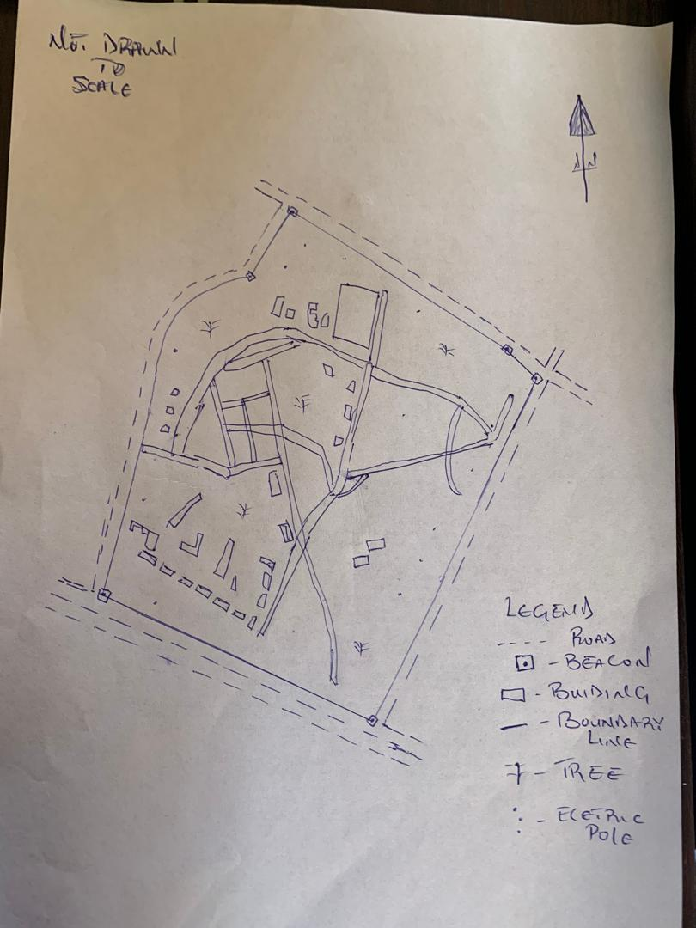

Fig.3.2.2.1: shows Recce diagram of the study area (not drawn to scale)

3.3 EQUIPMENT USED/ SYSTEM SELECTION AND SOFTWARE
3.3.1 HARDWARE USED

- Total station

- 1 reflector with a tracking rod.

- 1Tripod

- One(1)50m tape

- One(1)umbrella

- 1cutlass

- Handheld GPS

- Hammer

- Nails and bottle cover

- Field book and writing materials

- 1-No of Personal Computer HP655 and its accessories

- 1-No of HP DeskJetK7100A3 printer

- 1-No of HP DeskJet 1110 A4printer

3.3.2 SOFTWARE COMPONENT
- Notepad.

- Microsoft Excel.

- AutoCAD 2007

- ArcMAP10.2

- Surfer25

- Microsoft Word.

3.4 INSTRUMENT TEST
To ensure data quality, the Total Station used for this project was tested for both vertical index and horizontal collimation errors. It was also to ascertain the efficiency and reliability of the instrument. The procedure used is described below.
3.4.1 HORIZONTAL COLLIMATION TEST
This test was conducted to ensure that the line of sight was perpendicular to the two union axis. The Total Station was positioned over a specific point, and initial adjustments were made to ensure proper alignment, leveling, and focus (to eliminate parallax in the telescope). A vertical target was placed at a distance of 100 meters from the Total Station. To access the configuration menu of the Total Station, the menu key was pressed and held for approximately 2 seconds. From the main menu, the calibration sub-menu was selected, and within that, the horizontal collimation test option was chosen. The target was then observed and divided into two halves, with horizontal readings recorded to Face left and Face right. The readings are shown in Table 3.4.1 below.

Total Station
REFLECTOR(TARGET)
100m

STATIONA
FairlyLevelGround
STATIONB

Fig3.4.1.1;Horizontal Collimation and Vertical Index error test.

Table3.4.1.1:Horizontal Collimation Data

Station | Target | Face | HzReading | Difference | Error
A | B | L | 25˚32‟32”
 |  | R | 205˚32‟35” | 180˚00‟03” | 0˚0’03”

3.4.2 VERTICAL INDEX ERROR TEST

This test was conducted to verify the accuracy of the vertical reading when the line of sight is horizontal. The desired measurement for this test is exactly ninety degrees (90˚),any deviation from this value is referred to as the vertical index error.

The Total Station was positioned over a specific point, and necessary temporary adjustments were made to ensure proper alignment and functionality. A target was placed approximately 100 meters away from the Total Station, and the instrument was aimed at the target. The target was bisected by aligning the instrument on the face left, and the corresponding reading was recorded. Similarly, the target was then bisected on the face right, and the respective reading was also recorded. The recorded readings are provided below:

Table3.4.2.1: Vertical Index Data

Instrument Station | Target Station | Face | Vertical | Sum | Error
A | B | L | 95˚00‟00”
 |  | R | 275˚00‟02” | 360˚00‟02” | 0˚0’02”

3.4.3 ANALYSIS OF COLLIMATION AND VERTICAL INDEX DATA
The reading obtain during calibration were reduced to obtain new collimation and vertical errors.
Horizontal collimation={(FR–FL)–180}/2={(00˚00‟03”}/2=1.5”

Vertical collimation={(FL+FR)–360}=(95˚00‟00”+275˚00‟02”)–360}=02”The result shows that the instrument is still in good working condition.

3.5 CONTROL CHECK
Three control beacons (SC/KW GI544AD, SC/KW GI545AD and SC/KW GI547AD) were used. In order to ascertain the situation of the control beacons, a check was carried out on them by observing the angle between them and comparing the result obtained with the computed angles from the giving coordinates.
The total station instrument was set on the control beacon PBIL3306. After performing all the necessary temporary adjustment, the reflector was placed on the control beacon PBIL3306 which served as the back station. The horizontal angular reading was taken and recorded while the instrument was on face left. The reflector was taken to the NILL which serves as the forward station, the horizontal angle reading was then taken and recorded on both face left and face right. The reflector was taken back to the back station, the horizontal angle was then recorded on face right.

Table3.5.1: Table showing the back computation of the control coordinates

From STN | Bearing | Dist(m) | ∆N | ∆E | Northing(m) | Easting(m) | ToSTN
 |  |  |  |  | 936467.388 | 668133.317 | SC/KW GI544AD
SC/KW GI544AD | 118°6'  1'' | 41.031 | 19.326 | -36.194 | 936486.714 | 668097.123 | SC/KW GI545AD
SC/KW GI544AD | 97°16'  21'' | 43.730 | -5.536 | 43.379 | 936481.178 | 668140.502 | SC/KW GI547AD

Table3.5.2: Table showing the distance observation result of the control check

FROM | OBSERVED DISTANCE  (m) | COMPUTED DISTANCE  (m) | TO
SC/KW GI544AD | 41.041 | 41.031 | SC/KW GI545AD
SC/KW GI545AD | 43.741 | 11.562 | SC/KW GI547AD

Table3.5.3: Table showing the observation result of the control check

STN | SIGHT | FACE | OBSERVED HZ ANGLE HD | REDUCED HZ ANGLE | MEAN
 | KWPT3009PT | L1 | 10° 42'35''
ND20 | KWPT3009APT | L2 | 128° 48'49'' | 118° 6'14''
 | KWPT3009APT | R2 | 308° 48'52'' | 118° 6' 11''
 | KWPT3009APT | R1 | 190° 42'41'' |  | 118° 6'13''

Difference in angle (observed -computed)=118°6'13''-188°6'9''=00° 00'04''

Since the allowable accuracy (angular) of third order traverse of one station is 00° 00' 30'' and the result obtained from the control check (00°00'04'')is less than allowable error. Therefore, the controls were angularly intact.

3.6 MONUMENTATION
The boundary of the area carved out was demarcated with the precast concrete beacons, after clearing the required line of sights. The identified points of changes in directions were dug and beacons were buried on it, leaving about 15cm part of the beacon above the ground level. The beacons were buried at convenient distances as dictated by the nature of the boundary.
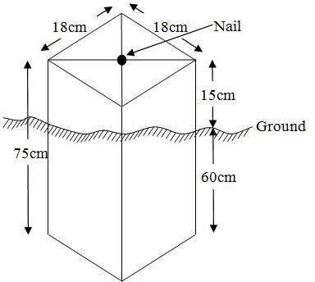

Fig.3.6.1: Pillar Description

3.7 DATA ACQUISITION
PRIMARY DATA SOURCE
Field observation was the primary source of data for this project. Ground based method was used in acquiring data with the use of Total Station Instrument, which involved the collection of X, Y, Z data through coordinated Ground control Points (GCP) established at conspicuous points within the study area.

SECONDARYD AT A SOURCE

An imagery of the area was acquired through Updated Google earth; this was used to ascertain the extent of coverage of the project area.

3.7.1 GEOMETRIC DATA ACQUISITION
The total station instrument was set carefully on control point SC/KW GI545AD, back sight taken to SC/KW GI544AD after necessary station adjustments has been carried out on it. The adjustments include; centering, leveling and focusing. The following procedures were then followed to determine the position of the next point (PL1) and the same procedure were repeated until all we come close to the site. The method used in acquiring data on site was radiation method where two or more points are coordinated from one point.

- Having set up the instrument and temporary adjustment carried out, the instrument was powered „on‟ and a job was created under job menu in the internal memory of the instrument. The job created was named GRP2B
- On the job, the coordinates of the three (2) control points were keyed in to the memory of the instrument and some codes were also saved. The codes include„RD‟for road,„SP‟for spot height,„BD for buildings,etc.
- The height of the instrument was measured and saved on the memory of the instrument as well as the reflector height.
- On coordinate menu, orientation was set by in putting the coordinates of the instrument station and back sight. The reflector at the back station was perfectly bisected before the orientation was confirmed by clicking “yes‟.
- Having done the orientation, the reflector at the next nail; was bisected and “obs‟(observe)option was clicked. The three-dimensional coordinate of the point (E,N, H) were displayed on the display unit of the instrument and „rec‟ (record) was clicked to save the data into the memory of the instrument. For subsequent observation after this,„ all‟ option was used instead of pressing “obs‟ and pressing„ record ‟later.

- It was ensured that the center of the prism of the reflector was bisected and that it was set perfectly on the tripod in order to minimize the error on height determination.
- The instrument is been shifted to another nail after all details, spot height and boundary point visible from the instrument station have been picked, set over it and temporary adjustments carried out.

Nonetheless, the above operations were repeated until all the boundary points with heights were coordinated.

In this project all spot height is not in grid intervals but randomly acquired. Three edges (3) of building were picked. At the end of data acquisition process all details were acquired and properly recorded to be shown in their respective positions on the plan.

3.7.2 ATTRIBUTES DATA ACQUISITION
Attribute data is information about spatial features. They provide the characteristics, description and nomenclature about spatial objects. Thus, the attributes data acquired includes names of buildings and their uses such as classrooms, roads, water facilities and prominent natural features likes river and trees found and vegetation were properly identified within and around the study area.
3.8 DATA DOWNLOADING AND PROCESSING
3.8.1 DATA DOWNLOADING AND EDITING
This is stage whereby all data acquired which were automatically stored in the Total Station were downloaded into personal computer. This was done with the aid of downloading cable connected to the computer and some associated complementing software installed on the System.

3.8.2 DATA PROCESSING AND DATA EDITING
The geometric data downloaded were further processed in order to convert it to a useful format and to enhance its accuracy. The output coordinates, were edited and exported in *.txt, *.xls and *.pdf format. Thereafter, they were imported into Arc GIS 10.3 for further operations and to carry out spatial analysis.

3.8.3 DATA PROCESSING USING AUTOCAD 2007

Before lunched AutoCAD, we used Notepad to processed the coordinate data we observed in field after it copy it to AutoCAD and this following below is step by step were used for process in Autocad
- Launch AutoCAD on computer.
- Click on New from the application menu o
- Type UNITS in the command line and press Enter.
- Select the desired unit type (eg, decimal, architectural, engineering).
- Select poly line in menu bar
- Copy from notepad to Autocad and press Z enter E enter
3.8.4 DATA PROCESSING USING ARCGIS10.3
Before launching of ArcGIS AutoCAD was used in plotting of feature data saving them separate lying different file named road, boundary line, buildings, tree.
- Launch the ArcMap in ArcGIS10.3
- Click on A NEW EMPTY MAP on the dialog box displayed after loading
- Click on Tools on the menu bar, then select extensions, mark all and close.
- At the LHS, right click on layers, and then select properties.
- Click on coordinate system to set the projection system to MINNADATUMZONE31N and general to set the unit, then apply and okay.
- Add data was selected at the tool bar all saved AutoCAD file was selected and load on to the table of content layer section
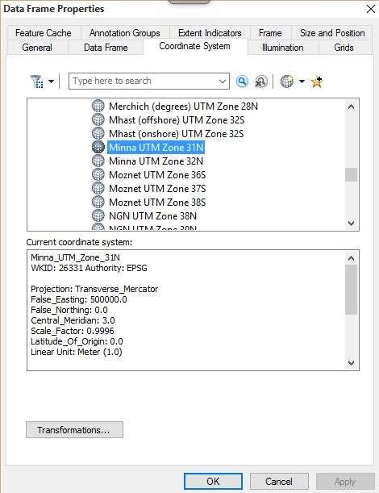
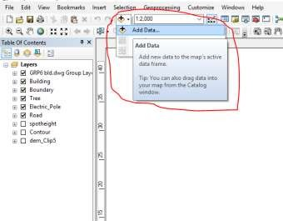
All drawing was exported to shape file. After the feature class has been creates, click on Edit or to start Editing, and then click on the load object.

CREATING CONTOUR: Firstly, DEM was created by searching in the search icon INTERPOLATION> NATURAL NIGHBOR and selecting THE XYZ data for creation of DEM in respect to the boundary line as extent. In order to create contours, you will need to enable the Spatial Analyst toolbar, which can be found by going to Customize > Toolbars >Spatial Analyst or open the search bar. You can do this by clicking Windows >Search, or by clicking on the search icon.
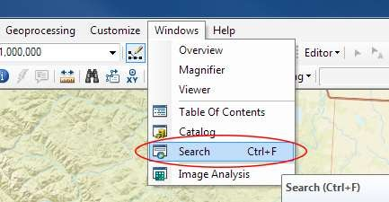

In the search bar type Contour, and select Contour (Spatial Analyst) from the search results list.
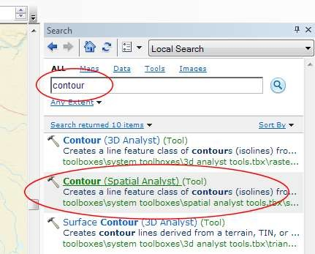

After choosing Contour, a dialogue window will appear, prompting you for five settings Input raster: select the DEM file from which you want to generate contours by locating it on your hard drive or in the dropdown menu, showing layers present in the Table of Contents Output polyline features: indicate where you want to save your output contours Contour interval: set the distance between contour lines in meters – the smaller the number, the greater the number of lines Base contour (optional): the starting point from which the lines are generated – for example, the default is 0 so with an interval of 25 meters, the contours are generated at 25, 50, 75, 100…, but if the base contour is set at 40, then the contours are generated at 65, 90, 115, 140 and so on Z factor (optional): can be used to adjust the units of data; for example, if you have data in meters and you want to produce your contours in feet, use az-factor of 3.28 because 3.28feet equals one meter.

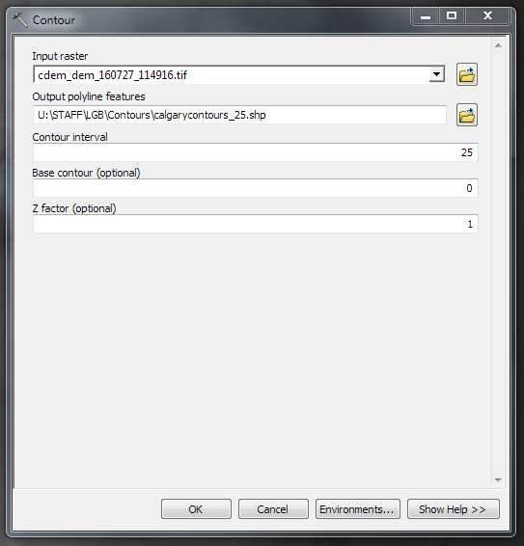

The generated contours will automatically be added to the map.
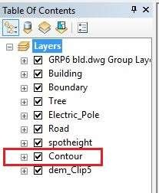

Input the data which is the AutoCAD drawing and select the feature type you want to load,

- Click Add and Next, then select the Target layer you want it to be

- Load it into from the feature class created on the ARCGIS.

- Click on Next, then select “only the features that satisfy the

- Query”and click on Query Builder to query for the feature to be loude.g.“layer”=Boundary”.
- Click on Next. Then finish
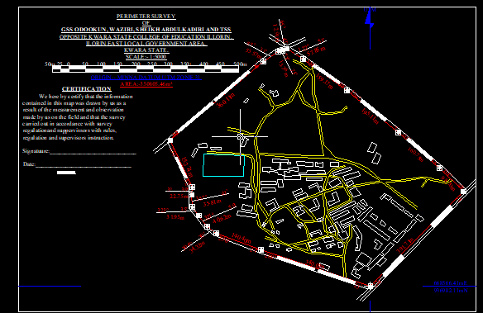
Right click on the Boundary In the table of content and click on zoom to layer to display thefeature.

EDITING, CONVERTING AND MERGING GEO-DATABASE

- Remove all necessary features by right clicking on it and press "REMOVE"

- Convert some features that are not in their correct„features-type‟likepoint, line, and polygon features etc.
To convert a GEO-DATABASE FEATURE CLASS to another the following steps were taken:
- FOR LINE FEATURE CLASS TO POLYGON FEATURE CLASS

- Goto WINDOW on the menu bar and select ARC Toolbox.

- Select DATA MANAGEMENT TOOLS, click on FEATURES, and then Select FEATURE TO POLYGON.
- ON INPUT FEATURES, select feature to be converted, on OUTPUT FEATURE CLASS, then save on the GRP6C FOLDER, press OK and CLOSE.
- Then remove the converted feature class in the LAYER Menu and ARC CATALOG files.
- On INPUT DATA SETS, select features to be merged, on OUTPUT DATA SETS, then save on the GRP6C folder, press OK and CLOSE.
- Then remove the converted feature class in the LAYER Menu and ARC CATALOG files.

TABLECREATION

There is need to create attribute tables for the features so as to be used for queries. NOTE: The editor on the menu bar must be stopped before adding field to its table. THE FOLLOWING PROCEDURES WERE FOLLOWED:
- Right click on the feature class, then select OPEN ATTRIBUTE STABLE click on OPTIONS and select ADD FIELD.
- Give it FIELD NAME,click on TYPE andselect[SHORT INTEGER or LONG INTEGER for SHORT or LONG WHOLE VARIABLES or DOUBLE FOR
- DECIMAL VARIABLES OR TEXT variable or DATE for DATE], then enter precision or LENGTH for text width and scale for DECIMAL PLACES, and then click OK
- To input variables on the ATTRIBUTE TABLE, go to the EDITOR on Menu bar, select START EDITING,
- Click on ATTRIBUTE on menu bar [behind the TARGET], click on the features on the DATA VIEW display, and then input the variables of data acquired through SOCIAL SURVEY or DATA ACQUIRED ON THE FIELD.
- Save it after the input by selecting SAVE EDITS on the editor menu. To switch toother layers, select STOP EDITING on the EDITOR menu. Then repeat the above step to create other fields. Populate the table and save.

Table3.8.3.1: Building

ENTITY | FIELD ALIAS | DATA TYPE | FIELD SIZE
B_ID | Building Identification | Numeric | -
B_name | Building Name | Text | 14
B_Area | Building Area | Numeric | -
B_E | Building Easting | Numeric | -
B_Northing | Building Northings | Numeric | -

Table3.8.3.2:Road

ENTITY | FIELD ALIAS | DATA TYPE | FIELDSIZE
R_ID | RoadI dentifier | Numeric | -
R_Length | Road Length | Numeric | -
R_Width | Road Width | Numeric | -
R_Type | Road Type | Text | 14
R_Condition | Road Condition | Text | 14

Table3.8.3.3:Trees

ENTITY | FIELD ALIAS | DATATYPE | FIELDSIZE
TR_ID | Tree Identifier | Numeric | -
TR_Spp | Tree specy | Text | 14
TR_E | Tree_Easting | Numeric | -
TR_N | Tree Northing | Numeric | -

Table3.8.3.4:Electric Poles

ENTITY | FIELD ALIAS | DATATYPE | FIELDSIZE
EP_ID | Electric pole Identifier | Numeric | -
EP_Type | Electric pole Type | Text | 14
EP_Height | Electric pole Height | Numeric | -
EP_E | Electric pole Easting | Numeric | -
EP_N | Electric pole Northing | Numeric | -

ADDING SPOT HEIGHTS DATA

- NOTE: STOP EDITING on the EDITOR MENU before adding data field,

- Go to FIELD ON THE MENU BAR, scroll to add Data and then ADD XYZ DATA

- Browse the EXCEL FILE for SPOT HEIGHTS, select EASTING VALUE on X-FIELD and NORTHING VALUE on Y-FIELD and ELEVATION
- « Select DATA the EXPORT DATA, locate the folder created and give it name then YES AND OK, remove the previous layer by right clicking on it and select REMOVE.

TIN, ASPECT AND SLOPE CREATION USING ARCMAP

Uses of tin in map
- High Accuracy: Represents terrain more precisely in areas with complex elevation changes.
- Efficient Modelling: Requires fewer data points in flat areas and more in rugged areas — making it efficient and detailed.
- 3D Modelling: Helps generate realistic 3D models of the earth's surface.
- Engineering Design: Used in road and site grading design, mining, and flood simulation.
- Volume Calculations: Useful in cut-and-fill analysis for construction or excavation
NOTE: Making sure the 3D Analyst Extension is active, select VIEW on MENU bar, then click TOOL BARS and MARK the 3D Analyst EXTENTION Then X,Y Data

TO CREATE TIN

- Click on 3D Analyst arrow, select create TIN and then create TIN from FEATURE.
- On layers mark the SPOT HEIGHT LAYER, select height data on HEIGHT, then ok.
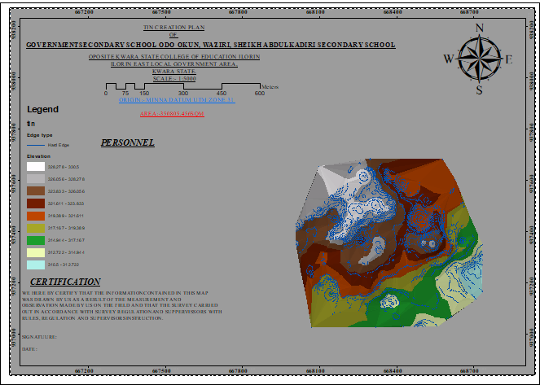

TO CHANGE THE FACE OF THE TIN ACCORDING TO ITS ELEVATION

- RIGHT CLICK on the TIN, select PROPERTIES, and click on SYMBOLOGY.

- Then ADD, select FACE ELEVATION WITH COLOR RAMP, click ADD, and then select APPLY and OK.

TO CREATE ASPECT

- Click on 3D analyst arrow, select SPATIAL ANALYST TOOLS, SURFACE and THEN DOUBLE CLICK on ASPECT.
- Browse to where the raster format of all the acquired data created from the surfer was saved to.
- Browse to where you want the OUTPUT RASTER to be saved

- You can change the OUTPUT MEASUREMENT to Degree OR percent

- Click OK [then it displays on the data view screen], then Close.

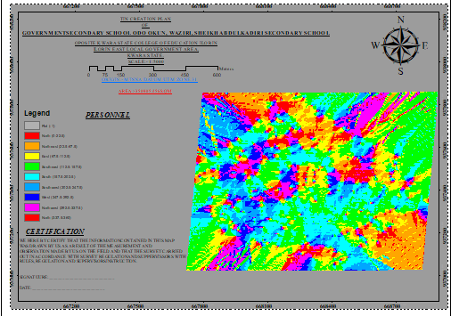

3.9 DATABASE IMPLEMENTATION

This is the database creation phase. Having completed the three stages of design phase (i.e.Reality, Conceptual and Logical design), the data base was created using ArcGIS10.3 software. It involves the combination and storage of acquired graphic data and attributes data in creating the database for the purpose of spatial analysis and query.
Database is an organized integrated collection of data stored so as to be capable of use by relevant application with data being accessed by different logical part. After the Attribute table was populated via the keyboard, some attributes such as areas of settlements were automatically displayed by special command in the ArcGIS10.3 version. The ArcGIS software was used to link the graphic data and table for query generation.

3.9.1 DATA BASE MANAGEMENT SYSTEMS
Data base management is a collection of software for creating, storing, manipulating, updating, organizing and querying of information in a database (Kufoniyi, 1998). It is a software package whose function is to manipulate a data base on behalf of the user.
A good DBMS must provide the following functions:

a Storage and retrieval of data.

b Access to by several users at a time.

c A standardized interface between data base and application programmed.

d Standardized access to data and separation of data storage and retrieval functions from the program using the data.
e Maintenance of data security and integrity.

3.9.2 DATABASE MAINTENANCE
Having created the database, proper maintenance practice was made to meet its stated objectives. The ability to include more data and remove irrelevant data was possible by way of maintenance. There is every need for the data to be updated regularly because of the physical changes that may occur on the landscape with time. Both security and integrity were also exercised to ensure maintenance and to meet its stated objectives.
Proper observance, updating and management of database ensure its currency and quality to stand a profound chance in Spatial Decision Support System (SDSS). The quality of any database depends on the currency and fitness for use as a decision support system (SDSS).The quality of database depends on its ability to generally fit and use as a decision system (DSS). The storage media should be from time to time justified if otherwise could necessitate data in accessibility or physical deterioration of the storage media. Also, care must be taken during populating any database system, as a database is only good as the data supplied. In archiving stable media should be used. Examples of these are
- Computer compatible tape reader

- Magnetic tape

- Optical disc and compact disc

3.9.3 BACK COMPUTATION
Table3.9.3.1:Back Computation
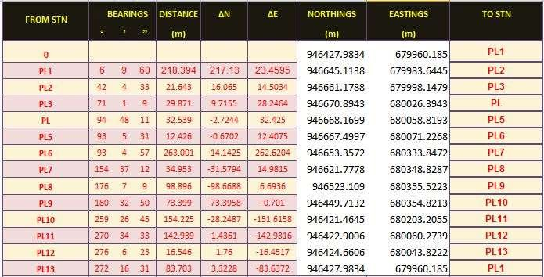

3.9.4 AREA COMPUTATION
Table3.9.4.1:Area Computation
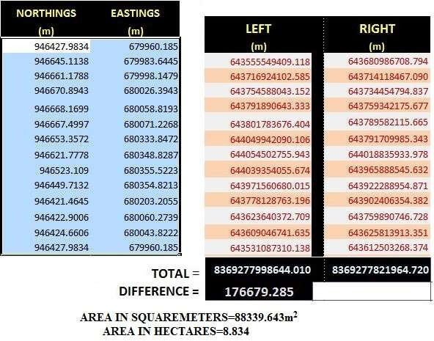

CHAPTER FOUR

4.0 SPATIAL ANALYSES AND PRESENTATION
GIS is distinct among other information system because of its spatial analytical capability; especially overlay operation, buffering, spatial search, topographic operation, and neighborhood and connectivity operations.GIS uses this spatial analytical capability to answer fundamental generic question of location, condition, trend, routing, pattern and modeling by the manipulation and analysis of input data. The major analyses performed in this project were overlay operations, topographic operations and spatial search.
4.1 TESTING OF DATABASE
This is the test carried out to determine whether there exists a relationship between data modeled about entities in a spatial database as well as putting in to test its retrieval capabilities. This was done by designing a sample query with certain conditions attached and the query will be ran to see if desired result is achieved.

Analysis of Result

The contour whose value is greater or equal to 350 meters depicts the likelihood that such area may not be prone to flood in the project area as shown in Fig. 4.5(Query 1). This represents the elevation of points that are greater than to 350m. The displayed attribute table confirmed that North-East part of the institute had the highest elevation. Height is an important factor when considering the surface or slope of the terrain. The South-west part of the school had the lowest elevation which is very prone to erosion. Buildings that will besited in that region must have a very high foundation above the ground level. The result of the query will afford the school management to decide concisely the terrain characteristic sand the kind of building that should build in every region of the project area looking critically at the terrain of the area.

SINGLE SELECTION CRITERION

Query1: Shows the retrieving Area whose height is Greater than 320 meters

SELECT* FROM Contour WHERE "CONTOUR">320

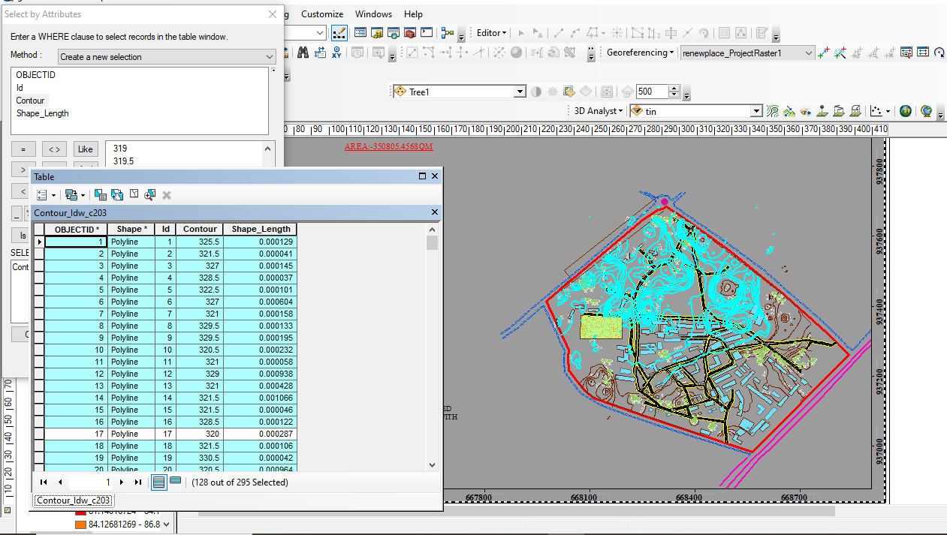

Fig4.1.1: Shows the retrieving Area whose height is greater than 320 meters

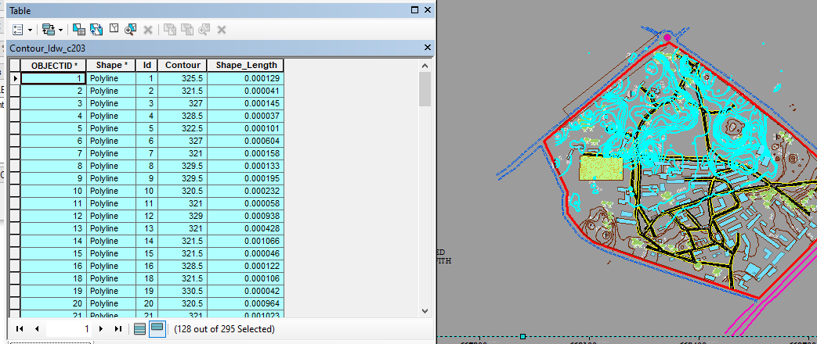

Fig4.1.2: Shows the result of area whose height is greater than 320 meters

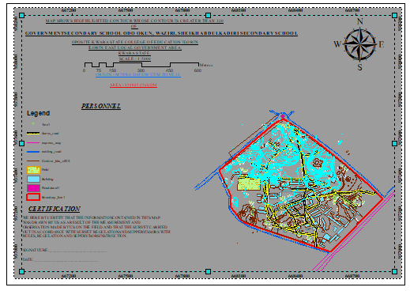

Fig4.1.3: Show the result of area whose height is greater than 320 meters

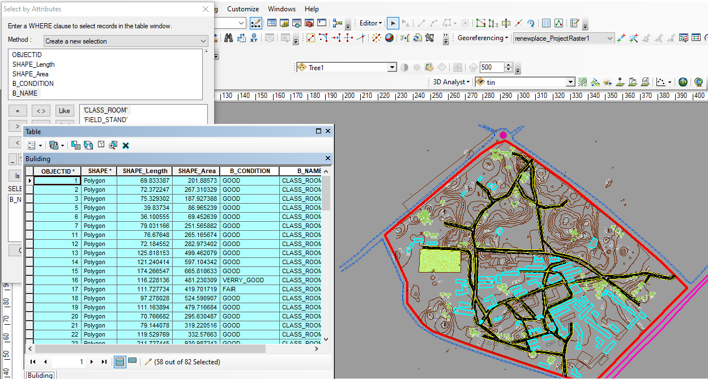

Fig4.1.4 Query Shows the result of Buildings Used for Class Rooms (B_NAME = 'CLASS_ROOM')

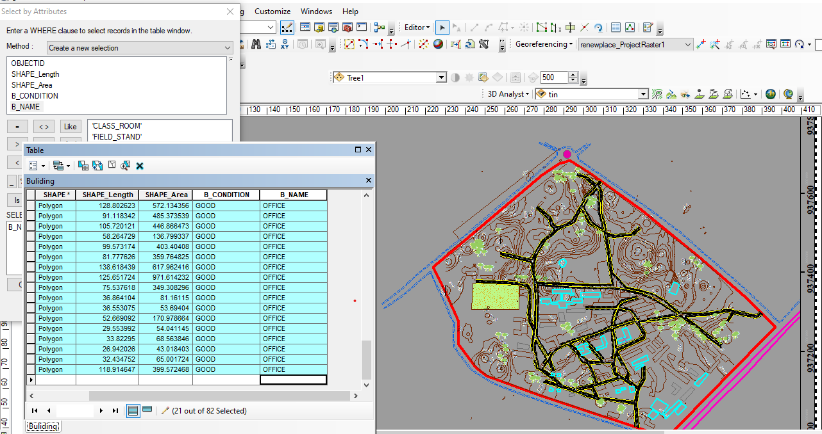

Fig4.1.5 Query Shows the result of Buildings Used for Offices (B_NAME = 'OFFICE'

CHAPTER FIVE
5.0 COST ESTIMATION, SUMMARY, RECOMMENDATION AND CONCLUSION
5.1 COSTESTIMATION

This stage the total cost spent on the project from day one to the final stage.

Table5.1.1: Direct cost parameters

S/N | DIRECTCOST
1 | Reconnaissance(1day)
 | PERSONNEL | Dailyrate | Amount(N:K)
 | 1x surveyor | 9814.20 | 9814:20
 | 1x assistant surveyor | 7944.83 | 7944:83
 | 1x technical officer | 6542.8 | 6542:80
 | 3x skilled labour | 4078.66 | 12235:98
 | Basic equipment | 5000 | 5000:00
 | transportation(vehicle, Driver and fuel) | 10000 | 10000:00
 |  | sub-total | 51537:81
2 | Monumentation(1day)
 | PERSONNEL
 | 1x assistant surveyor | 7944.83 | 7944:83
 | 1skilled labour | 6542.8 | 6542:80
 | transportation(vehicle, Driver and fuel) | 10000 | 10000:00
 | Basic equipment | 5000 | 5000:00

 | Beacon(6) | 1000 | 6000
 |  | sub-total | 43,644:95
3 | Data acquicision(2days)
 | PERSONNEL
 | 1x assistant surveyor | 7944.83 | 15889:66
 | 1x technical officer | 6542.8 | 13085:60
 | 3x skilled labour | 4078.66 | 24471:96
 | Total Station and accessories | 15000 | 30000:00
 | transportation(vehicle, Driver and fuel) | 10000 | 20000:00
 |  | sub-total | 103447:22
5 | Data Processing(2days)
 | PERSONNEL
 | 1x surveyor | 9814.2 | 19628:40
 | 1x assistant surveyor | 7944.83 | 15889:66
 | 1x technical officer | 6542.8 | 13085:60
 | computer/accessories | 15000 | 30000:00
 |  | sub-total | 78603:66
7 | Technical Report(1day)
 | PERSONNEL
 | 1x surveyor | 9814.2 | 9814:20
 | 1x assistant surveyor | 7944.83 | 7944:83

 | 1x secretary | 5000 | 5000:00
 | computer/accessories | 15000 | 15000:00
 |  | sub-total | 37759.03
TOTAL (DIRECT COST) 1,170,205:09 MOBILIZATION/DEMOBILIZATION=5% of Direct Cost
=0.05 ×1,170,205:09

=N58,510:25

CONTINGENCY ALLOWANCE =5%ofDirectCost

=0.05 ×1,170,205:09

=N58,510:25

GRAND TOTAL =N1,170,205:09+N58,510:25 +N58,510:25

=N1,287,225:59

VAT(@5%GRAND TOTAL) =0.05 ×1,170,205:09

=N64,361:28

TOTALCOSTPAYABLE =GRAND TOTAL + VAT

=N1,287,225:59 +N64,361:28

=N1,351,586:87.

5.2 SUMMARY
The primary objective of this project is to accurately determine the elevation differences in the terrain and identify the various features within the designated site area. This was achieved through the implementation of a ground survey method using specialized equipment like the Total Station instrument and its associated accessories. By utilizing the radiation method, the instrument efficiently collected precise data on coordinates and elevation.
The acquired data was then processed and analyzed to generate several informative outputs. Plans were created, offering a comprehensive visualization of the area in dimensions, effectively highlighting the variations in elevation. Additionally, a perimeter and detailed plan were developed to depict the boundaries and specific features present within the site. A wireframe plan was also constructed to visualize the surface and its contour lines, while a contour plan was generated to illustrate the different elevation levels across the entire area.
To facilitate the analysis and processing of the collected data, a range of software tools were employed. ArcGIS was utilized for spatial analysis and data manipulation, Surfer9 was employed for generating contour plots and visually representing the terrain, Microsoft Excel was used for efficient data management and analysis, and Notepad served as a text editor for handling data in a tabular format.
5.3 RECOMMENDATION
Throughout the execution of this project, a plethora of new insights and knowledge were acquired. Based on these experiences, I highly recommend conducting similar projects in a practical manner, as it offers students a profound understanding of the subject matter. Additionally, it is crucial to provide students with an enhanced learning environment equipped with digital tools and equipment to further enhance their educational experience.
5.4 CONCLUSION
In conclusion, the topographical survey conducted in this project holds significant importance for planning, design, and landscaping purposes. The accurate and comprehensive information gathered through the survey provides valuable insights for Engineers and Architects to make informed decisions and design infrastructure that is safe, accessible, and efficient. The project's adherence to survey rules and regulations further validates the credibility of the survey results and ensures the quality of the project's outcomes

REFERENCE
MacMillan Dictionary of Data Communication (1985)- This is a reference to a dictionary that defines the term"data"in the context of data communication. Downling(2000)-This is a reference to an author named Downling who provided a definition of"data" as individual facts that have not been organized.
Nick (2000) - This is a reference to an author named Nick who provided a definition of "data" as in formation that has been organized in a useful way.
Ndukwe(2001)-This is a reference to an author named Ndukwe who provided a definition of"information" as a useful data element for a specific application.
Burrough (2006) - This is a reference to an author named Burrough who provided a definition of Geographic Information System (GIS) as a tool for collecting, storing, retrieving, and analyzing spatial data.
Sharma E. O. (2006) - This is a reference to an author named Sharma who discussed the value-added capabilities of GIS in organizing and analyzing spatial data.
Charles(2012)-This is a reference to an author named Charles who discussed the importance of topographic maps with larger scales and digital map products for better planning.
Lexicon Universal Encyclopedia (1989) - This is a reference to an encyclopedia that defines Topographic Information System as the combination of human effort and computer-based tools for collecting, storing, analyzing, an d retrieving geographic data.
NOAA(2017)-This is a reference to the National Oceanic and Atmospheric Administration, which highlights the importance of topographic data for scientific and technical applications. Onuigbo, Zita, Gbedu, Pious,& Samaila(2015)-This is a reference to multiple authors who discussed the use of GIS in analyzing topographic data and deriving topographic information systems.
Odo, Idhoko, Oha, Okoro, & Okafor (2015) - This is a reference to multiple authors who discussed the evolution of GIS as a technology for spatial decision making using geographic and attribute data.
Otto&Rolf (2009)

APPENDIX

pt1 | 679975.1 | 946502 | 353.44 | pt129 | 680069.9 | 946612.7 | 356.511
pt2 | 679984.5 | 946586.2 | 355.341 | pt130 | 680096 | 946612.7 | 356.712
pt3 | 679964.2 | 946680.5 | 359.283 | pt131 | 680121.2 | 946612 | 356.879
pt4 | 679941.7 | 946681.1 | 359.93 | pt132 | 680146.7 | 946610.9 | 357.287
pt5 | 679965 | 946702.4 | 359.52 | pt133 | 680168.9 | 946613.5 | 357.878
pt6 | 679910 | 946686.7 | 359.646 | pt134 | 680176.8 | 946595.5 | 357.272
pt7 | 679910.5 | 946678.4 | 359.448 | pt135 | 680144.1 | 946593.6 | 356.483
pt8 | 679926.7 | 946674.1 | 359.388 | pt136 | 680123.1 | 946595.9 | 356.224
pt9 | 679946.8 | 946652.9 | 358.378 | pt137 | 680099.8 | 946596.9 | 356.217
pt10 | 679955.3 | 946624.8 | 356.841 | pt138 | 680083 | 946574.8 | 355.498
pt11 | 679938.5 | 946702.6 | 359.953 | pt139 | 680087 | 946587.8 | 355.919
pt12 | 679950.8 | 946720.3 | 359.904 | pt140 | 680134.3 | 946585.7 | 356.023
pt13 | 679970.4 | 946722 | 359.636 | pt141 | 680151.3 | 946553.1 | 355.483
pt14 | 679986.5 | 946702.6 | 359.027 | pt142 | 680151.4 | 946544.1 | 355.24
pt15 | 679987.5 | 946678.7 | 358.471 | pt143 | 680150.6 | 946533.4 | 354.941
pt16 | 680003 | 946687.5 | 358.227 | pt144 | 680150.1 | 946523.7 | 354.677
pt17 | 680023.7 | 946682.6 | 357.417 | pt145 | 680150.3 | 946512.6 | 354.38
pt18 | 680024 | 946675.3 | 357.28 | pt146 | 680150.2 | 946503.6 | 354.14
pt19 | 680002.8 | 946670.9 | 357.79 | pt147 | 680149.9 | 946493.9 | 353.606
pt20 | 679974.6 | 946653.9 | 357.884 | pt148 | 680149.7 | 946484.3 | 352.77
pt21 | 679961.6 | 946658.1 | 358.336 | pt149 | 680150 | 946468.7 | 351.413
pt22 | 679979.4 | 946646 | 357.496 | pt150 | 680150.4 | 946459.7 | 350.642
pt23 | 679999.1 | 946629.9 | 356.727 | pt151 | 680137.6 | 946462.1 | 350.851
pt24 | 679998.8 | 946625 | 356.593 | pt152 | 680129.7 | 946452 | 349.979
pt25 | 680000.5 | 946624.3 | 356.565 | pt153 | 680130 | 946472.5 | 351.753
pt26 | 680001.1 | 946609.5 | 356.155 | pt154 | 680131.7 | 946489.3 | 353.214
pt27 | 680004.7 | 946658.1 | 357.409 | pt155 | 680140.2 | 946498.2 | 353.98
pt28 | 679988.4 | 946650.9 | 357.518 | pt156 | 680130.9 | 946508.2 | 354.219
pt29 | 679991 | 946635.5 | 356.976 | pt157 | 680131.7 | 946526.1 | 354.623
pt30 | 679978.5 | 946634.6 | 357.076 | pt158 | 680141.9 | 946538.3 | 354.994
pt31 | 679978.2 | 946620.9 | 356.556 | pt159 | 680133.2 | 946545.8 | 355.083
pt32 | 679994.4 | 946619.1 | 356.435 | pt160 | 680173.5 | 946576.7 | 356.531
pt33 | 680002.5 | 946598.6 | 355.86 | pt161 | 680202.2 | 946586 | 357.425
pt34 | 679988.5 | 946597.5 | 355.733 | pt162 | 680205.6 | 946568.7 | 356.797
pt35 | 679973.8 | 946600.7 | 355.755 | pt163 | 680200.6 | 946551.1 | 356.035
pt36 | 679972.5 | 946578.8 | 355.073 | pt164 | 680200.9 | 946542.1 | 355.688
pt37 | 679980.8 | 946577.5 | 355.099 | pt165 | 680212.9 | 946560.5 | 356.579
pt38 | 679995.6 | 946575.9 | 355.147 | pt166 | 680213.6 | 946551.9 | 356.226
pt39 | 680000.4 | 946576.1 | 355.181 | pt167 | 680213.4 | 946550.4 | 356.16
pt40 | 680000.4 | 946585.4 | 355.466 | pt168 | 680211.4 | 946535 | 355.499
pt41 | 679999.6 | 946563.5 | 354.794 | pt169 | 680200.3 | 946531.5 | 355.27
pt42 | 679985.4 | 946562.9 | 354.76 | pt170 | 680200.1 | 946521.2 | 354.872
pt43 | 679972.2 | 946561.8 | 354.721 | pt171 | 680213.4 | 946507.7 | 354.374
pt44 | 679970.9 | 946543.9 | 354.362 | pt172 | 680199.6 | 946511.4 | 354.488

pt45 | 679986.6 | 946544.2 | 354.281 | pt173 | 680199.4 | 946502.2 | 354.134
pt46 | 679993 | 946546.3 | 354.307 | pt174 | 680199.1 | 946492.1 | 353.428
pt47 | 679993.1 | 946532.1 | 353.909 | pt175 | 680198.9 | 946482.3 | 352.58
pt48 | 679986.9 | 946532.1 | 353.969 | pt176 | 680198.5 | 946467.3 | 351.277
pt49 | 679976.8 | 946533.8 | 354.105 | pt177 | 680213.1 | 946462.7 | 350.872
pt50 | 679968.7 | 946531.6 | 354.136 | pt178 | 680211 | 946488.4 | 353.106
pt51 | 679969.6 | 946512.7 | 353.758 | pt179 | 680219.8 | 946595.3 | 358.19
pt52 | 679982.5 | 946514.4 | 353.587 | pt180 | 680197.6 | 946605.6 | 358.154
pt53 | 679992.2 | 946512.5 | 353.376 | pt181 | 680192.3 | 946618.1 | 358.583
pt54 | 680002.7 | 946515.6 | 353.299 | pt182 | 680184.5 | 946637.7 | 359.271
pt55 | 680016.6 | 946515.8 | 353.09 | pt183 | 680176.3 | 946655.4 | 359.86
pt56 | 680036.1 | 946512.7 | 352.647 | pt184 | 680216.4 | 946654 | 360.668
pt57 | 680050.8 | 946511.6 | 352.848 | pt185 | 680216.1 | 946620.2 | 359.19
pt58 | 680051.5 | 946489.9 | 351.69 | pt186 | 680233 | 946626.6 | 359.781
pt59 | 680026.7 | 946493.4 | 351.865 | pt187 | 680231.2 | 946599.4 | 358.599
pt60 | 680003.6 | 946495.3 | 352.513 | pt188 | 680231 | 946583.8 | 357.938
pt61 | 679981.9 | 946496.3 | 353.066 | pt189 | 680230.7 | 946572.1 | 357.442
pt62 | 679972.7 | 946481.4 | 351.914 | pt190 | 680234.8 | 946656.2 | 361.045
pt63 | 679992.6 | 946478.2 | 351.269 | pt191 | 680251.4 | 946654.5 | 361.209
pt64 | 680008.5 | 946476.4 | 350.848 | pt192 | 680274.7 | 946652 | 361.447
pt65 | 680034.1 | 946474.4 | 350.253 | pt193 | 680294.7 | 946650.2 | 361.672
pt66 | 680051.6 | 946474.8 | 350.518 | pt194 | 680313.9 | 946655.9 | 362.063
pt67 | 680050.6 | 946457.6 | 349.167 | pt195 | 680321.2 | 946659.5 | 362.062
pt68 | 680019.7 | 946463.6 | 349.635 | pt196 | 680322 | 946668.6 | 362.317
pt69 | 680007.6 | 946464 | 349.833 | pt197 | 680342.5 | 946648 | 361.424
pt70 | 679995.8 | 946464.4 | 350.03 | pt198 | 680301.9 | 946627.5 | 361.011
pt71 | 679979.2 | 946465.2 | 350.346 | pt199 | 680271.9 | 946633.2 | 360.705
pt72 | 679969.1 | 946449.2 | 349.019 | pt200 | 680245.5 | 946626 | 359.974
pt73 | 679985.3 | 946446.2 | 348.577 | pt201 | 680256.4 | 946583.5 | 358.5
pt74 | 680006.3 | 946438.8 | 347.754 | pt202 | 680274.4 | 946596.6 | 359.391
pt75 | 679999 | 946446 | 348.435 | pt203 | 680263.6 | 946610.2 | 359.682
pt76 | 680006.3 | 946428 | 346.863 | pt204 | 680276.9 | 946616.4 | 360.172
pt77 | 679986.5 | 946429.8 | 347.135 | pt205 | 680290.3 | 946615.4 | 360.383
pt78 | 679972.4 | 946431.1 | 347.329 | pt206 | 680303.9 | 946614.2 | 360.601
pt79 | 680015.8 | 946533.8 | 353.749 | pt207 | 680308 | 946599.5 | 360.193
pt80 | 680029.9 | 946532.5 | 353.566 | pt208 | 680294 | 946598.7 | 359.875
pt81 | 680053.1 | 946531.4 | 353.678 | pt209 | 680284.3 | 946591.4 | 359.408
pt82 | 680073.3 | 946530 | 353.904 | pt210 | 680284.6 | 946578.5 | 358.959
pt83 | 680083.6 | 946527.6 | 353.972 | pt211 | 680308.1 | 946590.9 | 359.909
pt84 | 680082.8 | 946508.9 | 353.353 | pt212 | 680331.9 | 946579 | 359.537
pt85 | 680064.8 | 946509.4 | 353.026 | pt213 | 680276.5 | 946543.5 | 357.483
pt86 | 680063.8 | 946490.2 | 351.964 | pt214 | 680264.2 | 946545.8 | 357.231
pt87 | 680081.5 | 946489.9 | 352.295 | pt215 | 680244.8 | 946544 | 356.632
pt88 | 680081.3 | 946473.4 | 350.957 | pt216 | 680234.6 | 946546.1 | 356.449
pt89 | 680063.1 | 946473.4 | 350.617 | pt217 | 680227.3 | 946545.9 | 356.24
pt90 | 680062.4 | 946453.6 | 349.045 | pt218 | 680230.7 | 946521 | 355.279

pt91 | 680081.7 | 946453 | 349.311 | pt219 | 680245.2 | 946525.2 | 355.883
pt92 | 680080.6 | 946435.4 | 347.857 | pt220 | 680271 | 946522.7 | 356.553
pt93 | 680067.6 | 946440.2 | 348.058 | pt221 | 680290.5 | 946521.9 | 357.1
pt94 | 680084.4 | 946548 | 354.643 | pt222 | 680283.8 | 946516.8 | 356.72
pt95 | 680083.9 | 946557.1 | 354.928 | pt223 | 680284.1 | 946509.1 | 356.446
pt96 | 680076.7 | 946557.1 | 354.873 | pt224 | 680291.6 | 946500.8 | 356.391
pt97 | 680077.1 | 946574.1 | 355.451 | pt225 | 680292.2 | 946480.4 | 354.56
pt98 | 680076.5 | 946596.4 | 356.154 | pt226 | 680280.1 | 946497.1 | 355.782
pt99 | 680065.6 | 946575.3 | 355.453 | pt227 | 680247.3 | 946484.5 | 353.585
pt100 | 680007.9 | 946578.6 | 355.309 | pt228 | 680271.5 | 946484.8 | 354.353
pt101 | 680031.2 | 946578.9 | 355.474 | pt229 | 680260.4 | 946497.1 | 355.15
pt102 | 680030 | 946585.1 | 355.723 | pt230 | 680230.8 | 946500.6 | 354.416
pt103 | 680018.4 | 946561.8 | 354.759 | pt231 | 680227.5 | 946483.7 | 352.913
pt104 | 680028.4 | 946550.2 | 354.297 | pt232 | 680231.1 | 946469.5 | 351.76
pt105 | 680048.7 | 946553.2 | 354.501 | pt233 | 680249.2 | 946472.6 | 352.573
pt106 | 680048 | 946576.2 | 355.431 | pt234 | 680238.9 | 946469.1 | 351.95
pt107 | 680069.5 | 946542.2 | 354.288 | pt235 | 680265.9 | 946474.5 | 353.234
pt108 | 680068.2 | 946558.3 | 354.851 | pt236 | 680280.9 | 946473.9 | 353.62
pt109 | 680025.5 | 946601.2 | 356.059 | pt237 | 680287.5 | 946468.9 | 353.347
pt110 | 680021 | 946610.7 | 356.206 | pt238 | 680288.7 | 946459.8 | 352.501
pt111 | 680020.8 | 946629.1 | 356.54 | pt239 | 680303.7 | 946472.8 | 354.18
pt112 | 680033.6 | 946613.4 | 356.253 | pt240 | 680284.1 | 946447.1 | 351.183
pt113 | 680049.3 | 946612.3 | 356.342 | pt241 | 680271.1 | 946444 | 350.55
pt114 | 680051.8 | 946633.5 | 356.708 | pt242 | 680314.4 | 946489.2 | 355.991
pt115 | 680032.5 | 946636.1 | 356.539 | pt243 | 680317.3 | 946513.9 | 357.38
pt116 | 680019.9 | 946653.7 | 357.004 | pt244 | 680337.3 | 946512.4 | 356.952
pt117 | 680045.3 | 946654.9 | 356.913 | pt245 | 680336.7 | 946500.5 | 356.508
pt118 | 680046 | 946669.3 | 357.138 | pt246 | 680354.2 | 946514.8 | 356.737
pt119 | 680058.1 | 946669.4 | 357.477 | pt247 | 680361.4 | 946514.4 | 356.588
pt120 | 680070.1 | 946668 | 357.782 | pt248 | 680348.6 | 946531.4 | 357.521
pt121 | 680066.9 | 946657.7 | 357.468 | pt249 | 680331.3 | 946528.7 | 357.672
pt122 | 680081.8 | 946664.6 | 358.008 | pt250 | 680314.9 | 946530.6 | 357.978
pt123 | 680109 | 946662.4 | 358.642 | pt251 | 680345.7 | 946554.1 | 358.484
pt124 | 680149.1 | 946659 | 359.43 | pt252 | 680334.3 | 946570.7 | 359.216
pt125 | 680162.4 | 946633.5 | 358.61 | pt253 | 679960.2 | 946428 | 347.098
pt126 | 680129.2 | 946630.8 | 357.774 | pt254 | 680060.3 | 946422.9 | 346.231
pt127 | 680099.7 | 946635 | 357.489 | pt255 | 680203.2 | 946421.5 | 346.765
pt128 | 680071.1 | 946633.1 | 356.994 | pt256 | 680354.8 | 946449.7 | 351.375

