PARADIGM SHIFT IN AUTOMOTIVE LUBRICATION: THE LUBRICANT INDUSTRY CHALLENGES

BY
LAWAL RIDWAN OPEYEMI
HND/23/MEC/FT/0029

A PROJECT WORK SUMMITED TO DEPARTMENT OF MECHANICAL ENGINEERING
INSTITUTE OF TECHNOLOGY KWARA STATE POLYTECHNIC, ILORIN.

IN PARTIAL FULFILLMENT OF THE REQUIREMENTS FOR THE AWARD OF HIGHER NATIONAL DIPLOMA (HND) IN MECHANICAL ENGINEERING

JULY, 2025

CERTIFICATION
This is to certify that this project has been read and approved by as meeting part of the requirements for the award of Higher National Diploma in Mechanical Engineering, Institute of Technology {IOT}, Kwara State Polytechnic, Ilorin.

……………………………………………….. ………………………………………………..
Engr. Dr. L.B. ABDULQADIR DATE
{PROJECT SUPERVISOR}

……………………………………………….. ………………………………………………..
Engr. Ayantola .A.A DATE
{HEAD OF DEPARTMENT}

……………………………………………….. ………………………………………………..
Engr. Dr. Zubairu Peter Tsado DATE
{EXTERNAL EXAMINER}

DEDICATION
As well as everything that I do, I would be honoured to dedic will never finish to thank my father and my mother for all the opportunities that they have offered and given me, for all the teachings that they have told me and for every advice that comes out of their mo
ate this Compilation to my parents. The two people that gave me the tools and values necessary to be where I am standing today. My parents support me on every step I make, and decision I take; but it is necessary to understand that they let me take my decisions alone in order for me to learn from my personal mistakes and as my father says to "learn and grow from each seatback". I also dedicate
this Project to all the people who have worked hard to help us complete this project.

ACKNOWLEDGEMENTS
I would like to express my sincere gratitude to Engr.Dr.L.B Abdulqadir for their guidance and support throughout this project. Their expertise and feedback were invaluable in shaping this work.
Additionally, I acknowledge the resources and facilities provided by kwara state polytechnic , which enabled me to conduct this research.
Thank you all for your help and support in making this project a success.

ABSTRACT

The automotive lubricant industry is undergoing a significant transformation driven by evolving engine technologies, stringent environmental regulations, and growing demand for sustainable solutions. This research investigates the paradigm shift in automotive lubrication, examining the challenges faced by the lubricant industry, with a focus on the Nigerian context. A mixed-method approach was employed, combining an extensive literature review, expert interviews with key stakeholders (including lubricant manufacturers and regulatory bodies), and a structured questionnaire survey administered to vehicle users and automotive technicians. Findings from the literature revealed the emergence of advanced lubrication technologies, the increasing adoption of bio-based and nano-enhanced lubricants, and the growing importance of additives in improving performance and emissions control. Expert interviews highlighted the industry's on-going efforts to integrate nano-additives and comply with environmental standards, while also revealing practical challenges such as cost constraints and residue issues with bio-lubricants. The questionnaire survey showed that while synthetic oils are widely used and trusted, consumers’ awareness regarding lubricant specifications remains low, with most users relying heavily on automotive mechanics and technicians for decision-making. This study underscores the urgent need for increased research and development, regulatory reinforcement, and widespread public education to support the transition to high-performance, environmentally friendly lubricants. It concludes that collaborative efforts among manufacturers, regulators, automotive mechanics and technicians, and consumers are essential to successfully navigate the evolving demands of modern automotive lubrication.
Keywords: Automotive Lubrication, Lubricant Industry, Bio-Based Lubricants, Nano-Additives, Sustainability, Engine Oil, Nigeria.

TABLE OF CONTENTS

PARADIGM SHIFT IN AUTOMOTIVE LUBRICATION: THE LUBRICANT INDUSTRY CHALLENGES i
CERTIFICATION ii
DEDICATION iii
ACKNOWLEDGEMENTS iv
ABSTRACT v
TABLE OF CONTENTS vii
LIST FIGURES xi
LIST OF TABLES xii
CHAPTER ONE 1
1.0 INTRODUCTION 1
1.1 BACKGROUND OF STUDIES 1
1.2 STATEMENT OF PROBLEM 1
1.3 AIM AND OBJECTIVES OF STUDY 2
1.3.1 AIM 2
1.3.2 OBJECTIVES 2
1.4 SCOPE OF STUDY 2
1.5 PURPOSE OF STUDY 2
1.6 SIGNIFICANCE OF STUDY 2
1.7 LIMITATION OF STUDY 3
1.8 BENEFIT OF STUDY 3
1.9 AUTOMOTIVE LUBRICATION 3
1.9.1 TYPES OF AUTOMOTIVE LUBRICATION 5
1.9.2 IMPORTANCE OF AUTOMOTIVE LUBRICATION 6
1.10 AUTOMOTIVE LUBRICANT 7
1.10.1 TYPES OF AUTOMOTIVE LUBRICANT 8
1.10.2 IMPORTANCE OF AUTOMOTIVE LUBRICANT 9
1.10.3 FUNCTIONS OF AUTOMOTIVE LUBRICANT 10
1.11 AUTOMOTIVE ENGINE LUBRICANT 13
1.11.1 IMPORTANCE OF AUTOMOTIVE ENGINE LUBRICANT 14
1.11.2 TYPES OF AUTOMOTIVE ENGINE LUBRICANT 16
1.11.3 LUBRICANT IN SPARK IGNITION ENGINE 18
1.11.4 LUBRICANT IN COMPRESSION IGNITION ENGINE 20
1.11.5 CHALLENGES OF LUBRICANTS IN MODERN ENGINE 21
1.12 COMPOSITION OF AUTOMOTIVE ENGINE LUBRICANT 25
1.13 ADDITIVES IN LUBRICANT 26
1.13.1 TYPES OF ADDITIVES 27
1.13.2 IMPORTANCE OF ADDITIVES 28
1.13.3 FUNCTIONS OF ADDITIVES 29
1.13.4 ROLES OF ADDITIVES 31
1.14 ADDITIVES IN FUEL 32
1.14.1 TYPES OF FUEL ADDITIVES 33
1.14.2 IMPORTANCE OF FUEL ADDITIVES 33
1.14.3 FUNCTIONS OF FUEL ADDITIVES 34
1.14.4 ROLES OF FUEL ADDITIVES 34
1.15 AUTOMOTIVE INDUSTRY 35
1.15.1 GLOBAL AUTOMOTIVE INDUSTRY 35
1.15.2 NATIONAL AUTOMOTIVE INDUSTRY 37
1.15.3 LOCAL AUTOMOTIVE INDUSTRY 40
1.16 LUBRICANT INDUSTRY 42
1.16.1 GLOBAL LUBRICANT INDUSTRY 42
1.16.2 NATIONAL LUBRICANT INDUSTRY 45
1.16.3 LOCAL LUBRICANT INDUSTRY 48
CHAPTER TWO 50
2.0 LITERATURE REVIEW 50
2.1 REVIEW OF RELATED STUDIES 50
CHAPTER THREE 56
3.0 METHODOLOGY 56
3.1 LITERATURE REVIEW 56
3.1.1 TRIBOLOGY AND LUBRICATION TECHNOLOGY 56
3.1.2 SUSTAINABLE LUBRICANTS AND BIO-BASED SOLUTIONS 56
3.1.3 ADVANCED LUBRICANT FORMULATION AND ADDITIVE TECHNOLOGIES 56
3.1.4 FUEL EFFICIENCY AND ENERGY MANAGEMENT 57
3.1.5 MECHANICAL ENGINEERING AND ENGINE PERFORMANCE 57
3.2 EXPERT INTERVIEWS 57
3.3 QUESTIONNAIRE SURVEY 57
3.4 DATA ANALYSIS 57
CHAPTER FOUR 57
4.0 RESULTS AND DISCUSSIONS 57
4.1 FINDINGS FROM LITERATURE REVIEW 57
4.1.1 ADVANCED LUBRICATION TECHNOLOGIES 57
4.1.2 SHIFT TOWARDS BIO-BASED AND SUSTAINABLE LUBRICANTS 58
4.1.3 ADDITIVE ADVANCEMENTS 58
4.1.4 FUEL EFFICIENCY AND EMISSION BENEFITS 58
4.1.5 GAPS AND CHALLENGES IDENTIFIED 58
4.2 RESPONSES FROM VERBAL INTERVIEWS 59
4.2.1 LUBRICANT MANUFACTURER (LUBCON) 59
4.2.2 REGULATORY BODY (SON-STANDARDS ORGANISATION OF NIGERIA) 60
4.3 RESULTS FROM QUESTIONNAIRE SURVEY 62
4.3.1 DISCUSSION 63
4.4 IMPLICATIONS FOR INDUSTRY AND POLICY 64
4.4.1 IMPLICATIONS FOR LUBRICANT MANUFACTURERS 64
4.4.2 IMPLICATIONS FOR REGULATORY BODIES 65
4.4.3 IMPLICATIONS FOR AUTOMOTIVE TECHNICIANS AND OEMS 65
4.4.4 IMPLICATIONS FOR POLICY AND STRATEGIC DEVELOPMENT 66
4.4.5 IMPLICATIONS FOR CONSUMERS 66
CHAPTER FIVE 67
5.0 SUMMARY, CONCLUSION, AND RECOMMENDATIONS 67
5.1 SUMMARY 67
5.2 CONCLUSION 67
5.3 RECOMMENDATIONS 68
REFERENCES: 69
APPENDICES 75

LIST FIGURES
FIGURE 1.1: How the Lubrication System Works In an Engine 16
Figure 1.2: lubricant-manufacturing-process 20
Figure 1.3: Types of Base Oil 21
Figure 1.4: Engine Oil 26
Figure 1.5: GEAR And OIL 26
Figure 1.6: Conventional Oil And Synthetic Oil Molecules 27
Figure 1.7: Life Cycle of Bio-lubricant and Synthetic Lubricant 28
Figure 1.9: SAE Viscosity Grade And Outdoor Temperature 29
Figure 1.10: Base Oil Categories 30
Figure 1.11: Additives in Oil 38
Figure 1.12: Types of Lubricant Additives 40
Figure 1.13: Classification according to different forms of Additives 44
Figure 1.14: Different Types of Additives 45
Figure 1.15: Global Automotive Industry Market 47
Figure 1.16: Global Electric Car Fleet 56

LIST OF TABLES
Table 1.1: Key Engine Components Requiring Lubrication 16
Table 1.2: oil condition base on colour comparisons (hadjad, et al., 2015). 22
Table 1.3: Lubrication Regimes and Their Characteristics (Tung and McMillan, 2004). 24
Table 1.4: Effect of Lubricant Viscosity on Fuel Efficiency (Taylor and Coy, 2000). 25
Table 1.5: Oxidation Stability of Different Lubricant Types (Mortier, et al., 2010). 34
Table 1.6: Lubricant Formulation Trends For Advanced Engine Materials (Mortier, et al., 2010). 34
Table 1.7: Types Of Additives And Their Functions (Mortier, et al., 2010); (Taylor and Coy, 2000). 42
Table 1.8: Global Automotive Production By Region 2023 (Nugroho, et al., 2024). 49
Table 1.9: Global Lubricant Market Segmentation by Application (Mortier, et al., 2010). 54
Table 1.10 62
Table 4.1: Insights from High-Ranked Journals 71
Table 4.2: Key Insights from Expert Interviews 73

CHAPTER ONE

1.0 INTRODUCTION

1.1 BACKGROUND OF STUDIES
The automotive lubrication industry is experiencing a paradigm shift driven by technological innovations, environmental concerns, and the push for enhanced fuel efficiency. As internal combustion engines (ICEs) evolve and electric vehicles (EVs) gain traction, the need for high-performance, sustainable lubricants has intensified (Tung and McMillan, 2004). The demand for eco-friendly alternatives is challenging traditional petroleum-based lubricants, particularly with the emerging of bio-lubricants derived from renewable sources (Sharma and Singh, 2017). Modern engine tribology emphasizes minimizing friction and wear while optimizing lubricant composition for improved thermal stability and longer service life (Priest and Taylor, 2000).
One of the major challenges facing the lubricant industry is the need to balance sustainability with performance. The push for lower emissions and higher efficiency has led to increased research into bio-based lubricants, such as those formulated from palm oil and waste cooking oil (Aiman and Syahrullail, 2017). These alternatives offer promising tribological properties while reducing environmental impact (Bongfa et al., 2015). Furthermore, advancements in additive technology have improved lubricant adhesiveness, enhanced wear protection and reducing frictional losses in automotive components (Hsu, 2004).
This project, Paradigm Shift in Automotive Lubrication, explores the challenges and innovations shaping the lubricant industry. The study will assess the impact of regulatory changes, advancements in tribology, and the potential of bio-lubricants to replace conventional engine oils. By analysing the latest developments, this research aims to contribute to the ongoing transformation in automotive lubrication, providing insights for engineers, manufacturers, and policymakers.

1.2 STATEMENT OF PROBLEM
The increasing demand for high performance lubricants that meet strict emission standard and efficiency standard has posed a challenge to the lubricant industry. Conventional lubricant often struggles to provide adequate protection under extreme operating conditions, leading to increase in wear and reduce engine efficiency. Additionally, environmental concern associated with the disposal and sustainability of lubricants further complicate the industry ability to meet regulatory and performance expectations.

1.3 AIM AND OBJECTIVES OF STUDY

1.3.1 AIM
This project will examine the shift in automotive lubrication, focusing on the challenges faced by the lubricant industry and exploring emerging solutions that enhance performance and sustainability.

OBJECTIVES
- To identify major challenges in the lubricant industry related to automotive applications.
- To investigate the role of advanced lubricants and additives in enhancing lubricant performance and reducing emissions.
- To evaluate the impact of stringent emissions regulations on automotive lubrication.
- To evaluate the potential of new materials and technologies, such as bio-based, and their potential solutions to automotive industry challenges.
- To examine the challenges and opportunities associated with the adoption of electric vehicles (EVs) and their impact on automotive lubrication.

1.4 SCOPE OF STUDY
This project focuses on the transformation of automotive lubrication, including challenges in meeting industry standards, technological developments in lubricant formulation, and environmental considerations. It will cover the influence of regulatory policies, emerging lubricant technologies, and their implications for automotive applications.

1.5 PURPOSE OF STUDY
The purpose of this study is to provide a comprehensive understanding of the changes occurring in the lubricant industry and their impact on automotive lubrication. Additionally, this project seeks to contribute to the advancement of the lubricant industry by exploring innovative, sustainable solutions that tackle the challenges posed by evolving automotive technologies.

1.6 SIGNIFICANCE OF STUDY
This project addresses critical issues in the automotive lubrication industry, including environmental sustainability, performance optimization, and compatibility with emerging technologies. By exploring alternatives such as bio-lubricants and advanced additives, this study contributes to the development of lubricants that not only enhance engine performance but also reduce the ecological footprint of the automotive sector. Furthermore, it highlights the role of innovation in solving the lubrication challenges presented by new vehicle technologies, particularly electric and hybrid vehicles.

1.7 LIMITATION OF STUDY
This project may be limited by the availability of data on the long-term performance of newer lubricant formulations, particularly in real-world applications. The research also faces challenges in accessing proprietary data from lubricant manufacturers, which may limit the depth of certain case studies. Additionally, variations in regulatory policies across different regions may pose challenges in drawing generalized conclusions.

1.8 BENEFIT OF STUDY
The benefit of this study is to provide valuable insights into the potential of bio-lubricants and other sustainable lubricants in automotive applications. By identifying major challenges and opportunities, the findings of this research can help guide future lubricant development strategies that are both environmentally friendly and high performing. Furthermore, this project can assist automotive manufacturers in transitioning to greener technologies and contribute to the reduction of the industry’s carbon footprint.

1.9 AUTOMOTIVE LUBRICATION
Lubrication is the application of a fluid or semi-solid substance (lubricant) between moving surfaces to reduce friction and wear. The lubricant forms a protective layer, preventing metal-to-metal contact and ensuring smooth mechanical operations.
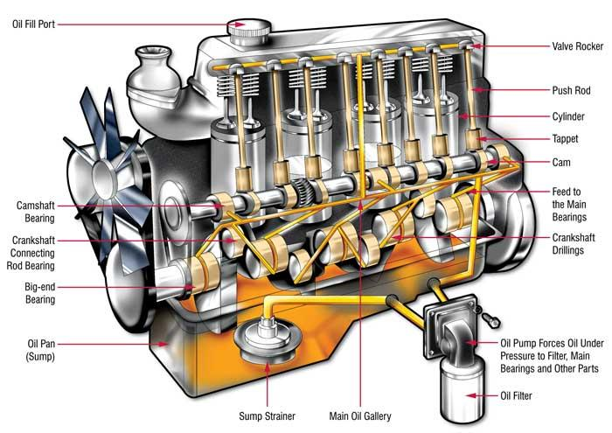
FIGURE 1.1: How the Lubrication System Works In an Engine
Source: https://www.lubrita.com/news/78/671/how-the-lubrication-system-works-in-an-engine/

Lubrication is essential for various automotive components, including:
- Engines (ICEs and hybrid powertrains)
- Transmissions and gearboxes
- Bearings and axles
- Braking systems
- Electric vehicle drivetrain components
Table 1.1: Key Engine Components Requiring Lubrication
Component | Lubrication Function | Common Lubrication Issues
Piston Rings | Reduces friction against cylinder walls | Oil breakdown leading to wear
Crankshaft Bearings | Supports rotating movement | Excessive heat causing bearing failure
Camshaft and Lifters | Ensures valve timing accuracy | Sludge formation blocking oil flow
Turbocharger Bearings | Handles high-speed rotation | Oil coking due to extreme temperatures

Effects of Inadequate Lubrication:
- Increased Friction: Higher energy losses and fuel consumption.
- Accelerated Wear: Premature engine failure.
- Overheating: Excessive thermal expansion and metal deformation.
- Sludge Formation: Clogged oil passages, reducing lubrication effectiveness.
Research by Mortier et al., (2010) found that 75% of engine failures are linked to lubrication issues, emphasizing the importance of proper oil selection and maintenance.

1.9.1 TYPES OF AUTOMOTIVE LUBRICATION
The types of automotive lubrication systems are categorized by the method in which the lubricant is supplied to engine components
- Splash Lubrication System: In this system, engine parts like the crankshaft dip into the oil in the sump and "splash" it onto other components. Common in smaller engines (e.g., lawnmowers, early motorcycles), but It is Inconsistent in lubrication at high engine speeds or inclines.
- Pressure (Forced Feed) Lubrication System: A pump circulates oil under pressure through galleries to critical engine parts such as bearings and camshafts. It is mostly used in modern cars and heavy-duty engines; it is consistent and reliable lubrication at all operating conditions, but more complex and expensive (Mortier, et al., 2010); (Priest and Taylor 2000).
- Semi-Pressure (Combination) Lubrication System: This system combines both splash and pressure systems-oil, to deliver oil to some parts under pressure, while other receive splash lubrication. It is found in medium-duty and older-generation engines. It balances between cost and performance.
- Dry Sump Lubrication System: Oil is stored in an external reservoir instead of a sump. A scavenging pump returns oil from the engine to the tank after circulation. Used in high-performance, racing, and aviation engines. It improved lubrication under high-speed cornering and inclines, better engine cooling, but more complex and expensive to maintain (Tung and McMillan 2004).
- Mist Lubrication System: Lubricant is mixed with air (usually in 2-stroke engines) and carried into the engine as a fine mist. It is common in two-stroke motorcycles and marine engines. Lightweight, no need for oil pumps, but less precise lubrication with high oil consumption and emissions (Suhane, et al., 2012).
- Grease Lubrication: Grease is used instead of oil for components that require long-lasting lubrication and are not easily accessible (e.g., wheel bearings, chassis joints). Long service life, excellent sealing properties. Not suitable for high-speed moving engine parts.
- Oil Mist or Spray Lubrication (in advanced EVs and hybrids): In some advanced drivetrains (e.g., electric axles), oil is sprayed or misted onto bearings and gears using nozzles. Used in high-efficiency gearboxes in electric vehicles, with precision cooling, lubrication and energy-efficient (Nugroho, et al., 2024).

1.9.2 IMPORTANCE OF AUTOMOTIVE LUBRICATION
Automotive lubrication is vital to the optimal operation and longevity of vehicle systems, especially the engine, transmission, and drivetrain. It enables mechanical components to function smoothly under harsh conditions while protecting them from degradation. Without proper lubrication, engine performance deteriorates rapidly, and system failure becomes inevitable.
- Minimizing Friction Between Moving Parts: Lubrication reduces direct metal-to-metal contact, forming a protective film that decreases friction. This ensures smoother engine operation, less power loss and improved efficiency (Hsu 2004); (Mortier, et al., 2010).
- Reducing Wear and Extending Component Life: By creating buffers between engines part, lubricants help minimize wear on components like pistons, camshafts, and bearings, especially under high pressure and temperature (Priest and Taylor 2000).
- Cooling Engine and Mechanical Components: Friction and combustion generate heat. Lubricants act as heat transfer mediums, absorbing excess thermal energy and dissipating it via the oil sump or cooler. This helps avoid overheating and material fatigue (Tung and McMillan 2004).
- Cleaning Engine Internals: Detergent and dispersant additives in lubricants remove and suspend contaminants, including soot, sludge, and carbon deposits. This keeps the engine clean, improving fuel combustion and reliability (Hsu 2004).
- Preventing Rust and Corrosion: Lubricants contain corrosion inhibitors that shield internal engine parts from water, combustion acids, and other corrosive elements, especially during engine idle or storage (Sharma and Singh 2017).
- Sealing Gaps between Piston Rings and Cylinder Walls: Lubrication helps maintain effective combustion chamber sealing, reducing blow-by gases and improving engine compression, fuel efficiency, and emissions control (Heywood 2018).
- Supporting Hydraulic Systems: In engines with hydraulic valve lifters, cam phases, and timing mechanisms, lubricants also serve as hydraulic fluids, transmitting pressure and facilitating precise control (Mortier, et al., 2010).
- Enhancing Fuel Economy: Friction-reducing additives lower mechanical resistance, thereby increasing engine efficiency and reducing fuel consumption. Modern low-viscosity lubricants are tailored for maximum fuel economy (Taylor and Coy 2000); (Wong and Tung 2004).
- Compatibility with Emission Control Technologies: Advanced lubricants are formulated to be low in ash, phosphorus, and sulphur (low-SAPS) to avoid damaging emission control systems such as diesel particulate filters (DPFs) and catalytic converters (Nugroho, et al., 2024).
- Enabling Longer Maintenance Intervals: High-quality lubricants with strong oxidative stability and detergent systems allow for extended oil drain intervals, reducing maintenance frequency and cost (Suhane, et al., 2012).

1.10 AUTOMOTIVE LUBRICANT
A lubricant is a substance introduced between moving surfaces to reduce friction, wear, and heat generation. In automotive applications, lubricants serve as a protective film that prevents direct metal-to-metal contact, thereby improving the operational efficiency and lifespan of vehicle components. Common lubricants include engine oils, gear oils, greases, and transmission fluids, each tailored to meet the specific thermal and mechanical needs of vehicle systems. Figure 1.1 shows the Lubricant Production process, (Mortier, et al., 2010).
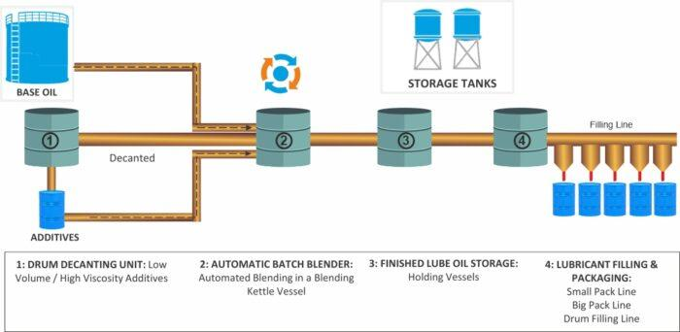
Figure 1.2: lubricant-manufacturing-process
Source: https://trinitypetro.ae/manufacturing-capability/

1.10.1 TYPES OF AUTOMOTIVE LUBRICANT
There are various types of automotive lubricant:
Conventional (Mineral-Based) Lubricants
- These are derived from refined crude oil.
- Cost-effective, widely used in older vehicles.
- Limited oxidation stability and thermal resistance (Priest and Taylor, 2000).
Synthetic Lubricants
- Chemically engineered for superior performance.
- Provide extended drain intervals, better viscosity stability, and enhanced wear protection.
- Common in modern high-performance and turbocharged engines (Mortier, et al., 2010).
Semi-Synthetic Lubricants
- A blend of mineral and synthetic oils.
- Offers a balance between performance and cost.
- Used in passenger cars and light trucks (Tung and McMillan, 2004).

Bio-Based Lubricants
- Derived from renewable sources, such as castor, jatropha, and palm oils.
- High biodegradability, reducing environmental impact.
- Challenges: Oxidation stability and cost-effectiveness (Suhane, et al., 2012).
Figure 1.3 shows the types of oil, content, and their traction force.

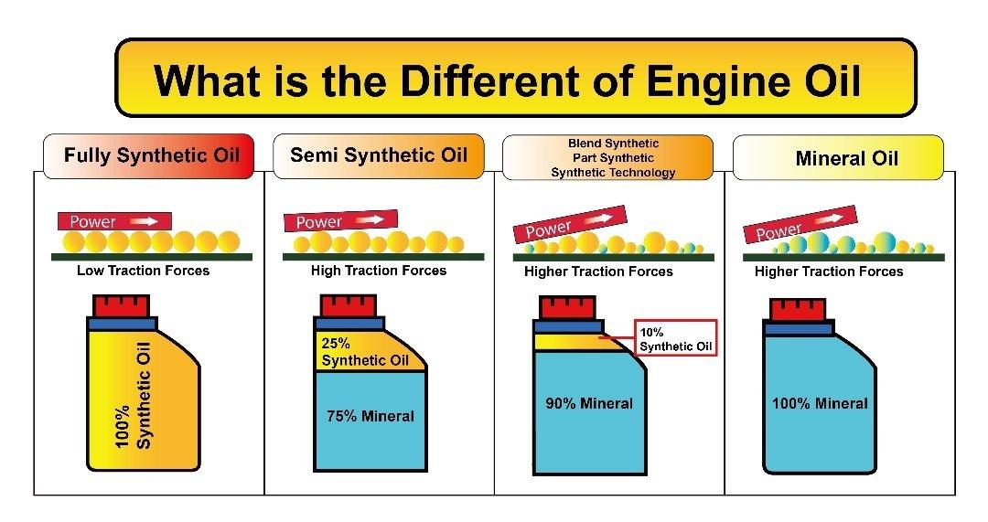
Figure 1.3: Types of Base Oil
Source: https://atlanticlubes.com/2023/01/20/fully-synthetic-vs-semi-synthetic-vs-mineral-oil/

1.10.2 IMPORTANCE OF AUTOMOTIVE LUBRICANT
Lubricants play an essential role in nearly all automotive systems, including internal combustion engines (ICEs), transmissions, gearboxes, and braking systems. In traditional gasoline and diesel engines, lubricants are required to:
- Reduce metal-to-metal contact by forming a protective film between moving components.
- Dissipate heat generated from friction and combustion processes.
- Minimize wear and tear, preventing premature component failure.
- Improve fuel efficiency by reducing frictional losses.
- Enhance engine cleanliness by suspending contaminants and preventing sludge formation (Hsu, 2004).
In electric and hybrid vehicles, the role of lubrication is different but equally critical. While EVs do not have traditional engines requiring motor oil, they still rely on specialized lubricants and thermal management fluids for components such as gearboxes, battery cooling systems, and electric motor bearings (Nugroho, et al., 2024). The demand for low-viscosity, high-efficiency lubricants has increased as automotive manufacturers strive to enhance energy efficiency and durability.

Table 1.2: oil condition base on colour comparisons (hadjad, et al., 2015).

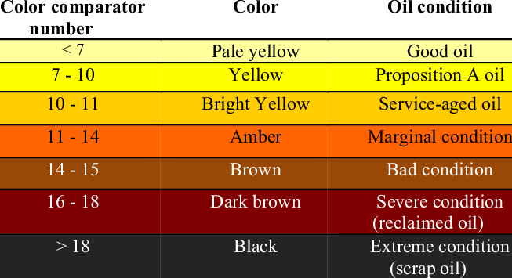

1.10.3 FUNCTIONS OF AUTOMOTIVE LUBRICANT
Automotive lubricants play a crucial role in the performance, efficiency, and longevity of vehicle component, especially within the engine and transmission system. The main functions of automotive lubricants include:
- Friction Reduction: One of the most fundamental functions of automotive lubricants is to reduce friction between moving components within the engine and drivetrain. In high-speed and high-load operations, direct metal-to-metal contact can cause significant damage. Lubricants form a hydrodynamic or boundary film that separates these surfaces, minimizing contact and allowing for smoother operation.
“The efficiency of tribological contact depends significantly on the lubricant’s ability to form a stable and continuous film” (Hsu, 2004).
- Wear Protection: Modern automotive engines experience extreme pressure and stress, particularly at interfaces like cams, lifters, and crankshaft bearings. Lubricants contain anti-wear additives such as zinc dialkyldithiophosphate (ZDDP), which form a protective layer on metal surfaces. This layer sacrificially wears away, preserving the integrity of engine parts under boundary lubrication conditions.
Advanced lubrication is essential in reducing wear caused by contact asperities and preserving component life (Tung and McMillan, 2004).
- Heat Dissipation (Cooling Function): Engines generate significant heat during combustion and mechanical motion. While the coolant system handles macro-scale temperature regulation, lubricants assist by absorbing and transporting heat away from friction zones (e.g., pistons, turbochargers) to the oil sump, where it is dissipated.
Lubricants act as thermal conductors, reducing localized heat accumulation that can cause varnish and oxidation (Priest and Taylor, 2000).
- Contaminant Removal and Cleaning: Engine operation generates contaminants like soot, unburned fuel, metal debris, and oxidation by-products. Lubricants are designed with detergents and dispersants to neutralize and suspend these contaminants in the oil, preventing them from settling and forming sludge.
“Dispersants enhance the lubricant’s ability to carry contaminants, while detergents neutralize harmful acids from fuel combustion” (Mortier et al., 2009).
- Corrosion and Rust Prevention: Internal engine parts are exposed to moisture and acidic by-products of combustion, which can lead to corrosion if unprotected. Inhibitor additives in lubricants coat metal surfaces, preventing oxygen and acidic compounds from initiating corrosive reactions.
Lubricant films prevent oxidative degradation of metal surfaces, crucial in wet or cold start conditions (Sharma and Singh, 2017).
- Sealing Function: Lubricants also serve a secondary role as sealing agents, particularly between piston rings and cylinder walls. This enhances compression by reducing blow-by gases (unburnt gases escaping past the piston), which improves fuel efficiency and reduces emissions.
Proper lubrication seals combustion chambers, aiding in pressure retention and engine power delivery (Heywood, 2018).
- Noise and Vibration Damping: By forming a cushioning layer between components, lubricants reduce mechanical noise and vibration. This is especially important in valve trains, gearboxes, and differential assemblies, where high-frequency metal contact could result in undesirable acoustic emissions.
Lubricants dampen vibratory interaction between friction pairs, improving acoustic comfort and mechanical performance (Wong and Tung, 2016).
- Oxidation Stability: As lubricants operate at high temperatures, they are prone to oxidative degradation, which forms acids, sludge, and varnish. High-quality lubricants include oxidation inhibitors that preserve oil integrity over longer service intervals, critical for modern engines with extended oil change cycles.
Oxidation resistance extends the lubricant's life and protects engine components from deposit build-up (Taylor and Coy, 2000).
Table 1.3: Lubrication Regimes and Their Characteristics (Tung and McMillan, 2004).
Lubrication Regime | Characteristics | Examples in Automobiles
Boundary Lubrication | Thin lubricant film; high metal-to-metal contact | Piston rings and camshaft lobes
Mixed Lubrication | Partial separation of surfaces combination of boundary and hydrodynamic lubrication | Gearbox and transmission components
Hydrodynamic Lubrication | Thick lubricant film completely separates moving parts | Main engine bearings and crankshaft journals

To prevent wear, lubricants incorporate anti-wear agents, such as ZDDP, boron-based compounds, and extreme pressure (EP) additives for high-load applications.
- Hydraulic Function in Engine Systems: In engines equipped with variable valve timing (VVT) and hydraulic lifters, lubricants act as hydraulic fluids, transferring pressure to activate mechanical functions precisely.
- Fuel Economy Enhancement: Low-viscosity, synthetic lubricants with friction modifiers reduce internal engine resistance. This leads to improved fuel efficiency and lower CO₂ emissions, critical under modern emission regulations.

Table 1.4: Effect of Lubricant Viscosity on Fuel Efficiency (Taylor and Coy, 2000).
Lubricant Viscosity Grade | Fuel Efficiency Impact (%) | Application
SAE 0W-16 | +5.0% improvement | Hybrid and fuel-efficient gasoline engines
SAE 5W-20 | +3.5% improvement | Modern gasoline engines
SAE 10W-30 | +1.0% improvement | Conventional ICEs
SAE 15W-40 | No improvement | Older diesel engines

Lower-viscosity lubricants reduce internal drag, leading to better fuel economy. However, they must still provide adequate wear protection, requiring advanced additive technology.
- Protection of Emission Control Systems: Lubricants formulated as low-SAPS (Sulphated Ash, Phosphorus, and Sulphur) prevent poisoning of after-treatment devices like Diesel Particulate Filters (DPFs) and Three-Way Catalytic Converters (TWCs).
- Extended Service Life and Monitoring: With advancements in additive technology and base oils, lubricants now support longer drain intervals, reducing maintenance costs. Additionally, used oil analysis can help diagnose engine health, aiding preventive maintenance.
- Lubrication of Additional Components: Modern engines often include components like turbochargers, which can spin at extremely high speeds (hundreds of thousands of RPM) and operate at high temperatures. The bearings in these turbochargers rely entirely on engine oil for lubrication and cooling. Similarly, variable valve timing (VVT) systems use oil pressure to control valve timing, requiring the lubricant to have appropriate flow characteristics.

1.11 AUTOMOTIVE ENGINE LUBRICANT
Automotive engine lubricant, commonly known as engine oil, is a vital fluid that ensures the proper operation, longevity, and efficiency of internal combustion engines. Its importance stems from its ability to perform a multitude of functions and fulfil critical roles within the complex environment of a running engine.

Figure 1.4: Engine Oil
Source: https://blog.amsoil.com/understanding-oil-viscosity/amp/

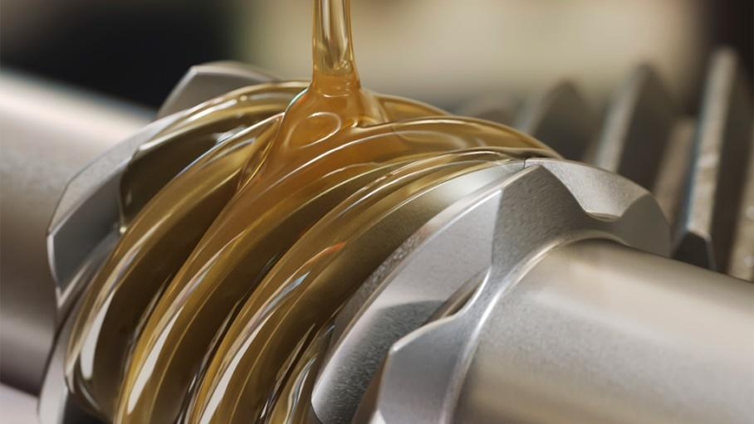
Figure 1.5: GEAR And OIL
Source: https://blog.amsoil.com/understanding-oil-viscosity/amp/

1.11.1 IMPORTANCE OF AUTOMOTIVE ENGINE LUBRICANT
The proper selection and maintenance of engine lubricant are paramount for several reasons:
- Engine Longevity: By minimizing friction and wear, high-quality lubricant significantly extends the lifespan of critical engine components, preventing premature failure and costly repairs.
- Optimal Performance: Effective lubrication ensures smooth movement of internal parts, maximizing power output, responsiveness, and overall engine performance. Inadequate lubrication can lead to sluggishness and reduced efficiency.
- Fuel Efficiency: Reduced friction translates directly into improved fuel economy. When engine parts move freely, less energy is wasted overcoming resistance, leading to better mileage.
- Reduced Emissions: Proper lubrication contributes to cleaner combustion. By preventing wear and maintaining efficient operation, engine oil helps minimize the emission of harmful pollutants.
- Engine Cleanliness: The detergent and dispersant additives in engine oil prevent the build-up of harmful deposits, keeping vital oil passages clear and ensuring efficient heat transfer and lubrication. Sludge and varnish can severely impede engine function.
- Protection against Extreme Temperatures: Engine oil is formulated to perform effectively across a wide range of operating temperatures, from cold starts to high-load, high-temperature conditions. The viscosity characteristics are crucial for this (SAE International, Latest Version).
- Corrosion Prevention: Additives in engine oil neutralize corrosive by-products of combustion, protecting metal surfaces from rust and degradation, which can compromise engine integrity.
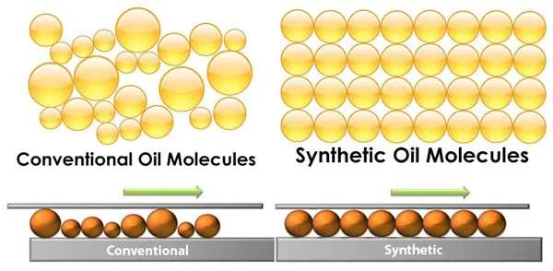
Figure 1.6: Conventional Oil And Synthetic Oil Molecules
Benefit of synthetic over non-synthetic: Less friction, higher oxidation resistance, higher chemical resistance, higher thermal stability, Lower toxicity, Lower volatility, higher viscosity index, Lower pour point, longer oil life, reduced oil consumption, Higher flash point
Source: https://nalube.com/courses/nal-training/lesson/synthetic-vs-non-synthetic/

1.11.2 TYPES OF AUTOMOTIVE ENGINE LUBRICANT
Engine oils are broadly classified based on their base oil and viscosity:
- Based on Base Oil:
- Mineral Oils: These are derived from crude oil and are the most traditional type. They are cost-effective but may not offer the same level of performance and protection as synthetics under extreme conditions.
- Synthetic Oils: These are chemically engineered oils that offer superior performance in terms of thermal stability, oxidation resistance, low-temperature flow, and wear protection. They are generally more expensive than mineral oils.
- Semi-Synthetic Blends: These are a mixture of mineral and synthetic base oils, aiming to offer a balance of performance and cost.
- Bio-based Oils: Derived from renewable sources like vegetable oils, these are gaining attention for their potential environmental benefits, although their performance characteristics are continuously being developed and evaluated.
- High-Mileage Engine Oils: Formulated specifically for engines with over 75,000 miles, these oils include conditioners and seal enhancers to reduce leaks and oil consumption

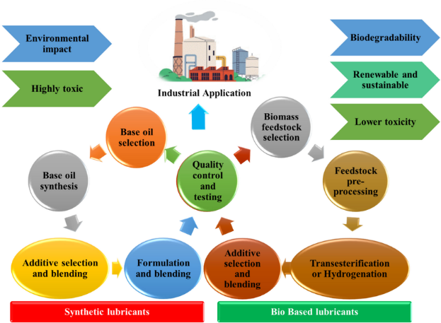
Figure 1.7: Life Cycle of Bio-lubricant and Synthetic Lubricant
Source: (Akanksha, et al., 2024).
- Based on Viscosity (SAE Grades):
- Single-Grade Oils (e.g., SAE 30, SAE 40, and SAE 5W): These oils meet viscosity requirements at either high or low temperatures but not both. They are less common in modern vehicles.
- Multigrade Oils (e.g., SAE 5W-30, SAE 10W-40): These oils are designed to provide adequate viscosity across a wider temperature range. The "W" grade indicates low-temperature performance, while the second number indicates high-temperature viscosity.
Figure 1.9 shows the temperature in which different SEA viscosity grade can operate in.

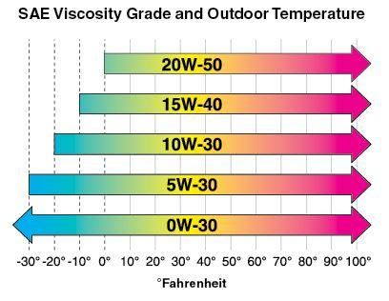
Figure 1.9: SAE Viscosity Grade And Outdoor Temperature
Source: https://blog.amsoil.com/wp-content/uploads/2018/04/SAE_Viscosity_Grade_Temps.jpg
Classification and Standards
Engine lubricants are classified according to their viscosity grade (SAE – Society of Automotive Engineers) and performance standards such as those from the API (American Petroleum Institute) or ACEA (European Automobile Manufacturers Association). These standards ensure that the lubricants meet the specific requirements of different engine types and operating environments.
Environmental and Efficiency Considerations
With the increasing demand for fuel efficiency and lower emissions, modern lubricants are being engineered to be more environmentally friendly while delivering superior performance. Low-viscosity oils, for example, reduce internal engine drag and improve fuel economy but must also maintain sufficient film strength to prevent wear.

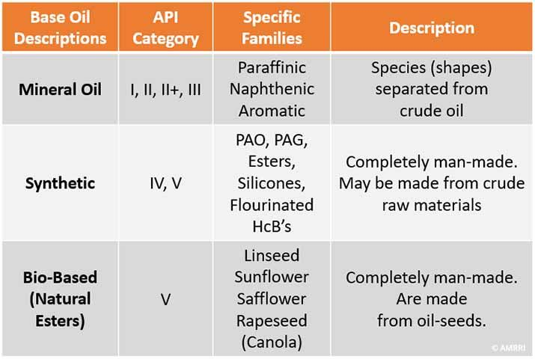
Figure 1.10: Base Oil Categories
Source: https://precisionlubrication.com/articles/base-oils/

1.11.3 LUBRICANT IN SPARK IGNITION ENGINE
A Spark Ignition (SI) engine is a type of internal combustion engine (ICE) where the air-fuel mixture is ignited by a spark plug. These engines, commonly found in gasoline-powered vehicles, operate at high speeds and temperatures and demand specialized lubrication to ensure optimal performance, reliability, and longevity. The lubricant used in SI engines must be tailored to handle thermal stress, fuel dilution, oxidation, and deposit control.
- Primary Functions of Lubricant in SI Engines
- Friction Reduction: Lubricants reduce metal-to-metal contact between components like pistons, camshafts, and crankshafts, improving fuel efficiency and power output.
- Heat Dissipation: The lubricant carries heat away from hot engine parts, maintaining thermal balance during high-speed operation.
- Protection: Anti-wear additives protect engine components subjected to repetitive stress, especially in the valve train and cylinder walls.
- Cleaning and Deposit Control: Detergents and dispersants prevent build-up of carbon, varnish, and sludge due to gasoline combustion by-products.
- Sealing: A thin oil film enhances the seal between piston rings and cylinder walls, reducing blow-by gases and improving combustion efficiency (Hsu 2004); (Mortier, et al., 2010).
- Lubricant Requirements for SI Engines
- Fuel Dilution: Unburned fuel mixes with oil during cold starts or short trips, thinning the lubricant and reducing film strength.
- Oxidation: High engine temperatures can degrade the oil, leading to sludge and acid formation.
- Low-Speed Pre-Ignition (LSPI): Especially in modern turbocharged gasoline direct injection (GDI) engines, LSPI can cause engine knock and damage. Modern lubricants must be LSPI-resistant (Taylor and Coy 2000); (Wong and Tung 2016).
- Additive Requirements for SI Engine Oils
- Antioxidants: To prevent thermal degradation of oil.
- Friction Modifiers: To enhance fuel economy.
- Detergents and Dispersants: To prevent piston deposits.
- Anti-wear Agents (e.g., ZDDP): To protect camshafts and lifters (Priest and Taylor 2000); (Nugroho, et al., 2024).
- Emission System Compatibility
Modern SI engines are paired with three-way catalytic converters (TWC). Therefore, engine oils must be formulated as low-SAPS (low in Sulphate Ash, Phosphorus, and Sulphur) to avoid catalyst poisoning and ensure longevity of emission control systems (Nugroho, et al., 2024); (Mortier et al., 2010).
- Trends in SI Engine Lubrication
- Use of synthetic low-viscosity oils (e.g., SAE 0W-20 or 5W-30) for better cold-start performance and fuel efficiency.
- Advanced additive packages to meet the demands of turbocharged GDI engines.
- Extended oil drain intervals due to improved oxidation stability (Taylor and Coy 2000); (Suhane et al., 2012).

1.11.4 LUBRICANT IN COMPRESSION IGNITION ENGINE
A Compression Ignition (CI) engine, commonly referred to as a diesel engine, ignites fuel by the heat of compression rather than a spark. These engines operate at higher pressures and temperatures compared to spark ignition engines, and they are often used in heavy-duty vehicles, trucks, and industrial machinery. As a result, the lubricants used in CI engines must be specifically formulated to handle severe operating conditions, including soot contamination, acidic by-products, and heavy loads.
- Primary Functions of Lubricant in CI Engines
- Wear Protection: Lubricants reduce metal-to-metal contact in high-load areas such as pistons, cam lobes, and crankshaft bearings.
- Soot Suspension and Dispersion: CI engines generate significant soot due to incomplete combustion. The lubricant must suspend these particles to prevent sludge and deposit formation.
- Neutralization of Acidic Compounds: Sulphur in diesel fuel can create sulfuric acid during combustion. Lubricants with high Total Base Number (TBN) neutralize these acids.
- Cooling of Engine Components: The lubricant removes heat from piston rings, cylinder walls, and turbochargers.
- Corrosion and Rust Protection: Additives in the oil protect engine components from acidic attack and moisture (Mortie, et al., 2010); (Ricardo 1922).
- Lubricant Challenges Unique to CI Engines
- High Soot Loading: Particularly in EGR (exhaust gas recirculation) engines, soot can overwhelm dispersant capacity.
- Fuel Contamination: Unburned diesel can dilute the lubricant, lowering its viscosity and film strength.
- Oil Consumption: Higher than in gasoline engines due to longer drain intervals and higher operating pressures.
- Thermal Stress: From turbocharging and prolonged high-load operation (Tung and McMillan 2004); (Wong and Tung 2016).
- Additive Requirements in CI Engine Oils
- Dispersants: To keep soot particles suspended and prevent agglomeration.
- Detergents: To clean piston lands and neutralize acidic combustion by-products.
- Anti-wear Additives: Like ZDDP to protect high-load components.
- TBN Boosters: Typically, calcium- or magnesium-based additives that neutralize acids.
- Antioxidants: To prevent oil thickening due to oxidation (Hsu 2004); (Priest and Taylor 2000).
- Compatibility with Emission Control Systems
Modern diesel engines are equipped with:
- Diesel Particulate Filters (DPFs)
- Selective Catalytic Reduction (SCR) systems
However, CI lubricants must be low-SAPS (low in sulphated Ash, Phosphorus, and Sulphur) to prevent clogging and degradation of emission control components (Nugroho, et al.,., 2024); (Mortier et al., 2010).
- Trends and Advancements in CI Engine Lubrication
- Development of bio-based and synthetic diesel engine oils for environmental compliance and biodegradability.
- Use of nanotechnology-enhanced oils to improve load-carrying capacity and thermal resistance.
- Extended drain intervals supported by better base oils and additive systems (Nugroho, et al., 2024); (Suhane, et al., 2012).

1.11.5 CHALLENGES OF LUBRICANTS IN MODERN ENGINE
As internal combustion engines (ICEs) continue to evolve with tighter packaging, higher specific outputs, and environmental regulations, lubricants must meet increasingly complex and severe performance requirements. Modern engines operate under high loads, extreme temperatures, and tight tolerances, making them more sensitive to lubricant quality and formulation.
- Elevated Operating Temperatures and Pressures
Modern engines, particularly turbocharged and downsized units, operate at higher combustion temperatures and pressures to meet performance and efficiency demands. This environment accelerates:
- Oil oxidation and thermal breakdown
- Thickening of the lubricant
- Depletion of key additives like antioxidants
As temperatures rise, oils need better volatility control and thermal stability to prevent viscosity loss and deposit formation. Synthetic base oils (Group IV/V) and high-performance antioxidants are now essential in premium lubricants (Mortier, et al., 2010); (Taylor and Coy 2000).
Table 1.5: Oxidation Stability of Different Lubricant Types (Mortier, et al., 2010).
Lubricant Type | Oxidation Stability (Hours at 150°C) | Deposit Formation Risk
Mineral-Based Oils | 500 – 1000 | High
Synthetic Oils | 2000 – 5000 | Low
Bio-Based Oils | 1000 – 2500 | Moderate

The table show the Oxidation Stability of different Lubricants and their impact on the Environment
- Low-Speed Pre-Ignition (LSPI) in GDI Engines
LSPI is a severe form of engine knock seen in turbocharged gasoline direct injection (TGDI) engines operating under low-speed, high-load conditions. It is often triggered by interactions between the fuel-air mixture, oil droplets, and surface deposits.
Lubricants required are: LSPI-resistant additive packages
- Calcium and molybdenum balance optimization
- Advanced friction modifiers that minimize hot-spot formation. (Wong and Tung 2016); (Nugroho, et al., 2024).
Table 1.6: Lubricant Formulation Trends For Advanced Engine Materials (Mortier, et al., 2010).
Engine Material | Lubricant Requirement | Challenges
Aluminium Alloys | Corrosion inhibitors | Prone to oxidation and surface wear
DLC-Coated Components | Low-SAPS formulations | Friction modifiers must be compatible
Titanium Engine Parts | High-film strength lubricants | Risk of surface fatigue

- Fuel Dilution and Cold-Start Effects
Frequent cold starts, short trips, and advanced injection strategies increase fuel dilution, where unburned fuel mixes with the lubricant. This:
- Reduces oil viscosity
- Weakens the lubricating film
- Accelerates oxidation and corrosion
Modern lubricants must resist thinning and provide sufficient low-temperature fluidity for instant start-up protection, even when fuel is present in the oil (Priest and Taylor 2000).
- Exhaust After-Treatment System Compatibility
Modern engines are equipped with advanced emission systems like:
- Diesel Particulate Filters (DPFs)
- Selective Catalytic Reduction (SCR)
- Three-Way Catalytic Converters (TWC)
Lubricants must now be Low-SAPS (low Sulphated Ash, Phosphorus, and Sulphur) to:
- Prevent catalyst fouling
- Avoid particulate build-up
- Extend system durability
Balancing low-SAPS requirement while maintaining anti-wear protection and detergent actions are major formulation challenges (Nugroho, et al., 2024); (Mortier et al., 2010).
- Extended Drain Intervals
Many OEMs recommend longer oil change intervals-sometimes up to 25,000 km. These demands:
- Oils with exceptional oxidative stability
- Robust additive retention over time
- Resistance to sludge, soot, and wear for extended cycles
Synthetic lubricants with advanced base stocks and long-life additive chemistries are necessary to meet these durability expectations (Tung and McMillan 2004).
- Soot Loading in Diesel Engines
In diesel engines, especially the ones using exhaust gas recirculation (EGR), soot particles mix with engine oil. Excessive soot:
- Increases oil viscosity
- Leads to sludge formation and filter blockage
- Causes abrasive wear in cylinder liners and bearings
Lubricants must contain powerful dispersants and be validated for soot-handling capacity, particularly in CI engines (Ricardo 1922); (Priest and Taylor 2000).
- Engine Downsizing and High Mechanical Stress
Modern engines are designed for higher specific outputs, delivering more power from smaller displacements. This results in:
- Higher bearing and piston temperatures
- Increased shear stress on oil films
- Risk of lubricant breakdown in thin-film regions
Lubricants must offer:
- Excellent high-temperature high-shear (HTHS) stability
- Film strength under boundary and mixed lubrication regimes (Hsu 2004); (Wong and Tung 2016).
- Frequent Start-Stop and Hybrid Duty Cycles
Start-stop systems and hybrids introduce intermittent engine operation, meaning:
- Lubricant must provide instant protection at engine start
- Must resist condensation and cold-thickening
- Maintain protection during low-speed, high-torque electric-motor transitions
Oils must be formulated with advanced pour point depressants, viscosity modifiers, and base oils with low volatility (Taylor and Coy 2000).
- Environmental Regulations and Sustainability Targets
- Biodegradability
- Renewable feed-stocks (bio-based oils)
- Low carbon footprint across their lifecycle
Developing lubricants with green chemistry, such as vegetable oil esters and Nano-bio additives, presents both performance and supply chain challenges (Suhane, et al., 2012); (Nugroho, et al., 2024).

1.12 COMPOSITION OF AUTOMOTIVE ENGINE LUBRICANT
Automotive engine lubricants are highly engineered fluids formulated to meet the demanding conditions of modern engines. Their composition is a carefully balanced blend of base oils and performance-enhancing additives. Each component serves a distinct role in ensuring that the lubricant performs reliably under varying temperatures, pressures, and mechanical stresses.
- Base Oil (70–90%)
The base oil forms the major portion of the lubricant and provides the fundamental lubricating properties such as viscosity, film formation, and thermal stability.
Types of Base Oils:
- Mineral Oils (Group I and II): Derived from crude oil through refining.
- Synthetic Oils (Group III, IV and V): Chemically engineered for higher thermal/oxidation stability.
- Bio-Based Oils: Derived from renewable sources like castor, palm, or jatropha oils (Suhane et al., 2012); (Aiman and Syahrullail, 2017).
Function: Provide lubrication, heat transfer, and serve as a medium for additives (Mortier, et al., 2010).
- Additives (10–30%)
Additives are chemical compounds blended into base oils to improve or enhance specific properties of the lubricant.
Key Additives Include:
- Antioxidants – Prevent oil degradation (e.g., phenolic, aminic compounds).
- Detergents – Clean surfaces and neutralize acids (e.g., calcium sulfonates).
- Dispersants – Suspend contaminants to prevent sludge (e.g., PIB-succinimide).
- Anti-wear agents – Reduce surface wear (e.g., ZDDP).
- Friction Modifiers – Improve fuel economy (e.g., molybdenum compounds).
- Corrosion Inhibitors – Protect against rust.
- Viscosity Index Improvers – Stabilize viscosity over a wide temperature range.
- Pour Point Depressants – Improve cold-start properties.
Function: Extend oil life, protect engine parts, improve cleanliness, and ensure compliance with environmental standards. (Hsu 2004); (Taylor and Coy 2000); (Nugroho, e t al., 2024).
- Optional Enhancers (in modern and synthetic oils)
Some high-performance or application-specific lubricants may include:
Nano-additives: For reducing wear and enhancing tribological properties
(e.g., palm oil bio-lubricants doped with nanoparticles) (Nugroho, A. et al., 2024).
Polymeric Esters or Biodegradable Enhancers: For environmental sustainability and high-temperature stability (Singh, et al., 2024).

1.13 ADDITIVES IN LUBRICANT
Additives are chemical compounds, organic or inorganic, incorporated into base oils to enhance or impart specific properties to lubricants. They play a crucial role in improving performance, extending service life, and ensuring the lubricant meets the demands of modern automotive applications (Mortier, et al, 2010).
Figure 1.11 shows the Additives content in different types of Oil
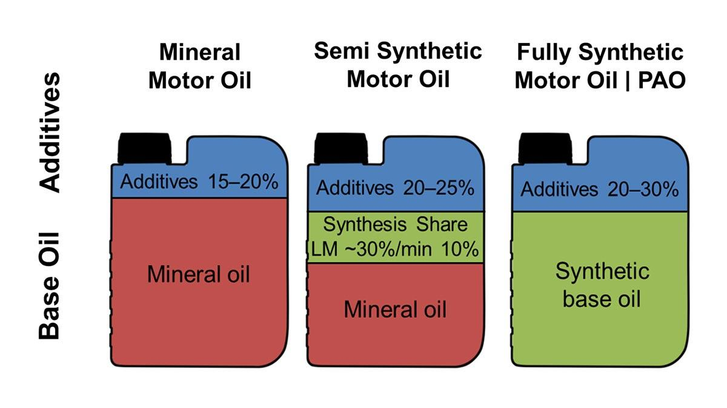
Figure 1.11: Additives in Oil
Source: https://lmem.my/featured/the-complete-guide-to-choosing-the-right-engine-oil-for-your-car/

1.13.1 TYPES OF ADDITIVES
The various types of additives are:
- Antioxidants: it prevents the oxidation of the base oil, which can lead to sludge, varnish formation, and viscosity increase. Example: Aminic and phenolic antioxidants (Mortier, et al., 2010).
- Detergents: It neutralizes acidic combustion by products and prevent deposit formation on engine components like pistons and valves. Example: Calcium sulphurnate, magnesium sulphurnate (Hsu, 2004).
- Dispersants: It Keep soot, sludge, and other contaminants suspended in the oil, preventing agglomeration and deposit formation. Example: Polybutenyl succinimide (Taylor and Coy, 2000).
- Anti-Wear Agents: It form protective layers on metal surfaces to reduce wear in high-load areas such as valve trains. Example: ZDDP (Zinc Dialkyldithiophosphate). (Priest and Taylor, 2000).
- Extreme Pressure (EP) Additives: It provides protection under high-pressure, high-temperature conditions, particularly in gear systems. Example: Sulphur-phosphorus compounds (Mortier et al., 2010).
- Friction Modifiers: It reduces friction between moving parts, improving fuel economy and engine responsiveness. Example: Molybdenum dithiocarbamate, esters (Wong and Tung, 2016).
- Viscosity Index Improvers (VIIs): It enhances the lubricant’s viscosity-temperature behaviour, allowing it to remain effective across a wide temperature range. Example: Olefin copolymers (OCP), polymethacrylates (PMA) (Nugroho, et al., 2024).
- Pour Point Depressants: It prevents wax crystal formation at low temperatures, allowing the lubricant to remain fluid in cold conditions. Example: Polymethacrylates, alkylated naphthalene’s (Suhane et al., 2012).
- Corrosion and Rust Inhibitors: It form a protective barrier on metal surfaces to prevent rust and corrosion due to moisture or combustion acids. Example: Amine-based or ester-based inhibitors (Sharma and Singh, 2017).
- Foam Inhibitors (Defoamants): It prevent or break foam bubbles in the oil to ensure consistent lubrication and prevent air entrapment. Example: Silicone-based compounds, non-silicone polymers (Mortier et al., 2010).
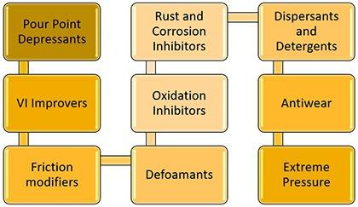
Figure 1.12: Types of Lubricant Additives
Source: https://strategicreliabilitysolutions.com/what-are-the-types-of-lubricant-additives/

1.13.2 IMPORTANCE OF ADDITIVES
Additives are critical components of modern lubricants, especially in automotive applications where operating conditions are becoming more demanding due to advanced engine designs, emissions control systems, and fuel economy requirements. Without additives, base oils alone would not meet the performance, durability, and environmental standards required in today's vehicles.
- Enhance Base Oil Performance: Base oils provide the foundational lubricating properties, but their capabilities are limited without enhancement. Additives modify these properties to improve lubrication under varying temperatures, pressures, and speeds (Mortier, et al., 2010).
- Extend Engine Life: Additives such as anti-wear agents and corrosion inhibitors form protective films on metal surfaces, reducing wear, preventing rust, and minimizing metal fatigue. This protection extends the operational life of engine components, especially under high-load and high-temperature conditions (Priest and Taylor, 2000).
- Improve Oil Longevity and Stability: Antioxidants prevent the oxidation of oil, which would otherwise lead to thickening, sludge formation, and loss of lubricity. This allows lubricants to maintain their properties over longer drain intervals, reducing maintenance costs (Taylor and Coy, 200).
- Keep Engines Clean: Detergents and dispersants help prevent the formation and deposition of sludge, varnish, and carbon residues in the engine. They ensure the suspension of contaminants in the oil, allowing them to be removed through filtration (Hsu, 2004).
- Optimize Fuel Efficiency: Friction modifiers lower the coefficient of friction between engine components. This reduces mechanical drag, enhances engine responsiveness, and improves overall fuel efficiency (Wong and Tung, 2016).
- Protect Against Extreme Conditions: Additives like extreme pressure (EP) agents and viscosity index improvers allow the lubricant to perform under extreme temperature, pressure, and load conditions. This is especially important in gearboxes, turbocharged engines, and heavy-duty vehicles (Tung and McMillan, 2004).
- Enable Environmental Compliance: Modern additives are designed to be low in sulphated ash, phosphorus, and sulphur (low-SAPS), ensuring compatibility with catalytic converters, diesel particulate filters (DPFs), and other emissions control systems. This helps vehicles meet stringent environmental regulations (Nugroho, et al., 2024); (Sharma and Singh, 2017).
- Provide Specialized Functions: Additives enable lubricants to serve as hydraulic fluids (e.g., in VVT systems), cooling agents (thermal conductivity), or dielectric insulators (in electric vehicles). Their versatility allows lubricants to support multiple engine technologies (Hsu, 2004).

1.13.3 FUNCTIONS OF ADDITIVES
The functions of additives are:
- Friction Reduction: Friction modifiers minimize resistance between engine parts by creating a low-friction surface film. This result in smoother operation, reduced power loss, and improved fuel economy. Example: Organic molybdenum compounds (Wong and Tung 2016).
- Wear Protection: Anti-wear additives such as ZDDP form a protective barrier on metal surfaces under high-pressure contact, preventing scuffing and metal fatigue. (Priest and Taylor 2000).
- Oxidation Resistance: Antioxidants inhibit the chemical breakdown of oils when exposed to high temperatures and oxygen, preventing sludge formation and maintaining oil longevity (Mortier, et al., 2010).
- Cleaning Engine Surfaces: Detergents neutralize acidic by-products of combustion and prevent the build-up of deposits on pistons, valves, and cylinder walls.
Dispersants keep soot and sludge suspended in the oil to be captured by filters (Hsu, 2004).
- Thermal Stability and Viscosity Control: Viscosity index improvers (VIIs) allow the lubricant to maintain optimal viscosity across a wide range of operating temperatures, ensuring fluidity in cold starts and film strength at high temperatures. (Taylor and Coy, 2000).
- Corrosion and Rust Protection: Corrosion inhibitors form a chemical barrier that protects engine surfaces from water, acids, and combustion gases that cause oxidation and rusting (Sharma and Singh, 2017).
- Load-Bearing and Shock Absorption: Extreme pressure (EP) additives provide load-carrying capability by forming sacrificial layers that protect surfaces during boundary lubrication, especially in gears and heavy-duty applications (Tung and McMillan 2004).
- Foam Suppression: Foam inhibitors reduce air bubble formation in oil, maintaining consistent lubrication and preventing cavitation in oil pumps (Mortier et al., 2010).
- Pour Point and Cold Flow Improvement: Pour point depressants allow oils to flow at low temperatures by preventing wax crystal formation, ensuring start-up protection in cold climates (Suhane et al., 2012).
- Environmental Protection and Emission System Compatibility: Low-SAPS additives protect after-treatment devices like diesel particulate filters (DPFs) and three-way catalysts by reducing ash and sulphur emissions (Nugroho, et al., 2024).
Table 1.7: Types Of Additives And Their Functions (Mortier, et al., 2010); (Taylor and Coy, 2000).
Additive Type | Function | Examples
Viscosity Modifiers | Maintain viscosity at varying temperatures | Polymethacrylates, Olefin copolymers
Anti-Wear Agent | Prevent metal-to-metal contact, reducing wear | Zinc dialkyldithiophosphate (ZDDP), Boron compound
Detergents | Prevent deposit and sludge formation | Calcium and magnesium sulfonates
Dispersants | Suspend contaminants in oil | Polyisobutylene succinimide
Friction Modifiers | Reduce friction and improve fuel economy | Molybdenum-based compounds, esters
Oxidation Inhibitors | Prevent oil degradation due to oxidation | Phenolic and amine antioxidants
Anti-Foaming Agents | Prevent excessive foaming in high-speed applications | Silicone-based compounds
Corrosion Inhibitors | Protect metal surface from rust and corrosion | Barium sulfonates, Amine phosphates

1.13.4 ROLES OF ADDITIVES
Additives in automotive lubricants are not merely optional enhancers, they are essential components that transform base oils into high-performance, multifunctional fluids capable of meeting the extreme demands of modern internal combustion engines (ICEs), hybrid powertrains, and even electric vehicles (EVs). The roles of additives extend across functional, protective, regulatory, and performance domains.
- Enhancing Lubricant Performance: Additives modify the physical and chemical properties of base oils to ensure they can perform effectively under diverse conditions, such as high loads, varying temperatures, and extended drain intervals. Without additives, base oils lack the robustness needed for automotive use (Mortier, et al., 2010).
- Ensuring Engine Cleanliness: Additives like detergents and dispersants play a crucial role in maintaining internal engine cleanliness. They prevent the accumulation of carbon deposits, sludge, and varnish that can impair engine function, particularly in high-performance and turbocharged engines (Hsu, 2004).
- Protecting Engine Components: Through the action of anti-wear and extreme pressure (EP) agents, additives reduce the wear and tear on vital engine parts, such as camshafts, pistons, and gears. This protection ensures longer engine life and lowers maintenance costs (Priest and Taylor, 2000).
- Supporting Environmental Compliance: Modern additives enable lubricants to comply with emission and environmental regulations by reducing harmful components like sulphur, phosphorus, and ash (low-SAPS). They also aid in compatibility with after-treatment systems like diesel particulate filters (DPFs) and catalytic converters (Taylor and Coy, 2000); ( Nugroho, et al., 2024).
- Improving Fuel Efficiency: Friction modifiers reduce internal engine resistance, which leads to lower fuel consumption. This role is increasingly important in meeting global fuel economy standards and reducing CO₂ emissions (Wong and Tung, 2016).
- Extending Oil Life and Stability: Additives such as antioxidants and corrosion inhibitors enhance the thermal and oxidative stability of lubricants, allowing for longer oil change intervals and better performance under stress (Tung and McMillan, 2004).
- Facilitating Cold Start and High-Temp Protection: Viscosity modifiers and pour point depressants ensure the lubricant remains fluid at low temperatures for easy engine start-up while maintaining film strength at high temperatures. This dual role ensures year-round engine protection (Suhane et al., 2012).
- Enabling Specialized Functions: In advanced powertrains—such as those with variable valve timing (VVT) or hydraulic lifters—additives enhance the lubricant’s role in hydraulic actuation. In EVs, lubricants require electrically insulating and thermally conductive properties supported by tailored additive formulations (Nugroho, et al., 2024).

1.14 ADDITIVES IN FUEL
Fuel additives are chemical compounds blended into base fuels to enhance their properties, performance, and environmental compatibility. Their use has become increasingly critical in modern engines, especially in the context of emissions regulations, fuel economy targets, and engine durability.
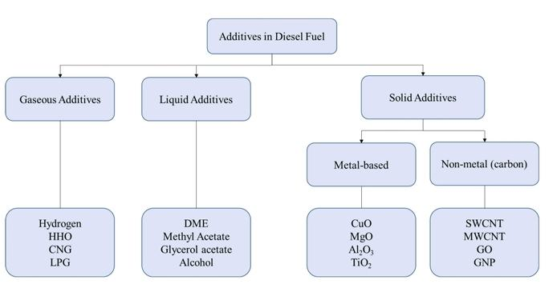
Figure 1.13: Classification according to different forms of Additives
Source: http://www.aimspress.com/journal/energy

1.14.1 TYPES OF FUEL ADDITIVES
According to Alli and Kotha (2023) and Daud et al., (2022), fuel additives are categorized as:
Type Purpose
Detergents Clean fuel injectors and intake valves
Anti-knock Agents Raise octane/cetane rating to prevent knocking
Corrosion Inhibitors Prevent rust in the fuel system
Stabilizers Enhance fuel storage life by preventing oxidation
Lubricity Improvers Improve lubrication, especially in ULSD and biodiesel
Anti-icing Agents Prevent fuel line freezing in cold weather
Cetane/Oxidation Improvers Improve combustion quality in fuels
Combustion Enhancers Increase thermal efficiency and reduce soot formation

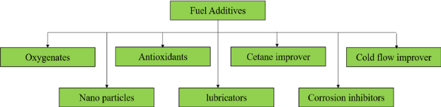

Figure 1.14: Different Types of Additives
Source: (Dhanarasu, et al., 2022).

1.14.2 IMPORTANCE OF FUEL ADDITIVES
The importance of fuel additives are:
- Performance Enhancement: Additives improve combustion efficiency and engine response. This results in better acceleration, smoother engine operation, and improved power output.
- Emission Reduction: They help lower harmful emissions like CO, NOx, and particulate matter by promoting cleaner and more complete combustion.
- Engine Protection: Additives prevent carbon deposits, corrosion, and wear, thereby extending engine life.
- Fuel Economy: By optimizing combustion and reducing friction, additives contribute to improved fuel mileage.
- Adaptation to Biofuels and Alternative Fuels: Fuel additives are essential for compensating for the drawbacks of biofuels, such as poor lubricity and instability.
Fuel additives significantly influence fuel efficiency, engine durability, and emission control in internal combustion engines, especially under modern operating conditions (Daud, et al., 2022).

1.14.3 FUNCTIONS OF FUEL ADDITIVES
The various functions of additives in fuel are:
- Cleaning: Detergents prevent deposits on injectors and valves, maintaining optimal spray patterns and combustion.
- Octane/Cetane Boosting: Enhancers allow engines to run at higher compression ratios without knocking.
- Corrosion Control: Inhibitors protect fuel system components, especially in ethanol-blended fuels.
- Cold Flow Improvement: Additives ensure fuel flow in low-temperature conditions, especially relevant for biodiesels.
- Stabilization: Antioxidants and stabilizers prevent fuel degradation over time.
Detergents and cetane enhancers play a crucial role in ensuring combustion efficiency and maintaining injector cleanliness in biodiesel-blended fuels (Alli and Kotha, 2023).

1.14.4 ROLES OF FUEL ADDITIVES
Additives plays an important role in fuel, these roles are:
- Adaptation to Low-Quality or Blended Fuels: Additives help modern engines function optimally even with fuels like ethanol or biodiesel.
- Environmental Compliance: Additives enable compliance with stringent emission norms by reducing particulate matter and unburnt hydrocarbons.
- Extending Maintenance Intervals: By minimizing deposit formation and corrosion, they reduce the need for frequent maintenance.
- Fuel Compatibility: They improve compatibility of fuels with various engine materials (e.g., seals, injectors).
Additives are integral to modern fuel design, ensuring compatibility with advanced engine technologies and reducing environmental impact (Daud et al., 2022).

1.15 AUTOMOTIVE INDUSTRY

1.15.1 GLOBAL AUTOMOTIVE INDUSTRY
The global automotive industry is one of the world’s most significant economic sectors, both in terms of revenue and technological influence. It comprises the design, development, manufacturing, marketing, and servicing of motor vehicles. In recent decades, the industry has experienced dramatic changes driven by technological advancements, environmental concerns, consumer preferences, and regulatory shifts. These changes have a direct impact on automotive lubrication technologies, influencing the demand for more efficient, durable, and environmentally friendly lubricants.
Figure 1.15 shows the prediction of Global Automotive Market by 2034.
E
Figure 1.15: Global Automotive Industry Market
Source: https://www.precedenceresearch.com/automotive-motors-market
- Size and Scope of the Global Automotive Market
As of 2024, the global automotive market is valued at over $3.5 trillion, with leading producers including the United States, China, Japan, Germany, and South Korea.
Global vehicle production exceeds 90 million units annually, including passenger cars, commercial vehicles, and electric vehicles (EVs).
The sector employs over 50 million people worldwide, directly and indirectly (Heisler, H. 2002); (Carmo, J. P., and Ribeiro, J. E. 2012).
- Technological Advancements and Research and Development
The industry is rapidly embracing electrification, hybridization, automation, and connectivity.
Major players invest heavily in research and development for electric powertrains, autonomous systems, and lightweight materials to meet fuel efficiency and emission targets.
These advancement demand specialized lubricants for electric motors, e-axles, and hybrid systems.
Lubricant Implication: This requires development of new dielectric lubricants, advanced cooling oils, and low-viscosity fluids with excellent thermal stability (Nugroho, et al., 2024).

- Environmental and Emission Regulations
Regulatory bodies such as the European Union (Euro 7), the U.S. EPA, and China have imposed stringent CO₂ and NOx emission standards.
Automakers are transitioning to low-emission ICEs, hybrids, and EVs, necessitating lubricants that support after-treatment devices and lower tailpipe emissions.
High demands for low-SAPS oils, biodegradable lubricants, and fuel-efficient formulations (Taylor and Coy 2000); (Mortier, et al., 2010).
- Electrification and the Shift to EVs
EVs now represent over 15% of global new car sales, and are projected to reach 50% by 2035 in leading markets.
EVs reduce demand for traditional engine oils but require:
- e-Transmission fluids
- Coolant-lubricant hybrids
- Greases for bearings and e-motors
Lubricants must now offer electrical insulation, material compatibility, and noise-damping properties (Chen, et al., 2020).
- Global Supply Chain and Market Consolidation
The COVID-19 pandemic and geopolitical events have exposed vulnerabilities in the global automotive supply chain.
Many OEMs are localizing production, affecting lubricant formulation requirements based on regional fuel quality and environmental conditions.
The industry is witnessing mergers and acquisitions, especially in the electric mobility and green lubricant sectors (Sazzad, et al., 2024); (Pichler, et al., 2023).
- Sustainability and Circular Economy
Manufacturers are adopting re-refining techniques, eco-label certifications, and carbon-neutral production goals.
Lubricants are being reformulated for biodegradability, low carbon footprint, and recyclability.
Table 1.8: Global Automotive Production By Region 2023 (Nugroho, et al., 2024).
Region | Annual Vehicle Production (Million Units) | Market Share (%)
Asia-Pacific | 50.5 | 56%
Europe | 115.2 | 20%
North America | 15.1 | 17%
Latin America | 4.15 | 5%
Middle East and Africa | 1.6 | 2%

1.15.2 NATIONAL AUTOMOTIVE INDUSTRY
The automotive industry in Nigeria represents a significant, yet underdeveloped, sector of the national economy. With its large population and growing urbanization, Nigeria offers a strong potential automotive market. However, its industrial ecosystem is constrained by infrastructural challenges, weak policy enforcement, and over-reliance on imports. These realities directly influence the types, quality, and performance requirements of automotive lubricants used nationwide.
- Vehicle Market Composition and Characteristics
Over 12 million registered vehicles operate in Nigeria, with a motorization rate of approximately 0.06 vehicles per capita, much lower than the global average.
The majority (~75-150%) of vehicles are used imports (locally referred to as tokunbo), primarily from Europe, the U.S., and Asia.
These imported vehicles often have worn-out engines, which are more sensitive to oil viscosity, oxidation stability, and anti-wear properties.
The prevalence of aging engines increases the demand for High-viscosity oils (e.g., SAE 20W-50)
Formulations with strong detergent, dispersant, and anti-wear package (Tung and McMillan, 2004); (Mortier, et al., 2010).
- Lubricant Industry Dependence and Blending Operations
Nigeria imports 90-95% of its base oils and additives for local blending. Finished lubricants are produced by both multinational (e.g., Total Energies, Shell, and Mobil) and indigenous companies (e.g., Oando, Forte Oil).
Despite over 30 blending plants, the quality varies due to:
- Limited standardization
- Inadequate government oversight
- Lubricant adulteration in informal markets
The presence of low-quality or counterfeited lubricants threatens engine reliability.
Emphasis must be placed on enforcing NMDPRA/SON standards, investing in Research and Development, and educating consumers on oil specifications (Mortier, et al., 2010)
- National Automotive Industry Development Plan (NAIDP)
Launched in 2013 by the National Automotive Design and Development Council (NADDC), the NAIDP aims to:
- Encourage local vehicle assembly
- Attract foreign investment
- Reduce import dependence
- Promote local content development
However, its implementation has faced setbacks due to:
- Poor infrastructure (roads, power, logistics)
- Weak policy continuity
- Low investor confidence
A thriving local manufacturing base would require customized, OEM-approved lubricants, and
Growth in local auto assembly (e.g., Innoson, Stallion, and Peugeot Nigeria) could drive demand for modern low-viscosity, synthetic, and bio-lubricants (Carmo J. P., and Ribeiro J. E. 2012)
- Fuel Quality and Engine Adaptability
Nigeria’s available fuels (both petrol and diesel) often contain high levels of sulphur and contaminants, which:
- Promote acid formation in combustion
- Accelerate oil degradation and corrosion
- Fuel adulteration (e.g., kerosene mixed with petrol) remains a challenge.
Oils with high Total Base Number (TBN) are necessary to neutralize acid by-products.
Strong anti-corrosion and anti-wear additives are vital for extended engine protection. (Ricardo, 1922); (Suhane, et al., 2012).
- Market Opportunities and Sustainability Trends
With increased activity in ride-hailing, logistics, and public transportation, fleet servicing is growing, offering bulk lubricant application opportunities.
Nigeria’s rich agricultural base presents opportunities to develop bio-based lubricants from palm, castor, jatropha, and other non-edible oils.
Rising global and regional interest in environmental protection and green technologies aligns with NADDC’s pilot electric vehicle projects and clean mobility goals.
Local research and development and support for eco-friendly lubricants will enable Nigeria to participate in green tribology and sustainable engine oil formulation (Singh, et al., 2024); (Pichler, et al., 2023).
- Regulatory Environment and Consumer Awareness
While SON and NMDPRA regulate lubricant quality, enforcement is weak, and consumers often lack technical knowledge.
Lubricant labelling, authenticity verification, and application education remain low in the informal sector.
The absence of localized OEM lubricant standards leads to improper product selection.
Possible Solution:
- The need for policy harmonization, market surveillance, and consumer sensitization.
- Potential for mobile apps or QR-based platforms for verifying genuine lubricants (Mortier, et al., 2010).

1.15.3 LOCAL AUTOMOTIVE INDUSTRY
The local automotive industry in Nigeria refers to automotive activities at the state, community, and grassroots levels, where informal economic systems dominate. Unlike the national sector governed by formal policies and international investments, the local industry is driven by small-scale mechanics, used vehicle imports, roadside retailers, local lubricant vendors, and spare parts markets. Despite being fragmented and largely unregulated, it plays a critical role in sustaining mobility, employment, and small business growth across the country.
- Structure and Characteristics
The local automotive industry is composed mainly of:
- Artisan workshops (mechanics, panel beaters, vulcanizers)
- Spare parts dealers (new and used parts from Ladipo, Owode, Nnewi)
- Independent lubricant retailers
- Used vehicle sales agents (car marts, auctions) these businesses often lack formal registration but serve as the primary support system for millions of vehicle owners.
Lubricants used at this level are often chosen based on price, availability, and word-of-mouth recommendation, not necessarily OEM specifications (Mortier, et al., 2010)
- Lubricant Practices and Challenges
- Adulteration is common: Lubricants are often diluted or rebranded in unsealed containers.
- Poor lubricant knowledge: Many local mechanics and users rely on outdated recommendations (e.g., always using SAE 40 or 20W-50 for every engine).
- Low adoption of synthetic oils: Due to cost, unfamiliarity, and myths about damage to older engines.
Effect: Engines are more prone to wear, overheating, and sludge due to the use of incorrect or degraded oil.
Education campaigns and dealer certification programs could improve the quality and application of lubricants at this level (Hsu, 2004); (Sharma and Singh, 2017).
- Role of Local Mechanics and Technicians
Local artisans are influential in consumer lubricant choices. Many vehicle owners:
- Rely on mechanics to select or supply lubricants
- Accept recommendations without verifying product specs
- Rarely follow manufacturer-recommended oil change intervals
Opportunity: Engaging mechanics through training programs, incentive-based certifications, and partnerships with lubricant companies can improve oil use culture (Tung and McMillan, 2004).
- Environmental and Health Concerns
Improper disposal of used oil is widespread: waste oil is dumped in drains, soil, or reused for rust-proofing.
- This contributes to soil and groundwater contamination, affecting public health and agriculture.
- There is minimal awareness of oil recycling, re-refining, or safe disposal methods.
Effect: A push for waste oil collection centres, community-level sensitization, and NGO collaboration could foster better environmental practices (Sazzad, et al., 2024).
- Economic Impact and Employment
The local auto industry is a major employer of informal labour, particularly among youth and vocational school graduates.
It supports thousands of small businesses, especially in auto clusters like Nnewi (Anambra), Ladipo (Lagos), and Kaduna auto hubs.
Provides critical services that help keep Nigeria’s transport system functional despite economic challenges.
There is a steady lubricant demand at the grassroots level, especially for:
- High-mileage vehicles
- Motorcycles (okada)
- Tricycles (keke)
- Small commercial fleets (taxi, bus, logistics vans) (Carmo J. P and Ribeiro J. E. 2012).
- Digitalization and Emerging Trends
New ventures are emerging, such as:
- E-commerce platforms for engine oil sales
- Mobile oil change services
- Local app-based diagnostic tools
These innovations can help bridge the gap between formal standards and informal application. Digitizing the lubricant value chain at the local level could improve authentic product distribution, reduce counterfeits, and increase awareness (Pichler, et al., 2023).

1.16 LUBRICANT INDUSTRY
The lubricant industry plays a critical role in global industrialization and mobility by supplying essential fluids that reduce friction, protect machinery, and improve energy efficiency. Within the automotive sector, lubricants are indispensable for ensuring engine reliability, reducing emissions, and enhancing fuel economy. The industry includes the production, formulation, blending, distribution, and sale of base oils, additives, and finished lubricants tailored to various engine types and environmental conditions.

1.16.1 GLOBAL LUBRICANT INDUSTRY
The global lubricant industry stands at the epicentre of a profound transformation in response to the paradigm shift in automotive lubrication. Driven by the rapid evolution of engine technologies, the electrification of vehicles, tightening environmental regulations, and growing demand for sustainable products, lubricant producers must now redefine traditional practices to remain relevant in an increasingly competitive and technologically demanding landscape.
Table 1.9: Global Lubricant Market Segmentation by Application (Mortier, et al., 2010).
Sector | Market Share (%) | Growth Drivers
Automotive | 55% | Increased vehicle production, synthetic oil adoption
Industrial | 30% | Expansion of manufacturing and heavy machinery use
Marine and Aviation | 10% | Specialized lubricants for extreme conditions
Others | 5% | Agricultural and specialty lubricants

- Transformation from Traditional to Advanced Formulations
Historically, the industry relied heavily on mineral oil-based lubricants (Group I and II base oils) for internal combustion engines (ICEs). However, the modern push toward fuel efficiency, lower emissions, and extended drain intervals has accelerated the shift toward Group III+, Group IV (PAO), and Group V (esters and synthetic blends).
Advanced lubricants are now engineered to:
- Maintain film integrity under high shear conditions
- Minimize oxidation and sludge in turbocharged engines
- Enable energy-efficient operation with low-viscosity grades (e.g., 0W-20, 0W-16) (Mortier, et al., 2010); (Taylor and Coy, 2000).
- Regulatory Pressures and Low-SAPS Innovation
The implementation of global emissions policies—such as Euro VI, EPA Tier 3, and China VI—has significantly impacted lubricant formulation. Emissions control devices like diesel particulate filters (DPFs) and three-way catalytic converters (TWCs) are sensitive to sulphated ash, phosphorus, and sulphur (SAPS) content in lubricants.
As a result, the global industry is now focused on:
- Low-SAPS lubricants to ensure after-treatment device protection
- Reduced metal-based additive systems
- Compatibility testing with OEM hardware to avoid catalyst fouling and filter clogging (Nugroho, et al., 2024); (Wong and Tung, 2016).
- Electrification and Emerging Fluid Demands
The rise of electric vehicles (EVs) and hybrid electric vehicles (HEVs) is reshaping global lubricant consumption. Traditional engine oils are becoming less relevant in EVs, but new demands are emerging for specialized fluids such as:
- E-axle fluids with cooling and dielectric properties
- Thermal management fluids that function as both coolants and lubricants
- Low-friction greases for high-speed electric motors and reduction gears
Lubricants must now address electrical conductivity, copper corrosion, and compatibility with e-motor insulation materials, marking a significant departure from conventional formulation criteria (Chen, et al., 2020); (Nugroho, et al., 2024).
Figure 1.15 shows the global electric car fleet from 2015 to 2023, which is one of the major challenges in the lubricant industry.
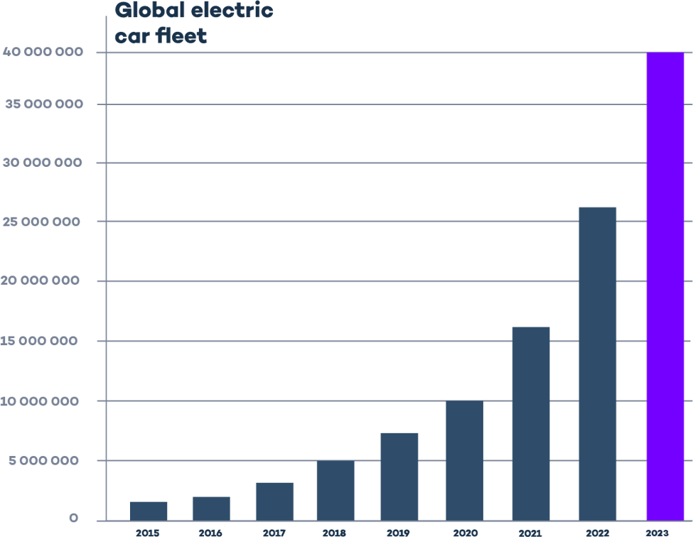Figure 1.16: Global Electric Car Fleet
Source: https://www.virta.global/global-electric-vehicle-market
- Sustainability and Green Tribology
Global lubricant producers are under immense pressure to align with sustainability goals and circular economy principles, leading to innovation in:
- Bio-based lubricants using feed-stocks like palm, castor, and jatropha oils
- Biodegradable esters and synthetic polyols to reduce ecological footprint
- Re-refined base oils (RRBOs) and eco-certifications to reduce lifecycle carbon emissions (Pichler, J. et al., 2023); (Suhane et al., 2012); (Sazzad, et al., 2024).
These changes are not just market-driven, but also mandated by international regulations and customer demand for low-impact, non-toxic lubrication solutions.
- Innovation and Digitization
The paradigm shift has also spurred digital transformation within the industry:
- Smart lubricants with embedded sensors for real-time condition monitoring
- Cloud-based predictive maintenance platforms for fleet lubricant management
- AI-driven formulation models to accelerate product development and testing
Digital innovation is expected to be the next frontier for global lubricant producers, enabling them to enhance efficiency, reduce waste, and offer performance-based lubricant solutions.
- Market Fragmentation and Strategic Alliances
In response to the changing market dynamics, the lubricant industry is:
- Diversifying into niche electric mobility fluids
- Forming strategic alliances with OEMs (e.g., Tesla, Toyota, Volkswagen) to develop proprietary formulations
- Consolidating global operations to reduce cost and expand market access (e.g., Shell’s acquisitions in Asia and Africa).
These strategic moves are essential to remain competitive amid the global transition away from fossil fuel engines.
- Challenges and Constraints
Despite growth and innovation, the global lubricant industry faces several challenges:
- Volatile raw material prices, particularly additive packages and specialty base oils
- Disrupted supply chains due to geopolitical tensions and pandemics
- Counterfeit lubricant products, especially in developing markets
- Lack of harmonized international lubricant standards, which complicates global compliance (Ricardo, 1922); (Singh, et al., 2024).

1.16.2 NATIONAL LUBRICANT INDUSTRY
The national lubricant industry in Nigeria plays a crucial role in supporting transportation, agriculture, manufacturing, and power sectors. Despite its large consumer base and strategic potential, the industry faces substantial challenges linked to product adulteration, regulatory enforcement, import dependency, and technological stagnation. As the global automotive lubrication landscape shifts towards efficiency, electrification, and sustainability, Nigeria’s lubricant sector must adapt to remain competitive and relevant.
- Market Size and Structure
Nigeria is the largest lubricant consumer in sub-Saharan Africa, accounting for an estimated 700 million litters of lubricant demand annually, with the automotive sector making up over 65% of usage. The industry comprises over 30 registered blending and filling plants, most of which are located in Lagos, Ogun, and Anambra states.
Major market players include:
- Multinationals: TotalEnergies, Mobil (11 Plc), Shell, Castrol
- Indigenous brands: Ammasco, Lubcon, Techno Oil, Eterna, Oando
Blending plants operate under license from the Standards Organisation of Nigeria (SON) and rely heavily on imported base oils (mostly Group I and II), due to limited refining capacity (Mortier, et al., 2010); (Carmo J. P., and Ribeiro J. E. 2012).
- Major Challenges Facing the Industry
Adulteration and Quality Control Issues
- A high percentage of lubricants in Nigeria are sold in informal markets, where products are often adulterated with kerosene, recycled oil, or low-grade additives.
- This compromises engine protection and increases environmental pollution.
Lubricant users, especially commercial transporters and rural motorists, frequently suffer from engine failure and reduced fuel efficiency due to poor lubricant quality (Ricardo, 1922); (Pichler, et al., 2023).
Import Dependency
Nigeria imports over 90% of its base oils and additives, making the sector vulnerable to:
- International oil price fluctuations
- Exchange rate volatility
- Global supply chain disruptions
Blending costs are high, limiting the affordability of synthetic or premium-grade oils, which are essential for modern engines and emission standards (Nugroho, et al., 2024).
Limited Research and Development and Innovation
- Most indigenous blending plants focus on repackaging or basic blending rather than innovation.
- There's limited investment in: Bio-lubricant development, Low-SAPS formulation, and Nano-additive enhancement
Nigeria lags behind in developing lubricants compatible with hybrid and electric powertrains, or tailored for fuel economy and environmental compliance (Suhane, et al., 2012); (Nugroho, et al., 2024).
Regulatory and Policy Inconsistencies
- While SON and NMDPRA regulate lubricant quality, enforcement is inconsistent due to weak surveillance and limited penalties.
- The National Automotive Industry Development Plan (NAIDP) lacks direct provisions or incentives to upgrade the lubricant sector to align with automotive technology shifts (Carmo J. P., and Ribeiro J. E. 2012)
- Emerging Trends and Opportunities
Bio-Based Lubricants
- Nigeria’s agro-based economy provides potential feedstocks such as palm oil, castor oil, jatropha oil, and waste cooking oil.
- Recent studies show promising results in using green copolymer additives and bio-lubricant formulations for sustainable performance (Singh, et al., 2024)
Local OEM Partnerships
- With the growth of indigenous automakers like Innoson Vehicle Manufacturing (IVM), there’s an opportunity to co-develop engine-specific lubricants tailored for local operating conditions and fuels.
Expansion of Fleet and Logistics Sectors
- The rise of e-commerce, ride-hailing, and intercity logistics has increased demand for fleet-oriented lubrication services and bulk lubricant sales.
There’s a growing need for extended-drain, high-mileage, and energy-efficient oils.
Digitalization and Branding
- Emerging use of mobile platforms and QR verification systems allows users to verify genuine lubricants and engage in predictive maintenance scheduling.
- Adapting to the Paradigm Shift
For Nigeria’s lubricant industry to thrive amidst the global paradigm shift in automotive lubrication, it must:
- Invest in RandD for synthetic and bio-based alternatives.
- Strengthen policy enforcement against fake and adulterated lubricants.
- Promote public-private partnerships to scale up blending innovation and OEM collaboration.
- Educate mechanics and consumers about oil specifications, change intervals, and quality assurance.
- Develop sustainable production practices aligned with green chemistry and circular economy goals.

1.16.3 LOCAL LUBRICANT INDUSTRY
The local lubricant industry in Nigeria—encompassing independent blenders, roadside vendors, informal mechanics, and regional distribution chains—represents a crucial component of the country’s transportation and maintenance ecosystem. It supports a large population of vehicle users, especially in semi-urban and rural areas where access to branded or OEM-recommended lubricants is limited. However, this informal sector faces significant obstacles that affect the quality, effectiveness, and sustainability of lubricants in the automotive system. These challenges are central to the ongoing paradigm shift in automotive lubrication, driven by new engine technologies, emission regulations, and sustainability demands.
- Informal Market Dominance and Structure
The local lubricant market is highly fragmented, characterized by:
- Small-scale blending operations with limited quality control
- Roadside oil vendors and open-market retailers
- Heavy reliance on used oil repackaging and counterfeit products
- Frequent use of generic, outdated formulations not tailored to modern engines
Despite this, the local industry serves over 70% of vehicle owners, many of whom operate high-mileage, imported used vehicles that require affordable, high-TBN lubricants (Mortier, et al., 2010); (Suhane, et al., 2012).
- Major Challenges in the Local Lubricant Industry
Adulteration and Quality Degradation
- Many products in open markets are diluted with base oils, kerosene, or recycled oil.
- Packaging is easily forged, and labelling rarely meets global API or SAE standards.
- This leads to engine wear, sludge formation, high oil consumption, and even failures.
Lack of Regulation and Enforcement
- Weak monitoring by SON and NMDPRA allows substandard products to thrive.
- Many blenders operate without compliance to national or international standards.
Consumer Knowledge Gap
- Mechanics and end-users often select lubricants based on colour, smell, or price.
- Little awareness exists regarding oil viscosity, additives, change intervals, or compatibility with modern engines (Sharma and Singh, 2022); (Hsu, 2004).
- Technological Mismatch with Modern Engines
Modern engines, including turbocharged gasoline direct injection (TGDI) and downsized diesels, require:
- Low-SAPS, low-viscosity, and LSPI-resistant oils
- Synthetic or semi-synthetic formulations
- Precise additive packages to maintain after-treatment systems (e.g., DPFs, TWCs)
Most local lubricants do not meet these requirements, leading to:
- Emission system damage
- Reduced fuel efficiency
- Poor performance in high-pressure conditions (Nugroho, et al., 2024); (Chen et al., 2020).
- Sustainability and Environmental Gaps
The informal market lacks infrastructure for:
- Waste oil collection and recycling
- Eco-friendly blending practices
- Use of renewable base stocks or biodegradable additives
Improper disposal of used lubricants into waterways and soils is widespread, contributing to environmental degradation and public health risks (Sazzad, et al., 2024); (Singh. et al., 2024).
- Emerging Opportunities Amidst the Paradigm Shift
Despite these challenges, the paradigm shift in automotive lubrication presents opportunities for the local industry to evolve:
Table 1.10
Opportunity | Potential Impact
Development of bio-based oils | Utilize castor, jatropha, and palm oil for greener blends
Mechanic training programs | Improve product knowledge and application accuracy
Mobile oil labs and diagnostics | Enable real-time oil condition monitoring in rural areas
Digitized authentication tools | Combat counterfeit sales via QR verification platforms
Government backed re-refining | Promote waste oil recycling and circular economy models

- Strategic Recommendations
To integrate the local lubricant industry into the global paradigm shift, Nigeria must:
- Strengthen enforcement of national quality standards (e.g., SON, API, and SAE)
- Support local RandD in additive formulation and bio-lubricant development
- Expand mechanic and consumer education through workshops and certification
- Incentivize sustainable lubricant production through tax breaks and subsidies
- Develop lubricant cooperatives and blending clusters in key auto markets like Ladipo (Lagos), Nnewi (Anambra), and Kaduna.

CHAPTER TWO

2.0 LITERATURE REVIEW

2.1 REVIEW OF RELATED STUDIES
Research by Suhane, A. et al., (2012), Potential of Non-Edible Vegetable Oils as an Alternative Lubricants in Automotive Applications, explore the potential of non-edible vegetable oils as sustainable and environmentally friendly alternatives to conventional lubricants for automotive applications. Non-edible vegetable oil-based bio-lubricants are biodegradable, non-toxic, and contribute to net-zero greenhouse gas emissions, making them eco-friendly options. They also offer enhanced lubricity, high viscosity index, good anti-wear properties, and high load-carrying abilities, which can improve engine performance and longevity. Despite their benefits, non-edible vegetable oils may have limitations such as poor oxidative stability and a tendency to form gums over time, which can affect their performance as lubricants. To overcome these limitations, chemical modifications and the use of additives can be employed to enhance the oxidative stability and overall performance of non-edible vegetable oil-based lubricants.
Pendbhaje, G. et al., (2025), Bio-lubricants as viable replacements for mineral oils in automotive engines: A review, to assess the viability of bio-lubricants derived from renewable sources, such as vegetable oils, as sustainable alternatives to conventional mineral oils for automotive engine lubrication. Bio-lubricants offer notable environmental benefits, including reduced toxicity and enhanced biodegradability. Challenges associated with bio-lubricants include variability in raw material quality and higher production costs posing obstacles to widespread adoption in the automotive industry. Continuous research and development are essential to address these limitations, Strategies such as optimizing agricultural practices to ensure consistent raw material quality and improving production processes to reduce costs can collectively enhance the applicability and competitiveness of bio-lubricants in automotive applications.
Singh, Y., and Garg, R. (2015), Aspects of Non-edible Vegetable Oil-Based Bio-lubricants in the Automotive Sector, evaluate the feasibility of utilizing non-edible vegetable oil-based bio-lubricants as sustainable alternatives in the automotive sector. Non-edible vegetable oil-based bio-lubricants offer several benefits, including enhanced lubricity, high viscosity index, good anti-wear properties, increased equipment service life, high load-carrying capacity, low evaporation rates, and reduced emission of metal traces into the atmosphere. ​Despite their advantages, these bio-lubricants face challenges such as poor oxidative stability, limited low-temperature fluidity, and compatibility issues with existing seal and gasket materials. To address these limitations, chemical modifications and the use of additives can enhance the oxidative stability and performance of bio-lubricants.
Singh, N. et al., (2024), "Evaluation of multifunctional green copolymer additives doped waste cooking oil extracted natural antioxidant in bio lubricant formulation" study to explore the potential of curcumin-extracted waste cooking oil (WCO) as a sustainable base oil in the formulation of bio-lubricants by incorporating multifunctional green additives (MGAs), aiming to provide an eco-friendly and performance-driven alternative to petroleum-based lubricants. The formulated bio-lubricants demonstrated notable improvements in viscosity index, thermal stability, and pour point performance, especially at extreme temperature conditions. Despite its promising performance, challenges faced are variability in waste oil quality, potential degradation during extraction, and compatibility challenges with conventional mineral oils may limit the scalability. To overcome these limitations, the study employed a systematic blending strategy using different concentrations of MGAs and mineral oil ratios, to optimize the formulation, ensuring the bio-lubricant meets standard physicochemical properties and can be adapted for commercial-scale applications.
Nugroho, A. et al., (2024), "Enhancing Tribological Performance of Electric Vehicle Lubricants: Nanoparticle-Enriched Palm Oil Bio-lubricants for Wear Resistance, HELIYON" this study investigate the potential of nanoparticle-enriched palm oil-based bio-lubricants as a sustainable and high-performance alternative for electric vehicle (EV) lubrication systems, aiming to reduce environmental impacts and enhance tribological and thermal efficiency. The integration of nanoparticles such as graphene into palm oil-based bio-lubricants resulted in significant performance improvements, reduction in the coefficient of friction, outperform conventional lubricants under high-temperature and high-pressure, and it aligned with global sustainability goals. Certain challenges were faced, such as oxidative degradation over time, inconsistent stability when exposed to prolonged stress, and limited scalability due to sourcing of high-quality nanoparticle additives. These challenges can be address by further research into optimizing nanoparticle dispersion, improving oxidative resistance, and enhancing formulation techniques.
Tung, S. C., and McMillan, M. L. (2004), "Automotive tribology overview of current advances and challenges for the future" it presents a comprehensive overview of lubrication practices across major components of an automotive powertrain system. This presentation offers valuable insights into evolving lubricant standards, such as showcases recent advancements in light-weight materials, including the use of aluminium and magnesium alloys, which contribute to reduced vehicle weight, and enhanced fuel efficiency. Despite progress, the transition from traditional materials like cast iron to light-weight composites pose challenges in terms of cost, large-scale manufacturability, and ensuring material compatibility with advanced lubricants under high-load conditions. To address these limitations, the industry is embracing improved manufacturing techniques such as hydroforming, liquid moulding, enhanced stamping, development of robust structural adhesives and composite moulding technologies.
Hsu, S. M. (2004), "Molecular basis of lubrication" this research is to understand and enhance the performance of lubricants and additives at a molecular level, particularly within boundary lubrication regimes, to support modern engineering systems. Advancements in analytical instrumentation and nanotechnology have significantly improved the ability to study the complex chemistry of lubrication systems, enabling the development of monomolecular thin films that offer valuable insights into anti-wear film behaviour and lubricant functionality. Historically, the development of lubricants was largely empirical, lacking a detailed scientific understanding of the underlying chemical mechanisms, especially regarding how additives function within dynamic mechanical environments. Recent technological breakthroughs now allow researchers to probe surfaces at nanometre scales and chemically characterize lubricating films with precision, paving the way for a more scientific, evidence-based evolution of lubrication technology that could transform current formulation strategies.
Shao, J. et al., (2024), "Recent advances in biomimetic related lubrication" the main goal is to minimize friction-related energy losses and mechanical wear by leveraging biomimetic design principles to develop advanced lubrication materials and systems. Biological surfaces like lotus leaves, fish skin, and snakeskin offer unique antifriction and hydrophobic properties that inspire innovative lubrication strategies, which can significantly enhance the durability, self-cleaning, and tribological performance of engineered surfaces. Despite the promise of biomimetic approaches, the complexity of replicating natural chemical structural interactions and the limited understanding of some biological lubrication mechanisms pose challenges in fully translating these concepts to industrial applications. Through chemical, structural, and chemical structural coupling strategies such as bio-inspired coatings researchers can simulate nature’s lubrication mechanisms, leading to reduced friction and wear, improved system longevity, and contributions toward energy efficiency, and emission reduction.
Mobarak, H. M. et al.,., (2014), "The prospects of bio-lubricants as alternatives in automotive applications" the aim is to explore the viability of bio-lubricants, particularly those derived from vegetable oils, as environmentally friendly alternatives to conventional petroleum-based lubricants in automotive applications. The bio-lubricants offer numerous benefits, including biodegradability, non-toxicity, low emissions, high viscosity index, excellent anti-wear properties, natural multi-grade performance, good load-carrying capacity, and low evaporation rates. Challenges associated with bio-lubricants include variability in raw material properties, oxidative instability, and higher production costs. Ongoing research and development, supported by growing environmental awareness and rising crude oil prices, are driving improvements in formulation techniques, and market acceptance, thus enhancing the performance and prospects of vegetable oil-based bio-lubricants.
Priest, M., and Taylor, C. M. (2000), "Automobile engine tribology — approaching the surface" the main objective is to enhance fuel efficiency and environmental performance of internal combustion engines. Advances in tribological modelling and surface topography analysis offer the potential to optimize lubrication in high-load components such as piston assemblies, valve trains, and journal bearings. The push for lower viscosity oils and compact engine designs results in reduced oil film thickness, making it more difficult to maintain reliable lubrication and increasing sensitivity to surface roughness. Mathematical modelling of engine tribology, incorporating realistic surface topography data, is being developed to predict and improve frictional performance, guiding future engine design and identifying critical areas for further research.
Binfa Bongfa. et al.,., (2015), Comparison of lubricant properties of castor oil and commercial engine oil, aim to evaluate the tribological performance of crude Nigerian-based castor oil compared to commercial 20W-50 crankcase oil, to assess its potential as a base stock for indigenous engine lubrication. Unrefined castor oil demonstrated superior friction reduction and load-bearing capacity even in its raw state, and when formulated with appropriate anti-wear additives, it can match commercial oil in wear protection while offering environmental benefits. In its unformulated form, castor oil lacks the complete additive profile required for comprehensive engine protection. By integrating suitable anti-wear agents and refining techniques, castor oil can be developed into an effective and eco-friendly alternative base stock for crankcase oils, particularly in Nigerian vehicles and power plant engines.
Dyson, C. J. et al., (2023), The Flow of Lubricant as a Mist in the Piston Assembly and Crankcase of a Fired Gasoline Engine, the study aims to investigate the influence of lubricant misting within the piston assembly of a fired gasoline engine and how it affects friction, wear, oil consumption, and emissions, with a focus on understanding droplet behaviour and size distribution. Experimental findings reveal that higher base oil viscosity and the use of polymeric viscosity modifiers can significantly reduce the formation of mist-sized lubricant droplets, which may help decrease oil degradation and improve lubrication performance. Despite numerous modelling efforts, existing tribological flow models are still unable to fully account for the complexity of lubricant behaviour within the piston assembly, particularly regarding droplet formation and transport via gas flows. By using advanced experimental tools like laser diffraction particle sizers to characterize droplet size distribution, researchers can better understand lubricant misting, refine predictive models, and optimize lubricant formulations to enhance engine performance and reduce emissions.
Wong, V. W., and Tung, S. C. (2016), "Overview of automotive engine friction and reduction trends– Effects of surface, material, and lubricant-additive technologies" This study is to enhance automotive engine efficiency and reduce environmental impact by minimizing frictional losses through advancements in tribology, surface engineering, and lubricant additive technologies. Implementing friction reducing strategies, such as surface coatings, surface texturing, and advanced lubricant formulations, can significantly decrease parasitic losses in engine components, this leads to improved fuel economy, reduced greenhouse gas emissions, and compliance with international climate change accords. The integration of emerging powertrain technologies and the implementation of new surface and lubricant solutions present challenges, including the need for extensive research and development, potential high costs, and the necessity to balance friction reduction with engine durability and reliability. A comprehensive approach involving synergistic advancements in component design, material science, surface engineering, and lubricant-additive formulations is essential. Collaborative efforts among OEMs, lubricant manufacturers, and researchers are crucial to formulate novel engine oil technologies that protect engines, optimize fuel economy, and ensure durability.
Tamilselvan, S. et al., (2024), A review on the effects of Nano-additives in alternative fuel for CI engines, on performance and emission characteristics, evaluate the impact of incorporating Nano-additives, such as Al₂O₃, SiO₂, carbon nanotubes (CNTs), and TiO₂, into conventional and alternative fuels on the performance and emissions of compression ignition (CI) engines. The addition of Nano-additives to diesel and biodiesel fuels has been shown to enhance combustion efficiency, increase power output, and reduce harmful emissions. Despite these benefits, challenges remain regarding the variability in the effectiveness of Nano-additives due to differences in fuel composition and engine types. To overcome these limitations, further research is necessary to standardize Nano-additive formulations and assess their performance across various engine configurations.

CHAPTER THREE

3.0 METHODOLOGY
This research employed a qualitative and quantitative approach to explore the paradigm shift in automotive lubrication and the challenges faced by the lubricant industry. The methodology consisted of three key components: literature review, expert interviews, and a structured questionnaire survey.

3.1 LITERATURE REVIEW
An extensive literature review was conducted to establish a comprehensive understanding of automotive lubrication, focusing on recent advancements, industry challenges, and sustainable solutions. This review relied on peer-reviewed journals categorized as Q1 and Q2 in the SC Imago Journal Rank (SJR), ensuring credibility and quality.

3.1.1 TRIBOLOGY AND LUBRICATION TECHNOLOGY
Tribology International (Q1) provided insights into lubrication mechanisms and wear protection. Tung and McMillan (2004) highlighted the evolution of automotive tribology and challenges. Hsu (2004) explained the molecular basis of lubrication.

3.1.2 SUSTAINABLE LUBRICANTS AND BIO-BASED SOLUTIONS
Green Chemistry Letters and Reviews (Q1) discussed sustainable lubricant formulations. Pichler et al.,. (2023) focused on bio-based alternatives. Biomass Conversion and Bio refinery (Q2) explored multifunctional green additives.

3.1.3 ADVANCED LUBRICANT FORMULATION AND ADDITIVE TECHNOLOGIES
Tribology Letters (Q2) provided insights on additive impacts. Dyson, Priest, and Lee (2023) studied lubricant mist behaviour. Lubricants (MDPI, Q2) focused on biomimetic lubrication (Shao et al., 2024).

3.1.4 FUEL EFFICIENCY AND ENERGY MANAGEMENT
International Journal of Ambient Energy (Q2) examined the impact of fuel additives on efficiency (Alli and Kotha, 2023).

3.1.5 MECHANICAL ENGINEERING AND ENGINE PERFORMANCE
Frontiers in Mechanical Engineering (Q2) explored lubricant performance in electric and hybrid vehicles (Chen et al., 2020).

3.2 EXPERT INTERVIEWS
Semi-structured interviews were conducted with industry stakeholders to gain practical insights. Participants included lubricant manufacturers, automotive OEM engineers, and regulatory body representatives. The interviews focused on emerging trends, formulation challenges, and regulatory compliance. Thematic analysis was applied to the collected data.

3.3 QUESTIONNAIRE SURVEY
A structured questionnaire was designed and administered to automobile users and technicians. It covered demographic information, awareness of lubricant types, and technical insights on lubricant performance. Data were collected both online and offline, and analysed statistically.

3.4 DATA ANALYSIS
Qualitative data from interviews were analysed using thematic analysis, identifying recurring themes related to lubricant challenges and advancements. Quantitative data from the survey were analysed using descriptive statistics, highlighting user preferences and technician insights.

CHAPTER FOUR

4.0 RESULTS AND DISCUSSIONS

4.1 FINDINGS FROM LITERATURE REVIEW

4.1.1 ADVANCED LUBRICATION TECHNOLOGIES
The literature reveals that the evolution of automotive engines, particularly SI and CI types, has necessitated advanced lubrication solutions.
Tribology International (Tung and McMillan, 2004); (Hsu, 2004) emphasized the increasing stress on lubricants due to higher operating temperatures and reduced clearances in modern engines. These stressors accelerate oil degradation, demanding superior formulations with robust thermal stability and friction-reducing properties.
Discussion: These findings highlight the critical role of molecular-level understanding of lubricants and surface interactions in prolonging engine life and improving performance.

4.1.2 SHIFT TOWARDS BIO-BASED AND SUSTAINABLE LUBRICANTS
Sustainable alternatives are gaining traction due to environmental concerns. Green Chemistry Letters and Reviews and Biomass Conversion and Bio-refinery provided strong evidence that bio-based lubricants, derived from sources like waste cooking oil or palm oil, can significantly reduce dependency on fossil-based lubricants (Singh et al.,., 2024); (Pichler et al., 2023).
Discussion: This shift is not only driven by environmental regulations but also by improvement in the performance characteristics of these green lubricants, though challenges like oxidation stability and pour point remain.

4.1.3 ADDITIVE ADVANCEMENTS
Additives such as antioxidants, dispersants, and anti-wear agents have become essential to enhancing base oil performance. Tribology Letters (Dyson et al.,., 2023) demonstrated that lubricant mist behaviour in combustion chambers could be optimized with improved additive packages.
Discussion: This supports industry trends to incorporate Nano-additives and bio-derived polymers to enhance engine cleanliness, reduce deposit formation, and extend lubricant life.

4.1.4 FUEL EFFICIENCY AND EMISSION BENEFITS
Studies in International Journal of Ambient Energy and Frontiers in Mechanical Engineering showed that well-formulated lubricants and fuel additives improve combustion efficiency, reduce friction, and lower emissions (Alli & Kotha, 2023; Chen et al.,., 2020).
Discussion: These findings reinforce the potential of fuel-lubricant synergy in meeting global emission standards without compromising engine performance.

4.1.5 GAPS AND CHALLENGES IDENTIFIED
- Lack of long-term field data on bio-lubricants in commercial vehicles.
- Need for standardization in testing protocols for new additives.
- Difficulty in balancing cost, performance, and sustainability.
Discussion: These gaps signal the need for more collaborative research between academia and industry, especially in the African and national contexts where infrastructure and testing capabilities may be limited.

Table 4.1: Insights from High-Ranked Journals
Journal (Q-Rank) | Focus Area | Key Findings
Tribology International (Q1) | Advanced lubrication technology | Modern engines require thermally stable, low-friction oils
Green Chemistry Letters and Reviews (Q1) | Sustainable lubricants | Bio-lubricants are viable but need improved oxidation stability
Biomass Conversion and Bio-refinery (Q2) | Bio-based formulations | Green copolymer additives improve lubricant effectiveness
Tribology Letters (Q2) | Additive behaviour & lubrication models | Lubricant mist efficiency depends on additive dispersion
International J. of Ambient Energy (Q2) | Additives in fuel/lubricant blends | Fuel additives enhance emission control and fuel economy
Frontiers in Mechanical Engineering (Q2) | Lubricant in electric vehicles | EV lubricants require low-viscosity, long-life performance

4.2 RESPONSES FROM VERBAL INTERVIEWS
Semi-structured interviews were conducted with key industry stakeholders, including a lubricant manufacturer (LUBCON) and a regulatory body (SON – Standards Organisation of Nigeria). Thematic analysis of the responses yielded valuable insights into formulation practices, regulatory compliance, technology adoption, and market dynamics.

4.2.1 LUBRICANT MANUFACTURER (LUBCON)
The manufacturer provided in-depth responses regarding formulation strategies, additive technologies, regulatory alignment, and consumer trends.
Key Theme Findings
Formulation Considerations LUBCON considers parameters such as pour point, splash point, and application type (e.g., petrol vs diesel engines, marine vs industrial machines) in formulating lubricants.
Additive Use Common additives include pour point depressants, viscosity index improvers, friction modifiers, defoamants, and anti-wear agents. These are used to improve cold start flow, reduce wear, enhance oil longevity, and prevent sludge formation.
Technology Integration LUBCON has integrated Nano-additives into its lubricants, which help repair engine micro-damage and reduce fuel consumption. While bio-based additives were also tested, challenges with residue formation limited their full adoption.
Environmental Compliance The Company monitors sulphur content using a Sulphur Content Analyzer, ensuring compliance with environmental regulations by maintaining sulphur levels within accepted specifications. High sulphur content is associated with greater environmental contamination.
Consumer Trends A growing preference for fuel-efficient and eco-friendly lubricants was observed. However, mineral-based lubricants remain dominant due to affordability concerns in the market.
Discussion: LUBCON’s practices reflect a strong alignment with global trends in lubricant innovation and environmental consciousness. Nonetheless, economic constraints and technical limitations, especially in bio-lubricants, pose adoption challenges.

4.2.2 REGULATORY BODY (SON-STANDARDS ORGANISATION OF NIGERIA)
SON outlined the regulatory framework and enforcement mechanisms used to ensure lubricant quality and environmental safety.
Key Theme Findings
Regulatory Standards Lubricants must be eco-friendly, low in sulphur, and compliant with national and international fuel efficiency standards. Certification through MANCAP (Mandatory Conformity Assessment Programme) is compulsory.
Environmental Requirements Lubricants must meet emission standards and minimize environmental impact. Eco-friendliness is a primary regulatory criterion.
Monitoring & Enforcement SON uses a multi-tier strategy: lab testing, factory inspections, market surveillance, and legal enforcement. Tools include product testing labs, routine inspections, retail market surveillance, and sanctions for non-compliance.
Collaboration & Awareness SON collaborates with agencies such as Customs and EFCC to tackle smuggling and counterfeit products. Public campaigns are also conducted to raise consumer awareness and promote reporting of substandard lubricants.
Support for Innovation SON supports the adoption of bio-based and Nano-enhanced lubricants, considering them environmentally progressive. Nano-additive use is growing in Nigeria.
Discussion: The regulatory environment in Nigeria is robust, emphasizing quality assurance, environmental safety, and consumer protection. SON’s proactive approach, through both enforcement and advocacy, reflects a commitment to aligning local practices with global standards.
Table 4.2: Key Insights from Expert Interviews
Stakeholder | Theme | Insights
LUBCON | Additive Use | Use of friction modifiers, VI improvers, Nano-additives for performance and fuel economy.
LUBCON | Technology Adoption | Integration of Nano-additives; limited bio-based use due to residue formation.
LUBCON | Consumer Trends | Preference for affordable mineral oils; growing awareness of eco-friendly lubricants.
SON | Regulation | Strict sulphur and emission limits; compliance through MANCAP, lab tests, and inspections.
SON | Enforcement Strategy | Surveillance, joint task forces, sanctions, and public awareness campaigns.
SON | Innovation Support | Advocates for Nano- and bio-based lubricants as sustainable alternatives.

4.3 ANALYSIS FROM QUESTIONNAIRE SURVEY
A structured questionnaire was administered to 50 respondents, comprising 28 automobile owners and 22 mechanics/technicians. The survey aimed to assess lubricant awareness, usage behaviour, performance experiences, and preferences among Nigerian vehicle users and service professionals.
- Respondent Profile
- Automobile Owners: 56%
- Mechanics/Technicians: 44%
This balanced representation provided insights from both the consumer and technical service perspectives.
- Lubricant Types Used
Respondents reported the following lubricant types currently in use or recommended:
- Fully Synthetic Oil – 48%
- Semi-Synthetic Oil – 16%
- Mineral Oil – 14%
- Total Oil (Brand) – 4%
- Depends on Engine Type – 2%
Conclusion: Fully synthetic lubricants are most widely adopted, especially among technicians, who cited superior performance and longer drain intervals as the main benefits.
- Frequency of Oil Change
- Every 5,000 miles – 48%
- Every 3,000 miles – 34%
- Every 7,000 miles – 12%
- Other (service-based/3-month) – 6%
Conclusion: Most users adhere to recommended service intervals (3,000–5,000 miles), although a minority rely on less specific cues like “when due for service.”
- Factors Influencing Lubricant Choice
Respondents could select multiple influencing factors. The most commonly cited were:
- Mechanic’s Recommendation – 28
- Brand Reputation – 23
- Price – 10
- Availability – 7
- Manufacturer Specification – 1
Conclusion: The majority rely heavily on mechanics' advice, suggesting that technician education significantly impacts end-user choices. Brand perception and cost also influence decisions.
- Lubrication-Related Engine Problems
- Yes – 23
- No – 27
Discussion: Nearly half of the respondents reported engine issues linked to lubrication, emphasizing the critical role of correct oil selection and application in engine health.

4.3.1 DISCUSSION
The questionnaire survey highlights a moderate to high level of lubricant awareness, especially regarding synthetic oil benefits. However, there are persistent challenges:
- Knowledge Gap: Many users depend entirely on technicians, with limited personal understanding of oil viscosity, API ratings, or bio-based alternatives.
- Affordability vs. Performance: Mineral oil remains in use largely due to cost, despite synthetic oil’s advantages.
- Technician Influence: Mechanics play a pivotal role in shaping consumer lubricant behavior, highlighting the need for their continued training on evolving lubricant technologies.
- Lubricant Misuse: Engine problems reported by 46% of respondents suggest a gap in either lubricant quality or application accuracy.

4.4 IMPLICATIONS FOR INDUSTRY AND POLICY
The results of this study underscore significant implications for industry stakeholders, regulators, and consumers, especially within the Nigerian and broader African context. As the automotive industry experiences a paradigm shift, the lubricant sector must evolve to meet performance demands, environmental mandates, and consumer expectations.

4.4.1 IMPLICATIONS FOR LUBRICANT MANUFACTURERS
- Product Innovation and R&D Investment:
Manufacturers must invest in the development of advanced lubricant technologies, including:
  - Nano-additives
  - Bio-based or biodegradable formulations
  - Extended-drain and low-SAPS lubricants for emissions control
- Quality Control and Environmental Compliance:
Compliance with environmental standards-especially on sulphur levels-must be achieved through real-time analysis tools like sulphur content analyzers, and through certification processes such as MANCAP.
- Affordability vs. Performance:
The industry must find ways to produce cost-effective yet high-performance lubricants, especially for price-sensitive markets.

4.4.2 IMPLICATIONS FOR REGULATORY BODIES
- Stronger Enforcement and Surveillance:
Substandard and counterfeit lubricants remain a challenge. Regulators must strengthen enforcement mechanisms through:
  - Market surveillance
  - Joint task forces
  - Retail outlet monitoring
  - Sanctions and legal actions
- Support for Innovation Adoption:
Regulatory frameworks should support the transition to advanced lubricants by:
  - Fast-tracking approvals
  - Offering tax incentives for R&D
  - Promoting local research and development partnerships
- Public Awareness Campaigns:
Education on lubricant authenticity, API/ACEA classifications, and eco-standards is critical. These campaigns can involve:
  - Mass media education
  - Mechanic outreach programs
  - QR-code-based product authentication tools

4.4.3 IMPLICATIONS FOR AUTOMOTIVE TECHNICIANS AND OEMS
- Technician Training and Certification:
With mechanics influencing over 50% of lubricant decisions, structured training is needed in:
  - Lubricant specifications
  - Engine-oil compatibility for ICEs, hybrids, and EVs
  - Diagnostics of lubrication-related engine faults
- OEM Collaboration with Lubricant Brands:
Original Equipment Manufacturers (OEMs) should work with lubricant producers to develop engine-specific, performance-tested formulations, enhancing both reliability and brand trust.

4.4.4 IMPLICATIONS FOR POLICY AND STRATEGIC DEVELOPMENT
- National Lubricant Policy Review:
A National Lubricant Development Strategy is required to streamline:
  - Quality control mechanisms
  - Innovation support
  - Standard enforcement
  - R&D frameworks between universities and industries
- Bio-Based Lubricant Roadmap:
A strategic roadmap is necessary to phase in sustainable lubricants, addressing:
  - Feedstock sources (e.g., waste oils, palm oil)
  - Processing infrastructure
  - Performance testing and market readiness

4.4.5 IMPLICATIONS FOR CONSUMERS
- Informed Decision-Making:
Consumers should be better educated on:
  - The differences between lubricant types (synthetic, mineral, bio-based)
  - How to read oil specifications (API, SAE grades)
  - The consequences of using substandard or incompatible lubricants
- Authenticity and Safety Concerns:
Given the prevalence of counterfeit products, measures like:
  - Mobile product verification systems
  - Clear labeling
  - Public complaint platforms
are essential to safeguard consumer health and engine reliability.
Discussion: The paradigm shift in automotive lubrication is technologically, economically, and environmentally driven. This research highlights the need for collaborative engagement between lubricant producers, policy-makers, technicians, and consumers. Together, they can ensure a sustainable, efficient, and compliant lubrication ecosystem for future mobility.

CHAPTER FIVE

5.0 SUMMARY, CONCLUSION, AND RECOMMENDATIONS

5.1 SUMMARY
This research explored the paradigm shift in automotive lubrication, with a specific focus on technological advancements, sustainability trends, and industry challenges, particularly in the Nigerian contexts. The study employed a mixed-method approach, including literature review, expert interviews, and a structured questionnaire survey. The key findings are as follows:
- From the literature, advanced lubrication technologies are evolving in response to stricter engine performance and emission requirements. Studies affirmed the increasing role of bio-based lubricants, nano-additives, and fuel-lubricant synergy.
- Interviews with industry experts (LUBCON, SON) revealed that lubricant manufacturers are incorporating nano-additives and exploring sustainable formulations, though challenges persist, such as residue formation and environmental compliance.
- Survey responses showed a strong preference for synthetic oils, driven largely by mechanic recommendations. However, awareness of lubricant specifications and long-term effects remained low among users.
- Regulatory agencies (e.g., SON) continue to enforce quality through MANCAP, testing, factory inspections, and market surveillance, but still face the menace of substandard products in circulation.

5.2 CONCLUSION
The automotive lubricant industry is undergoing a profound transformation due to technological innovations, environmental policies, and changing consumer expectations. While fully synthetic and nano-enhanced lubricants are gaining traction, cost sensitivity and low awareness hinder widespread adoption.
Nigeria, like many developing nations, must address regulatory gaps, infrastructure challenges, and consumer education deficits to align with global standards. Collaborative research, policy reform, and targeted investment will be vital to enabling this transition.

5.3 RECOMMENDATIONS
To Lubricant Manufacturers:
- Invest in R&D to improve the stability and performance of bio-based and nano-enhanced lubricants.
- Develop mid-cost synthetic blends for affordability in emerging markets.
- Expand technician training programs to improve correct lubricant application.
To Regulatory Bodies (e.g., SON):
- Strengthen enforcement through improved testing, surveillance, and penalties for violators.
- Promote innovation through subsidies or tax incentives for sustainable lubricant R&D.
- Launch public awareness campaigns to educate consumers about genuine and eco-friendly lubricants.
To Automotive Mechanics and Technicians:
- Participate in certified training on emerging lubricant technologies.
- Advice customers based on manufacturer specifications rather than just price or familiarity.
To Policy Makers:
- Draft a National Lubricant Strategy focusing on sustainability, quality, and innovation.
- Support industry-academic partnerships for long-term solutions in additive and base oil development.
To Consumers:
- Verify lubricant products through approved channels and avoid counterfeit oils.
- Demand quality assurance and seek guidance on the right lubricants for their engines.
As the lubricant industries pivot towards a sustainable and performance oriented future, all stakeholders, manufacturers, regulators, technicians, and consumers must work together to navigates this paradigm shift. Embracing innovation, ensuring regulatory compliance, and fostering education will be keys to securing long-term success in automotive lubrication.

REFERENCES:

Aiman, Y., & Syahrullail, S. (2017). Development of palm oil blended with semi synthetic oil as a lubricant using four-ball tribotester. Jurnal Tribologi, 13, 1–20.

Akanksha, M., Penugonda, S., U V, A., Nachimuthu, R., & Ravichandran, M. (2024). The modification and adoption of biolubricants as alternatives in the automotive industry. Environmental Science and Pollution Research, 32, 1043–1072. https://doi.org/10.1007/s11356-024-35670-z

Alli, A. K., & Kotha, M. M. (2023). Significance of fuel additives on the performance and emission characteristics of diesel engine with biodiesel fuel: A review. International Journal of Ambient Energy, 44(1), 1990–2004. https://doi.org/10.1080/01430750.2023.2204891

Binfa Bongfa, P. A., Atabor, A. B., & Adeoti, M. O. (2015). Comparison of lubricant properties of castor oil and commercial engine oil. Journal Tribology, 5, 1–11.

Carmo, J. P., & Ribeiro, J. E. (Eds.). (2012). New advances in vehicular technology and automotive engineering. Intech Open. https://doi.org/10.5772/2617

Chen, Y., Jha, S., Raut, A., Zhang, W., & Liang, H. (2020). Performance characteristics of lubricants in electric and hybrid vehicles: A review of current and future needs. Frontiers in Mechanical Engineering, 6, 571464. https://doi.org/10.3389/fmech.2020.571464

Daud, S., Hamidi, M. A., & Mamat, R. (2022). A review of fuel additives' effects and predictions on internal combustion engine performance and emissions. AIMS Energy, 10(1), 1–20. https://doi.org/10.3934/energy.2022001

Dhanarasu, M., Ramesh Kumar, K. A., & Maadeswaran, P. (2022). Different types of fuel additives [Figure 1]. In Recent Trends in Role of Nanoadditives with Diesel–Biodiesel Blend on Performance, Combustion and Emission in Diesel Engine: A Review. International Journal of Thermophysics, 43(11). https://doi.org/10.1007/s10765-022-03092-z

Dyson, C. J., Priest, M., & Lee, P. M. (2023). The flow of lubricant as a mist in the piston assembly and crankcase of a fired gasoline engine. Tribology Letters, 71(12). https://doi.org/10.1007/s11249-022-01686-0

Hasan-Zadeh, A., & Poshtiban, M. (2021). Car engine oil: Investigation of function and related challenges, and provision of environmental solutions. Asian Journal of Applied Sciences, 9(1). https://doi.org/10.24203/ajas.v9i1.6486

Hadjadj, Yazid & Fofana, Issouf & Sabau, John & Briosso, Eduardo. (2015). Assessing insulating oil degradation by means of turbidity and UV/VIS spectrophotometry measurements. IEEE Transactions on Dielectrics and Electrical Insulation. 22. 2653-2660. 10.1109/TDEI.2015.005111.

Heisler, H. (2002). Advanced vehicle technology (2nd Ed.). Butterworth-Heinemann.

Heywood, J. B. (2018). Internal combustion engine fundamentals (2nd Ed.). McGraw-Hill Education.

Hsu, S. M. (2004). Molecular basis of lubrication. Tribology International, 37(7), 553–559. https://doi.org/10.1016/j.triboint.2003.12.004

Liang, J. (2015). Analysis on selection orientation and degradation of automobile engine lubricant. In International Conference on Education Technology and Economic Management (ICETEM 2015).

Miller, J. W. (1984). Synthetic lubricants and their industrial applications. Journal of Synthetic Lubrication, 1(2), 117–124. https://doi.org/10.1002/jsl.3000010204

Mobarak, H. M., Mohamad, E. N., Masjuki, H. H., Kalam, M. A., Al Mahmud, K. A. H., Habibullah, M., & Ashraful, A. M. (2014). The prospects of biolubricants as alternatives in automotive applications. Renewable and Sustainable Energy Reviews, 30, 34–43. https://doi.org/10.1016/j.rser.2014.01.062

Mortier, R. M., Fox, M. F., & Orszulik, S. T. (Eds.). (2010). Chemistry and technology of lubricants (3rd Ed.). Springer. https://doi.org/10.1007/978-90-481-2728-2

Nugroho, A., Kozin, M., Mamat, R., Bo, Z., Ghazali, M. F., Kamil, M. P., Puranto, P., Fitriani, D. A., Azahra, S. A., Suwondo, K. P., Ashfiya, P. S., & Daud, S. (2024). Enhancing tribological performance of electric vehicle lubricants: Nanoparticle-enriched palm oil biolubricants for wear resistance. Heliyon, 10, e39742. https://doi.org/10.1016/j.heliyon.2024.e39742

Pendbhaje, G., Ali, M., & Bajaj, D. (2025). Bio-lubricants as viable replacements for mineral oils in automotive engines: A review. Proceedings of the Institution of Mechanical Engineers, Part J: Journal of Engineering Tribology, 19(1). https://doi.org/10.1177/17515831241306547

Pichler, J., Eder, R. M., Besser, C., Pisarova, L., Dörr, N., Marchetti-Deschmann, M., & Frauscher, M. (2023). A comprehensive review of sustainable approaches for synthetic lubricant components. Green Chemistry Letters and Reviews, 16(1), 2185547. https://doi.org/10.1080/17518253.2023.2185547

Priest, M., & Taylor, C. M. (2000). Automobile engine tribology—approaching the surface. Wear, 241(2), 193–203.

Ricardo, H. R. (1922). Recent research work on the internal-combustion engine. SAE Transactions, 17(Part 1), 1–93. https://www.jstor.org/stable/44729538

Sazzad, M. R. I., Rahman, M. M., Hassan, T., Rifat, A. A., Mamun, A. A., Adib, A. R., Meraz, R. M., & Ahmed, M. (2024). Advancing sustainable lubricating oil management: Re-refining techniques, market insights, innovative enhancements, and conversion to fuel. Heliyon, 10, e39248. https://doi.org/10.1016/j.heliyon.2024.e39248

Shao, J., Lan, G., Song, H., Dong, X., & Li, M. (2024). Recent advances in biomimetic-related lubrication. Lubricants, 12(11), 377. https://doi.org/10.3390/lubricants12110377

Sharma, U. C., & Singh, N. (2017). Bio-greases for environment friendly lubrication. In B. R. Gurjar & S. Y. Rao (Eds.), Environmental science and engineering Vol. 1: Sustainable development (pp. 305–317). Studium Press LLC.

Singh, N., Agarwal, P., Porwal, J., & Porwal, S. K. (2024). Evaluation of multifunctional green copolymer additives–doped waste cooking oil–extracted natural antioxidant in bio-lubricant formulation. Biomass Conversion and Bio-refinery, 14(1), 761–770. https://doi.org/10.1007/s13399-022-02348-w

Singh, Y., & Garg, R. (2015). Aspects of non-edible vegetable oil-based bio-lubricants in the automotive sector. Green, 5(1). https://doi.org/10.1515/green-2015-0003

Stone, R., & Ball, R. (2014). Automotive engineering fundamentals. SAE International.

Suhane, A., Rehman, A., & Khaira, H. K. (2012). Potential of non-edible vegetable oils as alternative lubricants in automotive applications. International Journal of Engineering Research and Applications (IJERA), 2(5), 1330–1335.

Tamilselvan, S., Prakash, N., Boopathy, S., Krishnaveni, R., Singh, R., & Kumar, R. (2024). A review on the effects of Nano-additives in alternative fuel for CI engines, on performance and emission characteristics. E3S Web of Conferences, 588, 03018. https://doi.org/10.1051/e3sconf/202458803018

Taylor, R. I., & Coy, R. C. (2000). Improved fuel efficiency by lubricant design: A review. Shell Research & Technology Centre, UK.

Tung, S. C., & McMillan, M. L. (2004). Automotive tribology: Overview of current advances and challenges for the future. Tribology International, 37(7), 517–536.

Wong, V. W., & Tung, S. C. (2016). Overview of automotive engine friction and reduction trends–Effects of surface, material, and lubricant-additive technologies. Friction, 4(1), 1–28. https://doi.org/10.1007/s40544-016-0107-9

https://blog.amsoil.com/understanding-oil-viscosity/amp/
https://www.virta.global/global-electric-vehicle-market
https://www.precedenceresearch.com/automotive-motors-market
https://atlanticlubes.com/2023/01/20/fully-synthetic-vs-semi-synthetic-vs-mineral-oil/
https://lmem.my/featured/the-complete-guide-to-choosing-the-right-engine-oil-for-your-car/
http://www.aimspress.com/journal/energy
https://doi.org/10.3934/energy.2022001
https://www.lubrita.com/news/78/671/how-the-lubrication-system-works-in-an-engine/
https://trinitypetro.ae/manufacturing-capability/
https://nalube.com/courses/nal-training/lesson/synthetic-vs-non-synthetic/
https://addinol.de/en/products/lubricants-for-the-automotive-sector/oil-electric-cars/
https://precisionlubrication.com/articles/base-oils/
https://ilindia.idemitsu.com/advise/single/frequently-asked-questions
https://www.uxhjmall.shop/?path=page/gglist&ggcid=1995174
https://strategicreliabilitysolutions.com/what-are-the-types-of-lubricant-additives/
https://www.globenewswire.com/news-release/2024/03/14/2846022/0/en/Global-Automotive-Industry-Market-Size-To-Exceed-USD-6-861-45-Billion-By-2033-CAGR-Of-6-77.html

APPENDICES
- Appendix: Questionnaire
This questionnaire aims to gather information on the types of lubricants used by automobile owners and technicians. Your responses will help us understand current trends and perceptions in the automotive lubrication industry.
A. Questionnaire for Automobile Users
Section 1: General Information
- Age?
[ ] 18 – 25
[ ] 26 – 35
[ ] 36 – Above
- Gender:
[ ] Male
[ ] Female
- Are you an automobile owner or a technician?
[ ] Automobile Owner
[ ] Mechanics/Technician
- How long have you been using/maintaining automobiles?
[ ] Less than 1 year
[ ] 1–5 years
[ ] 5–10 years
[ ] More than 10 years
Section 2: Lubricant Usage and Awareness
- Do you know the type of lubricant used in your engine?
[ ] Yes
[ ] No
- What type of lubricant do you currently use in your vehicle/recommend to customers?
[ ] Mineral Oil
[ ] Fully Synthetic Oil
[ ] Semi Synthetic Oil
[ ] Other (Please specify): ________________________
- How often do you change your engine oil/recommend changing engine oil?
[ ] Every 3,000 miles
[ ] Every 5,000 miles
[ ] Every 7,000 miles
[ ] Other (Please specify): ________________________
- What factors influence your choice of lubricant? (Select all that apply)
[ ] Price
[ ] Mechanic’s Recommendation
[ ] Brand reputation
[ ] Availability
[ ] Other (Please specify): ________________________
- Have you experienced any engine-related problems related to lubrication?
[ ] Yes (Please specify): ________________________
[ ] No
- Are you satisfied with the performance of your current lubricant?
[ ] Yes
[ ] No
[ ] Neutral
B. Questionnaire for Automotive Technicians
Section 1: Background Information
- Years of experience?
[ ] Less than 1 year
[ ] 1–5 years
[ ] 5–10 years
[ ] More than 10 years
- Type of vehicles serviced:
[ ] Petrol
[ ] Diesel
[ ] Both
Section 2: Technical Insights
- What are the most common lubrication-related issues you encounter?
[ ] Engine wear
[ ] Overheating
[ ] Oil sludge
[ ] Others (specify): _____________
- What type of lubricants do you recommend most frequently?
[ ] Mineral
[ ] Synthetic
[ ] Semi-synthetic
[ ] Depends on the engine
- Are there specific brands you consider superior in performance?
[ ] Yes (Why?): _____________
[ ] No
- Have modern engines posed new challenges for lubricants in your experience?
[ ] Yes (specify): __________________________
[ ] No
- How important are additives in the lubricants you use or recommend?
[ ] Very important
[ ] Moderately important
[ ] Not important
- Do you educate customers on choosing the right lubricant?
[ ] Always
[ ] Sometimes
[ ] Rarely

- Appendix: Interview Transcript (LUBCON, SON)
LUBCON MANUFACTURING INDUSTRY
- What are the main factors you consider when formulating lubricants for automotive applications?
- What are the most commonly used additives in your lubricant products, and why?
- Have you integrated nano-additives, bio-based additives, or other advanced technologies in your lubricants?
- How do you ensure that your lubricants comply with environmental regulations?
- What trends do you observe in consumer demand for automotive lubricants?

SON (STANDARD ORGANIZATION OF NIGERIA)
- What are the key regulatory standards for automotive lubricants in your region?
- What are the emission limits and environmental requirements that lubricants must meet?
- How do you monitor and enforce compliance among lubricant manufacturers?
- Do you support the adoption of bio-based or sustainable lubricants?

