SMART ATTENDANCE MONITORING USING PALM PRINT RECOGNITION

PRESENTED BY
ABIODUN AYOMIDE STEPHEN
HND/23/COM/FT/475

A Project Submitted to the Department of Computer Science, Institute of Information and Communication Technology, Kwara State Polytechnic, Ilorin

In Partial Fulfillment of the Requirements for the Award of Higher National Diploma (HND) in Computer Science

July, 2025

CERTIFICATION
This is to certify that this project was carried out by ABIODUN Ayomide Stephen with matriculation number HND/23/COM/FT/475 has been read and approve as meeting part of the requirements for the award of Higher National Diploma (HND) in Computer Science.

_______________________ ___________________
MR. SAKA T. O. Date
Project Supervisor

_______________________ ___________________
MR. OYEDEPO F. S Date
Head of Department

_________________________ ____________________
EXTERNAL EXAMINER Date
DEDICATION
This project is dedicated to the creator of the earth and universe, the Almighty God. It is also dedicated to my parents for their moral and financial support.

ACKNOWLEDGEMENT
All praise is due to the Almighty God the Lord of the universe. I praise Him and thank Him for giving me the strength and knowledge to complete my HND programme and also for my continue existence on the earth.
I appreciate the utmost effort of my supervisor, Mr. Saka, T. O., whose patience support and encouragement have been the driving force behind the success of this research work. She gave useful corrections, constructive criticisms, comments, recommendations, advice and always ensures that excellent research is done. My sincere gratitude goes to the Head of the Department and other members of staff of the Department of Computer Science, Kwara State Polytechnic, Ilorin, for their constant cooperation, constructive criticisms and encouragements throughout the programme.
Special gratitude to my parents who exhibited immeasurable financial, patience, support, prayers and understanding during the periods in which I was busy tirelessly in my studies. Special thanks go to all my lovely siblings.
My sincere appreciation goes to my friends and classmates.

TABLE OF CONTENTS
Title Page i
Certification ii
Dedication iii
Acknowledgements iv
Abstract v
Table of Contents vi
CHAPTER ONE: GENERAL INTRODUCTION
  - Background to the Study 1
  - Statement of the Problem 3
  - Aim and Objectives of the Study 3
  - Significance of the Study 4
  - Scope of the Study 4
  - Organization of the Report 5
CHAPTER TWO: LITERATURE REVIEW
2.1 Review of Related Works 6
2.2 Review of Related Concepts 10
2.2.1 Overview of Attendance System 10
2.2.2 Overview of Biometric Systems 11
2.2.3 Types of Biometric Systems 12
2.2.4 Overview of Machine Learning 13
2.2.5 Voice Recognition in Attendance System 14
CHAPTER THREE: RESEARCH METHODOLOGY AND ANALYSIS OF THE EXISTING SYSTEM
  - Research Methodology 15
  - Analysis of the Existing System 16
  - Problems of the Existing System 17
  - Description of the Proposed System 17
  - Advantages of the proposed system 18
CHAPTER FOUR: DESIGN, IMPLEMENTATION AND DOCUMENTATION OF THE SYSTEM
  - Design of the System 19
    - Output Design 19
    - Input Design 22
4.1.3 Procedure Design 24
  - Implementation of the System 26
    - Choice of Programming Language 26
    - Hardware Support 26
    - Software Support 27
  - Documentation of the System 28
    - Program Documentation 28
    - Maintaining the System 29
CHAPTER FIVE: SUMMARY, CONCLUSION AND RECOMMENDATION
  - Summary 30
  - Conclusion 30
  - Recommendation 31
References
Appendices

ABSTRACT
Biometric technology has revolutionized the way organizations manage attendance, offering enhanced accuracy, security, and efficiency. This paper focuses on a smart attendance monitoring system utilizing palm print recognition, a biometric modality that leverages the unique patterns and ridges of an individual’s palm for identification. The system’s design incorporates a robust architecture featuring high-resolution scanners, advanced preprocessing techniques, and secure database management. Through its implementation, the system aims to address challenges like proxy attendance and manual errors, providing a scalable and user-friendly solution. Key advantages include high accuracy, enhanced security, and adaptability to various sectors. This paper provides insights into the system’s objectives, architecture, implementation, and advantages, underscoring its potential to transform attendance management.

CHAPTER ONE
INTRODUCTION
  - BACKGROUND TO THE STUDY
The integration of biometric technology into attendance monitoring systems represents a significant advancement in ensuring accuracy, efficiency, and security. Traditional methods of attendance tracking, such as manual roll calls or swipe cards, are susceptible to errors and fraud, including proxy attendance. To address these challenges, biometric-based systems have emerged as a robust solution. Among the various biometric modalities, palm print recognition has gained attention due to its unique characteristics and ease of use (Kumar & Zhang, 2024).
Palm print recognition leverages the distinct patterns of lines, ridges, and textures on an individual’s palm to establish identity. This method is not only reliable but also non-intrusive, making it ideal for diverse environments such as educational institutions, workplaces, and healthcare facilities. The technology’s ability to process data quickly and accurately enhances its practicality in real-world applications (Jain, et al., 2021).
The adoption of a smart attendance monitoring system has far-reaching implications for operational efficiency and data security. The use of advanced algorithms ensures that the system can distinguish between individuals with minimal error rates. Furthermore, its adaptability to various scenarios underscores its versatility and effectiveness in managing attendance (Liu & Zhang, 2018).
This paper researched on the development and implementation of a smart attendance monitoring system that utilizes palm print recognition. By examining its architecture, objectives, and implementation process, the paper aims to highlight the advantages and potential of this innovative system. Additionally, the discussion includes a comparison with other biometric systems to emphasize its superiority.
The human body has an advantage of having the unique features for each individual. These unique characteristics proceed in the field of biometrics and its application in the field of security. Biometrics gained popularity in less time and proved to be reliable mode ensuring the privacy and security. This system has number of applications in the places like schools, colleges, airports, hospitals, offices etc. Biometric is the study of involving the application of statistical analysis to biological data. The main concern in the biometrics is the inherent and uniqueness in the features. It includes various physical traits like fingerprint, palm, veins structure, face, iris etc. When it comes to the term of security, the accuracy and reliability are two important parameters (Kyaw et.al, 2024).
1.2 STATEMENT OF THE PROBLEM
Attendance tracking is a crucial activity in educational institutions, workplaces, and events. Traditional methods of attendance, such as manual roll calls or card-based systems, are time-consuming, prone to errors, and susceptible to fraud, such as buddy punching or proxy attendance. With the advent of biometric technologies, more secure and efficient solutions have been developed, but these often rely on expensive hardware and intrusive methods like fingerprint or facial recognition, which may raise privacy concerns.
1.3 AIM AND OBJECTIVES OF THE STUDY
The aim of this study is to design and develop a Smart Attendance System using palm print recognition that provides a secure, efficient, and non-intrusive method for attendance management. The system seeks to automate attendance tracking by leveraging the unique patterns of an individual’s palm print, ensuring accuracy, reducing time consumption, and eliminating fraudulent practices such as proxy attendance. The primary objectives of the smart attendance monitoring system using palm print recognition include:
- Eliminate errors associated with manual or card-based attendance systems;
- Prevent fraudulent practices such as proxy attendance;
- Reduce the time and effort required for attendance management; and
- Develop a system that can accommodate large-scale implementation.
1.4 SIGNIFICANCE OF THE STUDY
The development of a Smart Attendance System using palm print recognition is significant for addressing common challenges in attendance management, such as inefficiencies, inaccuracies, and fraudulent practices. By utilizing the unique patterns of palm prints, this system enhances security and accuracy, ensuring that attendance records are reliable and tamper-proof. Automating the process also saves time and reduces costs compared to traditional methods, which often require manual intervention or expensive hardware. Additionally, the non-intrusive nature of palm print recognition improves user acceptance, as it avoids privacy and hygiene concerns associated with methods like fingerprinting or facial recognition.
1.5 SCOPE OF THE STUDY
The scope of this study encompasses the design and implementation of a functional prototype for a Smart Attendance System using palm print recognition. It focuses on environments such as educational institutions and corporate offices, where accurate and efficient attendance tracking is essential. The study involves the development of components for image acquisition, preprocessing, feature extraction, and pattern matching, ensuring compatibility with readily available and cost-effective hardware like standard webcams or mobile cameras.

1.6 ORGANIZATION OF THE REPORT
The project write-up is organized into five distinct chapters. Chapter one covers general introduction, which contains introduction to the research topic, statement of the problem, aim and objectives, significance of the study, scope of the study and organization of the report. Chapter two covers literature review, which contains review of related work, review of general text which include overview of phishing, overview of phishing website detection, overview of machine learning, decision tree algorithm and phishing detection using decision tree algorithm. Chapter three explains the project methodology which includes the implementation algorithm, analysis of existing system, problems of the existing system, and the description of the proposed system and advantages of proposed system. Chapter four explains the design, implementation and documentation of the system which contain system design output design, input design, database design and procedure design, implementation of the system hardware and software support and documentation of the new system installation procedure, operating the system and system maintenance. Lastly, chapter five explains the summary of the research, recommendations and conclusion.

CHAPTER TWO
REVIEW OF RELATED WORK
2.1 LITERATURE REVIEW
Attendance monitoring system means computerized software along with special devices to capture attendance data such as arrival time, duration of absence from the section. Attendance management keeps track of your students. It is the system you use to document the time students attend lectures and the time they take off. Attendance management can be done by recording names and Matriculation number on paper, using spreadsheets, punching time cards, or using online attendance software for your institution. Every organization should have an attendance management system for students. Your system needs to comply with the Fair Labor Standards Act timekeeping requirements, regardless of how you implement it (Anjola, 2023).
Attendance management systems allow you to calculate the lectures attended by students accurately. This is especially beneficial if you have students running away from lectures. Attendance management also lets the department keep track of how many days off students use without attending lectures. Sometimes, clubbed with an attendance management system is also a leave management system, which, together with attendance management software, delivers the inputs for the department (Pascua & Dellosa, 2021). Coming back to the various attendance management software available in the market today, here’s a quick outline:
A biometric attendance system essentially verifies the identity of the students and captures their time of entry and exit using his or her fingerprint. Such systems are very popular today and for good reasons. This prevents any chances of buddy punching, which leads to time leakages that can affect the productivity of an organization as a whole.
Muhammed (2019) opined that biometric systems are usually integrated with other systems to convert the data into lucid reports. This can be done easily. Such systems have also been found to be extremely cost-effective as there are no-cost heads apart from the actual biometric machine itself. Adding or removing student too can be done easily, quickly and with minimum inconvenience. ‍
Many institutions or types of organizations feel the need to track the duration of breaks taken by employees/students as the case may be. For them, break-time tracking software is just the key. With such software, employees can punch in and punch out multiple times throughout the day. The first punch-in is treated as the employee’s entry into the company premises. Thereafter, every punch out and subsequent punch-ins are treated as a break from work. The time phase between each punch-out and punch-in is treated as one break. Such systems find use particularly in companies where the time spent on projects is critical.
A timekeeping system that offers a web login facility is generally known as online attendance management software. These functions use cloud technology to ensure that one’s attendance data can be accessed and logins and logouts performed from virtually any location with an internet connection. Logins and logouts can also be performed with ease at the simple click of a button a convenience many employees expect in our digital age. Such systems also come in handy when you have a large part of the workforce that’s working remotely, at client locations or in outbound sales roles (Anjola, 2023).
Biometrics uses unique behavioural and physical traits in humans to identify individuals. This usually involves acquiring an image of the individual’s unique physical trait and comparing it with the previously stored templates in a database. This has made it possible to use biometrics in a wide range of applications and the field keeps evolving. The face, voice, fingerprints and many other physical traits have found use in a diverse range of applications. The iris is surrounded by the pupil and sclera. It is one of the most reliable physical traits that can be used for individual identification. The stable, invariant and unique nature of the fingerprint is in a special class of its own. It is a more stable biometric trait in comparison to others. The fingerprint is so unique that it is different for the left and right of the same individual (even twins) (Adams, 2023).
Biometric based attendance systems attracted the user because of its accuracy. It is found in many real time applications. The development of the fingerprint-based attendance system is usually done using Linux platform. In this approach, the attendance system using Linux based Raspberry Pi has been proposed since Linux can support complex programming or working. The process is initiated with the database creation through fingerprint reader and proceeds with the recognition and authentication using the given system. The entire process is done on raspberry Pi platform. This paper presents the standardized fingerprint authentication model which is able to extract the finger print of the individual and test it with the stored database. Also, it provides daily and monthly attendance to the teachers and sends monthly attendance and marks to parents.
Srinidhi (2022) proposed the main purpose of this paper is to develop a safe and secure web-based attendance monitoring system using Biometrics and Radio Frequency Identification (RFID) Technology based on multi-tier architecture, for both computers and smart phones. There is a functionality of automatic attendance performance graph in the system, which gives an idea of the student's consistency in attendance throughout the semester.
Bolle (2022) proposed the task of extracting knowledge from the given palm. They provide the identification method from fingers. Muhammed (2020) proposed that how accurate our measurements can be with respect to resolution of the image taken. He proposed that hand biometrics have been developed by using different metrics Anjola (2023), in this research he proposed hand features that are extracted from a color photograph taken when the user has placed his hand on a platform designed for such a task. Different pattern recognition techniques have been tested to be used in classification and/or verification from Euclidean distance to neural networks
2.2 REVIEW OF RELATED WORK
Unnati et al., (2019) developed a student attendance management system using RFID and face recognition. The paper reviews various computerized attendance management system. In the system basic problem of student attendance management was defined which is traditionally taken manually by faculty. One alternative to make student attendance system automatic is provided by Computer Vision. In the paper they reviewed the various computerized system which is being developed by using different techniques. Based on this review a new approach for student attendance recording and management was proposed to be used for various colleges or academic institutes.
Saidot et al. (2018), in their study, biometric attendance monitoring system using raspberry PI and Fingerprint was proposed a biometric technology based on Internet-of-things (IoT) with the encrypted biometric information stored on the cloud using Raspberry Pi and authentication created through biometric services as the host on cloud.
Eze and Uzoechi (2019) worked on design of a biometric attendance system with online monitoring for a university system. The study developed a system that combines fingerprint Attendance system with remote monitoring for staff and students of institutions of higher learning. The system was also developed to be web-based with real-time remote monitoring interface with the capability to enable the management to view staff as they check-in and out of the system. The study emerged as a result of the absence of staff and students in classes resulting in the poor quality of graduates turned out.
Bhise et al. (2020) proposed an attendance system using NFC technology with an embedded camera on mobile devices. The need to provide a better means of evaluating student’s attendance necessitated this study; the developed system was based on NFC technology and run on a mobile application. Adewole et al (2017) worked on the study development of fingerprint biometric attendance system for non-academic staff in a tertiary institution. The study identified the need to migrate from the manual means of taking attendance to an automated one to improve the productivity of the institution.
2.3 Palm Print
A palm print refers to the unique pattern of ridges, lines, and textures on the inner surface of the human palm. It is a biometric trait used to identify individuals due to its distinctive features, which remain consistent over a person’s lifetime. Palm prints are considered a reliable modality in biometric systems, as they contain abundant information such as principal lines, wrinkles, and texture patterns.
2.3.1 Palm Print Recognition Techniques
Palm print recognition involves several stages to identify and authenticate individuals based on their unique palm patterns. The process begins with image acquisition, where palm images are captured using devices such as cameras, scanners, or contactless sensors. This stage is critical to ensure uniform lighting, proper positioning, and a clear background for accurate results. Once the image is captured, preprocessing techniques are applied to enhance its quality. These include noise reduction, contrast adjustment, and segmentation to isolate the palm region from the background. Alignment methods are also used to address variations in palm orientation and positioning.
Feature extraction is the next step, where unique patterns such as principal lines, wrinkles, and textures are identified. Line-based methods focus on extracting major lines and ridges, while texture-based methods use wavelet transforms or Gabor filters to analyze the palm's surface texture. Statistical approaches, including local binary patterns and histograms, provide additional detail. Deep learning techniques, such as convolutional neural networks (CNNs), have recently been employed to automatically learn and extract complex patterns from palm prints.
2.3.2 Palm Print as a Biometric Identifier
Palm prints serve as a reliable biometric identifier due to their unique and stable patterns. Unlike fingerprints or facial features, palm prints provide a larger surface area, offering more features such as lines, ridges, and minutiae points for identification. These features are consistent throughout a person’s lifetime, enhancing their reliability. Palm prints are also resistant to fraudulent replication, as their intricate patterns are difficult to forge. Additionally, the non-intrusive nature of palm print recognition makes it a user-friendly alternative, avoiding direct contact and addressing hygiene concerns.
Compared to other biometric modalities, palm prints offer significant advantages. They are less affected by external factors such as skin conditions or facial expressions and provide a balance of security and usability. This makes them suitable for applications where both accuracy and user comfort are priorities.
2.3.3 Applications of Palm Print Technology
Palm print recognition has diverse applications across various industries. It is widely used for attendance management in educational institutions and workplaces, where it automates the process and ensures accuracy. In access control systems, it enhances security by providing a reliable method for identity verification. The healthcare sector employs palm print technology for patient identification, reducing errors and improving service delivery. In banking and finance, it serves as a secure method for customer authentication, facilitating safe transactions.

CHAPTER THREE
RESEARCH METHODOLOGY AND ANALYSIS OF THE EXISTING SYSTEM
3.1 RESEARCH METHODOLOGY
The methodology for developing a Smart Attendance System using palm print recognition involves several interconnected phases to ensure the system is accurate, efficient, and reliable. These phases include system design, data acquisition, preprocessing, feature extraction, pattern matching, and system evaluation. Each phase is described in detail below.
The process begins with system design, where the requirements and specifications of the attendance system are established. This includes determining the hardware (e.g., cameras for image capture) and software tools (e.g., programming frameworks and libraries) to be used. The design also considers user interaction, database integration, and scalability for future enhancements.
Next is the data acquisition phase, where palm images are collected from participants under controlled conditions. The images are captured using standard cameras or mobile devices to simulate real-world usage scenarios. Efforts are made to ensure consistent lighting, minimal background noise, and proper alignment of the palm to achieve high-quality images suitable for processing.
The preprocessing stage involves preparing the acquired images for further analysis. This includes steps like noise reduction to remove any distortions, segmentation to isolate the palm area, and normalization to standardize the size and orientation of the palm. Image enhancement techniques, such as contrast adjustment, are applied to improve the visibility of palm features, making them easier to extract. In the feature extraction phase, unique characteristics of the palm, such as principal lines, wrinkles, and texture patterns, are identified. This is done using various algorithms, including line-based methods, texture-based analysis, and advanced techniques like convolutional neural networks (CNNs). The extracted features are then encoded into a format suitable for comparison and matching.
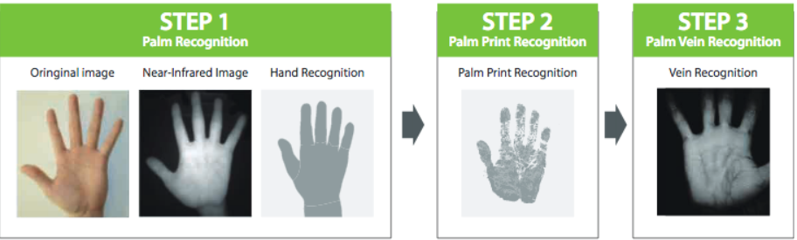
Figure 3.1: Palm Recognition
STEP 1: Palm Recognition
When a palm is presented close to the camera, the camera will first function as the palm recognition process to identify whether the detected area is a palm. If the nearing object is not a palm, it will stop the further recognition process. If the nearing object is a palm, it will process to the next step.
STEP 2: Palm Print Recognition
After the palm recognition process, the infrared camera will get activated and process palm-print recognition and palm vein recognition simultaneously. The camera will recognize the feature point of the palm print and cross-check with the database.
STEP 3: Palm Vein Recognition
Meanwhile, the infrared camera will use the infrared light to observe the palm vein, which is not naked to the human eye, as same as the palm print. It will then recognize the feature point of the palm vein and then cross-check with the database for its availability.

3.2 ANALYSIS OF THE EXISTING SYSTEM
Existing attendance systems typically rely on manual methods, card-based systems, or other biometric modalities like fingerprint or facial recognition. Manual roll-call systems involve recording attendance on paper, which is time-consuming and prone to human error. Card-based systems, such as RFID or magnetic swipe cards, streamline the process but are susceptible to fraud, including card sharing or loss. Biometric systems like fingerprint or facial recognition offer enhanced security, but they often involve significant hardware costs, are affected by environmental conditions (e.g., lighting or skin texture), and may raise privacy or hygiene concerns.
3.3 PROBLEMS OF THE EXISTING SYSTEM
The primary issues with existing attendance systems include:
- Time Inefficiency: Manual roll calls are slow and disruptive.
- Susceptibility to Fraud: Card-based systems are prone to proxy attendance and loss.
- Hardware Dependency: Biometric systems like fingerprint scanners and facial recognition devices require costly and maintenance-intensive hardware.
- Hygiene Concerns: Contact-based systems, such as fingerprint scanners, raise hygiene issues, especially in public or shared spaces.
- Privacy Concerns: Facial recognition systems may infringe on user privacy and are sometimes perceived as intrusive.
- Environmental Sensitivity: Systems like facial recognition or fingerprint scanning are affected by lighting, skin conditions, or obstructions, leading to errors or failures.
3.4 DESCRIPTION OF THE PROPOSED SYSTEM
The proposed system is a Smart Attendance System using Palm Print Recognition, designed to address the limitations of existing systems. This system utilizes the unique and stable patterns of palm prints for secure and efficient attendance tracking. Palm images are captured using standard cameras or mobile devices, eliminating the need for specialized hardware. The system applies advanced image processing techniques to extract and match features such as principal lines and textures.
3.5 ADVANTAGES OF THE PROPOSED SYSTEM
The Smart Attendance System using palm print recognition offers several advantages over existing systems:
- Enhanced Accuracy and Security: Palm print patterns are unique and difficult to forge, ensuring reliable and fraud-proof attendance tracking.
- Contactless Operation: The system captures palm images without physical contact, addressing hygiene concerns and improving user comfort.
- Cost-Effectiveness: By using standard imaging devices, the system eliminates the need for expensive biometric hardware.
- Scalability and Flexibility: The system can be easily adapted for various environments, including schools, offices, and events.

CHAPTER FOUR
DESIGN, IMPLEMENTATION AND DOCUMENTATION OF THE SYSTEM
4.1 DESIGN OF THE SYSTEM
This is the computation of the particulars of a new system and the determination of what the new system would be and the function it is to perform. This may involve changing from one system to another or modifying the existing system operation. The most challenging phase of the system life cycle is the change from manual operation to a faster and more accurate one; system design stage covers the technical specifications that will be employed in the implementation of the new system in order to modify the previous system. Some factors are put in consideration. These factors include input design, output design, definitions file and procedure designs and other documentation.
4.1.1 OUTPUT DESIGN
This incorporates the objectives of solving the existing system problems and challenges. This involves the structuring of the desired information and also to enhance efficient and effective attendance system. Things taken into consideration in determining the output are represented below:
Figure 4.1: Palm Print Enrollment
The figure 4.1 above is the palm print enrollment with the machine. The palm enroller will be used to enroll the student palm in the space provided and the reader will read the palm information on the student.

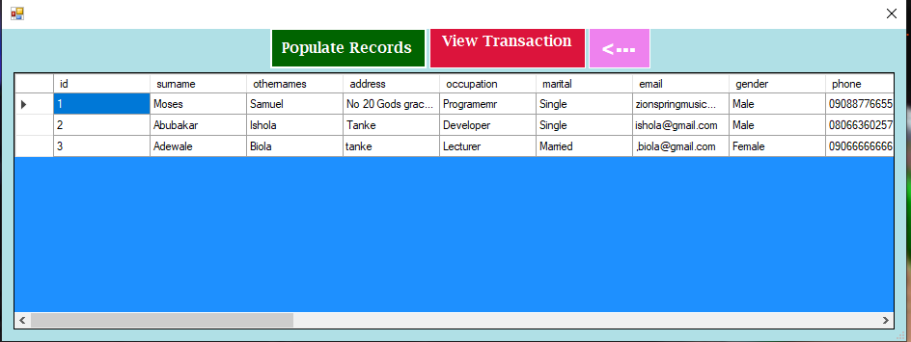
Figure 4.2: Student Records
This displays the records of all the student registered on the system.
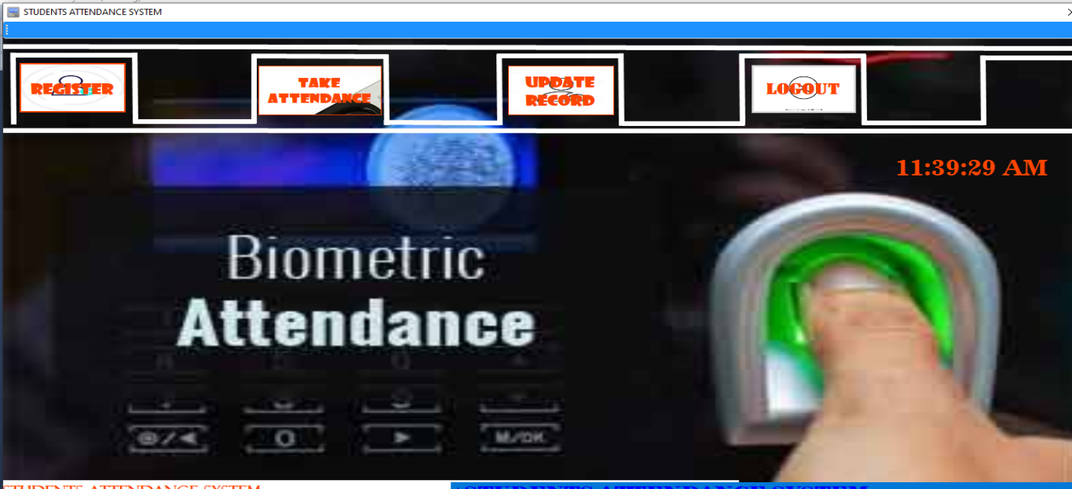
Figure 4.3: Student Interface
This page shows the student interface where some buttons are provided to navigate to another page.

4.1.2 INPUT DESIGN
The input to run this software is obtained from lecture attendance system using fingerprint recognition system. The administrator is expected to safeguard the files and document using fingerprint authentication. The input design describes the input interface for data entry into the program. Data entry interfaces needs to be considered in developing a new system to ensure users’ friendliness. Data entry is done through the use of keyboard, camera, and in some cases selection from the dropdown combos and list boxes are done using mouse selection. The interface descriptions are as shown below:
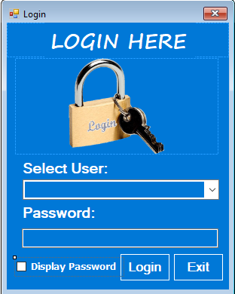
Figure 4.4: Login Interface
This interface is where the admin and student can login to the system by entering their username and password.
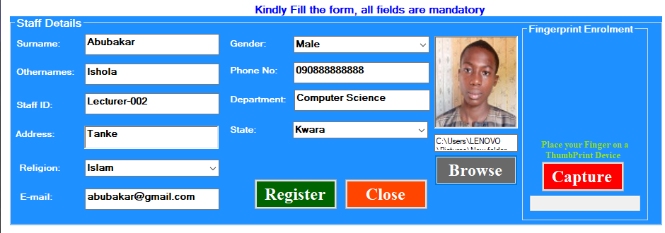
Figure 4.5: Student Registration form
This page displays some textboxes which student will fill to register on the system.
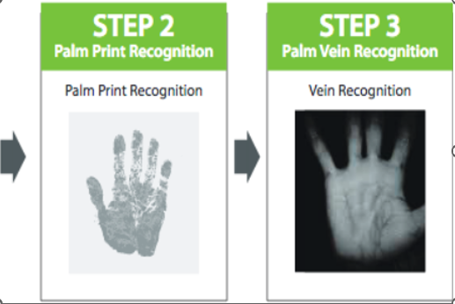
Figure 4.6: Student Palm Attendance
This is the page where student will take attendance by placing their palm on the machine and the lecturer can view this attendance in the database.
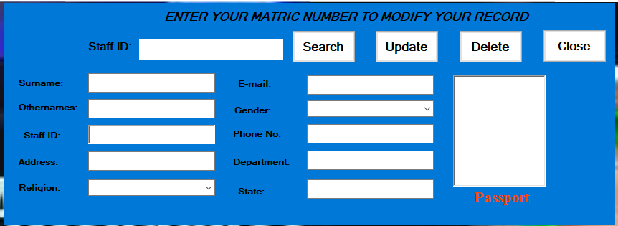
Figure 4.7: Student Records Modification Interface student
4.1.3 DATABASE DESIGN
The structure and organization of records in the tables is a database file is essential to be considered in designing a database driven application. The database files main record where house for keeping data and information relevant for this application.

Table 1: Student Table
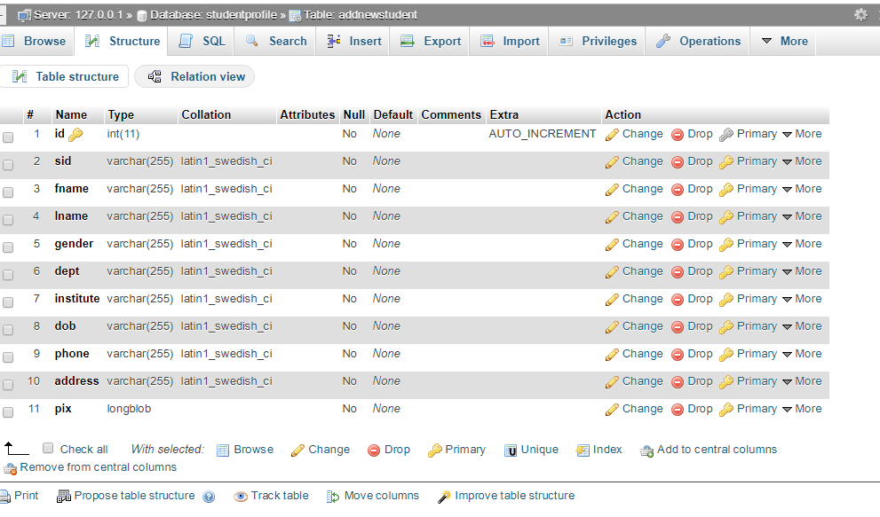
This houses the entire records of registered students.
Table 2: Attendance Table
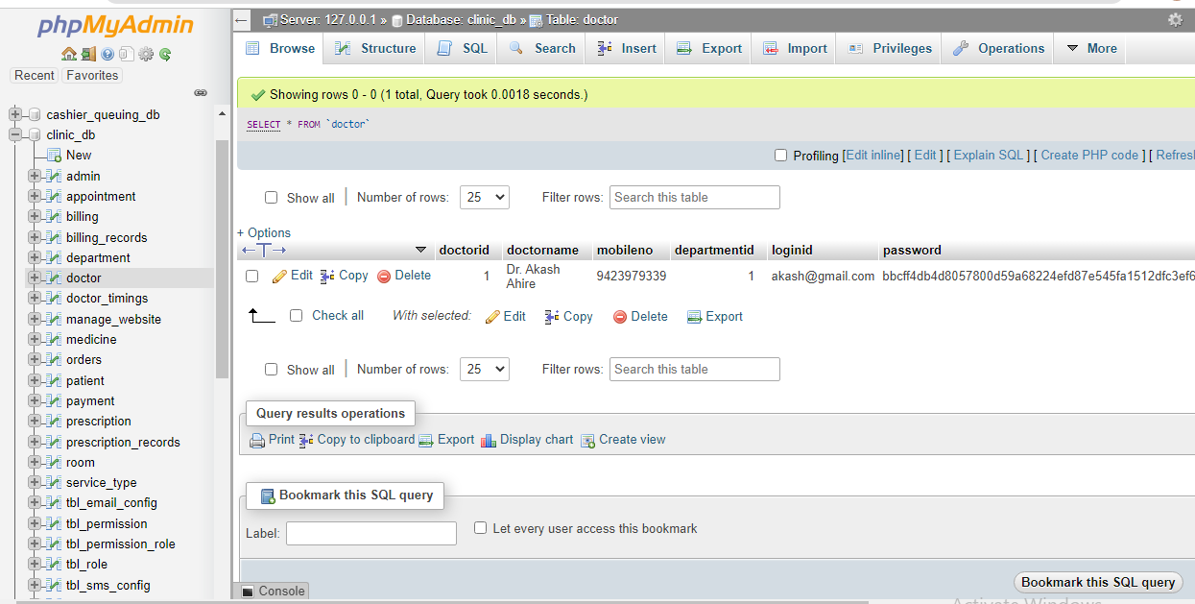
This is the table that house the attendance of all the present students.
4.13 PROCEDURE DESIGN
These are the steps involved in unifying the whole process to produce the desired output. It involves computer procedures which starts from the original input lessons to the output result file. This allows the processing of the information and result to be possible. Menu is provided to aid user in the processing of the output file.

4.2 IMPLEMENTATION OF THE SYSTEM
This entails the choice of the programming language employed to implement the software which should-be suitable for lecture attendance using fingerprint recognition authentication. The software is designed for the use of lecture attendance system which should serve as an assistant for the management in monitoring the attendance system for students.
4.2.1 CHOICE OF PROGRAMMING LANGUAGE
The Application was developed in a .net (dot net) integrated development environment (.net IDE). The Application IDE is chosen following the fact that extracted information needs to be presented in an enhanced pictorial/graphical format and easy communication with the database for program flexibility in windows platform.
4.2.2 HARDWARE REQUIREMENTS
Minimum of Microcomputer Pentium IV- Intel 1.5 GHZ processor, 1.0 GB RAM, 40GB Hard disk, 14” VGA Monitor Windows XP or higher, Enhanced keyboard, mouse and pad.
4.2.3 SOFTWARE REQUIREMENT
i. Windows 7
ii. C#
iii. Fingerprint Sensor
IV. MYSQL Server
4.2.4 CHANGE OVER TECHNIQUE
These deals with the processes and steps taking to put the system into use, before the system can be fully employed into the system, some training might have been done by the user of the application if he or she is a computer illiterate, because the user might be a computer illiterate, so also the system might have also been use.
Since the work of an expert cannot be eliminated from the system, the computerized system will have to work hand in hand with the expert in the field.
4.3 DOCUMENTATION OF THE SYSTEM
After the program has been well tested with input that the output has already been known, the next is to install the software in to the computer system for use.
The process of installing is been stated below
- Insert the CD into the system through the CD-ROM after the computer is switch on
- Locate the CD drive directory in my computer and click it to open
- After open, locate setup.exe, and then click to install the program by following the necessary step in installing the program.
- Ensure full installing of the software for effective operation of the system.
After the program has been fully install. The next thing is to locate the package install to put it into operation, to locate the package for expiration purpose the following step are to be taking.
- Click on start menu from task bar. Then select all program
- From the display sub option, select by locating the software installed named Information to load the software.
4.3.1 PROGRAM DOCUMENTATION
The program is packaged for use in any system irrespective of either it runs C# Application or not. After developing a program in Visual Basic, there is a facility provided in Microsoft Visual Studio suite called “Package and Deployment Wizard” that is used in Visual studio application packaging and deployment.
The automated face recognition-based lecture attendance system is packaged into an installable setup that can be run from any system.
4.3.2 MAINTAINING THE SYSTEM
The system maintenance refers to making modification to an already existing application/program without necessarily re-writing everything from start. Program maintenance of a program includes modification of the program to meet-up with certain requirements of the users. In this course, additional features can be added, errors corrected, ambiguous interfaces redesigned to eliminate confusions and unnecessary features removed.
Maintaining this program can be done in Visual studio environment. Any future modification can be by re-running the program source code in a C# environment making necessary changes and updates and recompile the application into an upgrade version of the existing version of the mini word processing application. Further versions of this program can be named following their year of release or it can be given a different version number.

CHAPTER FIVE
SUMMARY, CONCLUSION AND RECOMMENDATIONS
5.1 SUMMARY
This study focuses on developing a Smart Attendance System using Palm Print Recognition to address the challenges associated with traditional and existing attendance systems. Manual methods and card-based systems are prone to inefficiencies and fraud, while existing biometric systems often suffer from high costs, privacy concerns, and environmental sensitivities. By leveraging the unique and stable features of palm prints, the proposed system offers a contactless, accurate, and scalable solution for attendance management. Through processes like image acquisition, preprocessing, feature extraction, and matching, the system ensures reliable identification while maintaining user comfort and data security.
The system's advantages include enhanced accuracy, cost-effectiveness, and robustness under varying conditions. Its applications span across educational institutions, workplaces, and other environments where attendance tracking is critical.
5.2 CONCLUSION
The proposed palm print-based attendance system effectively addresses the limitations of existing solutions, providing a secure, efficient, and user-friendly method for attendance tracking. Its reliance on readily available hardware makes it cost-effective and adaptable to diverse settings. The contactless nature of the system ensures hygiene and privacy, making it a viable alternative to other biometric systems like fingerprints or facial recognition. The research highlights the potential of palm print recognition as a robust biometric modality and contributes to advancements in attendance management technologies.

5.3 RECOMMENDATION
It is recommended that future work focus on improving the system's adaptability to real-world conditions, such as varying lighting and diverse user demographics. Further development could involve integrating additional biometric modalities to enhance versatility and security. It would also be beneficial to conduct large-scale testing in different environments to refine system performance and user experience. Collaboration with stakeholders in education, corporate, and public sectors could expedite the deployment of the system and its adoption in broader contexts.

REFERENCES
Jain, A. K., Flynn, P., & Ross, A. A. (2021). Handbook of Biometrics. Springer.
Kumar, A., & Zhang, D. (2024). Hand geometry recognition using entropies of hand images. IEEE Transactions on Information Forensics and Security, 1(2), 181-187. https://doi.org/10.1109/TIFS.2006.873601
Kyaw (2024) low cost computing using raspberry pi. Pg no 287
Liu, G., & Zhang, D. (2018). Palmprint recognition: A comprehensive survey. IEEE Transactions on Systems, Man, and Cybernetics: Systems, 48(11), 1627-1645. https://doi.org/10.1109/TSMC.2017.2705588
Maltoni, D., Maio, D., Jain, A. K., & Prabhakar, S. (2019). Handbook of Fingerprint Recognition. Springer.
Mohammed, S. & Raghu, P. (2019). Automatic Control of Student Attendance in Classroom Using RFID, IEEE International Conference. Vol. 3. Pp. 14-15. IOP Publisher.
Patel, M. (2021). Contactless solutions in the post-pandemic era. Technology Today, 8(3), 34-42.
Pascua, C. & Dellosa, H. (2019). An Attendance Monitoring System using Biometrics Authentication, International Journal of Advanced Research in Computer Science and Software Engineering. Vol. 3, Issue: 2. Pp. 56-57.
Sivakumar, H. & Balasubramanian, U. (2020). Attendance Marking System, Journal of Software Engineering and Simulation Vol. 5, Issue: 2. Pp. 27-29.
Smith, R., & Lee, T. (2022). The role of AI in attendance management systems. Journal of Organizational Efficiency, 19(2), 102-118. DOI: 10.1109/JOE47207.2019.45386289
Venkatesh, K. & Anesh, M. (2023). Smart Attendance System Using Voice Recognition, (International Journal of Engineering Science and Advanced Technology (IJESAT). Vol. 23. Issue: 9. Pp. 1234-1235.
Vinesh, A., Prasad, A., K., Govind, S., Surya, S., G. & Shandry, K. (2024). Attendance Management System using Image and Voice Recognition, International Journal of Innovative Science and Research Technology. Vol. 9: Issue 7. doi.org/10.38124/ijisrt/IJISRT24JUL1745
Watson, L., & Brown, K. (2020). Challenges in implementing voice recognition technology. Tech Innovations, 15(5), 78-85. DOI: 10.1109/TIP47207.2019.8985867
Williams, D. (2019). Enhancing educational administration with AI. Educational Technology Review, 14(1), 23-39.
Zhang, D., Kong, W. K., You, J., & Wong, M. (2020). Online palmprint identification. IEEE Transactions on Pattern Analysis and Machine Intelligence, 25(9), 1041-1050. https://doi.org/10.1109/TPAMI.2003.1227981.

Appendices
Appendix 1: System Flowchart
TAKE ATTENDANCE
VIEW STUDENT LIST
VIEW ATTENDANCE
REGISTER NEW STUDENT

STOP
SPLASH SCREEN

FILE
START

Appendix 2: Student Registration Flowchart
START
OPEN DATABASE
INCREMENT ID BY 1
ENTER STUDENT DETAILS
SAVE INTO DATABASE
CLOSE DATABASE
MORE RECORD?
RETURN
Yes
No
DISPLAY STUDENT
ENTRY FORM
CAPTURE STUDENT PALM

Appendix 3: Take Attendance Flowchart
OPEN DATABASE
START

CAPTURE STUDENT VOICE

VERIFY STUDENT PALM
RETURN
CLOSE DATABASE
MORE ?

Yes

No

Appendix 4: View Student List Flowchart
RETURN
CLOSE DATABASE
OPEN DATABASE
START
DISPLAY ALL
STUDENT DETAILS

MORE TO VIEW?
No
Yes
Appendix 5: View Attendance Flowchart
RETURN
CLOSE DATABASE
OPEN DATABASE
START
VIEW ALL STUDENT ATTENDANCE

VIEW MORE?
Yes
No

Appendix 6: Source Program Listing
using System;
using System.Collections.Generic;
using System.ComponentModel;
using System.Data;
using System.Drawing;
using System.Linq;
using System.Text;
using System.Windows.Forms;
using System.Data.OleDb;

namespace MultiFaceRec
{
public partial class Form3 : Form
{
private OleDbConnection bookConn;
private OleDbCommand oleDbCmd = new OleDbCommand();
private String connParam = @"Provider=Microsoft.Jet.OLEDB.4.0;Data Source=C:\Users\PROGRAMMER\Desktop\face recornition project\FaceRecProOV\bin\Debug\faceattendance.mdb;Persist Security Info=False";

public Form3()
{
bookConn = new OleDbConnection(connParam);
InitializeComponent();
}

private void nDIToolStripMenuItem1_Click(object sender, EventArgs e)
{

int hh = 1;

dataGridView1.DataSource = null;
dataGridView1.Rows.Clear();
dataGridView1.Refresh();

OleDbDataAdapter dAdapter = new OleDbDataAdapter("select * from StudentDetails WHERE Slevel = 'ND I'", connParam);
OleDbCommandBuilder cBuilder = new OleDbCommandBuilder(dAdapter);

DataTable dataTable = new DataTable();
DataSet ds = new DataSet();
dAdapter.Fill(dataTable);
for (int i = 0; i < dataTable.Rows.Count; i++)
{
dataGridView1.Rows.Add(hh, dataTable.Rows[i][1], dataTable.Rows[i][2], dataTable.Rows[i][3], dataTable.Rows[i][4], dataTable.Rows[i][5]);
hh++;
}

bookConn.Close() }

