DESIGN AND I MPLEMENTATION OF A VIRTUAL LIBRARY FOR TERTIARY INSTITUTION

BY

OLADEPO EUNICE BOLUWATIFE ND/23/COM/PT/0144

A PROJECT SUBMITTED TO

THE DEPARTMENT OF COMPUTER SCIENCE, INSTITUTE OF INFORMATION AND COMMUNICATION TECHNOLOGY
KWARA STATE POLYTECHNIC, ILORIN

IN PARTIAL FULFILLMENT OF THE REQUIREMENTS FOR THE AWARD OF NATIONAL DIPLOMA (ND) IN
COMPUTER SCIENCE

JUNE, 2025.

CERTIFICATION

This is to certify that this project work was carried out by OLADEPO EUNICE BOLUWATIFE with Matriculation Number ND/23/COM/PT/0144The project has been read and approved as part of the requirement for the award of National Diploma (ND) in Computer Science Department, Institute of information and communication technology, Kwara state polytechnic, Ilorin.

MRS. ADEMOLA R. DATE

PROJECT SUPERVISOR

MR. OYEDEPO F. S. DATE

HEAD OF DEPARTMENT

EXTERNAL SUPERVISOR DATE

DEDICATION

This work is dedicated to Almighty Allah for His mercy on me, and my family for their support, love and understanding.

ACKNOWLEDEGEMNT

All glory, adoration and glorification are due to almighty Allah (S.W.T) the most gracious, the most beneficent the most merciful, the creator of all creatures, for seeing me through my studies and this project in this great institution KWARA STATE POLYTECHNIC ILORIN, may his abundant blessings continue to be upon his prophet (S.W.T)
I appreciate the utmost effort of my Supervisor, MRS ADEMOLA.R. Whose patience, support and encouragement have been the driving force behind the success of this research work. She gave useful corrections, comments, recommendations, advice and always ensures that an excellent research is done.my sincere gratitude goes to Head of department and other members of staff of the department of computer science, kwara state polytechnic, ilorin. For their constant cooperation constructive criticism and encouragement throughout the programmed.
Special gratitude to my parents, who exhibited immeasurable financial, patience, support and prayers. And has made it possible for me to complete my OND program in this intuition KWARA STATE POLYTECHNIC, ILORIN. Special thanks also go to my lovely siblings.
Special thanks go to my friends Faozan and Mariam, I really appreciate all your efforts, less I forget my amiable sister and her husband MR &MRS BAKARE for always stood by me throughout the journey of my OND Program.
I will like to show a great appreciation to all staffs of computer science departments in the great institutions KWARA STATE POLYTECHNIC ILORIN. MAY ALMIGHTY ALLAH CONTINUE TO BLESS YOU ALL (AMEN)

ABSTRACT

Libraries have been an important part of educational and information sector of any school. The success of any library largely depends on proper management. Several libraries have suffered failure as a result of inadequate management and incapacitations in handling sensitive information as regards members of the library. This research therefore, aimed at developing a digital library system, which will help, direct and position library to meets its ever-increasing demands. In the course of the development of this new system, the current system was analytically and critically studied or assessed and thus the identified strengths and weaknesses were highlighted and a new system was designed for the weakness. The Internet in its ever-evolving state is becoming a serious method of business communication and data transfer worldwide. As students and other institutions and organizations beginning to use the Internet as a new method for awareness creation and information search, then there comes a need for a website that will provide them with the comprehensive list of all the research materials they need. This was what motivated us into embarking on this research work the present system was analyzed using a standard procedure recognized worldwide for such purpose and this is called Structured System Analysis and Design Methodology (SSADM). The PHP and MySQL as a relational database were used to code the program modules developed for the system using some computer aided design tools.

TABLE OF CONTENTS

Title page i

Certification ii
Dedication iii
Acknowledgement iv
Abstract v
Table of content vi
CHAPTER ONE: GENERAL INTRODUCTION
  - Introduction 1
  - Aim and objectives of the Study 1
  - Statement of the Problem 1
  - Significance of the Study 2
  - Scope and Limitation 2
  - Organization of the Report 2
CHAPTER TWO: LITERATURE REVIEW
  - Literature Review 3
CHAPTER THREE: METHODOLOGY AND ANALYSIS OF THE SYSTEM
  - Research Methodology 10
  - Description of Existing System 10
  - Problem of Present System 11
  - Description of the Proposed System 11
  - Advantages of the Proposed System 12
CHAPTER FOUR: DESIGN AND IMPLEMENTATION OF THE SYSTEM
  - Design of the System 14
    - Output Design 14
    - Input Design 15
    - Database Design 17
    - Procedure Design 18
  - Implementation Techniques 18
    - Programming Languages Used with Reasons 19
    - Hardware Support 19
    - Software Support 19
  - System Documentation 19
    - Program Documentation 19
    - Operating the System 20
    - Maintenance of the System 20
CHAPTER FIVE: CONCLUSION AND RECOMMENDATIONS
  - Summary 21
  - Conclusion 21
  - Recommendations 21
References 22
Appendix 1: Flowchart 24
Appendix 2: Source Code 30

CHAPTER ONE

Introduction
A library can be defined as a room or building where books are kept and referenced. It is an area of multifarious activity on book management. A library as a repository of knowledge, houses collections of books, both reference and general, technical reports, periodicals, journals, conference proceedings and the likes. Consequently, truth and knowledge can be found and acquired from the library through the aforementioned sources. The information contents of any of the collections can be recorded on microfilms, audiotapes, microchips and other materials traditionally kept in the library, which is charged with the responsibility of acquiring, organizing, maintaining, and judicial circulation of the books and other library materials through the various sections of the library, for efficient use of the library by the users.

The acquisition, cataloguing, bindery and circulation sections of the library undertake the acquiring, organizing, maintaining and circulation of the books/library materials respectively. When the library through the acquisition section of the library acquires a book, its record is taken and accession number is given to the book after which the book will be sent to cataloguing section of the library. Under this section, the book will be carefully studied and given catalogue number before it will be sent to circulation section of the library as the case may be. The circulation section is responsible for circulation or distribution of books. This section also arranges the consulted books in the shelves.

There are other sections like reference section, which provides reference questions and bibliographic service, and serial section where periodical, journals and related materials are kept. The library also houses special collections and also operates circulation control in which books are lent to users. In fact it is indeed a place of multifarious activities on book management. Libraries originated with writing about 6000 years ago and that was when writing was being done using materials like bones, clay, wax, papyrus, metals, silk, leather, parchment, paper, and other available materials. Later, these materials were assembled together to form libraries.
Among the earliest libraries were ANCIENT LIBRARIES OF CLAY, which emerged in Iraq and other Mesopotamian region like Syria and Turkey. In these libraries, records were kept on clay tablets. Within that period were also ANCIENT LIBRARIES OF ANIMAL

SKIN and ANCIENT LIBRARIES OF PAPYRUS of which Alexandria libraries in Egypt were the examples. These libraries invariably were connected with temples, for these institutions were the centers of the whole life of the whole communities. Moreover, it is widely believed that the private and institutional libraries are traceable to Egypt and Greece respectively, and the emergence of public libraries started in Rome. Libraries studies was given a boost by Julius Caesar during the first century of the Roman especially with his conferment of the Franchise privilege on all foreign teachers of liberal education residing in Rome. However, it was Augustus, who succeeded Caesar that gave a greater impact to scholarship development. He founded the first public libraries in Rome (69 – 70 AD). He established a library in the temple of peace, which formed the nucleus of a school of higher learning at a later time.

The history of library development in Nigeria is of recent vintage. In fact, the earliest library in Nigeria was Tom Jones Library, which was established in 1910. That was the first public subscription library in Nigeria. The beginning of academic library was marked in Nigeria with the founding of Yaba Higher College in 1948. Later on the British council took over the library sense with the foundation of the first municipal council library in Lagos, and established British council libraries in various parts of the country.

Unfortunately, these became a great loss of library stock after the Nigerian Civil War, and the federal government then took it as part of its rehabilitation effort in promulgating the National Library’s decree of 1970, which provided for the branches to be set up in every state of the federation. Hence repealing the former National Library Act 1964. Within the first decade of its existence, the National Library has succeeded in stock over 75000 volumes, 2000 period leads, 150 Newspapers and became a depository for the United Nations Organization (UNO) and its agencies.

With the increase in establishment of universities all over the country, the government of Nigeria also sees the essence of providing library in every institution of learning. Now, Nigeria can boast of libraries in all the higher institutions of learning, almost all the academic establishments and even private and public establishments. There are also National and state libraries throughout the states of federation. But all these libraries have one problem in common; the backwardness in the automated library world.

Statement of Problem

In human endeavors, there are a lot of developments, researches, and discoveries, which result in multifarious production of publications and library materials. These have brought increase in complexity of library system and its operations. Based on these, a number of problems are facing the library systems, which include:

    - Unnecessary delay in library processes.
    - High cost of staff recruitment and maintenance.
    - Error prone operations/processes.
    - Inefficiency in library operation.
    - Too many paper work and replication of data on multiple pieces of paper.
    - Unreliable card catalogue system.
    - Mutilation of books by students i.e. students tear/hide books.

Aim and objectives of the study

The aim of this project is to design and implement a virtual library with a video
tutorial

There is hardly any aspect of human endeavor that is today not being assisted by computerization. The objective of this project: Design and Implementation of a virtual library. The application program developed in this research essentially monitors and keep records of the individual book movement together with the operations going on in various sections of the library particularly concerned with book control. These operations include book lending, returning of the borrowed books, reservation of books, acquisition processes, registration of users and other related activities in Library management system.

In this study therefore, the researchers hope to accomplish the following objectives:

    - To design a better way of avoiding loss of books in the library.
    - To solve the problem of delay in locating books.
    - Assist the Liberian to carry out library operations more effectively.
    - Eliminate manual operations in the library.
    - To achieve high efficiency in the library services.

Significance of the Study
The study gave birth to a new system (Digital Library Services System) designed to bring efficiency in the library system operations. It will eliminate some of the problems associated with the old (manual) system of library management, which include cost of equipment and staff maintenance and also allow institutions to manage the affairs of libraries easily.

Scope of the Study

This project looks into the processes involved in keeping tracks of the books in the library system. The researchers concentrated on the operations going on in the Acquisition, cataloging and most especially, circulation sections in the library.

Definition of Terms

    - DESIGN: It is a detail plan or arrangement to achieve a particular purpose.
    - A SYSTEM: It is an assemblage of interrelated elements, which we find interesting to study. It could be a process, a machine or a program.
    - A PROGRAM: It is a set of instructions and procedures that tells the computer what to do.
    - AN APPLICATION: A program designed to perform particular tasks.
    - THE RESEARCHERS: This refers to the developers of the system in study (i.e. Richard).
    - THE USER: The user here refers to the library staff or the people who make use of the library. It also refers to the person who uses the program (e.g. library staff).
    - AUTOMATION/COMPUTERIZATION: It is a process of making a system to carry out its processes on its own. That is without much helps from man.
    - MODULE: An independent unit that is part of a larger development. It is the same thing as sub-tasks.
    - VISUAL LIBRARY SYSTEM: It is an application or program designed by researchers to manage library operations. It is a program designed with a visual programming language in which the user will make use of a mouse in operating. It is event driven and objects appear in their visual forms to the user.

Organization of the Report

This project is segmented into five distinct chapters. Chapter one describes the introduction, aims and objectives, significance of the study, scope and limitation, choice of programming language as well as the organization of the report.

The second chapter talks about the review of relevant literature, pre-requisites of the e-voting system, overview of the considered e-voting system.

The third chapter deals with the analysis of the existing system description and the advantages of the proposed system and methodologies.

The second to the last chapter deals with the design of the system which entails the output, database and procedure design of the system, the implementation comprises of the hardware and support while the documentation comprise of how to use the system and the system maintenance.

The last chapter deals with the summery experienced gained, conclusion and recommendation.

CHAPTER TWO

Literature Review

2.1 Review of Related Work
This chapter reviews literature related to digital library initiatives globally, with emphasis on national, regional, and international efforts. Secondary data were gathered from both print and online scholarly sources. While literature on Malaysian digital library initiatives remains limited, there is a wealth of research from international contexts that offer valuable insights and models for adaptation. Malaysian digital library projects have also been explored and reported where available.
Recent studies highlight the growing significance of virtual library services, especially video tutorials, in enhancing access to information literacy and supporting self- directed learning among tertiary students. For instance, research by Aharony (2022) underscores the role of multimedia resources in increasing student engagement and improving research skills in academic libraries. Furthermore, global digital library initiatives are increasingly integrating artificial intelligence and interactive technologies to personalize user experiences (Smith & Kumar, 2023).
At the regional level, Southeast Asian countries, including Malaysia, have begun adopting digital libraries and virtual learning tools to address accessibility challenges in higher education (Rahman et al., 2024). These initiatives demonstrate a trend toward hybrid models combining physical and digital resources to meet the evolving needs of students and educators.
Internationally, projects such as Europeana and the Digital Public Library of America serve as benchmarks for digital library development, emphasizing interoperability, metadata standards, and open access (Johnson et al., 2023). These platforms support diverse collections and educational outreach through video tutorials and other asynchronous learning materials, which have been shown to improve user competence and satisfaction (Lee & Chen, 2023).
Digital libraries have evolved significantly from mere digital repositories to dynamic, user-centered platforms that integrate multimedia resources, including video tutorials, to enhance academic learning (Liu & Luo, 2021). Globally, initiatives such as Europeana and the Digital Public Library of America (DPLA) have set benchmarks for interoperability, open access, and educational outreach, often incorporating video tutorials to support information

literacy and user engagement (Johnson et al., 2023; Lee & Chen, 2023). Research shows that video tutorials improve student learning outcomes by offering flexible, accessible, and engaging methods for developing research skills (Aharony, 2022; Bowles-Terry et al., 2010). Effective tutorial design emphasizes clear, concise content segmented into manageable chunks, with accessibility features like captions and transcripts to accommodate diverse learners (ALA, 2022; Puckett, 2022). The integration of video tutorials within Learning Management Systems (LMS) and mobile-friendly formats further enhances usability and reach (Lee & Chen, 2023).
Within the Malaysian context, digital library initiatives are growing but remain under- researched. Projects such as the Digital Library of Malaysia (MyDL) and university-based efforts demonstrate a commitment to expanding academic and cultural resource accessibility, often focusing on bilingual content to serve the country’s multilingual population (Rahman et al., 2024; Lim & Abdullah, 2023). Despite these advances, challenges such as limited infrastructure, technical expertise, and funding for multimedia production impede widespread implementation of video tutorials (Salleh & Hassan, 2023). Studies indicate positive student perceptions and improved independent learning outcomes when virtual tutorials are available, suggesting strong potential for further development (Salleh & Hassan, 2023). Emerging technologies, including artificial intelligence and machine learning, offer promising avenues for personalized learning experiences and intelligent tutorial systems that adapt to user needs (Smith & Kumar, 2023). Mobile optimization and gamification are also increasingly recognized as effective strategies for boosting engagement and motivation (Rahman et al., 2024; Lee & Chen, 2023). However, sustainability remains a concern, as continuous content updates and digital literacy training for both students and librarians are essential to maximize the benefits of virtual tutorials (Lim & Abdullah, 2023; Puckett, 2022).
In conclusion, while the international literature provides extensive guidance on the design and implementation of virtual library video tutorials and digital library systems, Malaysian initiatives are still in an emergent stage. Addressing infrastructural and resource challenges, leveraging new technologies, and fostering collaboration among academic institutions will be key to realizing the full potential of virtual library services in Malaysia’s tertiary education sector.

Global Digital Library Initiatives

The concept of digital libraries has evolved substantially over the past two decades. Early efforts focused primarily on digitizing collections to increase accessibility (Liu & Luo, 2021). More recent work emphasizes user-centered design, interoperability, and integration with educational technologies (Johnson et al., 2023). Virtual libraries now serve as dynamic platforms for accessing diverse digital content, including e-books, multimedia, and instructional resources such as video tutorials.
Virtual library video tutorials have gained prominence as tools for enhancing information literacy. According to Aharony (2022), multimedia tutorials increase engagement and provide scaffolded learning experiences, allowing students to develop research skills at their own pace. Video tutorials also support inclusive education by catering to different learning styles and providing accessible formats for diverse learners (Puckett, 2022).

Video Tutorials in Tertiary Institutions

The use of video tutorials in academic libraries aligns with broader trends in e- learning and digital pedagogy. A study by Bowles-Terry et al. (2010) demonstrated that students who used video tutorials performed better in information literacy assessments than those relying solely on text-based guides. Moreover, the integration of interactive elements within tutorials has shown mixed results; while some studies suggest improved engagement, others highlight the need for careful instructional design to ensure learning efficacy (Stiwinter, 2013).
Recent advancements include the use of collaborative platforms such as PLUMED (2024), which enable librarians and educators globally to co-create and share high-quality tutorial content. These platforms promote community-driven content updates and encourage the adoption of best practices in tutorial design, including accessibility features like captions and transcripts (ALA, 2022).

Malaysian Digital Library Initiatives

Malaysia has made significant strides in digital library development, though scholarly documentation remains limited. National projects such as the Digital Library of Malaysia (MyDL) and university-based initiatives have sought to expand access to academic and cultural resources (Rahman et al., 2024). These initiatives often emphasize bilingual content delivery to cater to Malaysia’s multilingual population.
However, challenges persist, including infrastructure limitations, digital literacy gaps, and limited funding for multimedia content production such as video tutorials (Lim & Abdullah, 2023). Despite these obstacles, pilot programs integrating virtual library tutorials in Malaysian universities have reported positive student feedback and improved self-directed learning outcomes (Salleh & Hassan, 2023).

Challenges and Opportunities

The implementation of virtual library video tutorials is not without challenges. Technological barriers, such as inadequate bandwidth and lack of technical expertise among library staff, can hinder development and delivery (Smith & Kumar, 2023). Additionally, maintaining tutorial content to reflect changing databases, software, and academic requirements demands ongoing resources. Conversely, opportunities abound with advances in AI and machine learning enabling personalized learning paths and intelligent tutoring systems (Lee & Chen, 2023). Mobile-friendly tutorials and integration with Learning Management Systems (LMS) also enhance accessibility and student engagement.

CHAPTER THREE

Methodology and Analysis of the System

  - Methodological Approach

There are different types of methodological approach that can be employed in a project work. In executing and investigating this research work so as to have an in-depth understanding of the subject matter of the research work, get reliable answers to the questions that are been investigated and to achieve the aims of this research, we adopted qualitative research method. The reason why the qualitative research method is chosen in this research work is because of its nature of flexibility (Yin, 2003). It gives room for interaction between the researchers and the participants hence providing in-depth understanding of the issue that is been investigated.

Different Types of Data Used

Data was sourced through primary and secondary means. Archival records, documentations, direct observations, participants' observations, and interviews are means through which qualities approach can be utilized according to Yin 2003.

Primary Data

Primary data are referred to as first hand data mainly because this data is collected specifically purpose of the research by the researchers. A good advantage of this means is that it gives appropriate answers to the questions under investigation in a research work. And a key point here is that the data collected is unique to the researchers and the research and until the work is end no one else has access to it. Ghauri and Gronhaug (2005) identified some sources of data to be observations, surveys, interviews, experiments.

Secondary Data
Secondary data are information collected by others for some certain purposes which could be different from or similar to that of a researcher who opts to use the same information (Ghauri and Gronhaug 2005;91). Also secondary data can be referred to as second - hand data mainly because the data is not gathered for a single purpose but it could be used for different purposes by different researchers at different times.

Data Collection Methods

Based on the research methodology approach chosen in this research work which is qualitative research methodology, the researcher collected data from both primary and secondary sources. Secondary data was sourced from related literatures such as books, journals, articles, past research works and electronic databases so as to be well enlightened on what has been studied on subject matter under review. Primary data was gathered through Interviews. A face-face interview was adopted in the research work and well structured questions were used for the interviews. The questions consisted of open and close ended questions. Open ended questions allows respondents to answer the questions in their own words without been subjected to any limitation by the researcher, while close ended questions will entail multiple choice questions that will require respondents just to tick the right answers. The questions were simplified and structured in a way that enabled respondents to provide relevant answers to them and also that will not make them to be biased or pissed off from answering the questions. The researcher adopted this method to get quality information and to get as much information as possible so as to be able to capture well how insured claims are managed in insurance companies and to be able to critically analyze this. We are of the opinion that this method will make participants impress their minds explicitly.

Analysis of the Existing System

The existing system of library management system involves lots and lots of paper work. The system involves that all library user details will be taken on a white and black method. To borrow book from a library a borrower ticket is issued to every registered user and collected from each user when a borrower is made by such user to be collected back when return of the book is completed. A ticket is only allowed to be used for one transaction (borrowing book) only.

3.2 Problem of the Existing System

- Time consuming: The present system is time consuming in the sense that it takes too much time for processing and making of enquiry.
- Inefficiency: Many errors being made reduce efficiency of the manual methods. For example: it is very common for manual record keeping of store to be neglected by the customer service.

Description of the Proposed System

The proposed system will be developed using the recent web technologies. It will be developed in such a way that there will be room for the addition of tutorials, journals, and the modification of the inserted information. There will be room for report of all the information inserted into the system and also to book appointment. It will be developed to increase the efficiency of E-library on web based system.

Advantages of the Proposed System

    - Storage capability: The computerize system have a very large storage capacity, very large computer installations are capable of storing billions of data which could be accessed by manual users at a time compare to the manual approach, which is tedious.
    - Security of Data: Data to be processed or information can be store in secondary storage and this secondary storage devices are kept safety even with back up (i.e. having duplicate). They are compact and can be kept safely.
    - Very convenient: It fits well with the Student’s needs, activities and plan.
    - Easy to access via PC: There is easy usage of the system by a computer because the operations to be performed can all be initiated by just a click or double compared to the manual approach of the previous system.
    - Effective and efficient: The computer has one of it advantages to be effectiveness and efficiency which is one of the primary goal of this system. It ensures all the operations are effected and performed in the shortest time and a minimal storage is used.
    - Flexibility: The program is very flexible and will be easy for modification. Example, the total number of a videos and journals may be required and can be easily inserted.

CHAPTER FOUR

Design and Implementation of the System

Design of the System

System designs calls for the creativity of the analyst. Therefore, creating an acceptable design, the system analyst must exclude all prejudice.
The design of the system is the approach of work out how best computers together with other resources may be applied to perform data storage, management and retrieval for decision making.

Output Design
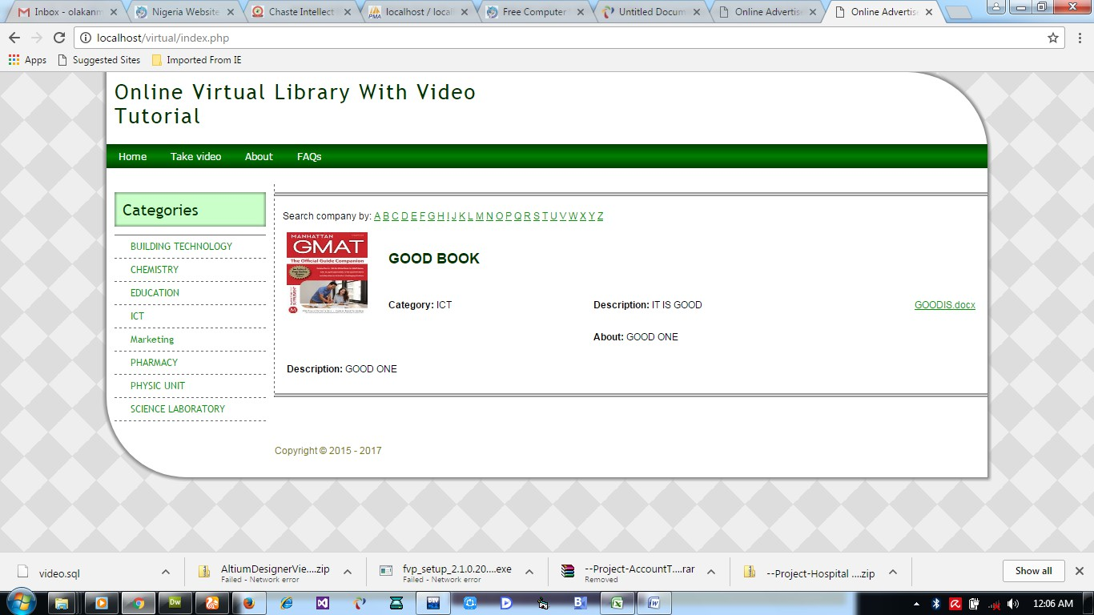
Figure 4.1: Home page: This home page of the designed Video Tutorial site, several of events is been display on.

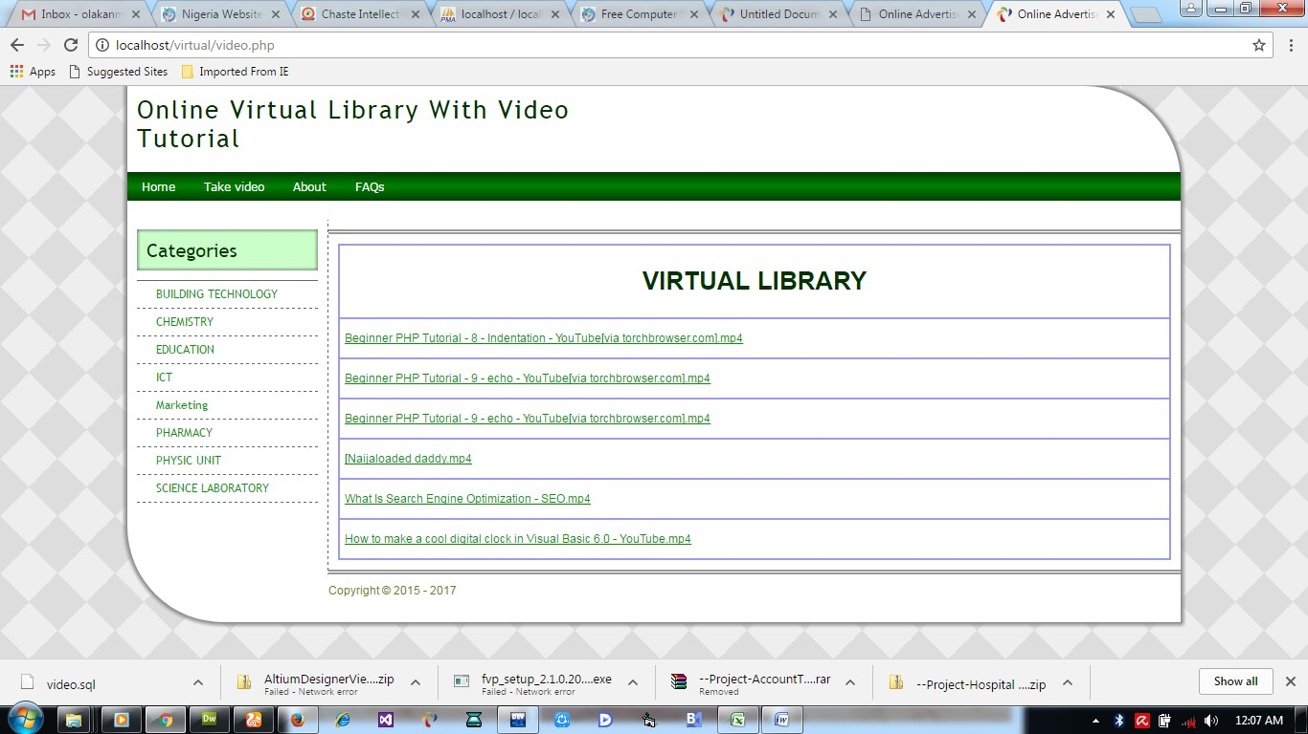

Figure 4.2: Video Library page

Input Design
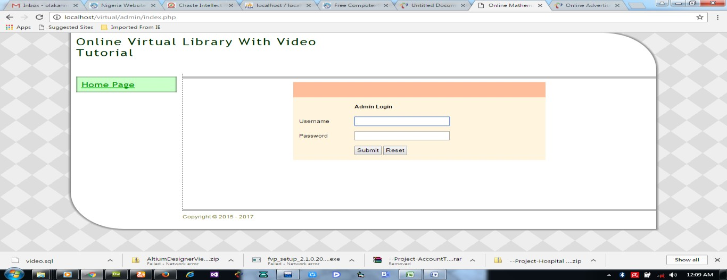

Figure 4.3: Admin Log in Page

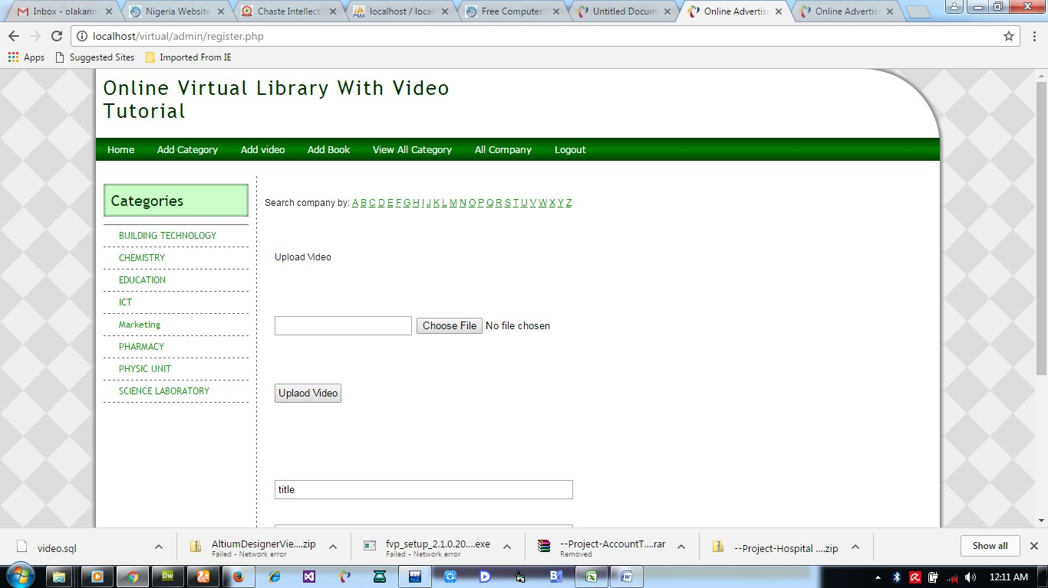

Figure 4.4: Upload video page
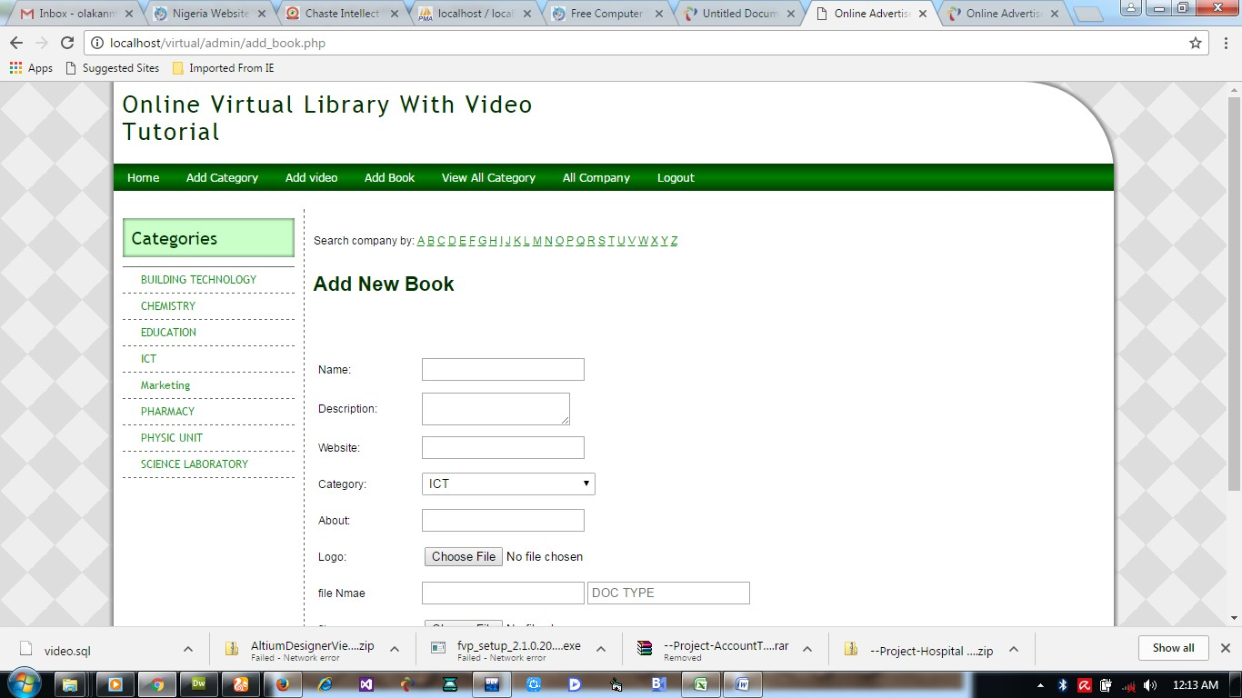

Figure 4.5: Upload Book

Database Design
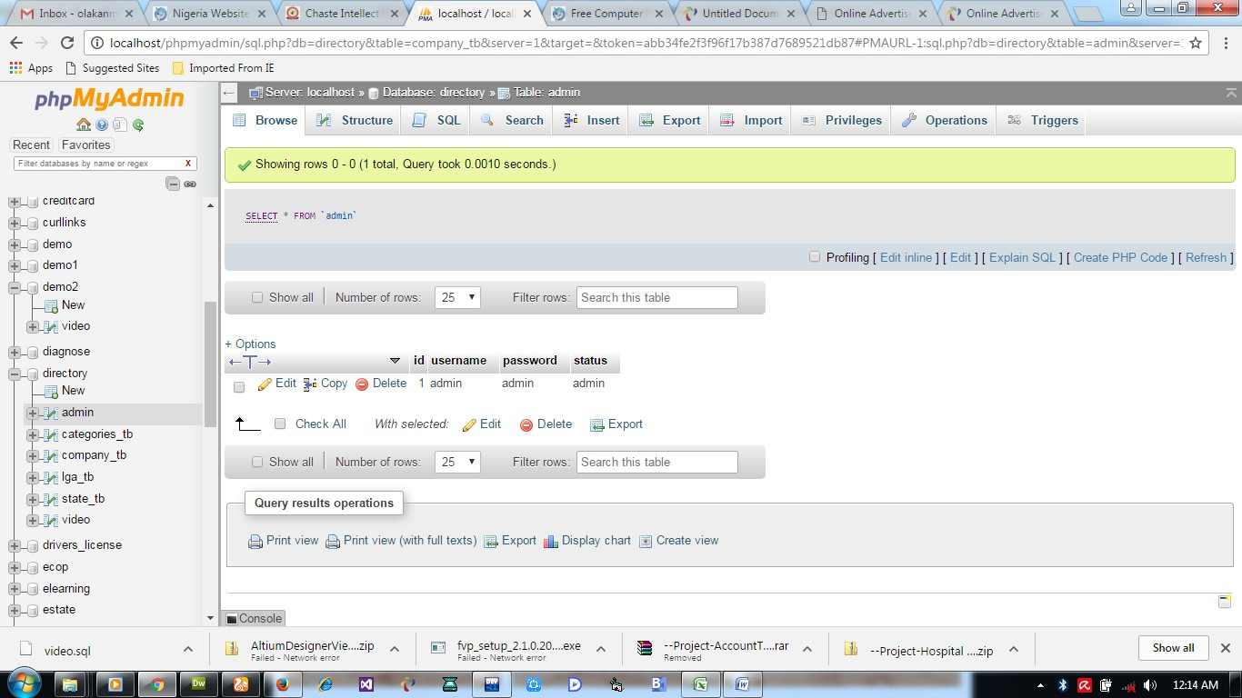

Table 4.1: Admin Table
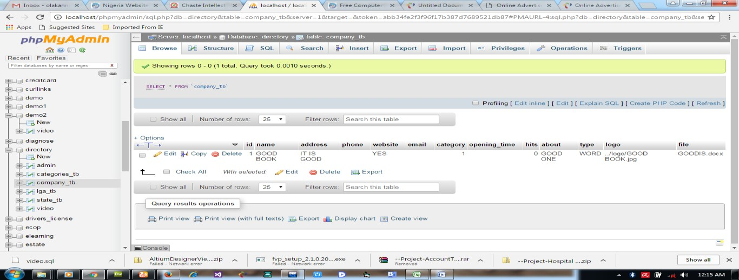

Table 4.2: Book Table

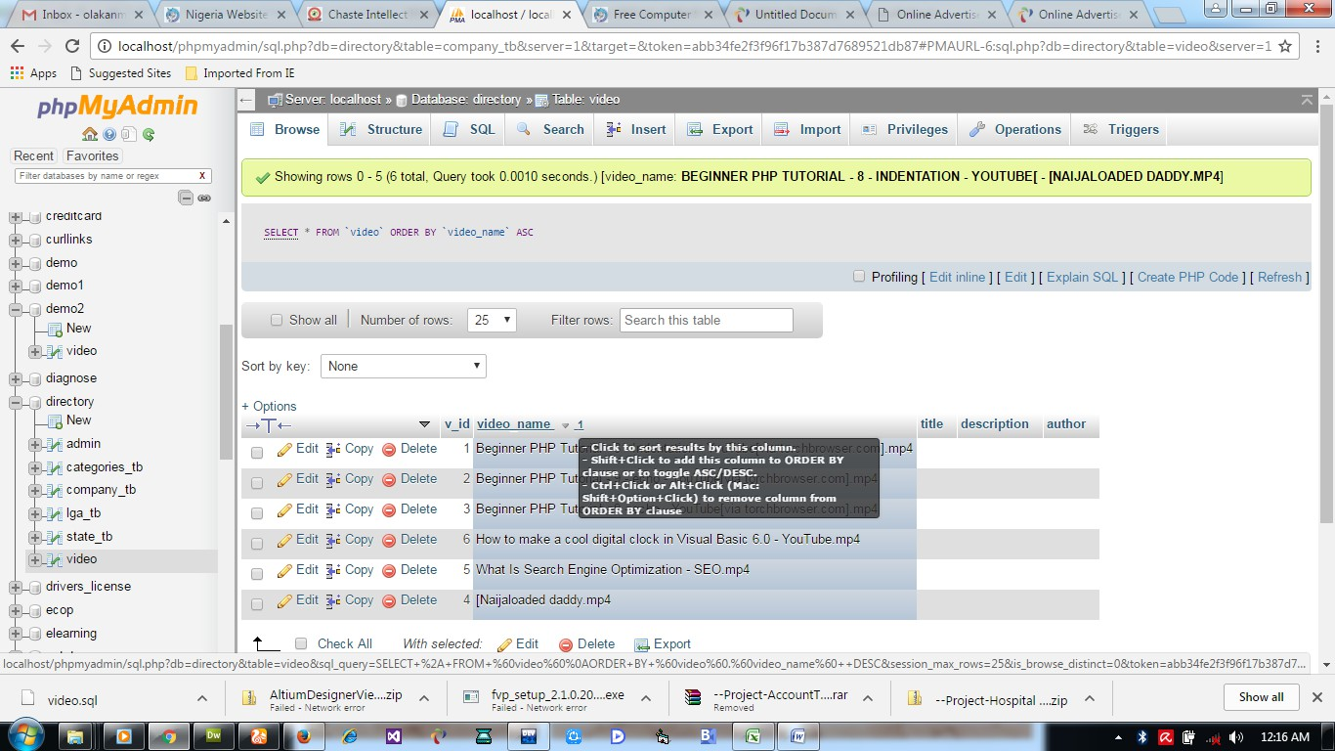

Table 4.3: Video Table

Procedure Design
The procedure design of the new system is the generalized description of the purpose of various main programs in the system as well as the interrelationship among the subprogram.
The procedure design of the system is achieved through the use of html, dreamweaver and php to create design and database system. The application is made up of five modules which consist of pull down modules. A module is a set of program statement which when combined or linked together complete a specific task. In order words, the program module involves the breaking of program into unit with each performing specific task, which enhances easy coding, debugging and easier to maintain task.

Implementation of Techniques Used in Details

    - Choice of Programming Language

The programming language used in the proposed system is php. PHP meaning (PHP Hypertext Preprocessor) is a server-side programming language. It is an open source server- side scripting language that has taken web-based development to a new level of sophistication. The PHP scripting engine is well optimized for the response times needed on web applications, it can even part of the web server itself improving the throughput even more.

If it were only a matter of improving the speed of the scripts, then PHP will be one of solutions. But there is more to the PHP equation than that. There is the simplicity and robustness of the language and the scripting engine. There is the connectivity to an ever increasing number of database servers, the shorter development cycles and the ease (encouraged by syntaxes and constructs) of creating modular and reusable components.

Hardware Support

The hardware needed are the basic hardware of the computer system such as:

      - VDU (Visual Display Unit),
      - Central Processing Unit (CPU) with RAM of 2GB and above
      - Mouse and Keyboard.
      - Uninterrupted Power Supply (UPS) for protection against loss of data through sudden power failure
      - Keyboard.

Software Support

The software required are basically any web browser (internet explorer, firefox and the likes) WampServer and a network service, be it wired or wireless, it enable the hardware components to function effectively.

System Documentation

Program Documentation

The program documentation generally covered the statement of the function of individual program that made up of the entire system. It is indeed important that the documentation of the finished application is produced .This refers to the ways in which the proposed system will be installed and the steps are as follows:
- Click WampServer on the desktop
- Click start on the computer desktop
- Select all programs
- Select any browser e.g. internet Explorer, Mozilla Firefox, Google Chrome e.t.c e)

Operating the System

- Click start on the computer desktop
- Select all programs
- Select any browser e.g internet Explorer, Morzilla Firefox, Google Chrome e.t.c
- Type the url (Uniform Resource Locator) of the system into the address bar (localhost/vid_tutorial/)

Maintaining the System

The following instructions must be strictly adhere to in other to make efficient use of the system. Best is to Install an anti-virus and always make sure it is usually updated to date. And frequently updating of new information for the usage of customers.

Summary

CHAPTER FIVE

Summary, Conclusion Further Study

This research work focused on the design and implementation of a virtual library system tailored for use in tertiary institutions. The primary aim was to address the limitations inherent in traditional library systems, such as restricted access to materials, physical deterioration of resources, limited operating hours, and space constraints. The virtual library system provides an online platform where users can register, log in, search for books, access reading materials, and download academic resources in various formats such as PDF, DOCX, and PPT. Chapter One provided an overview of the project, highlighting the background, problem statement, objectives, scope, significance, and the structure of the project. Chapter Two discussed the relevant literature, including theoretical frameworks, existing virtual library systems, their features, strengths, and limitations. It also addressed the evolution of digital libraries and their role in modern education. Chapter Three focused on the methodology adopted, including the system design approach, tools used for development (such as HTML, CSS, PHP, MySQL), data collection methods, and system analysis techniques. The current system was reviewed and its limitations identified, which informed the need for a more efficient digital solution. Chapter Four presented the implementation of the proposed virtual library system. It detailed the system architecture, user interface designs, database structures, and functionalities. Screenshots and code snippets illustrated how the system works, from user registration to accessing and downloading resources.

Conclusion
The development of the virtual library system has effectively demonstrated how digital technology can enhance access to academic materials and improve the learning experience in tertiary institutions. By enabling students and staff to access a wide range of educational resources remotely and at any time, the system addresses the key issues faced by traditional libraries. It offers a scalable, user-friendly, and efficient platform that supports learning, research, and academic excellence.
Furthermore, the project showcases the practical application of web technologies in solving real-world problems. The system is also adaptable for future expansion, including the integration of e-learning modules, video lectures, discussion forums, and AI-based recommendation engines.

Recommendation

Based on the findings and outcomes of this project, the following recommendations are suggested:
    - Adoption by Institutions: Tertiary institutions should consider adopting virtual libraries as a supplement or replacement for physical libraries, especially in institutions with limited physical resources.
    - Regular Updates: The library database should be regularly updated with current academic materials to ensure relevance and encourage usage by students and researchers.
    - User Training: Adequate orientation and training should be provided for students and staff on how to use the virtual library system effectively.
    - Security Measures: Strong user authentication and file access control measures should be implemented to prevent unauthorized access and ensure the integrity of stored materials.
    - Feedback Mechanism: A feedback and support system should be integrated to allow users to report issues, suggest improvements, and communicate with administrators.
    - System Scalability: The system should be developed further to accommodate multimedia content, mobile responsiveness, and offline accessibility to cater to broader user needs.

References
Hooly Gunn, "virtual libraries supporting student learning", July [online] http://www.accesswave.ca/~hgunn/special/papers/virlib/
Clifford Lynch (2005). Where do we go from Here? The next decade for Digital Libraries, D-Lib Magazine. July/August 2003, Volume II, Number 7/8.
Fox, E. A. Envisioning a Computer Science Digital Library. Presented at Digital Libraries of the Future Panel, ACM Multimedia 93, Anaheim, C. A., 1993.
Harter, S., (1997). Scholarly Communication and the Digital Library: Problems and Issues. Journal of Digital Information. http://jodi.ecs.soten.ac.uk
Levy, D. M. & Marshall, C. C., (1995). Going Digital: A Look at Assumptions Underlying Digital Libraries Communications of the ACM, 38(4), 77-84.
L.T Nowell and E. A. Fox: Envision: Information Visualization in a Digital Library; Demonstration. Seattle, WA: ACM SIGIR 95, July 10, 1995.
Robertsons, S. Jitan & Resse, K. (1997). Web Based Collaborative Library Research.
Proceedings of the 2nd ACM International Conference on Digital Libraries 152 – 160.
Sharifabadi, S. R. (2006). How Digital Libraries can Support E-Learning. The Electronic Library 24(3).
Dictionary.com, "software," in The American Heritage® Dictionary of the English
Language, Fourth Edition. Source location: Houghton Mifflin Company, 2004.
Available: http://dictionary.reference.com/browse/software. About Student Affairs, Department Description, [Online] Available:
http://saweb.csus.edu/students/departments.aspx
California Community Colleges, Chancellor’s Office, August 23, 2007 [Online]
Available:http://www.cccco.edu/ChancellorsOffice/IntheNews/PressReleases/CCC TranscriptServiceAvailable/tabid/1018/Default.aspx
California State University, Long Beach, October 1, 2007 [Online]
Available:http://daf.csulb.edu/offices/univ_svcs/budget/docs/fy0708/employee_dat a/salaries_tenure.html
Student Affairs Workload Analysis March – 2008 (Author: Edward Mills) Office of Vice-President, Student Affairs (Internal Report), Contact: Lori Rowe The California
State University, December 3, 2009 [Online]
Vision, Mission and Core Values, Source location: Student Affairs Website [Online] Available: http://saweb.csus.edu/students/mission.aspx

APPENDIX 1: FLOWCHART
ADD VIDEO
ADD BOOK
VIEW ALL CATEGORY
ALL BOOKS
ADD CATEGORY
HOME
Administrator
LOG OUT
STOP
Start
FAQ
About
Take video
Home
End User

23

Login Flowchart
Input Username and password

This flowchart explains how the login into the system is carried out.

Start

Is Username and
Password Correct
NO
Try Again?

YES

Admin Page

Return

Figure 3.2: Login Flowchart

Add Book Flowchart

Book Adding into the database is seen in their pictorial form here
Start
Open Database
Supply the Details
Add To Database
Add More
Records?
Yes
Close Database
No
Return

Figure 3.3 Add Book Flowchart

Add video
Video Adding into the database is seen in their pictorial form here
Start
Open Database
Supply Video Details
Save to Database
More
Records?
Yes
Close Database
No
26
Return

Figure 3.4 Add Video flowcharts A new category is added if need there is a need.
Start
Open Database
Supply Category Details
Add To Database
Add More
Records?
Yes
27
Close Database
Return

No

Figure 3.5 Modify Book flowchart

View all category flowchart

START
Display All Category
RETURN

TAKE VIDEO
START
Take Video
RETURN

Display all book flowchart
START
Display All Books
STOP

Logout flowchart
Yes
Start
Select Option
Is Log out?
No
Return
Show Login Page
Home Page

APPENDIX 2: SOURCE CODE

<?php ob_start(); session_start();
include('Connections/directory.php');
?>
<!DOCTYPE html PUBLIC "-//W3C//DTD XHTML 1.0 Transitional//EN" "http://www.w3.org/TR/xhtml1/DTD/xhtml1-transitional.dtd">
<html xmlns="http://www.w3.org/1999/xhtml">
<head>
<meta http-equiv="Content-Type" content="text/html; charset=utf-8" />
<link rel="shortcut icon" type="image/ico" href="images/logo.jpg" />
<link href="style/style.css" rel="stylesheet" type="text/css" />
<link href="style/sign.css" rel="stylesheet" type="text/css" />
<script src="Scripts/AC_RunActiveContent.js" type="text/javascript"></script>
<title>Virtual Library</title>
</head>
<body>
<div id="main_container">
<div id="container">
<div id="header">
<div id="search">
<!--<form id="form1" name="form1" method="post" action="">
<label for="textfield"></label>
<input type="text" name="textfield" id="textfield" />
<label for="select"></label>
<select name="select" id="select">
</select><input name="" type="button" value="Search" />
</form>-->

</div>
</div>
<?php include("menu.php");?>
<div id="spacer">&nbsp;</div>
<div id="main_body">
<div id="side_bar">
<p class="heading">Categories </p>
<?php include('cat.php'); ?>
</div>
<div id="main_content">
<div id="image">
</div>
<div id="content">
<?php

<?php // get all company

FROM company_tb") or die(mysql_error()); mysql_fetch_array($query)){

include("fields.php");
?>

$query = mysql_query("SELECT * while ($rs =
$cat = $rs['category'];
$pix = $rs['logo'];
$file =$rs['file'];
$get_cat = mysql_query("SELECT *

FROM categories_tb WHERE id = '$cat'") or die(mysql_error());
$rs_cat = mysql_fetch_array($get_cat);
$cat_name = $rs_cat['cat_name'];
?>

<table width="100%" border="0" cellspacing="0" cellpadding="5">
<tr>
<td width="15%" rowspan="3" valign="top" style="text-decoration:none;"> <?php echo '<img src="logo/'.$pix.'"height ="104" width ="101">';?></td>
<td colspan="2" valign="top"><h3><?php echo $rs['name'];?></h3></td>
</tr>
<tr>
<td width="33%" valign="top"><strong>Category: </strong><?php echo
$cat_name;?></td>
<td width="52%" valign="top"><strong>Description: </strong><?php echo
$rs['address'];?></td>
</tr>
<tr>
<td valign="top"><?php echo $rs['opening_time'];?></td>
<td valign="top"><strong>About: </strong><?php echo $rs['about'];?></td>
</tr>
<tr>
<td colspan="3" valign="top"><strong>Description: </strong><?php echo
$rs['about'];?></td>
</tr>
<tr>
<td valign="top">Download Document</td>
<td width="30%" ><a href='file/<?php echo $file;?>' title='Click here to Download the Document '><?php echo $file;?></a></td>
</tr>
</table>
<p style="width:100%; color:#004000; border:solid" id="menu_bar"></p>
<?php } ?>
</div>

</div>
</div>
<div id="footer">
<div id="one">Copyright &copy; <?php if (date("Y") != "2015"){
echo " ".date("Y");
?></div>
<div id="two"></div>
</div>
</div>
</div>
</body>
</html>
<?php ob_start(); session_start();
include('Connections/directory.php');
?>
<!DOCTYPE html PUBLIC "-//W3C//DTD XHTML 1.0 Transitional//EN" "http://www.w3.org/TR/xhtml1/DTD/xhtml1-transitional.dtd">
<html xmlns="http://www.w3.org/1999/xhtml">
<head>
<meta http-equiv="Content-Type" content="text/html; charset=utf-8" />
<link rel="shortcut icon" type="image/ico" href="images/logo.jpg" />
<link href="style/style.css" rel="stylesheet" type="text/css" />
<link href="style/sign.css" rel="stylesheet" type="text/css" />
<script src="Scripts/AC_RunActiveContent.js" type="text/javascript"></script>

<title>Virtual Library</title>
</head>

<body>
<div id="main_container">
<div id="container">
<div id="header">

<div id="search">

<?php include("header.php");?>

<!--<form id="form1" name="form1" method="post" action="">
<label for="textfield"></label>
<input type="text" name="textfield" id="textfield" />
<label for="select"></label>
<select name="select" id="select">
</select><input name="" type="button" value="Search" />
</form>-->
</div>
</div>
<?php include("menu.php");?>
<div id="spacer">&nbsp;</div>
<div id="main_body">
<div id="side_bar">
<p class="heading">Categories </p>
<?php include('cat.php'); ?>
</div>
<div id="main_content">
<div id="image">

</div>
<div id="content">
<?php //include("fields.php");?>

<table width="100%" align="center" cellpadding="5" cellspacing="0" border="1" bordercolor="#9999FF">
<tr>
<td><center>
<h1>VIRTUAL LIBRARY</h1>
</center></td>
</tr>
<?php
$get_product = mysql_query("SELECT * FROM video") or die(mysql_error());
while ($rs =

mysql_fetch_array($get_product)){

<tr>

$qty = $rs['video_name'];
?>

<td><a href='test_upload/<?php echo $rs['video_name'];?>' title='Click here to watch the video '><?php echo $qty?></a></td>
<?php }?>
</table>
</div>
</div>
</div>
<div id="footer">
<div id="one">Copyright &copy; <?php if (date("Y") != "2015"){
echo " ".date("Y");
}
?></div>
<div id="two"></div>
</div>

</div>
</div>
</body>
</html>
<?php ob_start(); session_start();
include('Connections/directory.php');
?>
<!DOCTYPE html PUBLIC "-//W3C//DTD XHTML 1.0 Transitional//EN" "http://www.w3.org/TR/xhtml1/DTD/xhtml1-transitional.dtd">
<html xmlns="http://www.w3.org/1999/xhtml">
<head>
<meta http-equiv="Content-Type" content="text/html; charset=utf-8" />
<link rel="shortcut icon" type="image/ico" href="images/logo.jpg" />
<link href="style/style.css" rel="stylesheet" type="text/css" />
<link href="style/sign.css" rel="stylesheet" type="text/css" />
<script src="Scripts/AC_RunActiveContent.js" type="text/javascript"></script>

<title>Online Advertisement System in Challenge bookshop</title>
</head>

<body>
<div id="main_container">
<div id="container">
<div id="header">

</div>
<?php include("menu.php");?>

<?php include("header.php");?>

<div id="spacer">&nbsp;</div>
<div id="main_body">
<div id="side_bar">
<p class="heading">Categories </p>
<?php include('cat.php'); ?>
</div>
<div id="main_content">
<div id="content">
<?php

<h2>Company Registration</h2>

include("fields.php");
?>

<form action="reg_pro.php" method="post" enctype="multipart/form-data" name="register" id="form1">
<table width="100%" cellpadding="5" cellspacing="0">
<tr>
<td>&nbsp;</td>
<td><?php echo @$_SESSION['msg'];?></td>
</tr>
<tr>
<td width="13%">Name:</td>
<td width="87%"><label for="opening"></label>
<input name="compname" type="text" id="name" value="" /></td>
</tr>
<tr>
<td>Address:</td>
<td><textarea name="address" id="adrs"></textarea></td>
</tr>
<tr>

<td>Phone number:</td>
<td><input type="text" name="phone" id="phone" /></td>
</tr>
<tr>
<td>Website:</td>
<td><input type="text" name="website" id="web" /></td>
</tr>
<tr>
<td>Email:</td>
<td><input type="text" name="email" id="email" /></td>
</tr>
<tr>
<td>Category:</td>
<td>
<select name="category" id="category">
<?php
$sql=mysql_query("SELECT * FROM categories_tb") or die(mysql_error());
?>
while ($row = mysql_fetch_array($sql)){
$id = $row['id'];
$cat_name = $row['cat_name'];
?>
<option value="<?php echo $id;?>"><?php echo $cat_name;?></option>
<?php }?>
</select></td>
</tr>
<tr>
<td>Opening Time</td>
<td><label>

&nbsp;
<input type="text" name="opening" id="opening" />
</label></td>
</tr>
<tr>
<td>About:</td>
<td><input type="text" name="about" id="about" /></td>
</tr>
<tr>
<td>Logo:</td>
<td><label>
<input type="file" name="passport" id="passport" />
</label></td>
</tr>
<tr>
<td align="center">&nbsp;</td>
<td><input type="submit" value="Register" />

<input name="Reset" type="reset" value="Reset" /></td>
</tr>
</table>
</form>
<p>&nbsp; </p>

</div>
</div>
</div>
<div id="footer">
<div id="one">Copyright &copy; 2015 <?php if (date("Y") != "2015"){
echo " - ".date("Y");

}
?></div>
<div id="two"></div>
</div>
</div>
</div></body>
</html>
<?php
$_SESSION['msg'] = "";
ob_flush();
?>

