

PROJECT REPORT ON LAND INFORMATION SYSTEM OF URBAN ESTATE, OKE OSE. ILORIN,
KWARA STATE

BY

AYODELE TAIYE OPEYEM
MATRIC NO: HND/23/SGI/FT/072

SUBMITTED IN PARTIAL FULFILMENT OF THE REQUIREMENTS FOR THE
AWARD OF HIGHER NATIONAL DIPLOMA (HND) IN SURVEYING AND
GEO-INFORMATICS TO THE DEPARTMENT OF SURVEYING AND
GEOINFORMATICS, KWARA STATE POLYTECHNIC, ILORIN.

JULY, 2025

CERTIFICATE
This is to certify that all the field work and information given in this project were obtained as a result of the observations and measurements carried out by me and that the survey was carried out in accordance with survey rules and regulations as well as departmental instructions.

Name of the Student: AYODELE TAIYE OPEYEMI
Signature of the Student: ______________________
Date of Completion:

CERTIFICATION
This is to certify that this project report was prepared and submitted by AYODELE TAIYE OPEYEMI with Matric No:- HND / 23 / SGI / FT / 072 to the department of Surveying and Geo-informatics, Institute of Environmental Studies, Kwara State Polytechnic, Ilorin, as a result of field observation and measurement using appropriate instruments and equipment to carry out the task.

------------------------------------ ---------------------------
SURV A.O AKINYEDE DATE
Project Supervisor

------------------------------------ -------------------------
SURV R.S AWOLEYE DATE
Project Coordinator

------------------------------------ -------------------------
MR ISAU ABIMBOLA DATE
Head of Department

………………………………………………. ………………………………..
(EXTERNAL EXAMINER) DATE

DEDICATION
I dedicate this project report to Almighty God, the creator of heaven and earth.

ACKNOWLEDGEMENT
My profound recognition goes to my amiable supervisor in person, Surv. A.O Akinyede for his total effort and support in supervising and correcting my write up, also his professional suggestion which finally brought the project to lime light. I also stress my thanks to all the staff and lecturers of surveying and geo informatics for their course of humanity. May Almighty God enrich you with more knowledge and understanding.
With gratitude and thanks to Almighty God who out of his infinite power and mercy gave me the grace of writing this project report. I esteem it a privilege to give glory and thanks.
I would like to dedicate this project to my father. His unwavering support, guidance and encouragement helped me to become the person I am today. Although he is no longer with us, his memory will continue to inspire me to strive to excellence.
My keen gratitude goes to my World, My Armor, My Pillars, My everything in person of Mr Ayodele for his unflinching support, prayers, comforting words, financial assistance, moral advice and their unyielding effort which have pushed me forward in life for good, May Almighty God grant you long life and good health to enable you reap the fruit of your labor (AMIN).
In conclusion, I wish to commend all my group members for their support and cooperation towards the successful completion of the project. I wish all of us success.

ABSTRACT
This project focused on creation of Land Information System of Urban Estate, Oke Ose, Ilorin East Local Government Area, Ilorin, Kwara State. The task involved creation of the database for cadastral information system. The adopted mechanisms encompass the acquisition of geometric and attribute data, data processing, data analysis and information presentation. The geometric data were acquired using Differential Global Positioning System (DGPS). The attribute data were acquired by conducting social survey (oral interview). The data were downloaded and processed with appropriate software and the processed data were analyzed using AutoCAD Land development and ArcGIS software. The database was design and linked using relational (table) database structure approach. Generic queries were performed and generated to demonstrate the capability of the software. Also the security of the database created was ensured to allow for use. The result acquired from the exercise was presented in hard and softcopy format respectively for sustainable land development project planning in the study area.

TABLE OF CONTENTS
Pages
CERTIFICATE………………………………………………………………………………………………….ii
CERTIFICATION………………………………………………………………………………………………iii
DEDICATION…………………………………………………………………………....................................iv
ACKNOWLEDGEMENTS…………………………………….……………………………………………..v
ABSTRACT……………………………………………………………………………………………………vi
TABLE OF CONTENTS……………………………………………………….…………………………....vii
LSIT OF FIGURES………………………………………………………………………………………….viii
LIST OF TABLES…………………………………………………………………………………………...ix
CHAPTER ONE………………………………………………………………………………………………1
1.0 INTRODUCTION ………………………………………………………………………………………...1
1.1 BACKGROUND TO THE PROJECT……………………………………………………………………1
1.2 STATEMENT OF PROBLEM ……………………………………………………………………………3
1.3 RESEARCH QUESTIONS……………………………………………………………………………….4
1.4 AIM OF THE PROJECT…………………….……………………………………………………………4
1.5 OBJECTIVES OF THE PROJECT…………...…………………………………………………………...5
1.6 SCOPE OF THE PROJECT……………………………………………………………………………….6
1.5 PERSONNEL INVOLVED IN THE PROJECT…………………………………………………………6
1.6 PROJECT AREA…………………………………………………………………………………………7
CHAPTER TWO……………………………………………………………………………………………..8
2.0 LITERATURE REVIEW…………………………………………………………………………………8
CHAPTER THREE…………………………………………………………………………………………16
- METHODOLOGY………………………………………………………………………………………16
3.1.1 VIEW OF REALITY……………………………………….…………………………………………..17
3.1.2 CONCEPTUAL DESIGN……………………………………………………………..……………….18
3.2 RECONNAISSACE...………………..……………………………………….…………………………19
3.2.1 OFFICE PLANNING………………………………………………………………………………….19
3.2.1.2 FIELD RECONNAISSANCE………………………………………………………………………..20
3.2.1 DATA ACQUISITION…………………………………………………………………………………20
3.2.2 MONUMENTATION………………………………………………………………………………….20
3.2.3 EQUIPMENT USED/SYSTEM SELECTION AND SOFTWARE………………….……………….21
3.2.4 TEST OF INSTRUMENT……………………………………………..………………………………21
3.2.5 CONTROL CHECK……………………………………………………………………………………22
3.2.7 GEOMETRIC DATA ACQUISITION………………………………………………………………..23
3.3 DATA PROCESSING…………………………………………………………………………………..23
3.3.1 DOWNLOADING/EDITING………………………………………………………………………….24
3.3.1.2 LINEAR ACCURACY……………………………………………………………………………….24
3.4 PHYSICAL DESIGN……………………………………………………………………………………25
3.5 DATABASE IMPLEMENTATION……………………………………………………………………26
3.6.1 DATA SECURITY……………………………………………………………………………………..26
3.6.2 DATA INTEGRITY……………………………………………………………………………………27
3.6.3 DATABASE MANITENANCE………………………………………………………………………..27
CHAPTER FOUR…………………………………………………………………………………………..28
4.0 SPATIAL ANALYSES AND INFORMATION PRESENTATION……………………………………28
4.1 TESTING OF DATABASE……………………………………………….……………………………..32
4.2.1 QUERY AND PRESENTATION OF ANALYSIS………………………………………………..…..34
4.2.2 SINGLE CRITERRION ANALYSIS………………………………………………………………….35
CHAPTER FIVE…………………………………………………………………………………………….40
5.0 PROJECT COSTING, SUMMARY, CONCLUSION AND RECOMMENDATIONS……….………….40
5.1 PROJECT COSTING……………………………………………………………………………………… 40
5.2 SUMMARY………………………………………………………………………………………………...44
5.3 CONCLUSION……………………………………………………………………………………………..45
5.4 RECOMMENDATION……………………………………………………………………………………..46
REFERENCE………………………………………………………………………………………………...47

LIST OF FIGURES
FIG 1.6 STUDY AREA……………………………………………………………………………………..6
FIG 3.1 DESIGN AND CONSTRUCTION PHASE OF A SPATIAL…………………….……………….21
FIG 3.3 POINT ENTITY AND ITS ATTRIBUTES………………………………………….……………..22
FIG 3.4 LINE ENTITY AND ITS ATTRIBUTES………………………………….………..……………..22
FIG 3.5 POLYGON ENTITY AND ITS ATTRIBUTES…………………………………….……………...22
FIG 3.7 RECCE DIAGRAM OF THE PROJECT AREA…………………………………………………...26
FIG 3.8 TYPICAL CONCRETE PILLER……………………………………………………………………27
FIG 3.9 DIAGRAM SHOWING CONTROL POINT CHECK……………………………………………...30

LIST OF TABLE
TABLE 3.1: NODE ENTITY AND ITS ATTRIBUTES……………………………………………………23
TABLE 3.2: ARC ENTITY AND ITS ATTRIBUTES………………………………………………………24
TABLE 3.3: POLYGON ENTITY AND ITS ATTRIBUTES………………………………………………24
TABLE 3.6 CONTROL CHECK FROM OBSERVED VALUE…………………………………………..29
TABLE 3.2.5 OBSERVED ANGLE FOR CONTROL………………..……………………………………30
TABLE 3.5 CONTROL CHECK FROM OBSERVED VALUES…………………………………………30
TABLE 3.7 ANALYSIS THE CONTROL BY DISTANCE CHECK…………………………………….31
TABLE 3.9 BACK COMPUTATION OF PERIMETER PILLAR COORDINATES………...…………..34
TABLE 3.9 STARTING AND CLOSING COORDINATES FOR LINEAR ACCURACY………………34
TABLE 3.11 NODE ENTITY DATA STRUCTURE……………………………………………………….36
TABLE 3.1 ARC ENTITY AND ITS ATTRIBUTES STRUCTURE………………………………………36
TABLE 3.13: POLYGON DATA STRUCURE …………………………………………………………….36
CHAPTER ONE
INTRODUCTION
1.1 BACKGROUND TO THE STUDY
Land is the aspect which covers the totality of the environment and it’s fundamental to man’s survival. This is true because this provides us with working space, and also provides us with biological and natural capital in addition to other resources of land. It is also our source of food, clothing and a host of other raw materials. According to the Encyclopaedia Britannica, Land is the resource that encompasses the natural resources used in production. From it we obtain the food we eat, the shelter we need and the place to work. In the early century, land for settlement and cultivation was in abundant in direct proportion to the size of the population, there was little need for land-related information management and administration. But, with the growth of agriculture and competition for the available space, land rights and controls over land use began to emerge. Thus, the implementation of cadastres and cadastral surveys and/or mapping began. For decades, the traditional cadastral systems of mapping have enjoyed a reputation for their reliability and well defined processes. Then, it was a very recognized guarantee of security to private ownership of land. Tremendous technological progress, social changes, globalization and increasing intercommunication of business relation with their legal and environmental consequences has put a strain on the traditional systems. Over the years, the manual method of data handling has dominated cadastral information management in a disordered manner among various parastatals within the state or in the land tenure systems of private individuals. It is obvious that manual method of handling cadastral information can no longer cope with the increasing demand and requirements of users of such information. Hence there is a need for a well organised plan to managing cadastral information. Cadastral is the method of registering land, designed to ensure the rights of individuals and the state of their property. Every activity in general and developmental project activity in particular, are associated with land and land transaction. Therefore, for planning purpose all land-associated information should be available in the form of a computer database, which can be easily accessed, manipulated by decision makers while formulating and executing a work. Such a database system is called Land Information System.
Land Information System (LIS) is a geographic information system for cadastral and land-use mapping, typically used by local governments and even state governments. A LIS consists of an accurate, current and reliable land record cadastre and its associated attribute and spatial data (that is, geographic data representing the location of objects; latitude and longitude, as well as height information) that represent the legal boundaries of land tenure and provides a vital base layer capable of integration into other geographic systems or as a standalone solution that allows data stewards to retrieve, create, update, store, view, analyze and publish land information. A Cadastre is normally a parcel based and up-to-date land information system containing a record of interests in land (e.g. rights, restrictions and responsibilities). It usually includes a geometric description of land parcels linked to other records describing the nature of the interests, the ownership or control of those interests and often the value of the parcel and its improvements (FIG, 1995). Cadastral Survey Information is often an element in Geographic Information Systems (GIS) or Land Information Systems (LIS) used to assess and manage land and built infrastructure. Computerization of land administration activities, involving the creation of a digital cadastre as part of Spatial Data Infrastructure (SDI), is considered necessary to improve data access, usability, and coordination of land related activities (Carter et. al., 2007).
Spatial Data Infrastructure is the technology, policies, standards, human resources, and related activities necessary to acquire, process, distribute, use, maintain, and preserve spatial data (Office of Management and Budget OMB, 2002). Thus, digital cadastre is a tool for achieving land administration. Traditional method of data management has proved to be inefficient and cumbersome. It is faced with problems such as redundancy (unnecessary repetition or duplication of data), high maintenance costs, difficulties in moving from one system to another, difficulties in data sharing, lack of security and standard, lack of coherent corporate views of data management among others. An ideal land administration must be able to include the provision of information on land in an effective and efficient way to correctly identify those people who have interest in real estate and providing information about these interests (such as duration of leases). It must also allow easy access to land for development where it is needed, increase efficiency in land use management through good planning, and promote greater social equity. It should also allow for revenue generation to the government (taxation), maintenance of environmental quality, and provide security of tenure (Usman, 2010). An analogue map cannot necessarily provide the following listed above effectively and efficiently.
1.2 STATEMENT OF THE PROBLEM
Since analogue cadastral maps are still being used for land development, planning public administration, land development and private transactions in land or, are accepted as valid documents in settling land dispute in the courts, issues such as retrieval of cadastral information, manipulating, updating, large storage capacity, Multiple land owner, Integrating large volume data and assessing large volumes of information still remain the major problem in some ministries and parastatals. In Kwara State in particular, their system of cadastral record keeping is analogue method, as such the cadastral layout plan and its attribute information’s need to be converted and kept in a digital format for easy manipulation, retrieval and accessibility of large volume of information(s) within short period of time, the case of Urban Estate, Oke ose, which is the study area is not different as its plan has not been converted and the analogue layout designed plan is seriously affected by individuals or parastatals. The data resulting from the classical model of land cadastre information are now becoming insufficient. In the course of economic development the demand for more varied information items becomes increasingly pressing. Data stored in traditional cadastral systems fail to meet requirements connected with supervision, management, decision-making, forecasting and development planning. The major problems that prompt me to embark on this research are; retrieval of cadastral information, manipulating cadastral information, assessing large volumes of information, updating cadastral information, large storage capacity, multiple land owner and Integrating cadastral data.
1.3 AIM OF THE PROJECT
The aim of this project is to provide an integrated platform for managing, storing and analyzing land related data to support efficient land administration, planning and decision making.
1.4 OBJECTIVES OF THE STUDY
The following objectives were considered in order to accomplish the above aim
- Project planning
- Monumentation
- Data downloading and processing
- Data analysis and information presentation
- Query
- Report writing
1.5 SCOPE OF THE PROJECT
The project entails the under listed operations to be carried out.
- Data capturing using digital surveying equipment e.g Total station and its accessories, DGPS.
- Data processing
- Database design and creation
- Information display and presentation
- Database acquisition.

1.6 PERSONNEL INVOLVED IN THE PROJECT
The under listed names are the members of the group who worked together to ensure the success of the project.
S/N | NAMES | MATRIC NO | ROLE
1 | AYODELE TAIYE OPEYEMI | HND/23/SGI/FT/072 | AUTHOR
2 | ABOLADE BISOLA OPEYEMI | HND/23/SGI/FT/073 | MEMBER
3 | AKEEM HAMID AJAGBE | HND/23/SGI/FT/074 | MEMBER
4 | ABDULQUADRI ABUBAKR .S. | HND/23/SGI/FT/075 | MEMBER
5 | AFOLAYAN IFEOLUWA .M. | HND/23/SGI/FT/077 | MEMBER
6 | ABDULFATAI ABDULAFEEZ | HND/23/SGI/FT/120 | MEMBER
7 | ADEKUNLE FLORENCE | HND/23/SGI/FT/123 | MEMBER
8 | AYEGBOYIN QUDUS | HND/22/SGI/FT/071 | MEMBER

Source: Author, 2025

1.7 PROJECT AREA
The project site is Urban Estate opposite Government cementary area, Oke Oyi, Kwara State in Ilorin East Local Government Area of Kwara State Nigeria. The estate falls between latitude 08°31’47’’N and on longitude 04°32’27’’E on the geographical coordinates.

1a. Nigeria Map showing Kwara State
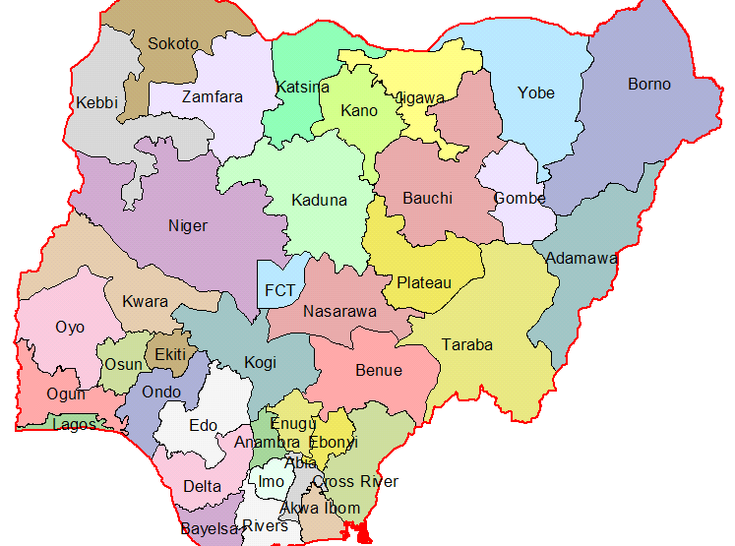
1b. Kwara State Map showing Ilorin East Local Government Area
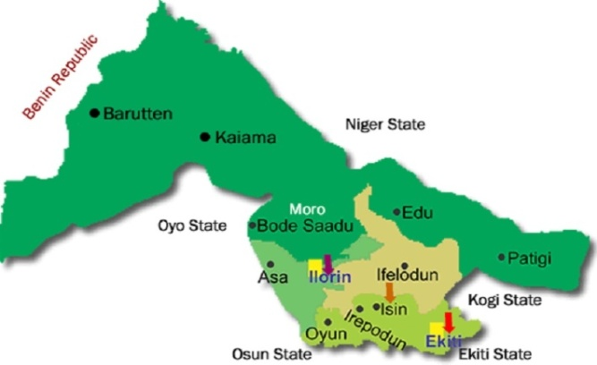

CHAPTER TWO
LITERATURE REVIEW
2.1 INTRODUCTION
The origins of fiscal cadastres that support a system of land valuation, and land tax can be traced to Egyptian times (Dale and McLaughlin 1988). On the other hand juridical cadastres, information systems that underpin the legal registration of land in support of land transactions are far more recent. Over time many of these cadastral systems have evolved beyond their primary purposes to provide the basis for general land administration systems (Ting and Williamson 1999). Therefore for any jurisdiction, the current cadastral system is a unique product, evolved from its initial design function in a manner that is specific to the cultural and social history of the jurisdiction within which it has evolved. This proposition is reinforced in the paper Understanding Cadastral Maps (Williamson and Enemark 1996), which details the development of the cadastral systems and the cadastral maps of Australia and Denmark. Evolving differences and subsequent incompatibility of cadastral data sets can extend to specific jurisdiction levels within a single nation. A workshop for digital cadastral databases (DCDB) for New Zealand and the Australian states concluded that: “The considerable diversity between different DCDBs came as a surprise to some and reinforced that jurisdictions have different cadastral systems, different title registrations systems and different methods of maintaining and updating their DCDBs.” (PSMA 1996) Fuller historical overviews of cadastres can be found in the book Land Information Management: An introduction with special reference to cadastral problems in Third World Countries by Dale and McLaughlin (1988), while Williamson’s Ph.D. thesis, A Modern Cadastre for New South Wales (Williamson 1983), provides background information on some additional western cadastral systems. Readers will find country or state specific histories are offered by many authors when describing the current status of their jurisdiction’s cadastral systems: Denmark (Williamson and Enemark 1996), Austria (Höflinger 1993), Germany (Hawerk 1995), Australia (Williamson and Enemark 1996), Australia, Queensland (Cook 1994), etc These authors indicate that present day western cadastres have their genesis in 19th Century Napoleonic Europe. These cadastral systems, and their supporting maps, have evolved significantly different roles within each of their juridical cadastral systems, indeed the changing role of the cadastre is itself a significant research area (Ting and Williamson 1999). Irrespective of their historical, social and cultural underpinnings, and their technical differences, the cadastral data within these cadastral systems fulfil wider roles than were originally intended. It is now recognised that an effective cadastral system is the basis for an efficient real estate market and fundamental for an efficient system of sustainable land use management (UN-FIG 1996).
Most human activities and developmental efforts are based on land. Therefore, a systematic record of land and rights in land are vital for public administration, planning, land development and private transactions in land. The increasing growth in rural population and the massive migration of people to the cities (especially in the developing countries) have put increasing pressure on rural and urban lands.
The International Federation of Surveyors (FIG 1995) statement on Cadastral defines cadastral as follows: « A cadastral is normally a parcel based, and up-to-date land information system containing a record of interests in land (e.g. rights, restrictions and responsibilities). Cadastral is a daily maintained record system which contains an unambiguous description of the physical location of the parcel of land and the extent of the land, the related interest on the lands and the information on the land. It usually includes a geometric description of land parcels linked to other records describing the nature of the interests, the ownership or control of those interests, and often the value of the parcel and its improvements. It may be established for fiscal purposes, legal purposes, or to assist in the management of land and land use and enables sustainable development and environmental protection.
Also, according to Potdar, V. B. (2010). Land Information System in the Present Day Context. www.GIS Development.net. Accessed march 27th 2015. to integrate the three cadastres, it has to come through legislations as an Act of Law. He said that, modern technology such as the use of GPS system for demarcating village boundaries and Total stations or EDMs for measuring land parcels and for plotting purposes, computers can be used extensively. He also asserts that, spatial data consists of parcel boundaries, size, area etc. while the non-spatial data consists of record of right, land use pattern, revenue details, loans, crop details past transactions etc.
Ndukwe, N. K. (2001), Digital Technology in Surveying and Mapping: Principles, Application and Legislative Issues. observed that the classical cadastre has many inherent problems. Parcel related information cannot be collected and disseminated systematically and regularly, nor can they be managed effectively to support user needs. He explained that digital cadastre is a parcel based information system that focuses on the acquisition (using the latest technology of data acquisition), presentation (through cadastral plans), storage and dissemination of parcel based data or information associated with individual parcels of land.
According to Elayachin, E. and El-hassane, S. (2001), Digital Cadastral Map: Multipurpose Tool for Sustainable Developments. International Conference on Spatial Information for sustainable development. Narobi, Kenya. The design and implementation of a digital land information system which require an approach that enables the integration of cadastral operations with GIS packages and a tool that should be of use in a multipurpose system can be achieved through three levels.
(a) In the first level, the existing cadastral applications must be understood and all projects conducted for modernizing land information system should be analyzed;
(b) In the second level, it is necessary to outline different methods for linking cadastral data models to GIS software, where the existing methods, their strengths and weaknesses are discussed;
(c) The third level is concerned with the manner by which the conceived system is implemented.
Buragohain, et al (2002) developed a land information system using integrated remote sensing and GIS Technology for Guwahati city, India, in order to come up with an advanced database management system (DBMS) for the city. The methodology adopted in the study was the map of Guwahati city and its surrounding areas were digitized. The industrial data comprised of the characteristics of the draining network, road and railway network as well as infrastructure facilities in the city.
Also satellite data are processed and classified using supervised classification method to prepare the land use and land cover map. The spatial and temporal changes in growth pattern are recognized from the digital data. At the end, plot- wise urban, land use map was prepared and attributes were assigned for every plot with full ownership information. The result of the research was ended by developing a decision support system created to supply information regarding every plot and its attributes. A database was converted into a web supported format and, customized to provide query facilities for immediate and ready extraction of information through the web.
Raghavendran, S. (2002). Cadastral Mapping and Land Information System. GIS, Pixel infortekPvt.ltd.www.GIS development.net.com, described how an automated cadastral mapping and land Information system could be created. He outlined two main issues of concern for setting up a land information system, i.e., spatial components/survey data describing the spatial disposition of the parcels in the real world cadastral maps and non-spatial component describing details such as ownership and tax value, e.t.c. He uses spatial database (SDE) for the spatial components and micro station geographic for the non-spatial data. For customized query and reported generation, the database was put in Oracle format. At the end, analysis with the new LIS was unlimited, though it depend on the data that has been put as well as the user requirement.
Surveying is a very ancient art in Dynastic Egypt the fields were measured out a new each year after the Nile flood in order that their areas might be calculated for tax purposes. The earliest preserved writings on surveying are those of Heron the Elder, a Greek who lived in Alexandria about 150 – 100B. His writings include a treatise, Dioptra (Surveyor’s transit) a geometry book, measurement, and an optical work mirrors. In measurement, he describes the method used in determining the area of triangle from the length of three sides. The Dioptra could be used for measuring angles.
The common understanding of cadastre is that it is a form of land information system. A land information system (LIS) gives support to land management by providing information about the land, the resources upon it and improvement made to it.
The cadastre is a subset of LIS that has been defined as a record of interest in land (or property right) may be narrowly constructed as a legal right capable of ownership or more broadly interpreted to include uniquely recognized relationship among people with regard to the acquisition and management of land (NRC 1980).
The basic spatial unit of cadastre is a land parcel on which all land tenure and land use records are complied. Data that may appear in a cadastre include geometric data (coordinates, maps) property addresses, land use, real property information the nature and duration of the tenure, details about the construction of buildings and apartments, population and land taxation values (CERCO 1995).
The cadastre serves the following purposes:
- Legal purpose
- Fiscal purpose
- Facilities management
- Base mapping
- Value assessment
- Land use planning
- Environmental impact assessment
Before 1978 the system of land tenure in Nigeria differed between Northern and Eastern states. In the East, individuals, families, clans, and chiefs, might hold land, while in the North under the land tenure law, all defined as “native land” and the commissioner of lands and survey was empowered to grant right of occupancy to individual McEntyre, (1987). The land use decree of 1978 has replaced the former tenure system operate in the North and East as all land were now vested in the hand of the state and local government. “These systems did little to solve most of the fundamental problems always associated with land tenure as in Nigeria. The records were inaccurate and poorly kept, quality of process in doubtful and analogue mode used created more problems rather than solving them” (Henssen 1990), J. L. G. Henssen, “Cadastre, Indispensable for Development,” International Institute for Aerospace Survey and Earth Science (ITC), Enschede, 1990.
As a result of the failure of the existing mode of cadastral system various countries of the world now adopt the use of computer system. This technology has influence the acquisition, processing and use of topographical data. The versatility of computer and development of geographical information system (GIS) played prominent role in cadastral systems. The integration of the technology leads to land information systems. In cadastral surveying and mapping with the utilization of information technologies the process substantially changes. The determination of object coordinate becomes easier with total station instrument, GPS and remote sensing methods and the direct drafting of objects on a map in superseded by the creation of objects in an information system. The result of this process is a data model of the real world.
Modeling of objects in an information system made possible the creation of products such as reports, statistics, documents, maps etc maps are created out of this model by using representation function operating plotters and drafting machines. The distribution of information increasingly takes place with the help of data transfer possibilities geographical information is sent over the data high way. The internet and its ability to facilitate worldwide data network is playing an important role in the exchange of cadastral data. The exchange of data models will become common practice in the distribution of land information. (FIG Cadastral 2014).
This new procedure has several advantages.
- Flexibility in the representation of information of the data model. Type, scale and content of a representation can be chosen according to the needs.
- The information in stored once and different products are derived from the some data.
- The digital model in easy to handle and data representing the model cannot be destroyed physically as can traditional maps.
- Distribution and publication of cadastral information is easily possible with the help of the exchange of digital data models.
One of the key benefits of LIS is that it can help to promote social equity by providing accurate and reliable information on land ownership and use. This can help to prevent land disputes and conflicts, and ensure that land resources are distributed fairly and equitably.
Overall, LIS is an essential tool for effective land management, and can help to promote sustainable development, social equity, and economic growth. It is an important investment for governments, landowners, and other stakeholders who are committed to responsible land management practices.
The aim of a Land Information System (CIS) is to provide a comprehensive and up-to-date database of land ownership and use. The primary objective of a LIS is to facilitate the management of land resources, by providing accurate and reliable information on the location, extent, and ownership of land parcels.
LIS has several objectives, including:
- Providing a comprehensive and accurate database of land ownership and use.
- Facilitating the management of land resources, by providing accurate and reliable information on the location, extent, and ownership of land parcels.
- Supporting land administration, land registration, and land valuation processes.
- Providing a platform for land use planning and management.
- Supporting the development of land policies and regulations.
- Facilitating the resolution of land disputes and conflicts.
Overall, a LIS is an essential tool for effective land management, and can help to promote sustainable development, social equity, and economic growth.

CHAPTERTHREE

3.0 METHODOLOGY
This stage involves the methods and procedure used in planning, data acquisition, data processing, and creation of database, creation of database management system and information presentation. These operations were logically structured and carried out in stages involving database design. It is normally considered to involve a spatially referenced and structured digital database and appropriate application software for geospatial analysis. This basically describes the techniques and principles adopted in carrying out the project.
Geographic information system methods were adopted in accomplishing the desired results.

3.1 DATABASE DESIGN
The design of any data base involves three stages namely;
i Conceptual design
ii Logical design
iii Physical design

3.1.1 VIEW OF REALITY
In database design, there is need for reality which is referred to as the phenomenon that actually exists, including all aspects which may or may not be perceived by individuals. The view of reality however, is the mental abstraction of the reality for a particular application or group of applications.
For this application, the view of reality is made of the topography of the project. Since it is not possible to represent the real world, the only option is to conceptualize and model it in a specified manner to represent the real world. The area of interest to us in this project Includes; Green Reserve, Roads, Electric poles, Trees, Water Facilities, Buildings, Football pitch, Streams.

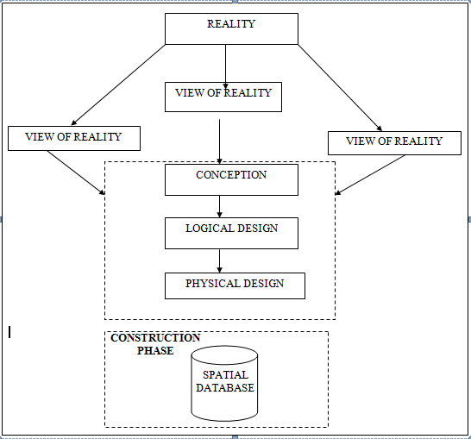
Fig.3.1Design and Construction Phases in Spatial Database

3.1.2 CONCEPTUAL DESIGN
Vector data model is the data type adopted for this project, which is represented, by points, lines and polygon. The identified entities are:-
      - Vegetation area (polygon)
      - Roads(line)
      - Trees(point)
      - Boundary line (polygon)
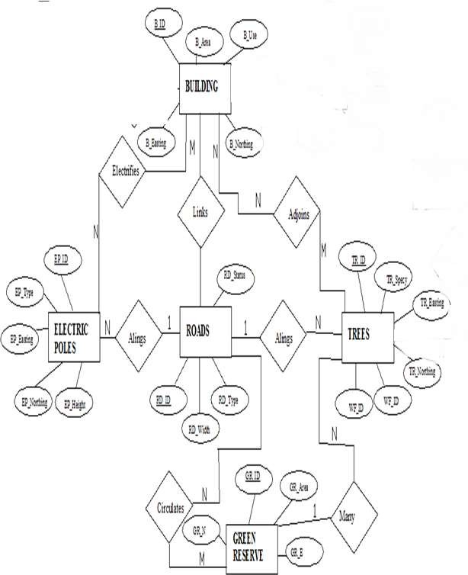
      - Buildings(polygon)

Fig.3.2.:E-R Diagram (Entity relationship diagram)

3.1.3 LOGICAL DESIGN
This is the design aspect of the database refers to the process of creating a conceptual framework or model that represents the structure and organization of spatial data within the system. It involves defining the data element, their relationship, and the rules for data manipulation and analysis. In this phase, the entities, their attributes and their relationships are represented in a single uniform manner in form of relation in such a way that would be no information loss and at the same time no unnecessary duplication of data. In this study, the logical database design is employed to generate a geo-relation database structure. Each entity has unique identifier in bold type. An attribute type or combination of attribute types that serves to identify an entity type is termed an identifier.
- Building (B_ID,B_Area, B_Name,B_Easting,B_Northing)
- Roads (R_ID,R_Width,R_Type,R-Condition,R_Easting,R_Northing)
- Vegetation (V_ID,GR_Area,)
- Tree (TR_ID,TR_spp,TR_Importance,TR_Easting,TR_Northing)
- Electric Pole (EP_No,EP_Type,EP_Height,EP_Easting,EP_Northing)
- Water Facility (WF_ID,WF_Depth,WF_Type,WF_Easting,WF_Northing)
- Football Pitch (FP_ID,FP_Area,FP_Status)
- Stream (S_ID,Length,Width)

3.1.4 PHYSICAL DESIGN

Table3.1: Building and its attribute
ENTITY | DESCRIPTION
B_ID | Building Identification
B_name | Building Name
B_Area | Building Area
B_Easting | Building Easting
B_Northing | Building Northings

Table3.2: Road and its attributes
ENTITY | DESCRIPTION
R_ID | Road Identifier
R_Length | Road Length
R_Width | Road Width
R_Type | Road Type
R_Condition | Road Condition

Table3.3: Trees and its attributes
ENTITY | DESCRIPTION
TR_ID | Tree Identifier
TR_Spp | Tree specy
TR_E | Tree_Easting
TR_N | Tree Northing

Table3.4.:Vegetation and its Attributes
ENTITY | DESCRIPTION
V_ID | Vegetation Identifier
V_Area | Vegetation Area
V_E | Vegetation Easting
V_N | Vegetation Northing

3.2 RECONNAISSANCE
This is the preparatory stage before the execution of this project, it involves collection of available information about the project area. The necessary step taken for the successful execution of the project involves two stages, which are:-
- Office Planning
- Field reconnaissance

3.2.1 OFFICEPLANNING
This involves the collection of information about the study area, testing the instrument to be used in execution of the project and itemizing the numbers of equipment needed, number of days to be use, how each activity is to be carried out, delegation of works to each team members based on supervisor’s guide/instructions.

Table.3.5 Coordinates of Controls
Station | Northing(m) | Easting(m) | Height(m)
KPT 120X | 945235.040 | 682280.278 | 211.976
KWCS102 | 945738.095 | 683583.702 | 201.532
SC/KWEAS5072 | 945974.041 | 684070.314 | 200.087
Source: Surveying and Geo-informatics department Kwara State Polytechnic.

3.2.2 FIELD RECONNAISSANCE
The field reconnaissance is the first visitation to the project site to get intimated with the environment.
- Boundary points was selected

- The distribution of features was studied

- Controls to be used were located

- Method and type of instrument to be use was determined

- Subsidiary point for Ground control Points were picked and define using nail and bottle cock
- A diagram of the study area was drawn.

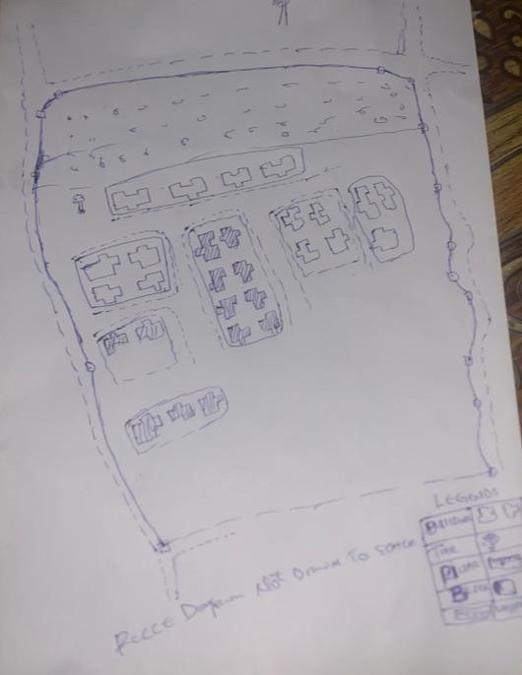

Fig.3.3: Recce diagram of the study area (not drawn to scale)

3.3 EQUIPMENT USED/SYSTEM SELECTION AND SOFTWARE

3.3.1 HARDWARE USED
- Total station
- 1reflectorwith a tracking rod.
- 1Tripod
- One(1)50m tape
- One(1)umbrella
- 1cutlass
- Handheld GPS
- Hammer
- Nails and bottle cover
- Field book and writing materials
- 1-No of Personal Computer HP655 and its accessories
- 1-NoofHP Desk JetK7100 A3 printer
- 1-No of HP Desk Jet 1110 A4 printer

3.3.2 SOFTWARE COMPONENT

- Notepad.
- Microsoft Excel.
- utoCAD2007
- ArcGIS10.3
- Microsoft Word.

3.4 INSTRUMENT TEST
To ensure data quality, the Total Station used for this project was tested for both vertical index and horizontal collimation errors. It was also to ascertain the efficiency and reliability of the instrument. The procedure used is described below.

3.4.1 HORIZONTAL COLLIMATION TEST
This test was conducted to ensure that the line of sight was perpendicular to the trunnion axis. The Total Station was positioned over a specific point, and initial adjustments were made to ensure proper alignment, leveling, and focus (to eliminate parallax in the telescope). A vertical target was placed at a distance of 100 meters from the Total Station. To access the configuration menu of the Total Station, the menu key was pressed and held for approximately 2 seconds. From the main menu, the calibration sub-menu was selected, and within that, the horizontal collimation test option was chosen. The target was then observed and divided into two halves, with horizontal readings recorded for Face left and Face right. The readings are shown in Table 3.4.1 below.
Total Station
100m
REFLECTOR (TARGET)

STATION A
Fairly Level Ground

STATION B

Fig3.4; Horizontal Collimation and Vertical Index error test

Table3.6: Horizontal Collimation Data
Station | Target | Face | Hz Reading | Difference | Error
A | B | L | 38˚42‟32”
 |  | R | 218˚42‟35” | 180˚00‟03” | 03”
Source field work

3.4.2 VERTICAL INDEX ERROR TEST
This test was conducted to verify the accuracy of the vertical reading when the line of sight is horizontal. The desired measurement for this test is exactly ninety degrees (90˚), any deviation from this value is referred to as the vertical index error.
The Total Station was positioned over a specific point, and necessary temporary adjustments were made to ensure proper alignment and functionality. A target was placed approximately100 meters away from the Total Station, and the instrument was aimed at the target. The target was bisected by aligning the instrument on the face left, and the corresponding reading was recorded. Similarly, the target was then bisected on the face right, and the respective reading was also recorded. The recorded readings are provided below:

Table3.7: Vertical Index Data
Instrument Station | Target Station | Face | Vertical | Sum | Error
A | B | L | 90˚00‟00”
 |  | R | 270˚00‟02” | 360˚00‟02” | 02”
Source field work
3.4.3 ANALYSIS OF COLLIMATION AND VERTICAL INDEX DATA
The reading obtain during calibration were reduced to obtain new collimation and vertical errors.
Horizontal collimation={(FR–FL)–180}/2={(00˚00‟03”}/2=1.5”

Vertical collimation={(FL+FR)–360}=(90˚00‟00”+270˚00‟02”)-360}=02”The result shows that the instrument is still in good working condition.

3.5 CONTROL CHECK
Three control beacons (KPT 120X, KWCS102 and SC/KWEAS5072) were used. In order to ascertain the in-situ of the control beacons, a check was carried out on them by observing the angle between them and comparing the result obtained with the computed angles from the giving coordinates.
The total station instrument was set on the control beacon KWCS102. After performing all the necessary temporary adjustment, the reflector was placed on the control beacon KPT 120X which served as the back station. The horizontal angular reading was taken and recorded while the instrument was on face left. The reflector was then taken to the control beacon SC/KWEAS5072 which serves as the forward station, the horizontal angle reading was then taken and recorded on both face left and face right. The reflector was taken back to the back station, the horizontal angle was then recorded on face right.

Table3.8:Table showing the back computation of the control coordinates
From STN | Bearing | Dist(m) | ∆N | ∆E | Northing(m) | Easting(m) | To STN
 |  |  |  |  | 945235.040 | 682280.278 | KPT 120X
KPT 120X | 68°53'46'' | 1397.130 | 503.050 | 1303.424 | 945738.095 | 683583.702 | KWCS102
KWCS102 | 64°07'57'' | 540.797 | 235.946 | 486.612 | 945974.041 | 684070.314 | SC/KWEAS5072
Source: Office of Surveyor General Kwara State

Table 3.9: Table showing the distance observation result of the control check
FROM | OBSERVED  DISTANCE  (m) | COMPUTED  DISTANCE  (m) | TO
KPT 120X | 1397.029 | 1397.130 | KWCS102
KWCS102 | 540.694 | 540.797 | SC/KWEAS5072

Table 3.10: Table showing the observation result of the control check
STN | SIGHT | FACE | OBSERVEDHZANGLE | REDUCED HZANGLE | MEAN
 | KPT 120X | L1 | 357° 08'47''
KWCS102 | KPT 120X | L2 | 288° 14'07'' | 68° 54'40''
 | SC/KWEAS5072 | R2 | 108° 52'13'' | 68° 54'46''
 | SC/KWEAS5072 | R1 | 177° 46'59'' |  | 68° 54' 43''

Difference in angle (observed -computed)=68°54'43''-68°54'40''

=00° 00'03''
Since the allowable accuracy (angular) of third order traverse of one station is 00° 00' 30'' and the result obtained from the control check (00°00'03'') is less than allowable error. Therefore, the controls were angularly intact.

3.6 MONUMENTATION
The boundary of the area carved out was demarcated with the precast concrete beacons, after clearing the required line of sights. The identified points of changes in directions were dug and beacons were buried on it, leaving about 15cm part of the beacon above the ground level. The beacons were buried at convenient distances as dictated by the nature of the boundary
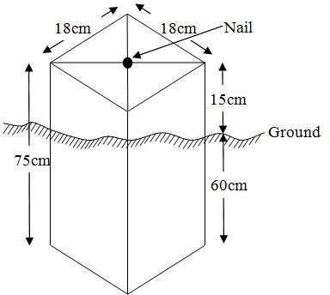
Fig.3.5:Pillar Description

3.7 DATA ACQUISITION
It’s fundamental to digital mapping. Data acquisition here implies security coordinate data of map features in a computer compatible from there exist several topographical data collection techniques the choice of a particular technique depends on the source of data available hardware / software, envisage revel of accuracy, man power etc. apart from field and laboratory data acquisition data may be obtained from social survey, in this project, data acquisition it refers the ways and method through which the data used were obtained. There was divided in to two viz; geometric data and attribute data

PRIMARY DATA SOURCE
Field observation was the primary source of data for this project. Ground based method was used in acquiring data with the use of Total Station Instrument, which involved the collection of X, Y, Z data through coordinated Ground control Points (GCP) established at conspicuous points within the study area

SECONDARY DATA SOURCE
An imagery of the area was acquired through Updated Google earth; this was used to ascertain the extent of coverage of the project area.

3.7.1 GEOMETRIC DATA ACQUISITION
The total station instrument was set carefully on control point; KWCS102 back sight taken to KPT 120X after necessary station adjustments has been carried out on it. The adjustments includes; centering, leveling and focusing. The following procedures were then followed to determine the position of the next point SC/KWEAS5072 and the same procedure were repeated until all we come close to the site. The method used in acquiring data on site was radiation method where two or more points are coordinated from one point.
- Having setup the instrument and temporary adjustment carried out, the instrument was powered „on‟ and a job was created under job menu in the internal memory of the instrument. The job created was named GRP5B
- On the job, the coordinates of the three (3) control points were keyed in to the memory of the instrument and some codes were also saved. The codes include
- „RD‟for road,„ SP‟for spot height, BD for buildings,etc.
- The height of the instrument was measured and saved on the memory of the instrument as well as the reflector height.
- On coordinate menu, orientation was set by in putting the coordinates of the instrument station and back sight. The reflector at the back station was perfectly bisected before the orientation was confirmed by clicking yes‟.
- Having done the orientation, the reflector at the next nail; was bisected and „obs‟(observe) option was clicked. The three dimensional coordinate of the points (E,N, H) were displayed on the display unit of the instrument and „rec‟ (record) was clicked to save the data into the memory of the instrument. For subsequent observation after this all‟ option was used instead of pressing obs‟ and pressing Record ‟later.
- It was ensured that the center of the prism of the reflector was bisected and that it was set perfectly on the tripod in order to minimize the error on height determination.
- The instrument is been shifted to another nail after all details, spot height and boundary point visible from the instrument station have been picked, set over it and temporary adjustments carried out.
- Nonetheless, the above operations were repeated until all the boundary points with heights were coordinated.
- In this project all spot height are not in grid intervals but randomly acquired. Three edges (3) of building were picked. At the end of data acquisition process all details were acquired and properly recorded to be shown in their respective positions on the plan.

3.7.2 ATTRIBUTES DATA ACQUISITION
Attribute data is information about spatial features. They provide the characteristics, description and nomenclature about spatial objects. Thus the attributes data acquired includes names of buildings and their uses such as classrooms, roads, water facilities and prominent natural features likes river and trees found and vegetation were properly identified within and around the study area.

3.8 DATA DOWNLOADING AND PROCESSING

3.8.1 DATA DOWNLOADING AND EDITING
This is stage whereby all data acquired which were automatically stored in the Total Station were downloaded into personal computer. This was done with the aid of downloading cable connected to the computer and some associated complementing software installed on the System.

3.8.2 DATA PROCESSING AND DATA EDITING
The geometric data downloaded were further processed in order to convert it to a useful format and to enhance its accuracy. The output coordinates, were edited and exported in *.txt, *.xls and *.pdf format. Thereafter, they were imported into Arc GIS 10.3 for further operations and to carryout spatial analysis.

3.8.3 DATA PROCESSING IN AUTOCAD
The AutoCAD is tool that can be used for design and drawings, the software was built to general drawing standard hence the difficulty that comes with localizing this standard to various discipline.
Plotting in AutoCAD can be achieved using coordinate geometry (COGO) by either running script file (.scr) or using the command line (i.e. inputting the values using keyboard). In this project plotting was achieved by using command line in AutoCAD environment. The layout plan was produced as shown in figure below.

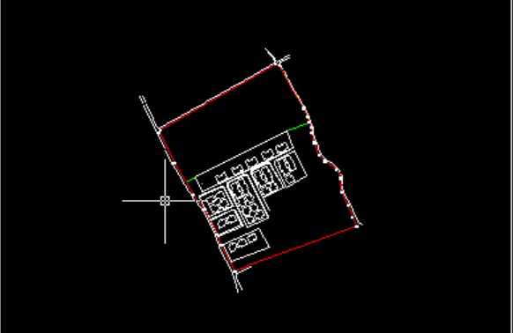

Figure 3.6 shows the layout plan in AutoCAD
Exporting to ArcView, cad file can be exported to GIs software environmental for final cartographic production. This requires that the graphic data can be in a standard exchange format. A standard graphic data exchange format AutoCAD dxf (data exchange format).

3.8.4 DATA PROCESSING USING ARCGIS10.3 SOFTWARE
Is one of the contemporary software that is easy and facilitate geographic system operation design, map production, analysis and result computation possibility in any spatial project. ArcView was lunched by double clicking on the desktop shortcut icon. See the attribute table in table 3.1

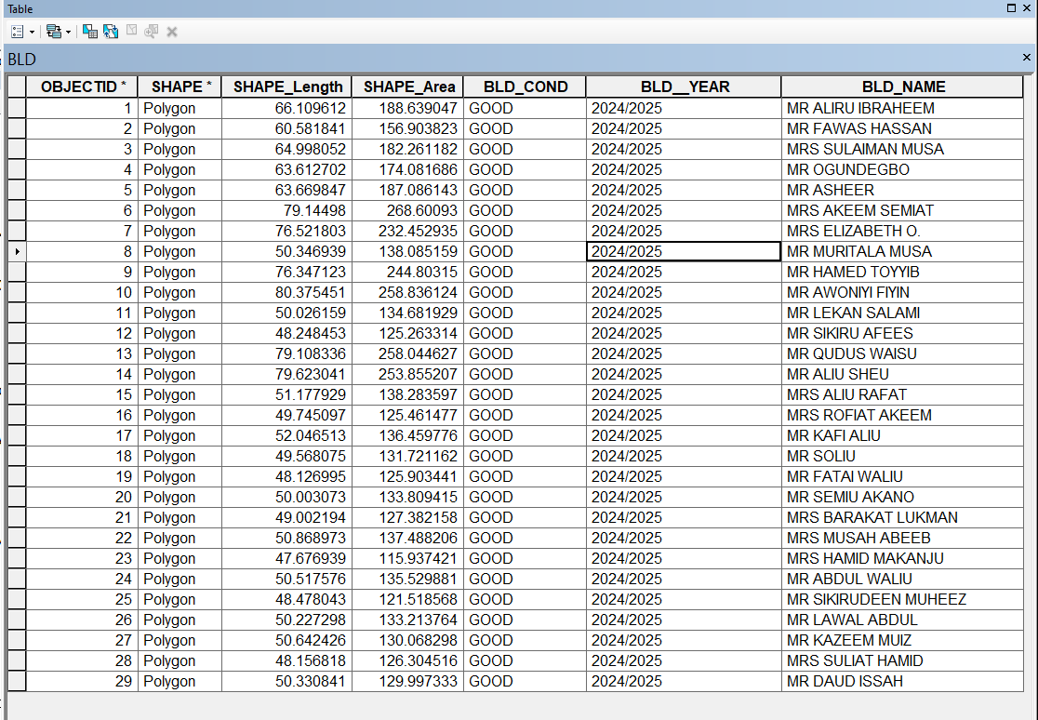

Figure 3.7 shows the attribute table

It demonstrates capability of carrying out a wide range of spatial analysis that may required in land administration. The land information system (LIS) was robust enough to produce (spatial and non spatial). It was subjected to as show in figure 2 below;
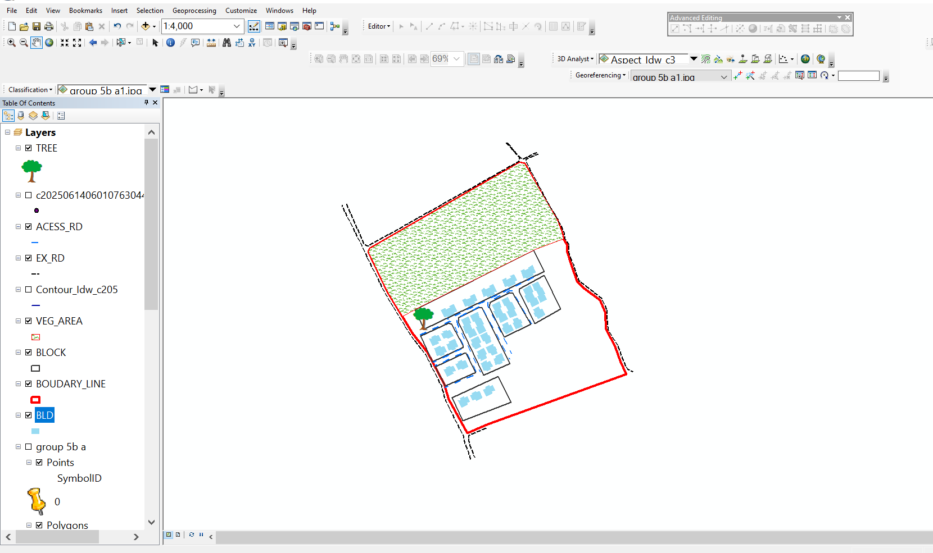

Figure 3.8 shows lay out view in ArcView windows

3.9 DATABASE IMPLEMENTATION
This is the database creation phase. Having completed the three stages of design phase (i.e.Reality, Conceptual and Logical design), the database was created using ArcGIS10.2software. It involves the combination and storage of acquired graphic data and attributes data in creating the database for the purpose of spatial analysis and query.
Database is an organized integrated collection of data stored so as to be capable of use by relevant application with data being accessed by different logical part. After the Attribute table was populated via the keyboard, some attributes such as areas of settlements were automatically displayed by special command in the ArcGIS10.3 version. The ArcGIS software was used to link the graphic data and table for query generation.

3.9.1 DATABASE MANAGEMENT SYSTEMS
Database management is a collection of software for creating, storing, manipulating, updating, organizing and querying of information in a database (Kufoniyi, 1998). It is a software package whose function is to manipulate a database on behalf of the user.
A good DBMS must provide the following functions:

      - Storage and retrieval of data.
      - Access to by several users at a time.
      - A standardized interface between database and application programmed.
      - Standardized access to data and separation of data storage and retrieval functions from the program using the data.
      - Maintenance of data security and integrity.

3.9.2 DATABASE MAINTENANCE
Having created the database, proper maintenance practice was made to meet its stated objectives. The ability to include more data and remove irrelevant data was possible by way of maintenance. There is every need for the data to be updated regularly because of the physical changes that may occur on the landscape with time. Both security and integrity were also exercised to ensure maintenance and to meet its stated objectives.
Proper observance, updating and management of database ensure its currency and quality to stand a profound chance in Spatial Decision Support System (SDSS). The quality of any database depends on the currency and fitness for use as a decision support system (SDSS).The quality of database depends on its ability to generally fit and use as a decision system (DSS). The storage media should be from time to time justified if otherwise could necessitate data inaccessibility or physical deterioration of the storage media. Also care must be taken during populating any database system, as a database is only good as the data supplied. In archiving stable media should be used. Examples of these are:-
- Computer compatible tape reader
- Magnetic tape
- Optical disc and compact disc
3.9.3 BACK COMPUTATION Table 3.11: Back Computation
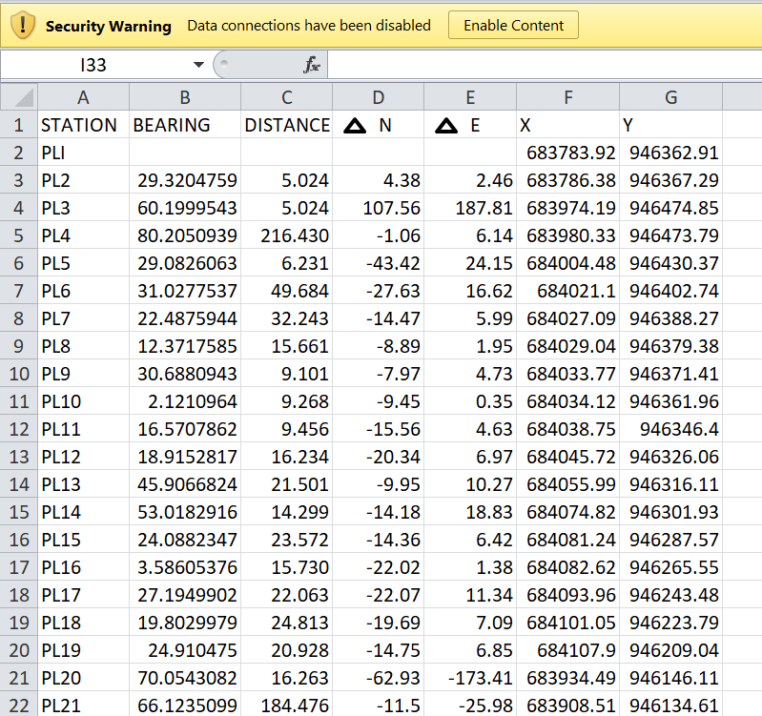

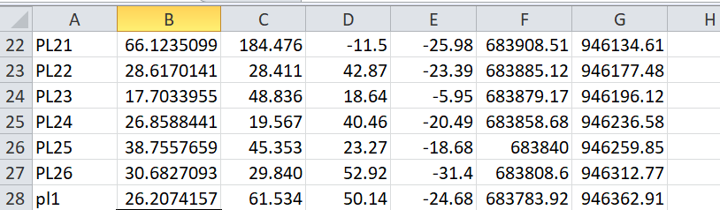

3.9.4 AREA COMPUTATION

Table3.12:Area Computation
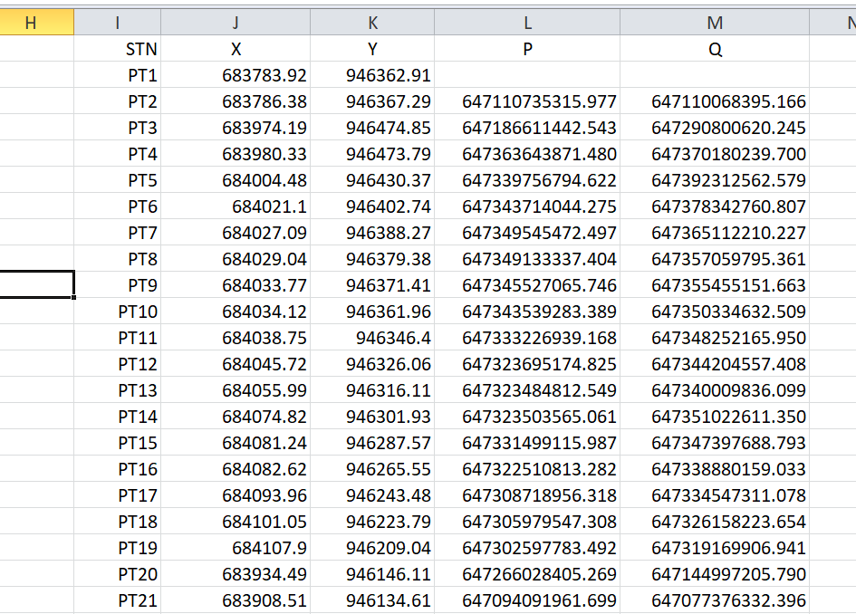

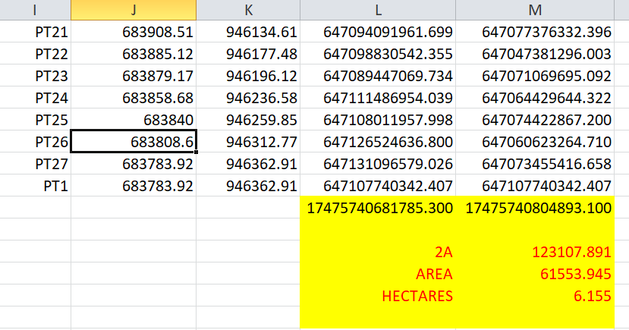

CHAPTER FOUR

4.0 SPATIAL ANALYSES AND PRESENTATION
GIS is distinct among other information system because of its spatial analytical capability, especially overlay operation, buffering, spatial search, topographic operation, and neighborhood and connectivity operations. GIS uses this spatial analytical capability to answer fundamental generic question of location, condition, trend, routing, pattern and modeling by the manipulation and analysis of input data. The major analyses performed in this project were overlay operations, topographic operations and spatial search.

4.1 TESTING OF DATABASE
This is the test carried out to determine whether there exists a relationship between data modeled about entities in a spatial database as well as putting into test its retrieval capabilities. This was done by designing a sample query with certain conditions attached and the query will be ran to see if desired result is achieved.
Analysis of Result
Data captured were full to ensure standardization of task. Coordinated point were used in order to produce information required (LIS) and lastly to decision making and produce the output in digital form, while the attribute presented in tabular form. In most GIS operation package including arcview these include measurement techniques, query analysis and geometric operation in this project include questions such as:-
- Residential land use
- Vegetation area
- Developed area
- Slope aspect
- Building that does not have C of O
- Building that have C of O
- Building that have R of O

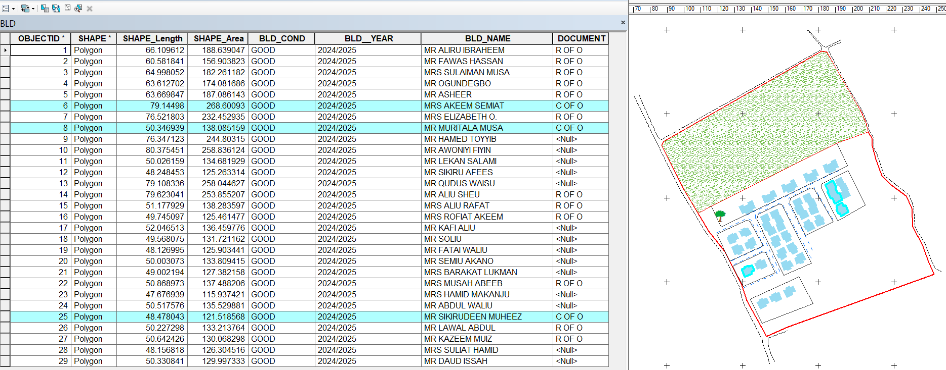
The above listed queries are shown in blue

Fig4.1.: shows the building that have C of O
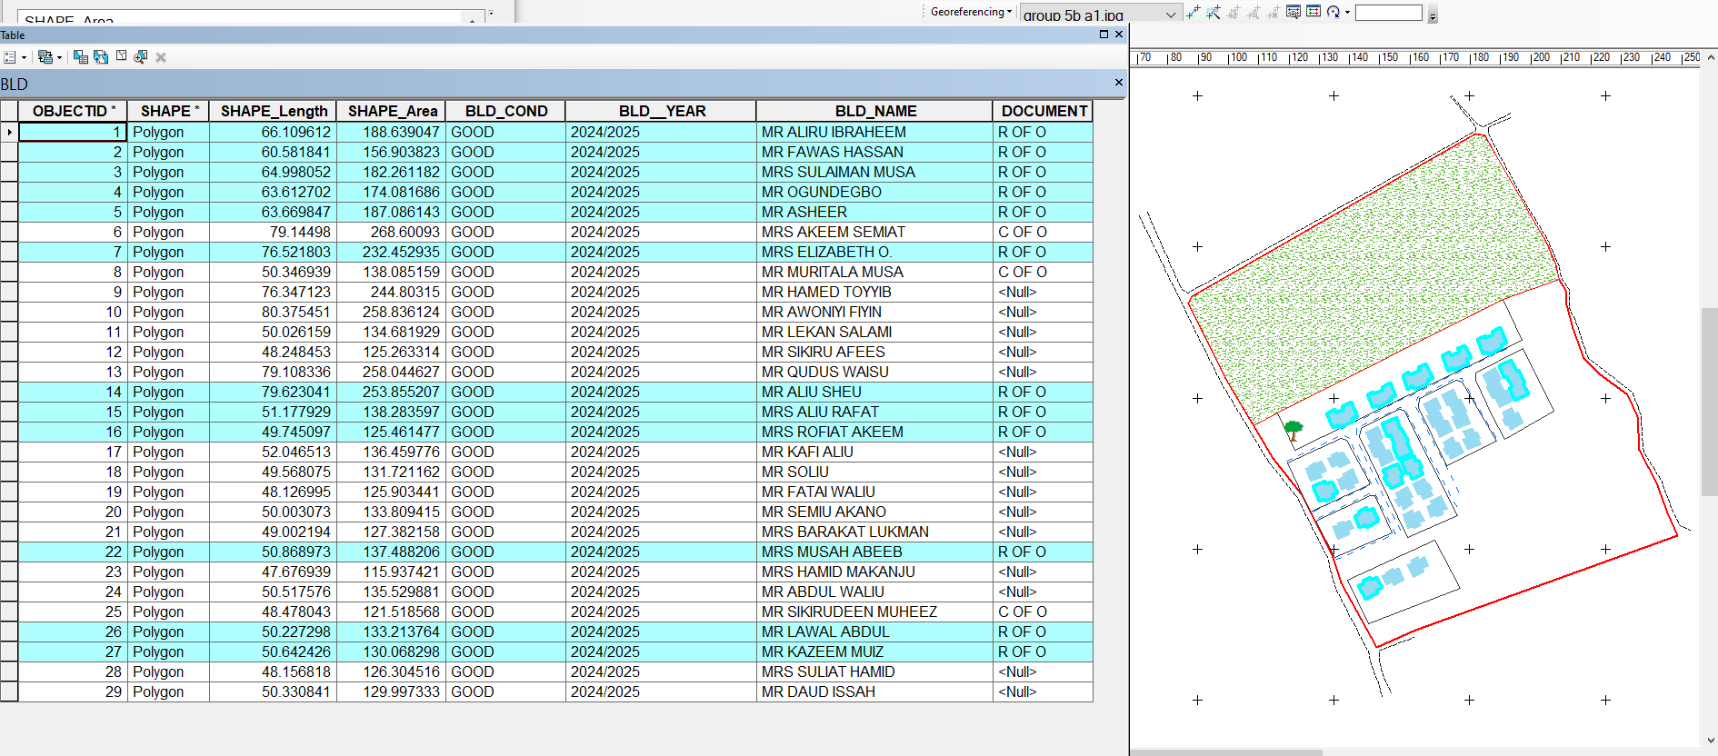

Fig4.2: shows the building that have R of O

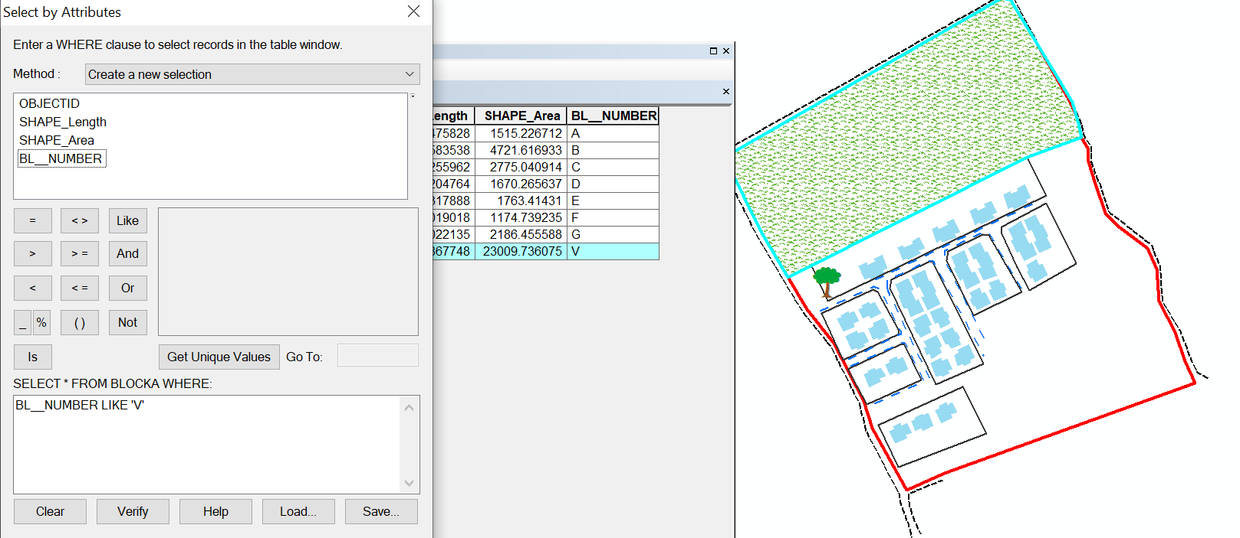

Fig 4.3: show the area use for vegetation

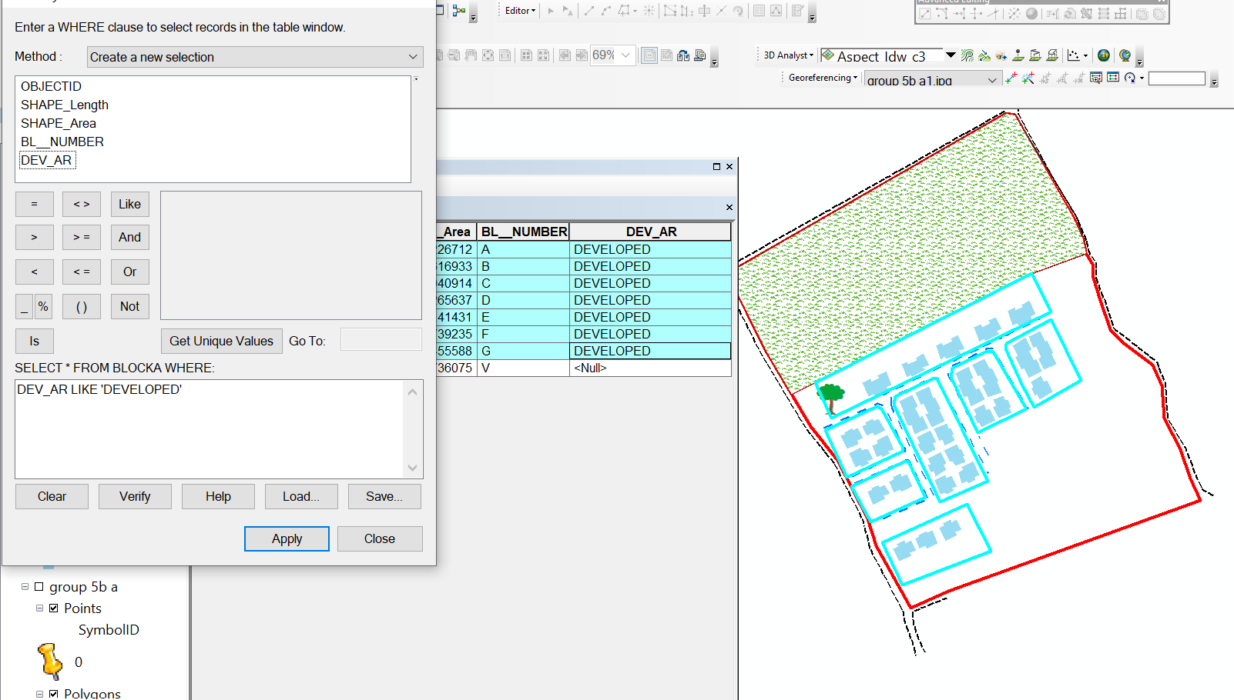

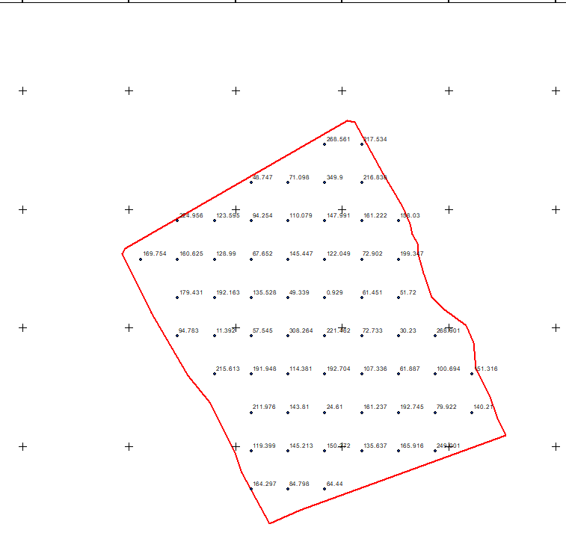
Fig 4.4: show the developed area

Figure 4.5 shows the spot height
This is the compass direction of that a slope faces and it plays a significant role in environmental and land management decision
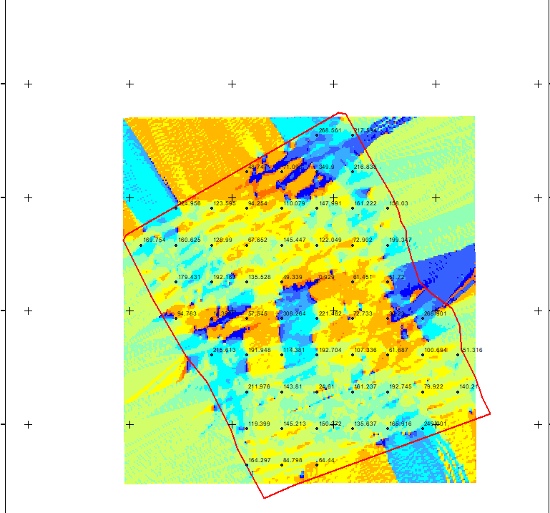

Figure 4.6 shows the slope aspect

The total number of building in the lay out are29 all of them are residential and vegetation area is 1, the table 4.1 below shows the land use percentage

Table 4.1 shows the land use percentage
Residential | 0.475266 percent
Vegetation area | 2.292255 percent

Figure 4.7 shows the pie chart of land use

CHAPTER FIVE
PROJECT COSTING, SUMMARY, CONCLUSION AND RECOMMENDATIONS
5.1 COSTING
RECCONNAISSANCE
S/N | PERSONNEL | QTY | DAILY RATE | NO OF DAYS | REMARK
1 | Group leader | 1 | 5000 | 1 | 5000
2 | Ass group leader | 1 | 2500 | 1 | 2500
3 | Basic equipment | 1 | 25000 | 1 | 25000
4 | Transportation | 1 | 3000 | 1 | 3000
Subtotal = #35,500
Monumentation
S/N | PERSONNEL | QTY | DAILY RATE | NO OF DAYS | REMARK
1 | Group leader | 1 | 5000 | 1 | 5000
2 | Ass group leader | 1 | 2500 | 1 | 2500
3 | Skilled labor | 3 | 1500 | 1 | 4500
4 | Basic equipment | 1 | 25000 | 1 | 25000
5 | Transportation | 1 | 7500 | 1 | 3000
Subtotal = #40,000
Beaconing
S/N | PERSONNEL | QTY | DAILY RATE | NO OF DAYS | REMARK
1 | Group leader | 1 | 5000 | 1 | 5000
2 | Ass group leader | 1 | 2500 | 1 | 2500
3 | Basic equipment | 1 | 5000 | 1 | 5000
4 | Transportation | 1 | 3000 | 1 | 3000
Subtotal = #5,500
Beacon
S/N | PERSONNEL | QTY | DAILY RATE | NO OF DAYS | REMARK
1 | Group leader | 1 | 5000 | 1 | 5000
2 | Ass group leader | 1 | 2500 | 1 | 2500
3 | Beacon | 10 | 1000 | 1 | 10,000
4 | Transportation | 1 | 3000 | 1 | 3000
Subtotal = #19,500
Traversing
S/N | PERSONNEL | QTY | DAILY RATE | NO OF DAYS | REMARK
1 | supervisor | 1 | 6000 | 1 | 6000
2 | Group leader | 1 | 5000 | 1 | 5000
3 | Ass group leader | 1 | 2500 | 1 | 2500
4 | Skilled labour | 6 | 1500 | 1 | 10,000
5 | Basic equipment | 1 | 25000 | 1 | 5000
6 | Transportation | 1 | 10,500 | 1 | 10,500
Subtotal = #43,500
Contouring
S/N | PERSONNEL | QTY | DAILY RATE | NO OF DAYS | REMARK
1 | Supervisor | 1 | 6000 | 2 | 12,000
2 | Group leader | 1 | 5000 | 2 | 10,000
3 | Ass group leader | 1 | 2500 | 2 | 5000
4 | Skilled labor | 6 | 1500 | 2 | 20,000
5 | Basic equipment | 1 | 25000 | 1 | 5000
6 | Transportation | 1 | 10,500 | 2 | 21,000
Subtotal = #73,000
Data processing
S/N | PERSONNEL | QTY | DAILY RATE | NO OF DAYS | REMARK
1 | Group leader | 1 | 5000 | 1 | 5000
2 | Ass group leader | 1 | 2500 | 1 | 2500
3 | Basic equipment | 1 | 10,000 | 1 | 10,000
4 | Generator and fuel | 1 | 10,000 | 1 | 10,000
Subtotal = #27,500

Technical report
S/N | PERSONNEL | QTY | DAILY RATE | NO OF DAYS | REMARK
1 | Group leader | 1 | 5000 | 1 | 5000
2 | Ass group leader | 1 | 2500 | 1 | 2500
3 | Basic equipment | 1 | 10,000 | 1 | 10,000
4 | Generator and fuel | 1 | 10,000 | 1 | 10,000
Subtotal = #27,500
Sum total = 271,500.00

Contingency allowance = 271,500.00 X 5 = 13,575
100

VAT = 271,500.00 X 7.5 = 20,362.5
100

ACCOMODATION = 271,500.00 X 1.5 = 4,072.5
100

MOB/DEMB = 271,500.00 X 10 = 27,150
100

GLEARANCE TAX = 65, 159.5
5.2 SUMMARY
This project is strictly computer based on record keeping, storage, retrieval and management systems for land and property records it also showcases parcel data that can be converted into a powerful information system, as well as unified co-ordinate system. The survival of any organization depends on the acquisition and effective use of information, in which GIS technology can be used to solve problems connected with Cadastral management. Differential Global Positioning System was used to acquire geometric data, while social survey was used to acquire attribute data. In order to make retrieval manipulation and data update relatively easy, database was created from the acquired data. Analysis of result was done by using relational database model (Tables); structured query language (SQL) in ARCGIS 10.2 Queries used in the database, and generated information could be used in decision making and physical planning of the study area in future. The results were presented in both hard and soft copies.
5.3 PROBLEM ENCOUNTERED
The problem encountered during this project ranges from in adequate low technical how of the equipment, weather and unruly behavior from the occupants of the estate initially, but later put under control by admin and portal in charge of the estate, who made passionate plea to some sections of the occupant during questioning process foe name, and other personal records.

5.4 RECOMMENDATIONS
Having successfully completed this project, I would like to make the following recommendations: that,
- There should be awareness to land owners about changing land policies from Federal, State, and Local Government.
- There should be a unified Cadastral Digital Database in a unified co-ordinate system in all over the country.
- Ilorin East Local Government should make use of the outcome of this project made known in aiding town planning, internal revenue board in discharging their constituted duties.
- The project stages, products and lessons learnt, be presented to relevant establishment, department or institution that may be willing to implement similar system in future to their lost community.
- The database should be created well and updated from time to time, and should not be limited to an area, agencies or government alone; it should be extended to private, communal and individual as it enhance security and identification of next neighbour.
- Lastly this project is open for review in the future since there could any changes made by any specific occupant as well as a reference for any one embarking on this kind of project
5.5 CONCLUSION
The project focused on injecting the digital technology into cadastral system of land administration to propagate the switching from analogue system to digital format which allows information storing, assessing, retrieving and editing of land information. The techniques and general procedures for land information system will be fully described and technology has come to play a vital role in keeping cadastral record by making possible for information to be kept in different formats, allowing them to be assembled in any desired manner by individual, Parastatal or responsible body for the Estate that are directly involved with land related matter in satisfying their required need.
Having satisfied the entire requirement, thus, the aim and objectives of the project is met since accuracy obtained is within the expected and the database created will go a long way assisting decision making for the environment concerned.

REFERENCES
Adeoye A.A. (1998): “Geographic/Land information system” Lagos Nigeria.
Asoegwu R.N (1991): A case for Geodetic Control Networks for the State Cadastral Surveys. Published by the Nigerian Institution of Surveyors (NIS), Anambra State Branch, Enugu.

Brown, A. G. (1996) Defining the Cadastral Layer of a Municipal GIS Using Registered Land Parcels. Proceedings of GIS/ LIS, Annual Conference and Exposition. Denver, Colorado, USA, 19-21 November 1996.

Checkland, P. B. (1988) Information systems and systems thinking: a time to unite? International Journal of Information Management 8: 239-248.
Coleman, D. J. and McLaughlin, J. (1997) Defining Global Geospatial Data Infrastructure (GGDI): Components, Stakeholders and Interfaces. Proceedings of the Global Spatial Data Infrastructure Conference. Chapel Hill, North Carolina USA. 21 October 1997.
Dale, P. F. (1976) Cadastral Surveys within the Commonwealth London: Her Majesty's Stationery Office.
Dashe, J.D. (1987): Cadastral survey practice in Nigeria; Kaduna Department of Printing Technology, Kaduna Polytechnic. Pp.1-2.
Dale P. F., and McLaughlin J. (1988) „ Land Information Management‟ An introduction with special reference to cadastral problems in third world countries, Clarendon Press Oxford.
Enemark, S. and Sevatdal, H. (1999) Cadastres, Land Information Systems and Planning - is decentralization a significant key to sustainable development? Proceedings of the UN-FIG Conference on Land Tenure and Cadastral Infrastructures for Sustainable Development. Melbourne, Australia, 25-27 October.
Eleyachin, E. and Elhassance, S. (2001): Digital Cadastral Map: Multipurpose Tool for sustainable Developments. International conference on Spatial Information for sustainable development. Nairobi, Kenya.
Felix Naumann, Dennis Shasha, Gottfried Vossen (2013) Databases: Their Creation, Management and Utilization
FIG Working Week 2011 Bridging the Gap between Cultures Marrakech, Morocco, 18‐22 May 2011
Governance and Land Administration Lee Youngho The Role of Cadastral System for the Good Land Administration in Korea Shaping the Change XXIII FIG Congress Munich, Germany, October 8-13, 2006
Hesse, W. and Williamson, I. P. (1990) A Review of Digital Cadastral Data Bases in Australia and New Zealand. The Australian Surveyor.
Hesse, W. and Williamson, I. P. (1993) MAGIC Revisited: An Object-Oriented Solution to the Cadastral Maintenance Problem. The Australian Surveyor.
Hesse, W. J., Benwell, G. L. and Williamson, I. P. (1990) Optimising, Maintaining and Updating the Spatial Accuracy of Digital Cadastral Data Bases. The Australian Surveyor, 35(2): 109-119.
LIC (1998b) Personal Communications with Cadastral maintenance staff.
LIC (1999) Statement of Purpose. Land Information Centre, State Government of NSW, Australia. http://www.lic.gov.au/, (12 Nov 1999). Lind, M. (1997) The address as independent registration unit - pitfalls and disadvantages, Property Department, National Survey and Cadastre, Denmark.
LTO (1996) Computerised Cadastral Index. Internal Report. Land Titles Office, NSW, Australia.
Jayeoba E.A (2015): Communication in english.
Kufoniyi O. (2002) „Cadastral Database, An Essential Component of the fundamental Datasets of a National Geospatial Data Infrastructure NIS37‟AGM Conference, Owerri.
Onyeka, E.C. (2007) „Geoinformatics in Environmental Monitoring. San Press Ltd. First Edition.
Shulabu U. (2008): Cadastral Land Information system for sustainable land Conveyance in Bauchi State. M. tech project Department of Surveying and Geo-informatics. Federal University of Technology Yola.
Williamson, I. P. and Rainbird, B. C. (1986) The Australian Capital Territory Cadastral Survey and Mapping System. The Australian Surveyor.
Wolters, J. (1997) Identification of Parcels, Properties, Cadastral Zones, Buildings and Addresses in Denmark. Proceedings of MOLA - Managers of Land Information - Economic Commission for Europe, Workshop on Definition and Numbering of Objects in Cadastres and Land Registers.

APPENDIX
ID | EASTINGS | NORTHINGS | HEIGHT |  | ID | EASTINGS | NORTHINGS | HEIGHT
P1 | 678223.887 | 940129.04 | 311.963 |  | P64 | 678189.168 | 939906.919 | 320.847
P2 | 678010.772 | 939958.8882 | 311.735 |  | P65 | 678194.082 | 939925.142 | 320.303
P3 | 677998.098 | 939930.4719 | 312.49 |  | P66 | 678118.846 | 939930.854 | 319.988
P4 | 678030.309 | 939919.1424 | 312.229 |  | P67 | 678158.957 | 939958.424 | 319.394
P5 | 678040.654 | 939947.3471 | 310.983 |  | P68 | 678198.081 | 939954.381 | 318.672
P6 | 678206.4 | 940155.1631 | 311.295 |  | P69 | 678165.889 | 939980.517 | 318.567
P7 | 678204.043 | 940130.0322 | 308.727 |  | P70 | 678215.502 | 940015.866 | 319.324
P8 | 678050.653 | 940076.2466 | 310.979 |  | P71 | 678174.726 | 940023.498 | 319.5
P9 | 678249.664 | 940149.6206 | 311.686 |  | P72 | 678222.88 | 940043.891 | 319.803
P10 | 678045.785 | 940018.6731 | 310.714 |  | P73 | 678224.589 | 940152.833 | 308.619
P11 | 678040.387 | 940001.6869 | 309.894 |  | PT 1 | 677996.066 | 939928.454 | 308.125
P12 | 678033.508 | 939983.4306 | 310.018 |  | PT 2 | 678015.163 | 939969.728 | 310.5781
P13 | 678026.893 | 939966.4972 | 310.986 |  | PT3 | 678036.824 | 940012.166 | 309.517
P14 | 678059.257 | 939940.4044 | 312.795 |  | PT 4 | 678046.423 | 940091.29 | 312.2569
P15 | 678049.07 | 939911.4854 | 314.948 |  | PT 5 | 678072.632 | 940180.469 | 309.2145
P16 | 678076.613 | 939934.5835 | 313.83 |  | PT 6 | 678181.432 | 940158.362 | 311.686
P17 | 678052.822 | 939956.443 | 313.01 |  | PT 7 | 678250.294 | 940149.54 | 315.142
P18 | 678058.908 | 939974.4347 | 312.533 |  | PT 8 | 678257.732 | 940142.843 | 319.324
P19 | 678067.639 | 939992.1618 | 312.227 |  | PT 9 | 678200.825 | 939974.438 | 320.303
P20 | 678075.63 | 940034.7598 | 312.366 |  | PT 10 | 678198.081 | 939954.381 | 321.636
P21 | 678048.113 | 940037.2999 | 312.54 |  | PT 11 | 678194.082 | 939925.142 | 315.2363
P22 | 678048.748 | 940056.7732 | 312.106 |  | PT 12 | 678177.322 | 939862.989 | 314.369
P23 | 678252.098 | 940126.1711 | 310.248 |  | SH 1 | 678156.827 | 940097.293 | 312.937
P24 | 678107.27 | 940071.4276 | 311.14 |  | SH 2 | 678139.438 | 940107.303 | 313.154
P25 | 678105.048 | 940051.2134 | 313.071 |  | SH 3 | 678175.9 | 940150.36 | 309.062
P26 | 678106.635 | 940030.7082 | 314.224 |  | SH 4 | 678120.834 | 940127.439 | 308.631
P27 | 678103.975 | 940031.0558 | 314.788 |  | SH 5 | 678019.216 | 939961.279 | 309.796
P28 | 678257.346 | 940141.7004 | 315.142 |  | SH 6 | 678021.244 | 939974.689 | 308.743
P29 | 678103.728 | 940006.5287 | 315.237 |  | SH 7 | 678122.461 | 940162.96 | 308.918
P30 | 678075.206 | 940012.3231 | 315.226 |  | SH 8 | 678064.379 | 940118.83 | 310.767
P31 | 678097.537 | 939982.2929 | 314.905 |  | SH 9 | 678225.216 | 940095.111 | 312.183
P32 | 678089.123 | 939963.2164 | 314.752 |  | SH 10 | 678087.651 | 940119.369 | 312.384
P33 | 678082.033 | 939946.0713 | 314.545 |  | SH 11 | 678032.2 | 939994.979 | 309.28
P34 | 678096.411 | 939926.7915 | 314.656 |  | SH 12 | 678045.444 | 940063.452 | 309.731
P35 | 678066.85 | 939905.2941 | 315.763 |  | SH 13 | 678038.545 | 940019.74 | 311.863
P36 | 678086.436 | 939898.5022 | 315.539 |  | SH 14 | 678116.935 | 940111.052 | 311.593
P37 | 678092.387 | 939941.4376 | 316.288 |  | SH 15 | 678045.891 | 940088.948 | 309.517
P38 | 678110.771 | 939994.7147 | 316.44 |  | SH 16 | 678093.714 | 939963.164 | 315.033
P39 | 678118.846 | 940053.7667 | 311.161 |  | SH 17 | 678057.722 | 939947.052 | 314.372
P40 | 678120.539 | 940080.2251 | 309.836 |  | SH 18 | 678122.816 | 940017.751 | 316.029
P41 | 678146.998 | 940050.38 | 310.313 |  | SH 19 | 678117.182 | 940035.899 | 314.277
P42 | 678144.299 | 940007.8217 | 316.979 |  | SH 20 | 678115.146 | 940084.336 | 312.868
P43 | 678115.461 | 939920.1558 | 316.887 |  | SH 21 | 678113.272 | 940023.327 | 314.463
P44 | 678105.195 | 939891.1574 | 316.841 |  | SH 22 | 678171.402 | 940018.296 | 315.665
P45 | 678123.901 | 939884.9397 | 316.838 |  | SH 23 | 678153.892 | 939924.006 | 317.714
P46 | 678137.037 | 939879.6074 | 318.434 |  | SH 24 | 678167.545 | 939962.364 | 317.811
P47 | 678146.574 | 939921.3292 | 318.531 |  | SH 25 | 678128.62 | 939924.168 | 317.177
P48 | 678144.246 | 940028.1549 | 312.673 |  | SH 26 | 678146.189 | 939893.862 | 318.511
P49 | 678149.961 | 940075.78 | 309.705 |  | SH 27 | 678159.645 | 939941.534 | 317.945
P50 | 678179.383 | 940069.6417 | 313.61 |  | SH 28 | 678124.237 | 940048.624 | 316.734
P51 | 678187.929 | 940047.9128 | 316.046 |  | SH 29 | 678125.589 | 940026.547 | 315.827
P52 | 678175.361 | 940044.665 | 316.84 |  | SH 30 | 678108.618 | 940009.234 | 313.946
P53 | 678185.574 | 940024.6823 | 317.552 |  | SH 31 | 678188.826 | 940064.898 | 315.213
P54 | 678170.757 | 940005.2817 | 317.914 |  | SH 32 | 678165.441 | 939909.431 | 320.879
P55 | 678181.923 | 939992.9322 | 317.933 |  | SH 33 | 678162.657 | 939900.798 | 320.81
P56 | 678205.007 | 939986.2416 | 317.983 |  | SH 34 | 678156.365 | 939883.479 | 320.386
P57 | 678200.825 | 939974.4376 | 318.092 |  | SH 35 | 678152.785 | 939874.001 | 319.936
P58 | 678152.816 | 939939.4528 | 318.351 |  | SH 36 | 678175.185 | 939866.845 | 321.636
P59 | 678173.218 | 939965.1311 | 318.62 |  | SH 37 | 678171.444 | 939883.497 | 321.911
P60 | 678140.065 | 939987.5016 | 319.544 |  | SH 38 | 678180.263 | 939896.694 | 321.473
P61 | 678098.102 | 939960.6993 | 319.951 |  | SH 39 | 678217.727 | 940106.943 | 319.056
P62 | 678147.317 | 939910.4985 | 320.364 |  | SH 40 | 678206.678 | 940063.497 | 318.837
P63 | 678156.258 | 939917.5501 | 320.935 |  | SH 41 | 678223.846 | 940060.205 | 317.844
 |  |  |  |  | SH 42 | 678104.398 | 940168.491 | 312.691
 |  |  |  |  | SH 43 | 678221.439 | 940083.52 | 312.618

