PROJECT REPORT

ON

IMPLEMENTATION OF RELATIONAL DATABASE SYSTEM FOR CADASTRAL INFORMATION PRODUCTION

OF PART OF IREWOLEDE ESTATE ALONG NEW YIDI ROAD, ILORIN. KWARA STATE

BY

OLAREWAJU TOLULOPE OMOWUNMI
HND/23/SGI/FT/0053

SUBMITTED TO THE DEPARTMENT OF SURVEYING AND GOEINFORMATICS, INSTITUTTE OF ENVIROMENTAL STUDIES (I. E .S), KWARA SATE POLYTECHNIC, ILORIN

IN PARTIAL FULFILLMENT OF THE REQUIREMENTS FOR THE AWARD OF HIGHER NATIONAL DIPLOMA (HND) IN SURVEYING AND GEOINFORMATICS

JULY, 2025

CERTIFICATE
I hereby certify that all field work and information contained in this project report were obtained as a result of the observation and measurement carried out by me and my group member in the field and that the survey was executed in accordance with the Survey Regulations and Departmental Instructions

___________________________________
OLAREWAJU TOLULOPE OMOWUNMI
MATRIC NUMBER:-HND/23/SGI/FT/0053

CERTIFICATION
This is to certify that OLAREWAJU TOLULOPE OMOWUNMI with Matric No:-HND/23/SGI/FT/0053 has satisfactorily carried out her project under my instructions and direct supervision. I hereby declare that she has conducted herself with diligence, honesty and sobriety on the project.

SURV.R.S.AWOLEYE ___________________
(PROJECT SUPERVISOR) SIGNATURE AND DATE

____________________
(PROJECT COODINATOR) SIGNATURE AND DATE

MR ISAU ABIMBOLA ____________________
(HEAD OF DEPARTMENT) SIGNATURE AND DATE

EXTERNAL MODERATOR ____________________
SIGNATURE AND DATE

DEDICATION
This project is dedicated to Almighty GOD who saw me through the programme.

ACKNOWLEDEGEMENT
My profound gratitude goes to the Almighty GOD for his unfeigned admiration towards me, for the grace, guidance and opportunity given me to move forward against all odds. Also for his support that led to successful completion of this project.
My special ovation goes to my dearest, energetic, hardworking, caring and loving project supervisor SURV.R.S AWOLEYE, and other lecturers in surveying and geo-informatics for their unflinching support, moral advice and their unrelenting effort toward my education. SURV A.G AREMU, SURV R.O ASONIBARE, SURV WILLIAMS KAZEEM, SURV BELLO FELIX DIRAN, SURV BABATUNDE KABIR, MR A.I ISSAU, SURV ABDUSALAM.
I also acknowledge my parents (Mr & Mrs Olarewaju) brothers and sisters for their support though out this programme. And the whole of HND 2, 2024/2025 academic session for their cooperation, believe and understanding towards the successful completion of this project. I wish all of us success.
ABSTRACT
The project is aim at creating Implementation of a relational database system for cadastral information production of Irewolede Estate along new yidi road, Ilorin South Local Government Area, Kwara State. Satellite imagery were acquired for base map, Spatial data were acquired with the aid of DGPS, while attribute data were acquired by social surveys. The database of the project site was created by adopting a relational database method. Thereafter, the implementation of the database was done in the database environment. The graphic representation shall be done using AutoCAD software and ArcGIS for spatial analysis.

TABLE OF CONTENTS
Title Page
Certificate ………………………………………………………………. I
Certification ……………………………………………………………. II
Dedication ……………………………………………………………… III
Acknowledgement ……………………………………………………. IV
Abstract ………………………………………………………………. VII
Table of Contents …………………………………………………….. VIII
List of Tables …………………………………………………………. IX
List of Figures ………………………………………………………… X
Appendixes ………………………………………………………… XI
CHAPTER ONE
1.0 INTRODUCTION…………………………………………………… 1
1.1 BACKGROUND TO THE STUDY………………………………..........1
1.2 STATEMENT OF PROBLEM …………………………………..............3
1.3 AIM OF THE PROJECT ………………………………………................4
1.4OBJECTIVES OF THE PROJECT ……………………………................4
1.5 SIGNIFICANCE OF THE STUDY………………………………………..5
1.6 SCOPE OF THE PROJECT ………………………………………............5
1.7 THE STUDY AREA ………………………………………………..........6
1.8 PERSONNEL INVOLVED ………………………………………….......6
CHAPTER TWO
2.0 LITERATURE REVIEW…………………………………………. 7
CHAPTER THREE
3.0 METHODOLOGY………………………………………………… 15
3.1 DATABASE DESIGN……………………………………………..15
3.1.1 VIEW OF REALITY…………………………………....................16
3.1.2 CONCEPTUAL DESIGN...…………………………………...........16
3.1.3 LOGICAL DESIGN……………………….………….. ..................17
3.2 DATA SOURCE…………………………………………................17
3.3DATA ACQUISITION……………………………….............................17
3.3.1 RECONNAISSANCE ……………………………….....................18
3.3.1.1 OFFICE PLANNING ……………………………………….............18
3.3.1.2 FIELDRECONNAISSANCE ………………………………….........18
3.3.2 SYSTEM SELECTION ……………………………………................19
3.3.3 CONTROL POINTS CHECK ………………………………...........20
3.3.4 PROCESS OF CHECKING CONTROL POINT……………............20
3.5 GEOMETRIC DATA ACQUISITION ………………………............20
3.5.1 TRAVERSING WITH TOTAL STATION ……………………….........20
3.5.2 DETAILING …………………………………………………...............21
3.3.5.3 ATTRIBUTE DATA ACQUISITION ……………………….............21
3.4 PLOTTING/SCRIPT RUNNING …………………………….............22
3.4.1 ADDING AND GEO-REFERENCING OF DOWNLOADED IMAGERIES…...................................................................................................22
3.4.2 DIGITIZING OF THE EXISTING MAP……………………...........22
3.5 ATTRIBUTE DATA…………………………………………........23
3.6 GROUND TRUTHING ……………………………………….......23
3.7 CHANGES DETECTION ………………………………................23
3.8 MAP UPDATING ………………………………………................24
3.9 OVERLAY OPERATION……………………………...................25
3.10 PHYSICAL DESIGN………………………………..………............25
3.10.1 DATABASE IMPLEMENTATION …………................................26
3.10.2 DATA MANAGEMENT SYSTEM…………………………….........26
3.10.3 DATA SECURITY……………………………………......................26
3.10.4 DATA INTEGRITY……………………………………………..........27
3.10.5 DATABASE MAINTAINANCE………………………………..........27
CHAPTER FOUR
4.0 SPATIAL ANALYSIS AND INFORMATION PRESENTATION ….28
4.1 SPATIAL ANALYSIS……………………………………………........29
4.2 QUERY AND PRESENTATION OF ANALYSIS……………….........30
4.2.1 QUERIES ………………………………………………………….........31
4.2.2 PRESENTATION OF ANALYSIS……………………………..............32
4.3 CRITERION QUERY………………………………………………..........32
4.3.1 SINGLE CRITERION QUERY …………………………………….......32
4.3.2 THE MULTIPLE CRITERIA QUERY…………………………….........33
4.3.3 ANALYSIS ONE (SINGLE CRITERIA QUERY) ……………............33
4.3.4 ANALYSIS TWO (SINGLE CRITERIA QUERY)…………………….....34
4.3.5 ANALYSIS THREE (MULTIPLE CRITERIA QUERY)………………...34
4.4 TESTING OF DATABASE………………………………………………....34
4.4.1 WHY DO WE TEST A DATABASE……………………………………..35
4.4.2 DATA INTEGRITY………………………………………………............35
4.4.3 HOW TO TEST (DATABASE TESTING PROCESS)…………………...36
4.5 APPLICATION PROJECT……………………………………………….....36
CHAPTER FIVE
5.0 COSTING, PROBLEMS ENCOUNTERED, RECOMMENDATIONS AND CONCLUSION …………………...................................................37
5.0 SUMMARY………………………………………………………….......37
5.1 COSTING ………………………………………………………….......38
5.2 PROBLEMS ENCOUNTERED ………………………..........................40
5.3 RECOMMENDATIONS ……………………………………………............41
5.4 CONCLUSION…………………………………………………………........41
REFERENCES

APPENDIXES
Appendix I: Boundary of the Perimeter Survey..............................................49
Appendix II: Coordinates of all Features that existed within the project area..50
LIST OF TABLES
Table 1.1:- Showing list of personnel...................................................................17
Table 3.1:- Showing the Easting, Northing and Height coordinates of the control points.........................................................................................................……….35
Table 3.2:- Collimation test for the Total Station (Field Observation)……….37
Table 3.3:- In-situ Check…….…………………………………………………38
Table 3.4: - Control Points of the entire Boundary Pillars……………………....40
Table 3.5:- Primary datasets for implementation of relational database of Irewolede Estate, Ilorin.........................................................................................42
Table 5.1:- Costing of the project…………………………………………..…59
LIST OF FIGURES

Fig. 1: The Study Area…………………………………………………………..17

Figure.2: Flowchart and procedure for the study………………………………..30
Figure.3 Designs and Construction Phase of Spatial Database …………………30
Figure.4 Entity Relationship diagram of building data base information system..31
Figure.5: Node Entity and its Attribute…………………………………………..31
Figure.6: Arc Entity and its Attributes…………………………………………...32

Figure .7: Building Entity and its Attributes……………………………………..32

Figure .8: Recce diagram (not drawn to scale)……………………………………38

Figure 9: Query of Building that is allocated to female occupants in the layout…45

Figure 10: Query of buildings that are bungalow with cream and ash colour…....46

CHAPTER ONE
1.0 INTRODUCTION
1.1 BACKGROUND TO THE STUDY
Implementation of a relational database for cadastral information system which also refer to land information system is defined as a geographic information system for cadastral and land use mapping, typically consisting of an accurate, current and reliable spatial information and associated attributes. It is paramount for the development of a town, state or nation.The population of the world increases, there is a growing need for land to meet the demand therein. But land is a static and finite resource and therefore, the good management of it will give room for sustainability so that the demand of future generations will not be undermined. With continuous revolution in all man’s activities, there was extensive demand for land allocation either for residential, religious, academic, agriculture, sports, commercial purposes etc. therefore, a pool of information on these facts of spatial problems became inevitable. Geographic information system is a computerised tool for capturing, storing, checking, integrating, manipulating, analysing, and displaying data which are spatially referenced to the Earth (Kuforiyi 1990).
Land use information system is a computerized tool for data acquisition, storage, processing, manipulating, analysing and presentation of information on land use (Alibied, 1999). By land use, we are talking about the uses to which a land is put, while land cover relates to the types of features present on the earth surface such as Road networks, lakes, glacial ice etc. Kufoniyi (1998), defined Geographic Information System as a computer base information system that allows capturing, modelling, manipulating, retrieving, analysing and presentation of geographically referenced data with GIS, it is now possible to store large data and retrieve information at will, database can be updated where there are new development or changes by adding or removing data or replacing old information with new ones, customized maps, can also be produced to meet the test of time.
Geographic information system (i.e.., land information, spatial information) is information that can be associated with a place name, a street address, section/township, a zip code, or coordinates of latitude and longitude. A multitude of government functions require geographic information; at least 70percent of all information used by local governments is geographically referenced. For example, property records and assessment, planning and zoning, permit tracking, natural resource management, infrastructure and transportation management, economic development planning, and health and public safety. All of these applications consider the location of certain features on the landscape in relation to other features. For instance, in assessment, the location of soil types relative to property parcels is considered, whereas in planning and zoning, the location of animal confinement facilities relative to residential areas might be relevant. A geographic information system (GIS) allows the user to examine and visualize these relationships.
A “geographic information system” (GIS) is a computer-based tool that allows you to create, manipulate, analyse, store and display information based on its location. GIS makes it possible to integrate different kinds of geographic information, such as digital maps, aerial photographs, satellite images and global positioning system data (GPS), along with associated tabular database information (e.g., ‘attributes' or characteristics about geographic features). Using GIS, you can incorporate all of this information into a single system and execute common database operations. For example, GIS allows you to perform statistical analysis or spatial queries, to explore ‘what-if' scenarios, and to create predictive models. For example, GIS can help answer questions such as:
What exist at a given location?
Where does something occur?
What has changed since a specific point in time?
GIS allows you to examine and analyse geographic information at different levels of detail or from different perspectives. Then, it enables you to customize the display of your maps and analyses for presentation to particular audiences. GIS and Coastal Management GIS can be used for any number of coastal management applications, like improving the administration and enforcement of zoning ordinances. It can measure straight-line distances and areas, and thus determine a minimum lot width of 100 ft. and minimum lot size of 20,000 sq. ft. as often mandated in subdivision regulations. Or, GIS can also be used to generate buffers around lines or designated areas.
The benefits of taking a GIS approach to coastal management might include:
(1). the ability to model, tests, and compares alternative scenarios - before the proposed strategy is imposed on the real world;
(2). the ability to handle much larger data bases and to integrate and synthesize data -- leading to a more holistic and coordinated management strategies; and
(3) enhanced capacity for data exchange.
GIS and decision making Local government units make countless land-related decisions. As a whole, these decisions shape the way in which land is used and the built environment is managed. GIS has tremendous potential for facilitating this decision-making process and for revealing the combined effect of incremental decisions. Indeed, many have praised GIS for its ability to provide “better information” – information that is faster, cheaper, more reliable, more readily available, and more understandable – which, in turn, might lead to “better decision-making”.
Furthermore, information technologies like GIS can affect an organization's planning and problem-solving processes in contradictory ways. Elwood (2000) notes that use of these technologies can “provide new opportunities for some community members to participate, make valued and influential contributions to an organization's planning efforts, and enhance their capacity to take effective action on their own behalf and that of their neighbourhood ” At the same time, however, use of information technologies also can “reinforce education and expertise barriers to participation by some residents, and diminish the authority and influence of knowledge claims based on local experience in favour of professional expertise.
Thus, it is important not to adopt an “appliance mentality” when using GIS.
Remember that successful use of GIS does not depend on technical choices alone. Organizational and institutional factors frequently are a greater barrier to successful GIS use. To make this innovation a useful component of a decision-making process, a community should carefully consider all facets of GIS implementation – technical, organizational, legal, and administrative.
Database is the heart of GIS and it should be able to answer some generic questions such as;
- What is where? i.e. querying by location
- Where is what? i.e. querying by attribute
- The Trend question i.e. the statistical analysis of the changes within a given period.
- Pattern question i.e. the distribution of certain quantities.
- Modelling i.e. what if question to create scenarios.
- Routing questions i.e. the optimal analysis of routing or the computation of the shortest route in terms of distance or time
- Proximity questions i.e. how many numbers of objects A are within certain number of meters or kilometres from object B.
- Spatial query i.e. finding the area, perimeter of an object
We need to organize our data because of the following reasons:
- To allow speedy retrieval and updating.
- To be good for repetitive works e.g. customized map production.
- To be able to query the database i.e. to allow selection of items.
- To allow sharing of data.
- To remove redundancy.
- It is a catalyst or stimulus for much advancement.
- It makes reproduction faster and easier.
- It is good for easier updating or alteration.
- It is also good for storage.
GIS tools are divided into two major parts namely (a) hardware and (b) software.
The tools are for data capturing, processing, management, storage, presentation and security.
1.2 STATEMENT OF PROBLEM
The availability of the land is the key to human existence and its distribution and use are of paramount importance. But a situation most often arises where land is used for purpose which is different from the original master plan and the growing population of students in the school made it necessary to produce new land use map for intensive management of the land.
As the population of the world keeps increasing, the analogue method of map production and management has been in use over the years with its associated errors and limitation. More organization and institution are now clamouring for modernization in techniques for keeping and updating information relating to land.
This gives room for vital information; about improper handling of data, encroachment, uneven distribution of basic facilities and method of operating such record is expensive, stressful, huge human effort required and time consuming. In order to facilitate its update with modern and necessary information, there is need for Information System that will help in managing and achieving this aim, which is cadastral Information.
1.3 AIM AND OBJECTIVES OF THE PROJECT
1.3.1 AIM OF THE PROJECT
The aim of this project is to develop database for the land use of Irewolede Estate along New Yidi road, Ilorin, Ilorin South Local Government Area, Kwara State.
1.3.2 OBJECTIVES OF THE PROJECT
The objectives of the project include the following:
- Data acquisition (spatial and attribute data)
- Data processing
- Data analysis
- Information presentation

1.4 SIGNIFICANCE OF THE STUDY
Implementation of a relational database of Irewolede Estate along New Yidi road, Ilorin, Ilorin South Local Government Area, Kwara State will help the government in proper planning, policy formulation and decision making and will serve as a basis for other researchers to carry out further research work in future.
1.5 SCOPE OF THE PROJECT
The scope of the project includes the following:
- Data acquisition, using digital ground survey method and
- Database creation.
- It is not restricted to the creation of database as these will help in answering some basic generic questions like:
What is at a particular location? Querying by location
Where is what? Querying by attribute.
The trend question i.e. the distribution of various land use e.g. the area covered by the various land uses can be compared with the total area or two different land uses can be compared.
- Information presentation
1.6 THE STUDY AREA
The study area for the project is situated on Part of Irewolede Estate, Ilorin West Local Government Area, Kwara State. The geographic location of the study area lies between latitude 08º 27' 29.94"N to 08º 27' 49.59"N and longitude 04º 32' 56.74"E to 04º 33' 21.36"E.

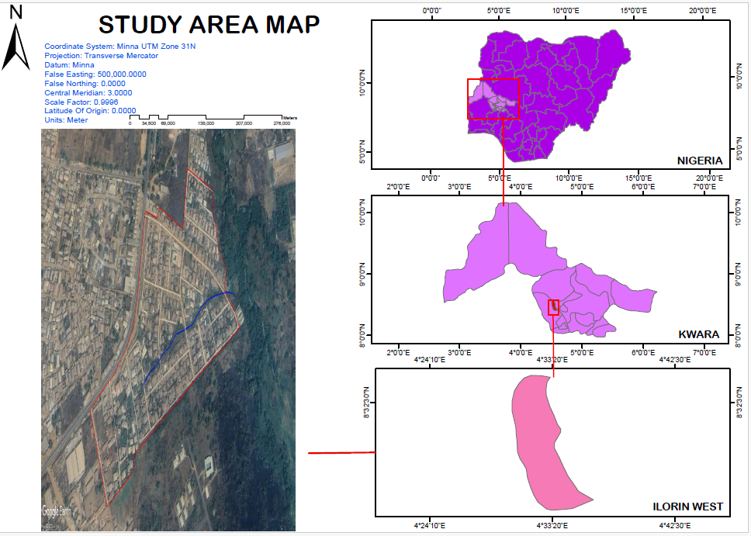

Fig 1. Study area. (SOURCE: - GOOGLE)
1.7 PERSONNEL INVOLVED
The following people participated in the project, they are:

S/N | NAME | POSITION
1 | HND/23/SGI/FT/0053 | Author
2 | HND/23/SGI/FT/0049 | Member
3 | HND/23/SGI/FT/0062 | Member
4 | HND/23/SGI/FT/0086 | Member
5 | HND/23/SGI/FT/0050 | Member
6 | HND/23/SGI/FT/0061 | Member
7 | HND/23/SGI/FT/0058 | Member
8 | HND/23/SGI/FT/0121 | Member

CHAPTER TWO
2.0 LITERATURE REVIEW
Dashe (1987) states that land is man’s most valuable free gift and therefore needs good management to meet the needs of future generations, In the early 19th century and beyond, most nations faced a formidable task of recoding and keeping accurate data relating to land matters. Even here in Nigeria, various land ministries were still using analogue process of keeping records, therefore records relating to land were being mutilated and good management of the wonderful resources being thwarted. According to a report by the United Nations’ food and agriculture organization, land degradation exacerbated where there has been an absence of any land use planning or of its orderly execution, or existence of financial or legal incentives that have led to the wrong land use decisions. As a consequence, the result has often being misery for large segment of the local population and distribution of valuable ecosystems. Because of the problems associated with land, the industrial statistical congress was organized and it held its first meeting in 1853 with the view of using statistical approach to solve this spatial problems. Land use was part of its agenda because it produces factual data on area related to land use and management of its resources. This historical fact was before the colonial power got firm hold on our nation. Even then, they saw the problems we are facing over this spatial entity and therefore left over the concept of land registry system (Ayobola, 2005 unpublished).Land use is the human modification of natural environment such as fields, pastures and settlements. Land use is the physical material at the surface of the earth. Land use planning is the term used for a branch of public policy which encompasses various disciplines that seek to order and regulate the use of land in an efficient and ethical way. Despite confusing nomenclature, the essential function of land use planning remains the same whatever term is applied. The Canadian Institute of Planners offers a definition that. Land use planning means the scientific, aesthetic and orderly disposition of land, resources, facilities and services with a view to securing the physical economic and social efficiency, health and well-being of urban and rural communities. LAN WILLIAMS in some of his paper (www.unimed.edu/research/publication/ipw), said that countries like Australia, New Zealand, Singapore, Japan and Korea rely on a well-established land use information system, supporting an efficient land distribution and planning in relative use.
Unfortunately, Africa are lacking behind compared with the countries in western Europe, which are building on well established (complete) system, that are over 100years old and are now applying technologies from highly sophisticated industrial and educational base. These shortcomings have forced the improvement and upgrading of our land use, which can be observed in my country (Nigeria) today, especially in Irewolede Estate along New Yidi road, Ilorin, Ilorin South Local Government Area, Kwara State. The processes evoke both model changes and alterations of analogue systems. Notwithstanding the changing scenario in development and modern technologies, the demands, for better understanding of needs and planning of our environment is essential (Huxhold, 1991).
(Alonge, 2004 unpublished) stated that it is important to partition land parcel into different land use zones. For instance, Academic and Administrative land uses must not be too far from the Residential area in the campus while Commercial area must be separated from Academic area since the later requires a conducive atmosphere for leaning. Before a particular land could be classified for a particular use, it is paramount to consider first and foremost the land cover, the economic and the social concept, as well as political importance.
Kufoniyi (1998) defined GIS as a computerized tool for capturing, storing, checking, integrating, manipulating, analysing, and displaying data which are spatially referenced to the earth. It is normally considered to involve a spatially referenced and structured digital database, and appropriate application software. The acquisition of spatially referenced data is the prerogative of the land surveyor.
Adeleke (2000) stated that the surveyor is concerned with knowing what (object) is where (space) and when (time) using a field base or an object base concept of reality. The field base approach is a raster based. It conceptualizes the reality as a non-empty space composed of a tilling of area with known location in which yet to be identified, terrain objects are located at a particular time using ground survey technique, and this location is known. The object based concept views reality as an ‘empty’ space filled at a particular time by known individual terrain objects whose locations are known (Adeleke, 2000). Here reality or real refers to a given geographic space including all the entities embedded in the space. The ground surveying method using total station was used for data capture in the project. The realities were conceptualized as points O-D, lines 1-D, polygon (area) 2-D and volume 3-D. The spatial objects consist of two components, geometric and attributes, assuming time to be constant.. The geometric components could be divided into location, spatial relationship between the objects and shape and size. The attribute components of terrain objects are the observed facts (non- spatial) about the object. For instance, the names of the land use (Academic).Perimeter, Area etc.
The next step is the complex analytical operation. Frequently, this requires access of data spread across several layers and the use of statistical and spatial analytical techniques. More complex forms of condition questions and trend questions can be answered.
Land covers include grass, asphalt, trees, bare ground, water, etc. There are two primary methods for capturing information on land cover: field survey and analysis of remotely sensed imagery. For land cover, fields are usually coloured yellow and brown, water is coloured blue, and urban surfaces are coloured red, (Fisher et al., and 2005). Land cover is distinct from land use despite the two terms often being used interchangeably. Land use is a description of how people utilize the land and socio-economic activity. Urban and agricultural land uses are two of the most commonly known land use classes. At any one point or place, there may be multiple and alternate land uses, the specification of which may have a political dimension, (Fisher et al., 2005).
Land cover change has been described as the most significant regional anthropogenic disturbance to the environment (Roberts et al., 1998). In essence both land use and land cover changes are products of prevailing interacting natural and anthropogenic processes by human activities (the use to which land is being put). Land use and cover change and land degradation are therefore driven by the same sets of proximate and underlying factors elements. Land use and cover change is therefore central to environmental processes, environmental change and environmental management through its influence on biodiversity, water budget, radiation budget, trace gas emissions, carbon cycling, livelihoods (Verburg et al., 2002), and a wide range of socio-economic and ecological processes (Desanker et al., 1997), which on the aggregate affects global environmental change and the biosphere. Land use and land cover data are data from water- resource inventory, flood control, water-supply planning, waste-water treatment, inventories of existing activities on public lands combined with the existing and changing uses of adjacent private lands to improve the management of public lands.
Land use (Williamson, 1997) is the presentation of human activities on the land. So, land use information is very important to manage the city efficiently, it can be integrated with land use information system, since land use is the human use of land which involves the management and modification of natural environment or wilderness into built environment such as fields, pastures, and settlements. It has also been defined as "the arrangements, activities and inputs people undertake in a certain land cover type to produce, change or maintain it" (FAO, 1997a; FAO/UNEP, 1999).
The word “land use” (Dale and John, 1999) can mean different things to different people. For many, land use is synonymous to a map where the geo-space under study is divided and classified according to dominant use. For others, land use is more than a map output. It is a complex process that deals with allocating land and determining its use for sustainable development. It is very much a socio-political concern as it is economic and geographic.
In the Philippines, land use refers both to the substantive issues of land conversion, land reform, environmental protection, agricultural productivity, land valuation, as well as to a map layer of a municipal information system or a fundamental dataset of a planned geo-spatial data infrastructure. Land use (Philippine Free Press, 2003) is defined as the “economic and cultural activities practiced upon the land”. It is about the relationship of man to land and his action on this relationship. Land use, therefore, is viewed more as a process than an output. It is a dynamic concept denoting complex interaction and changes occurring over time.
Land use information system (Ajibade, 1999) is a computerized tool for data acquisition, storage, processing, manipulating, analysing and presentation of information on land use. By land use, we are talking about the uses to which a land is put to. Land use (Electronic Encyclopaedia, 2007) is based on the functional dimension of land for different human purposes or economic activities. Typical categories for land use are dwellings, industrial use, transport, recreational use or nature protection areas. Land use is also explained as exploitation of land for agricultural, industrial, residential, recreational, or other purposes. Land use (Electronic Encyclopaedia, 2007) is the way in which land is used, especially in farming and city planning. The way land is developed and used in terms of the types of activities allowed (agriculture, residences, industries, etc.) and the size of buildings and structures permitted.
The land use (Ajibade, 1999) of a place can be classified into Residential, Religious, Commercial, Recreation, Utilities, Academics, Administrative and open space. Different land uses are designated using different colours e.g. brown designates high density residential land use, orange designates medium density residential land use, yellow designates low density residential land use, red designates institutional land use, green for agricultural use, light green for recreational use, blue for commercial use, purple for industrial use, red for administrative use, light red for academic land use, then series of grey for roads.
The Land use Information System (Ajibade, 1999) was achieved through:
- Conceptual data model where the reality is conceptualized as point, lines and polygons (vector data modelling) with x, y as the coordinates of points with relationship among the entities and the attributes of interest of the land use identified and analysed.
- Relational database structures in which the conceptual model is translated into a relational data structure. Five relations (database tables) are designed namely:
- Node (nodeid, ea, an)
- Arc (bnode,enode,lparcel,rparcel,object)
- Area(a_id, use, area, dist, perimeter, cente, centn)
- Line(l_id, use, length, dist)
- Point(p_id, use, dist, node, a_id)
- Linkage i.e. where the spatial data and the attribute data files where linked using a GIS software.
- Physical design i.e. Systems selection, data types determination (depending on the software). In the book, dBase-IV, Idrisi for windows, BASIC language and AutoCAD were selected and used.
Finally, GIS is used to determine pattern of land use which helps in the effective management of the land and also provides supportive measures for decision makers.
DATA ACQUISITION FOR GIS
Data are raw collection of facts. Data relating to land may be acquired and held in alphanumeric form (for example books), or graphically (for example, as maps or aerial photographs), or digitally (for example, using electronic methods). To become information, the raw data must be processed so that it can be understood by a decision maker. Land information management system may be designed to serve one primary function or they may be multifunctional for supporting strategic planning.
Land information is an integral part of government, non-profit, and private sector activities. Adopting LIS technique can advance broader social purposes by making more effective public decisions and by using natural resources in a more optimal way. LIS supports spatial analysis and modelling procedure for solving complex planning and management problem. Information management system is an integrating technology where resources and activities are brought together to support the decision making process of an organization. By taking the advantage of Remote Sensing (RS) and Geographic Information System (GIS) technology, Land Record Information Management System for cadastral mapping was developed by integrating digital cadastral map and land record database. The fast development of society has been hastening the application of technologies especially LIS and technology in land administration. As an important facet of nature and society, land is attracting people’s attention.
According to Dele and McLaughlin (1998), land forms the basis for all forms of human activity, “from it we obtain the food we eat, the shelter we need, the space to work and the room we relax”. The usefulness of land is enormous; therefore man has to guard it jealously considering its scarce nature. For this reason, conflicts most often arise in the sharing of resources or right of ownership of the land.
The resources of land are neither inexhaustible nor indestructible. The importance of land to human existence and the need to survey and manage effectively and efficiently for the use and good of mankind is very crucial. Therefore, for Nigeria’s sustainable development, information relating to the location, size, use (residential, commercial, agricultural, industrial, educational, recreational, and cultural etc), contents/value, ownership and state of land must be aggregated as a system so that its administration would be less cumbersome and people driven. This means, land information is a pre-requisite for land administration (Molen, 2001).
DATA:
Data is the smallest but possible the most important part of the component of GIS. Geographic data and related tabular data can be collected in-house or purchased from a commercial data provider. A GIS will integrate spatial data with other data resources and can even use a DBMS, used by most organizations to organize and maintain their data, to manage spatial data.
METHOD OF MANIPULATION/ANALYSIS:
A successful GIS operates according to a well-designed plan and business rules, which are the models and operating practices unique to each organization. The manipulating step in achieving the desire goal of a GIS is embedded in this component.
COMPONENTS OF GIS
HARDWARE:
Hardware is the computer on which a GIS operates. Today, GIS software runs on a wide range of hardware types, from centralized computer servers to desktop computers used in stand-alone or networked configurations.
SOFTWARE:
GIS software provides the functions and tools needed to store, analyse, and display geographic information. Key software components are tools for the input and manipulation of geographic information. A database management system (DBMS) tools that support geographic query, analysis, and visualization. A Graphical User Interface (GUI) for easy access to the tools. A computer without software is like a car without a manual, it is the set of instruction that allows the computer to communicate effectively with the user.
HUMAN WARE:
GIS technology is of limited value without the people who manage the system and develop plans for applying it to real-world problems. GIS users range from technical specialists who design and maintain the system to those who use it to help them perform their everyday work. Any functioning, reliable and successful GIS task will be referenced back to the people in charge of the operation.
APPLICATION OF GIS
The application of GIS to Land and parcel management is fast becoming widespread. In the more developed countries of North America, Australia, and Europe, several municipal countries and local government authorities now use the GIS technology to handle various aspect of land and property (building) management. GIS is a relevant and valuable tool in the information harvesting and planning of natural physical, bio-medical, social-cultural, eco-climate economics, engineering sciences and business environments. The global community is now so dependent on computers and computerized information that we can’t do without them. Computerization has opened vast new potential in the way we communicate, analyse our surroundings and make decision.
The power of GIS comes from the ability to relate different information in a spatial context and reach a conclusion about this relationship. Most of the information we have about our world contain a location reference, when parcel or land information is collected. It is important to know where the plot is located and its topology. This is done by using a location reference system, such as longitude and latitude and perhaps elevation. A GIS therefore, can reveal new information that leads to better decision making. Different kind of data in map form can be entered into a GIS. A GIS can also convert existing digital information, which may not be in map form into map forms so that it can be recognizable and can be used. For example digital satellite images can be analysed to produce a map of digital information about land use and land cover.
However, land information system is an important system to support administration of land. Information System include coordinate of beacons, lengths and bearing of boundary lines, area of a plots, perimeter, parcel owner, ground rent, land market value, land use adjoining plots, reference controls etc. It is mainly applicable in built-up or urban areas in large scale maps (e.g. scales 1:250, 1:5000). Therefore, LIS is an aspect of Geographic Information System which includes every record about land (agriculture, commercial land use, etc) and their market/economic. Therefore, GIS help to store and manage large amount of spatially referenced data. It provides analyses tools and therefore helps in a better understanding of the activities on the earth surface. Land information system (LIS) is crucial to any planning and management activity, particularly in our cities.
DATABASE MANAGEMENT SYSTEM (DBMS)
Database Management System (DBMS): A Database management system is a computerized record-keeping system. It is a repository or a container for collection of computerized data files. The overall purpose of DBMS is to allow the users to define, store, retrieve and update the information contained in the database on demand. Information can be anything that is of significance to an individual or organization.
LAND INFORMATION SYSTEM (LIS)
Land Information System (LIS) is a tool for legal, administrative and economic decision making as well as an aid for planning and development. This involves on the one hand, the database containing, spatially referenced land related data and on the other hand the procedures and techniques for systematic collection, updating, processing and distribution of the data to the end users in an efficient manner. The base of a land information system is a uniform referencing system that could facilitate in linking the different types of data within the system and with other land related datasets. The most important thing in the land information management is the quantity of the data which can be handled, the speed with which these data can be processed and the ways in which the data can be manipulated and analysed.
GEOGRAPHICAL INFORMATION SYSTEM (GIS)
Geographic Information System (GIS) technology has given a new insight to addressing a variety of resource development, management and planning activities. Without reliable registers, transaction in land is often costly, time consuming, and uncertain. It is normally necessary to establish the fact that the reputed owner and trustee actually have the legal rights to deal with the property. Another difficulty being faced by many developing countries due the absence of the proper land records is the real land market. The reason may be unclear delimitation of individual or group rights, insecure ownership, etc. A cadastral database can remove such obstacles. The necessity for a functioning land market opens the way not only for private development but also for public land acquisition and other means of ensuring that land is available for dwelling and other urban needs.

CHAPTER THREE
METHODOLOGY
This explain the method and techniques used to achieve the aims and objectives this project of this project work, the execution of this project was based on the following basic principle of surveying
- Working from whole to the part.
- The principle of choosing the method of survey most appropriate to meet the desired result.
- The principle of provision for adequate checks to meet the required accuracy
3.1 OFFICE PLANNING
Office planning which could be termed as office reconnaissance involved knowing the type of instruments, purpose, specification and accuracy require of the survey to be carried out. These led to the choosing of appropriate equipment and method to be employed, also costing of the survey operation was done in the office. Information related to the give project was collected from various sources the coordinate (x, y, and z) of the initial and that of the three choosing controls used for orientation were all obtained from department office.
3.1.1 FIELD RECONNAISSANCE
The project site was visited by all the group members to have the true picture of the site for the better planning. The recce diagram was drawn alongside the carrying out and the reasonable artificial features were fixed along and within the traverse lines, the traverse was fixed to maintain perfect indivisibility.
3.2 INSTRUMENT USED
Selection of instrument to be used is:
- Total station
- Tripod
- Linear tape
- Steal tape
- Field book
- Pencil
- Targets and their tripod
- Reflectors stand and target
- Nails
- Pegs
3.3 MONUMENTATION
In selecting station to represent the perimeter of the while carved, establishment of the station were done so as to define the boundaries of the project study area using a temporary Pegs since the place is Government property, station was established and they were marked with pegs. The peg was firmly even into the ground hence, ensuring that stability of the station pegs in such w away that they cannot be temper with.
Ground level
18cm
18cm
Beneath Ground level
75cm long
60cm
80cm Iron rod
Above Ground level
15cm

Fig.3.2 typical third order survey beacon

3.4 TESTS OF DIFFERENTIAL GPS
The two GPS receivers (Tersus Differential GNSS) were tested to ascertain its working capability on two known established points. The reference receiver (base) and rover receiver were setup using the RTK (Real Time Kinematics) mode with boosts from external radio to increase the communication linkup and range between the two receivers. The interface was access using S1 controller to set the parameter. The data acquired was downloaded using beam methods (Bluetooth) of the windows mobile platform in text format (.txt)
However, the result displayed the following on the controller:
Status (P): | Fixed
Horizontal Root Mean Square (H): | 0.014
Vertical Root Mean Square (V): | 0.021
Satellite Number (S): | 10+4
Communication Mode (Channel): | 4
Time (T) | 11:05:38

3.5 CONTROL CHECK
Control check was carried out on the beacons PT 02 and PT 03 in order to ensure whether they were still maintaining their original positions. The reference receiver (base receiver) was set on PT 01 while the rover receiver was set on PT 02 and PT 03 respectively. The following are the result obtained
Table 3.5.1: Coordinate of the observed and the original values of PT 02
PILLAR | NORTHING | EASTING | STATUS | REMARKS
PT 02 | 935768.084 | 670900.867 |  | ORIGINAL
PT 02 | 935768.099 | 670900.847 | FIXED | OBESRVED
DISCREPANCY | 0.015 | 0.020
Table 3.5.2: Coordinate of the observed and the original values of PT 03
PILLAR | NORTHING(m) | EASTING(m) | STATUS | REMARKS
SC/KW E4583R | 935791.554 | 670975.362 |  | ORIGINAL
SC/KW E4583R | 935791.575 | 670975.384 | FIXED | OBESRVED
DISCREPANCY | 0.021 | 0.022
The result shows that the control pillars were in Situ and in good condition for the survey operation. In the case of the instrument, it can be concluded to be in good working condition.
3.6 DATA SOURCE
Control coordinate were given from existing map, which is considered as secondary data. This was plotted using AutoCAD. The main source of data used is primary source.
3.7 GEOMETRIC DATA ACQUISITION
This involve the acquisition of both northing and easting value of features that are present on the project site. During the data acquisition, Real Time Kinematic method was employed coordinates of boundary points, as well as details and notable features along the perimeter using total station. Boundary pillars are established and accurately measured. These points serve as reference markers and are essential for maintaining consistency and accuracy throughout the survey. Additionally, these coordinates serve as valuable information for future reference, analysis, or planning purposes. They can also be used to assess potential impacts on the survey area and aid in making informed decisions during the project's development or construction phases.
Data Acquisition
To gather the necessary data for the project, observations and measurements were carried out. Obtaining the information needed to create the project plan was the focus of this stage. The processes listed below were completed.
- Selection of control points. Perimeter Traverse
- Detailing
Complete surveying programs with the ability to record data and set parameters are included with the instrument used. Additionally, it uses software modules with built-in memory and has convenient memory management capabilities.
Perimeter Traverse
The act of traversing is the survey of a group of interconnected lines, known as traverse legs, the ends of which have been marked in the field and the lengths and directions of which have been established by observation. Traverse stations are places of changes or turning. Open and Closed
Traverses are the two basic categories into which traversing can be placed.
Closed traverse always begins and end on sets of known points (points with known coordinates previously established). Perimeter are frequently encircled by shapes, such as polygons, in closed traverse surveying. Although this type is expected to be employed in all projects in surveying generally.
An open traverse consists of a collection of traverse lines that are connected but do not begin and end at a known point. When no controls are present where the traverse action is to stop, this type is typically utilized. In this kind of traverse, the observer's main responsibility is to make sure that the task is being checked at each stage. Surveys of this kind are frequently used in the engineering industry, such as route surveys.
The closed traverse type was employed in this project as it was started on an existing control point (PT 02) and closed on the same control (PT 02).
Base Station Setup
The base station is required in order to ensure an accurate position to be used in the topographic survey of Extension to Textile Factory. The use of a base station is now a standard routine in surveying practice; this is to validate the fundamental principle of carrying out a survey “from whole to part”. This means that networks of horizontal and vertical control points are first established. The temporary adjustment (centering and leveling) was performed on it. All the connections necessary for RTK mode stated below was carried out,
- The base station comprising of Tersus GNSS GPS receiver shown in figure 3.1 below was setup on a tripod stand on PT 02.

Figure 3.1 Tersus GNSS GPS receiver
NB: The position of the base station used is 935768.084mN, 670900.867mE. It was located in an area free from obstruction and interferences. It has been set to the WGS 84 system with Clarke 1880 ellipsoid.
The procedure for the data capturing is stated below;
- The instrument was switched on using the power button and also the data lodger (TC20).
- Then the instrument was placed on the tribrach which was already attached to the tripod and levelled.
- On the data lodger, the Nuwa app, Survey Office software was launched.
- The software was allowed to load and then, on the Project creation page, a project folder called ‘CIS’ was created and then opened.
- On the series of pages that followed however, the datum was selected as ‘Minna’, the mask angle as ‘15º’, while the minimum observation time was set at ‘5 minute’. After this page, the Base page was loaded.
- On the instrument Connect page (the Bluetooth connection page), the base station instrument serial number 52000754 was selected and down the page, the ‘connect’ button was clicked. This connects the lodger to the base instrument.
- On the Base page, the get location icon was click, and this bring the approximate coordinate of PT 2control, the coordinate was then corrected to the values obtained after this, the ‘start’ button was clicked and the base observation commenced.
- The Rover instrument’s battery was then fixed into it and switched on using the power button then mounted on the tracking rod (a single legged pole) and tightened.
- The tracking rod was set at 2.00m as height of the instrument.
- On the instrument Connect page (the Bluetooth connection page), the base station instrument serial number 52000754 was then disconnected and the Rover instrument serial number 52000764 was selected and down the page, the ‘connect’ button was clicked. This connect the lodger to the Rover instrument. The voice information FIXED was then heard from the instrument.
A complete setup of the base and the interface of the Project Creation page are shown
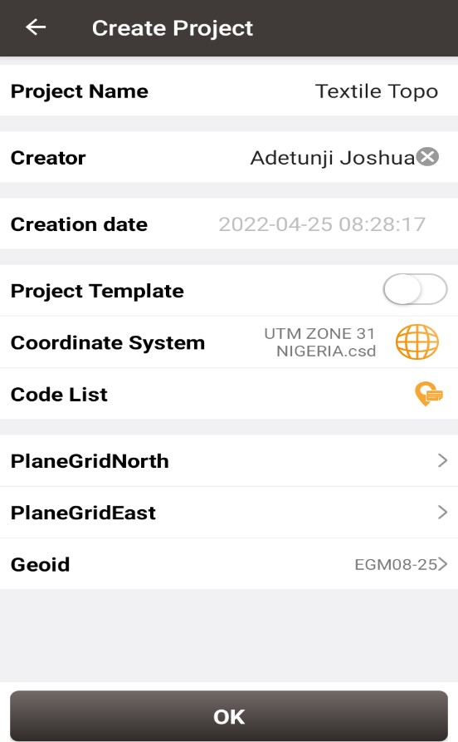
AINASVG/G13/13
CISSVG/G13/13
03-12-2024
Figure 3.2 Showing the project creation page on Nuwa app
FIELD OBSERVATION
- Aftersetting up the base, the rover instrument with serial number 52000764 was taken to site.
- NOTE: - Each station in a differential GPS observation is typically observed independently (though with direct reference to the base station), i.e., the instrument is placed on each station one at a time until the final point or detail in the site is observed.
- The instrument was placed on the first station i.e. the base of the tracking rod was placed on the center of the pillar.
- On the data lodger, the Nuwa app was launched and the Survey page of the app was click. On the Survey page, the get location icon was click to obtained the Northing and Easting of the station.
- NB: Given that the time segment of the instrument has been set to 5secs already, the observation automatically ends when its period of the time segment already pre-set elapsed
- The Station ID was then changed from pt1 to P1.
- After 5sec of observation, the observation stopped automatically and then the instrument was moved to the next station i.e. P2
- NOTE: - that the data lodger was not switched off after the first station had been observed since the stations are not far from one another i.e. not more than 50m from each another.
- On the data lodger with the Survey page on, the ‘get location’ icon was clicked and the observation started since the instrument had automatically given the next station name. The observation was allowed for 5sec again.
- The process in step (v) was repeated for all the subsequent stations and other details that were observed on the site.
- At the end of the observation, the instrument was switched off. The Survey page on the data logger was closed and the data lodger was also switched off (though in the warm boot mode).
- The data logger was taken to the base station and switched on again. The instrument’s serial number was selected on the Bluetooth page which also led to the Base station page.
- On the base station page, the ‘stop base’ button was clicked and then the instrument was
- switched off including the data lodger.
3.7.1 ATTRIBUTE/ SOCIAL SURVEY
This aspect of data acquisition entails the collection of other data which geometric in nature. Such data were directly related to the features to which geometric data was acquired. They included building names, the purpose of which the building is used for. etc.
To collect attribute data, survey was employed. This involves oral interviews, reading information from sign posts, wall signs, virtual observation, etc.
3.8 DATABASE CREATION/IMPLEMENT
For efficient and effective management of data in the computer environment, data item are usually arranged and stored in a database or databank. The content of this database could be in form of a text, number, polygon or graphics. The creation of this database involved the combination and storage of the acquired graphical and attributes data obtained in former designed GIS database of a generic structure for the purpose in spatial analysis and queries on project site
In the creation of a land information system data mode, a widely used technique called layering was employed. The features that are present within the project site have been classified into different layers in the AutoCAD software independently. The polyline entities were joined using the polyline tool while appropriate symbols were used for the point entities. These layers were then exported to ArcGIS environment where shape files were created using attributes fields as conceptualized in the schema. These attribute table were then populated accordingly with attributes values for each particular entity as observed in the field and from the social survey template (attached as appendix)
The personal Geodatabase was then created finally in Arc Catalog environment. Where other tables that are non-geometric where created while the already created shape files where imported. Relationship between these tables were also established and the tables were later populated in the Arc Map environment. The following are some of the tables created
3.8.1. DATABASE MANAGEMENT SYSTEM (DBMS)
According to Dale and McLaughlin (1998), database management system was defined as a computer program to control the storage, retrieval and modification of data in the database. DBMS comprises of set of programmers which are used to maintain and manipulate the data orderly and acts as the central control over all the interactions. It manages that data using alphanumeric data with limited capabilities of performing spatial queries
A DBMS must allow the definition of data and their attributes and relationships as well as providing security and on interface between the end users and their application and the data themselves it reduces redundancy. Therefore, Arc GIS 10.2 version was used to create, manipulate, maintain and access the database easily.
3.8.2. DATA QUALITY
Some forms of quality control and quality assurance were incorporated in the project at every phase. These include conformity with data templates, data competences and data accuracy. Conformity with data templates in this premises refers to the degree to which the captured data conformed with the designed templates, while data competence was understood as the degree to which the available data in the report and for which there are specific templates have been extracted.

3.8.3 DATA INTEGRITY
The data captured as exactly downloaded into the system then exported to AutoCAD via notepad and eventually into Arc GIS. The process involves ensuring that the data in the database were accurate and setting of certain constraint to prevent inconsistency in the database.
3.8.4 DATA SECURITY
Security is of great concern to land administration because of the legal implication of cadastral records. Security of the records is of almost importance to all concerned. These includes:
- Physical and system security
- Physical security: The use of burgling proof, fire-fighting equipment-controlled access, proper records of the moment of personal and our of the office circuit break
- System Security: Uninterrupted power supply (UPS) will be used to control voltage, use of passwords and backups
In view of the foregoing, locking mechanism was adopted to protect the data in the database from unconscious deletion. Password was used to prevent unauthorized user from breaking into the database and a backup was created for the whole project on the rentable DVD.
Having succeeded in analysis the methodology employed in the execution of this project to arrive at the successful completion. it is equally necessary to examine the processes undertaken to ascertain the reliability and effectiveness of the created land information system
CHAPTER FOUR
4.0 DATA PROCESSING AND PRESENTATION
4.1 SPATIAL ANALYSIS
Spatial analysis is a specialized function that distinguishes GIS from other information systems. It entails the examination of spatial and attributes characteristics of geographic features that are within the database to establish relationships from which spatial problems can be tackled. In this project work, spatial analyses were performed to select, combine and intersect existing geospatial data-sets in order to generate new information suitable for answering specific spatially-related questions.
The results from these analyses can be shown in a number of ways depending on the required output format. Where attribute information about map features is required, they can be presented as tables containing such valves as are needed from the query analysis. They can also be presented as maps with legend information showing the queried features and their topological relationships with other features shown on the map.
For this project AutoCAD 2007 was used to carry out the plotting of all the parcels. The drawing was exported to ArcGIS 10.3 where all other operations were carried out.
4.2 Spatial Query
Searching of data components using certain criteria of retrieving them from the database is known as spatial query. The information retrieved is used to support decision making. The Cadastral Information System (CIS) plays its role when a relational database is linked to graphics in real time.
A good Cadastral Information System (CIS) allows the user to select records or attributes in the database and to view the result on coverage displayed which can be printed on a hardcopy.
4.3 Query Design
A query design is a precise definition of what is to be selected from the database. For example, the following queries designs were used in this project:
- Query by P Status=Developed, P use=commercial
- Query by P use = Residential
- Query by P use = Residential, P area = 1345.624sqm and Owners name = Mr Qudus
4.4 Testing Of Database
This is the test carried out to determine whether the relationship between the geometric data about the objects and their attributes is capable of being retrieved. This was done by designing a simple query and running the query to see if the desired result is achieved. The query ran, hence the database was confirmed fit for analysis.
4.5 Existing Parcels and Blocks
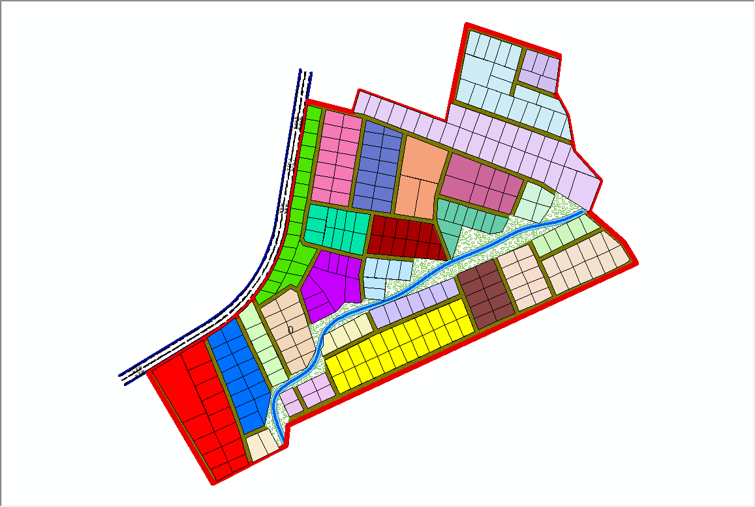

Fig 4.5.1:- the exported cadastral plan of the study area showing the blocks within the area
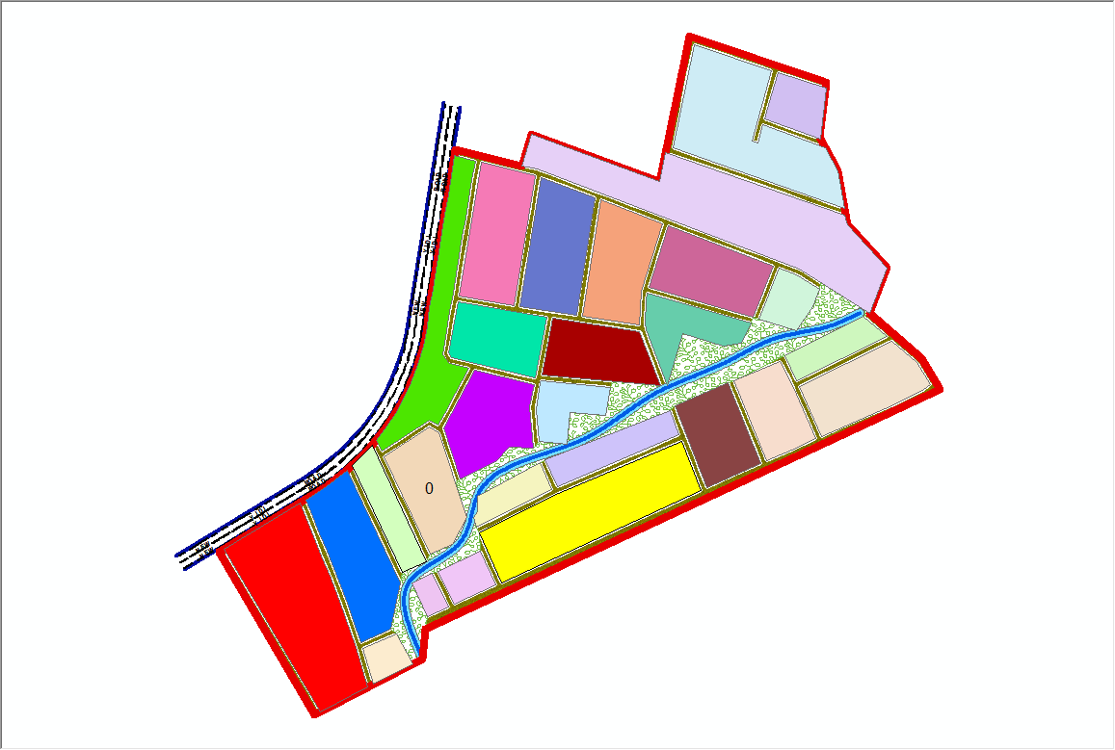
Fig 4.5.2:- the exported cadastral plan of the study area showing the all the parcels within the area.
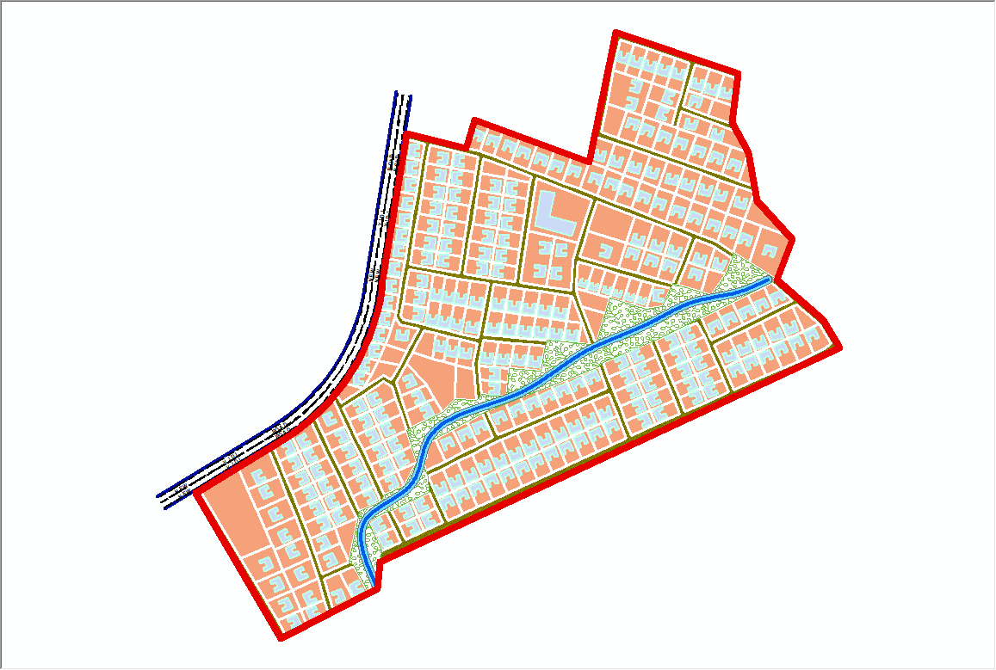

Fig 4.5.3:- the cadastral plan of the study area showing the boundary,
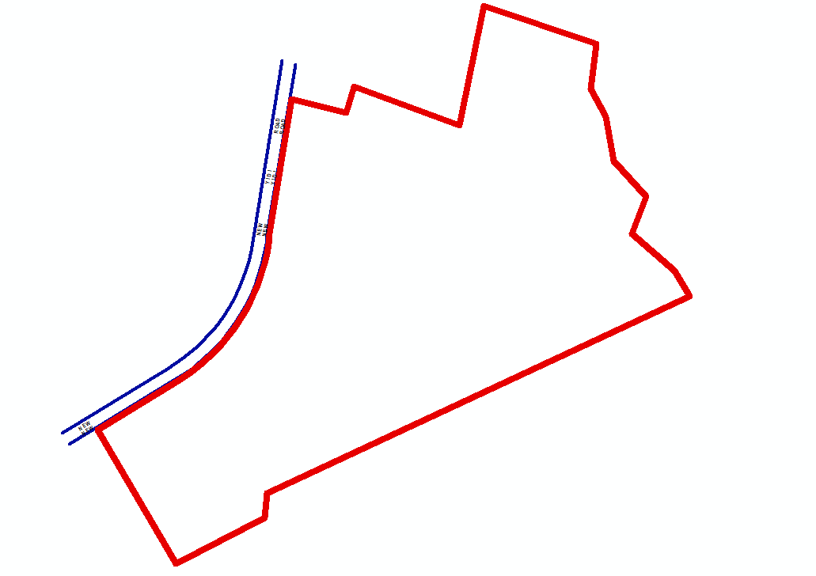

4.6 Spatial Query
Queries were designed for the purpose of retrieving information from the database. The queries performed in this project gave answers to certain generic questions asked from the database. This was made possible as a result of the implicit link of both the spatial and attributes data. The queries were based on the products from the analysis carried out on the database.
4.6.1 Single Criterion Query
A single criterion is carried out where one condition is used to design query. This condition is used to retrieve the information from the database.
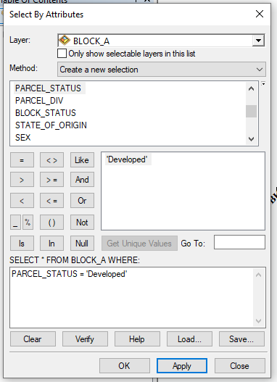
Fig 4.6.1.1:- Query for Parcel status for developed Purposes in the Study Area
SYNTAX; ([Parcel_status]) =’developed’)

4.6.2 Query by Parcel Status (Residential)
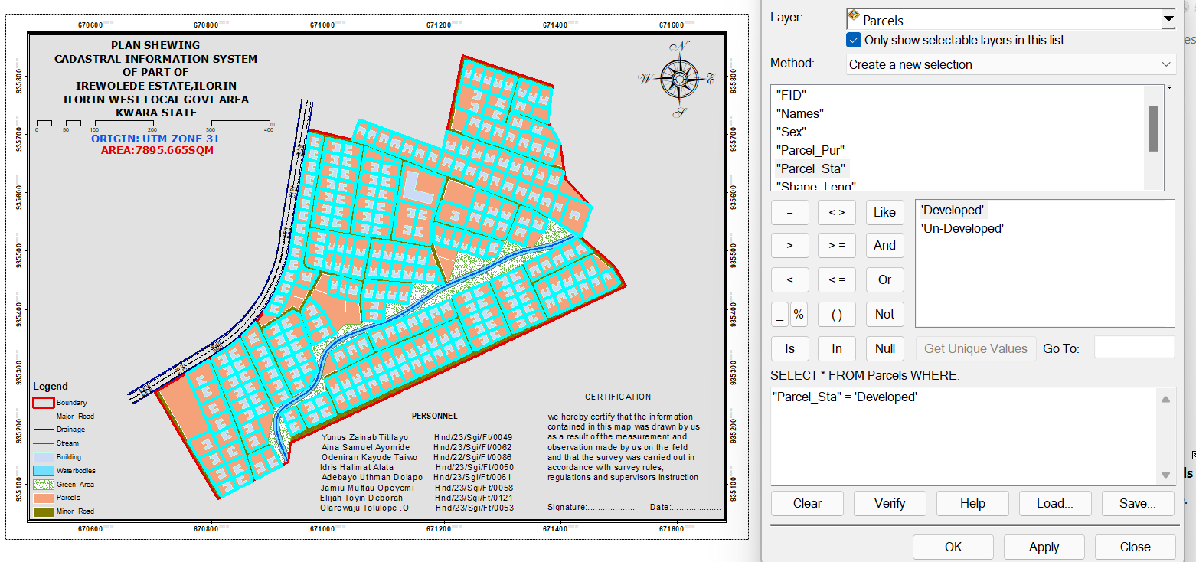
Fig 4.6.2.1: Result of Query for Parcel Used for residential area in block A in the study area
SYNTAX; ([Parcel_status]) =’developed’)
4.6.3 Discussion of Result
Figure 4.6.2.1 Shows parcels that are meant for developed purposes. It consists of the syntax model or the query builder box, attribute table as well as the map of the selected plot in light green color. The result shows that 8 parcels out of the 20 parcels are meant for commercial purposes.

4.6.4 Query by Parcel Status (commercial)
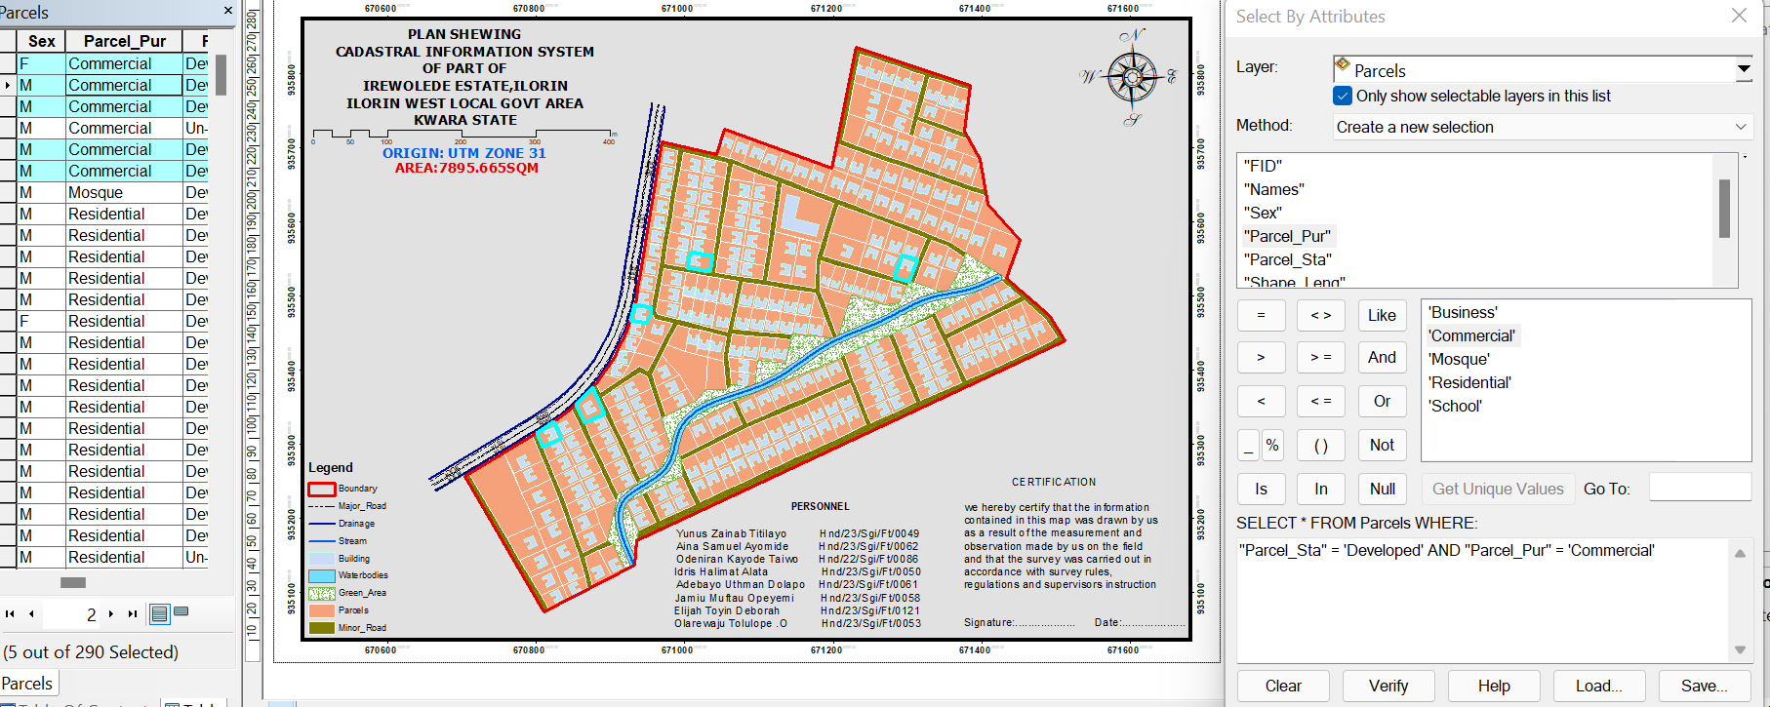
Fig 4.6.4.1: Result of Query for Parcels that are commercial purpose in the study area.
SYNTAX; ([Parcel status]) =’commercial’)
4.7 Discussion of Result
Figure 4.6.4.1 shows parcels that already have some type of commercial on it. It consists of the syntax model or the query builder box, attribute table as well as the map of the selected plot in light green color. The result shows that 5 parcels out of the 290 parcels have been developed. This information, however will help in informing the necessary quarters the level of development within the layout.
4.8 Multiple Criteria Query
The database created is then used for implementing several selection queries in determination of user-defined requirements such as parcels whose occupiers are actual owners, occupier’s citizenship, occupier’s occupation, number of residents in each flat, selection of unoccupied flats and other such security.
4.8.1 Query By Parcel Use And Parcel Status (Parcels meant for school, residential, commercial purposes that are “Developed”
Query was carried out in two stages, parcels meant for residential purposes were first queried by means of the parcel use field. In this case parcel use was selection criteria. The shapefile data of the query was exported as a layer and named accordingly. Next, the attribute table of the query result was queried by means of parcels meant for residential purposes that are yet to be developed i.e. Developed Parcels using the “Developed” selection criteria. This gives result for the parcels meant for residential purposes that are developed this also will help inform on the level of development within the layout.

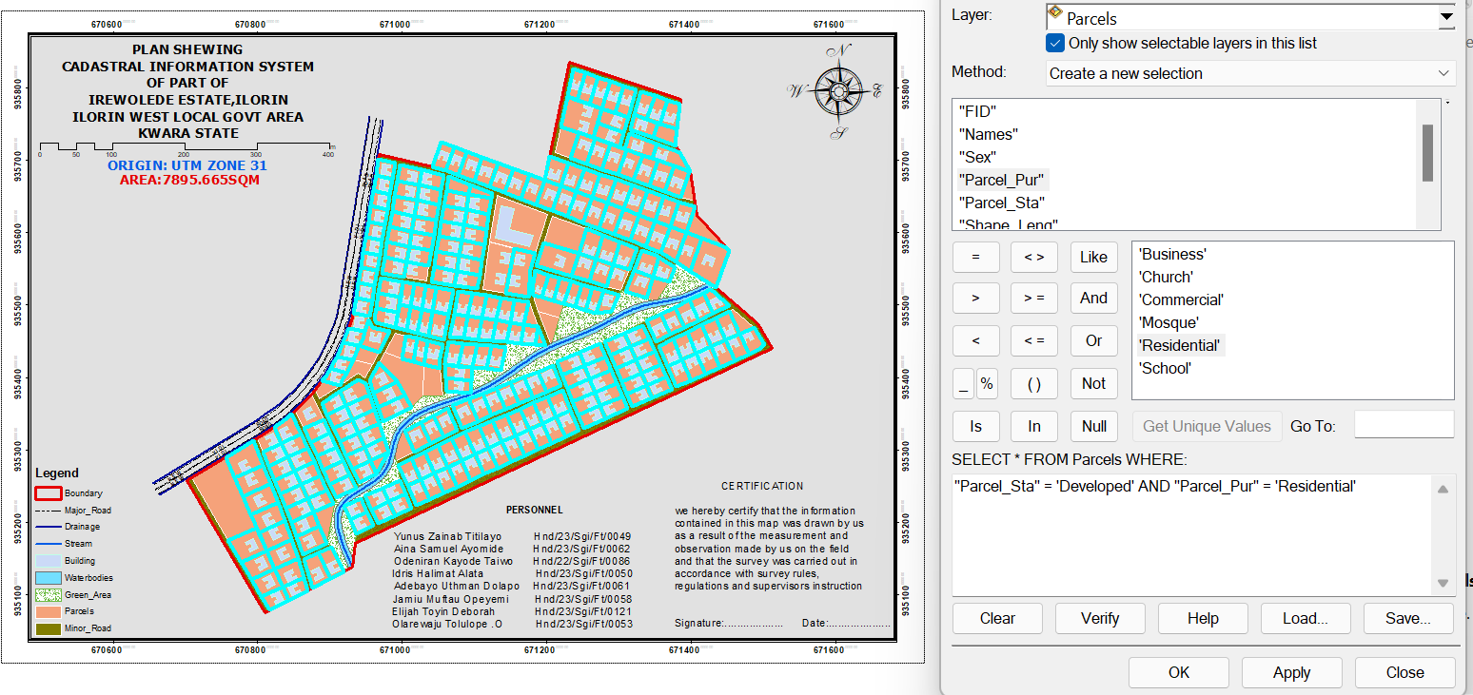
Fig 4.8.1.1: Screen print showing parcel use and parcel status in the layout.
SYNTAX;PARCEL_USE = 'Residential' AND PARCEL_STATUS = 'Developed’
Discussion of Result
Figure 4.8.1.1 shows the syntax modeled, the attribute table and the map of the multiple criteria queries ran on parcel meant for residential purposes and number of
Developed residential purpose parcels within the study area, they are highlighted in
Light green color. The result showed that 265 of the 290 parcels are developed.

4.8.2 Query By Parcel Use (Commercial) And Parcel Status (Parcels meant for commercial purposes that are “Developed”)
Following the procedure in the query for parcels meant for residential purposes that are yet to be developed. All parcels meant for commercial purposes were first queried and then, the resulting attribute table, query was carried out for parcel for which are Developed.
Fig 4.8.2.1: Screen print showing parcel meant for commercial purpose that are
Developed in the layout.
SYNTAX;PARCEL_USE = 'Commercial' AND PARCEL_STATUS = 'Developed'4.7.2.1
Discussion of Result
Fig 4.8.2.1 shows the result of syntax modeled, attribute table as well as unformatted map of developed parcels meant for commercial purposes. The table shows that all the 5 parcels meant for commercial purposes are developed. This is a pointer to the high rate of commercial developments in the study area.

4.8.3 Query By 10m Proximity to the stream (Parcel within 10m proximity to the stream).
Following the procedure in the query for parcels within close proximity to the stream (10m), query was carried out to show the parcels within close range to the stream.

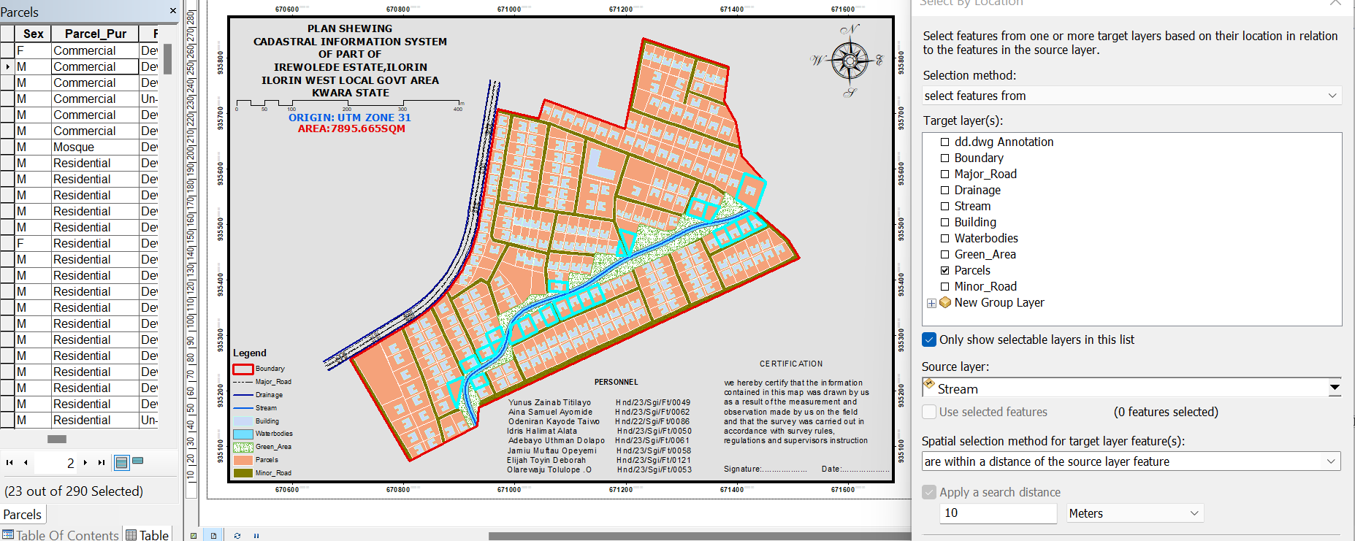
Fig 4.8.3.1: Screen print showing parcel parcel within 10m proximity to the stream

4.8.3.2 Discussion Of Result
Figure 4.8.3.1 shows the result of syntax modeled, attribute table. The table shows that only two out of all the parcels, only 25 parcel are within 10m proximity to the stream.

Fig4.8.5.4 Screen-shot showing the database created for the study area
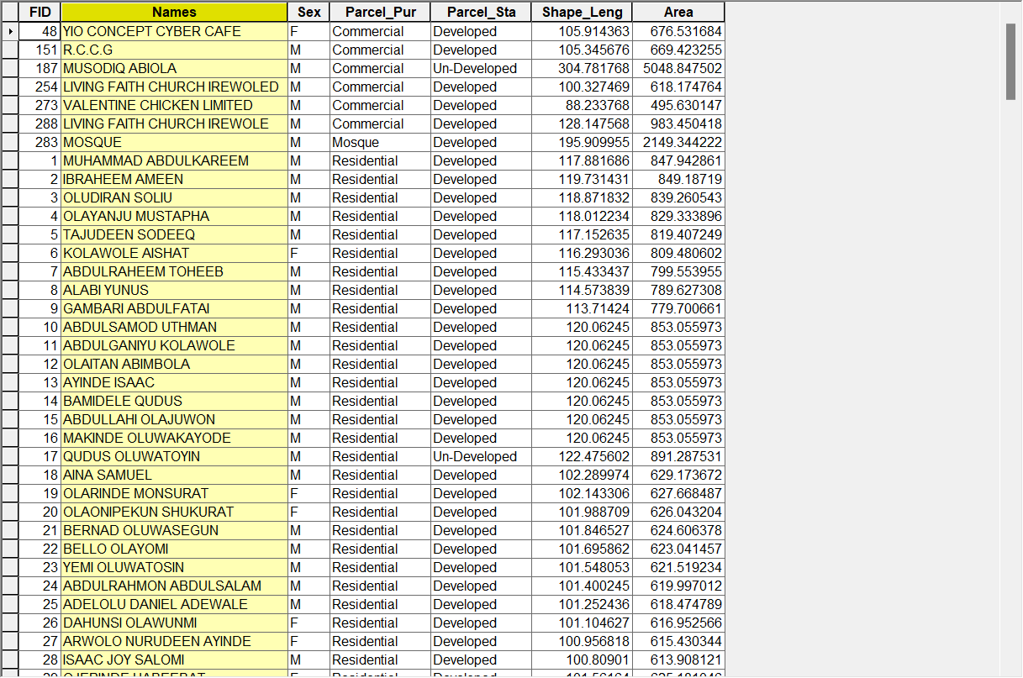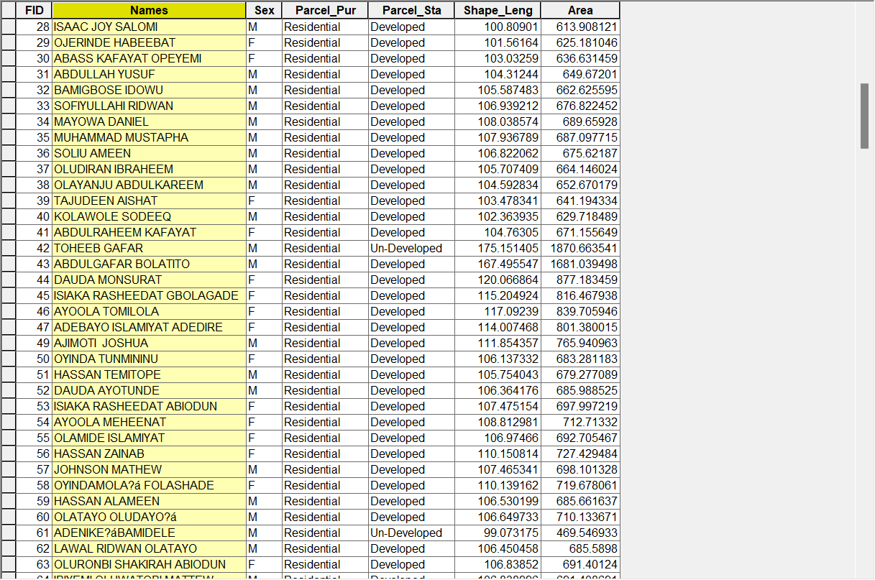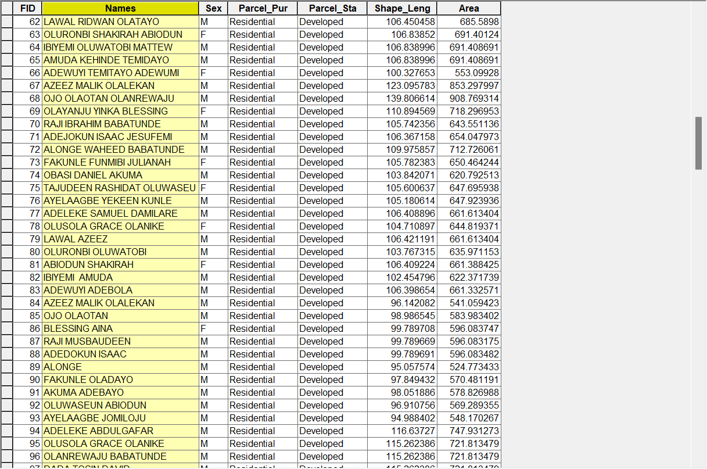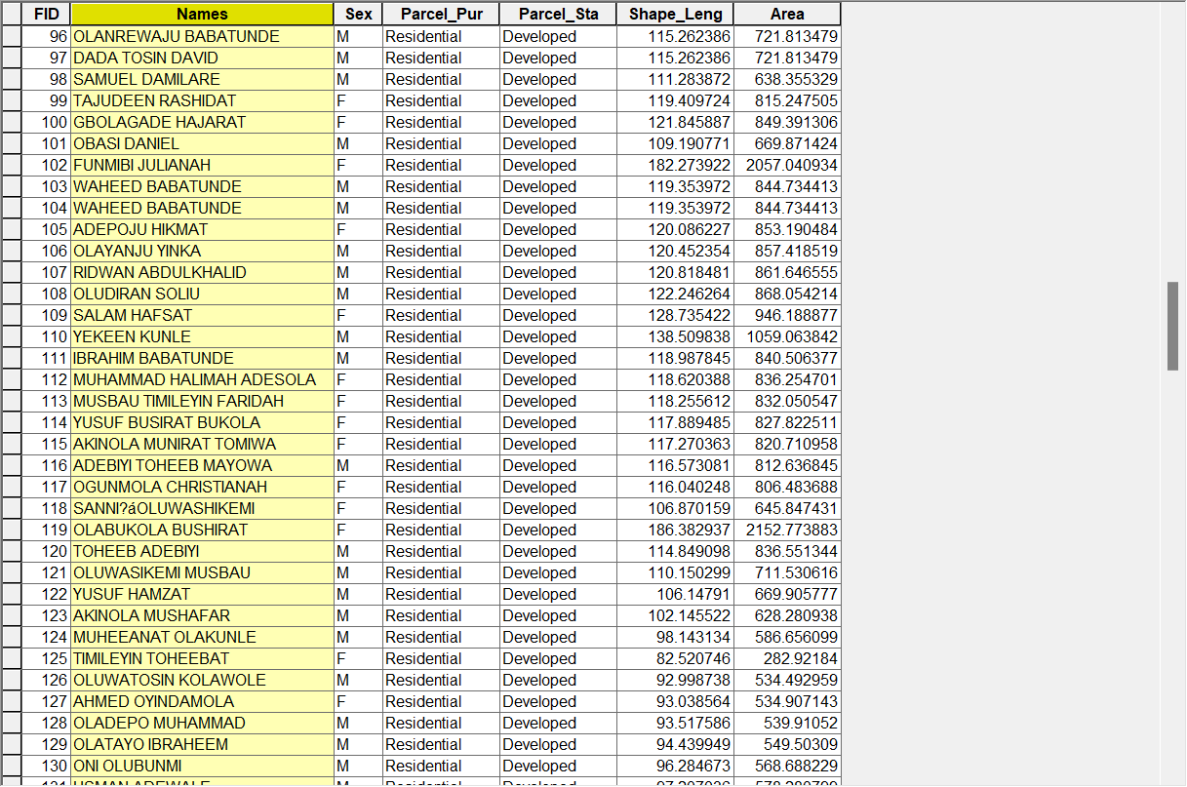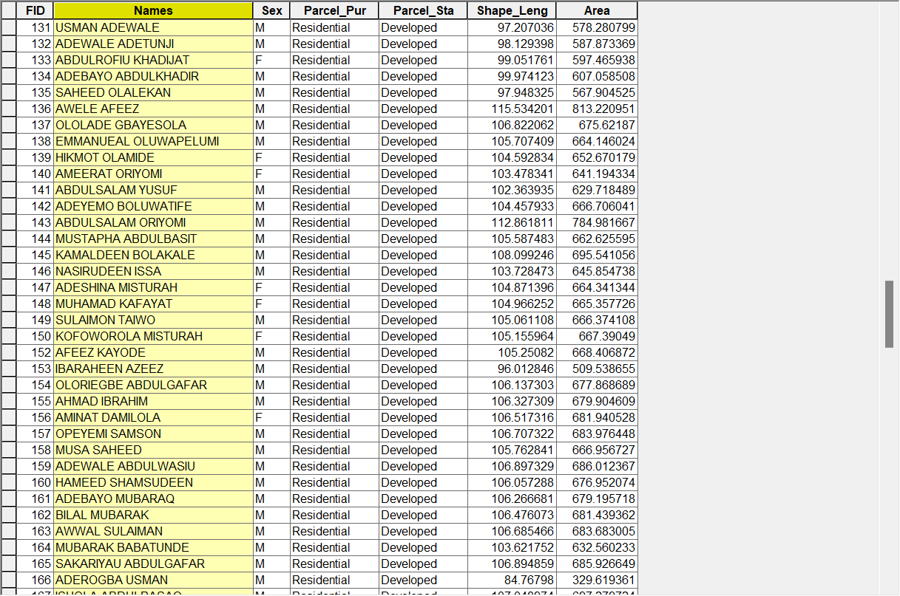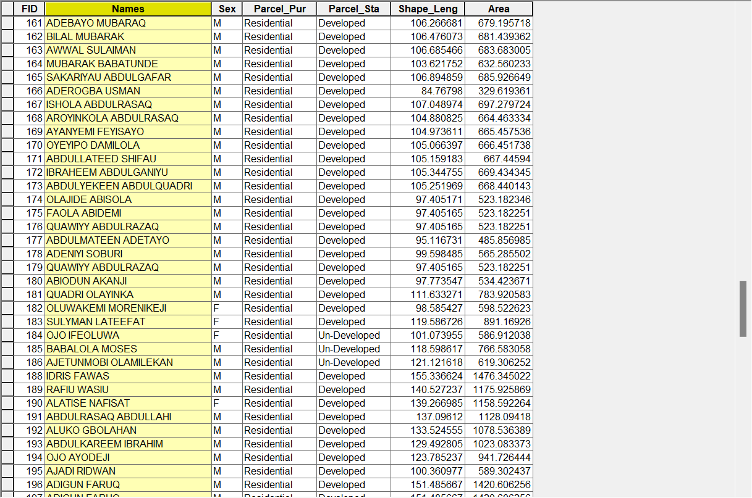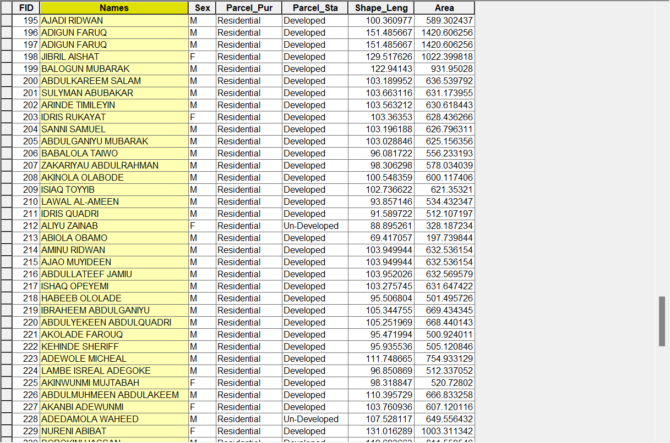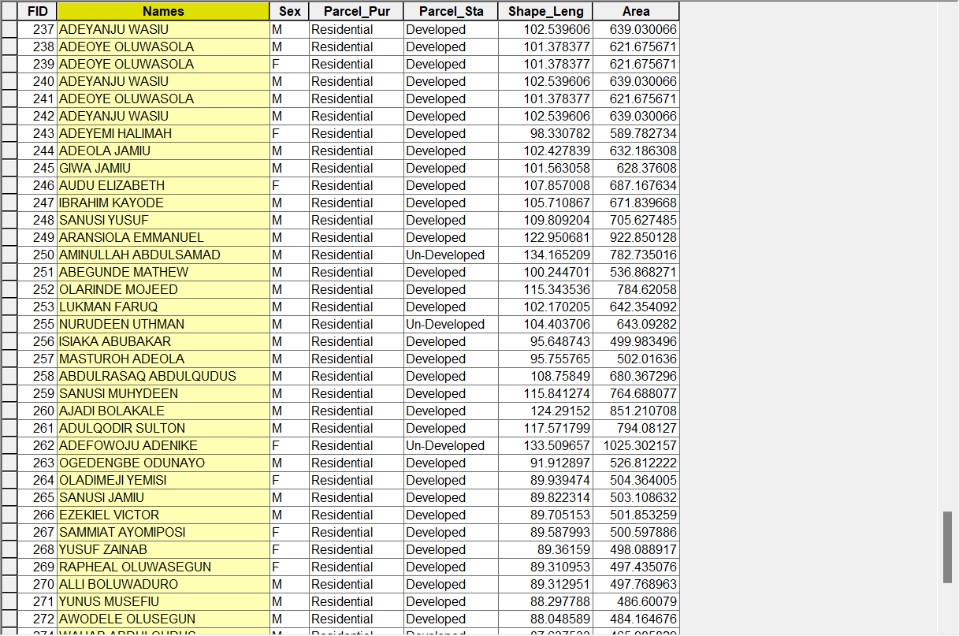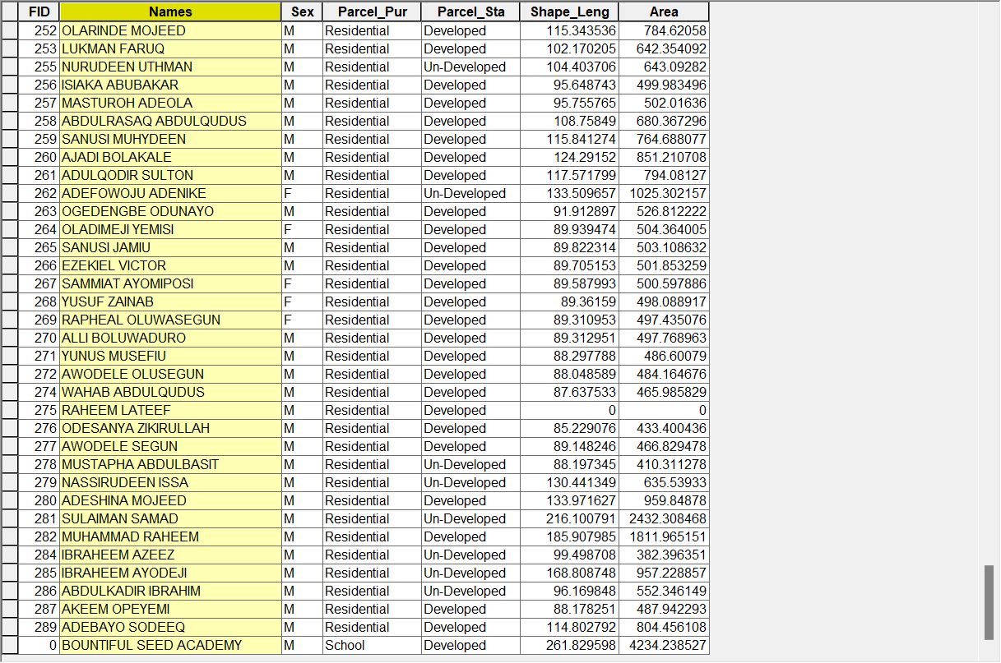

CHAPTER FIVE
SUMMARY, PROBLEM ENCOUNTERED, CONCULSION, RECOMMENDATIONS AND COST EFFECTIVE ANALYSIS.
5.1 SUMMARY
Control point KWC93P was set on and backsight to KWC91P and foresight to peg 1 and peg 2 then repeat the same procedure all through to acquire all the data and then the data was download at office using Ts-link and then using AutoCAD 2007, sufer 2008 and ArcGIS 10.2 to processing the data and creation of database
5.2 COSTING
The costing of this project was done using the Nigeria Institution of Surveyors (NIS) professional scale of fees for Consultant in the construction industry. The total area of the project is 4.779 hectares, the project component and their direct costs were as follows.
- RECONNAISANCE
PERSONAL/QUANTITY | UNIT RATE(₦) | DAY(S) | TOTAL AMOUNT(₦)
1 Senior Surveyor | 50,000 | 1 | 50,000
Assistant surveyor | 30,000 | 1 | 30,000
2 Skilled Labour | 15,000 | 1 | 15,000
Transportation | 33,000 | 1 | 33,000
Basic Equipment | 40,000 | 1 | 40,000
TOTAL |  |  | 168,000
Source: Author 2025.

- LINE CLEARING
PERSONAL/QUANTITY | UNIT RATE(₦) | DAY(S) | TOTAL AMOUNT(₦)
1 Assistant Surveyor | 75,000 | 5 | 375,000
1Assistant Surveyor | 40,000 | 5 | 200,000
6 Labour crew | 20,000 | 5 | 600,000
Transportation | 25,000 | 5 | 125,000
Basic Equipment (6) | 36,000 | 5 | 180,000
TOTAL |  |  | 1480000
Source: Author 2025.
- DEMARCATION
PERSONAL/QUANTITY | UNIT RATE(₦) | DAY(S) | TOTAL AMOUNT(₦)
24 Beacons | 48,000 | 4 | 192,000
1Assistant Surveyor | 40,000 | 4 | 160,000
6 Labour crew | 60,000 | 4 | 240,000
Transportation | 30,000 | 4 | 120,000
Basic Equipment | 25,000 | 4 | 100,000
TOTAL |  |  | 812,000
Source: Author 2025.

- TRAVERSING AND DETAILING
PERSONAL/QUANTITY | UNIT RATE(₦) | DAY(S) | TOTAL AMOUNT(₦)
1 Surveyor | 75,000 | 2 | 150,000
1 Assistant Surveyor | 40,000 | 2 | 80,000
4 Labour crew | 20,000 | 2 | 40,000
Transportation | 30,000 | 2 | 60,000
Basic Equipment | 25,000 | 2 | 50,000
TOTAL |  |  | 380,000
Source: Author 2025.

- DATA EDITING AND PROCCESING
PERSONAL/QUANTITY | UNIT RATE(₦) | DAY(S) | TOTAL AMOUNT(₦)
1 Surveyor | 50,000 | 2 | 100,000
1 Assistant Surveyor | 25,000 | 2 | 50,000
Standard set | 15,000 | 2 | 30,000
Computer Accessories | 10,000 | 2 | 20,000
TOTAL |  |  | 200,000
Source: Author 2025
- PLAN AND MAP PRODUCTION
PERSONAL/QUANTITY | UNIT RATE(₦) | DAY(S) | TOTAL AMOUNT(₦)
1 Surveyor | 50,000 | 1 | 50,000
1 Assistant surveyor | 20,000 | 1 | 20,000
Standard set | 10,000 | 2 | 20,000
Computer Accessories | 25,000 | 2 | 25,000
TOTAL |  |  | 115,000
Source: Author 2025.

PERSONAL/QUANTITY | UNIT RATE(₦) | DAY(S) | TOTAL AMOUNT(₦)
1 Surveyor | 40,000 | 1 | 40,000
2 Assistant Surveyor | 35,000 | 1 | 35,000
1 Secretary | 20,000 | 1 | 20,000
1 Computer | 15,000 | 1 | 15,000
Consumable | 10,000 | 1 | 10,000
TOTAL |  |  | 120,000
- TECHNICAL REPORT

Source: Author 2025.

- ACCOMODATION
PERSONAL/QUANTITY | UNIT RATE(₦) | DAY(S) | TOTAL AMOUNT(₦)
1 Surveyor | 10,000 | 10 | 100,000
1 Technical Officer | 10,000 | 10 | 100, 000
1 Assistant Technical Officer | 10, 000 | 10 | 100,000
6 labour crew | 10,000 | 10 | 100,000
TOTAL |  | 3 days X 400,000 | 1200,000
Source: Author 2025

- SUMMARY OF THE COST RATE
ITEM | PROJECT QUANTITY | UNIT RATE(₦)
1 | Reconnaissance | 168,000
2 | Land clearing | 1480000
3 | Demarcation | 812,000
4 | Traversing and detailing | 380,000
5 | Data Editing and processing | 200,000
6 | Plan and map production | 115,000
7 | Technical report | 120,000
8 | Accommodation | 1200,000
11 | VAT 5% | 2,23750
 | TOTAL | 4,475000

The total Estimated Cost of the project =4, 475000
(Four million four hundred seventh five thousand naira)
  - PROBLEM ENCOUNTER
- Due to rain season, it took us time to carry out our survey practical.
- Due to busy road, motor causing obstruction, it takes us two minute to observe a point.
5.4 RECOMMENDATION
I hereby recommend that this project serve monitoring of Topographical survey of Irewolede Estate, Ilorin and creation of relational database to known a kind of building that is there.
5.5 CONCLUSION
Despite all odds encountered during the process of the project we are able to overcome the entire problem. The aim of the project which is land information system in order to have a database for the information that existed in Irewolede Estate, Ilorin to allow easy access to information regarding to any land, buildings, such as lecture rooms, director office, offices, ict, roads, electric poles, e.t.c the challenges faced and the simple and complex approach apply will ever remain fresh in our memories.

REFERENCES
Adeniran, O.,(1999): Geographic information system; A lecture delivered at human resources development training of management staff of Federal School of Surveying Oyo November, 1999 p15
Adeoye, A.A.(1998): “Geographic/Land information system principle and application” Lagos, Nigeria. PP 8-11.
Baalman, John (1979): Outline of Law in Australia (4th edition by GA Flick), The Law Book Company Australia.
Babalola S.O. and Kardam M.S. (ATBU Journal of Environmental Technology, 4, (1), December,2014): Developing a cadastral information system for part of Fadama –Mada Area of Bauchi Metropolis for Sustainable Development. PP 105-108
Buragohain, D. R. (2002): Development of a Web-based Land Information System, LIS, Using Integrated Remote Sensing and GIS Technology for Guwahati city India. Abhinava ,PVT Ltd Guwahati Assam India. PP 21-26
Calkins H.W and Roger F. Tomlinson., (1977): Geographical Information Systems, on Geographical Data Sensing and Processing, Resource and Land investigation (RALI) program, Virginia 1977. P 3
Dale P.F and McLaughlin J.D. (1976): Land Information Management, Oxford University Press, New York. P 21
Demers, M.N., (2000): Fundamentals of Geographic Information System, 2nd edition, John Wiley & sons, New York, Pp 7-9.
FIG (1995): Statement on the Cadaastre, Internation Federation of Surveying(FIG) Bureau, Canberra, Australia
Hallmann, F (1994): Legal Aspects of Boundary Surveying in New South wales, (2nd edition by FK Ticehurst), The Institution of Surveyors Australia Inc New South Wales Division Sydney Australia.
Kufoniyi, O.(1998): Basic concept in Geographic Information System (GIS) in Ezeigbo, C.U. (ed): principle and Application of Geographic Information System. Department of surveying, University of Lagos, Akoka, PP 1-15
Oyinloye, R.O., (2002): Topographic Database Management System for National Development. A paper delivered/workshop of NIS at Owerri, Imo State, Nigeria, 7th – 10th May 2002,Pp1-2
Raghavendran, S. (2002): Cadastral Mapping and Land Information System. GIS, Pixel infortekPvt.ltd.www.GIS development.net.com
Shuiabu, U. (2008): Cadastral Land Information System for Sustainable Land Conveyance in Bauchi State. M.tech Project Department of Surveying and Geoinformatics.FederalUniversity of Technology, Yola.
Tella, F. and Rably, P. (2002): An ILS White paper on Integrated Registry and CadastralSystem.International Land System inc.
USGS (1997): Geography Information System an information brochure published by the United State Greographical Survey, Reston, VA (http://Info.er. usgs.gov/research/gis/title.html).
Webster’s (1913): Online Dictionary (web viewed on 3rd February, 2016)

APPENDIX
NORTHING EASTING NORTHING EASTING
935609.976 | 671158.208 | 935610.110 | 671030.195
935685.660 | 671212.601 | 935588.956 | 671026.735
935622.014 | 671387.359 | 935546.647 | 671019.817
935629.861 | 671365.636 | 935567.802 | 671023.276
935637.708 | 671343.913 | 935664.242 | 671076.822
935645.555 | 671322.190 | 935645.404 | 671074.784
935653.402 | 671300.467 | 935624.237 | 671071.395
935661.249 | 671278.745 | 935603.069 | 671068.005
935669.097 | 671257.022 | 935581.902 | 671064.616
935676.944 | 671235.299 | 935539.915 | 671057.753
935716.912 | 671249.292 | 935560.735 | 671061.227
935709.268 | 671271.086 | 935639.619 | 671105.861
935701.623 | 671292.881 | 935618.433 | 671102.569
935693.979 | 671314.675 | 935597.248 | 671099.278
935686.334 | 671336.469 | 935576.062 | 671095.987
935678.690 | 671358.263 | 935534.572 | 671089.394
935671.046 | 671380.057 | 935554.877 | 671092.696
935725.350 | 671227.181 | 935655.785 | 671106.863
935240.915 | 671022.720 | 935679.816 | 671010.043
935249.541 | 671041.425 | 935658.092 | 671006.633
935258.168 | 671060.131 | 935636.946 | 671003.128
935266.794 | 671078.837 | 935615.800 | 670999.623
935275.421 | 671097.543 | 935594.655 | 670996.117
935284.048 | 671116.249 | 935552.364 | 670989.106
935292.674 | 671134.955 | 935573.509 | 670992.612
935301.301 | 671153.660 | 935524.068 | 671205.203
935309.927 | 671172.366 | 935515.221 | 671235.964
935318.554 | 671191.072 | 935519.645 | 671220.583
935327.180 | 671209.777 | 935510.884 | 671250.773
935336.027 | 671228.624 | 935504.090 | 671283.194
935269.006 | 671010.266 | 935506.546 | 671265.582
935277.890 | 671028.849 | 935529.850 | 671189.894
935286.775 | 671047.415 | 935557.110 | 671337.973
935295.653 | 671065.988 | 935547.745 | 671361.057
935304.533 | 671084.563 | 935528.420 | 671327.953
935313.039 | 671103.241 | 935522.537 | 671351.230
935321.370 | 671122.060 | 935498.124 | 671202.080
935329.702 | 671140.880 | 935472.693 | 671203.593
935338.033 | 671159.699 | 935231.108 | 670754.994
935346.365 | 671178.518 | 935285.608 | 670781.967
935354.696 | 671197.337 | 935257.017 | 670793.476
935363.530 | 671216.911 | 935231.699 | 670804.245
935596.725 | 671224.596 | 935206.333 | 670814.776
935563.069 | 671214.309 | 935180.802 | 670825.001
935584.247 | 671260.588 | 935155.206 | 670835.135
935552.140 | 671250.658 | 935129.538 | 670844.802
935575.974 | 671284.398 | 935107.378 | 670852.546
935544.888 | 671274.792 | 935167.868 | 670786.896
935538.411 | 671297.333 | 935167.868 | 670786.896
935568.137 | 671307.769 | 935140.042 | 670801.171
935433.953 | 671370.158 | 935115.530 | 670813.691
935405.605 | 671382.624 | 935093.982 | 670824.527
935414.568 | 671402.715 | 935502.026 | 671084.189
935443.362 | 671390.053 | 935499.132 | 671103.593
935452.770 | 671409.947 | 935496.224 | 671123.004
935423.531 | 671422.806 | 935493.321 | 671142.406
935462.179 | 671429.842 | 935490.418 | 671161.809
935432.518 | 671442.880 | 935463.704 | 671136.585
935471.388 | 671449.462 | 935466.019 | 671117.070
935441.629 | 671462.734 | 935468.337 | 671097.552
935451.108 | 671483.132 | 935470.649 | 671078.036
935476.286 | 671467.271 | 935461.388 | 671156.099
935468.597 | 671353.972 | 935459.070 | 671175.602
935478.261 | 671373.662 | 935483.156 | 671177.142
935487.975 | 671393.422 | 935453.430 | 671189.700
935497.690 | 671413.182 | 935427.021 | 671129.515
935504.834 | 671432.220 | 935428.791 | 671109.892
935719.739 | 671329.150 | 935430.561 | 671090.268
935704.331 | 671369.279 | 935432.350 | 671070.662
935762.962 | 671371.238 | 935514.752 | 671006.514
935770.229 | 671352.385 | 935503.179 | 670980.879
935776.532 | 671334.275 | 935524.324 | 670984.384
935747.563 | 671333.903 | 935511.905 | 671021.844
935736.698 | 671363.979 | 935509.146 | 671037.212
935358.509 | 671292.218 | 935506.012 | 671056.247
935345.200 | 671261.646 | 935482.715 | 671001.291
935376.305 | 671285.023 | 935479.456 | 671016.515
935363.475 | 671254.509 | 935406.672 | 671077.743
935394.616 | 671277.589 | 935388.609 | 671077.778
935381.896 | 671247.186 | 935304.276 | 671001.256
935412.976 | 671270.160 | 935132.843 | 670881.560
935400.358 | 671239.962 | 935143.924 | 670901.723
935431.389 | 671262.824 | 935199.080 | 670944.115
935418.907 | 671232.943 | 935217.901 | 670935.258
935374.037 | 671327.634 | 935325.946 | 670882.117
935391.311 | 671320.459 | 935287.781 | 670900.075
935409.422 | 671312.917 | 935306.864 | 670891.097
935427.707 | 671305.270 | 935249.617 | 670918.034
935445.993 | 671297.622 | 935268.699 | 670909.055
935386.102 | 671355.184 | 935305.492 | 670850.972
935402.922 | 671348.018 | 935267.327 | 670868.931
935420.838 | 671340.270 | 935286.409 | 670859.952
935439.009 | 671332.411 | 935229.162 | 670886.889
935457.067 | 671324.282 | 935248.245 | 670877.910
935781.749 | 671308.542 | 935293.188 | 670824.574
935787.881 | 671290.829 | 935254.605 | 670841.591
935793.688 | 671273.367 | 935273.888 | 670833.084
935799.496 | 671255.905 | 935215.952 | 670858.275
935805.767 | 671239.660 | 935235.332 | 670850.059
935755.833 | 671291.382 | 935196.705 | 670865.611
935735.338 | 671285.147 | 935174.652 | 670873.956
935705.906 | 671056.621 | 935203.130 | 670893.197
935759.977 | 671246.836 | 935476.149 | 671031.692
935635.714 | 671245.297 | 935472.246 | 671050.137
935627.491 | 671266.888 | 935482.431 | 670977.757
935619.441 | 671288.540 | 935313.233 | 670816.342
935611.305 | 671310.162 | 935443.675 | 670992.243
935603.168 | 671331.783 | 935439.993 | 671009.974
935594.978 | 671353.413 | 935436.238 | 671025.075
935585.241 | 671374.680 | 935431.771 | 671042.892
935574.896 | 671395.501 | 935376.631 | 670980.972
935643.850 | 671223.675 | 935357.973 | 670989.395
935651.986 | 671202.055 | 935397.772 | 670970.938
935660.122 | 671180.433 | 935394.162 | 671041.033
935668.259 | 671158.812 | 935687.989 | 670976.739
935676.332 | 671137.182 | 935666.376 | 670973.276
935684.392 | 671115.525 | 935645.229 | 670969.777
935692.489 | 671093.889 | 935624.082 | 670966.277
935699.732 | 671074.318 | 935602.936 | 670962.778
935560.442 | 671424.725 | 935560.723 | 670955.792
935379.334 | 670934.082 | 935581.827 | 670959.299
935358.770 | 670942.090 | 935539.550 | 670952.250
935339.340 | 670949.618 | 935518.387 | 670948.846
935319.912 | 670957.145 | 935497.160 | 670945.233
935300.484 | 670964.672 | 935476.333 | 670940.522
935282.407 | 670967.180 | 935435.900 | 670925.461
935242.796 | 670988.892 | 935417.749 | 670916.522
935223.786 | 670997.339 | 935400.550 | 670906.629
935212.953 | 670973.883 | 935384.335 | 670893.462
935231.870 | 670965.236 | 935409.826 | 670937.803
935269.705 | 670947.943 | 935454.280 | 670960.722
935288.622 | 670939.296 | 935401.806 | 671004.824
935307.540 | 670930.650 | 935544.173 | 671162.659
935326.457 | 670922.003 | 935551.179 | 671132.073
935345.374 | 670913.356 | 935659.225 | 671395.568
935363.828 | 670905.558 | 935604.088 | 671414.051
935350.086 | 671086.877 | 935430.315 | 670949.641
935358.537 | 671107.690 | 935455.752 | 670933.596
935366.356 | 671126.728 | 935350.755 | 670871.399
 |  | 935327.572 | 670841.425

