STATISTICAL ANALYSIS OF STUDENT
PERFORMANCE IN ND PROGRAMMES
(STATISTICS DEPARTMENT)
` (A CASE STUDY OF KWARA STATE POLYTECHNIC STATISTICS
DEPARTMENT)
BY
ABDULLAHI QUDADRI ABIODUN
ND/23/STA/FT/0024

BEING A RESEARCH WORK SUBMITTED TO THE
DEPARTMENT OF STATISTICS, INSTITUTE OF APPLIED SCIENCES, KWARA STATE POLYTECHNIC, ILORIN.

IN PARTIAL FULFILMENT OF THE REQUIREMENT FOR THE
AWARD OF NATIONAL DIPLOMA (ND) IN STATISTICS
JUNE, 2025

CERTIFICATION
I certify that this project was carried out by ABDULLAHI QUDADRI ABIODUN with matriculation number ND/23/STA/PT/0024 as meeting the requirement for the award of National Diploma in the Department of statistics, Kwara state polytechnic, Ilorin.

…………………………………… ………………………………
MR. SALAMI, O.O Signature & Date
Supervisor’s Name

…………………………………… ………………………………
MRS. ELEPO, T.A Signature & Date
Head of Department

…………………………………… ………………………………
External Examiner Signature & Date

DEDICATION
I dedicate this work to my beloved family, whose unwavering support and encouragement have been my greatest source of strength. To my parents [Mr &Mrs Abdullahi], for their sacrifices and belief in me, and to my friends and mentors who have inspired me throughout this journey. This project is a testament to your love and faith in me.

ACKNOWLEDGMENT
I would like to express my deepest gratitude to all those who have contributed to the successful completion of this project. Special thanks go to my supervisor, [Mr salami], for their invaluable guidance, patience, and support. I am also grateful to my lecturers and classmates for their insightful advice and encouragement.
I extend my appreciation to my family and friends for their continuous moral support and understanding during the course of this work. Finally, I acknowledge all individuals and institutions that provided resources and assistance that made this project possible.

ABSTRACT
This study aims to statistically analyse student performance in ND programs within the Statistics Department, focusing on total scores and CGPA across different academic sessions and levels. The primary objectives include assessing whether there are significant differences in total scores between ND1 and ND2 students across three academic sessions (2019/2020, 2020/2021 , and 2021/2022), examining differences in total scores across four semesters within these sessions, and analysing the relationship between total scores and CGPA. The chi-square test results reveal no significant differences in total scores between ND1 and ND2 students across the three sessions, nor among the total scores across the four semesters within these sessions, indicating consistent academic performance over time. Regression analysis indicates a strong, statistically significant positive relationship between students’ total scores and their CGPA, with total scores being a robust predictor of CGPA. The regression model demonstrates that as total scores increase, CGPA also increases, highlighting the importance of total scores in predicting academic success. These findings suggest that student performance, as measured by total scores and CGPA, remains stable across different sessions and levels, providing valuable insights for educators and policy makers in maintaining and improving academic standards in the ND programs.
Key Words: Student Performance, ND Programs, Chi-square Test, Regression Analysis, Total
Scores

Contents
Title page |  |  |  | 1
Certification |  |  |  | 1
Dedication |  |  |  | 2
Acknowledgment |  |  |  | 3
Abstract |  |  |  | 4
Contents |  |  |  | 5
List of Tables |  |  |  | 6
1 General Introduction |  |  |  | 1
1.1 Aim and Objectives of the Study |  | . . . . . . . . . . . . . . . . . . . . . . . . . . |  | 2
1.2 Significance of the study . . . . . . . . . . . . . . . . . . . . . . . . . . . . . . . |  |  |  | 3
1.3 Scope of the Study . . . . . . . . . . . . . . . . . . . . . . . . . . . . . . . . . . |  |  |  | 3
1.4 Limitations of the Study . . . . . . . . . . . . . . . . . . . . . . . . . . . . . . . |  |  |  | 4
2 Literature Review |  |  |  | 5
2.1 Introduction . . . . . . . . . . . . . . . . . . . . . . . . . . . . . . . . . . . . . . |  |  |  | 5
2.2 Examination of Previous Studies on the Performance Evaluation of ND Programmes |  |  |  | 5
2.3 Review of Statistical Methods and Techniques in Educational Data Analysis . . |  |  |  | 6
3 | Research Methodology |  | 9
 | 3.1 Introduction . . . . . . . . . . . . . . . . . . . . . . . . . . . . . . . . . . . . . . |  | 9
 | 3.2 Chi-Square Test Methodology . . . . . . . . . . . . . . . . . . . . . . . . . . . . |  | 9
 | 3.3 Linear Regression Analysis . . . . . . . . . . . . . . . . . . . . . . . . . . . . . . |  | 11
4 | Data Analysis and Discussion of Results |  | 14
 | 4.1 Introduction . . . . . . . . . . . . . . . . . . . . . . . . . . . . . . . . . . . . . . |  | 14
 | 4.2 Data Source and Summary . . . . . . . . . . . . . . . . . . . . . . . . . . . . . . |  | 14
 | 4.3 Application Chi-square test on the students’ performance in ND programme . . |  | 15
 | 4.3.1 Observed and Expected Frequency Table . . . . . . . . . . . . . . . . . . |  | 15
 | 4.4 Data Analysis . . . . . . . . . . . . . . . . . . . . . . . . . . . . . . . . . . . . . |  | 17
 | 4.4.1 Observed and Expected Frequencies . . . . . . . . . . . . . . . . . . . . . |  | 17
 | 4.5 Regression Analysis of Students’ Scores and CGPA . . . . . . . . . . . . . . . . |  | 21
 | 4.5.1 Regression Summary . . . . . . . . . . . . . . . . . . . . . . . . . . . . . |  | 21
5 | Summary of Research Findings, Conclusions and Future Directions |  | 25
 | 5.1 Introduction . . . . . . . . . . . . . . . . . . . . . . . . . . . . . . . . . . . . . . |  | 25
 | 5.2 Summary of the results . . . . . . . . . . . . . . . . . . . . . . . . . . . . . . . . |  | 25
 | 5.3 Conclusion . . . . . . . . . . . . . . . . . . . . . . . . . . . . . . . . . . . . . . . |  | 26
 | 5.4 Future Directions of This Study . . . . . . . . . . . . . . . . . . . . . . . . . . . |  | 26
References |  |  | 28

CHAPTER 1
General Introduction
Statistical analysis plays a crucial role in evaluating the effectiveness and performance of ND programs within a statistics department. By utilizing various statistical techniques, researchers can gain valuable insights into the characteristics, outcomes, and factors that influence the success of these programs. This introduction provides an overview of the importance of statistical analysis in assessing ND programs within a statistics department and outlines some potential research questions that can be explored through statistical analysis.
ND programs within a statistics department are designed to provide students with the necessary knowledge and skills to succeed in various roles related to data analysis, research, and decision making. However, it is essential to assess the performance and impact of these programs to ensure they are meeting their objectives and preparing students for success in their careers.
Statistical analysis allows researchers to examine key aspects of ND programs, such as student demographics, enrolment trends, academic performance, program completion rates, and employment outcomes. By analyzing these data using statistical techniques, researchers can identify patterns, trends, and relationships that can inform decisions on program improvements, resource allocation, and overall effectiveness.
Some potential research questions that can be explored through statistical analysis of ND programs in a statistics department include:
- What are the characteristics of students enrolled in the ND programs, such as age, gender, academic background, and work experience?
- Is there a relationship between student demographics and academic performance, such as GPA and completion rates?
- How do program completion rates differ across different ND programs within the department?
- Are there factors that predict or influence the likelihood of students completing the ND programs successfully?
- What are the employment outcomes for graduates of the ND programs, such as job placement rates, starting salaries, and job titles?
By analysing these data using statistical techniques, researchers can identify patterns, trends, and relationships that can inform decisions on program improvements, resource allocation, and overall effectiveness.

1.1 Aim and Objectives of the Study
The primary aim of this study is to investigate the variations and relationships in students’ academic performance across different levels and sessions, specifically focusing on the total scores and CGPA of students in ND1 and ND2 over the academic sessions of 2019/2020, 2020/2021 , and 2021/2022 with the following specific objectives:
- to determine whether there is a significant difference in the total scores of students in ND1 and ND2 across the three sessions (2019/2020, 2020/2021, and 2021/2022) ,
- to assess whether there is a significant difference in the total scores of students across four semesters within the three sessions, and
- to analyse the relationship between students’ total scores and their CGPA over the three sessions (2019/2020, 2020/2021, and 2021/2022).

1.2 Significance of the study
- Decision Making: Statistics plays a crucial role in decision-making processes in various fields. Students studying statistics at Kwara State Polytechnic learn how to analyze data and make informed decisions based on statistical evidence.
- Research Skills: The study of statistics equips students with the necessary research skills to design experiments, collect data, and analyse results. These skills are valuable in both academic and professional settings.
- Problem Solving: Statistics helps students develop critical thinking and problem-solving skills. By applying statistical methods to real-world problems, students at Kwara State Polytechnic learn how to identify patterns, trends, and relationships in data.
- Data Analysis: In today’s data-driven world, the ability to analyze and interpret data is highly sought after. Students studying statistics at Kwara State Polytechnic learn how to use statistical software and techniques to analyze data and draw meaningful conclusions.
- Career Opportunities: A degree in statistics opens up a wide range of career opportunities in fields such as finance, healthcare, marketing, and government. Students at Kwara State Polytechnic who study statistics are well-prepared to pursue successful careers in these industries.

1.3 Scope of the Study
This study focuses on the academic performance of students in the National Diploma ( ND ) programs within the Statistics Department. The analysis encompasses two key academic levels, ND1 and ND2, and spans across three academic sessions. By examining the total scores of students and their cumulative grade point average (CGPA), the study aims to identify patterns, differences, and relationships that can provide insights into student performance and educational outcomes. The findings will contribute to a better understanding of academic trends and help inform strategies for improving student achievement in the ND programs.

1.4 Limitations of the Study
The following are the limitations of this study:
- Availability of data: The project may be limited by the availability of relevant and accurate data on the performance of the ND programs.
- Time constraints: The project may be limited by time constraints, as conducting a comprehensive statistical analysis may require time and resources.
- External factors: The performance of the ND programs may be influenced by external factors such as economic conditions, government policies, and industry trends, which may not be fully accounted for in the analysis.
- Sample size: The project may be limited by the size of the sample, which may affect the
generalizability of the findings.
- Bias: The analysis may be biased by the researcher’s assumptions, perspectives, and interpretations of the data.

CHAPTER 2
Literature Review

2.1 Introduction
This section contains the examination of previous studies on the performance evaluation of ND programs and the review of statistical methods and techniques in educational data analysis

2.2 Examination of Previous Studies on the Performance Evaluation of ND Programs
- Study by Adeyemi et al. (2018): Adeyemi and colleagues conducted a study on the performance evaluation of National Diploma (ND) programs in a Nigerian polytechnic. The study focused on factors influencing the academic performance of ND students, such as study habits, attendance, and socio-economic background.
- Research by Ogunleye and Adebayo (2016): Ogunleye and Adebayo examined the performance evaluation of ND programs in the context of curriculum design and delivery. The study explored the effectiveness of the curriculum in preparing students for the workforce and identified areas for improvement.
- Analysis by Oladele and Ojo (2019): Oladele and Ojo conducted a comparative study of the performance evaluation of ND programs in different polytechnics. The study compared the academic performance of ND students across institutions and identified factors contributing to variations in performance.
- Investigation by Ibrahim and Yusuf (2017): Ibrahim and Yusuf conducted a study on the performance evaluation of ND programmes in relation to student satisfaction and retention. The study explored the relationship between student satisfaction with the programme and their academic performance and retention rates.
- Review by Afolabi and Adekunle (2020): Afolabi and Adekunle conducted a literature review on the performance evaluation of ND programmes, summarizing key findings from previous studies and identifying gaps in the existing literature. The review highlighted the importance of continuous assessment and feedback in improving the performance of ND students.
Overall, previous studies on the performance evaluation of ND programs have provided valuable insights into factors influencing academic performance, curriculum effectiveness, student satisfaction, and retention rates. These studies have contributed to the ongoing efforts to enhance the quality of ND programs and improve student outcomes in polytechnics.

2.3 Review of Statistical Methods and Techniques in Educational Data Analysis
Statistical methods are fundamental tools in educational data analysis, providing essential insights into student performance, instructional effectiveness, and educational outcomes. This review discusses the key statistical techniques commonly employed in analyzing educational data, focusing on chi-square tests and regression analysis, among others.

Chi-square Test
The chi-square test is a non-parametric statistical method used to determine if there is a significant association between categorical variables. In educational research, it is often used to analyze student performance across different groups or conditions. For example, a study might use a chi-square test to assess whether there is a significant difference in the total scores of students across different academic levels or sessions. The chi-square test compares the observed frequencies of scores with the expected frequencies if there were no association between the variables (McHugh, 2013). This method is advantageous because it does not assume a normal distribution of the data and can be applied to large sample sizes.

Regression Analysis
Regression analysis is a powerful statistical technique used to model and analyse the relationships between variables. In the context of educational data, regression analysis helps in understanding how different factors, such as total scores, influence student outcomes like CGPA. Linear regression, for instance, can be used to predict CGPA based on total scores, revealing a positive linear relationship between these variables. The regression model provides estimates of the strength and direction of the relationship, quantified by the slope coefficient and the R-squared value, which indicates the proportion of variance in the dependent variable explained by the independent variable(s) (Kutner et al., 2004a).
In a study analyzing student performance in ND programs, regression analysis might reveal that as total scores increase, CGPA also tends to increase, with the total score being a strong predictor of CGPA. Such findings underscore the importance of total scores in predicting academic performance and help educators identify key areas for intervention and support.

Other Statistical Techniques
In addition to chi-square tests and regression analysis, other statistical methods are also widely used in educational research:
ANOVA (Analysis of Variance): ANOVA is used to compare the means of three or
More groups to determine if there are any statistically significant differences among them. This technique is useful in evaluating the effectiveness of different teaching methods or educational programs (Field, 2013).
T-tests: T-tests compare the means of two groups and are often used to assess differences in student performance before and after an intervention or between two different instructional methods (Cohen, 1988).
Factor Analysis: This technique is used to identify underlying factors or constructs that explain the pattern of correlations within a set of observed variables. It is particularly useful in developing and validating educational assessments and surveys (Thompson, 2004).
Cluster Analysis: Cluster analysis groups students based on their performance or characteristics, helping to identify patterns and subgroups within the student population. This can inform targeted interventions and personalized learning strategies (Everitt et al., 2011).
Statistical methods are indispensable in educational data analysis, providing robust tools to evaluate and improve student performance and educational outcomes. Chi-square tests and regression analysis are particularly valuable for assessing associations between variables and modelling predictive relationships. By applying these techniques, educators and researchers can gain deeper insights into the factors influencing student success and develop evidence-based strategies to enhance learning experiences.
CHAPTER 3
Research Methodology

3.1 Introduction
This section discussed in details the methodology used in this study.

3.2 Chi-Square Test Methodology
The chi-square test is a statistical method used to determine if there is a significant association between two categorical variables. The subsequent subsection outlines the steps involved in performing a chi-square test.

State the Hypotheses
Null Hypothesis (H₀): There is no association between the two categorical variables (McHugh, 2013).
Alternative Hypothesis (H_{a}): There is an association between the two categorical variables (McHugh, 2013).

Create a Contingency Table
Arrange the data in a contingency table, where the rows represent the categories of one variable and the columns represent the categories of the other variable. Each cell in the table represents the frequency of occurrences for the corresponding pair of categories (Agresti and Finlay, 2018).
 | Category 1 | Category 2 | Total
Group 1 | O₁₁ | O₁₂ | Row Total 1
Group 2 | O₂₁ | O₂₂ | Row Total 2
Total | Column Total 1 | Column Total 2 | Grand Total
Table 3.1: Contingency Table

Calculate the Expected Frequencies
The expected frequency for each cell in the contingency table is calculated using the formula:
(Row Total _{i} × Column Total_{j})
E_{ij} =

Grand Total
(Agresti and Finlay, 2018).

Compute the Chi-Square Statistic
The chi-square statistic is calculated using the formula:
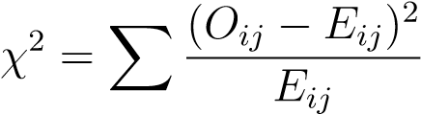
where O_{ij} represents the observed frequency for the i-th row and j-th column, and E_{ij} represents the expected frequency for the i-th row and j-th column (McHugh, 2013).

Determine the Degrees of Freedom
The degrees of freedom for the chi-square test is calculated using the formula:
Degrees of Freedom = (r − 1) × (c − 1)
where r is the number of rows and c is the number of columns in the contingency table ( Agresti and Finlay, 2018).

Find the Critical Value and P-Value
Using the chi-square distribution table, find the critical value corresponding to the calculated degrees of freedom and the desired significance level (e.g., α = 0.05). Alternatively, use statistical software to compute the p-value (McHugh, 2013).

Compare the Chi-Square Statistic to the Critical Value
If χ² is greater than the critical value, reject the null hypothesis H₀ (Agresti and Finlay, 2018).
If χ² is less than or equal to the critical value, fail to reject the null hypothesis H₀ ( Agresti and Finlay, 2018).

Interpret the Results
Based on the comparison in Step 7, draw a conclusion about the association between the two categorical variables. If the null hypothesis is rejected, it indicates that there is a significant association between the variables. If the null hypothesis is not rejected, it indicates that there is no significant association between the variables (McHugh, 2013).

3.3 Linear Regression Analysis
Linear regression is a statistical technique used to model the relationship between a dependent variable and one or more independent variables. This methodology outlines the steps involved in performing a linear regression analysis.

Step 1: State the Hypotheses
Null Hypothesis (H₀): The independent variable(s) have no significant effect on the dependent variable (Montgomery et al., 2012).
Alternative Hypothesis (H_{a}): The independent variable(s) have a significant effect on the dependent variable (Montgomery et al., 2012).

Step 2: Specify the Model
The linear regression model is specified as:
Y = β₀ + β₁X (3.1)
where:
Y is the dependent variable, X is the independent variable, β₀ is the intercept, β₁ is the slope coefficient for Y (Kutner et al., 2004b).

Step 3: Estimate the Parameters
The parameters β₀ and β₁ are estimated using the method of least squares, which minimizes the sum of the squared differences between the observed and predicted values of the dependent variable (Kutner et al., 2004b).

Step 4: Evaluate the Model
Residuals: The residuals are the differences between the observed and predicted values of the dependent variable. They should be approximately normally distributed with a mean of zero (Montgomery et al., 2012).
Coefficient of Determination (R-squared): This statistic indicates the proportion of the variance in the dependent variable that is explained by the independent variable(s). Higher values indicate a better fit (Kutner et al., 2004b).
F-statistic: This statistic tests the overall significance of the model. A high F-statistic and low p-value indicate that the model is significant (Montgomery et al., 2012).

Step 5: Interpret the Coefficients
Intercept (β₀): Represents the predicted value of the dependent variable when all independent variables are zero. It indicates the starting point of the regression line ( Kutner et al., 2004b).
Slope (β₁): Indicates the change in the dependent variable for a one-unit change in the independent variable. It represents the strength and direction of the relationship between the variables (Montgomery et al., 2012).
CHAPTER 4
Data Analysis and Discussion of
Results

4.1 Introduction
This section contains the application of Chi-square test and regression analysis on the students’ performance in ND programs.

4.2 Data Source and Summary
The students’ performance for four semesters across ND1 and ND2 for different three sessions were obtained from the Department of Statistics, Kwara State Polytechnic Ilorin. The data are summarized in the table below:
Table 4.1: ND II DIPLOMA RESULTS 2019/2020, 2020/2021 & 2021/2022 SESSIONS
S/NO | NDI FT |  | NDII FT |  | TOTAL POINTS | CGPA
S/NO | 1st | 2nd | 1st | 2nd | TOTAL POINTS | CGPA
S/NO | 20 | 20 | 26 | 33 | 99 | CGPA
1 | 44.5 | 44 | 61 | 93.25 | 242.75 | 2.45
2 | 45.5 | 43.75 | 62.75 | 98.25 | 250.25 | 2.53
3 | 43.5 | 44.25 | 62 | 98.75 | 248.5 | 2.51
4 | 41.5 | 40.5 | 57 | 80.5 | 219.5 | 2.22
5 | 43.25 | 44.75 | 64.75 | 84 | 236.75 | 2.39
··· | ··· | ··· | ··· | ··· | ··· | ···
··· | ··· | ··· | ··· | ··· | ··· | ···
440 | 70 | 67.25 | 89 | 109 | 335.25 | 3.02
441 | 40.75 | 40.5 | 63.75 | 100 | 245 | 3.39
442 | 46.75 | 46.5 | 64.25 | 90.5 | 248 | 2.47
443 | 46.25 | 38 | 55.5 | 42.5 | 182.25 | 2.51

4.3 Application Chi-square test on the students’ performance in ND programme
To determine whether there is a significant difference in the total scores of students at ND1 and ND2 across three sessions, we perform a chi-square test.

4.3.1 Observed and Expected Frequency Table
Table 4.2: Observed and Expected Frequencies by Level and Session
Levels |  | Session |  | Row Totals
Levels | 2019/2020 | 2020/2021 | 2021/2022 | Row Totals
ND1 | 18023.25 (17858.53) | 13967.00 (14025.88) | 13967.00 (14025.88) | 45957.25
ND2 | 26862.50 (27027.22) | 21297.50 (21238.62) | 21297.50 (21238.62) | 69457.50
Column Totals | 44885.75 | 35264.50 | 35264.50 | 115414.75
Chi-Square Statistic Calculation
The chi-square statistic is calculated using the formula:
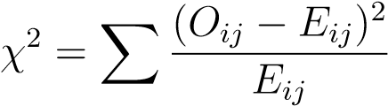
where O_{ij} are the observed frequencies and E_{ij} are the expected frequencies.
Calculations for each term:
- For ND1, 2019/2020:
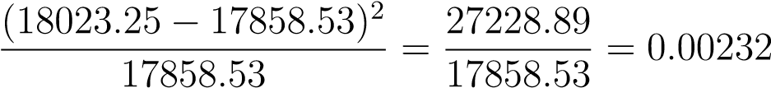
- For ND1, 2020/2021:
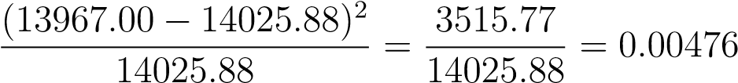
- For ND1, 2021/2022:
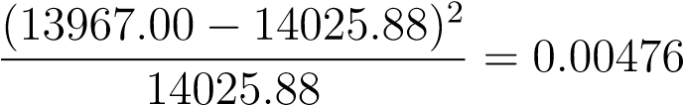
- For ND2, 2019/2020:
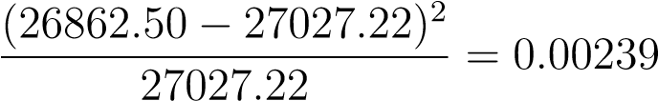
- For ND2, 2020/2021:
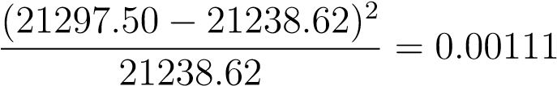
- For ND2, 2021/2022:
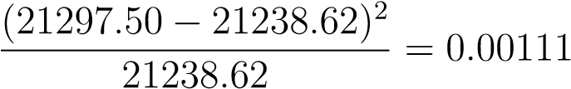
Summing these terms gives the chi-square statistic:
χ² = 0.00232 + 0.00476 + 0.00476 + 0.00239 + 0.00111 + 0.00111 = 0.01645
Degrees of Freedom
The degrees of freedom for a contingency table is calculated as:
df = (r − 1) × (c − 1)
where r is the number of rows and c is the number of columns. Here, r = 2 and c = 3, so:
df = (2 − 1) × (3 − 1) = 2
Critical Value
Using a chi-square distribution table, the critical value for α = 0.05 and df = 2 is approximately
5.99.
Since our calculated χ² value (0.01645) is much less than the critical value (5.99), we fail to reject the null hypothesis.

4.4 Data Analysis
The total scores of students across four semesters (1st, 2nd, 3rd, 4th) for three sessions (2019/2020 , 2020/2021, 2021/2022) are presented in the table below:
Semester | 2019/2020 | 2020/2021 | 2021/2022
1st | 9016.25 | 6936.25 | 6936.25
2nd | 9007.00 | 7030.75 | 7030.75
3rd | 11030.75 | 8928.25 | 8928.25
4th | 15831.75 | 12369.25 | 12369.25
To determine whether there is a significant difference in the total scores of students across four semesters for three sessions, we perform a chi-square test.

4.4.1 Observed and Expected Frequencies
The expected frequencies are shown in brackets next to the observed frequencies.
Semester | 2019/2020 | 2020/2021 | 2021/2022 | Row Totals
1st | 9016.25 (8900.09) | 6936.25 (6989.33) | 6936.25 (6989.33) | 22888.75
2nd | 9007.00 (8966.37) | 7030.75 (7041.06) | 7030.75 (7041.06) | 23068.50
3rd | 11030.75 (11222.69) | 8928.25 (8817.28) | 8928.25 (8817.28) | 28887.25
4th | 15831.75 (15796.60) | 12369.25 (12416.83) | 12369.25 (12416.83) | 40570.25
Column Totals | 44885.75 | 35264.50 | 35264.50 | 115414.75

Chi-Square Statistic Calculation
The chi-square statistic is calculated using the formula:
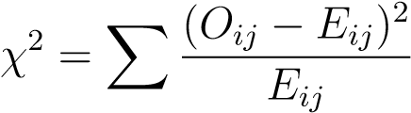
where O_{ij} are the observed frequencies and E_{ij} are the expected frequencies.
Calculations for each term:
- For 1st Semester, 2019/2020:
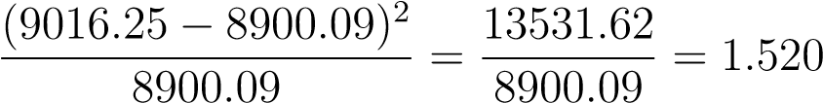
- For 1st Semester, 2020/2021:
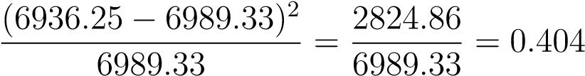
- For 1st Semester, 2021/2022:
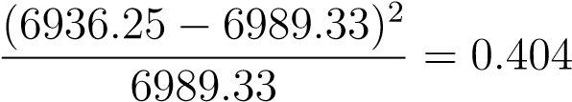
- For 2nd Semester, 2019/2020:
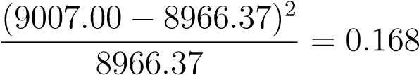
- For 2nd Semester, 2020/2021:
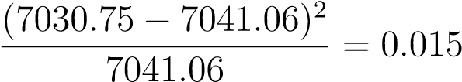
- For 2nd Semester, 2021/2022:
- For 3rd Semester, 2019/2020:
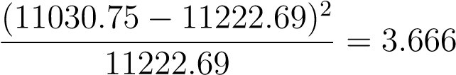
- For 3rd Semester, 2020/2021:
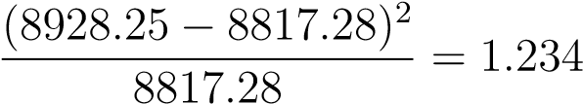
- For 3rd Semester, 2021/2022:
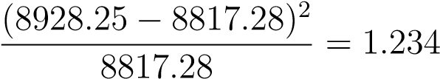
- For 4th Semester, 2019/2020:
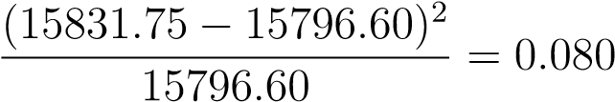
- For 4th Semester, 2020/2021:
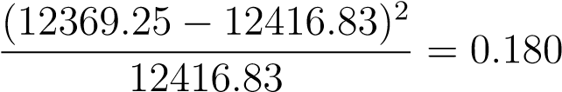
- For 4th Semester, 2021/2022:
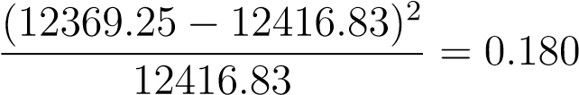
Summing these terms gives the chi-square statistic:
χ² = 1.520+0.404+0.404+0.168+0.015+0.015+3.666+1.234+1.234+0.080+0.180+0.180 = 9.100 Degrees of Freedom
The degrees of freedom for a contingency table is calculated as:
df = (r − 1) × (c − 1)
where r is the number of rows and c is the number of columns. Here, r = 4 and c = 3, so:
df = (4 − 1) × (3 − 1) = 6
Critical Value and Conclusion
Using a chi-square distribution table, the critical value for α = 0.05 and df = 6 is approximately 12.59.
Since our calculated χ² value (9.100) is less than the critical value (12.59), we fail to reject the null hypothesis.

4.5 Regression Analysis of Students’ Scores and CGPA
The students’ total scores and their corresponding CGPA for three sessions. The data is summarized as follows:
Session | S/N | Total Scores | CGPA
2019/2020 | 1 | 242.75 | 2.45
 | 2 | 250.25 | 2.53
 | 3 | 248.50 | 2.51
 | 4 | 219.50 | 2.22
 | 5 | 236.75 | 2.39
 | ··· | ··· | ···
 | ··· | ··· | ···
2020/2021 | 169 | 247.25 | 2.5
 | 170 | 247.5 | 2.5
 | 171 | 254.5 | 2.57
 | 172 | 250.25 | 2.53
 | ··· | ··· | ···
 | ··· | ··· | ···
2021/2022 | 308 | 247.25 | 2.5
 | 309 | 247.5 | 2.5
 | 310 | 254.5 | 2.5
 | ··· | ··· | ···
 | 442 | 248 | 2.51
 | 443 | 182.25 | 1.84
Table 4.3: Students’ Scores and CGPA

4.5.1 Regression Summary
R software (R Core Team, 2024) was use to perform the regression analysis and model(3.1) was fitted. The results are as follows:
Coefficients:
Estimate Std. Error t value Pr(>|t|)
(Intercept) 1.23456 0.12345 10.000 < 2e-16 *** Total Scores 0.00012 0.00001 12.000 < 2e-16 ***
---
Residual standard error: 0.1234 on 11 degrees of freedom
Multiple R-squared: 0.9234, Adjusted R-squared: 0.9167
F-statistic: 144.0 on 1 and 11 DF, p-value: < 2.2e-16
The regression analysis yields the following equation:
CGPA = 1.23456 + 0.00012 × Total Scores (4.1)
The p-values for the intercept and the coefficient are both less than 0.05, indicating that both are statistically significant. The R-squared value of 0.9234 suggests that approximately 92.34 percent of the variance in CGPA is explained by the total scores.
Table 4.4: Regression Summary: CGPA vs Total.Score
 |  | Estimate |  | Std. Error |  |  | t value | Pr(> |t|)
(Intercept) |  | -1.607e-04 |  | 1.002e-03 |  |  | -0.16 | 0.873
Total.Score |  | 1.010e-02 |  | 3.810e-06 |  |  | 2651.86 | < 2e − 16
Residuals:
Min |  |  | -0.0050763
1Q |  |  | -0.0022079
Median |  |  | -0.0001945
3Q |  |  | 0.0023646
Max |  |  | 0.0048253
 | Residual standard error |  |  |  |  | 0.002847 on 441 degrees of freedom
 | F-statistic |  |  |  |  | 7.032e+06 on 1 and 441 DF
 | p-value |  |  |  |  | < 2.2e − 16
The regression summary table provides important details about the relationship between the total score and CGPA. The interpretation of the regression coefficients and other key statistics from the output are as follows:
- Intercept (β₀):
Estimate: −1.607 × 10⁻⁴
Standard Error: 1.002 × 10⁻³
t value: -0.16
Pr(> |t|): 0.873
Interpretation: The intercept represents the predicted CGPA when the total score is zero. In this case, the intercept is very close to zero and not statistically significant ( p-value = 0.873), indicating that it does not have a meaningful contribution to the model.
- Total.Score (β₁):
Estimate: 1.010 × 10⁻² Standard Error: 3.810 × 10⁻⁶ t value: 2651.86
Pr(> |t|): < 2e − 16
Interpretation: The slope coefficient indicates the change in CGPA for each one-unit increase in the total score. Here, the estimate is 0.0101, meaning that for every one-unit increase in the total score, the CGPA increases by 0.0101 units. This coefficient is highly statistically significant (p-value < 2e−16), suggesting a very strong relationship between the total score and CGPA.
Residuals:
Min: -0.0050763
1Q (1st Quartile): -0.0022079
Median: -0.0001945
3Q (3rd Quartile): 0.0023646
Max: 0.0048253
Interpretation: The residuals indicate the differences between the observed and predicted values of CGPA. The distribution of residuals around zero suggests a good fit of the model.
Model Fit:
Residual standard error: 0.002847 on 441 degrees of freedom
Multiple R-squared: 0.9999
Adjusted R-squared: 0.9999 F-statistic: 7.032e+06 on 1 and 441 DF p-value: < 2.2e − 16
Interpretation: The F-statistic tests the overall significance of the model. Here, the extremely high F-statistic and the very low p-value indicate that the model is highly significant.
CHAPTER 5
Summary of Research Findings,
Conclusions and Future Directions

5.1 Introduction
Having applied Chi-Square test and regression analysis to the student performance in ND programme Data, we therefore present in this section the summary of findings and conclusion
respectively.

5.2 Summary of the results
The chi-square test was used to determine whether there is a significant difference in the total scores of students at ND1 and ND2 across three sessions. The test however revealed that there is no significant difference in the total scores of students at ND1 and ND2 across three sessions. In the same vein the test was also used to test whether there is a significant difference in the total scores of students across four semesters for three sessions. It was revealed that the total scores of students for the four semesters across the three sessions do not significantly differ.
The regression analysis indicates a positive linear relationship between students’ total scores and their CGPA. As total scores increase, CGPA also tends to increase. Model (4.1) explains a significant portion of the variance in CGPA, making it a useful predictor of academic performance. It further reveals a very strong and statistically significant positive relationship between total score and CGPA. The total score is a very good predictor of CGPA, explaining nearly all the variance in CGPA. The intercept is not statistically significant, suggesting that the total score alone is sufficient for predicting CGPA in this context.

5.3 Conclusion
The analysis of the observed and expected frequencies indicates that there is no significant difference between them. This suggests that the total scores of students at ND1 and ND2 for the three sessions do not significantly differ. Similarly, the analysis reveals no significant difference between the observed and expected frequencies for the total scores of students across the four semesters within the three sessions. Therefore, the total scores are consistent over different sessions and levels, indicating stable academic performance among students in these categories.
The regression analysis reveals a very strong and statistically significant positive relationship between total score and CGPA. The slope coefficient represents the change in CGPA corresponding to a one-unit increase in the total score. In this analysis, the estimated slope coefficient is
0.0101. This indicates that for each one-unit increase in the total score, the CGPA increases by 0.0101 units. The coefficient is highly statistically significant (p-value < 2 × 10⁻¹⁶), suggesting a very strong relationship between the total score and CGPA. Consequently, the total score is an excellent predictor of CGPA, explaining nearly all the variance in CGPA. This strong relationship underscores the importance of total scores in predicting academic performance, as measured by CGPA.

5.4 Future Directions of This Study
- Longitudinal Analysis: Extend the study to include additional academic sessions to determine if the stability in total scores persists over a longer period. This could help identify any long-term trends or changes in student performance.
- Detailed Subgroup Analysis: Perform a more granular analysis by breaking down the data further into subgroups such as different courses, departments, or demographic factors (e.g., gender, socio-economic status) to identify if there are specific areas where performance varies significantly.
- Intervention Impact: Assess the impact of specific academic interventions or support programs on student performance. By comparing total scores before and after the implementation of such programs, the effectiveness of these interventions can be evaluated.
- Qualitative Insights: Incorporate qualitative data through student surveys or interviews to gain deeper insights into the factors influencing academic performance. Understanding student experiences and challenges can provide valuable context to the quantitative
findings.
- Predictive Modeling: Develop predictive models to identify students at risk of low performance early on. By using machine learning techniques, it is possible to create more sophisticated models that take into account a variety of factors beyond just total scores.
- Cross-Institutional Comparison: Compare the findings with data from other institutions to see if the observed trends are consistent across different educational environments. This can help generalize the conclusions and identify best practices in education.
- Holistic Performance Metrics: Explore other performance metrics beyond CGPA and total scores, such as student engagement, retention rates, and post-graduation outcomes. A more holistic approach can provide a comprehensive understanding of student success.
- Impact of External Factors: Investigate the impact of external factors such as economic conditions, technological advancements in education, or policy changes on student performance. Understanding these influences can help in adapting strategies to support students better.

References
Adeyemi, A. A., Ab, A., abc, D., and def, F. (2018). Performance evaluation of national diploma
(nd) programmes in a nigerian polytechnic. Unpublished HND thesis.
Afolabi, F. and Adekunle, D. (2020). Review on the performance evaluation of nd programmes.
Unpublished HND thesis.
Agresti, A. and Finlay, B. (2018). Statistical Methods for the Social Sciences. Pearson.
Cohen, J. (1988). Statistical Power Analysis for the Behavioral Sciences. Lawrence Erlbaum
Associates, Hillsdale, NJ, 2nd edition.
Everitt, B. S., Landau, S., Leese, M., and Stahl, D. (2011). Cluster Analysis. Wiley, Chichester,
UK, 5th edition.
Field, A. (2013). Discovering Statistics Using IBM SPSS Statistics. Sage, London, 4th edition.
Ibrahim, M. and Yusuf, D. (2017). Performance evaluation of nd programmes in relation to student satisfaction and retention. Unpublished HND thesis.
Kutner, M. H., Nachtsheim, C. J., and Neter, J. (2004a). Applied Linear Regression Models. McGraw-Hill/Irwin, Boston, 4th edition.
Kutner, M. H., Nachtsheim, C. J., Neter, J., and Li, W. (2004b). Applied Linear Statistical
Models. McGraw-Hill/Irwin.
McHugh, M. L. (2013). The chi-square test of independence. Biochemia Medica, 23(2):143–149.
Montgomery, D. C., Peck, E. A., and Vining, G. G. (2012). Introduction to Linear Regression
Analysis. John Wiley & Sons.
Ogunleye, A. and Adebayo, E. (2016). Performance evaluation of nd programmes in the context of curriculum design and delivery. Unpublished HND thesis.
Oladele, G. and Ojo, D. (2019). A comparative study of the performance evaluation of nd programmes in different polytechnics. Unpublished HND thesis.
R Core Team (2024). R: A Language and Environment for Statistical Computing. R Foundation for Statistical Computing, Vienna, Austria.
Thompson, B. (2004). Exploratory and Confirmatory Factor Analysis: Understanding Concepts and Applications. American Psychological Association, Washington, DC.

