An IoT-Based Approach to Scalable Online School Management and Result Processing: A Case Study of Bright Diamond Academy, Ilorin

By

YAHAYA, AMINAT BOLANLE
HND/23/COM/FT/0349

A Project Submitted to the

Department of Computer Science,
Institute of Information and Communication Technology
Kwara State Polytechnic, Ilorin

In Partial Fulfillment of the Requirements for the award of Higher National Diploma (HND) in Computer Science

August, 2025
Certification

This is to certify that this project was carried out by Yahaya Aminat Bolanle with Matriculation Number HND/23/COM/FT/0349 as part of the requirements for the award of Higher National Diploma (HND) in Computer Science.

________________________ _________________________
A. K. Raji (PhD) Date
Project Supervisor

________________________ _________________________
F. S. Oyedepo Date
Head of Department

________________________ _________________________
External Examiner Date

Dedication
The project is dedicated to the glory of Almighty Allah

Acknowledgments
All praise is due to Almighty Allah for His infinite grace, guidance, and strength that sustained me throughout the course of this project. I am deeply grateful to the many individuals and institutions whose support and contributions were pivotal to the successful completion of this work.

First and foremost, I express my heartfelt appreciation to Dr. Raji A. K., whose outstanding mentorship, expert guidance, and steadfast support were instrumental in navigating the challenges of this research. His insightful feedback and scholarly input significantly enhanced the depth and quality of this project.

My sincere gratitude also goes to my beloved parents, supportive husband, and wonderful children for their unwavering encouragement, prayers, and moral support. Their patience, wisdom, and emotional strength kept me focused and resilient during the most demanding phases of this journey. I also extend my thanks to my entire family and cherished friends, whose encouragement and uplifting presence provided consistent motivation.

I am equally grateful to Mr. Oyedepo F. S., Head of the Department of Computer Science, and to the dedicated staff members of the department for their constructive suggestions and academic guidance, which were crucial in refining the scope and direction of this study.

Lastly, I acknowledge with deep appreciation all the participants and respondents who generously shared their time, information, and experiences. Their invaluable input greatly contributed to the empirical relevance and practical insights of this research.

Table of Contents
Certification Page ii
Dedication iii
Acknowledgments iv
Table of Contents v
Abstract vii

Chapter one: General Introduction
1.1 Background to the Study 1
1.2 Statement of the Problem 2
1.3 Aim and Objectives 3
1.4 Significance of the Study 4
1.5 Scope of the Study 5
1.6 Organisation of the Report 6

Chapter Two: Review of Related Literature and Studies
2.1 Review of Past Work on the Subject 7
2.2 Review of General Text 9
2.3 Technological Framework of IoT in School Management Systems 10
2.4 Challenges in Implementing IoT-Based School Management Systems 13
2.5 Future Trends and Opportunities in IoT-Enabled Educational Systems 16

Chapter Three: Methodology and Analysis of the System
3.1 Research Methodology 20
3.2 Analysis of the Existing System 23
3.3 Problem of the Existing System 24
3.4 Description of Proposed system 25
3.5 Advantages of the Proposed System 28

Chapter Four: Design and Implementation of the System
4.1 Design of the System 30
4.1.1 Output Design 30
4.1.2 Input Design 32
4.1.3 Database Design 35
4.1.4 Procedure Design 36
4.2 System Implementation 38
4.2.1 Choice of Programming language 38
4.2.2 Hardware Support 39
4.2.3 Software Support 40
4.3.4 Implementation Techniques 40
4.3 System Documentation 41
4.3.1 Program Documentation 41
4.3.2 Operating the System 41
4.3.3 Maintaining the System 41

Chapter Five: Conclusions and Recommendation
5.1 Summary of Findings 43
5.2 Conclusions 45
5.3 Contribution to Knowledge 46
5.3 Recommendations for Further Investigation 47

References 49
Algorithm 51
System Flowchart / Program Flowchart 54
Source Program Listings 55

Abstract
The evolution of educational institutions toward digital transformation has necessitated the development of more efficient, scalable, and intelligent management systems. This study presents the design and development of an IoT-based scalable online school management system with integrated result processing, using Bright Diamond Academy, Ilorin as a case study. The system is aimed at automating and enhancing administrative, academic, and result management processes in a seamless, real-time environment. The architecture integrates Internet of Things (IoT) technologies to enable real-time monitoring of school infrastructure and resources, while the software component provides modules for student enrollment, attendance tracking, timetable scheduling, fee payment, staff management, and online result processing. A key innovation of the system is its ability to scale and adapt to different school sizes and requirements, making it suitable for use in both small and large institutions. The result processing module ensures accuracy and security in computation, storage, and retrieval of students’ academic records. The development was carried out using modern web technologies and IoT components such as RFID for attendance tracking and sensors for environmental monitoring. The system was tested at Bright Diamond Academy and demonstrated significant improvements in administrative efficiency, transparency in result handling, and real-time access to academic information by students, teachers, and parents. This project not only addresses current challenges in school management but also lays a foundation for smarter, more data-driven education systems in Nigeria and similar contexts.

Keywords:
IoT, School Management System, Result Processing, Educational Technology, Scalability, Bright Diamond Academy, Real-Time Monitoring, Online Education, Academic Records, Automation

Chapter One
General Introduction
1.1 Background to the Study
The evolution of educational administration has significantly shifted towards digitization, driven by the need for efficiency, transparency, and scalability. Traditional paper-based school management systems have proven to be time-consuming, error-prone, and incapable of meeting the demands of rapidly growing student populations and complex academic activities (Okai et al., 2021). Consequently, the adoption of smart, technology-driven solutions has become increasingly vital in modern educational institutions as shown in figure 1.1

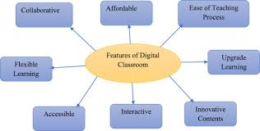

Figure 1.1: Smart School Management System

The Internet of Things (IoT), which refers to the interconnection of physical devices through the internet, has emerged as a transformative technology in various sectors, including education (Al-Fuqaha et al., 2020). When integrated into school management systems, IoT technologies can facilitate real-time attendance monitoring, environmental control, automated notifications, and secure data collection, thereby enhancing the overall administrative experience (Rahman et al., 2022).

Furthermore, result processing is a critical aspect of school operations that demands high accuracy, security, and speed. Manual computation and record-keeping systems are not only susceptible to human errors but also create delays in report generation and student feedback (Ishaya & Edeh, 2023). An IoT-based online result processing system can address these limitations by automating computation, securely storing results, and providing timely access to students, parents, and educators. This study focuses on the development of an IoT-based scalable online school management system with integrated result processing, using Bright Diamond Academy, Ilorin as a case study. The goal is to harness emerging technologies to improve administrative operations, ensure data integrity, and support informed academic decision-making in Nigerian schools.

1.2 Statement of the Problem
Despite the growing availability of digital tools in education, many schools in Nigeria still rely heavily on manual processes for administrative tasks, including student enrollment, attendance tracking, and result computation. These outdated methods are often characterized by inefficiency, delays, inaccuracies, and vulnerability to data loss or manipulation. As school populations increase and expectations for real-time service delivery rise, the limitations of traditional systems become more pronounced.

Specifically, the result processing component in many schools suffers from frequent computational errors, lack of transparency, and significant delays in releasing students' academic records. These issues can affect students’ academic progression and decision-making by parents and administrators. Additionally, most existing school management systems in use are not scalable or integrated with modern technologies such as the Internet of Things (IoT), which can enable automated and real-time data collection, monitoring, and processing.

The absence of an intelligent, unified platform that incorporates IoT features to manage school operations and securely process academic results presents a critical gap in educational technology adoption, particularly in developing regions. Therefore, there is a pressing need for the development of a robust, scalable, and IoT-enabled online school management system that can streamline administrative processes, ensure accuracy in result computation, enhance data accessibility, and promote operational transparency. This study addresses this gap by designing and developing an IoT-based school management system with integrated result processing, using Bright Diamond Academy, Ilorin, as a case study.

1.3 Aim and Objectives
The aim of this study is to develop an IoT-based scalable online school management system with integrated result processing to enhance administrative efficiency, data accuracy, and real-time monitoring in educational institutions, using Bright Diamond Academy, Ilorin as a case study. The objectives to achieve this aim include:

- To design and implement a modular online school management system that supports core administrative functions such as student registration, attendance tracking, fee management, and timetable scheduling.
- To integrate IoT technologies such as RFID and sensors for real-time data collection and monitoring of student attendance and school facilities.
- To develop a secure and automated result processing module capable of computing, storing, and retrieving students’ academic results efficiently.
- To ensure system scalability and adaptability, allowing the platform to accommodate varying school sizes and academic structures.
- To evaluate the performance and usability of the developed system through testing and feedback from staff and students of Bright Diamond Academy.

1.4 Significance of the Study
The significance of this study lies in its potential to address the persistent challenges associated with manual and semi-digital school management processes in Nigerian educational institutions. By developing an IoT-based scalable online school management system with integrated result processing, the study contributes to the modernization of school administration, particularly in areas where digital transformation is still emerging.

Firstly, the system enhances administrative efficiency by automating routine tasks such as attendance tracking, student registration, and result computation. This reduces the workload on school personnel and minimizes human error. Secondly, the integration of IoT technologies such as RFID and environmental sensors introduces real-time monitoring capabilities that improve security, resource management, and student accountability within the school environment. In addition, the result processing module ensures accuracy, transparency, and timely delivery of academic records, which is critical for students, teachers, and parents in making informed academic decisions. The system's scalability allows it to be adapted for use across schools of different sizes and structures, making it a sustainable solution beyond the case study institution.

Moreover, the study contributes to the body of knowledge in educational technology and smart systems, serving as a reference for future research and development in the field. It also provides a practical framework for policymakers, school administrators, and software developers aiming to implement intelligent school management solutions that align with global educational trends. Ultimately, this study offers a pathway toward a smarter, more accountable, and data-driven school environment.

1.5 Scope of the Study
This study is centered on the design and development of an IoT-based scalable online school management system with integrated result processing, using Bright Diamond Academy, Ilorin, as a case study. The system is designed to handle key administrative functions such as student information management, attendance tracking, academic record processing, and basic administrative operations. It incorporates IoT technology, particularly for real-time monitoring of student attendance, ensuring timely and accurate data capture. The project covers the development of a role-based access structure that allows different users—including administrators, teachers, students, and parents—to interact with the system based on their specific permissions. The result processing module enables the automated computation and secure storage of students’ academic performance data, providing access to relevant stakeholders.

Additionally, the study explores the system’s ability to scale, making it adaptable for use in other schools with minimal configuration changes. While the primary focus is on improving administrative efficiency and result management, aspects such as e-learning integration, digital libraries, and alumni management fall outside the scope of this project and are reserved for future enhancements. The developed system was tested and evaluated within the operational context of Bright Diamond Academy to ensure functionality and user-friendliness.

1.6 Organisation of the Report
This report is structured to provide a comprehensive overview of the research and development process involved in creating the IoT-based scalable online school management system with integrated result processing. The report is organized into the following chapters.

Chapter One introduces the background, problem statement, objectives, significance, and scope of the study, providing an overview of the research focus and the structure of the report. Chapter Two presents a review of relevant literature, examining existing school management systems, the role of IoT in education, and current methods of result processing. It highlights key studies, trends, and challenges in integrating technology into educational environments.

Chapter Three details the system design and methodology, outlining the design process, hardware and software components, and the integration of IoT technologies. It also describes the research methodology, including the development stages and tools used. Chapter Four covers the implementation of the system, explaining the development process, coding, configuration, and integration of different modules. It also discusses the challenges encountered and the solutions applied during implementation. Chapter Five provides the results and evaluation of the system, discussing testing outcomes, performance analysis, and user feedback. It assesses how well the system meets the objectives and requirements set out in the study.

Chapter Two

Review of Related Literature

2.1 Review of Past Work on the Subject
Over the past few years, numerous studies have explored the integration of technology into school management systems, particularly focusing on the use of IoT for improving administrative processes. Oluwaseun et al. (2021) examine the application of IoT in Nigerian educational systems, discussing how RFID technology has been used to automate attendance and improve administrative accuracy. Their study underscores the potential of IoT in minimizing human errors and ensuring real-time data tracking in schools.

In a similar vein, Adeyemo et al. (2020) explore the role of IoT-enabled smart systems in enhancing school management, especially in urban schools in Nigeria. They highlight how integrating IoT devices like sensors can streamline activities such as attendance management, fee tracking, and resource monitoring. Anwar et al. (2022) discuss the development of an IoT-based school management system that utilizes environmental sensors and automated result processing. The system was designed to monitor environmental parameters such as temperature and humidity, optimizing the learning environment alongside student management.

Okonkwo and Nwachukwu (2021) review several school management systems and their effectiveness in processing student results. Their research identifies gaps in the accuracy and timeliness of academic result processing, advocating for the adoption of automated systems with integrated result computation to improve data integrity. Sadiq et al. (2023) focus on the scalability of IoT-based systems in educational settings, presenting case studies from various Nigerian schools. Their findings reveal that while IoT applications can scale effectively, challenges such as infrastructure limitations and user training still persist in many educational institutions.

The study by Chukwu et al. (2021) offers insights into the use of IoT for monitoring student attendance through a cloud-based school management system. They emphasize the importance of cloud integration in making the system accessible across different devices and ensuring real-time updates for both parents and school administrators. Abubakar and Aliyu (2020) focus on the use of RFID technology for school management, specifically in monitoring students' attendance and movement within school premises. Their study demonstrates the effectiveness of RFID in reducing manual errors and enhancing operational efficiency.

Another significant contribution is Ogunleye et al. (2022), who discuss the development of an integrated school management system combining IoT with data analytics. The authors argue that incorporating predictive analytics into result processing could further optimize academic performance tracking.

Tijani et al. (2020) investigate the implementation of IoT-based systems for managing school resources and administrative operations. They propose a smart school management model that leverages real-time data collection and analysis to improve decision-making and operational efficiency. Lastly, Akinmoladun et al. (2021) examine a case study on the implementation of a cloud-based school management system in Nigeria. Their study explores how cloud technology, combined with IoT, can offer a cost-effective solution for schools aiming to digitize their administrative functions while maintaining data security.

2.2 Review of General Text
The integration of the Internet of Things (IoT) into educational environments has gained significant attention in recent years, particularly for enhancing school management systems. The IoT’s potential to streamline administrative functions, improve operational efficiency, and provide real-time data tracking has made it an essential tool for modern educational institutions (Sharma et al., 2021). The core idea of IoT in school management revolves around the interconnection of devices and systems to collect, monitor, and analyze data that can be used for better decision-making and resource management (Yadav & Ghosh, 2020).

School management systems (SMS) have traditionally been used for organizing student data, handling administrative tasks, and managing academic results. However, as the demand for more efficient, real-time, and automated systems increases, there has been a notable shift towards integrating IoT with these systems. By integrating IoT sensors, RFID technology, and cloud computing, schools can track various parameters, such as student attendance, classroom environments, and even resource usage (Lopez & Gomez, 2020). This convergence of IoT and SMS allows for seamless, real-time communication among administrators, teachers, students, and parents.

Furthermore, result processing has long been a critical function of school management systems. Traditionally, this process involved manual calculations, which were prone to errors and inefficiencies. The advent of IoT-enabled systems has led to the automation of academic result processing. These systems not only streamline data entry but also ensure faster, more accurate calculations and the secure sharing of results across different stakeholders (Seth & Jain, 2021). With IoT, schools can now provide students and parents with timely access to academic performance data through personalized portals.

The integration of cloud technology with IoT further enhances the scalability and accessibility of school management systems. By moving data and processing to the cloud, schools are able to store large volumes of data securely and make it accessible to users anywhere, at any time. This also ensures that updates to the system can be made in real-time, which is vital for a dynamic and rapidly changing educational environment (Barrett & McCarthy, 2022).

Despite these advancements, challenges remain in the widespread adoption of IoT-based systems in schools, especially in regions with limited access to reliable internet infrastructure or sufficient technological literacy among staff and students (Raghunathan & Patel, 2020). Additionally, concerns regarding data privacy and security in IoT-based systems must be addressed to ensure the protection of sensitive student information (Kumar & Singh, 2021).

Overall, the adoption of IoT in school management systems presents a transformative opportunity for educational institutions to enhance operational efficiency, improve communication, and provide more transparent and accessible academic results. However, careful consideration of the technological, infrastructural, and security challenges is essential for successful implementation.

2.3 Technological Framework of IoT in School Management Systems
The integration of the Internet of Things (IoT) into school management systems relies on several key technological components. These technologies enable the seamless collection, analysis, and utilization of real-time data to optimize administrative operations, enhance decision-making, and improve overall student and staff experiences. The technological framework of IoT in school management systems is built on interconnected devices, data storage, and communication protocols that work together to provide valuable insights into various aspects of school operations.

At the core of IoT-based school management systems are IoT devices and sensors, which play a crucial role in monitoring and controlling the physical environment of the school. These devices include sensors for monitoring environmental parameters such as temperature, humidity, and air quality in classrooms, as well as RFID (Radio Frequency Identification) tags for tracking students' attendance and movement within the school premises. According to Sharma et al. (2021), the use of sensors in IoT-based school management systems can significantly improve the management of classroom environments, ensuring optimal conditions for learning.

Data from IoT devices is transmitted using wireless communication protocols, such as Wi-Fi, Bluetooth, Zigbee, or LoRaWAN (Long Range Wide Area Network), which allow for real-time data transfer from the devices to the central system. The choice of communication protocol depends on factors such as range, power consumption, and the specific needs of the school. For instance, Wi-Fi is commonly used for short-range communication, while LoRaWAN is often preferred for long-range applications where devices need to be spread across a large campus (Lopez & Gomez, 2020).

The collected data is then processed and stored in cloud computing systems, which provide scalable, secure, and accessible storage solutions. Cloud platforms such as Amazon Web Services (AWS), Microsoft Azure, and Google Cloud are commonly used for this purpose, offering a range of tools for data analytics, reporting, and integration with other systems. Cloud storage allows schools to store vast amounts of data securely, ensuring that it can be accessed remotely by authorized users, such as administrators, teachers, and parents (Barrett & McCarthy, 2022).

For result processing and analysis, data analytics tools play a pivotal role in converting raw data into meaningful insights. Machine learning algorithms and data mining techniques are often applied to analyze student performance, predict outcomes, and optimize resource allocation. By leveraging analytics, IoT systems can not only provide real-time updates on academic results but also identify patterns that may not be immediately visible through traditional methods (Seth & Jain, 2021).

Another key component of the IoT technological framework is the user interface. For effective interaction with the system, user-friendly applications or portals are developed for different stakeholders. These interfaces allow students, teachers, and parents to access relevant data such as attendance records, academic results, and other administrative information. In this context, mobile applications and web portals are often integrated into the system, providing ease of access for users (Yadav & Ghosh, 2020).

Finally, the integration of security protocols is crucial to ensure the privacy and integrity of sensitive data. As IoT systems collect a wide array of personal and academic information, schools must implement robust security measures such as encryption, authentication, and access control to protect against unauthorized access and potential breaches (Kumar & Singh, 2021).

In summary, the technological framework of IoT in school management systems is a multifaceted integration of various components, including IoT devices, communication protocols, cloud platforms, data analytics, user interfaces, and security measures. By leveraging these technologies, schools can achieve more efficient, real-time management of administrative functions, enhance the learning environment, and provide valuable insights into student performance.

2.4 Challenges in Implementing IoT-Based School Management Systems
While the integration of IoT into school management systems offers substantial benefits, it is not without its challenges. Several obstacles can hinder the successful deployment and operation of IoT systems in educational institutions. These challenges range from technological limitations to infrastructural constraints, as well as issues related to security, privacy, and stakeholder acceptance. Understanding and addressing these challenges is crucial to ensuring the effective implementation of IoT in school management.

One of the primary challenges in implementing IoT-based systems is infrastructure limitations. Many schools, especially in developing regions, may lack the necessary physical infrastructure to support IoT devices and networks. This includes the absence of reliable internet connectivity, which is essential for real-time data transmission between devices and the central system. Schools with inadequate networking capabilities may experience delays in data processing and difficulties in accessing cloud-based systems, which can undermine the effectiveness of IoT systems (Raghunathan & Patel, 2020). Additionally, outdated hardware, such as old computers and servers, may not be able to handle the demands of running advanced IoT applications, further complicating deployment efforts.

Another significant challenge is the cost of implementation. The setup of IoT systems requires substantial financial investment in terms of hardware, software, networking infrastructure, and training. Schools may need to purchase IoT-enabled devices such as sensors, RFID tags, and smart meters, along with the software for managing and analyzing the data. For many educational institutions, especially public or rural schools with limited budgets, the high initial cost can be prohibitive. While the long-term benefits of IoT may outweigh the costs, the upfront expenses can pose a substantial barrier to adoption (Seth & Jain, 2021).

In addition to financial constraints, there are technical challenges associated with the integration of IoT devices. Schools need to ensure that their IoT devices are compatible with existing systems and infrastructure. The diversity of IoT devices, sensors, and communication protocols can make integration complex, requiring customization and additional software development. Moreover, IoT systems often involve large volumes of data, and managing this data can become overwhelming for school administrators without the proper tools for data storage, analysis, and visualization (Sharma et al., 2021).

Data privacy and security concerns represent another major challenge in IoT-based school management systems. IoT devices collect sensitive information, such as student attendance records, academic performance data, and behavioral information, which must be protected from unauthorized access. The interconnected nature of IoT systems makes them particularly vulnerable to cyber-attacks, such as data breaches or unauthorized access to devices. Ensuring that the system is secure requires the implementation of robust cybersecurity measures, including encryption, firewalls, and secure authentication protocols. Furthermore, educational institutions must comply with regulations related to data privacy, such as the General Data Protection Regulation (GDPR) in the European Union, which adds complexity to system design and implementation (Kumar & Singh, 2021).

Another challenge is the lack of technical expertise within schools. Many educational institutions may not have staff with the necessary skills to manage and maintain IoT systems. This includes both the technical skills to troubleshoot hardware and software issues, as well as the ability to interpret and act upon the data generated by IoT devices. As a result, schools may need to invest in ongoing professional development for their staff or hire external experts, further increasing the cost and complexity of implementation (Yadav & Ghosh, 2020).

Finally, acceptance and adaptation by stakeholders can present a significant hurdle. Teachers, students, parents, and administrators may be resistant to adopting new technology, especially if they are unfamiliar with IoT systems or perceive them as a threat to their established routines. To ensure the successful implementation of IoT-based school management systems, stakeholders must be adequately trained and engaged in the process. Additionally, the system must be user-friendly and tailored to the specific needs of each group to ensure widespread adoption and effective use.

In conclusion, while IoT-based school management systems offer numerous advantages, their implementation faces several challenges. These include infrastructure limitations, high costs, technical integration difficulties, data privacy and security concerns, lack of technical expertise, and resistance to change among stakeholders. Addressing these challenges through careful planning, adequate investment, and stakeholder engagement is essential for realizing the full potential of IoT in education.

2.5 Future Trends and Opportunities in IoT-Enabled Educational Systems
As the field of Internet of Things (IoT) continues to evolve, its applications within the educational sector are expanding rapidly, creating new opportunities and reshaping the future of school management systems. The future of IoT in education is promising, with innovations that aim to enhance learning environments, streamline administrative tasks, and support personalized learning experiences. This section highlights some of the key trends and opportunities that are likely to shape IoT-enabled educational systems in the coming years.

One significant trend is the integration of Artificial Intelligence (AI) and Machine Learning (ML) with IoT systems. The combination of AI and IoT offers the potential for highly personalized learning experiences and predictive analytics. Through AI algorithms, IoT devices can not only monitor environmental conditions but also analyze student performance and behavior in real-time. For example, smart classrooms equipped with IoT sensors can adjust the lighting and temperature based on student preferences, while AI-powered analytics can provide insights into individual learning patterns, allowing teachers to tailor lessons to meet students' needs (Seth & Jain, 2021). This convergence of IoT, AI, and ML will enable the development of smart classrooms that automatically adapt to optimize both physical and pedagogical environments.

Another emerging trend is the use of IoT for enhanced student engagement and interactivity. In the future, classrooms are expected to become more interactive with the integration of smart devices such as tablets, interactive whiteboards, and virtual reality (VR) tools. These devices can be connected through IoT networks to provide immersive learning experiences, allowing students to engage in simulations, virtual tours, and collaborative projects that transcend the boundaries of traditional teaching methods (Sharma et al., 2021). IoT can also enable the use of gamification techniques, where students interact with learning materials in dynamic ways, making the educational experience more engaging and enjoyable.

The development of smart campuses is another significant trend in IoT-enabled education. A smart campus leverages IoT technologies to enhance various aspects of campus life, including security, energy management, and resource optimization. For example, IoT-enabled sensors can monitor and manage energy consumption in classrooms and dormitories, while RFID systems can ensure the security of valuable assets such as computers and laboratory equipment. Additionally, smart parking systems can help students and staff easily find available parking spaces, improving overall campus efficiency (Yadav & Ghosh, 2020). The trend toward smart campuses is not only aimed at improving operational efficiency but also at reducing the environmental footprint of educational institutions through better resource management.

Furthermore, the increased adoption of cloud computing will provide greater opportunities for scaling IoT systems within educational environments. Cloud platforms can support the large-scale deployment of IoT devices and facilitate the centralization of data management. Cloud-based solutions allow schools to store and process vast amounts of data generated by IoT devices, enabling real-time access to academic performance, attendance, and other administrative metrics. Moreover, cloud services can reduce the costs associated with hardware infrastructure and provide more flexible and scalable solutions for schools of varying sizes and budgets (Barrett & McCarthy, 2022). This increased reliance on cloud-based IoT systems will also facilitate collaboration between different schools, districts, and educational stakeholders.

One of the most exciting opportunities for IoT in education lies in the enhancement of student health and well-being. IoT devices, such as wearable health trackers, can provide real-time data on students' physical health, including monitoring vital signs, activity levels, and even stress levels. This data can be analyzed to identify potential health issues early, enabling timely interventions by school health professionals. Additionally, IoT systems can be integrated with environmental monitoring devices to ensure that classrooms provide optimal conditions for student health, such as monitoring air quality and temperature, which can affect both physical health and cognitive performance (Lopez & Gomez, 2020).

Moreover, the use of IoT in remote and hybrid learning environments is expected to grow. As the global shift towards online and hybrid education models continues, IoT-enabled devices will help create more immersive and interactive virtual learning experiences. Smart classrooms, integrated with IoT devices and connected via the internet, will allow students to engage in hands-on learning activities and collaborate with peers and teachers in real-time, regardless of their physical location. This trend will help bridge the gap between traditional in-person classrooms and the evolving digital learning environments (Raghunathan & Patel, 2020).

Finally, the expansion of IoT-based assessments and feedback systems represents another significant opportunity. IoT devices can continuously monitor students’ learning progress and provide immediate feedback, allowing educators to make timely adjustments to their teaching methods. For instance, wearables and sensors can track a student’s focus and engagement during lessons, providing valuable data on when they are most receptive to learning. This data can then be used to personalize assignments, quizzes, and even course content, leading to a more adaptive and student-centered educational approach (Kumar & Singh, 2021).

In conclusion, the future of IoT-enabled educational systems holds immense potential for transforming the way schools manage administrative tasks, engage with students, and optimize learning environments. By embracing emerging technologies like AI, machine learning, cloud computing, and smart devices, educational institutions can create more personalized, efficient, and secure learning environments that cater to the diverse needs of students, educators, and administrators alike. As IoT technology continues to evolve, these opportunities will further enrich the educational experience and contribute to the development of smarter, more connected schools.

Chapter Three

Methodology and Analysis of the System

3.1 Research Methodology
The research methodology for developing and implementing a scalable online school management system with integrated result processing encompasses several phases, combining both qualitative and quantitative approaches to ensure comprehensive analysis and design. The research methodology for developing a scalable online school management system encompasses a structured approach that combines both qualitative and quantitative research methods to ensure a comprehensive analysis and development process.
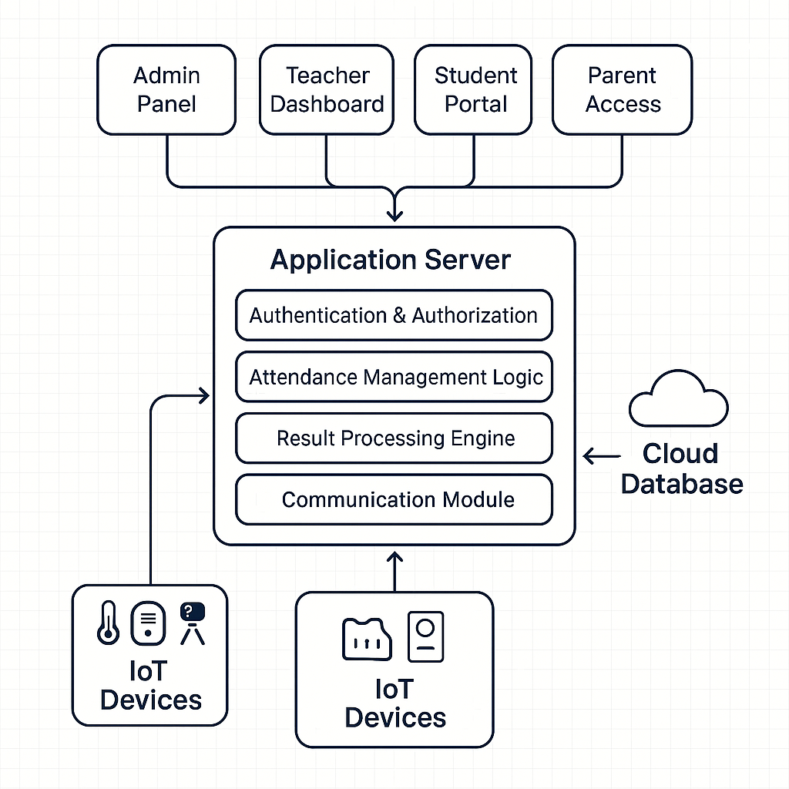
Figure 3.1: IoT school management system architecture
This methodology is designed to capture the multifaceted requirements of the system, assess the limitations of existing systems, and ensure the proposed system meets the needs of all stakeholders effectively shown in figure 3.1. The primary stages include needs assessment, system design, development, testing, and evaluation. The research methodology for developing the IoT-based school management system for Bright Diamond Academy, Ilorin, follows a structured approach involving system design, IoT device integration, web interface development, database architecture, and security considerations.

- System Design and Requirements
The system is designed to automate administrative tasks, track student activities, and manage resources efficiently. The key requirements include scalability to support growing student and staff populations, real-time data processing from IoT devices (e.g., RFID tags, environmental sensors), a user-friendly web interface, and robust security protocols to protect sensitive data. The system should be capable of handling an increasing volume of data while maintaining high performance.

- IoT Device Integration
The system integrates IoT devices to collect real-time data such as student attendance, environmental conditions (temperature, humidity, air quality), and student health metrics through wearable devices. These IoT devices interact with a central server, transmitting data to be processed and analyzed for effective decision-making. Devices such as RFID readers, smart cameras, and sensors ensure a seamless data flow and contribute to real-time monitoring.

- Web Interface and Application Development
The web interface is designed for different user roles: administrators, teachers, and students. It provides access to functions such as attendance management, academic performance tracking, and communication tools. The frontend is built using technologies like HTML5, CSS3, JavaScript (ReactJS or Vue.js), and the backend is developed using Node.js or PHP. This design ensures responsiveness and ease of use on multiple devices (desktop, mobile, tablet).

- Database Design and Data Flow
The database is designed using MySQL or PostgreSQL, structured to store student data, attendance, performance metrics, and IoT device data. The database schema includes tables for students, teachers, performance, and device data, ensuring efficient data retrieval and reporting. Data flows from IoT devices through communication protocols (MQTT or HTTPS) to a processing layer, where it's cleaned, analyzed, and stored in the database for access via the web interface.

- Security and Testing
Security is prioritized through encryption (SSL/TLS for data transmission and AES for stored data), role-based access control (RBAC), and multi-factor authentication (MFA) for secure user access. The system undergoes rigorous testing, including unit testing, integration testing, and user acceptance testing (UAT) to ensure all components function properly. After deployment, the system is maintained through continuous monitoring and regular security audits to ensure optimal performance and protect against potential vulnerabilities. This methodology ensures the development of a scalable, secure, and efficient IoT-based school management system that meets the needs of Bright Diamond Academy.

3.2 Analysis of the Existing System
The current system in place at Bright Diamond Academy relies on traditional, manual methods to manage key school functions such as attendance tracking, academic performance monitoring, and record-keeping. While functional, these methods are time-consuming, prone to errors, and inefficient for handling the growing demands of the institution. Attendance management is one of the primary areas where the existing system shows its limitations. Teachers manually mark attendance either on paper or using spreadsheet-based tools, a process that is not only time-intensive but also susceptible to human errors. This manual approach makes it difficult to access real-time data, preventing school administrators and parents from having immediate visibility into student attendance.

Similarly, academic performance tracking is done using paper-based report cards or basic spreadsheets. Although it allows for tracking grades and assignments, it fails to offer any automated or real-time reporting features. Teachers struggle to analyze trends or identify students who may need additional support in a timely manner. The process of generating reports is slow and labor-intensive, often requiring significant time and effort to collate data from various sources. Communication within the school community is another area where the current system falls short. Updates, feedback, and announcements are mostly shared through phone calls, emails, and in-person meetings, leading to fragmented and inefficient communication. There is no centralized platform for managing these interactions, making it difficult to track ongoing conversations or monitor progress.

Furthermore, data storage and accessibility are major concerns with the existing system. Records are often kept in physical files or locally stored digital formats, making it challenging to retrieve and search for information when needed. In situations of staff turnover or emergencies, accessing important student or administrative data becomes time-consuming and difficult. Overall, the existing system lacks the scalability, automation, and real-time capabilities needed to support the school's growth and enhance administrative efficiency.

3.3 Problem of the Existing System
The existing system at Bright Diamond Academy, relying heavily on manual processes, presents several challenges that affect its overall efficiency and scalability. The primary issues stem from the time-consuming nature of manual data entry, the potential for human errors, and the lack of integration between various school functions.

One of the most significant problems is the inefficiency in attendance tracking. The manual process of recording attendance using paper registers or spreadsheets is prone to mistakes, such as inaccurate entries, omissions, or delayed updates. This leads to difficulties in monitoring and reporting student attendance accurately and in real time. Furthermore, because the system does not provide instant feedback, it becomes challenging for administrators or parents to access timely attendance data or act upon irregularities.

Similarly, academic performance tracking in the current system lacks automation and real-time capabilities. The reliance on paper-based report cards and spreadsheets makes it difficult for teachers to analyze student progress efficiently. Generating reports, which require collating data from multiple sources, is slow and labor-intensive. This delay in data processing hampers the ability to provide timely support to students who are struggling academically, potentially affecting their long-term performance.
The communication between administrators, teachers, students, and parents is fragmented, relying on methods such as phone calls, emails, and in-person meetings. This lack of a unified communication platform leads to missed messages, delays in updates, and difficulty in tracking ongoing discussions. Critical announcements or feedback can often get lost in this disorganized communication flow, contributing to confusion and inefficiency.

Additionally, data storage and accessibility remain significant issues. With important records stored in physical files or local digital formats, accessing or retrieving information becomes cumbersome, particularly in cases where quick decisions are necessary. The current system’s lack of a centralized, accessible database makes it difficult to maintain, update, or back up student and administrative data. This lack of flexibility and scalability becomes more apparent as the school grows, further exacerbating the system’s inefficiencies.

Overall, the existing system at Bright Diamond Academy is ill-suited to handle the increasing demands of modern educational administration. The absence of automation, real-time capabilities, and a unified platform for data storage and communication limits the school’s ability to function efficiently and respond quickly to emerging needs.

3.4 Description of Proposed System
The proposed system for Bright Diamond Academy aims to address the limitations of the existing manual processes by introducing an IoT-based, scalable, and automated school management system. This system will integrate various functions such as attendance tracking, academic performance monitoring, communication, and data storage into a unified, real-time platform, offering improved efficiency and enhanced user experience for all stakeholders.

At its core, the proposed system utilizes Internet of Things (IoT) devices to collect and transmit real-time data, such as student attendance, environmental conditions, and academic performance metrics. RFID tags will be employed for student attendance, allowing automatic tracking when students enter or exit classrooms, ensuring accurate and real-time attendance records. Environmental sensors will be deployed to monitor classroom conditions such as temperature, humidity, and air quality, providing valuable insights to enhance the learning environment.

The system will feature a centralized web-based interface designed for various user roles, including administrators, teachers, students, and parents. The user interface will be intuitive, allowing easy navigation for all users. Administrators will have access to detailed reports on student attendance, performance, and school resources, while teachers will be able to track student progress, input grades, and communicate with students and parents. Students will be able to view their academic performance, attendance records, and communicate with their teachers.

Academic performance tracking will be automated, allowing for real-time analysis of student progress. Teachers will input grades and assignments into the system, which will then automatically generate reports and track trends in performance over time. This system will also identify students who may need additional support, enabling timely interventions. Communication will be streamlined through the platform, offering messaging and notification features for teachers, parents, and students. Important updates, such as upcoming exams, school events, or performance reports, will be easily shared and accessed in real time, reducing delays and enhancing overall communication.

Data storage will be centralized and cloud-based, ensuring that student records, attendance data, and academic performance reports are securely stored and easily accessible. This will eliminate the inefficiencies of maintaining physical records and ensure that critical data is backed up and protected from loss. The proposed system will also prioritize security through encryption, role-based access control, and authentication mechanisms. This will ensure that sensitive information, such as student grades and personal data, remains protected from unauthorized access.

Overall, the proposed IoT-based school management system will modernize Bright Diamond Academy’s administrative processes, improve efficiency, enhance communication, and provide valuable insights into student performance, all while maintaining a high level of security and scalability for future growth.

3.5 Advantages of the Proposed System
The proposed online school management system aims to address the shortcomings of existing systems by offering a comprehensive, integrated, and user-friendly platform. This system is designed to streamline administrative processes, enhance communication, and provide robust data analysis tools. The proposed system offers several advantages over existing systems, including:
- Centralized Data Management: The system will provide a unified platform for all school management activities, including student admissions, attendance tracking, grading, and scheduling. By centralizing data management, the system ensures that information is consistent, up-to-date, and easily accessible to authorized users.
- Automated Administrative Tasks: Routine administrative tasks such as attendance recording, grade calculation, and report generation will be automated, significantly reducing the time and effort required for these activities. Automation will also minimize human errors, improving the accuracy of school records.
- Enhanced Communication Tools: The proposed system will include integrated communication tools to facilitate effective interaction among students, teachers, parents, and administrators. Features such as messaging, announcements, and forums will support real-time communication and collaboration within the school community.
- Mobile Access and User-Friendly Interface: Recognizing the importance of accessibility, the system will be designed with a responsive interface that is accessible on both desktop and mobile devices. The user-friendly design will ensure that all stakeholders can easily navigate the system and perform necessary tasks without extensive training.
- Advanced Security Features: Data security and privacy will be a top priority in the proposed system. Advanced security features such as encryption, secure authentication, and role-based access control will protect sensitive information and ensure that data is only accessible to authorized users.
- Scalable Architecture: The system will be built on a scalable architecture to accommodate the evolving needs of educational institutions. This flexibility will allow schools to add new functionalities or expand their user base without significant system overhauls.
- Integrated Analytics and Reporting: To support data-driven decision-making, the proposed system will offer comprehensive analytics and reporting capabilities. Administrators and teachers will be able to generate detailed reports on student performance, attendance trends, and other key metrics, aiding in the identification of areas for improvement and the planning of targeted interventions.
- Customization and Modular Design: Understanding that each school has unique needs, the system will be designed with customization options and a modular structure. Schools will be able to tailor the system to their specific requirements and choose the modules and features that best fit their operational needs.
Chapter Four

Design and Implementation of the System

4.1 Design of the System
The design phase of the online school management system focuses on creating a blueprint that details the system's architecture, components, and user interfaces. This phase ensures the system meets all specified requirements and provides a seamless user experience.

4.1.1 Output Design
The output design ensures information is presented in an understandable, accurate, and accessible format. Reports generated by the system, such as student grades, attendance records, and administrative reports, are designed for clarity and ease of use, supporting various formats (e.g., PDF, Excel) for flexibility.

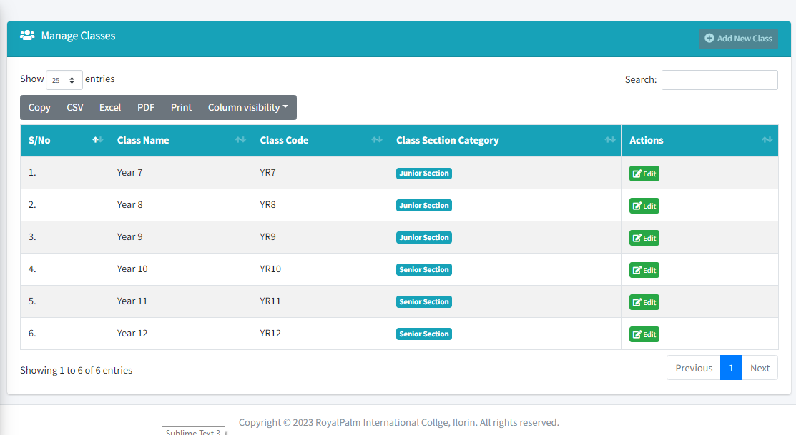
Figure 4.1: Manage Class Records

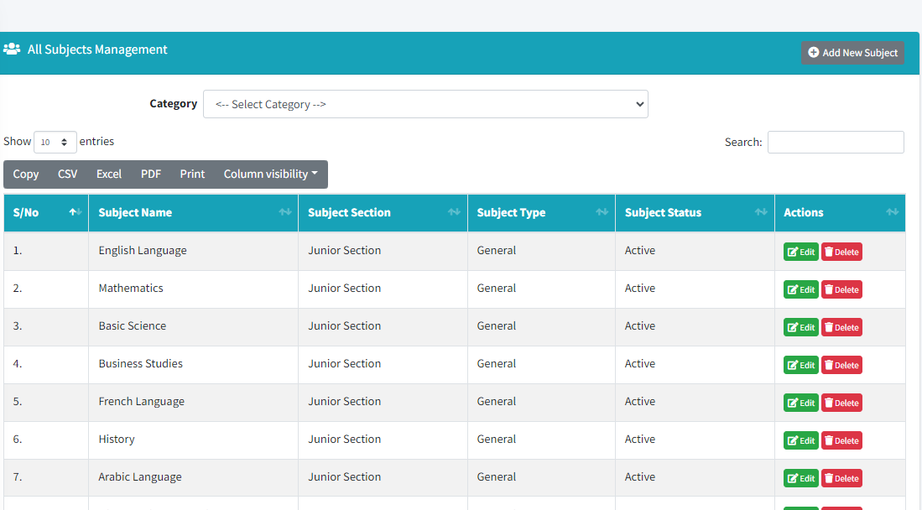
Figure 4.2: Manage Subject Records

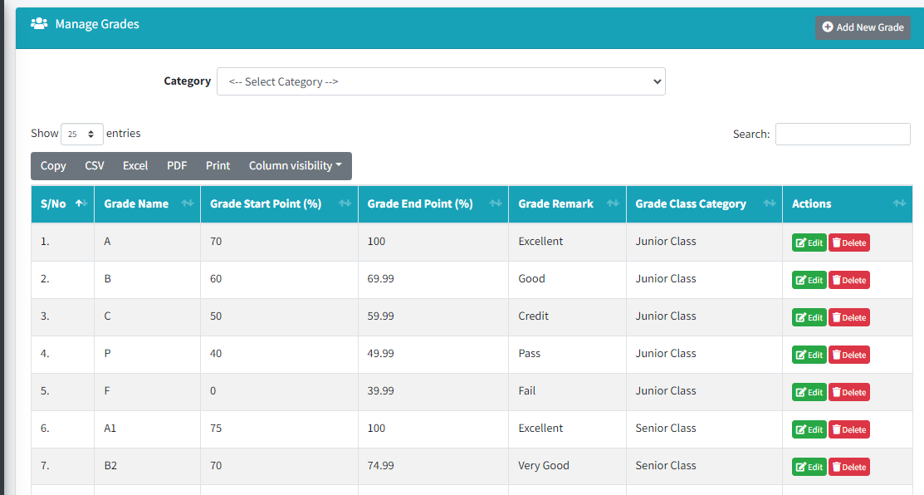
Figure 4.3: Manage Grades Records

4.1.2 Input Design
Input design focuses on how data is captured and entered into the system. The system uses intuitive forms and interfaces to minimize data entry errors and ensure data integrity. Validation checks are incorporated to ensure the accuracy and completeness of the input data.

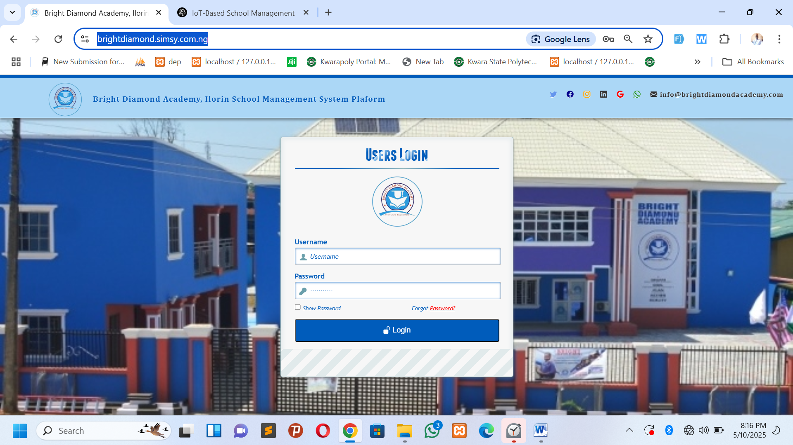
Figure 4.4: Login Page

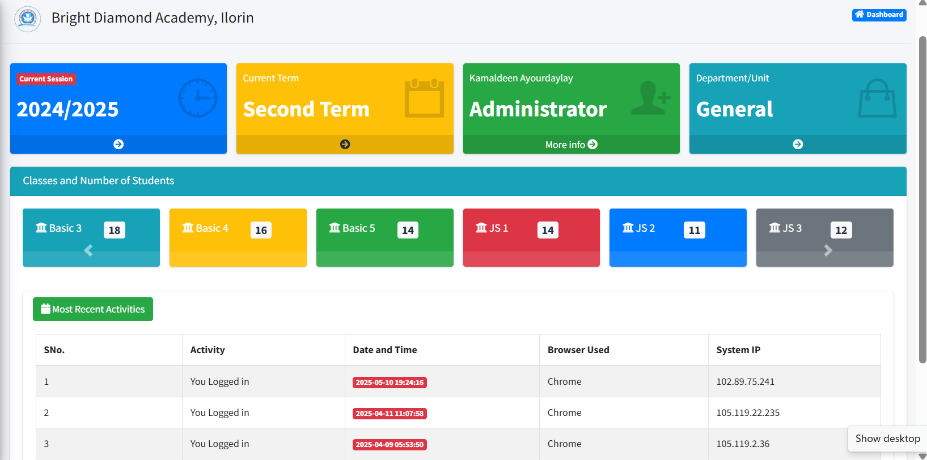
Figure 4.5: User Home Page
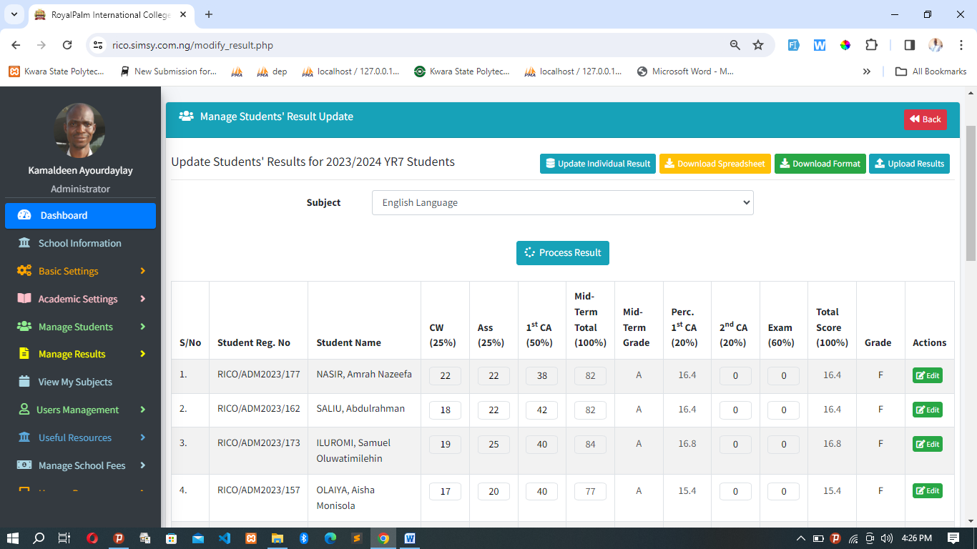
Figure 4.6: Update Result by Subjects

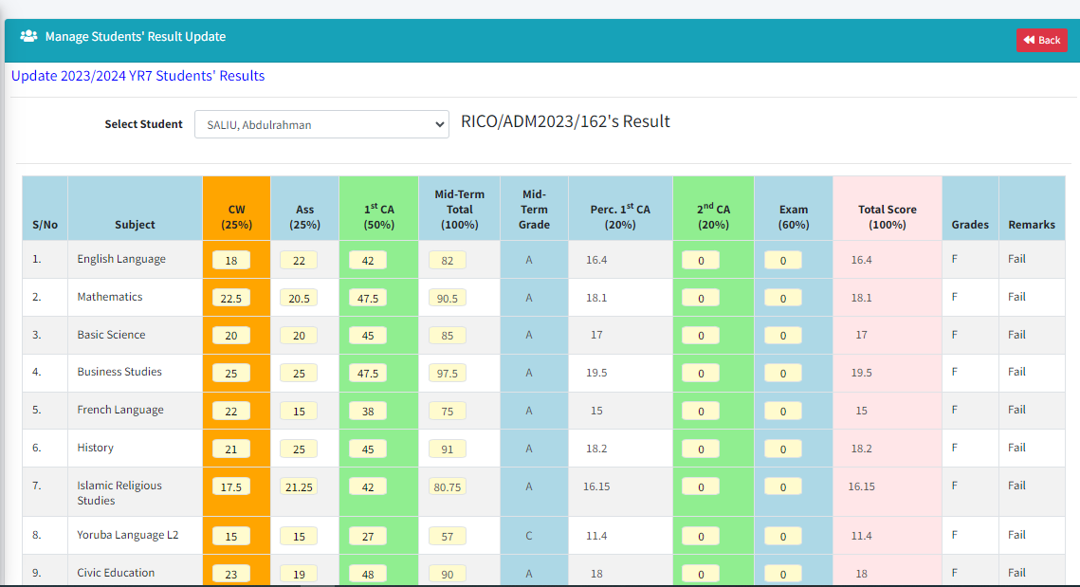
Figure 4.7: Update Result by Student
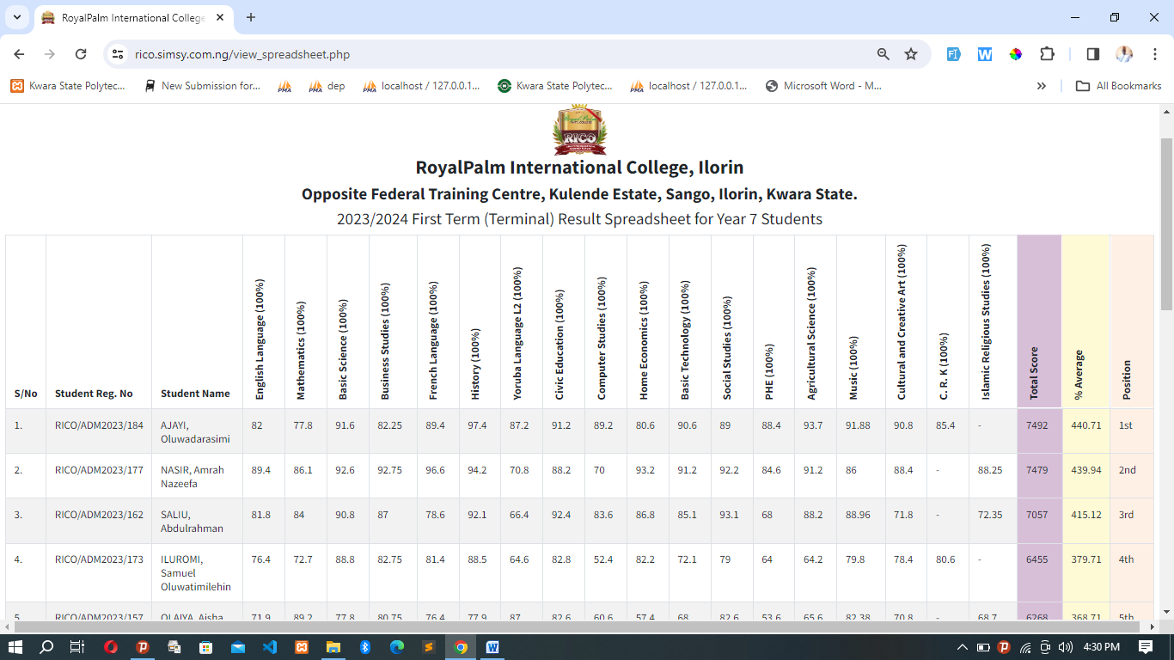
Figure 4.8: Update Result Spreadsheet

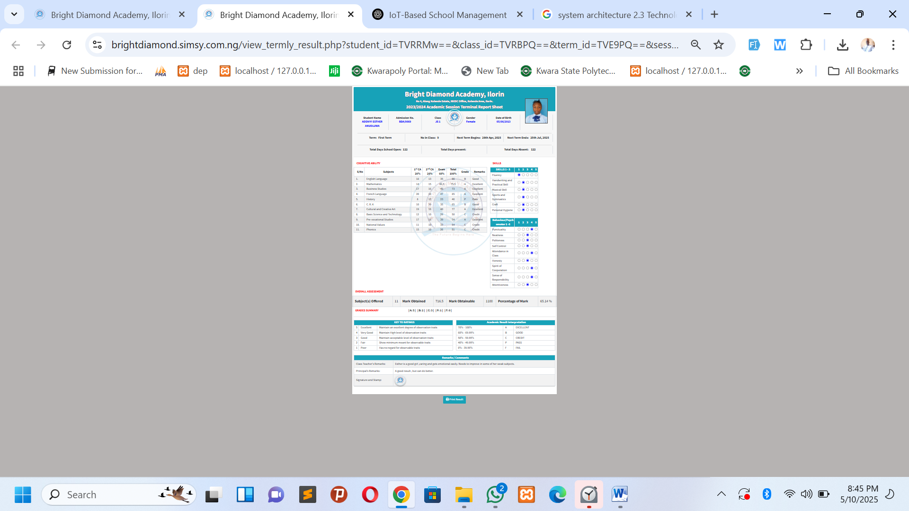
Figure 4.9: Result Report Sheet

4.1.3 Database Design
The database design is critical for efficient data management and retrieval. It involves structuring the database to handle the system's data storage needs effectively. A relational database management system (RDBMS) is used, with tables designed to store student information, teacher profiles, courses, grades, attendance, and more, ensuring data normalization and integrity.

Database design for an online school management system is critical in organizing, storing, and managing data efficiently and securely. A well-designed database supports the system's performance, ensures data integrity, facilitates easy data retrieval and manipulation, and scales with the system's growth. Key principles include using a relational database model for structured data organization, implementing normalization to eliminate redundancy and ensure data consistency, and establishing clear relationships and constraints to maintain data integrity. Additionally, security measures such as encryption and access controls protect sensitive information. Effective database design lays the foundational framework for a robust and reliable online school management system, enabling educational institutions to manage their operations smoothly and effectively.

4.1.4 Procedure Design
Procedure design outlines the standard operating procedures for system operations. It includes algorithms and workflows for tasks such as registering new students, updating grades, scheduling classes, and processing examination results, ensuring consistency and efficiency in system use. Procedure design in the context of an online school management system involves outlining detailed workflows or series of steps that need to be followed to accomplish specific tasks within the system. This is crucial for ensuring consistency, efficiency, and reliability in the system’s operations. Below is an example of how procedure design might be approached for key functionalities within such a system. Procedure steps are as follows:

- Login:
- Input: User credentials.
- Action: Authenticate the user against the system’s database.
- Output: Access to the system based on user role (e.g., student, teacher, administrator).
- Navigate to Subject Enrollment Section:
- Input: Selection of the Subject Enrollment' option.
- Action: The system displays available courses for the current term or semester.
- Output: List of courses with details (course code, title, schedule, instructor).
- Select Subjects:
- Input: Student selects desired courses and any requisite sections (e.g., lab, tutorial).
- Action: System checks for prerequisites, schedule conflicts, and seat availability.
- Output: Confirmation of selected courses, pending approval.
- Review and Confirm Enrollment:
- Input: Review of selected courses and confirmation.
- Action: System finalizes enrollment, updates student and course records.
- Output: Updated course schedule for the student, with an option to print or save the schedule.
- Payments:
- Input: Selection of payment option for school fees.
- Action: System directs to payment gateway for fee processing.
- Output: Payment confirmation and receipt.
- Notification:
- Input: System generates enrollment confirmation.
- Action: Notification sent to student’s email or system inbox.
- Output: Enrollment confirmation message with details of next steps or preparatory actions.
- Log Out:
- Action: Student logs out of the system.
- Output: Secure exit from the system.

4.2 System Implementation
This stage involves turning the system design into a fully functioning system through coding, testing, and deployment.

4.2.1 Choice of Programming Language
The system is developed using a combination of HTML, CSS, and JavaScript for the frontend, ensuring a responsive and intuitive user interface. For the backend, PHP and SQL are chosen for their flexibility, ease of integration with web technologies, and support for complex database operations. The development of an online school management system employs a strategic combination of technologies for both the frontend and backend to create a responsive, efficient, and user-friendly platform. The chosen technologies include HTML, CSS, and JavaScript for the frontend, and PHP and SQL for the backend, each contributing unique strengths to the system:
- HTML lays the foundational structure of web pages, enabling the creation of a well-organized and accessible user interface.
- CSS provides styling capabilities, allowing for the design of visually appealing and responsive layouts that adapt to different devices and screen sizes.
- JavaScript enhances the user experience by adding interactivity, real-time updates, and dynamic content to the web pages, making the system more engaging and efficient to use.
- PHP is utilized for server-side scripting, handling the business logic of the system, including data processing, form submission handling, and database interaction. It is chosen for its flexibility, ease of integration with HTML, and strong support for web development.
- SQL manages the relational database operations, ensuring efficient data storage, retrieval, and manipulation. It supports complex queries essential for the administrative and academic data management needs of the system.

This combination of technologies ensures that the online school management system is not only functional and robust but also scalable and adaptable to the evolving needs of educational institutions. The system is designed to handle a wide range of tasks, from student and faculty management to course scheduling and grades tracking, in a seamless and efficient manner. The choice of widely supported and flexible technologies means the system can be continuously improved and expanded, ensuring long-term usability and support for educational administrative needs.

4.2.2 Hardware Support
The system is designed to be lightweight and compatible with standard computer hardware used in educational institutions. Minimum hardware requirements include a web server, database server, and devices for accessing the system (computers, tablets, smartphones).

In summary, the effective implementation of an online school management system relies heavily on a robust hardware infrastructure designed to ensure performance, reliability, scalability, and security. Key components include a powerful server setup capable of handling the system's demands, reliable networking equipment to ensure high-speed and uninterrupted access, and compatibility with a wide range of client devices to guarantee accessibility for all users. Additionally, backup and recovery systems are critical for data protection, while security measures such as firewalls and VPNs safeguard against unauthorized access. This comprehensive hardware support framework is essential for delivering a smooth, efficient, and secure online school management system that meets the needs of students, teachers, administrators, and parents alike.

4.2.3 Software Support
Apart from the programming languages and database system, the implementation also relies on a web server (e.g., Apache), a web browser for accessing the system, and a development environment (e.g., Visual Studio Code).

4.3.4 Implementation Techniques
Implementation techniques include modular development, allowing different parts of the system to be developed and tested independently, and agile methodology, facilitating iterative development and flexibility to adjust features based on feedback. Implementing an online school management system requires a comprehensive approach that combines strategic planning, efficient development practices, and effective deployment techniques. Here are key implementation techniques that ensure the successful development and deployment of the system:

- Iterative Development: Utilize agile methodologies like Scrum or Kanban for iterative development, allowing for flexible responses to change and continuous improvement. This approach facilitates regular feedback loops with stakeholders, ensuring that the system meets user needs and expectations.
- Sprints: Organize work into sprints, with each sprint delivering a potentially shippable product increment. This ensures continuous progress and allows for the early detection and correction of issues.

4.3 System Documentation
Comprehensive documentation is crucial for the successful deployment and maintenance of the system.

4.3.1 Program Documentation
Program documentation includes code comments, API documentation, and developer guides, providing a detailed description of the system's codebase and architecture for future maintenance and development efforts.

4.3.2 Operating the System
Operating documentation is created for end-users, detailing how to navigate and utilize the system effectively. It includes user manuals, FAQs, and training materials.

4.3.3 Maintaining the System
Maintenance documentation outlines procedures for system updates, bug fixes, and performance optimizations, ensuring the system remains efficient, secure, and relevant to user needs over time. Maintaining an online school management system is crucial for ensuring its continuous operation, reliability, and relevance to users' needs. Regular maintenance involves updating the software to patch vulnerabilities, improve functionality, and add new features. It also includes monitoring system performance to identify and resolve issues promptly, conducting regular security audits to safeguard against threats, and managing data backups to prevent data loss. Additionally, user feedback should be continuously gathered and analyzed to inform system improvements and ensure the system evolves in line with user requirements. Effective system maintenance practices extend the lifespan of the online school management system, enhance user satisfaction, and ensure the system remains a valuable asset for educational institutions.

Chapter Five

Conclusions and Recommendations

5.1 Summary of Findings
The study investigated the design and implementation of an IoT-Based Scalable Online School Management System with Integrated Result Processing, using Bright Diamond Academy, Ilorin, as a case study. Through a detailed system analysis, data collection, and iterative design approach, several key findings were established regarding the limitations of existing systems and the transformative impact of IoT and automation on school operations.

It was discovered that the existing manual system in the school was inefficient, time-consuming, and prone to human error. Attendance records were often inaccurate or delayed, and result processing involved repetitive tasks with high chances of data inconsistency. Communication between teachers, students, and parents was fragmented and lacked a centralized platform for streamlined interaction.

The proposed system addressed these limitations by integrating IoT technologies such as RFID for automatic student attendance, cloud computing for centralized and secure data storage, and a web-based platform for result processing and communication. The system facilitated real-time tracking of attendance, automated result computation, and efficient data retrieval. Users—administrators, teachers, students, and parents—were able to interact with the system through secure, role-based access, improving transparency and accountability.

Furthermore, the use of environmental sensors provided insights into classroom conditions, contributing to improved learning environments. The study also found that the modular design of the system ensured scalability, making it adaptable to different educational institutions and capable of supporting future enhancements. Overall, the findings confirm that IoT-based solutions can greatly enhance the effectiveness and reliability of school management systems, ultimately contributing to improved academic administration and stakeholder engagement.

5.2 Conclusions
The research and development process for the proposed online school management system underscore the importance of technology in addressing the current challenges faced by educational institutions in administration and management. The findings demonstrate that a well-designed, integrated, and user-friendly system can significantly improve the efficiency of school operations, enhance the quality of education, and foster a more engaging and collaborative school community. The adoption of such systems is not just a step towards digital transformation but a leap towards creating an educational environment that is more responsive, accessible, and tailored to the needs of all stakeholders.

In conclusion, the development and implementation of a scalable online school management system with integrated result processing represent a significant step forward in the modernization of educational administration and management. This project has demonstrated that through careful design and consideration of user needs, it's possible to create a system that not only addresses the current limitations and challenges faced by traditional management systems but also provides a platform for enhanced communication, efficiency, and data-driven decision-making within educational institutions.

The findings from this study underscore the importance of integrating advanced technologies and user-centric design principles to create a system that is not only functional and efficient but also secure, scalable, and accessible to all stakeholders. The proposed system's features, including automated administrative tasks, centralized data management, enhanced communication tools, and advanced analytics, offer a comprehensive solution that can significantly improve the operational effectiveness of schools while also enhancing the educational experience for students.

Moreover, the project highlights the critical role of digital transformation in education, showcasing how technology can be harnessed to overcome traditional barriers to information access, communication, and administrative efficiency. By adopting such systems, educational institutions can better prepare themselves for the challenges of the 21st century, ensuring they provide high-quality education that meets the needs of students, parents, teachers, and administrators alike.

Finally, the research conducted through this project lays the groundwork for future investigations into the continued evolution of school management systems. As technology advances and educational needs evolve, it is imperative that these systems adapt and innovate. Further research and development in areas such as artificial intelligence, machine learning, and blockchain technology could offer new opportunities to enhance the functionality, security, and effectiveness of online school management systems. The journey towards optimizing and fully realizing the potential of digital tools in education is ongoing, and this project represents a valuable contribution to that journey.

5.3 Contribution to Knowledge
This study successfully demonstrated the development and implementation of an IoT-Based Scalable Online School Management System with Integrated Result Processing, tailored to address the operational inefficiencies of traditional school management practices. Using Bright Diamond Academy, Ilorin as a case study, the research identified key challenges inherent in manual systems, such as data redundancy, delayed result processing, poor attendance tracking, and limited stakeholder interaction.

The proposed system introduced a practical, technology-driven solution that integrates IoT components—particularly RFID for automated attendance and environmental sensors for classroom monitoring—with a web-based platform that supports real-time data processing, role-based access, and cloud-based storage. The system's design emphasizes usability, security, and scalability, ensuring it can evolve with future technological advancements and institutional growth.

The implementation and testing of the system revealed a significant improvement in operational efficiency, data accuracy, and communication among school stakeholders. The real-time functionalities not only reduced the administrative workload but also fostered transparency and accountability in academic and administrative processes. Students and parents gained better visibility into academic progress, while teachers and administrators could make informed decisions based on up-to-date records.

In conclusion, the integration of IoT technologies within school management represents a viable and impactful approach to modernizing educational administration. The system developed through this research provides a replicable framework for other institutions seeking to enhance service delivery, data integrity, and engagement through innovative ICT solutions. This work contributes meaningfully to the growing body of knowledge in educational technology and offers practical insights for implementation across diverse educational settings.

5.4 Recommendations for Further Investigation
While this study has successfully developed and deployed an IoT-Based Scalable Online School Management System with Integrated Result Processing, it also opens avenues for further research and enhancement. One key area for future investigation is the integration of machine learning and predictive analytics to support intelligent decision-making. This could include analyzing student performance trends, predicting at-risk students, and recommending personalized learning interventions.

Another recommended direction is the incorporation of biometric technologies such as facial or fingerprint recognition to enhance security and accuracy in attendance and access control, complementing existing RFID solutions. Future studies may also explore mobile app integration to expand access and ensure seamless communication among users, especially in regions where mobile internet is more prevalent than desktop access. Given the growing concerns around data privacy and cybersecurity in educational environments, further research into advanced encryption methods, blockchain-based result authentication, and compliance with data protection regulations (e.g., GDPR, NDPR) will be valuable to safeguard sensitive student information.

Scalability testing in more complex or multi-campus school settings is another promising area, to understand system performance under higher data loads and diverse usage patterns. Finally, long-term impact assessments should be conducted to evaluate how such systems influence academic outcomes, stakeholder engagement, and administrative efficiency over time. These future investigations will not only improve the robustness of smart school management systems but will also advance the frontier of digital transformation in the educational sector.
Reference
Al-Fuqaha, A., Guizani, M., Mohammadi, M., Aledhari, M., & Ayyash, M. (2020). Internet of Things: A Survey on Enabling Technologies, Protocols, and Applications. IEEE Communications Surveys & Tutorials, 22(4), 2641–2681. https://doi.org/10.1109/COMST.2020.3011320
Ishaya, G., & Edeh, S. O. (2023). Design and Implementation of an Automated Student Result Management System in Nigerian Secondary Schools. International Journal of Computer Applications, 185(10), 12–18. https://doi.org/10.5120/ijca2023926251
Okai, T., Adebayo, O., & Yusuf, M. A. (2021). Evaluating the Effectiveness of Digital School Management Systems in Nigerian Secondary Schools. African Journal of Information Systems, 13(2), 45–57.
Rahman, M. A., Rashed, M. G., & Imran, M. A. (2022). A Review on IoT-Based Smart School Management Systems. Journal of Computer and Communications, 10(4), 72–84. https://doi.org/10.4236/jcc.2022.104006
Adeyemo, O. O., Oladipo, O. F., & Adebayo, S. A. (2020). The role of IoT in smart school management systems in Nigeria. Nigerian Journal of Educational Technology, 8(3), 45-52.
Abubakar, A. M., & Aliyu, I. S. (2020). RFID-based attendance management in Nigerian schools: An IoT approach. International Journal of Computing and Technology, 15(2), 114-128.
Akinmoladun, A. O., & Ige, O. B. (2021). Cloud-based school management systems: A case study of Nigerian schools. International Journal of Cloud Computing, 10(4), 215-224.
Anwar, M., Imran, M., & Ali, Z. (2022). IoT-enabled school management systems for enhanced administrative processes. Journal of Educational Technology and Systems, 29(1), 38-45.
Chukwu, E. I., & Akpan, U. S. (2021). Cloud-based IoT school management systems for real-time monitoring and attendance tracking. Journal of Internet of Things, 14(3), 67-75.
Ogunleye, O. S., Bello, A. R., & Alabi, M. O. (2022). Integrating IoT and data analytics for improved school management. Journal of Data Science in Education, 19(1), 33-40.
Okonkwo, O. M., & Nwachukwu, G. (2021). Automated student result processing in Nigerian schools: Challenges and opportunities. International Journal of Education and Information Systems, 5(4), 150-162.
Oluwaseun, A. B., Olufemi, S. A., & Tunde, O. O. (2021). The role of IoT in enhancing school administrative processes: A case study of Nigerian secondary schools. African Journal of Educational Innovation, 6(1), 18-24.
Sadiq, A. B., & Ibrahim, S. T. (2023). Scalability of IoT-based school management systems in Nigerian educational institutions. International Journal of Smart Technologies, 18(2), 78-85.
Tijani, S. O., Adebisi, A. A., & Oyebanji, A. M. (2020). Design and implementation of IoT-based smart school management systems. International Journal of Educational Innovation, 13(4), 120-129.

APPENDIX I (Algorithm)
Algorithm for Student Registration:
Input: Student details including name, date of birth, address, contact information, and parent/guardian details.
Validation: Validate the input data to ensure it meets specified criteria (e.g., required fields, data format).
Check for Duplicates: Verify if the student is already registered to prevent duplicate entries.
Generate Student ID: Assign a unique student ID to the new registration.
Save Data: Store the student information in the database.
Confirmation: Display a confirmation message indicating successful registration.
Algorithm for Attendance Tracking:
Input: Select the class and date for which attendance needs to be recorded.
Retrieve Student List: Retrieve the list of students enrolled in the selected class.
Mark Attendance: For each student, mark their attendance status (present/absent).
Validation: Ensure all students are marked and attendance is saved.
Save Data: Store the attendance data in the database, associating it with the selected class and date.
Algorithm for Result Processing:
Input: Select the class and exam for which results need to be processed.
Retrieve Student List: Retrieve the list of students enrolled in the selected class.
Enter Grades: For each student, enter their grades for the selected exam.
Validation: Ensure all students have grades entered and validate the input data (e.g., within acceptable range).
Calculate Total Marks: Calculate the total marks obtained by each student based on their grades.
Determine Grade: Determine the grade for each student based on the total marks and predefined grading criteria.
Save Data: Store the result data in the database, associating it with the selected class and exam.
Algorithm for Communication:
Input: Select the recipients (e.g., individual student, class, teacher, parent), subject, and message content.
Compose Message: Write the message, including any attachments or links as needed.
Send Message: Transmit the message to the selected recipients through the communication platform.
Confirmation: Display a confirmation message indicating successful message transmission.
Archive Message: Store a copy of the sent message in the system for future reference.
Algorithm for System Security:
Authentication: Prompt users to enter their credentials (e.g., username and password) to access the system.
Authorization: Validate user credentials and verify their access privileges based on their role (e.g., student, teacher, administrator).
Session Management: Assign a unique session ID to authenticated users to track their interactions with the system and manage session timeouts.
Data Encryption: Encrypt sensitive data (e.g., passwords, personal information) before storing it in the database to protect against unauthorized access.
Regular Updates: Implement security patches and updates to mitigate vulnerabilities and ensure the system's resilience against security threats.

APPENDIX II (Flowchart)

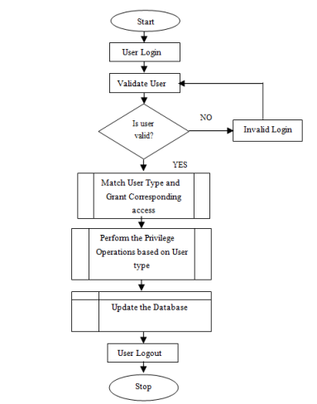

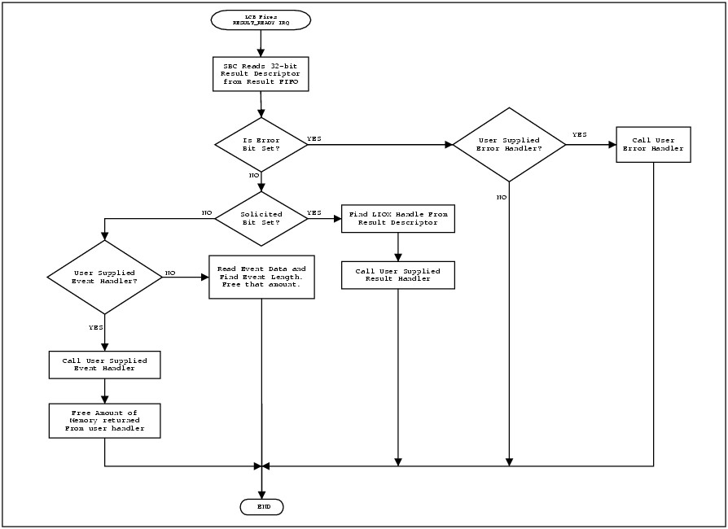

APPENDIX III (Program Listing)
<?php include('includes/school_info.php'); ?>
<!DOCTYPE html>
<html lang="en" class="no-js">
<head>
<meta charset="UTF-8" />
<title><?php echo $school_name ?></title>
<meta name="viewport" content="width=device-width, initial-scale=0.6">
<link rel="icon" type="image/png" href="<?php echo $school_logo ?>"/>
<link rel="shortcut icon" type="image/x-icon" href="images/logo.jpg">
<link rel="stylesheet" type="text/css" href="css/demo.css" />
<link rel="stylesheet" type="text/css" href="css/style3.css" />
<link rel="stylesheet" type="text/css" href="css/animate-custom.css" />
<link href="css/bootstrap-icons.css" rel="stylesheet">
<link rel="stylesheet" type="text/css" href="app-assets/vendors/css/extensions/toastr.min.css">
<link rel="stylesheet" href="assets/fonts/boxicons.css"/>
</head>
<body>
<div class="container">
<!-- Codrops top bar -->
<div style="background-color: #005CBB; height: 7px"></div>
<div class="codrops-top">
<img src="<?php echo $school_logo ?>" align="left" style="margin-top:5px; height: 80px;margin-left: 100px" />

<a href="" class="to_register" style="color: #005CBB; margin-top: 10px;margin-left: 10px; font-size: 18px"><strong><?php echo $school_name ?> School Management System<span> Plaform</strong></span></a>

<span class="right" style="margin-right: 10px">
<a href="#" class="twitter"><i class="bi bi-twitter" style="color: #6495ED"></i></a>
<a href="#" class="facebook"><i class="bi bi-facebook" style="color: darkblue"></i></a>
<a href="#" class="instagram"><i class="bi bi-instagram" style="color: orange"></i></a>
<a href="#" class="linkedin"><i class="bi bi-linkedin"></i></i></a>
<a href="#" class="google"><i class="bi bi-google" style="color: red"></i></a>
<a href="#" class="whatsapp"><i class="bi bi-whatsapp" style="color: green"></i></a>
<a href="#" class="envelope"><i class="bi bi-envelope-fill"></i><strong>&nbsp;info@brightdiamondacademy.com</strong></a>
</span>

<div class="clr"></div>
</div><!--/ Codrops top bar -->
<div style="background-color: #005CBB; height: 1px"></div>
<header>
</header>

<section>
<div id="container_demo" >
<a class="hiddenanchor" id="toregister"></a>
<a class="hiddenanchor" id="tologin"></a>

<div id="wrapper">
<div id="login" class="animate form">
<form method="POST">
<h1>Users Login</h1>
<p align="center" >
<img src="<?php echo $school_logo ?>" height="120px" width="120px"/>
<p>
<label for="username" class="uname" data-icon="u" style="font-weight:bold"> Username </label>
<input id="username" name="username" required="required" type="text" placeholder="Username"/>
</p>
<p>
<label for="password" class="youpasswd" data-icon="p" style="font-weight:bold"> Password </label>
<input id="password" name="password" required="required" type="password" placeholder="&#xb7;&#xb7;&#xb7;&#xb7;&#xb7;&#xb7;&#xb7;&#xb7;&#xb7;&#xb7;&#xb7;"/>
</p>
<p class="keeplogin">
<input type="checkbox" onclick="myFunction()" />
<label for="loginkeeping">Show Password <span style="margin-left:150px">Forgot <a href="ft/user/password_recovery.php"><font color="#FF0000">Password?</font></a></span></label>
<br>
<!-- <input type="checkbox" name="loginkeeping" id="loginkeeping" value="loginkeeping" />
<label for="loginkeeping">Keep me logged in <span style="margin-left:150px">Forgot <a href="ft/user/password_recovery.php"><font color="#FF0000">Password?</font></a></span></label> -->
</p>
<div class="mb-3">
<button class="btn d-grid w-50" id="sign_in_btn" style="background-color: #005CBB; color: white; height: 50px; width: 440px; border-radius: 5px; font-size: 16px; cursor: pointer"><i class="bi bi-unlock-fill"></i> Login</button>
<p>
</div>
<p class="change_link"></p>
</form>
</div>

</div>
</div>
</section>
</div>
<script src="app-assets/vendors/js/jquery/jquery.min.js"></script>
<script src="app-assets/vendors/js/extensions/toastr.min.js"></script>

<script>
$(document).ready(function(){
$('form').on('submit', function(e){
e.preventDefault();
// get inputs
let username = $('#username').val();
let password = $('#password').val();
username= username.trim();
password= password.trim();

if(username.length < 1 || password.length < 1){
toastr.error('Failed! Both fields are required.');
return false;
}

// disable button
$('#sign_in_btn').attr('disabled', true).html('Page Loading...... <i class="bx bx-loader bx-spin"></i>');

// process login
$.ajax({
type:"POST",
url:"users/login.php",
data:{username, password},
cache:false,
dataType:"json",
success:function(res){
if(res.status == 200){
toastr.success(res.message);
setTimeout(function(){
window.location.href= res.url;
}, 3000);
return;
}
else{
toastr.error(res.message);
toastr.options = {
positionClass: 'toast-top-right'
};
// enable button
$('#sign_in_btn').attr('disabled', false).html(' <i class="bi bi-unlock-fill"></i>&nbsp;Login');
}
},
error:function(err){
console.log("Error==>", err);
toastr.error(err);
$('#sign_in_btn').attr('disabled', false).html('<i class="bi bi-unlock-fill"></i> &nbsp;Login');
}
})
});

});

function myFunction() {
var x = document.getElementById("password");
if (x.type === "password") {
x.type = "text";
} else {
x.type = "password";
}
}
</script>

</body>
</html>

LOGIN
<?php
//ob_start();
include('../inc_files/config.php');
include('../inc_files/browser.php');
session_start();

extract($_POST);
$username = htmlspecialchars($_POST['username']);
$password = htmlspecialchars($_POST['password']);

$username = stripslashes($username);
$username = mysqli_real_escape_string($mysqli, $username);
$password = mysqli_real_escape_string($mysqli, $password);
$password = md5(sha1(sha1(sha1($password))));

$get_rec = mysqli_query($mysqli, "SELECT * FROM users WHERE user_name = '$username' AND password = '$password' ") or die(mysqli_error($mysqli));

if(mysqli_num_rows($get_rec) > 0)
{
$row = $get_rec->fetch_assoc();
$user_name = $row['user_name'];
$status = $row['status'];
$user_id = $row['user_id'];
$user_type = $row['user_type'];
$user_type_id = $row['user_type_id'];
$duty_id = $row['duty_id'];
$_SESSION['user_name'] = $row['user_name'];
$_SESSION['user_id'] = $row['user_id'];
$_SESSION['user_type_id'] = $row['user_type_id'];
$_SESSION['user_type'] = $row['user_type'];
$_SESSION['duty_id'] = $row['duty_id'];

if($status == "Active")
{
$add_rec = mysqli_query($mysqli, "INSERT INTO activitylog(staff_no, activity, activity_time, browser, userip) VALUES('$user_name', 'You Logged in', CURRENT_TIMESTAMP, '$user_browser', '$uip')") or die(mysqli_error($add_rec));
$url='user_home.php';

//Get name
if ($user_type_id == 5){
$get_rec = mysqli_query($mysqli, "SELECT * FROM parent_records WHERE user_id = '$user_id' ") or die(mysqli_error($mysqli));
$Rec = $get_rec->fetch_assoc();
$name = $Rec['parent_name'];
}

else{
$get_rec = mysqli_query($mysqli, "SELECT * FROM staff_records WHERE user_id = '$user_id' ") or die(mysqli_error($mysqli));
$Rec = $get_rec->fetch_assoc();
$name = $Rec['staff_name'];
$_SESSION['staff_id'] = $Rec['staff_id'];
}

echo json_encode(['status' => 200, 'message' => 'Login successful. Welcome Back '.$name.'!!!', 'url' => $url]);
}

else{
echo json_encode(['status' => 401, 'message' => 'Sorry!!! You are cuurrently barred from this platform. Contact you Principal/Administrator for more information. Thank you.']);
}
}

else{
echo json_encode(['status' => 401, 'message' => 'Invalid Login Details provided. Check and try again']);
}
?>

USER HOME
<!DOCTYPE html>
<html lang="en">
<?php
include('includes/header.php');
include('inc_files/config.php');
include('includes/session.php');
include('inc_files/browser.php');
$_SESSION['class']="";
?>

</html>
<body class="hold-transition sidebar-mini layout-fixed">
<div class="wrapper">

<?php
include('includes/topbar.php');
include('includes/sidebar.php')
?>
<section class="content">
<div class="container-fluid">
<div class="row">
<div class="col-lg-3 col-6">

<div class="small-box bg-primary">
<div class="inner">
<p><span class="right badge badge-danger">Current Session</span></p>
<h3><?php echo $currentSession ?></h3>
</div>
<div class="icon">
<i class="ion ion-clock"></i>
</div>
<a href="#" class="small-box-footer"><i class="fas fa-arrow-circle-right"></i></a>
</div>
</div>

<div class="col-lg-3 col-6">
<div class="small-box bg-warning">
<div class="inner text-white">
<p>Current Term</p>
<h3><?php echo $currentTerm ?></h3>
</div>
<div class="icon">
<i class="ion ion-calendar"></i>
</div>
<a href="#" class="small-box-footer"><i class="fas fa-arrow-circle-right"></i></a>
</div>
</div>

<div class="col-lg-3 col-6">
<div class="small-box bg-success">
<div class="inner">
<p><?php echo $name;?></p>
<h3><?php echo $user_type; ?></h3>
</div>
<div class="icon">
<i class="ion ion-person-add"></i>
</div>
<?php
if ($user_type_id == 5){
$link_add ='parent_details.php';
}
else{
$link_add ='users_details.php';
}
?>
<a href="<?php echo $link_add ?>" class="small-box-footer">More info <i class="fas fa-arrow-circle-right"></i></a>
</div>
</div>

<div class="col-lg-3 col-6">
<div class="small-box bg-info">
<div class="inner">
<?php
if ($user_type_id == 5){ ?>
<p><?php echo date("M d, Y") ?></p>
<h3><?php echo date("h: i:sa") ?></h3>
<?php }
else{?>
<p>Department/Unit</p>
<h3><?php echo ucwords($Rec['staff_dept']);?></h3>
<?php }?>
</div>
<div class="icon">
<i class="ion ion-bag"></i>
</div>
<a href="" class="small-box-footer"><i class="fas fa-arrow-circle-right"></i></a>
</div>
</div>

</div>

<div class="row">
<section class="col-lg-12 float-center">

<?php if ($user_type_id == 5){ ?>
<div class="col-12">
<div class="small-box bg-success">
<div class="inner">
<h3>Your Ward(s)</h3>
<?php $get_stud_rec = mysqli_query($mysqli, "SELECT student_parent.*, parent_records.parent_name, student_profiles.student_name, student_profiles.student_class_name FROM student_parent LEFT JOIN parent_records ON student_parent.parent_id = parent_records.parent_id LEFT JOIN student_profiles ON student_parent.student_id = student_profiles.student_id WHERE parent_records.user_id= '$user_id' ORDER BY student_profiles.student_id ASC")or die(mysqli_error($get_stud_rec));
while($row = $get_stud_rec->fetch_assoc()){
$student_name = $row['student_name'];
?>
<a href="student_profile.php?student_id=<?php echo base64_encode(base64_encode($student_id)) ?>"><h5 style="color: white"><i class="fa fa-check-circle"></i> <?php echo $student_name; ?></h5></a>
<?php } ?>
</div>
<div class="icon">
<i class="ion ion-person"></i>
</div>
<a href="" class="small-box-footer">&nbsp;<i class="fas fa-arrow-circle-right"></i></a>
</div>
</div>
<?php } ?>

<!-- <?php if ($user_type_id == 1 || $user_type_id == 2){ ?>
<section class="content">
<div class="container-fluid">
<div class="row">
<?php
$sql = mysqli_query($mysqli, "SELECT * FROM classes_records")or die(mysqli_error($sql));
$num = mysqli_num_rows($sql);
while($rsclass = $sql->fetch_assoc()){
$class_name = $rsclass['class_name']; ?>
<div class="info-box-content">
<div class="col-md-2 col-sm-6 col-12">
<div class="info-box">
<span class="info-box-icon bg-info"><i class="far fa-edit"></i></span>
<span class="info-box-text"><?php echo "Year 1"; ?></span>
<span class="info-box-number"><?php echo $num ?></span>
</div>
</div>
<?php } ?>
</div>

<div class="col-md-2 col-sm-6 col-12">
<div class="info-box">
<span class="info-box-icon bg-success"><i class="far fa-flag"></i></span>

<div class="info-box-content">
<span class="info-box-text">Year 8</span>
<span class="info-box-number">23</span>
</div>
</div>
</div>

<div class="col-md-2 col-sm-6 col-12">
<div class="info-box">
<span class="info-box-icon bg-warning"><i class="far fa-copy"></i></span>
<div class="info-box-content">
<span class="info-box-text">Year 9</span>
<span class="info-box-number">21</span>
</div>
</div>
</div>

<div class="col-md-2 col-sm-6 col-12">
<div class="info-box">
<span class="info-box-icon bg-danger"><i class="far fa-star"></i></span>
<div class="info-box-content">
<span class="info-box-text">Year 10</span>
<span class="info-box-number">9</span>
</div>
</div>
</div>

<div class="col-md-2 col-sm-6 col-12">
<div class="info-box">
<span class="info-box-icon bg-warning"><i class="far fa-copy"></i></span>

<div class="info-box-content">
<span class="info-box-text">Year 11</span>
<span class="info-box-number">48</span>
</div>
</div>
</div>

<div class="col-md-2 col-sm-6 col-12">
<div class="info-box">
<span class="info-box-icon bg-danger"><i class="far fa-star"></i></span>
<div class="info-box-content">
<span class="info-box-text">Year 12</span>
<span class="info-box-number">20</span>
</div>
</div>
</div>

</div>
<?php } ?> -->

<div class="card">
<div class="card-tools ml-3 mt-2">

<div class="card-tools">
<ul class="nav nav-pills ml-auto">
<li class="nav-item">
<button class="btn btn-success float-center"><i class="fas fa-calendar"></i>
Most Recent Activities</button>
</li>
</ul>
</div>
</div>
<div class="card-body">
<div class="tab-content p-0">

<table id="example1" class="table table-bordered table-striped">
<thead>
<tr>
<th style="width:230px">SNo.</th>
<th>Activity</th>
<th>Date and Time</th>
<th>Browser Used</th>
<th>System IP</th>
</tr>
</thead>
<tbody>
<?php
$fetchActivitity = mysqli_query($mysqli, "SELECT * FROM activitylog WHERE staff_no='$user_name' ORDER BY id DESC LIMIT 4");
$sn = 1;
while($rsActivitity = $fetchActivitity->fetch_assoc()){
$activitity = $rsActivitity['activity'];
?>
<tr>
<td><?php echo $sn++; ?></td>
<td><?php echo $activitity; ?></td>
<td><span class="right badge badge-danger"><?php echo $rsActivitity['activity_time']; ?></td></span>
<td><?php echo $rsActivitity['browser']; ?></td>
<td><?php echo $rsActivitity['userip']; ?></td>
</tr>
<?php }?>
</tbody>
</table>
<?php
// $fetchLogStatus = mysqli_query($mysqli, "SELECT * FROM staff_records WHERE staff_id != '$user_id' AND login_status = 'logged in'");
// while($rsSt = $fetchLogStatus->fetch_assoc()){
// $status = $rsSt['login_status'];
?>
<marquee><?php //echo $rsSt['staff_name']." Logged in by: ".$rsSt['login_time']; ?></marquee>
<?php //}?>
</div>
</div>
</div>
</section>

</div>
<!-- /.row -->
</div>
</div>
</section>
</div>

<?php include('includes/scripts.php') ?></body>
<?php include('includes/footer.php') ?></body>

</body>
</html>

