CHAPTER ONE
INTRODUCTION
1.1 Background of the study
The stores contributes effectively to manufacturing or production by holding of materials in stock in a medium sized productive operation such as raw materials, component parts, packaging, spare parts, tools, work in progress, finished stocks and maintenance materials. For example a production operation will have raw materials, component parts, work in progress, and packaging and associated materials. A distribution operation will have finished stock, component parts and part completed work. An engineering and maintenance operation will have spare parts, tools, equipment and clearing and servicing materials. Due to the nature and wide variations in the kind of items that can be found in any stores, most well established organizations set up other sub – stores to facilitate effective manufacturing such as central stores which is seen as the concentration of all stock at one point, subsidiary stores, which is designed to serve as supplementary to central stores, salvage stores which is established to cater for rejected scraps, surplus and redundant materials, etc (Bosompem, 2024).
In view of this, the services of stores to every organization is very important and due to the importance attached to their operations, the store officers need to have a wide working knowledge of a great number of material types and their operations. When this is well managed, it avoids any hazardous breakdown and inefficiencies in manufacturing or production but rather contributes significantly to manufacturing.
On the other hand, manufacturing or production is a department in organizations that brings out total output. It is at manufacturing or production that we combine raw materials and capital (labour intensive and capital intensive) to produce output. The labour intensive method of manufacturing or production is the method by which a large quantity of labour (i.e. a large number of workers) and only a few simple machines (i.e. small quantity of capital) are employed in the production of a commodity. The capital intensive method of manufacturing or production is the method by which a large quantity of highly automated machines (i.e. a large quantity of capital) and only a very small number of workers (i.e. a small quantity of labour) is employed in the manufacturing or production of a commodity (Ben, 2023).
KalpakjianSerope (2019) defines manufacturing as the process of converting raw materials into product, it encompasses the design and manufacturing of goods using various production methods and techniques. Manufacturing is to make something from raw materials, especially in large quantities using machine (Chambers 21st Century Dictionary, 2022). Ben DonkorBlege (2023) defines production as the process by which factor inputs such as labour, land and capital are combined to produce a unit output of goods and services which satisfy human wants.
Bosompem S.K (2024) explains that production is the act of making goods and services. The term may be defined also as the creation or provision of goods and services. The term production could be used in a sense that refers to the total quantity or amount of a good or service produced or the total volume of goods and services produced at a particular period.
Stores refers to an organization as an area within the company in which all kinds of materials needed for production, distribution, maintenance, packaging etc. are kept received and issue(Carter and Price, 2020). Management refers to the function that coordinates the efforts of people to accomplish the goals and objectives by using available resources efficiently and effectively. This includes planning, organizing, staffing leading or directing and controlling an organization to accomplish the goal or target (Wikipedia).
Keeping a large amount of perishable inventory on hand risks the possibility that you will be unable to sell some of the inventory in time before it goes bad which can force you to throw away product. Again, certain goods might not sell due to shifts in market. Carrying too few goods on hand can also be harmful to a business. If you run out of certain product, you could miss out on potentially profitable sales and this could cause customers to give their business to your competitors. It would be reasonable to argue that, the most important aspect of stores operations are concerned with adequate supply of materials and parts consistent with economic inventory. In such circumstances, it would receive the right goods in the right condition, in the right quantity, at the right time and at right place and at the right time (Lysons, 2003). According to Emmett et al (2024) explain that stores management make sense if the following contributions is provided:
- To make available balance flow of materials, tools, equipment and stationary necessary to meet operational requirement.
- To provide maintenance materials, spare parts and general stock that is required.
- To accept and store scrap and other discarded materials as it arises.
- To account for all receipts.
- To issue goods in bulk and break bulks.
According to Marc Goetscharcky, (2021), the performance of storage systems depends on four internal characteristics and their interrelations; storage capacity or equivalent storage density, ease of access to storage locations, complexity of the internal structure and level of information technology. According to Corina Gavrea, (2022), the years eighties and nineties were marked by the fact that the identification of organizations objectives was more complex than initially considered, managers begun to understand that an organization is successful if it accomplished its goals (effectiveness) using a minimum of resources (efficiency). In this context profit became one of the many indicators of performance.
In reality, the study in this area has become necessary because there has been no proper research of stores on production. It is demonstrably clear that where materials or equipment are supplied in large quantities, the storehouse performs the activity of taking delivery of bulk consignment and issuing in smaller lots to the operations department to enhanced effective and continuous flow of production (Chambers 21st Century Dictionary, 2022). Therefore stores activities when combine effectively with manufacturing or production enhances profitability of the organization.
1.2 Statement of the Problem
Developing a system for effective stores operation on manufacturing or production is a major problem confronting most organizations. The fact is that a significant measurs is not adopted in its operations and has resulted in an increased in inventory cost. Moreover, it has increased the rate of redundancy and as a result rendered most materials obsolete due to poor management of stores. It is worth mentioning that stores officials lack the necessary basic knowledge in the coding of material which has resulted in theft, pilferages and damages of materials in stores which then subsequently lead to the firm competitiveness, revenue, poor product etc. For Ghacem Company Limited to remain profitable in manufacturing or production and growth, conscious efforts would have to be made to eliminate these problems and adopt best store practices.
1.3 Research Question
- From the above named objective, the following question are for the purpose of research.
Does proper stores management contribute to the profit of a business organization?
- Does the employment of professional qualified store keeper and manager contribute to the efficiency of store work?
- How does stores fall short in standard of work provided to determine whether education, professional qualification of stores staff in the case.
1.4 OBJECTIVE OF THE STUDY
This research or therefore has the objective of highlighting the neglected but important benefits of product stores management and the contribution it can make the revamping of our national economy especially the research has the following objectives:
- To determine the efficiency and effectiveness degree of the stores management function in International tobacco company, Ilorin.
- To determine through the analysis, the degree of its impact on the organization.
- If the stores fall short in standard of work provided to determine whether education, professional qualification of stores staff in the case.
1.5 Research Hypothesis
This means are idea or explanation of something that is based on a few known facts but that has not yet seen provide tit be time or correct. Therefore, the hypothesis to be tested in this study is:
Ho: Store should not efficient and economically managed.
HI: Store is essential business resources and as such should not be efficiently and economically managed.
Ho: There are no merits derivable from efficient stores management.
HI: There are merits derivable from efficient store management
Ho: Efficient and effective stores management does not enhanced the operation of a business concerns.
HI: Efficient and effective stores management enhances the operation of a business concerns.
1.6 SIGNIFICANCE OF THE STUDY
It is objective of every production business management to apply and control funds profitably, and this profitability of the organization starts with the creation of stable materials, which can meet and absorb all the demand of the organization product system. It is therefore the brief of the researcher gather from this study will go a long way to manager to the fact that with strict adherence to the principles and techniques of stores management lot wastages (obsolesce, deterioration, redundancy etc) of material will be avoided or reduced to the barest minimum therefore creating an avenue for profitability.
1.7 SCOPE OF STUDY
This study is designed to give insight into ways of solving a national problem, the problem of materials management. Business organization abound in Nigeria and for the researcher to study all of them will be impossible within the time given, and have decided to use Nigerian Breweries Plc Aba as a case study so as to carryout in-dept study of the organization. This study will be carried out on the branch of Nigerian Breweries here in Aba, using their workers as respondents. The researcher intends to find out the system of operation of the Nigerian Breweries Stores and compare it with professional standard, so as to detect deviations and recommend correction measures accordingly.
1.8 LIMITATION THE STUDY
The researcher in the course of carrying out this researcher had to contact with some factor, which militated in or way or the other against that enthusiasm and zeal posed, they include:
TIME:
Owing to the fact that the researcher is still a student and have a lot of academic work to contend with and as the project work has been given specific period in the researchers class time table the research area of coverage so as to fall within the little time available another content here that this study has to be carried out and completed between the 2024-2025.
FINANCE:
When one looks at the ugly picture painted of Nigerian economic state, the researcher being a student who still received pocket money from home. Not to mention the rate of which the naira keep losing value an cost of research materials which were also too exorbitant to be boom by the researcher movement to and fro the research area as the distance was not trek-able.
NO RESPONSE:
This was the greatest limiting factor to the study, as a matter of fact, some of the respondents are not showing positive reactions to the question, many of the respondents declined to give the needed information terming them classified. This is to a very extent hindered the researcher access to some data in the organization.
PLACE:
This also contributes in hindering the activities of carrying out the research work. As a matter of fact it can hinder or initiate the researcher’s view of getting what he needed for work. Sometimes, the store management is located at the wring place, it can also be attached to other department where they limit the researcher from achieving his goals. Take for instance when store management is left into the hand of accounting or purchasing department you will see that it will be very difficult for the purchasing department or accounting manager to give the researcher the accurate information needed.
STAFF:
The kind of people employed as staff or store management also hinders or limit the study. This implies that many of the staff employed in the stores department are not well experienced in things concerning store management. Therefore, when the researcher went to them, it will be hard for him to get the necessary information.
1.9 DEFINITION OF TERMS
Purchasing: Is activity towards seeming by legal means the materials, supplies and equipment required in the operation of enterprises.
Inventory: All of the material, port suppliers, expensive tools and in process on the boom by an organization and kept its storeroom, warehouse and plants.
Quality: The characteristic to satisfy the intended need at the most reasonable cost.
Stock control: This is the process of continuously gong flow by material so that stock balances are adequate to support the current rate of consumption with due regard to encourage economy.
Shop: A unit of an organization where the production process takes place.
Stock taking: Verifying physically, the quantity balances of the entire range of item held in stock.
Redundancy: Situation where the quantity of the items in stock is more than it is reasonably necessary to produce activity the excess over normal is said to be redundant.
Obsolescence: A situation where an item in stock are going out of use, but not completely unstable as a result of development of new design or charged in production plans.
Obsolete: An item is obsolete when it is no longer in stable by the organization concerned because of a change in operational practice or production method.
Identification: This direct process of systematically defining and describing all item in stock.
Receipt: This is the process of accepting from all sources, all authorized deliveries makes to the organization.
Specification: The description of an item, starting its dimension, analysis performance, or other relevant characteristics sufficient detain to ensure that is will be suitable in all respite for the purpose for which it is intended.
Standardization: A specification contended for recurrent use, standardization differ from specification in that while every standard is a specification, not every specification is a standard.
Provision: The process of determining in advance requirement of material considering existing stocks, delivery times and rate of consumption so that the amount of stock is had anytime will be in accordance with the stock control policy.

CHAPTER TWO
LITERATURE REVIEW
2.0 Introduction
This section reviews extant literature related to the phenomenon of interest which is, International the importance of stores function to effective performance of manufacturing company. It is organized into three sub-sections, namely conceptual framework, theoretical framework, and empirical review.
2.1 Conceptual Framework
2.1.1 The Concept of stores
The following dictionary definitions are considered to aid in the proper and accurate understanding of the topic under study. According to Oxford dictionary (second edition) stores is the supply of something available for use. The Cambridge dictionary (2021) also describes stores as a place where a lot of things are kept in one place to be used in the future. The Business dictionary (new edition) defines stores as a confine area where items are kept and stored for future use. The Encarta dictionary also sees a store to be a place where several items are stored to be demanded.
In the same light, the Longman dictionary defines store as “the place to put things away and keep them until they are needed. All the definitions points to the fact that the store is a place where items are kept and obtained when needed in the future. But all the definitions in the dictionaries fail to highlight how stores operations can be operated effectively and economically with regards to receipt, storage and issues of materials to user department in the near future. Considering the definition of the Business dictionary, it has mentioned the store to be a confined area, meaning that apart from any enclosed area items cannot be kept in any open places but this definition has failed to point out certain factors for example, there are instances where certain items need not to be stored in confined areas due to their temperature levels and must be stored in an open places to receive enough sunlight (Jessop and Morrison, 2021).
On the other hand, the following author’s definitions are considered to elaborate more on the topic under study. Carter and Price (2020) defined stores in most organizations as an area in which all kinds of materials needed for production, distribution, maintenance, packaging and others are stored received and issued. According to him stores operation is basically concerned with holding stocks. According to Jessop and Morrison (2021) stores are considered as a temporary location for material, needed for operational purposes and should be planned, organized and operated in such a way that the period of residence of each item is as short as possible, consistent with economic operation. The only good reason for carrying operations stock in stores is that the materials are needed for production to continue. Fawcette P, McLeish R. Ogden (2023), defined stores as the systematic ways and means of receiving storing, protecting and issuing articles and commodities for future use. With regards to the authors’ definitions of stores above, they are all stressing on how stores can be designed suitable to meet production capacity in order to ensure continuations of production without failures and deteriorations of materials. They also presumes that stores are areas where adequate warming is given to the store department about the need for materials, together with information about the typed and quality required, future demands and the performance of the materials that are to be stored and issued tom manufacturing or production department.
Both authors hold similar view about the definitions of stores by identifying certain key words in their definitions such as receiving, storing and issuing of items but Fawcette included a different idea in his definition by mentioning protection of articles and commodities in which all the authors as well as the dictionary definitions fails to highlight. To the lay man understanding, a store could be seen as an area whether open or closed where items of several nature are stored and attended to when needed to serve a purpose. It would be reasonable to argue that the most important aspect of stores operations are concerned with adequate supply of materials and parts consistent with economicinventory.Insuchcircumstances,itwouldreceivetherightgoodsintherightcondition,intherightquantity, at the right time and at the right place at the right orientation to serve a given task of the organization. However, the very simplicity of this statement believes that the complexity of stores operation is desirable to provide service to production department and other departments economically as possible (Fawcette etal., 2023),. The value of stores in stock must be maintained at the lowest practical level at all times in order to economize the use of working capital and to minimize storage costs. It can be appreciated that there is some conflict between the need to give a good service and the need to economize in stockholding. The more stock held, the better the service, that is, demands are satisfied. On the other hand, the more stock held, the greater the cost incurred.
A satisfactory compromise must be bound between these two opposing factors in order that the stores functionwouldoperateeffectively.Thestoreisacostcenteranditmuststrivetomakesavingsinmaterialsandother expenditure held in stock because any cost saved in the stores is a direct contribution to the profitability of the company. Nair(2023) notes that store keeping are the function of receiving, storing and issuing of materials. In almost all organizations, materials (raw materials, components, tools, and spares) represent a very large investment. It is therefore important that strict order line and methods are employed to ensure accuracy preservation and safety at all stages of materials movement and custody. The stores management carries a very wide range of duties and responsibilities that it performs. All these are important to the overall efficiency of the organization and its achievement of objectives.
2.1.2 Storage System types
According to Saleemi,,(2022), storage system is one of the physical distribution functions of marketing and warehouse in the tool with which this function is performed. The existence of storage system enables the organization to hold stocks at points convenient for different regional distribution thus storage systems become part and parcel of the organizational efficiency. Preserving of the goods for future is a pervasive human desire even in the dim and distant past when man’s food supply consisted of grains, roots and wild fruits; there is ample evidence to believe that they were preserved from the time of its maximum availability to time of great need. Thus storage system shall be governed by random access storage system.
2.1.3.1 Central Storage System
According to Jessop, (2024), a central storage system is generally recognized as one which acts as a wholesale supplier to the unit, departmental or sub-stores operating on critical basis issuing goods directly to users. This is not to say that central stores never make issues to users because, in appropriate circumstances, they may be required to perform this function in addition to replenishing their subsidiary storehouses. There are two main types of central stores. That’s where there is a large factory or process plant more or less within one perimeter fence, a central store serves departments in various places within the factory, using internal transport.
Central storage of this type, normally stocks tools, fixtures and general stores, but the extent to which they hold raw materials or pick parts depends on how many of those items have a common use in several sections of the factory. As a general rule, work in progress is not held centrally where the organization consists of a number of establishment engaged on similar work and within daily travelling distance of a central point, a central storage may be set up at that point. Where the organization is widespread throughout the country or is international a central storage may be used to hold the bulk stocks or common spares for machines manufactured by the industry for assembly or service in different locations.
2.1.4 Closed Storage System
According to Fearson, (2024), closed storage system is one in which all materials are physically stored in a closed or controlled area. The general practice of this storage system is to maintain physical control by locking the storage area, materials enters and leaves the area only with one accompaniment of authorizing document. This system is designed to offer maximum physical, maximum security and a tight accounting control of inventory material. This storage system enables an organization to ensure clear and complete identification of all materials on the engineering bill of materials. For the materials incurred, a single company – wide inventory numbering system is a must when this system is used. Under this storage system, the bill of materials goes first to the inventory record section, where the total requirement for each material needed on a job is deducted from the current inventory balance. The required amount is set aside and will not be allocated for use on another job before the content requirement materializes in the shop. The apportioning system can be used to assure material availability for specific jobs regardless of the method used to authorize stores withdrawals. Thus the closed system is widely used among firms with job shop type operation to ensure that organizations efficiency is maintained.

2.1.5.3 Open Storage System
According to Aguillar, (2023), open storage system represents the second major type of stores system. Its widest use is in highly represents the second major type of stores system. Its widest use is in highly repetitive, production in masses, types of operations that exhibit a continuous and predictable and high volume usage to make profit. The open storage system is most applicable in situations where a repetitive production operation produces standardized products and in just in time type of operation. Materials handled in an open system should not be easily damaged. If production requires delicate or pilferage items, they probably should be controlled in a closed store room. Generally speaking an open system is most likely to function successfully if it is not applied to a large number of items thus organizational applying such a system to several numbered items typically experience better organizational profitability that most applying it to several thousand items.
2.1.6.4 Automated Storage System
According to Roodbergen K.J, (2019), automated storage system is a technique where no space is needed to allocate particular items and facility in the form of bar coded which allows accurate and rapid items identification. Operation managers know the quality and location of every unit. Its information can be used with human operators to load unit anywhere in the storehouse. Accurate inventory required quantities and exact locations mean the potential utilization of the whole facility because space does not need to be stocked for certain storekeeping units as explained by Hessen et.al (2023). For a growing number of firms, the automated storage system is now a reality. Nowadays a number of stores stock, work are replaced with automated storage system that are mounted either on captive floor rails that reduces injuries hence increase in safety. Even though a satisfactory identification system is developed, safety of materials in the store room may still be a problem. The step in minimizing this problem is to record the storage location in the inventory catalog.
When a storeroom is properly laid out even storage location has a numerical items designation using a conventional system (now random access) each inventory item should be assigned specific storage location. De Boer, (2020) says these locations can be noted in the catalog or in storage location index so that anyone can locate any material with ease hence increases safety.
2.2.4 Organizational efficiency
According to Corina Govrea et al, (2022) continuous performance is the objective of any organization because only through better performance organizations may be able to grow and progress. According to Baker P., (2020), the stores and receiving jobs are closely related. Therefore, the storage activities usually are placed under the supervision of the store’s manager. As most carriage means in a majority of holdings, industries and firms, stores either report to the purchasing and supply department or is grouped with purchasing in a materials management. The stores activity is materials oriented activity and therefore should report to a department whose primary interest and expertise also, that is in supply operations. Supervisory personnel that will recognize and be equipped to deal with materials and supply problems encountered in receiving and stores. Receiving is the last step in materials on the accounting of materials. Materials are usually put into production without the use of a document. No perpetual inventory records are kept in an open system.
2.1.7 Output level
According to Vanik, M (2021), the operation efficiency of an organization can be increased more by linking that production planning computer system with the automated storage control computer. The required production materials are automatically located and mechanically placed from storage by a computer command initiated by a computer released production schedule in the production planning departments.
Because of high outputs these storage systems in the organization utilize warehouse space well, which is a welcome news to any financial manager concerned about the cost of buildings and real estate, hence reducing the warehouse labor requirements and high operation costs which can lead to low outputs. This type of organization required a large initial investments acquisition process and stores is the last step in the material supply process from the aspect of the materials control the activities should be included with the rest of the materials activities from an operating point of view; such as material organization facilities coordination between the related material activities in making the decision.
Management primary concern should be fulfillment of three basic objectives; to optimize the effectiveness of the total procurement and supply process by utilizing and assessing individual’s ability to ensure that materials are in good conditions and are available where and when needed to meet operating requirements as scheduled, to accomplish these objectives and resulted activities at an optimal cost.
2.1.8 Safety levels
According to Mullar M., (2020), safety can be conducted in an orderly and relaxed manner which is conducive to an accurate user; it helps in easy detection and elimination of basic causes of errors that might otherwise continue throughout the year. Safety facilitates efficient utilization of stores personnel. Many plants attempts to centralize as much materials as is practical to enable them to handle bulky materials that are costly to handle thus reducing high risk of reaching easily whenever the need arises. Any staff member is allowed to pick the materials and use it for repairs and use it for repair within the organization. It ensures availability of spare parts in a production unit. In a central store system, the branches make requisition which is directed to the central stores manager who later issues the products. This type of storing is commonly found in county government and public procuring entities. It’s slow, time wasting due to the long process followed. Its advantage if that it fulfills that needs of the materials as per the requisition letter.
2.1.9 Stores Organization
This involves dividing the work of an organization according to importance and then grouping them into one. A good stores organization according to importance is one wherein the functions of stores department have been carefully planned and coordinated to achieve the objectives of store keeping successfully.
Therefore a stores organization should aim at the following functions in order to achieve the organizations efficiency: Smooth functioning of the whole enterprise, perfect coordination different functional departments as well as between other departments in the organization avoidance of all types of delay, wastage and spoilage and reduction of operational costs at all levels including reduction in time and effort in the accomplishment of a job. Purchasing function should be invariably being separated from materials organization and should be looked after by an independent executive separately responsible for his assignment and answerable directly to the chief executive Mullar M., 2020),. The whole materials holdings organization should be looked after by an independent executive separately responsible for his assignment and answerable directly to the chief executive.
Division of the holdings materials organization would be too broad but clearly distinguishable categories; Top functionaries designated as top materials management and operating staff In order for the storage systems to functions efficiently, the storekeeper must be in place and in the manner prescribed; to issue the stores and proper authorization and to proper persons following the correct procedure and of course, within least possible time, to maintain complete, up – to – date and correct records, to preserve the materials for maintaining their original value and quality, to replenish the stock and to advise the management on day to day affairs of the stores department, particularly regarding obsolete, unserviceable and slow moving items according to Mullar M., (2020) .
According to Jessop, (2024), the above duties, the store keeper should also ensure that the responsibilities are achieved. Therefore the storekeeper should be responsible for the materials which he receives. It ensures that all the materials are received on a proper authorization and checked with reference to the specification given in the order form. Materials should be kept in the right place and in the right prescribed manner. Stores verification is essential for the purpose of valuation. Issues of stores are the most important thing which involves comparatively greater responsibility. This is ensured by comparing the code number and correct nomenclature of the part that only the right type of part is issued.
2.1.10 Preservation of Materials in Stores
This is the protection of materials from all kinds of damage so as to maintain the original value of the materials which have been carried into the store. It ensures that all the stores are protected from fire, rust, corrosion, dust, theft, bad weather and cold with the aim of maintaining their original value and quality. The following are the aims of preservation; to maintain materials safe from all kinds of damage and spoilage, to see that the materials which have been carried into the stores are made available whenever they are required in a perfect and serviceable condition.
Preservation simulates in itself the function of mankind available the materials not only in serviceable condition but according to the requirement of the department which has requisitioned them. It helps store keeping in its smooth and efficient functioning and therefore is meant to promote efficiency. It helps to lower the investment rate and volume Mullar, (2020). This is to ensure that materials in the storeroom are preserved keeping in view the following factors; components for manufacturing of articles, the degree of temperature required for its preservation and the duration for which as item should be preserved. Therefore arrangements should be made according to the individual requirements of the articles.
2.2 Theoretical Framework
2.2.1 Contingency theory
Building on a contingency theoretical lens, we adopt the notion that performance and effectiveness of a given system depends on the appropriate “fit” of factors that can allow the right responses to the given situation in which it is located (Zeithaml et al., 2023). Another assumption is that the effectiveness of the system studied can be achieved in more than one way, but that each way is not equally effective under all conditions. Certain responses are more appropriate than others, depending on the situation. Thus, our approach suggests that the effectiveness of the system depends on the appropriate matching of contingency factors with system design choices that can allow appropriate responses to the environment.
This research is in particularly interested in the relations between SC strategy, SC management accounting and SC relationship structure. From previous research these variables are related, and it is relevant to explore their relationship (Zeng and Chen, 2021). Together these variables constitute the elements of an aligned SC management practice specifically focused on postures of management accounting as one instance of a SC management component (Cooper et al., 2023). SC management accounting can thus be understood as a response variable developed in response to strategic SC contingencies. This view implies that a major SC management task is the development of postures of SC management accounting practices to support a firm’s strategic choices and managerial emphasis related to its SC management practices.
For the purpose of identifying and understanding postures of SC management accounting practices a distinction between SC management accounting techniques and SC management accounting practices is made. Building on Flameholtz and Das (1985)’s integrative framework of organizational control the technique and its specific design and use comprise the SC management accounting practice. A SC management accounting technique is the set of standard principles and procedures guiding users in collecting and manipulating cost or performance information to develop input for SC decision making or control purposes.
2.3 Empirical Review
Eric (2020) examines the Impact of Stores Management on the Operations of the Production Industries. The revealed that, Mostly a well-established organization needs a storehouse. It is within this storehouse that all the finished and semi-finished goods and work – in – progress are stored and attended to when the need arises. The stores are to provide a service to the user department of its organization. The standard of the stores service affects the entire efficiency of the organization. This is because it provides service to other user departments and the relationship between them is very important. To this end, it needs certain form of participation and information from the user departments so that the service it provides will be efficient so as to enable the organization to achieve its corporate and core objectives. Carter R.J and Price P.M (2020) opines that, stores can be can be defined in most organizations as an area in which all kinds of materials needed for production, distribution, maintenance, packaging, etc are stored, received and issued. The stores function is therefore basically concerned with holding stocks. They explained that stores operations contributes immensely towards manufacturing or production by holding issuing stocks as well as the control of all storehouses, stockyards and outside storage of items making it possible for quality control measures to be carried out by qualified and trained store personnel to avoid defective items when held in stock. The store management is invested with the responsibility of carrying out all the duties in the storehouse and stockyard by avoiding associated and unnecessary cost to ensure value for money and profitability of the company. When this function is managed and operated in a highly efficient way, it efficiently contributes to the success of the organizations productivity simply because stores holds about fifty – five (55%) to sixty (60%) percent of the organizations yearly budget.
Oro and Jaoko (2021), determine effect of storage systems on the organizational performance: study of holdings within Kisumu city. The study revealed that, To collect data the researchers used questionnaires, oral interviews and observation. The research study analyzed the storage systems considered to be efficiency in activating organization to its effectiveness. Other resources for studyinclude; determining the types of storage system, to determine the indicators of organizational profitability, to determine the relationship between the storage systems and organizational profitability. From the problems identified and conclusions drawn, appropriate recommendations were made and an approach considered looking into the circumstances leading to inefficiency in the organization’s performance and storage systems hence effective solutions be made promptly. The research was carried out as a comparative study two supermarkets in Kisumu City. The researchers analyzed data, listing data sources, sampling procedures, sample frame, sample size, data collection instruments, questionnaire techniques, the person interviewed and how the data was analyzed. The findings contained different storage systems implemented by the supermarket holdings visited, that is; open storage system, closed storage system, random access storage system and automated storage system. The research was therefore concluded by establishing the data; establishing and identifying different storage systems course that the firms should offer and adopt for their organizations in different operations to enable them meet set goals and objectives. Recommendations that firms should adopt the storage systems program to enable their organizations to increase output through efficiency practices.
Uniproject (2022), this research work is carried out on the role of effective store management in business organization (a case study of Nigerian Breweries Plc, Aba). Effective store management enhances profit maximization in every business organization. The development of this life of an organization depends on the effectiveness of the stores operations. This achievement can only be attained by the employment of professionally trained workers, the population of this study consist of some of the Nigerian Breweries workers who have knowledge of store activities. The data of this study collected from primary and secondary sources. The instrument used for the research work were questionnaire distributed were 95 and only 81 were received. 81 are used in the appropriate sample for the study. The data was analyzed and interpreted using statistical tool. The findings shows that some of the staff employed to carryout stores functions related to materials are not professionally qualified workers. Some of the division on stores function are not so efficient and this inefficiency in operations have adversely affected the profit objectives of the organization. There is waste of materials in Nigerian Breweries as these are caused by over stocking, inefficient handling and perishable nature of items. Nigerian Breweries should employ more professionally trained workers to carryout stores management and its activities should be equipped with basic amenities or adequate facilities.

2.4 Gap in Literature
Despite the growing recognition of supply chain and inventory management in the manufacturing sector, specific studies focusing on the stores function as a distinct operational component remain limited—especially within the Nigerian manufacturing context. The following gaps have been identified in the existing literature:
- Limited Focus on the Stores Function as a Strategic Unit
Many existing studies emphasize overall supply chain or logistics performance without isolating the stores department’s unique role. This leads to a lack of detailed insight into how effective storekeeping directly contributes to manufacturing performance.
- Contextual Gap in Local Industries
Most available literature is based on studies from multinational or foreign manufacturing firms, with few focusing on indigenous Nigerian companies like International Tobacco Company, Ilorin. This creates a gap in understanding context-specific challenges, such as inadequate infrastructure, staff training, or technological limitations.
- Inadequate Empirical Evidence Linking Store Functions to Performance Metrics
While many works suggest that poor inventory practices affect productivity, quantitative evidence showing the direct relationship between stores activities and key performance indicators (KPIs)—such as production efficiency, cost savings, or lead time—is scarce.
- Neglect of Technological Impact
There is a noticeable gap in exploring how modern inventory systems (e.g., ERP, RFID, barcoding) affect the efficiency of stores functions in Nigerian manufacturing firms. Many firms still operate manually, and this digital divide is rarely examined in current literature.
- Lack of Comparative Studies
Few studies compare companies with strong stores functions to those with weak systems, limiting broader understanding of best practice

CHAPTER THREE

RESEARCH METHODOLOGY
3.1 Introduction
The researchers chose to carry out a comparative study to evaluate effects of various storage systems in the Tuyil and Nakumatt holding. They wanted to highlight the various types of storage systems that are available, the importance of each storage systems and how they are likely to affect the organization’s performance.
3.2 Research Design
The comparative research was specifically meant to give the conclusive in nature as opposed to exploratory research, this based on the fact that the two holdings have been in operations at different length periods. They gathered quantifiable information that was used for statistical inference on the targeted population through data analysis.

3.3 Target Population
The research was conducted in the following firms in Tuyil pharmaceuticals; pharmacy and Ola olu pharmaceuticals and supermarket holdings. The study targeted the employees of these firms at all levels of the organization that uses the services of storage systems.
Table3.1:TargetPopulation
Supermarketholdings | POPULATION | SAMPLESIZE(30%)
Tobacco | 100 | 28
One step  Ola olu | 143  59 | 40  17
Total | 312 | 85

Source: (PilotSurveyfromfield,2025)

In the above named two organizations, Tobacco Company cLimited had a population of one hundred and nineteen and only a sample of thirty percent was taken as supported by Mugenda and Mugenda, (2003) for social sciences. While the One step a population one hundred and only a sample Ola olu of fifty nine was taken which equals thirty percent of the total population.

2.4 Sample size Sampling Techniques
Selection of the sample was done through stratification of the respondents. Kothari, (2021), recommends stratified sampling because it is accurate, easily accessible, divisible into relevant strata and enhance better comparison, hence representation across strata. A sample only provides an estimate of a population characteristics and accuracy of the system. The method also had demerits. The respondent at times becomes suspicious about the questions and may not be ready to give out some information.

3.5 Method of Data collection
Data was collected from both primary and secondary sources by the researchers. For the success of the research carried out, the following data collection methods were used;
3.6 Data Collection Instruments

Questionnaires
Questions were prepared on a piece of paper and spaces or answering choices are provided. It enables the researchers to get the option of the future reference expressed in the research. This method had the following advantages; there was always time for the respondent to get areasonable reply, the data collected could be kept for future reference, no biasness in the data collection and the method was simple.

3.7 Method of Data Analysis
This was where the information as per the subject was obtained from purchasing and inventory management books. The information obtained from these books enable the researchers to obtain and compile the research report.

Observation
Theresearchersvisitedthetwoholdingsasspecifiedduringtheirresearch.Theycollected data by observing the storage methods and how efficient the methods were for the holdings operations. This method had the following advantages; the expressions and situations could be seen easily to draw the conclusions. The method was simple and less time consuming.

CHAPTER FOUR

Data Analysis and presentations
The data was collected from primary data and secondary sources were directly from research work conducted in the two holdings. The data collected was analyzed using descriptive statistics which dealt on ideas and opinions in summary forms. Ideas were given from different respondents in line with their understanding of the issues. Hencethey were able to develop ideas which enable the researchers to achieve his objective. Opinions were also given by different respondents according to their questions, and then the data was analyzed. Discussions, conclusions and recommendations were made upon final results obtained from the analyzed data. The data was lastly summarized and analyzed by the use of percentages. Results from data analyzed were presented using tables and pie charts to provide a clear understanding.

PRESENTATION OF FINDINGS
The researchers presented excess questionnaire to the two organizations to reduce the effectofquestionnairesnotreturnedonthesamplesize.Theypresented40 questionnaires to Tobacco company instead of 35 and 55 questionnaires to Nakumatt holdings instead of fifty.

Table4.1:Presentation of FindingsAccordingtoResearchQuestions
Holdings visited | No.of questionnaires | Questionnaires returned | Questionnaires not returned | Percentage of returned.
Tobacco | 40 | 34 | 6 | 85%
Supermarket  Nakumatt | 55 | 50 | 5 | 90.91%
holdings
Totals | 95 | 84 | 11
Source:(Fielddata, 2025)

The table shows that by producing excess questionnaires the researchers were able to achieve their targeted objectives of collecting information from the anticipated 30% ofthe population.

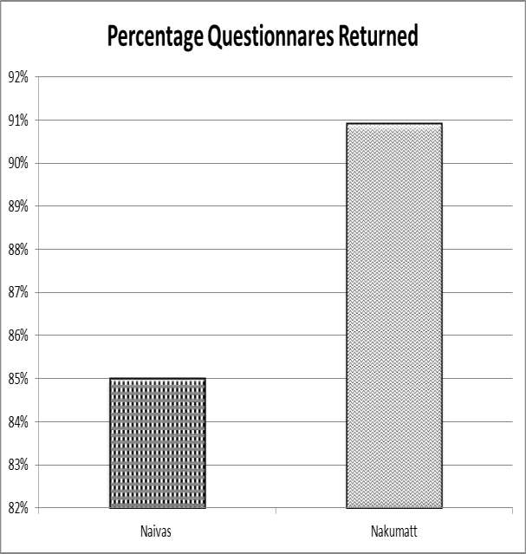

Figure4.1:Percentageof questionnairesreturned

Source:(Fielddata,2025)

The graph shows that Tobacco Company returned only 85% of the questionnaires while One step 90.19% of the questionnaires returned.

Gender
Tobacco Company 12respondentswhichare35%oftheparticipantswerefemale while 22 respondents which represented 65% of the participants were male.

Table.4.2.Gender– Tobacco Company

Gender No of respondents Percentagerespondents

Male 12 35%
Female 22 65%

Source;Fielddata,(2025)

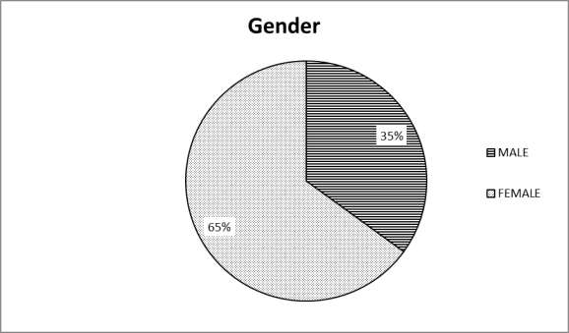

Fig4.2:Gender– Tobacco Company holdings. Source; (Field data, 2025)

At One step Tobacco Company 39% of the respondents which equals 20 participants werefemale while 61% of the participants which is 30 were male.

Table 4.3: Gender – One step holdings Gender No of respondents Percentage respondents
Male 20 39%
Female 30 61%

Source;Fielddata,(2025)

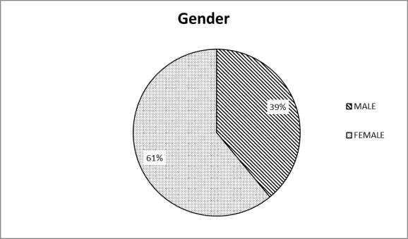

Table4.3:Gender–Nakumattsupermarket Source; Field data, (2025)

Levelof Education

Table4.4:LevelofEducation- Tobacco Company holdings

Levelof education | Numberof employees | Percentage
O– level | 12 | 36%
A– level | 1 | 3%
Certificate | 9 | 26%
Diploma | 8 | 24%
Degree | 4 | 11%
Totals | 34 | 100%
Source;Fielddata,(2025)
Findingsshowedthat36% | oftherespondentsat | Tobacco Company twere form four
leavers(O–levels),26%percentwerecertificateholders,24%percentwerediploma holders, 11% were degree holders, while 3% wereA– level certificate holders

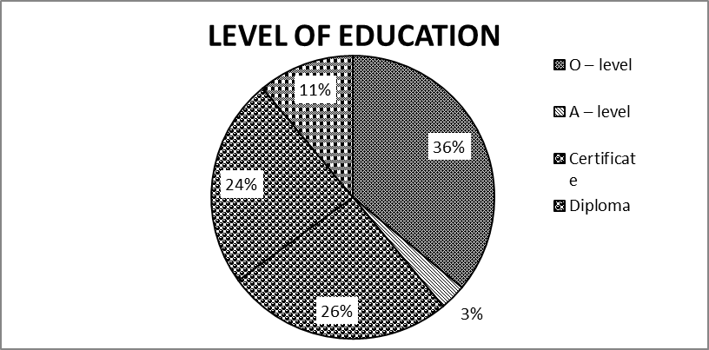
Figure4.4:LevelofEducation– Tobacco Company Source; Field data, (2025)

LevelofEducationatNakumattSupermarketHoldings:

Table4.5:LevelofEducation–Nakumattsupermarket

Levelof education | Numberof employees Percentage
O– level | 5 10%
A– level | 4 8%
Certificate | 14 28%
Diploma | 18 36%
Degree | 9 18%
Totals | 50 100%
Source:(Fielddata,2025)
Findingsshowedthat10% | oftherespondentsatOne step holdingswereforO–
levels),28%percentwere certificateholders,36%percentwerediplomaholders,18% were degree holders, while 8% wereA– level certificate holders.

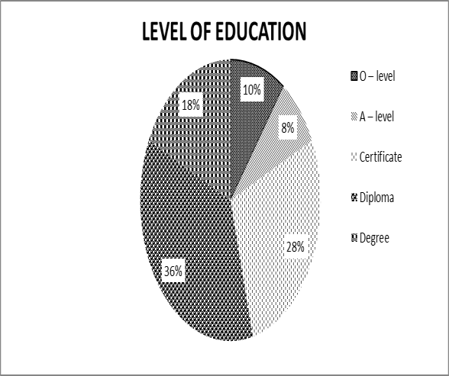

Figure4.5:LevelofEducation–One step holdings

Source:Fielddata,(2025)

StorageSystemsandFrequencyofUse
Findings showed that at Tobacco Company holding the most frequently used storage system was the open storage system with an average of 60% usage, followed by closed storage system with an average of 30% and random access storage with 10%. They were not using automated storage system.

Table4.6:Storagesystemsusedandfrequencies– Tobacco Company
STORAGESYSTEMS | PERCENTAGEUSE
Open storage | 60%
Closedstorage system | 30%
Random–accessstorage | 10%
Automatedstorage | 0%
Total | 100%
Source:Fielddata,(2025)

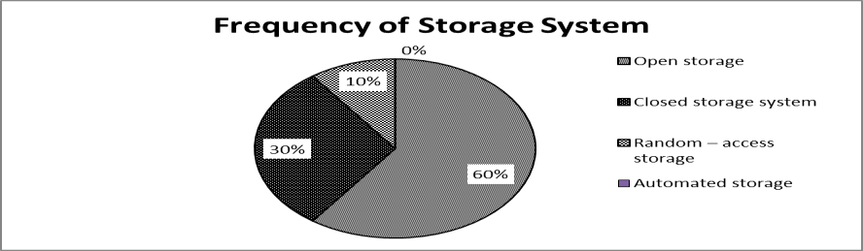
Figure4.6:Storagesystemsusedandfrequencies– Tobacco Company

Source:Fielddata,(2025)

Findings showed that at One step Tobacco Company holdings, closed storage system was mostly used with an average of 80% usage, followedby 15% open storage system with15% and random access storage with 5% while automated storage system was not being used at all.

Table4.7.:Frequencyofstoragesystemuse–One step Tobacco Company

STORAGESYSTEMS | PERCENTAGEUSE
Open storage | 80%
Closedstorage system | 15%
Random–access storage | 5%
Automatedstorage | 0%
Total | 100%
Source:SelfConceptualized,(2025)


Frequency

15%
Openstorage
Closedstorage system
Random–accessstorage
Automatedstorage

Figure4.7Storagesystemsusedandfrequencies–One step Supermarket

Source:Fielddata,(2025)

Response on organizations improved performance for the storage system used According to the research findingsat Tobacco Supermarket 5 respondents(14.7%) wereforincreasedsafety,14(41.17%)wereforminimumobsolescence,highoutput6 (117.65%) of respondents, improved accuracyrepresented by4 (11.76%), while 1 (1.7%) representative.

Table 4.8: Response on organizations improved performance for the storage system used
Performance | FREQUENCY | FREQUENCY  PERCENTAGE | IN
Safety | 5 | 14.70%
Minimum obsolescence | 14 | 41.17%
HighOutput | 6 | 17.65%
Accuracy | 4 | 11.76%
None | 5 | 14.70%
TOTAL | 34 | 100%
Source:Fielddata,2025)
Theinformation canfurtherbepresented inthe piechart below;
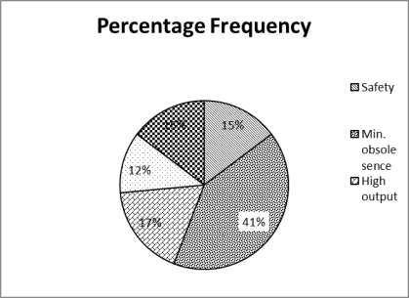

Figure4.8:Responseonorganizationsimprovedperformanceforthestoragesystemused

Source;(Fielddata,2025)

According to the research findings at One step 11 respondents (22%) were improved safety,13(26%)wereforminimumobsolescence,Highoutputhad10(20%)of
participantsaccuracyrepresented by13(26%), nonehad 3 (6%) representative.

Table 4.9: Response on organizations improved performance for the storage system used

Performance | FREQUENCY | FREQUENCY PERCENTAGE | IN
Safety | 11 | 22%
Min. obsolescence | 13 | 26%
Highoutput | 10 | 20%
Accuracy | 13 | 26%
None | 3 | 6%
TOTAL | 50 | 100%

Source:fielddata,(2025)

Theinformationcanfurtherbepresentedin thedata below;

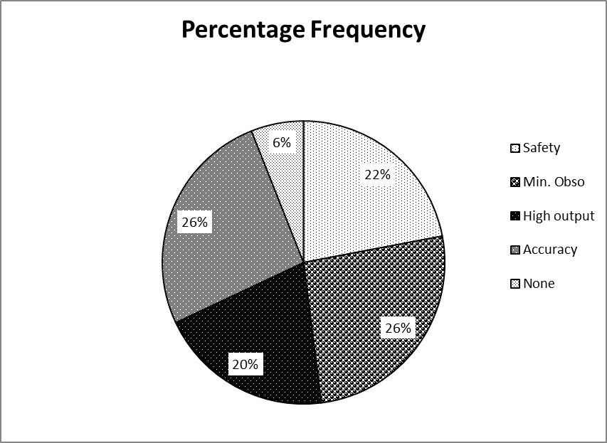
Figure4.9:Departmentsinvolved

Source:Fielddata,(2025)

Presentation of Respondents Interviewed on the highest ranked system in performance
The table below shows the ranks and number of respondents interviewed in all the two organizations. The information clearly shows that middle level management gave more information as compared to other levels of management interviewed in the organization visited.

Figure4.10:Systemwithhighestefficiencyinthe holding.
Rank interviewed | No. respondents interviewed FormTuyil | of | Respondent interviewfrom One step | %frequency interview of- respondents
Opensystem | 10 |  | 15 | 29.76%
Closed system | 10 |  | 25 | 41.67%
Randomsystem | 7 |  | 5 | 14.29%
Othersystems | 7 |  | 5 | 14.29%
Total | 34 |  | 50 | 100%

Source:Fielddata,(2025)

RespondentsRanks
30%
14%
open
closed random
others
42%
14%
Figure4.10:Storagesystem adopted

Source:Fielddata,2025)

From the above graph it is clear closed system was most popular 42%, followed by open system at 30%, then random at 22% the least being other systems being the least

Responseonwhethertoadoptautomatedormanualstorage system.

The table below shows the ranks and number of respondents interviewed in all the two organizations. The information shows the level of preference of automated and manual systems the organization visited

Table4.11:Responseonwhethertoadoptautomatedormanualstoragesystem.

System | No. respondents interviewed FormTobacc | of | Respondent interviewfrom One step | %frequency interview of- respondents
Manualsystem | 12 |  | 15 | 32.14%
Automated  system | 22 |  | 35 | 67.86%
Total | 34 |  | 50 | 100%
Source:(Fielddata, 2025)
From the above table it is clear automated system was most popular 67.86%, followed by manual system at 32.14% least preferred.
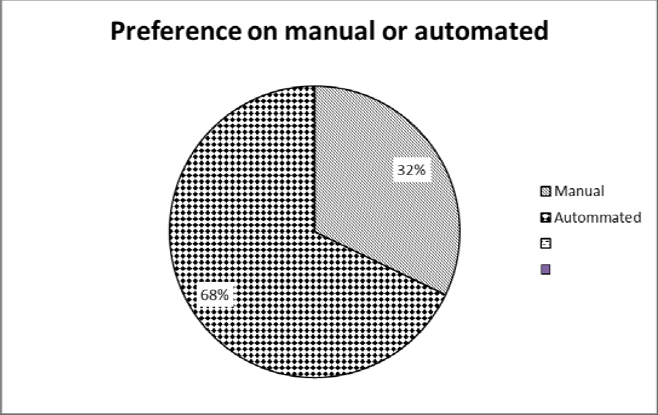

Fig4.11preferenceonmanualorautomatedstoragesystems. Source: (field data,2025)
SummaryofDataAnalysis
The researchers presented the questionnaires two different organizations i.e Tobacco Company and One step supermarket ltd.

The researchers collected information on the types of storages used and the closedstorage system and Open storage were the most used storage methods by the two organizations. The researchers learnt that most of the products were and essential items werestoredusingclosedstoragesystemwhilemostofthecommonequipmentwasstored in the open storage systems.

Considering the number of respondents interviewed and their ranks in the organization, the researchers realized that the middle level management gave more information or participated more as compared to other levels of management interviewed in the organizations visited.
The researchers also learnt that most (90%) of the employees appreciated the use of storage systems while only a few 10% had bad attitude towards storage systems in both the organizations. Out of whom 68% were in need of automated systems and only 32% favoring the manual systems.
In the interviews conducted, the researchers realized that most of the employees at all levels of management strongly agreed that storage systems has led to ease in customer service hence increased customer satisfaction, reduction in stock outs in the organization while they agreed that storage systems has led to increased organizational profitability.
Participants in both the organizations agreed that the organizations have realized steady increase in profitability for the past five years hence improved performance.

SummaryofMajorFinding
The findings of the storage systems and organizational efficiency based on the two organizationsrevealedthatvarioustypesof storagesystemsareusedinthe organizations. These were; open storage system, closed storage system, centralized storage system and random access storage. The two organizations also maintain good public relations with the institutions and other managements.

StorageMethods
The organizations practice the two main basic storage methods, that is ;- Open storage method and closed storage method. From the statistical pie charts drawn, it is clear that most organizations pay much attention to closed storage methods unlike open storage method. The idea behind this is that the closed storage method is less costly in the long run and the organizations prefer it.

Open storage method creates an ease in finding the products stored, and is suited for storing items which are less costly and low valued items while closed storage systems is best suited for items which are high valued and having high risk to the environment and therefore only authorized personnel are allowed to operate.

Productivity
Alltheorganizationsconsiderstorageproductivityasamajoraspectoforganizational efficiency. When goods are stored well, their value is maintained.

CHAPTER FIVE

SUMMARY OF FINDINGS
.Stores Function is Crucial to Operations:
The study found that the stores department plays a vital role in ensuring smooth operations in manufacturing. It supports production continuity by ensuring the availability of raw materials and spare parts when needed.
. Efficiency in Inventory Management:
Proper inventory control by the stores department helped reduce waste, pilferage, and overstocking. This efficiency led to better cost control and resource utilization, directly improving company performance.
. Contribution to Cost Reduction:
The stores function was shown to contribute significantly to the reduction of production costs, thus boosting profit margins. Efficient procurement and storage practices minimized unnecessary expenditures.
. Improved Production Planning:
With accurate stock records and timely supply of inputs, production planning was more predictable and reliable. This reduced delays and increased productivity and customer satisfaction.
. Interdepartmental Coordination:
The study highlighted the need for close coordination between stores, production, and finance departments.
Effective communication among these units enhanced the company’s overall performance.
.Challenges Identified:
Some challenges included poor documentation, lack of automation, and inadequate training for store personnel. These issues affected inventory accuracy and delayed material delivery.

5.2 CONCLUSION

From the literature review, interviews and data analysis on storage systems and organizations efficiency, there is need for implementing storage systems. Organizations need to take on storage systems seriously and follow the guidelines to enable the organizations to follow the set rules pertaining the team in the organization so as to enhanceefficiency.Data collectedfromboththeorganizationsrecallsthatmuchattention on storage systems is given to the organizations than other functions.

The benefits achieved through properlyestablished storage systems were reduced storage costs, minimum deterioration, avoid misuse of space hence enable the organization to achieve its organizations efficiency.

5.3 Recommendations
Fromtheanalyticalpointofview,theresearchersrecommendedthefollowing;
Most firms should adopt the closed storage system because once implemented, there is a corresponding increase in output, fewer accidents are realized, low spoilage of materials and improved efficiency. Closed storage system is much secured than open storage system.
Thestoragesystemshouldbeestablishedoncethe organizationis set.
Further research should be carried out to find out if both organizations and storage systems are benefitting from the set storage systems assessment within organizations should be strictly followed as the policy requires.
Well-equipped systems should be maintained in organizations to realize effective and efficient business operations. which will offer the possibility to do findings comparative analysis to see how the analyzed firms evolved over time and improved their storage systems. In order toincrease the validity of the research the future research to adopt combination the firsthand data collected through questionnaires and interviews with second hand data from various literatures.

REFERENCES

AGUILLAR,F.J(2023),GeneralManagersinaction:policiesandstrategiesNewYork: Oxford University Press.
BAKER,P.(2020)Principlesofwarehousingdesign.(3rdedition)CharteredInstituteof Logistics and Transport in UK.
CORINA,G.(2022),DeterminantsofOrganizationalPerformance;Thecaseof Romania:
DE BOER, Q,(2020)Aconceptual model for assessing the impact of electronic procurement,AfricaJournalofPurchasingandsupplychainManagementVol.3
FEARON,H.E(2024),Historicalevolutionofpurchasingfunctions;Journalof Purchasing and Material Management2571-81
GOETSCHALCK,M(2021),WarehousinginglobalsupplyChain:advancedmodels, tools and application for storage system. London publication page 31-51.
GUPTA,M.(2003)Movingprocurementsystemstointernet:theadoptionanduseofe procurement technologies models: South African Management Journal
HESSEN,et.al.(2023),Applicationofalayout/materialhandlingdesignmethod;
InternationaljournalofAdvancedManufacturingtechnology17(3)page216-220 JESSOP, D & MORRISONA, (2024) storage and supply of materials (6th edition).
CharteredInstituteofsupplyManagement.PrenticeHall
KOTHARI,M.(2023),QualitativeResearchMethods,2ndeditionbyMcGrawHill Publishers , New york
MUGENDAANDMUGENDAM.(2003)ResearchMethods–Quantitativeand qualitative Approaches, ACTS Publishers, Nairobi.
MULLER,M.(2020)Essentialsofinventorymanagement.AMACOMAdivisionof American Management Association.
ROODBERGENK.J.(2019),Asurveyof Literatureonautomatedstorageandretrieval systems; European journal of operation research 194page 343-362
SALEEMI,N.E.(2022),InformationTechnologysimplified.Nairobi,SaleemiPublishers. VANIK, M. (2021) Warehouse Management, prentice Hall Publishers, New york.

