
ROUTE SURVEY OF LAJOLO TO MAYA AND ELEKO ANFEYIN ROAD TO MAYA VILLAGE ILORIN,
MORO LOCAL GOVERNMENT, KWARA STATE

Presented By
ABASS KAFAYAT OPEYEMI
HND/23/SGI/FT/0060

SUBMITTED TO THE DEPARTMENT OF SURVEYING AND GEOINFORMATICS, INSTITUTE OF ENVIRONMENTAL STUDIES, KWARA STATE POLYTECHNIC, ILORIN

IN PARTIAL FULFILLMENT OF THE REQUIREMENTS FOR THE AWARD OF HIGHER NATIONAL DIPLOMA IN SURVEYING AND GEOINFORMATICS

JULY, 2025

CERTIFICATION
This is to certify that ABASS KAFAYAT OPEYEMI with Matric Number HND/23/SGI/FT/0060 from department o surveying and geo-informatics, institute of environmental studies has carried out a practical field work which formed basic of the project in accordance with survey rules and regulation and departmental instruction.

_________________ ______________
Surv. Abdulsalam Ayuba Date
Project Supervisor

_________________ ______________
Surv. A.O Akinyede Date
Project Coordinator

_________________ ______________
Mr. Abimbola Ibrahim Isau Date
Head of Department

_________________ ______________
External Examiner Date

DEDICATION

This project is dedicated to the Almighty Allah, the most beneficent, the most merciful who gave me the strength, wisdom, knowledge and understanding to write this project successfully. Also to my beloved, caring parent, Alhaji Issau Bolakale and Alhaja Taibat Olusola Abass whose love and care cannot be described mere page of paper may your live long to reap the fruit of your labour. Also, its dedicated to my project supervisor in person of Surv. Abdulsalam Ayuba for his care and support towards the success of my final year project.

ACKNOWLEDGEMENT
I give glory, honor and adoration to Almighty Allah, who is the alpha and the omega, the author and the finisher of my faith; who had made me to endure the vigor of my study. So, I return all glory back to God.
Words are not enough to thank my lovely and caring parent Alhaji Issau Bolakale and Alhaja Taibat Olusola Abass, may you live long to eat the fruit of your labour (Amin).
Also my profound gratitude to my wonderful and caring supervisor in person of Surv. Abdulsalam Ayuba and also to all the lecturers in the department of surveying and Geo-Informatics for sharing their knowledge, intelligence and time to bring out the best in us all.
Furthermore, my special thanks goes to my beloved siblings for their support Dr. Taofeek, Sis Rukayat, Alfa Quadri and also to my younger ones Faheedat, Khadijat, Abdul-Lateef and Abdul-Ahmed may God grant you all success in life (Amin).
Also to make a profound gratitude to my uncle Abass Yunus Olarenwaju (A.K.A last born) for your support toward my academic both financially and morally.
Furthermore, not only to express my indebtness to the dramatic form, but also to acknowledge those numerous people who stood my heart with wonderful experiences and exciting lessons in my life which are my cousins, Alfa Ridwan (A.K.A Banzer), my roommate Islamiat they are the best.
I shall not forget my troublesome friends in persons of Nafisat, Olawunmi, Opeyemi, Rahmat Mustupha and Nurudeen thanks for your support may God be with you all.
Finally I give glory to Allah who count me worthy which I am still alive I will always give glory, adoration and praise to you Lord.
TABLE OF CONTENTS
Title page …………………………………………………………………………...i
Certification ………………………………………………………………………..ii
Dedication ………………………………………………………………………...iii
Acknowledgement ………………………………………………………………...iv
Table of Contents ………………………………………………………………..…v
Abstract viii
CHAPTER ONE 1
Introduction 1
1.1 Background of the Study 1
1.2 Statement of the Problem 1
1.3 Significance of The Project 2
1.4 Aim 2
1.5 Objectives 2
1.6 Scope of the Project 3
1.7 Project Specification 3
1.8 Personnel 4
1.9 Study Area 5
CHAPTER TWO 7
Literature Review 7
2.1 Research Analogy 7
CHAPTER 3 16
Research Methodology 16
3.1 Research Design 16
3.2 Planning 16
3.2.1 Office Planning 17
3.2.2 Reconnaissance 18
3.3 Equipment Used 19
3.3.1 Hardware requirements 19
3.3.3 Software Used 19
3.4 Test of Instrument 20
3.4.1 Test of Sokkia Total Station 20
3.5 Data Acquisition 21
3.5.1 Control Check 22
3.5.1.1 Initial Control Check 22
3.5.2Traversing (Profiling) 24
3.5.3 Detailing 24
3.6 Total Station Data Downloading 25
CHAPTER FOUR 26
Data Processing And Result Analysis 26
4.2 Data Editing 26
4.3 Plan Production 26
Profile 30
4.5 RESULT ANALYSIS 33
CHAPTER FIVE 34
Conclusion and Recommendations 34
5.1 Summary 34
5.2 Problem Encounter 34
5.3 Recommendation 34
5.4 Conclusion 35
References 36
Appendices 38

ABSTRACT
This project report analyses route survey, and alignments design which was carried out from the road that connects Lajolo to Maya Anfeyin Road in Moro Local government. The project started with reconnaissance to be familiar with the project site. Control points were established and coordinated using GPS to minimize error. Marking of the centre line at an interval of 25m and pegging of cross sectioning points were done. Total station (SOKKIA) was used to acquire geometric data of the centre line and cross section points while details were also picked through this process. The acquired data were downloaded with Sokkia link software and processed using software’s like Microsoft Excel and Notepad. AutoCAD Land Development was used in plotting and designing horizontal and vertical alignments of the said route. The plans were produced in hard copy and finally, a comprehensive project report was written. The methodology involved reconnaissance, data acquisition using advanced surveying instruments such as total stations and GNSS receivers, and data processing with industry-standard software like AutoCAD Civil 3D. Key aspects of the survey included horizontal and vertical alignment studies, cross-sectional profiling, and identification of existing utilities and environmental constraints. This project underscores the importance of route surveys in infrastructure development, ensuring efficient design, cost-effective implementation, and long-term sustainability of transportation networks. Limitations, and inadequate collaboration. This study not only underscores the importance of addressing these challenges but also provides a roadmap for leveraging radio to foster a more informed and supportive community.
CHAPTER ONE

Introduction

1.1 Background of the Study
Surveying has been and would always be the bedrock of every meaningful development in any nation because it plays a vital role in human development and always precedes every human/societal development activity. It has various branches of which engineering survey is one.
Route survey which is an aspect of engineering survey may be defined as the survey operation that is done for the establishment of the horizontal and vertical alignment of transportation facilities. It involved: planning, design and setting out of any route such as railways, highways, pipelines and canals etc. as obtained by a surveyor and it also involved the proper assessment of natural and man-made features.
In addition, this type of survey should be applied when there is need for alignment, expansion, or rehabilitation at any existing route (road) e.g. for traffic purposes. The reason is that route survey provides a plan/map that shows the alignment, details, profile and cross sectional leveling which depicts the nature of the terrain of a given strip of land which serves the purpose of location, design and construction of route networks.
Good road network is one of the basic amenities needed by human being as movement is one of the characteristics of living things. There are needs for people to move from one place to the other and transportation of goods and services. Therefore for any meaningful development in a country, good road is a must.

1.2 Statement of the Problem
It was discovered that the Route from Lajolo junction to Maya Anfeyin ,Ilorin, Kwara State in Moro Local Government Area is dilapidated and causes a lot of lot of difficulty for farmers and villagers in the communityas such, there is the need for acquisition of geometrical data and provision of profile and cross-sectioning information which would assist engineers for the proper design and rehabilitation of the route to ensure the safety of those that are plying the road.

1.3 Significance of The Project
The project was carried out to provide information (geometric data) for future usage for reconstruction or perhaps the extension of the route which when carried out is expected to decongest traffics and enhance social and economic interaction between the areas it linked.

1.4 Aim
The aim of this project is to provide both horizontal and vertical alignment of the route.

1.5 Objectives
In order to achieve the aim, the following objectives were followed:
- Reconnaissance which includes office planning and field reconnaissance.
- Identification of existing features and adjoining roads.
- Stability of the ground controls to be use for orientation.
- Determination of centre line and marking of chainages along the centre line at an interval of 25m.
- Marking out some selected points for the cross-sectioning at 3m (6m) intervals on both sides of the centre line and also the edges of drainage was marked.
- Third order traverse to determine the orientation of the road way.
- Spot heightening to determine the height of some selected points at regular intervals along the road.
- Detailing
- Plan production (graphical representation of the surveyed road way) drawn with appropriate scale.
- Reports write up.

1.6 Scope of the Project
The scope of the project covered the following operation:
- Reconnaissance
- Test of instrument
- Control check
- Marking of chainage points at every 25m along the route
- Longitudinal section at 25m interval
- Detailing of all features (both natural and artificial features) within the right of way.
- Data downloading, Data processing/computation (volume, total length and linear accuracy) and analysis.
- Alignment designs
- AutoCAD drafting (Plotting of the vertical coordinates against the horizontal coordinates to obtain the longitudinal profile of the Centre line points) and presentation
- Report writing

1.7 Project Specification
The following are the specification to be ascertained in the project:
- Traverse must commence on three coordinated (known) controls and Closed on another set of three coordinated controls which must be confirmed undisturbed by necessary measurement (control checks).
- Third order traverse must be run along the zero observations and the angular difference from both faces should not be more than thirty Seconds (30”).The angular misclosure is determined by 30” here ‘n’ Is the total number of station observed
- Establishing traverse points by using pegs together with nails and Bottle corks.
- Spirit levelling must commence on a known benchmark and closed back on another known benchmark. Formulae for its misclosure are ±24m mvk, where ‘k’ is the total distance covered in kilometres.
- Levelling must be observed at every 25m intervals on both sides of the Centre line and at 5m interval on both sides of the centre line for the cross sectioning. Edges of drainage at both sides should be heightened.
- Fixing of relevant features to enhance assessment and necessary composition for good interpretation of plan.
- Setting out curve by using deflection angle method within third other Survey.
- The accuracy of the project must fall within the order of the project.

1.8 Personnel
The following names are the members of HND23 (Group 6B) that was assigned to carry out this project:
- ABASS KAFAYAT OPEYEMI HND /23/SGI/FT/0060
- BAMIGBOSE IDOWU MAYOWA HND/23/SGI/FT/0066
- AROWOLO NURUDEEN AYINDE HND/23/SGI/FT/0067
- ISAAC JOY SALOMI HND/23/SGI/FT/0068
- DAHUNSI OLAWUNMI COMFORT HND /23/SGI/FT/0069
- ADELOLU DANIEL ADEWALE HND/23/SGI/FT/0070
- OJERINDE ROMOKE HABEEBAT HND/23/SGI/FT/0112
- ABDULLAHI YUSUF SOFIYULLAHI HND/23/SGI/FT/0117

Study Area
The Road which connect Lajolo to Maya Anfeyin Road in Moro Local government was an ancient road which connect the two towns.

Geographical Extent and Location of the Study Area
The project site lies between latitude (ɸ) range (8˚ 32’ 35.44” to 8˚ 31’ 33.44”N) and longitude (λ) range (4˚ 38’ 06.61”E to 4˚ ,38’ 47.19”E) respectively. The site covers approximately 4.5km in total

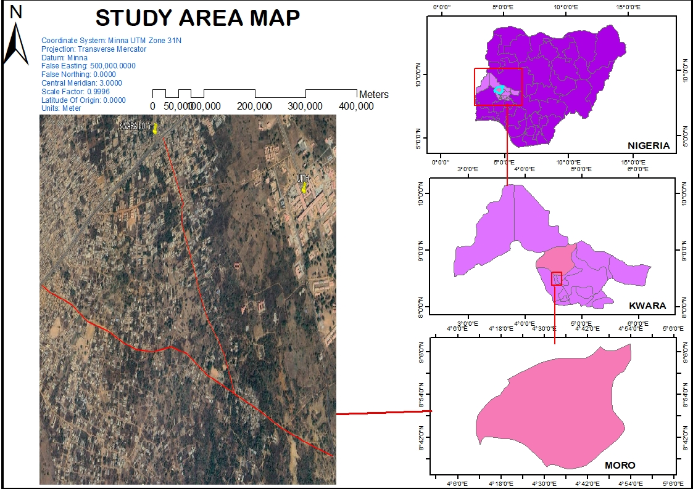
The Project Route is verged red (Source: Google Earth Imagery, February, 2024)
FIG 1.1 THE STUDY AREA (NOT TO SCALE)

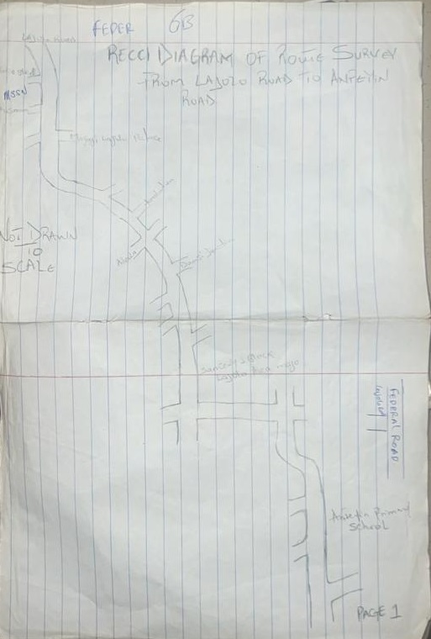

CHAPTER TWO

Literature Review

2.1 Research Analogy
The American Congress on Surveying and Mapping ACSM in (1997), defined the term surveying as the science and art of making all essential measurements to determine the relative position of points and /or physical and cultural details above, on, or beneath the surface of the earth, and to depict them in a usable form, or to establish the ‘position of points and /or details. Brinker (1977) stated that, surveying is used for quick determination of the distance, direction and elevation of points by a single observation from an instrument station.
Norman (1961), defined engineering survey as an expression for any survey work carried out in connection with the construction of civil engineering and building projects. He also stated that engineers and surveyors are involved in the project. Surveying is responsible for all aspect of dimensional control on such schemes. According to him, the main purposes of engineering surveying are:
- To provide large scale topographical map/ plan and other measurement at the concept design stage.
- To provide precise framework at the construction stage.
- To monitor structural movement on major retaining structure at the post construction stage.
According to Basak (1994), roads are used by various forms of transportation, such as trucks, automobiles, buses, motorcycles, and bicycles. Roads allow trucks to move goods from points of production, such as fields and factories, directly to markets, shopping centres and economic benefits. Private individuals rely on roads for safe and efficient automobile, motorcycle, and bicycle travel. Fire departments, medical services, and other government agencies depend on an organized system of roads to provide emergency services to the public in times of need. The earliest roads evolved from animal paths and served as trails for early hunters. Paths eventually grew around primitive settlements, and as trade grew, longer routes were developed to transport food and other important materials. The use of wheeled vehicles encouraged construction of better roads. The roads built by the ancient Romans were carefully planned and solidly constructed. Modern methods of road construction were first developed in the 18th century. Innovations of the time included waterproof surfaces and better drainage systems. Modern engineers make use of a variety of materials and construction techniques to build roads that can handle the high volumes and stresses of modern automobile and truck traffic.
Route surveying can also be explained as the survey carried out in establishing the horizontal and vertical alignment of a particular area needed for social utilities or construction like railways, highways, transmission lines, pipeline and canals. The purposes of every engineering surveying are for social development. This route survey project was made possible by the application of leveling traversing Maurray (1980), explained route surveying as the constructional processes and procedure that is involved in the production of design of route such as, pipeline, railways, transmission lines, road. Further still, Mikhail (1976), also explained route surveying as the topographical and constructional surveys that are necessary for the location and construction of lines of communication and transportation, roads and canals. Route Survey can be explain as a survey of the earth’s surface along a particular route in the compilation and updating of topographical, geological, soil, and other maps and the correlation of selected contours and objects with geodetic reference points or landmarks during linear surveys, and also in the study of the dynamics of natural and socioeconomic phenomena in a narrow strip of terrain. Allen et al (1968), defined traversing as an orderly sequence of determination of the length and directions of lines between two points on the surface of the earth to determine the exact position of point referred to the ground and the previous survey made and connected to in order to determine coordinate of such points. There are two types of traverse, namely
Closed traverse
Open traverse
Leveling was defined by Schofied (1972), as “the process of obtaining the height of specific points on the earth’s surface above a datum plane”. In a similar vein, Banister and Raymond (1972)defined leveling, as “the operation required in the determination or more strictly the comparison of heights of specific points on the earth’s surface. Dueto advancement in technology, computers are now used extensively in engineering surveying for general application such as network analysis, automated data processing for plan production and computation of setting out data and qualities, earthwork computation” etc.
Wilson (1977) opined that when there is need for design of route to be carried out, different types of plans must be acquired to enable such design to be appropriately, Such plans are cadastral and topographic plan. Since prior to the design, field survey work, Which enables the production of various plans such as preliminary survey from which the plan done showing extent of the existing road and other topographic features is produced on scale of either 1/25000 or 1/250 depending on the site involved.
Topographical map is a map on which features are shown by use of suitable symbols and relief characteristics (contours). These features are both natural and man-made. Also Cadastral map on which the location, shape and size of plots/properties are shown with a suitable scale Linear (horizontal and vertical distances), area and volume of surface structures are usually the geometrical elements obtained for ascertaining the undulation of surface of structures and size. In establishing any communication route, the importance of route survey cannot be over-emphasized. Route survey consists of the following:
Location survey or alignment, compensation survey (inventory of road corridor furniture) or properties.
Profile survey and essence of cross-sectioning a given route.
With regard to location survey, the lines projected after the preliminary surveys having carefully studied and compared with regard to the cost and operating expenses, selection of the scheme to be adopted are made. The remaining field work is directed to make a more detailed investigation of the ground along the preliminary survey line selected. The final location may be performed on the field, the surveyor using the gradient shown on the preliminary profile as a guide in seeking for improvements in the alignment. The detail work would be performed by traversing.
Clark (1971) explained profile leveling as a term used to describe the field work involved in surveying a longitudinal section of a route. The profile leveling may be of any regular interval such as 25m/30m which would be a continuous process until the closing station is reached Where cross section was done along line perpendicular to the center line. Once any new road formation or construction is proposed, it is certain to involve cut and fill, a useful convention is that of the width of cross sections of the road has to be marked with pegs. This is done purposely to indicate the extent of the new or future route to be constructed/expanded when necessary.
Agor (1993) remarked that longitudinal and cross sectioning are the integral parts of route surveying. It consist of obtaining a record of the undulation of the ground surface along a particular line, straight or curve so that they may be represented to scale. In a route survey, representations of the actual course of the survey and of the plane horizontal features (including the terrain, if necessary) on both sides of it within the limits of direct visibility are plotted using methods of instrument surveying (plane-table, tachometric, and aerial photo topographic surveying) or exploratory surveying. At the time of the United State national road construction, road quality was poor and construction proceeded slowly. Improvements in materials came with the introduction of asphalt paving in 1870, but the biggest motivation for road improvement came with the popularity of the automobile at the start of the 20th century. A government survey of public roads done in 1904 showed that about 3 million km (about 2 million mi) of all roads in the United States were unpaved. Only 248,000 km (154,000 mi) of these roads were surfaced. Automobile use increased the wear and tear on these roads, and efforts increased nationwide to improve road conditions. Local governments administered most roads at the time. State governments soon formed highway agencies to take over and organize improvement efforts. In 1912 the Federal Government began funding one-third of the cost of roads on which mail was carried. The Federal Road Act of 1916 provided even more federal participation in state roads improvements.Roads originated for economic reasons, related to the need to move food and other goods from one point to another.
Early transportation focused on moving food from a hunt or a harvest to the places where people lived. Trails evolved from prehistoric animal paths, and early humans carried or dragged their loads along these paths. As humans learned to domesticate animals, they transferred their loads to pack animals, such as horses, mules, camels, llamas, elephants, and dogs.World War I (1914-1918) temporarily halted highway construction, but the rapidly expanding use of the automobile, along with increased truck traffic, brought on a growing demand for even better roads. In 1919, a tax was added to gasoline to help provide federal financing. By 1930, the principal population centres of the United States were connected by a system of all-weather, two-lane roads. However, much of the road construction was not adequate for the growing volume of traffic, especially truck traffic with its increasingly heavy loads and high speeds. Construction of the interstates began in the 1950s and continued through the 1990s. In 1991 the U.S. Congress named the interstate highway system the Dwight D. Eisenhower System of Interstate and Defense Highways. Private, commercial, and government vehicles use the interstate highways. This network of roads saves the United States billions of dollars each year in time and transportation costs. Therefore route survey of the route provides adequate information that yielded a better route design and construction. In the 1950s and 1960s, Canada also began major roadway construction to serve the rise in vehicle ownership that occurred after the end of World War II. Work began on construction of what is known as the MacDonald-Cartier Freeway, serving southern Ontario. The Trans-Canada Highway stretches across Canada, linking St. John’s, Newfoundland and Labrador, on the Atlantic coast with Victoria, British Columbia, on the Pacific coast, with ferries plying parts of the route. The highway was formally opened in 1962. It passes through every provincial capital and also through several other major cities in the southern part of Canada.
Civil engineers continue to research ways of designing and building the most efficient and cost-effective roads. New types of road surfacing make roads more durable and easier to construct. Computers play a large role in helping engineers experiment with different road designs and in anticipating how factors like population growth affect road and highway transportation. There are many different types of roads, from multilane freeways and expressways to two-way country roads. One important quality of a road is known as control of access. This term describes how vehicles are allowed to enter and exit a road. By controlling access to a road, the road can support more traffic at higher speeds. Roads can be classified into three broad categories: highways, urban or city streets, and rural roads. Each type of road controls access to different degrees. Each type also differs in location, the amount of traffic it can safely support, and the speed at which traffic can safely travel.
Road path established over land for the passage of vehicles, people, and animals. Roads provide dependable pathways for moving people and goods from one place to another. They range in quality from dirt paths to concrete-paved multilane highways. Highways with fully controlled access can handle the most traffic and are built to the highest construction standards. Interstate highways, freeways, and expressways are examples of fully controlled-access highways. Vehicles that enter or exit these types of highways can do so only at certain points along the highway, generally by using special entrance and exit ramps. The ramps allow vehicles to access the road without disturbing the flow of traffic.
Incoming vehicles must merge with flowing traffic, and vehicles leaving the highway use exit ramps that guide them off the highway without blocking the traffic behind. Intersections with other roads are avoided by using either bridges known as overpasses to carry one roadway over another or short tunnel-like structures called underpasses to carry one roadway under another. Finished strips called shoulders on the edges of highways allow drivers of disabled vehicles to make repairs or await assistance without blocking traffic.
Some highways offer only partial control of access. These types of highways handle less traffic than do highways with fully controlled access. Highways with partially controlled access may intersect other roads at the same level (called at-grade), rather than using overpasses or underpasses. Vehicles can enter highways with partially controlled access at intersections rather than using ramps. However, the right-of-way is often given to one direction of travel, rather than requiring all traffic to stop at the intersection. Giving the right-of-way to one direction of traffic helps keep traffic moving at higher speeds, although typically not at speeds as high as those on a highway with fully controlled access. One benefit of highways with partially controlled access is that they are much cheaper to construct than highways with fully controlled access. Many U.S. and state highways are roads with partially controlled access.
Microsoft ® Encarta ® (2009) to support heavy vehicles moving at high speeds, a modern road is made up of several layers. Each layer helps the layers above it support the weight and pressure of moving traffic. Roads that carry more traffic at higher speeds, like highways, are built to stronger standards than roads that carry less traffic, such as rural collector roads. The number of layers in a road often depends on the intended use of the road, but generally roads have three distinct layers. From bottom to top, the layers are the roadbed, the base course, and the wearing course.
The roadbed is the very bottom layer of a road. Natural soil is the most common roadbed material. The roadbed is shaped to make a smooth, level surface that will support the layers built over it. Engineers use bulldozers and other construction equipment to distribute soil evenly along the roadbed. If a road is planned through an area where the natural landscape is uneven, soil can be removed or filled in as needed to obtain a level surface. The discovery and use of the wheel was undoubtedly a driving force in building and improving roads. Crude roads were in use in Mesopotamia in about 3000 bc. Italy was connected to Denmark by a roadway as early as 2000 bc.
During the period from 1900 to 300 bc, four trade routes, known as amber roads, ran across central and eastern Europe. Amber was an important ingredient in primitive and medieval medicine and was also used for statuary and jewellery. One of the first preplanned roads was the Persian Royal Road, built by Darius I in 500 bc in what is now Iran. The Royal Road was about 2,400 km (about 1,500 m) long and stretched throughout ancient Persia. The road was constructed for royal use, and it allowed Darius to keep informed, to convey orders, and to transport goods needed by the royal court. The road followed the shortest and most efficient route. It bypassed some of the largest towns in part, for the sake of following shortest route, but because large towns had the potential to rebel. An uprising in a town near the road could have threatened the security of the route or prevented troops from being dispatched.
Makanjuola (1988) stated that, because of employment opportunities provisions, there have been a continued migration of people from the rural area to urban area, the result of this is led to higher road traffic and congestion. This is a very big factor that constitute to route reconstructions, so as to provide solutions to this road traffic congestions. Haven’t considered the points above, the processes that are involved in route survey is explain in the next chapter

CHAPTER 3

Research Methodology

3.1 Research Design
All operations both on the field and in the office carried out to obtain all spatial data using appropriate automated surveying methods are dealt with in this chapter. The spatial data obtained from the field are the X, Y, Z coordinates of objects. The procedures and techniques employed in executing this project would be discussed in subsequent sections of this chapter. These include reconnaissance, office planning, field reconnaissance, test of total stations, data acquisition, total station configuration, total station observations, traversing, longitudinal profiling and cross sectioning and detailing.

3.2 Planning
The essence of a good planning cannot be overemphasized. The resources and time spent on planning are never futile and it is the foundation of the project planning. Reconnaissance survey is a vital aspect of surveying that involves both the planning and preliminary inspection of the project area before the commencement of the real survey exercise. It is done for the purpose of planning on how to execute the project, selecting station, locating controls, etc. It involved the use of available records such as plan, topographical map sheet, charts, and other relevant information about the project area. Meanwhile the benefit of the reconnaissance survey can never be overlooked since it enables the surveyor to foreseen the favour, problems, challenges or obstacle that are likely to be encountered during the real survey work. This in turn could help the surveyor in utilizing judiciously the available resources (i.e. time, energy, fund etc.) towards solving the problems. The two phases of reconnaissance are:
- Office planning
- Field reconnaissance (Data search).

Figure 3.0: Flowchart Showing the Planning Procedure
RECONNAISSANCE
OFFICE / FIELD

DATA ACQUISITION

DATA PROCESSING
DOWNLOADING/
COMPUTATION

PLOTTING

PLAN PRODUCTION

A series of planning, pre-observation and analysis as shown in the flow chart were carried out during the project implementation.

3.2.1Office Planning
This involved the collection of relevant materials and information needed for the successful execution of the project at hand. This was done to help in determine the expected accuracy, necessary instrument to be use, choice of scale and personnel.
The main information that was sourced for in this project were the collection of existing control stations, coordinates and instruments from Department, Surveying and Geoinformatics, Ilorin and test of instruments to ascertain its condition before use. The table 3.1 below shows the coordinate of control stations used for the project.
Table 3.1: Coordinate of the Existing Ground Controls Used
POINT ID | EASTINGS(m) | NORTHINGS(m) | HEIGHTS (m)
Point 01 | 679748.116 | 944715.534 | 350.785
Point 02 | 679981.321 | 944665.616 | 349.954
Point 03 | 680215.990 | 944716.757 | 348.872

3.2.2 Reconnaissance
Reconnaissance is the initial and one of the most important stages in surveying. This is the actual visitation to the particular area to be surveyed, in order to obtain an overall picture of the area before any type of survey work is undertaken. Reconnaissance survey helps to minimize any delays or changes in the observing schedule. There may be unnecessary loss of workdays if one goes to the project site with inadequate and insufficient information, which is needed to arrange for logistics and description for locating survey marks. But for this project; it was carried out in two ways namely:
- Office reconnaissance
- Field reconnaissance
It involves taking a general study or view of an area of operation with a view of knowing how best the operation is to be carried out in terms of energy and time. As this project was concerned, the reconnaissance was carried out in two stages. The stages were the office planning and field reconnaissance.

3.3 Equipment Used

These consist of instruments used in the execution of this project. It equally included both hardware and software used. However, they were categorized into two and given as follows:

3.3.1 Hardware requirements
The hardware components used for this project includes:
- A set of Total Station Sokkia its accessories
- Tripod Stand
- 50m Steel tape
- 3m Pocket tape
- Cutlass
- Hammer
- Nails with bottle corks
- Writing Materials
- Hp EliteBook laptop computer for data processing
- (A4 Printer)for printing reports.
- An HP Color LaserJet 5550dtn Printer (A3 printer) for printing hard copy plans.

3.3.3 Software Used
The software components used for this project includes:
- AutoCAD Civil 3D 2021 for plotting of acquired data
- Microsoft office 2016 (Word and Excel)for grouping and formatting downloaded data
- Notepad for grouping and formatting downloaded data

3.4 Test of Instrument
This is an important exercise in any survey operation, it has to be carried out before embarking on any survey project, and this was done in order to confirm the good working condition or otherwise of the equipment used.

3.4.1 Test of Sokkia Total Station
The total station used for this project was tested for both horizontal collimation and vertical index error. The following procedures were carried out in testing Sokkia Total Station:
Two points A and B were selected on a relatively level ground and were used as instrument and target station respectively.
- The instrument was set over the first point ‘A’, centered, leveled and focussed, while the target was set over the second point ‘B’.
- The instrument was powered ON and its menu option was navigated through. From the configuration mode screen “Collimation” was selected and the instrument prompted for sighting on face one (F1).
- At this jucnture, the target was bisected on face left of the instrument and enter button was pressed. The instrument again, prompted for sighting on second face (F2).
- The instrument was transited and the target bisected on face right of the instrument and enter button was pressed again. The results of the test were displayed and shown in the table 3.2 below.

Table 3.2: Test of Sokkia Total Station
Collimation | Horizontal reading | Vertical Reading
New | +00⁰ 00’ 08” | +00⁰ 00’ 07”
Old | +00⁰ 00’ 10’’ | +00⁰ 00’ 12’’
Source: Field Observation (January, 2025)
Expected angular accuracy is:
30” n where n is the number of station occupied
n=1
30” 1 = 30”
Obtained accuracy is: = +00⁰ 00’ 20”
Horizontal Collimation Error = 0º 00’ 08”
Vertical Index Error = 0º 00’ 07”
Allowable Angular accuracy = 30”√n, Where n is the number of station occupied
Therefore, n=1
Allowable Angular accuracy = 30”√1 = 30”
Each of obtained Horizontal Collimation and Vertical Index errors was lesser than the allowable Angular accuracy of 30”. Therefore, the instrument was suitable for data acquisition

3.5 Data Acquisition
This shows how the survey was carried out to achieve the desired result on the field. The activities involved are GPS observation, longitudinal and cross section and detailing.Field observations involved the acquisition of data in accordance with the specification given. The data acquired during the field measurements were distances and angles relative to the horizontal and vertical planes that is, to determine X, Y and Z coordinates of points
This has to do with the different field operations carried out and the technology adopted to acquire necessary data (observed facts) about the project site which. Schedules of operations are as follows:
- Third order traversing using total station.
- Detailing using total station the center line at 25m interval and cross section at 5m and 10m on either sides of the center line were determined.
Furthermore, both man-made and natural features were fixed. All the data acquired were fully automated

3.5.1 Control Check

3.5.1.1 Initial Control Check
The control check was carried out to ascertain that the controls used for orientation still maintained their position for correct orientation of the project work.The control check was carried out to ascertain that the controls used for orientation still maintained their position for correct orientation of the project work. The instrument was set up on Point A and all necessary temporary adjustments were carried out. The reflector at back station on Point Bwas bisected, read and recorded. The instrument was turn to fore station Point Cand reflector was bisected and also read and recorded.
The difference between computed and observed was deduced and it was within the allowable misclosure because the result obtained is less than expected misclosure as shown below;

Table 3.3: Coordinates of the Starting Control Pillars
STATIONS | EASTING(m) | NORTHING(m) | HEIGHT(m)
Point 01 | 679748.116 | 944715.534 | 350.785
Point 02 | 679981.321 | 944665.616 | 349.954
Point 03 | 680215.990 | 944716.757 | 348.872

Table 3.4: Back Computation from the Existing Coordinates of the Starting Control Pillars
From Stn | Bearing  °′ˮ | DDist(m) | ∆E(m) | ∆N(m) | Eastings  (m) | Northings  (m) | Height  (m) | To Stn
 |  |  |  |  | 679748.116 | 944715.534 | 3350.785 | Point 01
Point 02 | 2822539 | 1238.49m | -233.205 | --49.918 | 679981.321 | 944665.616 | 3349.954 | Point 02
Point 03 | 2874221 | 2240.18m | --234.669 | -51.141 | 680215.990 | 944716.757 | 3348.872 | Point 03

3.5.2 Traversing (Profiling)
The instrument was set up on point Bwhile a target was held vertically on Point Aas the back station. Temporary adjustments (Centering, Levelling and Focusing) were carried out on the instrument and the instrument was then powered on. A job was created on the memory of the instrument and ‘coordinate’ option was selected from the menu list. Coordinate of the instrument station was keyed in to the instrument and the height of the instrument and that of reflector were measured and keyed in as well. The coordinate of the back station was also keyed in. having supplied the coordinate of the instrument station, the back station was bisected and the bearing and distance between the instrument station and the back sight were displayed on the display unit of the total station.
The option ‘yes’ was clicked to accept the orientation direction as bisected and the parameters displayed. At this juncture, the instrument had been oriented and observation started. The target was taken to the first chainage of the center line of the route.
Horizontal coordinates of the centerline points at 25m interval were determined along the route. Every point visible form the control points were coordinated before the instrument was shifted to the first temporary point. On the temporary point, the same procedures were repeated until no other point is visible and the instrument station thereby changed. However, the 25m interval was not maintained whenever there is noticeable change in the course of the route and therefore data were acquired along such curve.

3.5.3 Detailing
This was carried out in order to fix and to determine the true position of the natural and artificial features existing along the route. The details were taken along the route by holding the reflector at the edge of detail and turn the telescope of the instrument to bisected the prism of the reflector. After observation has been taken, the coordinate display on the instrument screen is stored in the instrument memory. And adequate Recce diagram was drawn to aid the proper plotting of the detailing. At least three points were picked in detail like buildings. The procedures were repeated at every detail around the route. The features fixed include the uncompleted buildings, the adjoining roads, stream, well and completed building electric poles, trees, fences, etc.
Total station was used to acquire the location data (x,y,z) of the features

3.6 Total Station Data Downloading
The data acquired through Total Station was downloaded using Bluetooth connecting from the total station storage to the laptop.

CHAPTER FOUR

Data Processing and Result Analysis
4.1 Data Processing Procedure
This is the process of transferring the captured data stored in the memory of the instrument via the data transfer port of the equipment through the cable (downloading cable) to the computer for further processing and analysis.
Data processing includes numerical calculation, classification of data and the transmission of data from one place to another. Below is the procedure used for data processing:
The file was opened and point data were displayed. This was then copied to a notepad and Microsoft excel environment for further processing.
On notepad, data were well spaced to differentiate one column from the other and unwanted information deleted. On Microsoft excel, data were prepared for scripting purpose in AutoCAD.

4.2 Data Editing
Data editing is done using the Microsoft excel. The following steps are followed to edit our data in the project:
- The Microsoft excel was lunched.
- Click on file, the click on “all file” and select the group data.
- On open “test import wizard”, select “delimitated” and click on next.
- Select comma, tap and space then click on next. All the co-ordinates will be arranged then click on finish.
- Cut and copy and arrange in its appropriate positions if there is any misclosure

4.3 Plan Production
Plan and profile production using AutoCAD Civil 3D provides a comprehensive overview of the tools and techniques necessary for creating detailed plans and profiles for civil engineering projects. This typically covers the step-by-step process of generating plan and profile, starting from importing survey data to creating alignments, profiles, and sheets.
The steps are as follows:
- Creating points
The X, Y, and Z data are used to create point. The data could be in any of the following format:
.pm.
.csv
.xyz
.auf
.nez
.pnt
To import the point, open the toolspace, click on prospector at the right of the tool space, then right click on points to create points. The create points toolbar will then appear, click on import points to import the data. The import point tool will then appear, click on add files then browse to the folder which
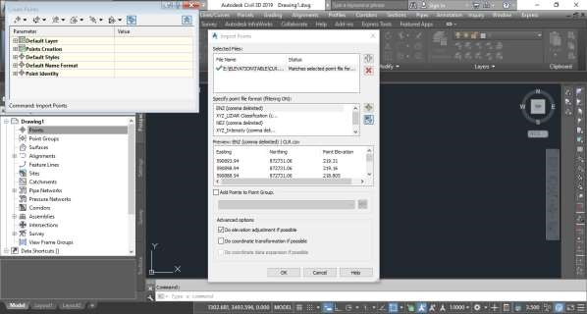
Contains that data. Select the data, click ok, then select point format, and click ok. Close all the dialogue and zoom to extent to display the points.

- Creating Surface
After the points have been created, the next is to create surface. On the tool-space, right click on surface and select create surface, then ”create surface” dialogue will appear, type the name of the surface e.g. New Surface and click ok.
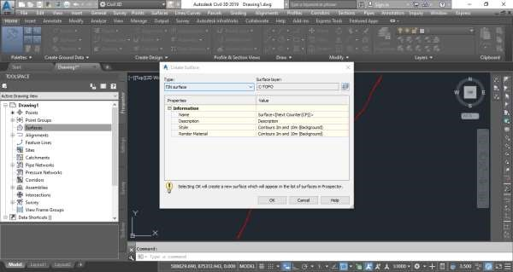
Then expand the New Surface, expand “Definition”, then right click on “Point Groups” and click
“Add”, the “Point Group” dialogue will then appear and “All points” and then ok. Now the surface has been created.
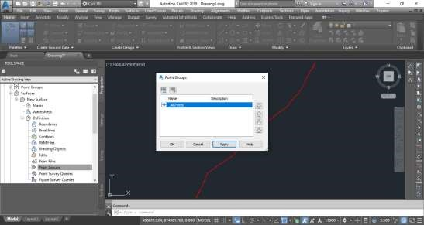

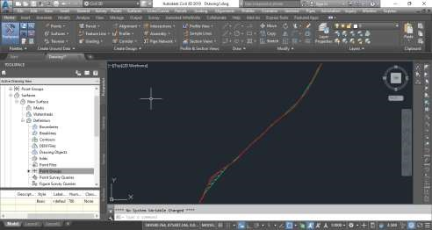
- Creating alignment

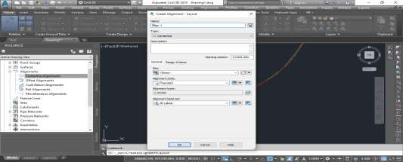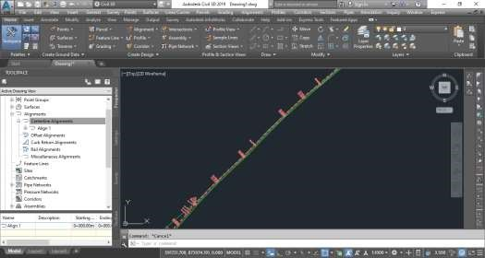
The next thing after creating the surface is to create alignment. To create alignment, click on
“Home” menu, click on alignment, then “Alignment Creation Tools”, the “Create Alignment layout” will appear, then name the alignment e.g. Align 1, then click ok. The "Alignment Layout Tools -Align 1" will then appear, select "Tangent-Tangent (With Curves)" then zoom to the starting point and click on the center points till the last , then press escape and close the "Alignment Layout Tools -Align 1" window . With that, the alignment has been created.

Profile
Once the alignment has been drawn, the profile can be plotted. To do this, click on the
Home ribbon click on “profile” then “create profile from surface”, the create profile from surface window will then appear. Click on “add” to add the surface then click “Draw in profile view”, then ‘Create Profile View – General” will also appear, you can type the name of the profile or accept default, then click next, next, next, next, next, next and then click
“Create Profile View”, you can then select profile view origin which can be any desired space on the drawing page. Now the profile has been plotted.
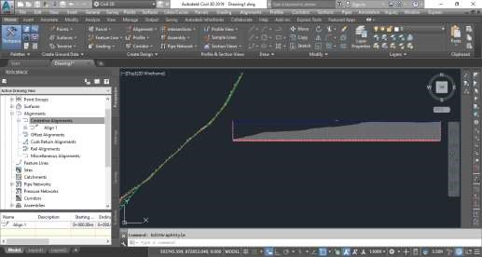

Sample line
To create sample lines for the cross section, click on the “sample line” on the home ribbon the select the alignment created earlier, the “create sample line group” window will appear, give it a name of accept default and click ok. On the “sample line tools” window, click on
“sample line creation method” and select “by range of stations”, the " "Create Sample Lines - By Station Range" window will appear, enter the left swath width and right swath width, then press ok and the escape. Now, the sample line has been created.
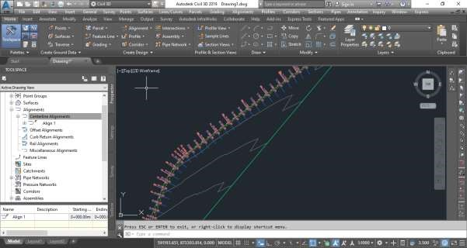

Cross section
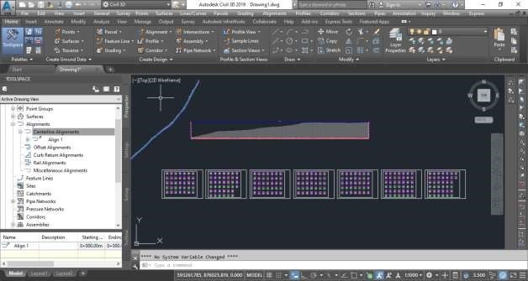
Once the sample line has been drawn, the cross section can be plotted. To plot the cross section, click on “Section View’ on the home ribbon and then, click “Create Multiple Views” then, the "Create Multiple Section Views - General" window will then appear, you can name it or accept default, then click next, next, next, next, next then click “Create Section Views”, then select any desired empty area on the drawing page for the section view origin. The cross section has been plotted.

4.5 RESULT ANALYSIS
This was done to compare the results obtained with the minimum allowable accepted for the order of survey job according to survey rules and departmental instructions. The analysis of the result table is shown in the appendices.
The route survey traverse started from TBM1 and closed back on TBM 4
Table 4.1: Abstract of TBM coordinates
TBM NO. | EASTINGS (m) | NORTHINGS(m) | HEIGHTS(m)
TBM 1 | 680079.673 | 944607.829 | 350.254
TBM 2 | 680498.890 | 943188.23 | 350.119
TBM 3 | 681274.349 | 942704.360 | 352.702
TBM 4 | 678881.884 | 943974.523 | 324.328

CHAPTER FIVE

Conclusion and Recommendations

5.1 Summary
The project covered a total length of 4.5km. The field work however involved the following processes; Reconnaissance, Monumentation, Traversing, and Detailing. Total Station (Sokkia) was used for the data acquisition and its software for downloading and transforming the acquired data respectively. The adjusted coordinates were used for the production of the final plans.

5.2 Problem Encounter
During the cause of the project, the following problems were encountered
- Movement of vehicles along the project site.

5.3 Recommendation
Having successfully carried out the project exercise, I hereby recommend the following,
- The data and results obtained from this project could be used for further construction analysis
- The results obtained can further be used for more research work along/within the road limit
- Practical of such should be given to students not for final year project alone as it broaden student knowledge of engineering aspect of surveying
- Application of computer programming should be fully implemented so as to make the student carry out the data processing exercise faster and efficiently
- The school authority should provide adequate equipment especially, digital instruments to the students so as to improve the accuracy and the speed of the project execution

5.4 Conclusion
Despite the encountered problems during the execution of this project with the respect to the instructions, the result obtained were of accepted accuracy, these were achieve due to the precautions taken on the field during the execution.Also, at the end of the project, I was able to acquire a commendable practical techniques and skills owing to the fact that this project has exposed me to many aspect of surveying tasks and as well, the aim and the objectives of the project were achieved.

REFERENCES
Allanetal. (1968): Practical field Surveying and computation,1stEd, William Heinemann ltd, London, P. 150.
Agor R (1993): Engineering surveying, 4th Ed, Khan publishing limited, Delhi India, P. 340.
Bannister and Raymond (1977): Surveying, 4th Ed, Pitman Publishing Limited, London, P. 205
Bannister and Raymond (1992): Surveying, 6th Ed, Pitman Publishing Co-ltd, Great Britain, P. 14
Basak N.N. (1994): Surveying and leveling, 10th Ed, Tata MC Graw Hill publishing company ltd, New Delhi, P. 177.
Bright S.G. (1977): Surveying for Engineers, 5th Ed, Fitshoney and Whiteside Limited, Toronto, P. 275.
Brinker R.C. (1977): Elementary surveying, 6TH edition, Thomas Y Company. London, P. 74
Clark A. D. (1971): Geodetic for Engineers, 26th Ed, E.D.S Ccoshanchore, P. 312.
Microsoft ® Encarta ® 2009. © 1993-2008 Microsoft Corporation. All rights reserved.
Mikhail E. (1976): Route Surveying, 10th Ed, North Holland publications, co New York, P.156.
Mikhail E.M. (1985): Introduction to Surveying, 12th Ed, North Holland Publications, co New York, P.160.
Makanjuola S.A. (1988): Factors affecting optimal use of highway system, Vol 5, no 1 & 2, P. 92.
Maurray S. (1980): Introduction to Surveying,6th Ed, Kinkeding printing company, Republic of Singapole, P. 4, P. 463.
Norman T.W. (1961): Route surveying, 1st Ed, Edward Arnold publishers, P. 145.
Schofied .W. (1972): Engineering Surveying, 4th Ed, newness Butteer, London, P.45-46.
Wilson R.T.P. (1976): Land Surveying, 2th Ed, Pitman Press, London, P. 250
Wilson R.T.P. (1977): Land Surveying, 3th Ed, Macolanall and Evans, London, P. 287

Appendices
NORTHING EASTING HEIGHT NORTHING EASTING HEIGHT
680057.200 | 944604.780 | 347.497 |  |  | 680095.520 | 943435.790 | 341.017
680060.610 | 944605.900 | 347.566 |  |  | 680117.910 | 943425.260 | 342.678
680064.130 | 944607.790 | 347.687 |  |  | 680116.600 | 943423.600 | 342.592
680070.800 | 944590.570 | 347.207 |  |  | 680115.170 | 943421.820 | 342.497
680068.170 | 944589.670 | 347.215 |  |  | 680135.480 | 943408.970 | 343.819
680064.980 | 944588.220 | 347.224 |  |  | 680136.910 | 943410.520 | 343.917
680071.650 | 944572.880 | 347.781 |  |  | 680138.880 | 943412.520 | 344.035
680075.060 | 944574.000 | 347.925 |  |  | 680168.600 | 943387.870 | 345.979
680077.700 | 944574.780 | 348.045 |  |  | 680167.730 | 943385.330 | 345.921
680082.470 | 944564.630 | 348.800 |  |  | 680166.200 | 943383.220 | 345.823
680078.630 | 944562.840 | 348.623 |  |  | 680196.350 | 943360.230 | 345.719
680074.450 | 944561.610 | 348.342 |  |  | 680197.670 | 943361.670 | 345.766
680080.470 | 944543.830 | 349.877 |  |  | 680199.310 | 943363.780 | 345.833
680084.210 | 944544.170 | 350.369 |  |  | 680227.140 | 943344.770 | 345.729
680088.500 | 944544.630 | 350.909 |  |  | 680225.600 | 943343.210 | 345.736
680094.640 | 944525.860 | 353.391 |  |  | 680223.190 | 943341.320 | 345.715
680091.230 | 944525.620 | 352.883 |  |  | 680240.090 | 943327.460 | 346.915
680087.700 | 944525.280 | 352.370 |  |  | 680241.410 | 943328.570 | 346.882
680088.940 | 944518.760 | 353.083 |  |  | 680242.940 | 943330.230 | 346.834
680070.800 | 944514.590 | 350.893 |  |  | 680272.120 | 943303.920 | 347.967
680071.910 | 944510.280 | 351.441 |  |  | 680270.480 | 943301.820 | 347.928
680088.850 | 944514.880 | 353.378 |  |  | 680268.280 | 943299.590 | 347.860
680091.660 | 944501.180 | 354.617 |  |  | 680288.400 | 943281.980 | 348.663
680096.390 | 944502.090 | 355.175 |  |  | 680275.680 | 943269.540 | 347.942
680100.790 | 944503.430 | 355.724 |  |  | 680277.230 | 943267.120 | 348.071
680105.120 | 944495.490 | 356.046 |  |  | 680291.160 | 943279.780 | 348.882
680135.700 | 944501.260 | 356.748 |  |  | 680294.580 | 943277.700 | 349.070
680135.930 | 944498.380 | 356.654 |  |  | 680295.560 | 943279.360 | 349.046
680106.780 | 944492.510 | 356.071 |  |  | 680296.880 | 943281.800 | 348.994
680106.510 | 944479.120 | 356.017 |  |  | 680319.170 | 943267.960 | 350.200
680103.100 | 944478.000 | 356.000 |  |  | 680317.420 | 943265.740 | 350.212
680099.030 | 944476.880 | 355.709 |  |  | 680315.670 | 943262.970 | 350.244
680109.360 | 944455.360 | 354.881 |  |  | 680335.650 | 943251.550 | 350.405
680113.650 | 944455.710 | 354.984 |  |  | 680336.960 | 943253.540 | 350.299
680117.390 | 944456.170 | 355.082 |  |  | 680338.050 | 943256.090 | 350.177
680124.980 | 944432.090 | 354.328 |  |  | 680366.200 | 943239.510 | 350.133
680122.240 | 944430.750 | 354.194 |  |  | 680364.990 | 943237.400 | 350.183
680118.940 | 944429.080 | 354.031 |  |  | 680363.240 | 943234.520 | 350.263
680131.160 | 944402.920 | 353.546 |  |  | 680394.580 | 943218.840 | 350.032
680134.570 | 944404.370 | 353.738 |  |  | 680395.670 | 943220.500 | 350.057
680138.090 | 944405.380 | 353.916 |  |  | 680396.870 | 943223.050 | 350.097
680148.130 | 944374.560 | 353.516 |  |  | 680408.490 | 943210.710 | 349.502
680144.390 | 944372.890 | 353.151 |  |  | 680408.170 | 943206.620 | 349.131
680141.090 | 944371.550 | 352.827 |  |  | 680398.170 | 943202.040 | 348.874
680148.330 | 944352.660 | 352.428 |  |  | 680399.060 | 943200.170 | 348.702
680151.300 | 944353.340 | 352.752 |  |  | 680414.110 | 943207.530 | 349.163
680155.370 | 944354.460 | 353.187 |  |  | 680415.210 | 943209.080 | 349.305
680162.060 | 944332.700 | 354.345 |  |  | 680416.410 | 943211.190 | 349.509
680159.650 | 944331.920 | 354.139 |  |  | 680429.760 | 943203.950 | 348.806
680156.680 | 944331.350 | 353.866 |  |  | 680428.670 | 943202.720 | 348.680
680162.370 | 944311.910 | 355.042 |  |  | 680427.350 | 943201.170 | 348.530
680165.010 | 944312.590 | 355.283 |  |  | 680437.730 | 943194.360 | 347.865
680167.210 | 944313.260 | 355.458 |  |  | 680439.050 | 943196.020 | 348.019
680176.460 | 944288.300 | 356.606 |  |  | 680440.030 | 943198.130 | 348.231
680173.490 | 944287.520 | 356.357 |  |  | 680457.790 | 943188.580 | 347.669
680170.190 | 944286.730 | 356.089 |  |  | 680456.700 | 943186.590 | 347.462
680187.420 | 944245.990 | 354.680 |  |  | 680455.170 | 943184.590 | 347.319
680190.060 | 944246.890 | 354.865 |  |  | 680480.430 | 943171.760 | 347.632
680193.140 | 944247.900 | 355.087 |  |  | 680481.640 | 943172.870 | 347.694
680208.150 | 944213.340 | 354.193 |  |  | 680482.520 | 943174.420 | 347.775
680204.850 | 944212.440 | 354.132 |  |  | 680505.690 | 943160.580 | 347.355
680201.770 | 944211.430 | 354.081 |  |  | 680504.270 | 943158.920 | 347.241
680204.880 | 944180.810 | 354.408 |  |  | 680502.410 | 943157.030 | 347.115
680207.960 | 944180.600 | 354.355 |  |  | 680529.120 | 943139.890 | 347.873
680210.930 | 944180.390 | 354.303 |  |  | 680531.420 | 943143.330 | 347.891
680201.290 | 944169.070 | 354.791 |  |  | 680532.400 | 943145.760 | 347.898
680197.880 | 944169.500 | 354.885 |  |  | 680565.290 | 943128.100 | 347.896
680194.570 | 944170.370 | 354.959 |  |  | 680563.650 | 943124.550 | 347.993
680179.200 | 944159.800 | 355.810 |  |  | 680561.800 | 943120.340 | 347.691
680181.850 | 944157.820 | 355.787 |  |  | 680588.610 | 943104.970 | 346.714
680184.830 | 944156.840 | 355.720 |  |  | 680590.030 | 943107.850 | 346.899
680185.960 | 944125.100 | 356.975 |  |  | 680591.560 | 943111.950 | 347.168
680183.420 | 944125.200 | 357.020 |  |  | 680624.240 | 943091.070 | 346.846
680181.110 | 944125.410 | 357.060 |  |  | 680622.710 | 943087.860 | 346.796
680177.880 | 944083.150 | 358.291 |  |  | 680620.520 | 943084.980 | 346.726
680181.290 | 944082.830 | 358.379 |  |  | 680656.600 | 943065.550 | 346.156
680185.700 | 944082.520 | 358.495 |  |  | 680658.240 | 943068.100 | 346.186
680192.220 | 944050.360 | 358.040 |  |  | 680659.440 | 943071.320 | 346.255
680189.690 | 944050.350 | 357.954 |  |  | 680687.250 | 943056.170 | 346.440
680185.610 | 944050.330 | 357.821 |  |  | 680686.160 | 943053.510 | 346.576
680194.020 | 944014.200 | 355.825 |  |  | 680684.520 | 943050.850 | 346.681
680197.430 | 944014.880 | 356.098 |  |  | 680711.010 | 943034.260 | 348.573
680201.610 | 944015.780 | 356.429 |  |  | 680713.200 | 943037.480 | 348.355
680211.890 | 943979.880 | 354.320 |  |  | 680715.060 | 943040.810 | 348.106
680209.590 | 943978.870 | 354.184 |  |  | 680755.020 | 943015.210 | 347.394
680206.400 | 943978.090 | 354.016 |  |  | 680753.050 | 943013.320 | 347.336
680207.210 | 943966.920 | 353.442 |  |  | 680750.640 | 943010.980 | 347.303
680183.580 | 943958.410 | 351.421 |  |  | 680774.370 | 942996.040 | 345.985
680184.590 | 943953.660 | 351.240 |  |  | 680776.340 | 942998.480 | 346.030
680210.100 | 943961.840 | 353.325 |  |  | 680777.660 | 943000.590 | 346.074
680217.150 | 943935.220 | 353.679 |  |  | 680799.300 | 942985.200 | 345.112
680219.890 | 943936.450 | 353.883 |  |  | 680797.990 | 942983.420 | 345.045
680224.180 | 943937.570 | 354.204 |  |  | 680796.120 | 942981.540 | 345.000
680240.580 | 943888.090 | 356.371 |  |  | 680817.890 | 942962.490 | 343.314
680237.060 | 943887.190 | 356.259 |  |  | 680819.430 | 942964.600 | 343.274
680234.310 | 943885.850 | 356.172 |  |  | 680820.630 | 942966.930 | 343.282
680247.270 | 943841.560 | 355.148 |  |  | 680841.190 | 942946.220 | 340.531
680250.680 | 943842.900 | 355.272 |  |  | 680842.940 | 942949.000 | 340.541
680254.310 | 943843.580 | 355.364 |  |  | 680843.810 | 942951.430 | 340.648
680264.900 | 943813.210 | 355.743 |  |  | 680871.820 | 942940.820 | 339.949
680261.270 | 943811.870 | 355.668 |  |  | 680870.520 | 942937.720 | 339.751
680258.520 | 943810.530 | 355.613 |  |  | 680869.650 | 942934.290 | 339.527
680269.250 | 943773.410 | 356.614 |  |  | 680896.810 | 942916.600 | 339.236
680273.210 | 943773.650 | 356.523 |  |  | 680898.890 | 942919.820 | 339.607
680276.400 | 943774.330 | 356.456 |  |  | 680901.520 | 942922.810 | 340.001
680282.850 | 943732.770 | 354.815 |  |  | 680913.490 | 942904.170 | 338.329
680279.330 | 943731.760 | 354.810 |  |  | 680929.890 | 942878.030 | 335.986
680274.600 | 943731.410 | 354.872 |  |  | 680934.450 | 942867.540 | 335.983
680287.080 | 943696.180 | 352.907 |  |  | 680939.070 | 942868.340 | 336.066
680290.050 | 943696.520 | 353.013 |  |  | 680931.280 | 942889.210 | 336.862
680293.020 | 943696.750 | 353.270 |  |  | 680934.120 | 942892.760 | 337.206
680302.630 | 943663.390 | 354.506 |  |  | 680937.080 | 942896.200 | 337.563
680300.100 | 943662.610 | 354.415 |  |  | 680964.000 | 942884.150 | 337.170
680298.020 | 943661.270 | 354.386 |  |  | 680963.130 | 942881.710 | 336.976
680311.800 | 943630.140 | 356.517 |  |  | 680962.590 | 942879.500 | 336.855
680315.100 | 943630.600 | 356.495 |  |  | 680990.050 | 942867.890 | 337.360
680317.190 | 943631.270 | 356.468 |  |  | 680990.810 | 942869.660 | 337.446
680326.800 | 943597.800 | 356.436 |  |  | 680991.800 | 942871.320 | 337.532
680325.150 | 943597.460 | 356.424 |  |  | 681021.450 | 942862.930 | 339.024
680323.060 | 943597.120 | 356.414 |  |  | 681020.910 | 942860.940 | 338.927
680333.780 | 943562.220 | 354.855 |  |  | 681020.250 | 942859.940 | 338.847
680335.980 | 943563.110 | 354.946 |  |  | 681053.690 | 942840.510 | 338.274
680338.180 | 943563.010 | 354.992 |  |  | 681055.010 | 942842.060 | 338.411
680355.820 | 943530.350 | 355.667 |  |  | 681057.420 | 942843.840 | 338.578
680352.860 | 943528.340 | 355.803 |  |  | 681065.750 | 942828.620 | 337.591
680349.790 | 943526.340 | 355.716 |  |  | 681064.430 | 942827.280 | 337.505
680360.920 | 943522.290 | 355.698 |  |  | 681062.230 | 942826.060 | 337.427
680376.220 | 943524.350 | 355.195 |  |  | 681072.730 | 942817.030 | 336.837
680376.230 | 943520.920 | 355.306 |  |  | 681074.160 | 942817.920 | 336.895
680363.360 | 943518.650 | 355.643 |  |  | 681074.920 | 942819.140 | 336.971
680373.330 | 943504.100 | 355.986 |  |  | 681088.050 | 942814.110 | 336.642
680370.140 | 943502.650 | 355.933 |  |  | 681086.950 | 942812.230 | 336.521
680367.180 | 943500.860 | 355.863 |  |  | 681085.860 | 942810.340 | 336.396
680389.230 | 943466.670 | 356.517 |  |  | 681104.150 | 942807.540 | 335.511
680391.210 | 943467.680 | 356.641 |  |  | 681104.030 | 942808.980 | 335.634
680393.410 | 943468.680 | 356.773 |  |  | 681104.250 | 942810.860 | 335.776
680409.470 | 943445.410 | 356.675 |  |  | 681129.570 | 942810.640 | 334.676
680406.510 | 943443.630 | 356.364 |  |  | 681129.140 | 942808.540 | 334.461
680404.860 | 943441.740 | 356.134 |  |  | 681128.820 | 942805.880 | 334.197
680410.630 | 943432.370 | 355.897 |  |  | 681153.940 | 942801.670 | 332.702
680410.590 | 943416.330 | 354.891 |  |  | 681154.270 | 942802.780 | 332.853
680403.810 | 943404.470 | 353.904 |  |  | 681155.140 | 942804.440 | 333.063
680405.360 | 943401.710 | 353.803 |  |  | 681183.240 | 942797.930 | 332.880
680412.470 | 943413.020 | 354.773 |  |  | 681182.590 | 942796.600 | 332.740
680419.390 | 943418.140 | 355.260 |  |  | 681182.150 | 942795.380 | 332.616
680422.020 | 943419.690 | 355.419 |  |  | 681188.670 | 942789.100 | 332.229
680425.100 | 943421.480 | 355.623 |  |  | 681190.650 | 942789.660 | 332.355
680437.880 | 943392.220 | 353.514 |  |  | 681192.630 | 942790.560 | 332.479
680435.020 | 943390.990 | 353.467 |  |  | 681198.080 | 942776.980 | 331.185
680432.170 | 943389.650 | 353.429 |  |  | 681196.660 | 942775.860 | 330.989
680451.020 | 943357.330 | 351.681 |  |  | 681194.240 | 942775.520 | 330.837
680453.880 | 943359.110 | 351.759 |  |  | 681201.930 | 942754.100 | 328.977
680456.180 | 943360.670 | 351.816 |  |  | 681203.460 | 942755.100 | 329.159
680470.040 | 943338.940 | 351.850 |  |  | 681205.440 | 942755.550 | 329.324
680481.350 | 943345.950 | 352.633 |  |  | 681210.320 | 942747.060 | 328.804
680483.010 | 943343.750 | 352.795 |  |  | 681209.230 | 942745.500 | 328.598
680473.360 | 943334.860 | 352.093 |  |  | 681207.910 | 942743.730 | 328.365
680465.880 | 943331.730 | 351.949 |  |  | 681214.320 | 942738.450 | 327.985
680457.480 | 943314.660 | 352.223 |  |  | 681221.300 | 942729.520 | 327.126
680455.370 | 943318.080 | 352.048 |  |  | 681222.280 | 942730.630 | 327.220
680463.770 | 943336.040 | 351.741 |  |  | 681223.710 | 942732.180 | 327.353
680481.010 | 943296.400 | 353.116 |  |  | 681234.410 | 942726.360 | 326.957
680484.530 | 943297.410 | 353.195 |  |  | 681233.650 | 942724.480 | 326.916
680487.830 | 943297.870 | 353.270 |  |  | 681232.780 | 942722.380 | 326.870
680491.520 | 943258.620 | 352.706 |  |  | 681247.980 | 942720.340 | 326.507
680493.710 | 943259.410 | 352.760 |  |  | 681248.300 | 942721.780 | 326.548
680495.690 | 943260.080 | 352.807 |  |  | 681248.300 | 942723.550 | 326.616
680506.070 | 943227.830 | 352.367 |  |  | 681251.940 | 942721.350 | 326.389
680503.980 | 943227.710 | 352.254 |  |  | 681257.740 | 942702.910 | 325.246
680501.010 | 943227.030 | 352.074 |  |  | 681261.150 | 942703.470 | 325.072
680508.510 | 943223.750 | 352.277 |  |  | 681256.450 | 942722.260 | 326.249
680509.080 | 943218.770 | 352.159 |  |  | 681267.010 | 942724.510 | 325.967
680525.720 | 943216.410 | 352.622 |  |  | 681267.110 | 942726.060 | 326.056
680525.390 | 943214.530 | 352.429 |  |  | 681267.330 | 942727.830 | 326.150
680511.890 | 943206.060 | 351.163 |  |  | 681286.380 | 942725.700 | 326.200
680509.360 | 943205.280 | 351.010 |  |  | 681286.060 | 942724.260 | 326.063
680505.840 | 943204.600 | 350.816 |  |  | 681285.630 | 942721.940 | 325.832
680512.900 | 943175.320 | 348.532 |  |  | 681311.670 | 942709.330 | 324.348
680514.880 | 943176.210 | 348.656 |  |  | 681311.880 | 942711.540 | 324.650
680517.300 | 943176.890 | 348.781 |  |  | 681311.980 | 942713.980 | 324.984
680521.140 | 943153.020 | 347.522 |  |  | 680061.040 | 944608.670 | 350.745
680516.140 | 943162.730 | 347.814 |  |  | 680077.180 | 944567.920 | 351.276
680521.420 | 943163.860 | 348.063 |  |  | 680088.210 | 944535.790 | 354.613
678832.000 | 944021.720 | 324.000 |  |  | 680096.920 | 944507.400 | 358.048
678835.410 | 944023.720 | 324.000 |  |  | 680102.180 | 944486.630 | 358.920
678839.800 | 944025.510 | 324.000 |  |  | 680111.880 | 944459.020 | 358.135
678850.970 | 944013.720 | 324.000 |  |  | 680125.470 | 944421.800 | 357.007
678846.910 | 944011.270 | 324.000 |  |  | 680139.490 | 944386.800 | 356.470
678844.280 | 944008.280 | 324.000 |  |  | 680151.850 | 944353.790 | 355.824
678869.000 | 943993.890 | 322.570 |  |  | 680162.220 | 944322.750 | 357.683
678871.190 | 943997.110 | 322.460 |  |  | 680173.590 | 944289.400 | 359.490
678873.270 | 943999.330 | 322.350 |  |  | 680184.060 | 944259.910 | 358.249
678908.810 | 943978.020 | 320.126 |  |  | 680192.750 | 944236.280 | 357.346
678906.740 | 943973.150 | 320.313 |  |  | 680201.650 | 944214.090 | 357.095
678904.340 | 943968.930 | 320.480 |  |  | 680209.260 | 944185.250 | 357.244
678945.340 | 943956.830 | 320.283 |  |  | 680202.270 | 944171.290 | 357.704
678946.320 | 943959.490 | 320.374 |  |  | 680185.240 | 944163.360 | 358.497
678947.740 | 943962.700 | 320.501 |  |  | 680181.960 | 944132.930 | 359.662
678982.030 | 943949.800 | 319.503 |  |  | 680183.460 | 944089.810 | 361.305
678981.160 | 943947.580 | 319.255 |  |  | 680184.470 | 944060.500 | 361.119
678979.860 | 943944.260 | 318.992 |  |  | 680250.120 | 943845.330 | 358.362
679009.190 | 943932.550 | 319.259 |  |  | 680272.440 | 943772.650 | 359.545
679010.390 | 943934.430 | 319.454 |  |  | 680278.550 | 943734.410 | 358.053
679010.820 | 943937.090 | 319.661 |  |  | 680303.000 | 943654.660 | 357.968
679038.850 | 943921.060 | 319.506 |  |  | 680324.640 | 943588.610 | 359.134
679037.330 | 943918.070 | 319.182 |  |  | 680354.520 | 943526.030 | 358.826
679035.570 | 943915.510 | 318.970 |  |  | 680421.680 | 943422.460 | 358.622
679040.610 | 943922.060 | 319.646 |  |  | 680467.300 | 943336.160 | 354.850
679047.840 | 943931.160 | 320.610 |  |  | 680480.640 | 943304.700 | 356.159
679049.940 | 943928.850 | 320.457 |  |  | 680486.230 | 943284.700 | 356.080
679042.490 | 943919.970 | 319.514 |  |  | 680491.940 | 943261.720 | 355.761
679086.440 | 943889.630 | 318.663 |  |  | 680496.190 | 943246.040 | 355.630
679084.580 | 943885.970 | 318.168 |  |  | 680501.440 | 943229.470 | 355.189
679081.070 | 943883.410 | 317.608 |  |  | 680506.360 | 943212.230 | 354.588
679102.690 | 943872.330 | 317.194 |  |  | 680511.960 | 943187.820 | 352.384
679104.890 | 943874.330 | 317.686 |  |  | 680517.890 | 943165.610 | 351.062
679107.080 | 943877.000 | 318.248 |  |  | 680520.810 | 943152.020 | 350.527
679117.510 | 943883.790 | 319.985 |  |  | 678835.840 | 944025.600 | 324.000
679120.490 | 943881.590 | 319.882 |  |  | 678853.200 | 944007.540 | 323.872
679110.390 | 943874.910 | 318.195 |  |  | 678874.510 | 943994.030 | 322.126
679133.270 | 943854.100 | 317.021 |  |  | 678896.140 | 943981.180 | 320.646
679130.410 | 943851.880 | 316.720 |  |  | 678918.640 | 943971.540 | 320.325
679126.900 | 943848.880 | 316.295 |  |  | 678942.570 | 943961.460 | 320.463
679163.460 | 943822.600 | 314.825 |  |  | 678969.370 | 943950.960 | 319.463
679165.760 | 943825.370 | 315.003 |  |  | 678997.710 | 943940.790 | 319.341
679167.730 | 943828.260 | 315.259 |  |  | 679016.800 | 943930.480 | 319.465
679184.180 | 943815.720 | 314.366 |  |  | 679032.030 | 943920.140 | 319.201
679195.140 | 943828.920 | 314.757 |  |  | 679053.670 | 943906.630 | 318.854
679199.000 | 943826.290 | 314.351 |  |  | 679073.320 | 943893.770 | 318.216
679187.830 | 943813.740 | 314.236 |  |  | 679094.740 | 943879.160 | 317.730
679201.430 | 943799.530 | 313.891 |  |  | 679114.180 | 943864.530 | 316.989
679200.440 | 943797.430 | 313.819 |  |  | 679134.720 | 943848.580 | 316.533
679198.580 | 943795.320 | 313.671 |  |  | 679153.060 | 943834.940 | 315.783
679259.070 | 943757.970 | 319.000 |  |  | 679176.690 | 943816.900 | 314.447
679263.570 | 943762.850 | 319.000 |  |  | 679199.560 | 943797.640 | 313.772
679266.740 | 943766.850 | 318.797 |  |  | 679228.150 | 943779.400 | 316.087
679334.370 | 943734.280 | 319.750 |  |  | 679261.260 | 943761.630 | 319.000
679332.080 | 943729.300 | 319.731 |  |  | 679296.000 | 943747.950 | 319.000
679330.340 | 943722.540 | 319.764 |  |  | 679326.230 | 943731.930 | 319.527
679385.840 | 943695.680 | 319.409 |  |  | 679359.660 | 943715.810 | 319.417
679389.230 | 943700.120 | 319.562 |  |  | 679391.990 | 943698.030 | 319.688
679392.730 | 943704.560 | 319.664 |  |  | 679424.210 | 943680.690 | 321.947
679396.120 | 943710.770 | 319.775 |  |  | 679439.000 | 943672.680 | 323.009
679404.380 | 943735.690 | 319.999 |  |  | 679465.940 | 943653.330 | 324.268
679400.970 | 943735.670 | 319.989 |  |  | 679493.440 | 943633.200 | 324.631
679394.020 | 943713.410 | 319.709 |  |  | 679516.850 | 943617.160 | 325.775
679388.100 | 943706.750 | 319.514 |  |  | 679547.870 | 943598.480 | 327.038
679435.670 | 943679.410 | 322.585 |  |  | 679594.630 | 943578.880 | 331.000
679434.360 | 943675.540 | 322.827 |  |  | 679618.700 | 943562.510 | 330.967
679432.290 | 943671.430 | 322.953 |  |  | 679643.750 | 943549.450 | 330.190
679462.640 | 943653.760 | 324.217 |  |  | 679664.500 | 943536.600 | 330.467
679463.850 | 943654.870 | 324.171 |  |  | 679691.520 | 943526.100 | 330.481
679465.270 | 943656.090 | 324.095 |  |  | 679722.620 | 943513.730 | 330.863
679491.330 | 943637.180 | 324.440 |  |  | 679753.490 | 943503.680 | 332.532
679489.800 | 943635.400 | 324.582 |  |  | 679787.980 | 943495.540 | 334.201
679488.050 | 943633.510 | 324.736 |  |  | 679814.430 | 943489.120 | 335.491
679518.850 | 943613.850 | 325.918 |  |  | 679850.580 | 943481.090 | 336.783
679520.710 | 943615.620 | 325.852 |  |  | 679883.180 | 943478.020 | 338.155
679522.020 | 943617.510 | 325.790 |  |  | 679918.640 | 943476.290 | 339.749
679556.900 | 943597.530 | 327.514 |  |  | 679943.300 | 943477.060 | 339.677
679555.040 | 943594.200 | 327.508 |  |  | 679968.840 | 943478.050 | 339.859
679553.080 | 943590.100 | 327.522 |  |  | 680004.080 | 943474.000 | 340.521
679598.620 | 943572.150 | 331.000 |  |  | 680034.320 | 943458.530 | 339.905
679600.600 | 943574.260 | 331.000 |  |  | 680077.330 | 943441.350 | 339.418
679602.240 | 943576.930 | 331.000 |  |  | 680132.260 | 943415.260 | 343.611
679630.490 | 943560.680 | 330.580 |  |  | 680175.910 | 943379.170 | 346.077
679629.400 | 943558.240 | 330.618 |  |  | 680216.670 | 943347.150 | 345.524
679627.980 | 943555.800 | 330.662 |  |  | 680232.670 | 943337.050 | 346.153
679653.580 | 943540.310 | 330.344 |  |  | 680272.360 | 943299.390 | 347.930
679655.120 | 943542.090 | 330.286 |  |  | 680292.470 | 943281.010 | 348.893
679656.760 | 943543.870 | 330.230 |  |  | 680329.900 | 943258.050 | 350.380
679686.100 | 943531.490 | 330.488 |  |  | 680374.380 | 943231.800 | 350.147
679684.790 | 943528.830 | 330.584 |  |  | 680411.570 | 943211.390 | 349.553
679683.260 | 943526.170 | 330.697 |  |  | 680458.910 | 943185.160 | 347.447
679721.520 | 943513.170 | 330.860 |  |  | 680496.980 | 943164.300 | 347.509
679722.610 | 943514.720 | 330.797 |  |  | 680520.920 | 943152.020 | 347.532
679723.600 | 943516.610 | 330.708 |  |  | 680541.250 | 943137.170 | 347.942
679730.760 | 943514.210 | 331.100 |  |  | 680568.720 | 943122.140 | 347.835
679736.650 | 943526.950 | 330.887 |  |  | 680591.360 | 943107.520 | 346.878
679739.520 | 943526.520 | 330.979 |  |  | 680613.880 | 943092.800 | 346.511
679734.950 | 943513.450 | 331.289 |  |  | 680636.490 | 943083.270 | 346.912
679750.390 | 943506.550 | 332.249 |  |  | 680658.350 | 943068.990 | 346.208
679749.410 | 943504.660 | 332.334 |  |  | 680680.540 | 943055.700 | 346.354
679748.540 | 943502.340 | 332.456 |  |  | 680703.390 | 943041.420 | 347.766
679783.030 | 943493.970 | 334.139 |  |  | 680719.590 | 943036.510 | 348.632
679784.240 | 943496.070 | 334.045 |  |  | 680740.790 | 943023.000 | 348.016
679785.430 | 943499.170 | 333.880 |  |  | 680765.510 | 943009.280 | 346.961
679828.750 | 943488.630 | 335.992 |  |  | 680778.440 | 942998.050 | 345.957
679828.320 | 943486.530 | 336.111 |  |  | 680799.760 | 942981.000 | 344.885
679827.770 | 943484.310 | 336.240 |  |  | 680813.580 | 942968.010 | 343.822
679836.680 | 943487.780 | 336.168 |  |  | 680831.230 | 942958.900 | 342.116
679843.120 | 943500.630 | 335.662 |  |  | 680849.680 | 942943.830 | 340.153
679845.100 | 943500.310 | 335.674 |  |  | 680875.700 | 942934.760 | 339.645
679838.660 | 943487.120 | 336.222 |  |  | 680902.200 | 942916.730 | 339.455
679855.300 | 943483.210 | 336.634 |  |  | 680915.010 | 942907.610 | 338.657
679854.320 | 943480.770 | 336.845 |  |  | 680922.200 | 942899.670 | 337.881
679853.560 | 943478.670 | 337.023 |  |  | 680929.870 | 942883.560 | 336.310
679882.200 | 943475.580 | 338.390 |  |  | 680942.980 | 942854.750 | 336.039
679882.630 | 943477.580 | 338.177 |  |  | 680947.540 | 942844.370 | 335.648
679883.500 | 943480.790 | 337.834 |  |  | 680949.890 | 942888.620 | 337.142
679913.230 | 943479.810 | 339.243 |  |  | 680975.590 | 942875.900 | 337.153
679912.910 | 943476.710 | 339.506 |  |  | 680998.420 | 942867.700 | 337.677
679912.480 | 943473.940 | 339.742 |  |  | 681022.450 | 942860.400 | 339.007
679955.190 | 943475.560 | 339.520 |  |  | 681041.770 | 942848.750 | 338.854
679955.190 | 943477.330 | 339.578 |  |  | 681054.010 | 942844.160 | 338.554
679955.170 | 943479.980 | 339.668 |  |  | 681063.650 | 942828.390 | 337.574
679990.850 | 943478.260 | 340.371 |  |  | 681068.640 | 942822.320 | 337.183
679990.530 | 943475.710 | 340.192 |  |  | 681076.250 | 942817.380 | 336.859
679990.220 | 943472.720 | 339.990 |  |  | 681086.180 | 942813.220 | 336.586
680002.120 | 943470.230 | 340.214 |  |  | 681101.940 | 942809.970 | 335.802
679995.740 | 943441.670 | 339.137 |  |  | 681117.030 | 942808.480 | 335.008
679998.940 | 943440.570 | 339.163 |  |  | 681133.880 | 942807.670 | 334.155
680007.520 | 943468.700 | 340.286 |  |  | 681159.440 | 942802.140 | 332.863
679999.330 | 943478.840 | 340.682 |  |  | 681178.730 | 942798.240 | 332.825
680000.670 | 943499.200 | 342.053 |  |  | 681186.560 | 942794.840 | 332.662
680006.630 | 943496.570 | 342.078 |  |  | 681191.320 | 942789.330 | 332.346
680004.400 | 943477.430 | 340.754 |  |  | 681197.890 | 942771.670 | 330.572
680030.440 | 943463.600 | 340.164 |  |  | 681203.250 | 942753.770 | 329.031
680029.130 | 943461.160 | 340.043 |  |  | 681208.680 | 942745.610 | 328.577
680027.710 | 943457.950 | 339.893 |  |  | 681218.750 | 942733.600 | 327.499
680047.780 | 943451.070 | 339.405 |  |  | 681227.580 | 942727.110 | 326.983
680048.320 | 943452.840 | 339.523 |  |  | 681239.050 | 942722.620 | 326.838
680048.860 | 943454.720 | 339.647 |  |  | 681248.850 | 942722.220 | 326.544
680073.010 | 943446.310 | 339.478 |  |  | 681260.400 | 942725.150 | 326.243
680072.360 | 943444.980 | 339.421 |  |  | 681271.630 | 942726.410 | 325.916
680071.260 | 943443.420 | 339.342 |  |  | 681283.960 | 942725.470 | 326.120
680093.990 | 943432.680 | 340.756 |  |  | 681295.000 | 942719.320 | 325.713
680094.750 | 943434.230 | 340.891 |  |  | 681311.100 | 942712.200 | 324.758

