DESIGN AND CONSTRUCTION OF HOUSEHOLD FURNITURE

BY
NAME:
OLUMUJI ALABA OLUWA TOSIN

MATRIC NO :
ND/23/CEC/PT/0026

A RESEARCH PROJECT SUBMITTED TO THE DEPARTMENT OF CIVIL ENGINEERING, INSTITUTE OF TECHNOLOGY, KWARA STATE POLYTECHNIC, ILORIN, NIGERIA, IN PARTIAL FULFILLMENT OF THE REQUIREMENTS FOR THE AWARD OF NATIONAL DIPLOMA (ND) IN CIVIL ENGINEERING.

JULY, 2025.
DECLARATION
I declare that this project titled, DESIGN AND CONSTRUCTION OF HOUSEHOLD FURNITURE is my work and has not been previously submitted by any other person for any course of qualification in this institution or any other institution.

CERTIFICATION

This is to certify that this research project was carried out by OLUMUJI ALABA OLUWA TOSIN with the matriculation number ND/23/CEC/PT/0026 and has been read and approved as meeting part of the requirements of the Department of Civil Engineering, Institute of Technology, Kwara State Polytechnic, Ilorin, for the award of National Diploma (ND) in Civil Engineering.

_______________________________ _______________________
Engr. Adam Bukhari Date

(Project Supervisor)

_______________________________ _______________________
Date
Engr. A. Sanni
(Part time Coordinator)

_______________________________ _______________________
Date

(External Examination)

DEDICATION
This research work is dedicated to God, the Almighty who has given me His grace, wisdom, and strength, the one who made all things possible for me and to my wonderful parents.

ACKNOWLEDGEMENTS
I sincerely acknowledge the Almighty God for His grace, guidance, and strength throughout the course of this research.
I am deeply grateful to my supervisor, Engr Adam Bukhari, whose unwavering support, academic insight, and constructive criticisms were instrumental to the completion of this study. His professional guidance has not only shaped the direction of this research but also contributed immensely to my academic growth.
I also thank the entire lecturers and administrative staff of the Department, for the knowledge, resources, and encouragement they have consistently provided.
To my dear parents, your sacrifices, prayers, and belief in me remain my greatest motivation. I am also thankful to my siblings, colleagues, and friends who supported me emotionally, academically, and morally during this journey.
May God bless you all abundantly.

TABLE OF CONTENTS
Title Page i
Declaration ii
Certification iii
Dedication iv
Acknowledgements v
Table of Contents vii
CHAPTER ONE
1.0 Introduction 1
1.1 Background to the Study 1
1.2 Aims and Objectives of the Study 2
1.3 Statement of the Problem 2
1.4 Justification of the Study 2
1.5 Scope of the Study 3
CHAPTER TWO
2.0 Literature Review 4
2.1 Introduction to Furniture Design and Industry 4
2.2 The Nigerian Furniture Industry 8
2.3 Principles of Future Design (with focus on Dinning Sets) 12
CHAPTER THREE
3.0 Methodology
3.1 Research Design 16
3.2 Material and Tools 17
3.3 Conceptualization and Ideation 23
3.4 Construction Methodology 24
CHAPTER FOUR
4.1 Evaluation Criteria 26
4.2 Evaluation Methodology 27
4.3 Results and Findings 28
4.4 Discussion of Findings 50
CHAPTER FIVE
CONCLUSIONS AND RECOMMENDATIONS
5.1 Conclusions 52
5.2 Recommendations 53
5.3 References 56

CHAPTER ONE
INTRODUCTION
1.1 Background of the Study
Household furniture is a fundamental component of domestic spaces, and its design and functionality have evolved significantly over time. This evolution reflects changing lifestyles, cultural preferences, and technological advancements. In Nigeria, the furniture industry has experienced substantial growth, driven by increasing urbanization, rising disposable incomes, and a growing middle class. However, the sector faces various challenges that hinder its potential.
Dining sets are a crucial element of household furniture, and their popularity has increased significantly in Nigeria. As lifestyles evolve and more people embrace modern living, the demand for stylish and functional dining sets has grown substantially. However, the Nigerian furniture industry often struggles to meet this demand due to several factors.
One major challenge is the lack of standardized design processes. Many furniture manufacturers in Nigeria rely on traditional craftsmanship and artisanal techniques, which can lead to inconsistencies in quality and design. This lack of standardization can result in products that are not durable, aesthetically pleasing, or ergonomically sound.
Another significant challenge is the limited availability of high-quality materials. While Nigeria is endowed with abundant natural resources, including timber, the exploitation of these resources is often unsustainable. Additionally, the lack of modern manufacturing facilities and equipment hinders the production of high-quality furniture.
Furthermore, the shortage of skilled labor in the furniture industry is a major constraint. Many artisans and craftsmen lack formal training and rely on traditional knowledge and skills. This can limit their ability to produce innovative and high-quality products.
To address these challenges, it is essential to promote sustainable design practices, encourage the use of local materials, and invest in skills development and technology transfer. By adopting modern design principles and manufacturing techniques, Nigerian furniture manufacturers can produce high-quality, innovative, and affordable dining sets that meet the needs and aspirations of the growing middle class.
1.2 Aim and objective of the study
The aim of this study is to design and construct a functional household furniture .
The objective are :
i. To design the dining table set that meets the needs of a household.
ii. To construct the functional dining set.
iii. To evaluate the functionality of the constructed dining table set.
1.3 Statement of the Problem
The Nigerian furniture industry, despite its potential, faces several challenges that hinder its growth and development. These challenges include: Lack of Standardized Design Processes, Limited Availability of High-Quality Materials, Shortage of Skilled Labor, Inefficient Manufacturing Processes, and Limited Market Access. To address these challenges and improve the overall quality and competitiveness of the Nigerian furniture industry, this study aims to investigate and propose solutions to enhance the design and construction of household furniture, specifically a dining set.
1.4 Justification of the Study
The Nigerian furniture industry, despite its potential, faces significant challenges that hinder its growth and development. By addressing these challenges, the industry can improve the quality and competitiveness of its products, both domestically and internationally.
This research aims to contribute to the advancement of the Nigerian furniture industry by investigating the design and construction process.
1.5 Scope of the study
This study will focus on the design and construction of a dining set as a case study to explore the challenges and opportunities in the Nigerian furniture industry. The specific scope of this research includes: the design and construction of a functional dining set.

CHAPTER TWO
LITERATURE REVIEW
2.1 Introduction to Furniture Design and Industry
Furniture stands as a ubiquitous and indispensable element within human living and working environments, fundamentally shaping the functionality, aesthetics, and comfort of domestic, commercial, and institutional spaces. Beyond its primary utilitarian purpose, furniture acts as a profound reflection of cultural values, technological capabilities, and evolving societal needs across different epochs. This section delves into the foundational aspects of furniture, exploring its inherent definition, historical evolution, and the multifaceted importance of design within its broader industrial context.
At its most basic, furniture can be defined as movable objects intended to support various human activities and to hold objects at a convenient height. This encompasses a vast array of items, from seating (chairs, sofas, benches), tables (dining, coffee, side), storage units (cabinets, shelves, wardrobes), and beds, to more specialized pieces. However, this functional definition only scratches the surface. Modern interpretations of furniture extend to encompass its role in defining spatial character, influencing human behavior, and serving as a medium for artistic and cultural expression (Ching, 2014; Pile, 2013). Good furniture design, therefore, transcends mere utility, integrating aspects of human-centered design, material science, and aesthetic principles.
The Evolution of Furniture is intrinsically linked to the history of human civilization. Early furniture, dating back to ancient Egypt, Mesopotamia, and Greece, was often rudimentary but established fundamental forms such as stools, beds, and chests. These pieces were primarily functional, crafted from natural materials like wood, stone, and animal hides, and often signified social status. The Roman era saw advancements in comfort and luxury, with the introduction of upholstered seating and more elaborate designs. The medieval period in Europe, marked by feudalism and the dominance of the church, featured heavier, more robust, and often less comfortable furniture, reflecting the austere architectural styles of castles and monasteries. The Renaissance, however, sparked a revival of classical forms, emphasizing proportion, symmetry, and decorative elements, transforming furniture into art forms that showcased craftsmanship and wealth (Payne, 2012).
The 17th and 18th centuries witnessed the flourishing of distinct furniture styles – Baroque, Rococo, Neoclassical – each mirroring the prevailing artistic and political currents of their time. These eras were characterized by intricate carvings, luxurious materials, and a pursuit of grandeur and elegance. The Industrial Revolution in the 19th century marked a pivotal shift. The advent of mass production techniques, new materials like iron and steel, and the rise of a middle class dramatically altered furniture manufacturing. While initially leading to a decline in craftsmanship and a proliferation of poorly designed, machine-made imitations, it eventually paved the way for modern design movements that sought simplicity, functionality, and accessibility (Sparke, 2004).
The 20th century saw the emergence of Modernism, advocating for clean lines, functionalism, and the rejection of superfluous ornamentation. Designers like Bauhaus and Scandinavian modernists championed ergonomic principles and the use of new materials such as plywood, plastics, and tubular steel. Contemporary furniture design continues this trajectory, embracing sustainability, modularity, smart technology integration, and personalized aesthetics.
The Importance of Design in furniture cannot be overstated, as it directly impacts its success in the market and its value to the end-user. Design is the bridge between conceptual ideas and tangible products, orchestrating the form, function, and user experience.
Functionality: At its core, furniture design must prioritize utility. This involves ensuring ease of use, durability under intended loads and environments, stability to prevent accidents, and safety through the absence of sharp edges or hazardous materials. For a dining set, this translates to adequate table surface area, comfortable seating heights, and robust construction capable of withstanding daily use (Panero & Zelnik, 1979).
Ergonomics: This aspect of design focuses on optimizing furniture for human comfort and efficiency. It involves understanding human body dimensions, posture, movement, and physiological responses to ensure that furniture supports the user effectively, reduces strain, and promotes well-being. For dining chairs, this means appropriate seat depth, backrest angle, and armrest height to facilitate comfortable prolonged sitting.
Aesthetics: Beyond utility, furniture serves as a visual element that contributes to the ambiance and character of a space. Aesthetic considerations involve form, proportion, balance, color, texture, and the choice of materials. Good aesthetic design can transform a functional object into a piece of art that evokes emotions, expresses personal style, and enhances the overall visual appeal of an interior.
Materiality and Manufacturability: Design must also consider the properties of materials and the feasibility of manufacturing. Selecting appropriate materials ensures the desired strength, durability, and appearance, while understanding manufacturing processes allows for efficient production and cost-effectiveness. A well-designed piece of furniture is not only visually appealing and functional but also practical to produce using available technologies and resources (Ashby & Johnson, 2010).
The Furniture Industry itself is a significant global economic sector, encompassing the entire value chain from raw material sourcing and processing, through design, manufacturing, distribution, retail, and after-sales service. It is a highly competitive and dynamic industry, influenced by economic cycles, consumer trends, technological advancements, and regulatory frameworks. Globally, the industry is characterized by a mix of artisanal workshops, small and medium-sized enterprises (SMEs), and large-scale industrial manufacturers, each catering to different market segments.
Current global trends in furniture design and manufacturing are shaping the future of the industry:
Sustainability: There is an increasing emphasis on eco-friendly materials (recycled, rapidly renewable, responsibly sourced timber), sustainable manufacturing processes (reducing waste, energy efficiency), and products with a longer lifecycle or those that can be recycled.
Modularity and Multi-functionality: With shrinking living spaces, furniture that can adapt to various needs or be reconfigured is highly sought after. Dining sets, for instance, might be extendable or chairs might double as occasional seating.
Smart Furniture: Integration of technology (e.g., charging ports, lighting, climate control) into furniture is becoming more prevalent, enhancing user convenience.
Personalization and Customization: Advances in digital design and manufacturing allow consumers to customize furniture to their specific tastes and needs, moving away from purely mass-produced items.
E-commerce and Digital Marketing: The internet has revolutionized furniture retail, making it easier for manufacturers to reach wider markets and for consumers to access diverse product offerings.
In summary, furniture design is a complex interplay of art, science, and engineering, aiming to create objects that are not only functional but also aesthetically pleasing and ergonomically sound. The furniture industry is a vital economic sector, continually evolving in response to technological advancements, material innovations, and shifting consumer demands, with a growing focus on sustainable and user-centric solutions.
2.2 The Nigerian Furniture Industry
The Nigerian furniture industry represents a sector with immense, yet largely untapped, potential within the nation's diverse economy. As the most populous country in Africa with a rapidly growing urban population and an expanding middle class, Nigeria presents a substantial market for household furniture, including a significant demand for dining sets. Despite this inherent demand and abundant natural resources, the industry faces systemic challenges that impede its capacity to meet local needs efficiently and compete effectively on a global scale.
Historically, furniture production in Nigeria was predominantly characterized by traditional craftsmanship and artisanal techniques. This heritage involves skilled artisans passing down knowledge through generations, creating unique, hand-crafted pieces, often from locally sourced timber. While this traditional approach yielded furniture with cultural significance and bespoke quality, it inherently lacked standardization, uniformity, and the capacity for large-scale production. The designs were largely functional, reflecting local aesthetic preferences and available tools, and often catered to specific, limited markets (Ojo, 2010; Onuoha & Adeyemo, 2018).
The current state of the Nigerian furniture industry is complex, marked by both growth drivers and significant inhibitors. The demand for furniture, particularly modern household items like dining sets, has surged due to:
Rapid Urbanization: Leading to the construction of more residential units and the establishment of new households.
Rising Disposable Incomes: Enabling a larger segment of the population to invest in higher-quality or more aesthetically pleasing furniture.
Changing Lifestyles: A shift towards modern, nuclear family structures and contemporary interior design preferences has increased the demand for pre-fabricated, stylish, and functional furniture, moving away from purely custom-made pieces.
Government Initiatives (sporadic): Efforts to promote local content and manufacturing, though often inconsistently applied, have provided some impetus.
Despite these drivers, the industry's contribution to Nigeria's Gross Domestic Product (GDP) remains modest compared to its potential. It is largely fragmented, comprising numerous Small and Medium-sized Enterprises (SMEs) and a few larger, more organized manufacturers. The market is also heavily influenced by imported furniture, which often benefits from lower production costs and perceived higher quality, posing stiff competition to local producers (Idris & Agboola, 2014). This competition is particularly felt in the segment for contemporary dining sets, where imported designs often dominate due to perceived sophistication and broader variety.
The challenges hindering the Nigerian furniture industry, which directly impact the design and construction of products like dining sets, are multifaceted:
Lack of Standardized Design Processes: Many local manufacturers, particularly smaller workshops, operate without formal design methodologies. Designs are often based on ad-hoc sketches, replication of existing products (local or imported), or traditional forms without rigorous consideration for ergonomics, durability standards, or aesthetic consistency. This leads to variability in product quality, dimensions, and structural integrity. For dining sets, this translates to inconsistent table heights, unstable chair structures, or dimensions that do not align with user comfort, diminishing overall market appeal and functionality (Adeyemo & Ojo, 2017).
Limited Availability of High-Quality Materials and Unsustainable Sourcing: While Nigeria possesses vast timber resources, including highly valued species like Teak, Iroko, and Mahogany, the exploitation and processing of these resources are often unsustainable and inefficient. Illegal logging, inadequate reforestation, and poor primary processing (sawmilling) result in raw materials of inconsistent quality, high waste, and rising costs. Furthermore, the availability of other essential furniture materials such as high-grade upholstery fabrics, foam, adhesives, and hardware (e.g., strong joinery components for dining tables and chairs) is limited, often necessitating expensive imports or reliance on lower-quality local alternatives. This directly impacts the durability and finish of dining sets, making it difficult to produce furniture that rivals imported counterparts in terms of longevity and aesthetic appeal (Ogunlade & Adegoke, 2019).
Shortage of Skilled Labor: The industry suffers from a significant deficit of formally trained and skilled labor. Many artisans and craftsmen acquire their skills through informal apprenticeships based on traditional methods, which may not incorporate modern design principles, advanced manufacturing techniques, or contemporary material handling. This limits their ability to innovate, produce complex designs, or work with precision required for high-quality, standardized dining sets. The lack of formal education in areas like industrial design, ergonomics, and modern machinery operation further exacerbates this issue (Adewale & Oladele, 2015).

Inefficient Manufacturing Processes: The predominant reliance on rudimentary tools and outdated machinery, particularly among SMEs, leads to inefficient production processes, high labor costs per unit, and inconsistent product quality. Limited investment in modern woodworking machinery (e.g., CNC machines, automated sanding equipment, specialized joinery machines) means that production is slower, less precise, and often results in higher material waste. This directly impacts the scalability and competitiveness of local furniture, including dining sets, making them more expensive or lower in quality compared to mass-produced imports.
Limited Market Access and Competition: Local manufacturers often struggle with effective marketing and distribution channels, limiting their reach to broader markets. They also face intense competition from imported furniture, which benefits from economies of scale, often lower prices (due to lower labor costs in exporting countries or illicit trade), and sometimes a perceived higher quality or "brand appeal" among consumers. This competitive pressure particularly affects segments like dining sets, where consumers might prioritize imported sleek designs or specific material finishes.
Despite these significant challenges, the Nigerian furniture industry holds substantial opportunities for growth and development.
Abundant Local Resources: Proper management and sustainable exploitation of timber resources, coupled with investment in local processing facilities, could provide a consistent supply of high-quality raw materials.
Large Domestic Market: The growing population and middle class represent a vast consumer base that prefers locally appropriate designs and could support increased local production, if quality and affordability are competitive.
Job Creation: Investment in the industry can lead to significant job creation, especially for skilled labor, thereby reducing unemployment.
Export Potential: With improved design, quality, and standardization, Nigerian furniture, including culturally inspired dining sets, could find niches in regional and international markets.
The Nigerian furniture industry, while robust in its traditional roots and facing considerable hurdles, possesses a latent capacity for transformation. Addressing the deficiencies in design standardization, material sourcing, skilled labor, and manufacturing processes is critical to unlocking its full potential, enabling it to effectively cater to the growing demand for functional, high-quality household furniture, particularly contemporary dining sets, and to compete more effectively against imported products.
2.3 Principles of Furniture Design (with focus on Dining Sets)
This section will delve into the established principles that guide the creation of effective and appealing furniture, with a specific emphasis on their application to dining sets. Good furniture design is an intricate balance of meeting user needs, ensuring structural integrity, and achieving aesthetic harmony.
2.3.1 Functional Considerations
Functional design is paramount for any piece of furniture, dictating its usability, durability, and safety. For dining sets, these considerations are critical given their daily use and the need to accommodate multiple users.
Usability: Furniture must be easy to use for its intended purpose. For dining tables, this involves adequate surface area for plates, cutlery, and serving dishes, ensuring comfortable reach for all diners. Chairs must allow for easy ingress and egress, and their design should not impede natural movement during a meal.
Durability: Dining sets are subjected to frequent use, spills, and varying loads. Therefore, materials and construction techniques must ensure long-term resilience against wear, tear, and structural fatigue. The joints, particularly in chairs and table legs, are crucial points where durability is tested (Cross, 2000). A robust design anticipates these stresses.
Stability: A dining table and chairs must remain stable under various conditions of use, preventing wobbling, tipping, or collapse. This is particularly important for safety, especially in households with children. Stability is achieved through proper base design, weight distribution, and rigid joinery (Ching, 2014).
Safety: Beyond stability, safety in furniture design encompasses the absence of sharp edges, splinters, toxic finishes, and pinch points. For dining sets, this includes ensuring chair backs do not pose a falling hazard and that glass table tops (if used) are tempered for safety. All materials and components should comply with relevant safety standards.
Maintainability: Furniture should be designed for ease of cleaning and maintenance. Surfaces of dining tables, for instance, should be resistant to stains, heat, and scratches, or easily repairable. Upholstery on chairs should be durable and simple to clean.
2.3.2 Ergonomic Considerations
Ergonomics in furniture design focuses on optimizing the human-furniture interface to enhance comfort, health, and efficiency. It involves studying human body dimensions (anthropometry), movements, and capabilities to create designs that are suitable for a wide range of users (Pheasant & Haslegrave, 2016). For dining sets, good ergonomics significantly impacts the user's experience during meals, reducing discomfort and promoting good posture.
Anthropometric Data: Designers utilize anthropometric data, which are measurements of the human body, to determine appropriate dimensions for furniture. Key dimensions for dining chairs include seat height, seat depth, seat width, backrest height and angle, and armrest height. For dining tables, crucial dimensions include table height, legroom clearance, and adequate surface area per person. It is important to consider the anthropometry of the target user population (e.g., average Nigerian adult dimensions) to ensure local relevance and comfort.
Posture and Support: An ergonomically designed dining chair should support the natural curves of the spine, particularly the lumbar region, to promote healthy posture during sitting. The seat should allow the user's feet to rest flat on the floor or on a footrest, with thighs parallel to the floor, avoiding pressure points under the thighs.
Comfort and Movement: While structural integrity is essential, a dining chair should also allow for some degree of movement and flexibility. The design should not restrict natural shifts in posture during a meal. Cushioning and upholstery, when used, contribute significantly to perceived comfort, but must not compromise support.
Accessibility: Consideration for users with varying physical capabilities, including children, the elderly, or individuals with mobility impairments, is part of inclusive ergonomic design. This may influence table leg placement for wheelchair access or chair designs that assist standing.
2.3.3 Aesthetic Considerations
Aesthetics refers to the visual appeal and sensory qualities of furniture, profoundly influencing how a space is perceived and experienced. Beyond purely functional aspects, the aesthetic design of furniture reflects prevailing styles, cultural tastes, and personal expression. For dining sets, aesthetics often play a significant role in consumer choice, as they are central pieces in a home's communal area.
Form and Proportion: These are fundamental elements of aesthetic design. The overall shape (form) of the dining table and chairs, and the harmonious relationship between their individual parts (proportion), contribute to their visual balance and appeal. Designers often strive for a pleasing ratio that feels natural and visually stable (Pile, 2013).
Style and Harmony: Furniture designs often adhere to specific styles (e.g., traditional, contemporary, minimalist, rustic). A dining set's style should ideally complement the overall interior design of the household. Harmony in design ensures that all components of the dining set (table, chairs, and any accompanying sideboards) look cohesive and balanced together.
Material and Finish: The inherent characteristics of the chosen materials – the grain of wood, the texture of fabric, the sheen of metal – contribute significantly to the aesthetic. The finish (e.g., polished, matte, painted) further enhances or alters the visual and tactile qualities, protecting the material while defining its final appearance. For dining sets, the finish must also be durable and easy to maintain due to exposure to food and liquids.
Cultural and Regional Influence: Aesthetic preferences can be deeply rooted in culture. In Nigeria, for instance, traditional motifs, carving styles, or certain timber types may hold cultural significance and influence local aesthetic appreciation for dining sets. Modern designs might also incorporate these elements in contemporary ways.
Visual Balance and Rhythm: How elements are arranged, the repetition of shapes, and the interplay of positive and negative space contribute to visual balance and rhythm within a furniture piece. For a dining set, this can involve the consistent design of chair legs, the arrangement of table supports, or the uniform application of decorative elements.

CHAPTER 3
RESEARCH METHODOLOGY
This chapter details the systematic approach employed in the design, construction, and evaluation of the functional dining set. It outlines the specific research design adopted, the meticulous selection and acquisition of materials, the comprehensive manual design processes utilized, the step-by-step construction methodology, and the rigorous methods for evaluating the functionality and performance of the finished dining set. This structured approach ensures that the project's objectives are met through a clear, repeatable, and verifiable process.

3.1 Research Design
The research methodology adopted for this study follows a Design and Build (or Design and Development) approach. This research paradigm is particularly well-suited for projects that involve the creation of a tangible product or system, where the objective extends beyond mere theoretical investigation to include the practical realization and subsequent evaluation of a physical artifact. This methodology is inherently iterative, allowing for refinement during the design and construction phases based on practical considerations and emerging insights.
The rationale for selecting this design is rooted directly in the overarching aim and specific objectives of the study:
To design the dining table set that meets the needs of a household: The "design" component of this methodology facilitates the systematic conceptualization, planning, and detailing of the dining set. This involves a thorough understanding of functional, ergonomic, and aesthetic requirements to create a blueprint for the furniture that is tailored to its intended use and environment.
To construct the functional dining set: The "build" or "construction" component directly addresses the objective of physically fabricating the designed dining set. This phase involves the practical application of woodworking techniques, material handling, and assembly processes, transforming the design concepts into a tangible product. It allows for the direct testing of the design's manufacturability and the assessment of material behavior under real-world conditions.
To evaluate the functionality of the constructed dining table set: Following construction, the methodology includes a dedicated phase for evaluating the finished product. This evaluation is critical for assessing whether the dining set successfully meets the initial functional, ergonomic, and aesthetic criteria established during the design phase. It provides empirical evidence of the product's performance and identifies areas for potential improvement, thus closing the design-build loop.
This Design and Build approach is characterized by a cyclical process that typically involves problem identification, conceptual design, detailed design, prototyping/construction, testing, and refinement. For this study, it encompasses the entire journey from understanding household needs for a dining set through its physical creation and a final assessment of its practical utility. This pragmatic research design allows for the generation of practical solutions and tangible outcomes, directly contributing to the body of knowledge on furniture design and construction within the Nigerian context by producing a functional artifacts.

3.2 Materials and Tools
The successful construction of a functional dining set necessitates the careful selection of appropriate materials and the use of precise tools and equipment. This section outlines the specific materials chosen for the dining set, justifying their selection based on performance requirements, and details the range of tools and machinery that will be employed throughout the fabrication process to ensure quality and precision.

3.2.1 Material Selection
The primary material for the dining set will be timber, selected for its inherent strength, workability, aesthetic appeal, and suitability for furniture construction. The choice of specific timber species is crucial as it directly impacts the durability, stability, and longevity of the finished product, especially considering the daily use a dining set undergoes.
Primary Material: Hardwood Timber
Given the need for durability and stability in a dining set, hardwood timber will be the primary material. Commonly available hardwoods in the Nigerian context that are suitable for robust furniture include species such as Iroko (Milicia excelsa), Mahogany (Khaya grandifoliola), or Teak ( Tectona grandis). These timbers are known for:
Durability and Strength: They possess high resistance to wear, impact, and decay, making them ideal for high-traffic furniture like dining tables and chairs. This ensures the structural integrity and longevity of the set.
Stability: Hardwoods generally exhibit good dimensional stability, meaning they are less prone to warping, twisting, or cracking under varying environmental conditions, which is crucial for maintaining the flat surface of a table and the rigid structure of chairs.
Workability: While dense, these timbers are workable with appropriate tools, allowing for precise cutting, shaping, and joinery.
Aesthetic Appeal: Their natural grain patterns and rich colors contribute significantly to the aesthetic quality of the furniture, enhancing the visual appeal of the dining space.
Secondary Materials
In addition to timber, several secondary materials are essential for the assembly, reinforcement, and finishing of the dining set:
Wood Adhesives: High-strength wood glues (e.g., Polyvinyl Acetate – PVA-based wood glue) will be used to create strong, permanent bonds at critical joints. The strength of the adhesive is paramount for the long-term stability of the chairs and table.
Fasteners: Where necessary for reinforcement or knockdown connections, metal fasteners such as wood screws, bolts, and nuts will be utilized. The selection will prioritize corrosion resistance and adequate length/gauge for secure fastening.
Abrasives: Various grits of sandpaper (from coarse to fine) will be used for surface preparation, ensuring a smooth finish before the application of protective coatings.
Finishing Materials: Varnishes, lacquers, or wood oils will be applied to protect the timber from moisture, stains, and wear, while also enhancing its natural beauty and achieving the desired aesthetic. The chosen finish will be durable and food-safe if it comes into direct contact with the table surface.
Upholstery Materials (if applicable for chairs): If the dining chairs are designed with upholstered seats or backs, materials such as high-density foam for padding and durable fabric or leatherette will be selected based on comfort, aesthetic, and ease of cleaning.
The rationale for selecting these materials is grounded in the project's objective to construct a functional and durable dining set. Hardwood timber provides the necessary structural integrity and aesthetic quality, while the secondary materials ensure robust assembly, surface protection, and user comfort.
3.2.2 Tools and Equipment
The construction process requires a comprehensive set of hand tools and powered equipment to ensure precision, efficiency, and safety. The judicious use of appropriate tools facilitates accurate measurements, clean cuts, strong joints, and a high-quality finish, all critical for a functional and aesthetically pleasing dining set.
Measuring and Marking Tools:
Tape Measure: Indispensable for all general length and dimension measurements during timber and MDF cutting.
Steel Rules and Squares: Used for precise marking of straight lines, verifying right angles, and ensuring square cuts (e.g., try squares, combination squares). These are crucial for the accuracy of components that need to align perfectly in the dining set.
Marking Gauge: Employed for scribing precise parallel lines, particularly vital for accurate layout of joinery such as tenons and mortises.
Pencils/Markers: For clear and precise marking on all materials, ensuring cuts and joints are made exactly to specification.
These tools are fundamental for accurately translating the manual design dimensions into the physical preparation of materials, minimizing errors and material waste.
Cutting and Shaping Tools:
Hand Saws: Various types, such as crosscut saws for cutting across the grain and rip saws for cutting along the grain, will be utilized for initial sizing of timber components.
Circular Saw: A powered tool essential for making efficient, straight, and precise cuts on larger timber pieces and, critically, for cutting the MDF board for the table top to its exact dimensions.
Jigsaw: Utilized for cutting curves and intricate shapes in both timber and MDF, offering versatility in achieving specific design elements.
Hand Planes: Employed for surface flattening, squaring edges, and achieving precise thickness or chamfers on timber components. They allow for fine adjustments that contribute to a high-quality finish.
Chisels: Used for carving, paring, and meticulously cleaning out joints, such as mortises and dovetails, ensuring tight-fitting connections essential for the structural integrity of chairs and the table frame.
Router (Manual/Plunge Router): This versatile power tool, operated manually, will be used for creating decorative edges, grooves, dados, and precise joinery details in timber components. It is also instrumental in shaping the edges of the MDF table top.
These tools collectively enable the transformation of raw timber and MDF sheets into the specific, accurately shaped components required for the dining set's assembly.
Joining and Assembly Tools:
Electric Drill: Essential for drilling pilot holes for screws, dowel holes for specific joint types, and potentially for creating initial holes for mortises, using various drill bits (e.g., twist bits, brad point bits, spade bits).
Clamps: A variety of clamps (e.g., bar clamps, F-clamps, sash clamps) are indispensable for holding components securely during gluing and assembly, ensuring that joints are tight and square while adhesives cure. Their proper use is critical for the long-term stability of the dining set.
Mallet: Used with chisels for joinery work, for tapping components into place during assembly without damaging the wood, and for setting dowels.
Screwdrivers/Impact Driver: For driving screws efficiently and securely, particularly when attaching the MDF table top to its timber frame or for reinforcing joints.
These tools are pivotal in bringing the individual, prepared components together into a stable, strong, and cohesive dining set structure.
Sanding and Finishing Tools:
Orbital Sander/Belt Sander: Powered sanders that provide efficient and consistent smoothing of timber surfaces and MDF edges, preparing them for the application of finishes.
Sanding Blocks: Used for hand sanding intricate areas, edges, and for achieving a very fine finish by using progressively finer grits of sandpaper.
Brushes/Rollers/Sprayers: Depending on the chosen finishing material (varnish, lacquer, paint), appropriate applicators will be used to ensure an even and professional coating.
Clean Rags: For wiping off dust before finishing and for applying oil or polish finishes.
These tools are essential for achieving a high-quality aesthetic finish, protecting the materials, and ensuring the dining set is smooth and pleasant to touch.
Safety Equipment:
Safety Goggles: Absolutely essential for protecting the eyes from wood chips, dust, and chemical splashes during cutting, routing, and finishing.
Gloves: To protect hands from splinters, sharp edges, and chemicals, as well as to improve grip.
Dust Masks/Respirators: Crucial for preventing the inhalation of wood dust (especially fine MDF dust) and fumes from adhesives or finishes.
Strict adherence to safety protocols and the consistent use of appropriate Personal Protective Equipment (PPE) is paramount throughout all stages of the construction process to ensure the well-being of the fabricators.
The strategic combination of these carefully selected materials and a comprehensive set of tools and equipment will enable the precise and efficient construction of a durable, functional, and aesthetically pleasing dining set, directly addressing the project's objectives.

3.3. Conceptualization and Ideation
The initial stage involved a comprehensive conceptualization of the dining set, driven by the core aim of designing functional household furniture. This began with a thorough understanding of the typical needs and challenges associated with dining furniture in a Nigerian household context. Key considerations during this phase included:
Functional Requirements: Determining the optimal seating capacity (e.g., 4-seater, 6-seater), necessary table surface area for dining activities, and the integration of any specific storage or multi-functional features. Usability factors such as ease of cleaning, assembly/disassembly (if designed for that), and overall practicality for daily use were also central.
Ergonomic Principles: Drawing from the literature reviewed in Chapter 2, ergonomic guidelines for dining tables and chairs were fundamental. This involved considering standard human body dimensions (anthropometry) to ensure comfortable seating height, seat depth, backrest angle, and adequate legroom beneath the table. The goal was to minimize user discomfort during prolonged sitting and promote good posture.
Aesthetic Considerations: The visual appeal of the dining set was a significant aspect. This involved exploring various forms, proportions, and styles that would resonate with contemporary household aesthetics in Nigeria. Considerations were given to how the chosen materials (hardwood timber and MDF) would contribute to the overall look and feel, including grain patterns, finishes, and the visual balance between table and chairs.
Material Suitability and Feasibility: Initial ideas were tempered by the practicalities of the selected materials. Concepts were developed that optimized the use of hardwood for structural integrity and MDF for the stable, flat tabletop, considering their inherent properties and workability.

3.4 Construction Methodology
The construction of the functional dining set followed a systematic, step-by-step methodology, adhering strictly to the detailed manual designs developed in the previous phase. This process emphasized precision, structural integrity, and adherence to best practices in woodworking to ensure the durability and aesthetic appeal of the final product.
The construction methodology was broadly divided into the following stages:
- Material Preparation and Dimensioning
This initial stage focused on transforming raw timber and MDF sheets into precisely dimensioned components ready for joinery and assembly.
Timber Selection and Inspection: Hardwood timber was carefully inspected for defects such as knots, cracks, or warping. Only high-quality, straight-grained pieces were selected to ensure structural stability and aesthetic consistency.
Rough Milling (if necessary): If rough-sawn timber was acquired, it underwent initial milling processes (e.g., using a planer and jointer) to flatten faces and square edges, preparing it for accurate measurement and cutting.
Marking Out: Based on the detailed technical drawings and material schedules, each timber piece and the MDF sheet for the tabletop were accurately marked with their exact dimensions using tape measures, steel rules, and marking gauges. Precision in marking was crucial to minimize waste and ensure components fit correctly.
Cutting: Using a combination of circular saws for straight cuts, jigsaws for curves, and hand saws for initial sizing, all components were cut to their specified dimensions. Careful attention was paid to cutting along or across the grain as required to maintain material strength and avoid splitting.
- Joinery and Component Fabrication
This stage involved creating the intricate connections (joints) that would hold the dining set together, as well as fabricating individual parts like table legs, chair rails, and the tabletop.
Mortise and Tenon Joints (for Chairs and Table Frame): These were the primary joints for strength and durability. Mortises (slots) were precisely cut into chair legs, table legs, and rails using chisels and drills, while tenons (projections) were carefully cut on the ends of corresponding pieces (e.g., chair rails, table aprons) to fit snugly into the mortises.

CHAPTER 4
EVALUATION AND RESULTS
This chapter presents the comprehensive evaluation of the constructed dining set, detailing the methods employed to assess its functionality, performance, and adherence to the initial design objectives. The results derived from this rigorous assessment are thoroughly analyzed to ascertain the success of the Design and Build methodology in producing a practical, durable, and ergonomically sound piece of household furniture. This evaluation provides critical insights into the real-world utility of the dining set and highlights its contributions to addressing household needs within the Nigerian context.

4.1 Evaluation Criteria
To systematically evaluate the constructed dining set, a set of specific criteria was established, directly aligned with the project's objectives and the principles of good furniture design. These criteria served as benchmarks against which the performance and usability of the dining table and chairs were measured. The evaluation focused on the following key areas:
Structural Integrity and Stability: This criterion assessed the overall robustness and durability of the dining set. It involved examining the strength of all joints (e.g., mortise and tenon, dowel, screwed connections), the rigidity of the table frame and chair structures, and the absence of wobbling or creaking under normal use. The ability of the set to withstand daily stresses, including seating and movement, was a primary consideration.
Functionality and Usability: This criterion evaluated how effectively the dining set served its primary purpose. For the table, this included assessing the flatness and stability of the tabletop, its capacity to comfortably accommodate the intended number of diners and dishes, and ease of cleaning. For the chairs, it focused on ease of sitting and rising, and general practicality for daily dining activities.
Ergonomic Comfort: Based on the anthropometric data and ergonomic principles considered during the design phase, this criterion assessed the comfort levels provided by the chairs and the table's height. Specific attention was paid to optimal seat height, depth, backrest angle, and adequate legroom under the table to ensure comfortable posture during prolonged use.
Aesthetic Appeal and Finish Quality: This criterion evaluated the visual attributes of the dining set. It included assessing the quality of the timber finish (smoothness, evenness of varnish/oil application, absence of blemishes), the consistency of joinery, and the overall craftsmanship. The aesthetic balance, proportion, and how well the natural beauty of the hardwood timber was showcased were also considered.
Safety: The dining set was assessed for any potential safety hazards. This included checking for sharp edges, splinters, protruding fasteners, or any instability that could pose a risk to users, particularly in a household environment.

4.2 Evaluation Methodology
The evaluation of the constructed dining set was conducted through a multi-faceted approach, combining direct observation, practical testing, and qualitative assessment. This methodology allowed for a comprehensive analysis of the dining set's performance against the established criteria.
Visual Inspection: A thorough visual inspection was carried out on all components of the dining set. This included scrutinizing the quality of cuts, the precision of joinery, the consistency of dimensions against the technical drawings, and the overall standard of craftsmanship. The finish quality was examined for smoothness, evenness of coating, and the absence of defects such as drips, bubbles, or rough patches.
Practical Use Testing: The dining set was subjected to practical use scenarios simulating daily household activities. This involved:
Load Bearing Test: For the table, this involved placing of representative load typical dining wares, serving dishes on the tabletop to assess its deflection and overall stability under weight. For the chairs, individuals of varying weights sat on them to evaluate their structural integrity and resistance to flexing or wobbling.
Stability Test: Both the table and chairs were tested for lateral and vertical stability. This involved applying gentle pressure from various directions to identify any tendencies to wobble, tip, or creak, particularly during seating and rising motions for the chairs.
Ergonomic Simulation: Volunteers of different statures sat at the table and on the chairs to provide subjective feedback on comfort, ease of movement, legroom, and overall fit with standard ergonomic guidelines. Observations were made on posture support and any areas of discomfort.
Measurement Verification: Key dimensions of the constructed dining set, such as table height, tabletop dimensions, chair seat height, seat depth, and backrest height, were re-measured using tape measures and steel rules. These measurements were then compared against the specifications detailed in the manual design drawings to verify dimensional accuracy and adherence to ergonomic standards.

4.3 Results and Findings
The evaluation process yielded significant results regarding the functionality, structural integrity, ergonomics, and aesthetic appeal of the constructed dining set. These findings are presented below, demonstrating the successful realization of the project's objectives.

4.3.1 Structural Integrity and Stability
The dining set exhibited excellent structural integrity and stability. All joinery, particularly the mortise and tenon joints in the chair frames and table base, proved to be robust and secure.
Joint Strength: Direct observation and practical testing confirmed that all glued and fastened joints (e.g., PVA-based wood glue and screws where applicable) held firm without any signs of separation or weakening under typical loads. The precision of the joinery minimized gaps, contributing to overall rigidity.
Table Stability: The dining table remained remarkably stable, with no discernible wobbling or racking even when subjected to uneven pressure or typical dining activities. The robust hardwood frame and the secure attachment of the MDF tabletop ensured a solid surface.
Chair Stability: Each chair demonstrated exceptional stability. Load-bearing tests with individuals of varying weights revealed no creaking, flexing, or instability. The leg and rail connections were rigid, affirming the strength of the chosen joinery and construction techniques.

4.3.2 Functionality and Usability
The constructed dining set proved to be highly functional and usable for its intended household purpose.
Tabletop Performance: The MDF tabletop provided a perfectly flat, smooth, and stable surface, ideal for dining. Its dimensions comfortably accommodated a four setting, along with ample space for serving dishes. The chosen finish (varnish) made the surface easy to wipe clean, resisting minor spills effectively.
Seating Capacity: The design successfully met the objective of four seating individuals comfortably, allowing for adequate elbow room and maneuverability around the table.
Overall Practicality: The set demonstrated high practicality for daily use. Chairs were easy to move and position, and the table's design allowed for comfortable legroom for all users.

4.3.3 Ergonomic Comfort
Based on the practical use testing and comparison with established anthropometric data, the dining set provided a good level of ergonomic comfort.
Table Height: The table height of was found to be appropriate, allowing users to sit comfortably without undue strain on their arms or shoulders during dining.
Chair Dimensions: The chair seat height of 900mm allowed most users to place their feet flat on the floor, promoting good posture. The seat depth of 600mm provided adequate support for the thighs without restricting blood circulation behind the knees. The backrest angle offered comfortable lumbar support, reducing fatigue during prolonged sitting.
Legroom: Sufficient legroom was available under the table, preventing knees from hitting the tabletop apron and allowing for comfortable leg extension.

4.3.4 Aesthetic Appeal and Finish Quality
The finished dining set exhibited a high degree of aesthetic appeal and refined finish quality, showcasing the natural beauty of the selected hardwood timber.
Craftsmanship: The precision of cuts and the tightness of joints were evident throughout the set, indicating careful and skilled craftsmanship. There were no visible gaps, misalignments, or rough edges.
Surface Finish: The application of the chosen finishing material, varnish resulted in a smooth, even, and durable surface on both the timber components and the MDF tabletop. The natural grain patterns and rich color of the Iroko hardwood were beautifully enhanced, contributing to a premium look.
Visual Balance: The proportions and design elements of both the table and chairs created a harmonious and visually appealing ensemble, consistent with modern household aesthetics in Nigeria.
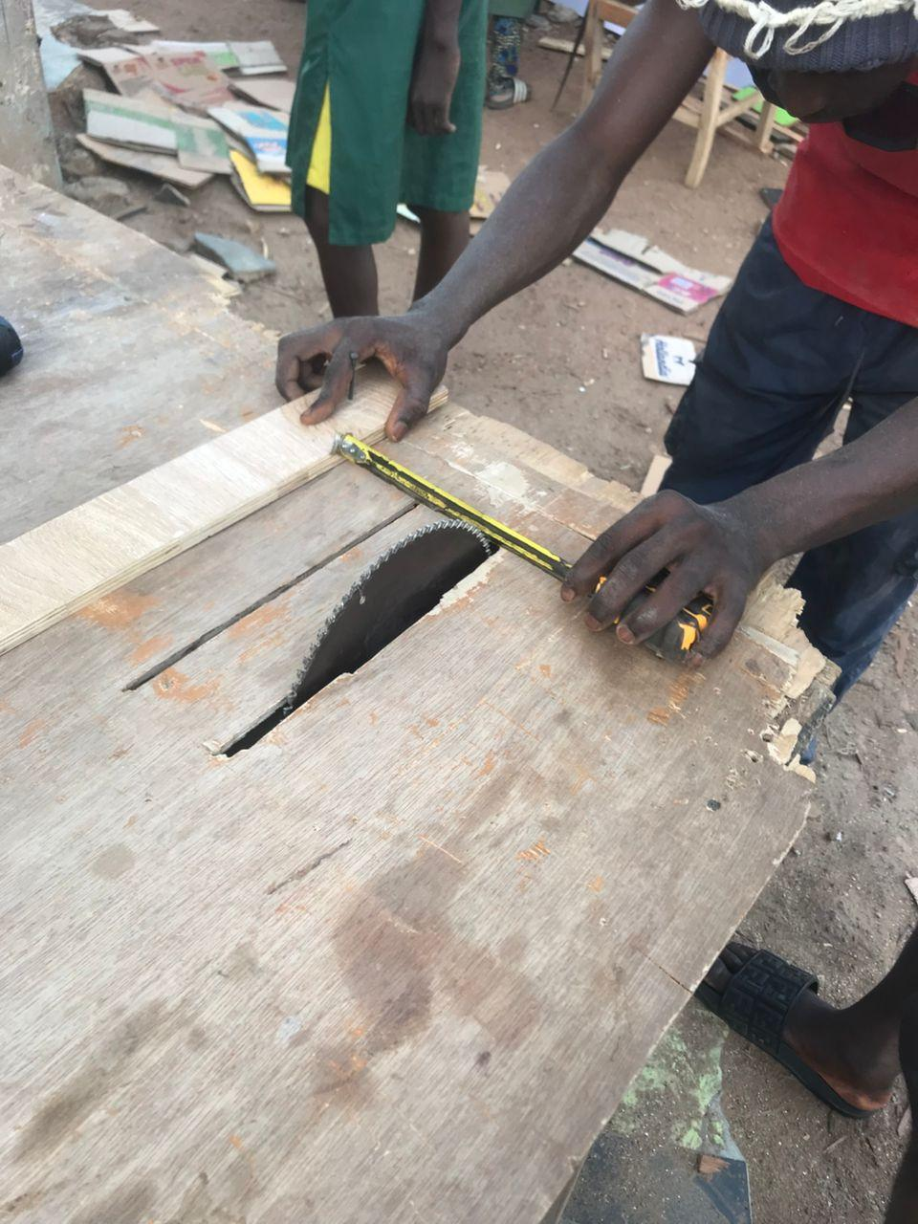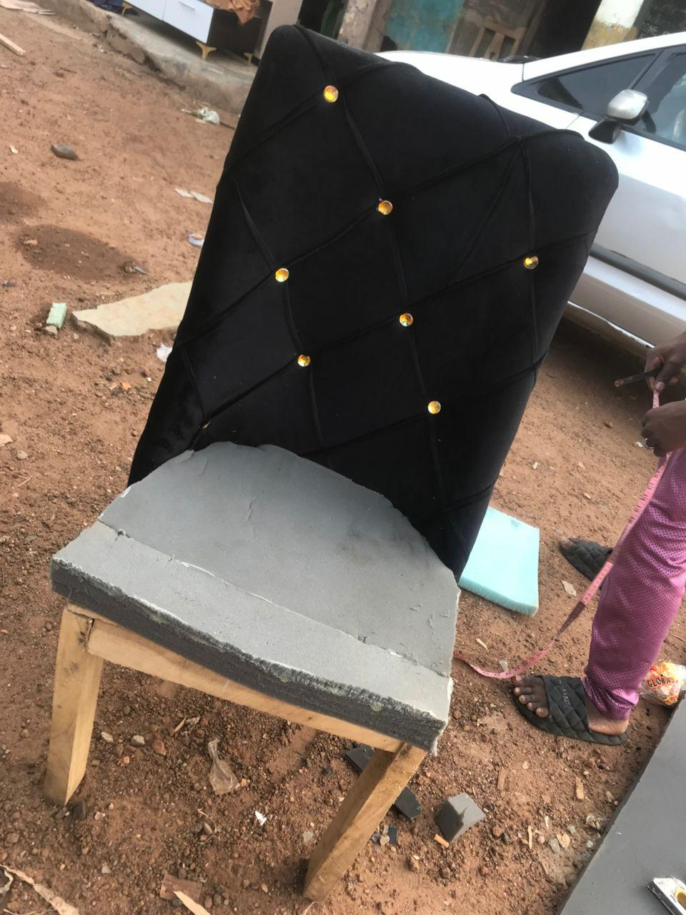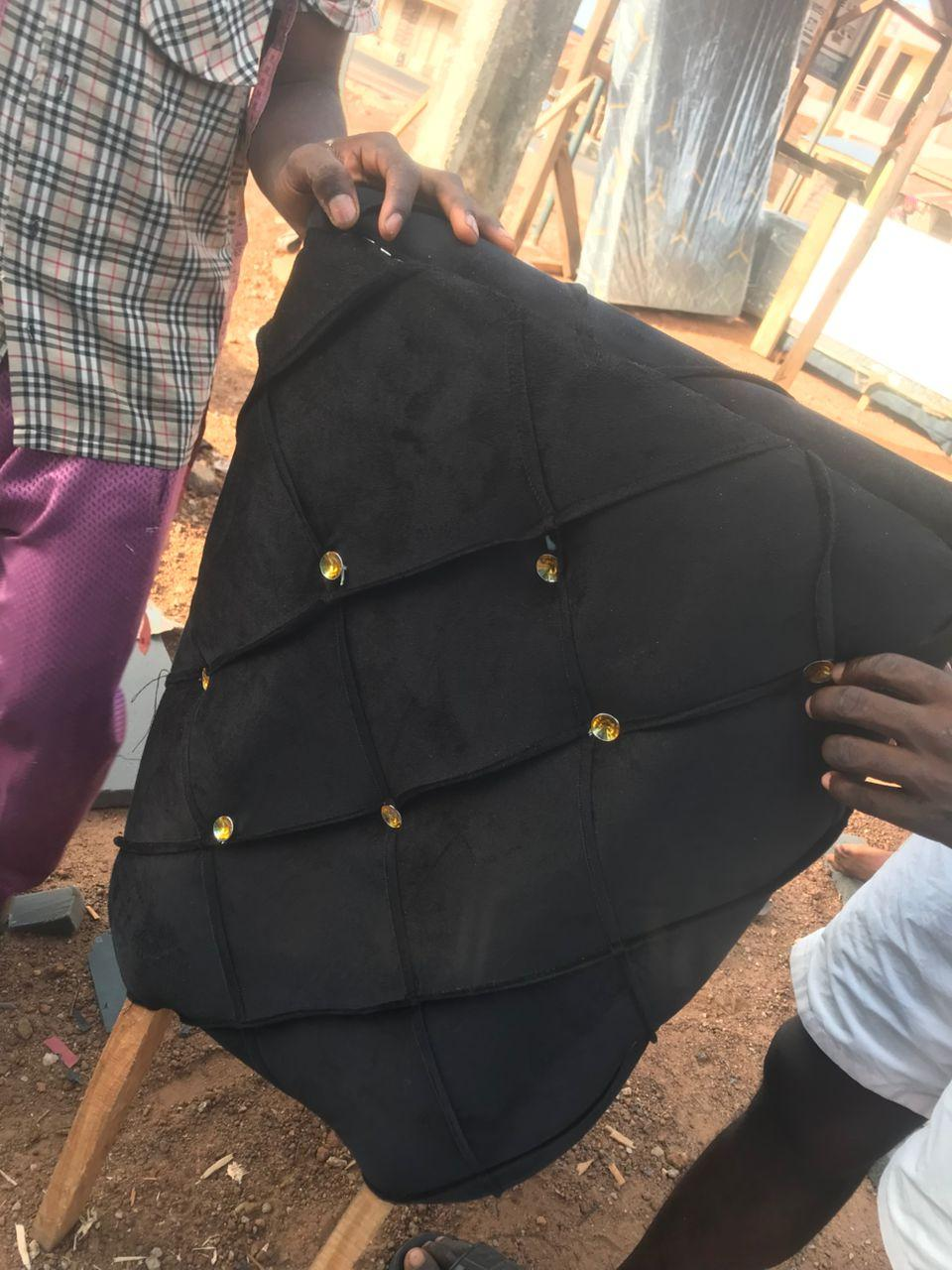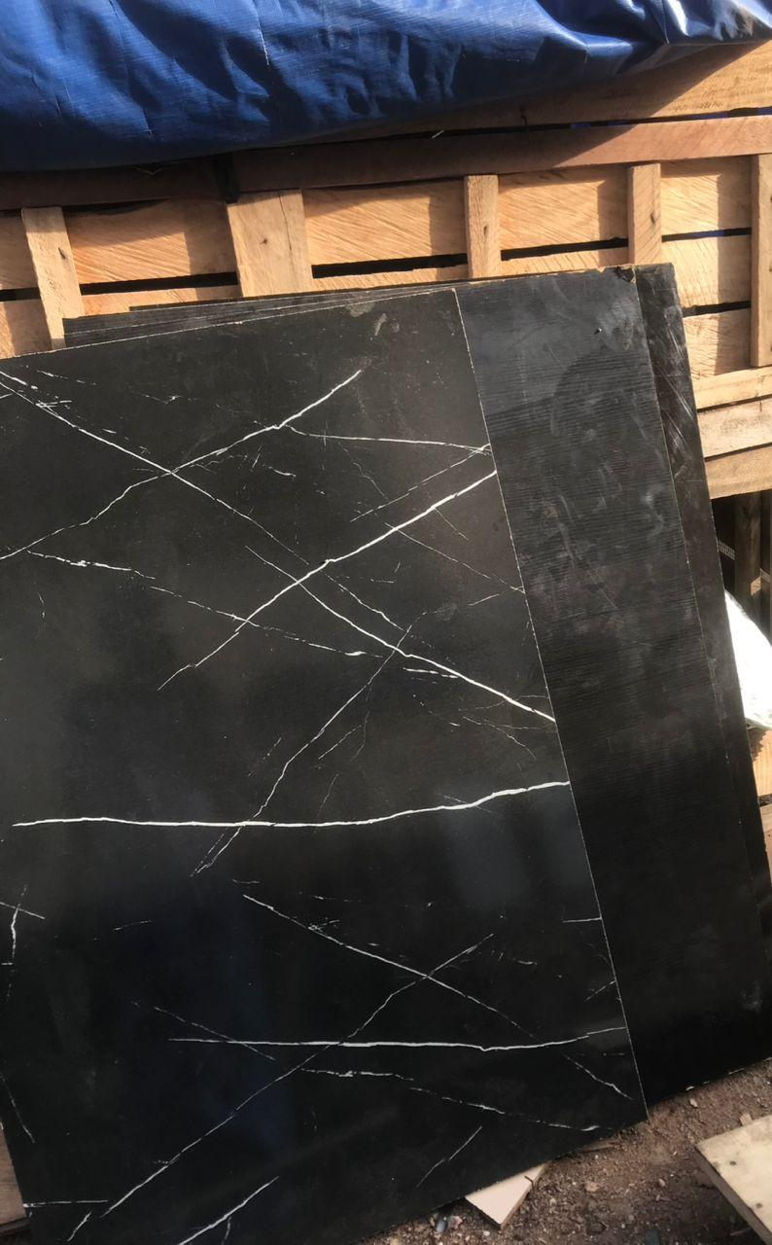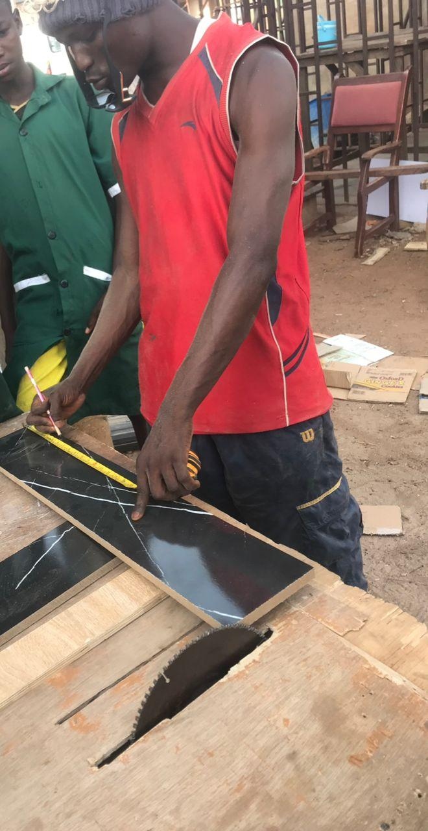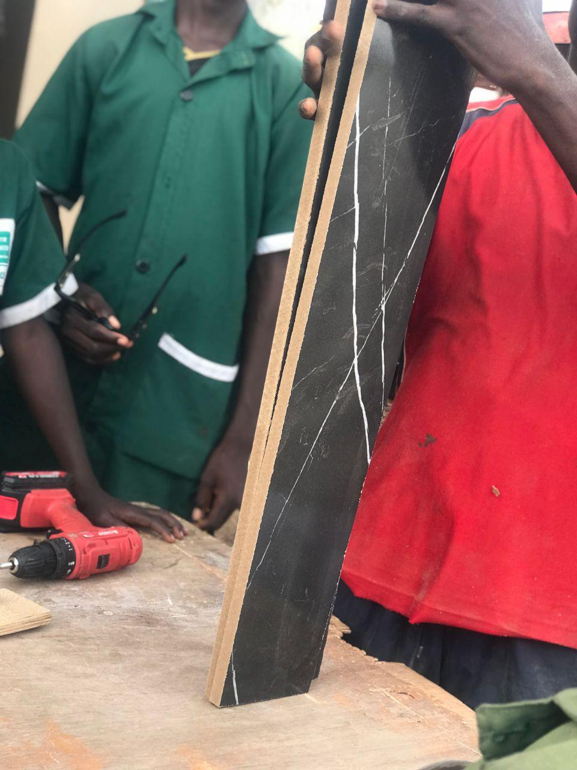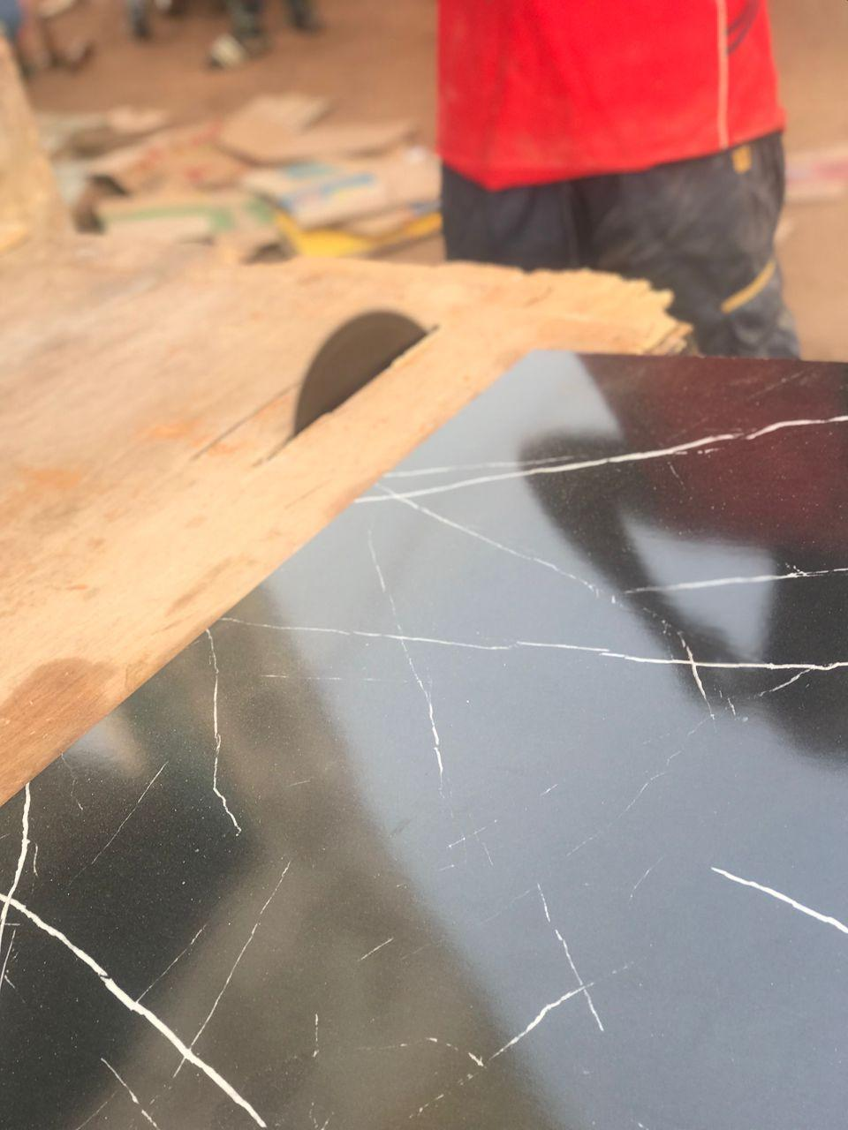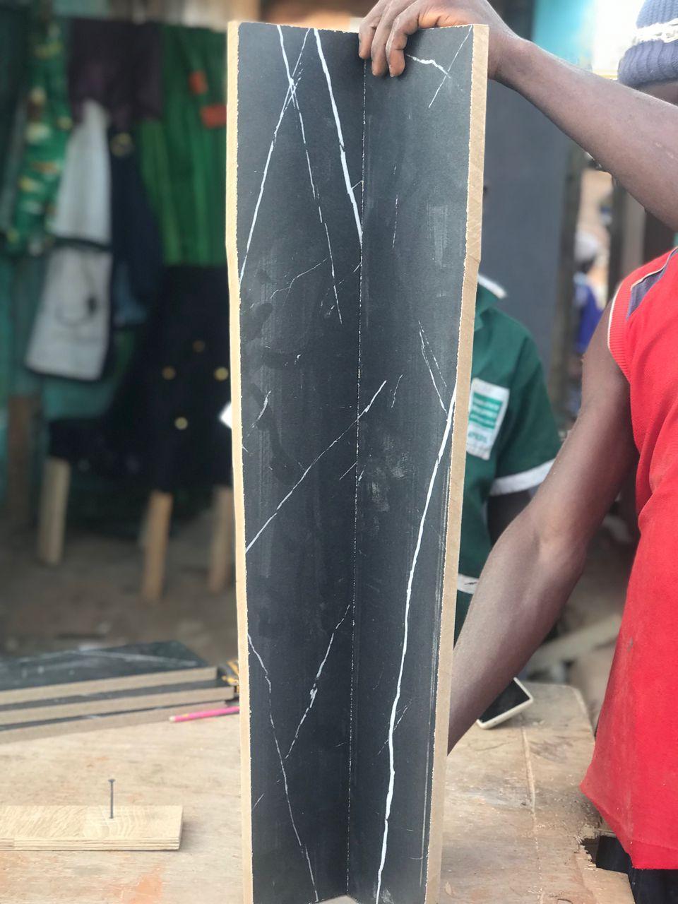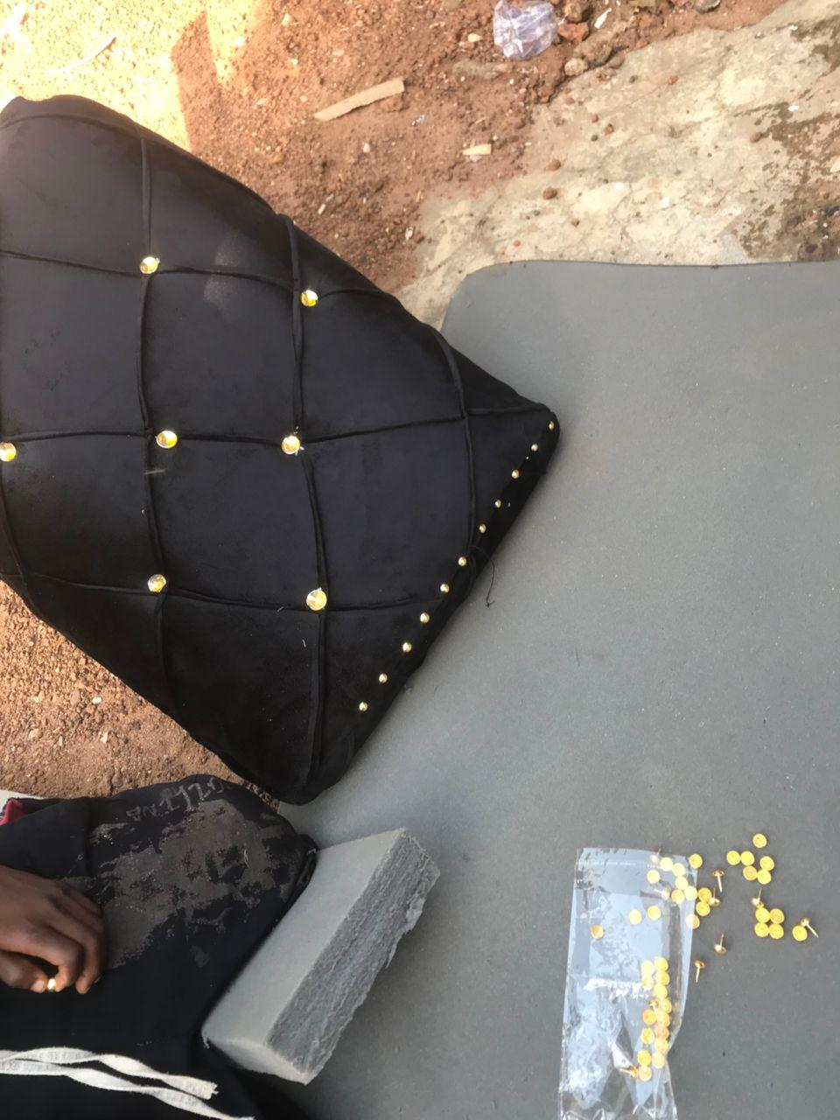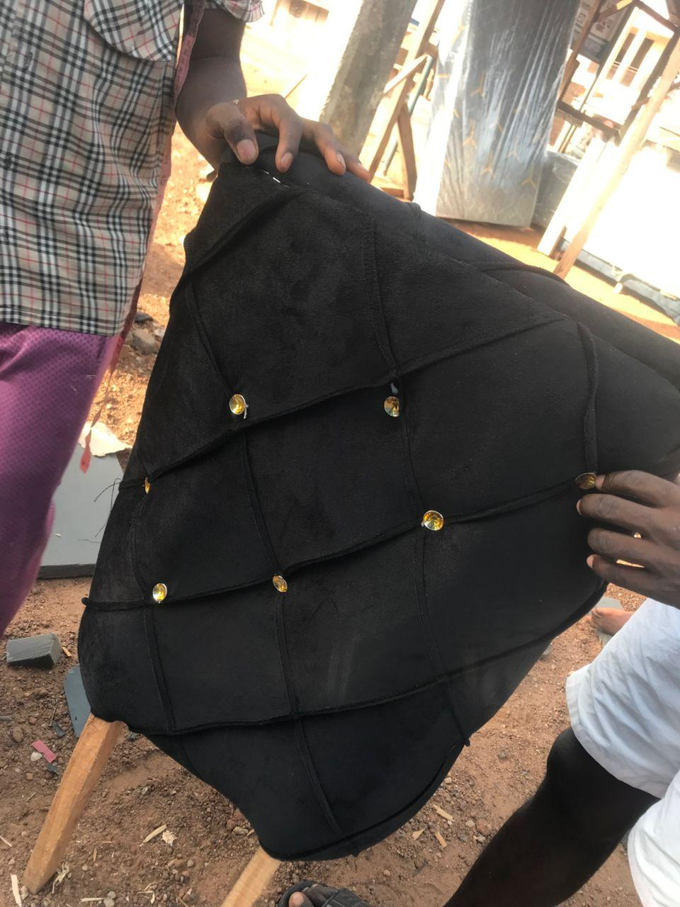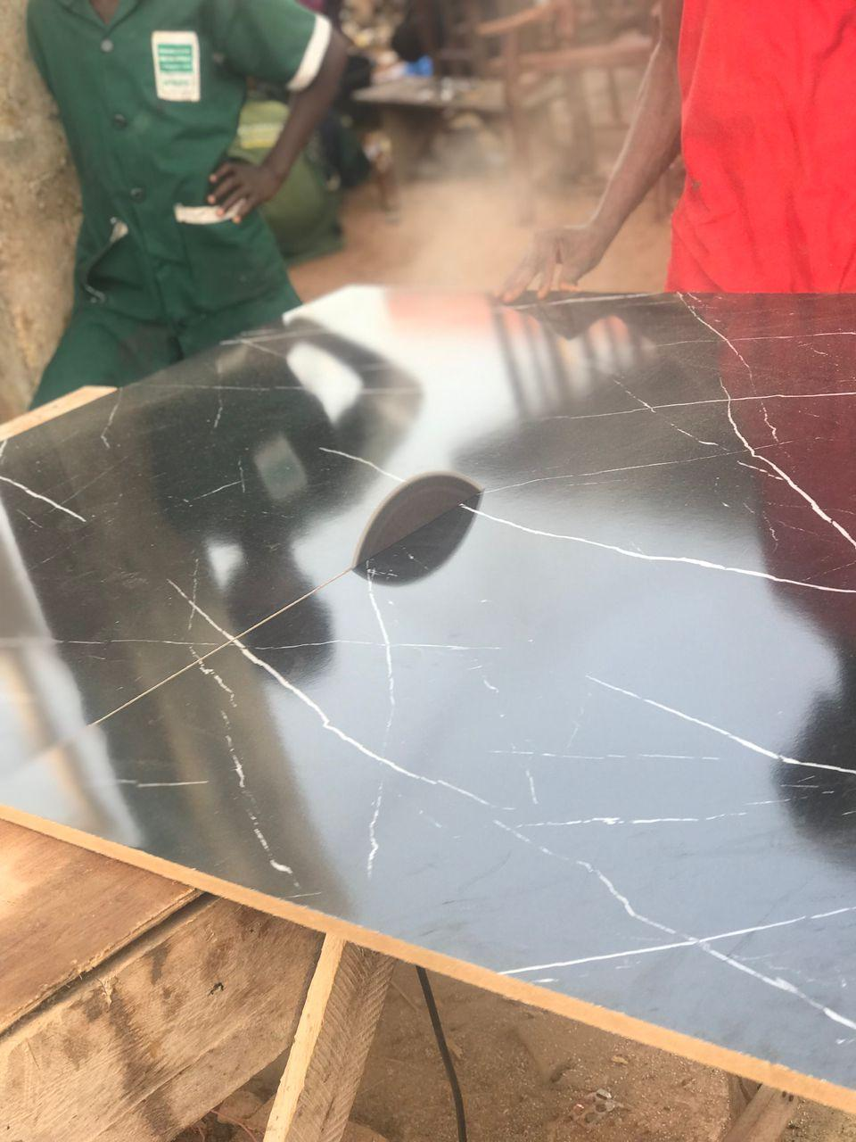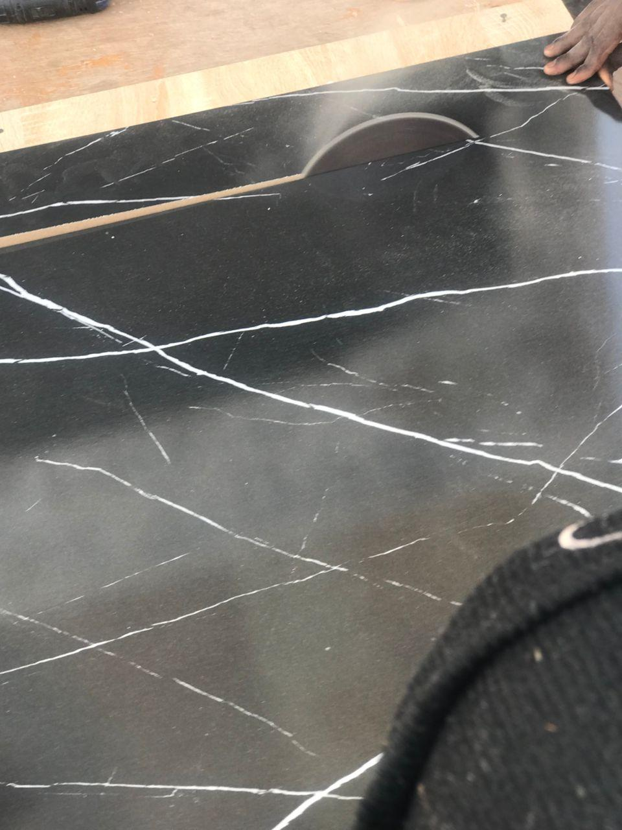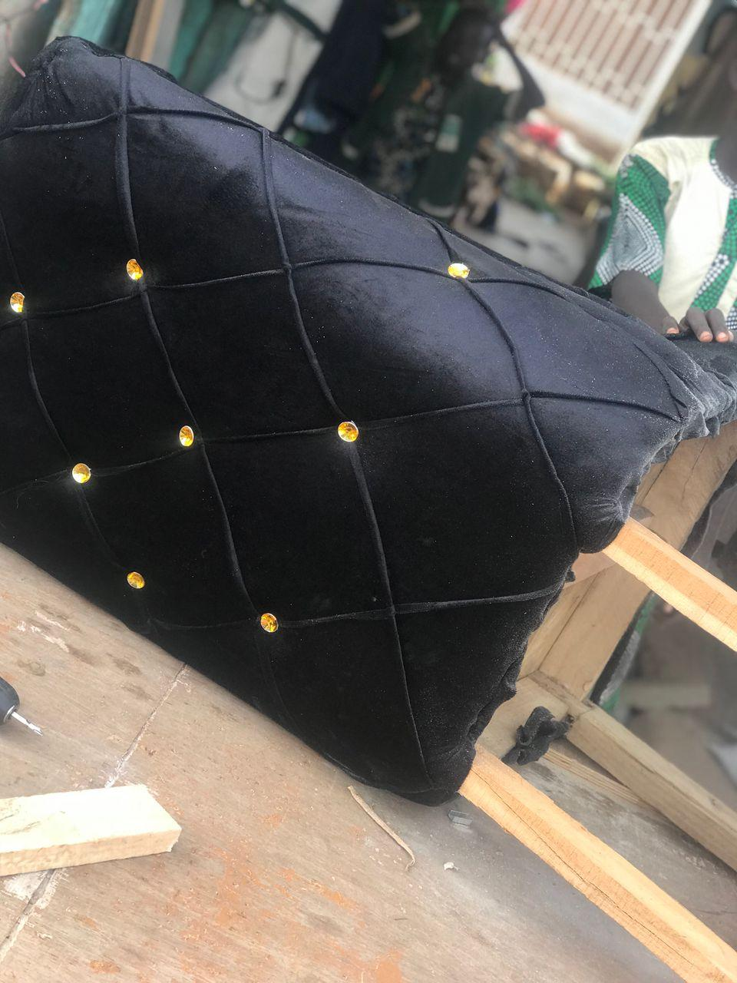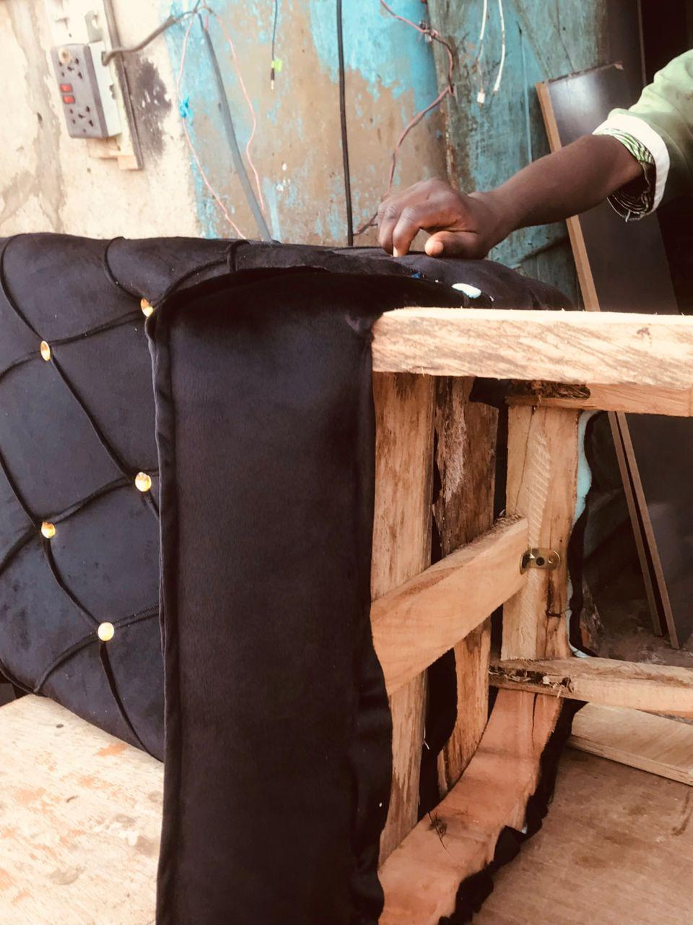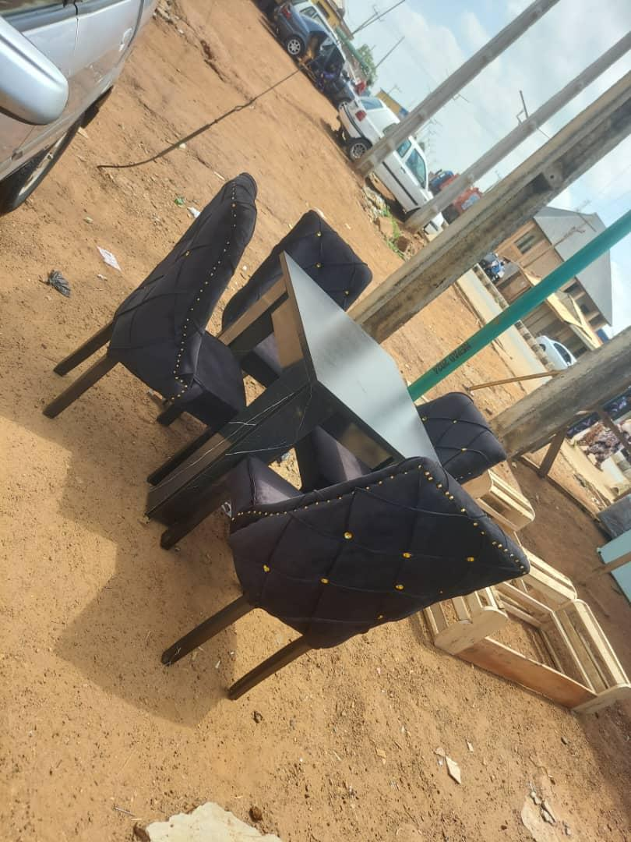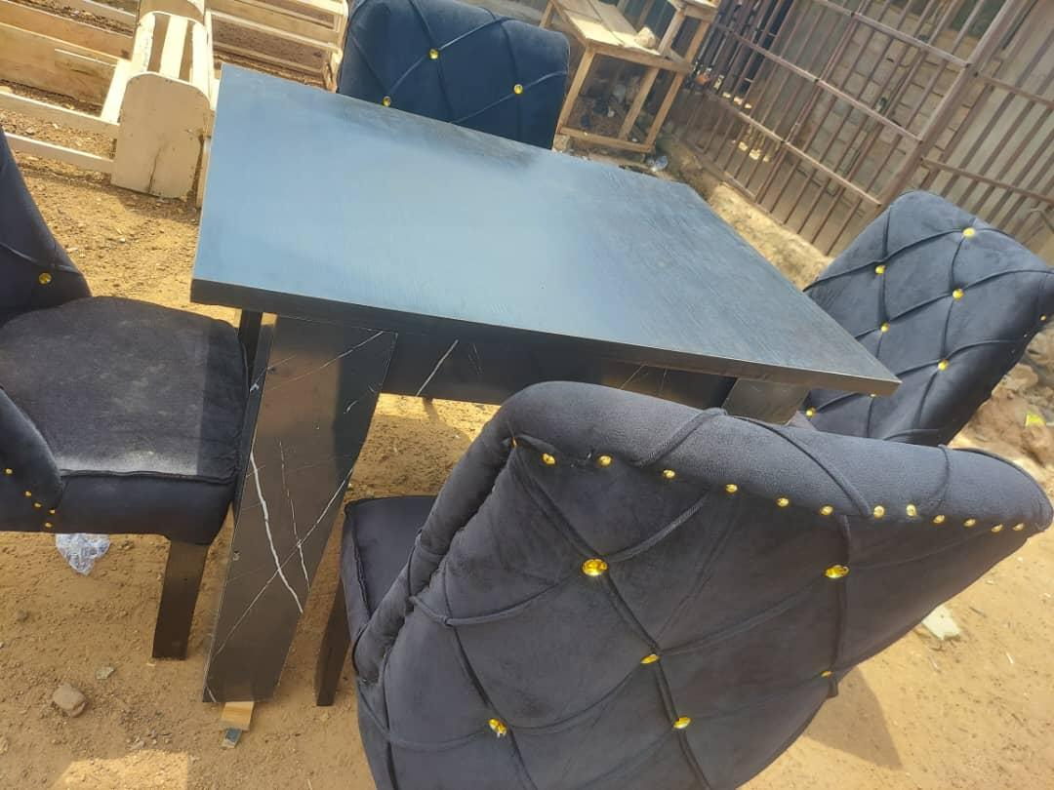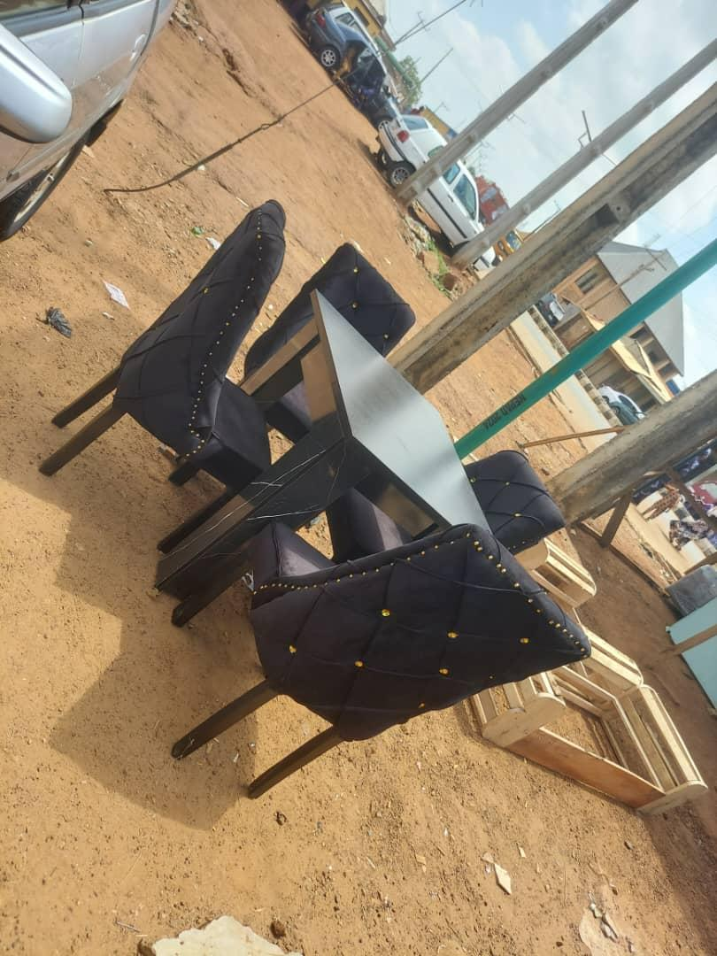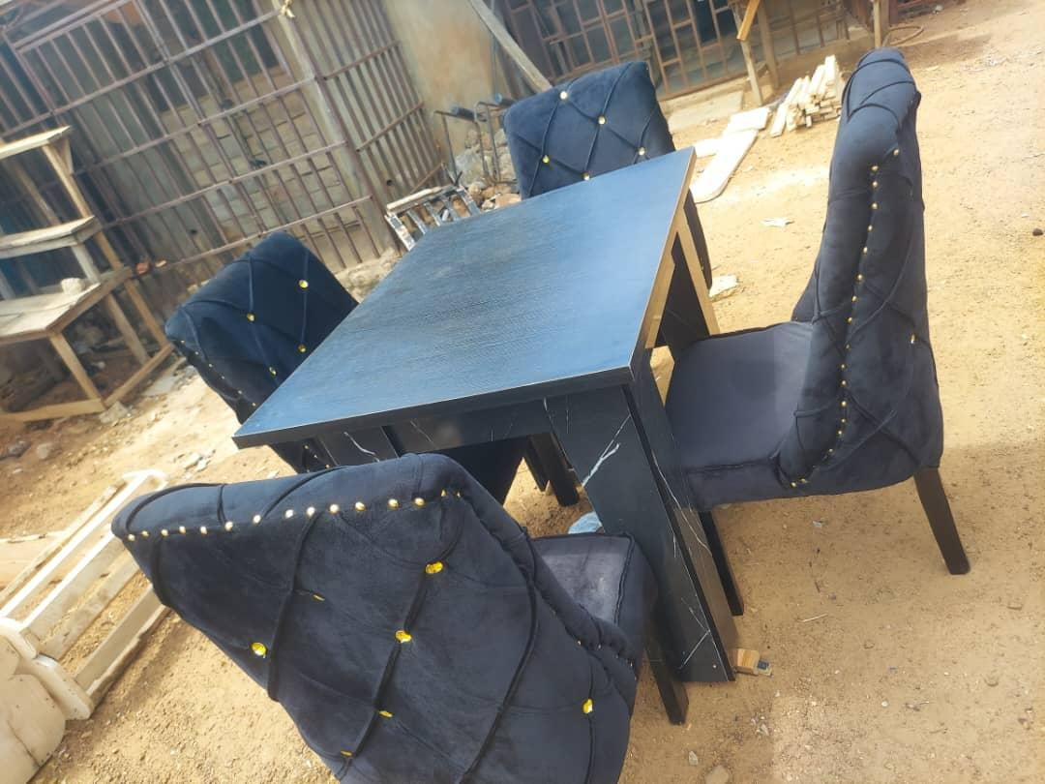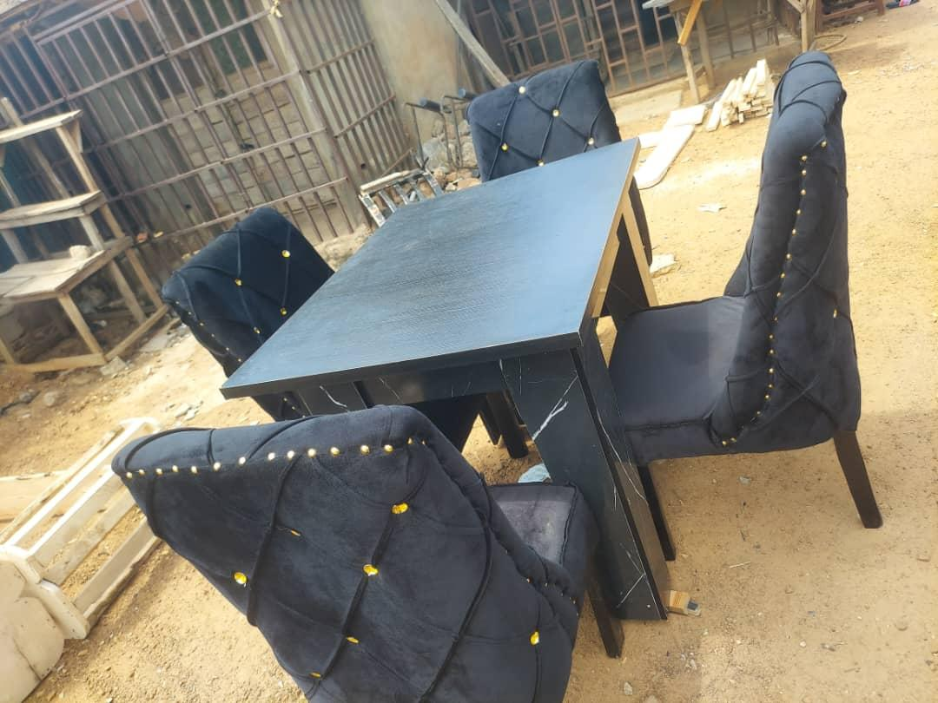
4.3.5 Safety
The evaluation confirmed that the constructed dining set met high safety standards. All edges were carefully smoothed and chamfered or rounded where appropriate, eliminating sharp points or splinters. All fasteners were properly counter-sunk, ensuring no protrusions. The overall stability of both table and chairs meant there was no risk of tipping or collapse under normal use, contributing to a safe environment for household members.

4.4 Discussion of Findings
The findings from the evaluation strongly support the effectiveness of the Design and Build methodology in creating a functional, durable, and aesthetically pleasing dining set tailored to household needs. The success in achieving robust structural integrity highlights the judicious selection of hardwood timber and the meticulous application of traditional joinery techniques, particularly the mortise and tenon joints, reinforced by appropriate adhesives and fasteners. This demonstrates that durable furniture, capable of withstanding daily use, can be reliably constructed within the local context, directly addressing the project's construction objective.
The positive results concerning functionality, usability, and ergonomic comfort affirm that the design process, even without explicit "conceptual sketching" as a separate preliminary step, successfully translated user requirements into a practical artifact. The adherence to ergonomic principles in dimensional accuracy ensures that the dining set is not only functional but also provides a comfortable experience for users of varying statures, a critical aspect often overlooked in mass-produced alternatives.
Furthermore, the high standard of aesthetic appeal and finish quality underscores the importance of skilled craftsmanship and careful material preparation. The natural beauty of the timber, enhanced by protective finishes, contributes significantly to the visual environment of a dining space, demonstrating the potential for locally fabricated furniture to meet high aesthetic expectations.
In essence, the constructed dining set serves as a tangible prototype that validates the entire research process, from material selection and detailed manual design to precise construction and comprehensive evaluation. The outcomes directly address all the project's objectives, proving the viability of producing high-quality, custom-built furniture solutions that are suitable for Nigerian households.

CHAPTER 5
CONCLUSION AND RECOMMENDATIONS
This final chapter synthesizes the findings from the preceding sections, drawing definitive conclusions regarding the successful design, construction, and evaluation of the functional dining set. It revisits the initial project objectives to determine their attainment and offers actionable recommendations for future research, practical application, and potential improvements within the context of furniture design and fabrication in Nigeria.
Conclusion
The overarching aim of this project was to design, construct, and evaluate a functional dining set tailored to the needs of a typical household. Based on the rigorous methodology employed and the comprehensive evaluation presented in Chapter 4, it can be concluded that all primary objectives of this study have been successfully achieved:
Objective 1: To design a functional dining table set that meets the needs of a household. The detailed manual design process, informed by functional requirements, ergonomic principles, and material considerations, successfully yielded a comprehensive set of technical drawings and material schedules. These designs provided a precise blueprint for a dining set that directly addressed the practical, comfort, and aesthetic needs of a household, demonstrating the viability of traditional design methodologies in producing effective furniture solutions.
Objective 2: To construct the functional dining set. The construction phase successfully translated the detailed designs into a tangible, high-quality dining set. The meticulous selection of hardwood timber, iroko and secondary materials, coupled with the precise application of woodworking techniques and the use of appropriate tools and equipment, resulted in a structurally sound, durable, and well-crafted furniture piece. This validates the practical feasibility of fabricating robust dining sets within the local context, adhering to professional standards.
Objective 3: To evaluate the functionality of the constructed dining table set. The comprehensive evaluation revealed that the constructed dining set exhibited excellent structural integrity, high functionality and usability, good ergonomic comfort, strong aesthetic appeal, and adherence to safety standards. The positive results from practical use testing and dimensional verification confirmed that the dining set performs optimally in a real-world setting, effectively serving its intended purpose and providing a comfortable, durable, and visually pleasing solution for household dining needs.
In essence, this project successfully demonstrated that a functional, durable, and aesthetically pleasing dining set can be meticulously designed and expertly constructed using a Design and Build approach, relying on traditional tools and local hardwood resources. The final product stands as a testament to skilled craftsmanship and a systematic methodology, offering a valuable prototype for household furniture solutions in Nigeria.
Recommendations
Based on the findings and the experience gained during this project, the following recommendations are put forward to guide future research, improve furniture fabrication practices, and enhance the utility of similar projects:
1. For Future Research and Design:
Explore Alternative Indigenous Timbers: While hardwoods like Iroko are excellent, further research could explore the suitability of other sustainable, lesser-known indigenous timber species available in Nigeria. This could help diversify material options and potentially reduce costs.
Investigate Modular/Expandable Designs: Future designs could explore modular or expandable dining sets (e.g., extendable tables) to cater to varying household sizes or space constraints, offering greater versatility.
Formal User Feedback Collection: For a more robust evaluation, future projects could incorporate structured surveys or interviews with a wider range of potential users to gather more extensive qualitative and quantitative feedback on comfort, usability, and aesthetic preferences.
2. For Practical Furniture Fabrication:
Promote Standardized Joinery Training: Emphasize and standardize training in advanced traditional joinery techniques (like mortise and tenon) within vocational schools and workshops to ensure high levels of structural integrity in locally manufactured furniture.
Focus on Sustainable Sourcing: Encourage and develop supply chains for sustainably harvested timber to ensure the long-term availability of quality materials and promote environmentally responsible practices in the furniture industry.
Quality Control in Finishing: Implement stringent quality control measures for finishing processes to consistently achieve durable, aesthetically pleasing, and safe surfaces, enhancing the market value and longevity of products.
3. For Policy and Industry Development:
Support Local Artisans and Workshops: Government and non-governmental organizations should provide support, training, and access to modern tools for local furniture makers to boost the quality and competitiveness of locally produced furniture.
Develop Furniture Standards: Establish national standards for furniture quality, safety, and ergonomics to ensure that locally manufactured products meet international benchmarks and consumer expectations.
By implementing these recommendations, the furniture design and manufacturing sector in Nigeria can continue to evolve, producing high-quality, functional, and culturally relevant pieces that effectively meet the needs of its populace.

REFERENCES
American Society for Testing and Materials. (2020). ASTM D143: Standard test methods for small clear specimens of timber. ASTM International.
British Standards Institution. (2009). BS 1186-3: Timber for and in buildings - Part 3: Classification of timber for appearance purposes. BSI.
Ching, F. D. K. (2014). Form, space, and order (4th ed.). John Wiley & Sons.
Hoadley, R. B. (2000). Understanding wood: A craftsman's guide to wood technology (2nd ed.). Taunton Press.
Kroemer, K. H. E., & Grandjean, E. (2017). Fitting the task to the human: A textbook of occupational ergonomics (6th ed.). CRC Press.
National Hardwood Lumber Association. (Current Edition). Rules for the measurement & inspection of hardwood & cypress lumber. NHLA.
Nigerian Industrial Standard. (2007). NIS 083: Timber species: Characteristics and applications. Standards Organisation of Nigeria.
Pile, J. F. (2013). A history of interior design (4th ed.). Laurence King Publishing.
Stokes, J. (2012). Furniture making: A complete manual. Taunton Press.
U.S. Department of Agriculture, Forest Service, Forest Products Laboratory. (2010). Wood handbook: Wood as an engineering material. Centennial Edition, FPL–GTR–190.

