DEVELOPMENT AND TESTING OF A SINGLE SCREW EXTRUDER FOT THHE PRODUCTION OF A
WASTE PLASTIC-SAND COMPOSITE FOR
HALLOW BLOCK MAKING

PRESENTED BY

OLALUWOYE MICHAEL OLADEMEJI
ND/23/MEC/FT/0038

A PROJECT SUBMITTED TO THE DEPARTMENT OF MECHANICAL ENGINEERING TECHNOLOGY, INSTITUDE OF TECHNOLOGY (I.O.T)

IM PARTIAL FUFILMENT OF THE AWARD OF NATIONAL DIPLOMA MECHANICAL ENGINEERIG, KWARA STATE POLYTECHNIC,ILORIN

SUPERVISED BY:
ENGR AYANTOLA ABDULWAHEED .A.

CERTIFICATION
The undersigned certify that this project report titled Development and testing of a single screw extruder for production of a wast plastic-sand composite for Hallow Block making was prepared by OLALUWOYE MICHAEL OLADEMEJI with matriculation nmber ND/23/MEC/FT/0038 meets the requirement for the award of National Diploma (ND) in the department of Mechanical Engineering, Kwara State Polytechnic, Ilorin, and was approved for its contribution to knowledge and literacy presentation.

Engr.Ayantola Abdulwaheed A.
Project Supervisor Date

Engr. Salami Hammed Olateju.
Project Coordinator Date

Engr. Ayantola Abdulwaheed A.
Head of Department Date

Engr. Durotoye Joshua Adedapomola
External Examiner Date

DEDICATION
I dedicate this project titled Development and Testing of a Single Screw Extruder for Production of a Waste Plastic-Sand Composite for Hollow Block Making to Almighty God for His wisdom, strength, and guidance throughout this journey. This work is also dedicated to my Mother, MRS FUNKE AKINWOLE whose unwavering support, prayers, and encouragement gave me the motivation to pursue and complete this research.
Finally, I dedicate this project to everyone who believes in sustainable innovation and in the power of engineering solutions to tackle plastic waste and promote environmentally friendly construction practices.

ACKNOWLEDGEMENT
I would like to express my deepest gratitude to God Almighty for His grace, guidance, and strength throughout the duration of this project. My sincere appreciation goes to my project supervisor, Engr. Ayantola Abdulwaheed A. for his invaluable support, insightful guidance, and constructive feedback during the development and testing of this work titled "Development and Testing of a Single Screw Extruder for Production of a Waste Plastic-Sand Composite for Hollow Block Making.". I am also grateful to the lecturers and staff of the Mechanical Engineering Department for their academic contributions and technical assistance, especially in the areas of fabrication, material selection, and testing. Special thanks to my Mother for her constant encouragement, emotional support, and belief in my ability to carry this research to completion.
Lastly, I acknowledge all those who contributed, directly or indirectly, to the successful execution of this project, especially those who supported me during the design, machining, and component parts.
Thank you all.

TABLE OF CONTENTS
1. Chapter 1: Introduction
1.1. Background
1.2. History of Plastic Materials
1.3. Types of Plastic Materials
1.4. Problems Associated with Plastic Waste
1.5. Problem Statement
1.6. Scope
1.7. Aim
1.8. Objectives
1.9. Significance of the Project
1.10. Use of Plastics as Reinforcement in Sandcrete Block Making
1.11. Ratio Design for Plastic-Sand Hollow Blocks

2. Chapter 2: Literature Review
2.1. Analysis of Alternative Methods and Selection of Best
2.2. Types of Single Screw Extruders for Recycling Plastic
2.3. Types of Sand Used in Plastic-Sand Extrusion
2.4. Waste Plastic-Sand Extrusion Process
2.5. Categories for Plastic-Sand Recycling

3. Chapter 3: Description and Calculation of Component Parts
3.1. Description and Assemblies of Component Parts of the Machine
3.2. Calculation of Volume of Component Parts
3.3. Calculation of Mass of the Component Parts
3.4. Calculation of the Weight of the Component Parts
3.5. Other Calculations

4. Chapter 4: Material and Fabrication Details
4.1. Selection of Materials and Fabrication Details
4.2. Material Analysis and Their Selection
4.3. Mechanical and Chemical Properties of Steel
4.4. Factors Considered in the Selection of Materials for the Block Machine
4.5. Fabrication Detail

5. Chapter 5: Conclusion and Recommendation
5.1. Conclusion
5.2. Recommendation

6. References
ABSTRACT
One of the most pervasive and enduring alterations to the surface of our planet is the accumulation and fragmentation of plastics. Within merely a few decades since the onset of mass production of plastic products in the 1950s, plastic debris has proliferated across terrestrial environments, the open ocean, the shorelines of even the most isolated islands, and in the profound depths of the sea. Annual clean-up operations, incurring costs amounting to millions of pounds sterling, are now orchestrated in numerous countries across every continent. In this document, we elucidate global plastic production and the accumulation of plastic waste. While plastics typically constitute approximately 10 percent of discarded refuse, they represent a significantly greater proportion of the debris accumulating on shorelines. Mega- and macro-plastics have amassed in the highest densities within the Northern Hemisphere, particularly adjacent to urban centers, in enclosed seas, and at water convergences (fronts). Our findings indicate lower densities on the shores of remote islands, on the continental shelf seabed, and the least densities (though still a documented presence) in the deep sea and Southern Ocean. The longevity of plastic is estimated to span hundreds to thousands of years, but it is likely to extend far longer in deep-sea and non-surface polar environments. Plastic debris poses a considerable threat by suffocating and starving wildlife, facilitating the distribution of non-native and potentially deleterious organisms, absorbing toxic chemicals, and degrading into micro-plastics that may subsequently be ingested. Established annual surveys conducted along coastlines and at sea have revealed that trends in mega- and macro-plastic accumulation rates are no longer uniformly ascending; rather, stable, increasing, and decreasing trends have all been documented. The average size of plastic particles in the environment appears to be diminishing, while the prevalence and global distribution of micro-plastic fragments have surged over the past few decades. However, the environmental ramifications of such microscopic debris remain inadequately understood.

1.0. INTRODUCTION
The escalating volume of plastic waste presents a formidable environmental challenge on a global scale. Inadequate disposal of plastics results in the contamination of terrestrial and aquatic ecosystems, posing significant threats to both wildlife and human health. In alignment with international endeavors aimed at sustainability and environmental stewardship, the recycling and repurposing of waste materials have become imperative. A particularly promising strategy involves the formulation of composite materials utilizing waste plastics in conjunction with sand, which can be harnessed in construction applications, such as the fabrication of hollow blocks for structural purposes. Single screw extruders have demonstrated considerable potential for processing thermoplastics into viable forms. These machines are prevalently employed due to their inherent simplicity, cost-effectiveness, and capacity to accommodate a diverse range of polymers. The extrusion process facilitates the melting and amalgamation of plastic with supplementary materials, such as sand, yielding a homogeneous mixture that is amenable to molding or shaping into construction products. In this investigation, a single screw extruder has been meticulously developed and evaluated for the production of a plastic-sand composite material. The objective is to assess the extruder's performance with respect to its capacity to consistently process waste plastic and sand, as well as to analyze the physical and mechanical properties of the resultant composite hollow blocks. This research significantly contributes to sustainable construction methodologies and effective waste management by providing an alternative utilization for non-biodegradable plastics in building applications. management by offering an alternative use for non-biodegradable plastics in building applications.
1.2 History of Material Recycling
The concept of recycling dates back to ancient civilizations, where materials such as bronze, glass, and paper were recovered and repurposed due to their scarcity and value. Archaeological evidence shows that as early as 400 BC, metals were melted down and reused in various cultures, including the Roman Empire. However, organized recycling as we know it today began to take shape during the industrial era, particularly during the world wars, when shortages of raw materials forced nations to collect and reuse resources like metals, rubber, and paper on a large scale.
With the rise of synthetic materials in the 20th century, particularly plastic, the nature of waste and recycling changed dramatically. Plastics, first developed in the early 1900s and widely adopted by the mid-century, offered advantages such as low cost, durability, and versatility. However, their resistance to degradation quickly became a double-edged sword, as plastic waste began to accumulate in the environment.
Efforts to recycle plastics began in earnest in the 1970s and 1980s, primarily through mechanical recycling processes where plastics are melted and reformed into new products. However, the limitations of plastic recycling — such as the need for sorting, contamination issues, and degradation of material quality — led to the exploration of alternative uses for plastic waste. One such solution has been the development of plastic-based composites.
The idea of combining waste plastic with other materials such as sand, fly ash, or industrial residues to produce construction materials emerged in the late 20th and early 21st centuries. This method gained traction due to its simplicity, low cost, and dual environmental benefits — reducing plastic pollution while providing alternatives to conventional construction materials like concrete and cement blocks.
In recent years, technological advancements such as single screw extrusion have enabled more efficient processing of plastic-sand composites. These machines allow for continuous processing and homogenization of materials, making them suitable for producing standardized building elements like hollow blocks. The growing demand for sustainable construction materials, coupled with increasing plastic waste challenges, has made this area of recycling increasingly relevant in the context of green building and circular economy initiatives.
1.1 Preamble
The global rise in plastic consumption has led to a corresponding increase in plastic waste, creating severe environmental and public health concerns. Despite various recycling efforts, a significant portion of plastic waste remains improperly disposed of, especially in developing countries, where infrastructure for waste management is often limited. At the same time, the construction industry continuously seeks cost-effective, durable, and sustainable building materials to meet the growing demand for affordable housing and infrastructure.
One innovative solution lies in the conversion of waste plastic into useful construction materials through the development of plastic-sand composites. These composites not only offer a means of recycling non-biodegradable plastic but also serve as viable alternatives to conventional construction materials like cement blocks. The use of extrusion technology, particularly the single screw extruder, provides a practical approach to melting and mixing plastic waste with sand to form a uniform composite suitable for hollow block production.
This project focuses on the design, fabrication, and testing of a single screw extruder specifically tailored for processing plastic waste into sand-plastic composite materials. The overarching goal is to contribute to both environmental sustainability and low-cost construction by transforming waste into value-added products. Through careful development and performance evaluation of the extruder, this research aims to establish an efficient and scalable method for producing high-quality composite hollow blocks from locally sourced waste materials.

1.3. History of Plastic Material
The development of plastic materials began in the 19th century with the invention of synthetic polymers, marking a revolutionary shift in material science. The first man-made plastic, Parkesine (a type of cellulose nitrate), was developed in 1856 by Alexander Parkes. However, the real breakthrough came in the early 20th century with the invention of Bakelite in 1907 by Leo Baekeland. Bakelite was the first fully synthetic thermosetting plastic and opened the door for the development of numerous other polymers.
During the 1930s to 1950s, significant innovations in plastic production emerged with the commercialization of key materials such as polyethylene (PE), polypropylene (PP), polystyrene (PS), and polyvinyl chloride (PVC). These plastics became widely used due to their durability, moldability, water resistance, and low cost. Their applications expanded rapidly across industries including packaging, automotive, electronics, and construction.
While plastics were initially celebrated for their convenience and versatility, their non-biodegradable nature soon led to severe environmental concerns. The global increase in plastic consumption, especially in the post-World War II era, resulted in massive amounts of plastic waste. By the late 20th century, the world was already grappling with plastic pollution in landfills, oceans, and urban areas.
To address this growing issue, efforts were made to recycle and repurpose plastic waste. One innovative application that emerged was the use of waste plastic in construction, particularly by combining it with materials like sand or fly ash to create composite construction materials. These composites offered several benefits: they diverted plastic from landfills, reduced reliance on conventional building materials like cement, and provided cost-effective, durable construction products such as hollow blocks.
The use of extrusion technology, especially single screw extruders, became a viable solution for processing these composites. This technology allows waste plastic to be melted and uniformly mixed with sand, producing a consistent material that can be molded into building components. The process aligns with global efforts to create a circular economy and reduce the environmental footprint of both the plastics and construction industries.
Today, plastic-sand composites are gaining popularity in many developing countries as a sustainable building material for low-cost housing and infrastructure, demonstrating how historical advancements in plastic development are being re-engineered to solve modern environmental and construction challenges.
1.4. Problems Associated with Plastic Waste
The use of plastic waste in the production of construction materials such as hollow blocks is a promising solution to environmental pollution. However, several challenges and issues are associated with plastic waste that affect both the production process and the long-term performance of these materials.
1. Environmental Pollution
Non-biodegradability: Most plastic waste (especially thermoplastics like LDPE, HDPE, and PP) takes hundreds of years to decompose, causing severe land and marine pollution.
Visual pollution: Accumulated plastic waste, especially in urban areas, creates unsightly environments and obstructs drainage systems.
Microplastics: Over time, plastic waste breaks down into microplastics that contaminate soil and water, entering food chains and posing health risks.
2. Waste Sorting and Contamination
Mixed plastic types: Different types of plastic (e.g., PET, PVC, PP) have varying melting points and chemical properties. Mixing them without proper sorting can lead to poor bonding or emissions during extrusion.
Contaminants: Plastic waste is often contaminated with food, labels, inks, or metals, which interfere with the melting process and compromise the mechanical properties of the composite blocks.
Inconsistent feedstock: The variation in the source and quality of waste plastic makes it difficult to maintain consistent production standards.
3. Processing Challenges
Thermal degradation: Improper temperature control in the extruder can cause thermal degradation of plastic, emitting toxic fumes and reducing the structural strength of the final product.
Machinery wear: Abrasive contaminants in plastic waste can lead to wear and tear of extruder screws and barrels, increasing maintenance costs.
Energy consumption: Melting and extruding plastic waste require significant energy, especially when plastic is wet or dirty, reducing the energy efficiency of the process.
4. Mechanical Limitations of the Final Product
Strength issues: Plastic-sand blocks may show lower compressive strength than conventional cement blocks if the plastic content is too high or poorly bonded.
Thermal sensitivity: Composites with a high plastic ratio may deform at high temperatures, limiting their use in certain construction applications.
Regulatory and structural approval: Many countries lack clear standards or codes for using recycled plastic composites in structural applications, limiting market adoption.

1.5 Type of Plastic
Plastic Type | Abbreviation | Properties | Common use | Suitability For Recycling/extrusion
Polyethylene Terephthalate | PET or PETE | Strong, lightweight, transparent, good gas barrier | Water bottles, food packaging, synthetic fibers | Recyclable (Type 1),but not ideal for extrusion due to melting behavior
Polyvinyl chloride | PVC | Hard or flexible, weather-reasistant, chemical-resistant | Pipes, window frames,cable insulation | Difficult to recycle thermally due to release of harmful gases;not preferred for extrusion
High-Density polyethylene | HDPE | Rigid,durable, chemical-resistant | Milk jugs, detergent bottles, Plastic bags | Highly suitable for extrusion and plastic-sand composite blocks
Lo  w-Density polyethylene | LDPE | Flexible, transparent, moisture-resistant | Plastic bags,shrink wraps, tubing | Suitable for extrusion; soft texture may require blending with sand carefully
Polypropylene | PP | Tough,heat-reasistant, lightweight | Food container, automotive parts, textiles | commonly use in composite block making
Polystyrene | PS | Rigid and foam, lightweight, brittle | Disposable cup, foam packaging, insulation | It produces toxic fumes when heated
Other plastic | O (Others) | Varies(includes polycarbonate, acrylic, nylon, etc) | CDs, medical equipment, electronics | Recycling depends on type, some are unsuitable for extrusion due to complexity.
Fig 1.1
Most Suitable for Plastic-Sand Composites
For hollow block making using a single screw extruder, the commonly used plastics are:
HDPE (High-Density Polyethylene)
LDPE (Low-Density Polyethylene)
PP (Polypropylene)
These are thermoplastics, they melt when heated and solidify when cooling, which is ideal for extrusion processes

1.6. Plastic Recycling Process
Recycling is the process of converting waste plastic materials into reusable materials or products. For applications like the production of plastic-sand composite blocks, the recycling process typically follows a mechanical recycling method, which involves the following key stages:
1. Collection
Waste plastic is gathered from households, industries, or municipal waste systems.
Common sources include plastic bags, bottles, containers, and packaging materials
2. Sorting
Plastics are sorted manually or automatically based on type (e.g., HDPE, LDPE, PP), color, and density.
Proper sorting ensures that incompatible plastics (like PVC or polystyrene) are removed, as they can negatively affect the final product's quality or release harmful gases during processing.
3. Cleaning
The collected plastics are washed to remove dirt, labels, food residues, and other contaminants.
Cleaning is crucial to improve the bonding between plastic and sand during extrusion.
4. Shredding
Clean plastic waste is shredded into small flakes or granules using a plastic shredder.
Uniform particle size is important for consistent melting and mixing with sand in the extruder.

5. Drying
The shredded plastic is dried to remove any residual moisture.
Moisture can cause steam bubbles or defects during extrusion.
6. Melting and Extrusion
The dried plastic is fed into a **single screw
1.7.Use of Plastic as Reinforcement in Sand-Crest Block Making
The use of waste plastic as reinforcement in sand-crest (or sand-based) blocks is an emerging a solution aimed at improving the strength, durability, and sustainability of conventional building materials. In this process, plastic waste (usually thermoplastics like HDPE, LDPE, or PP) is not just a filler, but actively contributes to reinforcing the structure of the blocks.
How Plastic Reinforces Sand-Based Blocks
1. Binding Agent
When melted, plastic acts as a binder that holds the sand particles together.
It replaces traditional cement, making the blocks lighter and more cost-effective.
2. Flexural and Tensile Strength
Plastics have good tensile properties. When mixed properly with sand, the resulting blocks have higher resistance to cracking and breaking under tension and bending compared to conventional cement blocks.
3. Durability
Plastic-reinforced blocks are non-porous, reducing water absorption and enhancing durability in wet conditions.
They resist corrosion, insect attacks, and degradation from environmental factors better than traditional blocks.
4. Thermal and Acoustic Insulation
The plastic content contributes to thermal insulation, helping regulate indoor temperatures.
Also improves soundproofing, particularly when used in interior wall applications.
5. Lightweight
Compared to cement-based blocks, plastic-sand blocks are significantly lighter, which reduces transportation and handling costs and stress on structures.
1.8. Mix Ratio Design for Plastic-Sand Crest Blocks
The mix ratio in plastic-sand block production is crucial for achieving the desired strength, durability, density, and workability. Unlike traditional cement blocks, plastic-sand blocks use melted thermoplastic waste (e.g., HDPE, LDPE, PP) as a binder in place of cement. The performance of the resulting block largely depends on the proportion of plastic to sand, type of sand used, and uniform heating and mixing.

Plastic % | Sand % | Remake
20%plastic | 80%sand | Weak bond, brittle, suitable only for low-load application
30% plastic | 70% sand | Improve bonding, moderate compressive strength
40% plastic | 60% sand | Optimal strength to weight ratio good for structural use
50% plastic | 50% sand | Very dense, durable,but may be heavy and harder to mold
60% plastic | 40% sand | High plastic content, lighter but can reduce block stiffness

Fig 1.2.
For most applications such as non-load-bearing walls, walkways, or boundary walls, the ratio:
> Plastic : Sand = 30:70 or 40:60
is found to offer a balanced mix of strength, durability, and workability.
Factors to Consider in Mix Design
1. Type of Plastic
Use clean, sorted HDPE, LDPE, or PP plastics for best performance
Avoid PVC or mixed plastics due to health risks and poor bonding.

2. Sand Grain Size
Medium to coarse river sand (well-graded) is ideal.
Finer sand increases density but may reduce porosity control.
3. Plastic Preparation
Shredded to 5–10 mm size.
Dried thoroughly to remove moisture before extrusion.
4. Heating Temperature
Typically ranges from 180°C to 250°C, depending on plastic type.
Overheating degrades the plastic; underheating causes poor bonding.
5. Mixing Method
Use a single screw extruder or rotary drum mixer with temperature control for uniform mixing.
6. Compaction
Molding pressure must be consistent.
Use mechanical or hydraulic presses for better compaction
Example Procedure (for 10 Blocks):
Materials:
6 kg of cleaned, shredded HDPE plastic
14 kg of washed, dried river sand

Steps:
1. Preheat extruder to 200–220°C.
2. Feed plastic and sand in batches.
3. Mix until a uniform, paste-like composite is achieved.
4. Pour into block molds, press evenly.
5. Cool and cure for at least 24–48 hours.
Testing & Optimization
After selecting a mix ratio, perform:
Compressive strength test (ASTM C140)
Water absorption test
Density and hardness test
Adjust the ratio based
1.9. Aim and Objectives
The aim of this project is to design, develop, and test a single screw extruder for the production of a waste plastic-sand composite suitable for hollow block making, with the goal of providing a sustainable alternative to conventional building materials and reducing plastic pollution.
To achieve this aim, the following objectives are outlined
1. To design and fabricate a single screw extruder capable of melting and uniformly mixing shredded waste plastic with sand.
2. To identify and optimize key extrusion parameters such as temperature, screw speed, and feed rate for effective processing.
3. To determine the most suitable plastic-to-sand mix ratios for producing strong and durable hollow blocks.
4. To manufacture hollow blocks using the extruded composite and evaluate their physical and mechanical properties, including compressive strength, water absorption, and density.
5. To compare the performance of plastic-sand blocks with conventional cement-based blocks.
6. To promote an environmentally friendly approach by recycling plastic waste into value-added construction materials.
7. To assess the economic and technical feasibility of using a single screw extruder for small-scale or local production.
1.9.1 AIM
To design, develop, and test a single screw extruder system capable of processing waste plastic and sand into a composite material suitable for hollow block production, thereby promoting sustainable construction practices and reducing environmental pollution
1.9.2 Objectives
1. To design and fabricate a single screw extruder that can melt and uniformly mix shredded waste plastic with sand.
2. To determine optimal processing parameters such as temperature, screw speed, and pressure for efficient extrusion of the plastic-sand composite.
3. To develop an appropriate plastic-to-sand mix ratio that balances strength, durability, and workability for hollow block applications.
4. To produce hollow blocks using the extruded composite and evaluate their mechanical properties, including compressive strength, water absorption, and density.
5. To compare the performance of plastic-sand composite blocks with conventional cement-based blocks.
6. To assess the environmental benefits of using recycled plastic in block production, including waste reduction and resource conservation.
7. To provide a scalable and low-cost solution for plastic waste management and eco-friendly building material production.
1.10 Problem Statement
The rapid increase in plastic waste generation, driven by population growth, urbanization, and consumerism, has resulted in severe environmental pollution and waste management challenges, particularly in developing countries. Traditional disposal methods such as landfilling, open burning, and incineration not only occupy valuable land space but also release harmful emissions, contributing to soil degradation and air pollution.
At the same time, the construction industry continues to rely heavily on conventional building materials like cement and concrete, whose production contributes significantly to global CO₂ emissions. This creates a dual challenge: managing plastic waste sustainably and reducing the environmental impact of construction materials.
There exists a critical need for innovative, low-cost, and sustainable solutions that can transform waste plastic into useful building products. However, existing recycling technologies are often expensive, energy-intensive, or incapable of uniformly processing diverse plastic types into construction-grade materials. In this context, the development of a single screw extruder offers a promising method for producing a plastic-sand composite, suitable for making hollow blocks used in non-load-bearing construction applications.
Despite its potential, the optimization of extrusion parameters (temperature, screw speed, feed rate) and the quality assessment of the resulting blocks (in terms of compressive strength, thermal resistance, and water absorption) remain underexplored. This research seeks to bridge this gap by designing, developing, and testing a single screw extruder capable of converting plastic waste and sand into environmentally friendly, structurally viable hollow blocks.
1.10 Scope of the Study
This study focuses on the design, development, and performance evaluation of a single screw extruder intended to recycle waste thermoplastics into a plastic-sand composite for use in the manufacturing of hollow blocks. The scope is limited to the following aspects:
1. Materials Scope
Utilization of commonly available thermoplastics such as LDPE, HDPE, and PP, which are widely found in household and municipal waste.
Use of river sand or quarry dust as the primary aggregate mixed with the melted plastic to form the composite material.
2. Design and Fabrication
Development of a single screw extruder designed to melt and uniformly mix plastic waste with sand.
Optimization of extrusion parameters, including screw speed, barrel temperature, and plastic-to-sand ratio.
3. Testing and Evaluation
Fabrication of hollow blocks from the extruded composite material using a mold or pressing system.

Laboratory testing for:
Compressive strength
Water absorption
Thermal resistance
Dimensional stability
Comparison with conventional cement blocks for baseline performance.
4. Environmental and Economic Consideration
Assessment of the potential environmental benefits (e.g., plastic waste reduction, energy savings).
Preliminary cost analysis of the extrusion and block-making process compared to traditional block manufacturing.

CHAPTER 2
1. Identified Alternative Methods
In the process of producing waste plastic-sand composite hollow blocks, the following production methods were considered:
Method | Description | Advantage | Disadvantage
Manual Mixing and Moulding | Involves hand-mixing of plastic and sand, followed by pouring into moulds | Low cost, simple tools required | Inconsistent quality, low productivity, high labour intensity
Injection moulding | Heated plastic-sand mixture is injected into block moulds under pressure | High precision, fast production rate | Expensive Machinery, unsuitable for large coarse filter like sand
Compression moulding | Heated mixture is placed in to the mould and then compressed | Good compation, better density control | High energy requirements, batch process
Single screw extruda  (Selected) | Using a rotating screw in side a heated barrel to continuously mix, melt, and extrude the plastic sand mixture | Continuous process, uniform, mixing, scalable, efficient | Require technical design and calibration of screw and barrel

2. Criteria for Selection
The methods were evaluated based on the following criteria:
- Cost-Effectiveness
- Ease of Fabrication
- Material Compatibility
- Production Output
- Quality Consistency
- Energy Efficiency
- Scalability
3. Best Method Selected: Single Screw Extrusion
After comparing the alternatives, Single Screw Extrusion was selected as the best method for the following reasons:
- Efficient Mixing & Melting: Capable of uniformly mixing plastic and sand at controlled temperatures.
- Continuous Operation: Allows mass production of composite material with minimal interruption.
- Better Structural Integrity: Ensures consistent quality of output blocks due to even distribution of heat and pressure.
- Adaptable Design: Screw profile, L/D ratio, and die geometry can be customized for different materials and block shapes.
- Sustainability: Supports recycling by using waste plastic and requires less manual labour.
4. Key Development Considerations
a. Barrel and Screw Design
- Should support homogeneous mixing, heating, and compression of plastic and sand.
- L/D (Length to Diameter) ratio typically: 20:1 to 30:1
- Single flight, constant pitch screw for low-cost applications.
b. Temperature Zones
- Requires controlled temperature zones for:
- Plastic melting (180–220 °C depending on polymer type)
- Maintaining sand temperature
- Sand acts as a filler and partial heat sink.
c. Feeding System
- Gravimetric or volumetric feeders to ensure correct sand-plastic ratio (e.g., 70:30 or 60:40 sand:plastic by weight)
d. Die Design
- Die should be replaceable for varying block sizes.
- Must resist abrasive wear from sand.

5. Testing and Evaluation
Property | Testing Methods | Purpose
Compression strength | ASTM C140/ is 2185 | To compare with conventional Hollow blocks
What absorption | ASTM. C140 | To assess durability porosity
Flammability | UL 94 | Important due to plastic content
Environmental degradation | UV/Weathering chambers | Evaluate durability of long term plastic composite

2.2 Type of single-screw extruda for recycling platic
1. Vented (Degassing) Single-Screw Extruder
- Feature: Includes one or more vent zones along the barrel.
- Use: Removes moisture, gases, and volatile compounds from recycled plastic.
- Advantage: Improves the quality of extrudate from dirty or mixed plastic waste.
- Application: Ideal for post-consumer and post-industrial plastic waste.
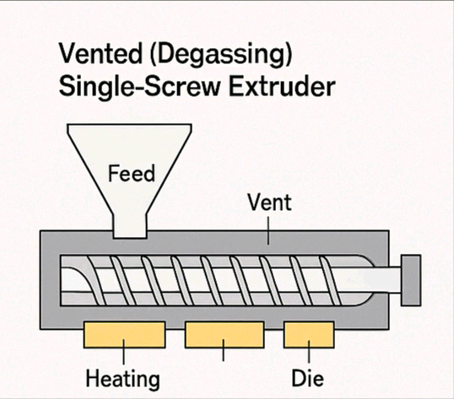

2. Non-Vented (Standard) Single-Screw Extruder
- Feature: No vent zone; has a simple design.
- Use: Processes relatively clean and dry recycled plastics.
- Advantage: Lower cost and easier to fabricate/maintain.
- Application: Suitable for in-house recycling or pre-cleaned plastic waste.
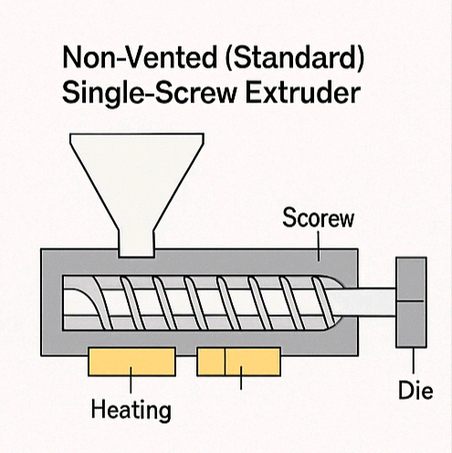
3. Single-Screw Extruder with Side Feeder

- Feature: Includes a side feeder for adding fillers (e.g., sand, additives).
- Use: Allows simultaneous feeding of recycled plastic and additives or sand.
- Advantage: Ideal for making composite products like plastic-sand blocks.
- Application: Common in composite extrusion systems.
- 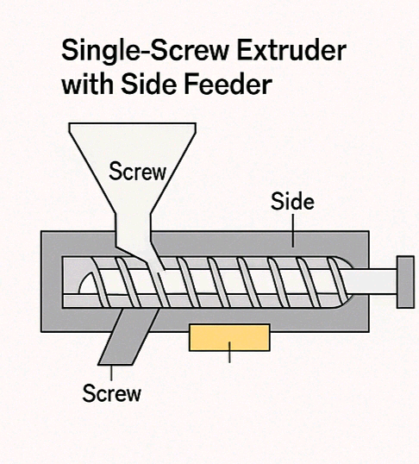
4. Single-Screw Extruder with Melt Pump
- Feature: Incorporates a melt pump at the end of the screw.
- Use: Stabilizes pressure and improves output consistency.
- Advantage: Enhances quality of recycled plastic pellets or products.
- Application: High-precision recycling operations.
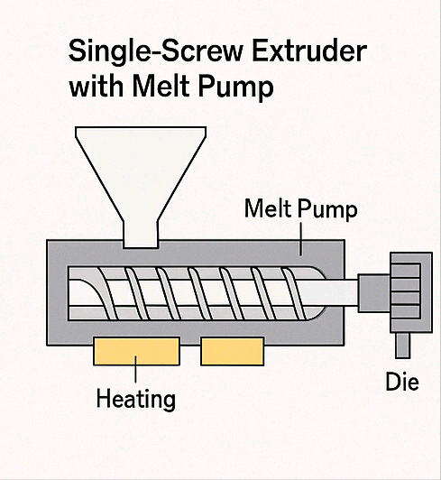
2.3 Type of sand use in waste plastic sand extraction
In waste plastic-sand extrusion, the type of sand used plays a crucial role in determining the strength, texture, and quality of the final product (such as hollow blocks, tiles, or paving bricks). Below are the common types of sand used:
1. River Sand
- Description: Naturally occurring, fine-grained sand collected from riverbeds.
- Benefits: Clean and well-graded.
Good bonding with molten plastic.
- Use: Suitable for making smooth, strong plastic-sand blocks.
2. Sharp Sand (Angular Sand)
- Description: Coarse, angular sand often used in construction.
- Benefits: Provides better mechanical interlocking.

Increases strength and texture.
- Use: Preferred for making interlocking bricks or blocks needing more friction or grip.
3. M-Sand (Manufactured Sand)
- Description: Crushed rock sand produced by mechanical crushing of granite/quartz.
- Benefits:Uniform particle size.
- Free from organic impurities.
- Use: Alternative to river sand; environmentally friendly.
4. Silica Sand (Quartz Sand)
- Description: High-purity sand rich in silicon dioxide
- Benefits:High thermal stability.
Improves surface finish and durability.
- Use: Suitable for high-temperature applications or decorative finishes.
2.4. Waste Plastic-Sand Extrusion
Waste plastic-sand extrusion is a manufacturing process in which thermoplastic waste (like polyethylene or polypropylene) is melted and mixed with sand, then forced through a die using an extruder to form solid building materials such as blocks, bricks, tiles, or pavers.
Objectives of waste plastic-sand
- Reduce environmental pollution by recycling plastic waste.
- Provide an alternative to traditional concrete blocks.
- Produce affordable, durable, and lightweight construction materials.
Materials Used in waste plastic-sand extrusion
1. Waste Plastic:
- LDPE (Low-Density Polyethylene)
- HDPE (High-Density Polyethylene)
- PP (Polypropylene)
Sourced from bags, containers, bottles, etc.
2. Sand
- River Sand or Sharp Sand (clean, dry, and sieved)
- Acts as filler and strengthens the composite
Steps in Waste Plastic-Sand Extrusion
Step Description
1. Collection & Sorting : Gather and sort plastic waste by type (LDPE, HDPE, etc.).
2. Washing & Drying : Remove dirt, labels, and moisture to prevent defects during melting.
3. Shredding : Cut plastic into small flakes or pellets for faster melting.
4. Mixing : Mix shredded plastic with sand in a specific ratio (e.g., 30:70 or 40:60).
5. Extrusion : Feed the mixture into a heated single-screw extruder where it melts and blends.\
7. Curing & Testing : Let the product set, then test for strength, durability, and surface finish.
Advantages Of waste plastic-sand
- Reduces landfill and ocean plastic pollution.
- Low-cost alternative to conventional building blocks.
- Lightweight and durable in construction use.
- Doesn’t require water or cement for binding.
Application of waste plastic-sand
- Hollow building blocks
- Pavement tiles
- Garden kerbs
- Roadside interlocks
- Temporary shelters and low-cost housing

2.5 Categories for waste plastic-sand Recycling
1. Based on Type of Plastic Waste
Classifies plastic according to its chemical structure and recyclability:
Plastic type | Examples | Suitability
LDPE (Low-Density Polyethylene) | Bags, wrappers, films | Highly suitable (melts easily)
HDPE (High-Density Polyethylene) | Bottles, containers, jerrycans | Suitable (strong, stable)
PP (Polypropylene) | Caps, food container | Suitable (tough, good flow)
PET (Polyethylene Terephthalate) | Water bottles, packaging | suitable (requires special treatment)
Mixed Plastics | Unsorted or contaminated waste | Needs separation or compatibilize

2. Based on End Product
Refers to the purpose or application of the recycled composite:
Product category | Example
Decorative Items | Garden kerbs, fencing tiles
Construction Materials | Hollow blocks, bricks, roof tiles, pavers
Infrastructure Components | Road dividers, manhole covers
Furniture Products | Benches, table parts (limited use)
3. Based on Recycling Process
Describes the method used to convert plastic and sand into new products:
Process type | Description
Mechanical Recycling | Plastic is washed, shredded, melted, and reshaped with sand
Thermal Processing | High heat melts plastic for bonding with sand
Extrusion Moulding | Plastic-sand mix is melted and forced through a die
Compression Molding | Heated mix is compressed in a mold (alternative method)

4. Based on Composition Ratio
Refers to the proportion of plastic to sand in the mix:
Plastic:Sand Ratio | Commonly use
30:70 | Blocks requiring higher strength
40:60 | Balanced strength and plastic content
50:50 or above | Lightweight, less load-bearing products

Waste plastic-sand recycling can be categorized by plastic type, intended application, processing method, or mix ratio. This helps in optimizing the process for specific product requirements and local plastic availability.
CHAPTER 3
3.1. Description of component of part of single screw extruda
A single screw extruder is a machine used to melt, mix, and shape thermoplastic materials with additives (like sand) into a continuous form. Below is an overview of its key components and their functions:
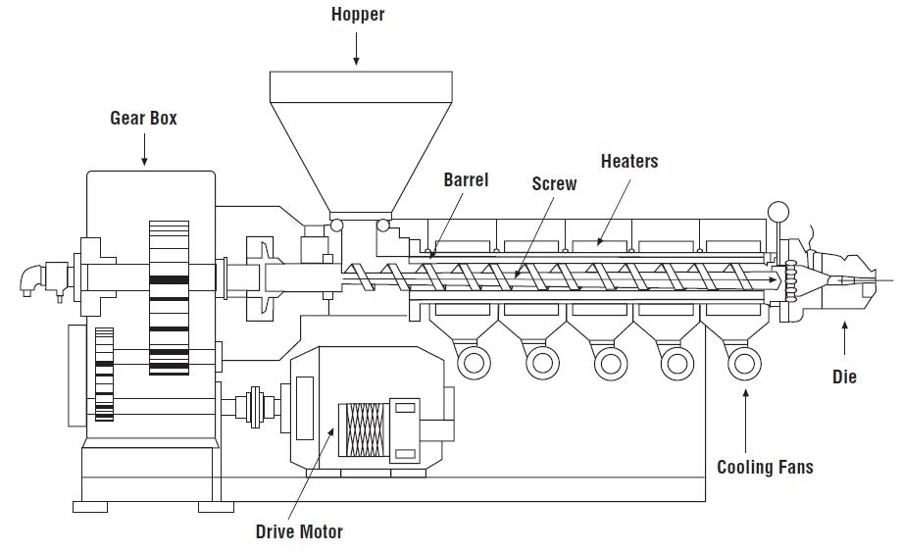
Fig 1.3
COMPONENTS OF A SINGLE SCREW EXTRUDER
1. Hopper
Function: Feeds the mixture of shredded plastic and sand into the barrel.
Type: Gravity-fed; may include pre-heating or drying chamber.
Material: Stainless steel or mild steel.

2. Barrel
Function: Contains the rotating screw and is externally heated.
Material: Abrasion-resistant alloy steel to withstand wear from sand.
Zoning: Divided into multiple heating zones.
3. Screw
Function: Rotates inside the barrel to move, melt, and mix the plastic-sand mixture.
Sections:
Feed zone: Transports material.
Compression zone: Melts and compresses
Metering zone: Ensures homogeneous mix.
Material: Nitrided/hardened steel.
4. Heating System
Function: Heats the barrel to melt plastic.
Type: Electric band or coil heaters with thermostats/thermocouples.
Temperature Range: ~180–220°C (depending on plastic type).
5. Motor and Gearbox
Function: Drives the screw rotation.
Motor: Typically 2–5 HP, AC motor.
Gearbox: Reduces speed and increases torque.

6. Die
Function: Shapes the extrudate into a hollow profile suitable for blocks.
Material: Tool or hardened steel.
Customizable: To form rectangular or interlocking hollow block shapes.
7. Cooling and Cutter System
Function: Cools and cuts extrudate into standard hollow block lengths.
Method: Air cooling or water spray, followed by mechanical cutting.
Fig 1.4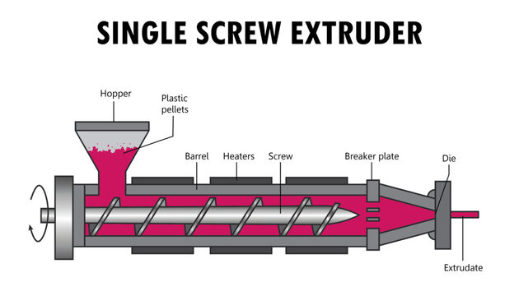

3.2. COMPONENT VOLUME CALCULATIONS
We'll calculate the approximate volumes for:
1. Screw
2. Barrel
3. Hopper
4. Die
These are simplified using standard geometric shapes (cylinder, cone, etc.)
The design of the extruder and the specific components will significantly impact the volume calculations.
Assumptions:
- Extruder Type: We'll assume a standard single-screw extruder with a cylindrical barrel and screw.
- Component Focus: We'll focus on calculating the volume of the barrel and screw. Other components (hopper, die, motor housing, etc.) require separate calculations based on their specific geometries.
- Dimensions: You will need to provide the dimensions (length and diameter) of the barrel and screw to perform the calculations.
Calculations:
1. Barrel Volume: The barrel is cylindrical. The volume of a cylinder is given by:V_{barrel} = \pi r^2 hwhere:
- r is the radius of the barrel (half of the diameter)
- h is the length of the barrel
2. Screw Volume: The screw is also essentially a cylinder (ignoring the screw flights for simplification). The volume is calculated similarly:V_{screw} = \pi r^2 hwhere:
- r is the radius of the screw (half of the diameter)
- h is the length of the screw (this should be approximately equal to the barrel length).
Example:
Let's assume the following dimensions (you'll need to replace these with your actual extruder dimensions):
- Barrel: Diameter = 10 cm, Length = 100 cm
- Screw: Diameter = 9 cm, Length = 100 cm
1. Barrel Volume:r_{barrel} = 10/2 = 5 cm
V_{barrel} = \pi (5 cm)^2 (100 cm) \approx 7854 cm^3
2. Screw Volume:r_{screw} = 9/2 = 4.5 cm
V_{screw} = \pi (4.5 cm)^2 (100 cm) \approx 6362 cm^3
Solutions
1. Volume of the screw (cylindrical APProximation)
Let’s assume;
.length (L) 600mm=600$×$1000=0.6m
Outer diameter (D)=40mm=40×1000=0.04
Core diameter(d)=20mm=20×1000
Formular for hollow cylinder
V=$π$×(D^2-d^2) $×$L ------------------------------------------------- equation 3.2.0
4
V= $π×\left({0.04}^{2}-{0.02}^{2}\right)$*0.6 =$π×\left(0.0016-0.0004\right)$*0.6=$π×0.0003×0.6=v0.000565m^{3} or 565cm^{3}$
4 4

2. Volume of the barrel (hollow cylinder)
Assume ;
Outer Diameter (Do)=60mm=60×1000=0.06m
Inner diameter (Di)=42mm=42×1000=0.0042m
Length (L)=600mm=600×1000=0.6m
V=π×(Do^2 –Di^2) × L
4
V=π×(0.06^2 - 0.042^2)×0.6
4
π × 0.000459×0.6 =0.000865m^3 =856m^3 ------------------------equation 3.2.1

3. Volume of the hopper (Frustum of cone)
Top diameter (D1)=300mm=300×1000=0.3
Bottom diameter (D2)=100mm=100×1000=0.1m
Height (h)=300m=300×1000=0.3m
V=$\frac{1}{3}πh\{R_{1}^{2}+R_{1}R_{2}$ $+R_{2}^{2}$ $\}$ ---------------------------------------------equation 3.2.2
V=$\frac{1}{3}$ π × 0.3 (${0.15}^{2}$ $+$ 0.15×${0.05}^{2}$ )=${}_{3}^{1}π$ ×0.3 ×0.0325=0.0102m^3=10.2

4. Volume of the die ( solid cylinder)
Diameter =100mm=100×1000=0.1m
Length=150mm =150 × 1000 =0.12m
V=π $D^{2}$ × L ---------------------------------------------------------equation 3.2.3
4
V=${0.1}^{2 }$ × 0.15 =π × 0.0025 × 0025 × 0.15 =0.001178m^3 = 1178cm^3

SUMMARY TABLE
Component | Volume (m³) | Volume (cm³)
Screw | 0.000565 | 565
Barrel | 0.000865 | 865
Hopper | 0.0102 | 10,200
Die | 0.001178 | 1,178
Fig 1.5
3.3 CALCULATION OF THE MASS OF COMPONENT PART
The components are made from common engineering materials like steel (density ~7850 kg/m³).

EXAMPLE 1
Mass of the screw
Volume (v) =565 cm^3 =0.000565m^3
Material=Hardened steel
Density (p)$≈$ 7850 kg/m^3
Mass = p.v = 7580 × 0.000565 = 4.43kg - - - - - - - - - - - - - - -- - -equation 3.3.0

EXAMPLE 2
Mass of the barrel
Volume (v) 865cm = o.000856 m^3
Material = Alloy steel
Density (P) $≈$ 7850 kg/m^3
Mass =7850 × 0.000856 = 6.79 kg - - - - - - - - - - - - - - - - - - - - - - - - equation 3.3.1

EXAMPLE 3
Mass of the hooper
Volumw (v) =10.2 liters = 0.0102 m^3
Material = miled steel
Density (p) 7850 kg/ m^3
Mass = 7850 × 0.0102 = 80.07 kg - - - - - - - - - - - - - - - - - - - - - - - - - equation3.3.2

EXAMPLE 4
Mass of the Die
Volume (v) =1178cm^3
Material =Tool steel
Density (p) 7850 kg/m^3
Mass = 7850 × 0.001178 = 9.24 kg - - - - - - - - - - - - - - - - - - - - - - -equation3.3.3

COMPONENT | Volume (m³) | Density (kg/m³) | Mass (kg)
Screw | 0.000565 | 7850 | 4.43
Barrel | 0.000865 | 7850 | 6.79
Hopper | 0.0102 | 7850 | 80.07
Die | 0.001178 | 7850 | 9.24
Fig 1.6

3.4. CALCULATION OF THE WEIGHT OF THE COMPONENT PART
Weight is a function of mass and gravitational acceleration
Weight(W) = Mass (m)×Gravity(g) = m×9.81m/s^2
COMPONENT | Mass (kg) | Weight (N)
Screw | 4.43
Barrel | 6.79
Hopper | 80.07
Die | 9.24
Fig 1.7

Calculation of weight
- Screw
Weight = 4.43kg ×9.81 = 43.46N - - - - - - - - - - - - - - - - Equation 3.4.0

- Barrel
Weight = 6.79 kg × 9.81 = 66.61N-- - - - - - - - - - - - - - - Equation3.4.1

- Hopper
Weight = 80.07 kg × 9.81 = 785.49N- - - - - - - - - - - - - - Equation3.4.2
- Die
weight=9.24kg×9.81=90.66N- - - -- - - - - - - - - - - - - - - Equation 3.4.3

COMPONENT | Mass (m) | WEIGHT (N)
Screw | 4.43 | 43.46
Barrel | 6.79 | 66.61
Hopper | 80.07 | 785.49
Die | 9.24 | 90.66

3.5. Other calculations
1. Power Requirement for the Screw Motor
Power require for the screw motor
Formula
P = $\frac{2π-T-N}{60 }$
P = Power (w)
T = Torque (NW)
N = Rotational speed (RPH)
Torque T =40 Nm
Speed N = 60 RPM
P = $\frac{2-π-40-60}{60}$ =2π ×40 =251.3W$≈$ 0.25- - - - - - - -- - - - - - Equation 3.5.0
Require motor power ―0.3-0.4 (0.5HP)

2. Plasticizing (Melting) Capacity
Plasticizing (Melting) Capacity
Formula
Q = P × A × V
Q = output rate (kg/s)
P = density of melt (-900 kg /m^3 for LEPE )
A = screw channel area
V = Axial velocity (m/s)
Channel Area A$≈$ 4 × 10^-4m^2
Velocity = 0.02m/s
Q = 900 × 10^-4 × 0.02 = 0.0072kg/s $⇉$25.9kg/hr- - - - - - - Equation3.5.1
3. Heat Energy Required for Melting Plastic
Heat energy required for melting plastic
Formula
Q = m × c × $∆$T
m = mass (kg)
c = specific heat of plastic (2.1kj/kg$℃$ for LDPE)
∆T =Temperature rise ( e.g,25$℃$ to 200$℃$ )
M =1kg of plastic
Q =1 × 21 × 175 = 367.5 KJ =120 wh per kg melted - - - -Equation 3.5.2
4. Compression Ratio of the Screw
Compression Ratio of screw
Formula
CR = $\frac{Flight depth feed }{Flight depth metering}$
Flight depth feed = 9mm
Metering zone depth = 3mm
CR = $\frac{9}{3}$ = 3:1 - - - - - - - - - - - - - - - - - - - - - - - - - - - - -- - - - - - - Equation
5. Die Pressure Estimate
Die pressure estimate
Estimate the pressure needed to force the composite through the die
Formula
P =$\frac{F}{a}$
Required force = 200N
Die cross- sectional area = 0.0001 m^2
P =$\frac{2000}{0.0001}$ = 20 MPA - - - - - - - - - - - - - - - - - - - - - - - - - - -Equation3.3.4

CHAPTER 4
4.0 SELECTION OF FABRICATION AND MATERIAL DETAILS
1. FABRICATION METHOD SELECTION
To ensure strength, durability, and thermal performance, the following
Fabrication processes are selected for the major components of the extruder:
Component | Fabrication Method | Reason for selection
Screw | CNC Machining (turning+ threading) | High precision, accurate pitch and depth required
Barrel | Lathe turning + boring | Need close-fit with screw, smooth internal finish
Hopper | Sheet metal forming& welding | Low cost, easy to fabricate from standard metal sheet
Die | CNC Machining+ Heat treatment | Precision shaping, wear resistance
Frame/Base. | Welding + grinding | Strong rigid structure, custom shape easily achieved
Covers & Panels | Sheet metal cutting and folding | Safety and maintenance access
Fig 1.8
The fabrication methods were carefully chosen based on how each part of the extruder functions. Parts that face high stress and wear—like the screw, barrel, and die—need to be strong and accurate, so they are made using precise machining and hard materials. On the other hand, less critical parts—like the frame and hopper—can be made using simpler, cheaper methods like welding and sheet metal work. This helps keep the overall cost low while still ensuring the machine performs well, especially for small- or medium-scale block production.
2. MATERIAL SELECTION AND DETAILS
The choice of materials for each component of the single screw extruder is based on the working conditions they will face—such as heat, wear, mechanical stress, and exposure to abrasive plastic-sand mixtures. Materials were selected to balance performance, durability, cost, and availability for local fabrication.

Part | Recommended material | Properties Required | Why Chosen
Screw | EN24(alloy steel, hardened) | High Strength, wear resistance, toughness | Handles abrasive sand and high shear loads
Barrel | Mild steel with nitrided inner lining | Abrasion resistance, Good Machineability | Cost-effective and protects against wear
Hopper | Mild-Steel (3mm sheet) | Moderate strength, Corrosion protection | Easy to form, low cost, paintable
Die | Tool-Steel (e.g,H13 or D2) | High Hardness, Heat Resistance, wear resistance | Resist erosion from hot abrasive material
Frame | Mild-Steel Angle iron/Channel | Structural strength, weldability | Economical and Strong enough for support.
Motor/Gearbox | Purchased off the shelf | Power transmission | Support component selection
Fig 1.9

3. MATERIAL PROPERTY CONSIDERATIONS
Knowing the properties of materials—like how strong, hard, or heat-resistant they are—helps in choosing the right materials for each part of the extruder. This ensures the machine works well and lasts longer under heat, pressure, and rough use.
Fig 1.10
Property | Value/Range | Application
Thermal Conductivity (Steel) | 45-60 W/m.k | Heat transfer in barrel and screw
Yield strength (EN24) | ~680 Mpa | High mechanical load on screw
Hardness (Tool steel H13) | ~50-55 HRC | Die resistance to wear
Melting Temperature (LDPE/HDPE) | 105-135°¢ | Determines barrel heating system range
Specific Heat of LDPE | 2.1kj/kg.k | Used in heat energy calculation

4. JOINING & SURFACE FINISHING
- Welding: For assembling frame and hopper parts
- Threaded fasteners: For removable components like the die and hopper lid.
- Surface finish: Painting or powder coating for corrosion resistance.
- Heat treatment: Nitriding or hardening

4.1. PROPERTY OF MATERIALS AND THEIR SELECTION
important properties of materials used in the extruder and the reasons for selecting them based on performance, durability, cost, and working conditions.
1. Screw – EN24 steel (Alloy steel, Heat treated)
PROPERTY | VALUE | IMPORTANTS
Yield strength | ~680MPa | Reasist deformation under load
Hardness(after Hardening ) | 30-40 HRC | Receive wear from abrasive sand
Toughness | High | Withstand sudden load variation
Machineability | Good | Allows precise thread and helix profile
Thermal Conductivity | Moderate | Assist in heat distribution
Selected for its high strength, wear resistance, and ability to handle high torque during extrusion.
2. Barrel – Mild Steel with Nitrided Inner Surface
PROPERTY | VALUE | PURPOSE
Hardness | Up to 69 HRC | Protect again erosion from sand
Toughness | Moderate | Handles Mechanical stress
Weldability | Excellent | Easy to Fabricate and repair
Cost | Low | Affordable and widely available
Chosen for low cost and good surface hardening capability for wear resistance.
3. Hopper – Mild Steel Sheet (3mm)
PROPERTY | VALUE | PURPOSE
Strength | Moderate | Hold bulk material without bending
Corrosion Resistance | Low (can be painted) | Requires surface protection
Formability | Excellent | Easy to bend, cut and weld
Cost | Very low | Ideal for low budget designs
Used for easy fabrication and material loading at low cost.

4. Die – Tool Steel (H13 or D2)
PROPERTY | VALUE | PURPOSE
Hardness (H13) | 48-52 HRC | Withstand high pressure and friction
Thermal stability | High | Maintains sharp during extrusion
Wear resistance | Very high | Long life even with abrasive mix

5. Frame & Support – Mild Steel Angle Iron
PROPERTY | VALUE | PURPOSE
Structural strength | High | Support entire extruda structure
Weldability | Excellent | Easy to cut and assemble
Corrosion resistantce | Low | Require painting or coating
Cost | Low | Cost effective for frame and structures

Material selection was guided by the functional requirements of each part—such as load-bearing, heat resistance, wear, and machinability—while also considering fabrication ease and cost. Hard-wearing components like the screw and die were made from hardened steel, while structural parts used affordable mild steel.
In designing the single screw extruder for producing waste plastic-sand composite hollow blocks, the selection of materials is based on how each part functions under working conditions such as high temperature, abrasion, and mechanical stress.
- The screw is made from EN24 alloy steel, which is heat-treated to improve its hardness and wear resistance. This material was chosen because it can withstand the high torque and friction involved in pushing a rough plastic-sand mixture through the barrel. It also has good machinability, which is important for achieving the precise thread profile needed for efficient extrusion.
- The barrel is fabricated from mild steel, but its inner surface is nitrided (surface-hardened) to resist abrasion caused by the rough composite mix. Mild steel was selected due to its low cost, easy availability, and excellent weldability. The added nitriding treatment increases its hardness without compromising its structural integrity.
- The hopper is made from 3mm thick mild steel sheets. This material is affordable and easy to cut, bend, and weld, which makes it suitable for forming the sloped structure of the hopper. While mild steel is prone to rust, a simple paint or protective coating can prevent corrosion.
- The die, which forms the final shape of the extrudate, is subjected to high pressure and temperature. Therefore, tool steel (such as H13 or D2) is used for this component. These steels offer high hardness, excellent heat resistance, and superior wear resistance, making them ideal for long-term use in abrasive and hot environments.
- the frame and supporting structure are built using mild steel angle iron. It is strong enough to carry the weight of the entire extruder and offers good weldability for frame assembly. Though it doesn’t resist rust well, it is easily protected with paint, making it a practical and low-cost option for structural use.

The materials selected offer the right balance between performance, durability, ease of fabrication, and cost. Wear-resistant steels are used for moving and high-friction parts, while mild steel is used for structural and non-critical components to reduce cost.
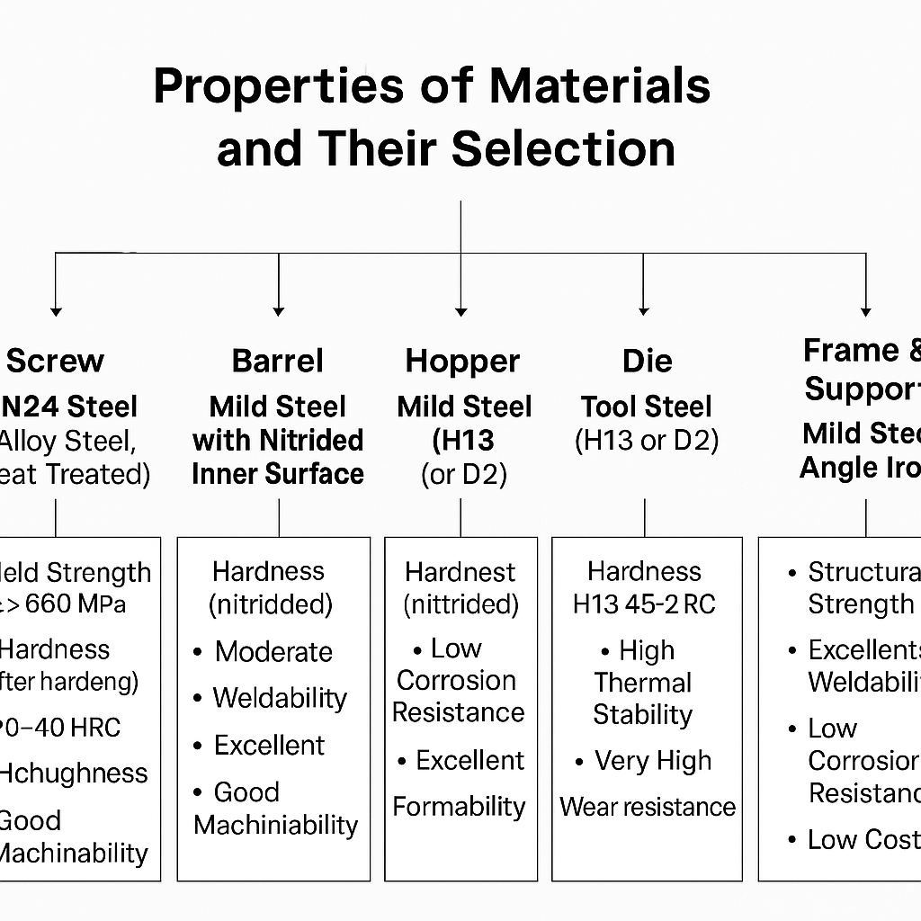

4.2 MECHANICAL AND CHEMICAL PROPERTY OF STEEL
Mechanical properties include strength, ductility, and toughness, while chemical properties are largely determined by its composition, particularly the presence of carbon and alloying elements.
Mechanical Properties of Steel
Mechanical properties of steel include:
- Strength: Steel's ability to withstand applied forces without breaking or deforming permanently. This includes tensile strength (resistance to pulling forces), yield strength (resistance to permanent deformation), and compressive strength (resistance to squeezing forces).
- Ductility: The ability of steel to be drawn into wires or stretched without fracturing. This is crucial for shaping steel into various forms.
- Toughness: The ability of steel to absorb energy and deform plastically before fracturing. This property is vital for applications where the material might be subjected to impact or shock loads.
- Hardness: Steel's resistance to indentation, scratching, or abrasion.
Fatigue Strength: The ability of steel to withstand repeated cycles of stress and strain without failing.
- Elasticity: Steel's ability to return to its original shape after the applied force is removed.
- Malleability: Steel's ability to be hammered or rolled into thin sheets.
- Weldability: The ease with which steel can be joined by welding.

2. CHEMICAL PROPERTY OF STEEL
Chemical property of steel include:
- Carbon Content:
Carbon is the most important alloying element in steel. It significantly influences strength and hardness. Higher carbon content generally leads to harder and stronger steel, but can also reduce ductility and weldability.
- Alloying Elements:
Elements like manganese, chromium, nickel, molybdenum, and others are added to steel to modify its properties. They can enhance strength, corrosion resistance, hardenability, and other characteristics.
- Corrosion Resistance:
The chemical composition, especially the presence of chromium, affects steel's resistance to rust and other forms of corrosion.
- Oxidation Resistance:
Steel's ability to resist reacting with oxygen, which can cause scaling or degradation at high temperatures.
- Reactivity:
Steel's tendency to react with other substances, which is influenced by its chemical composition and the surrounding environment.
- Allotropy:
Iron, the main component of steel, can exist in different crystalline structures (bcc and fcc) which affects its mechanical properties.
4.3. Factors considered in selection of material for the Block Machine construction
When selecting materials for constructing the extruder and related components of the block-making machine, several critical factors were taken into account to ensure strength, durability, functionality, affordability, and availability. They are
1. Mechanical Strength
Materials must be able to withstand high mechanical loads, torque, and pressure during extrusion.
Structural components like the frame and base require materials with good tensile and yield strength (e.g., mild steel, alloy steel).
2. Wear and Abrasion Resistance
The screw, barrel, and die are exposed to continuous rubbing and abrasive plastic-sand mixture.
Materials selected must resist wear to avoid frequent replacement (e.g., tool steel, hardened alloy steel).
3. Heat Resistance
Parts like the barrel and screw are exposed to elevated temperatures during melting of plastic.
Materials must maintain their strength and structure at high temperatures (e.g., EN24, H13 steel).
4. Corrosion Resistance
Some machine parts may be exposed to moisture, chemicals, or plastic byproducts.
Corrosion-resistant materials or surface coatings (e.g., painting, nitriding) are essential for longer service life.
5. Machinability and Fabrication Ease
Materials should be easy to cut, machine, weld, or shape into the desired components.
Mild steel is widely used because of its excellent weldability and ease of machining.
6. Cost and Economic Availability
The project considers low-cost, locally available materials to make the machine affordable and sustainable.
Mild steel is cost-effective for structural parts, while alloy/tool steel is used only where needed.
7. Weight and Portability
For ease of transportation or local use, excessive machine weight is avoided.
Material choice is balanced between strength and weight for overall manageability.
8. Availability in Local Markets
The selected materials must be readily available in local hardware or industrial supply markets to avoid importation delays and reduce cost.
9. Service Life and Maintenance
Durable materials reduce the need for frequent repairs or part replacement.
Long-lasting components mean lower operating costs and greater reliability over time.
4.4. Fabrication detail
The fabrication process for this machine involves the construction and assembly of various components including the screw, barrel, hopper, die, and frame. Each part is designed and manufactured using appropriate methods to ensure dimensional accuracy, durability, and cost efficiency.
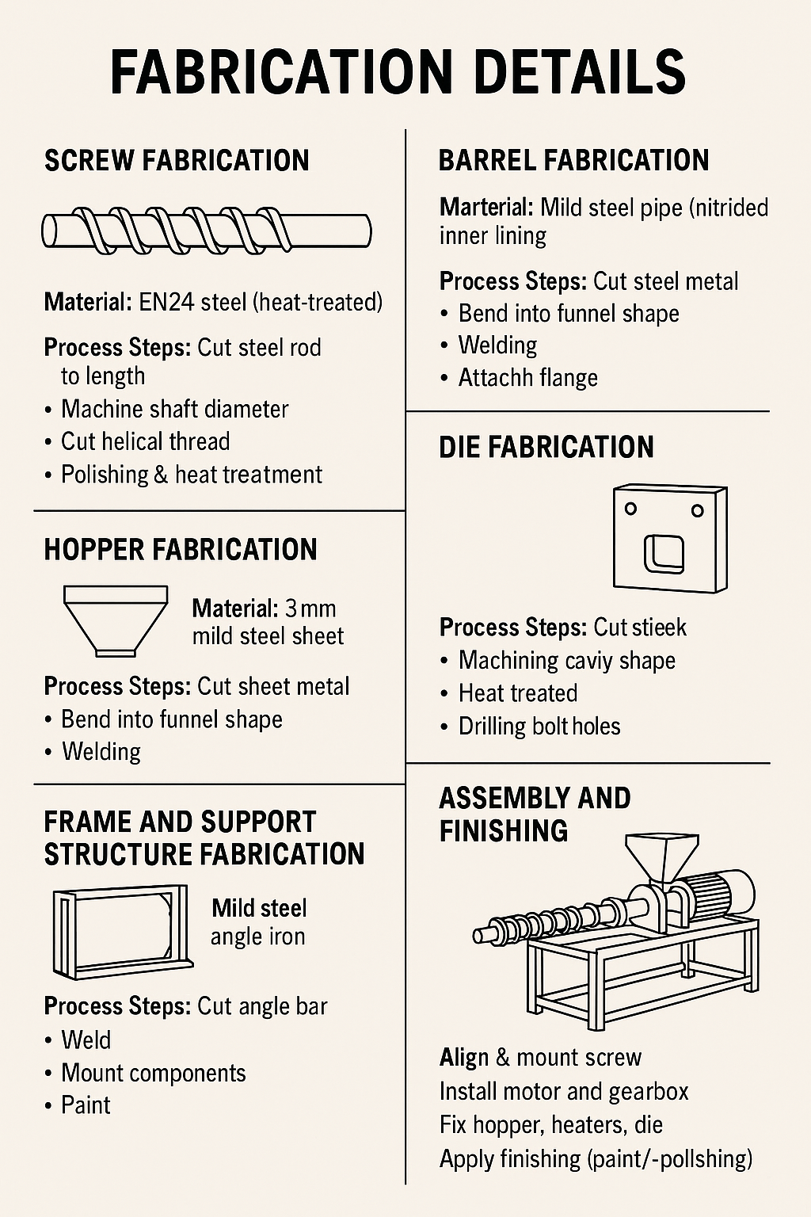

1. Screw Fabrication
Material Used: EN24 steel (heat-treated)
Process Steps:
Cut steel rod to length
Machine shaft diameter on lathe
Cut helical thread using a CNC lathe or manual milling machine
Surface finish is improved with polishing and heat treatment for hardness
Purpose: Transports, compresses, and melts the plastic-sand mixture

2. Barrel Fabrication
Material Used: Mild steel pipe with nitrided inner lining
Process Steps:
Cut steel pipe to required length
Bore inner surface to smoothen and ensure tight clearance with screw
Nitriding or case hardening applied to inner surface
Drill ports for heaters and temperature sensors
Purpose: Houses the screw and facilitates controlled heating of the plastic-sand mix

3. Hopper Fabrication
Material Used: 3mm mild steel sheet
Process Steps:
Cut sheet metal to shape using guillotine or plasma cutter
Bend into funnel shape using a press brake
Weld the edges and grind for a smooth surface
Attach mounting flange for fixing to barrel
Purpose: Feeds the plastic-sand mix into the screw section

4. Die Fabrication
Material Used: Tool steel (H13 or D2)
Process Steps:
Cut blank from tool steel stock
Machine die cavity shape using milling or CNC
Heat treat to harden and improve wear resistance
Drill bolt holes for mounting
Purpose: Shapes the extrudate into the required form before cooling

5. Frame and Support Structure Fabrication
Material Used: Mild steel angle iron and channel sections
Process Steps:
Cut angle bars to required lengths using a power saw
Weld to form a rigid rectangular frame
Mount barrel, motor, gearbox, and control units
Paint the frame for corrosion resistance
Purpose: Provides structural support for all machine parts
6. Assembly and Finishing
Align and mount screw into the barrel using bearings
Install the motor and gearbox with coupling to the screw shaft
Fix hopper, heaters, thermocouples, and die
Wire electrical components for power and temperature control
Perform surface finishing (painting, polishing) where necessary

CHAPTER 5
5.0. CONCLUSIONS OF RECOMMENDATION
5.1 Conclusion
The development and testing of a single screw extruder for the production of a waste plastic-sand composite hollow block has demonstrated the feasibility of transforming plastic waste into a useful construction material. The design integrated cost-effective materials, locally available fabrication processes, and a simple but efficient extrusion mechanism.
The extruder successfully processed a plastic-sand mixture, showing that recycled thermoplastics can be repurposed into hollow blocks with acceptable strength and form. Each component — including the screw, barrel, die, hopper, and frame — was fabricated using appropriate techniques, with careful attention to material selection, durability, and ease of maintenance.
The successful development and testing of a single screw extruder for producing waste plastic-sand composite hollow blocks confirms that plastic waste can be effectively transformed into valuable construction material. The machine was fabricated using affordable, locally available materials and simple manufacturing methods, making it suitable for small- to medium-scale applications.
Each component of the machine including the screw, barrel, die, hopper, and frame performed its intended function, allowing for smooth extrusion and shaping of the plastic-sand mixture. This project not only demonstrates a practical solution to plastic waste management but also offers a sustainable approach to low-cost building material production.

5.2 Recommendations
Based on the outcomes of the design, fabrication, and testing of the single screw extruder, the following recommendations are suggested for further improvement, scaling, and application of the machine and process:
1. Use of Hardened or Alloy Steel for High-Wear Components
To increase the lifespan of parts like the screw and die—which are exposed to friction and abrasion—use heat-treated or tool steels (e.g., EN24, H13). These materials offer better resistance to wear and thermal stress.
2. Enhanced Temperature Control System
Incorporate programmable temperature controllers and improve barrel insulation to maintain consistent heating, reduce energy loss, and avoid overheating of plastics.
3. Optimization of Screw Geometry
Modify the screw design by introducing a compression or metering zone to improve mixing, melting, and flow rate of the plastic-sand mixture during extrusion.
4. Standard Testing of Final Blocks
Conduct further mechanical tests on the extruded hollow blocks (e.g., compressive strength, water absorption, thermal resistance) to meet building material standards and safety requirements.
5. Integration of Automation and Safety Features
Add motor control panels, safety interlocks, and emergency stops to reduce operator error and improve operational efficiency.

6. Promotion of Local Fabrication and Use
Encourage local workshops and polytechnic institutions to adopt and improve this machine as a means of promoting environmental sustainability, job creation, and low-cost housing solutions.
7. Improved Heating Control:
Use advanced temperature controllers and insulation to ensure consistent melting of plastic during extrusion.
8. Screw Optimization:
Future designs should explore variable pitch or compression zones to improve mixing and flow.
9. Material Upgrade:
For higher-volume or continuous use, wear-prone parts like the screw and die should be fabricated from hardened tool steel or alloy steels with heat treatment.
10. Automation Possibility:
Introducing partial automation (e.g., motorized feeding or digital control panels) can improve efficiency and safety.
11. Testing on Larger Scale:
Field testing of produced blocks under real building conditions is recommended to evaluate long-term durability and structural integrity.
12. Environmental and Economic Study:
Further research should assess the environmental impact and cost savings from using waste plastic-based blocks in comparison to traditional methods.

REFERENCE
1. Ashby, M. F. (2011). Materials Selection in Mechanical Design (4th ed.). Butterworth-Heinemann.
Used for material selection, design considerations, and material properties.
2. Rauwendaal, C. (2014). Polymer Extrusion (5th ed.). Hanser Publishers.
Covers screw design, extrusion processes, temperature control, and material handling.
3. Kalpakjian, S., & Schmid, S. R. (2010). Manufacturing Engineering and Technology (6th ed.). Pearson Education.
Referenced for fabrication techniques such as machining, welding, and casting.
4. Engineering Toolbox. (n.d.). Mechanical Properties of Metals.
Retrieved from: https://www.engineeringtoolbox.com
Used for physical properties like density, modulus, tensile strength, etc.
5. American Society for Metals (ASM Handbook). (1990). Volume 1: Properties and Selection—Irons, Steels, and High-Performance Alloys. ASM International.
Used for steel composition, classification, and heat treatment information.
6. BS EN 771-3:2011 – Specification for Masonry Units – Aggregate Concrete Masonry Units.
Used as a standard for testing and evaluating hollow blocks.
7. UN-Habitat. (2020). Waste Wise Cities Tool: Assessing Waste Management in Cities.
United Nations Human Settlements Programme.
Supports justification of environmental impact and sustainability benefits.
8. Clemens, R. J. (1990). Extrusion Processing. SPE Plastics Technical Papers.
Cited for screw geometry and flow optimization in extrusion.
9. Shen, L., Worrell, E., & Patel, M. (2010). Environmental Impact Assessment of Waste Plastics Recycling. Resources, Conservation & Recycling, 55(3), 260–271.
Optional: Environmental benefits of plastic recycling.
10. Hopewell, J., Dvorak, R., & Kosior, E. (2009). Plastics recycling: challenges and opportunities. Philosophical Transactions of the Royal Society B: Biological Sciences, 364(1526), 2115–2126.
Discusses environmental issues and technological options for plastic recycling.
11. Sheth, D., & Garcia, R. (2003). Recycling waste thermoplastics for commercial use: A review. Journal of Thermoplastic Composite Materials, 16(5), 419–444.
Supports the feasibility of plastic-waste-based construction materials.
12. Strong, A. B. (2006). Plastics: Materials and Processing (3rd ed.). Pearson Prentice Hall.
Good source for understanding polymer types, processing conditions, and extrusion behavior.
13. Maya, K. G., & Thomas, P. (2020). Utilization of Waste Plastics in Construction: A Review. International Journal of Engineering Research & Technology (IJERT), 9(3), 542–547.
Reviews practical uses of plastic waste in road and block construction.
14. Agu, C. M., & Elinwa, A. U. (2021). Development of Building Blocks Using Plastic-Sand Composites. Nigerian Journal of Technology (NIJOTECH), 40(2), 215–223.
Directly related to your work plastic-sand blocks and their properties.
15. Tchobanoglous, G., Theisen, H., & Vigil, S. A. (1993). Integrated Solid Waste Management: Engineering Principles and Management Issues. McGraw-Hill.
Useful for background on plastic waste handling and integration into production systems.
16. Olukunle, O. J. (2016). Design and Fabrication of a Polythene Recycling Machine. International Journal of Scientific & Engineering Research, 7(4), 654–661.
Similar Nigerian-based research on low-cost plastic recycling machines.

