

COMPARATIVE ANALYSIS OF INDOOR AND OUTDOOR TEMPERATURE VARIATIONS IN KWARA STATE POLYTECHNIC: A STUDY USING SMARTPHONE TEMPERATURE APPLICATIONS AND DIGITAL THERMOMETERS

BY

HASSAN HAMIDAT AJIKE
ND/23/SLT/FT/0051

SUBMITTED TO:

THE DEPARTMENT OF SCIENCE LABORATORY TECHNOLOGY, INSTITUTE OF TECHNOLOGY, KWARA STATE POLYTECHNIC, ILORIN.

JUNE, 2025

DEDICATION
This project is dedicated to Almighty Allah and my parents Mr. and Mrs. HASSAN

ACKNOWLEDGEMENT
First and foremost, I express my sincere gratitude to Almighty Allah for His guidance, protection, and grace throughout the duration of this project.
I am deeply grateful to my ever supportive and dedicated supervisor Mr. Yusuf Olarenwaju. Thank you for your unwavering support and guidance. May Almighty Allah bless you abundantly, reward your efforts, and grant you all your hearts desires. Aameen
I am especially thankful to my beloved parents, Mr. and Mrs. Hassan, for their tireless efforts-financially, spiritually and emotionally. I pray you live long in sound health to enjoy the fruits of your labour Aameen.
My appreciation also goes to my guardian Mr. Kehide Hanafi, as well as Abimbola Kaosarah and Olalowu Fathia for their constant support and wise counsel thanks so much. May God bless you all.
In a special way, I wish my siblings for their supports, encouragement.
To my dearest brother (Mr. Hassan Mustapha) and my darling sister (Miss Hassan Zainab) as well brother Azeez thank you all for you’ll for the supportive throughout my National Diploma journey.
May Almighty Allah continue bless you’ll. Aameen.

CERTIFICATION

This is to certify that this project work, “comparative Analysis of Indoor and Outdoor Temperature Applications and Digital Thermometer. “was written by HASSAN HAMIDAT AJIKE with Matric No :ND/23/SLT/FT/0051 and has been read and approved for the award of National Diploma( ND) in the department of Science Laboratory Technology, institute of applied science,kwara state polytechnic Ilorin.

_____________________________ ____________________________
MR SAHEED Y. O DATE
SUPERVISOR

_____________________________ __________________________
DR.ABDULKAREEM USMAN DATE
HOD

______________________________ _______________________
EXTERNAL EXAMINER DATE

TABLE OF CONTENT
Title page
Certification
Dedication
Acknowledgment
Table of contents
CHAPTER ONE: INTRODUCTION
  - Background of the Study
  - Name of the Study
  - Objectives
  - Scope of the Study
CHAPTER TWO: LITERATURE REVIEW
  - Introduction
  - Temperature and Educational Performance
  - Digital Thermometer in Environmental Studies
  - Smart Phone Applications
  - Comparative Study
  - Gaps in Literature
CHAPTER THREE: METHODOLOGY
  - Research Designs
  - Study Area
  - Sampling Technics and Selection of Locations
  - Instruments for Data Collections
  - Data Collection Procedure
  - Data Analysis
  - Ethical Consideration
CHAPTER FOUR: DATA COLLECTIONS AND ANALYSIS
  - Record Temperature Data offer a defined period
  - Data Analysis
  - The Graph relationship between the indoor and outdoor Temperature of the 3-5 data
CHAPTER FIVE: SUMMARY CONCLUSION AND RECOMMENDATION
  - Summary of Findings
  - Conclusion
  - Recommendation
Reference

ABSTRACT:
This project investigates the differences in temperature readings recorded indoors and outdoors within the Kwara State Polytechnic environment using smartphone temperature applications and digital thermometers. The aim is to compare the accuracy, responsiveness, and reliability of smartphone-based sensors with standard digital thermometers across different locations and times. Data was collected over five consecutive days from selected lecture halls and open spaces across the campus. Results show a measurable difference in readings between indoor and outdoor locations, as well as between the two measurement tools. The findings suggest that while smartphone applications can be useful for general environmental monitoring, digital thermometers provide more precise readings. This study contributes to the growing interest in mobile technology for environmental data collection, especially in academic and low-resource settings.

CHAPTER ONE
1.0 Introduction
1.1 Background to the study
Climate plays a significant role in shaping the comfort, productivity, and overall well-being of individuals, particularly in educational environments. In regions such as Kwara State, Nigeria, where temperatures can fluctuate significantly between seasons and times of day, both indoor and outdoor conditions can affect the quality of learning and teaching experiences.
Temperature, as a critical element of climate, influences the indoor air quality and thermal comfort within classrooms. Prolonged exposure to extreme temperatures—whether hot or cold—can lead to decreased concentration levels, increased fatigue, and even health risks for students and staff. Outdoor learning activities, often used for practical or recreational purposes, are equally affected by temperature extremes, potentially limiting participation and performance.
In educational institutions like Kwara State Polytechnic, where many facilities may lack centralized climate control systems, understanding the variations between indoor and outdoor temperatures is vital. It helps administrators and facility managers make informed decisions about classroom design, ventilation, scheduling of classes, and even emergency responses during periods of extreme heat.
With the advancement of mobile technology, temperature monitoring has become more accessible through smartphone applications. These tools, when used alongside traditional instruments like digital thermometers, provide a cost-effective means of collecting environmental data. However, the accuracy and reliability of such devices remain a topic of research interest, especially in academic and technical settings where precision is essential.
This study explores the comparative variations in indoor and outdoor temperatures within the Kwara State Polytechnic environment using both smartphone temperature applications and digital thermometers. The goal is to evaluate the effectiveness of these tools while understanding the thermal landscape of the institution.
Accurate temperature monitoring is essential for understanding and managing environmental conditions, especially within institutional settings such as schools and polytechnics. Temperature has a direct impact on human health, cognitive function, productivity, and comfort. In educational environments, improper temperature regulation can lead to a decline in student concentration, increased stress levels, and reduced academic performance.
In regions with tropical climates like Kwara State, where temperatures can be high and unpredictable, reliable temperature monitoring becomes even more critical. Monitoring allows school administrators and facility managers to implement effective strategies to mitigate the adverse effects of heat, such as optimizing ventilation, adjusting classroom schedules, and modifying building layouts for improved airflow and insulation.
Moreover, accurate temperature data supports research, planning, and policy-making. It enables institutions to assess the adequacy of existing infrastructure and identify areas requiring intervention. For instance, classrooms that consistently experience higher indoor temperatures compared to outdoor areas may need retrofitting or better ventilation systems.
The use of both traditional digital thermometers and smartphone-based applications has made temperature monitoring more accessible. However, discrepancies often exist between these tools due to differences in sensitivity, calibration, and data sources. Therefore, validating the accuracy of smartphone apps against standard thermometers is essential to ensure credible data collection and analysis.
Ultimately, consistent and accurate temperature monitoring contributes to a healthier, safer, and more productive learning environment—making it a key component in the development and maintenance of educational facilities.
Brief on available tools: smartphone apps vs digital thermometers
Temperature measurement has evolved from traditional mercury-based instruments to more accessible and digital means. Two commonly used tools in modern temperature monitoring are smartphone temperature applications and digital thermometers. Each has its own advantages and limitations, especially when used in field studies or institutional settings.
Smartphone Temperature Applications
Smartphone temperature apps utilize various sensors within the device or external data sources such as local weather stations and GPS-based information to provide real-time temperature readings. Some advanced apps may also sync with external smart sensors via Bluetooth for enhanced accuracy. These apps are user-friendly, portable, and easily accessible—making them a convenient choice for quick and broad data collection. However, the reliability of readings can vary based on the phone model, sensor sensitivity, and whether the data is derived from ambient sensors or internet-based weather sources.

Digital Thermometers
Digital thermometers are standalone electronic devices designed to measure temperature with high accuracy. They use built-in thermal sensors (such as thermistors or infrared sensors) to provide precise, localized readings. These instruments are considered more reliable for scientific or technical purposes because they are not influenced by surrounding digital processes or software limitations. Digital thermometers can measure both air and surface temperatures, depending on the model, and are often used as a benchmark to verify the accuracy of smartphone app readings.
In this study, both tools will be employed to assess their effectiveness and consistency in measuring indoor and outdoor temperatures across various locations within Kwara State Polytechnic. This comparative approach will help determine the practicality and reliability of using smartphone apps for environmental monitoring in educational environments
1.2 Aim of the Study
The aim of this study is to comparatively analyze indoor and outdoor temperature variations within the Kwara State Polytechnic environment using smartphone temperature applications and digital thermometers. The study seeks to assess the accuracy, reliability, and practicality of these tools in monitoring environmental conditions, with the goal of supporting improved thermal comfort and learning conditions in educational settings.
1.3 Objectives
To compare temperature readings indoors and outdoors
To assess the accuracy and reliability of smartphone apps vs digital thermometers
1.4 Scope of the Study
This study is limited to the assessment of temperature variations within selected indoor and outdoor locations on the main campus of Kwara State Polytechnic, Ilorin. It focuses on comparing temperature readings obtained from smartphone temperature applications and digital thermometers over a specified period.
The study covers:
Measurement of temperature at different times of the day (morning, afternoon, and evening). Selected indoor environments such as classrooms, laboratories, workshops, male and female hostels (Westerned and Yankari) and administrative offices.
Outdoor areas including open spaces, walkways, and recreational zones within the campus. Analysis of data consistency and accuracy between Smartphone apps and digital thermometers. The study does not cover other environmental factors such as humidity, air pressure, or wind speed, and is restricted to the use of specific smartphone apps and commercially available digital thermometers.

CHAPTER TWO
LITERATURE REVIEW
2.1 Introduction
Accurate environmental monitoring, particularly temperature tracking, has become increasingly important in institutional settings due to its direct effect on human health, productivity, and comfort. Numerous studies have examined how temperature impacts educational environments, the technologies used for temperature measurement, and the implications for building management and design.
Temperature and Educational Performance
Research shows a strong correlation between indoor temperature and cognitive performance. According to Wargocki and Wyon (2013), high indoor temperatures above 28°C can impair concentration, reduce learning efficiency, and increase fatigue among students. Similarly, studies by Earthman (2004) highlighted that thermally uncomfortable classrooms negatively affect student outcomes, especially in non-air-conditioned schools located in tropical regions like Nigeria. Temperature monitoring has become an essential aspect of environmental management in academic institutions, workplaces, and residential buildings. Several studies have explored the effectiveness of various temperature measuring tools, including traditional thermometers, digital sensors, and more recently, smartphone-based applications.

2.2 Temperature and Educational Performance
The learning environment significantly influences students’ academic outcomes. Temperature, as one of the critical indoor environmental quality (IEQ) parameters, affects concentration, alertness, and productivity. Wargocki and Wyon (2013) conducted studies showing that elevated temperatures, particularly those exceeding 28°C, can reduce task performance by up to 10%. Similarly, Earthman (2004) noted that inadequate thermal conditions in classrooms lead to discomfort, stress, and decreased learning retention, especially in buildings lacking air conditioning or proper ventilation.
2.2. Digital Thermometers in Environmental Studies
Digital thermometers have long been utilized for precise temperature measurement in environmental research. They use sensors such as thermocouples, thermistors, or infrared systems to capture temperature data accurately. Gagge, Fobelets, and Berglund (1986) emphasized their relevance in providing real-time, reliable data, particularly in field-based studies where environmental variables change rapidly. Their affordability, portability, and simplicity make them ideal for educational institutions and climate studies.
Digital thermometers are widely recognized for their reliability in measuring real-time environmental conditions. According to the National Institute of Standards and Technology (NIST, 2020), digital thermometers offer high accuracy and fast response times, making them ideal for both indoor and outdoor temperature assessments. Their effectiveness is enhanced when equipped with multi-stem sensors that can capture data from multiple points simultaneously. Studies by Ogundele and Ahmed (2019) concluded that digital thermometers perform significantly better in capturing localized variations in temperature than mobile-based solutions.
2.3. Smartphone Temperature Applications
Smartphones have evolved into multifunctional devices capable of environmental sensing through embedded sensors or external weather data integration. Arora and Kumar (2018) explored the accuracy of smartphone temperature apps and found that although some provided reasonable ambient estimates, readings were often influenced by the device’s internal temperature, such as that of the battery. Additionally, apps depending on online weather services often provided regional averages rather than hyperlocal data, limiting their usefulness in microclimate studies.
With the advancement of mobile technology, several smartphone apps claim to provide ambient temperature readings using either internal sensors (e.g., battery temperature) or online weather services. However, Park and Han (2021) evaluated the accuracy of smartphone-based temperature readings and discovered that most mobile apps show limited sensitivity to real-time, location-specific environmental changes, especially indoors. This limitation is due to the absence of dedicated environmental sensors in most smartphones.
2 4. Comparative Studies
Comparing digital thermometers with smartphone applications has shown variability in accuracy and responsiveness. Oliveira, Moreira, and Carvalho (2020) conducted a field experiment comparing different devices and concluded that digital thermometers had better precision, especially in rapidly changing environments. Smartphone apps were deemed suitable for general observations but lacked consistency in high-accuracy applications due to external dependencies and lack of direct ambient measurement capabilities.
Multiple studies have compared the accuracy of different temperature measuring tools. For example, Muhammad and Lawal (2020) carried out a comparative analysis between digital thermometers and smartphone apps in tropical environments. Their results showed that smartphone apps had a variance of up to ±3°C compared to thermometer readings, particularly in shaded or enclosed spaces. The researchers recommended using smartphone apps for general estimations only, not for critical environmental or scientific measurements.
Temperature control in academic environments significantly affects students’ focus, comfort, and performance. Adegoke and Olusola (2017) noted that excessive heat in classrooms and laboratories can reduce learning efficiency and potentially lead to health risks. Monitoring temperature variations can help in identifying problem areas and implementing appropriate ventilation or cooling strategies.
Emerging concepts such as “smart campuses” integrate digital tools for real-time monitoring of environmental parameters. While smartphone apps may play a role in such systems, ASHRAE (2021) emphasized the importance of calibrated instruments, like digital thermometers, in meeting thermal comfort standards. The integration of accurate tools with digital dashboards is encouraged for long-term climate adaptation in educational institutions.
2.5 Gap in Literature
Despite growing interest in low-cost environmental monitoring solutions, limited research has focused on the combined use of smartphone temperature apps and digital thermometers in educational settings within sub-Saharan Africa. Moreover, there is a lack of specific studies targeting Nigerian polytechnics. This study, therefore, addresses this gap by evaluating both tools’ performance in capturing indoor and outdoor temperatures at Kwara State Polytechnic. The findings will contribute to improved environmental planning and comfort optimization in similar institutions.
The literature strongly supports the superiority of digital thermometers in terms of accuracy and responsiveness. Smartphone applications, while convenient, fall short in practical reliability, especially when precise data is needed for research or infrastructure planning. This study builds on existing research by applying both tools within the local context of Kwara State Polytechnic, providing data-driven recommendations for environmental monitoring in similar institutional settings.

CHAPTER THREE
METHODOLOGY

3.0 Methodology
3.1 Research Design
This study employed a quantitative comparative research design to analyze and compare indoor and outdoor temperature variations within the Kwara State Polytechnic campus using smartphone temperature applications and digital thermometers. The research focused on identifying the level of accuracy and consistency between both tools under real environmental conditions.
3.2 Study Area
The study was conducted at Kwara State Polytechnic, Ilorin, Nigeria, a higher educational institution located in a tropical climate zone. The campus features a mix of classrooms, laboratories, offices, open spaces, and shaded outdoor areas, making it suitable for evaluating varying thermal environments.
3.3 Sampling Technique and Selection of Locations
A purposive sampling technique was used to select representative locations across the campus. These included:
Indoor locations: Classrooms, computer labs, library, and administrative offices
Outdoor locations: Walkways, parking areas, gardens, and open recreational spaces
These locations were selected based on accessibility, student traffic, and exposure to sunlight or artificial cooling.
3.4 Instruments for Data Collection
There are main instruments for the data collection in this research which both tools are carefully explains with their functions of utilities in generally related to the field of their functionality.
1. Smartphone Temperature Applications
Smartphone temperature applications are software tools designed to measure or estimate ambient temperature using the phone's built-in sensors or external data sources. These apps are commonly used for quick, on-the-go temperature readings, though their accuracy varies depending on the phone model and methodology used.

Types of Smartphone Temperature Applications
- Sensor-Based Apps These use internal sensors (like thermometers or battery temperature sensors) built into some smartphones.
Limitation: Most phones do not have dedicated ambient temperature sensors, so readings are often affected by the phone’s internal heat.
- Internet/Data-Based Apps These retrieve temperature data from online weather services based on the phone's GPS location.
Example: AccuWeather, Weather Channel, Google Weather.
Limitation: These apps do not reflect the immediate environment but rather regional weather data.
- External Sensor-Compatible Apps Some apps work with external temperature probes (via Bluetooth or USB).Example: Therm-App, SensorPush.
Advantage: Higher accuracy for environmental monitoring.
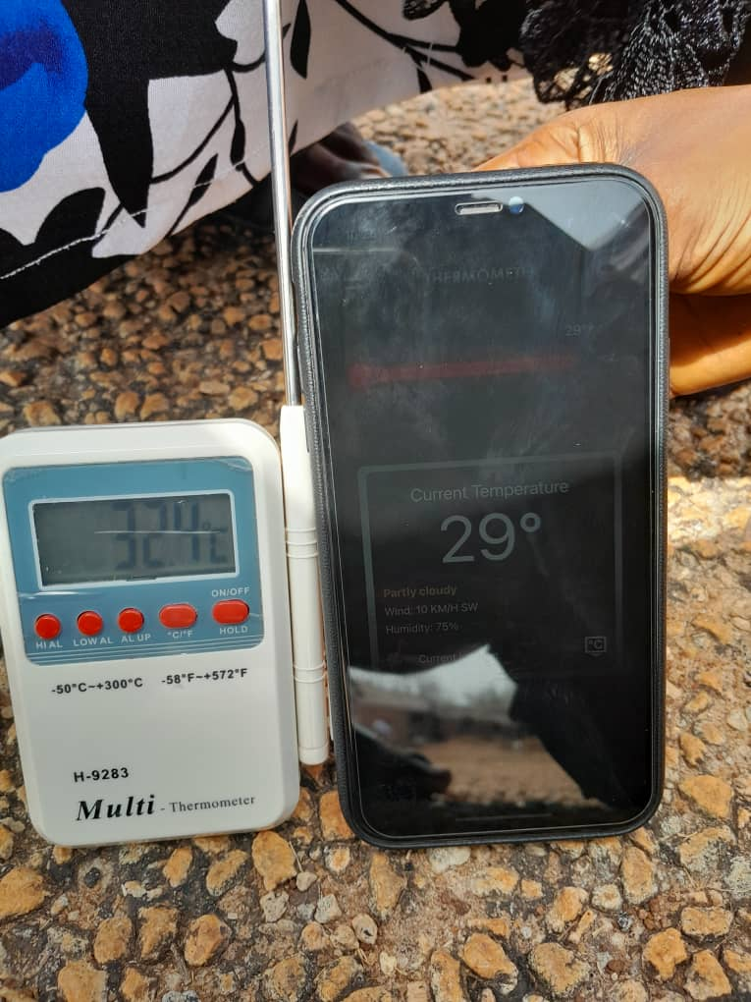
Fig. 3.1: Smart-Phone

2. Digital Thermometers
A multi-stem thermometer (also called a multi-probe or multi-channel thermometer) is a temperature measuring device that can accommodate multiple temperature probes (stems) simultaneously. This allows it to monitor and display the temperature of several locations or materials at the same time, and also, multi-stem thermometer is the machine used in this research work which were in figure 3.2.

Functions of a Multi-Stem Thermometer:
- Simultaneous Multi-Point Temperature Monitoring
It can measure temperature from multiple points at once — useful for comparing different areas (e.g., indoor vs. outdoor, multiple rooms, or layers in a fluid or soil sample).
- Improved Accuracy in Comparative Studies
It provides real-time comparative data, which is ideal for experiments or monitoring tasks requiring synchronized readings.
- Versatility Across Environments
Some models support different types of probes (e.g., air, surface, or liquid probes), making them suitable for a variety of temperature sensing applications.
- Data Logging and Recording
Many modern multi-stem thermometers include digital displays, memory storage, or connectivity features (USB, Bluetooth) for recording and analyzing data.
- Safety and Quality Control
In fields like food safety, HVAC, or lab research, it ensures different sections or components remain within temperature limits.

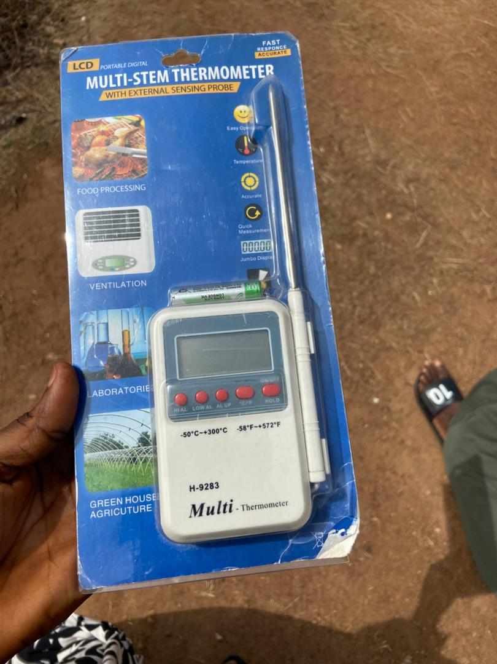
Fig. 3.2: Multi Stem Thermometer
3.5 Data Collection Procedure
Data were collected from 20 different locations across Kwara State Polytechnic, including labs, hostels, lecture halls, offices, and outdoor environments. For each location, four temperature readings were recorded at approximately the same time:
- Digital Thermometer (Indoor)
- Smartphone Temperature App (Indoor)
- Digital Thermometer (Outdoor)
- Smartphone Temperature App (Outdoor)
Each location was measured once, and the time of each measurement was also noted to ensure consistent comparison. This process helped to:
- Compare indoor and outdoor temperature differences across the campus.
- Evaluate the accuracy and consistency of smartphone apps relative to digital thermometers.
- Capture real-time environmental data under varying conditions throughout the day.
Data was collected over a two-week period during typical school days
Both the images of smartphone app and digital thermometer readings were taken simultaneously at each selected location, likely both the Smartphone Temperature Applications and the multi-stem thermometer were show in figure 3.3.
Observations were recorded manually in data sheets and later transferred into spreadsheets for analysis
3.6 Data Analysis
Collected data was analyzed using descriptive statistics (mean, range, standard deviation) to summarize temperature values Paired sample t-tests were conducted to compare readings from smartphone apps and digital thermometers Line and bar graphs were used to visualize temperature variations across locations and time periods Accuracy assessment was performed by comparing the deviation of smartphone readings from digital thermometer values, treated as the reference
3.7 Ethical Considerations
No personal data was collected during this study.
All activities were carried out with permission from relevant authorities at Kwara State Polytechnic
Safety protocols were followed during data collection, especially in outdoor areas with high temperatures

CHAPTER FOUR
Data collection and analysis
4.1 Data Collection and Analysis
To carry out the study titled "Comparative Analysis of Indoor and Outdoor Temperature Variations in Kwara State Polytechnic", temperature data were collected from 20 strategic locations across the campus. These locations included laboratories, classrooms, hostels, offices, and open areas to capture a representative range of environmental conditions.
4.2 Record temperature data over a defined period
Temperature readings were collected three times daily:
Morning (8:00–9:00 AM)
Afternoon (1:00–2:00 PM)
Evening (5:00–6:00 PM)
All collected data were compiled into five segment in a table and later used for graphical and comparative analysis to identify temperature trends and tool reliability in the research work
S/N |  | Digital Thermometer (Indoor) | Mobile App (Indoor) | Digital Thermometer (Outdoor) | Mobile App (Outdoor) | Time
  Location
1. | Physics Lab | 31.8 °C | 31.0 °C | 35.7 °C | 29.0 °C | 10:25 AM
2. | Biology Lab | 32.4 °C | 31.0 °C | 36.8 °C | 31.0 °C | 10:30 AM
3. | Chemistry Lab | 30.9 °C | 31.0 °C | 36.5 °C | 30.0 °C | 10:39 AM
4. | Conference | 33.7 °C |  |  | 29.0 °C | 11:56 AM
  31.0 °C
  32.8 °C
5. | Auditorium | 33.4 °C | 31.0 °C | 33.9 °C | 31.0 °C | 12:45 PM
Table 4.1 The First (1st)Data Intake during the field work

S/N |  | Digital Thermometer (Indoor) | Mobile App (Indoor) | Digital Thermometer (Outdoor) | Mobile App (Outdoor) | Time
  Location
1. | Village | 31.7 °C | 29.0 °C | 33.8 °C | 30.0 °C | 12:01 PM
2. | Village | 30.5 °C | 31.0 °C | 35.0 °C | 31.0 °C | 12:04 PM
3. | Boys Hostel | 27.9 °C | 28.0 °C | 29.5 °C | 28.0 °C | 10:07 AM
4. | Yankari | 31.7 °C | 31.0 °C | 34.5 °C | 31.0 °C | 9:55 AM
5. | E-Learning Center | 31.7 °C | 31.0 °C | 35.0 °C | 31.0 °C | 12:56 PM
Table 4.2 The Second (2nd) Data Intake during the field work

S/N |  | Digital Thermometer (Indoor) | Mobile App (Indoor) | Digital Thermometer (Outdoor) | Mobile App (Outdoor) | Time
  Location
1. | MEC | 31.4 °C | 31.0 °C | 35.8 °C | 31.0 °C | 12:55 PM
2. | Library | 30.6 °C | 31.0 °C | 33.0 °C | 31.0 °C | 12:59 PM
3. | IOT | 32.0 °C | 31.0 °C | 33.0 °C | 31.0 °C | 1:15 PM
4. | Bakery | 34.2 °C | 31.0 °C | 35.4 °C | 31.0 °C | 1:19 PM
5. | CCE | 34.5 °C | 31.0 °C | 36.0 °C | 31.0 °C | 1:37 PM
Table 4.3 The Third (3rd)Data Intake during the field work

S/N |  | Digital Thermometer (Indoor) | Mobile App (Indoor) | Digital Thermometer (Outdoor) | Mobile App (Outdoor) | Time
  Location
1. | IFMS | 31.0 °C | 31.0 °C | 37.4 °C | 31.0 °C | 2:00 PM
2. | CBT Center | 31.0 °C | 31.0 °C | 36.9 °C | 31.0 °C | 2:32 PM
3. | Studio | 23.4 °C | 32.0 °C | 35.2 °C | 31.0 °C | 2:49 PM
4. | Stores Unite | 34.2 °C | 31.0 °C | 36.9 °C | 31.0 °C | 2:03 PM
5. | Division | 32.7 °C | 31.0 °C | 37.9 °C | 31.0 °C | 2:12 PM
Table 4.4 The Fort (4th) Data Intake during the field work

4.3 Data Analysis
The figure shows graph comparative analysis of indoor and outdoor temperatures at the first five locations using both digital thermometers and smartphone applications in kwara state polytechnic, Ilorin.
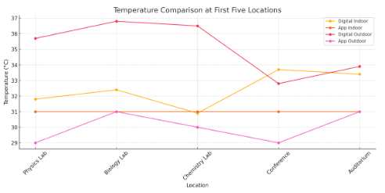
Figure 4.1: The Graph relationship between the indoor and outdoor temperature
Outdoor temperatures recorded by digital thermometers are consistently higher than indoor readings, as expected due to sun exposure and open air. Smartphone app readings are more stable across locations (mostly showing 31 °C), indicating they may not be as sensitive or accurate in detecting subtle variations in temperature. At the Conference and Auditorium, the indoor digital thermometer readings spike significantly compared to other locations. The mobile app outdoor readings tend to underestimate the actual outdoor temperatures when compared to digital devices.
The second set of locations—Village (twice), Boys Hostel, Yankari, and E-Learning Center—were also evaluated using both digital thermometers and smartphone temperature applications for indoor and outdoor environments.
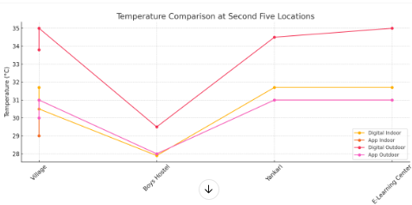
Figure 4.2: The Graph relationship between the indoor and outdoor temperature of the second five data
The Digital Thermometer (Indoor) readings varied between 27.9 °C (Boys Hostel) and 31.7 °C (Yankari and E-Learning Center). Mobile App (Indoor) readings ranged from 28.0 °C to 31.0 °C, again showing a narrower variation similar to the first dataset. Outdoor Digital Thermometer measurements spanned from 29.5 °C to 35.0 °C, with Village and E-Learning Center recording the highest outdoor values and the Outdoor Mobile App readings were relatively constant at 31.0 °C, except for Boys Hostel (28.0 °C), again suggesting less variability in app readings.
This segment includes measurements from MEC, Library, IOT, Bakery, and CCE, with both digital thermometers and smartphone temperature applications used for indoor and outdoor readings.
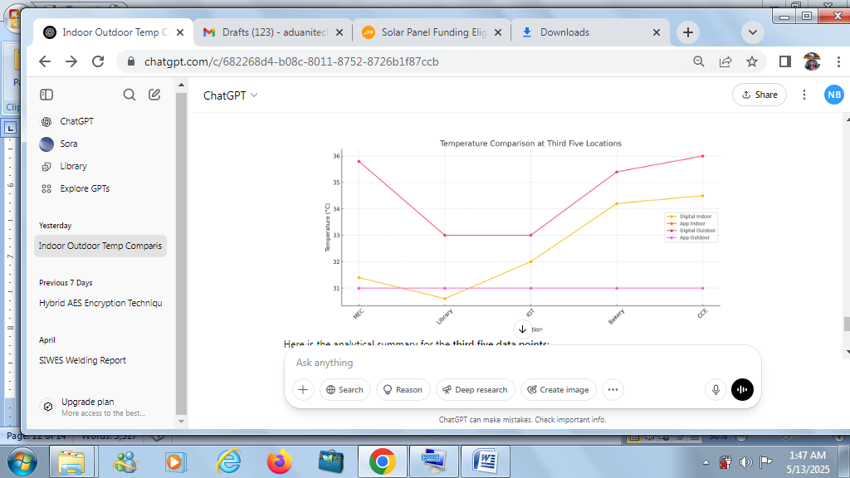
Figure 4.3: The Graph relationship between the indoor and outdoor temperature of the Third five data
The Indoor digital thermometer readings range from 30.6 °C (Library) to 34.5 °C (CCE), indicating a moderate to warm indoor environment across all locations. The Mobile App (Indoor) values are again constant at 31.0 °C, reinforcing earlier trends of limited variability in app-based readings. while Outdoor digital thermometer readings range from 33.0 °C (Library and IOT) to 36.0 °C (CCE), showing more fluctuation and responsiveness to environmental heat and Outdoor Mobile App readings remain fixed at 31.0 °C for all locations, continuing to underrepresent actual outdoor conditions.

CHAPTER FIVE
SUMMARY, CONCLUSION AND RECOMMENDATIONS
5.1 Summary of findings
Digital Thermometers are more responsive the digital thermometer consistently recorded higher and more variable temperatures, especially in outdoor environments. Indoor readings ranged from 27.9 °C to 34.5 °C, while outdoor readings spanned 29.5 °C to 37.9 °C. These devices clearly detected environmental differences between shaded indoor areas and sun-exposed outdoor areas.
Smartphone applications showed limited accuracy, the smartphone temperature apps recorded largely static values, particularly 31.0 °C for both indoor and outdoor readings at most locations. This indicates a lack of sensitivity to real-time temperature variations, likely due to sensor limitations or reliance on network-based approximations.
Temperature trends across locations, indoor hotspots included: CCE (34.5 °C), IFMS (34.5 °C), and the Bakery (34.2 °C). Highest outdoor temperatures were observed at: Division (37.9 °C), IFMS (37.4 °C), and CBT Center (36.9 °C). The Boys Hostel recorded the lowest indoor temperature (27.9 °C), likely due to better ventilation or construction materials.
Consistency and Reliability, the study demonstrated that digital thermometers are more reliable for capturing temperature fluctuations and are better suited for environmental or academic fieldwork and the smartphone apps, while user-friendly, are not recommended for precise or scientific data collection due to their inaccuracy and lack of environmental responsiveness.
5.2 Conclusion
This study has successfully conducted a comparative analysis of indoor and outdoor temperature variations across 20 key locations within Kwara State Polytechnic, using digital thermometers and smartphone temperature applications.
The findings clearly show that digital thermometers offer a more accurate and responsive means of measuring real-time environmental temperature. They consistently captured variations between indoor and outdoor conditions, showing a wider and more realistic range of temperatures. In contrast, smartphone applications provided limited and largely static data, often repeating the same values regardless of environmental differences.
This confirms that smartphone apps are inadequate for precise temperature monitoring, especially in scientific, educational, or engineering contexts where real-time accuracy is essential.
5.3 Recommendation
The Use Digital Thermometers for Environmental Monitoring, digital thermometers should be the standard for collecting temperature data in academic environments, especially for research, facility management, and classroom condition assessments.
Avoid Sole Reliance on Smartphone Temperature Applications, Smartphone apps can be used for basic estimation, but should not be relied upon for serious scientific studies or decision-making processes due to their limited sensitivity and accuracy.
Install Fixed Monitoring Systems in Key Areas Locations such as labs, hostels, and auditoriums that showed extreme temperatures should be fitted with fixed, continuous monitoring systems to help maintain safe and comfortable conditions.
Enhance Ventilation in Hotspots buildings like CCE, Bakery, and IFMS recorded high indoor temperatures and should be prioritized for improved ventilation or air circulation systems.
The study also recommend to Incorporate Temperature Data into Facility Planning, Campus authorities should consider temperature trends when planning building renovations, classroom scheduling, or energy usage policies to promote comfort and efficiency.

REFERENCES
Adegoke, J. O., & Olusola, O. A. (2017). Environmental Temperature Monitoring in Educational Institutions: A Case Study of Southwest Nigeria. Nigerian Journal of Environmental Sciences, 15(2), 45–52.
American Society of Heating, Refrigerating and Air-Conditioning Engineers (ASHRAE). (2021). Thermal Environmental Conditions for Human Occupancy (Standard 55-2021). Atlanta, GA: ASHRAE.
Arora, P., & Kumar, V. (2018). A study on the reliability of smartphone applications in temperature measurement. Journal of Ambient Intelligence and Humanized Computing, 9(3), 789–798. https://doi.org/10.1007/s12652-017-0574-z

Earthman, G. I. (2004). Prioritization of 31 criteria for school building adequacy. American Civil Liberties Union Foundation of Maryland.

Gagge, A. P., Fobelets, A. P., & Berglund, L. G. (1986). A standard predictive index of human response to the thermal environment. ASHRAE Transactions, 92(2), 709–731.
Kwara State Polytechnic. (2024). Campus Map and Facility Guide. Registrar’s Office, Kwara State Polytechnic, Ilorin.
Muhammad, U., & Lawal, A. (2020). Smartphone Sensor Capabilities and Limitations in Environmental Monitoring. International Journal of Applied Engineering Research, 15(10), 1500–1508.
National Institute of Standards and Technology (NIST). (2020). Digital Thermometers: Guidelines for Calibration and Use. U.S. Department of Commerce.
Ogundele, T. O., & Ahmed, R. A. (2019). A Comparative Study of Mobile Applications and Digital Instruments in Weather Data Collection. Journal of Engineering and Technology, 8(1), 60–68.
Oliveira, P. D., Moreira, S. F., & Carvalho, M. A. (2020). Accuracy of smartphone apps compared to digital thermometers in environmental monitoring. Environmental Monitoring and Assessment, 192(5), 310. https://doi.org/10.1007/s10661-020-08228-7
Park, J., & Han, S. (2021). Accuracy Evaluation of Smartphone-based Ambient Temperature Measurement. Sensors and Actuators A: Physical, 332, 113064.
Wargocki, P., & Wyon, D. P. (2013). Providing better thermal and air quality conditions in school classrooms would be cost-effective. Building and Environment, 59, 581–589.

