LAND INFORMATION SYSTEM
(A CASE STUDY OF PART OF ASA-DAM COMMUNITY AREA, ILORIN WEST LOCAL GOVERNMENT, KWARA STATE.) (LAND USEAGE)

PRESENTED BY

ABDULAZEEZ QUDUS OYEKANMI
MATRIC NUMBER: HND/23/SGI/FT/0006

TO

THE DEPARTMENT OF SURVEY AND GEOINFORMATICS,
INSTITUTE OF ENVIROMENTAL STUDIES,
KWARA STATE POLYTECHNIC, ILORIN

IN PARTIAL FULFILMENT OF THE REQUIREMENTS FOR AWARD OF HIGHE NATIONA DIPLOMA IN SURVEYING AND GEOINFORMATICS.

JUNE, 2025.
CERTIFICATE
I ABDULAZEEZ QUDUS OYEKANMI, with the Matriculation number HND/23/SGI/FT/0006
hereby certify that all the information given in this project work was carried out in accordance with the survey Laws, Regulations and departmental instructions. To be submit to the Department of Surveying and Geoinformatics, Institute of Environmental Studies, Kwara State Polytechnic, Ilorin. In partial fulfilment of the requirements for award of Higher National Diploma in Surveying and Geoinformatics.

Candidate’s Name: ABDULAZEEZ QUDUS OYEKANMI
Matric No: HND/23/SGI/FT/0006
Signature ............................................... Date:…………………………...

CERTIFICATION
This is to certify that this project was carried out by Abdulazeez Qudus Oyekanmi with matric number HND/23/SGI/FT/0006 in accordance with survey laws and departmental instructions.
___________________________ ____________________________

Surv. R. O. Asonibare ……………………………
Supervisor Signature & Date

Surv. R. S. Awoleye …………………………..
Project Coordinator Signature & Date

Surv. I. I. Abimbola ……………………………
Head of Surveying & Geoinformatics Department Signature & Date

DEDICATION
This project work is dedicated to Almighty God for His infinite mercy and protections over my life and my families.

ACKNOWLEDGEMENT
Glory be to Almighty Allah who gave me the opportunity to complete my HND. .I’m grateful to project supervisor in person of Surv. R.O Asonibare, for his gracious technical advice and encouragement and his unreserved teaching guidance supervision. My profound gratitude goes to my mom in person of Mrs Balogun Khadijat and my sister in person of Abdulazeez Kawthar for their support financially, morally and physically. I also acknowledge my amiable lecturers in the department who encouraged me toward my academics. Finally, my sincere thanks goes to my fellow students for the love we showed each other.

ABSTRACT
Land Information System (LIS) can provide us a better and more efficient system for land management. This was used to develop an efficient system for the management of part of asa dam, Kwara State, Nigeria. . A Land Information System is a tool for legal, administrative and economic decision-making and an aid for planning and development which consists on the one hand of a data base containing spatially referenced land related data for a defined area, and on the other hand, of procedures and techniques for the Systematic collection, updating, processing and distribution of the data.. The base of a land information system is a uniform spatial referencing system usually includes a geometric description of land parcels linked to other records describing the nature of interests, the ownership or control of other interests and often the value of the parcel and its improvements. Using Arc GIS, the study was able to achieve the efficient and effective management of the land of the study area with the ability to identify the layout parcels, it was designed for data generation to provide a database that will enhance data collection, storage, manipulation, retrieval and dissemination of information precisely at short time and eventually been able to query the database.

Keywords: LIS, database, layout, query

TABLE OF CONTENTS
Tittle page i
Certificate ii
Certification iii
Dedication iv
Acknowledgement v-vi
Abstracts vii
Table of contents viii
CHAPTER ONE
1.0. INTRODUCTION 1
1.1. BACKGROUND OF STUDY
1.2. STATEMENT OF THE PROBLEM
1.3. AIM AND OBJECTIVES
1.4. SCOPES OF THE PROJECT
1.5. SPECIFICATIONS OF THE PROJECT
1.6. LIMITATION OF PROJECT
1.7. STUDY AREA
1.8. PERSONNEL
CHAPTER TWO
2.0. LITERATURE REVIEW
CHAPTER THREE
3.0 METHODOLOGY
3.1 RECONNAISSANCE
3.2.1 OFFICE RECONNAISSANCE
3.2.2 FEILD RECONNAISSANCE
3.3.1 EQUIPMENT USED
3.3.2. HARDWARE
3.3.3. CONTROL CHECK
3.5.1. DATA SOURCE
3.5.2. PRIMARY SOURCE
3.5.3. SECONDARY SOURCE
3.6.1. GEOMETRIC DARA ACQUISITION
3.6.2. PERIMETER
3.6.3. DETAILING
3.6.4. ATTRIBUTE / SOCIAL SURVEY
3.7.1. DATABASE CREATION/ IMPLEMENTATION
3.7.2. DATABASE MANAGEMENT SYSTEM (DBMS)
3.7.3. DATA QUALITY
3.7.4. DATA INTEGRITY
3.7.5. DATA SECURITY
3.8.1. DATA PROCESSING
3.8.2. DRAFTING AND PLOTTING
3.8.3. DATABASE CREATION AND PROCEDURE
CHAPTER FOUR
4.0. SPATIAL ANALYSIS, DATA DOWNLOADING, PROCESSING AND PRESENTATION
4.1. SPATIAL ANALYSIS
4.3.1. QUERIES
4.3.2. SPATIAL QUERY
4.4. SINGLE CRITERION QUERY
4.5. MULTIPLE CRITERIA QUERY
4.6. RESULT ANALYSIS
4.7. APPLICATION OF PRODUCT
4.8. SPATIAL SEARCH
4.9. SPATIAL DEPENDANCE
CHAPTER FIVE
5.0. COSTING, SUMMARY, PROBLEMS ENCOUNTERED, CONCLUSION AND RECOMMENDATIONS
5.1. PROJECT COSTING
5.1.1. RECCI
5.1.2. BEACON 61
5.1.3 BEACONING
5.1.4. TRAVERSING
5.1.5. DATA DOWNLOADING AND PLOTTING 63
5.1.6. INFORMATION PRESENTATION
5.1.7. CONTINGENCIES
5.1.8. VALUE ADDED TAX(VAT)
5.1.9. MOBILIZATION AND DEMOBILIZATION
5.1.10. ACCOMODATION
5.2. SUMMARY
5.3. PROBLEM ENCOUNTERED
5.4. RECOMMENDATIONS
5.5 CONCLUSION
List of figures
List of tables

LIST OF FIGURES
Fig. 1.1: Diagram of study area…………………………………………………………….
Fig. 4.4.1: Shows a single query made on the database of the project ……………………….
Fig. 4.4.2: Showing the question made on the database for a built up area<196.12m² ......
Fig. 4.4.3: Showing the result of query made on the database for a built up area<196.12m²..........
Fig. 4.4.4: Showing the result of query made on the database for a built up area<196.12m² …………
Fig. 4.5.1: Showing the question made on the database for built up area >403.99m² and their purpose are for commercial use............
Fig. 4.5.2: Showing the result of query made on the database for built up area >403.99m² and their purpose are for commercial use……………………………………………………………..
Fig. 4.5.3: Showing the result of query made on the database for built up area >403.99m² and their purpose are for commercial use …………………………………………………………………
Fig. 4.5.4: Showing the question made on the database for vacant area less than or equal to 901.93m2 and are not fenced........
Fig. 4.5.5: Figure: Showing the result of query made on the database for vacant area less than or equal to 901.93m2 and are not fenced …………….
Fig. 4.5.6: Showing the result of query made on the database for vacant area less than or equal to 901.93m2 and are not fenced...........
Fig. 4.9.1: Screen-shot showing the database created for the study area ...............

LIST OF TABLES
Table 1.1: Personnel………………………………………………………………
Table 3.4.1: Coordinate of the observed and the original values of (KW/1206/AW)
Table 3.7: Coordinate of the observed and the original values of (KW/37RB) …..
Table 3.8: Coordinate of the observed and the original values of (KW/12210/RS)..
Table 5.1: Costing for Recci ……………………………………………………
Table 5.2: Costing for Beaconing …………………………………………………..
Table 5.3: Costing for Traversing …………………………………………………..
Table 5.4: Downloading Data and Plotting …………………………..
Table 5.5: Costing for Information presentation ………………………………..

CHAPTER ONE
1.0 INTRODUCTION
  - Background Of The Study
Land is the ultimate resource of the biosphere which refers to a specific area of the earth surface with physical entity in terms of its topography and spatial nature, and one of the characteristics of space that is widely recognized as a significant for planning and management purposes (Abbas et al., 2010).
Land information is an integral part of government, non-profit, and private sector activities. Adopting LIS technique can advance broader social purposes by making more effective public decisions and by using natural resources in a more optimal way. LIS supports spatial analysis and modelling procedure for solving complex planning and management problem. . The Ministry of Lands, Survey and Town Planning especially in Nigeria, should effectively tap the potentials of communication and information technology to improve on its service delivery, revenue collection and physical land use planning.
The management of land information has been in existence since people first took to sedentary agriculture (Dale et al, 1988). When the Babylonians occupied the lands between the Tigris and the Euphrates and the Egyptians cultivated the fertile regions of the Nile, the need for orderly land management was recognized. This in turn led to the development of rudimentary land information systems. More recent examples include topographical and geological mapping programs, valuation and forest inventory surveys and land title survey and registration systems. These systems provide both the information infrastructure necessary for land allocation and settlement and the additional techniques and resource information needed for resource development.
Alemie et al. (2015), Biraro et al. (2021a), Krigsholm et al. (2018), and Sattler & Nagel (2010)have asserted that access to adequate and reliable land information is essential for a well-functioning land administration. Such information is very relevant for stakeholders in making land-related decisions (Aydinoglu & Bovkir, 2017; Indrajit et al., 2021; Todorovski et al., 2018).
This has made land information systems (LIS) imperative for efficient and effective land administration. A land information system (LIS) is a set of software and hardware-based databases that enable the entry, processing, storage, and retrieval of land records (Rakhmonov & Abdurakhimova, 2021). LIS enhances land record management and efficient access to information and reduces the bureaucracies in land administration processes (Meijer, 2009). Countries that have successfully implemented LIS for land administration continue to realise the benefits. For instance, experience from developed countries like the Netherlands has demonstrated the usefulness of LIS in making geographic data accessible to all, promoting transparency, and facilitating individual choices about real estate (Kadaster International, n.d.).
A land information system for state administration on land is expected to consist of the following components.
- Geospatial data
- Software and programs
- Hardware system (data server, workstation, computers, scanners, printers,
- plotters, computer network: LAN, WAN, UPS etc)
- the operators (surveyors, land officers etc)
- the integrated approaches and methods

Benefits Of Land Information System
Land information system offers several benefits including;
- Reduced corruptions: Transparency in land transactions through a centralized system can minimize opportunities for fraud and bribery
- Efficient property taxation: Precise land data allows for fair and accurate property taxation assessments, generating reliable revenue for government
- Improved Urban Planning: Access to detailed and use information enables better planning for infrastructure development, zoning and urban growth
- Enhanced decision making: LIS provides decision makers with accurate and up to date data, enabling informed decision making on land related issues
- Better disaster management: LIS helps in identifying areas prone to natural disaster, enabling proactive measures to miligate or minimize risks
- Improved land valuation: LIS enables accurate land valuation, supporting fair compensation for land acquisition and development
- Sustainable land use planning: LIS promotes sustainable land use planning by providing data on environmental impacts and risks

1.2 STATEMENT OF THE PROBLEM

The lack of reliable and up-to-date land use information is a significant challenge in areas like Asa-Dam area. This issue hampers proper planning, resource allocation, and policy implementation. As Asa-Dam area experiences gradual urbanization, unplanned development and inefficient use of land resources are becoming prevalent, resulting in environmental degradation and socio-economic disparities. Despite advances in geospatial technologies, many rural communities have yet to benefit from such tools. This project seeks to address this gap by developing a comprehensive land use information system for part of Asa-Dam (Batty, 2013).

1.3 AIM AND OBJECTIVES OF THE PROJECT
AIM
To develop a land use information system for part of Ara village in Ilorin, Kwara State, providing actionable data to support sustainable planning and resource management.

OBJECTIVES
1. To map the current land use of the selected area using GIS tools.
2. To analyze changes in land use patterns over time.
3. To identify areas of inefficiency or concern in land utilization.
4. To propose strategies for optimizing land use based on research findings.
5. Presentation of information (Graphic & Reports)
6. Testing the efficiency of the cadastral database

1.4 SCOPE OF THE PROJECT

This project will focus on a specific portion of part of Asa-Dam in Ilorin, Kwara State. It will involve the collection, analysis, and presentation of land use data. The study will cover various land use categories, including residential, agricultural, commercial, and undeveloped areas. However, inaccessible private properties and areas with insufficient data will not be included in the analysis.

1.5 Specification of the project
In other to obtain the land information system of (Land Use), special key factors must be considered. These specifications include;
- Data Types:

- Spatial data: Parcel boundaries ,property lines, topographic features and infrastructural networks
- Attribute Data: Ownership details(owners names, addresses), land use classification(residential, commercial, agricultural), zoning regulations, property values and legal descriptions

- Data Collection Methods:

- Cadastral surveys(field measurements, aerial photographs)
- Existing land records digitization
- Remote sensing data integration

- Data Quality standards:

- Accuracy level for spatial data
- Data validation procedures

- Database Design:

- Entity relationship diagrams defining data relationships
- Spatial data storage and indexing mechanisms
- Data integrity constraints to maintain data consistency

1.6 Location Of Project Area
The location of project area is part of Asa-Dam community area, Ilorin, Asa local government area. It is located in zone 31 of the Universal Transverse Mercator (UTM) system between longitude 4º 55’ E and latitude of 8º 48’ N in the north central geopolitical zone of Nigeria. The figure 1.1 below shows the diagram of the study area

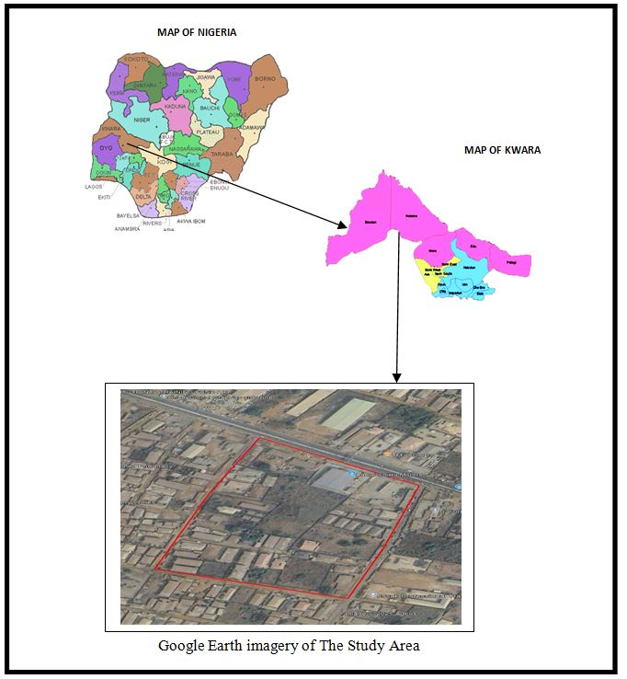
Fig. 1.1 shows the diagram of the study area

Table 1.1: Personnel

NAMES | MATRIC NO | ROLE
- ADULAZEEZ QUDUS | HND/23/SGI/FT/0006 | AUTHOR
- OCHOCHE EMMANUEL | HND/23/SGI/FT/0007 | MEMBER
- GANIYU AYUBA ALANI | HND/23/SGI/FT/0009 | MEMBER
- ADEBOWALE MARY PROMISE | HND/23/SGI/FT/0011 | MEMBER
- ODENIYI IDAYAT BOLUWATIFE | HND/23/SGI/FT/0012 | MEMBER
- ADAMS FATIMAH OLAMIDE | HND/23/SGI/FT/0013 | MEMBER
- ODEYEMI IKEOLUWA | HND/23/SGI/FT/0014 | MEMBER

CHAPTER TWO
2.0 LITERATURE REVIEW
Bannister and Raymond (1997) define surveying as the art and science of making measurements of the relative positions of natural and artificial features on the earth’s surface, and the representations of these measurement to some suitable scale to form a map, a plan or section.
Land is the ultimate resource of the biosphere which refers to a specific area of the earth surface with physical entity in terms of its topography and spatial nature, and one of the characteristics of space that is widely recognized as a significant for planning and management purpose (Abas et al., 2010).
Land information is an integral part of government, non-profit, and private sector activities. Adopting LIS technique can advance broader social purposes by making more effective public decisions and by using natural resources in a more optimal way. LIS supports spatial analysis and modeling procedure for solving complex planning and management problem. Information management system is an integrating technology where resources and activities are brought together to support the decision making process of an organization.
The operation of a Land Information System (LIS) includes the acquisition and assemblage of data, their processing, storage, and maintenance; and their retrieval, analysis and dissemination. The usefulness of such a system will depend upon up-to-dateless, accuracy, completeness, and accessibility and also upon the extent to which the system is designed for the benefit of the user rather than for the producer of the information (Date and McLaughlin, 1988).
UNFIG (1999) defined land registration as the process of recording rights in land either in the form of registration of deeds or the registration of title to land, and adjudication as the process whereby the ownership and rights in land are officially determined. Dale and McLaughlin (1999) averred that land registration provides the means for recognizing formalized property rights, and for regulating the character and transfer of these rights. Registries take note of certain interests in land including information about the nature and spatial extent of these interests and the names of the individuals to whom these interests relate. In Lesotho, the registration system focuses on the land with the unique identifier obtained from cadastral surveying (Selebalo, 2004).
Kurwakumire (2007) submitted that without functional and up-to-date land information, it is difficult to implement planning, development and exploitation of land resources sustainably for the betterment of the communities. Land is unarguably one of the most valuable resources of any nation and land information management forms a major part of urban development. Likewise, the increasing growth in rural population and the massive migration of people to the cities (especially in the developing countries) have put increasing pressure on rural and urban lands and facilities (Dale & McLaughlin 1988). Therefore, a systematic record and rational use of the land should be of prime importance to planners and policy makers.
An ideal land administration must be able to include the provision of information on land in an effective and efficient way to correctly identify those people who have interest in real estate and providing information about these interests (such as duration of leases). It must also allow easy access to land for development where it is needed, increase efficiency in land use management through good planning, and promote greater social equity. It should also allow for revenue generation to the government (taxation), maintenance of environmental quality, and provide security of tenure.

A computer-based land administration system will force standardization in the collation and processing of land data; decrease the cost and space required for storing records; prevent unnecessary duplication; facilitate access to land related data; improve information distribution, reduce the time and cost involved in transferring property rights, processing mortgages, facilitates the monitoring and analysis of market and rental value of land and property; and provide built in mechanism for quality control. The system will permit the integration of records of land ownership, land values, and land use with sociological, economic, and environmental data in support of physical planning. This will allow spatial analysis of any kind - this is the power of the system as a generic tool.
Bannister and Raymond (1997) define surveying as the art and science of making measurements of the relative positions of natural and artificial features on the earth’s surface, and the representations of these measurement to some suitable scale to form a map, a plan or section.
Land is the ultimate resource of the biosphere which refers to a specific area of the earth surface with physical entity in terms of its topography and spatial nature, and one of the characteristics of space that is widely recognized as a significant for planning and management purpose (Abas et al., 2010).
The operation of a Land Information System (LIS) includes the acquisition and assemblage of data, their processing, storage, and maintenance; and their retrieval, analysis and dissemination. The usefulness of such a system will depend upon up-to-dateless, accuracy, completeness, and accessibility and also upon the extent to which the system is designed for the benefit of the user rather than for the producer of the information (Date and McLaughlin, 1988).
GEOGRAPHICAL INFORMATION SYSTEM (GIS)
Geographical Information System (GIS) technology has given a new insight to addressing a variety of resource development, management and planning activities. Without reliable registers, transaction in land is often costly, time consuming, and uncertain. It is normally necessary to establish the fact that the reputed owner and trustee actually have the legal rights to deal with the property. Another difficulty being faced by many developing countries due to the absence of the proper land records is the real land market. The reason may be unclear delimitation of individual or group of rights, insecure ownership, etc. A cadastral database can remove such obstacles. The necessity for a functioning land market opens the way not only for private development but also for public land acquisition and other means of ensuring that land is available for dwelling and other urban needs.
Computerized land information system through GIS is therefore seen as the most appropriate technology in the reformation of cadastral systems and land administration all over the world (Siriba & Farah, 2014). GIS according to Nuhu (2009) is one of the modern methods that could be used in the computerization of land records as well as enhancing the process of land registration in Nigeria. This underscores the reason why many state governments in Nigeria are beginning to adopt GIS in their land administration processes.
Land administration is sometimes viewed as the management of land. From this perspective, the term ‘land administration’ is used to refer to “the processes of regulating land and property development and the use and conservation of the land, the gathering of revenues from the land through sales, leasing, and taxation, and the resolving of conflicts concerning the ownership and use of land” (Dale and McLaughlin, 2009). For this study, the author adopts Barry’s definition (1999) of land administration as a set of operational sub-systems that puts policies concerning land into action. This definition implies that the administration of land is not in itself a strategic process. In particular, land administration does not involve strategic planning or policy development; rather, it is merely an implementation system that follows regulations and rules stated in the policies.
Land use or physical planning can be described as a process aimed at achieving orderly physical development with the overall aim of evolving a functional and liveable environment where individual and common goals can be achieved. In urban centres, the essence of land use planning is to ensure that urban activities are organized and developed in physical space with due consideration for the protection of the public interest which include health, safety, convenience, efficiency, energy conservation, environmental quality, social equity, social choice and amenity (Adeagbo, 1998; Nnah et al., 2007).

DATABASE MANAGEMENT SYSTEM (DBMS)
Database Management System (DBMS): A database management system is a computerized record-keeping system. It is a repository or a container for collection of computerized data files. The overall purpose of DBMS is to allow the users to define, store, retrieve and update the information contained in the database on demand Database Management System was used to accomplish this study. Specifically, a Structured Query Language (SQL) database containing information that describes or defines a plot of land among several others within a layout was designed.

CHAPTER THREE
3.0 METHODOLOGY
​The following are the methods adopted in carrying out land information system analysis of part of Asa-Dam area, Ilorin, Asa local government area,Nigeria.
3.1 RECONNAISSANCE
​This is the preliminary field inspection of the project site to be surveyed. It involves the overall view of the entire land in question or the project site in order to plan on how to go about the surveying operation to achieve the aim of the work in accordance with the survey rules and regulation pertaining to the order of job required (i.e. first. Second or third order), the reconnaissance was done by considering the purpose of the survey operation and method of observation. There are the two types of reconnaissance that are carried out are:-
- Field Reconnaissance
- Office Reconnaissance
3.2.1OFFICE RECONNAISSANCE
​Information about the study area like existing map/plan of the project site and preferably historical data of the site in question, letter of notification, necessary information equipment needed to carry out the survey and coordinates of control point was carried out under this section.
3.2.2FIELD RECONNAISSANCE
At this stage, we visited the project area and take note of the crucial points, locating of existing control points, drawing of the reconnaissance diagram and also the determination of the best method for the Survey.
3.3.1EQUIPMENT USED
Total Station and its accessories.
3.3.2 HARDWARE
1. Laptop Computer
2. Mouse
3, Printer etc.
3.3.3SOFTWARE
The following Software was used:
1. Microsoft word
2. Microsoft Excel
3. Note Pad
4. Google Earth
5. ArcGis 10.0

3.4 CONTROL CHECK
It is not enough to work from whole to part but it is equally expected that the set of controls to be used are properly checked to ascertain their suitability for the job. The insitu check for both linear and angular measurements as well as the coordinate was carried out
Table 3.4.1: Coordinate of the observed and the original values of PT 31
PILLAR | NORTHING | EASTING | STATUS | REMARKS
PT 31 (KW/AW/ 1206) | 934630.687 | 668601.336 |  | ORIGINAL
PT 31 ( KW/AW/1206) | 934630.677 | 668601.356 | FIXED | OBSERVED
DISCREPANCY | 0.010 | 0.020

Table 3.4.2: Coordinate of the observed and the original values of PT 32
PILLAR | NORTHING(m) | EASTING(m) | STATUS | REMARKS
PT32 ( KW/RB/37) | 934634.584 | 668590.327 |  | ORIGINAL
PT32 ( KW/RB/37) | 934634.563 | 668590.349 | FIXED | OBSERVED
DISCREPANCY | 0.021 | 0.022
Table 3.4.3: Coordinate of the observed and the original values of PT 33
PILLAR | NORTHING(m) | EASTING(m) | STATUS | REMARKS
PT33 KW/RS/12210) | 934663.590 | 668506.841 |  | ORIGINAL
PT33 KW/RS/12210) | 934663.579 | 668506.861, | FIXED | OBSERVED
DISCREPANCY | 0.011 | 0.020

3.5.1 DATA SOURCE
Control coordinate were given from existing map, which is considered as secondary data. This was plotted using AutoCAD. There are two main source of data used primary and secondary source.
3.5.2P RIMARY SOURCE
This involve the collection of the X,Y and Z coordinate (Spatial data) using land surveying Technique with Total Stationand its accessories.
3.5.3 SECONDARY SOURCE
This type of source that was gotten from the google earth application for land information system of part of Asa DamAgakaarea. Ilorin, Kwara State.
3.6.1 ​GEOMETRIC DATA ACQUISITION
This involve the acquisition of both Northing, Easting And Height value of features that are present on the project site. In the aspect of this project digital land survey method was adopted.
    - PERIMETER
This coordinate of the boundary pillar of the project site were obtained through perimeter traversing of the area
3.6.3DETAILING
​Detailing refer to fixing of features that are found in an area where survey operation had been carried out. Building, Roads, Electricity pole and other facilities located within the project area were detailed using land survey method.

3.6.4​ATTRIBUTE/ SOCIAL SURVEY
​This aspect of data acquisition entails the collection of other data which Such data were directly related to the features to which geometric data was acquired. They included building names, the purpose of which the building is used for etc.
​To collect attribute data, questionnaire Survey was employed. This involve oral interviews, reading information from sign posts, wall signs, virtual observation, etc.
3.7.1 DATABASE CREATION/IMPLEMENT
For efficient and effective management of data in the computer environment, data item are usually arranged and stored in a database or databank. The content of this database could be in form of a text, number, polygon or graphics. The creation of this database involved the combination and storage of the acquired graphical and attributes data obtained in former designed GIS database of a generic structure for the purpose in spatial analysis and queries on project site
In the creation of a land information system data mode, a widely used technique called layering was employed. The features that are present within the project site have been classified into different layers in the AutoCAD software independently. The polyline entities were joined using the polyline tool while appropriate symbols were used for the point entities. These layers were then exported to ArcGIS environment where shape files was created using attributes fields as conceptualized in the schema. These attribute table were then populated accordingly with attributes values for each particular entity as observed in the field and from the social survey template (attached as appendix)
The personal Geo database was then created finally in Arc Catalog environment. Where other tables that are non-geometric where created while the already created shape files where imported. Relationship between these tables were also established and the tables were later populated in the Arc Map environment. The following are some of the table created
3.7.2DATABASE MANAGEMENT SYSTEM (DBMS)
​According to Dale and McLaughlin (1998), database management system was defined as a computer program to control the storage, retrieval and modification of data in the database. DBMS comprises of set of programmers which are used to maintain and manipulate the data orderly and acts as the central control over all the interactions. It is manages that data using alphanumeric data with limited capabilities of performing spatial queries
​A DBMS must allow the definition of data and their attributes and relationships as well as providing security and on interface between the end users and their application and the data themselves it reduces redundancy. Therefore, Arc GIS 10.0version was used to create, manipulate, maintain and access the database easily.
3.7.3​DATA QUALITY
Some forms of quality control and quality assurance were incorporated in the project at every phase. These include conformity with data templates, data competences and data accuracy. Conformity with data templates in this premises refers to the degree to which the captured data conformed with the designed templates, while data competence was understood as the degree to which the available data in the report and for which there are specific templates have been extracted.
3.7.4 ​DATA INTEGRITY
​The data captured as exactly downloaded into the system then exported to AutoCAD via notepad and eventually into Arc GIS. The process involves ensuring that the data in the database were accurate and setting of certain constraint to prevent inconsistency in the database.
3.7.5​DATA SECURITY
​Security is of great concern to land administration because of the legal implication of cadastral records. Security of the records is of almost importance to all concerned. This includes:
- Physical and system security
- Physical security: The use of burgling proof, firefighting equipment controlled access, proper records of the moment of personal and our of the office circuit break
- System Security: Uninterrupted power supply (UPS) will be used to control voltage, use of passwords and backups
In view of the foregoing, locking mechanism was adopted to protect the data in the database from unconscious deletion. Password was used to prevent unauthorized user from breaking into the database and a back up was created for the whole project on the rentable DVD.
Having succeeded in analysis the methodology employed in the execution of this project to arrive at the successful completion. It is equally necessary to examine the processes undertaken to ascertain the reliability and effectiveness of the created land information system

3.8.1​DATA PROCESSING
AutoCAD and ArcGIS were used for plotting and database creation.
3.8.2DRAFTING AND PLOTTING
​During plotting of the data, was firstly used to plot out all the points that are picked on the field. The downloaded data of those points were well arranged in the Microsoft excel. The following steps were carried out:
- The data was save on the desktop for easy location
- AutoCAD 2007 was launched
- All the necessary parameters were set ranging from the drawing units, text, point style and others
- The data was then located on the desktop through the Civil CAD and opened,
- The refresh button was clicked and the data was refresh with a successful message displayed
- Then the zoom extend was used to bring all the plotted point into view.
The Civil CAD plotted the coordinate along with their point ID and this make the detailing of the features (such as Roads, electric poles and other) quite easier when transfer into AutoCAD environment.

3.8.3​DATABASE CREATION PROCEDURES
​The plan in the AutoCAD format was added as data on ArchMap10.0. on Arc Catalog, a file Geo-database was created and subsequently a feature classes such as the line feature for the roads and others and polygon feature for the buildings.
Below are the procedures:
1. A folder was created for the project on the desktop and the plan with Dwgextension was saved in it,
2. ArcMap in ArcGIS10.0 software was launched
3. Then an empty new map which was displayed after loading was clicked on the minimize catalog on the right side was then maximize to view the ready created folder which contain the drawing in the AutoCAD format. The drawing was dragged from the folder and placed on the empty map and then the coordinate system was set.

CHAPTER FOUR
4.0 SPATIAL ANAYSIS, DATA PROCESSIN AND PRESENTATION
4.1 SPATIAL ANALYSIS
Spatial analysis is a specialized function that distinguish GIS from other information systems. It entails the examination of spatial and attributes characteristics of geographic features that are within the database to establish relationships from which spatial problems can be tackled. In this project work, spatial analyses were performed to select, combine and intersect existing geospatial data-sets in order to generate new information suitable for answering specific spatially-related questions.
The results from these analyses can be shown in a number of ways depending on the required output format. Where attribute information about map features are required, they can be presented as tables containing such valves as are needed from the query analysis. They can also be presented as maps with legend information showing the queried features and their topological relationships with other features shown on the map.

4.2. TESTING OF DATABASE
This is carried out to ascertain the quality of the database created, it was necessary to tryout the database so as to determine if information could be readily retrieved from it as required. Testing the database was important to determine whether the established relationships between features and their characteristics attributes are so represented on the database.

4.3.1 QUERIES
Queries are specific questions in the form of "what is where", "where is what", "when" or how long has it been there.This provides answer to the needed information through processing or manipulating spatial data.
4.3.2SPATIAL QUERY

Queries were designed for the purpose of retrieving information from the database. The queries performed in this project gave answers to certain generic questions asked from the database. This was made possible as a result of the implicit link of both the spatial and attributes data. The queries were based on the products from the analysis carried out on the database.

4.4 SINGLE CRITERION QUERY
A single criterion is carried out where one condition is used to design query. This condition is used to retrieve the information from the database. An example of a single criteria query is shown below
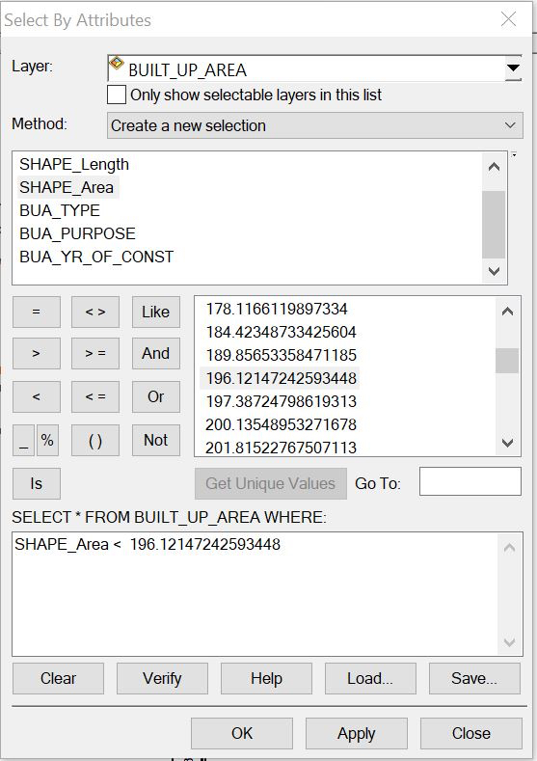

.

Figure: 4.4.1 Shows a single query made on the database of the project
Query 1: The query one is in interested in selecting or showing the built up area that have an area less than 196.12msq/m²
Syntax:built _up _area <196.12msq/m²
Figure: 4.4.2 showing the question made on the database for built _up _area <196.12msq/m²

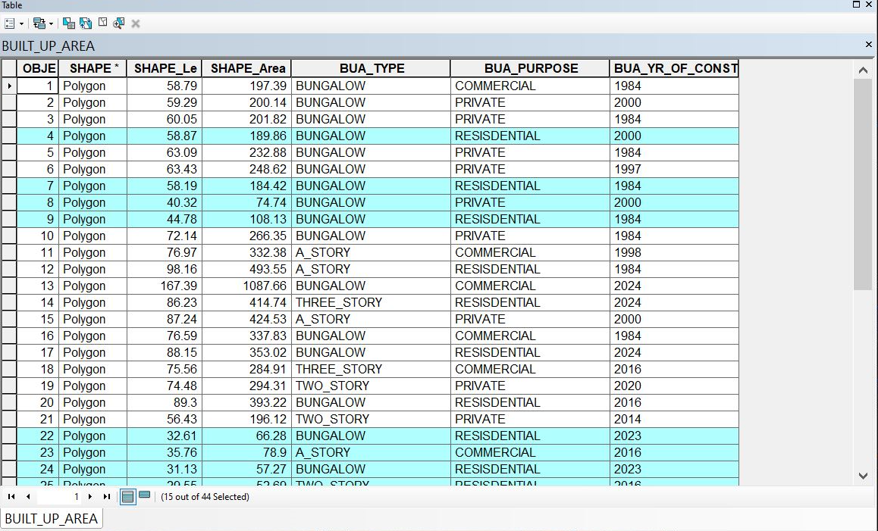

Figure: 4.4.3 showing the result of the query made on the database for built _up _area <196.12msq/m² in form of a table

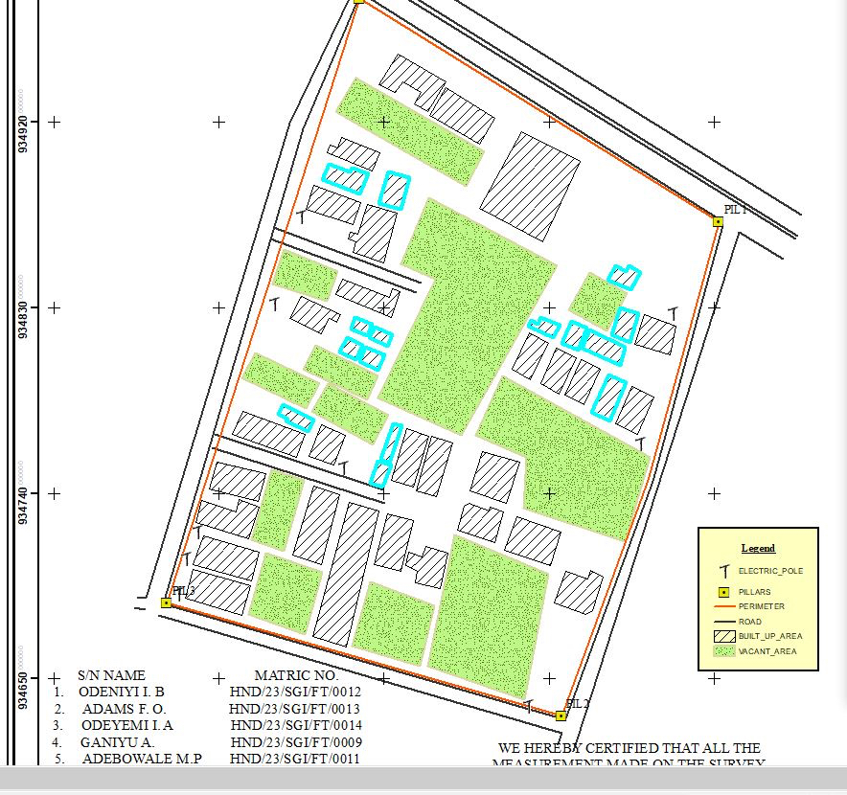

Figure: 4.4.4showing the result of the query made on the database for built _up _area <196.12msq/m²on the plan
Discussion of Result
Figure 4.4.3 and 4.4.4 Shows the built up area that have an area less than 196.12msq/m It consists of the syntax model or the query builder box, attribute table as well as the map of the selected plot in mint blue color. The result shows that 15 built_up_areaout of the 44built _up _area have an area less than 196.12msq/m²

4.5 MULTIPLE CRITERIA QUERY
The database created is then used for implementing several selection queries in determination of user-defined requirements such as built up area whose purpose are for commercial or private use, year of construction, type of building (bungalow,2 story, duplex etc.) and other security which will be effective in planning in such environment.

Query2: The query 2 is interested in showing the building area that are greater than 403.99m²and their purpose that are used for commercial
Syntax:built_up_ area > 403.99 m²ANDtheir purpose are for commercial use.

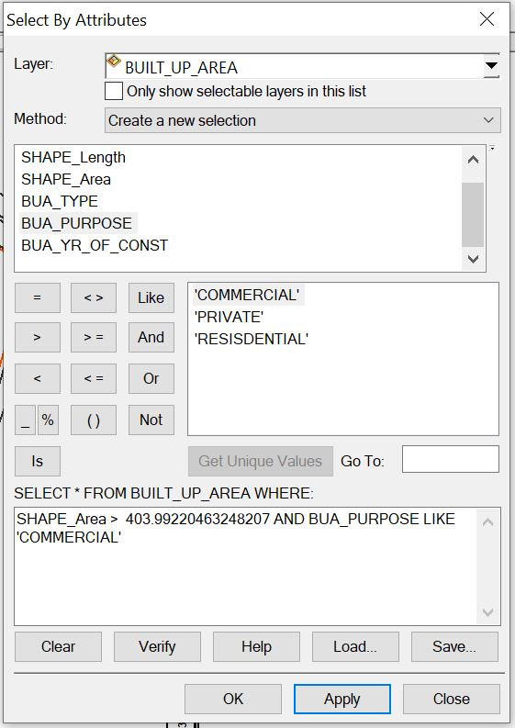
Figure:4.5.1 showing the question made on the databasefor built _up_ area > 403.99m² and their purpose are for commercial use.

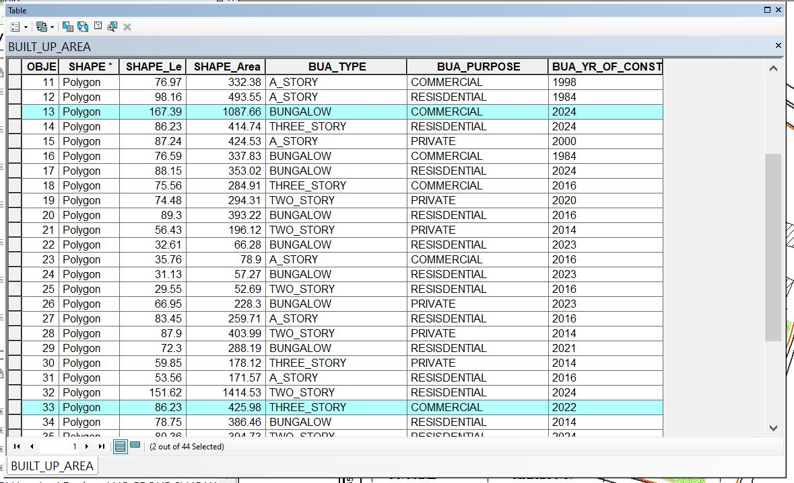

Figure: 4.5.2 showing the result of the query made on the databasefor built _up_ area > 403.99 m² and their purpose are for commercial usein form of a table
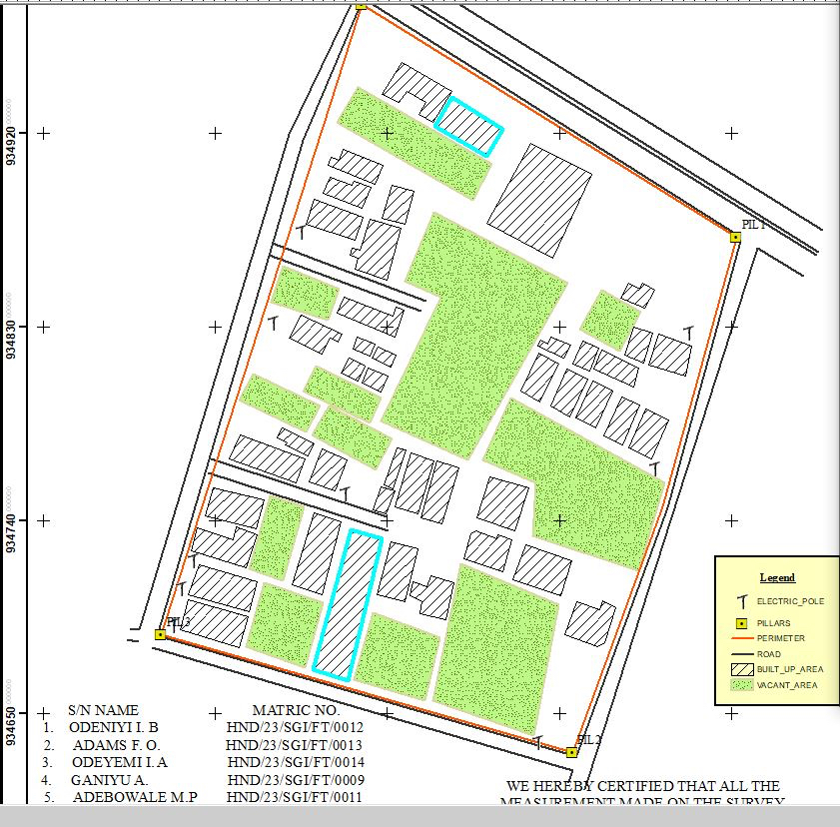

Fig: 4.5.3 showing the result of the query made on the database for built _up_ area > 403.99 m² and their purpose are for commercial use on the plan

Discussion of Result
Figure 4.5.2 and 4.5.3 Shows the built _ up _ area > 403.99㎡and purpose are commercial on the planIt consists of the syntax model or the query builder box, attribute table as well as the map of the selected plot in mint blue color. The result shows that 2 built _up _area out of the 44 built _up _area have an area greater than 403.99 m² and their purpose are for commercial use.
Query3: The query 3 is interested in showing the vacant area less than or equal to 901.99m and are not fenced to query about the vacant area of land less than or equal to 901.13m²and are not fenced
Syntax:vacant_ area <= to 901.13m²AND are not fenced

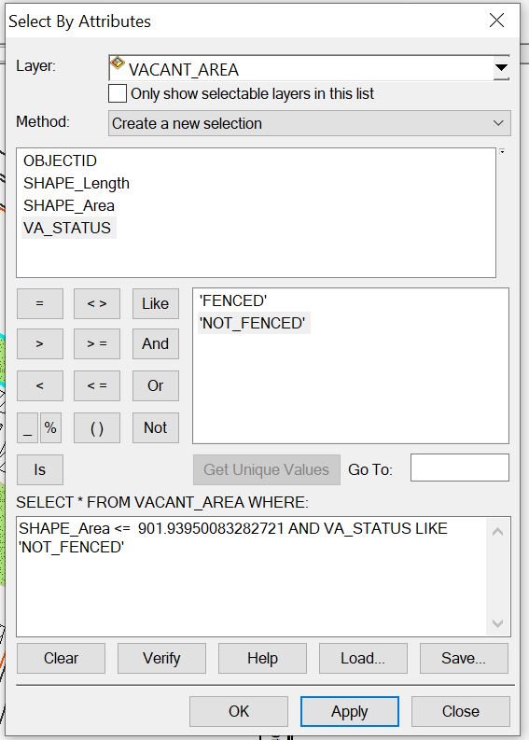

Figure: 4.5.6showing the question made on the database for vacant_ area less than or equal to 901.93m²and are not fenced

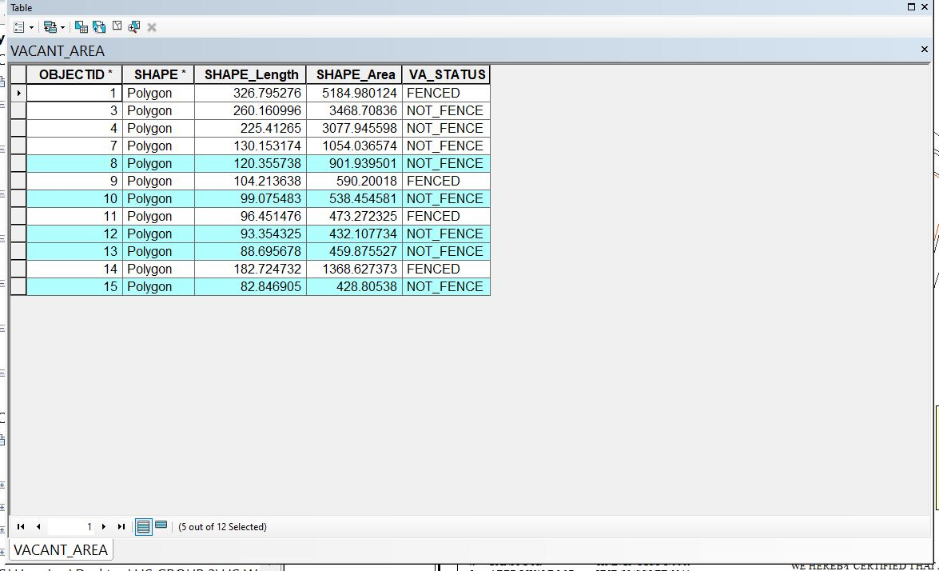

Figure: 4.5.7showing the result of the query made on the database for vacant_ area <= 901.13m²and are not fenced in form of a table
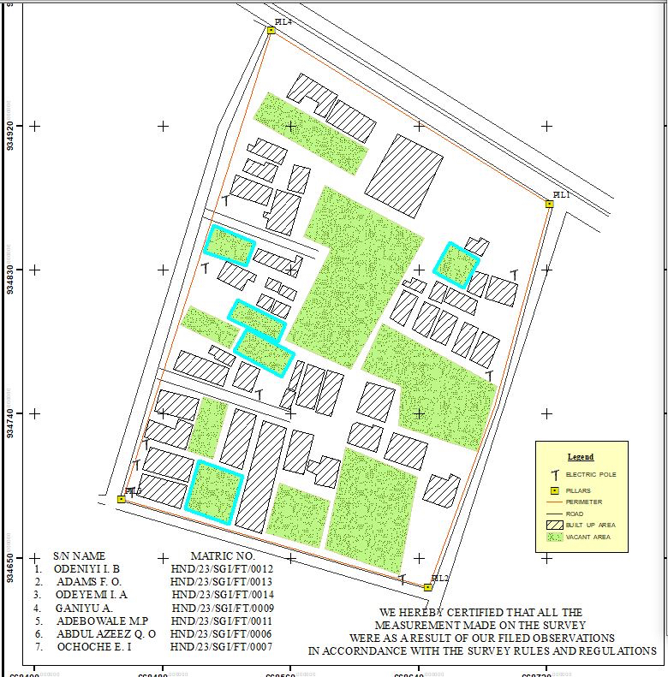
Figure: 4.5.8 showing the result of the query made on the database for vacant_ area <= 901.93m²and are not fenced on the plan.

Discussion of Result
Figure 4.5.7 and 4.5.8 Shows the vacant area less than or equal to 901.93m²and are not fenced on the plan It consists of the syntax model or the query builder box, attribute table as well as the map of the selected plot in mint blue color. The result shows that 5 vacant area out of the 12vacant _area have an area less than 901.93m² and are not fenced.

4.6 RESULTS ANALYSIS
The results analysis gotten from this project can be used by authority in charge to facilitate planning on the land available to also know certain features about the area in question such as the type of building, the purpose of the building etc. The pie chart shows the representation of the features that existing the project site, it also shows the percentage of the each features.

LOCATION | SIZE | PERCETAGE
Total built Up Area | 1285.2724 | 42.3%
Vacant area | 48165.342 | 52.2%
Total Road Distance (meters) | 1685.195 | 5.5%
​

TOTAL ROAD DISTANCE
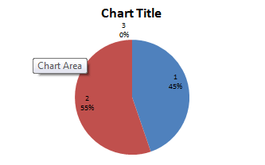
TOTAL BUILT-UP AREA
VACANT AREA

4.7APPLICATION OF PRODUCT
- It facilitates the use of GIS for effective land management and physical planning.
- It can be used for distribution of infrastructural facility in the study area.
- It can be used for utility distribution, planning and operation.
- The product will provide an integrated approach to analysis of land information.
- It can be used for sustainable land development project in the study area
4.8 SPATIAL SEARCH
The database developed/created was queried in order to reduce the spatial variation in the various information categories ranging from built up area, vacant area, electric poles, and roads (as revealed by the database created) were used for the information system.
4.9 SPATIAL DEPENDENCE
Information system is not the same in every place, even within the project area, to talk of the whole institution neither the whole state, therefore, to detect the information increment/decrement within Part of Asa Dam area,Agaka ( which is the study area) the strength of spatial relationships between the attributes must be established, the strength is known as "Spatial Dependence" and is based on Waldo Tabler's "First Law of Geography" whereby everything is related to everything else, but closer things are more related. Spatial dependence must be measured to establish a relationship limit between the environment and how the facilities is used by the people. This dependence will likely changes over the study area as the environmental factors change (Haining, 2003). This is known as a spatial process, and when it changes across space it will non-stationery. This cannot be measured just by visually determining what is on ground because it is subjective and this must be done with a scientific approach to achieve a more concrete and precise information.

Screen-shot showing the database created for the study area

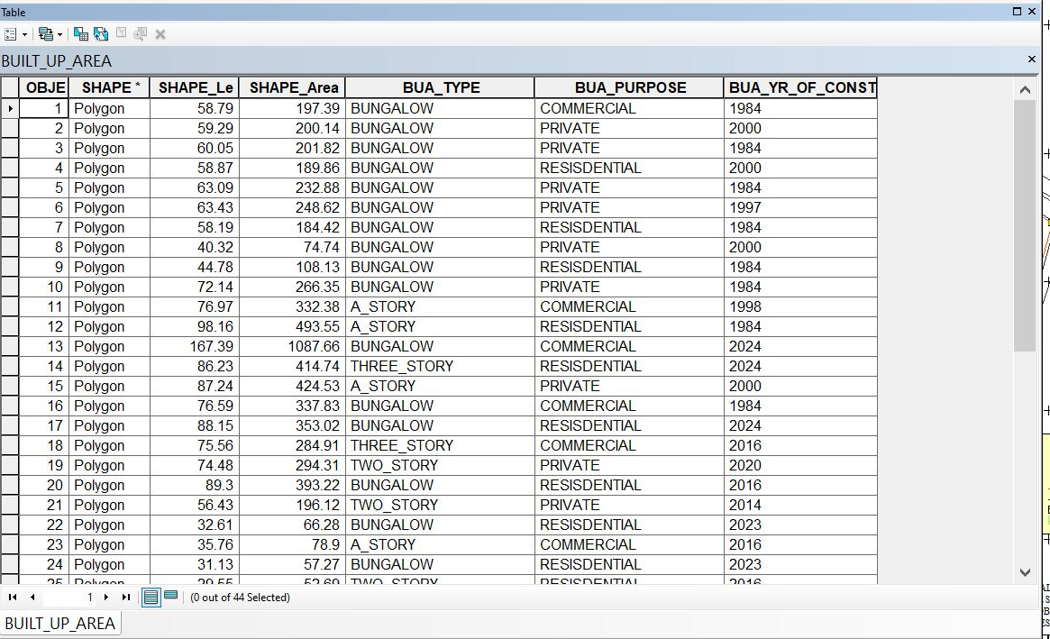

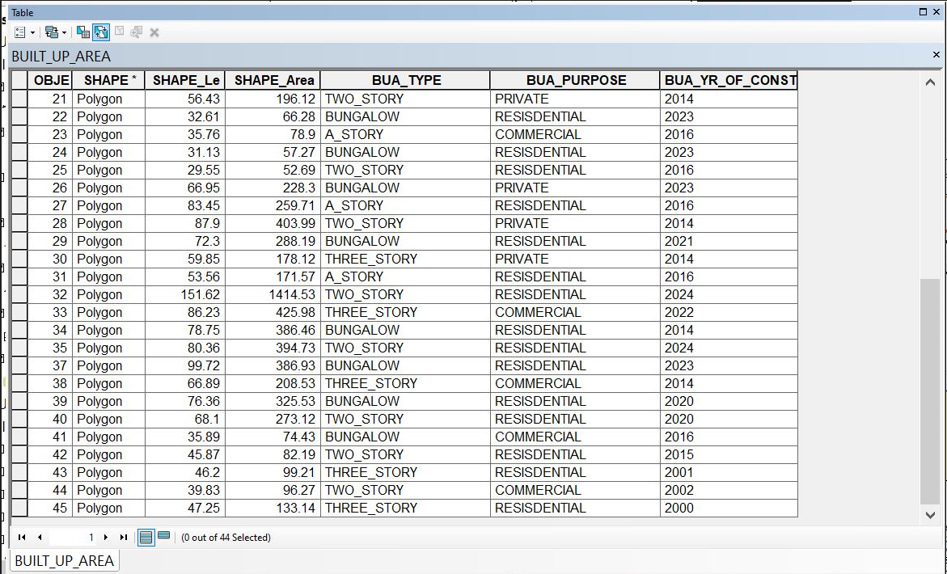

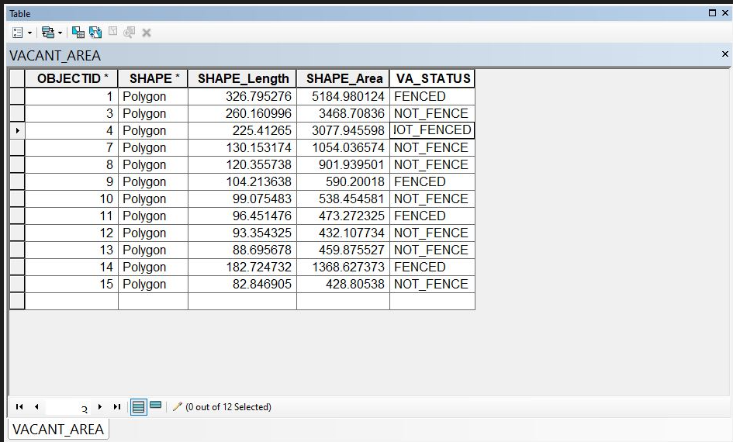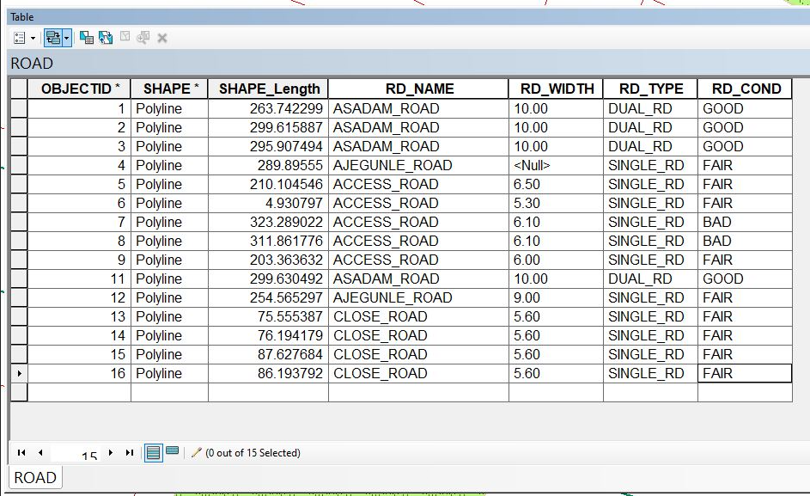
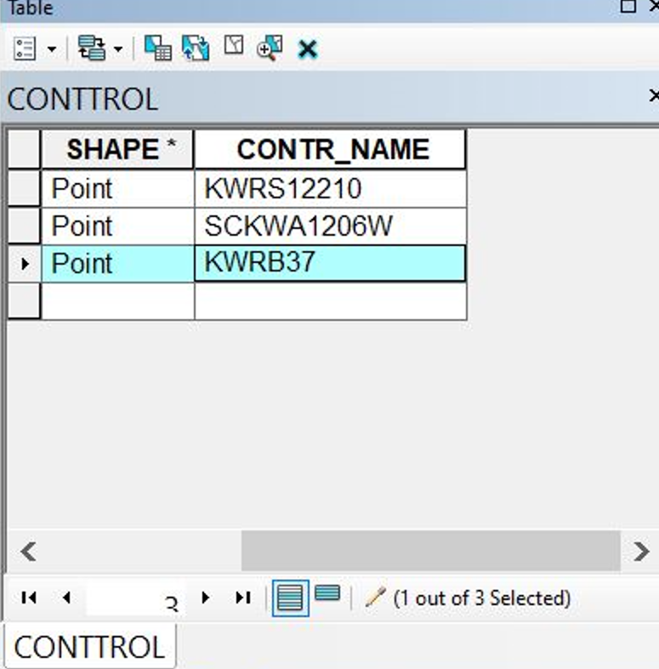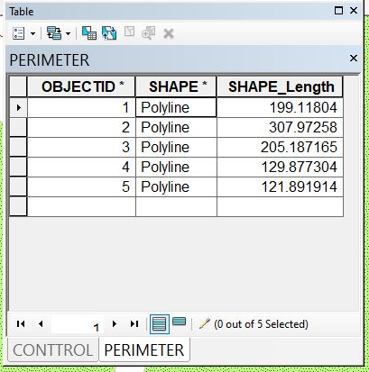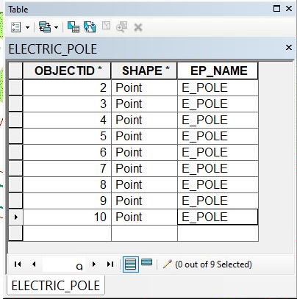

CHAPTER FIVE

5.0 COSTING, PROBLEMS ENCOUNTERED, RECOMMENDATION AND CONCLUSION
5.1 COSTING
The costing of this project was done using the Nigeria Institution of Surveyor's (NIS) professional scale of fees for consultant in the construction industry. This stage shows the total cost that was spent on the project from day one to the final stage.

5.1.1 RECCI
PERSONAL/QUALITY | DAY(S) | UNITRATE(N) | TOTAL AMOUNT(N)
1 Senior Surveyor | 1 | 15,000.00 | 15,000.00
Assistant Surveyor | 1 | 8,000.00 | 8,000.00
Transportation | 1 | 7,000.00 | 7,000.00
Basic Equipment | 1 | 8,000.00 | 7,000.00
TOTAL |  |  | #38,000.00

5.1.2. BEACON= 2,100 × 5
= #10,500

5.1.3. BEACONING
PERSONAL/QUALITY | DAY(S) | UNITRATE(N) | TOTALAMOUNT(N)
1Assistant Surveyor | 1 | 8,000.00 | 8,000.00
Basic Equipment(6) | 1 | 8,000.00 | 8,000.00
Transportation | 1 | 7,000.00 | 7,000.00
TOTAL |  |  | #23,000.00

5.1.4. TRAVERSING
PERSONAL/QUALITY | DAY(S) | UNITRATE(N) | TOTALAMOUNT(N)
1 Assistant Surveyor | 2 | 8,000.00 | 16,000.00
Basic Equipment | 2 | 8,000.00 | 16,000.00
Transportation | 2 | 7,000.00 | 14,000.00
TOTAL |  |  | #46,000.00

5.1.5. DOWNLOADING DATA AND PLOTTING
PERSONAL/QUALITY | DAY(S) | UNITRATE(N) | TOTALAMOUNT(N)
1Senior Surveyor | 2 | 15,000.00 | 30,000.00
1AssistantSurveyor | 2 | 8,000.00 | 16,000.00
Transportation | 2 | 7,000.00 | 14,000.00
Consumables | 2 | 7,000.00 | 14,000.00
TOTAL |  |  | #74,000.00

5.1.6. INFORMATION PRESENTATION
PERSONAL/QUALITY | DAY(S) | UNITRATE(N) | TOTALAMOUNT(N)
1Assistant Surveyor | 1 | 8,000.00 | 8,000.00
Transportation | 1 | 7,000.00 | 7,000.00
TOTAL |  |  | #15,000.00

(1) # 38,000.00
(2) # 10,500.00
(3) # 23,000.00
(4) # 46,000.00

(5) #74,000.00
(6) # 15,000.00
TOTAL # 206,500.00
5.1.7. CONSTIGENCIES=5%
206,500.00×5%÷ 100
= #10,325.00

5.1.8. V. A. T = 7.5%
206,500.00×7.5%÷100
= #15,487.50

5.1.9. MOBILIZATION AND DEMOBILIZATION =10%
206,500.00 × 10%. ÷ 100
= #20,650.00
5.1.10. ACCOMODATION = 1.5%
206,500.00 ×1.5%÷100
= 3,097.50
TOTAL = 206,500.00
10,325.00
15.487.50
20,650.00
3,097.50
GRAND TOTAL = 256,060.00

5.2 SUMMARY
The purpose of the project was to create a database for Land Information System (LIS) of part of Asa Dam area and it was achieved. This project covered data capturing, data processing and information presentation.
The acquired data was downloaded, edited and plotted using AutoCAD this was exported to ArcGIS for spatial analysis. The Queries involved in the database, generated information that could be used in decision making and potential physical planning of the study area. The results are presented in both softcopy and hardcopy. The process of data acquisition, data processing and information presentation, cumulated in the writing of a comprehensive report.
The supervisor`s instructions and departmental instructions were equally strictly adhered to. All data computed were within the expected.

5.3 PROBLEMS ENCOUNTERED
The following were the problems encountered during the execution of the project;
Due to the fact that we were using total station, our measurement and observation took a longer period which cause a delay in the execution of our project
During the execution of the project the main problem encountered was in the aspect of social survey. Residents refused to give out information about their land due to the fact that they were not notified before coming.

5.4 CONCLUSION
In conclusion, a Land Information System (LIS) is an essential tool for effective land management and planning. By integrating various types of land-related data, LIS enhances the ability of governments, organizations, and communities to make informed decisions about land use, resource allocation, and environmental protection. Its capabilities in data collection, management, analysis, and dissemination not only streamline administrative processes but also promote transparency. As urbanization and environmental challenges continue to grow, the importance of a robust LIS becomes even more pronounced. It enables stakeholders to address complex land issues, optimize land use, and support sustainable development goals. Ultimately, a well-implemented Land Information System serves as a foundation for sustainable land administration, contributing to economic growth, environmental conservation, and social equity. to allow easy access to information regarding to land, buildings such as commercial buildings, industrial buildings and private houses etc. road, electric poles and any other structures. The challenges faced and the simple and complex approach apply will ever remain fresh in our memories.

RECOMMENDATION
- Improve data quality by acquiring high-resolution imagery and expanding attribute data to include ownership and tax information.
- Strengthen technical infrastructure through partnerships to enhance internet access and standardize software workflows.
- I will hereby recommend that much surveying instrument should be provided for the department and also laboratory should be provided in order to hasten any project being given and to make data processing and presentation easier, faster and more accurate.
- Implement strong security protocols to protect sensitive land data from unauthorized access and breaches.
- Incorporate Geographic Information Systems (GIS) to visualize land data in a spatial context. This helps in understanding geographic patterns and relationships.

REFERENCES

- Abbas, I.I; Muazu, K.M and Ukoje, J.A (2010). Mapping Land use- land cover and Change Detection in Kafur Local Government, Katsina, Nigeria (1995-2008) Using Remote Sensing and GIS. Research Journal of Environmental and Earth Sciences, 2010 Vol.2.Issue 1, pp 6- 12.
- Dele P.F and Maclaughlin, (1998). Land Information Management: An introduction with spatial reference to cadastre problems in third world countries. Clear Dem Press Oxford.
- Enemark, S., Williamson, I., and Wallace, J. (2005). Building Modern Land Administration Systems in Developed Economies. Journal of Spatial Science, Perth, Australia, Vol. 50, No. 2, pp 51-68.
- Uluocha, N. O. (2007). Maps and Sustainable Economic Development. Nigerian Journal of Business and Social Sciences, New Series, Vol.1. No.
- UN-ECE (2005). Land Administration in the UNECE Region – Development trends and main principles. UNECE, Geneva. Retrieve August 25, 2017.

APPENDIX
EASTING NORTHING
668548.191 934980.009
668547.444 934980.307
668544.293 934982.894
668544.636 934985.710
668548.811 934982.607
668552.283 934991.899
668553.984 934993.093
668558.627 935001.645
668612.439 934967.966
668607.837 934959.071
668606.116 934957.957
668601.641 934949.128
668722.519 934871.483
668723.124 934872.773
668724.097 934869.820
668731.395 934865.208
668732.254 934866.800
668741.023 934874.594
668742.620 934875.863
668745.124 934885.688
668698.610 934743.591
668689.780 934745.713
668648.259 934630.293
668646.292 934623.439
668644.216 934617.787
668651.595 934614.517
668653.983 934620.525
668656.616 934627.794
668646.138 934631.747
668615.759 934624.995
668601.356 934630.677
668590.349 934634.563
668506.861 934663.579
668508.229 934669.629
668454.711 934686.553
668452.802 934686.335
668450.440 934680.815
668443.943 934683.679
668444.292 934689.110
668440.342 934689.467
668439.062 934684.378
668477.787 934768.863
668472.675 934772.053
668501.603 934853.331
668495.835 934856.335
668503.845 934857.130
668503.181 934853.400
668520.586 934917.005
668514.356 934919.536
668330.073 | 934975.882
668328.992 | 934964.073
668319.569 | 934966.250
668318.736 | 934954.992
668305.881 | 934943.799
668300.220 | 934950.705
668301.033 | 934950.755
668298.428 | 934952.025
668321.104 | 934924.364
668332.039 | 934911.762
668340.412 | 934902.341
668339.462 | 934903.387
668342.002 | 934902.159
668345.628 | 934894.337
668356.216 | 934903.513
668356.235 | 934913.457
668367.037 | 934912.573
668367.051 | 934922.633
668375.290 | 934927.740
668379.518 | 934921.695
668382.943 | 934930.495
668383.519 | 934930.846
668384.672 | 934931.755
668388.637 | 934925.416
668400.405 | 934935.273
668410.694 | 934944.050
668419.914 | 934951.844
668430.100 | 934960.652
668439.336 | 934968.353
668442.424 | 934968.837
668445.738 | 934967.573
668433.111 | 934973.249
668434.863 | 934976.583
668434.489 | 934979.525
668421.764 | 934992.501
668412.992 | 934002.332
668413.674 | 934001.431
668413.978 | 934999.115
668400.765 | 934983.361
668387.643 | 934970.816
668372.546 | 934956.453
668364.659 | 934941.208
668361.683 | 934948.254
668359.006 | 934947.770
668355.937 | 934947.982
668352.330 | 934948.924
668349.740 | 934942.036
668345.407 | 934956.388
668232.803 | 934006.370
668236.243 | 934001.262
668243.668 | 934997.611
668246.723 | 934995.725
668258.677 | 934985.928
668267.990 | 934974.700
668277.762 | 934962.964
668287.608 | 934951.569
668296.917 | 934939.935
668305.526 | 934929.423
668313.738 | 934919.229
668314.056 | 934917.640
668312.926 | 934920.662
668294.021 | 934898.148
668292.028 | 934898.084
668282.578 | 934905.380
668284.330 | 934892.422
668284.450 | 934891.265
668274.794 | 934902.138
668263.628 | 934913.475
668271.875 | 934917.725
668260.952 | 934929.200
668919.463 | 934354.974
668747.065 | 934930.769
668249.484 | 934941.101
668236.143 | 934942.333
668230.950 | 934960.340
668230.233 | 934948.397
668220.299 | 934958.778
668205.690 | 934983.850
668205.762 | 934972.832
668204.564 | 934973.115
668194.701 | 934963.732
668183.777 | 934953.210
668173.975 | 934943.265
668185.313 | 934931.280
668196.735 | 934919.087
668202.541 | 934913.271
668213.234 | 934922.664
668207.074 | 934927.995
668215.849 | 934935.512
668213.337 | 934901.798
668223.888 | 934890.587
668233.518 | 934898.610
668245.472 | 934908.718
668250.384 | 934902.109
668241.487 | 934894.703
668229.640 | 934884.388
668240.262 | 934873.056
668247.325 | 934865.816
668251.618 | 934864.934
668260.617 | 934871.607
668271.918 | 934880.313
668353.041 | 934881.175
668361.489 | 934866.745
668368.638 | 934854.674
668373.526 | 934846.366
668392.444 | 934862.869
668386.136 | 934868.355
668398.086 | 934878.892
668403.983 | 934873.186
668413.133 | 934882.227
668416.867 | 934883.038
668418.066 | 934881.953
668390.206 | 934911.981
668401.420 | 934911.340
668399.567 | 934900.992
668411.959 | 934899.981
668407.767 | 934893.019
668408.536 | 934891.575
668408.506 | 934889.819
668422.483 | 934888.530
668432.318 | 934878.086
668438.260 | 934859.979
668388.677 | 934819.770
668392.797 | 934818.164
668396.893 | 934810.435
668407.718 | 934819.929
668403.455 | 934827.977
668417.997 | 934829.394
668414.386 | 934838.161
668429.317 | 934839.706
668424.666 | 934847.624
668440.401 | 934849.583
668444.149 | 934865.114
668450.932 | 934859.108
668462.498 | 934868.505
668455.517 | 934875.155
668465.022 | 934883.863
668465.786 | 934886.040
668465.263 | 934888.202
668471.026 | 934893.907
668472.749 | 934892.991
668476.534 | 934894.045
668485.052 | 934901.651
668495.414 | 934911.778
668496.054 | 934914.071
668494.952 | 934915.928
668511.623 | 934909.718
668507.142 | 934908.510
668503.908 | 934906.499
668495.940 | 934899.490
668484.813 | 934889.469
668461.051 | 934904.686
668454.370 | 934900.152
668451.357 | 934915.371
668444.144 | 934911.083
668440.556 | 934927.162
668433.581 | 934922.671
668430.988 | 934937.049
668424.496 | 934932.520
668454.970 | 934958.396
668464.931 | 934947.753
668475.340 | 934936.764
668484.834 | 934926.772
668535.706 | 934948.642
668533.816 | 934947.782
668531.735 | 934947.993
668529.396 | 934949.483
668520.761 | 934958.700
668510.934 | 934968.974
668500.061 | 934980.496
668490.422 | 934991.175
668479.937 | 934002.172
668469.618 | 934013.182
668457.819 | 934025.340
668452.040 | 934031.749
668441.855 | 934042.616
668431.218 | 934053.846
668425.505 | 934059.376
668415.832 | 934070.030
668406.527 | 934080.474

